Identification of Macro-Invertebrate Taxa as
Indicators of Nutrient Enrichment in Rivers

MF Paisley, WJ Walley and DJ Trigg

Centre for Intelligent Environmental Systems
Faculty of Computing, Engineering & Technology
Staffordshire University ST18 0AD
United Kingdom

Proofs to be sent to: Dr MF Paisley at the above address, m.f.paisley@staffs.ac.uk,
Tel 01785 353510, Fax 01785 353497.

KEYWORDS: Eutrophication, diffuse pollution, biological monitoring, artificial intelligence, modelling, benthic macroinvertebrates, Water Framework Directive (or WFD), bioindicators.

Abstract
Eutrophication of fresh waters, especially from diffuse sources, is often a priority environmental issue for industrialised countries. Understanding the relationships between nutrient pressures and their impacts on ecology is essential for predicting the likely benefits of a programme of remedial measures to return nutrient concentrations to former levels. The aim of this study was to use mutual information to analyse the strength of association between macroinvertebrate families and nutrient levels (Total Oxidised Nitrogen and Total Reactive Phosphorus) in data covering rivers in England and Wales. Prior to the analysis the dataset was screened to minimise the confounding effects of organic pollution and split according to site type and season. Significance thresholds for the values of mutual information were calculated and the most significant indicator taxa were identified for each site type, season and nutrient pressure. It was found that in upland rivers the most significant indicator taxa were generally positive indicators, that is, their presence is indicative of high levels of at least one nutrient. In addition the number of significant indicators was greatest in upland rivers and least in lowland rivers.

1. Introduction
Eutrophication, defined as the enrichment of waters by nutrients resulting in an array of biological changes, is widespread in the lakes and rivers of industrialised countries (Schindler, 2006, Lampert & Sommer, 2007). Typical symptoms include increased algae production (Walling and Webb, 1992), often accompanied by enhanced growth of higher aquatic plants (Dodds, 2006). Apart from economic cost (Pretty et al., 2003), ecological consequences include variation in oxygen levels (Newbold, 1992) which may lead to fish kills (Smith, 2003) and ultimately a reduction in biodiversity following changes in species composition (Smith, 2003; Hilton et al., 2006).

Implementation of nutrient removal measures at sewage treatments works under the European Commission (EC) Urban Waste Water Treatment Directive has reduced the discharge of nutrients from point sources of pollution (EEA, 2005), but control of diffuse sources, such as agriculture, is more difficult and these are likely to represent an increasingly important source of nutrients in the future (Mainstone and Parr, 2002; EEA, 2005).

To be effective however, measures to control eutrophication require an understanding of the relationships between nutrient pressures, concentrations in the receiving water and impacts on the composition of the resident ecological community. Biological monitoring provides the primary means of classifying river quality and underlies the EC Water Framework Directive (European Commission, 2000). The response of benthic macroinvertebrate communities to environmental stresses in rivers is acknowledged to be indicative of trends in water quality (Metcalfe, 1989) and forms the basis of scientific methods for its assessment such as IBI (Index of Biotic Integrity; Karr et al., 1986), RIVPACS (River Invertebrate Prediction and Classification System; Moss et al., 1987) and AUSRIVAS (Australian River Assessment System; Davies, 2000).

Although specific responses to nutrient enrichment have been studied it is unclear whether a given nutrient regime produces a particular biological community. Recent literature certainly suggests that the macroinvertebrate community as a whole responds negatively to an increasing nutrient gradient. For example macroinvertebrate data sampled from mountain and lowland streams across several European countries showed significant negative response when measured by several different metrics (Johnson et al., 2006, Hering et al., 2006). A review of the literature over a decade or so found ten further significant relationships between nutrient concentration and measures of river taxon diversity - eight showing negative effects and only two showing positive effects (Weitjers et al. 2009). Miltner’s (2010) study demonstrated clear links between increasing nutrient concentration, stream eutrophication and measurable stress to macroinvertebrate communities.

The effect on the community as a whole may be a poor guide to the response of individual members. Analysis of sample abundance data on macroinvertebrate from streams in Ohio showed an overall negative correlation with increasing nutrient concentration, as measured by a multimetric parameter based on structure and composition, but also showed increasing as well as decreasing abundance for some individual taxa, usually according to stream size (Miltner and Rankine, 1998). Abundances of grazing and scraping invertebrates in particular were found to be highest at sites in headwater streams having elevated nutrient levels.

The premise that some taxa are intolerant to increasing nutrient concentration while others are tolerant underlies a recently developed nutrient index (Smith et al., 2007). A dataset of samples containing macroinvertebrate and chemical data was split roughly equally across a number of bins that covered the nutrient ranges, and weighted averaging used to calculate a ‘nutrient optimum’ for each taxon (approximately the mean nutrient concentration of the bin with the largest number of occurrences). The range of optima was then split into eleven groups to assign tolerance values on a scale 0 (intolerant) to 10 (tolerant). A value of the index, for both nutrients, was then calculated for each sample and shown to correlate reasonably with mean nutrient values, with the conclusion that it provided a robust measure of stream nutrient status. A similar approach was taken for data in southeast Queensland, Australia (Haase and Nolte, 2008) but the impact gradient was a linear combination of environmental variables rather than nutrient alone.

A contrasting view of the utility of macroinvertebrates for these purposes is provided by Friberg et al. (2010) based on analysis of presence-absence macroinvertebrate data from Danish rivers. Although negative responses to total phosphorus and ammoniacal nitrogen were found, no relationship was found with total nitrogen, leading to the conclusion that macroinvertebrates are poor indicators of eutrophication. However this may have been more a consequence of being unable to detect changes in abundance, and the relatively small range of taxa which included few grazers, unlike the study of Smith et al. (2007). Lewis and McCutchan (2010) also reported no significant relationship between nutrients and macroinvertebrate abundance in river data collected in Colorado, but this study did not include sites that were substantially polluted with nutrients, and the results were acknowledged to be only applicable to nutrient concentrations arising from natural variability and mild anthropogenic enrichment.

The array of confounding factors is large, including geographical location, geology, water chemistry, hydrological regime, season, biotic relationships (such as competition and predation), light levels and habitat (Hilton et al, 2006; Withers and Jarvie, 2008; Miltner, 2010). On the other hand, it is likely that for a particular set of external factors there is a relationship between nutrient enrichment and the composition of the biological community. Such relationships might only be termed associations, rather than cause and effect relationships, since the nutrients, in general, have an indirect impact on the benthic community. Even so, knowledge of such associations would be useful in identifying or diagnosing where eutrophication has occurred, and in predicting the likely benefits of measures to return nutrient concentrations to former levels.

Such a possibility could be realised through the use of artificial intelligence (AI) techniques (Walley et al, 1998 for example). Techniques such as unsupervised pattern recognition (Walley and O’Connor, 2001; O’Connor and Walley, 2002; Walley et al. 2002a; Paisley et al., 2008) and Bayesian belief networks (Walley et al., 2002a; Trigg, 2004; Paisley et al, 2008) have been demonstrated to be well-suited to modelling complex relationships in the field of river quality. Recent reviews demonstrate that supervised pattern recognition (Maier and Dandy, 2000; Maier et al, 2010), unsupervised pattern recognition (Kalteh et al., 2008; Chon, 2011) and Bayesian belief networks (Aguilera et al., 2011) are becoming established tools in environmental modelling and ecological sciences in general.

A key feature of a Bayesian belief network is its ability to reason diagnostically (effect to cause) or predictively (cause to effect) between variables as required. In the context of eutrophication diagnostic reasoning would provide an indication of the likely extent of eutrophic conditions given sample abundances of indicator taxa, while predictive reasoning would indicate the likely effect on abundance levels of returning eutrophic conditions to earlier previous levels. Although an early attempt was made to develop such a network to model eutrophication (Walley et al, 2002b) it was recommended that greater efforts be made to find suitable key indicator taxa.

The objective of the work described here then is the identification of macroinvertebrate taxa which are indicative of a strong association with nitrogen and phosphorus levels over a wide geographic area of England and Wales for use in a diagnostic and predictive model such as a Bayesian belief network, and refines an earlier investigation (Paisley et al., 2003). The approach taken consists of analysing data relating to macroinvertebrate taxa and concentrations of phosphorus and nitrogen. Importantly however the data incorporated abundance and covered a wide range of nutrient concentrations. The technique used to measure the associations between the taxa and the two nutrient variables is novel, being based on mutual information. Mutual information is a concept from information theory (for example see Cover and Thomas, 2006) and appropriate for measuring the strength of relationships between variables described by ordinal data, such as abundance levels. Mutual information is a measure of the amount of information one variable contains about another, and can be interpreted as the reduction in uncertainty in the distribution of one variable resulting from knowledge of the distribution of the other. Each taxon has an associated discrete distribution according to level of abundance and nutrient concentration. When the data is converted to probability format the mutual information (MI) value is found as:

$\text{MI}(X:Y)=\sum{\sum{p(x,y)}}{\text{log}}_{2}\frac{p(x,y)}{p(x)p(y)}$,

where$p(x,y)$ represents the probability values in the bivariate distribution and $p(x), p(y)$represent values in the marginal distributions (the prior probabilities).

Given that many factors, other than the levels of nitrogen and phosphorus, affect the composition of the benthic community it was important to try to neutralise the more important ones, subject to the constraint of the variables in the dataset. Along with the influence of organic pollution (Hering et al., 2006), season is known to be significant (Mainstone and Parr, 2002), as is the type of site (Hilton et al., 2006), and in this work attempts have been made to minimise or account for their impacts. It was not possible to account for other likely significant factors such as habitat, however.

2. Methodology
The data analysed were derived from the Environment Agency’s (EA) 1995 biological, environmental and chemical surveys of rivers in England and Wales. The project database had around 7000 records, split between spring and autumn, although as explained later not all the records were used. The biological data consisted of the abundance levels of 76 BMWP (Biological Monitoring Working Party; Hawkes, 1997) families that were recorded in the spring and autumn of 1995. The BMWP system is based on taxonomic families (except Oligochaeta, which is not a true family) and follows the taxonomy and taxonomic nomenclature described in Maitland (1977). In these data the abundance levels of taxa were recorded on a logarithmic scale as follows:

Abundance Level 0 1 2 3
Number of individuals present 0 1-9 10-99 ≥100

The chemical data recorded with each biological/environmental record consisted of the concentrations of up to 34 chemical variables, each averaged over the three months preceding the date of the biological sample. The annual average values of Total Oxidised Nitrogen (TON, mg N/l), Total Reactive Phosphorus (TRP, mg P/l), total ammoniacal nitrogen (AMMN, mg/l) and biochemical oxygen demand (BOD5) were used in this study.

The physical character and alkalinity of the rivers are known to be significant factors (Walley and Fontama, 1998) and consequently each site was classified as belonging to one of five ‘Site Types’, based on the altitude, alkalinity and the composition of the substrate of the site (Walley et al., 1998). This classification distinguishes fast-flowing upland streams with the nature of riffles (Site Type 1) from slow-flowing lowland rivers with the nature of pools (Site Type 5). The other three categories in between represent progression between these extremes with continuously decreasing altitude, increasing alkalinity and change of substrate from boulders/pebbles to mainly silt with sand/pebbles. The essential characteristics of the five Site Types are given in Table 1. It should be noted that the Site Type classification was based on the overall pattern of the six variables (altitude, alkalinity and substrate percentage of boulders, pebbles, sand and silt) as identified by a standard back-propagation neural network, not on discrete bands of the variables (Walley and Fontama, 1998, Walley et al., 1998). Hence some of the variables, such as Pebbles and Altitude, do not appear to be as discriminating as others.

Table 1. Average site characteristics (altitude, alkalinity and substrate
percentage of boulders, pebbles, sand and silt) of the five Site Types

Site | Composition of Substrate (% by area) |  |  |  | Altitude | Alkalinity
Type | Boulders | Pebbles | Sand | Silt | m | mg/l
1 | 55.4 | 38.9 | 4.4 | 2.3 | 110.4 | 32.6
2 | 41.1 | 47.1 | 6.3 | 5.5 | 52.5 | 89.9
3 | 25.4 | 52.6 | 11.8 | 10.1 | 58.4 | 182.6
4 | 15.4 | 48.6 | 18.1 | 17.9 | 46.8 | 223.1
5 | 6.2 | 24.1 | 20.4 | 49.2 | 24.7 | 231.0

Raised levels of nutrients generally lead to enhanced growth of algae, which in turn deplete levels of oxygen at night (Walling and Webb, 1992, Parr and Mason, 2004). This mechanism would be expected to occur for both oxidised nitrogen and phosphorus. However, the case of oxidised nitrogen is complicated by its association with ammonia and other nitrogen compounds; high levels of oxidised nitrogen are often associated with the oxidation of organic pollutants such as ammonia, which in turn depletes river oxygen levels further (Newbold, 1992). In order to separate the impact of oxidised nitrogen and phosphorus on the benthic community from that of ammonia, it was necessary to confine our analysis to sites with low levels of organic pollution. The biological General Quality Assessment (GQA; Hemsley-Flint, 2000) adopted by the Environment Agency for England and Wales at the time was used for this purpose, which defined six quality classes: ‘a’ (very good), ‘b’ (good) to ‘f’ (bad). Only class ‘a’ and ‘b’ sites were included in the project database, since the status of Classes ‘c-f’ as impacted sites would have undermined the validity of the analysis. In the earlier work (Paisley et al., 2003) this was done by only using samples from biological GQA class ‘a’ and ‘b’ sites. A more stringent procedure has been adopted for this study as follows.

AMMN and BOD5 were used as appropriate indicators of organic pollution, and samples were removed if recorded levels were above specified threshold values. These threshold values were determined by steadily reducing the thresholds to values where the percentage of biological GQA class ‘a’ and ‘b’ sites remaining could reasonably be considered to be free of impact from organic pollution. Clearly, this involved a value judgement, but it served the purpose of removing from our analysis those class ‘a’ and ‘b’ sites that were most likely to be impacted, if only slightly, by organic pollutants. The thresholds thus derived were 0.15 mg/l for AMMN and 2.25 mg/l for BOD5.

Table 2 gives the number and proportion of sites within each Biological GQA class which remained after removing sites at which AMMN and/or BOD5 were above their respective threshold values. Data consisting of the Class ‘a’ and ‘b’ sites that satisfied the threshold criteria were then visually examined to remove outliers in any other variable (such as metals). This resulted in a project dataset of 1375 sites each with spring and autumn samples. The low correlation coefficients between AMMN and BOD5 and each of the two nutrients in the remaining data indicated only weak associations (0.2862 and 0.4194 respectively for TON, and 0.3245 and 0.3640 respectively for TRP), confirming that residual confounding effects of AMMN and BOD5 on our analysis were probably small.

Table 2. Number and proportion of sites remaining after
removal of ‘organically’ polluted sites (as defined above).

 | Before | After | % Remaining
Class a | 2200 | 1538 | 69.9
Class b | 2180 | 1214 | 55.7
Total | 7016 | 3446

The data from those sites remaining in Classes ‘a’ and ‘b’ were separated into their spring and autumn samples. These subsets were then used to identify biological indicators of nutrients in the eutrophication analysis presented later, on the assumption that the effects of organic pollution had been significantly reduced.

As mentioned earlier the biological data for each site consisted of discrete abundance levels based on a logarithmic scale. To facilitate the mutual information calculation the continuous values of TON and TRP were converted to discrete bands. Table 3 shows the ranges that define the bands and the numbers of sites in each nutrient band for each Site Type. Reasonably even spreads of sites were achieved among the bands for both nutrients and the Site Types. It is clear however that lower concentrations of each nutrient were generally found in the more upland sites (Site Types 1-2) whereas higher concentrations were found in the more lowland sites (Site Types 4-5.

Table 3. Distribution of sites by Site Type and discrete
band of (a) TRP and (b) TON.

(a)

(b)

When converted to probability distribution format, the data in Table 3 formed the basis of the calculation of the mutual information between abundance level and nutrient band, for each taxon in each site type. An indication of statistical significance of the results was obtained as follows. The value of the mutual information is zero for independent variables (since $p(x,y)=p(x)p(y)$). Non-zero values of mutual information can arise from data on variables which are genuinely dependent, or when data on independent variables is insufficient, for instance, giving the appearance of dependence. To distinguish these cases significance thresholds can be determined which correspond to given significance levels, based on sample size and the number of categories in the discrete distributions. A value of mutual information above the 5% threshold, for example, would be regarded as significant in the sense that there is a probability of 0.95 that the variables are genuinely dependent and 0.05 that they are independent.

According to Henery (1994), for a sample of size$N$across$d$levels and $q$classes the distribution of $2N\text{MI}(X:Y)$ is approximately $χ^{2}$ with $(d−1)(q−1)$ degrees of freedom. Threshold values for significance for the mutual information can thus be deduced from the critical values of the$χ^{2}$distribution. The five chemical bands and four abundance values used in this work lead to $d=5$and $q=4$, giving 12 degrees of freedom. The thresholds for the 1%, 5% and 10% significance levels for each site type are given in Table 5, and as expected are lowest for the site types with most data (see Table 3).

Table 4. MI threshold values of 1%, 5% & 10%
significance levels for the five site types.

 | Site Type
Sig Level | 1 | 2 | 3 | 4 | 5
1% | 0.0307 | 0.0482 | 0.0599 | 0.0572 | 0.0575
5% | 0.0246 | 0.0387 | 0.0480 | 0.0459 | 0.0461
10% | 0.0217 | 0.0341 | 0.0424 | 0.0405 | 0.0407

Although it may be interesting to view the behaviour of the MI values across the Site Type range, in practice it may be more useful to view the data for each Site Type separately. After all, a particular site under investigation for potential effects of (or remediation following) eutrophication will belong to just one of the types. The results presented in this format are discussed below.

3. Results
Preliminary analysis of the results showed that the mutual information values for approximately half of the BMWP taxa were not significant at the 1% level for either TON or TRP, at any of the five Site Types, or either of the two seasons. These taxa can be considered not relevant as indicators of either nutrient. On the other hand the mutual information values for the remaining taxa are significant at the 1% level for at least one Site Type, one nutrient and one season. This is illustrated graphically in Figure 1, where the variation of mutual information across Site Type for Spring and Autumn is shown for three taxa which exhibit different behaviours.

The MI values for Hydrobiidae, Figure 1(a), are strikingly similar for both nutrients across the range of Site Types, with values well above the 1% threshold in both seasons for Site Type 1. The values drop below the 10% thresholds for both seasons for Site Types 3 and 4, with the autumn value recovering for both nutrients in Site Type 5. The values for Sphaeriidae, Figure 1(b), also display similar behaviour across the Site Types for both seasons, and the Spring values especially indicate a strong association across most of the Site Type range for both nutrients. The values for Gammaridae, Fig 1(c), behave rather differently for TON compared with TRP. Strong associations with TON are seen in both seasons for Site Types 1 and 2 only, while the associations with TRP are strong across most of the Site Type range, and especially in Spring.

The results for Site Types 1, 3 and 5 are summarised in Tables 5-7. The tables list the taxa in decreasing order of indicator value (i.e. MI) and show whether they are a positive indicator (i.e. indicative of high levels of nutrient) or a negative indicator (i.e. indicative of low levels) for that particular Site Type. Note that in Site Type 1 the most significant taxa are generally positive indicators, while in Site Type 3 and especially Site Type 5, many more are negative.

There is a distinct trend in the MI values that favours the upland streams over the lowland rivers, in that there are more taxa exhibiting strong association with nutrients in the upland streams than in the lowland rivers. There are very few taxa for Site Type 5 for which the MI values are above the 1% threshold – see Table 7. Table 8 shows that the number of taxa with MI values greater than the 5% significance value tends to decrease across the Site Types from Site Type 1 to Site Type 5, and rather more so in the case of TON than TRP.

Table 8. Distribution by Site Type and Season of the number of BMWP taxa
having MI values for TRP and TON greater than the 5% significance value.

 |  | Site Type
 |  | 1 | 2 | 3 | 4 | 5
TRP | Spring | 15 | 12 | 14 | 15 | 6
TRP | Autumn | 13 | 13 | 8 | 9 | 7
TRP | Average | 14 | 12.5 | 11 | 12 | 6.5
TON | Spring | 23 | 15 | 11 | 11 | 2
TON | Autumn | 17 | 13 | 15 | 5 | 4
TON | Average | 20 | 14 | 13 | 8 | 3

The low correlation between the nutrients and organic variables mentioned earlier was reassuring in that it indicated that the potentially confounding effect of organic pollution was only weak. Nevertheless it is likely that the confounding effect of other pollutants was present to some degree, especially in the lower reach sites (Site Types 4 & 5). On the other hand Site Type 1, presumably being least affected by other pollutants and having the largest sample size, produced the largest number of indicator taxa with statistically significant MI values. The decrease in the number of significant taxa along the site type gradient concurs with Europe-wide studies showing that macroinvertebrates are better indicators of nutrient enrichment in mountain streams than lowland streams (Johnson et al., 2006; Hering et al., 2006).

4. Discussion of Results

4.1 General
As expected the significant indicator taxa vary from one Site Type to another. As mentioned earlier, however, those in Site Type 1 are overwhelmingly positive indicators, while those in Site Type 5 tend to be negative. Furthermore, if a particular taxon is significant across the range of Site Types, such as Gammaridae or Spaeridae for example, its response generally changes from positive to negative. A range of factors may be responsible for this trend, and in particular habitat preference. The BMWP taxa are comprised of different species each of which is likely to have a preferred habitat as the river continuum is traversed (Vannote et al., 1980).

On the other hand it is also likely that the variation of nutrient concentration level with Site Type is also a factor (see Table 3). Lower concentrations are generally found in the more upland rivers (Site Types 1-2) and higher concentrations in the more lowland rivers (Site Types 4-5). At low concentrations the presence of nutrient may act to increase food sources, especially algae, causing some taxa to thrive and thus act as positive indicators (Miltner and Rankine, 1998). In Site Type 1, for example, Hydrobiidae, Elmidae, Ancylidae, Ephemerellidae and Heptageniidae are among the most significant positive indicators of TON and TRP in both Spring and/or Autumn. These belong to the trophic group of scraper/grazer which may graze on rockbound algae (Pavluk, 1997) and are consistent with Miltner and Rankine’s observation that abundances of this group were highest at sites in headwater streams having elevated nutrient levels. In other cases, the food source itself may be the cause of the increase in nutrients. For example, decaying fallen leaves may provide food for scavengers such as Gammaridae and Hydropsychidae (Pavluk, 1997), but also add nutrients to the river (Graca, 2001). Gammaridae is a significant positive indicator of both TON and TRP in Site Type 1, but especially TON, concurring with Smith et al. (2007). The situation is not clear however – in studies of five streams ostensibly similar in substrate and nutrient concentration to Site Type 1 it was found that numbers of shredders in general and Gammaridae in particular declined (Gulis et al, 2006; Baldy et al, 2007). Habitat may be the key factor in the difference - riparian vegetation was dense in these cases whereas no habitat features were recorded in the data for the present study and the sites almost certainly represent a broader range of habitat types.

In Site Types 3 and 5 many of the taxa are negative indicators, including those which may have been positive in Site Type 1. For example the most significant indicator in Site Type 3 is Chironomidae, and in Site Type 5, Gammaridae, both of which are negative, but were positive in Site Type 1. Habitat may again be the critical factor; Chironomidae, for example, is a particularly diverse group whose species exhibit a spectrum of feeding habits which influence the location in which each is found (Lindegarde and Broderson, 1994), and the response to nutrients of those found at each Site Type may be quite different. On the other hand nutrient concentration may be at least a contributing factor, though indirectly through changes in oxygen level. Slow-flowing eutrophic rivers can undergo large diurnal variation in oxygen concentration with low night-time and high day-time oxygen values (see Parr and Mason, 2004 for an example in Eastern England). Furthermore the macroinvertebrate community under an increasing nutrient gradient has been shown to be negatively correlated with the diurnal range of dissolved oxygen concentration as well as its minimum level (Miltner, 2010). Such variations are likely to be greatest in slower-flowing rivers at lower altitudes (Site Types 1-3) in the absence of attenuating tendencies such as turbulence found in rivers at higher altitudes, and the vulnerability of some taxa to low oxygen concentration and others to high is most likely in these Site Types. Although there is no direct evidence that oxygen fluctuations occurred at any of the sites in the study, Parr and Mason’s (2004) example is typical of a river with the characteristics of Site Types 5.

4.2 Is there a relationship between indicators of organic pollution and those of eutrophication?
In Site Type 1 (Table 5), where the indicator taxa are overwhelmingly positive (tolerant of nutrient), several of the most significant have BMWP score ≤ 5 (Hydrobiidae (3), Baetidae (4), Erpobdellidae (3)), which reflect tolerance of organic pollution. Several others have BMWP score ≥ 6 (Ephemerellidae (10), Leptophlebidae (10), Heptageniidae (10), Ephemeridae (10)), which reflect intolerance. A similar conclusion follows examination of the taxa of Site Types 3-5, where there are many more negative indicators; the BMPW scores of the significant taxa are split roughly equally between those with BMWP score ≤ 5 and those with scores ≥ 6. The same holds if the scores are those of SIGNAL (Chessman, 1995), a similar system to BMWP. Thus, as expected, no relationship was found between indicators of organic pollution and nutrient enrichment.

4.3 Comparison with an index of nutrient enrichment NBI
The nutrient biotic index (NBI; Smith et al., 2007) was derived from data from 129 locations on streams in New York State which were sampled once per year over a ten year period. Although the sampling period (July – September) matches neither the spring nor autumn sampling periods of the UK data used here, the locations were all riffle areas, corresponding most closely to Site Type 1. Direct comparison is difficult for several reasons however, not least because of differences in climate, geography, habitat and dominant species within families. In addition the NBI is based on species scores, and family scores used for comparison with Table 5 must be obtained by averaging species values. Based on such averaging, the NBI scores (total phosphorus and nitrate) for the top five taxa in Table 5 are towards the upper (tolerant) end of the NBI scale as might be expected, since these taxa are generally positive indicators and tolerant of nutrients. However the scores for the next five taxa for which an NBI score is available tend to be more towards the lower (intolerant) end of the NBI scale, which accords less well with our expectation. It is likely that the averaged values may be quite unreliable however - the sensitivities of individual species within a family may span a large portion of range of the scale, and differences in the distribution of species in families may alter the appropriate family score profoundly. Although comparison of the results of the two studies is difficult, the advantage of the mutual information approach would seem to be clear when compared to the nutrient optimum approach taken to derive the NBI scores; the mutual information approach identifies the most discriminating taxa, whereas an NBI score is allocated to a taxon regardless of how discriminating it is.

4.4 Towards a monitoring system
It is anticipated that the taxa identified in this study can be used to develop a monitoring system for eutrophic conditions. Such a monitoring system could either be through a metric/score system such as NBI (Smith et al., 2007) or preferably through a Bayesian belief network (Lauritzen and Speigelhalter, 1988; Jensen, 1996). A network was developed for this purpose but it was concluded that better knowledge of the key indicator taxa was required (Walley et al., 2002b). It is hoped that the findings of this study will fill that gap.

The knowledge base of a Bayesian belief network consists of two components: a causal network and a set of conditional probability matrices that relate each variable to its causal variables. The causal network defines the 'cause-effect' links between the variables. The ‘effect’ variables would consist of the taxa identified in the study while season, site type, TON and TRP could make up the ‘cause’ variables, as illustrated in Figure 2 (after Walley et al., 2002b). The conditional probability matrices define the probabilistic relationship that exists between the states of each ‘effect’ (or child) variable and the states of its ‘cause’ (or parent) variables, and are based on the raw conditional probabilities derived from the dataset.

The construction and testing of the network is left as the subject of another paper. It may also be desirable to repeat the analysis using larger amounts of more recent data.

5. Conclusions
The work described here has demonstrated some strong associations between the abundance levels of some BMWP taxa and nutrient levels, especially in the more upland Site Types 1-3. In the upland rivers the most significant indicator taxa were generally positive indicators, whereas in the lowland rivers they tended to be negative. The technique used was based on mutual information which is particularly appropriate for ordinal data like abundance levels. Approximately 15 taxa were found to be significant at the 5% level for Site Types 1-3, but less for Site Types 4 and 5. These latter Site Types are more challenging to analyse because of the more complex nature of the pollutant cocktail, and the approach suggested is likely to be less useful. The associations were found to have little trend with measures of sensitivity given by BMWP scores as expected. In contrast to a scoring system the approach used has identified the most discriminating taxa, and it is anticipated that they could be used as the basis of a monitoring tool such as a Bayesian belief network.

Acknowledgement
The authors wish to thank H.A. Hawkes for valuable discussion and are grateful for the comments of two anonymous referees.

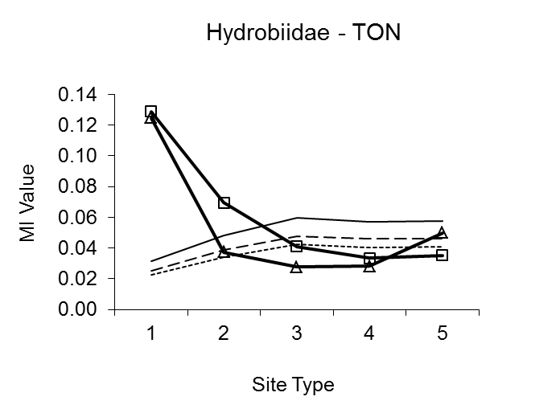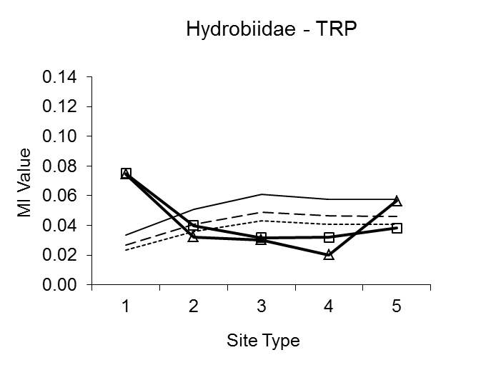

(a) Hydrobiidae

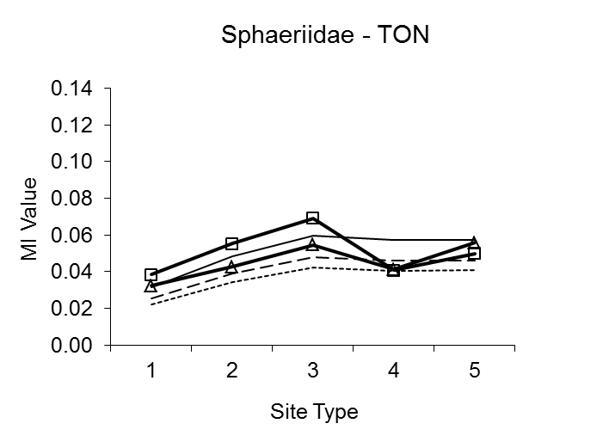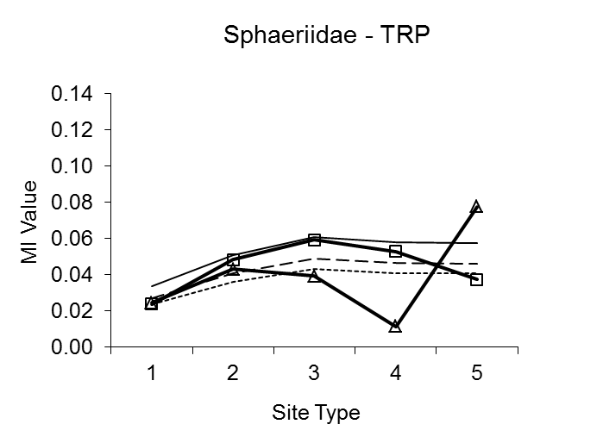

(b) Sphaeriidae

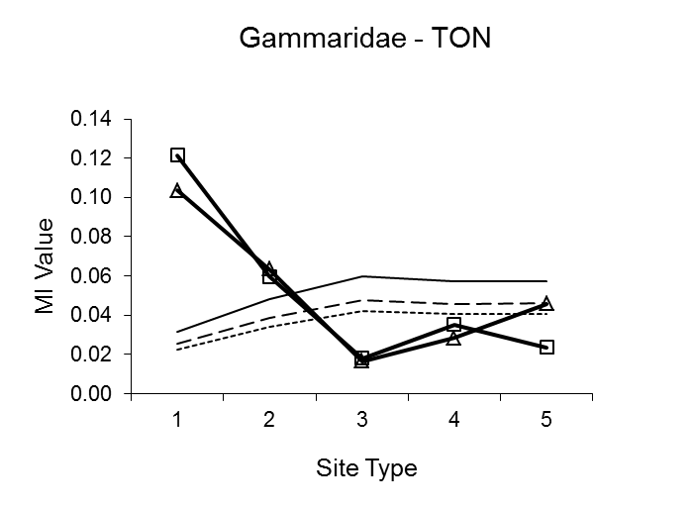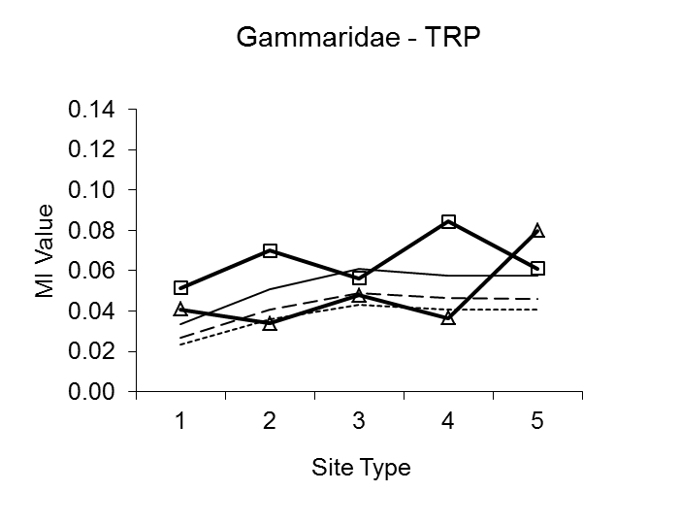

(c) Gammaridae

Figure 1. Variation of MI value with Site Type for TON and TRP in Spring
and Autumn for (a) Hydrobiidae, (b) Sphaeridae (c) Gammaridae.
Legend: Results for Spring ( ) and Autumn ( )
Threshold levels 1% ( ), 5% ( ) and 10% ( )

Alkalinity
Altitude
Substrate
Site Type
Season
TON
TRP
--------------------
Indicator
Taxon
Indicator
Taxon
Indicator
Taxon
Indicator
Taxon

Figure 2. Configuration of a possible ‘Eutrophication’ Bayesian Belief Network
Table 5. The most significant taxa ranked in decreasing order of MI value for Site Type 1 with significance threshold (%).
The sign (±) shows whether the taxon is a positive or negative indicator.

Table 6. The most significant taxa ranked in decreasing order of MI value for Site Type 3 with significance threshold (%).
The sign (±) shows whether the taxon is a positive or negative indicator.

Table 7. The most significant taxa ranked in decreasing order of MI value for Site Type 5 with significance threshold (%).
The sign (±) shows whether the taxon is a positive or negative indicator.

References
Aguilera P.A., Fernandez A., Fernandez R., Rumi R. and Salmeron (2011) Bayesian networks in environmental modelling. Environmental Software xxx 1-13.

Baldy V., Gobert V., Guerold F., Chuavet E., Lambrigot D., and Charcosset J.-Y. (2007) Leaf litter breakdown budgets in streams of various trophy status: effects of dissolved inorganic nutrients on microorganisms and invertebrates. Freshwater Biology, 52, 1322-1335.

Chessman B.C. (1995) Rapid assessment of rivers using macroinvertebrates: A procedure based on habitat-specific sampling, family level identification and a biotic index. Australian Journal of Ecology, 20, 122-129.

Chon T.-S. (2011) Self-organising maps applied to ecological sciences. Ecological Informatics 6, 50-61

Cover T.M. and Thomas J.A. (2006). Elements of Information Theory. Wiley Interscience.

Davies P.E. (2000) Development of a national river bioassessment system (AUSRIVAS) in Australia. In: Wright, J.F., D.W. Sutcliffe & M.T. Furse (Eds). Assessing the biological quality of fresh waters: RIVPACS and other techniques. Ambleside, Freshwater Biological Association, 113-124.

Dodds W.K. (2006) Eutrophication and trophic state in rivers and streams. Limnology and Oceanography, 51, 671-680.

Henery R.J. (1994) Methods for Comparison. In Machine Learning, Neural and Statistical Classification, Michie D, Spiegelhalter DJ, CC Taylor (eds), Ellis Horwood Series in Artificial Intelligence.

EEA (2005) Source apportionment of nitrogen and phosphorus inputs into the aquatic environment. EEA Report No. 7 ⁄ 2005. European Environment Agency, Copenhagen, 48 pp.

European Parliament and Council of the European Union (2000) Directive 2000/60/EC of the European Parliament and of the Council of 23 October 2000 establishing a framework for Community action in the field of water policy. Official Journal of the European Communities, L 327: 1-72.

Graca M.A.S. (2001) The role of invertebrates on leaf litter decomposition in streams – a review. International Review of Hydrobiology, 86, 4-5, 383-393.

Gulis V., Ferreira V. and Graca A.S. (2006) Stimulation of leaf litter decomposition and associated fungi and invertebrates by moderate eutrophication: implications for stream assessment. Freshwater Biology (2006) 51, 1655-1669.

Friberg N., Skriver J., Larsen S.E., Pedersen, M.L. and Buffagni A. (2010) Stream macroinvertebrate pollution and eutrophication. Freshwater Biology, 55, 1405-1419.

Haase R. and Nolte U. (2008) The invertebrate species index (ISI) for streams in southeast Queensland, Australia. Egological Indicators, 8, 599-613.

Hawkes, H.A. (1997) Origin and development of the Biological Monitoring Working Party score system. Water Research, 32 no. 3, 964-968.

Hemsley-Flint, B (2000) Classification of the biological quality of rivers in England and Wales. In: Wright, J.F., D.W. Sutcliffe & M.T. Furse (Eds). Assessing the biological quality of fresh waters: RIVPACS and other techniques. Ambleside, Freshwater Biological Association, 55-69.

Hering D., Johnson R.K., Kramm S., Schmutz S., Szoszkiewicz K. and Verdonschot P.F.M. (2006) Assessment of European streams with diatoms, macrophytes, macroinvertebrates and fish: a comparative metric-based analysis of organism response to stress. Freshwater Biology, 51, 1757-1785.

Hilton J., O’Hare M., Bowes M.J., Jones J.I. (2006) How green is my river? A new paradigm of eutrophication in rivers. Science of the Total Environment 365, 66-83.

Johnson R.K., Hering D., Furse M.T. and Clarke R.T. (2006) Detection of ecological change using multiple organism groups: metrics and uncertainty. Hydrobiologia, 566: 115-137.

Jensen F.V. (1996) An introduction to Bayesian networks. ULC press, London, ISBN 0387915028.

Kalteh A.M., Hjorth P. and Berndtsson R. (2008) Review of the self-organising map (SOM) approach in water resources: Analysis, modelling and application. Environmental Modelling and Software 23, 835-845.

Karr J.R., Fausch, K.D., Angermeier P.L., Yant P.R., Schlosser I.J. (1986) Assessment of biological integrity in running waters: a method and its rational. Illinois Natural History Survey Special Publication vol 5, Champaign, IL.

Lindegaard C. and Brodersen K.P. (1994) Distribution of Chironomidae (Diptera) in the river continuum. In P. Cranston (ed) Chironomids: From Genes to Ecosystems. CSIRO, East Melbourne, Australia, 257-271.

Lampert W. and Sommer U. (2007) Linoecology: The ecology of Lakes and Streams. Oxford University Press.

Lauritzen S.L. & Speigelhalter D.J. (1988) Local computations with probabilities on graphical structure and their application to expert systems. Journal of the Royal Statistical Society, Series B (Methodological), 50 (2), 157-224.

Lewis W.M. and McCutchan J.R. (2010) Ecological response to nutrients in streams and rivers of the Colorado mountains and foothills. Freshwater Biology (published online June 2010).

Maier H.R. and Dandy G.C. (2000) Neural networks for the prediction and forecasting of water resource variables: a review of modelling issues and applications. Environmental Modelling & Software 15, 101-124.

Maier H.R., Jain A., Dandy G.C., Sudheer K.P. (2010) Methods used for the development of neural networks for the prediction of water resource variables in river systems: Current status and future directions. Environmental Modelling & Software 25, 891-909.

Mainstone C.P. and Parr W. (2002) Phorphorus in rivers – ecology and management. Science of the Total Environment 282-283, 25-47.

Maitland P. S. (1977) A Coded Checklist of Animals Occurring in Fresh Water in the British Isles. Edinburgh: Institute Of Terrestrial Ecology. 76pp.

Metcalfe J.L. (1989) Biological water quality assessment of running waters based on macroinvertebrate communities: history and present status in Europe. Environmental Pollution 60, 101-139.

Miltner R.J. (2010) A method and rationale for deriving nutrient criteria for small rivers and streams in Ohio. Environmental Management 45, vol 4, 842-857.

Miltner R.J. and Rankin E.T., (1998) Primary nutrients and the biotic integrity of rivers and streams. Freshwater Biology 40, 145-158.

Moss D., Furse M.T, Wright J.F, and Armitage P.D. (1987) The prediction of the macro-invertebrate fauna of unpolluted running-water sites in Great Britain using environmental data. Freshwater Biology 17, 41-52.

Newbold J.D. (1992) Cycles and spirals of nutrients. In: Calow P. and Petts G.E. (Eds) The rivers handbook volume 1. Blackwell Scientific Publications 379-408.

O’Connor M.A. & Walley W.J. (2002). River Pollution Diagnostic System (RPDS) – Computer-based Analysis and Visualisation for Bio-Monitoring Data. Water Science and Technology 46, no 6, pp17-23

Paisley M.F., Trigg D.J., Martin R., Walley W.J., Andriaenssens V., Buxton R. and O’Connor M. (2008) Refinement of AI-Based Systems for Diagnosing and Predicting River Health. Technical Report EMC/WP06 077. Environment Agency, Bristol.

Parr L.B. and Mason C.F., 2004. Causes of low oxygen in a lowland, regulated eutrophic river in Eastern England. Science of the Total Environment 321, 273-286.

Paisley MF, Walley WJ, Nikhade J & Dils R. 2003. Identification of the key biological indicators of nutrient enrichment in rivers for use in predictive/diagnostic models. Proceeding of the 7th International Specialised Conference on Diffuse Pollution and Basin Management.

Pavluk, T.I., 1997. The trophic structure of macropinvertebrate communities as an approach for estimation of river ecosystem condition. Report Russian Researh Institute for Complex Water Utilisation and Protection of Water Resources, Ekaterinburg.

Pretty J.N., Mason C.F., Nedwell D.B., Hine R.E., Leaf S., Dils R. (2003) Economic costs of freshwater eutrophication in England and Wales. Environmental Science and Technology 37, 201-208.

Schindler D.W. 2006. Recent advances in the understanding and management of eutrophication. Limnol Oceanogr 51 (1, part 2), 356-363.

Smith V.H. (2003) Eutrophication of freshwater and marine ecosystems: a global problem. Environ. Sci. Pollut. Res. Int. 10, 126–139

Smith A.J., Bode R.W. and Kleppel G.S., 2007. A nutrient biotic index for use with benthic macroinvertebrate communities. Ecological Indicators 7, 371-386.

Trigg D.J. (2004). The development of an expert system using plausible reasoning for the diagnosis and prognosis of river quality. Ph.D. Thesis, Staffordshire University.

Vannote R.L., Minshall G.W., Cummins K.W., Sedell J.R. and Cushing C.E. (1980) The river continuum concept. Canadian Journal of Fisheries and Aquatic Sciences, 37, 130-137.

Walley W. J., Fontama V. N. & Martin R. W. (1998) Application of Artificial Intelligence in River Quality Surveys. R&D Technical Report E52. Environment Agency, Bristol. Publication No. TH-01/98-B-BASA.

Walley W.J. and Fontama V.N. (1998) Neural network predictors of average score per taxon and number of families at unpolluted river sites in Great Britain. Water Research 32(3), 613-622.

Walley W. J. & O’Connor M. A. (2001). Unsupervised pattern recognition for the interpretation of ecological data. Ecological Modelling 146, 219-230.

Walley WJ, O’Connor MA, Trigg DJ, Martin RW. 2002a. Diagnosing and Predicting River Health from Biological Survey Data using Pattern Recognition and Plausible Reasoning. R&D Technical Report E1-056/TR. Environment Agency, Bristol, UK. ISBN 1 85705 816X.

Walley WJ, Trigg DJ, Martin RW, Nikhade J, O’Connor MA, Paisley MF. 2002b. Assessment of river phosphorusand nitrogen from macroinvertebrate data using artificial intelligence techniques. R&D Technical Report, Environment Agency, Bristol UK.

Walling D.E. and Webb B.W. (1992) Water quality 1. Physical characteristics. In: Calow P. and Petts G.E. (Eds) The rivers handbook volume 1. Blackwell Scientific Publications 48-72.

Weitjers M.J., Janse J.H., Alkemade R. and Verhoeven J.T.A., 2009. Quantifying the effect of catchment land use and water nutrient concentrations on freshwater river and stream biodiversity. Aquatic Conservation: Marine and Freshwater Ecosystems, 19, 104-112.

Withers P.J.A. and Jarvie H.P., 2008. Delivery and cycling of phosphorus in rivers: a review. Science of the Total Environment 400, 379-395.

