Running head: DRAWING DEVELOPMENT IN THREE EDUCATIONAL SETTINGS

An investigation of the Expressive and Representational Drawing Development in
National Curriculum, Steiner and Montessori Schools

Sarah E. Rose, Richard P. Jolley and Amy Charmin
Department of Psychology and Mental Health, Staffordshire University

Author Note
The authors thank all the children who participated, the parents who gave their consent, and the teachers with whom we coordinated with during the process of conducting this study.

Correspondence concerning this article should be addressed to Sarah Rose, Department of Psychology and Mental Health, Faculty of Sciences, Staffordshire University, College Road, Stoke-on-Trent, ST4 2DE, UK (e-mail: s.e.rose@staffs.ac.uk, telephone: +44 1782 295787).

Abstract
Little is known about how children’s drawing ability may vary between different educational approaches. This study investigated the expressive and representational drawing ability of British National Curriculum, Steiner and Montessori pupils aged 5 to 9 years old. Ability was measured from performance on specified drawing tasks. One hundred and thirty five children participated, 45 from each educational establishment consisting of 15 from each of the three age groups, 5-, 7- and 9-year-olds.
Participants completed three expressive drawings (depicting a happy, sad and angry mood) and three representational drawings (observational drawing of a wooden mannequin, a house from memory and a free drawing). Results indicated that for expressive drawings Steiner pupils generally depicted more content themes, used formal properties more expressively, and produced higher quality expressive drawings than Montessori and National Curriculum pupils. Where there were differences between National Curriculum and Montessori pupils the Montessori children tended to do better than the National Curriculum pupils on these measures. Although representational drawing development varied in younger Steiner pupils compared to their National Curriculum and Montessori peers, no differences were observed among the oldest children attending the three schools. The positive relationship between expressive and representational drawing performance was the strongest in Steiner pupils.
The results suggest the art program in Steiner education is more conducive to nurturing expressive drawing ability than those delivered in Montessori and National Curriculum education, with seemingly no disadvantage in representational drawing ability in the primary school years.
Key words: drawing, expression, representation, education, development
An investigation of the Expressive and Representational Drawing Development in
National Curriculum, Steiner and Montessori Schools
Drawing is an activity with many benefits, undertaken and enjoyed by most children. Learning to draw enables children to appreciate art and equips them with sufficient skill to express themselves (Hetland & Winner, 2004). Drawing education aids the development of observation, visualization, communication and concentration skills (Barnes, 2002). Although the majority of teachers recognize the potential benefits of drawing (Burkitt, Jolley & Rose, 2010; Jolley, 2010; Rose, Jolley & Burkitt, 2006), there is much uncertainty about how best to teach children to develop their drawing skills, creativity and appreciation of art (e.g., Anning, 2002).
Differences in drawing education between cultures have been observed, and variation in the drawings that the children produce has been found. For example, in children’s human figure drawings considerable variation in popularity, style and structure have been found across cultures (Cox, 1993). However, it is often unclear to what extent differences observed in the drawings are the result of cultural or educational influences (Cox, 2005; Jolley, 2010). For instance, Cox, Koyasu, Hiranuma and Perara (2001) compared the human figure drawings of Japanese and British children. They found that although the Japanese figures were not constructed differently, they were more skillfully drawn and more highly rated then those of the British children. A potential explanation put forward by the authors is the distinctive drawing style of Manga. However, this style is common in the images surrounding Japanese culture as well as shown in the formally taught art lessons in Japanese schools (Cox, 2005). This highlights one of the challenges for cross-cultural research into children’s drawing development, that of teasing apart educational influences from cultural ones. The present study aims to investigate the effects on children’s drawing ability of three educational approaches, namely National Curriculum, Steiner, and Montessori within the same country, England.
The literature that has evaluated children’s drawing ability from a graphic skill/esthetic standpoint has focused on two main forms of communication, that of representation and expression (for a review see Jolley, 2010). Representational drawing refers to the depiction of subject matter from our three-dimensional world that enables a viewer to recognize the real-world referent. The drawing may be produced from direct observation of the subject matter or via memory. The extent to which a drawing may be perceived as visually realistic depends upon the child’s use of detail, spatial alignment, proportion, color, depth, partial occlusion and perspective techniques (see Cox, 2005; Golomb, 2004; Jolley, 2010). Expressive drawing refers to the communication of moods, feelings and ideas through three broad types of expressive techniques: literal, content and abstract (Ives, 1984; Jolley, 2010; Jolley, Fenn & Jones, 2004; Morra, Caloni & d’Amico, 1994; Picard, Brechet & Baldy, 2007). Literal expression is typically depicted by facial expressions. Content expression uses subject matter from life, such as a countryside scene on a sunny day to express a happy mood. Both literal and content expression involve the depiction of representational forms, but these have an expressive purpose rather than being a straightforward depiction of particular subject matter. Abstract expression refers to formal properties such as color, line and composition. All three expressive techniques are of course not mutually exclusive, as they can appear in the same picture or even in a single image. Furthermore, expressive content can be rendered realistically or with little or no representational content (as in the case of abstract art).
Drawing in English National Curriculum Schools
Art was included in the Education Reform Act of 1988 by the British government as a National Curriculum foundation subject. The Program of Study (Department for Education and Employment, 1999) outlines what pupils, between the ages of 5 and 14 years, should be taught during the recommended one hour a week art lesson. The National Curriculum for all subjects is broken down into Key Stages; these are defined by the age of the pupils. Children only move up from one Key Stage to the next at the beginning of the relevant school year determined by their age. The National Curriculum for Art and Design aims to strike a balance between drawing from observation and encouraging children’s expression and creativity. For instance at Key Stage One (5 to 7 years) the curriculum states, “pupils should be taught to … represent observations, ideas and feelings” (Department for Education and Employment, 1999, p.16) and similar, more developed, statements are given for Key Stages Two (7 to 11 years) and Three (11 to 14 years). However, the Program of Study is somewhat vague and much interpretation of its delivery is left to teachers, who in the case of general primary school teachers receive very little art training. Over 20 Exemplar Schemes of Work, covering the three Key Stages, have been published by the DfEE/QCA to help teachers see how the Program of Study can be translated into practical, manageable teaching plans. Looking through these it is notable that although tasks requiring both expressive and representational skills are included, there is a bias towards representational work. More than half of the schemes of work focus on representation whereas only about a quarter focus on more expressive aspects of art making (the remainder are projects focusing on the discovery of materials, e.g., textiles, film making). Furthermore, the disparity is even greater among the schemes of work designed for the very youngest children (5- to 7- year-olds), where the schemes of work principally focus on observational techniques and craft based activities. Some teachers may develop their own schemes of work involving expressive drawing skills. However, based on previous research concerning the attitudes and practices of teachers (Burkitt, et al., 2010; Rose, et al., 2006), this curriculum bias towards facilitating representational drawing skills is certainly representative of what happens during Key Stage One and also much of Key Stage Two.
Drawing in Steiner Schools
The first Steiner school was established in 1919, based on the beliefs and practices of Rudolf Steiner (1861-1925). Steiner schools, also known as Waldorf schools, have gained in popularity and by December 2009 there were 996 Steiner schools in 58 countries, 32 of them in the United Kingdom (Bund der Freien Waldorfschulen, 2010). Steiner education aims to educate the whole child (mind, body and spirit) and is based upon its own theory of child development (Nicholson, 2000; Woods & Woods, 2002). Up until age 7 the children attend Kindergarten where, in a home-like environment, imaginative play is encouraged along with participation in domestic activities such as baking, cooking, cleaning, gardening and sewing. At this stage learning occurs through physical activity, imitation and play (Easton, 1997). Between ages six and seven pupils enter Class One, this is where formal teaching begins. Nonetheless, the children spend much time drawing their own illustrations to stories that teachers narrate to them and in decorating their workbooks (Nicholson, 2000). The classrooms are decorated with a wide range of artwork, created by the pupils themselves, their teacher and artists. It is believed that through the creation of artistic works the child becomes more aware of sensations, feelings and thoughts (Easton, 1997). Consequently, throughout the whole curriculum the visual arts are considered essential to the development of the child’s attitudes, feelings and understanding for all subjects (Nicholson, 2000; Woods, Ashley & Woods, 2005). Children have much freedom in choosing the subject matter and the style of their drawings. Some drawings represent specific scenes from the stories told, others are more abstract in nature. In this way children have the opportunity to experiment with both expressive and representational drawing skills. However, there is little formal teaching of drawing until the pupils reach 12-years-old. This is reflective of Steiner’s belief that the purpose is not to necessarily to achieve a product of high artistic merit, but instead to find a path to knowledge and understanding (Nobel, 1991). In most of the 15 British Steiner schools surveyed by Woods et al. (2005) drawing was not taught as an individual subject lesson until the pupils were 14 years old, instead it was integrated into most lessons throughout the school day. From the same survey, Woods et al. found that 95% of teachers perceived the artistic and creative skill of the teacher a distinguishing characteristic of the pedagogy. This is in contrast to the ‘generalist’ teacher in National Curriculum Primary Schools who often reports feeling vulnerable teaching art (Burkitt, et al., 2010; Clement, 1994).
Drawing in Montessori Schools
Current estimates of the number of Montessori schools suggest there are around 7,000 schools worldwide. However, obtaining a definitive number is difficult as, unlike Steiner schools, there is little regulatory control over schools choosing to call themselves Montessori. Montessori schools are based on the theory of child development advocated by Maria Montessori (1870-1952). As a constructivist, she saw children as active, eager for knowledge and prepared to learn (Edwards, 2002). Consequently, the emphasis within these schools is on learning real-life and practical skills as it is not believed that children gain competence or self-esteem from carrying out artificial or contrived activities (Mooney, 2000). The children acquire knowledge through independently working on hands-on-projects and reflecting on their progress. Children are generally grouped into multi-age classrooms, spanning three year intervals. Children are given considerable freedom in choosing which projects they will work on. However, fantasy, imaginative play and myth are discouraged in order to direct the child’s focus towards learning subjects considered to be more constructive subjects (Montessori, 1965). This is a clear contrast to the position taken by Rudolf Steiner, see above. Art materials are generally available for children to experiment with as they choose. Maria Montessori did not advocate the direct teaching of drawing skills. Instead, she argued that good drawing can only be achieved through the development of mechanical technique and the child’s freedom to explore and observe their surroundings (Montessori, 1918). Children are encouraged to observe very carefully and to depict what they see. Free drawings from imagination are not valued, Maria Montessori seeing these as ‘nothing but monstrous expressions of intellectual lawlessness’ (Montessori, 1918, p. 308). Teachers following the Montessori approach take the role of a consultant and facilitator (Rosvanova, 2003). Defining the amount of time spent on drawing is problematic as subjects are not taught in blocks, rather they are provided for the children to chose when they are ready and interested (Goldsbrough, 2003). While traditionally the approach within Montessori schools has been to focus on observational and technical drawing skills, the value and benefit of expressive drawing skills have become more appreciated in recent years. Consequently, Montessori pupils are now allowed greater freedom in their drawings, with fantasy elements no longer being so actively discouraged (see also Cox & Rowlands, 2000).
Previous Research
Steiner, Montessori and National Curriculum schools clearly differ in their pedagogical practices. The impact of these on the development of children’s drawing has been the topic of some preliminary studies. Ogletree (2000) compared the development of creative thinking in 1,165 Steiner and State school children aged 8- to 11-years-old, matched on socio-economic status, from England, Scotland and Germany. The Torrance Test of Creative Thinking (Torrance, 1966) was administered. This includes verbal and figural tasks of divergent thinking and problem solving. Among the tasks administered three specifically involved drawing, these are the focus in our reporting here as they are the most relevant to the current study. In one of these, a picture construction task, children were instructed to draw the most creative and interesting picture using a banana-shaped paste-on as part of their drawing. The other two drawing tasks were a picture completion task which involved children receiving incomplete figures to complete a finished drawing, and a circles task in which children were provided with a series of circles and asked to make pictures. The findings were not broken down to the level of the separate tasks and details of scoring were not included. However, it was concluded that Steiner pupils, across all cultures, obtained higher creativity scores than their state school peers. Furthermore, in relation to the drawing tasks, Ogletree commented that the Steiner pupils were ‘more mature in terms of skill and technique’ (unpaged) with form and line being developed by shading and color blending. In contrast, the National Curriculum pupils tended to first draw an outline and then color it in.
A study focusing more closely on drawing development, rather than general creativity, among National Curriculum, Steiner and Montessori pupils was carried out by Cox and Rowlands (2000). Sixty children aged between 5 and 7 years of age completed three drawings: a prescribed scene drawing, an observational picture of an artist’s wooden model of a man running and a free drawing. Children were not separated into different age groups and only between school differences were considered by two raters. These raters were independent to the study and had no knowledge of the sex or age of the children, or which school they attended. The free and scene drawings were rated by two raters on a scale of 1-5, one being ‘a very poor drawing’ and five being ‘an excellent drawing’. No firm criteria were given for the points on the scale. Inter rater reliability was reported to be good for these drawings, with the two raters agreeing on the exact rating for over 75%. For the remaining drawings raters were within one point of each other. For the drawing of the model running a more detailed 12-point scale was used from Cox’s earlier work (Cox, Perara & Xu, 1998). This scale was designed to assess how representational the drawing of the model was. Points were awarded depending on the presence of certain aspects within the drawing (overlap, partial occlusion, proportion, detail and direction of body parts). Raters had exact agreement on 75% of the model drawings, were within one point on 20% and within two points on the remaining 5%. Results indicated that Steiner pupils’ scene, free and representational drawings were rated significantly more highly compared to Montessori and National Curriculum pupils’ drawings. The only significant difference between National Curriculum and Montessori pupils was in the scene drawing, where National Curriculum received the higher ratings. Cox and Rowlands also investigated color use in the scene and free drawings. Raters counted the number of colors used in each drawing and also rated on a five point scale the ‘use of color’ (1 = ‘very poor use of color’, 5 = ‘excellent use of color’). For color use Steiner pupils’ free and scene drawings received significantly higher ratings compared to drawings from National Curriculum and Montessori school pupils. The difference in color use between Montessori and National Curriculum pupils was less straightforward. For the free drawings the Montessori pupils’ drawings received significantly higher ratings than the National Curriculum pupils. Whereas, for the scene drawing, this difference was reversed as National Curriculum pupils out-performed Montessori. This was reflective of the number of colors used too. In the free drawings Steiner and Montessori pupils used more colors, while in the scene drawing Steiner and National Curriculum pupils used a greater number.
Both the Ogletree (2000) and Cox and Rowlands (2000) studies indicate that the drawing skills of Steiner pupils are superior to those of National Curriculum pupils and, in the case of Cox and Rowlands, Montessori pupils. Cox and Rowlands’ finding that Steiner pupils produced more accurate representational drawings of the artist’s mannequin is somewhat surprising as observational drawing skills are not taught to children until about age 12. Although Cox and Rowlands obtained good interrater reliability on the 5-point scales used for the free and scene drawings, it is unclear exactly what aspects of the drawings raters were basing their decisions on as they were simply asked to rate the drawings ‘for how good they thought they were’ (p.491). Similarly, we know little about the specific nature of the between school differences in drawing ability from Ogletree’s findings as the results for the three drawing tasks were not presented separately. Furthermore, neither study considered age related differences and only a limited range of children’s drawing abilities were examined. Children were investigated as one age group and the majority of the tasks involved prescribed subject matter from the researchers, with limited drawing opportunity for the children to express feelings through their own chosen content. As explained in the introduction, drawing skill is much more than depicting objects either from still-life observations or memory. While Cox and Rowlands did comment on the use of color in the three school systems we do not know whether the raters were basing their decisions on representative or expressive color use. Furthermore, different uses of line and composition, as well as the depiction of various subject matter themes, are all communicators that can express imagination and creativity (Davis, 1997a; Goodman, 1976; Jolley et al., 2004; Kennedy, 1982). Expressive drawings provide the children with an opportunity to communicate without relying on either the spoken or written word. The opportunity for expression is the most frequently reported benefit of drawing by teachers, parents and indeed the children themselves (Burkitt, et al., 2010). Consequently, it is important that expressive drawings are considered as well as the more traditional, representational drawing tasks.
Present Study
It is clear that National Curriculum, Steiner and Montessori schools are quite different in their approach to developing children’s creativity and imagination, and this may lead to differences in their children’s expressive drawing skills. The present study aimed to assess both the expressive and representational drawing abilities of children from National Curriculum, Steiner and Montessori schools across three age groups (5-, 7-, and 9-year-olds). To assess expressive drawing ability all children were asked to draw a happy, sad and angry picture. Children were given the freedom to choose their own subject matter for these three expressive pictures, but were encouraged to make their drawings expressive of the intended mood. These tasks have been used successfully in previous research assessing expressive drawing development (e.g. Davis, 1997a; Jolley et al., 2004; Pariser & van den Berg, 1997). However, no previous research has considered how the drawings of different moods may vary between different types of schools. The basic moods of happy, sad and angry were chosen as previous research has established that these mood descriptors are easily understood by all children aged five years and over (Ridgeway, Waters & Kuczaj II, 1985). These moods can be expressed through relatively simple graphical techniques and are easily distinguishable from one another, unlike depictions of surprise and fear which may be depicted in a somewhat similar way. Furthermore, the other basic mood descriptors of surprise, fear and disgust are less well understood and less frequently used by young children (Ridgeway et al, 1985).
In addition to the expressive drawing tasks children were given a range of representational drawing tasks with instructions that emphasized drawing the subject matter realistically. They were asked to make an observational drawing from a wooden human figure mannequin. The same task was used by Cox and Rowlands so it allowed a direct comparison to be made with their findings. Furthermore, human figure drawings have been consistently found to be the most popular and well practiced subject matter among children (Cox, 1993). As children frequently draw representational pictures from memory, rather than always having a model in front of them, children were also asked to draw a ‘real and life-like’ house from their memory. The topic of a house was chosen as it is popular among children and a scale for measuring how realistically children draw a house has previously been developed (Barrouillet, Fayol & Chevrot, 1994). Finally, children were asked to draw a free drawing of anything ‘real and life-like’ as this removed all restrictions of content matter.
The production and measurement of both representational and expressive drawings provides the opportunity to investigate the relationship between these two skills. It has been suggested that children’s developing ability in representational drawing during mid-childhood might stifle their expressive drawing (e.g., see Davis, 1997a, 1997b; Gardner, 1980, 2006; Rosenblatt & Winner, 1988). However, this is a question that has received only minimal research attention, and under limited task conditions (Picard, et al., 2007; Jolley, Barlow & Cox, 2011, Jolley et al., 2004). Both Jolley et al. (2004) and Picard et al. found evidence for positive correlations between expressive and representational drawing skills, although only one of these reached significance. This was Picard et al.’s finding that participants’ scores on representational and expressive drawings of a person were significantly positively correlated. Jolley et al. (2011) found significant correlations between representational drawings and five measures of expressive drawing ability (subject matter, use of color, line, composition, and the overall expressive quality). These positive correlations do not appear to be supportive of the above claim that development in representational drawing ability stifles the development of expressive drawing skill. The question of the relationship is also relevant when applied to different art educational curricula and settings. For instance, it is important to discover how the nature of the developing relationship in children’s representational and expressive drawing varies in different educational settings, and in particular, which program seems to be the most mutually beneficial.
The nature of this study was somewhat exploratory as within the limited literature comparing Steiner, Montessori and National Curriculum children’s drawings, there has been no investigation of how education school type differences may vary with age, or how expressive drawing performance may differ. However, on the respective biases in the curricula of the three educational establishments, the following between-school predictions were formed relating to the pupils’ expressive and representational drawing ability. It was hypothesized that Steiner children would produce expressive drawings of higher quality, using formal properties more expressively and depicting more items of expressive content than National curriculum pupils. Based on the traditional bias against expressive and imaginative drawing in Montessori schools it was hypothesized that Montessori pupils would produce the weakest expressive drawings. However, if as Cox and Rowlands suggest, expressive drawings are now valued and encouraged, we might expect little difference between their expressive drawing and those of their National Curriculum peers. While Cox and Rowlands (2000) found Steiner pupils to have superior realistic drawing abilities, the respective pedagogies would predict that Montessori pupils would have the most developed realistic drawing abilities followed by National Curriculum children, with Steiner pupils showing themselves to have the weakest representational ability. We made no hypothesis concerning the relative strengths of the relationships between the two drawing skills across the three educational settings. However, we see stronger positive relationships as an indication of the curriculum mutually benefiting both expressive and representational drawing ability.
Method
Participants
Participants were 135 children, 45 from each of the three educational establishments: National Curriculum, Steiner and Montessori. The 45 children participating from each school type were further divided into 15 from each of three age groups: 5-, 7- and 9-year olds. The mean age (with standard deviations), and gender split of the children is shown in Table 1. Participants came from two National Curriculum schools, two Steiner schools and two Montessori schools, all in England. Children, largely of white ethnic-origin, were selected by teachers from their classes. Teachers were instructed to select children that they thought would enjoy participating in the drawing activities, but they were also requested to select children who were representative of their classes’ drawing ability rather than just those who were especially good at drawing.
There were too few Montessori and Steiner schools in England to make it possible to select only schools from the same geographic location, consequently schools from across England were chosen and matched according to geodemographic classification using ACORN. ACORN is a freely available, internet geodemographic tool which divides United Kingdom postcodes into five main sociodemographic categories. Categorization is based on UK census data and extensive lifestyle surveys. Variables included in the categorization process are too numerous to list here but they include house type, size and ownership, family size, educational attainment, occupation, level of spending, financial investments held, internet use, preferred newspaper and television channels. Updating occurs annually, and also takes into account feedback from users and the general public. Five of the six schools visited were in areas inhabited by ‘wealthy achievers’. The sixth, one of the Montessori schools, was in an area of ‘urban prosperity’, which is just one band below wealthy achievers. Also, this ‘urban prosperity’ school contributed the minority (n=13) of children to the Montessori sample. All of the schools contacted volunteered to take part in this research.
Schools were chosen to be as representative as possible of their particular school type. The Montessori schools chosen were members of, and regularly inspected by, the Montessori Schools Association. The Steiner schools were all well-established schools with experienced Steiner trained teachers. Additionally, confidence of reliability in Steiner teaching can be gained from the latest government funded report commenting on the high level of consistency among Steiner schools (Woods, Ashley & Woods, 2005) National Curriculum schools all follow a prescribed curriculum, supported by detailed schemes of work and are regularly inspected. Inspections occur approximately every four years and schools are graded as being inadequate, satisfactory, good or outstanding. The two schools participating in this research had been evaluated as being good and satisfactory. Consequently, although only a small number of schools participated in this research, the results are likely to be representative of the respective school types.
Materials
A separate sheet of white A4 paper was used by each child for each of the six drawings. For both the expressive and representational drawings each child was provided with seven colored pencils (red, green, blue, yellow, pink, brown and black) and an HB pencil. For the observational drawing, six artist’s wooden mannequins were used. These had facial features (eyes, mouth and nose) added, and one was set up in a running position facing the right (from the child’s vantage point) on the table in front of each child.
Procedure
Parental (written) and child (verbal) consent was gained prior to participation and no one declined to participate. Every child completed all six drawing tasks. Children completed the drawing tasks in groups of six or less. They were seated as far apart as possible to deter copying, and talking was discouraged. The six drawings were completed during two separate sessions. Each session lasted approximately 30 minutes, with ten minutes allocated to each drawing task. During one session the children completed the three representational drawing tasks and during the other the three expressive drawing tasks. The order of sessions was counterbalanced, as was the order of the drawings within each session. The following instructions were given for each drawings task.
Expressive drawings.
“I would like you to draw me a happy/sad/angry picture. It can be of anything that you want as long as it looks happy/sad/angry. It does not matter what the picture is of, but you must make it look as happy/sad/angry as you can.” The instructions were repeated, with the emotion replaced, until the children had completed all three expressive drawings.
Realistic drawings.
Mannequin task. “Look at the man in front of you, he is running that way (experimenter pointed to the child’s right). I want you to draw exactly what you see, but not the base or the pole (experimenter pointed). Also you don’t need to draw the detail of the joints/circular bits (experimenter pointed). Draw the man running that way (experimenter pointed to the child’s right). Draw the very best picture that you can.”
House task. “I would like you to draw me a picture of a house. Try to make it look as real and as life-like as you can. It can be of any house as long as it looks like a real house.”
Free drawing. “I would like you to draw me a picture of anything that you want, as long as it looks real and life-like. Use your own imagination and try and make it look as real as possible.”
The instructions for each specific drawing task were followed by the general directions of, “Use the sheet of paper in front of you and any of the pencils that you want. You have up to ten minutes to do the drawing and I want it to be all your own work so please do not copy anyone else’s picture. Does anyone have any questions?” The experimenter then answered any questions, but did not tell the children what or how to draw. If any child was still drawing after nine minutes the experimenter told him or her, “You have one minute to finish your drawing.” When the children completed each drawing, or the time was up, they were complimented on their drawing which was replaced with a new sheet of paper for the next drawing.
Scoring of Drawings
The raters were blind to the school, age and gender of the drawer, but not to the intended mood of the expressive drawings. Two experienced English artists were employed to rate the drawing on the five expressive measures. The first rater was a 59-year-old female, who had a BA honors degree in fine art (painting). She is a professional artist who had exhibited her work in galleries in many English cities. She describes her style of painting as ‘figurative towards abstractive, with an emphasis on expressing emotion rather than reality’. The second rater was a 53-year-old female, holding a BA and MA in fine art. She is a professional artist, and has exhibited her work in galleries and other venues in England and France. She has also run many art workshops with children over the last 20 years. She describes her own painting style as ‘semi-abstract, being idea-based and experimental’. The artistic style of both these artist raters, therefore, was biased towards expressive and conceptual art, rather than representation. Consequently, it was considered appropriate for them to rate the expressive drawings.
The expressive drawings were assessed on five measures: the expressive use of formal properties (line, color and composition), overall quality of expression and the number of expressive subject matter themes depicted. The criteria relating to each of these measures had been created during a previous, large scale study of children’s (4- to 14-year-olds) drawings (Jolley et al., 2011; see also Jolley, 2010), in collaboration with the same two artists described above. For the expressive subject matter score each child’s drawing was assessed for the presence of each of the following themes. The themes for the ‘happy’ drawings were: personification, season, weather, person(s), disembodied body parts, celebrations, vehicles, buildings, animals, action, speech, text, patterns or shapes, fantasy and miscellaneous. The sad and angry themes included all the above themes in addition to two extra ones: tools (including weapons) and death/injury. These themes originated from the previous study mentioned above (Jolley et al.). They had been derived using the procedure of content analysis as described by Krippendorf (1980) and Weber (1990). This involved all subject matter items being listed and then common themes identified. In the present study, the two artist raters were asked to record which themes had been used and whether this use was appropriate or inappropriate for the expression of the intended mood. For example, a depiction of a smiling person indicated appropriate use of the ‘person’ theme in a happy drawing whereas it would be deemed inappropriate for a sad drawing. It was stressed in the guidelines that some drawings may show a theme in which both appropriate and inappropriate expression had been used. For instance, a happy drawing might include a sun and rain, indicating appropriate and inappropriate expression of the theme ‘weather’. Only ‘appropriately’ expressed themes were allocated a point for the purpose of data analysis. Additionally, raters were instructed that depiction of multiple items from the same theme were not awarded additional points, and that each content item in the drawing should be allocated to one theme only. Each child’s expressive drawing was awarded a score therefore for the total number of subject matter themes depicted which appropriately expressed the intended mood. A high score was indicative of a child’s greater repertoire of subject matter themes used to communicate the intended mood. To ensure reliability all the drawings were rated by both raters and intraclass correlations showed high exact agreement on the number of appropriate subject matter items depicted for all three moods: happy: ICC _{(A, k)} = .919, 95% CI [.886, .942], Cronbach’s α = .918; sad: ICC _{(A, k)} = .859, 95% CI [.728, .918], Cronbach’s α = .885; angry: ICC _{(A, k)} = .843, 95% CI [.739, .900], Cronbach’s α = .863. The mean of the scores given by each rater was calculated and these composite scores were used in all further statistical analysis.
The formal properties and the overall quality of the expressive drawings were rated by three raters, two were the trained artists described above and the third was a 26-year-old female, carrying out her PhD into art education in British primary schools. The additional rater was included to ensure reliability on these more subjective measures. The overall quality of expression scores and the three formal properties measures were each obtained according to 7-point likert type scales (1 = very poor, 7 = very good) that had been devised by Jolley and colleagues (Jolley, 2010; Jolley et al., 2011) in discussion with the aforementioned artists. An instruction booklet defined the characteristics of each point on the scale for each measure, with example drawings provided to illustrate the criteria. Raters were encouraged to use the whole range of scores, and it was suggested that this could be achieved by sorting the drawings into seven piles each representing a point on the scale. All three raters rated all the drawings. Intraclass correlation coefficients were calculated to assess inter rater reliability. As can be seen from Table 2, consistently good level of inter rater agreement was found for exact agreement on all formal properties and overall quality across all moods. The three raters’ scores were combined to create composite scores which were used in all subsequent analysis.
Two raters rated all of the realistic drawings. The first was the third rater described above, and the second a 25-year old female researcher into children’s drawings who holds an International Baccalaureate Certificate in Visual Arts. The mannequin drawings were rated using a modified version of the rating scale devised by Cox et al. (1998). The criteria for clothing were omitted, as our mannequin had no clothes on. Additional points for the presence of head, torso, arms, hands, legs and feet, and whether these were depicted as a line (1 point) or as a zone (2 points) were included. This allowed for children’s scores to reflect their ability to draw the human figure as a conventional figure rather than in a less developmentally advanced way, such as a tadpole (a head with arms and legs but no torso). The maximum score possible on the revised rating scale was 23 points. Intraclass correlation showed very high inter rater reliability for exact agreement between the two raters, ICC _{(A, k)} = .981, 95% CI [.973, .986], Cronbach’s α = .981. For the statistical analysis the two raters’ scores were combined to create a composite score.
Rating criteria devised by Barrouillet, Fayol and Chevrot (1994) were modified to rate the house drawings. The criteria for chimney, vertical chimney, path, at least one window, two high windows, texture or shape of windows, attic and rebattement (folding out) were omitted as these items did not reflect the drawings in the current sample. This resulted in a 14-point scale. Intraclass correlation showed very high exact agreement between the raters, ICC _{(A, k)} = .973, 95% CI [.962, .981], Cronbach’s α = .973. For the statistical analysis the composite of the two raters’ scores were used.
Free drawings were rated on a 7-point likert type scale (1 = very poor, 7 = very good) on how realistic they were. Raters were encouraged to think of the amount and level of detail depicted, spatial arrangement, depth, proportion and perspective, in assigning their score to each drawing. Intraclass correlations again indicated a good level of exact agreement between raters, ICC _{(A, k)} = .814, 95% CI [.727, .871], Cronbach’s α = .825. For the statistical analysis the composite of the two raters’ scores were used.
An overall realism score out of 100 for each child was computed by each of the three realistic drawing scores contributing 33.3%.
Results
A sub-sample of Montessori schools pupils was created. The 13 pupils from the school in an area of urban prosperity were matched on gender, and as closely as possible on age, with children from the Montessori school in an area of wealthy achievers. ANOVAs were carried out to compare the ratings received by children attending the two different schools. No significant differences (all ps > .05) were identified for any main effect or interaction involving ACORN classification.
Expressive Drawing
For expressive drawings the number of content themes depicted, the use of formal properties (line, color and composition) and the overall quality were analyzed by three-way mixed ANOVAs (mood x age x school). For the sake of clarity and brevity, significant main effects are only reported if they were not involved in higher order significant interactions. All significant three-way interactions were further investigated through two-way ANOVAs (age x school) in which mood was held constant. Resulting significant two-way interactions were examined through one-way ANOVAs in which age was held constant. Post-hoc pair-wise contrasts were carried out using Tukey tests to examine for significant differences between schools. For each level of tests done on each data set the level of alpha was adjusted (base level .05) according to the number of tests done at each level.
Figure 1 presents the mean expressive scores for each measure by school, age group and mood. The following five sub-sections present the statistical findings for each of the five expressive drawing measures.
Subject matter themes. A three-way mixed ANOVA was conducted to examine the effects of school (3), age (3) and mood (3) on the number of expressive content themes depicted. A statistically significant three-way interaction between mood, school and age was identified, F(8,126) = 2.205, p = .028, η² =.029. Further investigation indicated that at age seven both Steiner and Montessori pupils depicted a significantly greater number of expressive subject matter themes in their happy drawings compared to their National Curriculum peers, Steiner: t(28) = 3.018, p = .012, d = 1.102; Montessori: t(28) = 2.438, p = .049, d = 1.044. Furthermore, 9-year-old Steiner pupils depicted a higher number of happy content themes compared to similar aged pupils from both National Curriculum and Montessori schools, NC: t(28) = 4.103, p = .001, d = 1.295; Montessori: t(28) = 2.931, p = .015, d = 0.976. The number of content items depicted in sad drawings did not differ for any age group between educational establishments. However, in drawings depicting an angry mood, although no age differences were detected, it was found that Steiner and Montessori pupils depicted a significantly greater number of content themes than National Curriculum pupils, Steiner: t(88) = 2.796, p = .016, d = 0.586; Montessori: t(88) = 3.408, p = .002, d = 0.784.
Line. A three-way mixed ANOVA was conducted to examine the effects of school (3), age (3) and mood (3) on the use of line to express the prescribed mood. The three-way interaction between mood, age and school was not found to be statistically significant F(8,252) = 1.87, p = .065, η² =.025. However, as it was approaching significance recommendations by Clark-Carter (2010) were taken and follow up analysis was carried out. Post-hoc tests indicated that 7-year-old Steiner pupils used line more expressively in angry drawings than Montessori, t(42) = 3.542, p = .003, d = 1.169 and National Curriculum pupils, t(42) = 2.434, p = .049, d = 0.233. At age nine Steiner pupils used line significantly more expressively in angry drawings than Montessori pupils, t(42) = 3.074, p = .01, d = 1.189. Similarly, in happy drawings, line was used more expressively at age nine by Steiner pupils compared to National Curriculum pupils, t(42) = 2.745, p = .024, d = 1.019. In sad drawings no significant differences between educational establishments and the pupils’ use of line was found.
Color. A three-way mixed ANOVA was conducted to examine the effects of school (3), age (3) and mood (3) on the use of color to express the prescribed mood. No statistically significant three-way interaction was detected, however, statistically significant two-way interactions between school and age, F(4,126) = 3.08, p = .019, η² =.025, and school and mood were identified, F(4,126) = 3.143, p = .015, η² =.049. As differences between educational pedagogies were of paramount interest the interaction between mood and school was further investigated through one-way ANOVAs in which mood was held constant, however no statistically significant school differences were detected. Similarly, no significant differences were detected between school type when age was held constant in further investigations of the school x age interaction.
Composition. A three-way mixed ANOVA was conducted to examine the effects of school (3), age (3) and mood (3) on the use of composition to express the prescribed mood. No statistically significant three-way interaction was detected, however a statistically significant two-way interaction between school and age was identified, F(4,126) = 5.899, p <.001, η² = .048. As differences between educational pedagogies were of paramount interest the interaction between mood and school was further investigated through one-way ANOVAs, in which mood was held constant, and post-hoc tests, in which age was held constant. At age 7 Steiner pupils were found to use composition significantly more expressively compared to the Montessori pupils, t(42) = 3.012, p = .012, d = 0.702. While at age 9 the Steiner pupils composition was significantly more expressive than their National Curriculum school counterparts t(42) 3.154, p =.008, d = 0.859.
Quality. A three-way ANOVA was conducted to examine the effects of school (3), age (3) and mood (3) on the overall expressive quality of the drawings. No significant three-way interaction was detected, but a statistically significant interaction between age and school was identified, F(4,126) = 5.445, p <.001, η² =.057. Further investigation of this two-way interaction revealed that at age nine Steiner pupils produced drawings with higher quality of expression than National Curriculum and Montessori pupils, NC: t(42) = 4.224, p < .001, d = 1.574; Montessori: t(42) = 3.573, p = .003, d = 1.296.
Figure 2 shows happy drawing depicted by children from each of the three age groups at the three different school types. The drawings were selected on the basis of having quality ratings reflective of the means for the three school types.
Representational Drawing
Figure 3 represents the mean representation scores by school and age-group. A two-way between subjects ANOVA was conducted to examine the effects of school (3) and age (3) on the level of representation in the drawings. A statistically significant interaction (school x age) was detected, F(4,126) = 5.856, p < .001, η² = .084. Subsequent analysis detected that at age five Steiner pupils produced weaker realistic drawings than National Curriculum and Montessori pupils, NC: t(42) = - 2.783, p = .021, d = 0.944; Montessori: t(42) = 4.135, p < .001, d = 1.424. Conversely, at age seven, Steiner pupils drew significantly better realistic drawings than National Curriculum pupils, t(42) = 2.818, p = .02, d = 1.055. At age nine there was no difference between the three school types. When the three representational drawing tasks were analyzed independently the same conclusion, in terms of significance, was drawn as above with the exception that at age 5, on the free drawing only, Steiner pupils performed no differently to their National Curriculum and Montessori school counterparts, and at age 7 there was no difference between the three school types on the house and free drawings.
Relationship between Representational and Expressive Drawing Ability
Pearson product moment correlations, with age in months partialed out, were conducted between scores for mean overall quality of expression (the mean of the overall quality scores received for happy, sad and angry expressive drawing) and overall representation (the composite score of the three representational drawings). A positive and significant correlation was identified between expressive and representational drawing ability among Steiner pupils, r(42) = .553, p < .001 and among Montessori pupils, r(42) = .355, p = .018., but not among National Curriculum pupils, r(42) = -.108, p = .487.
Discussion
In their expressive drawings Steiner pupils generally depicted more content themes, used formal properties more expressively and produced higher quality expressive drawings than Montessori and National Curriculum pupils. Little difference was detected in the expressive drawing ability of National Curriculum and Montessori pupils, although it was found that Montessori pupils depicted more items of expressive content in angry and happy drawings. The differences in expressive drawings between the educational pedagogies tended to occur among the seven and nine year olds, and for happy or angry drawings rather than sad drawings. Although these patterns were not always constant across all measures, the overall findings are consistent with the prediction that Steiner pupils would produce superior expressive drawings. However, no evidence was found of National Curriculum children producing more advanced expressive drawings than their Montessori counterparts. With regard to children’s ability to draw realistically it was found that, although at age five Steiner pupils were less advanced and at age seven more advanced, by age nine there were no differences between the three school types. This is contrary to the prediction that Montessori, followed by National Curriculum pupils, would draw more realistically than Steiner pupils.
Steiner pupils’ superior performance on the expressive drawing tasks add to the findings of Ogletree (2000) and Cox and Rowlands (2000) of more advanced ‘creative’ and ‘imaginative’ drawing ability among Steiner pupils. This superior performance is not surprising considering the strong role that the arts have throughout the Steiner Curriculum and the particular emphasis on expression, imagination and creativity. However, it was found that National Curriculum pupils did not produce more expressive drawings than Montessori pupils. In fact there was some small indication that the reverse may actually be true. A possible explanation of this finding is that National Curriculum pupils may actually receive drawing training which is more biased towards developing realistic drawing skills. Although the curriculum strives to maintain a balance between realistic and expressive drawing skills a lot of the detailed guidelines and the schemes of work seem to refer primarily to observational drawing. Furthermore, while the National Curriculum pupils are generally taught art by their ‘generalist’ year teacher, one of the participating Montessori schools in this study had an art specialist who came in to complete set projects with the children.
The differences in expressive drawing ability detected between the educational systems tended to be among the 7- and 9-year-olds. This is not surprising as these pupils will have been exposed to the influence of the educational approach for longer. Additionally this suggests that any differing attitudes and practices held by parents are negligible in their effect on children’s expressive drawing when they start school. However, there might be genuine differences in school children’s art experiences in the home but these only manifest themselves latter on. Future research into the attitudes and practices of parents who chose to send their children to National Curriculum, Steiner or Montessori schools might provide some insight into this.
Differences were detected in drawings depicting a happy or angry mood rather than those depicting a sad mood. Happy drawings are likely to be more frequently practiced by children from all three establishments, so any educational differences are most likely to be shown in these drawings. Conversely, children may draw ‘sad’ drawings less often. Evidence from Buckalew and Bell (1985) provides some support for this, their findings indicated that children more often draw a happy compared to a sad face. Furthermore, children’s experiences of anger and sadness were explored through a series of studies by Lewis, Wolman and King (1971, 1972a, 1972b) which showed that for sadness children tended to increase their avoidance responses with age, conversely for anger children actually increased their coping strategies and decreased their avoidance responses. Although this research did not refer directly to drawing we might hypothesize that this behavior could be reflected in children’s drawings. Similarly, parents may provide less encouragement for sad drawings as they may be concerned that these might be a sign that their child is unhappy, whereas an angry drawing may be valued more readily for its cathartic benefit. If, as this evidence seems to suggest, sad drawings are less frequently practiced this might explain differences between educational training having less impact, as children practice and develop these skills more seldom than those for communicating happy and angry moods.
At age five Steiner pupils had weaker realistic drawing abilities. This is in accordance with predictions and could also in part be due to the demands of the task being atypical for these young Steiner pupils. At age five Steiner school pupils are still in Kindergarten where little formal instruction is given. Instead, the children are ‘taught’ through imitation alone. The only drawing activity that children participate in is of their own free choice and the materials used are rectangular shaped wax crayons. Clearly, the constraints of the realism tasks, and the way in which these young Steiner children were asked to complete them, differed greatly to their school experiences of drawing. In many respects these young Steiner pupils will have also been disadvantaged for similar reasons in the expressive drawings. However, there was considerably more freedom in the expressive tasks and accuracy of line was less important. At age seven the Steiner pupils displayed superior realistic drawing ability compared to their National Curriculum and Montessori counterparts. The sample tested by Cox and Rowlands (2000) had a mean age of seven, so the present finding adds some further support to their conclusion that Steiner pupils produced superior observational drawings. This finding is somewhat surprising as although Steiner pupils are given abundant opportunities to engage in drawing, at this age they have received no formal drawing tuition. Nonetheless, the significant improvement from age five to age seven may be a reflection of Steiner pupils having become accustomed to general, formal classroom teaching and receiving instruction. Furthermore, a large proportion of the child’s school day is spent drawing as at age seven Steiner school pupils are only just beginning to learn to read and write. Consequently, drawing remains their main medium to record their experiences and the new knowledge that they are learning. Evidence of this can be seen from looking at the school books created by the 7-year-old children, as they are full of the children’s drawings (Patzlaff & Sassmannshausen, 2007). At age nine there was no difference in realistic drawing abilities between pupils attending the three school types. From the results it can be seen that National Curriculum and Montessori pupils have improved considerably, compared to their abilities at age seven, whereas Steiner pupils have improved marginally.
It had been expected that the Montessori pupils would have superior realistic drawing performance. As our data from the realistic drawing tasks did not support this prediction it appears that any focus on representational drawing in Montessori schools is either not having a marked effect or that perhaps what really happens in Montessori school art lessons is not very indicative of the pedagogical philosophy? Alternatively, although children at National Curriculum, Steiner and Montessori schools may receive very different teaching of representational drawing skills, the general approach of these school types to problem solving, a skill linked to representational drawing (Freeman, 1980; Golomb, 2004), may actually be quite similar as all three advocate learning through doing. In any event our findings suggest differing courses in the development of realistic drawing ability between the three educational approaches. Mapping out further developmental progressions among children older than the present study sampled would be useful, particularly as Steiner pupils are often not taught representational drawing skills until age 12. Additionally, observational work to provided insight into actual classroom practices in these three schools would help us understand these findings further.
The finding of a positive and significant correlation between the representational and expressive drawing ability of Steiner pupils indicates that those pupils who perform well on the expressive drawing tasks also perform well on the representational tasks. Taken with the evidence of their superior expressive drawing ability, and the fact that they perform no worse on the representational drawing tasks at age 9, indicates that development of representational drawing skills are not disadvantaged by the focus on expressive drawing or the relatively late teaching of representational drawing skills. As these skills were not as strongly related in Montessori pupils, and not at all for National Curriculum pupils, the evidence of the association in Steiner children’s drawings further supports the artistic advantage the Steiner education appears to confer on its pupils.
It is important that children’s drawing skills are nurtured and our understanding of the development of these skills increases. Drawing is a uniquely human activity involving both semantic and motor development. Hickman (2005) argues for art making being a fundamental human urge, biologically rather than socially driven. Drawing is one of the most basic forms of art as most works of art will either include the representation of an image on the paper or canvas, or will work from sketches of the artwork. Learning to draw enables children to appreciate art and equips them with sufficient skill to express themselves (Hetland & Winner, 2004) and their individuality through a tangible form (Barnes, 2002). Picture making allows children to express their feelings and ideas in a visual form as an alternative to spoken and written language, and is additionally beneficial for younger children who tend to be more proficient drawers than linguists. Drawing enables the child to relive a previously experienced happy event, as well as expressing negative feelings within the safety of a drawing. The cathartic and therapeutic benefits of art in clinical and art therapy settings have been frequently cited (e.g., Bekhit, Thomas & Jolley, 2005; Case & Dalley, 2006; Malchiodi, 1998). Furthermore, when children draw subject matter from real life, they not only begin to learn hand-eye coordination, but also to study their subject matter carefully. Drawing helps children to develop visual sensitivity. As they learn to see in far more specific ways they can disregard what is merely superficial and become attentive to the more subtle qualities and changes of form, thereby gaining greater insight into the world around them (Barnes, 2002). The many benefits of drawing are recognized by parents, teachers and the children themselves (Burkitt, et al. 2010). In particular the benefits to the child of expression, communication, cognitive skills, enjoyment and relaxation were frequently reported by these three key players in children’s drawing education.
We presented children receiving three distinct educational approaches with a range of expressive and representational drawings tasks, the performances of which were assessed by art experts across a comprehensive array of measurements. Steiner children consistently outperformed National Curriculum and Montessori children in the expressive drawing tasks. However, the representational drawings tasks revealed no clear differences in ability between the three school types. There is the inherent methodological problem of the lack of randomization in studies comparing performances in children attending schools following different educational pedagogies and curricula. We cannot rule out the possibility, therefore, that our reported differences were not contributed to by child and family variables. However, the majority of the tasks showed no significant between school differences at age 5, indicating that parental influences prior to the children starting school may have had little overall effect on drawing ability per se. It also suggests that the children’s cognitive capacity at school entry, relative to, the prescribed tasks was similar across the three samples. Bearing in mind all these considerations we cautiously conclude that the Steiner education appears to be more conducive to nurturing expressive drawing ability for children up to 9 years of age, compared to either the National Curriculum or Montessori education. Nonetheless, we acknowledge the importance of parental influence, both hereditary and environmental, on children’s drawing skills during the school years. Accordingly, we are currently investigating the attitudes and practices of parents’, teachers’ and children themselves that shape children’s drawing experience from different educational settings.
Further research also needs to consider the differing teaching approaches, and the drawings produced by pupils, in a more naturalistic setting. We cannot assume that what happens within classrooms is always reflective of the educational pedagogy of the particular school. Furthermore, drawings produced in response to specific instructions from a researcher may not be reflective of the drawings that children do for their teacher or themselves. To make a more direct link between teaching practice and drawing ability future research would need to involve classroom observation and analysis of the drawings produced in the observed lessons.
References
Anning, A. (2002). A conversation around young children’s drawing: the impact of the beliefs of significant others at home and at school. International Journal of Art and Design Education, 21, 197-208.
Barnes, R. (2002). Teaching art to young children. London: Routledge/ Falmer.
Barrouillet, P., Fayol, M. & Chevrot, C. (1994). Le dessin d'une maison. Construction d'une echelle de developpement [House drawings. Construction of a developmental scale]. Annee Psychologique, 94, 81-98.
Bekhit, N.S., Thomas, G.V., & Jolley, R.P. (2005). The use of drawing for psychological assessment in Britain: Survey findings. Psychology and Psychotherapy: Theory, Research and Practice, 78, 1-14.
Buckalew, L.W., & Bell, A. (1985). Effects of colors on mood in the drawings of young children. Perceptual and Motor Skills, 61, 689-690.
Bund der Freien Waldorfschulen, (2010, January). World list of Rudolf Steiner (Waldorf) schools and teacher training centers. Retrieved February 16th, 2010, from http://www.waldorfschule.info/upload/pdf/schulliste.pdf
Burkitt, E., Jolley, R. P. & Rose, S. E. (2010). Art educational issues in the attitudes and practices that shape children’s drawing experience at home and at school, International Journal of Design and Art Education. 29, 257-270.
Case, C. & Dalley, T. (2006). The handbook of art therapy (2nd Edition). London, Routledge.
Clement, R. (1994). The readiness of primary schools to teach the National Curriculum in art and design. Journal of Art & Design Education, 13, 1, 9-20.
Cox, M. V. (1993). Children’s drawings of the human figure. Hove, UK: Lawrence Erlbaum Associates.
Cox, M. V. (2005). The pictorial world of the child. Cambridge, UK: Cambridge University Press.
Cox, M. V., Koyasu, M., Hiranuma, H., & Perara, J. (2001). Children’s human figure drawings in the UK and Japan: The effects of age, sex, and culture. British Journal of Developmental Psychology, 19, 275–292.
Cox, M. V., Perara, J. & Xu, F. (1998). Children’s drawing ability in the UK and China. Psychologia, 41, 171–182.
Cox, M. V. & Rowlands, A. (2000). The effect of three different educational approaches on children’s drawing ability: Steiner, Montessori and traditional. British Journal of Educational Psychology, 70, 485-503.
Davis, J. H. (1997a). Drawing’s demise: U-shaped development in graphic Symbolization. Studies in Art Education: A Journal of Issues and Research, 38, 132-157.
Davis, J. H. (1997b). The what and whether of the U: cultural implications of understanding development in graphic symbolization. Human Development, 40, 145-154.
Department for Education and Employment, (1999). Art and design: the National Curriculum for England. London: Stationery Office.
Easton, F. (1997). Educating the whole child, head, heart and hands: Learning from the Waldorf Education. Theory into Practice, 36, 87-97
Edwards, C.P. (2002). Three approaches from Europe: Waldorf, Montessori and Reggio Emilia. Early Childhood Research and Practice, 4, 1. Retrieved September 8, 2010, from http://ecrp.uiuc.edu/v4n1/edwards.html.
Freeman, N. H. (1980). Strategies of representation in young children: Analysis of spatial skills and drawing process. London: Academic Press.
Gardner, H. (1980). Artful scribbles. New York: Basic Books.
Gardner, H. (2006). Reply to David Pariser. In J. A. Schaler (Ed.), Howard Gardner under fire: The rebel psychologist faces his critics (p. 336-341). Chicago: Open Court Press.
Golomb, C. (2004). The child’s creation of a pictorial world (2nd Edition). Mahwah, NJ: Lawrence Erlbaum Associates.
Goldsbrough, B. (2003). 3-6s want to know about their world. Montessori Newz, 30, 5.
Goodman, N. (1976). Languages of art. Indianapolis, IN: Hackett Publishing Company.
Hetland, L. & Winner, E. (2004). Cognitive transfer from art education to non arts outcomes: research evidence and policy implications. In E. W. D. Eisner, M. D. (Ed.), Handbook of Research and Policy in Art Education. Mahwah, N.J: Laurence Erlbaum Associates.
Ives, S, W. (1984). The development of expressivity in drawing. British Journal of Educational Psychology, 54, 152-159.
Jolley, R. P. (2010). Children and pictures: drawing and understanding. Oxford: Wiley-Blackwell.
Jolley, R. P., Barlow, C. & Cox, M. V (2011). What develops and why in British children’s expressive and representational drawings. Manuscript in preparation.
Jolley, R.P., Fenn, K. & Jones, L. (2004). The development of children's expressive drawing. British Journal of Developmental Psychology, 22, 545-567.
Kennedy, J.M. (1982). Metaphor in pictures. Perception, 11, 589-605.
Krippendorf, K. (1980). Content analysis: An introduction to its methodology. Beverly Hills, CA: Sage Publications.
Lewis, W.C., Wolman, R. N. & King, M. (1971). The development of the language of emotions. American Journal of Psychiatry, 127, 1491-1497.
Lewis, W.C., Wolman, R. N. & King, M. (1972a). The development of the language of emotions: II. Intentionality in the experience of effect. Journal of Genetic Psychology, 120, 303-316.
Lewis, W.C., Wolman, R. N. & King, M. (1972b). The development of the language of emotions: II. Types of anxiety in the experience of effect. Journal of Genetic Psychology, 120, 325-342.
Mooney, C. G. (2000). An introduction to Dewey, Montessori, Erickson, Piaget and Vygotsky. St Paul, MN: Redleaf Press.
Malchiodi, C. (1998). Understanding children's drawings. New York: The Guilford Press.
Montessori, M. (1918). The Advanced Montessori Method. London: William Heinmann.
Montessori, M. (1965). Spontaneous Activity in Education. New York: Schoken Books.
Morra, S., Caloni, B. & D’Amico, M. R. (1994). Working memory and the intentional depiction of emotions. Archives De Psychologie, 62, 71-87.
Nobel, A. (1991). Educating through art: The Steiner School Approach. Edinburgh: Floris Books.
Nicholson, D.W. (2000). Layers of experience: forms of representation in a Waldorf school classroom. Journal of Creative Studies, 32, 575-587.
Ogletree, E. J. (2000). Creative Thinking Development of Waldorf School Students. Trans Intelligence Magazine, 8, unpaged.
Pariser, P. D. & Van Den Berg, A. (1997). The mind of the beholder: some provisional doubts about the U-curve aesthetic development thesis. Studies in Art Education, 38, 158-178.
Patzlaff, R. & Sassmannshausen, W. (2007). Developmental signatures: Core values and practices in Waldorf education for children ages 3–9. New York, AWSAN
Picard, D., Brechet, C. & Baldy, R. (2007). Expressive strategies in drawing are related to age and topic. Journal of Nonverbal Behavior, 31, 243-257.
Ridgeway, D., Waters, E. & Kuczaj II, S.A. (1985). Acquisition of emotion-descriptive language: receptive and productive vocabulary norms from ages 17 months to 6 years. Developmental Psychology, 21, 901-908.
Rose, S.E., Jolley, R.P. & Burkitt, E. (2006). A review of children's, teachers' and parents' influences on children's drawing experience. International Journal of Art and Design Education, 25, 341-349.
Rosenblatt, E. & Winner, E. (1988). The art of children’s drawing. Journal of Aesthetic Education, 22, 3-15
Rosvanova, M. J. (2003). Montessori Elementary is different: What children study, what children do. Montessori Life, Spring, 2003, 8-10.
Torrance, E. P. (1966). Torrance test of creative thinking norms - technical manual. New Jersey: Personal Press, Inc.
Weber, R. P. (1990). Basic content analysis (2nd ed.). Newbury Park, CA.
Woods, P. & Woods, G. (2002). Policy on schools diversity: taking an existential turn in the pursuit of valued learning. British Journal of Educational Studies, 50, 254-278.
Woods, P., Ashley, M. & Woods, G. (2005). Steiner Schools in England. University of the West of England, Centre for Research in Education and Democracy.

Table 1: Means (year: month) and standard deviations of participants’ age and gender details by school type

Schools Type |  | National Curriculum  (n=45) |  |  |  | Steiner  (n=45) |  |  |  | Montessori  (n=45)
Age Group  Mean  Std  Gender | 5  (n=15)  5:4  3.31  9f, 6m |  | 7  (n=15)  7:5  3.42  6f, 9m | 9  (n=15)  9:3  2.81  7f, 8m | 5  (n=15)  5:5  3.06  5f, 10m |  | 7  (n=15)  7:5  3.22  5f, 10m | 9  (n=15)  9:2  3.18  9f, 6m | 5  (n=15)  5:7  1.77  7f, 8m |  | 7  (n=15)  7:6  5.21  8f, 7m | 9  (n=15)  9:3  4.26  5f, 10m

Table 2: Intraclass correlation coefficients and confidence intervals for inter rater reliability of expressive formal properties and quality of expression.
 | ICC _{(A, k)} | 95% CI | Cronbach’s α
Happy Line | .804 | [.728, .859]  [.267, .824]  [.557, .868]  [.831, .928]  [.717, .844]  [.570, .877]  [.738, .862]  [.318,. 643]  [.851, .930]  [.761, .876]  [.638, .863]  [.834, .917] | .820
Sad Line | .666 |  | .806
Angry Line | .771 |  | .840
Happy Color | .891 |  | .909
Sad Color | .789 |  | .796
Angry Color | .784 |  | .852
Happy Composition | .809 |  | .823
Sad Composition | .505 |  | .558
Angry Composition | .898 |  | .911
Happy Quality | .828 |  | .842
Sad Quality | .783 |  | .830
Angry Quality | .883 |  | .895

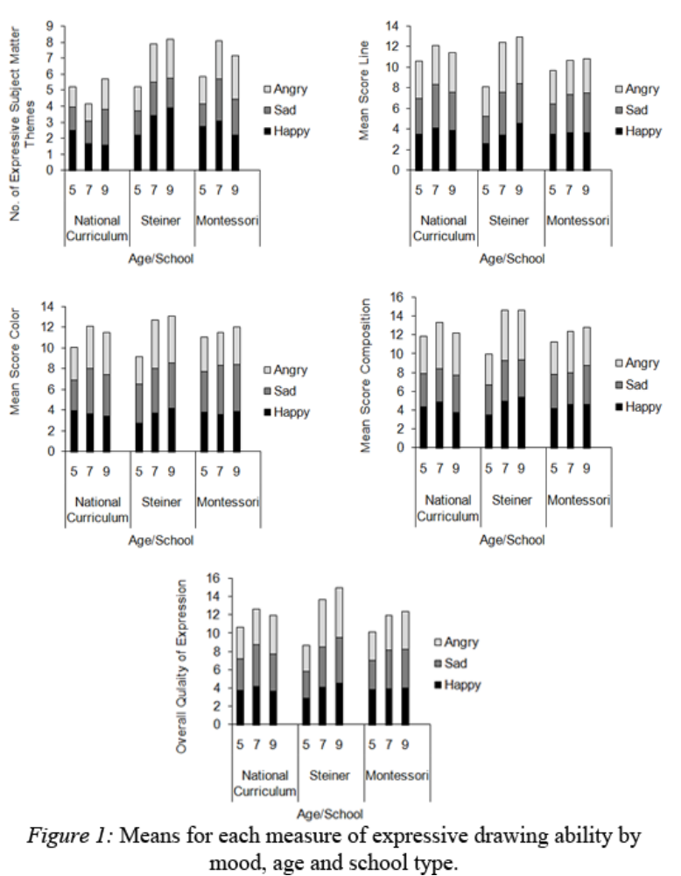
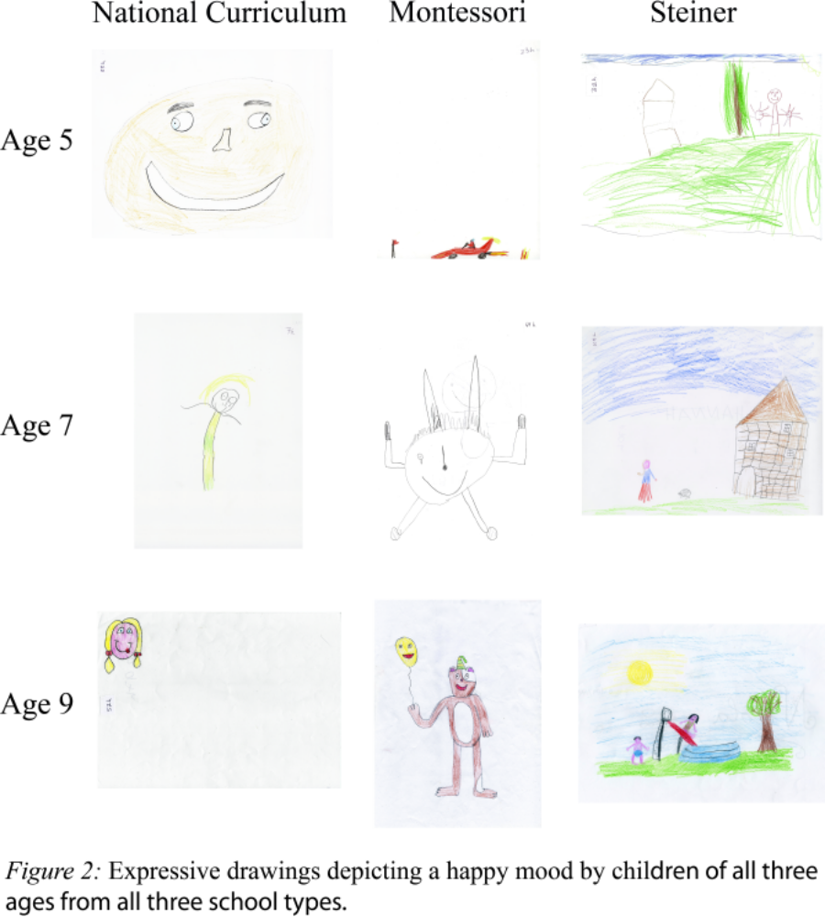

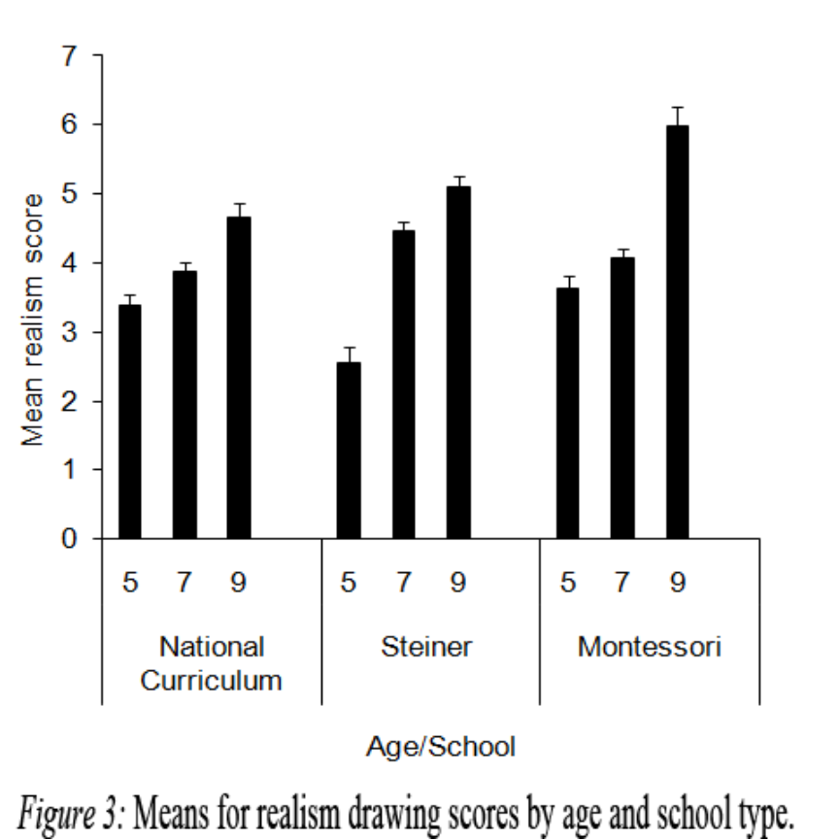

Additional information on the scales used can be obtained from Sarah Rose, Department of Psychology and Mental Health, Faculty of Sciences, Staffordshire University, College Road, Stoke-on-Trent, ST4 2DE, UK (e-mail: s.e.rose@staffs.ac.uk, telephone +44 1782 295787).

