**Inner and Outer Sphere Coordination of Tricyclohexylphosphine oxide with Lanthanide Bromides**

Allen Bowden1, Anthony M.J.Lees2* and Andrew W.G.Platt2*

*1. Department of Chemistry and Analytical Sciences, The Open University,*

*Walton Hall, Milton Keynes, MK7 6BT, UK*

*2.* *School of Sciences, Staffordshire University, Leek Road, Stoke-on-Trent, ST4 2DF, UK*

* Corresponding authors, E-Mail addresses [A.M.Lees@staffs.ac.uk](mailto:A.M.Lees@staffs.ac.uk), [A.Platt@staffs.ac.uk](mailto:A.Platt@staffs.ac.uk)

**Abstract**

Complexes of lanthanide bromides with tricyclohexylphosphine oxide (Cy3PO) form three distinct structural classes. Type I complexes LnBr3(Cy3PO)3 have been structurally characterised for Ln = La, Pr, Nd, Gd and Ho and are molecular 6 coordinate with a distorted meridional octahedral arrangement. Type II complexes are based on pentagonal bipyramidal [Ln(Cy3PO)n(H2O)5]3+ structures and fall into three subsets; n = 2 and 3 have been isolated for Ln = Lu and n = 4 with Ln = La, Dy, Er and Yb. The structures of [Lu(Cy3PO)2(H2O)5]Br3·2EtOH and [Ln(Cy3PO)2(H2O)5]Br3 (Ln = Dy, Er, Yb) have been determined. When n = 2 both ligands are directly coordinated to the metal whilst complexes in which n = 4 have two ligands bonded to the metal and two hydrogen bonded to the coordinated water molecules. Analysis of the bond distances shows that the lanthanide contraction accounts for about 99% of the observed trends. The infrared spectra of the complexes give a good means of identifying the structural types produced. 31P NMR show that the Type I complexes are fluxional in solution and that the Type II complexes undergo ligand exchange between metal and H-bonded ligands. Analysis of the lanthanide induced shifts indicates that the Type II complexes are isostructural in solution.

**Introduction**

The coordination complexes formed between lanthanide metal ions and phosphine oxides have been studied since the late 1960s [1]. Continued interest in this area comes as a result of the use of phosphine oxides in the solvent extraction in nuclear fuels reprocessing [2]. The phosphine oxide ligands are normally bonded in the first coordination sphere of the lanthanide ions. There are, however, numerous reports of other ligands binding to lanthanide ions by hydrogen bonding to coordinated water molecules. Thus 18-crown-6 has been shown to bind to lanthanide nitrates either in the primary or secondary coordination sphere depending on the ionic radius of the metal [3]. Similarly linear polyethers form outer sphere complexes with heavier lanthanide nitrates (Ho - Lu) [4], whilst scandium chloride forms inner sphere complexes with a variety of crown ethers which on hydrolysis are converted to outer sphere complexes [5]. The outer sphere coordination of water to gadolinium has significance in the effectiveness of MRI contrast agents [6]. Solution studies have shown a variety of coordination behaviours for bromo complexes of lanthanides in *N*,*N*-dimethylacetamide, *N*,*N*-dimethylformamide and their mixtures: inner and outer sphere coordination is observed dependent upon solvent composition [7]. In even concentrated solutions of perchlorate and halite ions only outer sphere coordination of the anion is observed [8].

Complexes between lanthanide chlorides and simple phosphine oxides have been reported and show the ligand to be directly bonded to the lanthanide metal as expected [9]. Although the corresponding complexes of lanthanide bromides and iodides are less well reported, similar *trans* octahedral [MX2L4]+ structures are formed with X = Br when L = Ph3PO [10], [11] and with X = I when L = (Me2N)3PO [12]. We have previously shown that lanthanide chlorides do not give the expected type of complexes with the bulkier tricyclohexyphosphine oxide, Cy3PO but rather form [Ln(Cy3PO)2(H2O)5](Cy3PO)Cl3 where the phosphine oxide binds in both the primary and secondary coordination sphere: LnCl3L3 complexes were not isolated [13]. Here we report the synthesis, structures and properties of a range of complexes of tricyclohexylphosphine oxide with lanthanide bromides.

**Results**

**Synthesis**

Mixing 95% ethanol solutions of hydrated lanthanide bromides and tricyclohexylphosphine oxide at ~70°C led to the isolation of two distinct series of complexes. The bulk compositions LnBr3(Cy3PO)3·0.5H2O, designated as Type I, and [Ln(Cy3PO)2(H2O)5](Cy3PO)nBr3, Type II have been confirmed by elemental analysis and by the structural determination of selected compounds by single crystal X-ray diffraction (discussed below). The Type I complexes can be crystallised for the lighter lanthanides La - Ho albeit often as minor products, by cooling the reaction mixture to room temperature and standing overnight. Type II complexes [Ln(Cy3PO)2(H2O)5](Cy3PO)Br3 can be obtained for all the lanthanides on slow evaporation of the cooled solutions following filtration of any Type I complexes initially formed. With intermediate metal to ligand ratios it was in one instance possible to isolate different Type II complexes with n = 2 (Type IIa) and n = 3 (Type IIb). [Lu(Cy3PO)2(H2O)5]Br3 is less soluble in ethanol than [Lu(Cy3PO)2(H2O)5](Cy3PO)Br3 and both types of complex could be obtained by fractional crystallisation of the reaction mixture.

During slow evaporation of ethanol solutions of reaction mixtures containing the lighter lanthanides, the increasing concentration of water led to the isolation of complexes which have infrared spectra very similar to those of the crystallographically characterised [Ln(Cy3PO)2(H2O)5](Cy3PO)2Br3. Thus the “cut off” between Type I and Type II structures cannot be considered to be a clean one; Type II complexes were obtained for La, Ce and Nd when reactions were carried out in dilute solutions necessitating a longer crystallisation time in an increasingly water rich environment. We have not, however, been able to prepare Type I complexes of the heavier lanthanides by reacting the bromides with tricyclohexylphosphine oxide in concentrated solution, these reactions led to the crystallisation of Type II complexes exclusively in good yield.

The tendency of the lighter lanthanides to form complexes with directly bonded bromide, whilst the heavier metals form hydrated complexes in preference, may be related to increased steric effects for the smaller lanthanides, but also to the structures of the hydrated bromides themselves [14], where 9-coordinate La and Ce, and 8-coordinate Pr - Dy have two bromides bonded to the metal whereas the smaller Ho - Lu ions are all 8-coordinate [Ln(OH2)8]3+ in the solid state. Although caution must be exercised in correlating solid state structures with solution processes it seems possible here that the Type I complexes form by coordination to an LnBr2+ based cation whilst the formation of Type II proceeds via [Ln(OH2)8]3+. The nature of the complexes which crystallise from solution also depends on the reaction conditions and may be strongly influenced by the solubilities of the complexes. Thus the isolation of LnBr3(Cy3PO)3 for the lighter lanthanides may be due to their lower solubility in the reaction media than similar complexes for the heavier metals, for which hydrated complexes only are isolated.

**Infrared spectroscopy**

The infrared spectra are typical of those expected for anhydrous or hydrated phosphine oxide complexes of lanthanides, and can be used to identify their structural type. The main features of the spectra are summarised in Table 1 for the crystallographically confirmed complexes. The P=O stretches show the expected shift to lower wavenumber on coordination to the metal ( ~ 60-70 cm-1) or on hydrogen bonding to the coordinated water molecules ( ~ 40 cm-1). The values for metal coordinated ligands are similar to those obtained for Cy3PO complexes with lanthanide nitrates [15] and the complexes CuCl2(Cy3PO)2 [16] and *cis*-Rh(CO)2Cl(Cy3PO) [17]. The Type I complexes have a weak OH stretch due to lattice water and an intense PO stretch with a weaker absorption 15-20 cm-1 lower, tentatively assigned to the “*trans*” and “*cis”* PO groups respectively on the basis of their relative intensities. The Type II complexes have a strong OH stretch due to the coordinated water, the position of which (below 3200 cm-1) is typical of hydrogen bonded water molecules. These water molecules are H-bonded to either to bromide or to both bromide and phosphoryl groups. The complex [Lu(Cy3PO)2(H2O)5]Br3 gives a single PO stretch due to the mutually *trans* ligands whilst [Ln(Cy3PO)2(H2O)5](Cy3PO)2Br3 show an additional peak about 15-20 cm-1 higher due to the presence of the hydrogen bonded Cy3PO ligands. The spectra of the two lutetium complexes clearly demonstrate the ease with which assignments can be made and are shown in Figure 1. The smaller shift in ­­P=O for the H-bonded Cy3PO implies a weaker interaction between the phosphoryl group when hydrogen bonding to the coordinated water. This is confirmed by X-ray crystallography described below which shows the lanthanide bound P=O bond to be more weakened that the H-bonded group. Hydrogen / deuterium exchange was carried out by recrystallization from MeOD in an attempt to further confirm the assignment, but apart from the large changes in OH and OH there was no discernible effect on the infrared spectrum.

**Structures**

The crystal structures have been determined for representative examples of the Type I and Type II structures. Details of the data collection and refinement are given in Table 2 and selected bond distances and angles in Tables 3 and 4 for the Type I and II complexes respectively. The structures of Type I complexes have been determined for Ln = La, Pr, Nd, Gd and Ho. The lanthanum complex is anhydrous compared with the hemihydrate for the remaining Type I complexes. The bulk composition is consistent with the hemihydrate for this complex and the crystal chosen for analysis is thus not representative of the bulk material. The structures show the same coordination geometry with the metal ion the metal ion coordinated to three bromides and three phosphine oxides in a slightly distorted *mer*-octahedral arrangement. The structure of the Nd complex is shown in Figure 2 as a representative example. The Ln-O and Ln-Br distances decrease from La - Ho as expected on the basis of the lanthanide contraction. If this decrease were entirely due to the lanthanide contraction, a plot of Ln-Br and Ln-O distances against the 6-coordinate ionic radii [18] should show a straight line. The plots are shown in Figure 3. Good straight lines with correlation coefficients generally >0.99 (r2 of 0.96 was obtained for one of the Ln-Br correlations) indicate that over 99% of the changes in Ln – O and Ln – Br distances can be accounted for by the lanthanide contraction.

The structures of the Type II complexes are 7-coordinate around the metal ion, the higher coordination number for the smaller lanthanides being explained by the lower steric demands of the ligand set; five waters and two phosphine oxides compared to three bromides and three phosphine oxides for the Type I complexes. The structure of the [Er(Cy3PO)2(H2O)5](Cy3PO)2Br3 complex is shown in Figure 4, and the [Lu(Cy3PO)2(H2O)5](EtOH)2Br3 complex is presented in Figure 5 showing the extended H-bonding network due to ethanol solvation. The structures have a distorted pentagonal bipyramidal arrangement about the lanthanide ion with two phosphine oxides in axial positions and five water molecules making up the equatorial plane as we found for the corresponding chloride complexes [13]. The metal atoms lie within 0.016 Å of the mean plane defined by the 5 oxygen atoms of the coordinated water molecules. The Ln – O distances decrease with the atomic number of the lanthanide in the expected manner. Plots of the Ln-O distances versus the 7-coordinate lanthanide ionic radii show good linear relationships with correlation coefficients of 0.93 and 0.99 for the Ln-O(H2O) and Ln-O(P) bonds respectively. The slightly weaker correlation with the Ln-O(H2O) distances is probably as a result of hydrogen bonding to bromide and phosphine oxide also affecting the bond distances in addition to the lanthanide contraction. In the Type II complexes (n = 4) the two hydrogen bonded phosphine oxides are strongly bound to the coordinated water molecules with average PO…O distances of 2.63(2) Å compared with a sum of van der Waals radii for oxygen of 3.04 Å. The hydrogen bonding of phosphine oxides to H+ is well known, for example (Ph3PO)2H+ [19] , (Me3PO)2H+ [20] and the polymeric diphosphine dioxide [(Ph2POCH2POPh2)H+]n [21]. The metal coordinated P=O distances at an average of 1.517(5) Å are consistent with those previously reported: 1.502(3) Å in Ln(Cy3PO)3(NO3)3 [15], 1.505(3) Å in Ni(Cy3PO)2(NO3)2 [22] and 1.52(1) in Rh(CO)2Cl(Cy3PO) [17]. The P=O(H bonded) distances are marginally shorter at 1.510(4) Å reflecting the slightly weaker nature of the H…O interaction compared with the Ln-O bond.

The bromide ions are also hydrogen bonded to the coordinated waters. The average Br….O distances (3.22 Å) are only slightly shorter than the sum of the van der Waals radii for oxygen and bromine (3.37 Å) and indicate that this interaction is relatively weak. The corresponding hydrogen bonding of the chloride ion in the analogous [Ln(Cy3PO)2(H2O)5](Cy3PO)Cl3 [13] is stronger with an average O….Cl distance of 3.05 Å compared with the sum of van der Waals radii of 3.27 Å.

The geometries of the Type I and II complexes have been analysed by continuous shape measures [23] using the SHAPE programme [24]. Smaller values of the shape measure, S, indicate a better the fit to the ideal polyhedron. The results are presented in Table 5 and show that for both classes of structure there are no significant distortions from the nearest regular polyhedron, values above 3 are the threshold which indicate significant distortion [23]. Comparisons were made between the observed structures and all reasonable coordination polyhedra. The data for octahedral and trigonal prismatic geometries are shown for the Type I complexes and indicate that the octahedron is the best description for the geometry in all cases (other 6-coordinate polyhedral gave larger S-values than the trigonal prism data shown for comparison). For the Type II complexes the S-values similarly show that the pentagonl bipyramind is the best description of the coordination geometry. A limited comparison between homoleptic and mixed ligand set lanthanum complexes [25] shows that the S-values are larger for the latter. The typical values found are within the range of values found for [La(thf)nX7-n]+ n = 4, 5 X = Br, I. Here the larger values found for the Type I complexes probably reflect distortions from ideal geometry imposed by the mixed O, Br ligand set.

**Solution NMR spectroscopy**

The solution properties of the complexes were examined by 31P NMR spectroscopy in CDCl3 and in CD2Cl2. The general features of the spectra are as expected from the solid state structures and the results are given in Table 6. Signals with considerable lanthanide induced shift for the paramagnetic complexes are observed for the Type I complexes. We have previously found that increasing the steric congestion in Ln(NO3)3(R3PO)3 leads to complexes with higher barriers to ligand exchange between inequivalent environments [26]. The La complex showed a single peak at ambient temperature, which at -90°C split into the two signals expected for static *mer*-octahedral structure. Other complexes gave spectra consistent with static pseudo-octahedral structures at temperatures which depended on the size of the lanthanide ion and chemical shift differences between the two environments. Thus the Pr complex shows a single broad peak at ambient temperature and two signals assigned to inequivalent phosphorus environments at -50°C whilst the Ho complex, with large paramagnetic shift differences shows a static structure at ambient temperature with two peaks at 522.5 and -107.7 ppm. The Type II complexes would be expected to show two signals in the absence of chemical exchange. One of these signals would be expected at a similar shift for Cy3PO assigned as the hydrogen bonded ligand with the second showing characteristically larger paramagnetic shifts assigned to the lanthanide bonded ligands. [La(Cy3PO)2(H2O)5](Cy3PO)2Br3 gives a single broad peak at ambient temperature indicative of rapid exchange between H-bonded and lanthanum bonded ligand. On cooling to -50°C two broad signals are observed consistent with the solid state Type II structures found for the heavier lanthanides. The complexes of europium onwards have spectra consistent with structures which are static on the NMR timescale. The Eu and Tb complexes show the presence of additional lanthanide bound ligands. These are tentatively assigned as other isomers present in solution and whilst these probably involve the arrangement of the H-bonded ligand the large shifts induced by the paramagnetic lanthanide centre make phosphorus more sensitive to changes in the local environment. The behaviour of the europium complex was examined at higher than ambient temperature, and at 40°C showed a coalescence of the signals from the two Eu-OP groups. At 60°C a broadening of the signals was observed indicating that exchange between the lanthanide and H-bonded ligands also occurs although coalescence could not be observed. On cooling to room temperature the spectrum shows the peak at -106.5 ppm to be much diminished in intensity. This implies that the formation of a thermodynamically preferred isomer has occurred during heating the solution.

Analysis of lanthanide induced shifts has previously been used to deduce whether structures remain constant across the lanthanide series in solution. Analyses based on the observation of one, two and three nuclei [27, 28] in a complex have been developed. The one nucleus method strictly applies only to axially symmetric complexes. In this method plots of i/Ci vs <Sz>i/Ci and i/<Sz>i vs Ci/<Sz>i are analysed. i is the paramagnetic shift for a given complex (where i = Ln – ½[ La + Lu]) and Ln, La and Lu are the observed shifts for the lanthanide complex and the lanthanum and lutetium complexes respectively. <Sz>i is the spin expectation value for a particular lanthanide ion and Ci is the Bleaney factor for the lanthanide ion which is constant for each ion. Both plots are expected to be linear if there is structural uniformity in solution across the series, whilst breaks in one or both imply minor or major structural changes respectively [29]. The single nucleus lanthanide induced shift plots for both Type I and Type II complexes show considerable scatter around best fit straight lines are given as supplementary information in Figure S1. This is probably in part, due to the non-conformity of the complexes to the structural requirements for single nucleus plots. It is worth noting that the Type I complexes give better fits to a straight line if the point from samarium is ignored and thus the data indicate that the structures are the same for all the lanthanides in solution. Increasing the number of nuclei reduces the geometrical constraints on the complexes with the three nucleus method being independent of the structure. Analysis of two nuclei [28] has been shown to give more reliable results than the single nucleus plots and this can be applied to the Type II complexes where there are two inequivalent phosphorus nuclei. Plots of ij/<Sz >j vs kj/<Sz >j, where the terms are as defined above and ij and kj are the paramagnetic shifts of the two nuclei in a given complex, are expected to show a break if there are structural changes in solution. The two nucleus plot for the Type II complexes is shown in Figure 6. Whilst there is some scatter on the plot (R2 = 0.79) the data indicates that the structures remain uniform in solution across the complexes studied.

**Conclusion**

Two types of compound can be isolated from the reaction of lanthanide bromides with tricyclohexylphosphine oxide. Single crystal X-ray crystallography shows that the solid state structures are distorted *mer*-octahedral for LnBr3L3 and distorted pentagonal bipyramids for the ionic [Ln(H2O)5L2]LnBr3. Solution NMR spectroscopy indicates that the complexes retain the overall structures observed in the solid state and that exchange between inequivalent phosphorus environments occurs. Analysis of the lanthanide induced 31P NMR shift is consistent with the solid state structures being retained in chlorocarbon solutions.

**Experimental**

**X-ray crystallography**

Data were collected by the National Crystallography Service at the University of Southampton using previously described procedures [30-33].

Structures were solved using direct methods (SHELXS) [34]. All remaining non-H atom positions were obtained through subsequent Fourier syntheses (SHELXL) [34], and refinement was by full-matrix least-squares on F2 data using SHELXL-2013 [34] from within the WinGX suite of software [35].

In each of the structures, all non-H atoms were refined anisotropically with the exception of the two alternative sites of one of the disordered carbon atoms in the Dy structure.

All ethanol and cyclohexyl H atoms were refined at calculated idealised positions using a riding model (methyl C-H = 0.98 Å, methylene C-H = 0.99 Å, methine C-H = 1.00 Å, O-H = 0.84 Å). The H atoms of water molecules were located close to their final positions, and restrained as necessary to give idealised H-O-H geometry. H atoms in each structure were assigned a common, refined, H atom isotropic displacement parameter.

Disorder was evident in some of the structures: the geometry one of the cyclohexyl groups of the Gd, Dy and Ho structures initially deviated from that expected for the cyclohexyl moiety, and the thermal ellipsoids of the C atoms in these groups displayed marked librational elongation. In each case, four of the C atoms (two on either side of an axis passing through the two atoms in the 1,4 positions of the cyclohexyl ring) were modelled in two alternative positions with complementary site occupation factors. Thermal and geometrical restraints (SIMU and SAME) were applied to maintain the cyclohexyl rings in a reasonable chair conformation which (with the exception of the one atom in the Dy structure) were stable to anisotopic refinement.

A disordered model was also adopted for one of the ethanol molecules in the Lu structure: two alternative positions with complementary site occupation factors were modelled, in which the geometric and thermal parameters of the O atoms were constrained to be equivalent (EXYZ and EADP).

Cavities were present in all of the lattices, and in all but the Yb complex these were large enough to accommodate solvent molecules. In the Pr, Nd, Gd and Ho structures, a water molecule was located near to one of the bromide ligands. The site occupation factors of these water molecules were initially refined, but finally fixed at half occupancy. No similar solvent could be located in the difference Fourier maps of the La structure. Residual peaks in the voids of the Dy, Er and Yb structures indicated the presence of disordered solvent, but this could not be satisfactorily modelled due to the observed electron density being located at centres of inversion in the crystal structures. For each of these three structures, the SQUEEZE [36] routine of PLATON [37] was used to exclude the disordered solvent and the modified reflection file was used for final refinement. Disordered solvent equivalent to an estimated 27, 169 and 141 electrons/cell was distributed in symmetry related voids of approximately 387, 3186 and 3123 Å3 total solvent accessible area for the Dy, Er and Yb structures respectively. Since an ethanol molecule contributes 26 electrons, this equates to approximately 0.5, 0.8 and 0.7 EtOH per formula unit unaccounted in the presented structures.

Molecular graphics were generated using ORTEP-3 [38].

Crystallographic data for the structures reported in this paper have been deposited with the Cambridge Crystallographic Data Centre, CCDC numbers 1019858 – 1019866 for the La – Lu complexes. Copies of this information may be obtained free of charge from The director, CCDC, 12 Union Road, Cambridge, CB2 1EZ, UK (fax: +44-1223-336033; e-mail: [deposit@ccdc.cam.ac.uk](mailto:deposit@ccdc.cam.ac.uk) or <http://www.ccdc.cam.ac.uk>).

**Synthesis**

The same general procedure was adopted for the synthesis of all the complexes. The lanthanide bromide and tricyclohexylphosphine oxide were dissolved in hot ethanol. Heating was continued for 1 hour during which time, in some cases, small quantities of crystalline material formed. Either cooling to room temperature followed by standing for 16 h or on prolonged standing and slow evaporation of the solution afforded crystalline materials. The crystals were filtered, washed with ethanol and dried at the pump. Representative syntheses and characterisations are described below.

**LaBr3(Cy3PO)3·0.5H2O**

LaBr3·7H2O (0.38 g 0.75 mmol) and Cy3PO (0.37 g 1.25 mmol) in 8.5 g ethanol gave 0.16 g (30%) colourless crystals on cooling.

IR(ATR)/cm-1: OH 3300 (w), PO 1088(s), 1073(m)

Analysis for LaBr3(Cy3PO)3·0.5H2O:required (found) C50.79(50.41) H 7.89(7.80)

**[La(Cy3PO)2(H2O)5](Cy3PO)2Br3**

In the preparation above prolonged standing / slow evaporation gave a small quantity of colourless crystals (0.08 g, 16%)

IR(ATR)/cm-1: OH 3260 (s), PO 1127(m), 1001(s)

Analysis required for [La(Cy3PO)2(H2O)5](Cy3PO)2Br3 (found) C47.76(48.13) H 8.09(8.37)

**PrBr3(Cy3PO)3·0.5H2O**

PrBr3·6H2O (0.25 g, 0.51 mmol) and Cy3PO (0.66 g, 2.24 mmol) in 4.0 g hot ethanol gave a small quantity of green crystals in the hot solution. These were removed, washed with a little cold ethanol and air dried giving 0.06 g. Slow evaporation gave a further crop of green crystals 0.30 g (55%) with an identical infrared spectrum.

IR(ATR)/cm-1: OH 3150 (w), PO1085 (s), 1073(m)

Analysis for PrBr3(Cy3PO)3·0.5H2O:required (found) C50.71(50.79) H 7.88(7.97)

**GdBr3(Cy3PO)3·0.5H2O**

GdBr3·6H2O (0.40 g, 0.80 mmol) and Cy3PO (0.56 g, 1.89mmol) in 7.5 g hot ethanol led to the formation of a small quantity of colourless crystals (0.04 g). On standing a further crop of colourless crystals (0.21 g, 30%) were obtained.

IR(ATR)/cm-1: OH 3230 (w) PO1095 (s), 1073(m)

Analysis for GdBr3(Cy3PO)3·0.5H2O required (found) C50.07(49.71) H 7.78(7.83)

**[Dy(Cy3PO)2(H2O)5](Cy3PO)2Br3·H2O**

DyBr3·6H2O (0.32 g 0.63 mmol) and Cy3PO (0.72 g 2.44 mmol) in 11 g hot ethanol on slow evaporation (21 days) gave a small quantity of colourless crystals (0.09 g, 1%)

IR(ATR)/cm-1: OH 3170 (w,br) PO1094 (s), 1079(m)

Analysis required for [Dy(Cy3PO)2(H2O)5](Cy3PO)2Br3·H2O (found) C51.02(50.96) H 8.56(8.78)

**[Er(Cy3PO)2(H2O)5](Cy3PO)2Br3·4H2O**

ErBr3·7H2O (0.36 g, 0.70 mmol) and Cy3PO (0.34 g1.13 mmol) in 12.0 g hot ethanol gave a small quantity of pink crystals on standing overnight and a further 0.37 g (75%) on slow evaporation. The infrared spectra of both batches were identical.

IR(ATR)/cm-1: OH 3219(m, br), OH 1633 (w), PO1100 (s)

Analysis required for [Er(Cy3PO)2(H2O)5](Cy3PO)2Br3·4H2O (found) C49.28(49.25) H 8.62(8.26)

**[Yb(Cy3PO)2(H2O)5](Cy3PO)2Br3·H2O**

YbBr3·6H2O (0.28 g 0.41 mmol) and Cy3PO (0.51 g 1.74 mmol) in 10 g hot ethanol gave 0.25 g colourless crystals on standing overnight. A further 0.36 g (51%) were obtained from the filtrate by slow evaporation. The infrared spectra of both batches were identical.

IR(ATR)/cm-1: OH 3180 (m), PO 1118(m), 1102(s)

Analysis required for [Yb(Cy3PO)2(H2O)5](Cy3PO)2Br3.H2O (found) C50.70(49.85) H 8.51(8.67)

**[Lu(Cy3PO)2(H2O)5]Br3**

LuBr3·7H2O (0.37g, 0.68mmol) and Cy3PO (0.45g, 1.50 mmol) in 4.8 g hot ethanol gave a colourless crystalline solid on standing overnight, 0.44 g (59%)

IR(ATR)/cm-1: OH 3219(m, br), OH 1617 (w), PO1100 (s)

Analysis for [Lu(Cy3PO)2(H2O)5]Br3: required (found) C39.39(39.46) H 6.98(7.44)

**[Lu(Cy3PO)2(H2O)5](Cy3PO)Br3**

The filtrate from the above on standing yielded a crop of colourless crystals of [Lu(Cy3PO)2(H2O)5](Cy3PO)Br3, 0.20 g (24%)

IR(ATR)/cm-1: OH 3173(m, br), OH 1643 (w), PO 1120 (m)1101 (s)

Analysis for [Lu(Cy3PO)2(H2O)5](Cy3PO)Br3: required (found) C46.53(46.63) H 7.88(8.07)

**References**

1. a) D. R. Cousins, F. A. Hart, *J. Inorg. Nucl. Chem*. 29 (1967) 1745-1757; b) D. R. Cousins, F. A. Hart, *J. Inorg. Nucl. Chem*. 30 (1968) 3009-3015.
2. J. V. Kingston, E. M. Krankovits, R. J. Magee, *Inorg. Nucl. Chem. Lett*. 5 (1969) 485-489.
3. C. Jones, P. C. Junk, M. K. Smith, R. C. Thomas, *Z. Anorg. Allg. Chem*. 626 (2000) 2491-2497.
4. C. C. Hines, C. B. Bauer, R. D. Rogers, *New J. Chem*. 31 (2007) 762-769.
5. M. D. Brown, W. Levason, D. C. Murray, M. C. Popham, G. Reid, M. Webster, *J. Chem. Soc. Dalton Trans.* (2003) 857-865.
6. a) D. Parker, H. Puschmann, A. S. Batsanov, K. Senanayake, *Inorg. Chem.* 42 (2003) 8646-8651; b) K. I. Hardcastle, M. Botta, M. Fasano, G. Digilio, *Eur. J. Inorg. Chem*. 5 (2000) 971-977; c) A. Barge, M. Botta, D. Parker, H. Puschmann, *Chem. Commun*. 12 (2003) 1386-1387.
7. a) S. Ishiguro, Y. Umebayashi, M. Komiya, *Coord. Chem. Rev*.226 (2002) 103-111; b) S. Ishiguro, Y. Umebayashi, R. Kanzaki, *Anal. Sci.*20 (2004) 415-421.
8. G. R. Choppin, *J. Alloy. Compd*. 249 (1997) 9-13.
9. a) M. J. Glazier, W. Levason, M. L. Matthews, P. L. Thornton, M. Webster, *Inorg. Chim. Acta* 357 (2004) 1083-1091; b) N. J. Hill, L-S Leung, W. Levason, M. Webster; *Acta Cryst*. C58 (2002) m295-m296.
10. N. J. Hill, W. Levason, M. C. Popham, G. Reid, M. Webster, *Polyhedron* 21 (2002) 445-455.
11. A. Bowden, A. W. G. Platt, K. Singh, R. Townsend, *Inorg. Chim. Acta* 363 (2010) 243-249.
12. J-C. Berthet, M. Nierlich, M. Ephritikhine, *Polyhedron* 22 (2003) 3475-3482.
13. A. M. J. Lees, A. W. G. Platt, *Polyhedron* 67 (2014) 368-372.
14. L. I. Semenova, P. C. Junk, B. W. Skelton, A. H. White, *Aust. J. Chem.*52 (1999) 531-538.
15. A. P. Hunter, A. M. J. Lees, A. W. G. Platt, *Polyhedron* 26 (2007) 4865-4876.
16. F. G. Moers, P. J. W. M. Müskens, J. Francot, *J. Inorg. Nucl. Chem*.41 (1979) 759-760.
17. G. Bandoli, D. A. Clemente, G. Deganelli, G. Carturan, P. Uguaglia, U. Belluco, *J. Organomet. Chem*. 71 (1974) 125-133.
18. D. Lundberg, I. Persson, L. Eriksson, P. D’Angelo, S. De Panfilis, *Inorg. Chem.* 49 (2010) 4420-4432.
19. H. P. Lane, S. M. Godfrey, C. A. McCauliffe, R. G. Prochard, *J. Chem. Soc. Dalton Trans*. (1994) 3249-3256.
20. E. M. Godfrey, N. Ho, C. A. McCauliffe, R. G. Prichard, *Angew. Chem. Int. Ed.* 35 (1996) 2344-2346.
21. A. A. Boraei, V-V. DuMont, F. Rulhe, P. G. Jones, *Acta Cryst*. C58 (2002) o318-o320.
22. A. R. Kennedey, S. W. Sloss, M. D. Spicer, *Acta Cryst*. C53 (1997) 292-293.
23. S. Alvarez, P. Alemany, D. Casanova, J. Cirera, M. Llunell, D. Avnir, *Coord. Chem. Rev.* 249 (2005) 1693-1708.
24. M. Llunell, D. Casanova, J. Cirera, P. Alemany, S. Alvarez, SHAPE – Program for the Stereochemical Analysis of Molecular Fragments by Means of Continuous Shape Measures and Associated Tools, Version 2.1, University of Barcelona, Spain, 2013
25. D. Casanova, P. Alemany, J. Bofill, S. Alvarez, *Chem. Eur. J*. 9 (2003) 1281-1295.
26. a) A. Bowden, S. J. Coles, M. B. Pitak, A. W. G. Platt, *Polyhedron* 68 (2014) 258-264; b) A. Bowden, K. Singh, A. W. G. Platt, *Polyhedron* 42 (2012) 30-35; c) A. Bowden, P. N. Horton, A. W. G. Platt, *Inorg. Chem.*50 (2011) 2553-2561.
27. N. Ouali, J-P Rivera, D. Chapon, P. Delange, C. Piguet, *Inorg. Chem.* 43 (2004) 1517-1529.
28. C. F. G. C. Geraldes, S. R. Zhang, A. D. Sherry, *Inorg. Chim. Acta* 357 (2004) 381-395.
29. P. Rubini, C. Ben Nasr, L. Rodehüser, J-J. Delpuech, *Magn. Reson. Chem.* 25 (1987) 609-618.
30. DENZO - Data collection and processing software: Z. Otwinowski, W. Minor in *Methods in Enzymology*, *Vol 276*; *Macromolecular Crystallography*, *part A*, (Eds.: C. W. Carter, Jr, R. M. Sweet), Academic Press, London, 1997, pp. 307-326.
31. COLLECT - Data collection software, R. Hooft, Nonius B.V., 1998.
32. Unit cell determination using DirAx: a) A. J. M. Duisenberg, *J. Appl. Crystallogr.* 25 (1992) 92-96; b) A. J. M. Duisenberg, R. W. W. Hooft, A. M. M. Schreurs, J. Kroon, *J. Appl. Crystallogr.* **33** (2000) 893-898.
33. Absorption correction: G. M. Sheldrick, SADABS. Version 2007/2. Bruker AXS Inc., Madison, Wisconsin, USA.
34. SHELX-2013: G. M. Sheldrick, *Acta Cryst.* A64 (2008) 112-122.
35. WinGX: L. J. Farrugia, *J. Appl. Crystallogr.* 45 (2012) 849-854.
36. SQUEEZE: P. van der Sluis, A. L. Spek, *Acta Crystallogr., Sect. A: Found. Crystallogr.* 46 (1990) 194-201*.*
37. PLATON: A. L. Spek, *J. Appl. Crystallogr*. 36 (2003) 7-13.
38. ORTEP3 for Windows: L. J. Farrugia, *J. Appl. Crystallogr*. 45 (2012) 849-854.
39. S. J. Coles, P. A. Gale, *Chem. Sci*. 3 (2012) 683-689.

**Acknowledgements**

The authors wish to thank EPSRC for the use of the National Crystallography Service at the University of Southampton for data collection and the National mass spectrometry service at Swansea University.

**Table 1 - Infrared spectra of crystallographically confirmed structures of the lanthanide bromide complexes.**

**Table 2 - Crystal data, data collection and refinement parameters.**

**Table 3 - Selected bond lengths (Å), bond angles (º) and non-bonded distances in Type I complexes.**

**Table 4 - Selected bond lengths (Å), bond angles (º) and non-bonded distances in Type II complexes.**

**Table 5 Shape Measures S, for the Type I and Type II complexes**

**Table 6 - 31P NMR data in CDCl3 at ambient temperature (unless otherwise stated).**

**Figure 1 - The infrared spectra of [Lu(Cy3PO)2(H2O)5]Br3 (lower) and [Lu (Cy3PO)2(H2O)5](Cy3PO)2Br3 (upper). The differences in P=O are indicated.**

**Figure 2 - The structure of Nd(Cy3PO)3Br3 showing the atom labelling scheme Thermal ellipsoids are drawn at the 30% probability level. H atoms have been omitted for clarity.**

**Figure 3 - The correlation between Ln – Br and Ln - O distances in the**

**Type I complexes and the 6 coordinate ionic radius [18].**

**Figure 4 - The structure of [Er(Cy3PO)2(H2O)5](Cy3PO)2Br3 showing the atom labelling scheme Thermal ellipsoids are drawn at the 30% probability level. Cyclohexyl H atoms have been omitted for clarity.**

**Figure 5 - The structure and H-bonding network of** **[Lu(Cy3PO)2(H2O)5]**

**(EtOH)2Br3 showing the atom labelling scheme. Thermal ellipsoids are drawn at the 30% probability level. Cyclohexyl groups and ethyl H atoms have been omitted for clarity. [Symmetry codes: i = 1½-x, ½-y, 1-z; ii = 2-x, y, 1½-z]**

**Figure 6 - The Two Nucleus Lanthanide Induced Shift Plot for the Type II Complexes**

**Figure S1 - Single Nucleus Lanthanide Induced Shift Plots for Type I and Type II complexes.**

**Table 1 - Infrared spectra of crystallographically confirmed structures of the lanthanide bromide complexes.**

Type I Type IIa Type IIb L

OH 3250(w) 3122(m) 3170-3180(m)

CH 2924(m), 2850(m) 2927(m), 2850(m) 2927(m), 2852(m) 2923(s),2850 (s)

OH 1617(w) 1633(w)

vP=O 1088-1095(s), 1110(s) 1118(m) 1147(s), 1138(s)

1073(m) 1095-1103(m)

**Table 2 - Crystal data, data collection and refinement parameters: Type I complexes**

|  |  |  |  |  |  |
| --- | --- | --- | --- | --- | --- |
| **Compound** | **La(Cy3PO)3Br3** | **Pr(Cy3PO)3Br3 ·½H2O** | **Nd(*Cy3PO)3Br3 ·½H2O*** | **Gd(Cy3PO)3Br3 ·½H2O** | **Ho(Cy3PO)3Br3 ·½H2O** |
| *Crystal Data* |  |  |  |  |  |
| Molecular formula | C54H99Br3LaO3P3 | C54H100Br3PrO3.5P3 | *C54H100Br3NdO3.5P3* | C54H100Br3GdO3.5P3 | C54H100Br3HoO3.5P3 |
| Molecular weight, Mr | 1267.88 | 1278.89 | *1282.22* |  |  |
| Crystal system | Monoclinic | Orthorhombic | *Orthorhombic* | Orthorhombic | Orthorhombic |
| Space group | P21 | Pc21b | *Pc21b* | Pc21b | Pc21b |
| Unit cell dimensions |  |  |  |  |  |
| a (Å) | 11.5112(2) | 11.4388(3) | *11.4454(2)* | 11.4515(4) | 11.4639(4) |
| b (Å) | 18.0923(3) | 18.2271(5) | *18.1865(3)* | 18.0984(5) | 18.0221(4) |
| c (Å) | 14.4341(3) | 28.7857(8) | *28.7832(5)* | 28.6827(9) | 28.5516(10) |
| α (°) | 90 | 90 | *90* | 90 | 90 |
| β (°) | 92.8761(10) | 90 | *90* | 90 | 90 |
| γ (°) | 90 | 90 | *90* | 90 | 90 |
| Cell volume, *U* (Å3) | 3002.32(10) | 6001.7(3) | *5991.27(18)* | 5944.6(3) | 5898.9(3) |
| Formula units/unit cell, *Z* | 2 | 4 | *4* | 4 | 4 |
| Density (calc.), *D*x (Mgm-3) | 1.402 | 1.415 | *1.422* | 1.447 | 1.467 |
| m (mm-1) | 2.825 | 2.928 | *2.986* | 3.252 | 3.494 |
| *F* (000) | 1308 | 2644 | *2648* | 2664 | 2676 |
| Reflections to obtain  cell parameters | 7023 | 49069 | *38510* | 93022 | 46561 |
| Temperature (K) | 120(2) | 120(2) | *120(2)* | 120(2) | 120(2) |
| Crystal description | block | block | *Block* | block | slab |
|  | colourless | colourless | *Colourless* | colourless | colourless |
| Dimensions (mm3) | 0.16 x 0.12 x 0.06 | 0.18 x 0.13 x 0.08 | *0.38 x 0.34 x 0.18* | 0.18 x 0.1 x 0.08 | 0.16 x 0.08 x 0.04 |
| θ range for data collection (°) | 3.16 - 27.51 | 2.94 - 27.52 | *2.95 to 27.50* | 2.96 to 27.54 | 2.96 to 27.49 |
| Index ranges |  |  |  |  |  |
| *h* | -14 → 14 | -14 → 14 | *-14* → *14* | -13 → 14 | -12 → 14 |
| *k* | -23 → 22 | -23 → 23 | *-23* → *23* | -23 → 19 | -23 → 21 |
| *l* | -18 → 18 | -31→ 37 | *-34* → *37* | -37 → 37 | -37 → 37 |
| Measured reflections | 33861 | 45479 | *46331* | 40540 | 38508 |
| Independent reflections (*R*int) | 13126 (0.0381) | 13569 (0.0652) | *13642 (0.0490)* | 12228 (0.0738) | 13127 (0.1231) |
| Completeness to θmax (%) | to θ = 27.54° 99.1% | to θ = 27.52° 99.6 | *to θ = 27.50° 99.7* | to θ = 27.54° 99.1 | to θ = 27.49° 99.7 |
| Absorption correction | semi-empirical  from equivalents | semi-empirical  from equivalents | *semi-empirical  from equivalents* | semi-empirical  from equivalents | semi-empirical  from equivalents |
| *T*max / *T*min | 0.8488 / 0.6606 | 0.7995 / 0.6208 | *0.6155 / 0.3966* | 0.7809 / 0.5922 | 0.7674 / 0.5720 |
| Refinement method | Full matrix least  squares on *F*2 | Full matrix least  squares on *F*2 | Full matrix least  squares on *F*2 | Full matrix least  squares on *F*2 | Full matrix least  squares on *F*2 |
| Data / Restraints/ Parameters | 13126 / 1 / 579 | 13569 / 3 / 593 | *13642 / 1 / 593* | 12228 / 87 / 630 | 13127 / 94 / 618 |
| Goodness-of-fit of *F*2 | 1.111 | 1.051 | *1.037* | 1.040 | 0.986 |
| Final R indices [*F*o > 2s(*F*o)] | *R*1 = 0.0358 | *R*1 = 0.0397 | *R1 = 0.0324* | *R*1 = 0.0473 | *R*1 = 0.0648 |
|  | *wR*2 = 0.0730 | *wR*2 = 0.0693 | *wR2 = 0.0635* | *wR*2 = 0.0971 | *wR*2 = 0.1078 |
| *R* Indices [all data] | *R*1 = 0.0425 | *R*1 = 0.0590 | *R1 = 0.0420* | *R*1 = 0.0731 | *R*1 = 0.1373 |
|  | *wR*2 = 0.0765 | *wR*2 = 0.0745 | *wR2 = 0.0666* | *wR*2 = 0.1070 | *wR*2 = 0.1294 |
| (Δ/σ)max | 0.003 | 0.003 | *0.004* | 0.001 | 0.002 |
| Largest diff. Peak  and hole (eÅ-3) | 0.669 and -0.510 | 0.530 and -0.747 | *0.474 and -0.891* | 1.003 and -1.715 | 1.068 and -1.086 |
| Absolute structure parameter | 0.085(6) | 0.025(6) | *0.033(6)* | 0.035(10) | 0.025(13) |

**Table 2 – Continued: Type II complexes**

|  |  |  |  |  |
| --- | --- | --- | --- | --- |
| **Compound** | **[Dy(Cy3PO)2(H2O)5] (Cy3PO)2Br3** | **[Er(Cy3PO)2(H2O)5] (Cy3PO)2Br3** | **[Yb(Cy3PO)2(H2O)5] (Cy3PO)2Br3** | **[Lu(Cy3PO)2(H2O)5] (EtOH)2Br3** |
| *Crystal Data* |  |  |  |  |
| Molecular formula | C72H142Br3DyO9P4 | C72H142Br3ErO9P4 | C72H142Br3YbO9P4 | C40H88Br3LuO9P2 |
| Molecular weight, Mr |  |  |  |  |
| Crystal system | Triclinic | Monoclinic | Monoclinic | Monoclinic |
| Space group | $$\text{P}\overline{1}$$ | C2/c | C2/c | C2/c |
| Unit cell dimensions |  |  |  |  |
| a (Å) | 13.8720(6) | 40.1699(11) | 40.3266(16) | 25.3053(3) |
| b (Å) | 14.8297(6) | 14.2282(4) | 14.2252(4) | 14.7446(2) |
| c (Å) | 23.5933(8) | 32.9555(8) | 32.8940(14) | 28.6808(4) |
| α (°) | 75.884(2) | 90 | 90 | 90 |
| β (°) | 82.761(2) | 102.5993(9) | 102.9832(12) | 103.6346(4) |
| γ (°) | 65.460(2) | 90 | 90 | 90 |
| Cell volume, *U* (Å3) | 4280.1(3) | 18382.0(8) | 18387.4(12) | 10399.7(2) |
| Formula units/unit cell, *Z* | 2 | 8 | 8 | 8 |
| Density (calc.), *D*x (Mgm-3) | 1.302 | 1.216 | 1.220 | 1.520 |
| m (mm-1) | 2.395 | 2.331 | 2.434 | 4.31 |
| *F* (000) | 1754 | 7032 | 7048 | 4848 |
| Reflections to obtain  cell parameters | 92627 | 74879 | 53514 | 110278 |
| Temperature (K) | 120(2) | 120(2) | 120(2) | 120(2) |
| Crystal description | block | block | slab | block |
|  | colourless | colourless | colourless | colourless |
| Dimensions (mm3) | 0.08 x 0.04 x 0.02 | 0.18 x 0.16 x 0.1 | 0.38 x 0.24 x 0.1 | 0.28 x 0.26 x 0.2 |
| θ range for data collection (°) | 2.97 to 27.72 | 2.91 to 27.62 | 2.90 to 27.57 | 2.92 to 27.55 |
| Index ranges |  |  |  |  |
| *h* | -18 → 18 | -52 → 52 | -52 → 52 | -32 → 32 |
| *k* | -19 → 19 | -17 → 18 | -18 → 18 | -19 → 19 |
| *l* | -30 → 30 | -42 → 42 | -42 → 42 | -37 → 37 |
| Measured reflections | 54959 | 95741 | 76562 | 103356 |
| Independent reflections (*R*int) | 18885 ( 0.0932) | 20899 (0.0489) | 19998 (0.0789) | 11946 (0.0386) |
| Completeness to θmax (%) | to θ = 27.72° 93.9 | to θ = 27.62° 97.8 | to θ = 27.57° 93.9 | to θ = 27.55° 99.5 |
| Absorption correction | semi-empirical  from equivalents | semi-empirical  from equivalents | semi-empirical  from equivalents | semi-empirical  from equivalents |
| *T*max / *T*min | 0.9537 / 0.8315 | 0.8004 / 0.6791 | 0.7928 / 0.4581 | 0.4794 / 0.3783 |
| Refinement method | Full matrix least  squares on *F*2 | Full matrix least  squares on *F*2 | Full matrix least  squares on *F*2 | Full matrix least  squares on *F*2 |
| Data / Restraints/ Parameters | 18885 / 91 / 860 | 20899 / 10 / 833 | 19998 / 16 / 833 | 11946 / 16 / 552 |
| Goodness-of-fit of *F*2 | 1.048 | 1.084 | 1.066 | 1.047 |
| Final R indices [*F*o > 2s(*F*o)] | *R*1 = 0.1015 | *R*1 = 0.0467 | *R*1 = 0.0563 | *R*1 = 0.0308 |
|  | *wR*2 = 0.1933 | *wR*2 = 0.0910 | *wR*2 = 0.1298 | *wR*2 = 0.0646 |
| *R* Indices [all data] | *R*1 = 0.1699 | *R*1 = 0.0631 | *R*1 = 0.0929 | *R*1 = 0.0350 |
|  | *wR*2 = 0.2240 | *wR*2 = 0.0977 | *wR*2 = 0.1452 | *wR*2 = 0.0664 |
| (Δ/σ)max | 0.002 | 0.003 | 0.005 | 0.003 |
| Largest diff. Peak  and hole (eÅ-3) | 1.395 and -0.980 | 1.581 and -0.880 | 1.415 and -1.574 | 2.061 and -2.082 |
| Absolute structure parameter | - | - | - | - |

**Table 3 - Selected bond lengths (Å), bond angles (º) and non-bonded distances in Type I complexes**

|  |  |  |  |  |  |
| --- | --- | --- | --- | --- | --- |
|  | **Ln(Cy3PO)3Br3** | | | | |
|  | **La** | **Pr** | **Nd** | **Gd** | **Ho** |
|  |  |  |  |  |  |
| Ln(1)-O(1) | 2.358(3) | 2.303(3) | 2.301(2) | 2.260(4) | 2.202(6) |
| Ln(1)-O(2) | 2.389(3) | 2.349(2) | 2.333(2) | 2.286(4) | 2.242(5) |
| Ln(1)-O(3) | 2.373(3) | 2.315(3) | 2.312(2) | 2.264(4) | 2.215(6) |
|  |  |  |  |  |  |
| Ln(1)-Br(1) | 2.9475(5) | 2.8950(5) | 2.9007(4) | 2.8468(7) | 2.8099(12) |
| Ln(1)-Br(2) | 2.9588(5) | 2.9460(4) | 2.9272(4) | 2.8738(6) | 2.8380(11) |
| Ln(1)-Br(3) | 2.9541(5) | 2.9222(6) | 2.8804(4) | 2.8286(7) | 2.7915(12) |
|  |  |  |  |  |  |
| P(1)-O(1) | 1.517(3) | 1.525(3) | 1.516(3) | 1.512(4) | 1.526(7) |
| P(2)-O(2) | 1.515(3) | 1.519(2) | 1.517(2) | 1.512(4) | 1.520(6) |
| P(3)-O(2) | 1.525(3) | 1.519(3) | 1.512(3) | 1.514(4) | 1.514(7) |
|  |  |  |  |  |  |
| Ln(1)….P(1) | 3.8684(10) | 3.8023(12) | 3.7901(9) | 3.7400(16) | 3.697(3) |
| Ln(1)….P(2) | 3.9016(11) | 3.8565(10) | 3.8397(9) | 3.7885(16) | 3.754(3) |
| Ln(1)….P(3) | 3.8352(10) | 3.7873(12) | 3.7708(10) | 3.7245(17) | 3.677(3) |
|  |  |  |  |  |  |
| O(1)-Ln(1)-O(2) | 98.24(10) | 92.71(11) | 92.76(10) | 92.52(16) | 92.9(2) |
| O(1)-Ln(1)-O(3) | 172.27(10) | 176.51(9) | 176.78(9) | 176.40(15) | 175.5(2) |
| O(1)-Ln(1)-Br(1) | 88.47(7) | 90.95(8) | 90.76(6) | 90.05(11) | 89.92(17) |
| O(1)-Ln(1)-Br(2) | 87.63(7) | 88.13(7) | 88.17(7) | 88.41(11) | 88.22(18) |
| O(1)-Ln(1)-Br(3) | 87.89(7) | 90.98(8) | 90.94(6) | 91.13(11) | 91.01(17) |
| O(2)-Ln(1)-O(3) | 89.11(10) | 90.71(11) | 90.41(10) | 90.91(16) | 91.2(3) |
| O(2)-Ln(1)-Br(1) | 85.48(7) | 85.91(9) | 87.39(7) | 87.56(12) | 87.04(19) |
| O(2)-Ln(1)-Br(2) | 174.12(7) | 177.91(8) | 177.60(7) | 177.55(11) | 177.93(16) |
| O(2)-Ln(1)-Br(3) | 82.28(7) | 87.17(9) | 85.80(7) | 86.16(12) | 87.05(19) |
| O(3)-Ln(1)-Br(1) | 94.53(8) | 89.99(8) | 88.84(7) | 89.00(11) | 88.35(17) |
| O(3)-Ln(1)-Br(2) | 85.01(7) | 88.47(7) | 88.68(7) | 88.20(11) | 87.74(19) |
| O(3)-Ln(1)-Br(3) | 90.74(8) | 88.49(8) | 89.84(7) | 90.19(11) | 91.15(17) |
| Br(1)-Ln(1)-Br(2) | 94.975(17) | 92.165(18) | 94.806(16) | 94.71(3) | 94.71(4) |
| Br(1)-Ln(1)-Br(3) | 166.595(15) | 172.902(16) | 173.051(14) | 173.65(2) | 174.06(4) |
| Br(2)-Ln(1)-Br(3) | 97.760(17) | 94.725(18) | 91.983(16) | 91.56(2) | 91.19(4) |
|  |  |  |  |  |  |
| P(1)-O(1)-Ln(1) | 172.89(18) | 166.56(18) | 166.21(17) | 164.8(3) | 164.8(4) |
| P(2)-O(2)-Ln(1) | 176.35(18) | 170.8(2) | 171.43(17) | 171.7(3) | 172.2(4) |
| P(3)-O(3)-Ln(1) | 158.84(18) | 161.73(18) | 160.48(17) | 160.3(3) | 160.4(4) |

**Table 4 - Selected bond lengths (Å), bond angles (º) and non-bonded distances in Type II complexes**

|  |  |  |  |  |
| --- | --- | --- | --- | --- |
|  | **[Ln(Cy3PO)2(H2O)5](Cy3PO)2Br3** | | | **[Ln(Cy3PO)2(H2O)5](EtOH)2Br3** |
|  | **Dy** | **Er** | **Yb** | **Lu** |
|  |  |  |  |  |
| Ln(1)-O(1) | 2.215(8) | 2.198(3) | 2.182(3) | 2.161(2) |
| Ln(1)-O(2) | 2.205(7) | 2.179(3) | 2.153(3) | 2.164(2) |
| Ln(1)-O(3) | 2.379(8) | 2.332(3) | 2.315(3) | 2.296(2) |
| Ln(1)-O(4) | 2.334(7) | 2.310(3) | 2.296(4) | 2.337(2) |
| Ln(1)-O(5) | 2.348(7) | 2.337(3) | 2.317(4) | 2.295(2) |
| Ln(1)-O(6) | 2.355(8) | 2.320(2) | 2.316(3) | 2.283(2) |
| Ln(1)-O(7) | 2.340(7) | 2.320(3) | 2.302(4) | 2.330(2) |
|  |  |  |  |  |
| P(1)-O(1) | 1.513(8) | 1.511(3) | 1.512(3) | 1.520(2) |
| P(2)-O(2) | 1.527(8) | 1.514(3) | 1.522(3) | 1.515(2) |
|  |  |  |  |  |
| Ln(1)….P(1) | 3.726(3) | 3.6991(10) | 3.6856(13) | 3.6622(8) |
| Ln(1)….P(2) | 3.694(3) | 3.6887(10) | 3.6702(14) | 3.6727(9) |
|  |  |  |  |  |
| O(1)-Ln(1)-O(2) | 173.6(3) | 178.95(9) | 178.83(13) | 177.58(9) |
| O(1)-Ln(1)-O(3) | 86.3(3) | 87.70(10) | 87.90(13) | 90.04(9) |
| O(1)-Ln(1)-O(4) | 86.9(3) | 89.60(10) | 89.77(13) | 89.66(8) |
| O(1)-Ln(1)-O(5) | 89.4(3) | 88.57(10) | 88.95(14) | 88.69(8) |
| O(1)-Ln(1)-O(6) | 89.6(3) | 90.35(10) | 90.24(13) | 92.53(9) |
| O(1)-Ln(1)-O(7) | 96.5(3) | 91.85(10) | 91.68(14) | 89.12(9) |
| O(2)-Ln(1)-O(3) | 93.8(3) | 92.98(10) | 92.80(13) | 87.58(9) |
| O(2)-Ln(1)-O(4) | 87.0(3) | 89.84(10) | 89.54(13) | 89.95(9) |
| O(2)-Ln(1)-O(5) | 86.9(3) | 90.42(10) | 89.94(14) | 93.46(9) |
| O(2)-Ln(1)-O(6) | 94.3(3) | 89.59(10) | 89.78(13) | 89.17(9) |
| O(2)-Ln(1)-O(7) | 89.6(3) | 89.13(10) | 89.44(14) | 89.73(9) |
| O(3)-Ln(1)-O(4) | 72.1(2) | 73.22(9) | 73.08(13) | 70.53(8) |
| O(3)-Ln(1)-O(5) | 145.3(2) | 145.84(9) | 145.44(13) | 142.26(8) |
| O(3)-Ln(1)-O(6) | 141.9(2) | 141.82(9) | 142.36(14) | 144.75(8) |
| O(3)-Ln(1)-O(7) | 72.1(2) | 70.56(9) | 71.19(13) | 71.75(8) |
| O(4)-Ln(1)-O(5) | 73.3(3) | 72.80(9) | 72.49(12) | 71.74(8) |
| O(4)-Ln(1)-O(6) | 145.5(2) | 144.91(9) | 144.53(13) | 144.59(8) |
| O(4)-Ln(1)-O(7) | 143.7(3) | 143.66(9) | 144.16(13) | 142.26(8) |
| O(5)-Ln(1)-O(6) | 72.4(3) | 72.12(9) | 72.04(13) | 72.98(8) |
| O(5)-Ln(1)-O(7) | 142.6(3) | 143.52(9) | 143.32(12) | 145.91(8) |
| O(6)-Ln(1)-O(7) | 70.8(3) | 71.40(9) | 71.29(13) | 73.14(9) |
|  |  |  |  |  |
| P(1)-O(1)-Ln(1) | 175.6(5) | 171.89(17) | 172.1(2) | 168.12(14) |
| P(2)-O(2)-Ln(1) | 163.5(5) | 174.34(17) | 174.2(2) | 172.86(17) |

|  |  |  |  |  |  |
| --- | --- | --- | --- | --- | --- |
| LnBr3(Cy3PO)3 | | | [Ln(H2O)5(Cy3PO)2]+ | | |
| Ln | S(Oh)a | S(TP)b | Ln | S(PBP)c | S(CTP)d |
| La | 2.262 | 12.512 | Dy | 0.307 | 4.899 |
| Pr | 1.419 | 15.922 | Er | 0.119 | 5.856 |
| Nd | 1.375 | 15.942 | Yb | 0.191 | 5.880 |
| Gd | 1.364 | 15.888 | Lu | 0.136 | 5.956 |
| Ho | 1.451 | 15.738 |  |  |  |

**Table 5 - Shape Measures S, for the Type I and Type II complexes**

a. Octahedron, b. Trigonal Prism, c. Pentagonal Bipyramid, d. Capped Trigonal Prism

**Table 6 - 31P NMR data in CDCl­3 at ambient temperature (unless otherwise stated)**

|  |  |  |  |  |
| --- | --- | --- | --- | --- |
|  | Type I | | Type II | |
|  |  | | P1c | P2d |
| La | 61.0b | 62.8,a  62.4 | 61.0 | |
| 61.5b | 52.4b |
| Pr | 212.8 | 359.9,b 141.0 |  | |
| Nd | 187.4, 167.6 |  | 153.3 | |
| Sm | 56.5 | 65.0,a 58.6 |  | |
| Eu |  |  | -74.4, -106.5 | 59.2 |
| Tb |  |  | 247.1,17.2 | 48.0 |
| Dy |  |  | -97.8 | 52.7 |
| Ho | 522.5, -107.7 |  | 518.4 | 0.5 |
| Er |  |  | -96.5 | 69.4 |
| Yb |  |  | -7.8 | 70.9 |
| Lu |  |  | 63.5  63.6 | 57.3  58.5 |

a -90°C in CD2Cl2 ; b at -50°C ;c Ln-OP ; d Ln-OH…OP

**Figure 1 - The infrared spectra of [Lu(Cy3PO)2(H2O)5]Br3 (lower) and [Lu (Cy3PO)2(H2O)5](Cy3PO)2Br3 (upper). The differences in P=O are indicated.**

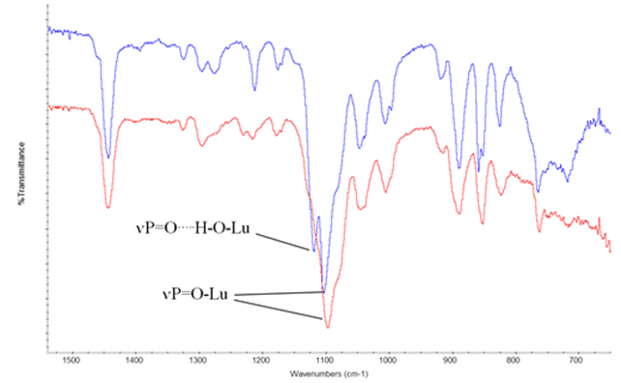

**Figure 2 - The structure of Nd(Cy3PO)3Br3 showing the atom labelling scheme Thermal ellipsoids are drawn at the 30% probability level. H atoms have been omitted for clarity.**

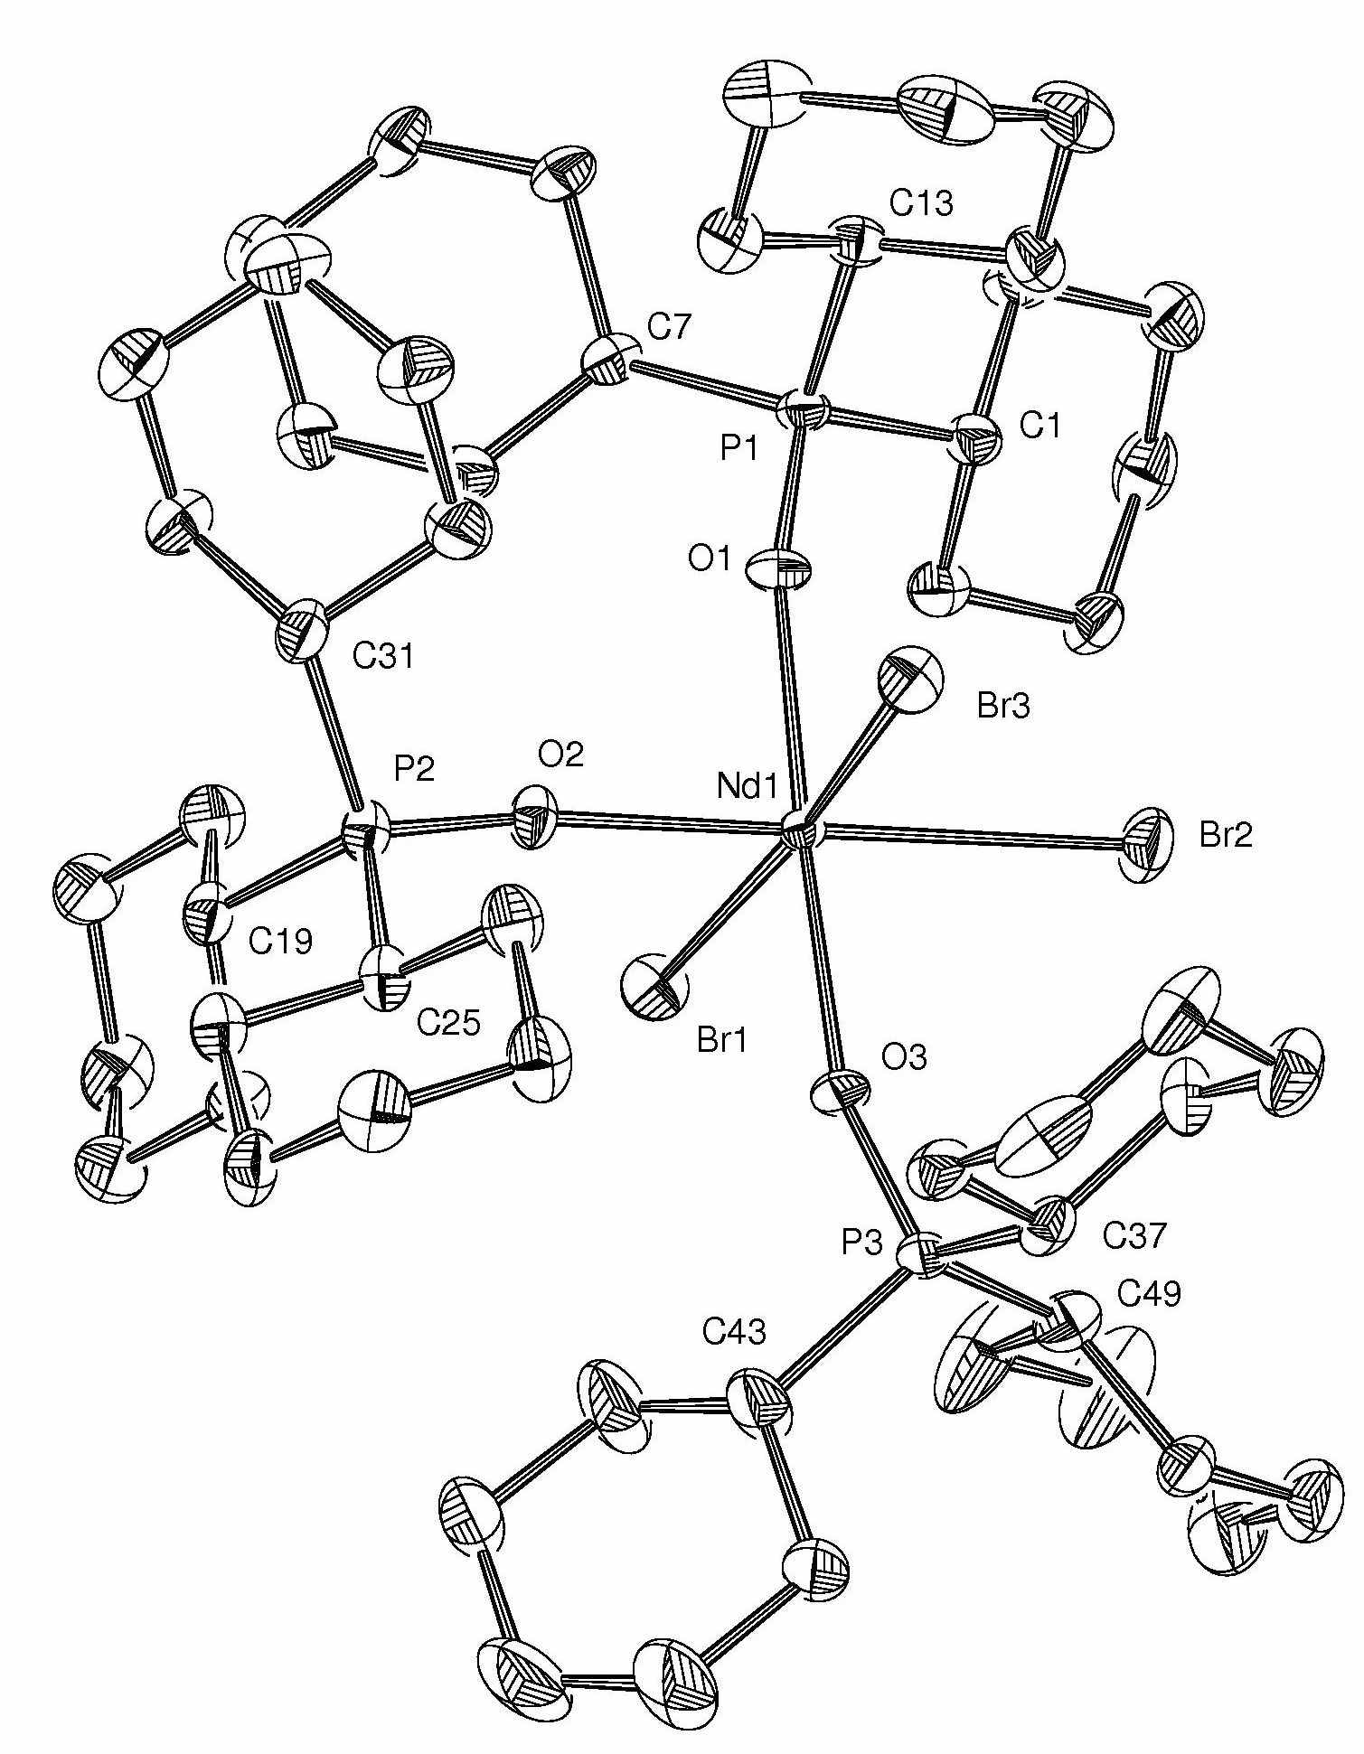

**Figure 3 The correlation between Ln – Br and Ln - O distances in the**

**Type I complexes and the 6 coordinate ionic radius [18].**

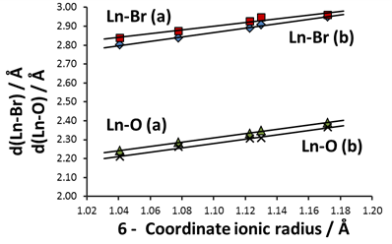

**Figure 4 - The structure of [Er(Cy3PO)2(H2O)5](Cy3PO)2Br3 showing the atom labelling scheme Thermal ellipsoids are drawn at the 30% probability level. Cyclohexyl H atoms have been omitted for clarity.**

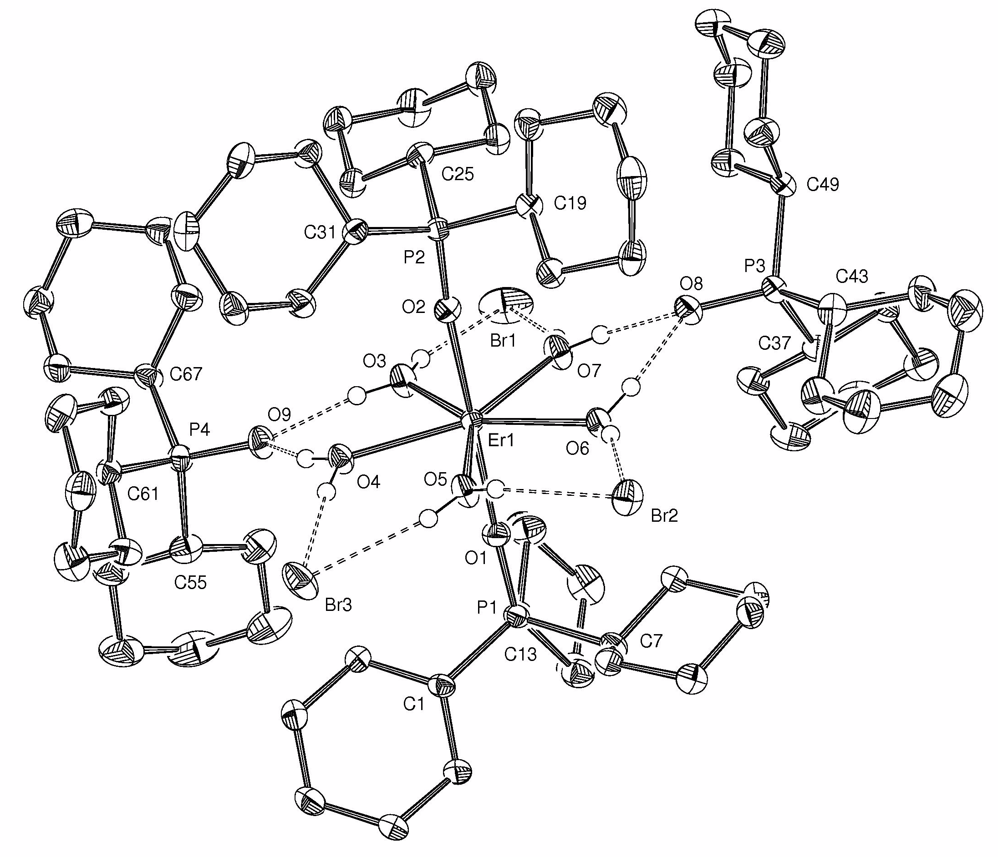

**Figure 5 - The structure and H-bonding network of** **[Lu(Cy3PO)2(H2O)5]**

**(EtOH)2Br3 showing the atom labelling scheme. Thermal ellipsoids are drawn at the 30% probability level. Cyclohexyl groups and ethyl H atoms have been omitted for clarity. [Symmetry codes: i = 1½-x, ½-y, 1-z; ii = 2-x, y, 1½-z]**

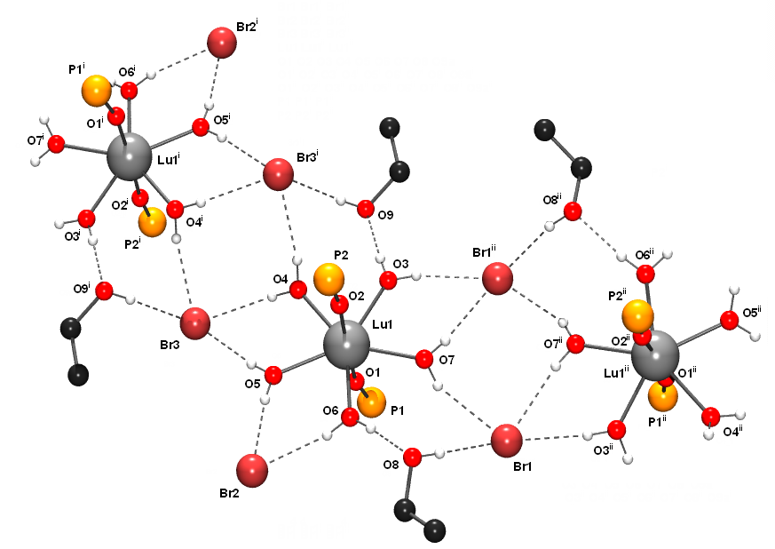

**Figure 6 - The Two Nucleus Lanthanide Induced Shift Plot for the Type II Complexes.**

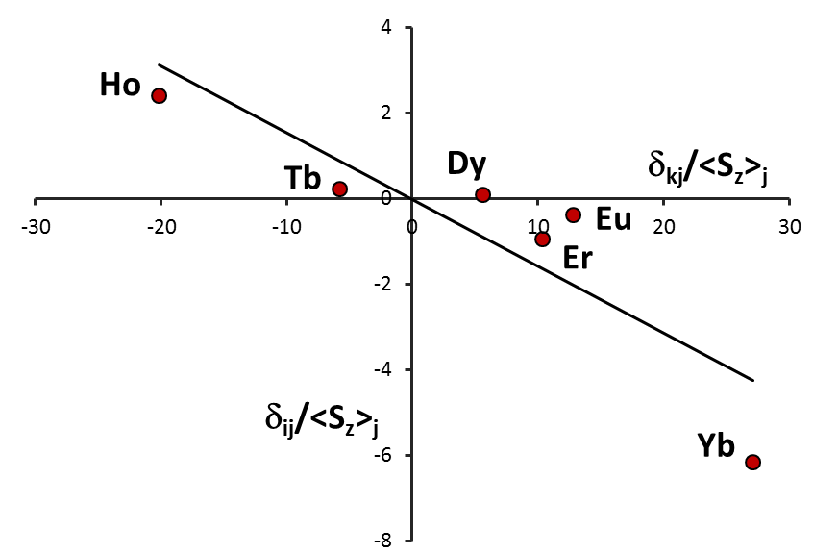

**Figure S1 - Single Nucleus Lanthanide Induced Shift Plots for Type I and Type II complexes.**



**Synopsis**

Complexes of lanthanide bromides with tricyclohexylphosphine oxide (=L) form in two distinct structural types. Type I, LnBr3L3 (Ln = La, Pr, Nd, Gd and Ho) are octahedral and Type II, [Ln(H2O)5L2]L2Br3(Ln = Dy, Er,Yb, Lu) , pentagonalbipyramidal with two L bonded to the lanthanide and two hydrogen bonded to the coordinated water. Over 99% of the changes in Ln-O and Ln-Br distances in Type I complexes can be accounted for by the lanthanide contraction. In the Type II complexes the hydrogen bonding of the coordinated water with phosphine oxides and bromide ions has a small influence on Ln-O distances Variable temperature solution 31P NMR measurements show a variety of dynamic processes. Analysis of the lanthanide induced shifts indicates structural uniformity in solution.

