Running head: LINEAR AND U-SHAPE TRENDS
Linear and U-shape Trends in the Development of Expressive Drawing from Pre-schoolers to Normative and Artistic adults

Richard P. Jolley and Claire M. Barlow
Staffordshire University, UK
School of Psychology, Sport and Exercise, Faculty of Health Sciences, Staffordshire University, Leek Road, Stoke-on-Trent, ST4 2DF. Email: r.jolley@staffs.ac.uk; c.m.barlow@staffs.ac.uk
Ken J. Rotenberg
Keele University, UK
School of Psychology, Dorothy Hodgkin Building, Keele University, Keele, Staffordshire,
ST5 5BG. Email: k.j.rotenberg@keele.ac.uk
Maureen V. Cox
University of York, UK
Department of Psychology, University of York, York, Y010 5DD. Email: maureenvcox@gmail.com
Author Note
This research was supported by The Leverhulme Trust (F/00799/A). The authors thank all the children who participated, the parents who gave their consent, and the teachers with whom we coordinated with during the process of conducting this study. Particular thanks are given to the following schools who gave permission to publish the drawings in Figure 5: Park Hall Academy, Oakhill Primary School, Thistley Hough Academy, St. Peter’s Academy, Madeley High School. Correspondence concerning this article should be addressed to Dr. Richard Jolley, School of Psychology, Sport and Exercise, Faculty of Health Sciences, Staffordshire University, Leek Road, Stoke-on-Trent, ST4 2DF, UK. Tel: ++44 1782 294887. Email: r.jolley@staffs.ac.uk
Abstract
This study sought to explain the apparently conflicting age-incremental and U-shaped developmental patterns found for the merit of expressive drawing by examining the role of representational realism drawing ability in the observed age patterns. Thirty children in each of seven age groups from young children to preadolescence (4, 5, 6, 7, 9, 11 and 12 years) were randomly sampled. Two further groups (normative and artist) of 14-year-olds and young adults were included to assess expressive drawing shown late in development. Each participant completed three expressive drawings (happy, sad, and angry) and three visual-realism drawing tasks. The expressive drawings were assessed on five measures of expressive merit (overall quality, color, composition, line, and content) developed and scored by two adult artists. The data analyses were performed on those scores (i.e., raw scores) and those scores when statistically adjusted for performance on the realism drawing tasks. The raw expressive drawing scores linearly increased up to preadolescence. Linear trends continued for the artist adolescent and adult samples, but tailed off and declined in curvilinear relationships for the normative counterparts. By contrast, the analyses yielded a U-shaped curve in the merit of expressive drawings when those scores were statistically adjusted by realism drawing performance: young children and adolescent/adult sample showed elevated merit, more notably the later sample when artists were considered. The findings suggest the previously reported age-incremental patterns were influenced by a consideration of realism drawing ability in the assessment, while the U-shape curve de-emphasises representational realism in the content of the drawings.
Expressive Drawing Development Linear U-shape

Linear and U-shape trends in the development of expressive drawing from pre-schoolers to normative and artistic artists
The process of drawing promotes many psychological benefits for children, including visual thinking, observation and the analysis of subject matter, problem solving, imagination, expression, creativity, as well as more general habits of thinking such as perseverance, experimentation and reflection (Arnheim, 1969; Barnes, 2002; Burkitt, Rose & Jolley, 2010; Hetland, Winner, Veenema & Sheridan, 2013). Furthermore, producing the artefacts develops children’s drawing ability, both for their representational drawing of the subjects depicted and their expressive drawing of emotional/conceptual messages. There is a general convergence in the literature that with age children denote subject matter in forms of increasing visual likeness (for reviews, see Cox, 2005; Jolley, 2010). However, there is a vibrant debate regarding the developmental pattern of children's expressive drawing. An influential claim for a U-shape pattern posits that very young children produce drawings of similar expressive quality to the works created by artistic adolescents and adults, with a dip in artistic merit in the intervening middle childhood period (e.g., Davis, 1997a; Gardner, 1980; Gardner & Winner, 1982; Rosenblatt & Winner, 1988). By contrast there is a body of work that shows variations of age-incremental increases in expressive drawing performance (e.g., Ives, 1984; Jolley, Fenn & Jones, 2004; Morra, Caloni & d’Amico, 1994; Picard, Brechet & Baldy, 2007; Picard & Gauthier, 2012; Winston, Kenyon, Stewardson & Lepine, 1995). This study set out to resolve the apparently conflicting age-incremental and U-shape patterns in children’s expressive drawing.
Expressive drawing is a communication of moods, feelings and ideas through three broad types of graphic techniques: literal, content and abstract (Ives, 1984; Jolley, 2010; Jolley et al., 2004; Morra et al., 1994; Picard et al., 2007). Literal expression is typically depicted by facial expressions. Content expression uses subject matter from life, such as a countryside scene on a sunny day expressing peacefulness or the beauty of nature. Abstract expression is served by a range of formal properties such as color, line and composition. For instance, bright colors, uplifting lines and a balanced composition might be interpreted as expressing positive affect. These techniques are not mutually exclusive, as they can appear in the same picture or even in a single representation. However, the term metaphorical expression is limited to content and abstract expression, and is considered an important aesthetic property in works of art (see Goodman, 1976). As Picard and Gauthier (2012) note, there have been two distinct and complementary approaches to the study of children's expressive drawings. One has been to assess the developing frequency in which the three techniques are used both in isolation and in combination (e.g., see Ives, 1984; Picard & Gauthier, 2012; Winston et al., 1995). An alternative approach that has driven the age-incremental versus U-shaped pattern debate is to assess the quality of expression in the drawings, and is the approach taken in this paper.
The U-shape Pattern
A particularly controversial element to the U-shape curve hypothesis is the elevated status assigned to young children’s aesthetic drawings. Such a view can be traced back to the Romantic artists in the late 18th and 19th centuries. They saw a natural creativity and inventiveness in the simplicity and innocence in how young children draw, whereas older children’s drawings were considered to suffer from representational conventions (Fineberg, 1997, 1998; Golomb, 2002). During the 20th century some notable artists (e.g., Dubuffet, Kandinsky, Klee, Miró, and Picasso) within abstract, cubism, surrealism and expressionism traditions collected and studied young children’s drawings to gain ideas and inspiration, further cementing the status of young children’s art (see Fineberg, 1997).
Many of these artistic movements emphasized the importance of emotion in aesthetics, and indeed much of the empirical research on children’s aesthetic drawings has focused on expressive aspects. Davis (1997a) examined evidence for the U-shape curve by asking groups of 5-, 8- 11-, 14-year-olds and adults in North America to make a happy, sad and angry drawing, with participants free to choose the content of their drawings. The 14-year-old and adult samples each consisted of two sub-groups, self-professed artists and non-artists. Davis reported consistent U-shape patterns according to two North-American artist judges who rated the expressive quality of the drawings on 4-point Likert-type scales across four aesthetic measurements. Three of these related directly to expression (expressive line, expressive composition, overall quality of expression), with the other measurement on overall balance (a formal property). According to the mean scores 5-year-olds scored higher than the 8-year-olds and 11-year-olds, with the developmental end-trajectory emerging upwards for the two artist samples of 14-year-olds and adults. Indeed, when the data from the 5-year-olds were grouped with that of the artist 14-year-olds and adults this composite group significantly outperformed the combined data from all other groups on each of the four measures. Interestingly, when Davis substituted the artist adolescents and adults with their non-artist counterparts an L-shape was observed. That is, after the dip from the 5-year-olds to 8-year-olds, a flat line of performance was shown across the remaining groups using a cumulative measurement of the four scales. Davis suggested the ‘L’ could stand for ‘literal’, a description that harks back to the Romantic artists’ view of older children’s drawings being affected by literal realism conventions.
The U-shape hypothesis of children’s expressive drawing has been challenged for depending upon a modernist art perspective in the judging of the drawings. That is, the artistic values of authenticity, directness, inventiveness and expression are valued more highly than other artistic styles, such as graphic technical skill in representation and children’s borrowing of graphic models from pictures they see (e.g., Duncum, 1986, Kindler, 2004; Pariser, Kindler & van den Berg, 2008; Wilson, 2004). That the U-shape curve is dependent upon a modernist vision of art has been accepted by its key supporters, Ellen Winner (see Jolley, 2010, p. 57-58) and Howard Gardner (2006). Furthermore, in a commentary on her own findings, Davis acknowledges that “the celebration of the artistry of young children derives from and is unique to
a modernist perspective” (Davis, 1997b, p.152).
As a modernist perspective is not a universal judgment of art, Pariser and van den Berg (1997, 2001) argued that the developmental pattern of expressive drawing development is culturally determined. For instance, in contrast to Western modernist values the Chinese have traditionally valued representational drawing skill (see Jolley & Zhang, 2012). Applying Davis’s (1997a) drawing tasks and age/artist groups to children and adults from the Montreal Chinese community, Pariser and van den Berg (1997) asked pairs of North-American and Chinese artists to rate the expressive drawings. Consistent with Davis’s findings the American judges’ ratings produced a U-shape curve. In contrast, the Chinese judges’ ratings reflected an uneven but upward sloping pattern with age, with the drawings of the youngest children (5-year-olds) assigned the lowest scores compared to all the older age groups. Interviews with the four artists revealed some common ground on rating criteria between the Chinese and American judgements (e.g., a consideration of expressive formal properties), but the Chinese artists appeared to give greater weight to complex drawings that showed subject matter communicating narrative/thematic sense drawn with technical skill. This distinction was further supported in a follow-up study where the authors had the same expressive drawings rated independently on graphic skill (including a consideration of representational realism). They reported a stronger relationship between these ratings and the Chinese judges’ expressive ratings than the North-American judges’ expressive ratings (Pariser & van den Berg, 2001).
Age-incremental Patterns
Age-incremental patterns in the children’s expressive drawing literature have not been limited to Chinese assessors but reported in some studies using Western judges. For instance, using British judges Jolley et al. (2004) found age-incremental patterns in British children’s (4-, 6-, 9- and 12-year-olds) drawings of happy/sad houses, trees and free drawings (although there was often no significant improvement between the 6- to 9-year-olds). After inspecting all the drawings from Davis’s study (see Davis, 1991), Jolley (2010) noticed a similar developmental shift in representational strategies to that shown in the drawings collected in his earlier study. He commented that in both studies the younger children tended to depict human figures with emotional faces. In contrast, older children drew more complex mood-laden scenes and events that included an increasing range of subject matter. Jolley and colleagues (Jolley, 2010; Jolley et al. 2004) argued that differences in the assessment of the drawings between their study and that adopted by Davis accounted for the diverging developmental patterns. They explained that Davis’s rating criteria gave more attention to expressive formal properties (abstract expression) than to content expression. This bias resonates with the modernist art tradition that tends to look beyond the particular representational vehicle depicted for the expressive meaning of the picture. In contrast, Jolley et al. accounted for their age-incremental shift in part by children’s increasing representational repertoire providing more opportunities for content expression.
Role of Representational Realism in Developmental Patterns of Expressive Drawing
The concern we raise in this paper is that while a U-shape curve in children’s expressive drawing depends upon de-emphasising the representational content in the drawings, age-incremental patterns may have been influenced by the representational realism of the content. In respect of the latter it is natural for observers of a drawing to initially consider the identity of the subject matter, and accordingly the content may be normally expected to assist in judgements on a picture’s expressive meaning and merit. However, the natural tendency to examine a picture for its representational content may confound the expressive assessment. For instance, the more immature representational forms seen in younger children’s drawings may lead to a disadvantage in the scoring of their expressive merit if the judges are unclear of its representational content. In contrast, older children’s drawings showing higher levels of visual realism in the subject matter depicted may influence judges favourably in their expressive ratings. Bearing in mind the strong leaps that children make in their representational drawing it is possible that judges not steeped in a modernist perspective may be susceptible to the confound presented by the realistic rendering of the subject matter. The references to complexity, technique and increasing representational repertoire as contributions to the age-related progressions reported (Jolley et al., 2004; Pariser & van den Berg, 2001) only serve further to caution us.
Overview of Study and Hypotheses
We addressed this concern of potential (negative and positive) biases relating to realism of the content in the judgment of their expressive drawing by statistically controlling for the participants’ representational drawing ability. This statistical strategy attempts to equalize the level of representational drawing for individuals across development, and in one sense minimizes the impact of representation that is found in a modernist assessment of the development of the quality of expressive drawing. If an age-incremental pattern is found without controlling for representational drawing skill, but a U-shape curve with the control, then this would provide a significant way forward to explaining the inconsistent developmental patterns reported in the literature. Considering the long-standing debate in this area it is surprising that no study has statistically modelled the developmental data for linear and curvilinear (U-shape) trends.
To accurately detect developmental patterns, whether linear or curvilinear, we sampled a large number and wide range of developmental points that included 11 groups from 4-year-olds to adults. Davis (1997a) found the end-trajectory of the U-shaped developmental pattern from her ‘artistic’ (14-year-olds and adult) samples. Accordingly, we included adolescents and adults who were enrolled on art courses which depended upon artistic aptitude. For our normative end-trajectory comparison we sampled from populations of 14-year-olds and adults enrolled on non-art education courses, with the expectation that some would nevertheless be gifted in drawing.
We made the following specific developmental predictions. We predicted that without controlling for differences in participants’ representational realism drawing ability the progression of expressive drawing develops linearly up to and including pre-adolescence. We expected this linear trend to continue for the artistic sample of adolescents and adults. However, when the normative sample of adolescents and adults were included instead we expected a curvilinear (i.e. quadratic) relationship in which the end trajectory performance reflected a horizontal asymptote or even a decline. This prediction was based on our anticipation that the majority of the normative sample of adolescents and adults would not be active practitioners in the visual arts, and the lack of practice would induce a tapering of performance in the drawing tasks. We note that the performance of the 14-year-olds and adult ‘non-artists’ in Davis’s study is consistent with this expectation. When expressive scores were adjusted for realism drawing ability we predicted a different form of curvilinear relationship, that of a U-shaped curve, particularly in analyses of the expressive measures that included the artist samples.
Method
Participants
Three hundred and fourteen participants (137 males and 177 females) ranging from 4 years 2 months to 40 years old were chosen from 14 schools (five primary, nine secondary) and a university in an English city in a stratified sample of 30 participants in 11 age/artist groups. There were thirty 4-year-olds (12 boys, 18 girls, M = 4;7, SD = 3 months), thirty 5-year-olds (15 boys, 15 girls, M = 5;6, SD = 3 months), thirty 6-year-olds (14 boys, 16 girls, M = 6;7, SD = 4 months), thirty 7-year-olds (15 boys, 15 girls, M = 7;7, SD = 3 months), thirty 9-year-olds (12 boys, 18 girls, M = 9;7, SD = 4 months), thirty 11-year-olds (16 boys, 14 girls, M = 11;6, SD = 3 months), thirty 12-year-olds (16 boys, 14 girls, M = 12;6, SD = 3 months), thirty 14-year-olds (16 boys, 14 girls, M = 14;1, SD = 2 months), thirty 14-year-old artists (GCSE Art pupils, 14 boys, 16 girls, M = 14;8, SD = 3 months), 20 young adults (Psychology undergraduates, 3 males, 17 females, M = 20;4, SD = 14 month), and 24 young adult artists (Art and Design undergraduates, 4 males, 20 females, M = 21;2, SD = 14 months). An additional 10 psychology undergraduates and six art and design undergraduates were also tested, but were subsequently omitted because they were considerably older than the typical young adult university sample. Most of the participants were Caucasian, and apart from the two artist groups, participants were chosen randomly from their classes with no attempt to select those gifted in the visual arts.
Informed consent was obtained from the parents/guardians of children and adolescents aged 14 years and under. Only those school children who expressed a willingness to take part in the study were tested. Informed consent from the adult samples was obtained directly.
Materials
The materials used for the expressive drawing tasks were white blank A4 paper, HB pencils, range of 10 colored pencils (black, brown, purple, light and dark blue, light and dark green, yellow, orange and red), and six crayons (red, orange, yellow, green, blue and black). The crayons were given to the 4-year-olds and the colored pencils to all the other age groups in the expressive drawing tasks. The materials for the visual realism drawing tasks were HB pencils, erasers, artist mannequins (30 cm high wooden models of a man), and wooden cubes (4 cm³).
Procedure
All participants completed three expressive drawing tasks (session 1) and three visual realism drawing tasks (session 2). Participants in all drawing tasks were tested in groups of four (apart from the 4-year-olds who were seen individually), and were seated around a table in a vacant classroom and spaced to prevent copying.
Session 1: expressive drawing. All participants were requested to draw a happy, sad and angry picture, in which they were free to choose their own content. These drawing tasks are those typically employed in studies assessing the quality of children’s expressive drawing (Davis, 1997a; Jolley et al., 2004, 2nd study; Pariser & van den Berg, 1997). Participants were presented with a page of A4 white paper in portrait orientation (although participants could change the orientation), and their own set of pencils/crayons. They were told, “I would like you to draw three pictures. One will be a happy drawing, one will be a sad drawing and the other will be an angry drawing. I will give you a separate piece of paper for each drawing. First, I would like you to draw me a happy (sad, angry) picture. It doesn’t matter what you draw as long as it looks like a happy (sad, angry) picture. Try to draw the best picture you can and you have up to 10 minutes to draw it. You can use as many of the colored pencils/crayons as you want to”. The order of expressive drawings was counterbalanced. The participants who were tested in groups (i.e. all except the 4-year-olds) were discouraged from copying. All participants were able to complete their drawings within the time limit.
Session 2: representational drawing. In the second session (a week later) all participants completed three visual realism drawing tasks (a man from memory, a man from observation of a wooden model, and a cube from observation), also within a time limit of 10 minutes per drawing. Participants were presented first with a page of A4 white paper in portrait orientation, an HB pencil and an eraser. All participants were first required to draw a man from memory, “please draw a man. Draw the whole man, not just the top part and not a cartoon picture. Take your time, work carefully and make the very best picture you can”. For the other two visual realism tasks (which were presented in a counterbalanced order) the participants were each given their own model (wooden man/cube) to draw from. The wooden mannequin of a man was presented about 30 cm away from each participant, oriented in a profile view with the parts of the man positioned to appear that he was running towards the right of the participant’s viewpoint. The participants were instructed, “Look at the man in front of you. He is running that way (experimenter pointed to the participant’s right). Look carefully at the man. I want you to draw exactly what you see, but not the base or the pole (experimenter pointed to the appropriate parts on the model). Draw the man running that way (experimenter pointed to the participant’s right). Draw the very best picture you can”. In the cube task the wooden cube was also placed about 30 cm away from each participant so that from the participants’ viewpoint they could see the front face, top face and the right hand face of the cube. The participants were instructed, “Look at the cube in front of you. Look carefully. I want you to draw the cube. Draw exactly what you see. Draw the very best you can.” All participants were able to complete their visual realism drawings within the time limit.
All participants were thanked for taking part in the study after each session.
Scoring and Inter-rater Reliability
Expressive drawing measures
Each drawing was assessed using a comprehensive range of five measures of expression: overall quality, color, composition, line and content. These measurements were developed by two experienced female professional English artists specifically for this research in discussions facilitated by the research team. The first artist, holding a BA honours degree in fine art (painting), has exhibited her work in galleries in many English cities. She describes her style of painting as ‘figurative towards abstractive, with an emphasis on expressing emotion rather than reality’. The second artist, holding a BA and MA in fine art, has exhibited her work in galleries and other venues in England and France. She has also run many art workshops with children for over 20 years. She describes her own painting style as ‘semi-abstract, being idea-based and experimental’. As the artistic styles of both raters leaned more towards expressive and conceptual art rather than representation, they each had the appropriate expertise in judging expressive drawings. The artists were blind to the hypothesis of the study, and to the age, gender and artistic experience of the drawer. Furthermore, they were asked to rate the drawings on their expressive merit only, and not to take into account the expected ability based on any conjecture of the age of the drawer.
For overall quality, color, composition and line separate 7-point scales for each measure were generated by the artists, in which detailed descriptions of each grade-point were formulated and written in a ratings booklet. For the overall quality of expression measure the artists were asked to consider the overall expressive impact of each drawing considering both the subject matter and formal properties (colour, composition and line) of the drawings. For the three formal properties the artists focused on the expressive use of color, composition and line separately. For colour, the artists examined the drawings for how well the colours displayed were expressive rather than realistic for the content depicted. The use of composition for expressive effect included the consideration of the size of the elements drawn, where they were placed, and how the elements were balanced with each other in respect to the dimensions of the page. In the judgements on expressive line, the use of shape, direction, thickness, texture and shading were considered. The artists were informed of the intended mood of each drawing so they could assess the extent to which the drawing displayed expressive merit as per the task instructions. Twelve intraclass correlations were calculated on the four scale measurements for each of the three moods. These showed very high agreement between the raters, ICC_{(C,k)} = .965 to .997, 95% CI (.957 to .996, .972 to .997). For each 7-point scale all drawings were agreed either to the same point or within one point (whereby a mean was taken).
The remaining measure, content expression, was assessed on the number of expressive subject matter themes depicted in each drawing that were appropriate for the intended mood. This allowed us to examine variations in the complexity and range of expressive content in the sample. The principles of content analysis derived from textual analysis (see Weber, 1990) were used to generate expressive subject matter themes for each mood set of drawings. The second author and an independent rater (a retired nursery school teacher) independently listed every item of representational content for each mood set. At this stage, where recognition allowed, they wrote down specific labels (e.g., dog) and not generic/category information (e.g., animal). After discussion between the two raters, three lists of content items were agreed, one for each mood. The two raters then independently generated subject matter themes in which the content items could be semantically grouped, with the themes reported by Jolley et al. (2004) on children’s ‘free’ drawings providing some guidance. For instance, both raters categorised the items ‘sun’, ‘clouds’, ‘sky’, ‘rain’ (etc.) into a ‘weather’ theme. Each rater understood that themes were independent categories, and that each content item was to be allocated to one theme only. The two raters then discussed their content themes and arrived at an agreed list for each mood (with accompanying content items linked to each theme). Seventeen themes were generated for the sad and angry drawings, fifteen for the happy drawings.
The themes, each with a description and some content item examples, were written in the rating booklet provided to the two artist raters. A theme was established for any given drawing if at least one content item associated with it was recognised. The artists had to decide for each item whether it had been drawn appropriately or not for the intended mood of the drawing. Any single drawing may show evidence, therefore, of appropriately and inappropriately expressed themes. Intraclass correlations were calculated on the total number of subject matter themes appropriately expressed as recorded by the two raters for each of the three moods. These showed very high agreement between the raters, ICC_{(C,1)} = .912 to .940, 95% CI (.892 to .925, .929 to .951). As the same total number of themes from the two raters can be derived by different patterns of themes, cross tabulations on the presence/absence of each theme were carried out as a further inter-rater reliability check. For each theme within each mood set the two raters agreed whether the theme had been expressed appropriately or not for between 92-100% of the drawings. Due to the high agreement one of the artist’s ratings was randomly chosen for the final analysis of the content expression scores. For each drawing the total number of appropriately expressed themes was calculated.
Representational drawing measures
The drawing a man from memory was scored according to the Naglieri’s (1988) Draw-a-Person (DAP) scoring system. The observational drawing of a mannequin model of a man was scored according to a scale based on one reported by Cox, Perara and Xu (1998). Points on an 11-point scale were awarded for direction, overlap, partial occlusion, proportion, detail, and recognisability of a person in relation to the model. The observational drawings of a cube were scored according to a scale based on that reported by Bremner, Morse, Hughes and Andreasen (2000). Each point on the 9-point scale is represented by graphic forms of increasing visual likeness to the model of a cube. The second author rated all the drawings, with an independent rater (the same as used for the content analysis of expressive subject matter themes) scoring 10% of the drawings from each of the three tasks. For the draw a man from memory task, 94% of the drawings were agreed to within 2 points of the 64-point scoring system. For the observational drawings of a man and cube, 97% and 100% of the drawings were agreed to the exact score on their respective scales. Due to the high agreement for all three tasks the scores from the second author were used in the analyses. The participants’ scores on the three tasks were converted to contribute equally to an overall single percentage score of their realism drawing ability.
Results
Strategy for the Analyses
The data analyses were carried out in the following four steps. In Step 1, the correlations between the measures were calculated. In Step 2, regression analyses were carried out to examine the potential linear and curvilinear (i.e. quadratic) relations between age (in months) for each of the five expressive drawing measures. As part of these analyses, regressions were carried out for each measure either: (a) on the raw scores or (b) on the raw scores when statistically adjusted for the participants’ realism drawing ability (assessed as standardized residuals). Furthermore, those regressions were carried out for two samples. Each of the two samples included the 4-year-olds, 5-year-olds, 6-year-olds, 7-year-olds, 9-year-olds, 11 year-olds, and 12-year-olds. However, while one of the samples included 14-year-olds and young adults who, like their younger counterparts, were randomly sampled (the ‘normative’ sample), the other sample included the 14-year-olds and young adults who were enrolled on art courses (‘normative/artist’ sample). In summary, a set of 2 x 2 regressions were carried out per expressive drawing measure: on two types of data (raw data or raw data adjusted for realism ability) and two types of participant samples (normative and normative/artist). The effect sizes are reported in the form of ∆R² when statistically significant effects were found. Additional analyses compared the relations yielded by the regression analyses of the raw data and regression analyses of the data adjusted for realism ability. The linear relations and the quadratic relations obtained were compared separately for each of the two participant samples.
In Step 3, ANOVAs were calculated on each of the expressive drawing measures with four age periods as the between factor in the design. The four age periods were designed to represent the four traditional periods in development: early childhood (4- and 5-year-olds), middle childhood (6-, 7-, and 9-year-olds), preadolescence (11- and 12-year-olds) and adolescence/young adulthood (two groups: normative and artist 14-year-olds and young adults). In terms of our objective of testing for the U-shape curve the early childhood and artist adolescence/young adulthood were expected to represent the tips of the U, while performance in middle childhood and early adolescence representing the dip. There were 60, 90 and 60 participants in the early childhood, middle childhood and preadolescence age periods respectively. There were 50 participants in the adolescence/young adulthood normative sample, and 54 participants in the adolescence/young adulthood artist sample. As recommended for ANOVAs, the sample sizes were substantive for each age period and were approximately equal across the four age periods. Similar to the regression analyses, four ANOVAs were performed for each of the expressive drawing measures, representing two types of data (raw scores and the raw scores statistically adjusted for realism ability) and two samples (normative and normative/artist, see above). Tukey Honestly Significant Difference Test (HSD) post hoc comparisons (p < .05) were carried out to identify differences between the age groups for each expressive drawing measure when statistical significant effects of age period were found.
The aforementioned ANOVAs were conducted with the understanding that examining segmented age periods would likely decrease the detection of the linear and curvilinear relations between the expressive drawing measures and age (in months) that were yielded by the regression analyses. This was expected because discrete age periods (as categories) are statistically less ‘sensitive’ to identifying linear or quadratic relations than the use of age as a continuum employed in the regression analyses. The primary purpose of these analyses, though, was to identify the differences between given age periods that appear to account for the patterns found in the regression analyses. Specifically, the ANOVAs and the corresponding post-hoc comparisons showed statistically significant ‘high’ and ‘lows’ in the expressive drawing measures among the age periods and therefore provided a framework from which to interpret the age patterns found with the regression analyses.
In step 4 we present a statistical comparison between the normative and artist samples of adolescents (14-year-olds) and young adults.
Correlations between the measures. The correlations between the expressive drawing measures with means and SDs are shown in Table 1. There were significant positive correlations between each of the five expressive drawing measures. There were significant positive correlations between each expressive drawing measure and both age and realism drawing ability, and age and realism ability were also positively correlated.
Regression analyses on the raw data for the normative sample. The regression analyses are shown in Figure 1. The regression analyses with age as a predictor yielded a statistically significant linear relation that was qualified by a quadratic relation for each drawing measure. There were increases with age for each expressive drawing measure but that was qualified by a modest decline in the older sample with the onset of the decline shown at 200 months of age (approximately 17 years of age/young adulthood). The effect sizes (∆R²) for the linear relations were .314, .274, .456, .210, and .260 for quality, color, content, composition, and line respectively. The effect sizes (∆R²) of the quadratic relations were .030, .022, .042, and .031, for quality, color, composition, and line, respectively.
Regression analyses on raw data when adjusted by realism ability for the normative sample. The regression analyses are shown in Figure 2. The regression analyses with age as a predictor yielded a significant linear relation between age and content expression only. In contrast, the regression analyses yielded significant quadratic relations with age for all measures except composition. The quadratic relation was U-shaped although asymmetrical due to a pronounced increase in scores with age in the older sample, with an onset of the increase shown at 215 months of age (approximately 18 years of age/young adulthood). The effect sizes (∆R²) for the linear relation was .041 for content. The effect sizes (∆R²) of the quadratic relations were .020, .046, .042, and .017, for quality, color, content and line, respectively.
Regression analyses on the raw data for the normative/artist sample. The regression analyses are shown in Figure 3. The regression analyses with age as a predictor yielded a statistically significant linear relation for each expressive drawing measure that showed performance increasing with age. The linear relation was qualified by a quadratic relation for the content and composition drawing measures, where a horizontal asymptote was observed in the older sample with an onset shown at 200 months of age (i.e., approximately 17 years/young adulthood). The effect sizes (∆R²) of the linear relation were .467, .361, .335, .384, and .436 for quality, color, content, composition and line respectively. The effect sizes (∆R²) of the quadratic relations were .036 and .016 for content and composition, respectively.
Regression analyses on the raw data adjusted by realism ability for the normative/artist sample. The regression analyses are shown in Figure 4. The regression analyses with age as a predictor yielded a statistically significant linear relation for each expressive drawing measure except content: performance on those measures increased with age. However, the regression analyses also yielded significant quadratic relations with age for all expressive measures except content. The quadratic relation was U-shaped due to an elevated performance early in development and a distinctive upward increase in the older sample, with an onset of that increase shown at 215 months of age (approximately 18 years of age/young adulthood). The effect sizes (∆R²) of the linear relations were .039, .031, .020, and .044 for quality, color, composition and line respectively. The effect sizes (∆R²) of the quadratic relations were .090, .049, .040, and .123 for quality, color, composition and line, respectively.
Comparisons of the relations for the raw data and the raw data adjusted by realism for each sample. The remaining question was whether the preceding relations between age and the expressive drawing measures were statistically different when the measures were raw and when those raw measures were adjusted by realism ability. In order to address that question, the (raw) betas for the linear relations and quadratic relations yielded for the raw data and the raw data adjusted by realism ability were compared using equations yielding z scores (see Paternoster, Brame, Mazerolle, and Piquero, 1998; also see Cohen, Cohen, West, and Aiken, 2003). These analyses were carried out separately for the normative and the normative/artist samples. All of these comparisons yielded significance. For the normative sample, there were statistically differences for the quality, color, content, composition and line measures in the linear relations, Zs = 2.73, 2.5, 3.18, 2.73, and 2.50 (all ps < .05) and in the quadratic relations, Zs = 11.50, 8.9, 10.38, 10.44 and 9.42 (all ps < .001). For the normative/artist sample, there were statistically differences for the quality, color, content, composition and line measures in the linear
relations, Zs = 2.50, 2.27, 3.00, 2.50, and 2.25 (all ps < .05) and in the quadratic relations Zs =
10.11, 8.9, 10.90, 10.34 and 10.00 (all ps < .001).
ANOVAs. The ANOVAs with comparisons between the means are shown in Table 2. The ANOVAs on the expressive raw measures for both normative and normative/artist samples uniformly yielded statistical significance. The post-hoc comparisons (Tukey’s HSD with p < .05) showed that performance on each of the expressive drawing measures systematically increased across the age groups in which each older age period showed higher scores than the preceding younger age period. There were some exceptions to that pattern at the end trajectory. The higher scores for the normative adolescent/young adult sample compared to the preadolescence sample were significant only for the expressive line measure. However, the higher scores for the artist adolescent/young adult sample were significant compared to the preadolescence sample for all measures except content expression. The effect sizes (partial eta-squared) on the raw measures shown in Table 2 showed that the effect sizes for developmental age period were large in strength when statistical significance was observed (see Warner, 2008).
The ANOVAs on the expressive drawing measures when adjusted for realism ability yielded a different pattern. The ANOVAs yielded statistically significant differences between the age periods for both analyses that included either the normative or normative/artist samples for content and line. Comparisons of the means yielded evidence for the U-shape quadratic relation between the expressive drawing measures and age for both of those measures. The dip of the U appeared at middle childhood and preadolescence for expressive content and line measures respectively, with all other age/artist periods performing at a significantly higher level. In addition, greater line expressiveness was shown during adolescence/young adulthood artists than during early childhood, middle childhood, and preadolescence. The ANOVAs also yielded statistical significance between the age periods on the colour and overall quality measures of expressive drawing. For these measures, however, significance was due to one or both of the adolescence/young adult samples having higher adjusted scores than the three childhood groups. Significantly higher colour expressiveness was shown by both the normative and artist adolescence/young adulthood groups, whereas for overall quality of expressiveness the artist adolescent/young adult group had higher adjusted scores compared to all other groups. There was no significant difference between any of the age periods for the expressive composition measure. The effect sizes (partial eta-squared) shown in Table 2 showed that the effect sizes for developmental age period on the raw measures adjusted for realism were small in strength when statistical significance was observed (see Cohen et al., 2003).
Drawings for the happy mood are presented in Figure 5 for representative age and artists groups. Quality ratings (raw and adjusted) are given below each drawing, and reflect as closely as possible the mean quality ratings of the age period/artist group the children belonged to.
Artists vs. Normative samples. Individual t tests were carried out to compare the artist and normative adolescents/adults on the raw expressive drawing measures. The t tests yielded effects of artist versus normative groups on the overall quality and line expressiveness measures, t(102) = 2.32, p = .02 and t(102) = 2.55, p = .01, respectively. As expected, artists demonstrated greater overall quality and line expressiveness (M = 4.94 and M = 4.86, respectively) than did the normative sample (M = 4.47 and M = 4.32, respectively).
Discussion
The study set out to reconcile the discrepant age-incremental and U-shaped expressive drawing developmental patterns reported in the literature by examining the role of representational realism drawing ability in the assessment of expressive drawing. In one set of analyses the participants’ scores on the expressive drawing measures were adjusted for their realism drawing ability (independently assessed), while the other set of analyses were conducted on the raw (unadjusted) expressive drawing scores. We sought to establish whether expressive drawing progresses linearly when participants’ realism drawing ability is not taken into account, but develops according to a U-shape (a quadratic trend) when scores are adjusted for realism. Our hypothesis was supported. The regression analyses for all five expressive drawing measurements yielded consistent support for age-incremental patterns (including linear and curvilinear trends) for the unadjusted expressive drawing measures. In contrast, the realism adjusted expressive drawing measures frequently revealed a U-shape pattern, with a pronounced end-trajectory performance particularly in analyses that included the adult artists. There were statistically significant differences between the relations found for the five expressive drawing measurements when raw and adjusted for realism ability scores were compared, with age as a continuous measure. Therefore, both the linear and quadratic relations were substantially different.
Our linear trends support the developmental progressions reported in much of the empirical literature on children's expressive drawings (e.g., Ives, 1984; Jolley et al., 2004; Morra et al., 2004; Picard et al., 2007; Picard & Gauthier, 2012; Winston et al., 1995), although only Ives included samples of adolescents and adults, and none of these studies conducted trend analysis on their data. The linear relations between age and the expressive drawing (raw) measures were, according to Cohen et al.’s (2003) criteria (see Warner, 2008), large in strength when age was a continuous measure. Consistent with our prediction, however, the linear trends were qualified by significant curvilinear trends for all the expressive measures when the randomly (normative) sampled adolescents and adults were included in the analyses. In each case progression began to taper off around adolescence followed by a modest decline in young adulthood. This normative sample of adolescents and artists may be expected to include relatively few artistically gifted and active practitioners in the visual arts, and therefore account for this curvilinear relationship at the end trajectory. When the artist adolescent and adult samples were included instead the significant linear trends for all measures were qualified by curvilinear relationships for content and composition expression only, where progression tapered to a horizontal asymptote around the age of the adult artists. Therefore, our prediction that a linear trend would continue to characterise developmental progression in expressive drawing throughout adolescent and adulthood in artistic samples was on the whole supported, particularly as this was reflected in the overriding quality of expression measure. The superior artistic ability expected to emanate from the artistic sample is likely to explain this continued developmental increase in performance. The quadratic relations between age and the expressive art (raw) measures were, when applying Cohen et al.’s (2003) criteria (see Warner, 2008), small with age as a continuous measure. These are consistent with the modest effect sizes of quadratic relations typically found in psychological research: they normally account on average approximately 4 percent of the variance (e.g., Carter et al., 2014; Chung-Yan & Butler, 2011; Daspe, Sabourin, Lussier, Péloquin, & Wright 2015).
The set of regression analyses conducted on the expressive drawing scores adjusted for realism drawing ability confirmed our expectation of U-shaped developmental patterns. That is, the performance of the youngest participants was followed by a modest dip among participants in mid-childhood and pre-adolescence, with performance then improving among the older participants. As we predicted, the U-shape patterns were more prominent in the analyses that included the adolescent and adult artists, with a particularly strong uplift in performance from the adult artists. However, in the analyses that included the randomly (normative) sampled adolescents and young adults the U-shape curves were much flatter, akin more to a saucer-shape. Nevertheless, in both sets of analyses the best fitting quadratic curves showed that the two tips of the U were not equally weighted. While there was consistent evidence of a noticeable up-lift in the performance of the young adult samples compared to children in middle childhood to adolescence, our data indicated only tentative support for an initial dip in performance from young to middle childhood. It is relevant here to note that Davis (1997a) did not test for any significant difference in performance of her 5-year-olds with that of the children in age groups representing the ‘dip’, so we remain cautious on the claims of the elevated artistry of young children’s drawings. Nevertheless, our findings on the expressive drawing scores adjusted for participants’ representational drawing ability resonate with the claim of a U-shape curve in the development of expressive drawing (Davis, 1997a; Gardner, 1980; Gardner & Winner, 1982; Rosenblatt & Winner, 1988). Similar to analyses of the raw data and previously observed quadratic relations in the field of psychology, the quadratic relations between age and the expressive drawing (raw) when adjusted by realism ability measures were, when applying Cohen et al.’s (2003) criteria (see Warner, 2008), small with age as a continuous measure.
To identify developmental shifts in the linear and quadratic trends of artistic merit we tested for significant differences between four age periods (early childhood, middle childhood, preadolescence, adolescent/young adulthood), both on the raw and adjusted (for realism) expressive drawing data. On all expressive drawing measures the raw scores significantly increased for each developmental period up to and including preadolescence. The performance of the normative adolescent and adult sample did not significantly increase further for four of the five measures, whereas performance did significantly increase for the artist adolescent and adult sample for all measures except content expression. These analyses by developmental period therefore supported the linear and curvilinear relationships from the regression analyses. Analyses for differences between the developmental groupings using the expressive scores adjusted for realism showed no evidence that scores were increasing with age. Instead, U-shape patterns for content and line were evident, with the dips occurring after early childhood in middle-childhood and pre-adolescence for content and line respectively. For quality and colour we found evidence for a significant improvement among the adolescent/adult artist sample compared to the other developmental groupings, but not for any dip in performance occurring after early childhood. Overall, these analyses for differences complemented the trend analyses, confirming in particular the linear and curvilinear trends on the raw scores. They were less consistently supportive of the quadratic U-shape patterns (on the adjusted scores). The results support the conclusion that categorising the participants into discrete age groupings attenuated the detection of age differences in the quadratic trends on the realism adjusted scores in particular. These differences may have been due to the effects of restricted range on the analysis of discrete summarized age groups compared to the analysis of age as a continuous measure (see Cohen et al., 2003), and affected the detection of quadratic relations, in particular, because the
strength of the quadratic effects depends on the analysis of the full breadth of individual scores.
Our prediction of linear trends for raw expressive scores and U-shape curves for scores adjusted for realism drawing ability was based on two premises, each relating to different artistic predispositions when judging art. First, the U-shaped curve of aesthetic drawing development is acknowledged as being dependent upon a modernist art perspective in judging the drawings, both by its supporters and critics (e.g., Davis, 1997a, 1997b; Duncum, 1986, Gardner, 2006; Jolley, 2010; Kindler, 2004; Pariser et al., 2008; Wilson, 2004). As Jolley states, in a modernist approach, ‘artists eschew the search for realism, instead abstracting formal properties from representations …’ (Jolley, 2010, p. 57). In other words, a modernist judge of the expressive quality of a drawing would tend to look beyond its representational content to discover its expressive communication through abstract properties such as line, colour, composition (etc.). Jolley points out further that Davis’ aesthetic dimensions of assessment reflected a modernist perspective as they were derived more on formal properties than expression through representation. The minimisation of representational content in a modernist judgement of a drawing necessarily diminishes the natural variation in children's and adults’ realism drawing ability in aesthetic judgement. Arguably, our approach to adjust expressive scores for representational realism presents an assessment of expressive drawing that has some resonance with a modernist perspective on the drawings. Our U-shaped curves using the adjusted scores, albeit with a less pronounced dip following young children's performance than apparent in Davis’ data, supports this position.
However, a modernist perspective in not a universal lens of art appreciation, and this leads to the second premise of our prediction: observers of art outside the modernist tradition are likely to give more consideration to the representational content of a picture. It is natural for observers (both artistically naive and experts) to look at any picture to see what it is denoting representationally. Furthermore, both literal and content expression depends upon a viewer considering the representational content in the picture. However, if that attention to a picture’s content leads to a consideration of the extent to which the subject matter is depicted visually realistically, a potential confound may influence the assessment of the expressive merit of the picture. It is possible, therefore, that children’s developing ability to depict subject matter realistically may have contributed to the age-incremental patterns of expressive drawing reported in the literature. In any event the attention that most non-modernist observers would naturally give to the representational content of pictures suggests that the linear trend in expressive drawing may reflect the trajectory of the majority. Data presented in Pariser et al.’s (2008) ‘three countries study’ supports this position. They asked children (of different ages) and adult judges to rate children's and adults’ drawings (half of which were obtained from expressive drawing tasks) produced in Canada, Brazil and Taiwan. While 60% of all judges rated the drawings according to an ‘upward-sloping’ pattern, only 8% of ratings followed a U-shaped pattern (almost entirely contributed by 29% of the 48 adult artist judges). We suggest tentatively that judgements of expressive drawings are likely to naturally follow a linear pattern for the majority of observers, unless participants’ representational realism ability is taken out of the assessment (either by statistical control or by asking judges who have a partiality for a modernist perspective of art).
If representational denotation is naturally and typically considered in evaluating a picture’s expressive merit should expressive qualities and representational realism be considered independent skills of drawing ability? Developmentally, children’s ideas on how to produce a mood-laden drawing are given more opportunity to be depicted by obtaining a greater repertoire of subject matter they can draw. Indeed, we observed a developmental shift from younger children’s simple literal depiction (e.g., a person with a smiling face) to older children’s drawings of a scene-based picture of a mood-driven event (see also Davis, 1997a; Picard & Gauthier, 2012). Furthermore, our consistently strong correlations between the children’s realism drawing ability (assessed from the three representational drawing tasks) and all our (raw) expressive drawing measures indicates that both forms of pictorial communication develop concurrently within children (see also Brechet & Jolley, 2014; Picard et al., 2007). Studies on the development of children’s representational and expressive drawings have tended to focus on one or the other, and as Jolley (2010) states, future research is now needed to incorporate representation and expression in a single theoretical framework of the development of drawing.
Nevertheless, expression in particular may be seen as one element of creativity, and parallels can be drawn between the assessment and development of expressive and creative artefacts and how they are culturally determined. Two fundamental characteristics to defining creativity are originality and appropriateness (Diedrich, Benedek, Jauk & Neubauer, 2015; Runco & Jaeger, 2012). Originality refers to novel and innovative ideas, whereas appropriateness relates more to how well the product fits with, and is of value, to the context in which the creativity is meant to apply. Both originality and appropriateness were evident in our assessment measures of expression. Originality of expressive ideas was one criterion that differentiated higher from lower points on the overall quality of expression scale. Appropriateness featured in all four of the scaled measures (quality, color, composition, line). Drawings that appeared to express a different or neutral mood to that given in the instructions were routinely assigned the lowest points on the scales, with increasingly higher scores characterised by more consistent use of aesthetic devices appropriate for the intended mood. Furthermore, only subject matter themes judged to be appropriate for the intended mood contributed to the content expression measure. Nevertheless, in assessments of creativity there appears to be a bias towards originality (see Diedrich et al., 2015). The mid-childhood slump reported to occur in the development of creativity (Gardner, 1982; Torrance, 1988) has been accounted for by children’s developing intellectual conformity to cultural conventions as they begin to consider whether their ideas are appropriate or not in accordance with school and peer expectations. Accordingly, their ideas may be seen as less original than those given by younger children, even though the younger children’s novel suggestions may not always be appropriate. Similarly, the trough in the U-shaped curve for expressive drawing has been attributed to the drawings attempting to show literal conventions of realism or formulaic stereotypes (Davis, 1997a, 1997b; Gardner, 1980; Rosenblatt & Winner, 1988), where appropriateness (in how the subject matter is depicted) is more apparent than originality. Such biases in evaluations present a cautionary reminder that neither expression nor creativity are solely embodied in the properties of the product but influenced also by the wider social and cultural context of the designers and users of the assessment criteria.
As well as this contextual background the extent to which judges understand the artist’s intended meaning of the picture is also relevant to evaluations (Freeman, 1995). The idea behind a drawing may be creative but not fully communicated in the drawing, or simply misunderstood by an observer. This is most likely to apply to younger children’s products, which have more limited representational repertoire and (arguably) weaker execution. Although we statistically controlled for the impact of representational realism in the drawings, the potential problem of failing to fully understand the expressive meaning of a picture still remained. In order to disentangle apparently conflicting developmental patterns in the literature we needed to replicate tasks and limit evaluations to the products only. Nevertheless, we recognise that this product-focused literature that ignores the context of the intentional process compromises the full picture of creativity and expression in drawing. Accordingly, we recommend that future research invites children (and adults) to comment on their expressive drawings to facilitate the assessments of the products by accessing the artists’ creative and imaginative ideas underpinning the drawings.
Clearly, the developmental question presented in this paper would benefit from longitudinal data, but the social and cultural art context intrinsically embedded in any evaluation indicates there will be no universal pattern of expressive/aesthetic drawing development (see also Gardner, 2006). Nevertheless, our paper specifically highlights how the representational realism of the content influences which developmental pattern is observed.
References
Arnheim, R. (1969). Visual thinking. Berkeley: University of California Press.
Barnes, R. (2002). Teaching art to children 4-9. London: Routledge/Falmer.
Brechet, C., & Jolley, R.P. (2014). The roles of emotional comprehension and representational drawing skill in children’s expressive drawing. Infant and Child Development, 23, 457-470
Bremner, J. G., Morse, R., Hughes, S., & Andreasen, G. (2000). Relations between drawing cubes and copying line diagrams of cubes in 7-to 10-year-old children. Child Development, 71, 621-634.
Burkitt, E., Jolley, R. P., & Rose, S. E. (2010). The attitudes and practices that shape children’s drawing experiences at home and at school. International Journal of Art and Design Education, 29, 257-270.
Carter, N. T., Dalal, D. K., Boyce, A. S., O’Connell, M. S., Kung, M-C., & Delgado, K. M. (2014). Uncovering curvilinear relationships between conscientiousness and job performance: How theoretically appropriate measurement makes an empirical difference. Journal of Applied Psychology, 99, 564-586
Chung-Yan, G. A. & Butler, A. M. (2011). Proactive personality in the context of job complexity. Canadian Journal of Behavioural Science. 43, 279-286.
Cohen, J., Cohen, P., West, S. G., & Aiken, L. S. (2003). Applied multiple
regression/correlation analysis for the behavioral sciences (3rd ed). Mahawah, New
Jersey: Lawrence Erlbaum Publishers.
Cox, M. V. (2005). The pictorial world of the child. Cambridge, UK: Cambridge University Press.
Cox, M. V., Perara, J., & Xu, F. (1998). Children’s drawing ability in the UK and China. Psychologia, 41, 171–182.
Davis, J. H. (1991). Artistry lost: U-shaped development in graphic symbolisation. Unpublished
Doctoral Dissertation, Graduate School of Education, Harvard University.
Davis, J. H. (1997a). Drawing’s demise: U-shaped development in graphic symbolisation. Studies in Art Education: A Journal of Issues and Research, 38, 132-157.
Davis, J. H. (1997b). The what and whether of the U: cultural implications of understanding development in graphic symbolisation. Human Development, 40, 145-154.
Daspe, M-E., Sabourin, S., Lussier, Y., Péloquin, K., & Wright, J. (2015). Is the association between sexual satisfaction and neuroticism in treatment-seeking couples curvilinear? Couple and Family Psychology: Research and Practice, 4, 92-105.
Diedrich, J., Benedek, M., Jauk, E., & Neubauer, A. C. (2015). Are creative ideas novel and useful? Psychology of Aesthetics, Creativity, and the Arts, 9, 35-40.
Duncum, P. (1986). Breaking down the alleged “U” curve of artistic development. Visual Arts Research, 12, 43-54.
Fineberg, J. (1997). The innocent eye: children’s art and the modern artist. Princeton, NJ: Princeton University Press.
Fineberg, J. (1998). Discovering child art: Essays on childhood, primitivism and modernism. Princeton, NJ: Princeton University Press.
Freeman, N. H. (1995). The emergence of a framework theory of pictorial reasoning. In C. Lange-Küttner and G.V. Thomas (Eds.), Drawing and looking (pp. 135-146). London: Harvester.
Gardner, H. (1980). Artful scribbles. New York: Basic Books.
Gardner, H. (1982). Art, mind, and brain: a cognitive approach to creativity. New York: Basic Books.
Gardner, H. (2006). Reply to David Pariser. In J. A. Schaler (Ed.), Howard Gardner under fire: the rebel psychologist faces his critics (pp. 336-341). Chicago: Open Court Press.
Gardner, H., & Winner, E. (1982). First intimations of artistry. In S. Strauss (Ed.), U-shaped
behavioral growth (pp. 147-168). New York: Academic Press.
Golomb, C. (2002). Child art in context: A cultural and comparative perspective. Washington
DC: American Psychological Association.
Goodman, N. (1976). Languages of art. Indianapolis: Hackett Publishing Company.
Hetland, L., Winner, E., Veenema, S., & Sheridan, K. M. (2013). Studio thinking: the real benefits of visual arts education (2nd ed.). New York: Teachers College Press and National Art Education Association.
Ives, S. W. (1984). The development of expressivity in drawing. British Journal of Educational Psychology, 54, 152-159.
Jolley, R. P. (2010). Children and pictures: drawing and understanding. Wiley-Blackwell.
Jolley, R. P., Fenn, K. & Jones, L. (2004). The development of children's expressive drawing. British Journal of Developmental Psychology, 22, 545-567.
Jolley, R. P., & Zhang, Z. (2012). How drawing is taught in Chinese infant schools. International Journal of Art and Design Education, 31, 30-43.
Kindler, A. M. (2004). Researching impossible? Models of artistic development reconsidered. In E. W. Eisner and M. D. Day (Eds.), Handbook of research and policy in art education (pp. 232-252). New Jersey: National Art Education Association and Lawrence Erlbaum Associates.
Morra, S., Caloni, B., & D’Amico, M. R. (1994). Working memory and the intentional depiction of emotions. Archives De Psychologie, 62, 71-87.
Naglieri, J. A. (1988). Draw A Person: A Quantitative Scoring System Manual. San Antonio, TX: The Psychological Corporation, Harcourt Brace Jovanovich.
Paternoster, R., Brame, R., Mazerolle, P., & Piquero, A. (1998). Using the correct statistical test
for the equality of regression coefficients. Criminology, 36, 859−866.
Pariser, D.A., Kindler, A.M., & van den Berg, A. (2008). Drawing and aesthetic judgments
across cultures: Diverse pathways to graphic development. In Milbrath, C., & Trautner, H. M. (Eds.), Children’s understanding and production of pictures, drawings and art: theoretical and empirical approaches (pp. 293-317). USA: Hogrefe & Huber.
Pariser, D., & van den Berg, A. (1997). The mind of the beholder: some provisional doubts about the U-curve aesthetic development thesis. Studies in Art Education, 38, 158-178.
Pariser, D., & van den Berg, A. (2001). Teaching art versus teaching taste, what art teachers can learn from looking at cross-cultural evaluation of children’s art. Poetics, 29, 331-350.
Picard, D., Brechet, C., & Baldy, R. (2007). Expressive strategies in drawing are related to age and topic. Journal of Nonverbal Behavior, 31, 243-257.
Picard, D., & Gauthier, C. (2012). The development of expressive drawing abilities during childhood and into adolescence. Child Development Research, 2012.
Rosenblatt, E., & Winner, E. (1988). The art of children’s drawing. Journal of Aesthetic Education, 22, 3-15.
Runco, M. A. & Jaeger, G.J. (2012). The standard definition of creativity. Creativity Research Journal, 24, 92-96.
Torrance, E. P. (1988). The nature of creativity as manifest in its testing. In R. J. Sternberg (Ed.), The Nature of creativity (pp. 43–73). New York: Cambridge University Press.
Warner, R. M. (2008). Applied statistics: From bivariate through to multivariate techniques. Los Angeles: Sage Publications.
Weber, R. P. (1990). Basic content analysis. London: Sage.
Wilson, B. (2004). Child art after modernism: visual culture and visual narratives. In E. W.
Eisner and M. D. Day (Eds.), Handbook of research and policy in art education (pp. 299-328). New Jersey: National Art Education Association and Lawrence Erlbaum Associates.
Winston, A. S., Kenyon, B., Stewardson, J., & Lepine, T. (1995). Children’s sensitivity to expression of emotion in drawings. Visual Arts Research, 21, 1-15.
Table 1
Correlations Between the Measures (with Means and SDs)
_________________________________________________________________________________________
Measure Mean SD RA QU CL CONT COMP LN
_________________________________________________________________________________________
Age (in Months) 134.35 61.51 .65*** .81*** .58*** .62*** .61*** .62***
Realism Ability (RA) 65.45 28.37 .63*** .54*** .60*** .61*** .58***
Expressive Measures
Quality (QU) 3.86 1.16 .72*** .56*** .81*** .90***
Color (CL) 3.65 1.25 .40*** .67*** .69***
Content (CONT) 2.27 1.44 .50*** .48***
Composition (COMP) 4.02 1.24 .75***
Line (LN) 3.75 1.14
___________________________________________________________________________________________
Note: ***p < .01, the dfs = 312

Table 2
ANOVAs on the Raw and Realism Ability adjusted Expressive Drawing Measures, with Means and Contrasts
_______________________________________________________________________________________________
Groups
Measure ANOVA (Fs)¹ Effect Sizes² EC MC Pre-Adol AD Norm (or) AD Artists
_______________________________________________________________________________________________
Raw
Quality 43.80***/66.62*** .34/.44 2.79ª 3.40^{b} 4.14^{c} 4.47^{c} 4.94^{d}
Color 38.71***/48.30*** .31/.36 2.66ª 3.13^{b} 3.87^{c} 4.35^{c} 4.71^{d}
Content 67.60***/53.41*** .44/.38 1.07ª 1.52^{b} 2.98^{c} 3.29^{c} 3.10 ^{c}
Composition 41.62***/47.34 *** .33/.35 2.78ª 3.74^{b} 4.34^{c} 4.67^{c} 4.90 ^{d}
Line 34.62***/55.94*** .29/.39 2.78ª 3.34^{b} 3.78^{c} 4.32^{d} 4.89^{d}
Adjusted for Realism Ability
Quality 1.48/6.20*** --/.07 .06ª -.19ª -.25ª .04ª .44^{b}
Color 2.51/6.58*** --/.07 .04ª -.23ª -.21ª .13^{b} .41^{b}
Content 6.85***/4.46** .07/.05 .10ª -.32^{b} .16ª .30ª .11ª
Composition .70/1.67 --/-- -.07 .02 -.20 -.01 .20
Line 3.99**/11.32*** .05/.12 .06ª -.14ª -.44^{b} -.01ª .54^{c}
__________________________________________________________________________________________
Note: ** p < .01 and *** p < .001. ¹ The first F value is for AD Norm with dfs = 3,256 for and the second F value is for Ad Artists with dfs = 3,260. ² The first value is the effect size for AD Norm and the second value is the effect size for AD Artists. Different subscripts denote a difference between the means for each measure and analysis. Also, EC denotes Early Childhood (4- and 5-year olds), MC denotes Middle Childhood (6-, 7- and 9-year-olds), Pre-Adol denotes Pre-adolescence (11- and 12-year-olds), AD Norm denotes normative Adolescence (14-year-olds)/Young Adult (undergraduates), and AD Artists denotes the artist Adolescents (14-year-olds)/Young Adult (undergraduates).

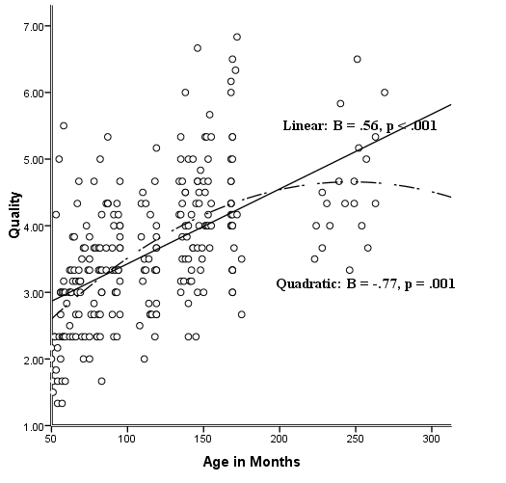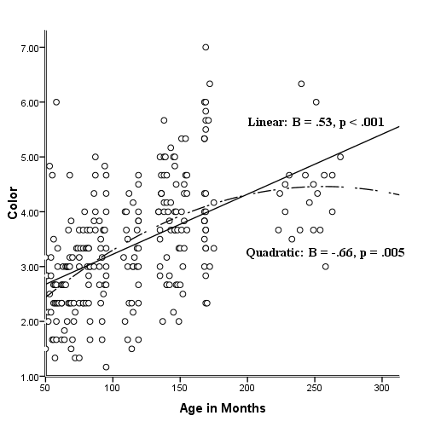

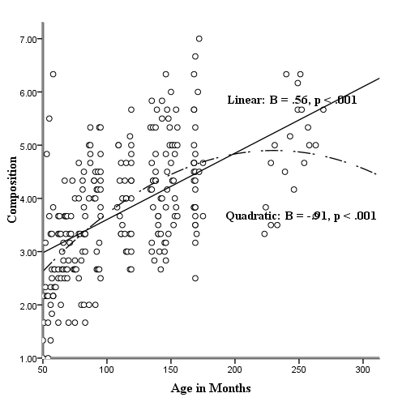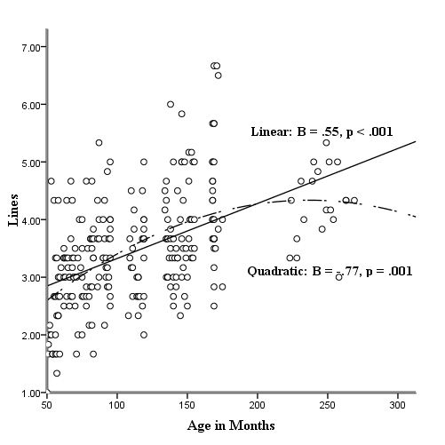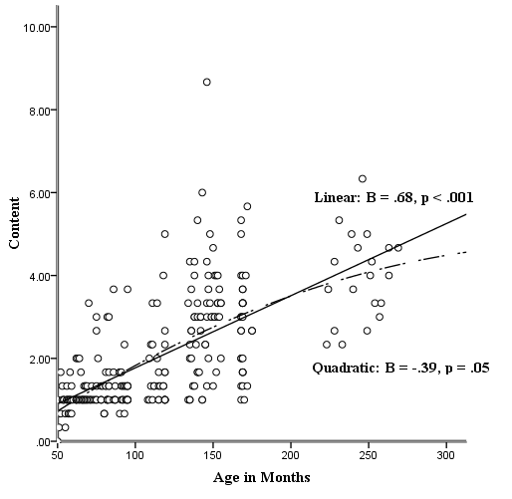
Figure 1. Linear and quadratic relations between age in months and the expressive drawing measures (overall quality, color, composition, line, subject matter) for normative sample on the raw data.
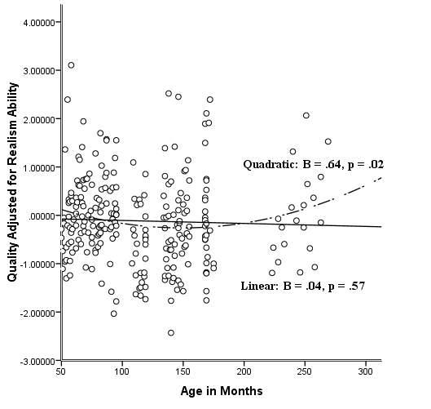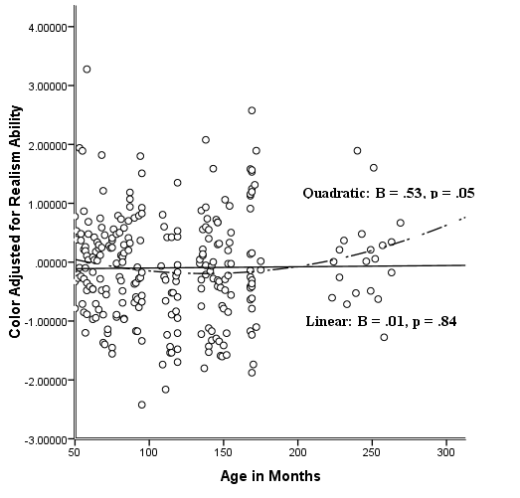
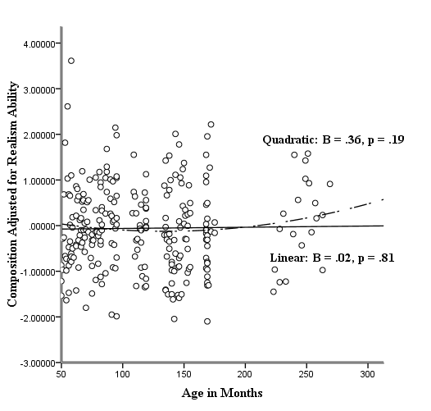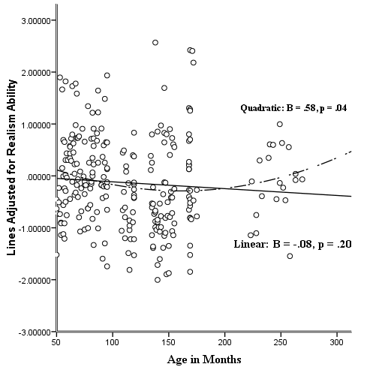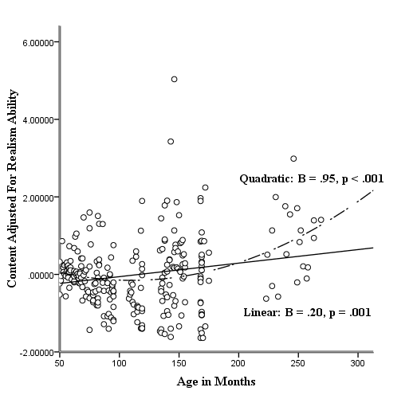
Figure 2. Linear and quadratic relations between age in months and the expressive drawing measures (overall quality, color, composition, line, subject matter) for normative sample on the data adjusted by realism drawing ability.

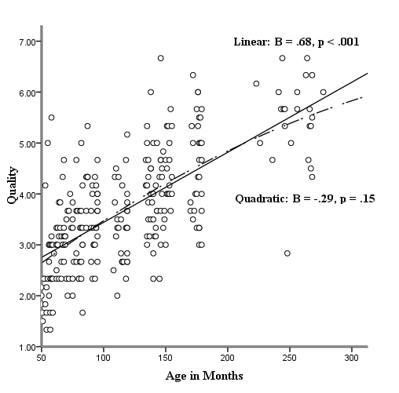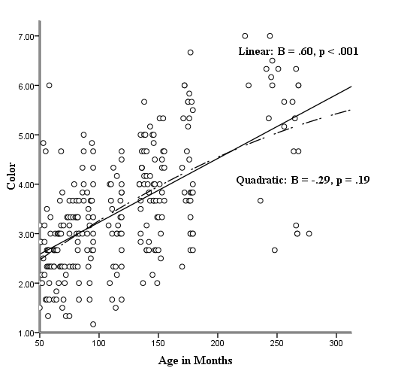

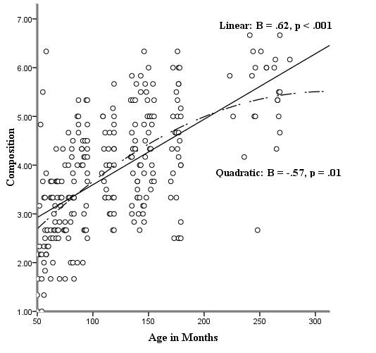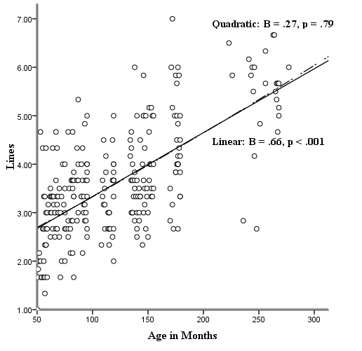
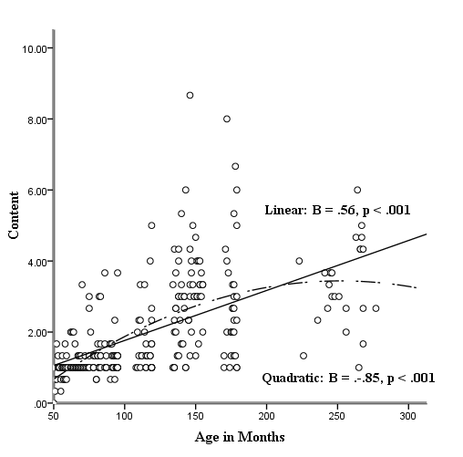
Figure 3. Linear and quadratic relations between age in months and the expressive drawing measures (overall quality, color, composition, line, subject matter) for the normative/artist sample on the raw data.
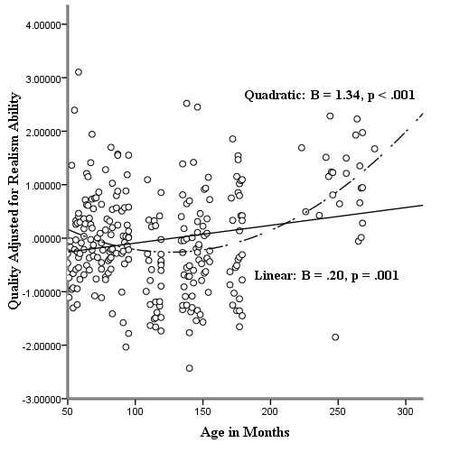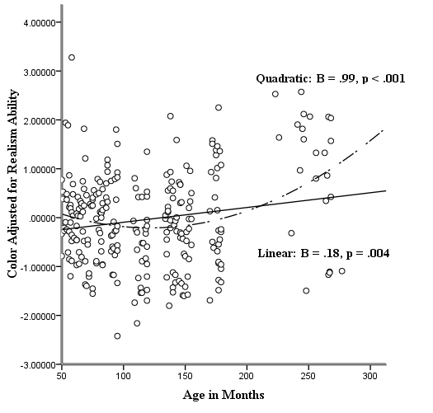

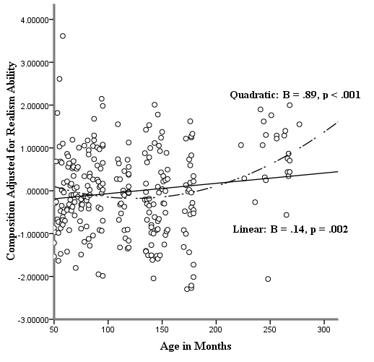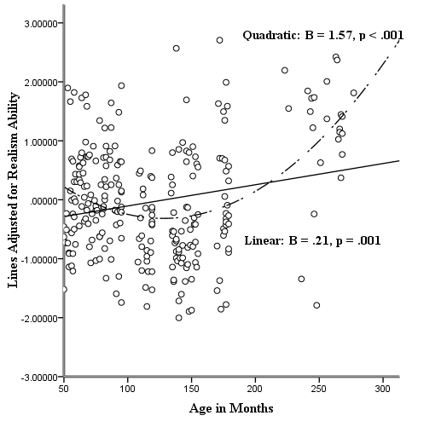
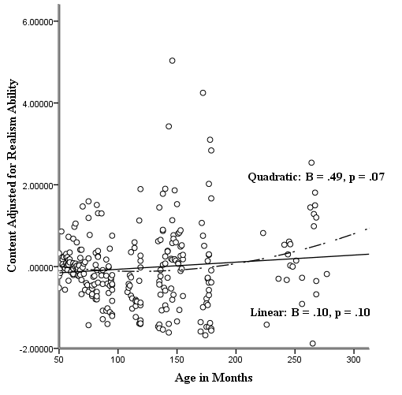
Figure 4. Linear and quadratic relations between age in months and the expressive drawing measures (overall quality, color, composition, line, subject matter) for normative/artist sample on the data adjusted by realism drawing ability.
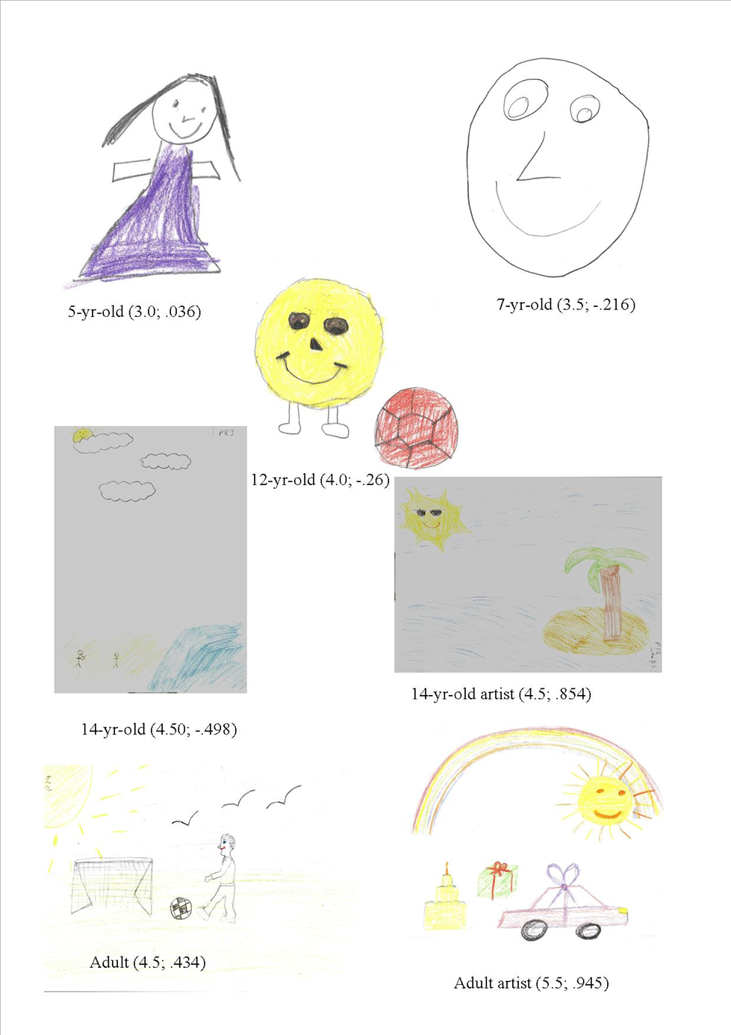

Figure 5. Happy drawings made by a 5-year-old, 7-year-old, 12-year-old, 14-year-old, 14-year-old artist, adult and adult artist (mean quality score: raw; realism adjusted).

¹The ANOVAS were performed on the raw scores when statistically adjusted for realism ability (i.e. the standardized residuals) because they were designed to parallel the regression analyses. For that reason ANCOVAS were not carried out.

