How Technology is Revolutionising Crime Scene Capture and Presentation

Visualising a Crime Scene using Novel Crime Scene Documentation Technology

K. Sheppard*, JP. Cassella, S. Fieldhouse.
Department of Forensic and Crime Sciences, Faculty of Computing, Engineering and Sciences, Staffordshire University, Staffordshire, United Kingdom.
*Correspondence author Correspondence email: Kayleigh.Sheppard@staffs.ac.uk

Abstract

The ability to document crime scene environments in a safe, timely and efficient manner is an integral aspect in the early stages of any criminal investigation. Current methods for documenting crime scenes rely heavily upon digital photography to capture a scene in its original state. In order to meet the demand of technological expectations of juries and law enforcement personnel, forensic investigation findings need to be clearly visualised. Traditional verbal methods of presenting evidence from crime scenes are no longer sufficient and advances in technology have produced systems which allow an entire scene to be documented quickly and efficiently, using spherical photography or 3D laser scanning. This technology allows users to visit a scene without having to be physically present and allows users to view the entire scene as opposed to only the information or evidence deemed relevant at that time. The technology provides a visual presentation tool and allows juries to better understand the evidence they are presented with, providing contextual relevance and conveying spatial relationships within a scene; an aspect that still-digital photography cannot offer.

This paper discusses some of the crime scene visualisation and presentation technologies, which are available to police forces, including the benefits and limitations of this technology and recommendations for future use of technology.

Keywords: Crime Scene Documentation; Digital Imaging Technology; Crime Scene Recording; Panoramic Imaging; Spherical Photography, Laser Scanning.

1.Introduction

There are currently 43 independent Police Services operating within England and Wales, each with their own procedures for documenting crime scenes. Due to the nature of crime scenes and the ephemeral evidence that they present, it is a challenging task for Scenes of Crime Officers (SOCO’s) to document (Komar et al, 2012). Crime scenes are unstable environments, which are often short lived and present difficult types of data to visualise easily and effectively to other individuals who were not present at a scene, particularly a jury (Gardner, 2008; Howard et al, 2000). Many Police Services rely primarily upon laborious manual methods for documenting crime scenes (Stranberg, 2015) including contemporaneous notes, sketches and digital photography (Chan, 2005; Komar et al, 2012; Carrier and Spafford, 2003).

Still-digital photography is extensively used for comprehensively recording a crime scene and capturing images of evidence items within a scene (Robinson, 2010) as it provides a visual representation of the scene as it was at the time (Milliet et al, 2014). Digital photography is known to be one of the best methods for conveying information to individuals in order for them to retain and understand that information, more clearly than is possible with verbal descriptions (Tung et al, 2015; Schofield, 2009). Complex crime scene information can easily be conveyed through a photograph as ‘A picture is worth a thousand words’ (Whitney and Greenberg, 2001). However, a still-digital photograph is limited in its ability to present spatial information or relationships of evidence within a scene (Tung et al, 2015).

2. Modern Technology Integration

With the continuous development of new technologies, there is the continuing need for more innovative and novel solutions for documenting and managing crime scenes that can improve performance and the quality of service given to the public (Association of Chief Police Officers, 2012). Criminal investigations are a very time consuming and laborious task and Police Services are continually striving to improve and develop the speed of these processes (Baber et al, 2006). The basic techniques of crime scene examination have remained in place for many years; however modern technologies are presenting more effective and efficient solutions (Association of Chief Police Officers, 2012).

Traditional verbal methods of presenting evidence from crime scenes are no longer sufficient, and significant advances in technology development over recent years have produced systems, which allow an entire scene to be documented quickly and efficiently, using spherical photography or three dimensional (3D) laser scanning. With a drive to improve efficiency and effectiveness with criminal investigations, the adoption of this type of technology is becoming more popular with police (Chan, 2001) for recording and visualising crime scene environments, and for use as visual presentation tools to assist viewers in understanding the environment layout (Fowle and Schofield, 2013) and conveying the distribution of evidence (Tung et al 2015).

There are a range of different digital recording technologies that are being utilised by police including photographic technology, which produces panoramas through stitching many images together using software such as Photosynth, or more recently automated panoramas which eliminate the requirements for stitching, and point cloud 3D laser scanning technology (Cavagnini et al, 2009). Panoramas or 3D representations can convey spatial perception and enable perpetration of a scene at anytime, including taking measurements and adding in linked information (Dang et al, 2011).

Both panoramic cameras and 3D laser scanning equipment consist of two main components; a hardware component, the actual scanning device, whether this is the laser scanner or the panoramic camera, and a software component. The software component presents the scene allowing navigation through and perpetration of the scene without having to be physically present. In addition to presenting the scene, other evidentially useful information can be added into the scene as ‘hotspots’ containing data in various formats such as video, audio, text files or PDFs, and image files. Both laser scanning and panoramic photography technology enables a user to gain a 360º by 180º view of a scene but through the production of different outputs (Galvin, 2009). As a result, the two categories of technology should not be confused but can both offer significant benefits to the criminal investigation process.

The technology provides a visual presentation tool and is allowing juries to better understand the evidence they are presented, providing contextual relevance and conveying spatial relationships within a scene, an aspect that still digital photography cannot offer. The visualisation of such complex information and evidence allows for a faster interpretation and comprehension (Fowle and Schofield, 2013).

360º photography

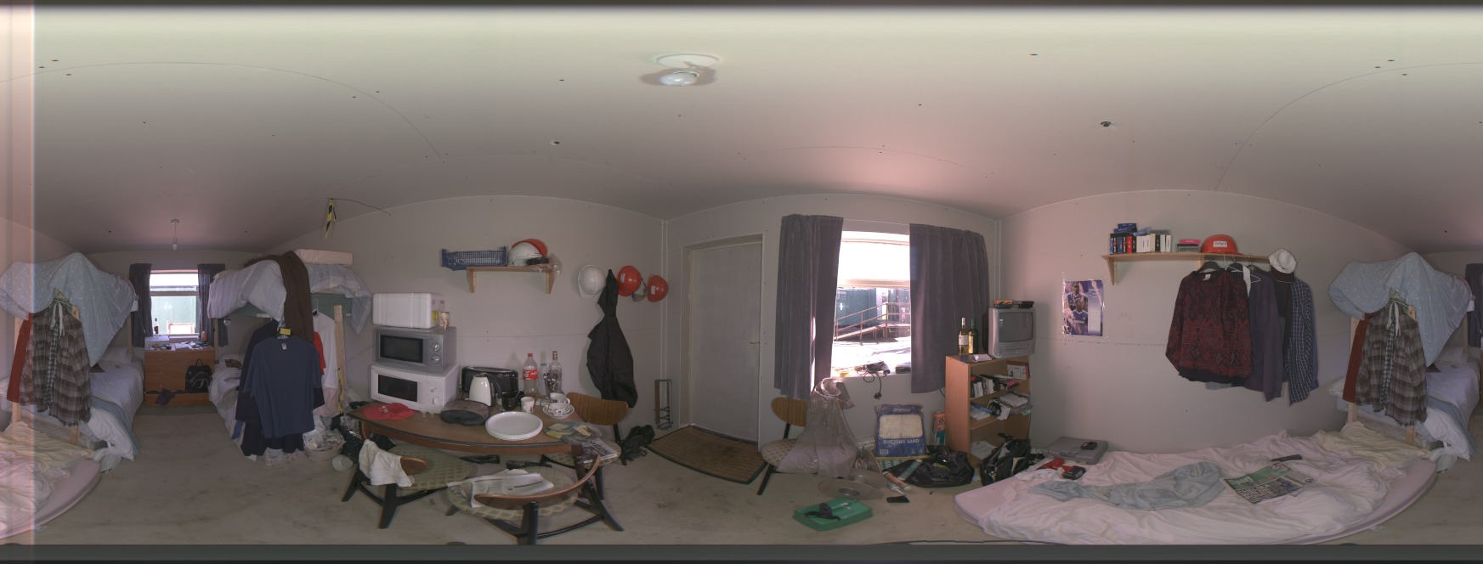
Spherical or 360º photography is a photographic technique that combines a series of photographs taken from a single position around a central point (Tung et al, 2015) and creates a highly detailed visual representation of a scene. The stitching of these photographs together using various software applications creates a panorama presenting a 180º by 360º field of view of an entire scene, floor to ceiling (National Institute of Justice Technology Center of Excellence, 2013; Marsh, 2014). Traditional methods involve taking a series of photographs at overlapping intervals and stitching the resultant images together, however technology development has created automated systems which eliminate the need for stitching and produce a spherical panorama in one photograph.
Figure 1: 360º panoramic photograph captured using the Spheron VR SceneCam. JPEG Equirectangular projection.
Figure 1 shows an Equirectangular projection of a scene captured using the Spheron VR SceneCam. This is 3D data which has been flattened onto a 2D plane and as a result presents distortion. Using the SceneCenter complementary software application, a user is able to stand in the centre of the scene and navigate through the environment left, right up and down and can interact with the scene, taking measurements and zooming.

3-D Laser scanning

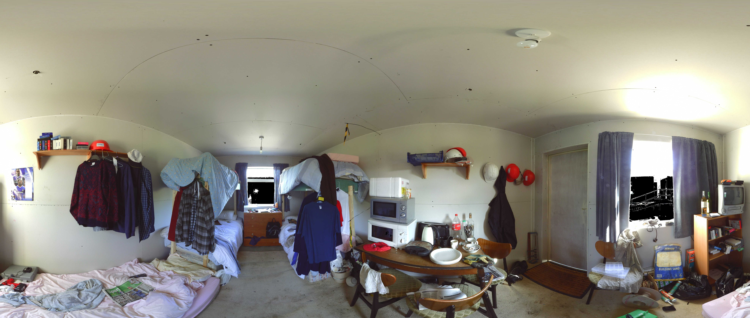
Laser scanners, particularly time of flight scanners, operate using the principle of the speed of light and as a result, distances of objects can be calculated easily using the laser. The laser is emitted within an environment and once this reaches an object, it reflects back to a sensor within the laser-scanning device. Using the time it took for the laser to be emitted, reflect off the object and back to the sensor, the distance of that object can be calculated (Sansoni et al, 2009). As a result, laser-scanning techniques can quickly capture a scene producing highly detailed point cloud data along with millions of measurements. Laser scanning enables 3D documentation of a scene and the data captured can be used to create digital reconstructions and simulations of events that may have occurred at a scene (Buck et al, 2013). This technology has been adopted for more complex crime scenes, such as Road Traffic Collisions (RTCs) where significant numbers of measurements need to be recorded, due to its speed in comparison with manual recording of measurements, which can be slow (Komar et al, 2012).
Figure 2: 3D Laser Scan data with colour captured using the FARO Focus X 330 Laser Scanner.

Figure 2 also shows an Equirectangular projection of the scene but using the FARO X 330 Laser scanner. The image shows distortion as it is presenting 3D data on a 2D plane and utilising the complementary software removes the distortion and allows the user to navigate through the 3D environment taking measurements and zooming.

3. Methodology

This paper identified a few specific criteria that should be considered by Forensic Investigators seeking to purchase crime scene documentation technology. These criteria consisted of lens type, image resolution, field of view, minimum capture time, storage format, storage device, whether the camera utilises High Dynamic Range (HDR), battery life, cost, whether additional lighting is available and whether measurements can be taken. To gather information about what forensic personnel consider when adopting a new piece of technology, discussions were conducted with Forensic Investigators from Police Services in the United Kingdom. To obtain information and specifications about the technology described in this paper, manufacturers of the technology were contacted, and where this was not possible, literature searching was conducted to obtain details from manufacturer websites.

The technology discussed in this paper is not an exhaustive list and does not imply that these are the only crime scene documentation technologies available to forensic investigators. The technologies which have been chosen for inclusion in this investigation represent a range of documentation technology which is available to police forces, nor are they the only technology which each company provide. These technologies represent a spectrum of some of the crime scene documentation technology available.

4. Results and Discussion

Police forces have to consider many factors when considering the adoption and integration of technology into their current practices. Some of the main considerations are how much the equipment costs, how often it will be utilised for cases and whether it will provide any probative value to the organisation and the crime scene investigations conducted (Koper et al. 2009).

The very nature of the crime scene documentation process requires that any new element within that process needs to be implemented in a risk free manner without complications (Association of Chief Police Officers. 2012). As a result, agencies need to invest a considerable amount of time evaluating the technologies to determine which is most appropriate to suit their needs – time which they currently don’t have.

Table 1: Crime Scene Documentation Technology Specifications
Photographic Technology
Technology | Lens Type |  | Image Resolution |  | Field of View Vertical x Horizontal |  | Minimum Capture Time/ seconds |  | Storage Format | Storage Device |  | HDR/ f stops | Battery Life/ hours/ shots per charge |  | Cost* |  | Additional Lighting |  | Measurements
iStar Fusion | Fisheye  f 2.6  (x4) |  | 50MP  (10000 x 5000px) |  | 180º x 360º |  | 5 |  | .nctri | SD Card or USB 2.0 transfer |  | HDR 3 | 5-6 |  | £4,750 |  | LED panels |  | Not currently – software in development
Panoscan MK-3 | Mamiya 645 format. Fisheye |  | (9000 x 18000) |  | 180º x 360º |  | 7 |  | TIFF and Adobe PNG | Hard Drive  USB 2.0 |  | HDR 12 | 6 |  | ~ £41,500 with software |  | Optional Lighting Unit |  | Yes using photogrammetry
SceneVision Panorama | Nikon Coolpix P300 (Or comparable) |  | 16MP |  | Panorama Mode  180º x 360º |  | Less than 240 |  | JPEG | SD Memory Card |  | ---- | 240 shots |  | ~£1616 US equivalent** |  | Flash on Camera |  | Yes using photogrammetry
Spheron SceneCam | Fisheye f 2.8 |  | 50 MP |  | 180º x 360º |  | 7 |  | .sph | USB 2.0 |  | HDR 26 | 8 |  | ~£60,000 |  | Quad column white LED array |  | Yes using photogrammetry
CSI:360 | Sigma 8mm f/ 3.5  Fisheye  Nikon D7200 |  | 16MP |  | 180^{o x} |  | 4 shots at 90º intervals |  | NEF (RAW) or JPEG | USB hiSpeed Card reader  SD Card |  | ---- | 850 shots |  | £3906.00  US equivalent |  | Speed Light kit included |  | Not currently
Laser Scanning Technology
 |  | Range |  | Distance Accuracy |  | Field of View  Vertical x Horizontal |  | Measurement Speed/ points per second |  |  | Storage Device |  |  | Battery Life /hours |  | Cost |  | Additional Lighting | Measurements
FARO Focus X 330 |  | 0.6m up to 330m |  | +/- 2mm |  | 180 x 360 |  | Up to 976,000 |  |  | SD Card |  |  | 4.5 |  | ~£45,000 |  | Not needed | Yes
Leica Scanstation C10 |  | Up to 300m |  | +/- 2mm |  | 180 x 360 |  | Up to 50,000 |  |  | SSD or USB Transfer |  |  | 3.5 (internal)  6 (external) |  | ~£97,000 |  | Not needed | Yes
*Costs are approximate **Higher Price outside the US

Advancements in technology have enabled some scene of crime officers to go paperless, through utilisation of modern technology. Table 1 details a range of different systems for capturing a crime scene which are available to police forces, ranging from low cost manually operated systems to higher cost high end automated systems. All of these technologies aim to create the same output; a panoramic representation of an environment, whether through photographic or laser scanning methods. Both panoramic imaging and 3D laser scanning techniques produce a permanent visual record of a scene in its untouched and original state (Strandberg, 2015).

At the lower costing end of the technology spectrum, photographic systems such as CSI:360^{[1]} and SceneVision^{[2]} Panorama utilise standard Digital Single Lens Reflex (DSLR) cameras as the environment capture method. This is not dissimilar from how crime scenes are currently capture, however, the companies have created their own rotating stage for the camera to attach which allows the camera to remain in one position but turn on a central axis. Additional components can be added to these systems as a range of packages sold by the manufacturers; the lense types can be changed on the camera system and additional lighting packages are available to account for low lighting scenes.

Photographs captured with these systems require the use of stitching software to allow multiple digital images to be collated to create a panorama. Each manufacturer provides its own software application to allow users to import their photographs and stitch them to create a panorama of a scene. These applications reduce the requirement to have extensive knowledge and experience of software stitching applications, previously needed with other applications.

At the opposite end of the spectrum are the more automated and higher cost photographic systems such as the Panoscan Mk-3^{[3]}, iStar Fusion produced by NCTech^{[4]}, and the SceneCam produced by Spheron VR Ltd^{[5]}. These systems have been created to eliminate the requirement for manually stitching photographs and the complementary software applications automatically process the images to create spherical panoramas. Both of these systems have been designed so that anybody can operate them, and no previous photographic experience or knowledge is needed, as capturing an environment is a simple button press operation. The Spheron SceneCam has the ability to take measurements of a scene, using photogrammetry, which is the process of taking measurements from a photograph, using triangulation methods. The iStar system currently cannot take measurements, but a software application is being developed so that measurements may also be taken (iStar, 2015). Photogrammetry as a technique itself is not as accurate as laser scanning systems (Chavalas, 2015).

All of the photographic systems discussed create an end product of full spherical immersive images and produce virtual tours, whereby individual panoramas can be ‘linked’ so users are able to ‘walk through’ the scene viewing it from each camera position.

Laser scanning systems such as the Leica^{[6]} ScanStation C10 and FARO^{[7]} Focus X 330 can capture a 360º x 180º view of a scene in the same way that the photographic systems do. Due to the fact that these systems use a laser, the ranges of these systems are far greater than that of the photographic systems, which are limited by their resolution, and the number of pixels used to create a panorama (Chavalas, 2015).

Advantages

Traditional methods of investigating crime scenes involve capturing a scene and those items within that scene which the investigator deems relevant at the time of the investigation. Panoramic photography and 3D laser scanning methods can eliminate this ‘what is relevant at the time’ issue as the whole environment is captured in a single scan. This technology has been developed to make criminal investigations more efficient and they can speed up the crime scene documentation process significantly (Crambitt and Grissim, 2010). In addition, each of them has the ability to transmit the data on a real time basis, so personnel not at the scene can quickly view the scene as it is captured.

Laser scanning and panoramic photography methods are often considered to be two completely separate entities and they are in respect of their methods for capturing an environment. However, one of the major advantages of both the panoramic imaging technology and the 3D laser scanning technology is that they are complimentary to one another and can be used together to create highly accurate and highly detailed crime scene reconstructions (Strandberg, 2015). The Leica Scanstation C10 and FARO X 330 laser scanners can be used to create point cloud data of a scene but can also utilise other photographic systems to provide colour to the data. Utilising the highly accurate point cloud data from the laser scanner and the highly detailed colour panoramas from the photographic equipment, a highly accurate and very detailed visual representation of a scene could be created.

Limitations

As with any new technology integration, there are limitations that have to be considered before adoption. Due to the costs of some pieces of equipment a decision to implement technology must be based upon criteria demonstrating effectiveness and value for money. Forces must assess whether the technology will be cost effective and how frequently it will be utilised to justify its purchase. In addition forces need to consider whether it will be compatible with already enforced operational systems or whether this new piece of technology will become an add on to existing systems.

Due to the lack of technology integration into the Courtrooms, these systems could not yet fully replace traditional digital photography, as these images are still required in most courtrooms. However, with the Digital Reform stating that all courtrooms will be paperless by 2016 and the digital by default plan (Ministry of Justice, 2014), traditional digital cameras may no longer be needed and may be superseded by these more advanced systems.

Police forces do not have the time or financial resources to conduct research investigating which technology is available to them that may aid in the investigation process and police are therefore not able to maximise the opportunities that technology could provide them (Association of Chief Police Officers, 2012). To aid forensic investigators in making these decisions about which particular type of technology to adopt, based upon the needs of that department, which will differ for the 43 existing services across the country, a comprehensive comparison study of different crime scene documentation technologies available should be conducted.

To date only one evaluation study has been conducted looking at three panoramic imaging technologies; SceneVision Panorama, Panoscan MK-3 and the Leica Scanstation C10. This investigation was conducted by the National Institute of Justice (NIJ) in America and focused upon hardware, cost, training, set up and calibration, data capture, image capture, software requirements and processing, and presentation preparation, as the categories with which each technology was evaluated (National Institute of Justice Technology Center of Excellence. 2013).

To build on the study conducted by the National Institute of Justice research is currently being conducted at Staffordshire University comparing and contrasting crime scene documentation and visualisation technologies, based upon criteria determined through discussions with Forensic Investigation Managers. Manufacturer specifications provide services with an overview of a piece of technology, but Police Services need to consider much more than those alone when adopting new technology and must consider how the technology will be used operationally in the field.

The technologies will be critically analysed to determine how accurate and precise the measurements taken with each system can be and what parameters can affect these measurements. The accuracy and precision of the measurements will be further evaluated in complex environments such as fire scenes to determine whether the measurements accurately represent the scene. The research aims to determine any photogrammetry and measurement issues which arise in different scenes and to suggest any potential solutions to these identified issues.

5. Conclusions

The adoption of technology, and in particular deliberation over which piece of technology, needs to be considered and assessment made as to whether it will facilitate Police services requirements and produce minimised risk to current procedures, operations and outcomes. The adoption of these technologies can be affected by many factors, ultimately the cost of the equipment and how they will be used operationally within a service. Future advancements in the portability, cost, speed of capture and the accuracy of these systems will facilitate the increase in adoption. These methods for documenting crime scenes will not replace current digital imaging processes at crime scenes, such as close up photographs of evidence, but these newer systems will be a welcome addition to more complex crime scenes.
Acknowledgements
Thank you to the personnel at Gardiners Fire Training Ltd who allowed us access to their fire investigation scenes and the data collected and shown in this paper would not have been possible without them.

References

- Association of Chief Police Officers (2012) Harnessing Science and Innovation for Forensic Investigation in Policing - Live-Time Forensics.
- Baber, C. Smith, P. Panesar, S. Yang, F. Cross, J. (2006) Supporting crime scene investigation. In Bryan-Kinnis, N. Blanford, A. Curzon, P. Nigay, L. People and Computers. London. Springer Verlag. 103-116.
- Buck, U. Naether, S. Rass, B. Jackowski, C. Thali, MJ. (2013). Accident or Homicide – Virtual Crime Scene Reconstruction using 3D methods. Forensic Science International. 225. 75-84.
- Carrier. B and Spafford. EH. (2003) Getting Physical with the Digital Investigation Process. International Journal of Digital Evidence. 2 (2)
- Cavagnini, G. Sansoni, G. Trebeschi, M. (2009) Using 3D range cameras for crime scene documentation and legal medicine. Proc. SPUE 7239, Three-Dimensional Imaging Metrology.
- Chan, A. (2005) The Use of Low Cost Virtual Reality and Digital Technology to Aid Forensic Scene Interpretation and Recording. Cranfield University PhD Thesis.
- Chan, J BL. (2001) The Technological Game: How Information Technology is Transforming Police Practice. Criminology and Criminal Justice.
- Chavalas, T. (2015) In: Strandberg, KW. (2015) A new way to capture crime scenes. How 3D scanners, laser scanners and advanced cameras are revolutionising investigation, as we know it. Law Enforcement Technology.
- Crambitt, B and Grissim, T. (2010) 3D Scanning: Visualising Scenes in another Dimension. Evidence Technology Magazine. 8. (5).
- Dang, TK. Worring, M. Bui, TD. (2011). A semi-interactive panorama based 3D reconstruction framework or indoor scenes. Computer Vision and Image Understanding. 115. 1516-1524.
- Fowle, K and Schofield, D. (2013) Technology Corner: Visualising forensic data: Evidence (Part 1). Journal of Digital Forensics, Security and Law. 8 (1).
- Galvin, B. (2009). Getting the Big Picture. Law Enforcement Technology. 36 (10). 68-75.
- Gardner, RM. (2008) Practical Crime Scene Processing and Investigation. Second Edition. Practical Aspects of Criminal and Forensic Investigation Series. CRC Press Taylor and Francis Group.
- Howard, TLJ. Murta, AD. Gibson, S. (2000) Virtual Environments for Scene of crime Reconstruction and Analysis. Electronic Imaging. International Society for Optics and Photonics.
- Komar. DA, Davy-Low. S, Decker. SJ. (2012) The Use of a 3-D Laser Scanner to Document Ephemeral Evidence at Crime Scene and Post-mortem Examinations. Journal of Forensic Sciences. 57. (1). 188-191
- Koper, CS. Taylor, BG. Kubu, BE. (2009) Law Enforcement Technology Needs Assessment: Future Technologies to Address the Operational Needs of Law Enforcement. Police Executive Research Forum. Lockheed Martin.
- Marsh, N. (2014) Forensic Photography: A Practitioners Guide. Chapter 10: Panoramic (Immersive or 360º) and Elevated imaging.
- Milliet, Q. Delemont, O. Margot, P. (2014) A forensic perspective on the role of images in crime scene investigation and reconstruction. Science and Justice. 54. 470-480.
- Ministry of Justice (2014) Transforming the Criminal Justice System. Strategy and Action Plan – Implementation Update.
- National Institute of Justice Technology Center of Excellence. (2013). Technical Advances in the Visual Documentation of Crime Scenes: An Overview.
- Robinson, EM. (2010) Crime Scene Photography. Second Edition. Elsevier Inc.
- Sansoni, G. Trebeschi, M. Docchio, F. (2009) State-of-The-Art and Applications of 3D imaging Sensors in Industry, Cultural Heritage, Medicine, and Criminal Investigation. Sensors. 9 (1). 568-601
- Schofield. D (2009) Animating Evidence: Computer Technology in the Courtroom. Journal of Information Law and Technology.
- Strandberg, KW. (2015) A new way to capture crime scenes. How 3D scanners, laser scanners and advanced cameras are revolutionising investigation, as we know it. Law Enforcement Technology.
- Tung, ND. Barr, J. Sheppard, DJ. Elliot, DA. Tottey, LS. Walsh, K AJ. (2015) Spherical Photography and Virtual Tours for Presenting Crime Scene and Forensic Evidence in New Zealand Courtrooms. Journal of Forensic Sciences. 60. (3). 753-758
- Whitney, JM. Greenberg, MS. (2001) Chapter 10: Why Use Visuals. Found in: Sullivan, PJ. Agardy, FJ. Traub, RK. (2001) Practical Environmental Forensics. Process and Case Histories. John Wiley and Sons.

[1] CSI: 360 (VPix) - www.csi360.net/360-crime-scene-cameras.php
[2] SceneVision Panorama (3rd Tech) - www.3rdtech.com/SceneVision_Panorama.htm
[3] Panoscan MK-3 - www.panoscan.com/
[4] NCTech - www.nctechimaging.com/istar/
[5] Spheron – www.spheron.com/home.html
[6] Leica - www.leica-geosystems.co.uk/en/index.htm
[7] FARO – www.faro.com/home

