A Knowledge Based Decision Making Tool to Support Cloud Migration Decision Making
Abdullah Alhammadi, Clare Stanier, Alan Eardley
Faculty of Computin,Eengineering andSsciences, Staffordshire University, Beaconside, Stafford, Staffordshire, United Kingdom ST18 0AD
^{a.alhammadi@staffs.ac.uk} ^{c.stanier@staffs.ac.uk} ^{w.a.eardley@staffs.ac.uk}

Abstract
Cloud computing represents a paradigm shift in the way that IT services are delivered within enterprises. Cloud computing promises to reduce the cost of computing services, provide on-demand computing resources and a pay per use model. However, there are numerous challenges for enterprises planning to migrate to a cloud computing environment as cloud computing impacts multiple aspects of enterprises and the implications of migration to the cloud vary between enterprises. This paper discusses the development of an holistic model to support strategic decision making for cloud computing migration. The proposed model uses a hybrid approach to support decision making, combining the analytical hierarchical approach (AHP) with Case Based Reasoning (CBR) to provide a knowledge based decision support model and takes into account five factors identified from the secondary research as covering all aspects of cloud migration decision making. The paper discusses the different phases of the model and describes the next stage of the research which will include the development of a prototype tool and use of the tool to evaluate the model in a real life context.

Keywords: Cloud computing, Cloud computing migration, Analytical hierarchical approach (AHP), Case based reasoning (CBR).
1 INTRODUCTION
Business are currently coming to terms with the paradigm shift in computing resources known as cloud computing, which has been classified by Gartner as one of the most important 10 technologies (Hashizume et al. 2013). Cloud computing has a number of definitions, depending on perspective. A widely used definition is that developed by NIST (National Institute of Standards and Technology) which defines cloud computing as “a model for enabling convenient, on-demand network access to a shared pool of configurable computing resources … that can be rapidly provisioned and released with minimal management effort or service provider interaction” (NIST, 2011). This definition focuses on the technical characteristics of cloud computing rather than the business perspective. Cloud computing has also been defined as the provision of virtual computing resources that provide an on-demand service, dynamically scalable, shared services, which require minimal management effort using the Opex paying model (Marston et al. 2011). This second definition extends the NIST understanding to include business aspects and is the sense in which cloud computing is understood in this paper.

Cloud computing is usually understood to include three different service models, Software as a service (SaaS), Platform as a service (PaaS), and Infrastructure as a service (IaaS). There are two major types of deployment model which are private cloud and public cloud, and these are extended to include hybrid and community clouds (Mell & Grance 2011). Adopting cloud computing changes not only technology but also the way in which enterprises manage their business (Gonzenbach et al. 2014). Migrating enterprise resources to a cloud solution involves decision making at strategic, tactical and operational levels and potentially impacts all aspects of the organisation.
2 cloud mIGRATION Issues
Migrating services and systems to the cloud has business as well as technological implications (Gonzenbach et al. 2014;). One of the factors restricting the growth of cloud computing is the issues involved in migrating existing systems to the cloud model. Research on migration to cloud provision has tended to be based in four main areas; the decision making stage including analysis of benefits and risks, identification of factors which affect cloud migration processes, solutions for specific cloud infrastructure and/or applications and case study based evaluation of the migration process.

Cost and benefits and risk analysis of cloud migration for a single service model were discussed by (Khajeh-Hosseini et al. 2011; Martens & Teuteberg 2011; Yam et al. 2011; Johnson & Qu 2012; Khajeh-Hosseini et al. 2012; Azeemi et al. 2013; Armenise et al. 2014).These studies focused only on cost and risk analysis, and did not discuss how deployment and service models should be selected and how to do the actual migration. In addition to models which focus on the business issues, there are approaches which consider migration from an application perspective. The literature shows that several studies propose a migration framework (Wang et al. 2013; Alonso et al. 2013; Menzel & Ranjan 2012; Tran et al. 2011; Meng et al. 2011; Binz et al. 2011). The key problem with these studies is that they focus only on migrating applications without taking into account other issues.

Cloud migration has also been studied from the perspective of deployment models and cloud service providers (CSPs) selection. Nussbaumer & Liu (2013) proposed a cloud migration framework to analyse the business requirements and select cloud service providers. Similarly, Kaisler et al. (2012) developed a framework to support cloud migration decision making which matched cloud solutions to business requirements.

There has been limited evaluation of cloud migration to date. Some empirical studies have been carried out to identify cloud adoption factors (Lian et al. 2014; Chang et al. 2013; Alshamaila et al. 2013; Carcary et al. 2013; Khajeh-Hosseini et al. 2010) but there is a lack of studies relating to cloud migration in developing economies. There have been a number of industry and vendor studies. However, these studies tend to be vendor specific, as with the Amazon migration strategy which is built around the Amazon Web Services (AWS) platform (Varia 2010) or consider only a subset of issues (Parakala & Udhas 2011) and again are focused on developed economies.

The studies presented so far have several limitations; firstly, most of the models and frameworks discussed focus on only one or two aspects of cloud migration. Secondly, some of these models and frameworks provide an approach for migrating applications to the cloud and they focus on technical aspects only without considering organisational, security and economic factors. Thirdly, numerous studies have been undertaken to identify the factors that determine cloud computing adoption but these studies do not provide implementation guidance for decision makers. The literature review has identified the need for an holistic approach to migrating IT systems to cloud computing. The variety of cloud migration frameworks and models at different decision making levels emphasise the need for an integrated, strategic approach, to manage the cloud migration process from the different standpoints of all decision making levels. The contribution of this research is an holistic model for decision making in cloud migration which can be applied both for developing and developed economies.
3 Decision making approach
Organisations are affected by internal and external factors as well as tangible and intangible factors. The literature shows that there is little research that provides an implementation guidance for supporting decision making during cloud computing adoption(Gonzenbach et al. 2014; Azeemi et al. 2013; Alshamaila et al. 2013).

Multi-criteria decision making (MCDM) is defined as “the evaluation of the alternatives for the purpose of selection or ranking” (Özcan et al. 2011). The decision making literature provides different methods and approaches to support MCDM decision making in different fields including planning, outsourcing, purchasing and investment (Özcan et al. 2011)). These approaches include the analytic hierarchy process (AHP) and the technique for order of preference similarity to ideal solution (TOPSIS),which are both are widely used in decision making especially in outsourcing which is a related field to cloud migration (Perçin 2009). AHP has been used in IS outsourcing (Akomode et al. 1998; Yang & Huang 2000; Yang et al. 2007; Bruno et al. 2012). Menzel & Ranjan (2012) used an AHP approach to selecting service providers in a cloud computing environment although this study was limited to the consideration of technical aspects. Kahraman et al. (2009) used TOPSIS to evaluate service providers, Perçin (2009) used a hybrid approach by combining the AHP and TOPSIS to evaluate the third party logistic providers.
3.1 The Analytic Hierarchy Process (AHP)
AHP is a multiple criteria decision making tool developed by Saaty in 1980 which decomposes a problem into subproblems and then aggregates the subproblems to obtain the optimum solution (Saaty 1994; Yang & Huang 2000; Bernasconi et al. 2010). Saaty (2008) defines AHP as “a theory of measurement through pairwise comparisons, which relies on the judgments of experts to derive priority scales” (2008, p. 83). Saaty’s definition emphasizes the experience of decision makers as the main driver in judgement making. One of the benefits of AHP is that it provides an MCDM method “for measuring either subjective or objective components without compromising any of these perspectives” (Akomode et al. 1998, p. 116). AHP can be defined as a multicriteria decision making method, to measure subjective and objective attributes based on the expertise of decision makers.

The AHP method is based on three fundamental pillars, the hierarchical structure of the model, pairwise comparison of criteria and alternatives, and finally synthesis of the priorities (Dağdeviren et al. 2009). In the structure of the model, problem solving goal come in the top of the hierarchy. The criteria come in the second level of hierarchy, and each one of the criteria may have subcriteria. Alternatives or solutions come at the lowest level of the hierarchy (Saaty 1994).
3.2 Cased Based Reasoning (CBR)
AHP is based on the knowledge and expertise available to the decision makers and the decision makers’ understanding of the problem (Levary 2008). The information available to the decision makers is critical to the success of the approach. This investigation therefore uses CBR to improve the information available to decision makers by retrieving similar cases to support the evaluation of the problem. CBR is a knowledge based problem-solving approach that relies on past, similar cases to find solutions to problems (Allen 1994), to modify and critique existing solutions and explain anomalous situations (McIvor & Humphreys 2000a). The CBR approach is widely used in a number of different disciplines (Hsu et al. 2004; Maurer et al. 2010). Hsu et al. (2004) described CBR as having 5 phases as follows: presentation, retrieval, adaptation, validation and update. As problems and solutions differ, CBR adapts, but also criticizes and modifies similar cases (McIvor & Humphreys 2000b). Işıklar et al., (2007) claim that using CBR can reduce the likelihood of repeating mistakes and encourages learning over time.
4 Development of the Cloud Migration Decision Model
This section presents a cloud migration decision model which integrates an AHP approach with CBR. The AHP approach supports decision makers in weighting criteria to allow the evaluation of options and selection of the best IT services delivery model. However, one criticism made of AHP is that the approach relies on users being able to make judgments based on expertise and available knowledge to deal with uncertainty (Dağdeviren et al. 2009). For this reason, as discussed in section 3.2, this study strengthens the AHP approach with CBR, using previous cases to help decision makers weight criteria and validate their results. An additional reason for using CBR, is that the CBR approach is able to handle incomplete and imprecise data (Işıklar et al. 2007) and this is relevant in the context of cloud migration decision making.

The Cloud Migration Decision Model was developed in three phases: the first phase consists of the CBR element, the second phase consists of the AHP element and the third phase integrates the CBR element with the AHP element to support decision making for cloud migration.
Phase one: Case Based Reasoning
This phase developed the case base to store previous cases. Each case is indexed with five attributes and each one of these attributes has a pre-defined value. The attributes used are firm size, sector type, firm status and IT maturity rate and level of technological diffusion. The attributes chosen were identified from the literature and validated during fieldwork which confirmed these factors as relevant to cloud migration decision making.
- Enterprise size: enterprise size has been identified to be one of the determinants of cloud computing adoption (Avram 2014; Alshamaila et al. 2013).
- Industry sector: cloud adoption rates have been shown to vary between sectors (Low et al. 2011)
- Enterprise status: the literature shows that startup enterprises find it easier to adopt cloud computing than established enterprises (Gupta et al. 2013; Alshamaila et al. 2013)
- IT maturity level: IT enterprise maturity rate has been shown to affect the adoption of a cloud computing environment (Khajeh-Hosseini et al. 2012).
- Technology Diffusion : technology diffusion in general and specifically for cloud computing varies between developing and developed countries (Avram 2014; Molla & Licker 2005) and this influences cloud migration issues

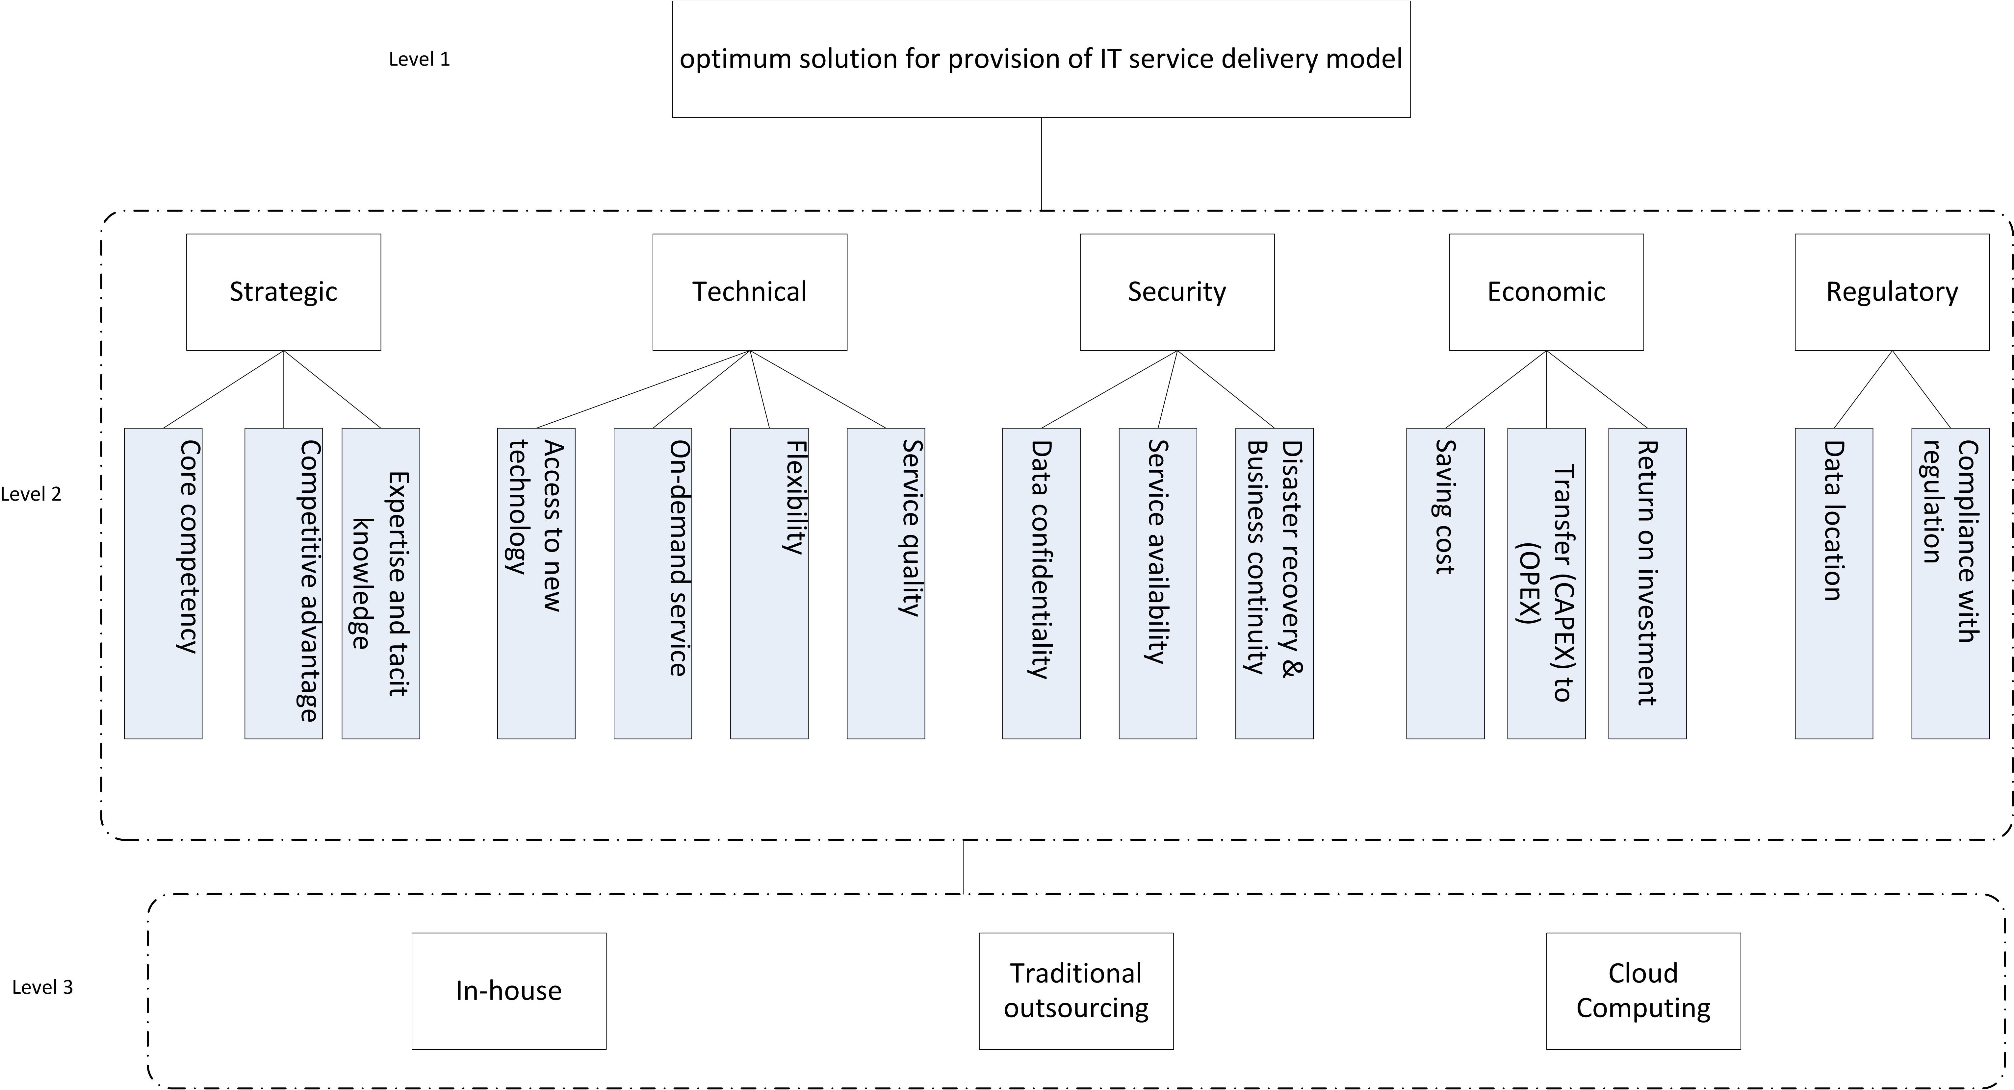
Figure 1: Cloud Migration Decision Model

Phase 2: AHP Model
This phase develops the AHP model, which uses pairwise comparison to weight the criteria, sup-criteria and alternatives. The model is shown in figure 1. Level 1 presents the problem solving goal; Level 2 presents the criteria and Level 3 presents the alternatives for the problem solution which for this scenario have been identified as providing an in house service, adopting a traditional outsourcing solution or migrating to a cloud computing solution. The criteria in the second level of the AHP model are based on five factors derived from the literature and validated by fieldwork in Saudi Arabia. The factors are: strategic, technical, security, economic and regulatory. Each criteria has a set of subcriteria, which provide more detailed factors for decision making.

Phase 3: Integration
This phase combines the CBR element with the AHP element. Using the AHP model described in Phase 2, pairwise comparisons are performed for sub-criteria with respect to the main criteria (parent in hierarchy), while pairwise comparisons are performed for criteria with respect of the goal. In the case of alternatives, there are two ways to rank the alternatives, which are absolute measurement and relative measurement. Relative measurement performs the pairwise comparisons between the alternatives with respect to each criterion. While in absolute measurement the alternative ranked with standard scale (Saaty 1994).

The first step in the model is comparing the new case with stored cases and finding similar cases as shown in figure 2. When the similar case is found, the AHP will be run to weight the criteria. Then, the AHP result will be compared with result of similar case, and if the decision makers are satisfied with result the new case will be added to the case base, otherwise the AHP process repeats. If the new case is not similar to the stored cases, the decision maker will run the AHP approach and add the case as a new case to case base. The process is illustrated in figure 2.

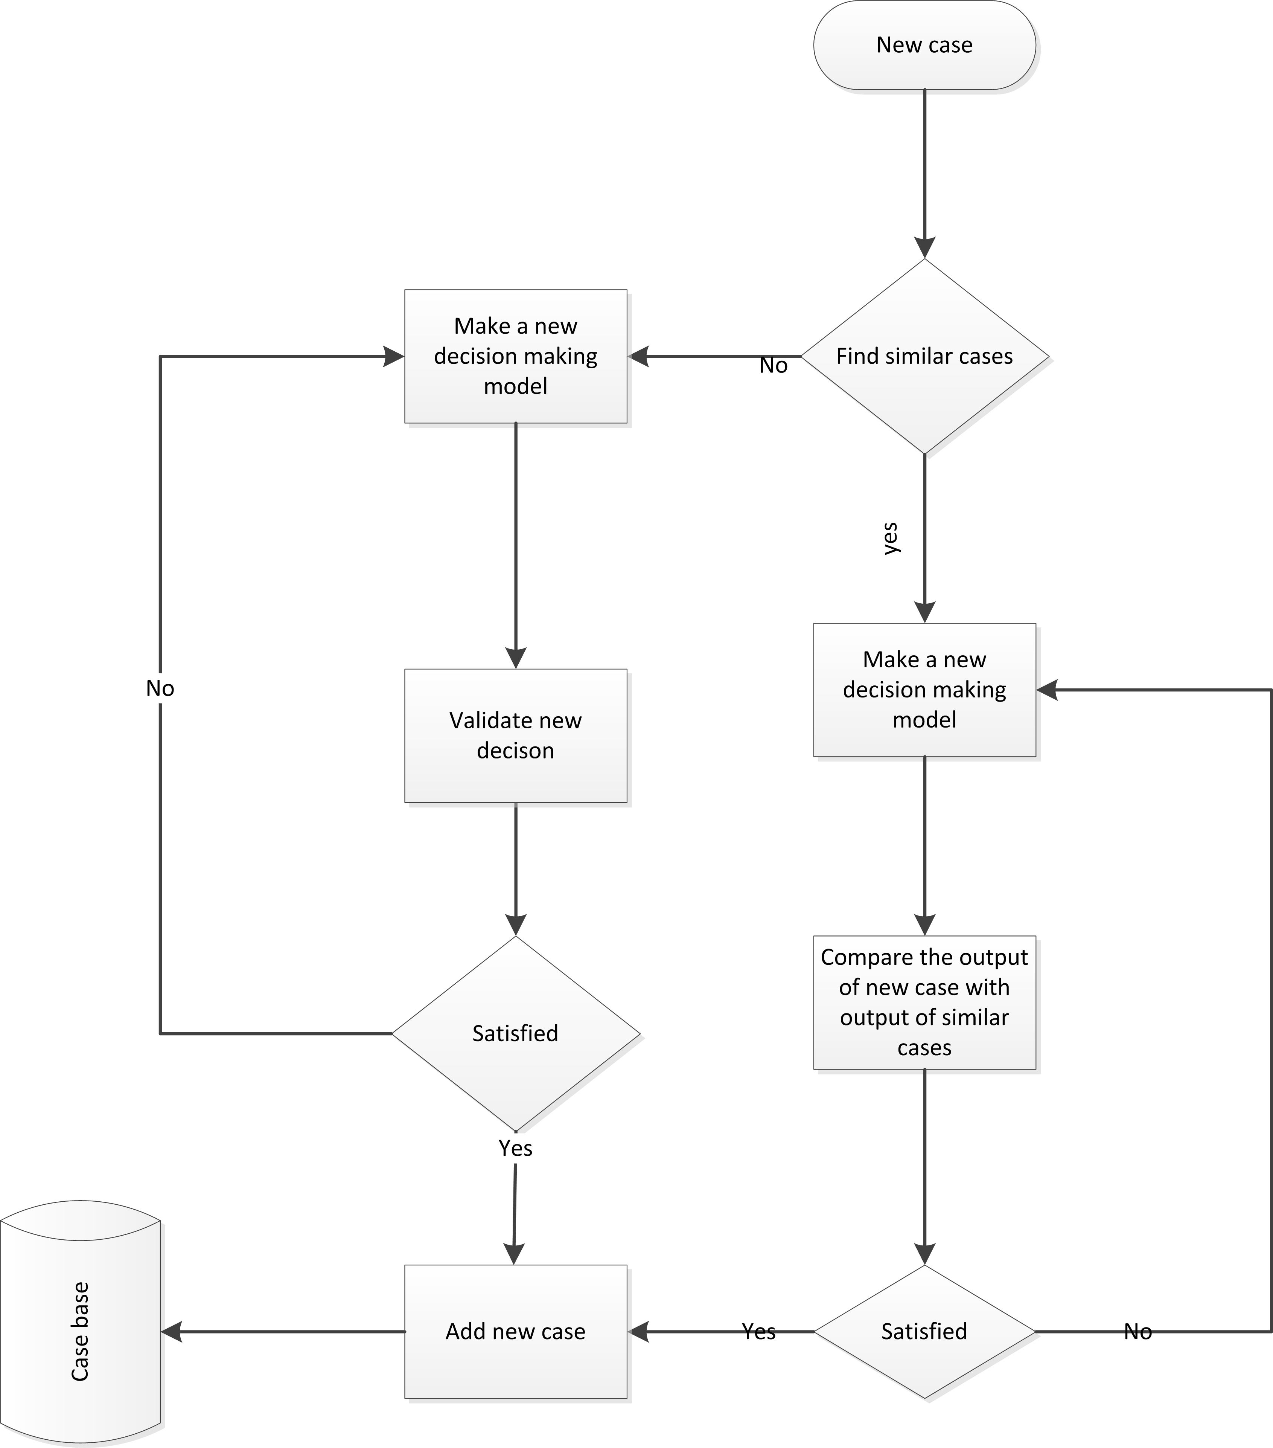
Figure 2: Flow chart of the process of cloud migration decision model
5 Discussion of the Model

Combining the AHP approach with CBR provides users with a knowledge base to support decision making. The decision as to whether to migrate to the cloud is a strategic decision which may not occur more than once in an enterprise’s life cycle. This means that users may lack the necessary underpinning knowledge to develop appropriate weightings and as discussed in section 3.2, this is one of the limitations of the AHP approach. Using CBR to provide a knowledge base gives users access to information about decisions taken in similar and different contexts and allows users access to a wider range of experiences.

The CMDM model was evaluated with expert users from a cloud services provider in Saudi Arabia to check the relevance of the model for use in an industry setting. The validation process consisted of three phases; model concept, factors validation and CBR attributes validation. The model concept phase examined whether the AHP criteria identified were comprehensive and supported structured examination of the problem, enhanced communication and reduced decision making times. The factors validation phase reviewed the subcriteria and the attributes identified for the CBR element of the model. The final phase of the validation of the prototype model involved open questions and an overview of the model approach. The validation process provided support for the model concept and allowed some elements of the model, such as the description of the subcriteria, to be fine tuned based on the feedback from the validation process. The validation process also identified the need for a user friendly tool to implement the model and allow it to be used by service users who may lack the expert knowledge of service provider.
6 Proposed development of CMDM Tool

The next stage of the research is the development of a prototype case tool to implement the CMDM. The model is primarily intended for service users rather than service providers but as noted in section 5, service users may lack the expertise to apply the model in the absence of a tool. Using the tool in a real life context with service providers and service users will also allow further validation of the CMDM. One of the issues identified in section 2 with respect to cloud migration is that there are a limited number of migration case studies and that most research around cloud migration has been carried out in developing economies. In order to provide a tool which will support an holistic approach to cloud migration and where the cases will be relevant to both developed and developing economies, the CBR element of the tool will include cases identified from the literature and cases developed from the field work carried out as part of this research in Saudi Arabia which is classified as a developing economy for the purposes of cloud migration.
7 Conclusion and Future Work
Cloud migration decision making has been investigated in a number of studies, however, these studies tend to focus on different aspects of the migration process such as cost and security aspect and none of the studies reviewed considered all elements of the decision making process for cloud computing. There are very few studies of the cloud migration process in developing economies. This paper presents an holistic model to support cloud computing migration decision making. The model includes all the features which were identified from the literature and these features were validated in the field with expert users. The CMDM presented in this paper uses a hybrid approach, combining AHP and CBR to strength the support for decision making and addressing the limitations of a pure AHP approach. This is an on-going research project; the next stage of this research is to design a prototype tool to evaluate the model and test and validate the model in a real life context.
References
Akomode, O.J., Lees, B. & Irgens, C., 1998. Constructing customised models and providing information to support IT outsourcing decisions. Logistics Information Management, 11(2), pp.114–127.
Allen, B.P., 1994. Case-based reasoning: business applications. Communications of the ACM, 37(3), pp.40–42.
Alonso, J. et al., 2013. Cloud modernization assessment framework: Analyzing the impact of a potential migration to Cloud. In 2013 IEEE 7th International Symposium on the Maintenance and Evolution of Service-Oriented and Cloud-Based Systems. IEEE, pp. 64–73.
Alshamaila, Y., Papagiannidis, S. & Li, F., 2013. Cloud computing adoption by SMEs in the north east of England: A multi-perspective framework. Journal of Enterprise Information Management, 26(3), pp.250–275.
Armenise, R. et al., 2014. The design of a Decision Support Tool for Delivery and Deployment Models. In 2014 IEEE 3rd Symposium on Network Cloud Computing and Applications. pp. 91–94.
Avram, M.G., 2014. Advantages and Challenges of Adopting Cloud Computing from an Enterprise Perspective. Procedia Technology, 12, pp.529–534.
Azeemi, I.K., Lewis, M. & Tryfonas, T., 2013. Migrating To The Cloud: Lessons And Limitations Of “Traditional” IS Success Models. Procedia Computer Science, 16, pp.737–746.
Bernasconi, M., Choirat, C. & Seri, R., 2010. The Analytic Hierarchy Process and the Theory of Measurement. Management Science, 56(4), pp.699–711.
Binz, T., Leymann, F. & Schumm, D., 2011. CMotion: A framework for migration of applications into and between clouds. 2011 IEEE International Conference on Service-Oriented Computing and Applications (SOCA), pp.1–4.
Bruno, G. et al., 2012. AHP-based approaches for supplier evaluation: Problems and perspectives. Journal of Purchasing and Supply Management, 18(3), pp.159–172.
Carcary, M., Doherty, E. & Conway, G., 2013. The Adoption of Cloud Computing by Irish SMEs – an Exploratory Study. The Electronic Journal Information Systems Evaluation, 16(4), pp.258–269.
Chang, B.-Y. et al., 2013. The determinant of adoption in cloud computing in Vietnam. In 2013 International Conference on Computing, Management and Telecommunications (ComManTel). IEEE, pp. 407–409.
Dağdeviren, M., Yavuz, S. & Kılınç, N., 2009. Weapon selection using the AHP and TOPSIS methods under fuzzy environment. Expert Systems with Applications, 36(4), pp.8143–8151.
Gonzenbach, I., Russ, C. & Brocke, J. vom, 2014. Make or Buy? Factors that Impact the Adoption of Cloud Computing on the Content Level. In J. vom Brocke & A. Simons, eds. Enterprise Content Management in Information Systems Research. Progress in IS. Berlin, Heidelberg: Springer Berlin Heidelberg, pp. 145–161.
Gupta, P., Seetharaman, a. & Raj, J.R., 2013. The usage and adoption of cloud computing by small and medium businesses. International Journal of Information Management, 33(5), pp.861–874.
Hashizume, K. et al., 2013. An analysis of security issues for cloud computing. Journal of Internet Services and Applications, 4(1), p.5.
Hsu, C.-I., Chiu, C. & Hsu, P.-L., 2004. Predicting information systems outsourcing success using a hierarchical design of case-based reasoning. Expert Systems with Applications, 26(3), pp.435–441.
Işıklar, G., Alptekin, E. & Büyüközkan, G., 2007. Application of a hybrid intelligent decision support model in logistics outsourcing. Computers & Operations Research, 34(12), pp.3701–3714.
Johnson, B. & Qu, Y., 2012. A Holistic Model for Making Cloud Migration Decision: A Consideration of Security, Architecture and Business Economics. In 2012 IEEE 10th International Symposium on Parallel and Distributed Processing with Applications. IEEE, pp. 435–441.
Kahraman, C. et al., 2009. Information systems outsourcing decisions using a group decision-making approach. Engineering Applications of …, 22, pp.832–841.
Kaisler, S., Money, W.H. & Cohen, S.J., 2012. A Decision Framework for Cloud Computing. In 2012 45th Hawaii International Conference on System Sciences. IEEE, pp. 1553–1562.
Khajeh-Hosseini, A. et al., 2011. Decision Support Tools for Cloud Migration in the Enterprise. In 2011 IEEE 4th International Conference on Cloud Computing. IEEE, pp. 541–548.
Khajeh-Hosseini, A. et al., 2012. The Cloud Adoption Toolkit: supporting cloud adoption decisions in the enterprise. Software: Practice and Experience, 42(4), pp.447–465.
Khajeh-Hosseini, A., Greenwood, D. & Sommerville, I., 2010. Cloud Migration: A Case Study of Migrating an Enterprise IT System to IaaS. 2010 IEEE 3rd International Conference on Cloud Computing, pp.450–457.
Levary, R.R., 2008. Using the analytic hierarchy process to rank foreign suppliers based on supply risks. Computers & Industrial Engineering, 55(2), pp.535–542.
Lian, J.-W., Yen, D.C. & Wang, Y.-T., 2014. An exploratory study to understand the critical factors affecting the decision to adopt cloud computing in Taiwan hospital. International Journal of Information Management, 34(1), pp.28–36.
Low, C., Chen, Y. & Wu, M., 2011. Understanding the determinants of cloud computing adoption. Industrial Management & Data Systems, 111(7), pp.1006–1023.
Marston, S. et al., 2011. Cloud computing — The business perspective. Decision Support Systems, 51(1), pp.176–189.
Martens, B. & Teuteberg, F., 2011. Decision-making in cloud computing environments: A cost and risk based approach. Information Systems Frontiers, 14(4), pp.871–893.
Maurer, M. et al., 2010. Towards Knowledge Management in Self-Adaptable Clouds. In 2010 6th World Congress on Services. Ieee, pp. 527–534.
McIvor, R. & Humphreys, P., 2000a. A case-based reasoning approach to the make or buy decision. Integrated Manufacturing Systems, pp.295–310.
McIvor, R. & Humphreys, P., 2000b. A case-based reasoning approach to the make or buy decision. Integrated Manufacturing Systems, 11(5), pp.295–310.
Mell, P. & Grance, T., 2011. The NIST Definition of Cloud Computing,
Meng, X. et al., 2011. Legacy Application Migration to Cloud. 2011 IEEE 4th International Conference on Cloud Computing, pp.750–751.
Menzel, M. & Ranjan, R., 2012. CloudGenius: decision support for web server cloud migration. In Proceedings of the 21st international conference on World Wide Web - WWW ’12. New York, New York, USA: ACM Press, pp. 979–988.
Molla, A. & Licker, P.S., 2005. eCommerce adoption in developing countries: a model and instrument. Information & Management, 42(6), pp.877–899.
Nussbaumer, N. & Liu, X., 2013. Cloud Migration for SMEs in a Service Oriented Approach. In 2013 IEEE 37th Annual Computer Software and Applications Conference Workshops. IEEE, pp. 457–462.
Özcan, T., Çelebi, N. & Esnaf, Ş., 2011. Comparative analysis of multi-criteria decision making methodologies and implementation of a warehouse location selection problem. Expert Systems with Applications, 38(8), pp.9773–9779.
Parakala, K. & Udhas, P., 2011. The Cloud Changing the Business Ecosystem. Available at: http://www.kpmg.com/IN/en/IssuesAndInsights/ThoughtLeadership/The_Cloud_Changing_the_Business_Ecosystem.pdf.
Perçin, S., 2009. Evaluation of third-party logistics (3PL) providers by using a two-phase AHP and TOPSIS methodology. Benchmarking: An International Journal, 16(5), pp.588–604.
Raj, P. & Periasamy, M., 2011. The Cloud Challenges for Enterprise Architects. Cloud Computing for Enterprise Architectures.
Saaty, T., 1994. How to make a decision: the analytic hierarchy process. European journal of operational research, 24(6), pp.19–43.
Saaty, T.L., 2008. Decision making with the analytic hierarchy process. International Journal of Services Sciences, 1(1), pp.83 – 98.
Tran, V.T.K. et al., 2011. Size Estimation of Cloud Migration Projects with Cloud Migration Point (CMP). 2011 International Symposium on Empirical Software Engineering and Measurement, pp.265–274.
Varia, J., 2010. Architecting for the cloud: Best practices,
Wang, X. et al., 2013. Service-Oriented Computing S. Basu et al., eds., Berlin, Heidelberg: Springer Berlin Heidelberg.
Yam, C.-Y.C. et al., 2011. Migration to Cloud as Real Option: Investment Decision under Uncertainty. 2011IEEE 10th International Conference on Trust, Security and Privacy in Computing and Communications, 0, pp.940–949.
Yang, C. & Huang, J., 2000. A decision model for IS outsourcing. International Journal of Information Management, 20(3), pp.225–239.
Yang, D. et al., 2007. Developing a decision model for business process outsourcing. Computers & Operations Research, 34(12), pp.3769–3778.

