Surface and geometry changes during a surge of Kverkjökull, central Iceland

Jonathan L. Carrivick¹, Fiona S. Tweed², William M. James¹, Tómas Jóhannesson³

¹School of Geography, University of Leeds, Woodhouse Lane, Leeds, West Yorkshire, LS2 9JT, UK.
²Geography, Staffordshire University, Leek Road, Stoke-on-Trent, Staffordshire, ST4 2DF, UK.
³Icelandic Meteorological Office, Bústaðavegi 9, 150 Reykjavík, Iceland.

Correspondence to:
Dr. Jonathan Carrivick,
Email: j.l.carrivick@leeds.ac.uk
Tel.: 0113 343 3324

ABSTRACT
Glacier surges are events of enhanced ice flow during which ice previously stored at elevation is rapidly discharged down glacier. Surges are important agents of erosion and deposition, they affect the timing and magnitude of meltwater runoff and in areas where surging is common, e.g. Iceland and Svalbard, they represent an important mechanism of glacier mass transfer. Glacier surges may usually be recognised by their distinctive surface morphological expression, and where appropriate data are available, by changes in terminus position, surface velocity and glacier surface elevation. However, many surge-type glaciers remain unrecognised because surge events can be short-lived and are rarely captured by satellite or field data. This study reports the first documented surge of Kverkjökull, central Iceland, adding a relatively short, narrow, steep and alpine outlet glacier from the Vatnajökull ice cap to the known surge-type glaciers in Iceland. The surge occurred after decades of persistent and recently accelerated terminus retreat. The surge initiated after 2008 and immediately preceded drainage of the Gengissig geothermal lake and the subsequent jökulhlaup in 2013. The surge was still in progress in 2013. It caused vertical surface displacements of up to 20 m that were most prominent in parts of the glacier >100 m thick. The magnitude of surface elevation changes, terminus advance and ice surface velocity changes probably reflect only a single surge phase. Asymmetry in the response of the glacier terminus to the surge front suggests interaction with near-stagnant ice but otherwise the trigger and mechanism of the Kverkjökull surge remain unexplained.

KEYWORDS glacier surge; lidar; airborne laser scanning

INTRODUCTION
The flow of a surge-type glacier is periodically interrupted by suddenly-enhanced ice-flow velocities for months or years (Meier and Post, 1969; Thórarinsson, 1969). This behaviour is apparently unrelated to climate change although climate may play a role in determining the periodicity of surges and whether or not a glacier will surge (Sharp, 1988). Surging glaciers tend to cluster in a few geographical areas such as Alaska, Yukon (especially the St. Elias Range), British Columbia, Svalbard, Andes, Caucasus, Karakoram, Pamirs, Tien Shan, and Iceland (Sevestre and Benn, 2015). In contrast, the European Alps, Scandinavia and the Rocky Mountains have very few surging glaciers. Understanding glacier surges is important because they can cause considerable and widespread landscaping (Sharp, 1988) and they affect meltwater runoff regimes, especially notably in Iceland (Björnsson et al., 2003). Furthermore, surges can account for significant glacier mass transport. For example, surges have contributed at least 10% to the total ice transport to the ablation areas of Europe’s largest ice mass; Vatnajökull, during the 20th Century (Björnsson and Pálsson, 2008). Understanding of surges is key to understanding glacier dynamics; they can yield important insights into basal processes through the analysis of surface velocity and geometry changes (e.g. Quincey et al., 2011, 2015) and improved understanding of surges may shed light on velocity variations of the large ice sheets of Greenland and Antarctica where large variations of ice flow velocity have attracted increasing attention in recent years (Rignot and Kanagaratnam, 2006; Rignot et al., 2011).

Identification of glacier surges tends to focus on rapid terminus position advances (e.g. Meier and Post, 1969; Hewitt, 1998; Björnsson et al., 2003) and on surface morphology that is indicative of a surge such as looped medial moraines, looped debris bands, contorted longitudinal foliation, and intense and chaotic crevassing (e.g. Barrand and Murray, 2006; Hewitt, 2007; Copland et al., 2011; King et al., 2015; Paul, 2015). Characterisation of glacier surges and interpretation of surge mechanisms usually comes from analyses of surface velocity where dramatic speed-ups and slow-downs and zones of high velocity propagating both up-glacier and down-glacier have been quantified (e.g. Raymond and Malone, 1986; Kamb and Engelhardt, 1986; Pritchard et al., 2003; Fischer et al., 2003; Kotlyakov et al., 2008; Quincey et al., 2011; 2015; Copland et al., 2009; Heid and Kääb, 2012; Burgess et al., 2012; Rankl et al., 2014; Dunse et al., 2015).

In contrast, measurements of surface elevation changes during glacier surges have been more limited, which is primarily due to poor data availability. This is unfortunate because the surface elevation evolution of surging glaciers is important for understanding surge mechanisms (Meier and Post, 1969; Sund et al., 2009). To date, measurements of 3D geometry changes of surges have either been (i) restricted to a few along-track profiles from altimetry data (e.g. Muskett et al., 2009; Burgess et al., 2012; Herzfeld et al., 2013), which has good vertical accuracy (typically ~1 m) or (ii) of medium (>10 m but usually 25 m or 30 m) spatial resolution (e.g. Muskett et al., 2008, Shugar et al., 2010; Kristensen and Benn, 2012; Gardelle et al., 2013; Rankl et al., 2014; Pitte et al., 2016) and consequently with poorer vertical accuracy (typically ~10 m). Thus, these medium spatial resolution analyses have focussed on longitudinal changes in glacier elevation profiles with some notable exceptions from studies in Iceland where spatially-distributed elevation changes have been reported including the country-wide studies of Björnsson et al. (2003), on the northern margin of Vatnajökull at Dyngjujökull, Aðalgeirsdóttir et al. (2005), around Vatnajökull by Magnússon et al. (2005), and at Drangajökull by Magnússon et al. (2016). Globally, measurements of 3D geometry changes of surging glaciers have been focussed on tidewater glaciers rather than on land-terminating glaciers.

Studies that have obtained high-resolution surface elevation measurements of surging glaciers have done so typically with ~10 m grid cell size photogrametrically-derived digital elevation models (DEMs) (e.g. Murray et al., 2012; King et al., 2015) or else with ~2 m resolution Airborne Laser Scanning (ALS) data but only for a single time frame only (e.g. Murray et al., 2012). These studies have demonstrated the utility of these high-resolution data for (i) quantifying spatially-distributed (longitudinal and lateral) variability in ice surface elevation, structure and morphology during surges, (ii) computing volume and mass displacements, and (iii) thereby assessing hypotheses of surge mechanisms. The work of Pitte et al. (2016) is notable because it is the only study to date to have explicitly quantified and fully analysed the 3D geometry changes of a surging land-terminating glacier (Table 1), perhaps made possible by focussing in detail on just one surging glacier rather than on an analysis of multiple surging glaciers. Sund et al. (2009) examined elevation changes of surging glaciers in Svalbard, 72% of which were land-terminating. They identified up to +40 m elevation changes due to the surges and, having examined multiple glaciers, identified three stages in the surge development.

In Alaska, 8% of the land-terminating glaciers studied by Arendt et al. (2002) for their elevation changes were identified as surging, but the elevation values for individual glaciers were not reported (Table 1). In the Karakorum, there are 101 documented surge-type glaciers (Rankl et al., 2014), which constitute ~13% of all Karakorum glaciers (Barrand and Murray, 2006). Only Gardelle et al. (2013) have quantified elevation changes of those land-terminating surging glaciers, finding equal thinning and thickening rates of ~16 m yr^{–1} in reservoir and receiving zones (Table 1). In Iceland, all the 26 surging glaciers that have been identified (Björnsson et al., 2003; Björnsson and Pálsson, 2008) are land-terminating, although some of them end in pro-glacial lakes along a part of the terminus, and spatially-distributed elevation changes during several surges of the lobate type Vatnajökull outlet glaciers have been mapped (Björnsson et al., 2003; Aðalgeirsdóttir et al., 2005).

The aims of this study are therefore to (i) analyse in unprecedented spatial detail the surface elevation changes of a land-terminating glacier during an active surge and (ii) use these measurements, in conjunction with terminus position, surface morphology and surface velocity observations, to interpret the likely timing and duration of the surge, and to speculate on the surge mechanism(s).

STUDY SITE
The Kverkfjöll central volcano on the northern margin of the Vatnajökull ice cap is a mountain massif with a relief of ~1200 m in central Iceland (Fig. 1). Kverkfjöll is situated within the Northern Volcanic Zone (NVZ), which marks the mid-Atlantic plate boundary (Jóhannesson and Sæmundsson, 1998; Hjartardóttir and Einarsson, 2012; Hjartardóttir et al., 2015). The southern part of the Kverkfjöll Volcanic System is mostly ice covered and includes two calderas (Fig. 1) and extensive geothermal areas around the northern caldera rim, particularly at Hveradalur (Ármannsson et al., 2000; Ólafsson et al., 2000; Cousins et al., 2013) (Fig. 1).

The glacier Kverkjökull flows through an 800 m wide gap – the ‘Kverk’ – in the northern caldera rim. Kverkjökull is ~10 km long, ~18.5 km² in area, and extends from ~1880 m asl. to ~950 m asl. Thus, the glacier is generally narrow and steep and ‘alpine’ in contrast to the other lobate outlets of northern Vatnajökull. The terminus of Kverkjökull has had several periods of minor advances both in the 1970s and the 1980s (Sigurðsson, 1998) but has overall retreated by 56 m from 1963 to 1971, 18 m from 1971 to 1993 and by 266 m between 1995 and 2012 (Sigurðsson and Einarsson, 2014), leaving a series of sub-parallel ~1 m high small (~1 m local relief) moraines that approximate annual terminus positions. It is now ~1 km behind its Little Ice Age (LIA) position (Fig. 1). The terminus supports an ice cave which remains open all year round because the Volga river is partially fed by hydrothermal outflow from Gengissig, which is a geothermal lake situated on the western margin of the glacier accumulation area (Fig. 1). An extensive area of ice-cored moraine lies within the proglacial area and immediately to the north of the contemporary outwash plain (Fig. 1). This ice-cored moraine is conspicuous for its extent, which corresponds to that of the LIA moraines, and for its high debris content in comparison to the contemporary surface of Kverkjökull.

The wider proglacial area of Kverkfjöll; ‘Kverkfjallarani’, holds abundant geomorphological and sedimentological evidence of Holocene jökulhlaups (Carrivick et al., 2004a,b; Carrivick and Twigg, 2005; Carrivick, 2007) and other examples of ice-volcano interactions that together suggest a deglacial control on volcanism (Carrivick et al., 2009). Historically, jökulhlaups from Kverkfjöll have occurred in 1959 (Jóhannsson, 1959), 1985, 1987, 1993, 1997, January 2002 (Sigurðsson and Jónsson, 1999; Sigurðsson et al., 2002; Sigurðsson and Einarssson, 2005; Rushmer, 2006; Guðmundsson and Högnadóttir, 2009) and August 2013 (Guðmundsson et al., 2013), and at least the more recent of these events have been due to the drainage of Gengissig (Rushmer, 2006; Guðmundsson et al., 2013). In both the proglacial zone and in Kverkfjallarani there is no geomorphological or sedimentological evidence that has been attributed to previous surges of Kverkjökull.

METHODS
Spot elevation measurements
A Leica GPS500 differential Global Positioning System (dGPS) was used to collect spot elevation measurements in August 2007 and in August 2008. Specifically, a base station receiver was set up on an arbitrary point, and continuously recorded its 3D position at 1 s intervals for up to 8 hrs per day. These 3D positions were post-processed relative to data from permanent Icelandic geodetic dGPS receivers at Kárahnjúkar and Höfn and an average position, accurate to ±0.005 m was computed for the base station. A rover receiver was used in Real Time Kinematic (RTK) mode to collect 3D positions of our points of interest; i.e. the 3D positions were calculated and differentially corrected in real time with base station data, the base and rover being linked by a radio. Rover 3D points include the 2007 and 2008 ice margin, transects of elevation of the glacier across the terminus area, and some control points and transects along relatively stable terrain in the proglacial area. They all have a 3D accuracy of ±10 cm owing to the rover moving (mounted on a back pack) during the survey.

Digital elevation models
A Digital Elevation Model (DEM) was produced using georeferenced Airborne Laser Scanning (ALS) data obtained on 6th August 2007 (Fig. 2A). Georeferencing of the ALS data was achieved via the base station receiver data as described above being post-processed against the GPS receiver and Inertial Measurement Unit (IMU) data from those instruments onboard the survey aircraft and linked in real time to the ALS system. The 2007 ALS data have mean point density of 0.8 per m² and they were aggregated using Inverse Distance Weighting (IDW) onto a regular 3 x 3 m grid with an estimated vertical accuracy of ±0.1 m.

The 2011 ALS measurements were carried out on 10th September 2011. They have a mean point density of 0.3 per m² and were aggregated onto a 5 x 5 m regular grid based on the mean point density being slightly lower than that for the 2007 ALS data (Icelandic Meteorological Office and Institute of Earth Sciences, University of Iceland, 2013: DEMs of Icelandic glaciers; Jóhannesson et al., 2013). The absolute vertical accuracy of the 2011 DEM is estimated to be better than 0.5 m but the relative accuracy may be expected to be similar to the 2007 DEM.

The 2011 DEM (Fig. 2B) was corrected vertically for the geoid height using the NKG96 geoid model for Iceland which is practically identical to the more recent 2011 geoid model (National Land Survey of Iceland, 2016). In contrast, the absolute vertical positioning of the 2007 DEM was derived on the basis of the calculated altitude above sea-level of the base dGPS station (see above). In order to eliminate possible vertical biases, the 2011 DEM was shifted vertically based on elevation differences in 130 random points off-glacier, snowfields and ice-cored moraines (yellow triangles in Fig. 2A). We interpolated a surface through our points of difference and found no spatial pattern, suggesting that both ALS datasets are spatially coherent and indeed uniform in tilt and pitch and yaw (i.e. IMU) corrections. Since the grid cell size of each DEM is greater than the point accuracy of our dGPS points, and the rough nature of parts of the surface under investigation, the absolute accuracy of our DEMs can be assessed with consideration of the variance of these two random variables, i.e. the RMS of grid cell differences / √ 2, which based on our 130 random points we found to be 5.6 m.

The 2007 and 2011 DEMs were each hillshaded to produce a 3D visual impression of the glacier surface with unprecedented spatial resolution when compared to other analyses of glacier surges. Each DEM was analysed for its representation of ice surface texture, specifically by (i) simply using a local (between adjacent grid cells) slope, and (ii) calculating local roughness as the elevation range between adjacent cells in a detrended elevation grid. Elevation in each DEM was detrended by subtracting the local (per grid cell) elevation from a surface calculated of mean elevation within a 4 x 4 cell (i.e. 20 m) moving window. The local relief of crevasses and seracs was quantified by calculating the difference in elevation between adjacent detrended grid cells, i.e. over a horizontal distance of 10 m.

After the vertical shifting of the 2011 DEM, the DEMs were subtracted on a cell-by-cell basis to give a new grid: a DEM of difference (DoD) where positive values represent an increase in elevation between August 2007 and August 2011, and negative values represent a decrease in elevation between those dates (Fig. 2B).

Satellite images
We checked Loftmyndir ehf. (loftmyndir.is) for aerial photographs and they had no imagery of Kverkjökull for the time period 2007 to 2011. We therefore obtained WorldView imagery (Table 2) that were resampled to a common 0.5 m grid cell size for efficiency of data management purposes. Our georeferencing of the WorldView images could only be to ~2 m via co-registration to the ALS data and orthorectification was not possible because the images have a very oblique view and belong to a slightly different strip and to a different time of day (Table 2), which together cause long and deep shadows. The images are from single strips and are not stereo-pairs so they could not be used photogrammetrically. Nonetheless, the WorldView images could be used for manual measurement of planform and surface texture changes via on-screen digitising, both at an unprecedented spatial resolution for glacier surge analyses.

Bed topography and ice thickness
Bed topography and ice thickness are not usually known for surging glaciers outside of Iceland but Murray et al. (2012) have reported measurements of ice thickness in their surge analysis. In Iceland, many subglacial bed profiles have been interpolated to estimate subglacial bed topography (Björnsson, 1988; Björnsson et al., 2003; Aðalgeirsdóttir et al., 2005). However, bed elevation has not been measured along the main trunk of Kverkjökull. The only bed elevation measurements that exist in the Kverkfjöll area are; (i) with uncertainty of ±50 m elevation and from a single traverse made in 1988 across the southern rim of the northern caldera that identified ice thickness of ~200 m (Finnur Pálsson pers. comm.; Björnsson and Einarsson, 1990), and (ii) in the immediate vicinity of Gengissig (Montanaro et al., 2016).

Therefore, in this study we have estimated the bed elevation of Kverkjökull by application of a simple steady state ‘perfectly plasticity’ one-dimensional (1D) model applied along a centreline profile of the glacier surface as represented in the 2007 DEM, and extrapolated in 3D across the 2007 glacier area, following the workflow of James and Carrivick (2016). Specifically, we used a valley-wide yield stress of τ = 130 kPa for the model, as suggested by Hoelzle et al. (2007), from Haeberli and Hoelzle (1995), as representative of alpine (European Alps) glaciers and including consideration of a shape factor, f (James and Carrivick, 2016). We interpolated our bed elevation from along the centreline over the entire area of the glacier using the ANUDEM algorithm (Hutchinson, 1989), which is an interpolation routine designed to generate hydrologically-correct surfaces from surrounding elevation data and which is commonly applied to reconstructing subglacial bed topography (James and Carrivick, 2016).

This bed elevation estimate must be considered as a first-order estimate only and it will not represent possible near flow-parallel features that may be present in the bed geometry. In terms of the applicability of this model, in lieu of any other suitable data for making bed elevation estimates, we considered firstly that a visual inspection of the 2007 DEM (Fig. 2A) showed no evidence of the onset of a surge, such as a bulge as reported at other glaciers by (Clarke et al., 1984, for example), or crevassing indicative of recently enhanced ice flow such as shearing of ice along the glacier margins or longitudinal crevassing (c.f. King et al., 2015). Secondly, quantitative comparison of the contours generated from the 2007 DEM with contours from other (lower resolution) mapping efforts (see Carrivick and Twigg, 2005) show good agreement between the two datasets. Thirdly, the Kverkjökull surge (as we have measured it between the 2007 and the 2011 DEMs) only constitutes elevation changes of up to a few tens of metres (Fig. 2C). Fourthly, we note that the surface elevation at the margin of Kverkjökull next to lateral moraines in 2007 was typically just ~50 m lower than the crests of LIA lateral moraines and thus has apparently changed little over the past one hundred years or so, although we accept that the lateral moraine is probably ice-cored and could have lowered as well. These four sets of observations in combination lead us to regard that the 2007 DEM represents a glacier in a non-surge state. We assumed that the bed elevation as estimated from the 2007 data was the same in 2011 and thus permitted calculations of ice thickness in 2007 and in 2011 as well as an evaluation of the change in driving stress, τ:
Δτ = ρgH₂tanα₂ – ρgH₁tanα₁
where ρ is the density of ice, 900 kg m^{–3}, g is gravitational acceleration, 9.82 m s^{–2}, H₁ and H₂ are ice thickness in time 1 (2007) and time 2 (2011), respectively, and α₁ and α₂ are the corresponding surface slopes. For this change in driving stress calculation, we resampled surface slope from 5 m to 20 m grid cell size to avoid locally high slope values due to crevasses.

River discharge
River discharge data was gained via the Icelandic Meteorological Office from continuous river stage recorders on the Kreppa River at Lónshnjúkur, and on the Jökulsá á Fjöllum at Upptyppingar. These two rivers both originate from the northern margin of Vatnajökull in the vicinity of Kverkfjöll so will both reflect changes in glacier mass balance. However, only the Upptypingar site receives meltwater directly from Kverkfjöll so the pair of sites together provide a useful assessment of whether meltwater runoff from Kverkfjöll catchment is unusual.

RESULTS AND INTERPRETATION
The hill-shaded DEMs revealed considerable structure, mainly crevasses, on the ice surface, because snow cover on the glacier is either absent or relatively thin, at least below ~1500 m asl. (Fig. 2A) due to the late summer data acquisition. Additionally, the hill-shaded DEMs indicated roughening of the ice surface due to increased crevassing, notwithstanding the possibility of more snow on the surface in 2011 than in 2007, and expansion laterally of the lower parts of the glacier against lateral moraines and cliffs (Fig. 2B). The DoD (Fig. 2C) showed a pattern of surface elevation changes between 2007 and 2011 that was negative at higher elevation and positive at lower elevation, which is remarkable because it is the opposite of what could be expected due to an overall negative mass balance regime of a normal glacier and ice dynamics. The magnitude of these surface elevation changes; tens of metres, and most importantly the spatial pattern of elevation changes along the glacier, cannot be explained by snow cover being thicker in one year or the other. Based on these variations in surface topography we infer that Kverkjökull surged during the 2007 to 2011 period. The boundary between the reservoir and receiving zones, which can be identified by a zero elevation change isoline, was complex and ranged from 1400 to 1528 m asl. and outlines at least three lobate-shaped areas of the glacier (Fig. 2C).

Comparison of our dGPS measurements of spot elevations in 2007 with the ALS-derived DEM of 2007 have excellent agreement, and comparison of our 2008 dGPS elevations with the 2007 ALS data show little change (Fig. 3), together giving us confidence that the surge had not yet started, or at least not reached the terminus, in August 2008. Furthermore, comparison between our dGPS measured elevation and those in the 2008 and the 2011 DEM demonstrate that by 2011 the north-eastern and south-western portions of the Kverkjökull terminus were behaving differently. Specifically, the north-eastern part of the glacier showed surface lowering, i.e. thinning, as would be expected due to a negative mass balance, or during the quiescence period of a surge-type glacier, whereas the south-western portion of the terminus had thickened, with the greatest thickening towards the terminus, as indicative of the passage of a surge front (Fig. 2C).

The asymmetric impact of the surge on ice surface elevations in the terminus area was conspicuous and warranted further investigation. Firstly, although our overall pattern of estimated ice thickness, based on a one-dimensional centreline flow model, looks reasonable (Fig. 4) we have no direct measurements of the detailed form of the bed geometry. The increased crevassing and amplified hummocky ice-surface undulations in the 2011 DEM (Fig. 2A,B) that extend from the centre of the terminus in a south-easterly direction may be interpreted as the manifestation of subglacial topography but we note that ice-free topography has ridges exclusively aligned SW-NE, so not along the boundary splitting the surge-affected and non surge-affected parts of the terminus. It is possible that the surge only affected the south-westerly part of the terminus region for some dynamical reason and that the increased crevassing and amplified hummocky ice-surface undulations are formed at the boundary between ice affected and unaffected by the surge. There are many examples in Iceland of surges affecting only a part of the corresponding ice-flow basin as further discussed below.

Therefore, we contend that the asymmetric pattern of surface elevation changes in the terminus area of Kverkjökull between 2007 and 2011 is best explained by a hypothesis of a different speed of surge front propagation between the north-eastern and south-western portions of the terminus. The surface expression of this more rapid front propagation in the south-western part of the terminus area is more widespread and more intensely hummocky surface texture of the 2011 DEM, as depicted in slope maps (Fig. 5A) and elevation range maps (Fig. 6), and field photographs (Fig. 7), as well as increased depth of crevasses and height of seracs. Quantitatively, crevasses and seracs had local relief in adjacent grid cells (i.e. over 10 m horizontal distance) of < 8 m in 2007 but up to 18 m in 2011, and local relief of > 5 m is found over 80 % of the example transects in 2011 compared with < 10 % in 2007 (Fig. 6). In the field, those accessible had the form of stacked thrust blocks revealed by exposed thrust planes between relatively ‘clean’ and ‘dirty’ ice (Fig. 7). The combination of changing slope gradient (Fig. 5A) and changing ice thickness produced a change in the driving stress with a relatively complicated pattern, which can be interpreted to have zones of relatively high and low changes in driving stress (Fig. 5B). Notably, a ‘corridor’ of relatively little change in driving stress, labelled ‘L’ in Figure 5B, exists from the vicinity of Gengissig towards the mid-reaches of the glacier.

The area of the glacier with negative surface elevation changes, i.e. thinning, between 2007 and 2011 was 7.4 km², and this related to a volume decrease across this area of 0.05 km³. The area of the glacier experiencing gains in elevation was 5.3 km² and across this area there was 0.04 km³ more ice in 2011 than in 2007. Thus the surge was characterised by a simple translation of mass from higher to lower elevations. The 0.01 km³ discrepancy in reservoir and receiving volumes is rather low to be due to normal ice wastage due to negative glacier mass balance. Part of the increased volume in the receiving area may be due to the increased crevassing and this may in part explain the relatively small reduction in ice volume over the period 2008 to 2011.

Scrutiny of WorldView images using manual feature tracking of points, such as the junction of major crevasses, and linear features such as longitudinal foliation and major dirt band edges, revealed horizontal surface velocities of up to ~80 m yr^{–1} in the terminus area (Fig. 8). However, whilst the direction of these surface velocities in the terminus area was spatially concordant, the magnitude of the velocities had no clear pattern (Fig. 8). Whilst most surface velocities had significantly reduced in 2012 to 2013, in comparison with 2011 to 2012 (Figs. 8 and 9), the terminus was still advancing between 2012 and 2013, with horizontal displacements of up to 79 m (Fig. 8), suggesting that the surge was not completely over. No manual feature tracking could be performed on images one year apart for the margins of the glacier due to horizontal shifts in surface features being too large and too variable in orientation to confidently detect the same feature in successive images (Fig. 8B). On the eastern margin of the glacier in its mid-section, near the Kverk or gap, ice surface features in images with an annual interval could not be manually tracked, but images at monthly intervals illustrated surface displacements of up to 21 m over 30 days (tentatively extrapolated to 250 m yr^{–1}) in the horizontal (Fig. 9).

For comparison, application of a simple ‘flux gate’ calculation, whereby the ice volume discharged from the reservoir to the receiving areas is compared with the product the velocity of ice, v, flowing through a cross-section with an area, A (for a parabola A = 2/3 x width x depth) over the duration of the surge, T (here assumed to be one year), in the vicinity of the net zero elevation change isoline (Figure 2C), produces a depth-averaged and cross-sectionally averaged velocity, v, of ~200 m yr^{–1}. This is only an indication of the order-of-magnitude of the velocity. The ice-flow velocities could have been much higher for shorter periods.

Runoff in the Jökulsá á Fjöllum river, which includes input from Kverkfjöll, was statistically higher (ANOVA p value < 0.01) in the years 2010 to 2013 compared to 2008, 2009 and 2014 (Fig. 10). In contrast for the same years, the Kreppa discharge, though visually raised was not statistically higher (Fig. 10). The difference between the runoff recorded at the two sites in those two sets of years is even more obvious if the volume of water is considered by integrating the discharge through time.

DISCUSSION
Glacier geometry changes
To have two airborne laser scan (ALS) surveys of a single glacier is unusual. For two ALS surveys to span the timeframe of a surge is extremely fortuitous. In general the pattern of surface elevation changes on Kverkjökull as revealed by the difference between the two ALS surveys demonstrates the discharge of ice from within the northern-most caldera of Kverkfjöll and this mass transport pattern (Fig. 2C) is typical of surges in land-terminating temperate glaciers (Murray et al., 2003; Murray et al., 2012). The magnitude of surface elevation changes that we have detected of up to +20 m (Fig. 2C) are modest when compared to the more spectacular elevation shifts of ~100 m in tidewater glacier surges (see Table 2 of King et al., 2015) and are low in comparison with what has been mapped of elevation changes in other surging land-terminating glaciers in Iceland (Björnsson et al., 2003; Magnússon et al., 2005; Aðalgeirsdóttir et al., 2005; Magnússon et al., 2016), on Svalbard (e.g. Kroppbreen: 40 m, Sund et al., 2009), in the Karakoram (Gardelle et al., 2013), but comparable to the vertical changes of a surging land-terminating glacier of up to +30 m on the Horcones Inferior Glacier, Argentina (Pitte et al., 2016).

The asymmetry of elevation changes in the terminus area of Kverkjökull (Fig. 2C) is remarkable. A possible physical reason for the differing propagation of the surge between the north and south parts of the terminus is unlikely to be due to subglacial topography, as based on our observations of the topographic pattern of the surrounding ice-free terrain and of our crude estimate of ice bed topography pattern via ice thickness estimations. Therefore the differing surge progression could also be caused by some internal dynamics of the surge as mentioned previously. We note that there are many examples of surges that only activated a part of the corresponding ice-flow basin such as at Þjórsárjökull, Hofsjökull ice cap, in 1991 and 1994, and surge fronts that did not reach the glacier margin as at Western-Hagafellsjökull, Langjökull ice cap, 1997–1998 (Björnsson et al., 2003). The north-eastern-most portion of the terminus area appears to have become progressively less active, prior to the surge, as evidenced by the lack of any significant surface morphology in the form of crevasses and longitudinal foliation, and indeed the rather smooth texture of that portion of the terminus in comparison with the south-western-most portion (Figs. 2A). Relatively intense longitudinal compression was thus caused as the surge wave encountered slow, if not near-stagnant ice, in the north-eastern part of the terminus area.

Glacier surface morphology
Surge-type glaciers in Iceland are characterized by gently sloping (<4º) ice surfaces although the maximum slope of a surging glacier in Iceland is 14º (Björnsson et al., 2003; Björnsson and Pálsson, 2008). Since the vast majority of the surface of Kverkjökull is >4º, a surge there not typical in an Icelandic context. Furthermore, none of the glaciers mentioned in Table 1 are generally steeper than 4º except perhaps in small localised parts. The exception is the surge of Horcones Inferior glacier because that glacier is steep and fed by ice falls (Pitte et al., 2015). The surging glaciers in the Karakoram are also generally low angle in their ablation areas but with steep ice falls to connect with accumulation areas.

The orientation of crevasses is normally dependent on the direction of maximum extending strain-rates, with a fracture typically forming perpendicular to the maximum extending strain-rate (Cuffey and Paterson, 2010). In our data, crevassing in 2007 was generally restricted to the margins of the glacier and to a few centrally-situated zones associated with proximity to bedrock outcrops (Fig. 2A). In contrast, in 2011 crevassing extended throughout the central portion of the glacier and was intense along the eastern margin and in the south-western part of the terminus region (Fig. 2B). Between 2008 and 2011, the evolving orientation of the crevasses close to the centreline of Kverkjökull demonstrates differential flow between the middle of the glacier and its margins. Longitudinally compressive stresses are interpreted in the highly-crevassed central lobe, whereas longitudinal extension is prevalent in the reservoir zone in the upper glacier.

Our surface velocities derived from manual feature tracking in the terminus area (Fig. 8) and in the mid-elevation parts of the glacier near the Kverk (Fig. 9) both suggest a deceleration of the glacier between 2012 and 2013 of ~20 to 25%. This slowdown is from velocities of up to 80 m yr^{–1} (Fig. 8) but the fastest sections of the glacier are probably those most crevassed and they were moving so quickly that our imagery did not have sufficient temporal resolution to confidently track features (Fig. 8). The fastest velocities that we could measure relate to a 21 m displacement over 30 days in 2012 (Fig. 9), equivalent to 0.7 m day^{–1}, which is not uncommon for ‘normal’ (non-surge) ice flow. The bias in our velocity measurements towards slower velocities probably explains why the surface speeds that we have measured are low in comparison to the surface velocity of land-terminating surging glaciers elsewhere (Table 1), but might also be an indication that we are measuring the final stages of the surge.

Our surface observations did not reveal any change in the number or position of glacier river outlets, which have been noted to commonly occur during other Icelandic glacier surges (Björnsson, 1998; Björnsson et al., 2003).

Surge timing and duration
We are limited by data availability for determining exactly when the Kverkjökull surge started and how long it lasted. However, we can say that it started after 2008 (Fig. 3) and before 2011. The surge front was well progressed by 2009 (Fig. 7) and had not reached the glacier terminus in 2010 (Fig. 6) but had by 2011 (Fig. 2C). The terminus continued to advance through 2013 (Fig. 8). Ice surface velocities apparently slowed between 2012 and 2013 (Figs. 8 and 9). The discrepancy between the daily discharge and seasonal volume of meltwater runoff between the years 2008, 2009 and 2014, and the years 2010, 2011, 2012 and 2013, in the Jökulsá á Fjöllum and the Kreppa suggest that the Jökulsá á Fjöllum river received an unusual amount of meltwater that was not seen in neighbouring catchments and so unlikely to be due to climate. Considering these observations together, the timing and duration of the surge of Kverkjökull might therefore be tentatively put at 2009 to 2013, and 4 years, respectively.

The duration of the Kverkjökull surge is longer than those at many temperate surge-type glaciers in regions such as Alaska, which typically surge for 1 to 2 years (Jiskoot et al., 2000). Other Icelandic glaciers that surge typically do so over ‘several years’ (Björnsson et al., 2003). The Kverkjökull surge is, however, apparently rather short in duration in comparison with some other high-latitude and polythermal glacier surges, such as those in Alaska, Svalbard and Greenland, which often last 10 to 15 years (Jiskoot et al., 1998; 2000) and even several decades (e.g. Frappé and Clarke, 2007). The part of a surge that is recognised in terminus position advance lasted >3 years at Kverkjökull (Fig. 8) and this is much longer than the 2 to 3 months typical of terminus advances during many other Icelandic glacier surges (Björnsson et al., 2003) although we note that the annual records by Sigurðsson published in Jökull show that some surging glaciers in Iceland, such as the outlets of Drangajökull in the 1930s and 1990s and Búrfellsjökull in 2002–2005 have advanced for >3 years in relation to surges.

The surge of Kverkjökull preceded a partial drainage (~30 m lake level draw down) of the geothermal lake Gengissig (Fig. 1; Montanaro et al., 2016) in August 2013. That drainage initiated a small glacier outburst flood, or ‘jökulhlaup’ that routed subglacially for 7.5 km along the length of Kverkjökull and exited the glacier terminus from the Volga ice cave (Fig. 1). The close coincidence of these events means that it could be speculated as to whether thinning of the ice in the vicinity of Gengissig, in the reservoir area of the surge (Fig. 2C), was sufficient to encourage the water in Gengissig to escape subglacially, although there have been many outbursts of water from Gengissig that have not asscociated with a surge.

Surge mechanism
Given the glacier geometry changes, surface morphology changes and the timing and duration of the surge as described above, and our knowledge of the study site, we can speculatively consider the mechanism(s) of the Kverkjökull surge. A hydrological mechanism of surging associated with ‘a thick low gradient temperate glacier that can have large englacial storage’ (Lingle and Fatland, 2003) or of ‘longer, wider, lower-gradient glaciers’ (Clarke, 1991) are not present at Kverkjökull. Our observations do not, however, rule out a hydrological surge mechanism of some sort as subglacial hydrology may be expected to play a major role in all dynamical ice flow variations in the temperate environment of Kverkjökull.

The magnitude of the surge in terms of elevation changes, terminus position changes, volume changes and surface velocity changes probably reflect just a single phase of a surge. Phases of surges have been described for Trapridge Glacier in Alaska by Kamb and Engelhardt (1987) and for Ryder Glacier in Greenland by Joughin et al. (1996). Some mini-surges may be distinct events or precede a full surge (Raymond and Malone, 1986; Kamb et al., 1985; Kamb and Engelhardt, 1987).

CONCLUSIONS
This study has described the first documented surge of the glacier Kverkjökull. A surge of Kverkjökull is conspicious in an Icelandic context and also to a lesser degree in a global context because it is a rather steep alpine glacier. The surge occurred after decades of persistent and recently accelerated glacier terminus retreat. The surge initiated after 2008 and was still in progress in 2013, immediately preceding the drainage of the Gengissig geothermal lake and the subsequent jökulhlaup in 2013. The Kverkjökull surge comprised a simple transfer of mass from a higher elevation reservoir area to a lower receiving area and caused vertical surface displacements that were most prominent in parts of the glacier >100 m thick. Asymmetry in the response of the glacier terminus to the surge front may be due to the (unresolved) internal dynamics of the surge. The surge at Kverkjökull remains unexplained in terms of mechanism.

More widely, this study has shown the utility of high-resolution airborne laser scanner (ALS) surveys and very high-resolution satellite images for making novel observations and quantification of 3D geometry changes on glaciers. These data have high vertical accuracy permitting quantifications in this case of the lateral asymmetry of surge front propagation, distributed surface elevation changes and local relief, and hence distributed changes in driving stress. We speculate that without such high-resolution data other minor surges of other glaciers may not have been recognised.

ACKNOWLEDGEMENTS
The ALS data of August 2008 was collected and processed by the Natural Environment Research Council (NERC) Airborne Research Survey Facility via a grant to JLC. The 2011 lidar mapping of Kverkjökull was part of lidar mapping of glaciers in Iceland with financial support provided by the Icelandic Research Fund (Rannís), the Landsvirkjun (the National Power Company of Iceland) Research Fund, the Icelandic Road Administration, the Reykjavík Energy Environmental and Energy Research Fund, the National Land Survey of Iceland, the Icelandic Meteorological Office, the Vatnajökull National Park, Friends of Vatnajökull and the Klima- og Luftgruppen (KoL) research fund of the Nordic Council of Ministers. Matthew Roberts is thanked for his provision of data from the IMO. WorldView satellite images are courtesy of the DigitalGlobe Foundation via a grant to JLC. Duncan Quincey, Owen King and Oddur Sigurðsson kindly read a draft of this manuscript and it was improved with the thoughtful and constructive advice from two anonymous reviewers.

REFERENCES
Arendt, A. A., K. A. Echelmeyer, W. D. Harrison, C. S. Lingle and V. B. Valentine 2002. Rapid wastage of Alaska glaciers and their contribution to rising sea level. Science 297(5580), 382–386.
Ármannsson, H., H. Kristmannsdóttir, H. Torfason and M. Ólafsson 2000. Natural changes in unexploited high-temperature geothermal areas in Iceland. Proc. World Geoth. Congr. 2000, 521–526.
Ađalgeirsdóttir, G., H. Björnsson, F. Pálsson and E. Magnússon 2005. Analyses of a surging outlet glacier of Vatnajökull ice cap, Iceland. Ann. Glaciol., 42(1), 23–28.
Barrand, N. E., and T. Murray 2006. Multivariate controls on the incidence of glacier surging in the Karakoram Himalaya. Arct. Antarct. Alp. Res. 38, 489–498.
Björnsson, H. 1988. Hydrology of ice caps in volcanic regions. Reykjavík, Soc. Sci. Isl., 45, 139 pp.
Björnsson, H. 1998. Hydrological characteristics of the drainage system beneath a surging glacier. Nature 395(6704), 771–774.
Björnsson, H., and P. Einarsson 1990. Volcanoes beneath Vatnajökull, Iceland: Evidence from radio echo-sounding, earthquakes and jökulhlaups. Jökull 40, 147–168.
Björnsson, H., and F. Pálsson 2008. Icelandic glaciers. Jökull 58, 365–386.
Björnsson, H., F. Pálsson, O. Sigurðsson and G. E. Flowers 2003. Surges of glaciers in Iceland. Ann. Glaciol. 36(1), 82–90.
Burgess, E. W., R. R. Forster, C. F. Larsen and M. Braun 2012. Surge dynamics on Bering Glacier, Alaska, in 2008–2011. The Cryosph. 6(6), 1251–1262.
Carrivick, J. L. 2004. Characteristics and impacts of jökulhlaups (glacial outburst floods) from Kverkfjöll, Iceland. Doctoral thesis: University of Keele.
Carrivick, J. L. 2007. Modelling coupled hydraulics and sediment transport and geomorphology of a high-magnitude outburst flood. Ann. Glaciol. 44, 143–154.
Carrivick, J. L., and D. R. Twigg 2005. Jökulhlaup-influenced topography and geomorphology at Kverkfjöll, Iceland. J. Maps 1(1), 7–17.
Carrivick, J. L., A. J. Russell and F. S. Tweed 2004a. Geomorphological evidence for jökulhlaups from Kverkfjöll volcano, Iceland. Geomorphology 63(1), 81–102.
Carrivick, J. L., A. J. Russell, F. S. Tweed and D. Twigg 2004b. Palaeohydrology and sedimentary impacts of jökulhlaups from Kverkfjöll, Iceland. Sediment. Geol. 172(1), 19–40.
Carrivick, J. L., A. J. Russell, E. L. Rushmer, F. S. Tweed, P. M. Marren, H. Deeming and O. J. Lowe 2009. Geomorphological evidence towards a de‐glacial control on volcanism. Earth Surf. Proc. Land. 34(8), 1164–1178.
Clarke, G. K. C., S. G. Collins and D. E. Thompson 1984. Flow, thermal structure, and subglacial conditions of a surge-type glacier. Can. J. Earth Sci. 21(2), 232-240.
Clarke, G. C. K. (1991). Length, width and slope influences on glacier surging. J. Glaciol. 37(126), 236–246.
Copland, L., S. Pope, M. P. Bishop, J. F. Shroder, Jr, P. Clendon, A. Bush, U. Kamp, Y. B. Seong, L. A. Owen 2009. Glacier velocities across the central Karakoram. Ann. Glaciol. 50(52), 41–49.
Copland, L., T. Sylvestre, M. P. Bishop, J. F. Shroder, Y. B. Seong, L. A. Owen, A. Bush and U. Kamp 2011. Expanded and recently increased glacier surging in the Karakoram. Arct. Antarct. Alp. Res. 43(4), 503–516.
Cousins, C. R., I. A. Crawford, J. L. Carrivick, M. Gunn, J. Harris, T. P. Kee, M. Karlson, L. Carmody, C. Cockell, B. Herschy and K. H. Joy 2013. Glaciovolcanic hydrothermal environments in Iceland and implications for their detection on Mars. J. Volcanol. Geoth. Res. 256, 61–77.
Cuffey, K. M., and W. S. B. Paterson 2010. The physics of glaciers. Academic Press.
Dolgushin, L. D., and G. B. Osipova 1975. Glacier surges and the problem of their forecast. In: Symposium on Snow and Ice in Mountain Regions, IUGG, IAHS Commission of Snow and Ice, XVth General Assembly, Moscow, 1971. IAHS Pub. 104, 292–304.
Dunse, T., T. Schellenberger, J. O. Hagen, A. Kääb, T. V. Schuler and C. H. Reijmer 2015. Glacier-surge mechanisms promoted by a hydro-thermodynamic feedback to summer melt. The Cryosph. 9, 197–215, doi:10.5194/tc-9-197-2015.
Fischer, A., H. Rott and H. Björnsson 2003. Observation of recent surges of Vatnajökull, Iceland, by means of ERS SAR interferometry. Ann. Glaciol. 37, 69–76.
Frappé, T. P., and G. K. C. Clarke 2007. Slow surge of Trapridge Glacier, Yukon Territory, Canada. J. Geophys. Res. Earth 112, F03S32, doi:10.1029/2006JF000607.
Gardelle, J., E. Berthier, Y. Arnaud and A. Kääb 2013. Region-wide glacier mass balances over the Pamir-Karakoram-Himalaya during 1999–2011. The Cryosp. 7, 1263–1286.
Guðmundsson, M.T., and Th. Högnadóttir 2009. Jökullón í Vestari Kverkfjöllum, þróun og jökulhlaupahætta (in Icelandic). Report for the Icelandic Road Administration.
Guðmundsson, M.T., B. Einarsson and B. Oddsson 2013. Hlaup og gufusprengingar (jökulhlaup and phreatic explosions) í Kverkfjöllum í ágúst 2013. Jökull 63, 149–151.
Haeberli, W., and M. Hoelzle 1995. Application of inventory data for estimating characteristics of and regional climate-change effects on mountain glaciers: a pilot study with the European Alps. Ann. Glaciol. 21, 206–212.
Harrison, W. D., and A. S. Post 2003. How much do we really know about glacier surging? Ann. Glaciol. 36, 1–6.
Heid, T., and A. Kääb 2012. Repeat optical satellite images reveal widespread and long term decrease in land-terminating glacier speeds. The Cryosp. 6(2), 467–478.
Herzfeld, U. C., B. McDonald, M. Stachura, R. G. Hale, P. Chen and T. Trantow 2013. Bering Glacier surge 2011: analysis of laser altimeter data. Ann. Glaciol. 54(63), 158–170.
Hewitt, K. 1998. Glaciers receive a surge of attention in the Karakoram Himalaya. EOS T. Am. Geophys. Un. 79(8), 104–106.
Hewitt, K. 2007. Tributary glacier surges: An exceptional concentration at Panmah Glacier, Karakoram Himalaya. J. Glaciol. 53, 181–188.
Hjartardóttir, Á. R., and P. Einarsson 2012. The Kverkfjöll fissure swarm and the eastern boundary of the Northern Volcanic Rift Zone, Iceland. B. Volcanol. 74, 143–162.
Hjartardóttir, Á. R., P. Einarsson, S. Magnúsdóttir, Th. Björnsdóttir and B. Brandsdóttir 2015. Fracture systems of the Northern Volcanic Rift Zone, Iceland: an onshore part of the Mid-Atlantic plate boundary. Geol. Soc. London, Spec. Publ. 420, SP420-1.
Hoelzle, M.,T. Chinn, D. Stumm, F. Paul, M. Zemp and W. Haeberli 2007. The application of glacier inventory data for estimating past climate change effects on mountain glaciers: A comparison between the European Alps and the Southern Alps of New Zealand. Global Planet. Change 56, 69–82.
Hutchinson, M. 1989. A new procedure for gridding elevation and streamline data with automatic removal of spurious pits. J. Hydrol. 106(3), 211–232.
James, W. H., and J. L. Carrivick 2016. Automated modelling of spatially-distributed glacier ice thickness and volume. Comput. Geos. 92(C), 90–103.
Jiskoot, H., P. Boyle and T. Murray 1998. The incidence of glacier surging in Svalbard: evidence from multivariate statistics, Comp. Geos. 24(4), 387–399.
Jiskoot, H., T. Murray and P. Boyle 2000. Controls on the distribution of surge-type glaciers in Svalbard. J. Glaciol. 46(154), 412–422.
Joughin, I., S. Tulaczyk, M. Fahnestock and R. Kwok 1996. A mini-surge on the Ryder glacier, Greenland, observed by satellite radar interferometry. Science 274(5285), 228–230.
Jóhannsson, M. 1959. Haustferð á Vatnajökul 1959 (in Icelandic). Jökull 9, 41–42.
Jóhannesson, H., and K. Sæmundsson 1998. Geological map of Iceland, 1: 500.000. Tectonics. Icelandic Institute of Natural History, Reykjavík.
Jóhannesson, T., H. Björnsson, E. Magnússon, S. Guðmundsson, F. Pálsson, O. Sigurðsson. Th. Thorsteinsson and E. Berthier. 2013. Ice-volume changes, bias estimation of mass-balance measurements and changes in subglacial lakes derived by lidar mapping of the surface of Icelandic glaciers. Ann. Glaciol. 63, 63–74, 10.3189/2013AoG63A422.
Kamb, B., and H. Engelhardt (1987). Waves of accelerated motion in a glacier approaching surge: the mini-surges of Variegated Glacier, Alaska, USA. J. Glaciol. 33(113), 27–46.
Kamb, B., C. F. Raymond, W. D. Harrison, H. Engelhardt, K. A. Echelmeyer, N. Humphrey, M. M. Brugman and T. Pfeffer 1985. Glacier surge mechanism: 1982–1983 surge of Variegated Glacier, Alaska. Science 227(4686), 469–479.
King, O., M. J. Hambrey, T. D. Irvine‐Fynn and T. O. Holt 2015. The structural, geometric and volumetric changes of a polythermal Arctic glacier during a surge cycle: Comfortlessbreen, Svalbard. Earth Surf. Proc. Land. 41(2), 162–177.
Kotlyakov, V. M., G. B. Osipova and D. G.Tsvetkov 2008. Monitoring surging glaciers of the Pamirs, central Asia, from space. Ann. Glaciol. 48(1), 125–134.
Kristensen, L., and D. I. Benn 2012. A surge of the glaciers Skobreen–Paulabreen, Svalbard, observed by time-lapse photographs and remote sensing data. Polar Research 31, 11106.
Lingle, C. S., and D. R. Fatland 2003. Does englacial water storage drive temperate glacier surges? Ann. Glaciol. 36, 14–20.
Magnússon, E., H. Björnsson, J. Dall and F. Pálsson 2005. Volume changes of Vatnajökull ice cap, Iceland, due to surface mass balance, ice flow, and subglacial melting at geothermal areas. Geophys. Res. Lett. 32, L05504.
Magnússon, E., J. Muñoz-Cobo Belart, F. Pálsson, H. Ágústsson and P. Crochet 2016. Geodetic mass balance record with rigorous uncertainty estimates deduced from aerial photographs and lidar data – Case study from Drangajökull ice cap, NW Iceland. The Cryosph., 10, 159–177.
Meier, M. F., and A. Post 1969. What are glacier surges? Can. J. Earth Sci. 6(4), 807–817.
Montanaro, C., B. Scheu, M. T. Guðmundsson, K. Vogfjörd, H. I. Reynolds, T. Dürig, K. Strehlow, S. Rott, T. Reuschlé and D. B. Dingwell 2016. Multidisciplinary constraints of hydrothermal explosions based on the 2013 Gengissig lake events, Kverkfjöll volcano, Iceland. Earth Planet. Sc. Lett. 434, 308–319.
Murray T., T. Strozzi, A. Luckman, H. Jiskoot and P. Christakos 2003. Is there a single surge mechanism? Contrasts in dynamics between glacier surges in Svalbard and other regions. J. Geophys. Res., 108(B5), 2237, doi:10.1029/2002JB001906.
Murray, T., T. D. James, Y. Macheret, I. Lavrentiev, A. Glazovsky and H. Sykes 2012. Geometric changes in a tidewater glacier in Svalbard during its surge cycle. Arct. Antarct. Alp. Res. 44(3), 359–367.
Muskett, R. R., C. S. Lingle, J. M. Sauber, A. S. Post, W. V. Tangborn and B. T. Rabus 2008. Surging, accelerating surface lowering and volume reduction of the Malaspina Glacier system, Alaska, USA, and Yukon, Canada, from 1972 to 2006. J. Glaciol., 54(188), 788–800.
Muskett, R. R., C. S. Lingle, J. Sauber, A. S. Post, W. V. Tangborn, B. T. Rabus and K. A. Echelmeyer 2009. Airborne and spaceborne DEM-and laser altimetry-derived surface elevation and volume changes of the Bering Glacier system, Alaska, USA, and Yukon, Canada, 1972–2006. J. Glaciol. 55(190), 316–326.
National Land Survey of Iceland. A new geoid for Iceland. http://www.lmi.is/en/ny-geoida-fyrir-island/ last visited 10/01/2016.
Ólafsson, M., H. Torfason and K. Grönvold 2000. Surface exploration and monitoring of geothermal activity in the Kverkfjöll geothermal area, central Iceland. Proc. World Geoth. Congr. 2000, 1539–1545.
Paul, F. 2015. Revealing glacier flow and surge dynamics from animated satellite image sequences: examples from the Karakoram. The Cryosph. 9(6), 2201–2214.
Pitte, P., E. Berthier, M. H. Masiokas, V. Cabot, L. Ruiz, L. Ferri Hidalgo, H. Gargantini and L. Zalazar 2016. Geometric evolution of the Horcones Inferior Glacier (Mount Aconcagua, Central Andes) during the 2002–2006 surge, J. Geophys. Res. Earth 121, 111–127.
Pritchard, H., T. Murray, T. Strozzi, S. Barr and A. Luckman 2003. Surge-related topographic change of the glacier Sortebræ, East Greenland, derived from synthetic aperture radar interferometry. J. Glaciol. 49(166), 381–390.
Quincey, D. J., M. Braun, N. F. Glasser, M. P. Bishop, K. Hewitt and A. Luckman 2011. Karakoram glacier surge dynamics. Geophys. Res. Lett. 38(18), doi:10.1029/2011GL049004.
Quincey, D. J., N. F. Glasser, S. J. Cook and A. Luckman 2015. Heterogeneity in Karakoram glacier surges. J. Geophys. Res. Earth 120(7), 1288–1300.
Rankl, M., C. Kienholz and M. Braun 2014. Glacier changes in the Karakoram region mapped by multimission satellite imagery. The Cryosph. 8, 977–989, doi:10.5194/tc-8-977-2014.
Raymond, C. F., and S. Malone 1986. Propagating strain anomalies during mini-surges of Variegated glacier, Alaska, U.S.A. J. Glaciol. 22(111), 178–191.
Raymond, C. F. 1987. How do glaciers surge? A review. J. Geophys. Res. Sol. Earth 92(B9), 9121–9134, doi:10.1029/JB092iB09p09121.
Rignot, E., and P. Kanagaratnam 2006. Changes in the velocity structure of the Greenland Ice Sheet. Science 311(5763), 986–990.
Rignot, E., I. Velicogna, M. R. van den Broeke, A. Monaghan and J. T. M Lenaerts 2011. Acceleration of the contribution of the Greenland and Antarctic ice. Geophys. Res. Lett. 38, L05503, doi:10.1029/2011GL046583.
Rushmer, E. L. 2006. Sedimentological and geomorphological impacts of the jökulhlaup (glacial outburst flood) in January 2002 at Kverkfjöll, northern Iceland. Geogr. Ann. A 88(1), 43–53.
Sevestre, H., and D. I. Benn 2015. Climatic and geometric controls on the global distribution of surge-type glaciers: implications for a unifying model of surging. J. Glaciol. 61(228), 646–662.
Sharp, M. 1988. Surging glaciers geomorphic effects. Progr. Phys. Geog. 12(4), 533–559.
Shugar, D. H., B. T. Rabus and J. J. Clague 2010. Elevation changes (1949–1995) of Black Rapids Glacier, Alaska, derived from a multi-baseline InSAR DEM and historical maps. J. Glaciol. 56(198), 625–634.
Sigurðsson, O. 1998. Glacier variations in Iceland 1930–1995. Jökull 45, 3–26.
Sigurðsson, O., Á. Snorrason and S. Zóphóníasson 1992. Jökulhlaupaannáll 1984–1988 (Jökulhlaup chronicle 1984–1988). Jökull 42, 73–80.
Sigurðsson, O., and P. Jónsson 1999. Jökulhlaup í Kverká, Kreppu og Jökulsá á Fjöllum (Jökulhlaups in Kverká, Kreppu and Jökulsá á Fjöllum). National Energy Authority, Reykjavík, Int. Rep. Osig-PJ-99-04.
Sigurðsson, O., and B. Einarsson 2005. Jökulhlaupaannáll 1989–2004 (Jökulhlaup chronicle 1989–2004). National Energy Authority, Reykjavík, Rep. OS-2005/031.
Sigurðsson, O., and B. Einarsson 2014. Jöklabreytingar 1930–1970, 1970–1995, 1995–2012 og 2012–2013 (in Icelandic). Jökull 64, 113–117.
Sund, M., T. Eiken, J. O. Hagen and A. Kääb 2009. Svalbard surge dynamics derived from geometric changes. Ann. Glaciol. 50(52), 50–60.
Thórarinsson, S. 1969. Glacier surges in Iceland with special reference to the surges of Brúarjökull. Can. J. Earth Sci. 6(4), 875–882.

TABLES

Glacier | Timing / Duration | Terminus position change (km) | Max. elevation changes (m) in reservoir and receiving zones⁺⁺ | Volume displ.  (km³) | Max. surface velocity (m.day⁻¹) | Surge mechanism | References
Variegated glacier, Alaska | 1982 to 1983 | NA | 110  – | ≈5 x 10⁸ | 65 | hydrological | Kamb et al., 1985; Raymond, 1987
Metvezhiy glacier, Pamir | 1963 and 1973 | NA | 120 | NA | 100 | hydrological? | Dolgushi and Osipova, 1975
Horcones Inferior Glacier, Argentina | 2002 to 2006 | +3.1 | +36  –72 | –1.1 x 10⁸  ⁺1 x 10⁸ | 14 | hydrological | Pitte et al., 2016
8 Karakorum glaciers | various | up to +2.4 | NA | NA | 5.5  [from max. of 2000 m yr^{–1}] | thermal | Quincey et al., 2011, 2015
Karakorum | NA | NA | +16m yr⁻¹  –16m yr⁻¹ | NA | NA | NA | Gardelle et al., 2013
Black Rapids Glacier, Alaska | between 1949 and 1995 | NA | −249 m*  +63 m* | NA | NA | NA | Shugar et al., 2010
central Yulinchuan glacier, Tibet | 2008 to 2009 | 0.59 | Not studied | NA | 13 | NA | Guo et al., 2013
36 of 50 glaciers on Svalbard | various | NA | e.g. +40 m for Kroppbreen | NA | NA | NA | Sund et al., 2009
3 of 50 land-terminating glaciers studied in Alaska | NA | NA | NA | NA | NA | NA | Arendt et al., 2002
31 glaciers in Iceland | various | NA | NA | NA | NA | hydrological | Björnsson et al., 2003
Kverkjökull | 2009?–2013 | ? | +20  –20? | 5 x 10⁷ | 1? | hydrological | this paper

Table 1. A summary of the quantified geometry changes during surges of land-terminating glaciers. For interest and comparison, King et al. (2015) tabulate similar parameters of surges of ocean-terminating glaciers.⁺⁺ note that elevation changes occur over different time periods,* note that elevation changes reported probably include a time period of quiescence as well as the surge

Catalogue Id. | Imaging Bands | Spacecraft | Acquisition Date | Total Max Off Nadir Angle (º) | Area Max Off Nadir Angle (º) | Area Min Sun Elevation (km²) | Area Max GSD (km²) | Total Cloud Cover (%) | Area Cloud Cover (%) | Resolution after resampling (m)
1020010016648200 | Pan | WV01 | 22nd September 2011 | 18.68 | 18.04 | 25.50 | 0.55 | 1 | 1 | 0.5
103001001A4FCF00 | Pan  MS1  MS2 | WV02 | 2nd  August  2012 | 14.14 | 10.86 | 42.80 | 0.48 | 22 | 0 | 0.5
103001001B396A00 | Pan  MS1  MS2 | WV02 | 7th  September  2012 | 15.13 | 14.90 | 31.01 | 0.50 | 1 | 2 | 0.5
1020010023C5D200 | Pan | WV01 | 25th  July  2013 | 27.19 | 24.25 | 44.21 | 0.59 | 16 | 0 | 0.5
1020010023851F00 | Pan | WV01 | 19th  August  2013 | 24.37 | 19.54 | 37.67 | 0.56 | 26 | 19 | 0.5

Table 2. WorldView imagery used in this project.

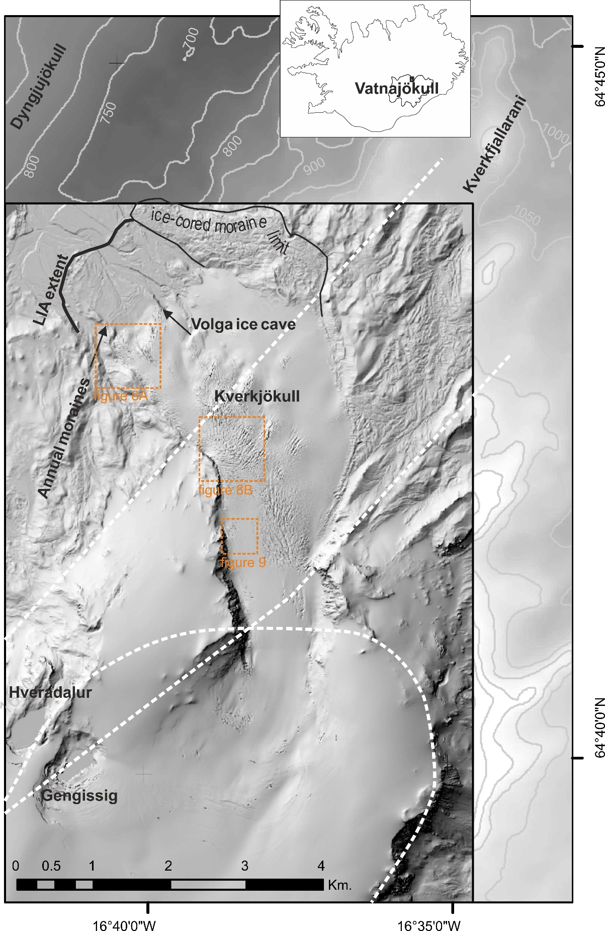

Figure 1. Location of Kverkfjöll in Iceland and sites mentioned in the text, detailing topography, large-scale geological structure: curved white dashed lines approximate the caldera rim (Jóhannesson and Sæmundsson, 1998) and straight white dashed lines depict major fissure lines – structural fault lines (Carrivick, 2004). The hill-shaded digital elevation model is that from September 2011 ALS data.
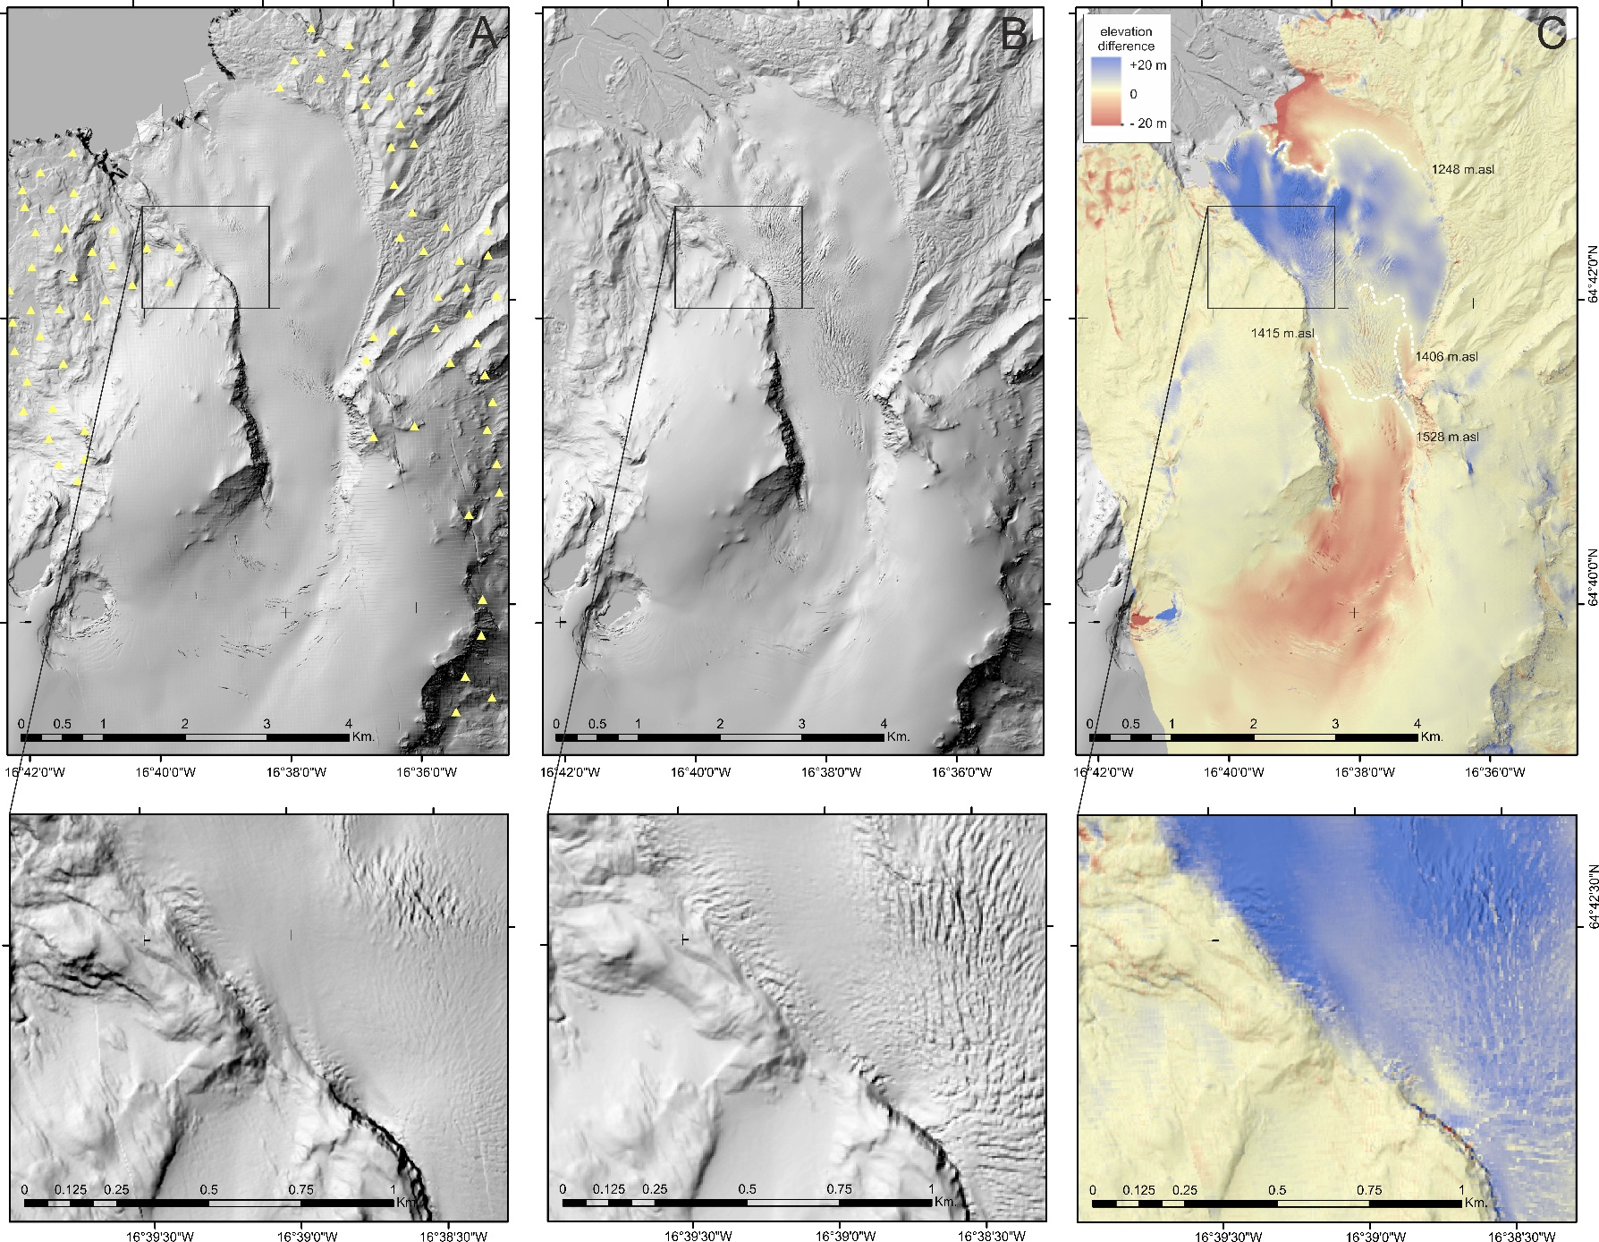

Figure 2. Hillshaded Digital Elevation Models (DEMs) for 2007 (A) and 2011 (B) and DEM of difference (DoD) between 2007 and 2011 (C). Yellow triangles are randomly placed points for comparing elevation values of grid cells in the 2007 and 2011 ALS datasets before geoid correction. White dashed lines in C are isolines of zero elevation change. Enlarged panel in each highlights roughening ice surface, and expanding and thickening of ice margin against lateral moraine and cliffs.
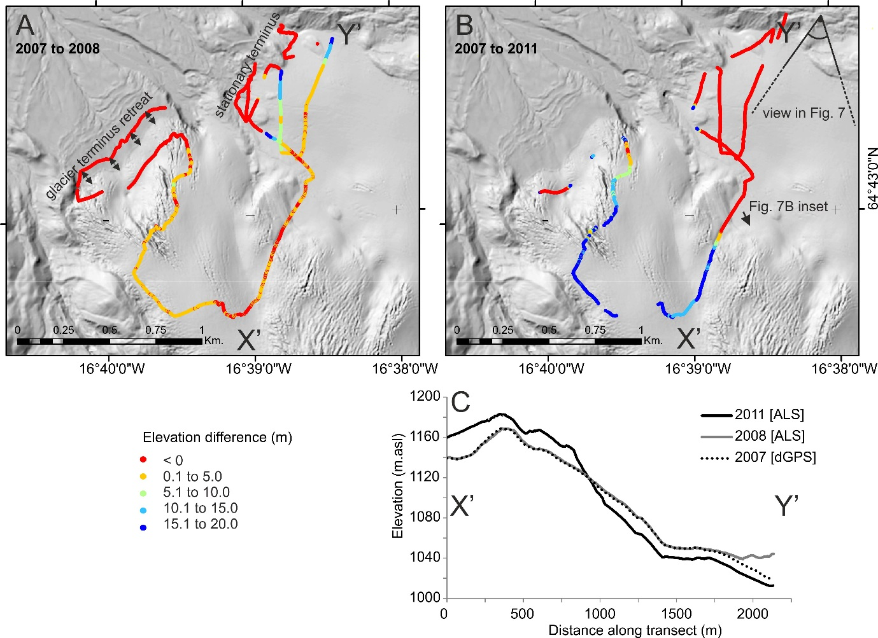

Figure 3. Difference in elevation at points measured for 3D position in 2008 with dGPS between those points and the 2007 ALS (A) and the 2011 ALS (B). A vertical transect between X’ and Y’ is depicted in panel C. All panels together evidence that the surge of Kverkjökull had not started, or at least reached the terminus, in 2008, and that by 2011 the north-eastern and south-western portions of the terminus were behaving differently.
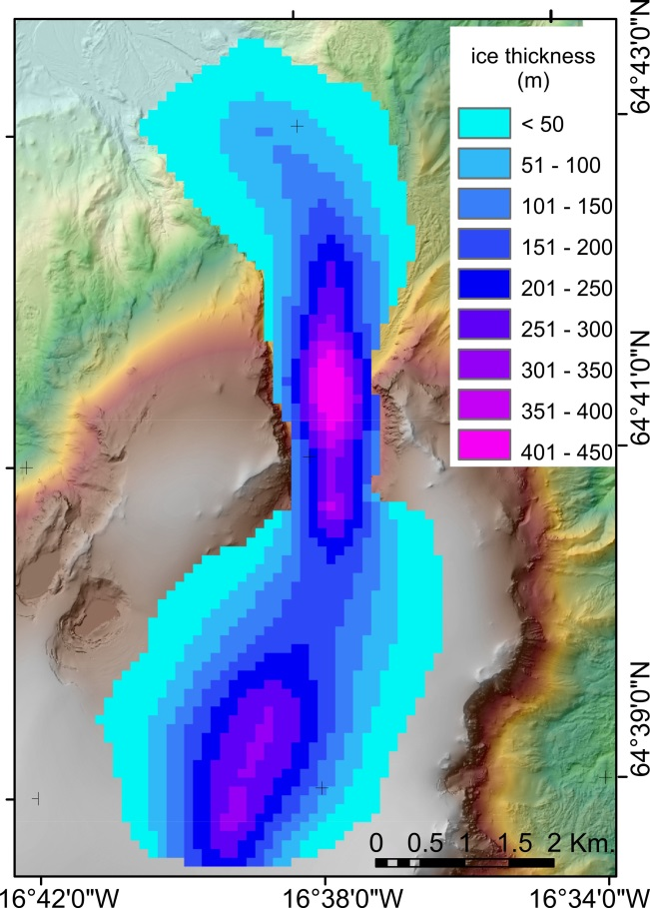

Figure 4. Ice thickness estimated via a 1D steady state ‘perfect-plasticity’ model.

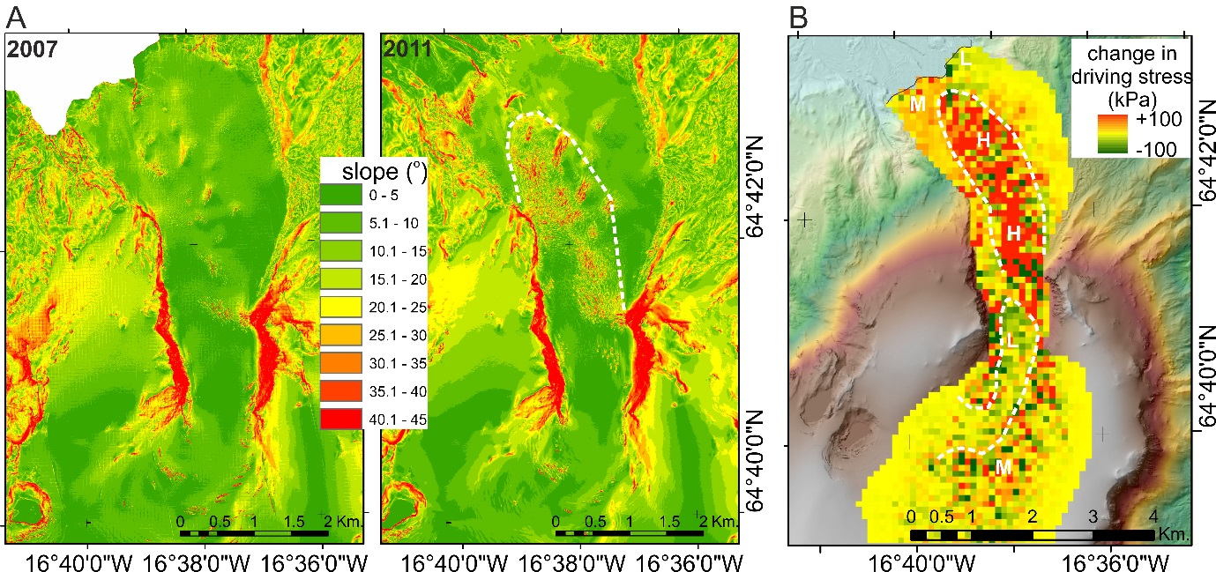

Figure 5. Slope maps (A) for 2007 and 2011 both depicting increased crevassing and serac formation in 2011 compared to 2007. The leading edge of the most chaotic ice surface is outlined with a white dashed line in A and forms a coherent lobe shape. The combination of changing slope and changing ice thickness produced a change in driving stress (B). In B, note the spatial pattern and zones of low (L), medium (M) and high (H) relative changes in driving stress as annotated and delimited by dashed white lines.

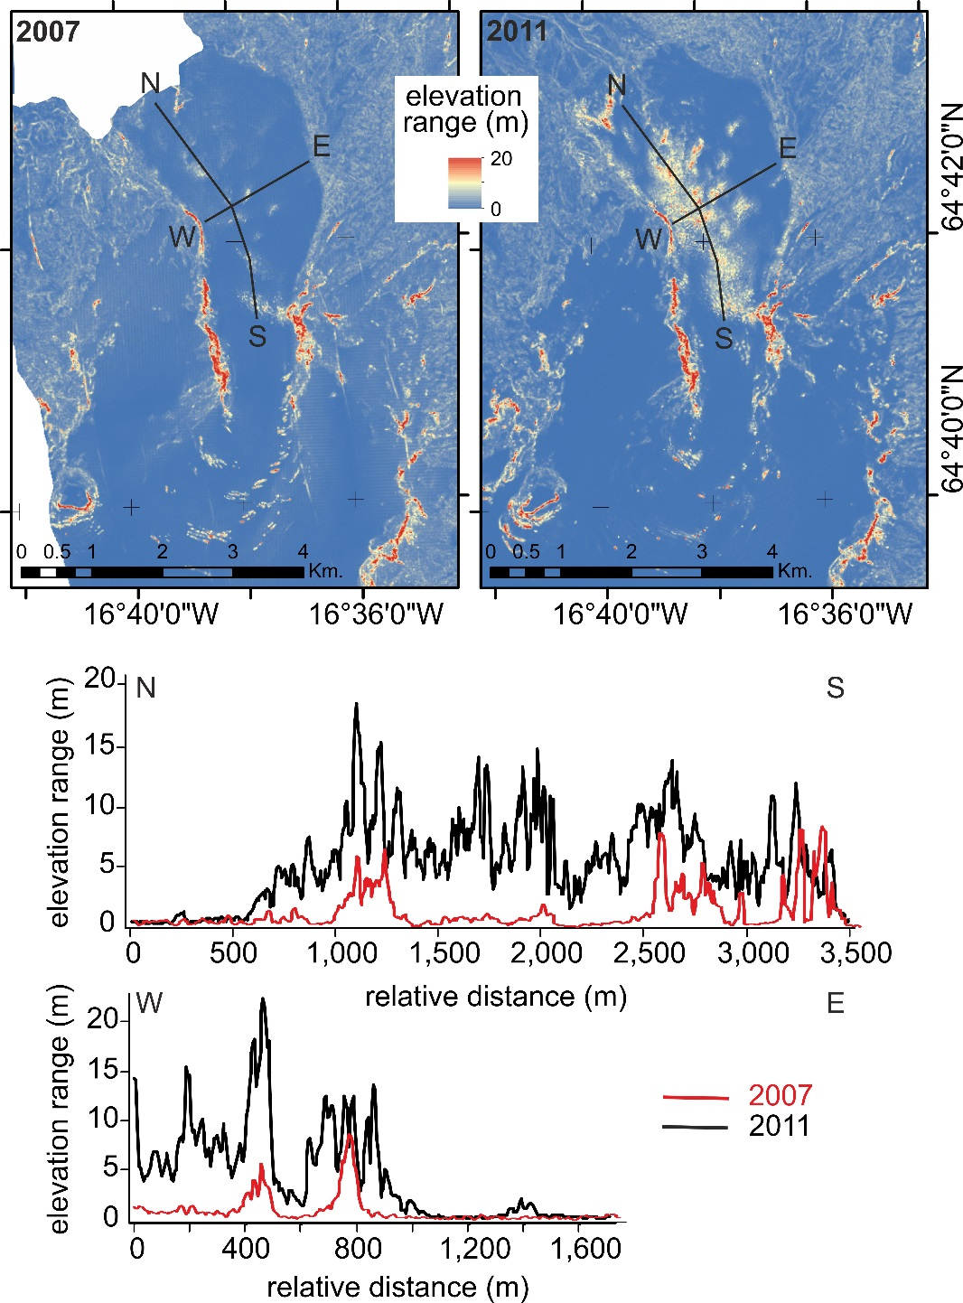

Figure 6. Local relief, as calculated by the difference in elevation of adjacent grid cells, i.e. over 10 m distance, in a detrended surface for 2007 and for 2011 and with a longitudinal (N–S) and lateral (W–E) transect of this local roughness graphed.
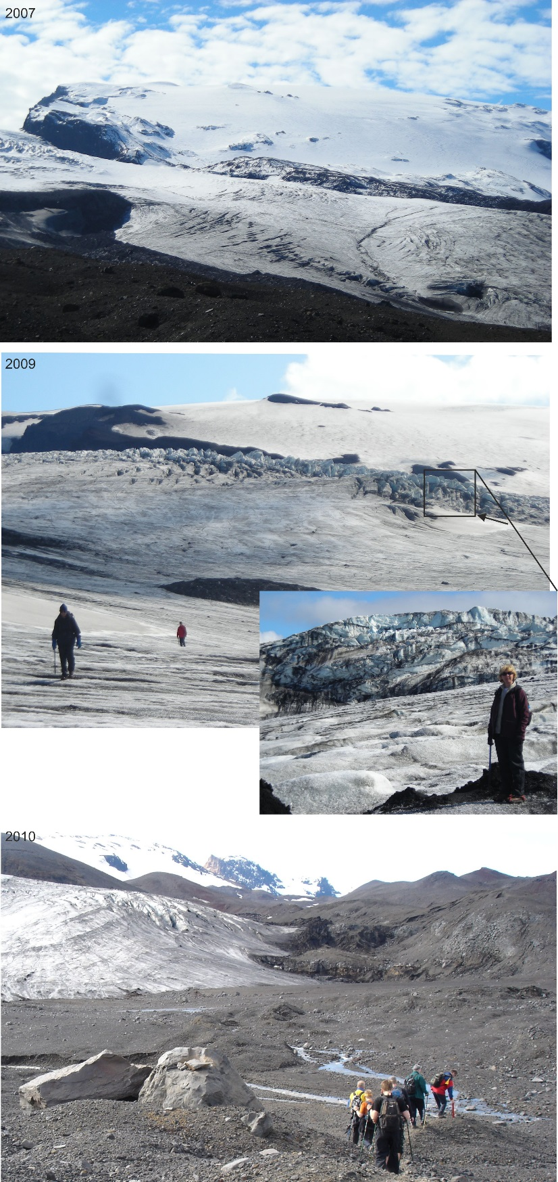

Figure 7. Local relief as seen in the field in 2007, 2009 and 2010. The orientation of the camera in 2007 and 2009 is near-identical and is depicted in Figure 3B, but view in 2007 is more distant from the glacier than in 2009. View in 2010 is of eastern part of the terminus. Note more chaotic surface in 2009 with local relief in inset image of up to 20 m. Inset image view is directly up-glacier and reveals exposed structure of ice with evidence of vertical compression in the form of stacked thrust planes. In 2010 heavy crevassing is visible just back from the terminus, which shows no signs of advance at that time. Image from 2010 is courtesy of Jónas Helgason.
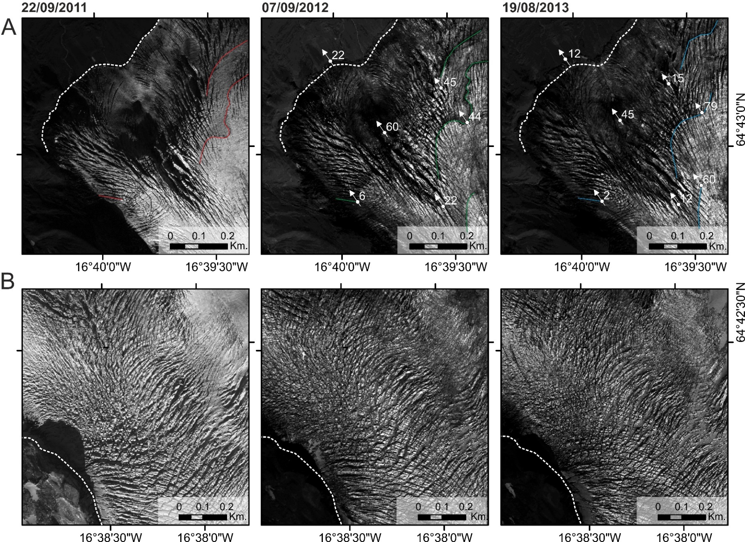

Figure 8. Analysis of surface horizontal motion by manual feature-tracking of selected points. Annotations denote most major horizontal shifts only for clarity and have units of metres since previous image. The location of these panels is indicated in Figure 1. Panels in A focus on the western part of the terminus where manual feature tracking worked well, whereas panels in B focus on a part of the western flank margin that is too chaotic and apparently moving too fast for confidence in finding the same features in successive images.

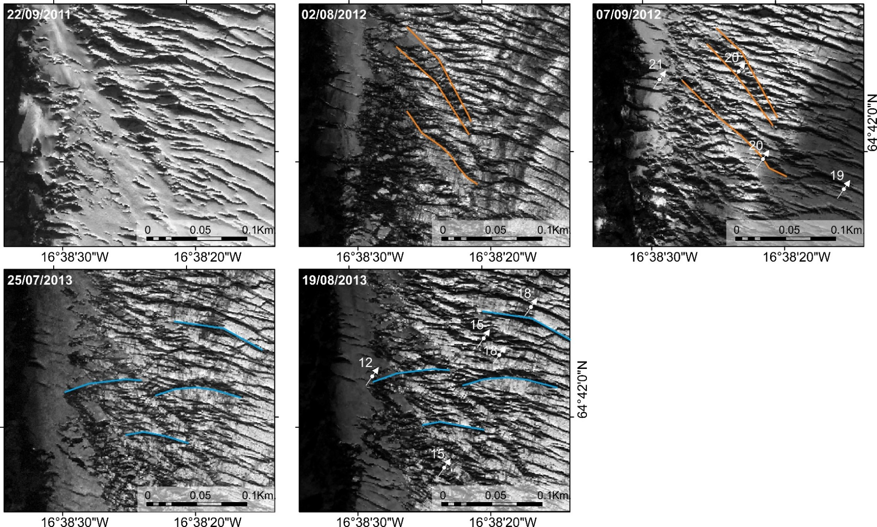

Figure 9. Analysis of surface horizontal motion by manual feature-tracking of a common line of features, such as the end of major crevasses. Usage of these ‘lines’ mitigated problems with finding exact points to track. Annotations denote most major horizontal shifts only for clarity and have units of metres since previous image. Note that only changes within a year could be resolved: between years horizontal displacement was too large to confidently see the same feature. The location of these panels is indicated in figure 1.
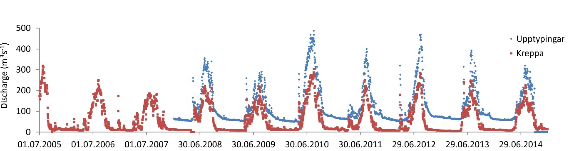

Figure 10. Discharge as derived from continuous stage records for two rivers draining from northern Vatnajökull in the vicinity of Kverkfjöll. Only the Jökulsá á Fjöllum receives meltwater directly from Kverkfjöll and has statistically higher discharge and seasonal volume of runoff in the years 2010, 2011, 2012 and 2013, in comparison to the years 2008, 2009 and 2014.

