**Society for the Study of Childhood in the Past blog**

At the Society for the Study of Childhood in the Past, we want to share our passion and enthusiasm for this subject with professionals and the public alike. Therefore, we have been busy organising events that highlight the importance of children in the past. In October 2016, the Society was involved in the Big Biology Day at Staffordshire University (UK). Activities delivered on the day focused centred around the biological development of children with hands on activities for all the family, including quizzes, bone identification tasks, and demonstrations (all using resin casts). Thank you to Claire Hodson (Durham University) and Dr David Errickson (Teesside University) for working very hard on the day and promoting the society.

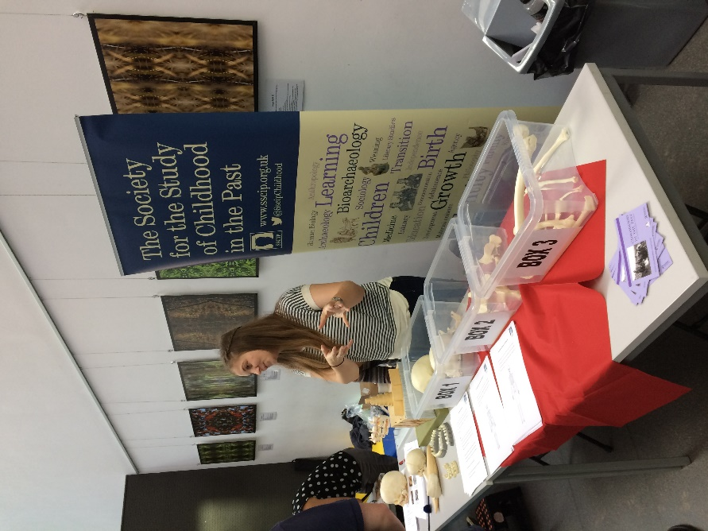

Image above: Claire telling visitors about developmental osteology

On Saturday 28th February 2017 the Society ran a joint event with Cambridge University Museum of Archaeology and Anthropology (MAA) to mark the closure of the Museum’s Heritage Lottery Funded “Hide and Seek: Looking for Children in the Past” exhibition. This unique exhibition has proved to be extremely popular and demonstrates the importance of including children in our interpretations of the past. Dr Jody Joy (one of the exhibition’s curators) offered tours of the exhibition and provided a unique insight into objects on display whilst the education and outreach team (Sarah-Jane Harknett, Matt Buckley, and Bob Bourn) ran family activities. Adults and children were tasked with making replica pots (based on those on display in the exhibition) and George and the Dragon puppets (based on the graffiti from Marsham, Norfolk) and also tried their hand at sticking on ‘microgold’ and decorating glasses. Plus, there were also Anglo-Saxon board games. The family day was a huge success and attracted around 40 visitors

One of the many highlights of the afternoon was Dr Sally Crawford’s (University of Oxford and President of the Society) key note talk titled “New kids on the block: the archaeology of childhood comes of age”, which attracted in the region of 50 visitors from an array of professional backgrounds. Sally explored the development of the archaeology of childhood and the importance of including children in our interpretation of archaeological sites and objects. After the talk, the MAA kindly funded a wine reception, which allowed visitors to discuss all aspects of childhood in the past and view the exhibition one final time before its closure. I, for one, am very sad to see the exhibition go but I am delighted that it has made our discipline more visible not only to the public, but to archaeologists and others working in the heritage and museum sector. Congratulations to Jody Joy, Imogen Gunn, Eleanor Wilkinson, Sarah-Jane Harknett, Lorena Bushell, Simon Weppel, Emanuela Vai and the rest of the MAA team for delivering a wonderful exhibition and thank you for allowing us to host this event with you.

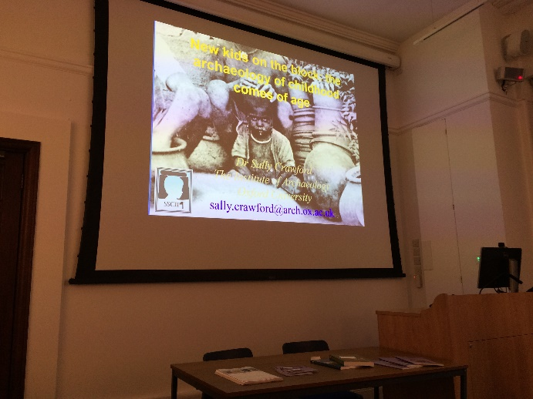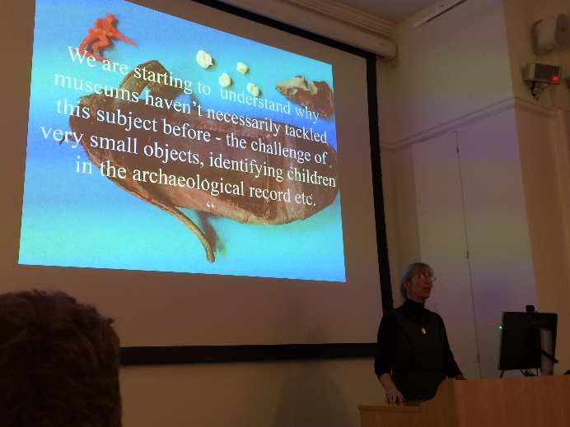

Image above: New kids on the block!

Image above: Sally delivering her keynote at the MAA

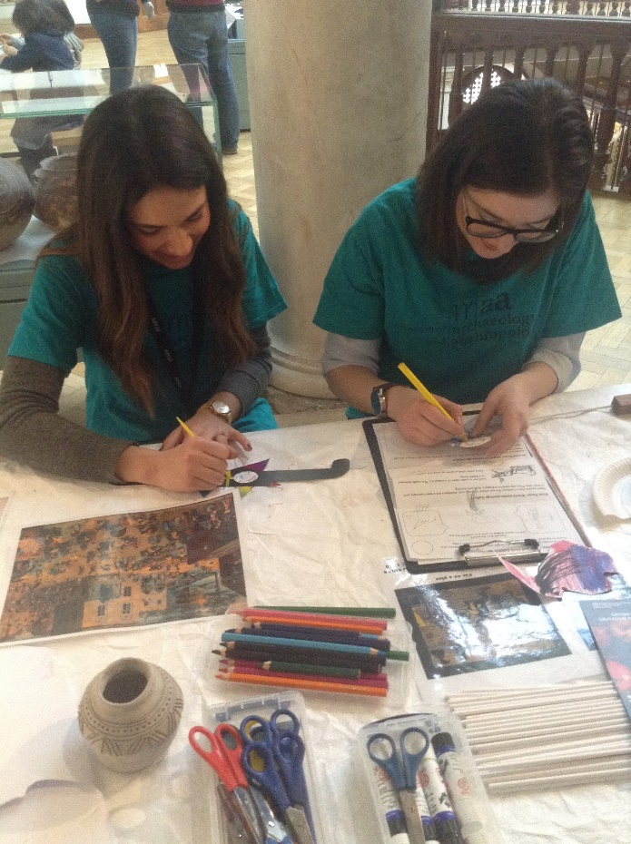

Image above: Lorena and Emanuela practising the activities on Saturday.

Further details about the “Hide and Seek” exhibition can be found at the following website: <http://www.hideandseekexhibition.org.uk/>

We are organising more events to showcase just how brilliant the archaeology of childhood is. Keep checking our blog for future events.