Quantification of rear-foot, fore-foot coordination pattern during gait using a new classification

Robert Needham*, Roozbeh Naemi and Nachiappan Chockalingam
CSHER, Staffordshire University Stoke-on-Trent, UK

Introduction

A dynamical systems approach using vector coding (VC) and circular statistics provides non-linear techniques to quantify coordination and variability. The outcome measure of the VC technique is the coupling angle (CA) and refers to the vector orientation between two adjacent data points on an angle-angle diagram relative to the right horizontal (Needham et al. 2014). To classify the CA to a coordination pattern, Chang et al. (2008) introduced the terms ‘in-phase’, ‘anti-phase’, ‘proximal phase’ or ‘distal phase’. The results of this study provided a quantitative analysis of rear-foot and fore-foot coordination and a new perspective on the function of the foot. However, this approach can only classify the CA to one of the four coordination patterns. For example, an in-phase coordination pattern suggests both segments are rotating in the same direction. However, this classification provides no information on which segment is dominant.
Recently, Needham et al. (2015) offered a new coordination pattern classification that expanded of the work of Chang et al. (2008) by proposing an interpretation of the CA which contained in-phase or anti-phase coordination along with the information on segmental dominancy. Whilst this study quantified lumbar-pelvic coordination during gait and offered an interpretation of the CA which would be useful for clinical conditions such as low back pain, this data analysis

technique has not been employed within the study of multi-segmental foot kinematics.

Purpose of the study

The purpose of this study was to quantify rear-foot and fore-foot coordination during gait using a classification of the CA which represents phase dominancy (in-phase or anti-phase) and segmental dominance information.

Methods

Ten healthy males participated in this study (mean ±SD: age: 21.6 ±3.13 years, height: 180.9 ±8 cm, body mass: 74.85 ±11.10 kg) Participants were required to walk barefoot at a preferred walking speed. An 8 camera motion capture system (Vicon, Oxford, UK.) was used to collect the trajectory of reflective markers that corresponds to the configuration proposed by Chang et al. (2014). Marker coordinate data was processed in Visual3D (C-Motion, USA) using a low-pass Butterworth filter with a cutoff frequency of 6Hz. The general procedures and protocols for analysis and assessment are reported elsewhere (Needham et al. 2014). Mean CA over five trials and across ten participants were calculated using circular statistics in the sagittal, frontal and transverse plane. Data was normalized for time to 100% of the gait cycle.

Results
(a)
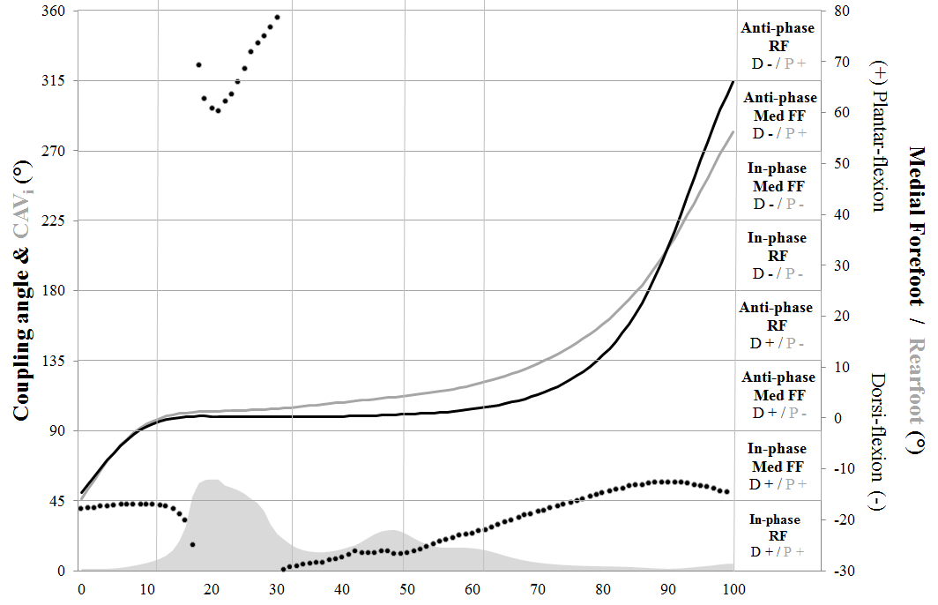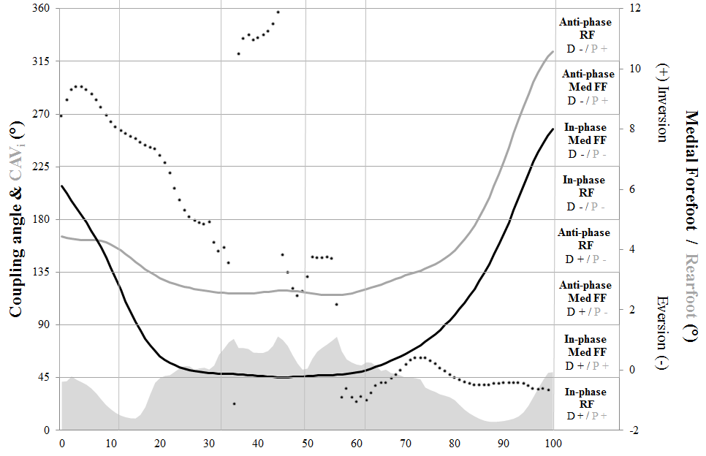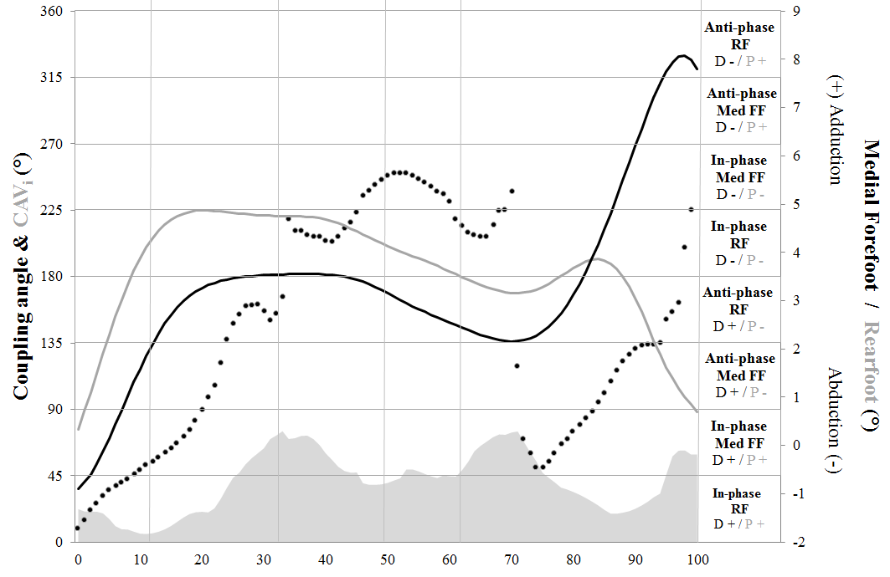
(c)
(b)

Figure 1. Mean CA (black dot) for rear-fore foot coordination in the sagittal (a), frontal (b) and transverse plane (c). Grey and black lines represent rear and fore-foot segmental angle data relative to the laboratory coordinate system. The grey shaded area at the bottom of the illustration presents coordination variability data.
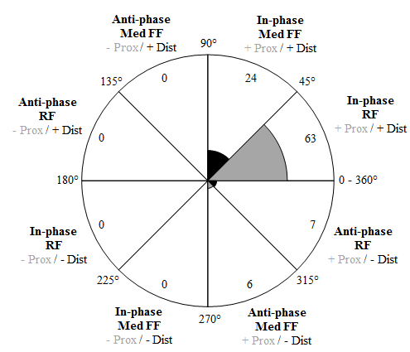

Figure 2. Coordination pattern frequency data for rear-fore foot coordination in the sagittal plane.

Discussion and conclusion

The pattern classification by Chang et al. (2008) limited the interpretation of the CA to one coordination pattern. In a previous study (Needham et al. 2014) global segmental data (grey and black lines) was presented alongside the CA to provide further information on the coordination between segments. By adjusting the 45° coordination pattern bins, Needham et al. (2015) offered an interpretation of the CA to contain in-phase or anti-phase coordination along with segmental dominancy information. This new coordination pattern classification was utilised in the current study and provided an accurate account of rear-foot fore-foot coordination when analysed against global segmental data. This data will provide further understanding of foot function which will lead to informed footwear designs and also influence clinical interventions.

References
Chang, R et al. (2008). J. Biomech, 41 (14), 3101-3105.
Needham, R.A. et al. (2015). J. Biomech, Under-review.
Chang, R. et al. (2014). J. Biomech, 47 (11), 2571-2577
Needham, R.A. et al. (2014). J. Biomech, 47 (5), 1020-1026.

