Developing the @MINDSET Conflict Prevention Programme in Schools

Dr Bobbie Fletcher, Staffordshire University, UK
Barbara Emadi-Coffin, Staffordshire University, UK
Janet Hetherington,Staffordshire University, UK

Abstract

This paper examines issues of conflict in schools by using a systems approach based on the Hackman and Morris (1975) Input-Process-Output Model of group performance and Granovetter’s multiple level perspective on macro, meso and micro group levels (1973). This analysis informs the understanding of a school as a community in order to further develop the diversity management programme for the @MINDSET Erasmus+ project. The @MINDSET Conflict Prevention Programme is based on the extensive work of Dunsebury et al (1997) on critical elements of conflict prevention in the classroom.

Key words

School Community, Group Performance, Conflict Prevention, Diversity Management

Introduction

Young people in schools today have to manage a wide range of stresses and pressures. These include intensifying pressures to perform on exams, even at a very young age, and stresses induced by the increasing diversity of our communities. As a result of increasing migration into and across European states and communities, as well as other pressures on young people, such as exams and social media, diversity management in European schools is becoming increasingly important in order to prevent conflicts in schools. The @MINDSET project has looked at diversity across a range of European states, and has developed a conflict prevention programme that provides CPD for European teachers.

In order to better understand the needs of young people in schools, it is important to understand the nature of school systems. The nature of European school communities can be usefully analysed through a systems approach using an Input-Process-Output Model of Group Performance (Hackman and Morris, 1975). This will demonstrate how factors at various levels of analysis impact on the learning environment of students. Figure 1 below illustrates the Hackman and Morris model.

Performance Outcomes
(Performance Quality, Speed of Solutions)
Group Level Factors
(Cohesiveness, Group esteem)
Group Interaction Process
Individual Level Factors
(Personality traits, knowledge skills and level)
Other Outcomes
(Member satisfaction, member Development)
Environmental Level Factors
(Motivation and Reward mechanisms)

Figure 1: Input-Process-Output Model of Group Performance
(Source: Hackman and Morris, 1975)

Figure 1 above, demonstrates that social institutions, including schools, can be looked at in terms of the Community (Macro Level), Groups within the community (Meso Level) and the Individual (Micro Level).
With the use of the "levels of analysis" model, school communities can be studied in the multi-level system. In order to do this, it is first necessary to looks at the structure of communities in order to identify the various levels. Figure 2 below shows how the levels of analysis can be applied to schools. Using the schools model demonstrated in Figure 2, the research will now outline how the various levels function in schools.

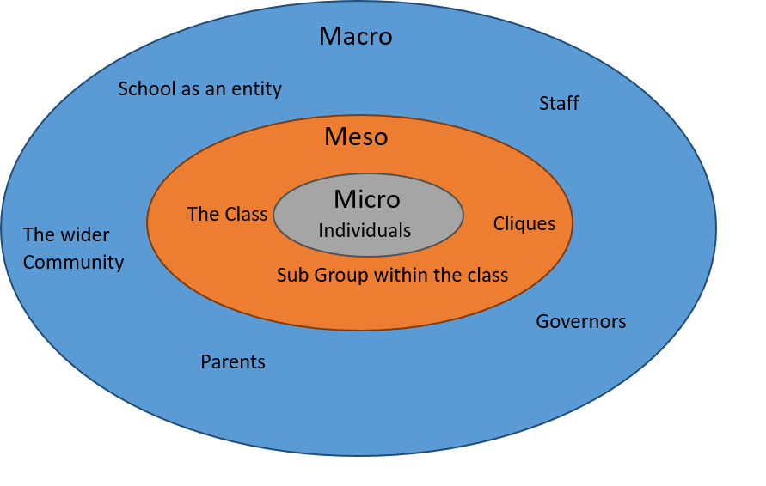
Figure 2: Community Structure Schools

Macro Level Factors in Schools:

The Macro Level of a school community consists of multiple stakeholders:
- Head of School
- Staff
- Governors
- Parents
- The Local Community
- The School itself as an entity

These stakeholders together develop the expected norms of behaviour of the school. Norms are the informal and formal social expectations used by the community to guide behaviour. An example of a norm is the idea that competitors should shake hands after a sports event. In schools, there are a variety of ways in which norms are communicated to the community. These may include:
- Behavioural contracts
- Shared belief words (tolerance, kindness, integrity, etc.)
- Mission statements (e.g. “creating educated and engaged citizens”)
- School motto (e.g. “working together with Jesus by our side”)
- School song
- Religious affiliations of the school

Schools often promote their norms to the wider community so that the local area will be more likely to support the school. Where positive and inclusive norms are established, this should reflect the needs of the macro stakeholders, the community sub-groups, and the individuals.
Positive and inclusive norms should also impact on school governance, the arena in which macro stakeholders interact. It is our contention that good governance has a direct effect on inclusivity within the school. It is personal interactions between stakeholders that can play an important role in school decision-making (van der Arend and Behagel, 2016).

Good Governance should include positive interpersonal interactions between:
- parents and the school
- the school and the wider community
- teachers and students
- teachers and parents

For a macro community, however, interpersonal interactions have many facets and it is not always possible to maintain positive relationships. For instance, there is a linkage between an individual's position within the community and their satisfaction with that community (Shaw, Robbin, and Belsar, 1981).

Group Factors at Meso Level

The Meso Level of a school consists of classes, sub-groups within classes, and cliques. Cliques are examples of self-categorising groups that develop their own ethos to perform effectively, taking into account influence and cohesion that is present at a group level.
When people join cliques, clubs, or societies, they chose to do so based on self-categorisation. The club or society not only follow its own rules, but it will also have a set of its own acceptable modes of behaviour and goals. This is where self-categorisation is extremely effective as it immediately gives the community member a clear sense of belonging and identification with the group forming a "self-organizing group." Forsythe (2006). Self-categorisation and identification is demonstrated in Figure 3 below
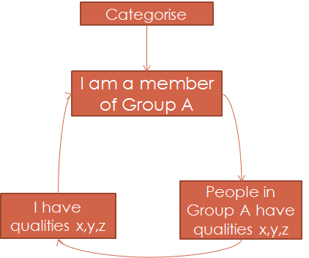
Figure 3: Social Categorization
In schools, classes are artificial constructs to put students into "concocted groups" Forsythe (2006). In these groups, students may not identify with each other as the groups are organised by the teachers and not by the group members. As this is the case, group members in the class may try to form self-organizing groups in the form of sub-groups or cliques. These “emerge when interacting individuals gradually align their activities in a cooperative system of interdependence" (Forsythe, 2006). If this is allowed to naturally, it leads to the possibility of exclusion of individuals or groups of individuals. Such social exclusion may have substantial and long lasting effects on cognitive performance, Emadi -Coffin, Fletcher, Hetherington (2015).
Traditional school classes struggle to develop group esteem due to the lack of the ability to socially (categorise when they are first formed. To give students a sense of identity, schools often create a second artificial group construct in the form of houses, where house points can be accumulated by individuals or house groups and put towards a grand total. These leave no room for social categorisation, unless, like Harry Potter, you are a student at Hogwarts and a sorting hat is applied on the day you enter the school.

Individual Factors at the Micro Level

The micro level reflects the individual and his or her needs. This is the level at which individuals interact with each other, both within and between groups. Individuals frequently strive to attain membership of groups, and desire to remain in the group, identify with the group, and adopt attitudes similar to the rest of the group. The behaviour that each individual displays due to their attitudes are: their decision to participate within the group, their susceptibility to interpersonal influences, their commitment to group goals and ultimately their attachment to the group belief system or norms. When individuals are part of self-organising groups, it is possible, though it may be difficult (e.g. gangs), for individuals to leave the group. However, if an individual in a school does not have an attachment to the school belief system or norms, it is much harder to leave a school than it is to leave the average self-organising group.

Environmental Level Factors

Environmental level factors are not related to the environment in a physical or virtual space where the community exists, but more to the social environment that determines the types of tools that are used for motivation and reward so that the individual as well as the group succeeds. It is important to use positive methods of motivation that encourage pupils to engage in the school norms and learning outcomes.
Over the last decade, Chou (2015) has created a framework for motivation primarily for the purposes of instruction into how to apply gamification to products and services in order to engage consumers. “Gamification is the process of using game mechanics and game thinking in non-gaming contexts to engage users and to solve problems. Gamification leverages game design, loyalty program design and behavioural economics to create the optimal context for behaviour change and successful outcomes.” (Engagement Alliance, 2016). Chou’s framework can be applied to engaging individuals in a community through eight core motivational drivers:
- Epic meaning and calling
- Narrative of personal growth
- Empowerment of creativity and feedback
- Ownership and possession
- Social influence and relatedness
- Scarcity and impatience
- Unpredictability and curiosity
- Loss avoidance
The first of the core drivers is epic meaning and calling. It is the driver that makes individual connect emotionally because they believe they are participating in something bigger than themselves. This is often a technique used in change management and organizational studies (Czarniawska,1998).

The second core driver motivates by developing a narrative of personal growth towards a targeted goal or set of goals. It creates a sense of accomplishment through challenges that can be quantified against others in the same setting and has its basis in performance studies (McGonigal, 2006).

Empowerment of creativity and feedback is the third core driver and is about autonomy. It is achieved through play and playfulness, including the creation and sharing of ideas and fun things to do. This drive has its roots in self-determination theory (Deci and Ryan, 1980).

The fourth driver, ownership and possession, derives from the human need to possess things and to protect those things that they own. Csikszentmihalyi (1993) splits these down into two main categories: objects of power and objects and continuity of the self. The motivation is based on the idea that objects extend the sense of self. “We need objects to magnify our power, enhance our beauty and extend our memory into the future” (Csikszentmihalyi 1993)

The fifth core driver, social influence and relatedness, is associated with the perception of individuals or groups of what others think of them. The perception may operate on a personal level or on a group level. This core driver motivates individuals to social mingle and compare themselves with others in terms of ability or material possessions.

The sixth core driver, scarcity and impatience, is centred on the human desire to have something that the individual cannot have, or at least cannot have immediately. In fact, when the goal is extremely hard to reach, this increase the scarcity and creates the same motivator. Scarcity and impatience is a combination of motivation caused by the economic concepts of supply and demand ( Marshall, 1890) which are now the basis for almost all economic theories, including Worchel, Lee, and Adewole (1975). This driver also draws on flow theory Csikszentmihalyi (1990), where the difficulty of the challenge must meet the ability of the participant and grow as the participant grows in experience.

With the seventh core driver, unpredictability and curiosity, the notion of reward derives from Forster & Skinner (1957). Skinner’s contingency of rewards that breaks them down into fixed and variable ratio schedules, fixed and variable interval schedules, and avoidance and chain schedules are the basis for the method of the distribution of the reward. The pacing of this reward can add a dimension of unpredictability which prevents the recipient falling into a rut and becoming demotivated.

The eighth and final core driver is loss avoidance. This is the simple motivator of fear of losing something. This may range from something that has been worked on to get and is hard earned both in time and or effort. Conversely the same effect can be achieved by the individual imagining or perceiving that they are missing out on something.

Schools do not often use the wide range of motivation drivers found in the games industry. When the School communities are analysed using the Octalysis Framework, which is an octagonal chart diagramming the Eight Core Drives of Gamification (George, 2012), it is not surprising to note the greater emphasis that schools place on using loss avoidance. See Figure 4 below. It appears that schools use loss avoidance as deterrent to poor behaviour more than other methods of motivation. Very little emphasis is placed on ownership and possession as motivational drivers in schools.

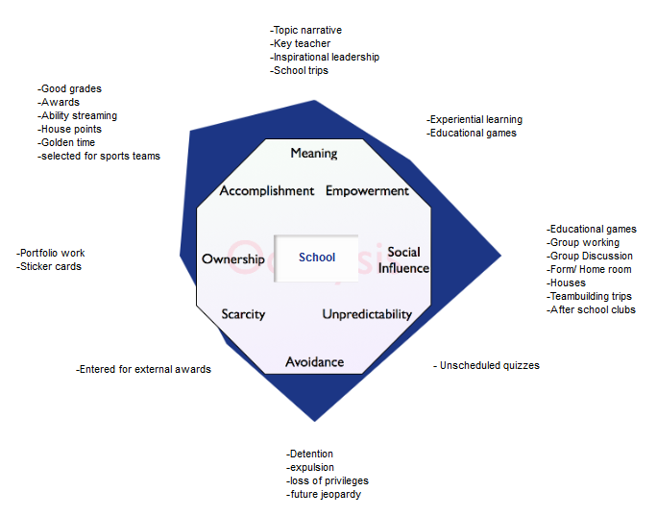
Figure 4: Octalysis for Schools
Analysis of the Input-Process-Output Model of Group Performance as applied to Schools
The analysis of levels of community within schools suggests that there are two lessons that can be learned for managing diversity in schools.
The first lesson derives from the Meso Level. The practise in schools of creating "concocted groups" is a practical way to organise large numbers of students in a school community, but it does not create a cohesive or a necessarily productive group of students. If there were a way of allowing "self-organizing groups" to naturally form as a part of the planned structure of the school community and to have these groups work towards their own shared goals, it might increase the quality of student performance and satisfaction levels. If the development of self-organising groups were facilitated to ensure that social inclusion was a priority, pupils might be able to work as productively together in school as they do in the world of games.
The second lesson that schools could learn comes from the Environmental Factors levels, specifically the use of motivational drivers. Currently, schools place heavy reliance on loss avoidance as a motivational driver. This has a significant effect as this type of driver is termed as “black hat” motivational driver (Chou, 2016). Extensive use of black hat motivational drivers, i.e. punishments as opposed to rewards, have been demonstrated in the games community to be demotivating as they cause feelings of powerlessness, a lack of fulfilment, dissatisfaction and a lack of control, Chou, (2016).
Once the factors promoting social exclusion in schools were understood, the @MINDSET project attempted to develop a programme that would work to counter the issues arising from discrimination, bullying, migration, concocted groups, and black hat motivational drivers.
Developing the Programme
In March, 2016, the @MINDSET team conducted an intensive study programme with 30 participants from five European countries: UK, Greece, Italy, Spain and Turkey. All participants were practising teachers and youth workers. During the intensive study programme, the @MINDSET team wanted to deliver and refine a curriculum developed for teachers to help them manage diversity in the classroom.
Based on the frame work of Nine Critical Elements of Violence Prevention, (Dusenbury et al, 1997), the participants split into three groups and considered the content of the Nine Critical Elements Framework that was designed to promote personal and social competencies among pupils.
According to Dusenbury et al (1997), there are a number of personal and social competencies that promote social inclusion in communities:
  - Understanding the negative consequences of conflict for the perpetrator, victim, victim’s family and friends
  - Learning to manage anger and develop self-control
  - Developing social perspective, that is, learning to see things from the perspective of others
  - Enhancing decision-making and problem-solving skills
  - Resisting peer pressure whilst maintaining friendships
  - Promoting active listening and effective communication
  - Having courtesy, compassion, caring and respect for others.
The @MINDSET project concludes that the lessons designed to deliver these competencies should be designed by the teaching staff. In this way, teaching staff will have ownership of the diversity management programme as a key stakeholder in the school macro level. This provides continuing professional development for the staff and insures that the program is implemented in the way in which it was intended.
The three groups in the intensive study programme each tackled the designing of the content in different ways based on their personal experiences and knowledge of their own classroom situations. The common element that emerged from this design phase was that all groups started out with strategies for managing individuals at the micro level and then developed more complex and involved activities which addressed groups at the meso level. As the ideas and confidence of the ISP grew, these activities were enhanced to address all stakeholders in and around the school community.
Figures 5, 6, and 7 illustrate the lesson plans that were developed to enhance respect for diversity within the school.

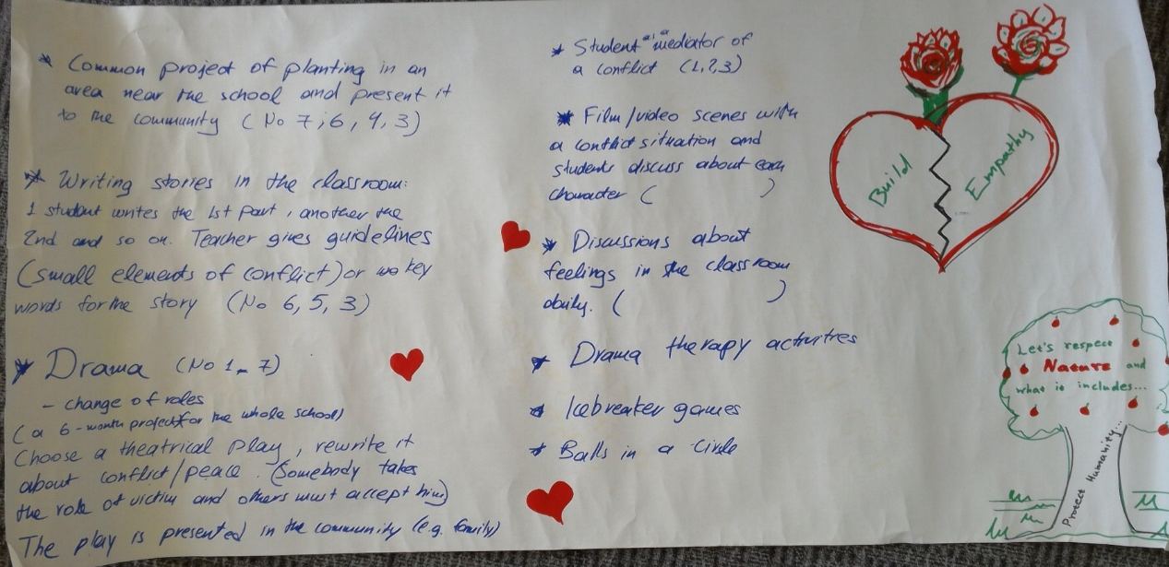
Figure 5: Group 1 Designs
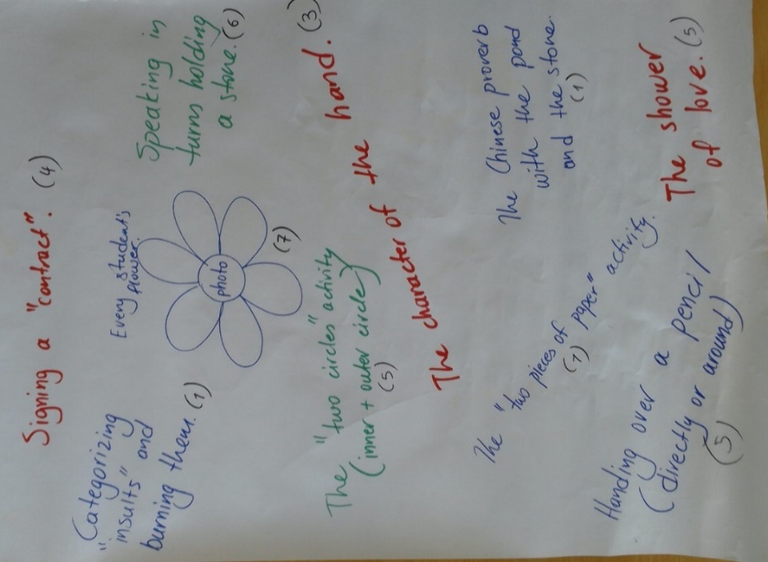
Figure 6: Group 2 Designs

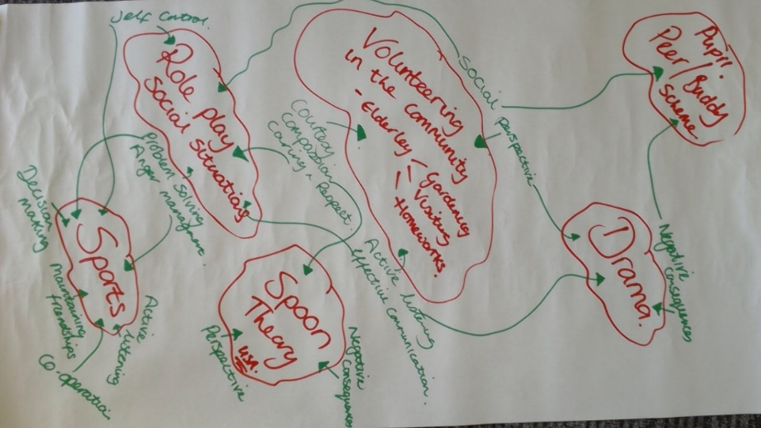
Figure 7: Group 3 Design’s
Conclusion
A Conflict Prevention Programme, such as the @MINDSET Managing Diversity curriculum, is a long term investment for a schools. It has to take a multi-faceted approach, starting with ideas at a micro level and extending them to both the meso and macro levels. It must also address group formation within the schools as well as motivational drivers. Each element is one cog within a machine that relies on each to be in place and working effectively. See Figure 7 below.
The seven key components of the @MINDSET Conflict Prevention Programme are:
- The content of the programme should promote personal and social competencies and be designed by the staff. This provides continuing professional development for the staff, and ensures the program is implemented in the way it was intended.
- Interactive techniques such as group work, where possible in non-concocted groups, as well as cooperative learning, discussions, role playing and behaviour reversal should be included.
- Developmentally tailored programs are important.
- A comprehensive, multi-faceted approach which includes families and the community should be used.
- Ethnically or culturally sensitive material should be matched with the characteristics of the group.
- The program should begin at primary school level and continue throughout the duration of schooling. The programme should not be based on loss avoidance motivational drivers, but rather on drivers of ownership and possession.
- Activities should be designed to promote a positive school culture and foster norms against violence, aggression and bullying.

3. Tailored

- Competencies
And Staff Development
2. Interactive
4. Community

5. Inclusive

6. Continuous
7. Peaceful Norms and
Positivity

Figure: 7 Key Components to the @MINDSET Conflict Prevention Programme.
Acknowledgements
This paper is part of Erasmus+ Project, @ MINDSET Project Managing Social Relations in Schools 2014-1-UK01-KA200-001766

References

Czarniawska, B. (1998) A Narrative Approach in Organization Studies. Thousand Oaks, California: Sage

Chou, Y (2015) Actionable Gamification: Beyond Points, Badges and Leaderboards, [Online] Lean Publishing

Csikszentmihalyi, M. (1993). “Why We Need Things,” in History from Things, Smithsonian Institution Press, P21-29

Csikszentmihalyi, Mihaly (1990). Flow: the psychology of optimal experience (1st ed.). New York: Harper & Row

Deci and Ryan (1980) “Self-determination Theory: When Mind Mediates Behavior,” Journal of Mind and Behavior, Vol.1, No.1, P33-43.

Dusenbury, L, Falco. M, Lake. A, Brannigan. R, Bosworth K (1997) “Nine Critical Elements of Promising Violence Prevention Programs,” Journal of School Health Vol 67 No 10

Emadi-Coffin, B., Fletcher, B., Hetherington, J. (2015) Diversity: Social and Cognitive Consequences in the UK, an investigation into the reasons for and the impact of diversity in schools, Staffordshire University.

Engagement Alliance (2016) What is Gamification? available @ http://engagementalliance.org/what-is-gamification/; accessed 16.07.16

Ferster, C. B., & Skinner, B. F. (1957). Schedules of reinforcement.

Forsythe, D. (2006) Group Dynamics, Fourth Edition, Thomson Higher Education

George, A.J. (2012) “eLearning & Gamification: The Octalysis Framework,” iConLogic, available @ http://iconlogic.blogs.com/weblog/2012/12/elearning-gamification-the-octalysis-framework.html; accessed 16.07.16
Granovetter, M. (1973) ‘The Strength of Weak Ties’, American Journal of Sociology, 78(6).
Hackman, J. R., & Morris, G. (1975) “Group tasks, group interaction process, and group performance effectiveness: A review and proposed integration,” in L. Berkowitz (Ed.), Advances in experimental social psychology (Vol. 8). New York: Academic Press

Marshall, A (1890), Principles of Economics

McGonigal J, E, (2006) This Might Be a Game: Ubiquitous Play and Performance at the Turn of the Twenty-First Century. PhD Dissertation University of California, Berkeley

Shaw, M., Robbin,R. Belsar, J (1981) Group dynamics: the psychology of small group behavior, McGrawhill

van der Arend, S. and Behagel, J. (2016) “Training Participants: Building a Community of Practice to Negotiate Sustainability,” in VoB, J-P and Freeman, R., Knowing Governance: The Epistemic Construction of Political Order, Palgrave Macmillan.

Worchel S, Lee J, and Adewole A (1975). “Effects of supply and demand on ratings of object value,” Journal of Personality and Social Psychology, Vol 32(5),906-914.

Contact email: b.d.fletcher@staffs.ac.uk

