Quantifying visual landscape quality in rural Wales: A GIS-enabled method for extensive monitoring of a valued cultural ecosystem service
Swetnam, R. D., Harrison-Curran, S. K., Smith, G. R.,
Abstract
Landscape views and the enjoyment people derive from them, represent an important cultural ecosystem service (CES) as recognised in frameworks such as the Millennium Ecosystem Assessment (2005) and TEEB (2010). We present a method to evaluate the quality of the landscape view, created for the assessment and monitoring of Welsh rural landscapes. This consists of: (i) a Visual Quality Index (VQI) and (ii) a viewshed model to calculate a Zone of Visual Influence (ZVI). From existing literature, we selected 19 landscape components commonly found to influence landscape quality ratings. Using vegetation surveys and GIS datasets each component was measured and assigned a numeric value based either on presence or quantity and/or extent for 150, 1km² survey sites across Wales. Totalling these values, then scaling and weighting them provided an index for each site between 0 and 1 (VQI). Each site was then evaluated for a range of potential users (pedestrians, cyclists, car-users) to calculate a modelled viewshed (ZVI). By combining the VQI and the ZVI, we capture two elements: firstly the intrinsic landscape quality (its aesthetics) and secondly, how much of the landscape can be seen by the public in order to enjoy the view.
Keywords: aesthetics; cultural ecosystem services; Glastir; GMEP; visual quality; Wales
- Introduction
Cultural ecosystem services (CES) are services provided by our environment that have a cultural, social or historic value to people (MEA, 2005; UK NEA, 2011). They are often abstract in nature and include social benefits such as spiritual well-being, inspiration, identity, heritage and aesthetic appreciation (Daniel et al., 2012; Tengberg et al., 2012) but are central to many published ecosystem service frameworks (see reviews by Hernández-Morcillo et al., 2013; Milcu et al., 2013 and La Rosa et al. 2016) Although CES provided by landscapes are difficult to quantify, their importance to people has long been acknowledged in the field of landscape studies (Tveit et al., 2006; Fry et al., 2009); indeed landscape aesthetics can be considered a major component of the CES provided by a landscape (Clay & Daniel, 2000; Dramstad et al., 2006; Uuemaa et al., 2009; Frank et al., 2013).
Although the ecosystem services paradigm was primarily conceived as a pedagogical tool for engaging public interest in issues of natural science (Gómez-Baggethun et al., 2010) the concept has evolved into a lynchpin of political and socioeconomic frameworks for land use management and planning (MEA, 2005; Portman, 2013). Although critiques exist, particularly from economists (Simpson, 2011), the work of projects such as TEEB (2010) have kept the approach foremost in many policy-related and land management fields. As such, ES frameworks remain current in natural and social science. One example is the Common International Classification of Ecosystem Services (CICES) published by Haines-Young & Potschin in 2013, which has two sub-classes of CES related to landscapes: the physical use of landscapes in different environmental settings (walking, climbing etc.) and a specific class related to aesthetics (Mononen et al., 2016; Potschin & Haines-Young, 2016). These two components are central to the work presented in this paper as both are concerned with these cultural aspects of landscape quality.
Landscape science has been wrestling with the intellectual and practical challenge of how to quantify landscape quality for decades. Measuring landscape quality through aesthetics could be thought of as a perceptual approach to this challenge, the landscape being considered a visible stimulus which interacts with human psychological processes (Dakin, 2003; Wu et al., 2006). It has some foundation in the early sensory mapping work of geographers such as Granö in the 1920s (Jones, 2007) and finds expression in the influential preference matrix approach of Kaplan and Kaplan (1989) and the holistic approaches exemplified Kellert and Wilson (1993). Meta-analysis by Stamps (2004) and more recent statistical modelling undertaken by van der Jagt et al., (2014) have re-evaluated these tools but their contribution to the measurement of CES remains valid. With a focus on pattern, colour and arrangements, the quantification of visual landscape quality retains strong connections to the discipline of landscape architecture where the aesthetics of the view are explored in detail (see Motloch, 2001). The concept of ‘imageability’ as developed by Kevin Lynch (1960) is also relevant here and refers to the ability of a landscape to make a strong impression on the viewer linking it to theories of place and identity. Responses to the landscape are personal and affected by ephemera such as weather, timing and the season in which the view is enjoyed (Tveit et al, 2006). Whether a person rates a landscape highly, may vary depending on when and where they are asked, and all such ratings could potentially be biased by age and life-experience (Jorgensen & Anthopoulou, 2007) and familiarity with the view (Stewart & Strathern, 2003; Van den Berg & Koole, 2006;).
Perceptual approaches to the assessment of landscape aesthetics often rely on qualitative forms of data collection including focus groups and semi-structured interviews (Fletcher et al., 2014); expert-based scoring (Moore & Hunt,2012)and photographic preference surveys (PPS) and could be characterised as a "bottom-up" approach to landscape assessment which is firmly rooted in the unique character of each specific location. The value and consistency of PPS has been vigorously debated but it remains a favoured technique in such evaluations (Gyllin & Grahn, 2015).
In contrast, the biophysical approach to landscape quality assessment assumes that overall visual appeal is controlled by inherent landscape characteristics such as topography, water or vegetation and that this is independent of human perceptions (Fig. 1). These physical elements are referred to as ‘environmental spaces or settings’ in the UK National Ecosystem Assessment (Church et al., 2011) and provide places where people can engage in activities such as walking or bird-watching (Tratalos et al., 2016) As distinct biophysical entities they offer an opportunity for quantification, with frequent use made of tools like Geographic Information Systems (GIS) (Sherrouse, et al., 2011), remote sensing and field survey (see Gobster et al., 2007, Ode et al., 2008 and La Rosa et al., 2016 for further discussion of approaches and frameworks). The biophysical approach can be characterised as 'top-down' or 'expert-led' with trained experts making informed decisions as to the value of landscape elements. Some have characterised this as a reductionist approach to the landscape and a classic example is found in the work of Lewis undertaken in Wisconsin in the USA in the 1960s (Lewis, 1964; 1996). Contemporary critics of this ‘component’ approach such as Crofts (1975) argued that the choice of elements to measure was highly subjective, whilst later authors remind us that these ‘experts’ cannot escape their own socio-cultural biases (Chiesura & de Groot, 2003; Gruehn & Roth, 2010; Frank et al., 2013) . However, this spatial quantification of landscape components remains a mainstay of many landscape evaluations and the widespread availability of digital data and GIS has aided this.
INSERT FIGURE 1 HERE
These two approaches possess different characteristics and there has been considerable discussion as to their pros and cons (Dakin 2003; Schirpke et al., 2013). It is tempting to think of them as two ends of the subjective / objective continuum, but in reality this distinction is somewhat artificial. Indeed, many PPS do explicitly contain questions relating to specific biophysical components (Kienast et al, 2012; Tenerelli et al., 2016). The elements of a landscape that we like looking at (determined by aesthetic quality) will inevitably influence what we decide is worth measuring (its biophysical properties). We know that heterogeneous landscapes can be better at fulfilling the life needs of a greater number of species than homogenous ones (Benton et al., 2003; Fahrig et al., 2011) and provide a greater array of ecosystem services (MEA, 2005). However, the appearance of an ecologically functioning landscape may not actually meet our aesthetic ideals and the challenge of reconciling these two has been highlighted by many (Nassauer, 1995; Gobster et al., 2007; Yang et al., 2014). That said, perceptions are not random and there is wide agreement amongst individuals with a shared cultural background, as to what is a high quality landscape and vice-versa (Arriaza et al., 2004;Tveit, 2009) .
This study contains components of both approaches but with an emphasis on the quantitative / biophysical approach to assessment. We detail a method to quantify visual landscape quality which has been developed for use within the Glastir landscape management programme of Wales, UK. The method draws heavily on the perceptual studies presented in the literature to determine what components of a landscape shape its aesthetic quality and then uses a GIS-based quantification of such to evaluate landscape quality, methodologically, it shares some parallels with work undertaken by Wu et al., (2006) in Melbourne, Australia and work undertaken by Tratalos et al., (2016) in Nottingham, UK.

Landscape quality assessment in Wales and the wider UK
Wales (UK) is situated in north-west Europe and is surrounded to the north, west and south by the Irish Sea and borders England to the east (Fig. 2). A relatively small country, with an area of approximately 21,000km² it has a population of 3.11 million people, most of whom live in a few large settlements along the north and south coasts. It is a rugged landscape, dominated by sheep and beef farming on the hills with much smaller areas of arable land in the lowlands. Although small in area, Wales has some of the finest mountain and coastal scenery in Europe and contains three of the UK’s National Parks: Snowdonia, the Brecon Beacons and the Pembrokeshire Coast, which attract tourists from across the UK and Europe.
Different approaches to the issue of mapping and assessing landscape quality have emerged over the last decades in Wales and the UK (Selman & Swanwick, 2009). For example, the National Character Areas (NCA) in England, contain a detailed narrative which includes: history, geology, drainage, land-use, industry as well as an assessment of key ecosystem services (NCA Natural England, 2016; Norton et al., 2012). Wales has its own unique landscape dataset called LANDMAP which shares many of the characteristics of the English NCAs but provides this through a detailed spatial database which contains five landscape themes: geological, habitats, visual and sensory, historic and cultural (Scott, 2002; Natural Resources Wales NRW, 2013), but systematic monitoring using this dataset is complex due to its scale and the variation in the units of assessment.

Cultural Ecosystem Services (CES) and the Glastir scheme in Wales
Glastir is the main land management scheme currently operating in rural Wales (NAW, 2011) and is managed and funded by the Welsh Government. Through direct payments to farmers and other rural land owners, it pays for the delivery of environmental goods and services including those which combat climate change, improve water and soil management, maintain and enhance biodiversity, protect the landscape and promote public access. It is an example of a land management policy which embraces the principles of ES as a means to deliver public goods (Wynne-Jones, 2015). Glastir is subject to independent evaluation by the Glastir Monitoring and Evaluation Programme (GMEP) (Emmett et al., 2013) which is designed to monitor a statistically robust sample of Welsh landscapes based on the well-established methodology of the UK Countryside Surveys (Maskell et al., 2008). GMEP has adapted to the ecosystem service approach of Glastir through the addition of landscape quality measures which are reported here. The method outlined has been newly created for GMEP, quantifying the CES provided by the landscape views of Wales, with a particular focus on the aesthetic quality of those views.

Landscape Parameters
In order to evaluate landscape visual quality for our Welsh sites, a literature review was undertaken to establish a defensible set of landscape parameters to evaluate. The public perception literature identifies a range of landscape elements or ‘indicators’ which have been linked with the discernment of landscape quality (Mononen et al., 2016; Norton et al., 2016). The majority of these studies used photographic preference methods where cohorts of people were asked to evaluate and rate representative landscape photographs. Studies often analysed statistics (Rogge et al., 2007; Legge-Smith et al., 2012; Garcia-Llorente et al., 2012) whilst others used remote sensing or GIS (Kienast, 1993; Hoechstetter et al., 2008; Vizzari 2011; Tian et al., 2014), or a combination of the two (Ode & Miller, 2011; Yang et al., 2014). Sometimes these studies were conducted over relatively small areas or the respondents were biased towards one group of people, but their findings are consistent and more recent examples in the USA (Klein et al., 2015) and in Switzerland (Junge et al., 2015) have involved extensive population-wide sampling.
A range of common landscape parameters emerged and for the purposes of our Welsh study we grouped these into five. Firstly, the physical landscape which contained a measure of terrain ruggedness. Secondly a ‘blue-space’ group, concerned with water. Thirdly a ‘green-space’ group which included a range of species and habitat parameters. The fourth group was termed ‘human’ and included the built component of the landscape both settlement and transport. Finally, we included ‘historic’ as our fifth group of influential parameters which included cultural and archaeological remains, highlighted as of particular significance by the Welsh Government. This is not an exhaustive list and it was in part tailored to the needs of the Glastir scheme which has a strong emphasis on evaluating the ecosystem services provided by soils, vegetation, landscape and access. A similar set of parameters was used recently by Tratalos et al., 2016 in a separately conducted study elsewhere in the UK.

Research aims
Certain landscape components, such as the pattern of land-cover, vegetation and topography, create the view that humans respond to and the aesthetic component of CES provided by that view. By measuring these components, we side-step the problems created by trying to measure aesthetic responses which are affected by ephemeral factors such as the time of day, weather, lighting or season. These introduce such a large array of uncertainty and variation into the coding or value that might be attached that they become unusable as a tool for monitoring. A field-based evaluation of aesthetic landscape quality by individuals over such a large number of sites was not a tractable response for monitoring purposes and so a pragmatic approach which made use of GIS datasets was employed. Our research aims were threefold:
- To develop a robust and repeatable method to quantify the visual landscape quality of rural Wales.
- To link landscape quality metrics to ecosystem services theory by calculating the visual accessibility of the landscapes to different users.
- To provide detailed baseline data for a representative sample of Welsh landscapes from which change in visual landscape quality can then be monitored.

Method
The Welsh GMEP landscape quality assessment method consists of two key components: (i) the creation of a Visual Quality Index (VQI) and (ii) the use of GIS-enabled viewshed models to calculate a Zone of Visual Influence (ZVI). Both stages are reliant on the detailed field survey data collected within the wider GMEP programme and associated digital datasets for their calculation. Key elements of the survey will be described, the scale and data required will be introduced and then the two components (VQI and ZVI) will be described in detail.
INSERT FIGURE 2 HERE

The GMEP sampling design
GMEP consists of 300, 1km² survey sites which represent a statistically robust sample of the Welsh rural landscape. The sample is stratified by the Land Classification of Great Britain (Bunce et al., 1996) which classifies every 1km² into one of 32 classes determined by a range of environmental and land-use variables including: geology, climate and terrain. The 300 sites are split into two components: a ‘Wider Wales’ component used for baseline monitoring of the Welsh landscape and an associated set of targeted sites which focus on priority habitats such as the peatbogs of the uplands which are important for delivering a wide range of ecosystem services such as carbon and water storage. Between them, the 300 sites have sufficient statistical power to allow trends to be reported at the Welsh level. Each GMEP 1km² site will be surveyed once every four years (75 per annum) on a rolling sample design which follows the methods of Kish (1990); further details are provided in Emmett et al., (2013). The 1km² survey methodology is adapted from the long-standing Countryside Surveys of GB (Carey et al., 2008) and has been designed to dovetail with the existing data that these surveys contain.
This 4-year rolling programme of survey, allows reporting to occur much earlier than that provided by one-off surveys completed at time intervals, giving a combination of statistical rigour and earlier detection of potentially damaging trends. Landscape quality assessment is only one part of the monitoring, the wider programme includes flora, birds, butterflies, soil carbon, water quality, and atmospheric carbon fluxes (Emmett et al., 2013; 2014). Importantly, cultural landscape components are fully integrated within the data collection Monitoring is undertaken at a field scale and is designed to detect changes in all these linked components. Ecological data collection followed field protocols established by the UK Countryside Survey (Maskell et al., 2008). A review by Geijzenddorffer & Roche (2013) concluded that sample-based biodiversity monitoring schemes of this type, can play an important role in contributing data to ecosystem service assessment but note that CES are less well served than services by such approaches. The GMEP survey has been designed to specifically fill the CES gap in the existing national monitoring schemes. For the landscape work, the key records from the field survey relate to the habitat, land use, species, individual trees, hedgerows and condition assessments of historic features. Data are reported here for the first two years of the survey programme representing 150 sites.

Scale
Although the 1km² scale was chosen to optimise the principal aspects of the GMEP survey, it is acknowledged that from a landscape perspective, this is limiting. In response, the landscape analysis adopted an additional 3 x 3 km envelope surrounding each site (Fig. 3). Its purpose was two-fold: firstly, to remove the artificial edge to a landscape view imposed by the 1km² scale; secondly, to account for the fact that a site does not exist in isolation but rather is part of its surrounding setting.
INSERT FIGURE 3 HERE

External Datasets
In addition to the GMEP field survey data, a number of externally licensed datasets were required in order to collate a holistic view of sample areas and to fill in information required for the mapping of the surrounding 3 x 3km areas (Table 1). All data storage, interrogation and analysis were undertaken within ESRIs ArcGIS v10.2 with Python coding used for data processing. Field survey data were recorded directly in the field onto a tablet computer running ESRI software ArcMobile, which allows direct attachment of attribute data to polygon, point or line features.
INSERT TABLE 1 HERE

The GMEP Visual Landscape Quality Index (VQI)
Following the review of the literature outlined in section 2. Nineteen parameters were quantified to calculate the GMEP VQI for each of the 150 sites (Table 2)
For each VQI parameter, values were assigned according to their positive or negative influence on landscape quality (Tables S1-S5). The majority take the form of a fairly simple 1 – 5 or 1 – 10 scale; however, the scale increments are tailored to the Welsh landscape and would require adjustment for other locations.
INSERT TABLE 2 HERE

VQI: Physical landscape
Topography has a significant influence on the perceived quality of a landscape (Arriaza et al., 2004) with mountains and ruggedness rated highly by many (Wu et al., 2006; Garcia-Llorente et al., 2012). With regard to quantifying terrain ruggedness within the VQI, a variation of the Terrain Roughness Index (TRI) of Riley et al., (1999) was employed. The TRI measures the difference between the value of each cell in the input and the mean of its 8-cell neighbourhood. The output takes the form of a raster with each pixel assigned a value representing the change in relief which falls into one of seven value ranges: level, nearly level, slightly rugged, intermediately rugged, moderately rugged, highly rugged or extremely rugged (Table S1).

VQI: Blue Space
Water has a positive impact on landscape quality ratings (Table S2). Landscape views which contain water are consistently rated more highly than those without (Kaltenborn & Bjerke, 2002; Nasar & Li, 2004; Volker & Kistemann, 2011; Garcia-Llorente et al., 2012; Yang et al., 2014). The presence of any sort of water feature gains a positive score in the VQI including point features such as waterfalls, wells and springs. Landscapes with the greatest area of standing water and linear length of flowing water are rated highly. A final binary weighting is applied where a portion or coast or sea is present within the site as coastal views are consistently valued (Wheeler et al., 2012; Natural England, 2013).

VQI: Green Space
Vegetation is a significant factor in the evaluation of rural landscapes and evidence for the importance of diverse habitats and greenery in positive landscape evaluations is extensive (Kaplan & Kaplan, 1989; See Table S3). The GMEP landscape evaluation had the significant advantage of being part of a wider monitoring programme which has a heavy focus on ecological mapping (see Section 2.1). This gave us the opportunity to exploit detailed data on habitat and species for all our study sites and to incorporate these fully within the landscape assessment. Many of the parameters used are common in landscape assessments and include those relating to woodlands and open space (Herzog & Bosley, 1992; Legge-Smith et al., 2012). Green space parameters included: habitat richness, area of woodland, presence of single trees, species diversity, hedgerow length and colour diversity (Table S3). Total hedgerow length is included in this class as a separate parameter. Hedgerows are small, vertical wooded structures which delineate field boundaries and can be varied in species and size. Many are old and species rich and they are important landscape structures across the UK and other parts of Northern Europe (Baudry et al., 2000; JNCC, 2012).
Colour variety is another factor found to have a positive influence on landscape quality ratings (Howley et al., 2012; Schüpbach et al., 2016), particularly in the context of seasonal colour changes - for instance spring blossom or autumnal leaf drop (Lindemann-Matthies & Bose, 2007; Junge et al., 2015). A database of the indicator species for each broad habitat type recorded in Wales, was populated with phenological information describing the main colour changes associated with each species. This metric is not attempting to capture every shade of colour, rather a relative measure of variety – for example, a deciduous woodland may have 3 colours associated with it: green (leafburst in Spring), white (Summer flowering), yellow (Autumnal leaf drop). The number of dominant colours associated with all the indicator species which define the broad habitat type was then summed and linked in the GIS database to the mapped broad habitats.

VQI: Human
The measures in this parameter class reflect human material encroachment, associated with negative impacts on perception of landscape quality (Brush et al., 2000; Rechtman, 2013). Landscape quality is perceived to decline as human influence increases both from the encroachment of buildings but also through the imposition of homogenous landscape patterns (Howley et al., 2012). It is acknowledged that some buildings can contribute significantly to the perceived attractiveness of a particular view. In Wales, many of these exceptional buildings have some legal protection and would be separately accounted for in the Historic group (see Section 2.4.5) but others would not so the metric does not capture this cultural component of the landscape in full. For the purposes of this study, built land is classes as a negative. The area covered by human-influenced land as well as that covered by buildings is included in this category along with counts of spot utilities such as wind turbines, electricity pylons and other visually-dominant vertical infrastructure. Roads are included here and the measures address not only their presence but also evidence that suggests the bigger or busier the road is with traffic, the more negatively it is perceived (Clay & Daniel, 2000; Garré et al., 2009). Since this class contains only negative elements, higher scores are assigned for the absence or lack of such elements (Table S4).

VQI: Historic
Preserving the heritage of the Welsh landscape and managing the CES associated with their presence is an important component of the Glastir scheme. Historic and cultural assets can be important for tourism, education and sense of place (Ashworth, 2008). In a long-settled landscape such as Wales, cultural components such as churches, castles, stone walls or prehistoric monuments shape the landscape view and character (Webley, 2004; Collier, 2013). In the framework proposed by Ode et al. in 2008, they are highlighted as “indicators of historicity” and were specifically included within our Welsh assessment. Within the VQI, the presences of four main types of historic asset are assessed: the length of dry stone boundary walls, presence of Scheduled Ancient Monuments (SAMs); presence of historic parks and gardens and the presence of listed buildings of historic note (Table S5).

Weighting of the index parameter values
The five themes of the VQI presented in detail in Table 2 (and in detail in Tables S1 to S5) represent 19 individual measures which are calculated for each 1km² within the GMEP survey. In their raw form, the contribution of these five themes is not equal due to differing number of parameters within each theme. To ensure parity between the five components, the values within each theme are therefore scaled and then weighted equally in the final index (Table S6 gives a worked example). A sensitivity analysis was undertaken to evaluate the impact of changing these weights between themes. This showed that the overall VQI remained stable when changes to individual class weights remained in the range between 0.1-0.4 (compared to the 0.2 applied here). By using equal weights, we assume that the different components of the landscape contribute equally to overall visual landscape quality; these weights were agreed with the main stakeholders as a reasonable compromise. Future refinement through the use of participatory methods to determine the importance that different individuals assign to different categories (Tenerelli et al., 2006) is a possibility but is not presented here (See S6 for details).

Development of the GMEP viewshed model
Accessibility is potentially a significant control on the visual quality of a landscape as it determines which components can be seen by visitors. In an ecosystem services context – whereby value is attached when a service is provided, if it cannot be accessed it is failing to provide CES to visitors (Muhar, 2004). This has been recognised in work to evaluate the links between service providing areas (SPA) and service benefiting areas (SBA) which make use of landscape metrics (Syrbe & Walz, 2012) and GIS models to evaluate these spatial links (Ala-Hulkko et al., 2016). Here, we take an immersive approach and evaluate the visual accessibility of each 1km² study to individuals moving through it or viewing it from the immediate surroundings .In this second stage of the GMEP landscape assessment method we establish the level of accessibility, as determined both in a physical sense through the presence of Public Rights of Way (PROW) and also in a visual sense through the evaluation of the available view as contained by topography or limited by infrastructure. The latter is assessed through the application of 3D viewshed modelling which has found wide application in the evaluation of visual impact (Wu et al., 2006; Joly et al., 2009; Garré et al., 2009). Although viewshed modelling has rightly had its critics in the past (see Fisher, 1993 for example), the algorithms and data available have improved markedly in recent times. Visual accessibility is rarely considered in this context and there were three primary issues to be considered: scale, barriers to observation and finally the represented observers.

Landscape context
The potential limitations of the 1km² survey scale was previously discussed in section 2.2 but with regard to visibility analysis, it is particularly pertinent to account for the influence of the surrounding landscape. Here, the visibility of the surrounding areas and how their landscape characteristics may add, or subtract from the experience of an observer standing within the 1km² site are assessed. Conversely it is equally important to consider that the landscape of the core site will be visible from some parts of the surrounding 3 x 3km envelope (Fig 3) and thus will contribute to the overall quality of the wider area. Some parts of the site which are not visible to the public when they are within the core site due to visual barriers may become visible from viewpoints in the surrounding landscape.

INSERT FIGURE 4 HERE
As such, three types of viewshed analysis were undertaken: simple, ‘looking-in’ and ‘looking-out’. The simple viewshed when both the observer and the observable area are within the core 1km² is based on the detailed field survey data collected for GMEP. A ‘looking-in’ viewshed where the observer points only fall within the surrounding 3 x 3km envelope area but the observable area includes the core 1km². Finally, the ‘looking-out’ viewshed where the observer points are situated within the core but the observable area expands to include the full 3 x 3km envelope (Fig 4). This computationally intensive approach has also been discussed by Carver and Markieta (2012).

Barriers to observation
With viewshed analysis, any potential barriers to visibility must be taken into account; these include buildings, treelines, solid boundaries such as walls plus the underlying terrain itself. The inclusion of such barriers represents the different between the products of viewshed analyses being regarded as “Zone of Visual Influence” (ZVI) versus “ Zone of Theoretical Visibility” (ZTV). Within the context of development proposals the LI/IEMA(2013) recommend the use of the latter, however, within the context of this project, it is the former ZVI which is most appropriate. This is because i) we are surveying relatively small spatial areas ii) the detailed field survey data to which we had access allows the inclusion of fences, walls, individual trees, buildings and area of extensive woodlands as potential obstructions. The heights for these elements derived from the survey data or collated from external data review.

Represented observers
We calculated separate viewsheds for four groups: i) pedestrians, ii) cyclists, iii) small vehicles and vi) rail passengers. These represent the range of users of Welsh landscapes with each subject to differing degrees of permitted access (Table 3). For each group (i-iv) an offset height was attached to represent the approximate eyeline of the observer which was set at 1.7m for pedestrians and cyclists, 1.5m for small vehicle passengers and 2.5m for rail passengers.
INSERT TABLE 3 HERE

Application of the GMEP viewshed model
Viewshed analysis was conducted within ESRI’s ArcGIS v10.2 using a 5m resolution Digital Terrain Model as the baseline landscape complimented by field survey data to provide structural detail. If not specifically recorded by the field surveyors, standard heights were assigned to vertical features as follows: buildings (12m), woodland and trees (20-30m species dependent), walls and fences (1m), hedgerows (2.5m), electricity pylons (50m) and wind turbines (60m).
Within each 1km² site, digital line data was extracted for each Public Right of Way (PROW) present and observer points were generated along each of these lines at a separation distance of 20m. For the areas of open access land (including beaches), polygon data was extracted for each designated area and random points were generated within each space with the separation distance between observer points maintained at 20m. An important step at this stage was to erase observer points which overlapped these added vertical features. This was to avoid the scenario where the theoretical observer would in effect, be standing on the top of the tree or wall. Following this, the features were converted into raster layers using the associated heights to assign pixel values which were then combined with the baseline topography of the DTM. In order for smaller or narrow features such as hedgerows to be correctly represented, the DTM was first re-sampled to 0.5m. The resulting combined raster layer then formed a fairly comprehensive representation of the potential visual barriers an observer might encounter from topographic variations to human factors (Fig 5). Broad daylight conditions were assumed and the viewshed process was then automated.
INSERT FIGURE 5 HERE

Results
The GMEP VQI has now been calculated for 150, 1km² sites from the first two years of the field survey. This gives us two pieces of information: firstly the rating itself – allowing us to compare sites within years; secondly it provides our baseline from which to measure future change.

Results of the Visual Quality Index
Values for the Welsh VQI range from 0.296 to 0.681 with a mean of 0.460 and a median value of 0.459. The values exhibit a normal distribution, though low values are relatively rare (Fig 6). When the VQI results are mapped, broad patterns are revealed. High values appear to be concentrated in two of the three National Parks (NP), Snowdonia in the north and the Brecon Beacons towards the south. Snowdonia NP and the associated coastal areas of the Lleyn Peninsula immediately to the west and the island of Anglesey to the north-west contain many sites with an overall VQI in the upper-quartile of the range. Likewise, the Brecon Beacons NP in the south. Both these areas have long-standing landscape protection through their NP status. A third cluster of upper-quartile values is shown in the central uplands of Wales. This area contains the Cambrian Mountains, which is subject to an ongoing campaign to have it designated as an ‘Area of Outstanding Natural Beauty’ (CMS, 2008). Pembrokeshire Coast NP in the south-west and the south coast of Wales as a whole tend to report VQI results in the lower-quartile of the range. These areas tend to be more densely populated, containing the main conurbations of Swansea, Cardiff and Port Talbot as well as landscapes with a long history of heavy industry including coal mining and steel-making. In tandem with the more urban character of this part of Wales, transport infrastructure in the form of railways and main roads are concentrated along the coastal strip. Here, the coastal scenery is often visually appealing but often combined with elements of the human landscape (such as buildings and roads) which tend to depress the VQI index.

One characteristic of the VQI is that survey sites with different components of landscape quality can share the same overall index. We believe this to be a strength rather than a weakness of the approach as it can capture the variety of landscapes without judging one part of the whole to necessarily be more important that another. Within our dataset, there are ten sites that all share the same overall median value of 0.459 but this index is collated differently for each (S7).
INSERT FIGURE 6 HERE

Viewshed outputs
For each site, a maximum of 12 viewsheds can be generated (4 users x 3 scales) resulting in a potential total of 1800 separate viewshed outputs. In reality this number was slightly lower as not all sites had all four categories of user. Of the 150 1st and 2nd year sites, a total of 1253 viewshed dataset were generated, each one a separate raster data layer of either 1 x 1km for the ‘simple’ and ‘looking in’ viewshed types or 3 x 3km for the ‘looking out’ viewshed. each with a cell size of 0.5m . Each viewshed dataset is a single-band raster with values ranging from 0 (not visible from any observer point) to a theoretical maximum determined by the number of observer points located either in the 1km² for the ‘simple’ and ‘looking out’ cases or the number of observer points located in the surrounding 3km² for the looking in viewshed (Fig 7). These outputs were converted to a binary grid where non-visible cells were assigned 0; those visible from any observer point were assigned 1. The percentage of the site which was visible could then be easily calculated for comparison as well as mapped to identify which component parts of the study sites were provided the view.
INSERT FIGURE 7 HERE
The viewshed model represents a theoretical maximum, assuming that all paths are fully accessible. In reality, this is rare as footpaths can be disused where poorly signed or maintained. Acquiring data on access is problematic; outputs presented here assume full access to ensure model parity. For the 150 sites modelled so far, pedestrians could see on average 45% of the 1km² site, and 40% of the 3 x 3km surroundings which is quite a high value and reflects the density of the public rights of way network in Wales. Cyclists tend to have similar visual accessibility to pedestrians as they can use some of the same paths as walkers (though not designated footpaths which are restricted to walkers). Car drivers are more restricted; on average their view covered 36% of the 1km². For pedestrians 44% of the sites had visibility values >50% meaning that more than half the landscape area was visible (Table 4).
INSERT TABLE 4 HERE

Combined outputs
Each site therefore has two index measures associated with it: the VQI which is a relative measure of overall landscape quality represented by an index with values between 0 and 1 and the ZVI (% of the site visible) which indicates public visual accessibility – where high quality landscapes can be seen they provide a public benefit. When these two values are plotted (Fig. 8) it is possible to identify candidate areas for possible improvement through management interventions.
Two–step cluster analysis was undertaken in SPSS on these data which shows that is rare to get high landscape values (VQI > 0.5) combined with high levels of public visual access (ZVI > 50%) with only 17.3% the 150 sites falling into this cluster. This is perhaps unsurprising as part of the public access to sites is given through the road network which rates negatively in the index (though note that footpaths and bridleways do not). A second cluster (8.7%) have the highest VQI (>0.6) but only average levels of accessibility. The remoteness and lack of public infrastructure which contribute to their high landscape ratings may mean that access is limited. The largest group (53.3%) of sites have average VQI values, however, they may be providing a wide range of ecosystem services (from farming, flood control) which may impact on their aesthetic valuation by the public. The remainder (20.7%) have lower values according to the VQI, though this does not mean that they are not valued or attractive in places. Those sites which currently enjoy good visual access would certainly be a target for minor landscape interventions to increase their landscape attractiveness to the public. The goal would be to have landscapes resting within the upper right quadrant of the graph, so showing high landscape quality and high accessibility. There are two ways to achieve this: either to improve accessibility to the sites by opening up new rights of way, particularly to pedestrians, or to attempt to improve visual landscape quality. The latter could be achieved by management of landscape features that impact on landscape aesthetics – particularly the removal of human infrastructure such as masts or pylons, the restoration of historic stone walls and the management of water features and woodland.
INSERT FIGURE 8 HERE

Discussion
It is widely recognised that measuring CES is challenging (Hernández-Morcillo, et al., 2013) often requiring a multi-disciplinary assessment to be truly comprehensive (Satz et al., 2013). One approach advocated by Tallis et al., (2011), is to be specific about what service is being quantified; in this paper, we focus on the visual aesthetics of landscape quality as one important CES. It is clear that the quality of the landscape view has cultural, emotional and physical importance to people, both residents and visitors (Kara, 2013). Therefore, measuring landscape quality and the view that it provides, remains an important goal for ecosystem service assessment (MEA, 2000; UKNEA, 2011). For many, it is not something that can or should be quantified; the scenic beauty of nature undoubtedly has an existence value which is apart from our human need to observe it. However, the groundwork laid by the MEA (2005) and subsequent national accounting efforts (UK NEA, 2011, Potschin & Haines-Young, 2016) attest to its continuing importance both in policy and management. Whilst there has been welcome development in the theoretical aspects of landscape quality assessment to support this (Tveit et al., 2006; Ode et al., 2008; Daily et al., 2009; Seppelt et al., 2012) and in the derivation of indicators to measure CES (Church et al., 2011) the practical application to large-scale monitoring programmes has been limited (but see Dramsted et al., 2006).

The contribution of GMEP to monitoring CES

In the GMEP approach to monitoring CES, we explicitly acknowledge the importance of landscape aesthetics in peoples’ perception of the quality of a landscape (Daniel et al., 2012; Hernández-Morcillo et al., 2013). Our method does not measure aesthetic quality directly because this changes with timing, context and audience (Gobster et al., 2007). It is difficult to control such variation and does not fit well with the need for a fixed baseline and measurement of change – all of which are central to a long-term, wide scale monitoring programme like GMEP. Our approach is to use measures which are tractable using GIS processing and those supported by a wide range of evidence from published photographic preference studies that link them to aesthetic enjoyment and high quality ratings (Joly, 2009; Legge-Smith et al., 2012). Our choice of parameters (Table 2) which determine the VQI is necessarily partial and partly determined by data availability and ease of measurement. However, the existing research literature provided our theoretical base and considerable care has been taken in selection of these parameters to ensure that monitoring is consistent over time (Tables S1 – S5). The 19 parameters which are used in the GMEP VQI are therefore, acting as surrogates, capturing some component of the aesthetic experience, but not all. A site with a high VQI may not be ‘prettier’ or more scenic than one with a lower value but it does contain lots of the biophysical components of a landscape which are linked to higher aesthetic ratings.
In its summary form, the VQI is one value (0 -1) and relying on this metric to solely describe the visual character of an individual landscape would be over-simplistic; understanding the component parts of the index are equally important (Fig S7). It does however allow us to rank the landscapes to identify groups of sites which tend to have lots of high quality features or vice-versa (Fig. 7). This is how we recommend the index to be used. A key benefit is that it provides a baseline from which change can be assessed. Degradation of landscape aesthetic quality is a concern and often goes unnoticed by human viewers until considerable damage has occurred (Fry et al., 2009). By measuring individual components of quality such as the length of hedgerows or stone walls, degradation will be noticed before it has the potential to impact on visual quality.
The GMEP landscape assessment approach is quantitative with an emphasis on spatially explicit metrics (the VQI) and 3D modelling (the ZVI). Our method is designed to provide Welsh policy-makers with baseline data on visual landscape quality as well as a quantitative means to monitor change over short timescales. It has the additional benefit of sitting efficiently within the wider landscape monitoring programme of GMEP and complements the existing qualitative narratives within the LANDMAP dataset (Scott, 2002). The ecosystem service paradigm has a clear focus on the delivery of economically quantifiable services to people (Fisher et al., 2008), and within Wales, the ES approach has driven the design of the entire Glastir programme (Emmett et al., 2013). Such emphasis on quantification is uncomfortable for many critics of landscape assessment methods but it is one part of the solution to the consideration of such CES.
By combining such landscape quality measures with an assessment of their visual accessibility, we believe our approach provides a method to indirectly quantify some of the key aesthetic components of the CES provided by the landscape of Wales. The viewshed modelling allows us to distinguish between the physical accessibility of a landscape as described by the PROW and the visual accessibility of a landscape (what can actually be seen by the visitor when modified by vegetation, topography and vertical structures) and provides us with a means to link the measurable, physical components of the landscape to their potential aesthetic appeal (Muhar, 2004).
We acknowledge that this modelling has been enabled by access to coherent, quality-assessed UK Ordnance Survey digital data and informed by fine-scale habitat survey which provides the necessary detail to attempt such an analysis (Maskell et al., 2008; Emmett et al., 2013,2014). Dependence on fine-scale data of this type could limit its wider application elsewhere, but the combination of detailed field-survey and complete digital topographic data certainly is possible for many smaller studies.
In reviewing the 19 parameters that make up the VQI (Table 2), 10 could be calculated using freely available national or global datasets. These include the TRI which requires a digital terrain model (DTM) as input and could be calculated using products like the Shuttle Radar Topography Mission (STRM) which is freely available from sites such as the Kings College London Geoportal (Jarvis, 2004). The area of standing water, length of flowing water, presence of coasts, quarries and utilities as well as road data are standard features of many global boundary datasets (Natural Earth, 2016). In addition, global datasets such as Globcover (Arino et al., 2012) or country-level landcover datasets such as Corine (EEA, 2006) can be used to extract the area of woodland, human-influenced land and buildings. Habitat richness can also be calculated from such remotely sensed landcover datasets. Some of the historic parameters used in the VQI are UK-specific but easily substituted with country-level data on designated sites whilst the UK-specific parameters relating to stone walls and hedgerows would need replacing with cultural landscape features of local relevance.
Due to the restricted public access to land in Wales, our viewshed analysis had to incorporate an additional layer of complexity which modelled the sight-lines from public routes such as footpaths and roads. In other countries, access is more open and here the modelling could be simplified to just account for topography (derived from a DTM) and significant vertical infrastructure such as woodlands or buildings. The latter are readily available in existing spatial datasets. Therefore, the method is transferable to other data-scarce locations and the approach which combines landscape quality metrics with viewshed analysis could be adopted, albeit at a coarser spatial scale.

Caveats

Any biophysically-based assessment of landscape quality will inevitably be partial and the work presented in this paper is not attempting to answer every criticism of the component approach; a number of caveats apply. Firstly, with respect to the scale of analysis undertaken within GMEP, most would recognise that the 1km² study sites are too small in themselves to be considered as true landscape studies. The scale of the detailed data collection was actually set by the wider biophysical monitoring being undertaken within the GMEP as a whole and so a compromise was required. A 1km² study site imposed an artificial barrier on our viewshed study and was problematic for a landscape evaluation. We therefore, extended the landscape viewshed component of the method out to include the 3 x 3km area within which the sites were placed. This allowed us to take full advantage of the detailed field survey within the study sites to create a landscape quality dataset of rigour whilst incorporating the longer views within the viewshed analysis. Of course, the boundaries can always be extended further, but the scale chosen for this work represented a balance between the demands of the computation of such detailed 3D modelling (Carver & Markieta, 2012), the experience of the person within a landscape and the desire to make the model meaningful in the Welsh context. Inevitably a compromise has to be made between detail and spatial extent and the decision about scale will be influenced by the context of the landscape under evaluation. For this study, the 3 x 3km final study area reflected the grain of the Welsh landscape – in other more open conditions, both the scale of the input data and the extent of the study sites may need adjustment.
Secondly, we do not explicitly include landscape pattern metrics in the list of parameters that define the VQI. Metrics such as shape, diversity, patch density are common in landscape ecology as indicators of biological function (Hargis et al.,1998; Kupfer, 2012) and they have been used in landscape aesthetic assessments (Frank et al., 2013). Many of these spatial metrics are however, prone to edge and scale effects and within a 1km² the impact of the site “edge” on these metrics would be problematic. Some of the parameters that are measured in the VQI (such as the area of woodland, length of rivers and roads and the diversity of habitat types) already capture some of the spatial variation that these metrics describe.
Thirdly, the assignment of class values as described in Tables S1 – S5 represents a fairly simple deterministic approach and could be described as arbitrary in that they represent equal divisions across the parameter ranges. These have partly been derived for ease of understanding by the users of the metric, rather than based on a statistical model but the raw data to which these classes are applied is also kept as a measure for future comparison of change. The weightings between the categories have been subject to a sensitivity analysis which indicates that the VQI is relatively stable when weightings operate in the 0.1-0.4 range; extremes inevitably impact it significantly (see S6). Therefore, our decision to use equal weightings is sound as a baseline for monitoring purposes.
Fourthly, the viewshed modelling undertaken to calculate the ZVI assumes that all PROW are fully accessible, so the visual accessibility outputs represent the theoretical maximum. Incidental monitoring was undertaken by the GMEP surveyors who used these paths during the field survey programme. These data showed that on average only 66% of the paths were fully open, accessible and clearly signed, though there was considerable variation present. Such closures would impact on the output viewshed for an individual site, though topography and vegetation remain the main determinants of the result. In other countries where public access is not confined to such a defined PROW network (i.e where access is effectively open) this may not be an issue. Where possible, these data should be available or collected systematically as part of the field programme and in future years GMEP will account for this explicitly.

Contribution to this Special Issue (SI) – Putting Ecosystem Services into Practice

The topic of this SI is concerned directly with the application of CES knowledge, tools and methods within the public sphere to ensure sustainable land management. Our work in Wales is one example of this type of application. Within the Glastir programme, the Welsh Government has a land management framework designed to sustain and improve the rural landscapes of Wales. One component of ES identified by the policy makers is that of landscape quality, a recognised CES (Haines-Young & Potschin, 2013; Frank et al., 2013) With its national scope (300 sites to be resurveyed every four years), the Glastir monitoring framework is ambitious both spatially, in its desire to act as a national monitoring scheme but also temporally in its longitudinal re-survey. Such ambition requires pragmatic solutions to assessment that can quantify CES in an objective fashion and so enable changes to be detected early. The desire of such monitoring is not only to understand the stock or ‘supply’ (Tratalos et al., 2016) of CES in the Welsh landscape but also to assess whether the CES are diminishing over time and so require improvement. Payments to landowners provide direct means to target such activity, either through the physical management of habitats such as woodlands; the physical protection of heritage sites or the provision of new forms of public access to the countryside. All these activities may secure CES for residents and visitors alike. The VQI metric helps to identify those landscapes where tangible improvements are required and when combined with the ZVI created by the viewshed modelling, these specific land management interventions can be targeted at a site level to maintain and improve CES provision to the public.

Conclusion
We acknowledge that attempting to quantify landscape quality using physical indicators inevitably provides only a partial answer to a complex question (Satz et al., 2013). The rejection of such approaches in the 1970s and 1980s reflected an over-reliance on simplistic tick-lists and helped to promote a more holistic response in the form of character assessment (Swanwick, 2003; Tudor, 2014). However, by themselves, such broad narratives of landscape type are not necessarily of practical use to policy makers for monitoring purposes. For reporting, government departments often require quantitative measures which can show trends over time – however partial they may be. By interrogating the landscape aesthetics literature and using well-accepted parameters with some common evidence of links to people’s preferences in landscape quality, we have attempted to adopt those measures which capture part of this complexity. With appropriate fine-tuning to account for important cultural differences in landscape perception and worth, the method presented here could be adapted to other landscape monitoring programmes.

References
Ala-Hulkko, T., Kotavaara, O., Alahuhta, J., Helle, P, Hjort, J. 2016. Introducing accessibility analysis in mapping cultural ecosystem services. Ecological Indicators, 66: 416-427.
Arino, O., Perez, R., Julio, J., Kalogirou, V., Bontemps, S., Defourny, P., Van Bogaert, E., 2012. Global Land Cover Map for 2009 (Globcover 2009) European Space Agency (ESA) & Université catholique de Louvain (UCL) doi: 10.1594/PANGAEA.787668
Arriaza, M., Cañas-Ortega, J. F., Cañas-Madueño,Ruiz-Aviles, P., 2004. Assessing the visual quality of rural landscapes. Landscape and Urban Planning, 69(1):115–125.
Ashworth, G., 2008. In search of the Place-identity Dividend: Using Heritage Landscapes to Create Place Identity. Chapter 13 in Eyles, J & Williams, A., (Eds.) Sense of Place, Health and Quality of Life. Ashgate Publishing Ltd: Aldershot, UK.
Baudry, J., Bunce, R.G.H., Burel, F., 2000. Hedgerows: An international perspective on their origin, function and management. Journal of Environmental Management, 60(1):7-22.
Benton, T. G., Vickery, J. A., Wilson, J. D., 2003. Farmland biodiversity: is habitat heterogeneity the key? Trends in Ecology and Evolution, 18(4):182-188..
Brush, R., Chenoweth, R. E., Barman, T., 2000. Group differences in the enjoyability of driving through rural landscapes. Landscape and Urban Planning, 47(1-2):39–45.
Bunce, R. G. H., Barr, C. J, Gillespie, M. K., Howard, D. C.,1996. The ITE Land Classification: providing an environmental stratification of Great Britain. Environmental Monitoring nad Assessment, 39: 39-46.
Carey, P. D. Wallis, S., Chamberlain, P. M., Cooper, A., Emmett, B. A., et al., 2008. Countryside Survey: UK results from 2007. Final report http://nora.nerc.ac.uk/5191/1/N005191CR%20UK%20Results.pdf
Carver, S., & Markieta, M., 2012. No High Ground: visualising Scotland's renewable energy landscapes using rapid viewshed assessment tools. Proceedings of GISRUK 2012, Lancaster University UK.
Chiesura, A & de Groot, R., 2003. Critical natural capital: a socio-cultural perspective. Ecological Economics,44: 219-231.
Church, A., Burgess, J., Ravenscroft, N., Bird W., et al., 2011 Cultural Services: UK National Ecosystem Assessment. UNEP-WCMC, Cambridge, pp 633-692.
Clay, G.R. & Daniel, T.C., 2000. Scenic landscape assessment: the effects of land management jurisdiction on public perception of scenic beauty. Landscape and Urban Planning, 49(1-2):1–13.
CMS (2008) The Cambrian Mountains Society . Cambrian Mountains - The Heart of Wales. Developing a Strategy for a Sustainable Future. Available from cambrian-mountains.co.uk
Collier, M. 2013. Field boundary stone walls as exemplars of 'novel' ecosystems. Landscape Research, 38(1): 141-150.
Crofts, R. S., 1975. The Landscape Component Approach to Landscape Evaluation.Transactions of the Institute of British Geographers, 66: 124-129.
Dakin, S., 2003. There’s more to landscape than meets the eye: towards inclusive landscape assessment in resource and environmental management. The Canadian Geographer/Le Geographe Canadien, 47(2):185–200.
Daily, G. C., Polasky, S., Goldstein, J., Kareiva, P. M., et al., 2009. Ecosystem services in decision making: time to deliver. Frontiers in Ecology and Environment, 7:21-28.
Daniel, T. C., Muhar, A., Arnberger, A., Anzar, O., et al., 2012. Contributions of cultural services to the ecosystem services agenda. PNAS, 109(2): 8812-8819.
Dramstad, W.E., Sundli-Tveit, M., Fjellstad, W. J., Fry, G. L. A., 2006. Relationships between visual landscape preferences and map-based indicators of landscape structure. Landscape and Urban Planning, 78(4):465–474.
Emmett, B.A., 2013. An integrated ecological, social and physical approach to monitoring environmental change and land management effects: the Wales Axis II Monitoring and Evaluation Programme. Aspects of Applied Biology, 118.
Emmett, B. A., and the GMEP team, 2014. Glastir Monitoring & Evaluation Programme.First Year Annual Report to Welsh Government (Contract reference: C147/2010/11). NERC/Centre for Ecology & Hydrology (CEH Project: NEC04780),pp. 442.
EEA , 2006. European Environment Agency, Corine Land cover data 2006. Available from www.eea.europa.eu/data-and-maps/data.
Fahrig, L., Baudry, J., Brotons, L., Burel, F. G., Crist, T. O., et al., 2011. Functional landscape heterogeneity and animal biodiversity in agricultural landcapes. Ecology Letters, 14:101-112.
Fisher, P. 1993. Algorithm and implementation uncertainty in viewshed analysis. International Journal of Geographical Information Systems, 7(4):331-347.
Fisher, B., Turner, K., Zylstra, M., Brouwer, R., de Groot, R., et al., 2008. Ecosystem services and economic theory: Integration for policy-relevant research. Ecological Applications, 18(8):2050–2067
Fletcher, R., Baulcomb, C., Hall, C., Hussain, S., 2014. Revealing marine cultural ecosystem services in the Black Sea. Marine Policy, 50(A): 151-161.
Frank, S., Fürst, C., Koschke, L., Witt, A., Makeschin, F. 2013. Assessment of landscape aesthetics - Validation of a landscape metrics-based assessment by visual estimate of scenic beauty. Ecological Indicators, 32: 222-231.
Fry, G., Tveit, M. S., Ode, Ä, Verlarde, 2009. The ecology of visual landscapes: Exploring the conceptual common ground of visual and ecological landscape indicators. Ecological Indicators, 9(5): 933-947.
García-Llorente, M. Martín-López, B., Ineiesta-Arandia, I., López-Santiago, C. A., et al., 2012. The role of multi-functionality in social preferences toward semi-arid rural landscapes: An ecosystem service approach. Environmental Science & Policy, 19-20:136–146.
Garré, S., Meeus, S.,Gulinck, H., 2009. The dual role of roads in the visual landscape: A case-study in the area around Mechelen (Belgium). Landscape and Urban Planning, 92(2):125–135.
Geijzendorffer, I. R., & Roche, P. K., 2013. Can biodiversity monitoring schemes provide indicators for ecosystem services? Ecological Indicators, 33: 148-157.
Gobster, P.H., Nassauer, J. I., Daniel, T. C., Fry, G., 2007. The shared landscape: what does aesthetics have to do with ecology? Landscape Ecology, 22: 959-972.
Gómez-Baggethun, E., de Groot, R., Lomas, P. L., Montes, C., 2010. The history of ecosystem services in economic theory and practice: From early notions to markets and payment schemes. Ecological Economics, 69(6):1209–1218.
Gruehn, D., & Roth, M., 2010. Landscape preference study of agricultural landscapes in Germany. Journal of Landscape Ecology, 67-78.
Gyllin, M. & Grahn, P., 2015. Semantic Assessments of Experienced Biodiversity from Photographs and On-Site Observations - A Comparison. Environment and Natural Resources Research 5(4):46-62
Haines-Young, R. & Potschin, M., 2013. Common International Classification of Ecosystem Services (CICES). Consulation on version 4, August December 2012. EEA Framework Contract No EEA/IEA/09/003 www.cices.ac.uk
Hargis, C. D., Bissonetter, J. A.,David, J. L. 1998. The behavior of landscape metrics commonly used in the study of habitat fragmentation. Landscape Ecology, 13: 167-198.
Hernández-Morcillo, M., Plieninger, T., Bieling, C., 2013. An empirical review of cultural ecosystem service indicators. Ecological Indicators, 29: 434-444.
Herzog, T.R. & Bosley, P.J., 1992. Tranquillity and preference as affective qualities of natural environments. Journal of Environmental Psychology, 12(2):115–127.
Hoechstetter, S., Walz, U., Dang, L.H., Thinh, N.X., 2008. Effects of topography and surface roughness in analyses of landscape structure – A proposal to modify the existing set of landscape metrics. Landscape Online, 3:1–14.
Howley, P., Donoghue, C. O., Hynes, S., 2012. Exploring public preferences for traditional farming landscapes. Landscape and Urban Planning, 104(1):66–74.
Jarvis, A., Rubiano, J., Nelson, A., Farrow, A., Mulligan, M., 2004. Practical use of STRM data in the tropics - Comparisons with digital elevation models generated from cartographic data. CIAT working document No. 198 available at http://srtm.csi.cgiar.org/PDF/Jarvis4.pdf.
JNCC, 2012. Joint Nature Conservation Committee and Defra: UK Post-2010 Biodiversity Framework, Available on line: http://jncc.defra.gov.uk/pdf/UK_Post2010_Bio-Fwork.pdf
Joly, D.,Brossard, T., Cavailhès, J., Hilal, M., et al., 2009. A Quantitative Approach to the Visual Evaluation of Landscape. Annals of American Geographers, 99(2): 292-308.
Jones, M., 2007. Seasonality and Landscape in Northern Europe: An Introductory Exploration. Chapter 2 in Palang et al., (Eds.) Seasonal Landscapes. Landscape Series Vol 7. Springer: Dordrecht. 257pp.
Jorgensen, A. & Anthopoulou, A. 2007. Enjoyment and fear in urban woodlands - does age make a difference? Urban Forestry and Urban Greening 6: 267-278.
Junge, X., Schüpbach, B.,Walter, T., Schmid, B., Lindemann-Matthies, P., 2015. Aesthetic quality of agricultural landscape elements in different seasonal stages in Switzerland. Landscape and Urban Planning,133: 67-77.
Kaplan, R & Kaplan, S., 1989. The Experience of Nature. Cambridge University Press: Cambridge, UK.
Kaltenborn, B. P & Bjerke, T., 2002. Associations between Landscape Preferences and Place Attachment: A study in Røros, Southern Norway. Landscape and Urban Planning, 133: 67-77.
Kara, B., 2013.Landscape Design and Cognitive Psychology. Procedia - Social and Behavioral Sciences 82 ( 2013 ) 288 – 291.
Kellert, S. R., & Wilson, E. O., 1993. The Biophilia Hypothesis. Island Press: Washington DC.
Kienast, F., 1993. Analysis of historic landscape patterns with a Geographical Information System - a methodological outline. Landscape Ecology, 8(2):103–118.
Kienast, F., Degenhardt, B., Weilenmann, B., Wäger, Y., Buchecker, M., 2012. GIS-assisted mapping of landscape suitability for nearby recreation. Landscape & Urban Planning 105 (4): 385–399,
Kish, L. 1990. Rolling Samples and Censuses. Survey Methodology, 16: 63-79.
Klein, L. R., Hendrix, W. G., Lohr, V. I., Kaytes, J. B, et al., 2015. Linking ecology and aesthetics in sustainable agricultural landscapes: Lessons from the Palouse region of Washington, U.S.A. Landscape and Urban Planning, 134: 195-209.
Kupfer, J. A. 2012. Landscape ecology and biogeography: Rethinking landscape metrics in a post-FRAGSTATS landscape. Progress in Physical Geography,36(3): 400-420.
Landscape Institute and Institute of Environmental Management & Assessment, 2013. Guidelines for Landscape and Visual Impact Assessment, 3rd Edition. Routledge: London, pp170.
La Rosa, D., Spyra, M., Inostroza, L. 2016. Indicators of Cultural Ecosystem Services for urban planning; A review. Ecological Indicators, 61(1): 74-89.
Lewis, P.H., 1964. Quality corridors for Wisconsin. Landscape Architecture 54(2):100-107.
Lewis, P. H. 1996. Tomorrow by Design. A Regional Design Process for Sustainability. New York, NY: John Wiley & Sons.
Lindemann-Matthies, P. & Bose, E. 2007, Species richness, structural diversity and species composition in meadows created by visitors of a botanical garden in Switzerland. Landscape and Urban Planning, 79: 298-307.
Legge-Smith, E., Bishop, I. A., Williams, K.J.H., Ford, R. M.,2012. Scenario Chooser: An interactive approach to eliciting public landscape preferences. Landscape and Urban Planning, 106(3):230–243.
Lynch, K. 1960 The Image of the City. Cambridge MA: The MIT Press.
Maskell, L.C. Norton, L. R., Smart, S. M., Carey, P.D, et al., 2008. CS Technical Report No.1/07 Field Mapping Handbook, NERC Centre for Ecology and Hydrology, 2008.
MEA, 2005. Millennium Ecosystem Assessment Ecosystems and Human Well Being: Current State and Trends Assessment, Volume 1. Island Press: London.
Milcu, A. I., Hanspach, J., Abson, D., Fischer, J., 2013. Cultural Ecosystem Services: A Literature Review and Prospects for Future Research, Ecology and Society, 18(3):44. http://dx.doi.org/10.5751/ES-05790-180344
Mononen, L., Auvinen, A-P., Ahokumpu, A-L., Rönkä, M., et al., 2016. National ecosystem service indicators: Measures of social-ecological sustainability. Ecological Indicators, 61: 27-37.
Moore, T.L. C & Hunt, W. F. 2012. Ecosystem service provision by stormwater wetlands and ponds - a means for evaluation? Water Research 46(20): 6811-6823.
Morton, D. Rowland, C., Wood, C., Meek, L., et al., 2011. Final Report for LCM2007 - the new UK land cover map. Countryside Survey Technical Report No 11/07. NERC/Centre for Ecology & Hydrology, 112pp.
Motloch, J. L., 2001. Introduction to Landscape Design, 2nd Edition. John Wiley & Sons: Chichester.
Muhar, A., 2004. Quantification of Public Access to the Landscape: Methods and Case Studies. In Open Space - People Space: An International Conference on Inclusive Environments.
Nasar, J. L. & Li, M. 2004. Landscape mirror: the attractiveness of reflecting water.Landscape and Urban Planning, 66:233-238.
Nassauer, J. I., 1995. Messy ecosystems, orderly frames. Landscape Journal, 14: 161-170.
NAW, 2011. National Assembly for Wales - An Introduction to Glastir and other UK agri-environment programmes. Members Research Services, February 2011.
Natural Earth, 2016. Natural Earth large scale vector data 1:10m. Available from www.naturalearthdata.com/downloads. Accessed October 2016.
Natural England, 2013. Monitoring of Engagement with the Natural Environment. Annual Report from the 2012-13 Survey, Natural England: Peterborough, UK.
National Character Areas, Natural England 2016. Natural England National Character Area Profiles. Available from http://publications.naturalengland.org.uk/category/587130 Accessed Feb 2016.
NRW, Natural Resources Wales, 2013. LANDMAP Methodology: Guidance for Wales. Monitoring Methodology.
Norton, L. R., Inwood, H., Crowe, A., Baker, A., 2012.Trialling a method to quantify the 'cultural services' of the English landscape using Countryside Survey data. Land Use Policy, 29(2):449-455.
Norton, L. R., Greene, S., Scholefield, P., Dunbar, M., 2016. The importance of scale in the development of ecosystem service indicators? Ecological Indicators, 61: 130-140.
Ode, Ä. Tveit, M. S., Fry, G., 2008. Capturing Landscape Visual Character Using Indicators: Touching Base with Landscape Aesthetic Theory. Landscape Research, 33(1):89-117.
Ode, Å. & Miller, D., 2011. Analysing the relationship between indicators of landscape complexity and preference. Environment and Planning - Part B, 38(1):24–40.
Portman, M.E., 2013. Ecosystem services in practice: Challenges to real world implementation of ecosystem services across multiple landscapes – A critical review. Applied Geography, 45:185–192.
Potschin, M., & Haines-Young, R., 2016. Defining and measuring ecosystem services. In Potschin, M., Haines-Young, R., Fish, R., and Turner R. K., (eds.) Routledge Handbook of Ecosystem Services. Routledge, London & NY: 25-44.
Rechtman, O., 2013. Visual Perception of Agricultural Cultivated Landscapes: Key Components as Predictors for Landscape Preferences. Landscape Research, 38(3):273–294.
Riley, S.J., DeGloria, S. D., Elliot, R., 1999. A terrain ruggedness index that quantifies topographic heterogeneity. Intermountain Journal of Sciences, 5(1-4):23–27.
Rogge, E.,Nevens, F., Gulinck, H., 2007. Perception of rural landscapes in Flanders: Looking beyond aesthetics. Landscape and Urban Planning, 82: 159-174.
Satz, D., Gould, R. K., Chan, K.M.A., Gnerry, A., et al., 2013. The Challenges of Incorporating Cultural Ecosystem Services into Environmental Assessment. Ambio 42,: 675-684.
Schirpke, U., Tasser, E. & Tappeiner, U., 2013. Predicting scenic beauty of mountain regions. Landscape and Urban Planning, 111:1–12.
Schüpbach, J., Junge, X., Lindemann-Matthies, P., Walter, T., 2016. Seasonality, diversity and aesthetic valuation of landscape plots An integrative approach to assess landscape quality on different scales. Land Use Policy, 53: 27-35.
Scott, A., 2002. Assessing Public Perception of Landscape: The LANDMAP experience. Landscape Research, 27(3):271–295.
Selman, P & Swanwick, C. 2009. On the meaning of Natural Beauty in Legislation. Landscape Research, 35(1):3-26.
Seppelt, R., Fath, B., Burkhard, B., Fisher, J. L., et al., 2012. Form follows function? Proposing a blueprint for ecosystem service assessments based on reviews and case studies. Ecological Indicators, 21: 145-154.
Sherrouse, B. C., Clement, J. M., Semmens, D. J., 2011. A GIS application for assessing, mapping and quantifying the social values of ecosystem services. Applied Geography, 31: 748-760.
Simpson, R. D. 2011. The "Ecosystem Framework": A Critical Assessment. Ecosystem Services Economics (ESE) Working paper number 5. Division of Environmental Policy Implementation, UNEP, January 2011.
Stamps, A., 2004. Mystery, complexity, legibility and coherence: A meta-analysis. Journal of Enviornmental Psychology, 24(1): 1-16.
Stewart, P.J. & Strathern, A., 2003. Introduction/Epilogue. In P. J. Stewart & A. Strathern, eds. Landscape, Memory and History: Anthropological perspectives. Pluto Press, London.
Syrbe, R., & Walz, U. 2012. Spatial indicators for the assessment of ecosystem services: Provding, benefiting and connecting areas and landscape metrics. Ecological Indicators 21: 80-88.
Swanwick, C., 2003.The Assessment of Countryside and Landscape Character in England: An Overview. In “From Global to Local: Developing Comprehensive Approaches To Countryside and Nature Conservation”. Eds. Bishop, K. and Phillips, A. Earthscan, London. 109-124
Tallis, H., S.E. Lester, M. Ruckelshaus, M. Plummer, K. McLeod, A. Guerry, S. Andelman, M.R. Caldwell, et al. 2011. New metrics for managing and sustaining the ocean’s bounty. Marine Policy 36: 303–306.
TEEB (2010) The Economics of Ecosystems and Biodiversity. Ecological and Economic Foundations. Pashpam Kumar (Ed.) Earthscan: London & Washington. Available from www.teebweb.org.
Tenerelli, P, Demšar, U., Luque, S., 2016. Crowdsourcing indicators for cultural ecosystem services: A geographically weighted approach for mountain landscapes. Ecological Indicators, 64: 237-248.
Tengberg, A., Fredholm, S., Eliasson, I., Knez, I., Saltzman, K., Wetterberg, O., 2012. cultural ecosystem services provided by landscapes: Assessment of heritage values and identity. Ecosystem Services, 2: 14-26.
Tian, Y., Jim, C. Y., Wang, H., 2014. Assessing the landscape and ecological quality of urban green spaces in a compact city. Landscape and Urban Planning, 121:97–108.
Tratalos, J. A., Haines-Young, R., Potschin, M., Fish, R., Church, A., 2016. Cultural ecosystem services in the UK: Lessons on designing indicators to inform management and policy. Ecological Indicators, 61: 63-73.
Tudor, C., 2014. An Approach to Landscape Character Assessment. Natural England Report NE579. ISBN-978-78367-141-0.
Tveit, M. S, Ode, Ä, Fry, G., 2006. Key concepts in a framework for analysing visual landscape character. Landscape Research, 31(3): 229-255.
Tveit, M.S., 2009. Indicators of visual scale as predictors of landscape preference; a comparison between groups. Journal of Environmental management, 90(9):282–288.
UK National Ecosystem Assessment, 2011. The UK National Ecosystem Assessment: Synthesis of the Key Findings. UNEP-WCMC, Cambridge., 87pp.
Uuemaa, E., Antrop, M., Roosaare, J., Marja, R., Mander, U. 2009. Landscape metrics and Indices: An Overview of their Use in Landscape Research. Living Reviews in Landscape Research, 3(1): 1-28.
van den Berg, A. E., & Koole, S. L. 2006. New wilderness in The Netherlands: An investigation of visual preferences for nature development landscapes. Landscape and Urban Planning, 78(4): 362-372.
van der Jagt, A.P.N., Craig, T., Anable, J., Brewer, M.J., Pearson, D. G. 2014. Unearthing the picturesque: The validity of the preference matrix as a measure of landscape aesthetics. Landscape and Urban Planning, 124: 1-13.
Vizzari, M., 2011. Spatial modelling of potential landscape quality. Applied Geography, 31(1):108–118.
Völker, S. & Kistemann, T., 2011. The impact of blue space on human health and well-being - salutogenetic health effects of inland surface waters: a review. International Journal of Hygiene and Environmental Health. 214(6): 449-460.
Webley, P., (Ed.) 2004. Dry Stone Walling Techniques and Traditions. Dry Stone Walling Association: Cumbria UK
Wheeler, B.W., White, M., Stahl-Timmins, W., Depledge, M.H., 2012. Does living by the coast improve health and wellbeing? Health & Place, 18(5):1198–1201.
Wu, Y., Bishop, I., Hossain, H., Sposito, V., 2006. Using GIS in landscape visual quality assessment. Applied GIS, 2(3).18.1-18.20.
Wynne-Jones, S., 2015. Collecting payments for ecosystem services and agri-environmental regulation: An analysis of the Welsh Glastir scheme. Journal of Rural Studies, 31: 77-86.
Yang, D., Luo, T., Lin, T., Qui, Q., Luo, Y., (2014) Combining Aesthetic with Ecological Values for Landscape Sustainability. PLoS One. 2014; 9(7): e102437

Acknowledgements
This project was funded by the Welsh Government and the European Commission via the Axis II component of the Rural Development Plan for Wales 2007-2013 (Contract reference: C147/2010/11) and forms part of the wider Glastir Monitoring and Evaluation Programme (GMEP) which is led at the NERC Centre for Ecology and Hydrology by Professor Bridget Emmett and managed by Bronwen Williams (CEH Project: NEC04780) and James Skates (Welsh Government). We acknowledge the contribution of all our project partners in GMEP to the development of these ideas and to the provision of data on which these models are built. We thank Agne Prochorskaite, Eneko Garro-Arroyo, and Jordan White for their contribution to the landscape work package of GMEP. Finally, we acknowledge our reviewers for their detailed and constructive comments which helped to improve this paper.
List of Figures
Figure 1: Theoretical framework for the evaluation of landscape quality.
Figure 2: Large areas of Wales are mountainous (areas shaded in grey are >300m) and it has a varied and valued coastline. GMEP is designed to sample the full range of Welsh landscapes and the samples are situated across the entire country – the site locations are confidential but the map shows areas on a 5km grid which contain 1 or more of the 150 1km² survey sites.
Figure 3: The landscape envelope composed of eight 1km² cells surrounding the core study site, which provides context to the core 1km² sites.
Figure 4: Three different scales of viewshed model developed with the concept of “borrowed view” in mind, wherein the background scenery is likely to have an influence on a person’s perception of the immediate landscape.
Figure 5: Visualisation of the inputs and the eventual output of the viewshed model.
Figure 6: Summary results of the GMEP Visual Quality Index (VQI) for 150 sites sampled across Wales with a median value = 0.459. The 1km² site locations are confidential; here they are mapped onto a 5km² grid to show the general trends, where more than one GMEP site was found within these larger areas, the highest VQI value was mapped. The three Welsh National Parks are shown for context.
Figure 7: Sample outputs for one site, for all three perspectives: (a) – Zone of Visual Influence (ZVI) within the core 1km², (b) – ZVI across the 3x3km envelope from observer points within the 1km² only (looking OUT of the core site) and (c) – ZVI across the 1km² site from observer points within the 3x3km envelope only (looking IN to the core site).
Figure 8: VQI for each of the 150 sites (x-axis, values can range from 0 – 1.0) plotted against the derived Zone of Visual Influence of the core 1km² (y-axis expressed as a percentage of the total coverage of areas visible from at least one hypothetical observer point).

Figure 1: Theoretical framework for the evaluation of landscape quality.
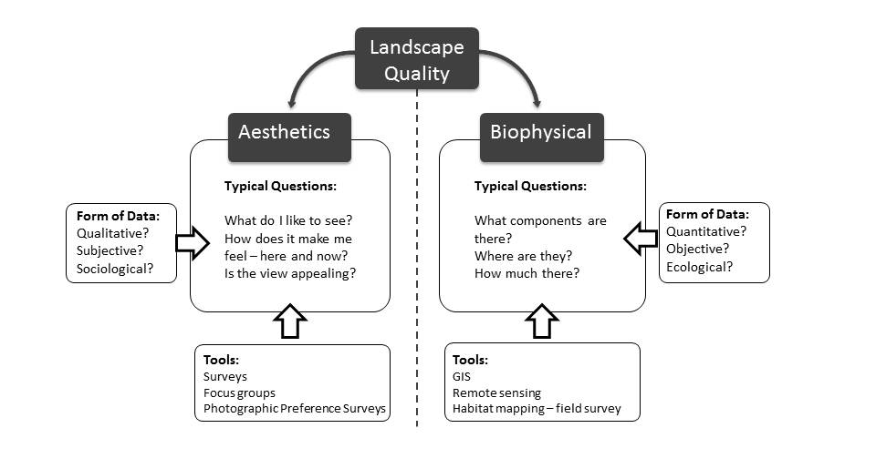
Figure 2: Large areas of Wales are mountainous (areas shaded in grey are >300m) and it has a varied and valued coastline. GMEP is designed to sample the full range of Welsh landscapes and the samples are situated across the entire country – the site locations are confidential but the map shows areas on a 5km grid which contain 1 or more of the 150 1km² survey sites.
Figure 3: The landscape envelope composed of eight 1km² cells surrounding the core study site, which provides context to the core 1km² sample sites.
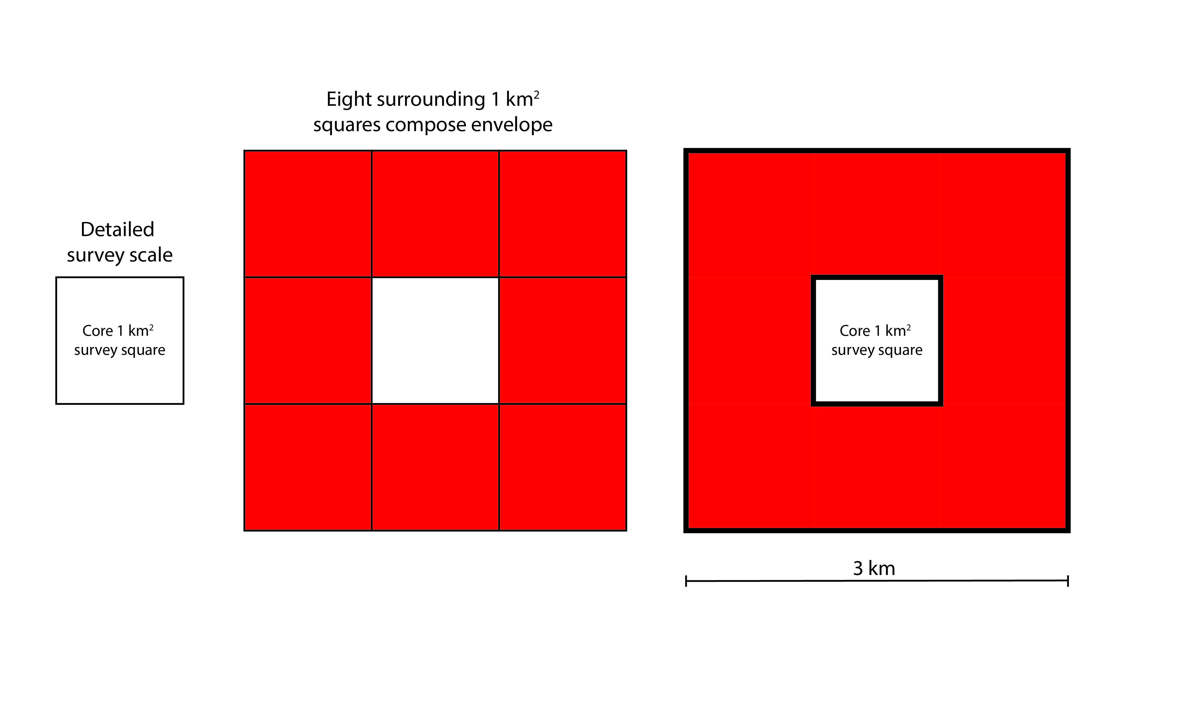

Figure 4: Three different scales of viewshed model developed with the concept of “borrowed view” in mind, wherein the background scenery is likely to have an influence on a person’s perception of the immediate landscape. ROW = Rights of Way.
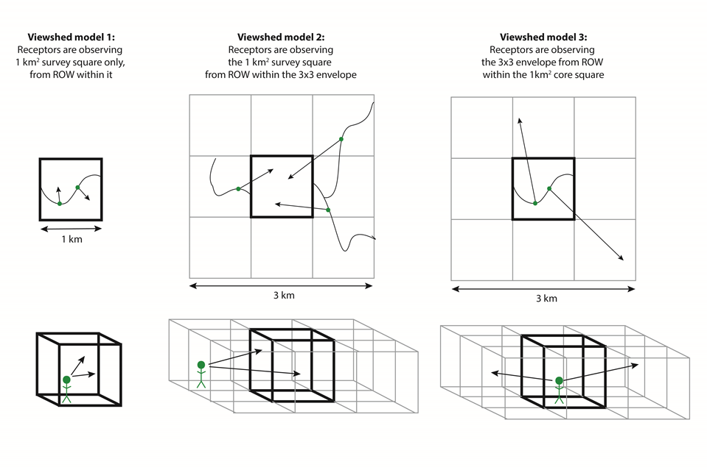

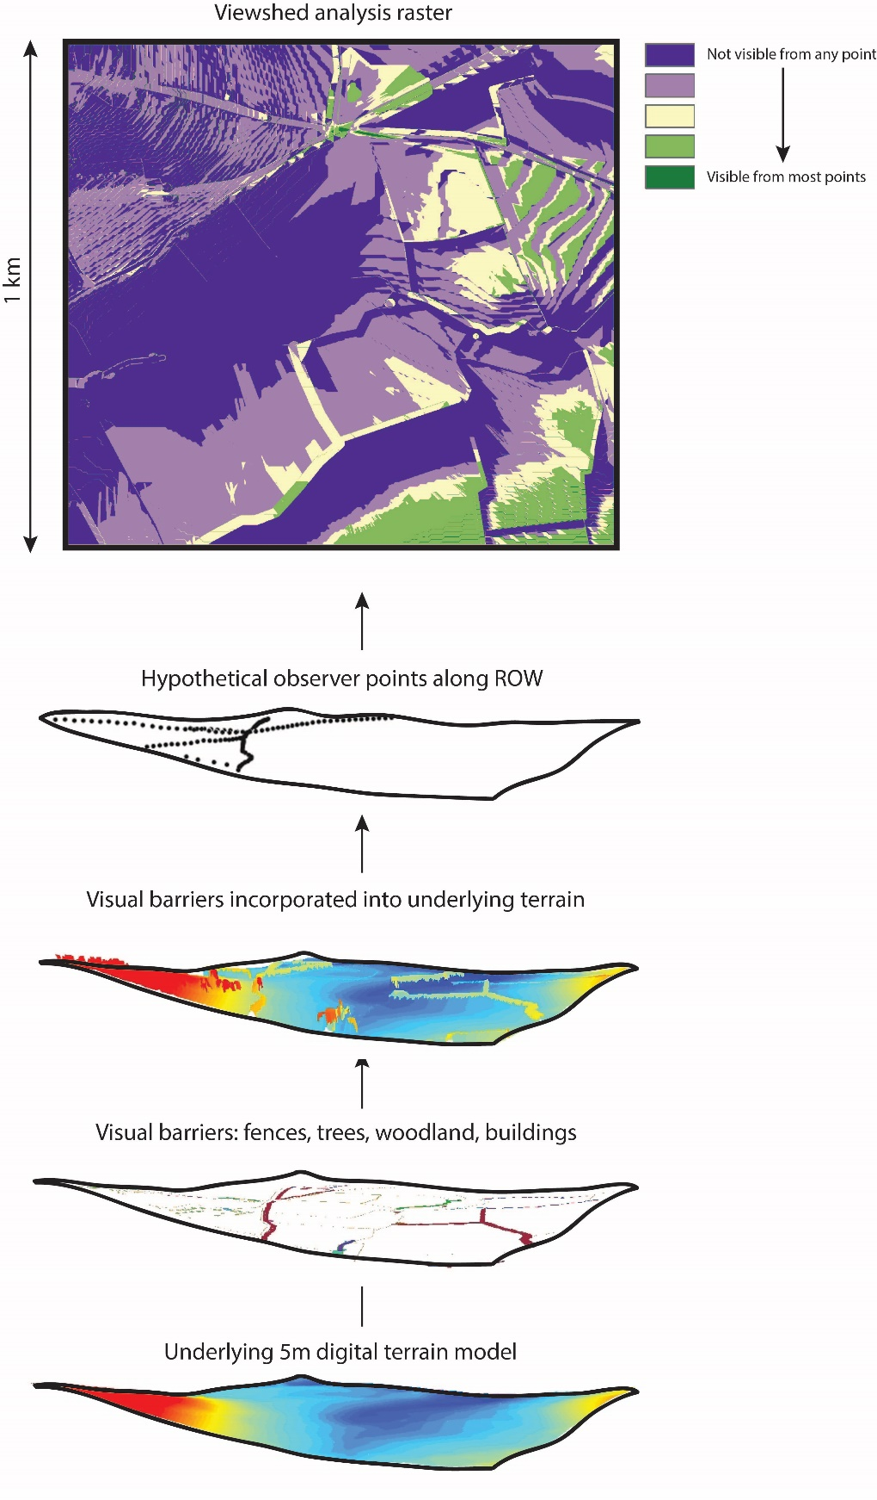
Figure 5: Visualisation of the inputs and the eventual output of the GMEP viewshed model.
Figure 6: Summary results of the GMEP Visual Quality Index (VQI) for 150 sites sampled across Wales with a median value = 0.459. The 1km² site locations are confidential; here they are mapped onto a 5km² grid to show the general trends, where more than one GMEP site was found within these larger areas, the highest VQI value was mapped. The three Welsh National Parks are shown for context.

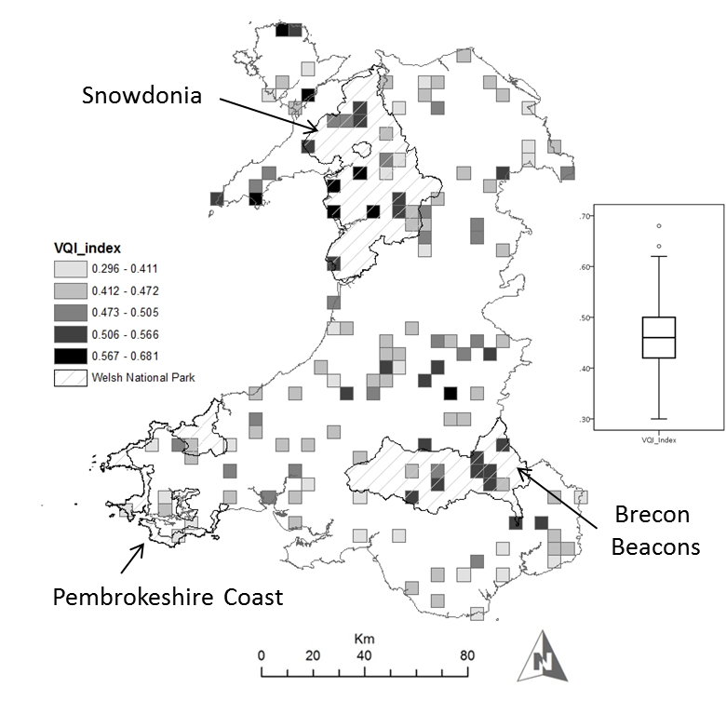

Figure 7: Sample outputs for one site, for all three perspectives: (a) – Zone of Visual Influence (ZVI) within the core 1km², (b) – ZVI across the 3x3km envelope from observer points within the 1km² only (looking OUT of the core site) and (c) – ZVI across the 1km² site from observer points within the 3x3km envelope only (looking IN to the core site).
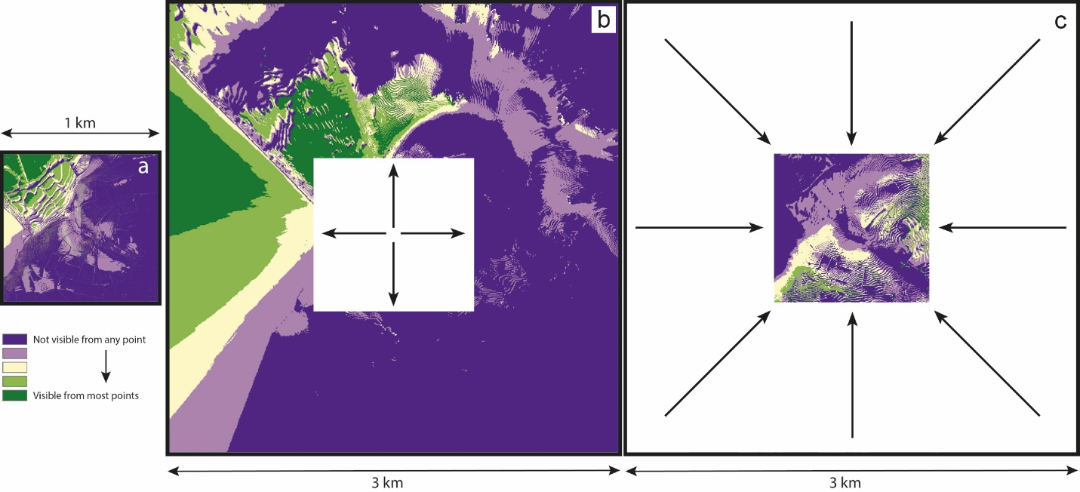

Figure 8: VQI for each of the 150 sites (x-axis, values can range from 0 – 1.0) plotted against the derived pedestrian Zone of Visual Influence of the core 1km² (y-axis expressed as a percentage of the total coverage of areas visible from at least one hypothetical observer point). Cluster analysis was applied and the plot symbols indicate group membership with the number of points and the % of the total in each cluster shown.
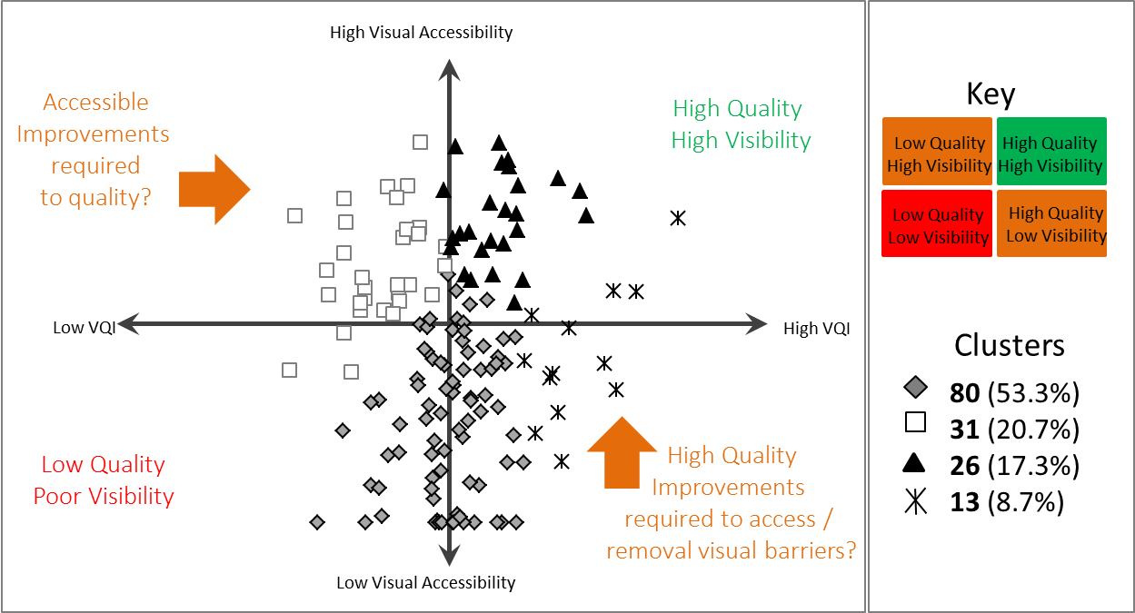

Table 1: Digital data sources used to generate the Visual Quality Index and the Zone of Visual Influence.
Type | Name | Resolution | Datatype | Description | Source
Terrain | NextMap DTM | 5m | Raster | High resolution terrain model | UK Ordnance Survey¹
Transport | Integrated Transport Network | 1:1250 | Vector | Detailed network of roads | UK Ordnance Survey
Access | UK Public Rights of Way Network (PROW) including all open-access land. | 1:1250 | Vector | Mapped network of all public footpaths, bridleways, byways and open access areas including beaches and common land | UK Ordnance Survey¹
Vegetation | GMEP field survey data (newly created by the monitoring programme) | 1:1250 | Vector | ArcGIS database of habitat, species, linear features, landscape photographs and historic condition surveys. | GMEP²
Vegetation | UK 2007 Land Cover Map | 20m | Vector | Land cover types provided habitat data for the surrounding 3 x 3km landscapes. | NERC Centre for Ecology & Hydrology³
Base mapping | Mastermap | 1:1250 | Vector | Detailed topological data | UK Ordnance Survey¹
Historic | Historic Environment Records | Approx 1: 10,000 | Vector | Polygon and point data indicating the type and location of historic / archaeological features. | Cadw and the Welsh Archaeological Trusts. ⁴
¹ Licenced from the UK Ordnance Survey, ²GMEP 1st Year Report (Emmett et al., 2014) ³ Morton et al., 2011 ⁴ Licensed to GMEP by Cadw.

Table 2: Parameters used within the GMEP Visual Quality Index and their impact on the overall index, further details of the classes are provided in Tables S1(physical), Table S2 (blue-space), Table S3 (green-space), Table S4(Human) and Table S5(Historic) provided in the Supplementary Materials.
Class | ID | Parameter | Description
Physical | 1 | Terrain Ruggedness Index¹ | Terrain Ruggedness was calculated using Riley et al., (1999). A 5m resolution Digital Terrain Model of the whole of Wales was processed using this method.
Blue space | 2 | Presence of waterfalls, wells, springs² | Areal extent of any water feature within the 1km² site was calculated from digital data and confirmed during the field survey. The cumulative length (m) of all flowing water in streams, rivers, canals was recorded.
 | 3 | Area of standing water²
 | 4 | Length of flowing water²
 | 5 | Presence of the coast²
Green space | 6 | Habitat richness ³ | The number of broad and priority habitats was mapped in the 1km² site during summer fieldwork. There are 23 broad habitats present in the UK (Jackson, 2000) and 65 priority habitats (JNCC, 2011).  In addition to mapping woodland, the GMEP field survey maps all individual trees present in fields or boundaries. A range of species sampling was undertaken to derive a full species list including: nested plots to provide a random sample of common vegetation types; targeted plots to sample priority habitats; unenclosed plots to sample broad habitats; boundary plots running adjacent to field boundaries full details are provided in Maskell et al., 2008 and Emmett et al.,2014.
 | 7 | Area of woodland³
 | 8 | Presence of single large trees³
 | 9 | Number of plant species³
 | 10 | Hedgerow Length³
 | 11 | Number of vegetation colours³
Human | 12 | Area of human-influenced land³ | Includes those land-uses which are demonstrably urban in form including: bare ground, campsites, car parks, dumps, garden centres, nurseries, any hard standing, horse paddocks, invasive vegetation, sports fields, railway tracks, static caravan parks, any industrial waste sites. Included in this category are conifer plantations and felled plantations. Built infrastructure which is dispersed and utilitarian such as electricity pylons, mobile phone masts and wind turbines is also included as well as quarries, sewage and water works. Road lengths were calculated from the integrated transport network for each 1km² site.
 | 13 | Number of spot utilities / quarries³
 | 14 | Building area²
 | 15 | Road length²
Historic | 16 | Dry-stone walls length³ | The length of dry stone walls was recorded by the GMEP field survey of each 1km² site. Scheduled Ancient Monuments, listed buildings and designated parks and gardens were extracted from spatial data provided via Cadw and Welsh Archaeological Trusts.
 | 17 | Presence of Scheduled Ancient Monuments²
 | 18 | Presence of designated historic parks or gardens²
 | 19 | Presence of listed buildings²
¹ Riley et al., 1999, ² Calculated directly from existing digital data, ³ Metric derived from GMEP field survey dataset

Table 3: Access levels for different users, as determined by the legal framework in Wales. Open access land tends to be extensive rough pasture or heathland and is common in parts of upland Wales.
Group | Open Access Land | Footpaths | Bridleways | Roads and tracks with public access excluding motorways | Motorways | Railways
Pedestrians | X | X | X | X
Cyclists |  |  | X | X
Small vehicles |  |  |  | X | X
Rail passengers |  |  |  |  |  | X

Table 4: Visibility at three scales for the 150 sites as calculated by the viewshed modelling. Note that rail lines were relatively rare in the rural landscapes of Wales, hence the low visibility scores throughout.
Landscape context | Visible Area (%) | Pedestrian |  | Cyclist |  | Small Vehicle |  | Rail
 |  | Count | % | Count | % | Count | % | Count | %
Within 1km² | Not Visible | 12 | 8.0 | 17 | 11.3 | 22 | 14.7 | 144 | 96.0
 | > 0 to 25 | 26 | 17.3 | 23 | 15.3 | 38 | 25.3 | 3 | 2.0
 | > 25 to 50 | 46 | 30.7 | 36 | 24.0 | 36 | 24.0 | 2 | 1.3
 | > 50 to 75 | 45 | 30.0 | 53 | 35.3 | 47 | 31.3 | 1 | 0.7
 | > 75 to 100 | 21 | 14.0 | 21 | 14.0 | 7 | 4.7 | 0 | 0.0
Looking out: surrounding 3km by 3km | Not Visible | 14 | 9.3 | 19 | 12.7 | 23 | 15.3 | 144 | 96.0
 | > 0 to 25 | 16 | 10.7 | 20 | 13.3 | 28 | 18.7 | 3 | 2.0
 | > 25 to 50 | 64 | 42.7 | 64 | 42.7 | 74 | 49.3 | 3 | 2.0
 | > 50 to 75 | 54 | 36.0 | 45 | 30.0 | 24 | 16.0 | 0 | 0.0
 | > 75 to 100 | 2 | 1.3 | 2 | 1.3 | 1 | 0.7 | 0 | 0.0
Looking in: from the surrounding 3km by 3km | Not Visible | 6 | 4.0 | 5 | 3.3 | 7 | 4.7 | 134 | 89.3
 | > 0 to 25 | 1 | 0.7 | 5 | 3.3 | 8 | 5.3 | 9 | 6.0
 | > 25 to 50 | 5 | 3.3 | 9 | 6.0 | 17 | 11.3 | 3 | 2.0
 | > 50 to 75 | 14 | 9.3 | 14 | 9.3 | 28 | 18.7 | 4 | 2.7
 | > 75 to 100 | 124 | 82.7 | 117 | 78.0 | 90 | 60.0 | 0 | 0.0

