Real Time Muscle Texture Morphing

Abstract

This paper presents a method for Real Time Muscle Texture Morphing utilizing the Unreal Developer Kit (UDK). The method applies wrinkle map technology to a torso; whereby multiple textures for tense and relaxed body poses are imported into the Unreal engine. The textures are blended using a skeletal control system, which animates UDK’s Scalar Material Options. The results show the system functions in real time (55.57 FPS) but has a 1.46 seconds / 2.62% decrease in FPS and a memory increase of 3.6MB / 5.91%.

Keywords: Rigging, Texturing, Shaders, UDK, Wrinkle Maps, Real Time Muscles

1 Introduction

Real time muscle creation takes two paths:

- The creation of muscle meshes to support a skinned mesh as shown by Yang (2006), Zhang (2006), Galda (2008) and
- The blending of textures for animation Oat (2007).

These solutions now feature in products such as 3D Studio Max (2012) and Puppetshop (2009).

This paper proposes that a real time texture blending system for a full body, such as in Fight Night Champion (2011), can be integrated into the Unreal Developer Kit (2009). Oat (2007) suggests that a texture blending system “involves compositing multiple wrinkle maps using a system of masks.” Real time texture blending has been integrated by developers such as Diamant (2008) in the AAA title Uncharted.

Real time texture blending technology remains homogeneous and relies on Material adjustment, as seen in the works of Diamant (2008), CryTek (2012), and OC3 Entertainment (2012).

Epic Games (2012) state a material is “an asset which controls the visual appearance of a scene”. Materials are broken into multiple “Material Expressions” which connect together with a Lighting Model to produce an assets appearance. Material Expressions are a useful tool for displaying muscle changes as they can be animated as shown by Erck (2010), this satisfies the requirement for muscles to change their form during body motion.

One approach to working with material expressions is shown by OC3 and Epic Games in OC3’s FaceFX System. Epic Games’ integration of the FaceFX product works with the material expression “Scalar Parameter”; shown in Figure 1.
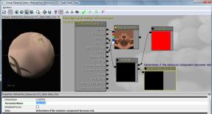
Figure 1 Unreal Material Editor and Scalar Parameters © 2012 Epic Games All rights reserved.

Scalar parameters adjust float / integer variables and are used in other systems such as the Wrinkle Maps in CryTek’s CryEngine (2012).

In Both Epic’s (2012) and CryTek’s (2012) facial animation systems the adjustment of Scalar parameters / material sliders are connected with blended normal maps. Cloward (2012) states the idea of a normal map is to “take all of the detail from the high poly model”. Artists such as Zuccarello (2011) use normal maps to define muscle volume and fine detail such as veins.

Normal map data such as Zuccarello’s (2011) requires a high polygon model. To create morphing normal maps, multiple high polygon assets are developed; an example of which can be seen in CryTek’s Head Models show on the CryTek Wiki (2012).

Faces produced by CryTek and FaceFX blend between a variety of exaggerated and relaxed expressions. This is also an important factor for full body systems, as limbs also need to go through a range of relaxed and tensed states.

FaceFX (2012) and CryTek (2012) already use morphing normal maps for facial expressions. An example of this technology applied to the muscles of the body can be found in titles such as Fight Night Champion, (2011). Fight Night’s muscle systems are not disclosed but the popping of the normal map is observable at run time. This paper takes the described normal mapping systems for facial blending of Epic Games (2012), CryTek (2012) and implements a full body approach in the Unreal Developer Kit.

2 Method

A driver was required to blend the varying normal maps. Two industry approaches are FaceFX technology, which uses uses audio clips; and lwarisl’s (2012) muscle morph targets, which are driven by polygon size. Neither of these approaches was appropriate because: -

- Torso muscle poses do not synch with audio clips.
- At the time of writing, polygon size cannot be exposed in the Unreal Developer Kit. This may be an option for full Unreal Engine licensees.

The chosen driver was bone rotations variables, such as pitch, roll and yaw. Rotation variables can be converted into a scalar parameter to blend textures, mirroring FaceFX (2012) and CryTek’s (2012) use of sliders. An example of the application is listed in the table below.

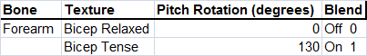
Figure 2 Possible Forearm rotations

The 2 two states shown are blended via a linear interpolate in UDK. At run time the game will work out the Blend by calculating rotation change such as:-

BlendAmount = (( MuscleUpperRotationThres - MuscleLowerRotationThres)-(ActualMuscleRotation - MuscleLowerRotationThres))/( MuscleUpperRotationThres - MuscleLowerRotationThres);

This equation has 2 aspects to note:-

- To calculate BlendAmount data from Unreal’s AnimTree and UScript need to be passed into the formula.
- In UDK, rotation is not automatically handled in degrees: the conversion is often handled by a constant Romero(2012) UnrRotToDeg = 0.00549316540360483;

To expose rotations, a custom Unreal Skeletal Controller was created as demonstrated by Cozmicaztaway (2010) and Epic Games (2012). A Skeletal Controller grants access to the rotation parameters and links in with Epic Games (2012) Animation Tree System. Animation Trees are useful as they provide a GUI for artists to customise settings. It is within this system that the parameters are setup to alter the blending materials. An example of the tree setup can be seen in Figure 3.

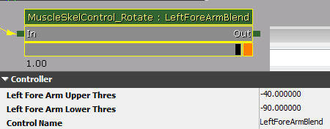

Figure 3 Animation Tree

With the rotations entered into an Animation Tree they then need to be connected to character motions In Game. There are 2 options to test the animation tree:

1) Place a Skeletal Mesh in a level and trigger the animations via Matinee as suggested by Busby, J, Parrish, Z, Wilson, J, (2010) or

2) script a custom game and implement the Skeletal Mesh as the player model; Cordone (2011). The second option was selected as it is then possible to test the Frames per Second Impact of full body player morphing.

The custom game code tied the Skeletal Control object and material functions with a Custom UDK Pawn. Examples of the Pawn’s functions are shown on the next page, illustrating the conversion and utilisation of Unreal Units into a parameter to drive the blending of a material.

The code framework aimed to expose as many variables as possible so that artists can customise the blends rather than leaving the system fully automated (samples are shown over the following pages.

Texture Break Down

The textures created for the project included diffuse, specular, masks and normal maps. An additional normal map was created which had pronounced veins to create the difference between relaxed and tensed muscle states. To control the blending of these states, a mask texture was developed that mirrored the functionality described by CryTek.

In this study, only two blending / morphing areas of the body were developed, the left and right arms. A large amount of wasted space is thus evident in the mask texture which would be unlikely in a full character solution.

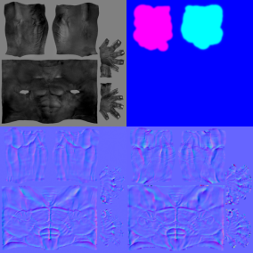

Figure 4 Specular, Mask, Normal Map, Wrinkle Normal Map

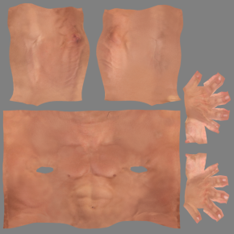

Figure 5: Diffuse Map

Material Break Down

To blend between the normal maps a Material Network of nodes was created. The network tied together the developed textures with the Scalar parameters calculated in the code. Figure 6 shows the Mask texture is connected to the RightForeArmBlend Scalar Parameter via a multiply. The mask is only ever activated once the correct value has been passed on via the code.

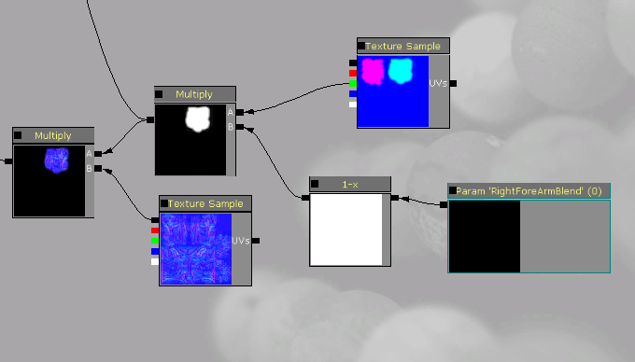

Figure 6 Right Forearm Blend

Each individual wrinkle map is added together in a chain before the wrinkle map is added to the whole model, as shown in Figure 7. The add expression allows for an unlimited amount of wrinkle map zones; the solution shown adds the left and right arm masked wrinkle map areas

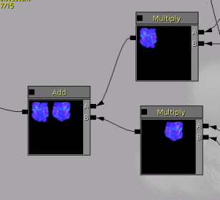

Figure 7 Combining Wrinkle map zones

The mask is useful for masking out the normal map underneath before combination; Figure 8 shows this.

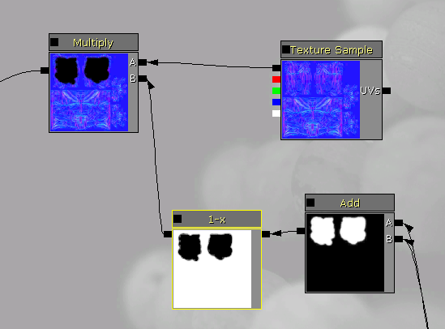

Figure 8 Masking out the standard normal map

This method replaces the default torso normal and adds in a new tense muscle map + veins.

The final combination of the maps is shown in Figure 9, both the masked original and combined morphing areas are added together to produce the final Normal Map result.

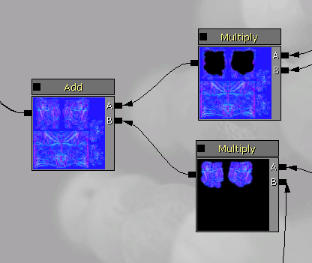

Figure 9 Adding the wrinkle map and standard normal map together

3 Results and Findings

To test the system 3 tests were devised: -

- Does the system work? For example, is the muscle change noticeable in the game engine?

- To what degree does the system impact on Frames per Second?

- Does the system alter the texture memory?

Test 1

The first test demonstrates the system working via in game video capture; this can seen at the following URL

http://www.youtube.com/watch?v=h8F9APJmkE8&feature=g-upl

Successful visual changes can be seen as a torso goes through various tense and relaxed poses that loop over time. The following major changes can be observed on the video clip as follows:

- At 1 second of play the left arm bicep goes into a tense state, here you can see the normal map blend showing veins. A relaxed pose can be seen at 7 seconds of play into the video showing an alternate map. Between these states the effect is blended using the rotation change algorithm.
- Both arms at 3 seconds of play show double front bicep tense where the normal map is altered and veins become more prominent.

Test 2

To measure the impact of the system on real time performance, a Matinee sequence was developed. In this sequence the following features were included: -

- Torso renders with and without the Wrinkle Normal Maps applied.
- A console log to capture the screen after 4 seconds of play.
- Frames per second rating.
- A Camera fly through to ensure the torso renders were the same.

Figure 11 shows the standard Normal Map animating and rendering at 57.03 FPS (Frames per second)
.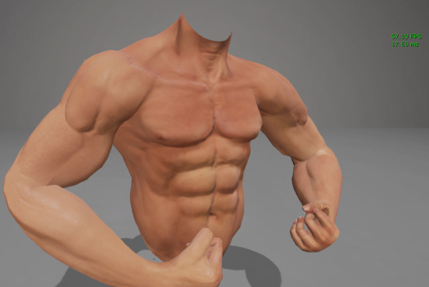

Figure 10 UDK No Wrinkle Map 57.03 FPS

Figure 11 shows the Wrinkle Map result rendering with the same animation at 55.57 FPS. The combination of the 2 Normal Map morphing areas has resulted in a drop in performance of 1.5 fps.

During Test 2 additional copies of the Wrinkle Map torso were also rendered to test the scalability of
the technique. It was found that the drop in FPS was about 1.5 FPS per additional torso.
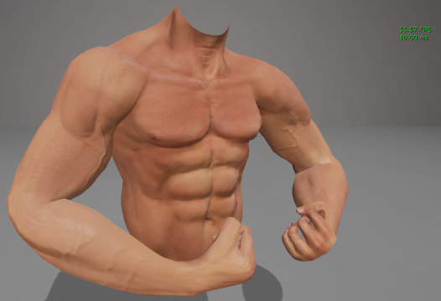
Figure 11 UDK Wrinkle Map 55.57 FPS

Test3

Test 3 evaluated how much additional memory the system used. The Wrinkle Map torso had an additional Normal Map and Mask when compared to the No Wrinkle Map Torso. The setup was the same as Test 2 but also evaluated the total scene memory, which was done by using the UDK command stat memory. Within the listed stats was texture memory, whilst this is a total value for the whole scene it is possible to compare this value as only the models were changed.

The no wrinkle map torso scene used 60.93MB as shown in Figure 12 whilst the wrinkle map torso used 64.53MB as seen in Figure 13. The difference then between the 2 systems is 3.6mb in this case.

All renders were captured on the following machine specification:

Macbook Pro
Intel Core i5 M540 @ 2.53 GHz
4GB Ram
NVidia 230M
Figure 12: UDK No Wrinkle Map Memory Reading 60.93MB

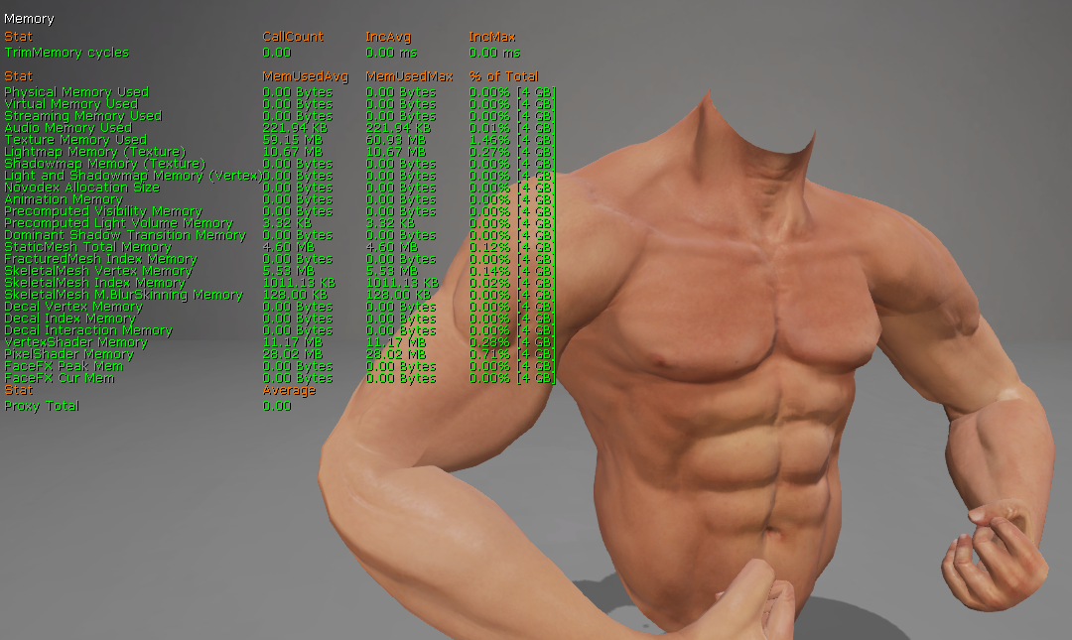
Figure 13: UDK Wrinkle Map Memory Reading 64.53mb

4 Conclusion

The system succeeds in its goal of real time muscle texture morphing in UDK. The solution provides controls for texture masking and animation tree customisation. It is not without its limitations, which are discussed below.

The code calls morphing blending every 10th of a second. Lowering the speed of the call makes the blending very visible. This requirement spread across further muscle groups could be a performance issue.

The driver of the muscle group morph in this paper was the bone rotation. Comparing performance against polygon tension / crunching algorithms RPM Manager (2012) & Kivistö Joni-Petteri lwarisl (2012) may provide a faster solution than bone rotation. The benefit bone rotation gives in comparison to crunching algorithms is that it provides 3 axis of rotation to track. The solution in this paper tracks one of these axis i.e. pitch / yaw, if all 3 axis were included it would allow for more potential blends but potentially lower FPS.

The blends themselves require texture memory; CryTek (2012) and Epic Games (2012) show ways of calculating 2 normal maps from one texture to reduce this requirement.

This paper has focused primarily on multiple normal maps, but other methods also exist for displacing and creating the illusion of detail. It would be interesting to test the DX 11 tessellation technology as shown by Mittring and Dudash (2012). Tessellation utilises only greyscale values, as described in Epic Games (2012), and thus may not suffer from the masking complication of combining maps that occurs with normal maps.

The memory comparison tests reported an increase of 3.6MB when the wrinkle map system was used. Applying the blending to more areas and on multiple characters will have a greater impact on memory. The significance of this impact on the memory, and the additional impact on the frames per second, both need to be tested in additional ways:

- Deployed on mainstream consoles such as an X-Box / PlayStation. The testing machine (MacBook Pro) has dissimilar hardware to most gaming machines/consoles;

- the system needs to be implemented on a complete character. Additional muscles zones will increase system requirements;

- Does the system scale? We discovered that rendering additional models reduced the FPS by 1.5 FPS. This does not prove scalability; just that the reduction is almost constant on the Macbook. It still remains unanswered what the FPS significance would be on several entire characters

Another technical consideration is skin rendering. CryEngine, UDK and Unity use
Sub Surface Scattering shaders to fake the filtering of light through the skin. The DX 11 version of UDK has an implementation of such as shader but it has not been integrated into this paper. Adding such shaders would help to give a more accurate reading of the performance cost of the morphing normal maps. Regardless of the technical constraints, is the change visible / beneficial to the game? Future work could test the effects of the morphing textures effects on players perception.

References

Autodesk. 2012. 3D Max Features. [ONLINE] Available at: http://www.usa.autodesk.com/3ds-max/features/. [Accessed 08 June 12].
Ben Mathis . 2011. Normal Map Generation. [ONLINE] Available at: http://www.poopinmymouth.com/tutorial/normal_workflow_3.htm. [Accessed 08 June 12].
Ben Cloward. 2011 Creating and Using Normal Maps. [Online] Available at: http://www.bencloward.com/tutorials_normal_maps1.shtml. [Accessed 08 June 12].
Busby, J, Parrish, Z, Wilson, J, 2010. Introduction to Level Design with Unreal Engine 3. 1st ed. USA: SAMS.
Cordone, R, 2011. Unreal Development Kit Game Programming with UnrealScript. 1st ed. UK: Packt.
Cozmicaztaway. 2010. Making a Skeletal Control to move an Arm. [ONLINE] Available at: http://udkc.info/index.php?title=Tutorials:Making_a_Skeletal_Control_to_move_an_Arm. [Accessed 08 June 12].
CryTek. 2012. Wrinkle Map Creation. [ONLINE] Available at: http://www.crydev.net/wiki/index.php?title=AssetCreation_WrinkleMapCreation&oldid=19264. [Accessed 08 June 12].
Diamant, R, (2008). Maya Integration and Use with Autodesk 3ds Max and Autodesk . In GDC. San Francisco, 2008. http://www.naughtydog.com: Naughty Dog. 1-44.
Electronic Arts. 2011 Fight Night Champion [DISC].
Epic Games 2007 Unreal Tournament 3 [DISC].
Epic Games. 2009 Unreal Developer Kit [DISC].
Epic Games . 2012. Feature List. [ONLINE] Available at: http://udk.com/features. [Accessed 08 June 12].
Epic Games, (2012), ParameterName1731 [ONLINE]. Available at: http://udn.epicgames.com/Three/rsrc/Three/UnrealSpecificFaceFXNodes/ParameterName1731.jpg [Accessed 08 June 12].
Epic Games. 2012. /Unreal Specific Face FX Nodes. [ONLINE] Available at: http://udn.epicgames.com/Three/UnrealSpecificFaceFXNodes.html. [Accessed 07/06/2012].
Epic Games. 2012. Using Skeletal Controller. [ONLINE] Available at: http://udn.epicgames.com/Three/UsingSkeletalControllers.html. [Accessed 08 June 12].
Epic Games. 2012. Using Skeletal Controller. [ONLINE] Available at: http://udn.epicgames.com/Three/TessellationDX11.html. [Accessed 08 June 12].
Eric Chadwick . 2012. Normal Maps. [ONLINE] Available at: http://wiki.polycount.com/NormalMap?action=show&redirect=Normal+Map. [Accessed 08 June 12].
Grant Adam. 2012. TensionMod. [ONLINE] Available at: http://rpmanager.com/plugins/TensionMod.htm. [Accessed 08 June 12].
Kivistö Joni-Petteri lwarisl. 2012. Realtime Muscle System Alpha Version. [ONLINE] Available at: http://www.blendswap.com/blends/game-engine/realtime-muscle-system-alpha-version/. [Accessed 08 June 12].
L. Dutreve and A. Meyer and S. Bouakaz . (2009). Real-Time Dynamic Wrinkles of Face for. ISVC '09 Proceedings of the 5th International Symposium on Advances in Visual Computing. 1 (2), Pages 25 - 34 .
Lumonix. 2012. PuppetShop. [ONLINE] Available at: http://lumonix.net/puppetshop.html. [Accessed 08 June 12].
Marcos Romero. 2012. Using Rotators in UnrealScript . [ONLINE] Available at: http://romerounrealscript.blogspot.co.uk/2012/01/using-rotators-in-unrealscript.html. [Accessed 09 June 12].
Mittring, M, Dudash, B, (2011). The Technology Behind the Direct X 11 Unreal Engine"Samaritan" Demo. In GDC. San Francisco, 2011. California : NVidia & Epic Games. 1-59.
Nick Zuccarello . 2011. Skeletal Mesh Examples. [ONLINE] Available at: http://sharecg.com/v/49629/view/3D-Model/UDK-HeavyDemon-Static/Skeletal-Mesh-Example-Files. [Accessed 08 June 12].
Oat.C, 2007. Real Time Wrinkle Maps. Siggraph 2007. San Diego Convention Center, USA 5-9 August 2007: USA: AMD.
OC3 Entertainment. 2012. FaceFx Documentation. [ONLINE] Available at: http://www.facefx.com/documentation/2012/W76. [Accessed 07/06/2012].
RPM Manager, 2012. OtherGear. [ONLINE] Available at: http://rpmanager.com/otherGear.htm#tension [Accessed 07/06/2012]
TJ, Galda , 2008. Advanced Character Rigging: Creating Advanced Tendon and Muscle Systems. 1st ed. USA: Lulu.
Ueno, H, (2010). The Next Generation of Fighting Games: Physics & Animation in UFC 2009 Undisputed. GDC . San Francisco, California, 2010. San Francisco, California: THQ. 0-48.
Unreal VFX - Material Transitions, 2009. [DVD] Bryan Erck , USA: Eat3D .
Yang, X. and Zhang, J. J. 2006. Automatic muscle generation for character skin deformation. COMPUTER ANIMATION AND VIRTUAL WORLDS, 17, 293–303.

UDK Code Samples

Sample Code from the Muscle Pawn Class

var MaterialInstanceConstant MatInst;
var MuscleSkelControl_Rotate LeftForeArm;
var bool createdMic;

//Here a custom function RunMuscles is called, this is where our blending begins.
simulated event PostBeginPlay()
{
super.PostBeginPlay();
SpawnDefaultController();
RunMuscles();
}
//PostInitAnimTree sets up any muscle controllers you are using this list can get quite long. labelling the anim tree controllers with the names of your bones in your character rig can make things easier.
simulated event PostInitAnimTree(SkeletalMeshComponent SkelComp)
{
if (SkelComp == Mesh)
{
LeftForeArm = MuscleSkelControl_Rotate( mesh.FindSkelControl('LeftForeArmController') );
}
}
//this is an executable function which can be triggered by the console to run the muscle blend every 0.5 seconds. This is currently called from PostBeginPlay.
exec function RunMuscles()
{
//QuatTest is a function in class MuscleSkelControl_Rotate used to measure the rotaton of the bones
LeftForeArm.QuatTest(self);
setTimer(0.1, true, 'RunMuscles');
}

// Update materials creates a MIC based on the meshes applied material. The meshes material is then altered based on a float "blendamount" this is calculated in the MuscleSkelControl_Rotate class.
function UpdateMaterials(float blendamount)
{
if (createdMic == false)
{
MatInst = new(None) Class'MaterialInstanceConstant';
MatInst.SetParent(Mesh.GetMaterial(0));
Mesh.SetMaterial(0, MatInst);
createdMic = true;
}
//the first parameter here selects the scalar parameter to modifiy
MatInst.SetScalarParameterValue('LeftForeArmBlend', blendamount);
}

Sample Code from the MuscleSkelControl_Rotate Class

var SkeletalMeshComponent BonesMesh;
//set 2 float variables for every bone rotation you want to use, in this case just the Left Forearm is setup
var(Controller) float LeftForeArmUpperThres, LeftForeArmLowerThres;;

exec function QuatTest(pawn defaultpawn)
{
local rotator bonerotator;
local float bonerotatortodegrees;
local MusclesPawn MP;
local float ForearmMuscleScalarBlend;

bonerotator = QuatToRotator( defaultpawn.mesh.GetBoneQuaternion(' LeftForeArmController ') );
bonerotatortodegrees = bonerotator.Pitch * UnrRotToDeg;

// calculate the percentage of the current rotation against the range
ForearmMuscleScalarBlend = (( LeftForeArmUpperThres - LeftForeArmLowerThres)-(bonerotatortodegrees - LeftForeArmLowerThres))/(LeftForeArmUpperThres - LeftForeArmLowerThres);

// cast back to pawn to change materials, potentially could also do that in this class
MP = MusclesPawn(defaultpawn);
MP.UpdateMaterials(ForearmMuscleScalarBlend);
// an additional float could be added to this section to designate which are to blend textures for i.e. 0 = neck, 1 = back
// thus the line could look like MP.UpdateMaterials(0,ForearmMuscleScalarBlend);
}

defaultproperties
{
LeftForeArmUpperThres=0
LeftForeArmLowerThres=0
bApplyTranslation=false
bApplyRotation=true
bAddRotation=true
BoneRotationSpace=BCS_BoneSpace
}

