- Title page:
A simulation of the viscoelastic behaviour of heel pad during weight-bearing activities of daily living

Authors: Sara Behforootan^{(*)}, Panagiotis E. Chatzistergos, Nachiappan Chockalingam and Roozbeh Naemi

School of Life Sciences and Education, Staffordshire University, Stoke-on-Trent, UK

*Corresponding Author
Sara Behforootan
School of Life Sciences and Education
Staffordshire University
Leek Road, Stoke on Trent,
ST4 2DF, UK
Email: sara.behforootan@research.staffs.ac.uk; sara.behforootan@gmail.com

- Abstract:
Internal strain is known to be one of the contributors to plantar soft tissue damage. However, due to challenges related to measurement techniques, there is a paucity of research investigating the strain within the plantar soft tissue during daily weight-bearing activities. Therefore, the main aim of this study was to develop a non-invasive method for predicting heel pad strain during loading. An ultrasound indentation technique along with a mathematical model was employed to calculate visco-hyperelastic structural coefficients from the results of cyclic-dynamic indentation and stress-relaxation tests. Subject-specific structural coefficients of heel pads were calculated from twenty participants along with the assessment of plantar pressure. The average difference between predicted and the measured force during the cyclic-dynamic indentation test was 5.8%. The predicted strain was 16% different when compared to the results from validated FE model while on average this was 14% different than the measured strain during walking. No statistically significant correlation was observed between maximum strain and peak plantar pressure during walking; indicating that predicting strain along with plantar pressure can improve our understanding of the mechanical behaviour of the plantar soft tissue.

Keywords: diabetic foot, soft tissue, plantar pressure, ultrasound indentation, strain, mathematical method, ultrasonography, mathematical computing, soft tissue injury
- Introduction:
Diabetic foot ulceration is a result of an inherent failure within the soft tissue that presents itself as a disintegration of the skin and deep soft tissue that can lead to an unhealed wound and even to amputation. Indeed, diabetic foot disease is the main cause of non-traumatic amputations worldwide⁵.

Some studies indicate that diabetic neuropathic foot ulcers begin internally and progress to the skin surface^{1,12,15,16,34}. Different mechanisms for tissue damage have been suggested as contributors to ulceration, including increased peak plantar pressure¹³, excessive stress or strain^{15,16,32,33}, excessive shear forces and stretching of the skin¹¹ and elevated intercellular calcium due to the high strain-rate of loading²². Although ulceration is clearly multifactorial¹⁰, the exact role and interplay of the aforementioned biomechanical parameters are not yet fully understood.

The measurement of plantar pressure is the most commonly used method for assessing and monitoring the biomechanics of the diabetic foot disease¹⁰. This is mainly due to the availability and relatively low cost of sensors and associated techniques for the measurement of plantar pressure (bare-foot and in-shoe). This has resulted in abundance of studies investigating the role of increased plantar pressure on ulceration and ulceration risk^{4,10,23}. However, several studies indicate that, the measurement of plantar pressure on its own is not sufficient for predicting or preventing foot ulcers, especially in cases where the damage starts deep in the tissue²⁷.
In the case of pressure ulcers, tissue strain is among the most important factors for tissue damage²⁴. In addition patient specific thresholds exist which when exceeded, trauma and ulceration occurs^{24,25}. Whilst foot ulcers are inherently different from pressure ulcers, similar biomechanical mechanisms may contribute to both types of ulcers. However, the lack of commercially available measurement tools for tissue strain significantly limits our ability to study its role in the formation of ulcers and to investigate the existence of similar strain thresholds for tissue damage.

Apart from a better understanding of the aetiology of ulceration, the discovery of strain thresholds for tissue damage in the soft tissues of the sole of the foot would pave the way for new and potentially more effective methods for ulcer prevention. However, in this case, a real time measurement of plantar soft tissue strain would be needed in order to warn and protect people with diabetic foot disease against overloading and trauma.

In contrast to plantar pressure, the in vivo measurement of internal tissue strain or strain-rate is very challenging; which leaves strain among the least investigated biomechanical parameters that are associated with ulceration. Indeed, the direct in-vivo measurement of plantar soft tissue strain involves the use of medical imaging which makes the whole process expensive and very difficult to implement^{17,37}.

In order to overcome the challenges associated with the use of medical imaging Yarnitzky et al.³⁶ and Atlas et al.¹ used modelling to infer in-vivo tissue strains and stresses from measurements of plantar loading. In the aforementioned studies, the mechanical behaviour of plantar soft tissue was simulated as linearly elastic; where its visco-hyperelastic (nonlinear-time-dependent) nature was ignored. This simplification could significantly affect the reliability of the calculated strains. Moreover, a number of studies have highlighted the importance of simulating the time-dependent aspect of the mechanical behaviour of plantar soft tissue^{28,31}.

It has been previously established that the non-time-dependent mechanical behaviour of the plantar soft tissue can be investigated based on quasi-static testing^{6,9,14}, where the viscoelastic behaviour of the tissue is minimised in low speed loading. However, the quasi-static test is relatively long and can potentially be harmful due to maintaining high strain for long periods of time. In order to overcome the difficulties of quasi-static testing, it was previously hypothesised that the mechanical response of plantar soft tissue to quasi-static loading can be inferred from the results of dynamic cyclic testing²⁸. Being able to assess both the time-dependent and non-time-dependent behaviour of tissues is particularly important for the quantitative assessment of the tissues mechanical properties using techniques such as finite element analysis^{2,6,14}.

While Finite Element (FE) inverse engineering is a well-established method for characterising the mechanical properties of the plantar soft tissue^{2,6,14}, it can be labour intensive and computationally expensive³. Furthermore, even with the rapid increase in the available computational power, FE-based methods cannot provide real-time estimations of internal strain.

Considering the lack of accurate and clinical applicable technique for measuring real-time strain, the aim of this study was to develop a method for the real-time calculation of plantar soft tissue strain during weight bearing activities of daily living without the need for lengthy in-vivo testing or labour intensive modelling techniques.

- Materials and methods:
4-1- In-vivo testing:
Twenty healthy right-foot-dominant participants (10 male, 10 female) with average (±stdev) age and body mass of 36(±11) years and 65kg(±13kg), respectively, were recruited for this study. Ethical approval was sought and granted by the University ethics committee and all participants provided full informed consent prior to any testing.

To quantify the mechanical properties of the heel pad, a motorised ultrasound indentation device was used to perform dynamic/quasi-static indentation and stress-relaxation tests^{2,6,7}. This custom device comprises a linear array ultrasound probe (LA523E, Esaote, Italy) in series with a loadcell (Zemic loadcell, L6E, C3). The device contains an actuator and a controller for programmable linear movement in one direction. During testing, the applied force and displacement of the indenter were recorded at 100Hz by the indentation device while b-mode ultrasound images were recorded at 27Hz by a clinical ultrasound unit (Esaote, Mylab25). The device was utilised to perform quasi-static, dynamic and stress-relaxation tests on the apex of the calcaneus.

Before testing, the participant’s foot was fixed on the device and the probe was positioned and centred at the calcaneal tuberosity to image the frontal plane (Figure1A). Then, the probe was pulled backwards to identify the point of first contact between ultrasound probe and the heel and to measure initial heel pad thickness.

After the end of testing, the deformation of heel pad at each frame of the recorded video was measured from the ultrasound images using video analysis software (Kinovea, www.kinovea.org) (Figure1B,C). After synchronisation, the recorded forces and measured heel pad deformations were used to plot the force-deformation graph of the indentation test.

Dynamic indentation tests were performed to a subject specific target-load, equal to the net force applied to an area equal to the footprint-area of the ultrasound probe that was measured in a preliminary plantar pressure measurements using a pressure mat (Matscan Walkway, Tekscan, Boston, MA, US-sampling at 100 Hz) during 3 independent trials of standing still for 10 sec² (Table1). In dynamic testing, thirty load/unload cycles were performed in total to the subject specific target-force with displacement-rate equal to 21 mm/s. The first 27 cycles were used for preconditioning to minimise the effect of loading history and the last three were utilised to calculate an average force-deformation graph of the indentation test ².

In the stress relaxation test, 27 load/unload were performed on the apex of the calcaneus as preconditioning cycles that followed by a sudden compression (approximately 0.2 sec of sudden loading) to 50% deformation²⁶ target with displacement-rate equal to 41.6mm/s (Table1). Probe position was kept constant for one minute while force was recorded at 100Hz.

Dynamic indentation and stress-relaxation were performed on both the left and right heels of all participants. In addition, a quasi-static indentation was also performed on the left heel of five participants with a view to test the hypothesis that the force-deformation graph during quasi-static indentation can be approximated by averaging the loading and unloading segments of the dynamic indentation test²⁸. Quasi-static testing was performed with loading-rate equal to 0.052 mm/s to the same measured subject specific target-force and according to the same preconditioning routine used for the dynamic indentation² (Table1). Once completed, the actual and approximated quasi-static force-normalised deformation graphs were compared and the significance of their differences was assessed using a paired samples t-test (significance was set at p<0.05).

4-2- Visco-elasticity modelling:
Simulations of the heel pad has been reported within the literature²¹ using the standard solid model (SSM) where the time-dependent structural properties have been assumed to be independent from non-time-dependent structural properties²¹. The SSM compromises a linear spring (E₁) that represents non-time-dependent structural behaviour, in parallel with a linear spring that is in series with a damper (Maxwell model) which represents time-dependent structural behaviour.
The differential equation for the SSM is as follows:
$\frac{dƐ(t)}{dt}={(E_{1}+E_{2})}^{-1}[\frac{dσ\left(t\right)}{dt}+\frac{E_{2}}{ƞ}σ\left(t\right)-\frac{E_{1}E_{2}}{ƞ}Ɛ\left(t\right)]$ (eq.1)
where dƐ(t)/dt is strain-rate, Ɛ(t) is strain, E₁ and E₂ is the stiffness of linear springs and ƞ is the damping coefficient. dσ(t)/dt is stress-rate, σ(t) is stress where stress is normalised force over total contact area.
$σ=\frac{F}{A}$ (eq.2)
where 𝝈 is the average stress, F is the applied force to the probe print area and A is the foot print area of the probe.
The use of only linear springs in SSM means that this model does not account for the hyperelastic behaviour of the tissue. To address this limitation, SSM was modified by replacing the linear spring that simulates non-time-dependent behaviour with a non-linear one (Figure2)²⁸.
The differential equation for the modified standard solid model (MSSM) is as follows:
$\frac{dƐ(t)}{dt}={(E_{N}(ε)+E_{L})}^{-1}[\frac{dσ\left(t\right)}{dt}+\frac{E_{L}}{ƞ}σ\left(t\right)-\frac{E_{N}\left(ε\right)E_{L}}{ƞ}Ɛ\left(t\right)]$ (eq.3)
where E_{N}(ε) is the stiffness (strain-dependent) of the non-linear spring that describes the tissue’s non-time-dependent behaviour. E_{L} and ƞ (constants) is the stiffness and damping coefficient respectively, that define the tissue’s time-dependent behaviour.
The stiffness of the non-linear spring is defined as follows:
$E_{N}(ε)=aƐ^{b-1}$ (eq.4)
where Ɛ is the value of strain and a and b are the spring coefficients. Changes in the value of coefficient a affects the overall stiffness of the spring while changes in b affects its strain stiffening behaviour.

4-2-1- Simulation of non-time-dependent behaviour
During quasi-static loading, the loading speed is so small that it can be considered to be equal to zero, therefore the applied stress to the damper and as a result, the applied stress to the Maxwell model (The linear spring- E_{L} and linear damper-η in series) will tend to be zero. Thus, the average stress in quasi-static testing can be simplified as follow:
${σ\left(ε\right)}_{quasi-static}=aε^{b}$ (eq.5)
where σ(ε)_{quasi-static} represents the average stress due to the nonlinear-elastic behaviour of the tissue, ε represents the strain and a and b are nonlinear-elastic coefficients. The abovementioned equation was fitted to the experimental stress-strain data during quasi-static testing to calculate a and b.
In all cases the aforementioned coefficients (a and b) were calculated based on the approximated quasi-static force deformation graph (i.e. the average of loading and unloading of dynamic indentation). However, for the first five participants, where results from quasi-static testing were also available, coefficients a and b were also calculated based on the actual quasi-static force deformation graph.

4-2-2- Simulation of time-dependent behaviour
In order to calculate the coefficients of the Maxwell model, the stress-relaxation test was utilised. During stress-relaxation test, the sudden application of deformation renders the damper completely rigid and deforms both springs in the MSSM (Figure2). After that, deformation is kept constant (equal in the two parallel segments of the model) as the resistance of the damper gradually drops. Damper stress tends to saturate and to decrease to zero over time, completely offloading the linear spring E_{L} (Figure2). Thus, the remaining stress after the saturation is exclusively carried by the nonlinear spring E_{N}. On the other hand, the decrease in the stress from the beginning of the stress-relaxation test to where the stress reaches saturation is equal to the applied stress to the Maxwell model. More specifically, the applied stress to the model is the sum of the applied stress to the nonlinear spring and Maxwell model. The applied stress to the Maxwell model in stress-relaxation test is saturated over time as a result of the damper property, whereas the applied force in nonlinear spring stays constant during the test. Therefore, the stress after saturation represents the applied stress to the nonlinear spring, whereas the decrease in stress from the beginning of the test up to saturation represents the applied stress to the Maxwell model. Thus, the applied stress during stress-relaxation test can be represented by the following equation:
${σ\left(t,Ɛ\right)}_{Stress-relaxation}=a{Ɛ_{0}}^{b}+Ɛ_{0}E_{L}\exp^{\frac{{-E}_{L}}{ƞ}t}$ (eq.6)
where σ(t,ϵ)_{stress-relaxation} represents relaxation stress during the time, a and b are elastic coefficients, Ɛ₀ represents strain during stress-relaxation, t represents time and $E_{L}$ and ƞ are the linear elastic and viscous coefficients and show the time-dependent behaviour of the plantar soft tissue. Thus, a parametric curve represented by the aforementioned equation was fitted to the stress-relaxation data to extract the values of constants E_{L} and ƞ of the Maxwell model.

Three measures of goodness-of-fit were calculated to find the best set of coefficients for each curve, namely: Sum of Square due to Error (SSE), Coefficient of determination (R²) and Root Mean Squared Error (RMSE) (Curve Fitting Toolbox, Matlab, Mathworks Inc., USA. 2014). More specifically, an SSE or RMSE value closer to zero indicates better fit while better fit is indicated by R² values closer to 1.

4-2-3- The strain in mid-stance phase of gait:
The MSSM was used to predict strain under the apex of the calcaneus during the mid-stance phase of gait. The mid-stance phase of gait was assumed from the start of loading on the area equivalent to the probe-print area under the apex of the calcaneus up to the point in time when this area is completely off-loaded. The measured force (Matscan Walkway, Tekscan, Boston, MA, US), along with the calculated structural coefficients were utilised to predict strain in mid-stance phase of walking. The behaviour of nonlinear spring between consecutive instances (time interval =0.01sec), was assumed to be linear to solve the general differential equation for constant stress-rate. The force-rate was assumed to be constant in each instance and the stiffness of the nonlinear spring (i.e. E_{N}) was calculated from eq.4 using the strain from the previous instance that happened 0.01 sec earlier. Thus, the strain of the heel pad under the apex of the calcaneus can be calculated as follow:
${Ɛ\left(σ,t\right)}_{Mid-stance}=\frac{σ}{E_{N}(ε)}-\frac{ƞ\dot{σ}}{{E_{N}(ε)}^{2}}(1-\exp\left(-\frac{E_{N}(ε)E_{L}}{ƞ(E_{N}(ε)+E_{L})}t\right))$ (eq.7)
Where Ɛ(F,t)_{Mid-stance} is the strain function, σ is the applied stress in mid-stance phase of gait over the probe area, E_{N}(ε) is the stiffness of the nonlinear spring for the instantaneous heel pad strain, E_{L} and ƞ are the constants of the MSSM, $\dot{σ}$ is the stress-rate in each instance and t indicates the time of loading. The measured values as well as the calculated coefficients were used in order to calculate the strain value under the apex of the calcaneus.

4-3- Validation:
4-3-1- In-situ validation:
The MSSM with subject specific structural coefficients that were calculated from quasi-static indentation and stress-relaxation tests was used to simulate dynamic indentation for the first five participants. This preliminary validation was performed to confirm the accuracy of the MSSM to predict tissue deformations.

During dynamic testing, the strain-rate remained constant. This enabled the calculation of the total reaction stress of the model as follows:
${σ\left(ε,t\right)}_{Cyclic-test}=aε^{b}+η\dot{ε}(1-\exp\left(-\frac{E_{L}}{η}t\right))$ (eq.8)
where σ(ε,t)_{Cyclic-test} is the applied stress to the MSSM, η, E_{L}, a and b are the subject-specific coefficients of the MSSM, Ɛ represents strain, ε• is constant strain-rate during loading and unloading and t represents time.

The calculated time-dependent and non-time-dependent coefficients that were calculated from stress-relaxation and quasi-static tests were used to predict the reaction force of the heel pad during dynamic testing. Finally, the numerically predicted reaction forces were compared against the experimentally measured values and their percent error was calculated.

4-3-2- In-vivo validation
In the third validation test, the predicted strains of the heel pad for mid-stance were compared against the in-vivo measured ones. The actual strain of the plantar soft tissue during mid-stance phase of gait was measured using a 14 camera opto-electronic motion capture system (sampling at 100Hz; Vicon, OMG, UK) for all twenty participants. Reflective markers were attached on the sustentaculum tali and Fibular trochlea bony prominences and the changes in the markers’ positions were followed in during the mid-stance phase of walking were followed. The applied force to the foot was measured using a pressure measurement system (Tekscan Walkway, Tekscan Inc., USA), which was synchronised with the motion capture system. The pressure measurement helped to identify the initial contact of the probe print area of the heel and the initial position of the markers. Furthermore, the changes in the average position of the markers in the direction of loading was measured and the calculated value was divided by the unloaded tissue thickness of each participant.
The measured strain using the abovementioned method was compared against the calculated one from eq.7.
2.4 Statistical analyses:
Pearson correlation analyses were performed to investigate the association between the extracted parameters (a, b, E_{L}, η), the maximum calculated strain and the measured peak plantar pressure. Preliminary analyses were performed to ensure the assumptions of normality, linearity and homoscedasticity are not violated. In case of violation of the normality assumption, a non-linear transformation (natural logarithm) of the data was used instead.

5- Results:
5-1- In-vivo testing:
The average force-deformation graphs of loading and unloading in cyclic dynamic tests on the left foot of five participants showed good fit against force-deformation data from quasi-static test from the same participants (Figure3). A paired-samples t-test was performed to compare the quasi-static test to the average of the cyclic dynamic test; this revealed that there was no significant difference between the results from the two methods (Figure4).

5-2- Visco-elasticity modelling:
The calculated coefficients of the MSSM and the predicted strain under the apex of the calcaneus over probe footprint area are presented for all twenty participants in Table2.
A paired samples t-test indicated that the coefficients a and b for the non-linear spring that were calculated based on dynamic indentation and quasi-static testing were not statistically significant (t(4)=-1.000, p=0.374 (two-tailed) and t(4)=-0.754, p=0.493 (two-tailed) for a and b respectively). More specifically, the average (±stdev) value of a was calculated to be equal to 1.361 (±0.543) and 1.718 (±0.707) based on dynamic indentation (loading/unloading) and quasi-static testing, respectively. In the case of coefficient b, the average (±stdev) value that was calculated based on dynamic indentation and quasi-static testing was 2.82 (±0.68) and 2.96 (±0.62), respectively.

5-3- Validation:
5-3-1- In-situ validation:
The average absolute difference between the in-situ measured forces and the numerically calculated ones (using the MSSM) for maximum deformation of dynamic indentation was 5.8%±3.1%.

5-3-2- In-vivo validation:
The average of the measured maximum heel pad strain in mid-stance phase of gait was 0.56%±0.13% on the left foot and 0.59%±0.11% on the right foot. The average of the calculated strain was 0.61±0.12 on the left foot and 0.63±0.13 on the right foot. Data from seven participants were not included within the data reduction and analysis procedures due to issues relating to the missing markers. Therefore, the calculated strain was compared against experimental strain for thirteen participants. The average of differences between the measured and predicted strain values were 14.0%±9.2% on left foot and was 14.4%±10.3% on right foot. To be specific, the minimum difference between the measured and predicted strain was 1%; whereas the maximum difference between them was 39%. It needs to be highlighted that motion capture was only used for validation purposes and the aforementioned technical issue with the visibility of the markers does not affect any possible future use of the developed system.

5-4- Statistical analysis:
Preliminary analyses indicated that parameters a, b, E_{N} and ƞ were not normally distributed and therefore a natural log transformation was used for these results. Pearson correlation analysis indicated that maximum strain under the apex of the calcaneus in mid-stance phase of walking was strongly negatively correlated with the thickness of the unloaded heel pad for the left foot (r=-0.784, n=20, p<0.0005). There was a strong, negative correlation between calculated maximum strain and stiffness (natural logarithm) of the nonlinear spring (a), for the left foot (r=-0.617, n=20, p=0.004) and for the right foot (r=-0.691, n=20, p=0.001). Furthermore, there was a positive correlation between the calculated maximum strain and of strain stiffening value (natural logarithm) of the nonlinear spring (b), for the left foot (r=0.491, n=20, p=0.028). The maximum strain was also negatively correlated to the stiffness of the spring (natural logarithm) of the Maxwell model for the left foot (r=-0.598, n= 20, p=0.005).
Peak plantar pressure was not correlated to the maximum calculated strain on either foot. However, the peak plantar pressure during standing was correlated to the damper capacity (natural logarithm) of the Maxwell model (r=0.495, n=20, p=0.026) and with the stiffness of the spring (natural logarithm) in Maxwell model (r=0.525, n=20, p=0.018) for the left foot. Moreover, the peak plantar pressure during standing was correlated (r=0.460, n=20, p=0.042) with the stiffness (a) of the nonlinear spring (natural logarithm) on right foot. Additionally, the peak plantar pressure on the heel region during walking is strongly correlated (r=0.537, n=20, p=0.015) with the capacity of the damper (natural logarithm) on the right foot.

- Discussion:
The importance of studying in-vivo strain and strain-rate in the plantar soft tissues of people with diabetic foot disease has been highlighted by studies linking strain/strain-rate to ulceration^{22,32,33}. However, the actual role of tissue strain/strain-rate in diabetic foot ulceration is not yet fully understood. This is mainly due to the lack of reliable and easy to use methods to measure tissue strain in-vivo. Although a number of methods are available to directly measure in-vivo strain, these methods are based on the use of medical imaging such as fluoroscopy¹⁷ or ultrasound³⁷ which makes the whole process expensive and difficult to implement, especially outside the research domain. Therefore, the current study aims to facilitate the real-time calculation and monitoring of strain/strain-rate of the heel pad during weight-bearing activities of daily living.

The new method that is presented in this paper is based on the use of a spring-damper model of the heel that takes into account the non-linear and time-dependent nature of the mechanical behaviour of its soft tissues. This structural model of the heel is calibrated based on non-invasive in-vivo tests and enables the real-time calculation of the heel pad's strain based on plantar pressure measurements.

More specifically, two different types of tests, namely the dynamic indentation and stress-relaxation, were performed to calculate the model’s coefficients that define its non-time-dependent and its time-dependent behaviour respectively. Non-time-dependent behaviour is usually studied using quasi-static tests, where loading is applied at very low speeds to minimise the effect of the time-dependent aspects of the tissue’s mechanical behaviour^{2,6,14}. Quasi-static tests require maintaining, possibly substantial, loads for prolonged periods of time which could be harmful specifically for people with diabetic foot disease where overloading can go unnoticed by the individual; as neuropathy can result in a loss of sensation. In order to overcome this challenge, the non-time-dependent mechanical behaviour of the heel pad was explored based on the results of dynamic testing²⁸. This approach was based on a previous study from our group²⁸ and its validity was established during the first phase of the present study. Indeed, no statistically significant difference was found in terms of the shape of the inferred and the actual quasi-static force-deformation behaviour. This comparison indicated that the non-time-dependent force-deformation behaviour of heel pad can be inferred with satisfactory accuracy (for the purpose of this study) from the results of dynamic cyclic indentation.

Most of the previous studies investigating the plantar soft tissue strain employed FE modelling. However, this approach can be very time consuming, labour intensive and cannot provide real-time results³. On the other hand, two studies^{1,36}, investigated the real-time stress/strain behaviour of the plantar soft tissue using numerical³⁶ or analytical¹ methods. Within these studies the mechanical behaviour of plantar soft tissue was assumed to be linearly elastic and non-time-dependent. However, it is established that the human heel pad has a non-linear visco-hyperelastic behaviour³¹. To address this challenge, in this study a MSSM was used which included a non-linear spring to simulate the time-dependent and non-linear nature of plantar soft tissues’ mechanical behaviour. The need for this was also verified by the results of the quasi-static test where the non-linear behaviour of heel pad was highlighted.

The proposed spring-damper model can be utilised to quantify the mechanical behaviour of the heel pad. Although the calculated coefficients depend on the tissues’ material properties, they are also affected by its geometry and therefore describe the macroscopic mechanical behaviour of the heel pad as a structure. Based on this, it is clear that FE based methods such as inverse FE analysis can offer more robust assessment of the actual material properties of the tissue^{2,6,14}. However, the method presented in this study is less time consuming, less computationally expensive and less labour intensive to the point that it can be used for real-time calculation and monitoring of heel pad’s strains/strain-rate.

The overall accuracy of the developed spring-damper modelling technique was assessed in two validation steps, namely in-situ and in-vivo validation. For the purpose of in-situ validation, the computationally predicted forces were compared against in vivo measured ones for loading scenarios similar to the ones that were used for the calibration of the MSSM (i.e. dynamic indentation). In the case of the in-vivo validation the calculated strains were compared against the in vivo measured ones for a clinically relevant scenario, namely for walking. These validation tests indicated that the developed modelling technique can accurately predict strain for well controlled loading scenarios as well as for weight bearing activities of daily living. In the case of in-situ validation the average absolute difference between the predicted and actual force for maximum deformation (for an indentation scenario that was different to the ones used to calibrate the model) was only 5.8%±3.1% in five participants. Moreover, during walking trials, the average difference between measured and predicted maximum strain of mid-stance was 14.0%±9.2% and 14.4%±9.6% for the left foot and the right foot respectively. Although the in-vivo measurement of deformation using reflective markers can contain errors due to skin movement artefact, in the case of the foot these errors are small and not systematic³⁵. At this stage, the aforementioned level of agreement with reality was deemed to be satisfactory^{6,8,14,20}. However, future studies will be needed to establish the actual level of accuracy that is required on an application specific basis³. Moreover, the relatively large difference in accuracy between participants indicates that possible clinical applications are very likely to require assessing reliability on a patient specific basis in order to ensure that the achieved accuracy meets the requirements of the specific application.

6-1- Comparison with previous studies:
Gefen et al.¹⁷ reported 35% and 40% of strain for the heel pad in two participants during the mid-stance phase of gait using fluoroscopy, whereas the range of maximum predicted strain in mid-stance phase of gait in the current study varied between 34% and 86%. The average of maximum strain under the apex of the calcaneus was 62%±12% for the left foot and 65%±12% for the right foot in the current study.

The value of parameter a represents the constant factor of stiffness of the nonlinear spring whereas b represents its strain stiffening behaviour and the curvature of the force-deformation graph in quasi-static loading of the tissue. Comparing the in-vivo properties of older diabetic and younger non-diabetic participants in a study by Chatzistergos et al.⁷ showed that the in-vivo mechanical behaviour of the plantar soft tissue in people with diabetes tends to be more nonlinear (higher b value). Therefore the method can potentially be used to follow changes in the structural behaviour of the tissue in diabetic foot disease in the situation where the resources are not enough to perform the FE analysis for characterising the material behaviour of the tissue^{2,6,14}.
6-2- The importance of strain:
The observed negative correlation between maximum strain during the mid-stance phase of gait and the stiffness factor (a) is expected, where generally increasing the stiffness of the plantar soft tissue, leads to decrease in strain for the same magnitude of plantar load. Furthermore, as a result of high stiffness of the nonlinear spring in maximum strain, the constant factor of stiffness of the heel pad is more dependent on the nonlinear spring. The significant correlation between the measured peak plantar pressure and the parameter which controls the time-dependent mechanical behaviour of the plantar soft tissue (ƞ) has also revealed the importance of considering the time-dependent mechanical properties of the plantar soft tissue.

The results of statistical analysis showed that there was no correlation between the peak plantar pressure and maximum strain under the apex of the calcaneus. This finding indicates that the peak plantar pressure and maximum strain are likely to be independent parameters and measuring both of them can give a better insight into the mechanical loading of plantar soft tissue. However, due to the relatively low number of participants, further testing involving people with diabetic foot disease is needed to draw definite conclusions on this issue.

Although strain thresholds for causing mechanical trauma have not been defined yet in the case of plantar soft tissue; it is generally believed that excessive strain and/or strain-rate can be harmful ^{22,32,33}. Therefore, measuring strain or deformation of the plantar soft tissue during weight bearing activities of daily living in high risk patients can be a decisive step towards a better understanding of the phenomena leading to foot ulceration.

The importance of strain is also highlighted in literature in the case of pressure ulcers, where excessive strain has been directly linked to tissue damage^{24,25}. However, the strain threshold beyond which damage occurs is variable between tissues and also between indivuals²⁴. Loerakker et al.²⁵ reported that the strain threshold for damage on tibialis anterior muscle of rats is not dependent on the time over which the tissue is loaded. However the amount of damage that is sustained by the tissue increases with time provided that the aforementioned threshold is exceeded²⁵.

The discovery of similar strain thresholds for damage in the soft tissues of the sole of the foot would lead to the development of new and potentially more effective methods for ulcer prevention. In addition, the real time measurement of tissue strain could be utilised to develop an early warning system to protect the foot-at-risk from overloading and reduce the risk of trauma and ulceration.
6-3- Limitations and future direction:
One of the main limitations of this study is the simulation of heel pad as a single layer of bulk soft tissue. Separately simulating the mechanical behaviour of microchamber and macrochamber layers in particular, could significantly enhance our understanding of internal loading conditions. In the literature, strain in microchambers has been reported to be significantly greater in people with diabetes compared to their non-diabetic counterparts¹⁸. Whereas strain in macrochambers’ has been found to be significantly smaller in people with diabetes compared to their non-diabetic participants¹⁹. Therefore, expanding the developed methodology to include different layers of soft tissue like ultrasound elastography^{29,30} should be the next step towards a more detailed and realistic simulation of the plantar soft tissue’s mechanical behaviour.

Although the focus of this work is on diabetic foot disease and the improvement of its therapeutic outcome, this study was limited to non-diabetic participants with a view to test our approach and its reliability and validity. Verifying the reliability and the clinical applicability of the developed testing and modelling methods for a control population is a necessary first step that opens the way for testing large cohorts of people with diabetic foot disease. Considering their non-invasive nature and based on previous experience in similar clinical tests², the developed techniques can be directly applied to diabetic populations without any modification. The only limitation with regards to testing in people with diabetic foot disease is the existence of active ulcers, in which case ultrasound indentation (or any type of in vivo testing that involves loading) is not applicable.

6-4- Conclusion:
The developed methodology enables the quantitative assessment of plantar soft tissue strain in the area of the apex of the calcaneus during weight-bearing activities based on plantar pressure measurements. Despite simplifications in terms of internal morphology, this methodology seems to be capable of reliably predicting heel pad strain in real-time. This study sets the basis for further in vivo investigation of the role of plantar soft tissue strain in the formation of ulcers to shed new light on its aetiology. Moreover, the developed integrated system enables for the first time, the search for possible strain thresholds for the initiation of internal tissue damage. This could lead to the development of new strategies for ulcer prevention and the improvement of the therapeutic outcome of diabetic foot disease.

- Acknowledgement:
Authors would like to acknowledge the Staffordshire University Research Studentship which supported the completion of this study.
- References:
1. Atlas, E., Z. Yizhar, and A. Gefen. The Diabetic Foot Load Monitor: A Portable Device for Real-Time Subject-Specific Measurements of Deep Plantar Tissue Stresses During Gait. J. Med. Device. 2:011005, 2008.
2. Behforootan, S., P. Chatzistergos, N. Chockalingam, and R. Naemi. A clinically applicable non-invasive method to quantitatively assess the visco-hyperelastic properties of human heel pad with implications for assessing the risk of mechanical trauma. J. Mech. Behav. Biomed. Mater. 68:287–295, 2017.
3. Behforootan, S., P. Chatzistergos, R. Naemi, and N. Chockalingam. Finite Element Modelling of the Foot for Clinical Applications: a Systematic Review. Med. Eng. Phys. 39:1–11, 2017.
4. Bennett, P., A. Stocks, and D. Whittam. Analysis of risk factors for neuropathic foot ulceration in diabetes mellitus. J Am Pod. Med Assoc 86:335–7, 1996.
5. Boulton, A. J. The diabetic foot: a global view. Diabetes. Metab. Res. Rev. 16:2–5, 2000.
6. Chatzistergos, P. E., R. Naemi, and N. Chockalingam. A method for subject-specific modelling and optimisation of the cushioning properties of insole materials used in diabetic footwear. Med. Eng. Phys. 37:531–538, 2015.
7. Chatzistergos, P. E., R. Naemi, L. Sundar, A. Ramachandran, and N. Chockalingam. The relationship between the mechanical properties of heel-pad and common clinical measures associated with foot ulcers in patients with diabetes. J. Diabetes Complications 28:488–93, 2014.
8. Chen, W.-M., T. Lee, P. V.-S. Lee, J. W. Lee, and S.-J. Lee. Effects of internal stress concentrations in plantar soft-tissue--A preliminary three-dimensional finite element analysis. Med. Eng. Phys. 32:324–31, 2010.
9. Chokhandre, S., J. P. Halloran, A. J. van den Bogert, and A. Erdemir. A three-dimensional inverse finite element analysis of the heel pad. J. Biomech. Eng. 134:031002, 2012.
10. Crawford, F., M. Inkster, J. Kleijnen, and T. Fahey. Predicting foot ulcers in patients with diabetes: a systematic review and meta-analysis. QJM 100:65–86, 2007.
11. Davis, B. L. Medical Hypotheses Foot Ulceration : Hypotheses Concerning Shear and Vertical Forces Acting on Adjacent Regions of Skin. Med. Hypotheses 40:44–47, 1993.
12. Delbridge, L., G. Ctercteko, C. Fowler, T. S. Reeve, and L. P. and Le Quesne. The aetiology of diabetic neuropathic ulceration of the foot. Br. J. Surg. 72:1–6, 1985.
13. Dinh, T. L., and A. Veves. A Review of the Mechanisms Implicated in the Pathogenesis of the Diabetic Foot. 4:154–159, 2005.
14. Erdemir, A., M. L. Viveiros, J. S. Ulbrecht, and P. R. Cavanagh. An inverse finite-element model of heel-pad indentation. J. Biomech. 39:1279–86, 2006.
15. Gefen, A. Plantar soft tissue loading under the medial metatarsals in the standing diabetic foot. Med. Eng. Phys. 25:491–499, 2003.
16. Gefen, A., and E. Linder-Ganz. Diffusion of ulcers in the diabetic foot is promoted by stiffening of plantar muscular tissue under excessive bone compression. Orthopade 33:999–1012, 2004.
17. Gefen, A., M. Megido-Ravid, and Y. Itzchak. In vivo biomechanical behavior of the human heel pad during the stance phase of gait. J. Biomech. 34:1661–1665, 2001.
18. Hsu T.C., Tsai WC., Hsiao T.Y., Tseng F.Y., Shau Y.W., Wang C.L., L. S. C. Diabetic effects on microchambers and macrochambers tissue properties in human heel pads. Clin. Biomech. 24:682–686, 2009.
19. Hsu, T.-C., Y.-S. Lee, and Y.-W. Shau. Biomechanics of the heel pad for type 2 diabetic patients. Clin. Biomech. (Bristol, Avon) 17:291–6, 2002.
20. Hsu, Y.-C., Y.-W. Gung, S.-L. Shih, C.-K. Feng, S.-H. Wei, C.-H. Yu, and C.-S. Chen. Using an optimization approach to design an insole for lowering plantar fascia stress--a finite element study. Ann. Biomed. Eng. 36:1345–1352, 2008.
21. Klaesner, J. W., M. K. Hastings, D. Zou, C. Lewis, and M. J. Mueller. Plantar tissue stiffness in patients with diabetes mellitus and peripheral neuropathy. Arch. Phys. Med. Rehabil. 83:1796–1801, 2002.
22. Landsman, A. S., D. F. Meaney, R. S. Cargill, E. J. Macarak, A. Thibault, and L. E. High strain rate tissue deformation. A theory on the mechanical etiology of diabetic foot ulcerations. William J. Stickel Gold Award. J. Am. Podiatr. Med. Assoc. 85:519–527, 1995.
23. Lavery, L. A. Practical Criteria for Screening Patients at High Risk for Diabetic Foot Ulceration. Arch. Intern. Med. 158:157–162, 1998.
24. Loerakker, S., E. Manders, G. J. Strijkers, K. Nicolay, F. P. T. Baaijens, D. L. Bader, and C. W. J. Oomens. The effects of deformation, ischemia, and reperfusion on the development of muscle damage during prolonged loading. J. Appl. Physiol. 111:1168–1177, 2011.
25. Loerakker, S., a Stekelenburg, G. J. Strijkers, J. J. M. Rijpkema, F. P. T. Baaijens, D. L. Bader, K. Nicolay, and C. W. J. Oomens. Temporal effects of mechanical loading on deformation-induced damage in skeletal muscle tissue. Ann. Biomed. Eng. 38:2577–2587, 2010.
26. Miller-young, J. E., N. A. Duncan, and G. Baroud. Material properties of the human calcaneal fat pad in compression : experiment and theory. J. Biomech. 35:1523–1531, 2002.
27. Mueller, M. Etiology evaluation, and treatment of the neuropathic foot. Crit Rev Phys Rehabil Med 3:309, 1992.
28. Naemi, R., P. . P. Chatzistergos, and N. Chockalingam. A mathematical method for quantifying in vivo mechanical behaviour of heel pad under dynamic load. Med. Biol. Eng. Comput. 54:341–350, 2016.
29. Naemi, R., P. Chatzistergos, L. Sundar, and A. Chockalingam, Nachiappan Ramachandran. Differences in the mechanical characteristics of plantar soft tissue between ulcerated and non-ulcerated foot. J. Diabetes Complications , 2016.
30. Naemi, R., P. Chatzistergos, S. Suresh, L. Sundar, N. Chockalingam, and A. Ramachandran. Can plantar soft tissue mechanics enhance prognosis of diabetic foot ulcer? Diabetes Res. Clin. Pract. 126:182–191, 2017.
31. Natali, C. G. G. Fontanella, E. L. Carniel, a. N. Natali, C. G. G. Fontanella, E. L. Carniel, Natali, C. G. G. Fontanella, and E. L. Carniel. Constitutive formulation and analysis of heel pad tissues mechanics. Med. Eng. Phys. 32:516–522, 2010.
32. Petre, M., A. Erdemir, and P. R. Cavanagh. An MRI-compatible foot-loading device for assessment of internal tissue deformation. J. Biomech. 41:470–4, 2008.
33. Petre, M., A. Erdemir, V. P. Panoskaltsis, T. A. Spirka, and P. R. Cavanagh. Optimization of Nonlinear Hyperelastic Coefficients for Foot Tissues Using a Magnetic Resonance Imaging Deformation Experiment. J. Biomech. Eng. 135:61001–12., 2013.
34. Stekelenburg, A., Gawlitta, D., Bader, D.L., Oomens, C. . Deep tissue injury: how deep is our understanding? J. Phys. Med. Rehabil. 89:1410–1413, 2008.
35. Tao, K., D. Wang, C. Wang, X. Wang, A. Liu, C. J. Nester, and D. Howard. An In Vivo Experimental Validation of a Computational Model of Human Foot. J. Bionic Eng. 6:387–397, 2009.
36. Yarnitzky, G., Z. Yizhar, and a. Gefen. Real-time subject-specific monitoring of internal deformations and stresses in the soft tissues of the foot: a new approach in gait analysis. J. Biomech. 39:2673–89, 2006.
37. Zabihollahy, F., B. M. Trindade, Y. Ono, and E. D. Lemaire. Continuous Monitoring of Mechanical Properties of Plantar Soft Tissue for Diabetic Patients using Wearable Ultrasonic and Force Sensors

Participants | Sex  (F/M) | Body mass (kg) | Age | Applied force to the probe print area |  | Initial thickness
 |  |  |  | Left foot | Right foot | Left foot | Right foot
#1 | M | 64.4 | 23 | 41 | 38 | 15.1 | 13.3
#2 | M | 58.2 | 29 | 55 | 39 | 13.1 | 13.4
#3 | M | 88.1 | 35 | 50 | 36 | 13.1 | 16.6
#4 | M | 77.6 | 40 | 68 | 60 | 14.8 | 14.6
#5 | F | 55.7 | 28 | 40 | 42 | 16.1 | 14.1
#6 | F | 46.3 | 34 | 67 | 66 | 16.3 | 15.4
#7 | F | 55.4 | 38 | 51 | 67 | 15.3 | 15.0
#8 | F | 71.7 | 64 | 51 | 66 | 19.2 | 13.7
#9 | M | 68.2 | 47 | 39 | 27 | 15.7 | 16.3
#10 | F | 79.9 | 39 | 62 | 66 | 13.7 | 13.8
#11 | M | 60.2 | 23 | 37 | 51 | 14.0 | 14.5
#12 | F | 71.1 | 32 | 23 | 36 | 12.8 | 15.0
#13 | M | 65.9 | 45 | 24 | 33 | 14.6 | 12.4
#14 | F | 53.8 | 34 | 26 | 23 | 18.6 | 14.4
#15 | M | 82.4 | 26 | 60 | 54 | 14.4 | 14.4
#16 | F | 63.4 | 29 | 67 | 63 | 20.8 | 16.7
#17 | F | 44.0 | 33 | 50 | 35 | 16.0 | 16.4
#18 | M | 82.1 | 45 | 62 | 66 | 12.5 | 12.6
#19 | F | 62.2 | 48 | 46 | 65 | 14.4 | 13.0
#20 | F | 46.3 | 34 | 67 | 66 | 16.3 | 15.4
Average |  | 64.7 | 36 | 47 | 47 | 15.2 | 14.5
STDEV |  | 13.1 | 11 | 16 | 17 | 2.2 | 1.3

Table 1- The key anthropometric characteristics of the participants and the in vivo measurements used to inform testing parameters.

Participants | Left |  |  |  |  |  | Right
 | a (MPa) | b | E_{L} (MPa) | ƞ (MPaS) | Max Strain Walking |  | a (MPa) | b | E_{L} (MPa) | ƞ (MPaS) | Max Strain Walking
#1 | 1.970 | 2.794 | 0.063 | 0.604 | 0.34 |  | 2.133 | 4.079 | 0.032 | 0.468 | 0.68
#2 | 0.772 | 3.228 | 0.028 | 0.324 | 0.6 |  | 3.000 | 5.876 | 0.030 | 0.408 | 0.59
#3 | 1.343 | 5.038 | 0.026 | 0.357 | 0.73 |  | 7.985 | 5.170 | 0.039 | 0.567 | 0.47
#4 | 1.369 | 2.488 | 0.059 | 0.725 | 0.72 |  | 1.365 | 3.106 | 0.044 | 0.491 | 0.84
#5 | 1.515 | 4.104 | 0.030 | 0.413 | 0.65 |  | 0.777 | 4.505 | 0.026 | 0.301 | 0.72
#6 | 2.378 | 2.569 | 0.078 | 0.918 | 0.58 |  | 11.940 | 5.252 | 0.022 | 0.266 | 0.68
#7 | 0.938 | 3.407 | 0.028 | 0.322 | 0.78 |  | 1.059 | 3.806 | 0.024 | 0.300 | 0.71
#8 | 9.261 | 5.571 | 0.016 | 0.187 | 0.81 |  | 2.693 | 3.435 | 0.030 | 0.587 | 0.57
#9 | 1.229 | 2.687 | 0.046 | 1.197 | 0.62 |  | 1.255 | 3.133 | 0.031 | 0.417 | 0.72
#10 | 4.842 | 6.566 | 0.052 | 0.577 | 0.68 |  | 8.100 | 7.741 | 0.052 | 0.743 | 0.86
#11 | 1.280 | 4.552 | 0.029 | 0.217 | 0.48 |  | 1.361 | 3.936 | 0.032 | 0.491 | 0.53
#12 | 1.532 | 2.577 | 0.041 | 0.532 | 0.67 |  | 0.963 | 2.705 | 0.033 | 1.366 | 0.68
#13 | 1.739 | 4.233 | 0.016 | 0.116 | 0.57 |  | 2.680 | 4.825 | 0.030 | 0.352 | 0.58
#14 | 3.500 | 2.832 | 0.062 | 0.629 | 0.6 |  | 4.050 | 6.598 | 0.029 | 0.432 | 0.67
#15 | 6.282 | 4.709 | 0.062 | 0.629 | 0.67 |  | 4.373 | 2.512 | 0.029 | 0.432 | 0.5
#16 | 6.510 | 2.674 | 0.067 | 0.804 | 0.75 |  | 3.575 | 5.712 | 0.027 | 0.656 | 0.69
#17 | 1.413 | 2.752 | 0.051 | 0.518 | 0.61 |  | 2.994 | 5.456 | 0.031 | 0.387 | 0.78
#18 | 2.994 | 5.456 | 0.037 | 0.905 | 0.66 |  | 3.670 | 2.771 | 0.037 | 0.905 | 0.66
#19 | 1.178 | 4.252 | 0.029 | 0.438 | 0.44 |  | 0.954 | 3.791 | 0.033 | 0.328 | 0.67
#20 | 1.446 | 4.395 | 0.020 | 0.235 | 0.52 |  | 1.198 | 5.346 | 0.022 | 0.424 | 0.37
Average | 2.675 | 3.844 | 0.042 | 0.532 | 0.624 |  | 3.306 | 4.488 | 0.032 | 0.516 | 0.65
STDEV | 2.297 | 1.215 | 0.019 | 0.280 | 0.116 |  | 2.923 | 1.407 | 0.008 | 0.255 | 0.12

Table 2- The calculated parameters for the modified standard solid model from cyclic dynamic and stress-relaxation test and the calculated maximum strain under the apex of the calcaneus during the mid-stance phase of gait.

Figures:
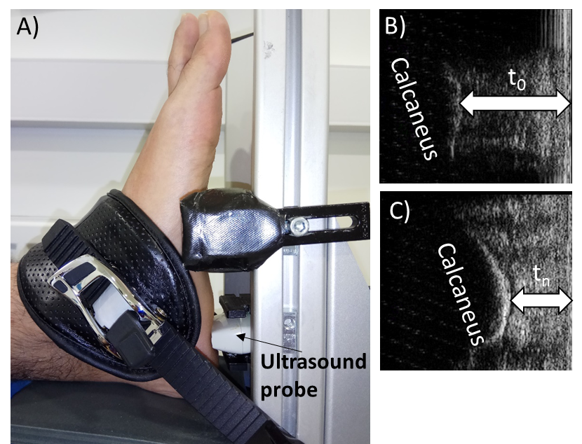
Figure 1. The testing set-up (A) and typical ultrasound images from an indentation test (B,C) that were used for the measurement of heel pad thickness (t) and the calculation of its strain (ε=(t0-tn)/tn). More specifically, heel pad is shown in its unloaded condition (A) and under maximum compression (B).

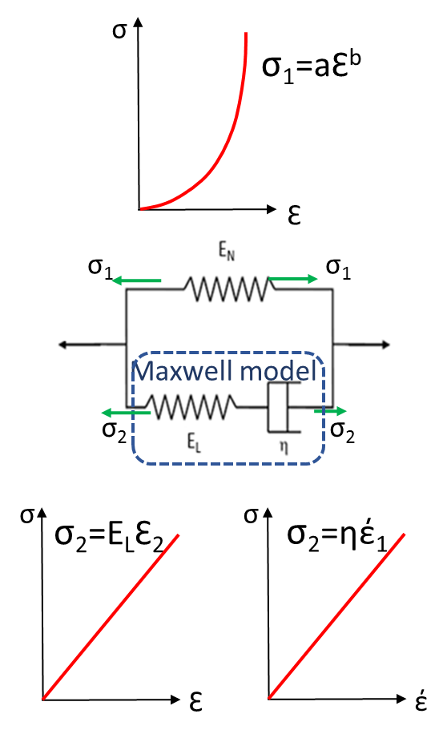

Figure 2: Modified standard solid model (middle), with one nonlinear spring (E_{N}) in parallel with a Maxwell model comprising a linear spring (E_{L}) in series with a linear damper (η). The mechanical behaviour of the non-linear spring (top), the linear spring (bottom left) and the linear damper (bottom right) is also presented.

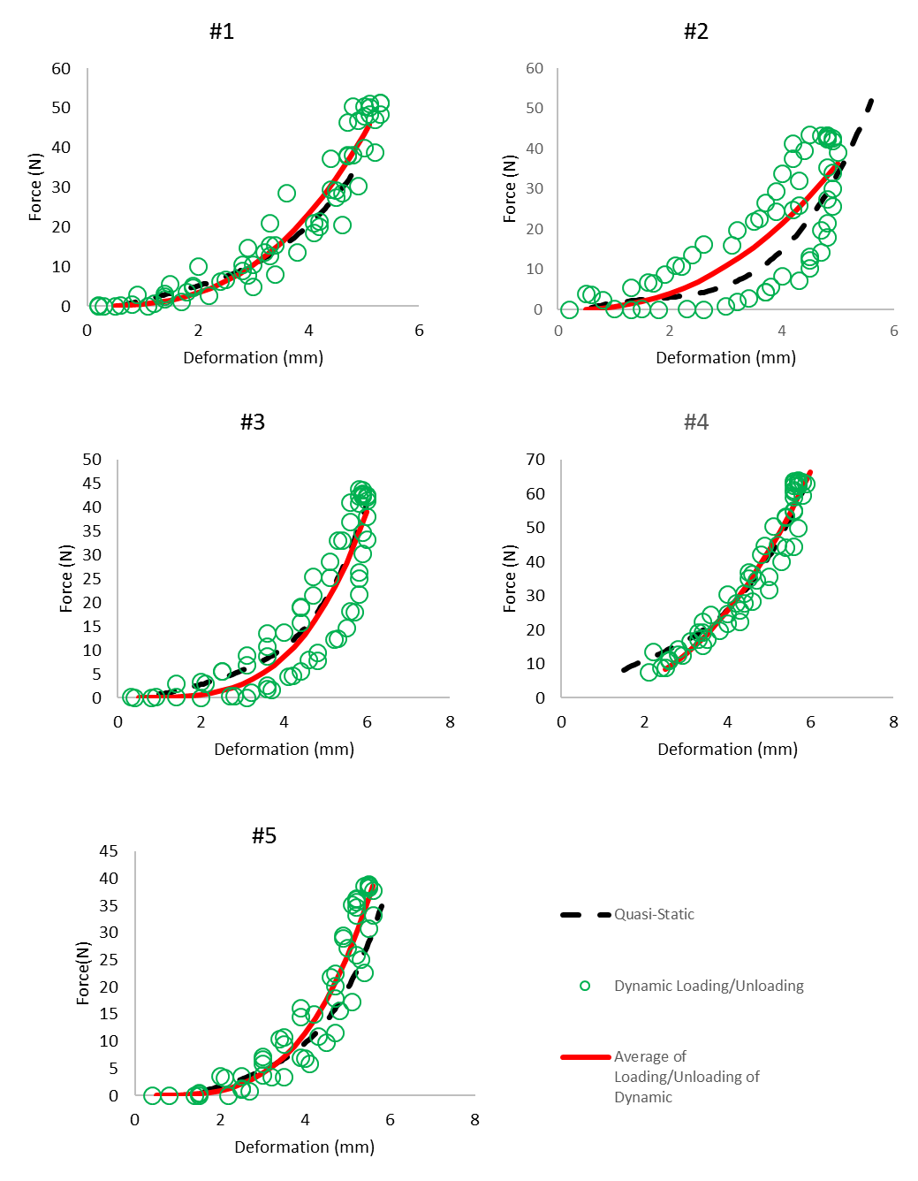
Figure 3. Comparison between the actual quasi-static indentation force/deformation graph and ones that are predicted by averaging the results for loading and unloading of dynamic indentation.

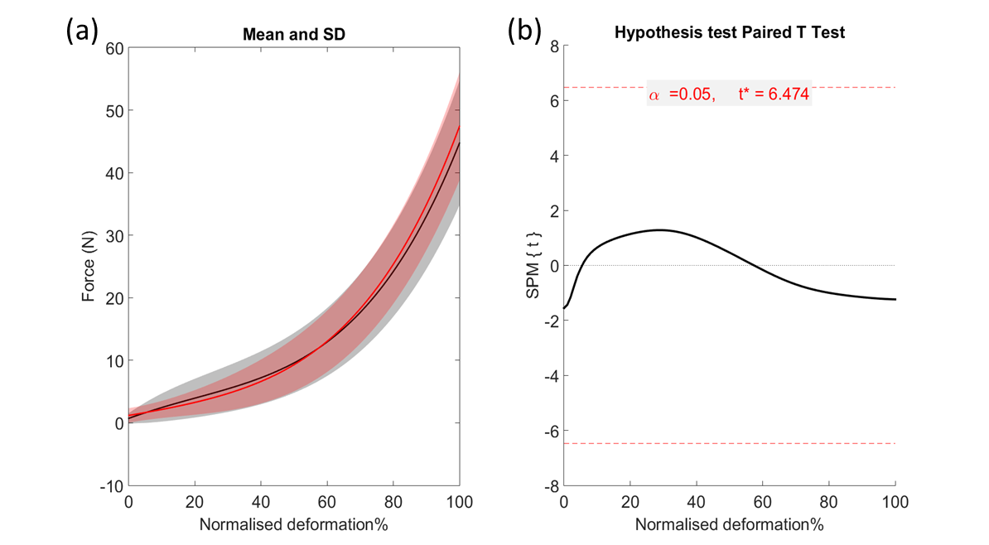
Figure 4. The result of paired-samples T-test on the force- normalised deformation graphs of the left foot of five healthy participants using quasi-static and average of loading and unloading in dynamic tests. (a) The average and standard deviation of force over normalised deformation using the quasi-static test (red) and average of loading and unloading (black), (b) statistical parametric map over normalised deformation for paired samples T-test. The dash line shows the threshold of significant difference, where the values more than 6.474 and less than -6.474 are the threshold of significant different between two methods.

