University of Huddersfield

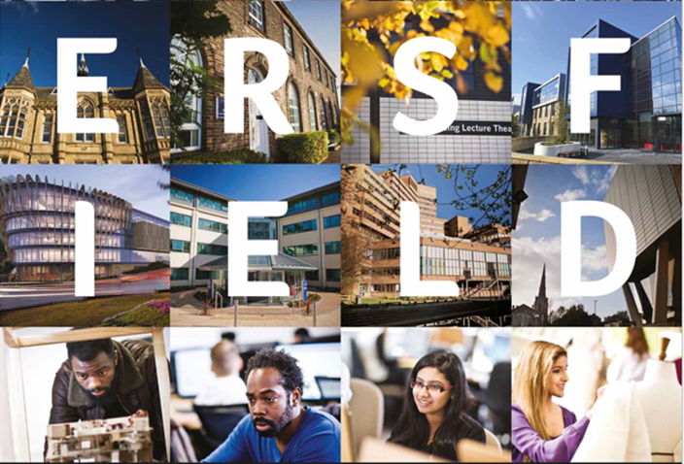
Building an Academic Community: engaging our students
Wednesday 13 September, from 9.00am-17.00pm
Prof Jess Power
Prof Christine Jarvis

This work is licensed under a Creative Commons Attribution 4.0 International License

Contents

Conference Introduction 2
Reflections 6
Keynote 7
Keynote Presentation 8
Conference Programme 16
Abstracts 17
Plenary 25
Final Word “The Student Voice” 30

Conference Introduction

The 2017 Teaching and Learning Conference “Building an Academic community: engaging our students” at the University of Huddersfield brought together over 200 delegates from across the seven schools and services, to consider approaches that would support the development of an inclusive, high achieving academic community. The morning started with an overview of the University’s achievements and successes in Teaching and Learning since the 2016 conference “Bridging the Gaps: redefining excellence in Teaching and Learning”. The reflective summary noted the prestigious Gold Award in the recent Teaching Excellence Framework, our unbroken succession of National Teaching Fellowships, which spans ten years; the strong relationships between research and teaching and the University’s excellent employability record, which demonstrates the relevance of our teaching to industry, commerce, the public sector and the community. Colleagues, students and the wider network of partners and collaborators were thanked for their contribution, enthusiasm, and commitment to excellence and innovation in Learning and Teaching. The most recent acknowledgement from the sector in testimony to Huddersfield’s Excellence in Teaching and Learning (T&L) was received the week prior to the conference, when the University won the Higher Education Academy’s inaugural Global Teaching Excellence Award, beating 26 finalists from across the world.

But of course there is still much to be achieved, much to tackle, in a complex and rapidly changing environment. TEF 3 offers new challenges, we have a new industrial strategy, the Higher Education Bill comes into force and our relationship with Europe is changing. The political mood seems committed to reducing the income to HEIs by cutting fees without any promise that the State will make up the shortfall. It is clear, though, that the focus on inclusivity and achievement for all remains as a theme in government policies. There are absolute differences in achievement between students from different backgrounds, right across the country. Our values tell us we are student-focussed and ambitious – we expect and encourage all students to achieve their potential, and we are doing well in this respect when compared with similar students elsewhere. It is particularly encouraging to see how thoroughly we embed opportunities for students to get real world experience, to work on live briefs and connect with employers and the world outside more generally. Coming to Huddersfield transforms life and places value on contribution to society locally, nationally and internationally. But we are never complacent. That is why the 2017 Teaching and Learning conference stimulated us to think about our student body and the different ways in which we can work together as cohesive academic community; encourages us to scrutinise student data and consider how to keep building and enhancing upon our practices to be the learning community we want to be.

The conference was split into four parts. It opened with a keynote from Liz Thomas which explored contextual information about student retention and success. This consolidated the key findings and recommendations from a 9 year project “what works”. Key messages were communicated including the need to create a strong sense of belonging in Higher Education (HE). Strategies to achieve this were discussed. These included developing supportive peer relations (friendship and networking is a key aspect of integration into HE), creating meaningful interactions between staff and students (facilitating engagement opportunities for students living at home), building knowledge, confidence and identity (the skills required to be effective in learning beyond HE) and facilitating an HE experience which is relevant to interests and future goals (supporting students in their learning journey prior to, during and after HE). Specific reference was made to sub-groups of students including commuter students and those from Black and Minority Ethnic groups. This theme resonated through the remainder of the conference cumulating in school and service specific discussion later in the afternoon.

A combination of 23 presentations and workshops formed the second part of the conference. Seven parallel sessions offered the opportunity to explore emerging themes. These clustered under three areas: A sense of belonging explored what “included” means. Delegates discussed developing rich and immersive learning journeys, explored achievement and satisfaction, measuring learning gain, and developing students and their families as partners. Interventions for success considered issues such as engaging with student course representatives, devising strategies to create safe, secure and challenging learning environments, using of social media, developing continuing professional development portfolios, analysing of responses to feedback, and examining innovative ways to integrate practice into T&L. Innovation in T&L explored team-based learning, playful learning, active learning, project based learning, challenge based learning, partnerships in learning, on-line learning, creating a personal learning environment, and embedding enterprise.

The third part of the conference enabled staff and students to work within their individual schools and services. Different approaches were taken to explore the main theme of the conference: building an academic community to engage our students. Each School or Service spent the afternoon examining data showing their student composition, and reflected on how ideas generated in the earlier parts of the conference might be used to increase engagement amongst their first year undergraduates. Some of the imaginative ideas considered included using empathy canvas mapping, prompting a clear focus on opportunities rather than challenges, using graduate interns to mentor students and developing a stronger student voice and sense of belonging by connecting different departments within academic schools. The importance of teaching with passion and developing interesting and relevant lecture materials which connects the latest research from world leading researchers both internally and externally was highlighted. Colleagues discussed influencing beyond one’s own immediate area of responsibility. They considered the importance of practical measures (such as lockers) to support student engagement with services such as the gym, library, extra-curricular activities and the social aspect of the higher experience. The value of interdisciplinarity in HE was explored in terms of building sustainable networks within and beyond schools.

The final part of the conference brought together the views of our students who through partnership with the student union participated across the day and provided an inspirational reflection (student voice) as the conference plenary. They echoed the importance of belonging, relationships and practical support.

This publication provides a snapshot of the day and includes the keynote presentation, abstracts of the parallel sessions and a synthesis of the student voice from the plenary session. Where possible links are provided to the lecture capture which will remain available until next year’s conference. Throughout the day there were many flashes of inspiration which we hope individuals, departments, school and services will develop and implement in the next few months. We hope you enjoy reading and reflecting on the 2017 teaching and learning conference as much as we enjoyed organising the event. We leave you with a selection of comments from the post conference evaluation and a thank you for participating in building an academic community of which we are proud to be part of at the University of Huddersfield.

Link to lecture capture: https://videohud.cloud.panopto.eu/Panopto/Pages/Sessions/List.aspx?folderID=09563762-4738-4512-8524-47e591fd617e

Jess and Christine

Prof Jess Power, Chair of Conference Steering Group
Prof Christine Jarvis, PVC Teaching and Learning
Reflections

“The Keynote speaker. Prof Liz Thomas gave an engaging speech, which was really relevant to our university and it also made me think about ways in which my service could tackle some of the issues she highlighted as things our students could be facing.”

“A Real focus on experiential learning. Learning by doing and engaging the students, will look at drops in attendance, following up students that miss two consecutive weeks, perhaps an early warning sign that they are not engaging.”

“The realisation that so many of our students are commuter students has made me think about how they might engage in a different way with the resources that the library provides and consider if there are other ways of ensuring their needs are met.”

“Letting students feel the module connects to their daily life and career future; Providing practices activity opportunities; so students come not only for learning knowledge, but also for improving their communicate skills and team work experience.”

Key Note

Professor Liz Thomas

Improving the engagement, belonging, retention and success of
students in a modern university

Liz’s presentation will take an evidence-informed approach to consider the challenges and opportunities for developing a community of learners in a modern university with a diverse student population; approximately 50% of students at Huddersfield are ‘commuter students’; those who live away from the university and travel to attend.

In particular this address will draw on the two phases of the What works? Student retention and success programme and research undertaken for National Union of Students about the engagement of commuter students.

Liz is an independent researcher and consultant for higher education and Professor of Higher Education at Edge Hill University. She has nearly twenty years’ experience of undertaking and managing research about widening participation, student retention and success and institutional approaches to improving the student experience.

Key Note Presentation

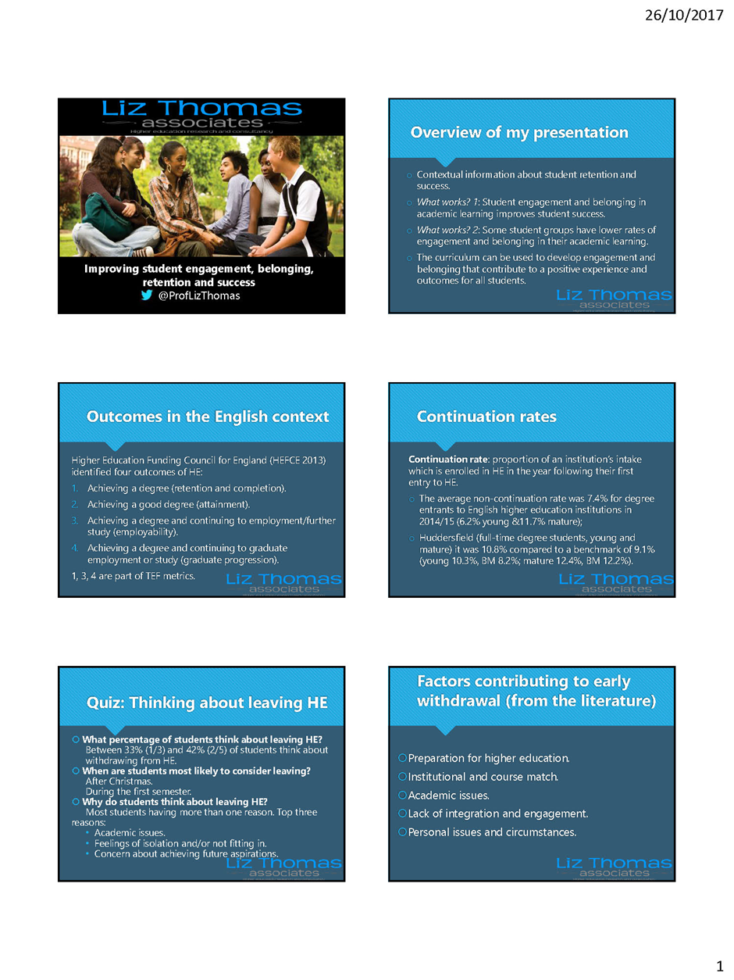
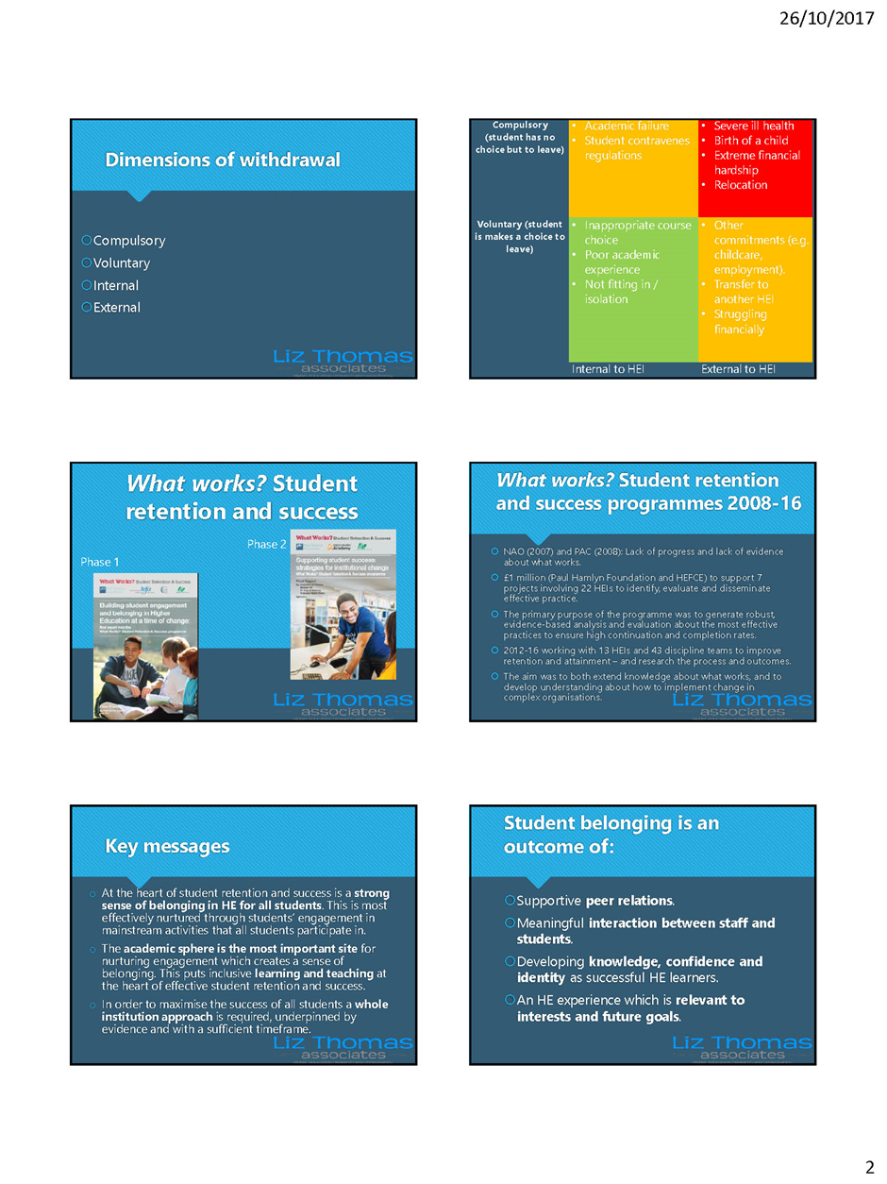

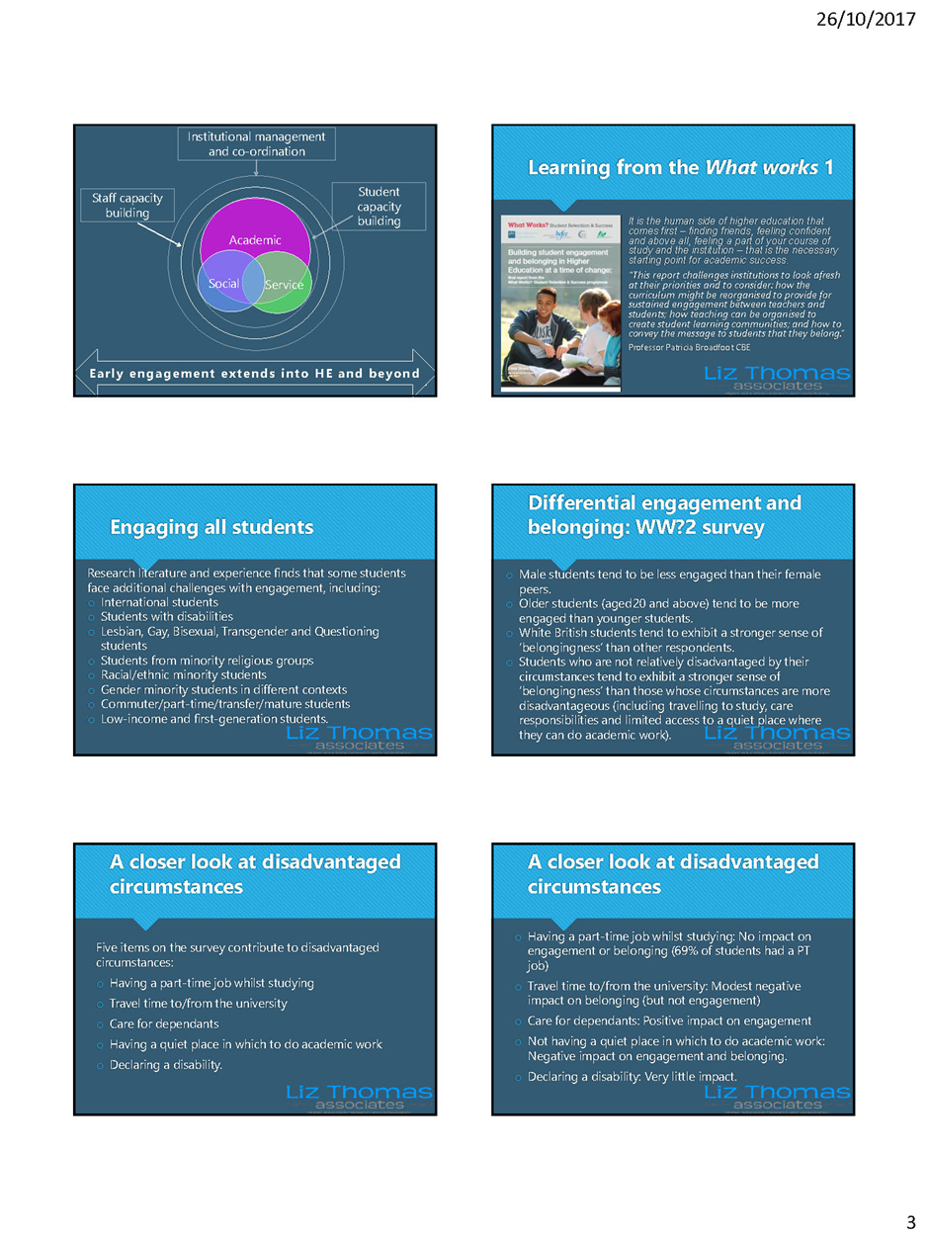

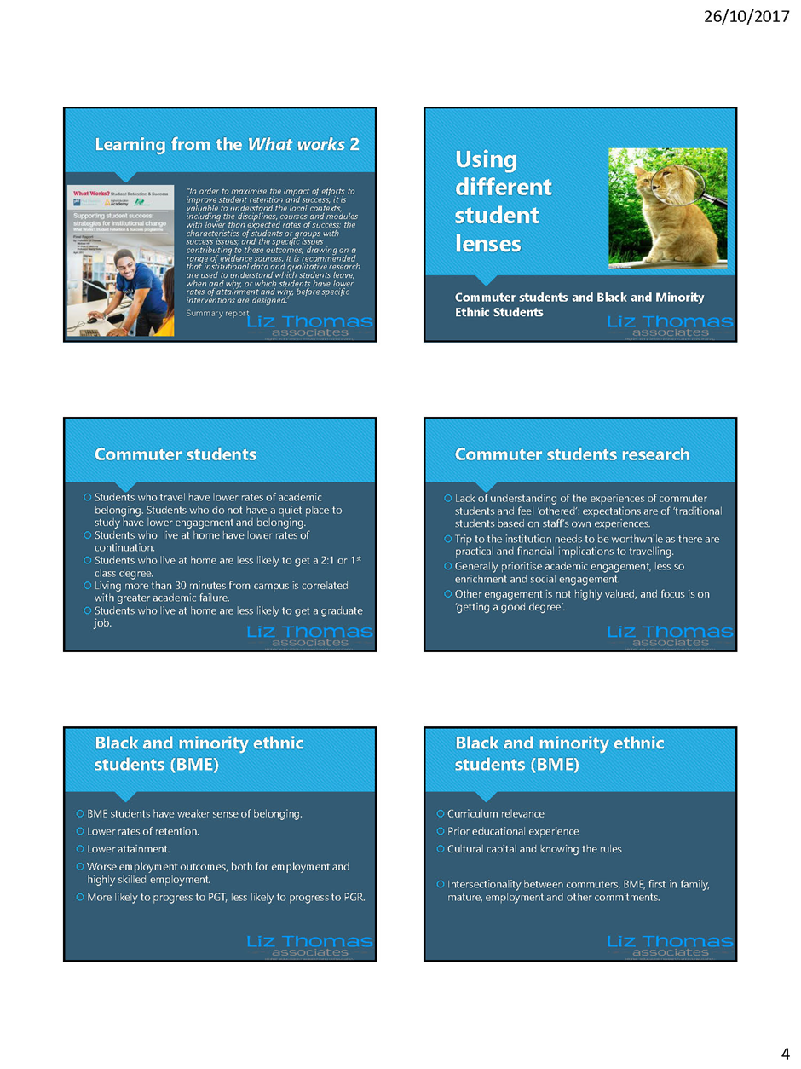

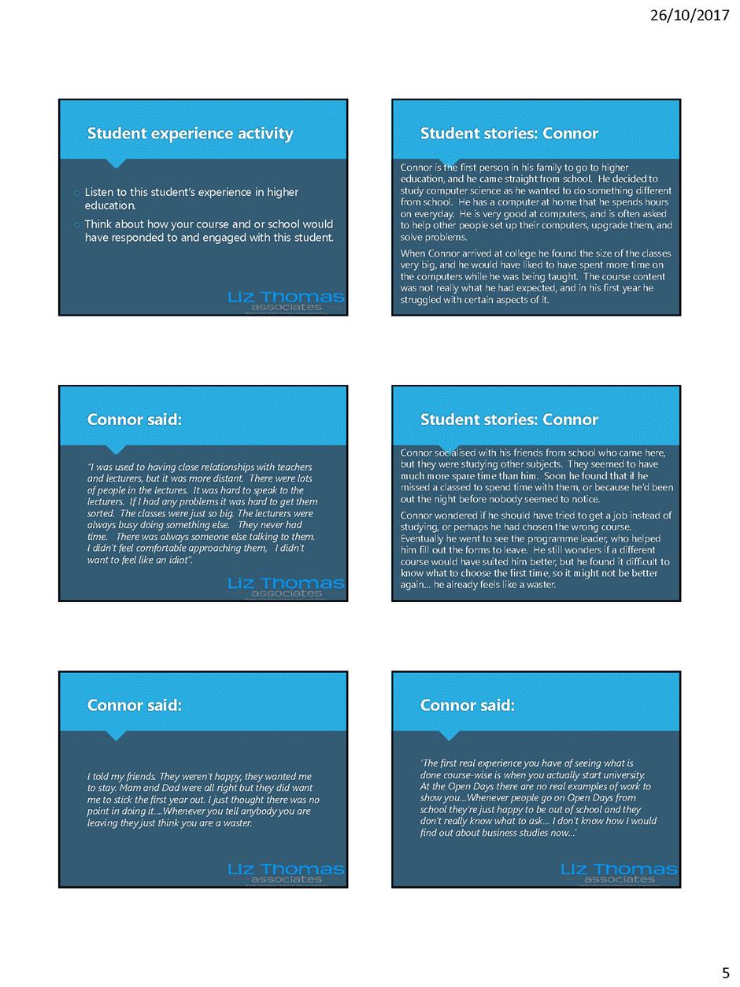

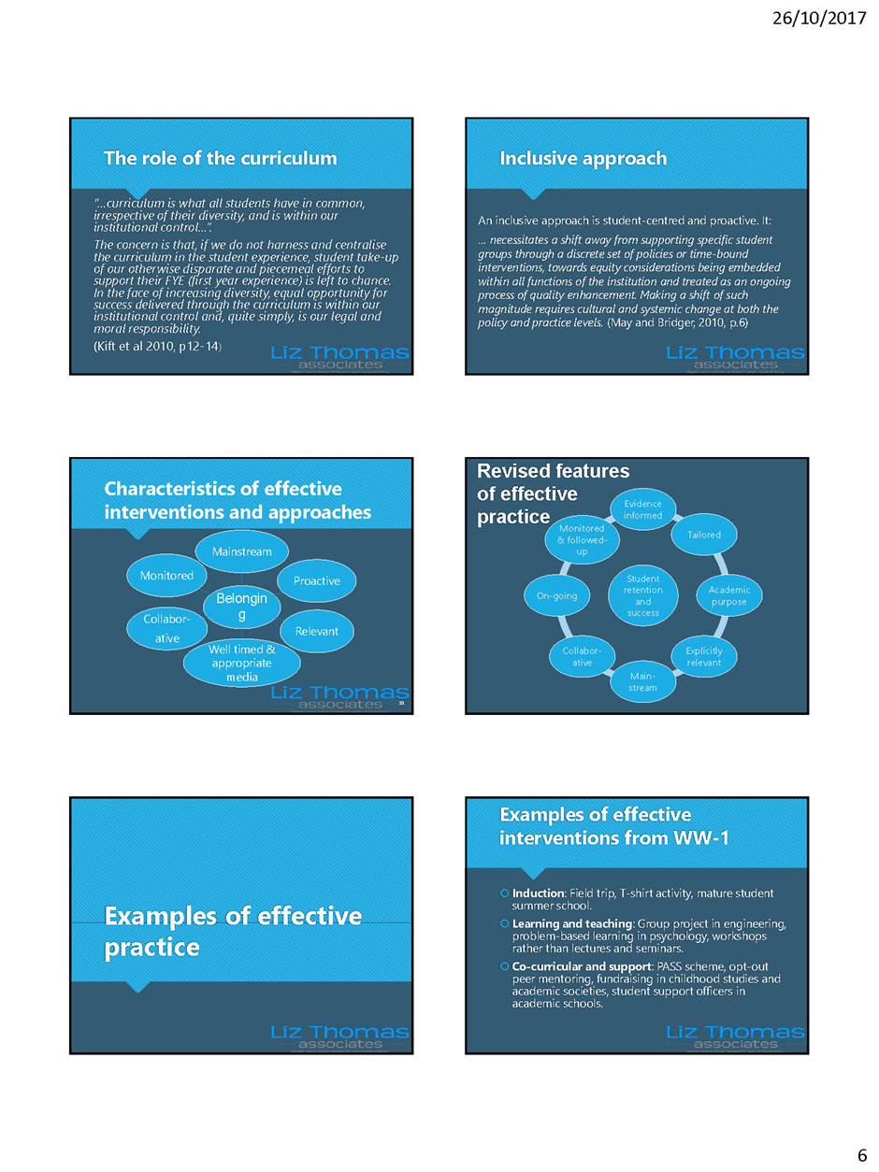

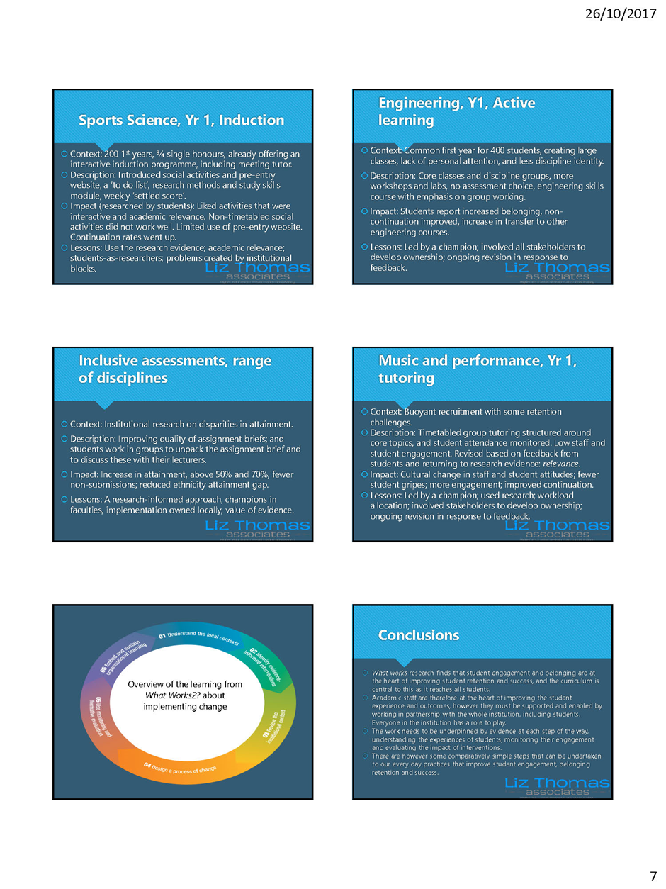

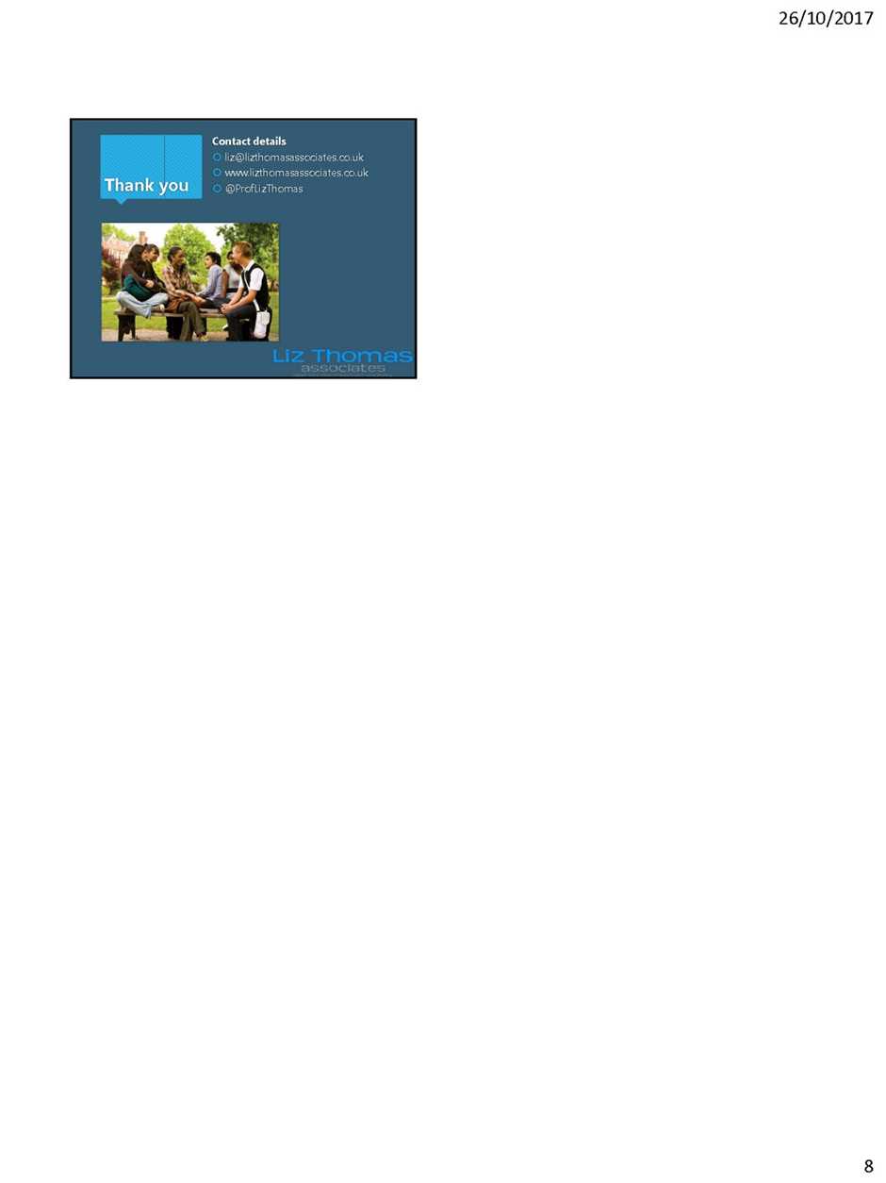

Conference Programme

Time Activity Location
09.00-09.30 | Registration and refreshments | BLG/C01, Ground floor - Bronte Lecture Theatres
09.30-09.35  09.35-09.50  09.50-10.50 | Welcome & Housekeeping - Dr Jess Power Opening - Professor Christine Jarvis  Keynote Speaker - Professor Liz Thomas | BLG/10, Ground floor - Bronte Lecture Theatres
10.55-11.15 | Morning refreshment break | Student Central, Students’ Union Level 5
11.20-12.20 | Parallel Session A: Workshops | Various rooms on levels 6 & 7 - Oastler Building
12.25-13.25 | Parallel Session B: Presentations | Various rooms on levels 6 & 7 - Oastler Building
13.25-14.20 | Lunch | Student Central, Students’ Union Level 5
14.20-15.50 | School / Service-based planning sessions | Various rooms on levels 6 & 7 - Oastler Building
15.50-16.10 | Afternoon refreshment break | Student Central, Students’ Union Level 5
16.20-17.00 | Student panel / feedback  Plenary - Graphic recorder summary & close | BLG/10, Ground floor - Bronte Lecture Theatres

Parallel Sessions A: Workshops
A1 | Heather Wade – How to engage with the course rep system and improve TEF scores
A2 | Christine Jarvis – Intervention for Success: The Catalyst Project
A3 | Christine Dearnley, Sheena Miller, Peter Roberts, Vikki Barry – Enhancing the student experience with Team-Based Learning: an overview of principles and practice
A4 | Matt Mills, Amanda Aspland – Levelling the playing field - student stats & stories to re-imagine a safe, secure and challenging environment
A5 | Andrew Walsh – Encouraging playful learning
A6 | Catherine Brentnall, Catherine McGrath – Engaging and developing students through enterprise
A7 | Liz Bennett, Sue Folley – Improving Student Retention through Active Learning

Parallel Sessions B: Presentations
B1 | Leigh Fleming, Violeta Holmes – Multidisciplinary project based learning, what we have learned
 | Dr Margaret Culshaw, Dr Stephen Hemingway, Dr John Stephenson – Prescribing safely: an evaluation of an inter-professional workshop involving non-medical prescribing and MPharm students
 | Jess Power – Crossing Discipline Boundaries - The Innovation and Creative Exchange
B2 | Jo Conlon, Andrew Taylor, Palveshah Ashruff, Laura Bird – Using LinkedIn groups in higher education Maximising community benefits for students & alumni
 | Deborah Philip, Judith Kidder, Shailesh Appukuttan – Continuing Professional Development Portfolio (CPDP): using a post-course e-portfolio to facilitate the transition from learner to becoming an established professional
B3 | Jane Tobbell, Berenice Golding, Christine Rhodes – What does being included mean to students?
 | Paul Ward, Rob Ellis – Crossing the ring road: Building partnerships with (history) students and the community
B4 | Jess Haigh – Student-Paced Online Resources and their use in embedding Critical Information Literacy into curriculums
 | Daniel Belton – Creating a rich and immersive learning journey using differentiated resources and active learning environments
B5 | Wilma Teviotdale – Improving UG Student Achievement and Satisfaction through understanding Assessment Criteria
 | Liz Bennett, Sue Folley – Students’ emotional responses to feedback on their progress using learning analytics dashboards
 | Qiang Xu – Case study on the feedback in an analytical type module
B6 | Lydia Blundell – Enhancing the Student Experience: SU Segmentation exercise
 | Zoë Mitton, Ryan Wilkinson – Measuring Learning Gain in Higher Education: A HEFCE-funded pilot project
B7 | Carla Reeves, Robin Kiteley – Students as Partners: Working with students to implement and research peer mentoring in the social sciences
 | Rob Allan – Embedding online lab based activities to develop students’ knowledge and understanding of key content
Abstracts

A1 Heather Wade – How to engage with the course rep system and improve TEF scores
This will be an interactive session with the Course Rep Team. Exploring how the University can gain the most out of the student representation and how this will be reflected in, but not driven by, a desire for the best possible NSS score. With student representation at the heart of this session we will demonstrate what effective representation looks like and consider the benefits that it brings through the formal structures and informal opportunities. We will examine the reality of the system and discuss the challenges and barriers that are faced across the campus. A panel of Course Reps and the Course Rep Team will be on hand to answer your questions and queries – and to take on board your comments. Together we will create a developmental plan for how we can continue to move the partnership forward. Ensuring that students remain at the heart of the co-creation of the curriculum at Huddersfield, that representation is effective and that Huddersfield maximises the NSS and therefore TEF measures.
A2 Christine Jarvis – Intervention for Success: The Catalyst Project
INTERVENTION FOR SUCCESS is a project involving four partner HEIs (Huddersfield, Lincoln, Coventry and MMU) to address barriers to student achievement. It focuses on tackling differential achievement, by developing practical activities and resources that will support students at risk of leaving or not achieving their potential. The interventions will be available for all students, but draw on national and institutional research which tells us about groups most likely to graduate and achieve a good degree (Commuter students, students from disadvantaged social groups and some categories of BME students). Each partner will use their own learner analytics and tracking and monitoring systems to enhance personal academic tutoring. Each institution will develop and trial a particular form of intervention, which personal academic tutors (PATS) can use to support students who are not making expected progress, or who have asked for support with a particular aspect of their studies. Participants in the workshop will be introduced to the project and asked to consider how they might apply some of the interventions in their own contexts.
A3 Christine Dearnley, Sheena Miller, Peter Roberts, Vikki Barry – Enhancing the student experience with Team-Based Learning: an overview of principles and practice
There is a tentative, though growing body of evidence to support team-based learning (TBL) as a strategy that can impact on student engagement, student satisfaction, attainment, practice development and transformative teaching and learning. The literature indicates that implementing TBL within the curriculum is not without challenge and requires a sustained and structured approach. Staff and students need to understand the processes involved, and why they should be adhered to, in the pursuit of enhanced student experiences and outcomes for students in Higher Education (Dearnley et al. in press). This session will provide an introduction to the principles and processes of TBL, which is a collaborative learning and teaching strategy designed around units of instruction that are taught in a three-step cycle. There will be an initial introduction to the TBL implementation project that is being undertaken in SHHS, its aims and achievements to date. This will be followed by interactive exercises designed to engage staff as learners in structured TBL activities.

A4 Matt Mills, Amanda Aspland – Levelling the playing field - student stats & stories to re-imagine a safe, secure and challenging environment
There are significant differences in levels of achievement and withdrawal between students with diverse backgrounds. The stats will clarify what the playing field currently looks like here at the University of Huddersfield. The stories will help us to re-imagine how we provide a safe, secure and challenging environment for every student. Through developing a better understanding of our students’ backgrounds participants will be invited to explore, excavate and build upon how we use the first 100 days at University with the aim of levelling the playing field and inspiring success for all students.
A5 Andrew Walsh – Encouraging playful learning
This workshop will introduce the benefits of play in adult learning and give opportunities for attendees to reflect on how their own teaching practice could become more playful. It will link play to student outcomes and satisfaction. Attendees will be introduced to learning games, educational escape room ideas, creative and playful teaching ideas, and other ways in which we can encourage more play in learning, particularly through game based learning.
The idea of “permission to play” will be discussed and how we can give students (and staff) permission to play at University. Attendees will receive a comic outlining some key benefits of play in Higher Education. And some sweets. And a kitten*. The session will be playful in nature and will involve opportunities to participate in play throughout the workshop.
*kitten subject to availability and may be substituted without notice.

A6 Catherine Brentnall, Catherine McGrath – Engaging and developing students through enterprise
This session will explore the soft (yet essential) skills, work-related learning and career development opportunities, which are created through student focussed enterprise learning pedagogies and entrepreneurial practice. Lackéus (2016) identifies that entrepreneurial learning approaches are good models for the development of non-cognitive skills. This workshop will share his conceptual framework, and illustrate how educational design that requires learners to create value for others, leads to frequent interactions with the outside world and other emotional events (feelings of happiness, motivation, relevancy, frustration), and that navigating these experiences develops student mind-sets and non-cognitive skills. The session will be co-delivered by students accessing the Enterprise Team’s Enterprise Support and/or Enterprise Placement Year at the University of Huddersfield. The students will demonstrate how developing enterprise projects and businesses is equipping them with confidence, professional skills and attributes and real world experiences, which are preparing them for life after university.

A7 Liz Bennett, Sue Folley – Improving Student Retention through Active Learning
Participants will be introduced to research from HEA and HERE on the factors and approaches that affect retention in higher education. The workshop will particularly focus on approaches to teaching that are known to support retention. Participants will share good practice from their context and will generate ideas to take forward into their own contexts. The workshop is designed around a couple of practical activities which have been developed as part of the popular and successful, D4 Curriculum Design Workshops.
D4 Retention Workshop (2017)
Available from http://ipark.hud.ac.uk/content/training-development
B1. Leigh Fleming, Violeta Holmes – Multidisciplinary project based learning, what we have learned
The session will introduce the planning and execution of the project which engaged 350 students from across the whole School of Computing and Engineering in a week long practical problem based activity. It will explore aspects of collaborative working with colleagues from other disciplines, engaging industry in student centred projects, the logistics and challenges of the project and also the positive outcomes which have resulted showing impact on TEF metrics and student outcomes. The students who engaged in the project were from very different subject areas, so the challenge of finding relevant activities to develop students from different backgrounds will be explored alongside the physical resource requirements.
The project has potential to impact on attainment, student satisfaction, employability and aspiration. Methods of evaluating the effectiveness of the project will also be open for discussion.
Dr Margaret Culshaw, Dr Stephen Hemingway, Dr John Stephenson – Prescribing safely: an evaluation of an inter-professional workshop involving non-medical prescribing and MPharm students
The judicious use of medicines can be major determinants in patient well-being. Unfortunately medicine errors can lead to adverse consequences for the patient rather than therapeutic benefit. It has been suggested inter-professional training between key stakeholders in the prescribing process can make a major contribution to negating medicine errors. With error prevention in mind, joint working between non-medical prescribers (NMPs: nurses, podiatrists and physiotherapists) and 4th Year MPharm students has been introduced in the form of a workshop centred on the issue of prescriptions, and determinants of competence and safety. Although both courses are at Master’s level, the workshop is designed to facilitate learning for students with differing experiential and educational backgrounds. NMPs have 3+ years clinical experience post-graduation, and are experts in practice. Pharmacy students have an extensive theoretical knowledge of drugs and their use, but little or no experience in practice. We evaluated the workshop for the two academic years it has run, using a questionnaire assessing knowledge, process and relationships. Data (n=337) was analysed using multivariate methods, revealing that NMPs rated significantly higher than MPharm students on all domains (p<0.001). Participant effect was greatest in the determination of knowledge scores (partial-η²=0.100); with smaller effects in other domains.
Jess Power – Crossing Discipline Boundaries - The Innovation and Creative Exchange
The Innovation and Creative Exchange Project has developed a legacy of learning that promotes innovation, design thinking, new product development and further opportunities to take products through to market through developing sustainable networks with the commercial sector. It provides a real opportunity to develop employability skills through partnerships with student peers and the commercial sector, in a fast paced flexible and challenging learning environment. It brings together students from across the University, who value innovative thinking, ideas generation and interdisciplinary working as part of their student experience. It has created a blue-print for innovation (case study) in pedagogy through a functioning exchange for industry and businesses to present challenges and opportunity for student to develop core skills in relation to employability and sustainable professional networks beyond their discipline. This session presents ICE as a best-practice models for embedding interdisciplinary collaboration into the UG student experience. Key challenges, levers/mechanisms and institutional barriers will be discussed and debated. By drawing on specific examples of interdisciplinary student collaborative industry challenges implemented in the last 4 years at the University of Huddersfield, the value to student learning, employability and professional development is ascertained.
B2. Jo Conlon, Andrew Taylor, Palveshah Ashruff, Laura Bird – Using LinkedIn groups in higher education Maximising community benefits for students & alumni
The aim of this project is to create a LinkedIn group to connect Fashion and Textiles academics, alumni and undergraduates to leverage the social capital within this network.
LinkedIn has become the premier social media site for professionals, most employers will search for a job candidate on LinkedIn; despite this many students use a range of other social media. LinkedIn has many powerful tools and inherent capabilities that facilitate the range of networking that students engage in to find internships, placements, jobs, and to make professional connections, but compiling a profile takes time with a slow build to engage as “future professionals”. The course team of Fashion Buying Management encouraged undergraduates to join the UoH alumni group on LinkedIn since 2013. This initiative has provided information on graduate destinations (including data for DHLE) and career progression, as well as enhancing networking opportunities for undergraduates. The project has demonstrated the potential to more actively utilise alumni as role models and mentors. Through this ADA funded project (2016/17) we have started immediately to launch LinkedIn with our first years, who have responded enthusiastically and very professionally. The project has attracted increased numbers of alumni and business partners to connect with the group.
Deborah Philip, Judith Kidder, Shailesh Appukuttan – Continuing Professional Development Portfolio (CPDP): using a post-course e-portfolio to facilitate the transition from learner to becoming an established professional
This presentation analyses the potential value and relevance of further extending the use of professional course e-portfolios to include post-course provision - the Continuing Professional Development Portfolio (CPDP). Involvement in post-course professional development raises issues such as employability, development of professionalism and professional identity, mentoring and other on-going support; relevant use of technology also has a role in this context. Drawing on experience of the current development of an e-portfolio using PebblePad for the professional training of teachers in the Lifelong Learning sector, the session will examine the concepts of liminal space around the transition from learner to employee. Implications of these issues are considered from the perspectives of the institution, tutors, learners and employers, and the extent to which they might benefit or not from involvement in the continuation of this process. Drawing on a survey of students and staff users of the professional training e-portfolio, a vignette style CPDP site will be used to present and discuss issues of post-student development and transition experience. Perceptions around four key issues of institutional targets, student experience, student benefits, and institutional benefits will be discussed.
B3. Jane Tobbell, Berenice Golding, Christine Rhodes – What does being included mean to students?
In this session I will present data from a project in the School of Human and Health Sciences where we trained students to collect data from their peers around what inclusivity means in Higher Education. Participants were asked what being included felt like, what practices caused difficulties in inclusion and finally for their suggestions to improve inclusive practice. Over 60 students were trained in data collection and 723 responses from over 200 students were gathered over a period of three months. Many themes emerged from the data but the most prominent themes surround the desire for relationships with peers and staff; empowering communication and knowing what’s going on. The nature of the relationship desired and the practices which empower communication and understanding will be discussed here. Participants in the session will be invited to generate ideas to maximise inclusion in light of the data.
Paul Ward, Rob Ellis – Crossing the ring road: Building partnerships with (history) students and the community
This presentation explores an integrated co-productive approach to student learning and staff research/impact and that collapses boundaries between communities of learning, communities of research and local communities. It explores how, in History, we develop students as partners in our research to enhance its impact through community-based learning. By working with a wide variety of external organisations, such as the Mental Health Museum, Kirklees Local TV, Skelmanthorpe Textile Heritage Centre and the National Coalmining Museum on student-centred projects, we are able to develop meaningful and productive partnerships with students in which they can see the social value of their university work, while it contributes to the development of university research and its impact. The presentation will examine some of the pedagogical literature on community-based learning and link it to developing methodologies in the co-production of historical knowledge and will apply this through explaining how this has worked in practice with groups of students on a range of second and third year modules. It will argue that approaches to research – rather than specific research outputs - can provide models for externally-focused teaching that values learning that takes place off campus and takes the university across the ring road.
B4. Jess Haigh – Student-Paced Online Resources and their use in embedding Critical Information Literacy into curriculums
This session describes a small research project conducted by Subject Librarian Jess Haigh, as part of a wider Teaching, Learning and Assessment Project within the School of Education and Professional Development. The wider project’s aims was to embed critical writing into the undergraduate framework. As part of a discussion on how the Library could be involved with this, it was decided to create an online, student-paced resource that would quickly give students an overview of good practice in searching for academic sources. This was to allow class time with the librarians to be freed up for concentrating on more critical practices such as evaluating resources. The resource would condense what was currently an hour long session with the librarian into a 15 minute online exercise that could be either done in class or tutorial time, or before information sessions using the “flipped classroom” approach, where students learn about something before class, therefore using class time for critical appraisal. A resource was designed and piloted on a group of BA Childhood Studies second year students. This presentation will go through the creation of the resource, created using NearPod, and the outcomes of this pilot. The findings of the pilot, which include information about the help-seeking behaviour of students, will be presented for discussion.
Daniel Belton – Creating a rich and immersive learning journey using differentiated resources and active learning environments
This session will outline the development of differentiated resources and active learning environments, designed to create a rich and immersive learning journey for students on a second year chemistry module. These developments include augmentation of online and face-to-face teaching, including: online video tutorials to introduce, explain and reinforce key concepts in advance of lectures and labs; structured reading assignments to encourage autonomous learning; e-notes that complement and support learning in lectures; ‘Peer Instruction’ to encourage active participation during class time; and gamification using medals to indicate progress within a specific topic. Online tutorials have also been developed and deployed. There can be taken over and over again, with slightly different questions each time (in many cases there are thousands of permutations). Marks, detailed feedback and worked solutions are provided for each question immediately after the tutorial is completed, enabling misunderstanding to be corrected. Students can draw upon all of these different resources as much or as little as they want in order to construct their own learning journey. In this session, I will explain how these changes were implemented and the effect it has had on student learning.
B5. Wilma Teviotdale, Karen Mountain – Improving UG Student Achievement and Satisfaction through understanding Assessment Criteria
This study set out to cover 10 UG honours level modules, across the Business School, to engage students directly with assessment criteria on summative work to improve their levels of understanding of what tutors are looking for (and hence student performance) and to improve levels of satisfaction with Assessment and Feedback questions in the NSS. Following discussions with course leaders, and then module leaders (MLs) involved in this study, tailored interventions were designed with MLs close to points of summative assessment. These interventions depended on the nature of the summative work and what MLs considered were key weaknesses in student understanding (hence lower assessment performance). Student views on each intervention were captured immediately via a short survey; focus groups will be used as a follow up. Staff views were captured via an individual interview. Mixed responses across modules at this point show key areas where improvements can be made before embedding this approach, beyond UG honours modules, in 2017/18. Not all MLs considered the approach worthwhile to date and impact on student performance is not yet known. Student views were very favourable overall but, at module level, this has been affected by ML and tutor views and approaches.
Liz Bennett, Sue Folley – Students’ emotional response to feedback on their progress using learning analytics dashboards
This presentation reports on a SRHE funded research project which seeks to understand how students respond to receiving information about their progress delivered to them via a student dashboard. Student dashboards have been shown to support positive student engagement in learning leading to improvements in student motivation, retention, satisfaction and attainment (Duval, Verbert, Klerkx, Govaerts, & Santos 2013; HEA 2014; Sclater 2014; UCISA 2015). In particular dashboards are used to support particular students through targeted interventions (for example those at risk of dropping out).
The presentation will report on the emergent findings from data gathered for this study. In particular, it will begin to answer the study’s research questions, which are:
- What is the emotional impact on students of dashboards and how do they respond to information about their progress and learning behaviours?
- Can certain aspects of design of feedback on progress (e.g. use of language and the way that interventions are signposted to students) support positive student engagement in their learning?
- How does the data collected in this study open up new ways of theorising institutional use of data and understanding students’ learning journeys?
Qiang Xu – Case study on the feedback in an analytical type module
Across the HE sector, assessment and feedback is recognised as the area of the NSS Survey in which there is the greatest room for improvement in scores for satisfaction, while participation rates in institutional module evaluation surveys have traditionally been too low to yield useful data. This session aims to address this gap in knowledge around students’ perceptions of the quality and effectiveness of feedback, reporting on the outcomes of a study into feedback delivered in an Honours module in Engineering. Three surveys were conducted with students: the first at the end of first semester, the second in the middle of second semester, and the third at the end of the teaching year. Generic feedback was given to the class after the first and second survey. Formative feedback was provided on early drafts of assignment work, and following an analysis of the impact of this feedback on final grades, interviews were conducted with a number of students to explore how they had responded to and utilised the formative feedback’ in finalising their assignment work. The findings of this case study suggest that 1) the feedback given in the specific module was adequate and good enough; 2) that our own student survey result was affected by the time in the learning cycle; 3) critical feedback is necessary and beneficial to students; 4) student do get some benefit in the feedback on their draft work, however, the improvement is strongly limited and/or affected by their understanding of the question.

B6. Lydia Blundell – Enhancing the student experience: SU Segmentation exercise
The Students’ Union has undertaken a ‘segmentation exercise’, to gain a deeper understanding of students’ attitudes, behaviours and values. Having constructed four student groups we will look at these in more detail, exploring students’ motivations for coming to University and for specifically choosing to study at Huddersfield. We will then consider how we can use this understanding to better support students, improve retention and help them engage with their studies; identifying barriers too engagement and methods of engagement for each group of students.

Zoë Mitton, Ryan Wilkinson – Measuring Learning Gain in Higher Education: A HEFCE-funded pilot project
This session will outline the University’s HEFCE funded longitudinal project on Learning Gain, the parameters of the project will be explained fully within the session, and its’ intended outcomes made clear. The project commenced in October 2015, in partnership with Lincoln University, and will conclude in July 2018, it is one of thirteen national projects, involving 70 university partners, being funded by HEFCE all focusing on different tools to measure Learning Gain. The details of the wider national project will be outlined, and its’ aims explained, including a proposed link to the Learning Gain metric of the Teaching Excellence Framework.

B7. Carla Reeves, Robin Kiteley – Students as Partners: Working with students to implement and research peer mentoring in the social sciences
The presentation will explore the operation of the first year of the Peer Mentoring in the Social Sciences scheme (2016/17) and findings from the PEER project: the qualitative research project exploring the impacts of the scheme in year 1 and ways to develop the scheme in the future.
Both the peer mentoring scheme and the PEER project were undertaken and developments designed in partnership with undergraduate students on social sciences courses who had volunteered to be peer mentors, with the PEER project engaging with the peer mentors as co-researchers through the later design and fieldwork phases (interviews with the co-ordinators, peer mentors and peer mentees). This presentation will explore the value gained from working with students in this way as well as lessons learned from this process, from the perspective of both the staff co-ordinating the projects (the presentation authors) and the peer mentors (subject to availability peer mentors will co-present the session).

Rob Allan – Embedding online lab based activities to develop students’ knowledge and understanding of key content
The School of Applied Sciences has invested in ‘Labster’ to create a portfolio of www based lab activities, many of which use cutting edge techniques not currently available at Huddersfield. The “labs” offer the student the opportunity to engage with a variety of materials either as preparation for lab activities, to practice techniques or to test their knowledge through on-line self-testing. The on-line lab on Eutrophication was used to illustrate the impact of nutrient loading on a water course and how it might be analysed. This supplemented information delivered in a traditional lecture and was designed to reinforce theoretical knowledge. The use of the lab was incorporated into a summative assessment, which resulted in a high participation rate. The results of the evaluation are presented here with specific reference to the impact on students’ understanding of the material, their performance levels together with an evaluation of the lab activity by participants.

Plenary

Thanks to the support of the Students’ Union, 20 of our students (Course Reps & Course Rep Assistants) attended some or all of this year’s teaching and learning conference, participating in workshops, attending presentations and presenting their reflections on the day as part of the closing plenary session.

Their feedback and thoughts were collected through the day and the students were given the opportunity to share, discuss and refine their ideas before they presented back.

The students all found the experience of attending the Conference a very positive one. They praised the energy and commitment which academic colleagues demonstrated in discussions and were reassured to hear the depth of discussion around the themes of student engagement and inclusion.

Having attended the morning sessions of the conference there were a number of themes that resonated with the students. Here are their suggestions and the ideas they heard that they responded to:

Improved working relationships with staff
Initiate meaningful interaction between staff and students more often, “say hello and engage us in conversation.”
Weekly settle score to see how students are settling in.
Staff should ensure that their enthusiasm for the content they are teaching is communicated to their students.
University social events for all staff and students like the recent ‘campus mile’ event organised by the Students’ Union.
More teacher + student shared learning experiences E.g. teacher + learning conference where ideas can be shared to improve the teaching and learning experiences of students.

Supporting commuter students
Awareness of the challenges of the commute when planning the timetable, dealing with latecomers, and providing study spaces and support.
On-campus parking.
Having more information before term 1 starts to support their transition i.e. parking, travel cards etc.
Reserved books in the library.
Lockers made available on campus.
Crèche.
Discounts for train & bus travel
Regular informal meetings with staff to discuss the course and with other students to feel part of the community.
A properly managed car sharing system.
Consider how to make it easier for all students to be more involved in extracurricular activities.
More free water machines around campus.

Experiential Learning
Develop the good practice in opt-out peer mentoring across more courses.
Opportunities to be involved in community based projects and field trips as part of every course.
Earlier conversations about placements (from year 1).
Make placement years easier and help fund those with low income backgrounds who may otherwise not consider them.
Reading assignments – upload your notes to discuss with tutor.

Educating tomorrow’s professionals
LinkedIn groups for each course so that students from 1st year have a cohort of connections with alumni, staff, and industrial figures to engage with.
Academic societies should be supported & encouraged by academics – help students develop skills.

Course and assessment design
There were significant concerns about the use of the Student Dashboard to provide individual students with their class rankings. Students worried that this might be divisive and demotivating.
Including students in course and assessment design.
More clarification on assessment briefs and other course information available for students.
Students assessing work in order to understand marking schemes.
Keep Wednesday afternoons for societies and sports clubs.

Helen Walker

Staff Development Manager
Final Word “The Student Voice”

The Students’ Union
It’s great that the university places students at the heart of teaching and learning by inviting a panel of students to take part in sessions, contribute to learning and close the day with their feedback. The students’ priorities focussed on the needs of commuter students, closing the feedback loop and improving student voice in teaching. Facing a room full of academics and support staff didn’t deter the students from talking about their own lived experiences of university, and sharing good practice from their course to make student life better across campus.

Partnership is integral for delivering excellent teaching and learning and the addition of the student panel reflects Huddersfield’s commitment to this.

Students’ Union Education Officer
It was great to see the Course Reps negotiate their partnership with academics in terms of overcoming course challenges as well as discussing the what good teaching looks like and the importance of acknowledging this. Important topics were highlighted throughout the day that included the Catalyst Project, which reflected avenues for student involvement in authentically representing the student voice here at Huddersfield. I look forward to working with the staff over the academic year in developing next year’s conference, and particularly, working towards diversifying the curriculum.
Jonathan Stephen

Further Information on the Student Engagement Partnership:
Illuminating the dynamics, challenges and success, underpinning the importance of our partnership with our student body :
TSEP article http://tsep.org.uk/the-people-behind-the-partnership/

