Best practice model for Technology Enhanced Learning in the creative arts

Abstract
This paper presents a best-practice model for the re-design of virtual learning environments (VLE) within creative arts to augment blended learning. In considering a blended learning best-practice model three factors should be considered: - the conscious and active human intervention, good learning design and pedagogical input, and the sensitive handling of the process by trained professionals.
This study is based upon a comprehensive VLE content analysis conducted across two academic schools within the creative arts at one Post-92 Higher Education (HE) Institution. It was found that four main barriers affect the use of the VLE within creative arts: lack of flexibility in relation to navigation and interface; time in developing resources; competency level of tutors (confidence in developing online resources balanced against other flexible open resources); and factors affecting the engagement of ‘digital residents’.
The experimental approach adopted in this study involved a partnership between the learning technology advisor and academic staff which resulted in a VLE best practice model which focused directly on improving aesthetics and navigation. The approach adopted in this study allowed a purposive sample of academic staff to engage as participants, stepping back cognitively from their routine practices in relation to their use of the VLE and questioning approaches to how they embed the VLE to support teaching and learning. The model presented in this paper identified a potential solution to overcome the challenge of integrating the VLE within creative arts. The findings from this work demonstrate positive impact on staff and student experience, and provide a sustainable model of good practice for the re-design of the VLE within creative disciplines.

Keywords: Virtual Learning Environment, digital literacy, aesthetics, staff development, participatory approach

Introduction
This paper presents a best-practice model for re-designing the Virtual Learning Environment (VLE) within creative arts to augment blended learning. This work was presented at the Association for Learning Technology Conference 2015 (ALT-C) and was positively received. The audience at ALT-C 2015 resonated with the perceived barriers in the use of VLE that were derived within this study: difficulty in navigation, concerns regarding integration with the physical teaching, and finally the visual appearance.
The rapid increase in technology use within education has impacted on teaching and learning practices greatly and Technology Enhanced Learning (TEL) has become one of the most significant challenges of the 21st century for institutions (Salmon, 2005; JISC, 2011). Most of our learners are digital residents and they expect VLEs to mirror the speed, agility, flexibility, navigation and visual appearance that they experience in their day-to-day digital activities (White & Le Cornu, 2011).
It has been acknowledged that multimedia assists learning because it appeals more readily to diverse learning preferences and can be designed to take advantage of our brains accessing information in nonlinear ways (Shank, 2005). Mayer (2003) asserts that multimedia learning enables students to learn more deeply from well-designed messages consisting of a combination of words and pictures. However, Shank (2005) warns that it could prove ineffective, even detrimental, when implemented poorly, so it becomes important that academics are able to embed this appropriately within the VLE to enhance learning.
Sharpe et al. (2006) identified the development of technology enhanced strategies at local level (for example, school or faculty) as the most influential lever of change, as opposed to institution wide strategies. Thus, it is the intention to explore the best-practice within individual discipline areas within Higher Education (HE) where the environment is constantly changing through a combination of new knowledge and new technology. Such permeation of technology into teaching and learning warrants the need to explore how the VLE is being used to facilitate blended learning.
There is much literature in relation to the value of the VLE including studies into student perceptions (Mwanza-Simwami, et al., 2013), staff perceptions (Svihla, et al, 2015) and case studies of good practice (Logan, 2007; Sclater et al, 2016). However, the literature is scarcer when it comes to actual VLE content and resources available within a VLE. It is claimed that in many areas the VLE is used to deliver content whilst incorporating technological tools to support interaction between learners and their tutors (Mwanza-Simwami et al., 2013). Yet paradoxically very few studies investigate VLE usage or synthesis of data beyond a specific module or a project designed to sit within an individual program (Logan, 2007; Sclater et al, 2016). A report commissioned by the Art and Design HEA Media Subject Centre synthesised e-learning nationally in Art, Design and Media (Logan, 2007). The project’s evidence provides a picture of the diverse and innovative use currently being made of e-learning across art, design and media disciplines through identifying good practice in the development and use of the VLE through a range of case studies. This is one of the few studies that quantify VLE usage in terms of types of resources and information. However, it goes little beyond reporting that the most significant use of the VLE in learning and teaching was the publication and dissemination of information. Further to this the results were obtained from a questionnaire, so based on perception from a select group of staff rather than a holistic analysis of reality. Therefore, it appears that there is a gap in literature in relation to VLE usage especially within the creative sector.
The challenges to improving the VLE use are therefore three-fold. Firstly, there is the need to explore how to engage academics with material design that is visually stimulating and suitable for on-line presentation. Secondly there is the requirement to investigate how to integrate the VLE to create blended learning approaches applicable to specific disciplines so that it is seen as a teaching companion and not a supplementation or distraction to the physical teaching environment. And finally, there is a need to understand how to integrate external platforms into the VLE so that students experience a one-stop shop in relation to the integration of E-learning resources.
In creative art disciplines there is an additional hurdle to the use of VLEs, as much of the practice-based work is conducted in studio environments. In studio based courses the importance of one to one teaching is still maintained by most staff (Shreeve & Batchelor, 2012) and hence some don’t see the VLE conducive or necessary for the enhancement of learning, and for others it is restrictive in comparison to external platforms that allow flexibility, accessibility, and ease of navigation.

This paper presents a best-practice model based on a case study from the creative arts sector at one UK institution. It employs a mixed approach to data collection incorporating both qualitative and quantitative methods. Aims
- Analyse the level and type of e-learning opportunities provided through the institution’s VLE across a range of undergraduate courses in creative arts and humanities.
- Identify examples of good practice in relation to blending technology to enhance teaching and learning within the VLE.
- Develop, implement and evaluate a strategy to support technology-enhanced blended learning in creative arts and humanities.

Methodology
A three-phase research approach was used to inform the development of a model of best practice for the re-design of the VLE within creative disciplines (Figure 1). Throughout the project an action research approach was adopted, to enable the researchers to constantly evaluate the external factors that drive change and its impact in relation to TEL within HE. A preliminary investigation was conducted to evaluate a suitable process and criteria for the content analysis which was to be conducted in phase 1. This used a qualitative approach involving administrating a digitally constructed questionnaire to a purposively selected sample from each of the seven schools within the selected institution. Further to this two literature reviews were conducted to underpin the study; firstly to investigate institutional blockages in relation to the development of VLE across the HE sector and secondly to evaluate methods of auditing the VLE to assess usage, good practice and developments.
The early stage of the project (phase 1) conducted a detailed content analysis of over 700 individual module areas within two schools (eight subject areas) at the University, using the process and criteria developed during the preliminary investigation. The findings were analysed holistically, by school and by subject area. The findings were used to develop themes for further exploration using qualitative data collection methods (phase 2), this enabled the researchers to gain a detailed understanding regarding effective use and challenges within the use of the VLE specific to creative arts. Research tools were developed in the form of an on-line questionnaire and specific questions where drawn out for further investigation through a series of focus group interviews with a convenient sample of academics from across both schools. The data collected was evaluated using a template analysis approach enabling themes to be drawn out and ranked in order of impact. The data from the literature review, questionnaires and focus groups were triangulated during phase 3 of the research leading to a set of research questions that were used to inform the development of a best-practice model. The model was implemented during 2014-15 within select modules within creative arts and involved collaboration between academic staff and the learning technology advisors who worked in partnership to investigate solutions to the fundamental issues of navigation and aesthetics within the VLE. Feedback was received from the participants involved and the impact was evaluated though a questionnaire from the learners’ perspective.
Figure 1 – Research Framework

Preliminary investigation
The preliminary investigation concluded that there is a strong view internally from the academic schools that VLE audits needed to be linked directly into strategic planning and used to inform staff development priorities to make them meaningful. These results support literature, clearly identifying that a change of culture is required to fully embrace technology enhanced learning (Salmon, 2005). It was found that data collection is required to inform strategy, policy and monitoring in relation to the development of technology enhanced learning and VLE. This will enable a clear picture to be achieved with regard to current and emerging practices within the institution. The survey also identified that it was difficult to monitor the progressive usage of the VLE across the institution due to a variety of factors. These factors were identified to be: a lack of audit standardisation between schools, variations in progress reporting, and different approaches to embedding the VLE within each school’s teaching and learning strategy. Some responses also identified that in certain high practice-based subjects minimum use of the VLE may be best practice. The survey revealed that detailed VLE audits were not being carried out on a regular basis, due to the lack of resources, infrastructural changes, and prior audits not linking to strategic planning. Four schools acknowledged that they had previously collated data regarding the contents of their VLE and its use as a teaching and learning resource, but this was not routinely administered. The auditing processes and criteria were explored and used to inform the approach to content analysis employed in this study (Appendix 1).

Content Analysis
A comprehensive VLE content analysis was conducted using the established criteria (see Appendix 1) across two academic schools within the creative arts. It involved over 700 individual module areas across a number of courses. The data collected was analysed by school, department and subject area. The findings presented in Figure 2 are the third level analysis (grouping by subject area) the data displayed illustrates the level of usage based on the criteria defined within Appendix 1. It was found that all modules were compliant with the university’s VLE policy by having a VLE presence. The data clearly illustrates that the humanities area (History, English and Journalism) were embedding the VLE into teaching and learning to a higher level than the creative art courses (Music, Drama, Art, Fashion & Textiles and Architecture and 3D). The mode and median average rankings for humanities were ranked at level 3 (embedding collaborative tools), whilst the same averages were ranked at level 1 within creative arts (some basic contents). The content analysis findings indicated that practice-based subjects had similar profiles based on the grading criteria for the study (independent of the department and school) and were utilising the VLE functions to a lower level than humanities.
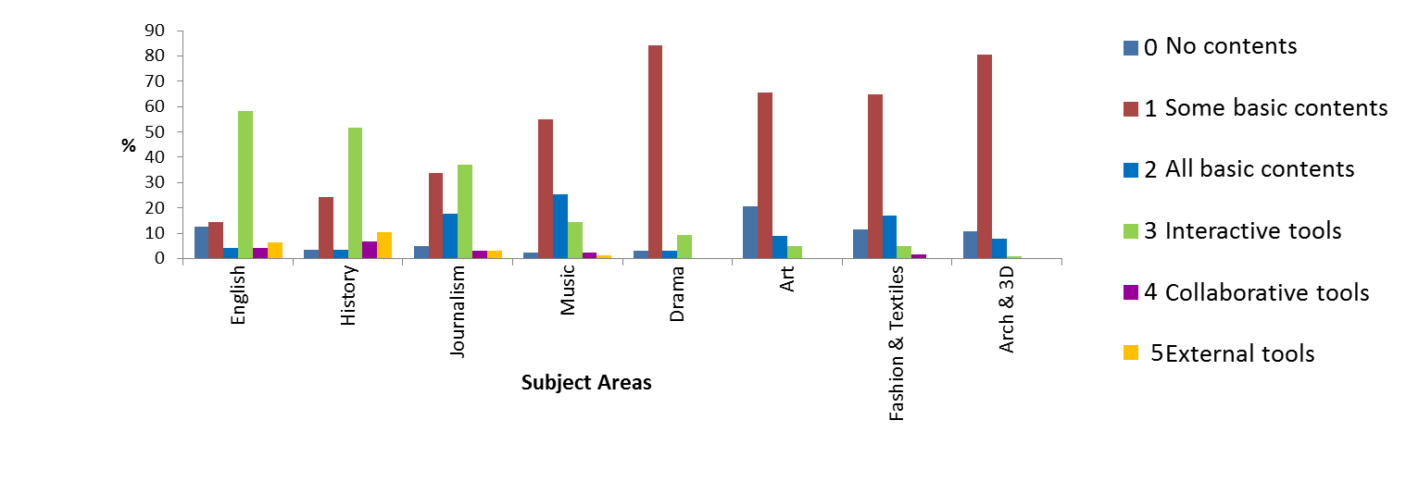Figure 2 – Content analysis graph
Interestingly there was a distinct divide between practice-based subjects and their counterparts within humanities. These findings corresponded with the study of UK HE institutions by Jenkins et al. (2011,) this survey focussed on the development of technology enhanced learning (rather than VLE). However, it had similar results in that lower usage of TEL was linked directly to the creative sector. This particular study analysed usage of TEL in science, humanities and the creative sector.

Qualitative Analysis
The second phase of the investigation used a qualitative approach to explore themes ascertained from the content analysis. Two data collection techniques were employed: a digital questionnaire and a series of focus groups and interviews. A convenient sample was used based on academic staff’s willingness and availability to participate. The research questions were initially informed by the content analysis and were categorised broadly under 4 themes. These categories were further refined during the development of research tool (questions) for the focus group (Table 1). Template analysis was used to generate and order themes from the transcripts of the focus groups and interviews.
Table 1 - Focus Group Categories
Focus Group Categories
- Areas of good practice in relation to embedding E/M-technology into the VLE
- Knowledge gaps in relation to engagement and usage
- Mechanisms for embedding and enhancing the use of e-learning within the VLE

A total of 18 main themes were identified with two of the main themes being “Barriers” and “Factor affecting use of TEL”. The sub themes within these revealed that the barriers were mainly four-fold: poor navigation/interface, technology competence, students’ attitudes, and lack of time. The transcripts revealed that the varied levels of technology competence of staff ranged from those with basic digital literacy to staff who were technology savvy. While some staff struggled to use the features of the VLE, the technology savvy found the VLE limiting which inhibited their enthusiasm and desire to use it. A few also acknowledged that other external systems such as social media were embedded into their teaching and learning. These variances led to a mixed level of staff usage which in turn affected students’ engagement with the VLE. Due to the inconsistent use of the VLE across courses, it was acknowledged that students may disengage leading to further lack of motivation for academics to blend the VLE into learning. Time was another key barrier, where some staff felt that within the creative sector there are constant face-to-face interactions with students in the studios, so uploading class discussions was an additional burden on time. Learning to use various functionalities within the VLE was also very time consuming especially when they used some of these functionalities only once a year. So after a long gap they had either forgotten how to use it, or the features of the VLE had changed, leading to a further re-investment of time to relearn the new functions. Other factors affecting the use of the VLE in creative arts were found to be related to the availability of easier systems to use outside the VLE as standalones. In some cases there was a fear of the unknown and a few participants suggested that embedding VLE into creative practice based modules was not suitable and conducive to their style of teaching or course ethos. It was evident from the analysis of the focus group transcripts that generally academic staff were aware of the benefits of an institutional VLE and were willing to use it. Nevertheless, the key barriers would have to be addressed to assist with further uses to promote blended learning.

Building a model
Phase 3 of this project developed a best-practice model for the effective use of VLE in the creative arts. To inform this process, the data from the secondary and primary investigations were triangulated leading to the formulation of three research questions.
- Are the tools in the VLE being used effectively to support learning within creative arts, or is it simply a repository model?
- How do we support staff to overcome the challenges of utilising a VLE in supporting the creative discipline?
- What can learners expect to find in the VLE within creative arts to support their learning and personal development?
It was discovered from the content analysis and reinforced within the focus groups that the advanced tools available in the VLE are used significantly less in the creative arts than in humanities. Interactive, collaborative and external tools were rarely embedded into the VLE to support class-based learning. This led to the initial conclusion, that the VLE was not being used effectively to support learning within the creative arts. From the focus groups it was ascertained that in the creative arts there were a number of reasons for this, which were complex. At one end of the spectrum there were some academic staff that were predominantly practice-based and lacking in confidence in terms of engaging with TEL, and at the other end of the spectrum there were some academic staff who find the institutions VLE clunky and clumsy and not able to provide the sophisticated, sleek interfaces that were available through social media or other external open platforms. In the focus groups, participants referred to a plethora of technologies that enhanced learning which they had successfully embedded within teaching and learning, but none of this was signposted through the VLE. Therefore, it could be suggested that TEL was prevalent in some modules within creative arts and that the VLE was being used appropriately as a repository for learning materials. An alternative approach to the interpretation of these findings could be that the VLE was not being used appropriately, since the intention of a VLE is to be a one-stop shop that signposts learners to learning resources and relevant external material that support their learning. There were some exemplary examples of this occurring within modules in humanities, but none in the creative arts. Therefore, if learners were by-passing the VLE system to engage with external platforms it could be confusing and potentially misleading, particularly if information is missed in lectures that refer to the location of specific sites. This could lead to potential disengagement with their studies. It also prevents the course leader from gaining an overview regarding the technologies underpinning learning and potentially limits the sharing of good practice across courses and departments.
In order for staff to embed the VLE into teaching and learning it isn’t enough to deposit materials into it, due consideration would also need to be given to the design “to support the learners in developing both their understanding and their autonomy” (Finlayson et al., 2016). Some fairly recent studies have been focussing on the role of teachers as designers of TEL (Kali and McKenney, 2012; McKenny et al., 2015; Svihla et al., 2015). Kirschner (2015) argues that designing is considered integral to the teaching and learning process, however our data revealed that academics may not always have the technical skills or aptitude of materialising them using multimedia designs within the VLE to enhance learning (Shank, 2005).
Some of the key barriers ascertained from the study particularly relate to the navigation and aesthetics of the user-interface along with the clunky and clumsy user-experience. Yet with the right knowhow, VLE areas can be engineered to improve both of these key features. However, this requires specific technical knowledge, effective organisation and planning and more importantly sharing of good practice. Since “time” was already perceived as a barrier to engagement with integrating the VLE into teaching it is unlikely that staff in creative arts would engage with specific training to re-design interfaces to improve navigation and aesthetics for visual learners. Particularly since this process may only be required once in any academic year. Therefore alternative mechanisms need to be investigated to embrace the available technology and utilise it to its potential, thus, ensuring VLE areas in creative arts are designed to be visually appealing, easy to navigate and a companion to learning. There was some appetite within the participants of the focus groups for standardisation, so that learner expectations are managed effectively, however, it was acknowledged that this should not be at the expense of good design. A one size fit’s all approach would not be considered best-practice in the creative arts since there are varied approaches employed to support teaching and learning. As Laurillard (2002) acknowledged there should not be a rush to adopt technologies without investigating the complexities of teaching practice within the specific subject discipline.

Model Development
It is acknowledged that having a VLE alone is not sufficient; its effective implementation is what contributes to a good learning experience. This can only be possible through the conscious and active human intervention, good learning design or pedagogical input, and the sensitive handling of the process by trained professionals (Salmon, 2005; JISC, 2011). Since this project was only limited to a specific discipline, making any institution wide changes or system wide improvements to the VLE was out of the scope of this project. Hence, the model presented in this paper intends to improve the VLE experience for both staff and students within the creative arts through redesigning the module spaces by the use of active participation of academic staff and a technology expert to support, guide and develop integration of the advanced functions within the VLE. The model presented in Figure 3 synthesised the research conducted during the three phases of study. Four factors were identified which could drive change within modules and courses: external environment, technology, curriculum and students.
Firstly the external environment including policy change impacts dramatically on processes at course level. The quality codes of practice, set by Quality Assurance Agency that all providers of UK higher education are required to meet, are reviewed regularly and often result in changes at course and module level.
Secondly courses would have to keep abreast of constant developments and changes in the technologies that could improve or maintain quality and standards. However, it should be acknowledged that technology should be used to enhance teaching and learning and not used solely because it is available (Laurillard, 2002). This is particularly important within creative arts due to the studio environments and creative workshops that could benefit through embedding VLE into their teaching and is perceived as good practice. Although, using the VLE as a repository model may be acceptable, it does not necessarily enhance learning.
Thirdly currency in the curriculum is essential and as the external environment changes the curriculum must change to accommodate this. An example of this could be the fashion industry, where technology has advanced to such a degree that areas such as 3D scanning, modelling and printing are now encompassed as mainstream within the curriculum, when once these were considered blue sky concepts.
Finally students are changing due to a number of factors, international students are increasing, transnational education is becoming mainstream, and students of the future are perceived to be digital residents with a different set of expectations in relation to the delivery and availability of information related to their learning. As personal learning environments become a norm it will impact significantly on VLEs, as we know them today.
In considering the four factors of change at the present time the model presented in Figure 3 places the VLE as the central point to access all teaching and learning activities (created upon internal and external platforms) both within and outside the classroom, studio and workshop, and as such should become a companion to teaching and learning.
The research acknowledges that it may not always be possible to bring everything within the VLE, because of the quantity of information, but VLE module areas should be designed to embed or direct students to relevant content. Further to this the interface used within the VLE should be clear and easy to navigate with a pleasing visual appearance. Ideally the VLE should work on various devices like mobiles, tablets and computers. It must be acknowledged that the VLE cannot do everything so it should be used as a mode of blended learning particularly in the creative arts. It is recognised that use of external platforms and tools shouldn’t be discouraged; however, it is perceived good practice to signpost these within the VLE, so that everything related to a module, is accessible from one place. The research accepts that not all academic staff are technology savvy, and therefore the proposal is to have a technology expert that will build visual interfaces and improve navigation, working in collaboration with academic staff. Thus, the academic can focus on module content and delivery and a design technologist could ensure a sound navigation and aesthetics to create an inspiring learning environment. This model would allow individuals to work to their strengths. Expertise in the school would increase in terms of VLE user-design and best-practices could be shared across courses and modules through the design technologist who would work across courses.
The framework is based around Kemmis and McTaggart’s (1988) action research model which involves participants’ continuous collective self-reflective inquiry in a social situation to improve the rationality of educational practices.
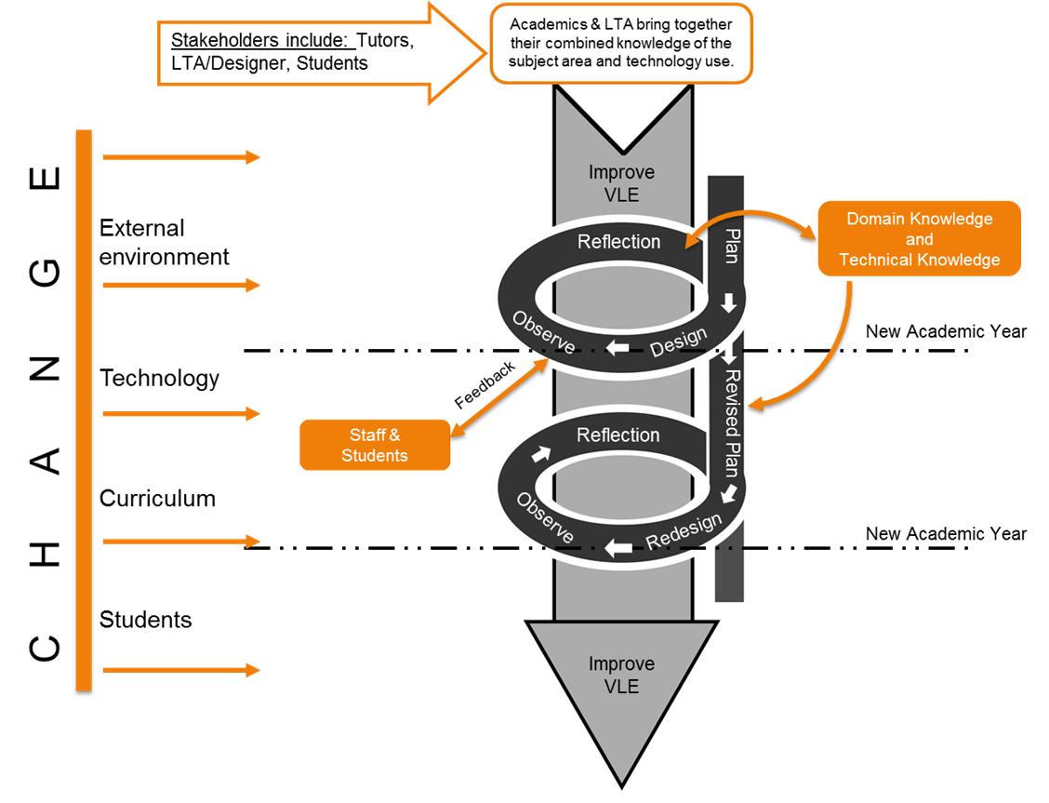
Figure 3 – Best practice model for VLE module design
The intervention that we planned into this action research project was the appointment of an intern who will be the technology expert (an intern who graduated with web technology skills) that would support staff in enhancing their VLE modules to improve students’ experience. The aim was to improve navigation, consistency and visibility of modules within VLE. The project was piloted with 3 courses within the creative arts discipline.
Literature around human computer intervention was reviewed to identify the key elements that would guide the process. During the review a few instructional design models were also considered, which included Keller’s (1987) ARCS model. This particular model was developed to motivate learning, which includes attention, relevance, confidence and satisfaction. It suggests that in order to motivate learning, the attention of the student should be sought at first, followed by delivering relevant content, generating confidence of the students on the subject matter and finally satisfying the student with their achievement of the learning objective. Designing TEL is considered integral to the role of teaching staff (Kirschner, 2015), however through this project we undertook to make it more efficient for academic staff by having a technology expert to offer technical expertise. Thus, assisting with the design through building the visual interface and improving navigation.
The technology expert worked closely with the module tutors to design the VLE module spaces. Initially a few prototypes were presented to tutors, to give them an indication of the possibilities within the VLE. Having seen the possibilities they were able to come up with new ideas around how they would like to deliver their modules through the VLE and the intern materialised these ideas within the module spaces. In total 21 module spaces across 3 courses and 2 school wide resource areas within the VLE were redesigned. Figure 4 shows a sample module prior to the enhancements being implemented. Figure 5 illustrates the appearance of the module area after intervention and collaborative working. It can been seen that in Figure 4 the welcome page just had ‘Announcements’ and was very text heavy and the standard menu to the left was available to access the rest of the content within the module. This was standard practice within all modules. To improve engagement of the students a new visual entry page was created with the use of images linking to relevant material within the modules, directing them to the key areas within that module (see Figure 5). The images used included some of the work generated by previous students and this created a preview of what would be expected from them through undertaking this module. The module also had a Pinterest page which was embedded into the module’s entry page, thus directing students to external course related social media content.
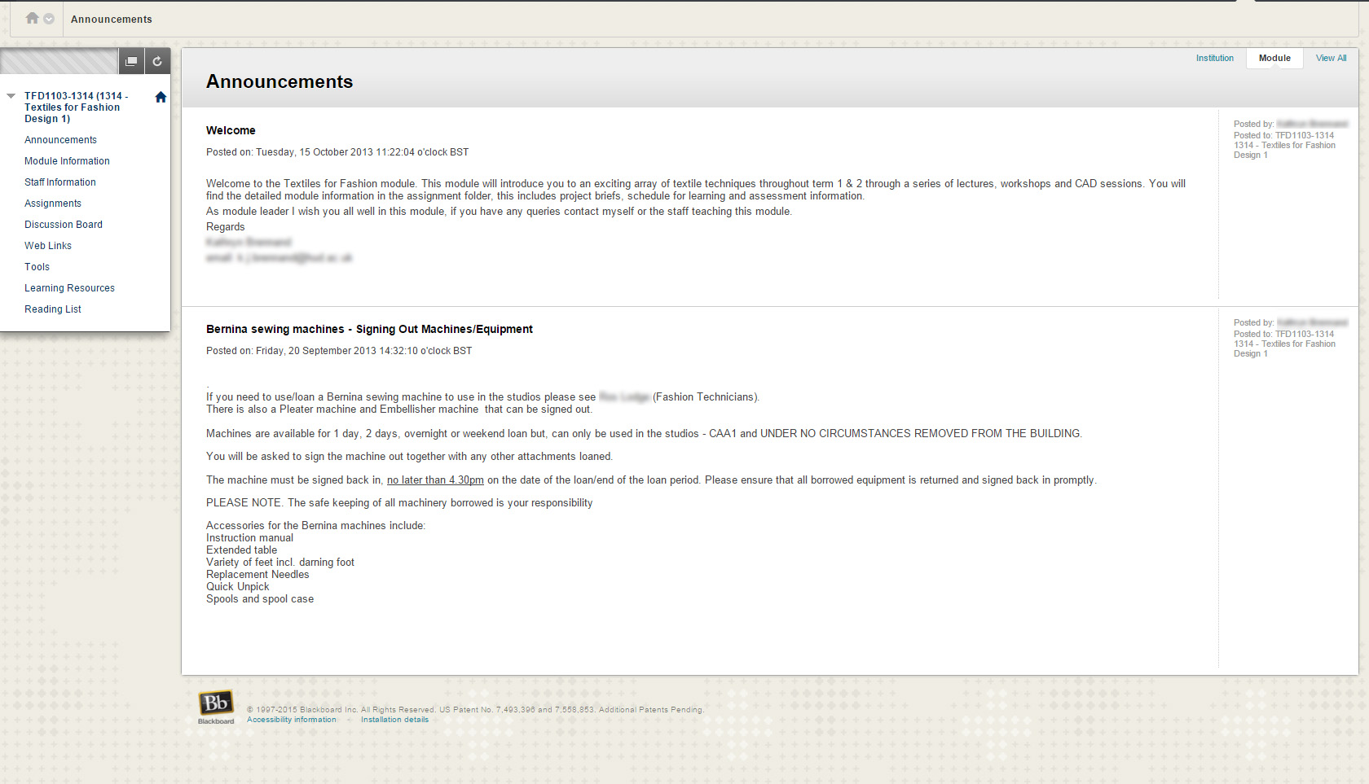
Figure 4 – A sample module before it was redesigned
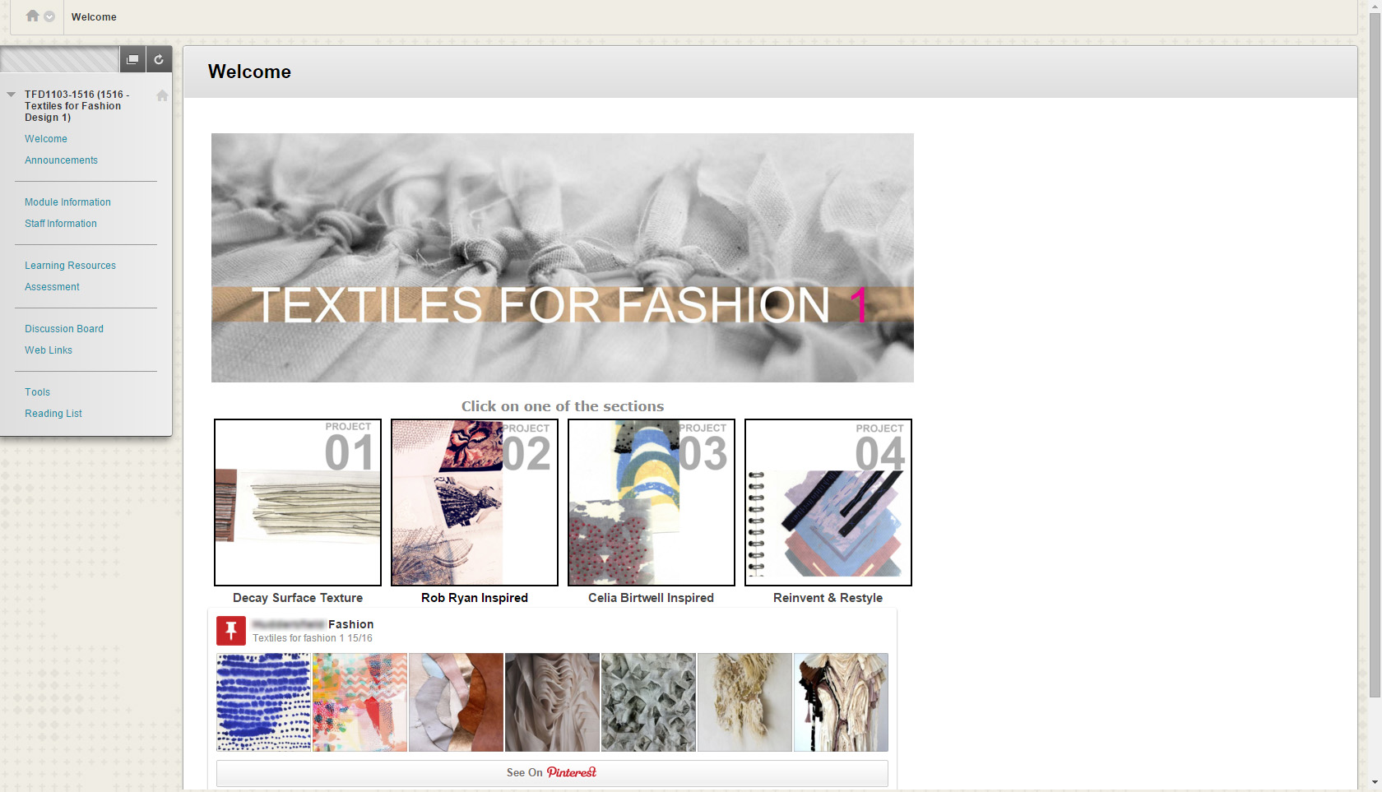
Figure 5 – The module after it was redesigned

Feedback
Following the implementation of the newly designed modules, which were released to the students during 2014-15, feedback was sought from staff and students. The project was presented at various university and school committees to disseminate the good practice. The results and feedback from this project exhibited a great impact on both staff and student experiences.
A questionnaire was sent out to all second and third year students who had previous experience of the old interface so that we could compare their experience with the new interface. Though the response rate was quite low, the feedback received was very positive. About 75% of the participants agreed that the new design had a positive impact on their learning and satisfaction. All of the responses agreed that the new modules were much easier to navigate. Some open comments acknowledged that the use of specific images to direct students to appropriate content helped them locate and access their course materials much more easily and made their modules more visually appealing.
Academic staff involved in this project also gave very positive feedback. All the participating staff appreciated the technical support they had received in designing and developing their modules. They all had similar sentiments with regard to being able to rethink the organization of the module contents and were able to think beyond what they had previously imagined was possible within the VLE. One of the module tutors had asked to embed a gallery of student works from previous years as an inspiration for the new batch of students. This idea was shared by the other two courses that we worked with enabling the sharing of good practice between courses. This project also achieved some unexpected benefits where staff from other courses were motivated to try these new aspects of module design within their own courses as well, proving to be a catalyst to the improvement in digital literacy of staff across the discipline.
This project was presented at various university events and the audience identified with the benefits of this project and requested guidance on how to build and implement the interface in their own modules. Members of staff from courses beyond the pilot group were also keen about extending this project out to their courses as well. Generally there were a lot of requests for guidance and suggestions on implementing this within their own courses and modules within the VLE. All this attention indicated that the project and our model had an influence on courses and individuals beyond the target group.

Summary
The model presented in this paper was shown to be effective in terms of improving the navigation and aesthetics for creative learners. It was praised by staff and students alike. Inadvertently it raised levels of digital literacy as more academics became interested and engaged with exploring new opportunities for developing exciting visually stimulating learning environments, involving techniques that they were previously unaware of. The design technologist was able to share good practice between different module leaders providing a visual interface which staff and students alike want to engage with. The ARCS model adopted by Keller (1987) suggested that in order to motivate learning, the attention of the student should be sought at first, followed by delivering relevant content, generate confidence of the students on the subject matter and finally making the student satisfied with their achievement of the learning objective. To facilitate this process we have removed technology barriers by providing an expert which made it easier for staff to improve the visual interface and improve navigation. In this way we could apply the ARCS motivational model to the VLE, to motivate students to engage through the application of the combined knowledge of the technology expert and the academic staff. The technology expert can exercise their skills to seek the students’ attention and build their confidence by improving the aesthetics and navigation of the VLE space, meanwhile the academics could bring in their subject knowledge making the content of the VLE relevant and improve student confidence leading to their satisfaction. The model, which is proposed as best practice, was developed to achieve an improved VLE experience and is based on Kemmis and McTaggart’s (1988) action research cycle model. Academic staff were provided with the opportunity to step back cognitively from their routine practices in relation to their use of the VLE and questioned and reconsidered the established methods of VLE use in their day to day teaching and learning activities, which resulted in the VLE moving from a repository model to a companion in learning.

Reference
Finlayson, B., Maxwell, H., Caillau, I., & Tomalin, J. (2006). e-Learning in Further Education: The Impact on Student Intermediate and End-point Outcomes. Sheffield: Department for Education and Skills.
Jenkins, M., Browne, T., Walker, R. and Hewitt, R. (2011). The development of technology enhanced learning: findings from a 2008 survey of UK higher education institutions. Interactive Learning Environments, 19(5), 447–465.
JISC (2011). Emerging Practice in a Digital Age. Retrieved from http://www.jisc.ac.uk/digiemerge
Keller, J. M. (1987a) Strategies for stimulating the motivation to learn, Performance & Instruction, 26(8), 1–7.
Kemmis, S. & McTaggart, R (1988), Action Research in Education. Victoria: Deakin University.
Kirschner, P. (2015). Do we need teachers as designers of technology enhanced learning? Instructional Science, 43(2), 309-322. doi: 10.1007/s11251-015-9346-9
Kali, Y., & McKenney, S. (2012). Teachers as designers of technology enhanced learning. In J. van Aalst, K. Thompson, M. J. Jacobson, & P. Reimann (Eds.), The future of learning: Proceedings of the 10th international conference of the learning sciences (Vol. 2, pp. 582–583). Sydney: International SocietyLogan, C., Allan, S., Kurien, A. and Flint, D. (2007). Distributed e-learning in Art, Design, Media: an investigation into current practice Research commissioned by the Art Design Media Subject Centre – Higher Education Academy (ADM-HEA)
McKenney, S., Kali, Y., Markauskaite, L., & Voogt, J. (2015). Teacher design knowledge for technology enhanced learning: An ecological framework for investigating assets and needs. Instructional Science, 43(2)181-2021–22. doi:10.1007/s11251-014-9337-2.
Mwanza-Simwami, Daisy; Kirkwood, Adrian; Thomas, Rhodri; Woods, William and Cross, Simon (2013). Understanding mobile VLE usage in distance education: A pilot study. In: World Conference on Educational Multimedia, Hypermedia and Telecommunications (EDMEDIA) 2013, 24th - 27th June, 2013 , Victoria, Canada, 601 -610.
Salmon, G. (2005). Flying not flapping: a strategic framework for e-learning and pedagogical innovation in higher education institutions. ALT-J, 13(3), 201–218.
Sclater, N., Peasgood, A. and Mullan, J. (2016) Learning Analytics in Higher Education – A full review of UK and international practice. JISC.
Shank, P. (2005). The value of multimedia in learning. Adobe Motion Design Center.
Sharpe, R., Benfield, G., and Francis, R. (2006) 'Implementing a university e-learning strategy: levers for change within academic schools', Research in Learning Technology, vol. 14, no. 2, pp. 135 - 151.
Shreeve, A., and Batchelor, R. (2012). Challenges to learning and teaching relations in higher education studio environments BrightONLINE Student Literary Journal, Issue 18. University of Brighton Faculty of Arts.
Svihla, V., Reeve, R., Sagy, O., & Kali, Y. (2015). Fingerprint pattern of supports for teachers’ designing of technology-enhanced learning. Instructional Science. 43(2) 283-307 doi:10.1007/s11251-014-9342-5.
White, D., & Le Cornu, A. (2011). Visitors and Residents: A new typology for online engagement. First Monday, 16(9). doi:10.5210/fm.v16i9.3171

Appendix
- Grading Criteria used for Content Analysis
 |  | Description of non-graded items | Grade descriptions
 |  |  | 0 | 1 | 2 | 3 | 4 | 5
Module Details | Module Code | Data to be collected from system.
 | Module Name
 | Department
 | Staff/Instructors
 | View Date
 | Number of Students Enrolled
Module Menu’s | Announcements |  | No Data. | Announcements present but include old redundant messages | Only welcome message but still have old messages. | Welcome Message for students and the area is clear of old messages | Regular productive use. | With module links.
 | Module Info/ Handbook/ Link to Specification. | Yes/No
 | Staff Information | Yes/No
 | Learning Resources | Yes/No
 | Assignments |  | No Content. | Assignment brief is present. No online submission. | Either TurnitinUK or general assignment. | Assignments have details of submissions times, dates and clear explanations of the assignment type. | GradeCentre or GradeMark used to mark submissions. | GradeCentre or GradeMark used to give in-depth feedback.
 | Reading List | Last Updated (YYYY)
 | Comments
Asynchronous | Blogs | Yes/No
 | Wiki's | Yes/No
 | Recorded Webinars | Yes/No
 | Discussion Board | Yes/No
Synchronous | Webinars | Yes/No
 | Virtual Classrooms | Yes/No
 | Chat | Yes/No
 | Comments
Assessment and Feedback: Assignments | Submission Date | Yes/No
 | Return Date | Yes/No
 | Evidence of Electronic Feedback | Yes/No
 | Quizzes | Yes/No
 | Test/Survey | Yes/No
 | Comments
TurnitinUK | Submissions | Yes/No
 | GradeMark Feedback | Yes/No
 | Comments
Other content | PLE/Social Learning | Yes/No
 | Embedded Content | Yes/No
 | Audio/Video Content | Yes/No
 | Internal/External | Internal /External /None
 | Comments
Module Overall Grade | Grade |  | 0 | 1 | 2 | 3 | 4 | 5
 | Description |  | No Content | Some content: Either Staff Info, Announcement or one/two documents | Basic Content: Staff Info + Announcements + Documents | Basic Content + Some Interactive Tools (e.g. Turnitin/Blog/Wiki etc.) | Collaborative Tools + Grademark + Grade 3. | All + Embedding External Tools/Content.
 | General Comments:

