The Body of Nursing as seen through the NHS Nursing Uniform

Laura Hardingham, l.a.hardingham@rgu.ac.uk, Robert Gordon University, Grays School of Art.
Rachel Heeley, r.h.heeley@rgu.ac.uk, Robert Gordon University, Grays School of Art.

Abstract

This paper aims to analyse the current NHS nursing uniform, how the uniform impacts upon the identity of the modern day nurse and how efficient the uniform is for the role required. From a design perspective the nursing uniform appears to have little consideration for aesthetics, gender, fit and comfort with practicality, cost and a universal “one-style fits all” overpowering the design thinking. As designers the authors discuss the importance of the aesthetics of a garment as being highest on their agenda, but appreciate that uniform is not fashion and as such practicality is important within the design. However, the authors argue that effective design should have a balance of these characteristics and question can a “one-style fits all” design philosophy really fit all?

Keywords

Design, identity, nurses, professional, uniform.

Aims

The aims of this research are to:
- Analyse the current NHS nursing uniform to gather data on the personal and professional identity of the modern day nurse.
- Evaluate the effectiveness of the current NHS nursing uniform in terms of practicality and aesthetics.

Introduction

As designers within fashion and textiles we are constantly focused on the aesthetic of a garment, how it looks not only to wearer but also how it is perceived by others. The cut of the garment and how it sits on different body shapes, the movement and interaction of the garment with the body as it moves, the colour and how it relates to different skin tones and the texture of the fabric and how comfortable it is to wear; these are all important considerations.

Working collaboratively on the Enhanced Nursing Through Educational Research project (ENTER) with Robert Gordon University’s (RGU) School of Nursing and Midwifery, gave the authors an opportunity to view the current nursing uniform. It was intriguing to see garments that appeared to have little consideration for aesthetics, fit and comfort with practicality, cost and irrespective of the nursing role held within the NHS profession having a universal “one-style fits all” overpowering the design thinking.

The authors were interested in defining the characteristics of who or what a nurse is as perceived through their uniform; both within and out-with the working environment. This led to researching nurses’ identity and the current nursing uniform to analyse the impact the uniform has on their personal and professional identity. Houweling (2004 p. 40) states “the nursing uniform has evolved with the times and the fashions. For many years, the all-white uniform symbolized and distinguished the nursing profession, imparting both group pride and identity”.

Through history the uniform has transformed from that of a smart appearance including dresses, cape, cap, apron and belts to universal pyjama style tunics and cargo trousers. The authors question: has this transformation impacted on nurses’ confidence? Sparrow (cited in Shaw and Timmons 2010 p.3) states “that when nurses did not wear uniform their assertiveness with doctors increased and they felt doctors were more willing to involve and to talk to them”. Has this assertiveness stemmed from feeling a greater sense of confidence and self-assurance in clothing they have selected to wear? Breward and Evans (2003 p. 2) states, “it (fashion) is a modern mechanism for the fabrication of the self” and as the saying goes “the clothes make the man (or woman)”.

From a fashion design perspective and taking the above into consideration, looking at the current tunics and cargo trouser combination, it is clear to see that for the vast majority of nurses they are wearing inadequately fitting uniforms; however, this affects some more significantly than others. Within the uniform design there appears to be little consideration for gender and anthropometrics, for the vast array of differing body sizes as seen in the nursing population.

The authors view the importance of the aesthetics of a garment as being highest on their agenda, although appreciate this is not necessarily the case for a nurse. Uniform is not fashion and as such practicality is foremost. To create a fit for purpose, well-fitting and stylish uniform, the design thinking process should follow a user centred approach with a balance between functionality and aesthetics reached. Figure 1 below shows the importance of consideration for the end user throughout the design process to conclude with a fit for purpose product or garment. When discussing designing effective uniform Hsu et al. (2014 p.69) comments “that the following factors should be taken into consideration; design thinking from the viewpoint of the user needs, with an integration of fashion design”.
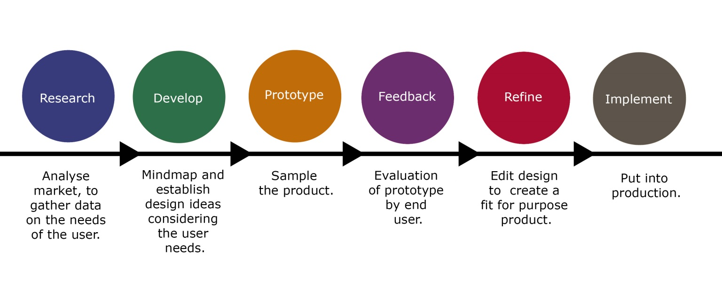
Figure 1: Design Thinking Process, Authors, 2015

Methodology

Background
Initially the research started out as a collaborative project between three fashion and textile staff, one fashion graduate and one nursing expert, from RGU’s Gray’s School of Art and the School of Nursing and Midwifery. The interdisciplinary project collaborated with the fashion and textile team to create an interactive exhibition stand that focused on gathering research data from nursing practitioners and nursing educators during the ENTER conference held in RGU in November 2014.
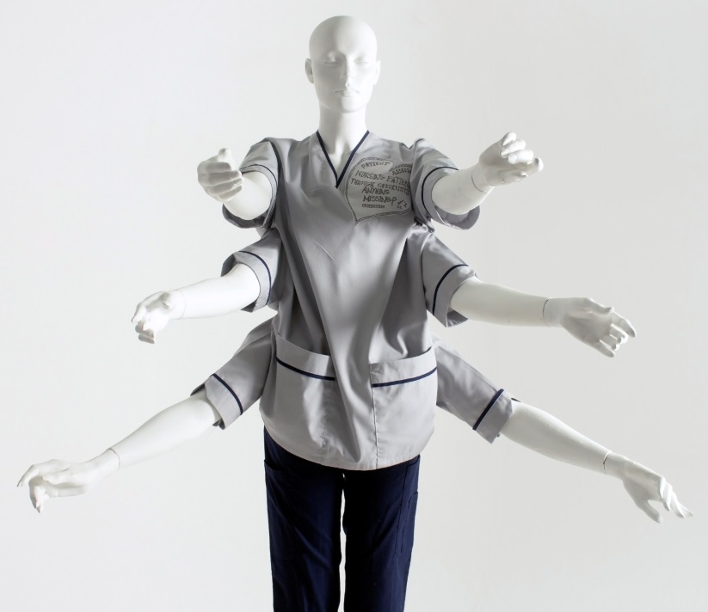  Figure 2: Alex x 6  Photograph: Callum Kellie | “Alex x 6” (figure 2), a six armed nurse was conceived from personal observation of the role a modern day nurse holds; representing being over-worked and under-staffed.  Dressed in a customised nurse’s uniform to allow for six arms, Alex was designed to be gender neutral to relate to both male and female nurses.

Alex was the main focal point on an interactive exhibition stand at the ENTER conference (figure 3). Nursing professionals were asked to respond to Alex by telling us about “the body of nursing” and “how should we clothe the body” gathering data from delegates by asking them to write on hospital bed sheets. The information gathered from participating in the ENTER project and conference opened up an opportunity for the authors to further develop the research, looking at nurses’ identity as seen through the uniform and how effective the current design is. | 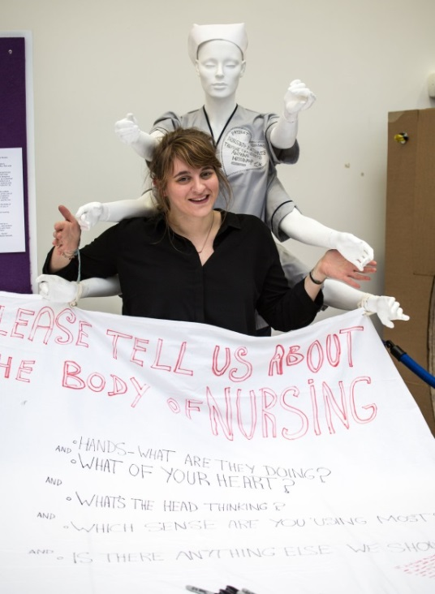  Figure 3: Emma Cantlay at the ENTER  conference with Alex x 6  Photograph: Martin Parker

Questionnaire
An online questionnaire was designed to gather qualitative data by asking ten specific questions. Distribution of the questionnaire was to current UK NHS registered nursing professionals, using social media and word of mouth. The questions asked were:

Q1. What is your gender?
Q2. What is your age?
Q3. Which NHS Trust do you work for?
Q4. Please list you current and previous NHS nursing positions?
Q5. Thinking about but not limited to, professionalism, empowerment and respect how do you feel your uniform is perceived by
a) you
b) your colleagues
c) patients
d) general public
Q6. When wearing uniform in what way, if any, does your identity change?
Q7. In what way, if any, does your profession restrict your personal style e.g. hair, make-up, footwear etc.
a) during work hours
b) out with work
Q8. Please give your opinion on the current NHS standard issue uniform in relation to gender
Q9. In terms of comfort and practicality, how do you think your current uniform is compatible with the tasks required and role of a modern day nurse and in what way, if any, could this be improved?
Q10. In terms of design, how appealing do you think your current NHS nursing uniform is and in what way, if any, do you feel it could be improved?

Results

Sixty four responses were received, of which twenty nine had completed every question. The ratio of male to female was 6.67% male responses to 93.33% female responses, with the Nursing and Midwifery Council (2015, p.15) stating the national ratio as 10% male to 90% female, these statistics are closely aligned to the national statistics for nursing staff. The age range showed a bell curve of ages from 21 to 55 or over, as illustrated in figure 4, showing a good representation of nurses at various stages of their lives and careers.

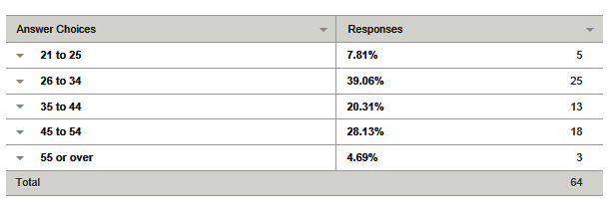
Figure 4: The Age Range of Interviewee, Authors 2015

NHS England, Northern Ireland and Scotland were all represented in the responses; however no completed questionnaires were received from NHS Wales. NHS Scotland was predominant in the response data with 5 of the 14 NHS Scottish Boards being represented. Therefore, this paper will be bias towards the national uniform as worn by NHS Scotland, implemented in 2012 (figure 5). | Figure 5: NHS Scotland National Nursing Uniform,  Photograph: NHS Photo Library

Analysis
When asked the question, in what way does your identity change when wearing your uniform? The majority responded to becoming professional or stepping into the role of the nurse. Respondent 21 commented ‘I turn into nurse, and not myself, I do feel like it generalises us all, and doesn’t leave any room for individuality’ and respondent 25 states ‘I go into nurse persona - it's like putting on costume to play a part in a play or film. It's a 'costume' that enables me to maintain emotional boundaries but still show compassion’. Out of all respondents only respondent 19 commented that their identity ‘Doesn’t change’. Analysing the responses it is evident that the respondents feel the role of a nurse is more important than their own personal identity, with professionalism being at the forefront as respondent 31 comments ‘Always remember patients or relatives could meet you outside work so we must always maintain a sense of professionalism’. It appears that for many nurses the uniform is used as an emotional barrier to provide a coping mechanism to differentiate between personal and professional lives.

It is very clear that committing to a nursing profession is not just a job, it is a vocation. White (2002 p. 283) sums this up by stating that “Florence Nightingale popularised the notion of nursing as a vocation”.

Focussing on identity in terms of personal style, the majority of respondents commented on the restrictions of hair, make-up, footwear and nails during working hours however, this was not an issue for all with respondent 47 saying:

‘Hardly at all. I don't wear a large amount of makeup anyway. It tends to be more subtle than many people my age. My hair, whilst often worn down outside of work, is pulled up at work, but would be if I was doing any significant housework/gardening etc. anyway. I still look and feel like me at work’.

For those who felt restricted, this is also an issue out with work, of being unable to adopt current beauty trends due to time restrictions between shift patterns with a large percentage of respondents agreeing with respondent 13 when they say ‘When out with work the job restricts you to what you can do with your style if it encroaches into your work e.g. acrylic nails’. Personal preference was a big factor in the responses to this question. Appearance, within and out with work situations unquestionably is more important to some than others, with some people only wearing clothes to cover the body and others using clothing, accessories, beauty products and jewellery to define their persona. Entwistle (2000 p.112) comments that “the tension between clothes as revealing and clothes as concealing of identity runs through much of the literature on fashion”. Therefore, it is understandable that it would impact upon some more than others.

Looking specifically at the uniform, nurses were questioned on the comfort, practicality and design of their current uniforms. There were several recurring themes within the responses that if addressed could improve the uniform for the wearer.

Infection Control
Highest on the agenda is infection control where nurses have very strong concerns about the tunic requiring to be pulled over the head or cut off the body when contaminated with a patient’s bodily fluid(s). A simple solution to this problem is to provide an opening to safely remove the tunic without the potential of the nurse’s head making contact with the contaminated area. The previous uniform incorporated a zip and although not questioned directly about this, a lot of respondents commented on preferring the tunic’s previous configuration.

Modesty
Modesty was a concern amongst female participants due to the neckline of the tunic. When performing certain tasks it is possible for a patient to see down their tunic and view the nurses’ body and underwear. This is embarrassing to the wearer and can be degrading to the profession.

Seasonal
Currently there is only one option of uniform for all seasons, resulting in some nurses feeling too warm during summer months and too cold during winter months. Concerns were raised by several participants as overheating can result in perspiration marks on their tunics, making them feel unprofessional and unhygienic. In particular, when their role requires physical interaction with patients and again this highlights the issue of infection control.

Trousers v Dresses
Trousers were definitely preferred over dresses for female nurses, with dresses being deemed out of touch for tasks required of a modern day nurse. That said, the trousers could be greatly improved in relation to gender, fit and comfort. The main issues raised were that the trousers are far too baggy, the crotch is too low and the elasticated/drawstring waist is ineffective. From the data gathered these respondents are only issued with cargo style trousers. As stated in The Scottish Government’s National Uniform Policy (2010) “Navy blue trousers are available in a unisex cargo style and ladies and gents tailored styles. It is anticipated that the cargo style will be worn with tunics and polo shirts and the tailored trousers worn with shirts and blouses. However this is a matter for local policy”.

Discussion

With the cargo style trousers and tunic tops being unisex it was inevitable that the issues above have been raised. Male and female body shapes differ significantly within and across the genders and therefore, do not lend themselves to a uniform that has to be worn to perform physical tasks whilst fitting both sexes effectively. Unisex clothing is a recurring fashion trend and is done particularly well by fashion designers such as Rad Hourani. However, this works for these designers as their target market is within a confined percentile of body shapes, unlike the NHS workforce that includes a broad spectrum of sizes (figure 4).

Uniform design whereby the outcome is a universal, one-style fits all both in terms of gender and varying nursing roles is going to be difficult to please an entire workforce. For a small minority of the nursing community fit and comfort may not raise any negative issues. However, there will be a large percentage of wearers whereby the uniform design is not effective using this design philosophy.

Nurses are now dealing with uncomfortable fabrics, inadequate fit and poor design in relation to infection control, gender, comfort, modesty and seasonality. Comfort could be improved through fabric choice, by introducing a stretch fabric or by embracing the advances in smart textiles.

Donning and doffing could be improved by offering an alternative to pulling the tunic over the head. Improving fit through cleverly designed adjustable features and openings. Taking inspiration from, for example, babies wear (see figures 6 and 7), or sportswear could offer the wearer a superior experience. | 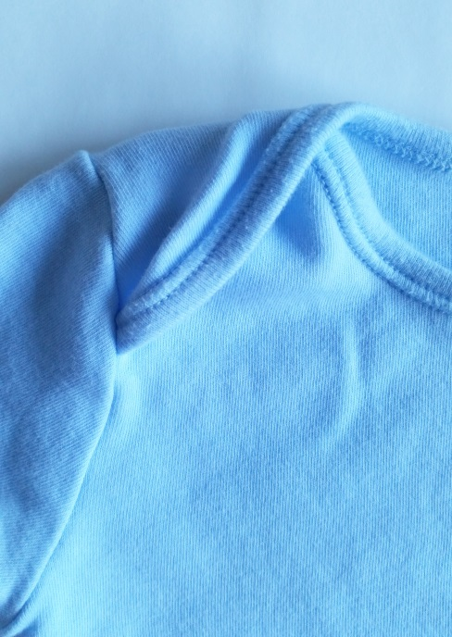  Figure 6: Babies vest neckline.  Photograph: Rachel Heeley | 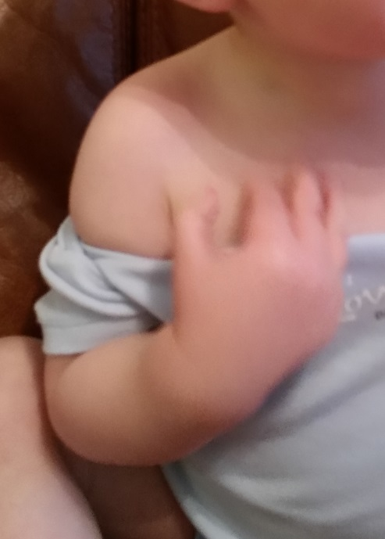  Figure 7: Showing vest being removed.  Photograph: Rachel Heeley

Budget constraints and cost implications highlight the design philosophy followed by the NHS. However, this paper highlights this as a potential false economy, with uniforms being destroyed if a nurse needs to be cut out of a contaminated garment. Respondent 5 says ‘In my opinion (the tunic) should have a zip front as if there are any spillages i.e. blood on the uniform then they are to be cut out off rather than taken over the head and washed.’ With taking the above into consideration does removing the tunic zip really save costs in the long term?

With aesthetics being important to the authors they very quickly form opinions based upon the visual. Uniform can be seen as a form of branding for a company and as such connections are made between smartness and professionalism. Fabric, cut and style of the current uniform do not portray the sense of pride historically linked with the profession.

It is evident from this research, that for nurses donning the uniform instils a sense of pride and comfortable or not, they accept the uniform as part of the profession. However, analysis has revealed that nurses in uniform do not relate to having a personal identity, with the profession overruling this characteristic. Members of the public often refer to nursing professionals as “nurse” rather than using their names therefore, it is understandable that they can feel anonymous.

Conclusion

The research gathered from the respondents for this paper has highlighted that the nursing profession are far less concerned with image and aesthetics than their fashion and textile counterparts. Foremost in nurses’ priorities is their ability to care for their patients effectively, followed by the practicality and comfort of the uniform to perform the tasks required of them. With the restrictions of the current dress code, where all nursing staff are limited in how they look it is somewhat understandable that professional identity overpowers personal. Respondent 4 states:

‘our uniforms are comfortable and practical but I personally do not like the blue tunics. I prefer navy and white for nurses. Colleagues feel our uniforms are easily laundered, easy to tell which staff are which grade etc. Our uniforms can make it difficult for patients to differentiate staff members and their grades. Nurses uniforms have to move with the times and I think the public feel that nurses are not as smart as they use to be. Uniforms are practical but not as smart as previous more formal uniforms which gave nurses recognition for their profession and qualification and responsibilities to the public. Bring back the capes and hats’.

Taking the above into consideration, the authors feel that re-designing the uniform using a design thinking process to formulate a balance between practicality, fit and aesthetics could restore the identity of the profession and improve the wellbeing during the working day for the nursing staff.

The research for this short paper has opened new areas of interest for the authors. Initially using the uniform to view the identity of the nurse and evaluate its effectiveness was the focus. However, the research raised interesting issues that the authors feel they could address with further research relating to this topic for example, smart textiles, public perception of the uniform, laundering and lifespan of garments, the uniform relating to differing roles of the nursing profession and their individual needs and differentiation of nursing roles.

References

Breward, C. and Evans, C., eds. 2005. Fashion and modernity. Oxford, Berg.

Entwistle, J., 2000. The fashioned body: fashion dress and modern social theory. Cambridge. Polity Press.

Houweling, L., 2004. Image, Function and Style: A history of the nursing uniform. American Journal of Nursing, 104(4), pp. 40-48.

Hsu, C. et al,. 2014. Designing “fashion” into uniform to Taipei city public cleaner team. In: P.L. PATRICK RUA, ed. Cross-Cultural Design. Switzerland: Springer International Publishing. pp. 68-79.

Nursing and Midwifery Council (NMC), 2015. Equality and Diversity Annual Report. London: NMC.

Scottish Government, 2010. National uniform policy CEL 42 (2010). Edinburgh. pp. 2

Shaw, K. and Timmons, S., 2010. Exploring how nursing uniforms influence self image and professional identity. Nursing times, 106(10), pp. 21-23.

White, K. 2002. Nursing as Vocation. Nursing Ethics, 9(3), pp. 279-289.

Bibliography

Bohemia, E., 2014. Designing with and for others. Archives of design research. [online]., 27(4). Available from: http://www.dbpia.co.kr/Journal/ArticleDetail/3527848 [Accessed 3 August 2015].

Catanzaro, S., 2013. Evolution of uniforms to cater for the needs of staff and patients. Nursing Management, 19(9), pp.24-25.

Fagermoen, M.S., 1997. Professional identity: values embedded in meaningful nursing practice. Journal of Advanced Nursing, 25 pp.434-441.

Lehna, C. et al., 1999. Nursing attire: indicators of professionalism? Journal of Professional Nursing, 15(3), pp. 192-199.

Mayra, J. et al., 2005. Utilizing end user knowledge in the designing of intelligent workwear. Nordes 2005 – In the making. [online]. Available from: http://www.nordes.org/opj/index.php/n13/article/view/192/175 [Accessed 3 August 2015].

Pearson, A. et al., 2001. Contemporary nurses’ uniforms – history and traditions. Journal of Nursing Management. 9, pp. 147-152.

Spragley, F. and Francis, K., 2006. Nursing uniforms: professional symbol or outdated relic? The Journal of Excellence in Nursing Leadership, 37(10), pp. 55-58.

Stockwell, F., 2010. A Contemporary Perspective on Florence Nightingale's Writings in Notes on Nursing and Florence Nightingale to her Nurses [online]. Available from: http://www.felicitystockwell.com/wp-content/uploads/2010/08/Florence-Nightingale-modern-nursing.pdf [Accessed 11 August 2015].

