WEIGHTINGS APPLIED |  |  |  |  |  |  |  |  | VQI
Physical | Bluespace | Greenspace | Built | SUM | Min | Mean | Max | StdevP | Median
0 | 0.33 | 0.333 | 0.333 | 1.00 | 0.254 | 0.545 | 0.749 | 0.107 | 0.54
0.1 | 0.3 | 0.3 | 0.3 | 1.00 | 0.249 | 0.545 | 0.735 | 0.100 | 0.55
0.2 | 0.267 | 0. 267 | 0. 267 | 1.00 | 0.244 | 0.545 | 0.725 | 0.097 | 0.55
0.3 | 0.233 | 0.233 | 0.233 | 1.00 | 0.238 | 0.544 | 0.722 | 0.098 | 0.55
0.4 | 0.2 | 0.2 | 0.2 | 1.00 | 0.233 | 0.544 | 0.719 | 0.103 | 0.55
0.5 | 0.167 | 0.167 | 0.167 | 1.00 | 0.227 | 0.544 | 0.716 | 0.112 | 0.54
0.6 | 0.133 | 0.133 | 0.133 | 1.00 | 0.222 | 0.543 | 0.714 | 0.122 | 0.55
0.7 | 0.1 | 0.1 | 0.1 | 1.00 | 0.216 | 0.543 | 0.735 | 0.135 | 0.56
0.8 | 0.067 | 0.067 | 0.067 | 1.00 | 0.211 | 0.542 | 0.757 | 0.150 | 0.58
0.9 | 0.033 | 0.033 | 0.033 | 1.00 | 0.205 | 0.542 | 0.778 | 0.165 | 0.59
1 | 0 | 0 | 0 | 1.00 | 0.200 | 0.542 | 0.800 | 0.182 | 0.60
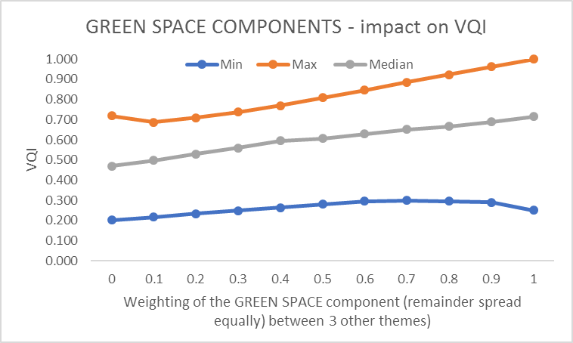
S1: A sensitivity analysis was undertaken to evaluate the impact of different weightings on the final VQI for the 32 sites. Each of the 4 themes were taken in order and their weight varied in increments of 10% with the remaining weights then spread equally between the other three themes. The VQI was then re-calculated for each site and the min, mean, median, max and standard deviation calculated. An example showing the process for the ‘green-space’ is shown in full below.

As would be expected, extreme manipulations where the greenspace component is either removed or increased to a weighting of over 60%, start to impact on the overall VQI significantly (see chart). This is the case with all of the four categories, though the Terrain category is very stable. The category which has the most impact is that of Green Space (see below). If the weight assigned to Blue Space, Green Space or Built/Historic category <0.6, the VQI is stable.
 | Median value of the VQI when weighting for that component is set as follows, all others equal.
 | 10 | 20 | 30 | 40 | Range
Terrain | 0.55 | 0.55 | 0.55 | 0.55 | 0.00
Blue Space | 0.58 | 0.56 | 0.53 | 0.52 | 0.06
Green Space | 0.50 | 0.53 | 0.56 | 0.60 | 0.10
Built /Historic | 0.57 | 0.55 | 0.54 | 0.55 | 0.03

