Introduction
Measurement of plantar pressure is a valuable resource to healthcare professionals when assessing various foot pathologies (1). It is widely used when assessing diabetic patients where high plantar pressure has been shown to be a major risk factor for the development of ulcers (2,3). In clinical settings plantar pressure is usually monitored by clinicians during infrequent visits in a lab environment that can only provide a brief window into the loading of that foot over the course of a day. This information is then used to prescribe shoes/orthoses to address the issues relating to abnormal pressure which causes ulceration. This raises the need for plantar pressure measuring devices that can continually monitor the patient’s pressure. Recently a new portable in shoe measurement device which allows for daily, continuous monitoring of plantar pressure has become available. This system named “WalkinSense” (Tomorrow Options Microelectronics, S.A., Sheffield, UK) consists of a data acquisition and processing unit and eight individual sensors for plantar pressure measurement (Figure 1) which can be attached to either an insole or the patient’s sock. Similar to the F-Scan (Tekscan Inc., Boston, USA) system these sensors are piezoresistive force sensors. Recent research (4) has shown the F-Scan system to be reliable for clinical measurement and hence it is considered capable of relative comparisons for use within this study. The overall aim of this preliminary study is to assess the repeatability of WalkinSense system and to compare the pressure values to the values reported by the F-Scan System and not to examine the clinical suitability or ease of use in patient assessment.

Methodology

Participants
3 healthy male participants with an average age of 36.3 (± 8.1years), weight of 85.0 (± 8.2 kg) and height of 177.0 (± 3.6 cm) were recruited for the study. Ethical approval was sought and received from the University Ethics Committee. All participants signed an informed consent before any laboratory testing.

Procedure
The study consisted of two testing sessions with the 1st session requiring participants to walk across the laboratory at a self selected pace while wearing their own footwear with both the F-Scan and WalkinSense systems in their right shoe. The 8 WalkinSense sensors were located as follows: 1 each on the hallux, midfoot, medial heel and lateral heel and 4 on the forefoot (Figure 2). The F-Scan sensor was calibrated to the manufacturer’s guidelines and both systems used a sampling rate of 100Hz. Both systems are capable of continuous plantar pressure recording and each participant completed 3 trials consisting of between 5 and 6 steps. This procedure was replicated after 24hrs on Day 2.

Data processing and analysis
Plantar pressure profiles for the 8 WalkinSense sensors for each trial were exported from the proprietary software (WalkinSense version 0.96, Tomorrow Options Microelectronics, S.A.). The positions of the 8 sensors in relation to the F-Scan sensor were located and 8 polygons (approximately the same surface area as the WalkinSense sensors) were created using the F-Scan software (F-Scan Research 6.33, Tekscan, Boston, USA). Plantar pressure profiles for these 8 polygons were then exported for each trial using the F-Scan software. Subsequently representative stance phase trials (with the first and last steps removed from the analysis) for both systems for each foot region on Day 1 and Day 2 were created by averaging all trials on each day for the 3 participants. Additionally the peak pressure value for the 8 regions for both the WalkinSense and F-Scan systems were identified.

Results

Figures 3-10 provide representative plantar pressure profiles for Day 1 and Day 2 across the 8 foot regions. Table 1 presents peak pressure values for the 8 foot regions measured using both systems on Day 1 and Day 2.

Discussion

With regards to the repeatability of WalkinSense, differences in peak pressure values at the 8 foot regions between day 1 and 2 ranged from a reduction of 0.24 kg/cm² to an increase of 0.42 kg/cm². Similar differences in peak pressure values were seen in F-Scan with values ranging from a reduction of 0.15 kg/cm² to an increase of 0.51 kg/cm². These ranges in peak pressure values across days are comparable to other pressure measurement systems (5).
When compared to F-Scan, WalkinSense consistently reported higher peak values, except for the hallux on Day 1. Differences in peak pressure values between systems ranged from a reduction of 0.12 kg/cm² to an increase of 0.91 kg/cm² on day 1 and increased between 0.07 and 0.95 kg/cm² on Day 2. There are some possible reasons that may explain the differences seen between the systems. Firstly, the polygons created using the F-Scan software were based on the entire surface area of the WalkinSense sensor which may not be equal to the active sensing area of the WalkinSense sensor.
Secondly, the location of the polygons in the F-Scan software may not have been in exactly the same position as the WalkinSense sensors. While these issues will not have affected the between day comparisons they may have affected the overall pressure value comparisons between the two systems.
In addition to the benefit of continuous daily plantar pressure monitoring that WalkinSense has over other measurement systems it may also potentially reduce the amount of time the clinician has to spend analysing the pressure data. It is common practice with other pressure measurement systems for the clinician to divide the foot into a number of regions (apply masks) that they deem to be most important in their analysis of the pressure data. However recent research had identified issues in the reliability of masking (6). As WalkinSense consists of 8 individual sensors the clinician can directly apply the sensors to the areas they want to assess with no need for post processing of the data.
In conclusion this preliminary study found WalkinSense system to be as repeatable as another currently available pressure measurement system. When compared to F-Scan WalkinSense appears to consistently report higher pressure values than F-Scan. This warrants further investigation with a larger sample size to fully ascertain the repeatability and reliability of the system.

References
(1) Rosenbaum D, Becker HP. Plantar pressure distribution measurements. Technical background and clinical applications. Foot Ankle Surg 1997;3(1):1-14.
(2) Stokes IAF, Faris IB, Hutton WC. The neuropathic ulcer and loads on the foot in diabetic patients. Acta Orthop Scand 1975;46(5):839-847.
(3) Veves A, Murray HJ, Young MJ, Boulton AJM. The risk of foot ulceration in diabetic patients with high foot pressure: a prospective study. Diabetologia 1992;35(7):660-663.
(4) Ahroni JH, Boyko EJ, Forsberg R. Reliability of F-scan in-shoe measurements of plantar pressure. Foot Ankle Int 1998 Oct;19(10):668-673.
(5) Ramanathan A, Kiran P, Arnold G, Wang W, Abboud R. Repeatability of the Pedar-X® in-shoe pressure measuring system. Foot Ankle Surg 2010;16(2):70-73.
(6) Deschamps K, Birch I, Mc Innes J, Desloovere K, Matricali GA. Inter-and intra-observer reliability of masking in plantar pressure measurement analysis. Gait Posture 2009;30(3):379-382.

Figure 1: WalkinSense system.

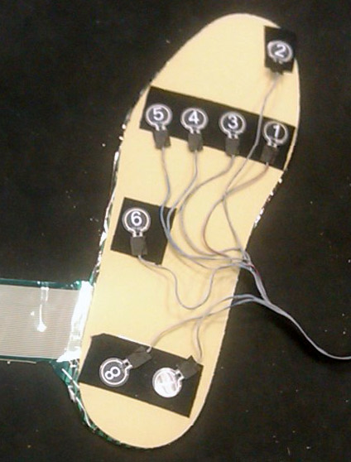
Figure 2: Placement of WalkinSense sensors and Fscan sensor beneath the flat insole.

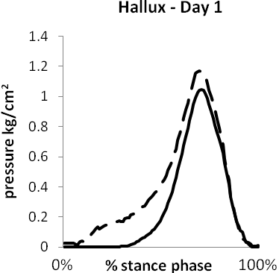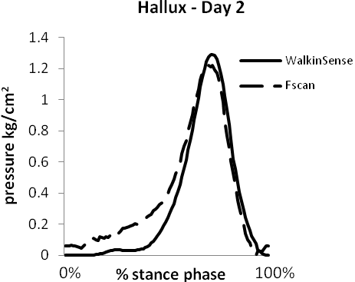
(a) (b)
Figure 3: Contact pressure profile of the hallux for WalkinSense and FScan during the stance phase of walking on Day 1 (a) and 2 (b).

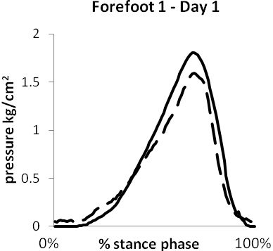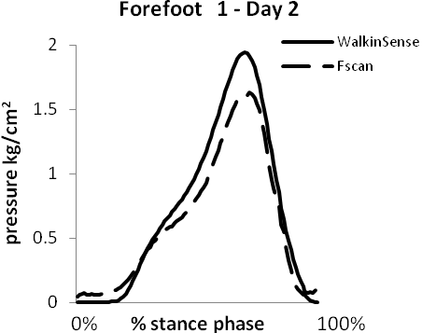
(a) (b)
Figure 4: Contact pressure profile of forefoot 1 for WalkinSense and FScan during the stance phase of walking on Day 1 (a) and 2 (b).

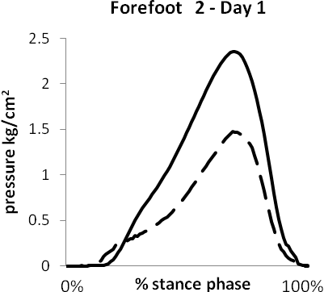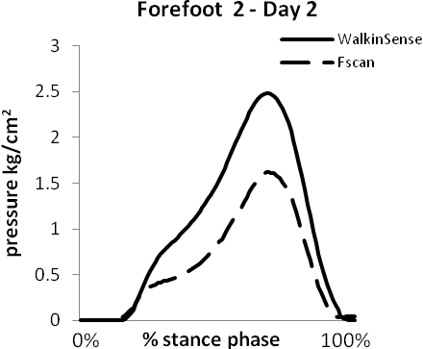
(a) (b)
Figure 5: Contact pressure profile of forefoot 2 for WalkinSense and FScan during the stance phase of walking on Day 1 (a) and 2 (b).

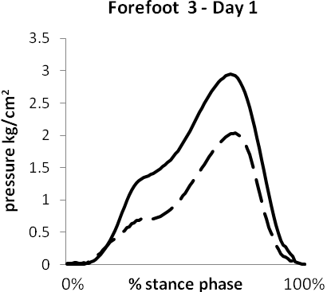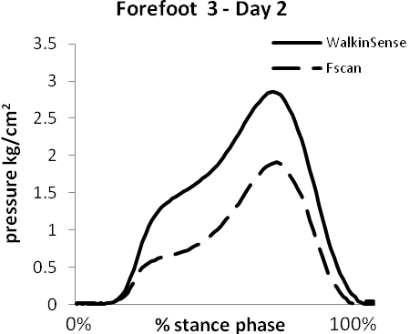
(a) (b)
Figure 6: Contact pressure profile of forefoot 3 for WalkinSense and FScan during the stance phase of walking on Day 1 (a) and 2 (b).

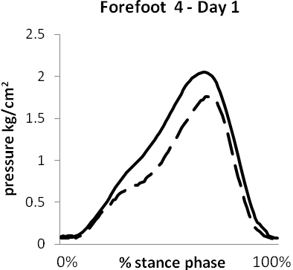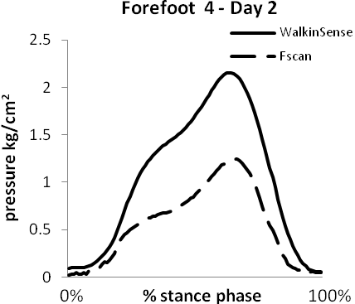
(a) (b)
Figure 7: Contact pressure profile of forefoot 4 for WalkinSense and FScan during the stance phase of walking on Day 1 (a) and 2 (b).

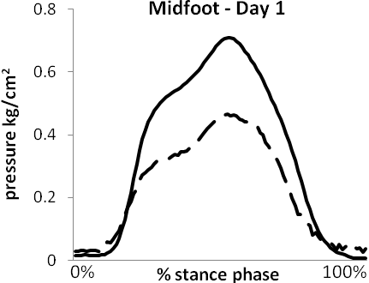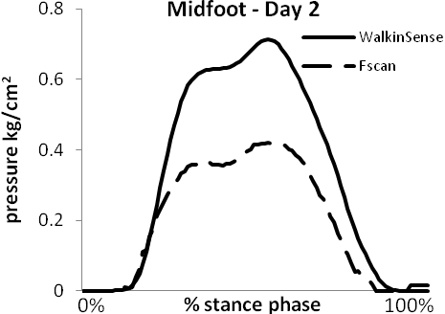
(a) (b)
Figure 8: Contact pressure profile of the midfoot for WalkinSense and FScan during the stance phase of walking on Day 1 (a) and 2 (b).

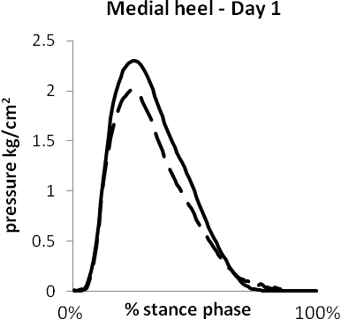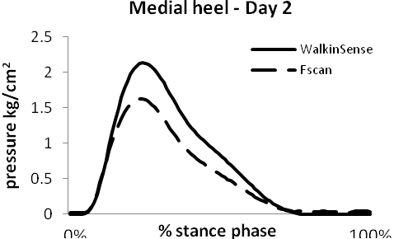
(a) (b)
Figure 9: Contact pressure profile of the medial heel for WalkinSense and FScan during the stance phase of walking on Day 1 (a) and 2 (b).

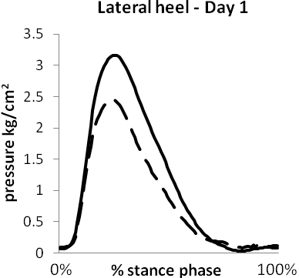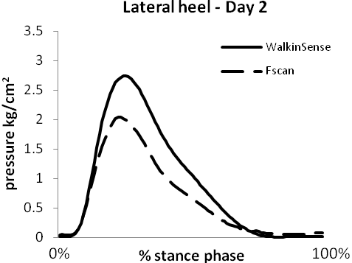
(a) (b)
Figure 10: Contact pressure profile of the lateral heel for WalkinSense and FScan during the stance phase of walking on Day 1 (a) and 2 (b).

