Tick borne encephalitis.

Abstract
This article will outline the transmission, risk and prevention of tick-borne encephalitis with details of the vaccines available in UK.

Introduction
Tick-borne encephalitis (TBE) is a disease caused by a virus transmitted to a human primarily from the bite of an infected tick of the Ixodes species, although it can also be transmitted through consumption of unpasteurised milk or dairy products from infected animals. TBE is one of the flaviviruses, others of which include yellow fever, Japanese encephalitis and dengue. (Travel Health Pro 2017a).

TBE is endemic in large areas across a number of regions of Europe and Asia where the presence of the reservoir host tick vectors and pathogen exist. There are three different subtypes of TBE; European TBE virus, Siberian TBE virus and Far Eastern TBE virus. (European Centre for Disease Prevention and Control (ECDC) (2012).

The World Health Organisation (WHO) report there to be between 10000 and 12000 cases each year but that this is probably an underestimate with potential for underreporting or lack of recognition in sufferers if milder presentation (WHO 2011).

Method of spread

TBE is maintained in nature through the cycle of an infected tick biting and infects small animals (voles and mice), domestic livestock (goats, cows) and some bird species. These act as reservoirs of the virus until the next tick bites and ingests blood containing the virus to take onto the next host and so the cycle perpetuates with humans occasionally becoming part of the cycle of infection if encroaching into areas where the virus is present (Public Health England (PHE 2013; Travel Health Pro, 2017a).

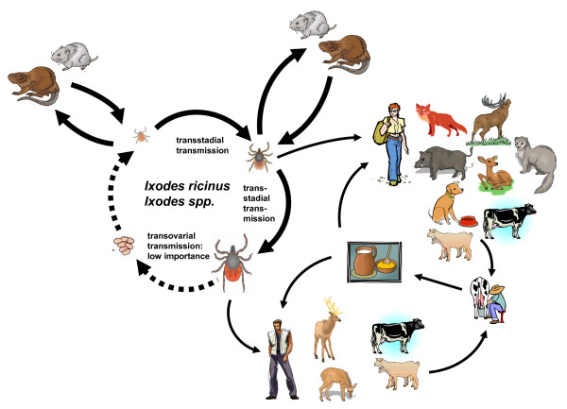
(Pfeffer and Dobler, 2010)

TBE countries affected.
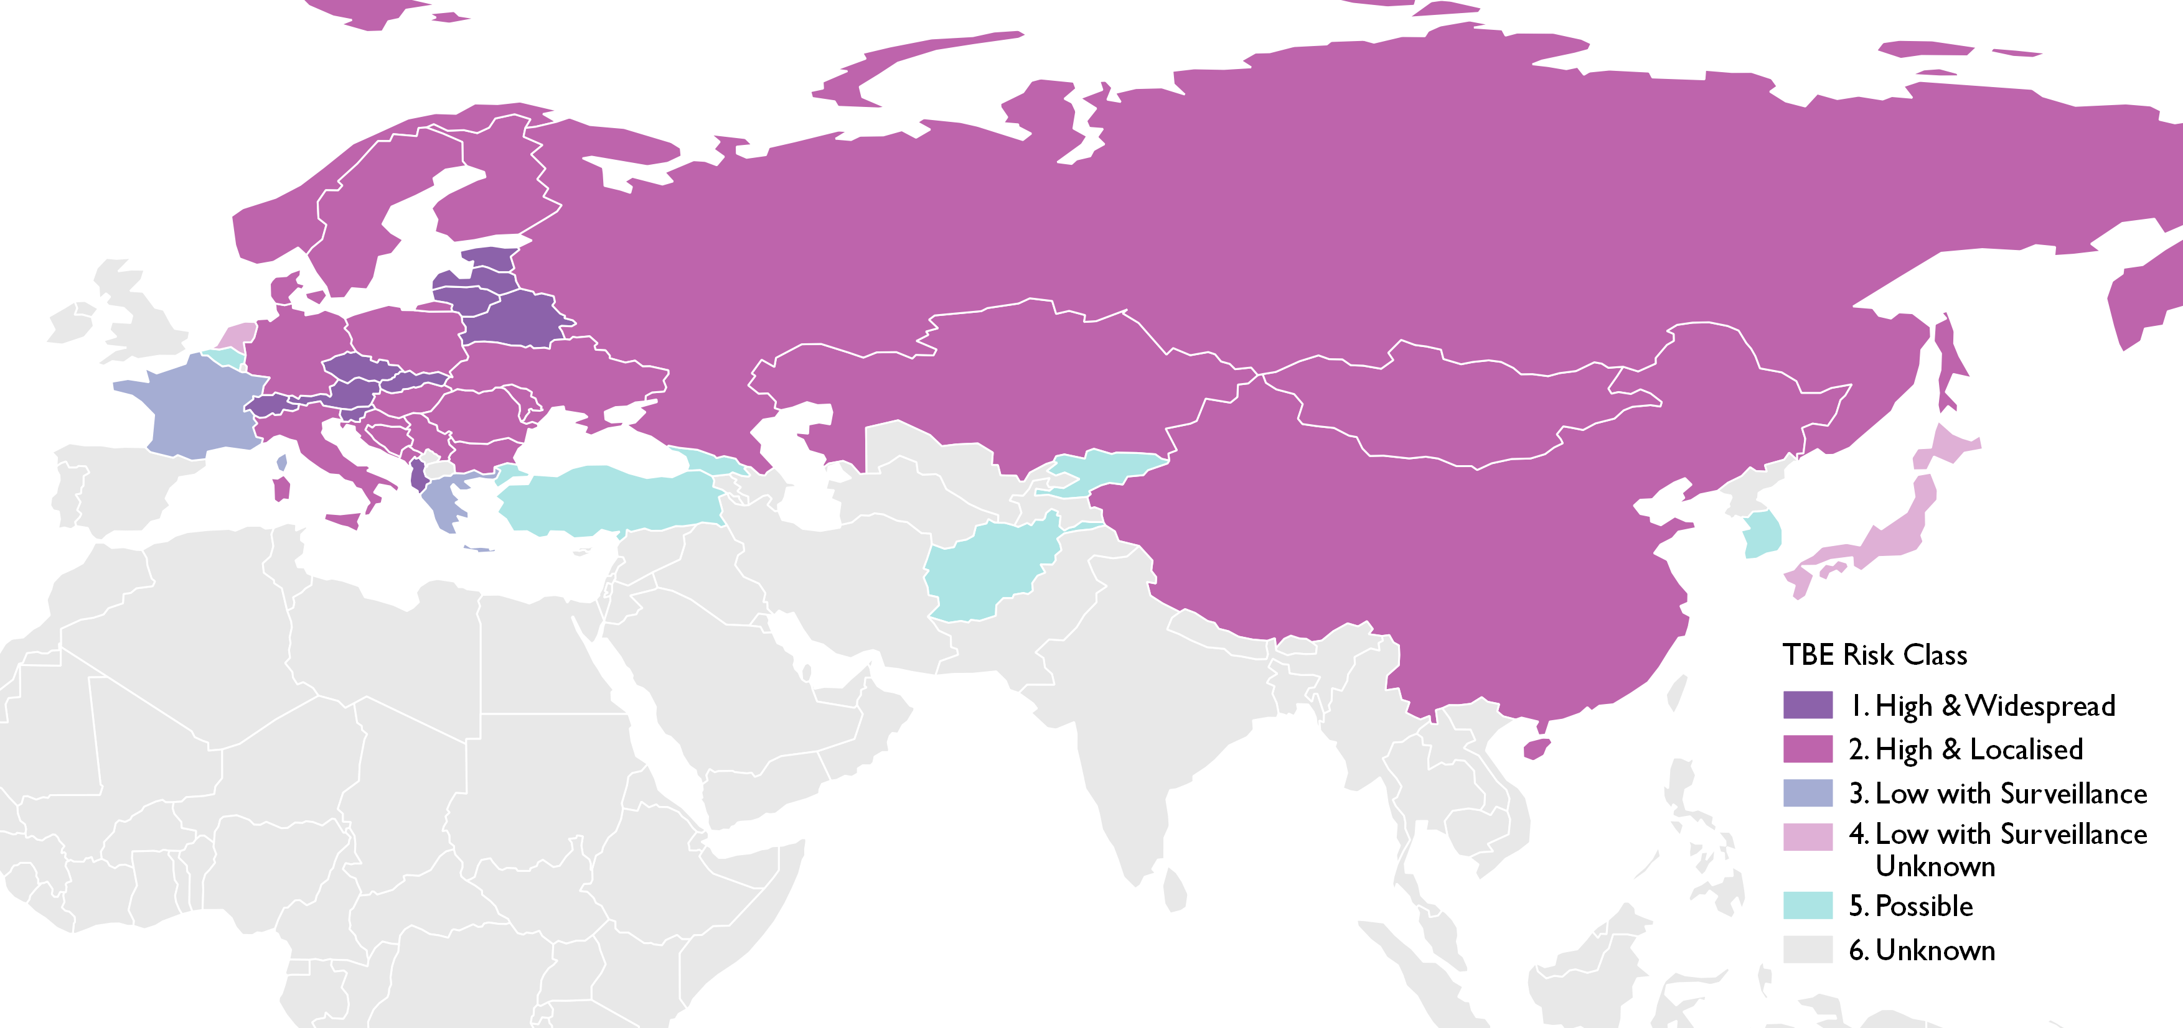
Travel Heath Pro (2017a).

Presentation of disease

Incubation can be from four to 28 days, though the Centres for Disease Control and Prevention (CDC) also report that this can be shorter (3-4 days) for milk borne exposure (CDC, 2017).

Clinical presentation may range from mild non-specific febrile illness to one with significant long term sequelae affecting the central nervous system, commonly meningoencephalitis and potential life threatening illness (PHE) 2013). Further the disease is typically biphasic whereby the initial presentation of non-specific flu like illness (fever, fatigue, headache and muscle pains) followed by a period of one to twenty days where the patient does not have any symptoms. Up to two thirds of patients will not have any further symptoms but one third progress to the second stage of disease (CDC, 2017; Travel Health Pro, 2017a).

The second phase is more likely to present with central nervous system involvement, heralded by a sudden rise in temperature and signs suggesting meningitis (inflammation of the brain lining only)’ meningoencephalitis (affecting the brain and its lining) or in around 10% of cases the more severe presentation of menignoencephalyomyelitis (which also includes the spinal cord). Those whose disease progresses to the second stage are at much greater risk of long-term sequelae (CDC, 2017; Travel Health Pro, 2017a).

Variation on severity and long-term sequelae does depend upon with subtype is contracted. CDC (2017) report that severity of disease does increase with age, with children reportedly having less severe disease and residual symptoms or neurological disease. Goodyer (2004) stated that only 1% of cases prove fatal with the greater risk in the older person, though PHE (2013) qualifies that is in the European form, with Travel Health Pro (2017a) support this and stating that the Siberian and Far Eastern subtypes are associated with more deaths.

CDC quantify the clinical course and long-term outcome by TBE subtype as below:

- The European subtype is associated with milder disease, a case-fatality ratio of <2%, and neurologic sequelae in up to 30% of patients.
- The Far Eastern subtype is often associated with a more severe disease course, including a case-fatality ratio of 20%–40% and higher rates of severe neurologic sequelae.
- The Siberian subtype is more frequently associated with chronic or progressive disease and has a case-fatality ratio of 2%–3%. (CDC, 2017)

Who is at risk:
ECDC (2012) identified that men aged 40-60 who work outdoors in countries where TBE is present were at greater risk but they also acknowledge that information available from the various countries is variable due to differences in diagnostic criteria and access to laboratory for diagnosis. Their document additionally commented that accurate identification of high-risk populations requires much more detailed surveillance data and epidemiological studies to clarify TBE risk for individuals. However, they also report that TBE has become an international public health problem due to the increase in the number of new areas where transmission has been reported, together with increasing mobility within and travel to endemic areas as well as greater public awareness.

Not every traveller from the United Kingdom to countries where the TBE virus is present will be at risk, some activities are associated with increased exposure risk. As infected ticks are largely found in woodland habitats and their immediate surroundings and grasslands undertaking activities in these areas, such as; rambling, cycling, camping, fishing, hunting and military exercises, increase the potential for exposure. (ECDC 2018).

While sporadic cases have occurred in colder seasons, increased tick activity is associated with wet summers and mild winters, though for each country you should always refer to the country specific advice in order to advice your patient appropriately (Travel Health Pro, 2017b).

In addition as there is potential transmission of TBE from unpasteurised milk or milk products in affected areas, knowingly consuming these presents a risk to the traveller (ECDC 2018).

It is also worth noting that many countries where there is high risk of transmission (see map above) are those of Western and Central Europe that do not usually result in traveller seeking pre-travel advice. For example from experience someone travelling to an international scouting jamboree in the Czech Republic in 2006 was advised by the organising group that they needed to be up to date with UK schedule vaccines only.

How can an individual protect themselves?

Wear suitable protective clothing, for example long sleeved tops and long trousers – tucked into socks, reduces the skin exposure, in addition clothing that is impregnated with insect repellent either purchased or self-treated works quite effectively (though can be expensive) when used as an adjunct to other measures. It would be wise to check clothing, including shoes and bags before entering buildings. (WHO 2011).

Check skin after potential exposure. Ticks crawl onto skin or clothing in order to find a suitable place to attach themselves and feed, places to be aware of are skin folds, groin, under arms, the scalp line and at the edges of underclothing. Regular and careful examination of skin for the small black ticks, often no bigger than a speck of dust before they have fed which when they become engorged and can be the size of a coffee bean, and careful removal as soon as possible is essential. (Travel Health Pro 2017a) Getting someone else to look at areas you cannot see yourself is also a good idea.

Tick removal should be undertaken as quickly as possible after identification of the tick. An attached tick should be removed using tweezers or fine pointed forceps, grasping it as closely as possible to where it is attached to the skin and pulling it gently upwards, trying not to break off the mouth parts. It is possible to purchase tick removers, a hook like tool or card in pet stores in UK or on line from a number of sources. Once removed from the skin apply disinfectant to the area of the tick bite to prevent infection. (WHO, 2011)

Avoid consuming unpasteurised milk products in at risk areas.

Medical attention should be sought as soon as possible if signs of illness occurs within 28 days of a tick bite (Travel Health Pro, 2017a). A history of tick bite may be a clue to this diagnosis; however, approximately 30% of TBE patients do not recall a tick bite (CDC, 2017)

Vaccination

Vaccination is recommended to anyone living in an area where TBE is endemic, ECDC (2012) report that in Austria vaccine coverage is in the region of 85% of the total population.

In addition those at occupational risk would also be recommended vaccination this includes, laboratory workers who may be exposed to TBE, those in endemic areas working in forestry, farming or on military activities (Travel Health Pro 2017a).

Vaccination is also available for travellers but this is not a NHS vaccine and is therefore administered as a private arrangement between the traveller and healthcare provider.

In UK there is are licensed adult and paediatric vaccines available.

Adult
Basic Immunization | Dose | Conventional Schedule | Rapid Immunization Schedule
1st dose | 0.5 ml | Elected date | Elected date
2nd dose | 0.5 ml | 1 to 3 months after the 1st vaccination | 14 days after the 1st vaccination
3rd dose | 0.5 ml | 5 to 12 months after the 2nd vaccination | 5 to 12 months after the 2nd vaccination
Booster doses
Persons from 16 to 60 years of age
The first booster dose should be given 3 years after the third dose (see section 5.1).
Sequential booster doses should be given every 5 years after the last booster dose.
Persons above 60 years of age
In general, in individuals over 60 years of age the booster intervals should not exceed three years.
Booster dose ≥ 16 to < 60 years | Dose | Timing
1stbooster | 0.5 ml | 3 years after the 3rd vaccination
Sequential booster doses | 0.5 ml | every 5 years

Booster dose ≥ 60 years | Dose | Timing
All booster doses | 0.5 ml | every 3 years
Electronic Medicines Compendium, (2018a)

Paediatric

Basic Immunization | Dose | Conventional Schedule | Rapid Immunization Schedule
1st dose | 0.25 ml | Elected date | Elected date
2nd dose | 0.25 ml | 1 to 3 months after the 1st vaccination | 14 days after the 1st vaccination
3rd dose | 0.25 ml | 5 to 12 months after the 2nd vaccination | 5 to 12 months after the 2nd vaccination
Booster doses
The first booster dose should be given 3 years after the third dose (see section 5.1).
Sequential booster doses should be given every 5 years after the last booster dose.
Booster dose | Dose | Timing
1st booster | 0.25 ml | 3 years after the 3rd vaccination
Sequential booster doses | 0.25 ml | every 5 years
(Electronic Medicines Compendium, 2018b)

As with all vaccines contraindications include allergy or hypersensitivity to previous TBE vaccination and any constituent of the vaccine. Additionally severe egg allergy reaction and severe febrile illness applies to the TBE vaccine.

Conclusion
TBE is an endemic disease across much of Europe and Asia, few travellers in the UK seek travel advice pre-travel to many of these areas but will be at risk of potential exposure. An awareness campaign in your practice may be the way to highlight the issue to those potentially at risk, being aware of preventive measures and sharing this and advising your patients about vaccination if appropriate may be the difference between a safe successful holiday and the potential long-term sequelae from a vaccine preventable illness.

Personal comment:
On personal trips in Baltic and Central European countries I did not personally consider the tours to pose a risk of TBE based on the itineraries, so did not seek pre-exposure vaccination. However on both trips I found myself taking a walk through forested areas one guided and one independently, I was fortunately prepared with personal protection having insect repellent and appropriate clothing but on reflection perhaps I ought to have sought vaccination. I spoke to the tour guides on these trips, in the Baltics the guide knew about TBE and was herself vaccinated regularly. Conversely in Slovakia the guide had experienced a hospital admission as a direct result of TBE which she acknowledged until that point she had no understanding of the virus or her risk as mountain tour guide. Perhaps reflective of the less affluent economy of Slovakia neither was she aware of or offered TBE vaccination by her healthcare provider.

References:

Centres for Disease Control and Prevention (CDC) (2017) Yellow Book, Chapter 3, Infection Diseases Related to Travel, Tick-borne Encephalitis. https://wwwnc.cdc.gov/travel/yellowbook/2018/infectious-diseases-related-to-travel/tickborne-encephalitis (accessed 04.01.18)

Electronic Medicines Compendium, (2018a) TicoVac 0.5 ml Suspension for injection in a prefilled syringe https://www.medicines.org.uk/emc/medicine/30324 (accessed 04.01.18)

Electronic Medicines Compendium, (2018b) TicoVac Junior 0.25 ml Suspension for injection in a pre-filled syringe https://www.medicines.org.uk/emc/medicine/30334 (accessed 04.01.178)

European Centre for Disease Prevention and Control (ECDC) (2018) Tick-borne encephalitis Factsheet.
https://ecdc.europa.eu/en/tick-borne-encephalitis/facts/factsheet (accessed 04.01.18)

European Centre for Disease Prevention and Control (ECDC) (2012) – Epidemiological situation of tick-borne encephalitis in the European Union and European Free Trade Association countries. https://ecdc.europa.eu/sites/portal/files/media/en/publications/Publications/TBE-in-EU-EFTA.pdf (accessed 30.12.17)

Goodyer, L. (2004) Travel Medicine for Health Professionals. London. Pharmaceutical Press.

Pfeffer, M. Dobler, G. (2010) Emergence of zoonitic arboviruses by animal and trade transmission. Parasites and Vectors Vol 3. No. 35. Open Access via https://www.researchgate.net/publication/43079229_Emergence_of_zoonotic_arboviruses_by_animal_trade_and_migration (accessed 04.01.18)

Public Health England (PHE) (2013) Chapter 27. Immunisation against Infection Disease (The Green Book). Rabies. Online https://www.gov.uk/government/uploads/system/uploads/attachment_data/file/85762/Green-Book-Chapter-27-v3_0.pdf (accessed 30.12.17)

Travel Health Pro (2017a) Tick-borne encephalitis Factsheet Online - https://travelhealthpro.org.uk/factsheet/22/tick-borne-encephalitis (accessed 30.12.17)

Travel Health Pro (2017b) Countries Online https://travelhealthpro.org.uk/countries (accessed 04.01.18)

World Health Organisation (WHO) (2011) Tick-borne encephalitis http://www.who.int/immunization/topics/tick_encephalitis/en/ (accessed 04.01.18)
Key Points:

This is a potentially life changing disease that is preventable.
This disease in areas where traditionally people do not seek pre-travel advice.
Practice Nurses need to be aware and be able to discuss the potential risks and preventive measure with patients.

