Overview of mosquito borne diseases and prevention strategies.

The photographs included were taken by me personally in Rwanda on 31 December 2016 and I declare that as owner I give permission for their use if you wish.

Introduction

When our travellers think about holidays most of their thoughts from a health perspective (if they give it any thought) are around what ‘jabs’ they need. Travellers may give little thought to the invertebrate beings that lurk in various places in and around them or the potential impact these can have on their enjoyment of their holiday. The advice we give about food and water is expected and real to the traveller because they can see the potential cause of illness, with mosquitos and other insect vectors of disease they are often invisible. Some diseases that mosquitos are linked to are vaccine preventable others not, but all require some action by the traveller to prevent them being the food source and the recipient of the infections the mosquito may be carrying. This article will give a brief outline of some of the mosquito borne diseases, you will need to refer to the various resources for advice about the signs and symptoms of the various diseases and any relevant vaccination indications, contraindications and schedules. In addition this article will discuss what our travellers can do to prevent being bitten.

There is not the scope within this article to discuss all aspects of risk assessment with which you should be familiar before embarking on patient pre-travel consultations, you can find more information in Chiodini et al (2012); Chiodini et al (2012a); Driver (2007); Lockie et al (2000); Steffen & Connor (2005) but remember to advise your patient that no vaccine is 100% effective (Public Health England (PHE) 2013).

Mosquitos the vector for the following diseases are attracted to humans by several factors, including the presence of carbon dioxide, heat, odours and movement. In order to reproduce the female mosquito requires a blood meal and they are not selective if it is a human, animal or bird as the source (PHE 2017).

Vaccine preventable mosquito borne disease:

Yellow Fever, a viral infection spread by the aedes aegypti mosquito which bites in daytime, primarily found in Central South America, parts of the Caribbean and Sub-Saharan Africa regions of the world, refer to Travel Health Pro (2017) or Travax for specific area details (see resources). Vaccination is administered at registered yellow fever vaccination centres to anyone from age 9 months, with due consideration to age risk assessment related advice in those 65 or older. As a live vaccine there are also contraindications associated with administration to certain people (Travel Health Pro 2017). An International Certificate of Vaccination or Prophylaxis (ICVP) issued to those vaccinated which is valid for the lifetime of the individual (World Health Organisation (WHO) 2016). In some instances an exemption certificate may be issued but only after a full risk assessment and clear criteria met for making the decision not to vaccinate. (PHE 2014)

Japanese Encephalitis a mosquito borne viral disease largely of the Asia and Pacific rim region. These mosquitos mainly feed during the night, from dusk to dawn with their favoured breeding sites around paddy fields but also being associated with pig farming areas. There is occasional urban transmission reported, the virus also a seasonal proliferation pattern. (Travel Health Pro 2017a)
The UK has a licensed vaccine for anyone two months of age or above refer to ‘The Green Book’ (PHE 2016) for full details of dosages, schedule and recommendations.

Mosquito borne disease where impact can be reduced by chemo-prophylaxis:

Malaria, fortunately not every anopheles mosquito carries one of the five plasmodium species of parasite known to the affect humans, as this is potentially a serious infection and fatal disease. (Travel Health Pro 2017b)
In 2015 there were 1,400 imported cases of malaria in UK, the majority being plasmodium falciparum, with six deaths reported. (PHE 2016a)
With such a significant disease it is vital you refer to the most contemporary sources to determine the potential risk for your traveller (see resources) and ensure that the advice with regard to prophylaxis and bite protection is in accordance with the most recent malaria guidelines (PHE 2017).
Chemo-prophylaxis decision can be complex there is not the scope to discuss in detail within this article. Each individual should be given sufficient information about what their options are with consideration of existing health conditions to enable them to select the appropriate chemo-prophylaxis to suit their needs.

None vaccine preventable mosquito borne diseases:

Chikungunya is a viral disease spread by the aedes aegypti mosquito that can result in fever and joint pain which can be quite debilitating. It commonly occurs in Africa, Asia and the Indian Sub-continent, but in recent years there have been reported transmission in Europe and America (WHO) 2016a).

Dengue is an emerging pandemic prone viral disease in many parts of the world.
Carried by mosquitoes are usually of the species aedes aegypti, which mainly bite during the day (WHO 2017). There are four different subgroups of dengue virus, outbreaks occur in both rural and urban areas of over 100 countries, predominantly Caribbean, South and Central America, Africa, SE Asia, Indian sub-continent and the Pacific Islands but with recent locally acquired cases reported in Croatia, France and Madeira (Travel Health Pro 2017c).

Zika is another virus that is transmitted by the Aedes mosquitos (WHO 2016b). While the infection is often mild and short lived in many of those who get infected, some may develop Guillain-Barré syndrome. The greatest reported impact has been to babies born to mothers who have had the disease in pregnancy where there can be serious complications e.g. microcephaly and other congenital anomalies (Travel Health Pro 2017d). As information is updated on this at regular intervals ensure you access the most contemporary advice for your traveler, particularly women of child bearing age and any sexually active male.

Eastern Equine Encephalitis is a viral infection transmitted by the bite of an infected mosquito, while as the name suggests mainly to horses it has also rarely been reported in humans (Centre for Disease Control and Prevention (CDC) 2016). The most common regions it is located is eastern, Gulf and north central USA and adjacent Canada with part of central and South America and the Caribbean (Health Protection Scotland (HPS) 2017).

Rift Valley Fever while predominantly a virus spread to humans through direct contact with blood tissue or organs of infected animals (e.g. cattle, goat and sheep) during slaughtering or butchery, bites from mainly mosquitos but rarely other insects with mouthparts can also result in transmission. No one mosquito species is dominant and cases have been reported in Sub Saharan Africa, North Africa and the Middle East (CDC 2013). There is concern about the potential emergence of this disease in Asia and Europe (HPS 2017a).

West Nile Fever is a viral infection which until 1999 it was only recognised in Africa, Asia, Middle East, and Europe. Subsequently the virus appeared in New York City and spread rapidly throughout North America, and is now found in Central and South America and the Caribbean. Birds and occasionally other animals are mainly infected by West Nile Virus but humans can be infected as well by mosquito bites (HPS 2017b). Human transmission has also been reported via Blood transfusions, organ transplants, and exposure in laboratory setting and from mother to baby during pregnancy, delivery or breastfeeding (CDC 2015). HPS (2017b) advised that travelers cannot donate blood for one month if they have travelled to an area experiencing a WNV outbreak. All travel must be mentioned to the Blood Transfusion Service before donating.

Prevention advice

Often in practice I had patients say, “I will be OK I am never bitten”! Well, all I could say is, we all know that it is easy to know when you have been bitten if you get the annoying redness, itching and swelling associated reaction, but not everyone will have a local reaction but may well have been bitten. Sadly mosquitos do not go around with labels on stating their infective status and the only way for any traveller to reduce the risk of illness associated with a mosquito bite is to take preventive action.

The advice produce below is based on that given by the Advisory Committee on Malaria Prevention (ACMP) (PHE 2017), which is applicable to all mosquito bite prevention, with some personal anecdotes added from my own travel experience.

Repellents

DEET (N,N-diethyl-m-toluamide) has been and remains the main repellent used by millions for many years. There are several commercially available strengths with lower strengths e.g. 20% DEET offering 1-3 hours of protection, 30% up to 6 hours and 50% 12 hours, but as with anything applied to the skin, sweat, activity and clothing can reduce the length of effectiveness and thus it requires reapplication.
Reports indicate that DEET can reduce the efficacy of sunscreen but not the reverse if using 33% or higher DEET concentration. The ACMP advice is that DEET should be applied after sunscreen if both required and at least 30SPF sunscreen used to compensate for reduction of SPF. (PHE 2017).
DEET is not recommended for infants under 2 months of age. It can damage some plastics so avoid contact. Avoid DEET contact with mucous membranes (eyes & mouth, broken skin). (PHE 2017)
Advice your patient to wash hands with soap and water after application and to wash all areas when no longer needed (Travel Health Pro 2017).

Lemon eucalyptus (p-menthane 3,8 diol) gives about the same amount of protection afforded by 15% DEET but is reported to provide a duration of protection (PHE 2017).

Icaridin (Picaridin) is reported to have repellent properties comparable to those of DEET with a similar duration of protection. It is available in different concentrations but if a traveller chooses to use icaridin for mosquito bite prevention, ACMP advises use of at least a 20% preparation (PHE 2017).

3-ethlyaminopropionate (IR3535) has a shorter duration of protection than DEET (20, 24) which gives protection times against Anopheles 20 to 25% higher than IR3535 at equal concentrations (PHE 2017).

Oil of citronella based products do have repellent properties, they provide short lived protection and are not recommended by ACMP. Citronella has been withdrawn in Europe. (PHE 2017).

Insecticides
Permethrin and other synthetic pyrethroids have a rapid knock-down effect on mosquitoes and are used to kill resting mosquitoes in a room (PHE 2017).

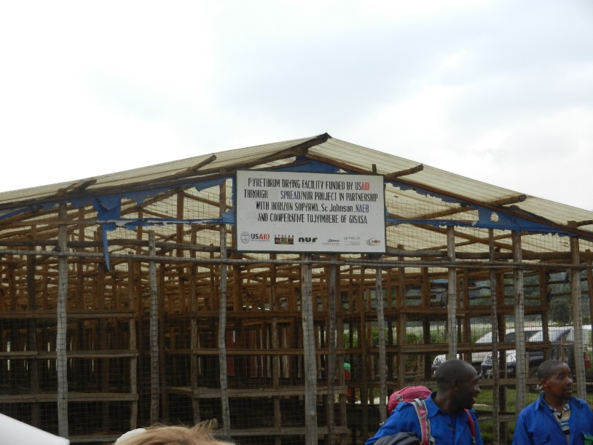
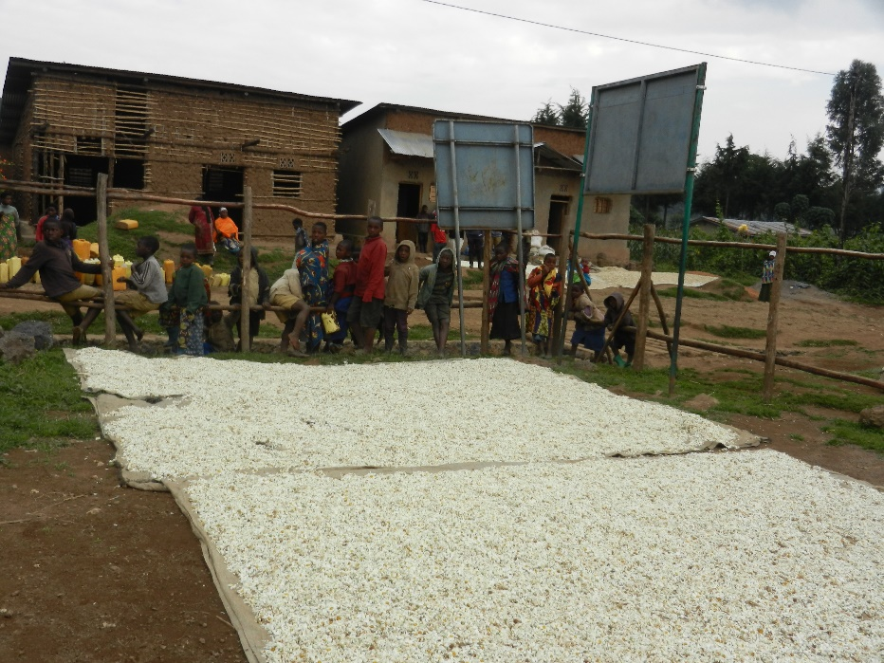
Rwanda – above factory for manufacture of pyrethroid products, below the flowers drying in the sun.

Rooms

For our luxury traveller the air conditioning in the room reduces the potential for bites with the air being cooler (PHE 2017) but consider this scenario:
Your traveller is in India, they leave their air conditioned hotel to join the equally air conditioned coach tour in the morning, with the briefest of walks from the doors of the hotel to experience the already hot and humid atmosphere of the world. Are they aware what lurks inside? Do they realise that while the air con is on now overnight the driver and his assistant used Indian air con while they slept in their vehicle, i.e. all the windows open! What does this mean, well mosquitos will have found their way into dark warmer places such as under your seat and when you sit down in your shorts and sandals you provide the ideal meal to keep them going!
One of my early travel lessons now I spray beneath the seat before sitting down.

Those in less luxurious accommodation need to endeavour to use rooms where doors and windows are screened with fine mesh netting that is intact. Rooms can also be sprayed with a knockdown insecticide and if electricity is guaranteed then there are proprietary heated liquid reservoir devices containing insecticide or an electrically heated devices to vapourise a “mat” (tablet) containing a synthetic pyrethroid (remember a new mat needed each night) (PHE 2017).
My tip is as lights attract mosquitos, – turn lights off before you leave the room and only back on once the door is closed.
Burning of a mosquito coil containing insecticide is an alternative which can repel and kill mosquitoes but is not recommended for use indoors (PHE 2017).
My tip: these are great at underneath the table if eating out but don’t forget to pick up the metal stand the coil sits on – there is only one in the box!)

There is nothing worse than being woken up in the night by the buzzing of a mosquito, this occurs regularly at home, I live in the UK above an old river bed. It is not unusual to kill ten or more mosquitos a day but one thing learned from experience is put the toilet lid down, they like the dark underside of the basin tell your travellers too!

Beds in hotels, lodges, tent may also have nets provided, ideally these should be treated with permethirin, free of holes, or the traveller can take their own. Compact portable nets that can be erected anywhere are available. Advising a traveller to carry a small sewing kit to affect repairs would be useful.

Clothing
Wearing loose fitting clothing that covers as much of the surface of the skin during mosquito biting hours is a recommendation, but not all that practical if you are in an area that is hot and steamy, you are aiming to get some sun (with your SPF cream on) on your holiday, or you are swimming or being active. Clothing that is impregnated with insect repellent either purchased or self-treated works quite effectively (though can be expensive) when used as an adjunct to other measures.

The Myths
The ACMP advice that with no evidence to support their use none of the products listed below are recommend for protection against mosquito bites (PHE 2017):

Herbal remedies
Homoeopathy
Electronic buzzers. Companies selling them have been prosecuted and fined under the UK Trades Descriptions Act.
Vitamin B1
Vitamin B12
Garlic
Savoury yeast extract spread It is sometimes stated that Marmite® taken orally repels mosquitoes either by giving off a cutaneous odour repellent to mosquitoes or via its vitamin B1 content.
Tea tree oil
Bath oils

Summary

While the focus of mosquito borne disease tends to be the biggest killer malaria, recently we have become more aware of the other diseases that the small biting insect can transmit to our travellers with media discussion about Zika. Hopefully from this brief article you are now aware of a few others and can refer to them when advising patients that there is more out there to get them that ‘a few jabs’ and ‘a tablet’ can prevent!

Resources:

Travel Health Pro - http://travelhealthpro.org.uk/ (free to all)
Travax http://www.travax.nhs.uk/ (log in required, access for health professionals only)
Fit for Travel - http://www.fitfortravel.nhs.uk/home.aspx (free to all)
NHS Choices http://www.nhs.uk/ (suitable for patients)

References:

Centre for Disease Control and Prevention (CDC) (2016) Eastern Equine Encephalitis. Online
https://www.cdc.gov/easternequineencephalitis/index.html. (accessed 17.03.17)

Centre for Disease Control and Prevention (CDC) (2015) West Nile Virus. Online
https://www.cdc.gov/westnile/index.html (accessed 17.03.17)

Chiodini J. Boyne L. Stillwell A. Grieve S (2012) Travel health nursing: career and competence development. RCN Guidance. London Royal College of Nursing.

Chiodini, J. Anderson, E. Driver, C. Field, V. Flaherty, G. Grieve, A. Green, A. Jones, M. Marra, F. McDonald, A. Riley, S. Simons, H. Smith, C. Chiodini, P. (2012a) Recommendations for the practice of travel medicine. Travel Medicine and Infectious Disease. V10. pp 109-128.

Driver, C. (2007) How to do a travel health risk assessment. Nursing in Practice. April 2007. p 20. 22-23.

Health Protection Scotland (2017) Fit for Travel. Easter Equine Encephalitis. Online
http://www.fitfortravel.nhs.uk/advice/disease-prevention-advice/eastern-equine-encephalitis.aspx (accessed 17.03.17)

Health Protection Scotland (2017a) Fit for Travel. Rift Valley Fever. Online
http://www.fitfortravel.nhs.uk/advice/disease-prevention-advice/rift-valley-fever.aspx (accessed 17.03.17)

Health Protection Scotland (2017b) Fit for Travel. West Nile Fever. Online http://www.fitfortravel.nhs.uk/advice/disease-prevention-advice/west-nile-fever.aspx (accessed 17.03.17)

Lockie, C. Walker, E. Calvert, L. Cossar, J. Knill-Jones, R. Raeside, F. (Eds.) (2000) Travel Medicine and Migrant Health. Edinburgh. Churchill Livingston.

Public Health England (PHE) (2013) Chapter 1. Immunisation against Infection Disease (The Green Book). Online https://www.gov.uk/government/collections/immunisation-against-infectious-disease-the-green-book (accessed 17.03.17)

Public Health England (PHE) (2014) Chapter 35. Immunisation against Infection Disease (The Green Book). Online https://www.gov.uk/government/collections/immunisation-against-infectious-disease-the-green-book (accessed 17.03.17)

Public Health England (PHE) (2016) Chapter 20. Immunisation against Infection Disease (The Green Book). Online https://www.gov.uk/government/collections/immunisation-against-infectious-disease-the-green-book (accessed 17.03.17)

Public Health England (PHE) (2016a) Malaria Imported Into the UK: 2015 Implications for those advising travellers. Online https://www.gov.uk/government/uploads/system/uploads/attachment_data/file/539502/Malaria_imported_into_the_UK_2015_report.pdf (accessed 17.03.17)

Public Health England (PHE) (2017) Guidelines for malaria prevention in travellers from the UK 2016. Online https://www.gov.uk/government/uploads/system/uploads/attachment_data/file/585695/2016_ACMP_guidelines_Final_-_Updated_Ethiopia__2_.pdf (accessed 17.03.17)

Steffen, R. Connor, B (2005) Vaccines in Travel Health: From Risk Assessment to Priorities. Journal of Travel Medicine. Vol 12. p 26-35

Travel Health Pro (2017) Yellow Fever. Online - http://travelhealthpro.org.uk/disease/194/yellow-fever (accessed 17.03.17)

Travel Health Pro (2017a) Japanese Encephalitis. Online - http://travelhealthpro.org.uk/disease/98/japanese-encephalitis (accessed 17.03.17)

Travel Health Pro (2017b) Malaria. Online - http://travelhealthpro.org.uk/disease/113/malaria (accessed 17.03.17)

Travel Health Pro (2017c) Dengue. Online - http://travelhealthpro.org.uk/disease/42/dengue (accessed 17.03.17)

Travel Health Pro (2017) Zika Virus. Online - http://travelhealthpro.org.uk/disease/196/zika-virus (accessed 17.03.17)

World Health Organisation (WHO) (2016) New yellow fever vaccination requirements for travellershttp://www.who.int/ith/updates/20160727/en/ (accessed 06.04.17)

World Health Organisation (WHO) (2016a) Chickungnya. Online http://www.who.int/mediacentre/factsheets/fs327/en/ (accessed 17.03.17)

World Health Organisation (WHO) (2016b) Zika Virus. Online
http://www.who.int/mediacentre/factsheets/zika/en/ (accessed 17.03.17)

World Health Organisation (WHO) (2017) Dengue. Online http://www.who.int/denguecontrol/disease/en/ (accessed 17.03.17)

