Please leave these first two lines blank for the Editors

Please leave these first two lines blank for the Editors

COMPARATIVE STUDY OF CALCULATED AND ACTUAL DIMENSIONS

IN SHAPED WEFT KNITWEAR

Please leave this line blank
Power, E.J.¹, Almond, K.²
¹ Staffordshire University, Leek Road, Stoke-on-Trent, UK.
² University of Leeds, Leeds, UK.
(Presenting author E-mail: eliza.power@staffs.ac.uk and K.Almond@leeds.ac.uk;
Corresponding author email: eliza.power@staffs.ac.uk)

Please leave these two lines blank

Please leave these two lines blank

ABSTRACT
The research aims to quantify the relationship between traditional mathematical theories used for the calculation of fully-fashioned, weft knitwear and the physical measurements of the garment. In contemporary weft knitting it is important to establish new relationships between calculated dimensions and knitted garments to improve fit and comfort during wear. A series of experiments were conducted in a controlled environment to compare and contrast fashioning frequencies, to determine the impact on the resultant selvedge dimensions. The trials were conducted using the basic principle of Pythagoras Theorem to calculate the sleeve head and armhole shapes from the stitch density. It was found that the greater the distance between the fashionings the less distortion occurred within the knitted structure and a stronger relationship existed between the calculated seam dimensions and those measured from the physical knitted panels. The research explores how this knowledge was transferred to a variety of traditional knitted armhole shapes, thus providing quantifiable evidence to develop new methods for calculating shaped, fully-fashioned knitwear. The research expands existing technical knowledge and provides an important point of reference of lasting influence for improving patterning and shaping capabilities that will result in greater consumer satisfaction and a more sustainable knitwear product.

Keywords: fully-fashioned, weft knitwear, knitted garments, improved fit, comfort, armhole

Please leave this line blank

Please leave this line blank

INTRODUCTION
In the last two decades there has been a significant growth in the sale and production of fully-fashioned, weft knitted garments (Power, 2008a; Weinswig, 2015). This growth has been attributed to several factors. The main being the advancement in flatbed knitting technology and the ability to combine advanced structures and patterning with complex shaping. The development of variable stroke within flatbed knitting technology has transformed fully-fashioned knitwear from a product largely associated with the luxury goods market to the preferred technology for high street, fashion knitwear (Brackenbury, 1992; Power, 2007). Flatbed technology is considered the most flexible method of commercial knitting as it combines fully-fashioned shaping with texture, patterning and colour. The new technologies of the mid 80s have continued to thrive into the millennium and beyond with further innovation of new takedown yarn feeds, control mechanisms and more sophisticated programming software (Demerol and Dias, 2000; Power, 2017). This revolution has been embraced by design teams across all sectors enabling much innovation in performance and functional wear (for instance: Adidas and Nike took weft knitting into mainstream footwear; Speedo streamlined swimsuits with compression panels and Armadillo took knitwear into space) to produce some of the most complex and sophisticated creations, leading to an unprecedented growth in knitwear within all market segments (Power, 2017). Further to this, the concept of casual dress has become acceptable in the workplace, with individuals preferring the comfort and fit of knitted garments offered by improved design and manufacture (Power, 2008b; Memon, 2011; Karl, 2013). The advancement in the technology has led to a surge of creativity and research as design, technical and marketing teams exploit the boundaries the technology offers for improved shape and fit.

Research has shown that greater consumer satisfaction comes from selling superior fitted garments (Ashdown, 2007). With the growing crisis in global garment waste, it is important to reduce the number of returned goods resulting from poor manufacturing (Fletcher, 2007). The study of body dimensions and sizing for fashion retail markets is therefore of significant importance (Ashdown, 2007; Power, 2008b). There has been plenty of research in recent years into anthropometrics for the clothing industry (Gupta, 2014). Most studies were based on the 1939-40 US Department of Agriculture size study. More recent studies such as, SIZE – UK, USA, Korea, China, Spain, Mexico, Canada, Thailand, France and Taiwan and the proposed 2018 INDIAsize, use modern 3D body scanning to obtain measurements (Apeagyei, 2010, Kaushiki, 2018). Data obtained from any sizing survey however is only of practical use to the fashion industry, when it informs the development of size charts and manufacturing specifications for garment production. There is a knowledge gap in this area specific to knitted garments due to the fact that knitting produces many different structures with a broad spectrum of mechanical properties (Mills, 1969; Spencer, 2001). These influence the dimensions of the resultant garments and their overall fit. The structural differences add a number of benefits, as the garment can be designed and manufactured to conform tightly to the human body (retaining excellent comfort properties) or simply drape it in a way that is not possible using woven structures (Eckert et al, 2000). Knitted garment size charts and specifications are specific to individual manufacturers and are often associated with brand differentiation and based on the empirical knowledge gathered over many years (Power, 2008b). They have been derived from extensive market knowledge aimed at meeting customer expectation in regards to size and fit. In the process of producing fully-fashioned knitwear the formation of the shape is integrated into the manufacturing of the fabric. Hence, the shaped panels (two sleeves, front panel and back panel), need to be joined together post knitting and then conform to the correct dimensions after the garment has been finished (in most cases this involves scouring and pressing). This is strongly dependent on the component fibres and intended laundry instructions given to the consumer. If the garment panels are sized incorrectly it leads to poor fit and high returns of garments to the retailer (Power, 2008b).

In fully-fashioned knitwear, the shape specification is achieved by calculating the number of wales (stitches) and courses (rows) and uses a set of mathematical principles combined with a general understanding of knitted structures and knowledge of resultant fabric properties (Spencer, 2001). The knitting specification provides information relating to the timing (frequency) of the narrowings and widenings (as defined by Spencer, 2001) to achieve the desired shape (Diagram 1). It is therefore critical that the relationship between the final measurements and the mathematical theories used for the calculation of fully-fashioned knitwear can be quantified. This improves the sustainability of knitting production as the calculations are correct at the onset of manufacture. A challenging area in terms of shape and conformity to the human form within a knitted garment is the armhole (Eckert et al, 2000). The complexity is 4-fold as the translation of the irregular eclipse shape required for the armhole within the body panels (front and back) and sleeve head (sleeve panels) when flattened into a 2D form is intricate. Diagram 1 illustrates half of a traditionally cut armhole shape, compared with that of a knitted, fully-fashioned panel. Secondly, in fully-fashioned knitwear, the fully formed loops are moved, resulting in the deformation of the structure (this can be advantageous for comfort, but needs to be accounted for in the knitted specification). Thirdly, the stitch densities in the body and sleeve fabric may appear identical however they are actually different due to the natural deformation of the knitted stitch in panels of different sizes. Finally, the armhole area joins together the courses and wales, which in their finished state (state of consolidation) should represent the same mathematical measurements. In the unfinished state, the knitted dimensions are vastly different. This is accounted for during manufacturing, as a skilled construction linker, would know the limitations to achieve smoothly joined post-finishing.

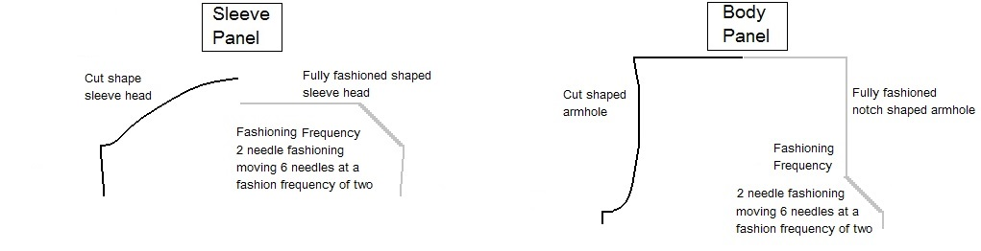
Diagram 1 – Traditional cut armhole V fully-fashioned knitted panel

It is therefore reasonable to conclude that in fully-fashioned knitwear, garment fit and shape are determined by the knitted structural properties, therefore making a single set of knitting specification, recommendations impossible. It should also be acknowledged that since the calculation of knitted shaped panels is fundamentally based on a set of established mathematical principles, a framework can be established to guide the development of accurately produced garments for a range of common armhole shapes. This research uses a plain structure (Power, 2008) to develop such a set of principles. The aims of this paper are:
- To quantify the relationship between traditional mathematical theories used for the calculation of fully-fashioned, weft knitwear and the actual physical measurements of the garment.
- To investigate the alignment of the armhole and sleeve panels in fully-fashioned knitwear.
- Develop a set of principles for new methods for calculating shaped fully-fashioned knitwear to promote better size, shape and fit.

MATERIALS AND EXPERIMENTAL METHODS
A series of 5 experiments were conducted, as detailed in Table 1, on a 10 gauge Stoll CMS knitting machine (this is a popular gauge in main stream knitwear - Power, 2008a). Technical parameters were controlled by initially balancing the available knitting systems in both knitting directions to deliver the stitch length as detailed in Table 1. The machine was calibrated at the start of each day, prior to loading a new knitting instruction programme and at any yarn changes. Yarn was stored in a controlled condition prior to delivery and the takedown speed was controlled throughout the trials. Since all the trials were completed on similar dimensions of fabric this was deemed to have a negligible effect on the resultant stitch density. The stitch densities in the state of consolidation (light scour, short spin and air dried flat in a controlled environment) were detailed in Table 1. This resulted in cover factors of 1.18 (1.15 is associated with a high quality fabric cover - Shinn, 1955). In order to assess fit and comfort during wear, the reduction in dimensions between the chest and the shoulder was 14cm in experiments, 1 – 4 (this is a common Diagram used for a basic notch shape - Power, 2008b). In experiment 5, the dimensions between the chest and shoulders were changed to 10cm to reflect a closer fitting to the body, thus accommodating a more fitted armhole and sleeve width (inset sleeve).

Table 1 – Experiment framework for study
No. | Purpose of experiment | Yarn | Stitch density | Stitch length
1 | Examine into the relationship between theoretical dimensions and those yielded in the knitted fabrics state of consolidation. | 2 x 2/28 Acrylic | 7.22 courses/cm  5.13 wales/cm | 161cm/200 needles
2 | Comparative study 1 of calculation methods used for an optimum fully fashioned notch armhole. | 2 x 2/28 Acrylic | 7.22 courses/cm  5.128 wales/cm | 161cm/200 needles
3 | Comparative study 2 of calculation methods used for an optimum fully fashioned notch armhole. | 2 x 2/30 Cashwool | 7.00 courses/cm  5.00 wales/cm | 155cm/200  needles
4 | Comparative study 3 of calculation methods used for an optimum fully fashioned notch armhole with reduced sleeve widest. | 2 x 2/30 Cashwool | 7.00 courses/cm  5.00 wales/cm | 155cm/200  needles
5 | To apply the theories established from Experiment 1-4 to a garment with an inset sleeve. | 2 x 2/27Cashwool | 6.51 courses/cm 4.70 wales/cm | 158cm/200 needles

Pythagoras’ Theorem was selected as the optimum theoretical formula to calculate the correct selvedge dimensions for the armhole shape, this is illustrated in Diagram 2. The narrowing sections as detailed in Diagram 1, used a six needle movement from the selvedge edge to ensure a smooth area for make-up, this is standard practice in fully-fashioned knitwear (Diagram 1).

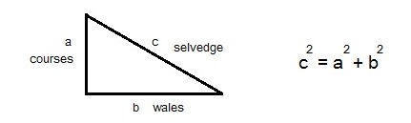
Diagram 2 – Pythagoras Theorem for weft knitwear

RESULTS
The main objective of Experiment 1 was to examine the relationship between theoretical dimensions (calculated using Pythagoras Theorem) and those yielded in the knitted fabrics state of consolidation, to determine the framework for the study. The number of wales and courses in the sample remained constant throughout the experimentation. 18 fashionings (narrowings) were used to reduce the width of the fabric by 7cm at each selvedge (thus, representing the chest to shoulder decrease, over intervals of 1, 2, 3 and 4 four course fashioning frequency. The calculated ‘dimension b’ (Diagram 2) remained constant at 7cm and the calculated ‘dimensions a’ was increased due to the change in the fashioning frequency. The theoretical measurements are displayed along with the off machine dimensions and the physical knitting dimensions in the state of consolidation (Table 2). It should be noted that this is a controlled experiment and it would be extremely rare to use a fashioning frequency of 1 course between narrowings in a commercial setting due to the distortion that is created in the finished fabric. The distortion is clearly evident from the results displayed in Table 2. The shaded column (dimension c) illustrates the actual knitted selvedge to be 54% of the calculated dimension. A difference of 46% is evident in the knitted sample for the lowest fashioning frequency (dimension c), whist a negligible 2% is calculated at the higher frequency of four courses. From this simple experiment it can be concluded that the greater the fashioning frequencies, the closer the dimensions in the knitted sample to those calculated using Pythagoras Theorem. The issue of selvedge distortion within fully-fashioned knitwear has been highlighted in prior research were trigonometry was used to access the differences in angles produced by different fashioning frequencies (Mills, 1969). The outcome was a series of adjustments to basic trigonometry functions to account for the distortion to the dimensions as a result of the knitting construction process. Three fashioning frequencies were explored in Mills’ work (1, 4 and 10 courses). Similarities can be drawn from the work presented in this paper and that of Mill’s earlier study. Thus it can be concluded that increases in fashioning frequencies result in less selvedge distortion and a closer alignment between the dimensions calculated and those in the knitted sample.

Table 2 Comparison of fully-fashioned theoretical dimensions and Physical
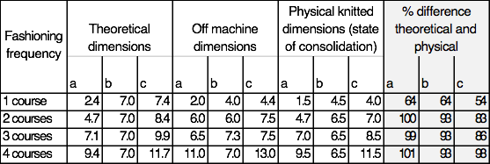

Experiment 2 expanded the work described in the results of the first experiments by comparing two empirical methods designed to align the sleeve and body panels (Diagram 3). A fully-fashioned sleeve panel was knitted up, to examine the alignment of the two components (body and sleeve) to determine the optimum calculation method. Two methods were explored over three different body fashioning frequencies (2, 3 and 4 courses). The sleeve fashioning frequencies were calculated mathematically (using Pythagoras Theorem) to ensure the components aligned as described in Diagram 3. Table 3 illustrates the theoretical dimensions compared to the actual knitted panels post-finishing. The experiment set a crude line between the two empirical methods used to align the sleeve and body panel. The shaded column (dimension c) illustrates that if the number of fashioning’s on the sleeve is less than the body the ‘Notch’ method should be used. If the body and sleeves are equal in number of fashioning’s either method could be used. However, if the sleeve consists of more fashioning’s than the body the optimum method to use is that of the Raglan.

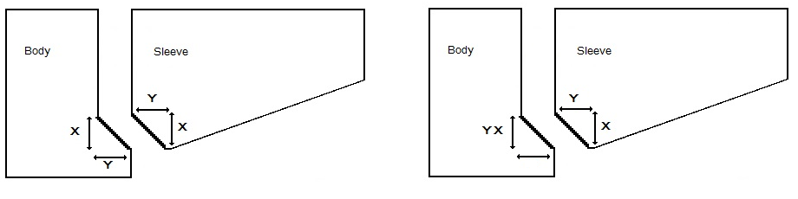
Notch Raglan

Diagram 3 – Empirical methods used to align body and sleeve panels

Table 3 – Using two different empirical methods to calculate knitted armhole shapes
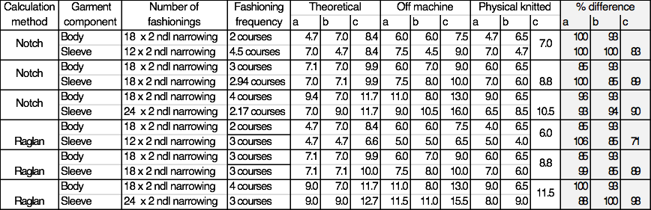

After the initial experiment, two higher fashion frequencies were explored (6 and 8 courses) taking the raglan method of aligning the sleeve and body and comparing this with a 10% reduction in courses within the sleeve head area. The shaded columns in Table 3 illustrate the theoretical dimensions compared to the actual knitted samples in the state of consolidation. The results demonstrate a good alignment between the selvedge measurements in the knitted sample and those calculated (between 93% and 108% for dimension c using the raglan method). The 10% reduction in courses however, appears to result in slightly better alignment between the theoretical dimensions and the knitted between 99-106%) The results of Experiment 3 expand the findings from Experiments 1 and 2. It can be concluded that increasing fashioning frequencies above 4 courses concludes in knitting dimensions within 10% of the calculated theoretical dimensions. This set of garments were further examined to determine their fit to the human form. It was discovered that when the actual garment was worn there was a noticeable distortion in the shoulder area. This was considered to be due to the steepness of the angle in which the sleeve fell, as a direct result of the increase in the sleeve head area. It was concluded that the experiment was useful in terms of assessing the theoretical relationships between the calculated methods and actual knitting dimensions. However, there needed to be further modifications to the shape of the body and sleeve panels if the resultant garment was going to conform to the human form. It was recognised that in knitwear the sleeve width is usually reduced so the sloped angle is achieved in the sleeve and a sloped shoulder is often used to reduce distortion in the shoulder area. This is explored further in Experiments 4 and 5.

Table 4 – Using two different empirical methods to calculate knitted armhole shapes
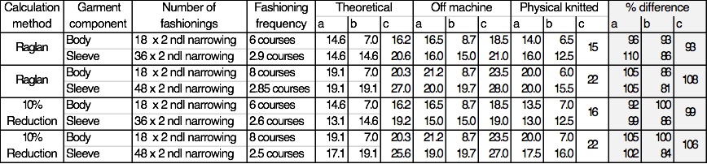

Experiment 4 modified one of the dimensions by reducing the sleeve width by 2cm. Whilst it was acknowledged the shoulder should be sloped to reflect the actual shape of the human form, it was kept straight to determine a two-step approach to access distortion in fit trials of the knitted garments as a result of changing the two components. The data has not been presented in a table due to the dimensions presenting a concluding set of results. In all (body) fashioning frequencies (2, 3, 4, 6, 8) the raglan method of aligning the sleeve panel produced dimensions that were closer to the calculated dimension. In the fit trials, the fashioning frequency increased but less distortion occurred in the shoulder area. In all trials however distortion was evident beyond what would be considered reasonable in a commercial garment.

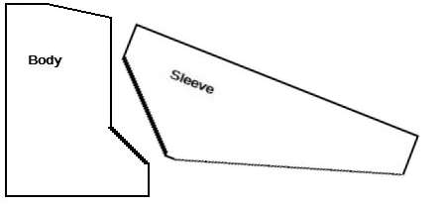
Diagram 4 – Inset sleeve – body and sleeve shapes

The final experiment explored a knitted armhole shape that fits more closely to the human form (inset sleeve – Diagram 4). The general principles learned from the prior experiments were applied. The sleeve width was reduced to 29cm (flat), a shoulder slope of 3cm was introduced on the body panel and the armhole was calculated using Pythagoras Theorem to equal 21cm. The 10% reduction on the raglan method was used to align the sleeve and body panels. Five trials were knitted and Table 5 displays the average results and demonstrate a good conformity between the theoretical calculated results and those produced in the knitted panel. When worn on the human form the sleeve produced conforms well to the body contour and was deemed to be comfortable by the wearer in the initial fit trials. In summary, the inset sleeve creates a sophisticated armhole that conforms to the body and the preferred method of calculation to ensure the sleeve head fits into the armhole shape and performs well during wear.

Table 5 – Inset sleeve – body and sleeve dimensions
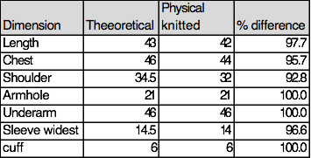

CONCLUSIONS
The experiments conducted during the research identified a quantifiable relationship between the theoretical dimensions calculated using the principle of Pythagoras Theorem and those produced in the fully-fashioned selvedge of a knitted sample. The following principles were observed. A fashioning frequency of 1 course was unacceptable, fashioning frequencies of 2 and 3 course resulted in the selvedge of the knitted samples measuring between 83-86% of the theoretical dimensions. The optimum fashioning frequency for shaping is 4 courses or above (the knitted selvedge dimensions were found to be 98% of the theoretical calculated). When aligning the sleeve and body panels it was ascertained that if the number of fashioning’s on the sleeve was less than the body, the notch alignment method should be used, If the sleeve and body fashioning’s are equal either method is suitable. Should the sleeve comprise of more fashioning’s than the body, the raglan method should be used. Further experimentation resulted in a new method for alignment, which reduced the raglan dimension by 10%, creating better conformity between the sleeve and the body panels during make-up and after finishing. This method was further examined in the context of an inset sleeve. The findings discovered the inset sleeve creates a sophisticated armhole that conforms to the body and the 10% reduction (raglan method) was the preferred alignment method to ensure the sleeve head fits into the armhole shape and conforms during wear. Ultimately, it can be concluded that it is possible to quantify the relationship between traditional mathematical theories used for the calculation of fully-fashioned, weft knitwear and the actual physical measurements of the garment. This significantly expands the range and depth of research in global knitwear technology and its application to the finished product and will result in improved fit and increased consumer satisfaction.

REFERENCES
Apeagyei, P. 2010. Application of 3D Body Scanning Technology to Human Measurement for Clothing Fit, International Journal of Digital Content Technology and its Application, 4 (7) 58-68
Ashdown, S. 2007. Sizing in Clothing. Cambridge: Woodhead. (7) 58-68.
Brackenbury, T. 1992. Knitted Clothing Technology. UK: Blackwell Science.
Demiroz, D. and Dias, T. 2000. A Study of the Graphical Representation of Plain Knitted Structures, Journal of the Textile Institute, 91 (4) 463-480.
Eckert, CM, Cross, N, and Johnson, J.H. 2000. Intelligent Support for Communication in Design Teams: Garment Shape Specifications in the Knitwear Industry, Design Studies, 21 (1) 99-112.
Fletcher, K. 2008. Sustainable Fashion and Textiles. UK: Earthscan.
Gupta, D. (ed.). 2014. Anthropometry, Apparel Sizing and Design. Cambridge: Woodhead Publishing Limited.
Karl, K., A. Hall, McIntyre, L, and Peluchette, J., V. 2013. City Employee Perceptions of the Impact of Dress and Appearance: You Are What You Wear. Public Personnel Management, 42 (3) 452-470.
Kaushiki, D. 2018. “An ‘India Size Chart’: What Does It Mean and Why do we Need It,” The Times of India March 5, 2018, https://timesofindia.indiatimes.com/city/delhi/an-india-size-chart-what-does-it-mean-and-why-do-we-need-it/articleshow/63157572.cms.
Memon N.A, 2011. Knitwear Industry: Playing Vital Role in Value Addition, Pakistan Textile Journal, 34-36.
Mills, R., W. 1967. The Shaping of Plain Fabrics. Journal of the Textile Institute, 58 (1) 40-46.
Power, J. 2007. Functional to Fashionable: Knitwear’s Evolution Throughout
the Last Century and Into the Millennium. Journal of Textile Apparel Technology and Management, 5 (4) 1-16.
Power, J. 2008. Developments in Apparel Knitting Technology. In Fairhurst Advances in Apparel Production. Cambridge: Woodhead.
Power, J. 2008a. Measuring up Knitting International. World Textile Publications, 114 (1360) 40-41.
Power, J. 2008b. Shaping Progress Knitting International. World Textile Publications, 114 (1358) 34-35.
Power, J. 2017. Advanced Knitting Technologies for High Performance Apparel. In High-Performance Apparel: Materials, Developments and Applications, ed. Sabir, T. and McLoughlin J. London: Elsevier.
Shinn, W., E. 1955. An Engineering Approach to Jersey Fabric Construction. Textile Research Journal, 25 270-277.
Spencer, D. 2001. Knitting Technology. Cambridge: Woodhead.
Weinswig, D. 2015. A Deep Dive into Sweaters. Fung Business Intelligence Centre. 1-22

