Nursing Management
XXXX
XXXX

Care Excellence Framework (CEF): from ordinary to predictable excellence
Rowson T, McSherry W (2018) Care Excellence Framework (CEF): from ordinary to predictable excellence. Nursing Management.
Date of submission: 20 December 2017; date of acceptance: 17 May 2018. doi: 10.7748/nm.2018.e1710
Trish Rowson
Director of nursing – quality and safety, Department of Nursing, Trust Headquarters
Royal Stoke University Hospital, University Hospitals of North Midlands NHS Trust
Newcastle Road, Stoke-on-Trent, Staffordshire, ST4 6QG
[Q?: Please provide the missing details for affiliation.]
Wilfred McSherry
Professor in nursing, Department of Nursing, School of Health and Social Care, Staffordshire University, Stafford, England/ University Hospitals of North Midlands NHS Trust. And Part time Professor VID vitenskapelige høgskole, Haraldsplass Bergen, Norway

Correspondence
Trish.Rowson@uhnm.nhs.uk

Conflict of interest
None declared
Peer review
This article has been subject to external double-blind review and has been checked for plagiarism using automated software
Online
For related information, visit nursingmanagement.co.uk and search using the keywords
Write for us
For information about writing for RCNi journals, contact writeforus@rcni.com
For author guidelines, go to rcni.com/writeforus

Abstract
Quality is complex and difficult to define, and institutions and organisations often have their own definitions, measurements and assurance processes. The Care Excellence Framework (CEF), developed and used at University Hospitals of North Midlands NHS Trust (UHNM), is a unique, integrated framework of measurement, clinical observations, patient and staff interviews, benchmarking and improvement. It also has an internal accreditation system that provides assurance from ward to board based on the five Care Quality Commission (CQC) domains and reflects CQC standards. The CEF has been established in its existing form for approximately two years during which time it has been used within all areas of the organisation. This article provides an overview of the development and use of the CEF in an acute care setting, demonstrates how the CEF acts as an internal accreditation system providing assurance from ward to board around the Care Quality Commission domains, and shows how the CEF is a motivator for effective change and transforming care from the ordinary to excellent.
Care excellence framework, service improvement, quality in care Ruth to check against taxonomy

Introduction
Health care is not a static entity but is dynamic, constantly transforming to meet the changing and diverse needs of those who access services. The NHS is experiencing unprecedented pressure due to a range of political and financial measures that have resulted in reduced funding. This combined with changing social-demographic factors, such as an ageing population, has led to increased demand and reduced capacity across many health and social care settings (NHS England 2017).
There is greater awareness about putting patients at the centre of health care ensuring their voice and the public’s voice inform service delivery and design. In light of recent failings in patient care even greater emphasis has been placed on quality and safety and led to the establishment of an independent regulator, the Care Quality Commission (CQC). The CQC ensures health and social care services provide safe, effective, compassionate and high-quality care and encourages care services to improve (2017a) [Q?: The reference CQC 2017 has been changed to CQC 2017a as per the reference list. Please check.].
Quality is complex and difficult to define (Raleigh and Foot 2010) and institutions and organisations often have their own perception of what it is in terms of domains, processes and measures (Raleigh and Foot 2010, Hanefeld et al 2017). For example, the CQC provides an overall rating for organisations through registration of health care providers, monitoring and inspection of services. The rating details information about standards and quality of care and the reports provide transparency, allowing the public to compare healthcare providers and ensuring they are informed and better able to make choices about where to receive treatment and care. CQC inspections are based on five domains, safety, effective, caring, responsive and well led. Several articles detail the inspection process, preparation and potential value to organisations (Glasper 2015, Foster 2016). The five CQC domains are used by NHS Improvement (2018) to contribute to its single definition of success, which suggests that in England there is a consensus and attempt to standardise the domains that determine quality in care.
Despite current constraints there are numerous examples of excellent, original and innovative practices across the health care spectrum that seek to capture and enhance quality care (The Health Foundation 2015) [Q?: The reference The Health Foundation 2018 has been changed to The Health Foundation 2015 as per the reference list. Please check.] and these can have a significant effect on patient experience and work culture/environment. Internationally health care is striving for excellence through delivery of holistic person-centred care and development of organisational cultures and values that nurture healthcare workers and teams.
McSherry et al (2016) describe excellence as follows: ‘Excellence is about sharing and celebrating success with healthcare workers, patients, carers and other significant stakeholders regarding how successful innovation, improvement and change have enhanced the quality of health, wellbeing, peaceful death and the services provided to local communities… Excellence is about integrating the physical, psychological, spiritual, emotional and social aspects of care to create an organisational health culture and working environment that recognises, respects and values the individual and their unique contribution in striving to provide holistic, therapeutic person-centre care.’ This definition affirms that to achieve excellence there must be transparent communication where success is shared and celebrated, and where healthcare workers feel valued. Care must be holistic and person-centred, and individuals should be recognised for their contribution. The main ingredients for assessing and recognising excellence are also outlined, for example patient and public engagement, multidisciplinary working and dialogue with stakeholders. Implicit in this definition is the need for organisations to be responsive and this includes learning from mistakes.
Numerous schemes are used to evidence the quality of a specific service, including The Excellence in Practice Accreditation Scheme (McSherry et al 2003) that recognises and rewards excellence. Another example is the Care Excellence Framework (CEF) developed and used in University Hospitals of North Midlands NHS Trust (UHNM). The CEF has been established in its existing form since autumn 2016 during which time it has been used in all areas of the organisation. This article gives a brief overview of the CEF and its use in an acute care setting.

Care Excellence Framework
UHNM is one of the largest and most modern trusts in the UK serving around three million people and was rated outstanding for care in the most recent CQC inspection. It comprises around 1,450 inpatient beds and 59 wards across two sites. However, during periods of high activity, such as winter, this can require opening escalation wards which increases the number of inpatient beds. The trust employs around 10,920 staff comprising 75.6% frontline clinical staff and 24.4% support staff. The nursing workforce vacancy level varies and is between 7% and 10%. During 2016/17 1,034,143 patients received care and treatment at the trust.
To achieve excellence rather than simply compliance with the CQC Essential Standards of Quality and Safety (2010) UHNM developed and implemented a unique, integrated CEF of measurement, clinical observations, patient and staff interviews, benchmarking and improvement. It offers an internal accreditation system that provides assurance from ward to board around the five CQC domains listed above, reflects CQC standards and provides the trust with a method of progressing from ‘requires improvement’ to ‘good/outstanding’. The CEF includes an award system for each domain and an overall award for wards/departments based on evidence. The awards range from bronze, silver and gold to platinum. Funding for the development and rollout of the CEF quality assurance process came from within the existing budget.
The CEF is supported by a bespoke IT system acting as a data warehouse for a suite of measures and that can triangulate and present high level and granular information at ward/departmental level, thus ensuring that ward visits, to review the domains, are tailored and intelligence driven. Managers can interrogate the system and benchmark themselves against other areas. The measures provide robust information to identify areas for improvement and areas of good practice, and clinical areas are supported to develop and deliver bespoke improvement plans and spread good practice.
The aim is for every ward to have at least one CEF visit a year to review all domains and to receive informal visits throughout the year to seek assurance about individual domains. The CEF is delivered in a supportive style fostering a culture of learning, sharing and improving, as well as reward for and recognition of achievement. This approach promotes morale and creates a sense of pride, value and completion across the organisation as all wards strive towards improvement and a platinum award. The IT system demonstrates improvements and trends over time and helps to benchmark and spread excellence across the organisation. Table 1 demonstrates the different elements addressed through the CEF.
An integral part of the CEF is conducting review visits to wards to validate the data sources used. Collectively, the elements provide a 360° assurance process. The process is structured around the CQC (2017b) key lines of enquiry (KLOE). Table 1 lists the domains relevant to the trust mapped against the [domains outlined in the Keogh quality review] (2013) and shows the methods used to gather evidence for review. The review is a combination of evaluation, observation, questioning and appraisal of documentation.
Initially there was some scepticism about the benefits of the CEF among ward/department managers and staff. However, they realised that to improve quality and care standards there was a need for good engagement and support in embedding the processes, and the initial scepticism has been replaced with real engagement.

Table 1. Care Excellence Framework domains of enquiry
Keogh domain | Related Care Quality Commission (CQC) outcome standards | Desk top evaluation | Staff interviews based on CQC key lines of enquiry | Observation of care | Patient interviews | Documentation review
Domain 1: Safety | Outcome 7: Safeguarding people who use services from abuse  Outcome 9: Management of medicines  Outcome 10: Safety and suitability of premises  Outcome 11: Safety, availability and suitability of equipment  Outcome 12: Requirements relating to workers  Outcome 13: Staffing  Outcome 20: Records
Domain 2: Effective | Outcome 2: Consent to care and treatment  Outcome 5: Meeting nutritional needs  Outcome 8: Cleanliness and infection control  Outcome 14: Supporting staff
Domain 3: Caring | Outcome 1: Respecting and involving people who use services  Outcome 4: Care and welfare of people who use services
Domain 4: Responsive | Outcome 6: Cooperating with other providers  Outcome 17: Complaints
Domain 5: Well led | Outcome 16: Assessing and monitoring the quality of service provision

The reviews and teams
The ward visits are made by between eight and 10 volunteer internal and external professionals from across the trust and the local health economy (Box 1), which means that staff from within and outside the organisation are exposed to a range of practices, providing greater scrutiny and challenge during the visits. Team members include staff from nursing, infection prevention, dieticians, pharmacists, governance team, estates, nursing students and junior doctors. External members include staff from clinical commissioning groups, Healthwatch and local universities. Having a combination of team members from a range of disciplines adds a layer of assurance, transparency and integrity to the process, for example having an independent stakeholder conduct patient interviews. The diverse expertise ensures that team members can concentrate on specific aspects of the review and accreditation process.

Box 1. Possible composition and role of review team members
Reviewer | Role
Review lead | Interviews with ward/departmental manager and staff
Quality improvement facilitator and/or external stakeholder | Patient interviews
Quality improvement facilitator and/or clinical expert | Observations of care (safety)
Quality improvement facilitator and/or clinical expert | Observations of care (caring)
Quality improvement facilitator and/or clinical expert | Observations of care (effective)
Quality Improvement facilitator and/or clinical expert | Observations of care (responsive)
Quality Improvement facilitator and/or clinical expert | Observations of care (Well led)
Quality improvement facilitator and/or governance lead | Review of documentation and information governance

The CEF review visits are delivered in two ways:
- Domain reviews, for example safety, caring. These are commissioned where a ward is demonstrating weak compliance against specific domains.
- Comprehensive reviews, all domains. All wards have one comprehensive review each year. A comprehensive review is also commissioned for wards that demonstrate weak compliance across a substantial number of ward indicators.
A pre-review meeting is held before undertaking a review during which local measures and intelligence are scrutinised to identify what they say about a specific area. KLOE and [CEF toolkit booklets for each of the domains] (Figure 1) are used to explore the different domains as well as observation and questions for staff and patient/public representatives. The reviews are unannounced, usually take up to two hours and are centrally organised within the trust.

Figure 1. Care Excellence Framework booklets

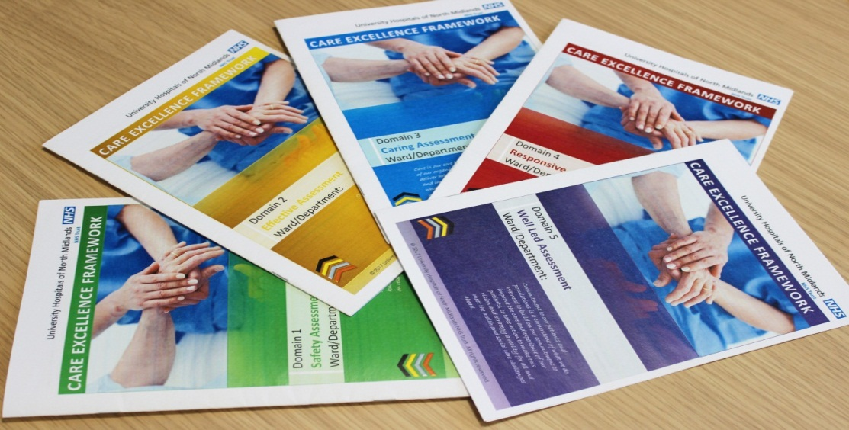

Award process
Figure 2 gives an example of scoring for a bronze award. It details the score for each of the CQC domains and the overall award. During the CEF visit the reviewers use their professional judgement to arrive at a score for each domain, and the scores are subject to challenge by the review team after the visit. Following a CEF review the duration for follow up is three months for bronze, six months for silver, nine months for gold and 12 months for platinum, unless a specific domain still requires achievement in which case a review is conducted sooner.

Figure 2. Example of scoring for a bronze award (area 1 date of visit March 2017)
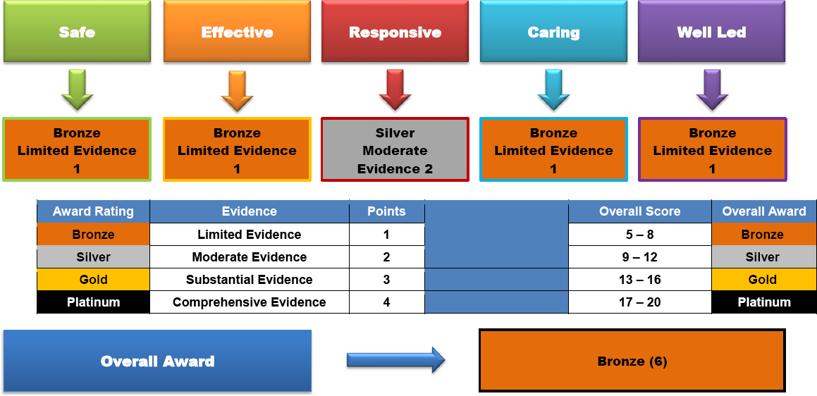

CEF award outcomes of comprehensive visits
The CEF operates around a continuous programme and cycle of service improvement, involving the initial comprehensive visit and subsequent domain revisits. A ward/department, referred to as an area, may be awarded a gold outcome after the initial comprehensive visit, but this may be improved to platinum at a subsequent visit if the points raised in the improvement plan are addressed. So far 63 comprehensive review visits have been conducted across UHNM with five areas awarded bronze awards (7.9%), 25 awarded silver (39.7%), 26 awarded gold (41.3%) and seven areas awarded platinum (11.1%). Figure 3 illustrates the significant improvements made after a revisit to the same ward shown in Figure 2.

Figure 3. Scoring for area 1 (gold award) after a revisit July 2017
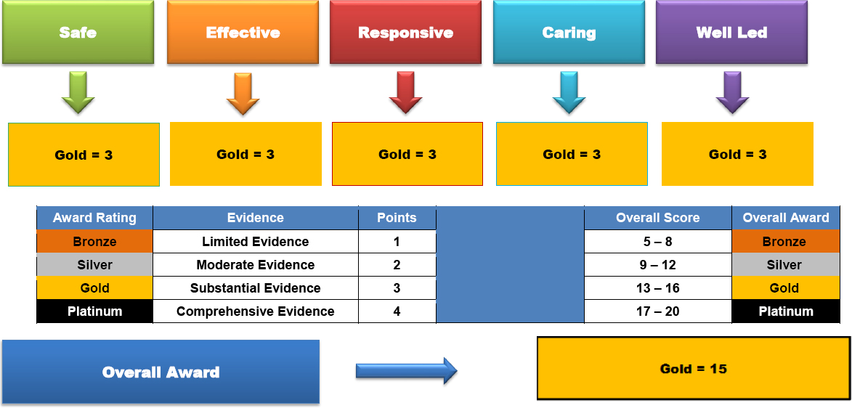
A number of wards/departments have deteriorated and their award level has reduced. Area one [table 2 is labelled area 1 and area 2 not area 5. Can you clarify? Also can you add dates to the table?] (Table 2) was revisited because of a concern. The department was awarded a silver in October 2016 and following the revisit in February 2017 was awarded a bronze. The department was adopted (see ‘adopt a bronze’ section below) and a rapid improvement event [what is this?] was initiated. Another visit was planned for three months later. This illustrates the dynamic nature of CEF and the underlying principles of support based on a system of reward.

Table 3. Scoring compared with revisit
Area | Safe | Effective | Responsive | Caring | Well led | Award
1 first visit 17 Oct 2016 | Bronze | Silver | Silver | Gold | Gold | Silver
Revisit  22 Feb 2017 | Bronze | Bronze | Silver | Silver | Silver | Bronze
2 first visit 17 Oct 2016 | Bronze | Bronze | Bronze | Bronze | Bronze | Bronze
Revisit  28 Feb 2017 | Gold | Gold | Silver | Platinum | Platinum | Gold

Adopt a bronze
The trust has established a Quality Academy (QA) supported by a team of quality improvement facilitators and the governance, audit and risk team. A programme manager coordinates the QA with the support of a data analyst. The aim of the QA is to expand the scope of quality improvement into every aspect of care across trust and to encourage the spread of innovation and learning. Quality Academy members (includes the Compliance Manger, a member of the Organisational Development Team and invited clinical teams) [do you mean the quality improvement facilitators?] have the knowledge and skills to support creative thinking and to empower staff to deliver improvements themselves. The QA is also responsible for analysing and presenting measurement information , in the form of clinical indicators such as pressure ulcers, falls, all clinical assessments, complaints, medication errors [what do you mean by measurement information?] to support improvement and reports progress to clinical teams. The clinical ward team, is responsible for collecting the measurement data and monitoring sustainability.
The QA has implemented an ‘adopt a bronze’ initiative in which a quality improvement facilitator supports the bronze wards/departments. The adoption relationship:
- Supports the ward sister/department manager to review the CEF recommendations and develop an improvement plan.
- Identifies and agrees the evidence required to confirm improvement and sustainability.
- Reviews the ward/department intelligence to identify trends related to harm and complaints and review existing improvement plans.
- Supports the ward team to develop a trajectory for improvement and agree priority actions for implementation.
- Provides visible and practical support, visiting the area three to four times a week.
- Provides access to QA meetings for ongoing support.

Findings from evaluations
The CEF is having a positive effect on the overall quality of care and on staff engagement with the awards. The framework offers a systematic and comprehensive approach to capturing and monitoring the quality and standards of care, and provides a robust, triangulated approach to quality assurance. UHNM has presented the CEF framework to, and received positive feedback from, Health Board Wales, Klynveld Peat Marwick Goerdeler, the CQC, Health Education England and the local CCG. Staff who receive and undertake the visits have also commented on their experience of the CEF process and Box 2 gives a selection of these comments from internal staff and external stakeholders. The comments demonstrate how the CEF contributes to the development of transparent cultures and provides reassurance to stakeholders because of the systematic cycle and nature of the process.

Box 2. Internal and external feedback comments
Higher education institution (HEI) | From an HEI educational stakeholder perspective, the Care Excellence Framework (CEF) is a useful method for monitoring and improving the quality standard of the placement area where nursing students are placed for their practice learning experience. The Nursing and Midwifery Council (NMC) standards for pre-registration nurse education require an educational audit be completed biannually for all clinical placement areas that take students for a learning experience. This is to ensure the quality standard of the practice learning environment for the continuance of students in practice. The CEF is an excellent way for the link lecturer to connect with the clinical practice area to ascertain the quality standard of care being delivered by the clinical team and for this to feed into the educational audit as required by the NMC. The CEF framework and the transparency the process provides, allows the link lecturer greater insight into the link area and the associated clinical teams’ strengths and, where relevant, development points
Clinical commissioning group (CCG) | The [name] were pleased to receive an open invitation from the trust corporate nursing team to participate in the CEF visits as integral team members. The CCGs were very impressed by the following aspects of the CEF process:  - Openness and transparency of the joint visiting process. It is pleasing that we are provided with the CEF visiting dates and can attend when possible  - The quality and comprehensiveness of the key performance indicator data provided for the pre-meet discussion for each ward  - CCGs can take assurance from knowing these visits are a systematic and integral part of the trust’s quality monitoring and improvement  - The comprehensiveness of the visiting team, which includes a number of specialists throughout the hospital  - The alignment of using the Care Quality Commission quality domains and key lines of enquiry  - The robustness of the confirm and challenge at the post visit review meeting  - Where insufficient evidence is available to rate a domain a return visit is undertaken  - The CEF visits not only identify wards requiring support but also celebrate excellence in practice  - The CEF visits with CCGs facilitate effective collaborative working which is most welcomed by the CCGs
Contract performance manager | The CEF process allows all members of the visiting team to be involved and to have a view on the visit. The process is clear, structured and beneficial to the improvement of patient care and although each domain is allocated to a lead, all group members are encouraged to share their view/experiences on the findings of the visit
Comments from staff receiving a CEF visit  Ward sister bronze ward | With regard to the CEF assessment and reassessment, can I say how supportive all members of the team have been. Our quality improvement facilitator was excellent with her support to us and she came up with some great audit tools that we are going to continue to use. To have a CEF visit ‘looming’ is always an anxious time as the ward want to show how we are improving and developing. The staff felt very proud after learning that our improvements had been recognised on the reassessment and while half the battle is maintaining the improvements I do feel the staff understand why assessments of this nature are important and so valuable. I have never worked at a trust before where there has been so much focus on safety, on feedback. So to come here at first it was ... a big shock with so much emphasis on governance. I think back and think why does this not happen everywhere else?
Ward sister platinum Ward | Once the date of the visit was confirmed I relayed this to all the staff. I explained the purpose of the visit and staff felt slightly apprehensive at first, however after further reassurance we all agreed that we are open and transparent with the service that we provide, and whether there is an inspection or not the standard of care remains consistently excellent. Receiving the Platinum score really boosted staff morale and we all felt that our hard work has been recognised and appreciated. We are all indeed ‘proud to care’

Ward/departmental toolkit booklets
The CEF tools for each of the domains have been developed into booklets (Figure 1) for use at ward/departmental level, and bespoke tools have been developed for maternity, theatres and the mortuary. Professionally-produced binders have been created giving the CEF a standardised approach with its own unique branding. In addition, master classes have been delivered by corporate quality improvement team members to support staff to use the tools themselves.

Quality boards
NHS organisations are required to publicly display key quality indicators at ward/departmental level and the trust recently updated its quality boards to reflect the CEF. The boards are bespoke and professionally designed to display the CEF domains. The corporate quality team is responsible for updating the boards to ensure they remain professional and standardised across the organisation. Figure 4 shows the design.

Figure 4. Quality board
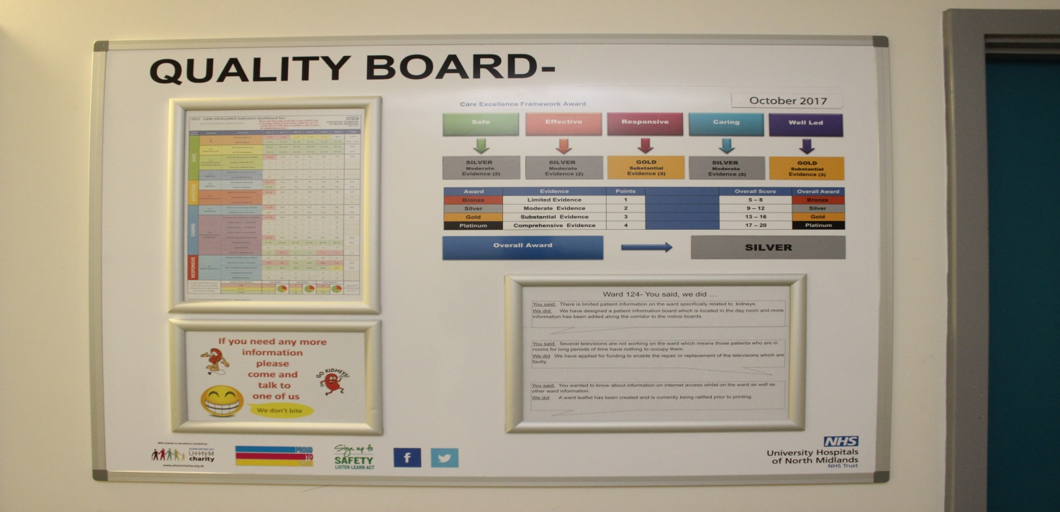

Recommendations and conclusion
Organisations should have a robust process for measuring, improving and sharing good patient care which informs all levels from ward to board. The CEF is a vehicle for achieving and:
- Offers a level of scrutiny and challenge at ward/departmental level providing assurance for quality and safety.
- Identifies areas of excellence in practice and area that require development to prepare staff for CQC inspections and other external reviews.
- Helps to dispel fear and reduce anxiety about inspections by helping to develop a culture in which individuals and teams are open to having their practice challenged and rewarded.
The CEF provides a rewards-based, systematic and robust framework for quality and service improvement. It is an intelligence-driven system that provides quality assurance based on the triangulation of multiple forms of evidence and data sources, and therefore acts as an internal accreditation system providing assurance from ward to board in the context of the CQC domains. Implementation of CEF supports the development of a transparent culture in which individuals feel engaged, valued and supported in the review process. The CEF is proving to be a valid and reliable tool capable of identifying positive areas of practice and highlighting areas for ongoing improvement.
The introduction of the CEF has resulted in staff feeling more engaged and prepared for quality inspections where the focus is on preparing for the next patient not the next visit. In this sense the CEF is an inspection-based model integrating and founded on the principles of patient-centred care. The success of the framework is that it takes a non-threatening and non-judgmental approach to the review process in which teams are empowered to challenge and drive forward change. In conclusion, the CEF is a motivator for effective change, transforming care from the ordinary to the excellent.

References
Care Quality Commission (2010) Essential Standards of Quality and Safety. Care Quality Commission, England.
Care Quality Commission (2017a) Who We Are. Care Quality Commission, England.
Care Quality Commission (2017b) Key Lines of Enquiry, Care Quality Commission, England.
Foster S (2016) How CQC fit are we as nurses? British Journal of Nursing. 25, 12, 709.
Glasper A (2015) The care quality commission hospital inspection process. British Journal of Nursing. 24, 15, 792-793.
Health Foundation (2015) Twenty-One Innovative Projects are Selected to Improve the Quality of Health Care. The Health Foundation, London.
Hanefeld J, Powell-Jackson T, Balabanova D (2017) Understanding and measuring quality of care: dealing with complexity. Bulletin of the World Health Organization. 95, 5, 368-374.
Keogh B (2013) Review into the Quality of Care and Treatment Provided by 14 Hospital Trusts in England: Overview Report. www.nhs.uk/nhsengland/bruce-keogh-review/documents/outcomes/keogh-review-final-report.pdf (Last accessed: 23 May 2018.)
McSherry R, Kell J, Mudd D (2003) Best practice using excellence in practice accreditation scheme. British Journal of Nursing. 12, 10, 623-629.
McSherry R, Grimwood K, Stubbings K (2016) A story of facilitators’ experiences of the excellence in practice accreditation scheme and its influence on quality, dignity and respect. In Tranvåg O, Synnes O, McSherry W (Ed) Stories of Dignity within Healthcare, M&K Publishing, Keswick, England,169–186.
NHS England (2017) The NHS 2017. NHS England, England.
NHS Improvement (2018) We Have Developed a Single Definition of Success. NHS Improvement, London.
Raleigh V, Foot C (2010) Getting the Measure of Quality Opportunities and Challenges. www.kingsfund.org.uk/sites/default/files/Getting-the-measure-of-quality-Veena-Raleigh-Catherine-Foot-The-Kings-Fund-January-2010.pdf (Last accessed: 23 May 2018.)

