Empirical evaluation of spring powered air rifle storage and modifications on forensic practice and casework

Abstract
Air weapons are commonly used by civilian populations across the world, particularly by those under 18, and discharges often result in desecration, criminal damage and animal abuse. Online forums and websites provide an accessible resource for civilians to access airgun modification methods proposing to increase muzzle velocity. However, there is limited published research that empirically evaluates the impact of air weapon modification and the potential to influence casework interpretation. Therefore, this paper aims to initiate such research by quantifying the effect of storage conditions (mainspring compression and oil travel/dieseling) and two modifications (reduction of barrel length and preloading through addition of washers) encountered in casework on recorded muzzle velocities using a small number of break barrel, spring powered air rifles.
Storing airguns vertically and/or cocked statistically effected the consistency of air pellet discharge and recorded muzzle velocities. Modifications typically resulted in significant variation in air rifle muzzle velocities, often with unfavourable side effects and/or to the detriment of the airgun. Deliberately reducing barrel length or incorporating preload demonstrated the greatest impact on muzzle velocity; however, the direction of muzzle velocity change could not be predicted by air rifle calibre, brand or model.
This preliminary study reinforces the requirement for practitioners to undertake timely weapon examinations and interpret casework on a case-by-case basis, especially for modified airguns. In addition, this research strongly recommends the re-evaluation of current air weapon storage and/or testing procedures to ensure accurate and reliable interpretations are obtained for legal classification and casework.

Keywords
airgun; examination; modification; muzzle velocity; storage

Introduction
Airguns have been used since the 16th century, and although their operation may have evolved, the method of propelling a projectile using air has principally remained the same. Modern airgun designs typically involve producing projectile motion using a compressed spring, release of liquid carbon dioxide that gets instantly converted into a gas or pneumatic action using pre-compressed air. Within each category there are a variety of mechanisms designed to induce the desired outcome. Walter [1] states the spring powered, break barrel airgun is the most straightforward and widely used system, although alternative methods of compressing the spring include using a side or under-mounted lever. From the primary author’s experience, the popularity of spring powered airguns in the United Kingdom (UK) has not lessened, accounting for 75 % of all airguns examined in their armoury (see Acknowledgements section) between 2010 and 2014. However, PCP (pre-charged pneumatic) air rifles are becoming more popular and exhibit their own performance variabilities [2], which are outside the scope of this research.
In 1983 it was estimated that approximately 2.5 million airguns were sold each year in the United States (US) [3] and in 2015, The British Association for Shooting and Conservation (BASC) estimated there were over 6.5 million air rifles in the UK [4,5], which may be legally held without Certificate under certain conditions. This paper uses the term gun, instead of firearm, when discussing air weapons as not all airguns will be legally classified as a firearm and the requirements for airgun licensing and certification differ significantly between countries across the world. For example, in England and Wales, pellets discharged from an air rifle must be below 12 foot pounds (ft lb) (16.3 joules, J) [6,7] in kinetic (muzzle) energy [8], whereas other European countries use 7.5 J (5.53 ft lb) for all airguns [9,10] and US federal law does not classify airguns as firearms at all [2]. Regardless of differences in legislative definition, air rifles under 12 ft lb cause injuries and fatalities each year internationally [11-13], demonstrating that air weapons are often misused despite gun controls. Due to variations in international gun law, this paper focuses its discussions on the UK legal context where 37 % of reported gun offences involved air weapons and 72 % of these resulted in property damage in a 12 month period [14].
Although an airgun discharging pellets over 1 J (0.74 ft lb) may be deemed to be a firearm in the UK [15], there is little similarity between air weapons and other types of firearms that use cartridges of ammunition to make a noise (e.g. a blank firing starter pistol) or propel a projectile. In spring powered airguns, the act of the user cocking the gun imparts energy into the compressed mainspring. When the trigger is pulled there is a build-up in pressure, which eventually overcomes the inertia of the projectile, forcing it along the barrel and out of muzzle. This energy in the compressed spring is transferred to the pellet and converted into kinetic energy when the projectile begins to move. Research into cartridge-based firearms and their development has dominated the field [16] and the majority of published airgun research focuses on terminal and wound ballistics [17]. There is very little research that investigates the most efficient function and mechanism of air weapon discharge [8,18,19], which would be beneficial to practitioners and hunters as airguns are frequently modified for use in hunting as a replacement for ammunition-based firearms [20].
Cardew and Cardew’s book [21] is widely recognised in openly accessible online resources [22-25] for their extensive research into air rifle modifications, such as spring strength, transfer port dimensions and lubrication, which are suggested to reduce recoil or increase accuracy and velocity. Although some resources explore their work to improve understanding of airgun function [23,24], others utilise their work to increase muzzle velocity [25], regardless of whether it is legal practice. There is currently no published research that evaluates the legitimacy of these claims or explores the impact of such modification on forensic practice and interpretation in casework. Sections 1.1 to 1.4 provide an overview of the main airgun modifications focused on in this research and their theoretical influence on muzzle energy.

Barrel length
In both airguns and firearms, as barrel length increases, muzzle velocity increases to a point [26], then remains at a consistent speed as the length of the barrel continues [27]. Cardew and Cardew [21] state it is within the first five inches of an air rifle barrel where all energy is imparted into the pellet and only after 25 inches the pellet will begin to slow down. Optimum barrel length is the trade-off between friction and the loss of gas pressure; if the barrel is too long, more energy is wasted overcoming contact friction between the projectile and barrel, but if too short, more gas pressure is wasted as it has not had the opportunity to accelerate the projectile [21,28]. According to Denny [26], a pre-charged .177 calibre air rifle is theoretically only 15 % efficient, and .22 calibre only 24 %, demonstrating the extent of energy wastage caused by friction and barrel length for example, in low energy guns. Although it would be valuable to calculate efficiency with practical experiments, this is outside the scope of this research.

Mainspring
A compressed mainspring is the gun component that stores potential energy when cocked and ready to discharge a projectile. A common air rifle modification introduces ‘preload’ [21,29], compressing the mainspring in an uncocked state through addition of spacers, coins or washers to replicate extra coils of the spring. Preloading requires more energy to cock the gun and therefore the spring contains greater potential energy when compressed. Such modification theoretically results in more kinetic energy being transferred from the spring to the pellet during firing, increasing muzzle energy and velocity.
Increased wear on the mainspring may also occur if the spring is compressed for a significant duration and/or beyond its yield point, ultimately influencing the amount of power the spring may be able to deliver [30]. Therefore, an air rifle that has been cocked for a long time may also be subject to a reduction in power and reduced pellet muzzle energy.

Lubrication and oiling
Airguns require a small amount of lubrication to ensure long-lasting, reliable function. However, incorrect amounts of oil are frequently applied, sometimes deliberately, which can have a huge impact on muzzle velocity resulting in both beneficial and detrimental consequences [1]. Too much oil can increase the forward motion of the working parts to the extent that the piston may impact the transfer port, damaging it. Dieseling may also occur; a phenomenon where excess oil combusts, increasing muzzle velocity [11,12] by up to 50 % [13]. Caunt [31] trialled 12 fuels and oils to see the effect on velocity and dieseling in air rifles. Half of those tested produced dieseling effects with increased muzzle velocities and erratic, unpredictable firing. This has the potential to impact on standard air weapon testing procedures, interpretation and reporting of casework [32] (see section 3.4).
Oil in airguns will drip, run or pool when left for any duration due to the influence of gravity and may consequently effect muzzle velocity; muzzle up may dry out the working parts and muzzle down causing oil to run and saturate the piston head [21]. Armouries and evidence storage units typically store guns vertically and muzzle up; this research therefore explores the implications of vertical storage conditions on airgun testing and subsequent legal classification, rather than specifically focusing on the impact of dieseling.

Forensic implications
When investigating shooting incidents, some airgun and pellet combinations are capable of transferring rifling marks onto the fired pellet for forensic identification to a specific weapon, but these engraved markings can be easily erased from soft pellet surfaces during transportation with incorrect packaging [33,34] and the airgun must be recovered to successfully link fired pellets to the gun that fired them. Although such forensic comparisons do play an important role in the investigation of airgun shootings for human crimes, this is not always true in the context of archaeology (for example desecration of tombstones), criminal damage and animal crime across the world. In 2011, the primary author was involved in investigating deaths of numerous swans shot and killed with an air rifle. Airguns were recovered from three individuals who had means and motive, but apart from being able to confirm consistent pellet calibre, no air rifle could be irrefutably linked. Alternatively, consider an incident of deliberate desecration and/or criminal damage where an airgun is only inferred. In all cases, if pellets are recovered the calibre could be identified, but the firing distance, airgun brand (this term is used instead of manufacturer throughout this paper as not all companies manufacture the products they market and sell) and model would be extremely difficult to ascertain, especially if the airgun was modified.
When examining an airgun, altering barrel length may make it look like a short-barrelled carbine, although many other modifications may not affect the outward appearance. Changes such as preload and dieseling could make the airgun function less predictably, potentially causing unintentional, accidental or negligent discharge, and could result in injury, or death. Interpreting shooting incidents involving a specific airgun may also prove difficult due to reduced precision, inconsistencies in discharge and differences in terminal surface, for example wood [35,36], which may result in significant challenges when determining the cause and manner of the damage.
As previously mentioned, there is very limited published research on airgun modification, with the most noteworthy [21] providing little raw empirical data (such as Figure 9.1, p.82) or analysis into the significance of the results. In addition, the research lacks detail and there is no application of the findings into real world settings, such as the impact of modification in a legal or forensic context. Ultimately, many concepts surrounding airgun modification and its effect on muzzle velocity are speculative and lack scientific credibility. Online discussions are open public forum, typically providing information for civilians to make changes that may be both illegal and dangerous. This danger is not just relevant to the public; law enforcement, security personnel, forensic investigators and examiners could face increased risks when faced with the muzzle end of such a weapon and when handling or examining these airguns. Therefore, this pilot study aims to assess, evaluate and quantify the validity of claims for four casework encountered modifications that theoretically affect muzzle velocity in spring powered air rifles. Additionally, this research considers the impact of air rifle examination and testing procedures undertaken by forensic practitioners.

Methods and Materials

Equipment
Nine second-hand, break barrel spring powered air rifles were sourced from the armoury department of a UK police force (see Acknowledgements) and randomly assigned, where possible, to one or two modifications (Table 1). To simulate casework, second-hand air rifles were deliberately acquired and therefore the history of use and original source of these weapons was unknown. All guns however were in good working condition and there were no obvious issues with their function. Prior to each test, all air rifles had their bore cleaned using a bore snake or jag and cloth. No oil or lubricant was added unless the test specifically required it. Before any modification was undertaken, each air rifle had 10 shots fired (‘as found’ state) with 20 to 30 seconds in between firings.
Waisted (diablo) ‘medium weight’ [41] lead air pellets were sourced from the armoury and weighed individually using RCBS digital calibrated scales before test firing. Due to differences in calibre and limited air pellet availability in the armoury, multiple brands were utilised in this research (Table 1). Pellet nose design also varied to some extent between tests (flat head, round-nosed or pointed), although the same mass, diameter and design were used within a test to reduce variation in energy transfer. Over the 12 inch testing distance (Figure 1), nose design should have a negligible effect on subsonic muzzle velocity [41] and the observed pellet fit (diameter) within the chamber was consistent.
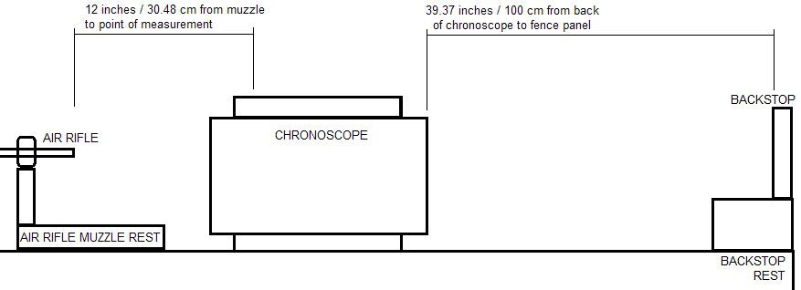
Figure 1 - Schematic of the experimental setup for measuring muzzle velocity with backstop (not to scale)

A bench rested air rifle was setup perpendicular to the SKAN Mark 9 calibrated chronoscope on a level, clean bench (Figure 1) as detailed in the Standard Air Gun Test [41]. Chronlog software (v3, 2010) was used to record the muzzle velocity of fired air pellets. A backstop was setup 100 cm (39.37 inches) behind the rear of the chronoscope. A digital clock (BasicXL, model BXL-WS11) was used to check temperature (18 to 25 °C) and humidity (57 to 68 %) throughout the research.

Table 1: Summary of technical detail, modifications performed and pellets used for each of the nine guns tested in this research (note, where multiple modifications were made to the same airgun, modification 1 was performed and testing conducted prior to modification 2, hence multiple pellet types could be used)
Brand | Webley & Scott | Westlake | Weihrauch | Gamo | Webley & Scott | Webley & Scott | Diana | Webley | Weihrauch
Model | Omega | Unknown | HW35 | Shadow 1000 | Vulcan | Vulcan | G80 | Falcon | HW80K
Serial number | 811218 | 110524269 | None visible | 04-1C-074247-04 | 909124 | 876493 | 1784 | None visible | 1729413
Calibre (inches) | .177 | .177 | .22 | .22 | .22 | .22 | .22 | .22 | .22
Technical specification: velocity (ft/s) | 675 [37] | 600 [38] | 574 [39] | 722 [40] | 650 [37] | 650 [37] | 500 [37] | 500 [37] | 804 [39]
Modification 1 | Storage (Oil) | Storage (Oil) | Storage (Oil) | Barrel length | Storage (Oil) | Preload | Preload | Storage (Cocked) | Storage (Cocked)
Pellet brand & type [nominal mass, grains (g)] | Bisley Practice – wadcutter  [8.18 (0.53)] | Bisley Practice -wadcutter  [8.18 (0.53)] | Webley Accupell – round nosed [14.30 (0.93)] | BSA Interceptor Hollowpoint Hunter  [15.43 (1.00)] | Webley Accupell – round nosed [14.30 (0.93)] | BSA Interceptor Hollowpoint Hunter  [15.43 (1.00)] | BSA Interceptor Hollowpoint Hunter  [15.43 (1.00)] | RWS Superpoint Extra  [14.50 (0.94)] | RWS Superpoint Extra  [14.50 (0.94)]
Actual pellet mass [grains (g)] | 8.20 (0.53) | 8.20 (0.53) | 14.50 (0.94) | 15.10 (0.98) | 14.50 (0.94) | 15.10 (0.98) | 15.10 (0.98) | 15.50 (1.00) | 15.40 (1.00)
Modification 2 | Barrel length | Barrel length | Barrel length | - | - | - | - | - | -
Pellet brand & type [nominal mass, grains (g)] | Bisley Practice – wadcutter  [8.18 (0.53)] | Bisley Practice – wadcutter  [8.18 (0.53)] | BSA Interceptor Hollowpoint Hunter  [15.43 (1.00)] | - | - | - | - | - | -
Actual pellet mass [grains (g)] | 8.60 (0.56) | 8.60 (0.56) | 15.10 (0.98) | - | - | - | - | - | -

Modification methods

Cocked mainspring (storage)
Following as found testing, the air rifles were checked as unloaded, cocked with the barrel closed, housed in a metal padded rifle case, stored securely in a horizontal orientation and not moved for six months. Following the six-month period, each air rifle discharged 10 air pellets as detailed in Table 1.

Oil and vertical storage
In each of the four air rifles (Table 1), two drops of low viscous gun oil (Parker Hale Express Gun Oil) were put into the transfer port hole and the barrel manipulated 10 times to allow the oil to work around the cylinder. Each air rifle was securely stored vertically, uncocked with the gun resting on its butt (muzzle up) for 14 days. After 14 days, each air rifle had 10 shots fired with appropriate calibre air pellets (Table 1). The air rifles were subsequently cleaned to remove excess gun oil and the process repeated, storing the gun vertically resting on its muzzle (muzzle down).

Preload
Each air rifle (Table 1) was dismantled and different combinations of 1.5 mm washers (Table 2) inserted both in front of the piston head and/or behind the spring at the back of the cylinder, subject to the washers fitting and safety (due to increased mainspring tension). Once washers were fitted, each air rifle was reassembled, and, subject to it successfully cocking, test fired with 10 shots. Although the Diana G80 and both .177 air rifles could have washers fitted in the front and/or rear of the spring, none of these guns could be successfully cocked and thus could not be used in this part of the investigation.

Table 2: Number and position of washers within air rifles used for preload test
.22 air rifle | 2 x front washers | 2 x rear washers | 4 x front washers | 4 x rear washers | 2 x front & 2 x rear washers | 4 x front & 4 x rear washers
Diana G80
W&S Vulcan 876493

Barrel length
Due to the destructive nature of this test and limited airgun availability, only four of the nine air rifles were investigated (Table 1). After initially measuring the overall barrel length, four inches (10.16 cm) were typically removed from the muzzle of each air rifle using a fine-toothed hacksaw. Burring was removed using a hand file and straightness checked using a set square. 10 shots were fired using pellets detailed in Table 1 and a further four inches removed until the air rifle could no longer be cocked (Table 3).

Table 3: Extent of barrel material removal for the guns investigated
Air rifle | Original barrel length (inches) | Removed barrel length (inches) |  |  |  | Final barrel length (inches)
 |  | 2 | 4 | 8 | 12
.22 Gamo Shadow 1000 | 18 |  |  |  |  | 10
.22 Weihrauch HW35 | 22 |  |  |  |  | 10
.177 Webley Omega | 15 |  |  |  |  | 7
.177 Westlake | 19 |  |  |  |  | 7

Data analysis
Raw muzzle velocity data was measured using Chronolog software (v3) and analysed using SPSS (v24.00). Outliers were identified, ranked, presented in box and whisker plots using SPSS and subsequently transformed as outlined by Tabachnick and Fidell [42]. Independent sample Mann-Whitney U was applied to statistically compare storage investigation datasets (sections 3.2.1 and 3.2.2) with Kruskal-Wallis H applied to interpret the effect of preload (section 3.3.1) and barrel length (section 3.3.2) modifications [43]. All data was analysed to 95 % confidence interval and statistically significant datasets were subsequently analysed using the Jonckheere Terpstra post hoc test with the Bonferroni correction, to reduce the chances of Type I error [44]. Where .22 calibre data was compared to .177 data, kinetic energy (KE) calculations ($KE= \frac{1}{2}{mv}^{2}$, where m is mass and v is velocity) were undertaken to further support interpretations.

Results and discussion

Muzzle velocities
As detailed in Table 1, the brands’ specified muzzle velocities for all seven .22 calibre air rifles tested were higher than those recorded the first time the airgun was fired in their as found state (Table 4). Most of these air rifles (four) demonstrated relatively minor reductions in recorded muzzle velocity, ranging between 4 and 12 % and are likely attributed to using different testing protocol between this research and the airgun manufacturer, which were unknown. For example, our research could have used a heavier pellet and/or placed the chronoscope at a different distance from the muzzle, reducing the muzzle velocity recorded. Alternatively, this could result from natural variation in manufacturing tolerances; additional research is needed using brand new air rifles to further explore this suggestion, however.
The greatest reduction in muzzle velocity (36 %) was demonstrated by the Gamo Shadow 1000, which was more likely caused by significant wear to the gun rather than variation in testing protocol. Wear could result from fatigue in the mainspring resulting in a reduced capability to retain kinetic energy potential when cocked, and/or a leaky gas seal, consequently reducing the transfer of energy to the pellet during firing. Play in the spring movement could also cause increased variation in the ability to create a consistent volume of rapidly moving gas. The percentage differences observed by the Weihrauch HW80K and Webley Falcon (Table 4) could result from a combination of wear and/or muzzle velocity testing differences.

Table 4 – Comparison between air rifle muzzle velocities the first time the gun was fired (as found state) and the brands’ technical specification
Air rifle |  | Muzzle velocity [ft/s (m/s)] |  |  | Muzzle velocity difference (%)
Calibre | Brand & model | Technical specification | As found | Difference
.22 | Gamo Shadow 1000 | 722 (220) | 462.22 (140.88) | -259.78 (-79.18) | -36
 | Webley Falcon | 500 (152) | 407.22 (124.12) | -92.78 (-28.28) | -19
 | Weihrauch HW80K | 804 (245) | 680.50 (207.42) | -123.5 (-37.64) | -15
 | Webley & Scott Vulcan | 650 (198) | 571.12 (174.08) | -78.88 (-24.04) | -12
 | Webley & Scott Vulcan | 650 (198) | 576.73 (175.79) | -73.27 (-22.33) | -11
 | Diana G80 | 500 (152) | 462.41 (140.94) | -37.59 (-11.46) | -8
 | Weihrauch HW35 | 574 (175) | 553.71 (168.77) | -20.29 (-6.18) | -4
.177 | Westlake | 600 (183) | 645.76 (196.83) | 45.76 (13.95) | +8
 | Webley & Scott Omega | 675 (206) | 750.12 (228.64) | 75.12 (22.90) | +11
For the two .177 calibre air rifles, their first shot muzzle velocities were higher than the brand’s technical specifications. This level of variability could be caused by using lighter pellets than the manufacturer’s testing protocol and/or natural variation in the efficiency of the spring to transfer energy to the pellet during discharge. It is possible the increase could have been caused by a hidden modification made before the armoury acquired the air rifles, although there were no visible indications of modification upon initial examination. During this research, some airguns also demonstrated trends in muzzle velocity change over consecutive repeat firings, for example Figure 2b, and will be specifically discussed in section 3.2. As there is no published literature or research detailing expected variations in muzzle velocities or their changes over time, definitive interpretations cannot be made. These findings do however support the theory that use, wear, storage and/or modifications may play an important role in airgun testing protocol and the subsequent interpretation of muzzle velocities, providing additional justification for this research.

Storage

Cocking of mainspring
Figure 2 compares the differences in muzzle velocity for two .22 calibre air rifles in their as found condition (T₀) and after storing for six months (T_{6months}) in a cocked state. Both airguns showed a statistically significant decrease in muzzle velocity (Table 5) after being stored cocked for six months. Despite the statistically significant decrease, the amounts were actually relatively small (Table 6); the Falcon on average decreased by 5.60 ft/s (1.71 m/s) and the HW80K decreased by 10.12 ft/s (3.08 m/s). These results are consistent with Pook [30], who showed that spring deformation occurred due to a load placed upon the springs for an extended amount of time. For the guns tested in this research, spring deformation had a negative impact upon the power the mainsprings could deliver, resulting in an average kinetic energy reduction of 0.15 ft lb (0.21 J) for the Falcon and 0.47 ft lb (0.64 J) for the HW80K, compared to the time of airgun recovery. These reductions suggest that for these airguns, cocking over extended storage periods should not significantly affect legal classification or forensic interpretations in the context of lethality.
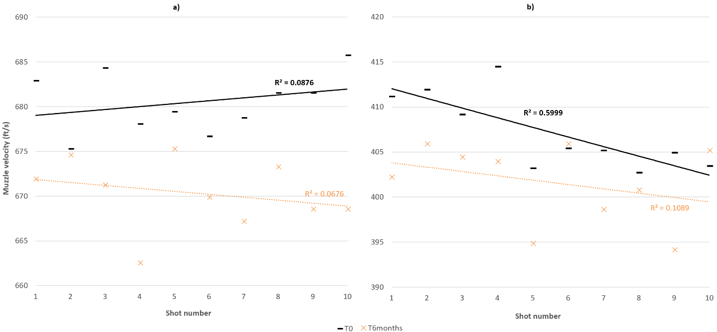
Figure 2 - a) Weihrauch HW80K and b) Webley Falcon muzzle velocity changes, trend lines and R² regression values in as found state and six months later

Table 5 – Statistical reporting for airguns where the modification produced statistically significant results
Modification (statistical comparison) | Airgun | Statistical reporting
 |  | Statistical test | Degrees of freedom | Test statistic | Significance (p) value
Storage - cocked  (T₀ to T_{6months}) | Webley Falcon | Mann-Whitney U | 19 | 22.500 | 0.0175
 | Weihrauch HW80K |  | 19 | 0.500 | 0.000
Storage - oil  (As found to muzzle up) | Weihrauch HW35 | Mann-Whitney U | 19 | 94.500 | 0.000
 | Westlake |  | 17 | 80.000 | 0.000
 | Webley Omega |  | 18 | 0.000 | 0.000
Storage - oil  (As found to muzzle down) | Weihrauch HW35 | Mann-Whitney U | 19 | 100.000 | 0.000
 | Webley Omega |  | 19 | 0.000 | 0.000
Preload  (As found to preloaded) | Diana G80 | Kruskal-Wallis H | 2 | 18.997 | 0.000
 | W&S Vulcan (876493) |  | 6 | 30.523 | 0.000
Barrel length (As found to shortened lengths) | Westlake | Kruskal-Wallis H | 3 | 25.493 | 0.000
 | Webley Omega |  | 2 | 25.835 | 0.000
 | Weihrauch HW35 |  | 3 | 19.166 | 0.000

Table 6 – Comparison between muzzle velocities before and after cocking for six months
Airgun | Mean muzzle velocity ± 1 standard deviation [ft/s (m/s)]
 | T₀ | T_{6months}
Falcon | 407.22 ± 4.19 (124.12 ± 1.28) | 401.69 ± 4.40 (122.44 ± 1.34)
HW80K | 680.50 ± 3.36 (207.42 ± 1.02) | 670.38 ± 3.83 (204.33 ± 1.17)
Although the muzzle velocities statistically reduced after the guns were cocked for six months, the shot-to-shot variation and inherent repeatability of the airguns remained extremely consistent. At both T₀ and T_{6months}, the Falcon’s muzzle velocity range was 11.77 ft/s (3.59 m/s). The range for the HW80K increased slightly from 10.42 ft/s (3.18 m/s) at T₀ to 12.76 ft/s (3.89 m/s) at T_{6months}. However, when observing the trend and R² values from shot 1 to shot 10 in Figures 2b and 3a to 3c, this suggests that the speed of repeat firings requires further consideration in standard testing protocols and any future research. Although there seems to be little correlation between the shot number and muzzle velocity for either the Weihrauch HW80K (Figure 2a) or HW35 (Figure 3d), there are moderately strong negative correlations for the Webley Falcon (Figure 2b) and W&S Vulcan (Figure 3b) .22 air rifles in their as found state and moderately strong positive correlations for the .177 Westlake (Figure 3c). This finding suggests that more than 30 seconds (as used in this research; section 2) may be needed for their springs to completely restore their elastic potential between discharges and could be a result of a comparably thicker, heavier and/or denser mainspring.
Cardew and Cardew [21] stated only poor quality air rifle springs would be subject to deformation, however, this research demonstrates that there is a small, but significant reduction even for more expensive, higher quality air rifles. Although these findings illustrate spring compression through cocking is unlikely to cause lasting damage to an airgun over time, without further research on poor quality airguns this hypothesis should not be underestimated.

Orientation and oil presence
Figure 3 illustrates the differences in muzzle velocity measured after storing the four guns in opposing vertical orientations. It was predicted that standing the airguns muzzle up would decrease muzzle velocity due to the movement of oil to the rear of the gun, whereas storing muzzle down would increase muzzle velocity due to the movement of oil to the front of the gun. This test was designed to investigate how gun storage affects muzzle velocity and establish if and when this action could result in dieseling. The test was not designed to mimic the addition of a signficant amount of oil previously shown to result in the dieselling phenomenom [11-13,31,32].
The mean as found muzzle energy differed for all four air rifles (Table 7) demonstrating differences in original gun design for those guns tested. Under typical European legislation, all these airguns would be classified as firearms as over the 7.5 J limit. In a UK context, three of the guns are significantly under the 12 ft lb (16.3 J) legal limit for unlicensed air rifles, however, the Vulcan may be classified by some practitioners as specially dangerous [6,7] at the time of recovery.
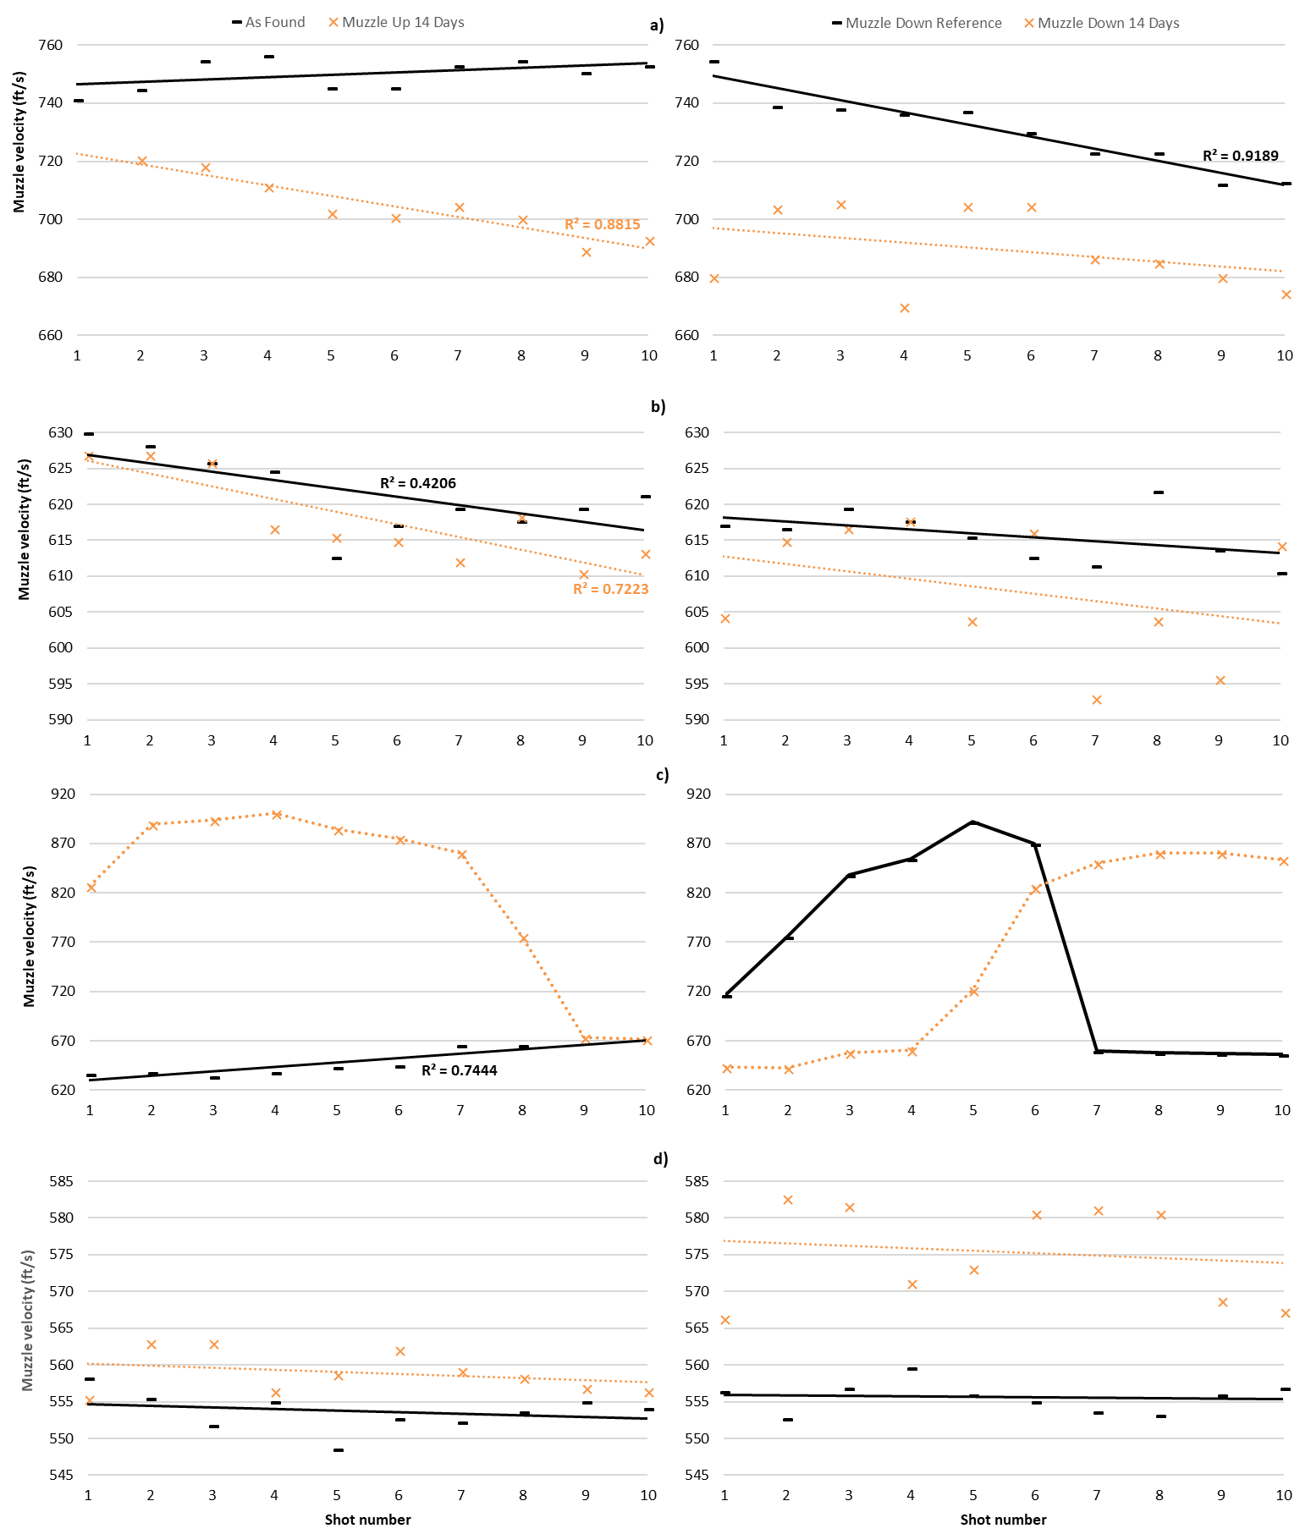
Figure 3 - a) Omega, b) Vulcan, c) Westlake and d) HW35 muzzle velocity changes in as found state, stored pointing muzzle up for 14 days (left column) and stored muzzle down for 14 days (right column) (note, where data points are omitted, the chronoscope did not register the measurements)

Table 7 – Mean muzzle energies of pellets discharged from airguns in their as found condition
Modification | Airgun |  | Pellet |  | Muzzle energy
 | Calibre | Brand & model | Brand & type | Actual mass [grains (g)] | (ft lb) | (J)
Storage (oil) | .177 | Westlake | Bisley Practice - wadcutter | 8.20 (0.53) | 8.0 | 10.8
 |  | W&S Omega |  |  | 10.8 | 14.6
 | .22 | Weihrauch HW35 | Webley Accupell - round nosed | 14.50 (0.94) | 9.9 | 13.4
 |  | W&S Vulcan |  |  | 12.5 | 16.9
Barrel length | .177 | Westlake | Bisley Practice - wadcutter | 8.60 (0.56) | 7.5 | 10.2
 |  | W&S Omega |  |  | 8.3 | 11.2
 | .22 | Gamo Shadow 1000 | BSA Interceptor Hollowpoint Hunter | 15.10 (0.98) | 7.2 | 9.7
 |  | Weihrauch HW35 |  |  | 8.1 | 11.0
The HW35, Westlake and Omega all generated statistically significant results supporting the theory that oil influences muzzle velocity when stored vertically for 14 days (Table 5). However, the direction was not always as predicted. The HW35 and Westlake both saw statistically significant increases in muzzle velocity after 14 days, whereas, the Omega’s dramatically decreased (as originally predicted) and the muzzle velocity of the pellets was more variable. Unfortunately, there was no way to determine whether the Omega parts dried out as Cardew and Cardew [21] suggest, or if the oil had simply pooled far enough away from the transfer port so it did not coat the barrel and pellets.
Although most of the airguns smoked, dieseling was only observed with the Westlake (Figure 3c left). After 14 days stored muzzle up, the first six shots generated pellets with approximately 200 ft/s (61 m/s) more muzzle velocity than the as found state. A dramatic decrease in muzzle velocity (186.8 ft/s, 56.9 m/s) was then observed between shots seven through nine as the oil burnt away or cleared, resulting in a plateauing of the muzzle velocity by shot 10, which was more consistent with the top end velocities of pellets fired in as found state. The rate of decreasing muzzle velocity in this case was significantly faster than observed during a previous air rifle examination [32], likely due to the smaller volume of oil needed to be worked out of the gun.
The HW35 and Omega were the only two air rifles to provide statistically significant results when stood muzzle down for 14 days (Table 5). Although again, the direction of change was not consistent. The HW35 was the only air rifle to show a significant increase in muzzle velocity following 14 days muzzle down, as originally predicted. This air rifle was fitted with a leather piston seal and would be consistent with Cardew and Cardew [21] who suggest that the seal absorbed excess oil, becoming saturated with it, while the remaining oil pooled around the piston head. Each time the gun was fired, the oil was worked further forwards and ended up in the compression chamber, even around the breech and pellet. Conversely, the Omega muzzle velocity decreased after standing muzzle down for 14 days, which may have been due to too much oil causing reduced friction and having a detrimental effect on the efficiency of the working parts [1].
The Westlake (Figure 3c right) rendered no statistically significant result overall when stored muzzle down after 14 days. However, in the muzzle down reference condition, the velocity decreased by 233.02 ft/s (71.02 m/s) between shots five and seven and rose significantly (193.97 ft/s, 59.12 m/s) between shots four and six when test firing after 14 days storage muzzle down. Although all guns were checked and cleaned between the muzzle up and muzzle down reference testing, it is plausible that oil remained within the gun causing the observed phenomenon. The Westlake was certainly one of the newer air rifles of the test set, and it is likely that the seals in and around the cylinder were in better condition. Without worn parts, the only way the oil could work around the body of the gun would be through firing. Being a newer gun, it also meant the rifle was more likely to be fitted with synthetic seals rather than leather, and this may have influenced oil travel [21]. Therefore, if future research is conducted, it is recommended that separate guns are used to test each condition and pellets continue to be test fired for the continual monitoring of muzzle velocity variations once oil has seemingly cleared.
The Vulcan failed to provide statistically significant data in either direction following muzzle up or muzzle down and, similar to the Omega, may be due to reduced friction and too much oil being present for this gun. Although increased recoil was not observed during Vulcan test firing, the muzzle up velocities produced were erratic, ranging from 610.44 ft/s (186.06 m/s) to 894.77 ft/s (272.73 m/s) within the 10 shots. This variability could be the result of the piston impacting the transfer port, referred to as piston bounce [21]; when the piston cannot compress the air any further it is forced back and bounces. Each air rifle is designed and manufactured with certain tolerances in mind, and when friction is reduced to such a large extent it will mean the air rifle is dealing with forces it is not intended to operate under.

Deliberate modification

Preload
Figure 4 shows the average muzzle velocity and standard deviation (SD) for two air rifles modified by fitting washers around the mainspring, creating increasing potential for preload. Both modified airguns demonstrated a statistically significant positive correlation between preload and muzzle velocity (Table 5) with a stronger correlation for the Vulcan airgun compared to the Diana G80.

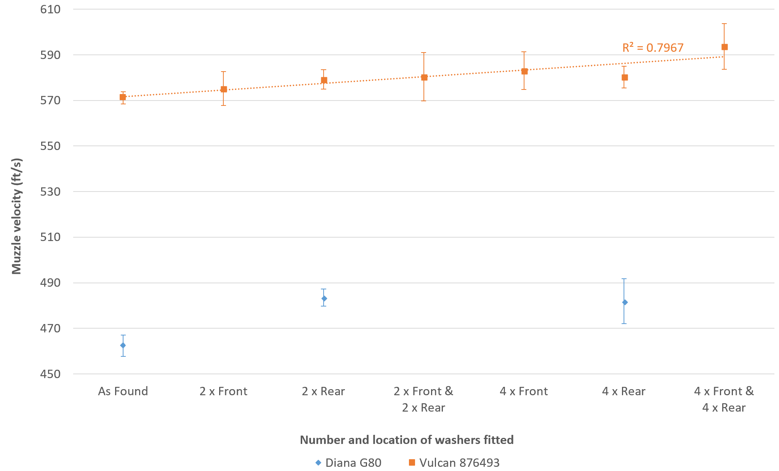
Figure 4 - Graph comparing preloading modifications against mean muzzle velocity ± 1 SD with linear regression trend lines (R² value displayed for strong correlation)

During this investigation, the second Vulcan (909124) was also tested, however, this Vulcan could not withstand any modification to the rear of the spring. The authors contacted Webley & Scott’s authorised airgun supplier, T.W. Chambers, but they were unable to determine the precise manufacturing dates and any specific production differences between these two guns. Unfortunately, there were insufficient pellets of the same brand remaining to make reliable comparisons for interpretation and discussion in this paper, however, the authors feel it important to note that when test fired (using RWS Superpoint Extra pellets, 15.50 grains [1.00 g]), significantly higher muzzle velocities were attained with each modification to this gun compared to the lower serial number Vulcan. Such increases in muzzle velocities could be due to changes in gun design/history and/or differences in pellet tail expansion between the two pellet brands used [21]. Either way, this observation supports the need for practitioners to consider changes in manufacturing design and tolerances over time as well as the influence of pellet tail shape within their standard test firing protocols.
Considering the Vulcan (876493), this research suggests that front preloading may have a greater influence than rear preloading. When only two washers were inserted in front of the mainspring there was an increase in muzzle velocity, but not to a significant extent. This was most likely because as the gun was fired, the washers at the front were physically forced forward as the spring released, increasing the movement of the spring and leading to increased friction, wear and fatigue on both the cylinder and spring. This movement resulted in increased variability in recorded muzzle velocities (SD_{mean} = ± 7.86 ft/s, 2.40 m/s) compared to when washers were added only at the rear (SD _{mean} = ± 4.50 ft/s, 1.37 m/s). Adding washers to both front and rear further reduced consistency in muzzle velocity (SD_{mean} = ± 10.32 ft/s, 3.15 m/s), potentially due to greater variability in where the mainspring came to rest. Adding two washers in front of the mainspring as well as two at the rear did not result in a statistically significant increase in muzzle velocity (Table 8). However, when two washers were only fitted behind the mainspring, the energy required to overcome friction was sufficient to significantly increase muzzle velocity compared to the as found state. Even though there was essentially less preload with only two washers fitted there was sufficiently less movement at the rear of the spring within the airgun, reducing friction and thus energy loss. Further, when the Vulcan had four washers added in front of the mainspring, velocity significantly increased, illustrating not only had the washers enabled the mainspring to overcome the increased contact friction, but it was sufficient to statistically increase the muzzle velocity.
Considering the Diana G80, a statistically significant increase in muzzle velocity (Table 8) was observed when fitting four washers in the rear of the gun compared with no washers, yet there was no significant difference between two and four washers fitted in the rear. This finding indicates different guns require differing levels of modification to achieve significant impact on muzzle velocity and is further supported by post hoc analysis of the Vulcan (876493); only two of the six modifications did not result in a statistically significant increase in muzzle velocity compared to its as found condition (Table 8). When muzzle velocities were inter-compared between preloading modifications, it was only when four washers were added at the front and rear of the spring where statistically significant increases occurred (Table 8).

Table 8 – Key statistical results for 1-tailed, Jonckheere Terpstra post hoc analysis of muzzle velocities recorded during preload investigation
Airgun | Statistical comparison |  | Test statistic | Significance (p) value | Statistical interpretation
 | Condition A | Condition B
Vulcan (876493) | As found | 2 x front | 13.219 | 1.000 | No statistical difference
 | As found | 2 x front & 2 x rear | 13.224 | 0.181 | No statistical difference
 | As found | 2 x rear | 13.224 | 0.005 | Statistical difference
 | As found | 4 x rear | 13.219 | 0.003 | Statistical difference
 | As found | 4 x front | 13.224 | 0.007 | Statistical difference
 | As found | 4 x front & 4 x rear | 13.224 | 0.002 | Statistical difference
 | 2 x front | 4 x front & 4 x rear | 13.224 | 0.009 | Statistical difference
 | 2 x rear | 4 x front & 4 x rear | 13.219 | 0.016 | Statistical difference
 | 4 x rear | 4 x front & 4 x rear | 13.219 | 0.033 | Statistical difference
Diana G80 | As found | 2 x rear | 13.219 | 0.000 | Statistical difference
 | As found | 4 x rear | 13.224 | 0.000 | Statistical difference
 | 2 x rear | 4 x rear | 13.209 | 1.000 | No statistical difference

Barrel length
Cardew and Cardew [21] state that energy in spring powered airguns is imparted into the pellet within the first five inches of the barrel, and pellet KE does not change until it has travelled a further 25 inches down the barrel. It would therefore be expected that reduction in barrel length would have no impact on measured muzzle velocity until the overall barrel length reaches five inches. However, this investigation (Figure 5) demonstrates that reducing barrel length can significantly effect the muzzle velocity (Table 5), especially for the two .177 air rifles tested.
For the .177 Omega, reducing the barrel length from 15 to 7 inches seemed to considerably and consistently reduce the muzzle velocity (Figure 5 and Table 9). However, for the longer barrelled Westlake, the impact of barrel shortening on muzzle velocity varied (Table 9), suggesting that there may be a critical point where barrel length effects the extent of energy transfer. Typically, the variation (SD) between repeat firings for the Westlake barrel ranged between 2.80 and 5.21 ft/s (0.85 and 1.59 m/s), however, at 11 inches this rose significantly to 88.53 ft/s (26.98 m/s). The exact cause of this variation remains undetermined and requires further research but could have been caused by pellet instability in the barrel and/or fluctuating levels of pressure and friction over the reduced length, amplifying any inherent variation in energy originally created by the spring. Differences in the impact of .177 calibre barrel shortening on muzzle velocity are likely due to a combination of original gun design and differing rifling twist rates, which are optimised by gun manufacturers for their recommended pellet specification(s).
In contrast to the significant impact that barrel length has on muzzle velocity for .177 calibre air rifles, shortening the .22 calibre rifles appeared to have little overarching impact (Figure 5) and may support Cardew and Cardew’s five-inch theory [21]. When comparing muzzle velocities for the Gamo Shadow 1000 datasets, none of the datasets resulted in statistical difference. Shortening the Weihrauch HW35, however, did demonstrate a statistically significant change in muzzle velocity (Table 5), but only between three of the dataset comparisons following post hoc analysis (Table 9). This statistical outcome was likely caused by differences in variance between the HW35 datasets obtained from each barrel length and the potential for oil to remain in the weapon after the gun’s prior involvement in oil and vertical storage testing (Table 1). As all airguns tested in this investigation produced similar calculated average muzzle energies (Table 7), this suggests that presence of excess lubricant and pellet type were not significant causing factors of the muzzle velocity variations observed.

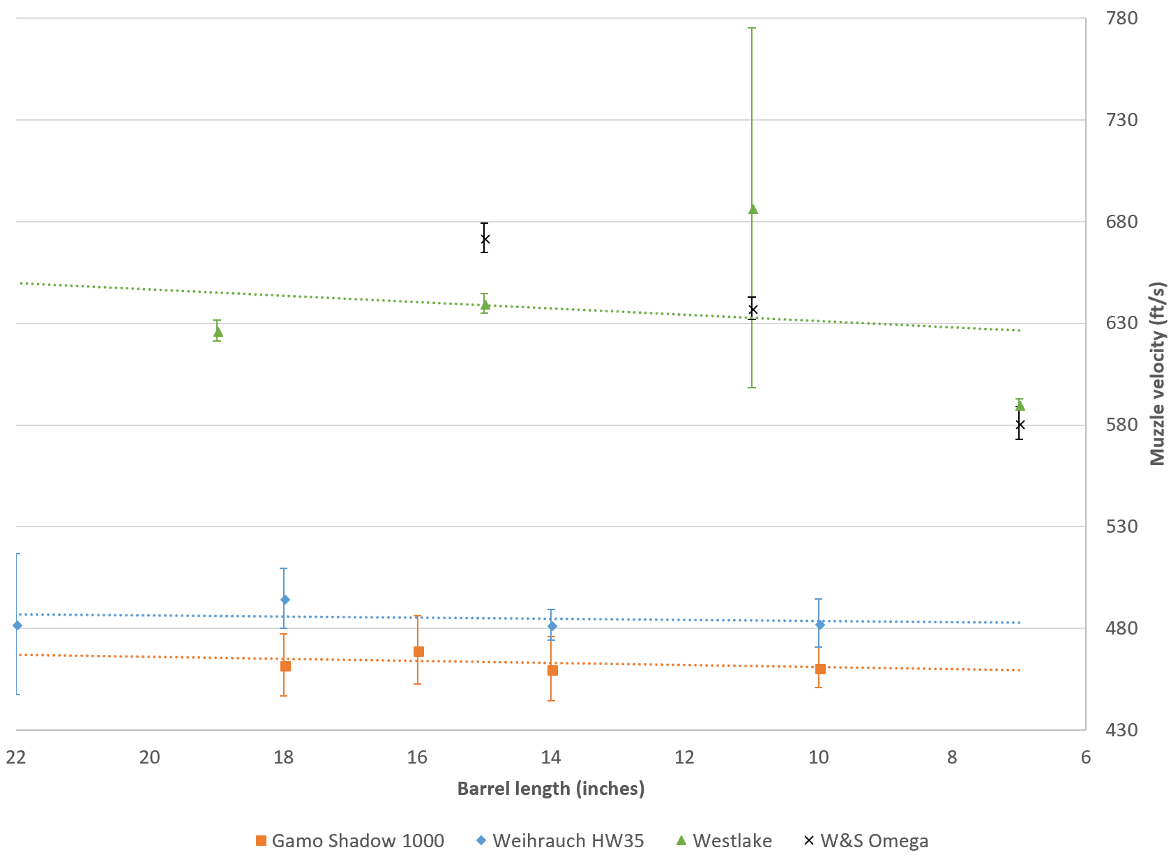
Figure 5 - Graph illustrating the impact of reducing barrel length on the mean muzzle velocity ± 1 SD (ft/s) for four air rifles

Table 9 – Key statistical results for 1-tailed, Jonckheere Terpstra post hoc analysis of muzzle velocities recorded following barrel shortening
Airgun |  | Statistical comparison |  | Test statistic | Significance (p) value |  | Direction of statistically significant change in muzzle velocity
Calibre | Brand & model | Condition A (inches) | Condition B (inches)
.177 | Westlake | 19 (as found) | 15 | 13.224 | 0.002 |  | Increase
 |  | 19 (as found) | 7 | 13.179 | 0.000 |  | Decrease
 |  | 15 | 7 | 13.174 | 0.000 |  | Decrease
 |  | 11 | 7 | 13.174 | 0.000 |  | Decrease
 | W&S Omega | 15 (as found) | 11 | 13.209 | 0.000 |  | Decrease
 |  | 15 (as found) | 7 | 13.224 | 0.000 |  | Decrease
 |  | 11 | 7 | 13.204 | 0.000 |  | Decrease
.22 | Weihrauch HW35 | 22 (As found) | 14 | 13.214 | 0.046 |  | Significantly reduced spread
 |  | 18 | 14 | 13.229 | 0.000 |  | Decrease
 |  | 18 | 10 | 13.229 | 0.007 |  | Decrease
An alternative reason for Gamo pellet velocities not being affected by barrel shortening may have been due to significant wear or a hidden internal fault in the gun. As discussed in section 3.1, the Gamo-fired pellets were significantly under powered (almost 300.00 ft/s [91.44 m/s]) compared to the gun’s expected technical specification (Table 4) and the impact arising from prior gun use may outweigh any effect arising from reductions in barrel length. Repeat testing using a brand new, or comparably newer, Shadow 1000 with known history is therefore required to further investigate this interpretation.
Without further modifications, none of the air rifles could be successfully cocked when their barrels were shortened below seven inches, therefore the authors could not fully test the five-inch limit [21]. Based on these findings, however, it is possible that the five-inch theory is more appropriate for .22 calibre airguns as the behaviour of a pellet when fired from a sawn-off .177 calibre barrel may significantly differ due to lower pellet mass, contact friction and differences in efficiency [26]. The Westlake, for example, may be more efficient with a slightly shorter barrel, resulting in a better trade-off between friction and gas pressure.

Forensic implications
In the primary author’s experience, airguns are often submitted for examination cocked, sawn-off or with other modifications typically made to alter muzzle velocity. Prior to this research, the potential impact of such incorrect storage and/or modifications on casework were unknown. Based on this pilot study, the authors recommend several actions and considerations to potentially improve current air weapon practices internationally (section 4).
Air weapon testing protocol typically involves an initial external and internal examination prior to test firing. External examination is usually able to detect obvious airgun modifications, such as barrel length reduction, however, it is not always apparent what the original barrel length may have been. This research has demonstrated that even with known barrel length reductions, the impact on muzzle velocity cannot be generalised between brands of the same calibre nor between calibres. The influence of initial barrel length, rifle twist, gun composition and efficiency of function, for example, are likely to be the reason for the variation observed, however, more extensive research is required to identify which may be the key determining factors across a significantly broader brand and calibre range. Internal examination will determine modifications such as preloading, which in this research, seemed to significantly impact upon muzzle velocity, but did not noticeably increase air rifles’ recoil. The location of the washers fitted influenced the extent of velocity increase and typically, the greater the number of washers fitted, the greater the increase in muzzle velocity as more energy could be stored within the mainspring. Fitting washers in front of the spring appeared to result in a comparatively lower muzzle velocity increase than expected from the extent of mainspring compression due to increased contact friction caused by washer movement. Increased force, wear and fatigue exerted upon a preloaded spring and other working components will most likely cause eventual damage to the gun. However, practitioners need to be aware that modification capabilities may differ even within the same model of airgun; the two W&S Vulcan air rifles examined in this study could not undergo the same type or level of modification.
Spring powered air rifles, by their very design, create inconsistent muzzle velocities. The way energy is transferred to the pellet can be highly variable and is demonstrated by the observed disparity of as found muzzle velocities attained from repeat test fires compared to the brand’s published specifications. Airgun manufacturers determine gun design, including barrel length and expected muzzle velocity, based upon its intended use (such as hunting, target shooting etc.) and preferred pellet type (calibre, shape, material composition and mass). Pellet recommendations and gun design are also influenced by country of import/export and any legislative controls dictating minimum barrel lengths and maximum permitted muzzle energies. As shown in Table 7, small increases in pellet mass can have significant effects on reducing calculated muzzle energies. Therefore, when interpreting the legal classification of airguns using muzzle energy, it is important to use the manufacturer’s recommended pellets rather than the wider ‘medium weight’ range currently utilised [41]. However, where such information is unknown, it would be beneficial for the industry to establish and adopt ‘standard’ air pellets of specific brand, type and mass (per calibre) to reduce variation in legal interpretation between practitioners. Additionally, in cases of airgun-related shootings, it is vital to test the gun using pellets attained from the crime scene and/or suspects. In a human context, this will enable the jury to interpret legislative wording, such as ‘capable‘ of causing lethal harm [6,45-47] and determine whether the gun is lethally barrelled (i.e. a firearm). However, it is also important for the correct interpretation of domestic animal and wildlife crimes, desecration and criminal damage for example, as pellet design and mass can often unpredictably effect observed impact damage. Although such recommendations may already be implemented in methods employed by laboratories accredited to ISO17025 using calibrated equipment to overcome potential differences, this may not currently be the case for all professionals who have a role in robustly testing airgun kinetic energy nationally [48] or internationally.
This research has also shown that storage conditions can significantly affect measured muzzle velocities after both short (two weeks) and longer (six months) durations. From the perspective of safety, cocking an airgun (and any other type of gun) before storage remains ill-advised and it is vital that all guns are also unloaded prior to placing in evidence storage. Additionally, this research provides the empirical evidence that storing a spring powered airgun cocked for six months can result in deterioration of the mainspring, significantly reducing the energy it was capable of transferring to the pellet upon discharge. Vertical storage of guns over time typically caused small, but statistically significant changes in muzzle velocity due to the influence of gravity on oil travel. From the air rifles examined, it was impossible to generalise or predict the extent of the impact due to gun design, quality and condition. In casework, more obvious or deliberate signs of oil presence may also be observed; a heavily oiled .22 calibre Cometa 400S break barrel air rifle was test fired 15 times [32], showing a significant decrease in muzzle velocity (275.17 ft/s [83.87 m/s]), and calculated muzzle energy (13.35 ft lb [18.10 J]), thus, strongly supporting the phenomenon of dieseling [31]. Even in this research, where only two drops of oil were applied, the combination of oil presence and vertical storage over two weeks appeared to result in dieseling for one airgun. Due to the very limited scope of this pilot research, these findings may not be attained for all spring powered airguns manufactured. Airguns of lesser quality, for example, may demonstrate a much larger effect on muzzle velocity as gun design, quality and condition appear to be more important than pellet design or the initial potential energy of the spring. Any significant changes in muzzle velocity may impact on the interpretation of legal classification and potential for lethality across the diverse range of airguns submitted in casework. This diversity reinforces the need for practitioners to reflect on their storage practices and carefully examine a gun’s internal working components, where possible, prior to measuring muzzle velocity to support testing and accurate interpretation in casework. During such internal examinations, practitioners should look for signs of oil residue build-up or saturation around the cylinder, as well as heavily worn or damaged parts, for example.
Further considering the impact of airgun testing protocol, speed of repeat discharge can affect muzzle velocity in some guns. For the air rifles used in this research, pellets were test fired with 20 to 30 second intervals. When muzzle velocities were analysed from consecutive firings, some airguns exhibited a consistent reduction in muzzle velocity, suggesting the elastic potential of the mainspring in these air rifles had not been fully restored before the next firing. Therefore, it is important that practitioners and future researchers consider and evaluate the effect of mainspring recovery on their observed muzzle velocities. To minimise the potential impact on muzzle velocity, a longer time interval between firings should be adopted, for example at least a minute. Gradual increase or decline of muzzle velocities may cause erroneous classification when testing air weapons, especially where fired pellet muzzle energies lie on the border of legal limits. Additionally, the presence of irregular, fluctuating or highly inconsistent velocities, and/or loss of accuracy may indicate the presence of airgun modification and should be considered during casework interpretation as this may cause significant changes in the extent of impact damage observed at a scene.
The findings of this research reinforce the need to expand the scope of this initial study across a larger number of air rifles, applying the method to the full range of airgun designs and their associated projectiles. Replicating these experiments with brand new air rifles across different calibres would be the first step to reduce the potential impact of variables resulting from unknown gun histories. However, the empirical evidence presented should be of significant value to any forensic practitioner tasked with investigating airgun-related discharges, particularly when muzzle velocities and/or observed terminal damage may be more or less severe than ordinarily anticipated for a reported air weapon shooting. This paper should also be of interest and importance to police officers, crime scene investigators and other professionals who are less experienced in gun handling to ensure they do not package or store weapons cocked prior to submission for forensic examination and testing.
In a slightly broader context, this research would also be of interest to archaeologists where a range of weapons, including ammunition-based and air powered guns, have been used to desecrate historical buildings, tombstones and memorial sites across the world. Little research has been conducted to support or evaluate the accuracy of the interpretations made by archaeologists when interpreting the cause of such damage. Therefore, the empirical evidence presented in this paper and future research can be used to appreciate the level of muzzle velocity and energy variations that may be exhibited by airguns in comparison to ammunition-based firearms for impact damage interpretation. As a result, the second author is conducting collaborative research with archaeologists aiming to calculate the level of projectile force upon impact and compare empirical data from impact sites against weapon types suggested within victim and witness statements.

Conclusion
Air weapons are commonly used by civilian populations across the world, particularly by those under 18, and discharges often result in desecration, criminal damage and animal abuse. Due to a limited body of published research focusing on the empirical evaluation of air weapons, this paper aimed to quantify and investigate the impact of evidence storage conditions and modifications (presence of oil, preloading and barrel shortening) previously encountered in casework on muzzle velocity, consequently considering the potential influence on examination protocols and legal classification. Due to the extensive range of airgun and pellet designs available to purchase in the civilian market, the authors focused this pilot study on spring powered, break barrel air rifles fired with lead diablo-shaped air pellets with a view to instigate further empirical research. Muzzle velocities were measured using a calibrated chronoscope and pellets were typically selected by mass to negate the need to calculate kinetic energy.
Most of the air rifle modifications applied resulted in small, yet statistically significant changes in muzzle velocity. The greatest changes in muzzle velocity resulted from incorporating preload, reducing barrel length and storing the airgun cocked for six months. At times, the effects on muzzle velocity were short lived, and/or contrary to initial theoretical predictions. Unless the case requires otherwise, key recommendations for practitioners to consider with respect to their current practices are therefore to:
- Store airguns in an uncocked, preferably horizontal orientation
- Conduct timely and thorough examinations of external and internal working gun components
- Use manufacturer’s recommended pellets when determining muzzle velocity and legal classification, alternatively identify and utilise ‘standard’ air pellets where pellet brand is unknown
- Ensure the most comparable brand, type and mass of air pellet is used when reconstructing casework
- Conduct at least 10 repeat firings to ensure variation of gun-pellet combination is taken into consideration
- Leave at least a minute between repeat firings to ensure restoration of the mainspring’s elastic potential.
Although the scope of this research was small, this study demonstrates there is no one size fits all approach for predicting how air rifle modification may impact on muzzle velocity and muzzle energy. As a result, it is vital that practitioners do not underestimate the extent of shot-to-shot variability associated with modified airgun testing or make prior assumptions on the level of damage expected to be created by a modified airgun. There are so many variations between air rifle type, design, quality and calibre that generalisations cannot be made as to whether a modification may cause advances or reductions in muzzle velocity and/or whether it may be beneficial or detrimental to the gun. The findings presented within this paper therefore support the need for more extensive research, particularly focussing on quantifying the effects of preloading, barrel length and evidence storage protocol across the range of available mechanisms, including brand new airguns.

References
[1] J. Walter, The Airgun Book, Arms and Armour Press, London, 1981.
[2] L.C. Haag, PCP Airguns: A Not-So-New Technology, AFTE J. 48 3 (2016) 155–162.
[3] S. Aslan, M. Uzkeser, Y. Katirci, Z. Cakir, O. Bilir, F. Bilge, M. Cakir, Air Guns: Toys or Weapons?, Am. J. Forensic Med. Pathol. 27 3 (2006) 260–262. DOI: 10.1097/01.paf.0000220919.45493.af.
[4] The British Association for Shooting & Conversation, Air Rifle Safety in England and Wales. https://basc.org.uk/airgunning/advice/basc-air-rifle-code-of-practice/, 2015 (accessed 13.09.16).
[5] The British Association for Shooting & Conversation, Long Delays in Scottish Firearms Licensing Are Unacceptable. https://basc.org.uk/blog/airgunning/long-delays-in-scottish-firearms-licensing-are-unacceptable/, 2015 (accessed 13.09.16).
[6] United Kingdom, Firearms (Dangerous Air Weapons) Rules, HMSO, London, 1969.
[7] United Kingdom, Police & Crime Act 2017: Elizabeth II. HMSO, London, 2017.
[8] B.J. Heard, Handbook of Firearms and Ballistics: Examining and Interpreting Forensic Evidence, 2nd ed., John Wiley & Sons Ltd, Chichester, 2008.
[9] Der Bundesrat, Bundesgesetz über Waffen, Waffenzubehör und Munition. https://www.admin.ch/opc/de/classified-compilation/19983208/index.html, 1997 (accessed 19.03.18).
[10] Banco Nazionale di Prova, Ammunition Testing. https://www.bancoprova.it/index.php/en/activities/ammunition-testing.html, 2010 (accessed 19.03.18).
[11] M. Bakovic, V. Petrovecki, D. Strinovic, D. Mayer, Shot through the heart-firepower and potential lethality of air weapons, J. Forensic Sci. 59 (2014) 1658–1661. DOI: 10.1111/1556-4029.12486
[12] G. Wightman, R. Cochrane, R.A. Gray, M. Linton, A contribution to the discussion on the safety of air weapons, Sci. Justice. 53 3 (2013) 343–349. DOI: 10.1016/j.scijus.2012.11.002.
[13] R.M. Bruce-Chwatt, Air gun wounding and current UK laws controlling air weapons, J. Forensic Leg. Med. 17 (2010) 123–126. DOI: 10.1016/j.jflm.2009.11.003.
[14] [dataset] Office for National Statistics, Offences involving the use of weapons 11/02/2016 - Appendix Tables, Appendix 3.07 and 3.08, 2016. http://www.ons.gov.uk/peoplepopulationandcommunity/crimeandjustice/compendium/focusonviolentcrimeandsexualoffences/yearendingmarch2015/chapter3offencesinvolvingtheuseofweapons.
[15] Home Office, Guide on Firearms Licensing Law, Home Office, London, 2015.
[16] M.G. Haag, L.C. Haag, Shooting Incident Reconstruction, 2nd ed., Academic Press, San Diego, 2011.
[17] G. Wightman, K. Wark, J. Thomson, The interaction between clothing and air weapon pellets, Forensic Sci. Int. 246 (2015) 6–16. DOI: 10.1016/j.forsciint.2014.10.039.
[18] E. Degirmenci, Effects of grain size and temperature of double base solid propellants on internal ballistics performance, Fuel. 146 (2015) 95–102. DOI: 10.1016/j.fuel.2015.01.027.
[19] D.E. Carlucci, S.S. Jacobson, Ballistics Theory and Design of Guns and Ammunition, 2nd ed., CRC Press, Florida, 2014.
[20] M.S. Luskin, E.D. Christina, L.C. Kelley, M.D. Potts, Modern Hunting Practices and Wild Meat Trade in the Oil Palm Plantation-Dominated Landscapes of Sumatra, Indonesia, Hum. Ecol. 42 1 (2014) 35–45. DOI: 10.1007/s10745-013-9606-8.
[21] G.V. Cardew, G.M. Cardew, The Airgun from Trigger to Target, G.V. & G.M. Cardew, [no place], 1995.
[22] Budd, Transfer Port. http://www.airgunbbs.com/showthread.php?784996-Transfer-port/, 2016 (accessed 26.09.16).
[23] Arthur John Smithsplease, Full Length HW77. http://www.airgunbbs.com/showthread.php?785505-Full-length-HW77&p=7093203, 2016 (accessed 12.10.16).
[24] B.B. Pelletier, Some talk about airgun lubrication: Part 1. http://www.pyramydair.com/blog/2016/10/some-talk-about-airgun-lubrication-part-1/, 2016 (accessed 12.10.16).
[25] Chalenger, What do you do to increase your power spring air rifle? http://www.gatewaytoairguns.org/GTA/index.php?topic=80807.0, 2015 (accessed 26.08.15).
[26] M. Denny, The Internal Ballistics of an Air Gun, Phys. Teach. 49 2 (2011) 81–83. DOI: 10.1119/1.3543577.
[27] E. Degirmenci, Semi-empirical prediction of internal pressure distribution and muzzle velocity in the rifled barrel of a light weapon, Meas. J. Int. Meas. Confed. 70 (2015) 123–128. DOI: 10.1016/j.measurement.2015.03.047.
[28] A. Şentürk, H. Işýk, C. Evci, Thermo-mechanically coupled thermal and stress analysis of interior ballistics problem, Int. J. Therm. Sci. 104 (2016) 39–53. DOI: 10.1016/j.ijthermalsci.2015.12.019.
[29] Mattatack, How does adding preload washers increase MV? http://www.airgunbbs.com/showthread.php?637533-how-does-adding-preload-washers-increase-mv, 2012 (accessed 16.08.15).
[30] L.P. Pook, An introduction to coiled springs (mainsprings) as a power source, Int. J. Fatigue. 33 8 (2011) 1017–1024. DOI: 10.1016/j.ijfatigue.2010.11.014.
[31] R. Caunt, Dieseling of Airguns Using Commonly Available Fuels, AFTE J. 35 2 (2003) 167–173.
[32] K. Greenslade, Evidential notes for the case of Alison for Avon & Somerset Constabulary, Unpublished, 2013.
[33] R.S. Bolton-King, J. Schulze, Firearms and Ballistics, in: D. Bailey (Ed.), Forensic Veterinary Practice, CAB International, Wallingford, 2016, pp. 81-117.
[34] R.S. Bolton-King, Preventing miscarriages of justice: A review of forensic firearm identification, Sci. Justice. 56 2 (2016) 129–142. DOI: 10.1016/j.scijus.2015.11.002.
[35] W. Kerkhoff, I. Alberink, E.J.A.T. Mattijssen, An Empirical Study on the Relation Between the Critical Angle for Bullet Ricochet and the Properties of Wood, J. Forensic Sci. 60 (2015) 605–610. DOI: 10.1111/1556-4029.12738.
[36] E.J.A.T. Mattijssen, I. Alberink, S.D. Brouwer, W. Kerkhoff, The Influence of Wood Grain on the Bullet’s Ricochet Behavior, J. Forensic Sci. 61 (2016) 765–772. DOI: 10.1111/1556-4029.13023.
[37] Blue Book of Gun Values, Airgun Values. http://bluebookofgunvalues.com/, 2016 (accessed 15.10.16).
[38] SMK, Sportsmarketing – Value. http://www.sportsmk.co.uk/cat/67/air-rifles-smk-air-rifles/value/, 2016 (accessed 14.10.16).
[39] Weihrauch, HW 35 Standard. http://www.weihrauch-sport.de/air-rifles/hw-35-standard?lang=en, 2015 (accessed 15.10.16).
[40] Aceros De Hispania, Table of technical characteristics of the Gamo airguns. http://www.aceros-de-hispania.com/gamo-airgun-specifications.htm, 2016 (accessed 06.09.16).
[41] C. Price, Helston Forensics Standard Air Gun Test, Unpublished, 2014.
[42] B.G. Tabachnick, L.S. Fidell, Using Multivariate Statistics, 6th ed., Pearson Education Limited, Essex, England, 2014.
[43] W.E. Martin, K.D. Bridgmon, Quantitative and Statistical Research Methods from Hypothesis to Results, John Wiley & Sons Inc., San Francisco, 2012.
[44] A. Mayers, Introduction to Statistics and SPSS in Psychology, Pearson Education Limited, Harlow, England, 2013.
[45] Scotland, Air Weapons and Licensing (Scotland) Act, The Stationary Offices, UK, 2015.
[46] United Kingdom, Firearms Act 1968: Elizabeth II, Chapter 27, HMSO, London, 1968.
[47] Moore v Gooderham. [1960] 3 All E.R. 575.
[48] M. Mastaglio, Air Guns, the Law and How the Police Frequently Get it Wrong, Expert Witness Journal. Summer (2014).

