The Psychological Wellbeing Practitioner Experience: An Interpretative Phenomenological Analysis

Abbie Parkinson

Thesis submitted in partial fulfilment of the requirements of Staffordshire University for the degree of Doctorate in Clinical Psychology

April 2018

Total word count: 17,613

THESIS PORTFOLIO: CANDIDATE DECLARATION
Title of degree programme | Professional Doctorate in Clinical Psychology
Candidate name | Abbie Parkinson
Registration number | 15027205
Initial date of registration | 21st September 2015

Declaration and signature of candidate
I confirm that the thesis submitted is the outcome of work that I have undertaken during my programme of study, and except where explicitly stated, it is all my own work.
I confirm that the decision to submit this thesis is my own.
I confirm that except where explicitly stated, the work has not been submitted for another academic award.
I confirm that the work has been conducted ethically and that I have maintained the anonymity of research participants at all times within the thesis.

Signed: Date: 24th April 2018

Acknowledgements

Firstly, I would like to acknowledge the participants, without which, this thesis would not have been possible. I would also like to offer my appreciation to all those who expressed an interest in taking part. This was a breath of fresh air, that gave me hope and motivation.
I would like to thank Helena Priest, whose wisdom and guidance has been invaluable. I would also like to thank Darrelle Villa for your unfaltering support and encouragement. Your continual belief in me is still surprising.
I wish to acknowledge the DClinPsy staff team and would like to thank the 2015 cohort, who have never failed to make me smile. I would like to give particular thanks to Rachel Wakelin, whose unwavering friendship has seen me through tears and laughter (and sometimes both!)
I would like to offer my deepest gratitude to Kate Jones. Without you, I would not have made it to interview, let alone be writing these acknowledgements! Your compassion and care has given me courage at the most difficult of times throughout this process.
Finally, I would like to extend my sincerest thanks to my family and friends. Your kindness, understanding and support has carried me through.

Contents
List of Appendices 7
Thesis Abstract 8

Chapter One: Literature Review
Title Page 9
Abstract……………………………………………………………………………. 10
Introduction 11
Literature Review Rationale 12
Method 13
Inclusion Criteria 13
Exclusion Criteria 13
Search Strategy 13
Results 15
Critical Appraisal 20
Study Design 20
Recruitment Strategy 22
Sample and Data Collection 23
Findings and Analysis 24
Summary of appraisal 27
Thematic Synthesis 28
Staff Wellbeing 29
Job Demands 30
IAPT as inflexible 31
Expectations VS Experiences 32
Clinical Application and Future Research 33
Limitations of this review 34
Conclusions 34
References 35

Chapter Two: Empirical Paper
Title Page 42
Abstract……………………………………………………………………………. 43
Introduction 44
Improving Access to Psychological Therapies (IAPT) 44
Burnout in Mental Health Workers 44
Burnout in IAPT Staff 45
Rationale for Study 46
Research Aims 46
Method 46
Epistemological Position 46
Interpretative Phenomenological Analysis (IPA) 47
Recruitment 47
Ethical Considerations 49
Reflexivity 49
Data Collection 50
Data Analysis 50
Results and Discussion 51
Superordinate Theme 1 – The Business Model 52
The Production Line 53
Magical Thinking in The Hierarchy 53
Superordinate Theme 2 – Process of Internalisation 55
Conflict Within Me 55
I’m No Good At This 57
Superordinate Theme 3 – Emotional and Clinical Impact 59
PWP Role Has a Shelf-Life 59
You’re Taking The Human Out Of The Equation 61
Superordinate Theme 4: Supportive Structures 64
Things That Kept You Going 64
Supervision 66
Limitations 68
Clinical Implications 68
Future Research 69
Summary and Conclusion 70
References 71

Chapter Three: Executive Summary
Chapter Three: Executive Summary 78
Background……………………………………………………………………….. 79
Method 80
Approach 80
Recruitment 80
Participants 81
Ethical Considerations 81
Data Collection 81
Data Analysis 81
Reflexivity 82
Results 82
Superordinate Theme 1 – The Business Model 82
Superordinate Theme 2 – Process of Internalisation 83
Superordinate Theme 3 – Emotional and Clinical Implications 84
Superordinate Theme 4 – Supportive Structures 84
Limitations 85
Recommendations 85
References 87

List of Appendices

A – Journal Submission Guidelines. 89
B – Search Terms 91
C – Adapted Critical Appraisal Tool for Qualitative Research 92
D – Adapted Critical Appraisal Tool for Survey Designs 93
E – Participant Information Sheet 94
F – Consent Form 99
G – Staffordshire University Ethical Approval 101
H – Health Research Authority Approval 102
I – R&D confirmation of Capacity and Capability 105
J – Staffordshire University Ethical Approval of Amendments 106
L – Data Analysis: Example of Coding 108
M – Example of Developing Emergent Themes 109
N – Master Theme Table 113

Thesis Abstract
This thesis evaluates the current literature on staff experiences within Improving Access to Psychological Therapies (IAPT) services. It extends on current knowledge and directly explores the experiences of Psychological Wellbeing Practitioners (PWPs).
Chapter one is a literature review, appraising what it is known about the experiences of clinical staff in IAPT services. Burnout and stress were found to be significant experiences of this population. Potential differences between IAPT professionals were also indicated. Limited qualitative research has been conducted in this area. It was recommended that further exploratory research is completed with independent staff groups, particularly PWPs.
Chapter two is an empirical paper designed to answer two research questions: How do PWPs experience their role? What meaning do PWPs give to these experiences? Nine participants were recruited to complete semi-structured interviews. Interpretative Phenomenological Analysis was employed, which indicated four superordinate themes: The Business Model, Process of Internalisation, Emotional and Clinical Impact, and Supportive Structures. The clinical implications and areas for service development are discussed with recommendations for future research.
Chapter three is an executive summary of the research paper. This aims to improve the accessibility and usability of the research. The paper is aimed at professionals, as they are the focus of this thesis.

Chapter One: Literature Review
What is known about the experiences of clinical staff working in Improving Access to Psychological Therapy (IAPT) services?

Abbie Parkinson
Doctorate in Clinical Psychology
Faculty of Health Sciences, Staffordshire University

Word count: 7,614

This paper has been written in accordance with author guidelines for The Journal of Mental Health Training, Education and Practice. (Appendix 1)

Abstract

Purpose
Over the last decade, primary care services in the NHS have been drastically redesigned. This has been in conjunction with the Improving Access to Psychological Therapies (IAPT) initiative. At the forefront of IAPT services is a relatively new workforce navigating their way through high demands, targets and time constraints. Many of the job characteristics can be associated with predictors of burnout (Morse, Salyers, Rollins, DeVita & Pfahler, 2012). This literature review aimed to explore what is known about the experiences of clinical staff working in IAPT.

Methodology
A systematic approach was employed in searching the literature. From this, eight papers were included in the review. An adapted appraisal tool was used to critique each paper and a scoring system was implemented.

Findings
A thematic synthesis of the papers was completed. Four themes emerged from this process: Staff Wellbeing, Job Demands, IAPT as Inflexible and Expectations VS Experiences. Overall, findings reflected staff groups experiencing burnout and stress.

Implications
Further exploration of staff experiences is required, as most studies focused on a specific aspect of experience rather than the perceptions of the role. It is also recommended that staff groups are researched independently.

Value
This paper has synthesised what is known about staff experiences in IAPT. From this, a clear direction for future research has been developed.

Introduction
In 2006, the UK government implemented the Improving Access to Psychological Therapies (IAPT) programme. Lord Layard, a British Labour Economist, argued that common mental health difficulties were a major contributing factor to unemployment and absence from work (Layard, 2004; Layard, 2006). Cognitive Behaviour Therapy (CBT) is acknowledged as having a strong evidence base and is presented as a cure for those with a diagnosis of depression and anxiety (Layard, 2006). Further to this, CBT is recommended by NICE guidelines (National Institute of Clinical Excellence, 2004). It was argued that few people were able to access this form of psychological therapy (Layard, 2006). A predominant idea underpinning IAPT is that improving access to CBT will fund itself, due to the subsequent reduction in incapacity benefits. Hence, this was thought to benefit personal wellbeing whilst also improving the economy (Layard, 2006).
Doncaster and Newham were home to the first IAPT pilot sites. Evaluation of these sites suggested a high throughput of people in the service and 50-56% of those were deemed as reaching recovery (Clark et al., 2009). Following the demonstration sites, a significant investment was made to train a new workforce and enable the delivery of IAPT services nationwide (Clark et al. 2009). This workforce consists mostly of Psychological Wellbeing Practitioners (PWPs) and High-Intensity Therapists (HI Therapists). PWPs provide high volume low-intensity CBT based interventions to those with a diagnosis of mild to moderate depression and anxiety (National Health Service [NHS] England, 2015). HI Therapists work with people with more complex difficulties and largely offer CBT therapy.
As IAPT has developed, the initiative has come under scrutiny. McPherson, Evans and Richardson (2009) argue that IAPT is too closely tied to NICE guidelines, which under closer inspection does not portray a reliable evidence base. One of the key components of IAPT is that it offers cost-effective therapies. Whilst research reports that IAPT is succeeding in this (Mukuria et al., 2013), others argue that the results may have been displayed in a favourable light (Griffiths & Steen, 2012a). Griffiths and Steen (2013b) argue that IAPT data is often presented in a misleading fashion, emphasising recovery rates and findings from outcome measures. Binnie (2015) argues that the focus on national targets overshadows what the targets are supposed to be illustrative of and what is most important; client experience.
Rizq (2011;2012a;2012b) uses psychoanalytic theory as a lens for understanding the possible processes that are being played out in IAPT services. Rizq (2011) outlines how the traditional anxiety containing role allocated to mental health workers is threatened by the IAPT initiative. Through exploration of unconscious processes, Rizq (2011) proposes that psychotherapists represent a split off section of IAPT, being drawn into burnout and unhelpful ways of working. In the second paper of the series, Rizq (2012a) goes on to present three mechanisms by which feelings of loss and vulnerability in staff and service users are denied. These include; a consumerist ethos, minimisation of fragility, and increased bureaucratic systems that monitor staff activity. Rizq (2012b) also proposes that the focus on targets, outcomes and procedures acts to overshadow service user needs. Rizq (2012b) concludes that a virtual reality has been created which leads to the denial of emotional realities.
The roles of IAPT workers are known to be fast-paced. Workers have high caseloads and are governed by national targets (Department of Health, [DoH], 2016). Supervision is also thought to be minimal and at times, a number-based exercise to gather outcomes (Watts, 2016).
Burnout is thought to be the experience of prolonged emotional and interpersonal work stress (Freudenberger, 1974). Some of the common predictors of burnout include lack of supervision, high work demands, role uncertainty and time constraints (Morse, Salyers, Rollins, DeVita & Pfahler, 2012). It is possible the above factors apply to the IAPT workforce.
Literature Review Rationale
Pressures placed on staff within IAPT seem to coincide with predictors of burnout in mental health workers (Morse et al., 2012). Rizq (2011;2012a;2012b) also suggests that staff members are getting drawn into unconscious processes that could be detrimental.
A recent census of IAPT staff shows a 10% job vacancy rate for low-intensity workers and 4% for high-intensity workers. It also indicates that low-intensity workers have a turnover of 22%, whereas high-intensity staff turnover is at 10% (NHS England, 2015).
As IAPT services are evolving, there is a need to increase our knowledge of the experiences of staff. This will prove valuable in informing the future developments of IAPT. It may also help to reduce turnover rates and will shed light on the possible issue of burnout amongst IAPT staff.
This literature review has been informed by the current backdrop of research and contextual factors regarding service delivery. This has led to the question: What is known about the experiences of clinical staff working in IAPT? The aim of this literature review is to answer this question by evaluating the research in this field.

Method
Inclusion Criteria:
- Papers related to experiences of IAPT services, involving clinical staff
- Papers from 2008-2017 (IAPT was rolled out nationally in 2008)
- Peer-reviewed papers
- Papers written in English

Exclusion Criteria:
- Research conducted outside of the UK (IAPT is a UK initiative)
- Research solely focused on experiences of intervention

Search Strategy
The searches were completed from April to July 2017. Healthcare Databases Advanced Search (HDAS) was utilised to complete searches in PsycINFO, CINAHL, EMBASE and Medline. A search was also conducted in the Cochrane Library. Search terms were generated based upon three topics: Service, Staff and Experience. These topics were explored as separate search strings and later combined. This process was replicated for each of the databases. Varying thesaurus terms and limiters were available, depending on the database (Appendix B). Results from all searches were exported from HDAS which yielded a total of 177 papers. Duplicates were then removed, which resulted in 107 papers. Following this, a screening process was applied, beginning with titles. Article titles were assessed based on the inclusion and exclusion criteria. At this stage, 66 papers were excluded and the remaining 41 were screened via abstract (Table 1). This yielded a total of 20 research articles. These articles were read in full and assessed for suitability which resulted in six papers. Hand searching was then completed by screening the reference lists of the identified papers. This yielded a total of five papers. The screening process was repeated for these five papers. Three subsequent papers were removed as they were positional pieces rather than formal research (Rizq 2011; 2012a; 2012b).

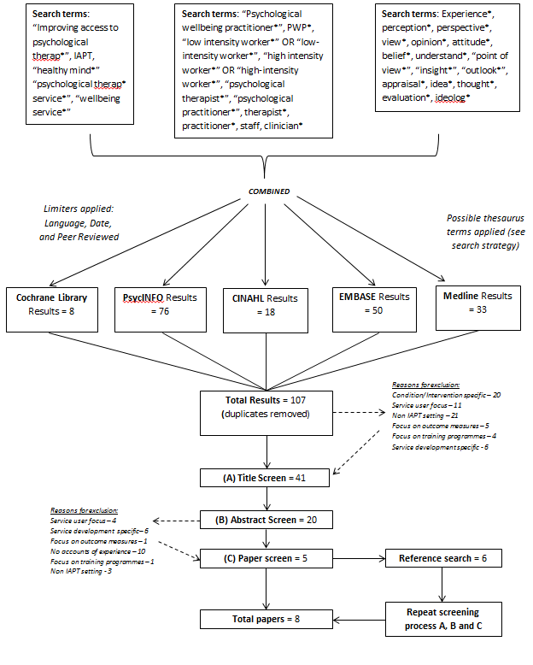
Table 1 – Search Strategy

Results
A total of eight research papers were highlighted for this literature review. An overall summary of these has been provided (Tables 2 and 3).

Table 2 – Qualitative Research Summary
16

Authors & Publication Year | Title | Aims | Methodology | Participants | Setting | Findings
Rizq et al. (2010) | Reflective voices: primary care mental health workers’ experiences in training and practice | To explore the experiences of Primary Care Mental Health Workers (PCMHWs) | Thematic analysis of reflective papers | 5 PCMHWs, all who attended reflective group practice. (4 x female, 1 x male) | Newly established Primary Care Service, implementing IAPT initiative | Main themes:  Training issues: too much information, hard to translate to practice.  Clinical work: pressures from the service to undertake clinical work too quickly. Difficulties dealing with emotions and lack of experience  Professional development: Not rewarding, little room for career development
Bassey and Melluish (2012)  Authors & Publication Year | Cultural Competence in the experiences of IAPT therapists newly trained to deliver cognitive-behavioural therapy: A template analysis focus study  Title | To investigate if experiences of IAPT CBT therapists suggest cultural competence and to establish how training has informed their practice  Aims | Template analysis of focus groups  Methodology | 10 therapists who had completed IAPT CBT training.  Participants | 3 IAPT sites across one geographical location  Settings | Main themes:  Awareness: of own values, beliefs, assumptions and those of the client. Also, how these interact.  Knowledge: Oppositional stances on whether it is helpful to have previous knowledge of specific ethnic groups prior to working with a client.  Skills: Adapting practice to facilitate cultural norms  IAPT Training: Was insufficient, particularly with respect to cultural components.  Findings
Altson, Loewenthal, Gaitanidis and Thomas (2015) | What are the perceived implications, if any, for non-IAPT therapists working in an IAPT service? | To explore possible implications of non IAPT trained therapists, working in IAPT. | Foucauldian Discourse Analysis of semi-structured interviews | 5 therapists who identified as: existential (2), post-existential (1), person-centred (1) and integrative (1). All worked in IAPT services but had not received IAPT training. | IAPT service outside of researcher’s place of work | Main discourses drawn upon:  Professional discourse: IAPT constructed as powerful service provider, that must be conformed to.  Institutional discourse: IAPT governed by rules and procedures. Employees monitored.  Scientific approach: Everything can be measured.  Non IAPT discourse vs IAPT discourse: Differences between work outside of IAPT and work within IAPT  Psychological vs medical power: Dissonance between psychological and medical discourses.
Marwood, Chinn, Gannon and Scior (2017) | The experiences of HI therapists delivering cognitive behavioural therapy to people with ID | To highlight the experiences of HI therapists delivering CBT to people with intellectual disabilities (ID) in an IAPT setting | Thematic analysis of semi structured interviews  Therapy confidence scale (not used for statistical analysis) | 10 HI therapists with varying qualifications (professional doctorate in Clinical Psychology – 7, professional doctorate in Counselling Psychology – 1, high-intensity diplomas – 2) | 5 IAPT services in inner city London | Main themes:  ID not on IAPT agenda: Tokenistic, inadequate training.  Service shortcomings: Service failing to make reasonable adjustments, ethical issues, unrealistic expectations.  Fit with short-term recovery model: Conflicting agendas, recovery expectations remained unaltered.  Uncertainty about the work: Complex work, working outside of competence, appropriateness of IAPT for people with ID

17

Table 3 – Summary of Survey Designs
18

Authors & Publication Year |  | Title |  | Aims | Methodology |  | Participants |  |  | Settings |  | Findings
Steel, Macdonald, Schroder and Mellor-Clark (2015) |  | Exhausted but not cynical: burnout in therapists working within Improving Access to Psychological Therapy Services |  | To examine the degrees of burnout experienced by IAPT therapists (hypothesis 1) and what predicts these levels (hypothesis 2) | Power analysis, effect size.  Maslach Burnout Inventory, Job Content Questionnaire, Coping Survey, Therapist Work Involvement Scale.  Descriptive statistics, univariate multiple regressions |  | 116 therapists (79% female, 21% male, aged between 24-61) |  |  | 15 IAPT services approached across UK. 8 agreed to participate. |  | IAPT workers showed high levels of emotional exhaustion in comparison to other samples. IAPT workers showed higher levels of depersonalisation compared to original sample, but lower levels of negative personal accomplishment.  Psychological job demands, decision latitude and stressful involvement were predictors of emotional exhaustion.  Therapist age and psychological job demands were predictors of depersonalisation  Resource variables were significant predictors of negative personal accomplishment, alongside length of training.
Westwood, Morison, Allt and Holmes (2017) |  | Predictors of emotional exhaustion, disengagement and burnout among improving access to psychological therapies (IAPT) practitioners |  | To estimate the prevalence of burnout in IAPT workers and what predicts this. | Power analysis  The Oldenburg Burnout Inventory (OLBI), the Mental Health Professionals Stress Scale  Descriptive statistics, regression modelling |  | 201 participants (105 PWPs, 96 HI therapists) |  | 15 IAPT services in the South of England |  |  | Over 2/3 of PWPs and ½ of HI Therapists show problematic signs of burnout. Organisational-environmental factors are stronger predictors of burnout compared with workforce characteristics. Predictors of burnout: high patient contact hours, high telephone contact, hours of overtime, high hours of data inputting, length of IAPT service
Authors & Publication Year | Title |  | Aims |  |  | Methodology |  | Participants |  |  | Settings |  | Findings
Walket and Percy (2014) | Stress and Coping in IAPT staff: A Mixed Methods Study |  | To examine the prevalence of stress in the IAPT workforce  To explore perceived sources of stress  To investigate the relationship between coping styles and stress in IAPT workers |  |  | Quantitative surveys using the General Health Questionnaire (GHQ-12) and the COPE (coping styles)  Inductive thematic analysis of semi structured interviews |  | 44 members of IAPT staff completed survey  The first 6 respondents also participated in interviews (3 HI therapists, 2 PWPs, 1 counsellor) |  |  | IAPT service in the UK |  | Survey: 29.5% of participants met threshold for significant minor psychiatric disturbance.  Negative correlation found between GHQ-12 score and acceptance coping and active coping.  Positive correlation between stress score and venting of emotions.  Qualitative themes:  High volume and target orientated work, constant change, resource issues, managing and holding distress/risk, team dynamics, demands of in-service training, home-work conflict.
Shankland and Dagnan (2015) | IAPT practitioners’ experiences of providing therapy to people with ID. |  | To explore IAPT workers’ views on providing therapy to those with ID, within IAPT.  To explore the positive outcomes, problems and perceived barriers within this context. |  |  | Survey utilising mixed methods  Descriptive statistics and correlations were used to interpret quantitative data.  Themes and sub themes utilised to analyse qualitative data. |  | 55 participants (46 females, 9 males: 24 PWPs, 17 HI therapists, 15 other). |  |  | IAPT services across four NHS trusts in the North West of England. |  | Qualitative Themes: Equality, Therapists’ negative expectations, specific problems with using a mainstream setup, positive solutions, engagement, ability to learn new skills, availability of suitable resources, communication, therapists’ confidence, positive outcomes for patient and therapist, patient’s limitations, limitations of therapist, limitations of the system or mainstream setup.
19

Critical Appraisal
Assessing the quality of research is an essential aspect to a successful literature review (Boland, Cherry & Dickson, 2014). All identified papers have been critically appraised to develop an understanding of their quality. For the qualitative papers, an adapted measure of quality has been utilised (Appendix C). This was informed by the Critical Appraisal Skills Program for qualitative research (CASP, 2013). For the papers utilising a survey design, a checklist has been devised from the CEBM (Center for Evidence-Based Management, 2011) critical appraisal tool for surveys (Appendix D). Both appraisal tools contain 10 questions that act as quality indicators.

Study Design
All studies established clear aims or research questions and subsequently an appropriate design. Rizq et al. (2010) aimed to investigate the experiences of PCMHWs within a Primary Care service that had recently implemented the IAPT initiative. Due to the exploratory nature of this aim, a qualitative design was employed. Members of a reflective practice group generated written accounts of their experiences in their role. This was then interpreted using thematic analysis. Although a qualitative methodology is suitable for the aims of this research, it is possible that using written accounts of experience is more restraining for participants than verbal interviews (Karchmer, 2001). Altson et al. (2014) also established an exploratory research question: what are the perceived implications, if any, for non-IAPT therapists working in an IAPT service? Semi-structured interviews were used to gather data and Foucauldian discourse analysis was used for interpretation. A clear explanation as to why this approach was used is presented. Bassey and Melluish (2012) also adopt a qualitative approach within their research. The aims are clearly identified and signal that a qualitative methodology is most appropriate, as they take an exploratory position and aim to illuminate subjective phenomena (Dancey & Reidy, 2007). This study focuses on the experiences of IAPT CBT therapists and how these may or may not reflect culturally competent practice. Focus groups were utilised to collect data and this was interpreted using template analysis. This enabled a framework of cultural competence to guide the analysis process and to make the connection between staff experiences and cultural practice. A further exploratory stance is employed within the research of Marwood et al. (2017). Their aim is to establish the subjective experiences of HI therapists working with people with intellectual disabilities (ID) in IAPT services. Semi-structured interviews were used to collect data. A questionnaire was also cascaded which acted as a measure of confidence levels in working with people with ID. These results were not used for statistical analysis but provided a context to the sample.
Two of the studies established a combination of exploratory and objective aims, indicative of a mixed methods design. Shankland and Dagnan (2015) identified a split between primary and secondary aims of the research. The primary aims are focused on the opinions of IAPT therapists about working with people with ID. The secondary aims involve examining the relationships between attitudes, demographic details, therapist confidence levels, and sense of self-efficacy. Consequently, an online survey was utilised to gather both quantitative and qualitative data. Walklet and Percy (2014) also utilised a mixed-methods design, stemming from clear aims: to explore the prevalence of stress in IAPT workers, to establish perceived stressors in IAPT staff and to investigate the relationship between coping styles and stress in this population. A postal survey was utilised and combined with semi-structured interviews. This research design enabled all aims to be explored.
Two further studies also implemented a survey design. Steel et al. (2015) identify distinct aims: to investigate the level of burnout within IAPT therapists and to establish what may predict this. A cross-sectional online survey was used, which included data collection regarding burnout and coping. Due to the more objective nature of the research aims, a quantitative survey design is appropriate to implement (Goodwin, 2009). Finally, Westwood et al. (2017) proposed similar aims but incorporated a prediction of the prevalence of burnout within this population. A survey was also identified as an appropriate design to meet the needs of the research.

Recruitment Strategy
All studies detailed information about the recruitment strategy employed, however, some important concepts were overlooked. Two of the papers consist of issues around positions of authority and the influences this may have on the research. Rizq et al. (2010) used a sample from an already formed reflective practice group. Participants completed written accounts of their experiences and the researcher analysed them. The supervisor of this group is the main author and the participants are the co-authors. With the main author being in a position of authority, a question is raised about the potential bias created in the data. The data may also be affected as the participants are co-authors. This makes it difficult to eliminate researcher bias, as the participants are the researchers. Shankland and Dagnan (2015) disseminated surveys collecting information about experiences of IAPT staff working with people with ID. The recruitment strategy involved clinical leads emailing potential participants. Participants may receive and respond to information differently when it is delivered by their manager, as opposed to someone impartial.
In three of the studies, the sample may not be representative of the targeted population. Marwood et al. (2014) define their research as exploring the perspectives of HI therapists. When the sample is detailed, it is unclear if this truly represents HI therapists. Out of the ten participants recruited, eight have completed Doctorates in Clinical Psychology or Counselling Psychology. This is not a requirement of HI therapists, and perhaps the sample better reflects perspectives of Clinical/Counselling Psychologists. Similar weaknesses are found in Altson et al. (2014). This research examines the perceived implications of non IAPT staff working in an IAPT setting. All participants recruited were involved in postgraduate training at the time. It could be proposed that the results better reflect perceptions from non-IAPT therapists in training, rather than generalising this to non-IAPT therapists. Similar conclusions may be suitable for Bassey and Melluish (2012). This study looked at experiences of newly-trained IAPT staff and culturally competent practice. Although the sample is described as newly-trained, there is no indication as to how long participants have been qualified. It is established that participants were identified through liaison with IAPT services, but it remains unclear as to who contacted the staff members and how. Two further studies also present limited information on the recruitment strategy (Steel et al., 2015; Walklet & Percy, 2014). Both studies outline how participants were contacted by email, however it is not established who instigated the contact. Due to the lack of information across papers it is difficult to determine if the recruitment strategies were robust against bias.

Sample and Data Collection
Data saturation refers to the notion that enough data has been collected when no new information is coming to light (Fusch & Ness, 2015). Out of the five qualitative or mixed method papers included in this review, none consider data saturation. Three of the papers acknowledge a small sample size (Marwood et al., 2017; Bassey & Melluish, 2012; Walklet & Percy, 2014), but do outline the amount of data collected. It is unclear in the remaining two papers how much data were collected as length of interviews is not described (Altson et al., 2014) or length of written accounts (Rizq et al., 2010). Another feature that has been overlooked within the literature is the location of data collection. One of the papers outlines that the focus groups were conducted at the work place of the participants (Bassey & Melluish, 2012). This generates some issues with confidentiality as other staff members may be aware of their colleagues attending focus groups. The setting may also have prohibited negative responses regarding work or training. The location is not discussed in the remaining studies (Marwood et al., 2017; Walklet & Percy, 2014; Altson et al., 2014), which makes it difficult to identify potential bias or ethical issues.
Two of the four studies utilising survey designs presented statistical power calculations to estimate the number of participants required to achieve a high effect size (Steel et al., 2015; Westwood et al., 2017). Following this process, both studies exceeded the number of participants identified. Three of these studies also recruited from a variety of IAPT services (Steel et al., 2015; Westwood et al., 2017; Shankland & Dagnan, 2015). Conversely, the remaining study recruited from one IAPT service and did not utilise power calculations regarding the sample size (Walklet & Percy, 2014). It is possible that this limits the generalisability of their findings to other IAPT services and brings the power of the research into question.

Findings and Analysis
Overall, the findings in the qualitative studies are clearly presented. Where appropriate, themes, sub-themes and categories are used (Rizq et al., 2010; Marwood et al., 2017; Altson et al., 2014; Bassey & Melluish, 2012; Walklet & Percy, 2014). Three of these studies presented a diagram or table of results which aided transparency of the analysis process (Rizq et al., 2010; Bassey & Melluish, 2012; Marwood et al., 2017). All papers utilised data extracts to evidence the interpretation, and all considered differing opinions or arguments. Most of the papers presented an equal distribution of quotations from different participants. This ensures that the interpretations are grounded in the data (Willig, 2013). Two of the studies seemed to use more quotations from one participant (Altson et al., 2014) or focus group (Bassey & Melluish, 2012). It is possible that one opinion is being portrayed more strongly than that of a shared opinion amongst participants.
Respondent validation provides participants with the opportunity to offer comments regarding the researcher’s interpretation. This is thought to improve rigour within qualitative research (Barbour, 2001). Two out of the five studies discussed the use of respondent validation (Rizq et al., 2010; Walklet & Percy, 2014). Although critical appraisal checklists suggest that respondent validation is a quality indicator (CASP, 2013), this is disputed in the literature. Atkinson (1997) proposes that participants’ accounts can be prioritised and take preference over the researcher’s interpretations. This could be thought of as colluding (Barbour, 2001) and skew the results. A helpful consideration is how the respondent validation is used: do the respondent’s opinions simply overturn the researcher’s, or is there careful consideration as to how the information is incorporated? The two papers identified do not discuss the use of respondent validation and how disagreements were approached.
Triangulation is a method of improving internal validity by using multiple methods for data collection (Barbour, 2001). One of the papers discusses the use of triangulation by using a quantitative survey and semi structured interviews, thus enhancing the rigour of the research. Using more than one analyst during the analysis stage is also thought to improve the rigour of qualitative research (Willig, 2013). Two of the studies utilised this method (Rizq et al., 2010; Walklet & Percy, 2014) as a quality check. Both used people that were already part of the research project, such as a second author. It may have been beneficial to use an independent analyst, particularly with Rizq et al. (2010), where the co-authors are also participants. This may have helped to reduce potential bias.
Due to the subjective nature of the research, it is inevitable that the personal context of the researcher is likely to influence the research from conception through to completion (Primeau, 2003). Researchers that offer reflections on their position and personal context can address some of the bias. It also increases the level of transparency and creates a trail for the reader to follow, leading to the results. Two studies offered sufficient levels of reflexivity. Rizq et al. (2010) offer reflections from the main author, detailing her professional role as a supervisor and the impact of participants being co-authors. Altson et al. (2014) also present a good level of reflexivity. The main author discusses her position in terms of the research question and reflects on the personal and professional context in which the research was conducted. Power dynamics are explored and the impact this may have had upon the research, particularly recruitment. One further study briefly outlines the epistemological position that was employed during the research, but does not transcend this (Marwood et al., 2017).
As previously highlighted, four of the studies included in this review used a survey design. The surveys play a significant role in the quality of the research. Three of the studies report on the internal reliability of the surveys and report Cronbach’s alpha values (Walklet & Percy, 2014; Steel et al., 2015; Westwood et al., 2017). Most of these values suggest high levels of internal reliability, however, Walklet and Percy (2014) report some lower values for sub scales of mental disengagement (0.36) and denial (0.29) on the coping styles survey. One paper fails to report on the internal reliability of the survey used (Shankland & Dagnan, 2015). All surveys used rely on self-report, which is a subjective measure. Paulhus and Vazire (2007) highlight variables that may implicate self-reporting such as socially desirable responding, acquiescent responding and extreme responding. These may have altered the responses received in this research.
Shankland and Dagnan (2015) report that 55 questionnaires were completed, and it was estimated that the questionnaire would have reached approximately 200 staff members online. One of the weaknesses of online surveys is that it is difficult to monitor how many people have been invited to take part (Birnbaum, 2000). This is important to capture, as it highlights the likelihood of the results being biased by non-participation. It is possible that the participants were drawn to the questionnaire because of certain experiences, therefore the results may reflect a narrow population. Three studies reported the response rates achieved: 33.4% (Westwood et al., 2017), 44.3% (Steel et al., 2015) and 37% (Walklet & Percy, 2014). Some of these are based on estimates due to the nature of online surveys (Steel et al., 2015; Westwood et al., 2017). It is evident that the literature is characterised by relatively low response rates and this has been acknowledged in the research (Walklet & Percy, 2014; Shankland & Dagnan, 2015). Morton, Bandara, Robinson and Carr (2012), however, argue that research yielding 20% response rates can still produce valid results. Knowledge about the non-participants is crucial in determining if a representative sample has been achieved. Steel et al. (2015) highlight this as a limitation within their research. None of the studies included in this review offer further information about the people who did not participate, therefore it is difficult to determine if the samples truly reflect the intended population.
Two of the studies used correlation statistics to interpret their results (Walklet & Percy, 2014; Shankland & Dagnan, 2015). Walklet and Percy (2014) examined the relationship between reported coping styles and stress levels. Kendall’s Tau correlations are reported alongside descriptive statistics. The research considers the statistical significance of the results. It is stated that a moderate negative correlation exists between stress levels and acceptance coping. It is also noted that there is a moderate positive correlation between stress levels and the focus on and venting of emotions. When exploring the reported statistics, the correlation coefficient value is -0.33 and 0.34 respectively. This would suggest a weak correlation opposed to moderate, as reported (Dancey & Reidy, 2007). The relationships observed in this study may not be as strong as suggested. Shankland and Dagnan (2015) also use correlation statistics to investigate how attitudes, confidence and efficacy relate to experiences of problems in therapy, positive outcomes and barriers. Although statistical significance is reported, there is no reference to the strength of the relationships observed. There are also no descriptive statistics presented.
Two studies used regression modelling to explore the predictors of burnout in IAPT staff (Steel et al., 2015; Westwood et al., 2017). Steel et al. (2015) directly compare the burnout results in their sample with previously published research. Confidence intervals and mean differences are presented. Multiple regression is also used to establish which factors can predict burnout. Although there are several covariates accounted for, Westwood et al. (2017) go on to include further covariates regarding job characteristics. Logistic regression modelling is used in this study, coincided with discussions of statistical significance and confidence intervals. Both studies present a robust analysis of results. However, the first seemed to overlook some covariates, such as job characteristics. If these had been included, their model may have accounted for more of the variance.

Summary of appraisal
A scoring system has been devised based upon the critical appraisal checklist (Appendices 2 and 3). Studies have been awarded one point for each question successfully answered. Half a point has been given for partially answered questions and no marks have been awarded if the research fails to answer the question. Table 4 presents a breakdown of the ratings and overall summary of the quality of these papers.

Table 4 – Study Ratings
Author, Publication Year, Title | Critical Appraisal Rating Scale  (out of 10)
Steel et al., 2015, Exhausted but not cynical: burnout in therapists working within Improving Access to Psychological Therapy Services. | 8.5
Westwood et al., 2017, Predictors of emotional exhaustion, disengagement and burnout among improving access to psychological therapies (IAPT) practitioners | 8
Rizq et al., 2010, Reflective voices: primary care mental health workers’ experiences in training and practice. | 8
Marwood et al., 2017, The experiences of HI therapists delivering cognitive behavioural therapy to people with ID | 6.5
Altson et al., 2014, What are the perceived implications, if any, for non-IAPT therapists working in an IAPT service? | 6
Walklet and Percy, 2014, Stress and coping in IAPT staff: A mixed methods study | 5.5
Bassey and Melluish, 2012, Cultural competence in the experiences of IAPT therapists newly trained to deliver cognitive-behavioural therapy: A template analysis focus study | 4.5
Shankland and Dagnan, 2015, IAPT practitioners’ experiences of providing therapy to people with ID | 4

Thematic Synthesis
A thematic synthesis acts to integrate findings across several studies and to establish the most prominent. It is suitable for qualitative approaches exploring subjective phenomena (Booth, Papaioannou & Sutton, 2012). When considering the original review question: What is known about the experiences of clinical staff working in IAPT? It is evident that a thematic synthesis is appropriate.
As recommended by Thomas and Harden (2008), each study was coded based on descriptions. The codes were then integrated to form sub-themes. These were examined for emerging patterns that enabled them to be collapsed into main themes. A process of circularity was implemented, whereby the themes were cross- referenced with the initial codes as a quality check (Aveyard, 2010). The findings are presented below.

Staff Wellbeing
Burnout and stress amongst IAPT staff were explored by three of the papers in this review (Walklet & Percy, 2014; Steel et al., 2015; Westwood et al., 2017). Two of the papers highlight that burnout is more strongly related to organisational factors as opposed to individual characteristics (Steel et al., 2015; Westwood et al., 2017). Walklet and Percy (2014) focused on individual coping styles in relation to stress and collected data via surveys and semi-structured interviews. The General Health Questionnaire (GHQ-12) was used to measure stress levels and the COPE collected information regarding coping styles. 29.5% of the participants exceeded the threshold for significant minor psychiatric disturbance. Correlational analysis suggested that active coping styles and acceptance were related to lower levels of stress, although this relationship was weak. Higher levels of stress were also associated with focus on and venting of emotions, but again this was a weak relationship. Steel et al., (2015) used Maslach’s Burnout Inventory (MBI) to measure burnout within a population of IAPT staff. The Job Content Questionnaire, Coping Survey and Therapist Work Involvement Scale were also used to measure demands, support and decision latitude. These relate to the General Model of Burnout (GMB; Maslach et al. 1996) and the proposed causal factors. IAPT workers showed consistently higher levels of emotional exhaustion in comparison to four other samples of mental health staff. However, they also showed consistently lower levels of depersonalisation. This could be explained by the GMB as it is a sequential model that suggests emotional exhaustion precedes depersonalisation. This is a fitting theory as IAPT is a relatively new initiative, limiting the number of years in service. Westwood et al. (2017) found that 68.6% of PWPs and 50% of HI therapists showed problematic signs of burnout in their sample. They estimate prevalence rates of 58.8% - 77.3% for PWPs and 40.2% - 60.8% for HI therapists. The Oldenburg Burnout Inventory (OLBI) was used as a measure alongside demographic data and job characteristics. The OLBI was thought to overcome limitations of the MBI. Large workloads, high overtime, and more hours of telephone contact were the highest predictors of burnout, whereas the supervision hours negatively predicted burnout.
From the limited research conducted in this area, it is evident that stress and burnout are evidenced in the population of IAPT staff. However, all studies had limited sample sizes and showed relatively low response rates, potentially altering the data collected. Whilst considering this, the evidence can also be linked with theory regarding burnout (GMB). It is possible that this will become more problematic as years of experience increase and the sequential model of burnout plays out.
Although these studies have been focused on measuring burnout, it helps to provide a context to staff experience. It informs us that a high proportion of this population are likely to be experiencing work related stress and emotional exhaustion. There is also a possibility that those in a PWP role are more vulnerable to this than HI therapists. Literature focusing on the subjective account of experience can shed more light on this phenomenon.

Job Demands
Five of the studies in this review discuss the experience of high targets and use of outcome measures. Two of the studies focused specifically on experiences of IAPT staff when working with people with ID (Marwood et al., 2017; Shankland & Dagnan, 2015). Both studies used semi-structured interviews as part of data collection. Participants talked about the inappropriate use of outcome measures particularly with clients with ID. The organisation required weekly scores on measures, yet participants experienced this as inappropriate and, at times, unethical. Some participants acknowledge the need to disregard service policies to implement person-centred approaches (Marwood et al., 2017). Shankland and Dagnan (2015) also refer to the pressure of meeting targets and how this can impinge on clinicians’ judgments. Although these findings are informative, it is important to note that both of these studies lack rigour. There is a lack of reflexivity within this research and few processes have been put in place to address the limitations, for example, respondent validation, data saturation or using more than one analyst.
Although the literature described has some methodological limitations, the findings have been replicated in other studies. Walklet and Percy (2014) also conducted semi structured interviews in their mixed methods research investigating stress in IAPT staff. A key theme reported was that of high volume and target orientated work. Participants highlight how targets seem to be prioritised within the system and overpower the experience of the service users. This links with Rizq’s (2012b) positional paper about the disavowal of emotional realities within IAPT. In the current study, this is thought to contribute to a culture of blame within the MDT and cause tensions within the staff team. This is echoed in studies focusing on PCMHWs experiences and the experiences of non-IAPT staff working in IAPT (Rizq et al., 2010; Altson et al., 2014). Rizq et al. (2010) report on the dominance of data collection in IAPT services and the implications this has on the role of PCMHWs. It is acknowledged that this can be disruptive to their therapeutic work and pose ethical dilemmas about client consent and data storage. Altson et al. (2014) explore how outcome measures rely on the medically driven ideologies regarding treatment and diagnoses. Participants within this study discuss how outcome measures are used to monitor their work. Outcome measures are constructed in a way that suggests participants are being watched and monitored, generating little power to make changes. It is clear from the research that the difficulties are not just about meeting high targets or finding the time to complete outcome measures but are more focused on the dilemmas this then poses for staff members in their role. It is possible that staff members are experiencing competing and opposing values, creating discomfort. This may connect to the prevalence of burnout rates previously reported.

IAPT as inflexible
Throughout many of the studies, IAPT is constructed as an inflexible system that applies a one size fits all ethos. Altson et al. (2014) identify a professional discourse within their findings that constructs IAPT as a large corporation, where the focus seems to be on data collection and funding, rather than people. An idea of reluctantly complying with this system is portrayed in this study, which again may reflect an experience of dissonance.
Furthermore, a similar experience is conveyed in the two studies focusing on experiences of working with people with ID in IAPT services (Marwood et al., 2017; Shankland & Dagnan, 2015). Shankland and Dagnan (2015) reported that participants acknowledge a need to be flexible in their work yet highlight how the system can prevent this. It is emphasised that adapted resources and outcome measures are required to meet the needs of this population, yet this is not something that seems to be implemented. There is also reference to the amount of sessions that staff members can offer and how this can also be experienced as limited. Such findings are echoed in Marwood et al. (2017). Participants talk about the benefits of working systemically, but due to service restrictions it can be difficult to work with carers and family members.
In the reflective accounts of PCMHWs, Rizq et al. (2010) discuss the one size fits all approach. IAPT is identified as applying categories and boxes to people, which then dictates the appropriate care plan. Participants talk about how their experiences defy this assumption. Feelings of uncertainty and a lack of confidence resonate within the literature. This again highlights the experiences of inflexibility within the system. The research of Rizq et al. (2010) and Altson et al. (2014) are strong contributors to this theme. Although they demonstrate good levels of reflexivity and considerations of rigour, both researchers have their own experience of IAPT and it is possible this has been influential in their research.

Expectations VS Experiences
Another prominent theme is the dichotomy between the expectations and actual experiences of working in IAPT. Four papers refer to the training involved in becoming IAPT workers and how the experiences of training are not necessarily translated into practice. Rizq et al. (2010) outline how the training tends to operate on the assumption that people fit into a neat pathway. Participants explored how this was not the experience when working clinically and that training does not translate well into practice. Consequently, participants expressed that the training did not sufficiently equip them for their job. This idea is replicated in Bassey and Melluish (2012). All participants highlighted that the training did not provide sufficient information regarding cultural considerations and the implications on their work. Supervision was thought to counteract this to some degree, however some found supervision to be lacking. This is an important consideration when combined with the findings that supervision is thought to reduce the vulnerability to burnout (Westwood et al., 2017). Two further studies reported that training did not adequately prepare participants for working with clients with ID (Marwood et al., 2017; Shankland & Dagnan, 2015). It was highlighted that although this was the case, participants were expected to have the knowledge and abilities to work with this client group.
Two studies also discuss how the client population differs from what participants expected in IAPT (Rizq et al., 2010; Walklet & Percy, 2014). Participants discuss the implications of risk management and the level of distress that can be experienced when working with complex clients presenting risks. It is acknowledged that IAPT services are designed for people experiencing mild to moderate difficulties and are considered as low risk. Participants explore their experiences of managing higher risks and working with more complexity than expected. There is a sense that participants can feel out of their depth (Marwood et al., 2017).

Clinical Application and Future Research
From the reviewed studies, it is evident that stress and burnout exist within the population of IAPT staff. This has not only been measured but reported in staff members’ experiences of their job. Presently, the evidence base is small and contains methodological flaws. There is a need to further explore burnout within this population, utilising randomised and more representative sampling methods. Where possible, more information about the non-respondents would also enhance the research findings, shedding light on potential bias. Furthermore, research directly exploring the experiences of IAPT staff would be beneficial. Many of the studies included focus on more specific populations, i.e. non-IAPT trained staff working in IAPT or PCMHWs. They also tend to focus on specific aspects of the work, for example, cultural competence, or working with people with ID. Although these papers have contributed to answering the review question, research directly focusing on experiences of IAPT staff would be beneficial. Some of the findings suggest differences between HI therapists and PWPs, therefore, it may be beneficial to explore these independently. Qualitative research in this area would also be helpful, addressing some of the limitations identified such as lack of reflexivity.
The research presented provides a context for the high staff turnover rates found in the census (NHS England, 2015). It is possible that by increasing supervision, and enhancing training, that staff members may be better equipped to remain in their roles and their wellbeing may improve.

Limitations of this review
As already identified, some of the research included in this review focuses on narrow populations or specific aspects of working in IAPT. There has been an underlying assumption that this information reflects the experiences of IAPT staff; however, a general overview may have provided different perspectives. In addition, it is possible that studies have been overlooked due to only including English papers and peer reviewed journals. This may have allowed for publication bias.
Although the critical appraisal checklists were based upon standardised measures, they were adapted for this review which could be a potential flaw. A second reviewer could also have been utilised during the search process and the thematic synthesis. This could have acted as a quality check, enhancing the credibility of the findings.

Conclusions
Returning to the review question, it is evident that there is a small, growing evidence base regarding the experiences of IAPT staff. Some research indicates high levels of stress and burnout within this population (Westwood et al., 2017). Qualitative studies elicit difficult experiences and potential stressors (Altson et al., 2014; Percy & Walklet, 2014). These early indications of a potentially struggling staff group highlight the need for this to be further explored in research and in practice. The current body of literature is characterised by small sample sizes, limited response rates and methodologies that struggle to account for confounding variables. Research adopting a qualitative design requires more considerations of rigour and reflexivity. Future research may benefit from focusing more globally on how staff experience their role. Due to some of the differences noted between PWPs and HI therapists, it may be useful to explore these groups separately to ensure there is a homogenous sample. This may provide more context to the figures on burnout and further explain the staff turnover rates (NHS England, 2015). Developing this understanding and knowledge will help to identify changes that might be required within IAPT services for their staff.

References
Altson, C., Loewenthal, D., Gaitanidis, A. & Thomas, R. (2014). What are the perceived implications, if any, for non-IAPT therapists working in an IAPT service? British Journal of Guidance & Counselling, 43(4), 383- 396.
Aveyard, H. (2010). Doing a literature review in health and social care: a practical guide. Berkshire: Open University Press.
Barbour, R.S. (2001). Checklists for improving rigour in qualitative research: a case of the tail wagging the dog? British Medical Journal, 322, 1115- 1117.
Bassey, S. & Melluish, S. (2012). Cultural competence in the experiences of IAPT therapists newly trained to deliver cognitive-behavioural therapy: a template analysis focus study. Counselling Psychology Quarterly, 25(3), 223-238.
Binnie, J. (2015). Do you want therapy with that? A critical account of working within IAPT. The Mental Health Review, 22(2), 79-83.
Birnbaum, M.H. (2000). Psychological experiments on the internet. London: Academic Press.
Boland, A., Cherry, G. & Dickson, R. (2014). Doing a systematic review: a student’s guide. London: Sage Publications Ltd.
Booth, A., Papaioannou, D. & Sutton, A. (2012). Systemic approaches to a successful literature review. London: Sage Publications.
Center for Evidence-Based Management critical appraisal tool of surveys (2017). Critical appraisal questions for a survey. Retrieved July 2, 2017 from: https://www.cebma.org/wp-content/uploads/Critical- Appraisal-Questions-for-a-Survey.pdf
Clark, D.M., Layard, R., Smithies, R., Richards, D.A., Suckling, R. & Wright, B. (2009). Improving access to psychological therapy: initial evaluation of two UK demonstration sites. Behaviour Research Therapy, 47(11), 910-920.
Critical Appraisal Skills Program. (2013). Qualitative Research Checklist. Retrieved July 15, 2017, from http://docs.wixstatic.com/ugd/dded87_29c5b002d99342f788c6ac670e 49f274.pdf
Dancey, C.P. & Reidy, J. (2007). Statistics without maths for psychology. Essex: Pearson Education Limited.
Department of Health. (2016). The five year forward view for mental health. Retrieved from https://www.england.nhs.uk/wp- content/uploads/2016/02/Mental-Health-Taskforce-FYFV-final.pdf
Freudenberger, H.J. (1974) Staff burnout. Journal of Social Issues, 30, 159- 165.
Fusch, P.I. & Ness, L.R. (2015). Are we there yet? Data saturation in qualitative research. The Qualitative Report, 20(9), 1408-1416.
Goodwin, J.C. (2009). Research in psychology: methods and design. New York: John Wiley & Sons.
Griffiths, S. & Steen, S. (2013a). Improving Access to Psychological Therapies (IAPT) programme: scrutinising IAPT cost estimates to support effective commissioning. The Journal of Psychological Therapies, 2, 142-156.
Griffiths, S. & Steen, S. (2013b). Improving Access to Psychological Therapies (IAPT) programme: setting key performance indicators in a more robust context: a new perspective. The Journal of Psychological Therapies, 2, 133-141.
Karchmer, R.A. (2001). The journey ahead: thirteen teachers report how the internet influences literacy and literacy instruction in their K-12 classrooms. Reading Research Quarterly, 36, 442-466.
Layard, R. (2004). Mental health: Britain’s biggest social problem. London: Department of Health.
Layard, R. (2006). The depression report: A new deal for depression and anxiety disorders. London: London School of Economics.
Marwood, H., Chinn, D., Gannon, K. & Scior, K. (2017). The experiences of high intensity therapists delivering cognitive behavioural therapy to people with intellectual disabilities. Journal of Applied Research in Intellectual Disabilities, 00, 1-11.
McPherson, S., Evans, C. & Richardson, P. (2009). The NICE Depression Guidelines and the recovery model: Is there an evidence base for IAPT? Journal of Mental Health, 18(5), 405-414.
Morse, G., Salyers, M.P., Rollins, A.L., DeVita, M. & Pfahler, C. (2012). Burnout in mental health services: A review of the problem and its remediation. Administration and Policy in Mental Health and Mental Health Services, 39, 341-352.
Morton, S.M.B., Bandara, D.K., Robinson, E.M. & Carr, P.E.A. (2012). In the 21st Century, what is an acceptable response rate? Australian and New Zealand Journal of Public Health. 36(2), 106-108.
Mukuria, C., Brazier, J., Barkham, M., Connell, J., Hardy, G., Hutten, R. … Parry, G. (2013). Cost-effectiveness of an Improving Access to Psychological Therapies Service. British Journal of Psychiatry, 202, 220-227.
National Health Service England. (2015). Adult IAPT Workforce Census Report. Retrieved from https://www.england.nhs.uk/mentalhealth/wp- content/uploads/sites/29/2016/09/adult-iapt-workforce-census-report- 15.pdf
National Institute of Clinical Excellence. (2004). Depression. Management of depression in primary and secondary care. London: NICE.
National Institute of Clinical Excellence. (2011). Common mental health problems: identification and pathways to care. London: NICE.
National Institute of Clinical Excellence. (2016). Depression in adults: recognition and management. London: NICE.
Paulhus, D.L. & Vazire, S. (2007). The self-report method. In R.W. Robins, C.R. Fraley & R.E. Krueger (Eds) Handbook of research methods in personality psychology. (pp. 224-239). New York: The Guilford Press.
Primeau, L.A. (2003). Reflections on self in qualitative research: Stories of family. American Journal of Occupational Therapy, 57, 9-16.
Richards, D.A. & Suckling, R. (2008). Improving access to psychological therapy: the Doncaster demonstration site organisational model. Clinical Psychology Forum, 181, 9-16.
Rizq, R. (2011). IAPT, Anxiety and Envy: A psychoanalytic view of NHS primary care mental health services today. British Journal of Psychotherapy, 27(1), 37 – 55.
Rizq, R. (2012a). The ghost in the machine: IAPT and organizational melancholia. British Journal of Psychotherapy, 28(3), 319 – 335.
Rizq, R. (2012b). The perversion of care: psychological therapies in a time of IAPT. Psychodynamic Practice, 18(1), 7-24.
Rizq, R., Hewey, M., Salvo, L., Spencer, M., Varnaseri, H. & Whitfield, J. (2010). Reflective voices: primary care mental health workers’ experiences in training and practice. Primary Health Care Research & Development, 11, 72-86.
Shankland, J. & Dagnan, D. (2015). IAPT practitioners’ experiences of providing therapy to people with intellectual disabilities. Advances in Mental Health and Intellectual Disabilities, 9(4), 206-214.
Smith, J., Flowers, P. & Larkin, M. (2009). Interpretative phenomenological analysis: theory, method and research. London: Sage Publications.
Steel, C., Macdonald, J, Schroder, T. & Mellor-Clark, J. (2015). Exhausted but not cynical: burnout in therapists working within improving access to psychological therapy services. Journal of Mental Health, 24(1), 33- 37.
Thomas, J. & Harden, A. (2008). Methods for the thematic synthesis of qualitative research in systematic reviews. BioMed Central Medical Research Methodology, 8(45) 11-17.
Walklet, W. & Percy, C. (2014). Stress and Coping in IAPT Staff: A Mixed Methods Study. Applied Psychological Research Journal, 2, 15-25.
Watts, J. (2016). IAPT and the ideal image. In J. Lees (Eds.), The future of psychological therapy: from managed care to transformational practice (pp. 84-101) London: Routledge.
Westwood, S., Morison, L., Allt, J. & Holmes, N. (2017). Predictors of emotional exhaustion, disengagement and burnout among improving access to psychological therapies (IAPT) practitioners. Journal of Mental Health, 26(2), 172-179.
Willig,C. (2013). Introducing qualitative research in psychology. Maidenhead: Open University Press.

Chapter Two: Empirical Paper
The Psychological Wellbeing Practitioner Experience: An Interpretative Phenomenological Analysis

Abbie Parkinson
Doctorate in Clinical Psychology
Faculty of Health Sciences, Staffordshire University

Word count: 7,988

This paper has been written in accordance with author guidelines for The Journal of Mental Health Training, Education and Practice. (Appendix 1)

Abstract
Purpose
Estimated prevalence rates suggest that 58.8% - 77.3% of Psychological Wellbeing Practitioners (PWPs) are experiencing burnout (Westwood, Morison, Allt & Holmes, 2017), but little is known about the subjective experiences of this staff group. This study aimed to answer the following questions: How do PWPs experience their role? What meaning do PWPs give to these experiences?
Methodology
Nine participants were recruited to complete semi-structured interviews. The sample reflected both current and previous PWPs. Interpretative Phenomenological Analysis (IPA) was identified as the most appropriate form of data analysis.
Findings
Four superordinate themes were established: The Business Model, The Process of Internalisation, Emotional and Clinical Implications, and Supportive Structures. IAPT was constructed as implementing a business model. This seemed to be internalised by the sample. Internalisation was interpreted as creating inner conflict and feelings of incompetence, which had a significant impact on the wellbeing and practice of PWPs. Protective elements of the role were social support, rewarding work and job variety.
Implications
Recommendations for services included increasing job autonomy and social support within the role. Further research is required to explore systemic issues and experiences of service users.
Value
This study has provided a voice for an underrepresented workforce. Exploring these experiences will help to inform positive change in services and practice.

Introduction

Improving Access to Psychological Therapies (IAPT)
Lord Layard, a British Labour Economist detailed the detrimental impact that common mental health difficulties were having on the UK economy (Layard, 2004; Layard, 2006). It was proposed that Cognitive Behaviour Therapy can “lift at least a half of those affected out of their depression” and that for £750, someone with depression or anxiety can be “cured” (Layard, 2006, p.1.) If an individual can work for one month following treatment, then the therapy is proposed to pay for itself.
Given the foundations of IAPT, there is a strong emphasis on obtaining targets and delivering cost-effective practice. A key responsibility for both Psychological Wellbeing Practitioners (PWPs) and High-Intensity Therapists (HI Therapists) in IAPT services, is the collection of data to demonstrate client progress (Department of Health [DoH], 2011). National targets indicate that at least 50% of service users should be classed as “moving to recovery” (DoH, 2008; p.15). By 2020, services are expected to be seeing 1.5 million people a year (DoH, 2016).

Burnout in Mental Health Workers
Work environments involving high workload and time pressures are known to be connected to experiences of stress and burnout (Maslach, 1976). Freudenberger (1974) categorised burnout as a psychiatric condition that occurs due to long term exposure to stress in the work environment. The conceptualisation of burnout has focused on the interpersonal stress that may be experienced when developing working relationships, suggesting that healthcare professionals are particularly vulnerable to this experience (Volpe et al., 2014). It is proposed that burnout can affect the personal wellbeing of staff and is thought to impact upon the quality of care they are able to offer (Salyers et al., 2017). Although personal characteristics, such as age and gender, can be connected to burnout, it is more strongly predicted by the environmental context, such as high caseloads and time pressure (Morse, Salyers, Rollins, DeVita & Pfahler, 2012). Up to 67% of mental health professionals are thought to be experiencing burnout (Morse et al.,2012).

Burnout in IAPT Staff
Using a survey design, Westwood, Morison, Allt and Holmes (2017) estimated that 58.8% - 77.3% of PWPs and 40.2% - 60.8% of HI Therapists were experiencing burnout. This was defined by a cut-off on the Oldenburg Burnout Inventory. Particularly high levels of emotional exhaustion have also been found in this staff population (Steel, Macdonald, Schroder & Mellor-Clark, 2015). Walklet and Percy (2014) reported that 29.5% of their sample of IAPT staff showed significant levels of stress. Alongside reports of stress and burnout, NHS England (2015) completed an IAPT workforce census. This showed a 22% staff turnover rate for those delivering low-intensity interventions (mostly PWPs). They were also found to have the highest job vacancy rate amongst IAPT staff, at 10%. Whilst the underlying reasons for high staff turnover and vacancy rates cannot be directly related to burnout, the statistics indicate further research is required.
Qualitative research in this area has mostly focused on a specific aspect of experience, for example, working with people with learning disabilities in an IAPT service (Shankland & Dagnan, 2015; Marwood, Chinn, Gannon & Scior, 2017). To date, two studies have reported on the overall experiences of IAPT staff. Altson, Loewenthal, Gaitanidis and Thomas (2014) conducted interviews with non-IAPT trained staff, working in IAPT. Discourse analysis was used which indicated constructions of IAPT as a powerful corporation that staff must conform to. IAPT was perceived as being under strict governance which encouraged the monitoring of staff. A dissonance was also presented between psychological and medical perspectives. Walklet and Percy (2014) included a qualitative section in their mixed-methods design. Thematic analysis indicated high volume, target focused work. The experience of a home-work conflict was presented, alongside the difficulties of holding risk and managing team dynamics. Although both papers begin to establish the experiences of IAPT staff, they are focused on either non-IAPT trained staff (Altson et al., 2014) or staff experiences in relation to stress (Walklet & Percy, 2014). Furthermore, only two participants represent PWPs in this qualitative data (Walklet & Percy, 2014).

Rationale for Study
IAPT staff are faced with high caseloads and demanding targets (Walklet & Percy, 2014). The prevalence of burnout is thought to be high in this population (Westwood et al., 2017; Steel et al., 2015). Whilst some qualitative research has started to build a picture of the experiences of IAPT staff (Altson et al., 2014; Percy & Walklet, 2014), PWPs are underrepresented in the samples used. Given that PWPs report higher levels of burnout (Westwood et al., 2017) and have higher staff turnover and vacancy rates when compared with HI Therapists (NHS England, 2015), further research is required to explore the overall experiences of PWPs.

Research Aims
This research aims to explore the subjective experiences of PWPs to develop a better understanding of this population, in the context of current literature. It has been designed to investigate the following questions:
1. How do PWPs experience their role?
2. What meaning do PWPs give to these experiences?

Method

Epistemological Position
This research has been conducted from the epistemological position of critical realism. This incorporates elements of both positivist and constructivist philosophies. Critical realism acknowledges that there is a difference between reality and people’s perception of reality (Healy & Perry, 2000). Whilst there may be one reality, every person will have a different perception of this, which is shaped by our social conditioning (Dobson, 2002). Reality is thought to extend consciousness and thus can never be fully known (Krauss, 2005). Critical realism recognises that understanding of reality is accessed through peoples’ perceptions and interpretations (Ritchie, Lewis, McNaughton Nicholls & Ormston, 2014). The aim of research adopting this position is to identify the structures and processes that result in an experience.

Interpretative Phenomenological Analysis (IPA)
IPA was identified as the most appropriate approach to data analysis. IPA combines ideologies from phenomenology and hermeneutics (Brocki & Wearden, 2003). Phenomenological philosophy establishes the importance of experience and how it is perceived. Hermeneutic theory acknowledges that interpretation is idiographic, as it is informed by one’s own lived experiences and preconceptions (Smith, Larkin & Flowers, 2009). The marriage of these ideas suggests that there is not an objective reality that people simply perceive, but that people interpret their experiences through their own subjective lens, sitting well within a critical realist framework. Central to IPA is also the attempt to develop a rich and detailed account of personal experience and for that experience to be expressed in its own terms (Smith & Osborn, 2015; Smith, et al., 2009). This is suited to the proposed research questions, which focus on participant experiences. IPA is also particularly suitable when researching a new topic area, as it can facilitate a broad approach to analysis (Smith et al., 2009).

Recruitment
The recruitment strategy consisted of three main strands. The study was advertised via a local NHS IAPT service, local Universities and Facebook. Emails were sent out to the IAPT team detailing the study. Universities that facilitate PWP training, or similar courses, were targeted and emails were also cascaded to their mailing list. On Facebook, a study advertisement was shared on a purpose-built research interest page.
Participants were required to opt-in to the research by emailing the researcher and registering their interest. Participants were then sent the information sheet (Appendix E) and consent form (Appendix F). Once participants were familiar with the information, interviews were organised. Although three recruitment strands were employed, all participants were recruited through local Universities.
Inclusion Criteria
Inclusion criteria were that participants were qualified PWPs, currently or previously in post.
Exclusion criteria
Trainee PWPs were excluded from participating to support the homogeneity of the sample, as recommended when implementing IPA (Harper & Thompson, 2012). People well known to the researcher were also excluded to reduce ethical implications and the potential for bias. Due to limited resources, participants further than 30 miles from place of research were excluded.
Participants
Nine participants were recruited as this was indicative of an appropriate sample size for IPA (Smith et al., 2009). The data collected also suggested data saturation (Fusch & Ness, 2015). Information was collected regarding the number of years each participant has worked as a qualified PWP (Table 1). As there are a limited number of PWPs in the area; demographic details of the sample were not collected, as this may compromise anonymity. Participant pseudonyms have also been employed (Table 1).

Table 1 –Participant pseudonyms and years of experience
Participant no. | Years worked as qualified PWP
Beena | 9 months
Harvey | 2 years
Sonia | 3 years
Holly | 3 years
Elizabeth | 2 years
Caroline | 1 year
Alex | 6 months
Grace | 7.5 years
Sandra | 4 years

.

Ethical Considerations
Staffordshire University Ethics Committee reviewed the research proposal and granted ethical approval (Appendix G). The Health Research Authority (HRA) also granted approval for recruitment via NHS (Appendix H). One local service confirmed capacity and capability to be named as a research site (Appendix I). Due to limited recruitment, the strategy was revised and Staffordshire University Ethics Committee approved the amendments to pursue non-NHS sources (Appendix J).
To preserve researcher privacy, the study was advertised via a purpose-built research page on Facebook.
Participants’ right to withdraw and boundaries of confidentiality were outlined prior to interview and informed consent was obtained (Appendix F). It was acknowledged that the interviews may include sensitive topics for participants, therefore a debrief was offered.

Reflexivity
Reflexivity involves raising awareness of one’s own position and considering how this may influence the research (Finlay & Gough, 2003). Although it is not possible to remove preconceptions and social conditioning, being aware of these can ensure that the phenomenon of experience is prioritised over the interpretation (Smith et al., 2009). A researcher journal was kept throughout to help identify possible presuppositions. The researcher has previously worked as a PWP in an IAPT service. Whilst this generated a keen interest for the research topic, this is laden with personal experiences, expectations and assumptions. The researcher is aware of a critical stance held towards IAPT as a system and a strong allegiance with the staff working within it. Whilst such presuppositions cannot be removed, transparency has been offered to illustrate how interpretations have been arrived at. Analysis has also been quality checked by co-authors to improve the rigour of the study (Barbour, 2001).

Data Collection
Interviews took a semi-structured format, as recommended in the literature (Smith et al., 2009). In line with this, an interview schedule was designed (Appendix L). Interviews were facilitated in neutral, community settings such as fire stations and libraries.
Open questions were utilised during the interview to elicit the experiences of participants and facilitate detailed responses (Smith et al., 2009). Interviews ranged from 40 to 60 minutes in length and were audio-recorded. Interviews were transcribed, and participant pseudonyms were employed to support anonymity.

Data Analysis
The procedures for IPA proposed by Smith et al. (2009) have guided the research, particularly during data analysis. Initially, the audio-recordings were listened to and the transcripts were read to ensure emersion into the data. Following this, descriptive coding was completed which involved highlighting parts of the text and making initial notes, including comments on linguistic and conceptual phenomena (Appendix L). A more interpretative phase of coding was entered, whereby initial codes were clustered into emergent themes (Appendix M). The emergent themes were carefully constructed to include the participants’ original words but also the interpretations. Emergent themes were then scrutinised further to explore possible patterns and relationships between them. Abstraction was used to cluster together emergent themes of a similar nature. Polarization was employed to explore the difference between emergent themes and their oppositional positions. From this, super-ordinate themes were identified alongside respective sub-themes. In conjunction with the idiographic commitment made with IPA, this process was followed for each transcript, with the attempt to somewhat bracket the ideas born from previous transcripts.
Once this process was complete for each transcript, themes were brought together. These were explored using similar techniques, such as abstraction and polarisation. The similarities, differences and the possible relationships between them were explored. As overarching superordinate themes and their sub-themes were established, a reiterative process was followed, whereby themes were taken back to the original data to cross reference. A master table was developed demonstrating how the evidence from the data informed the themes (Appendix N).

Results and Discussion
The analysis process indicated four super-ordinate themes and eight sub-themes. In accordance with Smith et al. (2009), all themes are present in at least half of the sample. Sub-theme titles were mostly derived from direct quotes from participants, to demonstrate how themes are rooted within the transcripts (Table 2).

Table 2 – Theme Table
Superordinate Themes | Sub-Themes | Participants
The Business Model | The “production line” | Beena, Harvey, Sonia, Elizabeth, Holly, Caroline, Grace
 | “Magical thinking in the hierarchy” | Beena, Harvey, Sonia, Elizabeth, Holly, Caroline, Alex, Grace, Sandra
The Process of Internalisation | “Conflict within me” | Beena, Harvey, Sonia, Elizabeth, Caroline, Alex, Grace, Sandra
 | “I’m no good at this” | Beena, Harvey, Sonia, Elizabeth, Holly, Grace, Sandra
Emotional and Clinical Implications | PWP role has a “shelf-life” | Beena, Harvey, Sonia, Elizabeth, Holly, Caroline, Alex, Grace, Sandra
 | “You’re taking the human out of the equation” | Beena, Harvey, Sonia, Elizabeth, Holly, Caroline, Grace, Sandra
Supportive Structures | “Things that kept you going” | Beena, Harvey, Sonia, Elizabeth, Holly, Alex, Grace, Sandra
 | Supervision | Beena, Elizabeth, Holly, Caroline, Alex, Sandra

Superordinate Theme 1 – The Business Model
IAPT was thought to be underpinned by a “business model” (Beena, 314). This model of working was constructed as prioritising cost and targets. Relating to this, participants talked about experiencing their work as a “production line” (Sonia, 88). A further idea was portrayed that the business model stems from “magical thinking” (Grace,138), and that the targets and focus on costs are unrealistic in the context of their clinical practice.

The Production Line
All participants talked about services setting targets regarding the amount of contacts they have a day and how many people access the service. These targets were thought to be based primarily on cost. Participants presented experiences of their work as a production line and drew on similarities between their role as a PWP and factory work. This experience was thought to be a function of the business model.
Seven participants referred to the experiences of pressure to “get clients in and out” of the service (Beena, 242). Four participants used factory metaphors to convey their experiences:
“Honestly, I think it sometimes felt very much like a conveyer belt, which I, I’ve never been very keen on.” (Holly, 118-119).
Drawing comparisons between clinical work and a production line suggests that the work may be experienced as monotonous. It refers to a notion that one size fits all and the same procedures are followed for all clients.
The enactment of the business model was thought to give rise to a culture of monitoring, to ensure that participants were buying into the model and that their work was conveying this. Five participants talked about their diaries being surveyed regularly, and appointments being added in, without their consent at times. This was constructed as limiting the amount of choice and control they experienced in their role:
“Knowing they check your diary, you’re really like conscious for making sure there’s no gap… I feel bad even putting even the lunch gap in there, because I just think, are you going to think I’m not working?” (Grace, 281-283).

Magical Thinking in The Hierarchy
Participants explored how prioritising costs and targets seemed to encourage “magical thinking” (Grace, 138) in IAPT services. The concept of magical thinking related to experiencing targets as unrealistic. Participants talked about how the expectations from others were very different to their experiences in practice.
Whilst talking about assessment targets, Grace highlighted the discrepancy between the perceptions of those setting targets, and what her reality reflects:
“It almost seems like there’s this magical thinking in the hierarchy that you do an assessment in an hour…whereas the reality is…it creates actually, lots of potentially, lots of work after…that you’re not allowed to factor into your time.” (Grace, 138-143).
The idea of magical thinking was revisited by Sonia, who talked about a lack of understanding from the wider system. She highlights that others not only misinterpret what the role entails, but also misunderstand what it feels like to be in the role of a PWP.
“And I think that sometimes it feels like they’re talking from above, within the clouds and they just don’t understand really, what it’s like when you’re working back to back and when you don’t have time to go to the toilet.” (Sonia, 227-229).
The positioning of others as “above” suggests they are in positions of power and “within the clouds” indicates that their expectations are not based in her reality (Sonia, 228). This is similar to Grace’s narrative.
Rizq (2012a; 2012b) explores how mechanisms within IAPT may serve to create a virtual reality. These mechanisms are thought to include a consumerist ethos and bureaucratic systems that monitor staff activity. Rizq (2012a; 2012b) proposes that the virtual reality creates a denial of emotions. It is possible that the data presented above reproduces this idea. Services are constructed as employing a business model which creates “magical thinking” (Grace, 138) that is not coherent with participants’ experiences of the role. Sonia talks about experiences of others not understanding what it feels like. It is possible that this represents the denial of emotional realities proposed by Rizq (2012b). Furthermore, Altson et al. (2015) presented several discourses that were drawn upon when interviewing non-IAPT staff, working within an IAPT setting. Similar discourses seemed to have been used within this current sample of PWPs. Altson et al. (2015) highlight that IAPT is portrayed as a powerful system that must be conformed to. This is similar to the presentation of IAPT as a business model, where diaries are “constantly monitored” (Grace, 125). Participants from both samples draw upon ideas that their work is governed by targets, which can lead to restricted practice. Similar experiences were explored in interviews held with IAPT staff (Walklet & Percy, 2014). Key themes were identified as high volume, target driven work. Costs and targets were also thought to be prioritised over client experiences.

Superordinate Theme 2 – Process of Internalisation
As discussed, participants constructed IAPT services as implementing a business model. The internalisation of this model was thought to create inner conflict, which is the focus of this theme. This was primarily presented as a discordance between personal values and service values. Participants also outlined experiences of not meeting targets and interpreting this as a reflection of their own abilities.

Conflict Within Me
This sub-theme represents the dissonance associated with perceived restrictions on practice. Most participants referenced disparity between how they would like to work and what is expected from them. Participants also explored how it can be difficult to implement self-care. These conflicts are understood as originating from the internalisation of the business model.
Elizabeth talked about feeling restricted in every session with every client due to the imposed time limit of half an hour per session. Elizabeth eluded to experiences of internal conflict about how she wants to work and how she’s expected to work. The location of the conflict as within suggests internalisation.
“Some of that conflict within me, of this is what I’d like to be doing, but this is what I should be doing.” Elizabeth, 153-154.
Beena and Caroline built on this idea further. They expressed how the application of a business model acted as a disavowal of what was important to them. Beena identifies an integral mismatch between her own personal values and those held by the service.
“It felt like…more of a business model, and that didn’t… sit with my values of providing support for people who were struggling with mental health difficulties”. (Beena, 314-315).
Drawing on similar ideology, Sonia explores a paradox, that the PWP role sits within a caring profession but it is difficult to provide care in the role. Sonia presents a tentative account of this:
“The longer I was in the team, the more I realised that it’s, it’s a business model, and it’s not a model to…not not help people, I don’t think that’s the right word to use…I don’t know how to phrase this (.) I suppose it’s quite business driven and cost is at the forefront, without really thinking about the impact that it has on people, on patients.” (Sonia, 249-253).
Grace draws a parallel relationship between the nature of the PWP role and the personal experiences of staff. She highlights how PWPs are an experienced workforce, trained to work with people with mental health difficulties. An irony is highlighted in that the workforce reflects a population experiencing low mood, anxiety and stress:
“It’s quite ironic that we work in a mental health service … when actually if you look at a lot of the staff, they’re actually stressed, anxious… they’re not even allowed to look after themselves.” (Grace, 220-223).
It is possible that Grace is reflecting an unrealistic distinction between service users and professionals. She may also be indicating that PWPs know how to implement self-care but are not able to.
Flexibility is presented as a possible resolution to some of the conflict experienced. Caroline highlighted that initially flexibility was encouraged in her service. She talks about trying to “bend to fit the person” (Caroline, 130) and how this felt comfortable. Caroline reflected on service change that resulted in more rigidity being introduced. She interpreted this experience as leading to her leaving the profession:
“The room for manoeuvring and the room for adapting was like massively reduced then, and that, that was one of the reasons to me actually leaving”. (Caroline, 155-157).
Two further participants demonstrated how more flexibility in their work improved their experience of the role. Alex and Sandra talked about having “freedom” (Alex, 78) to plan their diary to suit them. Both participants present an overall more positive experience of the role compared to the rest of the sample. As well as reporting more experiences of flexibility, both participants are also currently in post as a PWP. It is possible that participants who have chosen to leave the role are more likely to have had negative experiences of the job.

I’m No Good At This
Many participants talked about internalising the experience of hard to meet targets, as a reflection of their own capabilities. Feelings of inadequacy were presented alongside a lack of confidence in their work, which is explored in this sub-theme.
Participants referenced a perceived trade-off between achieving targets and their own emotional wellbeing. A causal relationship between unrealistic targets and burnout is constructed:
“I think they were just quite unattainable. Well they are attainable but only if you like burnout in the process” (Harvey, 422-423).
This is similar to the idea presented in the previous subtheme regarding conflict associated with self-care. However, Harvey constructs the emotional impact (burnout) as specifically stemming from “unattainable” (Harvey, 422) targets.
Seven participants talk about feelings of inadequacy in their role, which is largely associated with targets. Elizabeth and Sandra talked about doubting their abilities in their work and at times, feeling like they are not good enough to do the role:
“It can make me feel oh gosh I’m no good at this, I’m no good as a PWP.” (Sandra,130-131).
The pace of the role is constructed as limiting feelings of accomplishment. This idea is explored by Holly who highlights how the never-ending nature of the work results in little time to appreciate what has been achieved:
“It feels like constant running, like you’re constantly running from one thing to the next, and there’s never that sense of well I’ve done that, I’m done, because there’s always something to replace it.” (Holly, 277-279).
Participants also presented the idea that a sense of inadequacy is experienced on a team level. Sonia draws on experiences of team meetings, where targets have not been met. She highlights how this “undermines” the “effort” (Sonia, 203) of the team and feelings of personal accomplishment are presented as stripped away.
Participants who experienced flexibility and autonomy reported overall more positive experiences of their role. Staff groups who experience limited control in their role are thought to be more likely to experience burnout, job dissatisfaction and job disengagement (Gittell, 2016). It is now well established that lack of job autonomy is a predictor of burnout (Steel et al., 2015; Hansung & Stoner, 2008). As well as predicting burnout, increasing job autonomy has been found to counteract such experiences (Demerouti, Bakker, Nachreiner & Schaufeli, 2001).
Also evident within this current sample of PWPs are experiences of job mismatch. Maslach and Leiter (1997) propose that burnout results from high levels of mismatch with a job. They hypothesise that dissonance within work-life experience will lead to burnout. A work-life area that is thought to be particularly significant is that of values. Several participants experienced a mismatch between their personal values and those of the service. This has also been found in the wider literature. Marwood et al. (2017) reported how participants experienced a need to disregard service policies to offer person-centred care to people with learning disabilities in IAPT services.
Furthermore, participants discussed a lack of personal accomplishment or perceived efficacy in their role. Diminished personal accomplishment is one of the major components of burnout (Maslach, Schaufeli & Leiter, 2001). When considering the development of burnout, low personal accomplishment comes at a later stage of the experience (Maslach et al., 2001), suggesting some of this sample might be in this sequence.

Superordinate Theme 3 – Emotional and Clinical Impact
This superordinate theme captures the perceived clinical and emotional effects of the role. All participants discussed the “emotional burden” (Alex, 136) associated with the job. Considerations as to how this can impact upon clinical practice were also explored. As part of this, participants talked about the phenomenon of dehumanisation. These experiences have been interpreted as stemming from the internalisation of the business model, as discussed in previous themes.

PWP Role Has a Shelf-Life
Participants constructed the PWP role as having a significant impact upon their emotional wellbeing. This was thought to be due to the nature and volume of the work. Participants portrayed the PWP role as a short-term position because of this.
Several participants described the role as consuming and provided accounts of how this carried an effect through to their home life. Alex uses imagery to convey the spilling over of emotions, suggesting an experience of feeling uncontained:
“You feel it going out of work, getting home, erm, you feel that, that, erm, emotional burden, in a way, erm, that stress, it spills over into your evening, definitely.” (Alex, 135-136).
Sandra suggests that there is little time to process the emotional content of her work with clients. Sandra’s account also conveys a lack of containment within the role. She attributes the pressure of having to meet targets to the experience of unresolved feelings of distress:
“She was very distressed and it actually made me feel quite distressed and … I had to take a few minutes to gather myself, it just felt like I only had like 5 or 10 minutes before the next person came in and I had to just pick myself up again.” (Sandra, 211-213).
Several participants referenced feeling tired because of their work. Harvey highlights how seeing clients back to back left her feeling “exhausted” (Harvey, 248). She also talks about feeling “zapped” (Harvey, 250) of energy. Many participants construct the role as one where they give a lot of themselves. Harvey refers to giving all day and being depleted after finishing work:
“If like, me or any of my like colleagues had a full clinical day, we were just so emotionally drained by the end of the day… you just couldn’t handle any more human conversation.” (Harvey, 137-140).
Grace details how she decided to take a break from the profession and discusses her perception of the underlying reasons behind this. She also describes the role as consuming and creates a causal relationship between the role itself and her experiences of low mood:
“My whole life was around work and just trying to, erm, just keep everything going and I just think, like it wasn’t until I got out of it that I realised how actually depressed it was making me.” (Grace, 321-323).
Some participants highlighted that due to the emotional impact, the PWP role has a “shelf-life” (Holly, 265). Several participants suggested that it is not possible to continue working as a PWP for longer than a few years:
The staff turnover in PWPs was so high. It wasn’t necessarily PWPs going off to other services... it was more that, there was only so many years you can be a PWP and stay sane. (Harvey, 356-359).

You’re Taking The Human Out Of The Equation
This sub-theme presents the perceived implications on clinical practice. Many participants suggest that the emotional impact of the role and application of a business model result in changes to practice. Participants also explored experiences of dehumanisation and how this affects clinical work.
Four participants talked about experiences of confusing clients and finding it difficult to hold everyone in mind. All four attributed this to being responsible for a large caseload. Elizabeth detailed occasions where she could not recall the client when they arrived for an appointment:
“Sometimes you might not even remember the person, they’d say like this person is here and you can’t remember who they are, like let alone what you’ve been doing.” (Elizabeth, 239-240).
Sandra expressed how time restraints prevent PWPs from using their full skill set. She describes this as feeling like she is “selling people short” (Sandra, 302). She also talks about the quality of assessments being compromised due to the focus on targets:
“Trying to do a thorough assessment, you’re trying to do one that’s you know, using all of your common factor skills, one where you’re being collaborative and you’re exploring things with people, but you’ve only got half an hour to do that…and that can feel quite pressured in a way.” (Sandra, 106-110).
Grace echoes similar experiences, but explores how stress can filter through the team, creating a less efficient service. This is portrayed as creating a cycle that acts to maintain stress and a lower quality of care for service users:
“Because they’re stressed and they don’t have time, they’re passing the buck which just gets me really mad, so that’s not helpful either.” (Grace, 379-380).
Five participants talked about experiences of dehumanisation within their role and how this can impact upon the service being offered. Harvey conceptualises the depersonalisation of clients as the only way to cope with the high demands of the job. Harvey also perceives this as the underlying reason for her leaving the PWP profession:
“One of the reasons I left IAPT, was that you just kind of lose your person centredness… Because you had to. So, I guess you see so many people…that the only way to kind of do that, and kind of meet your targets and get your workload done is to.” (Harvey, 132-147)
Rather than conceptualising this as a coping strategy, Sonia locates her experiences of dehumanisation as coming from the system. She highlights how it attempts to take “the human out of the equation” (Sonia, 117). Beena proposes that clients may internalise the dehumanisation and interpret this as a reflection of themselves:
“It can be difficult when you feel forced to put people, fit people to the model, rather than the model to the people, because then it can leave clients feeling like there is something wrong with them, but actually it’s just the model.” (Beena, 344-346).
Burnout is known to cause undesirable outcomes for staff. This includes a reduction in job engagement, reduced personal wellbeing and limited productivity and effectiveness (Maslach et al., 2001). Rogers (1957) proposes a set of common factors that are found throughout different modalities of therapy: empathy, respect and genuineness. These common factors facilitate the development of a powerful therapeutic relationship that can be utilised as a vehicle for change. The therapeutic relationship is proposed to be the most important component of therapy, regardless of therapeutic approach (Luborsky et al., 2002). Sandra refers to a limited capacity to use the “common factor” skills (108) during clinical work because of time restraints. Many participants also discussed difficulties holding information about their caseload due to the volume of clients they work with. It is possible that factors commonly known to underpin the therapeutic relationship are being compromised in the IAPT system. This may be having a detrimental impact upon service user experiences. Furthermore, research exploring experiences of IAPT staff, working with people with learning disabilities, suggested that the pressure to meet targets can impinge on clinical practice (Shankland & Dagnan, 2015).
However, research does suggest that service users are experiencing considerable improvement to their wellbeing. A review of the initial IAPT demonstration sites showed that over 50% of service users had reached recovery, which was above the national target (Clark et al., 2009). Further research indicates that 40.3% of clients showed reliable recovery and 63.7% showed reliable improvement in the first year of IAPT (Gyani, Shafran, Layard & Clark, 2013). Although research reflects recovery rates based on outcome measures, little has been found detailing the subjective experiences of clients using IAPT services.
Participants also highlighted how their work is emotionally tiring. Burnout consists of three main components: emotional exhaustion, depersonalisation and diminished personal accomplishment (Maslach et al., 2001). Emotional exhaustion is central to this model and is thought to lead to both depersonalisation and diminished personal accomplishment over time (Maslach et al., 2001). Steel et al. (2015) found that IAPT staff showed consistently higher levels of emotional exhaustion compared with samples of mental health professionals. This was reflected in the experiences of this current sample. Although Steel et al. (2015) found high exhaustion levels, lower levels of depersonalisation were reported. Depersonalisation is conceptualised as a coping mechanism, employed in response to emotional exhaustion (Maslach et al., 2001). Steel et al. (2015) propose that IAPT staff are at the early stages of burnout, not yet experiencing depersonalisation. However, in this current sample of PWPs, participants highlighted experiences of dehumanisation. It is possible that experiences of dehumanisation reflect the depersonalisation experienced in burnout. One of the participant accounts is consistent with this, constructing dehumanisation as a coping mechanism. Alternatively, other participants locate dehumanisation within the structure of IAPT rather than a coping mechanism. It is possible that the experiences of PWPs have progressed to later stages of burnout. It is also possible that the dehumanisation represents a systemic issue rather than an experience associated with burnout.

Superordinate Theme 4: Supportive Structures
This superordinate theme aims to capture what participants “love” (Sandra, 78) about their role. The teams they worked in were constructed as supportive and fundamental to their experience. Clinical work was established as rewarding and fulfilling. Many participants also talked about the variety of the role and how this kept their interest. Supervision was presented as a supportive structure, but differing views were presented.

Things That Kept You Going
In the context of a demanding job, participants often talked about what helped. This sub-theme presents the varying accounts of this. The most prominent support was constructed as the team. Participants also explored the rewarding nature of their work and developed a relationship between variety and interest.
Seven participants expressed that the team around them were a fundamental support in their role. Beena talked about sharing experiences with colleagues and how this can feel like sharing responsibility, so the experience of pressure is reduced:
“There were always people around…you could go and speak to, so you would never have to hold it alone … just being able to share that with other people… makes it easier.” (Beena, 107-111)
Sandra also conveys a sense of feeling protected by her team. She suggests that she can rely upon them to support her when needed and refers to an experience that “somebody has got my back” (Sandra, 377).
Caroline expressed an alternative view. Caroline mostly worked in GP surgeries which she perceived as limiting her contact with colleagues. This was a unique experience amongst the sample. Caroline also connects her experience with her immediate environment. She suggests that a small room with no windows can compound feelings of isolation. She uses a simile to compare the experience to being in prison:
“The worst thing for me was feeling quite isolated… some of these rooms were… tiny little offices, one had no windows, and I was just in that room for like 8 hours, with no one to speak to… it became like a prison cell.” (Caroline, 259-263).
Six participants identified their work as rewarding. This was portrayed as something that “kept you going” (Harvey, 176). Holly details seeing positive change when working with clients and how this was one of the greatest things she experienced:
“They would start to make links themselves. They’d obviously understood the model, understood the techniques and really ran with it, and started to independently make changes…and that was fabulous”. (Holly, 139-142).
Sonia highlighted a dichotomy between her experiences of the day-to-day role and her experiences of the system. She talked about enjoying the clinical work but finding systemic issues difficult to manage:
“I think the role itself was good, I enjoyed it. I think it was more the dynamics and…politics, and…the way that sometimes the service ran that…made it less enjoyable.” (Sonia, 204-206).
Four participants talked about experiencing variety within their role and proposed a relationship between this and their interest. Alex talked about working with lots of different members of the team. He highlights how this prevents him from experiencing the job as dull:
“You’re always working with different members of the team… so there’s a lot of variety to it, which I like, and it never gets dull, because of that.” (Alex, 72-74).
Alternatively, Beena and Harvey talked about how their role lacked variety and that the work became monotonous, suggesting a reduction in job engagement:
“It can feel a bit monotonous because you’re saying the same things over and over again and using the same materials.” (Beena, 282-283).
Although these accounts suggest a different experience, both participants identified job variety as an area for improvement in their role. This suggests that variety is perceived as being positively correlated with job enjoyment.

Supervision
Overall, supervision was portrayed as a supportive structure. It was constructed as helping to manage the stress associated with the job. Although some accounts were less positive, it was established as an important aspect to the job that provides support.
Beena constructs supervision as a place where experiences can be shared. She highlights how this helps her to feel less overwhelmed by the job demands:
“The support of case management supervision and, and the clinical skills supervision… if you were starting to feel sort of, overwhelmed, you’d have the opportunity to talk about it.” (Beena, 218-220).
Participants who reported a flexible supervision approach seemed to report more benefits. Caroline contrasts two experiences of supervision: one that followed the structure of case management and one that was more flexible. She outlines how she found the flexible approach much more beneficial:
“My case management used to be… quite flexible… But then… [supervision] was very strict … and I felt like that, for me, was more challenging, because every supervision was like; What’s your plan? Is it BA? Is it cognitive restructuring? How many sessions are you doing? How far are you into this? How far are you into that? And I found that really difficult.” (Caroline, 143-150).
When following the structure proposed for case management, supervision was presented as a surface-level activity that does not allow the supervisee to explore the emotional impact of the role. Caroline details how this limited her ability to reflect:
“Case management supervision… was very much like reviewing all of your cases, literally a few minutes per case, so you didn’t really get the time to discuss anything like feelings that were brought up.” (Caroline, 97-99).
The Division of Clinical Psychology (DCP, 2014) outline that supervision should facilitate the exploration of the emotional impact of clinical work. Furthermore, supervision can improve staff wellbeing and help to protect against phenomenon such as burnout and vicarious trauma (Westwood et al., 2017; Turpin & Wheeler, 2011; Sabin-Farrell & Turpin, 2003). Although overall positive experiences of supervision were conveyed, some participants perceived the more traditional model of case management as limiting their ability to explore the emotional impact of the role. It is possible that the structured format of case management inhibits one of the core purposes of supervision (DCP, 2014). This notion is supported in the literature, as case management supervision has been defined as a number-based exercise to gather outcomes (Watts, 2016). On the contrary, IAPT supervision guidelines detail how case management supervision can effectively meet the needs of PWPs (Turpin & Wheeler, 2011). They place integrity of the model and patient care at the forefront of supervision. It is possible, however, that supervision is not always being executed in the way it was intended.
Reflective supervision has been identified as a key component in building resilience. Kinman and Grant (2012) have produced a body of literature exploring resilience in social workers. Reflective supervision is a fundamental component in their conceptualisation of resilience, further emphasising the importance of this in the PWP role.
In addition to supervision, social support is an important factor in resilience and coping amongst social workers (Collins, 2008). The Job Demands-Resources Model illuminates a direct relationship between social support and intention to leave employment (Bakker, Demerouti & Euwema, 2005). This model attempts to combine literature focusing on the risks associated with a job and the resources available to combat them. An underlying assumption of the model is that job resources can counteract the effect of job demands. Job resources are thought to consist of social support, security and autonomy, whereas job demands incorporate workload and job requirements. Further research of this model has hypothesised that job resources act as a buffer to burnout (Bakker & Demerouti, 2007). This hypothesis is largely supported in this current sample of PWPs. Social support was constructed as central to job enjoyment. Those who did not experience social support reported more difficulties with the role. As the PWP role often involves working independently from GP surgeries, the role of social support needs to be carefully considered.

Limitations
People not currently in post as a PWP were initially excluded from taking part. Due to difficulties with recruitment, the inclusion criteria were changed to incorporate previous PWPs. Although this was thought to reflect the realistic population of PWPs, due to the high staff turnover, some participants did reference difficulties with recalling experiences. It is possible that the accounts of those not in post offered less clarity. It is also possible that hindsight influenced their perception.
More previous PWPs were recruited compared to current PWPs. As participants were self-selected, it is possible they were more motivated to take part if they had experienced difficulties in their role. This may explain this imbalance, as participants who had a difficult time are less likely to be in post currently.
Due to time restraints, respondent validation could not be employed, which is known to improve the rigour of qualitative research (Willig, 2013). Furthermore, the analysis was quality checked by co-authors. An independent analyst may have further improved this methodology.

Clinical Implications
Participants detailed experiencing a lack of autonomy in their role. This is not only thought to be a predictor of burnout, but increasing autonomy is thought to buffer against burnout (Bakker et al., 2005). IAPT services might benefit from implementing more autonomy and choice into the PWP position. Whilst this may act as a protective factor against burnout (Bakker et al., 2005), it may also alter perceptions of being “constantly monitored” (Grace, 125).
An additional buffer to burnout is thought to be social support (Bakker et al., 2005). This seems to be a significant strength in the PWP role and is something that services should continue to promote. It may be useful for services to think about PWPs that are heavily based in GP surgeries and how their support network can be maintained.
The core competencies that underpin the Clinical Psychology profession are thought to complement the essential skills required to provide effective leadership (British Psychological Society [BPS], 2010). As more Clinical Psychologists move into positions of leadership, the profession is likely to have a significant impact on the development and delivery of services. Applying psychological theory to the perceived organisational issues presented will benefit the experiences of PWPs.
Clinical Psychologists also provide supervision to PWPs (Turpin & Wheeler, 2011). This study can help to inform supervisors of the perceived experiences of supervision and how to adapt their practice.
Finally, clients working with Clinical Psychologists are likely to have accessed IAPT and worked with a PWP, particularly as IAPT continues to grow (DoH, 2016). Developing an understanding of PWP experiences and the wider IAPT context will be of benefit to wider clinical practice.

Future Research
Participants highlighted the impact of their experiences on their clinical practice. Further research into service user experiences of IAPT is recommended, as research in this field focuses on objective recovery rates (Clark et al., 2009; Gyani et al., 2013).
Participants located dehumanisation within the structures of IAPT and perceived it as stemming from the business model. Participants also detailed their experiences of unrealistic targets and their perceptions of “magical thinking in the hierarchy” (Grace, 138). Further exploration of structural dehumanisation and the impact of national targets on IAPT services is recommended.
Given the importance of supervision in clinical work (DCP, 2012) and how it can aid resilience (Kinman & Grant, 2002), further research into PWP experiences of supervision would be beneficial, as mixed perceptions of supervision were presented.

Summary and Conclusion
This study aimed to explore two questions: How do PWPs experience their role? What meaning do PWPs give to these experiences? Utilising IPA, four superordinate themes were identified: The Business Model, The Process of Internalisation, Emotional and Clinical Implications and Supportive Structures. IAPT was conceptualised as implementing a business model which was internalised by the PWPs. This internalisation gave rise to inner conflict and feelings of inadequacy. Participants conveyed the impact this had on their emotional wellbeing and clinical practice. Several factors were also constructed as protecting them from this experience. These included social support, rewarding work and good supervision. These experiences have been explored in terms of the potential clinical implications and recommendations have been made. This research will be of interest to PWPs, professionals working within IAPT (particularly Clinical Psychologists), Management and Service Commissioners.

References
Altson, C., Loewenthal, D., Gaitanidis, A. & Thomas, R. (2014). What are the
perceived implications, if any, for non-IAPT therapists working in an IAPT service? British Journal of Guidance & Counselling, 43(4), 383- 396.
Bakker, A.B., Demerouti, E. (2007). The job demands-resources model: state of the art. Journal of Managerial Psychology, 22, 309-328.
Bakker, A.B., Demerouti, E. & Euwema, M.C. (2005). Job resources buffer: the impact of job demands on burnout. Journal of Occupational Health Psychology, 10(2), 170-180.
Barbour, R.S. (2001). Checklists for improving rigour in qualitative research: a case of the tail wagging the dog? British Medical Journal, 322, 1115- 1117.
British Psychological Society. (2010). Clinical psychology leadership development framework. Retrieved from https://www1.bps.org.uk/system/files/Public%20files/DCP/cat-710.pdf
Brocki, J.M. & Wearden, A.J. (2006). A critical evaluation of the use of Interpretative Phenomenological Analysis (IPA) in Health Psychology. Psychology & Health. 21(1) 87-108.
Collins, S. (2008). Statutory Social Workers: stress, job satisfaction, coping, social support and individual differences. The British Journal of Social Work. 38(6), 1173-1193.
Clark, D.M., Layard, R., Smithies, R., Richards, D.A., Suckling, R. & Wright, B. (2009). Improving Access to Psychological Therapy: initial evaluation of two UK demonstration sites. Behaviour Research Therapy, 47(11), 910-920.
Division of Clinical Psychology. (2014). DCP Policy on Supervision. Retrieved from https://www1.bps.org.uk/system/files/Public
%20files/inf224_dcp_supe rvision.pdf
Demerouti, E., Bakker, A.B., Nachreiner, F. & Schaufeli, W.B. (2001). The job-demands resources model of burnout. Journal of Applied Psychology, 86(3), 499-512.
Department of Health. (2008). Improving Access to Psychological Therapies: Implementation Plan: National guidelines for regional delivery. Retrieved from https://www.uea.ac.uk/documents/246046/
11919343/implementation-plan-national-guidelines-for-regional- delivery.pdf/4809e585-a236-477a-bb2c- fcac51ce2b9b
Department of Health. (2011). Talking therapies: A four-year plan of action. Retrieved from https://www.uea.ac.uk/documents/246046/
11991919/talking-therapies-a-four-year-plan-of-action.pdf/0a929da8- 5945-49c0-8956-719281a705f1
Department of Health. (2016). The five year forward view for mental health. Retrieved from https://www.england.nhs.uk/wp- content/uploads/2016/02/Mental-Health-Taskforce-FYFV-final.pdf
Dobson, P.J. (2002). Critical realism and information systems research: why bother with philosophy? Information Research, 7(2). Retrieved from http://www.informationr.net/ir/7-2/paper124.html
Finlay, L., & Gough, B. (2003). Reflexivity: A practical guide for researchers in health and social sciences. Oxford: Blackwell
Freudenberger, H.J. (1974). Staff burnout. The Journal of Social Issues, 30, 159-165.
Fusch, P.I. & Ness, L.R. (2015). Are we there yet? Data saturation in qualitative research. The Qualitative Report, 20(9), 1408-1416.
Gittell, J.H. (2016). Rethinking autonomy: relationships as a source of resilience in a changing healthcare system. Health Services Research. 51(5), 1701-1705.
Gyani, A., Shafran, R., Layard, R. & Clark, D.M. (2013). Enhancing recovery rates: lessons from year one of IAPT. Behaviour Research and Therapy, 51(9), 597-606.
Grant, L. & Kinman, G. (2012). Enhancing wellbeing in social work students: building resilience in the next generation. Social Work Education. 31(5), 605-621.
Hansung, K. & Stoner, M. (2008). Burnout and turnover intention among social workers: effects of role stress, job autonomy and social support. Administration in Social Work. 32, 5-25.
Harper, D. & Thompson, A.R. (2012). Qualitative research methods in mental health and psychotherapy: a guide for students and practitioners. West Sussex: Wiley-Blackwell.
Healy, M. & Perry, C. (2000). Comprehensive criteria to judge validity and reliability of qualitative research within the realism paradigm. Qualitive Market Research – An International Journal, 3(3), 118-126.
Krauss, S.E. (2005). Research paradigms and meaning making: a primer. The Qualitative Report, 10(4), 758-770.
Layard, R. (2004). Mental health: Britain’s biggest social problem. London: Department of Health.
Layard, R. (2006). The depression report: a new deal for depression and anxiety disorders. London: London School of Economics.
Luborsky, L., Rosenthal, R., Diguer, L., Andrusyna, T.P., Berman, J.S., Levitt, J.T., …Krause, E.D. (2002). The Dodo bird verdict is alive and well – mostly. Clinical Psychology: Science and Practice. 9(1), 2-12.
Marwood, H., Chinn, D., Gannon, K. & Scior, K. (2017). The experiences of high intensity therapists delivering cognitive behavioural therapy to people with intellectual disabilities. Journal of Applied Research in Intellectual Disabilities, 00, 1-11.
Maslach, C. (1976). Burned-out. Human Behaviour, 5, 16-22.
Maslach, C. & Leiter, M.P. (1997). The truth about burnout. San Francisco: Jossey-Bass.
Maslach, C., Schaufeli, W.B. and Leiter, M.P. (2001). Job burnout. Annual Review of Physiology, 52, 391-422.
Morse, G., Salyers, M.P., Rollins, A.L., DeVita, M. & Pfahler, C. (2012). Burnout in mental health services: a review of the problem and its remediation. Administration and Policy in Mental Health and Mental Health Services, 39, 341-352.
National Health Service England. (2015). Adult IAPT workforce census report. Retrieved from https://www.england.nhs.uk/mentalhealth/wp- content/uploads/sites/29/2016/09/adult-iapt-workforce-census-report- 15.pdf
Ritchie, J., Lewis, J., McNaughton Nicholls, C. & Ormston, R. (Eds). (2014). Qualitative research practice: a guide for social science students and researchers (2nd ed.). London: SAGE Publications.
Rizq, R. (2012a). The ghost in the machine: IAPT and organizational melancholia. British Journal of Psychotherapy, 28(3), 319 – 335.
Rizq, R. (2012b). The perversion of care: psychological therapies in a time of IAPT. Psychodynamic Practice, 18(1), 7-24.
Rogers, C. (1957). The necessary and sufficient conditions of therapeutic personality change. Journal of Consulting Psychology, 21(1), 95-103.
Sabin-Farrell, R. & Turpin, G. (2003). Vicarious traumatization: implications
for the mental health of health workers? Clinical Psychology Review,
23, 449-480.
Salyers, M.P., Bonfils, K.A., Luther, L., Firmin, R.L., White, D.A., Adams, E.L., …Rollines, A.L. (2017) The relationship between professional burnout and quality and safety in healthcare: A meta-analysis. Journal of General Internal Medicine, 32(4), 475-482.
Smith, J.A., Flowers, P. and Larkin, M. (2009). Interpretive phenomenological analysis: theory, method and research. London: SAGE Publications.
Smith, J.A. & Osborn, M. (2015). Interpretative phenomenological analysis. In J.A. Smith (Eds.), Qualitative psychology: a practical guide to research methods. (3rd ed., pp. 53-80). London: SAGE Publications.
Shankland, J. & Dagnan, D. (2015). IAPT Practitioners’ experiences of providing therapy to people with intellectual disabilities. Advances in Mental Health and Intellectual Disabilities, 9(4), 206-214.
Steel, C., Macdonald, J, Schroder, T. & Mellor-Clark, J. (2015). Exhausted but not cynical: burnout in therapists working within Improving Access to Psychological Therapy services. Journal of Mental Health, 24(1), 33-37.
Turpin, G. & Wheeler, S. (2011). IAPT Supervision Guidance. Retrieved from
https://www.uea.ac.uk/documents/246046/11919343/IAPT+Superv
ision+Guidance+2011.pdf/3a8f6c76-cea0-4f76-af78-e2f0a1f64c5e
Volpe, U., Luciano, M., Palumbo, C., Sampogna, G., Del Vecchio, V. & Fiorillo, A. (2014). Risk of burnout among early career mental health professionals. Journal of Psychiatric and Mental Health Nursing, 21, 774-781.
Walklet, W. & Percy, C. (2014). Stress and coping in IAPT Staff: a mixed methods study. Applied Psychological Research Journal, 2, 15-25.
Watts, J. (2016). IAPT and the ideal image. In J. Lees (Eds.), The future of psychological therapy: From managed care to transformational practice (pp. 84-101) London: Routledge.
Westwood, S., Morison, L., Allt, J. & Holmes, N. (2017). Predictors of emotional exhaustion, disengagement and burnout among improving access to psychological therapies (IAPT) practitioners. Journal of Mental Health, 26(2), 172-179.
Willig,C. (2013). Introducing qualitative research in Psychology. Maidenhead: Open University Press.

Chapter Three: Executive Summary
The Psychological Wellbeing Practitioner Experience: An Interpretative Phenomenological Analysis
Abbie Parkinson

Doctorate in Clinical Psychology
Faculty of Health Sciences, Staffordshire University

Word count: 1,806

Background
The Improving Access to Psychological Therapies (IAPT) programme has been rolled out nationally since 2008. This has drastically changed how primary mental health care is delivered in the National Health Service (NHS). IAPT stems from the idea that accessing Cognitive Behaviour Therapy will improve wellbeing and reduce unemployment in the UK (1). This will enable IAPT to fund itself (1). As part of this initiative a new workforce has been developed. This consists of Psychological Wellbeing Practitioners (PWPs) and High-Intensity (HI) Therapists.
Burnout is defined as a response to significant levels of emotional and interpersonal stress in the workplace (2). Due to the nature of the work, it is a common experience amongst mental health professionals, with up to 67% experiencing this (3). Amongst the IAPT workforce, PWPs show the highest signs of problematic burnout, at 68.6% (4). They also have a higher staff turnover (22%) and vacancy rate (10%) when compared with HI Therapists (5).
Qualitative research exploring the experiences of IAPT staff has detailed the construction of IAPT as a powerful business that is governed by targets (6). Staff are thought to experience a need to conform to the system, and an exploration of work-life conflict has been presented (7). PWPs are underrepresented in the current literature. Given that they are experiencing higher levels of burnout and staff turnover (4, 5), further exploratory research is needed.
This study aimed to fill this gap in knowledge, which led to the following research questions:
- How do PWPs experience their role?
- What meaning do PWPs give to these experiences?

Method

Approach
Interpretative Phenomenological Analysis (IPA) was identified as the most appropriate means of data analysis. IPA facilitates the exploration of personal experience and is suitable for new topic areas (8). It acknowledges that every person has a unique interpretation of an experience, which is informed by their life experience, this includes the researcher (8). As the proposed research questions are exploratory and focus on experiences, IPA was applied.

Recruitment
Participants were recruited via three strands (Table 1).
Recruitment Strand | Advertisement Method
NHS IAPT Team | - Posters advertising the study in the workplace.  - Email detailing the study sent out to staff
Local Universities | - Universities offering the PWP training and similar courses were targeted.  - Emails were sent out to their mailing lists advertising the study.
Facebook | - An IAPT research page was generated and a post advertising this study was shared.
Table 1: Recruitment Strands

Participants
To take part in the study, participants had to meet the following criteria:
Inclusion Criteria:
- Qualified as a PWP.
- Currently or previously in post as a PWP.
- Located within 30 miles of research location.
Exclusion Criteria:
- Trainee PWPs.
- Participants well known to the researcher.
- Located further than 30 miles from research locations

Nine participants were recruited to take part in the study. This was thought to be a suitable sample size based on current recommendations (8).

Ethical Considerations
Ethical approval was obtained by the Staffordshire University Ethics Committee. Informed consent was obtained from participants prior to taking part and they were advised about their right to withdraw. As interviews may cover sensitive topics, participants were offered a debrief, where signposting was available.

Data Collection
Participants completed a semi-structured interview that explored their experiences of the PWP role. The interviews were recorded and guided by an interview schedule. They were between 40 and 60 minutes in length and were audio-recorded.

Data Analysis
Audio recordings were transcribed and the recommended steps for IPA analysis were followed (8). This involved descriptive coding, gathering of emergent themes and development of superordinate and sub themes. This process was followed for each individual transcript. The interpretations were then brought together to form overall superordinate and sub themes.

Reflexivity
It is acknowledged that the results are based on the researcher’s interpretations of the data. A research diary was kept throughout to help identify underlying assumptions and how this shapes interpretation. The researcher’s personal experiences of working as a PWP have been considered. Quality checking was completed by co-authors to identify where this may influence interpretation.

Results
Four superordinate themes were indicated. For each superordinate theme, two sub-themes were developed, totalling eight sub-themes (Table 2)
Table 2 – Theme Table
Superordinate Themes | Sub Themes
The Business Model | - The production line  - Magical thinking in the hierarchy
The Process of Internalisation | - Conflict within me  - I’m no good at this
Emotional and Clinical Implications | - PWP role has a shelf-life  - You’re taking the human out of the equation
Supportive Structures | - Things that kept you going  - Supervision

An overview of themes has been presented below. Participant pseudonyms have been used throughout to preserve anonymity.

Superordinate Theme 1 – The Business Model
Participants constructed IAPT as implementing a business model. This model was thought to place costs and targets at the forefront of services. Participants talked about a pressure to “get clients in and out” (Beena, 242) to meet national targets. They likened their experience to working in a “production line” (Sonia, 88). As part of this, participants felt “constantly monitored” (Grace, 125), which reduced their sense of autonomy and flexibility.
Within the context of the business model, participants referred to “magical thinking” (Grace, 138) within the system that leads to unrealistic targets. This was thought to create a dissonance between what is expected and what is possible. The role was constructed as misunderstood by other professionals within IAPT:
“And I think that sometimes it feels like they’re talking from above, within the clouds and they just don’t understand really, what it’s like when you’re working back to back and when you don’t have time to go to the toilet.” (Sonia, 227-229).
This added to current findings that IAPT is constructed as a corporate business focused on costs and targets (6). It has also been proposed that this system acts to deny the emotional reality of staff and clients (9).

Superordinate Theme 2 – Process of Internalisation
Participants were perceived to internalise the business model, which generated inner conflict. Some participants experienced dissonance between their personal values and those held by the service. This reflected a paradox; that the PWP role sits within the caring professions, but the role itself is not conducive to caring. Participants also talked about experiences of internalising the unrealistic targets and viewing this as a reflection of their competence. Participants perceived a trade-off between their wellbeing and achieving targets:
“My whole life was around work and just trying to, erm, just keep everything going and I just think, like it wasn’t until I got out of it that I realised how actually depressed it was making me.” (Grace, 321-323).
Those who reported more flexibility in their role reported more positive experiences. This was thought to reduce feelings of inner conflict and improve confidence. Whilst a conflict in values is a significant contributor to burnout (2), increasing job autonomy has been found to buffer against this experience (10).

Superordinate Theme 3 – Emotional and Clinical Implications
The process of internalisation was thought to impact upon participants’ own emotional wellbeing and clinical practice. Participants detailed the “emotional burden” (Alex, 135) experienced as part of their work. They detailed feeling exhausted after work. Participants also experienced the dehumanisation of service users. This was presented as an inevitable coping mechanism in response to the job demands, as well as being structurally located. Participants detailed how it can be difficult to remember everyone on their caseload and how session time limits prevent them from using their full skillset. The PWP role was constructed as a short-term position due to the emotional impact of the role and the effect it can have on practice:
The staff turnover in PWPs was so high. It wasn’t necessarily PWPs going off to other services... it was more that, there was only so many years you can be a PWP and stay sane. (Harvey, 356-359).
Exhaustion is central to the experience of burnout and is thought to impact upon clinical practice (2). Whilst depersonalisation has been understood as a coping mechanism in response to exhaustion, participants also located dehumanisation within the wider system. There is currently limited research exploring the experiences of service users accessing IAPT.

Superordinate Theme 4 – Supportive Structures
There are aspects of the PWP role that participants “love” (Sandra, 78). Seeing positive changes for service users was perceived as a “fabulous” (Holly, 142) part of the role. This was experienced as rewarding and fulfilling. Participants also highlighted that social support is a significant strength of the job. A strong sense of being part of a team and holding responsibility together was conveyed. This was thought to counteract experiences of job stress:
“There were always people around…you could go and speak to, so you would never have to hold it alone … just being able to share that with other people… makes it easier.” (Beena, 107-111)
Overall, supervision was also constructed as a positive of the role, although there was some variance. It was conveyed as providing support when participants were feeling “overwhelmed” (Beena, 219). A flexible approach to supervision seemed to produce more benefit compared with a rigid case management approach. It is essential that supervision allows for the exploration of the emotional impact of the work (11). Reflective supervision has also been found to increase resilience (12).

Limitations
As the sample includes previous PWPs, it is possible that their experiences were more difficult to recall, reducing clarity. Their experiences may have been influenced by their hindsight and lived experiences since leaving the role.
The sampling method meant that participants opted in to take part in the research. Those who had experienced difficulties might have been more drawn to taking part.
Respondent validation was not utilised in the current study. This is known to improve the quality of research (13). Although the analysis was quality checked by co-authors, the use of an independent analyst may have been beneficial.

Recommendations
The results of this study have indicated several clinical implications. Areas for service development and future research have also been established. The recommendations include:
- PWPs reported limited autonomy and control in their role. Job autonomy is classed as a resource that can buffer against the experiences of burnout (10). Given the prevalence rates of burnout in this population (4), it is recommended that services increase autonomy in the PWP role.
- Social support is also thought to act as a buffer against burnout (10). Although most participants reported strong social support, those located in GP surgeries found this to be a limitation. Services need to consider how to enhance the support network available to these PWPs.
- Those supervising PWPs will benefit from familiarising themselves with the results, as flexibility was perceived to improve supervision experiences. This will include, but not be exhaustive of Clinical Psychologists, HI Therapists and Senior PWPs. Research in this area is also recommended.

- Further exploration of the experiences of dehumanisation is required, as this was located within the IAPT system.

- Participants detailed how their clinical practice can feel restricted. Further qualitative research is required to explore service user experiences of accessing IAPT. This will further develop understanding of the current results.

References
- Layard R. The depression report: A new deal for depression and anxiety disorders. London School of Economics. Report number: 1, 2006.
- Maslach C, Schaufeli WB, Leiter MP. Job burnout. Annual Review of Physiology. 2001;52: 391-422.
- Morse G, Salyers MP, Rollins AL, DeVita M, Pfahler C. Burnout in mental health services: A review of the problem and its remediation. Administration and Policy in Mental Health and Mental Health Services. 2012;39: 341-352.
- Westwood S, Morison L, Allt J, Holmes N. Predictors of emotional exhaustion, disengagement and burnout among improving access to psychological therapies (IAPT) practitioners. Journal of Mental Health. 2017;26(2): 172-179.
- National Health Service England (NHS England), Adult IAPT Workforce Census Report. 2015. Available from: https://www.england.nhs.uk/mentalhealth/wp/content/uploads/sites/29/2016/09/adult-iapt-workforce-census-report-15.pdf [Accessed 16th March 2018]
- Altson C, Loewenthal D, Gaitanidis A, Thomas R. What are the
perceived implications, if any, for non-IAPT therapists working in an IAPT service? British Journal of Guidance & Counselling, 2014;43(4): 383-396.
- Walklet W, Percy C. Stress and coping in IAPT staff: a mixed methods study. Applied Psychological Research Journal. 2014;2: 15-25.
- Smith JA, Flowers P, Larkin M. Interpretive phenomenological analysis: theory, method and research. London: SAGE Publications; 2009.
- Rizq R. The ghost in the machine: IAPT and organizational melancholia. British Journal of Psychotherapy. 2012;28(3): 319 – 335.
- Bakker AB, Demerouti E, Euwema MC. Job resources buffer: the impact of job demands on burnout. Journal of Occupational Health Psychology. 2005;10(2): 170-180.
- Division of Clinical Psychology. DCP Policy on Supervision. Available from https://www1.bps.org.uk/system/files/Public%20files/inf224_dcp_supervision.pdf [Accessed 29th March 2018].
- Grant L, Kinman G. Enhancing wellbeing in social work students: building resilience in the next generation. Social Work Education. 2012;31(5): 605-621.
- Willig C. Introducing qualitative research in Psychology. Maidenhead: Open University Press; 2013.

Appendices

Appendix A – Target Journal Submission: The Journal of Mental Health Training, Education and Practice.

Disclaimer
The Journal of Mental Health Training, Education and Practice has been identified as the target journal for Papers 1 and 2. For the purposes of thesis submission, APA referencing has been used to ensure that University submission standards are adhered to. The University submission word count has also been followed. Prior to journal submission, referencing will be transferred to Harvard and any additional content added for thesis submission will be removed.
Relevant Author Guidelines:
- A title of not more than eight words should be provided.
- Articles should be between 3500 and 6500 words in length. This includes all text, including references and appendices. Please allow 350 words for each figure or table.
- Authors must supply a structured abstract in their submission, set out under 4-7 sub-headings, with a maximum of 250 words:
  - Purpose (Mandatory)
  - Design/Methodology/Approach (Mandatory)
  - Findings (Mandatory)
  - Research Limitations/Implications (If Applicable)
  - Practice Implications (If Applicable)
  - Social Implications (If Applicable)
  - Originality/Value (Mandatory)
- Authors should avoid using personal pronouns throughout
- Headings must be concise, with clear distinction between the hierarchy of headings. Preferred format is for first levels headings to be presented in bold format and subsequent sub-headings to be presented in medium italics.
- All figures should be of high quality, legible and numbered consecutively with Arabic numerals. Graphics may be supplied in colour.
- Tables should be typed and clearly labelled in the body of the text.
- References to other publications must in be Harvard style and carefully checked for completeness, accuracy and consistency.
Reference:
Emerald. (2018). Journal of Mental Health Training, Education and Practice: author guidelines. Retrieved April 24, 2018, from http://emeraldgrouppublishing.com/products/journals/author_guideline s.htm?id=jmhtep

Appendix B – Search Terms
Database | Thesaurus Terms Used | Limiters Applied
PsycINFO | THERAPISTS/ OR CLINICIANS/  "THERAPIST ATTITUDES"/ OR "PSYCHOLOGIST ATTITUDES"/ OR ATTITUDES/ OR "WORK (ATTITUDES TOWARD)"/ OR "HEALTH PERSONNEL ATTITUDES"/ OR "EMPLOYEE ATTITUDES"/ OR "COUNSELOR ATTITUDES"/ OR IDEOLOGY/ | Dates: 2008-2017  Peer Reviewed  English Language
CINAHL | "\MENTAL HEALTH PERSONNEL"/  "ATTITUDE OF HEALTH PERSONNEL"/ OR ATTITUDE/ OR "EMPLOYEE ATTITUDES"/ | Dates: 2008-2017  Peer Reviewed  English Language
EMBASE | THERAPISTS/ OR CLINICIANS/ OR "CLINICAL PSYCHOLOGISTS"/ OR "COUNSELING PSYCHOLOGISTS"/ OR PSYCHOLOGISTS/  "THERAPIST ATTITUDES"/ OR "PSYCHOLOGIST ATTITUDES"/ OR ATTITUDES/ OR "WORK (ATTITUDES TOWARD)"/ OR "HEALTH PERSONNEL ATTITUDES"/ OR "EMPLOYEE ATTITUDES"/ OR "COUNSELOR ATTITUDES"/ OR IDEOLOGY/ | Dates: 2008-2017  English Language
Medline | "ATTITUDE OF HEALTH PERSONNEL"/ OR ATTITUDE/ | Dates: 2008-2017  Peer Reviewed  English Language

Appendix C – Adapted Critical Appraisal Tool for Qualitative Research

Qualitative Critical Appraisal Tool

- Does the study outline clear research questions or aims?
- Is the design of the study suitable for the research questions and aims?
- Is the recruitment strategy clearly identified and appropriate for the study design?
  - Consider homogeneity of sample
- Are the data collection methods appropriate?
  - Is the setting explained?
  - Is the procedure outlined?
  - Is data saturation discussed?
- Is there a sufficient level of reflexivity?
  - Has the researcher considered their role in formulating research questions, collecting data, and analysing the data?
- Are ethical issues identified and discussed?
- Is the data analysis process rigorous?
  - Has the analysis been detailed?
  - Is it clear how the researcher came to their findings?
  - Are there discussions of triangulation, respondent validation and using more than one analyst?
- Are there sufficient data extractions to support the analysis
  - Has contradictory information been taken into consideration?
- Are the findings explicitly stated?
- Does the research contribute to the existing body of knowledge?
  - Is it clinical applicable?
  - Can it inform future research?

Appendix D – Adapted Critical Appraisal Tool for Survey Designs

Survey Critical Appraisal Tool

- Does the study outline clear research questions or aims?
- Is the design of the study suitable for the research questions and aims?
- Is the recruitment strategy clearly identified?
  - Consider possibility of selection bias
- Are the participants representative of the population to which the findings will refer to?
- Have statistical power calculations been used?
- Is a satisfactory response rate achieved?
- Are the questionnaires used established as valid and reliable measures?
- Are appropriate statistics used to analyse data?
  - E.g. statistical significance, confidence intervals
- Could there be any confounding variables that haven’t been explored?
- Are the results clinically relevant and applicable to the field?

Appendix E – Participant Information Sheet
The PWP Experience: A Qualitative study exploring Psychological Wellbeing Practitioners’ experiences of their role.
Contents:
1) What is the rationale for this study?
2) What are the criteria for
taking part?
3) What would taking part
involve?
4) Why would you take part?
5) Possible risks of taking part
6) Supporting information

You’re invited to take part!
This pack aims to provide you with information about the research that will be carried out
Please read the information provided carefully before deciding whether to take part or not.
Please don’t hesitate to contact me if you have any questions or if any of the information is not clear.

Important things you need to know…

I would like to explore how Psychological Wellbeing Practitioners (PWPs) experience working within an IAPT service.
I will be holding interviews with qualified PWPs to gather this information.
The interview will be approximately 45 minutes long and will be recorded for transcription purposes.
The interviews will then be analysed to establish meaningful themes, differences and similarities.
Participants are free to withdraw from the study until the data analysis process starts. This time scale will be confirmed prior to interview

Contact Information:
Abbie Parkinson
Email:
p027205f@student.staffs.ac.uk

1. What is the rationale for this study?
Improving Access to Psychological Therapies (IAPT) is an initiative that has been rolled out nationwide over the last 7 years. IAPT services aim to provide brief interventions based on cognitive behavioural therapy (CBT). These interventions are aimed at those who are experiencing ‘mild’ mental health difficulties. Psychological Wellbeing Practitioners play a vital role within IAPT services. To become a PWP, the practitioner needs to complete a one year Postgraduate Certificate. Once qualified, PWPs are responsible for delivery of low-intensity CBT interventions at step 2. The role is known for being fast paced and involves 1:1 work, telephone work, computerised CBT programs and psycho-educational groups. Since the roll out of IAPT across England, it has become evident that there is a rapid staff turnover of PWPs, with few people staying in the role long term. In recent years, there has been a surge of research exploring burnout rates within the PWP profession. It is clear that the fast-paced nature of IAPT services can play a part in PWP burnout. Although there has been a surge of research in this area, there has been minimal exploration of how PWPs experience working within IAPT services. This study aims to gather rich data about the experience that PWPs have when working. We hope to add insight into the rapid staff turnover and provide further information regarding burnout, and the positive/negative experiences that PWPs have.
2. What are the criteria for taking part?
To take part in this study you need to be/have been a qualified Psychological Wellbeing Practitioner (PWP). You also need to have been based within an IAPT service.
Additionally, only those within approximately 30 miles of place of research can take part. This is to ensure that the interview can be facilitated. Unfortunately, Trainee Psychological Wellbeing Practitioners are not eligible to take part.
3. What would taking part involve?
If, after reading the poster/email and you have expressed an interest, this information sheet will be sent to you. In addition, an interview will be arranged with you by email. The interview will last approximately 45 minutes long and will be recorded with a Dictaphone for transcription/analysis purposes. Prior to the interview, you will have been asked to read through this information sheet. You will then be required to sign a consent form to confirm that you are happy to proceed. You are free to change your mind and withdraw from the study, even after interviewing. However, you will not be able to withdraw once the data analysis process has started. This time scale will be confirmed on your interview date. Once the write up is complete, the researcher will disseminate the final piece of work to you, if you would like them to.
4. Why would you take part?
Unfortunately, the researcher is unable to offer any financial inducements for taking part. However, it may be useful to consider the impact that the research could have. Although this is not guaranteed, this research will aim to add to the body of knowledge around the PWP role and hopefully help to inform future changes within the profession and wider IAPT services. By participating, you may have an opportunity to bring about change or help to extend the knowledge we already have.
5. Possible risks of taking part
There are minimal risks involved in taking part in this research. Things to consider may include the impact that taking part in an interview could have. Bearing in mind the nature of the interview, if you have had difficult experiences whilst at work, you may find the interview process difficult. Following the interview, the researcher will be able to signpost you to local services should this be appropriate. It is also important to note that although all information is kept confidential and participants are made anonymous in the write up of the project, complete anonymity cannot be guaranteed. There is a very slight possibility that colleagues could identify you based on the process of elimination (for example if you disclose that you have been working in the service for 5 years and there is only one PWP in the team that has this length of service). Please note that this is unlikely to happen but it is important that you are aware of this potential.
6. Supporting Information
What will happen if you no longer want to take part?
You are free to withdraw from the research any time until data analysis starts. Prior to your interview, this will be discussed and you will be informed about when data analysis will begin.
What about confidentiality?
You will not be identifiable in the write up of this study. All information will be securely stored. All of the information collected during the interview will remain confidential. However, if the information you provide during the interview indicates that:
You or someone else is at serious risk of harm
OR
Specific criminal offences have been committed (specifically child protection offences, physical abuse of vulnerable adults, money laundering or terrorism-related offences)
OR
Serious malpractice is or has been taking place
Then the facilitator may have to take appropriate action or share this information with other relevant services. In such instances the facilitator will discuss their concerns with you, and keep you informed of any further action if appropriate.

How will data be stored?
The interview will initially be recorded on a Dictaphone. Once the interview is finished, the audio file will be transferred to an encrypted memory stick. All data will be stored on this memory stick whilst the researcher is transcribing. When the encrypted memory stick is not in use it will be stored in a locked cabinet. The transcriptions will not contain any identifiable information. All data will be stored securely for 10 years, in line with Staffordshire University regulations. Following this period, the data will be destroyed.
Who is organising this study?
The study is being organised by Abbie Parkinson, a Clinical Psychology Doctorate student, with supervision from Dr Helena Priest and Dr Darrelle Villa. The sponsor for this study is Staffordshire University. Please find contact information enclosed in this pack.
Who has reviewed this study?
This study has been reviewed by the Stafford University Ethics Panel, as well as HRA approval, where appropriate.
Thank you for reading.
Please don’t hesitate to contact me should you have any questions.
Contact details are provided on the front page.

Appendix F – Consent Form

Title of Project: The PWP Experience: A Qualitative Study exploring Psychological Wellbeing Practitioners’ experiences of their role.
Name of Researcher: Abbie Parkinson
Please initial
box

- I confirm that I have read the information sheet dated
.......................... for the above study.

- I have had the opportunity to consider the information,
ask questions and have had these answered satisfactorily.

- I understand that my participation is voluntary and that
I am free to withdraw, until data analysis starts on
……………………….. I understand that I can withdraw
without giving any reason.

- I understand that the interview will be audio-recorded.

- I consent that data collected could be used for publication
in scientific journals or could be presented in scientific
forums (conferences, seminars, workshops). It may also
be used for teaching purposes. I understand that all data
will be presented anonymously.

- I agree that data will only be used for this project,
although the data may also be audited for quality
control purposes.

- All data will be stored safely on a password protected
memory stick (electronic data) or locked away securely
(hard copies of data) for 10 years before being
destroyed.

- I hereby give consent to take part in this study.

Name of Participant Date Signature

Name of Researcher Date Signature

Appendix G – Staffordshire University Ethical Approval

Appendix H – Health Research Authority Approval
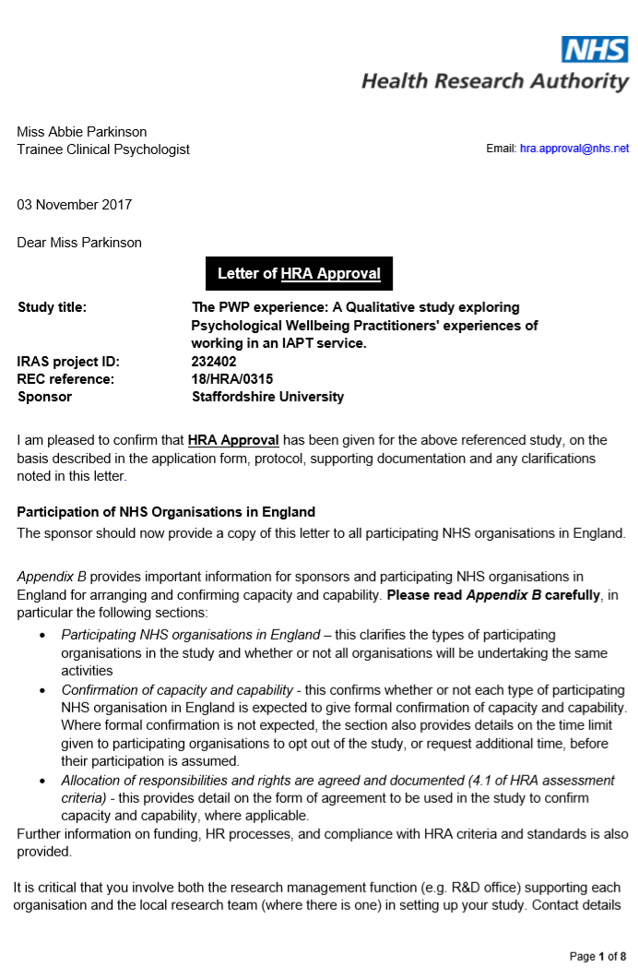

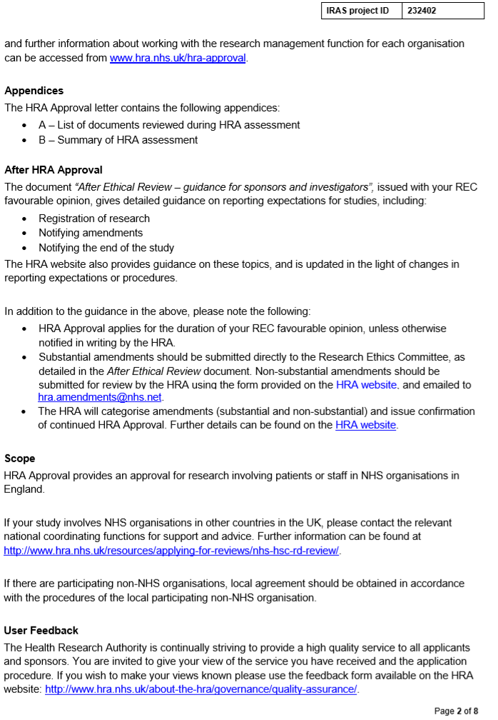

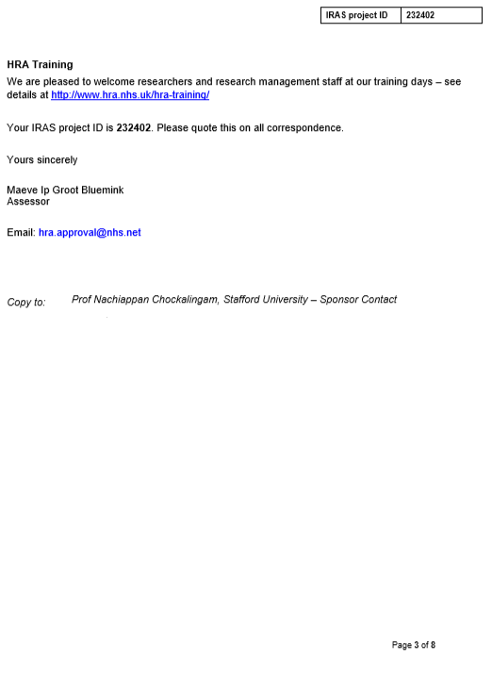

Appendix I – R&D Confirmation of Capacity and Capability
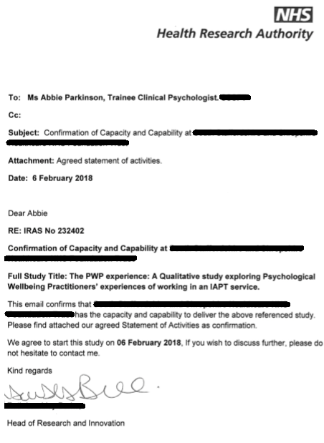

Appendix J – Staffordshire University Ethical Approval of Amendments
Appendix K – Interview Guide
Interview Guide
- Establishing work experience of participant
  - Can you tell me about how you came to be a PWP?
  - What did you do before?
  - How did you decide to train as PWP?
- Expectations of working as PWP
  - What did you expect the role to be like?
  - How did you come to those expectations?
- Experiences of working as a PWP
  - Can you tell me about the things that are/were involved with being a PWP?
  - Can you tell me about a typical day in the role?
  - What are the best things about being a PWP?
  - What are the worst things about being a PWP?
  - To what extent have your experiences differed to what you expected?
  - Can you tell me about your sense of value as a PWP?
- Experiences of the job context
  - How do you find working in the wider service context?
  - What’s the best thing about this?
  - What’s the worst?
  - Some recent data suggests that staff turnover is higher in PWP posts than other IAPT professionals. What are your thoughts about this? Why do you think this is?
- How things can change
  - How could the role be improved?
  - What would you like to see stay the same?

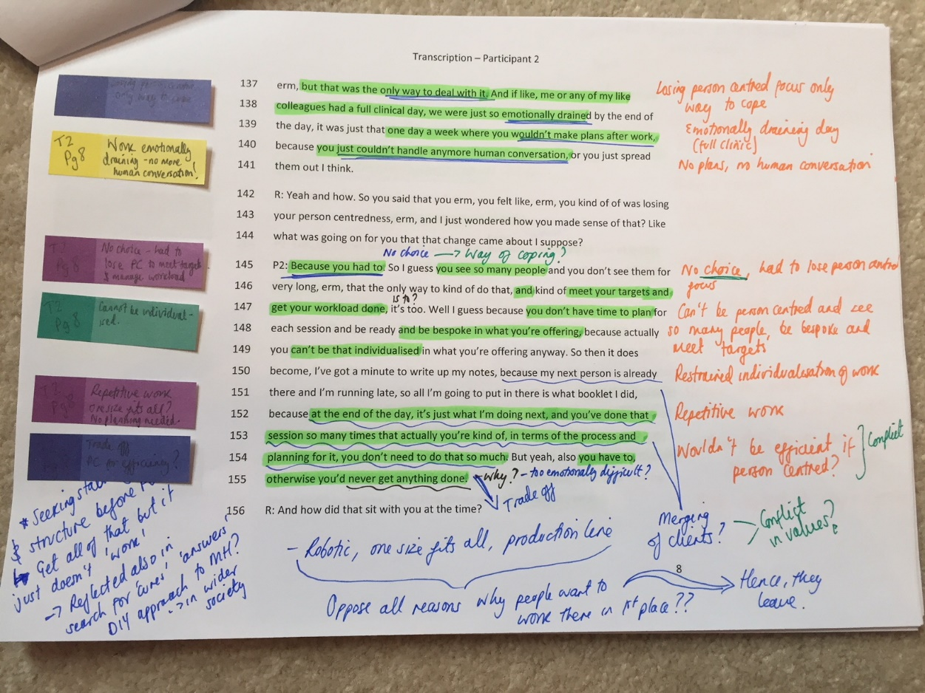
Appendix L – Data Analysis: Example of Coding (Sonia & Harvey)

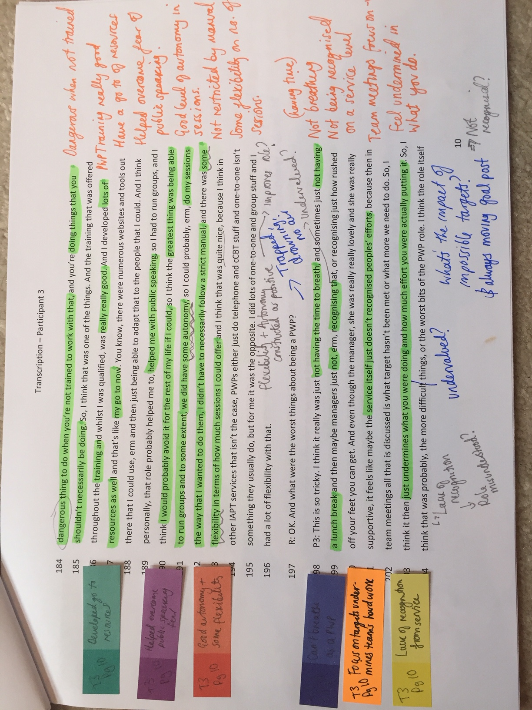
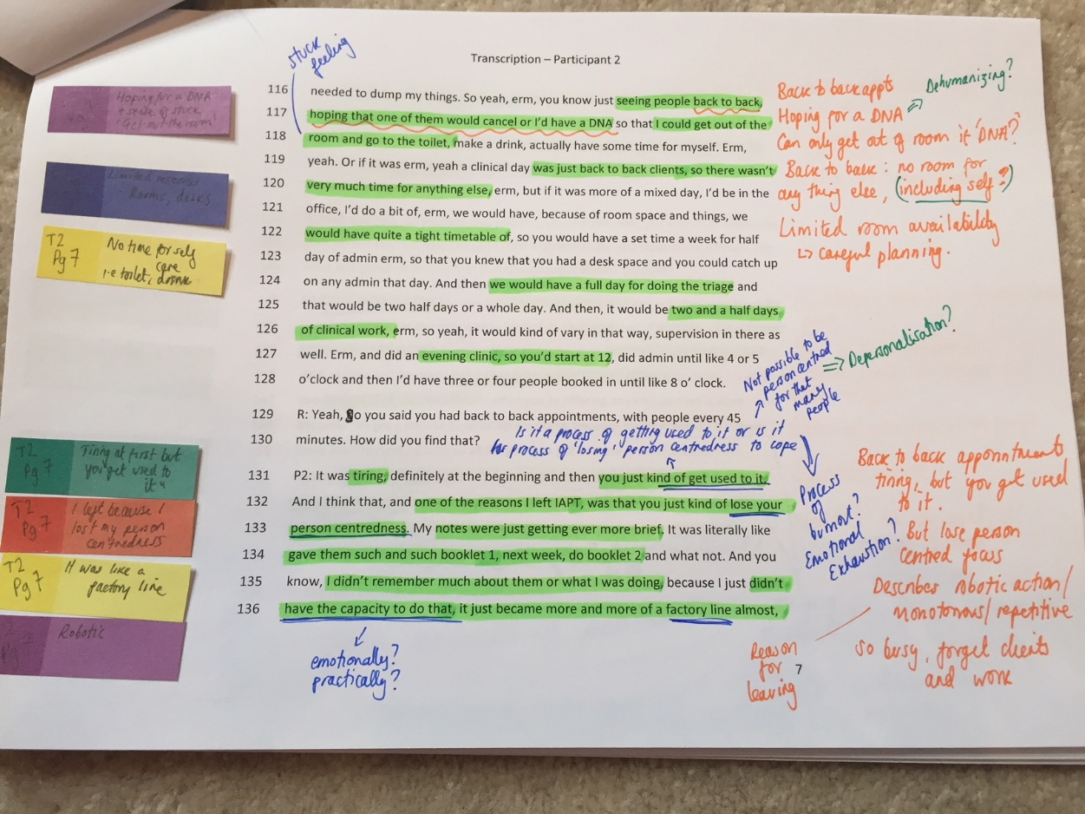
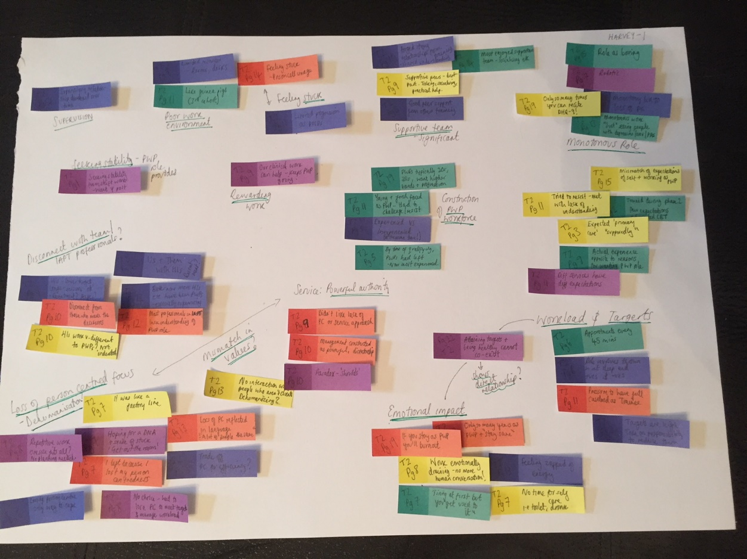
Appendix M – Example of Developing Emergent Themes for Harvey
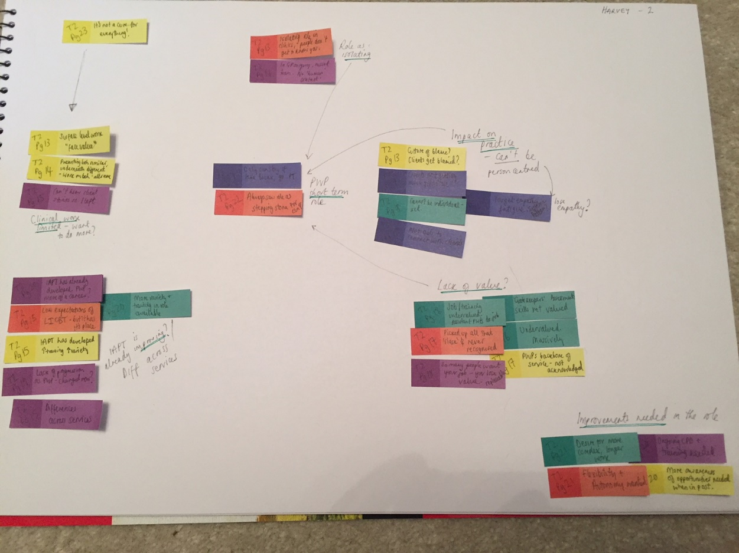

Appendix N – Master Theme Table

Theme | Quotations
Business Model  Production line | “You can’t always expect to have people in and out and feel like sometimes with the targets it views the people that attend as just numbers and a quick output of getting them in and out.” (Beena, 241-243)  “it just became more and more of a factory line.” (Harvey, line 136)  “I think because it was so fast paced and because it literally just felt like a production line and you had to get people in and out” (Harvey, 88-89)  “Honestly, I think it sometimes felt very much like a conveyer belt, which I, I’ve never been very keen on.” (Holly, 118-119).  “It felt too back to back a lot of the time, it felt like it was too much, too many people on your caseload”. (Elizabeth, 235-236).  “you sometimes feels as though, you’re in some kind of like car sales job, where everyone’s getting measured on their numbers.” (Caroline, 294-296)  “Knowing they check your diary, you’re really like conscious for making sure there’s no gap… I feel bad even putting even the lunch gap in there, because I just think, are you going to think I’m not working?” (Grace, 281-283).  “I think they treat PWPs like we’re machines, and it’s, it feels a bit like a production line from start to finish and our feelings are almost taken out of it.” (Grace 419-420)
Business Model  Magical thinking in the hierarchy | “It felt like you couldn’t please the service and the targets that they wanted. And that there was a lot of emphasis on that.” (Beena, 248-249)  “[targets] They were quite high… I think they were just quite unattainable.” (Harvey, 418-422)  “And I think that sometimes it feels like they’re talking from above, within the clouds and they just don’t understand really, what it’s like when you’re working back to back and when you don’t have time to go to the toilet.” (Sonia, 227-229).  “Honestly, the, the pressure. It almost felt like, I don’t know if this was the case or just how it felt, but it always felt like there was a pressure to do more sessions and see more  people, it always felt like there was always massive waiting lists for people to, to see.” (Holly, 154-156)  “I think the main thing I found stressful about that was the ideal of doing a session in half an hour. Which, I think I was lucky that now that is enforced, whereas when I was working as a PWP, it was more like an ideal, but you could still book a room for an hour and nobody kind of told you off for doing that.” (Elizabeth, 110-112)  “there’s this massive amount of pressure in there about numbers, and outcomes, and it just, it just feels a shame that, if the focus wasn’t all around that, people could probably get even more from the service.” (Caroline, 316-318)  “We’re continually assessed as a service on that, erm, so if we’re behind on that, then it does affect the team, you do feel that bit, ahhh, pressure and stress” (Alex, 261-263)  “It almost seems like there’s this magical thinking in the hierarchy that you do an assessment in an hour…whereas the reality is…it creates actually, lots of potentially, lots of work after…that you’re not allowed to factor into your time.” (Grace, 138-143).  “You have an hour to do an assessment and to write up the notes and to move onto the next one, and sometimes that is manageable but sometimes that’s quite difficult”. (Sandra, 103-105)
Process of Internalisation  Conflict within me | “it felt like a bit more of a business model, and that didn’t, at that point it didn’t really sit with my values of providing support for people who were struggling with mental health difficulties and that were all each individuals” (Beena, 314-316)  “I knew that I enjoyed working with people and hearing their stories and I wasn’t able to do that. Erm, Yeah, which is why I left”. (Harvey, 280-281)  “The longer I was in the team, the more I realised that it’s, it’s a business model, and it’s not a model to…not not help people, I don’t think that’s the right word to use…I don’t know how to phrase this (.) I suppose it’s quite business driven and cost is at the forefront, without really thinking about the impact that it has on people, on patients.” (Sonia, 249-253).  “Some of that conflict within me, of this is what I’d like to be doing, but this is what I should be doing.” (Elizabeth, 153-154)  “The room for manoeuvring and the room for adapting was like massively reduced then, and that, that was one of the reasons to me actually leaving”. (Caroline, 155-157).  “It’s just kind of like an ethical thing, that you, you have to do for yourself, because, I’d be more likely to, it’s hard isn’t it, you’d be more likely to keep someone on and face the consequences later, and let it affect your recovery rate or something, but yeah, it’s an ongoing challenge in your mind.” (Caroline, 324-327)  “I had like a week or 2, of like 10, 10 telephone or face-to-face contacts a day and that was too much, so I had to wind back on that”. (Alex, 150-151).  “  It’s quite ironic that we work in a mental health service … when actually if you look at a lot of the staff, they’re actually stressed, anxious… they’re not even allowed to look after themselves.” (Grace, 220-223).  “I think that sometimes there is also that conflict between wanting to do a bit more, wanting to do more for people but feeling restrained at step 2.” (Sandra, 147-149)
Process of Internalisation  I’m no good at this | “Every team meeting they would say OK, so we’ve met our targets or that we haven’t, erm, and that can (.) everybody, I think the whole team worked really hard so that could leave everyone feeling a bit demoralised” (Beena, 249-251)  “I think they were just quite unattainable. Well they are attainable but only if you like burnout in the process” (Harvey, 422-423).  “The service itself just doesn’t recognised peoples’ efforts, because then in team meetings all that is discussed is what target hasn’t been met or what more we need to do. So, I think it then just undermines what you were doing and how much effort you were actually putting in.” (Sonia, 201-203)  “It feels like constant running, like you’re constantly running from one thing to the next, and there’s never that sense of well I’ve done that, I’m done, because there’s always something to replace it.” (Holly, 277-279).  “I don’t think that I ever got to the point of feeling like I’m competent, like yeah, I can do this now.” (Elizabeth, 159-160)  “It does make you conscious knowing they check your diary, you’re really like conscious for making sure there’s no gap. And so, I feel bad even putting even the lunch gap in there,  because I just think, are you going to think I’m not working?” (Grace, 280-283)  “It can make me feel oh gosh I’m no good at this, I’m no good as a PWP.” (Sandra,130-131)
Emotional and Clinical Implications  PWP role has a shelf-life | “I don’t think you can sustain that level of working at such a fast pace for, for the long term. I think you could do short term to medium term of being able to do that, but the long term of h having to do that day in day out, I think could probably be quite draining” (Beena, 279-282)  The staff turnover in PWPs was so high. It wasn’t necessarily PWPs going off to other services... it was more that, there was only so many years you can be a PWP and stay sane. (Harvey, 356-359).  “There were, there were times when it did. And there were even times when you would just think, I can’t do this anymore” (Sonia,169-170)  “There is perhaps a shelf-life on it…from my experience, most PWPs can only do it for so long, before the pressure becomes such that it’s untenable.” (Holly, 265-268)  “I felt like a lot of responsibility, so that can make me feel quite anxious.” (Elizabeth, 252)  “I don’t think it’s something you can do for a really long period of time, erm, without becoming burnout, I don’t, I don’t see how it’s possible to do, I’d done 2 years, and only 1 year of that was actually qualified with a full caseload, erm, I, I wouldn’t still be able to do it now.” (Caroline 353-356)  “You feel it going out of work, getting home, erm, you feel that, that, erm, emotional burden, in a way, erm, that stress, it spills over into your evening, definitely.” (Alex, 135-136).  “I think it relates to what I said earlier about burnout, erm, I think, there is a lot of work to do, and, there’s always waiting lists and that is stressful. Erm, if you don’t manage it well, it will lead to burnout.” (Alex, 214-216)  “My whole life was around work and just trying to, erm, just keep everything going and I just think, like it wasn’t until I got out of it that I realised how actually depressed it was making me.” (Grace, 321-323).  “She was very distressed and it actually made me feel quite distressed and … I had to take a few minutes to gather myself, it just felt like I only had like 5 or 10 minutes before the next person came in and I had to just pick myself up again.” (Sandra, 211-213)
Emotional and Clinical Implications  You’re taking the human out of the equation | “It can be difficult when you feel forced to put people, fit people to the model, rather than the model to the people, because then it can leave clients feeling like there is something wrong with them, but actually it’s just the model.” (Beena, 344-346).  “One of the reasons I left IAPT, was that you just kind of lose your person centredness… Because you had to. So, I guess you see so many people…that the only way to kind of do that, and kind of meet your targets and get your workload done is to.” (Harvey, 132-147)  “you’re taking the human out of the equation and you can’t really work with people and just not have that human element there, if you’re so focused on targets”. (Sonia,117-118)  “I think it sometimes felt very much like a conveyer belt, which I, I’ve never been very keen on, because I like to give that person my full attention and for them to be kind of, the centre of that moment. But, I found that it was sometimes very hard”. (Holly, 118-121).  “Sometimes you might not even remember the person, they’d say like this person is here and you can’t remember who they are, like let alone what you’ve been doing.” (Elizabeth, 239-240).  “there’s this massive amount of pressure in there about numbers, and outcomes, and it just, it just feels a shame that, if the focus wasn’t all around that, people could probably get even more from the service.” (Caroline, 316-318).  “Because they’re stressed and they don’t have time, they’re passing the buck which just gets me really mad, so that’s not helpful either.” (Grace, 379-380).  “Trying to do a thorough assessment, you’re trying to do one that’s you know, using all of your common factor skills, one where you’re being collaborative and you’re exploring things with people, but you’ve only got half an hour to do that…and that can feel quite pressured in a way.” (Sandra, 106-110)
Supportive Structures  Things that kept you going | “There were always people around…you could go and speak to, so you would never have to hold it alone … just being able to share that with other people… makes it easier.” (Beena, 107-111)  “They’d come back kind of, having returned to work, or you know, suddenly you could tell they were getting more sleep at night because they weren’t so anxious. Those little things were what kept you going.” (Harvey, 174-176)  “I think that just having, having an office and having a base to go back to and just offloading to your team members was really helpful.” (Sonia, 172-174)  “They would start to make links themselves. They’d obviously understood the model, understood the techniques and really ran with it, and started to independently make changes…and that was fabulous”. (Holly, 139-142).  “The team were always good, people would just cover stuff, or cancel stuff for you if you really, if it was like this needs to happen now referral or phone calls.” (Elizabeth, 217-218).  “You’re always working with different members of the team… so there’s a lot of variety to it, which I like, and it never gets dull, because of that.” (Alex, 72-74).  “It’s rewarding, it’s more rewarding and enjoyable than stressful at the minute.” (Alex, 149)  The things they’re saying to you, and you see their scores come down, yeah. There’s nothing like that, because then you know you’ve changed someone’s life in a positive way. (Alex, 86-88)  “Variety, is definitely a positive… is great, because you know, it’s not just one thing that you’re going in to do.” (Grace 119-122)  “I almost feel as if somebody has got my back, you know, that if actually it got to a point where I just felt it’s too much, I could just got to anyone and say that and be supported.” (Sandra, 377-379)
Supportive Structures  Supervision | “The support of case management supervision and, and the clinical skills supervision… if you were starting to feel sort of, overwhelmed, you’d have the opportunity to talk about it.” (Beena, 218-220).  “I love the, the way that PWPs support each other, I love the fact that supervision for PWPs is offered by a PWP. A senior one, but a PWP who understands the role”. (Holly, 311-312).  “Supervision is good. The groups, clinical supervision was really useful. Although I feel like it was useful because a lot of the time it was from a non-PWP, so that would be useful to get other ideas.” (Elizabeth, 257-258)  “My case management used to be… quite flexible… But then… [supervision] was very strict … and I felt like that, for me, was more challenging, because every supervision was like; What’s your plan? Is it BA? Is it cognitive restructuring? How many sessions are you doing? How far are you into this? How far are you into that? And I found that really difficult.” (Caroline, 143-150).  “I had really good training, had the same supervisor when I was training, same team, so, really familiar with what we do by the time I’d qualified and how we do it, so, yeah, I hit the ground running from the training I think, which was good.” (Alex, 297-299).  “I think someone who has been a PWP before, kind of understands what that’s like, and, and, how difficult a role it can be, erm, but also make the best, I think clinical supervisors, in terms of knowing, erm, what PWPs can and cannot do.” (Sandra 418-420)

