EBN Opinion Article

Title: Meaning making And Generativity In Children and Young people with Life limiting conditions (MAGICYL)

EBN engages readers through a range of online social media activities to debate issues important to nurses and nursing. EBN Opinion papers highlight and expand on these debates.

Authors: Lucy Watts¹, Dr Alison Rodriguez², Dr Michael Tatterton³, Professor Wilfred McSherry⁴,
Dr Joanna Smith⁵
¹Lucy Watts, MBE (for services to young people with disabilities), young person ambassador
²Dr Alison Rodriguez, School of Healthcare, University of Leeds
³Dr Michael Tatterton, Martin House Hospice, Boston Spa
⁴Professor Wilfred McSherry, School of Nursing & Midwifery, Staffordshire University & University Hospitals of North Midlands, NHS, Trust and part time professor VID University College Norway
⁵Dr Joanna Smith, School of Healthcare, University of Leeds
Corresponding author Dr Joanna Smith j.e.smith1@leeds.ac.uk

This month’s opinion draws on an EBN Twitter chat that focused on dignity therapy and meaning-making activities for children and young people with life limiting conditions. Access the blog at http://ow.ly/oKnz30mSBxq and http://ow.ly/JLnr30mSBAG for a summary of the chat.

Background
In the UK there are just under 50,000 children and young people (CYP) living with a life-limiting condition (LLC). For these CYP there is uncertainty around prognosis and the longevity of their lives. The impact of LLCs on CYP, parents, brother and sisters and the wider family is considerable. Improving well-being throughout their shortened life journey requires care that also addresses the psycho-social and spiritual needs of CYP and their families.¹ In adult palliative care settings, research has found that helping people make sense of their lives is as important as managing disease symptoms.² Dignity Therapy (DT), based on the Dignity Conserving Model of Care,³ is a brief psycho-therapeutic intervention that assists individuals with shortened life expectancies to explore the meaning and purpose of their lives.⁴ During DT, trained professionals encourage people to discuss valued memories, accomplishments, roles, life lessons, and hopes for significant others. Interviews are recorded, transcribed, edited and returned to the patient, who can then add to the document. A generativity (or legacy) document is co-developed from the person’s narrative. Many people share these documents with significant others, providing opportunity for meaningful conversations that can assist future bereavement processes. Dignity is fostered when an individuals’ physical, emotional and spiritual needs are understood, valued and met.⁵ In the context of LLC, there is often an assumption that as the condition progresses there is an increased dependence on others; dignity, or sense of dignity can then be lost. Evidence suggests DT is well received in adult settings, and can reduce anxiety, and depression, and improve an individual’s overall quality of life by promoting a sense of purpose and preserving dignity.^{2,6,7}
A recent review found only four studies that had explored DT and related meaning making interventions with young people: one focused on young people (7-17 years), another three studies included young people but mean ages were 50-70.² DT and related meaning making interventions can improve wellbeing, and support families. However, further work is needed to develop and evaluate DT for younger populations and establish whether DT can address and meet the psycho-social and spiritual needs of CYP with LLC and their families.
The MAGICYL team came together through a shared passion that the dignity of every individual across care settings and the lifespan is central and a core value to care delivery. With expertise in advocacy for CYP with LLC, palliative, psycho-therapeutic and nursing, spiritual care, the MAGICYL team hope to develop DT based interventions for CYP with LLC.
Key messages from the Twitter Chat (#ebnjc)
A twitter chat led by the MAGICYL team explored opinion around DT and its potential for development in order to meet the psycho-social and spiritual needs of CYP with LLC. A range of issues were debated during the chat but two key themes emerged that have importance in relation to the nature and purpose of potential DT based interventions for CYP with LLC:
Valuing the individual
The chat involved a range of people from different backgrounds, who identified that DT is highly relevant for CYP with LLC but that therapeutic approaches must be tailored to the individual to meet their needs, wishes and hopes. CYP with palliative care needs are often involved, albeit to varying degrees, with their end of life care planning. There appears to be different approaches to this process and the extent to which the CYP feel that their voice is heard. DT could be aligned with the end of life care planning process, to move beyond consideration of clinical care pathways and thinking about wishes. An adapted DT, could assist professionals to explore with CYP their perceptions of the value in their lives lived so far and to think about what creative methods could be used to document their experiences. To this end, DT has the potential to make the CYP themselves feel valued and to enter a process that could be enriching and heighten perceptions of quality of life. A DT based intervention for CYP may also assist in meaning making, supporting family communication and enhancing perceptions of the self and purpose for the CYP. Figure 1 highlights some of views that were shared around valuing the individual.
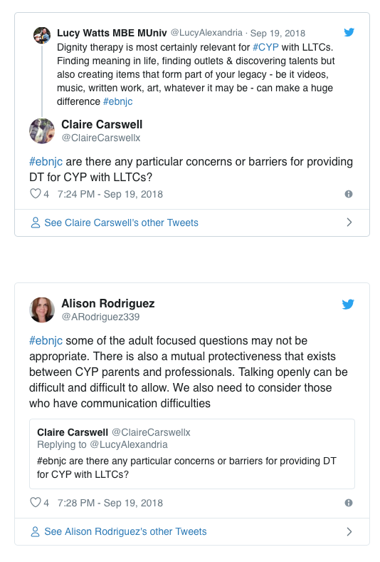 | 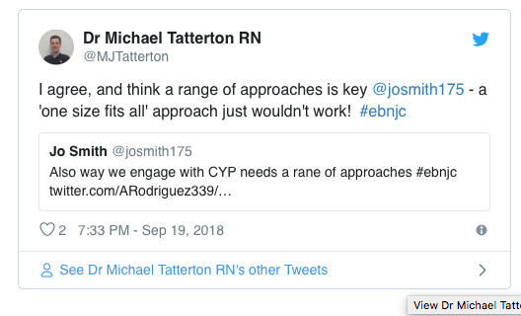

Figure 1: Valuing the individual
Being remembered
The second theme related to being remembered. If CYP can share their views about the lives they have lived and conceptualise this in their own way, they then also have a mechanism to harness their special memories. This could provide, some level of control over how CYP reflect on life, what they want to share with others and in what ways, and how they would like to be remembered. A DT based intervention could provide CYP with the space and means to communicate around what are generally perceived to be challenging and difficult topic areas. Sometimes in current practice end of life care conversations may not take place or take place very late in the illness trajectories. To be supported in creative ways, to discuss the wishes of CYP alongside issues of legacy and how they would like to be remembered, could possibly ease the existential worries that can burden families and CYP. Figure 2 provides some valuable insights into the theme of being remembered.

Figure 2: Being remembered

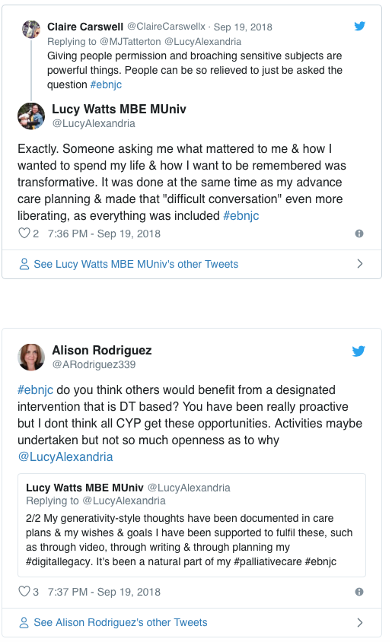 | 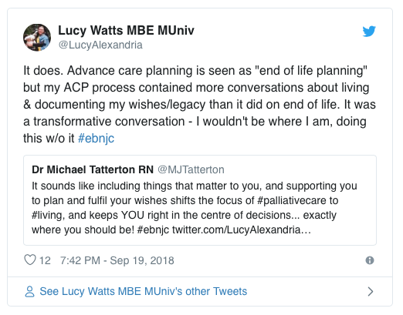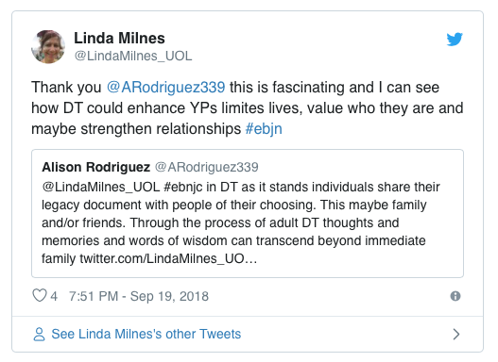

Were next?
The findings from the focused review¹ and the varied types of information gathering so far, including the Twitter chat, establishes support for the amendment and development of DT therapy for CYP with LLC. The MAGICYL team have also undertaken face to face consultation work with CYP and professionals to explore recommendations for development. Central to the work of MAGICYL team is having a young person ambassador, the lead author (LW) of this OPINION article, to guide future activities ensuring they meet the needs of CYP. The next step for the team is to explore wider family perceptions, especially how DT could be developed for younger children and those with communication difficulties. A protocol for the development of a digital intervention, with the support of NIHR MedTech Devices for Dignity is being designed for young adults aged 18-24 years and we are seeking external funding. A further study is planned to harness the creative practices already undertaken in hospice care facilities to facilitate a DT based intervention for adolescents and younger children.

References
¹Rodriguez, A., Smith, J. & McDermid, K. (2018) Dignity therapy interventions for young people in palliative care: a rapid structured evidence review, International Journal of Palliative Nursing, 24, (7), 112-121.
²Martínez, M., Arantzamendi, M., Belar, A., Carrasco, J. M., Carrajal, A., Rullan, M. & Centeno, C. (2017) ‘Dignity therapy’, a promising intervention in palliative care: A comprehensive systematic literature review. Palliative Medicine, 31(6), 492-509.
³Chochinov, H. M. (2002) Dignity conserving care: a new model for palliative care. JAMA, 287, 2253-2260.
⁴Chochinov, H M. (2012) Dignity Therapy: Final words for final days. Oxford: Oxford University Press.
⁵McSherry, W. (2010) Dignity in care: meanings, myths and the reality of making it work in practice. Nursing Times, 106 (40), 20-23.
⁶Chochinov, H.M., Kristjanson, L.J., Breitbart, W., Mcclement, S., Hack, T.F., Hassard, T.H., & Harlos, M.S. (2011). Effect of dignity therapy on distress and end-of-life experience in terminally ill patients: a randomised controlled trial. The Lancet. Oncology, 12 (8), 753-62.
⁷Hall S., Goddard C., Opio, D., Speck, P.W., Martin. P. & Higginson, I.J. (2011) A novel approach to enhancing hope in patients with advanced cancer: a randomised phase II trial of dignity therapy. BMJ Supportive & Palliative Care, 1, 315-321.

