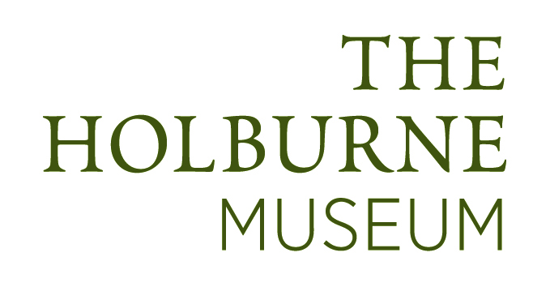
Ceramics and Politics Symposium
Friday 14 November 10am-5pm
A symposium exploring different approaches to contemporary ceramics practice, to accompany the exhibition Confected, Borrowed and Blue…an Installation by Paul Scott at the Holburne
(1 November 2014 – 18 January 2015).

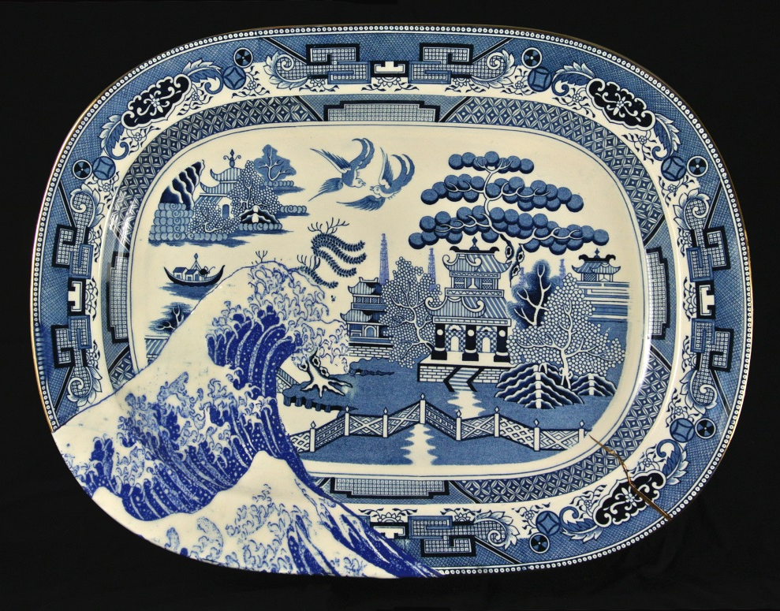
Scott's Cumbrian Blue(s), Fukushima. 2012, Paul Scott.Inglaze decal collage and gold lustre on
partially erased, cracked Willow pattern platter, marked Ocean, Sakakibara, Japan. 48cm x 36cm. © Paul Scott.

Professor Stephen Dixon Weinachtsfrieden: Ceramics and Political Narrative
Dr Linda Sandino Politics, Crockery and the V&A
Carol McNicoll The Politics of Pots
Dr Neil Brownsword Nature Needs its Vultures?

Keynote speaker Dr Paul Scott
Convened by Dr Jo Dahn
For more information about the speakers and the topics covered, see www.holburne.org/ceramics-symposium-2/
Tea/coffee provided. Lunch not included. Packed lunches (sandwich, brownie, crisps, water or coke)can be ordered at time of booking for an additional £9 per person; details of local eateries available on the day.
Ticket £30/£20concs/£10 students (1 accompanying tutor free with 5 or more students).

