A review of glacier outburst floods in Iceland and Greenland
with a megafloods perspective

Jonathan L. Carrivick¹ and Fiona S. Tweed²

¹School of Geography, University of Leeds, Woodhouse Lane, Leeds, West Yorkshire, LS2 9JT, UK
²Geography, Staffordshire University, College Road, Stoke-on-Trent, Staffordshire, ST4 2DE, UK

Correspondence to:
Dr. Jonathan Carrivick,
email: j.l.carrivick@leeds.ac.uk
tel.:+44 (0)113 343 3324

Contents

1. Introduction and aims 3
1.1 Defining megafloods
2. Data sources and methods 5
3. Glacier outburst floods in Iceland 5
3.1 Ice-dammed lake drainage in Iceland 6
3.2 Volcanically-generated jökulhlaups in Iceland 8
3.3 Jökulsá á Fjöllum 11
3.4 Katla 15
4. Glacier outburst floods in Greenland 17
4.1 Isvand 19
4.2 Russell Glacier 19
4.3 Kuannersuit Glacier 21
4.4 Lake Tininnilik 21
4.5 Unnamed lakes near the Amitsulooq Ice Cap 22
4.6 Iluliallup Tasersua 24
4.7 Ice-dammed lakes in Johan Dahl Land 25
4.8 Qorlortorssup Tasia 27
4.9 Ice-dammed lakes in Frederikshåb region 28
4.10 A. P. Olsen Ice Cap 30
5. The geological record of outburst floods from Iceland and Greenland 32
6. Future large glacier outburst floods in Iceland and Greenland 34
7. Summary and conclusions 35

Abstract
The very largest glacier outburst floods have been termed ‘megafloods’ given their volume and peak discharge. That definition might be revised because those floods have become understood due to their distinctive and pervasive landscape impacts. At least three floods in Iceland can be categorized as megafloods since they produced impressive bedrock canyons and giant fluvially-transported boulders. Glacier lake outburst floods (GLOFs) in Greenland might also have megaflood-type attributes given the enormous lake volumes drained. We therefore here present the first review of glacier outburst floods in Greenland: sites Isvand, Russell Glacier, Kuannersuit Glacier, Lake Tininnilik, two unnamed lakes near Amitsulooq Ice Cap, and Iluliallup Tasersua, Base Camp Lake, Lake Hullett, Qorlortorssup Tasia, Imaersartoq, Tordensø, North Midternæs and an outlet glacier of the A. P. Olsen Ice Cap. Overall, megaflood-type landscape impacts in Iceland tend to be best-preserved and most easily identified inland although there has also been extensive offshore sedimentation. There are very few reported impacts of glacier outburst floods in Greenland. In Greenland ice-dam failure causes frequent flooding compared to the volcanically-triggered floods in Iceland and this combined with the proximity of the Greenland glacier lakes to the coast means that most proglacial channels in Greenland are flood-hardened and most landscape impact is likely to be offshore in estuaries and fjords. Future floods with megaflood-type attributes will occur in Iceland induced by volcanic activity. In Greenland they will be induced by extreme weather and rapid ice melt. Any potential landscape impact of these future floods remains open to question.

Key words: jökulhlaup; GLOF; ice-dammed lake; ice sheet; landscape impact

Introduction and aims
Glacier outburst floods are common in Iceland from whence the term ‘jökulhlaup’ originates. Significant advances in our understanding of the mechanisms, processes and impacts of such floods have arisen from work undertaken in Iceland. Jökulhlaups in Iceland have threatened settlements, people and hydro-electric installations on glacier-fed rivers. They have also damaged tracts of land, with associated impacts on agriculture and livestock farming. Transport has been affected by floods due to damage caused to roads, bridges and associated infrastructure and larger jökulhlaups have generated flood waves in coastal waters (Rist, 1983; Björnsson, 2002; Carrivick and Tweed, 2016).

Substantial and distinctive landscape change, as evidenced by erosional and depositional landforms, has long been caused by jökulhlaups in Iceland. They have eroded large bedrock canyons and transported huge quantities of sediment over outwash plains. Truly catastrophic floods from the drainage of large Quaternary subglacial lakes have produced a pervasive landscape impact by cutting extensive river canyons, extending the coastline and producing voluminous offshore sedimentation (Björnsson, 2002). Indeed, it is these landscape impacts that are often used to identify the occurrence and characteristics of extremely large jökulhlaups, especially of those that occurred in prehistoric times. These Icelandic jökulhlaup landscape impacts are also commonly used as analogues for megafloods, both on Earth and on Mars.

Jökulhlaups also occur frequently in Greenland, yet they have never been reviewed despite having been sporadically described in the scientific literature for ~ 230 years (Fabricius, 1788; Rink, 1862 both cited in Higgins 1970). Furthermore, drainages of glacier lakes in Greenland have been mentioned several times in expedition reports, but without further analysis; Freuchen (1915) estimated that Nyeboes Randsø in North Greenland emptied at about 25-year intervals and Koch and Wegener (1930 p. 383) reported a lake near Jakobshavn Isbræ with about 10 years between floods. Some of the lakes that have suddenly drained in Greenland are so big that there is reason to believe that jökulhlaups in Greenland, like those in Iceland, could be megaflood analogues.

This paper aims to provide a review of research on glacier outburst floods from Iceland and Greenland with a megafloods perspective. After an initial consideration of what constitutes a megaflood , we i) consolidate the state of knowledge on jökulhlaups in Iceland; ii) provide the first review of jökulhlaups in Greenland; iii) identify and explain research directions on glacier floods in Iceland and Greenland and iv) evaluate Iceland and Greenland glacier floods as megaflood analogues.

1.1 Defining megafloods
Floods with a peak discharge of, or greater than, 10⁶m³s⁻¹ or 1 sverdrup are defined as megafloods (Baker, 2002; Carling, 2013), with the prefix ‘mega-’ applied in its strictest sense to mean a million. The largest known floods on Earth are associated with glacial environments (Baker, 1996; 2002). Of these largest known floods, the terrestrial floods that meet the strict definition of megaflood include the sudden inundations that occurred during the Quaternary from the drainage of ice-dammed lakes along the margin of the Laurentide Ice Sheet in North America (e.g. Kehew and Lord, 1986; O’Connor and Baker, 1992) and from along the margins of the Eurasian ice sheet (e.g. Rudoy, 1988; Carling et al, 2009; Carling et al., 2010).

Other terms such as ‘catastrophic flood’, ‘cataclysmic flood’ and ‘super flood’ are also used, sometimes indiscriminately, in the literature to describe extremely large floods. Catastrophic floods are considered to be events that are exceptional or rare following which the preservation of erosional landforms and sedimentary evidence persists over geological timescales (Russell, 2005; Tweed, 2011). Taking ‘catastrophic’ or ‘extreme’ flooding to be defined by peak discharge in excess of 100,000 m³s⁻¹ (an order of magnitude less than a megaflood) Tómasson (2002) claims that there are two floods each century in Iceland of this magnitude. In the absence of human impacts, catastrophic or extreme might be taken to imply intense, widespread and pervasive landscape impact produced in a geological instant

In his review of megaflood sedimentation, Carling (2013) included some Icelandic jökulhlaups because their sedimentary signatures are similar to megafloods. Others have observed that bedrock canyon systems and other erosive landforms attributed to glacial outburst floods in Iceland share characteristics with those generated by recognised megafloods (e.g. Baker, 2002; Waitt, 2002). In this paper, we adopt the term ‘megaflood attributes’ to recognise that flood characteristics other than peak discharge, such as bed shear stresses and stream powers, are also key factors in determining the severity and hence pervasiveness of the landscape impacts of particular events.

Data sources and methods
For the novel mapping in this paper, high resolution (2 m grid mosaic) topography was obtained from the Arctic DEM (Porter et al., 2018) via the Polar Geospatial Centre (https://www.pgc.umn.edu/data/arcticdem/). High resolution (< 3 m pixel) optical wavelength and multi-spectral satellite images covering the same ground space at sub-weekly intervals were obtained from Planet (2017) images and with an ‘Education and Research Program’ licence. An outline of the Greenland Ice Sheet (GrIS) was obtained from http://imbie.org/imbie-2016/drainage-basins/ and mountain glacier and ice cap outlines were obtained from http://glims.colorado.edu/glacierdata/ (the October 2017 release). Historical glacier lake outlines are those from Carrivick and Quincey (2014). Modern glacier lake outlines were mapped manually using the ArcticDEM and Planet products and analysed for water surface elevation, planimetric area and volume changes using the same software. Local geomorphology was interpreted visually using a hillshade of the DEM.

Glacier outburst floods in Iceland
Icelandic jökulhlaups result from the drainage of ice-marginal and subglacial lakes (i.e. they can be termed glacier lake outburst floods: GLOFs), but also from subglacial volcanism and geothermal activity, which can swiftly melt vast quantities of ice (Björnsson, 2002; 2010). Notable foundations for our current understanding of glacier outburst floods in Iceland include Thorarinsson’s (1939) identification and discussion of ice-dammed lakes and their relationship to glacier oscillations and Björnsson’s extensive publications on ice-dammed lakes, volcanically-induced jökulhlaups and the mechanisms of jökulhlaup initiation (e.g. Björnsson, 1974; 1977; 1978; 1988; 1992, 1998; 2002). These works are augmented by observations and analyses of specific events. The November 1996 jökulhlaup on Skeiðarársandur following the Gjálp eruption has been studied intensively (e.g. Gudmundsson et al., 1997; Björnsson, 1998; Roberts et al., 2000a, 2000b, 2001; Fay, 2002; Jóhannesson, 2002; Snorrason et al., 2002; Russell and Knudsen, 1999a, 1999b, 2002) and it was also part of the impetus for ‘The Extremes of the Extremes: Extraordinary Floods’ symposium held in Reykjavík in July 2000. There is a substantial body of work on Icelandic jökulhlaup landscape impacts, dating and the sedimentology of flood deposits (e.g. Dugmore, 1987; Larsen, 2000; Maizels, 1989a, 1989b, 1991, 1997; Russell et al., 2001, 2005, 2006; Smith and Haraldson, 2005; Smith and Dugmore, 2006; Duller, 2008; 2014).

Icelanders have recorded glacier floods for centuries and the research literature on Icelandic glacier outburst floods is extensive (Björnsson, 2010). For this reason, we summarise the key contributions with respect to megaflood analgues here and direct the reader to other work for further information. Tómasson (2002) identified four ‘catastrophic’ floods: i) a flood under Mýrdalsjökull flowing north and west about 1700 years ago; ii) a series of jökulhlaups down the Hvítá river about 9500 years ago; iii) jökulhlaups along the Jökulsá á Fjöllum from the northern margin of Vatnajökull 2500 years ago, and iv) floods generated by the 1918 Katla eruption. In this paper we devote more attention to the latter two events due to their impacts being megaflood analogues (see sections 3.3 and 3.4) and we also identify the jökulhlaup generated by the Öræfajökull eruption of 1362 as a catastrophic flood with megaflood attributes.

3.1 Ice-dammed lake drainage in Iceland
Early work identified ice-dammed lakes in Iceland, their extent and their drainage history. The two largest persistent ice-dammed lakes are Grænalón (Fig. 1, 64º 10’ N, 17º 21’ W), which is dammed by Skeiðararjökull, and Hagavatn (64º 29’ N, 20º 17’ W) dammed by Langjökull (Thorarinsson, 1939; Sigbjarnasson, 1967; Bennett et al., 2000). In the early 20th century Grænalón was the largest subaerial lake in the world capable of draining subglacially (Walder and Costa, 1996). Jökulhlaups from Grænalón have evolved from comparatively infrequent events involving almost total emptying of the lake to much smaller more frequent floods during which a small fraction of the lake volume drains (Björnsson, 1976; Roberts et al, 2005). This evolution has been driven by ice-water interactions and thinning of the ice dam since the beginning of the 20th century, which has gradually reduced the volume of Grænalón by 75% (Roberts et al., 2005). Significantly, Grænalón’s processes and mechanisms of drainage and floodwater pathways have evolved as the lake has diminished in size, thereby countering the general assumption that ice-marginal lakes drain by a similar set of processes each time (Roberts et al., 2005). These observations may assist us in understanding both the evolution of modern ice-dammed lakes and associated jökulhlaups and also the behaviour of ancient ice-marginal lakes and prehistoric ‘palaeofloods’. Other smaller ice-marginal ice-dammed lakes in Iceland have reduced in size with glacier recession and thinning, draining more frequently with smaller floodwater volumes, thereby conforming to the ‘jökulhlaup cycle’ (Evans and Clague, 1994; Tweed and Russell, 1999).

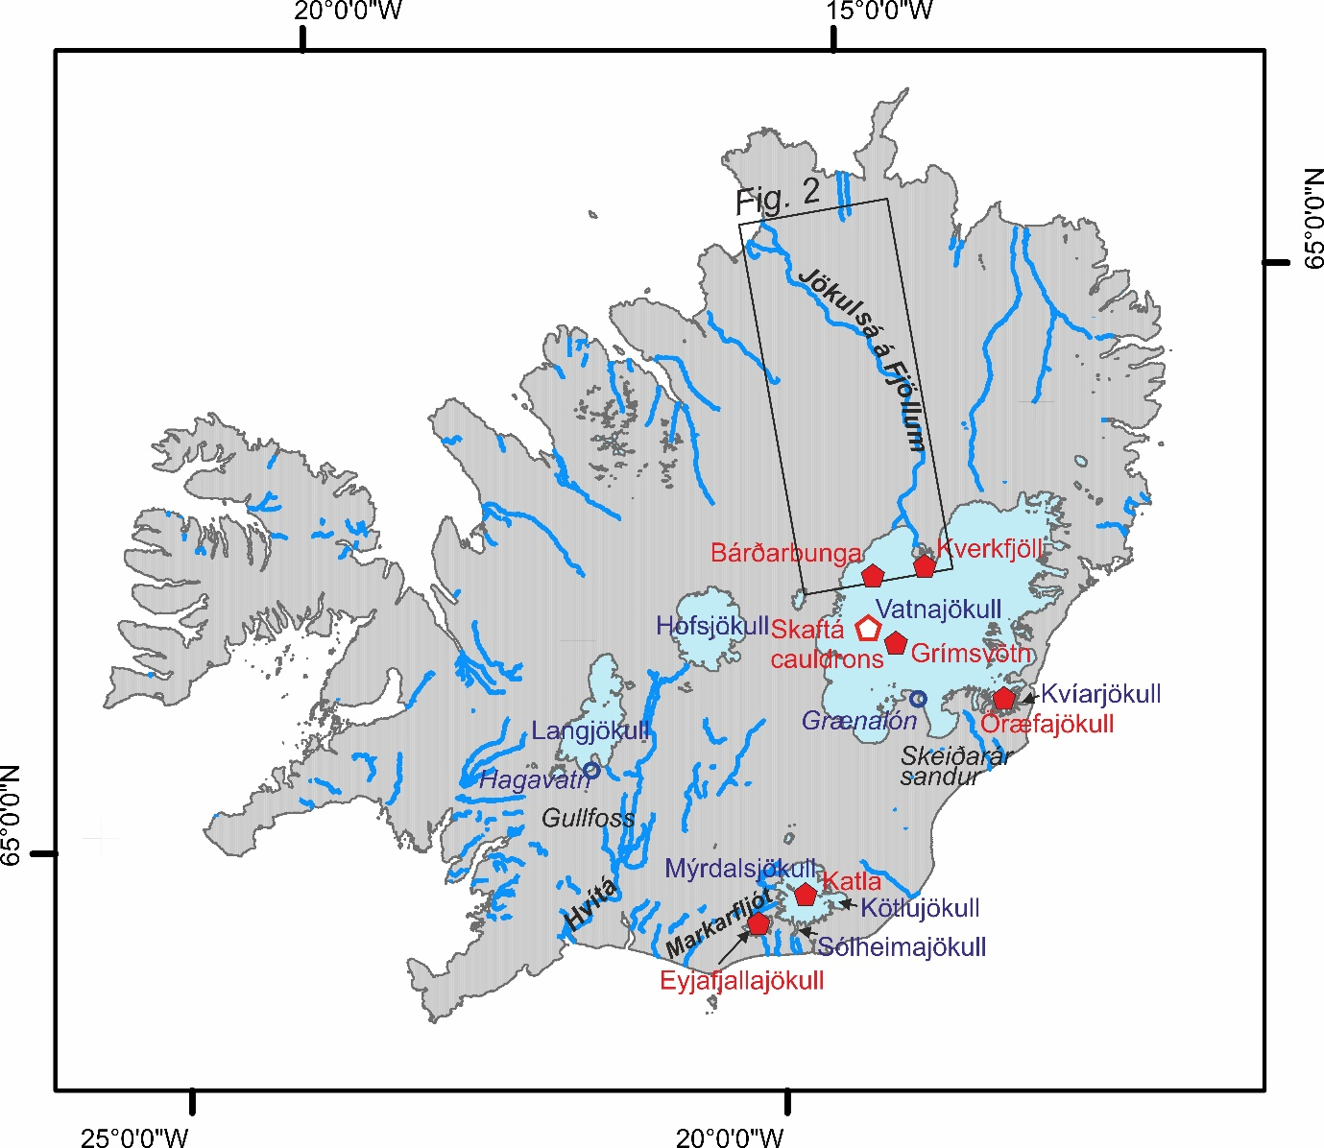

Figure 1. Sites associated with glacier outburst floods in Iceland mentioned in the text.

The area around the Hvítá river (Fig. 1) had favourable conditions for the creation of very large lakes and extremely large floods at the end of the last glacial period about 9500 years ago. Ice-dammed lakes formed when the main glacier retreated over a topographic water divide at Kjólur damming meltwater to the south (Tómasson, 1993). The first floods drained towards the north under a glacier tongue west of Kjólur, but most drained south under a glacier at Bláfell. Evidence of the existence and drainage of ice-dammed lakes is present in the form of shorelines, some of which have been surveyed (Tómasson, 2002) and there is widespread erosional landform evidence that is analogous to that of megafloods. For example, the cutting of the stepped canyon at Gullfoss (Fig. 1) is attributed to these floods, which are estimated to have had a peak discharge of 200,000m³s⁻¹; the volume of the canyon at Gullfoss is 100 x 10⁶m³ (Tómasson, 2002).

3.2 Volcanically-generated jökulhlaups in Iceland
Many floods in Iceland are triggered by subglacial volcanism and some arise from the release of water from subglacial lakes that have developed because of geothermal and volcanic activity. Most jökulhlaups from volcanic eruptions under Vatnajökull have drained northwards to the Jökulsá á Fjöllum (Fig. 1; see section 3.3) or southwards via Skeiðarársandur (Fig. 1) (e.g. Thorarinsson, 1974; Björnsson and Einarsson, 1991). The largest jökulhlaups in Iceland have been generated from eruptions in the huge ice-filled calderas of Barðabunga and Kverkfjöll in northern Vatnajökull (Fig. 1) (Björnsson, 1988; Björnsson and Einarsson, 1991) and these floods will be discussed further below in section 3.3 because they had megaflood attributes.

There have been notable and relatively frequent jökulhlaups from Grímsvötn, some of which have been associated with volcanic eruptions. Grímsvötn lake is situated at 64º 25’ N, 17º 19 W’ beneath a depression in the surface of Vatnajökull created by subglacial geothermal activity which melts ice; this generates a subglacial meltwater lake that is trapped by an ice dam. The depression fills with water via geothermal and volcanic activity, but then requires a separate trigger (breaking of the seal on the ice dam by flotation or the opening of waterways by increased localised melting, for example) to initiate flooding (e.g. Björnsson, 1974, 1992, 1998, 2002; 2010; Einarsson et al., 2016a). Jökulhlaups occur at four to ten-year intervals, inundating Skeiðarársandur (Björnsson, 2010). The study of floods from Grímsvötn has greatly advanced our knowledge of jökulhlaup processes (e.g. Thorarinsson, 1953; Björnsson, 1974, 1975, 1988, 1998, 2002, 2010; Jóhannesson, 2002; Roberts, 2005) and processes evident during the November 1996 jökulhlaup on Skeiðarársandur prompted re-evaluation of flood models. The swift rise to peak discharge marked the event as a rapidly-rising jökulhlaup (Björnsson, 1998; Roberts et al., 2000b) and the flood was characterised by hydrofracturing of ice due to high subglacial water pressures and fluvial emplacement of debris within Skeiðararjökull (Roberts et al., 2000b; Roberts et al., 2003).

The Skaftá cauldrons are located at 64º 29’ N, 17º 30’ W (Fig. 1) over geothermal systems ~10 to 15 km north-west of Grímsvötn and they frequently give rise to outburst floods. The peak discharge of 50-3000 m³s⁻¹ in the Skaftá river is usually reached in one to three days and floods typically recede in one to two weeks (Björnsson, 1977; 1992; 2002). Like floods from Grímsvötn, these jökulhlaups are triggered by flotation, of the glacier (Björnsson, 2002) and many are on the rapidly rising end of the spectrum of jökulhlaups (Einarsson et al., 2016a). Recent research has identified that, like other rapidly-rising floods, some of the floods in Skaftá cannot be explained by Nye’s (1976) jökulhlaup theory and instead the passage of a subglacial pressure wave forms the initial flood path (Einarsson et al., 2016a, 2016b). This assertion supports other work on rapidly rising jökulhlaups, which have been identified in Iceland and elsewhere (e.g. Björnsson, 1992, 2002; Roberts, 2005; Jóhannesson, 2002; Flowers et al., 2004) and our understanding of these processes has advanced significantly over the last twenty years. However, the conditions that govern whether a jökulhlaup develops as a rapidly rising event or more slowly, with an exponential rise to peak discharge, remain poorly understood.

Eruptions of Öræfajökull (Fig. 1, 64º 00’ N, 16º 38’ W) have resulted in extensive flooding due to rapid ice melt. The 1362 eruption of Öræfajökull was the largest explosive eruption in Europe since Vesuvius in AD79. A powerful jökulhlaup was generated, which lasted less than a day, but may have had a peak discharge greater than 100,000 m³s⁻¹ (Thorarinsson, 1958) which defines it as a catastrophic event. Less powerful floods were produced by an eruption in 1727, but the peak discharge of this event was still equivalent to the peak discharge of the November 1996 jökulhlaup on Skeiðarársandur (Roberts and Gudmundsson, 2015). Both floods carried copious quantities of ice which took decades to melt; some of the large stranded blocks were re-named as glaciers (Sigurdsson and Williams, 2008), which is testimony to their prominence, and there are reports of ice reaching the sea (Roberts and Gudmundsson, 2015). The flows also transported extremely large boulders; for example, the 10 m-long smjörsteinn or ‘butterstone’ (Fig. 2A) which is believed to have been deposited by the 1362 jökulhlaup, and a collection of angular boulders estimated to weigh 500 tonnes, which are embedded within jökulhlaup deposits (Thorarinsson, 1958; Roberts and Gudmundsson, 2015; Everest et al., 2017). The transport of these large boulders is an indication of exceptionally high flood competence and the lasting nature of the evidence akin to that of a megaflood environment. Examination of jökulhlaup deposits at the Kota fan, which is believed to have been formed during the 1727 eruption of Öræfajökull, suggests that the flows were highly debris-charged or hyperconcentrated (e.g. Maizels, 1993). Some of the landform and sedimentary evidence of the 1362 jökulhlaup was eradicated by the 1727 flood. The steep-sided nature of the topography and the short floodwater travel-time to settled locations and infrastructure makes Öræfajökull one of the most dangerous volcanoes in Iceland.

Similar floods have been produced from eruptions in Eyjafjallajökull (Fig. 1, 63º 38’ N, 19º 37’ W) in 1612 and 1821-23 and Hekla (Fig. 1, 63º 59’ N, 19 º 41’ W) in 1845 and 1947 (Kjartansson, 1951). The most recent eruption of Eyjafjallajökull, which began on 14th April 2010, generated jökulhlaups in the Markarfljót river (Fig. 1). The flood sequence was dominated by two large jökulhlaups on 14th and 15th April, but from 20th April to 16th May 2010, there were >140 discrete outburst floods with discharges ranging from 10 to 226 m³s⁻¹ above an elevated Markarfljót base flow of 200 to 300 m³s⁻¹ (Dunning et al., 2013). Research indicates that peak discharge and peak sediment flux were de-coupled and the dominant ice-proximal surface landforms were the product of a series of late stage lower discharge jökulhlaups over a period of weeks (Dunning et al., 2013). This abrupt and pervasive landscape impact challenges traditional ideas regarding the magnitude and frequency of landforming events. It has also become evident that the time of year of an eruption may influence flood timing and floodwater routing. For example, the 2010 Eyjafjallajökull eruption occurred at the end of winter when the glacial drainage system was inefficient and it took five hours from start of eruption for floodwater to reach the proglacial lake 5 km at the glacier margin. The 1996 Gjálp eruption, which generated the November 1996 jökulhlaup on Skeiðarársandur, occurred at the end of the summer when the glacier drainage system was better developed; hence a journey time of ten hours to travel 50 km on a gentler slope (Einarsson et al., 1997; Sgattoni et al, 2017).

The Markarfljót river canyon owes its origin to a flood from Mýrdalsjökull (Fig. 1), believed to have been volcanically-induced, which flowed north and west through the Innri Emstrur River area and the Markarfljót river basin and then down to the sea at Landeyjar 1700 years ago (e.g. Tómasson, 2002; Smith and Dugmore, 2006). The flood is estimated to be as large as the jökulhlaup generated from the 1918 eruption of Katla (see section 3.4). Researchers have noted the difference in canyon erosion in móberg (subglacially-erupted hyaloclastite and tuff) and basalt; the móberg section is narrow and deep, the basalt section is wide (Tómasson, 2002).

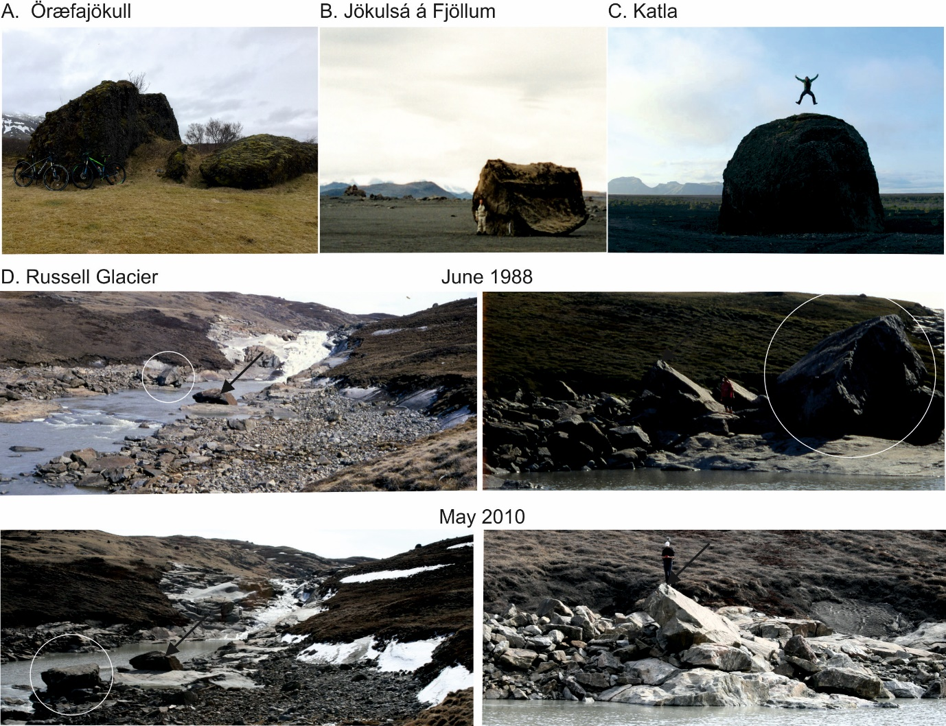
Figure 2. Giant boulders moved by outburst floods in Iceland and Greenland; the smjörsteinn or butter stone believed to have been deposited by the Öræfajökull floods of 1362 (A: image courtesy of Svava Björk Þorláksdóttir, 11th April 2017), along the Jökulsá á Fjöllum (B), and by Katla 1918 jökulhlaup (C: image courtesy of Hugh Tuffen), and In west Greenland giant boulders were moved between June 1988 and May 2010 in the upper Watson, most likely by the 2007 glacier outburst flood from the ice dammed lake on the northern margin of Russell Glacier. In panel D white circles indicate boulders moved and arrows indicate static boulders for reference. Note persons in each panel for scale. All panel D images courtesy of Andy Russell.

3.3 Jökulsá á Fjöllum
Many historical and early- to mid-Holocene glacier outburst floods have occurred along the Jökulsá á Fjöllum (Fig. 1, 3) in Iceland (Helgason, 1987; Thórarinsson, 1950, 1959; Waitt, 2002; Kirkbride et al., 2006; Baynes et al., 2015; see Table 2 in Carrivick et al., 2012). The earliest of these were also the largest and can been classified as megafloods by their reconstructed peak discharge, volume and landscaping impact (Waitt, 1998, 2002). Indeed it was the dry waterfalls or ‘cataracts’, plucked-bedrock ‘scablands’, bedrock flutings and plastically-sculpted or ‘p-forms’, potholes, giant boulders mobilised by the floods (Fig. 2B) and large-scale gravel bars (see both Table 1 in Carrivick et al., 2012 and Table 1 in Baynes et al., 2015a) that first attracted attention during surveys for hydroelectric development (Thórarinsson, 1950, 1959; Helgason, 1987). Most profoundly, it was realised that the modern Jökulsá á Fjöllum is far too small to have formed the Dettifoss canyon and the (now dry) canyon system at Ásbyrgi (Fig. 4; Tómasson, 1973; Elíasson, 1977; Malin and Eppler, 1981) and therefore that they must be products of very large jökulhlaups that routed ~ 150 km from northern Vatnajökull (Thórarinsson, 1950; Sæmundsson, 1973; Tómasson, 1973; Waitt, 1998, 2002). Megafloods generated by the Barðabunga (Fig. 1, 64º 38’ N, 17º 32’ W) volcanic system have drained through Dyngujökull on the northern margin of Vatnajökull and hence into the Jökulsá á Fjöllum (Tómasson, 2002) but there is also extensive geomorphological and sedimentological evidence for the occurrence of jökulhlaups with megaflood-type impacts routing into the Jökulsá á Fjöllum from the Kverkfjöll volcano (64º 36’ N, 16º 44’ W), which has two calderas (Carrivick, 2004; Carrivick et al., 2004a, b, 2007, Carrivick and Twigg, 2005; Marren et al., 2009). There is also geomorphological evidence that jökulhlaups from Kverkfjöll have been intimately associated with subglacial volcanism (Carrivick et al., 2009a). Overall, the geometric scale of the Dettifoss and Ásbyrgi canyons (Fig. 4) in the distal parts of the Jökulsá á Fjöllum (Fig. 3), and the presence of giant boulders and gravel bars, has prompted comparisons of the Jökulsá á Fjöllum floods with (i) the Columbia plateau or Missoula megafloods (Tómasson, 1973, 2002; Waitt, 1998, 2002), (ii) other terrestrial megafloods (Baker, 2002), and (iii) megafloods on Mars (Malin and Eppler, 1981; Baker, 2002; Lapotre et al., 2016) and brought awareness to the geological importance and deglacial association of jökulhlaups (c.f. Carrivick, 2011).
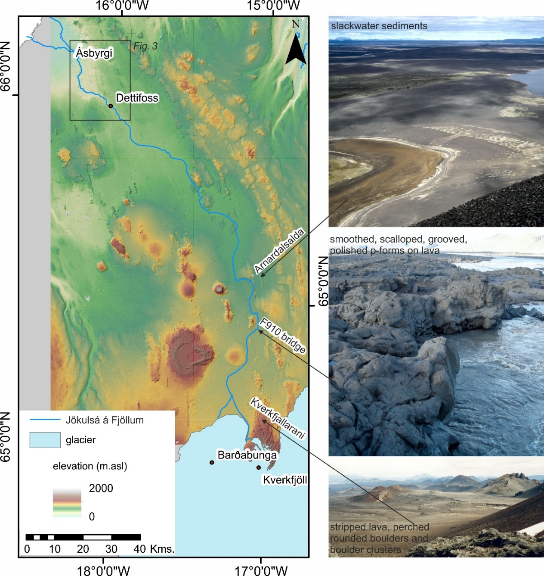

Figure 3. Route of the Jökulsá á Fjöllum through north-central Iceland from the northern margin of Vatnajökull.

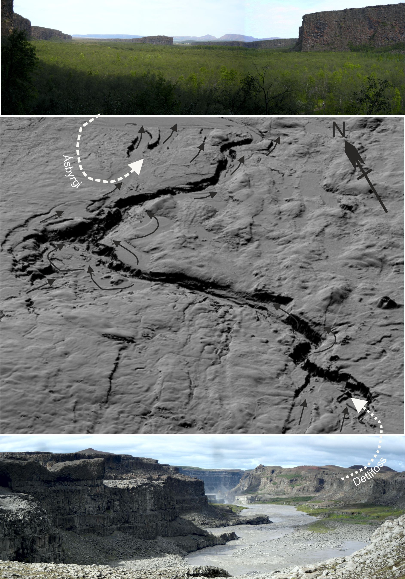
Figure 4. The 500 m wide Dettifoss canyon and the 1100 m wide Ásbyrgi canyons as represented in the ArcticDEM with some of the major palaeochannels as identified by Tómasson (2002) and Baynes et al. (2015a) indicated with black arrows. The direction of view of each of the photographs is indicated by the white dashed arrows.

Most recent research on the Jökulsá á Fjöllum floods has firstly used the geomorphological (e.g. Baynes et al., 2015) and sedimentological (e.g. Knudsen and Russell, 2009) evidence of the distal canyons to inform conceptual landscape evolution and palaeoflow character. Secondly, that field evidence and conceptualisation has been combined to drive mechanistic hydraulic models that not only consider the distal but also the proximal reaches, thereby enabling a relatively sophisticated quantification of the inundation, peak discharge, behaviour and likely source of the Jökulsá á Fjöllum floods (e.g. Alho et al., 2005; Carrivick, 2006, 2007a,b, 2009; Alho and Aaltonen, 2008). Particularly significant advances in understanding of the Jökulsá á Fjöllum floods have been made when such analyses have been combined with geochronological methods to give timings and rates of change; megaflood episodes at ~ 9000, 5000 and 2000 years ago with > 2000 m knickpoint recession associated with these individual (and geologically instantaneous) events: Baynes et al. (2015b). These rates can be compared with mean rates of knickpoint erosion during the Holocene of 0.7 m.a⁻¹ (de Quay et al., 2019), and mechanical denudation of 0.8 to 3.5 kg.m⁻²yr⁻¹ (Eiriksdottir et al., 2008), for example.

3.4 Katla
Katla caldera is situated at 63º 38’ N, 19º 08’ W (Fig. 1) and is 10 to 15 km in diameter, 600 to 700 m deep and covered by the Mýrdalsjökull ice cap in southern Iceland (Björnsson et al., 2000). The caldera wall is breached in three places: to the south-east, the north-west and the south-west; these gaps provide outflow paths for ice to feed main outlet glaciers, Kötlujökull, Sólheimajökull and Entujökull and they are also potential jökulhlaup pathways (Sturkell et al., 2010; Sgattoni et al., 2017). Katla has a history of explosive eruptions that rapidly generate meltwater, as most eruptions are confined to the caldera area. Eruptions can break through 400 m of ice cover in one to two hours (Björnsson, 2002) and give rise to jökulhlaups (‘Katlahlaups’) routed onto Mýrdalssandur. The path of each flood depends on the location of the eruptive site, the geometry of Mýrdalsjökull and the hydrological pathways under the ice (Björnsson et al., 2000; Larsen, 2000; Sturkell et al., 2010). Although most historic Katlahlaups exited Kötlujökull, several floods are known to have inundated Sólheimasandur and Skógasandur in the early 10th century (Dugmore, 1987; Dugmore et al., 2000; Larsen, 1978, 2009) and some floodwater from the 1860 Katla eruption also drained through Sólheimajökull (Hákonarson, 1860; Björnsson et al., 2000; Larsen, 2000). During more recent floods on Mýrdalssandur, floodwaters have exited Kötlujökull (Björnsson et al., 2000; Larsen, 2000; Russell et al., 2010).

The Katla volcanic system is one of the most active in Iceland; there have been at least twenty eruptions within the central volcano (Larsen, 2000) and one in its fissure swarm over the last 1,100 years. Water-transported volcanic debris has been estimated as from 0.7 to 1.6 km³ per event (Tómasson 1996; Larsen 2000) and evidence suggests that jökulhlaup peak discharge of 1 - 3 x 10⁵ m³s⁻¹ was typically reached in a few hours with total water volumes of 1 – 8 km³ draining over three to five days (Thorarinsson, 1974; Tómasson, 1996; Larsen, 2000). The jökulhlaups from Katla can therefore be classified as catastrophic floods. They can also be recognised for having megaflood attributes; Mýrdalssandur, Sólheimasandur and Skógasandur have been largely built by Katla jökulhlaups and are type-sites for Icelandic volcanogenic floods and their sedimentary characteristics (e.g. Einarsson et al., 1980; Haraldsson, 1981; Jónsson, 1982; Maizels and Dugmore, 1985; Maizels, 1989a, 1989b, 1991, 1993; Tómasson, 1996; Duller et al., 2008). Furthermore, marine sediments found several hundred kilometres south of Iceland reportedly contain sediments from the Katla eruption site (Björnsson, 2002). The intense, widespread and pervasive ‘megaflood-type’ impact of the jökulhlaups from Katla is perhaps in part due to the rate of increase of discharge and peak discharges that are both an order of magnitude higher than for any known jökulhlaup from a subglacial lake in Iceland (Tómasson, 2002).

The last major Katla eruption was in 1918. On 12th October, an earthquake was followed by 30 minutes of continuous tremor marking the onset of the eruption. Floodwaters burst from Kötlujökull and across Mýrdalssandur; it is reported that the leading edge of the outburst flood flowed from the glacier margin to the sea in 45 minutes (Tómasson, 1996). The main flood lasted 5 to 6 hrs before it began to wane; the calculated peak discharge was 300,000 m³s⁻¹, which is five to six times higher than the November 1996 jökulhlaup on Skeiðarársandur (Björnsson, 2002). It is estimated that 8 km³ of water was drained, inundating 400 km² of land (Tómasson, 1996). The floodwaters were sediment-rich and carried large boulders (Fig. 2C) and large blocks of ice in the flow, which were deposited on the sandur (Tómasson, 1996; Tómasson, 2002). The 1918 Katla jökulhlaup had high acceleration on the rising limb of 7 m³s⁻² (Roberts, 2005) and mean flow velocity of 6 to 12 ms⁻¹ (Duller et al., 2008). Combined with the high peak discharge, these characteristics define it as one of the largest and most powerful (historic) floods ever directly observed.

There has been debate over the nature of the flow properties of the Katla floods with research evaluating the sedimentary evidence for a turbulent water flow, hyperconcentrated flow or debris flow (e.g. Jónsson 1982; Maizels, 1992; Tómasson, 1996; Duller et al., 2008). Given that floodwater burst from the surface of Kötlujökull (Tómasson, 1996) it has been hypothesised that flood sediments were emplaced in the glacier in a similar way to the November 1996 jökulhlaup at Skeiðararjökull (Roberts et al., 2000a). Other more recent research has concentrated on landscape impacts of the 1918 Katla jökulhlaup; Duller et al. (2014) used time series analysis of historical topographic surveys over a 90-year period following the flood to identify regions of persistent topography that are likely to influence flow routing in future jökulhlaups and highlighted complete reorganisation of the main perennial meltwater channel. They identified extremely rapid and geologically-pervasive impact; ~ 4 km of coastline advance and ~ 2 km³ of sediment accumulation on Mýrdalssandur in only a few hours, which are analogous to megaflood impacts.

In 1955, a jökulhlaup from Katla swept away the Múlakvísl bridge. The flood was associated with the development of two ice cauldrons in Mýrdalsjökull, but there was no observable eruption (Rist, 1967). In July 1999, a volcanically-generated jökulhlaup burst from Sólheimajökull, marking the onset of a period of volcanic unrest from the Katla subglacial volcano (Einarsson, 2000; Sigurdsson et al., 2000; Einarsson et al., 2005; Soosalu et al., 2006; Gudmundsson et al., 2007; Sturkell et al., 2009; Russell et al., 2010). This event advanced our knowledge of jökulhlaup processes in several ways. This flood, like that of the November 1996 jökulhlaup on Skeiðarársandur, was characterised by a rapid rise to peak discharge (Roberts et al., 2000b; Roberts et al., 2003). The 1999 flood smoothed the long profile of the channel system considerably (Staines et al., 2014) and the peak erosion and deposition rates have been calculated to be 650 m³s⁻¹ and 595 m³s⁻¹ respectively, with deposition occurring on the rising stage of the event and erosion on the falling limb (Staines and Carrivick, 2015), challenging conceptual models of jökulhlaup sediment dynamics.

Glacier outburst floods in Greenland
A brief summary of the best-known ice-dammed lakes in West Greenland with periodic sudden drainages was given in Weidick and Olesen (1980). However, with technological advances, a more complete inventory of ice-dammed lakes that drain suddenly can be identified. For example, using (LandSat) satellite image analysis to construct multi-temporal ice-marginal lake inventories, Carrivick and Quincey (2014) found that between 1987 and 2010 15 % of (total n = 823) ice-marginal lakes in west Greenland decreased in size and a further number (> 15 %) drained completely. Whether these were sudden or slow drainages is hard to determine because the time interval between those satellite images is typically several months and in some cases several years. However, a common diagnostic signature of recent jökulhlaup events is the accumulation of huge ice blocks on the exposed lake floor and along the inundated downstream river plain. These time interval problems have been encountered by virtually all of the studies reviewed below with remote observations, but are reducing as WorldView, Planet and other satellites increase temporal coverage to just a few days, yet whilst maintaining near-complete global spatial coverage. In the section below we provide the first review of the ice-dammed lakes in Greenland that have been reported in the literature to produce glacier outburst floods (Fig. 5) and note where they have exhibited megaflood attributes.

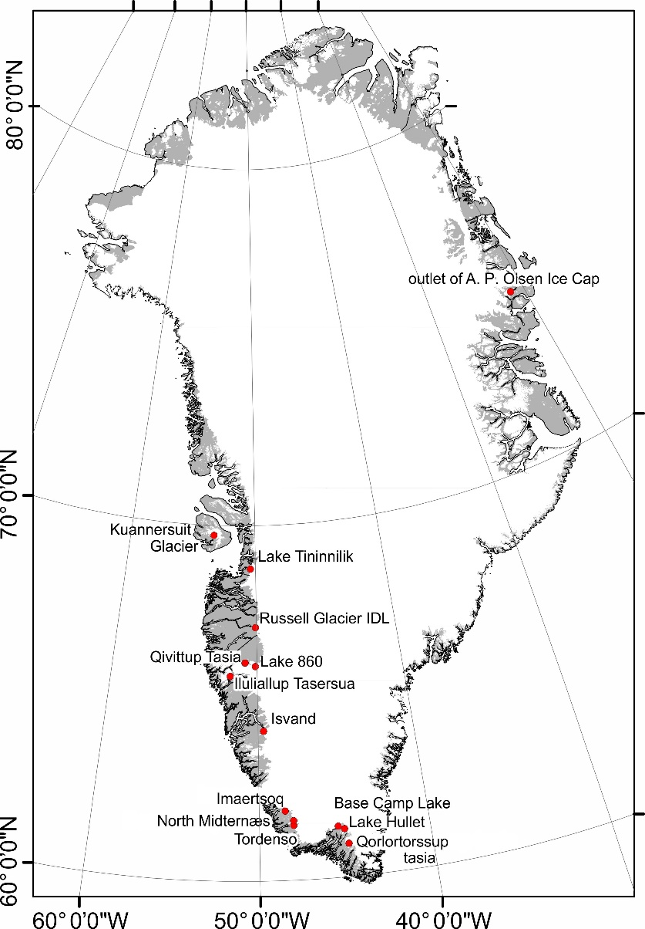
Figure 5. Overview of location of ice-dammed lakes that have been reported to produce glacier outburst floods in Greenland.

4.1 Isvand
Isvand (64º 13’ N, 49º 38’ W) is the earliest-described ice-dammed lake in Greenland, apparently appearing in written sources as early as the beginning of the 18th century (Weidick and Citterio, 2011) and named by Fridtjof Nansen at the culmination of his Greenland Ice Sheet (GrIS) crossing in 1888. The thinning of Kangiata Nunaata Sermia and the contemporaneous recession of the ice margin to Isvand was followed by a gradual growth of the ice-dammed lake from ~2 km² in 1888 to ~10 km² around 1960 (Fig. 6A). Satellite images (Fig. 6B) reveal that it drained in 2004 and again in 2009 (Weidick and Citterio, 2011). Those 2004 and 2009 drainages caused profound landscape impacts via changes in the proglacial hydrological routing; after ~ 250 years of permanent drainage to Ameralla fjord, Isvand now drains via Kangiata Nunaata Sermia to Kangersuneq fjord, as it did in the mediaeval epoch (Weidick and Citterio, 2011). In August 2018 the water level of Isvand was above that of 2010 but still relatively low at 409 m.asl and the wetted area was 9.05 km² (Fig. 6A).
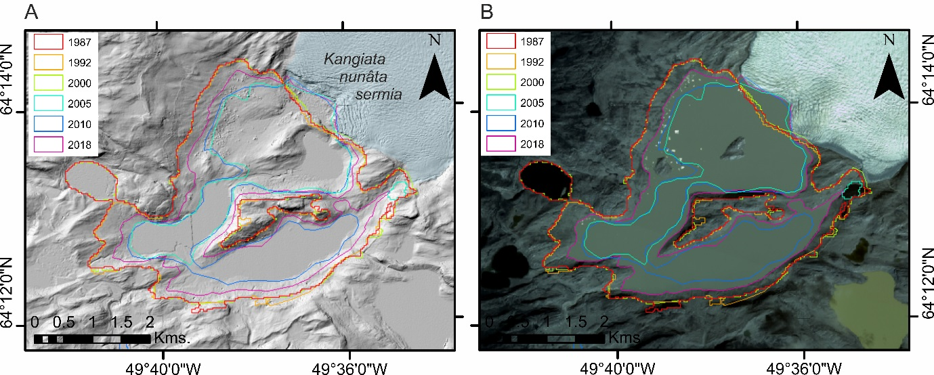
Figure 6. Lake Isvand in west Greenland with historical lake outlines derived from LandSat images (see Carrivick and Quincey, 2014) and from year 2018 Planet (2017) imagery, overlaid on the ArcticDEM mosaic (A) and a Planet (2017) image (B).

4.2 Russell Glacier
The most well-documented glacier outburst floods in Greenland have come from an ice-dammed lake at 67º 08’ N, 50º 04’ W on the northern margin of Russell Glacier (Fig. 7A) near Kangerlussuaq in west Greenland. This lake has formed repeatedly throughout the middle to late Holocene as the ice margin has advanced and retreated on a retrograde bedrock slope (Carrivick et al., 2018). There were outburst floods from this lake in 1945, 1953, 1974 (Gordan, 1986), 1984 (Sugden et al., 1985) and 1987 (Russell and de Jong, 1988; Scholz et al., 1988; Russell, 1989), and potentially also in 1968 and 1983 (Sugden et al., 1985). A new cycle of sudden lake drainages began in 2007 (Mernild et al., 2008; Russell et al., 2011) and continues to the present. In August 2018 the water level of the ice-dammed lake on the northern margin of Russell Glacier was very low at just 415 m.asl and the wetted area was 0.48 km² (Fig. 7B). Lake drainage events also have been reported from two small nearby ice-dammed lakes (Russell et al., 1990; Carrivick et al., 2018) but these lakes did not fill up after being drained.

The more recent floods from Russell Glacier ice dammed lake (IDL) have not only been studied at source (Russell et al., 2011; Carrivick et al., 2017b; Hasholt et al., 2018) but have also noted within gauged river water stage/discharge Watson River records at Kangerlussuaq (Mernild and Hasholt, 2009; Rennermalm et al., 2012; Hasholt et al., 2013; Yde et al. 2014, 2016), which is ~ 28 km down valley. The outburst floods affect fishing in the Kangerlussuaq fjord and farther beyond to coastal regions through sudden massive fluxes of suspended sediment and salinity changes (McGrath et al., 2010; Kjeldsen et al., 2014). Outburst floods from this part of the GrIS have been recognised in modern erosional and depositional landforms (Cesnulevicius et al., 2009; Carrivick et al., 2013), in Holocene braidplain deposits along the Watson River (Storms et al., 2012) and in terrestrial glacifluvial landforms situated far away from contemporary meltwater drainage and pertaining to the mid Holocene (Carrivick et al., 2017a). These glacifluvial landforms in the Russell Glacier area could be megaflood-type landforms because they are pervasive in the landscape despite having probably been formed in geologically-instantaneous time. They include bedrock canyons and spillways, streamlined bedrock hummocks, giant boulders mobilised by the floods (Fig. 2D), large-scale coarse gravel deltas and bars, erosional river terrace edges and large-scale outwash surfaces (Russell, 2007, 2009; Carrivick et al., 2013; Carrivick et al., 2017a). The diagnostic evidence of outburst floods in the Russell Glacier area extends to the sedimentology of the depositional landforms, which most distinctively comprises large-scale gravel-cobble cross-bedding that is often capped by an imbricated boulder lag (c.f. Maizels, 1997, 2002).
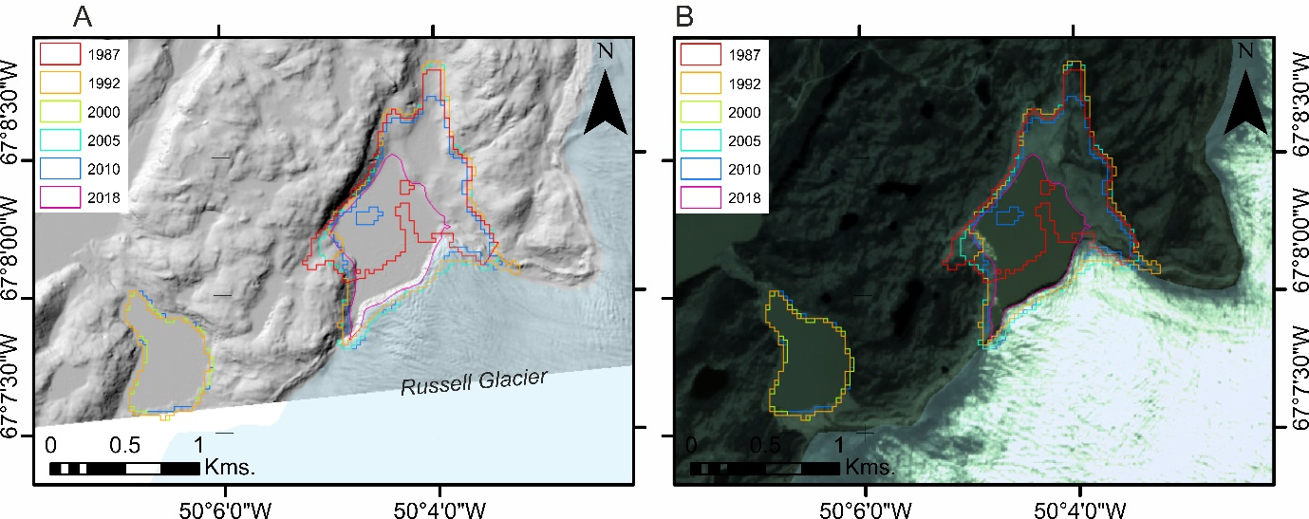
Figure 7. Ice-dammed lake on the northern margin of Russell Glacier in west Greenland with historical lake outlines derived from LandSat images (see Carrivick and Quincey, 2014) and from year 2018 Planet (2017) imagery, overlaid on the ArcticDEM mosaic (A) and a Planet (2017) image (B).

4.3 Kuannersuit Glacier
A 1.6 km long and 0.4 km wide ice-marginal lake formed at Kuannersuit Glacier (69°46′N, 53°15′W), which is on Qeqertarsuaq (formerly Disko Island) in west Greenland, as a result of a surge between 1995 and 1998 that advanced the glacier terminus by 10.5 km (Yde et al., 2019). The lake drained between the 11th and 13th August 2006 and did not re-fill but examination of the routing of water into and beyond the glacier before and after the drainage suggests that the outburst flood fundamentally changed the subglacial hydrological network (Yde et al., 2019). The most impressive landform produced by the outburst flood and exacerbated by the re-routed subglacial water was an ice-walled canyon through the Kuannersuit Glacier terminus (Yde et al., 2019) that is reminiscent of the ice-walled canyon produced in the 1996 Skeiðarárjökull outburst flood in Iceland (Russell et al., 2001; Burke et al., 2008). The surge produced a distinctive sedimentary signal in Kangerdluk (Disko Fjord) on Disko Island comprising diurnal laminations in fine-grained deposits and thin beds of sandy turbidites originating from slope failures on a delta front (Gilbert et al., 2002) but there has been no assessment of the sedimentological impact of the outburst flood.

4.4 Lake Tininnilik
Sudden ice-dammed lake drainage and glacier outburst floods have been reported from Lake Tininnilik (formerly known as Tiningilik) which is situated at 68º 46’ N, 50º 25’ W (Fig. 8A) for five occasions at ~ 10-year intervals between 1945 and 1985 (Braithwaite and Thomsen, 1984). Lake Tininnilik also outburst in 1993 and 2003 (Furuya and Wahr, 2005) and again in 2010 (Kelley et al., 2012). Braithwaite and Thomsen (1984) inferred a drainage time constant of 0.24 years and filling rates that varied by only about 10 % from one year to another. Furuya and Wahr (2005) found the total water volume lost during the 1993 jökulhlaup was ~ 2.3 km³. That volume is ~ 2/3 of the 1996 Grímsvötn outburst in Iceland (Gudmundsson et al., 1997) and ~ 1/4 of the volume of the flood generated by the 1918 eruption Katla in Iceland (Thorarinsson, 1974; Tómasson, 1996; Larsen, 2000), but we do not know over what time-frame the drainage lasted, so a peak discharge has never been proposed for floods from Lake Tininnilik. In August 2018 the level of Lake Tininnilik was above that in 2010, but still low at 207 m.asl and the wetted area was 28.94 km² (Fig. 8B).
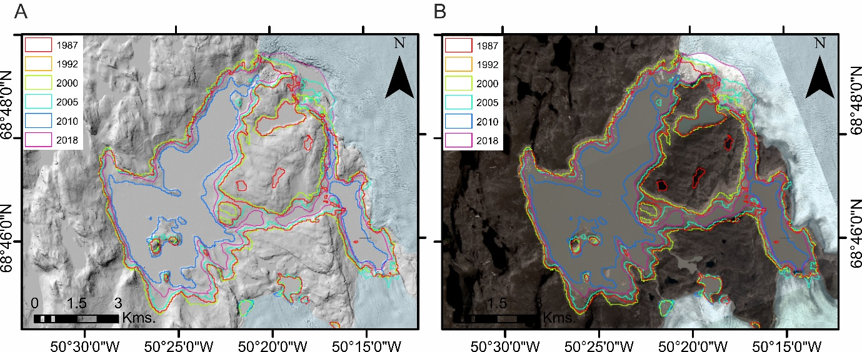
Figure 8. Lake Tininnilik in west Greenland with historical lake outlines derived from LandSat images (see Carrivick and Quincey, 2014) and from year 2018 Planet (2017) imagery, overlaid on the ArcticDEM mosaic (A) and a Planet (2017) image (B).

Unnamed lakes near the Amitsulooq Ice Cap
Qivittup Tasia (unofficial name) is a ~6 km² lake situated at 66°09’N, 50°54’W in west Greenland. It produced a jökulhlaup in August 2008 (Yde, 2011). Google Earth images indicate that it was full on 9th October 2009, drained on 22nd June 2011 and full on 11th July 2012. It appears partially drained in the ArcticDEM with a water level at 840 m.asl (Fig. 9A). No impacts of floods from Qivittup Tasia have ever been reported.
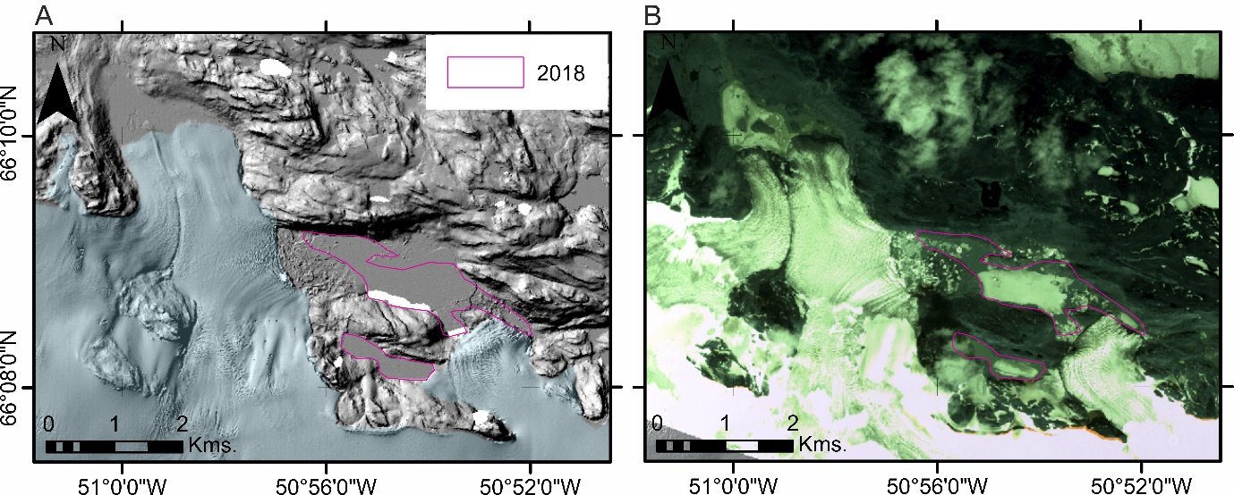

Figure 9. Qivittup Tasia (unofficial name) in west Greenland with lake outline for August 2018 derived from Planet (2017) imagery, overlaid on the ArcticDEM mosaic (A) and a Planet (2017) image (B).

Lake 860 (unofficial name by Olsen, 1986) at 66°00’N, 50°13’W just south of Amitsulooq Ice Cap and bordered by the Greenland Ice Sheet and Tasersiap Sermia (also known as Qaarajuttoq Ice Cap) (Fig. 10A) was reported by Olesen (1986) to have partially drained between 17th and 23rd August 1985. In 2018 it appeared full with a surface area of 85 km² (Fig. 10B). No impacts of floods from Lake 680 have ever been reported.

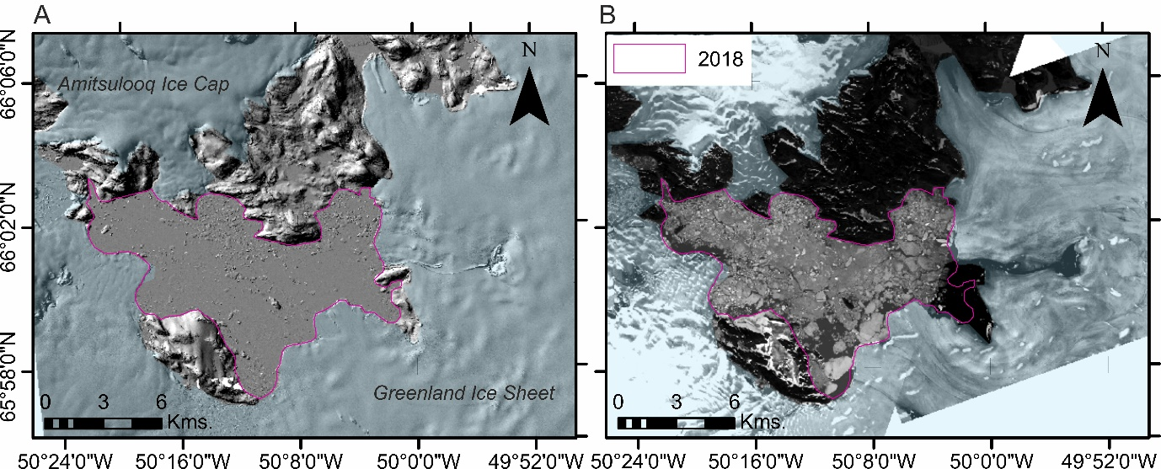
Figure 10. Lake 860 (unofficial name by Olsen, 1986) in west Greenland with lake outline for August 2018 derived from Planet (2017) imagery, overlaid on the ArcticDEM mosaic (A) and a Planet (2017) image (B).

4.6 Iluliallup Tasersua
Iluliallup Tasersua (previously known as Iluliagdlup Tasia) (Fig. 11A) is an ice-dammed lake situated at 65'45' N, 51'45' W that was first photographed in 1936 and repeated photographs since then and correspondence with people in Sukkertoppen, which is SW and 75 km away, has shown that the lake empties suddenly every five to seven years (Helk, 1966). When full, the lake has an area of 51 km² and when empty an area of 21 km² and the difference in the height of the water is ~ 180 m giving volume losses of ~ 6.4 km³ (Helk, 1966). That flood volume is comparable to the size of jökulhlaups in Iceland that produce megaflood-type impacts, but in contrast this is an ice-dammed lake outburst and not a volcanogenic flood. As with Lake Tininnilik, a peak discharge of outburst floods from Iluliallup Tasersua has never been proposed. The Iluliallup Tasersua floods route across valley-head sandar plains and into the fjord, so no distinctive flood impacts can be discerned in the terrestrial realm.

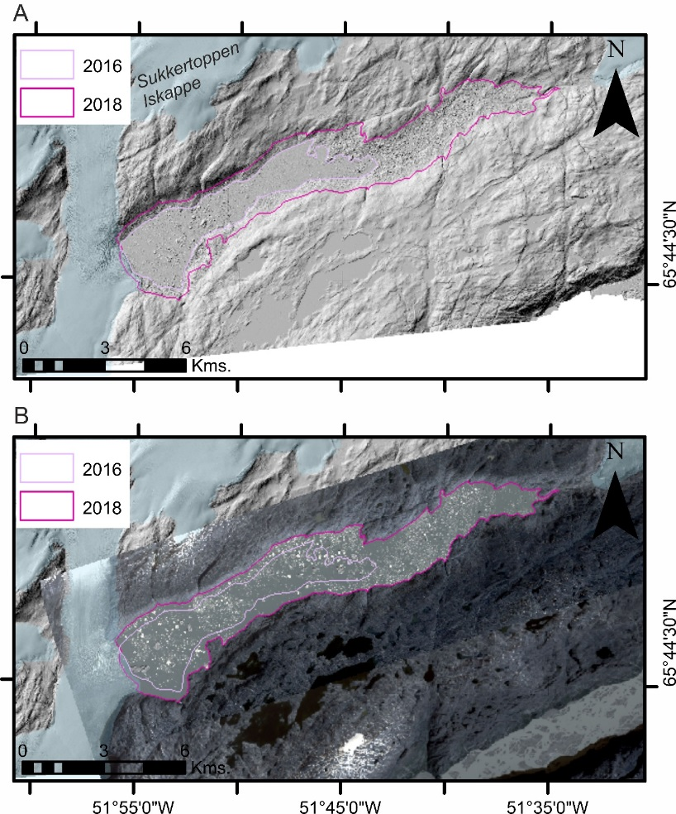
Figure 11. Iluliagdlup tasia in west Greenland with lake outlines derived from the ArcticDEM mosaic (A) and an August 2018 Planet (2017) image (B).

Iluliallup Tasersua was not considered by Carrivick and Quincey (2014) because it is not on the margin of the GrIS. However, it is evident in recent high-resolution data (Fig. 11B) that it (i) recently drained in 2016 to an area of 14.03 km² (ii) had refilled to a total area of 32.99 km² by August 2018 (Fig. 11A) and (iii) thus in just a few years had ~ 100 m gain in water surface elevation and thus ~ 2 km³ gain in volume.

4.7 Ice-dammed lakes in Johan Dahl Land
Base Camp Lake (unofficial name) is an ice-dammed lake at 61º 26’ N, 45º 20’ W on the eastern margin of Nordbogletscher, Johan Dahl Land, south Greenland (Fig. 12). In 1984 Clement (1984) reported that it drained annually by a submarginal stream to the proglacial lake Nordbosø and that the maximum water level and timing of that was virtually the same each year over a five-year time period. Nordbosø and Lake Hullet (Fig. 12) were linked during the mid-Holocene as indicated by palaeo-shorelines and moraines (Weidick, 1963; Dawson, 1983). Clement (1984) noted that Base Camp Lake did not appear to leak during filling and this was also found to be the case at Russell Glacier by Carrivick et al. (2017b). However, a key difference between the drainages of Base Camp Lake and those at Russell Glacier is that at Base Camp Lake the tapping level, i.e. the water level immediately after drainage, changes each year, whereas at Russell Glacier the tapping level is constant and it is the maximum water level that varies (Carrivick et al., 2017). Furthermore, and unusually amongst Greenland ice-dammed lakes, the drainage of Base Camp Lake is slow at ~ 2 months, because water initially breaks through the ice and overflows a threshold eventually eroding its way into and under the ice to become thereafter entirely submarginal or englacial (Clement, 1984). Exceptionally large drainages, as recorded by extremely low water levels and water level reductions of ~ 64 m occurred in 1953 and 1980 (Clement, 1984). At maximum water level the volume of Base Camp Lake is 12.8 million m³ and the area is 0.8 km³.

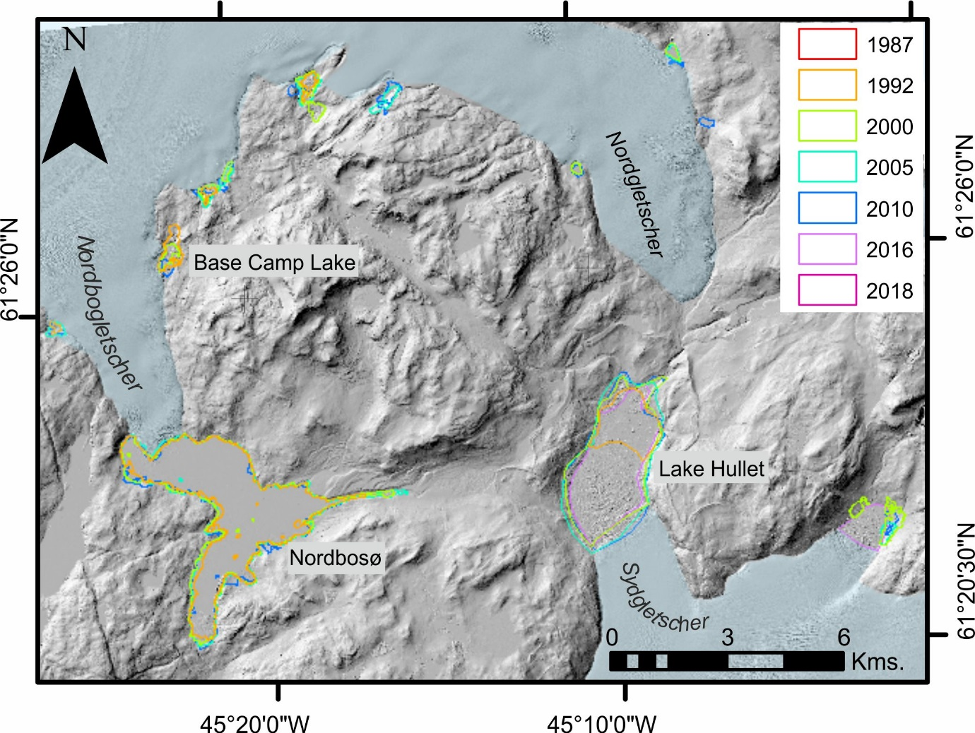
Figure 12. Lake Hullet, Nordbosø and Base Camp Lake Lake Isvand in Johan Dahl Land, south Greenland with historical lake outlines derived from LandSat images (see Carrivick and Quincey, 2014) and from year 2018 Planet (2017) imagery, overlaid on the ArcticDEM mosaic.

Lake Hullet situated at 61º 21’N, 45º 10’ W and 28 km NE of Narssarssuaq in Johan Dahl Land (Fig. 12) is one of the biggest ice-dammed lakes in south Greenland (Weidick, 1963). It drains primarily through Sydgletscher, which is unusual for flowing up-valley, i.e. with a retrograde bed slope, but also through the Kiagtût Sermiat glacier with a total subglacial tunnel length of ~ 23 km (Dawson, 1983). Information about its sudden outbursts are available back to 1957 (see citations in Clement, 1983). At least ten outbursts have been reported, each occurring at the end of a summer season or in the autumn with an interval of ~ 2 years (Clement, 1983a, b). The Lake Hullet water level decreases in each sudden drainage by ~ 110 m and given that the lake has an area 6.5 km² then the volume drained is typically ~ 600 x 10⁶ m³. The 1981 outburst had a peak discharge of ~ 200 m³s⁻¹ and a volume of 235 x 10⁶ m³ (Dawson, 1983). The largest outburst has been reconstructed from palaeo-shorelines to be 950 x 10⁶ m³ and was sufficient to cause pervasive landscape impact analogous to megaflood-type impacts via localised neotectonic crustal deformation; specifically faulting and displacement of shorelines, as well as rapid deglaciation of the Rundesø glacier outlet lobe (Dawson, 1983). The Lake Hullet outbursts temporarily disrupt proglacial drainage, especially due to sudden and widespread and intense deposition of ice blocks. The floods inundate the river plain at Narssarssuaq and the enormous amount of fresh water affects the hydrographic system of the Tunugdliarfik fjord. In 2018 Lake Hullet was refilling from a water level elevation of 500 m.asl and from a minimum surface area of 5.2 km² (Fig. 13).

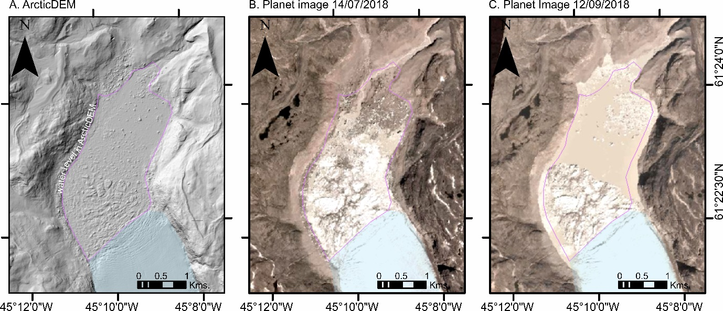
Figure 13. Lake Hullet with a water level at ~ 500 m.asl (A) and with steadily increasing water level throughout the summer of 2018 (B, C).

4.8 Qorlortorssup Tasia
Qorlortorssup Tasia (Fig. 14A) situated at 60º 55’ N, 44º 51’ W in south Greenland is fed by an ice-marginal lake within a basin that is empty of glacier ice. Mayer and Schuler (2005) report that this lake was impounded by an ice dam in 2005. This setting is similar to that at Russell Glacier and indeed so is the drainage event trigger: as the ice dam at Qorlortorssup Tasia thins it permits water to escape beneath it (Mayer and Schuler, 2005). The lake area increased from about 1.7 km² in 1942 to 2.25 km² in 1985 and during the same time the front of the dam retreated ~ 1 km, followed by a further retreat of 600 m between 1985 and 2003 (Mayer and Schuler, 2005). The final maximum extent of the lake in 2003 was 2.9 km² and ~ 55 x 10⁶m³ of water drained during an eight to ten-day period (Mayer and Schuler, 2005). Mayer and Schuler (2005) noted that the 2003 outburst re-routed subglacial(?) water and that flow became at least an order of magnitude greater than before the lake drainage. In Carrivick and Quincey’s (2014) analysis the lake was not detected as being ice-marginal (Fig. 14B) but in the analysis of this paper it can be shown that in August of 2018 the lake was not ice-dammed and the lake level was low at 1040 m.asl and with an area of just 1.25 km² (Fig. 14A). There has never been an analysis of the impacts of floods from Qorlortorssup Tasia.
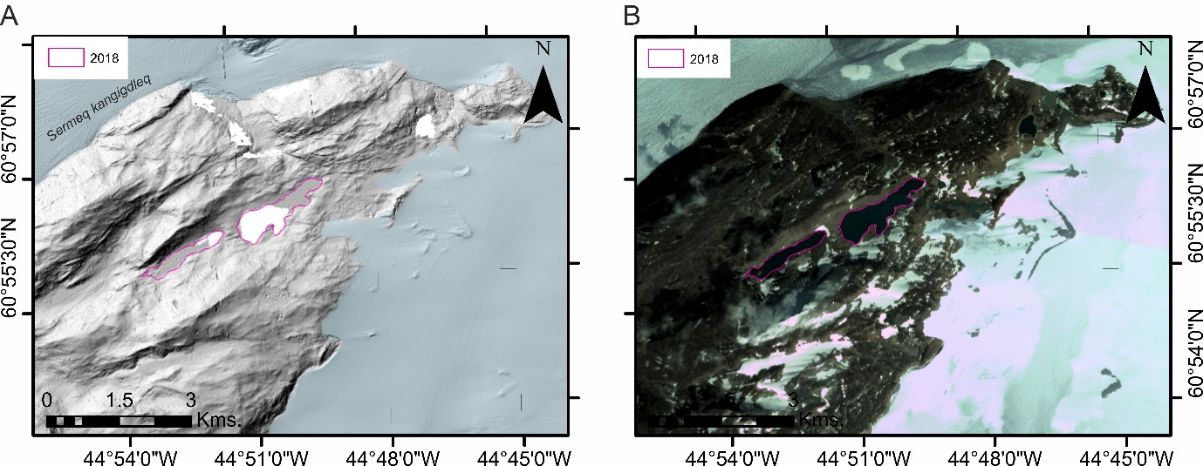
Figure 14. Qorlortorssup Tasia in south Greenland with lake outline derived from year 2018 Planet (2017) imagery, overlaid on the ArcticDEM mosaic (A) and a Planet (2017) image (B).

4.9 Ice-dammed lakes in Frederikshåb region
The ice-dammed lakes of Imaersartoq at 61º 57’ N, 48º 28’ W (Fig. 15A), Tordensø at 61º 33’ N, 47º 56’ W (Fig. 15A) and a temporary lake in the North Midternæs (61º 41’ N, 47º 59’ W) (Fig. 13A), part of Frederikshåb region of south Greenland, were all described by Higgins (1970). These three lakes empty periodically by subglacial drainage in the Frederikshab district, south-west Greenland. No landscaping impacts have been described for the floods from these lakes.

Drainages of Imaersartoq ‘A’ (Fig. 15B) which when full is 4.7 km², and of another 2 km² lake nearby and connected to it informally named as ‘Imaersartoq B’ (Higgins, 1970) have long been recognised to discharge ice bergs down valley into Sermilik fjord past the settlement of Narssalik (Fabricius, 1788; Rink, 1862, both cited in Higgins, 1970). The difference between high and low water levels in both lakes is about 50 m yielding drainage volumes of at least ~ 285 x 10⁶ m³ of water not accounting for water beneath the floating glacier termini (Higgins, 1970). Imaersartoq appeared to drain annually and usually in late August between 1942 and 1968 (Higgins, 1970).
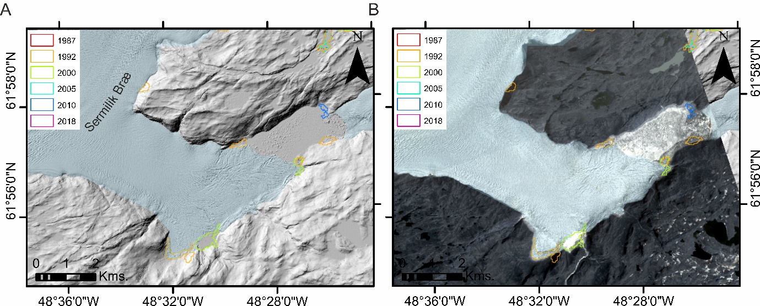
Figure 15. Imaersartoq in the Frederikshåb region of south Greenland with historical lake outlines derived from LandSat images (see Carrivick and Quincey, 2014) and from year 2018 Planet (2017) imagery, overlaid on the ArcticDEM mosaic (A) and a Planet (2017) image (B).

Tordensø is situated about 15 km east of the front of Sioralik Bræ (Fig. 16A) between the mainland of Midternæs and a large nunatak. Glaciers dam the lake at the east and west ends, in a situation comparable with Imaersartoq. The surface area of Tordensø at highest water levels is about 4.8 km², the maximum difference in water levels is ~ 160 m and so the volume of water released when Tordensø drains is of the order of 605 x 10⁶ m³, excluding water supporting the floating part of the west glacier at high water levels (Higgins, 1970). Tordensø probably emptied regularly, between 1942 and 1967 but at intervals of ~ 2 years (Higgins, 1970). In August 2018 the water level of Tordenso was at 360 m.asl and with an area of 3.74 km² (Fig. 16B).
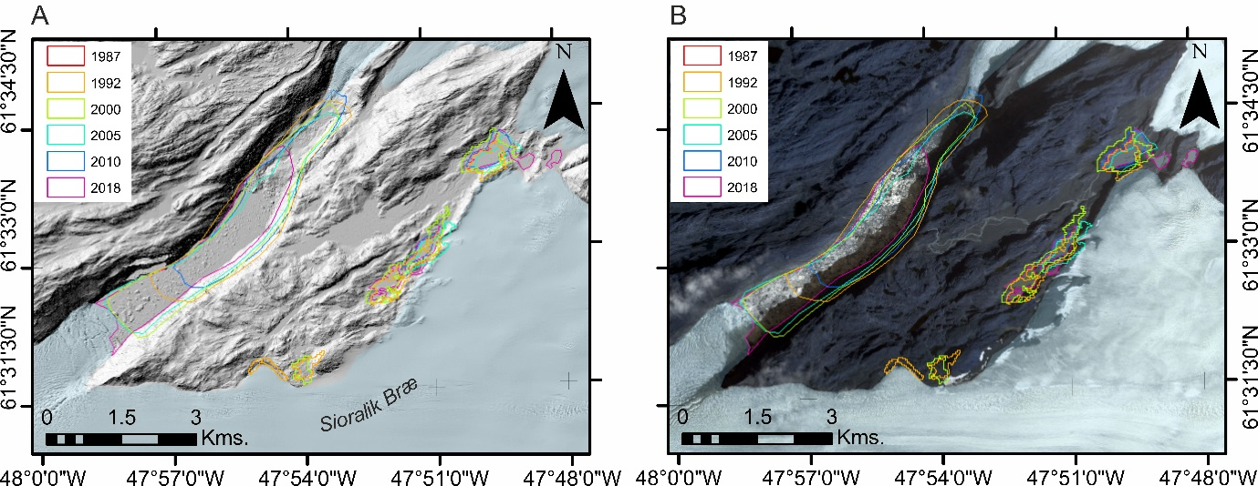
Figure 16. Tordensø in the Frederikshåb region of south Greenland with historical lake outlines derived from LandSat images (see Carrivick and Quincey, 2014) and from year 2018 Planet (2017) imagery, overlaid on the ArcticDEM mosaic (A) and a Planet (2017) image (B).
North Midternæs temporary lake (Fig. 17A) is situated ~ 20 km north-east of the front of Sermiligârssuk Bræ and has many lacustrine terraces surrounding it. These terraces could either mean that i) the critical water level for sudden lake drainage varies from year to year, or ii) the higher terraces were formed when the glacier front was differently configured or the glacier dam was higher/thicker (Higgins, 1970). The glacier dam is < 70 m high and in August 2018 the water level was very high at 499 m.asl. and was impounding up to 4.99 km² of lake water (Fig. 17B). Therefore the volume of water released during sudden drainage is ~ 70 x 10⁶ m³ and drainages occurred ~ annually between 1942 and 1967, typically in late July (Higgins, 1970).

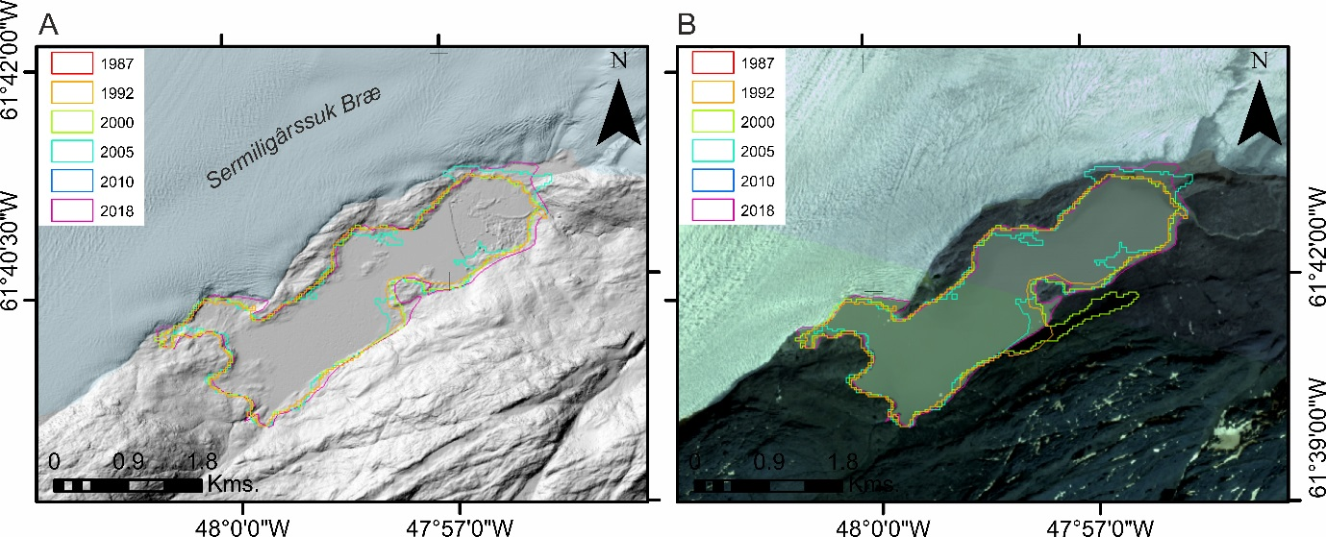
Figure 17. North Midternæs in the Frederikshåb region of south Greenland with historical lake outlines derived from LandSat images (see Carrivick and Quincey, 2014) and from year 2018 Planet (2017) imagery, overlaid on the ArcticDEM mosaic (A) and a Planet (2017) image (B).

4.10 A. P. Olsen Ice Cap
The only sudden lake drainages and consequent glacier outburst floods reported from locations other than west and south Greenland are those of an ice-dammed lake that is situated at 21º 23’ W on the margin of an outlet glacier of the A. P. Olsen Ice Cap in north-east Greenland (Fig. 18A). Floods from this ice-dammed lake route 38 km along Store-Sødal and past Zackenberg research station, where there is a hydrological gauging station that has enabled their detection. The first known glacial lake outburst was in 2005 and since then floods have been virtually annual, with durations of just one to two days (APRI, 2018). The lake drained completely between 4th and 8th August 2017 from an area of 0.64 km² (Fig. 18B, C) but from Planet (2017) imagery there is no indication that it drained in 2018. The approximate volume of the outbursts is 5 to 10 x 10⁶ m³ (APRI, 2018) and that is sufficient to strongly influence suspended sediment, mineral and nutrient exports from the catchment (Hasholt and Hagedorn, 2000; Hasholt et al., 2008; Søndergaard et al., 2015).

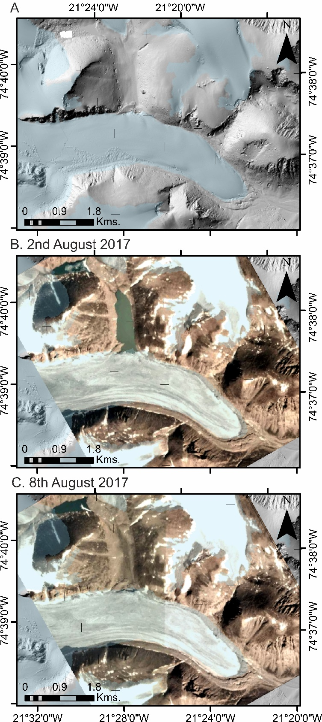
Figure 18. Ice-dammed lake on the eastern margin of an outlet glacier of the A. P. Olsen Ice Cap in north east Greenland as represented in the ArcticDEM mosaic (A) and as seen to have drained completely in August 2017 in Planet (2017) images (B, C).

The geological record of outburst floods from Iceland and Greenland
Given that glacier outburst floods are common in Iceland and Greenland, it stands to reason that they were also common in the past. However, there are two issues to identifying and understanding the geological record of outburst floods in Iceland and Greenland and these issues are no different to analyses of outburst floods and megafloods worldwide. Firstly, despite the sudden onset, high-magnitude nature of these flows both in terms of peak discharge and volume, the creation of diagnostic landforms and the subsequent preservation of those landforms is not necessarily guaranteed (Marren, 2005; Carrivick and Rushmer, 2006, 2009). For example, in terrestrial settings landforms can be created and destroyed within a single outburst flood, destroyed or subdued by successive floods or buried by sedimentation under normal flow conditions. Secondly, eventual detection of outburst flood landforms and sediments requires a variety of data, a coordinated research effort and expertise to piece together what will inevitably be a disparate and partly ambiguous set of landform and sedimentary evidence. Nonetheless, with care compelling models of the landscape impact of discrete extreme outburst floods events can be reconstructed (e.g. Lamb et al., 2014; Baynes et al., 2015b).

In Iceland the geological record of megafloods is limited to terrestrial settings in which the flood source was far from the coastline and in which contemporary environmental processes have been insufficient to remove or obscure that impact. The distal parts of the Jökulsá á Fjöllum, especially the Ásbyrgi and Dettifoss canyons (section 3.3), are perhaps the best examples but also the Gullfoss waterfall and the Hvítá canyon (section 3.1) have been attributed to sudden drainage of an extremely large proglacial lake. In contrast, there is widespread recognition of vast areas of outwash gravels deposited from high-energy outburst floods becoming hyperpycnal flows as they enter the ocean, especially off the south coast of Iceland, from both modern and ancient outburst floods (e.g. Lacasse et al., 1998; Carey et al., 2000; Geirsdóttir et al., 2000; Jennings et al., 2000; Maria et al., 2000; Mulder et al., 2003; Mulder and Chapron, 2011; Van Vliet-Lanoë et al., 2017).

In Greenland the situation of preserved megaflood impacts is similar to that in Iceland, whereby the majority of outburst floods discharge immediately onto valley-confined sandar or into fjords. Therefore even the very largest outburst floods leave very little diagnostic terrestrial landform and sedimentary evidence, but can be recognised in estuarine or fjord-head deltas (e.g. Storms et al., 2012). Where land-terminating parts of the Greenland Ice Sheet or Greenland’s peripheral glaciers and ice caps are far from the coastline, then evidence of past (Holocene) outburst floods has been recognised as bedrock canyons, streamlined hillocks, perched deltas and inactive outwash plains that are situated far from contemporary surface drainage routes (Carrivick et al., 2016). Additionally, in rare cases a suite of evidence can be brought together to unequivocally identify outburst floods in the Quaternary geological record in Greenland; Dam (2002) has shown that two valleys in the Nuussuaq Basin, west Greenland, were incised along normal faults and infilled by up to 120 m thick deposits of large-scale, low-angle, cross-bedded pebbly sandstones and conglomerates. These deposits have a sedimentology indicating rapid deposition from outburst flood(s) characterised by high concentrations of suspended coarse-grained sediment load (Dam, 2002). Dam also argued for a rapid decrease in that outburst flow and the establishment of a lacustrine environment within the valley(s). Dam (2002) reports that these deposits in west Greenland correspond to megaflood deposits described elsewhere by Baker (1973) and Carling (1996), for example, for glacier outburst floods in valley-confined settings and he asserts that a similar origin for the deposits in the Nuussuaq Basin is possible, although with an influence of tectonic faulting.

The few sediment cores that have been retrieved from offshore in Greenland come from estuaries and fjord heads and they all contain evidence of episodes of accumulation of vast volumes of relatively coarse-grained sediments and hyperpycnal deposits (e.g. Lloyd et al., 2005; Moros et al., 2006; Ó Cofaigh et al., 2013; Jennings et al., 2014; Gilbert et al., 2017). Most of these analyses have been conducted on ancient sediments and have not attributed a specific timing or duration to the emplacement of these deposits; i.e. a particular meltwater-sediment flux runoff regime has not been determined. It therefore seems reasonable to suggest that for most parts of Greenland the geological record of outburst floods, perhaps of megafloods, has yet to be detected. Indeed, Willems et al. (2011) have suggested that glacier outburst flood deposits in shallow marine settings are probably far more widespread than previously thought due to having similar sedimentological properties to normal proximal glacimarine accumulation.

Large glacier outburst floods in Iceland and Greenland might be detected in the geological record by identifying evidence of stress unloading as lakes suddenly drain, such as the faulted shorelines at Lake Hullet in west Greenland (Dawson, 1983). Alternatively, a seismic tremor can be caused by the propagation of an outburst flood wave through a pressurised glacier hydrological network, as noted at Grænalón in Iceland (Roberts et al., 2005). Evidence of unloading or of seismic tremors cannot be uniquely diagnostic of outburst floods however because they have been noted in Greenland to be caused by normal ablation-fed water movement (e.g. Bartholomaus et al., 2015).

Future large glacier outburst floods in Iceland and Greenland
Over half of the volcanic systems in Iceland considered active in the Holocene are overlain by glacier ice (Pagnuex et al., 2015a). There is a relationship between glacier retreat and thinning and increased volcanic activity (Pagli and Sigmundsson, 2008; Tuffen, 2010); in Iceland renewed volcanic activity could clearly signal eruptions that give rise to jökulhlaups. Volcanically-generated glacier outburst floods are likely to persist for at least another two centuries, despite the impact of climate change on ice cover (Jóhannesson et al., 2012). Over the last few years, particularly in the wake of the Eyjafjallajökull eruption and associated floods, attention has been focused on the possibility of large jökulhlaups from Katla and Öræfajökull (e.g. Pagneux et al., 2015b). In July 2011, there was a deepening of ice cauldrons on Mýrdalsjökull and a glacial flood that swept away the Múlakvísl bridge and damaged sections of road (Veðurstofa Íslands, 2011). There have been seismic swarms over recent years, usually intensifying in late summer and autumn. Yet, if the seismic record is examined, similar unrest has taken place at Katla several times since the 1950s without resulting in an explosive eruption. Some studies indicate that there is magma storage in the roots of the volcano (Veðurstofa Íslands, 2018), but there are currently no signs of this moving. Öræfajökull has also been under greater surveillance recently. In November 2017, there was a period of increased seismic activity and an ice cauldron 1 km wide and 15 to 20 m deep developed in the ice-covered caldera, fuelling speculation about an eruption (McGarvie et al., 2017). The development of the ice cauldron was associated with geothermal activity in the Öræfajökull caldera from which there was a steady release of geothermal water through Kvíarjökull (Veðurstofa Íslands, 2017). It could be as little as 20 minutes from the eruption onset to floods reaching populated areas and infrastructure hence Öræfajökull, like Katla, is carefully monitored. The potential for floods large enough to exhibit megaflood attributes and impacts from both volcanoes exists, but the future temporal evolution of events in Katla and Öræfajökull, along with other glacierised volcanoes in Iceland, is uncertain.

In Greenland, ongoing climate change and consequent deglaciation is causing glacier termini to retreat and thin and thus according to the jökulhlaup cycle (Evans and Clague, 1994) successive floods would be expected to become smaller. However, recently many lakes have drained apparently for the first time during the satellite era (Carrivick and Quincey, 2014) and some of these lakes are truly vast (e.g. Lake 480, Iluliallup Tasersua, Lake Tininnilik). Furthermore, ongoing climate change is also causing record ice surface melt across the GrIS and in July 2012, due to unusually warm air temperatures (e.g. Ngheim et al., 2012), ice melt was augmented by unprecedented supraglacial lake drainage (Fitzpatrick et al., 2014). Runoff from the GrIS, as recorded by a gauge on the Watson River at Kangerlussuaq, reached a record high, which was reached via a tripling of discharge in just two days (Mikkelsen et al., 2016). Whilst this event in Greenland in July 2012 was not itself an outburst flood in the strictest sense, the rapid onset, record flow magnitude and exceptional hydraulic power that it produced are all characteristics of an outburst flood. There has never been an analysis of the landscape impact of this latter type of flows, nor whether the record melt rapidly filled and/or caused drainage of any ice-marginal lakes in Greenland. As climate change proceeds, it is reasonable to expect more record melt, more record runoff and perhaps therefore large outburst floods in Greenland that are large enough to have megaflood-type impacts.

Conclusions
In terms of total flood volume or peak discharge, few glacier outburst floods in Iceland and Greenland are true megafloods. However, in terms of erosional and depositional impacts, which were formed over very short time scales (often hours to days) and which are pervasive in the landscape and geological record, several Iceland and Greenland jökulhlaups can be identified to have megaflood attributes, most notably in their extensive landscape impact. For these impacts to have been produced in this manner, then the hydraulics of these floods must have been comparable to those of megafloods, whether bed shear stress was sufficient to cause bedrock erosion, high sediment transport capacity (very high volume) and extreme flood competence permitting the transport very high calibre boulders where they were available (Fig. 2), for example.

Nonetheless, there is a still a question as to the extent to which the impacts of volcanically-generated floods, which account for the majority of jökulhlaups in Iceland, can be used as analogues to Quaternary megafloods, because the trigger mechanisms and hence the flood routing and resultant hydrograph are likely to be different. For example, floodwater routing through multiple outlets across the flanks of Kverkfjöll and Dyngjujökull on the north of Vatnajökull, or the multiple outlets attributed to single floods into the Markarfljót (e.g. Smith and Dugmore, 2006) are unlikely to be representative of many Quaternary ice-dammed lake outburst floods where a dam breach and a single channel for initial floodwater egress is more likely.

In Greenland many more ice-dammed lakes and many more sudden ice-dammed lake outbursts probably occur than have been detected and reported. Of those lake drainages that have been reported, some have been of a volume that would suggest the resultant floods were capable of producing megaflood-type impacts. However, there has been no analysis of the landscapes and landforms downstream of large ice-dammed lakes in Greenland. The exception is at Russell Glacier, near Kangerlussuaq where the landscape in the vicinity Russell Glacier has been studied and does contain bedrock canyons and giant fluvially-transported boulders (Carrivick et al., 2016), which are megaflood-type landforms. Furthermore, almost all the ice-dammed lakes in Greenland that have been reported to have drained have done so multiple times within a few years as the lake basins refill with ablation-fed meltwater. This frequency of flooding in Greenland contrasts strongly with the decades in between volcanically-generated floods in Iceland and the millennia between the few megafloods in Iceland and megafloods elsewhere. This repeated outburst flooding in Greenland means i) sustained high sedimentation rates in confined valley sandar and so a flood signature in those sediments is obscured and ii) most impacts of Greenland floods are probably offshore.

More widely, there remain several unresolved questions in the study of large glacier outburst floods that are not specific to Iceland and Greenland floods but are important in determining the geomorphological and sedimentary impacts of extremely large jökulhlaups; i.e. a megaflood signature. For example, trigger mechanisms are negated in models of outburst flooding (c.f. Carrivick et al., 2017b). We cannot constrain the processes that occur at flood initiation sufficiently to be able to identify why some floods have a rapid rise to peak discharge and some develop more slowly. We rarely have enough data to parameterise and validate models of outburst floods that include sediment transport (e.g. Carrivick et al., 2009b, 2010, 2013) and geomorphological changes via bed and bank evolution (e.g. Guan et al., 2015).

Acknowledgements
Thank you to special issue editor Paul Carling for inviting us to contribute to this body of work and for his assistance with the scoping of this paper. Thank you to an anonymous reviewer and to Edwin Baynes who very helpfully suggested amendments to improve the coherence of this paper.

References
Alho, P. and Aaltonen, J., 2008. Comparing a 1D hydraulic model with a 2D hydraulic model for the simulation of extreme glacial outburst floods. Hydrological Processes: An International Journal, 22(10), pp.1537-1547.
Alho, P., Russell, A.J., Carrivick, J.L. and Käyhkö, J., 2005. Reconstruction of the largest Holocene jökulhlaup within Jökulsá á Fjöllum, NE Iceland. Quaternary Science Reviews, 24(22), pp.2319-2334.
APRI., 2018. Glacier lake outburst flood in Greenland. http://www.polarresearch.at/glacier-lake-outburst-flood-in-greenland/ last visited in November 2018.
Baker, V.R., 1973. Paleohydrology and sedimentology of Lake Missoula flooding in eastern Washington. Geol. Soc. Amer. Spec. Pap., 144, 79 pp.
Baker, V.R., 1996. Megafoods and glaciation. In: Late Glacial and Postglacial Environmental Changes (Ed. Martini, I.P.), pp. 98-108. Oxford University Press, NY.
Baker, V.R., 2002. High-energy megafloods: planetary settings and sedimentary dynamics. In: Martini, P., Baker, V.R., Garzon, G. (Eds.), Flood and Megaflood Processes and Deposits: Recent and Ancient Examples. IAS Special Publication 32, Blackwell, Oxford, UK, pp. 3-15.
Bartholomaus, T.C., Amundson, J.M., Walter, J.I., O'Neel, S., West, M.E. and Larsen, C.F., 2015. Subglacial discharge at tidewater glaciers revealed by seismic tremor. Geophysical Research Letters, 42(15), pp.6391-6398.
Baynes, E.R., Attal, M., Dugmore, A.J., Kirstein, L.A. and Whaler, K.A., 2015a. Catastrophic impact of extreme flood events on the morphology and evolution of the lower Jökulsá á Fjöllum (northeast Iceland) during the Holocene. Geomorphology, 250, pp.422-436.
Baynes, E.R., Attal, M., Niedermann, S., Kirstein, L.A., Dugmore, A.J. and Naylor, M., 2015b. Erosion during extreme flood events dominates Holocene canyon evolution in northeast Iceland. Proceedings of the National Academy of Sciences, p.201415443.
Bennett, M.R., Huddart, D. and McCormick, T. 2000. An integrated approach to the study of glaciolacustrine landforms and sediments: a case study from Hagavatn, Iceland. Quaternary Science Reviews 19, 633-665.
Björnsson, H., 1974. Explanation of jökulhlaups from Grímsvötn, Vatnajökull, Iceland. Jökull 24, 1-26.
Björnsson, H. 1975. Subglacial water reservoirs, jökulhlaups and volcanic eruptions. Jökull 25, 1-11.
Björnsson, H. 1976. Marginal and Supraglacial Lakes in Iceland. Jökull 26, 40-50.
Björnsson, H., 1977. The cause of jökulhlaups in the Skaftá river, Vatnajökull. Jökull 27, 71-78.
Björnsson, H., 1978. Subglacial Water Reservoirs, Jökulhlaups and Volcanic Eruptions. Jökull 25, 1-15.
Björnsson, H., 1988. Hydrology of Ice Caps in Volcanic Regions 45, Societas Scientarium Islandica, Reykjavík.
Björnsson, H., 1992. Jökulhlaups in Iceland: prediction, characteristics and simulation. Annals of Glaciology 16, 95-106.
Björnsson, H., 1998. Hydrological characteristics of the drainage system beneath a surging glacier: Nature 395, 771-774.
Björnsson, H., 2002. Subglacial lakes and jökulhlaups in Iceland. Global and Planetary Change, 35, 255-271.
Björnsson, H., 2010. Understanding jökulhlaups: from tale to theory. Journal of Glaciology 56, 1002-1010.
Björnsson, H. and Einarsson, P. 1991. Volcanoes beneath Vatnajökull, Iceland: evidence from radio echo-sounding, earthquakes and jökulhlaups. Jökull 40, 147-168.
Björnsson, H., Pálsson, F., and Gudmundsson, M.T., 2000. Surface and bedrock topography of the Mýrdalsjökull ice cap, Iceland: The Katla caldera, eruption sites and routes of jökulhlaups. Jökull 49, 29-46.
Braithwaite, R. J., and H. H. Thomsen (1984), Runoff conditions at Kuussuup Tasia, Christianshab, estimated by modeling, Gletscher‐Hydrol. Meddelelser 84(2), 23 pp., Greenlands Geol. Underseegelse, Copenhagen.
Burke, M.J., Woodward, J., Russell, A.J., Fleisher, P.J. and Bailey, P.K., 2008. Controls on the sedimentary architecture of a single event englacial esker: Skeiðarárjökull, Iceland. Quaternary Science Reviews, 27(19-20), pp.1829-1847.
Carey, S., Maria, A. and Sigurdsson, H., 2000. Use of fractal analysis for discrimination of particles from primary and reworked jökulhlaup deposits in SE Iceland. Journal of Volcanology and Geothermal Research, 104(1-4), pp.65-80.
Carling, P.A., 1996. Morphology, sedimentology and palaeohydraulic significance of large gravel dunes, Altai Mountains, Siberia. Sedimentology, 43(4), pp.647-664.
Carling, P.A., 2013. Freshwater megaflood sedimentation: What can we learn about generic processes? Earth Science Reviews 125, 87-113.
Carling, P.A., Martini, I.P., Herget, J., Boradavko, P. and Parnachov, S. 2009. Megaflood sedimentary fill: Altai Mountains, Siberia. (Chapter 13) In: Burr, D.M., Carling, P.A. and Baker, V.R. (Eds.) Megaflooding on Earth and Mars. CUP, pp. 243-264.
Carling, P.A., Villaneuva, I., Herget, J., Wright, N., Boradavko, P. and Morvan, H. 2010. Unsteady 1D and 2D hydraulic models with ice dam break for Quaternary megaflood, Altai Mountains, southern Siberia. Global and Planetary Change 70, 24-34.
Carrivick, J.L. and Quincey, D.J., 2014. Progressive increase in number and volume of ice-marginal lakes on the western margin of the Greenland Ice Sheet. Global and Planetary Change, 116, pp.156-163.
Carrivick, J.L. and Rushmer, E.L., 2006. Understanding high‐magnitude outburst floods. Geology Today, 22(2), pp.60-65.
Carrivick, J.L. and Rushmer, E.L., 2009. Inter-and intra-catchment variations in proglacial geomorphology: an example from Franz Josef Glacier and Fox Glacier, New Zealand. Arctic, Antarctic, and Alpine Research, 41(1), pp.18-36.
Carrivick, J.L. and Twigg, D.R., 2005. Jökulhlaup-influenced topography and geomorphology at Kverkfjöll, Iceland. Journal of Maps, 1(1), pp.7-17.
Carrivick, J.L., 2004. Characteristics and impacts of jökulhlaups (glacial outburst floods) from Kverkfjöll, Iceland (Doctoral thesis, University of Keele, UK).
Carrivick, J.L., 2006. Application of 2D hydrodynamic modelling to high-magnitude outburst floods: an example from Kverkfjöll, Iceland. Journal of Hydrology, 321(1-4), pp.187-199.
Carrivick, J.L., 2007a. Hydrodynamics and geomorphic work of jökulhlaups (glacial outburst floods) from Kverkfjöll volcano, Iceland. Hydrological Processes: An International Journal, 21(6), pp.725-740.
Carrivick, J.L., 2007b. Modelling coupled hydraulics and sediment transport of a high-magnitude flood and associated landscape change. Annals of Glaciology, 45, pp.143-154.
Carrivick, J.L., 2009. Jökulhlaups from Kverkfjöll volcano, Iceland: modelling transient hydraulic phenomena. Megaflooding on Earth and Mars, p.273.
Carrivick, J.L., 2011. Jökulhlaups: geological importance, deglacial association and hazard management. Geology Today, 27(4), pp.133-140.
Carrivick, J.L., Russell, A.J. and Tweed, F.S., 2004a. Geomorphological evidence for jökulhlaups from Kverkfjöll volcano, Iceland. Geomorphology, 63(1-2), pp.81-102.
Carrivick, J.L., Russell, A.J., Tweed, F.S. and Twigg, D., 2004b. Palaeohydrology and sedimentary impacts of jökulhlaups from Kverkfjöll, Iceland. Sedimentary Geology, 172(1-2), pp.19-40.
Carrivick, J.L., Pringle, J.K., Russell, A.J. and Cassidy, N.J., 2007. GPR-derived sedimentary architecture and stratigraphy of outburst flood sedimentation within a bedrock valley system, Hraundalur, Iceland. Journal of Environmental & Engineering Geophysics, 12(1), pp.127-143.
Carrivick, J.L., Russell, A.J., Rushmer, E.L., Tweed, F.S., Marren, P.M., Deeming, H. and Lowe, O.J., 2009a. Geomorphological evidence towards a de‐glacial control on volcanism. Earth Surface Processes and Landforms, 34(8), pp.1164-1178.
Carrivick, J.L., Manville, V. and Cronin, S.J., 2009b. A fluid dynamics approach to modelling the 18th March 2007 lahar at Mt. Ruapehu, New Zealand. Bulletin of Volcanology, 71(2), pp.153-169.
Carrivick, J.L., Manville, V., Graettinger, A. and Cronin, S.J., 2010. Coupled fluid dynamics-sediment transport modelling of a Crater Lake break-out lahar: Mt. Ruapehu, New Zealand. Journal of hydrology, 388(3-4), pp.399-413.
Carrivick, J.L., Turner, A.G., Russell, A.J., Ingeman-Nielsen, T. and Yde, J.C., 2013. Outburst flood evolution at Russell Glacier, western Greenland: effects of a bedrock channel cascade with intermediary lakes. Quaternary Science Reviews, 67, pp.39-58.
Carrivick, J.L., Tweed, F.S., Carling, P., Alho, P., Marren, P.M., Staines, K., Russell, A.J., Rushmer, E.L. and Duller, R., 2013. Discussion of ‘Field evidence and hydraulic modeling of a large Holocene jökulhlaup at Jökulsá á Fjöllum channel, Iceland’ by Douglas Howard, Sheryl Luzzadder-Beach and Timothy Beach, 2012. Geomorphology, 201, pp.512-519.
Carrivick, J.L., Yde, J., Russell, A.J., Quincey, D.J., Ingeman‐Nielsen, T. and Mallalieu, J., 2017a. Ice‐margin and meltwater dynamics during the mid‐Holocene in the Kangerlussuaq area of west Greenland. Boreas, 46(3), pp.369-387.
Carrivick, J.L., Tweed, F.S., Ng, F., Quincey, D.J., Mallalieu, J., Ingeman-Nielsen, T., Mikkelsen, A.B., Palmer, S.J., Yde, J.C., Homer, R. and Russell, A.J., 2017b. Ice-dammed lake drainage evolution at Russell Glacier, West Greenland. Frontiers in Earth Science, 5, p.100.
Carrivick, J.L., Yde, J.C., Knudsen, N.T. and Kronborg, C., 2018. Ice-dammed lake and ice-margin evolution during the Holocene in the Kangerlussuaq area of west Greenland. Arctic, Antarctic, and Alpine Research, 50(1), p.S100005.
Cesnulevicius et al. 2009. Morphology and sediments of ice-dammed lake after its outburst, West Greenland. Geologija, 51(1-2), 42-52.
Clement, P., 1983a. Observationer omkring Hullet - en isdæmmet sø i Sydgrønland. Dansk geol. Foren, Årsskrift for 1983, 65-71.
Clement, P. 1983b. Glaciologiske undersøgelser i Johan Dahl Land 1982. Grønlands geol. Unders. Gletscher-hydrol. Aføtør 83/l, 56pp.
Clement, P., 1984. The drainage of a marginal ice-dammed lake at Nordbogletscher, Johan Dahl Land, South Greenland. Arctic and Alpine Research, 16(2), pp.209-216.
Dawson, A.G., 1983. Glacier-dammed lake investigations in the Hullet Lake area, South Greenland. Meddelelser om Grønland, Geoscience, 11, 24pp.
de Quay, G.S., Roberts, G.G., Rood, D.H. and Fernandes, V.M., 2019. Holocene uplift and rapid fluvial erosion of Iceland: A record of post-glacial landscape evolution. Earth and Planetary Science Letters, 505, pp.118-130.
Dugmore, A.J. 1987. Holocene glacier fluctuations around Eyjafjallajökull, south Iceland: A tephrochronological study. Unpublished PhD thesis. Department of Geography, University of Aberdeen.
Dugmore, A.J., Newton, A.J., Larsen, G. and Cook, G.T. 2000. Tephrochronology, environmental change and the Norse settlement of Iceland. Environmental Archaeology 5, 21-34.
Duller, R.A., Mountney, N.P., Russell, A.J. and Cassidy, N.J. 2008. Architectural analysis of a volcaniclastic jökulhlaup deposit, southern Iceland: sedimentary evidence for supercritical flow. Sedimentology 55, 939-964.
Duller, R.A., Warner, N.H., McGonigle, C., De Angelis, S., Russell, A.J. and Mountney, N.P. 2014. Landscape reaction, response and recovery following the catastrophic 1918 Katla jökulhlaup, southern Iceland. Geophysical Research Letters 41, 4214-4221.
Dunning, S.A., Large, A.R.G., Russell, A.J., Roberts, M.J., Duller, R., Woodward, J., Mériaux, A.S., Tweed, F.S. and Lim, M. 2013. The role of multiple glacier outburst floods in proglacial landscape evolution: the 2010 Eyjafjallajökull eruption, Iceland. Geology 41, 1123-1126.
Einarsson, B., Magnússon, E., Roberts, M.J., Pálsson, F., Thorsteinsson, T., Jóhannesson, T. 2016a. A spectrum of jökulhlaup dynamics revealed by GPS measurements of glacier surface motion. Annals of Glaciology 57, 47-61.
Einarsson, B., Jóhannesson, T., Thorsteinsson, T., Gaidos, E. and Zwinger, T. 2016b. Subglacial flood path development during a rapidly rising jökulhlaup from the western Skaftá cauldron, Vatnajökull, Iceland. Journal of Glaciology 63, 670-682.
Einarsson, E.H., Larsen, G., and Thorarinsson, S., 1980. The Sólheimar tephra layer and the Katla eruption of 1357. Acta Naturalia Íslandica 28, 1-24.
Einarsson, P., 2000. Course of events connected with the flood in Jökulsá á Sólheimasandi in July 1999. Geoscience Society of Iceland, February Meeting, 2000, p. 14.
Einarsson, P., Brandsdóttir, B., Gudmundsson, M.T., Björnsson, H., Grönvold, K., Sigmundsson, F., 1997. Center of the Iceland hotspot experiences volcanic unrest. EOS Transactions of the American Geophysical Union 78, 369. http://dx.doi.org/10.1029/97EO00237
Einarsson, P., Soosalu, H., Sturkell, E., Sigmundsson, F., Geirsson, H., 2005. The activity at the central volcano Katla and its vicinity since 1999 and possible scenarios. In: Gudmundsson, M.T., Gylfason, Á.G. (Eds.), Evaluation of Risk Due to Volcanic Eruption in Western Mýrdalsjökull and Eyjafjallajökull. University Press, Reykjavík, Iceland, pp. 151-158 (in Icelandic).
Eiriksdottir, E.S., Louvat, P., Gislason, S.R., Óskarsson, N. and Hardardóttir, J., 2008. Temporal variation of chemical and mechanical weathering in NE Iceland: evaluation of a steady-state model of erosion. Earth and Planetary Science Letters, 272(1-2), pp.78-88.
Elíasson, S., 1977. Molar um jökulsárhlaup og Ásbyrgi.
Evans, S.G. and Clague, J.J. 1994: Recent climatic change and catastrophic geomorphic processes in mountain environments. Geomorphology 10, 107-28.
Everest, J., Bradwell, T., Jones, L. and Hughes, L. 2017. The geomorphology of Svínafellsjökull and Virkisjökull-Falljökull glacier forelands, southeast Iceland. Journal of Maps 13, 936-945.
Fabricius, O. 1788: On the floating ice in the northern waters and particularly in the strait of Davis. Geogrl Rev. 45, 407-415.
Fay, H., 2002. Formation of kettle holes following a glacial outburst flood (jökulhlaup), Skeiðarársandur, southern Iceland, in Snorasson, A., Finnsdóttir, H.P. and Moss, M., eds., The extremes of the Extremes: Extraordinary Floods, International Association of Hydrological Sciences Publication 271, 205-210.
Fitzpatrick, A.A.W., Hubbard, A.L., Box, J.E., Quincey, D.J., Van As, D., Mikkelsen, A.P.B., Doyle, S.H., Dow, C.F., Hasholt, B. and Jones, G.A., 2014. A decade (2002–2012) of supraglacial lake volume estimates across Russell Glacier, West Greenland. The Cryosphere, 8(1), pp.107-121.
Flowers, G.E., Björnsson, H., Pálsson, F. and Clarke, G.K.C. 2004. A coupled sheet-conduit mechanism for jökulhlaup propagation. Geophysical Research Letters 31, L05401 (doi: 10.1029/2003GL019088).
Freuchen, P. 1915: General observations as to natural conditions in the country traversed by the expedition. (Report of the 1st Thule Expedition, 1912). Meddr Grønland 51, 341-370.
Furuya, M. and Wahr, J.M., 2005. Water level changes at an ice‐dammed lake in west Greenland inferred from InSAR data. Geophysical research letters, 32(14).
Geirsdóttir, Á., Hardardóttir, J. and Sveinbjörnsdóttir, Á.E., 2000. Glacial extent and catastrophic meltwater events during the deglaciation of Southern Iceland. Quaternary Science Reviews, 19(17-18), pp.1749-1761.
Gilbert, G.L., Cable, S., Thiel, C., Christiansen, H.H. and Elberling, B., 2017. Cryostratigraphy, sedimentology, and the late Quaternary evolution of the Zackenberg River delta, northeast Greenland. The Cryosphere 11, 1265 -1282.
Gilbert, R., Nielsen, N., Möller, H., Desloges, J.R. and Rasch, M., 2002. Glacimarine sedimentation in Kangerdluk (Disko Fjord), West Greenland, in response to a surging glacier. Marine Geology, 191(1-2), pp.1-18.
Gordon, J.E. 1986. Glacial lake drainage near Søndre Strømfjord, West Greenland. Journal of Glaciology, 32(111), page 304.
Guan, M., Wright, N.G., Sleigh, P.A. and Carrivick, J.L., 2015. Assessment of hydro-morphodynamic modelling and geomorphological impacts of a sediment-charged jökulhlaup, at Sólheimajökull, Iceland. Journal of Hydrology, 530, pp.336-349.
Gudmundsson, M.T., Sigmunðsson, F., and Björnsson, H., 1997. Ice-volcano interaction of the 1996 Gjálp subglacial eruption, Vatnajökull, Iceland. Nature 389, 954-957.
Gudmundsson, M.T., Högnadóttir, Þ., Kristinsson, A.B., Guðbjörnsson, S., 2007. Geothermal activity in the subglacial Katla caldera, Iceland, 1999-2005, studied with radar altimetry. Annals of Glaciology 45, 66-72.
Hákonarson, M., 1860. Kötluhlaup í Jökulsá á Sólheimasandi: Íslendingur 1, 19th July.
Haraldsson, H., 1981. The Markarfljót sandur area, southern Iceland: Sedimentological, petrographical and stratigraphical studies. Ph.D. Thesis, Uppsala University, Sweden.
Hasholt, B. and Hagedorn, B., 2000. Hydrology and geochemistry of river-borne material in a high arctic drainage system, Zackenberg, Northeast Greenland. Arctic, Antarctic, and Alpine Research, 32(1), pp.84-94.
Hasholt, B., van As, D., Mikkelsen, A.B., Mernild, S.H. and Yde, J.C., 2018. Observed sediment and solute transport from the Kangerlussuaq sector of the Greenland Ice Sheet (2006–2016). Arctic, Antarctic, and Alpine Research, 50(1), p.S100009.
Hasholt, B., Bech Mikkelsen, A., Holtegaard Nielsen, M. and Andreas Dahl Larsen, M., 2013. Observations of runoff and sediment and dissolved loads from the Greenland ice sheet at Kangerlussuaq, West Greenland, 2007 to 2010. Zeitschrift für Geomorphologie, Supplementary Issues, 57(2), pp.3-27.
Hasholt, B., Mernild, S.H., Sigsgaard, C., Elberling, B., Petersen, D., Jakobsen, B.H., Hansen, B.U., Hinkler, J. and Søgaard, H., 2008. Hydrology and transport of sediment and solutes at Zackenberg. Advances in Ecological Research, 40, pp.197-221.
Helgason, J., 1987. Jarðfræðirannsóknir á Vatnasviði Jökulsár á Fjöllum við Möðrudal., Report OS-87005/VOD-01: Orkustofnun, Reykjavík.
Helk, J. V. 1966: Glacier mapping in Greenland. Canadian Journal of Earth Science 3, 771-774.
Higgins, A. K., 1970: On some ice-dammed lakes in Frederikshåb district, south-west Greenland. Meddelelser fra Dansk Geologisk Forening, 19: 378-397.
Jennings, A., Syvitski, J., Gerson, L., Grönvold, K., Geirsdóttir, Á., Hardardóttir, J., Aandrews, J. and Hagen, S., 2000. Chronology and paleoenvironments during the late Weichselian deglaciation of the southwest Iceland shelf. Boreas, 29(3), pp.163-183.
Jennings, A.E., Walton, M.E., Ó Cofaigh, C., Kilfeather, A., Andrews, J.T., Ortiz, J.D., De Vernal, A. and Dowdeswell, J.A., 2014. Paleoenvironments during Younger Dryas‐E arly Holocene retreat of the Greenland Ice Sheet from outer Disko Trough, central west Greenland. Journal of Quaternary Science, 29(1), pp.27-40.
Jóhannesson, T., 2002. The initiation of the 1996 jökulhlaup from Grímsvötn, Vatnajökull, Iceland, in Snorasson, A., Finnsdóttir, H.P., and Moss, M., eds., The extremes of the Extremes: Extraordinary Floods, International Association of Hydrological Sciences Publication 271, 57-64.
Jóhannesson, T., Aðalgeirsdóttir, G., Ahlstrøm, A., Andreassen, L.M. Beldring, S., Björnsson, H., Crochet, P. Einarsson, B., Elvehøy, H., Guðmundsson, S., Hock, R., Machguth, H., Melvold, K., Pálsson, F., Radić, V., Sigurðsson, O., and Thorsteinsson, T. 2012. Hydropower, snow and ice. In Thorsteinsson, T. and Björnsson, H. (Eds.) Climate change and energy systems. Impacts, risks and adaptation in the Nordic and Baltic countries, pp 91-111. Copenhagen: Nordic Council of Ministers.
Jónsson, J., 1982. Notes on the Katla volcanogenic debris flows. Jökull 32, 61-68.
Kehew, A.E. and Lord, M.L. 1986. Origin and large-scale erosional features of glacial-lake spillways in the northern Great Plains. Geological Society of America Bulletin 97, 162-177.
Kelley, S.E., Briner, J.P., Young, N.E., Babonis, G.S. and Csatho, B., 2012. Maximum late Holocene extent of the western Greenland Ice Sheet during the late 20th century. Quaternary Science Reviews, 56, pp.89-98.
Kirkbride, M.P., Dugmore, A.J. and Brazier, V., 2006. Radiocarbon dating of mid-Holocene megaflood deposits in the Jokulsa a Fjollum, north Iceland. The Holocene, 16(4), pp.605-609.
Kjartansson, G., 1951. The Eruption of Hekla, 1947–48, II. 4. Water Flood and Mud Flows. Societas Scientiarum Islandica Reykjavik, 60 pp.
Kjeldsen, K.K., Mortensen, J., Bendtsen, J., Petersen, D., Lennert, K. and Rysgaard, S., 2014. Ice‐dammed lake drainage cools and raises surface salinities in a tidewater outlet glacier fjord, west Greenland. Journal of Geophysical Research: Earth Surface, 119(6), pp.1310-1321.
Knudsen, O., and Russell, A.J., 2002. Jôkulhlaup deposits at the Âsbyrgi Canyon, northern Iceland: sedimentology and implications for flow type. IAHS PUBLICATION, pp.107-112.
Koch, J. P. and Wegener, A. 1930: Wissenschaftliche ergebnisse der Dånischen expedition nach Dronning Louises-Land und quer fiber das Inlandeis von Nordgrønland 1912-13. Meddr Grønland 75, 676 pp.
Lacasse, C., Carey, S. and Sigurdsson, H., 1998. Volcanogenic sedimentation in the Iceland Basin: influence of subaerial and subglacial eruptions. Journal of Volcanology and Geothermal Research, 83(1-2), pp.47-73.
Lamb, M.P., Mackey, B.H. and Farley, K.A., 2014. Amphitheater-headed canyons formed by megaflooding at Malad Gorge, Idaho. Proceedings of the National Academy of Sciences, 111(1), pp.57-62.
Lapotre, M.G., Lamb, M.P. and Williams, R.M., 2016. Canyon formation constraints on the discharge of catastrophic outburst floods of Earth and Mars. Journal of Geophysical Research: Planets, 121(7), pp.1232-1263.
Larsen, G., 2000. Holocene eruptions within the Katla volcanic system, south Iceland: Characteristics and environmental impact: Jökull 49, 1-28.
Larsen, G., 2009. Katla: tephrochronology and eruption history. In: Krüger J; Schomacker A; Kjær KH, eds. The Mýrdalsjökull ice cap, Iceland: glacial processes, sediments and landforms on an active volcano. Amsterdam, The Netherlands: Elsevier Science, 23-49.
Lloyd, J.M., Park, L.A., Kuijpers, A. and Moros, M., 2005. Early Holocene palaeoceanography and deglacial chronology of Disko Bugt, west Greenland. Quaternary Science Reviews, 24(14-15), pp.1741-1755.
Maizels, J.K., 1989a. Sedimentology, palaeoflow dynamics and flood history of jökulhlaup deposits: palaeohydrology of Holocene sediment sequences in southern Iceland sandur deposits. Journal of Sedimentary Petrology 59, 204-223.
Maizels, J.K., 1989b. Sedimentology and palaeohydrology of Holocene flood deposits in front of a jökulhlaup glacier, South Iceland, in Bevan, K. and Carling, P., eds., Floods: Hydrological, Sedimentological and Geomorphological Implications: an Overview. John Wiley & Sons, 239-253.
Maizels, J.K., 1991. The origin and evolution of Holocene sandur deposits in areas of jökulhlaup drainage, south Iceland, in Maizels, J.K. and Caseldine, C., eds., Environmental Change in Iceland: Past and Present, Kluwer, Dordrecht, 267-302.
Maizels, J.K. 1993. Lithofacies variations within sandur deposits: the role of runoff regime, flow dynamics and sediment supply characteristics. Sedimentary Geology 85, 299-325.
Maizels, J.K., 1997. Jökulhlaup deposits in proglacial areas: Quaternary Science Reviews 16, 793-819.
Maizels, J., 2002. Sediments and landforms of modern proglacial terrestrial environments. In Modern and past glacial environments (pp. 279-316).
Maizels, J.K., and Dugmore, A.J., 1985. Lichenometric dating and tephrochronology of sandur deposits, Sólheimajökull area, southern Iceland: Jökull 35, 69-77.
Malin, M.C., Eppler, D.B. 1981. Catastrophic Floods of the Jökulsá á Fjöllum, Iceland. Reports of Planetary Geology Program – 1981, NASA Technical Memorandum 84211, Government Printing Office, Washington D.C., 272–273 pp.
Maria, A., Carey, S., Sigurdsson, H., Kincaid, C. and Helgadóttir, G., 2000. Source and dispersal of jökulhlaup sediments discharged to the sea following the 1996 Vatnajökull eruption. Geological Society of America Bulletin, 112(10), pp.1507-1521.
Marren, P.M., 2005. Magnitude and frequency in proglacial rivers: a geomorphological and sedimentological perspective. Earth-Science Reviews, 70(3-4), pp.203-251.
Marren, P.M., Russell, A.J. and Rushmer, E.L., 2009. Sedimentology of a sandur formed by multiple jökulhlaups, Kverkfjöll, Iceland. Sedimentary Geology, 213(3-4), pp.77-88.
Mayer, C. and Schuler, T.V., 2005. Breaching of an ice dam at Qorlortossup tasia, south Greenland. Annals of Glaciology, 42, pp.297-302.
McGarvie, D., Stevenson, J.A. and Nicholls, P. 2017. Is Iceland’s tallest volcano awakening? The Conversation, November 10th https://theconversation.com/amp/is-icelands-tallest-volcano-awakening-87132
McGrath, D., Steffen, K., Overeem, I., Mernild, S.H., Hasholt, B. and Van Den Broeke, M., 2010. Sediment plumes as a proxy for local ice-sheet runoff in Kangerlussuaq Fjord, West Greenland. Journal of Glaciology, 56(199), pp.813-821.
Mernild, S.H. and Hasholt, B., 2009. Observed runoff, jökulhlaups and suspended sediment load from the Greenland ice sheet at Kangerlussuaq, West Greenland, 2007 and 2008. Journal of Glaciology, 55(193), pp.855-858.
Mernild, S.H., Hasholt, B., Kane, D.L. and Tidwell, A.C., 2008. Jökulhlaup observed at Greenland ice sheet. Eos, Transactions American Geophysical Union, 89 (35), pp.321-322.
Mikkelsen, A.B., Hubbard, A., MacFerrin, M., Box, J.E., Doyle, S.H., Fitzpatrick, A., Hasholt, B., Bailey, H.L., Lindbäck, K. and Pettersson, R., 2016. Extraordinary runoff from the Greenland ice sheet in 2012 amplified by hypsometry and depleted firn retention. The Cryosphere, 10(3), pp.1147-1159.
Moros, M., Jensen, K.G. and Kuijpers, A., 2006. Mid-to late-Holocene hydrological and climatic variability in Disko Bugt, central West Greenland. The Holocene, 16(3), pp.357-367.
Mulder, T., and Chapron, E., 2011, Flood deposits in continental and marine environments: Character and significance, in R. M. Slatt and C. Zavala, Eds., Sediment transfer from shelf to deep water—Revisiting the delivery system: AAPG Studies in Geology 61, p. 1–30.
Mulder, T., J. P. M. Syvitski, S. Migeon, J.-C. Faugeres, and B. Savoye, 2003, Hyperpycnal turbidity currents: Initiation, behavior and related deposits: A review, in E. Mutti, G. S. Steffens, C. Pirmez, M. Orlando, and D. Roberts, eds., Turbidites: Models and problems: Marine and Petroleum Geology, Special Issue 20, no. 6–8, p. 861–882.
Nghiem, S.V., Hall, D.K., Mote, T.L., Tedesco, M., Albert, M.R., Keegan, K., Shuman, C.A., DiGirolamo, N.E. and Neumann, G., 2012. The extreme melt across the Greenland ice sheet in 2012. Geophysical Research Letters, 39(20).
Nye, J.F. 1976. Water flow in glaciers: jökulhlaups, tunnels and veins. Journal of Glaciology 17, 181-207.
Ó Cofaigh, C., Andrews, J.T., Jennings, A.E., Dowdeswell, J.A., Hogan, K.A., Kilfeather, A.A. and Sheldon, C., 2013. Glacimarine lithofacies, provenance and depositional processes on a West Greenland trough‐mouth fan. Journal of Quaternary Science, 28(1), pp.13-26.
O’Connor, J.E. and Baker, V.R. 1992. Magnitudes and implications of peak discharges from Glacial lake Missoula. Geological Society of America Bulletin 104, 267-279.
Olesen, O.B. 1986. Fourth year of glaciological field work at Tasersiaq and Qapiarfiup sermia, West Greenland. Rapport Grønlands Geologiske Undersøgelse, 130, 121-126.
Pagli, C. and Sigmundsson, F. 2008 Will present day glacier retreat increase volcanic activity? Stress induced by recent glacier retreat and its effect on magmatism at the Vatnajökull ice cap, Iceland. Geophysical Research Letters 35, L09304.
Pagneux, E., Karlsdóttir, S. Gudmundsson, M.T., Roberts, M.J. and Reynisson. V. 2015a. Volcanogenic floods in Iceland: an exploration of hazards and risks. In Pagneux, E., Gudmundsson, S., Karlsdóttir, S and Roberts, M.J. (Eds.) Volcanogenic floods in Iceland: An assessment of hazards and risks at Öræfajökull and on the Markarfljót outwash plain. Reykjavik: IMO, IES-UI, NCIP-DCPEM, p. 17-42.
Pagneux, E., Gudmundsson, M.T., Karlsdottir, S. and Roberts, M.J. (Eds.) 2015b. Volcanogenic floods in Iceland: An assessment of hazards and risks at Öræfajökull and on the Markarfljót outwash plain. Reykjavík: IMO, IES-UI, NCIP-DCPEM.
Planet Team (2017). Planet Application Program Interface: In Space for Life on Earth. San Francisco, CA. https://api.planet.com
Porter, C.,; Morin, P., Howat, I., Noh, Myoung-Jon; Bates, B., Peterman, K., Keesey, S., Schlenk, M., Gardiner, J., Tomko, K., Willis, M., Kelleher, C., Cloutier, M., Husby, E., Foga, S., Nakamura, H., Platson, M., Wethington, M. Jr.; Williamson, C., Bauer, G., Enos, J., Arnold, G., Kramer, W., Becker, P., Doshi, A., D’Souza, C., Cummens, P., Laurier, F., Bojesen, M., 2018, “ArcticDEM”, https://doi.org/10.7910/DVN/OHHUKH , Harvard Dataverse, V1, Accessed: November 2018.
Rennermalm, A.K., Smith, L.C., Chu, V.W., Forster, R.R., Box, J.E. and Hagedorn, B., 2012. Proglacial river stage, discharge, and temperature datasets from the Akuliarusiarsuup Kuua River northern tributary, Southwest Greenland, 2008–2011. Earth System Science Data, 4(1), pp.1-12.
Rink, H. 1862: Om vandets afløb fra det indre af Grønland ved kilder under isen. Naturhistorisk Ttdsskr. 3. række,l, 17 pp.
Rist, S. 1967. Jökulhlaups from the Ice Cover of Mýrdalsjökull on June 25, 1955 and January 20, 1956. Jökull 17, 243-248.
Rist, S., 1983. Floods and flood danger in Iceland. Jökull 33, 119-132.
Roberts, M.J. 2005. Jökulhlaups: A Reassessment of Floodwater Flow Through Glaciers. Reviews of Geophysics 43 (RG1002). 1-21.
Roberts, M.J. and Gudmundsson, M.T. 2015. Öræfajökull volcano: geology and historical floods. In Pagneux, E., Gudmundsson, S., Karlsdóttir, S and Roberts, M.J. (Eds.) Volcanogenic floods in Iceland: An assessment of hazards and risks at Öræfajökull and on the Markarfljót outwash plain. Reykjavik: IMO, IES-UI, NCIP-DCPEM, p. 17-42.
Roberts, M.J., Pálsson, F., Guðmundsson, M.T., Björnsson, H. and Tweed, F.S. 2005. Ice-water interactions during floods from Grænalón glacier-dammed lake, Iceland. Annals of Glaciology 40, 133-138.
Roberts, M.J., Russell, A.J., Tweed, F.S., and Knudsen, Ó., 2000a. Rapid sediment entrainment and englacial deposition during jökulhlaups. Journal of Glaciology 153, 349-351.
Roberts, M.J., Russell, A.J., Tweed, F.S., and Knudsen, Ó., 2000b. Ice fracturing during jökulhlaups: implications for englacial floodwater routing and outlet development. Earth Surface Processes and Landforms 25, 1429-1446.
Roberts, M.J., Russell, A.J., Tweed, F.S., and Knudsen, Ó., 2001. Controls on englacial sediment deposition during the November 1996 jökulhlaup, Skeiðarárjökull, Iceland. Earth Surface Processes and Landforms 26, 935-952.
Roberts, M.J., Tweed, F.S., Russell, A.J., Knudsen, Ó., and Harris, T.D., 2003. Hydrologic and geomorphic effects of temporary ice-dammed lake formation during jökulhlaups. Earth Surface Processes and Landforms 28, 723-737.
Rudoy, A.N., 1988. The regime of intermontane ice-dammed lakes of south Siberia. Data Glacial Research, Academy of Science USSR 61, 36-42.
Russell, A.J., 1989. A comparison of two recent jökulhlaups from an ice-dammed lake, Søndre Strømfjord, West Greenland. Journal of Glaciology, 35(120), pp.157-162.
Russell, A.J., 2005. Catastrophic floods. In Selley, R.C., Cooks, I.R.M. and Primer, I.R. (Eds.) Encyclopedia of Geology. Elsevier Oxford pp. 628-641.
Russell, A.J., 2007. Controls on the sedimentology of an ice-contact jökulhlaup-dominated delta, Kangerlussuaq, west Greenland. Sedimentary Geology, 193(1-4), pp.131-148.
Russell, A.J., 2009. Jökulhlaup (ice-dammed lake outburst flood) impact within a valley-confined sandur subject to backwater conditions, Kangerlussuaq, West Greenland. Sedimentary Geology, 215(1-4), pp.33-49.
Russell, A.J. and De Jong, C., 1988. Lake drainage mechanisms for the ice-dammed oberer russellsee, Søndre Strømfjord, West Greenland. Zeitsch. Gletscherk. Glazialg, 24, pp.143-147.
Russell, A.J. and Knudsen, Ó., 1999a. Controls on the sedimentology of November 1996 jökulhlaup deposits, Skeiðarársandur, Iceland, in Smith, N.D., and Rogers, R., eds., Fluvial Sedimentology VI, International Association of Sedimentologists Special Publication 28, 315-329.
Russell, A.J., and Knudsen, Ó., 1999b. An ice-contact rhythmite (turbidite) succession deposited during the November 1996 catastrophic outburst flood (jökulhlaup), Skeiðarárjökull, Iceland. Sedimentary Geology 127, 1-10.
Russell, A.J., Aitken, J.F. and De Jong, C., 1990. Observations on the drainage of an ice-dammed lake in West Greenland. Journal of Glaciology, 36(122), pp.72-74.
Russell, A.J., and Knudsen, Ó., 2002. The effects of glacier-outburst flood flow dynamics in ice-contact deposits: November 1996 jökulhlaup, Skeiðarársandur, Iceland, in Martini, I.P., Baker, V.R., and Garzón, G., eds., Flood and megaflood processes and deposits: recent and ancient examples, Special Publication of the International Association of Sedimentologists 32, 67-83.
Russell, A.J., Carrivick, J.L., Ingeman-Nielsen, T., Yde, J.C. and Williams, M., 2011. A new cycle of jökulhlaups at Russell Glacier, Kangerlussuaq, West Greenland. Journal of Glaciology, 57(202), pp.238-246.
Russell, A.J., Fay, H., Marren, P.M., Tweed, F.S. and Knudsen Ó. 2005. Icelandic jökulhlaup impacts. Caseldine, C.J., Russell, A.J., Knudsen, Ó. & Harðardóttir, H. (eds.) Iceland: Modern Processes and Past Environments. Developments in Quaternary Science 5, 154-203.
Russell, A.J., Knudsen, O., Fay, H., Marren, P.M., Heinz, J. and Tronicke, J., 2001. Morphology and sedimentology of a giant supraglacial, ice-walled, jökulhlaup channel, Skeiðarárjökull, Iceland: implications for esker genesis. Global and Planetary Change, 28(1-4), pp.193-216.
Russell, A.J., Knudsen, Ó., Fay, H., Marren, P.M., Heinz, J., and Tronicke, J., 2001. Morphology and sedimentology of a giant supraglacial, ice-walled, jökulhlaup channel, Skeiðarárjökull, Iceland: implications for esker genesis. Global and Planetary Change 28, 193-216.
Russell, A.J., Roberts, M.J., Fay, H., Marren, P.M., Cassidy, N.J., Tweed, F.S., and Harris, T. 2006. Icelandic jökulhlaup impacts: implications for ice-sheet hydrology, sediment transfer and geomorphology. Geomorphology 75, 33-64.
Russell, A.J., Tweed, F.S., Roberts, M.J., Harris, T.H., Gudmundsson, M.T., Knudsen, Ó. and Marren, P.M. 2010. An unusual jökulhlaup resulting from subglacial volcanism, Sólheimajökull, Iceland. Quaternary Science Reviews 29, 1363-1381.
Sæmundsson, K., 1973. Straumrákaðarklappir í kringum Ásbyrgi. Náttúrufræðingurinn 43, 52-60.
Scholz et al. 1988. Der Einfluss von Gletscherläufen auf die Schmelzwasserablagerungen des Russell-Gletschers bei Söndre Strömfjord (Westgrönland). Zeitschrift für Gletscherkunde und Glazialgeologie, 24(1), 55-74.
Sgattoni, G., Gudmundsson, Ó., Einarsson, P.Lucchi, F., Li, K.L., Sadeghistorkhani, H., Roberts, R. and Tryggvason, A. 2017. The 2011 unrest at Katla volcano: Characterization and interpretation of the tremor sources. Journal of Volcanology and Geothermal Research 338, 63-78.
Sigbjarnarson, G., 1967. The changing level of Hagavatn and glacial recession in this century. Jökull 17, 263-279.
Sigurðsson, O and Williams, R.S. 2008. Geographic names of Iceland’s Glaciers: Historic and Modern. U.S. Geological Survey.
Sigurðsson O., Zóphóníasson, S. and Ísleifsson, E., 2000. Jökulhlaup úr Sólheimajökuli 18 Júlí 1999: Jökull 49, 75-80.
Smith, K.T. and Dugmore, A.J. 2006. Jökulhlaups circa Landnam: mid- to late first millennium AD floods in south Iceland and their implications for landscapes of settlement. Geografiska Annaler 88A, 165-176.
Smith, K.T. and Haraldsson, H. 2005. A late Holocene jökulhlaup, Markarfljót, Iceland: nature, impact and implications for future hazards. Jökull 55, 75-86.
Snorrason, Á., Jónsson, P., Pálsson, S., Árnason, S., Víkingsson, S., Kaldal, I., 2002. November 1996 jökulhlaup on Skeiðarársandur outwash plain, Iceland. in Martini, I.P., Baker, V.R., and Garzón, G., eds., Flood and megaflood processes and deposits: recent and ancient examples, Special Publication of the International Association of Sedimentologists 32, 55-65.
Søndergaard, J., Tamstorf, M., Elberling, B., Larsen, M.M., Mylius, M.R., Lund, M., Abermann, J. and Rigét, F., 2015. Mercury exports from a High-Arctic river basin in Northeast Greenland (74 N) largely controlled by glacial lake outburst floods. Science of the Total Environment, 514, pp.83-91.
Soosalu, H., Jónsdóttir, K., Einarsson, P. 2006. Seismicity crisis at the Katla volcano, Iceland-signs of a cryptodome? Journal of Volcanology and Geothermal Research 153, 177-186.
Staines, K.E.H. and Carrivick, J.L. 2015. Geomorphological impact and morphodynamic effects on flow conveyance of the 1999 jökulhlaup at Sólheimajökull, Iceland. Earth Surface Processes and Landforms 40, 1401-1416.
Staines, K.E.H., Carrivick, J.L., Tweed, F.S., Evans, A.J., Russell, A.J., Jóhannesson, T. and Roberts, M. 2014. A multi-dimensional analysis of proglacial landscape change at Sólheimajökull, southern Iceland. Earth Surface Processes and Landforms 40, 809-822.
Storms, J.E., de Winter, I.L., Overeem, I., Drijkoningen, G.G. and Lykke-Andersen, H., 2012. The Holocene sedimentary history of the Kangerlussuaq Fjord-valley fill, West Greenland. Quaternary Science Reviews, 35, pp.29-50.
Sturkell., E., Einarsson, P., Sigmundsson, F., Hooper, A., Ófeigsson, B.G., Geirsson, H., and Ólafsson, H. 2010. Katla and Eyjafjallajökull Volcanoes. Developments in Quaternary Sciences 13, 5-21.
Sugden, D.E., Clapperton, C.M. and Knight, P.G., 1985. A jökulhlaup near Søndre Strømfjord, West Greenland, and some effects on the ice-sheet margin. Journal of Glaciology, 31(109), pp.366-368.
Thorarinsson, S., 1939. The ice-dammed lakes of Iceland, with particular reference to their value as indicators of glacier oscillations. Geografiska Annaler 21A, 216-242.
Thórarinsson, S., 1950. Glacier outbursts in the river Jökulsá a Fjöllum. Náttúrufræðingurinn 20, 113-133.
Thorarinsson, S., 1953. Some new aspects of the Grímsvötn problem. Journal of Glaciology 2, 267-274.
Thorarinsson, S., 1957. The jökulhlaup from the Katla area in 1955 compared with other jökulhlaups in Iceland. Jökull 7, 21-25.
Thórarinsson, S., 1959. Some Geological Problems Involved in the Hydroelectric Development of the Jökulsá á Fjöllum. Report to the State Electricity Authority, Reykjavík, Iceland: 35 pp.
Tómasson, H., 1973. Hamfarahlaup í Jökulsá a Fjöllum. Náttúrufræðingurinn 43, 12-34.
Tómasson, H. 1993. Jökulstifluð vötn á Kili og hamfarahlaup í Hvitá í Árnessýslu. Náttúrufræðingurinn 62, 77-98.
Tómasson, H., 1996. The jökulhlaup from Katla in 1918. Annals of Glaciology 22, 249-254.
Tómasson, H., 2002. Catastrophic floods in Iceland. In: The Extremes of the Extremes: Extraordinary Floods. In: Snorrason, A., Finnsdóttir A.P., Moss, M., (Eds.), Proc. of a Symp. July 2000, Reykjavík, Publ. no. 271, IAHS Press, Wallingford, Oxfordshire, UK, pp. 121-126.
Tuffen, H. 2010. How will melting of ice affect volcanic hazards in the twenty-first century? Philosophical Transactions of the Royal Society 368, 2535-2558.
Tweed, F.S. 2011. Catastrophic Flooding. Encyclopedia of Snow, Ice and Glaciers. (Ed.) Singh, V.P., Singh, P. and Haritashya, U.K. Encyclopedia of Earth Sciences Series, Springer, Dordrecht, pp. 112-113.
Tweed, F. S., and Russell, A.J., 1999. Controls on the formation and sudden drainage of glacier-impounded lakes: implications for jökulhlaup characteristics: Progress in Physical Geography 23, 79-110.
Van Vliet-Lanoë, B., Schneider, J.L., Guðmundsson, Á., Guillou, H., Nomade, S., Chazot, G., Liorzou, C. and Guégan, S., 2017. Eemian estuarine record forced by glacio-isostasy (southern Iceland)—link with Greenland and deep sea records. Canadian Journal of Earth Sciences, 55(2), pp.154-171.
Veðurstofa Íslands ((Icelandic Meteorological Office). 2011. Glacier-outburst flood from Mýrdalsjökull. https://en.vedur.is/about-imo/news/nr/2236
Veðurstofa Íslands (Icelandic Meteorological Office). 2017. Monitoring Öræfajökull. http://en.vedur.is/about-imo/news/monitoring-oraefajokull
Veðurstofa Íslands (Icelandic Meteorological Office). 2018. 100 years since Katla erupted. https://en.vedur.is/about-imo/news/100-years-since-katla-erupted
Waitt, R.B., 1998. Cataclysmic flood along Jökulsá á Fjöllum, north Iceland, compared to repeated colossal jökulhlaups of Washington's channelled scabland. 15th Int. Sedimentol. Congr., Alicante, Abstracts: 811-12.
Waitt, R.B., 2002. Great Holocene floods along Jökulsá á Fjöllum, north Iceland. In: Martini, P., Baker, V.R., Garzon, G. (Eds.), Flood and Megaflood Processes and Deposits: Recent and Ancient Examples. IAS Special Publication 32, city, country, pp. 37-51.
Walder, J.S., Costa, J.E., 1996. Outburst floods from glacier-dammed lakes: the effect of mode of drainage on flood magnitude. Earth Surface Processes and Landforms 21, 701-723.
Weidick, A., 1963: Ice margin features in the Julianehab district, South Greenland. Meddelelser om Grenland, 163(3). 133 pp.
Weidick, A. and Citterio, M., 2011. The ice-dammed lake Isvand, West Greenland, has lost its water. Journal of Glaciology, 57(201), pp.186-188.
Weidick, A. and Olesen, O.B., 1980. Hydrological basins in West Greenland. na.
Yde, J.C. 2011. Greenland glaciers outside the ice sheet. In: Encyclopedia of Snow, Ice, and Glaciers, 478-484.
Yde, J.C., Knudsen, N.T., Hasholt, B. and Mikkelsen, A.B., 2014. Meltwater chemistry and solute export from a Greenland ice sheet catchment, Watson River, West Greenland. Journal of Hydrology, 519, pp.2165-2179.
Yde, J.C., Knudsen, N.T., Steffensen, J.P., Carrivick, J.L., Hasholt, B., Ingeman-Nielsen, T., Kronborg, C., Larsen, N.K., Mernild, S.H., Oerter, H. and Roberts, D.H., 2016. Stable oxygen isotope variability in two contrasting glacier river catchments in Greenland. Hydrology and Earth System Sciences, 20(3), pp.1197-1210.
Yde, J.C., Žárský, J.D., Kohler, T.J., Knudsen, N.T., Gillespie, M.K. and Stibal, M., 2019. Kuannersuit Glacier revisited: Constraining ice dynamics, landform formations and glaciomorphological changes in the early quiescent phase following the 1995–98 surge event. Geomorphology.

