THE INTRODUCTION OF A NEW THEORETICAL LENS THROUGH WHICH TO FURTHER DEVELOP LEADERSHIP THEORY AND PRACTICE

By, R.T.

Ph.D. 2019
THE INTRODUCTION OF A NEW THEORETICAL LENS THROUGH WHICH TO FURTHER DEVELOP LEADERSHIP THEORY AND PRACTICE

Rune Todnem By

A thesis submitted in partial fulfilment of the requirements of Staffordshire University for the award of the degree of Doctor of Philosophy Based upon Published Work

May 2019

Staffordshire Business School
Staffordshire University

Table of contents
List of figures and tables …..........................................................................v
Acknowledgements .………............................................................................vi
Funding declaration …...................................................................................vii
Published work ……...............................................................................viii
Collaboration statement ….......................................................................xiv
Abstract ……..........................................................................................xv
Chapter 1: Introduction ……......................................................................1
  - Scope …....................................................................................1
  - Aims and objectives …...............................................................4
  - Contribution to knowledge …....................................................7
    - Established a common ground in the field of organisational change ……......................................8
    - Further developed change readiness theory ..........10
    - Expanded understanding of organisational change in higher education ......................................................10
    - Explicitly linked organisational change to leadership and ethics and reimagined the understanding of leadership 11
  - Challenge to organisational orthodoxies ................................12
  - Impact through practitioner outlets ...........................................13
  - Outline ......................................................................................14
Chapter 2: Organisational change management: a critical review ..........15
2.1 Introduction …............................................................................16
2.2 Chapter article …........................................................................16
2.3 Summary ...........................................................................29
Chapter 3: The limitations of dispositional resistance in relation to organizational change ……....................................................................30
3.1 Introduction ...........................................................................31
3.2 Chapter article ...........................................................................31
3.3 Summary ...........................................................................52
Chapter 4: Ready or not …........................................................................53
4.1 Introduction ...........................................................................54
4.2 Chapter article ...........................................................................54
4.3 Summary ...........................................................................64
Chapter 5: Getting organizational change right in public services: the case of European higher education ................................................................65
5.1 Introduction ...........................................................................66
5.2 Chapter article ...........................................................................66
5.3 Summary ...........................................................................82
Chapter 6: The changing face of English universities: reinventing collegiality
for the 21st century ...........................................................................83
6.1 Introduction ...........................................................................84
6.2 Chapter article ...........................................................................84
6.3 Summary .........................................................................107
Chapter 7: Leadership and change: the case for greater ethical clarity..108
7.1 Introduction .........................................................................109
7.2 Chapter article ………………………………….…………………109
7.3 Summary ………………………………………………….…124
Chapter 8: Reimagining organizational change leadership ...................125
8.1 Introduction .........................................................................126
8.2 Chapter article .........................................................................126
8.3 Summary .........................................................................145
Chapter 9: Conceptualising a new theoretical leadership lens ...................146
9.1 Introduction .........................................................................146
9.2 Exploring the role of purpose ....................................................147
9.3 Leadership as purpose ....................................................151
9.4 Introducing the Telos Leadership Lens ..............................154
9.5 Summary .........................................................................158
Chapter 10: Implications and recommendations for future research ........159
10.1 Implications ………..............................................................159
10.2 Recommendations for future research ..............................164
List of references ...................................................................................166
Appendix 1: Statements by collaborating authors ..............................174

List of figures and tables
Figure 1. Research programme ..................................................................5
Figure 2. By’s 10 steps towards successful leadership …….........................13
Figure 3. The Telos Leadership Lens ....................................................156
Table 1. Leadership vs Management ........................................................1
Table 2. Contribution to knowledge ........................................................8
Table 3. Challenge to organisational orthodoxies ................................12
Table 4. Applying the Telos Leadership Lens .........................................161
Table 5. Rost’s Leadership vs Leadership applying the Telos Leadership Lens ..........................................................................................................163

Acknowledgements

This thesis was inspired by my family, friends, colleagues and students, and would not be what it is without the support and constructive challenges offered by my advisors Professor Nachiappan Chockalingam and
Dr Katy Vigurs, and my examiners Professor Nada Kakabadse,
Professor Steve Kempster and Dr Matthew Slater.
Thank you all. I owe you my gratitude.

To Gunvor Bakke, Signe Krohn, Peter Dewhurst and Colin Carnall
for believing in me.
To Bernard Burnes, Cliff Oswick and Julian Randall
for your mentorship.
To James M. Burns, Joseph C. Rost and Richard A. Barker
for providing shoulders to stand on.
To Ben S. Kuipers and Malcolm Higgs
for the conversation in Naples.
To Mamma for kindly nagging me about writing up this PhD.
To Oliver for unveiling my purpose in life.

Funding declaration
None of the work included in this thesis is the result of any specific or dedicated research grant. However, my salary for doing what I love has been paid by University of Wolverhampton; Queen Margaret University, Edinburgh; Staffordshire University; and University of Stavanger. Furthermore, research meetings and conversations have been supported by the Erasmus Plus programme and the Public Leadership Foundation (The Netherlands).

Published work
References highlighted in bold are included as chapters 2-8 of this thesis.
Refereed journal articles
- Øygarden, O., By, R.T., Bjaalid, G. & Mikkelsen, A. (2019). Establishing a multidisciplinary day-care surgery department: challenges for nursing management. Journal of Nursing Management, 27(1), pp. 133-142.
- Burnes, B., Hughes, M. & By, R.T. (2018). Reimagining organizational change leadership. Leadership, 14(2), pp. 141-158. Chapter 8
- Burnes, B., Wend, P. and By, R.T. (2014). The changing face of English universities: reinventing collegiality for the 21st century. Studies in Higher Education, 39 (6), pp. 905-926. Chapter 6
- Michel, A., By, R.T. and Burnes, B. (2013). The limitations of dispositional resistance in relation to organizational change. Management Decision, 51(4), pp. 761-780. Chapter 3
- Diefenbach, T. and By, R.T. (2012). Bureaucracy and Hierarchy – What Else!? In T. Diefenbach and R.T. By (Eds.) Reinventing hierarchy and bureaucracy - from the bureau to network organisations, Research in the Sociology of Organizations. Vol. 35, pp. 1-27.
- Burnes, B. and By, R.T. (2012). Leadership and Change: The Case for Greater Ethical Clarity. Journal of Business Ethics, 108(2), pp.239-252. Chapter 7
- Klarner, P., By, R.T. and Diefenbach, T. (2011). Employee emotions during organizational change – Towards a new research agenda. Scandinavian Journal of Management, 27(3), pp.332-340.
- Diefenbach, T., By, R.T. and Klarner, P. (2009). A multi-dimensional analysis of managers’ power – functional, socio-political, interpretive-discursive, and socio-cultural approaches. Management Revue. 20(4), pp. 413-431.
- By, R.T., Diefenbach, T. and Klarner, P. (2008). Getting organizational change right in public services: the case of European Higher Education. Journal of Change Management. 8(1), pp. 21-35. Chapter 5
- By, R.T. and Dale, C. (2008). The successful management of organisational change in tourism SMEs: initial findings in UK visitor attractions. International Journal of Tourism Research. 10(4), pp. 305-313.
- Macleod, C. and By, R.T. (2007). Performance, Conformance and Change: Towards a Sustainable Tourism Strategy for Scotland. Sustainable Development. 15(6), pp. 329-342.
- McGuire, D., By, R.T. and Hutchings, K. (2007). Towards a model of human resource solutions for achieving generational interaction within organisations. Journal of European Industrial Training. 31(8), pp. 592-608.
- By, R.T. (2007). Ready or Not… Journal of Change Management. 7(1), pp. 3-11. Chapter 4
- By, R. T. (2005). Organisational Change Management: A Critical Review. Journal of Change Management. 5(4), pp. 369-380. Chapter 2

Journal editorials
- By, R.T. (2019). New Year’s Resolution. Journal of Change Management, 19 (1), pp. 1-5.
- By, R.T., Kuipers, B. & Procter, S. (2018). Understanding Teams in Order to Understand Organizational Change: The OTIC Model of Organizational Change. Journal of Change Management, 18 (1), pp. 1-9.
- By, R.T., Ford, J. & Randall, J. (2017). Changing times: What organizations can learn from Brexit and the 2016 US presidential election. Journal of Change Management, 17 (1), pp. 1-8.
- By, R.T., Hughes, M. & Ford, J. (2016). Change Leadership: Oxymoron and Myths. Journal of Change Management, 16 (1), pp. 8-17.
- By, R.T., Armenakis, A.A. & Burnes, B. (2015). Organizational Change: A Focus on Ethical Cultures and Mindfulness. Journal of Change Management, 15 (1), pp. 1-7.
- By, R.T., Oswick, C. & Burnes, B. (2014). Looking Back and Looking Forward: Some Reflections on Journal Developments and Trends in Organizational Change Discourse. Journal of Change Management, 14 (1), pp. 1-7.
- By, R.T., Burnes, B. and Oswick, C. (2013). Creating a leading journal and maintaining academic freedom. Journal of Change Management, 13 (1), pp. 1-8.
- By, R.T., Burnes, B. and Oswick, C. (2012). Change Management: Leadership, Values and Ethics. Journal of Change Management, 12 (1), pp. 1-5.

- Diefenbach, T. and By, R.T. (2012). Reinventing Bureaucracy and Hierarchy: From the Bureau to Network Organisations, Research in the Sociology of Organizations. Vol. 35.
- By, R.T., Burnes, B. and Oswick, C. (2011). Change Management: The Road Ahead. Journal of Change Management. 11(1), pp. 1-7.
- By, R.T. and Macleod, C. (2008). Special issue: Managing organizational change in public services. Journal of Change Management. 8(1), pp. 1-2.
Books
- Carnall, C. and By, R.T. (2014). Managing Change in Organizations. 6th edition. London: Pearson.
- Oreg, S., Michel, A. and By, R.T. (Eds.) (2013). The Psychology of Organizational Change: Viewing Change from the Employee's Perspective. Cambridge: Cambridge University Press.
- By, R.T. and Burnes, B. (Eds.) (2013). Organizational Change, Leadership and Ethics. London: Routledge.
- By, R.T. and Macleod, C. (Eds.) (2009). Managing Organizational Change in Public Services: International Issues, Challenges & Cases. London: Routledge.
Book chapters
- By, R.T. (2015). Organisational Change Management: A Critical Review (2005). In C. Duman & R.H. Beinecke (Eds.), Change Leadership. London: SAGE.
- Oreg, S., By, R.T. and Michel, A. (2013). Introduction to the Psychology of Change. In S. Oreg, A. Michel and R.T. By (Eds.), The Psychology of Organizational Change: Viewing Change from the Employee's Perspective. Cambridge: Cambridge University Press.
- By, R. T. and Burnes, B. (2013). Introduction: Ethical Change Leadership. In R.T. By and B. Burnes (Eds.), Organizational Change, Leadership and Ethics. London: Routledge.
- By, R.T. and Burnes, B. (2012). Leadership and Change: Whatever happened to ethics? In D. Boje, B. Burnes and J. Hassard (Eds.), Routledge Companion to Organizational Change. London: Routledge.
- By, R.T. (2010). Organisational Change Management: A Critical Review (2005). In J.C. Wood (Ed.), John P. Kotter. London: Routledge.
- By, R.T. (2009). Organisational Change Management: A Critical Review (2005). In D. Price (Ed.), The Principles and Practice of Change. Palgrave MacMillan/Open University Business School, pp. 46-58.
- Macleod, C. and By, R.T. (2009). An overview of managing organizational change in public services. In R.T. By and C. Macleod (Eds.), Managing Organizational Change in Public Services: International Issues, Challenges & Cases. London: Routledge.
- Macleod, C. and By, R.T. (2009). Organizational change management in public services: key findings and emerging themes. In R.T. By and C. Macleod (Eds.), Managing Organizational Change in Public Services: International Issues, Challenges & Cases. London: Routledge.

Practitioner outlets
- By, R.T. and Haas, O. (2017). Organisational change demystified: an interview with Professor Rune Todnem By. Organisations Entwicklung. 36 (3), pp. 18-20.
- By, R.T. and Moulton, T. (2017). Change Management Review Podcast: Change Readiness vs. Change Resistance, With Rune Todnem By. Change Management Review. http://www.changemanagementreview.com/change-readiness-vs-change-resistance-with-rune-todnem-by/ Accessed 09.07.2018.
The work above will be referred to by publication number within the thesis (e.g. Published work 2).
Note: Published work 9, 13 and 14 - making up chapters 5, 4 and 2 - were published in Journal of Change Management prior to my editorial affiliation with the Journal.

Collaboration statement
This thesis includes published work undertaken in collaboration with colleagues (Chapters 3, 5, 6, 7 and 8). Co-author statements confirming my contribution are provided in Appendix 1.

Abstract
This thesis outlines my contribution to knowledge. I have
- established a common ground in the field of organisational change;
- further developed change readiness theory;
- expanded understanding of organisational change in higher education;
- explicitly linked organisational change to leadership and ethics and reimagined the understanding of leadership.
Further developing my contribution to leadership as a utilitarian consequentialist process - emphasising the consequences of any action, and on achieving the best possible outcome for the largest number of people/stakeholders - I am conceptualising the Telos Leadership Lens through which existing leadership theory and practice can be reframed and further developed with a focus on doing (utilitarian consequentialism) rather than being (virtue ethics) and establish leadership as the shared pursuit of delivering on purpose rather than as a relationship between leaders and followers. The Telos Leadership Lens is supported by three principles:
- Leadership is a verb;
- Leadership is the shared pursuit of delivering on purpose;
- Purpose to be driven by internal goods such as sustainable development.

Chapter 1: Introduction
  - Scope
Revisiting the seminal work of Burns (1978) and Rost (1993), both highlighted the lack of a clear school of leadership - theoretical or practical - and without such a school of thought they argued we do not know what we are studying nor how to practice it. Further exploring this challenge, Rost (1995) stated there are almost as many leadership definitions as there are leadership scholars and practitioners. He even went as far as stating that most of what has been written about leadership is suggesting leadership to be good management (Rost, 1995). Outlining that we need both leadership and management for society and organisations to prosper and survive, he also argued they are vastly different concepts (see Table 1 below).
Leadership | Management
An influence relationship. | An authority relationship.
Done by leaders and collaborators (previously referred to as followers). | Done by managers and subordinates.
Involves leaders and collaborators intending real changes in an organisation. | Involves coordinating people and resources to produce and sell goods and/or services in an organisation.
Requires that the intended changes reflect the mutual purposes of the leaders and collaborators. | Requires coordinated activities to produce and sell the goods and/or services that reflect the organisation’s purpose.

Table 1: Leadership vs Management (Adapted from Rost, 1995).

Of course, much has happened in the field of leadership since Burns (1978) and Rost (1993; 1995) published their work, but utilising Rost’s (1993:3) framework of categorising leadership theory as either peripheral elements (“traits, personality characteristics, ‘born or made’ issues, greatness, group facilitation, goal attainment, effectiveness, contingencies, situations, goodness, style, and above all, the management of organizations – public and private”), content (“what leaders need to know about a particular profession, organization, or society in order to be influential in it”), or the essential nature of leadership (What is leadership?), it can be argued that the majority of leadership theory and practice still fall within his two first categories (cf. Kempster et al., 2011; Yukl, 2012).
Looking ahead, there are scholars and practitioners making headway towards addressing the fundamental question of what is leadership. For example, Fairhurst and Uhl-Bien (2012) and Clarke (2013) have explored leadership as a relational process engaging with exchange mechanisms. Although developments of shared and distributed leadership represent a move towards focusing on what is leadership (Pearce & Conger, 2002; Avolio et al., 2009; and Sweeney et al., 2018), Manheim (2017) concludes that these developments are still immature and tend to be leader-centric in their approach, focusing on the relationship between leaders and followers.
Another developing concept is that of responsible leadership (Maak & Pless, 2006; Jackson & Parry, 2011) where views of stakeholder engagement (Maak et al., 2016) are expanded upon to include societal considerations. Moving the focus from a relationship between leaders and followers to leaders and stakeholders and acknowledging the purpose of leadership in terms of serving a ‘common good’ (Maak & Pless, 2006) and good dividends (Kempster et al., 2019), this is an important step away from an exclusive focus on profit maximisation (Scherer & Palazzo, 2008). However, there remain considerable differences in terms of the concept’s definition and scope (Clarke et al., 2018), and there is still an overall focus on the relationship between leaders and non-leaders (stakeholders).
These developments represent a real opportunity to reframe leadership discourse in support of addressing the challenges faced in the 21st century. However, the individual initiatives, remaining persistently leader-centric, may be perceived as competing alternatives only appealing to smaller congregations. Consequently, the mainstream leadership theory and practice remain dominated by a neoliberal focus on leaders rather than leadership, and thus leaves considerable scope for further development (cf. Barker, 1997; 2001; Kempster et al., 2011; Yukl, 2012).
Emerging from my work on organisational change and leadership as a utilitarian consequentialist process (Published work 2 and 6) is a new theoretical lens in support of the further development of leadership orthodoxy (conceptualised and introduced in chapters 9 and 10). Coined the Telos Leadership Lens, it lends its name from MacIntyre’s (2004) Aristotelian definition of Telos as an overarching and ultimate goal of contributing to the good of humankind. However, I divert the notion of Telos from MacIntyre’s (2004) focus on virtue ethics – and hence the focus on individual leadership traits – to one of utilitarian consequentialism emphasising the consequences of any action, and on achieving the best possible outcome for the largest number of people/stakeholders.
Intended to be an inclusive theoretical lens of interest to a wider community of leadership scholars and practitioners, the Telos Leadership Lens consists of three principles which may be applied to existing theory and practice. Principle 1: Leadership is a verb. Decoupling the activity from any person and role, the Telos Leadership Lens focuses on action and process; Principle 2: Leadership is the shared pursuit of delivering on purpose, with purpose defined as the pursuit of a worthy idea and activity, the outcome of which goes beyond any individual and individual organisation; and Principle 3: Purpose to be driven by internal goods (common good).
I argue that by adopting these principles, existing leadership theory and practice can be reframed and further developed with a focus on doing (utilitarian consequentialism) rather than being (virtue ethics) and establish leadership as the shared pursuit of delivering on purpose rather than as a relationship between leaders and followers.
  - Aims and objectives
Setting out to contribute to the further development of leadership theory and practice in general, I do not intend my work to be a contribution to the development of ethical leadership, nor to be categorised as a contribution to any other specific and singular theory or practice. This includes critical leadership studies (CLS) (cf. Gabriel, 1997; Lipman-Blumen, 2005; Fairhurst, 2007; Sinclair, 2007; Banks, 2008; Nye, 2008; Collinson, 2011). Although fully acknowledging the contribution of CLS scholars - indeed, my own work challenge traditional leadership power dynamics, relationships and identity constructions - my overall focus is on leadership as a verb, and on the notion of purpose. Hence, it is essential to place my contribution at the centre of leadership theory and practice rather than at the periphery.
As such, my research aim is to conceptualise a new theoretical lens – the Telos Leadership Lens - through which existing leadership theory and practice can be reframed and further developed with a focus on doing (utilitarian consequentialism) rather than being (virtue ethics) and establish leadership as the shared pursuit of delivering on purpose rather than as a relationship between leaders and followers (see chapters 7, 8, 9 and 10).
Step 3: Explore organisational change challenges in a specific sector (higher education)

Step 2: Further explore the role of change readiness and resistance

Step 1: Critically review the organisational change literature to establish common ground

Step 5: Conceptualise new theoretical leadership lens (The Telos Leadership Lens)

Step 6: Future development of leadership theory and practice through the application of the Telos Leadership Lense
Step 4: Refocus from change management to leadership and reimagine leadership with an ethical focus

Figure 1: Research programme

Organisational change and leadership being intrinsically linked (Published work 2 and 6), the research programme (see Figure 1) commenced with an early focus on organisational change management and an objective (1) to map the field in order to provide fellow scholars and practitioners with a critical overview and common ground for future research and practice (see chapter 2). This was followed by an objective (2) to further explore the role of change readiness, partly by critically investigating some tenets of change resistance (see chapters 3 and 4). A further objective (3) was to explore the specific organisational change challenges in a specific sector – higher education (see chapters 5 and 6). Emerging from this study was the notion that one of the practical challenges surrounding organisational change today is that we too often treat is a simplistic phenomenon that can be managed rather than recognising it as the complex phenomenon it is which requires leadership. Consequently, the wrong diagnosis informs the wrong prescription resulting in poor prognosis. Hence, objective (4) was to move away from a focus on management and further explore, develop and reimagine the role and our understanding of leadership with an emphasis on ethics (see chapters 7 and 8).
My research is mainly conceptual, and whilst focusing on conceptualising new theory and reinterpreting existing ones, an integral part of my approach is to develop concepts that are both relevant and applicable. In my early research I did as many others and focused on peripheral elements such as traits and characteristics (see for example Published work 4) and content (see for example Published work 3 and 9). However, having matured as a researcher I find myself increasingly drawn to focusing on the essentials often represented by more philosophical questions such as what is organisational change; what is leadership; what is ethics; what is the link between change, leadership and ethics; what is purpose; and how is purpose linked to leadership (see for example Published work 2 and 6, and chapters 9 and 10).
An essential part of my approach is to rediscover and explore seminal work often forgotten, misinterpreted or even misrepresented (Published work 2, 3 and 6). By doing so my intention is to avoid developing theory and practice on a foundation of translations, interpretations and assumptions made by others. Unfortunately, all too often new research only serves to reinforce accepted but nevertheless unfounded ‘truths’ in the field of leadership studies (Rost, 1993; 1995; Barker, 1997; 2001) - a situation comparable to investing in extending a house built on unsound foundations.
With reference to empirical research and questions regarding epistemology (theory of knowledge) and ontology (nature of being), I have grown to embrace the interpretivist research paradigm (world view) which is mainly qualitative and inductive (although I have collaborated on work based on the positivist research paradigm). As such, I do not set out to deal with truths nor do I normally set out to test hypothesis (although this was done in Published work 4 in collaboration with other colleagues). Furthermore, I do not claim my findings and contributions to be objective or generalisable. Rather, I acknowledge, accept and expect that as human beings we experience different realities – indeed, that realities are subjective. Hence, my approach is about understanding and interpreting meanings in human behaviour. My approach is not about predicting human behaviour.
1.3 Contribution to Knowledge
The purpose of this thesis is to contribute to the further development of leadership theory and practice through the conceptualisation of a new theoretical lens. Based on the seven articles making up the main body of the thesis, my contribution to knowledge, theory building and practice to date has been outlined in Table 2 below and is further discussed in sections 1.3.1-1.3.4.
Note: Due to my role as editor-in-chief of Journal of Change Management I have not included any reference to articles published in this outlet when discussing my contribution to knowledge.

Contribution to knowledge | Outline of contribution
Established a common ground in the field of organisational change (1.3.1) | My provision of a critical review of organisational change (Published work 2) has created both an acknowledged high-quality introduction to the field, and a common ground for future research and practice. This work has been identified as seminal reading through its inclusion in books edited by Duman and Beinecke (2015), Wood (2010), and Price (2009).
Further developed change readiness theory (1.3.2) | The Published work 3, 4 and 9 contributes to the emerging focus on organisational change readiness by emphasising the essential role of collegiality (see below and section 1.3.3 for further information). Furthermore, Sung et al. (2017) utilises this work on change readiness when reflecting on the moderating role of dispositional resistance to change, and Shimoni (2017) refers to it when exploring what is resistance to change.
Expanded understanding of organisational change in higher education (1.3.3) | Through my Published work 3 and 9 I have contributed to a deeper understanding of organisational change in higher education. Based on this work, Tight (2014) makes the case for both collegiality and managerialism within HE, and Waring (2017) refers to the work as a call for the return to collegiality in support of organisational change in the sector.
Explicitly linked organisational change to leadership and ethics and reimagined the understanding of leadership (1.3.4) | My Published work 2 and 6 make explicit links between organisational change, leadership and ethics making way for a reimagined understanding of leadership. Sharif and Scandura (2014) identify my contribution as one of few making the link between leadership and change, and Reid and Dold (2018) identify the work as only one of two contributions in the field providing substantial summary on the seminal work of Burns (1978), including the importance of purpose.

Table 2: Contribution to knowledge

1.3.1 Established a common ground in the field of organisational change
As an early career researcher with an interest in organisational change, I established that many scholars and practitioners set out to address similar challenges utilising different approaches and organisational languages. As a result, I observed a less than ideal situation where individuals that could have worked together in order to further develop the field together are not - they are often operating in vacuums.
Rather surprisingly, my first publication (Published work 14) was extraordinarily well received when judged by citations, and the two key contributions acknowledged by colleagues were (1) a robust introduction to the field; and (2) a clear encouragement of further research on organisational change.
The work has been identified as seminal reading through its inclusion in books edited by Duman and Beinecke (Change Leadership, 2015), Wood (John P. Kotter, 2010), and Price (The Principles and Practice of Change, 2009), the latter book being a core textbook on the Open University Business School undergraduate course Making it Happen (60 credits). In praise of the book, Professor Sims (Director, Centre for Leadership, Learning and Change, Cass Business School at time of publication) wrote “This is a very valuable collection for giving students access to many of the best known papers on organizational change of recent years. As always, the papers turn out to be more subtle, nuanced and interesting than the very digested versions that most of us are aware of, and this book will give all of us, students and academics, a chance to acquaint or re-acquaint ourselves with the originals” (statement obtained from book back cover).

1.3.2 Further developed change readiness theory
As with so many other scholars and practitioners with an interest in organisational change, I had an early tendency of focusing on change resistance - typically perceived as something negative that must be managed (Published work 14). One contribution made with this focus in mind was to reveal that dispositional resistance to change does not moderate relations between change characteristics and commitment to change (Published work 4). Sung et al. (2017) utilised this work when reflecting on the moderating role of dispositional resistance to change when exploring employees’ responses to an organisational merger. Furthermore, Shimoni (2017:262) leans on the work when stating that “an individual’s dispositional resistance is always moderated (e.g., constructed) by change agents’ management style and by the change acceptors’ involvement in the change process.”
My contribution to understanding the importance of collegiality in increasing change readiness within higher education is further explored below in section 1.3.3.
1.3.3 Expanded understanding of organisational change in higher education
Through my work I have contributed to a better understanding of the factors driving organisational change in higher education; the notion of change for the sake of change; the rise of managerialism; and the importance of collegiality (Published work 3, 9). Referring to Published work 9, Winter (2009:129) quote us when stating that “A recurrent managerial challenge will be how to achieve more administrative efficiency when facing a ‘demoralised workforce with a lack of trust in, and commitment to, academia as a whole’ (By, Diefenback and Klarner, 2008, p. 32)”. Acknowledging collegiality as part of the answer, Waring (2017) refers to our work as a call for the return of such working conditions and practices, with Kligyte and Barrie (2014) stating that facilitating for such collegiality is of much greater importance now than ever before because of the diversity of international higher education. Furthermore, drawing on my work suggesting a collegiality/managerialism hybrid model to HE management (Published work 3), Tight (2014) suggests that collegiality or managerialism is indeed a false dichotomy.
1.3.4 Explicitly linked organisational change to leadership and ethics and reimagined understanding of leadership
Organisational change is often perceived as a phenomenon to be managed rather than led. This is perhaps exemplified in its simplest form through our choice of words when referring to change management (e.g university courses and book titles) rather than change leadership. In my opinion as a scholar and practitioner this is a situation of making the wrong diagnosis which in turn informs the wrong prescription resulting in poor prognosis.
In my Published work 2 and 6 I make explicit links between organisational change, leadership and ethics. These links are then paving the way for a reimagined approach to leadership. Sharif and Scandura (2014) identify my contribution as one of very few making the explicit link between leadership and change, and they refer to our work when stating that “Ethical leaders tend to plan organizational change before implementing it so that the change is transparent and ethical (Burnes and By, 2012)” (2014:188). Furthermore, Reid and Dold (2018), in their extensive review of the field, state that my work is one of only two contributions providing substantial summary on the seminal work of Burns (1978), including the importance of purpose.
Also, Hohn (2014:528) refers to this contribution to knowledge when problematising the role of MBA programs in undermining ethics when stating that “Burn[e]s and By (2012, p. 241) even go as far as to claim that there is now ‘an almost cult-like belief in leaders as heroic, larger-than-life, charismatic figures who have enormous self-belief and commensurate egos…”
1.4 Challenge to organisational orthodoxies
In addition to the specific contributions to knowledge outlined above, my work also challenges organisational orthodoxies as outlined in Table 3.

Organisational orthodox | Challenge
- There are leaders and then there are employees; | Most leaders are hired and can be fired and are hence also employees by definition. We are all on the same team, just with different roles and responsibilities (Published work 6);
- Leaders provide leadership; | Many leaders do not provide leadership, and many who do provide leadership do not necessarily perceive themselves as leaders (Published work 2, 6);
- Leaders are change agents and other employees are typically resisting change; | Everyone - including formal leaders - can simultaneously (a) initiate one change; (b) support a second; and (c) resist a third. Formal leaders do not have any more monopoly on change agency than other employees have on what is commonly perceived as negative resistance (Published work 2, 6);
- Change resistance must be avoided/managed; | - Labelling something as change resistance is a highly subjective act and may simply refer to someone offering a different opinion, someone simply asking a question, or someone challenging what has been proposed/done with the best interest of the organisation and those they serve at heart. As such, ‘resistance’ is required in any organisation where dialogue, learning, search for best solutions, innovation and entrepreneurship is required (Published work 13);  - Organisations should focus on building change readiness rather than demolishing change resistance (Published work 13).

Table 3: Challenge to organisational orthodoxies

1.5 Impact through practitioner outlets

In addition to disseminating my work in academic articles and books, I find it increasingly important to utilise practitioner outlets, one being the recent interview with Organisations Entwicklung, and another the Change Management Review Blog. Although not a great supporter of lists promising success, in the former example I was encouraged to present my knowledge and advice on organisational change and leadership in the format of a such list (see Figure 2 below). Together with the rest of the interview, it was published in the biggest German language organisation development (OD) and leadership practitioner outlet.

10 steps towards successful leadership

- Have a clearly defined organisational purpose (answer the questions: who are we - what are we here to do – where are we going/who are we not – what are we not here to do – where are we not going)

- Establish clear priorities (when everything is a priority nothing is…)

- Live and breathe a culture of US rather than «US & THEM»
- Provide everyone with trust, support, focus and control over what is their clearly defined job (don’t ask everyone to do everything as nothing will get done)

- Be proactive rather than reactive – dare to be first!

- Focus on building change readiness rather than on demolishing change resistance

- Embrace and expect decision making, [calculated] risk taking and learning

- Ensure structure supports purpose and culture (avoid bureaucracy and a tail-wagging-the-dog approach)

- Acknowledge that continuous change management does not equal continuous change

- Penalise rather than reward individual opportunistic behaviour which carries negative [medium to long term] consequences to the organisation and its stakeholders (what we do is for the organisation as a whole)

Figure 2: By’s 10 steps towards successful leadership

1.6 Outline

Consisting of 10 chapters, this thesis is made up of two distinctive parts. First, in chapters 2-8, the focus is on my research journey and contribution to knowledge to date. Second, the thesis culminates in chapters 9 and 10 with the conceptual development of a new theoretical lens through which existing leadership theory and practice can be reframed and further developed. This latter part - designed as a future-looking discussion and reflection of my work to date - is a direct continuation of the former part, neither of which could have been conceived or written without the inspirational thoughts, ideas and philosophies of a range of scholars, in particular Lewin (1939; 1943; 1946; 1947a; 1947b), Burns (1978), Rost (1993; 1995), Barker (1997; 2001) and Kempster et al. (2011).
Chapter 2: Organisational change management: a critical review

By, R. T. (2005)
Journal of Change Management, 5(4), pp. 369-380

(Published work 14)

This chapter is derived from an article published by Journal of Change Management in 2005

2.1 Introduction
This chapter is based on my very first article publication back in 2005. It initiates my contribution to knowledge through critically exploring what is the field of organisational change, suggesting that theories and concepts currently available are often contradictory, based on assumptions, and mostly lacking in evidence. The chapter presents a link between perceived high organisational failure rates, and the lack of a rigorous change methodology, and as such encourages further research to be undertaken.

By, R. T. (2005). Organisational Change Management: A Critical Review. Journal of Change Management. 5(4), pp. 369-380.

Note: According to Google Scholar this article has been cited 1323 times (as of 24.04.2019)

2.2 Chapter article
Please see next page.

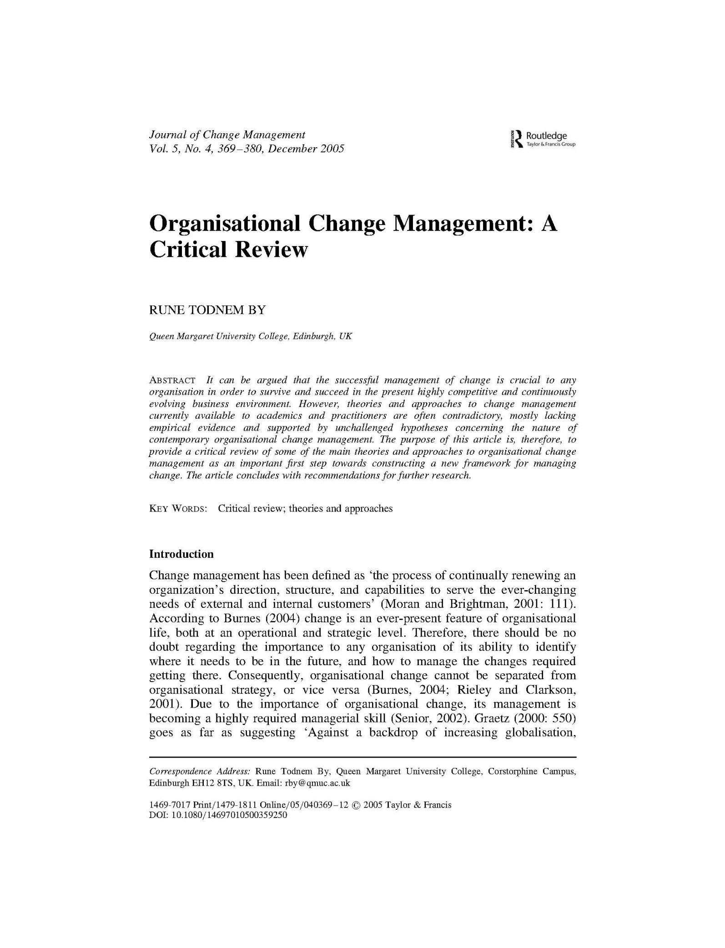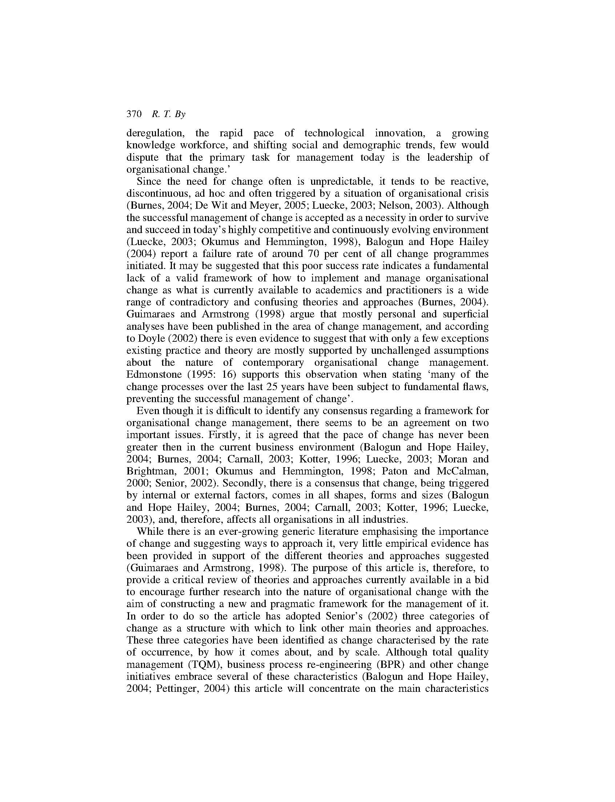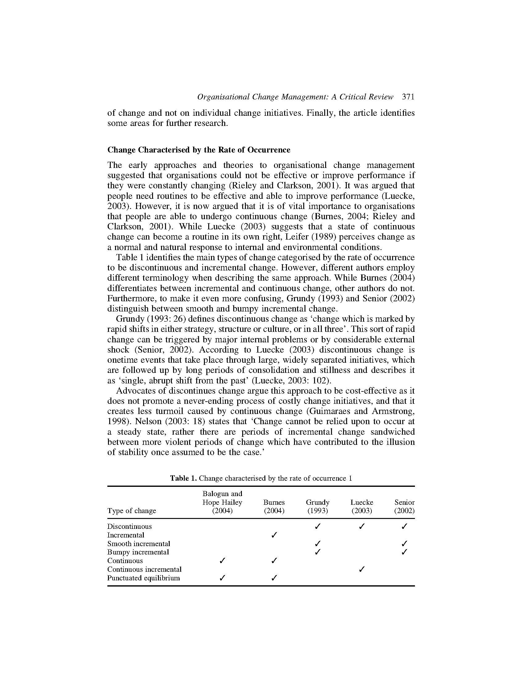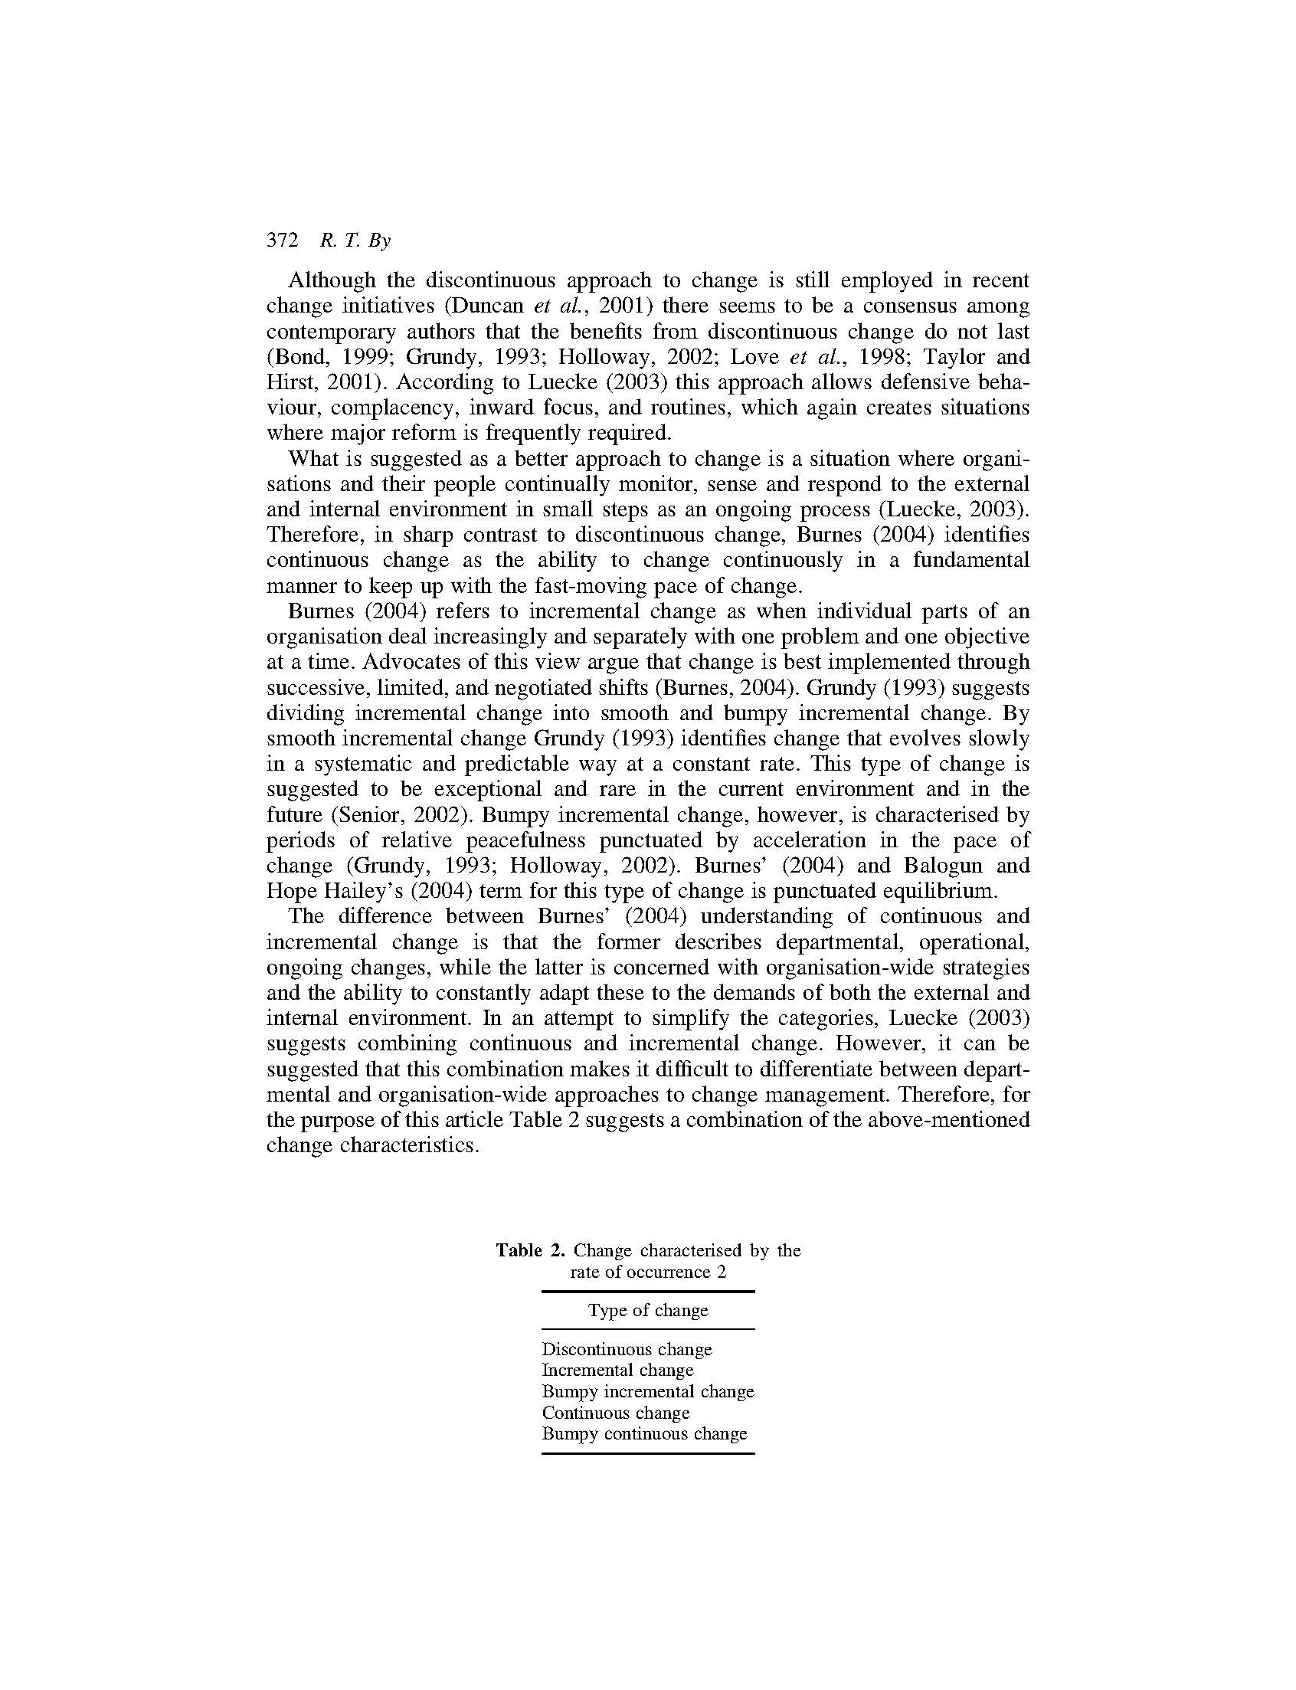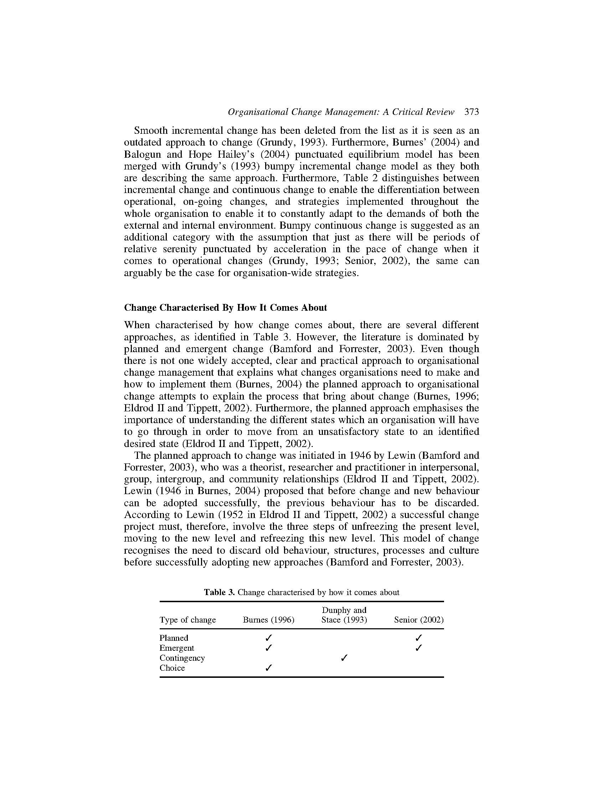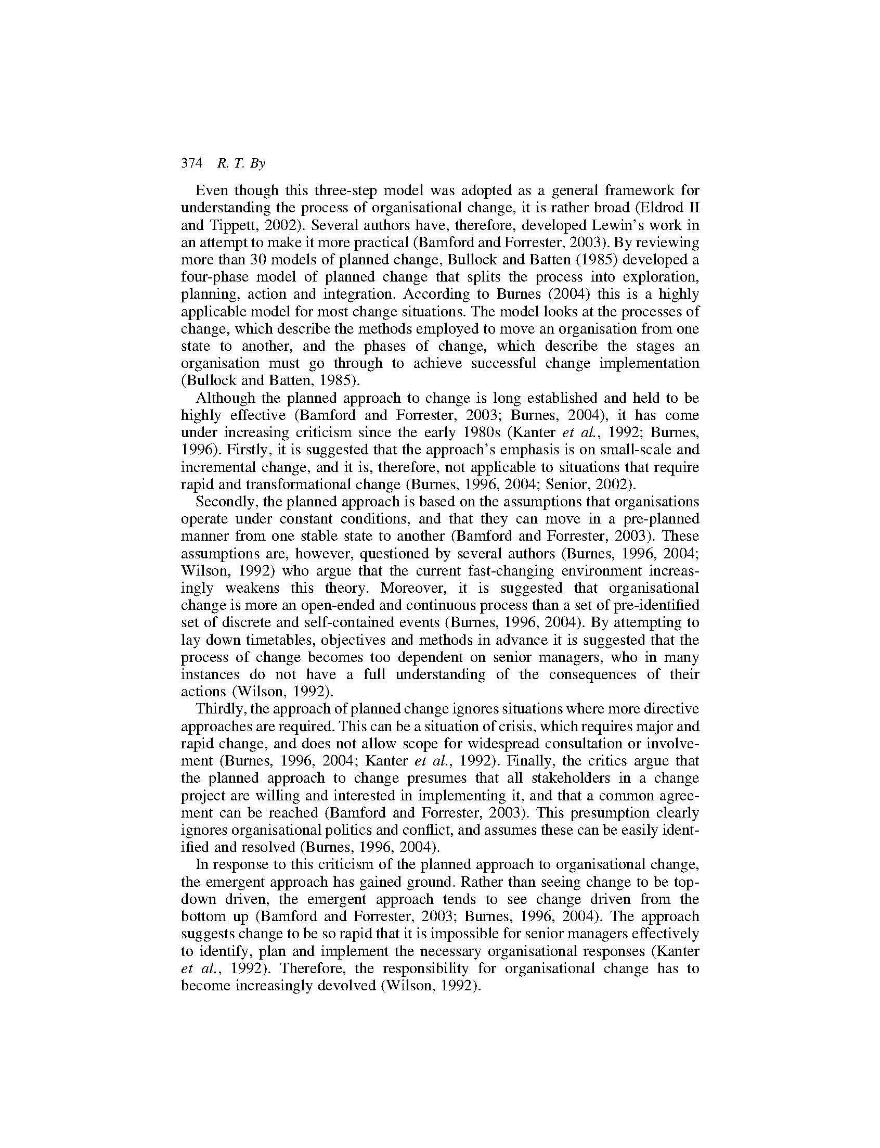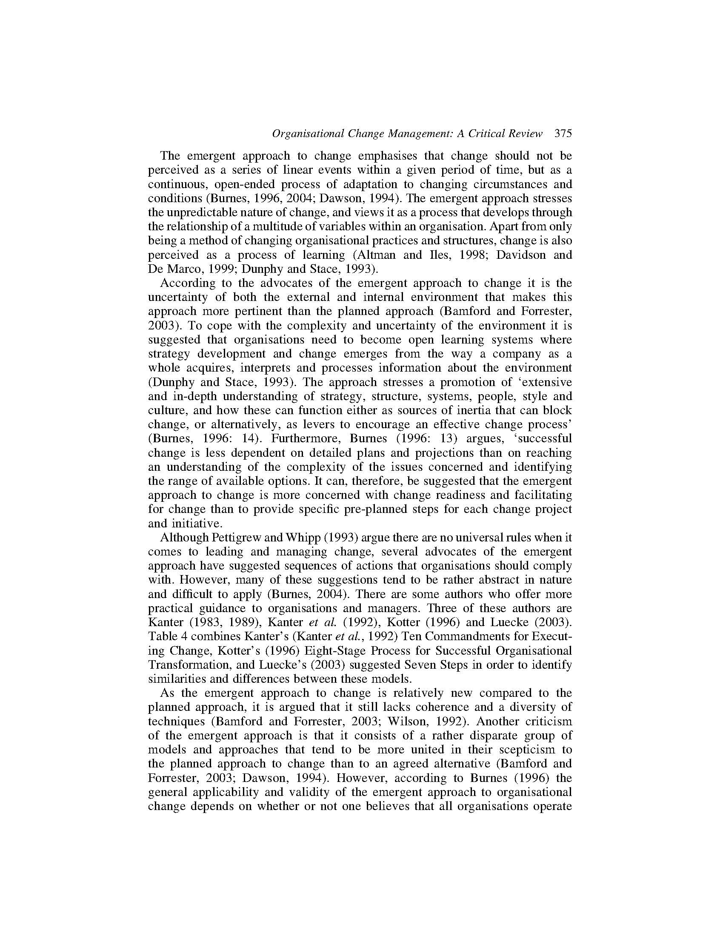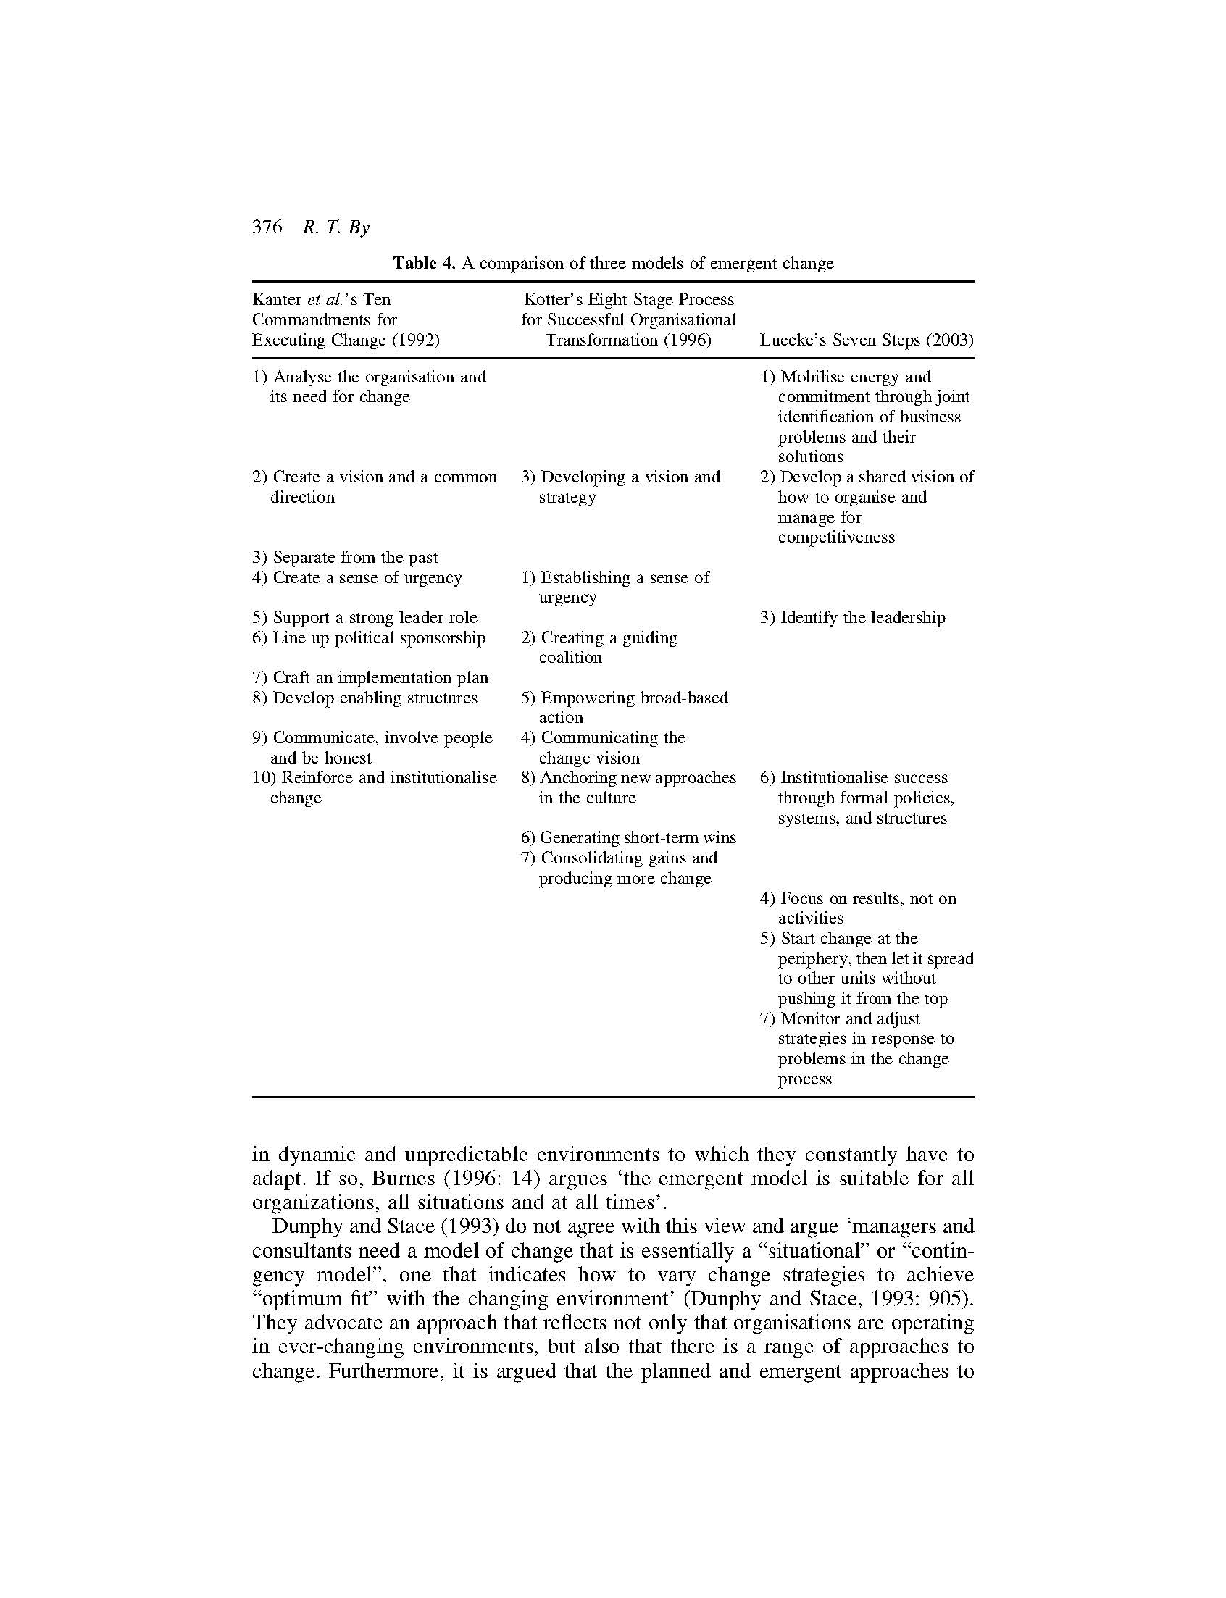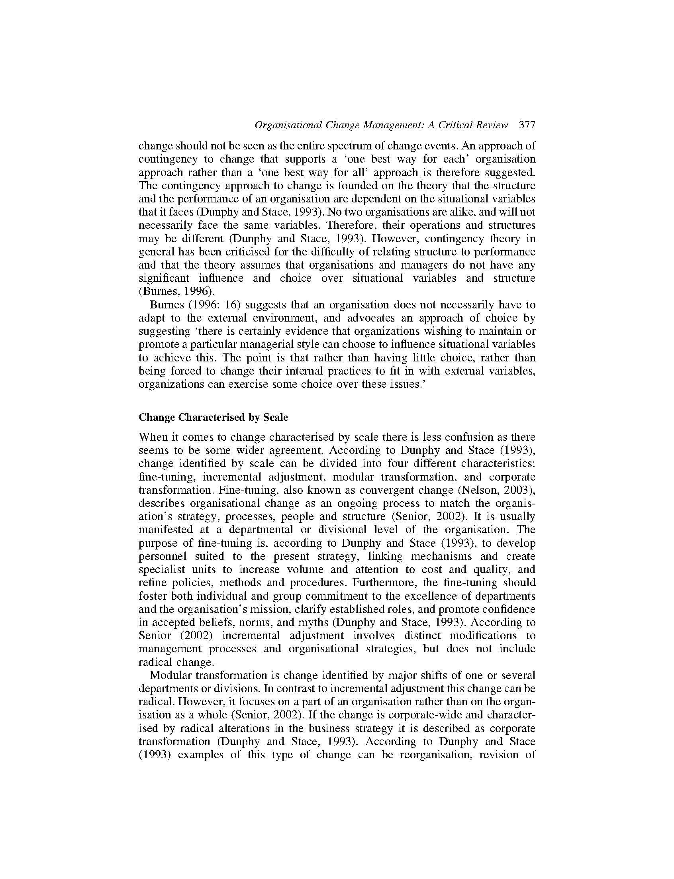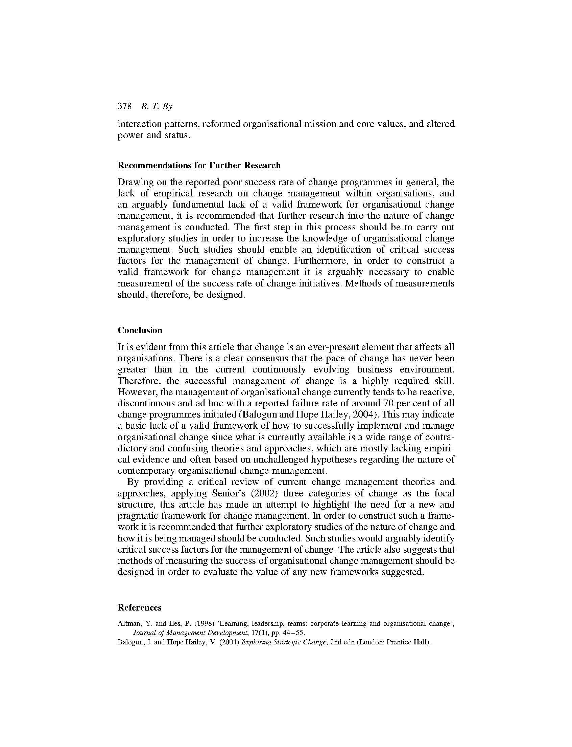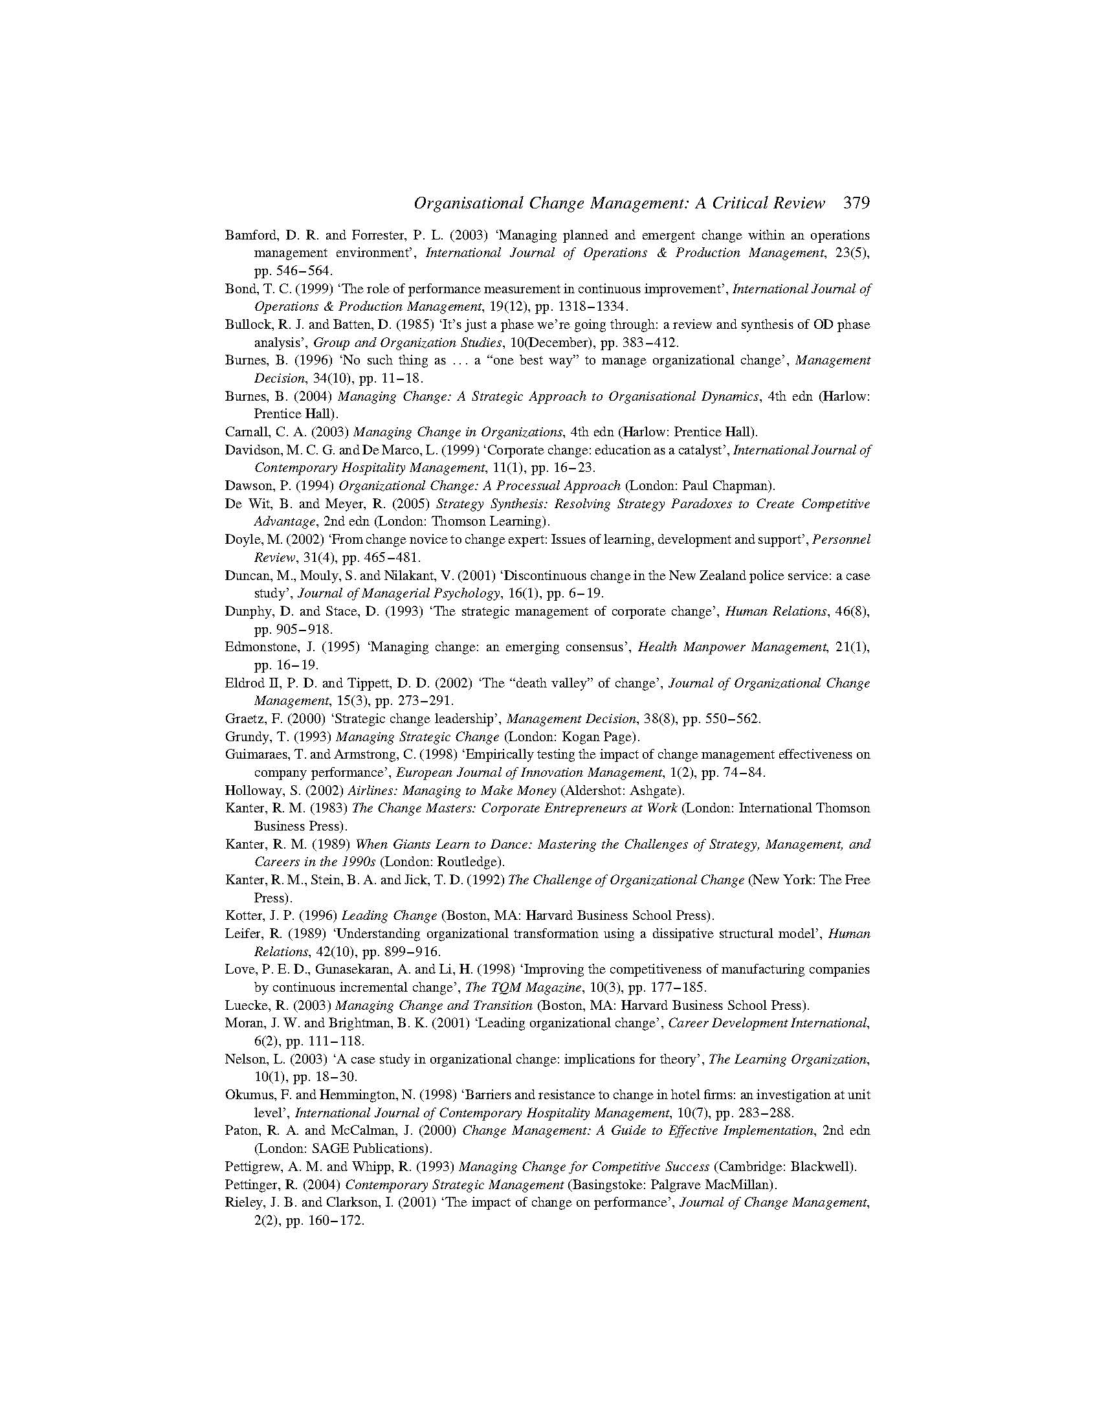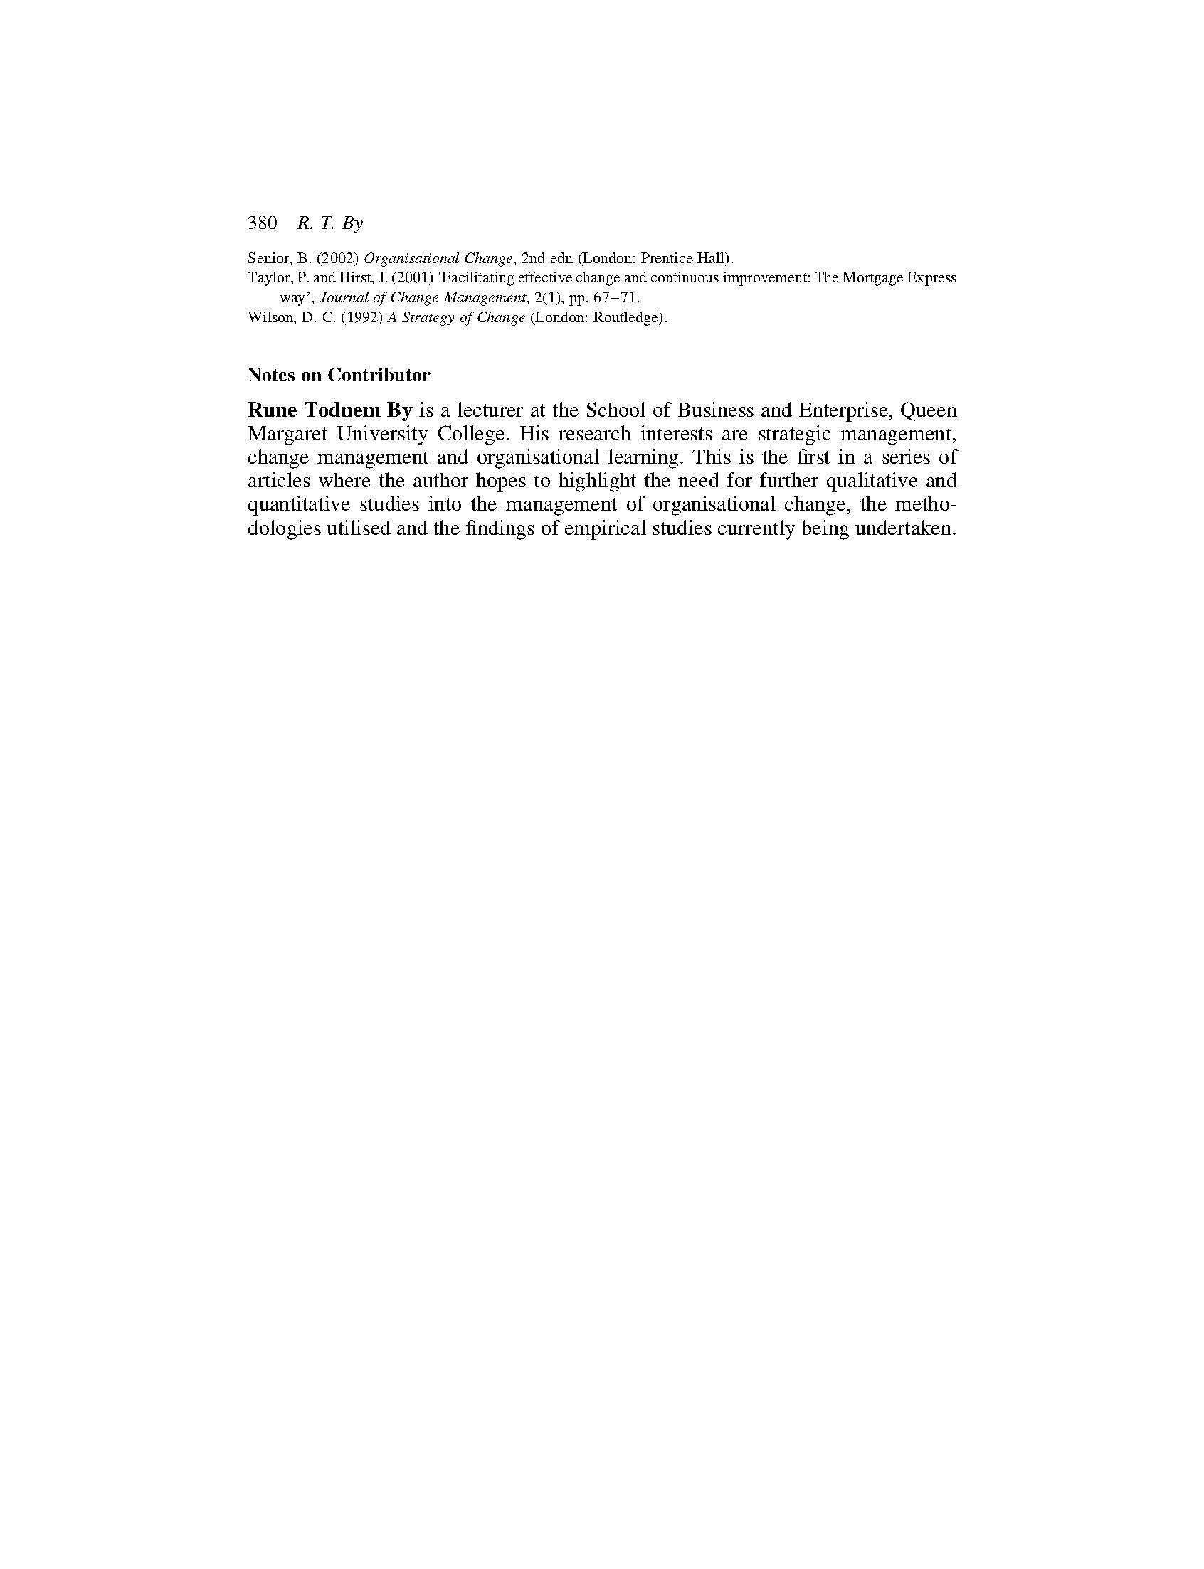
2.3 Summary
This chapter has presented the results of a critical literature review in the field of organisational change management. Its intention has been to establish a baseline in the field through comparing and contrasting existing theory and terminology. In doing so, it has established that some of the challenges facing academics, practitioners and students with an interest in organisational change and its management are that much of the theories and concepts available are (1) often based on assumptions, (2) contradictory, and (3) lacking in evidence. As such, it presents a strong justification for further research in the field.

Chapter 3: The limitations of dispositional resistance in relation to organizational change

Michel, A., By, R.T. and Burnes, B. (2013)
Management Decision, 51(4), pp. 761-780

(Published work 4)

This chapter is derived from an article published by Management Decision in 2013

3.1 Introduction
This chapter tests the moderating role of dispositional resistance in achieving organisational change. It sets out to critically evaluate Oreg’s (2003) postulation that an individual’s dispositional resistance to change can act as a predictor of whether they are more likely to accept or resist change. The findings presented within this chapter reveal that dispositional resistance to change does not moderate relations between change characteristics and commitment to change. The chapter argues that an individual’s actual level of resistance to change may vary from their level of dispositional resistance because of variables such as group norms and the way change is managed.

Michel, A., By, R.T. and Burnes, B. (2013). The limitations of dispositional resistance in relation to organizational change. Management Decision, 51(4), pp. 761-780.

Note: According to Google Scholar this article has been cited 81 times (as of 24.04.2019)

3.2 Chapter article
Please see next page.

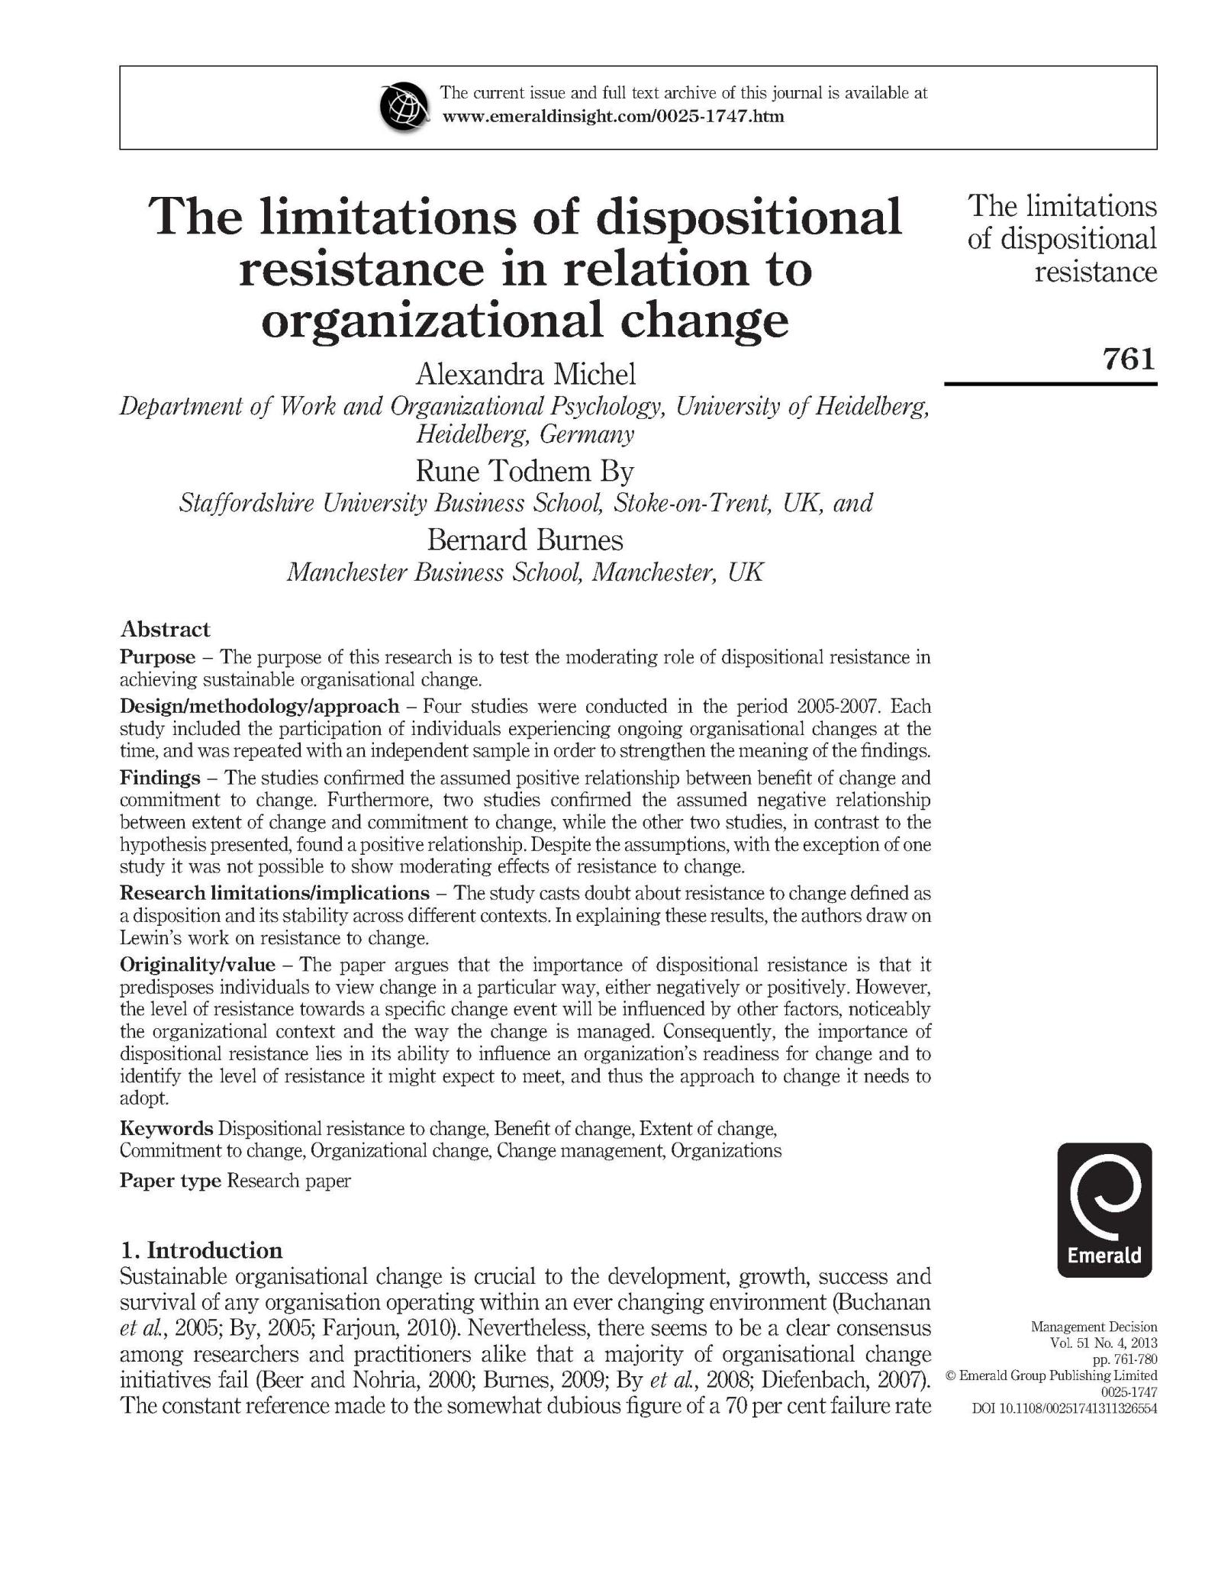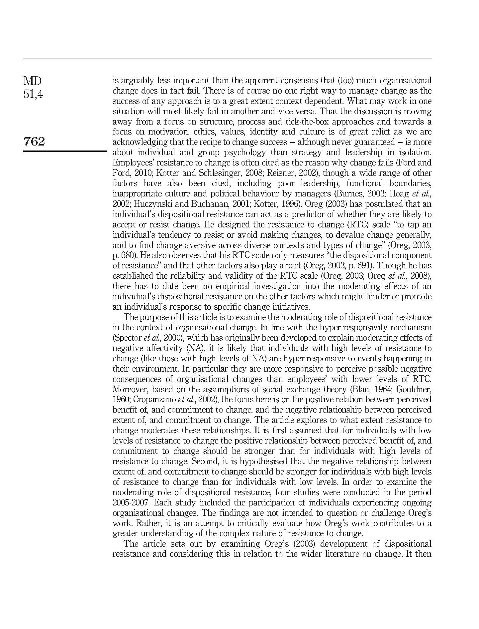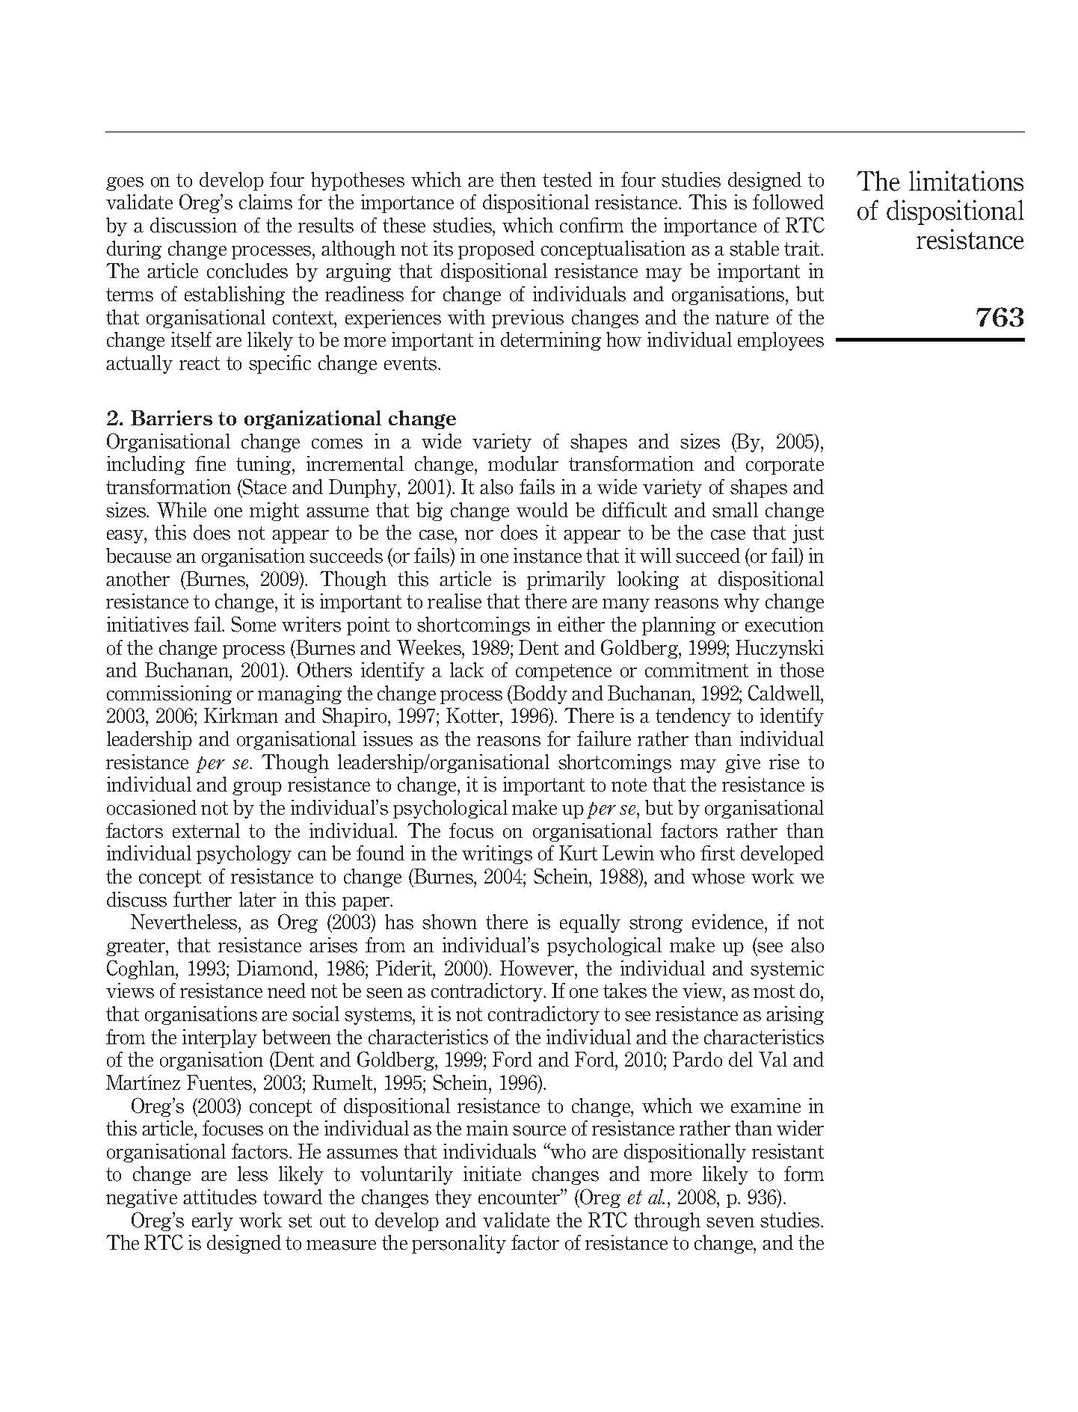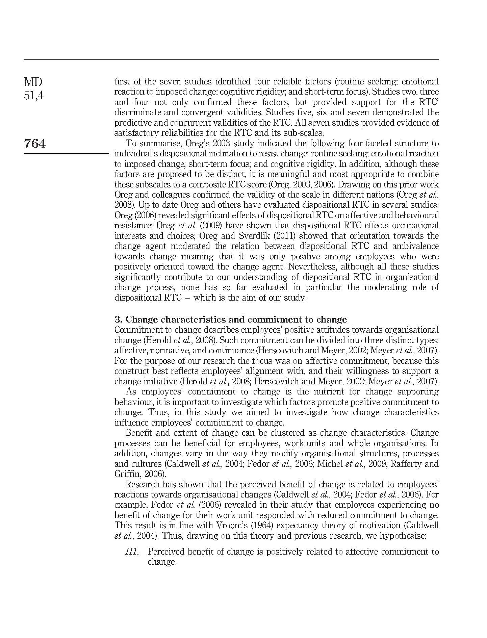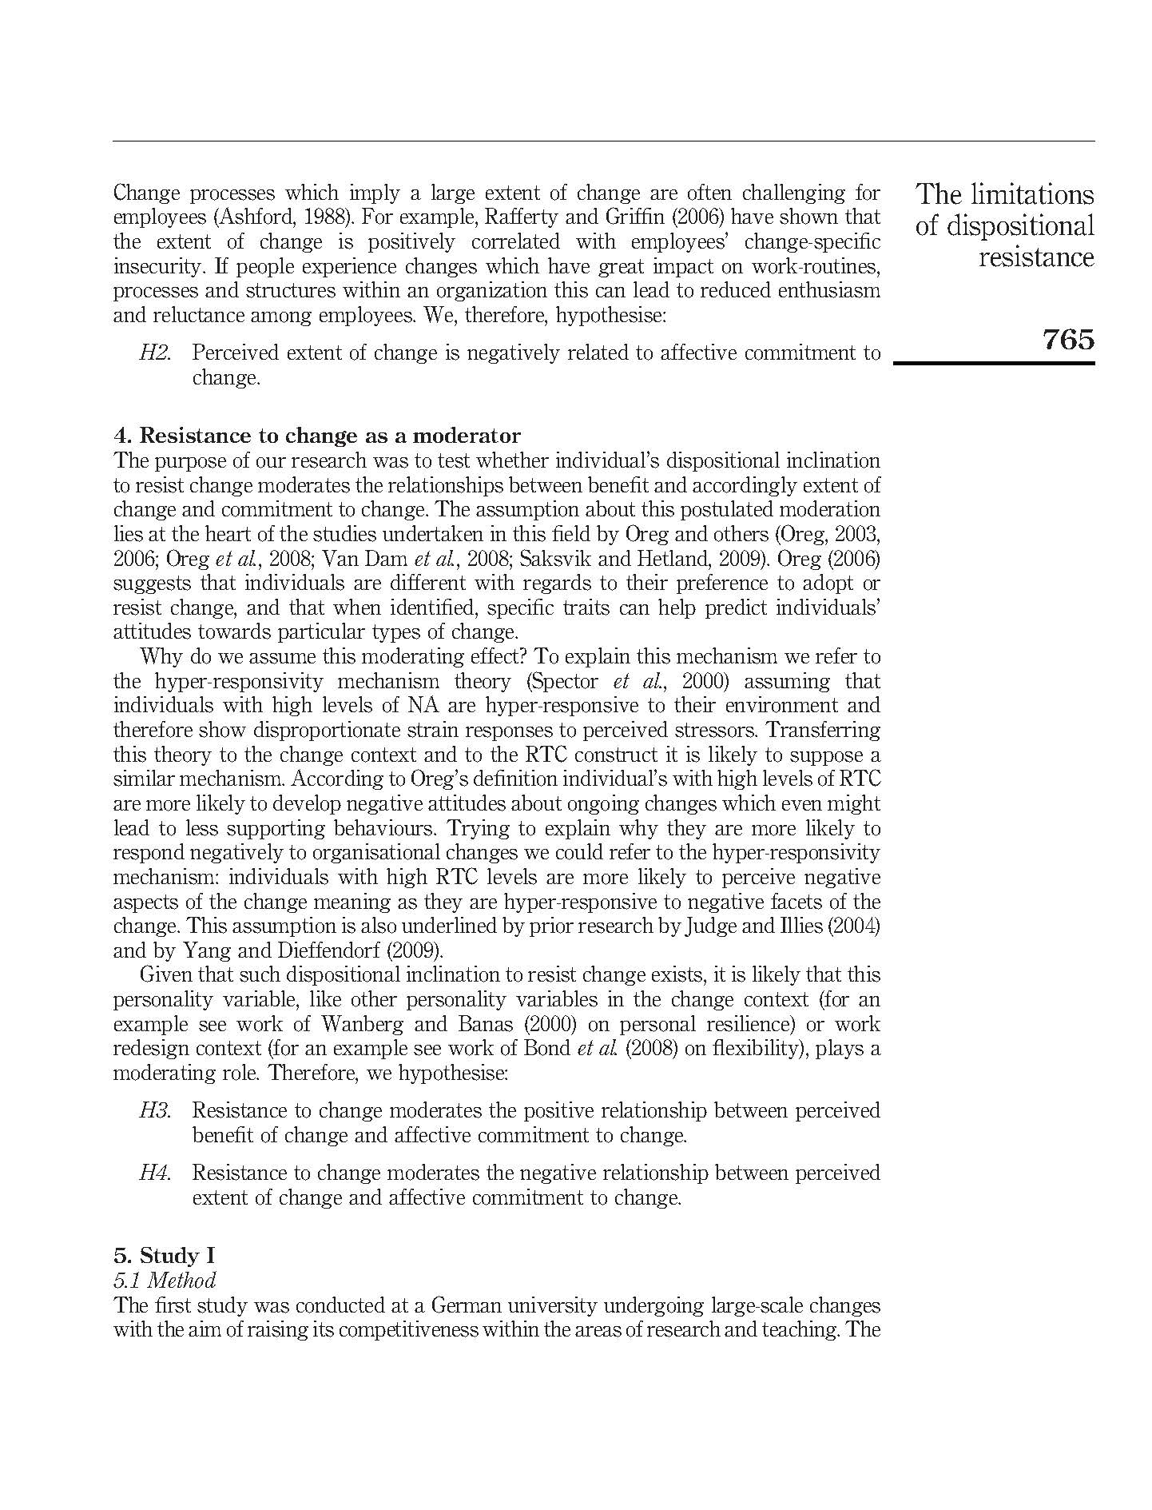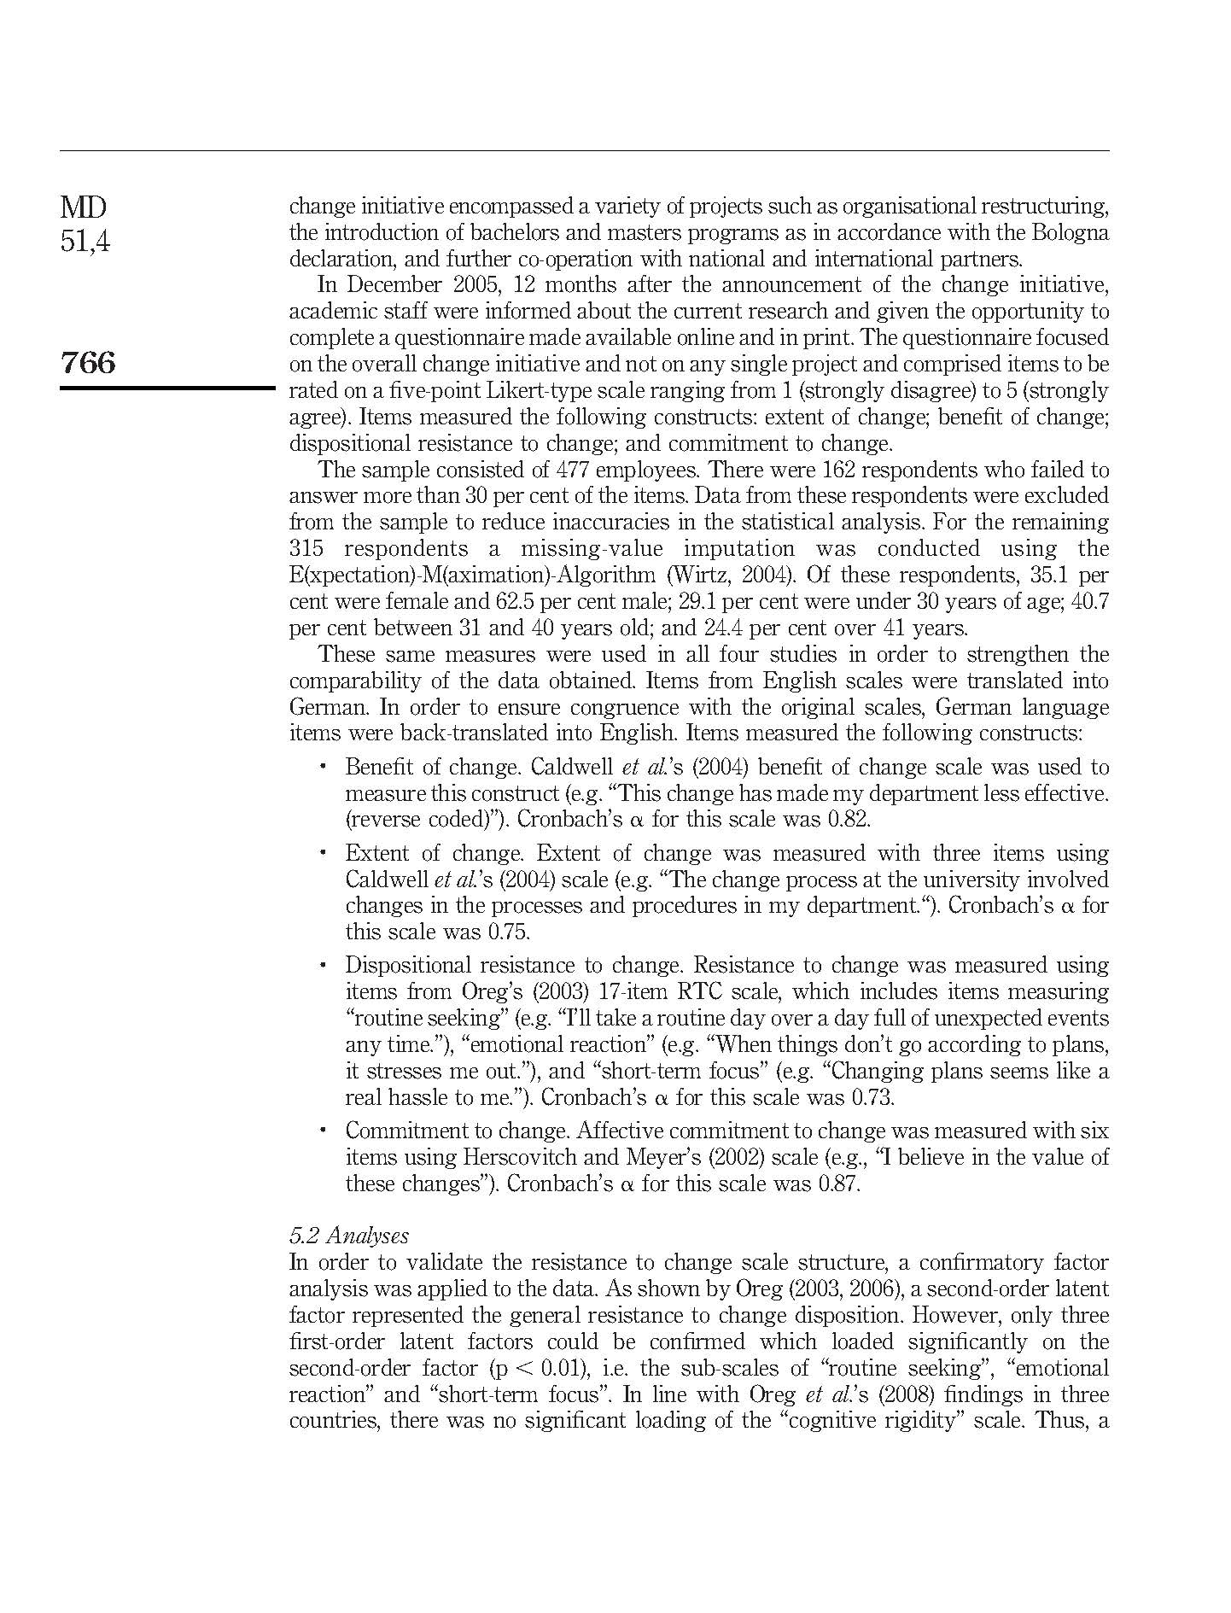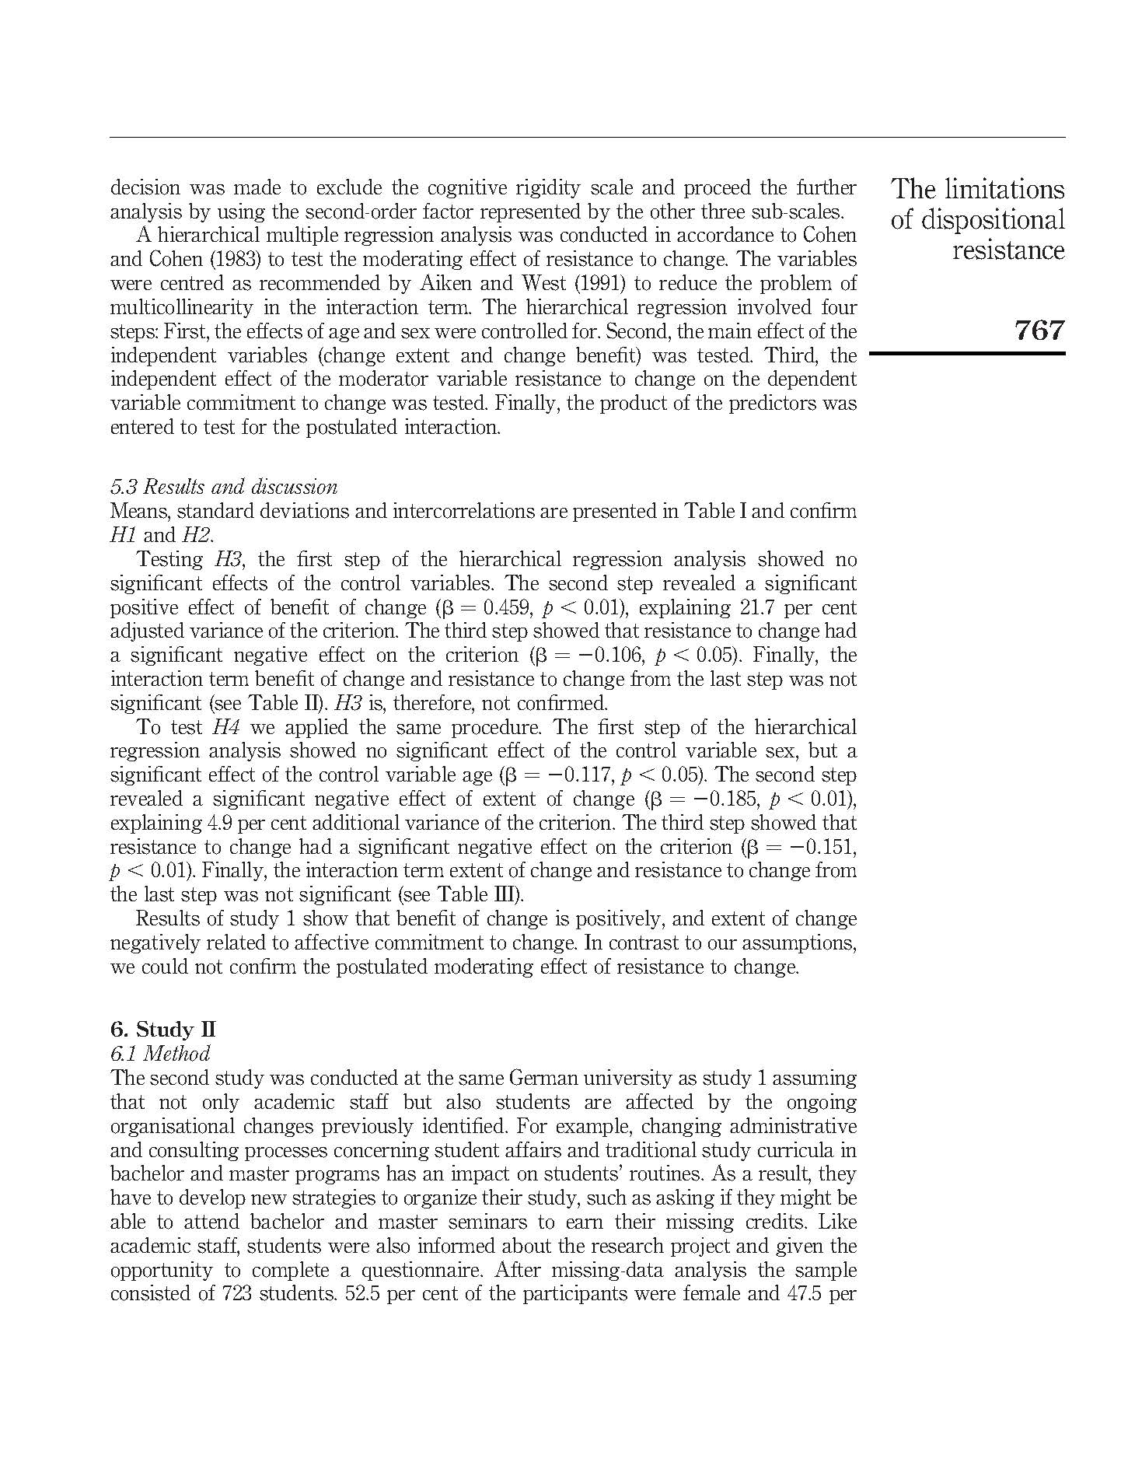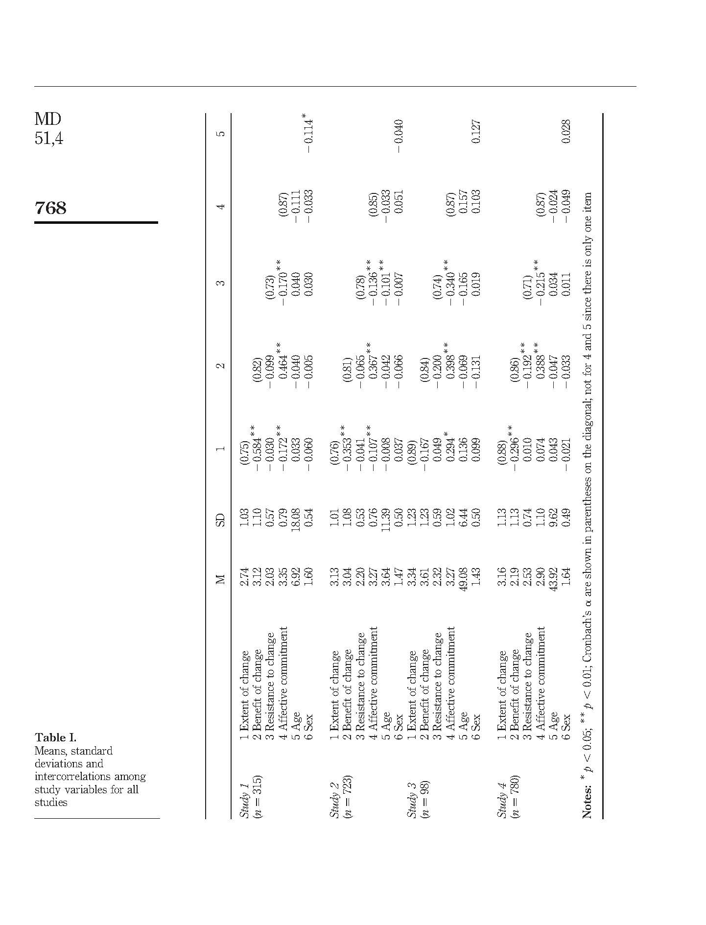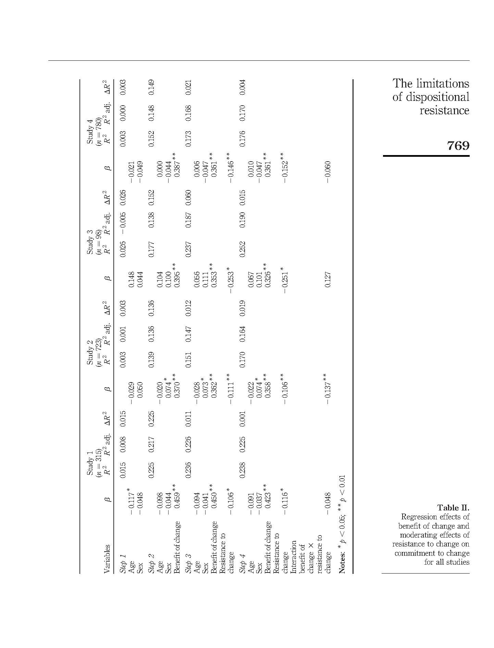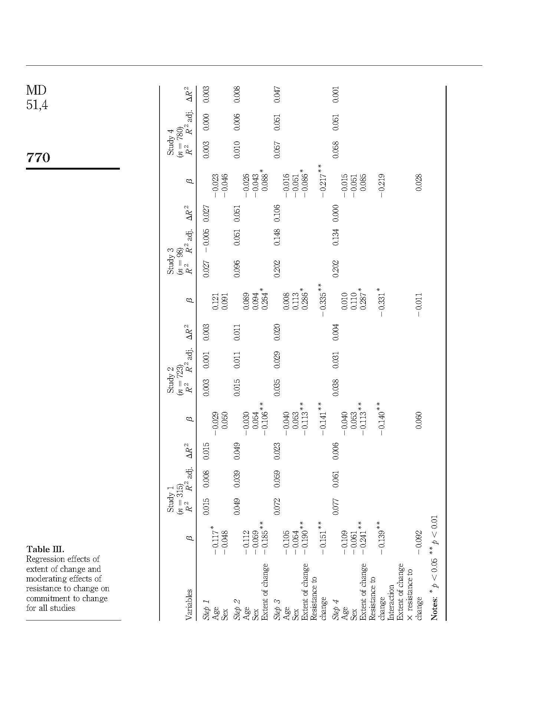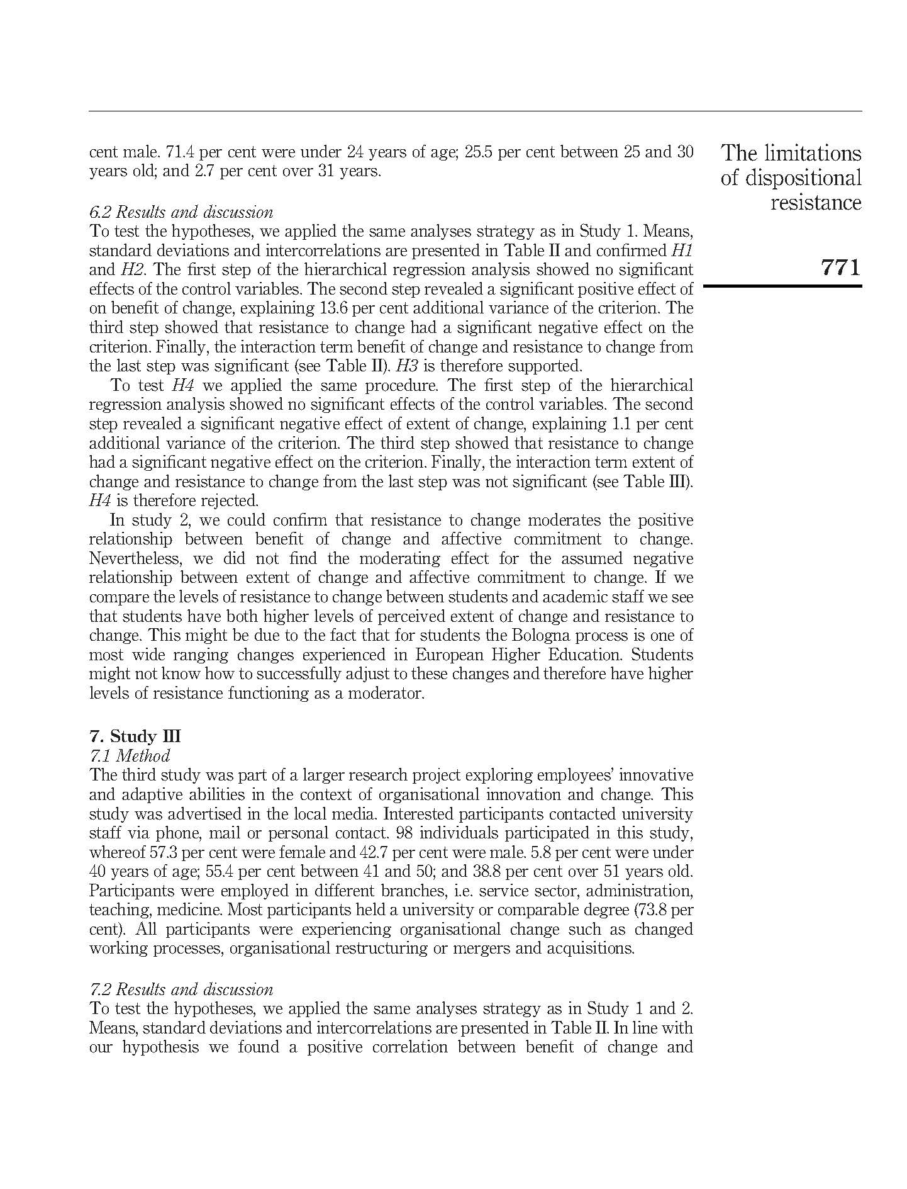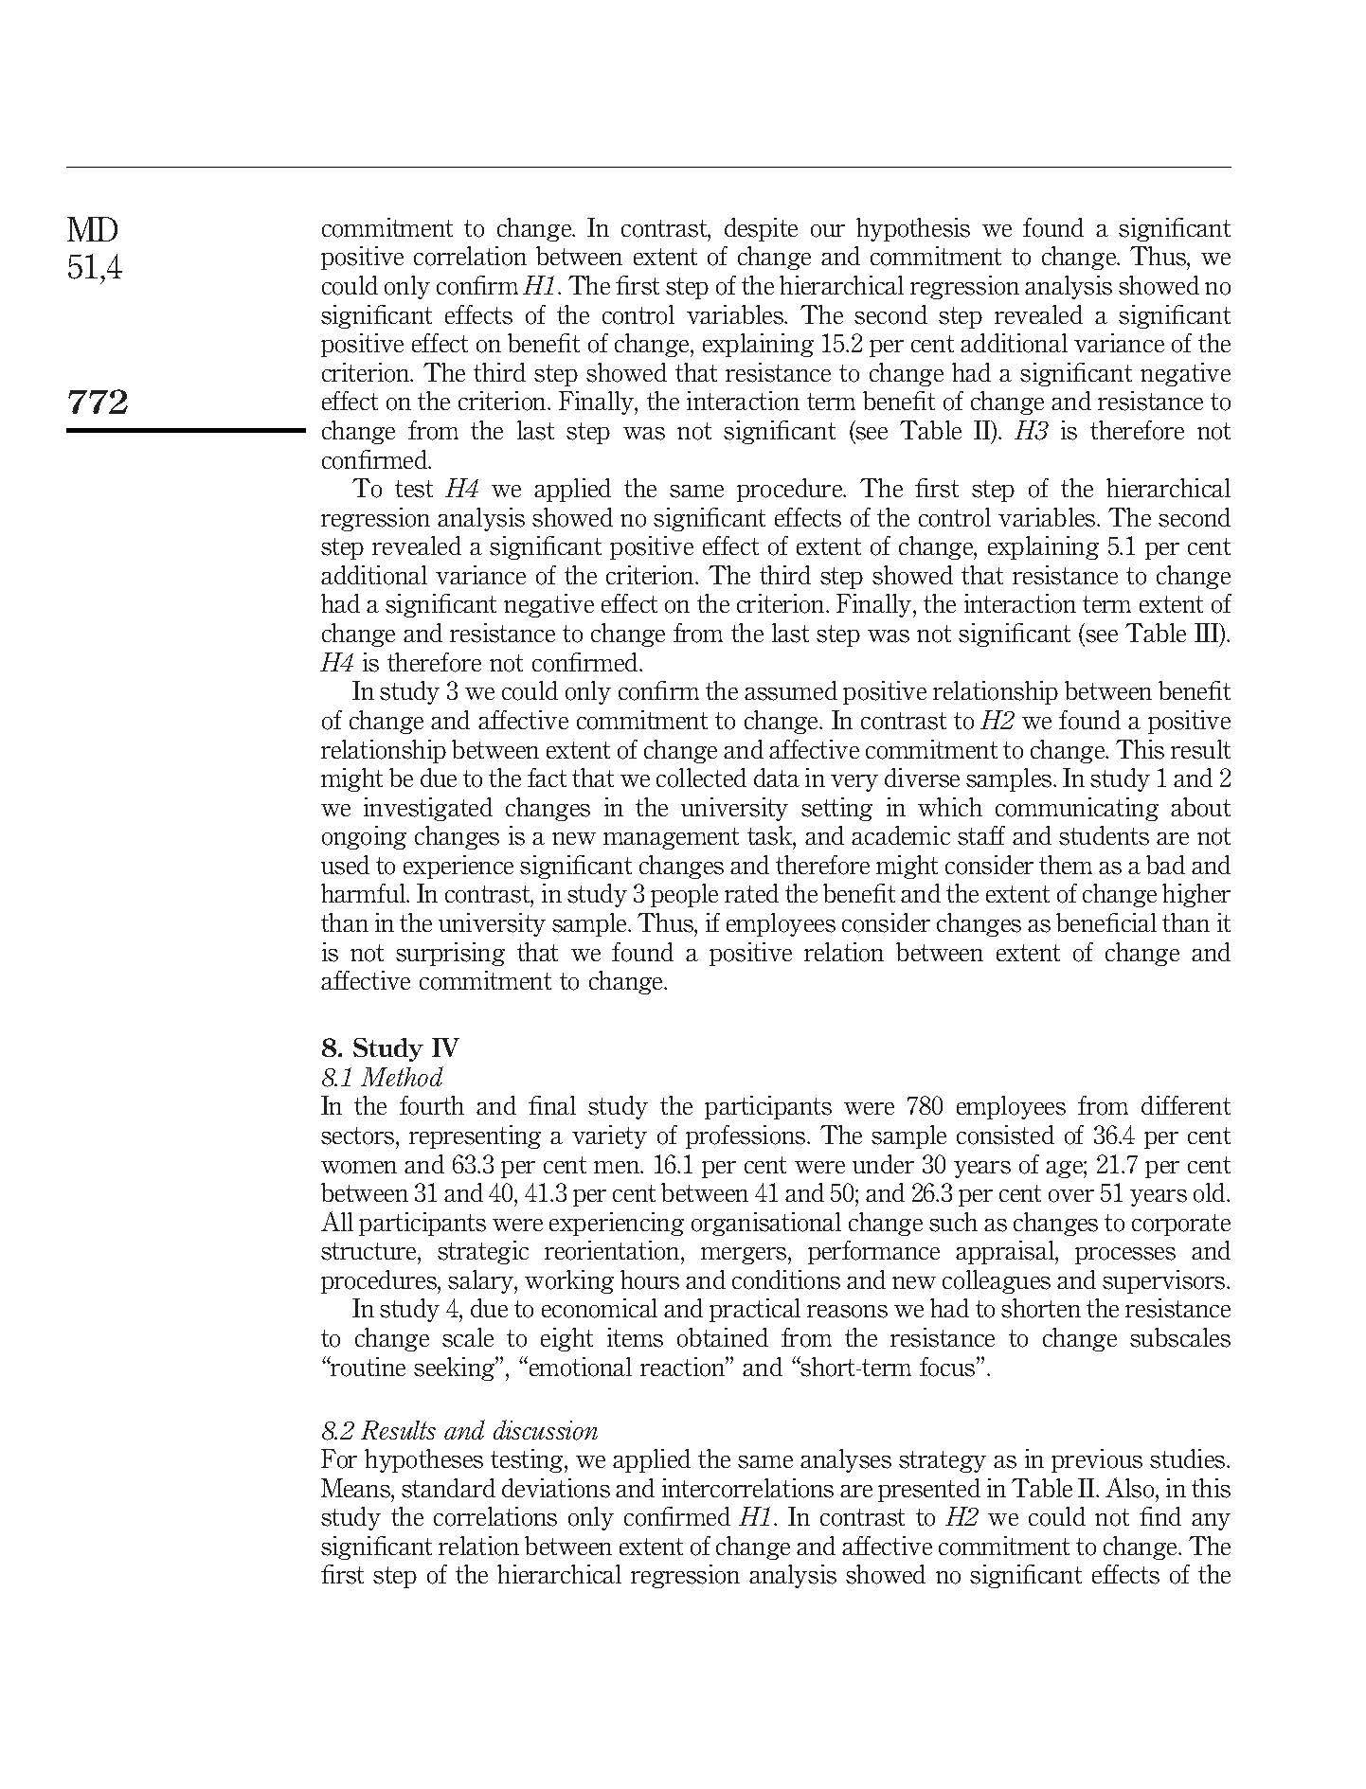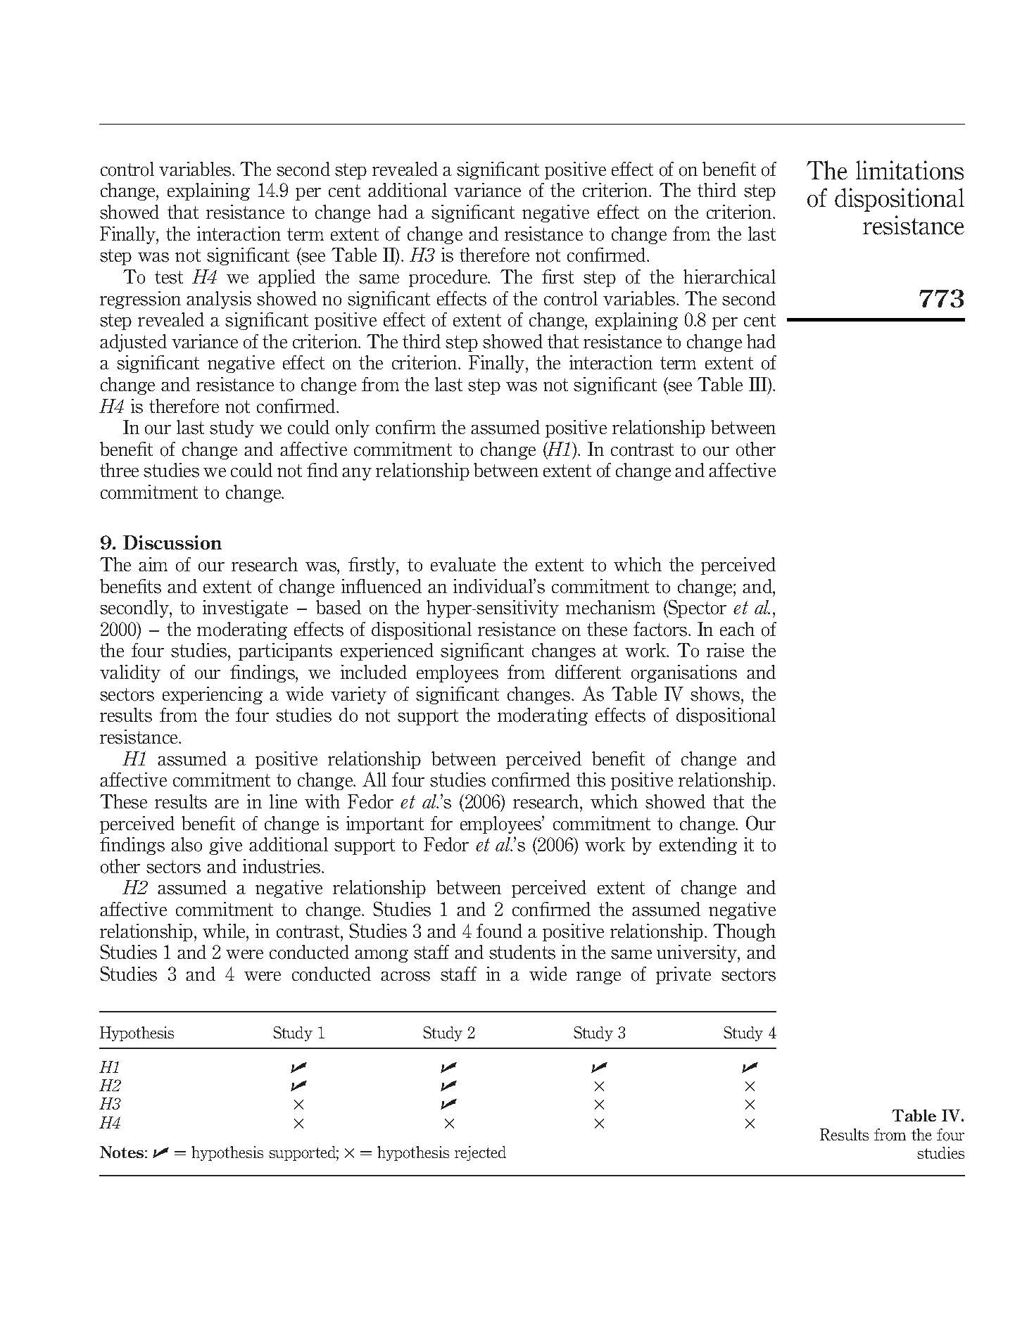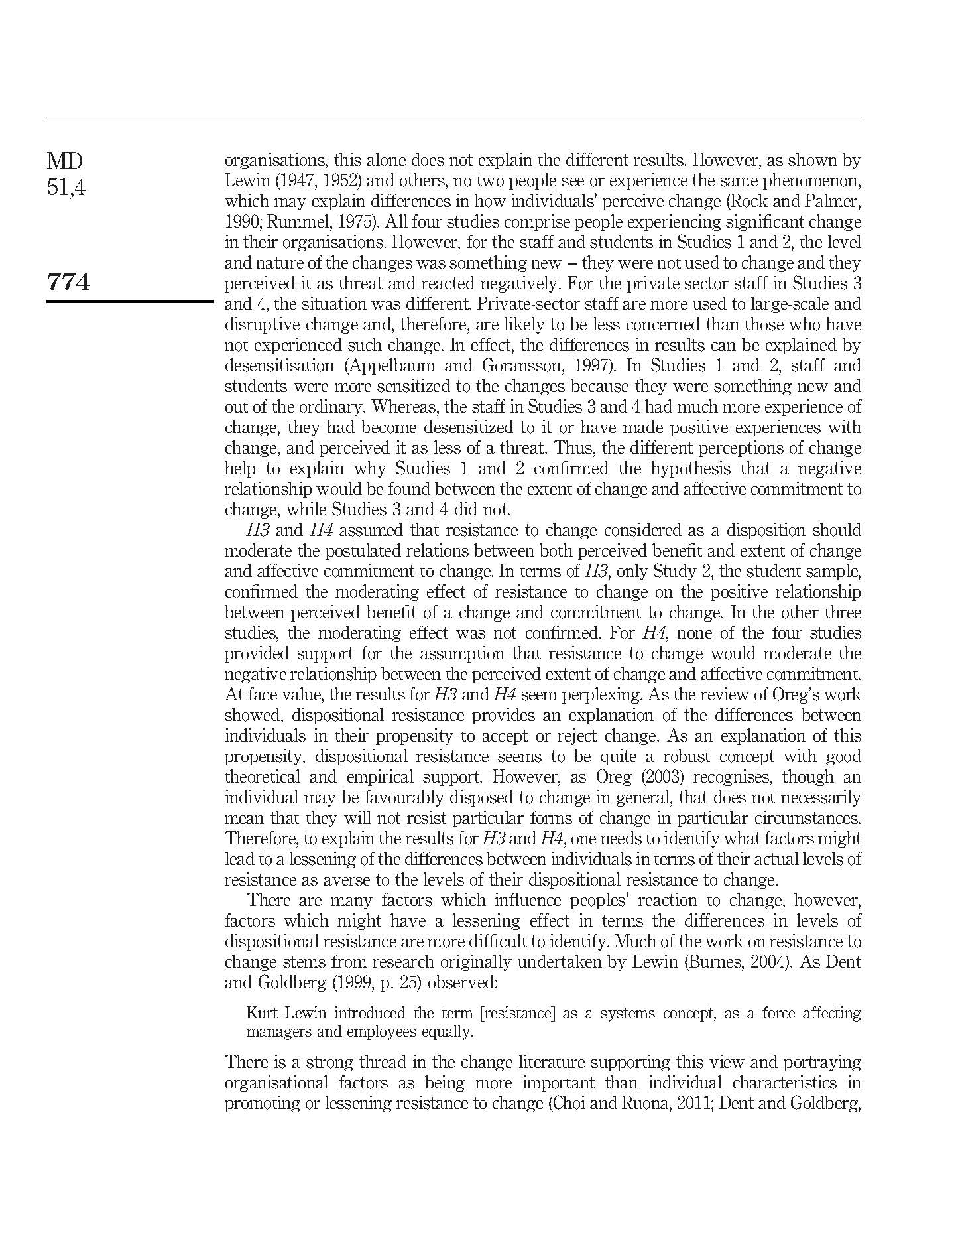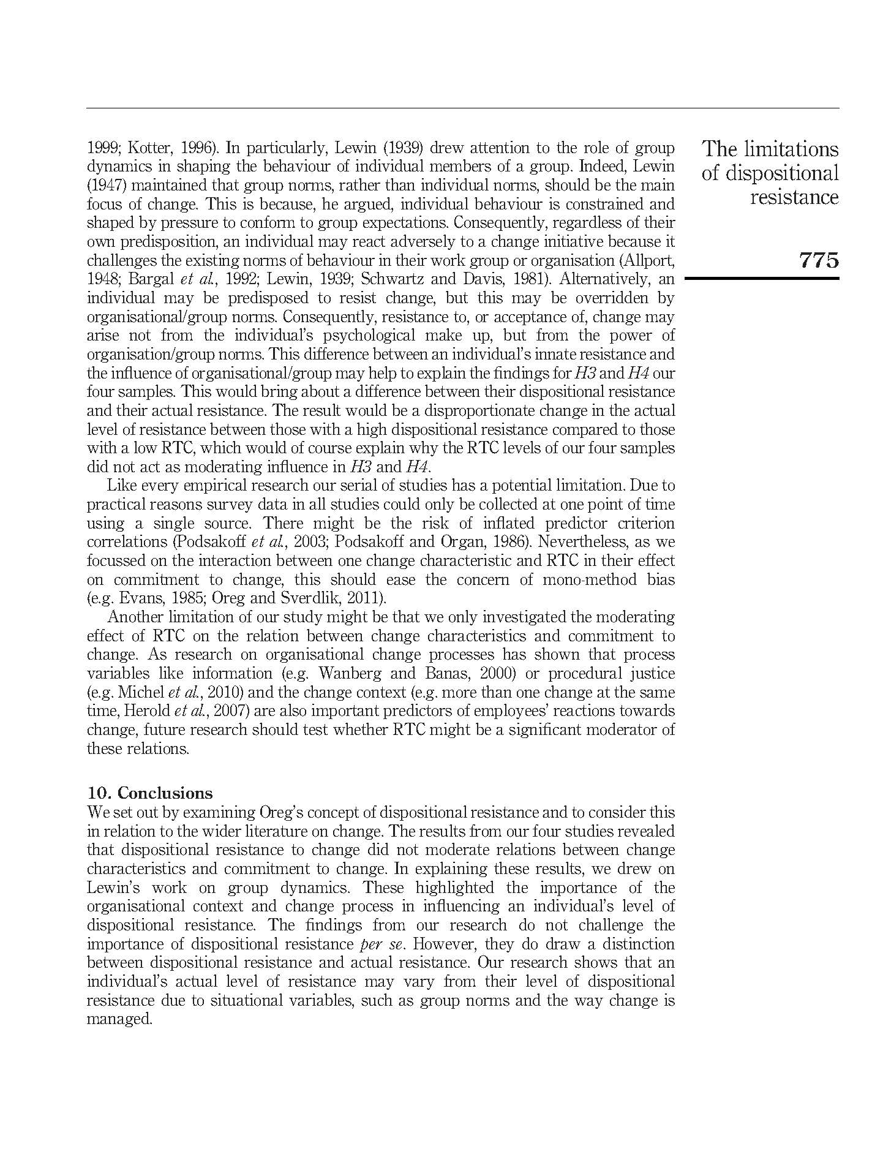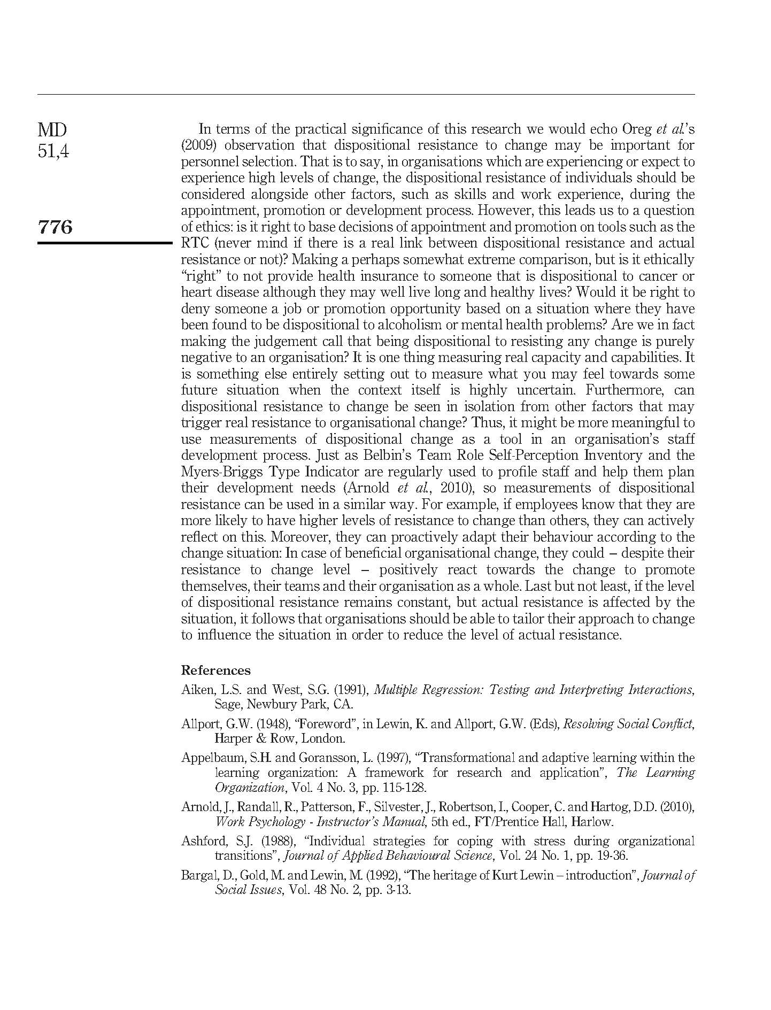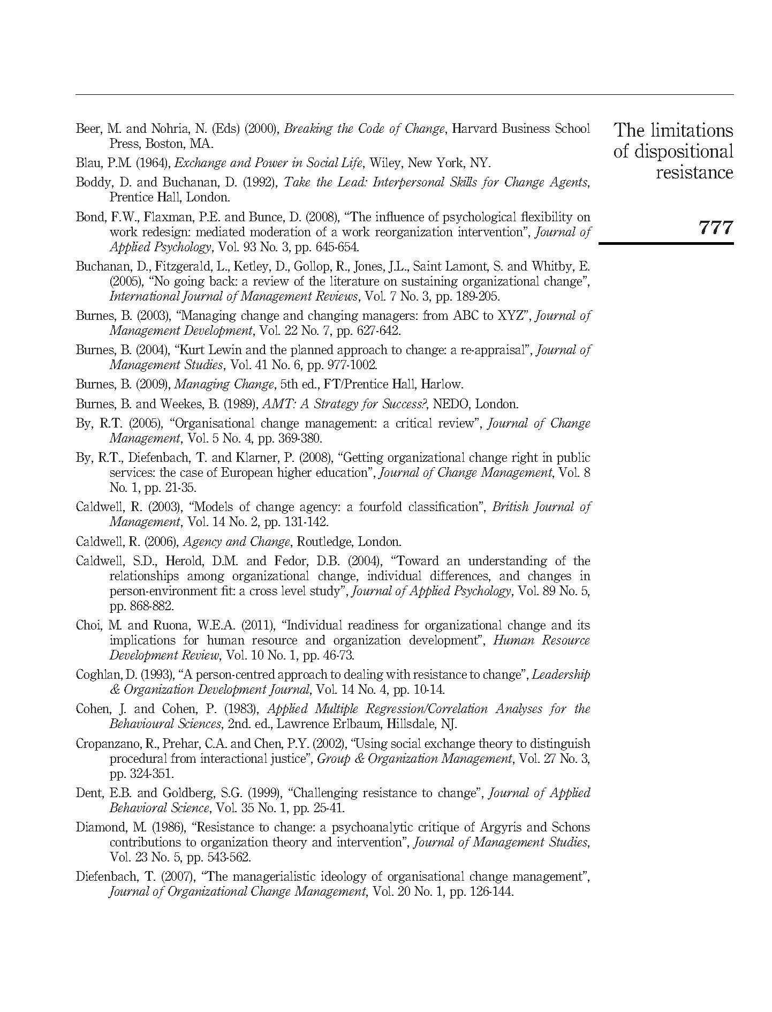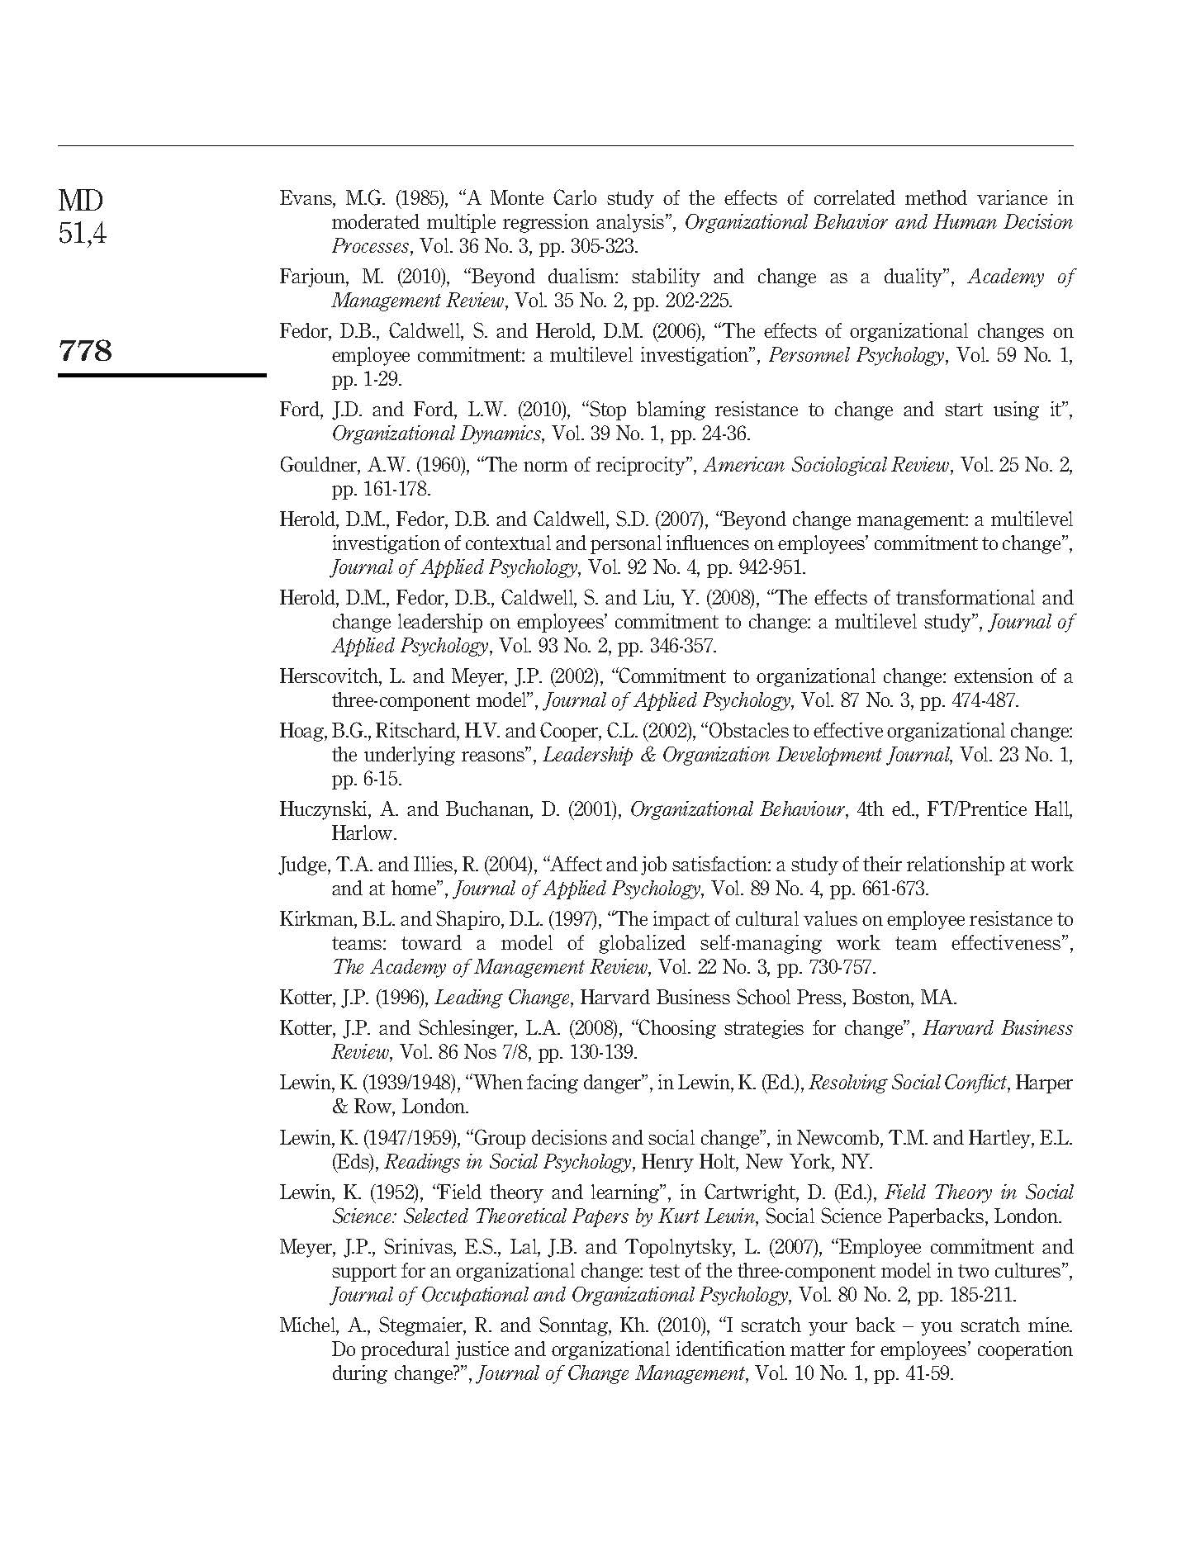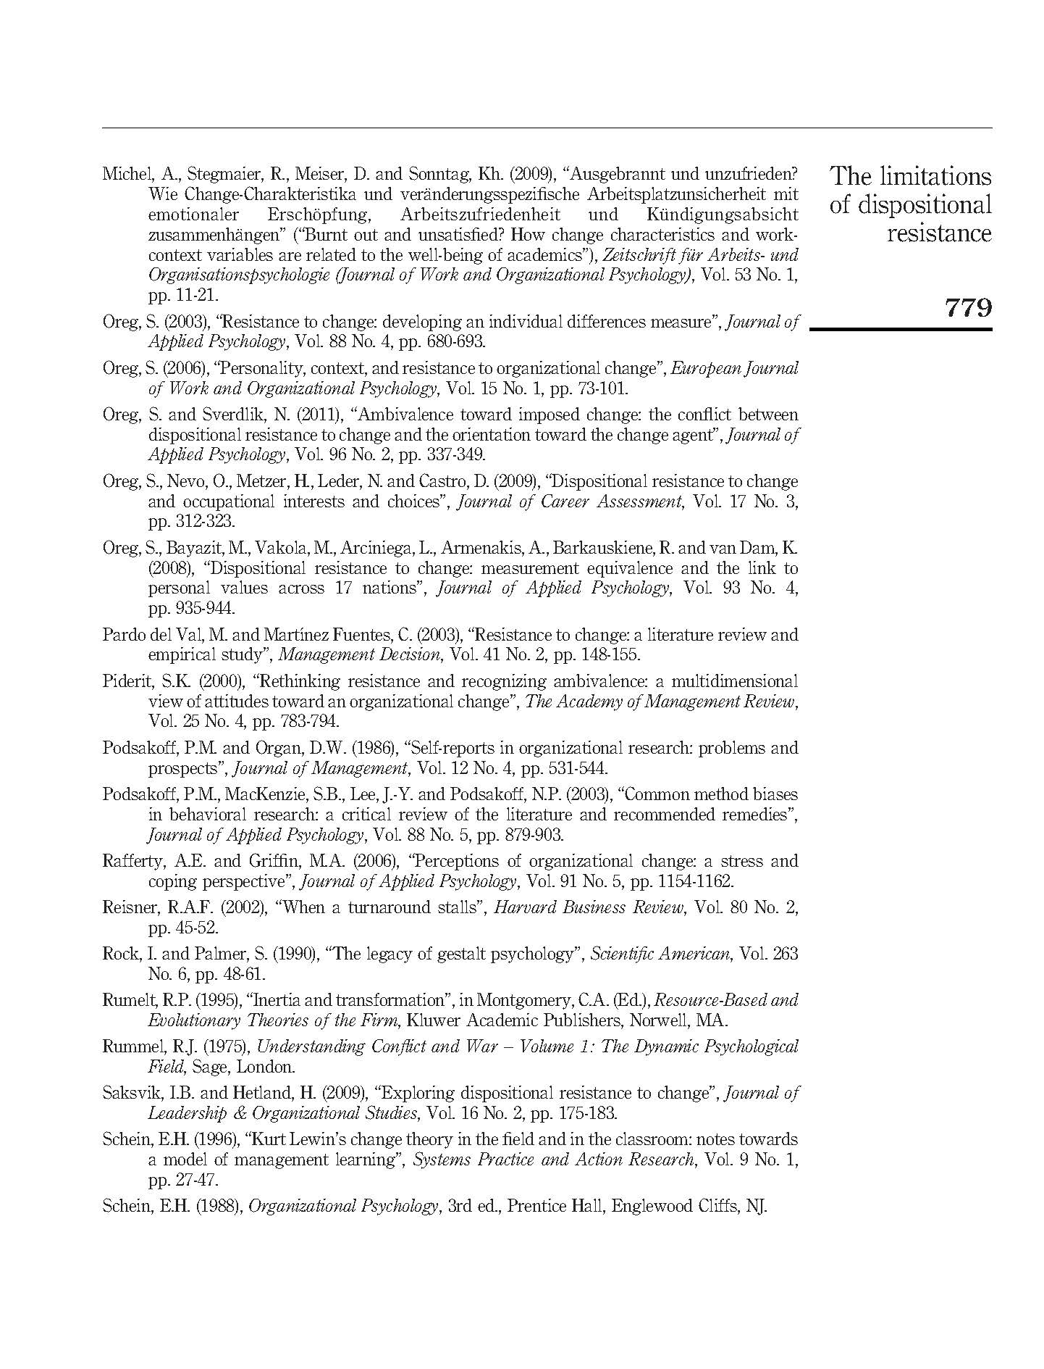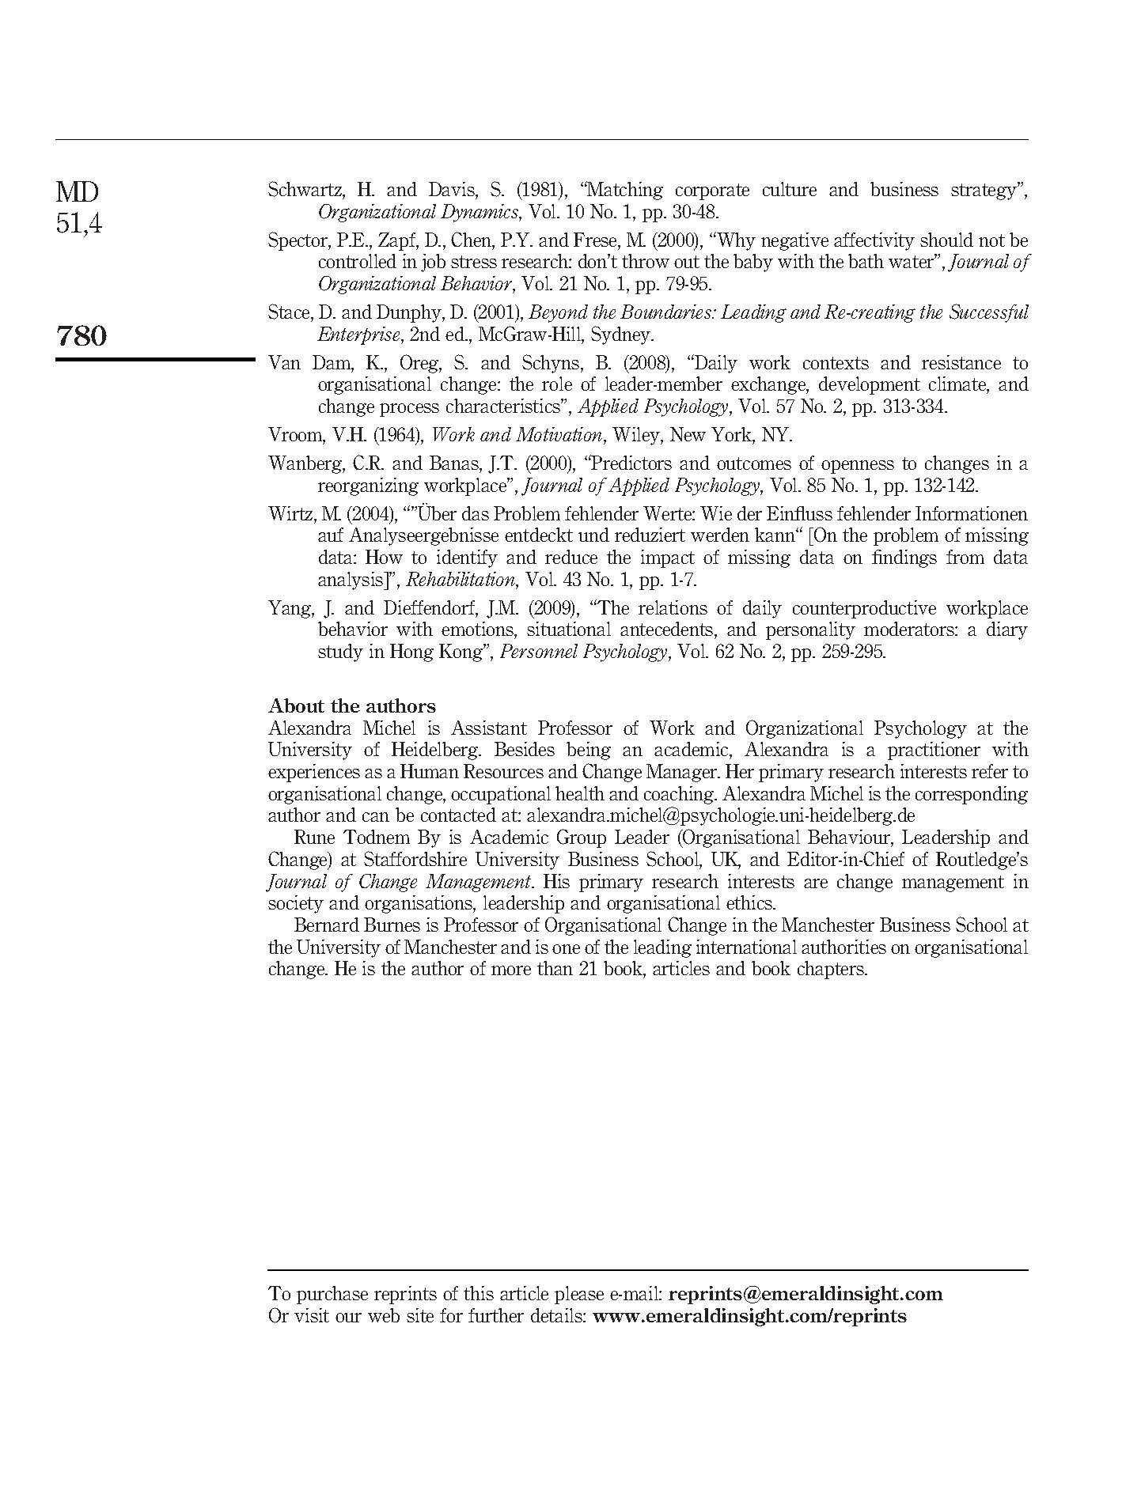
3.3 Summary
This chapter sat out to explore the role of resistance to change in achieving organisational change through testing the moderating role of dispositional resistance. By further evaluating Oreg’s (2003) hypothesis that an individual’s dispositional resistance to change can act as a predictor of whether they are more likely to accept or resist change, the findings presented suggest this is not necessarily the case. The picture is much more complex as this chapter argues that an individual’s true level of resistance to change will be influenced not only by their level of dispositional resistance but also by variables such as group norms and the way change is managed.

Chapter 4: Ready or not…

By, R.T. (2007)
Journal of Change Management, 7(1), pp. 3-11

(Published work 13)

This chapter is derived from an article published by Journal of Change Management in 2007

4.1 Introduction
This chapter provides a critical evaluation of Armenakis et al.’s (1993; 2002) original concept of organisational change readiness, which in many ways is an alternative perception to what others refer to as change resistance (See Chapter 3). It complements the original framework by suggesting a fourth change message conveying strategy (implicit communication). Furthermore, the chapter promotes a stronger emphasis on continuous change management, and the link between change readiness and successful organisational change. It goes on to argue that change management should focus on performance rather than conformance, and that when boiled down, there are only two overarching approaches to organisational change management: the conscious and the unconscious. The former advocating continuous change readiness, not necessarily continuous change.

By, R.T. (2007). Ready or Not… Journal of Change Management. 7(1), pp. 3-11.

Note: According to Google Scholar this article has been cited 31 times (as of 24.04.2019)

4.2 Chapter article
Please see next page.

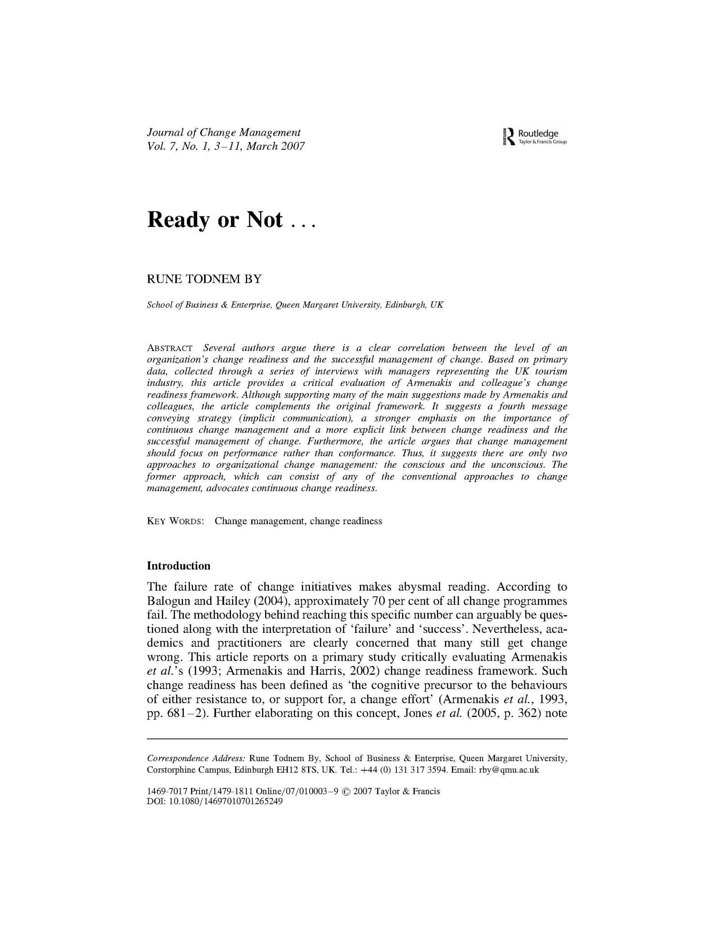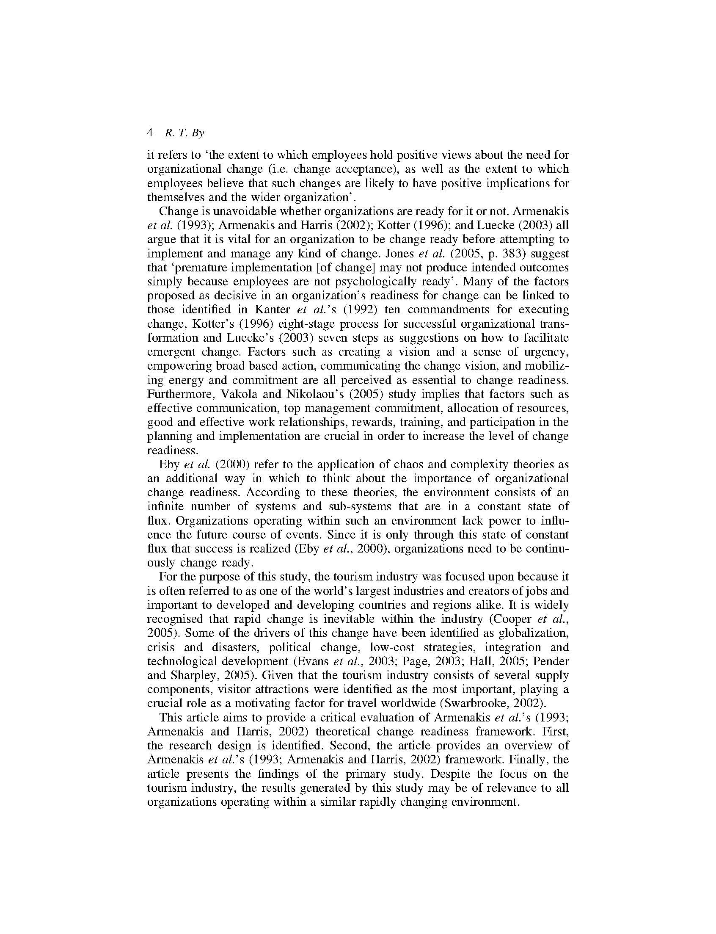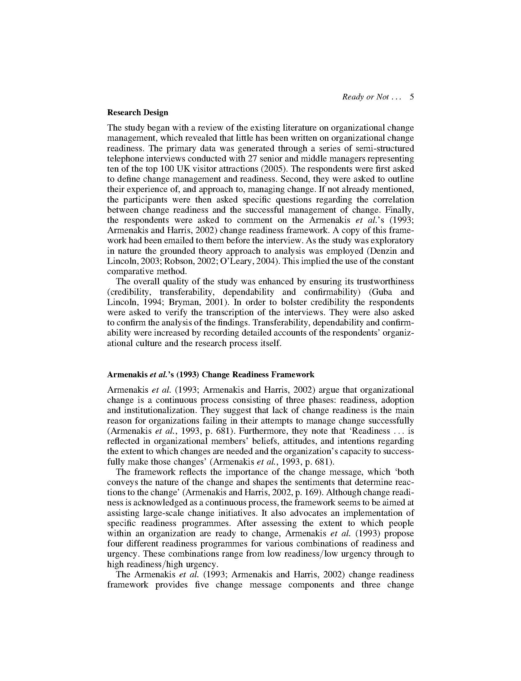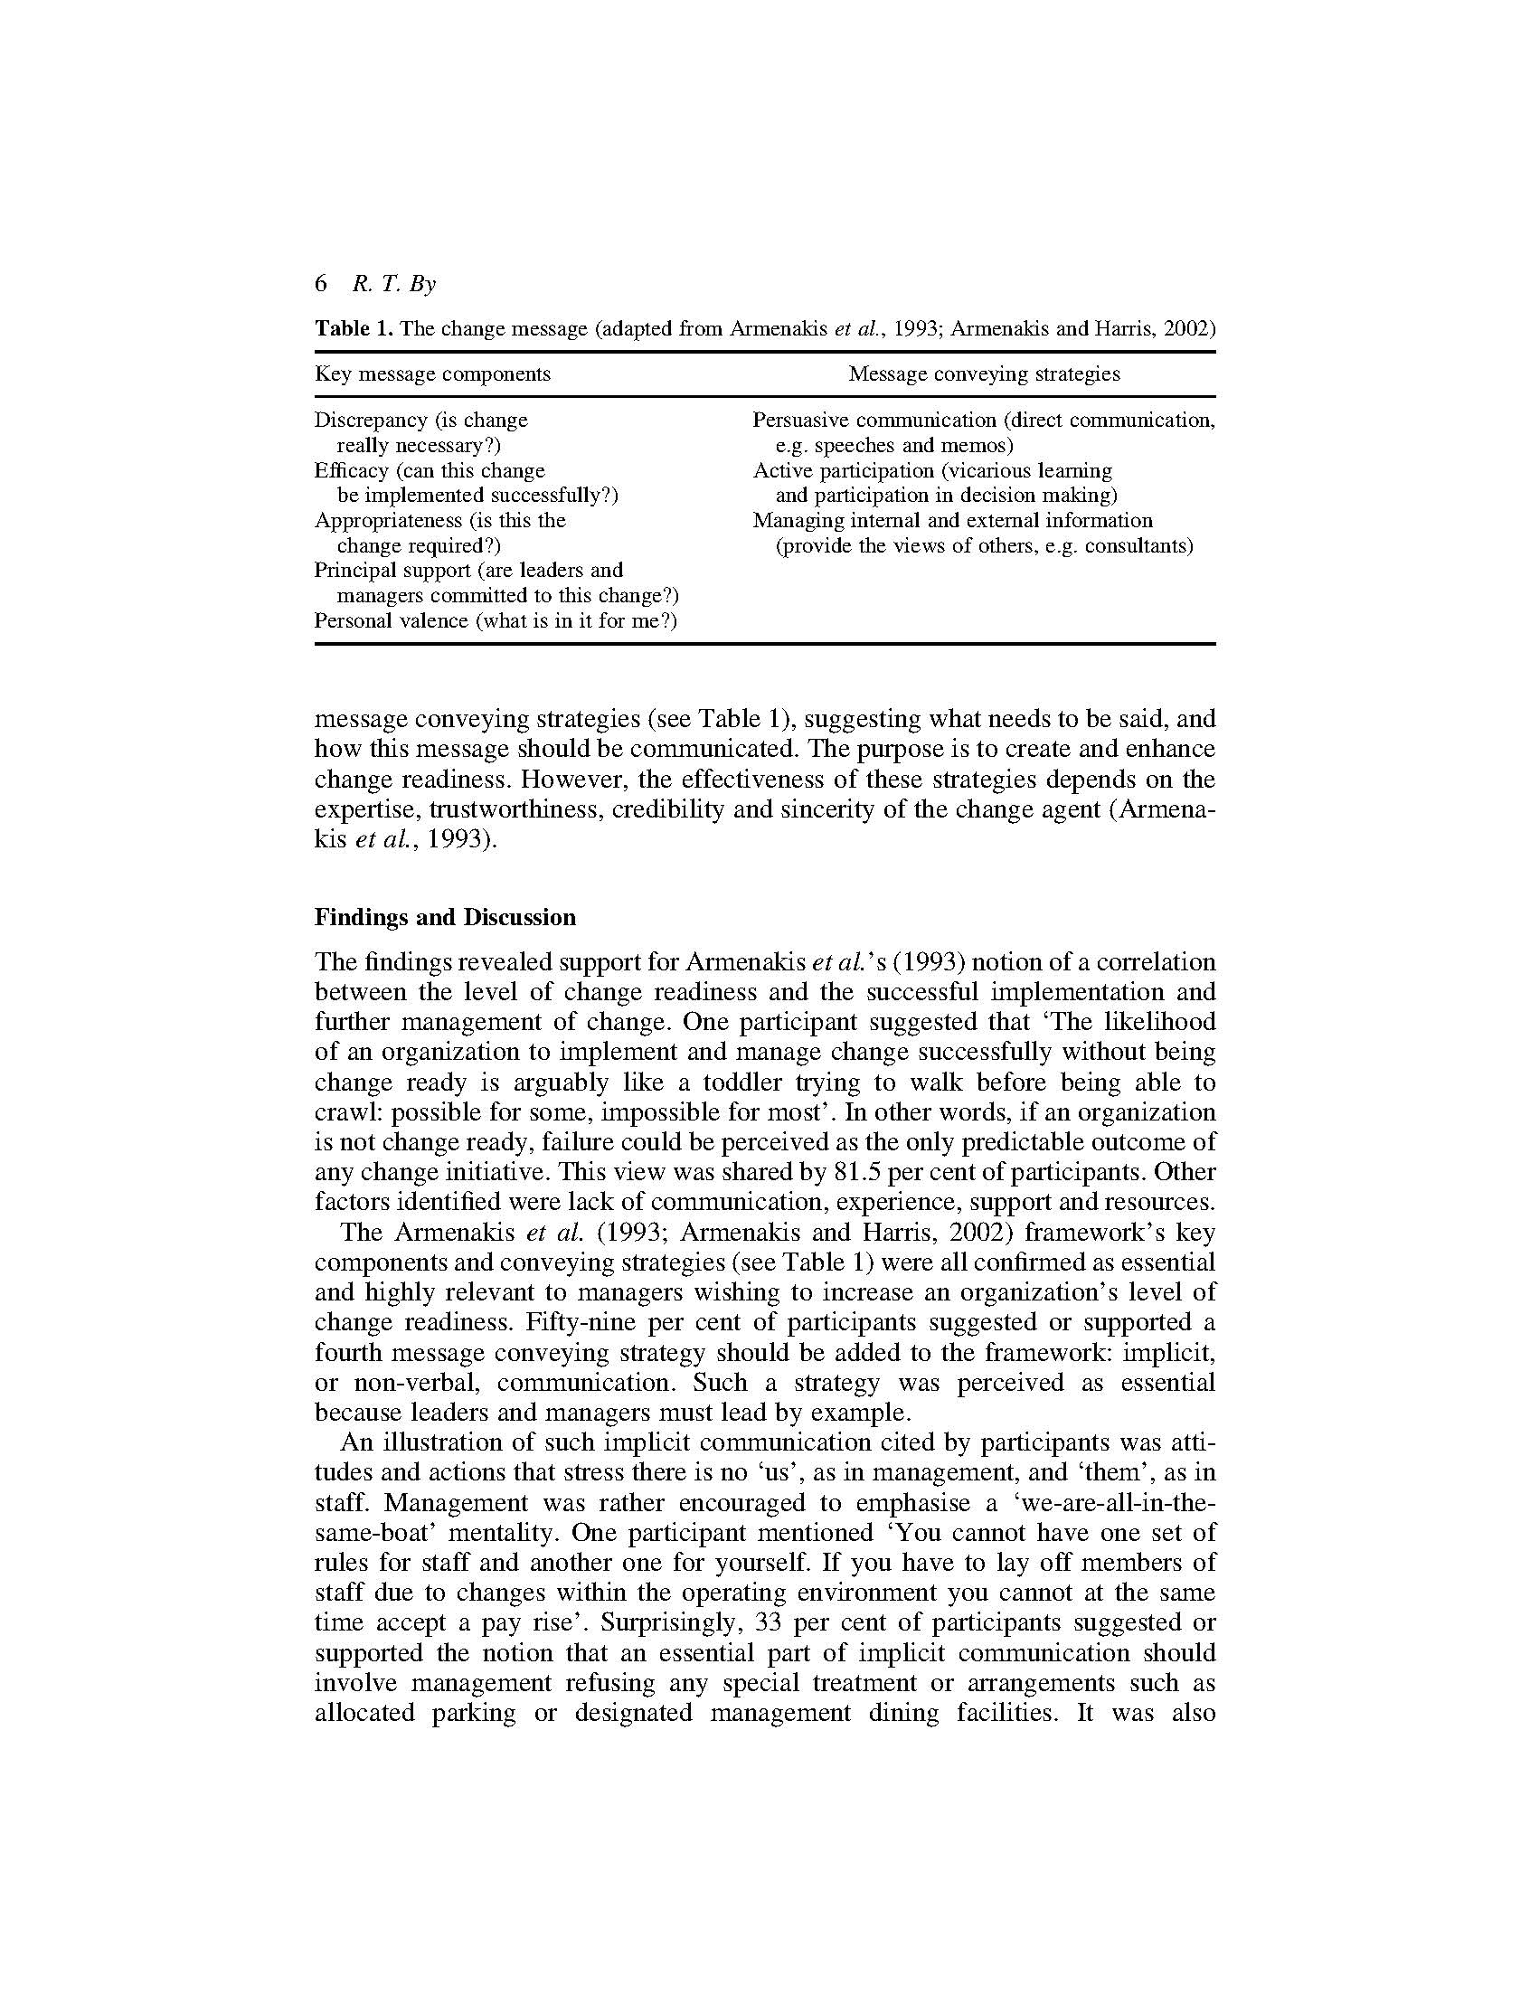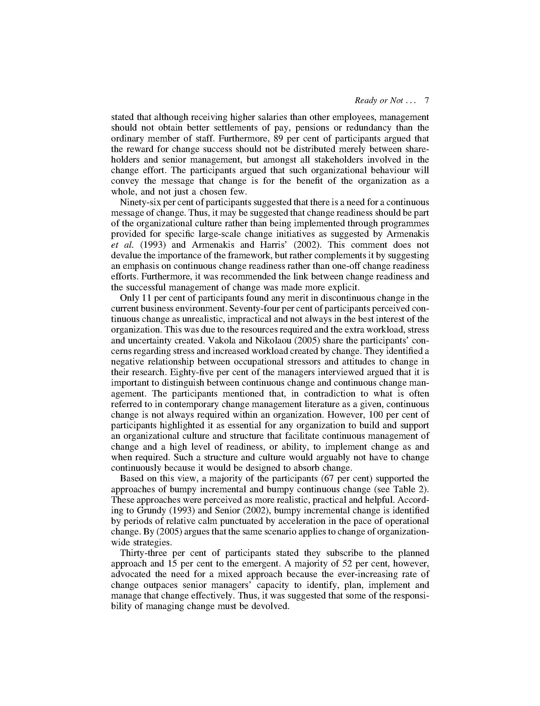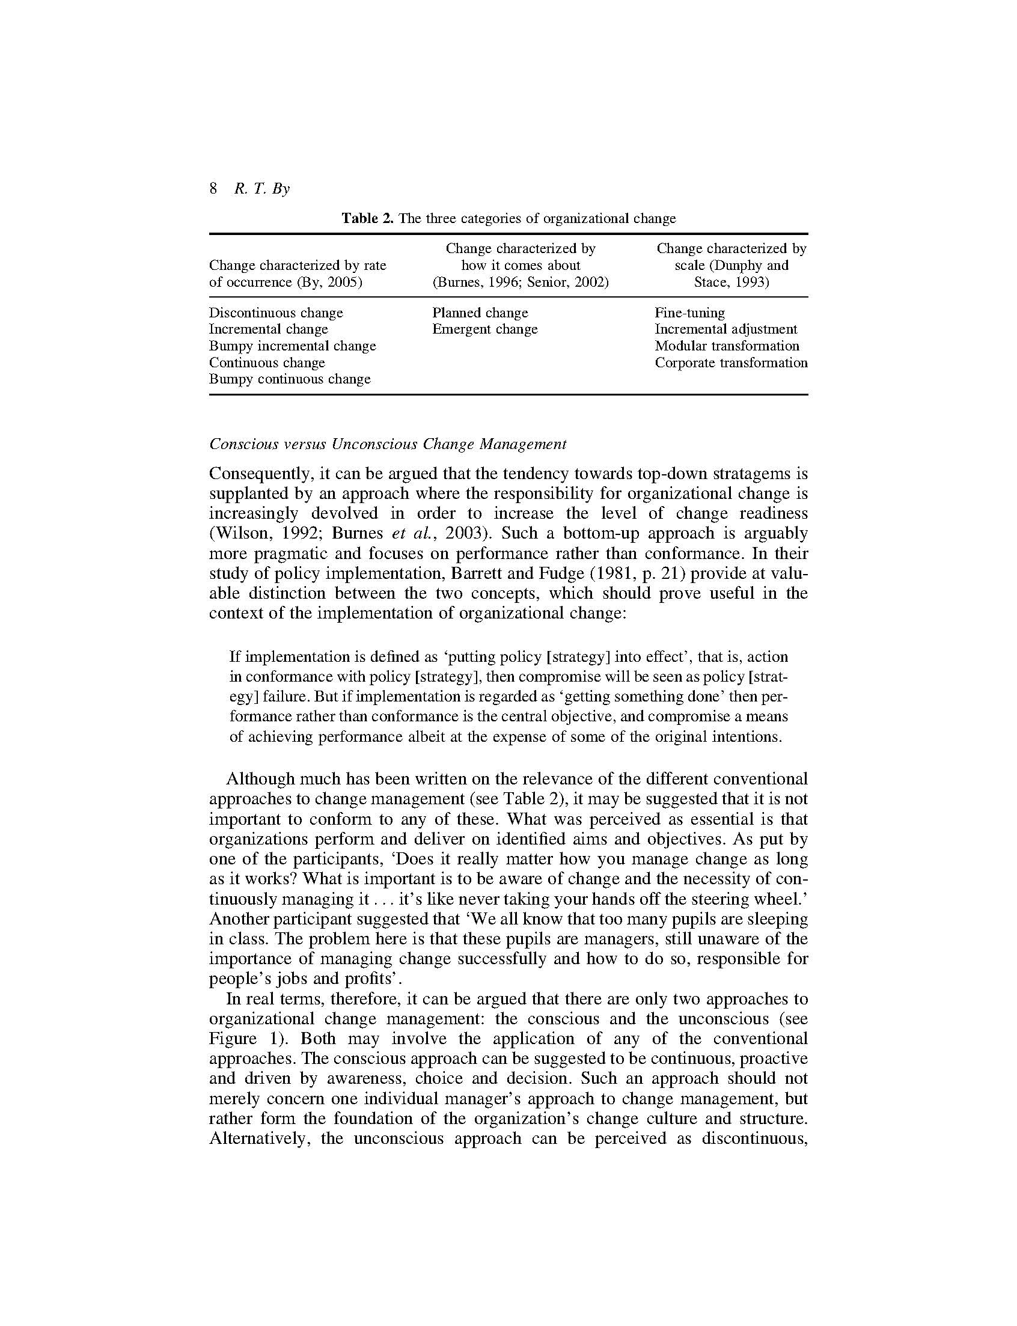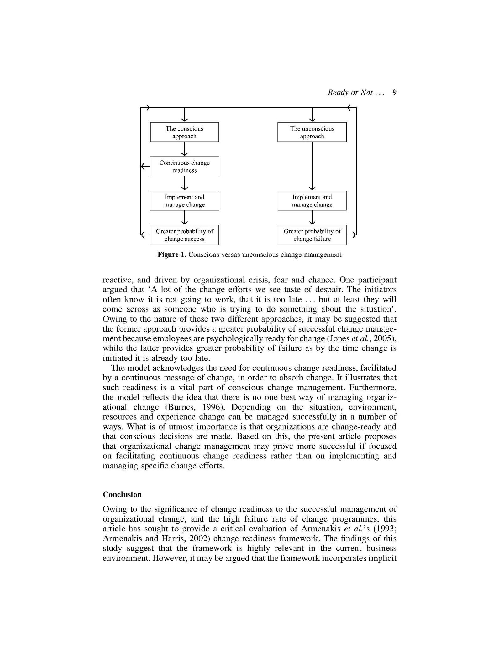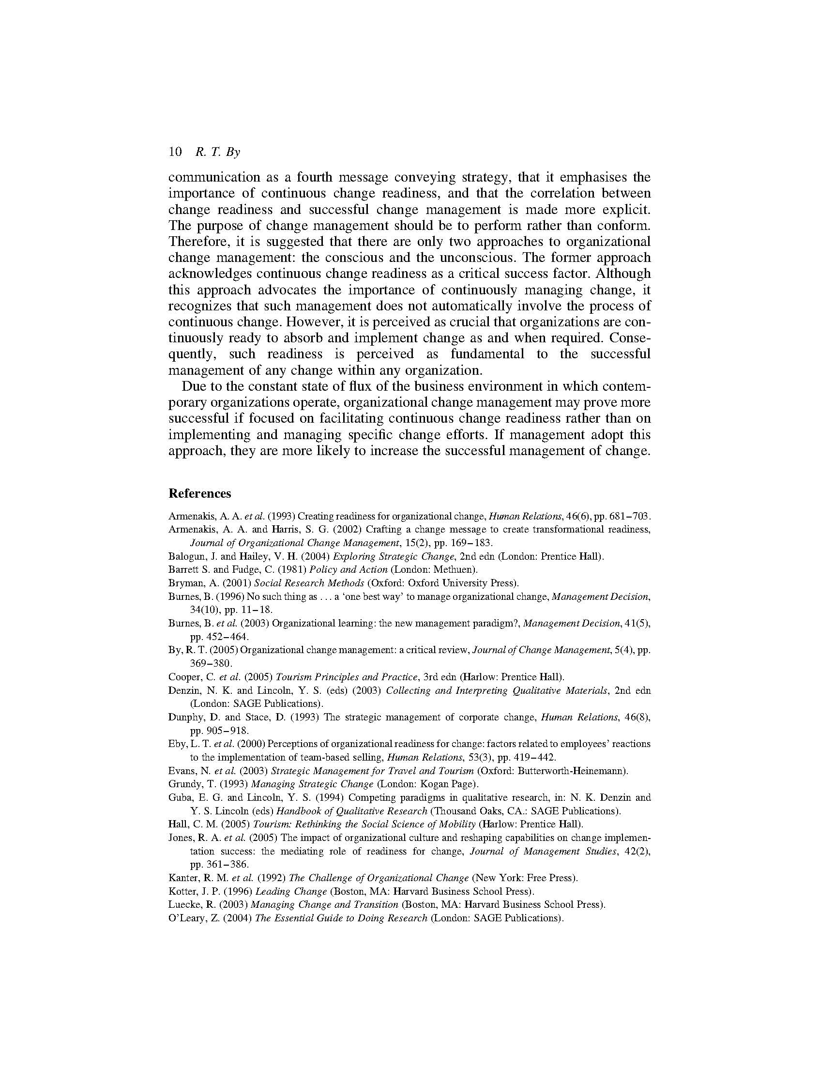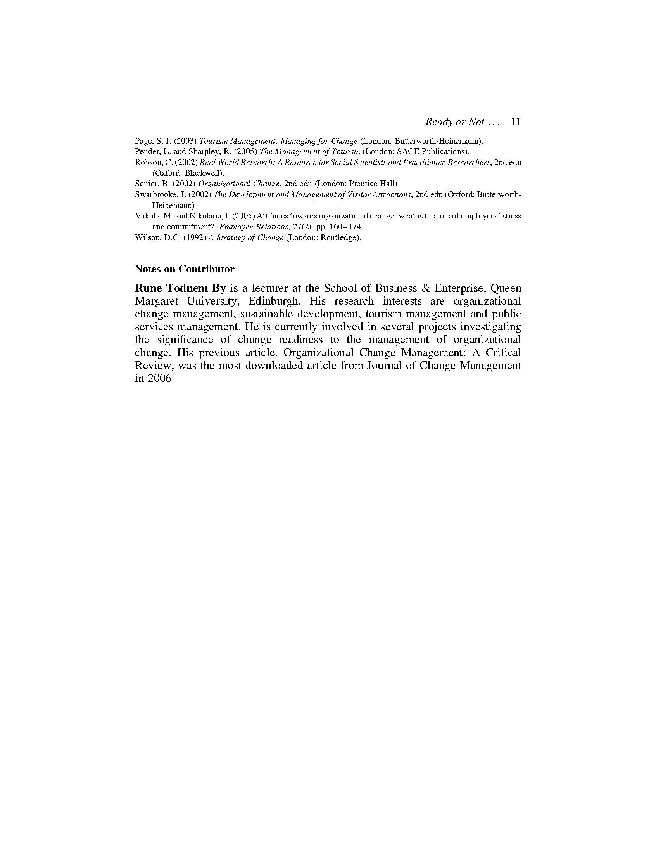
4.3 Summary
With reference to Armenakis et al.’s (1993; 2002) concept of organisational change readiness, this chapter complements the original framework by introducing ’implicit communication’ as a fourth change message conveying strategy. Progressing from this concept, it suggests that fundamentally there are only two overarching approaches to organisational change management: the conscious and the unconscious - the former advocating continuous organisational change readiness, not necessarily continuous organisational change.

Chapter 5: Getting organizational change right in public services: the case of European higher education

By, R.T., Diefenbach, T. and Klarner, P. (2008)
Journal of Change Management, 8(1), pp. 21-35

(Published work 9)

This chapter is derived from an article published by Journal of Change Management in 2008

5.1 Introduction
This chapter further develops the Conscious and Unconscious Change Management model first introduced in Chapter 4. With a focus on the higher education sector, it suggests that not all change is initiated for the right reasons – the right reasons being defined as the sector’s contribution to the further development of society through knowledge generation and transfer. The chapter suggests that an expanding audit culture and increasing levels of managerialism have resulted in an environment encouraging opportunistic behaviour such as cronyism, rent-seeking and the rise of organisational psychopaths, resulting in change for the sake of change, wasteful use of resources, a disheartened and exploited workforce, as well as political and short-term decision-making.

By, R.T., Diefenbach, T. and Klarner, P. (2008). Getting organizational change right in public services: the case of European Higher Education. Journal of Change Management. 8(1), pp. 21-35.

Note: According to Google Scholar this article has been cited 94 times (as of 24.04.2019)

5.2 Chapter article
Please see next page.

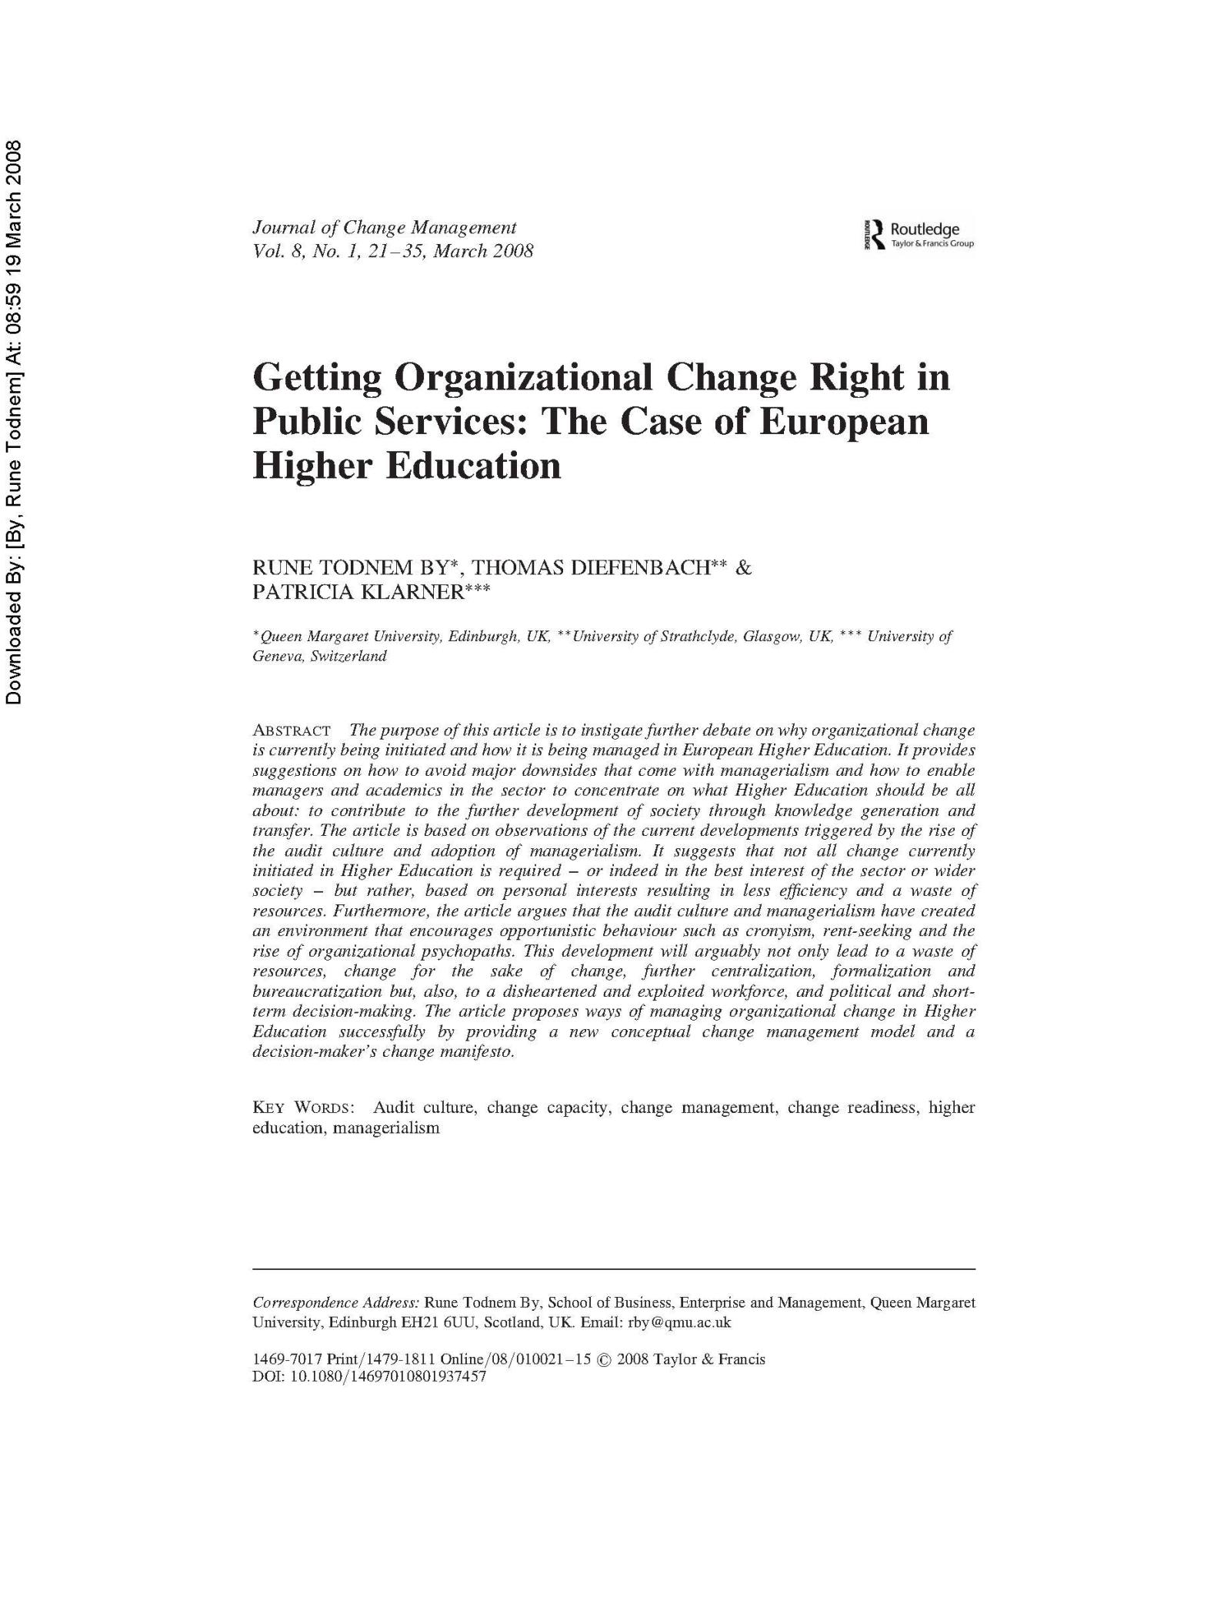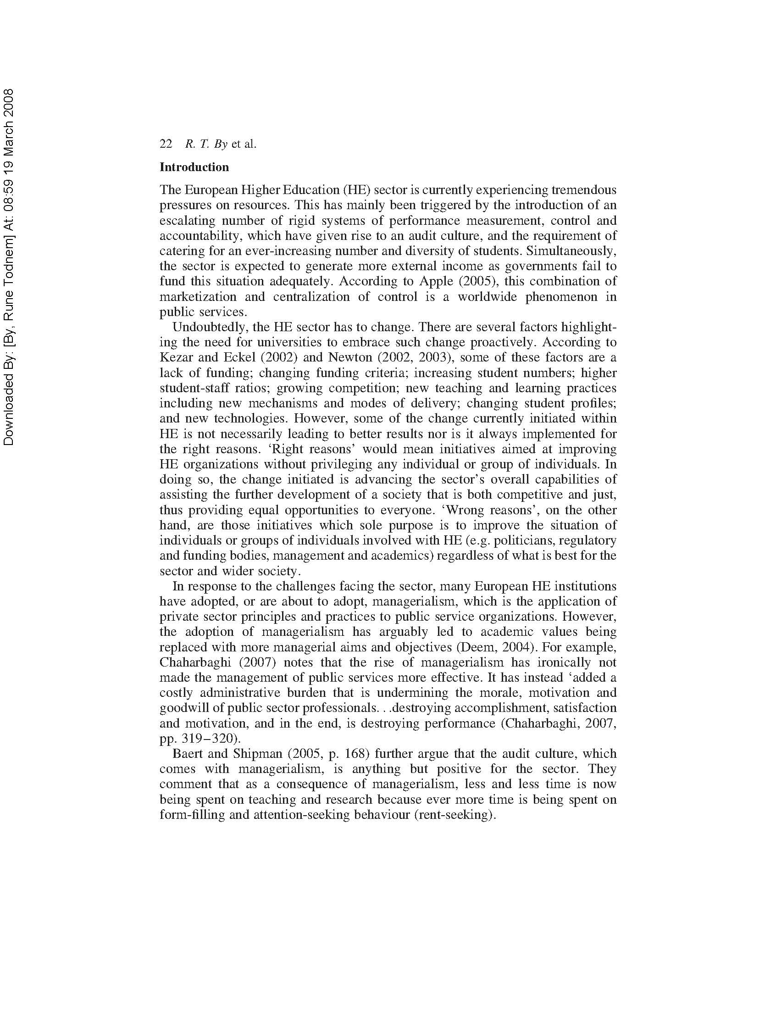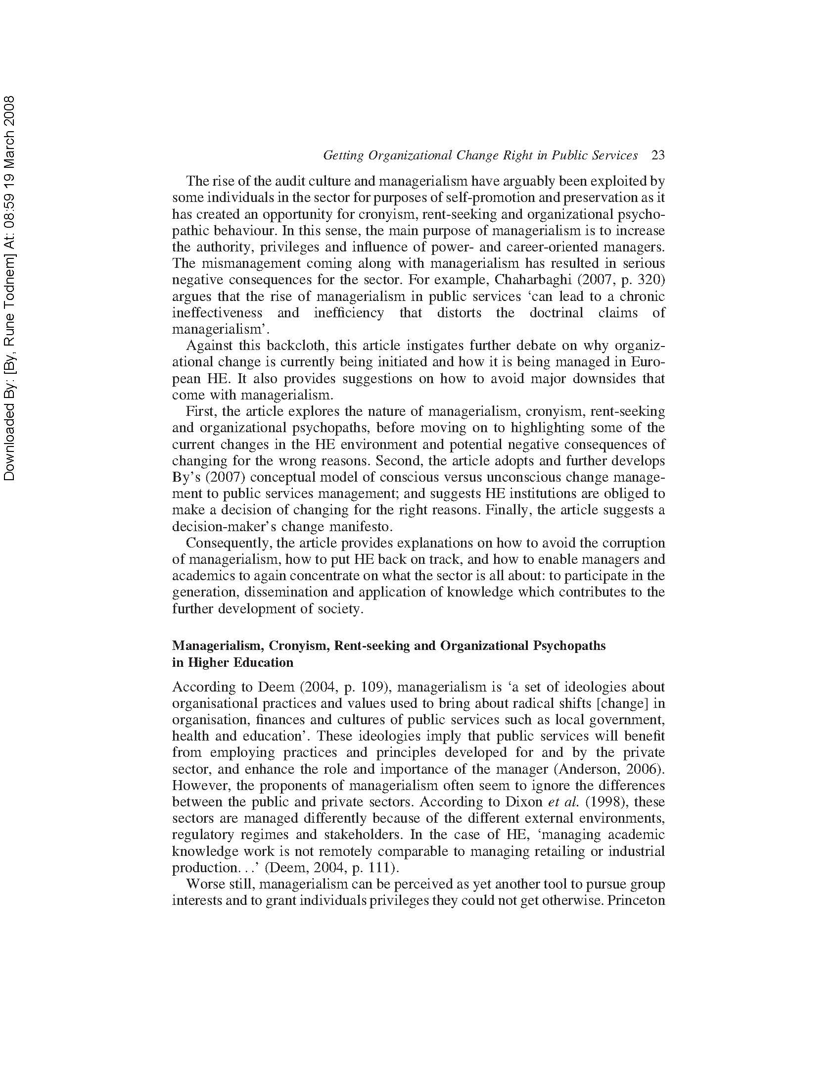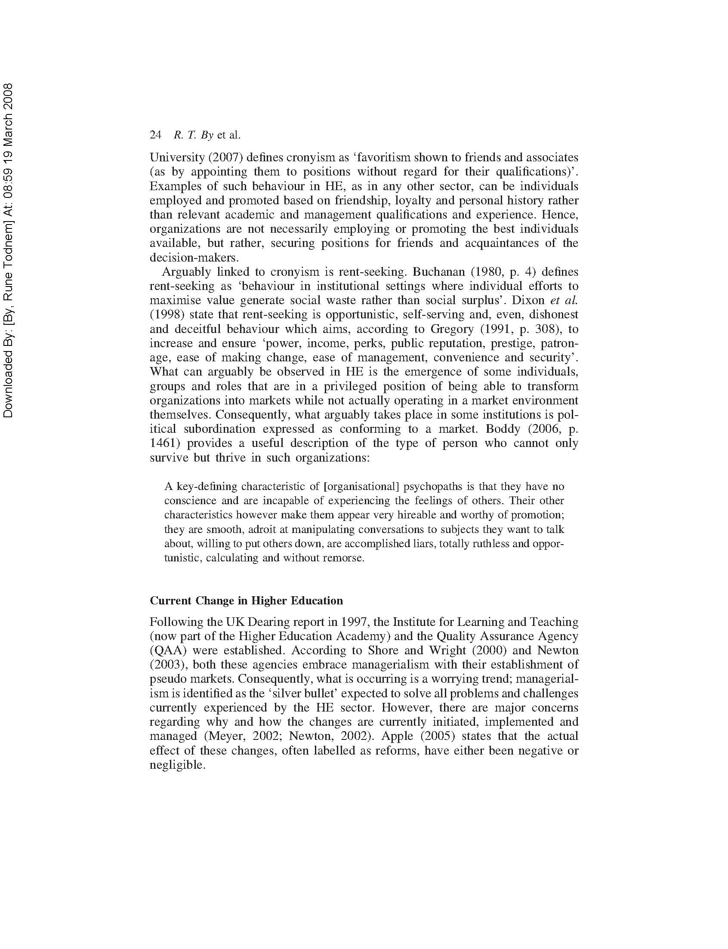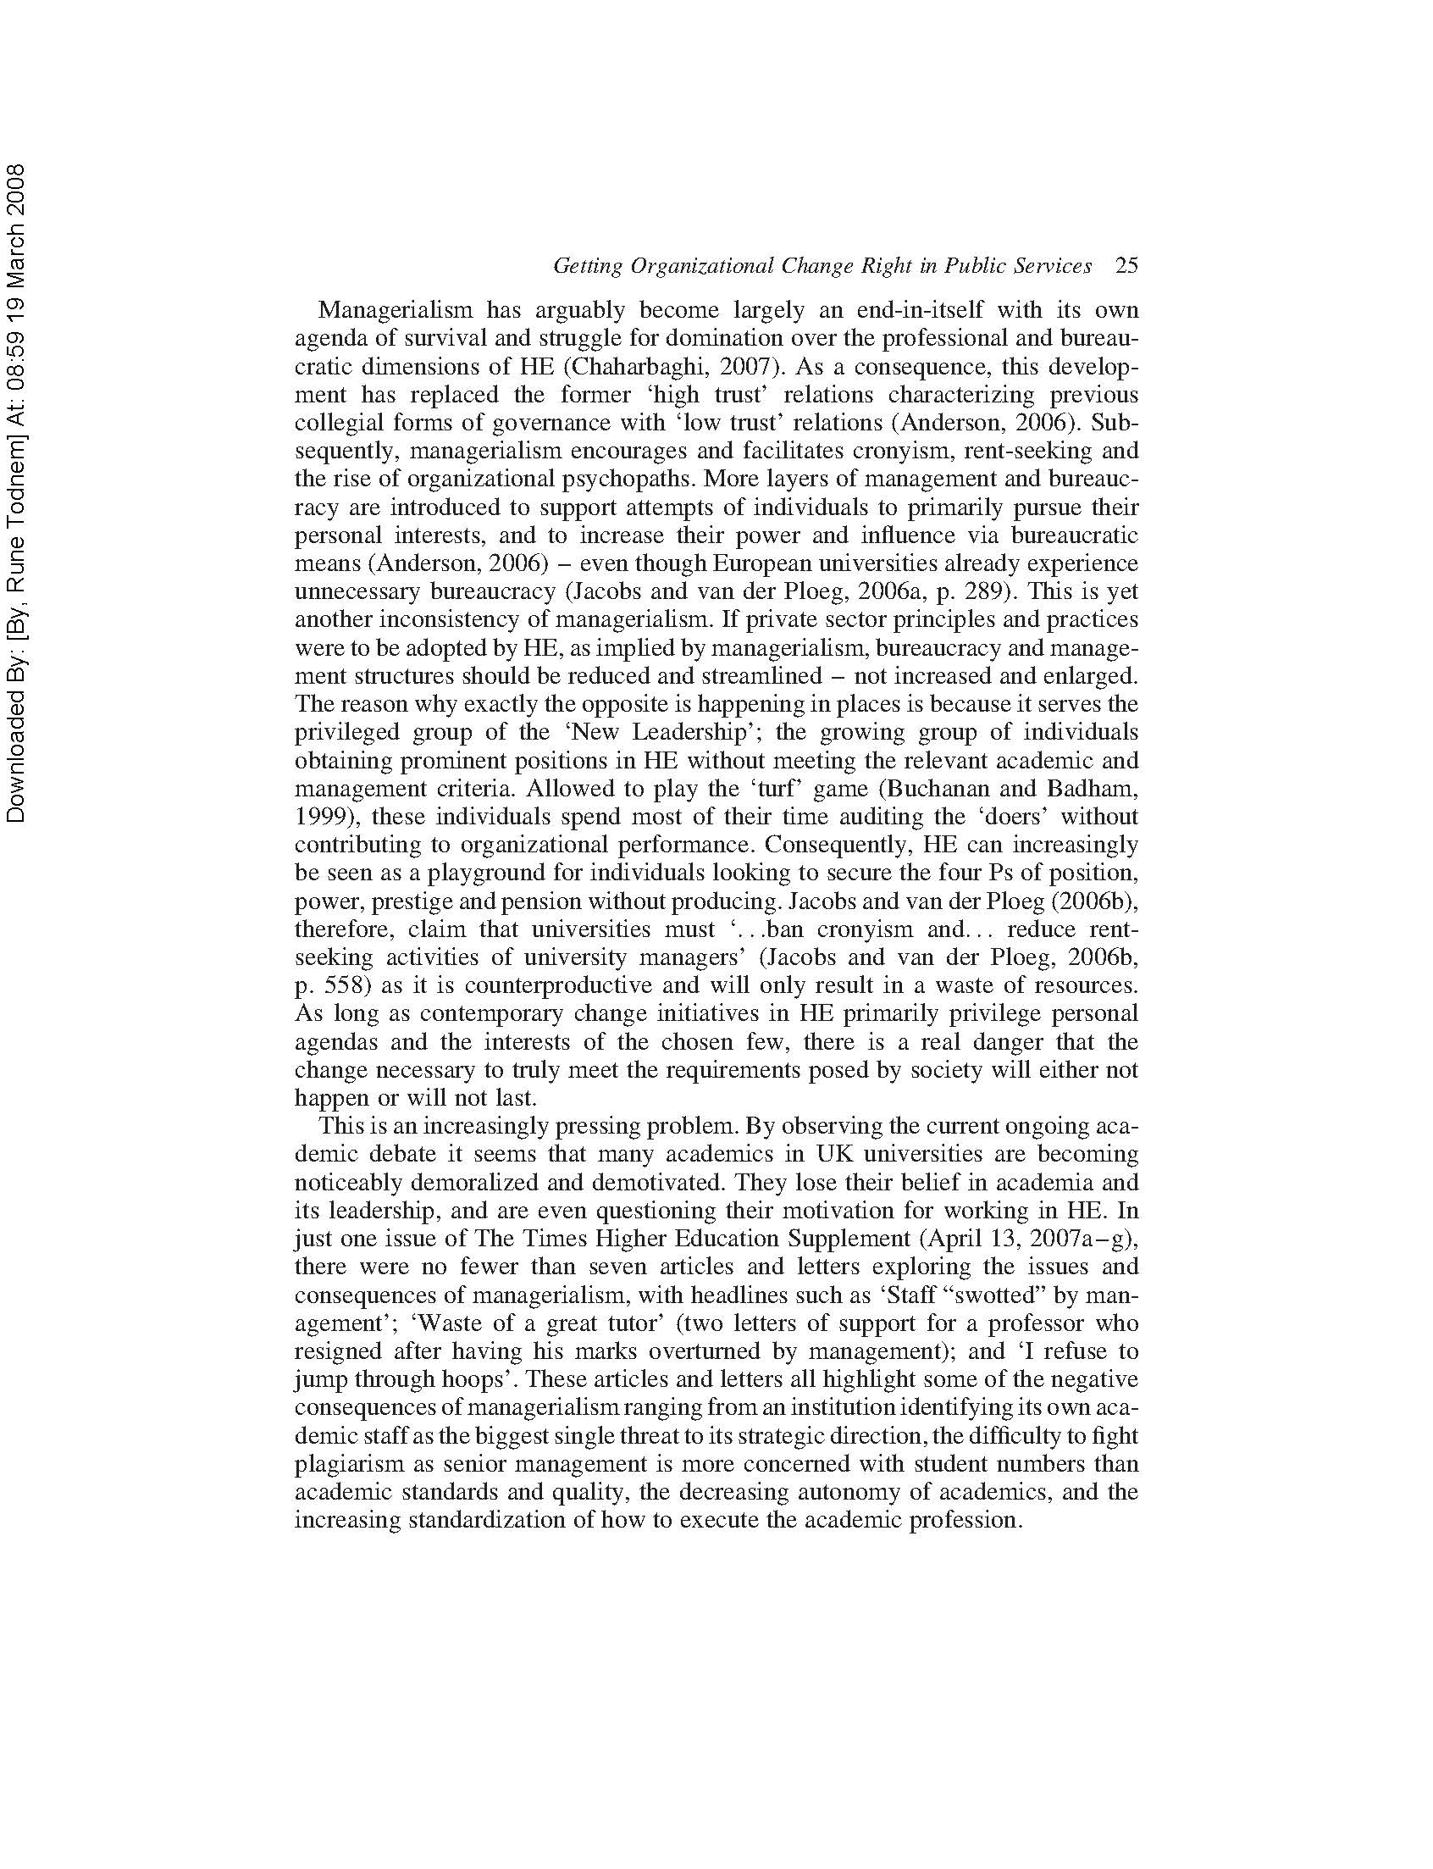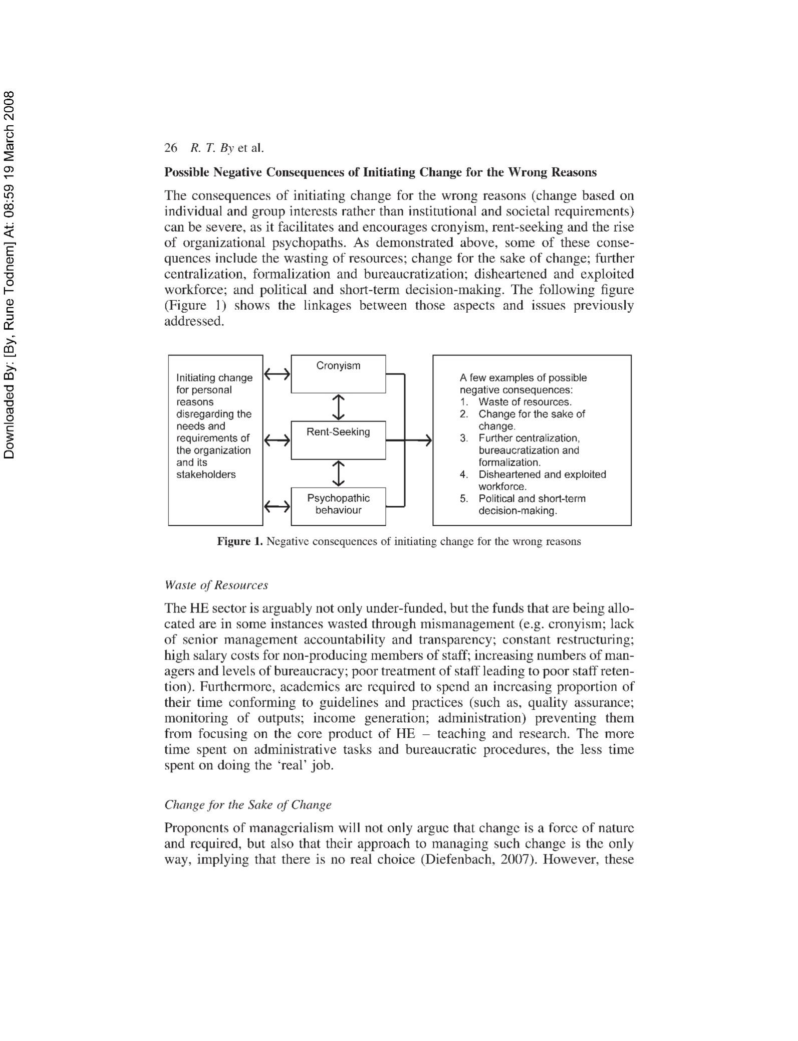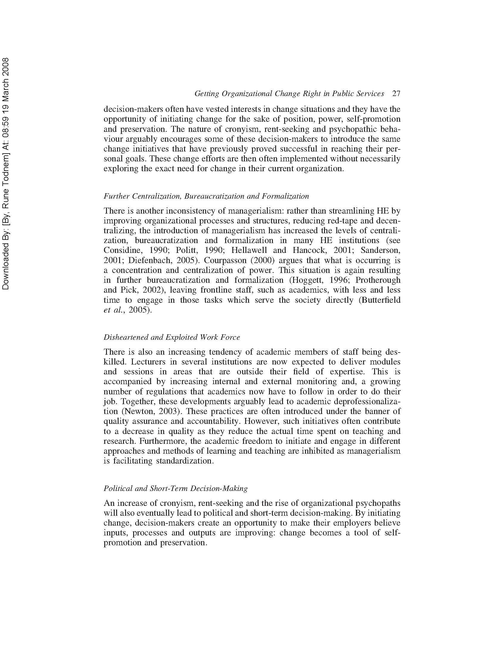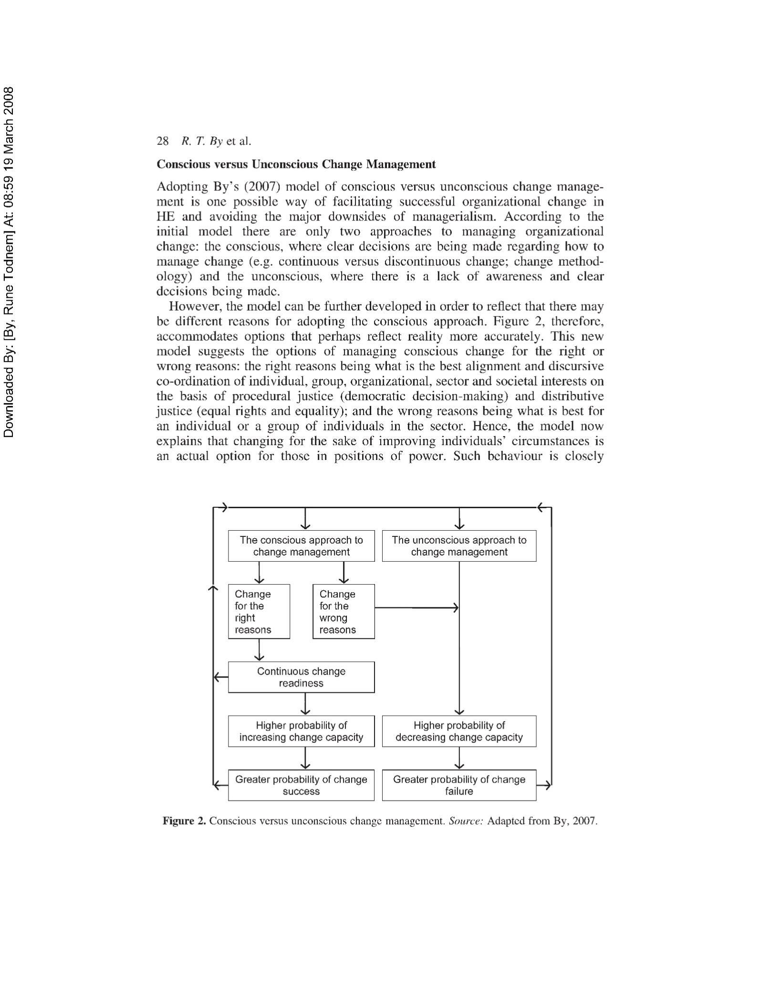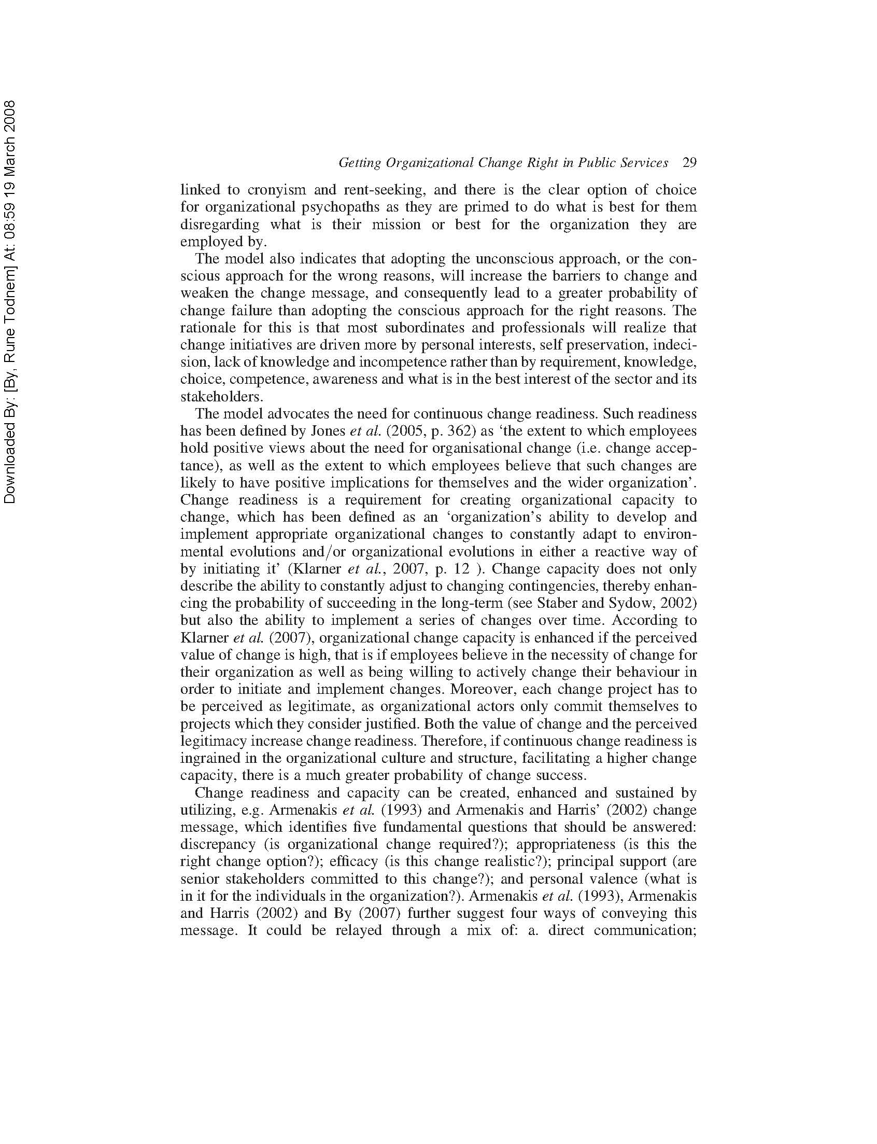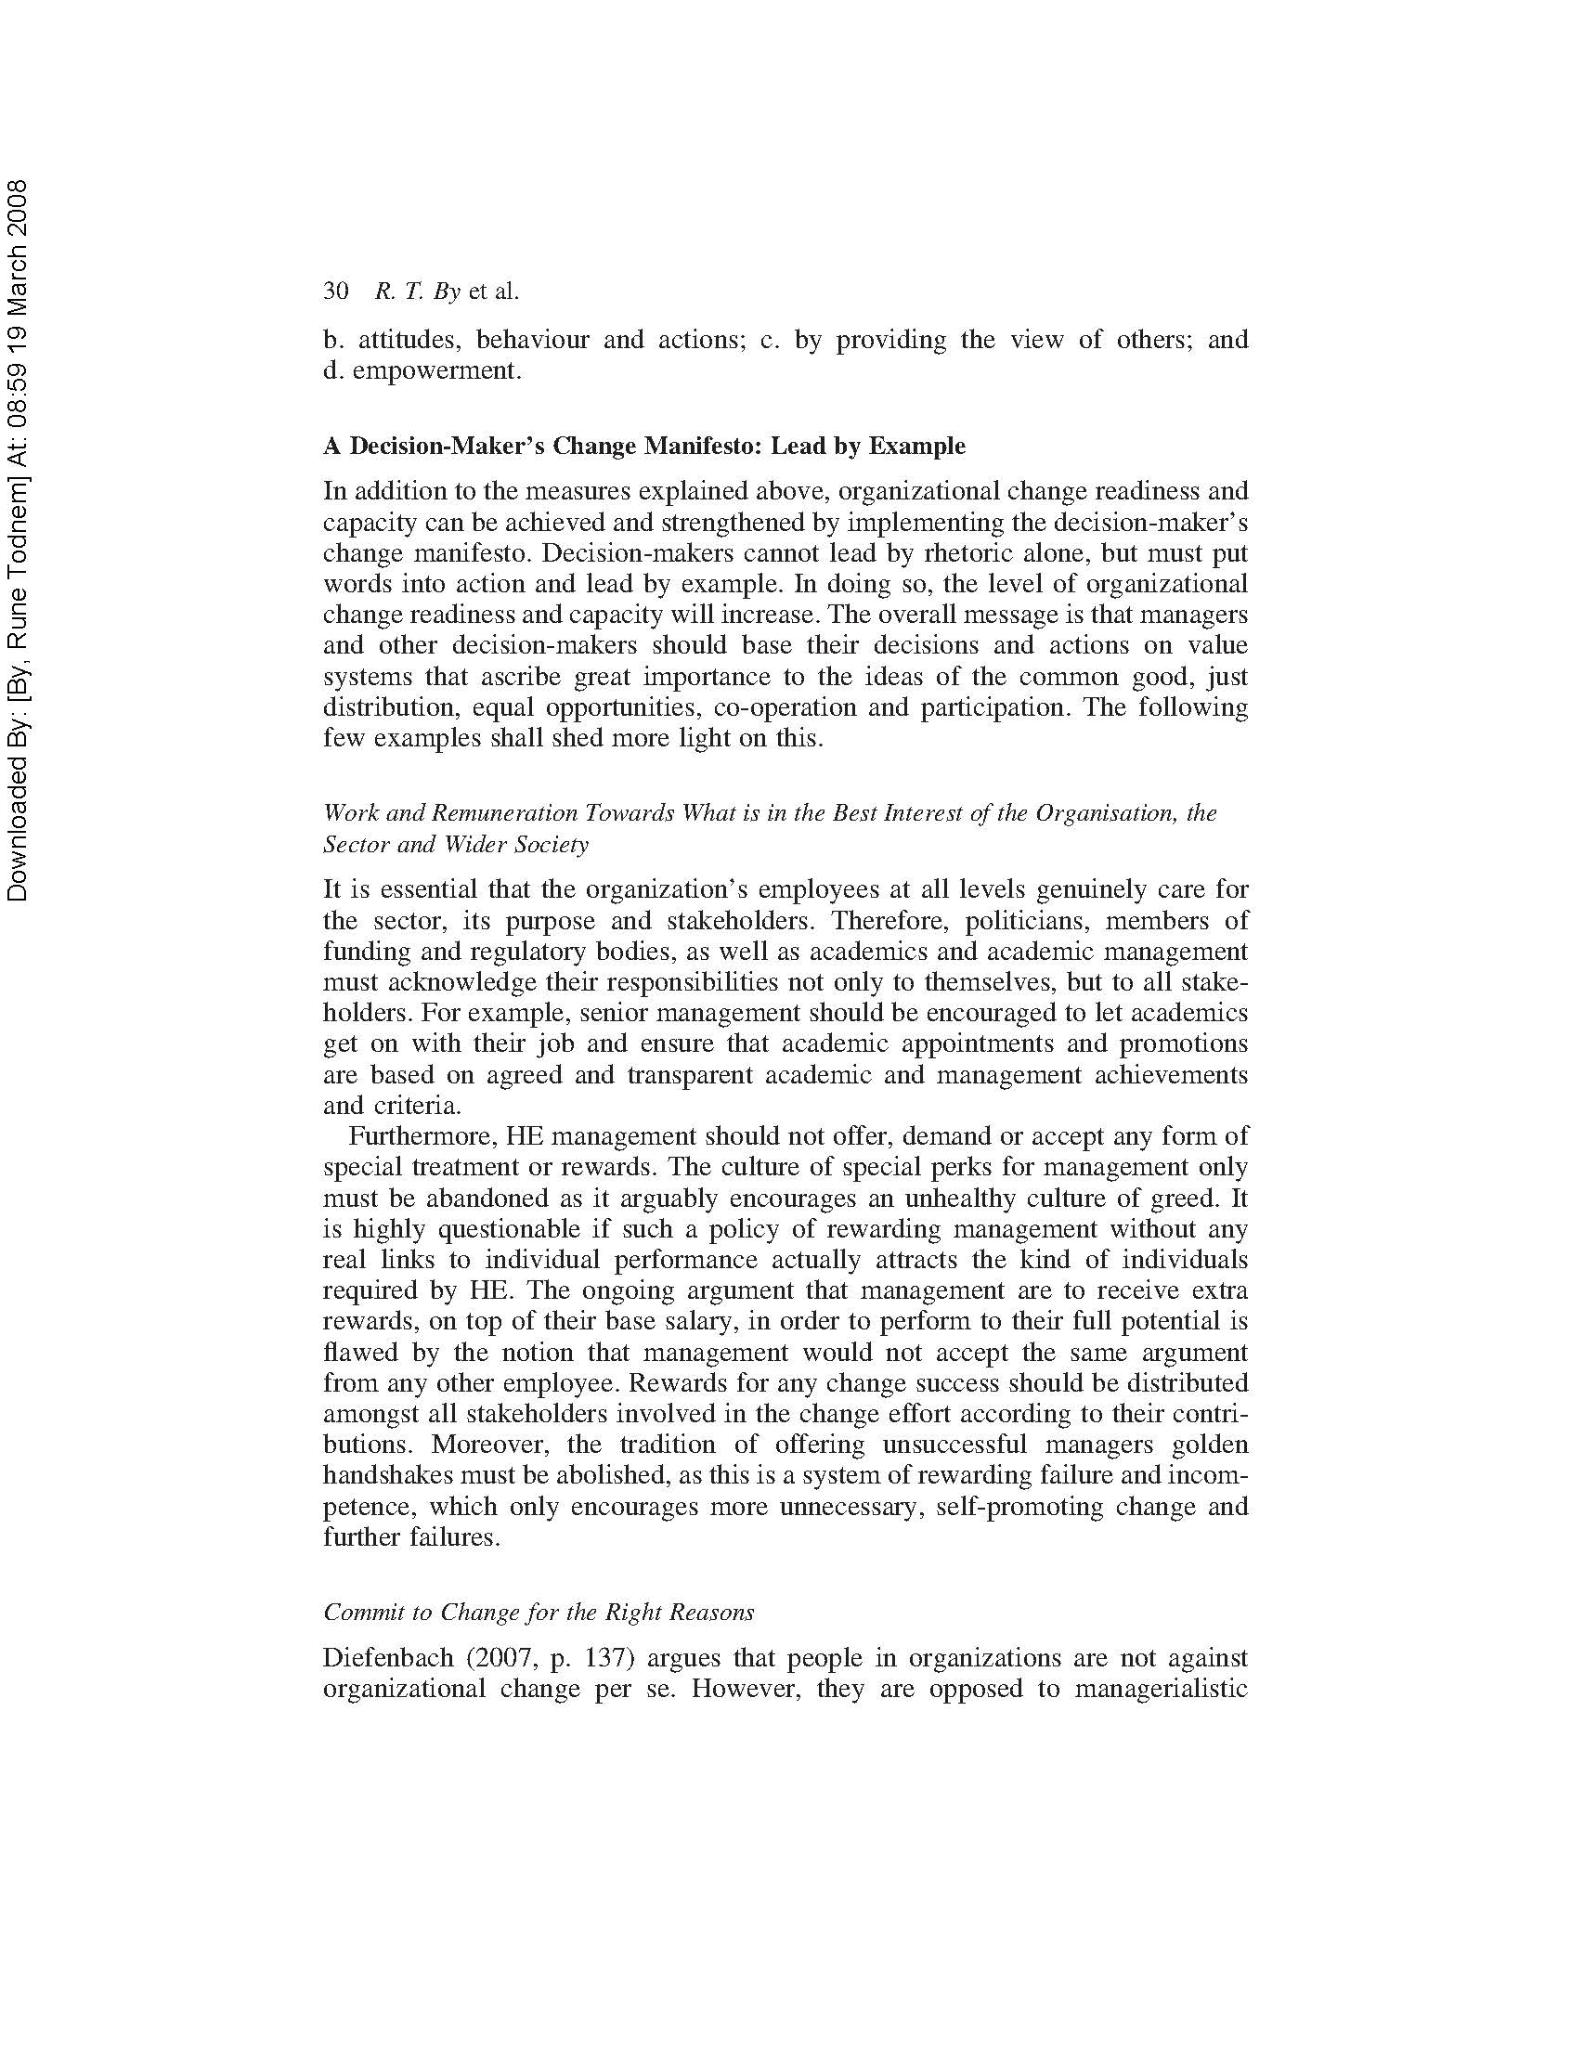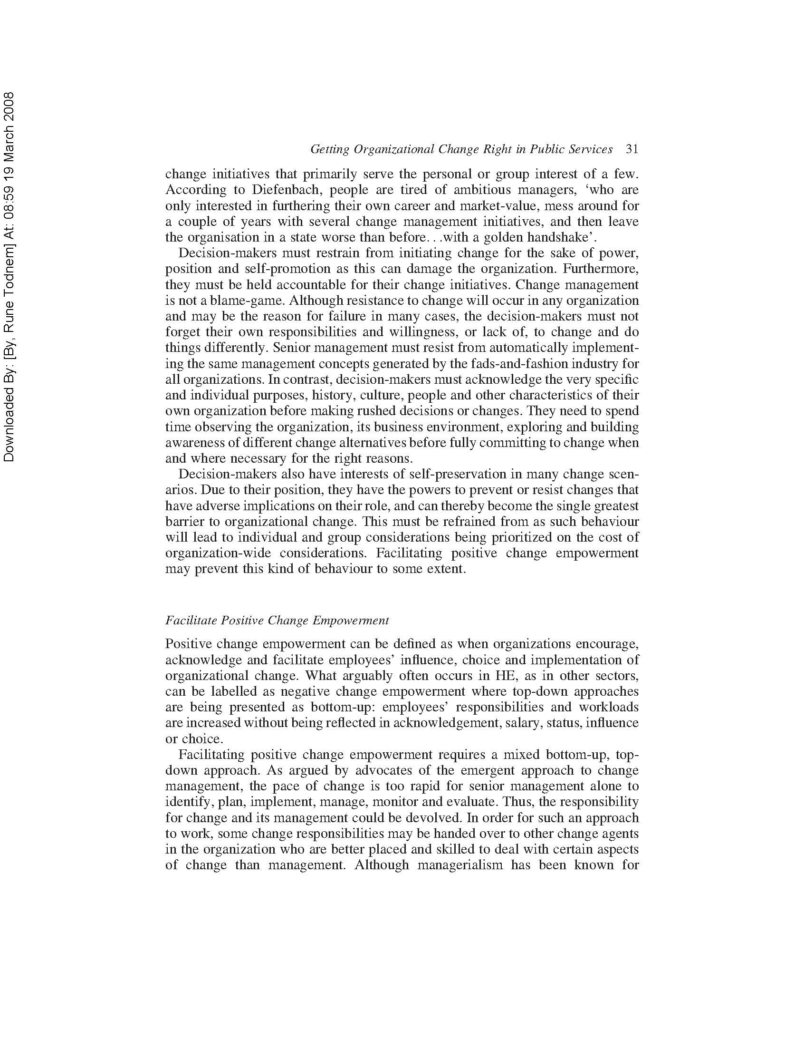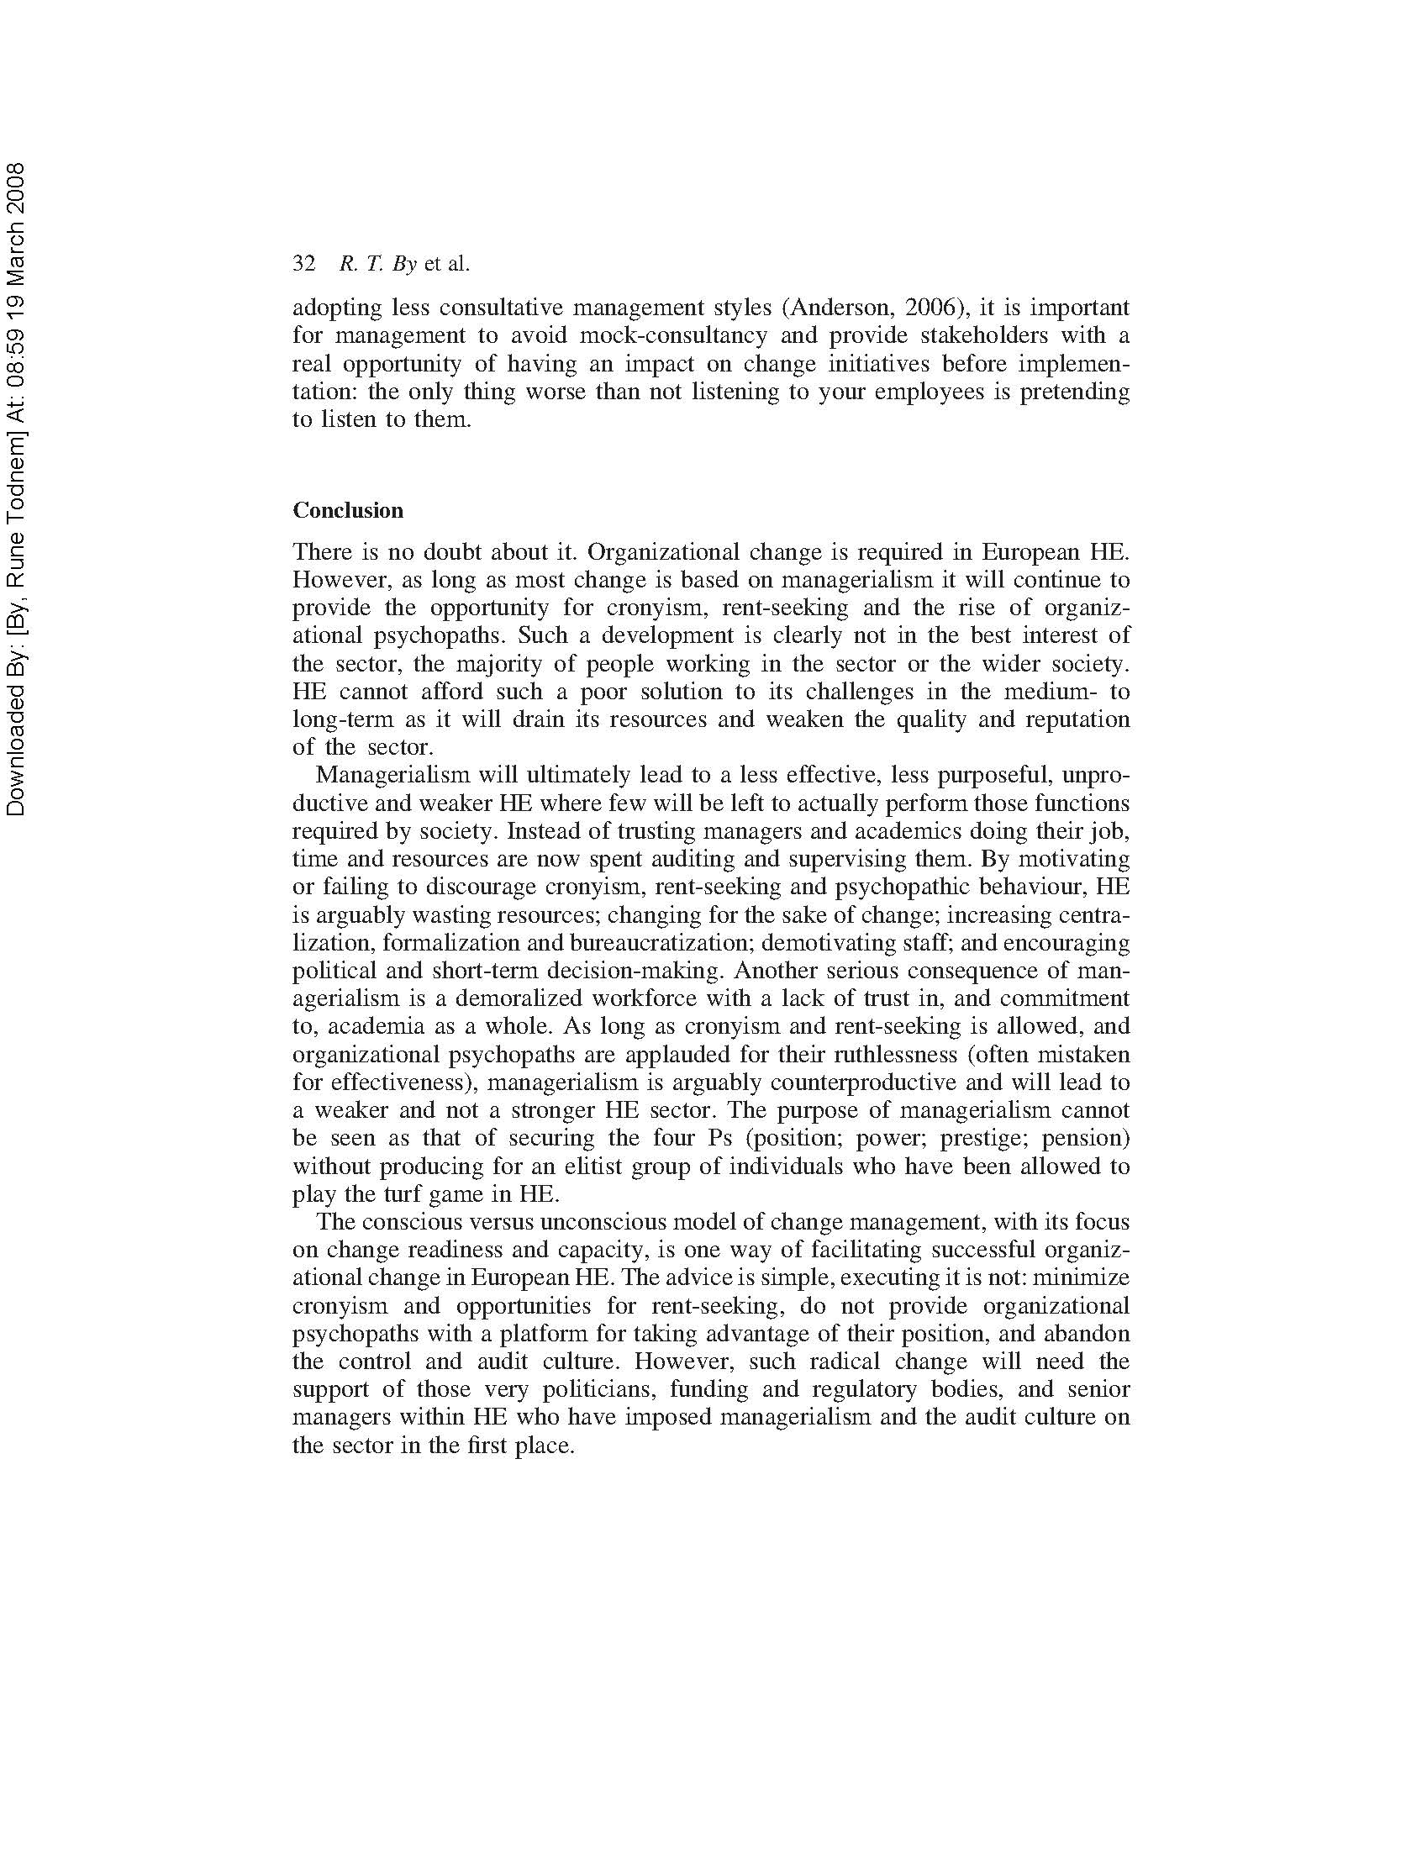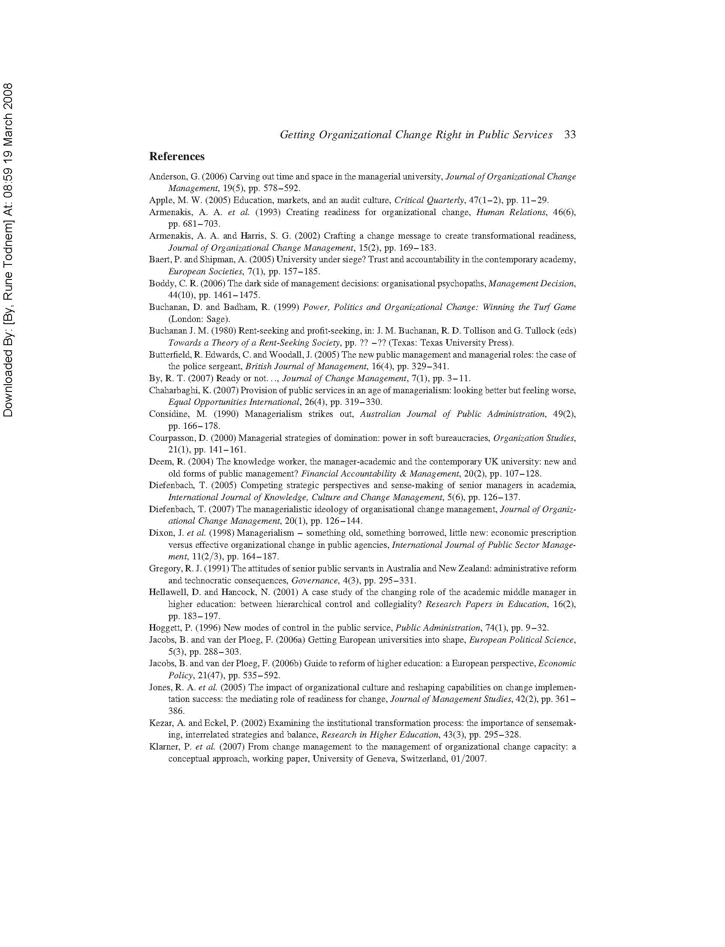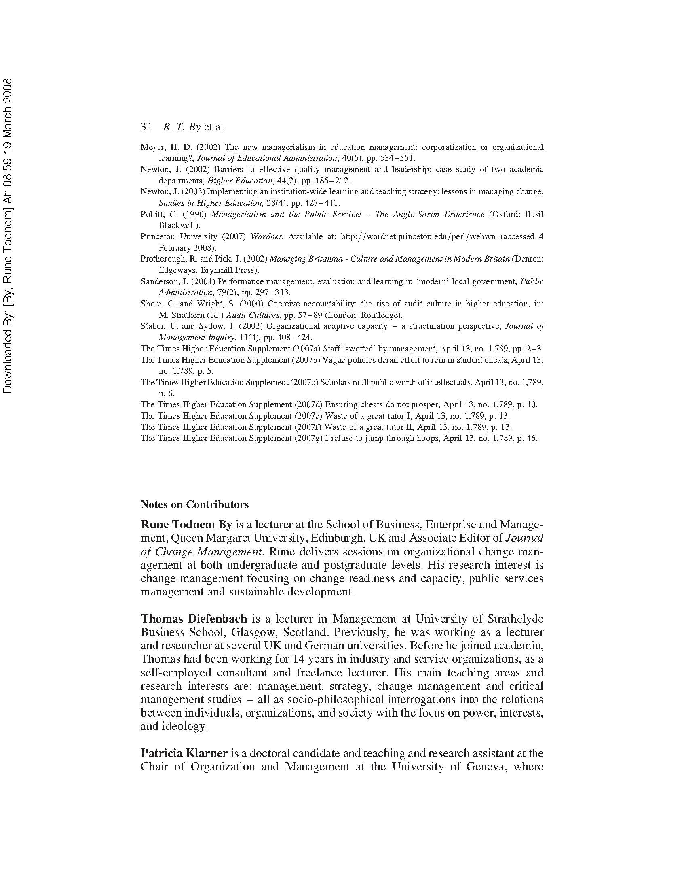
5.3 Summary
Continuing from Chapter 4, this chapter further developments the Conscious and Unconscious Change Management model. With a focus on the higher education sector, it refers to ethical questions of right and wrong when observing the motivation for much of the organisational change initiated. Defining right reasons as those enabling the sector’s contribution to the further development of society through knowledge generation and transfer the chapter suggests current changes - exemplified by expanding audit cultures and increasing levels of managerialism - have allowed for an environment conducive to opportunistic behaviour such as cronyism, rent-seeking and the rise of organisational psychopaths. As a result, we observe political and short-term decision-making, change for the sake of change, wasted resources, and a disheartened and exploited workforce.

Chapter 6: The changing face of English universities: reinventing collegiality for the 21st century

Burnes, B., Wend, P. and By, R.T. (2014)
Studies in Higher Education, 39 (6), pp. 905-926

(Published work 3)

This chapter is derived from an article published by Studies in Higher Education in 2014

6.1 Introduction
This chapter continues the focus on changes taking place in the HE sector, specifically the English university system. It argues that the development driven by successive governments cutting university funding and compelling them to behave more like businesses than educational institutions can be dysfunctional for both managers and other staff. As an alternative to this dysfunctional centralism, the chapter puts forward an alternative based on a twenty-first-century reinvention of collegiality which is compatible with rapid decision-making at the university centre and effective execution of change at the departmental level.

Burnes, B., Wend, P. and By, R.T. (2014). The changing face of English universities: reinventing collegiality for the 21st century. Studies in Higher Education, 39 (6), pp. 905-926.

Note: According to Google Scholar this article has been cited 57 times (as of 24.04.2019)

6.2 Chapter article
Please see next page.

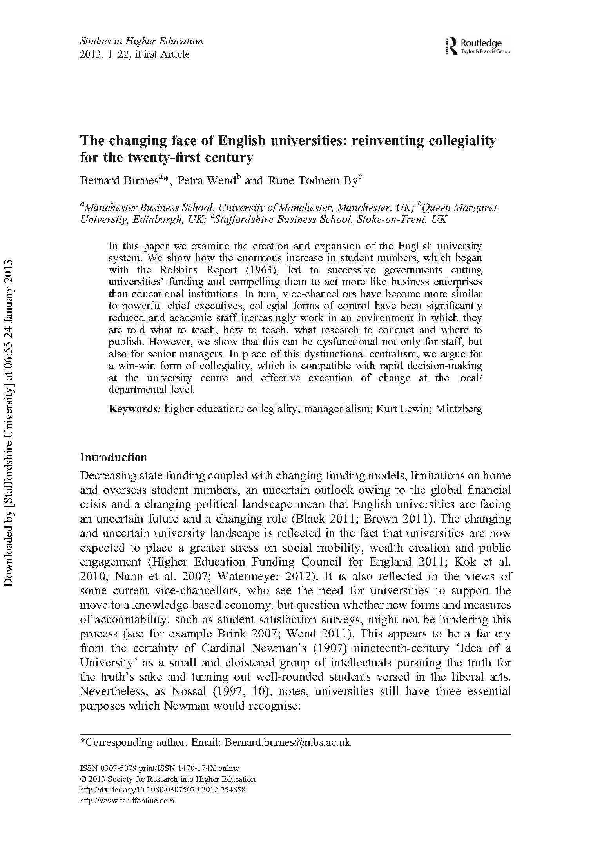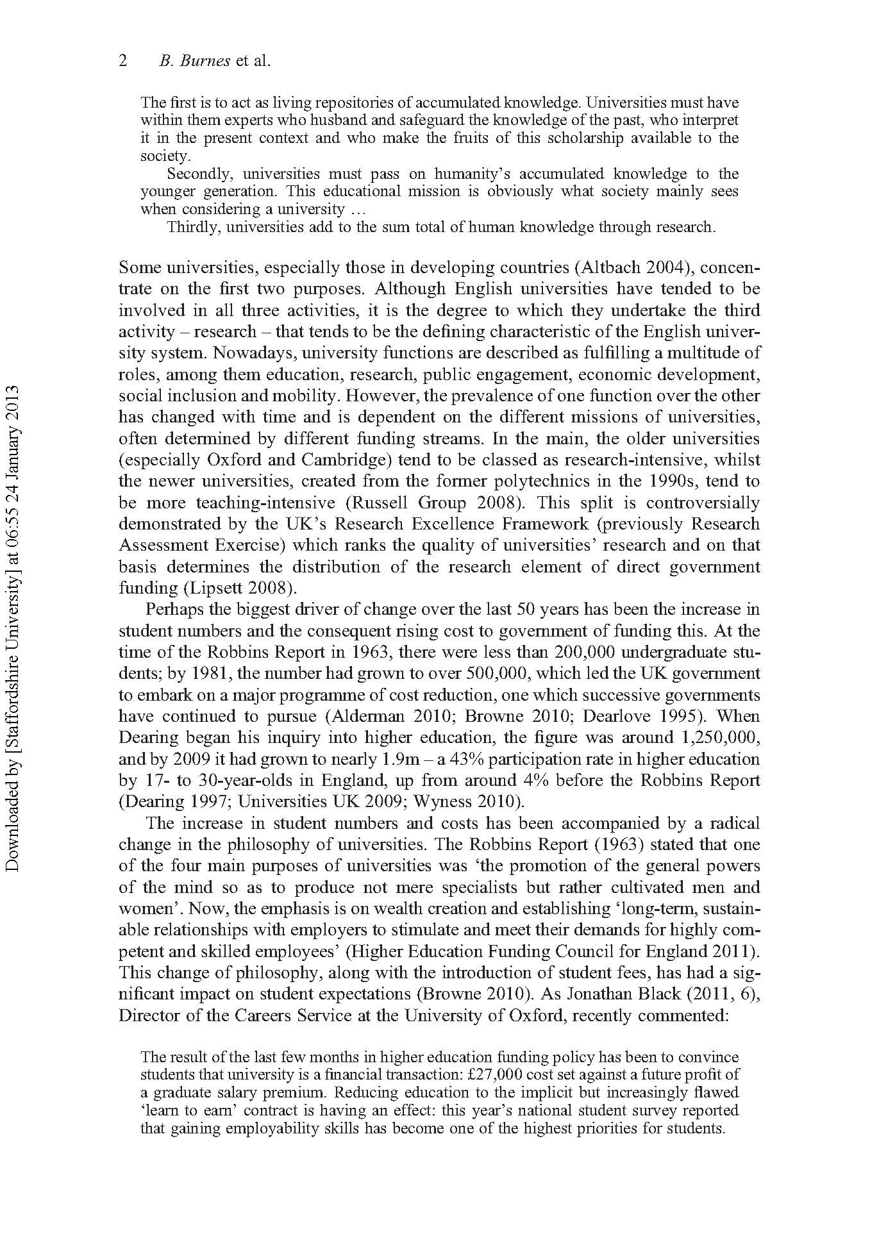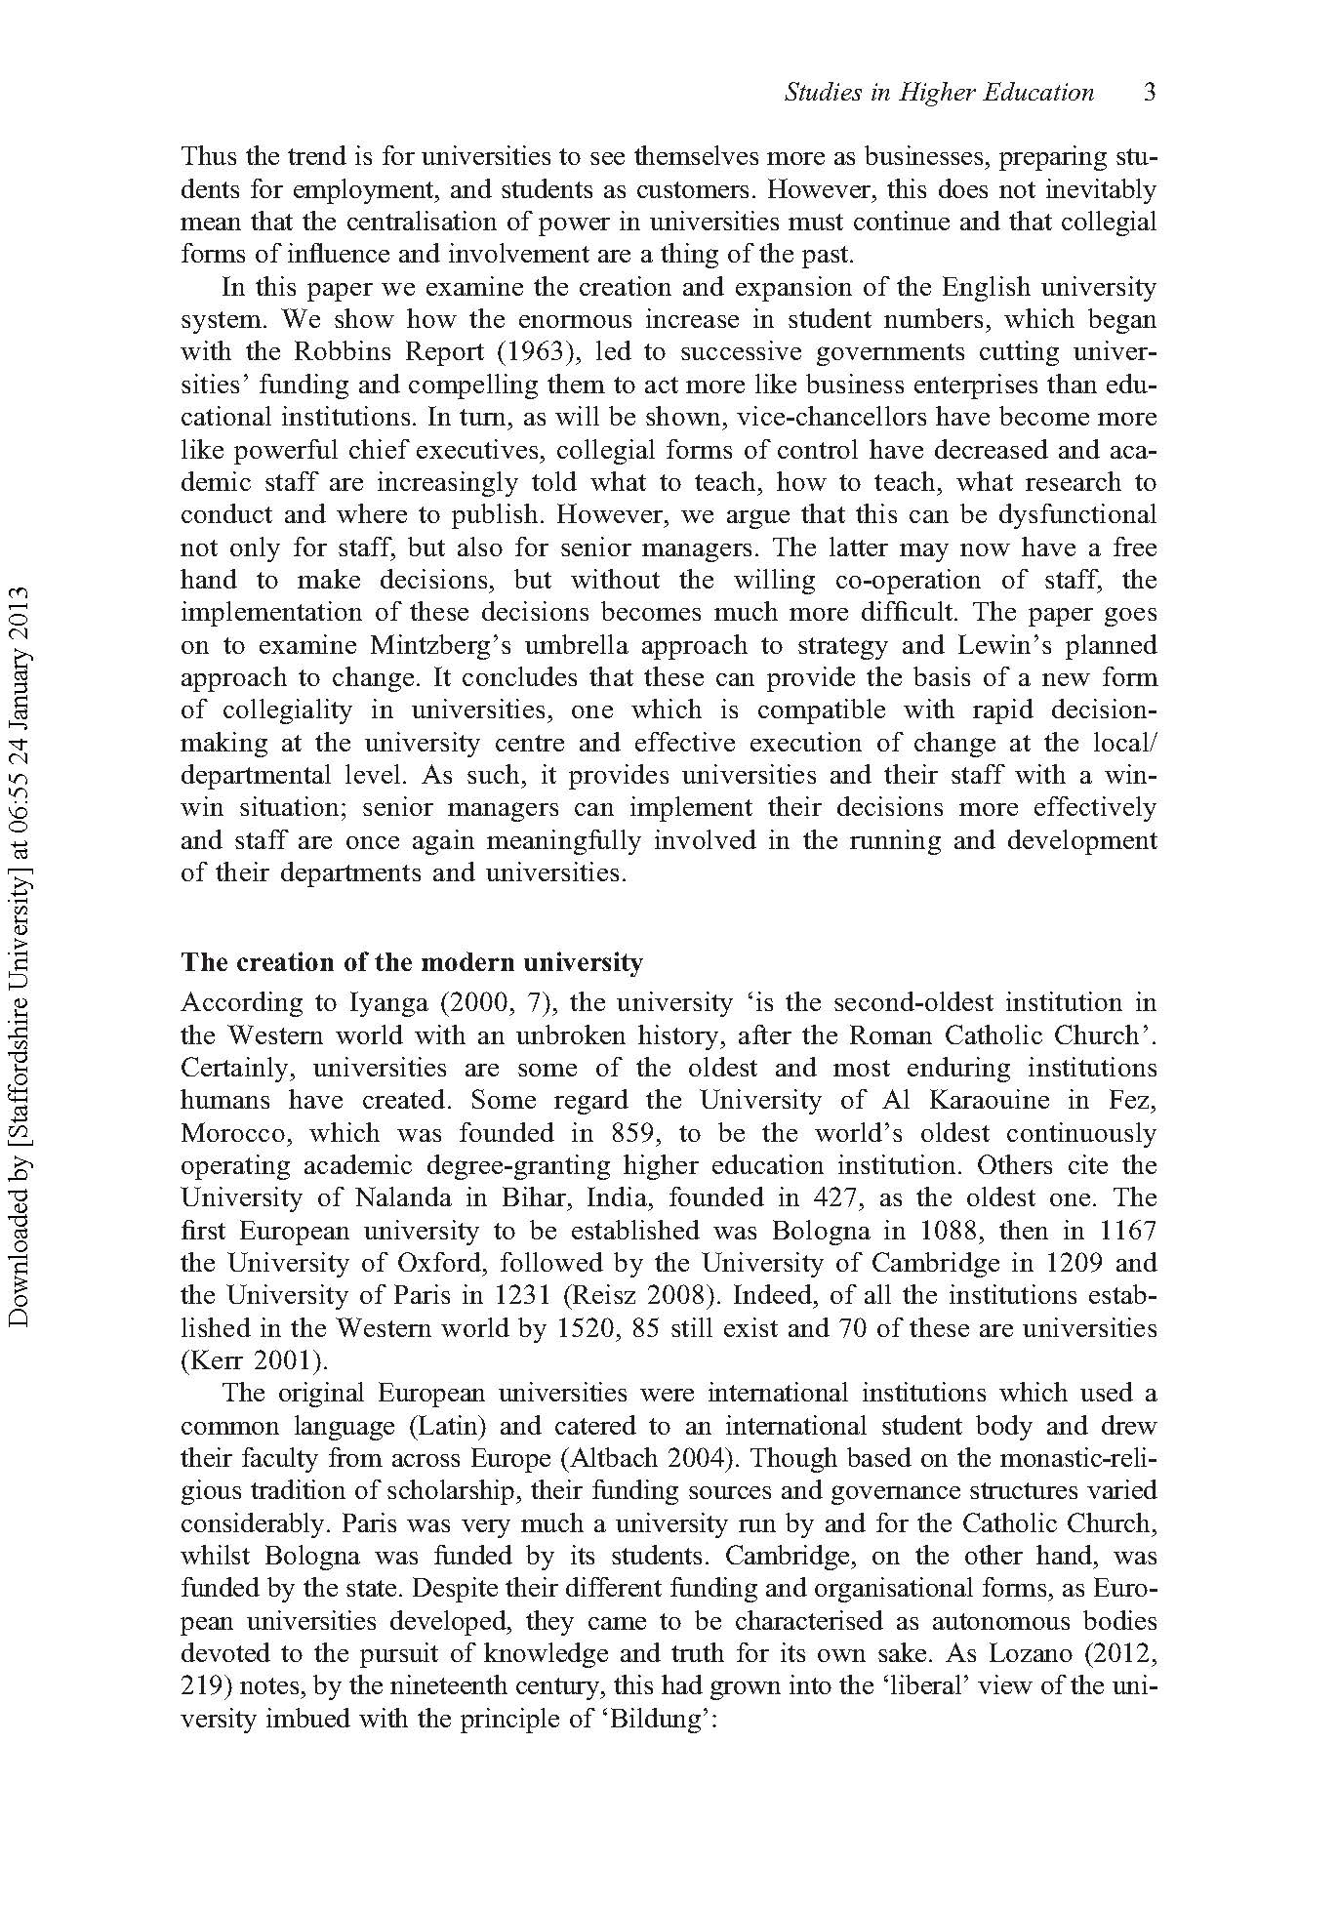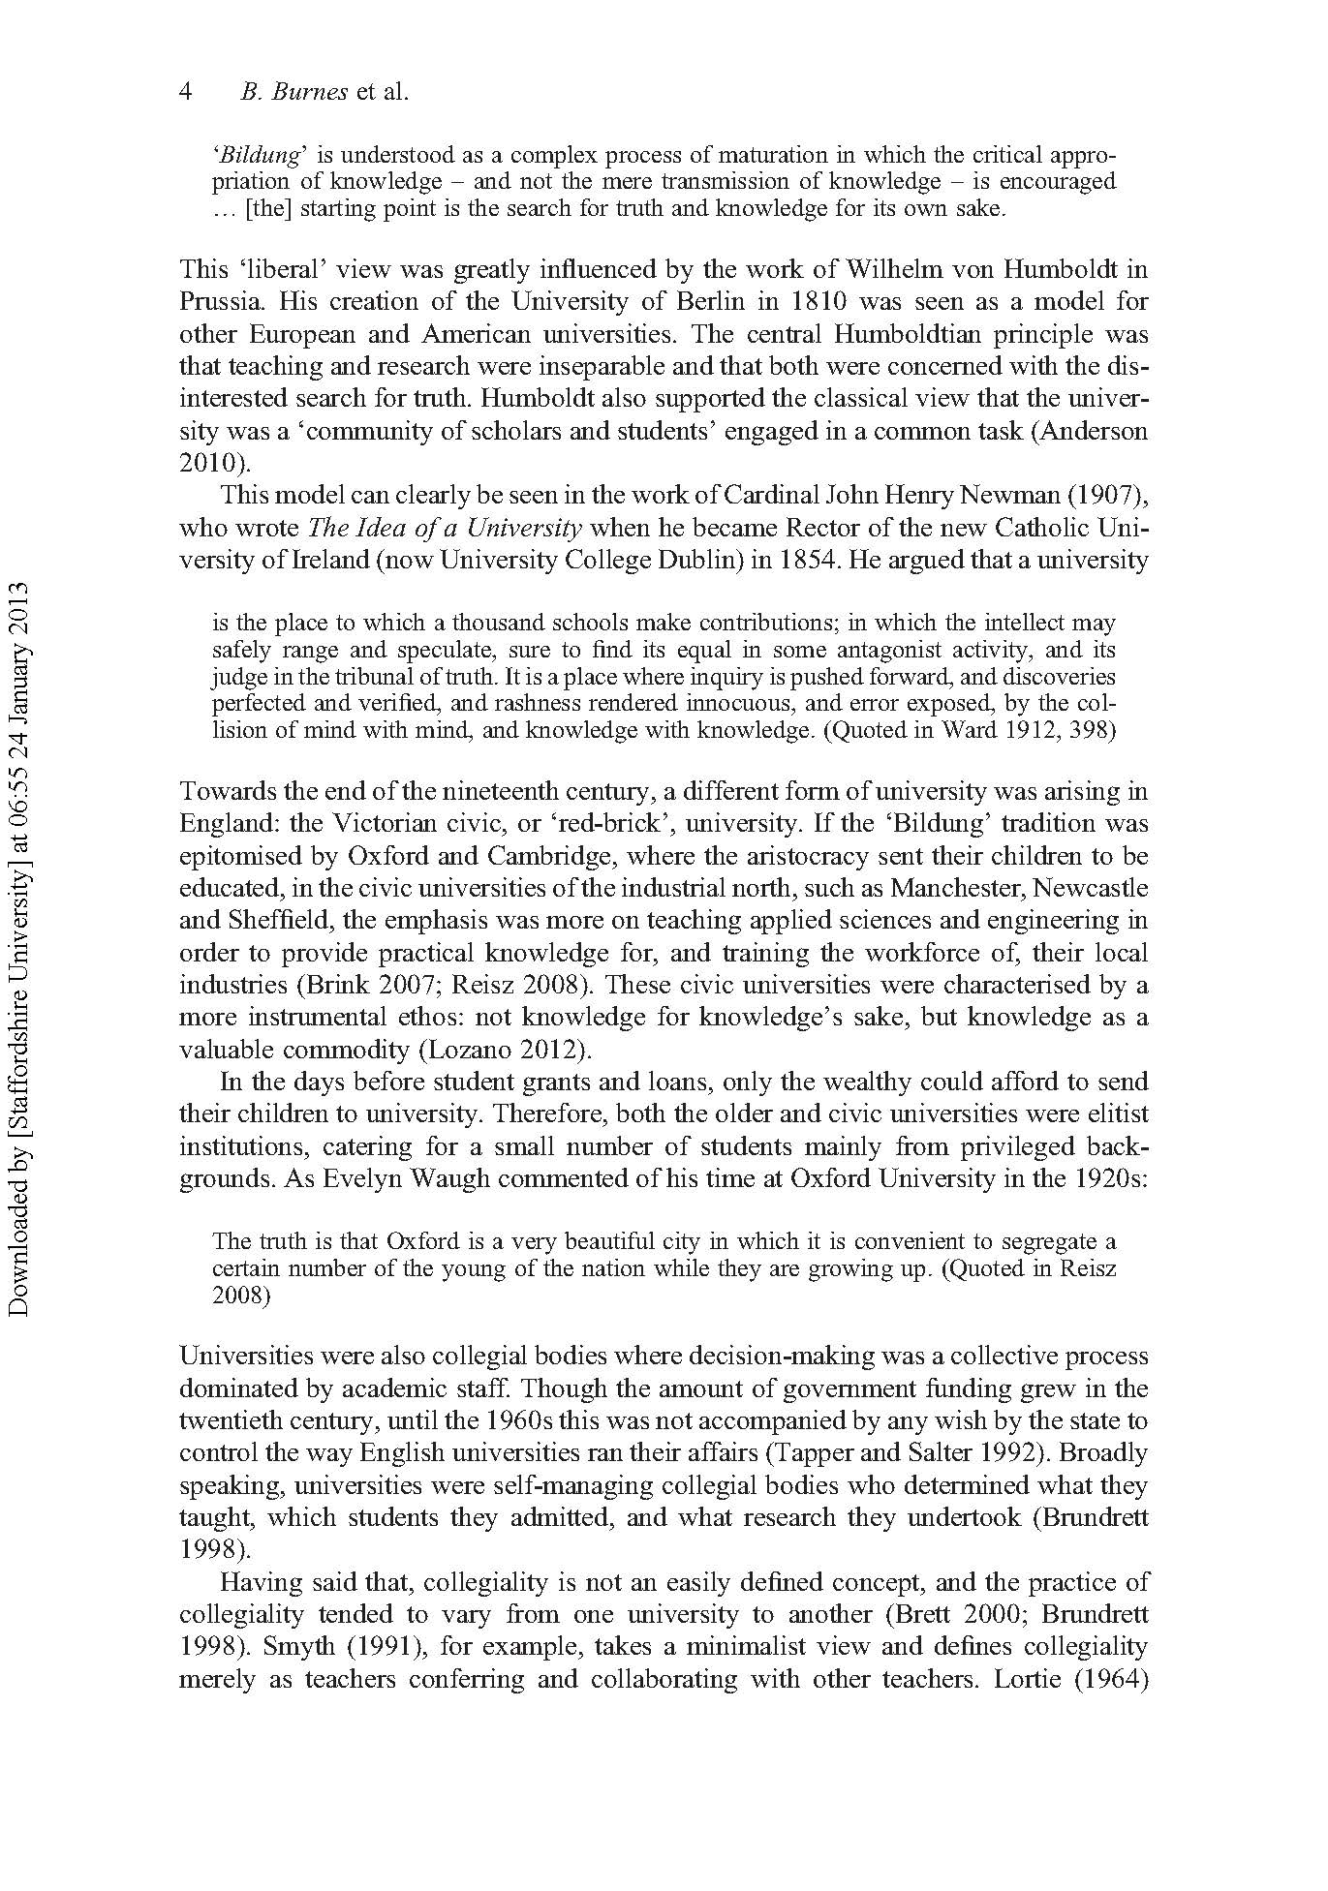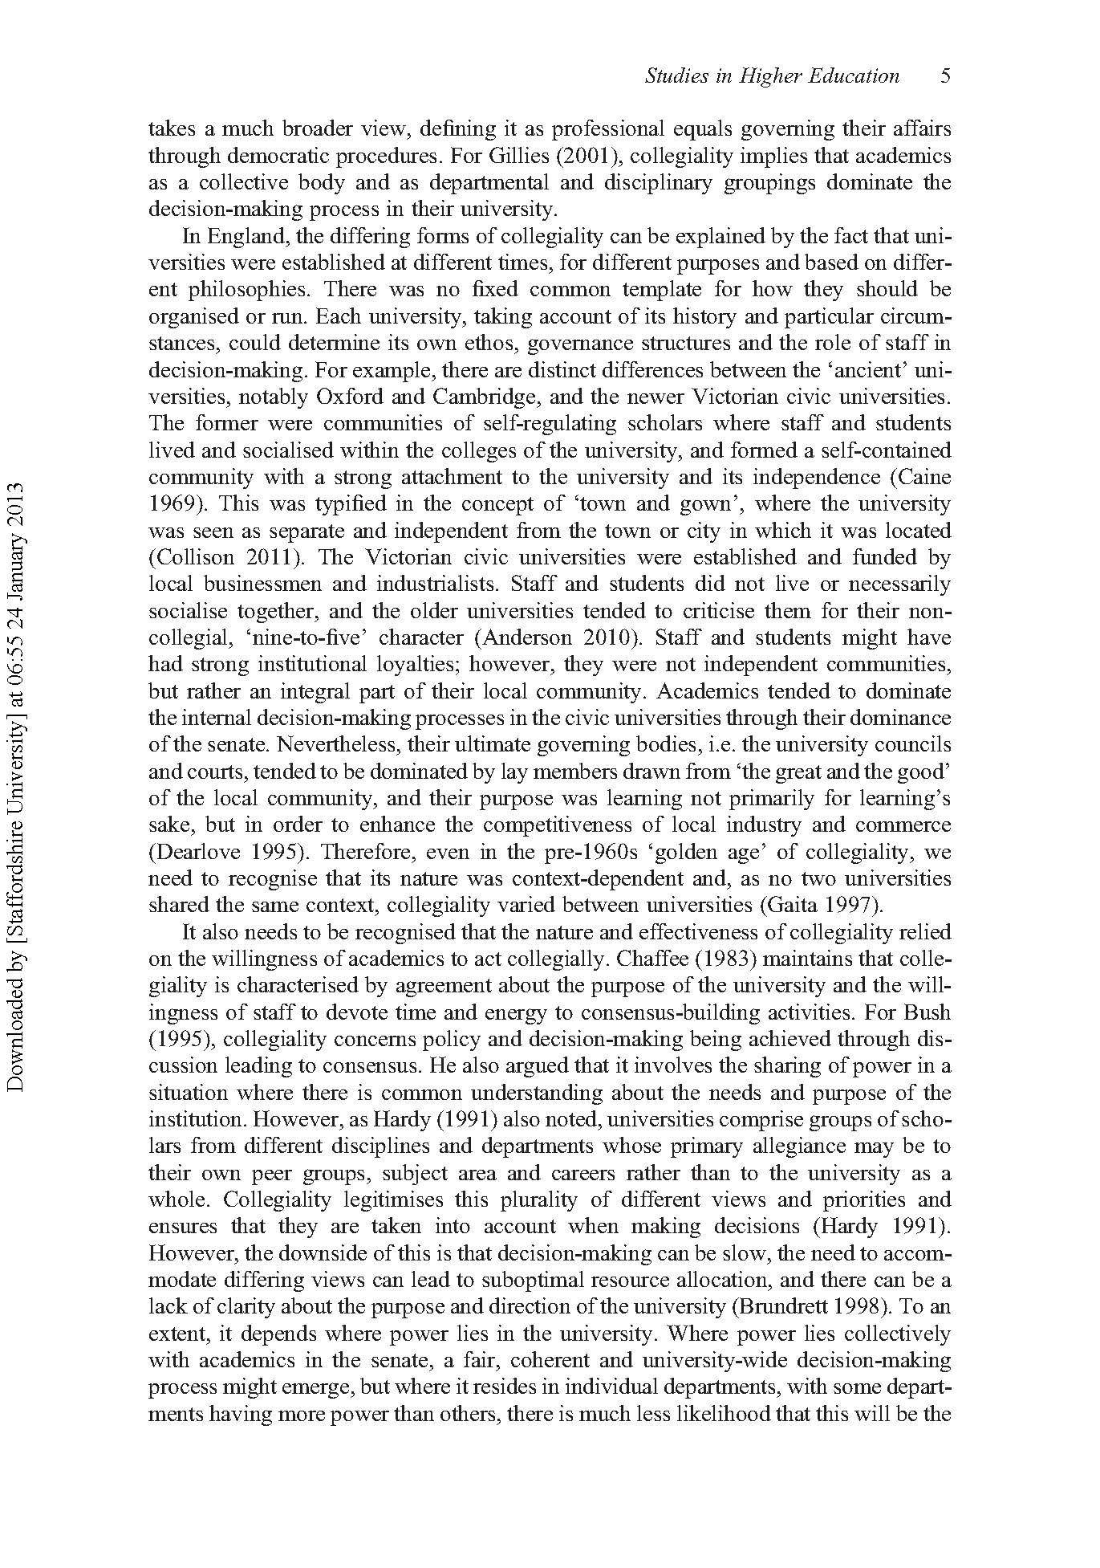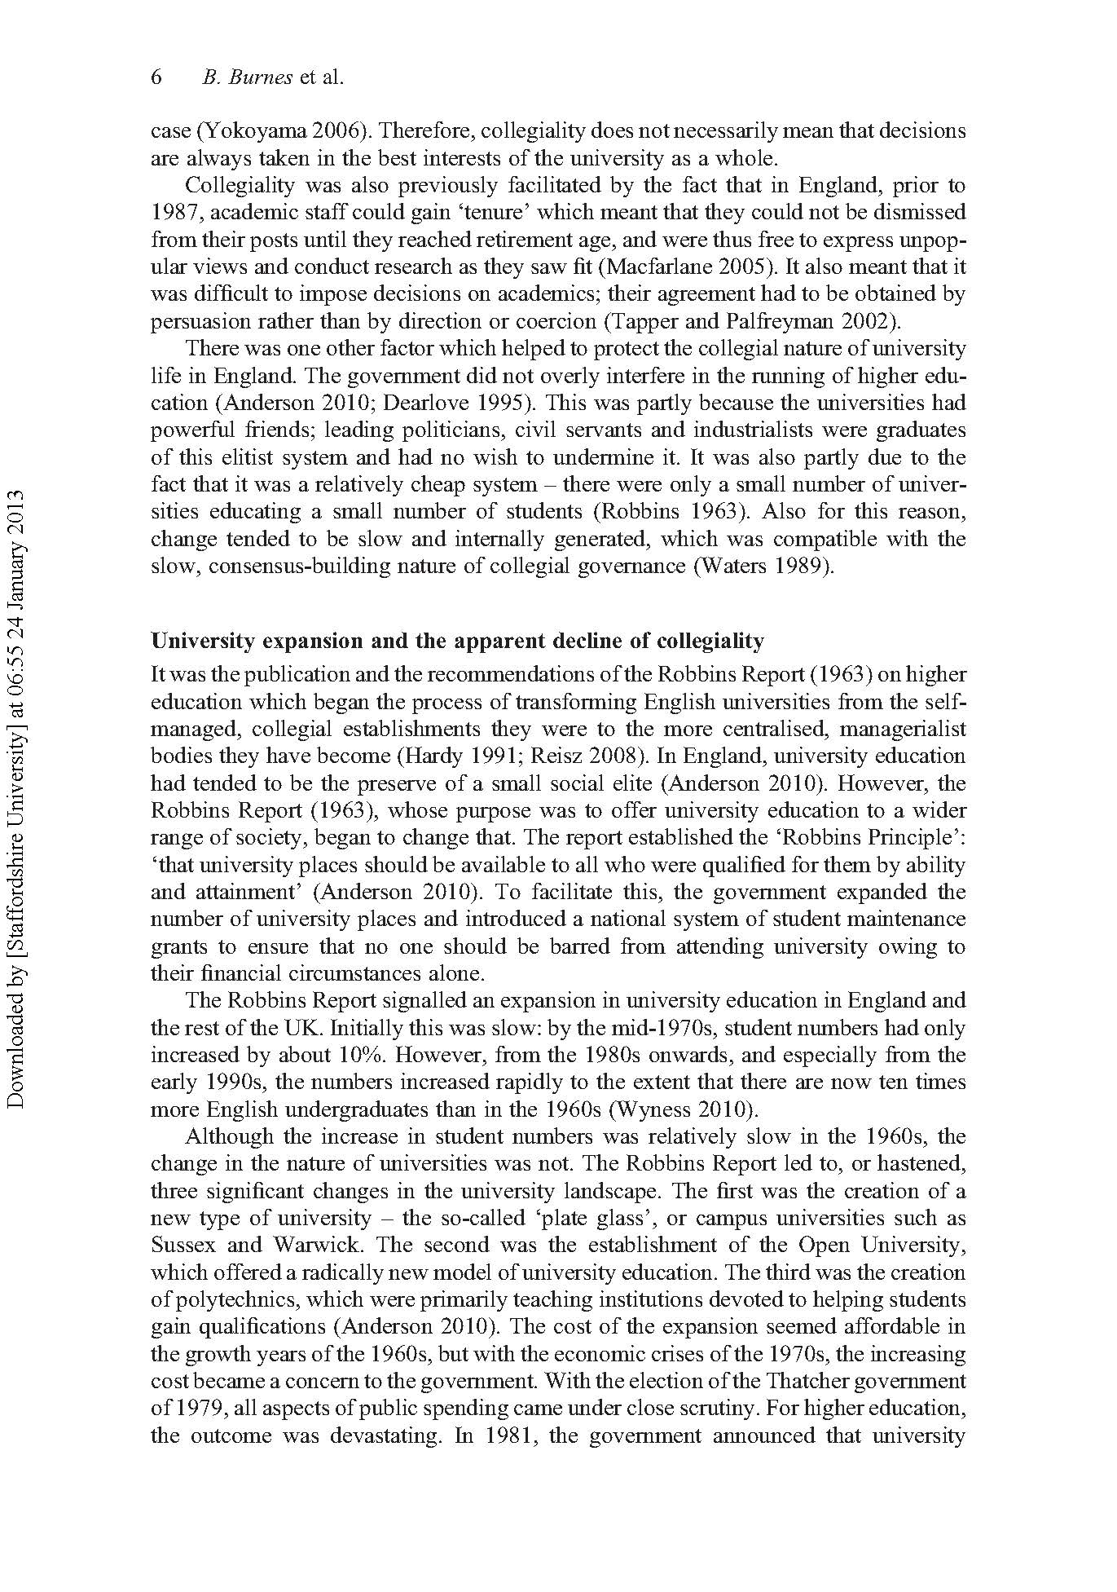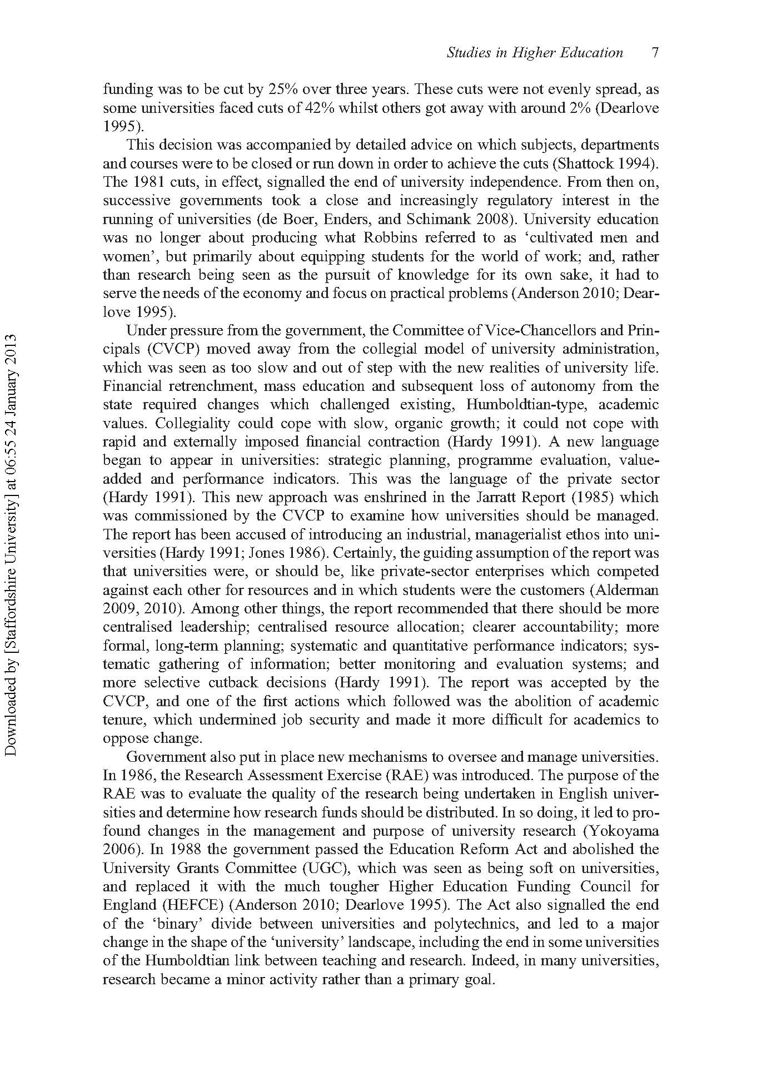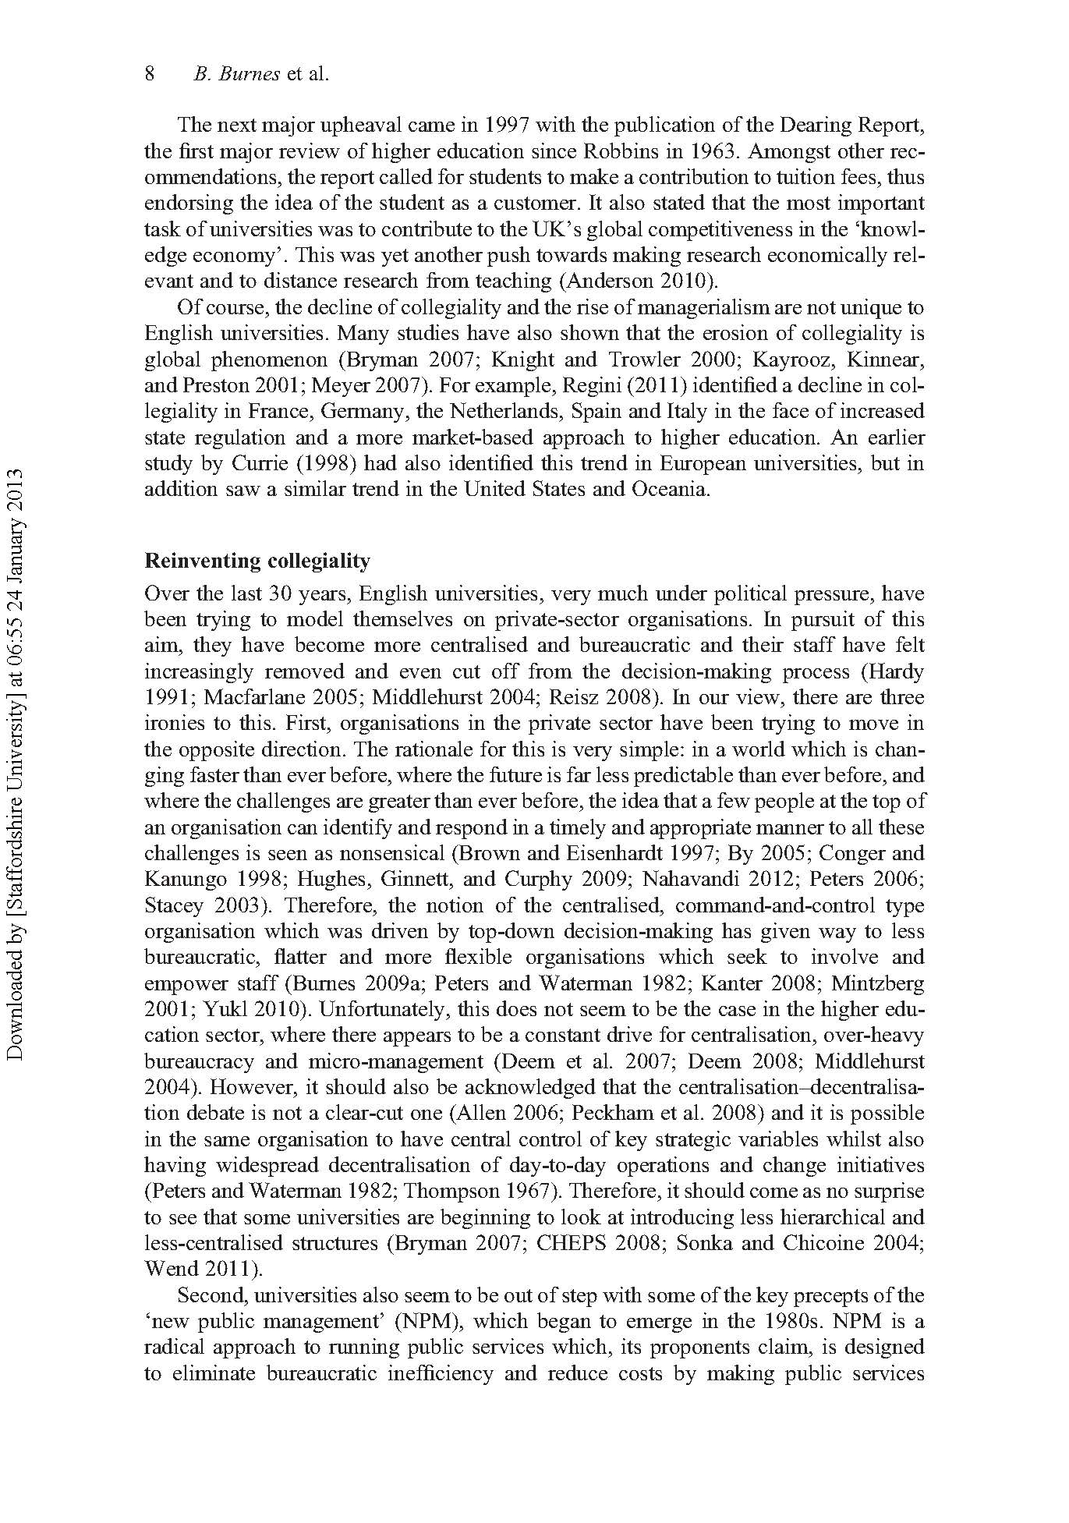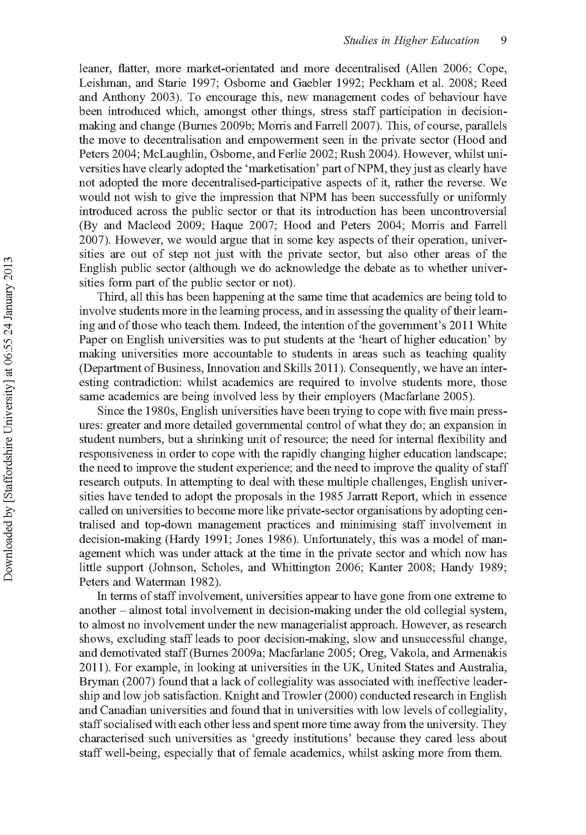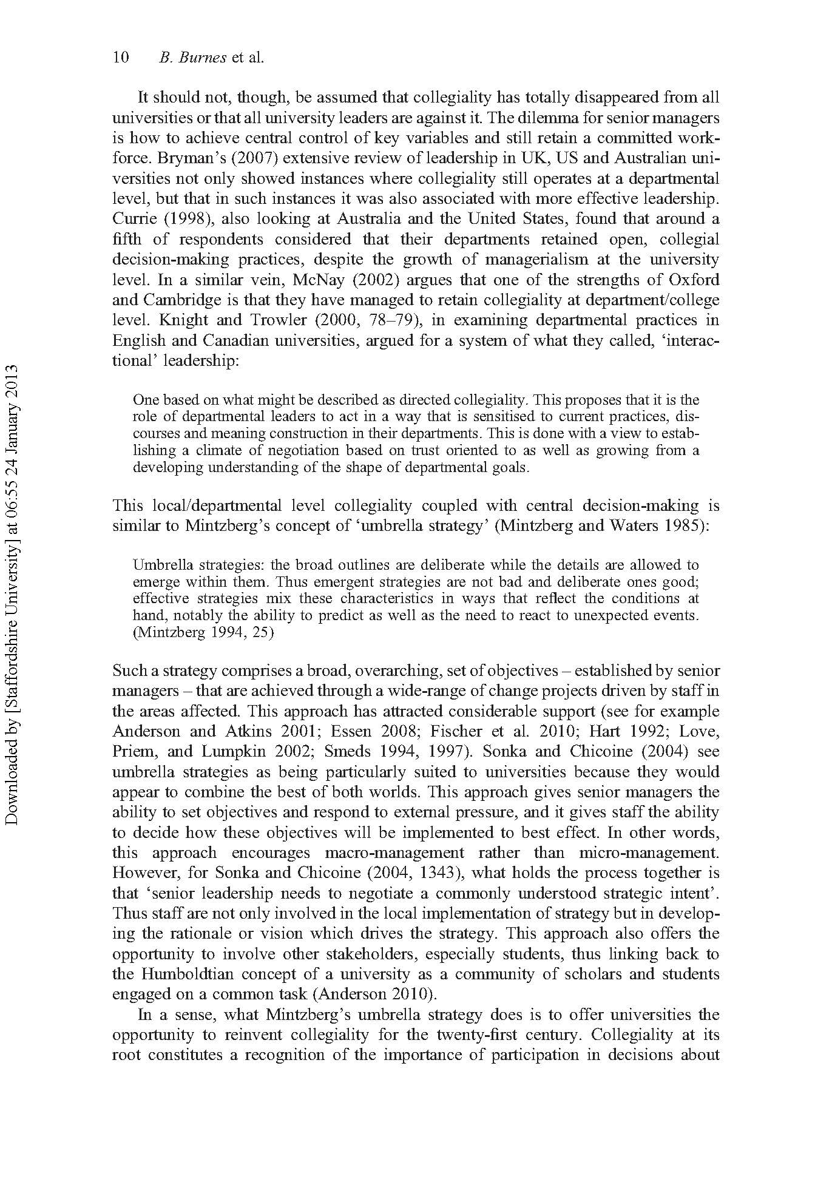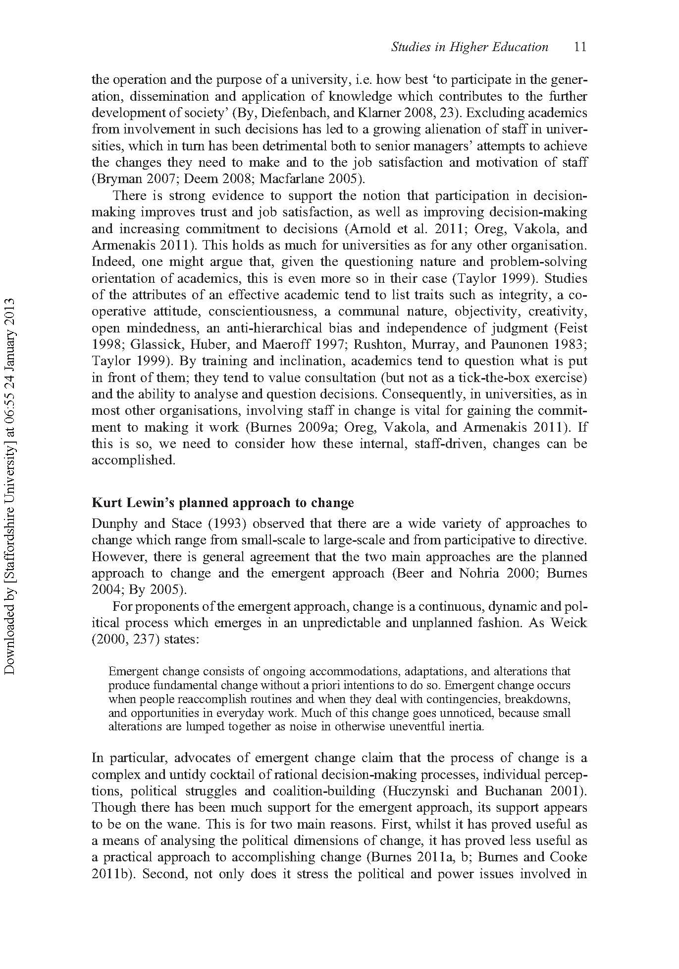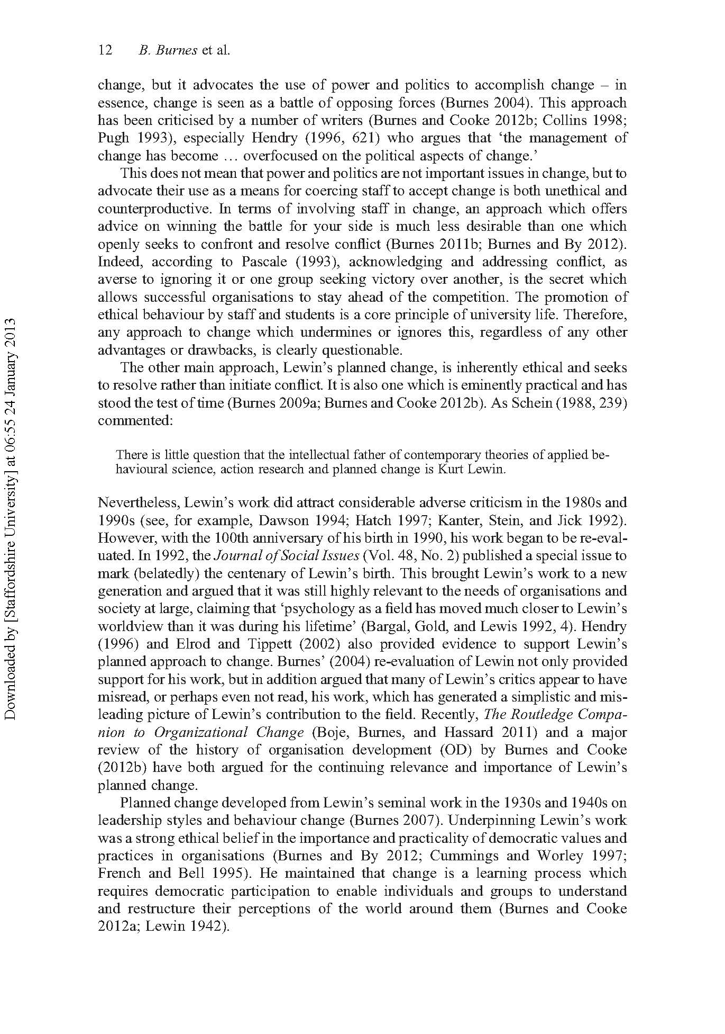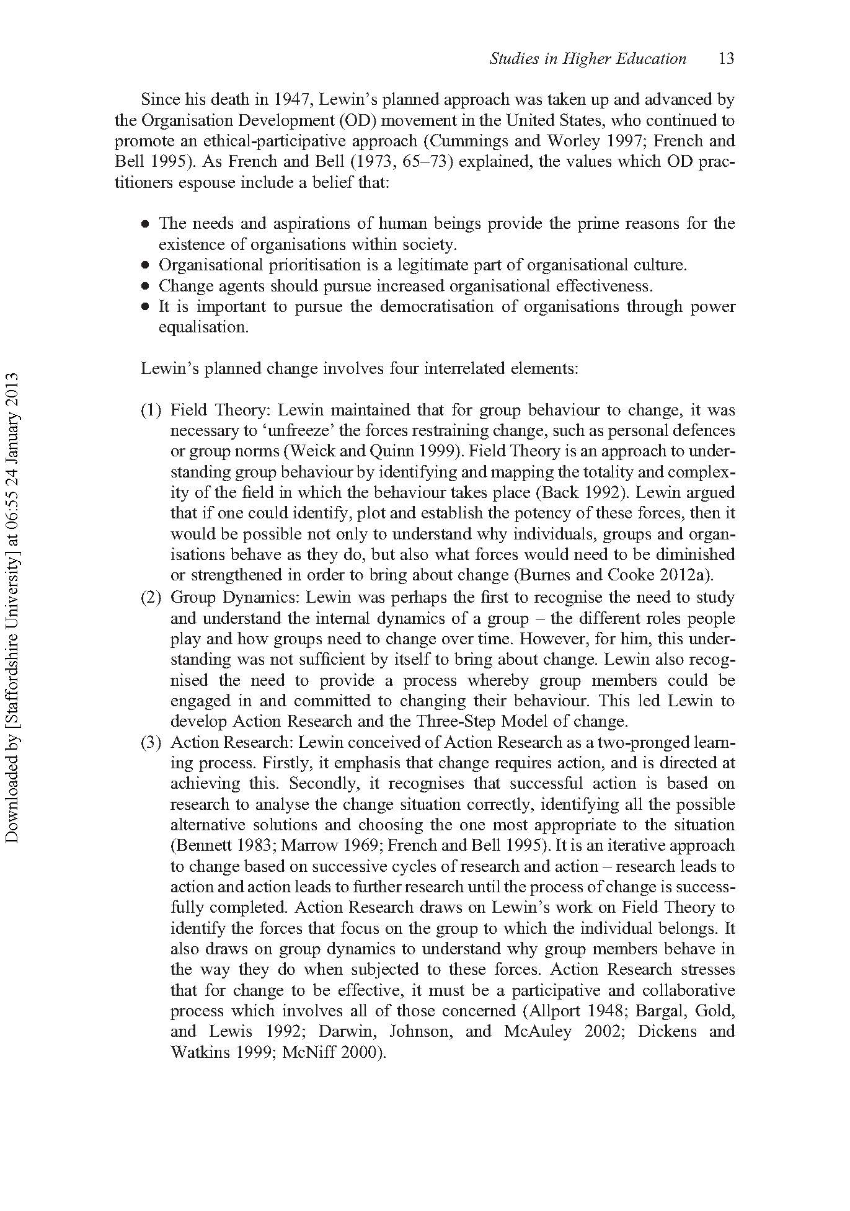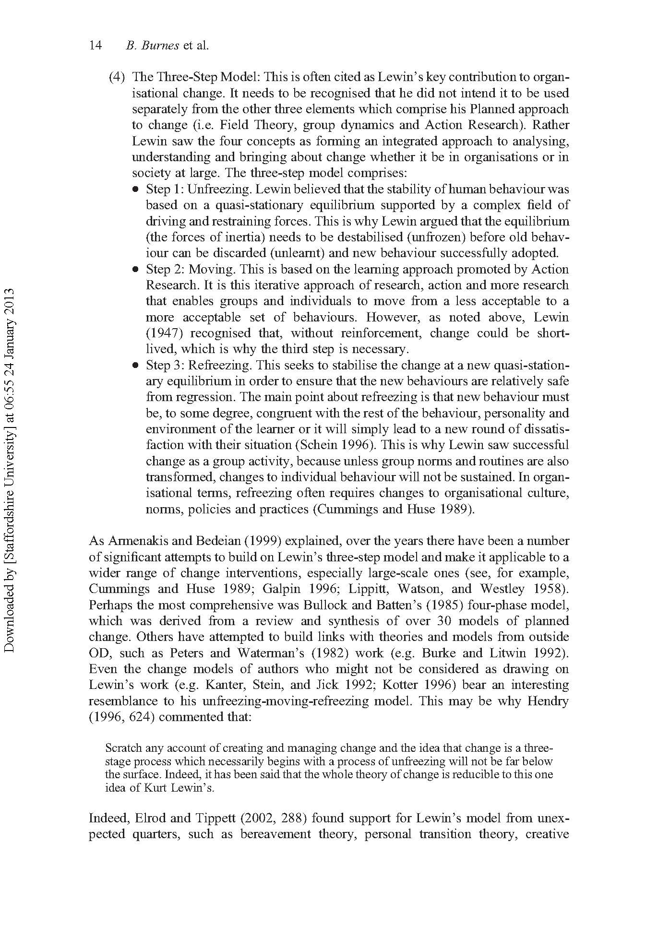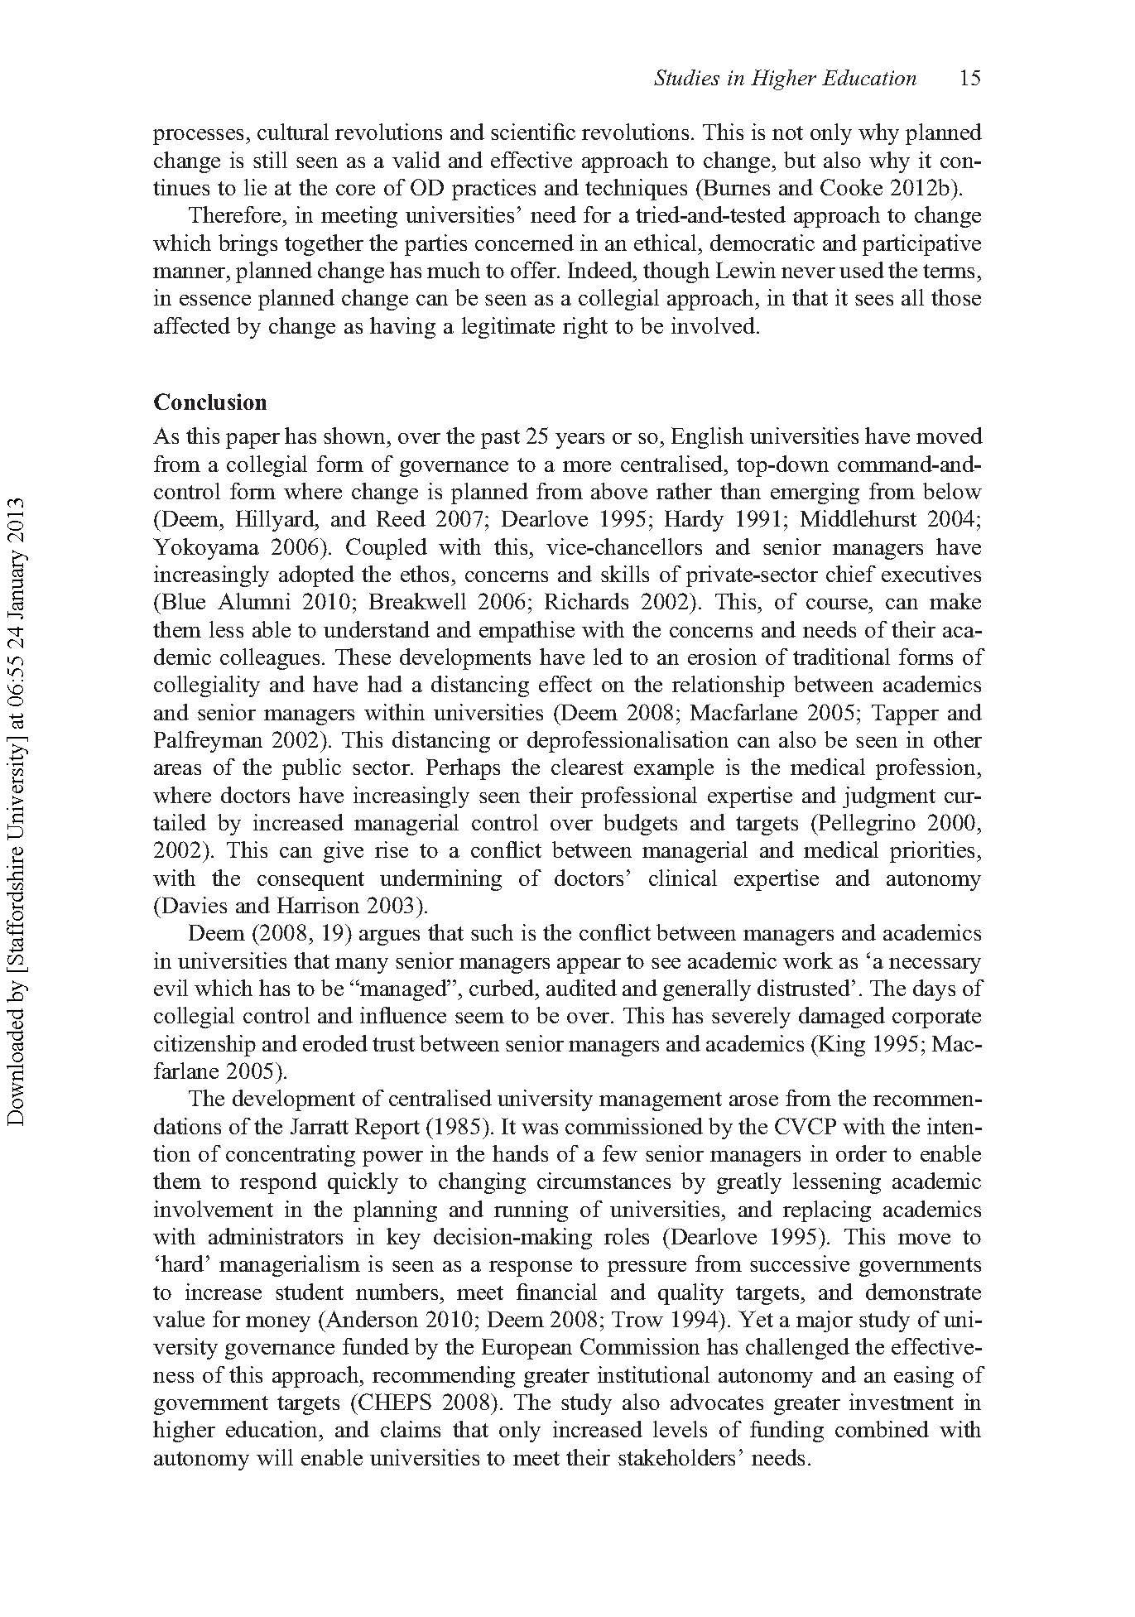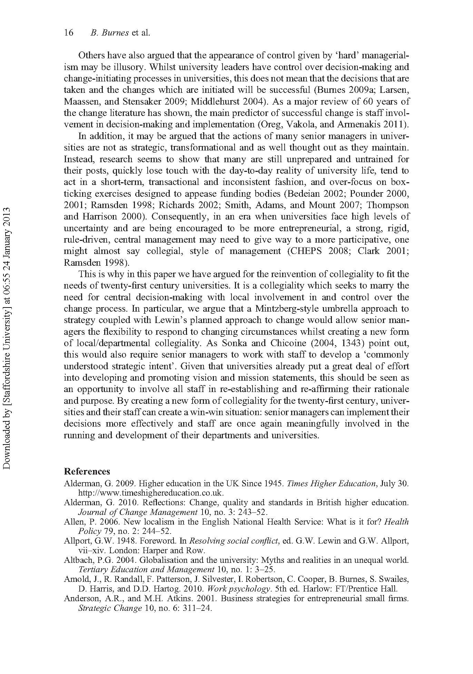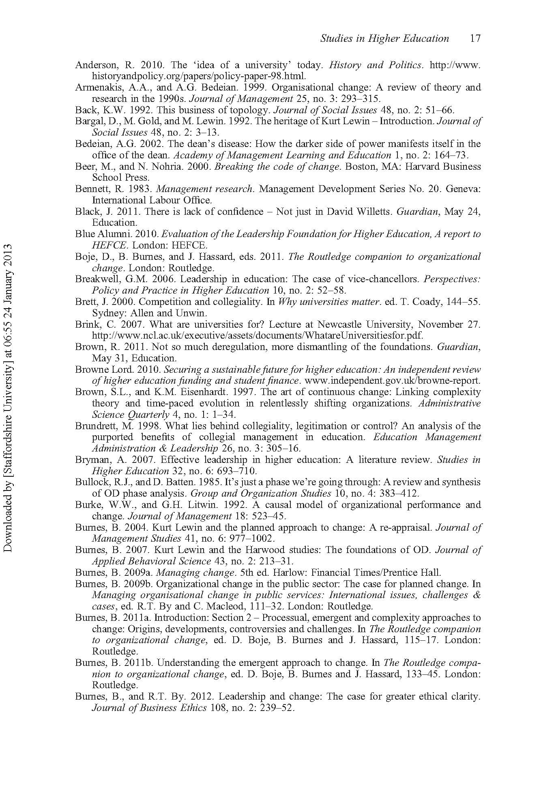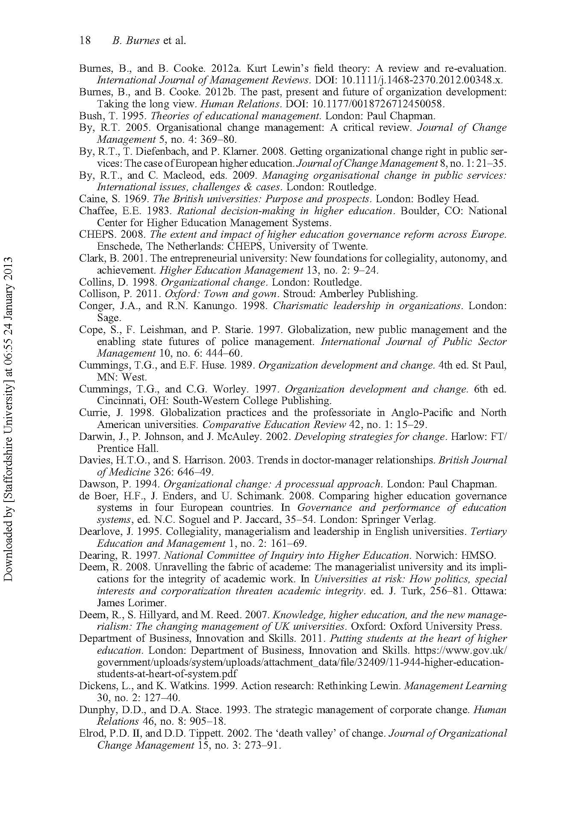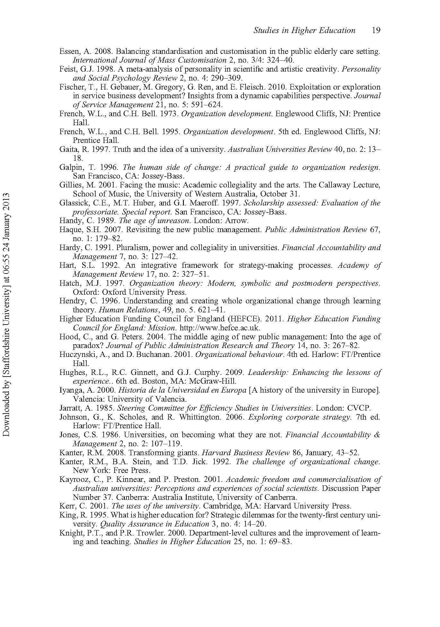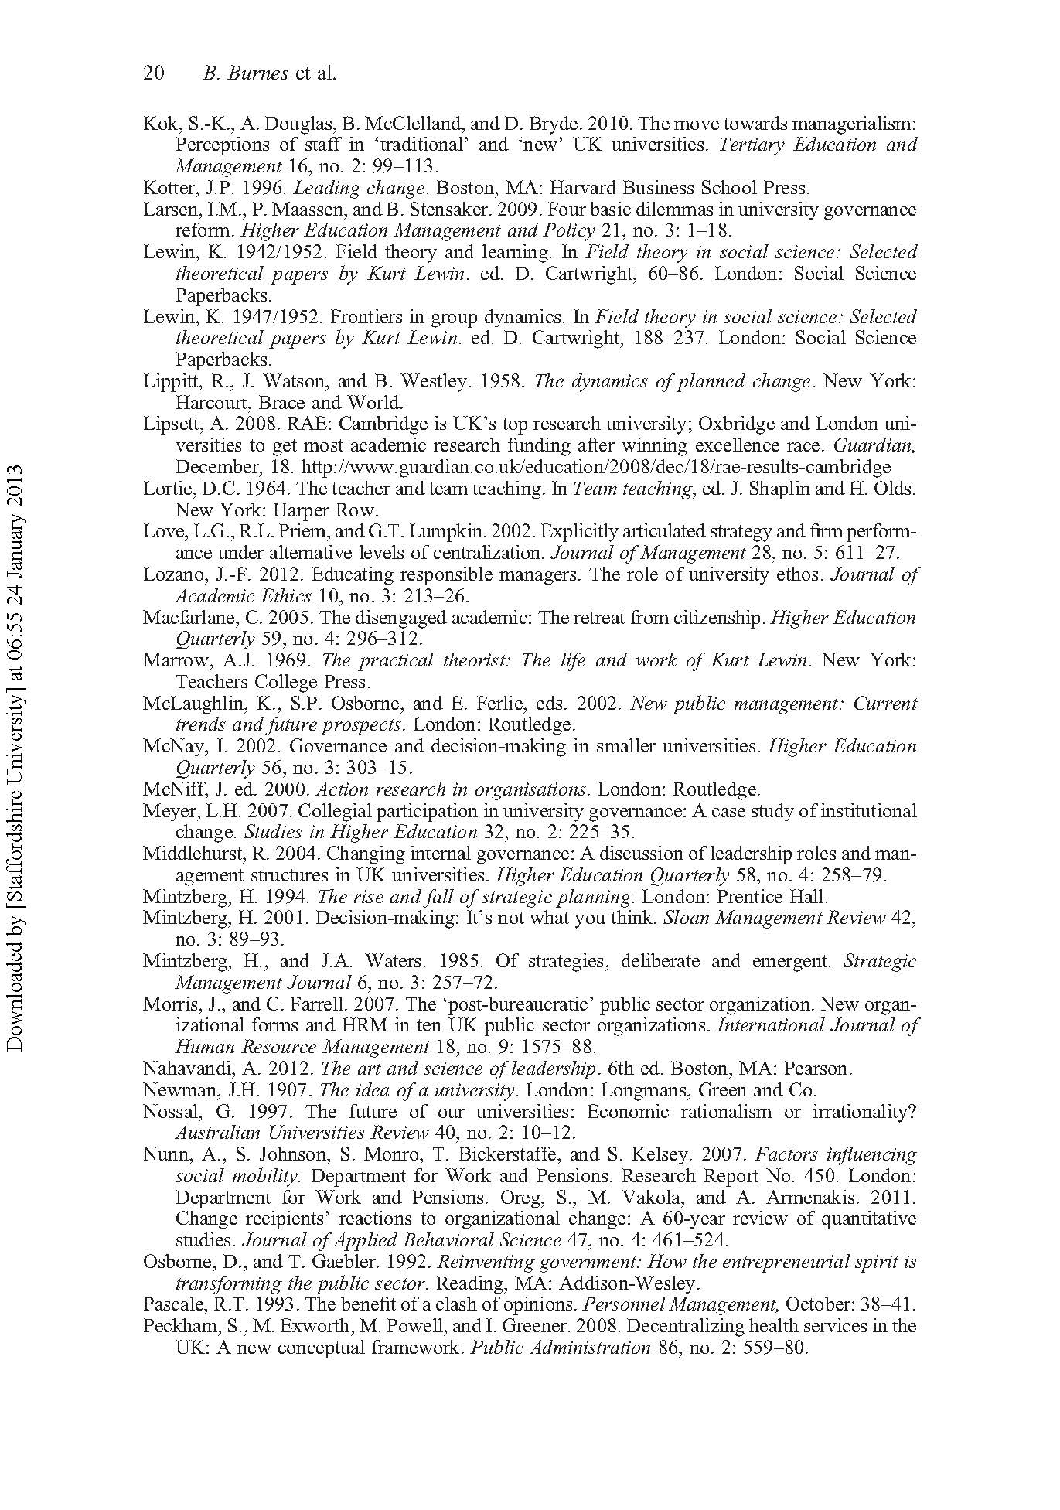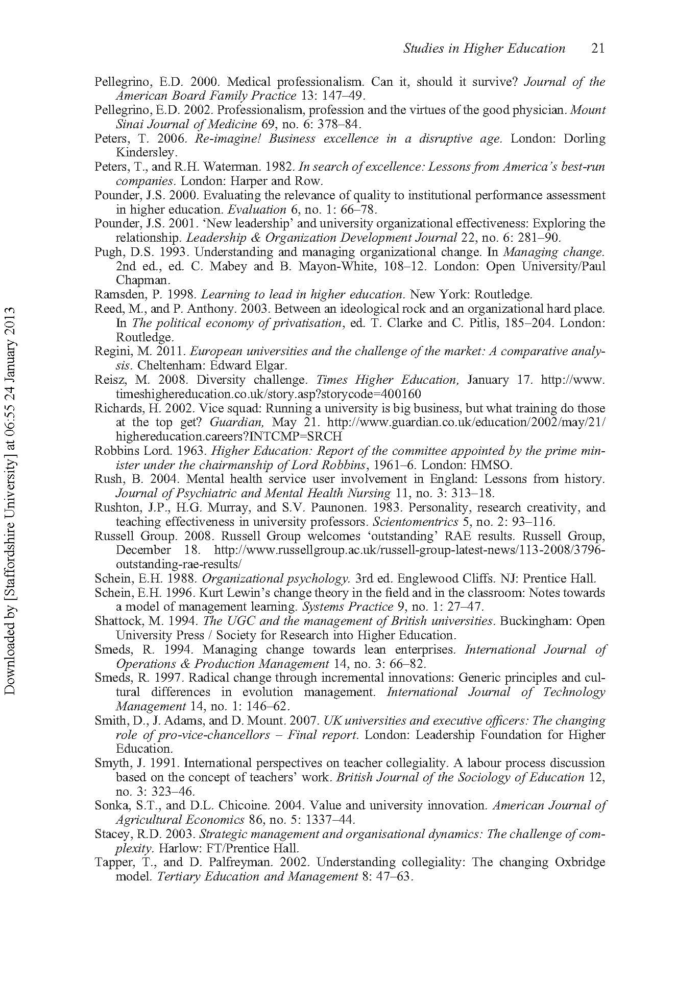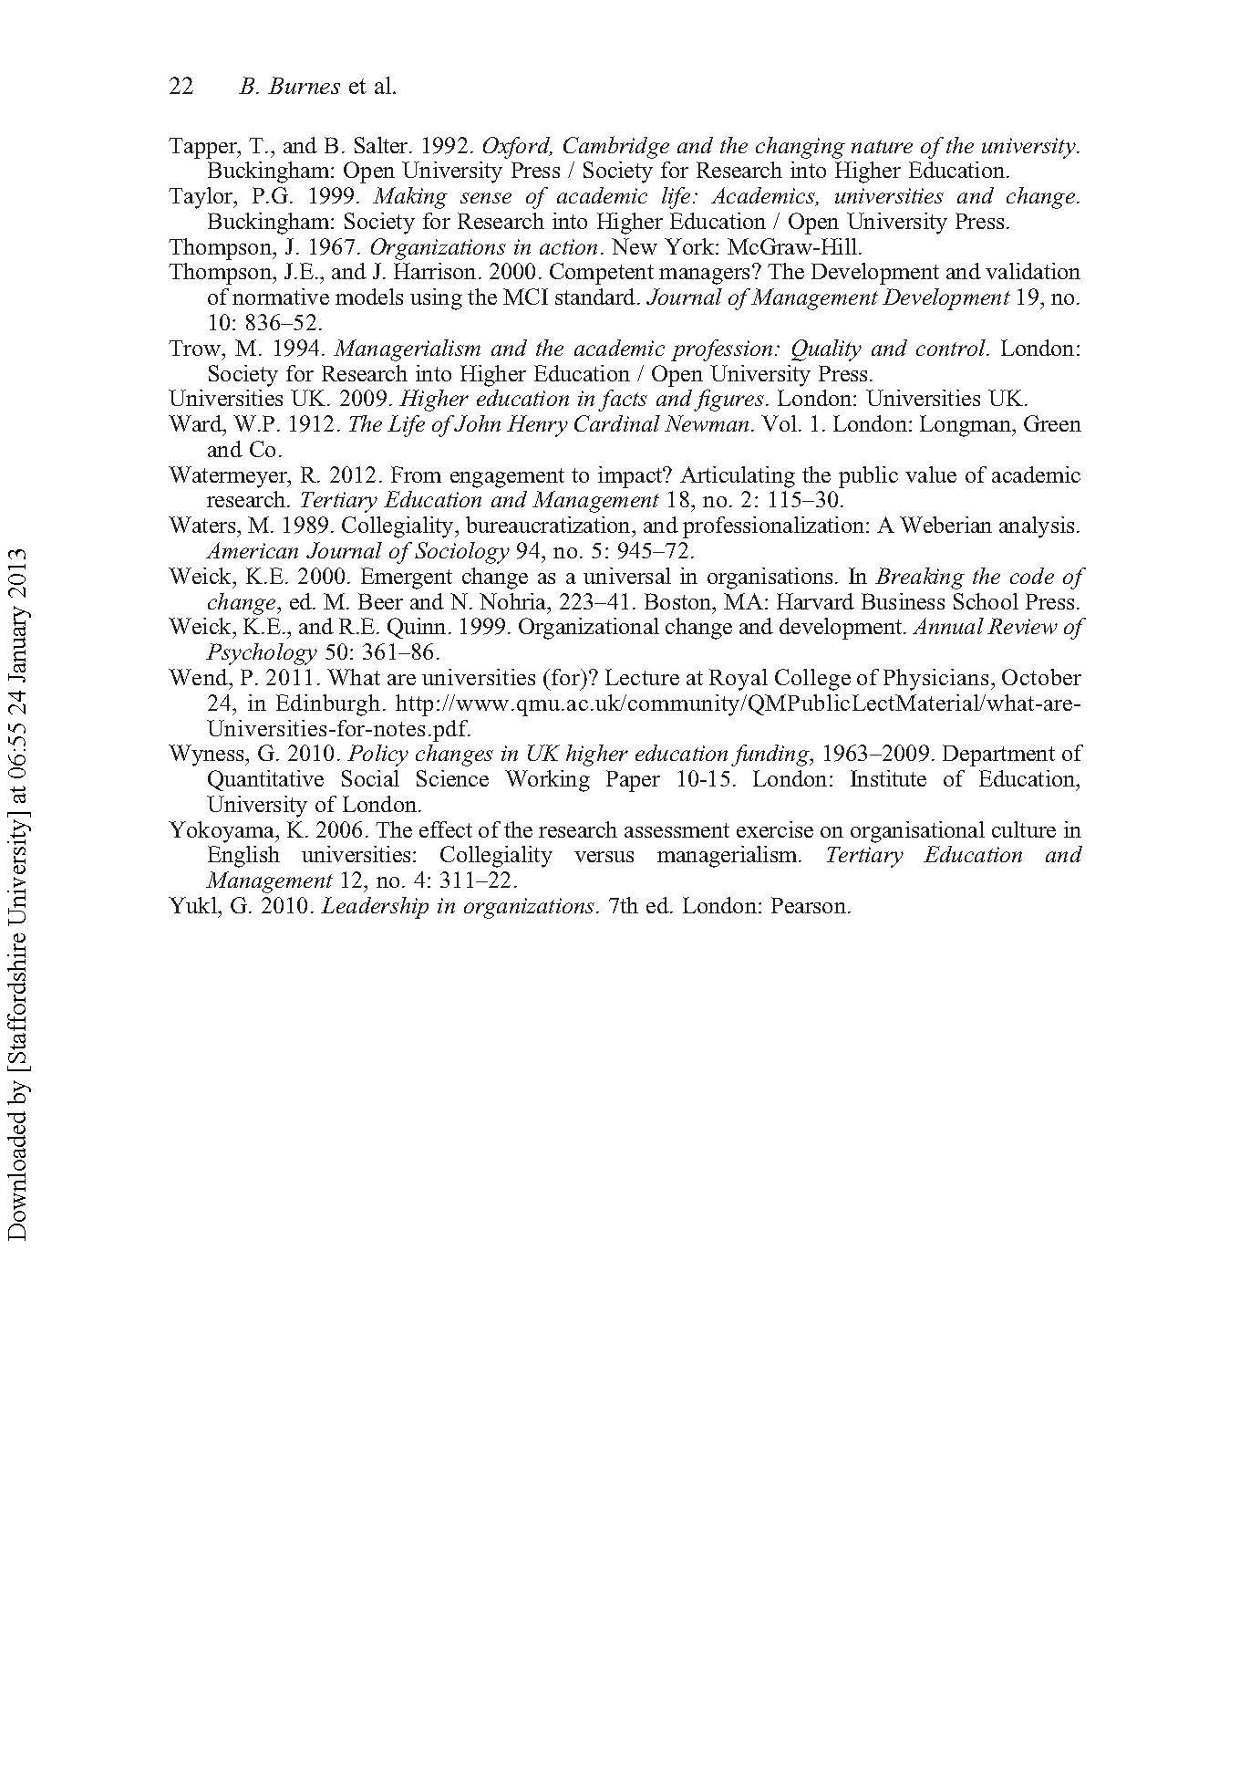
6.3 Summary
Continuing the focus on organisational change occurring within the higher education sector this chapter makes the case that successive governments’ cuts to university funding and compelling the sector to behaving more business-like may result in a dysfunctional situation for both managers and other staff. Presenting an alternative to this perceived dysfunctional centralism, the chapter introduces an approach based on a twenty-first-century reinvention of collegiality, combining effective execution of change at the departmental level with the required centralised decision-making at the university centre.

Chapter 7: Leadership and change: the case for greater ethical clarity

Burnes, B. and By, R.T. (2012)
Journal of Business Ethics, 108(2), pp.239-252

(Published work 6)

This chapter is derived from an article published by Journal of Business Ethics in 2012

7.1 Introduction
This chapter explicitly moves my focus from organisational change management to leadership. Acknowledging that organisational change and leadership are inseparable phenomena, it addresses the relationship between ethics, leadership and organisational change through adopting a utilitarian consequentialist perspective. Introducing the concept of Virtuous and Vicious Change Cycles, it argues that all approaches to organisational change are rooted in a set of values, some of which are more likely than others to result in ethical outcomes. The chapter puts forward the hypothesis that those adopting particular approaches to leadership are required to provide greater ethical clarity about their choice in order to achieve sustainable and beneficial change.

Burnes, B. and By, R.T. (2012). Leadership and Change: The Case for Greater Ethical Clarity. Journal of Business Ethics, 108(2), pp.239-252.

Note: According to Google Scholar this article has been cited 153 times (as of 24.04.2019)

7.2 Chapter article
Please see next page.

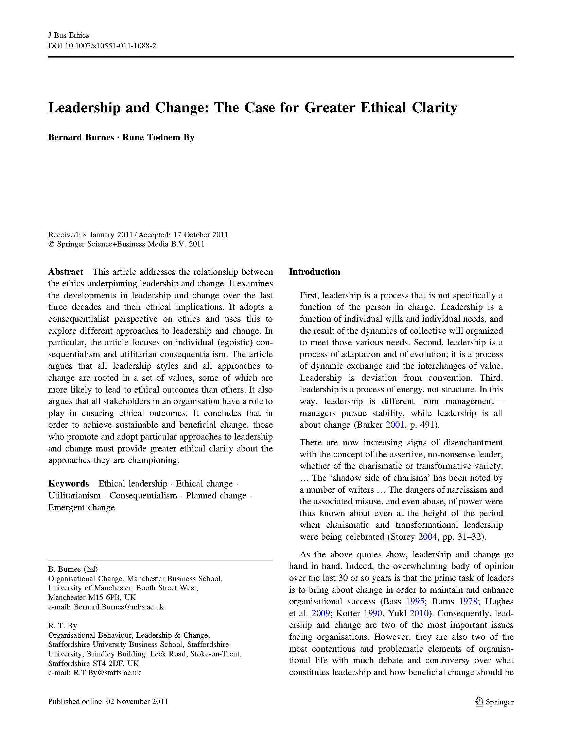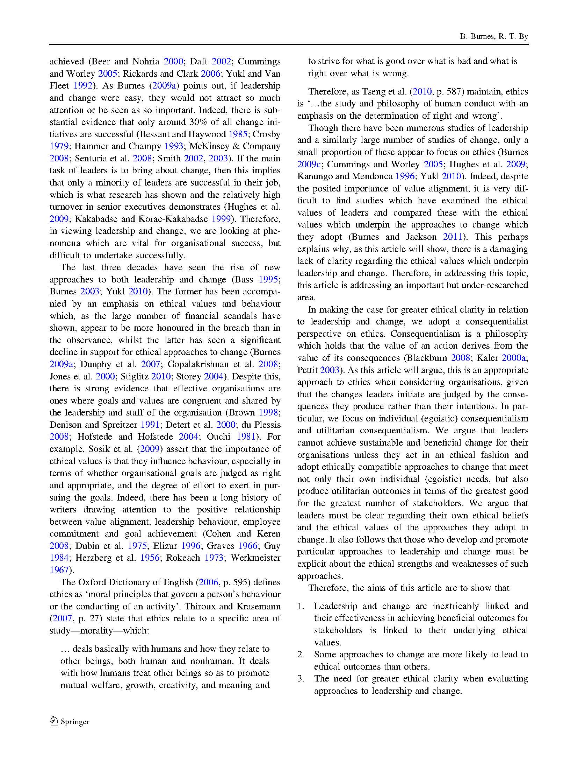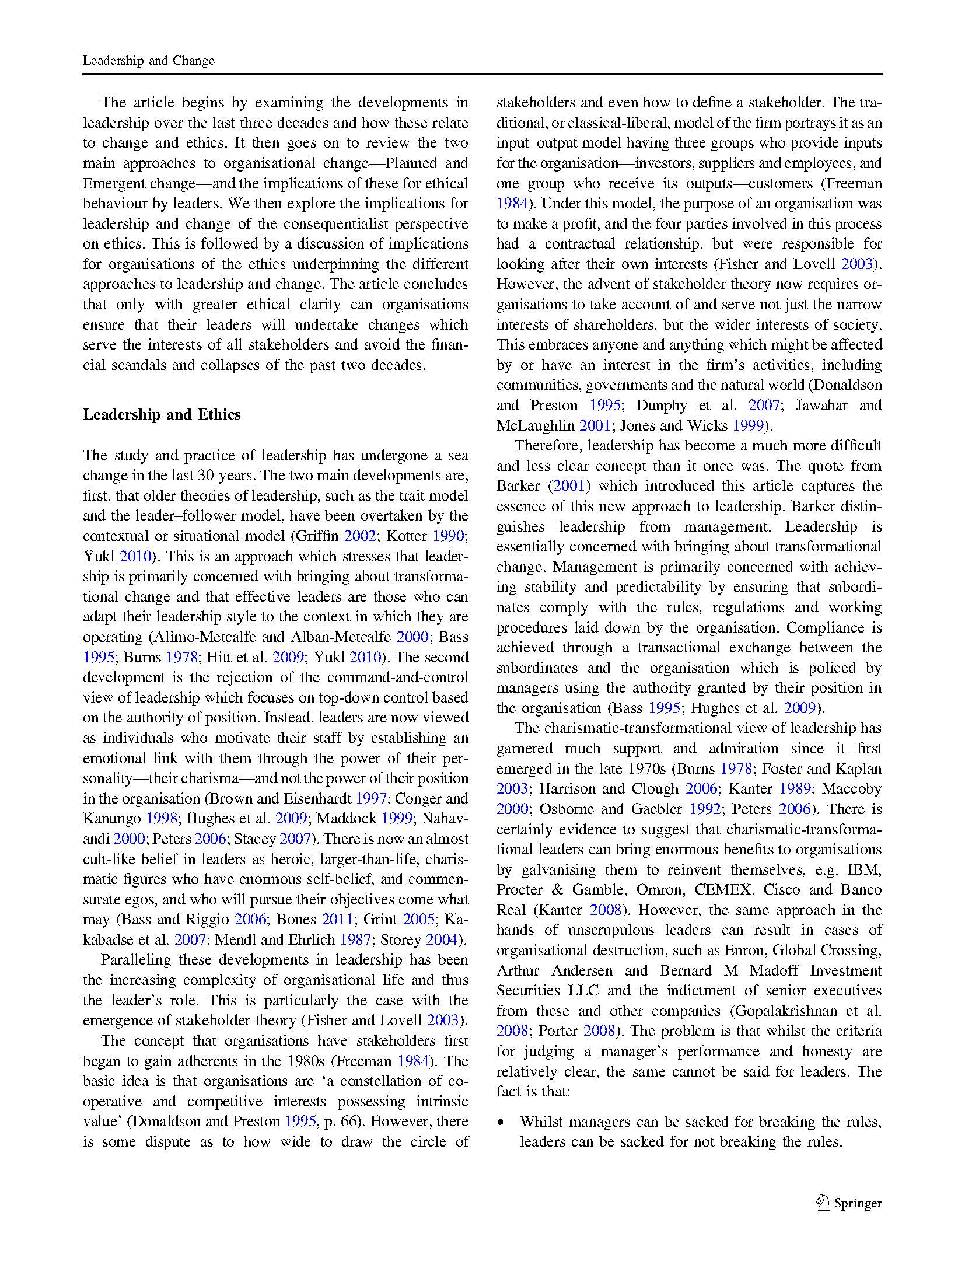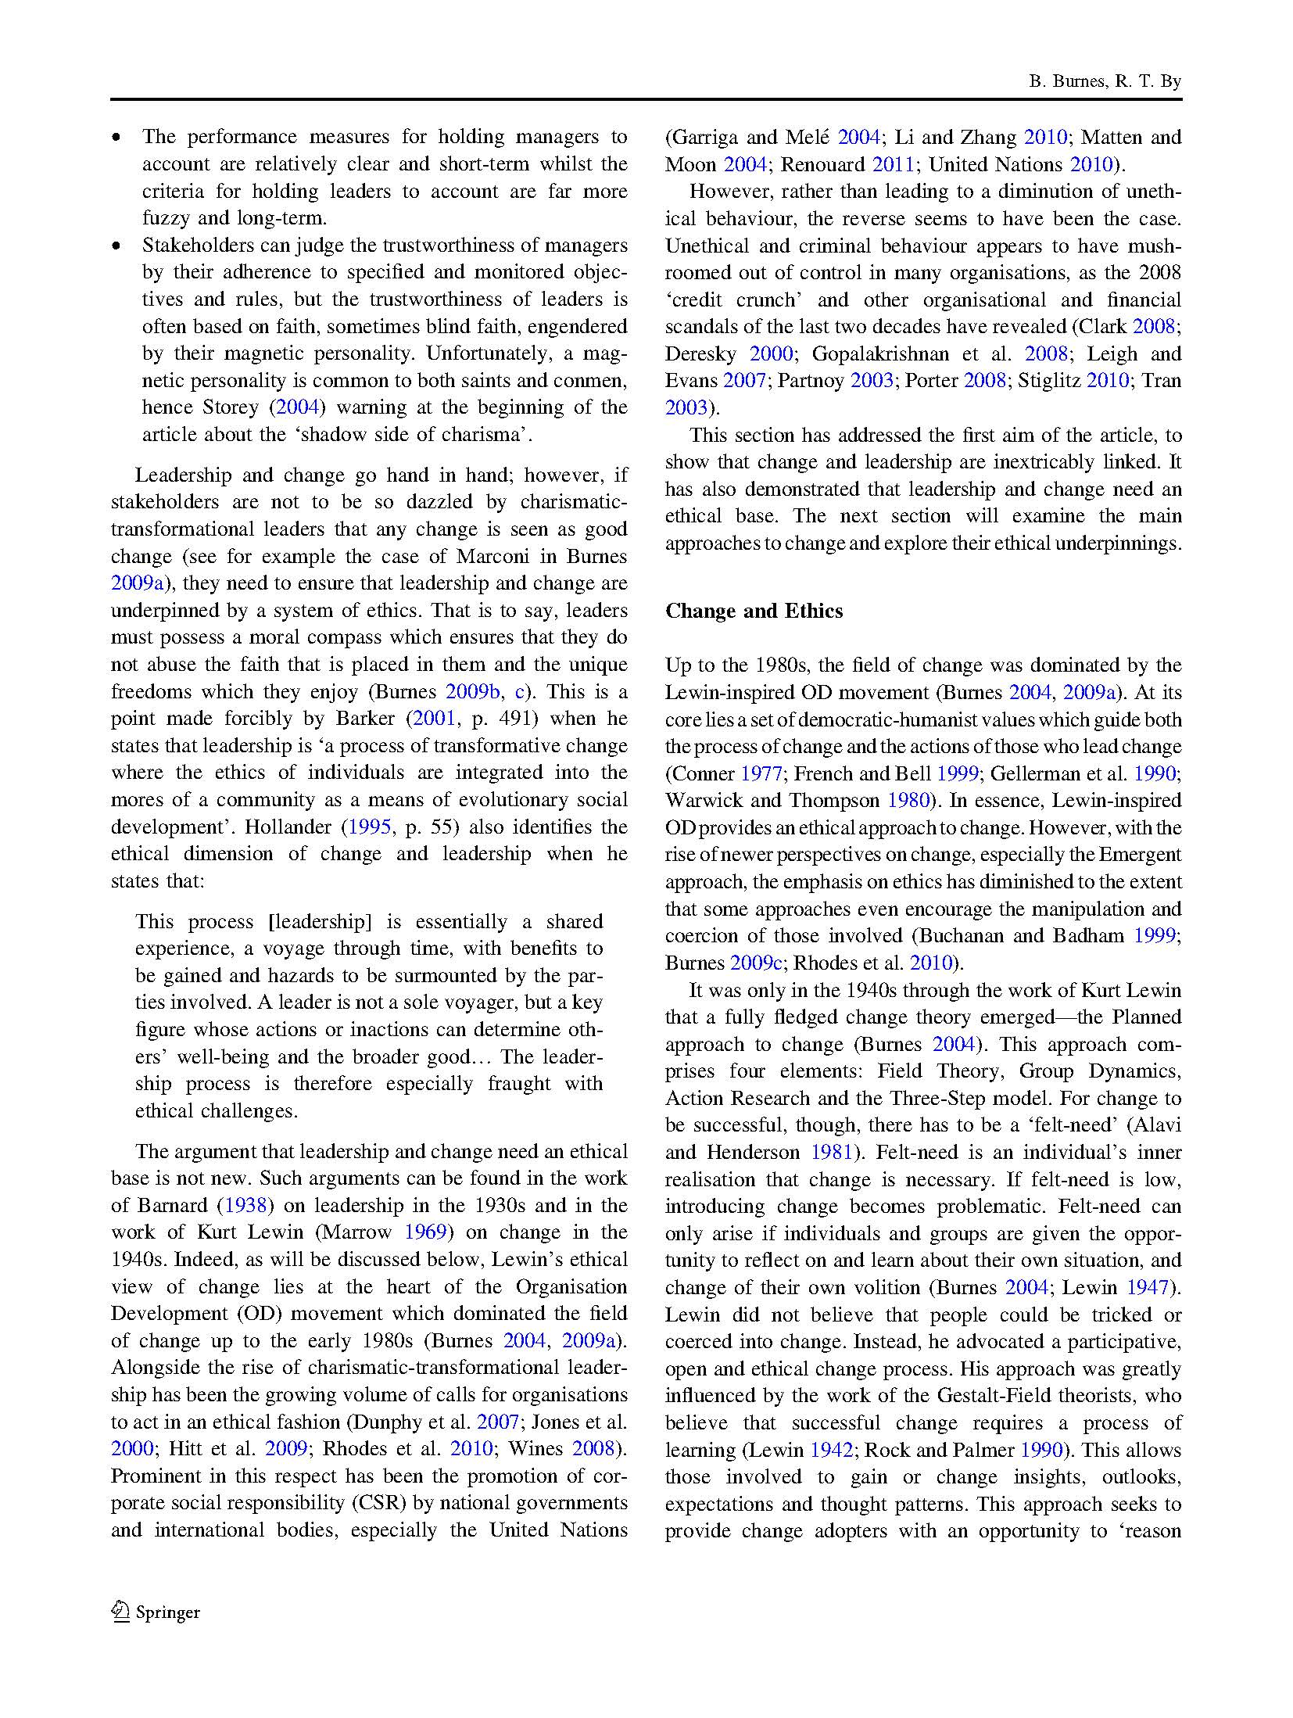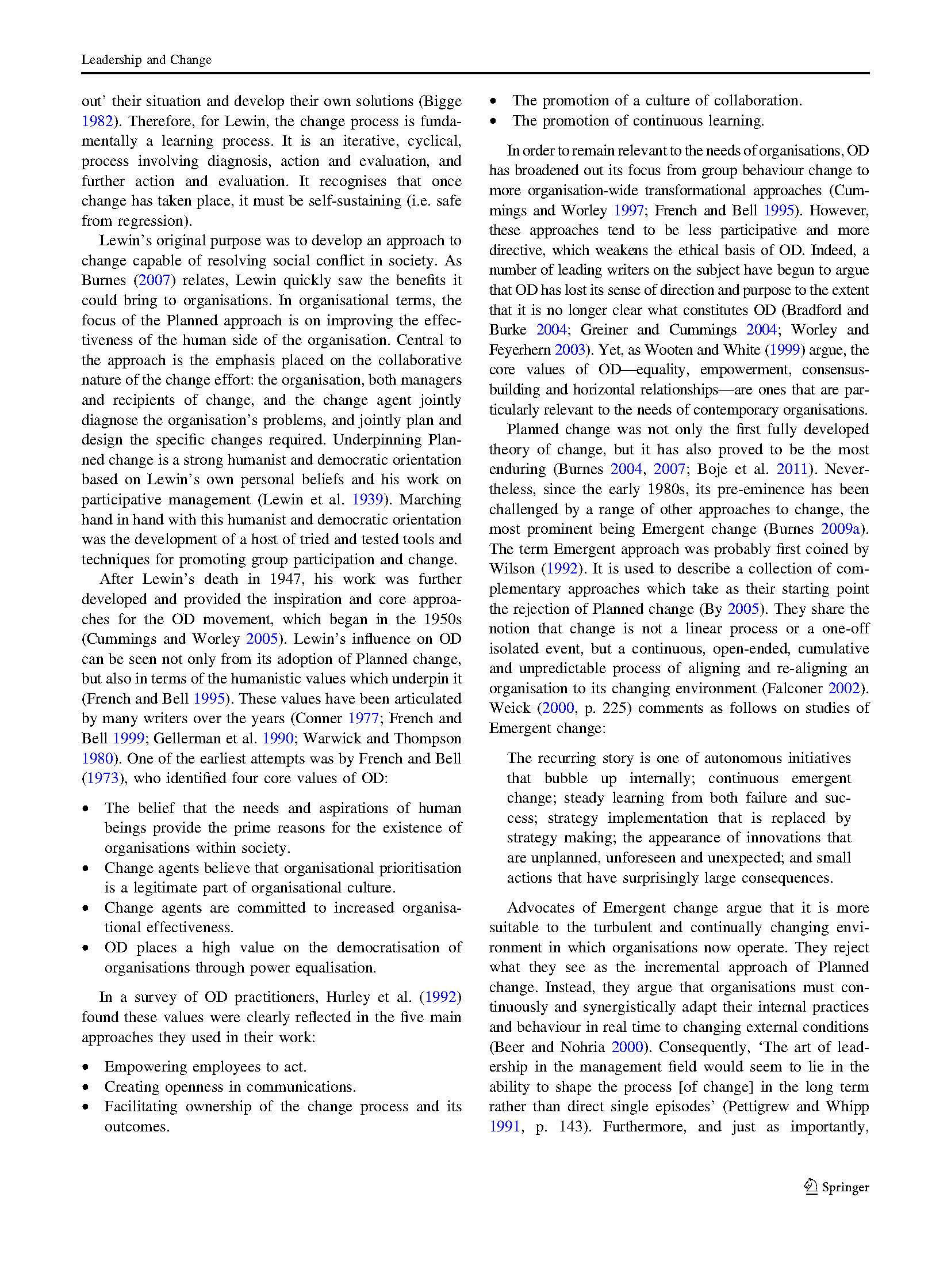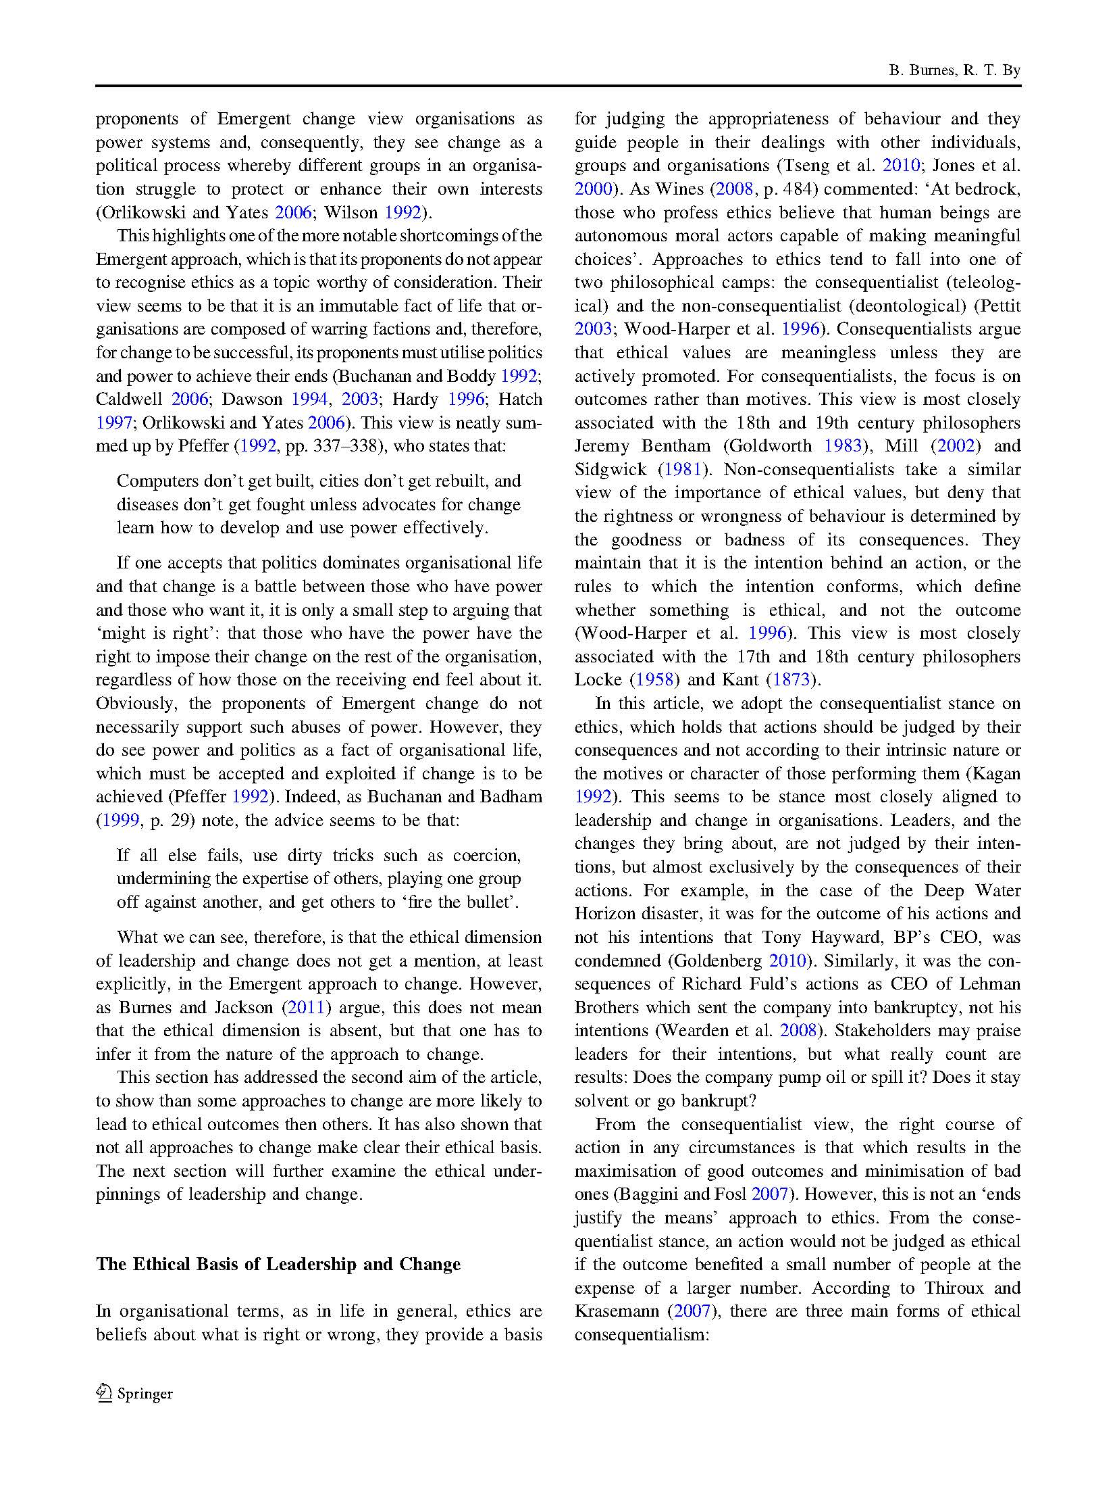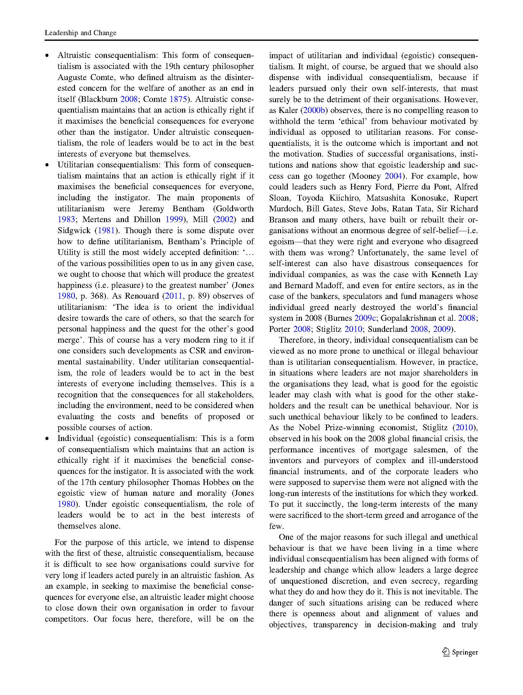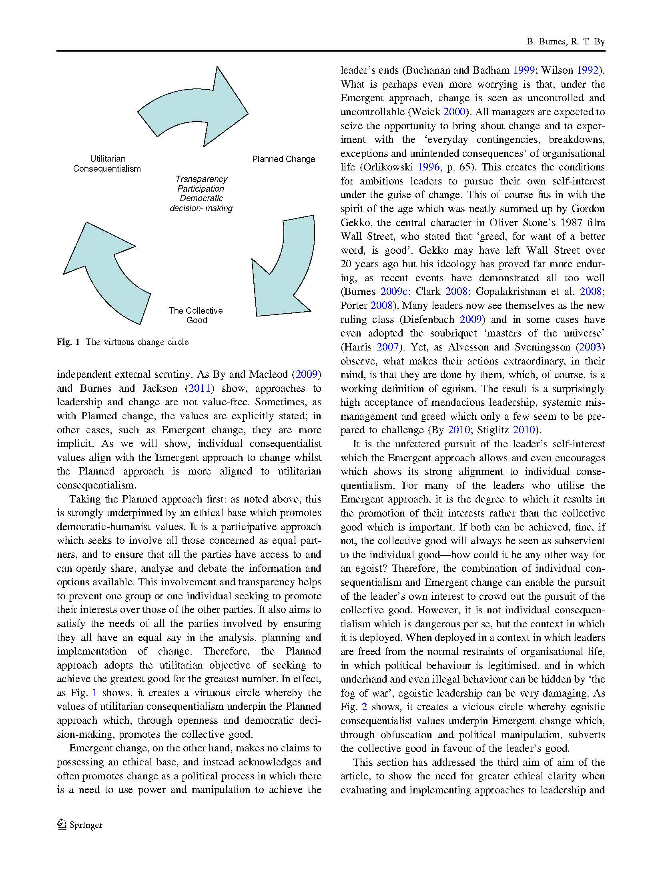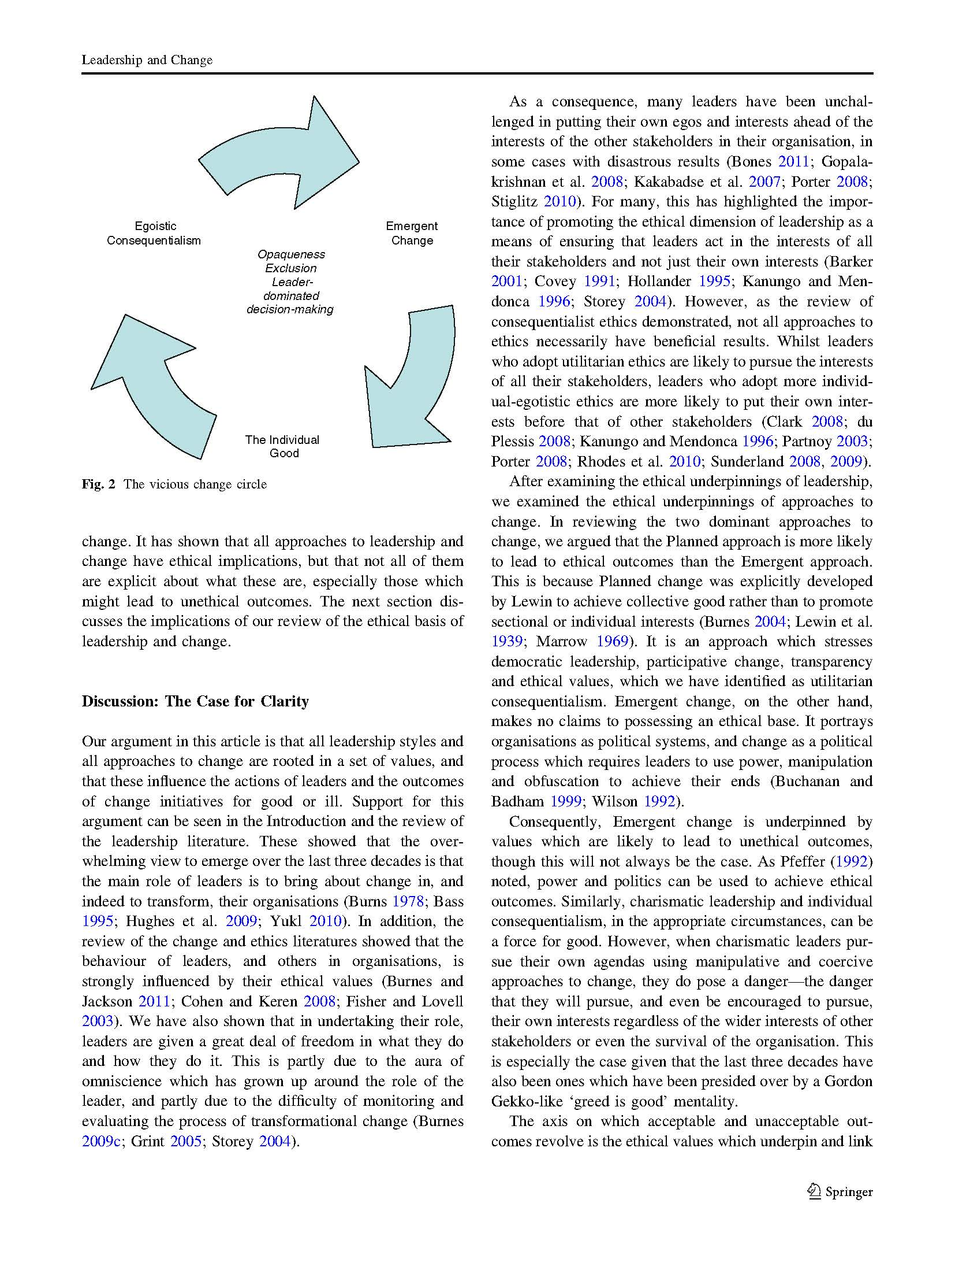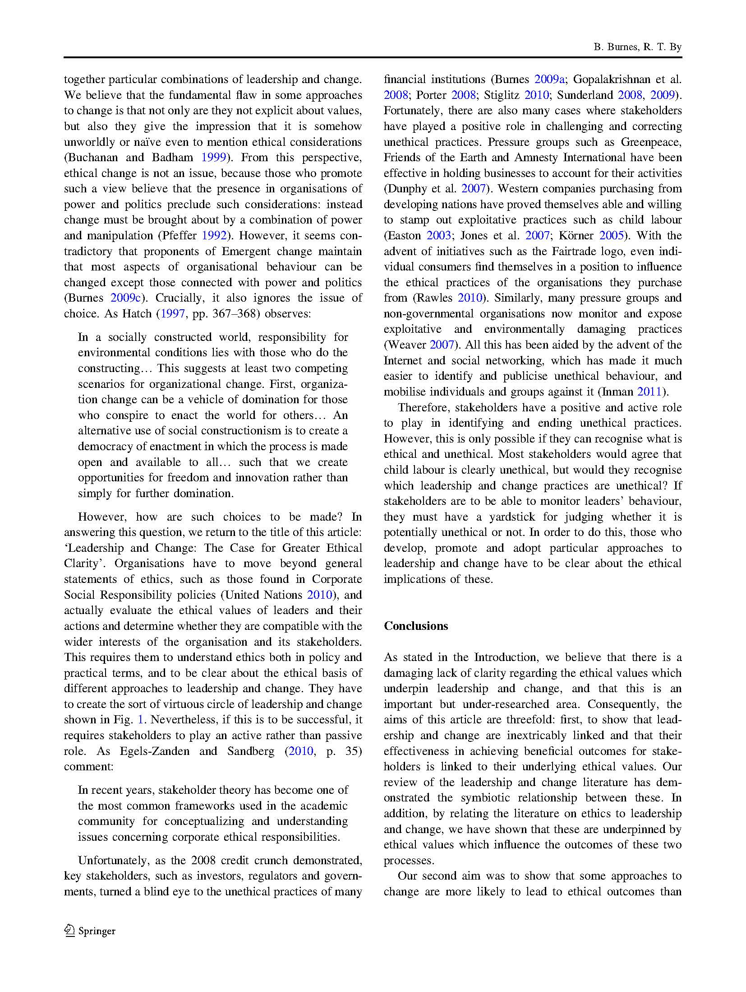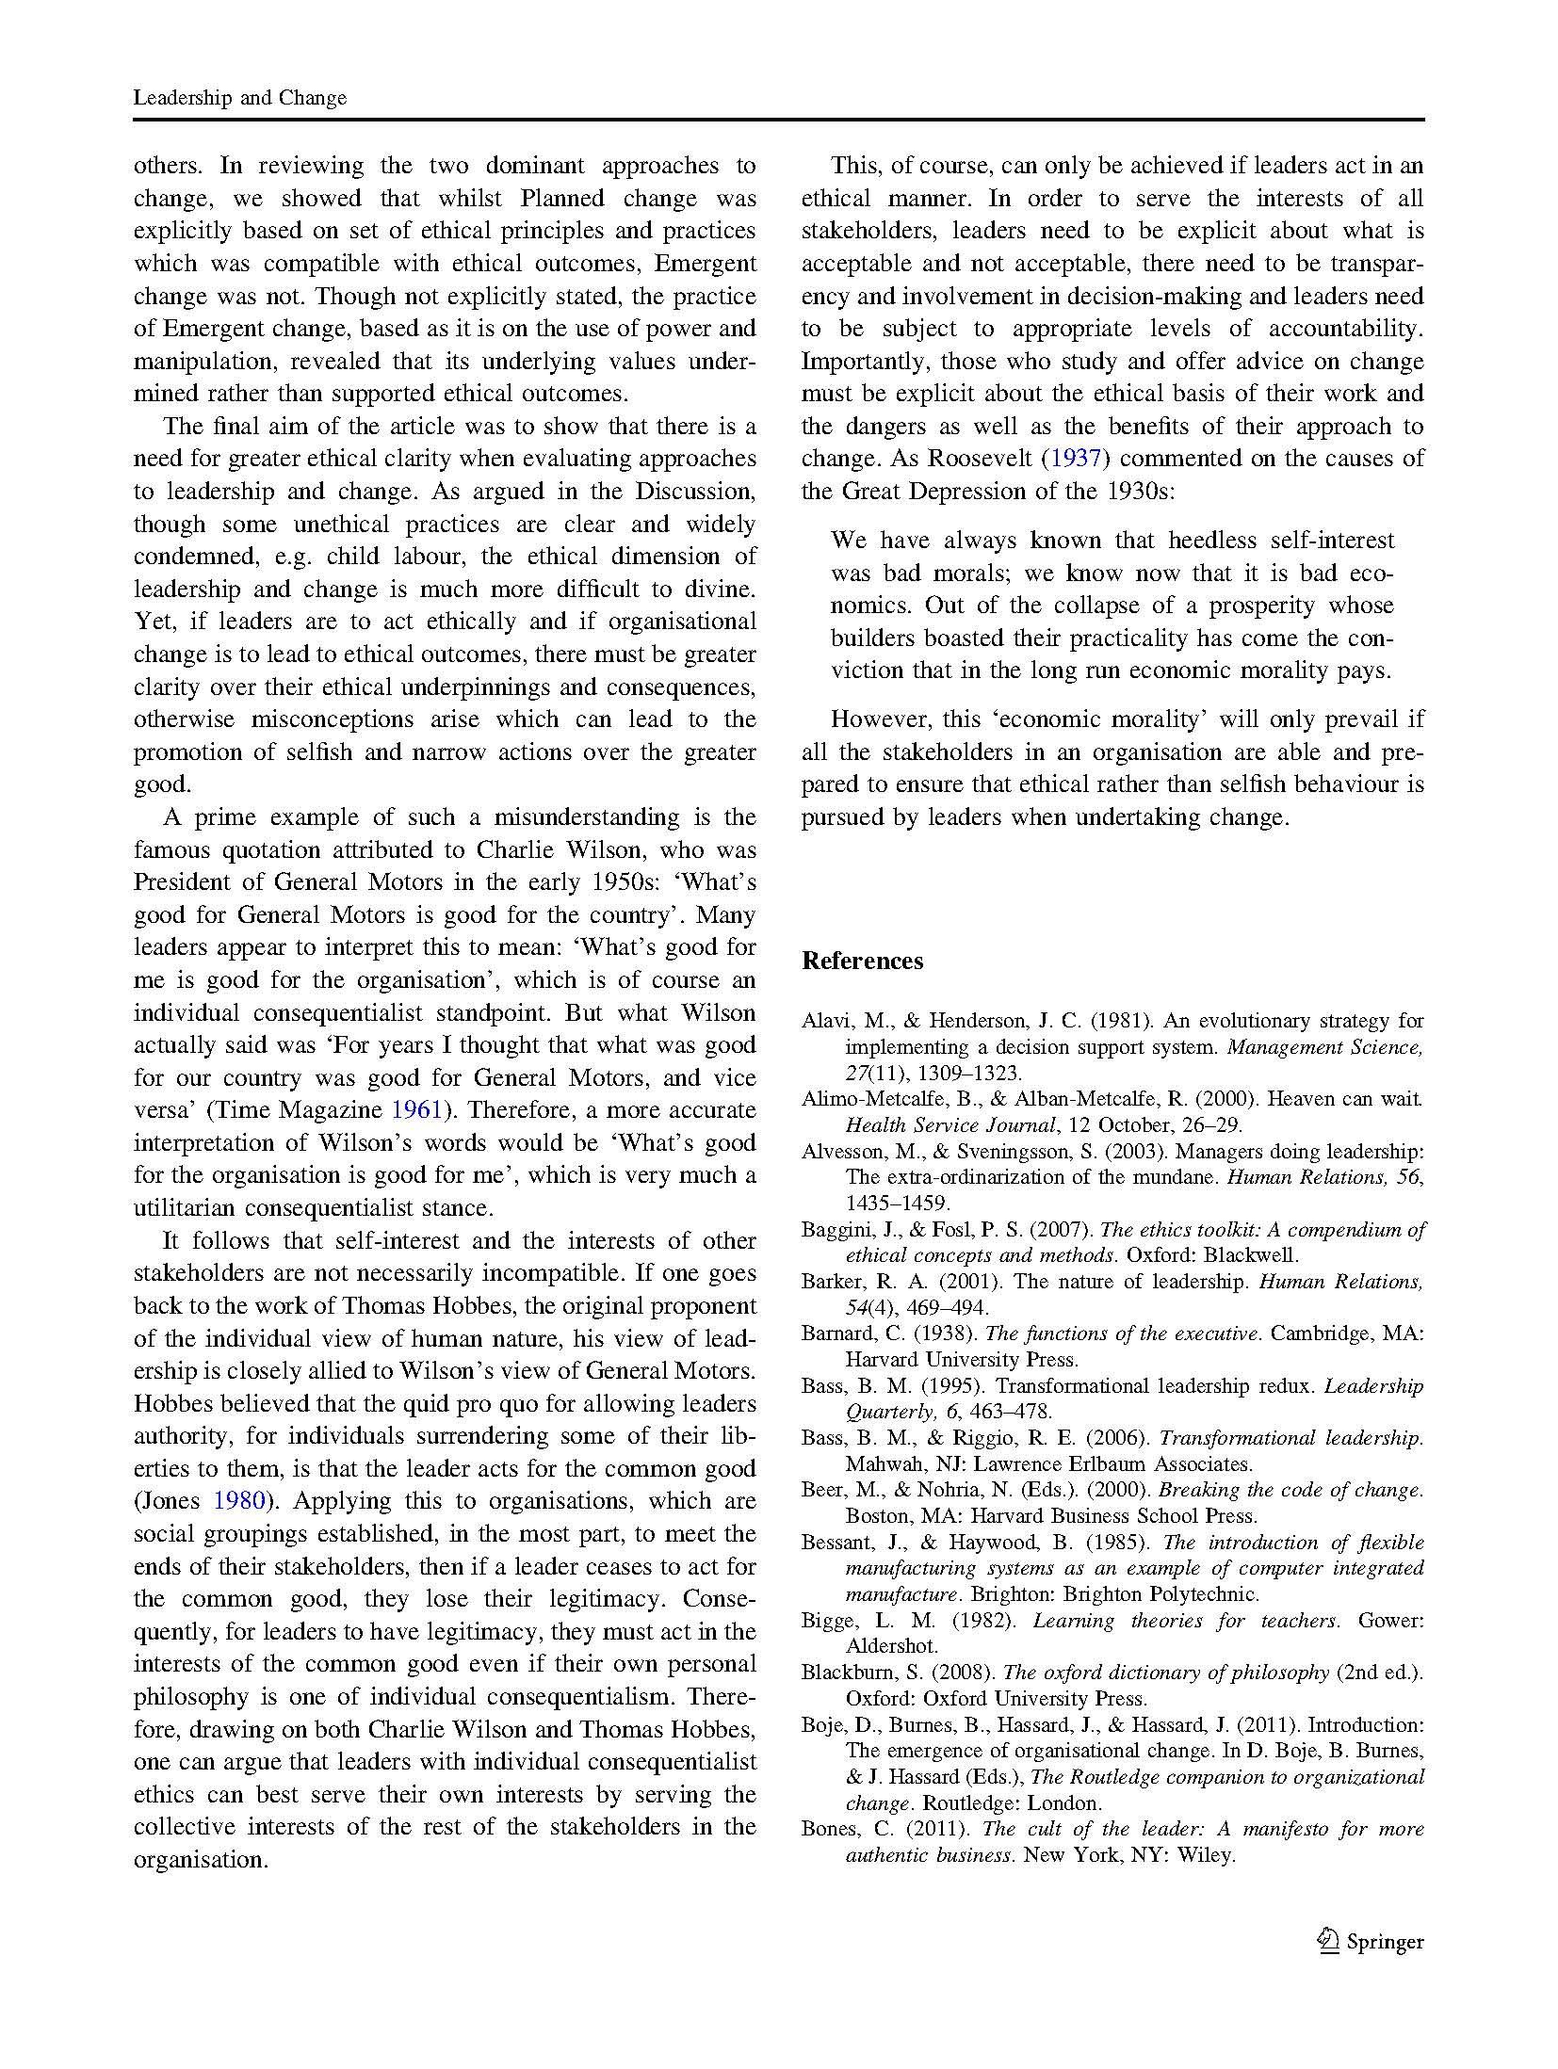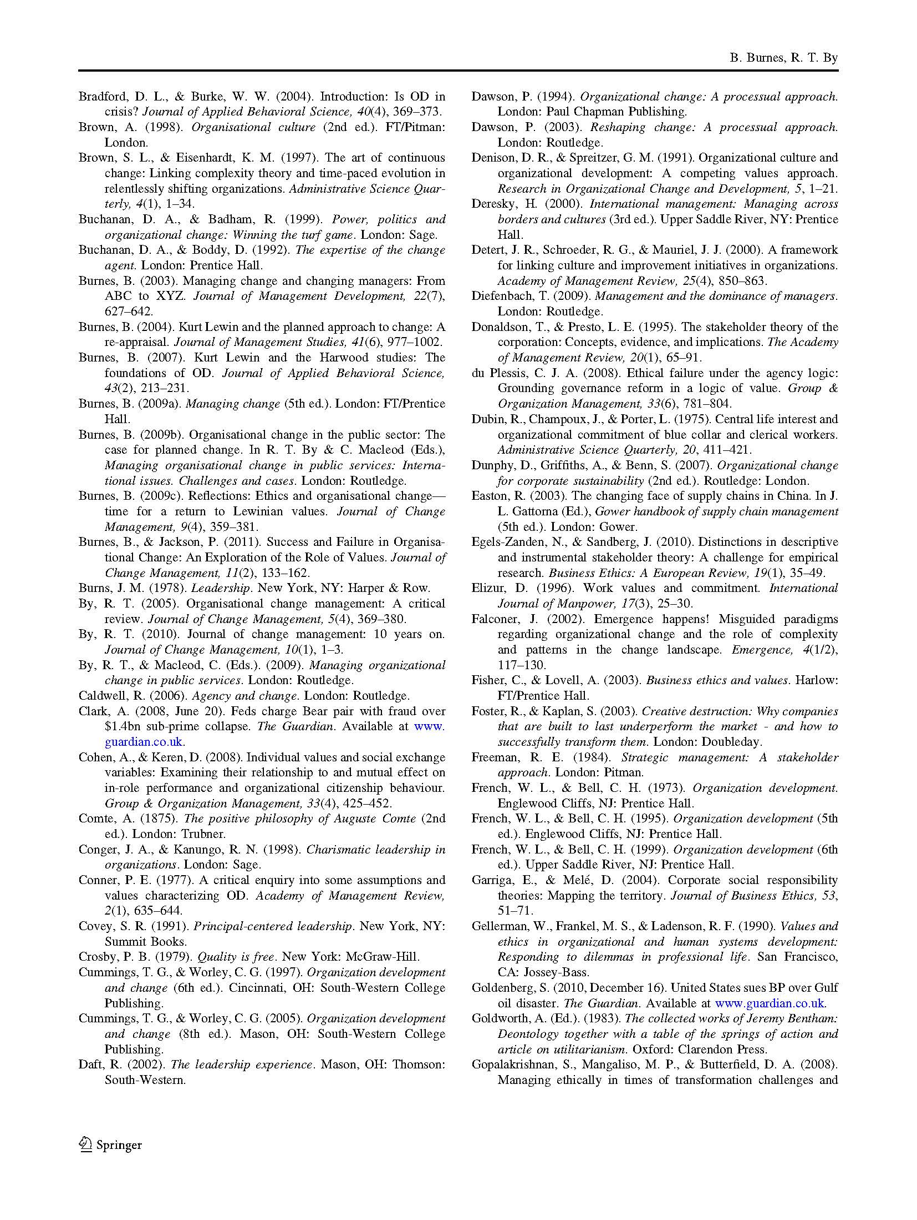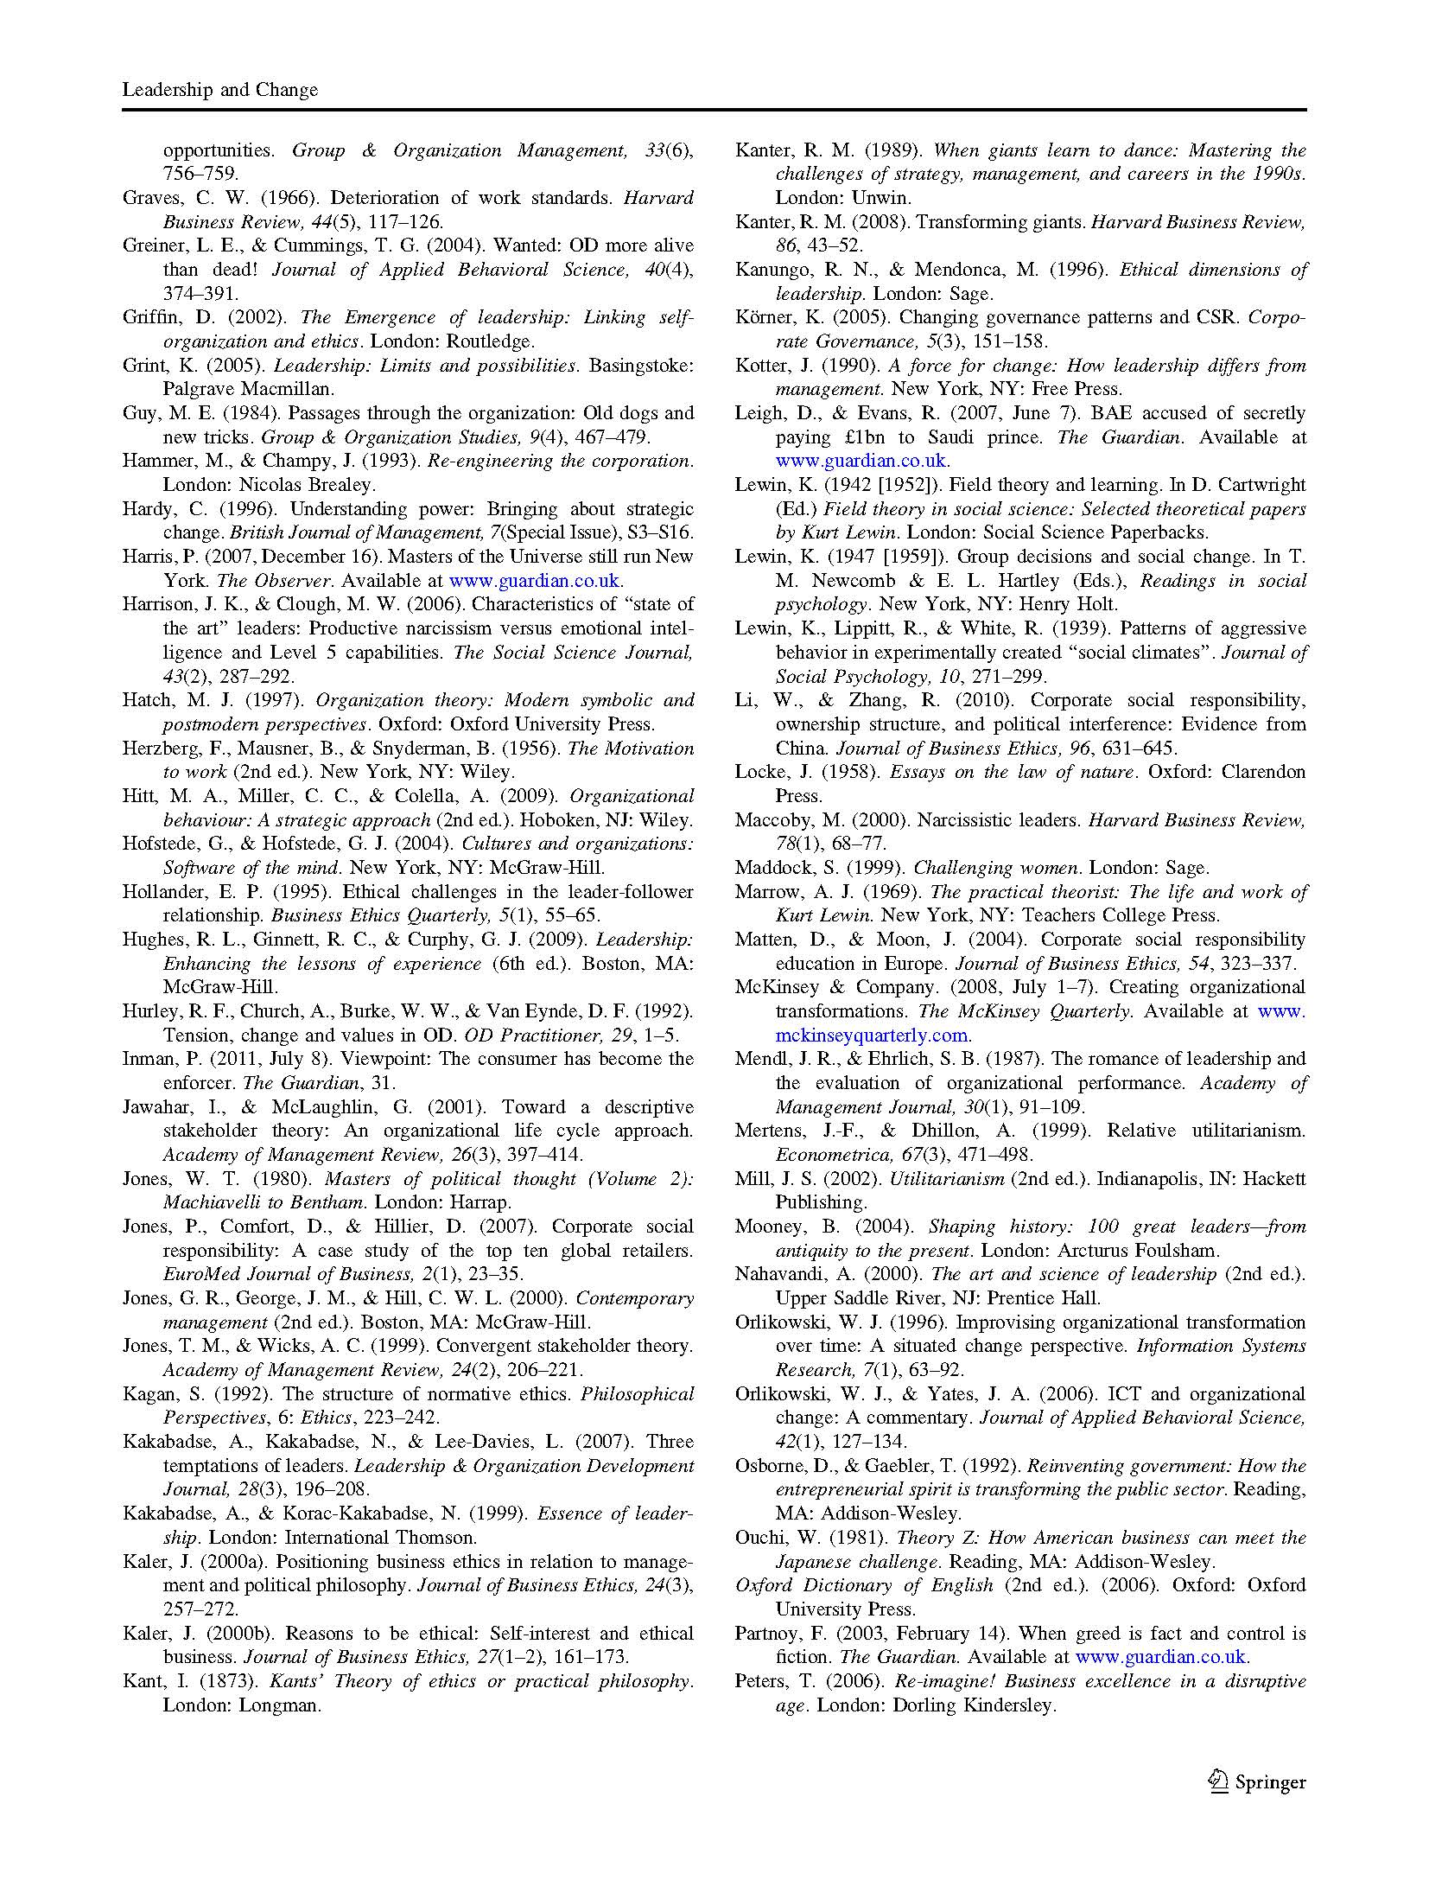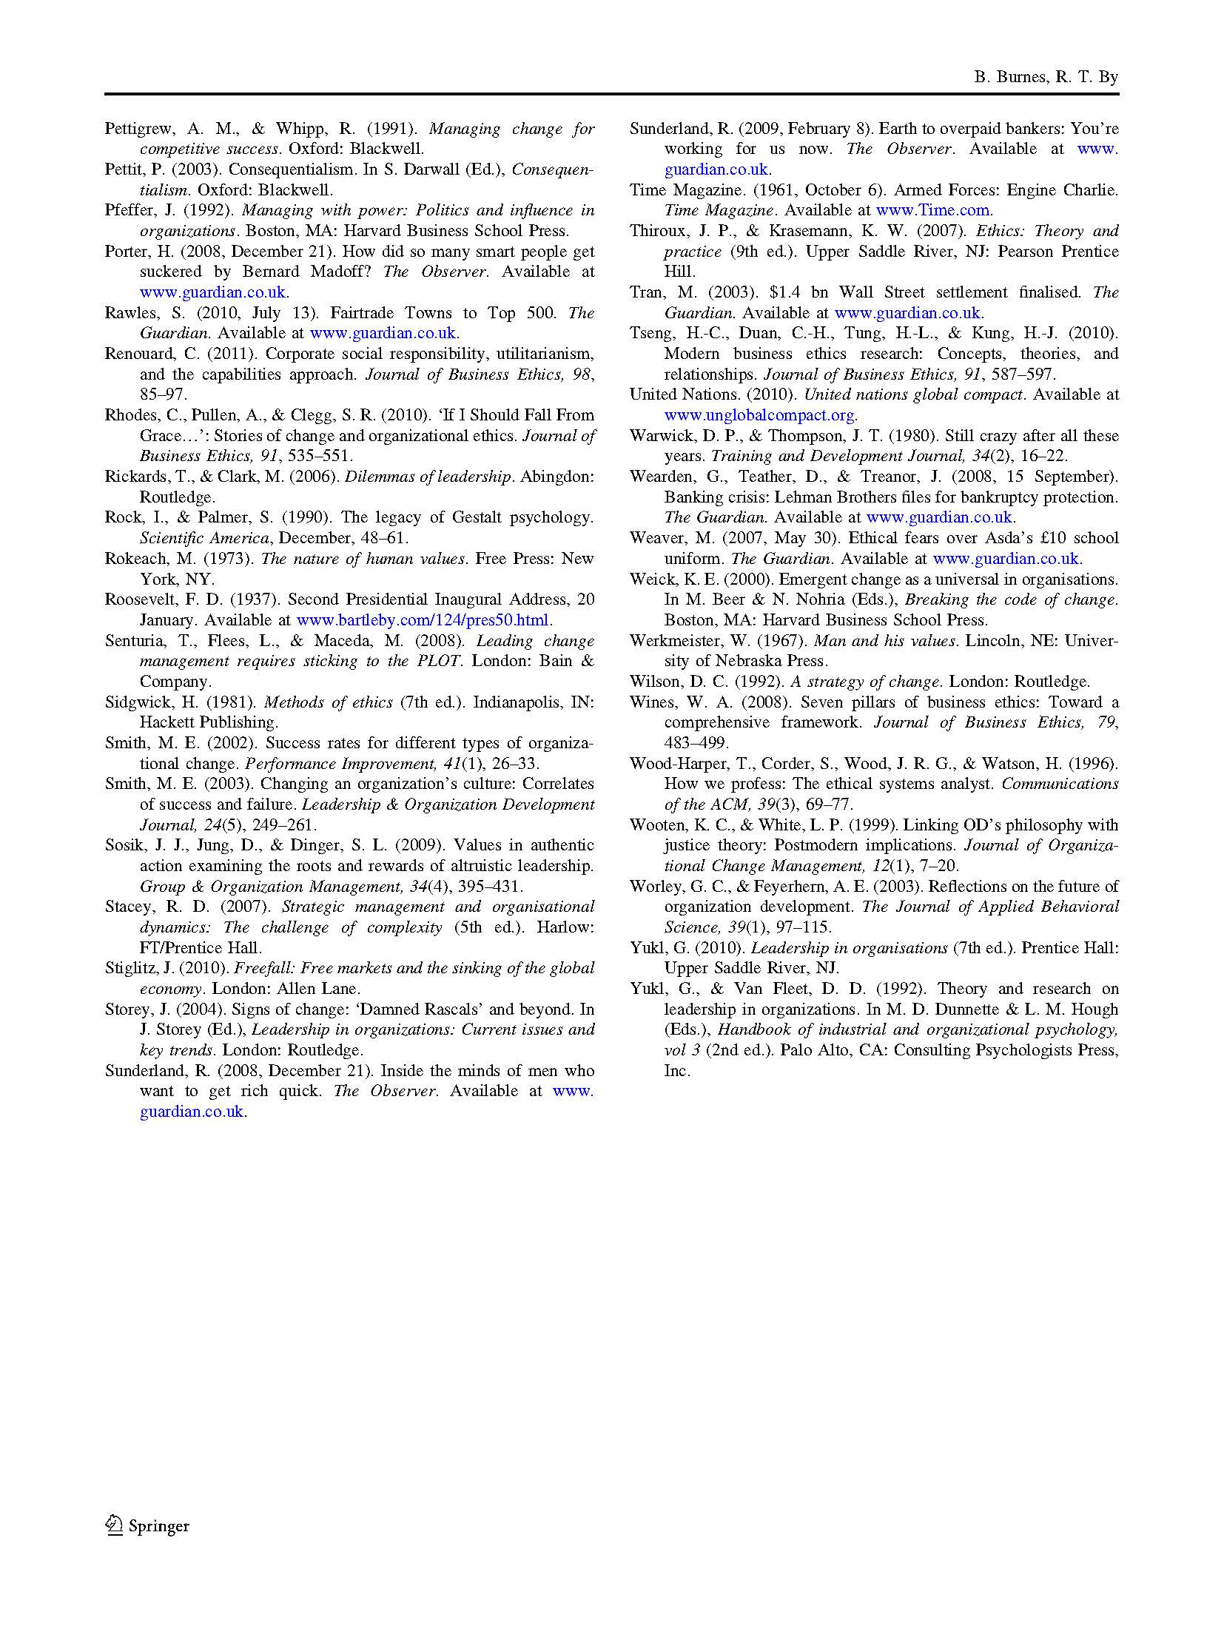
7.3 Summary
Acknowledging that organisational change and leadership are intrinsically linked, this chapter has explicitly moved my focus from organisational change management to leadership. Exploring the relationship between ethics, leadership and organisational change through adopting a utilitarian consequentialist perspective, the chapter develops the concept of Virtuous and Vicious Change Cycles. Furthermore, it hypothesises that in order to achieve sustainable and beneficial organisational change, those adopting particular leadership approaches are required to provide greater ethical clarity about their choice.

Chapter 8: Reimagining organizational change leadership

Burnes, B., Hughes, M. & By, R.T. (2018)
Leadership, 14(2), pp. 141-158

(Published work 2)

This chapter is derived from an article published by Leadership in 2018

8.1 Introduction
This chapter aims to set out a new path for leadership. Reflecting on a situation where after three decades of organisational change and leadership discourse leadership is still in crisis, the chapter introduces an alternative to the current orthodoxy. In doing so, it challenges the current change and leadership orthodoxies based on the work of Bass (1985) and Kotter (1995; 1996) and introduces leadership as a utilitarian consequentialist process based on the seminal work of Lewin (1947a & b) and Burns (1978).

Burnes, B., Hughes, M. & By, R.T. (2018). Reimagining organizational change leadership. Leadership, 14(2), pp. 141-158.

Note: According to Google Scholar this article has been cited 16 times (as of 24.04.2019)

8.2 Chapter article
Please see next page.

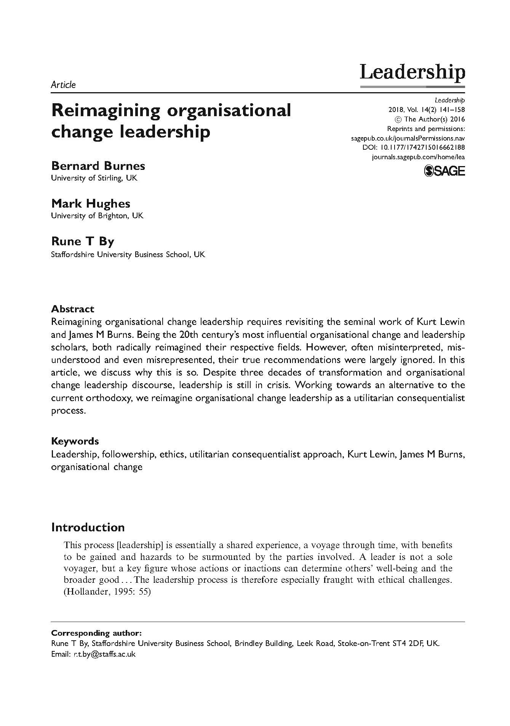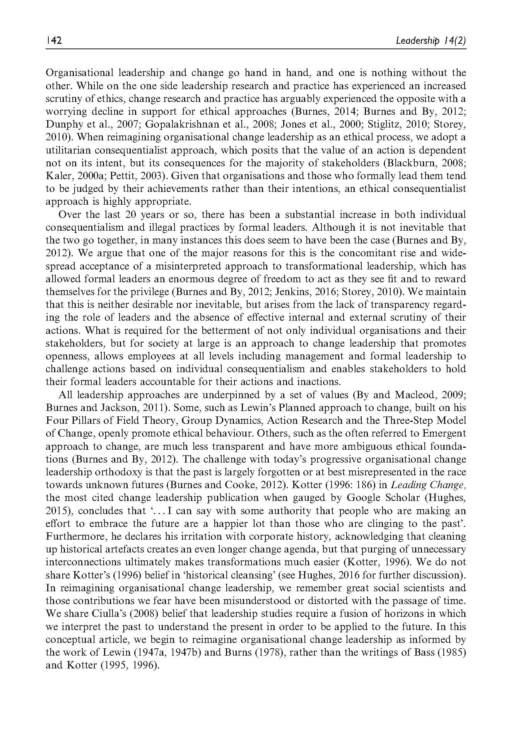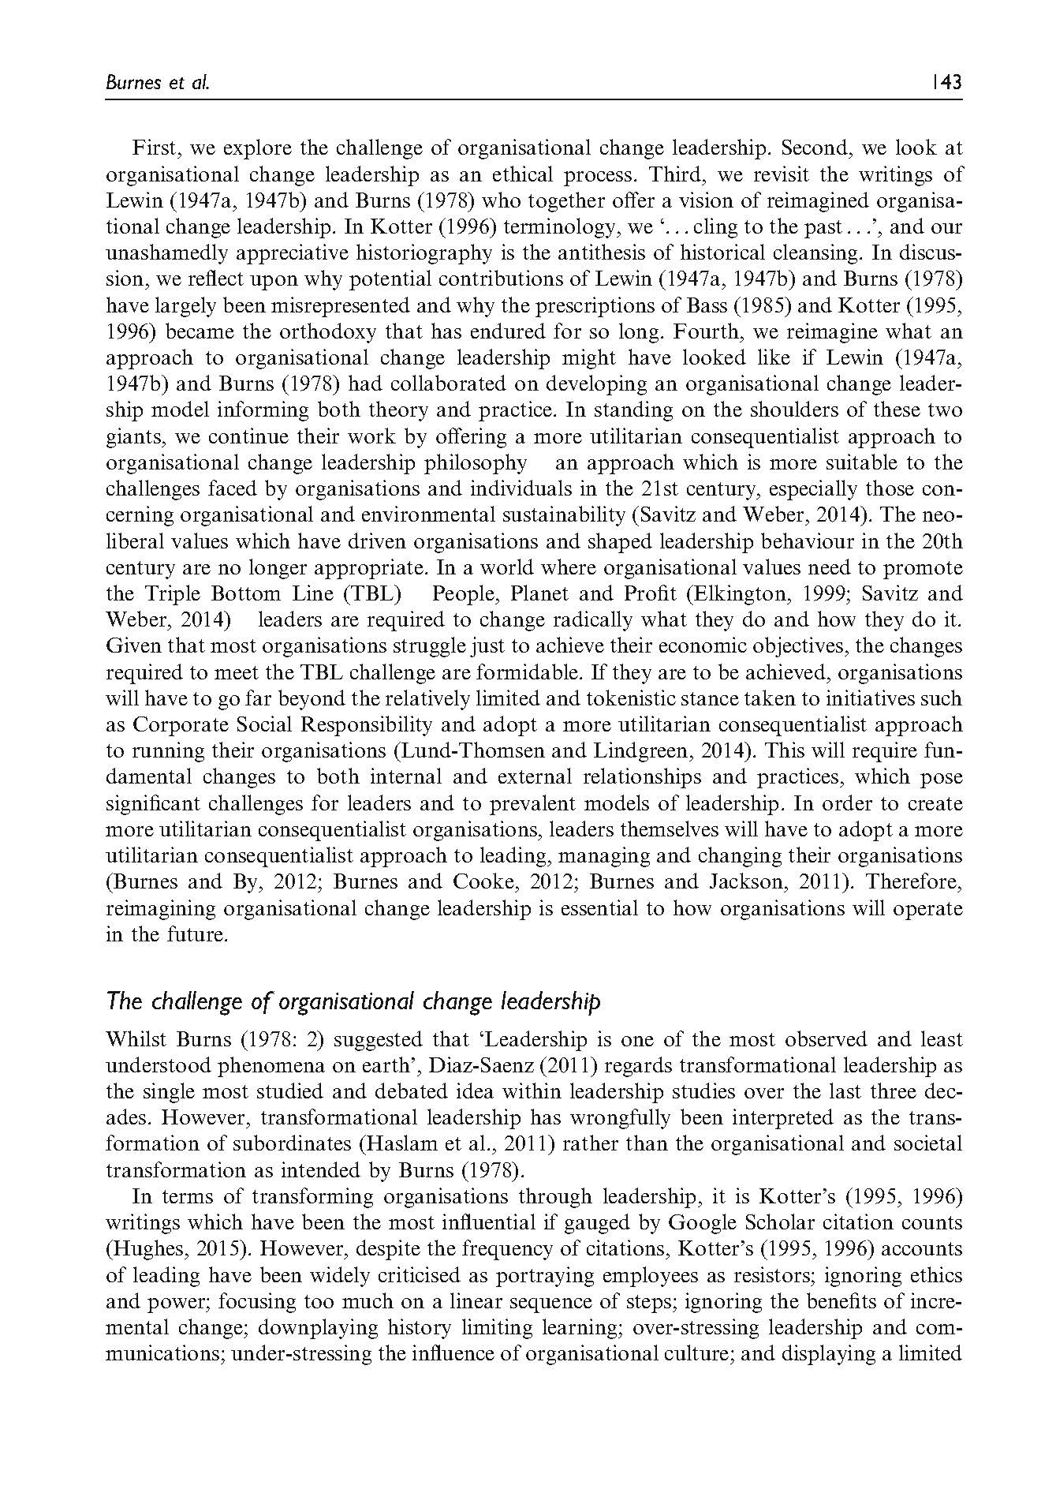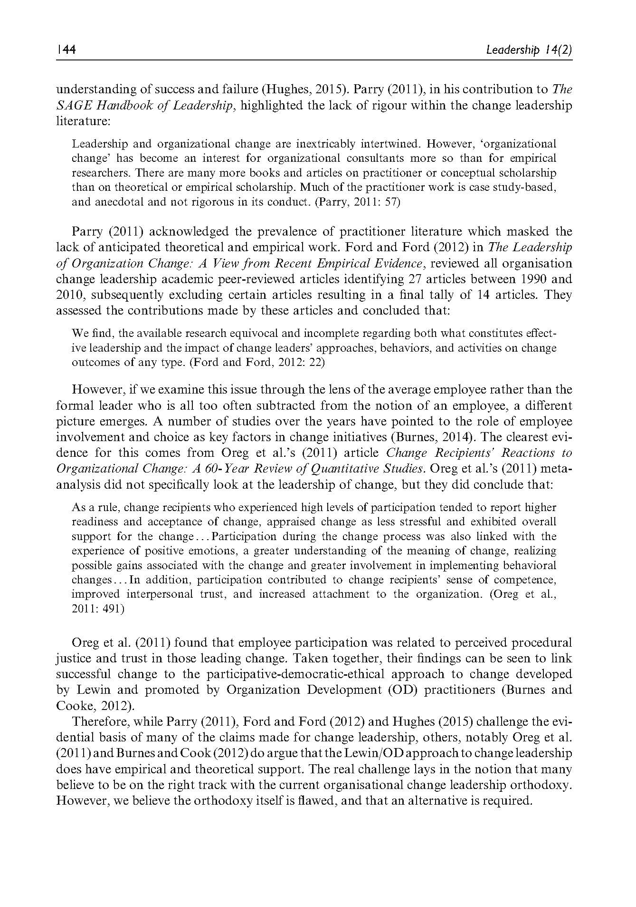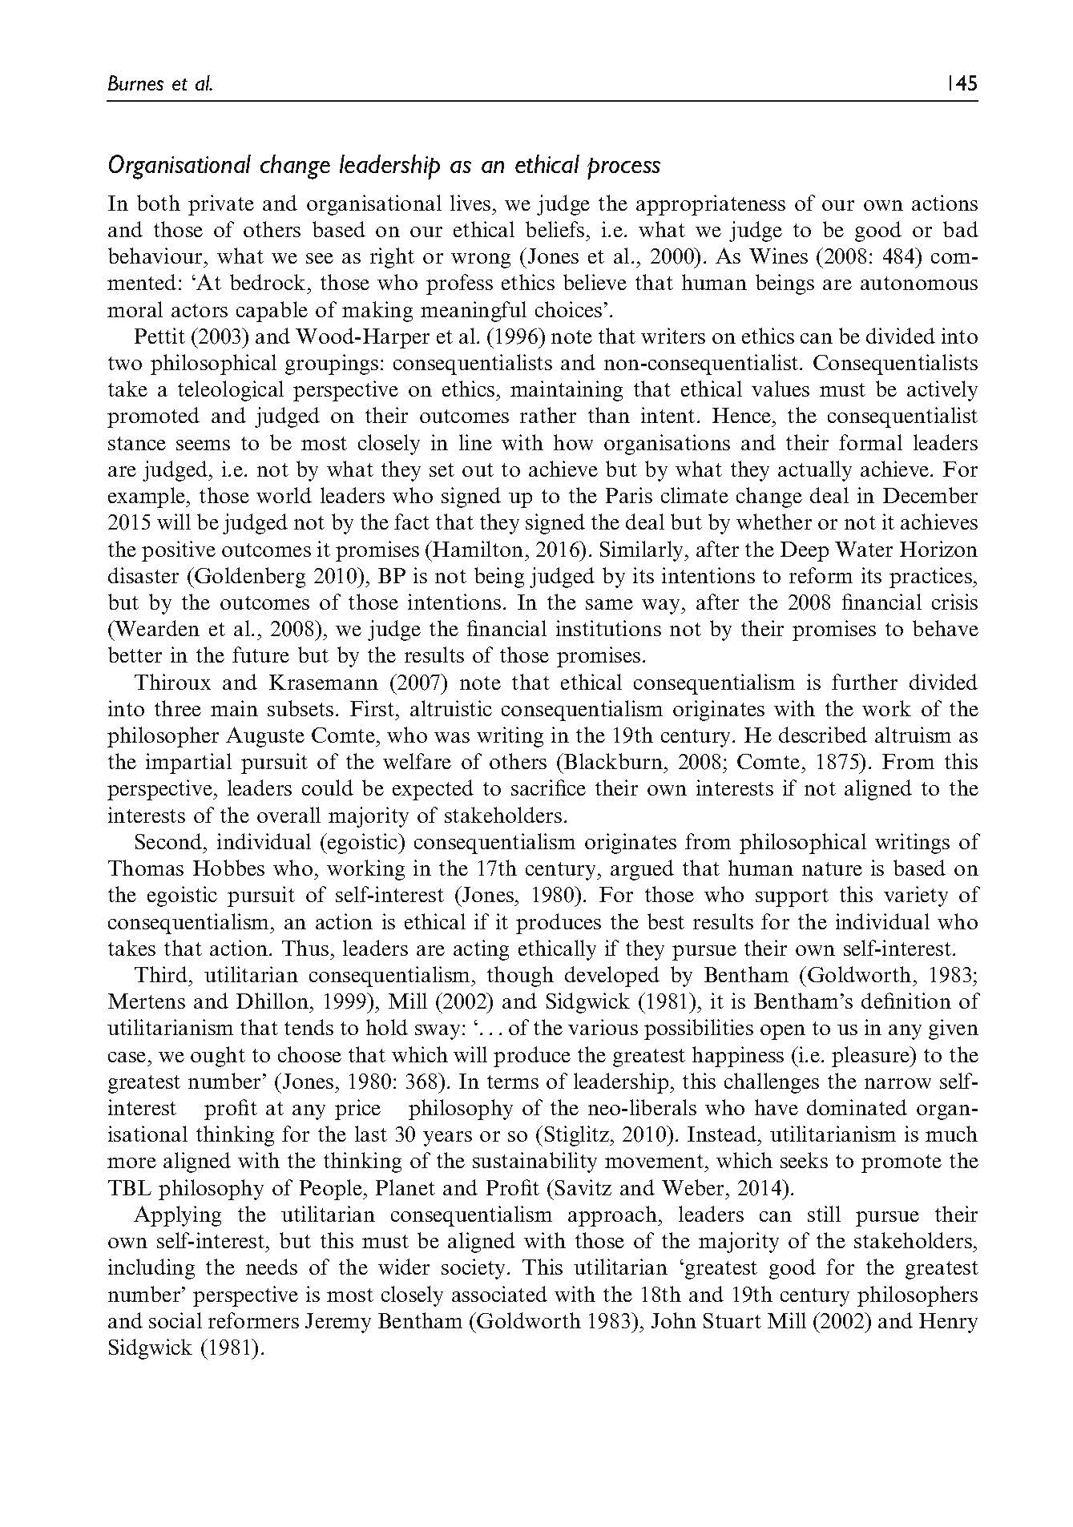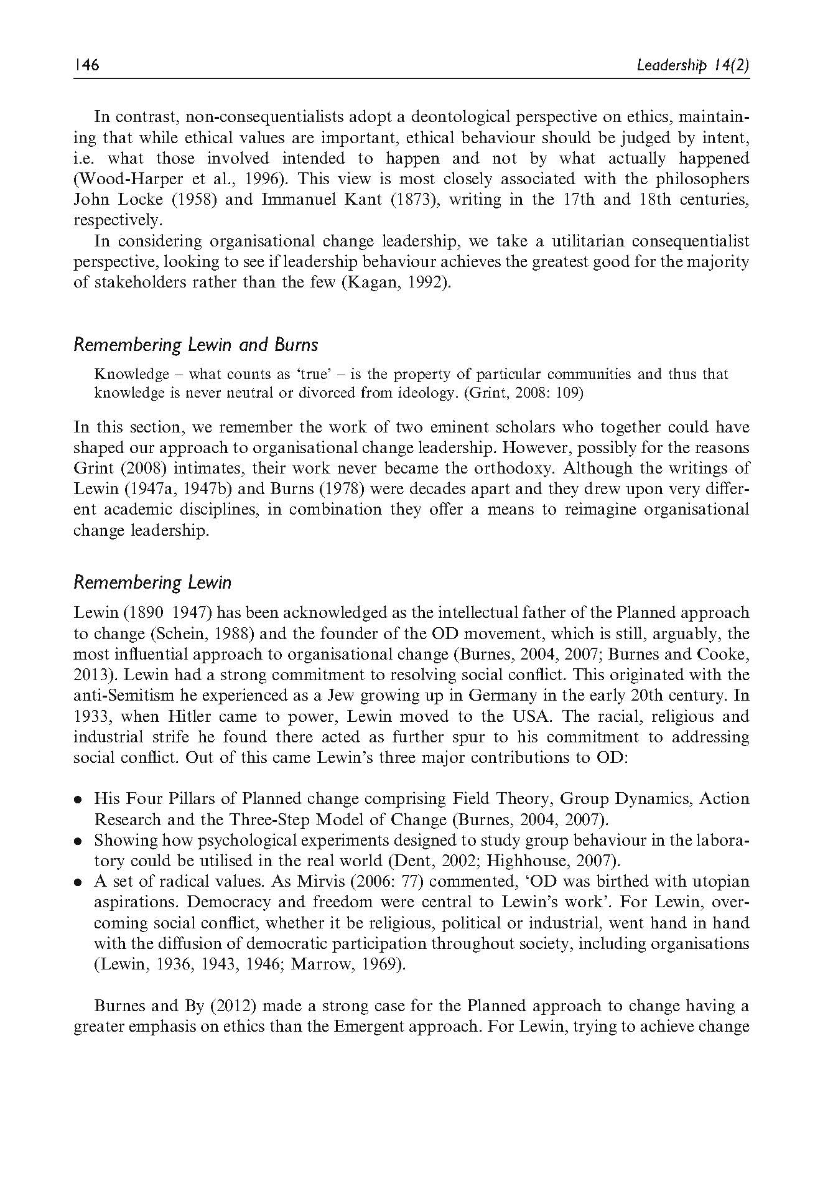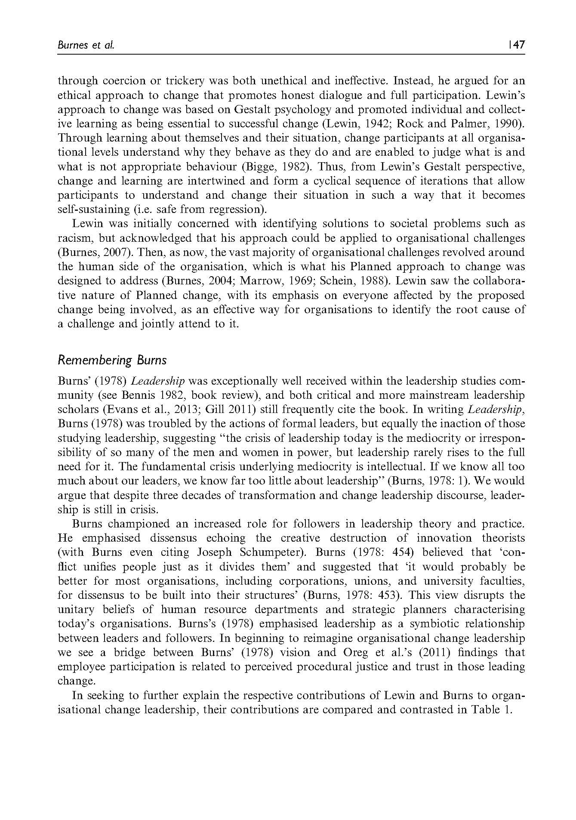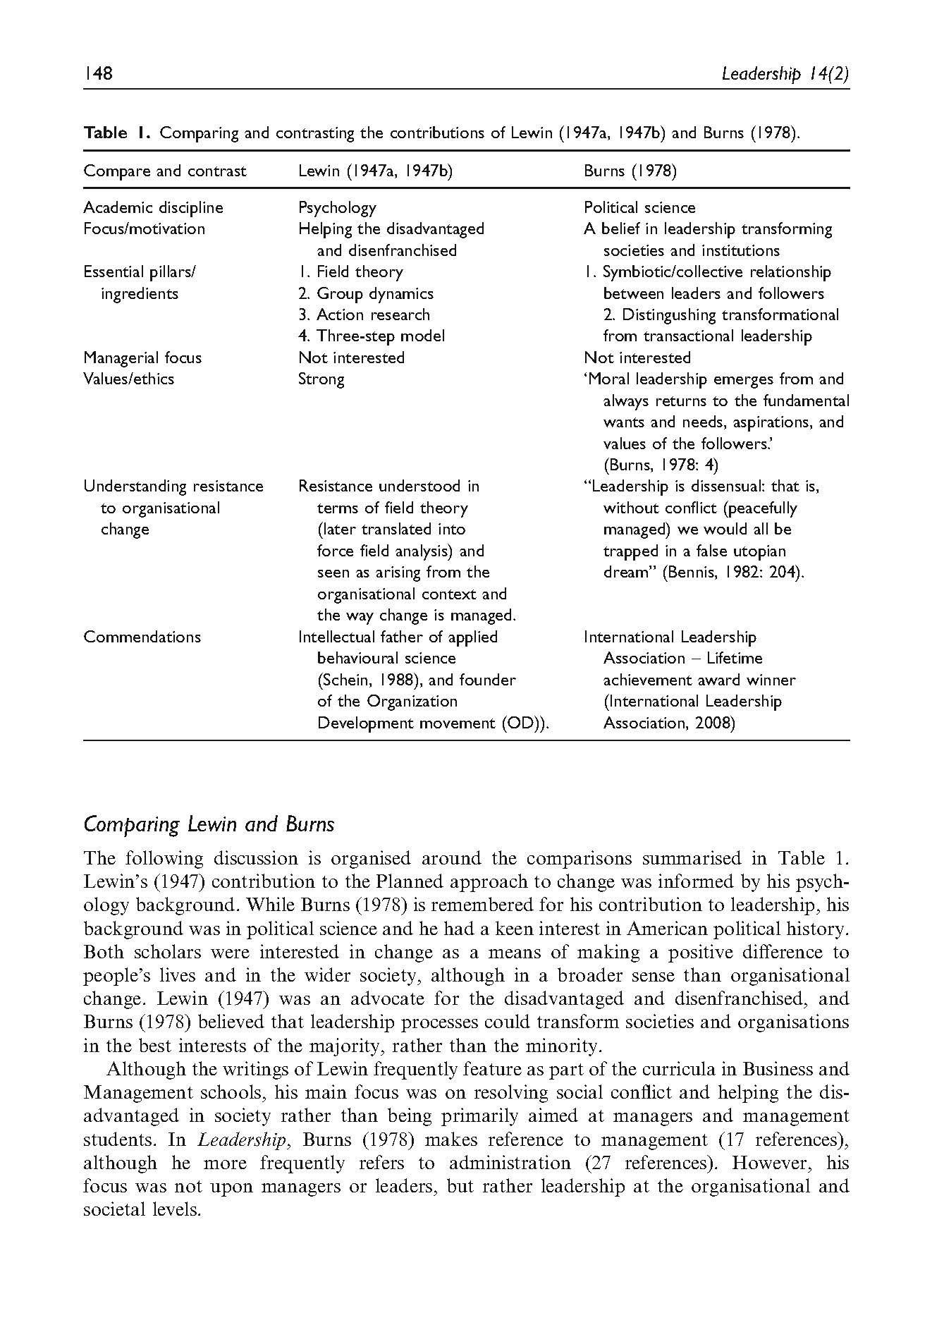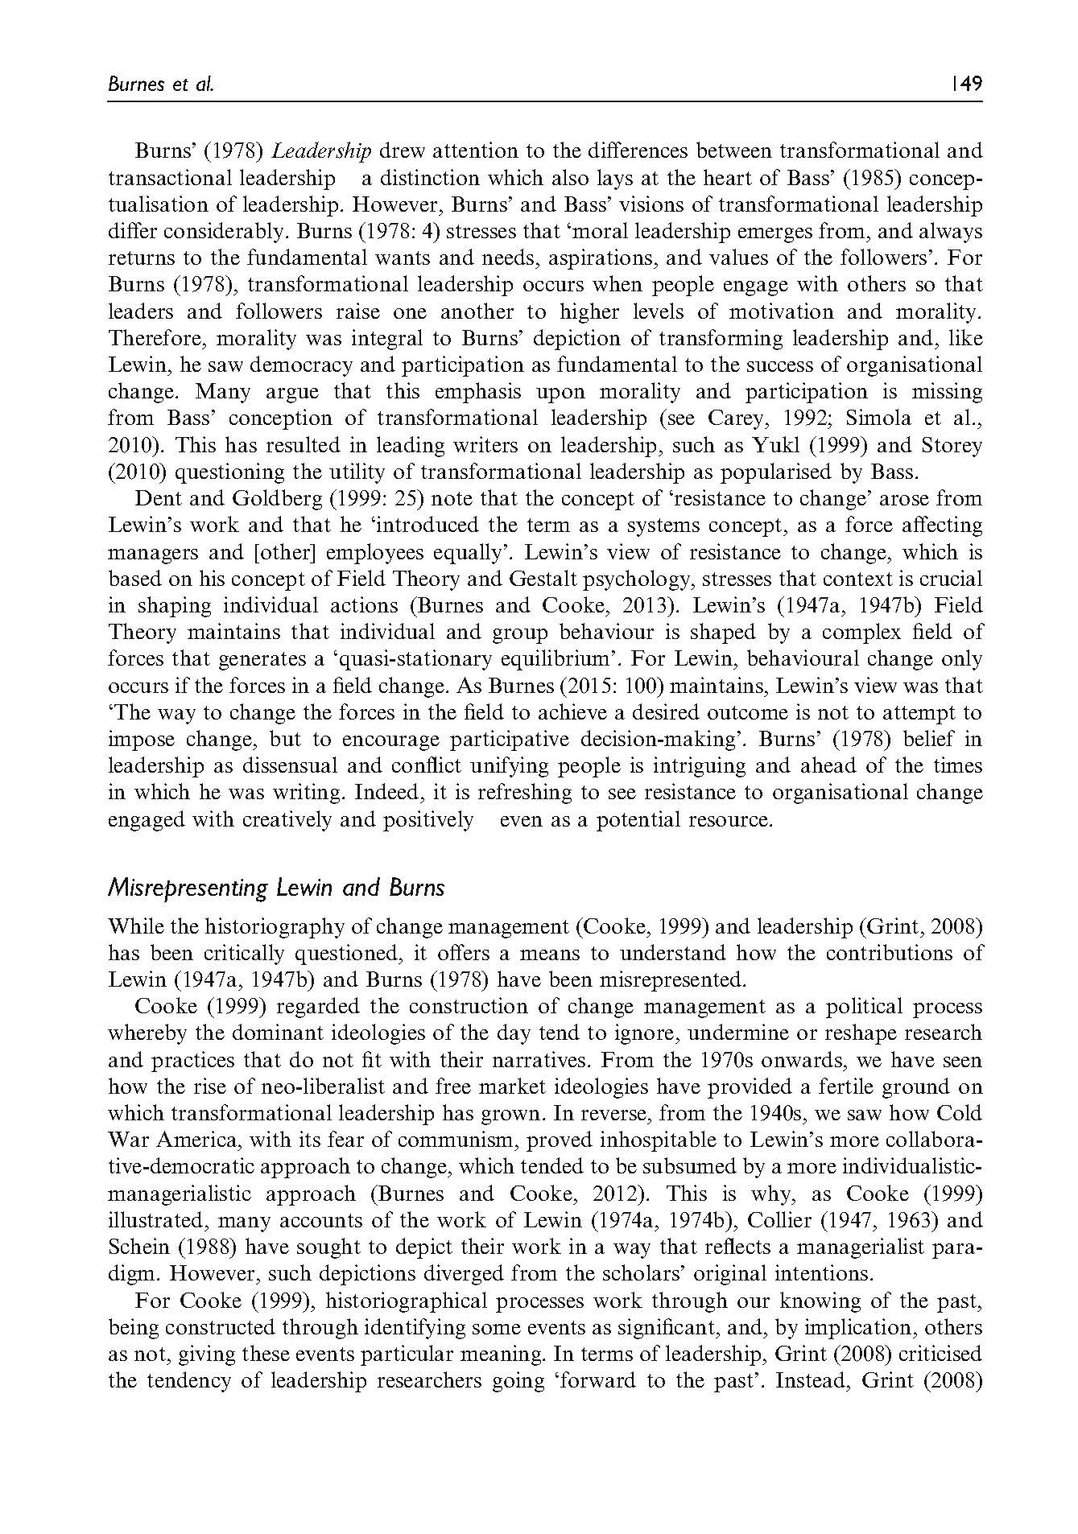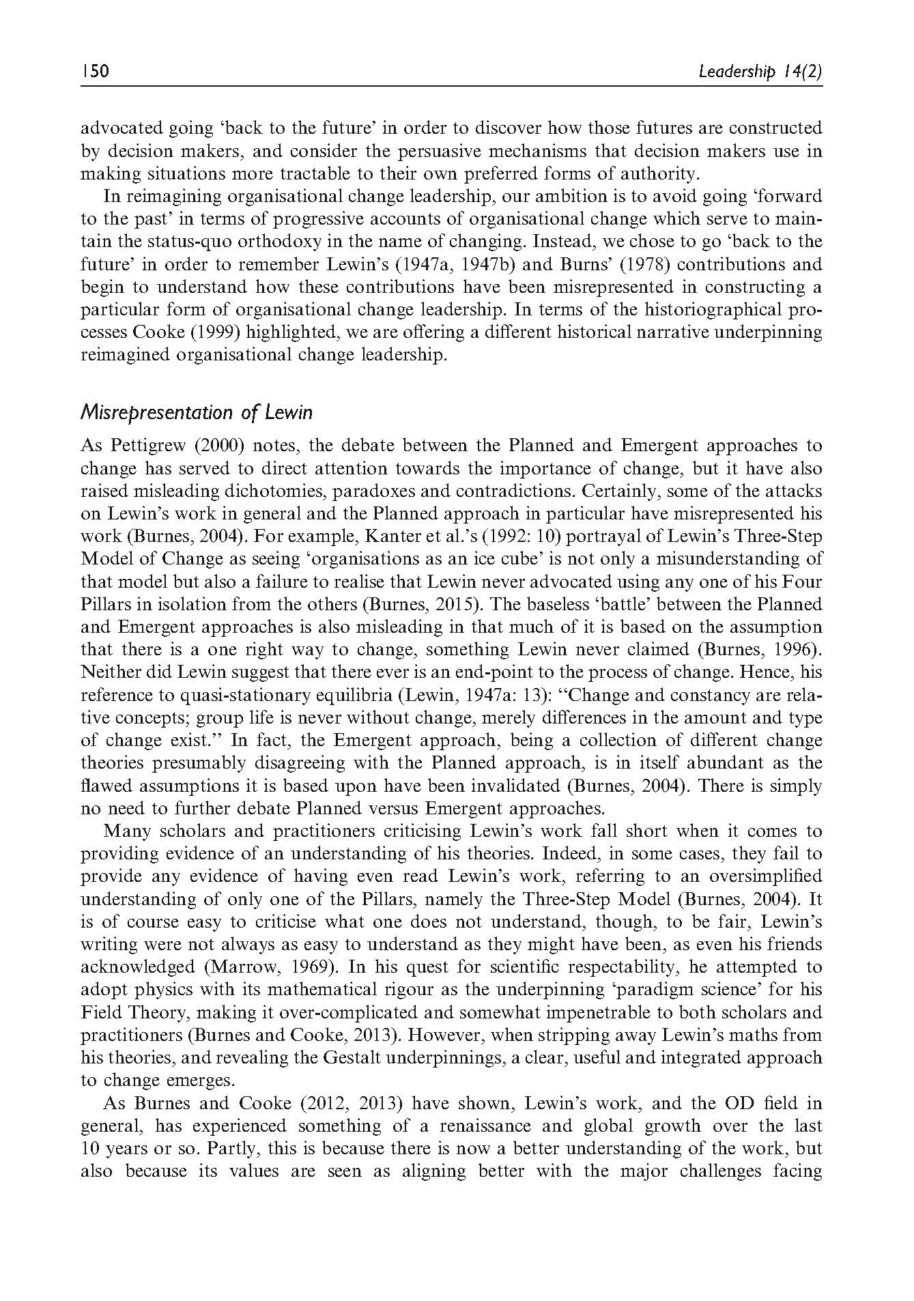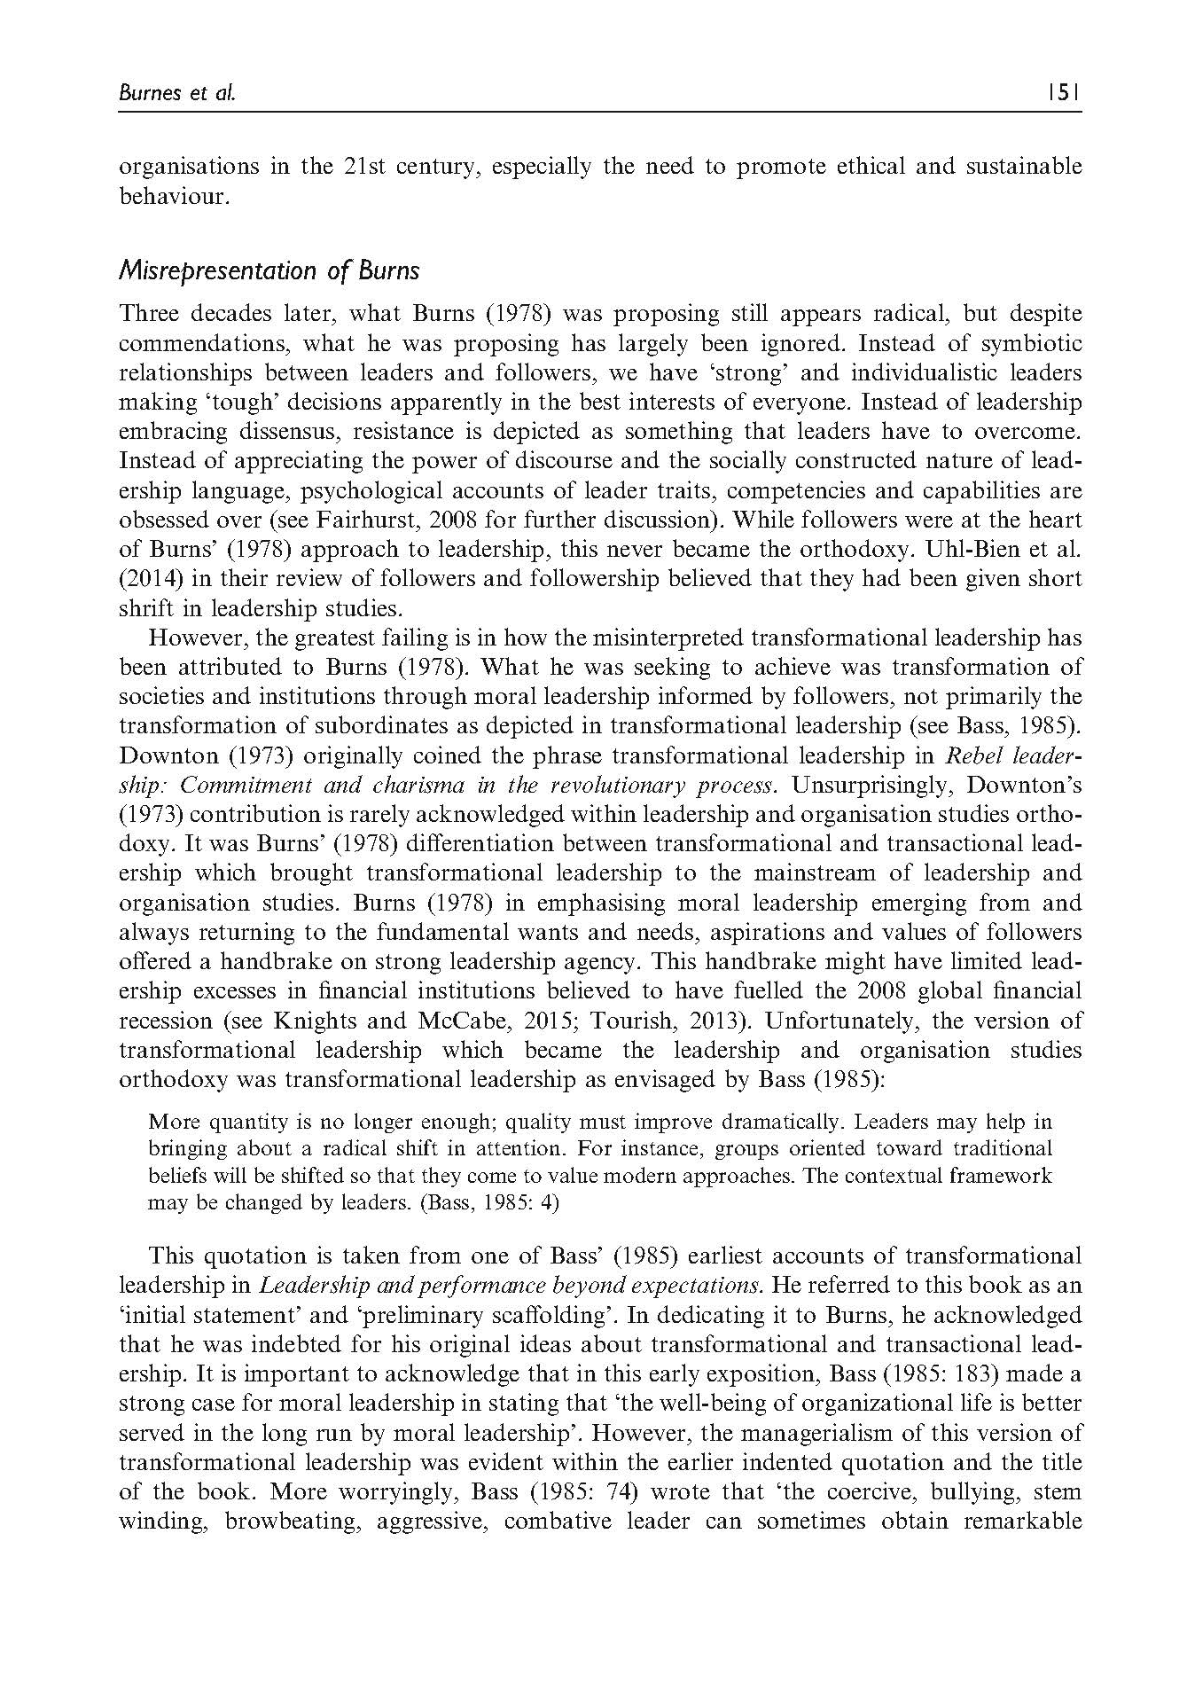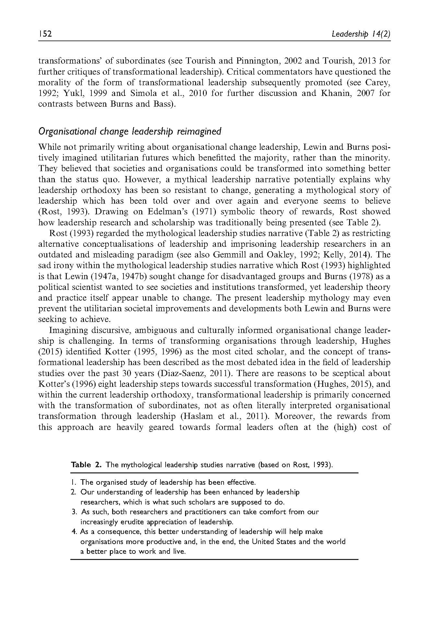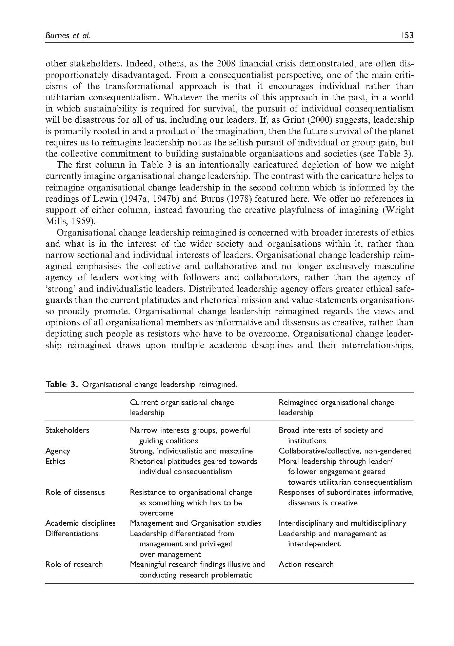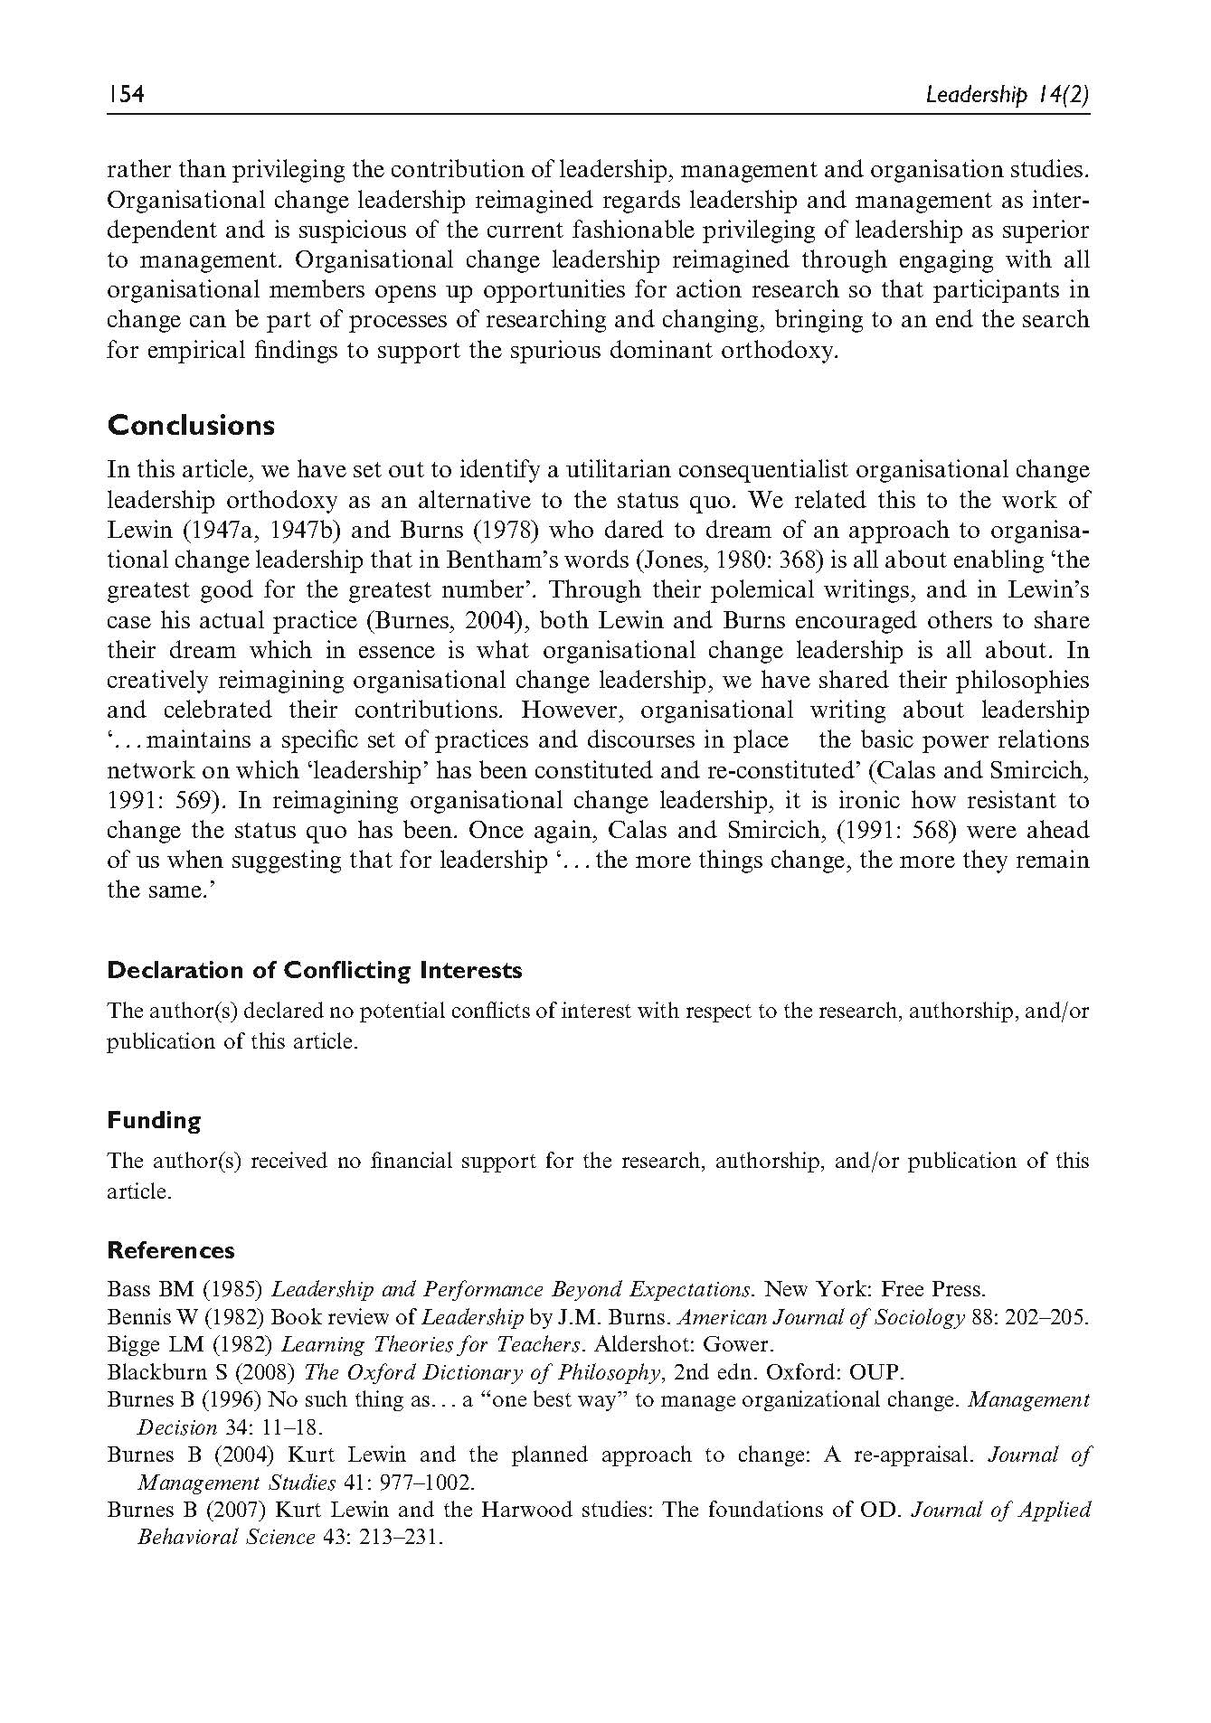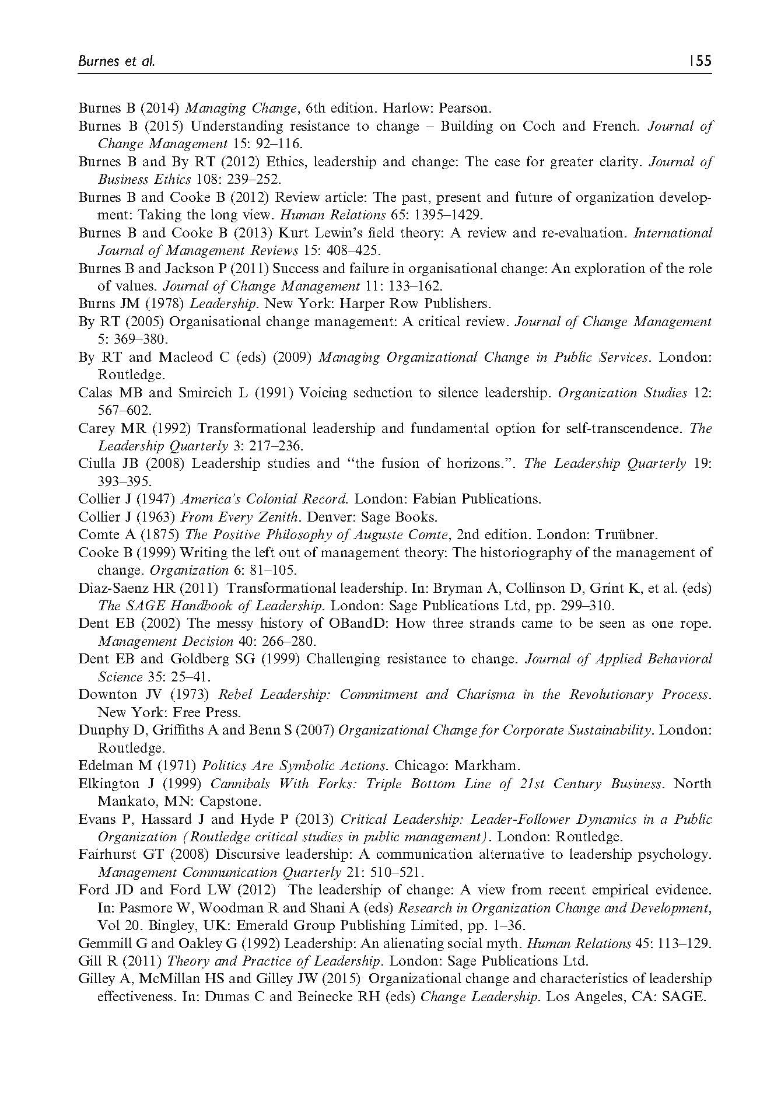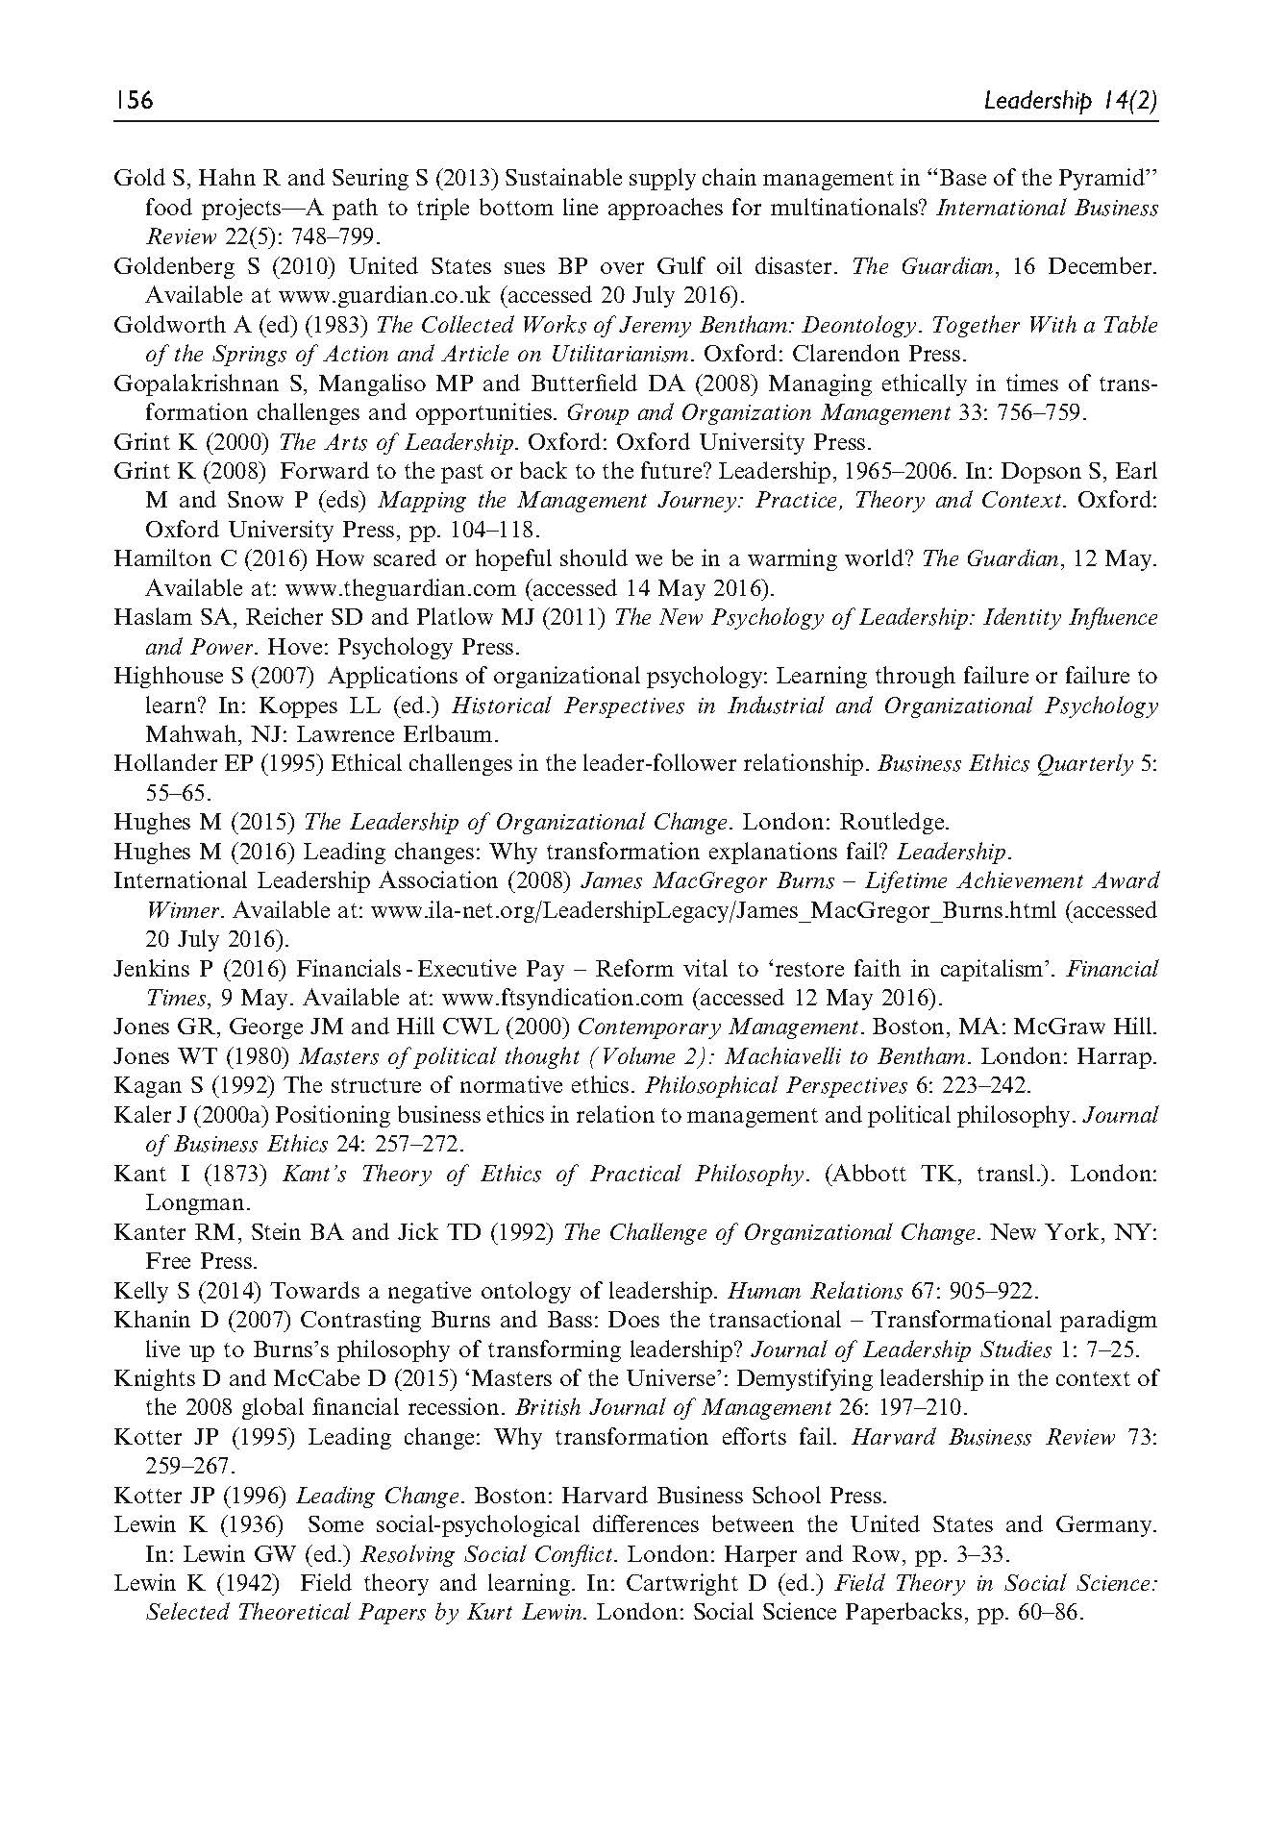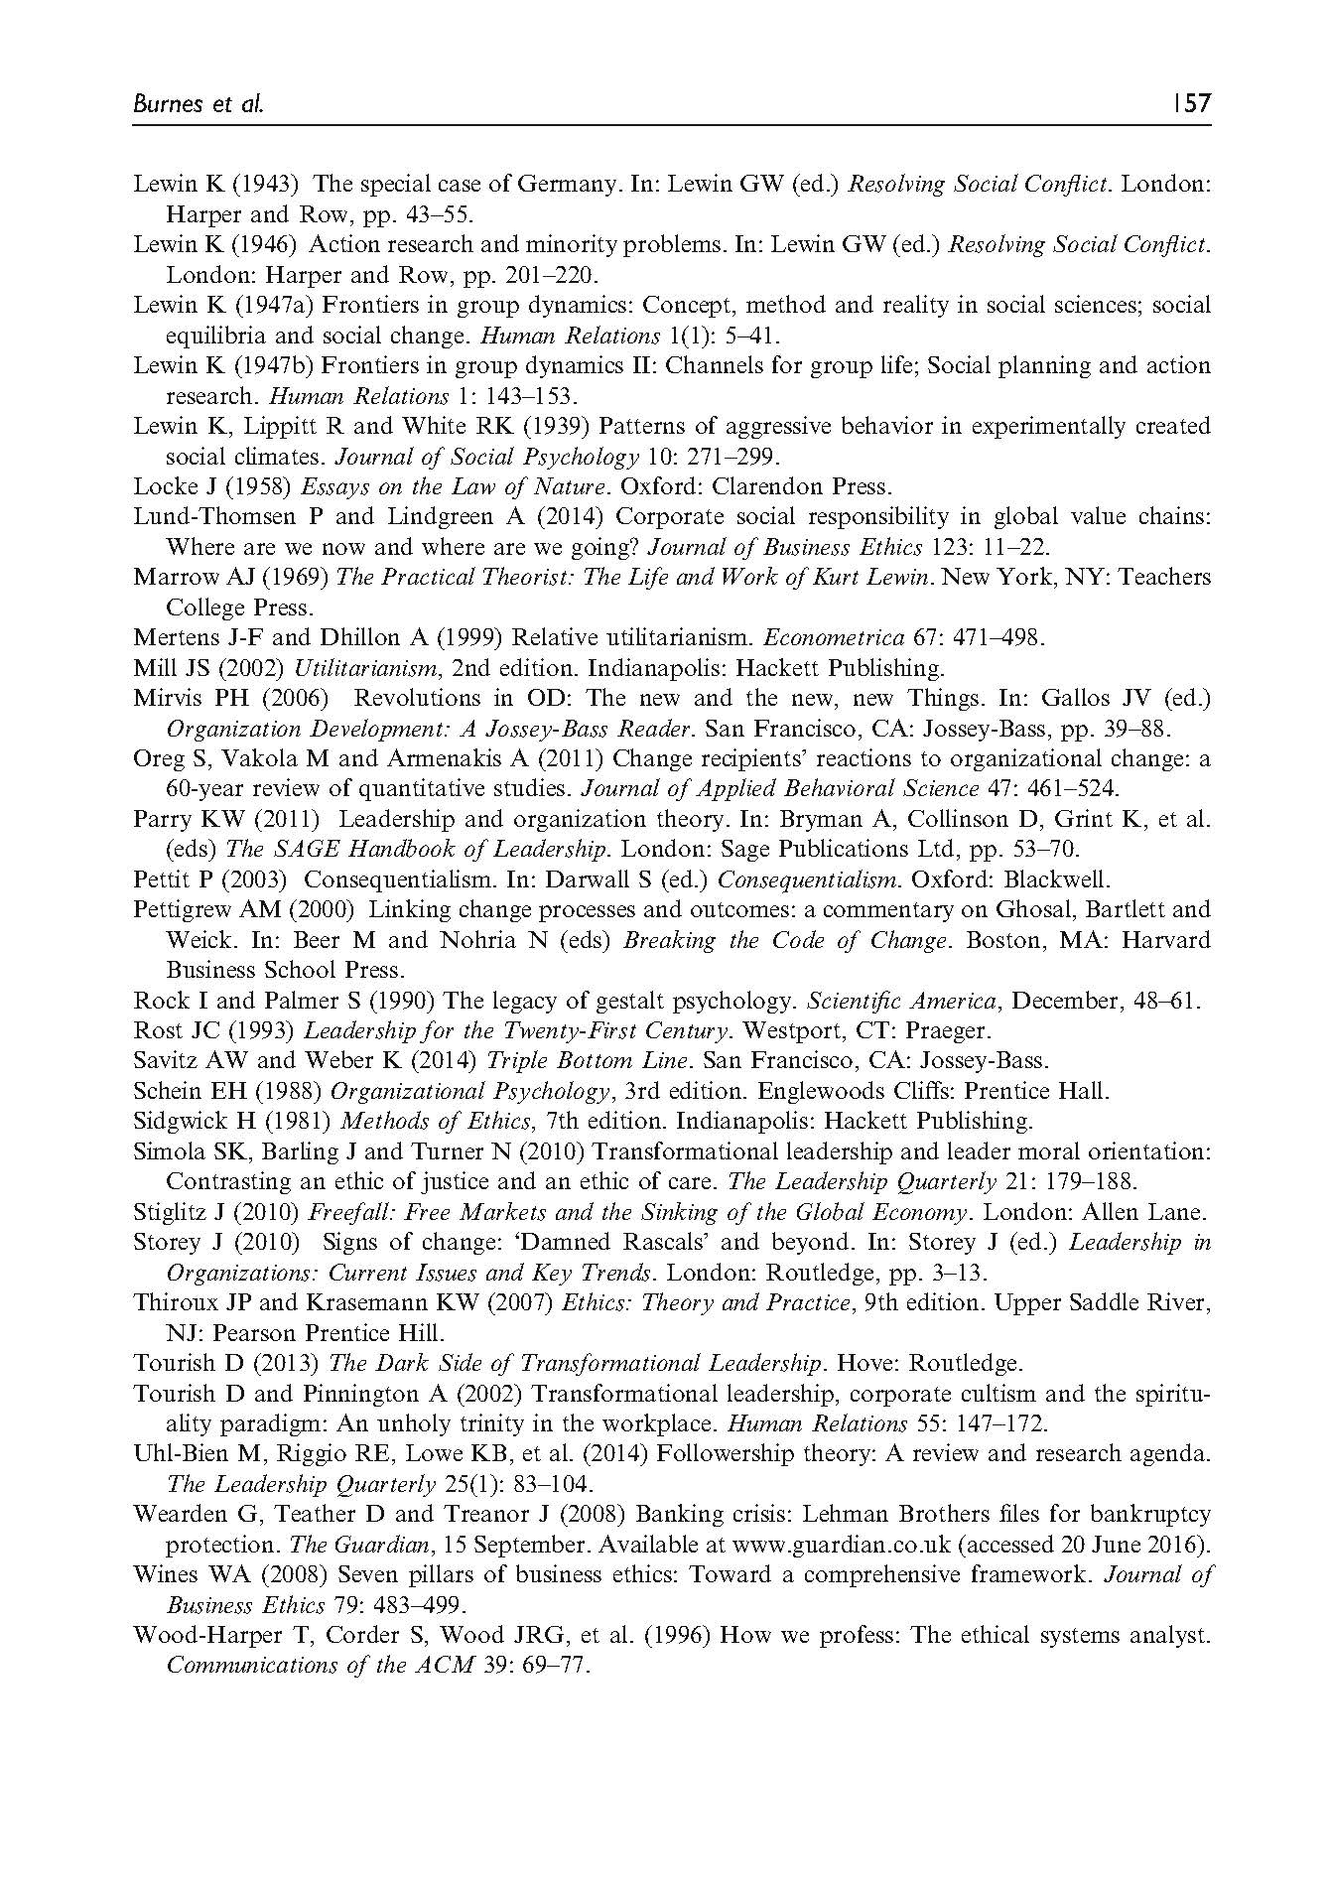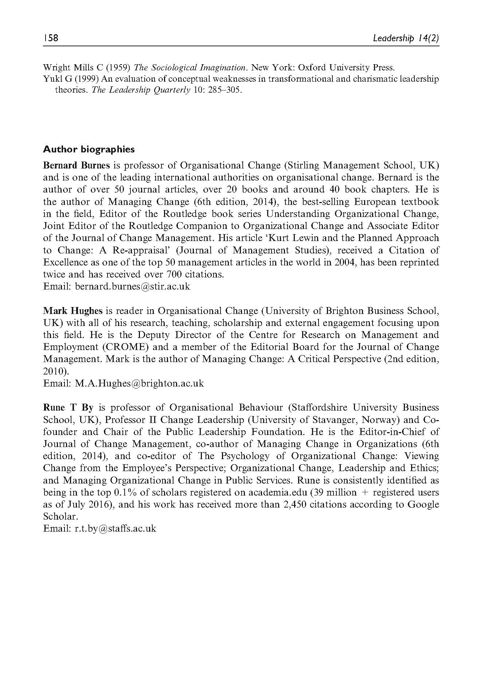
8.3 Summary
This chapter further develops my focus on organisational change and leadership. Observing that after three decades of organisational change and leadership discourse the field of leadership is still in crisis, it introduces an alternative to the current orthodoxy founded on the work of Bass (1985) and Kotter (1995; 1996). Based on the seminal work of Lewin (1947a & b) and Burns (1978) the chapter reframes leadership as a utilitarian consequentialist process as an alternative to status quo.

Chapter 9: Conceptualising a new theoretical leadership lens
9.1 Introduction
Further developing my contribution to leadership as a utilitarian consequentialist process - emphasising the consequences of any action, and on achieving the best possible outcome for the largest number of people/stakeholders (Published work 2 and 6), and organisational change for ‘good’ and the ‘right’ reasons’ (Published work 3 and 9), I coin the Telos Leadership Lens which principles are currently not covered by any one single theoretical lens, framework, concept or theory. Through its application, I argue that existing leadership theory and practice can be reframed and further developed with a focus on doing (utilitarian consequentialism) rather than being (virtue ethics) and establish leadership as the shared pursuit of delivering on purpose rather than as a relationship between leaders and followers.
Although adopting the notion of Telos - a word traditionally linked to virtue ethics and hence traditional leadership traits (Rost, 1995) - as an overarching and ultimate goal of contributing to the good of humankind, the Telos Leadership Lens stipulates that the importance of leaders in the traditional sense is secondary to that of leadership, and that such leadership must provide meaning, consistency, certainty and sense through an unwavering purpose in an otherwise volatile, uncertain, complex and ambiguous world.
In order to conceptualise this new theoretical lens, I first explore purpose and explicitly link this concept to leadership. Second, I provide an outline of the Telos Leadership Lens with its three principles (Implications and recommendations for future research are provided in chapter 10).
9.2 Exploring the role of purpose
From my work on leadership as a utilitarian consequentialist process emerges an overarching emphasis on purpose (Published work 2, 3, 6 and 9). Damon, Menon and Bronk (2003:121) defines purpose as “…a stable and generalized intention to accomplish something that is at once meaningful to the self and of consequence to the world beyond the self”. Expanding on this, McKnight and Kashdan (2009:242-243) suggest that
“Purpose is a central, self-organizing life aim that organizes and stimulates goals, manages behaviours, and provides a sense of meaning. Purpose directs life goals and daily decisions by guiding the use of finite personal resources. Instead of governing behaviour, purpose offers direction just as a compass offers direction to a navigator; following the compass (i.e. purpose) is optional. Living in accord with one’s purpose, however, offers that person a self-sustaining source of meaning through goal pursuit and goal attainment. Furthermore, purpose is woven into a person’s identity and behaviour as a central, predominant theme…Purpose is at the highest level of analysis and provides some degree of centrality in a person’s identity…”
Purpose is about a personal search for meaning and a desire to make a difference to matters beyond that of the individual (Damon, Menon and Bronk, 2003) (Note: To Make A Difference = to be MAD is a strap-line I actively use when disseminating my work in university lectures, public lectures and when talking with practitioners). According to McKnight and Kashdan (2009) the concept of purpose exists as either religiosity, spirituality or meaning. Frankl (2004) proposes that purpose is at the very core of what makes a good life as it provides meaning, fulfilment and sense. He goes as far as suggesting that happiness emerges from loyalty to a worthy purpose, and that without feeling connected to such a worthy purpose, individuals will be unhappy. This point is illustrated in more popular literature by Ove in ‘A Man Called Ove’ (Backman, 2014:12) who somewhat frustrated reflects on his previous managers: “What do they know about waking up on a Tuesday and no longer having a purpose?”
McKnight and Kashdan (2009) differentiate purpose from meaning, suggesting that the former does not necessarily drive the latter. Rather, meaning contributes to the development of purpose, and once developed, a sense of purpose drives meaning. In their own words: “purpose and meaning have a temporal, bidirectional relationship” (McKnight & Kashdan, 2009:243). Reker et al. (1987:44) further explore purpose in relation to meaning, and state that “Meaninglessness has been recognized as a modern day malaise that, if left unresolved, can lead to symptoms of anxiety, depression, hopelessness, or physical decline.”
Savolaine and Granello (2002) suggest that if an individual’s sense of meaning is intact it is less likely that uncertainty will arise or indeed persist. They argue that meaning can counterbalance discouragement and support existing positive behaviour and the initiation of new ones. Furthermore, they propose that “It often takes an additional element of motivation to begin a new activity, and a sense of purpose or meaning could be a deciding factor. This could happen by mentally associating the target behaviour to an element of higher purpose” (Savolaine & Granello, 2002:181). An example of such higher purpose is illustrated by Dale (1991, in Neck & Milliman, 1994:9) in the story about a reporter visiting a construction site:
The “reporter asked three brick masons what they were doing. The first answered gruffly, “I’m laying bricks.” The second replied, “I’m earning a week’s pay.” But the third mason said enthusiastically and with obvious pride, “I’m building a cathedral.”
McKnight and Kashdan’s (2009:249) work on purposeful living provides several hypotheses of interest to leadership and organisation studies:
- people pursuing a purpose ought to be less susceptible to avoidance behaviours such as procrastination compared to those merely goal-directed;
- purpose motivates people to persist rather than quit in face of difficult situations;
- purpose enhances rebound capacity through more efficient resource allocation;
- the refractory period following any stressful event will be shorter for those with purpose;
- people who live with a purpose will be less prone to illness and report fewer symptoms even when ill;
- stress and satisfaction will be dictated by the level of congruence between purpose and the opportunity to fulfil that purpose;
- purposeful living produces longer-term, durable benefits as compared with nonpurposeful living.
Not only do these hypotheses support the importance of purpose, they also suggest that having clear and aligned purpose between organisations and organisational members (including leaders) may very well support sustainable success. However, although Kempster et al. (2011) believe purpose to be intrinsic in all human beings, McKnight and Kashdan (2009) believe purpose may not be available to every person. Just as much as “A person who is unable to grasp abstract concepts might find it difficult to generate a purpose since purpose requires insight, introspection, and planning” (McKnight & Kashdan, 2009:243), it can be argued that an organisation can be as unable to generate and sustain a purpose.
Anchored to the work of Burns (1978), Rost (1993; 1995), Damon, Menon and Bronk (2003), MacIntyre (1984; 2004) and Kempster et al. (2011), purpose can be defined as the pursuit of a worthy idea and activity, the outcome of which goes beyond the individual and the individual organisation. Such a definition suggests that corporate and societal purposes are not necessarily mutually exclusive but inclusive – that what is good for society at large should be what is good for organisations and individuals within them. Charles E. Wilson, former president of GM is often misquoted as having said that “What is good for General Motors is good for America”. What Wilson actually said when questioned by the US Senate Armed Services Committee on January 15th, 1953 before being approved as President Eisenhower’s Defence Secretary on January 23rd that same year was that “…for years I thought what was good for our country was good for General Motors, and vice versa. The difference did not exist” (Chicago Tribute, 1953).
9.3 Leadership as purpose
Although scholars and practitioners seem to agree on the importance of clear organisational direction, the current position of purpose in leadership studies is one of all-too-often-being-taken-for-granted (Kempster et al., 2011). Burns’ (1978:3) notion that “…leadership is nothing if not linked to collective purpose…”, and Rost’s (1993) definition of leadership clearly linking it to purpose, have gone rather unnoticed in leadership theory and practice. Addressing this situation, Kempster et al. (2011) - drawing on the work of MacIntyre (2004) focusing on the notion of Telos - added Leadership as Purpose to Grint’s (2005) existing framework of Leadership as Person; Results; Position; and Process. With Telos in mind, MacIntyre (2004) conceptualised internal and external goods. Whilst internal goods refer to a common good, to what is good for the whole community, society, nation, and globe, and focuses on areas of for example education, health, equality, preventing war, saving lives, sustainable development etc., external goods are exemplified by seeking to increase power, influence, money and status as ends in themselves.
Also focusing on the notion of purpose, Collins and Porras (2005) first identified purpose beyond profit as the single common denominator explaining the sustained success experienced by what they identified as enduring great companies back in 1994. Emerging from their longitudinal study of 18 private sector organisations was a philosophy of purpose and profit, their ‘magical’ word being and rather than the dictatorial or. With few exceptions, their recommendation to focus on organisational purpose beyond profit is yet to be adopted, developed, explored or even acknowledged in mainstream leadership studies.
Drawing on their longitudinal study, they propose that great companies have a core ideology based on purpose and core values (Published work 6). Defining purpose as “The organization’s fundamental reason for existence beyond just making money – a perpetual guiding star on the horizon; not to be confused with specific goals or business strategies” they also outline core values as “The organization’s essential and enduring tenets – a small set of general guiding principles; not to be confused with specific cultural or operating practices; not to be compromised for financial gain or short-term expediency” (Collins & Porras, 2005:73).
The same year as Collins and Porras’ 10th anniversary edition was published, Chouinard, founder and owner of the outdoor apparel company Patagonia, provided an example of core values and enduring purpose (2005, in Chouinard, 2016): Patagonia exists to do no harm to the environment. Indeed, the company’s purpose was later refined to state that it is to do good and contribute towards decreasing the environmental crisis. Introducing his very own 10th anniversary edition, Chouinard (2016:1) stated that “Patagonia exists to challenge conventional wisdom and present a new style of responsible business”. Although being a private sector organisation, seeking to generate profit, growth and expansion are not core values to the business (Chouinard, 2016).
However, Patagonia and organisations like it are still the exception to the rule, as Kempster et al. (2011) argue that organisational vision, mission, objectives and targets are typically concerned with corporate purposes with the aim to deliver external goods. They argue that
“Purposes that are pronounced in dominant leadership discourses reflect objectives, mission and vision. Aligned to the delivery of these forms of purposes are discourses oriented towards performance management in the form of key performance indicators, action plans and a balanced score card. The outcome is the production of external goods and practices oriented to the production of these external goods” (Kempster et al., 2011:322).
Further developing this line of thought they argue that leadership practices in all sectors have “…succumbed to the corrupting influence of money, status and power “(Kempster et al., 2011:323). Such behaviour has arguably not only catalysed but cemented leadership into becoming looking-after-yourself-ship (Published work 9, 13). The continuous strive to deliver on reward-triggering, short-term targets as measured by KPIs, BSC or ROI, will arguably result in what is important but more complex to measure, and inconceivable to deliver on in the short-term becoming less important to decision-makers. Such leadership behaviour may very well have a devastating effect on wider goals such as sustainable development, education, avoiding wars, improving health, avoiding starvation and malnutrition, freedom, fighting poverty and social improvement, not to mention the sustained success or even survival of organisations.
As suggested by Frankl (2004), MacIntyre (2006), Collins and Porras (2005), and Kempster et al. (2011), a worthy purpose based on internal goods aiming at contributing to the good of humankind, can lead to happier individuals with a clearer sense of meaning and fulfilment, and sustained corporate success. Purpose can be about what best serves the interests of the human condition, and it can be beautiful (Ladkin, 2008). Based on this understanding of purpose there is a strong business case to be made for establishing stronger links between leadership and contributing towards a common good purpose such as for example sustainable development.
9.4 Introducing the Telos Leadership Lens
In my opinion, one of the core challenges restraining the further development of leadership theory and practice is the relentless leader-centric focus on the relationship between leaders and followers (or similar concepts such as stakeholders and collaborators). This focus is to be found in both leadership orthodoxy and main contenders. Despite their criticism of the leader-centric orthodoxy, both Burns (1978) and Rost (1993; 1995) actively contributed to this sustained focus through their own definitions. Whilst Burns (1978:19) defined leadership as “…leaders inducing followers to act for certain goals that represent the values and the motivations – the wants and the needs, the aspirations and expectations – of both leaders and followers”, Rost (1993:102) defined leadership as “an influence relationship among leaders and followers who intend real changes that reflect their mutual purposes.” However, he later replaced the word ‘followers’ with ‘collaborators’ because he had “given up on the concept of followers as hopelessly irredeemable, that is, inherently industrial in denotation” (Rost, 1995:133).
I argue that for leadership theory and practice to develop in order to meet the needs of a modern and sustainable society, we must stop defining the phenomenon as a relationship between leaders and followers (or similar concepts) and instead replace it with an overarching focus towards delivering on purpose, or Telos if you like. Hence, I borrow MacIntyre’s (1984; 2004) notions of Telos and internal and external goods, arguing that internal goods can be clearly linked to utilitarian consequentialism and external goods to egoistic consequentialism (Published work 2 and 6).
Referring to MacIntyre’s (1984) work as virtue ethics, Rost (1995:140) argues that “The major transformation needed is to replace the individual frame embedded in virtue ethics with a communal frame”. Hence, although adopting its name from Aristoteles and MacIntyre’s (1984; 2004) work, the Telos Leadership Lens clearly differentiates itself virtue ethics. Informed by my work on leadership as a utilitarian consequentialist process, the Telos Leadership Lens focuses on doing whilst virtue ethics focuses on being (Jonsson, 2011; Knights & O’Leary, 2006). Whilst utilitarian consequentialism emphasises the consequences of any action, and on achieving the best possible outcome for the largest number of people/stakeholders (Published work 2 and 6) - or maximisation of goodness in society (Knight & O’Leary, 2006) - virtue ethics focuses on a person’s (or agent’s) virtues of mind and character (Knights & O’Leary, 2006). According to Knights and O’Leary (2006: 130) “…virtue-based ethical systems centre on the agent, the character and dispositions of persons…” As such, virtue ethics supports the current leader-centric leadership orthodoxy with its focus on individuals’ skills, traits and characteristics, and Rost (1995:140) argues that “virtue ethics is not sufficient for the postindustrial world. A holistic, large group, organizational, community, global approach is needed.”
In response to this, the Telos Leadership Lens acknowledges the act of leadership as a shared responsibility not to be abdicating from. As opposed to the dominant leader-centric orthodoxy, Telos is a leadership-centric theoretical lens, and its principles are outlined in Figure 3 below. These principles address Kempster et al.’s (2011:318) concern that the omission of discussing purpose in the context of leadership studies has “profound implication for practicing leaders”, and Yukl’s (2012) concern that few current leadership theories engage in any wider societal accounts of leadership.
Principle 1 | Leadership as verb.  Leadership is about doing, process, and action rather than being, relationship, role and function. It is a verb rather than a noun, and a shared responsibility who is no ones’ prerogative, and which no one should abdicate from.  Leadership and followership as simultaneous, interdependent and equal activities which can be performed simultaneously.
Principle 2 | Leadership is the shared pursuit of delivering on purpose.  Purpose is defined as the pursuit of a worthy idea and activity, the outcome of which goes beyond the individual and the individual organisation.  Purpose and core values set out in support of such should not be compromised for financial gain or short-term convenience. It is what should not change in a changing world, but rather provide meaning, consistency, certainty and sense through an unwavering common good purpose in an otherwise volatile, uncertain, complex and ambiguous world. It should be the engine of proactive, innovative and risk embracing change. Organisational mission, vision, targets and behaviour amongst all employees, including leaders must align to organisational purpose and core values.  Whilst purpose is not to be confused with specific business strategies, goals or targets, core values are not to be confused with cultural or operating practices.
Principle 3 | Purpose driven by internal goods.  Internal goods being what is good for the whole community, society, nation, and globe, focuses on areas of for example sustainable development, education, health, equality, preventing war, saving lives etc. This in contrast to external goods exemplified with seeking to increase power, influence, money and status as ends in themselves. As a result, purpose must go beyond profit, but rather than jeopardising profit there is evidence to suggest that a clear purpose beyond profit supports sustainable profit when referring to private sector organisations.  The focus is on utilitarian consequentialism, emphasising the consequences of any action and on achieving the best possible outcome for the largest number of stakeholders, rather than virtue ethics with its focus on individual virtues of mind and character (traits).

Figure 3. The Telos Leadership Lens (informed by Burns, 1978; Rost, 1993; 1995; Barker, 1997; 2001; MacIntyre, 1984; 2004; Collins and Porras, 2005, Crevani et al., 2010, and Kempster et al., 2011)

Although based on the purpose-focused leadership tradition established by Burns (1978) and Rost (1993; 1995), I diverge from their focus on the roles of leaders and followers, and the relationship between the two - a focus they share with both current leadership orthodoxy and main contenders. Furthermore, I strongly disagree with Rost’s (1995) view of leadership as a relationship, where any definition must include his four essential elements of (1) The relationship is based on influence; (2) Leaders and collaborators are the actors in this relationship; (3) Leaders and collaborators intend real changes; and (4) The changes the leaders and collaborators intend reflect their mutual purposes (see Table 5 below).
Suggesting a move away from a leader-centric, relationship-obsessed view of leadership, the Telos Leadership Lens further acknowledges leadership and followership as interdependent and equal activities undertaken simultaneously by every individual involved in the process of leadership. Some may perform more leadership than others, but all perform followership (as in following a person, purpose, idea or conviction). Depending on context, there will be different leadership/followership configurations, but leadership and followership remain everyone’s societal and organisational responsibility.
  - Summary
In further developing my contribution to leadership as a utilitarian consequentialist process, I have conceptualised the Telos Leadership Lens based on the principles of (1) Leadership is a verb; (2) Leadership is the shared pursuit of delivering on purpose, with purpose defined as the pursuit of a worthy idea and activity, the outcome of which goes beyond any individual and individual organisation; and (3) Purpose to be driven by internal goods such as sustainable development.
Through the application of these three principles the Telos Leadership Lens can help reframe and further develop existing theory and practice with a focus on doing (utilitarian consequentialism) rather than being (virtue ethics) and establish leadership as the shared pursuit of delivering on purpose rather than as a relationship between leaders and followers.
Implications of the application of the Telos Leadership lens and recommendations for future research are further explored in chapter 10.

Chapter 10: Implications and recommendations for future research
10.1 Implications
When problematising the field of leadership one main challenge stands out, and that is one of definition: what exactly constitutes leadership (Burns, 1978; Rost, 1993; 1995; Barker, 1997; 2001)? This challenge can be further broken down into sub-challenges. First, there are almost as many leadership definitions as there are scholars and practitioners (Rost, 1995). Second, most leadership theories and definitions are either emphasising peripheral elements (“traits, personality characteristics, ‘born or made’ issues, greatness, group facilitation, goal attainment, effectiveness, contingencies, situations, goodness, style, and above all, the management of organizations – public and private”) or content (“what leaders need to know about a particular profession, organization, or society in order to be influential in it”) rather than emphasising the essential nature of what is leadership (Rost, 1993:3). Third, leadership is often mistaken for management and power (Burns, 1978; Barker, 1997; 2001). Fourth, leadership seems to be accepted as the relationship between leaders and followers (see for example Rost, 1995). Fifth, much of the excellent work currently challenging status quo seem absorbed by issues of power dynamics, relationships and identity constructions (se for example Avolio et al., 2009; Clarke, 2013; Clarke et al., 2018; Fairhurst & Uhl-Behn, 2012; Kempster et al., 2019; Maak & Pless, 2006; Maak et al., 2016; Manheim, 2017; Pearce & Conger, 2002; Sweeney et al., 2018) rather than on what constitutes leadership.
I suggest we can no longer afford continuing down this rather aimless path. Failing to change the direction of travel, we will all too soon find ourselves tirelessly repeating the observations of the past that the field of leadership is still in crisis (see for example Burns, 1978; Rost, 1993; 1995; Barker, 1997; 2001; and Burnes and By, 2012, Published work 6).
By conceptualising the Telos Leadership Lens, my intention is to contribute to the process of further developing the overall leadership discourse by suggesting a new direction of travel. I suggest that by applying this new theoretical lens, existing leadership theory and practice – main contenders as well as orthodoxy - can emphasise their development with a focus on doing (utilitarian consequentialism) rather than being (virtue ethics) and establish leadership as the shared pursuit of delivering on purpose rather than as a relationship between leaders and followers.
The intention is not for my work to be categorised as a contribution to the development of any one particular theory or practice, that being ethical leadership, critical leadership studies or any other singular concept. Elements of what I am proposing is of course already included in existing theories. For example, ethical leadership puts an emphasis on the ethics of what, how and why leaders do what they do (Jackson & Parry, 2011), but the theory is very much leader-centric focusing on the leader-follower relationship.
Table 4 below outlines how the application of the Telos Leadership Lens may help reframe future leadership development. I am not suggesting that the lens is the answer to the problem. Rather, I suggest it may provide scholars and practitioners with some clear principles to guide their future work and practice. By doing so the lens has the potential to point leadership development efforts in a new direction, helping the field becoming unstuck.
 | Current Leadership orthodoxy | Applying the Telos Leadership Lens
Leadership definition | According to Rost (1995), one of the problems in leadership theory and practice is the great number of different definitions.  Leadership is typically defined as a noun: the hierarchical role or position of being a leader; leading and influencing followers. | Leadership as a verb: The shared pursuit of delivering on purpose.
Relationship vs  Action | Focus on being (leader-centric); The relationship between leaders and followers (stakeholders; collaborators etc).  Leadership as the prerogative of formal/ordained leaders.  Leaders are important/special/limited numbers.  Leaders differentiated from and privileged over followers. | Focus on doing (leadership-centric); Leaders emerging from the action of leadership.  Leadership as a shared activity and responsibility not to be abdicated from.  The importance of leaders is secondary to that of leadership. Leaders are not important - Leadership is.  Leadership and followership as simultaneous, interdependent and equal activities which can be performed simultaneously.
Role of Purpose | Rarely defined. Mission statements often linked to the pursuit of external goods such as increasing power, influence, money and status as ends in themselves. | Purpose becomes the focal point of leadership. Defined as the pursuit of a worthy idea and activity, the outcome of which goes beyond the individual and the individual organisation.  Focus on internal goods such as sustainable development, education, health, equality, preventing war, saving lives, world peace.
Ethics | Often emphasising virtue ethics with a focus of defining the individual’s virtue of mind and character as a positive trait that makes someone a good human being (or not). | Utilitarian consequentialism emphasising the importance of consequences of any action, and on achieving the best possible outcome for the largest number of people/stakeholders.
Role of education | Focus on leader-centric training (skills) and development (traits and characteristics).  Ordaining the chosen few. Elite activity.  Moulding ‘leaders’ based on Great Man Theory and more recent incarnations of this theory.  Focus on short-term profit and efficiencies. | Focus on leadership-centric education acknowledging leadership as a shared responsibility not to be abdicated from. Not an elite activity restricted to business schools.  Focus on common/greater/internal good – on achieving what is good for society (the greatest number of people), planet, and sustainable profit.

Table 4. Applying the Telos Leadership Lens (informed by Burns, 1978; Bass, 1985; Rost, 1993; 1995; Barker, 1997, 2001; Yukl, 2012; Published work 2 and 6)

I fully acknowledge that the existing leadership related terminology may prove an added challenge in the further development of theory and practice. Whilst the word ‘leadership’ with its leader-centric connotations may very well keep reinforcing the current orthodoxy, the word ‘followership’ can be perceived as weak or even submissive. Although Rost (1995) suggests replacing the word ‘followers’ with ‘collaborators’ there is still a leader-centric focus on leadership as a relationship. Furthermore, synonyms suggested for the word ‘collaborators’ includes ‘traitors’, ‘turncoats’, spies’, agents’, and ‘grasses’ – words hardly more positive than ‘followers’ nor conducive of anyone wanting to undertake the activity. Hence, further focus on words, language and terminology facilitating for the application of the Telos Leadership Lens could prove essential. Having said that, an increased focus on doing and purpose rather than being and relationships may quickly replace the current relational focus, and new words referring to such a relationship may therefore prove irrelevant in the future.
The Telos Leadership Lens does not suggest a move towards anarchy or non-hierarchical structures as there will still be a requirement for formal leaders whose task is to perform leadership as defined by the Lens (the shared pursuit towards delivering on purpose). Consequently though, no-one is either or, nor is leadership the prerogative of a small number of ordained individuals, as the Telos Lens suggests we have a much larger pool of people who can contribute to leadership than what the current orthodoxy tends to suggest.
To further emphasise the main implications of applying the Telos Leadership Lens to existing theory and practice, I provide Table 5 below comparing Rost’s (1995) understanding of leadership as first introduced in chapter 1, with that promoted by the Telos Leadership Lens.
Rost’s essential leadership elements | Leadership when applying the Telos Leadership Lens
An influence relationship (being). | The shared pursuit of delivering on purpose (doing).
Done by leaders and collaborators. | Done by everyone. Leadership is a shared activity and responsibility not to be abdicated from.
Involves leaders and collaborators intending real changes in an organisation. | Involves leadership and followership as simultaneous, interdependent and equal activities which can be performed simultaneously.
Requires that the intended changes reflect the mutual purposes of the leaders and collaborators. | Requires a purpose, defined as the pursuit of a worthy idea and activity, the outcome of which goes beyond the individual and the individual organisation.

Table 5: Rost’s Leadership vs Leadership applying the Telos Leadership Lens (Adapted from Rost, 1995).

10.2 Recommended future research agenda
By providing a clear definition moving the leadership focus away from being to doing and linking this doing to a clear notion of purpose, I suggest the Telos Leadership Lens provides existing and new leadership theory and practice with an opportunity to further develop in a meaningful way. Having said that, this new theoretical lens goes beyond the challenge of leadership. It implies further interdisciplinary work is required in order to explore and re-establish how we socialise our children and our children’s children in support of them dealing with current and future environmental, societal and organisational challenges. Some fields that spring to mind in addition to leadership and ethics are sustainable development, education, language, psychology, equality and diversity, innovation and entrepreneurship, politics, finance, and accounting to mention a few.
We may already be the lost generation - lost to the current leadership indoctrination stipulating leadership as a relationship between leaders and followers without a clear common good purpose. In support of future generations, I argue that the Telos Leadership Lens’ principles are included as an integral part in education at all levels and subject areas. The overarching focus in future research should be on purpose – what are we setting out to achieve (Further short-term profit maximisation? Survival of planet and humankind? Equality cradle to grave)? Only when we have further explored what can we move on to how – how do we deliver on what we are setting out to achieve? Although we are currently observing a growing environmentalist movement (for example Greta Thunberg and Extinction Rebellion at time of writing up this thesis) and political rhetoric has changed, it can be argued that action has not. As Greta Thunberg argues, we will only solve a crisis when we treat it like one.
I suggest that leadership can no longer be studied and practiced in isolation, nor can it only be researched and taught in business schools. If we agree that leadership is about doing rather than being, then (1) we should all be made aware of this responsibility from the earliest age, and (2) we need to develop/facilitate for the ability for us all to do together.

List of References:

- Avolio, B.J., Walumbwa, F.O. and Weber, T.J. (2009). Leadership: Current theories, research, and future directions. Annual review of psychology, 60, pp. 421-449.
- Backman, F. (2014). A Man Called Ove. London: Hodder & Stoughton Ltd.
- Banks, S. (Ed.) (2008). Dissent and the Failure of Leadership. Cheltenham: Edward Elgar.
- Barker, R.A. (2001). The nature of leadership. Human Relations, 54(4), pp. 469-494.
- Barker, R.A. (1997). How Can We Train Leaders if We Do Not Know What Leadership Is? Human Relations, 50(4), pp. 343-362.
- Bass, B.M. (1985). Leadership: Good, better, best. Organizational Dynamics, 13(3), pp. 26-40.
- Beadle, R. and Moore, G. (2006). MacIntyre on virtue and organization. Organization Studies, 27(3), pp. 323-340.
- Burnes, B. Hughes, M. & By, R.T. (2018). Reimagining organizational change leadership. Leadership, 14(2), pp. 141-158.
- Burnes (2017a) After Paris: Changing Corporate Behaviour to Achieve Sustainability. Social Business, 3-4, pp. 333-357.
- Burnes, B (2017b) Managing Change (7th edition). Harlow: Pearson.
- Burns, J.M. (1978). Leadership. New York: Harper Row Publishers.
- Cambridge Dictionary Online (2018). Paradigm shift. https://dictionary.cambridge.org/dictionary/english/paradigm-shift Accessed on 09.07.2018
- Chouinard, Y. (2016). Let my people go surfing. New York: Penguin Books.
- Chicago Tribute (1953). Online archive. http://archives.chicagotribune.com/1953/01/24/page/1/article/o-k-wilson-for-cabinet-job Accessed on 22.06.2017
- Clarke, S. (2013). Safety leadership: A meta‐analytic review of transformational and transactional leadership styles as antecedents of safety behaviours. Journal of Occupational and Organizational Psychology, 86(1), pp. 22-49.
- Clarke, N., Higgs, M.J., D’Amato, A. and Vahedi, R. (2018). Responsible Leadership in Projects. Pennsylvania: Project Management Institute.
- Collins, J.C. and Porras, J.L. (2005). Built to Last: Successful Habits of Visionary Companies. London: Random House.
- Collinson, D.L. (2011). Critical Leadership Studies. In: Bryman, A., Collinson, D., Grint, K., Jackson, B. and Uhl-Bien, M. (eds). The Sage Handbook of Leadership. London: Sage, pp.179-192.
- Crevani, L., Lindgren, M. and Packendorff, J. (2010). Leadership, not leaders: On the study of leadership as practices and interactions. Scandinavian Journal of Management, 26, pp. 77-86.
- Damon, W., Menon, J. and Bronk, K.C. (2003). The Development of Purpose During Adolescence. Applied Developmental Science, 7(3), pp. 119-128.
- Duman, C. and R.H. Beinecke, R.H. (Eds.) (2015) Change Leadership. London: SAGE.
- Fairhurst, G. (2007). Discursive Leadership. Thousand Oaks: Sage.
- Fairhurst, G. and Uhl-Bien, M. (2012). Organizational discourse analysis (ODA): Examining leadership as a relational process. Leadership Quarterly, 23(6), pp.1043-1062.
- Gabriel, Y. (1997). Meeting God: when organizational members come face to face with the supreme leader. Human Relations, (50(4), pp. 315-342.
- Goffee, R. and Jones (2006). Why Should Anyone Be Led by You. Harvard: Harvard Business Press.
- Grint, K. (2005). Leadership: Limits and Possibilities. London: Palgrave Macmillan.
- Hohn, M.P. (2014). You reap what you sow: How MBA programs undermine ethics. Journal of Business Ethics, 121(4), pp. 527-541.
- Irving, J.A. and Klenke, K. (2004). Telos, Chronos, and Hermeneia: The Role of Metanarrative in Leadership Effectiveness through the Production of Meaning. International Journal of Qualitative Methods, 3(3), pp. 28-48.
- Jackson, B. and Parry, K. (2011). A very short, fairly interesting and reasonably cheap book about studying leadership (2nd ed.). London: SAGE.
- James, A. (2009). Academies of the apocalypse? The Guardian, Tuesday 7th April. https://www.theguardian.com/education/2009/apr/07/mba-business-schools-credit-crunch Accessed on 18.07.2018.
- Jonsson, P.O. (2011). On utilitarianism vs virtue ethics as foundations of economic choice theory. Humanomics, 27(1), pp. 24-40.
- Kempster, S., Maak, T. and Parry, K. (2019). Good dividends: responsible leadership of business purpose. London: Routledge.
- Kempster, S., Jackson, B. and Conroy, M. (2011). Leadership as purpose: Exploring the role of purpose in leadership practice. Leadership, 7(3), pp. 317-334.
- Kligyte, G. and Barrie, S. (2014). Collegiality: leading us into fantasy – the paradoxical resilience of collegiality in academic leadership. Higher Education Research and Development, 33(1), pp. 157-169.
- Knights, D. and O’Leary, M. (2006). Leadership, Ethics and responsibility to the Other. Journal of Business Ethics, 67, pp. 125-137.
- Kotter, J.P. (1995). Leading change: why transformation efforts fail. Harvard Business Review, 73, pp. 259-267.
- Kotter, J.P. (1996). Leading change. Boston: Harvard Business School Press.
- Ladkin, D. (2008). Leading beautifully: How mastery, congruence and purpose create the aesthetic of embodied leadership practice. The Leadership Quarterly, 19(2008), pp. 31-41.
- Laloux, F. (2014). Reinventing organizations. Brussels: Nelson Parker.
- Lewin, K., Lippitt, R. and White, R.K. (1939). Patterns of aggressive behaviour in experimentally created social climates. Journal of Social Psychology, 10, pp. 271-299.
- Lewin, K. (1943). The special case of Germany. In: Lewin G. W. (ed.), Resolving Social Conflict. London: Harper and Row, pp. 43-55.
- Lewin, K. (1946). Action research and minority problems. In: Lewin, G. W. (ed.), Resolving Social Conflict. London: Harper and Rowe, pp.201-220.
- Lewin, K. (1947a). Frontiers in group dynamics. Concepts, method and reality in social sciences; Social equilibria and social change. Human Relations, 1(1), pp. 5-41.
- Lewin, K. (1947b). Frontiers in group dynamics II. Channels of group life; Social planning and action research. Human Relations, 1(2), pp. 143-153.
- Lipmen-Blumen, J. (2005). The Allure of Toxic Leaders. Oxford: Oxford University Press.
- Maak, T., Pless, N.M. and Voegtlin, C. (2016). Business Statesman or Shareholder Advocate? CEO Responsible Leadership Styles and the Micro-Foundations of Political CSR. Journal of Management Studies, 53(3), pp. 463 - 493.
- Maak, T. and Pless, N.M. (2006). Responsible leadership in a stakeholder society–a relational perspective. Journal of Business Ethics, 66(1), pp. 99-115.
- Macleod, C. and By, R.T. (2007). Performance, Conformance and Change: Towards a Sustainable Tourism Strategy for Scotland. Sustainable Development, 15(6), pp. 329-342.
- Manheim, N. (2017). Shared leadership in teams: A theoretical and empirical investigation. Enschede: University of Groningen, SOM research school.
- McKnight, P.E. and Kashdan, T.B. (2009). Purpose in Life as a System That Creates and Sustains Health and Well-Being: An Integrative, Testable Theory. Review of General Psychology, 13(3), pp. 242-251.
- MacIntyre, A. (2004). Virtue ethics. In: Genster, H.J., Spurgin, E.W., and Swindal, J.C. (Eds). Ethics: Contemporary Readings. London: Routledge, pp. 249-256.
- MacIntyre, A. (1984). After Virtue (2nd ed.). Notre Dame: University of Notre Dame Press.
- Neck, C.P. and Milliman, J.F. (1994). Though Self-leadership: Finding Spiritual Fulfilment in Organizational Life. Journal of Managerial Psychology, 9(6), pp.9-16.
- Nye, J.S. (2008). The Powers to Lead. Oxford: Oxford University Press.
- Pearce, C.L. and Conger, J.A. (2002). Shared leadership: Reframing the hows and whys of leadership. Thousand Oaks: SAGE.
- Price, D. (Ed.) (2009). The Principles and Practice of Change. Milton Keynes: Palgrave MacMillan/Open University Business School.
- Reker, G.T., Peacock, E.J. and Wong, P.T.P. (1987). Meaning and Purpose in Life and Well-Being: A Life-Span Perspective. Journal of Gerontology, 42(1), pp. 44-49.
- Reid, W.M. and Dold, C.J. (2018). Burns, Senge, and the study of leadership. Open Journal of Leadership, 7, pp. 89-116.
- Rost, J.C. (1995). Leadership: a discussion about ethics. Business Ethics Quarterly, 5(1), pp. 129-142.
- Rost, J.C. (1993). Leadership for the twenty-first century. New York: Praeger.
- Savolaine, J. and Granello, P.F. (2002). The Function of Meaning and Purpose for Individual Wellness. Journal of Humanistic Counselling, Education and Development, 41(2), pp. 178-189.
- Scherer, G. and Palazzo, A.G. (2008). Corporate Social Responsibility, Democracy, and the Politicization of the Corporation. Academy of Management Review, 33(3), pp. 773-791.
- Sharif, M.M. and Scandura, T.A. (2014). Do perceptions of ethical conduct matter during organizational change? Ethical leadership and employee involvement. Journal of Business Ethics, 124(2), pp. 185-196.
- Shimoni, B. (2017). What is resistance to change? A habitus-oriented approach. Academy of Management Perspectives, 31(4), pp. 257-270.
- Sinclair, A. (2007). Leadership for the Disillusioned. London: Allen and Unwin.
- Sung, W., Woehcler, M.L., Fagan, J.M., Grosser, T.J., Floyd, T.M., and Labianca, G. (2017). Employees’ responses to an organizational merger: intraindividual change in organizational identification, attachment, and turnover. Journal of Applied Psychology, 102(6), pp. 910-934.
- Sweeney, A., Clarke, N., and Higgs, M.J. (2018). Shared Leadership in Commercial Organizations: A Systematic Review of Definitions, Theoretical Frameworks and Organizational Outcomes. International Journal of Management Reviews, https://doi.org/10.1111/ijmr.12181
- Tight, M. (2014). Collegiality and managerialism: a false dichotomy? Evidence from the higher education literature. Tertiary Education and Management, 20(4), pp. 294-306.
- Waring, M. (2017). Management and leadership in UK universities: exploring the possibilities of change. Journal of Higher Education Policy and Management, 39(5), pp. 540-558.
- Winter, R. (2009). Academic manager or managed academic? Academic identity schisms in higher education. Journal of Higher Education Policy and Management, 31(2), pp. 121-131.
- Wood, J.C. (Ed.) (2010) John P. Kotter. London: Routledge.
- Yukl, G. (2012) Leadership in Organizations (8th ed.). London: Pearson Education.

Appendix 1: Statements by collaborating authors

