The Witch, the Wasteland and the Gateway to Hell: Iceland’s Volcanoes and their Hazards

Fiona S. Tweed

Correspondence to:
Prof. Fiona Tweed, Geography, Staffordshire University,
College Road, Stoke-on-Trent, ST4 2DE, UK
Tel: +44 1782 294113
Email: f.s.tweed@staffs.ac.uk

Main article for Geography
Word count: 3825, excluding references, abstract, figure captions

Fiona Tweed is Professor of Physical Geography at Staffordshire University, Stoke-on-Trent, UK (email: f.s.tweed@staffs.ac.uk)

The Witch, the Wasteland and the Gateway to Hell: Iceland’s Volcanoes and their Hazards

Abstract
Iceland has become a popular travel destination and a favoured location for earth and environmental science fieldwork. Iceland’s volcanoes periodically feature in news headlines and events over the last ten years remind us that Icelandic volcanic activity can have transboundary impacts with disruptions to modern society. This paper reviews recent Icelandic volcanic activity and uses it a frame with which to highlight some historic eruptions, volcanic hazards and their impacts. Some of the challenges associated with securing reliable information and managing risks from Iceland’s volcanoes will be considered, particularly in the context of research on the potential impacts of future volcanic eruptions.

Key words: Volcano, geo-hazard, eruption, impacts, interconnected

1) Introduction
Iceland has acquired relatively recent notoriety in Europe through the twin agents of the financial crisis or kreppa of 2008 and the eruption of Eyjafjallajökull in 2010, which famously grounded flights and closed European airspace. Out of these catastrophes another Iceland has risen, buoyed by a dramatic increase in tourism which has fuelled wider discovery of its exciting culture, creative industries, mythology, landscape and nature. Iceland has become a popular location for Geography field trips as the country is an active laboratory for those studying earth and environmental science. Glaciers, volcanoes, geysers, waterfalls, mountains, coastal cliffs, black sandy beaches, rivers and geothermal activity provide an opportunity to study a diverse range of processes, landforms and landscapes within a relatively small country. Many tourists chose to visit Iceland’s volcanoes, either independently or as part of organised volcano tours.
Events over the last ten years have sharpened our focus on Iceland as a source of volcanic hazards that can have trans-boundary impacts (e.g. Gertisser, 2010; Donovan and Oppenheimer, 2011; Schmidt et al., 2015). Periodic volcanic unrest in Iceland is often reported in the media where it is recurrently framed by the impacts of the 2010 Eyjafjallajökull eruption, seldom escaping references to ‘ash clouds’ and burgeoning volcanic catastrophe. This prompts several questions. Should we be concerned about Iceland’s volcanoes? How likely is an eruption and what are the probable impacts? What do researchers say? Where can we go to for trustworthy information as situations evolve? In view of Iceland’s volcanic activity and the increasing popularity of Iceland as a travel and fieldcourse destination, this paper will i) briefly introduce Iceland’s volcanic setting, ii) examine recent volcanic activity, iii) reflect on some historic eruptions and their impacts and iv) draw attention to reliable sources of information on Iceland’s volcanoes. This analysis reports on recent activity and uses it as a lens through which to highlight past eruptions, volcanic hazards and associated impacts. Particular attention is devoted to events that have occurred over the last ten years and implications for the future.

Iceland’s Volcanic Setting and Hazards
Iceland owes its volcanic and seismic activity to the combination of a hot spot overlying a strong mantle plume and plate boundary processes occurring on the Mid-Atlantic Ocean Spreading Ridge. There are at least 30 volcanic systems in Iceland containing hundreds of individual volcanic outlets (Guðmundsson and Kjartansson, 1996). Approximately a tenth of Iceland’s land area is overlain by ice caps and glaciers (Thórhallsdóttir, 2007) and the combination of ice and volcanic activity produces some distinctive hazards. Volcanically-generated glacier outburst floods or ‘jökulhlaups’ frequently result from subglacial eruptions, as magma rapidly melts the overlying ice. Large outburst floods can significantly alter the landscape through erosion and deposition and they are a hazard, threatening infrastructure, lives and livelihoods. Alongside jökulhlaups, hazards created by Iceland’s volcanoes include lava flows, gas emissions, ash production, debris flows and lightning. These hazards operate at a range of scales from the local to the international, as do their impacts (Tweed, 2012).

Ash Clouds and Aviation Disruption
The 2010 eruption of Eyjafjallajökull is widely regarded as a game-changer in modelling and managing the impacts of a volcanic event in Europe and has become a point of reference for the media in speculating on the evolution of each rumbling from Iceland ever since. In a way, this is not surprising; the eruption resulted in the largest closure of European airspace since World War Two and had extensive consequences. The ice-covered stratovolcano, Eyjafjallajökull (Figure 1), is known to have erupted on four previous occasions - ~500 AD, ~920 AD, 1612 AD and 1821-23 AD (Pagneux et al., 2015). The main eruption began on 14th April 2010 and followed a smaller eruption from a fissure located east of Eyjafjallajökull in late March. The main eruption melted through 200m of glacier ice in just a few hours and generated a volcanic ash plume that rose at least 8km (Gertisser, 2010). Associated glacier outburst flooding and debris flows in Iceland (Dunning et al., 2011) were backstage in the immediate reporting of the event, which concentrated on the ash fall in European airspace.
Volcanic ash comprises small particles of rock and natural glass ejected during eruptions. Ash causes a variety of problems; it blots out daylight, accumulates on land and infrastructure, causes breathing difficulties (including silicosis and Chronic Obstructive Pulmonary Disorder, or COPD, from long-term exposure), causes skin and eye abrasions, can poison livestock and grazing land, clogs machinery, washes into lakes and rivers and can be lofted up high causing air traffic disruption (Figure 2). The scale and spatial extent of the impacts of ash varies from the local to the trans-boundary; this was clearly demonstrated by the Eyjafjallajökull eruption. Heavy ashfall in the area surrounding the volcano made agriculture or livestock grazing almost impossible; the high fluorine content of the ash was potentially lethal to animals. Ash deposits made it difficult to travel by road and internal flights were disrupted, which created problems for deliveries of goods and travel. As the ash cloud drifted, this led to airspace closure and disruption in Europe and the north Atlantic. Ash that gets into jet engine combustion chambers can melt creating molten glass that solidifies on the turbine blades and blocks the air flow; ultimately, this can result in engines stalling. Concerns over the spatial extent of the ash and caution regarding safe ash concentration thresholds for flying led to a huge area of airspace being shut down for six days. It is estimated that aviation industry losses of US$200-$400 million per day were incurred, 10 million passengers were affected and over 100,000 flights were cancelled (IATA, 2010).
The trans-boundary impacts of drifting ash were well-reported in the media, yet the combination of circumstances that led to these impacts was unusual. The nature of the explosive material and its rapid quenching by overlying ice generated a very fine-grained ash, which, when coupled with north-westerly winds from Iceland and a stable high-pressure system over Europe, resulted in the ash plume drifting south-east from Iceland (Gudmundsson et al., 2012). Whilst explosive eruptions in Iceland are not unusual, these weather conditions are atypical and prevail for only 6% of the time (Sammonds et al., 2010). The interdependency of ashfall impacts highlighted systemic vulnerabilities. Agencies concluded that improvements were needed in monitoring of volcanic ash plumes, chiefly by radar, to ensure accurate input data for dispersion models and to calculate the extent of ‘safe’ airspace (Sammonds et al., 2010). Preparedness, reaction and communication between agencies were also identified as requiring improvement (Donovan and Oppenheimer, 2011).
When another Icelandic volcano, Grímsvötn, produced its strongest eruption for 100 years in May 2011, despite fears of a repeat of Eyjafjallajökull the year before, it caused relatively little disruption. The Grímsvötn caldera lies under the Vatnajökull ice cap in south-east Iceland (Figure 1) and eruptions in this system are relatively frequent. The 2011 eruption lasted four days, produced an ash cloud that reached a height of 20km and ejected two to three times more bulk volume of ash than the 2010 Eyjafjallajökull eruption (Gudmundsson et al., 2012). The 2011 Grímsvötn eruption caused some disruption to air travel across northern Europe, the north Atlantic and Greenland, but the impact was much less than that of Eyjafjallajökull, even though the eruption was more powerful. There were several reasons for this. Firstly, the ash produced was generally coarser and fell to ground more rapidly. Secondly, the duration of the eruption was much shorter and the absence of strong upper tropospheric and stratospheric winds prevented widespread ash dispersal (Gudmundsson et al., 2012). In addition, the weather changed quickly during the event, helping to disperse any lofted ash. Critically, improved models of ash dispersal and changes to aviation policy regarding ash thresholds considered safe for flying resulted in fewer flights being cancelled.

The Slumbering Witch
In the immediate aftermath of the 2010 Eyjafjallajökull eruption there was unease about the potential for an eruption from neighbouring Katla, given that historic eruptions in Eyjafjallajökull have been followed by Katla eruptions. Katla lies under the Mýrdalsjökull ice cap, east of Eyjafjallajökull, near the town of Vík on the southern coast of Iceland (Figure 1). The centre of the Katla volcanic system is marked by a subglacial caldera with a diameter of 10km. Katla has a history of explosive eruptions that rapidly generate meltwater, as most eruptions are confined to the caldera area and there is very little storage of water. Eruptions can break through 400m of ice cover in less than two hours giving rise to huge jökulhlaups, which constitute a major hazard (Björnsson, 2002). Icelandic legend attributes these floods to Katla the witch, after which the volcano is named. A period of unrest began in 1999 following a volcanically-generated flood which was routed through Sólheimajökull, a glacier popular with tourists (Einarsson, 2000; Russell et al., 2010). Floods and earthquake swarms over the past eight years have increased speculation about Katla and both scientific monitoring and media interest has been growing. In July 2011, a glacial flood swept away the bridge over the Múlakvísl river which drains from Mýrdalsjökull and damaged sections of Iceland’s main ring road, Route 1 (Veðurstofa Íslands, 2011). There were intense seismic swarms in late summer and autumn 2016, 2017 and 2018 which featured in news headlines, along with changes in the intensity of odours from the rivers draining the area.
Trepidation regarding activity in Katla volcanic system is chiefly grounded in knowledge of the impacts of her previous major eruption. Katla last erupted in October 1918 generating a massive flood across Mýrdalssandur outwash plain; the estimated peak discharge of 250,000-300,000m³s⁻¹ is comparable to the average flow of the River Amazon (Tómasson, 1996). It is speculated that 8km³ of water was drained during the event, the scale and power of which is difficult for most people to imagine. The floodwaters were sediment-rich and carried large blocks of ice and boulders in the flow, which were deposited on the outwash plain (Tómasson, 1996). The characteristics of the flood make it one of the largest floods in Iceland to be directly observed. Since 1918, there has been no major eruption from Katla. The bridge over the Múlakvísl river was swept away by a flood in 1955, but there was no evidence of an eruption.
The current gap between major eruptions is the longest on record, which accounts for some of the media interest. Yet the same record tells us that seismic activity of the sort that has been occurring over the last few years has taken place several time since the 1950s, without a major explosive eruption (Smith, 2016). Earthquake swarms in Katla usually escalate in late summer and autumn; researchers attribute this to ice melt over the summer which increases pore water pressure in the rocks beneath, triggering tremors (Smith, 2016). Some studies indicate that there is magma storage in the roots of the volcano (Veðurstofa Íslands, 2018), but there is no sign of this moving. In autumn 2018, media scaremongering was triggered by the publication of research led by Evgenia Ilyinskaya. Her team had conducted gas monitoring of Katla, which demonstrated that the volcano emits much more CO₂ than previously thought (Ilyinskaya et al., 2018). The study’s measurements do not predict when an eruption will occur or even signal that one is looming; the work was misrepresented by the media who ran with headlines of an impending eruption. An apology was later issued, but this episode, along with other instances in which facts have been mis-communicated or sensationalised calls for meaningful consultation with experts and more responsible reporting (Smith, 2018). The onset of the 1918 eruption was marked by 30 minutes of continuous seismic tremor (Tómasson, 1996), which is regarded as an emphatic warning sign of imminent Katla eruption. Icelanders have been monitoring Katla for many years and robust risk communication and evacuation strategies are in place to ensure public safety in the event of an eruption and large flood.

Gas not Ash?
Glacier outburst floods and ash fall are not the only hazards generated by Icelandic volcanoes. In 2014, Iceland witnessed another spectacular eruption, but with different consequences. Known as the Holuhraun eruption, this event began in Bárðarbunga, a subglacial stratovolcano with a large caldera located under the Vatnajökull ice cap (Figure 1). Prior to 2014, seismic activity had been gradually increasing in Bárðarbunga and the fissures to the north of the volcano. An earthquake swarm began in mid-August 2014 and within 48 hours, 1,600 earthquakes had occurred in the Bárðarbunga system indicating that something was going on under the ice (Veðurstofa Íslands, 2014). Two fissure eruptions occurred in late August in the Holuhraun lava field to the north of the ice cap. Activity did not change significantly in the autumn; the eruption continued to produce lava along the fissures, at times jetting fountains 150m into the air. Volcanic activity persisted into the following year, but finally ceased at the end of February 2015. The event produced 1.5km³ of lava covering approximately 86km² (Schmidt and Witham, 2016).
Very little ash was produced, but the Holuhraun eruption generated another hazard – large amounts of sulphur dioxide (SO₂) were released. SO₂ is a toxic gas that is converted into sulphuric acid aerosol particles. Both SO₂ and its acid can affect air quality and cause breathing difficulties, particularly for those who already have respiratory problems. The remoteness of the location and the weather conditions made it challenging to monitor the impacts of the eruption, but satellite data and Meteorological Office modelling were used to track the dispersion of the volcanic gas cloud as well as estimating how much SO₂ was emitted. Air quality stations across Europe were crucial in monitoring. At its most powerful, the Holuhraun eruption was emitting eight times as much SO₂ per day as the total from all human-derived sources in Europe and the eruption was the largest volcanic sulphur pollution event in Iceland for more than 200 years (Schmidt et al., 2015; Schmidt and Witham, 2016). Gas was transported over very large distances and detected by air quality monitoring stations up to 2750km from Iceland. However, there was no big risk of long-term detrimental health effects in this case.
The impacts of recent events in Eyjafjallajökull and Holuhraun are dwarfed by those of the Laki fissure eruption of 1783-84, which is widely regarded as Iceland’s deadliest eruption. The Laki fissure (Figures 1 and 3) ejected lava for over six months with devastating impacts in Iceland where over half of the livestock perished, extensive damage was done to grazing land and at least a fifth of the Icelandic population died in the Móduharðindin or ‘haze famine’ that was caused by the eruption. The event produced huge volumes of gases and aerosols that drifted over Iceland and north-western Europe. Accounts of this event are both accessible and salutary (e.g. Grattan and Brashay, 1995; Witze and Kanipe, 2014) and describe the impacts in Europe, where evidence of crop damage and increased illness and deaths due to respiratory problems are reported.

The Gateway to Hell
Hekla (Figures 1 and 4), is one of Iceland’s most notorious volcanoes. It was referred to as the ‘Gateway to Hell’ (Figure 5) in the Middle Ages (Steinthorsson and Jacoby, 1985) due to its frequent and violent eruptions, which were visible to people making the journey along the south coast of Iceland and to ships offshore. Hekla is known to produce lava and copious quantities of ash. Eruptions of Hekla used to occur roughly twice a century, but they increased in frequency and regularity during the latter part of the twentieth century; for example, 1970, 1980-81, 1991 and 2000 (Soosalu and Einarsson, 2005). Despite this apparent regularity, there has been no Hekla eruption since 2000. Volcanic eruptions are usually preceded by ground inflation due to accumulation of magma in a magma chamber beneath the volcano. The stress that this generates on the rock above is often manifest as small earthquakes as the ground rises. This eruption ‘preparation’ stage can go on for years. Information from tilt meters installed at Hekla shows that the magma chamber beneath the volcano recharges at a consistent rate between eruptions; the pressure level in the magma chamber drops as eruptions occur and the cycle of inflation begins again as magma accumulates ready for the next eruption. Research shows that this does not occur until magma pressure reaches the level attained when it erupted previously. However, Hekla reached the pressure thought required to trigger an eruption in 2006 and magma pressure has continued to increase, without an eruption. Perhaps because of this, Hekla is periodically singled out by the media; for example, reports of an imminent eruption were circulating in summer 2016. Páll Einarsson from the University of Iceland routinely sets the record straight by explaining that this situation could carry on for years, or even decades, without an eruption (Einarsson, 2016).
When Hekla does erupt, will there be huge disruption to air traffic? Media reporting tends to assume that every Icelandic eruption will mirror the 2010 Eyjafjallajökull eruption, but the latter had several distinct circumstances associated with it, as explained earlier. Prior to the 2010 Eyjafjallajökull eruption, the last event to produce an ash plume that reached Europe was the initial explosive phase of the 1947 eruption of Hekla (Gudmundsson et al, 2012), which occurred before the development and rapid expansion of mass air transport. Eruptions of Hekla since 1947 have not caused significant air traffic disruption, but the threat to aviation remains. A watchful eye is kept on Hekla, as we have a window of warning of an eruption of only 1.5 to 0.5 hours beforehand (Einarsson, 2016). This is a short time to effect evacuation measures, especially given the popularity of the area with hikers and skiers and regular air traffic in the vicinity of the volcano.

Stirrings in the Wasteland
Along with Katla and Hekla, ice-covered stratovolcano Öræfajökull (Figures 1 and 6) has been under greater surveillance recently. Earthquakes in Öræfajökull are rare, but a period of increased seismic activity occurred in November 2017, accompanied by the development of a depression 1km wide and 15-20m deep in the ice-covered caldera. The formation of the depression was associated with geothermal activity in Öræfajökull caldera from which a steady release of geothermal water occurred through the glacier Kvíarjökull (Veðurstofa Íslands, 2017). The aviation colour code was raised from green (volcano is in typical background, non-eruptive state) to yellow (volcano is exhibiting signs of elevated unrest above known background levels) in autumn 2017 as a precaution and additional monitoring equipment was installed. It is not known how the situation will evolve; it could be that Öræfajökull settles down or the recent activity could escalate over the next few years (McGarvie et al., 2017).
So why the concern? Previous eruptions of Öræfajökull have generated extensive jökulhlaups due to rapid ice melt. The 1362 eruption of Öræfajökull is thought to be the largest explosive eruption in Europe since Vesuvius in AD79. It produced a powerful outburst flood with a peak discharge believed to be greater than 100,000 m³s⁻¹ (Thorarinsson, 1958). Less powerful jökulhlaups were created by the next eruption in 1727, but both sets of floods carried large quantities of ice which were deposited on the outwash plain and took several decades to melt. The flows also transported huge boulders, several metres in diameter (Thorarinsson, 1958; Roberts and Gudmundsson, 2015). The 1362 eruption buried farms in acidic ash in addition to the land being inundated by sediment-rich floodwater. Following the 1362 eruption, the area was abandoned and renamed ‘Öræfi’ or ‘wasteland’ when it was later re-inhabited, a testimony to the devastating impacts of the eruption (Thorarinsson, 1958). The steep-sided nature of the terrain around the volcano contributes to the short floodwater travel-time to settlements and infrastructure. It could be as little as 20-30 minutes from the start of the eruption to floods reaching populated areas, making Öræfajökull one of the most dangerous volcanoes in Iceland. Hence Öræfajökull, like Katla, is carefully monitored.

What Lies Ahead?
Volcanic hazard and risk management is dependent on monitoring, effective risk communication and risk education. Over half of Iceland’s volcanic systems that have been active in the last 10,000 years are overlain by glacier ice (Pagneux et al., 2015) and researchers have demonstrated that there is a link between glacier thinning and increased volcanic activity (e.g. Pagli and Sigmundsson, 2008; Tuffen, 2010). Most scientists agree that, since 1980, Iceland has entered a period of renewed volcanic activity (e.g. Larsen et al., 1998). Volcanically-generated glacier outburst floods are likely to persist for at least another two hundred years, even accounting for the reduction of ice cover due to the impact of climate change (Jóhannesson et al., 2012). Over the last ten years, there have been a range of volcanically-generated events in Iceland. In addition to the eruptions in Eyjafjallajökull (2010) and Holuhraun (2014), the aviation colour code has been changed from green to yellow several times in the past few years, due to heightened activity in other volcanoes. Iceland’s scientific monitoring and civil defence agencies are well-prepared for the impacts of jökulhlaups, lava flows and ash deposition and their monitoring of seismic activity and ground level changes aids our knowledge of the behaviour of volcanoes over time. The Icelandic Meteorological Office (IMO), works closely with civil protection agencies in Iceland and with researchers and other agencies nationally and internationally. It operates networks to monitor volcanic activity in Iceland and communicates with the London Volcanic Ash Advisory Centre (VAAC) on any events that could cause ash to be dispersed (Tweed, 2012). During the 2010 Eyjafjallajökull eruption and the Holuhraun fissure eruption, IMO demonstrated its effectiveness as a scientific communications hub and a reliable information source, as well as a research and monitoring agency.
The 2010 Eyjafjallajökull eruption demonstrated that explosive eruptions in Iceland have the potential to disrupt air transport in Europe and the mid-Atlantic and events in Holuhraun in 2014-15 are a reminder that volcanic pollution from Icelandic fissure eruptions can reach Northern Europe and degrade air quality. Recent occurrences have emphasised that, although the environmental characteristics of events are important in governing impacts of Icelandic volcanic eruptions, so too are changes to policies and procedures. One of the main lessons when studying hazards is that the impacts of events do not necessarily intensify with increasing magnitude. We need to be mindful of the pervasive nature of ‘fake news’ and seek credible sources of information when learning more about hazards and evaluating risks. There has been media escalation and miscommunication about the likely significance of some signals from Icelandic volcanoes, especially in the wake of the 2010 Eyjafjallajökull eruption. When planning travel or field study in Iceland, organisers can obtain reliable updates from Icelandic authorities to help to defuse any media-fuelled anxieties. A volcano can effectively ‘prepare for eruption’ for years, sometimes decades, without any danger to those visiting the surroundings, so any changes in levels of activity need to be fully evaluated by experts and communicated responsibly.

Acknowledgements
Thank you to Matthew Roberts and Málfríður Omarsdöttir for their repeated field assistance and friendship during field research visits to Iceland. Fieldwork and knowledge exchange following the 2010 eruption of Eyjafjallajökull was supported by a NERC research grant awarded to a research team led by Andy Russell. Additional observations and images were also obtained during Dynamic Iceland GeoVentures in 2014 and 2015, supported by the Geological Society of America and during fieldwork in Iceland in 2016 funded by the Staffordshire University Vice-Chancellor’s Research Fund.

References
Björnsson, H. 2002. Subglacial lakes and jökulhlaups in Iceland. Global and Planetary Change 35, 255-271.
Donovan, A.R. and Oppenheimer, C. 2011. The 2010 Eyjafjallajökull eruption and the reconstruction of geography. The Geographical Journal 177, 4-11.
Dunning, S.A., Large, A.R.G., Russell, A.J., Roberts, M.J., Duller, R., Woodward, J., Mériaux, A.S., Tweed, F.S. and Lim, M. 2013. The role of multiple glacier outburst floods in proglacial landscape evolution: the 2010 Eyjafjallajökull eruption, Iceland. Geology 41, 1123-1126.
Einarsson, P. 2000. Course of events connected with the flood in Jökulsá á Sólheimasandi in July 1999. Geoscience Society of Iceland, February Meeting, 2000, p. 14.
Einarsson, P. 2016. What is happening at Hekla volcano? The Icelandic Web of Science. https://www.why.is/svar.php?id=72668
Gertisser, R. 2010. Eyjafjallajökull volcano causes widespread disruption to European air traffic. Geology Today 26, 94-95.
Grattan, J. and Brayshay, M. 1995. An Amazing and Portentous Summer: Environmental and Social Responses in Britain to the 1783 Eruption of an Iceland Volcano. The Geographical Journal 161, 125-134.
Guðmundsson, A.R. and Kjartansson, H. 1996. Earth in Action: the Essential Guide to the Geology of Iceland. Vaka-Helgafell, Reykjavík.
Gudmundsson, M.T., Thordarson, T., Höskuldsson, A., Larsen, G., Björnsson, H., Prata, F.J., Oddsson, B., Magnússon, E., Högnadóttir, T., Petersen, G.N., Hayward, C.L., Stevenson, J.A., and Jónsdottír, I. 2012. Ash generation and distribution from the April-May 2010 eruption of Eyjafjallajökull, Iceland. Nature Scientific Reports 2, 572 DOI: 10.1038/srep00572.
International Air Transport Association (IATA) 2010. The impact of Eyjafjallajokull’s volcanic ash plume. IATA Economic Briefing, May2010. https://www.iata.org/whatwedo/documents/economics/volcanic-ash-plume-may2010.pdf
Ilyinskaya, E., Mobbs, S., Burton, R., Burton, M., Pardini, F., Pfeffer, M.A., Purvis, R., Lee, J., Bauguitte, S., Brooks, B., Colfescu, I., Petersen, G.N., Wellpott, A., and Bergsson, B. 2018. Globally Significant CO2 Emissions From Katla, a Subglacial Volcano in Iceland. Geophysical Research Letters 45 (19), 10332-10341.
Jóhannesson, T., Aðalgeirsdóttir, G., Ahlstrøm, A., Andreassen, L.M. Beldring, S., Björnsson, H., Crochet, P. Einarsson, B., Elvehøy, H., Guðmundsson, S., Hock, R., Machguth, H., Melvold, K., Pálsson, F., Radić, V., Sigurðsson, O., and Thorsteinsson, T. 2012. Hydropower, snow and ice. In Thorsteinsson, T. and Björnsson, H. (Eds.) Climate change and energy systems. Impacts, risks and adaptation in the Nordic and Baltic countries, pp 91-111. Copenhagen: Nordic Council of Ministers.
Larsen, G., Gudmundsson, M. and Björnsson, H. 1998. Eight centuries of periodic volcanism at the center of the Iceland hotspot revealed by glacier tephrostratigraphy. Geology 26, 943-946.
McGarvie, D., Stevenson, J.A. and Nicholls, P. 2017. Is Iceland’s tallest volcano awakening? The Conversation, November 10th https://theconversation.com/amp/is-icelands-tallest-volcano-awakening-87132
Pagli, C. and Sigmundsson, F. 2008 Will present day glacier retreat increase volcanic activity? Stress induced by recent glacier retreat and its effect on magmatism at the Vatnajökull ice cap, Iceland. Geophysical Research Letters 35, L09304.
Pagneux, E., Gudmundsson, M.T., Karlsdottir, S. and Roberts, M.J. (Eds.) 2015b. Volcanogenic floods in Iceland: An assessment of hazards and risks at Öræfajökull and on the Markarfljót outwash plain. Reykjavík: IMO, IES-UI, NCIP-DCPEM.
Roberts, M.J. and Gudmundsson, M.T. 2015. Öræfajökull volcano: geology and historical floods. In Pagneux, E., Gudmundsson, S., Karlsdóttir, S and Roberts, M.J. (Eds.) Volcanogenic floods in Iceland: An assessment of hazards and risks at Öræfajökull and on the Markarfljót outwash plain. Reykjavik: IMO, IES-UI, NCIP-DCPEM, p. 17-42.
Russell, A.J., Tweed, F.S., Roberts, M.J., Harris, T.H., Gudmundsson, M.T., Knudsen, Ó. and Marren, P.M. 2010. An unusual jökulhlaup resulting from subglacial volcanism, Sólheimajökull, Iceland. Quaternary Science Reviews 29, 1363-1381.
Sammonds, P., McGuire, B., and Edwards, S. 2010. Volcanic hazard from Iceland: analysis and implications of the Eyjafjallajökull eruption. UCL Institute for Risk and Disaster Reduction.
Schmidt, A. and Witham, C. 2016. Air pollution from Icelandic volcanoes. Planet Earth, NERC report http://www.nerc.ac.uk/planetearth/stories/1839/
Schmidt, A., Leadbetter, S., Theys, N., Carboni, E., Witham, C.S., Stevenson, J.A., Birch, C.E., Thordarson, T., Turnock, S., Barsotti, S., Delaney, L., Feng, W., Grainger, R.G., Hort, M.C., Höskuldsson, A., Iolanda Ialongo, I., Ilyinskaya, E., Jóhannsson, T., Kenny, P., Mather, T.A., Richards, N.A.D., and Shepherd, J. 2015. Satellite detection, long-range transport, and air quality impacts of volcanic sulfur dioxide from the 2014–2015 flood lava eruption at Bárðarbunga (Iceland). Journal of Geophysical Research: Atmospheres 120, 9739-9757.
Soosalu, H. and Einarsson, P. 2005. Seismic characteristics of the Hekla volcano and its surroundings, Iceland. Jökull 55, 87-106.
Smith, K. 2016. Is Katla crying wolf? Icelandic volcano’s rumblings don’t mean airspace chaos is imminent. The Conversation, 6th September. https://theconversation.com/is-katla-crying-wolf-icelandic-volcanos-rumblings-dont-mean-airspace-chaos-is-imminent-64920
Smith, K. 2018. ‘Fake news’ about volcanic eruptions could put lives at risk. The Conversation, 12th October. https://theconversation.com/fake-news-about-volcanic-eruptions-could-put-lives-at-risk-104083
Steinthorsson, S. and Jacoby, W. 1985. Crustal accretion in and around Iceland. Journal of Geophysical Research 90, 9951-9952.
Thorarinsson, S. 1958. The Öræfajökull eruption of 1362. Acta Naturalia Islandica 2, 1-99.
Thórhallsdóttir, T.E. 2007. Environment and energy in Iceland: A comparative analysis of values and impacts. Environmental Impact Assessment Review 27, 522-544.
Tómasson, H., 1996. The jökulhlaup from Katla in 1918. Annals of Glaciology 22, 249-254.
Tuffen, H., 2010. How will melting of ice affect volcanic hazards in the twenty-first century? Philosophical Transactions of the Royal Society of London A: Mathematical, Physical and Engineering Sciences 368 (1919), 2535-2558.
Tweed, F.S. 2012. ‘Now that the dust has settled…’ the impacts of Icelandic volcanic eruptions. Geology Today 28, 217-223.
Witze, A. and Kanipe, J. 2014. Island on Fire: The extraordinary story of Laki, the volcano that turned eighteenth-century Europe dark. Profile books, London.
Veðurstofa Íslands (Icelandic Meteorological Office). 2011. Glacier-outburst flood from Mýrdalsjökull. https://en.vedur.is/about-imo/news/nr/2236
Veðurstofa Íslands (Icelandic Meteorological Office). 2014. Bárðarbunga and Holuhraun - overview https://en.vedur.is/earthquakes-and-volcanism/articles/nr/2947
Veðurstofa Íslands (Icelandic Meteorological Office). 2017. Monitoring Öræfajökull. http://en.vedur.is/about-imo/news/monitoring-oraefajokull
Veðurstofa Íslands (Icelandic Meteorological Office). 2018. 100 years since Katla erupted. https://en.vedur.is/about-imo/news/100-years-since-katla-erupted

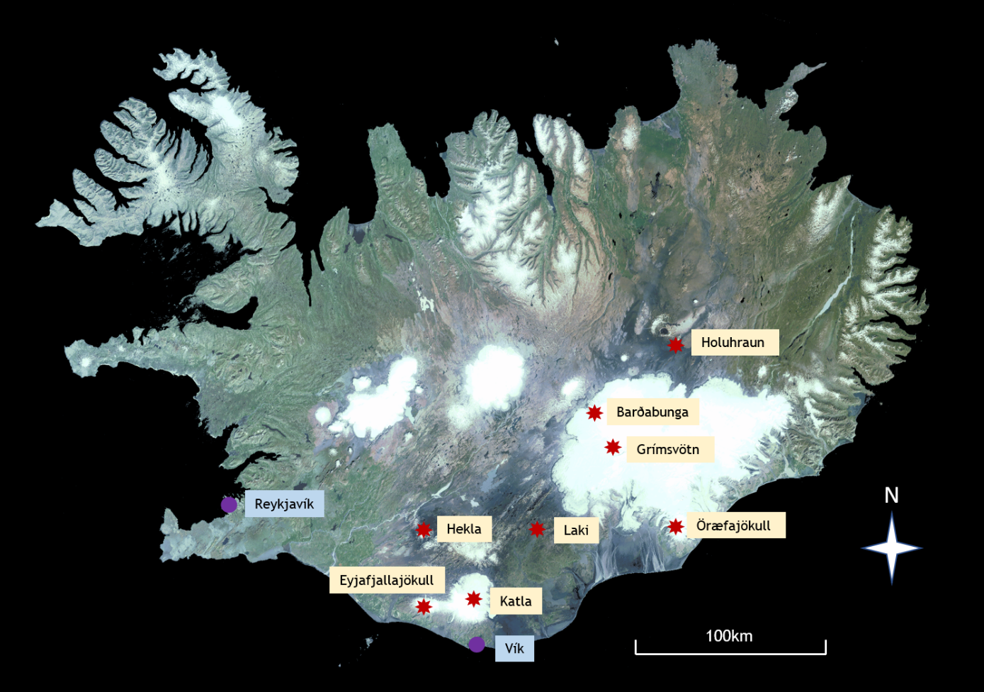

Figure 1: Locations of key sites referred to in the text.

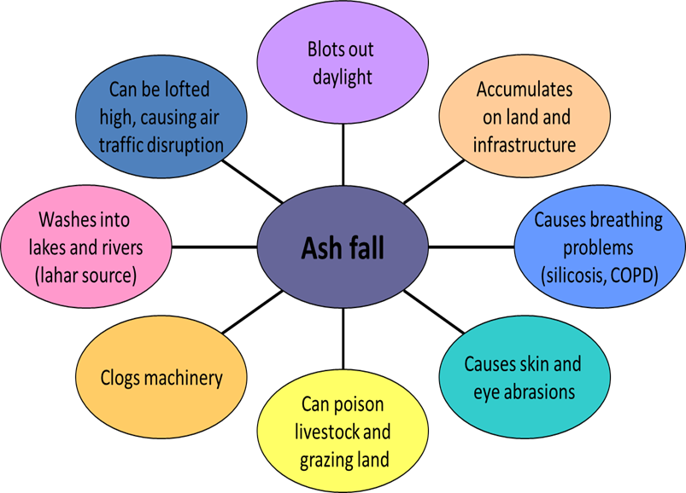

Figure 2: Impacts of volcanic ash fall.

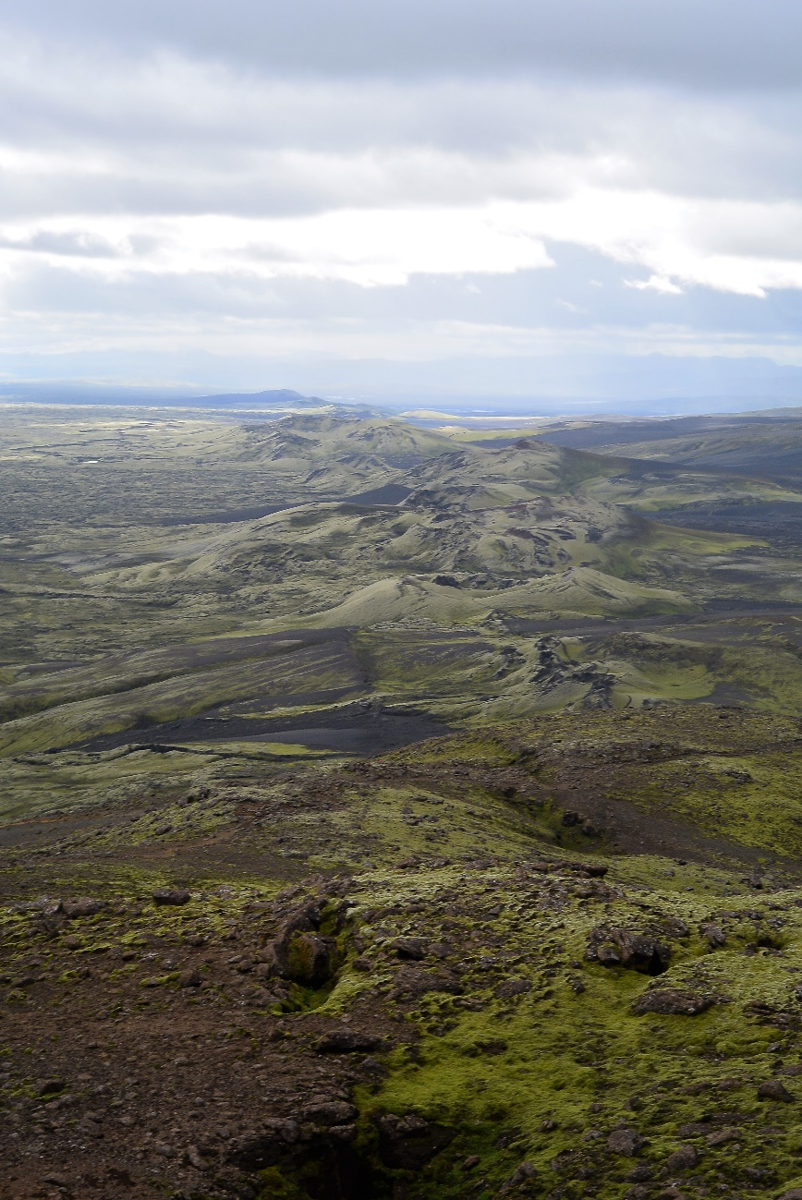

Figure 3: The Laki crater row.

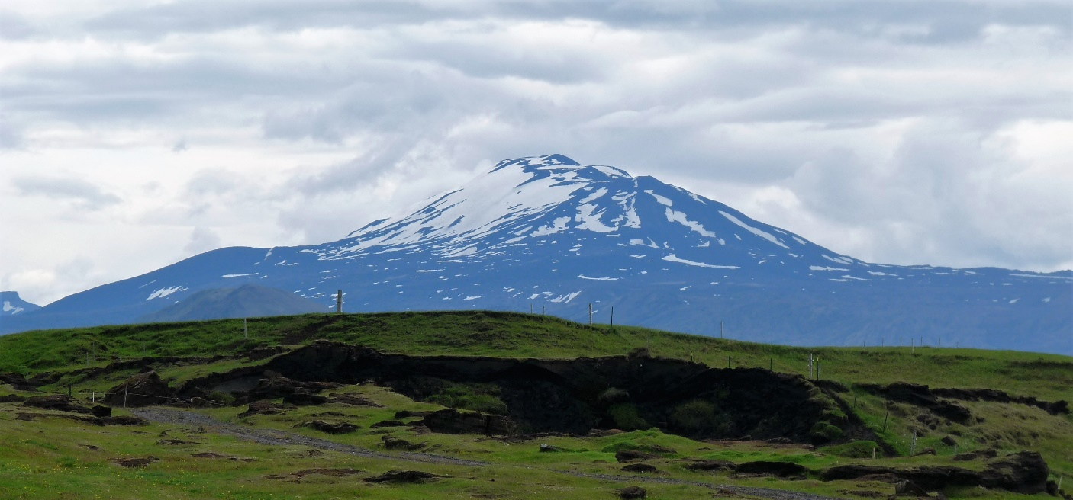

Figure 4: Hekla volcano, viewed from the south-west.

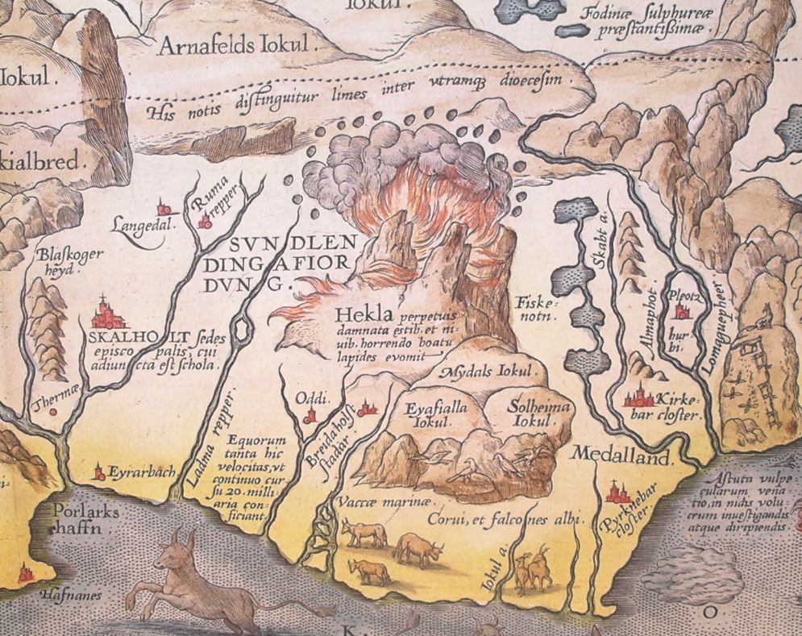

Figure 5: The Gateway to Hell. Detail from Abraham Ortelius' 1585 map of Iceland, illustrating Hekla erupting. The Latin text translates as: ‘Hekla, perpetually condemned to storms and snow, vomits stones under terrible noise’ (image from Wikimedia Commons, public domain).

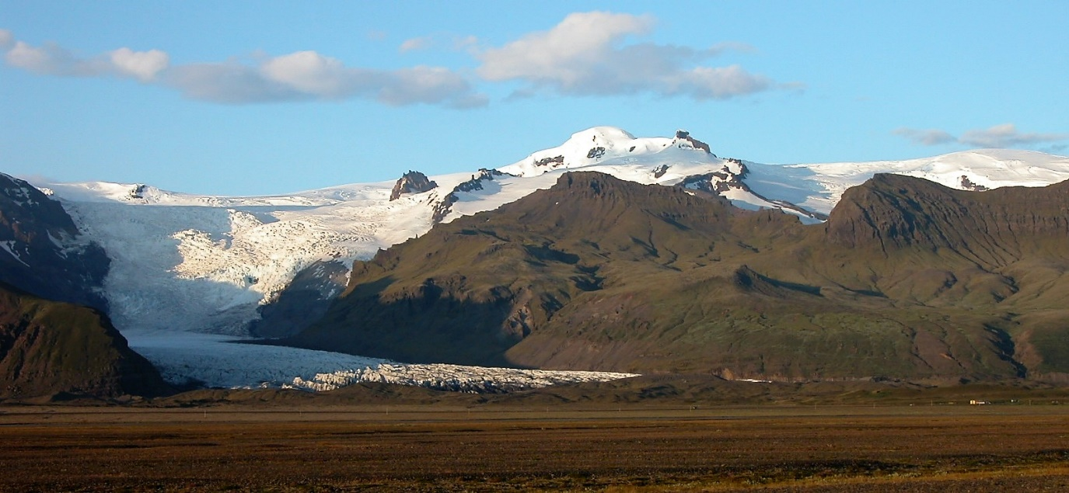

Figure 6: The edge of Öræfajökull, with Svínafellsjökull glacier descending from the ice cap.

