More Than a Tournament

Grassroots Play and Participation at Esports Events

Dr Ying-Ying Law, Staffordshire University
Dr Josh Jarrett, Staffordshire University

Abstract
This paper explores the grassroots esports of the Super Smash Bros. Melee (SSBM) (Nintendo, 2001) community in the United Kingdom. The research methods consist of ethnographic research, using field notes from observations and informal conversations with the players and organisers at the SSBM tournament ‘Heir to the Throne 5’ (Heir 5). Both researchers attended Heir 5 in Leicester, UK, between 17th-19th August 2018 as spectators, where over 800 SSMB players gathered to compete at the largest European SSBM tournament. The aim of this paper is to determine what the notion of ‘grassroots’ implies in an esports context through drawing on sources from game and cultural studies. Moreover, our critical aim is to question how far organised grassroots esports could represent an alternative to more mainstream and commercialised esports formats.

Introduction
Electronic sports (esports) in the West have grown exponentially in popularity since the establishment of live streaming platforms such as Twitch and Youtube. For games such as League of Legends (Riot Games 2009), Counter Strike: Global Offensive (Valve Corporation 2012) or Overwatch (Blizzard Entertainment 2016) this growth in viewership has equated to structured worldwide leagues, franchised teams, lucrative sponsorships and a general professionalisation of playing practices. Central to the commercial success each of these games encompass is a close relationship between the game’s developer/publisher and their esports industries; a co-creative relationship that has become the norm for many of the most watched games. However, alongside these developments in esports widening mainstream appeal has also been a more participatory, alternative and grassroots structure of competitive play that is present for many games that are not supported by the game’s developer. One of these games is Super Smash Bros. Melee (SSBM), a game released in 2001 by Nintendo for the Gamecube. As a game that is constitutively offline, unable to change and importantly for Nintendo, difficult to continually monetise, SSBM has always shared a tense relationship with its publisher. The director, Masahiro Sakurai believed that many players gave up on the purposely designed party game because it became; ‘too technical, because they can’t keep up with it… I think the philosophy behind them doesn’t go in line with Nintendo’s philosophy in that some of these players are playing for the prize money… I feel like a game at the end of the day, is about playing the game’ (Doolan, 2018, para 1). Consequently, Nintendo have always promoted their newer Smash Bros releases such as Super Smash Bros. Brawl (Nintendo 2008), Super Smash Bros. 4 (Nintendo 2014) and Super Smash Bros. Ultimate (Nintendo 2018). Curiously, SSBM has endured in popularity through each of these titles despite the game itself never changing, the game requiring dated equipment such as cathode-ray tube (CRT) televisions to play competitively and Nintendo ignoring (and at times resisting) SSBM’s esports culture (Elmezeny and Wimmer, 2015, 2). This paper seeks to delve into the curious existence of SSBM’s esports culture, critically asking why and how this game has remained a popular yet distinctively participatory, alternative and grassroots activity.
In particular, the focus of this paper is the vibrant grassroots culture surrounding the UK SSBM esport scene. The research presented here was conducted at an internationally popular tournament named ‘Heir to the Throne 5’ (Heir 5), an event hosted in Leicester during August 2018, where over 800 SSBM players gathered to compete in the largest European tournament. Heir 5 had numerous matches taking place at the same time and various community activities, including an international crew battle, an open stand-up comedy night and an LGBT meetup. Organised and funded by the community, for the community, Heir 5 had limited sponsors and no formal recognition from Nintendo. The aim of this paper is to identify what is unique about the grassroots organisation and ethos of a community organised tournament such as Heir. Research surrounding grassroots esports is not entirely new as T.L. Taylor’s (2012) seminal work surrounding pre-live streamed esports cultures exemplifies. However, in expanding on the notion of grassroots esports in particular, this paper aims to extend lines of inquiry opened up by work such as Taylor’s to reconsider what the activities of an esport event can entail.
Through drawing on literature from game and cultural studies, this paper seeks to explore the practicalities, practices and play involved in the grassroots activities of Heir 5. Although it has been noted that there is a relative lack of literature detailing the subcultural practices of players (Carbone and Ruffino, 2014), we turn to sources from cultural studies of subculture (Hebdige 1979) and fandom (Fiske 1992) to critically frame the resistant values and practices at play in SSBM. Moreover, it is an aim of this paper to provide an alternative account of esports to more commercialised examples that have come to define the current landscape. As Veli-Matti Karhulahti (2017: 46) has recently noted, the ‘e’ in contemporary esports is not representative of the ‘electronic’ but ‘economic’ as it is the extra economic foundation of an explicitly commercial game that sets esports apart from traditional sports. In the grassroots organisation, activities and play of SSBM; a critical alternative to more mainstream esports is described as more communal, commercially resistant and at times inclusive.

A Brief History of the UK Melee Scene
The original game of the Super Smash Bros. series was targeted at home console players, who would either play alone or with family and friends. The first public SSMB tournaments were held in early 2002 with the ‘Tournament Go Series’, held in California. Early tournaments had disputes over what the official ruleset should be, but the organiser Matt ‘MattDeezie’ Dahlgren came up with an official ruleset, similar to the current fundamental ruleset (four stocks, eight minutes, best-of-three). Although the GameCube may have run its commercial course, the console is still being played in a remarkable way at competitive tournaments and international stages.
Within the United Kingdom, the SSBM community consists mostly of players across different skill levels ranging from professional to amateur, but very few (if any) are able to play professionally full-time as a livelihood. To date, there has been limited research focusing on the demographic of players specific to certain esports titles, however, from Law’s (2016) ethnographic study, most of the UK Smash players she interviewed were predominantly male and in their mid 20’s. Competitive fighting games have a history of localised competition from arcade culture, living rooms and bedrooms with family and friends, local regional tournaments held in ‘liminal’ subcultural spaces (from local pubs, comic book shops, bowling alleys, churches, universities, warehouses, hotel conference rooms and gaming spaces), to national tournaments held in game related events (such as exhibitions and conventions centers) (Sheilds, 1992).

Research Methods
Both researchers have a background of attending a variety of UK based SSBM tournaments (mostly in North-West and South-West of England). This research draws on these experiences but also consists of empirical ethnographic research from Heir 5, using observational research and informal conversations with the players and organisers at this tournament. The informal conversations that informed this paper were selected from convenience sampling during the players ‘down-time’ (waiting between matches) and the researchers objective was to observe the players motives, attitudes and practices during the event. Although the informal conversations were not recorded, extensive field notes were taken from the discussions with players.

Defining a Grassroots Esports Culture
From its inception as an esports culture in North America and Europe, Super Smash Bros. Melee (SSBM) has always been associated with an alternative and particularly grassroots ethos. Upon winning a tournament in 2017, one of the most prominent professional SSBM players, Juan Debiedma (widely known as ‘Hungrybox’), proudly declared after using an expletive in an interview that ‘we’re not supposed to be this friendly old esports community, we came here from the gutter ourselves. We can say whatever the damn hell we want’ (Allen, 2017, para 4). Debiedma’s views are widely shared in SSBM’s competitive culture as the commercial developer of the game, Nintendo, has historically overlooked and at times resisted the continued existence of SSBM’s esport scene.
For example, in July 2013 after SSBM made a return to the premier annual fighting game event in North America named ‘EVO’ due to a community crowdfunding effort, Nintendo subsequently forbid any SSBM games from being streamed at the tournament. In this instance, the reaction to Nintendo’s decision was so severely rejected and controversial to SSBM’s culture that Nintendo reversed their decision. However, this attempt at cultural and playful governance by Nintendo is not an isolated example with another notable example coming in the form of the mod Project Melee. Project Melee is a total conversion mod for Super Smash Bros. Brawl that changes the game to play more like SSBM with regards to in-game speed and technique. As a game that was popular in the SSBM community, it was widely played in tournaments up until 2016 when Nintendo pressured Twitch to ban it from being streamed. Nintendo even banned their own users for mentioning Project Melee on their Miiverse social network (Cowley, 2016). Under this pressure, Project Melee cased development in 2016 and is now a niche activity for SSBM’s culture, although it remains a topic of much resentment towards Nintendo.
In both of these examples of commercially motivated governance by Nintendo, the culture of SSBM has been united in their own stance that is opposed to that of the game’s developer. The salient point here is that it is this background of playful defiance that animates SSBM’s culture and is notable in the affective texture of an event such as Heir 5 where feelings of independence, community and grassroots dynamism are palpable. As Debiedma goes on to state in the same post-game interview from above, ‘I want you [Nintendo] to hear the amount of people who support this league, the amount of people who want this to be a lifestyle for people. This is not just a video game, this is a lifestyle’ (Allen, 2017, para 6). It is the ethos of this ‘lifestyle’ and its oppositional relation to both Nintendo and mainstream esports that is crucial to define here as, at Heir 5 in particular, various grassroots cultural practices could be noted.
In using the notion of grassroots here, it is our intention to make direct comparisons between SSBM’s culture of competitive play and wider examples of community, DIY, alternative or participatory media practices (Jenkins, 2006; Newman, 2008, vii). In their own way, each of these forms of media production and circulation represents a grassroots form of cultural activity and it is this bottom-up agency that carries implications for the creative, commercial and democratic potentials of a media form. Writing about community media practices in the form of radio, television and online networking, Kevin Howley notes that community media entails, ‘...grassroots or locally oriented media access initiatives predicated on a profound sense of dissatisfaction with mainstream media form and content, dedicated to the principles of free expression and participatory democracy, and committed to enhancing community relations and promoting community solidarity’ (Howley, 2005, 2). Although the media forms Howley was considering differ from esports in the kinds of messages or experiences that are circulating, there are clear parallels in the ethos of these cultures of media production.
As noted above, SSBM’s relationship with Nintendo is a tense and at times antagonistic one that unites the culture of SSBM in their ‘dissatisfaction with the mainstream media form and content’. Although this form of resistance is compounded by the status of players playing and in many cases feeling affectionate towards Nintendo’s in-game characters, it is nonetheless notable in several aspects of the way tournaments are run. The forms of resistance include the grassroots organisation of the tournament, the communal negotiation of tournament rules, the retro aesthetic of the gaming setups (and the game itself) [see image_1] and highly modified and personalised Gamecube controllers. For example, the Heir 5 slogan, ‘2-0 is not an option’ considers standardised commercial tournament rules (single or double elimination) to be problematic for knocking out less familiar players after two rounds. In contrast, Heir 5 guaranties 8 sets of games for every player, promoting a sense of community and levelled relations between players of all experience and skill levels.

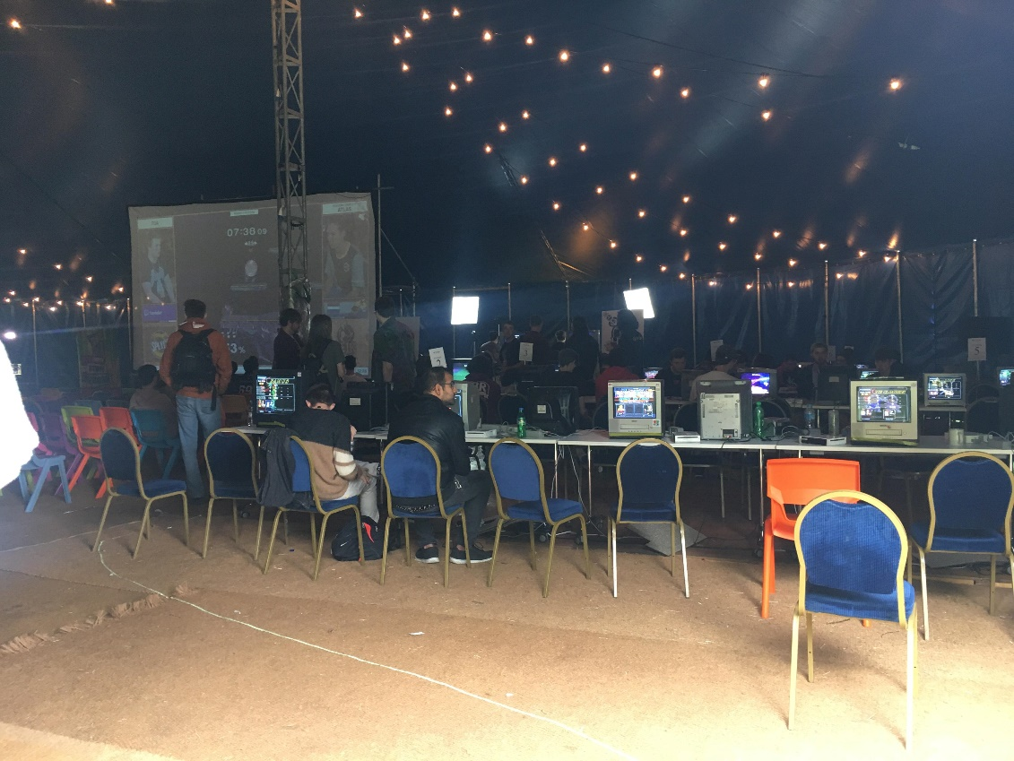
Figure 1: A tent at Heir 5 full of CRT’s with players freely playing

These cultural practices suggest a sense of belonging within a tight-knit gaming community - something that sometimes gets lost in commercialised events. Borrowing Hodkinson’s (2002) term of subculture, he suggests that there are elements of movement, overlap and change within subcultures, with remarkable levels of commitment, identity, distinctiveness, and autonomy. In relation to our findings, there was a strong sense of identity of ‘us’ and ‘them’, which involved a distinct cultural grouping and shared feelings of identity through community and ‘ritual’ practices. It is these communal practices that constitute the tightly bound, coherent and at times more inclusive culture of competitive play we experienced at Heir 5.

Conclusion
Taken together, these practices are constitutive of the alternative identity Smasher culture has crafted out for itself. Moreover, similar to many subcultural practices that provide a more inclusive and progressive space for identity, such as the alternative fan cultures described by Hebdige (1979) and Fiske (1992), Heir 5’s Smashers governed their space to allow anyone to participate. If as Hebdige (1979) argued, subcultures bring together like-minded individuals who feel neglected by societal standards and allow them to develop a sense of identity, then these identities were certainly encouraged by Smashers at Heir 5. Due to the scalability of larger more mainstream events, it is unclear if event organisers could host similarly inclusive esports in this way. However, at a grassroots level these events are happening, they are passionately attended and create a more alternatively welcoming event overall.

References
Allen, E. V. (2017). Smash Pro’s Tournament Victory Speech Calls Out Nintendo. Kotaku. Retrieved from: https://compete.kotaku.com/smash-pros-tournament-victory-speech-calls-out-nintendo-1795814824

Blizzard Entertainment. (2016). Overwatch. Blizzard Entertainment, California.

Carbone, M. B., and Ruffino, P. (2014). ‘Video Game Subcultures: Playing at the Periphery of Mainstream Culture’, The Italian Journal of Game Studies, Volume 1 (3).

Cowley, P. (2016). ‘Project M: The Outlaws of Competitive Smash Bros.’, Dot Esports. Retrieved from: https://dotesports.com/general/news/project-m-the-outlaws-of-competitive-smash-bros-7060

Doolan, L. (2018). ‘Masahiro Sakurai Isn’t Concerned About Competitive Aspect of Super Smash Bros: It’s about ‘playing the game’, NintedoLife. Retrieved from: http://www.nintendolife.com/news/2018/07/masahiro_sakurai_isnt_concerned_about_competitive_aspect_of_super_smash_bros

Elmezeny, A. and Wimmer, J. (2015). ‘How Gaming Achieves Popularity: The Case of the Smash Brothers’. Proceedings of the 2015 DiGRA International Conference. Diversity of Play. Vol 12.

Fiske, J. (1992). ‘The Cultural Economy of Fandom’, in Lewis, L, A. (1992) The Adoring Audience: Fan Culture and Popular Media, London: Routledge: pp 30 – 50.

Hebdige, D. (1979). Culture: The Meaning of Style. London: Routledge.

Hodkinson. P. (2002). Goth: Identity, Style and Subculture. Oxford and New York: Berg.

Howley, K. (2005). Community Media: People, Places, and Communication Technologies, Cambridge: Cambridge University Press.

Jenkins, H. (2006). Convergence Culture: Where Old and New Media Collide, London: New York University Press.

Karhulahti, V-M. (2017). ‘Reconsidering Esport: Economics and Executive Ownership’, Physical Culture and Sport: Studies and Research, Volume 74 (1).

Law, YY (2016). The Travelling Gamer: An Ethnography of Video Game Events. PhD Thesis Submitted to University of Salford, Manchester. UK. Retrieve from: http://usir.salford.ac.uk/id/eprint/40411/

Newman, J. (2008). Playing with Video Games. London: Routledge.

Nintendo. (2001). Super Smash Bro. Melee. Japan: Nintendo.

Nintendo. (2008). Smash Smash Bros. Brawl. Japan: Nintendo.

Nintendo. (2014). Super Smash Bros. for Nintendo 3DS and Wii U. Japan: Nintendo.

Nintendo. (2018). Super Smash Bros. Ultimate. Nintendo, Kyoto.

Riot Games. (2009). League of Legends. Riot Games, California.

Shields, R. (1992). Lifestyle Shopping, London: Routledge.

Taylor, T. L. (2012). Raising the Stakes: E-Sports and the Professionalization of Computer Gaming. Cambridge: The MIT Press.

Valve Corporation. (2012). Counter Strike: Global Offensive. Valve Corporation, Washington.

