THE INFLUENCE OF THE HONEYCOMB DESIGN PARAMETERS ON THE MECHANICAL BEHAVIOUR OF NON-PNEUMATIC TYRES
EVANGELIA GANNIARI-PAPAGEORGIOU
School of Creative Arts and Engineering, Staffordshire University, College Road, ST4 2DE,
Stoke-on-Trent, United Kingdom
evi.ganniari@staffs.ac.uk
PANAGIOTIS CHATZISTERGOS
Centre for Biomechanics and Rehabilitation Technologies, Staffordshire University, Leek Road, ST4 2DF,
Stoke-on-Trent, United Kingdom
Panagiotis.chatzistergos@staffs.ac.uk
XIAOXU WANG
London Electric Vehicle Company, Li Close, CV7 9RF,
Coventry, United Kingdom
xiaoxu.wang@levc.com
Received Day Month Year
Revised Day Month Year
Non-Pneumatic Tyres with honeycomb structure have complex design and their mechanical behaviour is influenced by their geometry. As a result, deep understanding of the effect of various design parameters is very important for design optimization. In this numerical analysis the effect of a wide range of internal geometrical parameters on the tyre’s weight and mechanical behaviour was quantified. For this purpose, a parametric finite element model was designed and subjected to vertical loading to assess its maximum stress, contact pressure, maximum vertical displacement and energy absorbed during loading. The analysis indicated that vertical stiffness is strongly affected by the density, thickness and internal angles of the honeycomb cells. The internal angles of the honeycomb also appeared capable of changing the tyre’s vertical stiffness without changing its weight, which is associated with the tyre’s fuel efficiency and dynamic properties. A decrease in cell length or an increase in cell density was capable of significantly reducing internal stresses. Proper tuning of cell thickness or cell length could also significantly reduce the magnitude of contact pressure developed by producing a more even distribution of loading between the tread and the road.

Keywords: Finite element method; honeycomb spokes; non-pneumatic tyres; radial stiffness.

Introduction
Non-pneumatic Tyres (NPTs) can achieve suspension performance, better handling and better driving comfort [Rangdale et al., 2018]. In addition, they are lighter and offer significant safety benefits as they cannot blow out. These advantages make them potentially very useful for a multitude of applications in the area of aerospace, civil, agricultural and military sectors as well as for everyday mobility [Gasmi et al. ,2012; Rhyne and Cron ,2006; Zhang et al. ,2013].
The behaviour of NPTs has been widely investigated during the last decades [Aboul-Yazid et al. ,2015; Deng et al. ,2018; Jin et al. ,2018; Ju, Kim, and Kim ,2012; Kim, Ju, and Kim ,2013]. In a recent study it was found that honeycomb spoke tyres offer the best alternative to conventional tyres because of their uniform traction and reduced wear [Umesh and Amith Kumar, 2016]. Aboul-Yazid et al. [2015] compared different spoke structures and investigated the influence of both the shape of the spoke and the shear layer on the tyre’s contact pressure [Aboul-Yazid et al., 2015]. Their analysis revealed that the honeycomb shape represents one of the best choices as it develops lower tyre contact pressure and lower stresses on the spokes.
Other investigations were focused on the influence of some specific geometrical features and the material of the spokes. More specifically, the optimum cross section shape of an innovative NPT design that is based on the creation of a curved geometry to the sidewalls has been investigated both experimentally and numerically [Sassi et al., 2016]. From this study it was concluded that the performance of this new design could be improved by a well-combined choice of material and geometry. Moreover, other studies have shown that the honeycomb spokes with a higher cell angle value will have lower local stresses and as a result, better fatigue properties [Marattukalam et al., 2015], whereas the material that tends to be the most preferable for the spokes is Nylon 4-6 due to its relatively low deformation under relevant loads [Shashavali et al., 2016].
Following the above studies an effort is undertaken here to investigate further the mechanical behaviour of NPTs and the influence of their geometry. The study focuses on tyres with honeycomb structure as this type of tyre is considered to be one of the most popular NPTs. Also, studies focusing on the investigation of the optimum performance of honeycomb spoke tyres are rather limited.

Methods

Finite element model design
A 3D model was created in ANSYS 18.1 (ANSYS, Canonsburg, PA, USA) comprising a hub, honeycomb spokes, an outer ring and a tread (Fig. 1a). The hub is a rigid cylindrical frame at the centre of the tyre which provides support to other components [Sassi et al., 2016]. The honeycomb spokes are the major components of the NPTs that absorb energy through deformation and provide both support and suspension [Jin et al., 2018]. The outer ring is a thin-walled cylinder that encloses the honeycomb structure. Finally, the tread is the component that comes in contact with the road to provide traction through friction.

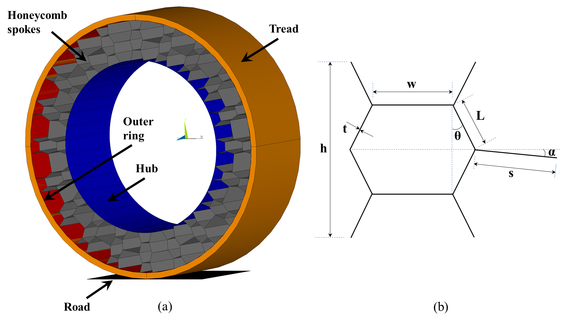
Fig. 1. (a) An overall view of the model and (b) schematic representation of the geometrical characteristics of the honeycomb.
The aforementioned components were designed with a depth of 222 mm. The outer diameter of the hub, outer ring and tread was 430.8 mm, 638.2 mm and 668.2 mm respectively. Their respective thickness was 1 mm, 0.5 mm and 15 mm [Marattukalam et al., 2015]. The honeycomb structure (Fig. 1b) was designed based on literature and the values of the geometrical parameters that define it are presented in Table 1 [Kim et al., 2013; Marattukalam et al., 2015]. This design was used as reference in the parametric analysis that follows. As a last step, the road surface was created to simulate the contact between tread and road. For this purpose, the road was simulated as a rigid rectangular surface with dimensions significantly larger than the possible contact area between the tyre and road (i.e. 334 mm×242 mm).
The hub and the outer ring were simulated as linearly elastic, while the honeycomb spokes and the tread were assumed to be incompressible hyperelastic according to literature (Table 2). Hyperelastic mechanical behaviour was simulated using the Ogden incompressible hyperelastic model (third order):
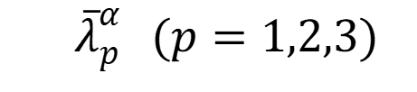
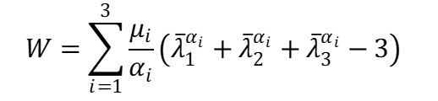
where are the deviatoric principal stretches and μ and α are the material coefficients defining the mechanical behaviour of the material.

Table 1. The honeycomb reference design values [Kim, et al., 2013; Marattukalam et al., 2015].
Design Parameters | Value | Definition
w | 36.66 mm | Cell width
L | 26.25 mm | Cell length
t | 3.20 mm | Cell thickness
h | 92.25 mm | Height of the total cell
θ | 15.76º | Cell angle
s | 32.78 mm | Length of connecting structure
α | 7.05º | Angle of connecting structure
N | 20 | Density of the honeycomb spokes  (Cell density)

Table 2. The material properties of the NPT components. [Aboul-Yazid et al. ,2015; Chang et al. ,2018; Kim, Ju, and Kim ,2013; Vinay et al. ,2015] . *:The material coefficients for the Ogden hyperelastic model have been adapted to account for differences between software in the model’s mathematical formulation.
NPT components | Materials | Density  (kg/m³) | Young’s modulus  (MPa) | Material coefficients* | Poisson’s ratio
Hub | AL 7075-T6 | 2800 | 72000 | - | 0.33
Outer ring | AISI 4340 | 7800 | 210000 | - | 0.29
Honeycomb | Polyurethane | 1200 | - | μ₁=17.906 MPa  α₁=1.513  μ₂=-2.114 MPa  α₂=2.212  μ₃=-0.075 MPa  α₃=-2.471 | 0.49
Tread | Rubber | 1043 | - | μ₁=16.358 MPa  α₁=1.633  μ₂=-6.980 MPa  α₂=1.9  μ₃=-0.047 MPa  α₃=-2.465 | 0.49

3D shell elements with mid-nodes (Shell281) were used for the honeycomb, hub and outer ring, while the tread was meshed using 3D 8-node solid elements (Solid185). Shell and solid elements were connected with the help of appropriate contact elements (Conta174, Targe170) to account for the differences in their degrees of freedom.
In order to simulate realistic loading conditions and achieve better contact detection which could provide much more reliable results, one pair of contact elements was created representing the road-to-tread contact. The static friction coefficient between road and tread is set equal to 0.7, which is the friction coefficient on the dry road [Al-Grafi et al., 2013].
To support the model, the internal nodes of the hub were rigidly linked to a master node in its centre. This master node was constrained to move only in the direction perpendicular to the ground. The model of the road was fixed. At the end, a vertical load of 3000 N was applied downwards at the hub centre. This force value corresponds to a quarter of the weight of a typical vehicle [Aboul-Yazid et al., 2015].
In order to decide the most appropriate mesh density for the model, a convergence analysis was carried out. The fact that the element type used for the tread component is different from the one used for the rest components may influence the convergence of the results. St Venant’s Principle implies that the local stresses in a specific component of a structure do not influence the stresses in another component of the structure. In this context, local mesh refinement was performed. The results from the mesh analysis of the shell and solid elements were analysed separately to identify the most suitable mesh size for each different element type.

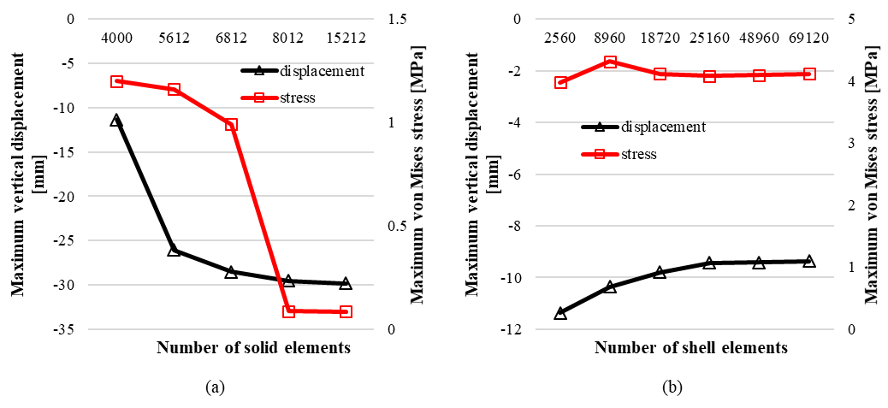
Fig. 2. The variation of the maximum von Mises stress and maximum vertical displacement with increasing number of (a) solid and (b) shell elements. In the cases of solid elements, the reported maximum stress corresponds to the maximum von Mises stress developed in the tread, while in the case of shell elements it corresponds to the maximum von Mises stress in the honeycomb. In both cases maximum vertical displacement is measured at the centre of the tyre.

Keeping the shell element size fixed, a convergence analysis was carried out for the solid elements of the tread (Fig. 2a). It was found that ≈8,000 solid elements are needed in the tread. Keeping the solid element size fixed, the same process was repeated for the shell elements (Fig. 2b). At the end it was found that ≈25,000 shell elements are needed in the remaining model to eliminate the effect of element size on the results. The final meshed model is shown in Fig. 3.

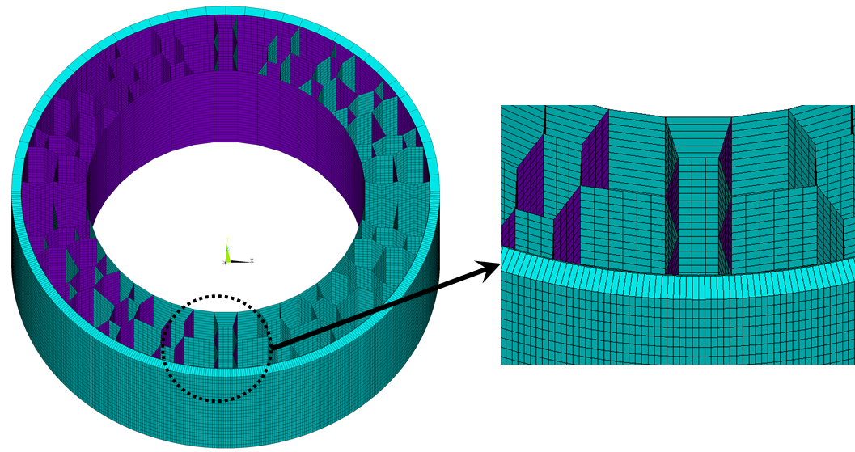
Fig. 3. The meshed model.

Parametric Analysis
Five design parameters that fully define the geometry of the honeycomb were investigated (Fig. 1b):
- Cell length (L): This parameter affects the volume of the honeycomb spoke. Larger length leads to larger honeycomb volume.
- Cell width (w): This parameter affects the single honeycomb volume. Larger width leads to larger single honeycomb volume, and also makes single honeycombs get closer to each other.
- Cell angle (θ): This parameter affects the flexibility of the structure [Ju et al., 2012].
- Cell thickness (t): This parameter affects both the weight of the tyre and the flexibility of the structure [Ju et al., 2012].
- Cell density (N): This parameter represents the number of hexagons in the NPT model and affects the ability of the structure to deform and the weight of the tyre.
Five scenarios were simulated for each parameter (25 in total) for values of the aforementioned parameters ranging between 80% and 120% of the reference values (Table 1) in increments of 10%. The geometry of the outer ring and the tread was kept constant. The diameter of the hub was adapted to changes in internal structure.
At the end of each analysis the following outcome measures were recorded to help the comparison between different scenarios: a) the vertical displacement at the centre of the hub, b) the total energy absorbed during loading, c) the maximum von Mises stress in the honeycomb, d) the maximum stress in the entire model and e) the maximum value of the contact pressure between the tyre and the road. All analyses were performed using ANSYS 18.1 (ANSYS, Canonsburg, PA, USA).

Results
The distributions of the vertical displacement and the von Mises stress are presented in Figs. 4 and 5 respectively for the reference design (100% design). As it can be seen in Fig. 4, the honeycomb structure undergoes buckling. The maximum vertical displacement appears at the hub and at the side parts of the tread which are close to the road. The displacement at the centre of the hub reached an absolute value of 27.66 mm. Moreover, as it was expected, no displacement is observed at the bottom part of the tyre which is in contact with the road.
The maximum von Mises stress for the entire model occurs at the bottom of the outer ring and is equal to 415 MPa (Fig. 5b). Lower stresses appear in the tread and the honeycomb (Fig. 5a,c). These stresses do not exceed the values of 0.87 MPa and 8.71 MPa respectively.

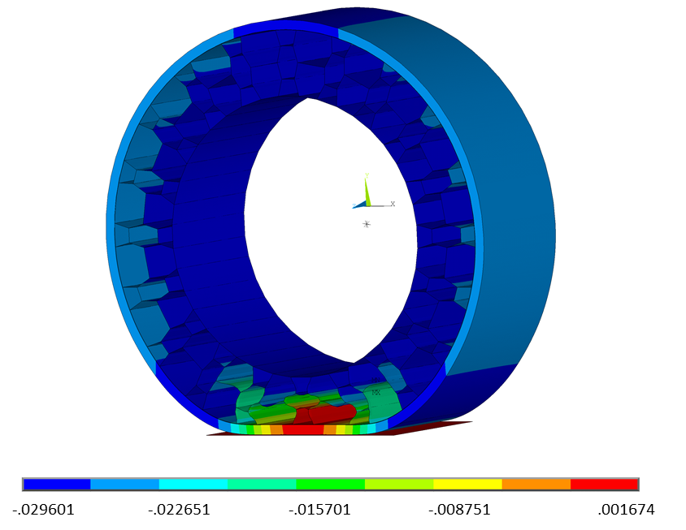
Fig. 4. An overall view of the distribution of the vertical displacement (in mm) for the reference design.

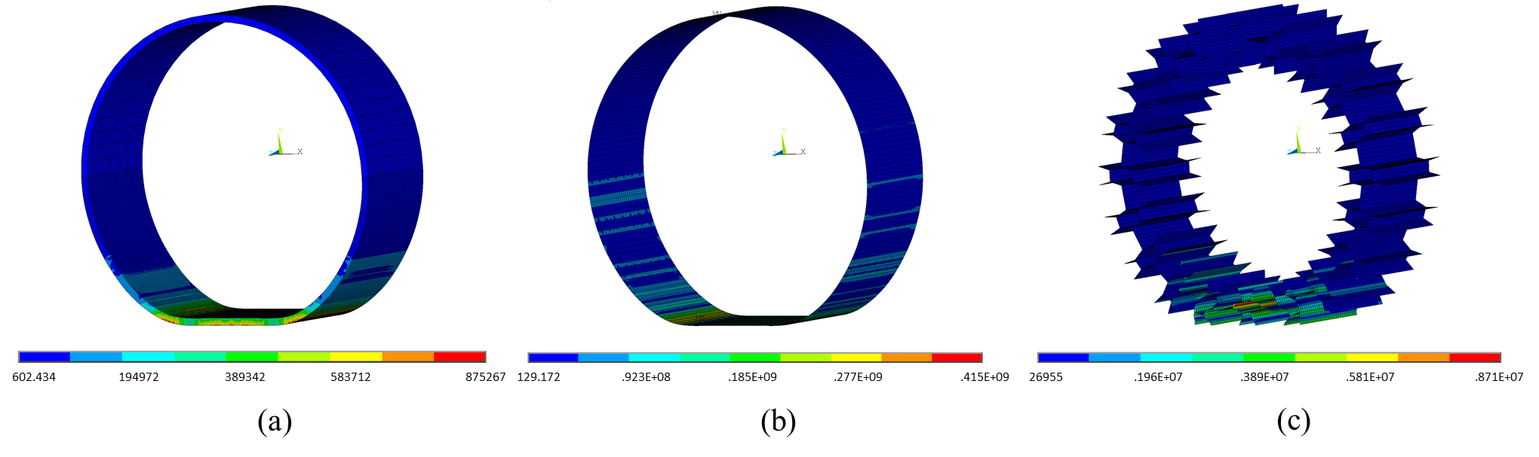
Fig. 5. An overall view of the distribution of the von Mises stress in (a) the tread, (b) the outer ring and (c) the honeycomb (in MPa) for the reference design.

Compared to the reference design, 20% decrease in cell length or cell angle reduces the vertical displacement by 25% or 4% respectively. At the same time 20% increase in these two parameters increases the vertical displacement by 24% or 6% respectively (Fig. 6a). On the other hand, 20% decrease in cell thickness and cell density increases the vertical displacement by 52% and 28% respectively, whereas 20% increase in the values of these two parameters decrease the vertical displacement by 30% and 18% respectively. Cell width does not appear to have a significant effect on vertical displacement (Fig. 6a). A similar trend was observed for the total energy that was absorbed during loading (Fig. 6b).

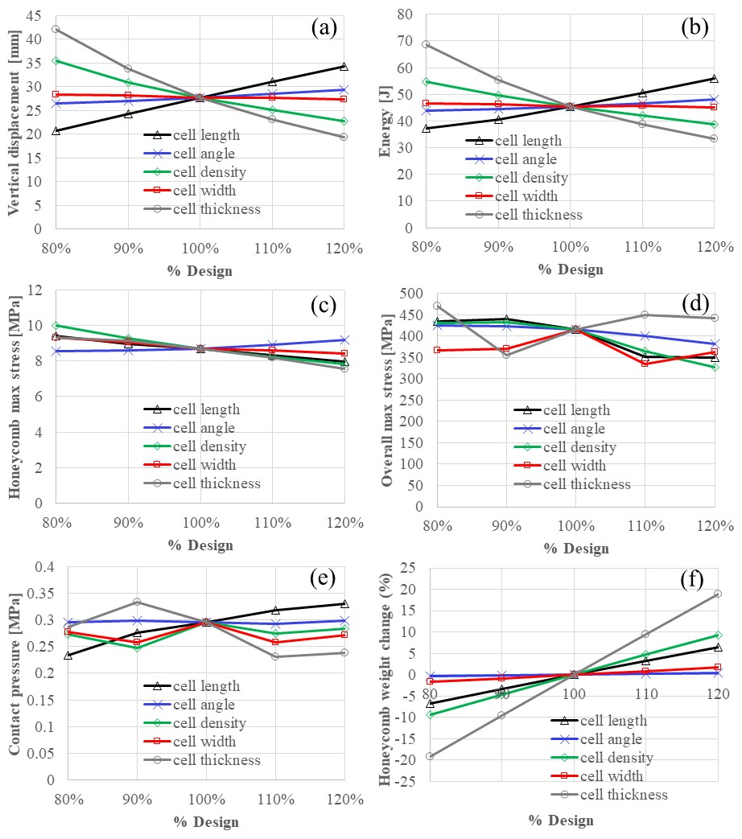
Fig. 6. The relationship between different honeycomb design parameters and (a) the vertical displacement at the hub centre, (b) the energy absorbed during loading, (c) the maximum von Mises stress in the honeycomb, (d) the maximum von Mises stress for the entire model, (e) the maximum contact pressure between the tread and the road. Changes in the weight of the honeycomb for different designs for all honeycomb design parameters are also shown (f). The total energy absorbed during loading was calculated as the area below the applied force - vertical displacement graph.
Maximum stress in the honeycomb appears to increase with decreasing cell length, density, width or thickness (Fig. 6c). More specifically, 20% decrease in these four parameters led to 8%, 15%, 7% or 7% increase in stress respectively. At the same time 20% increase in cell length, density, width or thickness led to 8%, 6%, 3% or 13% decrease in stress respectively. The trend is reversed for cell angle where decreasing its value by 20% led to 2% decrease in stress and increasing its value increased stress in the honeycomb by 6%.
Similar to the reference design, in every scenario that was tested, the maximum stress for the entire model (i.e. overall maximum stress) was developed in the outer ring. Overall maximum stress appears to marginally increase with decreasing cell length, angle or density relative to the reference condition (5%, 2% or 4% increase in stress for 20% decrease in each geometrical parameter respectively) (Fig. 6d). On the contrary overall maximum stress appears to significantly decrease with increasing cell length, angle or density (16%, 7% or 21% decrease in stress for 20% increase in each geometrical parameter respectively). There is no clear trend in the effect of cell width or cell thickness.

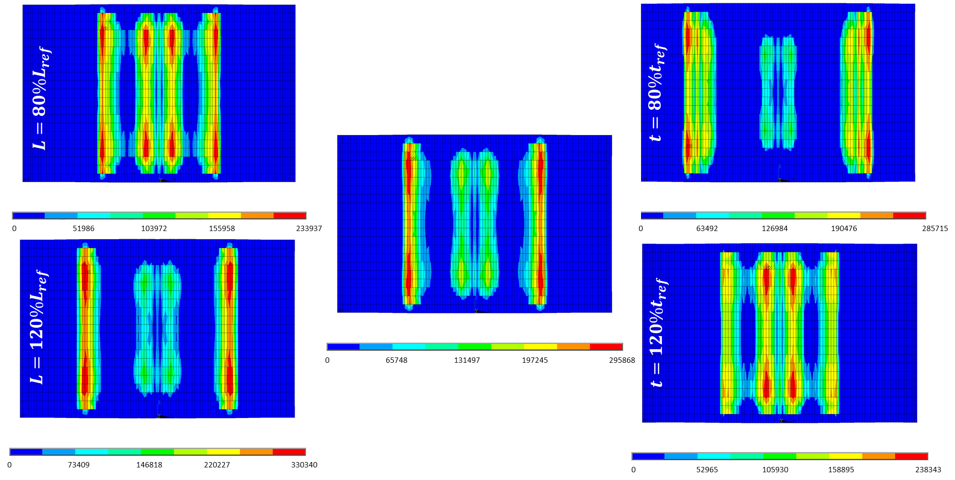
Fig. 7. The distribution of contact pressure between the tyre and the road (in Pa) for the reference design (centre) and for selected scenarios that was found to have a significant effect. Left: Distributions for different values of cell length (L). Right: Distributions for different values of cell thickness (t). In the two images at the top the design parameters are equal to 80% of the value for the reference design (L_{ref} and t_{ref}). In the two images at the bottom the design parameters are equal to 120% of the value for the reference design (Table 1).

The parameters that appear to have the most significant effect on contact pressure are cell length and cell thickness (Fig. 6e). In the case of cell length there is a clear increase of pressure with increasing length. More specifically, 20% decrease or increase in cell length led to 21% decrease or 11% increase in contact pressure respectively. The trend is not as clear in the case of cell thickness. However, it can be observed that increasing cell thickness by 10% or more led to a substantial decrease in contact pressure. The decrease in contact pressure measured for 10% or 20% increase in cell thickness was 22% and 20% respectively.
The effect of cell length and thickness on contact pressure can be better understood with the help of the distribution of contact pressure on the tread surface. As it can be seen in figure 7, the distribution of the contact pressure between the tread and the road has a symmetric pattern with areas of high pressure under the regions where the plates of the spokes of the honeycomb meet the outer ring. There are four areas of pressure concentration and in the reference design the maximum pressure (which is 0.296 MPa) is observed in the outermost two areas (Fig. 7, centre). The distribution of pressure between these four regions can be modulated by changing the values of cell length (L) and cell thickness (t). More specifically, increasing the value of L (Fig. 7, bottom left) or decreasing the value of t (Fig. 7, top right) appears to transfer more loading to the outermost two areas. A more even distribution is achieved by decreasing the value of L (Fig. 7, top left) or increasing the value of t (Fig. 7, bottom right). In these cases, decreased vertical displacement results in more loading being carried by the spoke that is perpendicular to the ground. This is also reflected on the deformation mode of the honeycomb (Fig. 8).

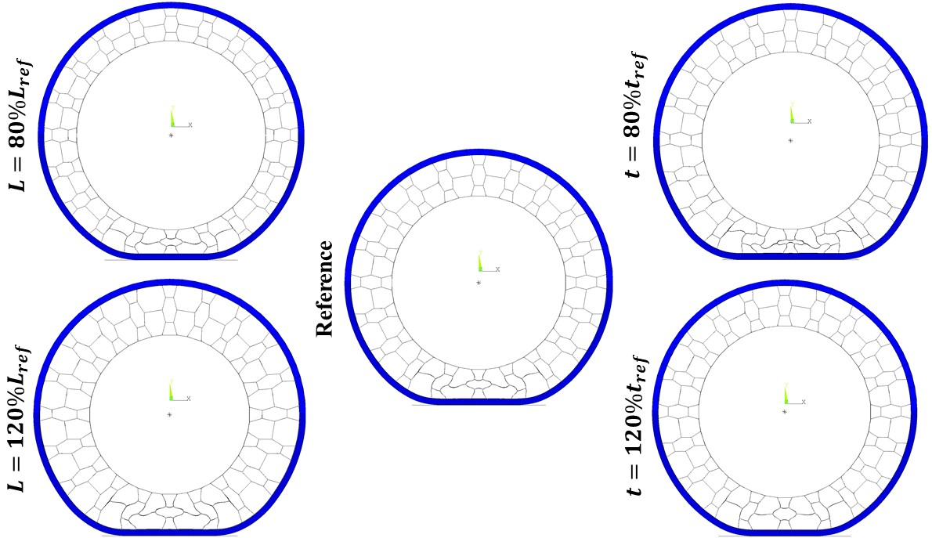

Fig. 8. The deformation modes for the reference design (centre) and for selected scenarios that was found to have a significant effect on vertical displacement and contact pressure. Left: Deformation modes for different values of cell length (L). Right: Deformation modes for different values of cell thickness (t). In the two images at the top the design parameters are equal to 80% of the value for the reference design (L_{ref} and t_{ref}). In the two images at the bottom the design parameters are equal to 120% of the value for the reference design (Table 1).

Discussion
Tuning the design of NPT tyres with honeycomb spokes for a specific application (e.g. specific type of vehicle, environment etc.) requires deep understanding of the effect of geometry on mechanical behaviour.
In this context the optimum shape of the honeycomb was investigated by conducting an extended FE parametric analysis. More specifically, this paper focused on the influence of different geometrical characteristics of the honeycomb spoke such as, cell length, cell width, cell angle, cell thickness and cell density, on the tyre’s mechanical behaviour (Fig. 1). Changes in mechanical behaviour were quantified in terms of changes in vertical displacement, energy absorbed during loading, contact pressure and changes in maximum von Mises stress (in the honeycomb and in the entire model) relatively to a reference design. This reference design was defined using characteristic values of the aforementioned geometrical parameters from literature [Kim et al., 2013; Marattukalam et al., 2015].
The tyre’s vertical displacement, sometimes referred to as the tyre’s vertical stiffness, is an important property of the tyre and it is commonly used to evaluate its performance [Ghosh et al., 2007; Mhaske et al., 2015; Taylor et al., 2000; Zöller et al., 2017]. Relatively low vertical stiffness can provide better road holding and support to the vehicle [Shirahatti et al., 2008], it can reduce wear and tear and it can better maintain the roundness of the tyre [Zang et al., 2014].
For the purpose of this study, vertical displacement is going to be directly compared between scenarios as a measurement of vertical stiffness. This direct comparison is made possible because the applied load and the size of the tyre is the same across all cases. However, any comparison against literature should also account for possible differences in loading and tyre dimensions. One of the most important design features that can affect the interpretation of vertical displacement as a measurement of vertical stiffness is the tyre’s diameter. Normalizing vertical displacement over the tyre’s diameter could enable overcoming this problem.
Based on that, the vertical displacement of the reference design for a maximum load of 3000N was equal to 4.1% of the tyre’s diameter. For the same load two previous numerical studies of similar designs of NPTs measured vertical displacements equal to 5.5% [Aboul-Yazid et al. ,2015] and 3.3% [Kim, Ju, and Kim ,2013] of the respective tyre’s diameter. The vertical displacement measured here for the reference design is also similar to that of a typical pneumatic tyre based on literature [Kim, Ju, and Kim ,2013]. More specifically, Kim et al. reported a vertical displacement of 2.9% of the pneumatic tyre’s diameter.
The results of this analysis indicated that vertical displacement is most strongly affected by cell length, cell density and cell thickness. Cell angle also had a significant effect.
The weight of the tyre is another important design parameter which is affected by changes in the geometry of the honeycomb and can compromise the tyre’s fuel efficiency and alter its dynamic properties. Considering that reduced weight is associated with better fuel efficiency, it should be highlighted that changes in cell density, cell thickness and cell length would also lead to significant changes in weight (Fig. 6f). More specifically changing cell density or cell thickness to decrease the tyre’s vertical displacement will substantially increase the tyre’s weight, whereas changing cell length to reduce vertical displacement will reduce its weight. At the same time cell angle is capable of changing vertical displacement without affecting the weight of the tyre. As it can be seen in figure 6f, the weight of the honeycomb remains practically the same when cell angle is decreased to 80% or increased to 120% of the reference condition.
In the case of maximum von Mises stress, cell density and length appeared to have the most significant effect. Increasing the value of either parameter, relative to the reference design, led to significant decrease of the maximum stress in the honeycomb (Fig. 6c) as well as of the overall maximum stress (Fig. 6d). Increasing the value of cell angle decreased the overall maximum stress too, but increased stress in the honeycomb. Considering that the overall maximum stress was always observed in the outer ring, the aforementioned changes in stresses indicate a transfer of loading from the outer ring to the honeycomb for higher values of cell angle.
Contact pressure between the tread and the road is another important result which could affect tyre performance [Kim, Ju, and Kim ,2013]. The results of this analysis indicated that more uniform patterns of pressure distribution could be achieved by decreasing cell length or by increasing cell thickness.
Even though wider ranges of design properties’ values have been used in literature [Ju et al., 2012; Kim et al., 2013; Mohan et al., 2017] the specific range of values investigated here was deemed appropriate for quantifying trends in the effect of honeycomb design on the tyre’s mechanical behaviour.
At this point it should also be emphasized that the analysis was carried out assuming that the tyre is subjected to compression only, equal to a quarter of a typical vehicle’s weight. Even though this is a relatively simple loading scenario, it is routinely used to assess vertical stiffness [Sassi et al., 2016]. In reality, a combination of radial and circumferential loading is applied to the tyre and as a result a shear effect is introduced. Moreover, the magnitude of applied loading is also expected to be higher, especially in highly dynamic loading scenarios. Complex loading and/or increased loading magnitude could lead to the complete collapse of the internal structure of the honeycomb. In such case a careful simulation of possible contacts between honeycomb plates should be performed. In the case of this analysis however, no contact between the internal surfaces of the honeycomb was observed. This was true even for the scenario that gave the highest vertical displacement; namely for cell thickness 80% of the reference value (Fig. 8, top right).
In addition, the mechanical behaviour of NPTs with honeycomb spokes depends on many other parameters such as material type, the size of the tyre etc. It is therefore clear that further investigation of the mutual interaction of all the parameters influencing the NPTs' mechanical behaviour should be carried out for more realistic loading before definite conclusions are drawn. Moreover, since the current study was purely numerical, experimental validation of findings will be needed before it is able to inform the design of honeycomb NPTs.
This study quantified for the first time the effect of all essential honeycomb cell design parameters on the mechanical behaviour of NTP tyres to conclude that specific parameters can be used to tune the tyre’s vertical displacement without compromising its fuel efficiency or strength.

Conclusions
In this numerical analysis the effect of a wide range of geometrical parameters of an NPT honeycomb structure on the tyre’s mechanical behaviour was investigated with a view to informing the design optimization of honeycomb NPTs. The results presented here indicate that:
- Vertical stiffness increases with increasing cell thickness and cell density, whereas it decreases with increasing cell length and cell angle. Cell width did not have any significant effect on vertical stiffness.
- Cell angle can be used to tune the tyre’s vertical stiffness without changing the tyre’s weight.
- The von Mises stress in the tyre can be significantly reduced by increasing the value of cell density or cell length.
- Increasing the value of cell angle leads to a transfer of loading from the outer ring to the honeycomb, which should be taken into account if cell angle is used to tune the tyre’s vertical stiffness.
- Contact pressure distribution between the tread and the road is significantly affected by cell length or thickness. More specifically, the values of these two parameters could be used to produce a more uniform distribution of pressure for specific loading magnitude.

References
Aboul-Yazid, A. M., M. A.A. Emam, S. Shaaban, and M. A. El-Nashar. [2015] “Effect of Spokes Structures on Characteristics Performance of Non-Pneumatic Tires.” International Journal of Automotive and Mechanical Engineering 11(1): 2212–23.
Al-Grafi, MW, MK Mohamed, and FA Salem. [2013] “Analysis of Vehicle Friction Coefficient by Simulink/Matlab.” International Journal of Control, Automation and Systems 2(2): 55–60.
Chang, Yeon Ha, Byung Soo Joo, Sang Mok Lee, and Ho Lee. [2018] “Size Effect of Tire Rubber Particles on Tribological Properties of Brake Friction Materials.” Wear 394–395: 80–86.
Deng, Yaoji et al. [2018] “Simulation of Steady-State Rolling Non-Pneumatic Mechanical Elastic Wheel Using Finite Element Method.” Simulation Modelling Practice and Theory 85: 60–79.
Gasmi, Amir, Paul F. Joseph, Timothy B. Rhyne, and Steven M. Cron. [2012] “Development of a Two-Dimensional Model of a Compliant Non-Pneumatic Tire.” International Journal of Solids and Structures 49(13): 1723–40.
Ghosh, P. et al. [2007] “Optimization of Tyre Design Parameters Through Finite Element Analysis and Correlation with Performance.”
Jin, Xiaochao et al. [2018] “Investigation on the Static and Dynamic Behaviors of Non-Pneumatic Tires with Honeycomb Spokes.” Composite Structures 187: 27–35.
Ju, Jaehyung, Doo-Man Man Kim, and Kwangwon Kim. [2012] “Flexible Cellular Solid Spokes of a Non-Pneumatic Tire.” Composite Structures 94(8): 2285–95.
Kim, Kwangwon, Jaehyung Ju, and Doo Man Kim. [2013] “Static Contact Behaviors of a Non-Pneumatic Tire with Hexagonal Lattice Spokes.” SAE International Journal of Passenger Cars - Mechanical Systems 6(3): 2013-01-9117.
Mhaske, Priyanka, P.N. Narwade, and M.P Nagarkar. [2015] “Analysis of Vertical Stiffness of Passenger Car Tire At.” In International Journal of Innovation in Engineering, Research and Technology [IJIERT] ICITDCEME’15 Conference Proceedings, Novateur Publication’s, 1–6.
Mohan, Aravind et al. [2017] “Design and Analysis of Non-Pneumatic Tyre.” IOP Conference Series: Materials Science and Engineering 263(6).
Rangdale, Pranav A., Kumar R. Chandak, and Ganesh M. Bagade. [2018] “Non Pneumatic Tyre.” International Journal Of Engineering Sciences & Research Technology 7(2): 61–68.
Rhyne, Tim B., and Steve M. Cron. [2006] “Development of a Non-Pneumatic Wheel.” Tire Science and Technology 34(3): 150–69.
Sassi, Sadok, Mohamed Ebrahemi, Musab Al Mozien, and Yousef El Hadary. [2016] “New Design of Flat-Proof Non-Pneumatic Tire New Design of Flat-Proof Non-Pneumatic Tire.” International Journal of Mechanical Systems Engineering 2(114): 1–7.
Shashavali, S., C.R. Reddy, and G.K. Yadiki. [2016] “Design and Analysis of Four Wheeler Airless Tire.” 08(22): 4298–4305.
Shirahatti, Anil, P.S.S. Prasad, Pravin Panzade, and M.M. Kulkarni. [2008] “Optimal Design of Passenger Car Suspension for Ride and Road Holding.” Journal of the Brazilian Society of Mechanical Sciences and Engineering 30(1): 66–76.
Taylor, R K, L L Bashford, and M D Schrock. [2000] “M m v t S.” 43(6): 1415–19.
Umesh, G.C., and S.N. Amith Kumar. [2016] “Design and Analysis of Non-Pneumatic Tyre (NPT) With Honeycomb Spokes Structure.” International Journal of Engineering Science and Computing 6(9): 2136–40.
Vinay, T V et al. [2015] “Modeling and Analysis of Non-Pneumatic Tyres with Hexagonal Honeycomb Spokes.” International Journal on Recent Technologies in Mechanical and Electrical Engineering 2(3): 19–24.
Zang, Liguo et al. [2014] “Mechanical Elastic Wheel Improving Road Holding and Wear Resistance of Tire.” Nongye Gongcheng Xuebao/Transactions of the Chinese Society of Agricultural Engineering 30(12): 56–63.
Zhang, Zhong Zhi et al. [2013] “Development of Non-Pneumatic Tire Technology.” Applied Mechanics and Materials 427–429: 191–94.
Zoller, Chris, Paul Wagner, and Hermann Winner. [2017] “Tires and Vertical Dynamics of Wheeled Mobile Driving Simulators.” Transportation Research Part F: Traffic Psychology and Behaviour.

evi.ganniari@staffs.ac.uk

