The Role of Attention in Emotional False Memory
Formation: Applying Eye-tracking to the
Misinformation Effect

Emma Victoria Roberts

Thesis submitted to fulfil the degree of Philosophy Doctorate
Awarded by Staffordshire University
July 2020

The program of research conducted and reported within this thesis was supervised by
Dr L. Humphreys and Dr S. Krähenbühl of Staffordshire University. Ethical approval was granted by the Health Sciences Ethics Panel of Staffordshire University.

My thanks go to my supervisors for their support and direction, and to Sarah Higgins
for her unflinching enthusiasm in the face of crazy ideas and many technical disasters.
I would like to thank my husband Paul for his programming wizardry and constant support, and to thank our three children who have listened, consoled, made cups of tea, done super hard 3D maths with me, and generally been amazing.

This copy has been supplied on the understanding that it is copyright material and that no quotation from the thesis may be published without proper acknowledgement.

Abstract
Attention is suggested to mediate the contrasting effect evidenced by misinformation research in which negative and highly arousing, events are recalled with high accuracy, whilst also being susceptible to memory distortion by misinformation. The current research extends existing findings by investigating the suggested role of attention in emotional false memory formation by applying eye-tracking as a measure of attention during the encoding phase of a series of misinformation studies. A total of 224 students (133 female), mean age 23.85 (SD = 7.34), were recruited from Staffordshire University. Three misinformation studies were conducted following a three-stage procedure of encoding, misinformation exposure, and recognition test, using three stimuli formats as events to be encoded: images, image sequences and video. Conditions of misinformation, valence, arousal and information location were compared across stimuli of increasing complexity. Eye-tracking measures were employed during event encoding to allow attention and memory accuracy data to be integrated using multiple regression analysis. Results evidenced no predictive relationship between attention and memory accuracy for central information in the absence of misinformation. For participants receiving misleading information, there were no consistent predictive relationships observed within valence or arousal event conditions across stimuli formats. However, the impact of misinformation reduced as event complexity increased, suggesting that event complexity mediates the ability of misleading information to distort memory accuracy. Current results present the first use of eye-tracking during a misinformation study, the first misinformation study conducted in a virtual reality environment and presents an objective and replicable method for defining central event detail in visual stimuli. Results have implications for judicial practise of presenting visual evidence in court and for future research employing visual stimuli formats.

 | Chapter contents | 6
 | List of tables | 7
 | List of figures | 9
 | Introduction, aims and thesis structure | 11
Chapter 1 | The role of attention in emotional false memory | 15
Chapter 2 | Selecting event stimuli | 35
Chapter 3 | Defining centrally emotional content | 63
Chapter 4 | Investigating the role of attention in emotional false memory formation using single image stimuli | 71
Chapter 5 | Investigating the role of attention in emotional false memory formation using sequential image stories | 105
Chapter 6 | Investigating the role of attention in emotional false memory formation using video presented in a virtual environment | 135
Chapter 7 | Comparative analysis of attention during encoding and memory accuracy for single images, sequential images and video | 171
Chapter 8 | Investigating the role of attention in emotional false memory formation: a discussion of main findings, implications and conclusions | 193
 | References | 231
 | Appendices | 244

Chapter 1 |  | The role of attention in emotional false memory |  |  |  | 15
 |  |  | False memory and the misinformation effect |  |  | 15
 |  |  | Variations in the misinformation effect |  |  | 16
 |  |  | Theories explaining the misinformation effect |  |  | 18
 |  |  | Eye-tracking as a measure of attention |  |  | 24
 |  |  | Methodological factors |  |  | 26
 |  |  | Summary of literature and rationale for research |  |  | 32
 |  |  | Addressing the problem |  |  | 33
 |  |  | Hypotheses and predictions |  |  | 33
Chapter 2 |  | Selecting event stimuli |  |  |  | 35
 |  |  | Images |  |  | 36
 |  |  | Film |  |  | 45
 |  |  | Interest areas and image sequences |  |  | 55
 |  |  | Summary |  |  | 59
Chapter 3 |  | Defining centrally emotional content |  |  |  | 63
 |  |  | Method applied to images |  |  | 64
 |  |  | Sequences and video |  |  | 68
 |  |  | Summary |  |  | 69
Chapter 4 |  | Investigating the role of attention in emotional false memory formation using single image stimuli |  |  |  | 71
 |  |  | Method |  |  | 72
 |  |  | Results |  |  | 77
 |  |  | Discussion |  |  | 100
Chapter 5 |  | Investigating the role of attention in emotional false memory formation using sequential image stories |  |  |  | 105
 |  |  | Method |  |  | 105
 |  |  | Results |  |  | 108
 |  |  | Discussion |  |  | 130
Chapter 6 |  | Investigating the role of attention in emotional false memory formation using video presented in a virtual environment |  |  |  | 135
 |  |  | Method |  |  | 136
 |  |  | Results |  |  | 142
 |  |  | Discussion |  |  | 165
Chapter 7 |  | Comparative analysis of attention during encoding and memory accuracy for single images, sequential images and video |  |  |  | 171
 |  |  | Method |  |  | 171
 |  |  | Results |  |  | 172
 |  |  | Summary |  |  | 190
Chapter 8 |  | Investigating the role of attention in emotional false memory formation: a discussion of main findings, implications and conclusions |  |  |  | 193
 |  |  | Review of the hypotheses |  |  | 194
 |  |  | Review of the aims |  |  | 218
 |  |  | Implications |  |  | 223
 |  |  | Conclusions |  |  | 227
Table 1 | Normative valence and arousal ratings from IAPS and NAPS for final selected images. |  |  |  |  |  | 40
Table 2 | Participant rated valence and arousal means with standard deviations for selected images. |  |  |  |  |  | 44
Table 3 | Means and standard deviations for image valence and arousal ratings combined by condition. |  |  |  |  |  | 44
Table 4 | Selected video clips with mean valence and arousal ratings and standard deviations. |  |  |  |  |  | 52
Table 5 | Combined means and standard deviations for video valence and arousal conditions. |  |  |  |  |  | 53
Table 6 | Mean valence and arousal ratings with standard deviations from the second rating phase. |  |  |  |  |  | 54
Table 7 | Mean valence and arousal ratings with standard deviations for BMIS and line scales. |  |  |  |  |  | 77
Table 8 | Participant image rating figures compared to normative valence and arousal figures. |  |  |  |  |  | 78
Table 9 | Means with standard deviations for image condition by information location for number of fixations, viewing time, and latency of first fixation. |  |  |  |  |  | 80
Table 10 | Means and standard deviations for number of correct, new false and misleading information statements. |  |  |  |  |  | 86
Table 11 | Spearman’s Rho correlations between eye-tracking measures during image viewing. |  |  |  |  |  | 94
Table 12 | Image stimuli control group multiple regression (criterion central memory accuracy, predictors age, sex, viewing time (VT), latency of first fixation (LFX)). |  |  |  |  |  | 98
Table 13 | Image stimuli control group multiple regression (criterion peripheral memory accuracy, predictors age, sex, viewing time (VT), latency of first fixation (LFX)). |  |  |  |  |  | 98
Table 14 | Image stimuli misled group multiple regression (criterion central memory accuracy, predictors age, sex, viewing time (VT), latency of first fixation (LFX)). |  |  |  |  |  | 99
Table 15 | Image stimuli misled group multiple regression (criterion peripheral memory accuracy, predictors age, sex, viewing time, latency of first fixation). |  |  |  |  |  | 99
Table 16 | Mood ratings using BMIS and line scale for valence and arousal. |  |  |  |  |  | 108
Table 17 | Participant sequence ratings means with standard deviations. |  |  |  |  |  | 109
Table 18 | Means and standard deviations for number of fixations, viewing time and latency of first fixations. |  |  |  |  |  | 111
Table 19 | Means and standard deviations for number of correct, new false and misleading information statements. |  |  |  |  |  | 118
Table 20 | Spearman’s Rho correlations between eye-tracking measures recorded during sequence viewing. |  |  |  |  |  | 124
Table 21 | Image sequence stimuli control group multiple regression (criterion central memory accuracy, predictors age, sex, viewing time (VT), latency of first fixation (LFX)). |  |  |  |  |  | 128
Table 22 | Image sequence stimuli control group multiple regression (criterion peripheral memory accuracy, predictors age, sex, viewing time (VT), latency of first fixation (LFX)). |  |  |  |  |  | 128
Table 23 | Image sequence stimuli misled group multiple regression (criterion central memory accuracy, predictors age, sex, viewing time (VT), latency of first fixation (LFX)). |  |  |  |  |  | 129
Table 24 | Image sequence stimuli misled group multiple regression (criterion peripheral memory accuracy, predictors age, sex, viewing time (VT), latency of first fixation (LFX)). |  |  |  |  |  | 129
Table 25 | Valence and arousal ratings with standard deviations for BMIS and line scales. |  |  |  |  |  | 142
Table 26 | Participant video rating means with standard deviations. |  |  |  |  |  | 143
Table 27 | Mean and standard deviations for IPQ subscale scores measuring presence in the virtual environment. |  |  |  |  |  | 144
Table 28 | Means with standard deviations for video type by information location (central, peripheral), for number of fixations, viewing time, and latency of first fixation. |  |  |  |  |  | 146
Table 29 | Means and standard deviations for number of correct, new false and misleading information statements. |  |  |  |  |  | 152
Table 30 | Spearman’s rho correlations between eye-tracking measures recorded during video viewing. |  |  |  |  |  | 159
Table 31 | Video stimuli control group multiple regression (criterion central memory accuracy, predictors age, sex, viewing time, latency of first fixation). |  |  |  |  |  | 163
Table 32 | Video stimuli control group multiple regression (criterion peripheral memory accuracy, predictors age, sex, viewing time, latency of first fixation). |  |  |  |  |  | 163
Table 33 | Video stimuli misled group multiple regression (criterion central memory accuracy, predictors age, sex, viewing time, latency of first fixation). |  |  |  |  |  | 164
Table 34 | Video stimuli misled group multiple regression (criterion peripheral memory accuracy, predictors age, sex, viewing time, latency of first fixation). |  |  |  |  |  | 164
Table 35 | Participants mean age with standard deviation and sex by group condition. |  |  |  |  |  | 172
Table 36 | Valence and arousal condition ratings for each stimuli format. |  |  |  |  |  | 173
Table 37 | Valence ratings for each emotion condition compared by stimuli format. |  |  |  |  |  | 174
Table 38 | Arousal ratings for each emotion condition compared by stimuli format. |  |  |  |  |  | 175
Table 39 | Viewing time and latency of first fixation in seconds for each stimuli format. |  |  |  |  |  | 176
Table 40 | One-way ANOVA results comparing stimuli format within each information location for each valence and arousal condition. |  |  |  |  |  | 178
Table 41 | Results of post hoc contrasts between latency of first fixation for images and sequence formats. |  |  |  |  |  | 179
Table 42 | Results of post hoc contrasts between latency of first fixation for sequence and video format. |  |  |  |  |  | 179
Table 43 | One-way ANOVA results comparing stimuli format within each information location for each valence and arousal condition. |  |  |  |  |  | 182
Table 44 | Results of post hoc contrasts between viewing time for sequence and video formats. |  |  |  |  |  | 182
Table 45 | Results of post hoc contrasts between viewing time for image and video formats. |  |  |  |  |  | 183
Table 46 | Memory accuracy means and standard deviations in percentage for image, sequence and video format, for central and peripheral information in each group condition. |  |  |  |  |  | 185
Table 47 | One-way ANOVA results for control and misled group comparing stimuli format within each information location for each valence and arousal condition. |  |  |  |  |  | 186
Table 48 | Results of control group post-hoc contrasts between image and sequence, and sequence and video formats. |  |  |  |  |  | 189
Table 49 | Results of misled group post-hoc contrasts between image and sequence, and sequence and video formats. |  |  |  |  |  | 189
Figure 1 | Self-Assessment Manikin (Bradley & Lang, 1994) depicting scale for valence and arousal. |  |  |  |  |  | 41
Figure 2 | Time points of still frames selected from video clips, frames used to generate drawn data for interest areas, and frames used as sequence images. |  |  |  |  |  | 58
Figure 3 | Image sequence display timings including count-in and grey end screen. |  |  |  |  |  | 58
Figure 4 | Combined line drawings by participants defining centrally emotionally information. |  |  |  |  |  | 65
Figure 5 | Example of single participants drawing flood filled with black. |  |  |  |  |  | 65
Figure 6 | Frequency heat map showing most selected pixel points as red to least selected as green. |  |  |  |  |  | 66
Figure 7 | Mask output set over original images to show centrally defined emotional areas. |  |  |  |  |  | 67
Figure 8 | Still frame images from the negatively low arousal video with heat map and final central mask area. |  |  |  |  |  | 68
Figure 9 | Mean latency of first fixation time for central and peripheral image areas by event condition. |  |  |  |  |  | 81
Figure 10 | Mean number of fixations for central and peripheral image areas by event condition. |  |  |  |  |  | 83
Figure 11 | Mean viewing time for central and peripheral image areas by event condition. |  |  |  |  |  | 85
Figure 12 | Mean memory accuracy for newly presented correct central and peripheral detail by image event condition. |  |  |  |  |  | 88
Figure 13 | Mean memory accuracy for newly presented incorrect central and peripheral detail by image event condition. |  |  |  |  |  | 89
Figure 14 | Mean memory accuracy for misleading information comparing control and misled groups by image event. |  |  |  |  |  | 90
Figure 15 | Mean memory accuracy for misleading central and peripheral information by image event condition. |  |  |  |  |  | 92
Figure 16 | Percentage of variance explaining memory accuracy by age and sex, viewing time and latency of first fixation using image stimuli. |  |  |  |  |  | 97
Figure 17 | Image sequence example with still frames and display timings. |  |  |  |  |  | 107
Figure 18 | Mean latency of first fixation time for central and peripheral image areas by sequence event condition. |  |  |  |  |  | 113
Figure 19 | Mean number of fixations for central and peripheral image sequence areas by event condition. |  |  |  |  |  | 114
Figure 20 | Mean viewing time for central and peripheral sequence image areas by event condition. |  |  |  |  |  | 116
Figure 21 | Mean memory accuracy for newly presented correct central and peripheral information by sequence event condition. |  |  |  |  |  | 119
Figure 22 | Mean memory accuracy for newly presented incorrect central and peripheral information by sequence event condition. |  |  |  |  |  | 120
Figure 23 | Control condition mean memory accuracy for central and peripheral misleading statements by sequence event. |  |  |  |  |  | 122
Figure 24 | Misled condition mean memory accuracy for central and peripheral misleading statements by sequence event. |  |  |  |  |  | 123
Figure 25 | Percentage of variance explaining memory accuracy by age and sex, viewing time and latency of first fixation using image sequence stimuli. |  |  |  |  |  | 127
Figure 26 | Mean latency of first fixation time for central and peripheral information by video event. |  |  |  |  |  | 148
Figure 27 | Mean number of fixations for central and peripheral information by video event. |  |  |  |  |  | 149
Figure 28 | Mean viewing time for central and peripheral information areas by video event. |  |  |  |  |  | 151
Figure 29 | Mean memory accuracy for newly presented correct statements by video event condition for misled and non-misled participants groups. |  |  |  |  |  | 153
Figure 30 | Mean memory accuracy for newly presented correct central and peripheral information by video event condition. |  |  |  |  |  | 154
Figure 31 | Mean memory accuracy for newly presented incorrect central and peripheral information by video event. |  |  |  |  |  | 156
Figure 32 | Mean memory accuracy for misleading central and peripheral information by video event condition. |  |  |  |  |  | 157
Figure 33 | Percentage of variance explaining memory accuracy by age and sex, viewing time and latency of first fixation using video stimuli. |  |  |  |  |  | 162
Figure 34 | Mean valence ratings for each emotion condition in each stimuli format. |  |  |  |  |  | 174
Figure 35 | Mean arousal ratings for each emotion condition in each stimuli format. |  |  |  |  |  | 175
Figure 36 | Mean latency of first fixation to central information for each emotion condition across the three study stimuli. |  |  |  |  |  | 177
Figure 37 | Mean latency of first fixation to peripheral information for each emotion condition across the three study stimuli. |  |  |  |  |  | 178
Figure 38 | Mean central viewing time for each emotion condition across the three study stimuli. |  |  |  |  |  | 181
Figure 39 | Mean peripheral viewing time for each emotion condition across the three study stimuli. |  |  |  |  |  | 181
Figure 40 | Mean central accuracy for control group across the three study stimuli. |  |  |  |  |  | 187
Figure 41 | Mean peripheral accuracy for control group across the three study stimuli. |  |  |  |  |  | 187
Figure 42 | Mean central accuracy for misled group across the three study stimuli. |  |  |  |  |  | 187
Figure 43 | Mean peripheral accuracy for misled group across the three study stimuli. |  |  |  |  |  | 187

Introduction, aims and thesis structure
Evidence that memory is not a fixed and stable record of past events has come from studies investigating false memory formation over the last 40 years (Gallo, 2010; Loftus, 1975), with many authors suggesting that it is attentional biases during encoding which mediate the distortion of episodic memory (Burke, Heuer, & Reisberg, 1992; Christianson, 1992; Easterbrook, 1959; Kensinger, 2009; Porter, Spencer, & Birt, 2003; Porter, ten Brinke, Riley, & Baker, 2014; Van Damme & Smets, 2014). Despite attention and memory research largely supporting that centrally emotional information during an event receives more attention (Fawcett, Russell, & Peace, 2013; Loftus, Loftus, & Messo, 1987) and is recalled with higher accuracy than peripheral information presented concurrently (Mahé, Corson, Verrier, & Payoux, 2015; Paz-Alonso, Goodman, & Ibabe, 2013), when attention and memory measures are integrated into analysis, attention has displayed little or no predictive relationship with memory accuracy (Bennion, Steinmetz, Kensinger, & Payne, 2013; Greene, Murphy, & Januszewski, 2017; Humphreys, Underwood, & Chapman, 2010; Steinmetz & Kensinger, 2012). Therefore, the explanation that attention during encoding is mediating memory accuracy is not supported and warrants further investigation.
Understanding the factors which influence the formation of false memory is especially important when considering areas such as witness testimony in criminal cases. For both presenters and triers of fact, evidence of innocence or guilt is often focused around eyewitnesses recall of event details (Forgas, Laham, & Vargas, 2005). Witness memory is involved in the judicial system from the first reporting of a crime, through police interviews, identifying suspects (Wixted, Mickes, Dunn, Clark, & Wells, 2016) and giving evidence in court. Original event memory and recall of evidence presented to witnesses, jurors and judges is often exposed to contradictory versions of events, involving complex (Murphy & Greene, 2016) and emotional crime details (Salerno, 2017). As a result, any impact of post-event information in reducing memory accuracy can have serious consequences when placed within this legal framework. The impact of memory error is illustrated by looking at rates of wrongful conviction involving witness error. In the United States it is estimated that approximately 69% of convictions which have been overturned (n = 253) by post-conviction DNA evidence were based on mistaken identification due to witness error (Innocence Project, 2019). Consequently, further investigation into the circumstances in which false memory occurs through the presentation of post-event information, and the attentional processes which might mediate memory error for eyewitnesses, could help to further inform and reform judicial practise (National Research Council, 2015).
To investigate the role of attention in emotional false memory, the studies presented in this thesis are the first to combine attentional measures of eye-tracking during an established misinformation methodology, enabling attention and memory accuracy to be integrated using multiple regression modelling. The current research aimed to use increasingly complex stimuli types to reduce the trade-off between experimental control and ecological validity evidenced by existing false memory research (Greene et al., 2017). A further aim was to address the variability presented in how centrally emotional information is defined in visual stimuli used for research, by developing a novel method to combine subjective emotional experience with objective measures. The overarching question to be answered by the present series of studies is whether attention during an event can predict the impact of misinformation on memory accuracy, and, if this effect varies according to the emotional content or complexity of the event being experienced.
To achieve these aims this thesis begins with a review of literature in the areas of emotional misinformation and attention with the aim of detailing a rationale for the research presented. In Chapter 2 existing limitations of visual stimuli used in misinformation research are detailed, and the selection and validation process of stimuli to address these issues outlined. Chapter 3 identifies limitations with existing methods for defining what is centrally emotional to an event, and details a novel, quantitative method to solve this problem which can be applied to any visual stimuli.
Chapters 4, 5 and 6 present results from three misinformation studies conducted using increasingly complex stimuli as events to be remembered. Chapter 4 details results using single images in combination with eye-tracking measures, Chapter 5 reports results using sequential images, and, continuing to build context and complexity, Chapter 6 utilises video clips displayed in an immersive virtual reality cinema scene. These studies present the first use of eye-tracking to measure attention during a misinformation paradigm. In addition, they are the first series of studies to compare emotion conditions across stimuli types using a misinformation method and detail the first results of a misinformation paradigm using virtual reality as an experimental environment.
Chapters 7 and 8 bring the three misinformation studies together, enabling comparisons to be made across stimuli and for conclusions to be drawn regarding the role of attention in emotional false memory. Chapter 7 reports the results of a cross-study analysis to compare attention and memory accuracy between the three stimuli types. Finally, Chapter 8 brings together key findings to assess evidence for hypotheses and to evaluate the aims of this thesis. It presents proposals for future research based on findings and suggests application of results for future research and for judicial practise.

Chapter 1 The role of attention in emotional false memory
The term false memory refers to a memory of an event which is either entirely fictitious, with events recalled which never happened, or to memory which contains inaccurate details of an experience (Roediger & McDermott, 1995). False memories can occur through two processes: by spontaneous misremembering and misattribution of existing information, and by the incorporation of new information from external sources (Bookbinder & Brainerd, 2016). Spontaneous false memory is often studied using the Deese–Roediger–McDermott paradigm using word associations (DRM; Deese, 1959; Roediger & McDermott, 1995) and implanted false memory is often evidenced by the misinformation effect (Loftus & Palmer, 1974) and will be the focus of this thesis.

False memory and the misinformation effect
Misinformation studies investigate how information received after an event influences the memory accuracy of the original experience, specifically exploring differences in distortion occurring from the presentation of correct versus incorrect information. Misinformation studies typically use a three-stage method and begin with participants experiencing an event to be encoded. For example, viewing single (Porter, ten Brinke, Riley, & Baker, 2014) or sequential images (Toffalini, Mirandola, Coli, & Cornoldi, 2015), viewing a film (Mahé, Corson, Verrier, & Payoux, 2015) or being involved in a staged event (Wiemers, Sauvage, Schoofs, Hamacher-Dang, & Wolf, 2013). Participants are then exposed to misinformation about that event, either in the form of misleading questions (Rindal, DeFranco, Rich, & Zaragoza, 2016) or as a written narrative (Kiat & Belli, 2017). Finally, participants’ memory accuracy for the original event is tested to assess whether misleading information has become incorporated into memory or caused distortion. The testing stage can use a recognition method with participants determining statements to be true or false (Van Damme & Smets, 2014), or by using free recall to record participants’ recollections unprompted (Porter, Spencer, & Birt, 2003). The misinformation effect is demonstrated when participants who were exposed to misleading information record higher rates of memory error and endorse more false information to be true, compared to participants who were not exposed to misinformation.

Variations in the misinformation effect
The three-stage misinformation method has evolved since first being implemented by Loftus and Palmer (1974), to allow different theory predictions to be tested by research. The standard procedure (Loftus & Palmer, 1974) originally employed a forced-choice test at recall between two concurrently presented statements, one regarding correct detail and one containing previously suggested misinformation. The standard procedure was criticised for being open to demand effects, that is, participants reporting information they feel is required instead of what is recalled (Paz-Alonso, Goodman, & Ibabe, 2013) and for hindering source memory (i.e., when the source of information is confused during recall), resulting in incorrect information being recalled (McCloskey & Zaragoza, 1985). As a result, a modified procedure was developed which presented original event detail alongside a new, previously unseen false detail during recall (Loftus, Miller, & Burns, 1978). The modified procedure controlled for demand characteristics by testing compliance with a new foil item presenting previously unseen misleading information during memory assessment. While the modified procedure continued to test if original event memory had been encoded, it was criticised for no longer testing if memory had been overridden by misleading information. To correct this limitation, a three-statement format was implemented, allowing original event detail to be assessed by statements about new correct details, misleading event detail to be tested using previously presented false information, and for compliance to be measured using the new foil detail (Gobbo, 2000; Pezdek & Roe, 1995).
Misinformation studies use a variety of modifications to the three-statement format, with some using all three statement types (Forgas, Laham & Vargas, 2005; Mahé et al., 2015; Paz-Alonso et al., 2013), others reporting new correct and misleading statements (Bonham & Gonzalez-Vallejo, 2009; Van Damme & Smets, 2014), and some only using misleading (Porter, Bellhouse, McDougall, ten Brinke & Wilson, 2010), or previously presented correct details (Porter et al., 2003; Porter et al., 2014). Results generally show that accuracy is lowered by misleading information, although there are variations in which information accuracy is reduced. For example, Van Damme and Smets (2014) observed that misinformation impaired accuracy for both details about which no fake information had been presented and details for which fake information was presented. In contrast, Forgas et al. (2005) evidenced no impact of misleading information on either new correct or new incorrect statement accuracy, with misleading information only lowering accuracy for misleading statements. Like Forgas et al., Mahé et al. (2015) also evidenced no impact of accuracy being lowered for information beyond that for which post-event misinformation had been presented. In addition to the type of information statement being impacted, contrasts have also been suggested in the location of details affected. For example, Porter et al. (2003) found accuracy to be reduced for peripheral misleading details and not for correct peripheral information, and conversely, Paz-Alonso et al. (2013) showed central accuracy to be reduced. Furthermore, there have been instances when the misinformation effect has not been evidenced. For example, when using the modified recognition test of McCloskey and Zaragoza, (1985) with an additional memory reactivation phase (Rindal et al., 2016) or when using a detailed narrative to test recall accuracy (Bonham & Gonzalez-Vallejo, 2009). Therefore, the impact of misleading information in lowering accuracy is not always predictable.

Theories explaining the misinformation effect
Misinformation studies have evidenced that negative events can result in increased instances of the misinformation effect, compared to positive or neutral events (Burke, Heuer, & Reiseberg, 1992; Porter et al., 2003; Van Damme & Smets, 2014). The reduced level of memory accuracy for negative events contrasts with wider memory research findings which commonly show a memory enhancement for negatively valenced information (Hoscheidt, LaBar, Ryan, Jacobs, & Nadel, 2014). The contrasting effect of negatively valenced information being memorially accurate, and at the same time more likely to be distorted by misinformation, has traditionally been explained by theories of memory. However, theories of attention can also be applied to explain the misinformation effect.

Memory theory and evidence
Misinformation research commonly applies theory which focuses on the processes occurring during memory encoding, during retrieval of detail from memory, or as a combination of both (Paz-Alonso & Goodman, 2008). One of the first theories applied to explain the misinformation effect was trace alteration theory (Loftus, 1975). Trace alteration theory proposed that information received after the original event had a destructive effect on previously encoded detail in memory, permanently changing the initial memory trace. Subsequent research has supported Loftus’ view that memory is reconstructed at recall by proposing that reactivation can cause a memory to be temporarily more liable to change (Agren, 2014), and that memory is strengthened or weakened by recent, or frequent, reactivation (Ayers & Reder, 1998; Dougherty, 2001). In contrast to trace alteration theory, other research suggests that both the initial event memory and the new post-event information can exist concurrently, without one replacing the other (Bekerian & Bowers, 1983). Bekerian and Bowers (1983) argue that the misinformation effect occurs as a result of retrieval blocking, with later encoding and activation of one memory impairing recall of an earlier one. The misinformation effect has also been suggested to be a result of source monitoring errors (Lindsay & Johnson, 1989; Mitchell & Johnson 2000) with the source of information i.e. from the original event or from information received after, being confused at recall, resulting in an incorrect memory being reported.
Other research and theory have focused on the strength of memory traces being formed during an event, their impact on retrieval (Kelley & Lindsay, 1993) and potential alteration by misleading information as a result of trace strength (Bless et al., 1996; Reyna & Brainerd, 1995). A commonly applied theory in misinformation research is fuzzy trace theory (Reyna & Brainerd, 1995). Fuzzy trace theory proposes that information accuracy is based on whether the original information was encoded using verbatim or gist. Verbatim memory accurately records surface form details about an event, whilst gist memory refers to the encoding of a context-based account, relying on semantic meanings linked to existing memory. Whilst verbatim and gist lie on opposing ends of this continuum, memory for events are suggested to be encoded using both processes in parallel i.e. encoding both accurate physical detail about an event whilst also encoding broader contextual meaning. Fuzzy trace theory suggests that information which is distorted by misleading post-event information was originally encoded as gist traces during an event. The theory suggests that gist memory can be distorted through the nature of its formation, as the process draws on semantically related contextual information. The wider activation of related content within memory strengthens links to other memory traces, increasing the likelihood of spontaneous errors due to reactivation. Gist memories are also more likely to be distorted through an updating bias, which allows additional relevant information to be incorporated into the memory as there are fewer verbatim details against which to verify (Bookbinder & Brainerd, 2016).
When applied to the misinformation effect this verbatim gist trade-off (Kensinger, Garoff-Eaton & Schacter, 2007) does not specifically predict how emotional arousal as a distinct factor from valence impacts accuracy. Emotional arousal ranges from calm, through alert, to excited or anxious, and on to very aroused or distressed (Mehrabian & Russel, 1974). In contrast to arousal, valence describes if an emotion is positive, neutral or negative (Barrett, 2006). Fuzzy trace theory describes that other event characteristics impact attentional allocation associated with arousal, such as level of complexity and semantic familiarity with the content. Although suggesting factors which may impact attentional allocation, fuzzy trace theory maintains the assumption that it is attention during encoding which mediates verbatim and gist processing. Fuzzy trace theory predicts that negative information will be processed with higher levels of gist, to explain why negative information is often more affected by misleading information, while positive information is processed with higher levels of verbatim detail.
In addition to theory regarding trace strength, accuracy has been observed to be impacted by processes beyond memory. Research has investigated the role of social compliance in acceptance of false information during testing, with evidence supporting that even when both event and misleading detail memory are accessible, participants choose to report what they feel is required (McClosley & Zaragoza, 1985; Paz-Alonso et al., 2013). Confidence has also been suggested as a possible influence on accuracy, with higher confidence suggested to indicate stronger memory traces or ease of access (Koriat, 1995; Nilsson, Olsson, & Juslon, 2005). However, contrasting research findings have suggested that confidence is not a predictor of accuracy, with research often showing no difference in confidence between participants receiving correct or misleading details, despite misinformation lowering accuracy (Bonham & Gonzalez-Vallejo, 2009).

Attention theory and evidence
While memory theories focus on processes of memory encoding and retrieval, attention theories applied to the misinformation effect try to explain memory accuracy as a function of prioritised selection and perception of information (Carrasco, 2011). Theories have long discussed the mediating role of emotion in directing attention to centrally salient information, at the expense of attention and resulting memory for peripheral information (Christianson & Loftus, 1991; Hamann, 2012; Talmi, Anderson, Riggs, Caplan, & Moscovitch, 2008). Laney, Campbell, Heuer, and Reisberg (2004) termed this effect the emotion-induced memory trade-off, and there is research to support the role of emotion mediating attention allocation in this way. For example, the trade-off is demonstrated in the weapon focus effect where attention is drawn to the emotionally arousing features (i.e., a weapon) of a scene (Fawcett, Russell, & Peace, 2013; Loftus, Loftus, & Messo, 1987).
Theories explaining the effect of emotion on attention are commonly based on Easterbrook’s (1959) cue-utilization hypothesis, which proposed that as emotional content increases, the attentional capacity to process other non-emotional information decreases. The effect of attentional narrowing, or ‘spotlight’ effect (Posner, 1980), has been demonstrated to be impacted by the level of emotion and arousal within an event. Negative valence and high arousal are theorised to trigger and narrow the attentional ‘spotlight’ to the emotional content (Christianson & Loftus, 1991; Christianson, Loftus, Hoffman, & Loftus, 1991; Hamann, 2012). In contrast, positive valence broadens this spotlight effect to allow a wider field of information to be attended to and processed (Fredrickson, 2001). The pattern of negative narrowing and positive broadening differs from memory theory, such as fuzzy trace theory, which would predict the opposite effect i.e. negative information being encoded with wider semantic detail. Along with emotion, contextual novelty has also been suggested to narrow attention. For example, the unusualness hypotheses states that items or events which are not contextually coherent also capture attention at study (Pickel, 1998). Therefore, increasing the methodological distinction between valence and arousal within research, and controlling for contextual novelty, may reveal clearer effects of emotion on attention and memory.
A theory of attentional selection which potentially accounts for the variability of central accuracy and peripheral distortion across events of different valence is perceptual load theory (Lavie, 1995; Lavie, Hirst, de Fockert, & Viding, 2004). Perceptual load theory specifies that perceptual capacity is limited and mediates awareness through the complexity of information (Murphy & Greene, 2016). When perceptual load is high, irrelevant information is less likely to be processed as capacity is filled by a narrower perceptual field, resulting in early attentional selection. When perceptual load is low i.e. when complexity is low, the perceptual field can be broader, allowing all available information to be processed to allow late selection. Evidence for variable selection due to complexity mediated load capacity has come from many research paradigms. For example, in the Eriksen flanker task (Eriksen & Eriksen, 1974) perception of distractor symbols is reduced when task complexity increases (Lavie, 1995; Roper, Cosman, & Vecera, 2013), in the Navon task (Navon, 1977) global processing of letters narrows to benefit local processing when concurrent task complexity is high (Wang, Chen, & Zhang, 2018), and during inattentional blindness (Simons & Chabris, 1999) and change blindness studies (Levin & Simons, 1997) scene items and major changes are not recognised when central task difficulty is increased (Murphy & Murphy, 2018). When applied to false memory, perceptual load theory could explain increased distortion of peripheral information during negative events as an effect of the centrally valenced information imposing high perceptual load, narrowing the attentional field to inhibit encoding of peripheral information. Murphy and Greene (2016) manipulated perceptual load within a video of an office theft with results supporting that complexity was impacting the witness’s ability to identify peripheral elements in the scene. Peripheral details observed high rates of spontaneous error and distortion through leading questions when tested immediately after video viewing. Although Murphy and Greene did not use the misinformation paradigm, their results provide support that perceptual capacity was being allocated to the high load central information, reducing available capacity for peripheral detail.
A central limitation of perceptual load theory, which is illustrated by Murphy and Greene’s (2016) results, is in not accounting for the impact of valence and arousal when defining complexity (Tan, Yin, Wang, Chen, & Egner, 2018). Consequently, perceptual load theory does not state how emotion impacts perceptual capacity. However, research by Van Damme and Smets (2014) suggests that increasing valence and arousal does impose a higher perceptual load as their results replicated those of Murphy and Greene. Van Damme and Smets separated valence and arousal by using event stimuli with distinct high and low arousal conditions. Results evidenced a memorial advantage of negative central valence, and of high arousal, for participants not exposed to misinformation, with a clear central peripheral trade-off in accuracy. The images of negative valence, and of high arousal, also demonstrated a misinformation effect for central information with all conditions having reduced peripheral accuracy. The impact of misinformation on central accuracy implies that any memorial advantage gained through valence or high arousal was being overridden by the presence of misinformation. Van Damme and Smets’ results of a peripheral lowering of accuracy replicate those of Murphy and Greene and could indicate that negative valence and high arousal conditions were inducing a higher perceptual load than positive valence or low arousal.
Van Damme and Smets (2014) suggested that attention may have been drawn to the emotionally central information within the negatively valenced and high arousal images, reducing resources available to process peripheral information, and resulting in higher central accuracy. Yet, although supported by Murphy and Greene’s (2016) findings and by research investigating attentional narrowing, as discussed above, attention was not measured by Van Damme and Smets to support this explanation. The current research aimed to address this limitation by adding a measure of attention during the encoding phase of a series of misinformation studies, allowing the role of attention in emotional false memory formation to be investigated.

Eye-tracking as a measure of attention
Eye-tracking provides an indirect measure of brain function by measuring eye gaze metrics such as dwell time, latency of first fixation and number of fixations, to represent cognitive attention (Eckstein, Guerra-Carrillo, Singley, & Bunge, 2016). The coupling of overt gaze with covert cognition has been well evidenced (Corbetta et al. 1998; Deubel & Schneider, 1996; Lowet et al., 2018; Yarbus, 1967) with visual attention demonstrated to be directed by cognitive thought and cognitive thought directed to what is being attended to in the visual field. Studies which have investigated attentional allocation to emotional stimuli using eye-tracking measures commonly uphold the finding that memory is enhanced for negative events (Christianson et al., 1991; Humphreys, Underwood, & Chapman, 2010; Riggs, McQuiggan, Farb, Anderson & Ryan, 2011). Yet they have also found that negative details can receive a reduced total viewing time in comparison to neutral and positive information (Humphreys et al., 2010; Kim, Vossel, & Gamer, 2013). Kim et al. (2013) used eye-tracking measures to compare attention and memory accuracy for negative and neutral items within sequential image stories. Results demonstrated that although centrally negative items received longer total viewing time compared to peripheral non-emotional items in the scenes, the negative images received shorter viewing times when compared to the neutral picture stories. The reduced viewing time to negative events suggests that while attention may have been drawn to emotionally negative content in an image, the negative information received less overt attention compared to neutral information. It has also been evidenced that less attention is drawn to negative images when presented simultaneously with images of positive and neutral valence. Humphreys et al. (2010) found that negative images received the lowest total viewing time and fixation duration when presented alongside positive and neutral images, and yet were still recalled with the highest accuracy.
Research which has integrated eye-tracking and memory measures has not presented clear evidence that attention predicts memory accuracy. In addition to evidencing reduced total viewing time for negative content, Kim et al. (2013) used hierarchal regression modelling which showed there to be no clear predictive relationship occurring between attention during encoding and resulting memory accuracy. Greene, Murphy and Januszewski (2017) also showed no relationship between attention and accuracy in a replication of Murphy and Greene’s (2016) study with the addition of eye-tracking to measure attention during encoding. There was no significant difference in viewing time, latency of first fixation, or in the number of fixations, to information later correctly or incorrectly recalled. In contrast, Riggs et al. (2011) did find that attention during encoding mediated central accuracy for negative information. However, there was no predictive relationship between attention and memory for peripheral detail as would be expected if less attention was reducing accuracy. Consequently, the suggested explanation that attention during encoding mediates memory accuracy has not been supported by existing research in attention and memory.
By adding eye-tracking measures during the encoding phase of a series of misinformation studies, the present research was able to investigate the role of attention in the occurrence of the misinformation effect. Furthermore, by integrating both memory accuracy and attention data using multiple regression modelling, the explanation that attention during encoding predicts memory accuracy and distortion resulting from misleading post-event information was able to be directly tested.

Methodological factors
As has been outlined, research in attention and misinformation has often yielded contrasting results. Whilst the main aim of this thesis was to test the explanation that attention during an experience mediates memory accuracy, the current research also aimed to investigate if variations in experimental methods could be impacting findings. For example, improving the distinction between high and low arousal conditions, and using a defined central information area in misinformation research (Porter et al. 2003, 2010; Van Damme & Smets, 2014) has allowed the role of arousal as a potential protective factor against distortion of central information to be detailed. Therefore, increasing experimental control of other methodological variations, such as how central information is distinguished from peripheral and the format in which stimuli are presented, may also explain contrasting results.

Defining central and peripheral
Methods to create an operational distinction between central and peripheral information vary across misinformation and attention research and often lack emphasis as a core methodological step. Methods may employ low participant numbers, are reported in brief detail, and often do not follow any standardised, or quantitative procedure. For example, Porter et al. (2003) asked three participants to judge what they felt to be the source of the emotion within each presented image and to draw around this area. From the participants’ lines, an averaged area was used as the distinction between central and peripheral information within the subsequent misinformation experiment. Van Damme and Smets (2014) used a similar procedure, asking a small sample of five participants to judge what they felt to be the emotional core of each image and to draw a line around this area. As in Porter et al., lines were combined, and an average area derived which defined central and peripheral content boundaries. However, neither Porter et al. nor Van Damme and Smets, detailed the method used for calculating this averaged area of convergent line drawings. Van Damme and Smets stated that the resulting central areas for all pictures “comprised about 25% to 30% of the total picture” (Van Damme & Smets, 2014, p. 313), although no distinction was made between emotionality conditions, and no detail was given as to how the averaged area was repositioned on the original images.
As defined by Christianson and Loftus (Christianson, 1984, 1992; Christianson & Loftus, 1991), the emotional core of a scene encompasses an extended effect of emotion, creating an area of influence beyond the key items or people from which the emotion is being generated (Heuer & Reisberg, 1990). Ibabe and Sporer (2004) also highlighted the wider influence of an event in defining central information with their use of the critical event criteria. Ibabe and Sporer defined centrality as being based on central actions and descriptions of the characters and scene details which critically relate to the event being experienced. An alternative method of defining centrally emotional information was used by Mahé et al. (2015), who utilised the memorial effect of the emotional central-peripheral trade-off (Laney et al., 2004). In Mahé et al.’s study, prior to a misinformation experiment, a pilot sample of participants watched a stimulus video, and a week later detailed what they could recall. Mahé et al. used the most frequently recalled elements to define what was to be considered as centrally emotional within the misinformation question and recall phases. Whilst it could be argued that Mahé et al.’s method provides more accuracy regarding the centrality of emotion due to the impact of that emotion on memory, this method is limited by its assumption of emotion residing within only those elements recalled most frequently. For example, it does not account for the emotional influence area which may extend beyond a recalled item or person, and conversely, does not distinguish between whole items and smaller details of an item.
Using eye-tracking to measure attention requires a definitive boundary to be implemented to separate central from peripheral information. The line drawing methodology of Van Damme and Smets (2014) and the recall method of Mahé et al. (2015) both rely on subjective judgements to combine data, limiting both the validity of defining and measuring what is centrally emotional and impacting the reliability of the study as there is no replicable method against which to test results. Eye-tracking research using defined central areas has used methods targeted towards the physical appearance of the items and images being used, instead of defining central from emotional meaning. For example, in the research by Loftus et al. (1987) investigating weapons focus, eye-tracking measures were calculated for two key scenes by taking the number of fixations made to predetermined central items i.e. the cheque and the gun, by using the physical boundary of the cheque and the gun as interest areas. Other eye-tracking studies investigating the influence of emotion on attention and memory have used the item boundary approach by placing emotional items within neutral scenes as targets for attention (Humphrey, Underwood, & Lambert, 2012; Kim et al., 2013; Steinmetz, Knight, & Kensinger, 2015), and some have developed computational algorithms to determine centrally salient information based on image characteristics such as luminosity, visual color, contrast, and line convergence (Pilarczyk & Kuniecki, 2014). Whilst item placements and algorithmically generated areas provide a standardised method for defining saliency or emotionality in visual stimuli, both methods are predetermined without participant input and do not consider the widening effect of emotional content.
To address the limitation in existing methods of defining what is centrally emotional to an event, this thesis aimed to create a novel process by merging the line drawing technique from Van Damme and Smets (2014) and the element of frequency from Mahé et al. (2015). Line drawings were generated as digital information and combined to generate frequency data for each pixel of each image. The new method allows each drawn line to be combined into a spatially accurate representation of the most frequently selected areas of each image and output as a defined central area able to be implemented into eye-tracking methodology.

Stimuli format
In addition to creating a novel method for defining visual stimuli into central and peripheral areas, the current series of studies also aimed to investigate the role that visual stimuli format may be having as a factor to impact attention and memory. While emotional memory and attention research has used a variety of stimuli types to elicit emotional conditions, and to allow memory to be assessed (Bookbinder & Brainerd, 2016), few studies have investigated if the stimuli format itself may be impacting results. Results generated using single images are regularly compared to those using image sequences or to video clips, however, there is evidence to suggest that stimuli format could be impacting both eye gaze and cognitive processing (Bradley, Houbova, Miccolo, Costa, & Lang, 2011). The seminal study by Loftus et al. (1987) investigating weapons focus used a series of image slides depicting a story in which a man either held a cheque or a gun towards a store cashier. Eye-tracking was recorded during key scenes in which the cheque or the weapon were present. Results showed the weapon to have received more fixations and to have been attended to for longer dwell times compared to the cheque. In contrast, research suggests that negative content receives fewer fixations and shorter dwell times compared to positive and neutral content when images are presented individually (Steinmetz & Kensinger, 2013) and when two different emotional images are presented concurrently (Humphreys et al., 2010), suggesting that using a story depicted as an image sequence may have mediated attention during the event.
Wider research has also indicated differences between image, sequence and video viewing. Bradley et al. (2011) measured attention using eye-tracking during single image viewing, and during repeated viewing of the same image, to compare the impact of scene complexity and repetition on attention. Bradley et al. found that complex scenes recorded more fixations when viewed as single images compared to simple scenes but found the number of fixations to reduce with repeated exposure to image content. Repeated images recorded higher total dwell times compared to novel images and fixation durations changed according to novelty. Single images evidenced short early fixations followed by longer fixations, while repeated images displayed the same short to long fixation pattern followed by a reduction in fixation length. In contrast to Bradley et al.’s results when using single and repeated images, Greene et al. (2017) observed no difference between low and high complexity events in the number of fixations, latency of first fixation or total viewing time when using video clips. Kaspar et al. (2013) also compared viewing behaviour when using single images and sequences of semantically related images. Like Bradley et al. (2011), Kaspar et al. evidenced large increases in fixation durations between the first and second image when using related sequences, with no difference between valence conditions. In contrast, for single images, negative scenes were scanned more actively than positive, receiving more fixations and recording shorter saccade lengths. The contrast suggested that any differences in attention mediated by valence for single images were removed when displayed as sequences. The differences between single and sequence viewing of images suggests that the repeated exposure of semantically related content could be impacting attention patterns, and, as illustrated by Greene et al., these patterns may again be different when viewing videos.
Research has presented evidence to suggest that increasing the level of content and narrative in events can make information easier to process (Cohn, Paczynski, Jackendoff, Holcomb & Kuperberg, 2012), can increase emotional experience and can enhance memory accuracy (Makowski, Sperduti, Nicolas & Piolino, 2017). For example, Cohn et al. (2012) found that sequences presented in semantic and temporal order recorded lower levels of event-related potentials compared to sequences which were jumbled or with no clear narrative, suggesting lower levels of cognitive effort were required to process the ordered information. Increasing the level of context and narrative have also resulted in an increased sense of presence, which can facilitate episodic memory (Makowski et al., 2017). Presence is often defined as a sense of ‘being there’ when experiencing an event (La Corte, Sperduti, Abichou & Piolino, 2019) and was measured by Makowski et al. along with emotional experience and memory for events seen during a film displayed at a cinema. Makowski et al. found that cinema goers who experienced greater emotion during the film had higher ratings of presence, and that emotion and presence mediated memory accuracy for events. In conjunction with research showing that film induces stronger emotional states than less complex, static images (Carvalho, Leite, Galdo-Álvarez, & Gonçalves, 2012; Siedlecka & Denson, 2019), Cohn et al. and Makowski et al.’s findings suggest that using different stimuli formats, which inherently have variable levels of complexity, context, and narrative, may potentially explain variations evidenced in misinformation and attention research which have used a variety of visual stimuli as events to be encoded.
To enable the role of stimuli format in misinformation and attention research to be investigated, the current research employed three stimuli types commonly used in misinformation studies i.e. single images, sequential images and video clips. Each study used the same experimental conditions of valence and arousal, as per Van Damme and Smets (2014), and stimuli were defined into centrally emotional content areas. Each format increased the level of information complexity, context and narrative available to participants and a cross-study analysis allowed any impact of stimuli format on memory or attention to be assessed.

Summary of literature and rationale for research
Over the last 40 years, misinformation research has presented evidence that memory accuracy can be reduced by the presentation of misleading post-event details, a finding which has serious implications when applied to the legal system and the role of eyewitness testimony in judicial cases. Although many misinformation studies have been conducted, the misinformation effect remains unpredictable. Defining valence, arousal and centrality of information has allowed new distinctions in results to be detailed regarding the contrast of negative events being both memorially accurate and at the same time more likely to be distorted. Theories have been presented which attempt to explain the contrasting effect of negative events, suggesting that attention is directed to centrally emotional information during an experience, which reduces attention to concurrent peripheral detail. However, research employing eye-tracking as a measure of attention has presented evidence suggesting that negative information is attended to for less time, and less frequently, than positive or neutral information. Therefore, the explanation that accuracy is enhanced for central detail of negative events, and conversely reduced for peripheral detail of negative events due to attention is not supported.

Addressing the problem
The current research aimed to address the contradiction presented by misinformation and attention research by adding eye-tracking as a measure of attention during the encoding phase of three misinformation studies. Three commonly used stimuli types were employed i.e. images, image sequences and video, to allow the impact of complexity and stimuli format to be investigated. A new method for defining centrally emotional detail was created along with an enhanced selection criterion to increase ecological validity and experimental control. The enhanced criterion allowed experimental conditions of valence, arousal, and centrality of emotion to be maintained across stimuli of increasing complexity. Multiple regression modelling was used to integrate attention and memory accuracy data, allowing the role of attention in emotional false memory formation to be directly investigated.

Hypotheses and predictions
Based on the reviewed literature, the hypotheses tested in this thesis are as follows.
1. There will be a difference between memory accuracy levels for central compared to peripheral information in the negative high arousal, negative low arousal and positive high arousal events – with central detail being recognised with greater accuracy.
2. There will be a difference in memory accuracy for post-event information between those exposed to correct details compared to those exposed to misleading details. Misleading post-event information will reduce memory accuracy for peripheral detail in all events and reduce memory accuracy for central details of the negative high arousal, negative low arousal and positive high arousal events.
3. There will be a difference in the level of attention between central compared to peripheral information in each event. Central event details within the negative high arousal, negative low arousal and positive high arousal stimuli will record longer total viewing times, faster first fixation latencies and higher numbers of fixations, compared to peripheral details in the same events.
4. Linked to the previous hypotheses, attentional measures of total viewing time, the number of fixations and latency of first fixation will predict higher memory accuracy scores – with increasing viewing time and number of fixations, and decreasing first fixation latency, predicting higher memory accuracy.
5. Finally, that memory accuracy, total viewing time and the number of fixations, will increase for central event details as the level of complexity of the stimuli event increases (from single images to image sequences, to video events), and that latency of first fixation will reduce with increasing complexity.

Chapter 2 Selecting event stimuli
Visual stimuli, such as photographs, image sequences, and film, are often used to simulate real-life events during experimental conditions and are commonly utilised in false memory research employing a misinformation paradigm (Bookbinder & Brainerd, 2016). Visual stimuli are especially prevalent in emotional false memory research as content can be varied to elicit different emotional responses in participants. Visual material elicits emotion in the viewer by triggering a loop of perception, cognition and physiological feeling (Damasio & Carvalho, 2013). Damasio and Carvalho (2013) detail that perception of exteroceptive stimuli (such as images) trigger a limbic system response, both via direct input from the visual system and through memory activation of similar content or experience. The limbic system triggers physiological changes in the autonomic nervous system, such as pupil dilation (Henderson, Bradley, & Lang, 2017), skin conductance and breathing (Gomez, Filippou, Pais, von Gunten, & Danuser, 2016), and heart rate (Choi et al., 2017). Change in the autonomic nervous system is then mapped to the central nervous system as interceptive stimuli, reinforcing the perceived emotion as both a mental experience and as a changed bodily state (Damasio & Carvalho, 2013).
The series of studies presented in this thesis utilise three types of visual stimuli commonly used in misinformation and attention research i.e. single images, sequential images, and video clips, to investigate the role of attention in emotional false memory formation. The following chapter details the process of stimuli selection and implementation for the three studies in this thesis covering static images first, followed by the process of selecting video clips and creating image sequences from selected video content.

Images
The first study in this thesis, which is presented in Chapter 4, replicates a misinformation study by Van Damme and Smets (2014) which used single images to investigate the role of arousal, valence and location of emotion in false memory formation. Due to limitations in the quality and content of images, only one of the images used by Van Damme and Smets was reused in the present replication, with the other five images being reselected.

Review of limitations
Van Damme and Smets’ (2014) images were selected from the International Affective Picture system (IAPS: Lang, Bradley, & Cuthbert, 1999, 2008). The IAPS is a collection of images depicting content grouped into semantic categories of people, scenes, non-living objects, and animals (Bradley & Lang, 2007), which are normatively rated for valence and arousal. Although an extensive image resource, the IAPS is limited by its poor representation of negative images with low arousal, and of neutral images with high arousal (Lang et al., 1999). While positive images in the collection range equally along the arousal scale from high to low, negative images are by their nature more arousing, and so fewer low arousal negative images are present. Neutral items are conversely more often rated as average or lower in arousal and so few high arousal, neutral valence images are present.
The IAPS collection has been widely criticised for the reduced ecological validity of its images, such as for dated appearance, occurrences of low quality, blurred content and non-naturalistic lighting which often depict culturally specific artefacts, attention magnets (for example weapons) and ambiguous content (Kim, Vossel, & Gamer, 2013; Marchewka, Żurawski, Jednoróg, & Grabowska, 2014; Schneider, Veenstra, van Harreveld, Schwarz, & Koole, 2016). For example, the images used by Van Damme and Smets (2014), feature dated clothing and non-natural lighting. In addition, the negative high arousal image contains two weapons which could be considered as attention magnets. Research suggests that weapons in the periphery of a scene may disproportionately caption attention, increasing the attention placed on the peripheral details, and impact the effectiveness of the emotionally central item (Fawcett, Russell, & Peace, 2013).
A further limitation of the images employed by Van Damme and Smets (2014) is the level of central and peripheral detail present. One of the main questions being explored by this series of studies is regarding the role of attention to emotionally central information, therefore it is important that the level of detail within the visual stimuli be comparable between these two areas. Low peripheral detail could impact the validity of memory assessment as fewer image details would be available with which to create recognition statements, forcing statements to detail more general, less distinguishable content.

Sourcing images to address limitations
To address the limitations of the images used by Van Damme and Smets (2014), images were selected from the Nencki Affective Picture System (NAPS; Marchewka et al., 2014), in combination with the IAPS collection. The NAPS contains five categories of images: people, faces, animals, objects and landscapes, which have been normatively rated along dimensions of valence and arousal. The database was created to address limitations identified with the IAPS and other image collections such as the Emotional Picture System (EmoPicS: Wessa et al., 2010), the unnamed collection by Machajdik and Hanbury (2010) rated by Kim and Lee (2015), and the Geneva Affective Picture Database (GAPED: Dan-Glauser & Scherer, 2011). Consequently, the authors of the NAPS excluded any images which were blurred, less than 1600 by 1200 landscape or 1200 by 1600 portrait pixel resolution, contained commercial logos or commonly recognisable places, and any images containing large written words which could make the database appear culture specific. The NAPS is also normatively rated for valence and arousal using the Self-Assessment Manikin (SAM; Bradley & Lang, 1994) nine-point scale, as was the IAPS collection, allowing a direct comparison of ratings between the two collections.
Combining the IAPS and NAPS collections widened the number of images available for selection to 2552, with each collection partially addressing the limitations of the other. The IAPS represents occurrences of negative low arousal and positive high arousal images more fully than the NAPS, and the NAPS images increase the ecological validity through image quality and content. Although issues remain regarding the ecological validity of the IAPS images, the collection is still widely and successfully used as a source for emotional stimuli in many areas of research. By combining the IAPS and NAPS collections these issues were able to be actively addressed during stimuli selection, enabling a more ecologically valid stimulus set to be employed (Adam, Schönfelder, Forneck, & Wessa, 2014; Kim & Lee, 2015; Pilarczyk & Kuniecki, 2014).

Method
The following sections detail the image selection process prior to the replication of Van Damme and Smets (2014) research in Chapter 4, and the results of the rating procedure which was undertaken as a manipulation check. Six images were originally selected however after preliminary analysis the positive high arousal image was not being rated comparably to the arousal level of the negative high image. As a result, the process was extended to include two more images in the positive high condition, from which one was selected.
Participants
An initial sample of 15 participants (10 female), with a mean age of 22.13 years (SD = 1.64), ranging from 20 to 25 years were recruited by opportunity sample. After preliminary analysis was conducted, a further seven participants were recruited, and six participants from the original sample of 15 returned to rate the additional images. The final sample of 22 participants (16 female) had a mean age of 22.05 years (SD = 1.59) ranging from 20 to 25.
Participants replicated the sample characteristics from Van Damme and Smets (2014). Specifically, the sample consisted of university students, with a female to male ratio of 3:1 and an age range between 18 and 25 years. Participants were not colour blind and had normal-, or corrected-to-normal, vision. In addition to these criteria, participants were required to have a level of English fluent enough to fully understand the participant information and consent form detail. All participants were advised not to take part if easily upset by strong emotional content. A pre-misinformation manipulation check to assess valence and arousal was not conducted in the Van Damme and Smets study, therefore a power analysis was run to establish a suitable participant sample size. Based on a large effect size (Cohen, 1988), 12 participants were estimated to be required when using paired-samples t-tests to compare mean differences between image conditions (Clark-Carter, 2010).

Materials
Image selection
Following the procedure from Van Damme and Smets (2014), images were selected using the normative valence and arousal ratings figures published with the IAPS and NAPS collections to form six event conditions: positive images with high and low arousal, negative images with high and low arousal, and neutral images with average and low arousal. Images were then visually inspected to ensure that they met the inclusion criteria as used by Van Damme and Smets: containing people, having a clear background, and not containing any animals or taboo subjects (such as nudity). In addition to this, images were also excluded following the criteria used by Marchewka et al. (2014). Following these criteria, any images which were blurred, contained commercial logos or commonly recognisable places, or any images containing large written words which would convey cultural specificity, were removed. Any images which were in a portrait orientation, featured a non-natural lighting effect or colouration (Kim et al., 2013), or which contained weapons (Fawcett et al., 2013), were also excluded.
The selection process reduced the available 2552 to 15 images which met the inclusion criteria, and which were approximately matched within valence and arousal conditions. Negative images were selected to have valence ratings of less than three, positive more than six, and neutral between four and five. Arousal conditions were selected to form low arousal with ratings of less than 5, highly rated as more than 6 and neutral at approximately 5 as a midpoint between low and high. Each image was then assessed for the level of detail. The misinformation paradigm being replicated required twelve elements of information within each image for memory assessment statements to be formed around: six each for central information and peripheral information. As a result, any images with less than twelve distinct elements, split equally between central and peripheral, were excluded. The normative valence and arousal ratings for the final six images are detailed in Table 1.

Table 1 Normative valence and arousal ratings from IAPS and NAPS for final selected images.

Image Condition | Image Reference | Description | Valence | Arousal
Positive Low | NAPS Faces 252 | Lady in market | 7.35 (1.25) | 4.54 (1.80)
Positive High | NAPS People 187 | Woman jumping | 7.84 (1.20) | 5.78 (2.18)
Negative Low | IAPS 9220 | Couple at grave | 2.06 (1.54) | 4.00 (2.09)
Negative High | NAPS People 022 | Truck crash | 2.13 (1.06) | 6.48 (2.08)
Neutral Low | IAPS 8121 | Resting athlete | 4.63 (1.54) | 4.14 (2.10)
Neutral Average | NAPS Faces 289 | Elderly gentleman | 4.69 (1.34) | 5.22 (1.05)
Analysis using normative ratings showed negative images to be rated as significantly more negative than neutral images t(2) = -70.15, p <.001, d = .56, CI [-2.69, -2.46] and positive images rated as significantly more positive than neutral t(2) = 44.834, p < .001, d = .34 CI [2.42, 2.79]. Images were also rated as significantly more arousing in the high arousal condition compared to the average arousal condition t(2) = 6.636, p = .011, d = 1.45 CI [0.39, 1.81] and the average arousal condition was rated as significantly higher in arousal than the low arousal condition t(2) = -4.756, p = .009, d = 1.29 CI [-1.66, -0.33]. All tests were one-tailed.

Measuring valence and arousal
Both the IAPS and NAPS image collections used the Self-Assessment Manikin (SAM) system (Lang, 1980; Hodes, Cook, & Lang, 1985; Bradley & Lang, 1994) to generate normative valence and arousal ratings. The study procedure being replicated (Van Damme & Smets, 2014) used the SAM system as a post-experiment manipulation check. Therefore, to ensure that participant valence and arousal ratings are comparable, the Self-Assessment Manikin (SAM) was employed throughout the series of studies being presented. Please see Figure 1 which illustrates the SAM scale.
Figure 1 Self-Assessment Manikin (Bradley & Lang, 1994) depicting scale for valence and arousal.

The SAM was developed to provide a pictorial, non-verbal rating scale for affective self-report, which assesses emotional experience along three dimensions: valence, arousal and dominance. The dimensional approach to emotional experience was proposed by Wundt in 1896, who suggested that all experience of emotional content could be assessed along three dimensions: pleasure, tension and inhibition. These dimensions were later experimentally tested by Osgood and colleagues (Osgood, 1952; Osgood, Suci, & Tanenbaum, 1957) who developed a factorial model using the terms ‘evaluation’, ‘activity’, and ‘potency’, to replace Wundt’s ‘inhibition’, ‘tension’ and ‘pleasure’. Building on this work, Mehrabian and Russel (1974) created a self-report measure to assess affective experience called the semantic differential scale. The scale consists of 18 opposite adjective pairs which are rated by the participant on a nine-point scale for each dimension, termed by Mehrabian and Russel as ‘valence’, ‘arousal’ and ‘dominance’. The semantic differential scale was criticised for being slow to use, for requiring a high time investment to complete and analyse results, and for being difficult to translate to other languages whilst ensuring replication of meanings were achieved (Bradley & Lang, 1994). Therefore, the use of the SAM pictorial scale aimed to address these limitations by simplifying the rating procedure and creating an affective measure which did not rely on language.
As the dominance scale was not used by Van Damme and Smets (2014) it is also not used in this series of studies, with participants only using the scales for valence and arousal. The original testing procedure used by Bradley and Lang (1994) was followed, with participants viewing images for 6 seconds, followed by 15 seconds in which to make their ratings. Participants were instructed to use the scales to rate how each picture made them feel whilst viewing it and to use the boxes between figures if they felt that their experience fell between two depicted states.

Procedure
Upon arrival, each participant read through the information sheet, gave written informed consent, and completed a demographic details sheet. Participants were then seated at the eye-tracking computer and asked to use the head and chin rest as if they were going to take part in an eye-tracking experiment. The use of the eye-tracking setting was to ensure that images were viewed at the same distance (60cm from eye to screen) and at the same size and luminosity as the image viewing conditions in the studies using the fixed frame eye tracker detailed in Chapters 4 and 5. Each of the images were displayed for 6 seconds at a size of 1400 by 1050 pixels and at 96 dpi resolution, in one of six counterbalanced orders. Following each image, a countdown screen was displayed for 15 seconds to prompt ratings to be made in the accompanying paper booklet. Images were displayed using the eye-tracking software (SR Research, Ontario, Canada), on a standard pc monitor. Participants viewed and rated all images individually and unobserved by the researcher who left the room during the task. When all images had been viewed and rated, the participant also completed a secondary task using imaging software, which is detailed in Chapter 3, to define centrally emotional content. After completing all tasks participants were fully debriefed, thanked for their time and given course credit vouchers if required. Each session took approximately 20 minutes to complete.
The image rating procedure was modified to incorporate two additional images after the original positive high arousal image was rejected. Returning participants, who had previously rated the original six images, viewed a reduced version of the display program featuring only the two new images, in alternating presentation sequence. Participants recruited after the positive high arousal image had been rejected followed the full rating procedure as above, with an amendment from six to eight images.

Results
Table 2 details the mean figures with standard deviations for participant rated valence and arousal for the final six images selected.

Table 2 Participant rated valence and arousal means with standard deviations for selected images.

Image Condition | Image Reference | Description | Valence | Arousal
Positive Low | NAPS Faces 252 | Lady in market | 6.59 (1.40) | 2.41 (1.65)
Positive High | NAPS People 187 | Woman jumping | 7.31 (1.38) | 5.69 (1.89)
Negative Low | IAPS 9220 | Couple at grave | 2.36 (1.22) | 3.86 (2.25)
Negative High | NAPS People 022 | Truck crash | 2.32 (1.25) | 6.18 (1.79)
Neutral Low | IAPS 8121 | Resting athlete | 4.55 (1.06) | 2.95 (1.50)
Neutral Average | NAPS Faces 289 | Elderly gentleman | 3.50 (1.19) | 3.55 (1.87)

NOTE: Visual depictions of the IAPS and NAPS images employed are not featured due to restrictions set out in the terms and conditions of each database licence agreement.

Valence
A within-subject’s Analysis of Variance (ANOVA) was run to compare valence ratings which showed a significant difference between positive, negative and neutral conditions F(1.14, 13.64) = 47.117, p <.001, ƞ_{p}² = .80. Within-subjects t-tests detailed significant differences between negative and neutral t(21) = -8.8343, p < .001, d = 1.88 CI [-2.10, -1.26], and neutral and positive conditions t(12) = -6.842, p <.001, d = 3.0 CI [-3.91, -2.02]. Please see Table 3 for means and standard deviations across combined valence and arousal conditions.

Table 3 Means and standard deviations for image valence and arousal ratings combined by condition.

Condition | Valence |  | Condition | Arousal
Positive (PH, PL) | 6.85 (1.16) |  | Low (NL, PL, AL) | 3.07 (1.38)
Neutral (NeuA, NeuL) | 4.02 (0.65) |  | Average (AA) | 3.55 (1.87)
Negative (NH, NL) | 2.34 (1.08) |  | High (NH, PH) | 6.15 (1.39)

Arousal
A within-subject’s ANOVA was run to compare arousal ratings between conditions of high, average (neutral), and low, which showed a significant difference, F(2, 24) = 7.925, p = .002, ƞ_{p}² = .40. Within-subjects t-tests detailed a significant difference between high and average arousal conditions t(21) = 2.856, p = .007, d = 2.03 CI [.474, 3.53] but no significant difference between average and low arousal t(21) = 1.062, p = .15, d = .29 CI [-.450, 1.39], one-tailed tests.
The non-significant result between average and low arousal images reflects the closeness between the sample rated figures. As detailed in Table 3 the low arousal mean is 3.07 compared to the average arousal mean of 3.55, reflecting the inflation of the low arousal figure by the rating of the negative low image. As it is not possible to use another negatively valenced image with a lower arousal figure, the current image was retained for use with arousal ratings being assessed within each of the following study chapters.

Film
The series of studies presented in this thesis aimed to address the issue of comparability across studies using different visual stimuli types. While the first study in the series is a replication of an existing misinformation study using single images, the second and third study are specifically designed to use the same event stimuli in different formats. Using the same events allows comparisons to be made regarding increasing ecological validity of stimuli in context, narrative, and complexity, and the potential impact of these factors on attention and resulting false memory formation. To achieve this aim image sequences were created from selected video clips.

Review of limitations
Film has consistently been evidenced to induce stronger emotional states in the viewer compared to static imagery (Carvalho, Leite, Galdo-Álvarez, & Gonçalves, 2012; Siedlecka & Denson, 2018; Westerman, Spies, Stahl, & Hesse, 1996). As a result, using video as event stimuli can directly address some of the limitations of using single imagery by being a dynamic, multi-modal event. One such limitation of single images is the potential of reducing affective impact over exposure time (Bradley, Codispoti, & Lang, 2006). Film clips address this limitation by exposing the viewer to a rapidly displayed linear narrative of images and audio, which works against habituation by conveying context and changing event details to the viewer. The dynamic nature of video also allows complex events to be replicated with greater ecological validity when compared to single images, which by their nature reduce the witnessed event to a single, static moment in time.
Whilst being able to address some limitations of using single images, video clips can still inherently lose ecological validity due to being historically or culturally specific. In addition, both types of stimuli often only represent pre-determined emotion conditions through staged, and often extremely dramatic, representation of events (Carvalho et al., 2012; Douglas-Cowie et al., 2007) which can reduce validity through being unrealistic. Early research using small numbers of video clips to evoke emotion, such as in Gross and Levenson (1995), Philippot (1993), and Tomarken, Davidson, and Henriques (1990), and later database collections of film clips, such as FilmStim by Schaefer, Nils, Sanchez, and Philippot (2010), DEAP by Koelstra et al. (2012), the Emotional Movie Database by Carvalho et al. (2012), and the Violent Scene Dataset by Demarty, Penet, Gravier, and Soleymani (2012), have all selected clips from commercially produced film titles. Using stimuli from high budget film titles does have advantages, such as enabling exposure to events which would otherwise be ethically impossible to recreate (Schaefer et al., 2010), and in resulting clips being of high visual and audio quality. However, there is an increased likelihood that the study participants will be familiar with actors, content and plot lines. Consequently, when commercial films are employed as stimuli events in memory research, experimental outcomes may be due to prior exposure to content and not to the manipulation of variable conditions.
As previously discussed for single images, video collections are often compiled to fulfil specific experimental outcomes. Therefore, the suitability of visual stimuli for emotional memory research, where the emotion is often embedded within the event to be remembered, as opposed to as a separate induction event, has not been a consideration when content was compiled (Bookbinder & Brainerd, 2016). In addition, memory research aims to utilise stimuli events which are comparable across experimental conditions, such as requiring standardised time lengths and complexity levels. As a result, memory research does not commonly select clips from existing databases, instead opting to edit bespoke clips from commercial films and resources which are determined as unlikely to have been previously viewed (Mahé et al., 2015; Paz-Alonso & Goodman, 2008). In practise this means that existing research has often had to accept a trade-off between ecological validity and novelty, as to achieve novelty, older films are selected.

Sourcing video to address limitations
A recent collection of video clips which has tried to address this validity to novelty trade-off is the LIRIS-ACCEDE (Baveye, Chamaret, Dellandréa, & Chen, 2015). The LIRIS-ACCEDE is a large database of video clips with valence and arousal normed ratings sourced from 40 feature films and 120 short films hosted on the online video platform VODO. Films are all free-to-share under the Creative Commons Licence without copyright constraints. Unlike other video websites which feature low quality user created content, the VODO site hosts work from professional filmmakers: such as film festival entries, media students’ final pieces, and big budget movies from distribution companies such as 20th Century Fox, which have been released with no copyright (Baveye et al., 2015). Whilst the collection is still unsuitable for direct use in the current studies due to the short length of clips, the original films from which the clips were taken do provide a source of content suitable for use in emotion and memory research. The films’ content has not been commercially screened through cinema, video or television release, and is of high quality and varied content, so successfully addresses the validity to novelty trade-off.
In summary, although existing collections could provide clips to match the required experimental conditions of valence and arousal, the resulting film clips would either not be of the required time duration or be limited by the validity to novelty trade-off. To address these issues, as is detailed in the next section, suitable content was selected to meet the required clip time duration from the source films of the LIRIS-ACCEDE collection.

Method
Participants
A sample of 18 participants (9 female), with a mean age of 29.94 (SD = 7.13), ranging from 19 to 44, were recruited by opportunity sample. Based on a large effect size of d >.8 and a power of .8 (Cohen, 1988), 12 participants would be needed when using paired-samples t-tests to compare mean differences between image conditions (Clark-Carter, 2010). Participants were not colour blind, had normal- or corrected-to-normal vision, and had a level of English high enough to fully understand the participant information and consent form detail. In addition, participants were advised not to take part if easily upset by strong emotional content.

Materials
Video sourcing and selection criteria
To create comparable stimuli content across the three studies, the images selected previously in this chapter were reviewed to create content criteria for video clip selection from the LIRIS-ACCEDE collection. In addition, a review of the images within the IAPS (Lang, Bradley, & Cuthbert, 1999, 2008), and NAPS (Marchewka et al., 2014), collections was conducted to identify common content themes within required valence and arousal conditions. The common themes and content criteria are detailed below.
Reviewing negative content. The image selected to represent the condition of negative valence with high arousal contained the covered body of a vehicle accident victim. The remains of the crashed vehicle is visible and the image is marked by its muted colours and lighting. Reviewing similarly rated images in the IAPS and NAPS collections highlighted common themes around the discrete emotions of fear, anger and disgust. Colours are dark or grey, often with rain or low natural light. Accident or crime scenes contain crashed vehicles and debris, violent scenes contain fighting and weapons, depictions of drug use, extreme poverty or illness, and people that are angry, fearful or in pain. Victims are either present with graphic detail of injury or threat or implied through articles of clothing, blood or emergency response vehicles. The image selected to represent the negative low arousal condition showed a man and woman stood by a grave. Colours are bright with natural sunlight, and as in other images with negative valence and low arousal, the focus is on the discrete emotion of sadness, conveyed through facial expression and body language. Similar to the negative high arousal condition, IAPS and NAPS images of comparable arousal contain grey or muted colours, but more emphasis is placed on low levels of energy with scenes often depicting death, illness and poverty.
Reviewing positive content. Arousal level in positive images also vary by conveyed energy. The image selected to represent the high arousal condition shows a woman jumping through a spray of water in a park. The image is brightly coloured with flowers and grass, depicts strong sunlight and blue sky, and conveys energy through the movement of the woman jumping and the water around her. The IAPS and NAPS collections feature positive themes of happiness and surprise, with images having bright colours, and natural environment themes. The weather is sunny with blue skies, and the people in the images are smiling, touching, and many images emphasise movement and energy. The selected low arousal positive image shows a smiling lady carrying brightly coloured items in a busy marketplace. As in the high arousal image, the scene is set in a natural environment with strong colours. Wider examples from the IAPS and NAPS show an emphasis on happiness being conveyed through facial expression and physical contact, and through low energy and movement.
Reviewing neutral content. In contrast to positive and negative valence, images rated as neutral in the IAPS and NAPS are often characterised by their lack of discernible emotion, rather than its presence, with faces hidden from view, or showing contrasting emotion. The selected neutral image with average arousal shows an elderly man walking in the snow. There is an indication of some movement through the action of walking and through falling snow. The low arousal image depicts an athlete with his face covered, with his body leant forward, resting. The scene is outside at a sports track and colours are bright and natural. For neutral images, differences in arousal rating in the IAPS and NAPS are conveyed by energy levels, and less by the contents’ emotional representation.
Summary of content review. Source films were accessed via the LIRIS-ACCEDE website listings for content locations, or via internet searches where locations were no longer accessible. Potential clips of positive valence were selected to show bright colours and lighting, and which showed clear positive facial emotion of happiness or surprise. Neutral clips were chosen which featured either mixed emotional or neutral facial expression. Arousal level was chosen to vary between high and low energy and movement. Negative content was selected to feature muted colours or non-natural light, and to depict facial expressions of fear or anger for the high arousal condition, and sadness for the low arousal condition.

Screening content
In addition to the content theme criteria, potential clips were screened to ensure content displayed stable context, for example removing those with excessive scene changes and character point of view shifts. Selecting clips with stable context created final video content which was comparable across level of detail, number of characters and background consistency (cf. Carvalho et al., 2012). Films were only included if they contained people, were filmed in colour, and had audible dialogue in English from characters, or clear scene noises, which were not masked by background music. Using these criteria, 18 video clips were selected from the original film content, to form three potential clips in each valence and arousal condition. Each film was cut to be approximately 30 seconds long, with small sections of film and corresponding audio removed where possible to reduce the clip length without altering the original story. All films are available under the Creative Commons License, and a full listing of titles, authors and clip time locations are found in Appendix 1.

Standardising clip length
To standardise the length of each video, a three-second countdown was added to the beginning of each clip using a sequence of three, two, and one dark grey circles on a lighter grey background. The countdown was to prepare the participant for the ensuing clip (cf. Baveye et al., 2015), and to provide a marker for eye-tracking data to accommodate any variation in the onset of video presentation timings due to the software. In addition, a static grey screen was added to the end of each clip to ensure each clip, combined with the countdown sequence, lasted for 35 seconds. Each clip was played at 24 frames per second to accommodate variations in the resolution of the original films, using the same computer equipment and procedure as in the study rating for single images. Audio was played through over-ear headphones at 40% volume.

Procedure
Each participant viewed the video clips in one of 18 counterbalanced orders, generated using a Latin square design. Following each clip, participants provided a valence and arousal rating using the SAM scale which was displayed, and responses recorded, using Experiment Builder software (SR Research, Ontario, Canada). After completing all ratings participants were fully debriefed, thanked for their time and given course credit vouchers if required. Each session took approximately 30 minutes to complete.

Results
Six video clips were selected using participant rated figures to ensure that pairs of valenced video clips were comparable within positive, negative and neutral conditions. Each pair of valenced clips was selected to contain a high and low arousal condition with the low arousal figure taken from the lowest rated negative clip and matched across neutral and positive conditions. Please see Table 4 for selected clip details.

Table 4 Selected video clips with mean valence and arousal ratings and standard deviations.

Film Title | Condition | Valence | Arousal
Slash in a Box | NeuH | 5.56 (1.82) | 6.44 (1.20)
Do Over | NeuL | 5.78 (1.13) | 4.56 (0.86)
After the Rain | NH | 2.78 (0.83) | 6.22 (1.73)
Superhero | NL | 2.06 (1.06) | 5.83 (0.86)
Break a Leg | PH | 6.56 (1.04) | 5.89 (1.03)
Treehouse | PL | 6.28 (1.07) | 4.50 (1.34)

As displayed in Table 4, the ‘Slash in a Box’ clip was rated as both neutrally valenced, and as high arousal, therefore the neutral average condition was revised to become a neutral high arousal condition, allowing comparison to the negative and positive high arousal conditions.
A within-subject’s ANOVA showed a significant difference between the three valence conditions, F(2, 32) = 102.952, p <. 001, ƞ_{p}² = .865. Pairwise comparisons confirmed that positive clips were rated as significantly higher in valence than neutral clips p = .0215, d = .90 CI [.022, 1.63], and negative clips were significantly lower in valence than neutral clips p < .001, d = 3.41 CI [-4.07, -2.40], one-tailed tests. Wilcoxon Signed Ranks tests confirmed the high arousal condition to be significantly higher in arousal than the low arousal condition, Z = -3.144, p < .001, N = 17, r = .76 CI [.222, .753]. Please see Table 5 for combined means and standard deviations across valence and arousal conditions.

Table 5 Combined means and standard deviations for video valence and arousal conditions.

Condition | Valence |  | Condition | Arousal
Positive (PH, PL) | 6.29 (0.77) |  | Low (NL, PL, NeuL) | 4.84 (0.39)
Neutral (NeuH, NeuL) | 5.47 (1.04) |  | High (NH, PH, NeuH) | 6.14 (0.80)
Negative (NH, NL) | 2.24 (0.85)
Reliability check
To check the reliability of valence and arousal ratings, a second ratings study was conducted with the six clips. An additional sample of 18 participants (9 female), with a mean age of 22.22 years (SD = 3.39), ranging from 19 to 31, were recruited by opportunity sample following the same inclusion criteria. A shortened version of the procedure was repeated, with each participant viewing and rating each of the six clips, in one of six display orders.

Table 6 Mean valence and arousal ratings with standard deviations from second rating phase.

Film Title | Condition | Valence | Arousal
Slash in a Box | NeuH | 5.33 (1.41) | 6.56 (0.71)
Do Over | NeuL | 5.28 (1.27) | 4.94 (1.39)
After the Rain | NH | 3.44 (1.34) | 5.72 (1.53)
Superhero | NL | 2.72 (1.41) | 6.22 (1.52)
Break a Leg | PH | 6.56 (1.20) | 6.22 (1.52)
Treehouse | PL | 6.61 (1.29) | 4.56 (1.58)

As detailed in Table 6, the two clips of negative valence received opposing arousal ratings by the second sample of participants, with the low arousal image being rated as more arousing than the high arousal image. For the following analysis the clips remained within the assigned condition, however in Chapters 5 and 6 video ratings were treated with caution and assessed based on the manipulation check ratings in each study.
A within-subject’s ANOVA was conducted which showed a significant difference between the three valence conditions, F(2, 34) = 43.889, p <. 001, ƞ_{p}² = .721. Pairwise comparisons confirmed that positive clips were rated as significantly higher in valence than neutral clips p = .009, d = 1.15 CI [.299, 2.26], and negative clips were significantly lower in valence than neutral clips p < .001, d = 1.83 CI [-2.97, -1.48]. The high arousal condition was also confirmed to be significantly higher than the low arousal condition, Z = -3.346, p < .001, N = 18, r = .79, CI [.514, 1.34]. In addition, mixed factor ANOVA comparing the first and second sample of participant valence and arousal ratings confirmed there to be no significant difference between the two sample groups for valence F(1, 33) = 2.268, p = .142, ƞ_{p}² = .064 or arousal F(1,33) = .370, p =.370, ƞ_{p}² = .024, supporting that film clips were reliable in their ability to represent the required emotion conditions.

Interest areas and image sequences
Unlike single images and video clips, normatively rated collections of image sequences do not currently exist, as far as the author can ascertain, as a free and accessible resource for research stimuli. There are several strands of research in the areas of false memory and weapons focus (Mirandola, Losito, Ghetti, & Cornoldi, 2014; Mirandola, Toffalini, Grassano, Cornoldi, & Melinder, 2014; Toffalini, Mirandola, Drabik, Melinder, & Cornoldi, 2014; Toffalini et al., 2015) which have used the same stimuli sets, such as those created by Heuer and Reisberg (1990), Hannigan and Tippens Reinitz (2001), and those by Christianson and Loftus (1987, 1991). These, and other image sets detailed in research (Kramer, Buckout, & Eugenio, 1990; Loftus, Miller, & Burns, 1978), are not available for use outside of author networks, with original research often not detailing how images were created, or where they were sourced from. The lack of availability, and of methodological reporting, leaves little replication guidance for subsequent research to allow comparisons to be made.
Studies which have detailed how sequences were created state that events were staged as required and photographed (Hannigan & Tippens Reinitz, 2001; Kim et al., 2013). Nevertheless, as detailed previously for static images and videos, this specific staging can limit further application, even if stimuli were made available for wider research. In the present series of studies, image sequences were required which represented linked video clip content, as a result, image stills were created from the video clip footage selected as detailed previously in this chapter. Whilst this method does not allow a high degree of control regarding specific item content, as in Kim et al. (2013), it does allow image sequences to be created from any available video resource, thus allowing replication. The following section details the process involved in selecting images to represent video content, and for interest area generation, and concludes with a summary of this chapter on visual stimuli selection.
Method
For eye-tracking technology to differentiate between areas of a visual image, a defining area boundary needs to be used. For example, in this series of studies each visual stimulus needs to be defined into what is centrally emotional to the event, and conversely, what is peripheral to that information. To facilitate this, each of the selected video clips were reviewed and still frames selected to represent the beginning and end of each story. Frames were also selected to convey the story narrative and context, and to represent any locational movements of characters, or changes in camera shot focus.
As well as generating still images to enable interest areas to be implemented, story sequences were also compiled to be used as experimental stimuli in Chapter 5. Each story sequence was required to match the exposure duration of the video clips i.e. 30 seconds, to allow comparison between the results of the three current misinformation studies. To achieve comparable exposure time, each sequence was split into five time-slots of 6-second duration (cf. Heuer & Reisberg, 1990; Kim et al., 2013) and images selected which represented the key story narrative and scene movements within each video clip. As per the video clip selection process, each sequence had a grey visual countdown added to the beginning, and a static grey screen added to the end to extend the time duration of each sequence to 35 seconds.

Results
Summary frames
As each film clip is approximately 30 seconds long and plays at 24 frames per second, there were 720 possible frames in each video from which to select. By marking character movement, character or item change in the same location, for example, a change of facial expression, and by marking camera shot changes, between six and eight image stills were selected for each clip. Summary frames were then reviewed to be used to generate drawn data for interest areas and for inclusion within the image sequence stimuli.

Frames for interest area generation
The number of frames selected from the summary images to generate interest areas were kept to a minimum to reduce fatigue and time duration for participants. Frames were selected to generate drawn data based on locational movement of characters in the video clips. Where a character or object remained in the same location over several frames, the frame at the beginning of that segment was selected, and the resulting interest area applied for the duration of that segment. This process resulted in 34 images being selected to be defined in to centrally emotional information by participants.

Frames for sequential image stories
Five of the video summary images were selected to enable the narrative of each clip to be represented as an image sequence. Figure 2 illustrates the time points for each of the selected summary frames, which frames were selected for use as sequential stimuli, and which were used to generate participant drawn data for central and peripheral interest areas. Figure 3 illustrates the structure and timings used in each image sequence display. Please see Appendix 2 for all selected summary images, interest area images and story sequences.

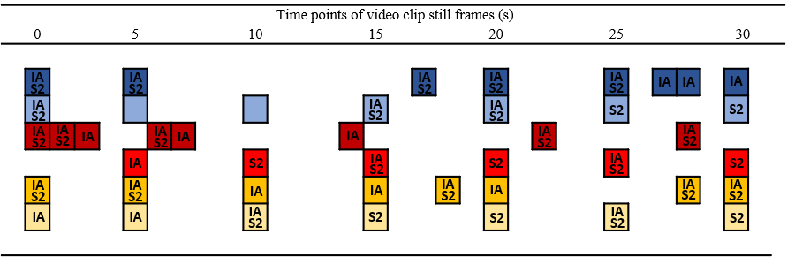
 | NeuH |  | NeuL |  | NegH |  | NegL |  | PosH |  | PosL | IA | Interest Area | S2 | Sequence
Figure 2 Time points of still frames selected from video clips, frames used to generate drawn data for interest areas, and frames used as sequence images.

Count in 3 seconds
Five frames displayed for 6 seconds each
End screen for 2 seconds

Figure 3 Image sequence display timings including count-in and grey end screen.

Editing audio
The audio from each film clip was edited to align the key image sequence events with the associated audio events. For example, in the After the Rain sequence illustrated in Figure 3, the audio event of the car hitting the man was aligned to occur with the time point the image of that event was displayed. If events were to be depicted differently through the modalities of vision and audio, for example through the audio and visual event not being aligned to occur at the same time, presence and immersion within the experience could be reduced for the viewer (Witmer & Singer, 1998) potentially impacting attention on the scene.

Summary
The present chapter has detailed the process of stimuli selection for the studies within this thesis: covering single images, video clips and sequential image stories. It has covered how selection criteria were developed from previous research, how limitations of previous research and stimuli resources have been addressed, and the process of testing the reliability of stimuli to convey expected emotional valence and arousal.
Static single images were selected from the International Affective Picture system (IAPS: Lang et al., 1999; Lang et al., 2008) and the Nencki Affective Picture System (NAPS; Marchewka et al., 2014). The images selected addressed the limitations of images in previous research being replicated. The selection process was informed by criteria used to create the NAPS collection, by criteria from previous research in false memory (Kim et al., 2013), misinformation (Porter, Spencer, & Birt, 2003; Van Damme & Smets, 2014) and in weapons focus (Fawcett et al., 2013), and by participant sample ratings. As a result, six images were selected to replicate the conditions used by Van Damme and Smets (2014): positive valence with high and low arousal, negative valence with high and low arousal, and neutral valence with average and low arousal. Images were also selected to be suitable for the current studies’ experimental conditions across central and peripheral information.
To enable comparisons across the three studies, the criteria for stimuli to be used as sequences and video clips were extended to include criteria and content themes from selected single images. Video material was drawn from the source films used to create the LIRIS-ACCEDE film clip collection (Baveye et al., 2015). Clips were selected to meet the content theme criteria developed from reviewing the IAPS and NAPS images, and by applying film production criteria, such as background consistency and scene changes (Carvalho et al., 2012). Film clips were then rated by a participant sample and six films selected to meet valence and arousal conditions. These final six clips were rated by a second participant sample, with results supporting that clips were reliable in their ability to convey the required emotional valence and arousal. Finally, each video clip was split into still frames to create a sequence story of the content and to allow drawn data to be generated to define centrally emotional information in each image.
Notable issues raised within this chapter have centred around the ability of image and video content to convey reliable valence and arousal to the viewer, specifically, the difference between normative, and sample rated figures, and across samples in the same population. During the single image selection process sample rated figures showed reduced arousal in the image of positive valence with high arousal and increased arousal in the image of negative valence with low arousal when compared to normative figures. The change in rated values highlights the importance of performing a manipulation check in a representative population sample to accommodate the impact of personal, cultural, and contextual, differences (Greenaway, Kalokerinos, & Williams, 2018; Kuppens, Tuerlinckx, Russell, & Barrett, 2013).
Comparing the video ratings from the first and second participant sample showed the video of negative valence with high arousal being rated as more positive by the second sample, and rated arousal for both videos of negative valence switching places. It is possible that valence and arousal were rated differently in the second sample of participants due to the removal of the other videos, and therefore the removal of other content with which to compare and provide context. For example, the first participant sample viewed a clip rated as highly negative and highly arousing which featured an elderly lady being beaten by a security guard. Even though the viewing order was counterbalanced by Latin square design, the viewing of this clip may have provided a level to be compared against when viewing the other images of negative valence, either sensitising participants to subsequent negative content through induced negative state (Westermann et al., 1996) or reducing the impact of the following content as being less negative in comparison through desensitisation (Mrug, Madan, Cook, & Wright, 2015). In the second participant sample, this context was not present as only one video clip was viewed per valence and arousal condition. Although any effect is difficult to determine in this case, further research could investigate the potential impact of rating stimuli as part of multi-clip presentations with that of single clip presentations in conditions of valence and arousal.
An important limitation to the process in this chapter is the assumption that image sequences created to represent video content convey the same valence and arousal as their sample rated source material. Due to time constraints, a separate ratings study for the images sequences was not conducted. To address this limitation a manipulation check was implemented into the procedure for each of the three studies presented in this thesis to allow a comparison of valence and arousal experience between stimuli format and presentation method.

Chapter 3 Defining centrally emotional content
Research investigating the impact of emotion on attention often uses visual stimuli to manipulate the emotionality of experimental conditions, such as using images selected from the International Affective Picture System (IAPS: Bradley & Lang, 1994; Lang, Bradley, & Cuthbert, 2008) or Nencki Affective Picture System (NAPS: Marchewka, Żurawski, Jednoróg, & Grabowska, 2014). Yet, whilst visual resources are rated to provide standardised valence and arousal figures, there is currently no standardised way of distinguishing the content within images into what is emotionally central to the event, and what can be considered as peripheral information.
The novel method devised and outlined below extends the line drawing technique used in Porter, Spencer and Birt (2003) and in Van Damme and Smets (2014), by adopting the element of frequency of selection from Mahé, Corson, Verrier, and Payoux (2015). Porter et al. and Van Damme and Smets, asked participants to draw on each stimuli image to indicate what they felt to be the emotionally central information in each scene. Line drawings were then subjectively combined and used to create a boundary between centrally emotional and peripheral details. In contrast, Mahé et al. asked participants to watch a video which would later be used in a misinformation study. Mahé et al. then used the most frequently recalled elements of the video as central items.
The method presented combines the drawing technique of Van Damme and Smets (2014) with the element of frequency from Mahé et al. (2015), allowing a standardised process for defining what is centrally emotional to a visual scene without removing drawn data from the original event. Consequently, the method maintains spatial acuity between selected content and resulting combined data. The following method is illustrated with the procedure and output from the stimuli as detailed in Chapter 2.
Method applied to images
Drawing phase
Following the image rating procedure as detailed in Chapter 2, participants were asked to complete a drawing task to define centrally emotional content in each image. Twenty-two participants (16 female), with a mean age of 22.05 years (SD = 1.59), viewed each image using imaging software, at a distance of 60cm from the screen. Participants were asked to draw a line around what they felt was the emotional core of each scene to form a closed loop i.e. both start and end points overlapped. If further clarification was needed, participants were asked to draw around the area of the image which they felt could be removed to remove the emotional content. The task was self-paced, with participants redrawing or amending the line until it represented what they had intended. The opportunity to redraw accommodated participants’ varying levels of prior experience with the imaging software. The researcher remained in the room during this task to assist with the software but remained withdrawn from any further interaction with participants after the instructions were given to minimise expectation effects. Line drawings were made using mouse input to control the pencil function in the software at size point five, and drawn data saved as separate layer elements to the original image.

Image screening
Each drawn layer was screened to ensure the line drawn formed a complete loop with both ends touching. Where this was not the case the lines were extending following their projected direction, or if the line left the image, a straight line was drawn from exit to entry point. As participants were asked to close the loops during drawing, gaps of this kind were minimal and spanned a small number of pixel points. Please see Figure 4 for examples of composite drawn data overlaid onto two of the selected images. Each drawn loop was then flood filled with black, for examples please see Figure 5.

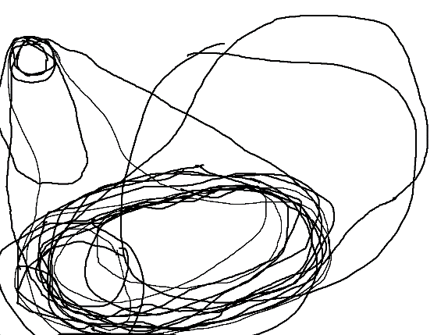 |  | 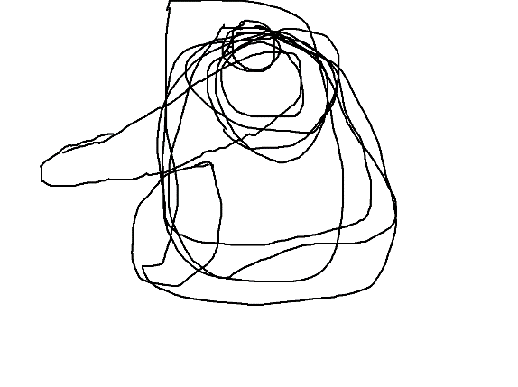
Negative high arousal image |  | Positive high arousal image
Figure 4 Combined line drawings by participants defining centrally emotionally information.

Negative high arousal image |  | Positive high arousal image
Figure 5 Example of single participants drawing flood filled with black.

Creating a frequency map
To create a defined central emotional area for each image, each participant’s flood filled drawn data was overlaid to create a frequency map at pixel data level. A custom software program allowed a 1400 by 1050 pixel sized grid to be created for each image onto which each participant’s data was digitally overlaid. Each time a pixel was coloured in black that pixel increased its frequency score by plus one. When all black filled loop data had been overlaid, and the cumulative frequency score for each pixel data point recorded, frequency data was output to show the highest scoring pixels (the pixel points which had been selected by participants most frequently).

Results
Frequency data
The resulting frequency data was output as a heat map to enable a visual check against the original composite line drawings, with each pixel displaying its selection frequency as a score colour. A red to green colour scale was created by dividing the maximum 256 red and green colour values by the highest frequency score recorded and incrementing each by one resulting value to represent each score. Green represents the lowest scoring pixels, through to red representing the highest scoring pixels. Please see Figure 6 for examples of heat map data.

Negative high arousal image |  | Positive high arousal image
Figure 6 Frequency heat map showing most selected pixel points as red to least selected as green.

As illustrated by Figures 4 and 5, the heat maps displayed in Figure 6 are a more effective visual representation of the most frequently selected image areas than the combined line drawings. The heat maps enable a clearer view of which areas were defined as emotionally central, most consistently. However, using these images alone to create a defined central area would rely on a subjective decision being made about where the defining line should be drawn to separate what is central from what is peripheral.

Creating mask output
To create a quantitatively defined central emotional area, a threshold was applied to the pixel frequency data using the median figure of the highest frequency recorded for each image. Please see Appendix 3 for frequency threshold examples. All pixel points which received a frequency count equal to or below the median value for each image were disregarded, and all pixel points with a frequency count of greater than the median were output as a black mask image. As a result, the top 50% of the frequency scores were output to form the centrally defined area i.e. only the pixels which were selected by more than 50% of all participants. Please see Figure 7 for examples of resulting mask output.
Negative high arousal image |  | Positive high arousal image
Figure 7 Mask output set over original images to show location of centrally defined emotional areas.

The resulting mask images were imported into Experiment Builder eye-tracking software (SR Research, Ontario, Canada) and used to create interest areas to distinguish central and peripheral data. The mask images were also used to define what was central and peripheral information when creating the content for the misinformation and recognition stages within the misinformation paradigm, as detailed in Chapter 4.

Sequences and video
The method detailed previously for images was applied to the still frame images selected to generate interest areas from the video clip content as detailed in Chapter 2. Still frames for interest areas were selected which represented the locational movement of a character or item, or a change of shot perspective within the video content, and so varied in number from three to eight. A total of 34 images were presented to 18 participants (9 female), with a mean age of 22.22 years (SD = 3.39), in an order relative to their appearance in the original film clip after participants had completed the second film ratings task detailed in Chapter 2.
As previously, participants used imaging software to draw around what they felt to be the emotional core of each scene. The resulting drawn loop was screened, and flood filled with black, then used within the frequency method software to create a masked central area. Please see Figure 8 which illustrates this process using stills from the negatively valenced, low arousal video clip.

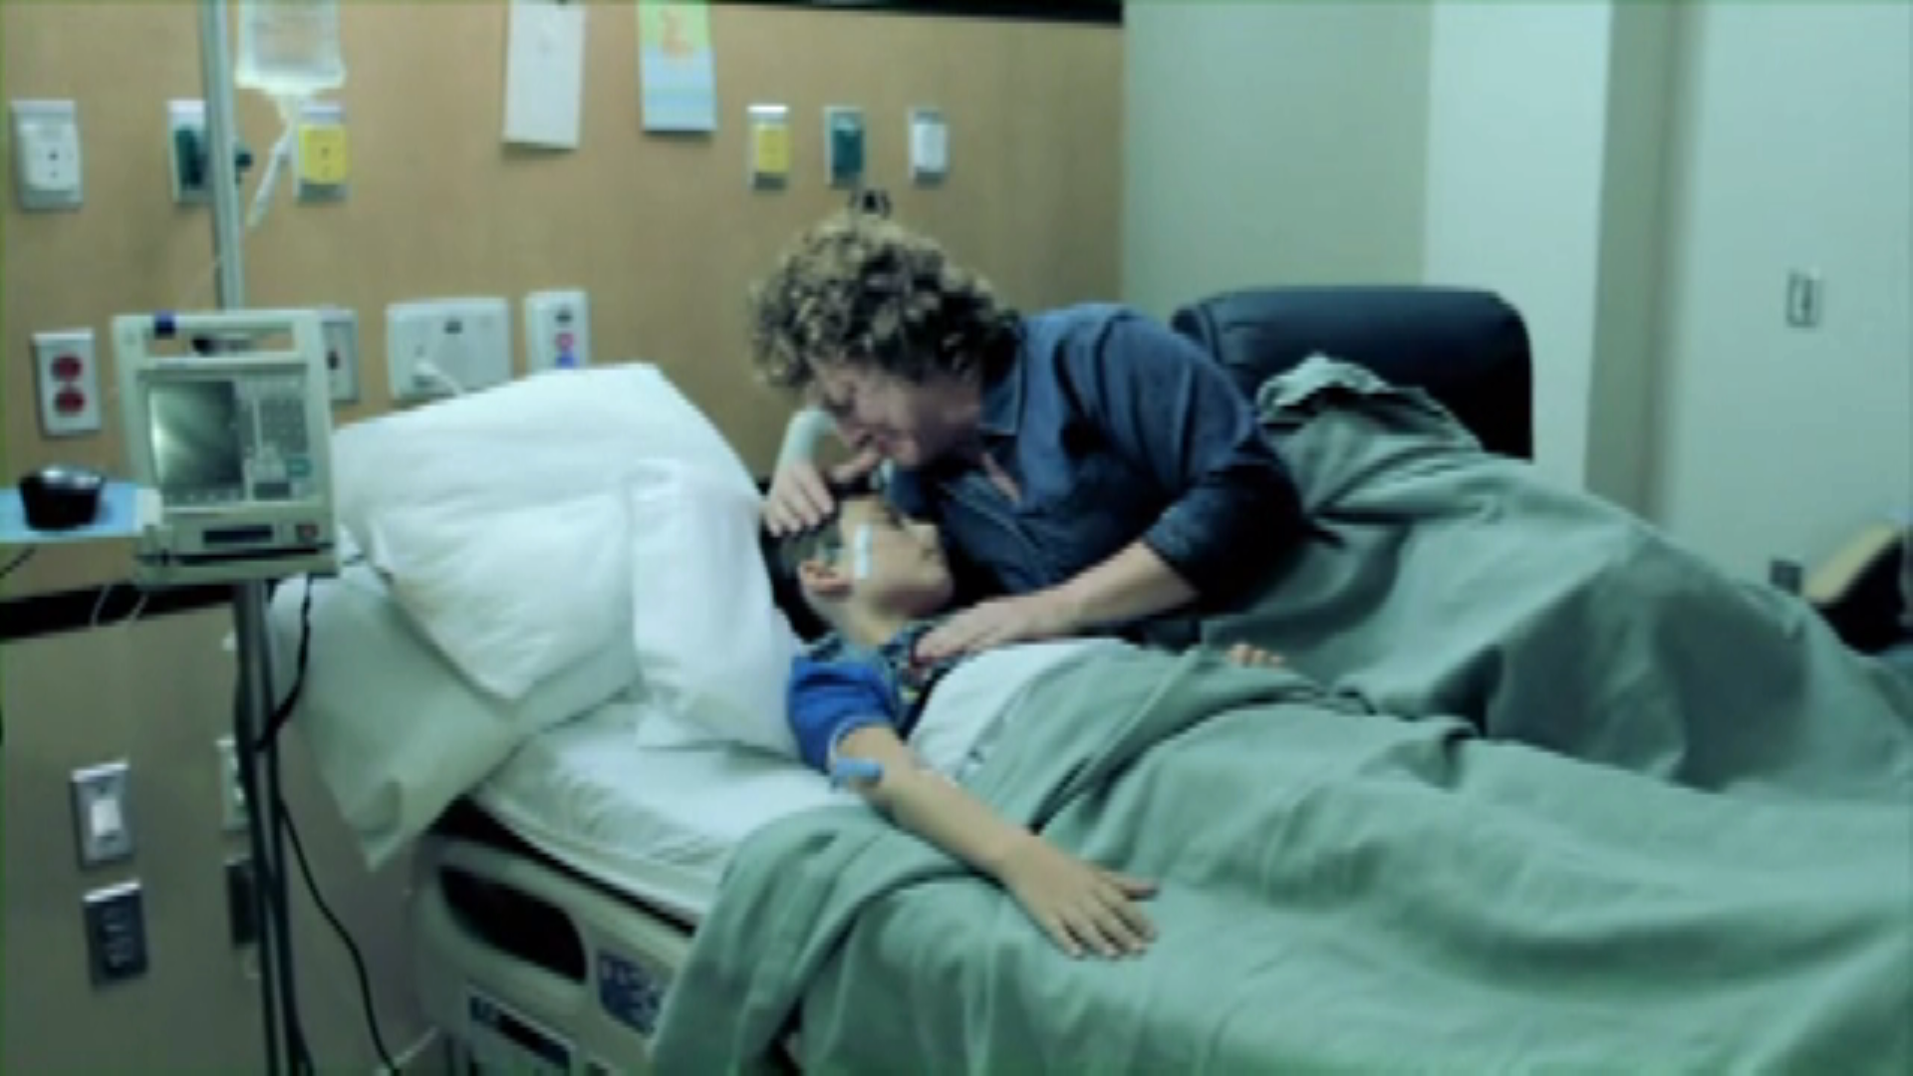
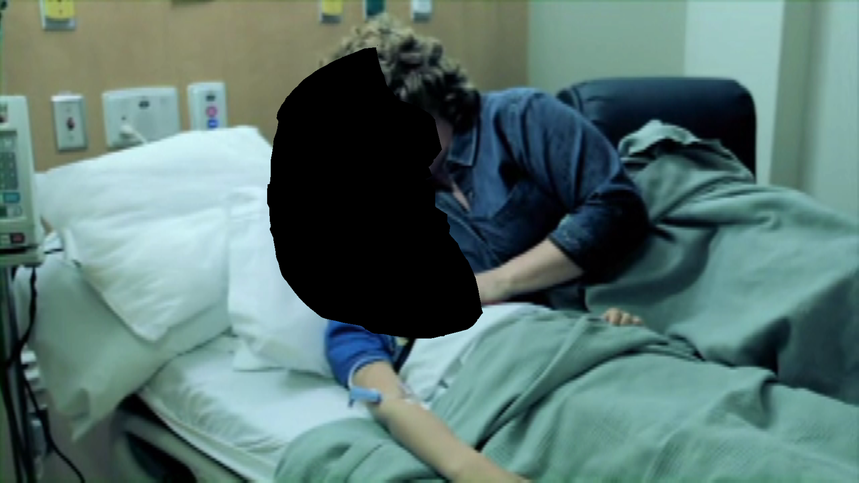
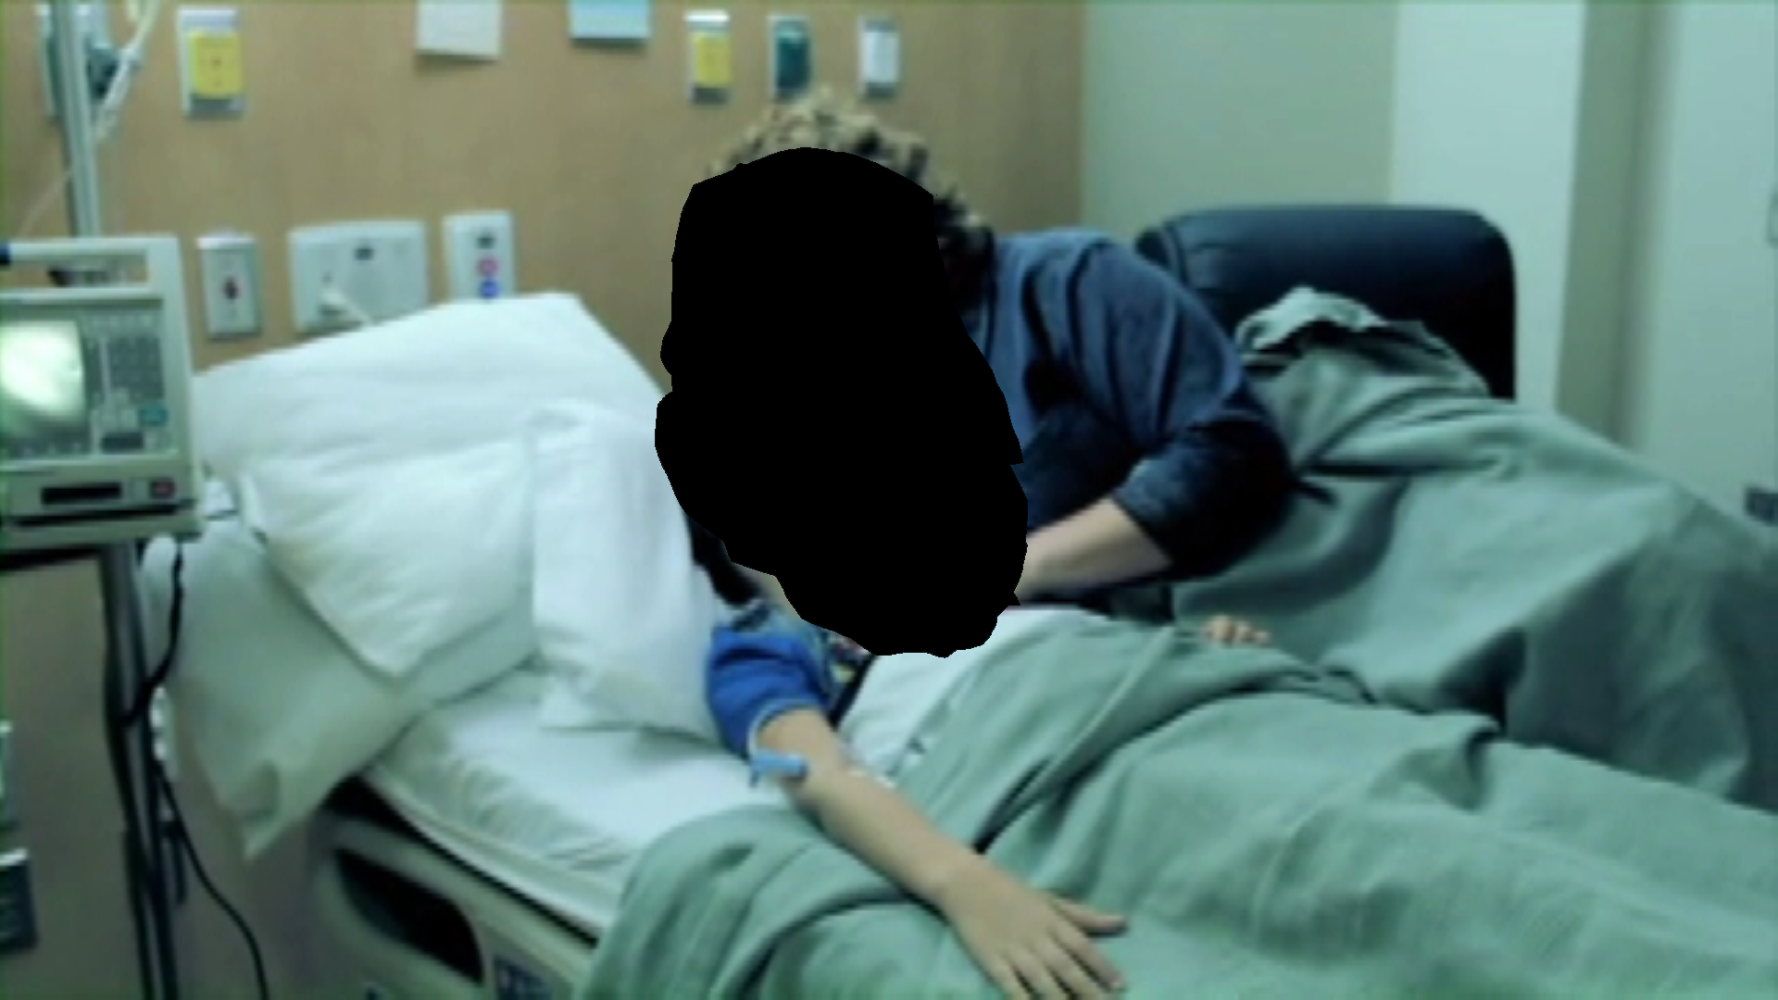
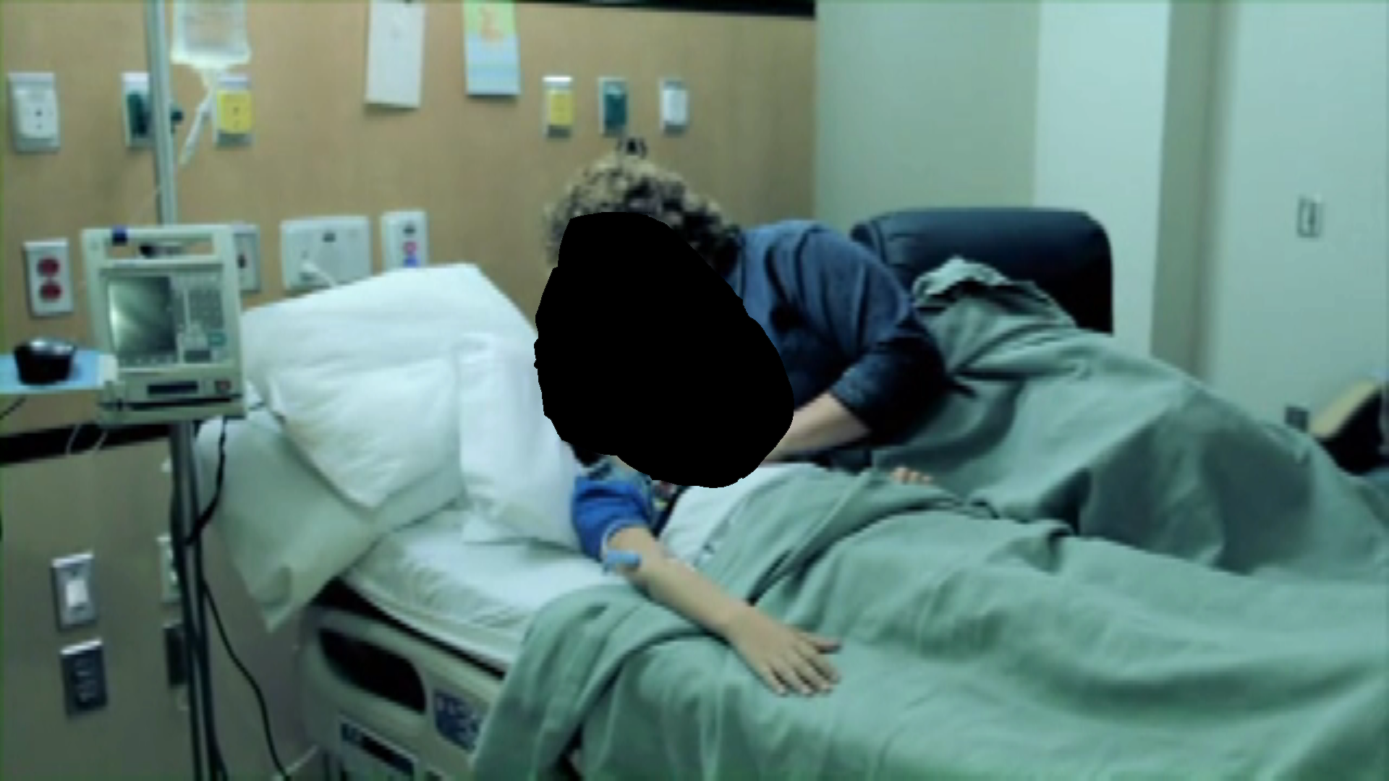

Figure 8 Still frame images from the negative low arousal video with heat map and final central mask area.

The mask output was used to create interest areas within the eye-tracking software with any multiple areas input and grouped together as central for that image. Unlike the mask outputs from the single images, output from the video still frames featured six occurrences where more than one emotionally central area was identified. Three occurred in the neutral stills of high arousal, one in the neutral stills of low arousal, and two in the negative stills of high arousal. Multiple areas occurred in image stills which featured a larger variation in the areas selected by participants. For example, in the neutral low video, two people are sat on steps talking. Participants varied in their choice regarding what was centrally emotional, choosing to select one or the other person, or both, or to partially select people in the scene i.e. faces but not heads. Therefore, although most participants selected both people, the shape of the drawn selection varied, creating areas of the image which received less selection and were not output within the mask as a result.
The masks were imported into Experiment Builder software and drawn around to create defined central and peripheral information areas in the sequential image study detailed in Chapter 5. In the study using video clips as detailed in Chapter 6, the masks were imported as collision maps which were overlaid onto the video to correspond with the time points each image still was selected to represent. This method allowed each fixation to be categorised as either central or peripheral based on its location colour i.e. either black as central information, or white as peripheral information.

Summary
The method detailed in this chapter allows the emotional core of any static image to be determined and implemented into the experimental methodology, using a quantitative, objective, and replicable process. The method builds on existing practise in misinformation research by allowing the wider impact of emotional items and events to be represented as an area of influence, extending beyond an item’s physical boundary. The current solution develops existing methods by removing the subjectivity from the process of combining individual data and maintains spatial acuity of drawn data with the original image content.
As this method is used throughout the following three studies in Chapters 4, 5 and 6, it is evaluated and discussed in the main discussion of Chapter 8.

Chapter 4 Investigating the role of attention in emotional false memory formation using single image stimuli
The first misinformation study presented in this thesis replicates methodology used by Van Damme and Smets (2014) and extends this research with the addition of eye-tracking measures (Greene, Murphy, & Januszewski, 2017) during the encoding phase of the misinformation paradigm. Van Damme and Smets employed distinct high and low arousal conditions within valence categories to explore the impact of post-event misinformation on central and peripheral event information. Their results suggested that misleading information reduced accuracy for central information in the positive high arousal, negative high and negative low arousal, and for all peripheral event details. As a result, Van Damme and Smets suggested that central detail was being enhanced by increased attention in the positive high arousal and for both negative conditions during the event. The bias of attention was suggested to explain the misinformation effect by increasing accuracy for participants not receiving misleading information, an effect which was overridden by the presentation of misleading information. In addition, the central bias of attention was suggested to facilitate reduced accuracy for peripheral detail as less attention was given to peripheral detail to enable verbatim encoding to occur. However, although attention was suggested to be mediating memory accuracy, no measure of attention during encoding was employed. Therefore, the addition of eye-tracking by the present research allows a direct measure of attention to be recorded during encoding, enabling the explanation that attention during an event predicts memory accuracy to be directly tested.
In line with Van Damme and Smets (2014) findings, the present study aimed to test the first four hypotheses of this thesis, as set out in Chapter 1. Firstly, that there would be a higher level of memory accuracy for central detail compared to peripheral detail for events of negative high arousal, negative low arousal and positive high arousal. Secondly, that memory accuracy would be lowered by misleading post-event information, specifically for peripheral event detail and for central details from the negative high arousal, negative low arousal and positive high arousal events. The third hypothesis predicted that central event detail within these three specific events would record longer total viewing times, faster first fixation latencies and higher numbers of fixations, compared to peripheral details in the same events. In an extension to the first three hypotheses, the fourth hypothesis predicted that the attentional measures recorded would predict higher memory accuracy scores when using multiple regression modelling – with increasing viewing time and number of fixations, and decreasing first fixation latency, predicting higher memory accuracy.

Method
Design
A two (group condition) by six (picture type) by two (information location) mixed design was used with participants allocated to either the control (n = 28) or misinformation (n = 28) condition. All participants viewed six images, as per Van Damme and Smets (2014), as detailed in Chapter 2: positive with low (PL) and high (PH) arousal, negative with low (NL) and high (NH) arousal, and neutral scenes with low (NeuL), and average (NeuA) arousal. Each image was defined in to central and peripheral emotion information areas, as outlined in Chapter 3. Participants were allocated to one of six presentation sequences, generated using counterbalanced Latin square design. Eye-tracking measures were recorded to assess attention during the encoding phase. Total viewing time and number of fixations were recorded to assess dwell time and frequency to event details, while latency of first fixation was recorded to measure the speed of attentional capture. Memory accuracy for new correct, misleading, and new incorrect information was tested to assess the impact of misleading information across group, picture type and information location conditions using twelve true or false choice statements about each image (cf. Van Damme & Smets, 2014).

Participants
Participants were 56 students (38 female, 18 male) from Staffordshire University, with a mean age of 20.3 years (SD = 1.65), ranging from 18 to 24. Between-subjects t-test confirmed that there was no significant difference in age between group conditions t(54) = -.080, p = .936, d = 0.02. Participants took part in exchange for research participation credit and were recruited by opportunity sample through advertising on department notice boards and in class groups. All participants had normal, or corrected-to-normal, vision with glasses or contact lenses, were not colour-blind, and did not suffer from photosensitive epilepsy. The sample size and age range were a replication of those from Van Damme and Smets (2014). A prospective power analysis was conducted prior to recruitment which indicated that a sample size of 50 participants would be required to achieve a power of .8 and a large effect of ƞ² = .14, as was reported by Van Damme and Smets. (Clark-Carter, 2010). Full ethical approval was granted for this study by the Faculty of Health Sciences Ethics Panel of Staffordshire University.

Materials
Eye-tracking and stimuli presentation
All instructions and questions were presented in English, and responses recorded through Experiment Builder software (SR Research, Ontario, Canada), in conjunction with a standard PC monitor with mouse and keyboard input. Eye-tracking measures of latency of first fixation, number of fixations, and viewing time (cf. Greene et al., 2017; Humphreys, Underwood, & Chapman, 2010; Kim, Vossel, & Gamer, 2013) were recorded using an Eyelink1000 eye tracker, comprising of a monocular infra-red desktop camera, tracking eye location every 1 ms, with a spatial accuracy between 0.2 and 0.4 degrees. A chin rest and forehead frame were used to minimise participant head movement, which was set at 60 cm distance from the monitor.

Image stimuli
Images were all in landscape orientation at 1400 by 1080 pixels and were selected from the IAPS and NAPS collections (Bradley & Lang, 1994; Lang, Bradley, & Cuthbert, 2008; Marchewka, Żurawski, Jednoróg, & Grabowska, 2014). Images were defined into content which was emotionally central to the image, and conversely information which was peripheral to this. Full details of the image selection process can be seen in Chapter 2, and the central and peripheral definition process in Chapter 3.

Questions
Two sets of questions were compiled for use within the misinformation paradigm: correct detail and incorrect detail questions to be asked during the misinformation phase, and statements to assess recognition during the testing phase. All questions were formed around items in the images and cross-checked over all images to remove duplication of items, or features, such as colour or location. To aid specificity between questions and image content further, questions and statements were presented in the same order as the images, and a prompt was placed at the top left of each question screen stating which image the question or statement was regarding i.e. ‘Question about: the crash scene’.

Mood measure
To monitor any potential effect of mood variation between the two grouping conditions (Forgas, Laham, & Vargas, 2005; Hüttermann & Memmert, 2015; Van Damme, 2013), the Brief Mood Inspection Questionnaire (BMIS; Mayer & Gaschke, 1988) was used to measure participant’s mood prior to image viewing. The BMIS is a self-report measure asking participants to rate 16 mood related adjectives and phrases on a 7-point Likert scale. In addition, participants were asked to rate their current mood from negative to positive, and from calm or drowsy to very excited or upset, using two line measures ranging from zero to a hundred (cf. Van Damme, 2013; Van Damme & Smets, 2014).

Procedure
The procedure was a replication of that used by Van Damme and Smets (2014), with the addition of eye-tracking during the image viewing stage. Participants were tested individually with the researcher monitoring progress via visual and audio feed in a separate room. Participants were advised that the study was investigating attention whilst viewing emotional images, with an aim to compare unconscious visual attention to conscious verbal description. Participants were not advised that the study was investigating memory or misinformation until debriefing to reduce targeted encoding and rehearsal of image detail. Participants were asked to verbally describe their thoughts during encoding to encourage them to attend to the images.

Encoding
Upon arrival, participants gave written consent to participate and completed demographic information detailing fluency of English, sex, age, any eyesight corrections with glasses or contact lenses, if colour blind and if in good general health. Participants then completed the BMIS and line scale mood measures. A nine-point calibration was completed for the eye-tracking equipment, and instructions given to “Look at each picture as if you unexpectedly witness the event and describe what you see.” Each image was viewed for 30 seconds whilst eye-tracking measures were recorded, during which the participant described the image verbally. Following a manually aligned drift correct lasting between 0.5 and 2 seconds, the next image was viewed until all six images had been displayed. Participants then moved away from the eye-tracking equipment to an adjacent desk and worked through a booklet of visual reasoning problems for 35 minutes. The booklet was presented as a study task but was to introduce a delay between encoding and misinformation stages.

Misinformation
The misinformation stage required participants to answer questions about their perception of the images by indicating “yes” or “no” by keyboard input, to four questions about each image: two each regarding central and peripheral detail. Questions were phrased comparably for both groups, but for the those in the Misinformation group, questions contained misleading information. For example, “Did you see the walking stick the elderly man was using?” while those in the Misinformation group were asked “Did you see the metal walking stick the elderly man was using?”. The misinformation stage was followed by a 35-minute block of reasoning problems, to function as a delay between misinformation and recall.

Recognition
Memory accuracy was tested using twelve statements about each image, divided equally across central and peripheral detail, which were answered as “true” or “false” by keyboard input. Four statements contained correct information not previously presented, four contained incorrect information not previously presented, and four tested accuracy for information presented during the Misinformation stage. Both group conditions received the same statements. For those in the Control group the statements testing misleading information contained new misleading information, as they had not received this information previously. The study session ended with a manipulation check (cf. Van Damme & Smets, 2014), as participants viewed each image again for six seconds, rating valence and arousal using the Self-Assessment Manikin (SAM; Bradley & Lang, 1994; Lang et al., 2008). Participants were then debriefed and thanked for their participation.

Results
Mood check
The BMIS subscales of pleasant-unpleasant and aroused-calm (Mayer & Gaschke, 1988) were used to score participant mood prior to image encoding, along with line ratings (cf. Van Damme & Smets, 2014). Please see Table 7 for mean figures with standard deviations.

Table 7 Mean valence and arousal ratings with standard deviations using BMIS and line scales.

Group |  | BMIS | Line Scale
All N = 56 | Valence | 70.82 (9.92) | 73.47 (13.07)
 | Arousal | 54.91 (8.90) | 49.84 (16.41)
Control n = 28 | Valence | 70.54 (9.33) | 73.02 (14.37)
 | Arousal | 54.96 (7.69) | 53.61 (16.82)
Misinformation n = 28 | Valence | 71.09 (10.64) | 73.93 (11.89)
 | Arousal | 54.86 (10.10) | 46.07 (15.36)

Between-subjects t-tests evidenced no significant difference between the two group conditions on valence using the BMIS: t(54) = -.209, p = .836, d = .05 CI [-5.92, 4.81], or line scale t(54) = -.258, p = .797, d = .07 CI [-7.98, 6.16], or in arousal using the BMIS: t(54) = .041, p = .967, d = .01 CI [-4.71, 4.91], or line scale t(54) = 1.751, p = .086, d = .47 CI [-1.09, 16.17], all tests two-tailed. However, as detailed in Table 7, the line scale ratings for arousal appear to be lower than ratings using the BMIS. This difference was confirmed by within-subjects t-test which showed there to be a significant difference between the BMIS and line scales for arousal t(55) = 2.113, p = .039, d = .38 CI [.262, 9.88] with the line scale recording a lower arousal mean, but not for valence t(55) = -1.520, p = .134, d = .23 CI [-6.16, .846]. This difference suggests that the two measures of arousal may not be comparable.

Image manipulation check
Table 8 details the results of the manipulation check ratings by participants, alongside normative figures, which illustrates that all ratings are within one scale point of published figures. Notably, arousal ratings had a greater level of variation than valence ratings, with both positive and the negative and neutral low arousal images, being rated as more arousing than expected, and negative and neutral higher arousal as less arousing.

Table 8 Participant image rating figures compared to normative valence and arousal figures.

Picture | Reference | Normed Valence | Normed Arousal | Rated Valence | Rated Arousal
PH | NAPS P187 | 7.84 (1.20) | 5.78 (2.18) | 7.80 (1.14) | 6.73 (1.56)
PL | NAPS F252 | 7.35 (1.25) | 4.54 (1.80) | 7.39 (0.97) | 5.23 (1.65)
NL | IAPS 9220 | 2.06 (1.54) | 4.00 (2.09) | 2.70 (1.37) | 4.36 (1.97)
NH | NAPS P022 | 2.13 (1.06) | 6.48 (2.08) | 2.38 (1.40) | 5.73 (2.21)
NeuA | NAPS F289 | 4.69 (1.34) | 5.22 (1.05) | 4.07 (1.56) | 4.43 (1.82)
NeuL | IAPS 8121 | 4.63 (1.54) | 4.14 (2.10) | 4.75 (0.84) | 4.36 (1.80)

The differences in arousal ratings, compared to the normative figures, may reflect participants’ prior exposure to the images, and to repeated focus on details about image content during the study session. Unlike valence, arousal is suggested to not be affectively stable with increased exposure (Postzich, Blask, Frings & Walther, 2016). As the manipulation check was conducted at the end of the study session the arousal ratings may not be an authentic representation of participants first experience. Accordingly, the rated arousal level will be treated with caution in the following results.
Within-subjects’ analyses showed that images were rated as significantly different across valence F(1.531, 84.19) = 393.127, p < .001, ƞ_{p}² = .89, and arousal conditions F(1.644, 90.398) = 32.178, p < .001, ƞ_{p}² = .37. Contrasts confirmed expected valence categories, with positive images rated significantly higher than negative images p < .001, d = 5.01, CI [4.50, 5.65], and neutral images rated higher than negative images p <.001, d = 1.93, CI [1.48, 2.28], and lower than positive images p < .001, d = 4.68, CI [2.82, 3.56]. Arousal contrasts also confirmed patterns expected from mean figures, with high arousal images significantly higher in arousal than both average p < .001, d = .67, CI [1.08, 2.56] and low arousal images p < .001, d = .90, CI [1.11, 2.06]. However, no significant difference was observed between the average and low arousal conditions p = 1, d = .14, CI [ -.816, .376].

Eye-tracking
To investigate the role of attention in memory accuracy, eye-tracking measures of the number of fixations, viewing time and latency of first fixation were recorded. Number of fixations indicated how many fixations were made to each defined central and peripheral interest area. Viewing time recorded total dwell time using the sum of all fixation length within the target areas irrespective of sequence, and latency of first fixation evidenced the time taken to first fixate on each target area from display onset after the initial fixation from the drift correct screen had been removed (cf. Bennion, Steinmetz, Kensinger, & Payne, 2013). An initial alpha level of .05 was set and adjusted using a Bonferroni correction where relevant to level of analysis. All confidence intervals are reported at 95% and outlying data points are defined as being plus or minus three standard deviations from the mean. Means and standard deviation for eye-tracking measures are presented in Table 9.

Table 9 Means with standard deviations for image condition by information location for number of fixations, viewing time, and latency of first fixation.

 | Number of Fixations |  | Viewing Time (s) |  | Latency of First Fixation (s)
Picture | Central | Peripheral | Central | Peripheral | Central | Peripheral
PH | 23.87 (9.54) | 65.04 (15.06) | 6.59 (2.66) | 16.95 (3.27) | 0.27 (0.12) | 0.77 (0.34)
PL | 23.31 (10.14) | 69.87 (15.41) | 6.29 (2.67) | 17.32 (3.03) | 0.39 (0.23) | 0.95 (0.66)
NH | 21.73 (7.45) | 69.75 (16.76) | 5.28 (2.25) | 18.02 (2.76) | 0.74 (0.72) | 0.74 (0.63)
NL | 64.10 (14.25) | 25.56 (14.48) | 17.36 (3.70) | 6.42 (3.24) | 0.23 (0.07) | 4.77 (2.91)
NeuA | 26.56 (11.05) | 63.98 (17.07) | 7.34 (3.41) | 15.83 (3.92) | 0.27 (0.04) | 0.84 (0.75)
NeuL | 27.19 (8.90) | 66.90 (15.80) | 6.79 (2.30) | 15.74 (2.87) | 0.52 (0.40) | 0.52 (0.31)

As detailed in Table 9, central information recorded fewer fixation numbers and shorter fixation durations than peripheral detail in the positive high and low arousal conditions, the neutral average and low arousal conditions, and in the negative high arousal condition. For the negative low arousal event, the opposite pattern was evidenced. Latency of first fixation indicated that attention was captured by central information later in the negative high arousal event and attentional capture was also delayed to peripheral information in the negative low arousal event.
To evaluate the effect of valence and arousal, and information location on number of fixations, viewing time and latency of first fixation, three six (picture type: positive high and low arousal, negative high and low arousal and neutral average and low arousal) by two (information location: central, peripheral), within-subjects ANOVA were conducted.

Latency of first fixation
There was a significant main effect of picture type for latency of first fixation F(1.333, 57.326) = 66.576, p < .001, ƞ_{p}² $=.608$. Pairwise comparisons demonstrated that first fixation latency was slower to the negative low image compared to all other images: positive high p < .001, d = 1.91 CI [-5326.86, -2612.73], and low p < .001, d = 1.73 CI [-5042.34, -2294.84]; negative high p < .001, d = 1.65 CI [-4888.53, -2183.11]; neutral average p < .001, d = 1.82 CI [2452.50, 5333.78], and low arousal p < .001, d = 1.88 CI [2646.84, 5298.39]. The high arousal positive image was slower to be fixated on than the low arousal image p = .049, d = 0.550 CI [-602.06, -.35], and the negative high image p = .004, d = 0.72 [-773.60, -94.36]. There was also a significant main effect of information location F(1.0, 43.0) = 149.983, p < .001, ƞ_{p}² $=.777$, which supported that central information (M = 402.57, SD = 146.31) was fixated on significantly faster than peripheral information (M = 1430.76, SD = 580.10).
In addition to main effects of picture type and information location, there was a significant interaction between picture type and information location within latency of first fixation F(1.543, 66.36) = 71.595, p < .001, ƞ_{p}² $=.625$. The interaction, as illustrated in Figure 9, was explored by splitting the data by picture type to compare central and peripheral information. Fixation to central information was significantly faster, at p < .001, for the positive high Z = -5.275, N = 44, r = 0.80 CI [-617.72, -385.92], and low arousal images Z = -5.088, N = 44, r = 0.77 CI [-764.15, -343.17], the negative low image Z = -5.777, N = 44, r = 0.87 CI [-5423.40, -3658.73] and for the neutral average image Z = -5.135, N = 44, r = 0.77 CI [-804.31, -343.10], compared to speed to fixate on peripheral information in the same scenes. Yet there was no significant difference observed in the speed to first fixate on central and peripheral information for both the negative high and neutral low arousal images.
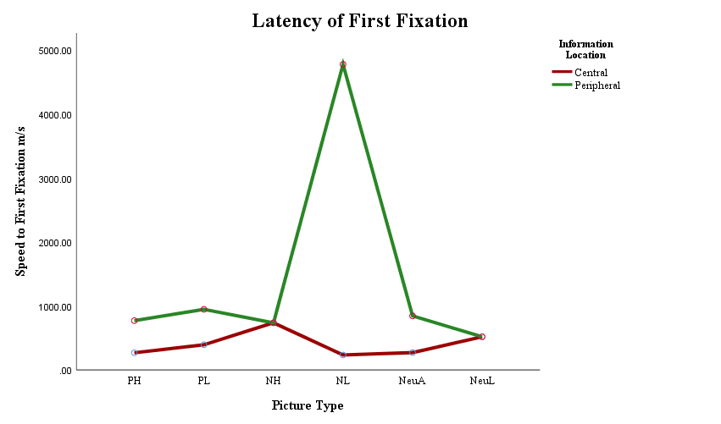
Figure 9 Mean latency of first fixation time for central and peripheral image areas by event condition.

Twelve participants’ data were excluded from the analysis due to containing outlying data points. Sensitivity analysis showed no change to main effects or interaction. Pairwise comparisons exploring the main effect of picture type remained showing the negative low being significantly slower to first fixation than all other images. However, the positive images first fixation speed moved from being significant at p = .049 to showing no difference at p = 1. Therefore, this result should be treated with caution. Contrasts to explore the interaction between picture type and information location displayed no change.

Number of fixations
There was a significant main effect of picture type for number of fixations F(5, 255) = 5.112, p <.001, ƞ_{p}² $=.091$. Pairwise comparisons evidenced the number of fixations to the positive low image to be significantly greater than the positive high image p < .001, d = 0.39 [-10.441, -2.097]. In contrast, there was no significant difference evidenced for fixations between the two negative or neutral images suggesting that no effect of arousal was occurring. The high arousal images evidenced no significant difference between valence conditions, but at low arousal the negative image received fewer fixations than both the positive p = .007, d = 0.35 CI [.498, 5.02] and neutral p = .019, d = 0.27 CI [.218, 4.22]. There was also a main effect of information location F(1, 51) = 213.055, p < .001, ƞ_{p}² $=.807$, which showed that central information was fixated upon less (M = 31.46, SD = 6.97) than peripheral information (M = 60.18, SD = 12.56).
Along with main effects of picture type and information location, there was also a significant interaction between picture type and information location F(4.285, 218.528) = 189.756, p <.001, ƞ_{p}² $=.788$.
To explore the interaction between picture type and information location, as illustrated in Figure 10, data was split by picture type to compare the number of fixations made to central and peripheral information areas. Paired samples t-tests showed peripheral information to have received significantly more fixations than central information in five of the six image conditions at p < .001: positive high t(51) = -15.398, d = 3.27, [-46.54, -35.81], and low arousal t(51) = -15.629, d = 3.57, [-50.28, -38.83], negative high t(51) = -17.297, d = 3.70, [-53.59, 42.45], neutral average t(51) = -11.370, d =2.60 [-44.03, -30.82], and neutral low arousal t(51) = -14.644, d = 3.10, [-45.16, -34.27]. The negative low arousal image observed the opposite result with significantly more fixations made to central information than peripheral t(51) = 11.598, p < .001, d = 2.68, [31.87, 45.21].

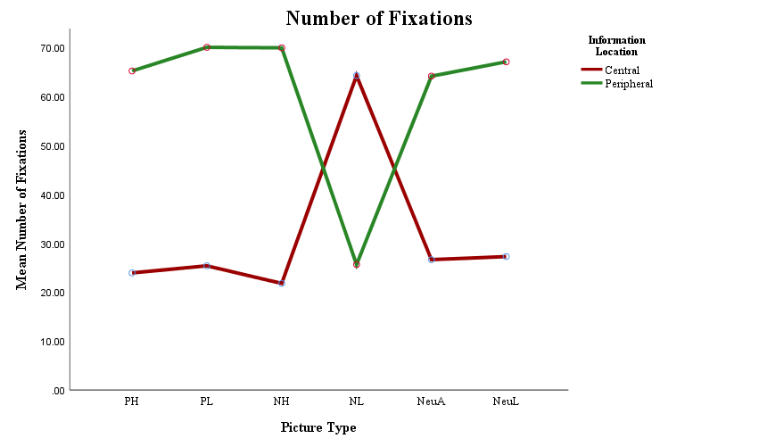
Figure 10 Mean number of fixations for central and peripheral image areas by event condition.

Four participants data were excluded from the analysis due to containing outlying data points. Sensitivity analysis confirmed that the removed outlying data had no effect on significance or effect direction.

Viewing time
There was a significant main effect of picture type observed for viewing time F(3.121, 156.040) = 2.8333, p = .038, ƞ_{p}² $=.054$. Contrasts to investigate the main effect showed no effect of valence, with no difference between high and low arousal conditions. There was no significant difference in viewing time to high arousal conditions, yet at low arousal the neutral image had significantly shorter viewing time than the positive image p = .007, d = 0.39 CI [95.12, 991.04] and the negative image p = .001, d = 0.45 CI [182.82, 1062.85]. There was also a main effect of information location F(1, 50) = 243.454, p < .001, ƞ_{p}² $=.830$ which indicated that central information (M = 8274.33, SD = 1836.91) was viewed for less time than peripheral information (M = 15045.26, SD = 2070.43).
In addition to main effects of picture type and information location, there was a significant interaction between the two F(5, 250) = 174.925, p < .001, ƞ_{p}² $=.778$. To investigate the interaction, as detailed in Figure 11, data was split by picture type to compare central and peripheral viewing time. Significantly shorter viewing times were evidenced in five of the six images for central information compared to peripheral information, at p < .001: positive high t(50) = -14.875, d = 3.48, [-11760.67, -8962.39], and low t(50) = -15.239, d = 3.86, [-12476.64, -9570.78], neutral average t(50) = -9.569, $d=$ 2.31, [-10267.26, -6704.94], and low t(50) = -15.363, $d=$ 3.44, [-10114.52, -7775.56] and negative high arousal Z = -6.215, N = 51, r = 0.87, [-13962.86, -11522.27]. As was evidenced for number of fixations, the negative low arousal image depicted the opposite pattern t(50) = 11.904, p < .001, $d=$ 3.15, [9088.64, 12778.11], with viewing time significantly higher for central compared to peripheral information.

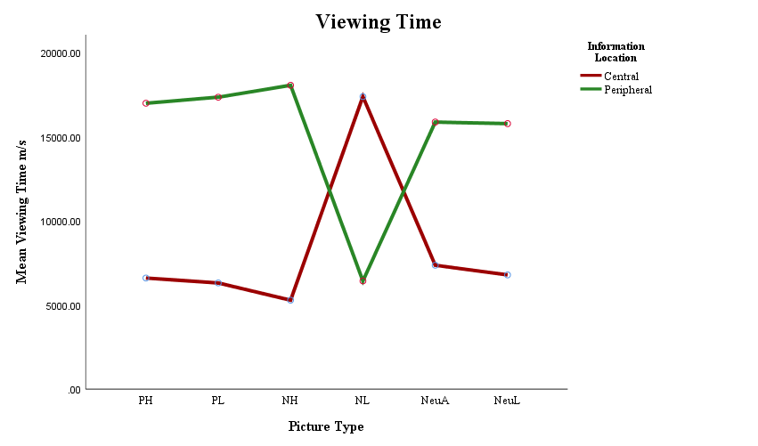
Figure 11 Mean viewing time for central and peripheral image areas by event condition.

Five participants data were excluded from the analysis due to containing outlying data points. Sensitivity analysis to explore the effect of the removed outlying data found the main effect of picture type moving from significant at p = .038 to marginally significant at p = .066. The main effect of information location, interaction between picture type and information location, pairwise comparisons and post-hoc contrasts to investigate the interaction, all remained significant with no change of effect direction.

Eye-tracking summary
In summary, the third hypothesis i.e. that central event details within the negative high arousal, negative low arousal and positive high arousal stimuli would record longer total viewing times, faster first fixation latencies and higher numbers of fixations, compared to peripheral details in the same events, was not supported. Participants fixated less, and spent less time looking at the emotionally central information, and more time looking at the non-emotional, peripheral areas in all images except the negative low arousal image. The negative low arousal image showed the opposite pattern of results, with participants fixating more and spending more time viewing central, compared to peripheral information. For high and low arousal positive images, the neutral average arousal image and the negative low arousal image, participants looked at the emotional information in the scene faster than at the non-emotional information. In the negative high arousal and neutral low arousal images, there was no difference between first fixation times to central and peripheral areas.

Memory accuracy
Three, three-way mixed ANOVAs using a two (group: misled, control) by six (picture type: positive high and low arousal, neutral average and low arousal, negative high and low arousal) by two (information location: central, peripheral) design were conducted to evaluate accuracy for new correct, new incorrect and misleading information. An initial alpha level of .05 was set and adjusted using a Bonferroni correction where relevant to level of analysis. All confidence intervals are reported at 95% and outlying data points are defined as being plus or minus three standard deviations from the mean. Means and standard deviations are presented in Table 10.

Table 10 Means and standard deviations for number of correct, new false and misleading information statements.

Statement | Group | Location | PH | PL | NH | NL | NeuA | NeuL
Correct | Control | Central | 1.88 (.33) | 1.04 (.68) | 0.68 (.69) | 1.52 (.59) | 1.72 (.46) | 1.96 (.20)
 |  | Peripheral | 1.76 (.44) | 1.04 (.68) | 1.48 (.59) | 1.04 (.79) | 1.36 (.48) | 0.72 (.84)
Correct | Misled | Central | 1.64 (.49) | 1.04 (.69) | 1.00 (.72) | 1.50 (.75) | 1.82 (.39) | 1.86 (.36)
 |  | Peripheral | 1.64 (.62) | 1.29 (.71) | 1.46 (.64) | 0.96 (.79) | 1.25 (.52) | 0.82 (.72)
False | Control | Central | 1.78 (.57) | 1.00 (.56) | 1.89 (.32) | 1.37 (.63) | 1.78 (.42) | 1.93 (.27)
 |  | Peripheral | 1.56 (.58) | 1.26 (.66) | 1.26 (.66) | 1.74 (.45) | 1.63 (.57) | 1.07 (.55)
False | Misled | Central | 1.71 (.46) | 1.25 (.75) | 1.75 (.44) | 1.29 (.60) | 1.61 (.57) | 1.79 (.42)
 |  | Peripheral | 1.29 (.76) | 1.21 (.74) | 1.57 (.57) | 1.57 (.57) | 1.46 (.58) | 1.07 (.47)
Misleading | Control | Central | 1.96 (.20) | 1.54 (.58) | 1.77 (.51) | 1.00 (.57) | 1.69 (.47) | 1.19 (.63)
 |  | Peripheral | 1.73 (.45) | 1.39 (.57) | 1.50 (.51) | 1.73 (.45) | 1.27 (.60) | 1.04 (.60)
Misleading | Misled | Central | 1.59 (.57) | 1.52 (.51) | 1.74 (.45) | 0.82 (.62) | 1.37 (.63) | 0.93 (.78)
 |  | Peripheral | 1.59 (.64) | 1.15 (.66) | 1.26 (.53) | 1.30 (.61) | 1.11 (.58) | 0.93 (.78)

The data in Table 10 illustrate no clear patterns occurring between control and misled participant accuracy, or accuracy between central and peripheral information. Accuracy appears to be higher in the positive high arousal and neutral average arousal conditions with all conditions recording accuracy above 1 i.e. at 50%. In contrast, the neutral low condition shows seven conditions in which accuracy is at or below 50%.

New correct information
Memory accuracy for new correct information observed a significant main effect of picture type F(5.265) = 14.445, p < .001, ƞ_{p}² $=.214$. When investigated by pairwise comparisons, the effect of picture type showed no clear effect of valence or arousal. The positive high arousal image had higher accuracy than the positive low arousal image p < .001, d = 1.27 CI [0.66, 1.64], but there was no difference between negative or neutral arousal conditions. When compared across valence there was no difference between positive and neutral higher arousal image accuracy, but the negative high arousal image demonstrated lower accuracy than both neutral average p < .001, d = 0.93, CI [-.613, -.151], and positive high arousal images p < .001, d = 1.35, CI [-.824, -.327]. At low arousal the positive image had lower accuracy than the neutral image p = .048, d = 0.50 CI [-.477, -.001], with no difference between positive and negative, or neutral and negative images.
There was also a main effect of information location F(1, 53) = 29.023, p < .001, ƞ_{p}² $=.354$, with higher accuracy for central (M = 7.79, SD = 1.17) compared to peripheral information (M = 7.42, SD = 1.95).
In addition to main effects of picture type and information location, there was a significant interaction between information location and picture type F(5, 265) = 28.602, p < .001, ƞ_{p}² $=.35$, The interaction, as displayed in Figure 12, split the data by picture type to allow comparisons to be made between central and peripheral accuracy. Contrasts showed significantly higher central accuracy in the negative low arousal image Z = -3.292, r = .45 CI [-595.26, -57.97], neutral average arousal image Z = -4.226, r = .58 CI [0.29, 0.66], and neutral low arousal image Z = -5.684, r = .78 CI [0.92, 1.35], and contrastingly higher peripheral accuracy in the negative high arousal image t(52) = -4.696, $d=$ 1.39 CI [-0.89, -0.36] (all p < .001, N = 53, one-tailed). There was no significant difference between central and peripheral accuracy in either positive images.

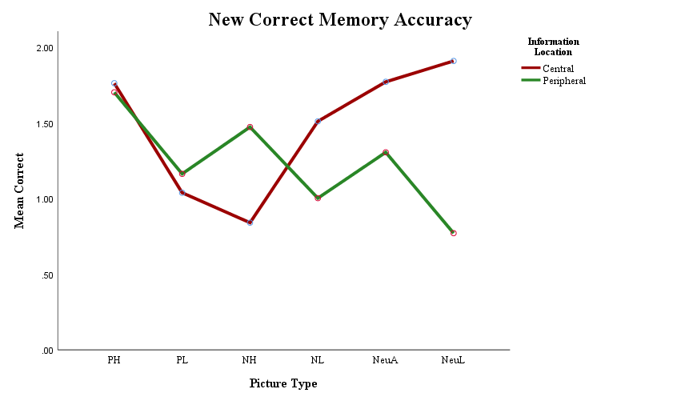
Figure 12 Mean memory accuracy for newly presented correct central and peripheral detail by image event condition.
Three participants’ data were excluded from the analysis due to containing outlying data points. Sensitivity analysis showed no change in the main effects or interaction, but pairwise comparisons exploring picture type showed the significant difference between positive and negative low arousal images changed to be non-significant at p = .219. Therefore, this result should be treated with caution. Contrasts investigating the interaction between picture type and information location remained unchanged.

New incorrect information
As observed in the analysis of new correct information, a significant main effect was evidenced for picture type F(5, 265) = 12.441, p < .001, ƞ_{p}² $=.190$. When investigated with pairwise comparisons it was evidenced that the positive low arousal image recorded significantly lower accuracy than the five other image conditions: positive high arousal p < .001, d = 0.92 CI [0.32, 1.24], negative high arousal p < .001, d = 0.95 CI [-1.28, -0.36], negative low arousal p = .003, d = 0.70 CI [-1.06, -0.14], neutral average arousal p < .001, d = 0.98 CI [-1.23, -0.45], neutral low arousal p = .006, d = 0.71. CI [-0.99, -0.10]. There was no difference between valenced matched negative and neutral images, or between higher arousal conditions. There was also a main effect of information location F(1, 53) = 15.705, p < .001, ƞ_{p}² $=.229$, which indicated that accuracy was higher for central new incorrect information (M = 9.56, SD = 1.69) compared to peripheral (M = 8.35, SD = 1.57).

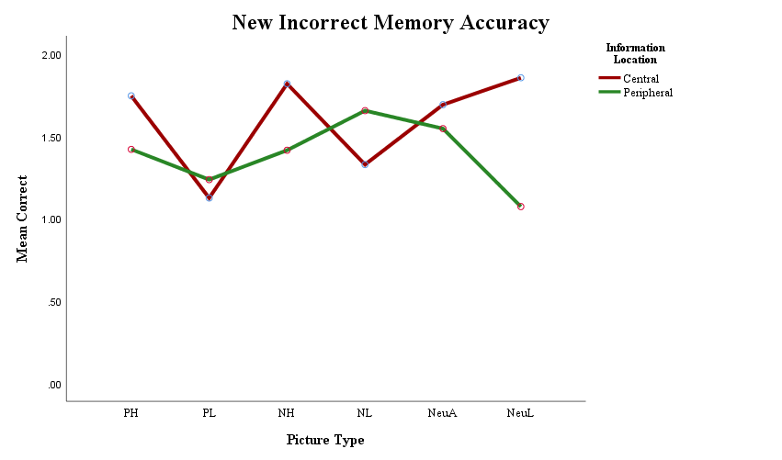

Figure 13 Mean memory accuracy for newly presented incorrect central and peripheral detail by image event condition.
In addition to main effects of picture type and information location, there was a significant interaction between the two F(3.981, 211.018) = 12.698, p < .001, ƞ_{p}² $=.193$. Contrasts to explore the interaction, as displayed in Figure 13, evidenced that central information accuracy was greater than peripheral in the positive high arousal image Z = -2.361, p = .01 r = .32, negative high arousal image Z = -3.657, $p$ < .001, r = .49 and neutral low arousal image Z = -5.879, $p$ < .001, r = .79, CI [0.07, 0.59], [0.21, 0.59], and [0.62, 0.94]. In contrast, for the negative low arousal image, accuracy was poorer for central compared to peripheral information Z = -2.781, $p$ = .001, r = .38, CI [-0.55, -0.11]. There was no significant difference between central and peripheral accuracy in the neutral average or positive low arousal images (all one-tailed, N = 55).
One participants data was removed from the analysis due to having outlying data points. Sensitivity analysis confirmed no change of significance or effect direction for ANOVA or follow up analysis.

Misleading information
In contrast to the analysis for new correct and incorrect information, memory accuracy for misleading information did display a significant main effect of group F(1, 51) = 9.071, p = .004, ƞ_{p}² $=.151$.

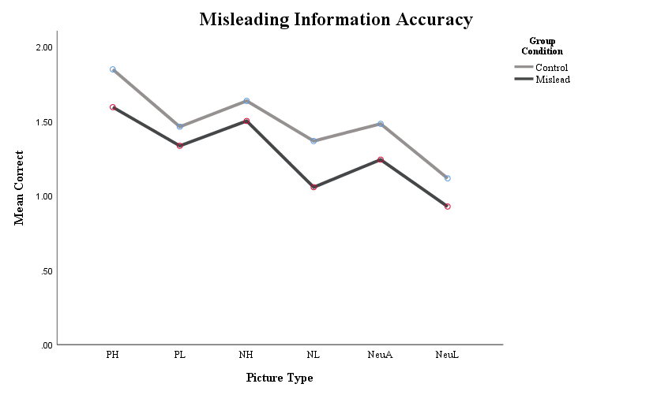
Figure 14 Mean memory accuracy for misleading information comparing control and misled groups by image event.

As illustrated in Figure 14, participants in the Control condition had higher accuracy scores (M = 17.81, SD = 0.44) than those in the Misled condition (M = 15.30, SD = 3.64), suggesting that the post-event misinformation was lowering accuracy. There was no interaction between Group condition and Picture Type, or between Group and Information Location, suggesting that misinformation was lowering accuracy with similar effect across all picture types and information locations.
As in new correct and new incorrect information, a significant main effect of picture type was observed F(5, 255) = 22.89, p < .001, ƞ_{p}² $=.310$. In contrast to the new correct and new incorrect information types, an effect of arousal was observed when exploring the main effect of picture type. The positive high arousal image had significantly higher accuracy than the positive low arousal image p = .002, d = 0.76, CI [0.16, 1.13], the negative high arousal image had higher accuracy than the negative low arousal image p < .001, d = 0.85, CI [0.29, 1.14], and the neutral average arousal image showed higher accuracy than the neutral low arousal image p = .003, d = 0.72, CI [0.16, 1.19]. High arousal images demonstrated the neutral image to have lower accuracy than both the positive image p < .001, d = 0.83 CI [-.565, -.152] and the negative image p = .040, d = 0.51 CI [-.408, -.005], with no difference between positive and negative image accuracy. At low arousal, the positive image displayed higher accuracy than the neutral image p = .001, d = 0.76 CI [.112, .641] with no difference between positive and negative, or between negative and neutral images. There was no main effect of information location for misleading information.
Along with a main effect of picture type, a significant interaction was evidenced between picture type and information location F(5, 255) = 13.452, p < .001, ƞ_{p}² $=.209$. As observed for new correct and new incorrect information, the interaction, as detailed in Figure 15, was explored by comparing central and peripheral accuracy within each image. In line with the hypothesis prediction, a central accuracy advantage was observed for the positive high arousal image t(52) = 5.547, p < .001, d = 0.22 CI [.325, .694] and negative high arousal image t(52) = 4.006, p < .001, d = 0.75 CI [.188, .566], along with a central accuracy advantage for the positive low arousal t(52) = 2.44, p = .009, d = 0.45 CI [.047, .481]and neutral average arousal image t(52) = 2.632, p = .005, d = 0.58 CI [.081, .599], but not for the neutral low arousal image. The negative low arousal image presented the opposite effect to that predicted, showing a peripheral advantage t(52) = -6.137, p < .001, d = 1.03, CI [-0.80, -0.41].

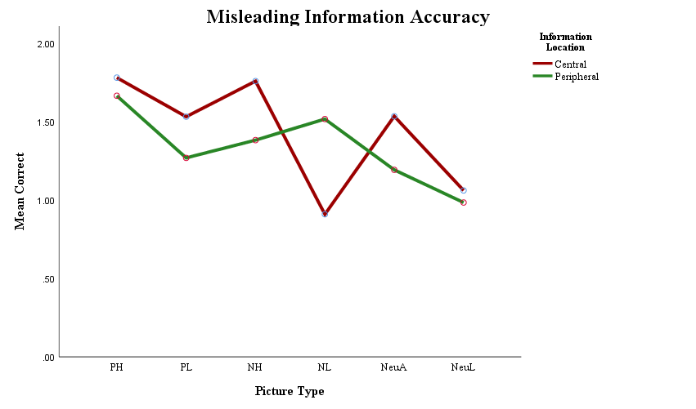
Figure 15 Mean memory accuracy for misleading central and peripheral information by image event condition.

Three participants’ data were excluded from the analysis due to containing outlying data points. Sensitivity analysis confirmed the main effects and interactions. Pairwise comparisons exploring the main effect of picture showed the significant difference between neutral average and negative high images at p = .04 move to show no difference at p = .115. In contrast, the comparison between positive and negative low arousal images moved to be significant at p = .023, d = 0.81 CI [.151, .670] with the negative low arousal image having lower accuracy. These results should, therefore, be treated with caution. Contrasts investigating the interaction between picture and information location showed no change in significance or effect direction.

Memory accuracy summary
In summary, the prediction of hypothesis one i.e. that central information in both negative events, and in the positive high arousal event, would be recalled with greater accuracy compared to peripheral detail, and hypothesis two i.e. that accuracy for these events, along with peripheral detail, would be reduced by participants exposure to misleading post-event information, are both only partially supported. A misinformation effect was only evidenced within misleading information presented during the misinformation phase however, misinformation reduced accuracy for both central and peripheral details in all event conditions. A misinformation effect was not observed for either new correct or new incorrect information. Within all new correct and new incorrect information types, participants recorded higher memory accuracy for central compared to peripheral information, although this trade-off effect varied when investigated by image type. An effect of arousal was only clearly detailed within misinformation statement accuracy, with higher arousal information recognised more accurately compared to valenced matched low arousal information. Yet this enhancing effect did not protect memory from being distorted by misinformation.

Multiple regression
To test the fourth hypothesis i.e. that attention during encoding predicts memory accuracy, multiple regression models were run using memory accuracy and eye-tracking data. Eye-tracking measures of viewing time and number of fixations displayed similar patterns of central and peripheral attention, with a clear central peripheral trade-off evidenced in results. As detailed in Table 11, Spearman’s Rho correlations confirmed that viewing time and number of fixations were significantly related. Consequently, in the following analysis viewing time is used to represent both measures to reduce the potential occurrence of multicollinearity.

Table 11 Spearman’s Rho correlations between eye-tracking measures during image viewing.

Location | Condition | VT x FX | VT x LFF | FX x LFF
Central | PH | r_{s} = .867⁺, p < .001* | r_{s} = .024, p = .860 | r_{s} = -.059, p = .664
 | PL | r_{s} = .866⁺, p < .001* | r_{s} = -.259⁺, p = .054 | r_{s} = .078, p = .570
 | NeuA | r_{s} = .898⁺, p < .001* | r_{s} = -.266⁺, p = .047* | r_{s} = -.327⁺, p = .014*
 | NeuL | r_{s} = .747⁺, p < .001* | r_{s} = -.115, p = .398 | r_{s} = -.260⁺, p = .053
 | NH | r_{s} = .844⁺, p < .001* | r_{s} = -.129, p = .342 | r_{s} = -.157, p = .249
 | NL | r_{s} = .522⁺, p < .001* | r_{s} = -.150, p = .269 | r_{s} = -.215, p = .111
Peripheral | PH | r_{s} = .626⁺, p < .001* | r_{s} = -.270⁺, p = .044* | r_{s} = -.295⁺, p = .027*
 | PL | r_{s} = .707⁺, p < .001* | r_{s} = -.225⁺, p = .096 | r_{s} = -.253⁺, p = .060
 | NeuA | r_{s} = .775⁺, p < .001* | r_{s} = -.161, p = .237 | r_{s} = -.295⁺, p = .027*
 | NeuL | r_{s} = .551⁺, p < .001* | r_{s} = -.055, p = .689 | r_{s} = -.111, p = .414
 | NH | r_{s} = .568⁺, p < .001* | r_{s} = .269⁺, p = .045* | r_{s} = .053, p = .697
 | NL | r_{s} = .935⁺, p < .001* | r_{s} = -.331⁺, p = .013* | r_{s} = -.377⁺, p = .004*
.
* significant at <= .05, ⁺ greater than medium effect size of 0.24. Two-tailed significance reported.

Memory accuracy was collapsed across the three statement types to allow a single percentage accuracy figure to be used (cf. Mahé, Corson, Verrier, & Payoux, 2015) as the criterion to be predicted in three models. The first model included demographic details of age and sex, the second added viewing time, and the third added latency of first fixation. Data was split by group condition to assess the ability of visual attention to predict memory accuracy when misleading post-event information had been presented. Full regression results are detailed in Tables 12 to 15 and illustrated in Figure 16.

Correct post-event information
As detailed in Table 12, for participants who received correct post-event information, age and sex accounted for 20.9% of the variance in accuracy for central information in the positive high arousal condition, with women having higher accuracy than men (Sex β = .399, p = .034).
Peripheral information accuracy, as can be seen in Table 13, was negatively related to age in the neutral average arousal condition, with age and sex explaining 23.9% of the variance (Age -.410 ≤ β ≤ -.382 .032 ≤ p ≤ .064). In contrast, for the neutral low arousal condition age positively predicted accuracy, with age and sex explaining 13.9% of variance (Age .366 ≤ β ≤ .379, .030 ≤ p ≤ .060). In addition to age and sex, viewing time accounted for a further 21.9% of variance (VT -.486 ≤ β ≤ -.478, p = .008), with accuracy reducing with longer dwell time during encoding. For the negative low condition age and sex explained 45.6% of the variance in accuracy scores, with women having higher accuracy than men (Sex .632 ≤ β ≤ .666, p ≤ .001). Upon removal of one multivariate outlier the variance explained by age and sex reduced to 8.4%, and the variance accounted for by viewing time increased to explain 22% (VT .442 ≤ β ≤ .540, .015 ≤ p ≤ .061).

Post-event misinformation
As detailed in Table 14, for participants who received misleading post-event information, decreasing central accuracy for information in the positive high arousal condition was predicted by both age and viewing time. Age and sex explained 17% of variance (Age -.516 ≤ β ≤ -.411, .008 ≤ p ≤ .037) with viewing time explaining a further 16% (VT -.417 ≤ β ≤ -.416, .028 ≤ p ≤ .031). As viewing time and age increased, accuracy decreased. In contrast, for the negative low arousal condition, viewing time was observed to have a positive predictive effect for central information. Viewing time explained 27.3% of variance in addition to the 7.8% explained by age and sex (VT .473 ≤ β ≤ .529, .004 ≤ p ≤ .007). On removal of multivariate outliers, latency of first fixation moved into significance with age and sex explaining 18.2% of variance, viewing time accounting for 20.7%, and latency of first fixation 10.9% (LFF β = .55, p = .040).
For peripheral information as can be seen in Table 15, viewing time positively predicted accuracy in the positive high arousal event, accounting for 17.9% of variance in addition to the 4.9% of age and sex (VT .464 ≤ β ≤ .465, .027 ≤ p ≤ .034). Men had higher accuracy than women for the negative low event detail, with age and sex accounting for 22.3% of the variance in accuracy scores (Sex -.416 ≤ β ≤ -.385, .030 ≤ p ≤ .050).

Summary of multiple regression
The fourth hypothesis i.e. that increased viewing time and number of fixations and decreased first fixation latency would predict higher memory accuracy, was not supported by multiple regression results. For the control group, attention to peripheral information in the neutral low arousal event decreased accuracy. In contrast, for the negative low arousal event increasing dwell time predicted higher accuracy for peripheral information. For misled participants, increased attention to event location predicted lower accuracy for the positive high arousal central information, and higher accuracy for the positive high arousal peripheral information. Longer viewing time also predicted higher central accuracy in the negative low arousal event, but only for misled participants.

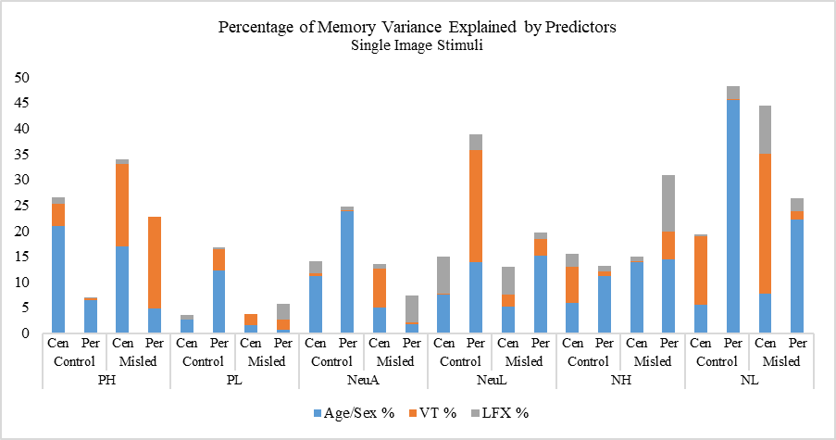
Age -
VT –
Age +
Sex F
VT –
Age -
Sex M
Sex F
VT +
VT +

Figure 16 Percentage of variance explaining memory accuracy by age and sex, viewing time and latency of first fixation using image stimuli.

Table 12 Image stimuli control group multiple regression (criterion central memory accuracy, predictors age, sex, viewing time (VT), latency of first fixation (LFX)).

Stimuli Emotion | Model 1: Age, Sex | Model 2: Age, Sex, VT | Model 3: Age, Sex, VT, LFX
Positive High  R² _{PRESS} = .05 | R² = .209, F(2, 27) = 3.308, p = .053, ƞ² = .21^{m}  Age β = -.216, p = .236 [-5.48, 1.41]  Sex β = .399, p = .034 [1.08, 25.34]* | R² = .253, F(3, 27) = 2.712, p = .067, ƞ² = .25^{m}  Age β = -.232, p = .202 [-5.62, 1.25]  Sex β = .249, p = .262 [-6.56, 23.07]  VT β = .258, p = .247 [-.001, .003] | R² = .265, F(4, 27) = 2.072, p = .117, ƞ² = .26  Age β = -.227, p = .219 [-5.63, 1.36]  Sex β = .248, p = .271 [-6.84, 23.27]  VT β = .232, p = .310 [-.001, .003]  LFF β = .111, p = .550 [-.076, .139]
Positive Low | R² = .026, F(2, 27) = .328, p = .723, ƞ² = .03 | R² = .026, F(3, 27) = .212, p = .887, ƞ² = .03 | R² = .035, F(4, 27) = .210, p = .930, ƞ² = .04
Neutral Average | R² = .112, F(2, 26) = 1.515, p = .240, ƞ² = .11 | R² = .118, F(3, 26) = 1.029, p = .398, ƞ² = .12 | R² = .0140, F(3, 26) = .895, p = .484, ƞ² = .14
Neutral Low | R² = .076, F(2, 27) = 1.028, p = .372, ƞ² = .08 | R² = .078, F(3, 27) = .680, p = .573, ƞ² = .08 | R² = .149, F(4, 27) = 1.010, p = .423, ƞ² = .15
Negative High | R² = .059, F(2, 25) = .716, p = .50, ƞ² = .06 | R² = .129, F(3, 25) = 1.082, p = .377, ƞ² = .13 | R² = .156, F(4, 25) = .972, p = .444, ƞ² = .16
Negative Low | R² = .056, F(2, 27) = .748, p = .484, ƞ² = .06 | R² = .190, F(3, 27) = 1.877, p = .160, ƞ² = .19 | R² = .193, F(4, 27) = 1.377, p = .273, ƞ² = .19

Table 13 Image stimuli control group multiple regression (criterion peripheral memory accuracy, predictors age, sex, viewing time (VT), latency of first fixation (LFX)).

Stimuli Emotion | Model 1: Age, Sex | Model 2: Age, Sex, VT | Model 3: Age, Sex, VT, LFX
Positive High | R² = .065, F(2, 27) = .875, p = .429, ƞ² = .07 | R² = .068, F(3, 27) = .587, p = .629, ƞ² = .07 | R² = .070, F(4, 27) = .432, p = .784, ƞ² = .07
Positive Low | R² = .123, F(2, 25) = 1.608, p = .222, ƞ² = .12 | R² = .165, F(3, 25) = 1.452, p = .255, ƞ² = .17 | R² = .168, F(4, 25) = 1.061, p = .400, ƞ² = .17
Neutral Average  R² _{PRESS} = .005 | R² = .239, F(2, 26) = 3.768, p = .038, ƞ² = .24*  Age β = -.405, p = .032 [-8.26, -.40]*  Sex β = .255, p = .166 [-4.22, 23.14] | R² = .240, F(3, 26) = 2.418, p = .092, ƞ² = .24  Age β = -.410, p = .036 [-8.45, -.306]*  Sex β = .247, p = .203 [-5.31, 23.67]  VT β = .030, p = .875 [-.002, .002] | R² = .248, F(4, 26) = 1.814, p = .162, ƞ² = .25  Age β = -.382, p = .064 [-8.42, .263]^{m}  Sex β = .238, p = .230 [-6.01, 23.68]  VT β = -.007, p = .974 [-.002, .002]  LFF β = -.102, p = .629[-.010, .006]
Neutral Low  R² _{PRESS} = .08 | R² = .139, F(2, 27) = 2.011, p = .155, ƞ² = .14  Age β = .366, p = .060 [-.205, 9.30]^{m}  Sex β = .076, p = .684 [13.39, 20.08] | R² = .358, F(3, 27) = 4.469, p = .013, ƞ² = .36*  Age β = .379, p = .030 [.51, 8.90]*  Sex β = .168, p = .322 [-7.69, 22.42]  VT β = -.478, p = .008 [-.005, -.001]* | R² = .388, F(4, 27) = 3.650, p = .019, ƞ² = .39*  Age β = .366, p = .035 [.35, 8.76]*  Sex β = .144, p = .40 [-8.90, 21.49]  VT β = -.486, p = .008 [-.005, -.001]*  LFF β = -.175, p = .30 [-.03, .01]
Negative High | R² = .112, F(2, 25) = 1.455, p = .254, ƞ² = .11 | R² = .120, F(3, 25) = 1.003, p = .410, ƞ² = .12 | R² = .132, F(3, 25) = .798, p = .540, ƞ² = .13
Negative Low  R² _{PRESS} = .22 | R² = .456, F(2, 26) = 10.06, p = .001, ƞ² = .46*  Age β = -.113, p = .461 [-6.20, 2.90]  Sex β = .666, p < .001 [18.27, 50.25]* | R² = .457, F(3, 26) = 6.47, p = .002, ƞ² = .46*  Age β = -.130, p = .449 [-7.04, 3.22]  Sex β = .664, p < .001 [17.80, 50.53]*  VT β = .042, p = .808 [-.003, .004] | R² = .483, F(4, 26) = 5.148, p = .004, ƞ² = .48*  Age β = -.191, p = .297 [-8.21, 2.63]  Sex β = .632, p = .001 [15.82, 49.20]*  VT β = .126, p = .508 [-.003, .005]  LFF β = .182, p = .304 [-.001, .004]

Table 14 Image stimuli misled group multiple regression (criterion central memory accuracy, predictors age, sex, viewing time (VT), latency of first fixation (LFX)).

Stimuli Emotion | Model 1: Age, Sex | Model 2: Age, Sex, VT | Model 3: Age, Sex, VT, LFX
Positive High  R² _{PRESS} = 1.19 | R² = .170, F(2, 26) = 2.450, p = .108, ƞ² = .17  Age β = -.411, p = .037 [-7.33, -.25]*  Sex β = -.016, p = .931 [12.47, 11.46] | R² = .330, F(3, 26) = 3.776, p = .024, ƞ² = .33*  Age β = -.516, p = .008 [-8.12, -1.39]*  Sex β = .036, p = .834 [-9.97, 12.23]  VT β = -.417, p = .028 [ -.01, .00]* | R² = .339, F(4, 26) = 2.815, p = .05, ƞ² = .34*  Age β = -.486, p = .0.17 [-8.08, -.88]*  Sex β = .024, p = .893 [-10.66, 12.15]  VT β = -.416, p = .031 [-.01, .00]*  LFX β = .098, p = .599 [-.03, .05]
Positive Low | R² = .016, F(2, 27) = .203, p = .817, ƞ² = .02 | R² = .038, F(3, 27) = .314, p = .815, ƞ² = .04 | R² = .038, F(4, 27) = .229, p = .919, ƞ² = .04
Neutral Average | R² = .051, F(2, 27) = .666, p = .523, ƞ² = .05 | R² = .127, F(3, 27) = 1.164, p = .344, ƞ² = .13 | R² = .135, F(4, 27) = .897, p = .482, ƞ² = .14
Neutral Low | R² = .052, F(2, 27) = .691, p = .510, ƞ² = .05 | R² = .075, F(3, 27) = .644, p = .594, ƞ² = .07 | R² = .129, F(4, 27) = .850, p = .508, ƞ² = .13
Negative High | R² = .138, F(2, 25) = 1.848, p = .180, ƞ² = .14 | R² = .141, F(3, 25) = 1.205, p = .331, ƞ² = .14 | R² = .149, F(4, 25) = .921, p = .471, ƞ² = .15
Negative Low  R² _{PRESS} = .16 | R² = .078, F(2, 27) = 1.051, p = .365, ƞ² = .08  Age β = .152, p = .435 [-3.15, 7.11]  Sex β = -.232, p = .238 [-28.36, 7.38] | R² = .351, F(3, 27) = 4.332, p = .014, ƞ² = .35*  Age β = .074, p = .659 [-3.49, 5.41]  Sex β = -.223, p = .188 [-25.39, 5.27]  VT β = .529, p = .004 [ .001, .004]* | R² = .444, F(4, 27) = 4.599, p = .007, ƞ² = .44*  Age β = -.021, p = .90 [-4.68, 4.14]  Sex β = -.272, p = .098 [-26.99, 2.44]  VT β = .473, p = .007 [.001, .004]*  LFX β = .330, p = .062 [-.005, .184]^{m}

Table 15 Image stimuli misled group multiple regression (criterion peripheral memory accuracy, predictors age, sex, viewing time (VT), latency of first fixation (LFX)).

Stimuli Emotion | Model 1: Age, Sex | Model 2: Age, Sex, VT | Model 3: Age, Sex, VT, LFX
Positive High  R² _{PRESS} = .12 | R² = .049, F(2, 27) = .646, p = .533, ƞ² = .05  Age β = .118, p = .552 [-2.96, 5.42]  Sex β = -.187, p = .346 [21.39, 7.79] | R² = .228, F(3, 27) = 2.365, p = .096, ƞ² = .23  Age β = .087, p = .634 [-2.96, 4.77]  Sex β = .004, p = .985 [-14.61, 14.89]  VT β = .465, p = .027 [.000, .005]* | R² = .228, F(4, 27) = 1.70, p = .184, ƞ² = .23  Age β = .088, p = .648 [-3.19, 5.03]  Sex β = .004, p = .986 [14.97, 15.24]  VT β = .464, p = .034 [.000, .005]*  LFF β = -.005, p = .980 [-.022, .21]
Positive Low | R² = .006, F(2, 25) = .070, p = .932, ƞ² = .01 | R² = .026, F(3, 25) = .199, p = .896, ƞ² = .03 | R² = .057, F(4, 25) = .318, p = .863, ƞ² = .06
Neutral Average | R² = .018, F(2, 27) = .224, p = .801, ƞ² = .02 | R² = .021, F(3, 27) = .173, p = .914, ƞ² = .02 | R² = .073, F(4, 27) = .451, p = .770, ƞ² = .07
Neutral Low | R² = .151, F(2, 27) = 2.226, p = .129, ƞ² = .15 | R² = .188, F(3, 27) = 1.851, p = .165, ƞ² = .19 | R² = .190, F(4, 27) = 1.349, p = .282, ƞ² = .19
Negative High  R² _{PRESS} = .11 | R² = .145, F(2, 26) = 2.039, p = .152, ƞ² = .15  Age β = -.074, p = .698 [-4.33, 2.95]  Sex β = -.378, p = .057 [-25.67, .416]^{m} | R² = .198, F(3, 26) = 1.887, p = .160, ƞ² = .20  Age β = -.092, p = .629 [-4.48, 2.76]  Sex β = -.352, p = .075 [-24.78, 1.27]^{m}  VT β = .231, p = .233 [-.001, .002] | R² = .309, F(4, 26) = 2.461, p = .075, ƞ² = .31^{m}  Age β = -.138, p = .45 [-4.77, 2.19]  Sex β = -.251, p =.192 [-21.32, 4.53]  VT β = .194, p = .293 [-.001, .002]  LFF β = .356, p = .073 [-.001, .023]^{m}
Negative Low  R² _{PRESS} = .07 | R² = .223, F(2, 26) = 3.441, p = .049, ƞ² = .22*  Age β = .203, p = .270 [-1.66, 5.66]  Sex β = -.416, p = .030 [-27.76, -1.54]* | R² = .238, F(3, 26) = 2.395, p = .094, ƞ² = .24  Age β = .195, p = .297 [-1.80, 5.64]  Sex β = -.405, p = .037 [-27.62, -.946]*  VT β = .124, p = .506 [-.001, .002] | R² = .263, F(4, 26) = 1.962, p = .136, ƞ² = .26  Age β = .194, p = .302 [-1.84, 5.66]  Sex β = -.385, p = .050 [-27.13, -.022]*  VT β = .206, p = .332 [-.001, .003]  LFF β = .178, p = .398 [-.002, .004]

Discussion
The present study aimed to test four hypotheses based on the findings of Van Damme and Smets (2014) and on their suggestion that it is increased attention during an event which enhances accuracy for positive high arousal events, and for events of negative valence. Furthermore, that it is attention to central details of an event which mediates accuracy being reduced for peripheral details by misinformation. Eye-tracking measures were added to a replication of Van Damme and Smets methodology, and multiple regression analysis conducted to test if attention during an event could predict memory accuracy.
There was little or no support for the four hypotheses tested. Hypothesis one predicted higher central accuracy for detail about the positive high arousal, negative high arousal and negative low arousal events. Results evidenced that central information was recognised with higher accuracy than peripheral detail for all events, and not specifically for these three as predicted. Similarly, hypothesis two was not supported as post-event misinformation reduced central and peripheral information accuracy in all event conditions, and not for the specific three events as predicted. The third hypothesis predicted great attention to be recorded to central details of the positive high arousal, negative high arousal and negative low arousal events. However, only the central detail of the negative low arousal image showed this pattern of results, with all other event conditions recording the opposite pattern i.e. greater levels of attention to peripheral details. Multiple regression results also suggested no clear support for the fourth hypothesis which expected there to be a predictive relationship between attention during encoding and memory accuracy.
The overall reduction in accuracy by misinformation suggests that for events encoded using single images, attention during encoding does not protect against memory distortion, or mediate accuracy in the absence of misinformation. The lack of a predictive relationship between attention and memory accuracy is supported by other studies which have also evidenced little (Humphreys, et al. 2010; Kim et al., 2013; Riggs, McQuiggan, Farb, Anderson, & Ryan, 2011) or no relationship between attention and accuracy (Bennion et al., 2013; Greene et al., 2017; Steinmetz & Kensinger 2013; Sharot, Davidson, Carson, & Phelps, 2008; Wessel, van der Kooy, & Merckelbach, 2000).
The current finding that a misinformation effect only occurred for details manipulated by misleading information is supported by other misinformation studies using picture stimuli (Porter, ten Brinke, Riley, & Baker, 2014), and by those using sequence (Rindal, DeFranco, Rich, & Zaragoza, 2016) and video (Mahé et al., 2015). However, this finding also directly contrasts with the results of Van Damme and Smets (2014) as they reported a misinformation effect in both new correct and misleading information statements, an effect which is explained by Van Damme and Smets as being due to increased confusion as a result of the exposure to misinformation impairing memory for information about which no false information had been presented. The contradiction between Van Damme and Smets results and the current findings could be a result of the imbalance in the level of detail between information considered to be centrally emotional and peripheral, and between event conditions, in the images employed by Van Damme and Smets. The low level of peripheral detail may have resulted in statements used to test memory accuracy featuring more ambiguous content which could be misinterpreted and recalled in error (Schneider, Veenstra, van Harreveld, Schwarz, & Koole, 2016). The imbalance of detail in the images used by Van Damme and Smets may also have biased attention during encoding towards the detail rich central information, meaning the less detail rich peripheral information was not attended to, and as a result was not encoded. Therefore, as the current research corrected the limitation of imbalanced central and peripheral detail, the current results represent a more valid representation of attention during an event and resulting memory accuracy.
The result of a misinformation effect in all events also contrasts with theory explaining false memory formation. Valenced, highly arousing, or motivationally intense events are predicted to narrow attentional capacity resulting in reduced processing of peripheral information (Christianson & Loftus, 1991; Lavie, 1995; Lavie, Hirst, de Fockert, & Viding, 2004, Posner, 1980; Threadgill & Gable, 2019), and to result in more gist memory being formed (Kensinger, Garoff-Eaton & Schacter, 2007; Reyna & Brainerd, 1995). The current findings do show some support for a narrowing of attention in memory measures as higher arousal conditions recorded higher accuracy than valenced matched low arousal conditions in misleading statement accuracy. Furthermore, central information recorded higher accuracy overall in new correct and new incorrect information types. In addition, it would be expected that if attention were narrowing to central information in valenced and highly arousing events that this would allow more verbatim details to be encoded, resulting in higher central accuracy for the same events. However, central information was not always recalled with higher accuracy than peripheral information when compared across valence and arousal conditions. Eye-tracking measures and memory appeared to have an inverse relationship i.e. less attention matched with higher accuracy. Nevertheless, results do not support mediation of memory by visual attention during encoding. The contrast suggests that post encoding processes were impacting both control and misled groups, potentially removing any predictive relationship between attention and accuracy.
The results of Van Damme and Smets (2014) suggested that information in events of negative valence, and of high arousal, were more susceptible to distortion by post-event misinformation, and this was attributed to attentional narrowing to central information. Yet, in the current study, no such pattern of results was observed. Accuracy was reduced by post-event misinformation for both central and peripheral detail in all valence and arousal conditions.

Chapter 5 Investigating the role of attention in emotional false memory formation using sequential image stories
The second study presented in this thesis extends the research detailed in Chapter 4 by employing image sequences coupled with an audio track, instead of single images, to convey an increased level of context, narrative and complexity in events to be encoded. The methodology from Van Damme and Smets (2014) was replicated and eye-tracking measures were recorded during the encoding phase (cf. Greene, Murphy, & Januszewski, 2017).
As previously, hypotheses one to four were tested. As per hypothesis one, in the absence of misinformation, an increased accuracy for central compared to peripheral detail was predicted for the positive high arousal event and for both negative events. For hypothesis two, a misinformation effect was expected to be observed for all peripheral information, and for central details of these specific high arousal and negative events. Hypothesis three predicted that central details in these specific events would receive greater total viewing times, increased numbers of fixations, and faster first fixation speeds in comparison to peripheral content in the same event scenes. Finally, hypothesis four expected that eye-tracking data would be able to predict the effects occurring in memory accuracy when using multiple regression modelling.

Method
Design
A two (grouping condition) by six (picture type) by two (information location) design was used with participants allocated to either the control (n = 28) or misinformation (n = 28) condition. All participants viewed six images sequences, as detailed in Chapter 2: positive with low (PL) and high (PH) arousal, negative with low (NL) and high (NH) arousal, and neutral with low (NeuL), and high (NeuH) arousal. Participants were allocated to one of six presentation sequences, generated using counterbalanced Latin square design.

Participants
Participants comprised 56 students (31 female, 25 male) from Staffordshire University, with a mean age of 25.82 years (SD = 9.46), ranging from 18 to 58. Between-subjects t-test confirmed that there was no statistically significant difference in age between group conditions t(54) = -1.25, p = .217, d = .33 CI [-8.19, 1.90]. Participants took part in the study in exchange for research participation credit. All were recruited by opportunity and volunteer sample through an online participation system. All participants had normal, or corrected-to-normal, vision with glasses or contact lenses, were not colour-blind, and did not suffer from photo-sensitive epilepsy. Full ethical approval was granted for this study by the Faculty of Health Sciences Ethics Panel of Staffordshire University.

Materials
Eye-tracking
The eye-tracking equipment, computer set-up, and data recording parameters were identical to those detailed in Chapter 4 for the single image study, with the addition of over the ear headphones worn by participants.

Image sequence stimuli
Image sequences were all in landscape orientation at 1400 by 1080 pixels, as detailed in Chapter 2, and content defined into emotionally central and peripheral as detailed in Chapter 3. Please see Figure 17 for an example of the image sequence with display timings illustrated with images for the neutral low arousal event.
Count in 3 seconds
Five frames displayed for 6 seconds each
End screen for 2 seconds

Figure 17 Image sequence example with still frames and display timings.

Questions
Two sets of questions were compiled following the process detailed in Chapter 4 and cross-checked against all images in sequences to remove duplications. To address a potential limitation in the previous study using single images, that the questions may have contained an imbalance of detail, the content of the current questions for each group was reviewed to ensure they were comparable in detail and length. For example, the question ‘Did you see the girls’ star hairclip?’ was changed by swapping the word ‘star’ to ‘moon’ for the mislead group condition.

Mood measure
As previously, the Brief Mood Inspection Questionnaire (BMIS; Mayer & Gaschke, 1988) was used to measure potential effects of initial mood variation between the two grouping conditions (Forgas, Laham, & Vargas, 2005; Hüttermann & Memmert, 2015; Van Damme, 2013), and two line measures used as representations of valence and arousal (cf. Van Damme, 2013; Van Damme & Smets, 2014).
Procedure
The procedure replicated that detailed in Chapter 4 following the same three stages: encoding, misinformation, and recognition. To address the limitation of stimuli ratings being made at the end of the procedure, the ratings occurred after each sequence had been viewed. During the encoding phase, participants used the Self-Assessment Manikin (SAM; Bradley & Lang, 1994; Lang, Bradley, & Cuthbert, 2008) to rate experienced valence and arousal during each sequence, prior to the next sequence commencing. In addition, participants were required to wear headphones during the encoding phase to allow audio tracks to be presented in parallel with image sequence events.

Results
Mood check
The BMIS subscales of pleasant-unpleasant and aroused-calm (Mayer & Gaschke, 1988) were used to score participant mood prior to sequence encoding, along with line ratings (cf. Van Damme & Smets, 2014). Please see Table 16 for means and standard deviations.

Table 16 Mood ratings using BMIS and line scale for valence and arousal.

Group |  | BMIS | Line Scale
All N = 56 | Valence | 71.14 (13.16) | 71.45 (17.42)
 | Arousal | 53.96 (9.46) | 56.25 (22.05)
Control n = 28 | Valence | 72.77 (12.61) | 68.68 (17.69)
 | Arousal | 56.75 (9.27) | 59.18 (19.61)
Misinformation n = 28 | Valence | 69.51 (13.73) | 74.21 (17.01)
 | Arousal | 51.17 (8.95) | 53.32 (24.25)

Between-subjects t-tests showed no significant difference between the two group conditions on valence using the BMIS t(54) = .926, p = .359, d = .25 CI [-3.80, 10.32], or line scale t(54) = -1.194, p = .238, d = .32 CI [-14.83, 3.76]. Yet, arousal measures showed contrasting results. The line scale showed no difference, t(54) = .994, p = .325, d = .27 CI [-5.89, 17.67], while the BMIS measure showed a significant difference between the two groups t(54) = 2.29, p = .026, d = .61 CI [.695, 10.46] all two-tailed tests, with the control group scoring higher in arousal than the misled group. Within-subjects t-test confirmed there to be no significant difference between scores using the BMIS and line rating for valence t(55) = -.182, p = .856, d = .02 CI [1.70, 3.10], or between BMIS and line ratings for arousal t(55) = -.746, p = .459 d = .14 CI [-8.45, 3.86]. Potential effects of the difference in arousal measure results on valence and arousal manipulation are explored in the following section.

Sequence valence and arousal manipulation
Participants gave a self-report rating of the sequences for valence and arousal after viewing each sequence as a manipulation check. Table 17 gives mean figures with standard deviations for each sequence.

Table 17 Participant sequence ratings means with standard deviations.

Sequence | Description | Valence | Arousal
PH | Break-a-Leg (Actors) | 5.87 (1.53) | 5.07 (1.90)
PL | Treehouse (Space) | 6.14 (1.47) | 4.86 (1.99)
NH | After the Rain (Crash) | 3.23 (1.45) | 5.77 (1.74)
NL | Superhero (Hospital) | 2.79 (1.26) | 5.52 (1.67)
NeuH | Slash-in-a-Box (Jack) | 5.39 (1.55) | 5.09 (2.04)
NeuL | Do-Over (Steps) | 5.25 (1.24) | 4.48 (1.94)

Within-subjects’ ANOVA showed that sequences were rated as significantly different across valence F(2, 110) = 120.738, p < .001, ƞ_{p}² = .687, with pairwise comparisons confirming expected valence categories: positive sequences were rated as significantly higher than negative p < .001, d = 2.65, CI [2.47, 3.53], and neutral rated higher than negative p <.001, d = 2.08 CI [1.80, 2.83], and lower than positive sequences p = .001, d = .65 CI [-1.13, -.245]. Paired samples t-tests also confirmed sequences in the high arousal condition to be significantly more arousing than those in the low arousal condition t(55) = 2.396, p = .010, d = .24 (one-tailed test) CI [.06, .66].
To assess the potential impact of increased mood arousal for the control group, as detailed in the previous section, independent samples t-tests compared control and misled group valence and arousal ratings for each sequence. There was no significant difference in valence rating (-1.216 ≤ t(54) ≤ .428, .259 ≤ p ≤ .858, .05 ≤ d ≤ .33), or arousal rating (-.85 ≤ t(54) ≤ 1.316, .194 ≤ p ≤ 1, 0 ≤ d ≤ .037) between groups in sequence ratings, indicating that the increased arousal scores for the control group at baseline were not affecting the manipulation of valence or arousal during sequence encoding.

Eye-tracking
To investigate the role of attention in memory accuracy, the following eye-tracking measures were recorded: number of fixations, total viewing time and mean latency of first fixation. Number of fixations comprised the total number of fixations made to central and peripheral interest areas across the five images in each sequence. Viewing time was calculated as the total dwell time i.e. the sum of all fixation lengths, to each interest area across all images in the sequence. Mean latency of first fixation was determined as a sum of each time duration from interest area onset to fixation, across each sequence image, divided by the number of valid first fixation times. Therefore, if no fixation was made to an information area within an image of a sequence, that occurrence was not included in the mean calculation. The first fixation made to the first image of each sequence was removed, and the second fixation recorded in its place (cf. Bennion, Steinmetz, Kensinger, & Payne, 2013). The replacement of first with second fixation for the first image of each sequence removed any effect of manipulation of attention to image content resulting from prior fixation to the centralised count down sequence.
To evaluate the effect of valence and arousal, and information location on number of fixations, viewing time and latency of first fixation, three 6 (sequence: positive high and low arousal, neutral high and low arousal, negative high and low arousal) by two (information location: central, peripheral), within-subjects ANOVA were conducted. An initial alpha level of .05 was adjusted using a Bonferroni correction where relevant to level of analysis. All confidence intervals are reported at 95% and outlying data points are defined as being plus or minus three standard deviations from the mean. Means and standard deviations are presented in Table 18.

Table 18 Means and standard deviations for number of fixations, viewing time and latency of first fixations.

 | Number of Fixations |  | Viewing Time (s) |  | Latency of First Fixation (s)
Sequence | Central | Peripheral | Central | Peripheral | Central | Peripheral
PH | 35.93 (10.91) | 51.80 (14.52) | 10.79 (3.44) | 11.68 (2.81) | 0.56 (0.35) | 0.30 (0.31)
PL | 45.19 (16.64) | 44.72 (15.93) | 12.94 (4.41) | 10.91 (3.85) | 0.40 (0.33) | 0.69 (0.40)
NH | 47.87 (14.13) | 33.37 (12.17) | 15.94 (4.03) | 7.92 (3.32) | 0.33 (0.16) | 0.37 (0.37)
NL | 44.96 (13.10) | 19.87 (10.93) | 19.31 (4.19) | 4.74 (2.34) | 0.17 (0.14) | 1.67 (0.82)
NeuH | 56.00 (10.80) | 30.85 (9.37) | 15.19 (2.29) | 7.65 (1.98) | 0.37 (0.25) | 1.02 (0.59)
NeuL | 60.63 (19.23) | 15.41 (10.95) | 19.15 (4.42) | 3.30 (2.44) | 0.21 (0.23) | 1.71 (0.90)

As detailed in Table 18, when using image sequences central information appears to have received greater numbers of fixations, longer viewing times and faster fixation latency than peripheral detail overall. Positive sequences appear to have similar viewing times and fixation numbers across central and peripheral detail while negative and neutral sequences have a clearer central bias.

Latency of first fixation
A significant main effect of sequence was observed F(3.628, 170.502) = 31.115, p < .001, ƞ_{p}² = .398 which was investigated using pairwise comparisons. The negative high arousal p <.001 d = 1.83 CI [-739.75, -386.16] and neutral high arousal sequences p = .041 d = 0.70 CI [-544.71, -5.86] were fixated upon significantly faster than the low arousal valence conditions. In contrast, there was no difference between the positive conditions, suggesting that negative and neutral valence with high arousal were capturing attention faster than content of positive valence and low arousal. When compared across arousal conditions no clear effect of valence was presented. For high arousal sequences the neutral was significantly slower to be fixated upon than both the positive p = .003, d = 0.93 CI [62.13, 457.05], and negative p < .001, d = 1.30 CI [164.15, 499.81]. For low arousal sequences, fixation occurred earlier as the positive was attended to significantly faster than both the neutral p < .001, d = 1.22 CI [-647.00, -215.45] and negative p < .001, d = 1.21 CI [-581.99, -191.85], with no difference evidenced for latency of first fixation to the negative and neutral low arousal sequences.
In addition to an effect of sequence, a significant main effect of information location was also evidenced F(1, 47) = 148.178, p < .001, ƞ_{p}² = .759. Central information (M = 338.72, SD = 123.32) was attended to significantly faster than peripheral Information (M = 948.63, SD = 276.12).
Along with main effects, a significant interaction was observed between sequence type and information location F(3.47, 163.091) = 61.265, p < .001, ƞ_{p}² = .566, as depicted in Figure 18. The interaction was investigated by comparing first fixation time to central and peripheral information areas within each sequence. Wilcoxon signed ranks tests showed that central information was fixated upon significantly faster than peripheral information in the positive low arousal Z = -3.20, p = .001, N = 50, r = 0.45 CI [-465.50, -116.15], negative low arousal Z = -6.063, p < .001, N = 49, r = 0.87 CI [-1759.10, -1252.05], neutral low arousal Z = -5.963, p < .001, N = 49, r = 0.85 CI [-1774.88, -1222.96], and neutral high arousal Z = -5.15, p < .001, N = 50, r = 0.73 CI [-838.87, -465.16], sequences. In the positive high arousal sequence, the opposite effect was evidenced, with peripheral information fixated upon faster than central information Z = -4.05, p < .001, N = 50, r = 0.57 CI [135.17, 381.53]. In the negative high arousal sequence, there was no significant difference between fixation time to central and peripheral information areas.

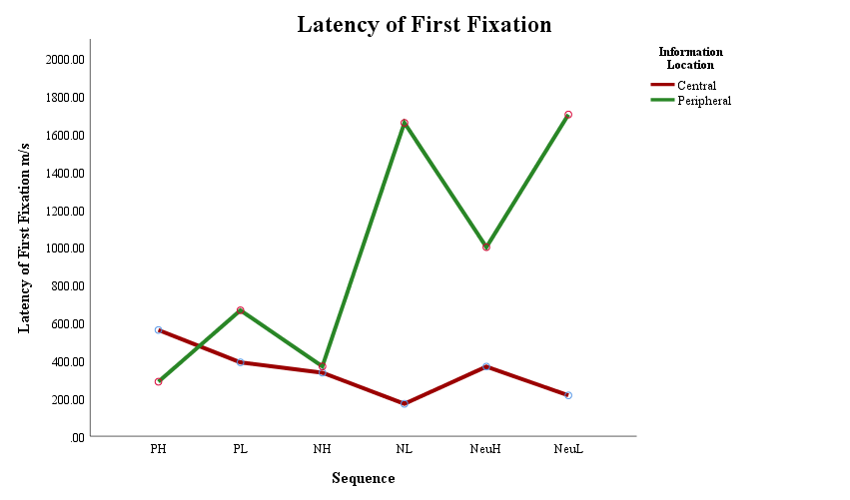
Figure 18 Mean latency of first fixation time for central and peripheral image areas by sequence event condition.

Number of fixations
A significant main effect of sequence type was evidenced F(5, 265) = 47.10, p < .001, ƞ_{p}² = .471 which was investigated using pairwise comparisons. The high arousal negative p < .001, d = 0.93 CI [5.31, 11.09] and neutral p < .001, d = 0.57 CI [8.50, 13.53] sequences received more fixations than valenced matched low arousal conditions. However, there was no significant difference between high and low arousal sequences of positive valence. When compared across high arousal conditions no significant difference was observed between valence, yet for low arousal conditions the number of fixations were significantly higher for positive sequences compared to neutral p < .001, d = 0.72 CI [3.54, 10.33], and higher to neutral compared to negative sequences p < .001, d = 0.59 CI [2.72, 8.48]. The negative low arousal condition received the least fixations (M = 64.83, SD = 16.04), and the positive low arousal sequence the highest (M = 89.91, SD = 16.68). There was also a main effect of information location F(1, 53) = 79.566, p < .001, ƞ_{p}² = .60, with central information (M = 289.57, SD = 67.91) fixated upon more times than peripheral information (M = 196.02, SD = 54.09).

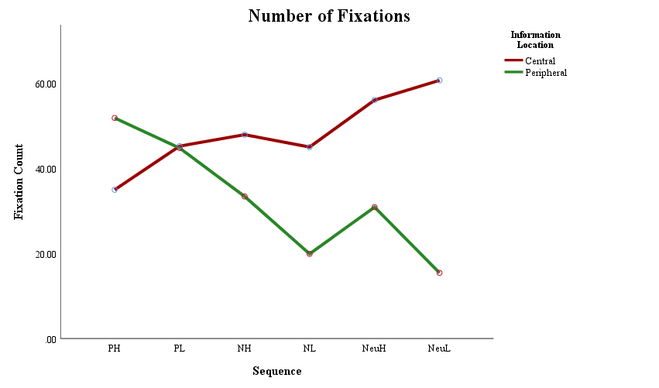
Figure 19 Mean number of fixations for central and peripheral image sequence areas by event condition.

In addition to main effects of sequence and information location, there was a significant interaction between the two effects F(3.644, 193.151) = 92.08, p < .001, ƞ_{p}² = .635. To investigate the interaction between sequence type and information location, as illustrated in Figure 19, data was split by sequence type to allow central and peripheral fixations to be compared. For both negative and neutral sequences central information received significantly more fixations than peripheral information, all p < .001: negative high arousal t(53) = 5.932, d = 1.10 CI [9.60, 19.40], negative low arousal t(53) = 10.231, d = 2.08 CI [20.17, 30.01], neutral high arousal t(53) = 15.278, d = 2.49 CI [21.85, 28.45], neutral low arousal t(53) = 14.779, d = 2.90 CI [39.09, 51.36]. There was no significant difference between fixation numbers to central and peripheral information for the positive low arousal sequence, yet for the positive high arousal sequence central information was fixated on significantly less than peripheral information t(53) = -7.384, p < .001, d = 1.32 CI [-21.45, -12.29].
Two participants data were removed from the analysis due to outlying data points. Sensitivity analysis confirmed there to be no change in significance or direction of results.

Viewing time
Analysis showed a significant main effect of sequence type F(3.636, 190.595) = 6.211, p < .001, ƞ_{p}² = .115. Pairwise comparisons conducted to investigate the main effect of sequence type showed no clear effect of valence or arousal. The positive low arousal sequence was viewed for significantly more time than both the positive high arousal p = .012, d = 0.43 [94.00, 1280.59], and the neutral low arousal sequences p = .001, d = 0.43 CI [197.54, 1198.59], but there were no other significant differences. A main effect of information location was also presented F(1, 48) = 184.948, p < .001, ƞ_{p}² = .794, with central information (M = 9332.69, SD = 17951.57) viewed for significantly longer than peripheral information (M = 46201.29, SD = 10687.51).
A significant interaction was evidenced between sequence type and information location F(3.773, 181.080) = 101.545, p < .001, ƞ_{p}² = .679. To investigate the interaction, as illustrated in Figure 20, data was split by information location to compare viewing time to central and peripheral information. Viewing time did not differ between central and peripheral information for positive sequences, yet for all other sequences central information was viewed for significantly longer than peripheral information, all at p < .001: negative high arousal Z = -5.654, N = 49, r = 0.81 CI [6190.04, 9848.13], negative low arousal t(48) = 17.163, d = 3.59 CI [12861.60, 16274.97], neutral high arousal t(48) = 17.052, d = 2.90 CI [6657.55, 8437.43], and neutral low arousal t(48) = 18.497, d = 3.74 CI [14131.32, 17578.11].

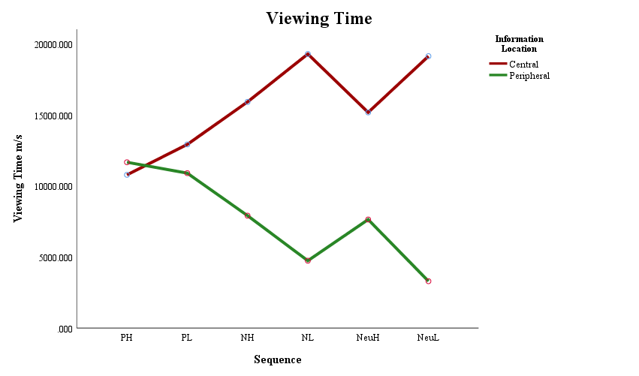
Figure 20 Mean viewing time for central and peripheral sequence image areas by event condition.

Seven participants data were excluded from analysis due to having outlying data points. Sensitivity analysis showed no change in significance for the main effects or interaction when analysis was conducted with outlying data points included.

Eye-tracking summary
In summary, there was some evidence to support hypothesis three, that central information in the events of negative valence would receive greater levels of attention compared to peripheral detail, however, this effect was not observed for the positive, high arousal event. For negative and neutrally valenced sequences, central information was viewed for longer and fixated on more frequently, than peripheral information in the same events. For positive sequences, there was no difference in viewing time between central and peripheral information. In contrast, peripheral information in the high arousal positive sequence was fixated on more frequently. Fixation was faster to central information in neutrally valenced, and low arousal conditions, compared to peripheral information in the same events. In contrast, peripheral information was attended to faster during the positive high arousal sequence, and during the negative high arousal event central and peripheral information were attended to almost simultaneously.

Memory Accuracy
Three, three-way mixed ANOVAs using a two (group: misled, control) by six (sequence: positive high and low arousal, neutral high and low arousal, negative high and low arousal) by two (information location: central, peripheral) design were conducted to evaluate accuracy for new correct, new incorrect and misleading information statements. An initial alpha level of .05 was set and adjusted using a Bonferroni correction where relevant to level of analysis. All confidence intervals are reported at 95% and outlying data points are defined as being plus or minus three standard deviations from the mean. Means and standard deviations are detailed in Table 19.
Data displayed in Table 19 show no clear trends to be occurring across sequence, information location or group conditions. For newly presented correct information, accuracy appears to be higher for central information compared to peripheral regardless of group condition. In contrast, newly presented incorrect and misleading statement accuracy appears to be mixed between central and peripheral and between group type.

Table 19 Means and standard deviations for number of correct, new false and misleading information statements.

Statement | Group | Location | PH | PL | NH | NL | NeuH | NeuL
Correct | Control | Central | 1.50 (.64) | 1.36 (.62) | 1.18 (.82) | 1.07 (.66) | 1.18 (.82) | 1.50 (.64)
 |  | Peripheral | 1.18 (.61) | 1.11 (.79) | 0.46 (.51) | 1.14 (.65) | 1.36 (.68) | 1.39 (.74)
Correct | Misled | Central | 1.36 (.73) | 1.25 (.52) | 1.07 (.81) | 1.29 (.71) | 1.39 (.74) | 1.57 (.50)
 |  | Peripheral | 1.11 (.63) | 1.07 (.77) | 0.46 (.51) | 1.25 (.80) | 1.11 (.74) | 1.46 (.58)
False | Control | Central | 1.41 (.64) | 0.89 (.80) | 1.63 (.56) | 1.81 (.40) | 0.93 (.62) | 1.74 (.45)
 |  | Peripheral | 1.00 (.68) | 1.52 (.70) | 0.74 (.66) | 1.41 (.75) | 1.48 (.64) | 1.48 (.58)
False | Misled | Central | 1.11 (.70) | 1.07 (.73) | 1.41 (.69) | 1.74 (.45) | 1.00 (.62) | 1.70 (.47)
 |  | Peripheral | 1.11 (.70) | 1.44 (.64) | 0.81 (.68) | 1.44 (.70) | 1.48 (.70) | 1.59 (.50)
Misleading | Control | Central | 1.39 (.69) | 0.89 (.42) | 1.25 (.65) | 1.29 (.46) | 1.39 (.63) | 1.61 (.57)
 |  | Peripheral | 0.54 (.58) | 1.21 (.63) | 1.82 (.39) | 1.36 (.62) | 1.61 (.57) | 1.71 (.46)
Misleading | Misled | Central | 1.32 (.72) | 1.00 (.61) | 1.00 (.77) | 1.39 (.57) | 1.54 (.58) | 1.39 (.63)
 |  | Peripheral | 0.93 (.77) | 0.93 (.60) | 1.63 (.48) | 1.36 (.48) | 1.64 (.56) | 1.82 (.39)

New correct information
Memory accuracy for new correct information observed a main effect of sequence F(5, 270) = 15.424, p < .001, ƞ_{p}² = .222. When explored using pairwise comparisons, memory accuracy was significantly lower for information in the negative high arousal sequence compared to all other sequences, at p < .001: negative low arousal d = .84 CI [-.647, -.139], positive high arousal d = 1.10 CI [-.712, -.270], positive low arousal d = .90 CI [-.630, -.174], neutral high arousal d = 1.03 CI [-.710, -.218], and neutral low arousal d = 1.51 CI [-.950, -.425]. However, there was no significant difference in accuracy between the positive high and positive low arousal sequence, or between the neutral high and neutral low arousal condition, suggesting no clear effect of arousal. There was also a main effect of information location F(1, 54) = 17.943, p < .001, ƞ_{p}² = .249, which indicated that central information (M = 7.86, SD = 1.73) was more accurately recalled than peripheral information (M = 6.55, SD = 1.95).
In addition to main effects, sequence type and information location were involved in a significant interaction F(5, 270) = 3.393, p = .005, ƞ_{p}² = .059. Contrasts to explore the interaction between sequence type and information location, as illustrated in Figure 21, revealed that central information was recalled with significantly higher accuracy than peripheral information in the positive high arousal t(54) = 2.255, p = .014, d = 1.11 CI [.032, .540] (one-tailed) and negative high arousal Z = -4.140, p < .001, N = 56 r = 0.55 CI [.390, .932] sequences. There was no significant difference evidenced between central and peripheral accuracy for the low arousal sequences, or for the neutral high arousal sequence.

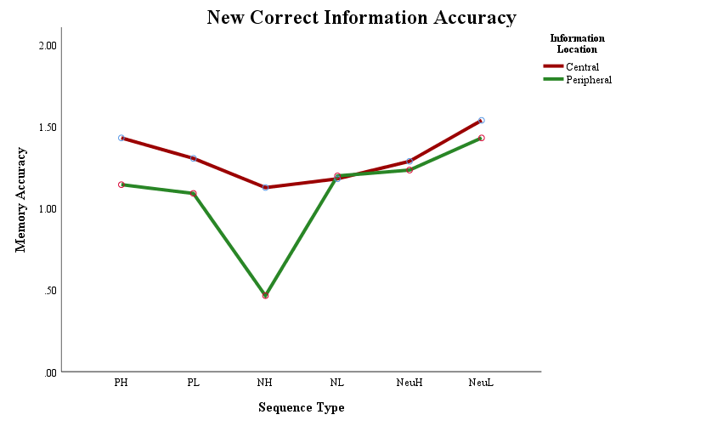
Figure 21 Mean memory accuracy for newly presented correct central and peripheral information by sequence event condition.

New incorrect information
For new incorrect information there was a significant main effect of sequence type F(5, 260) = 14.357, p < .001, ƞ_{p}² = .216. Pairwise comparisons exploring the main effect of sequence type showed an effect of arousal. Accuracy was significantly lower for the negative high arousal compared to the negative low arousal condition p < .001, d = .99 CI [-.714, -.193], and lower for the neutral high arousal compared to the neutral low arousal condition p < .001, d = 1.04 CI [-.617, -.198], yet there was no difference between the positive sequences. When matched by arousal there was no effect of valence at high arousal. For low arousal conditions. accuracy was lower for positive sequences compared to both the negative p = .001, d = 0.77 CI [-.627, -.114] and neutral p < .001, d = 0.87 CI [-.639, -.157] with no difference between negative and neutral. There was no main effect of information location, or an effect or interaction with group condition, suggesting that the misleading information was not impacting memory accuracy.

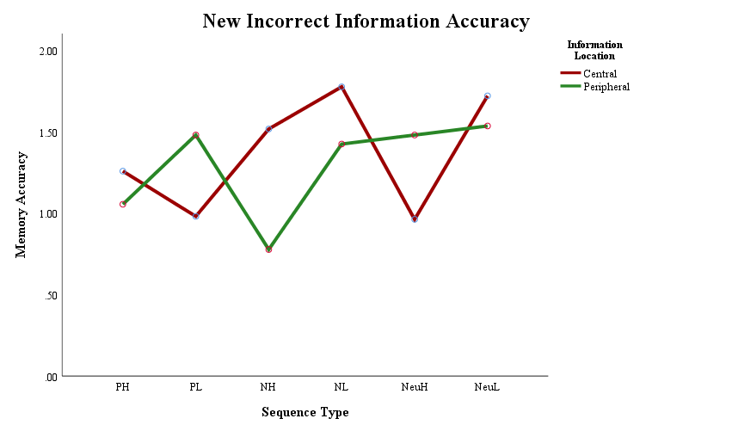
Figure 22 Mean memory accuracy for newly presented incorrect central and peripheral information by sequence event condition

Along with a main effect of sequence type, there was a significant interaction between sequence type and information location F(5, 260) = 18.261, p < .001, ƞ_{p}² = .260. Contrasts to explore the interaction between sequence and information location, as illustrated in Figure 22, split the data by sequence to allow central and peripheral information accuracy to be compared. Central information was recalled with significantly higher accuracy than peripheral information in both negative high arousal t(53) = 6.397, p < .001, d = 1.14 CI [.509, .973] and negative low arousal Z = -2.909, p = .002, N = 54, r = .40 CI [.126, .578] sequences. Peripheral information was recalled more accurately than central information in the positive low arousal Z = -3.421, p < .001, N = 54, r = .47, CI [-.758, -.242], and neutral high arousal t(53) = -3.943, p < .001, d = .81 CI [-.782, -.255] sequences. There was no difference in accuracy between central and peripheral information in the positive high or neutral low arousal sequences.
Two participant’s data were excluded from the following analysis due to containing outlying data points. Sensitivity analysis confirmed no change of significance or direction to the results.

Misleading information
Analysis of misleading information accuracy evidenced a significant main effect of sequence type F(5, 270) = 23.247, p < .001, ƞ_{p}² = .301. Pairwise comparisons to explore the main effect of sequence showed no effect of arousal occurring, with no significant difference in accuracy between valenced matched arousal conditions. For high arousal sequences, the positive condition had lower accuracy than both the negative p < .001, d = 0.78 CI [-.591, -.171] and neutral p < .001, d = 1.04 CI [-.746, -.254] conditions. For low arousal conditions, accuracy increased from positive to negative p < .001, d = 0.8 CI [-.535, -.144], and from negative to neutral p = .005, d = 0.72 CI [-.514, -.057]. A marginally significant main effect of information location was also observed F(1, 54) = 3.568, p = .064, ƞ_{p}² = .062, with peripheral information recalled with higher accuracy (M = 8.28, SD = 1.75) than central information (M = 7.73, SD = 1.84).
In addition to main effects of sequence type and information location, a significant two-way interaction was evidenced between sequence type and information location F(5, 270) = 15.045, p < .001, ƞ_{p}² = .218, and a three-way interaction between sequence type, information location and group condition F(5, 270) = 2.261, p = .049, ƞ_{p}² = .04. However, there was no main effect of group condition.

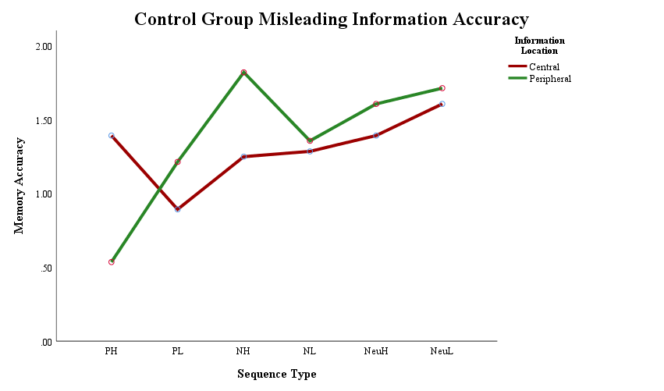
Figure 23 Control condition mean memory accuracy for central and peripheral misleading statements by sequence event.

Contrasts to explore the three-way interaction between sequence type, information location and group condition, as illustrated in Figures 23 and 24, split the data by group to enable central and peripheral information accuracy to be compared for each sequence, for both control and misled groups. For the positive high sequence both the control t(27) = 5.347, p < .001, d = 1.33 [.523, 1.19] and misled Z = -1.947, N = 28, p = .034, r = 0.34 [.007, .778] groups recalled central information with higher accuracy than peripheral information. In contrast, positive low arousal peripheral information was recalled with higher accuracy than central information in the control condition Z = -1.968, N = 28, p = .034, r = 0.37 [-.639, -.004]. In the misleading condition, peripheral accuracy was lowered to be comparable with central accuracy. For the negative high arousal sequence, both control Z = -3.119, N = 28, p = .001, r = 0.60 [-.878, -.265] and misled Z = -3.497, N = 28, p < .001, r = 0.66 [.-.907, -.356] groups had higher accuracy for peripheral information compared to central information. For the negative low arousal and neutral high arousal conditions there was no difference between central and peripheral information in either the control or misled group. In the neutral low, accuracy was comparable between central and peripheral for the control group, but misleading information lowered central accuracy resulting in peripheral information being recalled with higher accuracy than central Z = -2.556, N = 28, p = .007, r = 0.48 [-.735, -2.87].

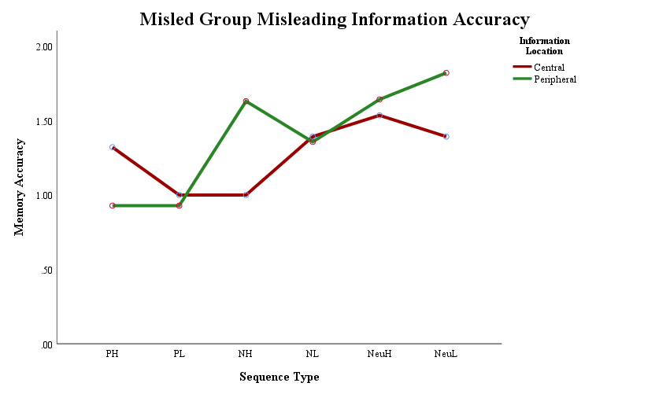
Figure 24 Misled condition mean memory accuracy for central and peripheral misleading statements by sequence event.

Memory accuracy summary
In summary, there was no support for hypothesis two, that misleading post-event information would reduce memory accuracy for central event details of the negative events, for central details of the positive high arousal event, or for peripheral detail accuracy of all events. There was only a lowering of accuracy observed in the misled group for previously presented misleading information in positive and neutral low arousal events. Accuracy was reduced for peripheral information in the positive low arousal sequence, and for central information in the neutral low sequence, suggesting that high arousal or negative valence was providing a protective effect against memory distortion. There was also no clear support for hypothesis one i.e. that a central memory advantage would be shown for detail about the positive high arousal, and for central detail about both negative sequences. Memory accuracy was higher for central details of the positive and negative high arousal sequence for correct information, but not for the negative low condition. For new incorrect detail, central accuracy was higher for negative events, but there was no difference in accuracy between central and peripheral information for the positive high arousal event. In contrast, statements testing misleading information displayed a central advantage for the positive high arousal event and a peripheral advantage for the negative high arousal event. There was no difference between central and peripheral accuracy in the negative low arousal event.

Multiple regression
As detailed in Chapter 4, eye-tracking measures of viewing time and number of fixations again showed similar patterns of central and peripheral attention when using sequential images as events to be encoded. Spearman’s Rho correlations confirmed that viewing time and number of fixations were positively correlated, with the exception of central information in the neutral high arousal sequence. Please see Table 20 for correlation results. Therefore, in the following analysis viewing time was used to represent both viewing time and number of fixations.

Table 20 Spearman’s Rho correlations between eye-tracking measures recorded during sequence viewing.

Location | Condition | VT x FX | VT x LFF | FX x LFF
Central | PH | r_{s} = .460⁺, p < .001* | r_{s} = -.379⁺, p = .004* | r_{s} = -.574⁺, p < .001*
 | PL | r_{s} = .737⁺, p < .001* | r_{s} = -.580⁺, p < .001* | r_{s} = -.724⁺, p < .001*
 | NeuH | r_{s} = .082, p = .550 | r_{s} = -.346⁺, p = .010* | r_{s} = -.023, p = .869
 | NeuL | r_{s} = .200, p = .139 | r_{s} = -.563⁺, p < .001* | r_{s} = -.240⁺, p = .075
 | NH | r_{s} = .303⁺, p = .023* | r_{s} = -.456⁺, p < .001* | r_{s} = -.280⁺, p = .037*
 | NL | r_{s} = .243⁺, p = .071 | r_{s} = -.754⁺, p < .001* | r_{s} = -.297⁺, p = .026*
Peripheral | PH | r_{s} = .685⁺, p < .001* | r_{s} = -.269⁺, p = .045* | r_{s} = -.469⁺, p < .001*
 | PL | r_{s} = .873⁺, p < .001* | r_{s} = -.541⁺, p < .001* | r_{s} = -.513⁺, p < .001*
 | NeuH | r_{s} = .592⁺, p < .001* | r_{s} = -.292⁺, p = .031* | r_{s} = -.239⁺, p = .079
 | NeuL | r_{s} = .927⁺, p < .001* | r_{s} = -.413⁺, p = .002* | r_{s} = -.391⁺, p = .003*
 | NH | r_{s} = .748⁺, p < .001* | r_{s} = -.225⁺, p = .096 | r_{s} = -.202, p = .135
 | NL | r_{s} = .890⁺, p < .001* | r_{s} = -.576⁺, p < .001* | r_{s} = -.519⁺, p < .001*

* significant at <= .05, ⁺ greater than medium effect size of 0.24. Two-tailed significance reported.
As conducted previously with single images, to test the fourth hypothesis i.e. that attention during encoding would predict memory accuracy, multiple regression models were run combining memory accuracy and eye-tracking data. Memory accuracy was collapsed across the three statement types to allow a single percentage accuracy figure to be used (cf. Mahé et al., 2015) as the criterion to be predicted in three models. The first model included demographic details of age and sex, the second added viewing time, and the third added latency of first fixation. Data was split by group condition to assess the ability of visual attention to predict memory accuracy when misleading post-event information had been presented. Full regression results are detailed in Tables 21 to 24 and illustrated in Figure 25.

Correct post-event information
As can be seen in Tables 21 and 22, for the participants who received correct post-event information, multiple regression models evidenced no significant predictors of accuracy for central or peripheral information, with no change to direction or significance with removal of multivariate outliers.

Post-event misinformation
As detailed in Table 23, for participants who received misleading post-event information there were significant predictors of central accuracy for both the negative and neutral conditions. For central information in the neutral high arousal sequence, early first fixation predicted increased accuracy. Latency of first fixation explained 21.4% of the variance in results, after 3.2% by age and sex and 14% by viewing time (LFF β = -.484, p = .013). Age positively predicted accuracy for central information in the neutral low arousal sequence, explaining 27.2% of the variance in results (Age .527 ≤ β ≤ .570, .003 ≤ p ≤ .005). For the negative high arousal condition central accuracy was negatively related to viewing time, with longer dwell times predicting reduced accuracy. Viewing time accounted for 27.8% of variance after the 1.5% explained by age and sex (VT -.551 ≤ β ≤ -.457, .005 ≤ p ≤ .035). When multivariate outliers were removed, models two and three moved to being marginally significant for the negative high arousal central information, however, there was no change in individual predictor significance levels. For the negative low arousal condition age and latency of first fixation positively predicted accuracy. Age accounted for 28.5% of variance in accuracy, viewing time 0.2% and latency of first fixation 20.6% (Age .460 ≤ β ≤ .493, .005 ≤ p ≤ .018, LFF β = .588, p = .007). For the negative low arousal sequence, central information was recalled with higher accuracy with increasing age and delayed first fixation time. As outlined in Table 24, for the misled group there were no significant predictors of accuracy for peripheral information.

Summary of multiple regression
In contrast to the prediction of hypothesis four, attention during encoding evidenced no predictive relationship to memory accuracy for participants receiving correct post-event information and no clear predictive relationship between attention and memory accuracy for misled participants. For misled participants, early first fixation to central information in the neutral higher arousal sequence predicted higher memory accuracy. For the negative sequences, increased attention predicted reduced central accuracy.

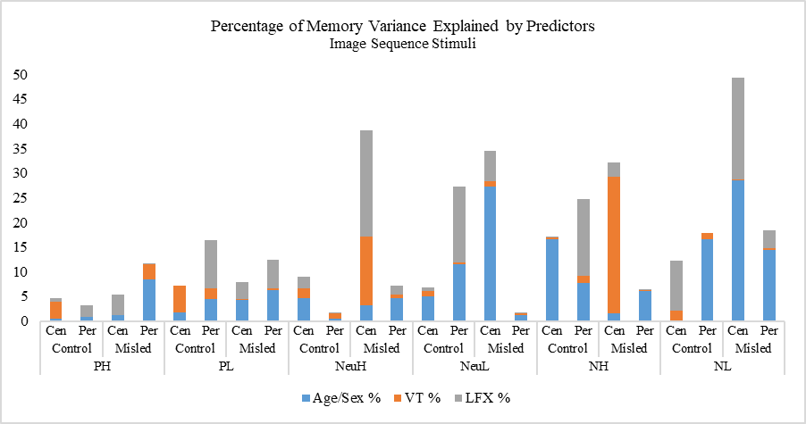
LFF -
Age +
VT -
LFF +
Age +

Figure 25 Percentage of variance explaining memory accuracy by age and sex, viewing time and latency of first fixation using image sequence stimuli.

Table 21 Image sequence stimuli control group multiple regression (criterion central memory accuracy, predictors age, sex, viewing time (VT), latency of first fixation (LFX)).

Stimuli Emotion | Model 1: Age, Sex | Model 2: Age, Sex, VT | Model 3: Age, Sex, VT, LFX
Positive High | R² = .005, F(2, 25) = .064, p = .939, ƞ² = .01 | R² = .039, F(3, 25) = .294, p = .829, ƞ² = .04 | R² = .047, F(4, 25) = .257, p = .902, ƞ² = .05
Positive Low | R² = .017, F(2, 26) = .206, p = .815, ƞ² = .02 | R² = .072, F(3, 26) = .591, p = .627, ƞ² = .07 | R² = .072, F(4, 26) = .427, p = .787, ƞ² = .07
Neutral High | R² = .046, F(2, 27) = .601, p = .556, ƞ² = .05 | R² = .066, F(3, 27) = .566, p = .643, ƞ² = .07 | R² = .090, F(4, 27) = .569, p = .688, ƞ² = .09
Neutral Low | R² = .051, F(2, 27) = .675, p = .518, ƞ² = .05 | R² = .061, F(3, 27) = .523, p = .671, ƞ² = .06 | R² = .068, F(4, 27) = .422, p = .791, ƞ² = .07
Negative High | R² = .166, F(2, 27) = 2.487, p = .103, ƞ² = .17 | R² = .170, F(3, 27) = 1.638, p = .207, ƞ² = .17 | R² = .171, F(4, 27) = 1.186, p = .343, ƞ² = .17
Negative Low | R² = .001, F(2, 27) = .018, p = .018, ƞ² < .001 | R² = .021, F(3, 27) = .170, p = .916, ƞ² = .02 | R² = .123, F(4, 27) = .804, p = .535, ƞ² = .12

Table 22 Image sequence stimuli control group multiple regression (criterion peripheral memory accuracy, predictors age, sex, viewing time (VT), latency of first fixation (LFX)).

Stimuli Emotion | Model 1: Age, Sex | Model 2: Age, Sex, VT | Model 3: Age, Sex, VT, LFX
Positive High | R² = .008, F(2, 26) = .097, p = .908, ƞ² = .01 | R² = .009, F(3, 26) = .072, p = .974, ƞ² = .01 | R² = .032, F(4, 26) = .184, p = .944, ƞ² = .03
Positive Low | R² = .044, F(2, 27) = .581, p = .567, ƞ² = .04 | R² = .066, F(3, 27) = .566, p = .642, ƞ² = .07 | R² = .165, F(4, 27) = 1.135, p = .365, ƞ² = .17
Neutral High | R² = .004, F(2, 27) = .051, p = .950, ƞ² < .001 | R² = .016, F(3, 27) = .133, p = .939, ƞ² = .02 | R² = .018, F(4, 27) = .103, p = .980, ƞ² = .02
Neutral Low | R² = .116, F(2, 24) = 1.447, p = .257, ƞ² = .12 | R² = .119, F(3, 24) = .943, p = .438, ƞ² = .12 | R² = .273, F(4, 24) = 1.879, p = .154, ƞ² = .27
Negative High | R² = .077, F(2, 27) = 1.042, p = .368, ƞ² = .08 | R² = .092, F(3, 27) = .814, p = .499, ƞ² = .09 | R² = .247, F(4, 27) = 1.887, p = .147, ƞ² = .25
Negative Low | R² = .166, F(2, 26) = 2.391, p = .113, ƞ² = .17 | R² = .178, F(3, 26) = 1.655, p = .204, ƞ² = .18 | R² = .178, F(4, 26) = 1.191, p = .343, ƞ² = .18

Table 23 Image sequence stimuli misled group multiple regression (criterion central memory accuracy, predictors age, sex, viewing time (VT), latency of first fixation (LFX)).

Stimuli Emotion | Model 1: Age, Sex | Model 2: Age, Sex, VT | Model 3: Age, Sex, VT, LFX
Positive High | R² = .012, F(2, 27) = .152, p = .860, ƞ² = .01 | R² = .013, F(3, 27) = .103, p = .957, ƞ² = .01 | R² = .053, F(4, 27) = .324, p = .859, ƞ² = .05
Positive Low | R² = .043, F(2, 27) = .557, p = .580, ƞ² = .04 | R² = .045, F(3, 27) = .379, p = .769, ƞ² = .05 | R² = .079, F(4, 27) = .491, p = .742, ƞ² = .08
Neutral High  R² _{PRESS} = .02 | R² = .032, F(2, 25) = .376, p = .691, ƞ² = .03  Age β = .153, p = .467 [-.482, 1.02]  Sex β = .111, p = .598 [-12.74, 21.64] | R² = .172, F(3, 25) = 1.523, p = .236, ƞ² = .17  Age β = .225, p = .269 [-.329, 1.12]  Sex β = .155, p = .439 [-10.17, 22.64]  VT β = .383, p = .066 [.000, .007]^{m} | R² = .386, F(4, 25) = 3.298, p = .030, ƞ² = .39*  Age β = .270, p = .145 [-.17, 1.12]  Sex β = .230, p =.204 [-5.43, 23.94]  VT β = .280, p = .132 [-.001, .005]  LFF β = -.484, p = .013 [-.063, -.008]*
Neutral Low  R² _{PRESS} = .12 | R² = .272, F(2, 27) = 4.668, p = .019, ƞ² = .27*  Age β = .527, p = .005 [.231, 1.19]*  Sex β = .085, p =.628 [-8.27, 13.45] | R² = .284, F(3, 27) = 3.181, p = .042, ƞ² = .29*  Age β = .548, p = .005 [.244, 1.23]*  Sex β = .059, p =.745 [-9.49, 13.09]  VT β = -.118, p = .522 [-.002, .001] | R² = .345, F(4, 27) = 3.035, p = .038, ƞ² = .35*  Age β = .570, p = .003 [.283, 1.25]*  Sex β = .110, p =. 543 [-7.91, 14.64]  VT β = .147, p = .567 [-.001, .002]  LFF β = .360, p = .157 [-.006, .037]
Negative High  R² _{PRESS} = .09 | R² = .015, F(2, 27) = .195, p = .824, ƞ² = .02  Age β = .007, p = .971 [-.683, .707]  Sex β = -.123, p = .546 [-20.45, 11.08] | R² = .293, F(3, 27) = 3.317, p = .037, ƞ² = .29*  Age β = -.007, p = .969 [-.614, .591]  Sex β = -.286, p = .129 [-25.18, 3.39]  VT β = -.551, p = .005 [-.004, -.001]* | R² = .321, F(4, 27) = 2.720, p = .055, ƞ² = .32^{m}  Age β = .006, p = .973 [-.596, .616]  Sex β = -.281, p = .136 [-25.05, 3.63]  VT β = -.457, p = .035 [-.004, .000]*  LFF β = .192, p = .340 [-.013, .036]
Negative Low  R² _{PRESS} = .17 | R² = .285, F(2, 26) = 4.788, p = .018, ƞ² = .29*  Age β = .460, p = .015 [.15, 1.26]*  Sex β = -.200, p = .267 [-20.01, 5.80] | R² = .287, F(3, 26) = 3.086, p = .047, ƞ² = .29*  Age β = .470, p = .018 [.138, 1.30]*  Sex β = -.214, p = .268 [-21.51, 6.28]  VT β = -.047, p = .811 [-.002, .001] | R² = .493, F(4, 26) = 5.343, p = .004, ƞ² = .49*  Age β = .493, p = .005 [.25, 1.26]*  Sex β = -.126, p = .454 [-16.69, 7.72]  VT β = .342, p = .119 [.000, .003]  LFF β = .588, p = .007 [.012, .065]*

Table 24 Image sequence stimuli misled group multiple regression (criterion peripheral memory accuracy, predictors age, sex, viewing time (VT), latency of first fixation (LFX)).

Stimuli Emotion | Model 1: Age, Sex | Model 2: Age, Sex, VT | Model 3: Age, Sex, VT, LFX
Positive High | R² = .084, F(2, 27) = 1.151, p = .333, ƞ² = .08 | R² = .115, F(3, 27) = 1.035, p = .395, ƞ² = .12 | R² = .116, F(4, 27) = .756, p = .564, ƞ² = .12
Positive Low | R² = .062, F(2, 27) = .822, p = .451, ƞ² = .06 | R² = .066, F(3, 27) = .564, p = .644, ƞ² = .07 | R² = .125, F(4, 27) = .821, p = .525, ƞ² = .15
Neutral High | R² = .047, F(2, 25) = .568, p = .574, ƞ² = .05 | R² = .054, F(3, 25) = .422, p = .739, ƞ² = .05 | R² = .071, F(4, 25) = .399, p = .807, ƞ² = .07
Neutral Low | R² = .012, F(2, 27) = .148, p = .863, ƞ² = .01 | R² = .015, F(3, 27) = .118, p = .949, ƞ² = .01 | R² = .017, F(4, 27) = .097, p = .983, ƞ² = .02
Negative High | R² = .061, F(2, 27) = .808, p = .457, ƞ² = .06 | R² = .062, F(3, 27) = .527, p = .668, ƞ² = .06 | R² = .063, F(4, 27) = .389, p = .814, ƞ² = .06
Negative Low | R² = .144, F(2, 26) = 2.016, p = .155, ƞ² = .14 | R² = .148, F(3, 26) = 1.329, p = .289, ƞ² = .15 | R² = .185, F(4, 26) = 1.250, p = .319, ƞ² = .19

Discussion
Results of the current study do not provide clear support for any of the four hypotheses being tested. For hypothesis one, although memory accuracy was higher for central detail of the negative events and positive high arousal sequences more often, this effect was not consistent across the three information statement types tested. Similarly, for hypothesis two, post-event misinformation was only observed to significantly lower accuracy for misleading statements concerning information in the positive and neutral low arousal sequences. There was no evidence to support that accuracy was being lowered for central information in the negative events, or in the positive event of high arousal, and there was no broad lowering of accuracy for peripheral information as had been predicted. In contrast, there was some support for the prediction of hypothesis three, as central detail in both negative events were viewed for longer and fixed on more frequently to indicate higher levels of attention to this information. However, this effect was not shown for the positive high arousal event and the expected early first fixation to central detail of these events was not evidenced. For hypothesis four, multiple regression results evidenced no predictive relationship to be occurring between attention and memory accuracy for participants not exposed to post-event misinformation. Results suggested that for misled participants, increased attention to negative events predicted a reduction in memory accuracy for central information.
When compared to the results of the previous study presented in Chapter 4, the misinformation effect in the current results was very specific. Accuracy was lowered for peripheral information in the positive low arousal sequence, and for central information in the neutral low arousal sequence. This contrasts with the previous findings presented in Chapter 4 of a misinformation effect in all conditions when using single images. The current findings are the opposite of what would be predicted if high arousal and negative valence were more likely to be impacted by misleading information, as would be expected based on the findings of Van Damme and Smets (2014). The contrast between results reported in Chapter 4 and the present results, suggests that increasing the complexity and ecological validity of the stimuli increased the ability of negative and high arousal events to be resistant to misleading information.
Other research which has used image sequences to investigate false memory and misinformation have displayed mixed results. Toffalini et al., (2015) found that negative image sequences reduced memory error in the absence of post-event misleading, while Rindal, DeFranco, Rich, and Zaragoza (2016) evidenced no impact of misleading post-event information. Seminal work by Loftus, Miller, and Burns (1978) used a slide sequence to display an auto-pedestrian crash prior to giving misleading information about a road sign, with results showing a clear impact of leading questions on accuracy for this peripheral detail. Although not directly comparable to the conditions of the current study, these results highlight that findings are often mixed and that differences in results may be being mediated by variations in valence, arousal and centrality, or a factor associated with stimuli format.
Variability in results between studies could be a factor related to stimuli format, as some studies have employed images (Steinmetz & Kensinger 2013; Sharot, Davidson, Carson, & Phelps, 2008) and some image sequences (Rindal et al., 2016; Toffalini et al., 2015). Sequences have been suggested to be perceived in a different way to static images by research evidencing change blindness (O’Regan, 1992: Simons & Ambinder, 2005) and visual search (Raynor, 2009). Evidence suggests that when there is a change in the visual feed signalled by a new image, this change is interpreted as a boundary in the building narrative of events being depicted (Cohn, Paczynski, Jackendoff, Holcomb, & Kuperberg, 2012). A perceived boundary has been suggested to impact recall for content occurring directly after the boundary (Gernsbacher, 1985) and to prompt increased visual search of the new information (Rensink, 2000). Increased visual search triggered by the presentation of a new image in a sequence, could explain the current results of higher viewing time and fixation numbers to central information. Each newly presented sequence image would result in renewed visual search and attentional capture by centrally emotional information. Therefore, increasing the viewing time and number of fixations to central information and reducing peripheral information attention.
Theories of attention, such as perceptual load theory (Lavie, 1995) also provide support for the findings of the current study. Perceptual load theory would predict that using sequences should increase the level of information available to process and consequently narrow attentional capacity to salient central information. Attention measures support that this narrowing of attention was occurring in the current study as both viewing time and number of fixations were higher for central information in both negative and neutral sequences. Conversely, the sequences of positive valence did not show a clear difference between viewing time and number of fixations, suggesting a broadening of attention and increased visual search for this information (Fredrickson, 2001).
Models proposing that emotion interacts with cognition based on motivational intensity suggest that the content of a negative event varies the broadening or narrowing of cognitive attentional scope (Gable & Harmon-Jones, 2008). Events with high motivational intensity, such as anger and threat, have been observed to enhance memory for central information, while low intensity, such as sadness, broaden attention, increasing memory for peripheral information (Threadgill & Gable, 2019). In the current study, the negative high arousal sequence did evidence higher central memory accuracy and greater attention as would be predicted for a narrowed attentional scope. Moreover, for the low arousal negative condition memory accuracy for central and peripheral information was comparable in two of the three statement types supporting that perceptual width was being increased. Nevertheless, there was no predictive relationship between attention and memory accuracy in the absence of misleading information, as would be expected if attention was being narrowed to facilitate enhanced memory. Furthermore, increased attention during encoding predicted greater memory distortion. The contrast between memory results supporting that motivational intensity was mediating attentional scope, and regression results refuting this view, suggests that covert cognitive processes were impacting attention during encoding.

Chapter 6 Investigating the role of attention in emotional false memory formation using video presented in a virtual environment
Virtual reality has become increasingly used in episodic memory research as it addresses the issue of low ecological validity in participants’ experience of laboratory studies. Participants can be placed in simulated real-world situations, creating a sense of self and a bodily experience of the event, whilst allowing experimental control of stimuli presentation and the standardisation of experienced events to be retained (La Corte, Sperduti, Abichou, & Piolino, 2019; Shapiro, 2011). Studies suggest that memory tasks delivered in virtual reality are more comparable to that of real-life than those delivered in a laboratory setting, with greater presence increasing factual recall (Makowski, Sperduti, Nicolas, & Piolino, 2017). In addition, it has been evidenced that skills learnt in a virtual environment are transferable to real-world situations, supporting that a virtual environment can successfully increase the complexity of an experienced event to be comparable to reality (Rizzo, Schultheis, Kerns, & Mateer, 2004).
In the present study, a virtual reality scene was used to enable implementation of a misinformation study in a non-traditional experimental setting. Using a virtual cinema scene to display video clips allowed both the stimuli to be encoded, and the study experience to replicate greater real-world context and complexity for the participant. The aim of this study was to further investigate the role of attention in memory distortion by misleading information. It aimed to increase the ecological validity of the experienced event, whilst retaining the experimental control required to record eye-tracking data as a measure of attention during encoding. As in Chapters 4 and 5, the following four hypotheses were tested. Firstly, that central details of negative events, and for the event of positive valence with high arousal, will be recalled with higher accuracy compared to peripheral information presented concurrently in the same scenes. Secondly, misleading post-event information is predicted to reduce accuracy for central detail in these events, along with reducing accuracy for peripheral detail in all events. Thirdly, attention is predicted to be greater to central information in these events, with longer viewing time, higher numbers of fixations and faster first fixation latency compared to peripheral information. Finally, hypothesis four predicted that attentional measures recorded during encoding will predict memory accuracy assessed during the recognition phase of the experiment when using multiple regression analysis.

Method
Design
As in the studies presented in Chapter 4 and 5, a two (group) by six (video) by two (information location) design was used with participants allocated to either the control (n = 27) or misled (n = 27) condition. All participants viewed six video clips: positive with low (PL) and high (PH) arousal, negative with low (NL) and high (NH) arousal, and neutral with low (NeuL), and high (NeuH) arousal. Participants were allocated to one of six presentation orders, generated using counterbalanced Latin square design.

Participants
Participants were 54 students (40 female, 14 male) from Staffordshire University, with a mean age of 24.74 years (SD = 8.76), ranging from 18 to 57. Between-subjects t-test confirmed that there was no significant difference in age between group conditions t(52) = .962, p = .340, d = 0.26 CI [-2.49, 7.09]. Participants took part in exchange for research participation credit. All were recruited by opportunity sample through advertising on department notice boards, and online research participation system. All participants had normal, or corrected-to-normal, vision with contact lenses, were not colour-blind, and did not suffer from photo-sensitive epilepsy or motion sickness. Full ethical approval was granted for this study by the Faculty of Health Sciences Ethics Panel of Staffordshire University.

Materials
Virtual reality and room set-up
All instructions and questions were presented in English as text displayed on the virtual cinema screen, with the participant sat in an auditorium seat. The scene was displayed using a HTC Vive virtual reality headset, with responses recorded using hand-held remote tracking wand controllers. The headset displayed at a resolution of 1080 by 1200 pixels per eye, with a field of view of 110 degrees and refresh rate of 90 Hz. Video was played as a projection on to the cinema screen, and audio projected through surround sound speakers in the virtual scene, and to the participant through on-ear headphones integrated with the headset.
The virtual scene resembled a modern chain cinema environment with plush seating in rows, increasing in height gradient with distance from the screen. The participant was seated five rows back in a central seat to allow the full screen to be viewed through eye movements only i.e. to minimise unnecessary head movement. To increase the perception of immersion through spatial awareness the experiment room was a large 4 by 4.5-metre space containing minimal furniture. Whilst in the virtual environment the participant was sat in a chair in the centre of the experiment room, chosen to replicate the feel of the virtual cinema seating, with plush upholstery, raised armrests, and comparable seat and back height. The hand-held controllers were remote tracked by room sensors and displayed in the virtual environment to correspond to the participants hand movements, again increasing the perception of presence and immersion in the scene. Whilst not being used the wands and headset were placed on a table of similar height to correspond to the neighbouring chair in the virtual row i.e. to facilitate the impression that the wands were being placed on the chair next to the participant in the scene.
Participants completed the reasoning and puzzle tasks between encoding and misinformation, and misinformation and recall phases, in paper form seated at a desk at the side of the room. A standard laptop was used to display instruction screens for these tasks and to display a count-down timer to indicate the filler task duration.
Participants were monitored by the researcher via visual and audio feed to an adjoining observation room to facilitate the immersion for the participant and minimise expectation bias.

Measuring sense of presence
To measure the effectiveness of the virtual environment in conveying a sense of presence to the participant, the Igroup Presence Questionnaire (IPQ: Schubert, Friedmann, & Regenbrecht, 1999) was completed at the end of the session. The IPQ measures sense of presence experienced in a virtual environment using 14 scale items to create a whole score, and three subscales: spatial presence, involvement, and experienced realism. Fourteen items use a -3 to +3 scale response, for example, ‘How real did the virtual world seem to you?’ from ‘completely real’ to ‘not real at all’, and an additional item asks for a rating between zero and a hundred on how negative to positive the experience of using the virtual environment was. The 14 scale items are scored from 0 to 6, with a possible total score range from 0 to 84. Thirteen items are used in calculating the subscales and one item is recorded as an internal comparison to the overall score as it asks participants to rate their ‘general sense of being there’ which draws on elements of the three subscales in combination (Regenbrecht, Schubert, & Friedmann, 1998).

Eye-tracking
Eye-tracking measures of latency of first fixation, number of fixations, and viewing time were recorded using a Tobii Pro eye-tracking system, retrofitted into the HTC Vive virtual reality headset. The Tobii Pro uses binocular infra-red pupil tracking with a gaze output frequency of 120 Hz, and an estimated spatial accuracy to 0.5 degrees. Participants were seated in the virtual scene at a location to allow the whole screen to be viewed without needing head movement, to allow replication of the Eyelink1000 eye-tracking set up reported in Chapters 4 and 5. Eye-tracking data was only recorded whilst the video clips were being presented, and while the participant was looking at the cinema screen.

Video stimuli and questions
Video clips were all in landscape orientation at 1400 by 1080 pixels, as detailed in Chapter 2, and content defined into emotionally central and peripheral information as detailed in Chapter 3. The ‘yes/no’ questions and ‘true/false’ statements from the image sequence study detailed in Chapter 5 were used during the misinformation and recall stages as the information detail being assessed was the same. Questions, statements, instructions and rating scales were all presented as text or images on the cinema screen.

Mood measure
As previously, the Brief Mood Inspection Questionnaire (BMIS; Mayer & Gaschke, 1988) was used to measure potential effects of initial mood variation between the two grouping conditions (Forgas, Laham, & Vargas, 2005; Hüttermann & Memmert, 2015; Van Damme, 2013), and two line were measures used as representations of valence and arousal (cf. Van Damme, 2013; Van Damme & Smets, 2014).

Procedure
The procedure was adapted from that detailed in Chapter 4 and 5, initially replicating that used by Van Damme and Smets (2014).

Encoding
In addition to completing consent, demographic information, and mood measures, participants were given an induction to using the virtual reality equipment. After the researcher left the room, the participant began the tasks displayed on the cinema screen starting with a five-point calibration for the eye-tracking. The participant used the controllers to indicate current mood using valence and arousal SAM scales (Bradley & Lang, 1994) as a training task to become familiar with the equipment. Participants were then instructed via text on the screen to “Look at each video as if you unexpectedly witness the event and describe what you see.” Eye-tracking measures were recorded during video display, during which the participant described the image verbally. After each video, participants were asked to rate how they felt whilst viewing it using the valence and arousal SAM scale displayed on the screen, and by using the wands to move a selection box to indicate which SAM figure was representative. After the six videos had been viewed and rated, participants were instructed to take off the virtual reality headset and move to the table to work through a booklet of visual reasoning problems. The booklet was presented as a study task but was to introduce a 35-minute delay between the encoding and misinformation stages. When complete participants were asked to move back to the central chair and replace the headset.

Misinformation
During the misinformation stage, questions were displayed to participants as text on the cinema screen in the virtual environment, and their “yes” or “no” input recorded using the left and right hand-held controllers. This stage was followed by another 35-minute block of reasoning problems, for which the participant was asked to remove the headset and to move to the side desk via an instruction screen.

Recognition
Memory accuracy was tested using twelve statements about each image, displayed as text on the cinema screen in the virtual environment, using the hand-held wands to record participants “true” or “false” responses. When complete participants were asked to remove the headset and to move back to the desk to complete the IPQ questionnaire (Schubert et al., 1999). Once complete the researcher came into the room to fully debrief the participant and thank them for their participation.

Results
Mood check
The BMIS subscales of pleasant-unpleasant and aroused-calm (Mayer & Gaschke, 1988) were used to score participant mood prior to video encoding, along with line ratings (cf. Van Damme & Smets, 2014). Please see Table 25 for mean figures with standard deviations.

Table 25 Valence and arousal ratings with standard deviations for BMIS and line scales.

Group |  | BMIS | Line Scale
All N = 54 | Valence | 70.72 (12.38) | 71.19 (16.74)
 | Arousal | 55.04 (11.41) | 60.37 (17.18)
Control n = 27 | Valence | 70.85 (13.96) | 68.33 (16.73)
 | Arousal | 55.96 (11.24) | 56.67 (16.35)
Misled n = 27 | Valence | 70.60 (10.83) | 74.04 (16.56)
 | Arousal | 54.11 (11.72) | 64.07 (17.49)

Between-subjects t-tests showed no significant difference between the two group conditions on valence using the BMIS t(52) = .071, p = .944, d = 0.02 CI [-6.58, 7.07], or line scale t(52) = -1.259, p = .214, d = 0.34 CI [-14.79, 3.39]. Arousal measures also showed no difference between group using the BMIS t(52) = .592, p = .556, d = 0.16 CI [-4.42, 8.12], or line scale t(52) = -1.608, p = .114, d = 0.43 CI [-16.65, 1.84] all two-tailed tests. Within-subjects t-test confirmed there to be no significant difference between scores using the BMIS and line rating for valence t(53) = -.241, p = .810, d = 0.03 CI [-4.29, 3.37]. However, there was a significant difference between BMIS and line ratings for arousal t(53) = -2.139, p = .037, d = 0.37 CI [-10.33, -.333] with the line measure returning a higher arousal mean than the BMIS. This difference was also observed in Chapter 4 and suggests that the two measures of arousal may not be comparable.

Video valence and arousal manipulation
Participants gave a self-report rating for each videos’ valence and arousal as a manipulation check. Table 26 gives mean figures with standard deviations for each video.

Table 26 Participant video rating means with standard deviations.

Video | Description | Valence | Arousal
PH | Break-a-Leg (Actors) | 6.04 (1.45) | 3.85 (2.07)
PL | Treehouse (Space) | 6.52 (1.66) | 3.54 (2.19)
NH | After the Rain (Crash) | 3.19 (1.57) | 5.63 (2.23)
NL | Superhero (Hospital) | 2.54 (1.25) | 5.24 (2.06)
NeuH | Slash-in-a-Box (Jack) | 5.41 (1.83) | 4.98 (2.28)
NeuL | Do-Over (Steps) | 5.46 (1.57) | 3.24 (2.09)

A within-subjects’ ANOVA showed that videos were rated as significantly different across valence conditions F(2, 106) = 125.649, p < .001, ƞ_{p}² = .703, with pairwise comparisons confirming expected valence categories. Positive videos were rated as significantly higher than negative videos p < .001, d = 3.08, CI [2.89, 3.95], 3.53]. Neutral videos (NeuH, NeuL) were rated higher than negative videos p <.001, d = 2.01 CI [2.02, 3.13], and lower than positive videos p = .002, d = 0.67 CI [-1.42, -.265]. Paired samples t-tests also confirmed videos in the high arousal condition to be significantly more arousing than those in the low arousal condition t(53) = 4.231, p < .001, d = 0.56 (one-tailed test) CI [.429, 1.20].
Although the high and low arousal conditions differed overall, the mean arousal figures for the two positive videos appear to be comparably low, and in contrast, the arousal ratings for the two negative videos appear to be comparably high (please see Table 26). When investigated, paired-samples t-tests confirmed there to be no significant difference in arousal between the positive high and low videos t(53) = .809, p = .422, d = 0.15 CI [.466, 1.10], or between the negative high and low videos t(53) = 1.293, p = .202, d = 0.18 CI [-.214, .992]. The neutral high was significantly higher in rated arousal than the neutral low t(53) = 5.155, p < .001, d = 0.80 CI [1.06, 2.42]. The potential impact of these arousal ratings is assessed in the discussion of this chapter.

Measuring presence in virtual reality
IPQ results were calculated to give an overall score and scores on each subcategory of Spatial Presence, Involvement and Experienced Realism (Schubert et al., 1999). The ‘general sense of being there’ item is reported as a comparison figure to the overall rating as this item draws on elements of the three subscales in combination (Regenbrecht, et al., 1998). Also reported are participants rating of how positive the experience of using the virtual environment had been. Table 27 shows participant IPQ results for the whole sample and split by group condition.

Table 27 Mean and standard deviations for IPQ subscale scores measuring presence in the virtual environment.

 | Overall Score | % | Control | Misled
Overall Score | 53.54 (11.67) | 63.74 | 53.31 (11.96) | 53.77 (11.61)
Spatial Presence | 4.11 (0.93) | 58.72 | 4.13 (0.99) | 4.09 (0.89)
Involvement | 4.00 (1.32) | 57.14 | 3.88 (1.43) | 4.12 (1.23)
Experienced Realism | 3.15 (0.89) | 45.00 | 3.15 (0.86) | 3.15 (0.94)
Sense of Being There | 4.40 (1.00) | 62.86 | 4.54 (0.91) | 4.27 (1.08)
Experience Rating | 80.92 (14.28) | 80.92 | 79.65 (12.51) | 82.19 (16.01)

As detailed in Table 27, overall presence was rated at 63.74% with ‘sense of being there’ being comparable at 62.86%. When divided into subscale scores ‘experienced realism’ scored the lowest at 45%, while ’spatial presence’ and ‘involvement’ were both rated towards 60%. Participant’s experience of the virtual environment was rated as highly positive at 80.92% (SD = 14.28).
Between-subjects t-tests confirmed there to be no significant difference in scores between participants in the control and misled conditions in either whole rating score, subscales, single item of ‘general sense of being there’ or rated valence of the experience (-.141 ≤ t(50) ≤ 0.975, .334 ≤ p ≤ 1, 0 ≤ d ≤ .27). This suggests that both condition groups had a comparable experience of the virtual environment and its content, and that the inclusion of misleading questions did not impact perceived presence.
Two participants ratings were excluded from analysis due to having outlying data points (defined as data points being plus or minus three standard deviations from the mean), with sensitivity analysis confirming the data to have no impact on significance levels or effect direction.

Eye-tracking
To investigate the role of attention in memory accuracy, eye-tracking measures of number of fixations, viewing time and mean latency of first fixation were recorded. Number of fixations comprised of the total number of fixations made to central and peripheral interest areas across the video duration. Viewing time was calculated as the total dwell time to each interest area as the sum of all fixation lengths. Mean latency of first fixation was determined as a sum of each time duration from interest area onset to fixation, divided by the number of valid first fixation times. As a result, if no fixation was made to an information area within the video, that occurrence would not be included in the mean calculation. The initial fixation made to the opening scene of each video was removed, and the second fixation recorded in its place (cf. Bennion, Steinmetz, Kensinger, & Payne, 2013). The replacement of initial with the second fixation for the first scene removed any effect of manipulation of attention to scene content resulting from prior fixation to the centralised count down sequence. Means and standard deviations are presented in Table 28.
As detailed in Table 28, when using videos as stimuli events central information appears to have received fewer fixations and less viewing time than peripheral information in both positive videos, the negative high arousal video and the neutral low arousal video. The negative and neutral low arousal videos show the opposite trend with increased attention to central information.

Table 28 Means with standard deviations for video type by information location (central, peripheral), for number of fixations, viewing time, and latency of first fixation.

 | Number of Fixations |  | Viewing Time (s) |  | Latency of First Fixation (s)
Video | Central | Peripheral | Central | Peripheral | Central | Peripheral
PH | 4.60 (2.51) | 81.44 (8.60) | 1.07 (.59) | 17.85 (18.77) | 0.20 (0.13) | 0.31 (0.11)
PL | 23.79 (7.91) | 59.08 (8.87) | 6.35 (2.20) | 15.23 (2.42) | 1.11 (0.83) | 0.51 (0.17)
NH | 26.83 (5.97) | 52.71 (6.45) | 7.49 (1.40) | 13.46 (1.68) | 0.40 (0.27) | 0.56 (0.28)
NL | 61.21 (9.66) | 14.46 (8.72) | 18.11 (3.73) | 4.05 (3.21) | 0.51 (0.40) | 1.92 (1.60)
NeuH | 44.52 (6.69) | 37.96 (6.75) | 11.56 (1.73) | 9.35 (2.00) | 0.63 (0.30) | 0.47 (0.19)
NeuL | 16.56 (6.89) | 59.77 (9.01) | 4.41 (1.89) | 17.19 (2.87) | 2.02 (1.64) | 0.83 (0.45)

To evaluate the effect of valence and arousal, and information location on number of fixations, viewing time and latency of first fixation, three six (video: positive high and low arousal, neutral high and low arousal, negative high and low arousal) by two (information location: central, peripheral), within-subjects ANOVA were conducted. An initial alpha level of .05 was adjusted using a Bonferroni correction where relevant to level of analysis. All confidence intervals are reported at 95% and outlying data points are defined as being plus or minus three standard deviations from the mean.

Latency of first fixation
There was a significant main effect of video for latency of first fixation F(2.543, 116.97) = 41.578, p < .001, ƞ_{p}² = .475, but no main effect of information location. Pairwise comparisons investigating the main effect of video showed the high arousal conditions to have been fixated upon significantly earlier than all valence matched low arousal conditions, all two-tailed: positive p < .001, d = 1.84 CI [-739.12, -362.86], negative p < .001, d = 1.35 CI [-1100.34, -369.96], and neutral p < .001, d = 1.48 CI [-1252.60, -500.21]. When matched by arousal, both high and low conditions observed faster fixation to positive valence compared to both negative and neutral: positive high arousal versus negative high arousal p < .001, d = 1.69 CI [-314.06, -133.13], positive high arousal versus neutral high arousal p < .001, d = 2.21 CI [-371.85, -212.39], positive low arousal versus negative low arousal p = .015, d = .67 CI [-766.95, -48.00], positive low arousal versus neutral low arousal p < .001, d = .95 CI [-961.29, -273.78]. There was no statistically significant difference in time to fixate on neutral and negative videos for either the high or low arousal conditions.
In addition to a main effect of video, there was a significant interaction between video and information location F(2.420, 111.32) = 29.237, p < .001, ƞ_{p}² = .389. The interaction between video and information location, as depicted in Figure 26, was investigated by comparing latency of first fixation to central and peripheral information areas within each video. For positive valence, central information was attended to faster than peripheral information in the high arousal condition Z = -4.191, p < .001, N = 47, r = .61 CI [-158.58, -64.38], while peripheral information was attended to faster in the low arousal condition t(46) = 4.70, p < .001, d = .99 CI [340.39, 850.37]. In both negative conditions, high Z = -2.413, p = .008, N = 47, r = .35 CI [-287.34, -34.89] and low arousal Z = -4.550, p < .001, N = 47, r = .66 CI [-1932.49, -881.20], central information was fixed upon faster. In both the neutral high t(46) = 3.023, p = .004, d = .67 CI [55.69, 277.58], and neutral low arousal conditions t(46) = 4.662, p < .001, d = .99, CI [678.04, 1708.28] peripheral information was attended to faster than central information.

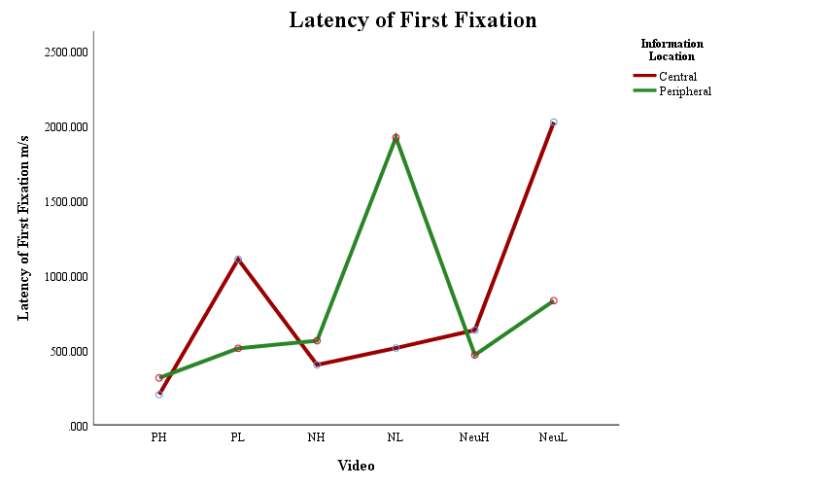
Figure 26 Mean latency of first fixation time for central and peripheral information by video event.

Seven participants’ data were excluded from the analysis due to outlying data. Sensitivity analysis confirmed there to be no change in main effects, interactions or follow up test significance, or direction.

Number of fixations
A significant main effect of video F(5, 235) = 20.128, p < .001, ƞ_{p}² = .3 was evidenced for number of fixations. Pairwise comparisons conducted to explore the main effect of video showed that the high arousal neutral video received more fixations than the valenced matched low arousal condition p < .001, d = .79 CI [1.18, 4.97], with no significant difference between high and low arousal videos of positive or negative valence. When compared across high arousal conditions the positive video recorded significantly more fixations than the negative video p = .002, d = .78 CI [0.85, 5.65], but there was no difference between the number of fixations to negative and neutral videos. At low arousal the positive video received more fixations than both the negative p < .001, d = .83 CI [1.54, 5.67] and neutral p < .001, d = .77 CI [2.82, 6.89] videos, but there was no difference between fixations to negative and neutral videos. A significant effect of information location F(1, 47) = 605.445, p < .001, ƞ_{p}² = .928 was observed, with central information (M = 177.52, SD = 22.85) fixated upon fewer times than peripheral information (M = 305.42, SD = 27.96).
In addition to the main effects of video and information location, a significant interaction was evidenced between the two F(3.986, 187.334) = 593.06, p < .001, ƞ_{p}² = .927. To investigate the interaction between video and information location, as illustrated in Figure 27, data was split by video to allow central and peripheral number of fixations to be compared, all results p < .001. Peripheral information received more fixations than central information within the positive high arousal t(47) = -54.95, d = 12.13 CI [-79.65, -74.02] positive low arousal t(47) = -16.992, d = 4.19 CI [-31.11, -16.99], negative high arousal t(47) = -19.876, d = 4.16 CI [-28.49, -23.26] and neutral low arousal Z = -6.022, N = 48, r = .87 CI [-47.19, -39.23] videos. For the negative low arousal Z = -6.021, N = 48, r = .87 CI [42.05, 51.46] and neutral high arousal video t(47) = 4.031, d = .98 CI [3.29, 9.84], more fixations were made to central information.

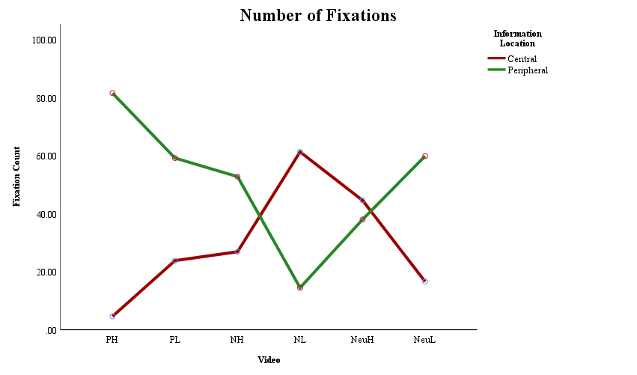
Figure 27 Mean number of fixations for central and peripheral information by video event.

Six participants data were removed from the analysis due to outlying data points. Sensitivity analysis confirmed there to be no change in significance or direction of results.

Viewing time
There was a significant main effect of video condition F(5, 245) = 35.934, p < .001, ƞ_{p}² = .423. Pairwise comparisons to investigate the main effect evidenced the positive high arousal p < .001, d = 1.39 [-1768.21, -936.55], and negative high arousal video p < .001, d = .61 [-963.61, -248.67] to have been viewed for less time than their valenced matched low arousal conditions. However, there was no difference between the neutral conditions. When matched by arousal there was no significant difference between the low arousal conditions. For high arousal conditions the positive video was viewed for less time than both the negative p < .001, d = 1.08 [-1422.04, -602.28] and neutral videos p < .001, d = 1.04 [-1419.54, -569.52], with no difference in viewing time between the negative and neutral high arousal videos. A main effect of information location was also observed F(1, 49) = 292.252, p < .001, ƞ_{p}² = .856, with central information (M = 48994.32, SD = 6524.03) being viewed for significantly less time than peripheral information (M = 77181.96, SD = 8356.97).
In addition to main effects of video and information location, a significant interaction was evidenced between the two conditions F(3.135, 153.636) = 402.508, p < .001, ƞ_{p}² = .891. To investigate the interaction between video and information location, as illustrated in Figure 28, data was split by information location to compare viewing time to central and peripheral information within each video. Central information was viewed for less time than peripheral information in the positive high arousal video t(49) = -58.351, d = 12.07 CI [-17360.11, -16204.18], positive low arousal t(49) = -15.111, d = 3.86 CI [-10111.56, -77737.76], negative high arousal t(49) = -17.135, d = 3.87 CI [-6669.85, -5269.63], and neutral low arousal video Z = -6.135, N = 50, r = .87 CI [-14025.69, -11533.43]. In both the negative low arousal Z = -5.922, N = 50, r = .84 CI [12173.95, 15936.49] and neutral high arousal t(49) = 4.887, d = 1.18 CI [1303.06, 3123.42] video this was reversed with central information being viewed for longer, all at p < .001.

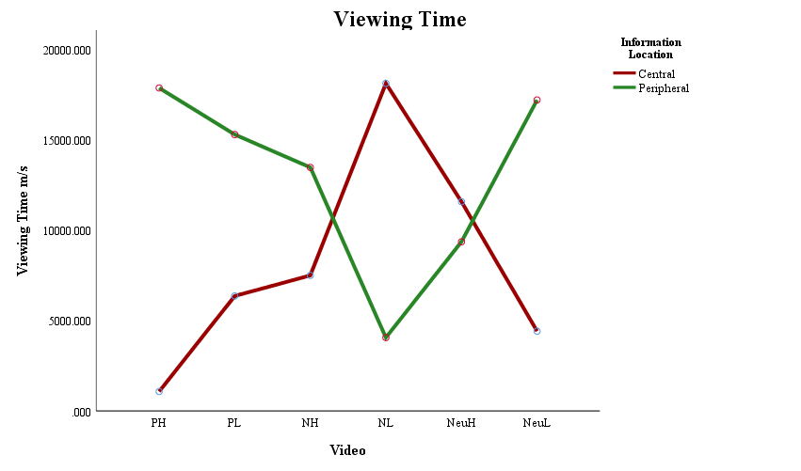
Figure 28 Mean viewing time for central and peripheral information areas by video event.

Four participants data were excluded from initial analysis due to having outlying data points. Sensitivity analysis confirmed there to be no change in significance or direction of results.

Eye-tracking summary
In summary, the present results suggest mixed support for hypothesis three i.e. that central information in negative events, and for central detail of the positive event of high arousal, would receive higher levels of attention during encoding compared to peripheral information in the same events. For both positive videos, the negative high arousal, and the neutral low arousal video, peripheral information was attended to more often and for longer than central information. For the negative low arousal and neutral high arousal video, this was reversed with more fixations and longer viewing times to central information. First fixations were faster to central information in both negative videos and in the positive high arousal video, and faster to peripheral information in both neutral videos and in the positive low arousal video.

Memory Accuracy
As displayed in Table 29, the data indicates no clear lowering of accuracy by misinformation to be occurring. Central information displayed higher accuracy than peripheral information in all conditions for the positive high arousal video and in the negative low arousal video.

Table 29 Means and standard deviations for number of correct, new false and misleading information statements.

Statement | Group | Location |  | PH |  | PL |  | NH |  | NL |  | NeuH |  | NeuL
Correct | Control | Central |  | 1.07 (.73) |  | 1.33 (.73) |  | 0.89 (.70) |  | 1.52 (.58) |  | 1.19 (.74) |  | 1.26 (.66)
 |  | Peripheral | 0.96 (.65) |  | 0.70 (.78) |  | 0.93 (.68) |  | 1.26 (.66) |  | 1.07 (.68) |  | 1.44 (.64)
Correct | Misled | Central |  | 1.33 (.73) |  | 1.37 (.56) |  | 1.33 (.62) |  | 1.04 (.71) |  | 1.04 (.65) |  | 1.41 (.64)
 |  | Peripheral | 1.00 (.68) |  | 0.59 (.64) |  | 0.85 (.60) |  | 1.00 (.62) |  | 1.11 (.75) |  | 1.48 (.64)
False | Control | Central |  | 1.30 (.72) |  | 1.37 (.57) |  | 1.33 (.68) |  | 1.56 (.64) |  | 1.04 (.52) |  | 1.52 (.70)
 |  | Peripheral | 0.85 (.72) |  | 1.33 (.56) |  | 0.74 (.76) |  | 1.41 (.64) |  | 1.37 (.69) |  | 1.56 (.64)
False | Misled | Central |  | 1.48 (.77) |  | 0.93 (.47) |  | 1.07 (.55) |  | 1.56 (.58) |  | 1.11 (.80) |  | 1.48 (.58)
 |  | Peripheral | 0.96 (.81) |  | 1.26 (.59) |  | 0.63 (.79) |  | 1.30 (.72) |  | 1.44 (.64) |  | 1.59 (.57)
Misleading | Control | Central |  | 1.22 (.70) |  | 1.00 (.68) |  | 1.37 (.69) |  | 1.30 (.67) |  | 1.30 (.67) |  | 1.30 (.67)
 |  | Peripheral | 0.96 (.59) |  | 1.30 (.72) |  | 1.67 (.68) |  | 1.04 (.59) |  | 1.26 (.66) |  | 1.67 (.55)
Misleading | Misled | Central |  | 1.37 (.74) |  | 0.85 (.66) |  | 1.30 (.78) |  | 1.41 (.50) |  | 1.22 (.75) |  | 1.26 (.53)
 |  | Peripheral | 0.78 (.75) |  | 1.26 (.71) |  | 1.26 (.66) |  | 0.93 (.73) |  | 1.48 (.70) |  | 1.63 (.56)

Three, three-way mixed ANOVAs using a two (group: misled, control) by six (video: positive high and low arousal, neutral high and low arousal, negative high and low arousal) by two (information location: central, peripheral), design were conducted to evaluate accuracy for new correct, new incorrect and misleading information. An initial alpha level of .05 was set and adjusted using a Bonferroni correction where relevant to level of analysis. All confidence intervals are reported at 95% and outlying data points are defined as being plus or minus three standard deviations from the mean.

New correct information
Analysis showed a significant main effect of video F(5, 260) = 7.027, p < .001, ƞ_{p}² = .119. Pairwise comparisons investigating the main effect of video showed no clear effect of valence or arousal. Only the neutral low arousal video showed significant difference to the other videos, with higher accuracy overall than that of the positive high arousal video p = .001, d = 0.6 CI [-.520, -.091], positive low arousal video p < .001, d = 0.98 CI [-.648, -.149], negative high arousal video p < .001, d = 0.89 CI [-.648, -.148], and neutral high arousal video p < .001, d = 0.64 CI [.104, .498], but not to the negative low arousal video. A significant effect of information location F(1, 52) = 14.533, p < .001, ƞ_{p}² = .218 was also observed, which indicated that central information (M = 7.39, SD = 2.06) was recalled with higher accuracy than peripheral information (M = 6.20, SD = 1.93).
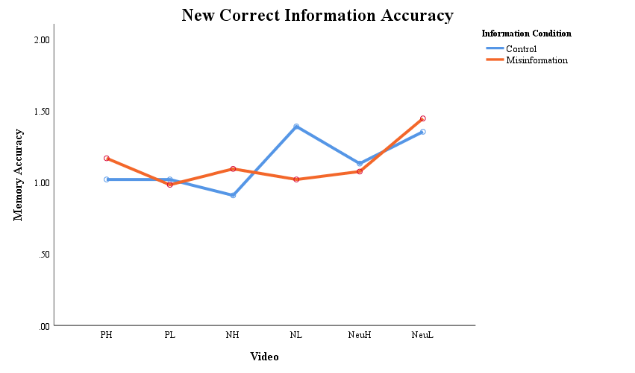
Figure 29 Mean memory accuracy for newly presented correct statements by video event condition for misled and non-misled participants groups.
In addition to main effects of video and information location, there were significant interactions between the two effects F(5, 260) = 4.654, p < .001, ƞ_{p}² = .082, and between video and group condition F(5, 260) = 3.198, p = .008, ƞ_{p}² = .058. There was no main effect of group condition and no three-way interaction between video, information location and group.
As illustrated in Figure 29, the interaction between video and group condition was split to compare control and misled group accuracy in each video. Non-parametric, between-subjects Mann-Whitey U tests showed significantly higher accuracy in the control group for the negative low arousal condition Z = -2.782, N = 54, p = .002, r = 0.38 CI [.218, 1.26], compared to the misled group. The lowering of accuracy suggests that post-event misleading information was reducing the ability of misled participants to correctly identify correct information about the original video event. No other significant differences were observed between group conditions for new correct information.

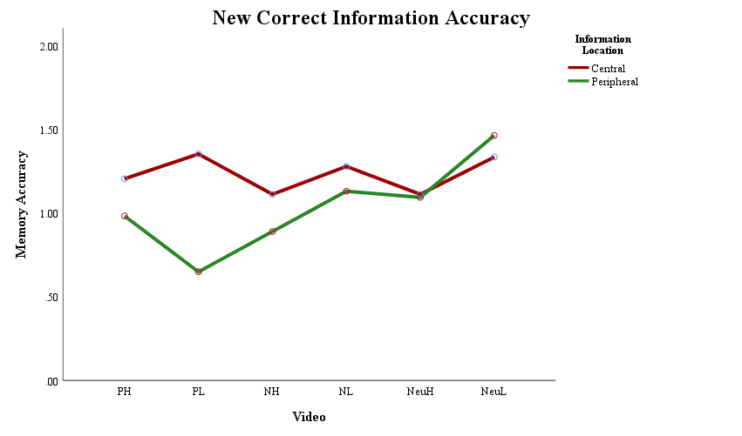
Figure 30 Mean memory accuracy for newly presented correct central and peripheral information by video event condition.

To investigate the interaction between video and information location, data was split to compare central to peripheral accuracy in each video condition, as illustrated in Figure 30. Central information was recalled with significantly higher accuracy than peripheral information in the positive low arousal condition t(53) = 4.590, p < .001, d = 1.04 CI [.153, .396] only. The positive high arousal Z = -1.892, N = 54, p = .04, r = 0.26 CI [-.007, .451], and negative high arousal t(53) = 1.693, p = .048 d = 0.34 CI [-.041, .486] conditions were marginally significant after Bonferroni correction, with corresponding medium effect sizes to suggest that with increased power these effects would reach significance. There was no difference between central and peripheral accuracy for the negative low arousal or both neutral videos.

New incorrect information
Results showed a significant main effect of video F(5, 260) = 12.758, p < .001, ƞ_{p}² = .197. Pairwise comparisons to investigate the main effect of video showed no clear effect of valence or arousal. The negative high arousal video showed higher accuracy than the negative low arousal video p < .001, d = 1.02 CI [-.814, -.205], but the neutral high arousal video showed opposite results with lower accuracy than the neutral low arousal video p = .002, d = 0.59 CI [-.519, -.074]. There was no main effect or interaction with group condition suggesting that misleading information was not impacting accuracy for new incorrect information.
In addition to a main effect of video, there was a significant interaction between video and information location F(5, 260) = 7.700, p < .001, ƞ_{p}² = .129. Data was split by video type to investigate the interaction between video and information location, as illustrated in Figure 31. The positive high arousal Z = -2.704, N = 54, p = .004, r = 0.37 CI [.097, .532] and negative high Z = -3.509, N = 54, p < .001, r = 0.48 CI [.260, .777] videos observed higher central accuracy compared to peripheral accuracy. Conversely, peripheral information was recalled with higher accuracy than central information in the neutral high arousal condition t(53) = -2.752, p = .008, d = 0.74 CI [-.576, -.090]. There was no central peripheral trade-off evidenced for any of the low arousal conditions suggesting that it was emotional valence combined with high arousal which was mediating the effect for positive and negative high arousal videos.

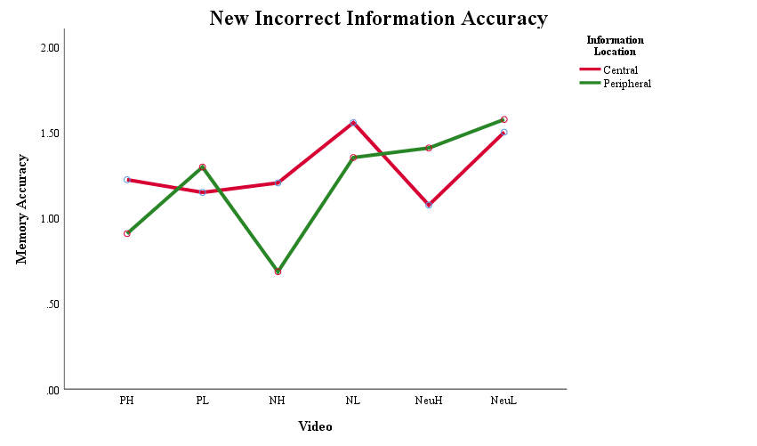
Figure 31 Mean memory accuracy for newly presented incorrect central and peripheral information by video event.

Misleading information
Analysis for misleading information evidenced a significant main effect of video F(5, 260) = 6.525, p < .001, ƞ_{p}² = .111. Pairwise comparisons to explore the effect of video demonstrated no clear effect of valence or arousal. There was no difference in accuracy between valenced matched arousal conditions. The high arousal conditions showed that accuracy was lower for the positive video compared to the negative video p = .028, d = 0.62 CI [-.11, -.019] with no difference between either the positive or negative video and the neutral video. When matched by low arousal conditions the neutral video had significantly higher accuracy than both the positive p = .005, d = 0.76 CI [-.649, -.073] and negative p = .011, d = 0.65 CI [-.551, -.042] videos.
In addition to the main effect of video, there was a significant interaction between video condition and information location F(5, 260) = 7.974, p < .001, ƞ_{p}² = .133. There was no main effect of, or interaction with, group condition suggesting that the post-event misleading information was not impacting accuracy.

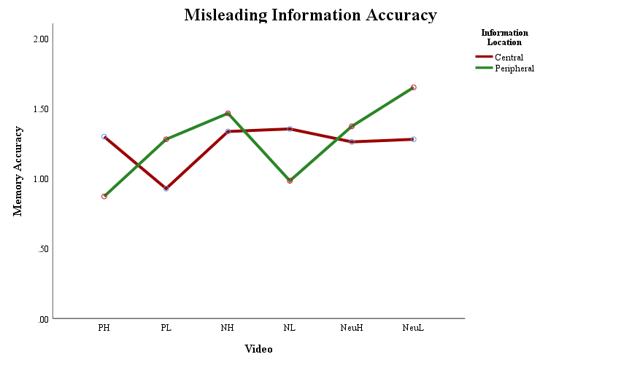
Figure 32 Mean memory accuracy for misleading central and peripheral information by video event condition.

When split by video condition to compare central and peripheral information accuracy, as illustrated in Figure 32, no clear effect of valence or arousal was observed. The positive high arousal t(53) = 3.013, p = .002, d = 0.62 CI [.142, .710] and negative low arousal t(53) = 3.369, p < .001, d = 0.59 CI [.150, .591] videos demonstrated higher central information accuracy, the positive low arousal t(53) = -2.708, p = .0045, d = 0.51 CI [-.613, -.091] and neutral low arousal Z = -3.532, N = 54, p < .001, r = 0.48 CI [-.556, -.184] videos had higher peripheral accuracy, and the negative and neutral high arousal videos evidenced no difference between accuracy for central and peripheral information.

Memory accuracy summary
In summary, there was no support shown in results for hypothesis two i.e. that memory accuracy would be reduced by post-event misinformation for central information in the negative events or for central detail of the positive high arousal event. Memory accuracy was reduced by post-event misinformation in the newly presented correct information statements, and only regarding details about the negative low arousal video. There was no other effect or interaction with group condition for new incorrect or for misleading information statements. There was some support for hypothesis one i.e. that memory accuracy for central detail in the negative events, and for central detail in the positive event of high arousal, was greater than that of peripheral detail in the same events. However, the pattern of valence or arousal evidencing a central or peripheral advantage across statement types was not consistent. Only the positive video with high arousal and the negative video with low arousal had higher central accuracy for all information types.

Multiple regression
As evidenced in Chapter 4 and Chapter 5, eye-tracking measures of viewing time and number of fixations showed similar patterns of attention to central and peripheral information. Spearman’s Rho correlations confirmed that viewing time and number of fixations were positively correlated for all videos and therefore viewing time was used to represent both measures in the following analysis. Please see Table 30 for correlation results.

Table 30 Spearman’s Rho correlations between eye-tracking measures recorded during video viewing.

Location | Condition | VT x FX | VT x LFF | FX x LFF
Central | PH | r_{s} = .831^{c}, p < .001* | r_{s} = .290⁺, p = .034* | r_{s} = .259v, p = .058
 | PL | r_{s} = .894⁺, p < .001* | r_{s} = -.224, ⁺ p = .104 | r_{s} = -.193, p = .161
 | NeuH | r_{s} = .594⁺, p < .001* | r_{s} = .039, p = .781 | r_{s} = -.045, p = .745
 | NeuL | r_{s} = .814⁺, p < .001* | r_{s} = -.036, p = .796 | r_{s} = .095, p = .493
 | NH | r_{s} = .617⁺, p < .001* | r_{s} = -.311⁺, p = .022* | r_{s} = -.302⁺, p = .027*
 | NL | r_{s} = .560⁺, p < .001* | r_{s} = -.285⁺, p = .037* | r_{s} = -.355⁺, p = .009*
Peripheral | PH | r_{s} = .710⁺, p < .001* | r_{s} = -.305⁺, p = .025* | r_{s} = -.218, p = .114
 | PL | r_{s} = .631⁺, p < .001* | r_{s} = -.196, p = .155 | r_{s} = -.468⁺, p < .001*
 | NeuH | r_{s} = .703⁺, p < .001* | r_{s} = -.169, p = .222 | r_{s} = -.256⁺, p = .061
 | NeuL | r_{s} = .550⁺, p < .001* | r_{s} = -.145, p = .296 | r_{s} = -.202, p = .142
 | NH | r_{s} = .440⁺, p = .001* | r_{s} = -.099, p = .474 | r_{s} = -.008, p = .952
 | NL | r_{s} = .952⁺, p < .001* | r_{s} = -.557⁺, p < .001* | r_{s} = -.522⁺, p < .001*

* significant at <= .05, ⁺ greater than medium effect size of 0.24. Two-tailed significance reported and N = 54.

To test hypothesis four i.e. that attention during encoding predicts memory accuracy, multiple regression models were run combining memory accuracy and eye-tracking data. Memory accuracy was collapsed across the three statement types to allow a single percentage accuracy figure to be used (cf. Mahé et al., 2015) as the criterion to be predicted in three models. The first model included demographic details of age and sex, the second added viewing time, and the third added latency of first fixation. Data was split by group condition to assess the ability of visual attention to predict memory accuracy when misleading post-event information had been presented. Full regression results are detailed in Tables 31 to 34 and illustrated in Figure 33.

Correct post-event information
As detailed in Table 31 and 32, for those who received correct post-event information, only central accuracy for the neutral low arousal video detail was significantly predicted, with accuracy decreasing as age increased (Age -.473 ≤ β ≤ -450, .036 ≤ p ≤ .044). Yet, when multivariate outliers were removed, age moved to be non-significant in all models.

Post-event misinformation
As can be seen in Table 33 and 34, for misled participants there were no significant predictors of accuracy for central information, or for peripheral information in either positive conditions. For the high arousal neutral condition viewing time explained 31.6% of the variance with accuracy increasing as dwell time increased (VT .635 ≤ β ≤ .637, p = .003). For the low arousal neutral condition increasing viewing time predicted reduced accuracy, accounting for 16.9% of variance (VT -.525 ≤ β ≤ -.426, .015 ≤ p ≤ .033). Similar to the neutral high arousal video, peripheral information accuracy in the negative high arousal condition was also predicted by increasing viewing time. Viewing time explained 11.5% of variance (VT .381 ≤ β ≤ .456, .021 ≤ p ≤ .067). Sex and latency of first fixation were also significant predictors with men having higher accuracy than women (Sex -.458 ≤ β ≤ -.328, .023 ≤ p ≤ .084), and early fixation predicting higher accuracy (LFF β = -.408, p = .029). However, when multivariate outliers were removed both sex and viewing time moved to be non-significant, with only latency of first fixation remaining. For peripheral information in the negative low arousal video accuracy increased with age (Age .441 ≤ β ≤ .499, .013 ≤ p ≤ .024).

Summary of multiple regression
In contrast to the prediction of hypothesis four, attention during encoding did not predict memory accuracy in the absence of misinformation. In addition, when post-event misleading information had been given, attention during encoding did not predict accuracy for centrally emotional information. For peripheral information increasing attention predicted higher accuracy for the neutral and negative high arousal conditions, and in contrast predicted lower accuracy for information in the neutral low condition.

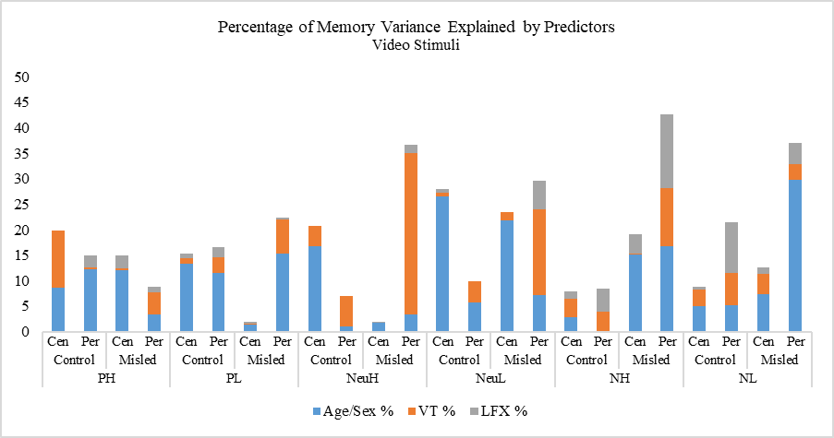
VT +
Age –
VT -
LFF -
VT +
Sex M
Age +

Figure 33 Percentage of variance explaining memory accuracy by age and sex, viewing time and latency of first fixation using video stimuli.

Table 31 Video stimuli control group multiple regression (criterion central memory accuracy, predictors age, sex, viewing time (VT), latency of first fixation (LFX)).

Stimuli Emotion | Model 1: Age, Sex | Model 2: Age, Sex, VT | Model 3: Age, Sex, VT, LFX
Positive High | R² = .086, F(2, 26) = 1.127, p = .341, ƞ² = .09 | R² = .199, F(3, 26) = 1.902, p = .157, ƞ² = .20 | R² = .199, F(4, 26) = 1.367, p = .278, ƞ² = .20
Positive Low | R² = .133, F(2, 25) = 1.769, p = .193, ƞ² = .13 | R² = .144, F(3, 25) = 1.231, p = .322, ƞ² = .14 | R² = .153, F(4, 25) = .951, p = .455, ƞ² = .15
Neutral High | R² = .167, F(2, 26) = 2.404, p = .112, ƞ² = .17 | R² = .208, F(3, 26) = 2.008, p = .141, ƞ² = .21 | R² = .208, F(4, 26) = 1.447, p = .252, ƞ² = .21
Neutral Low  R² _{PRESS} = .01 | R² = .265, F(2, 22) = 3.602, p = .046, ƞ² = .27*  Age β = -.450, p = .036 [-1.65, -.061]*  Sex β = -.412, p = .053 [-35.39, .258]^{m} | R² = .272, F(3, 22) = 2.371, p = .103, ƞ² = .27  Age β = -.473, p = .037 [-1.74, -.059]*  Sex β = -.410, p = .059 [-35.75, .762]^{m}  VT β = -.090, p = .661 [-.004, .002] | R² = .280, F(4, 22) = 1.753, p = .182, ƞ² = .28  Age β = -.468, p = .044 [-1.75, -.027]*  Sex β = -.412, p = .064 [-36.30, 1.16]^{m}  VT β = -.090, p = .669 [-.004, .003]  LFF β = -.089, p = .661 [-.008, .005]
Negative High | R² = .029, F(2, 26) = .352, p = .707, ƞ² = .03 | R² = .064, F(3, 26) = .524, p = .670, ƞ² = .06 | R² = .080, F(4, 26) = 3.476, p = .753, ƞ² = .08
Negative Low | R² = .051, F(2, 25) = .622, p = .546, ƞ² = .05 | R² = .052, F(3, 25) = .406, p = .750, ƞ² = .05 | R² = .058, F(4, 25) = .324, p = .858, ƞ² = .06

Table 32 Video stimuli control group multiple regression (criterion peripheral memory accuracy, predictors age, sex, viewing time (VT), latency of first fixation (LFX)).

Stimuli Emotion | Model 1: Age, Sex | Model 2: Age, Sex, VT | Model 3: Age, Sex, VT, LFX
Positive High | R² = .123, F(2, 26) = 1.688, p = .206, ƞ² = .12 | R² = .127, F(3, 26) = 1.112, p = .365, ƞ² = .13 | R² = .150, F(4, 26) = .970, p = .444, ƞ² = .15
Positive Low | R² = .116, F(2, 26) = 1.568, p = .229, ƞ² = .12 | R² = .147, F(3, 26) = 1.322, p = .291, ƞ² = .15 | R² = .166, F(4, 26) = 1.097, p = .383, ƞ² = .17
Neutral High | R² = .010, F(2, 26) = .115, p = .892, ƞ² = .01 | R² = .070, F(3, 26) = .573, p = .639, ƞ² = .07 | R² = .070, F(4, 26) = .411, p = .799, ƞ² = .07
Neutral Low | R² = .057, F(2, 26) = .719, p = .498, ƞ² = .06 | R² = .099, F(3, 26) = .844, p = .484, ƞ² = .01 | R² = .099, F(4, 26) = .607, p = .662, ƞ² = .01
Negative High | R² = .001, F(2, 26) = .014, p = .986, ƞ² < .001 | R² = .039, F(3, 26) = .310, p = .818, ƞ² = .04 | R² = .085, F(4, 26) = .508, p = .731, ƞ² = .09
Negative Low | R² = .052, F(2, 25) = .637, p = .538, ƞ² = .05 | R² = .116, F(3, 25) = .966, p = .427, ƞ² = .12 | R² = .214, F(4, 25) = 1.426, p = .260, ƞ² = .21

Table 33 Video stimuli misled group multiple regression (criterion central memory accuracy, predictors age, sex, viewing time (VT), latency of first fixation (LFX)).

Stimuli Emotion | Model 1: Age, Sex | Model 2: Age, Sex, VT | Model 3: Age, Sex, VT, LFX
Positive High | R² = .120, F(2, 25) = 1.568, p = .230, ƞ² = .12 | R² = .125, F(3, 25) = 1.047, p = .391, ƞ² = .12 | R² = .150, F(4, 25) = .927, p = .467, ƞ² = .15
Positive Low | R² = .014, F(2, 26) = .176, p = .840, ƞ² = .02 | R² = .015, F(3, 26) = .121, p = .947, ƞ² = .02 | R² = .020, F(4, 26) = .113, p = .977, ƞ² = .02
Neutral High | R² = .018, F(2, 26) = .224, p = .801, ƞ² = .02 | R² = .018, F(3, 26) = .144, p = .933, ƞ² = .02 | R² = .019, F(4, 26) = .109, p = .978, ƞ² = .02
Neutral Low | R² = .218, F(2, 22) = 3.074, p = .066, ƞ² = .22^{m} | R² = .234, F(3, 22) = 2.134, p = .126, ƞ² = .23 | R² = .234, F(4, 22) = 1.526, p = .233, ƞ² = .23
Negative High | R² = .155, F(2, 26) = 2.199, p = .133, ƞ² = .16 | R² = .157, F(3, 26) = 1.422, p = .262, ƞ² = .16 | R² = .194, F(4, 26) = 1.327, p = .291, ƞ² = .19
Negative Low | R² = .073, F(2, 24) = .868, p = .434, ƞ² = .07 | R² = .114, F(3, 24) = .901, p = .457, ƞ² = .11 | R² = .127, F(4, 24) = .726, p = .585, ƞ² = .13

Table 34 Video stimuli misled group multiple regression (criterion peripheral memory accuracy, predictors age, sex, viewing time (VT), latency of first fixation (LFX)).

Stimuli Emotion | Model 1: Age, Sex | Model 2: Age, Sex, VT | Model 3: Age, Sex, VT, LFX
Positive High | R² = .033, F(2, 26) = .414, p = .665, ƞ² = .03 | R² = .078, F(3, 26) = .648, p = .592, ƞ² = .08 | R² = .089, F(4, 26) = .539, p = .708, ƞ² = .09
Positive Low | R² = .154, F(2, 26) = 2.189, p = .134, ƞ² = .15 | R² = .221, F(3, 26) = 2.175, p = .118, ƞ² = .22 | R² = .224, F(4, 26) = 1.587, p = .213, ƞ² = .22
Neutral High  R² _{PRESS} = .07 | R² = .034, F(2, 26) = .419, p = .662, ƞ² = .03  Age β = .088, p = .681 [-.79, 1.19]  Sex β = .137, p = .523 [-12.40, 23.75] | R² = .350, F(3, 26) = 4.130, p = .018, ƞ² = .35  Age β = -.149, p = .443 [-1.23, .55]  Sex β = .012, p = .946 [-15.00, 16.02]  VT β = .637, p = .003 [.002, .008]* | R² = .367, F(4, 26) = 3.194, p = .033, ƞ² = .37  Age β = -.133, p = .499 [-1.21, .607]  Sex β = -.015, p = .936 [-16.61, 15.35]  VT β = .635, p = .003 [.002, .008]*  LFF β = -.134, p = .446 [-.046, .021]
Neutral Low  R² _{PRESS} = .003 | R² = .072, F(2, 26) = .925, p = .410, ƞ² = .07  Age β = -.182, p = .387 [-1.27, .510]  Sex β = .260, p = .221 [-6.38, 26.24] | R² = .241, F(3, 26) = 2.440, p = .090, ƞ² = .24^{m}  Age β = -.094, p = .632 [-1.04, .643]  Sex β = .298, p = .134 [-3.76, 26.55]  VT β = -.426, p = .033 [-.004, .000]* | R² = .296, F(3, 26) = 2.311, p = .090, ƞ² = .30^{m}  Age β = -.040, p = .841 [-.932, .766]  Sex β = .237, p = .235 [-6.33, 24.49]  VT β = -.525, p = .015 [-.005, -.001]*  LFF β = -.261, p = .206 [-.023, .005]
Negative High  R² _{PRESS} = .18 | R² = .167, F(2, 26) = 2.401, p = .112, ƞ² = .17  Age β = .282, p = .162 [-.260, 1.47]  Sex β = -.394, p = .055 [-31.32, .386]^{m} | R² = .282, F(3, 26) = 3.013, p = .051, ƞ² = .28^{m}  Age β = .140, p = .490 [-.585, 1.18]  Sex β = -.458, p = .023 [-33.29, -2.67]*  VT β = .381, p = .067 [.000, .008]^{m} | R² = .426, F(4, 26) = 4.075, p = .013, ƞ² = .43*  Age β = .049, p = .795 [-.724, .934]  Sex β = -.328, p = .084 [-27.62, 1.87]^{m}  VT β = .456, p = .021 [.001, .008]*  LFF β = -.408, p = .029 [-.049, -.003]*
Negative Low  R² _{PRESS} = .11 | R² = .299, F(2, 25) = 4.905, p = .017, ƞ² = .30*  Age β = .441, p = .024 [.181, 2.30]*  Sex β = .222, p = .234 [-7.40, 28.78] | R² = .329, F(3, 25) = 3.599, p = .030, ƞ² = .33*  Age β = .457, p = .020 [.220, 2.35]*  Sex β = .178, p = .354 [-10.15, 27.22]  VT β = .179, p = .330 [-.001, .003] | R² = .370, F(4, 25) = 3.082, p = .038, ƞ² = .37*  Age β = .499, p = .013 [.322, 2.49]*  Sex β = .147, p = .443 [-11.72, 25.83]  VT β = .303, p = .159 [-.001, .004]  LFF β = .237, p = .257 [-.002, .007]

Discussion
When using videos presented in a virtual reality environment as events to be remembered, there was little support for the four hypotheses being tested by this thesis. There was some support for hypothesis one, as central detail was recalled with higher accuracy than peripheral detail for the positive high arousal and the negative low arousal event with greatest consistency across statement types. However, the negative high arousal event did not display the same central advantage effect. In contrast to the prediction of hypothesis two, post-event misinformation only lowered accuracy for new correct information statements concerning details from the negative low arousal video. There was no lowering of accuracy for statements testing previously presented misinformation. There was mixed support for hypothesis three, as the negative low arousal event recorded great numbers of fixations and longer viewing time for central detail compared to peripheral detail. Fixation times were also faster to central detail of all three events predicted to receive greater attention during encoding. However, the amount of viewing time and the number of fixations did not display the same central bias for the positive and negative high arousal events. There was also no support shown for hypothesis four. When combining attentional measures with memory accuracy, no predictive relationships were observed between attention and accuracy for central information. For peripheral detail, attention predicted accuracy in the negative high arousal event, but only for participants exposed to misleading post-event information,
suggesting that a protective effect of attention was occurring.
The lack of a misinformation effect for misleading information suggests that increasing the level of information complexity through the virtual environment and video stimuli may have increased the ability of participants to discern correct from incorrect information (Makowski et al., 2017). Nonetheless, there was no reduction in accuracy as a result of post-event misleading information, which contrasts with other studies using video which have evidenced a misinformation effect occurring for misleading information (Forgas et al., 2005; Loftus, Levidow, & Duensing, 1992; Mahé et al., 2015; Paz-Alonso, Goodman, & Ibabe, 2013; Paz-Alonso & Goodman, 2008; Stille, Norin, & Sikström, 2017).
The current result of a misinformation effect for newly presented correct information is supported by other study findings (Paz-Alonso et al., 2013; Paz-Alonso & Goodman, 2008). Paz-Alonso et al. (2008, 2013) found that misleading information lowed accuracy for new correct statements along with misleading statements when using a negative high arousal video for both central and peripheral information. In contrast, Forgas et al. (2005), Mahé et al. (2015), and Loftus et al. (1992) only observed a reduction in accuracy for misleading statements when also using a negative high arousal video. None of these studies showed a misinformation effect in new incorrect statements, which is replicated by the current result. However, the current result of no lowering of accuracy for misleading statements by post-event misinformation is unusual.
The removal of a misinformation effect could be explained by using a less experimental and more ecologically valid method i.e. using the virtual cinema scene, though previous studies do not support this view that increasing ecological validity lessens the impact of misleading information. For example, Forgas et al. (2005) found a misinformation effect after a real-world staged negative event during a lecture. An alternative explanation could be that the virtual reality experience itself was impacting memory accuracy. The participants in the current study rated the virtual experience as highly positive overall but were not asked to record their previous level of experience in using virtual reality and were not asked to rate it specifically on both valence and arousal measures. The high positive rating could indicate high novelty of the experience or high arousal intensity. If high positivity were impacting memory it might be expected that a congruency effect would be observed for positive videos i.e. higher levels of false memory for positive videos, and less for the negative and neutral video content (Bland, Howe, & Knott, 2016). However, this was not the case. Increased arousal due to the novelty of using the equipment may better explain the reduction of the misinformation effect. Previous studies have evidenced that moderate levels of pre-task stress can enhance memory accuracy (Wiemers, Sauvage, Schoofs, Hamacher-Dang, & Wolf, 2013) and reduce the occurrence of false memory (Zoldaz et al., 2014). Therefore, the novel experience of using the equipment and being within the virtual environment may have increased the physiological arousal of participants prior to the encoding stage in which the videos were viewed. Increased arousal may explain the overall rejection of misleading information as encoding during the video events would have been enhanced. However, this explanation does not account for the misinformation effect for new correct information in the negative low arousal video condition.
The result of central and peripheral information accuracy being lowered by misleading information but only for newly presented correct information in the negative low arousal event is interesting as both negative videos were rated by participants as being low in valence and high in arousal. As a misinformation effect was only evidenced for the negative low video, this suggests that the content of the two negative videos was mediating the misinformation effect, and not the valence or arousal level i.e. the discrete themes of sadness and grief in the low arousal video and of fear and anxiety in the high arousal video (Roseman, Spindel, & Jose, 1990). Wider research in false memory has observed that when categorised as the discrete emotion of sadness, attention is broadened during encoding and retrieval (Gabel & Harmon-Jones, 2010). The widening of attention is theorised to allow more gist memory to be encoded from both central and peripheral information, with less verbatim detail. Consequently, memory for sad events are predicted to be more open to distortion by misleading information as a distinct contrast to pre-goal emotions which would be predicted to be more resistant to misleading information (Kaplan, Van Damme, Levine, & Loftus, 2016). Applying this approach to the current results may explain why a misinformation effect was evidenced for the negative low arousal image, as misleading information impacted both central and peripheral detail. Nevertheless, it does not explain why the effect was only apparent for new correct information.
In contrast to the motivational approach by Gabel and Harmon-Jones (2010), Storbeck, Dayboch, and Wylie (2018) have presented evidence that sadness allows greater targeting of attention through suppression of irrelevant information. Attentional measures in the current study support the view that overt attention was not broader during the negative low arousal event, compared to the negative high arousal event. Peripheral information was viewed for more time and more often in the negative high arousal condition, and central information was viewed for longer and more often in the low arousal condition, supporting the findings of Storbeck et al. (2018). Central memory accuracy for the negative low arousal event was also either comparable or higher than for detail in the negative high arousal event for the misleading and new incorrect information. The increased central accuracy for the negative low arousal video suggests that attention was narrowing. Despite indicating that central information had been targeted, there was no predictive relationship between attention and accuracy for the negative low arousal condition. For the negative high arousal condition, more peripheral attention did predict higher accuracy, but only when post-event misinformation had been given. The finding that attention to peripheral information increased accuracy when presented with misinformation suggests that it enabled participants to better distinguish between correct and incorrect detail at test, compared to the control group who received correct post-event information for whom no predictive relationship was observed.
The contrast between peripheral information in the negative high arousal condition showing a predictive relationship, and the central information in the low arousal condition not showing a predictive relationship, when attention and accuracy were concurrent in both, suggests that attentional measures during the negative low arousal event are not representative of encoding to memory.

Chapter 7 Comparative analysis of attention during encoding and memory accuracy for single images, sequential images and video
Misinformation research has used a mixture of single image, sequential slides and video content to investigate the role of misleading information in memory distortion (Bookbinder & Brainerd, 2016). Therefore, this thesis aimed to investigate if using different stimuli formats impacts attention during encoding and resulting memory accuracy. The research presented in the previous three chapters has used stimuli types of increasing complexity i.e. images, image sequences and video. Therefore, this chapter aims to establish if attention and memory results are comparable across the three studies, or whether attention and memory accuracy would change as the level of content complexity increased. Based on perceptual load theory (Lavie, 1995), the fifth hypothesis being tested by this thesis predicted that as complexity in stimuli events increased via stimuli format, memory accuracy and attention to centrally emotional information would increase to show longer viewing times, higher number of fixations, and faster first fixation latencies.

Method
Design
To enable a comprehensive understanding of the impact of stimuli format on attention and memory accuracy, the results from the studies in Chapters 4, 5 and 6 were combined to give a three (stimuli format) by two (grouping condition) by six (emotion condition) by two (information location) design. Due to the high correlations previously evidenced between number of fixations and viewing time, viewing time was used to represent both measures. To simplify analyses memory accuracy was collapsed across the three statement types and a percentage accuracy figure calculated for each participant (cf. Mahé, Corson, Verrier, & Payoux, 2015).

Participants
In total 166 participants data were included with a mean age of 23.61 years (SD = 7.82), ranging from 18 to 58, with 109 females and 57 males. Please see Table 35 for mean age and sex details for each group condition.

Table 35 Participants mean age with standard deviation and sex by group condition.

 | Male |  |  |  |  | Female
Group | n | Mean age (SD) | Range |  | Group | n | Mean age (SD) |  | Range
Control | 29 | 24.07 (6.98) | 18 to 42 |  | Control | 54 | 23.11 (7.00) |  | 18 to 57
Misled | 28 | 23.71 (9.47) | 18 to 58 |  | Misled | 55 | 23.80 (8.26) |  | 18 to 53

Results
Manipulation check
To assess the impact of stimuli format on valence and arousal manipulation from stimuli presentation, two, 3 (images, sequences, video) by 6 (positive high and low arousal, negative high and low arousal, neutral higher and low arousal) mixed ANOVA were conducted. An initial alpha level of .05 was set and adjusted using a Bonferroni correction. All confidence intervals are reported at 95% and outlying data points are defined as being plus or minus three standard deviations from the mean. Please see Table 36 for means and standard deviations.
Table 36 shows that rated valence was lower for the sequence format in both positive conditions, compared to image and video format. Both neutral conditions increased in valence rating as complexity increased. The negative high arousal condition had similar valence ratings for the sequence and video format, while the negative low arousal condition showed ratings which are similar in all three formats. Rated arousal reduced as complexity increased for both the positive conditions. Rated arousal was higher in the sequence format for both the neutral conditions. The negative high arousal condition was rated with similar arousal in all formats. In contrast, the negative low arousal condition was rated as having low arousal only in the image, with both sequence and video format being rated as having higher arousal.

Table 36 Valence and arousal condition ratings for each stimuli format.

 | Valence |  |  | Arousal
 | Image | Sequence | Video | Image | Sequence | Video
PH | 7.80 (1.13) | 5.88 (1.53) | 6.04 (1.45) | 6.73 (1.56) | 5.07 (1.90) | 3.85 (2.07)
PL | 7.39 (0.97) | 6.14 (1.47) | 6.52 (1.66) | 5.23 (1.65) | 4.86 (1.99) | 3.54 (2.19)
NeuH/A | 4.07 (1.36) | 5.39 (1.54) | 5.41 (1.83) | 4.43 (1.82) | 5.09 (2.04) | 4.98 (2.38)
NeuL | 4.75 (0.84) | 5.25 (1.24) | 5.46 (1.57) | 4.36 (1.80) | 4.48 (1.94) | 3.24 (2.09)
NH | 2.38 (1.40) | 3.23 (1.45) | 3.19 (1.57) | 5.73 (2.21) | 5.77 (1.74) | 5.63 (2.23)
NL | 2.70 (1.37) | 2.79 (1.26) | 2.54 (1.25) | 4.36 (1.97) | 5.52 (1.67) | 5.25 (2.06)

Valence
Results evidenced a main effect of emotion condition F(4.491, 718.522) = 266.615, p < .001, ƞ_{p}² = .625. Pairwise comparisons for the main effect of emotion showed there to be no significant difference between valence ratings within valence conditions i.e. positive, negative and neutral condition pairs were equally rated for valence. Comparisons confirmed neutral conditions to be significantly higher in valence than negative conditions (high arousal p < .001, d = 1.26, CI [1.54, 2.51], low arousal p < .001, d = 1.93, CI [2.09, 2.87]) and lower in valence than positive conditions (high arousal p < .001, d = 0.98, CI [-2.10, -1.13], low arousal p < .001, d = 1.11, CI [-1.96, -1.10]).
In addition to the main effect of emotion, there was a significant two-way interaction between emotion condition and stimuli format F(10, 160) = 15.159, p < .001, ƞ_{p}² = .159. To explore the interaction, which is illustrated in Figure 34, between subjects t-tests were conducted to compare valence for each emotion condition across stimuli format. Results are detailed in Table 37. As detailed in Table 37, there was no significant difference in valence rating between sequence and video formats for any condition. Sequences were rated as having higher valence to images in both the neutral and the negative high arousal condition. In contrast, both positive conditions demonstrated high valence ratings in image format. There was no difference in valence rating for the negative low arousal condition across all stimuli formats.

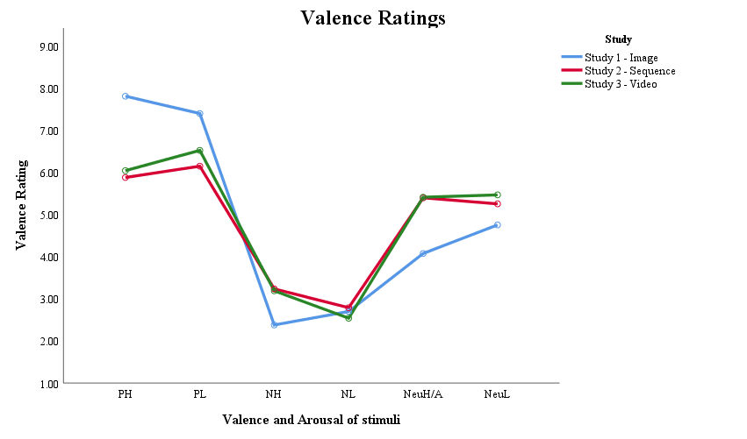
Figure 34 Mean valence ratings for each emotion condition in each stimuli format.

Table 37 Valence ratings for each emotion condition compared by stimuli format.

 |  | Format comparison | Direction  (higher rating)
PH | Image to Seq | t(110) = 7.588, p < .001, d = 1.43 CI [1.43, 2.43] | Image
 | Seq to Video | t(108) = -570, p = .570, d = 0.11 CI [-.73, .40] | -
PL | Image to Seq | t(95.05) = 5.317, p < .001, d = 1.01 CI [.78, 1.72] | Image
 | Seq to Video | t(108) = -1.259, p = .211, d = 0.24 CI [-.97, .22] | -
NeuH/A | Image to Seq | t(110) = -4.804, p < .001, d = 0.91 CI [-1.87, -.78] | Sequence
 | Seq to Video | t(108) = -.045, p = .964, d = 0.01 CI [-.65, .62] | -
NeuL | Image to Seq | t(110) = -2.502, p = .014, d = 0.47 CI [-.90, -.10] | Sequence
 | Seq to Video | t(100.633) = -.786, p = .434, d = 0.15 CI [-.75, .32] | -
NH | Image to Seq | t(110) = -3.185, p = .002, d = 0.60 CI [-1.39, -.32] | Sequence
 | Seq to Video | t(108) = .163, p = .871, d = 0.03 CI [-.52, .62] | -
NL | Image to Seq | t(110) = -.358, p = .721, d = 0.07 CI [-.58, .41] | -
 | Seq to Video | t(108) = 1.037, p = .302, d = .020 CI [-.23, .72] | -

Arousal
Results showed an interaction between emotion condition and stimuli format F(10, 160) = 11.213, p < .001, ƞ_{p}² = .123, along with main effects of both emotion F(4.530, 724.877) = 20.075, p < .001, ƞ_{p}² = .111 and format F(2, 160) = 6.109, p = .003, ƞ_{p}² = .071. Pairwise comparisons for the main effect of emotion showed high arousal conditions to be rated as more arousing than low conditions in each valence pair i.e. positive p = .003, d = 0.32 CI [.15, 1.21], negative p < .001, d = 0.36 CI [.21, 1.14], and neutral p < .001, d = 0.39 CI [.28, 1.34].
The interaction between emotion and format, as illustrated in Figure 35, was explored using between subjects t-tests to compare arousal ratings for each emotion condition between image and sequence, and sequence and video format.

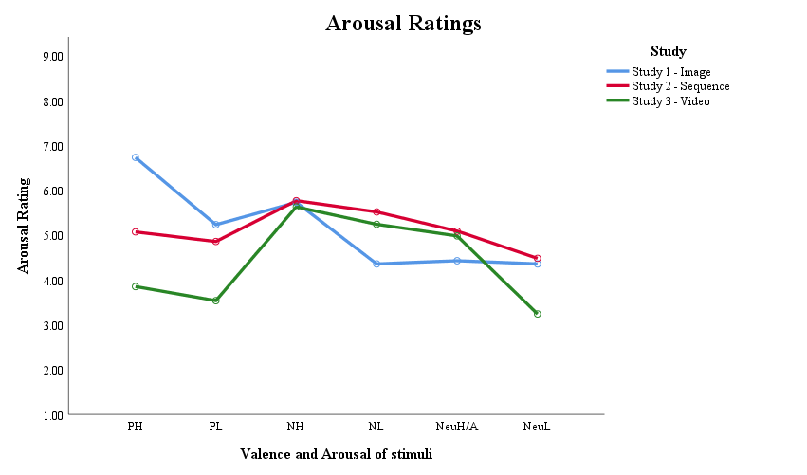
Figure 35 Mean arousal ratings for each emotion condition in each stimuli format.

Table 38 Mean arousal ratings for each emotion condition compared by stimuli format.

 |  | Format comparison | Direction  (higher rating)
PH | Image to Seq | t(110) = 5.068, p < .001, d = 0.96 CI [1.01, 2.31] | Image
 | Seq to Video | t(108) = 3.225, p = .002, d = 0.62 CI [.47, 1.97] | Sequence
PL | Image to Seq | t(110) = 1.084, p = .281, d = 0.21 CI [-.31, 1.06] | -
 | Seq to Video | t(108) = 3.310, p = .001, d = 0.63 CI [.53, 2.11] | Sequence
NeuH/A | Image to Seq | t(110) = -1.810, p = .073, d = 0.34 CI [-1.38, .063] | -
 | Seq to Video | t(108) = .262, p = .794, d = 0.05 CI [-.71, .92] | -
NeuL | Image to Seq | t(110) = -.353, p = .725, d = 0.07 CI [-.83, .58] | -
 | Seq to Video | t(108) = 3.225, p = .002, d = 0.62 CI [.48, 2.00] | Sequence
NH | Image to Seq | t(110) = -.095, p = .924, d = 0.02 CI [-.78, .71] | -
 | Seq to Video | t(100.225) = .362, p = .718, d = 0.07 CI [-.62, .90] | -
NL | Image to Seq | t(110) = -3.36, p = .001, d = 0.64 CI [-1.85, -.48] | Sequence
 | Seq to Video | t(108) = .775, p = .440, d = 0.15 CI [-.43, .99] | -

As detailed in Table 38, for both positive events and the neutral low event the video format was rated as less arousing than sequence format. For the neutral and negative high arousal conditions, there was no difference in arousal rating across formats. There was no difference in rating for both negative and the neutral higher event between sequence and video format.

Eye-tracking
Two, 3 (images, sequences, video) by 6 (positive high and low arousal, negative high and low arousal, neutral higher and low arousal) by 2 (central, peripheral) mixed ANOVA’s were conducted to compare viewing time and latency of first fixation across the between-subjects variable of stimuli format. An initial alpha level of .05 was set and adjusted using a Bonferroni correction. All confidence intervals are reported at 95% and outlying data points are defined as being plus or minus three standard deviations from the mean. Please see Table 39 for means with standard deviation figures.

Table 39 Viewing time and latency of first fixation in seconds for each stimuli format.

 |  | Viewing Time |  |  | Latency of First Fixation
 |  | Image | Sequence | Video | Image | Sequence | Video
PH | Cen | 6.59 (2.66) | 10.79 (3.44) | 1.07 (0.59) | 0.27 (0.12) | 0.56 (0.36) | 0.20 (0.14)
 | Per | 16.95 (3.27) | 11.68 (2.81) | 17.85 (1.88) | 0.77 (0.34) | 0.30 (0.31) | 0.31 (0.11)
PL | Cen | 6.29 (2.67) | 12.94 (4.14) | 6.35 (2.20) | 0.39 (0.23) | 0.38 (0.32) | 1.11 (0.83)
 | Per | 17.32 (3.03) | 10.91 (3.85) | 15.28 (2.42) | 0.95 (0.66) | 0.68 (0.39) | 0.51 (0.17)
NeuH/A | Cen | 7.34 (3.41) | 15.19 (2.29) | 11.56 (17.32) | 0.27 (0.04) | 0.37 (0.26) | 0.63 (0.30)
 | Per | 15.83 (3.92) | 7.65 (1.98) | 9.35 (2.00) | 0.84 (0.75) | 1.00 (0.58) | 0.47 (0.19)
NeuL | Cen | 6.79 (2.30) | 19.15 (4.42) | 4.41 (1.89) | 0.52 (0.40) | 0.21 (0.23) | 2.02 (1.64)
 | Per | 15.76 (2.86) | 3.30 (2.44) | 17.19 (2.87) | 0.52 (0.31) | 1.71 (0.91) | 0.83 (0.45)
NH | Cen | 5.28 (2.25) | 15.94 (4.03) | 7.49 (1.40) | 0.74 (0.72) | 0.33 (0.16) | 0.40 (0.27)
 | Per | 18.02 (2.76) | 7.92 (3.32) | 13.46 (1.68) | 0.74 (0.63) | 0.36 (0.37) | 0.56 (0.28)
NL | Cen | 17.35 (3.70) | 19.31 (4.19) | 18.11 (3.73) | 0.23 (0.07) | 0.17 (0.14) | 0.51 (0.40)
 | Per | 6.42 (3.24) | 4.74 (2.34) | 4.05 (3.21) | 4.77 (2.91) | 1.68 (0.83) | 1.92 (1.60)

Latency of first fixation
Analysis evidenced a three-way interaction between study stimuli, emotion, and information location F(10, 680) = 31.619, p < .001, ƞ_{p}² = .317. The three-way interaction was supported by two-way interactions between study stimuli and emotion F(10, 680) = 33.458, p < .001, ƞ_{p}² = .330, study stimuli and information location F(2, 136) = 63.574, p < .001, ƞ_{p}² = .483, and emotion and information location F(2.277, 309.681) = 111.001, p < .001, ƞ_{p}² = .449. Analysis also showed main effects of study stimuli F(2, 136) = 15.415, p < .001, ƞ_{p}² = .185, emotion F(2.210, 300.538) = 101.228, p < .001, ƞ_{p}² = .427, and information location F(1, 136) = 185.04, p < .001, ƞ_{p}² = .576.
The three-way interaction between emotion, information location and study stimuli, was investigated to explore the difference in latency of first fixation between the three study stimuli. As illustrated in Figures 36 and 37, the interaction was split into central and peripheral information data for each valence and arousal condition.

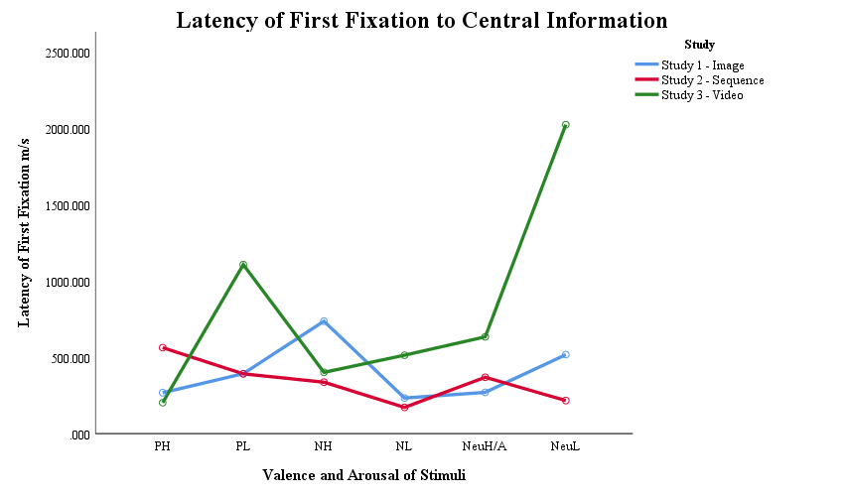
Figure 36 Mean latency of first fixation to central information for each emotion condition across the three study stimuli.

As illustrated in Figures 36 and 37, latency of first fixation to central and peripheral information show contrasting patterns. Peripheral information shows similar trends across all three stimuli types, with sequences and videos being closely aligned for positive and negative conditions, and all illustrate first fixation time being delayed for the negative low arousal condition. For central information, there was no overall trend observed. Images and sequences appear to be closer in latency of first fixation overall, but there are also similarities between sequences and video, and between video and images.

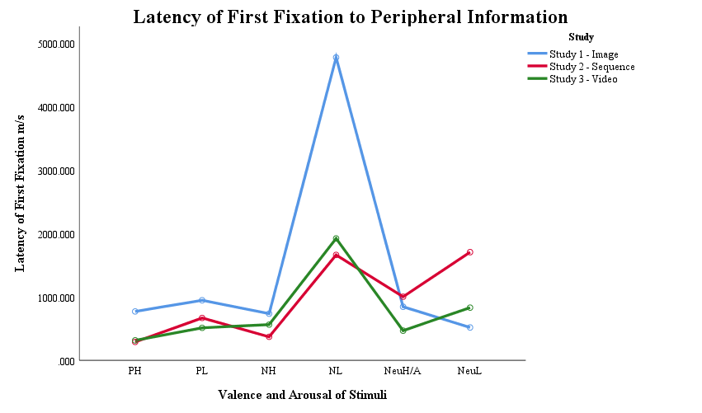
Figure 37 Mean latency of first fixation to peripheral information for each emotion condition across the three study stimuli.

One-way between-subjects ANOVA confirmed there to be a significant difference between the study stimuli in each emotion condition, see Table 40 for statistical justifications.

Table 40 One-way ANOVA results comparing stimuli format within each information location for each valence and arousal condition.

 | Central | Peripheral
PH | F(2, 139) = 32.213, p < .001, ƞ² = .39 | F(2, 139) = 43.371, p < .001, ƞ² = .39
PL | F(2, 139) = 28.246, p < .001, ƞ² = .29 | F(2, 139) = 10.915, p < .001, ƞ² = .14
NeuH/A | F(2, 139) = 30.761, p < .001, ƞ² = .31 | F(2, 139) = 11.558, p < .001, ƞ² = .14
NeuL | F(2, 139) = 45.864, p < .001, ƞ² = .40 | F(2, 138) = 46.107, p < .001, ƞ² = .40
NH | F(2, 139) = 10.773, p < .001, ƞ² = .14 | F(2, 139) = 8.079, p < .001, ƞ² = .11
NL | F(2, 139) = 25.039, p < .001, ƞ² = .27 | F(2, 139) = 35.761, p < .001, ƞ² = .34

Post hoc contrasts were run to compare latency of first fixation between images and sequences, and between sequences and video. Please see Tables 41 and 42 for statistical justifications.

Table 41 Results of post hoc contrasts between latency of first fixation for images and sequence formats.

 |  | Images to Sequences | Direction  (faster fixation)
PH | Cen | Z = -6.503, N = 93, p < .001, r = .67 CI [-402.54, -187.04] | Image
 | Per | Z = -5.410, N = 93, p < .001, r = .56 CI [332.02, 600.01] | Sequence
PL | Cen | Z = -1.547, N = 93, p = .123, r = .16 CI [-106.49, 121.52] | -
 | Per | Z = -1.662, N = 93, p = .097, r = .17 CI [46.91, 488.21] | -
NeuH/A | Cen | Z = -1.166, N = 93, p = .246, r = .12 CI [-171.94, -22.64] | -
 | Per | Z = -1.893, N = 93, p = .058, r = .12 CI [-433.88, 118.80] | -
NeuL | Cen | Z = -5.910, N = 92, p < .001, r = .62 CI [167.30, 441.13] | Sequence
 | Per | t(58.836) = -8.558, p < .001, d = 1.76 CI [-1465.18, -909.85] | Image
NH | Cen | Z = -4.348, N = 93, p < .001, r = .45 CI [178.61, 625.86] | Sequence
 | Per | Z = -3.944, N = 93, p < .001, r = .41 CI [153.72, 588.30] | Sequence
NL | Cen | Z = -4.325, N = 93, p < .001, r = .45 CI [17.69, 109.22] | Sequence
 | Per | t(49.181) = 6.816, p < .001, d = 1.45 CI [2185.31, 4012.60] | Sequence

Table 42 Results of post hoc contrasts between latency of first fixation for sequence and video format.

 |  | Sequences to Video | Direction  (faster fixation)
PH | Cen | Z = -6.820, N = 96, p < .001, r = .70 CI [251.19, 468.83] | Video
 | Per | Z = -2.781, N = 96, p = .826, r = .28 CI [-105.01, 84.09] | -
PL | Cen | Z = -4.570, N = 96, p < .001, r = .47 CI [-981.92, -462.15] | Sequence
 | Per | Z = -2.067, N = 96, p = .039, r = .21 CI [44.99, 288.93] | -
NeuH/A | Cen | Z = -4.299, N = 96, p < .001, r = .44 CI [-378.51, -154.05] | Sequence
 | Per | Z = -5.024, N = 96, p < .001, r = .44 CI [358.25, 710.37] | Video
NeuL | Cen | Z = -5.794, N = 96, p < .001, r = .59 CI [-2294.99, -1325.64] | Sequence
 | Per | Z = -4.980, N = 95, p < .001, r = .51 CI [582.64, 1166.412] | Video
NH | Cen | Z = -.268, N = 96, p = .791, r = .03 CI [-156.77, 22.04] | -
 | Per | Z = -3.991, N = 96, p < .001, r = .41 CI [-330.97, -65.67] | Sequence
NL | Cen | Z = -6.703, N = 96, p < .001, r = .68 CI [-468.84, -219.22] | Sequence
 | Per | t(68.129) = -.937, p = .352, d = .61, CI [-767.47, 246.87] | -

As detailed in Tables 41 and 42, content displayed as sequences had faster first fixation times to central information, while there was less effect of format evidenced for latency of first fixation to peripheral information. Both central and peripheral information showed no clear pattern in results between high or low arousal conditions, or between valence conditions.
Twenty-six participants’ data were excluded from the analysis due to containing outlying data points. Sensitivity analysis showed no change to ANOVA main effects, interactions, or pairwise comparisons with the inclusion of outliers. Post hoc tests to compare images and sequences showed no significant difference in latency of first fixation to central information in the positive high arousal, and neutral and negative low arousal conditions. Contrasts for peripheral information and between sequences and video remained unchanged.

Viewing time
Analysis evidenced a three-way interaction between study stimuli, emotion, and information location F(10, 735) = 80.983, p < .001, ƞ_{p}² = .524, supported by two-way interactions of study stimuli and emotion F(10, 735) = 7.130, p < .001, ƞ_{p}² = .088, study stimuli and information location F(2, 147) = 314.841, p < .001, ƞ_{p}² = .811, and emotion and information location F(4.309, 633.352) = 461.065, p < .001, ƞ_{p}² = .131. Analysis also showed main effects of study stimuli F(2, 147) = 15.896, p < .001, ƞ_{p}² = .178, emotion F(4.304, 632.722) = 17.264, p < .001, ƞ_{p}² = .105, and information location F(1, 147) = 22.082, p < .001, ƞ_{p}² = .131.
The three-way interaction between emotion, information location and study stimuli was investigated to explore the difference in viewing time between the three study stimuli. As illustrated in Figures 38 and 39, the interaction was split into central and peripheral information data for each valence and arousal condition.
As illustrated in Figures 38 and 39, central and peripheral viewing times show opposing patterns which represent the previously reported trade-off effects between central and peripheral attention in each study. Comparing the three studies shows trends in viewing times, with central attention increasing across conditions in all studies to a high at the negative low arousal condition. In contrast, viewing time was shortest for image and video format for the negative low arousal condition. The data for images and videos shows similar trends of viewing time while viewing time for sequences appear to be different. The difference between sequences and video would not be expected as sequences and video were representing the same content, whilst the images only represented the same themes of content.

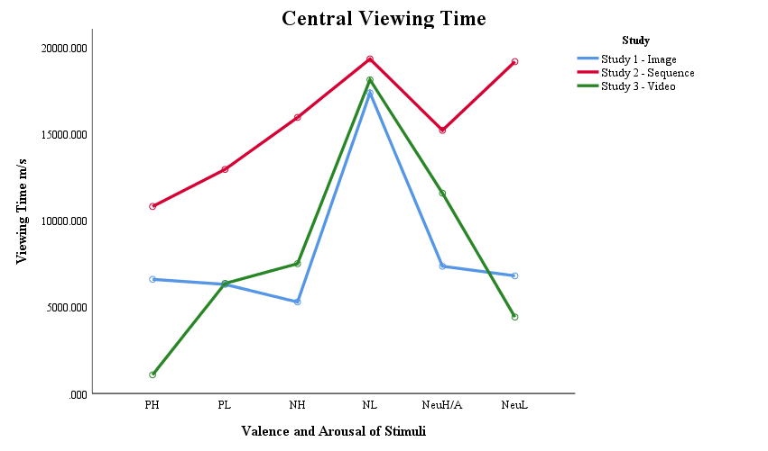
Figure 38 Mean central viewing time for each emotion condition across the three study stimuli.

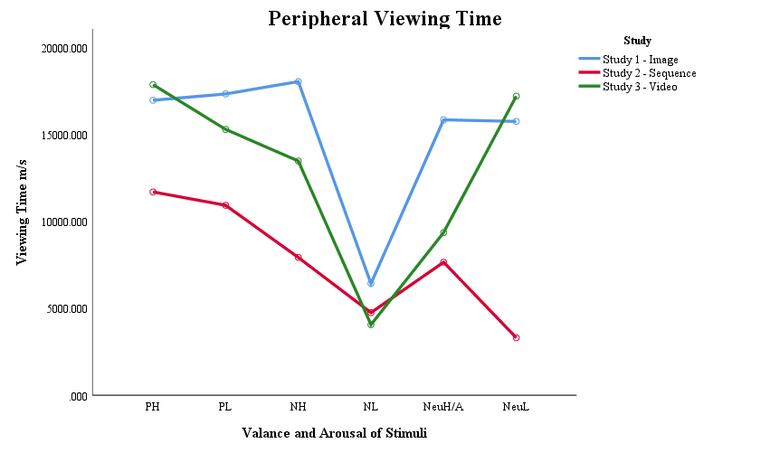
Figure 39 Mean peripheral viewing time for each emotion condition across the three study stimuli.

One-way between-subjects ANOVA confirmed there to be a significant difference between the study stimuli in each emotion condition, please see Table 43 for statistical justifications.

Table 43 One-way ANOVA results comparing stimuli format within each information location for each valence and arousal condition.

 | Central | Peripheral
PH | F(2, 149) = 184.729, p < .001, ƞ² = .72 | F(2, 149) = 74.235, p < .001, ƞ² = .50
PL | F(2, 149) = 74.891, p < .001, ƞ² = .51 | F(2, 149) = 53.657, p < .001, ƞ² = .42
NEUH/A | F(2, 149) = 115.975, p < .001, ƞ² = .61 | F(2, 149) = 119.848, p < .001, ƞ² = .62
NEUL | F(2, 149) = 329.94, p < .001, ƞ² = .82 | F(2, 149) = 384.872, p < .001, ƞ² = .84
NH | F(2, 149) = 204.708, p < .001, ƞ² = .74 | F(2, 149) = 179.388, p < .001, ƞ² = .71
NL | F(2, 149) = 3.237, p = .042, ƞ² = .04 | F(2, 149) = 8.513, p < .001, ƞ² = .10

Post hoc contrasts were conducted to compare viewing time in the image and video conditions and to compare viewing time in the sequences and video as these formats represented the same content. Tables 44 and 45 contain statistical justifications.

Table 44 Results of post hoc contrasts between viewing time for sequence and video formats.

 |  | Sequences to Video | Direction  (longer dwell)
PH | Cen | t(50.734) = 19.514, p < .001, d = 3.94, CI [8.72, 10.72] | Sequence
 | Per | t(83.567) = -12.830, p < .001, d = 2.58, CI [-7.13, -5.21] | Video
PL | Cen | t(72.778) = 9.851, p < .001, d = 1.98, CI [5.25, 7.92] | Sequence
 | Per | t(80.538) = -6.735, p < .001, d = 1.36, CI [-5.65, -3.07] | Video
NeuH/A | Cen | t(97) = 8.910, p < .001, d = 1.79 , CI [2.82, 4.44] | Sequence
 | Per | t(97) = -4.262, p < .001, d = .86 , CI [-2.50, -.911] | Video
NeuL | Cen | t(64.748) = 21.485, p < .001, d = 4.30, CI [13.37, 16.12] | Sequence
 | Per | t(97) = -25.90, p < .001, d = 5.21, CI [-14.95, -12.82] | Video
NH | Cen | t(59.145) = 13.875, p < .001, d = 2.80, CI [7.23, 9.67] | Sequence
 | Per | t(70.634) = -10.453, p < .001, d = 2.11, CI [-6.59, -4.50] | Video
NL | Cen | t(97) = 1.509, p = .135, d = .30, CI [-0.38, 2.79] | -
 | Per | t(97) = 1.220, p = .226, d = .25, CI [-0.43, 1.81] | -

As detailed in Tables 45 and 46, viewing time was higher for central information when presented in sequence format compared to video, for both neutral, positive low arousal and negative high arousal conditions, and peripheral information viewed for less time. For both high and low arousal positive, high and low arousal neutral, and for the negative high arousal condition, viewing time to central information increased between image and sequence format, then reduced between sequence and video. Viewing time to image and video formats showed mixed results.

Table 45 Results of post hoc contrasts between viewing time for image and video formats.

 |  | Images to Video | Direction  (longer dwell)
PH | Cen | t(54.955) = 14.475, p < .001, d = 2.87, CI [4.75, 6.28] | Image
 | Per | t(79.975) = -1.706, p = .092, d = .34, CI [-1.96, 0.15] | -
PL | Cen | t(99) = -.120, p = .905, d = .02, CI [-1.03, .910] | -
 | Per | t(95.09) = 3.741, p < .001, d = .74, CI [9.56, 3.13] | Image
NeuH/A | Cen | t(74.543) = -7.869, p < .001, d = 1.56 , CI [-5.29, -.3.15] | Video
 | Per | t(74.789) = 10.498, p < .001, d = 2.08 , CI [5.25, 7.71] | Image
NeuL | Cen | t(99) = 5.669, p < .001, d = 1.31, CI [1.55, 3.21] | Image
 | Per | t(99) = -2.546, p = .012, d = .51, CI [-2.59, -0.32] | Video
NH | Cen | t(83.878) = -5.953, p < .001, d = 1.18, CI [-2.95, -1.47] | Video
 | Per | t(82.731) = 10.065, p < .001, d = 2.00, CI [3.66, 5.46] | Image
NL | Cen | t(99) = -1.024, p = .308, d = .20, CI [-2.22, 0.71] | -
 | Per | t(99) = 3.686, p < .001 , d = .73, CI [1.09, 3.64] | Image

Both the positive and neutral, high and low arousal conditions, observed opposite results between central and peripheral information locations. Viewing time was longer to central information in the positive high arousal condition with no difference between image and video for peripheral information viewing time. In contrast, the positive low arousal condition evidenced no difference in viewing time to central information, while peripheral information in the image condition received longer viewing time. The neutral higher arousal condition displayed longer viewing time to the video format and peripheral longer to image. In contrast, the neutral low arousal condition evidenced longer viewing time to central information in the image and longer viewing to video for peripheral information. The negative high arousal condition observed the same pattern of results as the neutral higher arousal condition. For the negative low arousal content, viewing time to central information remained comparably high across all formats, with peripheral information reducing in viewing time from image to sequence, and sequence to video.
Sixteen participants’ data were excluded from the analysis due to containing outlying data points. Sensitivity analysis showed no difference in main effects or interactions. Post hoc tests comparing stimuli formats in the different emotional and location conditions showed the negative low arousal condition to have no significant difference between stimuli formats for both central or peripheral information. Post hoc contrasts showed viewing time to peripheral information in the neutral low arousal condition to have no difference between formats. All other results and effect directions remained unchanged.

Memory accuracy
A four-way mixed ANOVA using a 2 (control, misled) by 3 (images, sequences, video) by 6 (positive high and low arousal, negative high and low arousal, neutral higher and low arousal) by 2 (central, peripheral) design was conducted. Memory accuracy was compared across between-subjects’ factors of stimuli formats and exposure to misinformation. Accuracy scores for new correct, new incorrect and misleading statements were combined to form a percentage accuracy score for each participant. An initial alpha level of .05 was set and adjusted using a Bonferroni correction. All confidence intervals are reported at 95% and outlying data points are defined as being plus or minus three standard deviations from the mean. Means with standard deviations are presented in Table 46.
Analysis evidenced a four-way interaction between group, study stimuli, emotion and information location F(10, 7775) = 2.095, p = .023, ƞ_{p}² = .026 with three-way interactions between study stimuli, emotion and information location F(10, 775) = 16.868, p < .001, ƞ_{p}² = .179, and study stimuli, condition and emotion F(10, 775) = 2.272, p = .013, ƞ_{p}² = .028. Results were supported by two-way interactions with study stimuli and emotion F(10, 775) = 24.578, p < .001, ƞ_{p}² = .241, study stimuli and information location F(2, 155) = 3.344, p = .038, ƞ_{p}² = .041, and emotion and information location F(5, 775) = 9.661, p < .001, ƞ_{p}² = .059. Analysis also showed main effects of emotion F(5, 775) = 28.889, p < .001, ƞ_{p}² = .157, information location F(1, 155) = 39.248, p < .001, ƞ_{p}² = .202 and study stimuli F(2, 155) = 18.302, p < .001, ƞ_{p}² = .191.

Table 46 Memory accuracy means and standard deviations in percentage for image, sequence and video format, for central and peripheral information in each group condition.

 |  | Control Group |  |  | Misled Group
 |  | Image | Sequence | Video | Image | Sequence | Video
PH | Cen | 90.12 (14.07) | 72.02 (19.27) | 60.90 (21.05) | 82.14 (15.00) | 62.82 (19.04) | 66.67 (16.33)
 | Per | 82.72 (14.23) | 44.64 (19.27) | 46.79 (18.27) | 75.00 (17.27) | 53.21 (19.45) | 46.15 (19.61)
PL | Cen | 60.49 (13.19) | 52.38 (17.40) | 62.82 (18.44) | 63.10 (19.96) | 55.77 (14.86) | 52.56 (19.26)
 | Per | 61.11 (20.67) | 63.69 (14.38) | 55.13 (18.12) | 61.31 (18.73) | 57.05 (18.96) | 51.92 (15.15)
NeuH/A | Cen | 85.80 (11.04) | 58.93 (18.42) | 59.62 (17.75) | 79.76 (17.19) | 65.38 (20.51) | 57.05 (20.64)
 | Per | 69.75 (16.69) | 74.40 (17.26) | 62.18 (19.18) | 63.69 (15.75) | 70.51 (18.44) | 69.23 (16.79)
NeuL | Cen | 83.33 (13.07) | 80.36 (15.75) | 69.87 (23.10) | 75.60 (16.66) | 78.21 (14.73) | 70.51 (12.74)
 | Per | 45.06 (21.09) | 76.19 (18.39) | 80.77 (18.67) | 47.62 (20.14) | 83.33 (12.47) | 80.77 (13.07)
NH | Cen | 71.60 (13.72) | 67.26 (22.90) | 61.54 (20.96) | 73.81 (15.99) | 58.33 (19.00) | 60.90 (18.82)
 | Per | 69.14 (17.11) | 50.60 (16.66) | 55.77 (26.22) | 71.43 (16.27) | 48.51 (17.40) | 44.23 (16.96)
NL | Cen | 64.81 (16.88) | 68.45 (16.57) | 73.72 (19.54) | 59.52 (21.48) | 76.28 (17.11) | 67.95 (19.96)
 | Per | 72.84 (22.24) | 64.29 (15.53) | 62.82 (21.76) | 63.69 (17.60) | 66.67 (13.33) | 54.49 (22.39)

The four-way interaction was split by group condition to enable comparison across study stimuli type for the control and misled groups. Two, three-way ANOVAs observed a three-way interaction between study stimuli, emotion and information location to be significant for both control F(10, 390) = 11.453, p < .001, ƞ_{p}² = .227 and misled groups F(10, 385) = 37.605, p < .001, ƞ_{p}² = .165. Main effects and two-way interactions remained significant except for the interaction between study and information location, which moved to be non-significant for both groups. The three-way interactions for each group are illustrated in Figures 40 to 43.
As detailed in Table 47, one-way between-subjects ANOVA’s showed there to be no significant difference between accuracy for positive low arousal content across formats, for both the control and misled groups. For the control group, there was no difference in accuracy for negative low arousal content, or for central information in the negative high arousal content. For the misled group there was no difference in accuracy for peripheral information in the neutral higher arousal content, or for central information in the neutral low arousal content. Please see Table 47 for statistical justifications.
Table 47 One-way ANOVA results for control and misled group comparing stimuli format within each information location for each valence and arousal condition.

 |  | Central | Peripheral
Control | PH | F(2, 80) = 17.192, p < .001, ƞ² = .31 | F(2, 80) = 40.835, p < .001, ƞ² = .51
 | PL | F(2, 80) = 3.018, p = .055, ƞ² = .07 | F(2, 80) = 1.615, p = .205, ƞ² = .04
 | NEUH/A | F(2, 80) = 24.498, p < .001, ƞ² = .39 | F(2, 80) = 3.253, p = .044, ƞ² = .08
 | NEUL | F(2, 80) = 4.207, p = .018, ƞ² = .10 | F(2, 80) = 26.898, p < .001, ƞ² = .41
 | NH | F(2, 80) = 1.751, p = .180, ƞ² = .04 | F(2, 80) = 6.035, p = .004, ƞ² = .13
 | NL | F(2, 80) = 1.697, p = .190, ƞ² = .04 | F(2, 80) = 1.965, p = .147, ƞ² = .05
Misled | PH | F(2, 79) = 10.071, p < .001, ƞ² = .21 | F(2, 79) = 17.479, p < .001, ƞ² = .31
 | PL | F(2, 79) = 2.387, p = .099, ƞ² = .06 | F(2, 79) = 1.892, p = .158, ƞ² = .05
 | NEUH/A | F(2, 79) = 9.461, p < .001, ƞ² = .20 | F(2, 79) = 1.240, p = .295, ƞ² = .03
 | NEUL | F(2, 79) = 1.807, p = .171, ƞ² = .04 | F(2, 79) = 43.633, p < .001, ƞ² = .53
 | NH | F(2, 79) = 5.828, p = .004, ƞ² = .13 | F(2, 79) = 20.511, p < .001, ƞ² = .35
 | NL | F(2, 79) = 4.905, p = .010, ƞ² = .11 | F(2, 79) = 3.198, p = .046, ƞ² = .08

Post hoc contrasts were run between images and sequences, and between sequences and video to compare accuracy between stimuli formats for central and peripheral information, for each group. Please see Tables 48 and 49 for statistical justifications.
As detailed in Tables 48 and 49, for central information in both the control and misled groups there was no difference in accuracy between sequences and video format. For peripheral information, there was no difference between sequence and video for positive, negative high arousal, or neutral low arousal conditions. For the negative low arousal condition, video accuracy was lower for the misled group, and for the neutral low arousal condition, video accuracy was higher for the misled group whilst sequence accuracy reduced.

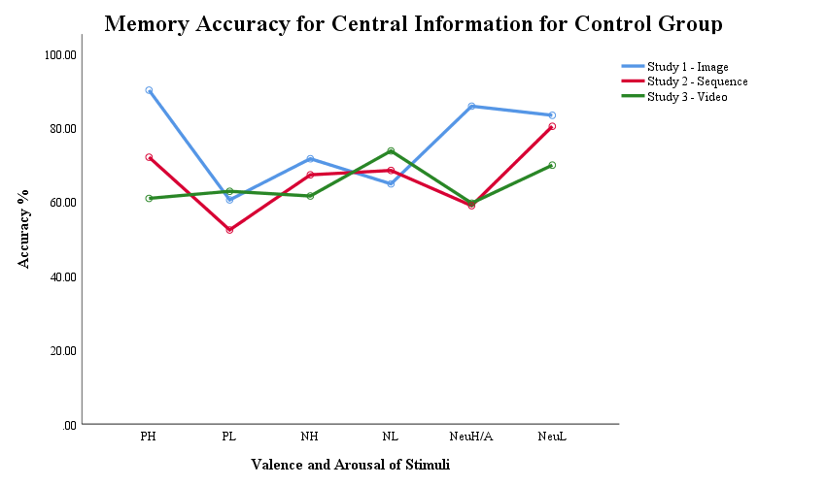 |  |  | 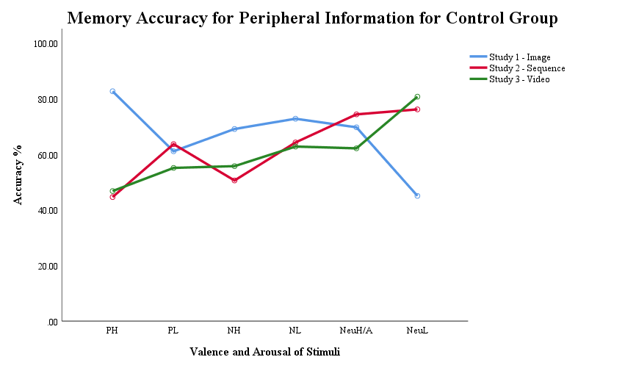
Figure 40 Mean central accuracy for control group across the three study stimuli. |  | Figure 41 Mean peripheral accuracy for control group across the three study stimuli.
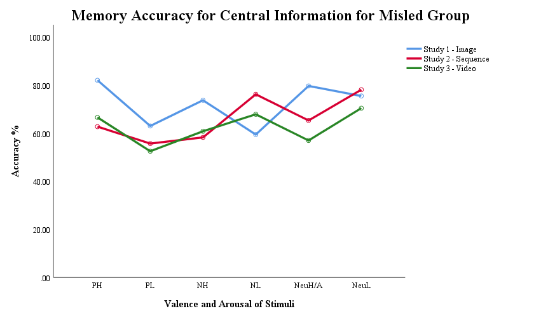 |  |  | 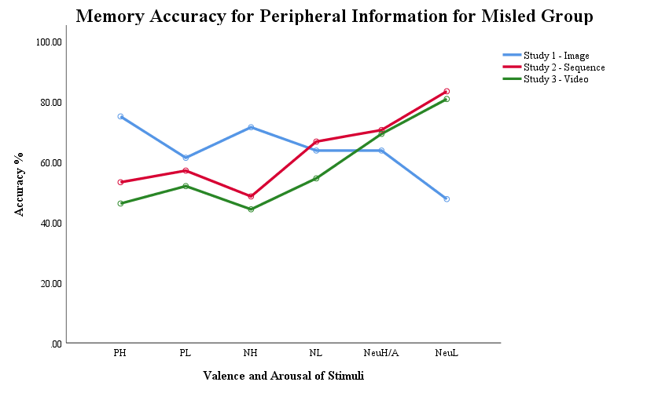
Figure 42 Mean central accuracy for misled group across the three study stimuli. |  | Figure 43 Mean peripheral accuracy for misled group across the three study stimuli.

For both the control and misled groups, images observed higher accuracy than sequences for central information in the positive and neutral higher arousal conditions, with no difference at low arousal. For negative high arousal content, sequence accuracy reduced for the misled group, whilst for negative low arousal content, image accuracy reduced whilst sequence accuracy increased. For peripheral information, positive and negative high arousal content recorded higher image accuracy compared to sequence for both control and misled groups, with sequence accuracy higher for neutral low arousal content. There was no difference in accuracy between image and sequence for the positive or negative low arousal, or for the neutral higher arousal condition.
Five participants’ data were excluded from the analysis as outlying data points. Sensitivity analysis showed no difference in the four-way or two-way interactions, however the three-way interaction between emotion, study and condition was no longer significant. Results of the three-way ANOVA split by group remained unchanged. For one-way ANOVA, accuracy for the misled group in the negative low arousal condition moved from p = .01 to marginal significance at p = .08. Post hoc contrasts showed accuracy moving to be non-significant between formats showing no difference for the misled group for the negative low arousal condition.

Table 48 Results of control group post-hoc contrasts between image and sequence, and sequence and video formats.

 |  | Image to Sequences | Direction | Sequence to Video | Direction
PH | Cen | t(53) = 3.966, p < .001, d = 1.07, CI [8.95, 27.25] | Image | t(52) = 2.028, p = .048, d = .55, CI [.12, 22.14] | -
 | Per | t(49.676) = 8.354, p < .001, d = 2.24, CI [28.92, 47.23] | Image | t(52) = -.420, p = .676, d = .11, CI [12.43, 8.12] | -
PL | Cen | No difference in ANOVA | - | No difference in ANOVA | -
 | Per | No difference in ANOVA | - | No difference in ANOVA | -
NeuH/A | Cen | t(44.462) = 6.591, p < .001, d = 1.77, CI [18.66, 35.09] | Image | t(52) = -.139, p = .890, d = .04, CI [-10.58, 9.20] | -
 | Per | t(53) = -1.015, p = .315, d = .27, CI [13.84, 4.54] | - | t(52) = 2.465, p = .017, d = .67, CI [2.27, 22.18] | Sequence
NeuL | Cen | Z = -.632, N = 55, p = .545, r = .09, CI [-4.87, 10.82] | - | Z = -1.661, N = 54, p = .100, r = .23, CI [-.24, 21.21} | -
 | Per | Z = -4.625, N = 55, p < .001, r = .62, CI [-41.82, -20.44] | Sequence | Z = -.917, N = 54, p = .372, r = .13, CI [-14.70, 5.55] | -
NH | Cen | No difference in ANOVA | - | No difference in ANOVA | -
 | Per | t(53) = 4.072, p < .001, d = 1.10, CI [9.41, 27.67] | Image | t(41.807) = -.858, p = .396, d = .24, CI [-17.34, 6.99] | -
NL | Cen | No difference in ANOVA | - | No difference in ANOVA | -
 | Per | No difference in ANOVA | - | No difference in ANOVA | -
Alpha at .025. All two-tailed

Table 49 Results of misled group post-hoc contrasts between image and sequence, and sequence and video formats.

 |  | Image to Sequences | Direction | Sequence to Video | Direction
PH | Cen | t(52) = 4.159, p < .001, d = 1.13, CI [9.99, 28.65] | Image | t(50) = -.489, p = .627, d = .22, CI [-13.72, 6.03] | -
 | Per | t(52) = 4.361, p < .001, d = 1.18, CI [11.77, 31.82] | Image | t(50) = 1.302, p = .199, d = .36, CI [-3.83, 17.93] | -
PL | Cen | No difference in ANOVA | - | No difference in ANOVA | -
 | Per | No difference in ANOVA | - | No difference in ANOVA | -
NeuH/A | Cen | t(52) = 2.800, p = .007, d = .80, CI [4.07, 24.68] | Image | t(50) = 1.460, p = .150, d = .41 CI [-3.13, 19.79] | -
 | Per | No difference in ANOVA | - | No difference in ANOVA | -
NeuL | Cen | No difference in ANOVA | - | No difference in ANOVA | -
 | Per | Z = -5.549, N = 54, p < .001, r = .76, CI [-44.95, -26.48] | Sequence | Z = -.623, N = 52, p = .566, r = .09, CI [-4.55, 9.68] | -
NH | Cen | t(52) = 3.246, p = .002, d = .88, CI [5.91, 25.04] | Image | t(50) = -.489, p = .627, d = .14, CI [-13.10, 7.97] | -
 | Per | t(52) = 5.004, p < .001, d = 1.36, CI [13.73, 32.11] | Image | t(50) = .897, p = .374, d = .25, CI [-5.29, 13.85] | -
NL | Cen | t(52) = -3.155, p = .003, d = .86, CI [27.42, 6.10] | Sequence | t(50) = 1.616, p = .112, d = .45, CI [-2.02, 18.69] | -
 | Per | t(50.044) = -.703, p = .485, d = .19, CI [-11.47, 5.52] | - | t(40.751) = 2.383, p = .022, d = .66, CI [1.86, 22.50] | Sequence
Alpha at .025. All two-tailed

Summary
The prediction of hypothesis five, that memory accuracy and attention would increase for central information detail in events, as the complexity of stimuli type increased, was not clearly supported by the data. Comparing attentional measures across the three stimuli types showed viewing time to centrally emotional information in the negative low arousal condition to be consistent in all formats. Viewing time to peripheral information reduced from image to sequence, and from sequence to video. However, these differences were not apparent when a sensitivity analysis was conducted, suggesting that the reducing levels were not significantly stable.
For both positive high and low arousal, both neutral higher and low arousal, and for the negative high arousal condition length of viewing time increased from images to sequences, then reduced from sequences to video. For latency of first fixation, central information in sequences was fixated upon earlier, while the effect of stimuli format was less evident for peripheral information. There was no difference in fixation latency between images and sequences for the positive low arousal and neutral higher arousal conditions. When sensitivity analysis was run there was also no difference between images and sequences for the positive high arousal, the neutral higher arousal and negative low arousal conditions.
Central information in the negative high arousal sequence was fixated upon more quickly when compared to central information in the negative high image, with no difference in fixation latency for both positive, negative low arousal and both neutral conditions. Overall peripheral information showed later fixation in images, but peripheral information also evidenced more instances of no difference between the three stimuli types suggesting similar fixation speeds across the stimuli formats.
For the higher arousal conditions, images evidenced higher memory accuracy than sequences, with little difference observed between memory accuracy for sequences and video. There was only a difference between the control and misled groups for centrally negative, high arousal information as image accuracy was higher than sequence accuracy overall for the misled group, with no difference between formats for the control group. Considering the changes when sensitivity analysis was run, for both the control and misled groups there was no difference in memory accuracy between images, sequence and video for central or peripheral information in the positive and negative low arousal conditions, and no difference in central information in the neutral low arousal condition.
In conclusion, longer viewing times were required to centrally emotional information when using sequences to achieve the same level of memory accuracy as viewing emotionally central information in images and videos for less time. Throughout all attention and memory comparisons, the negative low arousal condition was most consistent, suggesting that the content theme of sadness evoked the same attentional patterns during encoding and resulted in the same pattern of memory accuracy in all three formats.

Chapter 8 Investigating the role of attention in emotional false memory formation: a discussion of main findings, implications and conclusions
The main question that was investigated by the current research was if memory accuracy for an event could be predicted from the level of attention given to details during the event. Research has previously suggested that centrally emotional information in events which are negatively valenced, and which are high in emotional arousal, elicit higher recall accuracy than neutral and low arousal event details (Kim, Vossel, & Gamer, 2013; Van Damme & Smets, 2014). Yet, these same conditions are also more likely to be distorted by post-event misinformation (Burke, Heuer, & Reiseberg, 1992; Porter, Spencer, & Birt, 2003; Van Damme & Smets, 2014). The contrast of negative and high arousal events being memorially accurate and also more likely to be distorted, is suggested to be due to increased attention to central detail, which reduces available attention for peripheral detail (Burke et al., 1992; Christianson, 1992; Easterbrook, 1959; Kensinger, 2009; Porter et al., 2003; Porter, ten Brinke, Riley, & Baker, 2014; Van Damme & Smets, 2014). The explanation that attention is mediating memory accuracy has been supported by previous research findings which show that perception and memory for emotional information is often greater than for neutral information presented concurrently (Calvo & Lang, 2004; Fawcett, Russell, & Peace, 2013; Loftus, Loftus, & Messo, 1987). Nonetheless, when memory and attention measures are combined, attention has not been able to predict accuracy (Greene, Murphy, & Januszewski, 2017; Steinmetz & Kensinger, 2013; Sharot, Davidson, Carson, & Phelps, 2008; Wessel, van der Kooy, & Merckelbach, 2000). Therefore, the current research investigated the suggested explanation of attention mediating emotional false memory formation by adding eye-tracking as a measure of attention to the encoding phase of a series of misinformation studies. Thus, allowing the predictive relationship between attention and false memory formation to be assessed.

Review of the hypotheses
Memory for centrally emotional information and the impact of misinformation
The first hypothesis predicted that memory accuracy for central information in the negative high and low arousal events and in the positive high arousal event would be higher than concurrently presented peripheral information. In addition to this, the second hypothesis predicted that the presentation of misinformation would lower accuracy for centrally emotional details of the positive high arousal and negative events and reduce accuracy for peripheral details in all event conditions. In the absence of misinformation, central detail only evidenced a clear accuracy advantage in memory when using single images, however, this advantage was in all valence and arousal conditions. When using sequences and video there was no clear effect of valence or arousal on central memory accuracy. Misinformation reduced the ability to reject misleading statements in all conditions when using image events. For sequences, misinformation reduced memory accuracy for neutral and positive low arousal details only, suggesting that negative and high arousal conditions may have been protected from distortion. When using video events there was no misinformation effect for misleading statements. Misinformation lowered accuracy for newly presented correct information, but only for details in the negative low arousal event.

Central peripheral trade-off reduced to only impact verbatim detail
Previous research and theory would predict that participants who received correct post-event information would evidence enhanced memory accuracy for centrally emotional information, and in contrast, peripheral memory accuracy would be reduced (Christianson & Loftus, 1991; Hamann, 2012; Hoscheidt, LaBar, Ryan, Jacobs, & Nadel, 2014; Laney, Campbell, Heuer, & Reisberg, 2004; Talmi, Anderson, Riggs, Caplan, & Moscovitch, 2008). Negative valence and high arousal events have previously evidenced greater enhancements in accuracy, explained as a function of increased stress and arousal facilitating orientation to, and encoding of, information about aversive events (Brown & Kulik, 1977; Hoscheidt et al., 2014). In the current findings there was some evidence to suggest that an enhancement of central information occurred, although the expected effect was not consistently observed. As events increased in complexity the advantage in memory for centrally emotional information reduced from being observed in all information conditions, to impacting accuracy for central detail in newly presented information only. There was no clear memory accuracy advantage evidenced for central information of negative or highly arousal events.
The reduction of a central memory advantage suggests that increasing complexity in the stimuli format being presented i.e. from image to sequence to video, was able to increase the rate of acceptance of false information about central details. However, participants were still able to identify correct information being presented about central information. The central memory advantage observed for correct information suggests that central detail was encoded during events, even though the presence of this encoded information in memory did not increase the ability to recognise false information when presented. Memory theory based on trace strength during encoding would support that newly presented correct information would evidence higher accuracy than statements presenting false information (Bless et al., 1996; Reyna & Brainerd, 1995; Dougherty, 2001; Kelley & Lindsay, 1993). Trace strength would be expected to be strongest for centrally emotional information from the original event, due to emotional enhancement and so be the most easily reactivated trace when a recognition test presents the original detail again. In contrast, items assessing accuracy for false information would not be testing information which was directly encoded, as false information statements would rely on activation of related traces containing correct event detail against which to verify accuracy. The current finding suggests that central verbatim event detail was being encoded, but that the strength of encoding was reduced as the complexity of the events increased. Theory suggesting that reactivation of a memory trace enables alteration of the original event memory also support the current finding of correct information having higher central accuracy (Agren, 2014; Ayers & Reder, 1998; Bekerian & Bowers, 1983; Dougherty, 2001; Loftus, 1975). If a memory trace is weakened, or more easily altered, during the reactivation by a statement concerning false information, then the false information is more likely to be incorporated into the memory. Misinformation studies have provided some evidence to support that complexity may reduce a wide central memory advantage to only be evidenced for correct information when using recognition statements. For example, when using a video event Paz-Alonso and Goodman (2008) observed a central advantage for new correct statements but not for misleading or new foil statements. In comparison, Van Damme and Smets (2014) evidenced a central advantage in all statement types when using less complex image events. Yet, very few misinformation studies have investigated the role of event complexity or have used the three-item recognition test for both central and peripheral information. Consequently, further research is needed to test the potential role of complexity in removing the central advantage of emotional event detail, as suggested by the present findings.

A reducing impact of misinformation
The current results of a reducing misinformation effect from images to sequences, and from sequences to video, suggest that the impact of misinformation in reducing memory accuracy was being mediated by stimuli type. However, previous research using a variety of stimuli formats has presented a consistent effect of misleading information in lowing accuracy (Forgas, Laham, & Vargas, 2005; Mahé, Corson, Verrier & Payoux, 2015; Paz-Alonso, Goodman, & Ibabe, 2013; Porter, et al., 2003; Steinmetz & Kensinger, 2013; Toffalini, Mirandola, Coli, & Cornoldi, 2015; Van Damme & Smets, 2014). In contrast to this previous research, the current results have been generated using a series of studies which utilise the same repeated methodology and experimental variables. Consequently, although commonly showing a reduction in accuracy by misinformation, variations in previous research may be explained by differences in methodology and stimuli quality. For example, when using images, Porter et al. (2003) evidenced that all central and peripheral detail accuracy was reduced by misinformation. Van Damme and Smets (2014) extended the method used by Porter et al. to compare high and low arousal events, which resulted in a misinformation effect for all peripheral information - but only for central information in the positive high arousal and negative events. In the present studies, the limitations of stimuli quality in the images used by Van Damme and Smets (2014) were addressed using an enhanced selection criterion to improve ecological validity and improve central and peripheral detail balance. The valence and arousal criteria were maintained when selecting sequence and video content, and a consistent method of defining centrally emotional detail was employed for the three studies. Therefore, current findings are a more accurate representation of the impact of complexity on the ability of misinformation to reduce memory accuracy. Consequently, further research is needed to test the replicability of the current results in which the misinformation effect was reduced as stimuli increased in complexity.
The present result of a misinformation effect occurring for all image events contrasts with theory developed to explain the misinformation effect. Fuzzy trace theory by Reyna and Brainerd (1995) would predict that all negative event information would be encoded using a higher proportion of gist traces, resulting in a higher level of distortion by post-event misinformation. In the current results, negative events did not have higher levels of distortion compared to other events, and in contrast, positive events did not have higher levels of verbatim accuracy. Fuzzy trace theory might explain a reduction in the misinformation effect as an effect of increasing complexity resulting in increased levels of verbatim encoding for all events. However, current results do not support that higher levels of verbatim encoding were occurring, as accuracy levels did not increase with complexity. Moreover, verbatim accuracy reduced during the video study for the negative low arousal event for participants receiving misleading information. Although a misinformation effect in a negative event supports that negative details may have been encoded with a higher proportion of gist traces, in the current results this encoding only reduced participants’ ability to recognise correct information and was not distorted by misinformation.
A reducing misinformation effect may indicate that as events increased in complexity, that memory encoding of event detail was less likely to be altered by post-event misinformation, suggesting that discrimination between event memory and misinformation was improving. Research investigating source monitoring errors (Mitchell & Johnson 2000; Lindsay & Johnson, 1989) indicates that increased discrepancy detection for misleading information reduces its distorting ability (Butler & Loftus, 2017; Cochran, Greenspan, Bogart & Loftus, 2016). In the present findings, an increased ability to reject misleading information could indicate that original event encoding was being enhanced as complexity increased. Nonetheless, there was no clear impact of increasing complexity on accuracy for participants not given misleading information, suggesting that increasing complexity was not enhancing event encoding. Increased rejection of misinformation may instead represent an increasingly incongruent complexity level in the format of information being presented i.e. visual stimuli in the form of images, sequences and video, while the misinformation was presented in simple text format. Other research has matched information format, such as using image sequences followed by old or new images as test items (Kim et al., 2013), using video events followed by photographs of suspects (Greene et al., 2017) or by manipulating participants own written recollections of an event to incorporate misleading information (Stille, Norin & Sikström, 2017). The current findings may indicate that as event complexity increases, the ability to detect misinformation may also be increasing due to lack of comparable complexity, or format congruency, of the misleading information. Further research could implement a discrepancy test into the misinformation procedure, such as in Butler and Loftus (2017), to measure the level of misinformation identification. Different formats of event compared to post-event misinformation could be used, such as text compared to imagery, to investigate if making post-event detail more clearly discernable from original event detail reduces the misinformation effect.

Attention to centrally emotional information
The third hypothesis predicted that negative events and the positive events of high arousal would evidence greater levels of attention during encoding to facilitate an enhanced memorial effect for central information. Conversely, peripheral information was predicted to evidence less attention resulting in higher levels of peripheral distortion. When viewing images, five of the six conditions recorded lower levels of fixations and viewing time to central information compared to peripheral information, with only the negative low arousal condition evidencing the expected central bias of attention. In addition, there was no difference in latency of first fixation to central information in the negative high arousal image, while all other conditions showed central information to be fixated on earlier. In contrast, when viewing sequences as stimuli events, the negative and neutral conditions evidenced higher levels of attention to central information, with longer viewing time and more fixations. In addition, fixation was faster to centrally emotional information in the neutral and low arousal events, with the negative high arousal event again showing no difference between time to fixate on central and peripheral information. Attention during video events was similar to that observed for images, with four events evidencing increased dwell time and number of fixations to peripheral information. Fixation was faster to central information in both negative high and low arousal, and the positive high arousal events but was faster to peripheral information in both the neutral and positive low arousal events. Therefore, the prediction that negative and high arousal information would record greater levels of attention during encoding was not clearly supported. Only central information in the negative low arousal condition consistently recorded longer dwell time, more fixations and faster first fixations. The high arousal conditions showed no clear central bias of attention compared to the low arousal conditions and peripheral information observed greater attention than central for images and video.

Central bias of attention to negative valence
The negative low arousal event in the present research received longer central viewing time and higher numbers of fixations compared to peripheral detail in all three stimuli types, a result which has been replicated for negative events using images (Acunzo & Henderson, 2011; Chipchase & Chapman 2013; Riggs, McQuiggan, Farb, Anderson, & Ryan, 2011) and sequences (Christianson, Loftus, Hoffman, & Loftus, 1991; Kim et al., 2013; Wessel et al., 2000). The negative high arousal image and video had the opposite pattern of viewing time and number of fixations compared to the negative low arousal event in the current results. The contrast in findings between high and low negative arousal in current results may account for variation in previous research which present contrasting results when not defined by arousal. For example, in Humphreys, Underwood, and Chapman (2010) negative events recorded the least number of fixations and shortest viewing time, compared to Sharot et al. (2008) where negative events recorded more fixations than neutral.
Contrary to predictions of attention theory which suggest that attention is biased to centrally emotional or complex information (Christianson et al., 1991; Christianson & Loftus, 1991; Hamann, 2012; Lavie, 1995; Posner, 1980), the high arousal conditions in the current results evidenced no consistent bias of attention for central or peripheral information. Results observed there to be little difference between viewing time and number of fixations across positive, neutral or the negative high arousal events. Some theories of attention would expect a central narrowing of attention to be evidenced for events of negative valence and high arousal, while in contrast, positive events would be expected to broaden the attentional scope (Fredrickson, 2001). For example, previous research has suggested that perceptual load would be expected to be increased when viewing events containing emotional material (Lavie, 1995; Murphy & Greene, 2016; Van Damme & Smets, 2014) which would be predicted to reduce attentional capacity available to attend to peripheral information presented concurrently. Instead, the current results evidenced a peripheral bias when using image and video stimuli, suggesting a widening of attention. A central bias was consistently evidenced for the negative low arousal event only.
Applying a discrete emotions approach to the current results may partially explain the differences observed (Ekman, 1992; Gable & Harmon-Jones, 2010; Russell, 1994; Wang, Chen, & Zhang, 2018). The negative low arousal event conveyed a strong theme of sadness in all formats and consistently evoked higher central attention. Research by Wang et al. (2018) supports that increasing the intensity level of a sad event serves to narrow attention to central information, while low intensity broadens attention. In the current results, a central bias of attention may not have been evidenced in other emotion conditions due to low emotional intensity, or to events depicting different discrete emotions within the same condition. Using valence and arousal continuums to select experimental stimuli, as opposed to discrete emotion categories (Ekman, 1992; Russell, 1994) creates emotion conditions in which valence and arousal may be matched but content is not considered. For example, in the current study using video clips, both of the negative events were rated as highly negative and of high arousal but displayed opposing attention and memory results. Further research could explore the role of motivational intensity by incorporating discrete emotion labels into the stimuli rating procedure.

Delayed fixation and disengagement from negative content
In addition to longer viewing time to central information in the negative low event, negative events also showed a consistent delay in first fixation. For the negative low arousal condition, participants delayed looking at peripheral information for up to five times longer when compared to central information first fixation times. For the negative high arousal condition both central and peripheral information were fixated on almost simultaneously, with central fixation being delayed compared to other conditions and peripheral fixation being earlier. The almost concurrent fixation on central and peripheral information during the negative high arousal event, after delayed first fixation, may suggest that negative information is able to be processed from peripheral vision (Calvo, Nummenmaa & Hyönä, 2008; Fernández-Martín & Calvo, 2016; Fernández-Martín, Gutiérrez-García, Capafons & Calvo, 2017). Calvo et al. (2008) found that even in the absence of fixations, negative information was able to be processed from peripheral vision as gist detail. Evidence for extrafoveal processing i.e. processing of information not within the centre of focus, of negative detail has also been supported by research using concurrent task presentation. Fernández-Martín et al. showed that when presented with emotional images in peripheral vision during a letter discrimination task, positively valenced images recorded faster first fixation latencies and were fixated upon faster than negatively valenced images. Negative images demonstrated delayed first fixation but also evidenced a negativity engagement bias in which unpleasant scenes were viewed for longer, compared to pleasant images which showed a positivity bias for early fixation but not for viewing time.
Delayed disengagement from negative detail has also been well supported by research examining mood congruency and the role of anxiety in increased attention to negative and fearful faces (Eysenck, Derakshan, Santos & Calvo, 2007; Fox, Russo & Dutton, 2002). The present result of delayed fixation to peripheral information in the negative low arousal condition is also supported by Fernández-Martín et al.’s (2017) findings as delayed disengagement was replicated for unpleasant images. Fernández-Martín et al.’s findings of both delayed fixation and delayed disengagement for negative images may be further explained by the current study’s results as present findings defined events by arousal as well as valence. Further research could explore the role of arousal in extrafoveal processing of negative detail, as is suggested in the current results, as a distinct finding from delayed disengagement to low arousal negative events.

Complexity of information should increase central attentional bias
As an extension to the third hypothesis, hypothesis five predicted that any central attentional bias would increase as the level of complexity in events to be encoded increased. Results evidenced some support that increasing complexity narrowed attentional capacity as viewing time to peripheral information was reduced from image to sequence, and from sequence to video in five event conditions. Yet, the inverse effect was not demonstrated as images and video recorded comparably shorter viewing times to central information when compared to sequences. Early attention was not impacted by complexity as central information was fixated on equally quickly in all stimuli types with no evidence that fixation latency was changing as complexity increased. For high arousal conditions, images observed higher memory accuracy than sequences and video in both central and peripheral information, suggesting that the changing stimuli type was decreasing accuracy for high arousal events. For low arousal, and positive and neutral higher arousal, conditions, there was no impact of complexity on the ability of misinformation to lower accuracy. Nevertheless, as complexity increased through the stimuli format, accuracy for centrally negative, high arousal information was reduced to a greater extent for participants who had received misleading information compared to participants who received correct post-event information. Therefore, the hypothesis that central attentional bias would increase as the level of complexity in events to be encoded increased was not clearly supported.

Sequence format impacts visual attention
The finding that events in sequence format evidenced different attention patterns to events in images and videos, suggests that attention was being impacted by the sequence format. Previous research using sequences support the current finding as they have also demonstrated longer viewing times for centrally emotional information compared to peripheral information (Kim et al., 2013; Loftus et al., 1987). In Loftus et al. and Kim et al., the presence or absence of a weapon in target sequence slides was suggested to explain longer dwell times to central information. The sequence events in the current study did not contain any weapons, however central information was still viewed for longer, and recorded more fixations, than peripheral information. The similarity of the current results to previous research using sequences which did contain weapons, suggests that it was not the presence of a weapon which was impacting attention. In addition, the contrast in viewing time recorded to the same content represented in video and sequence format, and the equivalent target area in the image, also supports that the sequence presentation format was impacting attention to the centrally emotional information.
Longer viewing times for central information in sequences may indicate that sequence format was impacting attention through the repeated presentation of images and previous research supports this explanation (Bradley, Houbova, Miccolo, Costa, & Lang, 2011; Kaspar, 2013). Bradley et al. (2011) found that viewing content multiple times caused fixation numbers to decrease and fixation durations to increase, therefore increasing overall dwell time. Kaspar et al. (2013) also evidenced differences in attention patterns to emotional images when comparing fixation duration and saccade lengths between single images and sequences. Positive single images recorded shorter fixation durations than negative images, yet when presented as a sequence block of semantically related images there was no difference in viewing times or fixation length. The difference between single and sequence presentation in Kaspar et al., and the decreasing fixation numbers with repeated exposure to content in Bradley et al., suggest that repeated exposure to affective content reduces novelty and changes how information is attended to.
The patterns of attention and memory accuracy results across stimuli formats may also have been impacted by changes occurring in wider variables beyond complexity of information. For example, attention may have been mediated by the content or discrete emotion condition of events in each study (Ekman, 1992; Russell, 1994), or by the potentially increasing challenge of describing the events verbally for the think-aloud task (Benedek, Stoiser, Walcher, & Körner 2017). Consequently, it is uncertain that the complexity of the stimuli format alone can explain the current results and future research could investigate the impact of these elements as experimental variables.

Longer peripheral viewing time may indicate different cognitive function
The current results suggested that events in image and sequence format evidenced similar patterns of early attention across conditions, while video events were attended to later. Bradley et al.’s (2011) results support the current findings of comparable latency of fixation for both single and sequence images. Moreover, Bradley et al. observed that when images were displayed repeatedly, that fixation length formed an inverted u shape, with short first fixations becoming longer and then shorter again with increased exposure to content. Although Bradley et al.’s images were not defined into centrally emotional and peripheral information, their findings suggest that attention was being directed very early to emotionally salient information in the images, as has been demonstrated in the present results. Bradley et al. also evidenced fixation lengths to be shorter during complex scenes and during early fixations. The lengthening of fixation dwell after initial fixation in single images may support the current results of longer dwell times to peripheral information after an early first fixation to central detail. In contrast, during sequence display, the short-long-short pattern of fixation duration may indicate that visual attention was returning to the more complex centrally emotional information.
In contrast to the similarity of latency of first fixation to image and sequence events, latency to central information in the video format was slower, suggesting a longer visual search taking place. A delayed fixation to central information is supported by findings suggesting that the expected ‘pop-out’ effect of centrally emotional information is not evidenced in complex stimuli events (Acunzo & Henderson, 2011). Acunzo and Hendersons’ findings suggest that longer peripheral viewing times in both low complexity images and high complexity videos may represent the occurrence of different cognitive functions. The longer peripheral dwell time in images may be an effect of non-visual eye movement (Walcher, Körner, & Benedek, 2017). Non-visual eye movement is indicated by fewer fixations and longer dwell times resulting from attention being directed to internal cognitions, instead of being directed to the content of the visual field (Benedek et al., 2017). In the present research, participants were asked to describe each scene during encoding as a think-aloud task. Hence peripheral dwell during image viewing may represent the internally directed cognition required to perform this task. As both overt and covert cognitive processes compete for available perceptual load (Lavie, 1995), gaze may have been averted from centrally emotional information to increase available capacity for verbal descriptions. In contrast, video content was more complex, increasing the visual search time needed to attend to central information. In the current results, the duration of each fixation was not assessed. As a result, the number of fixations and total dwell time in each information area may include both long and short fixations, indicating both internal and externally directed cognition. It is consequently difficult to assess if longer peripheral viewing times for images do represent something different to longer peripheral viewing times for video. Future research could assess individual fixation duration as a measure of cognition origin. As predicted by fuzzy trace theory (Brainerd, Stein, Silveira, Rohenkohl, & Reyna, 2008) if both verbatim and gist traces are being encoded simultaneously, with verbatim detail being encoded from the event detail and gist being encoded from existing semantically linked memory detail level, then using fixation duration may be a measure of these two processes occurring in parallel.

No clear impact of complexity on memory accuracy
In addition to eye-tracking measures not providing clear support for attentional narrowing, when compared across formats memory accuracy also indicated no clear impact of increasing complexity. For non-misled participants, memory accuracy across formats was comparable for both negative, and low arousal, conditions. In the positive and neutral higher arousal conditions, accuracy was higher for central information in images, with comparable lower accuracy for sequence and video. For the misled group, accuracy in the negative high condition moved from being the same across formats to being higher for the image format, while sequences and video remained comparable. The similarity of accuracy for sequence and video was expected as both formats depicted the same content and used the same statements. Yet, image content accuracy was also comparable to that of sequence and video formats in the negative, and low arousal conditions for the control group, suggesting that these conditions were consistent across formats.
As has been discussed previously, the differences evidenced between the images and other formats could reside in the content of the events being presented. A limitation of selecting stimuli based on the dimensional axes of valence and arousal is that the content of the stimuli is not considered. As has been demonstrated by the current video stimuli, two events can be rated as equally valeanced and arousing but convey distinctly different discrete emotions (Ekman, 1992; Russell, 1994). Cordaro et al. (2018) recently found facial and bodily expression of twenty-two common emotions across five cultures but also showed cultural trends within these discrete emotions. Therefore, the content of the higher arousal images in the current research may represent different expression of emotional response by participants to that of the sequence and video content (Keltner, Tracy, Sauter, & Cowen, 2019). Although videos were selected based on common content of the IAPS (Bradley & Lang, 1994; Lang, Bradley, & Cuthbert, 2008) and NAPS (Marchewka, Żurawski, Jednoróg, & Grabowska, 2014) images in the same valence and arousal conditions as the images study, the video rating phase did not ensure that content represented the same discrete emotions. Results suggest that for both the negative, and the low arousal positive and neutral conditions, the content was similar enough to convey the same emotions. In contrast, the higher arousal positive, neutral and negative conditions may have conveyed different emotions as accuracy was higher in these conditions when using single image stimuli. Further research should employ a discrete emotions rating within stimuli selection and manipulation check to assess the impact of different discrete emotions within valence and arousal conditions.

Attention during an event can predict memory accuracy
The final hypothesis to be discussed was employed to test the main question of this thesis, does attention during an event predict later memory accuracy for that event? Hypothesis four predicted that attentional measures of total viewing time, number of fixations and latency of first fixation would predict higher memory accuracy scores – with increasing viewing time and number of fixations, and decreasing first fixation latency, predicting higher memory accuracy.
Results of multiple regression analyses evidenced no clear support for predictive relationships to be occurring across valence or arousal conditions. For participants who received correct post-event information, there was no predictive relationship between attention and memory accuracy for central or peripheral information during sequence and video events. During image events, increased attention decreased accuracy for the neutral low arousal peripheral detail, but increased accuracy for peripheral detail in the negative low arousal condition. There was no predictive relationship between attention and accuracy for any centrally emotional information for those receiving correct post-event information. When misleading information was presented there was no consistent pattern of results across stimuli event conditions to suggest a clear predictive relationship. Overall, results suggested that for the positive high arousal event, and negative events of high and low arousal, misinformation was able to reduce central accuracy to a greater extent as attention increased. In contrast, the neutral higher arousal event evidenced central accuracy increasing with attention. For high arousal conditions, peripheral information was less likely to be distorted by misleading detail when attention to peripheral information increased.
Current results provide some support for the hypothesis being tested, as misinformation reduced peripheral accuracy to a greater extent when lower levels of attention were recorded. However, the inverse effect of greater attention to central information predicting higher accuracy was not observed. Misinformation was able to reduce accuracy in emotionally valenced high arousal events by a greater amount as attention increased.

Attention did not predict accuracy for centrally emotional detail
Theories of attention and memory would expect there to be a relationship between attention and resulting memory accuracy due to increased attention during encoding facilitating higher accuracy for central detail (Christianson et al., 1991; Christianson & Loftus, 1991; Fawcett et al., 2013; Hamann, 2012; Kensinger, Garoff-Eaton & Schacter, 2007; Laney et al., 2008; Lavie, 1995; Loftus et al., 1987; Reyna & Brainerd 1995; Talmi et al., 2008). Despite this, previous research supports the current findings of there being little or no predictive relationship between attention and memory accuracy in the absence of misleading information (Bennion, Steinmetz, Kensinger, & Payne, 2013; Greene et al., 2017; Humphreys et al., 2010; Kim et al., 2013; Steinmetz & Kensinger, 2013; Riggs et al., 2011; Sharot et al., 2008; Wessel et al., 2000).
The findings of the present research have been replicated for images by Bennion et al. (2013), who observed no predictive relationship between viewing time and accuracy for central negative and neutral details after a 20-minute delay. Also using images, Sharot et al. (2008) evidenced no difference between the number of fixations made during encoding between participants who remembered correctly and those answering incorrectly during a recognition test. In addition, Steinmetz and Kensinger (2013) found no evidence of increased fixation numbers for correctly recalled central items of any valence when using images. When using sequences, Wessel et al.’s (2000) findings also support the current results as they found no predictive relationship between fixation duration and central accuracy. Furthermore, when using video stimuli as events to be encoded, Greene et al. (2017) evidenced no difference in viewing time between correct and incorrect identification of central detail.
There have also been studies which provide only partial support for the current results (Riggs et al., 2011) or which have found results suggesting that a weak predictive relationship between attention and memory accuracy may be occurring (Kim et al., 2013; Humphreys et al., 2010). Riggs et al. (2011) found there to be no predictive relationship between attention and accuracy for central information for neutral images, supporting current findings. Riggs et al. also evidenced no mediation of accuracy by attention for peripheral detail and evidenced partial mediation of central accuracy for detail in negative images. The difference between the current results and those of Riggs et al. may be explained by the display methods employed during encoding. In the current research, images were displayed as single items. In comparison, Riggs et al. used whole images presented in the centre of the screen and placed neutral items as separate items around the periphery. Consequently, if the current method for defining centrally emotional information was applied to the stimuli used by Riggs et al., the negative and neutral images themselves would contain both central and peripheral detail, with peripheral items being considered as additional peripheral detail. Therefore, Riggs et al.’s results do not distinguish if the details accurately recalled, and mediated by attention, were central or peripheral in the negative condition. Current results showed a positive relationship between peripheral accuracy and attention in the negative low arousal condition when using images, which may have been replicated by Riggs et al. if the images used were considered to have both central and peripheral detail.
In addition to Riggs et al. (2011) evidencing a partial mediation of accuracy by attention, Humphreys et al. (2010) observed a weak positive relationship between viewing time and number of fixations with accuracy for emotional images presented with neutral images. As Humphreys et al. were not comparing central and peripheral detail, their results are difficult to relate to current findings. The emotional image presented by Humphreys et al. could be considered as central information and neutral as peripheral. However, each image would have contained its own centrally emotional detail. Consequently, the relationship between attention and memory may not have remained significant if accuracy had been split into central and peripheral detail instead of accuracy representing the whole image. Humphreys et al. also employed a seven-day delay between encoding and test, which suggests that post encoding processes could have enhanced memory accuracy to better reflect attention recorded during encoding. Kim et al. (2013) also evidenced results suggesting that number of fixations and viewing time were mediating memory accuracy. Kim et al. found that overt attention measures were able to account for high levels of accuracy for central items in high and low arousal negative scenes, and for a moderate level of accuracy in peripheral items. However, Kim et al.’s results also showed that increasing attention during encoding did not significantly improve accuracy for central or peripheral items in high arousal negative scenes. In contrast, Kim et al. found that increased attention did significantly improve accuracy for items in low arousal conditions, suggesting that attention was predicting memory accuracy, but for low arousal sequences only.
Kim et al.’s (2013) results partially support the present findings as peripheral details in the negative and neutral low arousal events were mediated by attention for images. In contrast, results from the current study using sequences, as employed by Kim et al., showed no predictive relationships for participants not receiving post-event misinformation. The difference in findings may be explained by Kim et al. having a male only participant sample. Previous research suggests that men have less physiological reaction to negatively valenced events compared to women (Gomez, Filippou, Pais, von Gunten, & Danuser, 2016). Consequently, the differences in accuracy may be caused by differential physiological reaction between sexes. Further research could investigate the role of sex in mediating attention and memory accuracy by using a female only sample, thus allowing comparison to Kim et al.’s findings when using sequence stimuli.
Although the present results using eye-tracking measures of viewing time, fixation numbers and latency of first fixation are supported by existing findings suggesting little or no predictive relationship with memory accuracy, research using other measures of eye-tracking has demonstrated significant links. For example, pupil diameter has been used to measure task-evoked pupil response as an indication of focused attention (Hess & Polt, 1964; van der Wel & van Steenbergen, 2018) and has been evidenced to predict memory accuracy (Cheng, Kaldy & Blaser, 2018; Unsworth & Robison, 2017). Research using brain imaging has also detailed significant relationships between covert attention as cognitive activity and resulting memory accuracy (Bennion et al., 2013). Bennion et al. evidenced structural change in the prefrontal cortex and limbic system regions after encoding to be related to resting level cortisol and occurrence of sleep during the consolidation period i.e the period between encoding and test during which memory is moved into long term memory (Braddley, Eysenck, & Anderson, 2009). Change corresponded to regions showing increased activity during recognition testing for details which had received longer viewing times during encoding. As discussed above regarding Humphreys et al. (2010), Bennion et al.’s results suggest that viewing time and fixation numbers may not predict memory accuracy during immediate recognition testing but may predict potential encoding yet to occur as a result of consolidation during sleep. Therefore, the current series of studies may have evidenced different results if the recognition test phase had occurred the following day, instead of ninety minutes after event encoding.
Research which has investigated the impact of sleep on memory error as a result of post-event misinformation supports that sleep during the consolidation period concurrently enhances verbatim memory accuracy and increases distortion of memory for false post-event details (Calvillo, Parong, Peralta, Ocampo & van Grundy, 2016). Calvillo et al.’s (2016) results showed that increasing endorsement of misleading details corresponded to increased delay between encoding and test. The lowest levels of endorsement were from participants tested immediately with distortion rising through groups tested after 12 hours awake, 12 hours including sleep, to the highest distortion in those tested after a 24-hour delay. In contrast to the current research, Calvillo et al. (2016) did not define the stimuli employed into central and peripheral detail, or into high and low arousal conditions. Consequently, further research could implement a consolidation group into the current experimental method to allow the impact of sleep and delayed testing to be explored. In addition, eye-tracking measures of attention could be combined with measures of cortisol to assess if levels of cortisol might mediate the impact of misinformation through sleep and delayed testing, and if overt attention can predict this impact.

Increased distortion for central details and contrasting accuracy for peripheral information
For misled participants, attention predicted higher levels of distortion for central details in the positive high arousal condition for images, and for central detail in both negative event sequences. In contrast, increased attention predicted higher accuracy for central information in the negative low arousal image and for central information in the neutral high arousal sequence. Furthermore, increased attention predicted higher accuracy for peripheral detail in the positive high arousal image and in the neutral and negative high arousal videos. Overall, results suggest that centrally emotional detail was more easily distorted by misinformation as attention increased, and, that peripheral information in high arousal conditions was more likely to be accurate as attention increased. However, results were not consistent across valence or arousal conditions to suggest a reliable effect to be occurring.
The present findings of a predictive relationship between increasing attention and distortion for both the negative and the positive high arousal events, may be explained as a function of increased cortisol combined with visual attention (Bennion et al., 2013; Calvillo et al., 2016). Bennion et al. (2013) presented results indicating that event details which received the most visual attention, when coupled with higher cortisol levels, showed the greatest change in brain structures relating to emotion and memory after a delay which included sleeping. Structural change related to areas which recorded higher levels of cognitive activity during encoding, during recognition testing, and corresponded with increased memory accuracy. Bennion et al.’s results suggested that events which elicit higher cortisol release may prime details within those events to be consolidated more strongly during delay and through sleep. Calvillo et al. (2016) observed that as the delay between encoding and recognition testing increased, endorsement of misleading details also increased. In combination, Bennion et al.’s and Calvillo et al.’s research suggests that memory traces which are primed to be encoded more strongly are also more likely to be distorted by misleading information. In the current research, memory traces may have been primed to be consolidated more strongly by a combination of attention and increased cortisol resulting from the events high arousal and emotionally valenced content (Kensinger, 2009; Mather, 2007; Wiemers, Sauvage, Schoofs, Hamacher-Dang, & Wolf, 2013). Yet, the current research findings may not have evidenced an increase in memory accuracy or a consistent misinformation effect due to the short delay between encoding and testing.
In the current results increased distortion was predicted by increased attention for the misled group, but a clear opposite effect was not observed i.e. increased accuracy for the control group being predicted for the same central event details. There was some support for an enhancing effect of central detail occurring, as accuracy was higher for details regarding central verbatim information. Nevertheless, if increased visual attention combined with higher levels of cortisol were priming central details to be enhanced in memory then it would be expected that central attention would also predict central accuracy for higher arousal events. A reason for central attention not predicting central accuracy for high arousal events may be that employing a recognition test after a short delay of 90 minutes did not allow a long enough consolidation time to occur. Previous research supports that using a longer delay between encoding and recognition increases accuracy and distortion (Humphreys et al., 2010; Kiat & Belli, 2017; Mahé et al., 2015; Paz-Alonso & Goodman, 2008; Wiemers, 2013). Therefore, accuracy and distortion levels would be predicted to increase if a 24-hour delay had been used in the current research.
In contrast, the finding of a reduced misinformation effect in the present research suggests that misleading information was able to distort verbatim detail, but not in all conditions. The ability of misleading information to distort verbatim detail reduced as complexity of information increased. A misinformation effect occurred in all details regarding misleading information for images, which reduced for sequences to lower accuracy for low arousal, non-negative conditions. The misinformation effect reduced again for videos to lower accuracy for correct information statements about the negative low arousal event. The current results of similar patterns of rated valence and arousal across stimuli types, suggests that increasing complexity, and not increasing arousal, can explain the reducing impact of misinformation. Further research could investigate the role of complexity in verbatim and misleading information consolidation. It might be predicted that less complex events would require less time for consolidation and so evidence increased distortion by misinformation after a shorter delay. In comparison, more complex events may require longer periods of consolidation to evidence the same distorting effect.

Review of the aims
In addition to the reviewed hypotheses, the current research aimed to address two common limitations in attention and misinformation research: the trade-off between ecological validity and experimental control of stimuli (Marchewka et al., 2014), and how centrally emotional information is defined within events to be remembered (Paz Alonso et al., 2013).

Ecological validity versus experimental control across stimuli format
As detailed in Chapter 2, limitations in the ecological validity and quality of stimuli were addressed in the current research by using a comprehensive selection criterion. Criteria were informed by the process used to create the NAPS image collection (Marchewka et al., 2014), by criteria from previous research in misinformation (Porter et al., 2003; Van Damme & Smets, 2014), false memory (Kim et al., 2013) and weapons focus (Fawcett et al., 2013), and by participant ratings. As a result, six experimentally controlled conditions were able to be represented across three stimuli formats: images, image sequences and video. Analysis of stimuli manipulation ratings made during each study confirmed that valence conditions were similar across all three formats. The negative high arousal condition was most consistent in valence rating, while the negative low arousal event was most consistent in arousal rating. In contrast, ratings were more variable within the positive conditions. Variations in valence and arousal levels have been linked to cultural differences in emotional expression (Hareli, Kafetsios, & Hess, 2015), cognitive processing (Liu, Rigoulot, & Pell, 2015), and ideal affect (Tsai, et al. 2016). Therefore, the variation in ratings for positive stimuli may be explained by variations in individual response to the content being depicted. As discussed previously within the current chapter, future research could incorporate a discrete emotions rating when selecting stimuli (Ekman, 1992; Russell, 1994). Further research could also employ a more self-referential process such as in Bennion et al. (2013), where participants were asked if they would ‘approach or avoid’ the event. Despite variation in rated arousal, the six conditions allowed an improved level of experimental control to be employed, while the enhanced selection criterion ensured that stimuli content increased in ecological validity and complexity.
A further element in maintaining experimental control was achieved by using eye-tracking technology in all three misinformation studies to measure attention during stimuli events. As detailed in Chapters 4 and 5, a fixed frame eye tracker was used with images and sequences. In Chapter 6, eye-tracking was conducted using a system integrated within a virtual reality headset. Using the virtual reality system allowed participants to be placed within a simulated, real-world cinema setting. Virtual reality is increasingly being used to create experimental events which are removed from a typical laboratory setting, yet which maintain a standardised experimental experience (La Corte, Sperduti, Abichou, & Piolino, 2019; Makowski, Sperduti, Nicolas, & Piolino, 2017; Rizzo, Schultheis, Kerns, & Mateer, 2004; Shapiro, 2011). The use of virtual reality enabled the current research to compare attention and memory data from laboratory studies with data from a more ecologically valid environment, without changing experimental conditions. As the current research is the first misinformation study to be conducted in virtual reality, further research needs to be conducted to test replicability of the present findings.

Creating a quantitative definition of centrally emotional information
In addition to improving stimuli criteria, increasing complexity using three stimuli formats, and using eye-tracking, the current research also improved experimental control by developing a quantitative method for defining centrally emotional information in a visual event. As detailed in Chapter 3, the method presented combines previous techniques used in misinformation research. The line drawing technique detailed in Porter et al. (2003) and Van Damme and Smets (2014) was extended and combined with the element of frequency of selection employed by Mahé et al. (2015). A sample of participants were asked to draw on each image to indicate what they felt to be the emotionally central content of the scene (Christianson, 1984; 1992; Christianson & Loftus, 1991; Ibabe & Sporer, 2004). Each drawing was created digitally, allowing all drawn data to be combined into a frequency map of each image. The most frequently selected areas of each image were then outputted and imported into eye-tracking software to create a defined centrally emotional area. This new method allowed subjective judgements of emotion to be combined in an objective and replicable way. The method addresses limitations of previous research by maintaining spatial acuity between selected content and resulting combined data (Porter et al., 2003; Van Damme & Smets, 2014). The method also addresses limitations of using memory data to define emotional content (Mahé et al., 2015), such as the impacts of valence, arousal, event complexity, post-event information and time delay which have been discussed in the current work.
Although the application of this new method is potentially wide reaching in research, there are possible limitations which should be addressed. What is considered as emotionally central in each event can be highly variable and this was illustrated by the variety of drawn data for each image. The variability in defining central information could be due to the sample characteristics of the participants and may vary according to sex or wider cultural norms. Although the variability was not investigated in the current study, further research could be conducted to explore this. For example, applying the current method to established stimuli databases such as the IAPS (Bradley & Lang, 1994; Lang, et al., 2008) and the NAPS (Marchewka et al., 2014), would provide a standardised set of centrally emotional areas. The resulting set of defined images could then be compared to existing published sex differences in valence and arousal ratings from the database norming process. The new method may also be impacted by the language used in the data collection process. Research, such as conducted by Humphreys, Higgins and Roberts (2019), suggests that how an instruction is given during experimental conditions can alter the response by leading participants to focus on some elements of an image, and not others. Such response biases could be occurring in the current data as participants were asked to draw around the emotional core of the images. The use of ‘around’ may have led participants to draw more circular shapes, as opposed to areas featuring straight lines or angles, and could, therefore, be explored in future research varying the language used at instruction. Further research could also investigate the impact of using different methods of defining centrally emotional information on research data (Paz-Alonso et al., 2013). For example, comparing the current method with memory recall (Mahé et al., 2015) and item placement methods (Steinmetz, Knight, & Kensinger, 2015) to define statement and eye-tracking areas retrospectively.
As demonstrated in the series of studies within this thesis, the proposed method for defining centrally emotional detail is suitable for use within research requiring a defined boundary between what is centrally emotional to an event, and what can be considered as peripheral information. The resulting area selections can be integrated into eye-tracking procedures as interest areas and could be applied to any research investigating experience and meaning using visual stimuli through the collection and combination of drawn data.
The variability of the drawn data, and more broadly, the inconsistencies seen in the results presented in this thesis, may also be explained by failure to adequately control the statistical error rates in each study. Research and practise which recognises the importance of controlling error rates through having properly powered studies, using within-subjects designs and employing multiple instances of stimuli events (Larkens, 2014), has developed significantly since the research presented in this thesis was proposed and planned. For example, sample sizes in the current research were determined using a power analysis based on achieving a power of .8 and medium effect size of Cohens d of 0.5. Recent thinking for best practise in psychology research supports that using a higher level of power, such as .9 or .95 to determine sample size, reduces the type two error rate i.e. the probability of finding a false negative result (Brysbaert, 2019) by increasing sample size significantly. Research generated by the Many Labs venture (Klein, et al., 2018) has indicated that the use of a medium effect size of a Cohens d of 0.5, is not realistic and that most of the common findings in psychology have an effect size at approximately a d of 0.4. Reported effect sizes in published work have also been recognised to be inflated through the exclusion of non-significant literature in journals, therefore the use of bias correct effect sizes, such as Hedges g (Larkens, 2013) is now recommended. Using a bias-corrected effect size, along with a higher statistical power, may have reduced the inconsistencies seen in the current results to enable a clearer pattern of meaningful effects to be presented.

Implications
The current results challenge previous attention and misinformation research findings. As a result of increasing ecological validity and experimental control of experimental events, the current results present evidence to suggest that centrally emotional detail does not receive more attention during encoding. Furthermore, findings support that increased attention does not facilitate a central advantage in memory as proposed by existing literature (Christianson et al., 1991; Christianson & Loftus, 1991; Kensinger et al., 2007; Laney et al., 2004; Lavie, 1995; Loftus et al., 1987; Talmi et al., 2008). Current results also suggest that peripheral information is not more easily distorted as a result of increased attention to central detail, challenging existing misinformation research and attention theory (Fawcett et al., 2013; Hamann, 2012; Laney et al., 2004; Lavie, 1995; Loftus et al., 1987; Porter et al., 2003; Reyna & Brainerd 1995; Van Damme & Smets, 2014).
The current research instead presents evidence to suggest that when controlling for valence, arousal, centrality and complexity, that it is complexity and stimuli format which impact attention and rate of misinformation and not specific valence or arousal conditions. Sequence format was observed to impact attention during event viewing when compared to image and video format. Results suggest that previous research which has used sequence format to infer relationships between attention and memory should be treated with caution. Further research could be conducted to compare attention patterns when using different stimuli formats to assess the impact on research using sequences, such as in false memory (Kim et al., 2013) and weapons focus (Loftus et al., 1987).
Events of low complexity were impacted to a greater extent by misleading information, while increasing complexity was evidenced to reduce distortion. The reduction of misinformation impact as complexity increases implies that as events increase in realism that accuracy should also improve. However, due to the limitation in the current research of only having a comparatively short delay between encoding and recognition test, the impact of content complexity observed may change after longer consolidation periods (Bennion et al., 2013; Calvillo et al., 2016) and should be explored further. Further research should also be conducted to test the replicability of the present results when using an increased number of stimuli within each event condition (Westfall, Nichols, & Yarkoni, 2016). The current research was limited in its duration by the time investment required of participants in completing the replicated misinformation paradigm (Porter et al., 2003; Van Damme & Smets, 2014). Removing required participant attendance of filler tasks and presenting misinformation and testing stages either in smaller separate sessions, or using an internet hosted system, would allow more condition events to be viewed without increasing participant time investment.
In addition to specific implications for research in attention and misinformation, the current research also presents evidence extending existing literature in which virtual reality has been employed as an ecologically valid research experience (La Corte et al., 2019; Makowski et al., 2017; Rizzo et al., 2004; Shapiro, 2011). The present results illustrate that the emotional experience of stimuli presented in virtual reality was comparable to that of sequence and image events. Eye-tracking measures of dwell time and fixation numbers were comparable between video viewing in virtual reality and image viewing in the laboratory. Moreover, memory accuracy was comparable between video in virtual reality and sequence format depicting the same event content. Further research could assess comparability of attention and memory accuracy between video events presented in a laboratory and a virtual reality setting. Research could also be extended to enable comparisons between virtual reality events and real-life by employing mobile eye-tracking technology (Wan, Kaszowska, Panetta, Taylor & Agaian, 2019).
The new method of defining central information in visual stimuli events could be applied to any research which uses visual stimuli as an emotional event. The data detailed in the course of the current research highlights the variability of individual judgements about what is emotionally central to an event. Therefore, further research could investigate the role of individual differences by creating definitions of centrally emotional content for existing image databases such as the IAPS (Bradley & Lang, 1994; Lang, et al., 2008) and the NAPS (Marchewka et al., 2014). Defined content could be implemented into attention and memory research to create a standard definition of central and peripheral information. Furthermore, defined content could be combined with existing normative data to explore potential differences in the perception of emotion between sexes and cultures (Bi & Han, 2015; Kim & Lee, 2015; Huang et al., 2015; Lang et al., 1997; Marchewka et al., 2014).
Results also raise potential implications within judicial processes regarding how visual imagery is used to inform jury decisions and how witness testimony may be impacted by post-event information. Present results indicate that using single images to depict evidence, such as to illustrate crime scenes or injury to a jury (Salerno, 2017), may increase the occurrence of memory distortion if followed by speculative or incorrect event details (Lavis & Brewer, 2017; Murphy & Greene, 2016). The use of more complex visual information, such as body camera footage (Brayne, Levy, & Newell, 2018; Turner, Caruso, Dilich & Roese, 2018), would be suggested to be less liable to distortion according to current results. Further research could test the current finding that complexity reduces memory distortion by misleading information in a more ecologically valid legal setting, such as using a mock jury methodology (Feigenson, 2016). As detailed previously, a limitation of the present research is the relatively short delay between encoding and testing. Therefore, resistance to distortion from misleading information may only be applicable within a short time period and may consequently be eroded as consolidation time increases, such as in the time between an event and a police interview or through the course of a trial. Further research could look at the impact of increased delay between encoding and test for complex events and evaluate if the reduced misinformation effect remains or increases with time.
Although not conclusive, the current research suggests that events which are intensely negative may increase memory error from misleading information as a function of how long information is viewed for. The suggestion that longer exposure to negative event details could increase susceptibility to memory distortion could have implications for witness testimony accuracy. However, as detailed above, further results from the current research suggest that as events increase in complexity, the impact of misleading information reduces. Further research is needed to explore the contrast between complex events being less likely to be distorted by misinformation and intense negative events being more likely to be distorted if viewed for longer time. Research could aim to replicate current findings to investigate if all complex events are less likely to be distorted by employing increased numbers of stimuli events in each condition and complexity level. Research could also apply a discrete emotions approach (Ekman, 1992; Russell, 1994) to the events being tested to assess if attention mediates the impact of complexity for events depicting different negative emotions (Gable & Harmon-Jones, 2010) or within specific discrete emotions of differing intensity (Wang et al., 2018).

Conclusions
The overarching question aimed to be answered by the present series of studies was whether attention during an event could predict the impact of misinformation on memory accuracy. Moreover, the current research aimed to investigate if any predictive relationship between attention and memory was mediated by emotional valence, arousal, event complexity, or by the location of information. To achieve these aims a set of experimental stimuli were created which were defined by valence, arousal, emotional centrality, and complexity. Increasing experimental control allowed comparisons to be drawn across three common stimuli formats used in misinformation research: images, image sequences and video. Eye-tracking was used to measure attention during each event experience and resulting attention and memory data combined for analysis using multiple regression.
The main findings of the current research evidenced no predictive relationship between attention and accuracy for central detail in the absence of misleading information. When misleading questions had been asked, there were predictive relationships observed, but none were consistent within valence or arousal conditions. Results suggest that increased attention was related to increased distortion for central detail of positive high arousal and negative events. There was no consistent misinformation effect for events of specific valence and arousal across event formats. Yet, the occurrence of a misinformation effect reduced as event complexity increased.
In addition, the expected central peripheral trade-off in accuracy was reduced as event complexity increased and a predicted central bias of attention for high arousal events was not clearly demonstrated. Although peripheral detail recorded decreasing attention as complexity increased, no concurrent increase of attention to central information was evidenced. Results also indicated that event format was impacting attention during encoding, with events in sequence format evidencing opposite patterns to images and video. Only the low arousal negative event was comparable in attention measures and memory accuracy for all event formats.
The current results challenge existing research by evidencing no clear or consistent predictive relationship between attention during an event and resulting memory accuracy, or distortion, for any valence or arousal conditions. Results suggest that events of low complexity are more easily impacted by misleading information, while increasing complexity lessens distortion. Results have potential implications for the legal system regarding presenting evidence in court to inform jury decision making and in determining how likely it is that witness testimony may have been distorted by post-event information. Limitations of the current research could be addressed by employing increased numbers of stimuli events and by investigating the role of time delay and discrete emotion categories in the mediation of the misinformation effect by attention.
To conclude, the current research findings suggest that misleading post-event information reduced accuracy to a lesser extent as event complexity increased. However, there was no clear or consistent predictive relationship between attention and memory accuracy either with or without presentation of misleading post-event information.

References

Acunzo, D. J., & Henderson, J. M. (2011). No Emotional "Pop-Out" Effect in Natural Scene Viewing. Emotion, 11, 1134-1143. doi:10.1037/a0022586
Adam, R., Schönfelder, S., Forneck, J., & Wessa, M. (2014). Regulating the blink: cognitive reappraisal modulates attention. Frontiers in Psychology, 5, 1–12. doi:10.3389/fpsyg.2014.00143
Agren, T. (2014). Human reconsolidation: A reactivation and update. Brain Research Bulletin, xx, x-xx. doi:10.1016/j.brainresbull.2013.12.010
Ayers, M. S., & Reder, L. M. (1998). A theoretical review of the misinformation effect: Predictions from an activation-based memory model. Psychonomic Bulletin & Review, 5, 1-21. doi:10.3758/BF03209454
Barrett, L. F. (2006). Valence is a basic building block of emotional life. Journal of Research in Personality, 40, 35-55. doi:10.1016/j.jrp.2005.08.006
Baveye, Y., Dellandrea, E., Chamaret, C., & Chen, L. (2015). LIRIS-ACCEDE: A Video Database for Affective Content Analysis. IEEE Transactions on Affective Computing, 6, 43-55. doi:10.1109/TAFFC.2015.2396531
Bekerian, D. A., & Bowers, J. M. (1983). Eyewitness Testimony: Were We Misled? Journal of Experimental of Psychology: Learning, Memory, and Cognition, 9, 139-145. doi:10.1037/0278-7393.9.1.139
Benedek, M., Stoiser, R., Walcher, S., & Körner, C. (2017). Internally versus Externally Directed Cognition. Frontiers in Psychology, 8, 1-9. doi:10.3389/fpsyg.2017.01092
Bennion, K. A., Steinmetz, K. M., Kensinger, E. A., & Payne, J. D. (2013). Sleep and Cortisol Interact to Support Memory Consolidation. Cerebral Cortex, 25, 646-657. doi:10.1093/cercor/bht255
Bi, D., & Han, B. (2015). Age-related differences in attention and memory toward emotional stimuli. PsyCh Journal, 4, 155-159. doi:10.1002/pchj.99
Bland, C. A., Howe, M. L., & Knott, L. (2016). Discrete Emotion-Congruent False Memories in the DRM Paradigm. Emotion, 16, 611-619. doi:10.1037/emo0000153
Bless, H., Clore, G. L., Schwarz, N., Golisano, V., Rabe, C., & Wölk, M. (1996). Mood and the Use of Scripts: Does a Happy Mood Really Lead to Mindlessness? Journal of Personality and Social Psychology, 71, 665-679. doi:10.1037/0022-3514.71.4.665
Bonham, A. J., & Gonzalez-Vallejo, C. A. (2009). Assessment of calibration for reconstructed eye-witness memories. Acta Psychologica,131, 34-52. doi:10.1016/j.actpsy.2009.02.008
Bookbinder, S. H., & Brainerd, C. J. (2016). Emotion and False Memory: The Context-Content Paradox, Psychological Bulletin. Advance online publication. doi:10.1037/bul0000077
Braddley, A., Eysenck, M. W., & Anderson, M. C. (2009). Memory. Psychology Press: Hove, UK.
Bradley, M. M., Codispoti, M., & Lang, P. J. (2006). A multi-process account of startle modulation during affective perception. Psychophysiology, 43, 486-497. doi:10.1111/j.1469-8986.2006.00412.x
Bradley, M. M., Houbova, P., Miccolo, L., Costa, V. D., & Lang, P. J. (2011). Scan patterns when viewing natural scenes: Emotion, complexity, and repetition. Psychophysiology, 48, 1544-1553. doi:10.1111/j.1469-8986.2011.01223.x
Bradley, M. M., & Lang, P. J. (1994). Measuring emotion: The self-assessment manikin and the semantic differential. Journal of Behavioural Therapy and Experimental Psychiatry, 25, 49-59. doi:10.1016/0005-7916(94)90063-9
Bradley, M. M., & Lang, P. J. (2007). The International Affective Picture System (IAPS) in the study of emotion and attention. In J. A. Coan and J. J. B. Allen (Eds.), Handbook of Emotion Elicitation and Assessment (pp. 29-46). Oxford University Press: UK
Brainerd, C. J., Stein, L. M., Silveira, R. A., Rohenkohl, G., & Reyna, V. F. (2008). How Does Negative Emotion Cause False Memories? Psychological Science, 19, 919-925. doi:10.1111/j.1467-9280.2008.02177.x
Brayne, S., Levy, K., & Newell, B. C. (2018). Visual Data and the Law. Law & Social Inquiry, 43, 1149-1163. doi:10.1111/lsi.12373
Brown, R., & Kulik, J. (1977). Flashbulb Memories. Cognition, 5, 73-99. doi:10.1016/0010- 0277(77)90018-X
Brysbaert, M. (2019). How Many Participants Do We Have to Include in Properly Powered Experiments? A Tutorial of Power Analysis with Reference Tables. Journal of Cognition, 2, 1-38. doi: 10.5334/joc72
Burke, A., Heuer, F., & Reisberg, D. (1992). Remembering Emotional Events. Memory & Cognition, 20, 277-290. doi:10.3758/BF03199665
Butler, B. J., & Loftus, E. F. (2017). Discrepancy detection in the retrieval-enhanced suggestibility paradigm. Memory, 26, 483-492. doi:10.1080/09658211.2017.1371193
Calvillo, D. P., Parong, J. A., Peralta, B., Ocampo, D., & van Grundy, R. (2016). Sleep Increases Susceptibility to the Misinformation Effect. Applied Cognitive Psychology, 30, 1061-1067.
Calvo, M. G., & Lang, P. J. (2004). Gaze Patterns When Looking at Emotional Pictures: Motivationally Biased Attention. Motivation and Emotion, 28, 221-243. doi:10.1023/B:MOEM.0000040153.26156.ed
Calvo, M. G., Nummenmaa, L., & Hyönä, J. (2008). Emotional Scenes in Peripheral Vision: Selective Orienting and Gist Processing, But Not Content Identification. Emotion, 8, 68-80. doi:10.1037/1528-3542.8.1.68
Carrasco, M. (2011). Visual attention: The past 25 years. Vision Research, 51, 1484-1525. doi:10.1016/j.visres.2011.04.012
Carvalho, S., Leite, J., Galdo-Álvarez, S., & Gonçalves, Ó. F. (2012). The Emotional Movie Database (EMDB): A Self-Report and Psychophysiological Study. Appl Psychophysiol Biofeedback, 37, 279-294. doi:10.1007/s10484-012-9201-6
Cheng, C., Kaldy, Z., & Blaser, E. (2018). Focused attention predicts visual working memory performance in 13-month-old infants: A pupillometric study. Developmental Cognitive Neuroscience, 36, 100616. doi:10.1016/j.dcn.2019.100616
Chipchase, S. Y., & Chapman, P. (2013). Trade-offs in visual attention and the enhancement of memory specificity for positive and negative emotional stimuli. The Quarterly Journal of Experimental Psychology, 66, 277-298. doi:10.1080/17470218.2012.707664
Choi, K., Kim, J., Kwon, O. S., Kim, M. J., Ryu, Y. H., & Park, J. (2017). Is heart rate variabilty (HRV) an adequate tool for evaluating human emotions? - A focus on the use of the International Affective Picture System (IAPS). Psychiatry Research, 251, 192- 196. doi:10.1016/j.psychres.2017
Christianson, S., & Loftus, E. F. (1987). Memory for Traumatic Events. Applied Cognitive Psychology, 1, 225-239. doi:10.1002/acp.2350010402
Christianson, S., & Loftus, E. F. (1991). Remembering Emotional Events: The Fate of Detailed Information. Cognition and Emotion, 5, 81-108. doi:10.1080/02699939108411027
Christianson, S. (1984). The relationship between induced emotional arousal and amnesia. Scandinavian Journal of Psychology, 25, 147-160. doi:10.1111/j.1467- 9450.1984.tb01007.x
Christianson, S. (1992). Emotional Stress and Eyewitness Memory: A Critical Review. Psychological Bulletin, 112, 284-309. doi:10.1037/0033-2909.112.2.284
Christianson, S., Loftus, E. F., Hoffman, H., & Loftus, G. R. (1991). Eye Fixations and Memory for Emotional Events. Journal of Experimental Psychology: Learning, Memory, and Cognition, 17, 693-701. doi:10.1037/0278-7393.17.4.693
Clark-Carter, D. (2010). Quantitative Psychological Research: A student’s handbook, 3rd Edition. UK: Psychology Press.
Cochran, K. J., Greenspan, R. L., Bogart, K. J., & Loftus, E. F. (2016). Memory blindness: Altered memory reports lead to distortion in eyewitness memory. Memory & Cognition, 44, 717-726. doi:10.3758/s13421-016-0594-y
Cohen, J. (1988). Statistical power analysis for the behavioural sciences (2nd Edition). Hillsdale, NJ: Lawrence Erlbaum Associates, Inc.
Cohn, N., Paczynski, M., Jackendoff, R., Holcomb, P. J., & Kuperberg, G. R. (2012). (Pea)nuts and bolts of visual narrative: Structure and meaning in sequential image comprehension. Cognitive Psychology, 65, 1-38. doi:10.1016/j.cogpsych.2012.01.003
Corbetta, M., Akbudak, E., Conturo, T. E., Snyder, A. Z., Ollinger, J. M., Drury, H. A., ... Shulman, G. L. (1998). Neuron, 21, 761-773. doi:10.1016/S0896-6273(00)80593-0
Cordaro, D. T., Sun, R., Keltner, D., Kamble, S., Huddar, N., & McNeil, G. (2018). Universals and Cultural Variations in 22 Emotional Expressions Across Five Cultures. Emotion, 18, 75-93. doi:10.1037/emo0000302
Damasio, A., & Carvalho, G. B. (2013). The nature of feelings: evolutionary and neurobiological origins. Nature Reviews Neuroscience, 14, 143-152. doi:10.1038/nrn3403
Dan-Glauser, E. S., & Scherer, K. R. (2011). The Geneva affective picture database (GAPED): a new 730-picture database focusing on valence and normative significance. Behavior Research Methods, 43, 468-477. doi:10.3758/s13428-011-0064-1
Deese, J. (1959). On the prediction of occurrence of particular verbal intrusions in immediate recall. Journal of Experimental Psychology, 58, 17-22. doi:10.1037/h0046671
Demarty, C., Penet, C., Gravier, G., & Soleymani, M. (2012). A benchmarking campaign for the multimodal detection of violent scenes in movies. European Conference on Computer Vision, Workshop on Information Fusion in Computer Vision for Concept Recognition, Italy. hal-00767036. doi:10.1007/978-3-642-33885-4_42
Deubel, H., & Schneider, W. X. (1996). Saccade Target Selection and Object Recognition: Evidence for a Common Attentional Mechanism. Vision Research, 36, 1827-1837. doi:10.1016/0042-6989(95)00294-4
Dougherty, M. R. P. (2001). Integration of the Ecological and Error Models of Overconfidence Using a Multiple-Trace Memory Model. Journal of Experimental Psychology: General, 130, 579-599. doi:10.1037/0096-3445.130.4.579
Douglas-Cowie, E., Cowie, R., Sneddon, I., Cox, C., Lowry, O., McRorie, M., ... Karpouzis, K. (2007). The HUMAINE Database: Addressing the Collection and Annotation of Naturalistic and Induced Emotional Data. In: Paiva A.C.R., Prada R., Picard R.W. (eds) Affective Computing and Intelligent Interaction. ACII 2007. Lecture Notes in Computer Science, vol 4738. Springer, Berlin, Heidelberg. doi:10.1007/978-3-540-74889-2_43
Easterbook, J. A. (1959). The Effect of Emotion of Cue Utilization and the Organization of Behavior. Psychological Review, 66, 183-201. doi:10.1037/h0047707
Eckstein, M. K., Guerra-Carrillo, B., Singley, A. T. M., & Bunge, S. A. (2016). Beyond eye gaze: What else can eyetracking reveal about cognition and cognitive development. Developmental Cognitive Neuroscience, xx, 1-23. doi:10.1016/j.dcn.2016.11.001.
Ekman, P. (1992). An argument for basic emotions. Cognition & emotion, 6, 169-200. doi:10.1080/02699939208411068
Eriksen, B. A., & Eriksen, C. W. (1974). Effects of noise letters upon the identification of a target letter in a nonsearch task*. Perception & Psychophysics, 16, 143-149. doi:10.3758/BF03203267
Eysenck, M. W., Derakshan, N., Santos, R., & Calvo, M. G. (2007). Anxiety and Cognitive Performance: Attentional Control Theory. Emotion, 7, 336-353. doi:10.1037/1528- 3542.7.2.336
Fawcett, J. M., Russell, E. J., & Peace, K. A. (2013). Of guns and geese: a meta-analytic review of the ‘weapon focus’ literature. Psychology, Crime & Law, 19, 35-66. doi:10.1080/1068316X.2011.599325
Feigenson, N. (2016). Jurors' Emotions and Judgements of Legal Responsibility and Blame: What Does the Experimental Research Tell Us? Emotion Review, 8, 26-31. doi:10.1177/1754073915601223
Fernández-Martín. A. F., & Calvo, M. G. (2016). Selective orienting to pleasant versus unpleasant visual scenes. Cognition, 155, 108-112. doi:10.1016/j.cognition.2016.06.010
Fernández-Martín, A. F., Gutiérrez-García, A., Capafons, J., & Calvo, M. G. (2017). Adaptive attunement of selective covert attention to evolutionary-relevant emotional visual scenes. Consciousness and Cognition, 51, 223-235. doi:10.1016/j.concog.2017.03.011
Forgas, J. P., Laham, S. M., & Vargas, P. T. (2005). Mood effects on eyewitness memory: Affective influences of susceptibility to misinformation. Journal of Experimental Social Psychology, 41, 574-588. doi:10.1016/j.jesp.2004.11.005
Fox, E., Russo, R., & Dutton, K. (2002). Attentional Bias for Threat: Evidence for Delayed Disengagement from Emotional Faces. Cognition and Emotion, 16, 355-379. doi:10.1080/02699930143000527
Fredrickson, B. L. (2001). The Role of Positive Emotions in Positive Psychology: The Broaden- and-Build Theory of Positive Emotions. American Psychologist, 56, 218-226. doi:10.1037/0003-066X.56.3.218
Gable, P., & Harmon-Jones, E. (2010). The Blues Broaden, but the Nasty Narrows: Attentional Consequences of Negative Affects Low and High in Motivational Intensity. Psychological Science, 21, 211-215. doi:10.1177/0956797609359622
Gallo, D. A. (2010). False memories and fantastic beliefs: 15 years of the DRM illusion. Memory & Cognition, 38, 833-848. doi:10.3758/MC.38.7.833
Gernsbacher, M. A. (1985). Surface Information Loss in Comprehension. Cognitive Psychology, 17, 324-363. doi:10.1016/0010-0285(85)90012-x
Gobbo, C. (2000). Assessing the Effects of Misinformation on Children's Recall: How and When Makes a Difference. Applied Cognitive Psychology, 14, 163-182. doi:10.1002/(SICI)1099-0720(200003/04)14:2<163::AID-ACP630>3.0.CO;2-H
Gomez, P., Filippou, D., Pais, B., von Gunten, A., & Danuser, B. (2016). Breathing and affective picture processing across the adult lifespan. Biological Psychology, 119, 101- 111. doi:10.1016/j.biopsycho.2016.07.011.
Greenaway, K. H., Kalokerinos, E. K., & Williams, L. A. (2018). Context is Everything (in Emotion Research). Social and Personality Psychology Compass, 12, 1-18. doi:10.1111/spc3.12393
Greene, C. M., Murphy, G., & Januszewski, J. (2017). Under High Perceptual Load, Observers Look but Do Not See. Applied Cognitive Psychology, 31, 431-437. doi:10.1002/acp.3335
Gross, J. J., & Levenson, R. W. (1995). Emotion elicitation using films. Cognition & Emotion, 9, 87-108. doi:10.1080/02699939508408966
Hamann, S. (2012). Mapping discrete and dimensional emotions onto the brain: controversies and consensus. Trends in Cognitive Sciences, 16, 458-466. doi:10.1016/J.TICS.2012.07.006
Hannigan, S. L., & Tippens Reinitz, M. (2001). A Demonstration and Comparison of Two Types of Inference-Based Memory Errors. Journal of Experimental Psychology: Learning, Memory, and Cognition, 27, 931-940. doi:10.1037//0278-7393.27.4.931
Hareli, S., Kafetsios, K., & Hess, U. (2015). A cross-cultural study on emotion expression and the learning of social norms. Frontiers in Psychology, 6, 1-12. doi:10.3389/fpsyg.2015.01501
Henderson, R. R., Bradley, M. M., & Lang, P. J. (2017). Emotional imagery and pupil diameter. Psychophysiology, 55, 1-7. doi:10.1111/psyp.13050
Hess, E. H., & Polt, J. M. (1964). Pupil size in relation to mental activity during simple problem-solving. Science, 143, 1190-1192. doi:10.1126/science.143.3611.1190
Heuer, F., & Reisberg, D. (1990). Vivid memories of emotional events: The accuracy of remembered minutiae. Memory & Cognition, 18, 496-506. doi:10.3758/BF03198482
Hodes, R., Cook, E. W. III, & Lang, P. J. (1985). Individual differences in autonomic response: conditioned association or conditioned fear? Psychophysiology, 22, 545-560. doi:10.1111/j.1469-8986.1985.tb01649.x
Hoscheidt, S. M., LaBar, K. S., Ryan, L., Jacobs, W. J., & Nadel, L. (2014). Encoding negative events under stress: High subjective arousal is related to accurate emotional memory despite misinformation exposure. Neurobiology of Learning and Memory, 112, 237– 247. doi:10.1016/j.nlm.2013.09.008
Huang, J., Dongrong, X., Peterson, B. S., Hu, J., Cao, L., Wei, N., ... Hu, S. (2015). Affective reactions differ between Chinese and American healthy young adults: a cross-cultural study using the international affective picture system. BCM Psychiatry, 15, 60-67. doi:10.1186/s12888-015-0442-9
Humphrey, K., Underwood, G., & Lambert, T. (2012). Salience of the lambs: A test of the saliency map hypothesis with pictures of emotive objects. Journal of Vision, 12, 1-15. doi:10.1167/12.1.22
Humphreys, L., Higgins, S., & Roberts, E. V. (2019). Task demands moderate the effect of emotion on attentional capture. Manuscript in preparation.
Humphreys, L., Underwood, G., & Chapman, P. (2010). Enhanced memory for emotional pictures: A product of increased attention to affective stimuli? European Journal of Cognitive Psychology, 22, 1235-1247. doi:10.1080/09541440903427487
Hüttermann, S., & Memmert, D. (2015). The influence of motivational and mood states on visual attention: A quantification of systematic differences and casual changes in subjects' focus of attention. Cognition & Emotion, 29, 471-483. doi:10.1080/02699931.2014.920767
Ibabe, I., & Sporer, S. L. (2004). How You Ask Is What You Get: On the Influence of Question Form on Accuracy and Confidence. Applied Cognitive Psychology, 18, 711-726. doi:10.1002/acp.1025
Innocence Project. (2019). DNA Exonerations in the United States. Retrieved from https://www.innocenceproject.org/dna-exonerations-in-the-united-states/
Kaplan, R. L., Van Damme, I. V., Levine, L. J., & Loftus, E. F. (2016). Emotion and False Memory. Emotion Review, 8, 8-13. doi:10.1177/1754073915601228
Kaspar, K., Hloucal, T., Kriz, J., Canzler, S., Gameiro, R. R., Krapp, V., & König, P. (2013). Emotions’ Impact of Viewing Behavior Under Natural Conditions. PLoS ONE, 8, 1-14. doi:10.1371/journal.pone.0052737
Kelly, C. M., & Lindsay, D. S. (1993). Remembering Mistaken for Knowing: Ease of Retrieval as a Basis for Confidence in Answers to General Knowledge Questions. Journal of Memory and Language, 32, 1-24. doi:10.1006/jmla.1993.1001
Keltner, D., Tracy, J. L., Sauter, D., & Cowen, A. (2019). What Basic Emotion Theory Really Says for the Twenty-First Century Study of Emotion. Journal of Nonverbal Behavior, 43, 195-201. doi:10.1007/s10919-019-00298-y
Kensinger, E. (2009). Remembering the Details: Effects of Emotion. Emotion Review, 1, 99- 113. doi:10.1177/1754073908100432
Kensinger, E., Garoff-Eaton, R. J., & Schacter, D. L. (2007). Journal of Memory and Language, 56, 575-591. doi:10.1016/j.jml.2006.05.004
Kiat, J. E., & Belli, R. F. (2017). An exploratory high-density EEG investigation of the misinformation effect: Attentional and recollective differences between true and false perceptual memories. Neurobiology of Learning and Memory, 141, 199-208. doi:10.1016/j.nlm.2017.04.007
Kim, H., & Lee, I. (2015). Combining image databases for affective image classification. In 8th International Conference on Advances in Computer-Human Interactions, ACHI 2015 (pp 211-212). International Academy, Research and Industry Association, IARIA.
Kim, J., Vossel, G., & Gamer, M. (2013). Effects of Emotional Context on Memory for Details: The Role of Attention. PloS ONE, 8, 1-16. doi:10.1371/journal.pone.0077405
Klein, R. A., Vianello, M., Hasselman, F., Adams, B. G., Adams Jr, R. B., Alper, S., ... & Batra, R. (2018). Many Labs 2: Investigating variation in replicability across samples and settings. Advances in Methods and Practices in Psychological Science, 1, 443-490. doi: doi.org/10.1177/2515245918810225
Koelstra, S., Mühl, C., Soleymani, M., Lee, J., Yazdani, A., Ebrahimi, T., ... Patras, I. (2012). DEAP: A Database for Emotion Analysis using Physiological Signals. IEEE Transactions on Affective Computing, 3, 18-31. doi:10.1109/T-AFFC.2011.15
Koriat, A. (1995). Dissociating Knowing and the Feeling of Knowing: Further Evidence for the Accessibility Model. Journal of Experimental Psychology: General, 124, 311-333. doi:10.1037/0096-3445.124.3.311
Kramer, T. H., Buckhout, R., & Eugenio, P. (1990). Weapon Focus, Arousal, and Eyewitness Memory: Attention Must Be Paid*. Law and Human Behavior, 14, 167-184. doi:10.1007/BF01062971
Kuppens, P., Tuerlinckx, F., Russell, J. A., & Barrett, L. F. (2012). The Relation Between Valence and Arousal in Subjective Experience. Psychological Bulletin, 139, 917-940. doi:10.1037/a0030811
La Corte, V., Sperduti, M., Abichou, K., & Piolino, P. (2019). Remediation in Normal and Pathological Ageing Using Virtual Reality: A Mini Review. Frontiers in Psychology, 10, 1-6. doi:10.3389/fpsyg.2019.00173
Laney, C., Campbell, H. V., Heuer, F., & Reisberg, D. (2004). Memory for thematically arousing events. Memory & Cognition, 32, 1149–1159. doi:10.3758/BF03196888
Lang, P. J. (1980). Behavioural treatment and bio-behavioural assessment: computer applications. In J. B. Sideowski, J. H. Johnson, & T. A. Williams (Eds), Technology in mental health care delivery systems (pp 119-137). Norwood, NJ: Ablex.
Lang, P.J., Bradley, M.M., & Cuthbert, B.N. (2008). International affective picture system (IAPS): Affective ratings of pictures and instruction manual. Technical Report A-8. University of Florida, Gainesville, FL.
Lakens, D. (2013). Calculating and reporting effect sizes to facilitate cumulative science: a practical primer for t-tests and ANOVAs. Frontiers in psychology, 4, 863. doi: 10.3389/fpsyg.2013.00863
Larkens, D. (2014). Performing high-powered studies efficiently with sequential analyses. European Journal of Social Psychology, 44, 701-710. doi: 10.1002/ejsp.2023
Lavie, N. (1995). Perceptual Load as a Necessary Condition for Selective Attention. Journal of Experimental Psychology: Human Perception and Performance, 21, 451-468. doi:10.1037/0096-1523.21.3.451
Lavie, N., Hirst, A., de Fockert, J. W., & Viding, E. (2004). Load Theory of Selective Attention and Cognitive Control. Journal of Experimental Psychology: General, 133, 339-354. doi:10.1037/0096-3445.133.3.339
Lavis, T., & Brewer, N. (2017). Effects of a Proven Error on Evaluations of Witness Testimony. Law and Human Behavior, 41, 314-323. doi:10.1037/lhb0000217
Levin, D. T., & Simons, D. J. (1997). Failure to detect changes to attended objects in motion pictures. Psychonomic Bulletin & Review, 4, 501-506. doi:10.3758/BF03214339
Lindsay, D. S., & Johnson, M. K. (1989). The eyewitness suggestibility effect and memory for source. Memory & Cognition, 17, 349-358. doi:10.3758/BF03198473
Liu, P., Rigoulot, S., & Pell, M. D. (2015). Cultural differences in on-line sensitivity to emotional voices: comparing East to West. Frontiers in human neuroscience, 9, 311- 324. doi:10.3389/fnhum.2015.00311
Loftus, E. F., & Palmer, J. C. (1974). Reconstruction of Automobile Destruction: An Example of the Interaction Between Language and Memory. Journal of Verbal Learning and Verbal Behavior, 13, 585-589. doi:10.1016/S0022-5371(74)80011-3
Loftus, E. F. (1974). Leading Questions and the Eyewitness Report. Cognitive Psychology, 7, 560-572. doi:10.1016/0010-0285(75)90023-7
Loftus, E. F., Levidow, B., & Duensing, S. (1992). Who Remembers Best? Individual differences in memory for events that occurred in a science museum. Applied Cognitive Psychology, 6, 93-107. doi:10.1002/acp.2350060202
Loftus, E. F., Loftus, G. R., & Messo, J. (1987). Some facts about ‘weapon focus’. Law and Human Behaviour, 1, 55-62. doi:10.1007/BF01044839
Loftus, E. F., Miller, D. G., & Burns, H. J. (1978). Semantic integration of verbal information into a visual memory. Journal of Experimental Psychology: Human Learning and Memory, 4, 19-31. doi:10.1037/0278-7393.4.1.19
Lowet, E., Gomes, B., Srinivasan, K., Zhou, H., Schafer, R. J., & Desimone, R. (2018). Enhanced Neural Processing by Covert Attention only during Microsaccades Directed toward the Attended Stimulus. Neuron, 99, 207-214. doi:10.1016/j.neuron.2018.05.041
Machajdik, J., & Hanbury, A. (2010). Affective Image Classification using Features Inspired by Psychology and Art Theory. Proceedings of the 18th ACM international conference on Multimedia (pp 83-92). doi:10.1145/1873951.1873965"
Mahé, A., Corson, Y., Verrier, N., & Payoux, M. (2015). Misinformation Effect and Centrality. European Review of Applied Psychology, 65, 1–8. doi:10.1016/j.erap.2015.03.001
Makowki, D., Sperduti, M., Nicolas, S., & Piolino, P. (2017). "Being there" and remembering it: Presence improves memory encoding. Consciousness and Cognition, 53, 194-202. doi:10.1016/j.concog.2017.06.015
Marchewka, A., Żurawski, Ł., Jednoróg, K., & Grabowska, A. (2014) The Nencki Affective Picture system (NAPS): introduction to a novel, standardized, wide-range, high-quality, realistic picture database. Behavior Research Methods, 46, 596–610. doi:10.3758/s13428-013-0379-1
Mather, M. (2007). Emotional Arousal and Memory Binding. Perspectives on Psychological Science, 2, 33-52. doi:10.1111/j.1745-6916.2007.00028.x
Mayer, J. D., & Gaschke, Y. N. (1988). The Experience and Meta-Experience of Mood. Journal of Personality and Social Psychology, 55, 102-111. doi:10.1037//0022-3514.55.1.102
McCloskey, M., & Zaragoza, M. (1985). Misleading Postevent Information and Memory for Events: Arguments and Evidence Against Memory Impairment Hypothesis. Journal of Experimental Psychology: General, 114, 1-16. doi:10.1037/0096-3445.114.1.1
Mehrabian, A., & Russell, J. A. (1974). An approach to environmental psychology. Cambridge, MA: MIT Press.
Mirandola, C., Losito, N., Ghetti, S., & Cornoldi, C. (2014). Emotional false memories in children with learning disabilities. Research in Developmental Disabilities, 35, 261- 268. doi:10.1016/j.ridd.2013.11.004
Mirandola, C., Toffalini, E., Grassano, M., Cornoldi, C., & Melinder, A. (2014). Inferential false memories of events: Negative consequences protect from distortions when the events are free from further elaboration. Memory, 22, 451-461. doi:10.1080/09658211.2013.795976
Mitchell, K. J., & Johnson, M. K. (2002). Source monitoring: Attributing mental experiences. In E. Tulving & F. I. M. Craik (Eds.), The Oxford handbook of memory (pp. 179-195). New York: Oxford University Press.
Mrug, S., Madan, A., Cook, E. W., & Wright, R. A. (2014). Emotional and Physiological Desensitization to Real-Life and Movie Violence. Journal of Youth and Adolescence, 44, 1092–1108. doi:10.1007/s10964-014-0202-z
Murphy, G., & Greene, C. M. (2016). Perceptual Load Affects Eyewitness Accuracy and Susceptibility to Leading Questions. Frontiers in Psychology, 7, 1-10. doi:10.3389/fpsyg.2016.01322
Murphy, G., & Murphy, L. (2018). Perceptual load affects change blindness in a real-world interaction. Applied Cognitive Psychology, 32, 655-660. doi:10.1002/acp.3441
National Research Council. (2015). Identifying the culprit: Assessing eyewitness identification. National Academies Press.
Navon, D. (1977). Forest before the trees: The precedence of global features in visual perception. Cognitive Psychology, 9, 353-383. doi:10.1016/0010-0285(77)90012-3
Nilsson, H., Olsson, H., & Juslin, P. (2005). The Cognitive Substrate of Subjective Probability. Journal of Experimental Psychology: Learning, Memory, and Cognition, 31, 600-620. doi:10.1037/0278-7393.31.4.600
O'Regan, J. K. (1992). Solving the "real" mysteries of visual perception: The world as an outside memory. Canadian Journal of Psychology, 46, 461-488.
Osgood, C. (1952). The nature and measurement of meaning. Psychological Bulletin, 49, 172- 237. doi:10.1037/h0055737
Osgood, C., Suci, G., & Tannenbaum, P. (1957). The measurement of meaning. Urbana, IL: University of Illinois.
Paz-Alonso, P., M. & Goodman, G. (2008). Trauma and memory: Effects of post-event misinformation, retrieval order, and retention interval. Memory, 16, 58-75. doi:10.1080/09658210701363146
Paz-Alonso, P., M., Goodman, G., & Ibabe, I. (2013). Adult Eyewitness Memory and Compliance: Effects of Post-event Misinformation on Memory for a Negative Event. Behavioural Sciences and the Law, 31, 541-558. doi:10.1002/bsl.2081
Pezdek, K., & Roe, C. (1995). The Effect of Memory Trace Strength on Suggestibility. Journal of Experimental Child Psychology, 60, 116-128. doi:10.1006/jecp.1995.1034
Philippt, P. (1993). Inducing and Assessing Differentiated Emotion-Feeling States in the Laboratory. Cognition and Emotion, 7, 171-193. doi:10.1080/02699939308409183
Pickel, K. L. (1998). Unusualness and Threat as Possible Causes of "Weapon Focus". Memory, 6, 277-295. doi:10.1080/741942361
Pilarczyk, J., & Kuniecki, M. (2014). Emotional content of an image attracts attention more than visually salient features in various signal-to-noise ratio conditions. Journal of vision, 14, 4, 1–19. doi:10.1167/14.12.4
Porter, S., Bellhouse, A., McDougall, A., Brink, L. T., & Wilson, K. (2010). A Prospective Investigation of the Vulnerability of Memory for Positive and Negative Emotional Scenes to the Misinformation Effect. Canadian Journal of Behavioural Science, 42, 55- 61. doi:10.1037/a0016652
Porter, S., Spencer, L., & Birt, A. R. (2003). Blinded by emotion? Effect of the emotionality of a scene on susceptibility to false memories. Canadian Journal of Behavioural Science, 35, 165–175. doi:10.1037/h0087198
Porter, S., ten Brinke, L., Riley, S. N., & Baker, A. (2014). Prime time news: The influence of primed positive and negative emotion on susceptibility to false memories. Cognition and Emotion, 28, 1422-1434. doi:10.1080/02699931.2014.887000
Posner, M. I. (1980). Orienting of attention. The Quarterly Journal of Experimental Psychology, 32A, 3-25. doi:10.1080/00335558008248231
Postzich, C., Blask, K., Frings, C., & Walther, E. (2016). Timeless: A Large Sample Study on the Temporal Robustness of Affective Responses. Frontiers in Psychology, 7, 1-8. doi:10.3389/fpsyg.2016.00841
Raynor, K. (2009). The 35th Sir Frederic Barlett Lecture: Eye movements and attention in reading, scene perception, and visual search. The Quarterly Journal of Experimental Psychology, 62, 1457-1506. doi:10.1080/17470210902816461
Regenbrecht, H. T., Schubert, T. W., & Friedmann, F. (1998). Measuring the Sense of Presence and its Relations to Fear of Heights in Virtual Environments. International Journal of Human-Computer Interaction, 10, 233-249. doi:10.1207/s15327590ijhc1003_2
Rensink, R. A. (2000). Seeing, sensing, and scrutinizing. Vision Research, 40, 1469-1487. doi:10.1016/S0042-6989(00)00003-1
Reyna, V. F., & Brainerd, C. J. (1995). Fuzzy-Trace Theory: An Interim Synthesis. Learning and Individual Differences, 7, 1-75. doi:10.1016/1041-6080(95)90031-4
Riggs, L., McQuiggan, D. A., Farb, N., Anderson, A. K., & Ryan, J. D. (2011). The Role of Overt Attention in Emotion-Modulated Memory. Emotion, 11, 776-785. doi:10.1037/a0022591
Rindal, E. J., DeFranco, R. M., Rich, P. R., & Zaragoza, M. S. (2016). Does Reactivating a Witnessed Memory Increase Its Susceptibility to Impairment by Subsequent Misinformation? Journal of Experimental Psychology: Learning, Memory, and Cognition, 42, 1544-1558. doi:10.1037/xlm0000265
Rizzo, A. A., Schultheis, M., Kerns, K. A., & Mateer, C. (2004). Analysis of assets for virtual reality applications in neuropsychology. Neuropsychological Rehabilitation, 14, 207- 239. doi:10.1080/09602010343000183
Roediger III, H. L., & McDermott, K. B. (1995). Creating False Memories: Remembering Words Not Presented in Lists. Journal of Experimental Psychology, 21, 803-814. doi:10.1037/0278-7393.21.4.803
Roper, Z. J. J., Cosman, J. D., & Vecera, S. P. (2013). Perceptual load corresponds with factors known to influence visual search. Journal of Experimental Human Perception and Performance, 39, 1340-1351. doi:10.1038/nature13314.A
Roseman, I. J., Spindel, M. S., & Jose, P. E. (1990). Appraisals of Emotion-Eliciting Events: Testing a Theory of Discrete Emotions. Journal of Personality and Social Psychology, 59, 899-915. doi:10.1037/0022-3514.59.5.899
Russell, J. A. (1994). Is there universal recognition of emotion from facial expression? A review of the cross-cultural studies. Psychological Bulletin, 115, 102-141.
Salerno, J. M. (2017). Seeing Red: Disgust Reactions to Gruesome Photographs in Color (but not in Black and White) Increases Convictions. Psychology, Public Policy, and Law, 23, 336-350. doi:10.1037/law0000122
Schaefer, A., Nils, F., Sanchez, X., & Philippot, P. (2010). Assessing the effectiveness of a large database of emotion-eliciting films: A new tool for emotion researchers. Cognition and Emotion, 24, 1153-1172. doi:10.1080/02699930903274322
Schneider, I. K., Veenstra, L., van Harreveld, F., Schwarz, N., & Koole, S. L. (2016). Emotion, 16, 426-430. doi:10.1017/CBO9781107415324.004
Schubert T., Friedmann F., Regenbrecht H. (1999). Embodied Presence in Virtual Environments. In R. Paton, & I. Neilson (Eds) Visual Representations and Interpretations. (pp 269-278). Springer; London
Shapiro, L. (Ed.). (2014). The Routledge handbook of embodied cognition. Routledge; New York.
Sharot, T., Davidson, M. L., Carson, M. M., & Phelps, E. A. (2008). Eye Movements Predict Recollective Experience. PLoS ONE, 3, 8-11. doi:10.1371/journal.pone.0002884
Siedlecka, E., & Denson, T. (2019). Experimental Method for Inducing Basic Emotions: A Qualitative Review. Emotion Review, 11, 87-97. doi:10.1177/1754073917749016
Simons, D. J., & Ambinder, M. S. (2005). Change Blindness. Current Directions in Psychological Science, 14, 44–48. doi:10.1111/j.0963-7214.2005.00332.x
Simons, D. J., & Chabis, C. F. (1999). Gorillas in our midst: sustained inattentional blindness for dynamic events. Perception, 28, 1059-1074. doi:10.1068/p281059
Steinmetz, K. R. M., & Kensinger, E. A. (2013). The emotion-induced memory trade-off: More than an effect of overt attention? Memory & Cognition, 41, 69-81. doi:10.3758/s13421- 012-0247-8
Steinmetz, K. R. M., Knight, A. G., & Kensinger, E. A (2015). Neutral details associated with emotional events are encoded: evidence from a cued recall paradigm. Cognition and Emotion, xx, 1-9. doi:080/02699931.2015.1059317
Stille, L., Norin, E., & Sikström, S. (2017). Self-delivered misinformation - Merging the choice blindness and misinformation effect paradigms. PLoS ONE, 12, 1-17. doi:10.1371/journal.pone.0173606
Storbeck, J., Dayboch, J., & Wylie, J. (2018). Fear and Happiness, but Not Sadness, Motivate Attentional Flexibility: A Case for Emotion Influencing the Ability to Split Foci of Attention. Emotion. Advance online publication. doi:10.1037/emo0000471
Talmi, D., Anderson, A. K., Riggs, L., Caplan, J. B., & Moscovitch, M. (2008). Immediate memory consequences of the effect of emotion on attention to pictures. Learning and Memory, 15, 172-182. doi:10.1101/lm.722908
Tan, J., Yin, S., Wang, L., Chen, A., & Egner, T. (2018). Processing overlap-dependent distractor dilution rather than perceptual target load determines attentional selectivity. Attention, Perception, & Psychophysics, 80, 2048-2059. doi:10.3758/s13414-018-1545- 4
Threadgill, A. H., & Gable, P. A. (2019). Negative affect varying in motivational intensity influences scope of memory. Cognition and Emotion, 33, 332-345. doi:10.1080/02699931.2018.1451306
Toffalini, E., Mirandola, C., Coli, T., & Cornoldi, C. (2015). High trait anxiety increases inferential false memories for negative (but not positive) emotional events. Personality and Individual Differences, 75, 201-204. doi:10.1016/j.paid.2014.11.029
Toffalini, E., Mirandola, C., Drabik, M. J., Melinder, A., & Cornoldi, C. (2014). Emotional negative events do not protect against false memories in young adults with depressive- anxious personality traits. Personality and Individual Differences, 66, 14-18. doi:10.1016/j.paid.2014.02.042
Tomarken, A. J., Davidson, R. J., & Henriques, J. B. (1990). Resting Frontal Brain Asymmetry Predicts Affective Responses to Films. Journal of Personality and Social Psychology, 59, 791-801. doi:10.1037/0022-3514.59.4.791
Tsai, J. L., Ang, J. Y. Z., Blevins, E., Goernandt, J., Fung, H. H., Jiang, D., ... Haddouk, L. (2016). Leaders' Smiles Reflect Cultural Differences in Ideal Affect. Emotion, 16, 183- 195. doi:10.1037/emo0000133
Turner, B. L., Caruso, E. M., Dilich, M. A., & Roese, N. J. (2018). Body camera footage leads to lower judgements of intent than dash camera footage. Proceedings of the National Academy of Sciences of the United States of America, 116, 1201-1206. doi:10.1073/pnas.1805928116
Unsworth, N., & Robison, M. K. (2017). The Importance of Arousal for Variation in Working Memory Capacity and Attention Control: A Latent Variable Pupillometry Study. Journal of Experimental Psychology, 43, 1962-1987. doi:10.1037/xlm0000421
Van Damme, I., & Smets, K. (2014). The Power of Emotion Versus the Power of Suggestion: Memory for Emotional Events in the Misinformation Paradigm. Emotion, 14, 310-320. doi:10.1037/a0034629
Van Damme, I. (2013). Mood and the DRM paradigm: An investigation of the effects of valence and arousal on false memory. The Quarterly Journal of Experimental Psychology, 66, 1060-1081. doi:10.1080/17470218.2012.727837
van der Wel, P., & van Steenbergen, H. (2018). Pupil dilation as an index of effort in cognitive control tasks: A review. Psychonomic Bulletin and Review, 25, 2005-2015. doi:10.3758/s13423-018-1432-y
Walcher, S., Körner, C., & Benedek, M. (2017). Looking for ideas: Eye behaviour during goal- directed internally focused attention. Consciousness and Cognition, 53, 165-175. doi:10.1016/j.concog.2017.06.009
Wan, Q., Kaszowska, A., Panetta, K., Taylor, H. A., & Agaian, S. (2019). A Comprehensive Head-mounted Eye-tracking Review: Software Solutions, Applications, and Challenges. Electronic Imaging, 654-1. doi:10.2352/ISSN.2470-1173.2019.3.SDA-654
Wang, H., Chen, Y., & Zhang, Q. (2018). The Effects of Low and High Levels of Sadness on Scope of Attention: An ERP Study. Frontiers in Psychology, 9, 1-9. doi:10.3389/fpsyg.2018.02397
Wessa, M., Kanske, P., Neumeister, P., Bode, K., Heissler, J., & Schönfelder, S. (2010). EmoPicS: subjective and psychophysiological evaluation of new imagery for clinical biopsychological research. Z. Klin. Psychol. Psychother. Suppl, 1, 11-77.
Wessel, J. P., van der Kooy, P. J., & Merckelbach, H. L. G. J. (2000). Differential recall of central and peripheral details of emotional slides is not a stable phenomenon. Memory, 8, 95-109. doi:10.1080/096582100387641
Westerman, R., Spies, K., Stahl, G., & Hesse, F. W. (1996). Relative effectiveness and validity of mood induction procedures: a meta-analysis. European Journal of Social Psychology, 26, 557-580. doi:10.1002/(SICI)1099-0992(199607)26:4<557::AID- EJSP769>3.0.CO;2-4
Westfall, J., Nichols, T. E., & Yarkoni, T. (2016). Fixing the stimulus-as-fixed-effect fallacy in task fMRI. Wellcome Open Research, 1, 23.
Wiemers, U. S., Sauvage, M. M., Schoofs, D., Hamacher-Dang, T. C., & Wolf, O. T. (2013). What we remember from a stressful episode. Psychoneuroendocrinology, 38, 2268- 2277. doi:10.1016/j.psyneuen.2013.04.015
Witmer, B. G., & Singer, M. J. (1998). Measuring Presence in Virtual Environments: A Presence Questionnaire. Presence, 7, 225-240. doi:10.1162/105474698565686
Wixted, J. T., Mickes, L., Dunn, J. C., Clark, S. E., & Wells, W. (2016). Estimating the reliability of eyewitness identifications from police lineups. Proceedings of the National Academy of Sciences, 113, 304-309. doi:10.1073/pnas.1516814112
Wundt, W. M. (1896). Lectures on human and animal psychology. George Allen.
Yarbus, A. L. (1967). Eye movements during perception of complex objects. In Eye movements and vision (pp. 171-211). Springer; Boston, MA.
Zoldaz, P. R., Peters, D. M., Kalchik, A. E., Mackenzie, M. H., Aufdenkampe, R. L., Woelke, S. A., ... Talbot, J. N. (2014). Brief, pre-learning stress reduces false memory production and enhances true memory selectively in females. Physiology & Behavior, 128, 270-276. doi:10.1016/j.physbeh.2014.02.028

Appendix 1 Selected film clips used in video ratings study

Selected for positive valence of low arousal:

- Kite Falling, shared under Creative Commons Attribution-ShareAlike 3.0 Unported licence at https://www.kickstarter.com/projects/pigsawproductions/kite-falling. By Pigsaw Productions. 3.11 to 3.41 minutes. Child and elderly man flying a kite.

- Riding the Rails, shared under Creative Commons Attribution 3.0 Unported license at http://vimeo.com/17465105. By Juan Soto. 6.28 to 6.58 minutes. Child opening birthday present.

- Treehouse, shared under Creative Commons Attribution-NonCommercial 3.0 Unported licence at http://www.thetreehousefilm.com/. By Sam Shapson and A.J. Sheeran. 9.16 to 9.46 minutes. Boy and girl in space suits lay on floor laughing.

Selected for positive valence of high arousal:

- Beyond Belief, shared under Creative Commons Attribution 3.0 Unported licence at https://www.facebook.com/BeyondBeliefMovie. By William J. Stribling. 8.57 to 10.00 minutes. Man performing coin trick to group of teenagers at night.

- Break a Leg, shared under Creative Commons Attribution 3.0 Unported licence at https://vimeo.com/24130868. By William J. Stribling. 2.35 to 3.06 minutes. Man and woman actors rehearsing in dressing room.

- The Dabbler, shared under Creative Commons Attribution 3.0 Unported licence at http://www.royalbaronialtheatre.com/blog/the-dabbler-film-details-2wkfilm.html. By Reid Gershbein. 26.34 to 27.05 minutes. Man playing guitar to woman sat overlooking Golden Gate Bridge and harbour.

Selected for negative valence of low arousal:

- 21 Below, shared under Creative Commons Attribution 3.0 Unported license at http://vimeo.com/38939998. By Robbie Stauder. 1:21.25 to 1:21.55 hours. Two women in garden talking and crying.

- Decay, shared under Creative Commons Attribution-ShareAlike 3.0 Unported license at http://vimeo.com/55157792. By CERN physics PhD students. 31.05 to 31.35. Group of adults in basement find dead body.

- Superhero, shared under Creative Commons Attribution 3.0 Unported license at http://vimeo.com/23423341. By Langley McArol. 17.13 to 17.59 minutes. Woman sat with boy in hospital bed crying.

Selected for negative valence of high arousal:

- After the Rain, shared under Creative Commons Attribution-NonCommercial-ShareAlike 3.0 Unported license at http://vimeo.com/40104084. By Hits Enterprises & Video. 7.33 to 8.02 minutes. Man running then hit by car.

- Kin, shared under Creative Commons Attribution-NonCommercial-ShareAlike 3.0 Unported licence at https://vimeo.com/110216877. By Rudolf Fitzgerald-Leonard. 5.40 to 6.10 minutes. Fight between two men in a wood.

- Lapse, shared under Creative Commons Attribution-NonCommercial 3.0 Unported licence at https://vimeo.com/67400185. By SA. 8.00 to 8.30 minutes. Guard beats elderly woman.

Selected for neutral valence of low arousal:

- A Little Ways Down the Road, shared under Creative Commons Attribution-ShareAlike 3.0 Unported licence at https://vimeo.com/82909943. By Arbaaz Shroff. 3.39 to 4.09 minutes. Young man and woman walking along a train station platform after exiting a train, talking.

- No Words Came Down, shared under Creative Commons Attribution-NonCommercial 3.0 Unported licence at https://vimeo.com/53666701. By shakeyFILMS. 21.28 to 21.58 minutes. Woman washing plates and cutlery at kitchen sink.

- Puzzled, shared under Creative Commons Attribution-NonCommercial 3.0 Unported licence at https://vimeo.com/76920289. By Oliver Kember. 0.48 to 1.18 minutes. School boy enters house, mum gives him pocket money.

Selected for neutral valence of average arousal:

- Do Over, shared under Creative Commons Attribution-NonCommercial 3.0 Unported licence at http://facebook.com/DoOverMovie. By David Fabelo. 4.45 to 5.25 minutes. Teenage boy and girl sat talking on steps leading to front porch of girl’s house.

- Slash in the Box, shared under Creative Commons Attribution 3.0 Unported licence at http://www.popgoestheevil.com/. By Nick Everhart. 0.08 to 0.38 minutes. Man and woman sat at kitchen worktop winding a jack-in-a-box.

- 20 Mississippi, shared under Creative Commons Attribution-NonCommercial 3.0 Unported license at http://vimeo.com/20043857. By Michael Brettler. 23.34 to 24.04. Teenage boy and girl walking down a suburban street talking.

Appendix 2 Selected summary images, interest areas and story sequences

Time | Stills from video | Stills with IA mask | Sequence stills
0 sec
5 sec
17 sec
20 sec
25 sec
27 sec
27.5 sec |  | 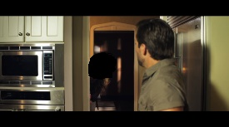
30 sec

Figure A1 Neutral valence of high arousal: Slash in a Box.

Appendix 2 Selected summary images, interest areas and story sequences

Time | Stills from video | Stills with IA mask | Sequence stills
0 sec
5 sec
10 sec
15 sec
20 sec
25 sec
30 sec

Figure A2 Neutral valence of low arousal: Do Over

Appendix 2 Selected summary images, interest areas and story sequences

Time | Stills from video | Stills with IA mask | Sequence stills
0 sec
2 sec |  | 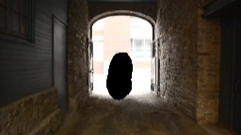
3 sec |  | 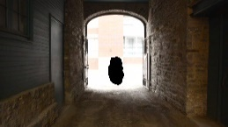
6 sec |  | 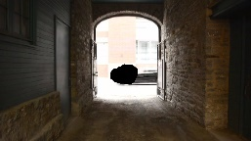
7 sec | 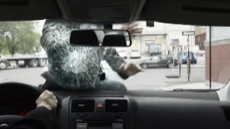
14 sec
22 sec
28 sec

Figure A3 Negative valence of high arousal: After the Rain

Appendix 2 Selected summary images, interest areas and story sequences

Time | Stills from video | Stills with IA mask | Sequence stills
5 sec
10 sec
15 sec |  | 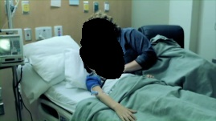
20 sec
25 sec |  | 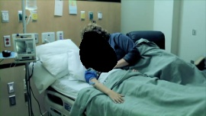
30 sec |  |  | 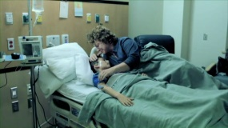

Figure A4 Negative valence of low arousal: Superhero

Appendix 2 Selected summary images, interest areas and story sequences

Time | Stills from video | Stills with IA mask | Sequence stills
0 sec
5 sec
10 sec
15 sec
18 sec
20 sec
27 sec
30 sec

Figure A5 Positive valence of high arousal: Break a Leg

Appendix 2 Selected summary images, interest areas and story sequences

Time | Stills from video | Stills with IA mask | Sequence stills
0 sec
5 sec
10 sec |  | 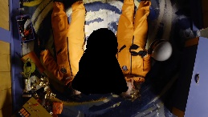
15 sec
20 sec | 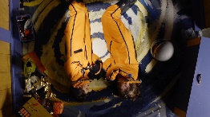
25 sec | 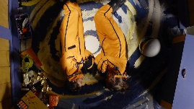 | 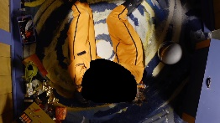
30 sec | 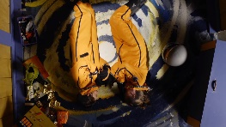

Figure A6 Positive valence of low arousal: Treehouse

Appendix 3 Frequency threshold example

Table A1 Frequency of pixel selection for each image condition with median threshold figure.

Frequency Selection: |  | Positive Low |  | % | Positive High | % | Negative Low | % | Negative High | % | Neutral Low | % | Neutral Average | %
0 |  | 675312 |  |  | 966579 |  | 703322 |  | 376230 |  | 417370 |  | 570400
1 |  | 523230 |  | 5 | 150769 | 8 | 206590 | 5 | 236953 | 5 | 263972 | 5 | 355357 | 5
2 |  | 44795 |  | 9 | 41851 | 15 | 39610 | 9 | 327195 | 9 | 118192 | 9 | 109920 | 9
3 |  | 21728 |  | 14 | 39330 | 23 | 37106 | 14 | 115272 | 14 | 189545 | 14 | 20966 | 14
4 |  | 9559 |  | 18 | 34197 | 31 | 41063 | 18 | 26562 | 18 | 88566 | 18 | 38834 | 18
5 |  | 11698 |  | 23 | 99122 | 38 | 24410 | 23 | 29224 | 23 | 116713 | 23 | 31039 | 23
6 |  | 11722 |  | 27 | 54093 | 46 | 40447 | 27 | 38932 | 27 | 33382 | 27 | 28965 | 27
7 |  | 10685 |  | 32 | 16352 | 54 | 34012 | 32 | 21311 | 32 | 16864 | 32 | 38535 | 32
8 |  | 11041 |  | 36 | 20047 | 62 | 22279 | 36 | 25931 | 36 | 17180 | 36 | 23618 | 36
9 |  | 13192 |  | 41 | 10884 | 69 | 30768 | 41 | 11072 | 41 | 14846 | 41 | 41579 | 41
10 |  | 8536 |  | 45 | 28564 | 77 | 42270 | 45 | 24533 | 45 | 12275 | 45 | 30436 | 45
11 |  | 7091 |  | 50 | 4365 | 85 | 95071 | 50 | 18090 | 50 | 13114 | 50 | 79234 | 50
12 |  | 39154 |  | 55 | 3847 | 92 | 32980 | 55 | 20517 | 55 | 10640 | 55 | 34255 | 55
13 |  | 15032 |  | 59 | 0 | 100 | 62045 | 59 | 19030 | 59 | 10794 | 59 | 12874 | 59
14 |  | 14361 |  | 64 | 0 |  | 43053 | 64 | 47061 | 64 | 7577 | 64 | 9041 | 64
15 |  | 5269 |  | 68 | 0 |  | 7863 | 68 | 107669 | 68 | 12256 | 68 | 10167 | 68
16 |  | 21821 |  | 73 | 0 |  | 7111 | 73 | 18352 | 73 | 10778 | 73 | 5011 | 73
17 |  | 4834 |  | 77 | 0 |  | 0 | 77 | 6066 | 77 | 13192 | 77 | 3495 | 77
18 |  | 5356 |  | 82 | 0 |  | 0 | 82 | 0 | 82 | 15410 | 82 | 7070 | 82
19 |  | 3058 |  | 86 | 0 |  | 0 | 86 | 0 | 86 | 31686 | 86 | 6534 | 86
20 |  | 2333 |  | 91 | 0 |  | 0 | 91 | 0 | 91 | 31821 | 91 | 9142 | 91
21 |  | 1863 |  | 95 | 0 |  | 0 | 95 | 0 | 95 | 9448 | 95 | 3531 | 95
22 |  | 8330 |  | 100 | 0 |  | 0 | 100 | 0 | 100 | 14378 | 100 | 0 | 100
Cut-off |  | >11 |  |  | >6 |  | >8 |  | >8.5 |  | >11 |  | >10.5
The above table shows the number of individual pixels which were selected zero, one, two, three, four, five, up to 13 or 22 times within each image (i.e. positive low arousal, positive high arousal, negative low arousal, negative high arousal, neutral low arousal, neutral average arousal). Five images were defined for central emotional content by 22 participants, and one image was defined by 13 participants. For example, within the positive low arousal image 8330 individual pixels were selected 22 times (i.e. each black mask image which was overlaid covered the same 8330 pixels which each received a cumulative count of 22). As the highest frequency count for this image was 22, 100% of participants selected those 8330 pixel points. The table also details that for the positive high arousal image (which was defined by 13 participants) the highest frequency count recorded was 12, with the same 3847 pixel points being selected by 92% of participants. For the negative low arousal image the highest frequency recorded was a count of 16 for 7111 individual pixels, which therefore translates as those pixels being selected by 73% of participants.
The cut-off figure along the bottom line of the table represents the threshold value for output to generate a defined area of pixels which were selected by the most participants. The median figure was found for the highest frequency count recorded in each image i.e. dividing the highest frequency by two. As this process is concerned with defining the most commonly selected area of each image, any pixels with a frequency count of less than or equal to the median were discarded, and those pixels with a count of greater than the median threshold were output to form a defined area in black. The highest frequency count was used to generate a median figure, and not the median of all participants defining the images, to target the data points selected by the participants. If the total participants had been used, the median figure would be artificially high and could include figures which received a frequency count of zero. For example, for the negative low arousal image, if the total participant figure had been used to generate the median (i.e. median of 11 opposed to median 8 using the highest frequency recorded), it would include five non-scoring frequency counts instead of the top scoring 50% of the frequency counts, which in this case were 9, 10, 11, 12, 13, 14, 15, and 16.

