Psychosocial factors of paediatric type one diabetes management: a Q-methodological study

Ami Brooks

Thesis submitted in partial fulfilment of the requirements of Staffordshire University for the degree of Doctorate in Clinical Psychology

April 2020

Total word count: 17,578

THESIS PORTFOLIO: CANDIDATE DECLARATION
Title of degree programme | Professional Doctorate in Clinical Psychology
Candidate name | Ami Brooks
Registration number | 17024108
Initial date of registration | September 2017

Declaration and signature of candidate
I confirm that the thesis submitted is the outcome of work that I have undertaken during my programme of study, and except where explicitly stated, it is all my own work.
I confirm that the decision to submit this thesis is my own.
I confirm that except where explicitly stated, the work has not been submitted for another academic award.
I confirm that the work has been conducted ethically and that I have maintained the anonymity of research participants at all times within the thesis.

Signed: Date: 20.04.2020

Acknowledgements

Firstly, thank you to my academic supervisor Helen Combes for introducing me to the world of Q-Methodology and for all of your support with the thesis process. Thank you to my clinical supervisor Charlotte Tolgyesi, you could not have been more helpful and generous with your time during recruitment and write up. My appreciation goes out to Dr Raffeeq and the Diabetes MDT for being so accommodating, interested and helpful throughout the whole process.

My eternal gratitude goes out to all of the people who took the time to take part in my research. I hope I can go some way to giving back to the community throughout my career. As well as my participants, there were a number of amazing service user consultants who played an invaluable role behind the scenes; thank you to Laura Frost, Ben Armstrong, Kelly Forrester and Ella Norris.

To my friends who have been there for me throughout this long process, despite my continual absence, I owe you all for your patience and ongoing friendship. I know you’ll be there, ready and waiting when this is all over (tequila?). To my amazing cohort, you have been impressing and inspiring me for three years now and I hope the fun continues long after this journey is over (tequila!). To my ‘little and broken but still good’ family: Dad, Raine and Kay, thank you for always cheerleading at the sidelines and believing in me when I didn’t believe in myself. Kay, Ben and Herschel, thank you for the home away from home during placement. Puppy cuddles made that commute worth it. Harold, I work so you can have a better life.

And last but by no means least, thank you to my long suffering husband, Nam. It’s been a long 12 years and an obscene amount of that time has been spent with me flitting from job to job, from dream to dream, from salary to not-so-great-salary. You have been right by my side the whole time, never holding me back and always assuring me I’m going to smash it. Thank you for being on my team. We smashed it. I promise, I’m done now.
(I’m absolutely not done now).

Preface

This thesis has been written and formatted using American Psychological Association (APA) seventh addition in line with submission guidelines for The Journal of Pediatric Psychology (impact factor 3.609). Submission guidelines can be found in Chapter 2, Appendix L.

Chapter 1: Literature review: 7824 (inc abstract)
Chapter 2: Empirical paper: 7834 (inc abstract)
Chapter 3: Executive summary: 1155
Thesis abstract: 400
Total word count: 17,578

Contents

Abstract 9
Introduction 10
Type one diabetes 10
Management 10
Diabetes and social support 11
Method 13
Search strategy 13
Inclusion and exclusion criteria 13
Process 14
Publication bias 14
Data synthesis 14
Figure 1. Flow chart of search and selection process 15
Results 16
Description of studies 16
Study design 16
Sample characteristics 16
Data analysis 17
Quality appraisal 18
Qualitative studies 18
Quantitative studies 19
Aims and sample 19
Measures 20
Demographics 20
Metabolic control and management 20
Friendship 21
Table 1. List of measures used to assess friendship and the reported validity and reliability 21
Follow up 21
Data analysis 22
Mixed methods studies 22
Sample 22
Method 23
Data analysis 23
Synthesis of findings 24
Figure 2. Summary model synthesis of findings 24
Impact of friendship on diabetes management 25
Positive impact 25
Instrumental support 25
Monitors 25
Cooperative 26
Emotional support 26
Negative impact 27
Metabolic control 27
Domination 27
Conflict 28
Neutral 28
No role 28
Individual differences 29
Impact of diabetes on friendship 29
Negative 29
Gets in the way 29
Limited understanding 30
Feeling different 30
Neutral 30
Same as controls 30
Little impact 30
Positive 31
More friends 31
Gender differences in T1D and friendships 31
Support 31
Conflict 32
Discussion 32
Implications and future research 34
Limitations and bias 35
Conclusions 36
References 37
Appendices 46
Abstract 58
Introduction 59
Type One Diabetes 59
Management 59
Impact of fluctuating blood sugar levels 61
What gets in the way of management? 61
Social support 61
Parenting and family 62
Psychological factors 63
How do families manage? 64
Q-Methodology 65
Method 65
Epistemological position 65
Approval 66
Creating the Q-set 66
Demographic questionnaire 67
Participants 67
Recruitment 67
The Q-sort task 68
Ethical considerations 68
Reflexivity 69
Results 69
Data analysis 69
Correlation matrix 69
Factor analysis 70
Table 1. Unrotated factor matrix 70
Table 2. Rotated Factor Matrix with defining sorts flagged 71
Figure 1. Factor array for Factor 1: The medical team and practical strategies 72
Table 3. Demographic details of participants loading onto each factor 72
Factor interpretations 74
Consensus 74
Managing as a family 74
Parenting a young person with diabetes 75
Flexibility 75
Factor one: the medical team and practical strategies 75
Relationships with medical staff 76
Practicalities 76
Factor two: friends and psychological concepts 76
Support from social network 76
Psychological factors 77
Diabetes is not an identity 77
Discussion 77
Social support 78
Parenting and family 79
Psychological factors 79
Limitations 80
Clinical implications 80
References 83
Appendices 95

Thesis Abstract

This thesis research was completed as part of a Doctorate in Clinical Psychology at Staffordshire University by the first author. The topic was developed by the author’s experience of working therapeutically with young people with type one diabetes (T1D) and their families. Many psychosocial barriers to managing diabetes in children became quickly apparent. However, there were also many families who were doing exceptionally well at managing the disease and this sparked an interest in how they did this. Chapter 1 is a literature review of studies exploring the relationship between friendships and T1D in children. It used structured appraisal tools and applies a systematic approach to searching for the relevant research. Findings suggest mixed results regarding whether diabetes gets in the way of forming friendships and whether friends have a positive or negative impact on diabetes management. Individual and gender differences were found. Chapter two is the empirical paper which uses Q-methodology to explore which psychosocial factors are most helpful for families in managing T1D in children. Nineteen participants’ (healthcare professionals, young people with T1D and parents of children with T1D) completed Q-sorts in which they ranked 49 statements regarding things that are helpful in managing diabetes. Two factors emerged 1) relationship with the medical team and practical strategies and 2) friendships and psychological factors. Both factors agreed that involving the whole family and taking a flexible approach to parenting were helpful. The majority of parents and young people in the study loaded onto factor two, suggesting a perspective that values the involvement of the medical team and the practical support they provide. All of the most senior medical professionals and the parent who was a nurse by profession loaded onto factor two, suggesting this group place more emphasis on the resources available to young people outside of the medical team. These results have implications for Clinical Psychologists working within Paediatric Diabetes MDTs, highlighting the importance of psychology being embedded in teams to support both staff and families to navigate what is helpful to them at particular points in their journey with diabetes. Chapters 1 and 2 have been written in APA format and will be edited further to meet journal standards. Chapter 3 is a service user executive summary of the empirical study. It has simplified the technical language and formatted to be appropriate for children aged 12 and over, summarising the main points of the study.

Chapter 1- Literature review

What is known about paediatric type one diabetes and friendship? A review of the literature

Abstract

Objective This paper reviews and synthesises the literature relating to friendship for children with type one diabetes (T1D), exploring how friendship impacts upon diabetes management, and how diabetes can impact upon friendships.

Method A systematic search across six databases was conducted with fourteen studies, within thirteen papers, meeting the inclusion criteria.

Results The quality percentage score of the studies ranged from 58-87%; three used qualitative and eight used quantitative methodologies, three studies used a mixed methods approach. The studies revealed that there is variability in how much support friends provide in the management of diabetes, how successful this is in improving metabolic control and how much young people want their friends to be involved. Four studies suggested that diabetes has little impact upon friendships; although some studies show that diabetes can get in the way of being with friends and that some friends do not fully understand T1D. There were a number of gender differences found in relation to the amount of friend support wanted (this was more varied for boys) and the impact of friend conflict (which has a bigger impact on mood and diabetes management for girls). The methodologies used in the included papers were broad, as were the specific research questions, limiting comparability.

Conclusions Future research should focus on the individual differences in what young people want from friendship and to consider piloting person-centred interventions that involve friends where appropriate.

Keywords: insulin dependent diabetes mellitus; friendship; metabolic control, type one diabetes; friends

Introduction

Type one diabetes

Type one diabetes (T1D) is a chronic autoimmune condition which occurs when the pancreas is unable to produce insulin to metabolise glucose. Approximately 29,000 people under 18 years old have T1D in the UK making it one of the most common chronic health conditions in children (HSCIC: National Diabetes Audit, 2018/19).

Management

Management of T1D requires a number of self-management behaviours throughout the day (Glasgow et al., 1999) including daily blood sugar level checks and calculated insulin injections, diet management and a quick response to hypoglycemia or hyperglycemia (NICE, 2015). As blood sugar fluctuates throughout the day it can have an impact on mood, concentration, behaviour and decision making (Penckofer et al., 2012; McDonnell et al., 2007; Rustad et al., 2013).

Given the often early onset of T1D and the complex task of management, young people and their families can find it difficult to maintain healthy blood sugar levels. At diagnosis, a diabetes management plan is created to help a family navigate the various tasks of treating diabetes (NICE, 2015). As children grow older they begin to take a more active role in the management of their diabetes. Children in secondary school often monitor their blood sugar independently (Karlsson et al., 2008). In adolescence, young people begin to spend more time away from the family (Larson & Verma, 1999) and are required to take more responsibility for checking their blood glucose, carbohydrate counting and giving insulin throughout the day. Research has shown that adolescents tend to have poorer metabolic control than younger children and adults (Anderson et al., 1997) and this control often declines as young people reach adolescence (Greening et al., 2007). This may be in part due to the increase in insulin required following hormonal changes in puberty (Goran & Gower, 2001) but may also be due to adolescent’s decline in self-care behaviours (Greening et al., 2007). Due to the evidence of a decline in metabolic control in young people as they move into adolescence, it is important for research to focus on factors which may impact upon management during this time.

Diabetes and social support

Research in the area of paediatric diabetes has focused on the impact of support from immediate family (see Wysocki & Greco, 2006, for a review) rather than on the implications of peer relationships. However, young people spend a lot of time with their peers whilst in education and this time increases as they move through to adolescence (Larson & Verma, 1999). Support from family, particularly parents, tends to reduce as support from friends increases (Scholte, van Lieshout & van Aken, 2001). Research on children with chronic illnesses suggests that friends play a larger role than parents in supporting an adjustment to illness (Varni et al., 1989). Therefore, friends may play an important role in providing emotional or practical support to young people with diabetes and this is worthy of further enquiry.

The complex nature of managing diabetes may impact upon the building and maintenance of friendships because these tasks can disrupt activities with peers (Beck & Smith, 1988). In a longitudinal study by Seiffe-Krenke (1997), tracking 14 year-old adolescents for four years, those with diabetes were less likely to develop romantic relationships. They also found that healthy adolescents had closer relationships than those with diabetes. Girls with diabetes caught up with healthy controls over the four years but the males with diabetes did not, suggesting there may be gender differences in the closeness of friendships for young people with diabetes. Studies show that the severity of diabetes increases difficulties with peers (Alderfer et al., 2002). This may be due to the impact of varying blood sugar on mood and decision making (McDonnell et al., 2007), which may negatively affect personal relationships. Furthermore, research has found that adolescents can be vulnerable to diabetic treatment non-adherence when confronted with peer pressure (Thomas et al., 1997).

Peers and friends are defined differently both in technical definition and in research. The Cambridge Advanced Learner’s Dictionary defines peers as ‘a person who is the same age or has the same social position’, and friend as ‘a person who you know well and who you like a lot’ (Walter, 2008). Although peers (especially those in the same school class as a young person) may have an impact upon diabetes management in an indirect way, it is likely that friends have a greater involvement in its day-to-day management. Similarly, diabetes management tasks are likely to have a greater impact upon the development of friendships rather than peer relationships because they disrupt usual activities with friends, such as eating together. Therefore, this review will focus specifically on research related to friends, rather than peers.

T1D is a complex chronic health condition that requires young people to carry out a number of daily management tasks as well as modify their behaviour and schedule to accommodate them. It is unclear the extent to which friends support or hinder the management of these tasks and whether these tasks change the process of developing and maintaining friendships. This literature review aims to critique and synthesise research related to friendships and T1D in young people. This review will synthesise what is known in relation to two general questions:

- How do friendships impact upon diabetes?
- How does diabetes impact upon friendships?

Following a systematic search, the literature will be critiqued using validated tools and the results will be synthesised to summarise what is currently known in this area. The results of this synthesis will suggest areas for future research and potential implications for both medical and psychological clinical practice.

Method

Search strategy

A preliminary search was carried out using the International Prospective Register of Systematic Reviews (PROSPERO) database and the Cochrane Reviews database to ensure that a review had not been previously carried out in this area. Although one review was found (Palladino & Helgeson, 2012), its focus was on general peer relationships rather than being specific to friendships. Therefore, between February 8 and February 26 2019 six databases were searched; CINAHL Plus with full text, Medline, PsycARTICLES, PsycINFO, SPORTDiscus with full text and Science Direct using the following terms (friendship OR "peer relationship" OR friend) AND (diabetes OR "type 1" OR IDDM). Search terms were determined through examining key-terms and definitions in relevant literature and discussions with clinical supervisor and academic librarian.

Inclusion and exclusion criteria

Criteria for inclusion in the review was a focus on T1D, with a sample of young people up to 18 years old in line with the age when they become responsible for their diabetes management (NICE, 2015). Studies were required to be related specifically to friendship rather than social or peer support. Often papers were not explicit regarding whether they were exploring peers in general or friends more specifically so efforts were made to clarify by looking at each paper in more detail. This involved looking at the definition of the area in question and examining the terms used within questions. Friendship was required to be a primary or secondary outcome and there needed to be enough detail in the analysis to draw conclusions regarding friendship. The analysis must not have merged friend, peer or family support.

Studies were rejected if they included young people with type 2 diabetes or sampled those with diabetes plus a physical or mental comorbidity. If the diabetes sample was the control group the study was excluded as the reported data was insufficient. Finally, intervention studies were excluded because the review was not comparing interventions.

Process

Following removal of duplicates and screening of title and abstract, five articles were identified that met criteria for inclusion in the review. A manual search was also completed of all references within these articles as well as a Google Scholar search of all articles which have cited these papers. All related published literature reviews and references from related outcome measures were manually searched and a further eight papers met the criteria for inclusion in the review (see Figure 1).

Publication bias

In order to minimise the effects of publication bias, non peer-reviewed articles were included in this review. One thesis for the award of Doctorate in Clinical Psychology was included from the formal search. The British Library EThOS database (a grey literature source for UK theses) was searched but did not yield any further results. The rationale for including doctoral theses is that they are required to meet stringent standards and are reviewed by internal and external examiners prior to the qualification being awarded and are therefore deemed to be of high quality.

Data synthesis

The results of the studies included in this review were synthesised using an inductive thematic approach. This approach was used because it is flexible enough to allow the comparison of studies with varying methodologies. The main outcomes in relation to friendship for each study were summarised and then grouped under the main two questions as categories. These categories were then analysed in more depth, drawing out any emergent themes or patterns from the results. A minimum number of studies supporting a theme was not required.

Identification |  | English peer reviewed journal articles identified through database searches  CINAHL Plus with full text (n = 52)  Medline (n = 48)  PsycARTICLES (n = 6)  PsycINFO (n = 41)  SPORTDiscus with full text (n = 14)  Science Direct (n = 60)  Total n = 221
 |  |  |  | 85 duplicates removed
Screening |  | 136 articles screened by title and abstract
 |  |  |  | 95 articles removed
Eligibility |  | 41 full-text articles assessed for eligibility
36 full text articles removed for the following reasons:

Review paper (n = 4)
Outcomes/ focus not related specifically to friendship (n = 14)
Focus on comorbidities (n = 3)
Diabetes group as control (n = 1)
Not T1D specific (n = 6)
Measure validation paper (n = 1)
Sample >18 years (n = 6)
Intervention study (n = 1)

 |  | Hand searching of articles’ citations (using Google Scholar), reference lists, relevant reviews and authors’ other publications for further eligible articles (n = 8)
Included |  | Articles meeting inclusion criteria: 5 + 8 (n = 13)

Figure 1. Flow chart of search and selection process

Results

Description of studies

The 13 articles included in this review described 14 studies; one paper (Peters et al., 2014) outlined two separate studies. Two papers were published in the 1990s (La Greca et al., 1995 and Kyngäs et al.,1998) and the remaining were published between 2004-2018. A summary of the characteristics of the included articles can be found in table A1 (see Appendix A).

Study design

The articles consisted of three qualitative studies, three mixed-method studies and eight quantitative studies, two of which were longitudinal (Helgeson et al., 2007; Helgeson et al., 2008). For these studies, follow-up time was one year (Helgeson et al., 2007) and four years (Helgeson et al., 2008).

All included studies gathered data directly from young people with diabetes. Other sources of information were healthy controls (Helgeson et al., 2007; Helgeson, Reynolds et al., 2005), medical teams (Helgeson et al., 2005; Helgeson et al., 2008), friends (Peters et al., 2014b) and parents (Helgeson et al., 2005; Helgeson et al., 2008).

Three studies were carried out in the UK (Rankin et al., 2018; Robinson, 2008; Doe, 2018), seven in the United States (Berlin et al., 2015; Hains et al., 2006; Helgeson et al., 2005; Helgeson et al., 2007; Helgeson et al., 2009; La Greca et al., 1995; Chao et al., 2016), two in the Netherlands (Peters et al., 2014) and one in Finland (Kyngäs et al., 1998).

Sample characteristics

Sample sizes ranged from 11 (Peters, et al., 2014a) to 28 (Peters et al., 2014b) for qualitative studies; from 74 (La Greca et al., 1995) to 256 (Helgeson et al., 2007) for quantitative studies and from 51 (Kyngäs et al., 1998) to 205 (Chao et al., 2016) for mixed methods studies. The age of participants with diabetes ranged from 9-18 years old and the percentage of female participants in each study ranged from 39% to 60%.

Participants with diabetes were most commonly recruited from the outpatient diabetes clinics attended every three months by young people with T1D (Rankin et al., 2018, Berlin et al., 2015; Hains et al., 2006; Helgeson et al. 2007; Helgeson et al., 2009; Helgeson et al. 2008; La Greca et al. 1995; Doe, 2018; Robinson, 2008; Peters et al., 2014; Kyngäs, et al., 1998). One study recruited from a diabetes camp (Helgeson et al. 2004) and another invited participants from the psychoeducation branch of a randomised control trial (Chao et al. 2016), which brings into question the representativeness of this sample. Healthy controls were recruited from athletic and art summer camps (Helgeson et al., 2004), health fairs (Helgeson et al., 2007) and through paediatric medical staff (Helgeson et al., 2007).

Seven studies required participants to have been diagnosed for a certain length of time to be included in the study, ranging from three months (Hains et al., 2006; Berlin et al. 2015) to 24 months (Robinson, 2008). Four studies set the minimum length of diagnosis at 12 months, in line with the estimated ‘honeymoon phase’ where the pancreas is still able to make small amounts of insulin (Kyngäs et al., 1998; Helgeson et al., 2007; Helgeson et al., 2009, Helgeson et al., 2008).

Data analysis

The qualitative methods of analysis included thematic analysis (Rankin et al., 2018; Peters et al., 2014b) and content analysis (Chao et al. 2016; Peters et al., 2014a; Kyngäs, et al., 1998). Quantitative analysis methods included confirmatory factor analysis (Berlin et al., 2015; Hains et al., 2006), path analysis (Berlin et al., 2015), chi-square (Berlin et al., 2015; Hains et al., 2006; La Greca et al. 1995), structural equation modelling (Hains et al., 2006), t-tests (Helgeson et al., 2007; Robinson, 2008; Chao et al. 2016), MANOVA (La Greca et al. 1995) logistic, multiple or hierarchical regression (Helgeson et al. 2007; Helgeson et al., 2009; La Greca et al. 1995; Doe, 2018; Robinson, 2008) and multilevel modelling (Helgeson et al., 2009; Helgeson et al. 2008).

Quality appraisal

As per guidelines by the National Institute for Health and Care Excellence (NICE), the qualitative articles in this review were critically appraised using the Critical Appraisal Skills Programme (CASP) checklist (CASP, 2018) and the quantitative articles were appraised using the Downs and Black (1998) checklist. For mixed method studies, a modified version of the Evaluation Tool for Mixed Methods Study Designs was used (Long, 2005). The methodology was also noted and given a score of 3 for RCT, 2 for observational studies and 1 for qualitative studies, in line with the hierarchy of evidence (Concato et al., 2000). In order to compare different critical appraisal tools, responses were given codes which were summed with methodology score and a percentage quality score was calculated (see Appendix B for quality scores).

Qualitative studies

Three studies investigated friendship and paediatric diabetes using qualitative approaches and this methodology appeared appropriate for their aims (Rankin et al., 2018; Peters et al., 2014b), which were expressed clearly in all cases. One used thematic analysis (Rankin et al., 2018) and one used content analysis (Peters et al., 2014a). One described a method that appeared to be thematic analysis but did not name it as such (Peters et al., 2014b) which reduced the reliability and validity of the study because it was unclear whether the codes and themes had been verified by another researcher.

Recruitment was carried out during routine outpatient diabetes clinic appointments for all studies. Data collection methods were semi-structured interviews (Rankin et al., 2018; Peters et al., 2014b) and online focus groups (Peters et al., 2014a). One study (Rankin et al., 2018) used ‘optional play-based tasks’ however the detail of this procedure was not adequately described. One study offered reimbursement of €15 for participation in the study (Peters et al., 2014a) which may have impacted young people’s motivation for taking part in the research and may have led to response bias.

Two researchers conducted the analysis in one study and detailed their method of constant comparison and validation (Rankin et al., 2018). They also stated that data collection and analysis continued until saturation was met (Rankin et al., 2018). The methodology of the other studies appeared to be less rigorous with one describing the analysis undertaken by one author and ‘spot checked’ by the second author (Peters et al., 2014a). Another paper did not describe who carried out the analysis and whether this was validated or verified (Peters et al., 2014b). Both studies used appropriate quotations to support their findings. Reflexivity in the form of discussion about potential researcher bias or influence was not apparent in any of the studies, which negatively impacted upon the overall quality scores.

Quantitative studies

Eight studies in this review evaluated friendship and paediatric diabetes using quantitative techniques (Berlin et al., 2015; Hains et al., 2006; Helgeson et al., 2007; Helgeson et al., 2009; Helgeson et al., 2008; La Greca et al., 1995; Doe, 2018; Robinson, 2008).

Aims and sample

All studies described clear aims at the end of their introduction section. Four studies did not report the exact proportion of the clinical population that were recruited to the study (Berlin et al., 2015; Hains et al., 2006; La Greca et al. 1995; Doe, 2018). Three studies clearly described how participants were approached, the number of individuals approached and how many took part (Helgeson et al., 2007; Helgeson et al., 2009; Helgeson et al. 2008; Robinson, 2008). One study included a flow chart highlighting at which point participants dropped out of the study (Robinson, 2008).

Three studies described the ethnic diversity of participants to be representative of the local T1D population (Berlin et al., 2015; Helgeson et al. 2008; La Greca et al. 1995); one other did not provide this information (Hains et al., 2006). Two studies did not collect information on the ethnicity of participants (Doe, 2018; Robinson, 2008). Two studies did not make reference to whether the demographics of the study participants was representative of the population, however the samples were mostly caucasian (>90%) which is representative of the individuals attending the clinic recruited from (Helgeson et al. 2007; Helgeson et al., 2009).

Four studies offered reimbursement for participation in the study; one with a gift certificate (Hains et al. 2006), one with an undisclosed monetary amount (Helgeson et al. 2008), one with $20 (La Greca et al. 1995) and another with $100 (Helgeson et al., 2009). The ethical implications of this reimbursement were not discussed in any of the articles.

Measures

Demographics

Six studies collected demographic data in relation to gender, age, ethnicity, and duration of diabetes and these appeared to be broadly in line with the local population (Berlin et al., 2015; Hains et al., 2006; Helgeson et al. 2007; Helgeson et al., 2009; Helgeson et al. 2008; La Greca et al. 1995). Some studies did not collect information related to ethnicity (Doe, 2018; Robinson, 2008;) or length of diagnosis (Doe, 2018).

Metabolic control and management

Seven studies used HbA1cs (an average blood sugar level over three months) collected from medical records as an outcome measure of glycemic control (Berlin et al., 2015; Hains et al. 2006; Helgeson et al. 2007; Helgeson et al., 2009; Helgeson et al. 2008; Doe, 2018; Robinson, 2008). One study used a structured interview to assess adherence to diabetes care (Hanson et al. 1987) and reported that previous studies had found moderate and significant correlations to HbA1cs (La Greca et al. 1995). One study developed an innovative data collection technique involving using a palm pilot to enter blood glucose levels in real time, relying on self-report (Helgeson et al., 2009). The Self-Care Inventory–Revised Version (SCI-R; Weinger et al., 2005) was used in one study, which has been shown to be well correlated with HbA1cs and has satisfactory reliability (Doe, 2018).

Friendship

A range of measures were used to assess friendship, as outlined in Table 1 below. The breadth of measures used limits the comparability of studies and highlights the diversity in how friendship is measured in current research.

Table 1. List of measures used to assess friendship and the reported validity and reliability
Measure | Used by | Reported quality
The Friend and Peer Attribution Questionnaires (Hains et al., 2006) | Berlin et al. 2015; Hains et al. 2006 | Good reliability (internal consistency) and concurrent criterion and construct validities
Berndt and Keefe friendship questionnaire (1995) | Helgeson et al. 2007; 2009; 2008 | Excellent reliability and validity
Diabetes Social Support Interview (La Greca et al. 1995) | La Greca et al. 1995 | High interrater reliability
Perceived Social Support from Friends (PSS-Fr, Procidano and Heller, 1983) | La Greca et al. 1995 | Reliability, validity and internal consistency
The Berlin Social Support Scale Scale (BSSS; Schulz and Schwarzer, 2003) | Doe, 2018 | Cronbach’s alpha of .89
The Diabetes Social Support Questionnaire–Friends Version (DSSQ-Friends; Bearman and La Greca, 2002) | Doe, 2018; Robinson, 2008 | Cronbach’s alpha .76;  face and content validity are evident

Follow up

Two studies used a longitudinal design and followed up at an appropriate period of one to four years (Helgeson et al. 2007; Helgeson et al. 2008). One study reported dropout rates were reported as 4% in the T1D group and 2% in the healthy controls group and reasons for drop out were reported (Helgeson et al. 2007). Another study reported dropout rates of 4% at T2, 5% at T3 and 5% at T4 (Helgeson et al. 2008).

Data analysis

All studies appear to have used appropriate statistical analysis to meet their aims. Five studies did not report exact p values (Berlin et al., 2015; Helgeson et al., 2007; Helgeson et al., 2009; Helgeson et al., 2008; La Greca et al., 1995).

Three studies reported that they were underpowered to detect small effects (Berlin et al. 2015; Hains et al. 2006, Doe, 2018). Despite the total number of participants being less than the a priori target following power analysis, one study reported that it had achieved appropriate power (Robinson, 2008). Two studies referenced that further participants were recruited in order to obtain appropriate power for analysis, but did not report the power (Berlin et al. 2015; Helgeson et al., 2009). Three studies did not reference power (Helgeson et al. 2007; Helgeson et al. 2008; La Greca et al. 1995).

Three studies outlined appropriate measures taken to address missing and non-normal data (Berlin et al., 2015; Hains et al., 2006; Doe, 2018) and four studies did not report whether the data was normally distributed (Helgeson et al., 2007; Helgeson et al., 2009; Helgeson et al., 2008; La Greca et al., 1995).

Mixed methods studies

Friendships in T1D were explored using a mixed-method approach in three of the included studies (Helgeson et al. 2004; Chao et al. 2016; Kyngäs, et al., 1998). All studies clearly outlined their aims and findings.

Sample

One study recruited from a diabetes summer camp, which is unlikely to be a representative sample (Helgeson et al., 2004). Furthermore, the control group for this study was recruited from a sports camp and an art camp, which is also unlikely to provide a comparative sample. It is unclear how the authors determined that this control group was ‘healthy’ (Helgeson et al., 2004). One study recruited from the psychoeducation arm of an ongoing randomised control trial, and data was collected during the fifth session of the intervention (Chao et al. 2016). This method of recruitment similarly has some potential issues with bias and generalisability; for example, the intervention was likely to have inclusion criteria and individuals who take part in intervention studies may have similar characteristics.

One study used self-report to assess compliance with diabetes treatment rather than HbA1cs (Kyngäs, et al., 1998) and it is unclear whether perceived control is likely to be correlated with actual blood sugar levels.

Method

One study provided limited information regarding the qualitative analysis used, reducing the reliability of the study (Helgeson et al., 2004). Kyngäs and colleagues (1998) gave a clear description of the methods used and rationale for decisions made. One study used thorough analysis methods however did not reflect on the researchers own position in relation to the analysis (Chao et al. 2016).

All studies received appropriate ethical approval and detailed the consent procedure (Helgeson et al. 2004; Chao et al. 2016; Kyngäs, et al., 1998). However, one study described consent being given directly by the young people (aged 11- 17) but did not report whether parent consent was obtained (Helgeson et al., 2004). Two studies did not detail the interview schedule or report whether follow up questions were asked (Helgeson et al. 2004; Kyngäs, et al., 1998).

Data analysis

One study reported good inter-rater reliability in their qualitative coding (Helgeson et al. 2004), two studies did not provide this information (Chao et al. 2016; Kyngäs, et al., 1998). None of the studies discussed bias and reflexivity in relation to their qualitative analysis (Helgeson et al. 2004; Chao et al. 2016; Kyngäs, et al., 1998). Overall, the qualitative aspects of all three mixed method studies lacked detail and rigour and this should be noted when interpreting the results.

Synthesis of findings

The synthesis of findings found that, as expected, papers explored two main topics; the ‘impact of friendship on diabetes’ and the ‘impact of diabetes on friendship’. Findings broadly fell into the categories of ‘positive’ impact, ‘negative’ impact and ‘neutral’. A number of themes were identified within each of these categories. A number of studies reported findings in relation to gender differences which have been synthesised and will be reported separately under the categories of ‘support’ and ‘conflict’. See Figure 2 for a model summary of the synthesis of findings.

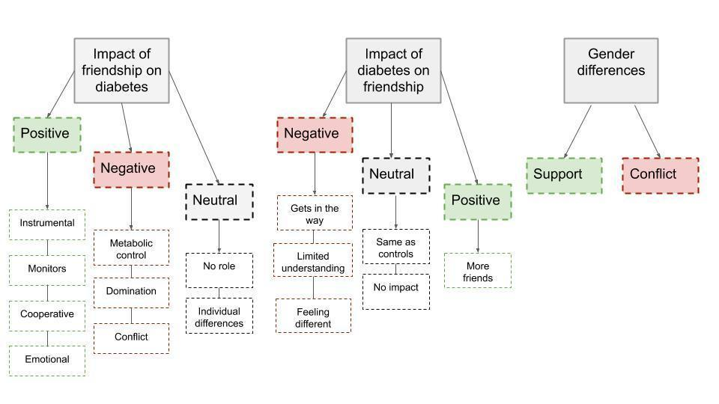

Figure 2. Summary model synthesis of findings

Impact of friendship on diabetes management

Positive impact

Four studies reported the positive impact that friends can have in the management of diabetes (Rankin et al., 2018; La Greca et al., 1995; Doe, 2018; Kyngäs, et al., 1998). The mechanisms of this impact have been synthesised into four broad categories: ‘instrumental support’, ‘cooperation’, ‘emotional support’ and ‘monitors’.

Instrumental support

Three studies described the role of friends in diabetes management as ‘helpers’, who provide practical support with tasks such as retrieving hypoglycemia treatments or alerting adults in an emergency (Rankin et al., 2018; La Greca et al., 1995; Doe, 2018). Doe (2018) found that this instrumental support predicts a small amount of variation in self-care activities. This instrumental support may encourage young people with T1D to carry out self-care activities in social situations.

Monitors

Two studies described the positive role of friends in acting as ‘monitors’ who look out for changes in behaviour that could indicate hypoglycemia, prompt to complete management tasks and check whether they can get involved in certain activities (Rankin et al., 2018; La Greca et al., 1995). Similar to the role of instrumental support, this monitoring from friends may act to encourage young people to continue to maintain their self-care activities whilst involved in social activities.

“..there’s been a few times where I kinda act like different than what I normally would. I kinda lose concentration and whatever if I’m having a hypo and whatever. And if they [friends] recognise that, they’d be like: ‘maybe you need to check your glucose or whatever.” (Rankin et al., 2018, pg 873)

Cooperative

A theme emerging from three studies was the role of friends in offering ‘silent support’ and cooperation in the form of adjusting their lifestyle (Kyngäs et al., 1998; La Greca et al., 1995; Rankin et al., 2018). This took the form of adjusting their activities and schedules to allow time for injections and blood glucose checks as well as taking a reminding role in carrying out these self-care tasks. One study found that young people who reported that their friends offer this kind of support also reported better compliance to diabetes management tasks (Kyngäs et al., 1998). This type of support from friends may reduce the amount of blood sugar checks and insulin doses that are missed because people do not want to lose out on time with friends. Adolescents can be vulnerable to diabetes non-adherence when confronted with peer pressure (Thomas et al., 1997).

“My friends change their schedule so that I can take my shots on time" (La Greca et al., 1995, p. 457).

Emotional support

Two studies reported the role of friends providing emotional support to young people with diabetes (Doe, 2018; La Greca et al., 1995). La Greca et al. (1995) found that this type of support helps young people to ‘feel good’ about their diabetes. In a regression analysis conducted by Doe (2018) emotional support predicted a small amount of variation in self-care (Doe, 2018). This is in line with research by Varni and colleagues (1989) who found that friends may play a larger role than parents in supporting adjustment to illness in children with chronic illness.

"When I'm feeling bad about diabetes, my friends cheer me up" (La Greca et al., 1995, p. 457)

Negative impact

Five studies, however, described the negative impact of friend’s involvement in diabetes care (Hains et al., 2006; Kyngäs et al., 1998; Robinson, 2008; Helgeson et al., 2009; Helgeson et al., 2008;). These negative aspects were broadly related to ‘metabolic control’, ‘domination’ and ‘conflict’.

Metabolic control

Hains et al. (2006) and Helgeson et al. (2008) both found that as the reported amount of friend support increased, so did the relationship between stress and poor metabolic control. Similarly, Robinson (2008) found that friends providing support in the management of tasks predicted poorer metabolic control among adolescents.

Hains’ et al. (2006) study, which explored the attributions given to friend’s reactions to diabetes, found that negative attributions led to anticipated adherence difficulties, which in turn led to increased diabetes stress and poorer metabolic control. Berlin et al. (2015) reported similar results in relation to peer attributions, but did not find any effects related to those of friends.

This suggests that friend support in the management of diabetes is provided with the purest of intentions, but that friends may not be knowledgeable enough about diabetes to provide effective help, which can lead to poor self-care practices.

Domination

In one mixed methods study, some young people said that the lifestyle of friends dominates their life, leading to behaviours that break health regimes. These young people self-reported poorer compliance (Kyngäs et al., 1998). It seems that peer pressure can encourage misconduct (Brown, Lohr & McClenahan, 1986) leading young people with diabetes to engage in activities with friends rather than completing diabetes management tasks. In addition they may join in with activities that directly impact upon diabetes (such as drinking alcohol or exercising).

“I don’t care for myself. I live like my friends. I can’t care for myself because self-care activities don’t fit my friend’s lifestyle.” (Kyngäs et al., 1998, p. 765)

Conflict

Two studies reported on the role of conflict within friendships in relation to diabetes management (Helgeson et al., 2009; Helgeson et al., 2008). One reported that conflict (such as disagreements and fallings out with friends) was related to poor self-care behaviour (Helgeson et al., 2009). A longitudinal study by Helgeson and colleagues (2008) also found that negative relationships with friends were associated with a decrease in metabolic control over a four year period. Research suggests that conflict with friends can have a negative impact upon wellbeing (Rook, Sorkin & Zettel, 2004) so it is likely that this effect is magnified for a young person managing a complex disease such as T1D.

Neutral

Four studies included in this review also reported on the more neutral or mixed impact of friends on the management of diabetes (Kyngäs et al., 1998; La Greca et al., 1995; Helgeson et al., 2009; Berlin et al., 2015). These have been collated into themes of ‘no role’ and ‘individual differences’.

No role

Four studies reported results that suggested that friends do not play a role in the management of diabetes (Kyngäs et al., 1998; La Greca et al., 1995; Helgeson et al., 2009; Berlin et al., 2015). In one qualitative study, some young people reported that they do not think that their friends play a role in their diabetes management (Kyngäs et al., 1998).

In quantitative studies, La Greca et al. (1995) found that the amount of friend support was not related to adherence and Helgeson, Lopez and Kamarck, (2009) reported that neither interaction enjoyment nor upset predicted blood glucose levels. One study found that although attributions regarding peers reactions had a negative impact on stress and metabolic control, those regarding friends did not (Berlin et al., 2015). These findings suggest that for many young people, they do not perceive that their friendships impact upon either the way that they manage their diabetes nor their resulting metabolic control.

Individual differences

Two studies by the same authors reported a range of individual differences in young people’s perspective of the involvement of friends. Peters, Nawijn and van Kesteren (2014) found that young people differed greatly in how much they wanted their friends to be involved in their diabetes management. They also found that young people viewed certain supportive actions differently depending upon how much involvement they wanted from friends. In interviews, some best friends reported that they would like to be more involved with their friend’s diabetes (Peters et al., 2014b).

These studies may go some way to exploring the diversity of the results of the studies reported above; there may be large differences between young people in how much they want their friends involvement, their attributions around the reactions of their friends to their diabetes and the attitude that their friends take to their diabetes.

Impact of diabetes on friendship

Four studies reviewed explored the impact of diabetes in the development and maintenance of friendships (Helgeson et al., 2007; Chao et al., 2016; Peters et al., 2014, study 2; and Helgeson et al., 2004). The findings are described below under the categories ‘positive’, ‘negative’ and ‘neutral’, which each contain at least one theme. Some of these themes are only found in one study and therefore should be interpreted cautiously.

Negative

Gets in the way

In one study, young people described how having diabetes ‘gets in the way of being with friends’ (Chao et al., 2016). This may be linked to the multitude of diabetes management tasks that young people are required to undertake, which may mean they miss out on activities with friends (for example, eating lunch at the same time).

Limited understanding

In two of the studies young people described that their friends have limited understanding of their diabetes and how serious of a condition it is (Chao et al., 2016; Peters et al., 2014a), which may connect with the findings which show that friend support has a negative impact on metabolic control; some friends may not understand diabetes well enough to provide effective practical support.

‘‘A lot of my friends don’t understand the severity of my diabetes.’’ (Chao et al., 2016, p. 137)

Feeling different

Chao and colleagues (2016) reported that young people can feel different from their friends because of their chronic condition. Although this theme only emerged from one study included in this review, it is in line with previous research suggesting that children with chronic illness, including T1D, feel different from their peers (Davidson et al., 2004; Isaacs & McElroy, 1980). This is based upon the number of adaptations to life and invasive tasks that young people with chronic illness often have to perform each day that other children do not have to think about.

Neutral

Same as controls

Helgeson (2007) and Chao (2016) found that there was no difference in self-reported variables of friendship between those with T1D and healthy controls. Furthermore, one study found that young people with diabetes are just as likely as healthy controls to report having a best friend, boyfriend or girlfriend (Helgeson et al., 2007).

Little impact

In two of the three qualitative studies reviewed some of the young people interviewed reported that diabetes had little impact on their friendship (Peters et al., 2014b; Helgeson et al., 2004). This provides further support for the idea that there is a large variation in individual differences among young people with T1D in terms of how much involvement their friends have in their diabetes and vice versa.

Positive

More friends

In a study by Helgeson et al. (2004), young people with diabetes reported a higher number of close friends and more support from friends than healthy controls. However, it should be noted that this study in question had the lowest quality score (58.8%) due to biased sampling methods and a lack of rigour in methodology.

Gender differences in T1D and friendships

Four studies in this review reported gender differences in their analysis of the relationship between friendship and T1D (Helgeson et al., 2009; Helgeson et al., 2007; La Greca et al., 1995; Peters et al., 2014a). These have been split into two categories; ‘support’ and ‘conflict’.

Support

In two studies, girls reported more support from their friends than boys (La Greca et al., 1995; Helgeson et al., 2009). In a study that compared healthy controls with young people with T1D, boys with T1D were found to have the lowest levels of support from friends across the four groups (Helgeson et al., 2007). These results are in line with research indicating that girls are more prone to supporting their friends and peers (Chapman & Mullis; Rose & Asher, 2004; Hastings, Anderson & Kelley, 1996). Furthermore, research suggests that girls are more likely to seek support from friends when experiencing stress, which is prominent in diabetes (Bird & Harris, 1990).

“My friends don’t support me and they also don’t need to.” (Boy, aged 16, Peters et al., 2014, study 1)

Conflict

One study found that conflict within friendships was more strongly associated with depressive symptoms in girls than in boys (Helgeson et al., 2009). This may be related to evidence that girls are more likely than boys to see their friendships as central to their sense of self (McGuire & McGuire, 1982) and therefore conflict may have a bigger impact on mood. A qualitative study found that there was a large variation in how much young people wanted support from their friends in managing their diabetes, and this was more extreme in boys than girls. Many boys reported that they did not want their friends to change their behaviour for them or get involved in their diabetes management.

“I don’t expect friends to not eat or drink certain things because I can’t at that time. They don’t have to make sacrifices for me. In fact, I find it irritating if they want to do that.” (Boy, aged 14, Peters et al., 2014, study 1)

Discussion

The aim of this literature review was to explore what is known about the interaction between T1D in young people and friendships. A review of fourteen studies within thirteen articles was undertaken. Each study was critically appraised using a tool appropriate to methodology and given a percentage quality score in order to aid comparability. The overall quality of included studies was moderate, with quality percentage scores ranging from 58- 87%. This quality score was taken into account when synthesising the results. The results of included studies were synthesised using an inductive thematic approach in order to organise the results into broad categories and more narrow themes. Synthesis revealed overall categories of ‘impact of friendship on diabetes’, ‘impact of diabetes on friendship’ and ‘gender differences’, each containing a number of themes.

There were contrasting results found within and across studies in relation to the impact of friendship on diabetes. Some results suggest a positive impact of friends being involved in diabetes management on a practical level (Rankin et al., 2018; La Greca et al., 1995; Doe, 2018) as well as providing emotional support (Doe, 2018; La Greca et al., 1995). Although Doe (2018) found that instrumental support predicts a small amount of variation in self-care activities, this accounted for a small amount of variance (6%). This positive effect may be linked to the potential protective influence of friendships as reported by Herzer and colleagues (2009) who found that peer support buffered the adverse effect on parental strain in children with a range of chronic health conditions. It may be the case that although practical and emotional support from friends had a small impact on glycemic control, it enables a young person to cope better when faced with other environmental stressors.

Five studies within this review show that conflict and domination within friendships may in fact have a negative impact, leading to low mood and poor glycemic control as well as to promoting behaviours that are a barrier to effective self-care (Hains et al., 2006; Kyngäs et al., 1998; Robinson, 2008; Helgeson et al., 2009; Helgeson et al., 2008). Some young people with T1D do not get their friends involved in their diabetes care, instead preferring to keep this aspect of their life separate (Kyngäs et al., 1998; La Greca et al., 1995; Helgeson et al., 2009; Berlin et al., 2015). These results highlight a large potential variation in individual differences relating to the impact of friendship and T1D. There may be a number of personal, social and psychological differences among young people that account for this variation, which may act as moderators. Once researched, the resulting information may aid in building diabetes care plans for young people that take into account their circumstances and beliefs in order to maximise glycemic control. This may be especially important in adolescence when young people are increasingly spending more time with friends (Larson & Verma, 1999) and family members take a less active role in helping with diabetes management (Karlsson, Arman & Wikblad, 2008).

Only four studies assessed the impact of diabetes on building and maintaining friendships. Chao et al., (2016) found that children report that diabetes ‘gets in the way’ of being with friends and makes them feel different. Although there is a paucity of articles assessing the impact of diabetes on friendships, it may be that research in this area regarding other chronic health conditions can be generalised to the T1D population. A review by Taylor, Gibson and Franck (2008) of studies across chronic illness found similar themes of feeling different and illness getting in the way of friendships. However, despite there likely being commonalities across experiences of T1D and other chronic health conditions, diabetes is unique in its impact on day-to-day activities, whilst also being an ‘invisible illness’ (Joachim & Acorn, 2000). Therefore, there may be a need for further research that specifically addresses T1D. However, although there is some evidence that young people with diabetes find this a barrier in their friendships, it may be that this is no more extreme than the experiences of many ‘healthy’ adolescents.

The final category gender differences, may enable researchers to examine the variables and moderators that impact the relationship between T1D and friendship. The findings in this category were fairly consistent, suggesting that gender differences are commonplace in diabetes care, as with general friendships in the ‘healthy’ population. Rose and Rudolph (2006) found that boys’ relational style is characterised by less interpersonal engagement and disclosure than that of girls. Boys with T1D may require different mechanisms of support if they are less likely to access this from friends, or may benefit from psychoeducation on the importance of relationships in managing stressors; moving away from a gender stereotypical view that boys should not express difficulties or distress.

Implications and future research

The range of contrasting results both within and between studies in this review suggest that there may be many personal, social and psychological variables that moderate how friends impact a young person’s diabetes care and how having diabetes impacts the building and maintenance of friendships. Although a number of studies point to gender differences, future research should also focus on other variables that may account for these variations as indicated by current research within the field of diabetes and chronic illness more broadly. Potential areas for investigation include personality traits (Žugelj et al., 2010), family circumstances (Anderson & Auslander, 1980), resources and family income (Schulman & Green et al., 2016; Woodson et al., 2015), psychosocial factors such as family and peer pressure and denial (Rhee et al., 2009), environment (Schulman & Green et al., 2016) and psychological adjustment (Dekker & de Groot, 2018) as well as beliefs about friendships and diabetes more broadly.

The findings have implications for clinical practice. Diabetes management plans are developed by medical staff in collaboration with families following diagnosis and regularly updated (NICE, 2015). This review indicates the importance of friendships in diabetes management as both a potential help and a hindrance. Medical staff should endeavour to engage in discussion with young people about their beliefs regarding involving their friends in their diabetes management and incorporate this into plans made. This should include strategies to limit the negative influence of peer pressure in relation to engaging in activities that hinder metabolic control, or missing important management tasks. Young people should also be given an opportunity to discuss any difficulties faced in making and maintaining friendships should they find that their diabetes becomes a barrier. The potential negative impact on metabolic control and NICE guidelines (2015) regarding the need for adequate psychological support highlights the importance of having a Clinical Psychologist as part of the multidisciplinary team in paediatric diabetes departments.

Limitations and bias

Although glycemic control was most often established using Hba1Cs, data regarding friendships relied solely on self-report. Self-report is likely impacted by bias and therefore limits the reliability and validity of the results. A clear definition of friendship is not provided in most of the included studies, and although attempts were made to ensure that each paper examined this rather than peer relationships more broadly, there is likely to be some overlap in both researcher and participants understanding of these two concepts. Although the majority of studies in this review are of high quality, it should be noted that there are a number of studies with a potential selection bias, particularly around control groups who were recruited from health fairs or sporting camps. Some of the qualitative methodology, in particular, was not rigorously described in the included papers, again reducing the reliability of results.

Another limitation of this review is that the search and critical appraisal was not checked by a second researcher and could therefore be subject to some bias. Furthermore, there were more papers found through the manual search than the systematic search. This could suggest that the systematic search terms did not capture the relevant papers due to limited choice of words. However, exploration of the terms used in the final papers for review showed a broad overlap of terms related to both friendship and peer support (which is not being explored in this review). Another reason why some of the included papers did not come up in the systematic review is that they may not be available on the chosen databases.

Conclusions

To conclude, the purpose of this review was to assess the current research regarding friendships and T1D. The results of this review suggest that the impact of friendships on diabetes management, and vice versa, are broad and can be positive, negative and neutral in nature. This review has highlighted potential individual differences in young people’s experiences of friends supporting diabetes management and the impact diabetes has on forming and maintaining friendships. Future research should focus on the mechanisms behind the differences found in the studies reviewed, in order to provide more person-centred diabetes support plans and interventions.

References

Alderfer, M. A., Wiebe, D. J., & Hartmann, D. P. (2002). Predictors of the peer acceptance of children with diabetes: Social behavior and disease severity. Journal of Clinical Psychology in Medical Settings, 9(2), 121-130.

Anderson, B. J., & Auslander, W. F. (1980). Research on diabetes management and the family: A critique. Diabetes Care, 3(6), 696-702.

Anderson, B. J., Brackett, J., Ho, J., & Laffel, L. M. (1999). An office-based intervention to maintain parent-adolescent teamwork in diabetes management. Impact on parent involvement, family conflict, and subsequent glycemic control. Diabetes Care, 22(5), 713-721.

Bearman, K. J., & La Greca, A. M. (2002) Assessing friend support of adolescents’ diabetes care: The diabetes social support questionnaire-friends version. Journal of Pediatric Psychology 27(5), 417–428.

Beck, S., Smith, L. K., & Karoly, P. (1988). Personality and social skills assessment of children, with special reference to somatic disorders. In P. Karoly (Ed.), Handbook of Child Health Assessment (pp. 149-172) Wiley.

Berlin, K. S., Hains, A. A., Kamody, R. C., Kichler, J. C., & Davies, W. H. (2015). Differentiating peer and friend social information-processing effects on stress and glycemic control among youth with type 1 diabetes. Journal of Pediatric Psychology, 40(5), 492-499.

Berndt, T. J., & Keefe, K. (1995). Friends’ influence on adolescents’ adjustment to school. Child Development, 66, 1312–1329.

Centers for Disease Control and Prevention. (2011). National diabetes fact sheet: national estimates and general information on diabetes and prediabetes in the United States, US Department of Health and Human Services, Centers for Disease Control and Prevention, 201(1), 2568-2569.

Chao, A. M., Minges, K. E., Park, C., Dumser, S., Murphy, K. M., Grey, M., & Whittemore, R. (2016). General life and diabetes-related stressors in early adolescents with type 1 diabetes. Journal of Pediatric Health Care, 30(2), 133-142.

Chapman, P. L., & Mullis, R. L. (1999). Adolescent coping strategies and self-esteem. Child Study Journal, 29(1), 69-69.

Concato, J., Shah, N., & Horwitz, R. I. (2000). Randomized, controlled trials, observational studies and the hierarchy of research designs. New England Journal of Medicine, 342(25), 1887-1892.

Critical Appraisal Skills Programme [CASP] (2018). CASP (Qualitative) Checklist. https://casp-uk.net/casp-tools-checklists/

Davidson, M., Penney, E. D., Muller, B., & Grey, M. (2004). Stressors and self-care challenges faced by adolescents living with type 1 diabetes. Applied Nursing Research, 17(2), 72-80.

Dekker, J., & de Groot, V. (2018). Psychological adjustment to chronic disease and rehabilitation–an exploration. Disability and rehabilitation, 40(1), 116-120.

Doe, E. (2018). An analysis of the relationships between peer support and diabetes outcomes in adolescents with type 1 diabetes. Journal of Health Psychology, 23(10), 1356-1366.

Downs, S. H., & Black, N. (1998). The feasibility of creating a checklist for the assessment of the methodological quality both of randomised and non- randomised studies of health care interventions. Journal of Epidemiological Community Health, 52, 377-384.

Garner, D. M. (1990) Eating Disorder Inventory-2, Psychological Assessment Resources Inc.

Glasgow, R. E., Fisher, E. B., Anderson, B. J., LaGreca, A., Marrero, D., Johnson, S. B., Rubin, R. & Cox, D. J. (1999). Behavioral science in diabetes. Contributions and opportunities. Diabetes Care, 22(5), 832-843.

Greening, L., Stoppelbein, L., Konishi, C., Jordan, S. S., & Moll, G. (2006). Child routines and youths’ adherence to treatment for type 1 diabetes. Journal of Pediatric Psychology, 32(4), 437-447.

Goran, M. I., & Gower, B. A. (2001). Longitudinal study on pubertal insulin resistance. Diabetes, 50(11), 2444-2450.

Hains, A. A., Berlin, K. S., Hobart Davies, W., Smothers, M. K., Sato, A. F., & Alemzadeh, R. (2006). Attributions of adolescents with type 1 diabetes related to performing diabetes care around friends and peers: the moderating role of friend support. Journal of Pediatric Psychology, 32(5), 561-570.

Haines, L., & Kramer, Z. (2009). Growing up with diabetes: children and young people with diabetes in England. Royal College of Paediatrics and Child Health.

Hanson, C. L., Henggeler, S. W., & Burghen, G. A. (1987). Social competence and parental support as mediators of the link between stress and metabolic control in adolescents with T1D. Journal of Consulting and Clinical Psychology, 55, 529-533.

Hastings, T. L., Anderson, S. J., & Kelley, M. L. (1996). Gender differences in coping and daily stress in conduct-disordered and non-conduct-disordered adolescents. Journal of Psychopathology and Behavioral Assessment, 18(3), 213-226.

Helgeson, V. S., & Fritz, H. L. (1998). A theory of unmitigated communion. Personality and Social Psychology Review, 2(3), 173-183.

Helgeson, V. S., Lopez, L. C., & Kamarck, T. (2009). Peer relationships and diabetes: retrospective and ecological momentary assessment approaches. Health Psychology, 28(3), 273.

Helgeson, V. S., Reynolds, K. A., Escobar, O., Siminerio, L., & Becker, D. (2007). The role of friendship in the lives of male and female adolescents: does diabetes make a difference? Journal of Adolescent Health, 40(1), 36-43.

Helgeson, V. S., Reynolds, K. A., Shestak, A., & Wei, S. (2005). Brief report: Friendships of adolescents with and without diabetes. Journal of Pediatric Psychology, 31(2), 194-199.

Helgeson, V. S., Siminerio, L., Escobar, O., & Becker, D. (2008). Predictors of metabolic control among adolescents with diabetes: a 4-year longitudinal study. Journal of Pediatric Psychology, 34(3), 254-270.

Herzer, M., Umfress, K., Aljadeff, G., Ghai, K., & Zakowski, S. G. (2009). Interactions with parents and friends among chronically ill children: Examining social networks. Journal of Developmental and Behavioral Pediatrics, 30(6), 499-508.

HSCIC: National Diabetes Audit 2011/12: Report 1: Care Processes and Treatment Targets. http://www.hscic.gov.uk/searchcatalogue?productid=13129andq=%22National+diabetes+audit%22andsort=Relevanceands ize=10andpage=1#top

Isaacs, J., & McElroy, M. R. (1980). Psychosocial aspects of chronic illness in children. Journal of School Health, 50(6), 318-321.

Joachim, G., & Acorn, S. (2000). Stigma of visible and invisible chronic conditions. Journal of Advanced Nursing, 32(1), 243-248.

Kamarck, T. W., Shiffman, S. M., Smithline, L., Goodie, J. L., Thompson, H. S., Ituarte, P. H., Jong, J. Y., Pro, V., Paty, J. A., Kassel, J. D., Gnys, M., & Perz, W. (1998). The Diary of Ambulatory Behavioral States: A new approach to the assessment of psychosocial influences on ambulatory cardiovascular activity. In D. Krantz & A. Baum (Eds) Technology and Methods in Behavioral Medicine, (pp. 163-194). Psychology Press.

Karlsson, A., Arman, M., & Wikblad, K. (2008). Teenagers with type 1 diabetes—a phenomenological study of the transition towards autonomy in self-management. International Journal of Nursing Studies, 45(4), 562-570.

Kyngäs, H., Hentinen, M., & Barlow, J. H. (1998). Adolescents’ perceptions of physicians, nurses, parents and friends: help or hindrance in compliance with diabetes self‐care?. Journal of Advanced Nursing, 27(4), 760-769.

La Greca, A. M., Swales, T., Klemp, S., & Madigan, S. (1988). Self-care behaviors among adolescents with diabetes. Ninth Annual Sessions of the Society of Behavioral Medicine, A42.

La Greca, A. M., Auslander, W. F., Greco, P., Spetter, D., Fisher Jr, E. B., & Santiago, J. V. (1995). I get by with a little help from my family and friends: Adolescents' support for diabetes care. Journal of Pediatric Psychology, 20(4), 449-476.

Larson, R. W., & Verma, S. (1999). How children and adolescents spend time across the world: work, play, and developmental opportunities. Psychological Bulletin, 125(6), 701.

Long, A. (2005). Evaluative tool for mixed method studies. School of Healthcare: University of Leeds.

McDonnell, C. M., Northam, E. A., Donath, S. M., Werther, G. A., & Cameron, F. J. (2007). Hyperglycemia and externalizing behavior in children with type 1 diabetes. Diabetes Care, 30(9), 2211-2215.

McGuire, W. J., & McGuire, C. V. (1982). Significant others in self-space: Sex differences and developmental trends in the social self. Psychological Perspectives on the Self, 1, 71-96.

Muris, P., Meesters, C., & Fijen, P. (2003). The self-perception profile for children: Further evidence for its factor structure, reliability, and validity. Personality and Individual Differences, 35(8), 1791-1802.

National Institute for Health and Care Excellence [NICE] (2015). Developing NICE guidelines: The manual appendix H. https://www.nice.org.uk/process/pmg20/resources

NHS (2007). Making every young person matter. Department of Health https://www.diabetes.org.uk/Documents/Reports/MakingEveryYoungPersonMatter.pdf

Palladino, D. K., &Helgeson, V. S. (2012). Friends or foes? A review of peer influence on self-care and glycemic control in adolescents with type 1 diabetes. Journal of Pediatric Psychology, 37(5), 591-603.

Penckofer, S., Quinn, L., Byrn, M., Ferrans, C., Miller, M., & Strange, P. (2012). Does glycemic variability impact mood and quality of life?. Diabetes Technology and Therapeutics, 14(4), 303-310.

Peters, L. W., Nawijn, L., & van Kesteren, N. (2014). How adolescents with diabetes experience social support from friends: two qualitative studies. Scientifica, 2014. https://doi.org/10.1155/2014/415849

Procidano, M., & Heller, K. (1983). Measures of perceived social support from friends and from family: Three validation studies. American Journal of Community Psychology, 11, 1-24.

Radloff, L. S. (1977). The CES-D scale: A self-report depression scale for research in the general population. Applied Psychological Measurement, 1(3), 385-401.

Rankin, D., Harden, J., Barnard, K. D., Stephen, J., Kumar, S., & Lawton, J. (2018). Pre‐adolescent children's experiences of receiving diabetes‐related support from friends and peers: A qualitative study. Health Expectations, 21(5), 870-877.

Robinson, V. M. (2008). The relative roles of family and peer support in metabolic control and quality of life for adolescents with type 1 diabetes [Unpublished doctoral thesis, The University of Edinburgh]. The University of Edinburgh Research Repository. https://era.ed.ac.uk/handle/1842/3427

Rook, K., Sorkin, D., & Zettel, L. (2004). Stress in social relationships: Coping and adaptation across the life span. In F. Lang & K. L. Fingerman (Eds) Growing together: Personal relationships across the life span (pp. 210-239). Cambridge Press.

Rose, A. J., & Asher, S. R. (1999). Children's goals and strategies in response to conflicts within a friendship. Developmental Psychology, 35(1), 69.

Rose, A. J. & Rudolph, K. D. (2006). A review of sex differences in peer relationship processes: Potential trade-offs for the emotional and behavioural development of girls and boys. Psychological Bulletin, 132, 89-131.

Rustad, J. K., Musselman, D. L., Skyler, J. S., Matheson, D., Delamater, A., Kenyon, N. S., & Nemeroff, C. B. (2013). Decision-making in diabetes mellitus type 1. The Journal of Neuropsychiatry and Clinical Neurosciences, 25(1), 40-50.

Saylor, C. F., Finch, A. J., Spirito, A., & Bennett, B. (1984). The Children's Depression Inventory: A systematic evaluation of psychometric properties. Journal of Consulting and Clinical Psychology, 52(6), 955.

Schafer, L. C., McCaul, K. D., & Glasgow, R. E. (1986). Supportive and nonsupportive family behaviors: Relationships to adherence and metabolic control in persons with type I diabetes. Diabetes Care, 9, 179–185.

Scholte, R. H., Van Lieshout, C. F., & Van Aken, M. A. (2001). Perceived relational support in adolescence: Dimensions, configurations, and adolescent adjustment. Journal of Research on Adolescence, 11(1), 71-94.

Schulz, U., & Schwarzer, R. (2003) Soziale Unterstützung bei der Krankheitsbewältigung: Die Berliner Social Support Skalen (BSSS) [Social support and coping with illness: The Berlin Social Support Scales (BSSS)]. Diagnostica 49, 73–82.

Scott, D. E. (2012). The lived experience of social support in adolescent diabetes patients [PhD thesis, Montana State University] Bozeman College of Nursing Research Repository.

Seiffge‐Krenke, I. (1997). The capacity to balance intimacy and conflict: Differences in romantic relationships between healthy and diabetic adolescents. New Directions for Child and Adolescent Development, 1997(78), 53-67.

Thomas, A. M., Peterson, L., & Goldstein, D. (1997). Problem solving and diabetes regiman adherence by children and adolescents with IDDM in social pressure situations: A reflection of normal development. Journal of Pediatric Psychology, 22(4), 541-561.

Varni, J. W., Babani, L., Wallander, J. L., Roe, T. F., & Frasier, S. D. (1989). Social support and self-esteem effects on psychological adjustment in children and adolescents with insulin-dependent diabetes mellitus. Child and Family Behavior Therapy, 11(1), 1-17.

Varni, J. W., Burwinkle, T. M., Jacobs, J. R., Gottschalk, M., Kaufman, F., & Jones, K. L. (2003). The PedsQL in type 1 and type 2 diabetes: Reliability and validity of the Pediatric Quality of Life Inventory generic core scales and type 1 diabetes module. Diabetes Care, 26(3), 631-637.

Walter, E. (2008). Cambridge advanced learner's dictionary. Cambridge University Press.

Weinger, K., Butler, H. A., Welch, G. W., & La Greca, A. M. (2005) Measuring Diabetes Self-Care: A psychometric analysis of the Self-Care Inventory-revised with adults. Diabetes Care 28(6): 1346-52.

Woodson, K. D., Thakkar, S., Burbage, M., Kichler, J., & Nabors, L. (2015). Children with chronic illnesses: Factors influencing family hardiness. Issues in Comprehensive Pediatric Nursing, 38(1), 57-69.

Wysocki, T., & Greco, P. (2006). Social support and diabetes management in childhood and adolescence: Influence of parents and friends. Current Diabetes Reports, 6(2), 117-122.

Zigmond, A. S., & Snaith, R. P. (1983). The Hospital Anxiety and Depression Scale. Acta Psychiatrica Scandinavica, 67(6), 361-370.

Žugelj, U., Zupančič, M., Komidar, L., Kenda, R., Varda, N. M., & Gregorič, A. (2010). Self-reported adherence behavior in adolescent hypertensive patients: the role of illness representations and personality. Journal of Pediatric Psychology, 35(9), 1049-1060.

Appendices
Appendix A.
Table A1. Summary of papers included in the literature review
# | Title | Year | Author(s) &  Location | Sample | Methods/ analysis | Findings | Strengths | Limitations | Implications | Quality score
1 | Pre-adolescent children's experiences of receiving diabetes- related support from friends and peers: A qualitative study. | 2018 | Rankin, D., Harden, J., Barnard, K. D., Stephen, J., Kumar, S., & Lawton, J.  Scotland | n= 24  9-12 yo  Half pump  > 6m diagnosed  45.8% fem | Qualitative  45 min interviews; play based tasks  Inductive thematic analysis.  ⅓ with parent (no differences) | Almost all had small # of close friends- ‘monitors and prompters’ ‘helpers’ ‘normalisers’  More likely to have negative experiences from wider peers  Prefer friendships based on interests than diagnosis | Younger age group- missing from literature;  Play based tasks;  Data saturation met;  2 coders agreement | Data elicitation not standardised. Unclear re: play based tasks were. No reflexivity. No triangulation or respondent validation. | Support groups might be less helpful than we thought;  Get proper friends more involved in diabetes management? | 76.9%
2 | Differentiating peer and friend social information-processing effects on stress and glycemic control among youth with T1D | 2015 | Berlin, K. S., Hains, A. A., Kamody, R. C., Kichler, J. C., & Davies, W. H.  USA, Midwest | N = 142  10-18 yo  58% fem  Ethnicity representative of country | Quantitative  Demographics2 validated questionnaires and HbA1cs over 2-3 months  Confirmatory factor analysis  Path analysis  Scaled chi-square differences | Negative attributions friends vs peers = distinct constructs  Attributions re peers’ reactions associated with diabetes related stress & glycemic control (not friends) | Validated measures  Theory based  Addressed missing and non-normal data | No causal claims  Underpowered for small effects  Misses important variables  No pump vs. injection  Did not assess adherence | Stress management interventions more strongly indicated for low HbA1cs  CBT/ ACT for negative attributions | 82.9%
# | Title | Year | Author(s) &  Location | Sample | Methods/ analysis | Findings | Strengths | Limitations | Implications | Quality score
3 | Attributions of adolescents with type 1 diabetes related to performing diabetes care around friends and peers the moderating role of friend support | 2006 | Hains, A. A., Berlin, K. S., Hobart Davies, W., Smothers, M. K., Sato, A. F., & Alemzadeh, R.  USA, Wisconsin | N = 102  10-18yo  60%fem  >3m diagnosed | Quantitative  Validated questionnaires  HbA1cs over 2-3 month period  Structural equation modelling | Friend support may increase the relation between stress and glycemic control  Friend support doesn’t impact attributions of others reactions or anticipated adherence difficulties. | Used validated questionnaires  Use of vignettes to elicit more real-life responses | Gift certificate  Validated questionnaire adapted  Response to vignette may not reflect reality of behaviour IRL  May not have completed independently  White  Causal relationships need longitudinal  Power | Increased stress may lead to more support from friends (get them involved in interventions)  Or: is increased support not helpful? Do they encourage bad choices?  Cognitive interventions for attributions | 85.3%
4 | Brief report: friendships of adolescents with and without diabetes. | 2004 | Helgeson, V. S., Reynolds, K. A., Shestak, A., & Wei, S.  USA, Pennsylvania | N = 138 (71 T1D 58% fem; 67 control  55% fem)  11-17yo  Estimate at least 99% T1D | Mixed methods  15 min interviews; demographic questions; relationship inventory; qual questions | No negative consequences to relationships from diabetes; more close friends; more support from friends; fem more emotional support |  | Sample of ppl at diabetes summer camp/ art camp homogenous  Did not check T1  Bias of participants volunteering;  Qual methods not rigorous | Maybe we don’t need to be worrying about the friendships of children with diabetes? | 58.8%
# | Title | Year | Author(s) &  Location | Sample | Methods/ analysis | Findings | Strengths | Limitations | Implications | Quality score
5 | Adolescents perceptions of physicians, nurses, parents and friends: help or hindrance in compliance with diabetes self‐care?. | 1998 | Kyngäs, H., Hentinen, M., & Barlow, J. H.  Finland | n= 51  13-17yo  > 1yr diagnosed | Mixed method  Questionnaire (apparently shown to be valid and reliable) and interview  Content analysis | Actions considered ‘motivating’ associated with better compliance. Friends offering ‘silent support’ (changing habits) or perceived as irrelevant reported good compliance. Domination by friends linked to poor compliance | No leading questions- waited for target topic to be elicited naturally. Took themes back to population for checking | Compliance relied on self report rather than hba1cs; some participants obtained during a ‘summer course’. Split of compliance scores not based on guidelines or science. Correlations could just be related to mindset | Support for YPs with diabetes to self care while continuing activities with friends | 70.5%
6 | The Role of Friendship in the Lives of Male and Female Adolescents: Does Diabetes Make a Difference? | 2007 | Helgeson, V. S., Reynolds, K. A., Escobar, O., Siminerio, L., & Becker, D.  USA; Pittsburgh | N = 256  132 T1D (46% fem)  131 cont. (51% fem)  10-13yo  >1y diagnosed | Quantitative  Interview and questionnaire (some validated)  T tests, logistic regression, hierarchical regression | Boys with T1D had lowest level of support. Neg relations with friends predicted poor control. T1D less likely to have other sex friend  Increase in friend support not seen over time for females with T1D | Longitudinal | Opt out- bit unethical?  Control from health fairs and paediatricians- unclear whether they were healthy  White  Sampled from one clinic | Friendship as a protective function- get involved in diabetes care especially for boys  Help managing conflict with friends | 70.7%
# | Title | Year | Author(s) &  Location | Sample | Methods/ analysis | Findings | Strengths | Limitations | Implications | Quality score
7 | Peer relationships and Diabetes: Retrospective and Ecological Momentary Assessment Approaches | 2009 | Helgeson, V. S., Lopez, L. C., & Kamarck, T.  USA; Pittsburgh | N = 76  13-16yo  50% fem  >1 year diagnosed | Quantitative  Questionnaires, interview, diary entries,  HbA1cs  Stepwise multiple regression  Multilevel modelling | Peer conflict associated with poor metabolic control, more in girls  Enjoyable interactions associated with fewer depressive symptoms and better self care, especially for girls | Monitored over a period of days; linking psychosocial to blood glucose  High compliance | White  Diabetes camp  Omitted/ added items on self-care questionnaire  Inconsistencies in findings  Diary not validated with adolescents | Conflict may be more salient and impactful than support;  Consider getting friends involved in interventions | 80.4%
8 | Predictors of metabolic control among adolescents with diabetes: a 4-year longitudinal study. | 2008 | Helgeson, V. S., Siminerio, L., Escobar, O., & Becker, D.  USA; Pittsburgh | N = 132  47% fem  10-14yo  > 1 year diagnosed | Quantitative  Parent, child and dr info  Validated questionnaires  Demographics, HbA1cs  Multi level/ longitudinal growth curve modelling | Support from friends associated with worse metabolic control.  Negative friend relations predicted changes in metabolic control over time | Longitudinal  large sample  Homogenous age group | Some measures could have been more appropriate  White  Opt out | Increase parental involvement in adolescence;  Interventions for managing peer relationships | 78%
# | Title | Year | Author(s) & location | Sample | Methods/ analysis | Findings | Strengths | Limitations | Implications | Quality score
9 | I get by with a little help from my family and friends: Adolescents' support for diabetes care. | 1995 | La Greca, A. M., Auslander, W. F., Greco, P., Spetter, D., Fisher Jr, E. B., & Santiago, J. V.  USA; Washington | n= 74  11-18yo  39%fem | Quantitative  Structured interview; validated measures.  Chi square, MANOVA, hierarchical regression | Friends provided more emotional support; involvement in meals and exercise, reminding, companionship, ‘feeling good about diabetes’. Girls reported more support than boys. Friend support not related to adherence | Allowed adolescents to elicit own views on what is supportive  Demographics reflective of population  Well thought through measure, rigorous validation | Monetary gain; doesn’t report exact p values; just yp report; didn’t look at Hba1cs; new measure | Involve peers as companions for meals and exercise. Encourage adolescents to talk to friends about diabetes, especially post diagnosis. More focus on social contexts | 85.3%
10 | An analysis of the relationships between peer support and diabetes outcomes in adolescents with type 1 diabetes | 2018 | Doe, E.  UK | n=90  15-18yo  59% fem | Quantitative  Validated questionnaires, hba1cs  Linear regression, hierarchical multiple regression | Peer support predicts self-care (7%) and glycemic control (5%). Emotional (7%) and instrumental (6%) support predict self-care. General diabetes support = 6% variance in hba1c. Above average hba1c = greater global peer support | Validated measures | Underpowered; perception of support may be inaccurate; did not check length of diagnosis | Support provided by peers may be erroneous- consider better education. May seem less like nagging if coming from peers rather than parents | 85.3%
# | Title | Year | Author(s) & Location | Sample | Methods/ analysis | Findings | Strengths | Limitations | Implications | Quality score
11 | The Relative Roles of Family and Peer Support in Metabolic Control and Quality of Life for Adolescents with Type 1 Diabetes | 2008 | Robinson, V. M.  UK; Edinburgh | n= 90  13-18yo  49% fem  >24mo diagnosed | Quantitative  Multiple regression, correlation, t test | Hba1c negatively correlated with peer support for glucose monitoring. Friends and family same amount of ‘companionship’ support. Peers more support with exercise. | Checked blood sugars before assessment; validated measures | Underpowered; High levels of support by family correlated with that of peers  Those who don’t turn up = worse metabolic control? Above average pump use. High hba1c average. What did they do with injection questions for pump people? | Peers involved in blood glucose monitoring for improved metabolic control | 87.8%
12 | General life and diabetes-related stressors in early adolescents with type 1 diabetes. | 2016 | Chao, A. M., Minges, K. E., Park, C., Dumser, S., Murphy, K. M., Grey, M., & Whittemore, R.  USA; Philidelphia | n=205  58% fem  11-14yo  >6mo diagnosed | Mixed methods  Content analysis, t test, | 49% reported social life as top 3 stressor (but only 4% mentioned diabetes in relation to this). Feeling different; not wanting to disclose diabetes to bf/gf; friends not knowing how serious diabetes is; getting in the way of being with friends | Data was typed anonymously- more honest? | Already involved in clinical trial- for psychoeducation- biased sample? Some unreferenced claims. No control group. Very high % of pump (59). Able to see each others responses. | Include interventions aimed at helping maintain social life and focus on fitting in, or on acceptance? | 64.7%
# | Title | Year | Author(s) & Location | Sample | Methods/ analysis | Findings | Strengths | Limitations | Implications | Quality score
13 | How Adolescents with Diabetes Experience Social Support from Friends: Two Qualitative Studies | 2014 | Peters, L. W., Nawijn, L., & van Kesteren, N.  Netherlands | n= 28 12-15yo | Qualitative  Online focus group  Content analysis | Friends do not fully understand diabetes; large variation in how much YPs wanted to involve their friends- more extreme in boys; appreciating friend’s interest; whether or not certain behaviours were viewed as supportive depended on involvement wanted | Homogenous groups; online focus group minimises socially desirable answers, can ensure accuracy in transcription | Payment; all had good management; miss nonverbal signals in an online focus group; | Type and level of support wanted should be discussed with YPs and involvement of friends introduced if helpful- learn skills to decide this for themselves | 69.6%
 |  |  |  | n=11  13-17yo | Qualitative  Interview with best friend  Content analysis  Thematic analysis? | TD1- little impact on their friendship. Used friends as fun and distraction. Liked when they showed an interest. Some friends would like to be more involved |  | Type of qualitative analysis unclear; seems to be thematic but limited detail | Perhaps it’s about matching needs with support provided and maybe psychoed to say that it is ok to have support from your friends | 65.2%

Appendix B.
Table B1. Quality scores and scoring system for qualitative studies

CASP questions | Rankin et al., 2018 | Peters et al., 2014, study 1 | Peters et al., 2014, study 2
Q1. Clear aims? | 2 | 2 | 2
Q2. Qualitative methodology appropriate? | 2 | 2 | 2
Q3. Research design appropriate? | 2 | 2 | 2
Q4. Recruitment strategy appropriate? | 2 | 1 | 2
Q5. Data collection appropriate? | 1 | 2 | 1
Q6. Relationship between researcher and participants considered? | 0 | 0 | 0
Q7. Ethical issues considered? | 2 | 2 | 1
Q8. Data analysis rigorous? | 2 | 1 | 1
Q9. Clear statement of findings? | 1 | 1 | 1
Q10. Value of research? | 2 | 2 | 2
CASP score | 16/20 | 15/20 | 14/20
Methodology score | 1/3 | 1/3 | 1/3
Overall score | 17/23 | 16/23 | 15/23
Overall percentage score | 73.9% | 69.6% | 65.2%
*Articles were scored out of 20 points as they were awarded 2 points if a criterion was fully met, 1 point if a criterion was partially met or 0 points if a criterion was not met or ‘can’t tell’.
The methodology score was 3 for an RCT, 2 for an observational study and 1 for a qualitative study.

Table B2. Quality scores and scoring system for quantitative studies
Downs and Black questions | Berlin  2015 | Hains  2006 | Helgeson  2007 | Helgeson  2009 | Helgeson  2008 | La Greca  1995 | Doe  2016 | Robinson  2008
Q1. Clear aims? | 2 | 2 | 2 | 2 | 2 | 1 | 2 | 2
Q2. Outcomes to be measured clear? | 2 | 2 | 2 | 2 | 2 | 2 | 2 | 2
Q3. Sample characteristics clear? | 2 | 2 | 2 | 2 | 2 | 2 | 1 | 1
Q6. Findings clearly described? | 2 | 2 | 2 | 2 | 2 | 2 | 2 | 2
Q7. Variability in data reported? | 2 | 2 | 1 | 2 | 2 | 2 | 2 | 2
Q9. Characteristics of drop outs described? | 2 | 2 | 2 | 2 | 1 | 2 | 2 | 1
Q10. Actual probability values reported? | 0 | 2 | 0 | 0 | 0 | 0 | 2 | 2
Q11. Approached sample representative? | 0 | 0 | 2 | 2 | 2 | 2 | 1 | 2
Q12. Participating sample representative? | 1 | 0 | 1 | 1 | 1 | 2 | 1 | 1
Q13. Staff and places representative? | 2 | 2 | 2 | 2 | 2 | 2 | 2 | 2
Q16. Data dredging made clear? | 2 | 2 | 2 | 2 | 2 | 2 | 2 | 2
Q17. Appropriate follow up time? | 2 | 2 | 2 | 2 | 2 | 2 | 2 | 2
Q18. Appropriate statistics? | 2 | 2 | 2 | 2 | 2 | 2 | 2 | 2
Q20. Outcome measures valid and reliable? | 2 | 2 | 2 | 1 | 1 | 2 | 2 | 1
Q21. From same population? | 2 | 2 | 1 | 2 | 2 | 2 | 2 | 2
Q22. Recruited at the same time? | 2 | 2 | 0 | 2 | 2 | 2 | 2 | 2
Q25. Confounding variables? | 2 | 2 | 0 | 1 | 1 | 2 | 2 | 2
Q26. Loses to follow up considered? | 2 | 2 | 2 | 2 | 2 | 2 | 2 | 2
Q27. Appropriate power? | 1 | 1 | 0 | 0 | 0 | 0 | 0 | 2
D&B score | 32/38 | 33/38 | 27/38 | 31/38 | 30/38 | 33/38 | 33/38 | 34/38
Methodology score | 2/3 | 2/3 | 2/3 | 2/3 | 2/3 | 2/3 | 2/3 | 2/3
Overall score | 34/41 | 35/41 | 29/41 | 33/41 | 32/41 | 35/41 | 35/41 | 36/41
Overall percentage score | 82.9% | 85.3% | 70.7% | 80.4% | 78% | 85.3% | 85.3% | 87.8%
*Articles were scored out of 38 points as they were awarded 2 points if a criterion was fully met, 1 point if a criterion was partially met or 0 points if a criterion was not met or ‘can’t tell’. If not applicable, full mark of 2 is given. The methodology score was 3 for an RCT, 2 for an observational study and 1 for a qualitative study.

Table B3. Quality scores and scoring system for mixed methods studies

Evaluative Tool for Mixed-Method Studies (Long, 2005) | Helgeson  2005 | Kyngas  1998 | Chao  2016
Area 1. Study evaluative overview  (aims; key findings) | 2 | 2 | 2
Area 2. Study and context  (setting; sample; outcome measurement) | 0 | 1 | 0
Area 3. Ethics (approval; issues addressed) | 1 | 1 | 1
Area 4. Group comparability  (control group; confounding variables) | 1 | 1 | 2
Area 5. Qualitative data collection and analysis (methods; analysis; bias) | 1 | 2 | 1
Area 6. Policy and practice implications (findings generalisable; implications) | 1 | 2 | 1
Area 7. Other comments  (references; reviewer) | 2 | 1 | 2
Long score | 8/14 | 10/14 | 9/14
Methodology score | 2/3 | 2/3 | 2/3
Overall score | 10/17 | 1217 | 11/17
Overall percentage score | 58.8% | 70.5% | 64.7%
*Articles were scored out of 20 points as they were awarded 2 points if a criterion was fully met, 1 point if a criterion was partially met or 0 points if a criterion was not met or ‘can’t tell’. If not applicable, full mark of 2 is given.
The methodology score was 3 for an RCT, 2 for an observational study and 1 for a qualitative study.

Chapter 2 - Empirical paper

Psychosocial factors of paediatric type one diabetes management: a Q-methodological study

Abstract

Objective This study explored dominant viewpoints regarding which psychosocial factors are helpful in managing paediatric type one diabetes (T1D).

Methods A Q-methodological approach was used. Statements regarding the psychosocial management of diabetes were collected and then sorted by participants in a forced choice normal distribution of agree to disagree. Participants (n = 19) were medical professionals (n = 7), parents (n = 7) and young people with T1D (n = 5).

Results A two-factor model explaining 39% of the variance was produced: (1) The medical team and practical strategies (accounting for 21% of variation), (2) Friends and psychological concepts (18%). Both viewpoints also indicated that it is helpful to involve the whole family, that flexibility is important and that parents should avoid strict parenting techniques when encouraging their child to self-manage. Eighty-four percent of young people and parents in this study held the view that the relationship with the medical team and practical strategies of management were most helpful. All of the most experienced medical staff loaded onto factor two, placing more value on the young person’s own psychological resources and social networks to manage T1D effectively.

Conclusions Parenting techniques and the importance of family in managing T1D were deemed as important by most people in their sorts, for some, the relationship with the medical team and practical management strategies were most helpful. Others believed support from friends and psychological factors to be most helpful in managing T1D. There is a role for clinical psychology in supporting families to work cohesively together, for young people to understand their identity and psychological resources, and to support medical teams to provide a psychologically minded, individualised approach.

Key words: insulin dependant diabetes mellitus, type one diabetes, paediatric psychology, psychosocial

Introduction

Type One Diabetes

Type one diabetes (T1D) is a chronic autoimmune condition resulting from the pancreas being unable to produce insulin to metabolise glucose. Diabetes is one of the most common diseases in childhood, affecting approximately 29,000 children in the UK (HSCIC: National Diabetes Audit, 2018/19). Throughout this paper, the term ‘diabetes’ will apply to type one diabetes only.

Management

It is a complex task to manage T1D effectively (McSharry et al., 2019). Management requires dietary monitoring, multiple daily blood sugar level checks, calculated insulin injections based on carbohydrate counting and an immediate response to hypoglycemia or hyperglycemia (NICE, 2015). When first diagnosed there is an overwhelming amount of information for both parents and young people to learn (Sullivan-Bolyai & Lee, 2011). Throughout childhood, children require ongoing support and scaffolding from parents and medical professionals in order to manage their diabetes (Streisand & Monaghan, 2014). Often, siblings and members of the wider family are informally involved (Adams et al., 1991). NICE (2015) advises that the physical condition and its management be reviewed every three months at a clinic appointment where the family meets with a range of professionals, including consultants, diabetes nurses and dietitians.

Alongside advice regarding medical management, NICE (2015) emphasises the importance of careful communication and education as well as timely and ongoing access to mental health professionals as many children experience psychosocial difficulties which can impact upon their diabetes management. A large UK study found that a significant majority of medical staff working with paediatric diabetes rated psychosocial issues more important to discuss in clinic appointments than medical issues, but felt less confident in addressing these issues (Hambly et al., 2009). The British Psychological Society (BPS) recommend that psychologists be embedded into medical teams in order to support both families and medical staff in the psychosocial management of diabetes (1994). More recent guidelines by The International Society for Paediatric and Adolescent Diabetes (ISPAD) recommend inclusion of psychologists in Multidisciplinary Teams (MDTs) to play a role in ongoing assessment of wellbeing and family functioning and delivering relevant interventions (Delamater et al., 2018).

Given the complex task of managing T1D, it is unsurprising that young people can find it hard to maintain healthy blood sugar levels. Blood sugar levels are measured using a blood test which provides the average blood glucose level over a period of two to three months (HbA1c). An HbA1c level of 6.5% or below is considered good for a young person with T1D (NICE, 2015). At the time of diagnosis, the medical team put together a diabetes management plan which helps families build a routine around the various treatment tasks. At this point parents take the lead role in managing a young person’s T1D. However, as children’s understanding of their diabetes and the associated tasks increase, they are encouraged to take a more active role (Karlsson et al., 2008). When young people reach adolescence, the amount of time spent with parents often decreases (Larson & Verma, 1999) and they are required to take more responsibility for checking their blood glucose, counting carbohydrates and administering appropriate doses of insulin throughout the day (Hamilton & Daneman, 2002). However, there is limited guidance on how to effectively navigate this transition. Some studies suggest that families that maintain parental involvement, guidance and control in teenage years may have better outcomes (Grey et al., 2001; Wysocki, 1996). Despite the increase in autonomy that adolescents have, management of diabetes remains a family matter and the responsibility of parents (Delamater et al., 2018; NICE, 2015).

However, the issue of self-management is complicated and cannot be explained entirely by adherence to a treatment regime. A meta-analysis by DiMatteo (2004) found a range of psychosocial factors to have an impact on self-management. Due to the wide number of factors that can influence a young person’s blood sugar levels (including hormones, mood and exercise) it is not uncommon for previously well-managed diabetes to falter when young people reach adolescence (Hoffman, 2002). Therefore, successful management of T1D appears to rely on a number of complicated biopsychosocial factors rather than strict adherence to a medical regime alone.

Impact of fluctuating blood sugar levels

When blood sugar levels are not maintained at a healthy level there can be a range of health consequences. Daily fluctuations in blood sugar can also impact upon mood (Penckofer et al., 2012), concentration (McDonnell et al., 2007) and decision-making (Rustad et al., 2013) and low blood sugar, if not treated quickly, can lead to diabetic coma. The long-term impact of high or low blood sugar levels include circulatory issues and renal disease (Centres for Disease Control and Prevention, 2011). At its most extreme, it can lead to nerve and kidney damage and lower limb amputations (Bade-White & Obrzut, 2009). Furthermore, the impact of T1D has been well documented in regards to psychological distress and mental-health diagnoses (Egede & Dismuke, 2012; Grey et al., 1995), social difficulties (Edmonds-Myles et al. 2010; Jacobson, 2011; Lin et al, 2013), family and medical team challenges (Gage et al 2004; Nurmi & Stieber-Roger, 2012) and reduced quality of life (Ellis et al, 2005).

What gets in the way of management?

A number of psychosocial factors can add to the medical challenges of managing T1D and become barriers to successful treatment, including social support, parenting and family and psychological factors. Although increasingly longitudinal and intervention methodologies are being used in order to address the issue of identifying causality, many studies exploring the links between diabetes outcomes and psychosocial factors have relied on correlation methodologies. Therefore, more evidence is still needed to establish the causality and investigate whether each psychosocial factor has an impact diabetes management or whether difficulties in maintaining healthy blood sugars have an impact on psychosocial functioning.

Social support

Due to the complex nature of the management tasks of diabetes, parents can be hesitant to ask others to help them manage their child’s T1D (Smaldone & Ritholz, 2011; Wysocki et al., 1989). Parents describe the loss of previous support systems from an unwillingness to involve members of the wider family or friends in the care of their child (Sullivan-Bolyai et al., 2003). Others feel stressed about leaving their children in the responsibility of teachers, as parents are not confident that staff are able to manage the condition effectively during the school day (Herbert et al., 2015). The perceived amount of support from the medical team has also been shown to have a negative impact on adherence (Auslander et al., 1997). Zoffmann and Kirkevold (2007) explored the various types of relationship between T1D patients and their medical team and found different staff approaches which varied in effectiveness in exploiting relational potential for change. The importance of building long term relationships between medical staff and patients has also been highlighted (Wigert & Wikström, 2014). There is some evidence that social support from friends is important in T1D, but the outcomes of such studies are mixed (Brooks, 2019).

Parenting and family

In a qualitative study the day-to-day experience of parenting a child with T1D was described as ‘unrelenting’ (Sullivan-Bolyai et al., 2003). The parents interviewed reported high levels of fear and a profound sense of responsibility. Having a child with diabetes also has an impact on the whole family, due to the high level of adjustment that is required to all day-to-day activities (Hatton et al., 1995; Lin et al., 2008; Rubin & Peyrot, 1992; Smaldone & Ritholz, 2011).

In addition, parental stress and family conflict have a direct impact upon children with T1D. Diabetes-specific family conflict (Laffel et al., 2003) and elevated parental fears (Barnard et al., 2010) have a significant detrimental impact upon children's quality of life. Communication patterns, interaction styles and alliances within the family network can be affected as the family adapts to the new diagnosis (Cerreto & Travis, 1984) which may then have an impact upon how the disease is managed. Parental distress has also been associated with an increased frequency of behavioural problems in children with T1D (Hilliard et al., 2011).

Parenting style may also play an important role; in one study around a third of adolescents felt that their parents were overprotective or worried too much about their diabetes and parent over-involvement was significantly associated with poorer metabolic control (Hoey et al., 2009). However, they found that some parental involvement was positive, as young people attending clinic appointments with their parents had lower HbA1Cs, fewer worries and greater wellbeing than those attending alone. Young and colleagues (2014) state that it is not only the amount of parental involvement that impacts upon an adolescent’s metabolic control, but also the type and quality of such involvement. Longitudinal studies have shown that higher levels of family conflict also have a negative impact on metabolic control (Ingerski et al., 2010; Jacobson et al., 1994). Studies have suggested that family communication, conflict resolution skills and parental acceptance had a positive impact on adolescent’s management of the disease (Berg et al., 2008; Wysocki, 1993).

Psychological factors

An individual’s thoughts and beliefs about diabetes have been found to play a significant role in their ability to manage it effectively. The way a young person feels about their diagnosis may impact upon their motivation and ability to treat it. Kuttner and colleagues (1990) demonstrated the relationship of a learned helplessness attributional style to long-term difficulties with metabolic control. Health beliefs, such as perceived severity and ability to control diabetes, may also impact metabolic control (Brownlee-Duffeck et al., 1987; Charron-Prochownik et al., 1993; Griva et al., 2000). Self-efficacy has been shown to be a key factor in health outcomes for children and adolescents (Holden, 1992) and research has highlighted specific relevance in T1D (Chih et al., 2010; Griva et al., 2000; Grossman, 1987; Iannotti et al., 2006; Ott et al., 2000). Furthermore, Skinner and colleagues (2002) found that emotional stability in young people with T1D determines self-care indirectly through personal model beliefs and an increased use of coping strategies such as problem solving, emotional expression and distraction. Such coping strategies have been found to lead to better metabolic control, whereas withdrawal or denial has an inverse effect (Jaser & White, 2011).

Although research in self-efficacy has often focused on the young person with T1D, general parenting literature suggests that a parent’s self-efficacy is also likely to have an impact on parent’s stress (Grus et al., 2001; Kwok & Wong, 2000; Streisand et al., 2005). High levels of parenting stress have been reported in families managing paediatric T1D (Müller‐Godeffroy et al., 2009; Niedel et al., 2013) as well as significant levels of anxiety, depression and posttraumatic stress symptoms (Cabizuca et al., 2009; Hilliard et al., 2011; Jaser et al., 2009). The additional stressors found in the lives of families managing a child with diabetes seem to have a direct impact on the ability to treat the condition (Whittemore et al., 2012; Streisand et al., 2005). This cumulative stress on parents of children with diabetes may lead to more negative and less positive interactions with children (Jaser & Grey, 2010) and can have a direct impact on management tasks (Helgeson et al., 2012). Furthermore, parenting stress and poor mental health are known to have a negative impact on quality of life and relationships within a family unit (Deater-Deckard, 2008). One international study found that adolescents of parents with good well‐being scores had significantly better HbA1c, lower impact of diabetes and less worries than those with parent’s reporting low wellbeing (Hoey et al., 2009).

How do families manage?

Despite the obstacles, many families do overcome the challenges of managing paediatric diabetes. Often, young people become confident in managing their diabetes throughout adolescence and in adulthood are able to successfully monitor and control their condition. However, there is limited published research either on the rates of successful management or on how it is achieved (Rubin & Peyrot, 1992). The Hvidoere Study Group on Childhood Diabetes (2009) report that development of intensive medical regiments for the treatment of the disease over the last few decades has not shown an improvement in overall HbA1cs. They suggest that medical regimes are only as good as the ability and motivation of the child and family to manage them and that itself will be influenced by psychosocial factors. There continues to be a focus on the psychosocial factors which negatively influence metabolic control but the inverse of these will not necessarily aid management.

All families face different social, cultural, psychological and personal challenges in managing paediatric diabetes; what is useful for one family is not necessarily helpful for others. Paediatric diabetes is described as a ‘family disease’ because of its impact on the family unit (Williams et al., 2009) but research in T1D has often focused on the experiences of medical teams (Beverly et al., 2011), parents (Carroll & Marrero, 2006; Ginsburg et al., 2005) and occasionally adolescents (Leonard et al., 2005). It is unusual for the voices of younger children and the wider family to be included despite evidence that siblings of children with T1D are at higher risk of emotional and behavioural problems (Jackson et al., 2008). Furthermore, there may be a disparity between the factors that theory suggests are helpful and what individuals actually believe to be helpful to them or the people they work with. This study is interested in the latter and has chosen its methodology accordingly.

Q-Methodology

Q-methodology combines qualitative and quantitative methods to explore subjective viewpoints via statistical analysis and qualitative interpretation (Baker, 2006). It has been chosen as an appropriate methodology to address the research question as it allows for dominant viewpoints to be explored from a range of individuals in a way that minimises participant burden and can be adapted for use with adults and children alike. There are four steps in Q-Methodology: first, a collection of items are developed by the researcher (statements or photographs, for example). These are then ordered by each participant according to a given subjective dimension, such as ‘agree-disagree’ or ‘important-unimportant’. This sorting process provides a unique Q-sort for each individual, which is a map of their subjective viewpoint. These Q-sorts are then compared and contrasted using inter-correlation and factor analysis, which highlights any shared perspectives and significant differences within the participant pool. The resulting factors are then interpreted by the researcher to gain a deeper understanding of the perspectives held within a given community.

This study will explore perspectives regarding what helps families manage paediatric T1D. It will collect statements about the psychological, social and contextual factors which people find to be helpful from a range of sources. It will then use Q-methodology to explore the beliefs of individuals within the above community, specifically asking the question ‘From your experience, which of these factors help families manage diabetes?’

Method

Epistemological position

A social constructionist epistemological stance was adopted for this study as the chosen research question and methodology assumes that multiple viewpoints can exist simultaneously and that these require interpretation (Braun & Clarke, 2013). It has a focus on a person’s opinion, knowledge and discourses which are constructed through an individual’s unique experiences within a particular context, in this case, a clinical setting (Berger & Luckman, 1966). Q-methodology lends itself to the ideology of social constructionism as multiple subjective viewpoints are illuminated by the analysis, which represent the many socially constructed beliefs regarding the topic in question. Since the philosophical position will influence the study, a researcher Q-sort was completed both prior and after data collection to ensure awareness of own bias. The data analysis involved in Q-methodology also limits researcher bias through use of statistics to highlight dominant viewpoints.

Approval

Ethical approval was obtained from the sponsor, Staffordshire University, and was approved by the Independent Peer Review Committee (Appendix A). Approval was also received from the Yorkshire & The Humber- Sheffield Research Ethics Committee (Appendix B). Approval was granted from the Health Research Authority [HRA] (Appendix C) and the Research & Development department at University Hospitals of North Midlands (UNMH) NHS Trust (Appendix D).

Creating the Q-set

The collection of statements used in this study (the Q-set) was developed over a 12-month period. Statements specifically related to factors that are helpful were gathered from academic journals, blog posts, news articles, social media and informal conversations with patients and their family members as well as professionals within a paediatric diabetes multidisciplinary team (MDT). The concourse (the range of opinions that exist about a topic) was explored, extracting relevant statements until saturation was reached (Rogers, 1995). Duplicate or overlapping statements were removed and the language was modified to a reading age of 12 using the Flesch-Kincaid Grade Level score converted to UK equivalents (Kincaid et al., 1975). The statements were validated by a Senior Clinical Psychologist working in a Paediatric Diabetes team, an academic experienced in using Q-methodology and a Trainee Clinical Psychologist familiar with Q-methodology. Five service users also validated the statements; three parents of young people with T1D, one twelve year old child with T1D and one adult sibling of a child with T1D. A number of additional statements were added following comments made during the validation process. A total of 49 statements made up the final Q-set (see Appendix E). These were printed on 6cm by 6cm squares and laminated. Statements were discreetly numbered for data entry purposes. Velcro dots were used to secure the statements to the Q-sort grid. The Q-sort grid was presented in an A1 frame, with corresponding Velcro dots on each square of the grid (see Figure 1 in the results section).

Demographic questionnaire

A demographic questionnaire was developed for each of the subcategories of participants (see Appendix F). The aim was to collect information that may help inform the interpretation of factors including those specific to diabetes (such as time since diagnosis and insulin method) and wider demographic information (such as job role and level of education). Questions were designed to allow for self-categorisation wherever possible as recommended by Watts and Stenner (2012).

Participants

In total 19 individuals completed the Q-sort; medical staff working within a paediatric diabetes MDT (n=7); parents of children with T1D (n=7); and children with T1D (n=5) (see Table 4 in results section for summary characteristics). All young people participating were required to be at least 12 years old.

Recruitment

Medical staff were made aware of the study during monthly MDT meetings and were provided with information sheets (Appendix G). They could then opt-in and book a time slot with the researcher to complete the study at their place of work. Family members and young people with diabetes were told about the study during their three monthly clinic appointments and given age appropriate information sheets. They had the option of completing the task at the end of their appointment, or completing an opt-in sheet for the researcher to contact them to arrange to meet them at their next clinic appointment.

The Q-sort task

After gaining consent, participants were given a sheet of instructions to read through for the Q-sort task (Appendix G/ H). The participants were verbally provided with the question ‘From your experience, which of these factors help families manage diabetes?’ Participants were then given the statements and asked to sort them into three piles: agree, neutral and disagree. Then they were asked to fill out the Q-sort grid, a forced-choice normal distribution on a scale of 6 (most agree) on the right to $-$6 (least agree) on the left (see Figure 1). Participants were instructed to continue to fill the grid until all statements were placed. Participants were advised that they could move the statements around until they were happy with their sort. Some participants chose to narrate their choices during the sort, leading to a dialogue with the researcher that provided some additional information about the participant. At the end of the task, participants were asked if there were any psychosocial factors that helped them or their family manage diabetes that were not included in the statements. No participants had anything to add to the statements.

Ethical considerations

Throughout the consent process it was emphasised that parents and young people did not need to take part in the study and their decision would in no way impact the medical care of the child. Medical staff were assured that their choice to participate would not affect their employment and their perspectives would be treated confidentially. It should be noted that the setting in which the research task was carried out (the clinic), the researcher’s previous position within the setting (as a clinician) and having parents in the room may have impacted on the participant Q-sorts. Participants may have felt pressure to highlight the importance of medical team or parents in their sorts due to the impact of having an observer from that group. It was reiterated to all participants that there were no right or wrong answers and that the research was genuinely interested in their personal experience.

Reflexivity

The lead researcher is a White British, middle class, female Trainee Clinical Psychologist. She has no personal experience of chronic physical illness within her family but has experience of living with mental health difficulties in a parent. She has worked with young people with T1D as part of her training in clinical psychology in the clinic setting where the data collection took place. Her previous role within this setting may have had an impact on both staff and service user Q-sorts due to assumptions regarding her own positioning. The researcher’s position as a clinician interested and experienced in working with children with diabetes may have impacted the selection of statements selected from the concourse. Validation strategies have been put in place in order to minimise and monitor the impact of the researcher’s own perspective upon the research process, such as completing own Q-sort and consulting service users, clinicians and academics to assist in the validation of statements and factors identified.

Results

Data analysis

The 49 Q-set statements from the 19 Q-sorts were entered into an excel template and analysed using an online platform Ken-Q (version 1.0.6, Banasick, 2016), following guidance from Watts and Stenner (2012) and Brown (1993).

Correlation matrix

Pairwise correlations identified the strength and significance of relationships between each Q-sort, which indicates the level of agreement in each participant’s ranking of statements (Kline, 1994; Field, 2009). Appendix I depicts the correlation matrix of pairwise correlation coefficients.
All 19 participants’ Q-sorts correlated significantly (r ≥ 0.28, p < 0.05) with at least one other Q-sort, suggesting their viewpoints were similar. A significant correlation value was calculated as ≥ 0.28 using the Brown (1980) formula at significance level p < 0.05: 1.96 x $\frac{1}{\sqrt{no of items in Q set}}$. Strong correlations were shown between 13 Q-sorts (r ≥ 0.50, Cohen, 1988).

Factor analysis

A centroid factor analysis was used to analyse the data further. Seven factors were extracted and an unrotated factor matrix produced (see Table 1).
The Kaiser Guttman criterion suggests including factors that have eigenvalues of one or above (Guttman, 1954; Kaiser, 1960). Table 1 shows that two factors met this criterion, indicating a two factor model.

Table 1. Unrotated factor matrix

Participant | Factor 1 | Factor 2 | Factor 3 | Factor 4 | Factor 5 | Factor 6 | Factor 7
1 | 0.6022 | -0.3378 | 0.114 | 0.0709 | -0.224 | 0.0677 | 0.3
2 | 0.7211 | 0.4431 | 0.1991 | -0.0456 | -0.0437 | 0.005 | 0.0258
3 | 0.7469 | 0.1243 | 0.0124 | 0.2343 | 0.2072 | 0.0733 | -0.2334
4 | 0.3522 | -0.2187 | 0.0457 | -0.2739 | 0.0811 | 0.0497 | 0.1002
5 | 0.5516 | -0.1553 | 0.0231 | -0.0226 | -0.1497 | 0.03 | -0.133
6 | 0.4626 | -0.1122 | 0.0123 | 0.1772 | -0.2248 | 0.0965 | -0.3383
7 | 0.4013 | 0.0552 | 0.0019 | 0.044 | -0.1322 | 0.0282 | 0.064
8 | 0.6263 | 0.097 | 0.007 | -0.3448 | 0.027 | 0.0853 | 0.0529
9 | 0.5489 | 0.0625 | 0.0026 | -0.241 | -0.2337 | 0.1081 | -0.1081
10 | 0.6052 | -0.3551 | 0.1274 | 0.1308 | 0.3038 | 0.0705 | -0.138
11 | 0.6049 | 0.0589 | 0.0023 | -0.2945 | 0.0835 | 0.0591 | -0.0384
12 | 0.3829 | 0.0857 | 0.0053 | 0.1176 | -0.4927 | 0.3336 | 0.2052
13 | 0.562 | -0.2996 | 0.0879 | 0.0496 | 0.0588 | 0.0017 | -0.2218
14 | 0.7466 | -0.014 | 0.0007 | 0.0309 | 0.0653 | 0 | 0.2362
15 | 0.5089 | -0.3648 | 0.1353 | -0.1842 | 0.118 | 0.0219 | 0.1586
16 | 0.6412 | 0.5078 | 0.2884 | 0.0829 | 0.0046 | 0.0086 | 0.1242
17 | 0.701 | 0.0623 | 0.0028 | -0.0236 | 0.1725 | 0.0092 | -0.0714
18 | 0.516 | 0.0659 | 0.0029 | 0.2949 | 0.073 | 0.0832 | 0.1838
19 | 0.3933 | 0.3087 | 0.0849 | 0.1505 | 0.4079 | 0.1365 | -0.1765
Eigenvalues | 6.2721 | 1.1481 | 0.1883 | 0.6199 | 0.8125 | 0.1883 | 0.5841
% Explained Variance | 33 | 6 | 1 | 3 | 4 | 1 | 3

Two factors were rotated using Varimax rotation as the study was exploratory and had no theoretical preconceptions to guide a judgemental rotation. It also allowed the factors to represent as much of the common variance as possible. Table 2 shows the factor matrix, highlighting the ‘flagged’ defining sorts and the explained variance for each factor.

Table 2. Rotated Factor Matrix with defining sorts flagged
Q-sort | Factor 1 |  | Factor 2
1 | 0.2027 |  | 0.6601 | flagged
2 | 0.8277 | flagged | 0.177
3 | 0.6263 | flagged | 0.4256
4 | 0.1039 |  | 0.4013 | flagged
5 | 0.292 |  | 0.4931 | flagged
6 | 0.2573 |  | 0.4005 | flagged
7 | 0.3284 | flagged | 0.237
8 | 0.5202 | flagged | 0.362
9 | 0.4404 | flagged | 0.3336
10 | 0.1929 |  | 0.6746 | flagged
11 | 0.4784 | flagged | 0.3749
12 | 0.3363 | flagged | 0.2023
13 | 0.1999 |  | 0.6047 | flagged
14 | 0.5306 | flagged | 0.5254
15 | 0.1165 |  | 0.6152 | flagged
16 | 0.8145 | flagged | 0.0751
17 | 0.5503 | flagged | 0.4387
18 | 0.4189 | flagged | 0.3085
19 | 0.4977 | flagged | 0.048
%Explained Variance | 21 |  | 18

Two factors were extracted and rotated, which explained 39% of study variance. All of the 19 Q-sorts loaded significantly onto one of these two factors. Factor loadings were flagged if significant at the <0.05 level (see Table 2). Q-sorts loading significantly onto the same factor have shared a similar sorting pattern and therefore a similar viewpoint regarding which psychosocial factors are helpful in managing paediatric T1D.
Factor arrays were created for the two factors (Appendix J). A factor array is one Q-sort which represents the overall ranking of statements based on the weighted averaging of participant Q-sorts which significantly loaded onto that particular factor (Watts & Stenner, 2012). See Figure 1 for an example factor array (factor one).

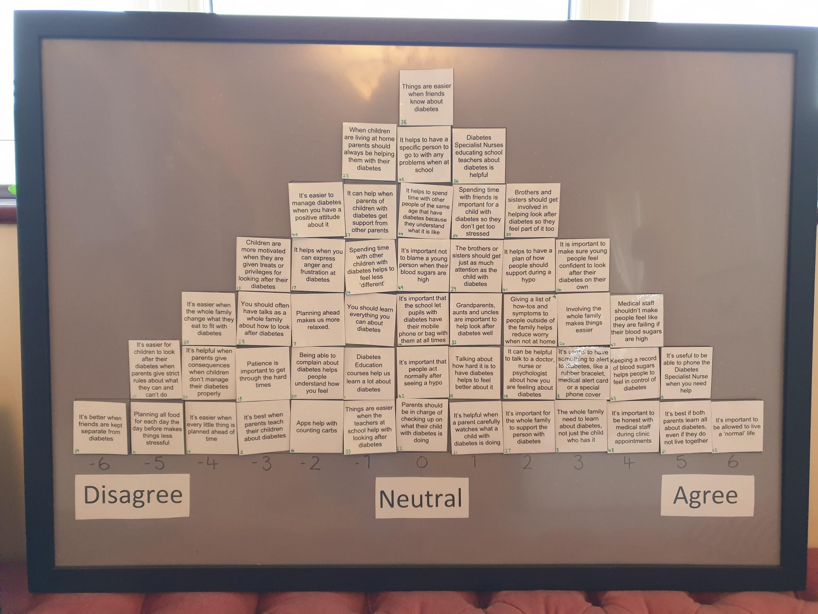

Figure 1. Factor array for Factor 1: The medical team and practical strategies

Qualitative information and demographics obtained during data collection were used to further the factor interpretations. See Table 3 for a summary of demographics for each factor.

Table 3. Demographic details of participants loading onto each factor
 |  | F1 | F2 | Total
Gender | Male | 5 | 1 | 6
 | Female | 7 | 6 | 13
Gender of child with T1D (for parents) | Male | 4 | - | 4
 | Female | 2 | 1 | 3
Group | Staff | 2 | 5 | 7
 | Parents | 6 | 1 | 7
 | YPS | 4 | 1 | 5
Ethnicity | White British | 11 | 7 | 18
 | Turkish | 1 | - | 1
Job role | Paediatric Diabetes Specialist Nurse | 1 | 4 | 5
 | Community Staff Nurse | 1 | 1 | 2
 | Senior Paediatric Dietitian | 0 | 1 | 1
 | Unemployed | 1 | 0 | 1
 | Business owner | 1 | 0 | 1
 | Manager | 1 | 0 | 1
 | Labourer | 2 | 0 | 2
 | Engineer | 1 | 0 | 1
Years working with T1D/ years since diagnosis | <1 | 2 | 0 | 2
 | 1-5 | 5 | 2 | 7
 | 6-10 | 4 | 2 | 6
 | 11-15 | 1 | 1 | 2
 | 16-20 | 0 | 0 | 0
 | >20 | 0 | 2 | 2
Age of child with T1D | 0-4 | 2 | 0 | 2
 | 5-11 | 3 | 1 | 4
 | 12-13 | 2 | 1 | 3
 | 14-15 | 3 | 0 | 3
 | 16+ | 0 | 0 | 0
Method of insulin | Injections | 5 | 2 | 7
 | Pump | 5 | 0 | 5
Siblings | Yes | 6 | 2 | 8
 | No | 4 | 0 | 4
Single parent | Yes | 3 | 0 | 3
 | No | 7 | 2 | 9
Education (for parents) | None | 3 | 0 | 3
 | Undergraduate degree | 3 | 1 | 4

Factor interpretations

Although factor arrays are a useful and relatively accessible depiction of ranking of items for each factor, further strategies can be used to enable a deeper interpretation of each viewpoint. Crib sheets were used to systematically explore the individual rankings of each factor whilst maintaining a holistic perspective of the viewpoint (Watts & Stenner, 2012). The crib sheet states the statements at the highest and lowest rankings in the array (in this case, statements ranked ≥±4). It then lists items that are ‘more agreed with’ and ‘more disagreed with’ for that factor compared to the other factor. Statements flagged as ‘distinguishing’ of each factor (placed significantly differently at p<0.05) were also examined. Finally, the demographic details of the individuals loading onto each factor are described and considered in relation to the viewpoint. Crib sheets for factor one and two are shown in Appendix K.
Two factors were identified for analysis: 1) The medical team and practical strategies; 2) Friends and psychological concepts. Each factor is labelled and described, detailing information about the participants’ whose sorts loaded significantly onto that factor.

Consensus

The two factors are highly correlated (r = 0.56) suggesting that, despite each factor representing distinct viewpoints regarding what is helpful, there were some areas where there was agreement. Rankings for factor 1 are in bold and for factor 2 are underlined.

Managing as a family

Both factors placed an emphasis on the importance of managing paediatric diabetes as a family. In order to manage paediatric diabetes, the whole family needs to learn about it and be involved in supporting the young person with diabetes (3: +3, +3; 26: +3, +3; 27: +2, +6). This includes both parents learning about diabetes, even if they do not live together (31: +5, +3). The wider family, such as grandparents, aunts and uncles are also important in managing diabetes well (32: +1, +2). However, this does not mean that family life needs to revolve around the young person with diabetes. It is not necessarily helpful to have frequent talks as a whole family about how to manage diabetes (28: -3, 0) or for the whole family to change what they eat (35: -4, 0). Siblings should be attended to as much as the young person with T1D (29: +1, +2).

Parenting a young person with diabetes

Both factors shared a similar viewpoint on how to parent a young person with T1D. Parenting a young person with diabetes should not involve motivating them to carry out their management tasks using treats or privileges (13: -3, -5) or putting in place consequences (24: -4, -5). Parents should not have to put in strict rules about what a young person can and can’t do (25: -5, -4). It is not the parent’s role, either, to teach the young person about diabetes (2: -3, -4).

Flexibility

Both factors highlighted a viewpoint that it is not helpful to have rigid plans when managing paediatric diabetes. It is not easier when every small detail is planned ahead of time (10: -4, -2) and planning out all of the food for each day does not make things less stressful (11: -5, -3). This emphasis on flexibility, rather than rigidity, may go some way to achieving something important to both viewpoints; that young people with T1D be allowed to live a ‘normal’ life (12: +6, +4)

Factor one: the medical team and practical strategies

Factor one has an eigenvalue of 6.27 and explains 21% of the study variance. Twelve participants are significantly associated with this factor (p <0.05) including two staff members, six parents (50% mothers) and four young people. Staff had been working with children with T1D for between one and four years and young people had been diagnosed for between one and ten years. Three were single parent families and six had siblings in the home. The two members of staff that loaded onto factor one had the least amount of experience working as specialists in T1D. All those loading onto this factor each had less than 10 years of experience (either as a diabetes specialist or since diagnosis).

Relationships with medical staff

This factor emphasises the importance of the relationship between the family and the supporting medical team in managing paediatric diabetes. It is important for families to be honest with the medical staff during their clinical appointments (48: +4) and the medical staff should not make people feel like they are failing when their blood sugars are high (47: +4). Being able to talk to a doctor, nurse or psychologist about how you are feeling about diabetes can be helpful (18: +2; 19: +1), as well as being able to phone the diabetes specialist nurse for advice when needed (5: +5).

Practicalities

The importance of practical strategies to help manage paediatric diabetes is demonstrated in this factor. It is useful to have something to alert others to a young person’s diabetes, such as a bracelet, phone case or card in their wallet (8: +3). It can also be helpful to give a list of instructions or ‘how-to’s to people outside of the family, including a plan of how to support during a hypo, in order to reduce worry when the young person is not at home (9: +2; 41: +2).

Factor two: friends and psychological concepts

Factor two has an eigenvalue of 1.15 and explains 18% of the study variance. Six participants are significantly associated with this factor (p <.05) including four staff members, one mother and one young person. Staff had been working with children with T1D for between six and 33 years and young people had been diagnosed for between one and four years. Both families had two parents and siblings in the home. All of the more senior members of staff in the sample (those with ≥10 years’ experience) loaded onto this factor. The one parent who loaded onto this factor was a nurse by profession.

Support from social network

Like factor 1, this factor emphasises the importance of family support in managing paediatric diabetes. However, this viewpoint also placed importance on the role of the young person’s friends. People loading within this factor felt strongly that things are easier when friends know about diabetes (38: +5), and spending time with them helps things seem less stressful (34: +3).

Psychological factors

Factor two demonstrates more of a focus on psychological processes in the management of paediatric diabetes. From this viewpoint, managing paediatric diabetes is easier when you have a positive attitude about it (40: +5) and patience is important to get through the hard times (15: +1).

Diabetes is not an identity

A key element within this factor is a desire for diabetes not to be a significant aspect of an individual’s identity. People that loaded onto this factor did not think diabetes should be a key part of a person’s identity or for them to be treated differently because of it. Items used to alert others to diabetes are not helpful (8: -4) for those loading onto this factor. It is not helpful to spend time with other young people with diabetes in order to feel less ‘different’ (14: -3) or to be with people who understand what it is like (44: -3). Nor is it helpful for parents to spend time with other parents of young people with diabetes (37: -2). As with Factor One, it is important for young people with diabetes to be able to live a ‘normal’ life (12: +4).

Discussion

This study explored the psychosocial factors that are helpful in managing T1D from a range of perspectives. Nineteen Q-sorts were completed by medical professionals, parents of young people with T1D and young people with T1D themselves. The data were analysed and interpreted showing two factors representing shared viewpoints on what best helps families to manage paediatric diabetes. These were broadly (1) The medical team and practical strategies and (2) Friends and psychological concepts. Both factors highlighted the importance of managing as a family, how to parent a child with diabetes and the need to be flexible in approach. Consideration of the statements within each factor and the demographics of participants loading onto them allowed for a more nuanced interpretation of the viewpoints. The perspectives were then interpreted in line with key themes in the literature as outlined in the introduction; social support, parenting and family and psychological factors.

Social support

Factor one highlighted the importance of the relationship between families and the medical team, in particular being able to phone them when you need help and being honest with them in clinic appointments. Those loading onto this factor also believed that it is helpful to be able to talk to a doctor, nurse or psychologist about how you are feeling about diabetes and the medical staff should not make them feel as though they are failing when their blood sugars are high. The majority of parents and young people with T1D in this study loaded onto this factor, suggesting this is particularly important to the families themselves. This reflects research highlighting that different styles of relationship between staff and patients can have an impact on effectiveness of treatment (Zoffman and Kirkevold, 2007) and the perceived amount of support from the medical team can impact adherence (Auslander et al., 1997). Many parents reflect that their own families and friends do not understand T1D (Smaldone & Ritholz, 2011) and so medical staff may provide essential social support alongside medical advice.

Factor one indicated that it is helpful to give a list of ‘how to’s’ to people outside of the family in order to minimise worries when the child is away from home. This may link to the hesitancy that parents sometimes feel when their child is being looked after by someone else (Herbert et al., 2015) and enables parents and young people alike to feel safer in these situations.

The viewpoints identified by both factors indicated that it is not helpful to keep friends separate from diabetes. Although the current literature on friends and diabetes shows mixed results (Brooks, 2019), this suggests that actively distancing friends from diabetes is not helpful. It was factor two that felt most strongly that friends are important in helping manage T1D. They highlighted the importance of spending time with friends to lower stress and that it is easier to manage when friends know about diabetes. Interestingly, those loading onto factor two were mostly medical staff and the parent with this viewpoint was a nurse by professional background. Medical staff are perhaps aware, through their experience, of the increase in time spent with friends as a child moves into adolescence (Larson & Verma, 1999), the increased responsibility of young people to carry out management tasks (Hamilton & Daneman, 2002) and therefore the vital role that friends may have in supporting a young person with their diabetes management. Parents and young people in the sample, however, may have not yet reached this point in their journey with diabetes.

Parenting and family

In regard to parenting and involvement of the family, the two factors in this study highlight similar viewpoints regarding what is helpful. Both factors indicate that managing diabetes as a family unit is vital. There was agreement that ‘involving the whole family makes it easier’, suggesting that managing as a cohesive family unit may alleviate some of the increased stress and responsibility felt by parents of children with T1D (Sullivan-Bolyai et al., 2003). Despite agreeing that it is important to involve the whole family in diabetes, those loading onto factor one did not believe that the whole family should change what they eat in order to fit with the diet of the child with T1D.

Those loading onto both factors agreed that when parenting a child with T1D, it is not helpful to use bribing or strict rules and consequences in order to motivate them to manage the disease. This reflects the literature which suggests that over-involvement from parents is linked to poorer metabolic control (Hoey et al., 2009). Both factors also highlighted that siblings have a role to play in managing diabetes so that they do not feel left out, but should also get just as much attention from parents as their sibling with T1D. There was agreement that both parents should learn about diabetes even if they do not live together. Focusing on family cohesion may go some way to minimising conflict within families, which has been shown to have an impact on the quality of life of children with T1D (Laffel et al., 2003).

Psychological factors

Although both factors indicated that it is ‘important for young people to feel confident in managing their diabetes on their own’, this was particularly poignant for those loading onto factor two. Those in factor two also believed strongly that it is important to have a positive attitude about diabetes in order to manage it effectively. This may reflect the literature on health beliefs and self-efficacy in diabetes management (Chih et al., 2010; Griva et al., 2000; Iannotti et al., 2006). More experienced medical professionals may be more aware of the literature and evidence base for psychological factors in the management of diabetes, thus placing more importance on this in their Q-sorts. Participants loading onto factor two also disagreed with management methods that lead to diabetes becoming a key part of a young person’s identity. This links to the statement that scored highly in both factors; that ‘it’s important to be able to live a normal life’.

Limitations

Due to the methodology used in this study it is not suggestive that these two factors provide the full picture of viewpoints on the matter of psychosocial management of paediatric diabetes and therefore are not intended to be generalisable to the whole population. Although efforts were made to reach saturation in collating the statements used within the study, there may have been important factors not presented to participants. Statements were limited to those related to things that are helpful in managing diabetes and therefore may reflect information that is limited in the current concourse. There are a number of socio-economic factors, such as poverty, which may have an impact on how difficult it is to manage T1D but were not reflected in the present study as statements referred only to psychosocial factors that are considered helpful. Unfortunately no members of the wider family, such as siblings, were recruited for this study, who may have provided different viewpoints regarding what is helpful. Although the demographics of the participant pool were representative in terms of the percentage of White British individuals in the local population (95%), it is noted that there are many different ethnicities and cultures represented in the remaining 5% of the population and their viewpoints have not been identified within this study.

Clinical implications

The findings from this study have implications for the role of Clinical Psychologists in paediatric diabetes teams, as recommended by the BPS (1994) and ISPAD (2018). All of the most experienced medical staff in this study expressed the viewpoint that psychological factors associated with managing T1D are important. Hambly and colleagues (2009) found that the majority of medical staff working with paediatric diabetes rated psychosocial issues more important to discuss in clinic appointments than medical issues, but felt less confident in addressing these issues. This highlights the importance of specialist clinical psychology staff being embedded within MDTs in order to support families and staff with psychological factors related to the disease, rather than relying on a traditional approach of referrals to psychology staff.

The results of this Q-methodology study suggests that there may be slight differences in the viewpoints of parents, children and medical staff and this may depend on where an individual is in their journey with T1D. Diabetes MDTs should assess what is important to a family and adapt support to fit with this individualised need, whilst balancing their own views about what is most helpful. Clinical Psychologists within teams have an important role to play in supporting teams with this through training, assistance with assessment and reflective practice and consultation for staff to consider their own viewpoints about what is helpful and how this impacts their practice. Psychologist attendance at MDT meetings may help in increasing psychological mindedness within teams and encourage the consideration of dynamics between staff and families and any parallel processes that may be occurring.

There is some evidence that families that maintain parental involvement, guidance and control in teenage years have better outcomes (Grey et al., 2001) and all participants were in agreement regarding how best to parent a young person with T1D. Clinical psychologists have a role to play in helping adolescents and their parents manage the transitions in development and lifestyle and balance their roles in managing the disease in order to improve metabolic control (Young et al., 2014). Both factors also highlighted the importance of managing as a family and therapeutic input involving the whole family may support them to reduce diabetes-specific family conflict (Laffel et al., 2003) which has been demonstrated to have a negative impact on metabolic control (Ingerski et al., 2010). Parenting interventions focusing on conflict resolution skills and parental acceptance may have a positive impact on adolescent’s management of the disease (Berg et al., 2008). Both factors highlighted the importance of flexibility when managing T1D and there is a role for the MDT in supporting families to take this approach. What is helpful for a family may change frequently as they move through their journey and as such opportunities to meet with a Clinical Psychologist should be available as well as annual psychological screenings carried out alongside medical reviews.

Both factors within this study indicated that ‘it is important to be able to live a normal life’; a challenging goal when managing a life-long chronic illness. It is vital for those working with young people with T1D and their families to support them to find a way for diabetes to fit into their life, rather than their life revolving around diabetes. As young people reach adolescence, work around considering their identity (and where diabetes fits into it) and their own personal psychological resilience may be important in increasing self-efficacy during the transition to adulthood.

References

Adams, R., Peveler, R. C., Stein, A., & Dunger, D. B. (1991). Siblings of children with diabetes: involvement, understanding and adaptation. Diabetic medicine, 8(9), 855-859.

Auslander, W. F., Thompson, S. J., Dreitzer, D., & Santiago, J. V. (1997). Mothers' satisfaction with medical care: perceptions of racism, family stress, and medical outcomes in children with diabetes. Health & Social Work, 22(3), 190-199.

Bade-White, P. A., & Obrzut, J. E. (2009). The neurocognitive effects of type 1 diabetes mellitus in children and young adults with and without hypoglycemia. Journal of Developmental and Physical Disabilities, 21(5), 425-440.

Baker, R. M. (2006). Economic rationality and health and lifestyle choices for people with diabetes. Social Science & Medicine, 63(9), 2341-2353.

Banasick. S. (2016). Ken Q Analysis. https://shawnbanasick.github.io/ken-q-analysis/#section1

Barnard, K., Thomas, S., Royle, P., Noyes, K., & Waugh, N. (2010). Fear of hypoglycaemia in parents of young children with type 1 diabetes: a systematic review. BMC Pediatrics, 10(1), 50.

Berg, C. A., Butler, J. M., Osborn, P., King, G., Palmer, D. L., Butner, J., Murray, M., Lindsay, R., Donaldson, D., Foster, C., & Swinyard, M. (2008). Role of parental monitoring in understanding the benefits of parental acceptance on adolescent adherence and metabolic control of type 1 diabetes. Diabetes Care, 31(4), 678-683.

Berger, P., & Luckman, T. (1996). The Social Construction of Reality. Penguin Books Ltd.

Beverly, E. A., Hultgren, B. A., Brooks, K. M., Ritholz, M. D., Abrahamson, M. J., & Weinger, K. (2011). Understanding physicians’ challenges when treating type 2 diabetic patients’ social and emotional difficulties: a qualitative study. Diabetes Care, 34(5), 1086-1088.

Braun, V., & Clarke, V. (2013). Successful qualitative research: A practical guide for beginners. Sage.

British Psychological Society (BPS), Division of Clinical Psychology (DCP) (1994) Purchasing Clinical Psychology Services for People with Diabetes Mellitus. Briefing Paper Number 4. British Psychological Society.

Brooks, A. G. (2019). What is known about paediatric type one diabetes and friendship? A review of the literature. [Unpublished manuscript], Staffordshire University.

Brown, S. R. (1980) Political subjectivity: applications of Q methodology in political science. Yale University Press

Brown, S. R. (1993). A primer on Q methodology. Operant subjectivity, 16(3/4), 91-138.

Brownlee-Duffeck, M., Peterson, L., Simonds, J. F., Goldstein, D., Kilo, C., & Hoette, S. (1987). The role of health beliefs in the regimen adherence and metabolic control of adolescents and adults with diabetes mellitus. Journal of Consulting and Clinical Psychology, 55(2), 139.

Cabizuca, M., Marques-Portella, C., Mendlowicz, M. V., Coutinho, E. S., & Figueira, I. (2009). Posttraumatic stress disorder in parents of children with chronic illnesses: a meta-analysis. Health Psychology, 28(3), 379.

Carroll, A. E., & Marrero, D. G. (2006). The role of significant others in adolescent diabetes. The Diabetes Educator, 32(2), 243-252.

Casdalgi, L., Christie, D., Girling, I., Ali, S., & Fredman, G. (2017). Evaluating the Tree of Life project: An innovative way of engaging children and young people with type 1 diabetes. Diabetes Care for Children & Young People, 6, 9–15.

Centers for Disease Control and Prevention. (2011). National diabetes fact sheet: national estimates and general information on diabetes and prediabetes in the United States, US Department of Health and Human Services, Centers for Disease Control and Prevention, 201(1), 2568-2569.

Cerreto, M. C., & Travis, L. B. (1984). Implications of psychological and family factors in the treatment of diabetes. Pediatric Clinics of North America, 31(3), 689-710.

Charron-Prochownik, D., Becker, M. H., Brown, M. B., Liang, W. M., & Bennett, S. (1993). Understanding young children's health beliefs and diabetes regimen adherence. The Diabetes Educator, 19(5), 409-418.

Chih, A. H., Jan, C. F., Shu, S. G., & Lue, B. H. (2010). Self-efficacy affects blood sugar control among adolescents with type I diabetes mellitus. Journal of the Formosan Medical Association, 109(7), 503-510.

Cohen, J. (1988). Statistical power analysis for the behavioural sciences (2nd edition). Academic Press.

Couper, J. J., Taylor, J., Fotheringham, M. J., & Sawyer, M. (1999). Failure to maintain the benefits of home-based intervention in adolescents with poorly controlled type 1 diabetes. Diabetes Care, 22(12), 1933-1937.

Deater-Deckard, K. (2008). Parenting stress. Yale University Press.

Delamater, A. M., de Wit, M., McDarby, V., Malik, J. A., Hilliard, M. E., Northam, E., & Acerini, C. L. (2018). ISPAD Clinical Practice Consensus Guidelines 2018: Psychological care of children and adolescents with type 1 diabetes. Pediatric Diabetes, 19, 237-249.

DiMatteo, M. R. (2004). Variations in patients' adherence to medical recommendations: a quantitative review of 50 years of research. Medical Care, 200-209.

Edmonds-Myles, S., Tamborlane, W. V., & Grey, M. (2010). Perception of the impact of type 1 diabetes on low-income families. The Diabetes Educator, 36(2), 318-325.

Egede, L. E., & Dismuke, C. E. (2012). Serious psychological distress and diabetes: a review of the literature. Current Psychiatry Reports, 14(1), 15-22.

Ellis, D. A., Frey, M. A., Naar-King, S., Templin, T., Cunningham, P. B., & Cakan, N. (2005). The effects of multisystemic therapy on diabetes stress among adolescents with chronically poorly controlled type 1 diabetes: findings from a randomized, controlled trial. Pediatrics, 116(6), e826-e832.

Field, A. (2009). Discovering statistics using SPSS (3rd edition). Sage.

Gage, H., Hampson, S., Skinner, T. C., Hart, J., Storey, L., Foxcroft, D., Kimber, A., Cradock, S., & McEvilly, E. A. (2004). Educational and psychosocial programmes for adolescents with diabetes: approaches, outcomes and cost-effectiveness. Patient Education and Counseling, 53(3), 333-346.

Ginsburg, K. R., Howe, C. J., Jawad, A. F., Buzby, M., Ayala, J. M., Tuttle, A., & Murphy, K. (2005). Parents’ perceptions of factors that affect successful diabetes management for their children. Pediatrics, 116(5), 1095-1104.

Grey, M., Boland, E. A., Davidson, M., Li, J., & Tamborlane, W. V. (2000). Coping skills training for youth with diabetes mellitus has long-lasting effects on metabolic control and quality of life. The Journal of Pediatrics, 137(1), 107-113.

Grey, M., Boland, E. A., Davidson, M., Yu, C., Sullivan-Bolyai, S., & Tamborlane, W. V. (1998). Short-term effects of coping skills training as adjunct to intensive therapy in adolescents. Diabetes Care, 21(6), 902-908.

Grey, M., Cameron, M. E., Lipman, T. H., & Thurber, F. W. (1995). Psychosocial status of children with diabetes in the first 2 years after diagnosis. Diabetes Care, 18(10), 1330-1336.

Grey, M., Davidson, M., Boland, E. A., & Tamborlane, W. V. (2001). Clinical and psychosocial factors associated with achievement of treatment goals in adolescents with diabetes mellitus. Journal of Adolescent Health, 28(5), 377-385.

Griva, K, Myers L. B., & Newman S. (2000) Illness perceptions and self efficacy beliefs in adolescents and young adults with insulin dependent diabetes mellitus. Psychology Health, 15(6):733–50.

Grossman, H. Y., Brink, S., & Hauser, S. T. (1987). Self-efficacy in adolescent girls and boys with insulin-dependent diabetes mellitus. Diabetes Care, 10(3), 324-329.

Grus, C. L., Lopez-Hernandez, C., Delamater, A., Appelgate, B., Brito, A., Wurm, G., & Wanner, A. (2001). Parental self-efficacy and morbidity in pediatric asthma. Journal of Asthma, 38(1), 99-106.

Guttman, L. (1954). Some necessary conditions for common factor analysis. Psychometrika, 19, 149-161.

Hambly, H., Robling, M., Crowne, E., Hood, K., Gregory, J. W., & DEPICTED Study Team. (2009). Communication skills of healthcare professionals in paediatric diabetes services. Diabetic Medicine, 26(5), 502-509.

Hamilton, J., & Daneman, D. (2002). Deteriorating diabetes control during adolescence: physiological or psychosocial?. Journal of Pediatric Endocrinology and Metabolism, 15(2), 115-126.

Hatton, D. L., Canam, C., Thome, S., & Hughes, A. M. (1995). Parents’ perceptions of caring for an infant or toddler with diabetes. Journal of Advanced Nursing, 22(3), 569-577.

Hauser, S. T., & Pollets, D. (1979). Psychological aspects of diabetes mellitus: A critical review. Diabetes care, 2(2), 227-232.

Herbert, L. J., Clary, L., Owen, V., Monaghan, M., Alvarez, V., & Streisand, R. (2015). Relations among school/daycare functioning, fear of hypoglycaemia and quality of life in parents of young children with type 1 diabetes. Journal of Clinical Nursing, 24(9-10), 1199-1209.

Hilliard, M. E., Monaghan, M., Cogen, F. R., & Streisand, R. (2011). Parent stress and child behaviour among young children with type 1 diabetes. Child: Care, Health and Development, 37(2), 224-232.

Hoey, H., & Hvidoere Study Group on Childhood Diabetes. (2009). Psychosocial factors are associated with metabolic control in adolescents: research from the Hvidoere Study Group on Childhood Diabetes. Pediatric Diabetes, 10, 9-14.

Hoffman, R. P. (2002). Adolescent adherence in type 1 diabetes. Comprehensive Therapy, 28(2), 128-133.

Holden, G. (1992). The relationship of self-efficacy appraisals to subsequent health related outcomes: A meta-analysis. Social work in health care, 16(1), 53-93.

HSCIC: National Diabetes Audit 2018/19: Report 1: Care Processes and Outcomes. https://www.rcpch.ac.uk/sites/default/files/2020-03/final_npda_core_report_2018-2019.pdf

Iannotti, R. J., Schneider, S., Nansel, T. R., Haynie, D. L., Plotnick, L. P., Clark, L. M., Sobel, D., & Simons-Morton, B. (2006). Self-efficacy, outcome expectations, and diabetes self-management in adolescents with type 1 diabetes. Journal of Developmental & Behavioral Pediatrics, 27(2), 98-105.

Ingerski, L. M., Anderson, B. J., Dolan, L. M., & Hood, K. K. (2010) Blood glucose monitoring and glycemic control in adolescence: contribution of diabetes-specific responsibility and family conflict. Journal of Adolescent Health, 47(2):191–7.

Jackson, C., Richer, J., & Edge, J. A. (2008). Sibling psychological adjustment to type 1 diabetes mellitus. Pediatric diabetes, 9(4pt1), 308-311.

Jacobsen, J. J. (2011). Racial/ethnic and socioeconomic factors associated with glycemic control in youth with diabetes [PhD thesis, California State University] California State University Research Repository.

Jacobson, A. M., Hauser, S. T., Lavori, P., Willett, J. B., Cole, C. F., Wolfsdorf, J. I., Dumont, R. H., & Wertlieb, D. (1994). Family environment and glycemic control: A four-year prospective study of children and adolescents with insulin-dependent diabetes mellitus. Psychosomatic Medicine, 56(5), 401–409.

Jaser, S. S., & White, L. E. (2011). Coping and resilience in adolescents with type 1 diabetes. Child: Care, Health and Development, 37(3), 335-342.

Jaser S S, Grey M. (2010) A pilot study of observed parenting and adjustment in adolescents with type 1 diabetes and their mothers. Journal of Pediatric Psychology. 35:738–747.

Jaser, S. S., Whittemore, R., Ambrosino, J. M., Lindemann, E., & Grey, M. (2009). Coping and psychosocial adjustment in mothers of young children with type 1 diabetes. Children's Health Care, 38(2), 91-106.

Kaiser, H. F. (1960). The application of electronic computers to factor analysis. Educational and psychological measurement, 20(1), 141-151.

Karlsson, A., Arman, M., a& Wikblad, K. (2008). Teenagers with type 1 diabetes—a phenomenological study of the transition towards autonomy in self-management. International Journal of Nursing Studies, 45(4), 562-570.

Kincaid, J. P., Fishburne Jr, R. P., Rogers, R. L., & Chissom, B. S. (1975). Derivation of new readability formulas (automated readability index, fog count and flesch reading ease formula) for navy enlisted personnel.

Kline, P. (1994). An easy guide to factor analysis. Routledge.

Kuttner, M. J., Delamater, A. M., & Santiago, J. V. (1990). Learned helplessness in diabetic youths. Journal of Pediatric Psychology, 15(5), 581-594.

Kwok, S., & Wong, D. (2000). Mental health of parents with young children in Hong Kong: The roles of parenting stress and parenting self-efficacy. Child and Family Social Work, 5, 57–65.

Laffel, L. M., Connell, A., Vangsness, L., Goebel-Fabbri, A., Mansfield, A., & Anderson, B. J. (2003). General quality of life in youth with type 1 diabetes: relationship to patient management and diabetes-specific family conflict. Diabetes Care, 26(11), 3067-3073.

Larson, R. W., & Verma, S. (1999). How children and adolescents spend time across the world: work, play, and developmental opportunities. Psychological Bulletin, 125(6), 701.

Leonard, B. J., Garwick, A., & Adwan, J. Z. (2005). Adolescents' perceptions of parental roles and involvement in diabetes management. Journal of Pediatric Nursing, 20(6), 405-414.

Lin, M. H., Connor, C. G., Ruedy, K. J., Beck, R. W., Kollman, C., Buckingham, B., Redondo, M. J., Schatz, D., Haro, H., Lee, J. M., Tamborlane, W. V. & Wood, J. R. (2013). Race, socioeconomic status, and treatment center are associated with insulin pump therapy in youth in the first year following diagnosis of type 1 diabetes. Diabetes Technology & Therapeutics, 15(11), 929-934.

Lin, H. P., Mu, P. F., & Lee, Y. J. (2008). Mothers' experience supporting life adjustment in children with T1DM. Western Journal of Nursing Research, 30(1), 96-110.

McDonnell, C. M., Northam, E. A., Donath, S. M., Werther, G. A., & Cameron, F. J. (2007). Hyperglycemia and externalizing behavior in children with type 1 diabetes. Diabetes Care, 30(9), 2211-2215.

McSharry, J., Byrne, M., Casey, B., Dinneen, S. F., Fredrix, M., Hynes, L., Lake, A. J., & Morrissey, E. (2019). Behaviour change in diabetes: behavioural science advancements to support the use of theory. Diabetic Medicine, 37(3), 455-463.

Müller‐Godeffroy, E., Treichel, S., Wagner, V. M., & German Working Group for Paediatric Pump Therapy. (2009). Investigation of quality of life and family burden issues during insulin pump therapy in children with Type 1 diabetes mellitus—a large‐scale multicentre pilot study 1. Diabetic Medicine, 26(5), 493-501.

National Institute for Health and Care Excellence [NICE] (2015). Diabetes (type 1 and type 2) in children and young people: diagnosis and management [NG18].

Niedel, S., Traynor, M., McKee, M., & Grey, M. (2013). Parallel vigilance: Parents’ dual focus following diagnosis of Type 1 diabetes mellitus in their young child. Health, 17(3), 246-265.

Nurmi, M. A., & Stieber-Roger, K. (2012). Parenting children living with type 1 diabetes: a qualitative study. The Diabetes Educator, 38(4), 530-536.

Ott, J., Greening, L., Palardy, N., Holderby, A., & DeBell, W. K. (2000). Self-efficacy as a mediator variable for adolescents' adherence to treatment for insulin-dependent diabetes mellitus. Children's Health Care, 29(1), 47-63.

Penckofer, S., Quinn, L., Byrn, M., Ferrans, C., Miller, M., & Strange, P. (2012). Does glycemic variability impact mood and quality of life?. Diabetes Technology and Therapeutics, 14(4), 303-310.

Ritholz, M. D., Beverly, E. A., & Weinger, K. (2011). Digging deeper: the role of qualitative research in behavioral diabetes. Current Diabetes Reports, 11(6), 494.

Rogers, R. (1995). Q methodology. In J. A. Smith, R. Harre & L. Van Langenhove (Eds.), Rethinking Methods in Psychology (pp. 178-192). Sage.

Rubin, R. R., & Peyrot, M. (1992). Psychosocial problems and interventions in diabetes: a review of the literature. Diabetes Care, 15(11), 1640-1657.

Rustad, J. K., Musselman, D. L., Skyler, J. S., Matheson, D., Delamater, A., Kenyon, N. S., & Nemeroff, C. B. (2013). Decision-making in diabetes mellitus type 1. The Journal of Neuropsychiatry and Clinical Neurosciences, 25(1), 40-50.

Schlundt, D. G., Flannery, M. E., Davis, D. L., Kinzer, C. K., & Pichert, J. W. (1999). Evaluation of a multicomponent, behaviorally oriented, problem-based “summer school” program for adolescents with diabetes. Behavior Modification, 23(1), 79-105.

Skinner, T. C., Hampson, S. E., & Fife-Schaw, C. (2002). Personality, personal model beliefs, and self-care in adolescents and young adults with Type 1 diabetes. Health Psychology, 21(1), 61.

Smaldone, A., & Ritholz, M. D. (2011). Perceptions of parenting children with type 1 diabetes diagnosed in early childhood. Journal of Pediatric Health Care, 25(2), 87-95.

Streisand, R., & Monaghan, M. (2014). Young children with type 1 diabetes: challenges, research, and future directions. Current Diabetes Reports, 14(9), 520.

Streisand, R., Swift, E., Wickmark, T., Chen, R., & Holmes, C. S. (2005). Pediatric parenting stress among parents of children with type 1 diabetes: the role of self-efficacy, responsibility, and fear. Journal of Pediatric Psychology, 30(6), 513-521.

Sullivan-Bolyai, S., Deatrick, J., Gruppuso, P., Tamborlane, W., & Grey, M. (2003). Constant vigilance: Mothers' work parenting young children with type 1 diabetes. Journal of Pediatric Nursing, 18(1), 21-29.

Sullivan-Bolyai, S., & Lee, M. M. (2011). Parent mentor perspectives on providing social support to empower parents. The Diabetes Educator, 37(1), 35-43.

Watts, S, & Stenner, P. (2012). Doing Q methodological research theory, practice and interpretation. Sage.

Whittemore, R., Jaser, S., Chao, A., Jang, M., & Grey, M. (2012). Psychological experience of parents of children with type 1 diabetes: a systematic mixed-studies review. The Diabetes Educator, 38(4), 562-579.

Wigert, H., & Wikström, E. (2014). Organizing person-centred care in paediatric diabetes: multidisciplinary teams, long-term relationships and adequate documentation. BMC Research Motes, 7(1), 72.

Williams, L. B., Laffel, L. M. B., & Hood, K. K. (2009). Diabetes‐specific family conflict and psychological distress in paediatric Type 1 diabetes. Diabetic Medicine, 26(9), 908-914.

Wysocki, T. (1993). Associations among teen-parent relationships, metabolic control, and adjustment to diabetes in adolescents. Journal of Pediatric Psychology, 18(4), 441-452.

Wysocki, T., Huxtable, K., Linscheid, T. R., & Wayne, W. (1989). Adjustment to diabetes mellitus in preschoolers and their mothers. Diabetes Care, 12(8), 524-529.

Wysocki, T., Taylor, A., Hough, B. S., Linscheid, T. R., Yeates, K. O., & Naglieri, J. A. (1996). Deviation from developmentally appropriate self-care autonomy: association with diabetes outcomes. Diabetes care, 19(2), 119-125.

Young, M. T., Lord, J. H., Patel, N. J., Gruhn, M. A., & Jaser, S. S. (2014). Good cop, bad cop: quality of parental involvement in type 1 diabetes management in youth. Current Diabetes Reports, 14(11), 546.

Zoffmann, V., & Kirkevold, M. (2007). Relationships and their potential for change developed in difficult type 1 diabetes. Qualitative Health Research, 17(5), 625-638.

Appendices
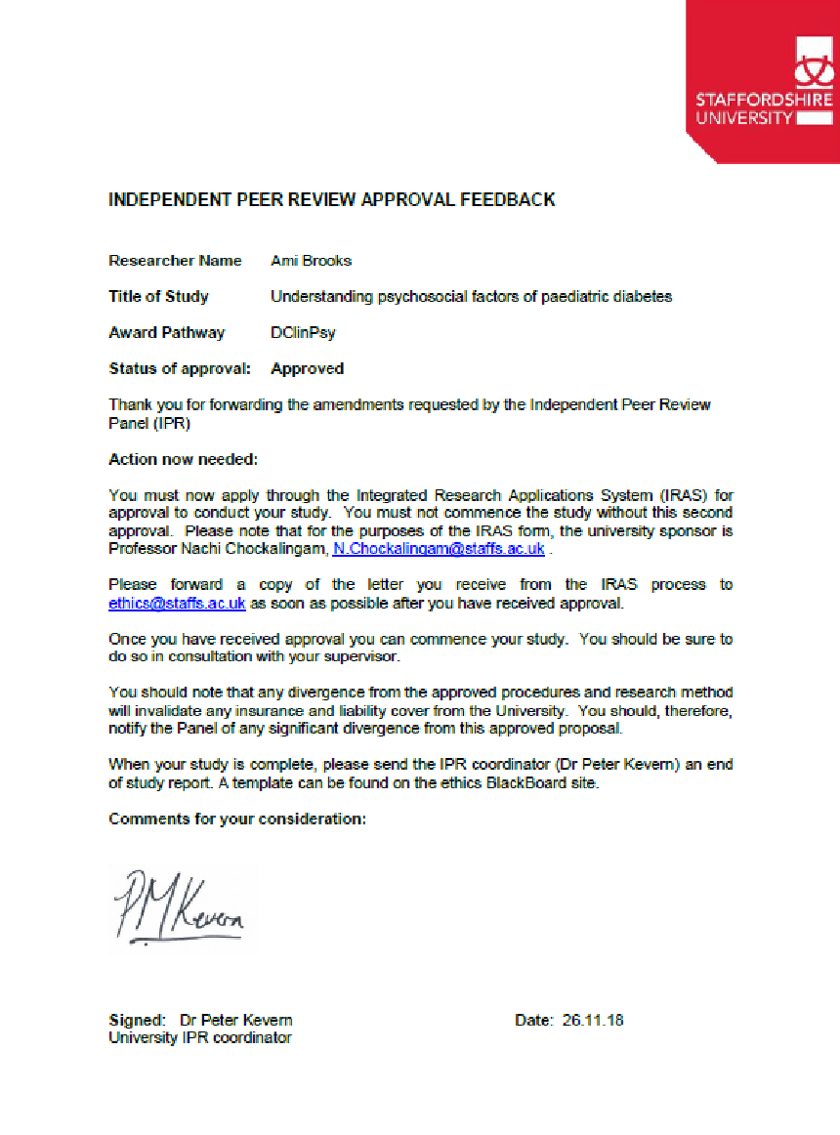
Appendix A
Independent Peer Review Approval
Appendix B
NHS Ethical Approval

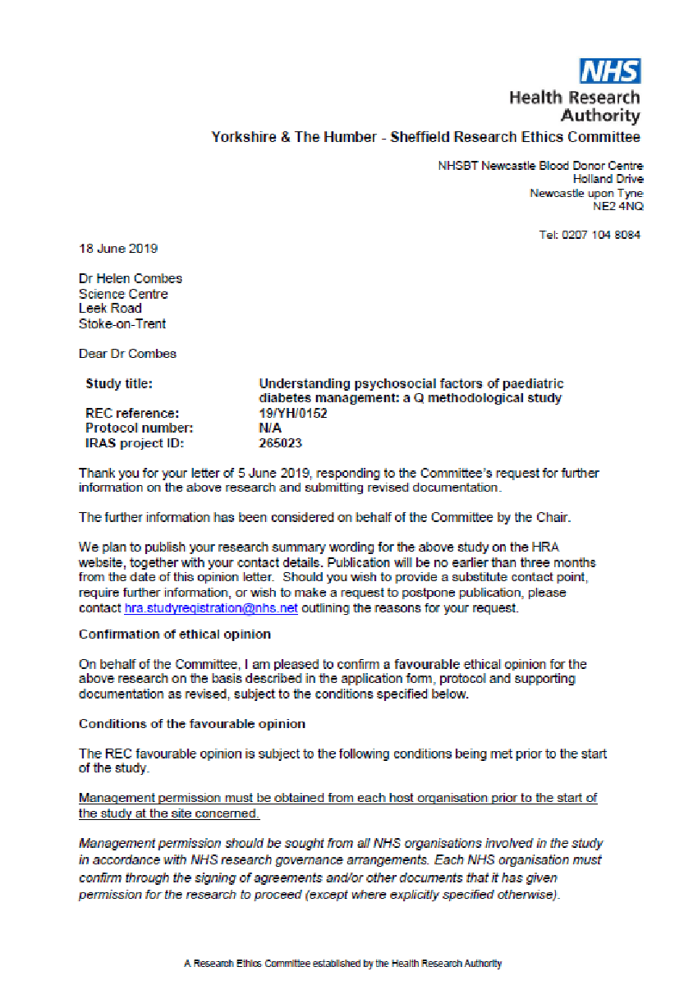
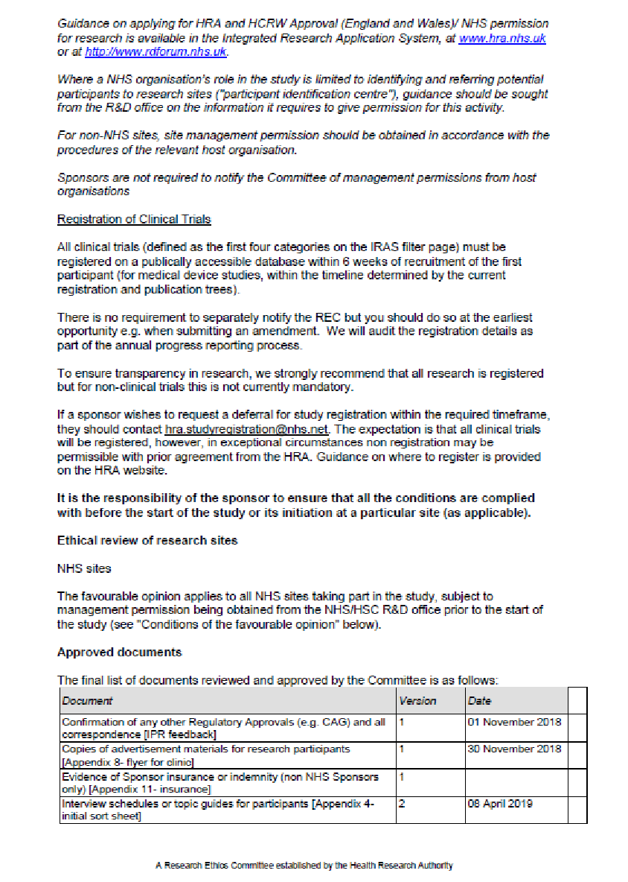

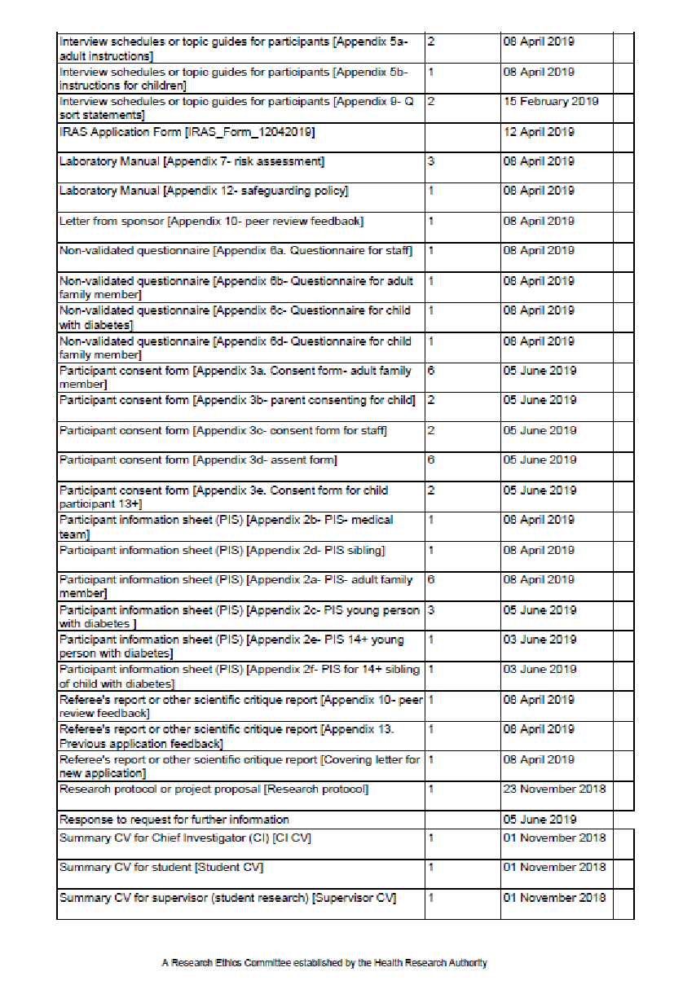
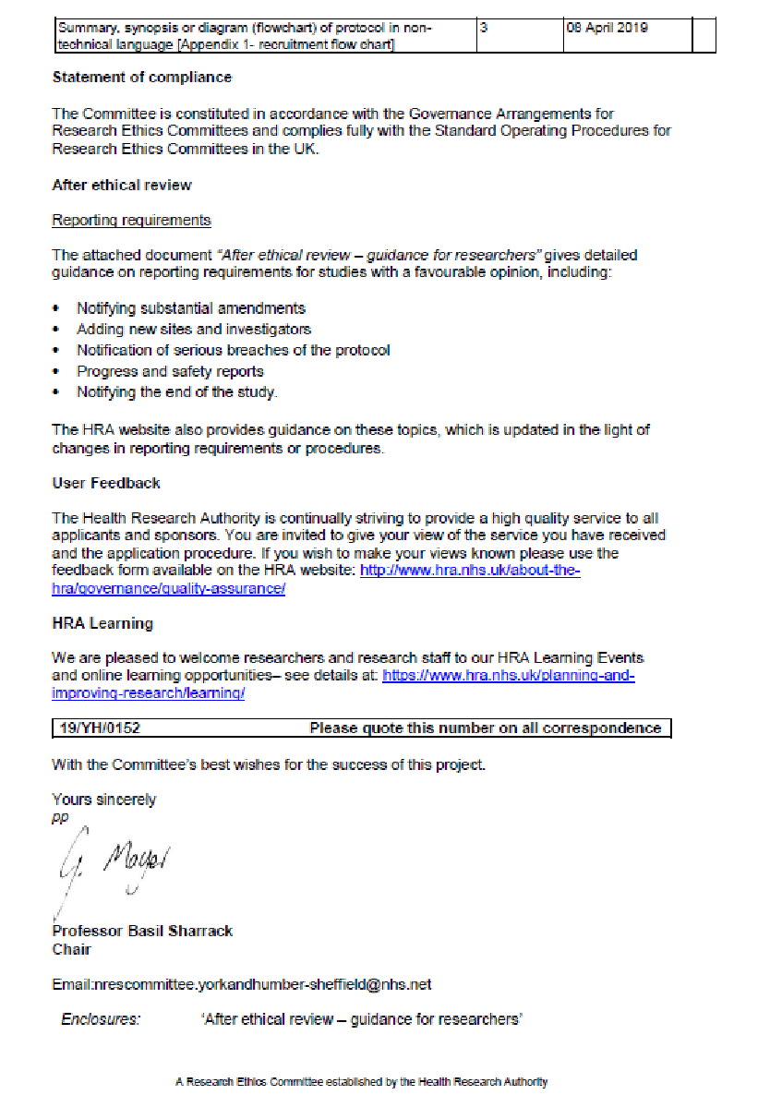
Appendix C
HCR and HCRW Approval

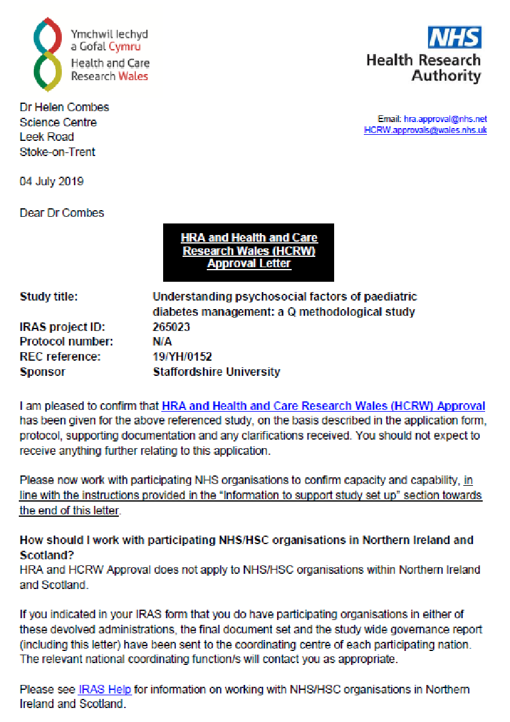

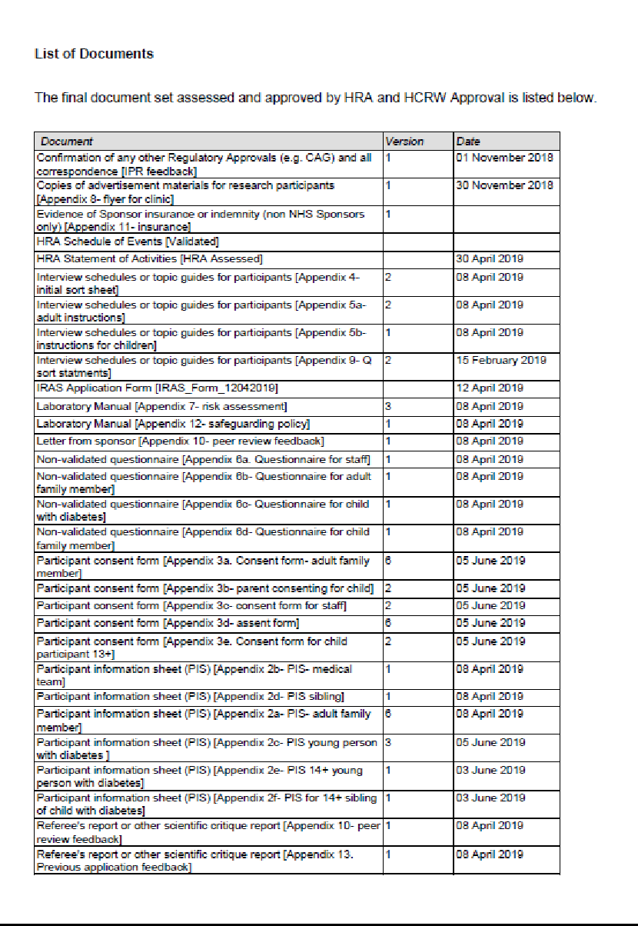

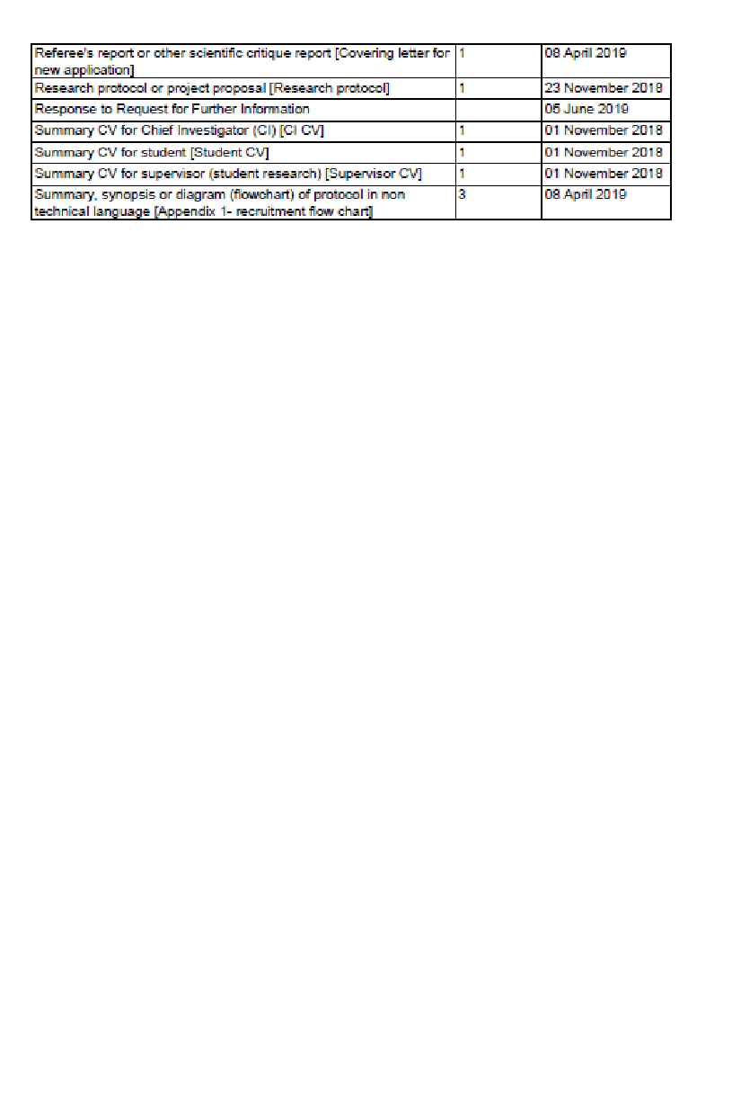

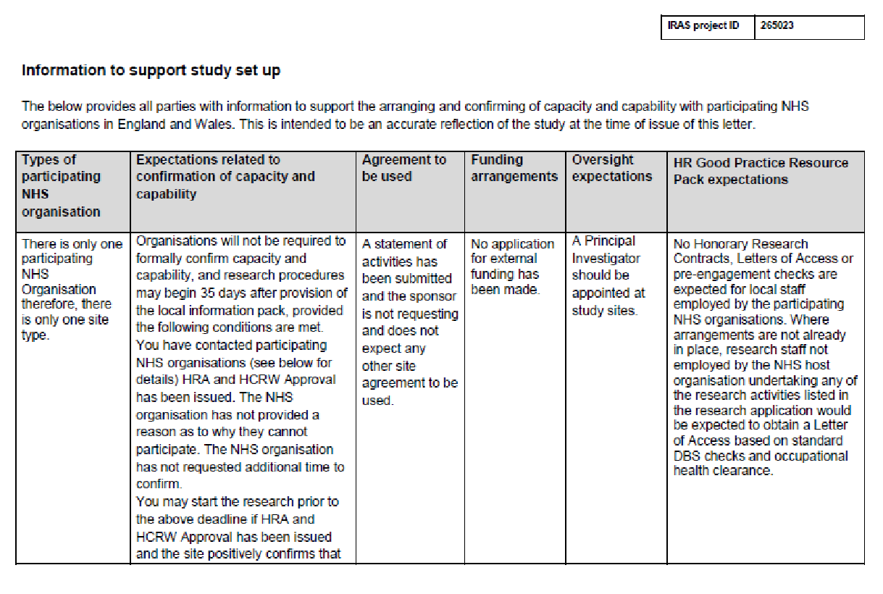
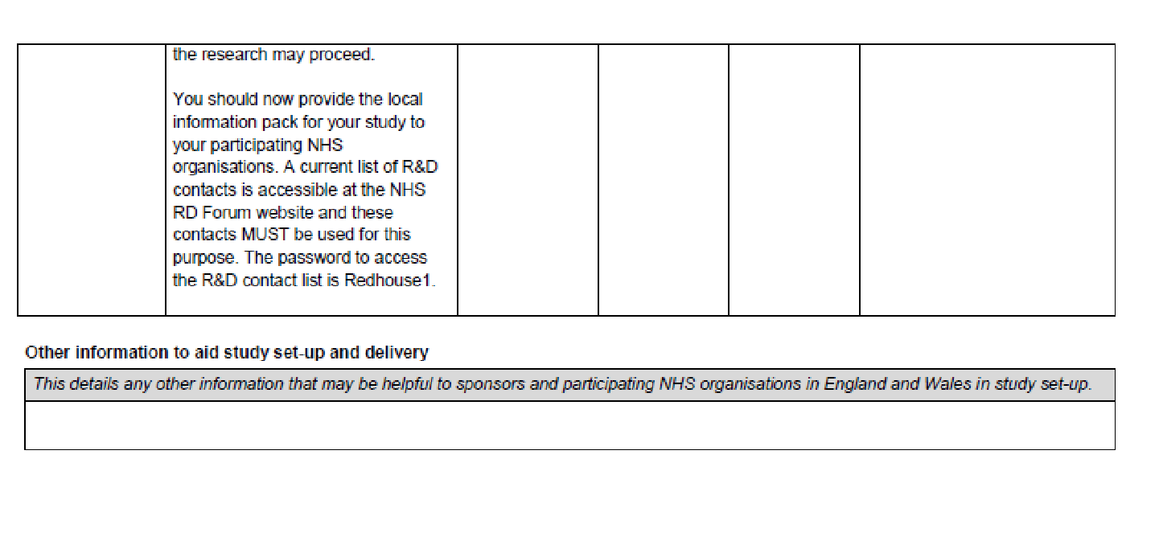
Appendix D
R&D Approval

FW: Clinical Psychology Doctorate project
Harrison, Anne <Anne.Harrison@uhnm.nhs.uk>
Wed 12/09/2018 13:56
To:
- BROOKS Amy G <b024108h@student.staffs.ac.uk>
1 attachments (750 KB)
peer review form.pdf;
Hi Ami,

UHNM R&D are happy to support and willing to host your project subject to carrying out our usual capacity and capability review upon receipt of ethics and HRA approvals, signed peer review form attached.

Good luck with your project

Best Wishes
Anne

Anne Harrison
Research Governance Facilitator

Study Set Up Team
Research and Development Department
Academic Research Unit
Courtyard Annexe C-Block
Royal Stoke University Hospital
University Hospitals of North Midlands NHS Trust
Newcastle Road, Stoke-on-Trent, Staffordshire, ST4 6QG
Tel: 01782 671095

Email: anne.harrison@uhnm.nhs.uk
Research.governance@uhnm.nhs.uk

Appendix E
Q-sort statements

1 | Diabetes Education courses help us learn a lot about diabetes
2 | It’s best when parents teach their children about diabetes
3 | The whole family need to learn about diabetes, not just the child who has it.
4 | You should learn everything you can about diabetes
5 | It’s useful to be able to phone the Diabetes Specialist Nurse when you need help
6 | Apps help with counting carbs.
7 | Planning ahead makes us more relaxed.
8 | It’s useful to have something to alert to diabetes, like a rubber bracelet, medical alert card or a special phone cover
9 | Giving a list of how-tos and symptoms to people outside of the family helps reduce worry when not at home
10 | It’s easier when every little thing is planned ahead of time.
11 | Planning all food for each day the day before makes things less stressful
12 | It’s important to be allowed to live a ‘normal’ life.
13 | Children are more motivated when they are given treats or privileges for looking after their diabetes
14 | Spending time with other children with diabetes helps to feel less ‘different’
15 | Patience is important to get through the hard times
16 | It is important to make sure young people feel confident to look after their diabetes on their own
17 | It helps when you can express anger and frustration at diabetes.
18 | It can be helpful to talk to a doctor, nurse or psychologist about how you are feeling about diabetes.
19 | Talking about how hard it is to have diabetes helps to feel better about it
20 | Being able to complain about diabetes helps people understand how you feel
21 | It’s helpful when a parent carefully watches what a child with diabetes is doing
22 | Parents should be in charge of checking up on what their child with diabetes is doing
23 | When children are living at home parents should always be helping them with their diabetes
24 | It’s helpful when parents give consequences when children don’t manage their diabetes properly
25 | It’s easier for children to look after their diabetes when parents give strict rules about what they can and can’t do
26 | Involving the whole family makes things easier
27 | It’s important for the whole family to support the person with diabetes
28 | You should often have talks as a whole family about how to look after diabetes
29 | The brothers or sisters should get just as much attention as the child with diabetes
30 | Brothers and sisters should get involved in helping look after diabetes so they feel part of it too
31 | It’s best if both parents learn all about diabetes, even if they do not live together
32 | Grandparents, aunts and uncles are important to help look after diabetes well
33 | Things are easier when the teachers at school help with looking after diabetes
34 | Spending time with friends is important for a child with diabetes so they don’t get too stressed
35 | It’s easier when the whole family change what they eat to fit with diabetes
36 | Diabetes Specialist Nurses educating school teachers about diabetes is helpful.
37 | It can help when parents of children with diabetes get support from other parents.
38 | Things are easier when friends know about diabetes.
39 | It’s better when friends are kept separate from diabetes.
40 | It’s easier to manage diabetes when you have a positive attitude about it.
41 | It helps to have a plan of how people should support during a hypo.
42 | It’s important that people act normally after seeing a hypo.
43 | Keeping a record of blood sugars helps people to feel in control of diabetes.
44 | It helps to spend time with other people of the same age that have diabetes because they understand what it is like.
45 | It helps to have a specific person to go to with any problems when at school.
46 | It’s important that the school let pupils with diabetes have their mobile phone or bag with them at all times.
47 | Medical staff shouldn’t make people feel like they are failing if their blood sugars are high
48 | It’s important to be honest with medical staff during clinic appointments
49 | It’s important not to blame a young person when their blood sugars are high

Appendix F
Demographic questionnaires

Demographic questionnaire for staff
Study Title: Understanding psychosocial factors of paediatric diabetes: a Q methodological study

Researcher: Ami Brooks Participant ID:

Please take the time to answer the questions below. Feel free to ask the researcher if you are unsure about a question.

Job title:
Number of years working with children with diabetes:

Do you have any family members with Type 1 Diabetes?
If yes, which family member(s)?

Are there any other things that you think are useful to families when managing paediatric diabetes?

Demographic questionnaire for adult family member

Study Title: Understanding psychosocial factors of paediatric diabetes: a Q methodological study

Please take the time to answer the questions below. Feel free to ask the researcher if you are unsure about a question.

Please give some details about your young family member with diabetes:
Age of child with diabetes:
Gender of child with diabetes:
Ethnicity of child with diabetes:
Length of diagnosis of child with diabetes:
Method of insulin:  Please tick | Injections
 | Pump
Please answer some questions about you:
What is your relationship to the child with diabetes?
Ethnicity:
Gender:
Who lives in your home?
Highest level of education:
Employment status:

Job title (if applicable):

Are there any other things that have been useful to you or your family when managing paediatric diabetes?
Demographic questionnaire for young person with diabetes

Study Title: Understanding psychosocial factors of paediatric diabetes: a Q methodological study

Please give answers to the questions below. Don’t worry if you are not sure of an answer.
You can fill this out on your own or you can ask a family member to do it for you or to sit with you to help you.
You can also ask a family member or the researcher to fill it out with you.
Feel free to ask the researcher if you are unsure about a question.

Please answer some questions about you:
How old are you?
What is your gender?
What is your ethnicity?
How old were you when you found out you had diabetes?
How do you get your insulin?  Please tick | Injections
 | Pump

Are there any other things that have been useful to you or your family when managing paediatric diabetes?

Demographic questionnaire for young person family member

Study Title: Understanding psychosocial factors of paediatric diabetes: a Q methodological study

Please give answers to the questions below. Don’t worry if you are not sure of an answer!
You can fill this out on your own or you can ask a family member to do it for you or to sit with you to help you.
You can also ask a family member or the researcher to fill it out with you.
Feel free to ask the researcher if you are unsure about a question.

Please give some details about your brother or sister with diabetes:
Age of sibling:
Gender of sibling:
Ethnicity of sibling:
Length of diagnosis of sibling:
Method of insulin:  Please tick | Injections
 | Pump
Please answer some questions about you:
How old are you?
What is your gender?
What is your ethnicity?

Are there any other things that have been useful to your family when managing diabetes?
Appendix G
Participant information sheets

Participant information sheet- adult family member
Study Title: Understanding psychosocial factors of paediatric diabetes: a Q methodological study
You are being invited to take part in a research study. The study is being carried out by Ami Brooks from Staffordshire University as part of the award of a Doctorate in Clinical Psychology.
Before you decide to take part it is important that you understand why the research is being done and what taking part will involve for you. Please read the following information carefully and take time to decide if you’d like to take part. Feel free to discuss this information with others (including your medical team). If you have any questions please get in touch.
1) Why is the study being carried out?
We hope to find out different people’s opinions on what psychological and social factors help make managing diabetes in children easier. We want to see whether children with diabetes, their family members and their medical team have different ideas about what can be helpful.
2) Do I have to take part?
Participation is completely voluntary. You should only take part if you want to and choosing not to take part will not disadvantage you in anyway. Once you have read the information sheet, please contact us if you have any questions that will help you make a decision about taking part. If you decide to take part we will ask you to sign a consent form and you will be given a copy of this consent form to keep. Your family member’s care will not be affected whether you decide to take part or not. You can choose to withdraw from the study at any point before data analysis and your information will be removed and destroyed.
3) What will I need to do if I take part?
If you decide that you would like to get involved, we will arrange to meet with you at your family member’s next clinic appointment. We will spend around an hour doing the task. You will be given a number of cards with statements written on them. The statements are ideas about what might help a family manage a child’s diabetes. You’ll be asked to decide which statements you agree and disagree with based on your own experiences. You will also be asked to fill out a short questionnaire asking some details about you and your family member with diabetes.
4) Why have I been invited to take part?
You have been invited to take part in the study because you have a child or young family member with Type 1 Diabetes.
5) What are the risks involved in taking part in the study?
We do not foresee there being any risks in taking part in the study. However, if you have any concerns following taking part in the study, please contact a member of the research team or speak to one of the diabetes nurses or your doctor. Support and information can also be found at diabetes.org.uk.
If you would like to contact the NHS trust regarding concerns about the study, please use the Patient Advice and Liaison Service (PALS) via 01782 676450 or email: patientadvice.uhnm@nhs.net​.
6) What happens to the information in the study?
Your data will be processed in accordance with the data protection law and will comply with the General Data Protection Regulation 2016 (GDPR).
All information that is collected about you during the study will be kept strictly confidential. We will replace participant names with anonymised participant numbers to ensure that you cannot be identified. The principle investigator will be responsible for the security of personal data and will hold the information on a password protected computer.
Confidentiality will only be breached if a participant tells us something that makes us worried that a child or adult is in danger of being harmed. In this case, we are required to follow safeguarding procedures to ensure the safety of that person. If we have any cause for concern, we will endeavour to discuss this with you wherever possible.
The data controller for this project will be Staffordshire University. The University will process your personal data for the purpose of the research outlined above. The legal basis for processing your personal data for research purposes under the data protection law is a ‘task in the public interest’ You can provide your consent for the use of your personal data in this study by completing the consent form that has been provided to you.
You have the right to access information held about you. Your right of access can be exercised in accordance with the General Data Protection Regulation. You also have other rights including rights of correction, erasure, objection, and data portability. Questions, comments and requests about your personal data can also be sent to the Staffordshire University Data Protection Officer. If you wish to lodge a complaint with the Information Commissioner’s Office, please visit www.ico.org.uk.
7) Who should I contact for further information?
If you have any questions or require more information about this study, please contact me via email ami.brooks@combined.nhs.uk or Dr Charlotte Tolgyesi (Clinical Supervisor) via email at charlotte.tolgyesi@combined.nhs.uk
Alternatively, discuss the study with a member of your Diabetes care team.
Opt in slip: Please return to Ami Brooks, Charlotte Tolgyesi or a member of the Diabetes Team
I am interested in taking part in the study and I agree to be contacted by the researcher to discuss participation.
Name: Contact Number:
Signed: Date:
Participant information sheet- MEDICAL TEAM
Study Title: Understanding psychosocial factors of paediatric diabetes: a Q methodological study

You are being invited to take part in a research study. The study is being carried out by Ami Brooks from Staffordshire University as part of the award of a Doctorate in Clinical Psychology.
Before you decide to take part it is important that you understand why the research is being done and what taking part will involve for you. Please read the following information carefully and take time to decide if you’d like to take part. Feel free to discuss this information with others. If you have any questions please get in touch.
1) Why is the study being carried out?
We hope to find out different people’s opinions on what psychological and social factors help make managing diabetes in children easier. We want to see whether children with diabetes, their family and medical team have different ideas about what can be helpful.
2) Do I have to take part?
Participation is completely voluntary. You should only take part if you want to and choosing not to take part will not disadvantage you in anyway. Once you have read the information sheet, please contact us if you have any questions that will help you make a decision about taking part. If you decide to take part we will ask you to sign a consent form and you will be given a copy of this consent form to keep. You can choose to withdraw from the study at any point before data analysis and your information will be removed and destroyed.
3) What will I need to do if I take part?
If you decide that you would like to get involved, we will arrange to meet with you at your workplace in the diabetes clinic. We will spend around an hour doing the task. You will be given a number of cards with statements written on them. The statements are ideas about what might help a family manage a child’s diabetes. You’ll be asked to decide which statements you agree and disagree with based on your own experiences. You will also be asked to complete a short questionnaire asking about your role and experience of diabetes.
4) Why have I been invited to take part?
You have been invited to take part in the study because you are part of a medical team who supports children with Type 1 diabetes and their families.
5) What are the risks involved in taking part in the study?
We do not foresee there being any risks in taking part in the study. However, if you have any concerns following taking part in the study, please contact a member of the research team.
If you would like to contact the NHS trust regarding concerns about the study, please use the Patient Advice and Liaison Service (PALS) via 01782 676450 or email: patientadvice.uhnm@nhs.net​.
6) What happens to the information in the study?
Your data will be processed in accordance with the data protection law and will comply with the General Data Protection Regulation 2016 (GDPR).
All information that is collected about you during the study will be kept strictly confidential. We will replace participant names with anonymised participant numbers to ensure that you cannot be identified. The principle investigator will be responsible for the security of personal data and will hold the information on a password protected computer.
Confidentiality will only be breached if a participant tells us something that makes us worried that a child or adult is in danger of being harmed. In this case, we are required to follow safeguarding procedures to ensure the safety of that person. If we have any cause for concern, we will endeavour to discuss this with you wherever possible.
The data controller for this project will be Staffordshire University. The University will process your personal data for the purpose of the research outlined above. The legal basis for processing your personal data for research purposes under the data protection law is a ‘task in the public interest’ You can provide your consent for the use of your personal data in this study by completing the consent form that has been provided to you.
You have the right to access information held about you. Your right of access can be exercised in accordance with the General Data Protection Regulation. You also have other rights including rights of correction, erasure, objection, and data portability. Questions, comments and requests about your personal data can also be sent to the Staffordshire University Data Protection Officer. If you wish to lodge a complaint with the Information Commissioner’s Office, please visit www.ico.org.uk.
7) Who should I contact for further information?
If you have any questions or require more information about this study, please contact me via email ami.brooks@combined.nhs.uk or
Dr Charlotte Tolgyesi (Clinical Supervisor) via email at charlotte.tolgyesi@combined.nhs.uk

Opt in slip: Please return to Ami Brooks or Dr Charlotte Tolgyesi
I am interested in taking part in the study and I agree to be contacted by the researcher to discuss participation.
Name: Contact Number:
Signed: Date:

Young person with diabetes information sheet

Study Title: Understanding psychosocial factors of paediatric diabetes: a Q methodological study

We are asking if you would join in a research project to find out what different people think is helpful for diabetes in children.
This leaflet will tell you what will happen if you say you would like to take part. Please read this with a family member or staff at the hospital and ask if you have any questions!

1) What is the study for?
We want to find out what different people think about diabetes. We’re asking children with diabetes, their family members and also the staff who work in the hospital.

2) Do I have to take part?
It is up to you if you would like to take part in the activity. It is ok if you say no. You will not be treated any differently by the staff at the hospital if you take part or not. If you say yes, it is ok if you change your mind- just let us know.

4) Why have I been asked to take part?
You have been invited to take part because you are aged 12-18 and have Type 1 Diabetes.

3) What will I need to do if I take part?
If you decide that you would like to take part, we will meet with you and your parent/carer at your next appointment at the hospital.
We will spend around an hour doing the task. You will be given some cards with sentences written on them. These are ideas about what might help a family manage diabetes. You’ll be asked to decide which sentences you agree and disagree with based on what you think. You or your parent/ carer will also be asked to fill out a short questionnaire with some more questions about you.

5) Will anything bad happen to me if I take part?
We do not think that anything bad will happen to you if you take part in the study.
Please let us know if you have any questions!
Young person family member information sheet

Study Title: Understanding psychosocial factors of paediatric diabetes: a Q methodological study

We are asking if you would join in a research project to find out what different people think is helpful for diabetes in children.
This leaflet will tell you what will happen if you say you would like to take part. Please read this with a family member or staff at the hospital and ask if you have any questions!

1) What is the study for?
We want to find out what different people think about diabetes. We’re asking children with diabetes, their family members and also the staff who work in the hospital.

2) Do I have to take part?
It is up to you if you would like to take part in the activity. It is ok if you say no. Your family member will not be treated any differently by the staff at the hospital if you take part or not. If you say yes, it is ok if you change your mind- just let us know.

4) Why have I been asked to take part?
You have been invited to take part because your brother or sister has Type 1 Diabetes.

3) What will I need to do if I take part?
If you decide that you would like to take part, we will meet with you and your parent/carer at your next appointment at the hospital.
We will spend around an hour doing the task. You will be given some cards with sentences written on them. These are ideas about what might help a family manage diabetes. You’ll be asked to decide which sentences you agree and disagree with based on what you think. You or your parent/ carer will also be asked to fill out a short questionnaire with some questions about you and your brother or sister.

5) Will anything bad happen to me if I take part?
We do not think that anything bad will happen to you if you take part in the study. Please let us know if you have any questions!
Young person 14+ with diabetes information sheet
Study Title: Understanding psychosocial factors of paediatric diabetes: a Q methodological study
We are asking if you would join in a research project to find out what different people think is helpful for young people with diabetes. Before you decide if you want to join in, it‘s important to understand why the research is being done and what it will involve for you. So please read the following information and talk to your family, friends, doctor or nurse if you want to.
1) Why is the study being carried out?
We hope to find out different people’s opinions on which psychological (thinking and feeling) factors and which social factors help make managing diabetes in children easier. We want to see whether children with diabetes, their family and medical team have different ideas about what can be helpful.
2) Do I have to take part?
No. It is up to you whether or not you would like to take part in the study. It is ok if you choose not to take part and your decision will not change your medical care. If you do choose to take part you will receive more information and sign a consent form. However, if you change your mind at any point you are free to stop doing the study.

4) Why have I been invited to take part?
You have been invited to take part in the study because you are aged between 12 and 16 and you have Type 1 Diabetes.
3) What will I need to do if I take part?
If you decide that you would like to get involved, we will arrange to meet with you and your parent/carer at your next clinic appointment.
We will spend around an hour doing the task. You will be given some cards with sentences written on them. The sentences are ideas about what might help a family manage a child’s diabetes. You’ll be asked to decide which sentences you agree and disagree with based on your own experiences.
Your parent or carer will also be asked to fill out a short questionnaire.

5) What are the risks involved in taking part in the study?
We do not think there being any risks of anything bad happening to you by taking part in the study.
6) What happens to the information in the study?
All information that is collected about you during the study will be kept strictly confidential (no one will see it except the researcher). We will replace your name with a number to make sure that no one knows that it is you. The researcher (Ami) will look after the information and will keep it on a password protected computer.

Contact for further information:
Ami Brooks (Principle Investigator) via email at amy.brooks@combined.nhs.uk
Dr Charlotte Tolgyesi (Clinical Supervisor) via email at charlotte.tolgyesi@combined.nhs.uk

Opt in slip: Please return to Ami Brooks, Charlotte Tolgyesi or a member of the Diabetes Team
I am interested in taking part in the study and I agree to be contacted by the researcher to discuss participation.
Name:

Parent contact number:

Signed:
Date:

Young person 14+ with sibling with diabetes information sheet
Study Title: Understanding psychosocial factors of paediatric diabetes: a Q methodological study
We are asking if you would join in a research project to find out what different people think is helpful for young people with diabetes. Before you decide if you want to join in, it‘s important to understand why the research is being done and what it will involve for you. So please read the following information and talk to your family, friends, or your sibling’s doctor or nurse if you want to.
1) Why is the study being carried out?
We hope to find out different people’s opinions on which psychological (thinking and feeling) factors and which social factors help make managing diabetes in children easier. We want to see whether children with diabetes, their family and medical team have different ideas about what can be helpful.
2) Do I have to take part?
No. It is up to you whether or not you would like to take part in the study. It is ok if you choose not to take part and your decision will not change your sibling’s medical care. If you do choose to take part you will receive more information and sign a consent form. However, if you change your mind at any point you are free to stop doing the study.

4) Why have I been invited to take part?
You have been invited to take part in the study because you are aged between 12 and 16 and you have a sibling with Type 1 Diabetes.
3) What will I need to do if I take part?
If you decide that you would like to get involved, we will arrange to meet with you and your parent/carer at your next clinic appointment.
We will spend around an hour doing the task. You will be given some cards with sentences written on them. The sentences are ideas about what might help a family manage a child’s diabetes. You’ll be asked to decide which sentences you agree and disagree with based on your own experiences.
You or your parent or carer will also be asked to fill out a short questionnaire.

5) What are the risks involved in taking part in the study?
We do not think there being any risks of anything bad happening to you by taking part in the study.
6) What happens to the information in the study?
All information that is collected about you during the study will be kept strictly confidential (no one will see it except the researcher). We will replace your name with a number to make sure that no one knows that it is you. The researcher (Ami) will look after the information and will keep it on a password protected computer.

Contact for further information:
Ami Brooks (Principle Investigator) via email at amy.brooks@combined.nhs.uk
Dr Charlotte Tolgyesi (Clinical Supervisor) via email at charlotte.tolgyesi@combined.nhs.uk

Opt in slip: Please return to Ami Brooks, Charlotte Tolgyesi or a member of the Diabetes Team
I am interested in taking part in the study and I agree to be contacted by the researcher to discuss participation.
Name:

Parent contact number:

Signed:
Date:

Appendix H
Consent forms

RESEARCH PROJECT CONSENT FORM parent

Title of Project: Understanding psychosocial factors of paediatric diabetes: a Q methodological Study

Researcher: Ami Brooks

Please read the following statements carefully and initial in each box to agree.

I confirm that I have read the information sheet dated 08.04.19 (version 6) for the above study. I have had the opportunity to consider the information, ask questions and have had these answered satisfactorily.

I understand that my participation is voluntary and that I am free to withdraw at any time without giving any reason, without my child’s medical care or legal rights being affected.

I consent that data collected could be used for publication in a scientific journals or could be presented in scientific forums (conferences, seminars, workshops) or can be used for teaching purposes and understand that all data will be presented anonymously.

I consent to anonymous direct quotes being used in publications related to this research

I understand that all data will be stored safely on a password protected computer (electronic data), or locked away securely (hard copies of data) for 10 years before being destroyed

I understand that I can withdraw my data from the project up to point of analysis without having to give an explanation

I hereby give consent to take part in this study to take part in this study

________________________ ________________ ____________________
Name Participant (print) Date Signature

________________________ ________________ ____________________
Name Researcher (print) Date Signature
RESEARCH PROJECT CONSENT FORM parent for child

Title of Project: Understanding psychosocial factors of paediatric diabetes: a Q methodological Study

Researcher: Ami Brooks

Please read the following statements carefully and initial in each box to agree.

I confirm that I have read the information sheet dated 08.04.19 (version 6) for the above study. I have had the opportunity to consider the information, ask questions and have had these answered satisfactorily.

I understand that my child’s participation in this study is entirely voluntary and that I or they can withdraw at any time without having to give an explanation without this in any way affecting my child’s treatment now or in the future.

I consent that data collected could be used for publication in a scientific journals or could be presented in scientific forums (conferences, seminars, workshops) or can be used for teaching purposes and understand that all data will be presented anonymously.

I consent that anonymised direct quotes may be used in any publications related to this study.

I understand that all data will be stored safely on a password protected computer (electronic data), or locked away securely (hard copies of data) for 10 years before being destroyed

I understand that I can withdraw my child’s data from the project up to point of analysis without having to give an explanation

I hereby give consent for my child to take part in this study

________________________ ________________ ____________________
Name Participant (print) Date Signature

________________________ ________________ ____________________
Name Researcher (print) Date Signature

RESEARCH PROJECT CONSENT FORM staff

Title of Project: Understanding psychosocial factors of paediatric diabetes: a Q methodological Study

Researcher: Ami Brooks

Please read the following statements carefully and initial in each box to agree.

I confirm that I have read the information sheet dated 08.04.19 (version 1) for the above study. I have had the opportunity to consider the information, ask questions and have had these answered satisfactorily.

I understand that my participation in this study is entirely voluntary and that I can withdraw at any time without having to give an explanation and without it impacting my employment.
I consent that data collected could be used for publication in a scientific journals or could be presented in scientific forums (conferences, seminars, workshops) or can be used for teaching purposes and understand that all data will be presented anonymously.

I consent for anonymised direct quotes to be used in any publication related to this study.

I understand that all data will be stored safely on a password protected computer (electronic data), or locked away securely (hard copies of data) for 10 years before being destroyed

I understand that I can withdraw my data from the project up to point of analysis without having to give an explanation

I hereby give consent to take part in this study

________________________ ________________ ____________________
Name Participant (print) Date Signature

________________________ ________________ ____________________
Name Researcher (print) Date Signature
RESEARCH PROJECT ASSENT FORM

Title of Project: Understanding psychosocial factors of paediatric diabetes: a Q methodological Study

Researcher: Ami Brooks

Please read the statements below carefully and put your initials in the box to show you agree.

Someone has read through the information sheet with me and I understand the study

I have had time to ask questions and these have been answered.

I know that I can stop doing the study at any time without my medical care (or my sibling’s medical care) being affected in anyway.

I agree to take part in the study

________________________ ________________ ____________________
Name Participant (print) Date Signature

________________________ ________________ ____________________
Name Researcher (print) Date Signature
.

RESEARCH PROJECT CONSENT FORM child

Title of Project: Understanding psychosocial factors of paediatric diabetes: a Q methodological Study

Researcher: Ami Brooks

Please read the following statements carefully and initial in each box to agree.

I confirm that I have read the information sheet dated 03.06.19 (version 1) for the above study. I have had the opportunity to think about the information, ask questions and have had these answered.

I understand that my participation is voluntary (I do not have to take part) and that I am free to drop at any time without giving any reason, without my/ my sibling’s medical care or legal rights being affected.

I consent that data collected could be used for publication in a scientific journals or could be presented in scientific forums (conferences, seminars, workshops) or can be used for teaching purposes and understand that all data will be presented anonymously.

I consent to anonymous direct quotes being used in publications related to this research

I understand that all data will be stored safely on a password protected computer (electronic data), or locked away securely (hard copies of data) for 10 years before being destroyed

I understand that I can withdraw my data from the project up to point of analysis without having to give an explanation

I hereby give consent to take part in this study

________________________ ________________ ____________________
Name Participant (print) Date Signature

________________________ ________________ ____________________
Name Researcher (print) Date Signature
Appendix I
Correlation Matrix

Table I1. Correlation matrix
 | 1 | 2 | 3 | 4 | 5 | 6 | 7 | 8 | 9 | 10 | 11 | 12 | 13 | 14 | 15 | 16 | 17 | 18 | 19
1 | 100 | .38 | .31 | .34 | .40 | .35 | .36 | .27 | .24 | .47 | .30 | .36 | .33 | .54 | .43 | .36 | .39 | .24 | .01
2 |  | 100 | .62 | .24 | .27 | .27 | .21 | .51 | .53 | .36 | .52 | .40 | .20 | .55 | .18 | .69 | .48 | .44 | .36
3 |  |  | 100 | .23 | .32 | .42 | .39 | .40 | .31 | .56 | .47 | .15 | .49 | .49 | .24 | .49 | .56 | .42 | .55
4 |  |  |  | 100 | .20 | -.01 | .12 | .28 | .24 | .38 | .23 | .06 | .19 | .34 | .37 | .06 | .26 | .03 | .08
5 |  |  |  |  | 100 | .38 | .20 | .46 | .41 | .38 | .31 | .27 | .40 | .37 | .28 | .15 | .34 | .33 | .13
6 |  |  |  |  |  | 100 | .22 | .20 | .30 | .40 | .22 | .29 | .39 | .22 | .29 | .21 | .26 | .20 | .13
7 |  |  |  |  |  |  | 100 | .34 | .23 | .01 | .17 | .30 | .33 | .19 | .23 | .21 | .30 | .26 | .06
8 |  |  |  |  |  |  |  | 100 | .37 | .27 | .44 | .14 | .30 | .40 | .39 | .43 | .47 | .40 | .23
9 |  |  |  |  |  |  |  |  | 100 | .21 | .42 | .30 | .28 | .40 | .24 | .48 | .35 | .13 | .17
10 |  |  |  |  |  |  |  |  |  | 100 | .30 | .03 | .50 | .43 | .34 | .29 | .45 | .42 | .32
11 |  |  |  |  |  |  |  |  |  |  | 100 | .18 | .39 | .41 | .39 | .49 | .48 | .22 | .17
12 |  |  |  |  |  |  |  |  |  |  |  | 100 | .08 | .38 | .07 | .39 | .20 | .27 | .10
13 |  |  |  |  |  |  |  |  |  |  |  |  | 100 | .42 | .45 | .16 | .36 | .27 | .15
14 |  |  |  |  |  |  |  |  |  |  |  |  |  | 100 | .43 | .57 | .51 | .42 | .35
15 |  |  |  |  |  |  |  |  |  |  |  |  |  |  | 100 | .21 | .39 | .23 | .01
16 |  |  |  |  |  |  |  |  |  |  |  |  |  |  |  | 100 | .46 | .42 | .39
17 |  |  |  |  |  |  |  |  |  |  |  |  |  |  |  |  | 100 | .24 | .48
18 |  |  |  |  |  |  |  |  |  |  |  |  |  |  |  |  |  | 100 | .32
19 |  |  |  |  |  |  |  |  |  |  |  |  |  |  |  |  |  |  | 100
Note: A significant correlation value was calculated as ≥ 0.28 using the Brown (1980) formula at significance level p<0.05: 1.96 x (1/√No. Of items in Q set) shown in bold. Strong correlations (r= ≥ 0.50, Cohen, 1988) shown underlined

Appendix J
Factor Arrays

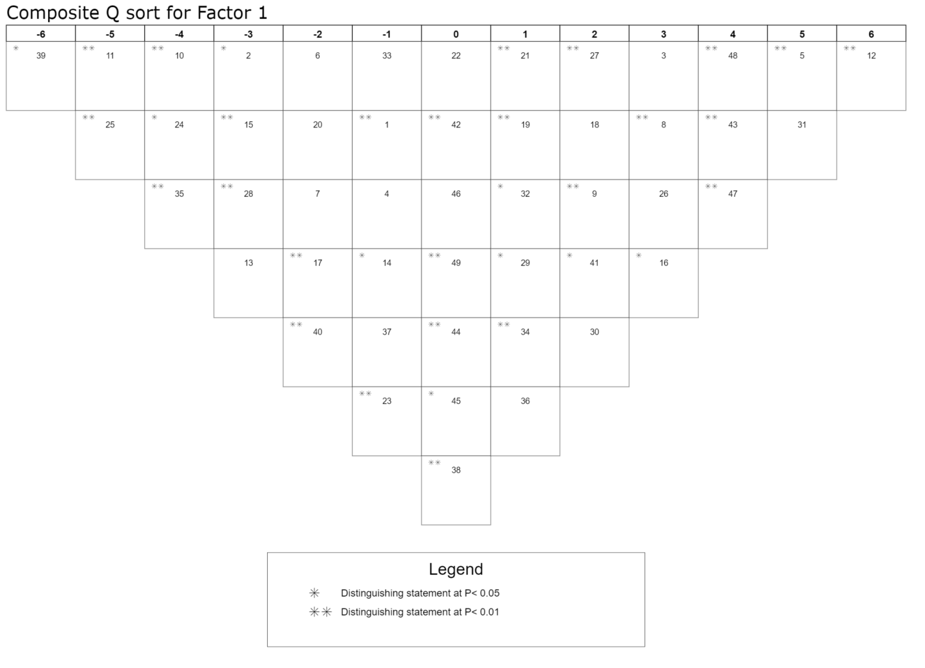
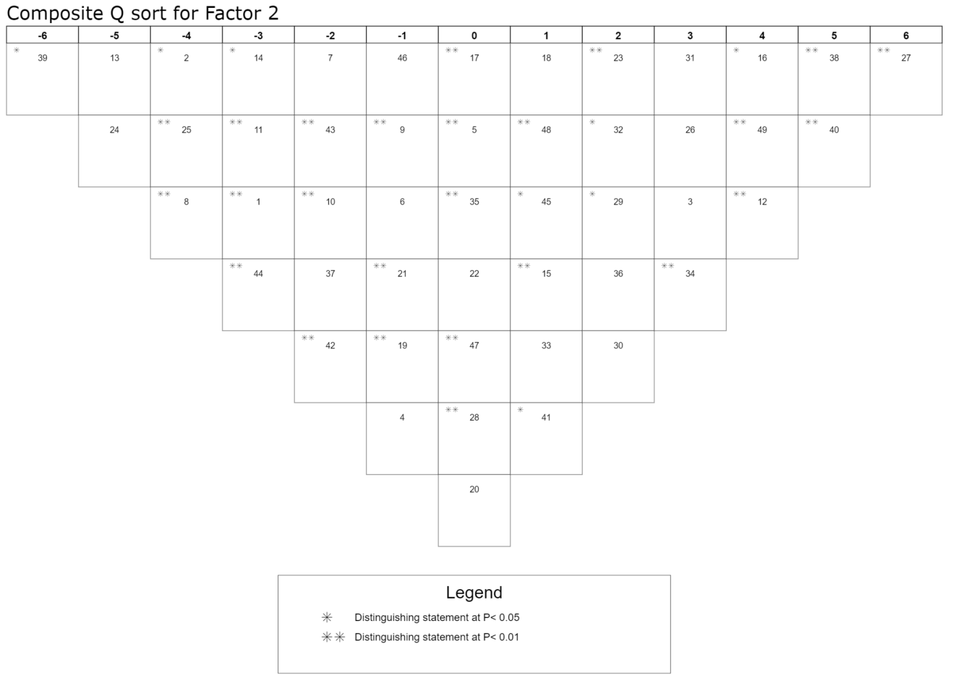

Appendix K
Crib sheets

Crib sheet for factor 1

Statements agreed with more than factor 2

5. It’s useful to be able to phone the diabetes specialist nurse when you need help (+5**)
8. It’s useful to have something to alert to diabetes, like a rubber bracelet, medical alert card or phone case (+3**)
43. Keeping a record of blood sugars helps people to feel in control of diabetes. (+4**)
47. Medical staff shouldn’t make people feel like they are failing if their blood sugars are high (+4**)
48. It’s important to be honest with medical staff during clinic appointments (+4**)

Other relevant or distinguishing statements agreed with

3. The whole family need to learn about diabetes, not just the child who has it (+3)
9. Giving a list of how-tos and symptoms to people outside of the family helps reduce worry when not at home (+2**)
12. It’s important to be allowed to live a ‘normal’ life (+6**)
16. It is important to make sure young people feel confident to look after their diabetes on their own (+3*)
18. It can be helpful to talk to a doctor, nurse or psychologist about how you are feeling
about diabetes (+2)
19. Talking about how hard it is to have diabetes helps to feel better about it (+1**)
21. It’s helpful when a parent carefully watches what a child with diabetes is doing (+1**)
26. Involving the whole family makes things easier (+3)
27. It’s important for the whole family to support the person with diabetes (+2**)
29. The brothers or sisters should get just as much attention as the child with diabetes (+1*)
31. It’s best if both parents learn all about diabetes, even if they do not live together (+5)
32. Grandparents, aunts and uncles are important to help look after diabetes well (+1*)
34. Spending time with friends is important for a child with diabetes so they don’t get too stressed (+1**)
41. It helps to have a plan of how people should support during a hypo (+2*)

Statements disagreed with more than factor 2

10. It’s easier when every little thing is planned ahead of time (-4**)
11. Planning all food for each day the day before makes things less stressful (-5**)
28. You should often have talks as a whole family about how to look after diabetes (-3**)
35. It’s easier when the whole family change what they eat to fit with diabetes (-4**)

Other relevant or distinguishing statements disagreed with

2. It’s best when parents teach their children about diabetes (-3*)
15. Patience is important to get through the hard times (-3**)
17. It helps when you can express anger and frustration at diabetes (-2**)
24. It’s helpful when parents give consequences when children don’t manage their diabetes properly (-4*)
25. It’s easier for children to look after their diabetes when parents give strict rules about what they can and can’t do (-5**)
39. It’s better when friends are kept separate from diabetes (-6*)
40. It’s easier to manage diabetes when you have a positive attitude about it (-2**)

Crib sheet for factor 2

Statements agreed with more than factor 1

27. It’s important for the whole family to support the person with diabetes (+6**)
38. Things are easier when friends know about (+5**)
40. It’s easier to manage diabetes when you have a positive attitude about it (+5**)
49. It’s important not to blame a young person when their blood sugars are high (+4**)
34. Spending time with friends is important for a child with diabetes so they don’t get too stressed (+3**)

Other relevant or distinguishing statements agreed with

16. It is important to make sure young people feel confident to look after their diabetes on their own (+4*)
12. It’s important to be allowed to live a ‘normal’ life (+4**)
3. The whole family need to learn about diabetes, not just the child who has it (+3)
31. It’s best if both parents learn all about diabetes, even if they do not live together (+3)
26. Involving the whole family makes things easier (+3)
23. When children are living at home parents should always be helping them with their diabetes (+2**)
32. Grandparents, aunts and uncles are important to help look after diabetes well (+2*)
29. The brothers or sisters should get just as much attention as the child with diabetes (+2*)

Statements disagreed with more than factor 1

1. Diabetes Education courses help us learn a lot about diabetes (-3**)
8. It’s useful to have something to alert to diabetes, like a rubber bracelet, medical alert card or a special phone cover (-4**)
13. Children are more motivated when they are given treats or privileges for looking after their diabetes (-5)
14. Spending time with other children with diabetes helps to feel less ‘different’ (-3*)
24. It’s helpful when parents give consequences when children don’t manage their diabetes properly (-5)
37. It can help when parents of children with diabetes get support from other parents (-2)
42. It’s important that people act normally after seeing a hypo (-2**)
43. Keeping a record of blood sugars helps people to feel in control of diabetes (-2**)
44. It helps to spend time with other people of the same age that have diabetes because they understand what it is like (-3**)

Other relevant or distinguishing statements disagreed with

2. It’s best when parents teach their children about diabetes (-4*)
7. Planning ahead makes us more relaxed (-2)
10. It’s easier when every little thing is planned ahead of time (-2**)
11. Planning all food for each day the day before makes things less stressful (-3**)
25. It’s easier for children to look after their diabetes when parents give strict rules about what they can and can’t do (-4**)
39. It’s better when friends are kept separate from diabetes (-6*)

Appendix L
Author submission guidelines
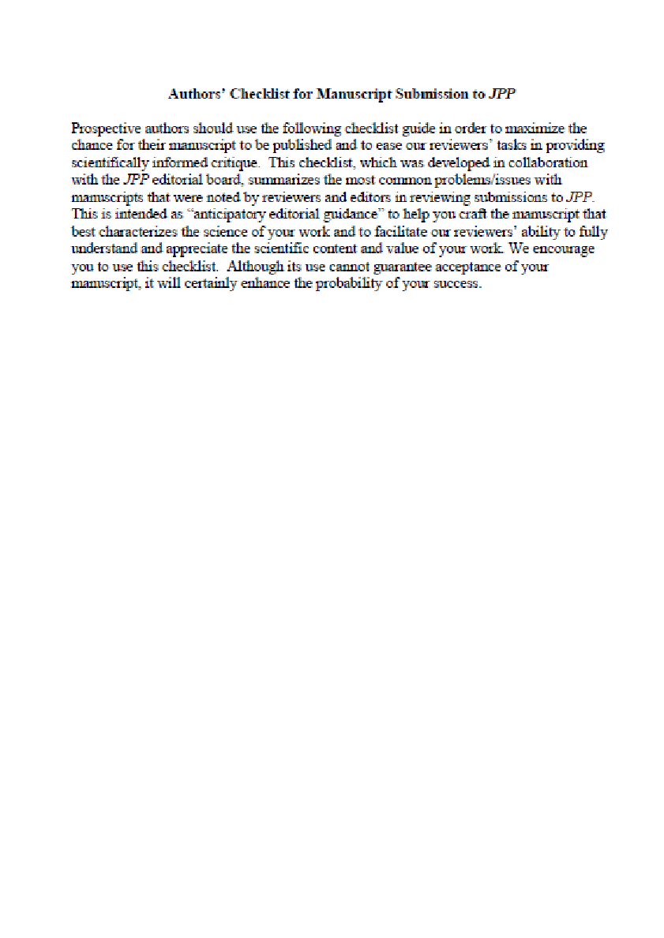

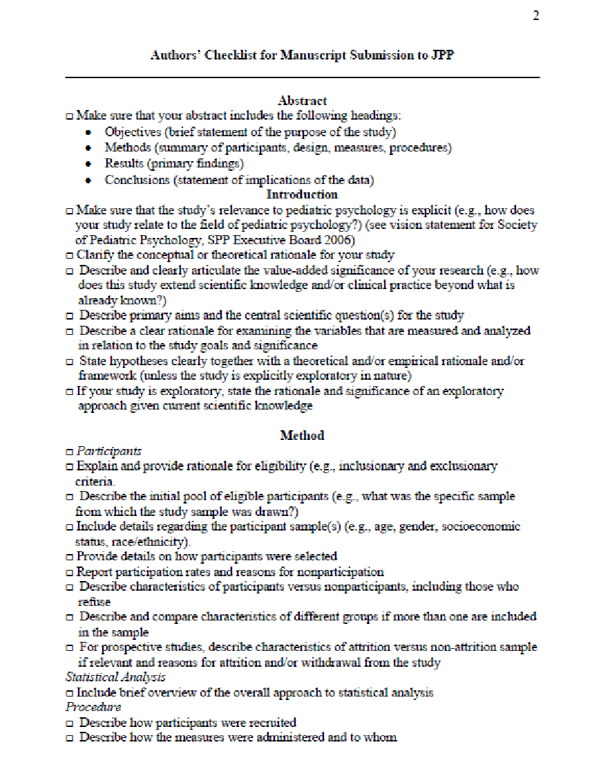

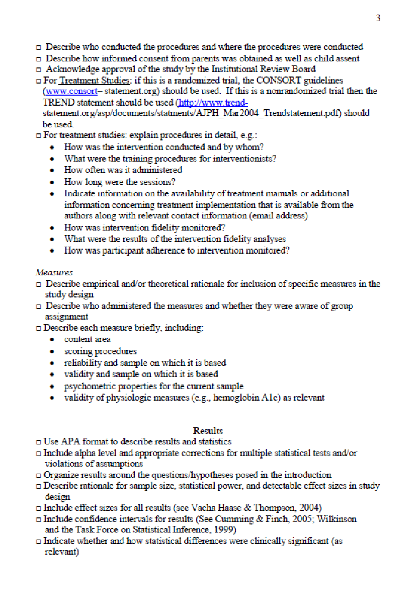

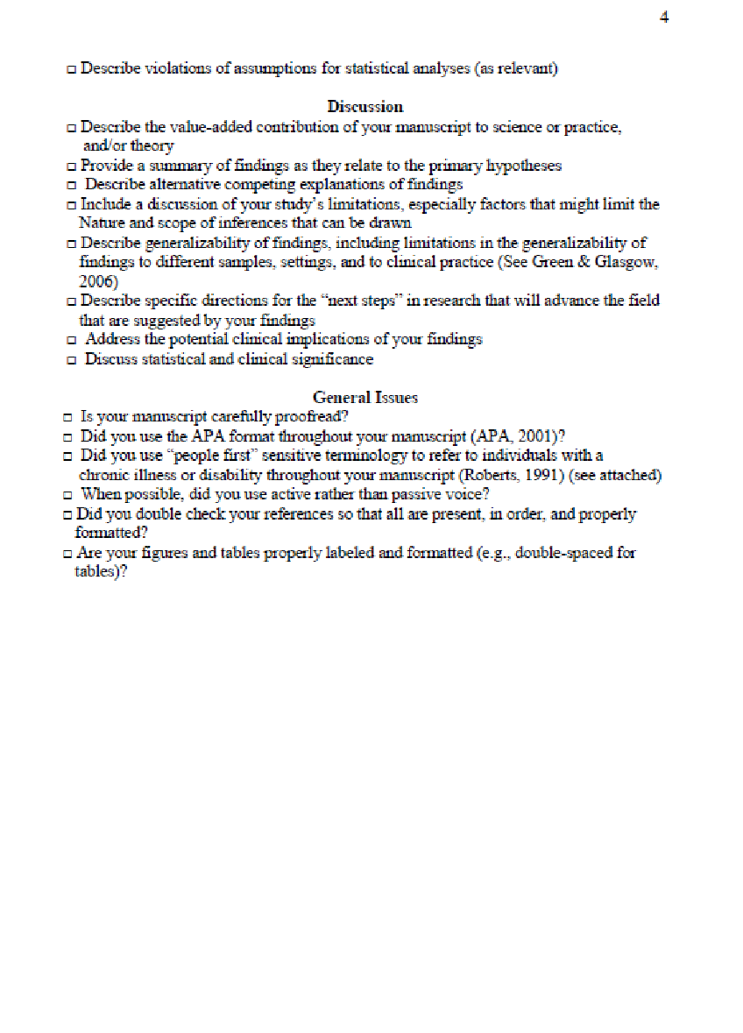

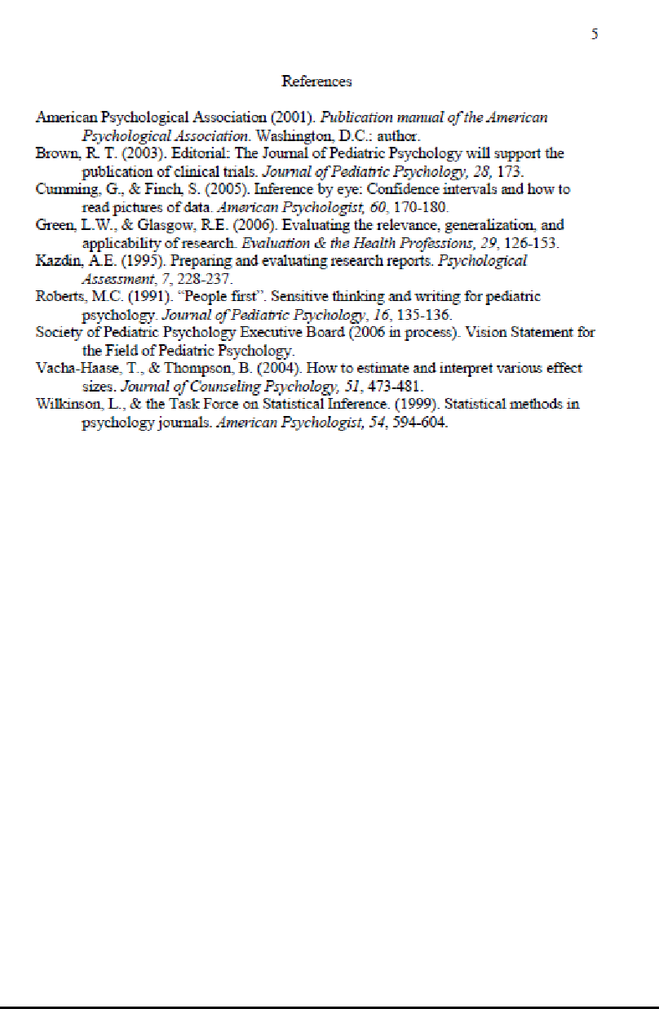

Chapter 3- Executive summary

This executive summary leaflet was designed to be accessible to young people aged twelve and older. It was written primarily as a summary of research for those who had participated in the study, however the aim is for it to be distributed to all families that attend the diabetes clinic as well as the multidisciplinary team that work there. The executive summary was validated by a range of service user consultants who offered their comments on the presentation of information; personal contacts of the researcher including a child of a parent with diabetes, a young person with diabetes and an adult sibling of a young person with diabetes.

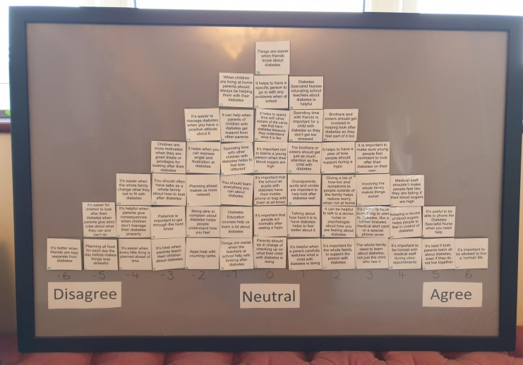

WHO I AM
My name is Ami and I am a Trainee Clinical Psychologist. As part of my training I have carried out a research project at a diabetes clinic under the supervision of Dr Charlotte Tolgyesi. You may have been one of the 19 young people, parents and medical staff that participated in my research or the many parents and young people with diabetes who helped me develop the project. If so, thank you! This booklet has been written to give you a short summary of what I did and what I found out.
What helps families manage diabetes?
Summary of research project
WHAT I WANTED TO FIND OUT
I am interested in the psychological and social things that make Type One diabetes easier to look after. I wanted to know what people’s opinions were from their own personal experience. I wondered whether parents, young people with diabetes and medical staff had similar opinions or had different ideas about what was helpful.
WHAT I DID
First, I tried to find out all of the things that people think are helpful when managing diabetes in young people. I read lots of books and articles, watched documentaries, asked parents and children with diabetes and looked online at blogs and discussion boards. When I couldn’t find any new ideas, I printed the statements on cards to use in my task.
Nineteen people took part in the task; 7 medical staff, 7 parents and 5 young people with diabetes aged 12– 15. Each person looked at all the statements and placed them on a board to show me which things they thought were most and least helpful to manage diabetes. Each person also filled out a questionnaire to tell me a little more about them.
Next, I used a computer program to see if there were any patterns or shared ideas about what different people thought.

145

146

WHAT I FOUND
I found that there were two main viewpoints that people held– these are called factors. There were also some things that both factors suggested was helpful.
Summary of research project
BEING FLEXIBLE
Both viewpoints suggested that it’s helpful to try to be flexible when managing diabetes. This means not planning every little detail ahead of time. Everyone also strongly agreed that young people with diabetes should be allowed to live a normal life.
WHAT WAS HELPFUL IN BOTH FACTORS
FAMILY
It’s helpful to work as a family when managing diabetes. This meant that the whole family should be involved and everyone should learn about diabetes including aunts, uncles and grandparents. But this didn’t mean that everything needs to revolve around the young person with diabetes– the whole family don’t need to change what they eat and siblings should get just as much attention as the young person with diabetes.
PARENTING
Both factors indicated similar viewpoints on how parents should help their children manage diabetes. They thought that parents don’t need to use treats, privileges, consequences or punishments to motivate young people to manage their diabetes. Parents shouldn’t have strict rules about what a child with diabetes can or can’t do.

FACTOR ONE– THE MEDICAL TEAM AND PRACTICAL STRATEGIES
Twelve of the people in this study had this viewpoint: two members of staff, six parents (three dads and three mums) and four young people with diabetes. The members of staff had 1-4 years of experience working with diabetes and the young people had been diagnosed for between one and 10 years.
Summary of research project
RELATIONSHIPS WITH MEDICAL STAFF
We think that having a good relationship with the medical team is helpful in managing diabetes. It’s important to be honest with the medical team during clinic appointments. Medical staff shouldn’t make people feel bad if their blood sugars are high. It’s helpful to be able to talk to a doctor, nurse or psychologist about diabetes. We also think it’s helpful to be able to telephone the nurse when you need help!
PRACTICAL STRATEGIES
We also believe that practical strategies are helpful when managing diabetes. This includes having something to alert others to diabetes, like a phone case or a bracelet. We also think it’s helpful to have a ‘how to’ list to give to people outside of the family. Parents need to watch what their children are doing to help them feel confident to manage their diabetes on their own one day.

147

148

Summary of research project

FACTOR TWO– FRIENDS AND PSYCHOLOGICAL FACTORS
Seven of the people in this study had this viewpoint: four members of staff, one mum (who was also a nurse) and one young person with diabetes. The members of staff had 6- 33 years of experience working with diabetes and the young person had been diagnosed for less than one year.

SUPPORT FROM FRIENDS
We think things are easier when friends know about diabetes and spending time with friends makes young people feel less stressed.
PSYCHOLOGICAL FACTORS
We also believe that the way you think about diabetes makes a difference. It helps when you have a positive attitude about diabetes and patience is really important to get through the hard times.

SO WHAT DOES THIS MEAN?
These results tell us that there are some things that people agree are important to help manage diabetes– like family, parenting and being flexible. But there are also some differences in what people think is helpful. Lots of medical staff thought that friends and the way we think about diabetes is most helpful, but lots of young people and parents thought that a good relationship with the medical team and practical strategies are more helpful. This information might change how medical teams support families based on what is most helpful for them.

WHAT NEXT?
This project was part of a doctorate in clinical psychology. There is a full report of the project and this may be published in a scientific journal. I hope you have found this summary interesting. If you have any questions, or would like to read the full report, please get in touch with me via email on amigracebrooks@gmail.com.

148
A big thank you to all of the young people, parents and medical staff who took part in my study and to Dr Raffeeq and the team for all of your help.

