**The Wounded Healer: Personal experiences of mental health difficulties and trauma and their influence on the professional practice of Clinical Psychologists and other therapy professionals**

Stephanie Ryan

Thesis submitted in partial fulfilment of the requirements of Staffordshire University for the degree of Doctorate in Clinical Psychology

April 2020

Total word count: 18,851

**THESIS PORTFOLIO: CANDIDATE DECLARATION**

|  |  |
| --- | --- |
| **Title of degree programme** | **Professional Doctorate in Clinical Psychology** |
| **Candidate name** | **Stephanie Ryan** |
| **Registration number** | **17023119** |
| **Initial date of registration** | **September 2017** |

|  |
| --- |
| **Declaration and signature of candidate** |
| I confirm that the thesis submitted is the outcome of work that I have undertaken during my programme of study, and except where explicitly stated, it is all my own work.  I confirm that the decision to submit this thesis is my own.  I confirm that except where explicitly stated, the work has not been submitted for another academic award.  I confirm that the work has been conducted ethically and that I have maintained the anonymity of research participants at all times within the thesis.  Image  Signed: Date: 19.07.2020 |

**Acknowledgments**

Thank you to my supervisor, Dr Helena Priest, who had faith in my project and was never anything but calm, consistent and supportive no matter how many confused and frantic emails I sent. Thank you also to Rosie, my lovely friend, your help was invaluable.

Thank you, mum, dad, and my brothers and sisters for your unconditional love, support, and every bit of faith you had in me that I could get to where I am today.

To Jenni, Laura and Sarah, I cannot even begin to thank you. I would not have gotten to this point without your love and support. Thank you for all the times you helped me get off my bedroom floor. Thank you for all the times you told me to go and lie down on the bedroom floor. Thank you to the rest of my cohort, Staffs University cohort of 2017, what fabulous, amazing, inspiring humans you are. Hands down the greatest gift of training I was given was to get to share this journey with all of you.

My last and biggest thank you goes to my research participants. Thank you, from the bottom of my heart, for giving me your stories. I don’t know if I can really communicate how much of a privilege it was to me. Your stories inspired and changed me. Every conversation we had I was blown away by your honesty, your courage, your strength and your wisdom. I am proud to be a clinical psychologist with lived experience alongside such incredible clinicians as you. Thank you.

I dedicate this thesis to anyone who has been to hell and managed to find their way free. But most of all I dedicate it to two I loved who did not, Henry and Joe.

**Contents**

**Thesis Abstract** 6

**Paper One: Literature Review** 7

Abstract 8

Introduction 9

Review Rationale 12

Method 13

Results 17

Discussion 28

Review Limitations 32

Directions for Future Research 32

Conclusions 33

References 34

Appendices 42

**Paper Two: Empirical Research Paper** 56

Abstract 57

Practitioner Points 57

Introduction 58

Study Rationale 61

Method 62

Findings 68

Discussion 76

Limitations 83

Directions for Future Research 83

Implications and Conclusions 84

References 86

Appendices 93

**Paper Three: Executive Summary** 126

Introduction 128

Method 130

Key Findings 132

Summary and Conclusions 137

Limitations 137

What now? 138

Dissemination 139

References 140

**Table of Appendices**

|  |  |
| --- | --- |
| Appendix | Page |
| Appendix A. Summary of studies included in literature review | 42 |
| Appendix B. STROBE Statement Critical Appraisal Tool | 50 |
| Appendix C. STROBE critical appraisal scores for each study | 51 |
| Appendix D. Author guidelines for submission to Journal of Trauma & Dissociation | 53 |
| Appendix 1. Ethical Approval Feedback | 93 |
| Appendix 2. Ethical approval feedback of amendment to procedure request | 94 |
| Appendix 3. Participant information sheet | 95 |
| Appendix 4. Participant debrief sheet | 99 |
| Appendix 5. study advertisement posted on UK Clinical Psychology Facebook webpage | 101 |
| Appendix 6. Consent to participate page from survey hosted by Qualtrics online survey platform | 102 |
| Appendix 7. Demographic question page from survey hosted by Qualtrics online survey platform | 103 |
| Appendix 8. Lived experience of mental health difficulties questionnaire hosted by Qualtrics online survey platform | 104 |
| Appendix 9. Adverse Childhood Experiences questionnaire hosted by Qualtrics online survey platform | 105 |
| Appendix 10. Trauma History questionnaire hosted by Qualtrics online survey platform | 107 |
| Appendix 11. Participant consent form | 110 |
| Appendix 12. Semi-structured interview guide | 111 |
| Appendix 13. Excerpt of interview transcript | 112 |
| Appendix 14. Extract from reflective log | 114 |
| Appendix 15. Coding of transcript Chris using Nvivo 12 Software | 116 |
| Appendix 16. Example of theme development process | 118 |
| Appendix 17. Author guidelines for submission to the British Journal of Clinical Psychology | 120 |

# **Thesis Abstract**

It is generally acknowledged that mental health professionals experience high levels of childhood adversity, trauma and mental health difficulties; however, research into how these experiences may influence professionals in their practice is unclear. Theory and research suggest these experiences can facilitate greater empathy, connection, hope and resilience in practice, but alternatively can increase the professional’s risk of vicarious trauma, negatively impact client work and lead to professional impairment. The subsequent three papers aim to bring clarity to this subject, and aid in the continuing facilitation of an open dialogue about lived experience of mental health difficulties and trauma in mental health professionals.

Paper one reports a literature review examining the relationship between a personal trauma history and vicarious trauma in therapists. In the fourteen-article review, eight studies found a significant relationship between a trauma history and vicarious trauma. The evidence suggests that additional personal and professional factors have a role in this complex relationship. A review of the quality of the evidence demonstrates the need for further definition and validation of vicarious trauma concepts.

Paper two details a piece of empirical research which qualitatively explores perceptions of how personal experiences of trauma and mental health difficulties might influence clinical psychologists in professional practice. Seventeen qualified clinical psychologists participated in interviews and three themes were identified using thematic analysis; (1) Experience as a clinical tool, (2) The interaction of personal and professional, and (3) Secrecy. The clinical implications and limitations of the study are discussed, and suggestions for further research are made.

Paper three presents an executive summary of the empirical paper, written for those who may have an interest in the research, such as clinical psychologists, other mental health professionals, mental health service users and those involved in mental health career education.

# **Paper One: Literature Review**

**The relationship between a personal trauma history and vicarious trauma in therapists: A literature review**

Word Count: 7,888

*The paper has broadly been written to the standard required for submission to publication in the Journal of Trauma & Dissociation (see Appendix D. for details).*

# **Abstract**

Vicarious trauma is a negative psychological response that can occur as a result of engagement with individuals who have experienced trauma. A factor proposed to increase the risk of vicarious trauma is the therapist having a personal history of trauma, but the evidence for this risk factor is mixed. This review aimed to synthesise and critically appraise the literature to identify what is known about the relationship between a personal trauma history and vicarious trauma in therapists. Fourteen articles met the inclusion criteria, and showed mixed results, with eight studies finding a statistically significant relationship. The evidence suggests that the relationship between trauma history and vicarious trauma is complex, influenced by other personal and professional factors. The critical appraisal of the evidence showed methodological problems within the literature, with the lack of valid measurement of trauma history and vicarious trauma, and the interchangeable use of the term vicarious trauma with related concepts being of greatest concern. The review highlights the need for future research to focus on defining and validating vicarious trauma and related concepts, and the development and consistent use of valid measures for vicarious trauma and trauma history.

Keywords: vicarious trauma; secondary traumatic stress; therapist; personal history.

# **Introduction**

It is increasingly recognised that mental health professionals are at high risk of poor mental health or psychological distress due to the demanding nature of their work (Guy, Poelstra & Stark, 1989; Radeke & Mahoney, 2000; O’Connor, 2001). Part of the demanding nature of that work, particularly for those in a therapist role, can involve exposure to the traumatic experiences of service users, and this can negatively impact the therapist’s wellbeing (Collins & Long, 2003). Three constructs used to describe the negative effects of exposure to a client’s trauma are vicarious trauma (VT), secondary traumatic stress (STS), and compassion fatigue (CF).

Vicarious Trauma was defined by McCann and Pearlman in 1990, to refer to the transformation in cognitive schemas and belief systems as a result of empathic engagement with the experiences of trauma victims. The theory is based in the conceptual framework of Constructivist Self-Development Theory (McCann & Pearlman, 1990), which proposes that individuals construct their reality through the development of cognitive schemas, which are used to interpret life experiences. When individuals directly or indirectly engage with trauma, it supposedly creates disruptions in beliefs about key issues such as safety, trust, and control, as well as alterations to one’s sense of identity and spirituality (McCann & Pearlman, 1990). These changes can potentially impact interpersonal relationships and emotion regulation (Bride, Radey & Figley, 2007a; Dunkley & Whelan, 2006; Pearlman & McCann, 1995; Pearlman & Saakvitne, 1995).

Closely related to VT is the construct of Secondary Traumatic Stress. Developed by Figley (1995), STS has been defined as the consequent behaviours and emotions resulting from exposure to another’s traumatic experience (Figley, 1995). The symptoms of STS are proposed to mirror those of Post-Traumatic Stress Disorder (PTSD), experienced by some after direct exposure to trauma. Symptoms of STS include intrusive imagery and thoughts, traumatic memories or nightmares associated with client trauma, insomnia, avoidant responses, physiological arousal and functional impairment (Bride et al., 2007a; Bride, Robinson, Yegidis & Figley, 2004; Figley, 1995; Jenkins & Baird, 2002). In much research, STS is used interchangeably with Compassion Fatigue, first coined by Joinson (1992), who described it as a unique form of burnout in nurses that resulted in a reduced ability to nurture others. Over time, the term has developed to encompass trauma symptomology and cognitive changes alongside burnout, and has been applied to various healthcare professionals, particularly therapists. Figley (1995) has suggested that CF is an equivalent term to STS but is more ‘user friendly’ and less stigmatising, and is often used as such in the literature (Figley, 1995; Bride et al., 2007a), although, unlike STS, CF is not trauma-specific.

The similarities between these concepts can make distinguishing them in the research literature challenging. Broadly, all three terms refer to the negative emotional response arising from clinical work with individuals who have been traumatised (Ivicic & Motta, 2017). The main distinctions between VT, STS and CF are in theoretical origin, symptom focus, and process; generally VT can be considered to be a cognitive concept with a gradual, cumulative development, whilst STS and CF focus on observable behavioural symptoms, usually developing rapidly (Jenkins & Baird, 2002). However, even in this distinction there is overlap.

As well as being closely related, the literature uses the terms interchangeably, increasing the difficulty in interpreting the research (Najjar, Davis, Beck-Coon, & Doebbeling, 2009). For example, some papers use the term STS, but discuss cognitive symptomology more theoretically characteristic of VT, or measured VT using a measure developed for assessing STS. As a result, distinguishing these terms from one another in the literature is virtually impossible (Sabin-Farrell & Turpin, 2003). For this paper, VT has been broadly defined to refer to the negative changes in belief structures and/or the presence of PTSD-like symptoms as a result of vicarious exposure to trauma through professional work, therefore encompassing all terms. VT was chosen as the umbrella term as it seemed the most appropriate given that it relates specifically to trauma work, is located within a theoretical framework and integrates intrinsic and extrinsic factors (Dunkley & Whelan, 2006)

Evidence on the prevalence and impact of VT is mixed, with arguments of insufficient evidence to support its existence (Sabin-Farrell & Turpin, 2003). Studies examining VT have reported varying levels of severity (Elwood et al., 2011), with some finding low levels of VT in therapists and reported distress measuring below clinically significant cut-offs (Collins & Long, 2003; Dunkley & Whelan, 2006; Ennis & Horne, 2003; Follette, Polusny, & Milbeck, 1994; Kadambi & Truscot, 2003; Pearlman & MacIan, 1995). Other studies have reported finding moderate to high levels of VT in therapists (Bride, Jones, & MacMaster, 2007b; Conrad & Kellar-Guenther, 2006; Kassam-Adams, 1995; Schauben & Frazier, 1995).

A suggestion for the inconsistent evidence for VT is that it is mediated by other factors (Sabin-Farrell & Turpin, 2003). One such factor widely researched is having a personal trauma history (TH). This is grounded in research suggesting high occurrences of childhood adversity, trauma and mental health difficulties in therapists. Pope & Feldman-Summers (1992) found that two thirds of women and one third of men working as therapists had a childhood abuse history. Elliot and Guy (1993) found significantly higher rates of physical and sexual abuse, parental mental health difficulties and bereavement in therapists compared with professionals in other occupations. Surveys have found that 63% of qualified clinical psychologists (Tay, Alcock, & Scior, 2018) and 67% of trainee clinical psychologists (Grice, Alcock, & Scior, 2018) reported personal experience of mental health difficulties.Researchers continue to ask what impact these high prevalence rates have on the practice of therapists. The theory that professionals with a history of personal trauma are more susceptible to VT was first introduced by Pearlman and MacIan (1995). They found more negative effects from therapeutic work in therapists with TH than those without. The authors proposed that exposure to client trauma would ‘reawaken’ the therapist’s own trauma memories, increasing the likelihood of a vicarious trauma process (Pearlman & MacIan, 1995).

The results to support the theory of increased vulnerability with TH have been inconsistent. Across disciplines, a significant relationship has been found between TH and a heightened risk of VT in welfare workers, (Nelson-Gardel & Harris, 2003) and law enforcement professionals (Folette et al., 1994). In therapists, Ghahramanlou and Brodbeck (2000) and Weaks (2004) found that trauma history significantly predicted both presence and severity of PTSD symptoms, and Kassam-Adams (1995) found a link between maltreatment history and VT. In contrast, other research has failed to find a link between TH and VT (Benetar, 2000; Schauben and Frazier, 1995; Way, VanDeusen, Martin, Applegate, & Jandle, 2004).

Attempts have been made to clarify this relationship through reviews and meta-analyses. A meta-analysis of 38 studies by Hensel et al. (2015) examined risk factors for STS in therapeutic workers, which included mental health, social work and medical professionals, and found that TH was positively related to VT but the strength of the association was low, with an effect size of *r* = .19. Baird and Kracen (2006) conducted a research synthesis of risk factors for both VT and STS, measured as distinct concepts, using a level of evidence approach. Examining sixteen studies, they concluded there was evidence for a link between STS, VT and TH; however, the evidence was unclear, stating the review found ‘reasonable’ evidence for a link with VT and ‘persuasive’ evidence for a link with STS. The review did not state how many of the sixteen papers in the review had studied TH as a risk factor, only listing papers in which a link was found, therefore it was not clear how many did not find a link, which makes it difficult to base conclusions on their evidence.

# ***Review Rationale***

The aim of this review is to provide an up-to-date synthesis of existing literature to answer the question: ‘what is known about the relationship between a personal trauma history and vicarious trauma in therapists?’

It builds on the review by Baird and Kracen (2006), who suggested further investigation was necessary when a greater amount of published research on the topic became available, as their review relied on largely unpublished dissertations not subject to peer review. When their review was conducted, VT was a newer topic of research, but since publishing there has been greater interest and research into the area. It is important that attempts continue to be made to clarify the inconsistent findings, due to the potential implications of VT for not just the therapist, but for the service users and mental health services also.

# **Method**

***Search Strategy***

A literature search was conducted using PsychINFO, PsychARTICLES, CINAHL Plus and MEDLINE, through the host websites EBSCOhost and Scopus. Grey literature was consulted by searching EThOS, an online host for unpublished British dissertations, and OpenGrey, a database with open access to a range of grey literature such as technical or research reports, doctoral dissertations and conference papers. Reference lists from key texts were hand searched, and published review articles on Vicarious Trauma (VT) were examined to identify appropriate articles not found in the database search.

The literature search was conducted in March 2018. In Scopus and EBSCO Host, the following terms were used in combination using Boolean terms:

("vicarious trauma" OR secondary OR “compassion fatigue”) AND (personal OR history) AND (abuse OR trauma OR adversity) AND (psychologist OR therapist OR "mental health professional").

When searching OpenGrey and EThOS the following terms were used:

(“Vicarious Trauma”) OR (“Secondary traumatic stress”)

The OpenGrey and EThOS terms were broader to ensure all relevant literature was captured. A start date of 2003 was used due to a review by Baird and Kraken (2006) reviewing the literature on this topic up until 2003.

***Inclusion and Exclusion Criteria***

*Inclusion Criteria*

Studies were included if the following criteria were met:

* They included the concept of vicarious trauma, secondary traumatic stress or compassion fatigue.
* The professional held a therapist role which involved building therapeutic relationships with traumatised clients, putting them in contact with traumatic material.
* The focus was on therapy disciplines.
* The personal trauma experienced by the therapist had a psychological or emotional focus.
* The past trauma the therapist experienced was personal and historic trauma, rather than trauma solely as a result of professional work with clients.
* The article was written in English.
* The article included research.

*Exclusion Criteria*

Articles were excluded if:

* The study examined medical, teaching and social work disciplines.
* When different disciplines were assessed together and group data were indistinguishable from one another, they were excluded, unless all professionals were described as specifically working as a therapist.
* The article was theoretical only.
* The trauma experienced by the therapist was solely physical illness or injury.

***Selection of Articles***

The initial search produced 305 articles; of these 91 were removed as duplicates. At the first stage of screening, titles were read, and a further 95 titles were removed that were irrelevant to the review topic but had failed to be filtered by the search terms, for example medication trials, physical health research or psychological intervention trials. At the second stage of screening, abstracts were reviewed to determine if inclusion and exclusion criteria were met. If this was unclear from the title and abstract, the full text was read to determine inclusion. Two unpublished theses were excluded as the thesis had later been published in a peer reviewed journal, therefore the two corresponding published articles were retained, and the theses excluded. In Figure 1. this is listed as ‘located published article’ in the exclusion reasons. This resulted in retention of 34 articles.

The final stage was to screen each full article. This stage resulted in the exclusion of 13 papers. All reasons for exclusion are shown in Figure 1. At this stage, a further 4 unpublished dissertations were excluded due to an inability to gain access to the full text. All known appropriate databases were consulted, the US institutions in which the dissertations were conducted were contacted and Staffordshire University Library consulted in an attempt to gain access before this exclusion was made. The abstracts of the remaining 17 papers were reviewed against inclusion and exclusion criteria by an independent reviewer and 3 more papers were excluded. This resulted in retention of 14 papers for inclusion in the literature review. Figure 1 illustrates the search strategy.

*Figure 1 –* Flow diagram demonstrating article inclusion flow process.

n=14

EBSCOhost n=169

Scopus n=81

EThOS n=25

OpenGrey n=11

Hand Searching n=19

**n=305**

**n=214**

Screened by title

Duplicates Removed

**n=91**

**Excluded n=95**

Reason: Not relevant

**Excluded n=85**

Reason:

Not studying VT or STS (n=18)

Not studying therapy discipline (n=10)

Mixed discipline groups (n= 3)

Theoretical (n=5)

Not measuring TH (n= 34)

Not relevant to topic (n=10)

Located published article (n=2)

Not assessing association between VT and TH (n=3)

**Excluded n=17**

Reason:

Not studying VT or STS (n=1)

Mixed discipline groups (n= 2)

Not written in English (n=2)

Theoretical (n=2)

Not measuring TH (n= 1)

Not directly assessing relationship (n=3)

Sample issues (n=1)

Clinician role unclear (n=1)

Full text unavailable (n=4)

**n=17**

Independent review of abstracts

**Excluded n=3**

Reason:

Literature reviews – not appropriate for synthesis together with empirical papers (n=2)

Not studying therapists (n=1)

**n=34**

Screened by full text

**n=119**

Screened by Abstract

***Data extraction and Quality Assessment***

Data was extracted using a data extraction form which captured basic study information (sample, method and key findings). When full texts were reviewed, the data extraction form was extended to cover quality information, including key strengths, limitations and a quality score (see Appendix A).

Following the examination of a range of critical appraisal tools, the Strengthening the Reporting of Observational Studies in Epidemiology statement (STROBE; Von Elm et al., 2008) was selected for this review. A single tool was chosen rather than the creation of a bespoke tool to increase the validity and reliability of the quality assessment. The STROBE statement provides a checklist of 22 items that should be included in reports of cross-sectional studies (Von Elm et al., 2008). All articles in this review were cross-sectional, supporting its use. The STROBE statement is available in Appendix B.

As the review focus was the relationship between VT and TH, where studies explored additional topics only those findings relevant to the search question were appraised.

# **Results**

***Study Characteristics***

*Overview of included studies*

(1) Adams and Riggs (2008)

Examined the relationship between VT, TH, and defense style in a sample of 129 trainee therapists using a MANOVA analysis. No significant relationship between TH and VT found.

(2) Cieslak et al. (2013)

Examined prevalence and risk factors of STS in 224 therapists working with individuals from the US military with a regression model. TH was a significant predictor in the regression model.

(3) Cosden, Sanford, Koch and Lepore (2016)

Examined VT and post-traumatic growth in 51 substance abuse counsellors in trauma-informed treatment programmes using multiple-regression. They found that counsellors in recovery were more likely to report TH, and TH significantly predicted VT.

(4) Creamer and Liddle (2005)

Examined the relationships between therapist characteristics, including TH, and VT in 81 disaster mental health workers who responded to the 9/11 attacks, using a regression analysis. No significant relationship between TH and VT found.

(5) Diehm, Mankowitz and King (2018)

Examined the relationship between professional factors such as exposure and years of experience, and personal factors such as TH and social support, and VT in 77 psychologists with a regression analysis. TH significantly predicted VT.

(6) Gulin (2017)

Examined protective and risk factors of VT and STS in 221 therapists, comparing trauma specific and generalist therapists, using ANOVA, regression and MANCOVA statistical analyses. They found no difference in VT and STS scores across the two therapist groups, and TH significantly predicted both VT and STS.

(7) Ivicic and Motta (2017)

Examined variables associated with VT, measured using the Modified Stroop Procedure as the VT measure, in 88 therapists using a regression analysis. TH was significantly associated with longer response latencies on the Modified Stroop procedure, which is indicative of higher trauma symptomology.

(8) Killian (2008)

Conducted a mixed method qualitative and quantitative study of VT, burnout and self-care in therapists. In the quantitative study, risk and protective factors for VT were examined in 104 therapists using regression analysis. TH was significantly associated with VT.

(9) Linley and Joseph (2007)

Examined factors associated with positive and negative therapist wellbeing, which included VT, in 156 therapists using MANOVA and regression analyses. They found that VT scores did not significantly differ between those who self-identified as experiencing TH to those that had not.

(10) Makadia, Sabin-Farrell and Turpin (2017)

Examined contributing factors, including TH, to the relationship between exposure to trauma work and VT and STS in 564 trainee clinical psychologists using regression analysis. They found no association between exposure to trauma work and VT scores, but a significant association between exposure to trauma work and STS. They then examined related factors and found that TH did not significantly influence relationship between exposure and STS.

(11) McKim and Smith-Adcock (2014)

Examined personal, including TH, and workplace factors related to quality of life, measured by compassion satisfaction and VT, in 98 therapists with regression analyses. They found no significant relationship between TH and VT.

(12) Sodeke-Gregson, Holttum and Billings (2013)

Examined the prevalence of, and predictors for VT, compassion satisfaction and burnout in 253 therapists working with traumatised adults using regression analyses. TH was a significant predictor of VT in the regression model.

(13) Trippany, Wilcoxon and Satcher (2003)

Examined personal, including a history of sexual trauma, and professional risk factors for VT in 114 female therapists, comparing differences between therapists who work with adults and therapists who work with children. The adult group showed no significant relationship between TH and VT. A significant association was found in the therapists who worked with children.

(14) Williams, Helm and Clemens (2012)

Aimed to test a model, which was based in Constructivist Self Development Theory, of factors contributing to the development of VT using a path analysis with a sample of 131 therapists. TH was a significant predictor of VT, and TH partially mediated the relationship between engaging in personal wellness activities and VT.

More detailed key characteristics of each study are summarised in Appendix A.

*Research Designs*

All studies used cross-sectional designs, with one paper (Killian, 2008) using a mixed method design of qualitative interviews for study one and a cross-sectional design for study two. For the purpose of this review only study two is included as relevant. Two of the studies included a comparison group, with Gulin (2017) comparing trauma specialist therapists with general mental health therapists and Trippany et al. (2003) comparing child therapists and adult therapists. Irrespective of design, all studies measured the relationship between trauma history and vicarious trauma (or the related term chosen by each author), at a single point in time, using questionnaires as a measure. One study (Ivicic & Motta, 2017) used a non-questionnaire method to measure VT, the modified Stroop Procedure.

The main analyses used were correlational, with thirteen studies using a regression analysis as the main analysis, one of which used a path mediation analysis (Williams et al., 2012), and employed additional tests such as MANOVA, ANOVA, MANCOVA, various t-tests and Pearson or Spearman correlations. Adams and Riggs (2008) used a multifactorial MANOVA for their main analysis.

***Sample***

Across studies, the sample was majority female, with individual samples ranging from 63% to 100% female, and a total average of 77% female. All but two of the samples are comprised of qualified therapy professionals, with Adams and Riggs (2008) and Makadia et al. (2017) using samples of trainee therapists.

***Measures***

When measuring trauma history, no study specifically defines trauma, and all but two papers adopted an interpretation which included a variety of possible traumatic experiences. Trippany et al. (2003) specified that they assessed for sexual trauma, and Williams et al. (2012) measured childhood trauma. A wide range of measures were used, with eight using measures self-developed by the authors. Three studies measured TH by listing traumatic events and asking respondents if they had experienced them (Adams & Riggs, 2008; Cieslak et al., 2013; Killian, 2008). Four studies describe gathering information about personal trauma history within demographic items but provide no information on how or what was gathered (Diehm et al., 2018; Makadia et al., 2017; Sodeke-Gregson et al., 2013; Trippany et al., 2003). Linley and Joseph (2007) provide even less information, only describing a dichotomised ‘yes’ and ‘no’ trauma history variable in the statistical analysis without explanation of how this information was collected. Validated measures of trauma history are used in six studies (Cosden et al., 2016; Creamer & Liddle, 2005; Gulin, 2017; Ivicic & Motta, 2017; McKim & Smith-Adcock, 2014; Williams et al., 2012). VT was measured using a total of seven different measures. The VT measures used are listed in Appendix 1.

***Study Findings***

*Personal Trauma History and Vicarious Trauma*

Broadly, eight studies found a significant relationship between a trauma history and vicarious trauma in therapists (Cieslak et al., 2013; Cosden et al., 2016; Diehm et al., 2018; Gulin, 2017; Ivicic & Motta, 2017; Killian, 2008; Trippany et al., 2003; Williams et al., 2012). These studies used a regression analysis, and the contribution of the regression model to the variance, as reported by the adjusted R², in VT ranged from 10% - 67%. Seven studies found no association (Adams & Riggs, 2008; Creamer & Lidle, 2005; Linley & Joseph, 2007; Makadia et al., 2017; McKim & Smith-Adcock, 2014; Sodeke-Gregson et al., 2013; Trippany et al., 2003). Trippany et al. (2003) is present in both groups due to that study comparing two samples, adult therapists and child therapists, with the groups yielding different results. This links with previous studies finding that the involvement of other factors influenced the relationship between TH and VT.

*Related Factors*

Diehm et al. (2018) found that although TH significantly predicted VT, the individuals’ own perception of the resolution of their trauma was a stronger predictor of VT scores. Similarly, Creamer and Liddle (2005) found no relationship between VT and TH; however, they did find that therapists who had discussed personal trauma in therapy had significantly higher VT levels than those who had not discussed it. William, Helms and Clemens (2012) found that engagement in personal wellness activities reduced the vulnerability to VT, even when a history of childhood trauma was present. In trainee therapists, Adams and Riggs (2008) found no significant main effect for TH and VT; however, they did find that a self-sacrificing defense style increased vulnerability to VT in those with TH.

Trippany et al. (2003) found that type of client group may play a role; finding a significant relationship for therapists working with children, but not in therapists who worked with adults. Gulin (2017) assessed individual categories of possible traumatic experiences using Trauma History Questionnaire (THQ; Green, 1996), and found that the category ‘Crime Related Events’, which involved being the victim of violent and non-violent crime, was the only category of personal traumatic experiences associated with higher VT in therapists.

*Use of Concept*

Nine of the studies did not define or differentiate between the concepts of VT, STS and CF within their introduction, and the fourteen reviewed studies cover all three terms. The four studies using the term CF measured this using the CF subscale on the Professional Quality of Life-III scale (ProQOL III; Stamm, 2005) which is appropriate; however in the other five studies the measures used were not always appropriate to the chosen concept, for example using the term STS in the paper whilst using a measure that focusses on cognitive changes, which would be more appropriate for VT.

The five remaining studies define the concepts and distinguish their use of a particular term. VT was used in one study (Trippany et al., 2003) and STS was used in two studies (Cieslak et al., 2013; Ivicic & Motta, 2017) and concept specific measures were used. Makadia et al. (2017) and Gulin (2017) differentiated the concepts and included both VT and STS, using measures specifically developed from the theoretical origins for VT and STS. In these studies, Gulin (2017) found that TH was a predictor of both VT and STS; however, Makadia et al. (2017) found no significant relationship between TH and STS and TH and VT.

All but one of the five studies (Makadia et al., 2017) that specifically defined the term chosen and used an appropriate measure found a relationship between the variables. Of the nine studies that did not define or differentiate concepts, five of them did not find a relationship (Adams & Riggs, 2008; Creamer & Liddle, 2005; Linley & Joseph, 2007; McKim & Smith-Adcock, 2014; Sodeke-Gregson et al., 2013).

***Methodological Quality***

When examining against the STROBE checklist quality scores, there seemed to be no noticeable difference between the studies that did find a relationship and those that did not in their overall quality, with each group having a range of quality scores. The quality scores of those that found a relationship ranged from 12 to 20, with a mean score of 17. In studies that did not find a relationship, the score range was also 12 to 20, with a mean of 17. Individual scores are shown in Appendix C. This could suggest that quality score overall might not be a simple explanation for the mixed findings; however, there were consistent methodological difficulties across all studies, whether or not they found a relationship, that are important to consider as a potential contributor to the unclear relationship between TH and VT.

All studies in this review had clear research questions or hypotheses. All were cross-sectional in design, which was appropriate for looking at relationships between variables, as many variables can be considered at once. It was also an appropriate design because there was no manipulation of variables or the environment by the researchers that needed to be investigated. However, a crucial limitation with a cross-sectional design, and by extension the studies included, is that it cannot show causality.

In many of the studies, TH was one variable that was examined in conjunction with other variables in their relationship with VT; no one study examined TH alone. Though understandable for a study to consider several variables simultaneously to offer greater insight, there are difficulties with this. The first relates to how this is reported. In the thirteen studies using regression analysis, although all studies reported the standardized beta coefficients of each predictor, very few of these reported in a way that gave the specific contribution of TH to the variance in a regression model. This was done by Diehm et al. (2018), who used a hierarchical regression model with two steps, each step containing one predictor, so it was able to deduce the individual contribution. Gulin (2017) took a similar approach.

In the other eleven regression studies this was harder to deduce, with the results reporting overall variance explained by a model containing from two to five predictors (Cieslak et al., 2013; Ivicic & Motta, 2017; Killian, 2007; Sodeke-Gregson et al., 2013; Trippany et al., 2003; Williams et al., 2012). Due to this, it is difficult to infer the specific relationship between TH and VT based on these results.

A further difficulty in having multiple predictors relates to the power and effect size of the study, which is tied in closely with sample size. The sample size used in the studies varied, with a large number of studies having samples small enough to raise concerns with the interpretation of results. Six studies used sample sizes of fewer than 100 participants (Cosden et al., 2016; Creamer & Liddle, 2005; Diehm et al., 2018; Ivicic & Motta, 2007; McKim & Smith-Adcock, 2014), with the smallest being 51 (Cosden et al., 2016) and only four studies had samples that exceeded 200 (Cieslak et al., 2013; Gulin, 2017; Makadia et al., 2017; Sodeke-Gregson et al., 2013). Trippany et al. (2003) had a total sample size of 114; however, their sample was split into two groups for comparison (66 and 48). The authors specifically state in the introduction that they would not have group sizes smaller than 50 participants in each, then did not address that they did not achieve this.

The number of predictors used, and the sample size, is intrinsically linked to the statistical power of a study. A power analysis informs the recommended sample size that is necessary for the results of a study to have statistical power, yet of the fourteen studies, only three (Gulin, 2017; Makadia et al., 2017; Sodeke-Gregson et al., 2013) detailed a power calculation. There is, therefore, a lack of transparency across the rest of the studies. This lack of transparency, and the small sample sizes in many of the studies, makes it difficult to conclude if certain studies were underpowered. Being under-powered increases the risk that a statistically significant finding is falsely positive (Christley, 2010), raising concerns about the reliability of results.

All studies make reference to the psychometric properties of their chosen measures except when a measure was self-developed by the authors for that current study. The use of either adapted measures for VT or self-developed measures for TH is a limitation across these studies. Both impact reliability and validity of results, and self-developed, poorly explained measures make comparison across studies challenging. No study which self-developed a tool to measure TH acknowledged this as a potential limitation. Only two studies use measures for both TH and VT that were validated and developed to measure specifically what is was designed to measure (McKim & Smith-Adcock, 2014; Ivicic & Motta, 2017).

The Impact of Events Scale- Revised (IES-R; Weiss, 2004), the Trauma and Attachment Belief Scale (TABS; Pearlman, 2003), Traumatic Stress Institute Belief Scale Revision-L (TSIBS-L; Pearlman, 1996), and the Trauma Symptom Inventory (TSI; Briere, Elliott, Harris, & Cotman, 1995), were used in six of the studies as a measure for VT (Cosden et al., 2016; Creamer & Liddle, 2005; Gulin, 2017; Makadia et al., 2017; Trippany et al., 2003; Williams et al., 2012). These measures were developed to measure the impact of a direct experience of trauma, rather than vicarious experience. Adaptations were made to make the measure more suited to VT, asking participants to rate their current reactions specifically to clients’ traumatic material, discarding their personal experiences (Adams & Riggs, 2008; Cosden et al., 2016; Creamer & Liddle; Gulin, 2017), but arguably this could be challenging for a participant to do. It introduced the possibility of a confounding variable, trauma symptoms resulting from own trauma, which only two studies acknowledged and attempted to control for (Cieslak, et al., 2013; Makadia et al., 2017). However, it is noted that the listed measures have been used in previous studies of VT (Bride, et al., 2007b) so this use of adapted, direct trauma measures for VT is not uncommon in VT literature.

For the majority of studies, the method of data analysis was clear and appeared appropriate to the research question. Only in one study, Ivicic and Motta (2016), was the analysis unclear; they report using two measures (the STSS and Modified Stroop) but only report the findings in relation to the Modified Stroop without explanation. Across studies, the main methodological consideration in data analysis relates to variation in the transparency in reporting. Some studies received high quality scores for their analysis and reporting due to a clear, transparent explanation of analyses and bias considerations. The best examples of this were Cieslak, et al., (2013), Diehm et al. (2018), Gulin, (2017), Makadia et al. (2017) and Sodeke-Gregson et al. (2013).

Some studies received considerably lower quality ratings due to the statistical analysis process being unclear, and/or missing key information. Examples of this come from Creamer and Liddle (2005) who provide no clear information on tests used, group sizes for analysis or descriptions of the data collected, making this study impossible to replicate. Killian (2008) had similar methodological limitations. It is difficult to ascertain how this may have impacted the individual study results, and subsequently the results of this review as a whole, as it is not clear what was not performed, and what may have been performed but omitted from the paper. Appendix 3 shows the individual quality scores.

The exact significance values of the statistical findings were reported in all studies, and all reported some effect size measure (e.g. correlation, regression, or path coefficients), which is positive. However, confidence intervals were only reported in three studies (Cieslak, et al., 2013; Diehm et al., 2018; Trippany et al., 2003). Confidence intervals provide the range in which the true value lies, therefore providing a more accurate evaluation of the data (Greenland et al., 2016). In the absence of confidence intervals, it is difficult to determine the true effect, which leaves questions as to the precision and reliability of the conclusions made.

Missing data was referred to in five studies, with three of these detailing the imputation or substitution method used to replace missing responses (Diehm et al., 2018; Gulin, 2017; Ivicic & Motta, 2016), and one removing the affected datasets it prior to analysis, giving a clear rationale for choice of resolution method (Williams et al., 2012). Cieslak et al. (2013), report missing data, but give no information on how or if this was resolved prior to analysis. Nine studies made no reference to missing data. In the remaining nine studies it is unlikely that none had missing data, as missing values is common in studies using multiple questionnaires (Eekhout et al., 2014). Most included studies performed regression analyses, a test which requires a full data set with no missing items (Rubin, Witkiewitz, Andre & Reilly, 2007), therefore it could be assumed that action was taken to resolve this where data was missing. How missing data is approached can create various problems; omitting whole cases with missing data can cause bias in estimation of the parameters, particularly when studies are underpowered (Kang, 2013). As previously discussed, there is a risk that some of these studies were underpowered, which raises concern. In contrast, if no action had been taken to resolve missing data, this violation of test assumptions could have also impacted the results (Pampaka, Hutcheson & Williams, 2016). Therefore, this lack of transparency in reporting means the results should be interpreted with caution.

***Generalisability and Representativeness***

There was evident variability in the quality of studies in relation to recruitment, sample size, and sample characteristics. The largely female samples of the studies is a notable bias, with Trippany et al. (2003) recruiting female participants only, with no justification as to why this was done. Most studies recruited samples through methods which meant a representative sample of therapists, recruiting from registries or directories of therapy professions from across national and international geographical locations. Four of the studies conducted in the US focussed on a smaller geographical area, such as a single city or state, which does impact the representativeness of their results (Adams & Riggs, 2008; Cosden et al., 2016; Ivicic & Motta, 2016; Killian, 2008). That two studies (Adams & Riggs, 2008; Makadia et al., 2017) focussed on therapy trainees is a further consideration in the representativeness of the studies, as arguably it is difficult to generalise to qualified professionals; depending on the discipline, trainees potentially have less cumulative experience of working with trauma, have smaller caseloads and can receive a greater amount of supervision, all of which could be factors impacting the relationship between TH and VT. However, both studies acknowledged this as a limitation to generalisability.

# **Discussion**

This paper aimed to review the evidence-base to identify what is known about the relationship between a personal trauma history and vicarious trauma in therapists. Fourteen articles met the inclusion criteria. The studies showed mixed results, with eight studies finding a statistically significant relationship, and seven finding no relationship. The evidence suggests that a relationship is likely to exist between TH and VT, but it is a complex one influenced by additional personal and professional factors, and as each study examined different variables in conjunction with TH, it is difficult to establish a clear picture of the relationship. This is reflected in the split findings. The critical appraisal of the evidence showed methodological problems within the literature in this area, the most crucial arguably being in the measurement of TH and VT.

***Review of findings***

This review faced difficulties from the outset in determining how to manage the lack of clarity around the use of the related concepts of VT, STS and CF. Based on previous research, the decision was made to incorporate all terms under a broad definition of VT, but to factor in the different use of concepts where the authors have specifically differentiated or measured more than one of the concepts. Interestingly, where studies had appropriately defined and differentiated based on the theoretical origins of the concepts, and used the appropriate corresponding measures, there were more significant findings of a relationship between VT, or STS, depending on the study. However, without further research, this is only speculation based on the observation of these findings. It raises the possibility that the lack of clarity in the relationship between TH and VT is related to the validity within the studies of what concept is being measured. In this review, when VT and STS were distinct and measured alongside each other, Gulin (2017), found no difference in the relationship between TH and STS and TH and VT, with TH significantly predicting both VT and STS. Makadia et al. (2017) found no statistical association between STS and TH, or VT and TH; however, they did find a positive association between STS, but not VT, and exposure to trauma work, suggesting possible differences in risk factors between these concepts. Makadia et al. (2017) do add a caveat that, as their studies used trainees, the cognitive changes characteristic of VT might not have yet developed due to the early stage of career, based in the Constructivist Self-Development Theory of VT which suggests that the effect is cumulative and the onset gradual (McCann & Pearlman, 1990).

Differences in validity between the various concepts has been supported in past research. Jenkins and Baird (2002) found that counsellors with an interpersonal trauma history scored higher in STS, as measured by the Compassion Fatigue Self-Test (Figley, 1995), than in VT, as measured by the TSI-BSL, (Pearlman, 1996). Overall, it is possible that TH might contribute differently to STS and VT, and this could be reflected in the current mixed findings. This is something that is difficult to truly establish, whilst there is such interchangeable use of terms and measures.

The review also highlighted personal factors that may be involved in the relationship between VT and TH. Gulin (2017) found that only ‘crime related events’ from the trauma type subscales was significantly associated with VT. Within this review it could not be established if this was a consistent finding, due to many TH measures using a categorical yes or no format, but regardless, it is an interesting finding and other studies have explained discrepancies in the VT literature by distinguishing between types of traumatic experiences. For instance, VanDeusen and Way (2006) and Way, VanDeusen, and Cottrell (2007) found that while a history of childhood sexual abuse was not associated with greater VT, childhood emotional neglect was. It is possible that there is further complexity in this, in that personal trauma type may interact with the type of trauma the therapist is working with. In their meta-analysis, Hensel et al. (2015) found higher effect sizes in the association between TH and VT among professionals with a history of sexual or domestic abuse who were supporting victims of sexual or domestic abuse, but lower effect sizes when the history differed from clients being supported. Such findings suggest the potential utility in differentiating between types of trauma when examining personal trauma history.

The results highlighted the perception of the trauma resolution as another potentially influential factor. In this review, Diehm et al. (2018) found that perception of trauma resolution was a greater predictor of VT than TH score. Creamer and Liddle (2005) found that previously engaging in personal trauma therapy, but not the TH score itself, was associated with VT. The authors explained this finding as evidence of unresolved trauma, which although speculative based on their findings alone, is an interesting theory. Again, the disparity in the measures made it difficult to examine further, as only two considered this, though findings in the wider evidence base could support this. In volunteer crisis-workers, Hargreve, Scott and McDowell (2006) found that those with self-rated non-resolved personal trauma had higher VT scores than volunteers whose trauma histories were perceived to be resolved. This is a difficult area to research due to the perception of trauma resolution being a subjective concept.

***Critical Appraisal***

Overall, the methodological rigour of included research was mixed, with no study meeting all the quality criteria as measured by the STROBE. It raises questions which cannot be ignored about the ability to draw conclusions based on the findings.

All studies included were cross-sectional, which is reflective of this research area more generally. Due to the inability to establish temporal precedence in cross-sectional studies, despite more than half of the included studies in this paper finding a significant relationship, the evidence presented in this review cannot provide confirmation of a causal relationship between TH and VT. Also, the contribution of other influencing factors cannot be fully assessed. The majority of studies were limited by the representativeness of the sample, lack of generalisability and lack of transparency about statistical power. The samples had a large female gender bias, though it could be argued that the sample is reflective of the gender ratio in therapy professions.

Arguably, a crucial methodological flaw lies in the use of measures across the studies. The use of adapting direct trauma impact measures for assessing VT does appear to be common practice in the VT literature (Bride et al., 2007b); however, the result is that it is difficult to distinguish what might be symptoms based on the therapist’s own trauma experience, and what is a result of vicarious exposure during therapeutic work. For example, Rossi et al. (2012) found that higher levels of VT were found in professionals who had experienced a negative life-event in the previous year, therefore what might have been being measured were the participants’ own reactions to personal events. Only one study included in this review attempted to control for this (Makadia et al., 2017). This raises further questions about the validity of the evidence, in this review and in the VT literature generally. Without fully untangling these factors, it is arguably very challenging to then measure the individual contribution of TH to VT specifically.

The wide variation in TH measurement is a concern and raises questions as to whether the entire potential range of traumatic experiences are being captured, and critically, if the same underlying construct is being measured across studies. Furthermore, TH is showing itself to be more complex, with type of trauma and its resolution playing a role. The individual’s general perception of the trauma is also ignored in many of these measures. This adds further difficulty, as one person may define an event as traumatic whilst another may not (Creamer & Liddle, 2005), therefore collecting a binary response of whether or not an event has been experienced may be adding a confounding factor. The mix of these potential confounding factors make seeing the nature of this relationship a challenge.

# ***Review Limitations***

This review was constrained by limitations which are important to consider. A decision was made to use a single quality appraisal tool rather than create an unstandardized tool from a combination of different tools, so as not to decrease the reliability and validity of the appraisal process. However, in doing this, the quality check may not have been as extensive as it could have been. Whilst the review of the literature was conducted in a systematic manner, it is possible that some relevant evidence may have been overlooked during the process of hand-searching or reviewing database lists. During the search process, attempts were made to avoid publication bias, through the searching of unpublished theses, dissertations and grey literature databases, but only one unpublished piece of research made it into the final analysis. Finally, the majority of this review was carried out by one independent researcher, with an independent review conducted by another researcher after articles had already been screened by full text. To address this potential limitation, the stages and process of the review were described in a detailed and transparent way.

# ***Directions for Future Research***

The key focus of future research should be to attempt to further clarify, differentiate and validate the terms of VT, STS and CF. Without this, future research will only add to the confusion. With a more robust understanding of the similarities and differences between these terms, a link between them and TH, if present, will be easier to establish. To further the understanding in this area, consistent use of valid measures specifically designed to measure the effects of vicarious exposure to trauma, rather than direct trauma exposure, will be important. The same is said of developing validated personal trauma measures that can capture a full range of trauma experiences, as well as perception of their impact and resolution. With this it might be possible to begin to tease out the way these factors may interact with a professional’s current practice.

# ***Conclusions***

The evidence in this review gives a mixed picture of the relationship between a personal trauma history and vicarious trauma, which mirrors previous research. It could be argued that it shows a link is present, but it is a complex one potentially influenced by a dynamic interaction of personal and professional factors in need of further exploration. Quality assessment of individual studies revealed significant concerns related to statistical reporting, samples and measurement of variables, which should be considered when interpreting the findings. To advance this topic, research in this area should focus attention on the validation of VT, its related concepts and its measures, and the development of a measure for trauma history that can begin to unpick the influencing factors, such as frequency and perception of trauma and its resolution. The review suggests that there is a relationship between TH and VT, but the nature of that relationship will not be evident until some of the confusion is cleared away.

It is important to continue in the attempt to understand this relationship due to its implications; theoretically, experiencing vicarious trauma could negatively impact the mental health of a practising therapist which could in turn negatively impact their clients. If research can support its presence, a potential vulnerability to the adverse effects of client work should be considered in the recruitment, training and supervision of therapists, ensuring first and foremost that those with a potential vulnerability are prepared, supported and are able to plan to prioritise their wellbeing. In the context of an emotionally demanding vocation, continued open dialogue about the impact of the work, and how therapists take care of themselves could improve lives for them, for the people they support and for mental health services.

# **References**

Adams, S. A., & Riggs, S. A. (2008). An exploratory study of vicarious trauma among therapist trainees. *Training and Education in Professional Psychology, 2*, 26-34.

Baird, K., & Kracen, A. C. (2006). Vicarious traumatization and secondary traumatic stress: A research synthesis. *Counselling Psychology Quarterly, 19*, 181-188.

Benatar, M. (2000). A qualitative study of the effect of a history of childhood sexual abuse on therapists who treat survivors of sexual abuse. *Journal of Trauma & Dissociation, 1,* 9-28.

Bernstein, D. P., & Fink, L. (1998). *Childhood Trauma Questionnaire: A retrospective self-report.* San Antonio, TX: The Psychological Corporation.

Blake, D. D., Weathers, F. W., Nagy, L. M., Kaloupek, D. G., Gusman, F. D., Charney, D. S., & Keane, T. M. (1995). The development of a clinician-administered PTSD scale. *Journal of Traumatic Stress*, *8*, 75-90.

Bride, B. E., Jones, J. L., & MacMaster, S. A. (2007a). Correlates of secondary traumatic stress in child protective services workers. *Journal of Evidence-Based Social Work*, *4*, 69-80.

Bride, B. E., Radey, M., & Figley, C. R. (2007b). Measuring compassion fatigue. *Clinical Social Work Journal*, *35*, 155-163.

Bride, B. E., Robinson, M. M., Yegidis, B., & Figley, C. R. (2004). Development and validation of the secondary traumatic stress scale. *Research on Social Work Practice*, *14*, 27-35.

Briere, J., Elliott, D. M., Harris, K., & Cotman, A. (1995). Trauma symptom inventory. *Journal of Interpersonal Violence*, *10*, 387-401.

Carlson, E. B., Smith, S. R., Palmieri, P. A., Dalenberg, C., Ruzek, J. I., Kimerling, R., Burling, T. A, & Spain, D. A. (2011). Development and validation of a brief self-report measure of trauma exposure: The Trauma History Screen. *Psychological Assessment*, *23*, 463.

Christley, R. M. (2010). Power and error: Increased risk of false positive results in underpowered studies. *The Open Epidemiology Journal*, *3*.

Cieslak, R., Anderson, V., Bock, J., Moore, B. A., Peterson, A. L., & Benight, C. C. (2013). Secondary traumatic stress among mental health providers working with the military: Prevalence and its work-and exposure-related correlates. *The Journal of Nervous and Mental Disease, 201*, 917.

Collins, S., & Long, A. (2003). Working with the psychological effects of trauma: consequences for mental health‐care workers–a literature review. *Journal of Psychiatric and Mental Health Nursing*, *10*, 417-424.

Conrad, D., & Kellar-Guenther, Y. (2006). Compassion fatigue, burnout, and compassion satisfaction among Colorado child protection workers. *Child Abuse & Neglect*, *30*, 1071-1080.

Cosden, M., Sanford, A., Koch, L. M., & Lepore, C. E. (2016). Vicarious trauma and vicarious posttraumatic growth among substance abuse treatment providers. *Substance Abuse, 37*, 619-624.

Creamer, T. L., & Liddle, B. J. (2005). Secondary traumatic stress among disaster mental health workers responding to the september 11 attacks. *Journal of Traumatic Stress, 18*, 89-96.

Deighton, R. M., Gurris, N., & Traue, H. (2007). Factors affecting burnout and compassion fatigue in psychotherapists treating torture survivors: Is the therapist's attitude to working through trauma relevant? *Journal of traumatic stress*, *20*, 63-75.

Devilly, G. J., Wright, R., & Varker, T. (2009). Vicarious trauma, secondary traumatic stress or simply burnout? Effect of trauma therapy on mental health professionals. *Australian and New Zealand Journal of Psychiatry*, *43*, 373-385.

Diehm, R. M., Mankowitz, N. N., & King, R. M. (2019). Secondary traumatic stress in Australian psychologists: Individual risk and protective factors. Traumatology, 25, 196.

Dunkley, J., & Whelan, T. A. (2006). Vicarious traumatisation: Current status and future directions. *British Journal of Guidance & Counselling*, *34*, 107-116.

Eekhout, I., de Vet, H. C., Twisk, J. W., Brand, J. P., de Boer, M. R., & Heymans, M. W. (2014). Missing data in a multi-item instrument were best handled by multiple imputation at the item score level. *Journal of Clinical Epidemiology*, *67*, 335-342.

Elliott, D. M., & Guy, J. D. (1993). Mental health professionals versus non-mental-health professionals: Childhood trauma and adult functioning. *Professional Psychology: Research and Practice*, *24*, 83.

Elwood, L. S., Mott, J., Lohr, J. M., & Galovski, T. E. (2011). Secondary trauma symptoms in clinicians: A critical review of the construct, specificity, and implications for trauma-focused treatment. *Clinical psychology review*, *31*, 25-36.

Ennis, L.P., & Horne, S. (2003). Predicting psychological distress in sex offender therapists. *Sexual Abuse: A Journal of Research and Treatment, 15*, 149-158.

Figley, C. R. (1995). Compassion fatigue: Toward a new understanding of the costs of caring. In B. H. Stamm (Ed.), *Secondary traumatic stress: Self-care issues for clinicians, researchers, and educators* (pp. 3-28). Baltimore, US: The Sidran Press.

Figley, C. R. (1999). Police compassion fatigue (PCF): *Theory, research, assessment, treatment, and prevention*. In J. M. Violanti & D. Paton (Eds.), Police trauma: Psychological aftermath of civilian combat (pp. 37-53). Springfield, IL: Charles C Thomas Publisher.

Follette, V. M., Polusny, M. M., & Milbeck, K. (1994). Mental health and law enforcement professionals: Trauma history, psychological symptoms, and impact of providing services to child sexual abuse survivors. *Professional psychology: Research and Practice*, *25*, 275.

Ghahramanlou, M., & Brodbeck, C. (2000). Predictors of secondary trauma in sexual assault trauma counselors. *International Journal of Emergency Mental Health, 2,* 229-240.

Green, B. L. (1996). Trauma history questionnaire. In B. H. Stamm (Ed.), *Measurement of stress, trauma, and adaptation* (pp. 366-369). Lutherville, MD: Sidran Press.

Greenland, S., Senn, S. J., Rothman, K. J., Carlin, J. B., Poole, C., Goodman, S. N., & Altman, D. G. (2016). Statistical tests, P values, confidence intervals, and power: a guide to misinterpretations. *European Journal of Epidemiology*, *31*, 337-350.

Grice, T., Alcock, K., & Scior, K. (2018). Mental health disclosure amongst clinical psychologists in training: Perfectionism and pragmatism. *Clinical psychology & psychotherapy, 25, 721*-729.

Gulin, S. (2017). *Predictors of vicarious traumatization among trauma clinicians and general mental health providers: A comparison* (Unpublished doctoral dissertation). Virginia Commonwealth University.

Guy, J. D., Poelstra, P. L., & Stark, M. J. (1989). Personal distress and therapeutic effectiveness: National survey of psychologists practicing psychotherapy. *Professional Psychology: Research and Practice*, *20*, 48-50.

Hargrave, P. A., Scott, K. M., & McDowall, J. (2006). To resolve or not to resolve: Past trauma and secondary traumatic stress in volunteer crisis workers. *Journal of Trauma Practice, 5*, 37-55.

Hensel, J. M., Ruiz, C., Finney, C., & Dewa, C. S. (2015). Meta‐analysis of risk factors for secondary traumatic stress in therapeutic work with trauma victims. *Journal of Traumatic Stress*, *28*, 83-91.

Ivicic, R., & Motta, R. (2017). Variables associated with secondary traumatic stress among mental health professionals. *Traumatology, 23*, 196-204.

Ivicic, R., & Motta, R. (2017). Variables associated with secondary traumatic stress among mental health professionals. *Traumatology, 23*, 196-204.

Jenkins, S. R., & Baird, S. (2002). Secondary traumatic stress and vicarious trauma: A validational study. *Journal of Traumatic Stress: Official Publication of The International Society for Traumatic Stress Studies*, *15*, 423-432.

Joinson, C. (1992). Coping with compassion fatigue. *Nursing, 22,* 116-118.

Kadambi, M. A., & Truscott, D. (2003). Vicarious traumatization and burnout among therapists working with sex offenders. *Traumatology*, *9*, 216-230.

Kang, H. (2013). The prevention and handling of the missing data. *Korean Journal of Anesthesiology, 64,* 402-406.

Kassam-Adams, N. (1995). *The risks of treating sexual trauma: Stress and secondary trauma in psychotherapists.* In B. H. Stamm (Ed.), Secondary traumatic stress: Self-care issues for clinicians, researchers, and educators (pp. 37-48). Baltimore, MD: The Sidran Press.

Killian, K. D. (2008). Helping till it hurts? A multimethod study of compassion fatigue, burnout, and self-care in clinicians working with trauma survivors. *Traumatology, 14*, 32-44.

Linley, P. A., & Joseph, S. (2007). Therapy work and therapists' positive and negative well-being. *Journal of Social and Clinical Psychology, 26*, 385-403.

Makadia, R., Sabin‐Farrell, R., & Turpin, G. (2017). Indirect exposure to client trauma and the impact on trainee clinical psychologists: Secondary traumatic stress or vicarious traumatization? *Clinical Psychology & Psychotherapy, 24*, 1059-1068.

McCann, I. L., & Pearlman, L. A. (1990). Vicarious traumatization: A framework for understanding the psychological effects of working with victims. *Journal of traumatic stress*, *3*, 131-149.

McKim, L. L., & Smith-Adcock, S. (2014). Trauma counsellors’ quality of life. *International Journal for the Advancement of Counselling, 36*, 58-69.

McNally, R. J., English, G. E., & Lipke, H. J. (1993). Assessment of intrusive cognition in PTSD: Use of the modified Stroop paradigm. *Journal of Traumatic Stress*, *6*, 33-41.

Najjar, N., Davis, L. W., Beck-Coon, K., & Carney Doebbeling, C. (2009). Compassion fatigue: A review of the research to date and relevance to cancer-care providers. *Journal of Health Psychology*, *14*, 267-277.

Newell, J. M., & MacNeil, G. A. (2010). Professional burnout, vicarious trauma, secondary traumatic stress, and compassion fatigue. *Best Practices in Mental Health*, *6*, 57-68.

Nishith, P., Mechanic, M. B., & Resick, P. A. (2000). Prior interpersonal trauma: The contribution to current PTSD symptoms in female rape victims. *Journal of Abnormal Psychology, 109*, 20-25.

O'Connor, M. F. (2001). On the etiology and effective management of professional distress and impairment among psychologists. *Professional Psychology: Research and Practice*, *32*, 345.

Pampaka, M., Hutcheson, G., & Williams, J. (2016). Handling missing data: analysis of a challenging data set using multiple imputation. *International Journal of Research & Method in Education*, *39*, 19-37.

Pearlman, L. A. (1996). Psychometric review of TSI Belief Scale, revision L. In B.H. Stamm (Ed.), *Measurement of stress, trauma, and adaptation*, (pp. 415-417). Lutherville, MD: The Sidran Press.

Pearlman, L. A. (2003). *Trauma and attachment belief scale*. Los Angeles, CA: Western

Pearlman, L. A., & Mac Ian, P. S. (1995). Vicarious traumatization: An empirical study of the effects of trauma work on trauma therapists. *Professional Psychology: Research and Practice*, *26*, 558.

Pearlman, L. A., & Saakvitne, K. W. (1995). Treating therapists with vicarious traumatization and secondary traumatic stress disorders. *Compassion fatigue: Coping with secondary traumatic stress disorder in those who treat the traumatized*, *23*, 150-177.

Pope, K. S., & Feldman-Summers, S. (1992). National survey of psychologists' sexual and physical abuse history and their evaluation of training and competence in these areas. *Professional Psychology: Research and Practice*, *23*, 353.

Radeke, J. T., & Mahoney, M. J. (2000). Comparing the personal lives of psychotherapists and research psychologists. *Professional Psychology: Research and Practice*, *31*, 82.

Robinson-Keilig, R. A. (2014). Secondary traumatic stress and disruptions to interpersonal functioning among mental health therapists. *Journal of interpersonal violence*, *29*, 1477-1496.

Rossi, A., Cetrano, G., Pertile, R., Rabbi, L., Donisi, V., Grigoletti, L., Curtolo, C., Tansella, M., Thornicroft, G., & Amaddeo, F. (2012). Burnout, compassion fatigue, and compassion satisfaction among staff in community-based mental health services. *Psychiatry Research, 200,* 933-938.

Rubin, L. H., Witkiewitz, K., Andre, J. S., & Reilly, S. (2007). Methods for handling missing data in the behavioral neurosciences: Don’t throw the baby rat out with the bath water. *Journal of Undergraduate Neuroscience Education*, *5*, A71.

Rzeszutek, M., Partyka, M., & Gołąb, A. (2015). Temperament traits, social support, and secondary traumatic stress disorder symptoms in a sample of trauma therapists. *Professional Psychology: Research and Practice*, *46*, 213.

Sabin-Farrell, R., & Turpin, G. (2003). Vicarious traumatization: Implications for the mental health of health workers? *Clinical Psychology Review, 23*, 449-480.

Schauben, L. J., & Frazier, P. A. (1995). Vicarious trauma the effects on female counselors of working with sexual violence survivors. *Psychology of Women Quarterly*, *19*, 49-64.

Sodeke-Gregson, E., Holttum, S., & Billings, J. (2013). Compassion satisfaction, burnout, and secondary traumatic stress in UK therapists who work with adult trauma clients. *European Journal of Psychotraumatology, 4*.

Sprang, G., Clark, J. J., & Whitt-Woosley, A. (2007). Compassion fatigue, compassion satisfaction, and burnout: Factors impacting a professional's quality of life. *Journal of Loss and Trauma*, *12*, 259-280.

Stamm, B. H. (2005). *The ProQOL Manual: The Professional Quality of Life Scale: Compassion satisfaction, burnout & compassion fatigue/secondary trauma scales.* Baltimore, MD: Sidran Press.

Stamm, B. H. (2009). *The concise ProQOL manual.* Pocatello, ID.

Stamm, B.H. (1997). *Stressful life experiences screening – Short form.* Idaho State University: Sidran Press.

Tay, S., Alcock, K., & Scior, K. (2018). Mental health problems among clinical psychologists: Stigma and its impact on disclosure and help‐seeking. *Journal of Clinical Psychology, 74,* 1545-1555.

Trippany, R. L., Wilcoxon, S. A., & Satcher, J. F. (2003). Factors influencing vicarious traumatization for therapists of survivors of sexual victimization. *Journal of Trauma Practice, 2*, 47-60.

VanDeusen, K. M., & Way, I. (2006). Vicarious trauma: An exploratory study of the impact of providing sexual abuse treatment on clinicians' trust and intimacy. *Journal of Child Sexual Abuse, 15*, 69-85.

Von Elm, E., Altman, D. G., Egger, M., Pocock, S. J., Gotzsche, P. C., & Vandenbroucke, J. P. (2008). The Strengthening and Reporting of Observational Studies in Epidemiology (STROBE) statement: guidelines for reporting observational studies. *Journal of Clinical Epidemiology, 61*, 344-9.

Way, I., VanDeusen, K. M., Martin, G., Applegate, B., & Jandle, D. (2004). Vicarious trauma: A comparison of clinicians who treat survivors of sexual abuse and sexual offenders. *Journal of Interpersonal Violence*, *19,* 49-71.

Way, I., VanDeusen, K., & Cottrell, T. (2007). Vicarious trauma: Predictors of clinicians' disrupted cognitions about self-esteem and self-intimacy. *Journal of Child Sexual Abuse, 16,* 81-98.

Weaks, K. A. (2000). Effects of treating trauma survivors: Vicarious traumatization and style of coping. *Dissertation Abstracts International: Section B: The Sciences and Engineering, 60*(9-B), 4915.

Weiss, D. S. (2004). The Impact of Event Scale-Revised. In J. P. Wilson & T. M. Keane (Eds.), *Assessing psychological trauma and PTSD* (pp. 168-189). New York, NY: The Guilford Press.

Williams, A., Helm, H., & Clemens, E. (2012). The effect of childhood trauma, personal wellness, supervisory working alliance, and organizational factors on vicarious traumatization. *Journal of Mental Health Counseling, 34*, 133-153.

# **Appendices**

**Appendix A. – Summary of studies included in literature review**

| **Author(s)** | **Date** | **Sample** | **Methods/ Measures** | **Key Findings** | **Strengths** | **Limitations** | **Quality Score** |
| --- | --- | --- | --- | --- | --- | --- | --- |
| Adams  Riggs | 2008 | 129 therapist trainees  83.7% female  Recruited from APA accredited programmes  US  Texas | Cross-sectional survey design.  Multi factorial MANOVA  ANOVA  VT:  The Trauma Symptom Inventory (TSI; Briere, Elliott, Harris, Cotman, 1995)  TH:  TH yes or no on 7 trauma events | No sig effect for TH and VT.  Defense style moderates TH and VT.  Adaptive defense style protective against VT regardless TH. | Potential impact of demographics as confounders, considered in analysis. | Used own developed, non-validated TH measure.  Only recruited from programmes in one state – generalisability and bias.  Small sample size. | 16/22 |
| Cieslak, Anderson  Bock  Moore  Peterson  Benight | 2013 | 224 MH therapists.  67% female.  Working with those in the military.  US | Cross-sectional Survey Design  Online.  Correlation  Hierarchical Regression  VT:  The Secondary Traumatic Stress Scale, (STSS; Bride, Robinson & Figley, 2004)  TH:  ‘a question referring list of 10 potentially traumatic events’ | Direct trauma exposure (TH) significantly correlated with STS.  Model (3 sig predictors) explained 27% of variance.  Having too many patients (β = 0.27, p < 0.001),  **Higher levels of direct trauma (β = 0.17, p = 0.004)**  More negative appraisal of impact of indirect exposure (β = 0.33, p < 0.001) | Provided confidence intervals.  Considered and accounted for confounding of own direct exposure when serving in military.  Good limitation section which acknowledges bias.  Clear description of statistical methods. | Used self developed TH survey with no explanation how traumatic events listed were chosen. | 20/22 |
| Cosden  Sanford  Koch  Lepore | 2016 | 51 substance abuse counsellors.  71% female.  US | Cross-sectional Survey Design  Online.  Hierarchical regression  VT:  Impact of Events Scale- Revised  (IES-R; Weiss, 2004)  TH:  Trauma History Screen  (Carlson, et al., 2011) | TH significantly predicted VT.  Model (1 significant predictor) explained 67% of the variance.  The regression analysis for IES-R scores was significant, R = .82, R2 = .67, adj. R2 = .62, F (6, 43) = 14.33, p < .01.  **β = .51\*\*** | Considered multicollinearity and addressed. | Small sample size.  Minimal description of statistical tests.  Adapted measures.  Unclear of job role of participants – possible confounder. | 16/22 |
| Creamer  Liddle | 2005 | 81 disaster mental health (DMH) workers.  63% female.  Responders to the 9/11 attacks.  US  Canada | Cross-sectional survey design.    Correlation  Multiple Regression  VT:  IES-R (Weiss, 2004)  TH:  Life Events Checklist  (Blake, et al., 1995), | No significant relationship between STS  and TH, r = .17, ns.  Therapists who had discussed their own past trauma in their own past therapy had higher IES scores (M = 20.62; SD = 14.51) than those who had not (M = 11.86; SD = 11.76), t(24.8) = 2.35,p < .05, η2 = .18. | Considered personal involvement in 9/11 as a confounder in exclusion criteria. | Small sample size.  Representativeness - only therapists who responded to the 9/11 attacks.  Adapted measures.  Poor description of statistics.  Do not provide group sizes for ANOVA – possible uneven groups. | 12/22 |
| Diehm  Mankowitz  King | 2018 | 77 Psychologists.  83% female.  Australia | Cross-sectional survey design.  Online.  Hierarchical Regression  VT:  Secondary Traumatic Stress Scale  (STSS; Bride, Robinson & Figley, 2004)  TH:  Own developed question. | TH a significant predictor of TV.  Step 1: TH and VT  Accounted for 13.69% of variance  **β = .37**  Step 2: TH, perception of TH resolution & VT  **Accounted for 28.99%** (15.30% extra)  **β = .48** | Detailed description of measures.  Includes effect size.  Description of normality, missing and abnormal data and how this was managed. | Small sample size.  Not enough information on self-developed TH measure.  Not enough information on recruitment or procedure. | 16/22 |
| Gulin | 2017 | 221 mental health treatment providers (total)  107 trauma clinicians  75% female  114 generalist providers  81% female  US (97%)  UK  Canada  Cyprus | Cross-sectional survey design.  Online.  Correlation  Hierarchical Regression  VT:  Trauma and Attachment Belief Scale  (TABS; Pearlman, 2003)  STS:  IES-R (Weiss, 2004)  TH:  Trauma History Questionnaire  (Green, 1996) | Having TH significantly predicted higher TABS (VT) and IES (STS) scores.  Across whole sample – no difference between groups in interaction.  No difference between general and trauma therapists in VT and STS score.  TH significant predictor of VT (36% of the variance, **TH β = .29**)  and STS (21% of the variance, **TH β = .18**)  Out of categories of events  from THQ, being the victim of a crime was uniquely associated with  higher VT. | Give full inclusion and exclusion criteria.  Recruited from a range of sources.  Large sample size.  Controlled for bias in measures with a measure to detect random responding.  Description of power analysis and effect size.  Thorough description of statistical analysis and tests used. | Use of adapted VT without explanation. | 20/22 |
| Ivicic  Motta | 2017 | 88 mental health professionals.  78% female.  US | Cross-sectional survey design.  Hierarchical Regression  VT:  Modified Stroop procedure  (McNally, English & Lipke, 1993)  STSS (Bride, Robinson & Figley, 2004)  TH:  Life Events Checklist  (LEC; Blake, et al., 1995) | TH was significantly associated with Stroop scores.  Accounted for 24.4% of variance  Individual TH contribution: 4.9% | Use of validated measures for both TH and VT.  Good description of psychometrics of measures used. | Small sample size.  Analysis of TH with only one measure and rationale for this not explained.  Modified Stroop harder to control for own experience of trauma.  Recruitment and procedure not clear.  Description of statistical analysis unclear. | 16/22 |
| Killian | 2008 | 104 trauma therapists  80% female  US | Mixed method:  Cross-sectional Survey design.  Qualitative Interview  VT:  Professional Quality of Life scale  (ProQOL; Stamm, 2005)  Compassion Fatigue  subscale  TH:  Self-developed measure. | TH was a significant predictor of CF score.  Model (four variables) accounted for 54% of the variance in CF  Doesn’t say how many was added into the model (only which were significant)  Work drain β = .32  Sense of work powerlessness β = .32  Emotional self-awareness β = -.24  **TH β = .23** | Use of qualitative and quantitative methods. | Small sample size.  Use of self-developed measure and poor description.  Measures completed with researcher in a workplace meeting – potential bias.  Limited description of statistics.  Making interpretations not supported by findings. | 12/22 |
| Linley  Joseph | 2007 | 156 therapists  79% female.  UK | Cross-sectional Survey design.  MANOVA  Correlation  Multiple Regression.  VT:  ProQOL: Compassion Fatigue Subscale (Stamm, 2005)  TH:  Self-developed survey – yes or no. | No significant difference between ‘yes’ and ‘no’ TH groups in CF scores. | Good description of recruitment process.  Explanation of how some bias was controlled for. | How groups of PT was split not clear and does not report group size.  No of TH measurement in method section.  Large number of measures and a small sample size - no mention of power or effect size.  Made adaptation to VT measure but provide no rationale. | 17/22 |
| Makadia  Sabin‐Farrell  Turpin | 2017 | 564 trainee clinical psychologists  90% female  UK | Cross-sectional Survey design.  Online.  Hierarchical Regression  VT:  STSS (Bride, Robinson & Figley, 2004)  TABS (Pearlman, 2003)  TH:  Self-developed question in demographics. | **VT non-significant** in correlation analysis so not added to regression.  STS significant so included in regression. **TH not a significant predictor**. | Large sample.  Included power calculation.  Considered and controlled for impact of PTSD from personal trauma.  Clear and transparent description of data handling and analysis. | Use of own TH with little explanation or validation for this. | 20/22 |
| McKim  Smith-Adcock | 2014 | 98 trauma therapists.  74% female  Recruited through international registries of trauma workers.  US  ‘International’ | Cross-sectional Survey design.  Online.  Correlations  Multiple-regression  VT:  ProQOL: Compassion Fatigue Subscale (Stamm, 2005)  TH:  Stressful Life Experiences – Short Form  (Stamm, 1997) | TH was not significantly correlated with CF. | Good description of inclusion and exclusion criteria, recruitment and procedure.  Clear and transparent description of data handling and analysis.  Reported all tests to show assumptions for analysis were met. | Small sample size.  No validation information provided for chosen measures.  No discussion of bias or limitations. | 17/22 |
| Sodeke-Gregson  Holttum  Billings | 2013 | 253 therapists  72% female  UK (NHS)  Working with adult trauma victims. | Cross-sectional Survey design.  Online.  Correlation  Multiple Regression  VT:  ProQOL (Version 5)  (Stamm, 2009)  Compassion Fatigue subscale.  TH:  Demographic information questionnaire  (inc. TH). | TH a significant predictor of VT.  Model (5 predictors) accounted for 10% of the variance.  3 (TH, supervison and self-care) significant  **TH β = -0.14** | Good description of data handling and description.  Includes power calculation, effect size desired, and recommended sample size. | Excludes those working with non-working age adults but offer no rationale for exclusion.  Use CF and STS term interchangeably which reduces clarity.  No explanation for how TH was measured. | 18/22 |
| Trippany  Wilcoxon  Satcher | 2003 | 114 sexual  trauma therapists  child therapists n=66  adult therapists n=48  100% female  US | Cross-sectional Survey Design.  Hierarchical regression  VT:  Traumatic Stress Institute Belief Scale Revision L  (TSIBS-L; Pearlman, 1996)  TH:  Self-developed – question in demographics | Adult Group: Non sig model, no variance accounted for.  Child Group:  Model (4 predictors) accounted for 12% of the variance  Only TH was a significant predictor.  Career longevity β = -.264  Supervision β = -.100  **TH β = .256**  Spirituality β = -.084  . | Good descriptive information of psychometric properties for TSIBS-L including evidence of it being validated for this population. | Female only sample and no rationale for this.  Description of TH measurement poor and unclear.  Limited description of statistics.  Limited rationale for separating by child and adult therapists.  Small group sizes for analysis.  No description of limitation or bias. | 13/22 |
| Williams  Helm  Clemens | 2012 | 131 mental health counsellors.  63% female.  US | Cross-sectional survey design.  Path Analysis Model  MANCOVA  VT:  TABS (Pearlman, 2003)  TH:  Childhood Trauma Questionnaire  (Bernstein & Fink, 1998) | TH a significant predictor. Regression model (5 variables) accounted for 46% of the variance in VT.  Personal wellness partially mediated relationship between VT and childhood trauma (-0.58). | Describe attempts to control for testing fatigue by randomising survey order.  Report of some data handling, ie. skew and kurtosis.  Good description of statistical analysis. | Use of adapted VT measure.  Missing details on recruitment. | 19/22 |

**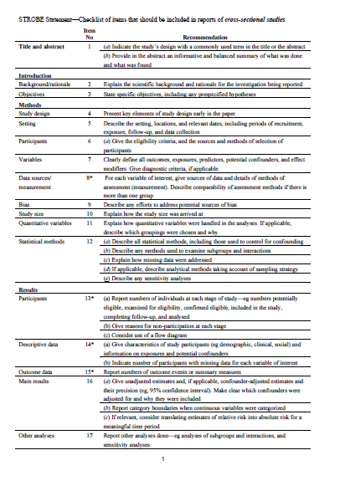****Appendix B. – STROBE Statement Critical Appraisal Tool**

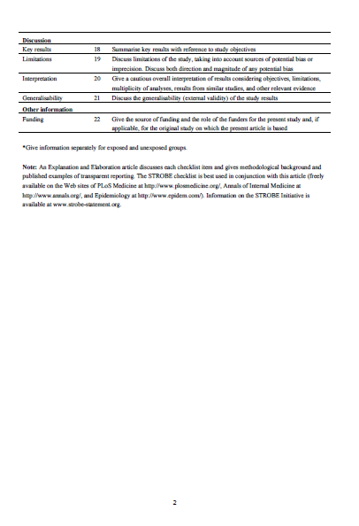

**Appendix C. – Critical appraisal table of STROBE scores for each study**

Y = item met

N = item not met

|  |  |  |  |  |  |  |  |  |  |  |  |  |  |  |  |
| --- | --- | --- | --- | --- | --- | --- | --- | --- | --- | --- | --- | --- | --- | --- | --- |
| STROBE Item | | Adams & Riggs  2008 | Cieslak, et al.  2013 | Cosden, et al.  2016 | Creamer & Liddle  2005 | Diehm, et al.  2018 | Gulin  2017 | Ivicic & Motta  2017 | Killian  2008 | Linley & Joseph  2007 | Makadia, et al.  2017 | McKim & Smith-Adcock  2014 | Sodeke-Gregson, et al.  2013 | Trippany, et al.  2003 | Williams, et al.  2012 |
| 1 | Title/abstract | Y | Y | Y | Y | Y | Y | Y | Y | Y | Y | Y | Y | Y | Y |
| 2 | Rationale | Y | Y | Y | Y | Y | Y | Y | Y | Y | Y | Y | Y | Y | Y |
| 3 | Objectives | Y | Y | Y | Y | Y | Y | Y | Y | Y | Y | Y | Y | Y | Y |
| 4 | Design | Y | Y | Y | Y | Y | Y | Y | Y | Y | Y | Y | Y | Y | Y |
| 5 | Setting | Y | Y | Y | Y | N | Y | N | Y | Y | Y | Y | Y | Y | Y |
| 6 | Participants | Y | Y | Y | Y | N | Y | Y | N | N | Y | Y | Y | Y | N |
| 7 | Variables | N | Y | Y | Y | Y | Y | Y | Y | Y | Y | Y | N | Y | Y |
| 8 | Measurement | Y | Y | Y | N | N | Y | Y | Y | Y | N | Y | N | N | Y |
| 9 | Bias | N | N | N | N | Y | Y | N | N | Y | Y | N | N | N | Y |
| 10 | Study size | N | N | N | N | N | Y | N | N | Y | Y | Y | Y | N | Y |
| 11 | Variables | N | Y | Y | N | Y | Y | N | Y | N | Y | Y | Y | Y | Y |
| 12 | Statistical Methods | Y | Y | N | N | Y | Y | Y | N | Y | Y | N | Y | N | Y |
| 13 | Participants | Y | Y | N | Y | N | Y | N | Y | Y | Y | Y | Y | Y | Y |
| 14 | Descriptive data | Y | Y | N | Y | Y | Y | Y | N | Y | Y | Y | N | Y | Y |
| 15 | Outcome data | Y | Y | Y | N | Y | Y | Y | N | Y | Y | Y | Y | Y | Y |
| 16 | Results | N | Y | N | N | Y | Y | N | N | N | Y | N | Y | Y | N |
| 17 | Other analyses | Y | Y | Y | Y | Y | Y | Y | N | N | Y | N | N | N | Y |
| 18 | Discussion results | Y | Y | Y | N | Y | Y | Y | Y | Y | Y | Y | Y | Y | Y |
| 19 | Discussion limitations | Y | Y | Y | Y | Y | Y | Y | N | Y | Y | Y | Y | N | Y |
| 20 | Interpretation | Y | Y | Y | Y | Y | Y | Y | Y | Y | Y | Y | Y | Y | Y |
| 21 | Generalisability | Y | Y | Y | N | Y | N | N | Y | Y | Y | Y | Y | N | Y |
| 22 | Funding | N | Y | Y | N | N | N | N | N | N | N | N | Y | N | N |
| Total |  | 16 | 20 | 16 | 12 | 16 | 20 | 16 | 12 | 17 | 20 | 17 | 18 | 13 | 19 |

**Appendix D. – Author guidelines for submission to the Journal of Trauma & Dissociation**

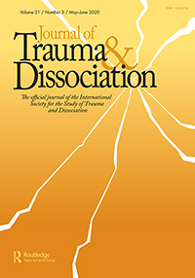

About the Journal

*Journal of Trauma & Dissociation* is an international, peer-reviewed journal publishing high-quality, original research. Please see the journal's [Aims & Scope](https://www.tandfonline.com/action/journalInformation?show=aimsScope&journalCode=WJTD) for information about its focus and peer-review policy.

Please note that this journal only publishes manuscripts in English.

*Journal of Trauma & Dissociation* accepts the following types of article:

The Journal of Trauma & Dissociation is the official scientific journal of the International Society for the Study of Trauma and Dissociation. The Journal of Trauma & Dissociation, dedicated to publishing peer-reviewed scientific literature on dissociation and trauma, seeks manuscripts on theory, basic science research, clinical treatment and research related to interpersonal trauma and/or dissociation in children and adults. The Journal welcomes contributions from a variety of different approaches including anthropological, cross-cultural, epidemiological, neurobiological, psychological, psychometric, psychotherapeutic, and social viewpoints. 2016 Journal Citations Report® ranks Journal of Trauma & Dissociation 64th out of 121 journals in Clinical Psychology and 70th out of 139 journals in Psychiatry with a 2016 Impact Factor of 1.682 © 2017 Clarivate Analytics, Journal Citation Reports®

Peer Review and Ethics

Taylor & Francis is committed to peer-review integrity and upholding the highest standards of review. Once your paper has been assessed for suitability by the editor, it will then be double blind peer reviewed by independent, anonymous expert referees. Find out more about [what to expect during peer review](http://authorservices.taylorandfrancis.com/what-to-expect-during-peer-review/) and read our guidance on [publishing ethics](http://authorservices.taylorandfrancis.com/ethics-for-authors/).

Preparing Your Paper

* Should be written with the following elements in the following order: title page; abstract; keywords; main text introduction, materials and methods, results, discussion; acknowledgments; declaration of interest statement; references; appendices (as appropriate); table(s) with caption(s) (on individual pages); figures; figure captions (as a list)

Style Guidelines

Please refer to these [quick style guidelines](http://authorservices.taylorandfrancis.com/tf_quick_guide/) when preparing your paper, rather than any published articles or a sample copy.

Please use American spelling style consistently throughout your manuscript.

Please use double quotation marks, except where “a quotation is ‘within’ a quotation”. Please note that long quotations should be indented without quotation marks.

Formatting and Templates

Papers may be submitted in Word format. Figures should be saved separately from the text. To assist you in preparing your paper, we provide formatting template(s).

[Word templates](http://authorservices.taylorandfrancis.com/formatting-and-templates/) are available for this journal. Please save the template to your hard drive, ready for use.

If you are not able to use the template via the links (or if you have any other template queries) please contact us [here](http://authorservices.taylorandfrancis.com/contact/).

References

Please use this [reference guide](http://www.tandf.co.uk/journals/authors/style/reference/tf_APA.pdf) when preparing your paper.

Taylor & Francis Editing Services

To help you improve your manuscript and prepare it for submission, Taylor & Francis provides a range of editing services. Choose from options such as English Language Editing, which will ensure that your article is free of spelling and grammar errors, Translation, and Artwork Preparation. For more information, including pricing, [visit this website](https://www.tandfeditingservices.com/?utm_source=WJTD&utm_medium=referral&utm_campaign=ifa_standalone).

Checklist: What to Include

1. **Author details.** All authors of a manuscript should include their full name and affiliation on the cover page of the manuscript. Where available, please also include ORCiDs and social media handles (Facebook, Twitter or LinkedIn). One author will need to be identified as the corresponding author, with their email address normally displayed in the article PDF (depending on the journal) and the online article. Authors’ affiliations are the affiliations where the research was conducted. If any of the named co-authors moves affiliation during the peer-review process, the new affiliation can be given as a footnote. Please note that no changes to affiliation can be made after your paper is accepted. [Read more on authorship](http://authorservices.taylorandfrancis.com/defining-authorship/).
2. You can opt to include a **video abstract** with your article. [Find out how these can help your work reach a wider audience, and what to think about when filming](http://authorservices.taylorandfrancis.com/video-abstracts/).
3. **Funding details.** Please supply all details required by your funding and grant-awarding bodies as follows:   
   *For single agency grants*   
   This work was supported by the [Funding Agency] under Grant [number xxxx].   
   *For multiple agency grants*   
   This work was supported by the [Funding Agency #1] under Grant [number xxxx]; [Funding Agency #2] under Grant [number xxxx]; and [Funding Agency #3] under Grant [number xxxx].
4. **Disclosure statement.** This is to acknowledge any financial interest or benefit that has arisen from the direct applications of your research. [Further guidance on what is a conflict of interest and how to disclose it](http://authorservices.taylorandfrancis.com/what-is-a-conflict-of-interest/).
5. **Data availability statement.** If there is a data set associated with the paper, please provide information about where the data supporting the results or analyses presented in the paper can be found. Where applicable, this should include the hyperlink, DOI or other persistent identifier associated with the data set(s). [Templates](http://authorservices.taylorandfrancis.com/data-availability-statement-templates/) are also available to support authors.
6. **Data deposition.** If you choose to share or make the data underlying the study open, please deposit your data in a [recognized data repository](http://authorservices.taylorandfrancis.com/data-repositories/) prior to or at the time of submission. You will be asked to provide the DOI, pre-reserved DOI, or other persistent identifier for the data set.
7. **Supplemental online material.** Supplemental material can be a video, dataset, fileset, sound file or anything which supports (and is pertinent to) your paper. We publish supplemental material online via Figshare. Find out more about [supplemental material and how to submit it with your article](http://authorservices.taylorandfrancis.com/enhancing-your-article-with-supplemental-material/).
8. **Figures.** Figures should be high quality (1200 dpi for line art, 600 dpi for grayscale and 300 dpi for color, at the correct size). Figures should be supplied in one of our preferred file formats: EPS, PDF, PS, JPEG, TIFF, or Microsoft Word (DOC or DOCX) files are acceptable for figures that have been drawn in Word. For information relating to other file types, please consult our [Submission of electronic artwork](http://authorservices.taylorandfrancis.com/submission-of-electronic-artwork) document.
9. **Tables.** Tables should present new information rather than duplicating what is in the text. Readers should be able to interpret the table without reference to the text. Please supply editable files.
10. **Equations.** If you are submitting your manuscript as a Word document, please ensure that equations are editable. More information about [mathematical symbols and equations](http://authorservices.taylorandfrancis.com/mathematical-scripts/).
11. **Units.** Please use [SI units](http://www.bipm.org/en/si/) (non-italicized).

# **Paper Two: Empirical Research Paper**

**Exploring the perceived influence of personal experiences of mental health difficulties and trauma on Clinical Psychologists’ professional practice**

Word Count: 7,888

*This paper has broadly been written to the standard required for submission to publication in the British Journal of Clinical Psychology (see Appendix. 17 for details).*

# **Abstract**

**Objectives.** This research aimed to explore how personal experiences of trauma and mental health difficulties might influence clinical psychologists in professional practice. **Design.** Semi-structured interviews were conducted and analysed using thematic analysis - a flexible qualitative method for identifying, organising and analysing themes within a data set. **Method.** Seventeen clinical psychologists (16 females, 1 male) participated in interviews via online video link or over the telephone. **Results.** Three themes were identified: (1) Experience as a clinical tool, with subthemes of (a) skills (b) empathy and connection, and (c) something to monitor and manage, (2) The interaction of personal and professional, with subthemes of (a) impact on career choices (2) impact on the self, and (3) Secrecy, with subthemes of (a) self-preservation, (b) standards for a psychologist, and (c) changing over time. **Conclusions.** Experiences of mental health difficulties and trauma become an integrated part of a clinical psychologist’s practice, with an interactive relationship between the personal and professional influence. Secrecy still surrounds conversations about this perceived influence, which highlighted pervading stigma and harmful narratives of perceived high standards for clinical psychologists. The clinical implications and limitations of the study are discussed and suggestions for further research are made.

*Keywords*: clinical psychologists; therapists; lived experience; practice

# **Practitioner Points**

* The paper presents research relevant to clinical psychologists, mental health professionals and to trainers and employers of this group.
* The data presented provides a useful insight into how clinical psychologists perceive and use their lived experience of mental health difficulties and trauma in their clinical practice.
* It highlights experiences and perceptions of stigma in mental health services that may be of consideration, particularly regarding professional disclosure and help-seeking.

# **Introduction**

The concept of the Wounded Healer, first coined by Jung (1951), refers to individuals who, after experiencing personal suffering, are driven by a desire to relieve the suffering of others. These individuals use their own ‘wounds’ to ‘heal’ others in distress through a process of increased empathy, connection and psychological awareness (Conchar & Repper, 2014). The Wounded Healer construct has been discussed extensively in relation to the work of mental health professionals (Zerubavel & Wright, 2012).

There is good evidence that mental health professionals report high incidences of childhood adversity, trauma, distress and mental health difficulties. Pope and Feldman-Summers (1992) surveyed 250 female and 250 male psychologists, finding that two thirds of female and one third of male participants had a history of physical or sexual abuse during childhood. When comparing mental health professionals with other professions, Elliot and Guy (1993) found a higher prevalence of childhood trauma in 340 female psychotherapists compared with 2,623 women working in other professions. Galvin and Smith (2015) similarly found significantly higher rates of negative childhood experiences in 168 UK trainee clinical psychologists when compared with 253 PhD students. In a survey of 749 psychologists in the US, 74% self-reported experiencing personal distress within the previous three years, with 36% reporting that the distress had negatively impacted the care they provided (Guy, Poelstra, & Stark, 1989). Surveys conducted in the UK found that 63% of 678 clinical psychologists (Tay, Alcock, & Scior, 2018) and 67% of 348 trainee clinical psychologists (Grice, Alcock, & Scior, 2018) reported experiencing mental health difficulties.

To what extent these experiences influence the career choices of mental health professionals is difficult to capture. Supporting the Wounded Healer construct, research suggests that individuals with these experiences may be more likely to choose to work in a mental health profession, and that for many, the decision to join the profession was directly influenced by difficult personal experiences (Aina, 2015; Barnett, 2007; Conchar & Repper, 2014; Cushway, 1995; Huynh & Rhodes, 2011; Murphy & Halgin, 1995; Nikčević, Kramolisova-Advani, & Spada, 2007).

Despite research showing high incidences of trauma and mental health difficulties in mental health professionals, research into what impact these experiences might have is limited and unclear. Jung’s (1951) construction of the Wounded Healer was originally posited as a positive process, suggesting that these ‘healers’ can make more effective therapists. Their personal experiences are theorised to give a fuller understanding of painful experiences, deepen the therapists empathic stance, give them a heightened appreciation for the difficulties of therapy and a greater faith in the recovery process (Fussell & Bonney, 1990; Gelso & Hayes, 2007; Zerubavel & Wright, 2012). However, the Wounded Healer construct has become multi-faceted over time to include the potential for professional impairment, referring to those whose personal distress, historic or current, adversely impacts their clinical work (Conchar & Repper, 2014). Those who have ‘personal wounds’ have been theorised to be at increased risk of poorer mental health, vicarious trauma and burnout, and in practice are at risk of transferring unmet emotional needs onto clients, overidentification and joining the professions to have ‘vicarious therapy’ (Cain, 2000; Conchar & Repper, 2014; Forrest, Elman, Gizara, & Vacha-Haase, 1999; Gilroy, Carroll, & Murra, 2001; Newcomb, Burton, Edwards, & Hazelwood, 2015; Zerubavel & Wright, 2012; Zosky, 2013).

Research has previously evidenced a potential link in mental health professionals between a personal history of trauma and poorer current wellbeing (Follette, Polusny, & Milbeck, 1994) and an increased vulnerability to vicarious trauma (Cieslak et al., 2013; Cosden, Sanford, Koch, & Lepore, 2016; Diehm, Mankowitz, & King, 2018; Gulin, 2017; Ivicic & Motta, 2017; Killian, 2008; Trippany, Wilcoxon, & Satcher, 2003; Williams, Helm, & Clemens, 2012). However, the evidence is inconsistent, with other research failing to find this link (Adams & Riggs, 2008; Creamer & Lidle, 2005; Elliot & Guy, 1993; Galvin & Smith, 2015; Linley & Joseph, 2007; Makadia, Sabin-Farrell, & Turpin, 2017; McKim & Smith-Adcock, 2014; Sodeke-Gregson, Holttum, & Billings, 2013; Trippany et al., 2003).

***Influence on practice***

The evidence is mixed in clarifying what impact these experiences might have on practice. Counsellors who reported a history of negative parent-child interactions were rated as more effective in their practice, measured by supervisor ratings, in a study by Watts, Trusty, Canada and Harvill (1995). Trusty, Ng and Watts (2005) found that an insecure attachment style was associated with greater levels of empathy in trainee counsellors. The perception of having greater empathy due to personal experiences of distress has been reported by a range of mental health professionals (Aina, 2015; Cain, 2000; Gilroy et al., 2001; Gilroy, Lynne, & Murra, 2002; Huynh & Rhodes, 2011). Levine (2015), in contrast, found that increased experiences of childhood relational trauma predicted lower affect consciousness, psychological mindedness and mindfulness in therapists.

Oates, Drey and Jones (2017) interviewed mental health nurses to explore the influence of personal mental health difficulties on their nursing practice. Participants reported a perception of their practice being enhanced by their experience, describing a deeper understanding of distress and recovery and increased feelings of empathy towards their patients. Telepak (2010) found similar results in an exploration of the impact of historic depression, anxiety and substance misuse on the practice of therapy professionals. Participants who felt they had effectively processed their own experiences considered themselves better able to be empathetic and establish therapeutic relationships. They described their experiences as having had a positive impact on their technical skills as a therapist and having improved their personal self-care practices. Alongside this, participants also felt their experience could negatively impact their ability to be effective with clients and they could feel more at risk of becoming impaired. These findings are echoed by Charlemagne‐Odle, Harmon and Maltby (2014), who qualitatively studied the impact of experiencing distress whilst practicing as a clinical psychologist. Participants reported that distress could adversely impact their clinical work through feeling more emotional, or passive in client sessions, but they also experienced a sense of increased empathy with their clients. In all three of these qualitative studies, participants discussed concerns surrounding disclosure and seeking support due to stigma (Charlemagne-Odle, et al., 2014; Oates et al., 2017; Telepak, 2010).

# ***Study Rationale***

Based on the existing literature, the professional influence of personal trauma, psychological distress and mental health difficulties, which from here on will be referred to as lived experience, is still difficult to discern. If personal ‘woundedness’ is as embedded in mental health professions as research suggests, this topic deserves further exploration. Previous research has either focussed on the influence of specific types of lived experience, has measured the influence on specific variables thought to be related to practice, such as empathy, or has grouped mental health disciplines together, making comparison across findings challenging. A narrow focus on lived experience or practice may miss important information due to experiences of distress being broad, complex and unique in their personal interpretation and impact across individuals (Johnstone et al., 2018). In addition, professional practice is arguably a combination of varying factors, which can be difficult to define and separate into individual elements. To address this, a narrower focus on a single mental health profession without limiting to specific forms of lived experience, or assessing specific factors thought to be related to clinical practice, may bring a richer understanding of this topic. No research has yet explored the influence of lived experience on the professional practice of clinical psychologists specifically. Arguably, as an under-researched topic closely related to individual experience, this is a challenging topic to capture quantitatively, therefore a qualitative exploration appears to be the methodology more suited.

Qualitative findings may provide a foundation to inform further research that can clarify some of the previously unclear quantitative results. A richer understanding of the perceived professional influence of lived experience could facilitate supportive conversations about ethical practice and impairment, how professionals with lived experience are supported, and what strengths they bring to their role that can be further developed. A more open dialogue, based in empirical research, could be helpful towards reducing stigma, and help inform decisions about how and when to disclose personal difficulties.

Research Aims

To explore whether traumatic experiences and mental health difficulties are perceived as influential in clinical psychologists' professional practice, and if so, in what ways.

# **Method**

Epistemological Positioning and Reflexivity

The locating and making sense of participants’ experiences was informed by a social constructionist epistemology. This position holds that all knowledge is derived from and maintained by social interactions (Gergen, 1985). It positions truth as being multiple and subjective (Braun & Clarke, 2013), challenging positivist assumptions that knowledge must be a product of induction through empirical methods (Gergen, 1985). Through a social constructionism position, knowledge gained in qualitative research is viewed as an interaction between the participant, the researcher, and the unique social and cultural context they are situated within (Losantos, Montoya, Exeni, Santa Cruz, & Loots, 2016).

It is, therefore, important to reflect that the lead researcher is a third-year trainee clinical psychologist with personal lived experience of mental health difficulties and trauma. There was an awareness throughout that the researcher’s personal experiences and investment would be influential in how sense was made of participants’ stories and could introduce biases, such as a tendency to be more attuned to stories that appeared to reflect more positively on practicing with lived experience, or giving greater weight during analysis to experiences similar to the researcher’s own. Potential biases such as these were reflected upon and managed using tools such as a reflexive journal and peer supervision.

Ethics

Ethical approval for this study was granted by the Staffordshire University Research Ethics panel (Appendix 1 – 2). Participants were provided with the study information prior to giving written consent to participate, which included detailed information on confidentiality, anonymity and their right to withdraw from the study (Appendix 3). Participants were provided a debrief at interview completion (Appendix 4), which included information on how to access support for potential distress arising from the interview. To protect the confidentiality and anonymity of participants, identifying information was altered or omitted during transcription and pseudonyms were maintained throughout analysis and reporting. No incentives were given to take part.

Design

A qualitative, semi-structured interview design was utilised for this study, developed to suit Thematic Analysis (TA) as the method of analysis.

Recruitment

Participants were recruited via an advert posted on the closed ‘UK Clinical Psychology’ Facebook group for trainee and qualified clinical psychologists in the UK. The advertisement contained brief details of the study, the inclusion and exclusion criteria, and a request to contact for further details (Appendix 5).

The criteria for study inclusion were that the participant was a qualified clinical psychologist who had been qualified for at least one year, and self-identified as having had a personal experience of mental health difficulties and/or traumatic experiences. Participants were invited to email the researcher to express interest in taking part. Those who contacted were emailed a participant information sheet (PIS; Appendix 3) and a link to an online survey (Appendices 6 – 10).

The survey consisted of a consent form, which required selecting the ‘I consent’ option before the participant could proceed (Appendix 6). The following pages contained: demographic questions (age, gender, time qualified and area of work), a survey on personal experience of mental health difficulties (based on Grice et al., 2018), the Aversive Childhood Experiences Questionnaire (ACE; Felitti et al., 1998) and the Trauma History Questionnaire (THQ; Hooper, Stockton, Krupnick, & Green, 2011). The ACE and THQ consist of a list of aversive or traumatic experiences, with a single point given per item selected. The 10-item ACE measures experiences before age 18, allowing a score from 0 – 10 of aversive experiences. The 20-item THQ allows a score from 0 – 20 of potential traumatic events experienced across the lifespan. All questionnaires are shown in Appendices 7 – 10.

The survey served a dual purpose of collecting demographic information and as a screening tool to ensure study criteria were met. The dual purpose of the survey was fully described in the PIS. To be eligible for the study, participants needed to select that they were at least one-year post qualified and select at least one mental health difficulty or a minimum of one item on the ACE or THQ.

Once survey data was received, the researcher emailed eligible participants to arrange an interview at their convenience. After scheduling the interview, participants were emailed a consent form and a request for it be returned before the interview (Appendix 11).

Participants

The original target sample size was 12 – 15 participants, based on guidance by Braun and Clarke (2013). Thirty-five people responded to the advertisement and were emailed a PIS and online survey link. Of these, 23 completed the survey and interviews were confirmed with 19 people, two of which were cancelled by the respondents before participating, leaving a total sample of 17 clinical psychologists.

16 participants were female and 1 male, aged between 29 – 57, qualified between 1 – 11+ years, and working with a range of clinical populations. The lived experience across the sample was broad, with 14 having experienced a range of current and/or historic mental health difficulties and 16 participants having one or more aversive or traumatic experience, as measured by the ACE and THQ. The frequency and types of aversive and traumatic events experienced were varied, with the highest ACE score being 6 out of a possible 10 aversive childhood experiences and the highest THQ score being 10 out of a possible 20 traumatic events. Item response rate was high, with only two participants omitting a single response in one questionnaire. The two omitted items were equivalent to a ‘no’ response in the final score, considered appropriate as no statistical tests were being conducted. The demographics are presented in separate tables (Tables 1-2) to protect participants’ anonymity.

**Table 1**

*Participant Demographics*

|  |  |  |  |  |
| --- | --- | --- | --- | --- |
| Pseudonym | Age | Gender | Years Qualified | Area of Work |
| Sam | 29 | Female | 1-3 | Older Adult |
| Lee | 31 | Female | 1-3 | Child and Adolescent |
| Jamie | 31 | Female | 1 - 3 | Health |
| Jan | 34 | Female | 4 - 7 | Adult |
| Mel | 36 | Female | 1 - 3 | Adult |
| Kieran | 37 | Female | 4 - 7 | Adult |
| Jordan | 38 | Female | 4 - 7 | Child |
| Morgan | 39 | Female | 11 + | Child |
| Ashley | 39 | Female | 4 - 7 | Adult |
| Lesley | 39 | Female | 8 - 10 | Child |
| Jo | 39 | Female | 4 - 7 | Adult |
| Max | 40 | Female | 11 + | Child and Adolescent |
| Reese | 40 | Female | 8 - 10 | Adult, Secure Care |
| Danny | 44 | Female | 11 + | Adult Neuropsychology |
| Ronnie | 50 | Female | 11 + | Adult |
| Alex | 53 | Male | 4 - 7 | Adult |
| Chris | 57 | Female | 11 + | Child |

**Table 2**

*Participant Experiences of Mental Health Difficulties and Trauma*

*Note.* Summary of data from MH experience survey, Adverse Childhood Experiences (ACE) Questionnaire and Trauma History Questionnaire (THQ). The ACE is scored from 0 – 10 and the THQ is scored from 0 – 20.

|  |  |  |  |
| --- | --- | --- | --- |
| Mental Health Difficulty | Difficulty Identified | ACE TOTAL | THQ TOTAL |
| Yes | Past Anxiety, PTSD | 4 | 6 |
| Yes | Past Anxiety | 0 | 1 |
| Yes | Past eating disorder, severe depression, | 2 | 2 |
| Yes | Past severe depression, past anxiety, past addiction, self-harm, EUPD | 5 | 5 |
| Yes | Past severe depression, eating disorder, self-harm | 6 | 7 |
| No |  | 3 | 8 |
| Yes | Past depression, current anxiety, PTSD | 2 | 4 |
| Yes | Past depression, eating disorder | 0 | 2 |
| Yes | Past severe depression, current anxiety, OCD, PD | 7 | 5 |
| No |  | 0 | 2 |
| Yes | Past depression, past anxiety, | 1 | 7 |
| No |  | 6 | 4 |
| Yes | Current depression, past severe depression, current anxiety, past eating disorder, dissociative disorder | 3 | 6 |
| Yes | Current anxiety, vomiting phobia | 0 | 0 |
| Yes | Past anxiety | 3 | 1 |
| Yes | Past depression, past anxiety, past eating disorder, past substance use | 3 | 10 |
| Yes | Past anxiety, past depression | 2 | 1 |

Data collection

Participants were recruited from the UK and Ireland and were offered an online video interview using Skype or Zoom, or a face-to-face interview at Staffordshire University. All participants opted for online video call interviews, though one interview was conducted over the telephone due to difficulty connecting via Skype.

Interviews were conducted by the lead researcher using a semi-structured interview schedule to guide discussion. A semi-structured design was chosen as a flexible method of data collection as it allowed several topics to be discussed and enabled tailoring of the schedule depending on participants’ responses (Willig, 2013). The schedule contained questions covering career background and motivations, impact of personal experiences, personal wellbeing, and disclosure (see Appendix 12). The average interview length was 78 minutes, ranging between 55 – 102 minutes.

Data Analysis

Thematic analysis was undertaken following the six-phase method outlined by Braun and Clarke, 2006. The method moves from data familiarisation, to coding, into theme development, then review in flexible stages. An inductive thematic approach to analysis was applied, which is a data-driven approach allowing for identification of unanticipated themes in the data whilst still driven by core research questions. Interviews were transcribed by the researcher verbatim. An example extract of an interview transcript is shown in Appendix 13.

At first stage of analysis, familiarity with the data was gained through transcription and the repeated reading of transcripts. Initial patterns and ideas for codes were recorded (see Appendix 14) during this stage. Using a computer programme (NVivo 12) to facilitate data management, transcripts were read and initial codes at a semantic and latent level were generated. See Appendix 15 for an example of coding on NVivo 12. Codes were examined in relation to one another and the supporting data and revised throughout the coding process. Overlapping codes were merged, distinct codes expanded, and irrelevant codes or those with too few instances were discarded.

Codes were written onto index cards and the remaining analysis was conducted without the use of NVivo 12. Codes were organised into broader themes and subthemes through a process of arranging code-labelled cards in search of patterns within the data (Appendix 16). A continuing process of examining, reorganising and refining themes alongside the supporting data was engaged in to ensure that data extracts supported theme presence and they formed a coherent pattern. Themes were further refined and defined by being given names that meaningfully represented the topic of the intended theme. Data checking was undertaken during analysis in collaboration with the research supervisor, in order to ensure the coherence of identified themes and subthemes.

# **Findings**

The analysis generated three themes to represent how participants felt lived experience influenced their professional practice, with subthemes present in each theme. These were: Experience as a clinical tool, The interaction of personal and professional, and Secrecy. These themes, the subthemes, and the relationships between them are detailed in Figure 1.

Standards for a psychologist

Self-preservation

Changing over time

Skills

Empathy and connection

Something to monitor and manage

Impact on the self

Impact on career choices

*Figure 1.* Thematic map of themes and subthemes. Links between themes and subthemes are identified by dotted lines.

Experience as a clinical tool

Participants described a process of lived experience being drawn on across the skills used in clinical work. This was felt to enhance clinical skills, however, it was also something that required self-monitoring and reflection. The theme is divided into three sub-themes: skills, empathy and connection, and something to monitor and manage.

Skills

Lived experience was felt to enhance therapy skills, such as sitting with and tolerating distress, validating clients, and model specific techniques. Personal experiences of recovery strengthened the ability to have and communicate hope.

“*I am a lot more comfortable at sitting with people in that distress and helping them to hold it and helping them to contain it…*” **Mel**

“*It’s given me faith that the people that I work with can do that (…) a belief in them that ‘yeah you can get through this, you can build your resilience, you can find your strengths’...*” **Chris**

*Empathy and connection*

From their experiential understanding, all participants felt increased empathy for clients and a deeper understanding of their experiences. This was felt to positively influence how they connected with and built a therapeutic alliance with their clients.

“…*actually having some sort of insight and understanding into how you could get into a mindset of feeling suicidal, and that seeming the only option that you have…* *I can have some grasp of that. It’s not something that’s theoretical*…” **Kieran**

“…*there's a way of connecting in a slightly different way because you are hearing things that resonate so clearly with what you went through yourself*…” **Danny**

When participants’ lived experience had commenced after qualifying, they described developing a new understanding of the experiences of those they work with that changed their practice.

“…*it’s made me a better psychologist because I think I can sit with that lived experience of absolute shittiness… and I think before I would have felt like I needed to say something more professional*.” **Lesley**

“… *having sat in appointments with her and seeing how staff can be, I think that just hammered home to me what a position of power I have (…) …how (…) the things that I say will probably stay with them* [client] *for the rest of their life*.” **Lee**

*Something to monitor and manage*

Few participants gave specific examples of occasions they felt their lived experience had been unhelpful in practice or they had felt impaired, but many questioned this as a possibility. The concern of a potential increased risk if the influence was not monitored and managed was common. Lived experience was perceived as influential clinical judgements, which had the potential to create unhelpful biases.

“… *it's really hard to like tread the line between scaffolding and structuring and how much you’re leading and just setting up for them to say something specific…* *I wonder how many of my questions are just so geared and directed to my own experience*...” **Jamie**

Assuming commonality of experiences was a potential risk that needed to be monitored.

“…*when I meet someone saying ‘my parents struggled with alcoholism’, I have to be as mindful as I can be of a response of assuming that that was just like my experience, and you responded in the same to it as I did… Because realistically, they could have responded to it in a million and one different ways and their experience was arguably nothing like my experience*.” **Alex**

Most participants chose not to use disclosure of lived experience directly as a therapeutic tool, though some had. It was felt that disclosure must be carefully reflected upon, managed, and should always be about the client’s needs or else it could be damaging for the therapy process and therapeutic relationship.

“…*I try to think about ‘am I doing this for me or for them*?’…” **Ronnie**

How the potential influence of lived experience was managed varied across participants, and could often depend on how open they had chosen to be about their experience in a professional context. Honest reflection and personal awareness were viewed as integral.

*“… I think had I not been fully aware of myself, of what I was going through, there would have been a potential for those triggers to be having an impact much more…”* **Danny**

Supervision, personal therapy or an active process of self-reflection were discussed as common tools to manage and monitor lived experience.

*“Supervision’s really important (…) if I’m experiencing an emotion that’s more to do with my personal experiences (…) in my head I’ll think to myself ‘I’ll come back to that later’, I need to focus on what this person is saying (…) Quite often I’ll take it to supervision.”* **Sam**

Participants questioned themselves about how influential their lived experience is objectively. Some felt unsure if their feelings, decisions and approach in practice were the same as any psychologist without lived experience might demonstrate, because they had no way to separate out their personal experience to measure this.

“*I don’t know with the skills that we have as psychologists, whether these are all things that we would do anyway (…) it’s really difficult to say what kind of psychologist would I be without having had the experiences I’ve had.*” **Jordan**

Interaction of personal and professional

Participants discussed an interacting relationship between personal and professional experience. The theme is divided into two subthemes: impact on career choices and impact on the self.

*Impact on career choices*

Lived experience impacted choices made throughout participants’ careers as clinical psychologists. For many, it had been influential in their motivation to join the profession and had shaped choices about specialty. When choosing a specialty, participants varied in how their lived experience influenced this. Generally, they were cautious of working with difficulties too similar to their own experience. For some it was an active choice to avoid, due to the potential impact this could have personally and/or how effective they would be professionally.

“…*I think I have tried to avoid environments that I feel like were very similar to my own experiences. And I don’t know whether that’s because I feel like it would affect me differently (…) or whether I just don’t want people to think like I'm trying to cure myself*…” **Morgan**

Lived experience appeared to shape what was valued as a clinical psychologist, with individual preferences in how to work often being linked to personal experiences of difficulty, services, professionals or therapy models.

*“…as a psychologist I think a lot about the notes that I write (…) about letters I send and how I word things… because the experience of getting my notes back was quite disappointing (…) the things that stayed with me the most were the things that people had got wrong…”* **Jan**

“*You know* [receiving CBT] *on some level helped saved my life (…) I guess that would influence me more than just, I dunno, reading it in a textbook or having a lecture on it*…” **Morgan**

*Impact on the self*

Professional work in turn influenced participants personally. Participants used psychological skills on themselves to manage own distress, and some felt that they processed their own lived experience alongside knowledge and experience they gained in their career. These processes were viewed positively.

“… *when I worked on an acute admission ward (…) I was handing over a client (…) so I ran through the history (…) and* [colleague] *said ‘well god, yeah pretty challenging physical abuse’ and I just-* *I remember saying ‘is that what constitutes physical abuse?*’ *And he just looked at me, and in that moment it’s like ‘right, okay, that’s what happened* [to me]’.” **Jo**

“…*that’s why you chose to do psychology cause you’re messed up* ((laughs)) *but actually, if this* [being a psychologist] *has improved my mental health and means I can help other people, why is that a bad thing?...”* **Jordan**

Being reminded of distressing personal experiences in clinical sessions, during lectures or training was a common experience and could be emotionally challenging.

“…*I’ve been sitting with people and they’ve said to me something that has happened to them and it’s like a bulb has gone off and I’ve been like ‘oh shit… that’s happened to me too’… and that’s been quite hard*.” **Jan**

Experiences of distress were influential in how participants cared for themselves personally and professionally.

“*I can be quite sensitive (…) I can go from being okay to suddenly being really upset. So yeah I do a lot of self-care things and like think about what’s important for me to keep doing to maintain my wellbeing*…” **Sam**

Secrecy

The desire to keep lived experience hidden in a professional environment was common. How participants had chosen to manage professional disclosure varied and could be a changing process. The theme is divided into three subthemes: self-preservation, standards for a psychologist, and changing over time.

*Self-preservation*

Secrecy surrounded lived experience for many. Few had been completely open about their experiences in a professional context, some open only when necessary or unavoidable, and some had chosen not to disclose at all.

“*I kept very, very secret my own issues that I've had previously.*” **Ashley**

“*I didn’t discuss it* [lived experience] *with anyone. I have never discussed this with anyone.”* **Max**

The urge for secrecy often related to a sense of disclosure feeling unsafe.

“*I have to be totally honest, it has never felt safe to share my own experience*.” **Jo**

The fear of being stigmatized against, particularly of competence being questioned, was closely associated with the idea of disclosure being unsafe.

“*I very much haven’t been completely open because… I guess worries of being seen differently, people becoming overly worried about me or doubting my resilience and ability to do the job.”* **Kieran**

For some, the reluctance to be open had been reinforced by experiences of observing stigma.

“… *I remember this comment that a psychiatrist made that ‘oh I hate working with anorexic girls because they just turn out to be personality disordered adults’ (…) and I felt like ‘y’know how could I possibly talk about my experience to people in a position of power over me if that’s what you think’*…” **Morgan**

*Standards for a psychologist*

There was a recurring narrative about the standards a psychologist has to live up to, particularly, underlying beliefs that a psychologist should not experience or disclose distress, and this influenced how participants judged their own difficulties.

“… *feeling like you’ve got to be doing all the right things yourself, because you should know them because you’re trying to teach them* ((laughs)) *to everybody else…”* **Ronnie**

Relevant in this was a psychologist’s role as a helper, with clients but also to other professionals within teams.

“*I definitely experienced that idea like somehow I should be on top of this, I should know better. I see that reinforced with colleagues, it’s like something awful happens and it’s ‘oh we’ll go to psychology team they’ll sort it out for us’ (…) there is this perception that we can somehow tolerate things in a superhuman way*.” **Reese**

*Changing over time*

Views about secrecy and disclosure could change over time. Many participants had felt more able to disclose lived experience professionally as their career progressed. Participants linked things such as confidence, personal acceptance of own difficulties and self-compassion with an increasing ability to be open.

“*I definitely feel more confident overall in myself and my abilities. You kind of collect that sort of positive feedback of things that’ve gone well and people that think highly of you (…) I feel much more safe now to be honest about* [lived experience] …*certainly with colleagues*…” **Jordan**

# **Discussion**

The current study aimed to explore perceptions of how personal experiences of mental health difficulties and trauma might influence the professional practice of clinical psychologists. Lived experience was a tool that was integrated into psychologists’ practice, drawn upon within therapy, especially in empathising and connecting with clients. The influence on clinical skills was generally interpreted as being positive for practice. However, there were simultaneous concerns of a potential negative impact, particularly that personal lived experience could lead to bias if not self-monitored. A theme of an interacting relationship between personal and professional experience developed, in which lived experience influenced choices throughout careers, and in turn careers could have a personal impact on the individual. Secrecy surrounded conversations about lived experience in a professional context, with fears of stigma being a prominent consideration in disclosure.

The findings highlighted that how lived experienced is perceived to influence practice is more complex than a simple ‘positive’ and ‘negative’ impact. Lived experience was embedded within the clinical skills used in practice in a multi-faceted way, and the experience influenced wider value sets in working. All participants reported a sense of increased empathy and understanding in some form, supporting Wounded Healer theories, which suggest that drawing upon experiential knowledge increases insight into distress and the recovery process and helps to build a therapeutic alliance (Conchar & Repper, 2014; Fussell & Bonney, 1990; Jung 1951; Newcomb et al., 2015; Zerubavel & Wright, 2012). It supports previous findings of a perception of greater empathy in practice, (Aina, 2015; Cain, 2000; Charlamagne-Odle et al., 2014; Gilroy et al., 2001; Gilroy et al., 2002 Huynh & Rhodes, 2011; Oates et al., 2017; Telepak, 2010), highlighting its consistency as a finding.

Alongside the beneficial influence of lived experience was a sense of caution. The same tool that enhanced practice, experiential knowledge, could equally be viewed as unhelpful. There was an awareness from participants of being vulnerable to risks of bias and identification which required monitoring. Over-identification has previously been theorised as a potential risk to practice in those with lived experience in Wounded Healer theories (Conchar & Repper, 2014; Newcomb et al., 2015; Zerubavel & Wright, 2012), which the current findings support. That many participants identified lived experience as influential in their career motivations and decisions further supports Wounded Healer theories and past research (Aina, 2015; Barnett, 2007; Conchar & Repper, 2014; Cushway, 1995; Huynh & Rhodes, 2011; Murphy & Halgin, 1995; Nikčević et al., 2007).

For the participants whose lived experience came after qualification, they were able to directly identify changes in their practice as a result. The ability to compare practice ‘before and after’ psychological distress supports that an experiential understanding of distress does influence practice. A curious contrast was that for those whose lived experience was historic, therefore always present in their practice, many questioned how influential the experience was in reality. Participants reflected on how they could evidence something so subjective despite most feeling sure it was influential. The questioning of objectivity and ability to measure the influence is a novel finding of this research, and could be impacted by clinical psychology’s origins in the scientist-practitioner model (Peterson, 2000), core competencies of which are the assessment and application of scientific methods and findings to clinical practice (Shapiro, 2002). The model is not the sole model of practice used in the profession, but it is still influential in clinical psychology training, and argued to be embedded within the identity of the profession (Henriques, 2013).

Participants also felt that self-monitoring was required in the use of personal disclosure of lived experience to clients. Concerns surrounding taking focus from the needs of the client and a negative impact onto therapeutic boundaries echoes findings by Oates et al. (2017), where nurses reported not using direct disclosure for similar reasons. Interestingly, research by Lewis-Holmes (2016) suggests that the concerns that MHPs have about clinical disclosure mirror those found in service users. Mental health service-users thought that lived experience may help the professional have a better understanding of them and their experiences, but also reported concerns about the clinician’s potential robustness, felt that the disclosure should be relevant without assuming commonality, and should not move the focus away from the their own issues (Lewis-Holmes, 2016). This suggests that participants’ desire to seriously reflect on the use of disclosure may be well founded.

The process of continual reflection and monitoring of how the personal may impact professional overlapped all themes. That personal experience was influential in professional practice, and professional experience impacted the personal, is not unique to those with lived experience. Goodbody and Burns (2011) defined personal and professional development in clinical psychology as a process of developing an understanding of the reciprocal relationship between personal life history and professional experience. Perhaps what makes this more notable in those with lived experience is the nature of the experiences, and the potential consequences of a lack of awareness of that reciprocity.

The potential increased vulnerability to negative effects of therapeutic work is commonly discussed in Wounded Healer literature. Participants varied in reports of feeling an increased vulnerability to effects such as vicarious trauma, which is reflective of previous mixed quantitative findings on this topic (Baird & Kracen, 2006). These mixed findings may be due to the influence of lived experience on vicarious trauma depending on additional factors (Sabin-Farrell & Turpin, 2003), one such proposed factor being self-care practices. The current findings can suggest that previous lived experience may positively influence self-care practices, and self-care has previously been suggested to reduce the impact of vicarious trauma (Dombo & Gray, 2013). Taken together, an increased investment in self-care by those with lived experience may be mitigating potential negative consequences of client work.

The experience of clients’ stories resonating with personal experience in a painful way supports previous findings (Aina, 2015; Telepak, 2010; Guy et al., 1989). The reports of distress caused when participants identified personally with content from teaching and training materials is more novel to this research. Social work education research appears to have considered this potential distress in those with lived experience more so than other helping disciplines. For example, Carello and Butler (2014) argued that those with lived experience are at risk of retraumatisation by social work teaching materials, particularly when teaching relates to trauma, and this can impact educational achievement. The authors have stressed the need for trauma-informed educational practice, which recognises the additional demands on students with a history of trauma and applies trauma-informed principles to teaching (Carello & Butler, 2015). The current findings cannot generalise to suggest that this approach is lacking in clinical psychology training, but may highlight the importance of further consideration.

In the literature, the negative personal impact of therapeutic work is often discussed in more detail than the positive impact, especially amid growing interest in vicarious trauma and trauma-informed mental health services (Sweeney, Filson, Kennedy, Collinson, & Gillard, 2018). The narrative that therapy professionals with historic lived experience might enter the profession to ‘heal’ themselves, sometimes referred to as ‘vicarious therapy’, is often discussed in negative terms, with a common concern being that the therapist’s distress is unrecognised or unresolved and contributes towards professional impairment (Forrest et al., 1999; Zerubavel & Wright, 2012). In the current study, many participants reported a fear of being labelled as such. Despite the concern, the descriptions of the profession enabling some to process their experiences and self-apply psychological skills in a positive way might challenge this negative perception. It is more in line with early conceptions of the Wounded Healer construct, that the process of self-healing through therapeutic work is beneficial for the therapist and the client (Conchar & Repper, 2014). The findings suggest that ‘self-healing’ in some form may be common for those with lived experience and could be a positive process going undiscussed due to concerns about being associated with the negative connotations of ‘vicarious therapy’.

In the current study, the minority of stories in participants’ accounts about lived experience negatively influencing practice raise questions as to what participants may or may not have felt comfortable discussing during their interviews, and why. Being interviewed by a trainee clinical psychologist may have impacted this. Participants may have felt reluctant to share negative experiences of training or professional experiences, out of a sense of wanting to protect the trainee. Indeed, more than one participant apologised after talking about difficulties during work or study, stating they did not want to ‘scare’ the interviewer. The power relationship between qualified and trainee clinical psychologists, which in practice is usually a supervisor and supervisee relationship, may have meant that some participants felt a need to present themselves positively, feeling less comfortable discussing things that could reflect negatively on their practice.

Participants’ concerns at being associated with negative perceptions of having lived experience contributed to the reluctance to be open professionally. In the current findings, the contributing and reinforcing factors for non-disclosure were complex, appearing to be generated internally and externally in an interactive way, and were closely tied to stigma. Externally, participants’ observations of stigma being influential in their unwillingness to be open reinforces evidence that stigma continues to persist in mental health services with negative consequences (Servais & Saunders, 2007; Wahl & Aroesty-Cohen, 2010).

Closely associated with external factors, barriers came from within through internalised standards of acceptable experiences and behaviour for a clinical psychologist. If personal experience did not match these standards, it could exacerbate fears of stigma and reinforce secrecy. The holding of high personal standards is commonly linked with maladaptive perfectionism (Ashby, Rice, & Martin, 2006), found to be a barrier to disclosure for trainee clinical psychologists in past research (Grice et al., 2018). Perfectionism has been previously evidenced in high levels in therapy professionals (Deutsch, 1984), though for clinical psychologists may be heightened due to specific features of the role. In the UK, clinical psychologists qualify at a doctoral level, often placing them in senior roles in teams. They can be expected to offer supervision and support to other mental health professionals generally, and also during crisis and incident support (Division of Clinical Psychology, 2012), which may potentially add to the perceptions that a clinical psychologist must be “superhuman”, as participant Reese described it. That UK clinical psychologists are working in increasingly challenging contexts as a result of austerity and service cuts (Sweeney et al., 2018) may be intensifying the expectations to work at a high level despite adversity. This complex interplay of internal and contextual factors influencing stigma could potentially be fuelling a closed culture in which some clinical psychologists feel unable to be open about their experiences professionally, and may have also influenced what participants felt able to express during the interview for the current research.

Professional disclosure and perceptions and experiences of stigma were the topics raised most frequently by participants during interviews, becoming the theme ‘Secrecy’. It seemed important to capture these discussions into a theme, despite being less clearly linked to professional practice, due to the prominence of the topics in participants’ discussions. This prominence may highlight it as a highly meaningful to clinical psychologists with lived experience, possibly more so than direct practice. The frequency with which stigma was raised could also be reflective of growing contemporary discourse about lived experience and stigma in clinical psychology. Recent calls for increased research in this area (Rhodes, 2017) and the sharing stories of lived experience in professional publications (Hacker Hughes, 2016) such as The Psychologist, published by the British Psychological Society, are examples of this growing discourse. A professional context currently encouraging openness on these topics could potentially have made the subject feel more comfortable for participants to discuss when compared with more challenging topics, such as impairment.

The current findings suggest that processes reinforcing secrecy may have less impact over time. The decreased negative self-judgements about personal experiences, and an increased willingness to disclose them in some participants suggested this. Participants linked the change with increased confidence in their professional abilities, acceptance and self-compassion. In their research with clinical psychologists, Tay et al. (2018) found that willingness to disclose increased with age and theorised that this could be the result of increasingly established careers, making clinical psychologists less likely to feel threatened by consequences of disclosure. This supports current findings, that fear of being judged as incompetent was a consistent consideration in the reluctance to disclose. Considering this, it is possible that the earlier in the career a focus on fostering clinical psychologists’ confidence in their roles and acceptance of personal experiences is undertaken, the more likely it is that barriers preventing disclosure might be broken down.

***Unique contributions of this research***

This research contributes towards the growing discourse about lived experience in mental health professionals by giving a deeper understanding of how it may influence professional practice. That participants consistently felt lived experience enhanced their ability to empathise and connect with clients replicates previous research, showing this is a consistent finding. It has shown that how individuals perceive the influence of their lived experience is complex, viewing it simultaneously as both beneficial and risky. The findings challenge negative narratives about vicarious therapy in the reports of positive self-processing using professional experience, something reported little in previous research, possibly due to concerns about being associated with the stigma of vicarious therapy. Stigma is still being experienced by those with lived experience, and some clinical psychologists with lived experience choose not to disclose their experiences professionally because it does not feel it is safe to do so. All of this may be related to unhelpful internal and external expectations of the role of clinical psychologists, which may be reinforcing a closed culture. Another notable finding of the study was that trainee and qualified psychologists are experiencing difficult emotional responses to training and learning materials.

# ***Limitations***

As with any research methodology, TA has its limitations. Due to its broad focus and use of a larger sample than is typical in other qualitative approaches, some depth was lost in the level of analysis. The deliberately broad criteria used for lived experience may have added to this limitation, which though chosen to enable a range of experiences to be accessed for analysis, it did make comparisons across participants more challenging. It is acknowledged that the researcher bias, though present in any qualitative research, may have been exacerbated in this study due to the researcher’s personal connection to the topic.

The potential participant bias in this study is also important to consider. The nature of the topic may have attracted clinical psychologists who feel more positively about their experiences, are more comfortable being open, or have spent more time reflecting on their experiences, in comparison with than those who did not volunteer to participate.

# ***Directions for Future Research***

Due to being explorative and broad in its focus, it was outside the scope of the current study to explore with depth all topics that emerged. It has raised new questions which would benefit from further research.

It was evident early in the data collection process that disclosure of lived experience was a topic which could have merited a research project in itself. Participants’ stories raised questions regarding what contributes to mental health professionals’ decisions to use or not use disclosure in a clinical capacity, and when it has been used, how has this been experienced by both the clinician and the client. This seems an important line of questioning to follow, if only so that mental health professionals who wish to use clinical disclosure can make an informed decision when doing so.

Mental health stigma is an extensively researched topic, but what appears lacking is research illustrating the perceptions of service users and professionals about mental health professionals with lived experience. With the fear of stigma, a key factor in professional disclosure, it is unknown how or to what extent it is warranted for individuals with lived experience to feel they must withhold their experience to protect themselves. A better understanding of the extent of this stigma would allow for the development of more effective approaches to reduce it.

# ***Implications and Conclusions***

What seems clear is that lived experience of mental health difficulties and trauma are an integrated part of many clinical psychologists’ professional practice. What is also clear is that a culture remains in which openness about lived experience feels unsafe, or those who do feel able to disclose, struggle to find a forum to do so. Secrecy makes the benefits of that experience more difficult to nurture, and the potential risks harder to reflect upon. Continuing to develop an open dialogue should be the critical point of focus, and this open dialogue should begin as early in careers as possible, starting from career education and recruitment into caring professions. A consistent approach in openly and regularly discussing the prevalence and influence of lived experience could positively impact the barriers reinforcing negative evaluations of lived experience. An approach such as this may already be practiced by many training courses and services, but, based on the current findings, further consideration may be useful to explore how existing approaches could be developed or strengthened. Discussion of lived experience is something that could be incorporated into wider teaching, workshops, reflective practice and one-to-one contact with staff. It is also important that the personal choice to disclose or not is respected within the growing desire for an open discourse about lived experience.

Ultimately, the role of a clinical psychologist is a very human one which every clinical psychologist brings a unique self to, and that individuality in all its forms is something we should strive to nurture.

# **References**

Adams, S. A., & Riggs, S. A. (2008). An exploratory study of vicarious trauma among therapist trainees. *Training and Education in Professional Psychology, 2*, 26-34.

Aina, O. (2015). *Clinical psychologists’ personal experiences of psychological distress* (Unpublished doctoral thesis). University of East London.

Ashby, J. S., Rice, K. G., & Martin, J. L. (2006). Perfectionism, shame, and depressive symptoms. *Journal of Counseling & Development, 84*, 148–156.

Baird, K., & Kracen, A. C. (2006). Vicarious traumatization and secondary traumatic stress: A research synthesis. *Counselling Psychology Quarterly, 19*, 181-188.

Barnett, M. (2007). What brings you here? An exploration of the unconscious motivations of those who choose to train and work as psychotherapists and counsellors. *Psychodynamic Practice, 13,* 257-274.

Braun, V., & Clarke, V. (2006). Using thematic analysis in psychology. *Qualitative Research in Psychology, 3,* 77-101.

Braun, V., & Clarke, V. (2013). *Successful qualitative research: A practical guide for beginners*. London: Sage.

Cain, N. R. (2000). Psychotherapists with personal histories of psychiatric hospitalization: Countertransference in wounded healers. *Psychiatric Rehabilitation Journal, 24*, 22-28.

Carello, J., & Butler, L. D. (2014). Potentially perilous pedagogies: Teaching trauma is not the same as trauma-informed teaching. *Journal of Trauma & Dissociation, 15*, 153-168.

Carello, J., & Butler, L. D. (2015). Practicing what we teach: Trauma-informed educational practice. *Journal of Teaching in Social Work, 35*, 262-278.

Charlemagne‐Odle, S., Harmon, G., & Maltby, M. (2014). Clinical psychologists’ experiences of personal significant distress. *Psychology and Psychotherapy: Theory, Research and Practice*, *87*, 237-252.

Cieslak, R., Anderson, V., Bock, J., Moore, B. A., Peterson, A. L., & Benight, C. C. (2013). Secondary traumatic stress among mental health providers working with the military: Prevalence and its work-and exposure-related correlates. *The Journal of Nervous and Mental Disease, 201*, 917-925.

Conchar, C., & Repper, J. (2014). “Walking wounded or wounded healer?” Does personal experience of mental health problems help or hinder mental health practice? A review of the literature. *Mental Health and Social Inclusion, 18,* 35-44.

Cosden, M., Sanford, A., Koch, L. M., & Lepore, C. E. (2016). Vicarious trauma and vicarious posttraumatic growth among substance abuse treatment providers. *Substance Abuse, 37*, 619-624.

Creamer, T. L., & Liddle, B. J. (2005). Secondary traumatic stress among disaster mental health workers responding to the September 11 attacks. *Journal of Traumatic Stress, 18*, 89-96.

Cushway, D. (1995). Tolerance begins at home: Implications for counsellor training. *International Journal for the Advancement of Counselling, 18,* 189-197.

Deutsch, C. J. (1984). Self-reported sources of stress among psychotherapists. *Professional Psychology: Research and Practice, 15,* 833-845.

Diehm, R. M., Mankowitz, N. N., & King, R. M. (2019). Secondary traumatic stress in Australian psychologists: Individual risk and protective factors. *Traumatology, 25*, 196-202.

Division of Clinical Psychology. (2012). *Guidelines of activity for clinical psychologists.* Leicester: The British Psychological Society. Retrieved from <https://www.bps.org.uk/files/Member%20Networks/Divisions/DCP/Guidelines%20of%20Activity%20for%20CP%27s.pdf>.

Dombo, E. A., & Gray, C. (2013). Engaging spirituality in addressing vicarious trauma in clinical social workers: A self-care model. *Social Work and Christianity, 40,* 89-104.

Elliott, D. M., & Guy, J. D. (1993). Mental health professionals versus non-mental-health professionals: Childhood trauma and adult functioning. *Professional Psychology: Research and Practice, 24*, 83-90.

Felitti, V. J., Anda, R. F., Nordenberg, D., Williamson, D. F., Spitz, A. M., Edwards, V., & Marks, J. S. (1998). Relationship of childhood abuse and household dysfunction to many of the leading causes of death in adults: The Adverse Childhood Experiences (ACE) Study. *American Journal of Preventive Medicine, 14*, 245-258.

Follette, V. M., Polusny, M. M., & Milbeck, K. (1994). Mental health and law enforcement professionals: Trauma history, psychological symptoms, and impact of providing services to child sexual abuse survivors. *Professional psychology: Research and Practice, 25*, 275-282.

Forrest, L., Elman, N., Gizara, S., & Vacha-Haase, T. (1999). Trainee Impairment: A review of the identification, remediation, dismissal, and legal Issues. *The Counseling Psychologist, 27*, 627-686.

Fussell, F. W., & Bonney, W. C. (1990). A comparative study of childhood experiences of psychotherapists and physicists: Implications for clinical practice. *Psychotherapy: Theory, Research, Practice, Training, 27,* 505-512.

Galvin, J., & Smith, A. P. (2015). Stress in UK mental health training: A multi-dimensional comparison study. *British Journal of Education, Society & Behavioural Science, 9,* 161-175.

Gelso, C. J., & Hayes, J. (2007). *Countertransference and the therapist's inner experience: Perils and possibilities.* London: Routledge.

Gergen, K. J. (1985). The social constructionist movement in modern psychology. *American Psychologist, 3*, 266-275.

Gilroy, P. J., Carroll, L., & Murra, J. (2001). Does depression affect clinical practice? A survey of women psychotherapists. *Women & Therapy, 23*, 13-30.

Gilroy, P. J., Lynne, C., & Murra, J. (2002). A preliminary survey of counselling psychologists’ personal experience with depression and treatment. *Professional Psychology: Research and Practice, 33,* 402–407.

Goodbody, L., & Burns, J. (2011). Deconstructing personal-professional development in UK clinical psychology: Disciplining the interdisciplinarity of lived experience. *International Journal of Interdisciplinary Social Sciences, 5*, 295-309.

Grice, T., Alcock, K., & Scior, K. (2018). Mental health disclosure amongst clinical psychologists in training: Perfectionism and pragmatism. *Clinical Psychology & Psychotherapy, 25*, 721-729.

Gulin, S. (2017). *Predictors of vicarious traumatization among trauma clinicians and general mental health providers: A comparison* (Unpublished doctoral dissertation). Virginia Commonwealth University.

Guy, J. D., Poelstra, P. L., & Stark, M. J. (1989). Personal distress and therapeutic effectiveness: National survey of psychologists practicing psychotherapy. *Professional Psychology: Research and Practice, 20*, 48-50.

Hacker Hughes, J. (2016). Experiencing what clients experience. *The Psychologist, 29*, 810-815.

Henriques, G. (2013). Evolving from methodological to conceptual unification. *Review of General Psychology, 17,* 168-173.

Hooper, L. M., Stockton, P., Krupnick, J. L., & Green, B. L. (2011). Development, use, and psychometric properties of the Trauma History Questionnaire. *Journal of Loss and Trauma, 16,* 258-283.

Huynh, L., & Rhodes, P. (2011). Why do people choose to become psychologists? A narrative inquiry. *Psychology Teaching Review, 17*, 64-70.

Ivicic, R., & Motta, R. (2017). Variables associated with secondary traumatic stress among mental health professionals. *Traumatology, 23*, 196-204.

Johnstone, L., Boyle, M., Cromby, J., Dillon, J., Harper, D., Kinderman, P., & Read, J. (2018). *The Power Threat Meaning Framework: Towards the identification of patterns in emotional distress, unusual experiences and troubled or troubling behaviour, as an alternative to functional psychiatric diagnosis.* Leicester: British Psychological Society. Retrieved from <https://www.bps.org.uk/news-and-policy/introducing-power-threat-meaning-framework>.

Jung, C. (1951). *Fundamental questions of psychotherapy*. Princeton, NJ: Princeton University Press.

Killian, K. D. (2008). Helping till it hurts? A multimethod study of compassion fatigue, burnout, and self-care in clinicians working with trauma survivors. *Traumatology, 14,* 32-44.

Levine, A. B. (2015). *Applying attachment theory and the wounded healer hypothesis to clinical psychology and mental health counselling graduate students* (Unpublished doctoral dissertation). Nova Southeastern University.

Lewis-Holmes, E. (2016). *"They’ve been there, they know”. How mental health service users think about mental health staff with lived experience* (Unpublished doctoral thesis). Royal Holloway, University of London.

Linley, P. A., & Joseph, S. (2007). Therapy work and therapists' positive and negative well-being. *Journal of Social and Clinical Psychology, 26*, 385-403.

Losantos, M., Montoya, T., Exeni, S., Santa Cruz, M., & Loots, G. (2016). Applying social constructionist epistemology to research in psychology. *International Journal of Collaborative Practice, 6,* 29-42.

Makadia, R., Sabin‐Farrell, R., & Turpin, G. (2017). Indirect exposure to client trauma and the impact on trainee clinical psychologists: Secondary traumatic stress or vicarious traumatization? *Clinical Psychology & Psychotherapy, 24*, 1059-1068.

McKim, L. L., & Smith-Adcock, S. (2014). Trauma counsellors’ quality of life. *International Journal for the Advancement of Counselling, 36*, 58-69.

Murphy, R. A., & Halgin, R. P. (1995). Influences on the career choice of psychotherapists. *Professional Psychology: Research and Practice, 26*, 422-426.

Newcomb, M., Burton, J., Edwards, N., & Hazelwood, Z. (2015). How Jung's concept of the wounded healer can guide learning and teaching in social work and human services*. Advances in Social Work and Welfare Education, 17*, 55-69.

Nikčević, A. V., Kramolisova-Advani, J., & Spada, M. M. (2007). Early childhood experiences and current emotional distress: What do they tell us about aspiring psychologists? *The Journal of Psychology, 141,* 25-34.

Oates, J., Drey, N., & Jones, J. (2017). ‘Your experiences were your tools’. How personal experience of mental health problems informs mental health nursing practice. *Journal of Psychiatric and Mental Health Nursing, 24*, 471-479.

Peterson, D. R. (2000). Scientist-practitioner or scientific practitioner? *American Psychologist, 55*, 252-253.

Pope, K. S., & Feldman-Summers, S. (1992). National survey of psychologists' sexual and physical abuse history and their evaluation of training and competence in these areas. *Professional Psychology: Research and Practice, 23,* 353-361.

Rhodes, E. (2017). Honest, open, proud. *The Psychologist, 30*, 10-11.

Sabin-Farrell, R., & Turpin, G. (2003). Vicarious traumatization: Implications for the mental health of health workers? *Clinical Psychology Review, 23,* 449-480.

Servais, L. M., & Saunders, S. M. (2007). Clinical psychologists’ perceptions of persons with mental illness. *Professional Psychology: Research and Practice*, *38*, 214–219.

Shapiro, D. (2002). Renewing the scientist-practitioner model. *The Psychologist, 15,* 232-235.

Sodeke-Gregson, E., Holttum, S., & Billings, J. (2013). Compassion satisfaction, burnout, and secondary traumatic stress in UK therapists who work with adult trauma clients. *European Journal of Psychotraumatology, 4*, 1 – 10. doi: 10.3402/ejpt.v4i0.21869

Sweeney, A., Filson, B., Kennedy, A., Collinson, L., & Gillard, S. (2018). A paradigm shift: Relationships in trauma-informed mental health services. *BJPsych advances, 24*, 319–333.

Tay, S., Alcock, K., & Scior, K. (2018). Mental health problems among clinical psychologists: Stigma and its impact on disclosure and help‐seeking. *Journal of Clinical Psychology, 74,* 1545-1555.

Telepak, L. C. (2010). *Therapists as wounded healers: The impact of personal psychological struggles on work with clients* (Unpublished doctoral dissertation). Miami University.

Trippany, R. L., Wilcoxon, S. A., & Satcher, J. F. (2003). Factors influencing vicarious traumatization for therapists of survivors of sexual victimization. *Journal of Trauma Practice, 2*, 47-60.

Trippany, R. L., Wilcoxon, S. A., & Satcher, J. F. (2003). Factors influencing vicarious traumatization for therapists of survivors of sexual victimization. *Journal of Trauma Practice, 2*, 47-60.

Trusty, J., Ng, K. M., & Watts, R. E. (2005). Model of effects of adult attachment on emotional empathy of counseling students. *Journal of Counseling & Development, 83*, 66-77.

Wahl, O., & Aroesty‐Cohen, E. (2010). Attitudes of mental health professionals about mental illness: A review of the recent literature. *Journal of Community Psychology*, *38*, 49-62.

Watts, R. E., Trusty, J., Canada, R., & Harvill, R. L. (1995). Perceived early childhood family influence and counselor effectiveness: An exploratory study*. Counselor Education and Supervision, 35*, 104-110.

Williams, A., Helm, H., & Clemens, E. (2012). The effect of childhood trauma, personal wellness, supervisory working alliance, and organizational factors on vicarious traumatization. *Journal of Mental Health Counseling, 34*, 133-153.

Willig, C. (2013). *Introducing qualitative research in psychology*. London: McGraw-Hill Education.

Zerubavel, N., & Wright, M. O. D. (2012). The dilemma of the wounded healer. *Psychotherapy, 49*, 482-491.

Zosky, D. L. (2013). Wounded healers: Graduate students with histories of trauma in a family violence course. *Journal of Teaching in Social Work, 33*, 239-250.

# **Appendices**

**Appendix 1. Ethical Approval Feedback**

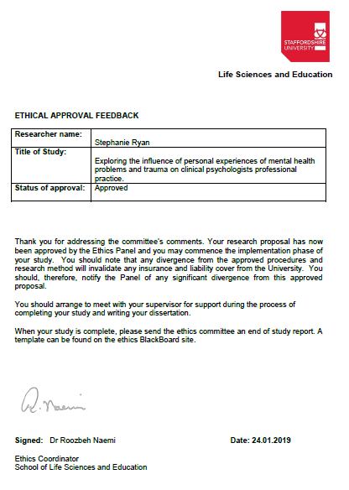

**Appendix 2. – Ethical approval feedback of amendment to procedure request**

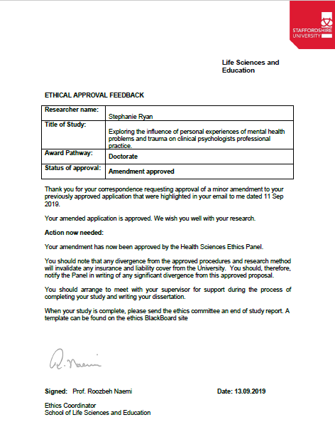

**Appendix 3. – Participant information sheet**



**Participant Information Sheet**

**Exploring the influence of personal experience of mental health difficulties and trauma on practice in Clinical Psychologists**

**Introduction**

We would like to invite you to take part in a research study. Please take time to read the following information carefully and discuss it with others if you wish. If there is anything that is not clear or if you would like more information, please get in touch using the contact details provided.

We are interested in speaking with qualified clinical psychologists who have a personal history of trauma, and/or lived experience of mental health difficulties. Research has shown that a large number of clinical psychologists have these experiences, but how, or if, these experiences might influence clinical practice is unclear. Similar research has explored this in other professions, such as nurses and psychotherapists, and found that individuals feel that their experiences can have both a positive and negative impact on their practice. We think this is an important topic to explore, as it has implications in practice, how psychologists are trained and supported throughout their career and topics such as stigma and disclosure.

**What will taking part involve?**

If you are a clinical psychologist who has qualified more than one year ago, and feel you have a personal history of trauma, or lived experiences of mental health difficulties and apply to take part in the study, you will be emailed an online link with four short surveys to complete. The information collected from these surveys will be included as part of the demographic information in the study. This data will be descriptive only and will not be analysed. Three of these surveys, a short questionnaire of lived experience of mental health, the Adverse Childhood Experiences (ACE) questionnaire and the Trauma History Questionnaire are also used a screening tool. Difficult experiences and mental health difficulties are personal, varied and subjective to measure in an individual, but to ensure some consistency you would need to answer ‘yes’ to experiencing a mental health problem and/or have a score that indicates a personal history of trauma or childhood adversity. It will be made clear as soon as you have submitted the surveys if you have met the criteria. If you have not met the study criteria, the survey data will not be used any further and will be destroyed.

If suitable, you will be contacted to take part in one semi-structured interview with a researcher. This interview can either be at Staffordshire University or a skype interview, depending on what is most convenient for you. At the end of the interview there will be a debrief period in which you can ask any questions or raise anything that may be of concern.

**What are the possible disadvantages of taking part?**

Some of the questionnaires may cover issues that are sensitive and/or distressing, such as asking about experiences of psychological distress and previous traumatic events. This may cause you some emotional distress or anxiety.

During the interview you will not be asked directly about these experiences, but we will discuss how you feel they have impacted your career. This has the potential to cause you some emotional distress or anxiety. You can stop at any stage of the interview if you feel uncomfortable and you can refuse to answer any questions that you feel are too distressing.

**What will happen if I don’t want to continue with the study?**

You are free to withdraw from the study, without having to give a reason. Withdrawing from the study will not affect you in any way. You can withdraw your data from the study up until two months from the date of your interview. After this date, withdrawal of your data will no longer be possible due to the data being processed, anonymised and collated with other participants data.

If you choose to withdraw from the study we will not retain any information that you have provided as part of this study.

**How will my information be kept confidential?**

*Your data will be processed in accordance with the data protection law and will comply with the General Data Protection Regulation 2016 (GDPR).*

After your survey data is received, a unique participant code will be assigned to each participant. After the interview the code will be linked to your interview data and any personal identifying information will be removed. Your consent form, demographic information and questionnaire scores will be stored securely in a separate electronic file from interview data. Your personal contact details will be destroyed unless you request a copy of the study results then your contact information will be retained but stored separately from the study data. If you submit the surveys but are not suitable to complete the study, the data you will have submitted up to then will be destroyed.

Your interview will be recorded but any audio data will be removed from the audio device as soon as possible and stored securely. Transcription of the interviews will be carried out in a private space, and once transcribed the audio data will be destroyed. Any personal identification information will be removed or changed during transcription. Some samples of interview transcripts may be accessed by research supervisors for analysis purposes, but they will not access participants personal data. Staffordshire University may access data for auditing purposes. All data will be stored on an encrypted, password protected USB stick. It will be stored, in line with university regulations, for 9 years in an archive room in CD format at Staffordshire university.

All the information which is collected about you during the research will be kept strictly confidential. The only limits to this confidentiality would be if any concerns about harm coming to yourself, to someone else, or your fitness to practice as a psychologist were disclosed during the interview. This is likely to be a very rare occurrence, and we would try to discuss this with you first.

**Data Protection Statement**

*The data controller for this project will be Staffordshire University. The University will process your personal data for the purpose of the research outlined above. The legal basis for processing your personal data for research purposes under GDPR is a ‘task in the public interest’ You can provide your consent for the use of your personal data in this study by completing the consent form that will be provided to you.*

*You have the right to access information held about you. Your right of access can be exercised in accordance with the General Data Protection Regulation. You also have other rights including rights of correction, erasure, objection, and data portability. Questions, comments and requests about your personal data can also be sent to the Staffordshire University Data Protection Officer. If you wish to lodge a complaint with the Information Commissioner’s Office, please visit*[*www.ico.org.uk*](http://www.ico.org.uk/)

**What will happen to the results of the study?**

The research should be completed by the end of 2020. You can have a summary of the results of the study once it is completed if you wish. You would need to request this by the end of your interview, as after that point your personal contact details will be destroyed. If the results of the study are published in a peer-reviewed journal all data will be completely anonymised. No individual will be identifiable from the published results.

**Further information and contact details**

This study has been reviewed and approved by the ethics panel at Staffordshire University.

If you have any questions relating to this research, or concerns about participation, please contact:

**Stephanie Ryan**

**Trainee Clinical Psychologist**

School of Life Sciences and Education

Staffordshire University

Science Centre

Leek Road

Stoke-on-Trent

ST4 2DF

[r024119h@student.staffs.ac.uk](mailto:r024119h@student.staffs.ac.uk)

**Dr. Helena Priest**

**Research Tutor**

School of Life Sciences and Education

Staffordshire University

Science Centre

Leek Road

Stoke-on-Trent

ST4 2DF

t: +44 (0)1782 294580

[h.m.priest@staffs.ac.uk](mailto:h.m.priest@staffs.ac.uk)

**Appendix 4. – Participant debrief sheet**



**Exploring the influence of personal experience of mental health difficulties and trauma on practice in Clinical Psychologists**

**Thank you for participating in this research.**

This study is interested in how, or if, a personal history of trauma, and/or lived experience of mental health difficulties might influence professional practice in clinical psychologists. I think this is an important topic to explore, as it has implications in practice, how psychologists are trained and supported throughout their career and topics such as stigma and disclosure. You giving your time to try and explore these topics is greatly appreciated.

You are still free to withdraw from the study, without having to give a reason. If you would like to withdraw your data please contact the researcher any time up until two months from the date of your interview. After this date withdrawal of your data will no longer be possible due to the data being processed, anonymised and collated with other participants’ data afterwards.

**Your interview date was:**

**Your last day to withdraw your data will be:**

If you choose to withdraw from the study, we will not retain any information that you have provided us as part of this study.

At the start of the interview you would have been asked if you would like a summary of the results of this study. If you requested this you will receive a summary by the end of 2020, using the contact details you have provided. If you have not requested this all your contact details will be destroyed after this interview.

If participation in this study led you to feel distressed and you would like to speak to someone about your thoughts, you can contact one of the following:

* **Your employer’s occupational health department**
* **Samaritans**

Phone: 116 123

Email: [jo@samaritans.org](mailto:jo@samaritans.org)

* **ReThink Mental Illness advice team**

Phone: 0300 5000 927

* **Mind Infoline**

Phone: 0300 123 3393

Email: [info@mind.org.uk](mailto:info@mind.org.uk)

Text: 86463

To make any requests, discuss any questions relating to this research, or concerns about participation, please contact:

**Stephanie Ryan**

**Trainee Clinical Psychologist**

[r024119h@student.staffs.ac.uk](mailto:r024119h@student.staffs.ac.uk)

**Appendix 5. – Study advertisement posted on UK Clinical Psychology Facebook webpage**

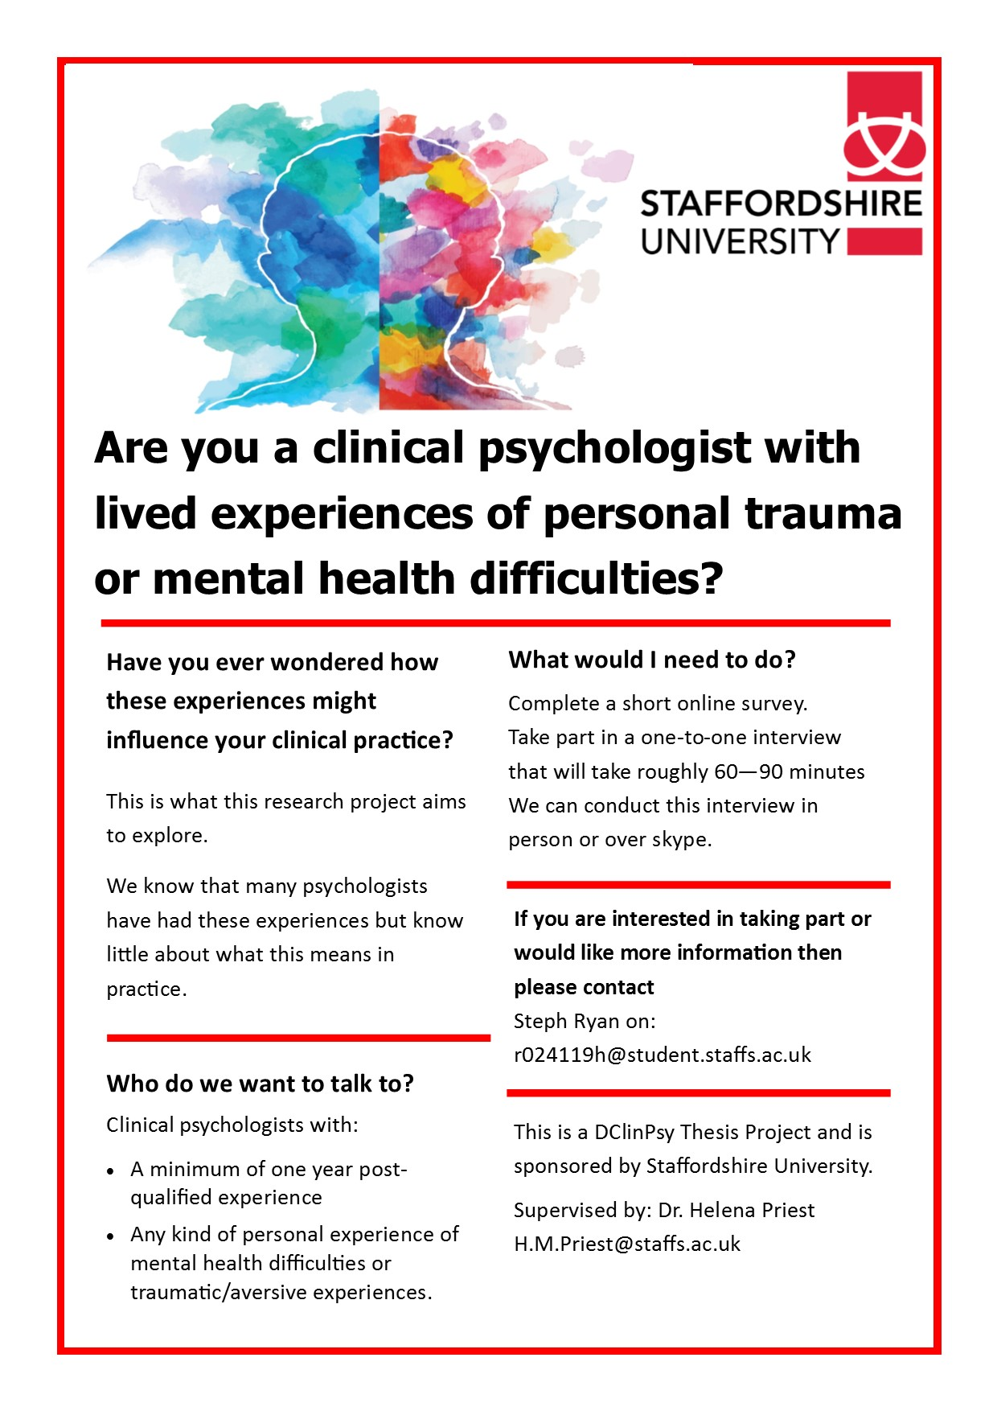

**Appendix 6. Consent to participate page from survey hosted by Qualtrics online survey platform**

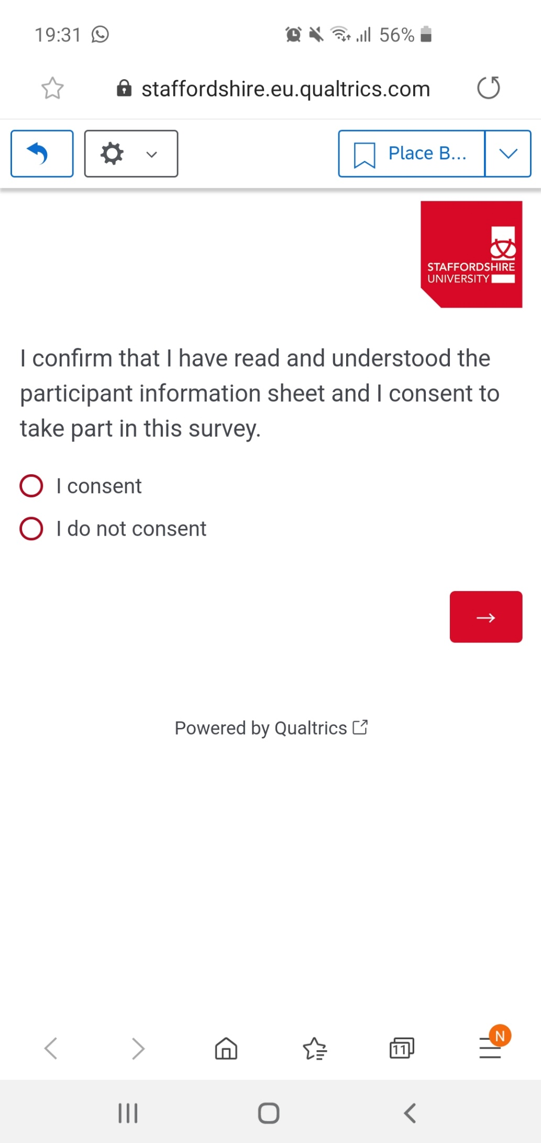

**Appendix 7. Demographic question page from survey hosted by Qualtrics online survey platform**

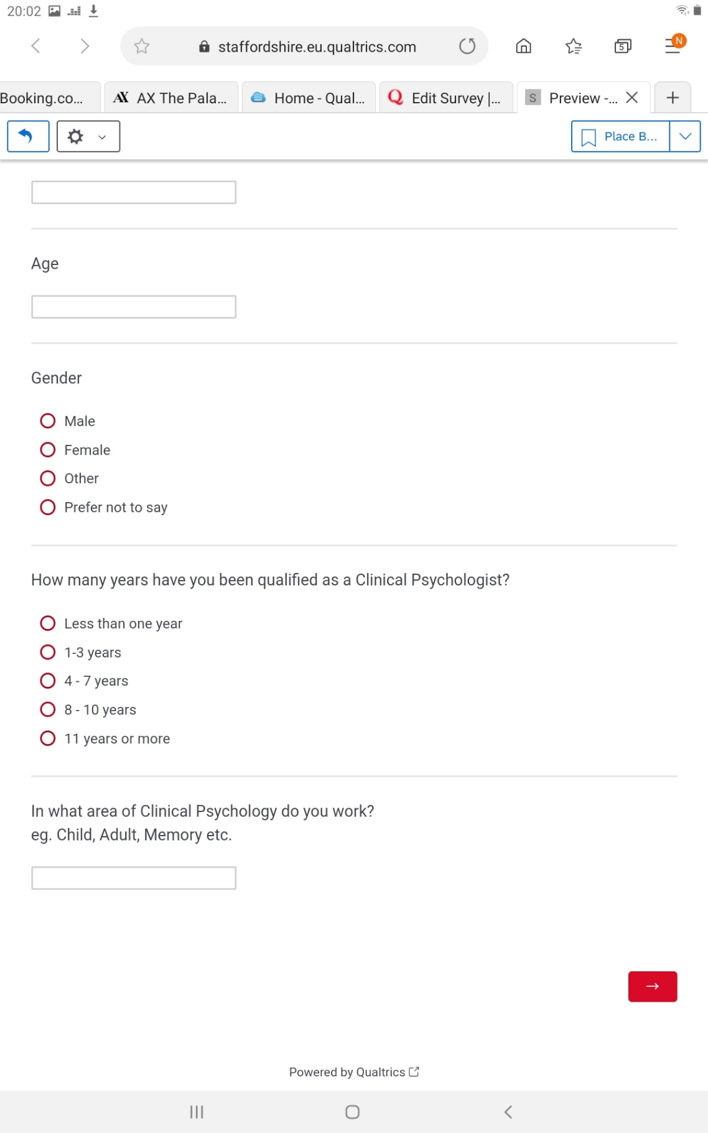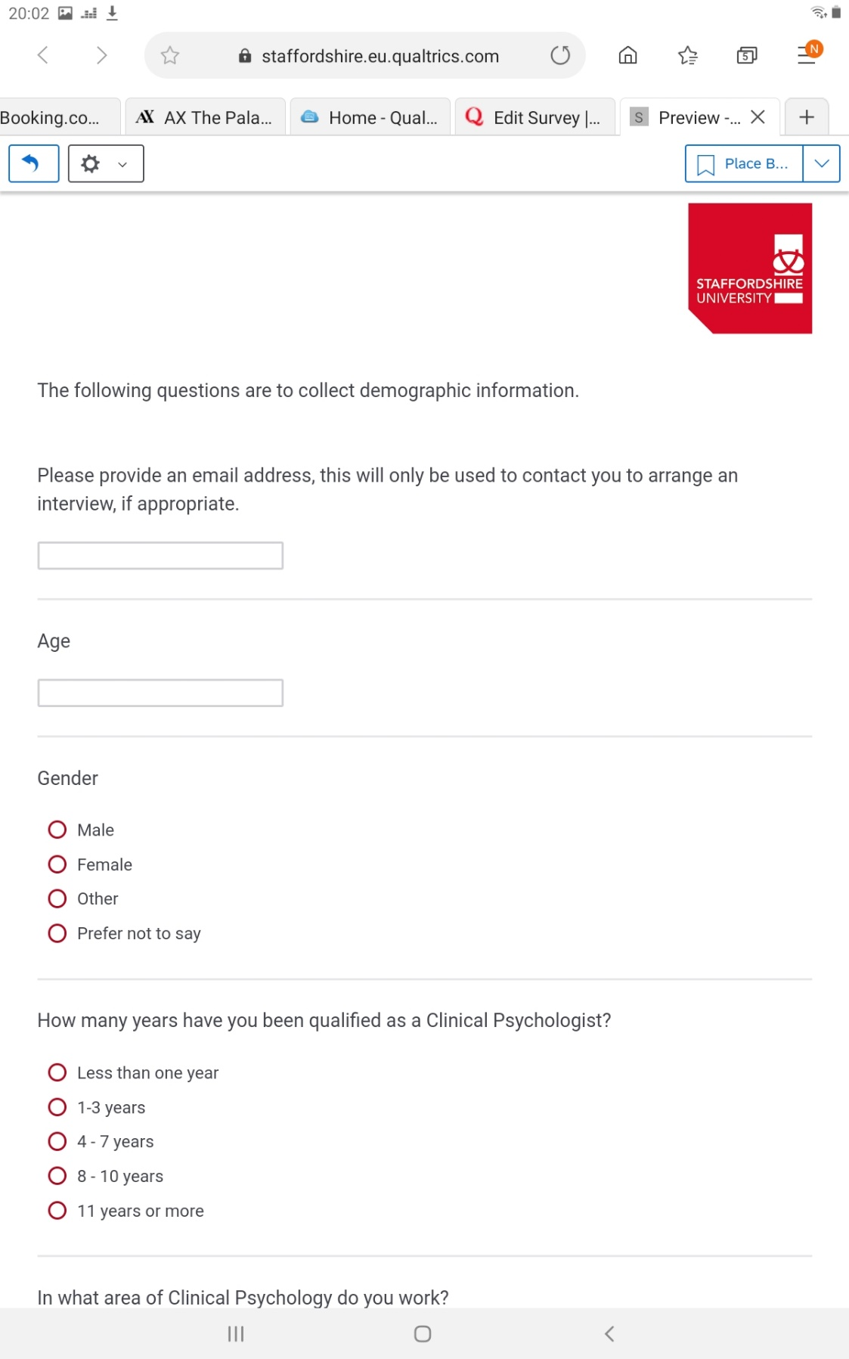

**Appendix 8. – Lived experience of mental health difficulties questionnaire from online survey hosted by Qualtrics online survey platform**

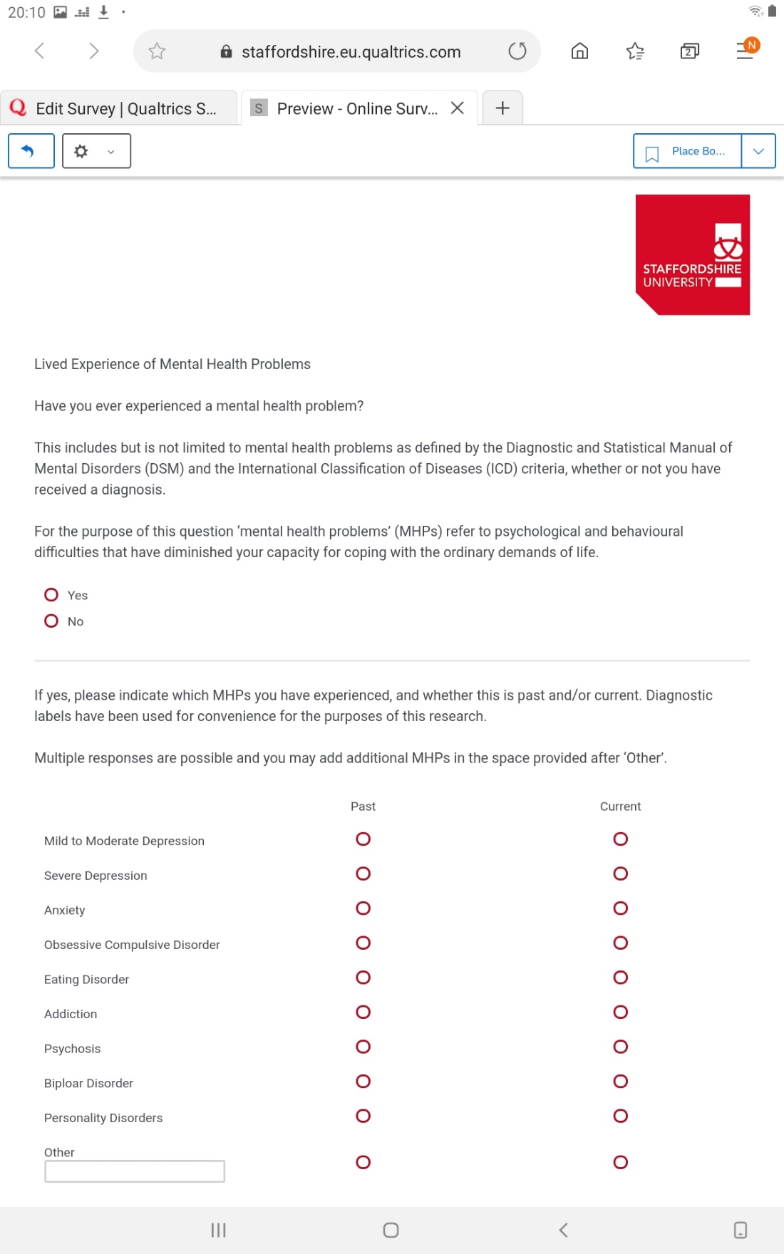

**Appendix 9. – Adverse Childhood Experiences questionnaire from online survey hosted by Qualtrics online survey platform**

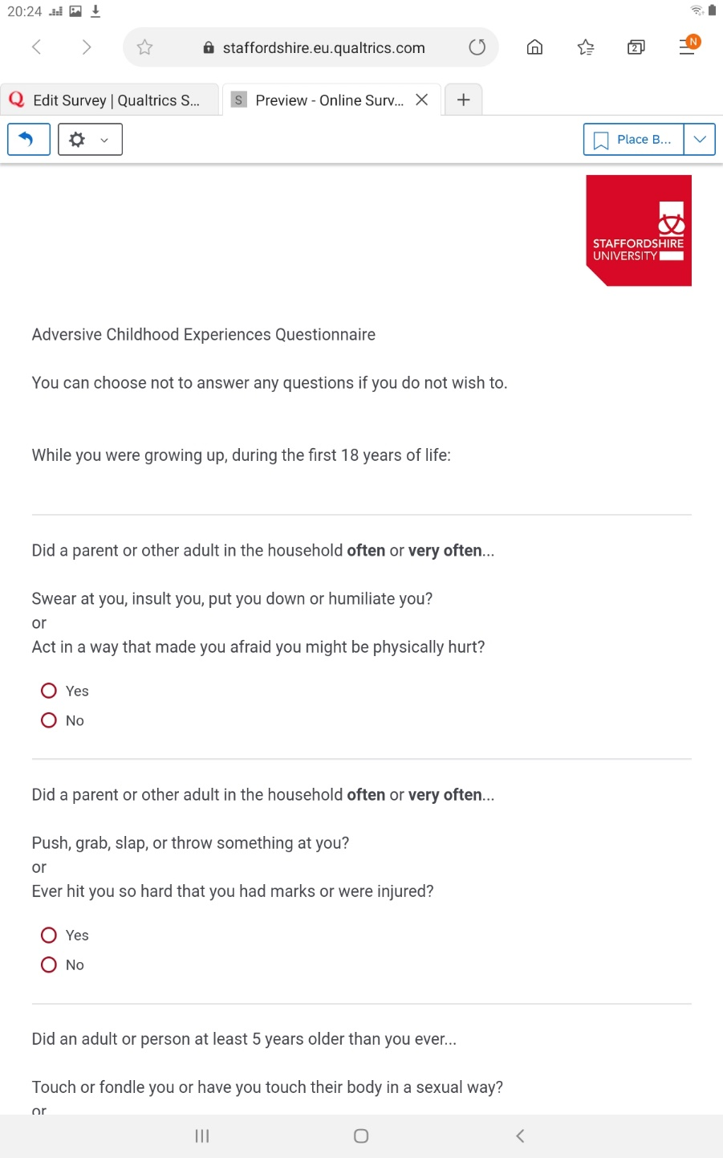

**Appendix 9. continued – Adverse Childhood Experience questionnaire**

ACE Full Questionnaire

While you were growing up, during you first 18 years of life:

1. Did a parent or other adult in the household often or very often…

Swear at you, insult you, put you down, or humiliate you? or act in a way that made you afraid that you might be physically hurt?

1. Did a parent or other adult in the household often or very often…

Push, grab, slap, or throw something at you? or Ever hit you so hard that you had marks or were injured?

1. Did an adult or person at least 5 years older than you ever…

Touch or fondle you or have you touch their body in a sexual way? or Attempt or actually have oral, anal, or vaginal intercourse with you?

1. Did you often or very often feel that …

No one in your family loved you or thought you were important or special? or Your family didn’t look out for each other, feel close to each other, or support each other?

1. Did you often or very often feel that …

You didn’t have enough to eat, had to wear dirty clothes, and had no one to protect you? or Your parents were too drunk or high to take care of you or take you to the doctor if you needed it?

1. Were your parents ever separated or divorced?
2. Was your mother or stepmother:  
   Often or very often pushed, grabbed, slapped, or had something thrown at her?

or Sometimes, often, or very often kicked, bitten, hit with a fist, or hit with something hard?

or Ever repeatedly hit over at least a few minutes or threatened with a gun or knife?

1. Did you live with anyone who was a problem drinker or alcoholic, or who used street drugs?
2. Was a household member depressed or mentally ill, or did a household member attempt suicide?
3. Did a household member go to prison?

**Appendix 10. – Trauma History questionnaire from online survey hosted by Qualtrics online survey platform**

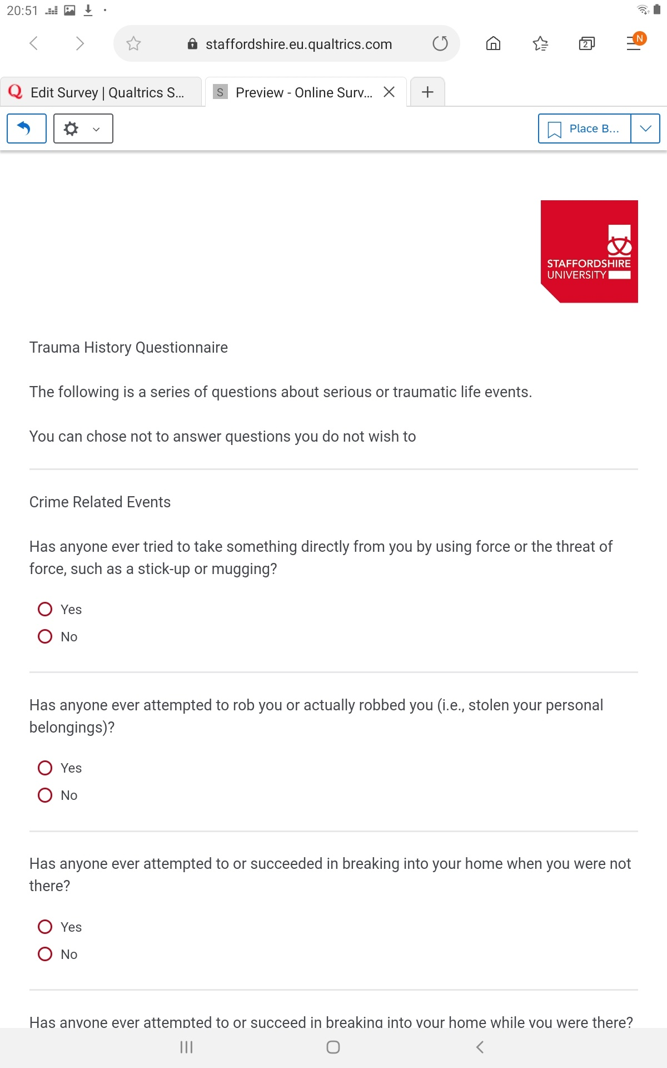

**Appendix 10. continued – Trauma History Questionnaire (THQ)**

**Full Questionnaire**

**Crime Related Events**

1. Has anyone ever tried to take something directly from you by using force or the threat of force, such as a stick-up or mugging?
2. Has anyone ever attempted to rob you or actually robbed you (i.e., stolen your personal belongings)?
3. Has anyone ever attempted to or succeeded in breaking into your home when you were not there?
4. Has anyone ever attempted to or succeed in breaking into your home while you were there?

**General Disaster and Trauma**

1. Have you ever had a serious accident at work, in a car, or somewhere else?
2. Have you ever experienced a natural disaster such as a tornado, hurricane, flood or major earthquake, etc., where you felt you or your loved ones were in danger of death or injury?
3. Have you ever experienced a “man-made” disaster such as a train crash, building collapse, bank robbery, fire, etc., where you felt you or your loved ones were in danger of death or injury?
4. Have you ever been in any other situation in which you feared you might be killed or seriously injured?
5. Have you ever seen someone seriously injured or killed?
6. Have you ever seen dead bodies (other than at a funeral) or had to handle dead bodies for any reason?
7. Have you ever had a close friend or family member murdered, or killed by a drunk driver?
8. Have you ever had a spouse, romantic partner, or child die?
9. Have you ever had a serious or life-threatening illness?
10. Have you ever received news of a serious injury, life-threatening illness, or unexpected death of someone close to you?
11. Have you ever had to engage in combat while in military service in an official or unofficial war zone?

**Physical and Sexual Experiences**

1. Has anyone ever made you have intercourse or oral or anal sex against your will?
2. Has anyone ever touched private parts of your body, or made you touch theirs, under force or threat?
3. Other than incidents mentioned in Questions 16 and 17, have there been any other situations in which another person tried to force you to have an unwanted sexual contact?
4. Has anyone, including family members or friends, ever attacked you with a gun, knife, or some other weapon?
5. Has anyone, including family members or friends, ever attacked you without a weapon and seriously injured you?

**Appendix 11. – Participant consent form**

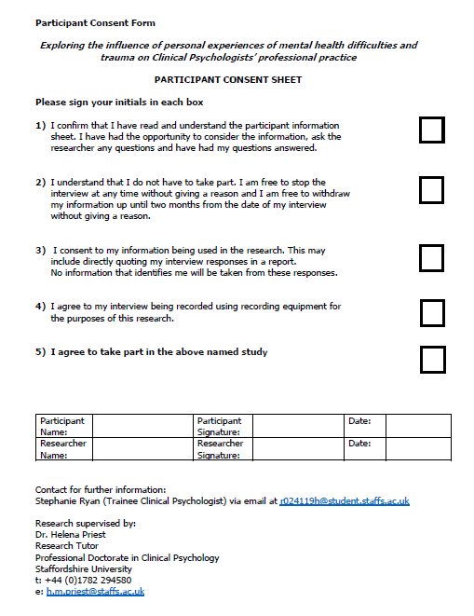

**Appendix 12. – Semi-structured interview guide**

**Introduction:**

* Discuss: 1. Confidentiality, 2. Anonymity, 3. Withdrawal from study, 4. Requesting results
* Confirm consent
* Check for questions

**Confirm consent to begin recording**

**Interview Topics**

**You don’t have to discuss any specific experiences of MH difficulties/trauma if you don’t want to as that isn’t our focus.**

1. Participant background information

* General career path
* Do you think your experiences have influenced your career choices?
* Do you think it influenced your choice about clinical psychology specifically?

2. Explore potential impact of experiences on:

* Training experience
* Was lived experience discussed during your training?
* Direct practice
* Does it vary – role, service user group, type of work ie. assessment, intervention, endings
* Advantages or disadvantages of experience
* Influence on supervision
* Influence on choice of specialty, theoretical orientation or therapeutic models

3. Maintaining personal wellbeing

* Wellbeing in your professional life

Self-care, resilience, help-seeking

4. Disclosure

* Thoughts on disclosure of lived experience: with colleagues, with service users
* Personal experiences of disclosing
* Beliefs and experiences of stigma
* Has the influence (on any area) changed over time?
* Is there anything I haven’t asked you about that you think is important to discuss?

**Confirm termination of recording and interview**

* Thank participant
* Check for further queries
* Debrief sheet reminder

**Appendix 13. – Excerpt of interview transcript with participant Chris, page 12.**

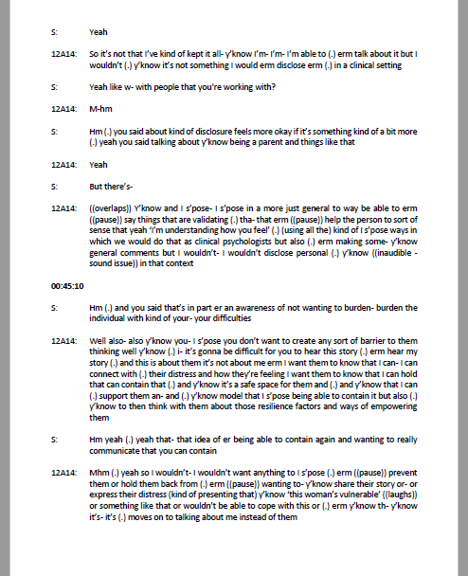

**Appendix 13. continued - Excerpt from Chris interview transcript, page 18.**

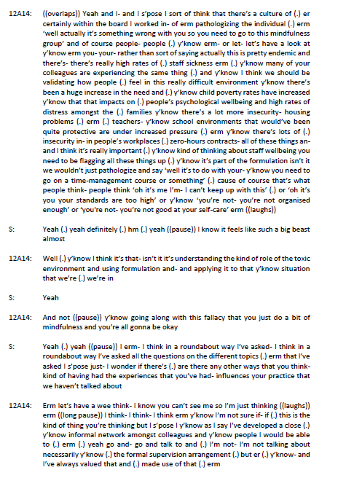

**Appendix 14. – Extract from reflective log showing initial code ideas at transcript review stage for participant Chris.**

28th December

Transcript Review

Participant Chris

* Saw link between own childhood and interest in psychology
* Psychology as a way to understand own experience?
* How stigma has changed over time
* Fears of how disclosure would be received
* Not understanding the link or impact early in the career
* Hardship giving resilience – ability to hold others resilience
* Compassionately understanding others’ behaviour/difficulties
* Own experience gives hope for recovery for others (own ability to have hope for others?)
* Ability to sit with sadness and distress
* She’s really reflective and open, seems to really understand her experience – but do I just think that because she labels herself as having experienced abuse?
* Own belief that it is a positive thing
* Processing own story is a process
* Using own formulation to understand
* Drawing on skills in clinical work that were developed to support self (resilience, containment, compassion)
* Experience influencing ability to work in NHS (stress) environment – (my thoughts - something about increased empathy making it harder to let families go or work with low resources?)
* Own difficult social context made her passionate about thinking about social context in career
* Disclosing about difficult being a parent – safe disclosure (my words and opinion, not hers)
* Not wanting to burden the patient
* Not wanting to disclose because want to know that the psychologist can contain – is there a belief that if you have problems you can’t contain others?
* Having had difficulties communicates vulnerability?
* Belief in keeping the professional boundary because it is good for supporting them and for the therapeutic process
* Communicating kindness and empathy without disclosure
* Reflecting on own protective factors in childhood and carrying it through to adult life
* Another question where I told her what others had experienced (and therefore what I was looking for in her answer – introducing bias?)
* Laying blame in the individual for distress – NHS pressures and systems
* Has never discussed in supervision
* Didn’t feel like it was ‘professional’ to disclose – something about ‘unprofessional’ as a code?
* Fears of how experience will be interpreted

**Appendix 15. – Coding of transcript Chris using Nvivo 12 Software**

**Highlighted data and corresponding codes**

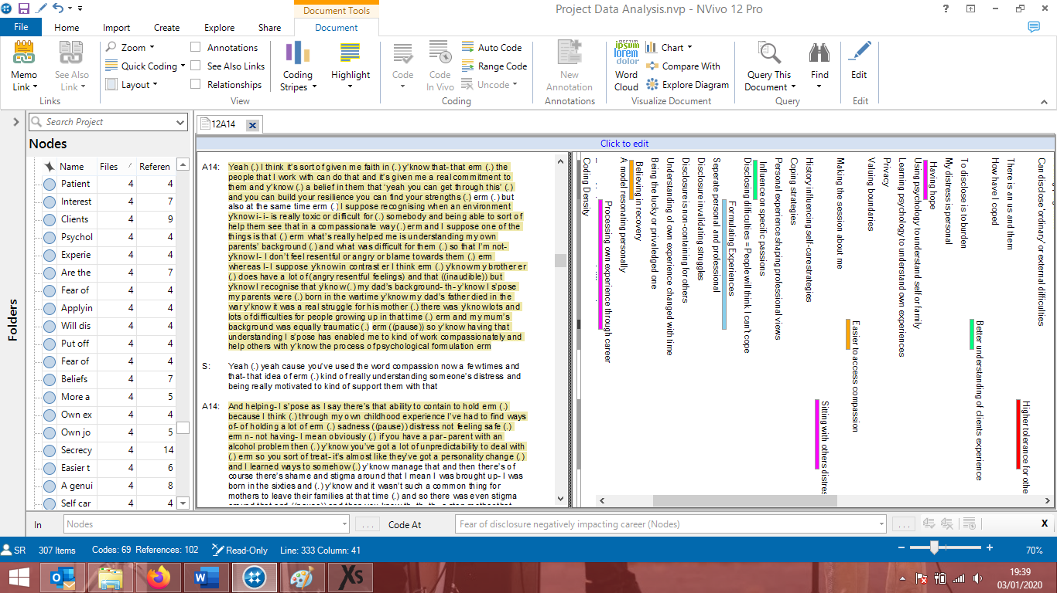

**Appendix 15. continued – Coding of transcript Chris using Nvivo 12 Software**

**All codes that were assigned to transcript Chris**



**Appendix 16. – Example of theme development process**



**Appendix 16. Continued – Example of theme development process**

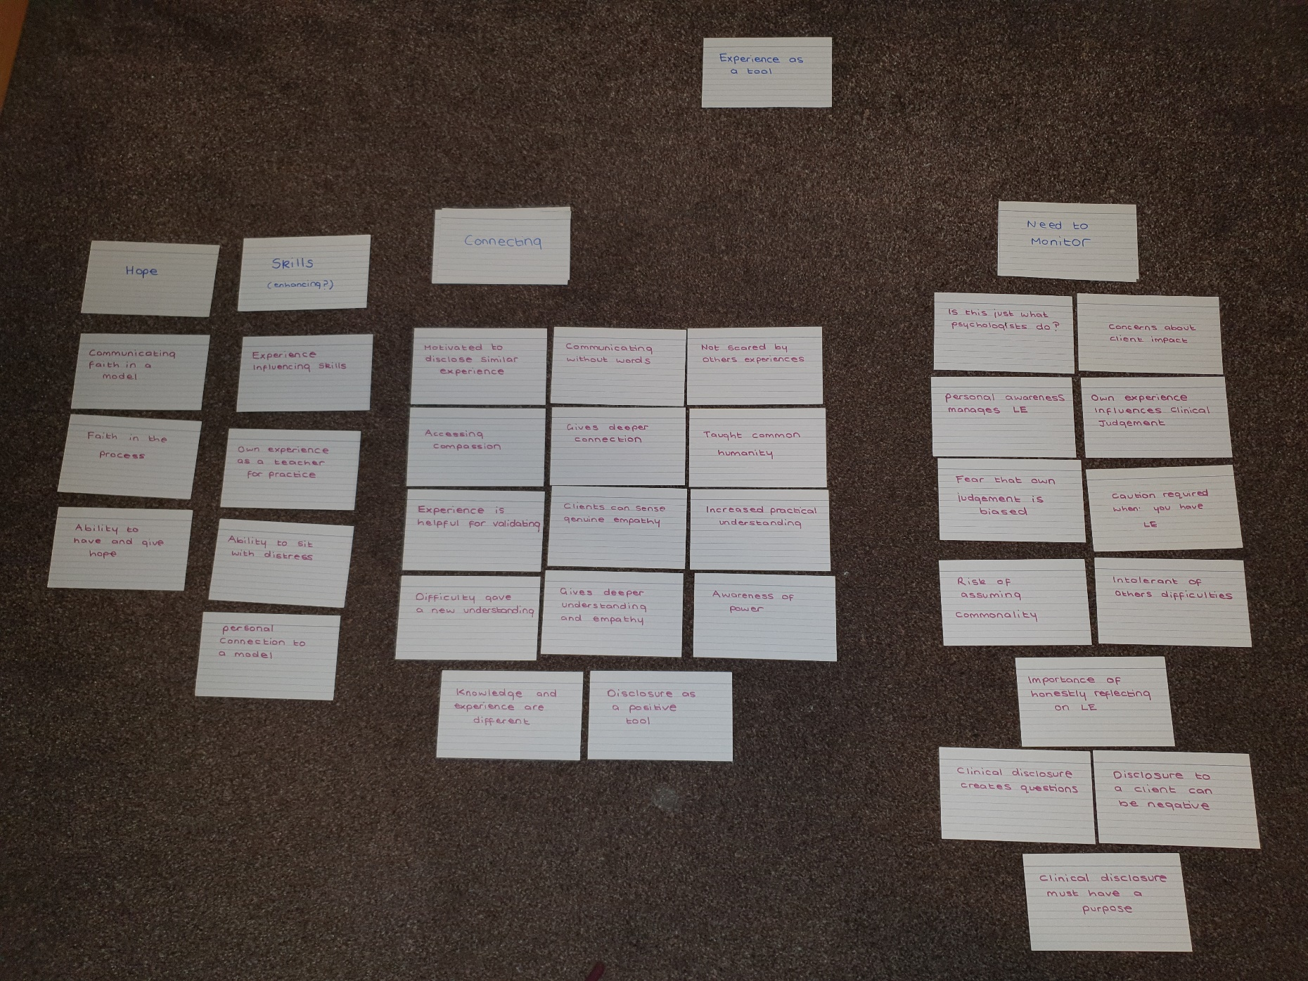

**Appendix 17. – Author guidelines for submission to the British Journal of Clinical Psychology**



3. MANUSCRIPT CATEGORIES AND REQUIREMENTS

Articles should be no more than 5000 words (excluding the abstract, reference list, tables and figures). Brief reports should not exceed 2000 words and should have no more than one table or figure. Any papers that are over this word limit will be returned to the authors. Appendices are included in the word limit; however online appendices are not included.

In exceptional cases the Editor retains discretion to publish papers beyond this length where the clear and concise expression of the scientific content requires greater length (e.g., explanation of a new theory or a substantially new method). Authors must contact the Editor prior to submission in such a case.

Please refer to the separate guidelines for [Registered Reports](https://onlinelibrary.wiley.com/page/journal/20448260/homepage/registeredreportsguidelines.htm).

All systematic reviews must be pre-registered.

4. PREPARING THE SUBMISSION

**Free Format Submission**

British Journal of Clinical Psychology now offers free format submission for a simplified and streamlined submission process.

Before you submit, you will need:

* Your manuscript: this can be a single file including text, figures, and tables, or separate files – whichever you prefer. All required sections should be contained in your manuscript, including abstract, introduction, methods, results, and conclusions. Figures and tables should have legends. References may be submitted in any style or format, as long as it is consistent throughout the manuscript. If the manuscript, figures or tables are difficult for you to read, they will also be difficult for the editors and reviewers. If your manuscript is difficult to read, the editorial office may send it back to you for revision.
* The title page of the manuscript, including a data availability statement and your co-author details with affiliations. (Why is this important? We need to keep all co-authors informed of the outcome of the peer review process.) You may like to use [this template](https://onlinelibrary.wiley.com/pb-assets/assets/2044835X/Sample_Manuscript_Title_Page%20-%20revised-1556026160210.docx) for your title page.

**Important: the journal operates a double-blind peer review policy. Please anonymise your manuscript and prepare a separate title page containing author details.** (Why is this important? We need to uphold rigorous ethical standards for the research we consider for publication.)

* An ORCID ID, freely available at [https://orcid.org](https://orcid.org/). (Why is this important? Your article, if accepted and published, will be attached to your ORCID profile. Institutions and funders are increasingly requiring authors to have ORCID IDs.)

To submit, login at <https://www.editorialmanager.com/bjcp/default.aspx> and create a new submission. Follow the submission steps as required and submit the manuscript.

If you are invited to revise your manuscript after peer review, the journal will also request the revised manuscript to be formatted according to journal requirements as described below.

**Revised Manuscript Submission**

Contributions must be typed in double spacing. All sheets must be numbered.

Cover letters are not mandatory; however, they may be supplied at the author’s discretion. They should be pasted into the ‘Comments’ box in Editorial Manager.

Parts of the Manuscript

The manuscript should be submitted in separate files: title page; main text file; figures/tables; supporting information.

Title Page

You may like to use [this template](https://onlinelibrary.wiley.com/pb-assets/assets/20448260/Sample_Manuscript_Title_Page%20-%20revised-1556025388890.docx) for your title page. The title page should contain**:**

1. A short informative title containing the major key words. The title should not contain abbreviations (see Wiley's [best practice SEO tips](http://www.wileyauthors.com/seo));
2. A short running title of less than 40 characters;
3. The full names of the authors;
4. The author's institutional affiliations where the work was conducted, with a footnote for the author’s present address if different from where the work was conducted;
5. Abstract;
6. Keywords
7. Data availability statement (see [Data Sharing and Data Accessibility Policy](https://onlinelibrary.wiley.com/page/journal/20448260/homepage/forauthors.html#data_share));
8. Acknowledgments.

**Authorship**

Please refer to the journal’s Authorship policy in the Editorial Policies and Ethical Considerations section for details on author listing eligibility. When entering the author names into Editorial Manager, the corresponding author will be asked to provide a CRediT contributor role to classify the role that each author played in creating the manuscript. Please see the [Project CRediT](https://casrai.org/credit/) website for a list of roles.

**Abstract**

Please provide a structured abstract under the headings: Objectives, Methods, Results, Conclusions. For Articles, the abstract should not exceed 250 words. For Brief Reports, abstracts should not exceed 120 words.  
  
Articles which report original scientific research should also include a heading 'Design' before 'Methods'. The 'Methods' section for systematic reviews and theoretical papers should include, as a minimum, a description of the methods the author(s) used to access the literature they drew upon. That is, the abstract should summarize the databases that were consulted and the search terms that were used.

**Keywords**

Please provide appropriate keywords.

**Acknowledgments**

Contributions from anyone who does not meet the criteria for authorship should be listed, with permission from the contributor, in an Acknowledgments section. Financial and material support should also be mentioned. Thanks to anonymous reviewers are not appropriate.

Practitioner Points

All articles must include Practitioner Points – these are 2-4 bullet points, following the abstract, with the heading ‘Practitioner Points’. These should briefly and clearly outline the relevance of your research to professional practice. (The Practitioner Points should be submitted in a separate file.)

Main Text File

As papers are double-blind peer reviewed, the main text file should not include any information that might identify the authors.

The main text file should be presented in the following order:

1. Title
2. Main text
3. References
4. Tables and figures (each complete with title and footnotes)
5. Appendices (if relevant)

Supporting information should be supplied as separate files. Tables and figures can be included at the end of the main document or attached as separate files but they must be mentioned in the text.

* As papers are double-blind peer reviewed, the main text file should not include any information that might identify the authors. Please do not mention the authors’ names or affiliations and always refer to any previous work in the third person.
* The journal uses British/US spelling; however, authors may submit using either option, as spelling of accepted papers is converted during the production process.

**References**

References should be prepared according to the Publication Manual of the American Psychological Association (6th edition). This means in text citations should follow the author-date method whereby the author's last name and the year of publication for the source should appear in the text, for example, (Jones, 1998). The complete reference list should appear alphabetically by name at the end of the paper. Please note that for journal articles, issue numbers are not included unless each issue in the volume begins with page 1, and a DOI should be provided for all references where available.

For more information about APA referencing style, please refer to the [APA FAQ](http://www.apastyle.org/search.aspx?query=&fq=StyleTopicFilt:%22References%22&sort=ContentDateSort%20desc).

Reference examples follow:

Journal article

Beers, S. R. , & De Bellis, M. D. (2002). Neuropsychological function in children with maltreatment-related posttraumatic stress disorder. The American Journal of Psychiatry, 159, 483–486. doi:[10.1176/appi.ajp.159.3.483](http://dx.doi.org/10.1176/appi.ajp.159.3.483)

Book

Bradley-Johnson, S. (1994). Psychoeducational assessment of students who are visually impaired or blind: Infancy through high school (2nd ed.). Austin, TX: Pro-ed.

Internet Document

Norton, R. (2006, November 4). How to train a cat to operate a light switch [Video file]. Retrieved from <http://www.youtube.com/watch?v=Vja83KLQXZs>

**Tables**

Tables should be self-contained and complement, not duplicate, information contained in the text. They should be supplied as editable files, not pasted as images. Legends should be concise but comprehensive – the table, legend, and footnotes must be understandable without reference to the text. All abbreviations must be defined in footnotes. Footnote symbols: †, ‡, §, ¶, should be used (in that order) and *, **, *** should be reserved for P-values. Statistical measures such as SD or SEM should be identified in the headings.

**Figures**

Although authors are encouraged to send the highest-quality figures possible, for peer-review purposes, a wide variety of formats, sizes, and resolutions are accepted.

[Click here](http://media.wiley.com/assets/7323/92/electronic_artwork_guidelines.pdf) for the basic figure requirements for figures submitted with manuscripts for initial peer review, as well as the more detailed post-acceptance figure requirements.

Legends should be concise but comprehensive – the figure and its legend must be understandable without reference to the text. Include definitions of any symbols used and define/explain all abbreviations and units of measurement.

**Colour figures.** Figures submitted in colour may be reproduced in colour online free of charge. Please note, however, that it is preferable that line figures (e.g. graphs and charts) are supplied in black and white so that they are legible if printed by a reader in black and white. If an author would prefer to have figures printed in colour in hard copies of the journal, a fee will be charged by the Publisher.

**Supporting Information**

Supporting information is information that is not essential to the article, but provides greater depth and background. It is hosted online and appears without editing or typesetting. It may include tables, figures, videos, datasets, etc.

[Click here](http://www.wileyauthors.com/suppinfoFAQs) for Wiley’s FAQs on supporting information.

Note: if data, scripts, or other artefacts used to generate the analyses presented in the paper are available via a publicly available data repository, authors should include a reference to the location of the material within their paper.

General Style Points

For guidelines on editorial style, please consult the [APA Publication Manual](http://www.amazon.co.uk/gp/product/1433805618?ie=UTF8&tag=thebritishpsy-21&linkCode=xm2&camp=1634&creativeASIN=1433805618) published by the American Psychological Association. The following points provide general advice on formatting and style.

* **Language:** Authors must avoid the use of sexist or any other discriminatory language.
* **Abbreviations:**In general, terms should not be abbreviated unless they are used repeatedly and the abbreviation is helpful to the reader. Initially, use the word in full, followed by the abbreviation in parentheses. Thereafter use the abbreviation only.
* **Units of measurement:** Measurements should be given in SI or SI-derived units. Visit the [Bureau International des Poids et Mesures (BIPM) website](http://www.bipm.org/en/about-us/) for more information about SI units.
* **Effect size:** In normal circumstances, effect size should be incorporated.
* **Numbers:** numbers under 10 are spelt out, except for: measurements with a unit (8mmol/l); age (6 weeks old), or lists with other numbers (11 dogs, 9 cats, 4 gerbils).

# **Paper Three: Executive Summary**

**Exploring the influence of personal experiences of mental health difficulties and trauma on Clinical Psychologists’ professional practice**

Word Count: 2,493

*This paper is not intended for publication. It is aimed at mental health professionals, mental health service users and those involved in mental health career education. It will be offered to the clinical psychologists who participated in the research.*

*This report was developed collaboratively with the input of mental health practitioners with lived experience of mental health difficulties and trauma.*

**Exploring the perceived influence of personal experiences of mental health difficulties and trauma on Clinical Psychologists’ professional practice**

**An Executive Summary**

“*The analyst must go on learning endlessly… it is his own hurt that gives the measure of his power to heal*.”

* Carl Jung

**Paper Contents**

|  |  |
| --- | --- |
| Section | Page |
| Introduction | 127 |
| Method | 129 |
| Findings | 131 |
| Summary and Conclusions | 136 |
| Limitations | 136 |
| What now? | 137 |
| Dissemination | 138 |
| References | 139 |

**Terminology**

In keeping with other research and discussion in this topic area, in this report, the term ‘**lived experience**’ is used to refer to personal experiences of trauma, psychological distress and mental health difficulties.

# **Introduction**

This executive summary is a condensed, accessible summary of a piece of qualitative research exploring how personal experiences of trauma and mental health difficulties might influence clinical psychologists in professional practice.

It is written for anyone who may have an interest in the research, such as clinical psychologists, other mental health professionals, those involved in mental health career education and mental health service users.

Background

Personal experiences of mental health difficulties, trauma and childhood adversity are commonly found in mental health professionals (Elliot & Guy, 1993; Guy, Poelstra, & Stark, 1989; Pope and Feldman-Summers, 1992). Recent research surveyed UK clinical psychologists and found that 63% out of a group of 678 clinical psychologists (Tay, Alcock & Scior, 2018) and 67% out of a group of 348 trainee clinical psychologists (Grice, Alock & Scior, 2018) reported they had experienced mental health difficulties. Some have suggested that people with lived experience may be more likely to choose to work in a mental health profession because of those experiences (Aina, 2015; Barnett, 2007; Conchar & Repper, 2014; Cushway, 1995; Huynh & Rhodes, 2011; Murphy & Halgin, 1995; Nikčević, Kramolisova-Advani, & Spada, 2007).

What does it mean in practice?

Based on the research so far, how lived experience might affect the work of mental health professionals is not clear. Lived experience may help the professional to understand the experiences of those they work with better and feel more empathy towards them (Charlemagne‐Odle, Harmon, & Maltby, 2014). Such experiences may also help them to feel more hopeful about mental health recovery (Oates, Drey, & Jones, 2017) and have a positive influence on therapy skills and techniques (Trusty, Ng, & Watts, 2005; Watts, Trusty, Canada, & Harvill, 1995). Some studies also suggest that having lived experience positively influences the professional’s self-care practices (Telepak, 2010).

In contrast, theory and research can suggest that lived experience might have a negative influence. Lived experience has been linked with poorer wellbeing in practising mental health professionals (Follette, Polusny, & Milbeck, 1994), and may also increase the risk of them being negatively impacted by their therapeutic work. Mental health professionals with lived experience might be at greater risk of experiencing vicarious trauma and secondary traumatic stress, terms used to describe when regular engagement with other people’s traumatic experiences leads to symptoms of trauma in the professional themselves (Baird & Kracen, 2006; Hensel, Ruiz, Finney, & Dewa, 2015), although the research findings on this are mixed (Makadia, Sabin-Farrell, & Turpin 2017; McKim & Smith-Adcock, 2014).

In clinical practice, those with lived experience have been theorised to be at risk of putting their own emotional needs onto their clients. It is possible that they have joined the professions to receive ‘vicarious therapy’; in other words, attempting to heal their own unresolved difficulties through the therapy they give to others (Conchar & Repper, 2014; Zerubavel & Wright, 2012).

Why was this research undertaken?

The ways in which personal experiences of mental health difficulties and trauma might influence the work of clinical psychologists has not been explored in research before now, despite evidence that these experiences are common within the profession. Exploring this influence to gain a better understanding is important, because more information could show what strengths those with lived experience bring to their role, how they may need to be supported and help facilitate conversations in the profession about ethical practice. Open conversations based in research such as this could also help to reduce stigma about experiences of mental health difficulties, and support those who wish to be more open about their personal experiences.

Research Aim

To explore whether traumatic experiences and mental health difficulties are perceived as influential in clinical psychologists' professional practice, and if so, in what ways.

# **Method**

Participants

To be included in the study, participants had to meet these criteria:

* Be a clinical psychologist qualified for at least one year,
* Self-identify as having personal experience of trauma or mental health difficulties.

Participants were recruited via an advert posted on the ‘UK Clinical Psychology’ Facebook group. Thirty-five people responded to the advert and of these 17 confirmed and participated in an interview.

The sample:

* 16 females and 1 male.
* Aged between 29 – 57.
* Qualified between 1 – 11+ years.

Data Collection

Stage One

Participants completed a survey online which included:

* Demographic questions: age, gender, time qualified and area of work.
* A survey on experiences of mental health difficulties.
* A questionnaire about difficult childhood experiences called the Aversive Childhood Experiences Questionnaire (ACE)

(Felitti et al., 1998).

* A questionnaire about possible traumatic experiences called the Trauma History Questionnaire (THQ)

(Hooper, Stockton, Krupnick, & Green, 2011).

Stage Two

* After submitting their survey, participants were contacted to arrange an interview.
* The interviews were conducted over Skype or Zoom with the researcher and lasted between 60 – 90 minutes.
* The interview explored the topics of career background and motivations, the impact of personal experiences, personal wellbeing, and disclosure of lived experience.

Data Analysis

* Thematic analysis (TA) was used to analyse written transcripts of the interviews.
* TA is a qualitative method of analysing data where the researcher closely examines their data to identify repeated themes in the data set (Braun and Clarke, 2006).

Thematic Analysis Keywords

* Theme

Describes a common recurring pattern of ideas or topics across the data.

* Subtheme

Shares the same concept as a theme it sits within but focusses on a specific element.

* Thematic Map

A visual representation of the themes, subthemes and the relationships between them.

# **Findings**

The qualitative analysis of the data generated three main themes which captured how participants perceived their lived experience as influential in their professional practice:

* Experience as a clinical tool
* The interaction of personal and professional
* Secrecy

Each theme contained subthemes, which are shown in the thematic map. Dotted lined represent where separate themes and subthemes link together.

Standards for a psychologist

Self-preservation

Changing over time

Skills

Empathy and connection

Something to monitor and manage

Impact on the self

Impact on career choices

* The themes and subthemes are explored in more detail below.
* Quotes have been used to illustrate the themes and subthemes.
* Where participants have been quoted their real names have been replaced with an alias.

Theme One: Experience as a clinical tool

This theme related to the ways in which lived experience became an integrated part of the clinical skills used in practice and how this was managed.

*Skills*

Participants felt that lived experience could positively enhance clinical skills such as the ability to sit with and tolerate distress, technical therapy skills and holding and communicating hope to clients.

*Empathy and connection*

Lived experience gave a sense of a deeper insight into a client’s difficulties. It gave feelings of increased empathy for and connection with those in distress.

“*…actually having some sort of insight and understanding into how you could get into a mindset of feeling suicidal and that seeming the only option that you have… I can have some grasp of that. It’s not something that’s theoretical…”* **Kieran**

*Something to monitor and manage*

It was felt that monitoring and self-reflection were important to prevent the influence of lived experience from becoming unhelpful in practice. Participants were cautious about how the influence of personal experience on clinical judgements could potentially create unhelpful biases and assumptions. Participants were also cautious about using personal disclosure as a clinical tool.

“*…I wonder how many of my questions are just so geared and directed to my own experience...”* **Jamie**

How the potential influence of lived experience was managed varied across participants. Honest reflection and personal awareness were viewed as integral. Participants discussed using tool such as their clinical supervision, personal therapy and active self-reflection to help them monitor the impact of their lived experience on their work.

“*… I think had I not been fully aware of myself, of what I was going through, there would have been a potential for those triggers to be much more having an impact…*’ **Danny**

Participants questioned themselves regarding how influential their lived experience is objectively. With no way to separate out their experiences, they were unsure if their feelings, choices and behaviours in practice were the same as any psychologist without lived experience might have.

“*I don’t know with the skills that we have as psychologists, whether these are all things that we would do anyway (…) it’s really difficult to say what kind of psychologist would I be without having had the experiences I’ve had*.” **Jordan**

Theme Two: Interaction of personal and professional

Participants discussed an interacting relationship between personal and professional experience.

*Impact on career choices*

Lived experience could be influential in the motivation to join the profession, and shaped choices about specialty. Participants varied in their feelings about choosing working contexts that were similar to their own difficulties. Mostly, there was a sense of caution at working with similar difficulties due to the potential impact this could have personally and/or how effective they would be professionally. The individual, guiding values as a psychologist and model preferences seemed to be shaped by personal experiences. A personal connection often made a model more appealing.

“*You know* [receiving CBT] *on some level helped save my life (…) I guess that would influence me more than just, I dunno, reading it in a textbook or having a lecture on it…”* **Morgan**

*Impact on the self*

For some, lived experience was felt to have a positive influence on how self-care was approached. Many participants described experiencing an ongoing processing of their lived experience alongside knowledge and experience gained within their career. This could be positive, but it could also be emotionally challenging, such as when work or training reminded of their own distressing experiences.

“*…there’s been times where I’ve been sitting with people and they’ve said to me something that has happened to them and it’s like a bulb has gone off and I’ve been like ‘oh shit… that’s happened to me too’. And that’s been quite hard.*”**Jan**

Theme Three: Secrecy

There was a sense of secrecy surrounding lived experience. The desire to keep lived experience hidden in a professional environment was common.

*Self-preservation*

Few participants had been completely open about their experiences in a professional context. This often related to a sense of disclosure feeling unsafe, and a desire to protect themselves from stigma. Participants feared that disclosure could lead to their competence being questioned, and for some this had been reinforced by observing others being stigmatized against.

“*I didn’t discuss it* [lived experience] *with anyone. I never have discussed this with anyone*.” **Max**

“*I very much haven’t been completely open because… I guess worries of being seen differently, people becoming overly worried about me or doubting my resilience and ability to do the job*.” **Kieran**

*Standards for a psychologist*

The findings revealed beliefs about high standards a psychologist must live up to, particularly, ideas that a psychologist should not experience or disclose distress. These beliefs seemed to influence personal interpretation of difficulties and the likelihood of openness. A psychologist’s role as a helper, to clients and in teams, contributed to these beliefs.

“…*it’s like something awful happens and it’s ‘oh we’ll go to psychology team they’ll sort it out for us’ (…) there is this perception that we can somehow tolerate things in a superhuman way*.” **Reese**

*Changing over time*

Views about secrecy, disclosure, and personal difficulties could evolve over time. A willingness to be open could increase as careers progressed, and this was linked with increasing confidence, self-acceptance and self-compassion.

“*I definitely feel more confident overall in myself and my abilities. You kind of collect that sort of positive feedback of things that’ve gone well and people that think highly of you (…) I feel much more safe now to be honest about* [lived experience] *…certainly with colleagues…*” **Jordan**

# **Summary and conclusions**

* The aim of this study was to explore the perceived influence of personal experiences of mental health difficulties and trauma on the professional practice of clinical psychologists.
* The analysis generated three main themes: **experience as a clinical tool**, **interaction of personal and professional**, and **secrecy**.
* Findings in this study have shown that individuals’ view of the influence of their lived experience is complex.
* The influence on clinical tools could be viewed as both beneficial and risky, with self-monitoring and reflection considered important in managing this.
* Lived experience influenced choices throughout careers, and in turn careers could have a personal impact on the individual in an interactive way.
* Participants described positive processes of self-healing through professional experience, which challenges previous narratives about individuals with lived experience joining the profession to ‘heal’ themselves when their own issues are unresolved.
* Stigma is still being experienced by those with lived experience and many still do not feel safe to share their experiences professionally.
* Unhelpful expectations of the role of clinical psychologists may be reinforcing stigma and a continued closed culture.
* These processes may have less of a negative impact over time, due to the development of increased confidence in professional abilities, personal acceptance and self-compassion throughout careers.

# **Limitations**

* Thematic Analysis often has a broad focus and uses a larger sample size than typical in other qualitative approaches, potentially resulting in some depth being lost in the analysis.
* The broad criteria for lived experience used in the study made comparisons across participants more difficult because their experiences varied greatly.
* The research may have attracted more clinical psychologists who felt positively about their experiences or felt more comfortable being open, possibly introducing bias in the findings.

# **What now?**

Clinical implications

* It is important to continue to develop open dialogue about lived experience in mental health professionals through research and discussions in public and professional forums.
* Discussions of lived experience should begin early in mental health careers, starting from career education and recruitment and continue throughout.
* It is also important that the personal choice over whether or not to disclose lived experience is respected within the context of a growing desire for open discussion about this topic.

Directions for future research

This explorative study highlighted questions that would benefit from future research:

* What are the views of mental health professionals and service users about professionals with lived experience?
* What is the extent of the stigma about mental health professionals with lived experience?
* What contributes to a mental health professional’s decision to use or not use personal disclosure as a clinical tool with service users?
* When a mental health professional has used personal disclosure, how was that experienced by the professional and the service user?

# **Dissemination**

* This Executive Summary will be provided to the clinical psychologists who participated in this study.
* The full research article will be submitted for publication in an academic journal.
* The full thesis portfolio will be submitted to Staffordshire University and will be published online on the British Library’s online e-theses website ‘EThOS’ (www.ethos.bl.uk).

# **References**

Aina, O. (2015). *Clinical Psychologists’ personal experiences of psychological distress* (Unpublished doctoral thesis). University of East London.

Baird, K., & Kracen, A. C. (2006). Vicarious traumatization and secondary traumatic stress: A research synthesis. *Counselling Psychology Quarterly, 19*, 181-188.

Barnett, M. (2007). What brings you here? An exploration of the unconscious motivations of those who choose to train and work as psychotherapists and counsellors. *Psychodynamic Practice, 13,* 257-274.

Braun, V., & Clarke, V. (2006). Using thematic analysis in psychology. *Qualitative Research in Psychology, 3,* 77-101.

Charlemagne‐Odle, S., Harmon, G., & Maltby, M. (2014). Clinical psychologists’ experiences of personal significant distress. *Psychology and Psychotherapy: Theory, Research and Practice*, 87, 237-252.

Conchar, C., & Repper, J. (2014). “Walking wounded or wounded healer?” Does personal experience of mental health problems help or hinder mental health practice? A review of the literature. *Mental Health and Social Inclusion, 18,* 35-44.

Cushway, D. (1995). Tolerance begins at home: Implications for counsellor training. *International Journal for the Advancement of Counselling, 18,* 189-197.

Elliott, D. M., & Guy, J. D. (1993). Mental health professionals versus non-mental-health professionals: Childhood trauma and adult functioning. *Professional Psychology: Research and Practice, 24*, 83-90.

Felitti, V. J., Anda, R. F., Nordenberg, D., Williamson, D. F., Spitz, A. M., Edwards, V., & Marks, J. S. (1998). Relationship of childhood abuse and household dysfunction to many of the leading causes of death in adults: The Adverse Childhood Experiences (ACE) Study. *American journal of preventive medicine, 14*, 245-258.

Follette, V. M., Polusny, M. M., & Milbeck, K. (1994). Mental health and law enforcement professionals: Trauma history, psychological symptoms, and impact of providing services to child sexual abuse survivors. *Professional Psychology: Research and Practice, 25,* 275-282.

Fussell, F. W., & Bonney, W. C. (1990). A comparative study of childhood experiences of psychotherapists and physicists: Implications for clinical practice. *Psychotherapy: Theory, Research, Practice, Training, 27*, 505-512.

Gelso, C. J., & Hayes, J. (2007). *Countertransference and the therapist's inner experience: Perils and possibilities*. London: Routledge.

Grice, T., Alcock, K., & Scior, K. (2018). Mental health disclosure amongst clinical psychologists in training: Perfectionism and pragmatism. *Clinical psychology & psychotherapy, 25*, 721-729.

Guy, J. D., Poelstra, P. L., & Stark, M. J. (1989). Personal distress and therapeutic effectiveness: National survey of psychologists practicing psychotherapy. *Professional Psychology: Research and Practice, 20*, 48-50.

Hensel, J. M., Ruiz, C., Finney, C., & Dewa, C. S. (2015). Meta‐analysis of risk factors for secondary traumatic stress in therapeutic work with trauma victims. *Journal of Traumatic Stress, 28,* 83-91.

Hooper, L. M., Stockton, P., Krupnick, J. L., & Green, B. L. (2011). Development, use, and psychometric properties of the Trauma History Questionnaire. *Journal of Loss and Trauma, 16,* 258-283.

Huynh, L., & Rhodes, P. (2011). Why do people choose to become psychologists? A narrative inquiry. *Psychology Teaching Review, 17,* 64-70.

Makadia, R., Sabin‐Farrell, R., & Turpin, G. (2017). Indirect exposure to client trauma and the impact on trainee clinical psychologists: Secondary traumatic stress or vicarious traumatization? *Clinical Psychology & Psychotherapy, 24,* 1059-1068.

McKim, L. L., & Smith-Adcock, S. (2014). Trauma counsellors’ quality of life. *International Journal for the Advancement of Counselling, 36,* 58-69.

Murphy, R. A., & Halgin, R. P. (1995). Influences on the career choice of psychotherapists. *Professional Psychology: Research and Practice, 26*, 422-426.

Nikčević, A. V., Kramolisova-Advani, J., & Spada, M. M. (2007). Early childhood experiences and current emotional distress: What do they tell us about aspiring psychologists? *The Journal of Psychology, 141,* 25-34.

Oates, J., Drey, N., & Jones, J. (2017). ‘Your experiences were your tools’. How personal experience of mental health problems informs mental health nursing practice. *Journal of Psychiatric and Mental Health Nursing, 24*, 471-479.

Pope, K. S., & Feldman-Summers, S. (1992). National survey of psychologists' sexual and physical abuse history and their evaluation of training and competence in these areas. *Professional Psychology: Research and Practice, 23,* 353-361.

Tay, S., Alcock, K., & Scior, K. (2018). Mental health problems among clinical psychologists: Stigma and its impact on disclosure and help‐seeking. *Journal of Clinical Psychology, 74,* 1545-1555.

Telepak, L. C. (2010). *Therapists as wounded healers: The impact of personal psychological struggles on work with clients* (Unpublished doctoral dissertation). Miami University.

Trusty, J., Ng, K. M., & Watts, R. E. (2005). Model of effects of adult attachment on emotional empathy of counseling students. *Journal of Counseling & Development, 83*, 66-77.

Watts, R. E., Trusty, J., Canada, R., & Harvill, R. L. (1995). Perceived early childhood family influence and counselor effectiveness: An exploratory study*. Counselor Education and Supervision, 35*, 104-110.

Zerubavel, N., & Wright, M. O. D. (2012). The dilemma of the wounded healer. *Psychotherapy, 49*, 482-491.