“I’m not getting out.”
An exploration into people’s lived experience of hearings to review detention under the Mental Health Act

Penny Foster

Thesis submitted in partial fulfilment of the requirements of Staffordshire University for the degree of Doctorate in Clinical Psychology

April 2020

Word Count
Paper 1: 7963
Paper 2: 7998
Paper 3: 2285
Total word count: 18806

THESIS PORTFOLIO: CANDIDATE DECLARATION
Title of degree programme | Professional Doctorate in Clinical Psychology
Candidate name | Penny Foster
Registration number | 17024114
Initial date of registration | September 2017

Declaration and signature of candidate
I confirm that the thesis submitted is the outcome of work that I have undertaken during my programme of study, and except where explicitly stated, it is all my own work.
I confirm that the decision to submit this thesis is my own.
I confirm that except where explicitly stated, the work has not been submitted for another academic award.
I confirm that the work has been conducted ethically and that I have maintained the anonymity of research participants at all times within the thesis.

Signed: Penny Foster Date: 28th April 2020

Acknowledgements

Thank you to all the participants who gave their time and their voice in order to help others. Without you this thesis would not have been possible. With you, there is hope for change.

I would like to massively thank Sue Ledwith for her support, guidance, and incredible patience throughout the construction of this thesis. Thank you for bearing with my episodes of mild(-to-moderate) panic and helping me see the light at the end of the tunnel! It is so appreciated, as is the advice and guidance received from other members of the Staffordshire University DClinPsy course team and Dr Rebecca Hutton. Thanks also to my amazing, supportive and super-brainy DClinPsy cohort who have given invaluable advice, kept me smiling, and sometimes brought cake.

Another big thank you to all the kind, helpful, wise and wonderful NHS staff and clinicians (including my superhero cousin and very generous matey Dr Steele) who have helped me with research procedures, recruitment, proof-reading etc. I won’t list names partly due to confidentiality but mainly as I don’t want this to read like an Oscars acceptance speech. My appreciation and gratitude to you all is ginormous.

A super special mention to my Mum and Sister for generally being the best, and also for the unwavering and thoroughly treasured supplies of love, encouragement and wine.

Finally, a heartfelt thanks to my partner and best Al-Pal, who has been my biggest cheerleader, my safe place, my happy place, and made life wonderful even through a pandemic and a literature review. After putting up with me and supporting me through the last three years of training and the M6 commute, you’re probably more equipped to be a psychologist than me.

Contents

Thesis Abstract 1

Paper 1: Literature Review
A review of the existing literature to investigate what is known about the experience of being detained as an inpatient under a section of the Mental Health Act (1983; 2007) 2
Abstract 3
Key Practitioner Message 3
Introduction 4
Aims 6
Method 6
Search Terms 6
Search Strategy 7
Results 9
Quality Assessment 11
Critique of Key Papers 21
Synthesis Results 25
1. Dignity and Respect 25
2. Relationships 26
3. Communication 29
4. Involvement in Decisions 30
5. Access to Meaningful Activities 31
6. Institutionalisation: Being Detained 32
Discussion 35
Limitations 37
Clinical Implications 38
Directions for Future Research 40
Conclusions 41
References 43

Paper 2: Empirical Paper
A thematic analysis of the impact of attending a hearing to review detention on people who remain detained on an acute mental health inpatient ward 51
Abstract 52
Key Practitioner Message 52
Introduction 53
Aims 57
Method 57
Recruitment 57
Participants 58
Procedure 59
Data Analysis 59
Reflexivity 61
Credibility 61
Additional Ethical Considerations 61
Results 62
‘Getting out’ 63
‘F**k…I’m not getting out.’ 65
‘I’m stuck here.’ 68
Discussion 70
Further Research 74
Limitations 75
Clinical Applications 77
Conclusion 79
References 80

Paper 3: Executive Summary 88
Background 90
Method 91
Recruitment and Participants 91
Procedure 92
Data Analysis 92
Ethical Considerations 93
Key Findings 93
Overview of Themes 94
1. ‘Getting out’ 94
2. ‘F**k…I’m not getting out.’ 95
3. ‘I’m stuck here.’ 96
Implications 97
Recommendations 98
Dissemination 99
Limitations 99
References 100

List of Appendices
Appendix A: Journal Submission Guidelines for Journal ‘Clinical Psychology & Psychotherapy’ 103
Appendix B: Critical Appraisal Skills Programme Qualitative Checklist 108
Appendix C: Critical Appraisal Skills Programme Randomised Controlled Trial Checklist 108
Appendix D: Participant Information Leaflet 109
Appendix E: Participant Information Sheet 111
Appendix F: Participant Information Poster 116
Appendix G: Informed Consent Form 117
Appendix H: Semi-Structured Interview Schedule 118
Appendix I: Thematic Analysis 119
Appendix J: Research Diary Extracts 127
Appendix K: Reflexive Statement 128
Appendix L: Staffordshire University Ethics Committee Ethical Approval 130
Appendix M: Letter of Indemnity 131
Appendix N: NHS Health Research Authority Notice of Ethical Approval 132
Appendix O: Favourable Opinion of Capacity and Capability from Participating NHS Trusts 140
Appendix P: Research Ethics Risk Assessment and Management 143
Appendix Q: Distress Management Protocol 145

List of Tables and Figures
Paper 1: Literature Review
Table 1: Search Terms and Concepts 7
Table 2: Inclusion and Exclusion Criteria 8
Figure 1: Bar chart to show the rates of detention under the MHA by age in 2017/18 9
Figure 2: Flow chart diagram of literature review screening and study selection process 10
Table 3: Quality Scores for Qualitative Articles Reviewed 11
Table 4: Quality Scores for Qualitative Articles Reviewed 15
Table 5: Data Extraction Table: Characteristics of Reviewed Studies. 17
Table 6: Superordinate and subordinate themes identified from the review of the literature on the experience of being detained as an inpatient under a section of the MHA. 25
Figure 3: Flow diagram to illustrate how a negative cycle may develop from a lack of communication between staff and detained inpatients 28
Figure 4: Flow diagram to illustrate how negative feelings may develop from inpatients experiencing a perceived lack of power and control 33

Paper 2: Empirical Paper
Table 1: Eligibility criteria. 57
Table 2: Participant information. 58
Figure 1: Thematic map representing the relationships between overarching theme, main themes and sub-themes. 63

Paper 3: Executive Summary
Table 1: Eligibility criteria. 91
Table 2: Themes Identified. 93
Figure 1: Map of the main themes and sub-themes of people’s experiences of an ‘unsuccessful’ DRH 94

Thesis Abstract

This thesis focuses on the lived experience of what it is like to be an inpatient detained under the Mental Health Act (MHA) in England and Wales. It aims to evaluate and contribute to national efforts being made to improve the experience of people under the care of the National Health Service (NHS); specifically in this case detained inpatients.

Paper 1 presents a review of the existing literature about the general lived experience of being detained as an inpatient under the MHA. It was found that people overall had a negative experience of detention. Significant aspects of this experience included the importance of being included, validated and treated with respect and the restrictions imposed on them whilst detained. This review indicated ways that experiences of detention could be improved, and further research that could be done to explore this.

Paper 2 is an empirical paper addressing the research question of what it is like to attend a hearing to review detention under the MHA after which detention is upheld. Thematic analysis was used to analyse data from interviews with eight participants. Three themes were identified: ‘Getting out’ (sub-themes: ‘Understanding vs Expectations’ and ‘Left To It’), ‘F**k…I’m not getting out’ (sub-theme: ‘Silenced’) and ‘I’m stuck here’ (sub-themes: ‘Captive’ and ‘I shouldn’t even be here’). Clinical implications are discussed with recommendations for future research.

An executive summary of this research is presented in Paper 3. It provides evidence about how detention review hearings resulting in upheld detention are experienced by inpatients, and suggestions on how this may be improved. This can be used to support health and social care initiatives aiming to improve mental health service-users’ experience.

Paper 1: Literature Review

A review of the existing literature to investigate what is known about the experience of being detained as an inpatient under a section of the Mental Health Act (1983; 2007)

Experience of Detention under the MHA: A Review

Penny Foster¹
¹School of Life Sciences and Education, Staffordshire University

Penny Foster
Doctorate in Clinical Psychology

Word Count: 7963

This paper has been written in accordance with Journal Submission Guidelines for the journal ‘Clinical Psychology & Psychotherapy’ (excluding word count). These guidelines can be found in Appendix A.

Conflict of Interest Statement
No conflicts of interest to declare.

Abstract

A review conducted by the Department of Health and Social Care in 2018 highlighted the need to improve people’s experience of being under the care of mental health services. Despite increasing numbers of individuals being detained under the England and Wales Mental Health Act (MHA, 1983; amended 2007) and growing emphasis on improving service-user experience, little is known about the actual experience of people detained under the amended MHA. This review aimed to identify and appraise existing literature to investigate what is known about this experience. Relevant articles were retrieved through searching various online databases from 2009 (when the 2007 MHA amendments would be incorporated into practice) onwards. The databases searched included EBSCOhost, Scopus, JSTOR and Open Grey. 10 articles were critiqued using Critical Appraisal Skills Program tools. Six overarching themes were identified: four reflected the importance of being included, validated and treated with respect (‘dignity and respect’, ‘relationships’, ‘communication’ and ‘involvement in decisions’), and two concerned restrictions imposed by being detained under the MHA (‘institutionalisation: being detained’ and ‘access to meaningful activities’). Findings suggest that the experience of detention under the amended MHA could be improved through providing access to meaningful activities and the development of effective therapeutic alliances with staff.

Key Practitioner Message
- Little is known about the lived experience of people detained under the amended MHA
- 10 papers on this topic were integrated and analysed
- Research suggests that the experience of detention does have positive aspects, but this experience is mainly negative
- Experience of detention could be improved through access to meaningful activities and the development of effective therapeutic alliances with staff
- The role of this review in contributing to the development of future care initiatives and practice is considered
Keywords: experience, inpatient, detained, involuntary treatment, Mental Health Act

Introduction

The Mental Health Act (MHA, 1983; 2007) provides legal authority in England and Wales for people with mental health difficulties to be admitted to hospital for treatment. The current Act was enacted in 1983 and reviewed in 2007. The main amendments resulting from this review included: the criteria for detention being broadened, including a wider range of settings in which someone could receive compulsory treatment, revising the definition of ‘mental disorder’, and including psychological intervention under the definition of medical treatment. Two new roles, ‘Approved Mental Health Practitioner’ and ‘Responsible Clinician’, were also created to allow professionals from a range of disciplines to assume powers under the Act (Department of Health [DoH], 2007). Another significant amendment was The Mental Health Units Act (2018) to stipulate oversight and management of the appropriate use of force in relation to people in mental health hospitals.

Detentions under the MHA are made when someone has a mental health difficulty that requires assessment or treatment in order to maintain the safety of themselves or others (Walker-Tilley, Exworthy, Baggaley, Wilkinson & Nilforooshan, 2011). The difficulty must be of a nature or degree that makes detention the necessary treatment option. Rates of detention in the UK are rising: 49,550 people were detained in 2017/18 compared to 43,361 in 2005/6 (NHS Digital, 2019). Whilst enforcement of the MHA can save lives, it can also mean that people are given treatment against their wishes (Department of Health and Social Care [DHSC], 2018).

In 2018, the DHSC completed an independent review of how the MHA legislation is used and how practice can be improved based on this. A survey conducted within this review asked service-users who had been detained if this was the best way to help with their mental health needs. Although many service-users thought that being detained was the best way to help them and that it had saved their life, just as many people said being detained was not the best way to help them. Moreover, two thirds of respondents said that the way they were detained did not respect their dignity as detained patients are vulnerable to potential coercive mistreatment, abuse and deprivation of human rights (DHSC, 2018), leading to physical and psychological harm.

Following their review, the DHSC (2018) made practice-based recommendations to government to ensure that: the dignity and rights of people treated under the MHA are protected, people have more say in decisions about their care and treatment, and people are treated in the least restrictive setting, with hospital as a last resort. Over recent years, several documents and initiatives have highlighted the importance of the service-user experience and the need to focus on improving this where possible through increased autonomy and dignity, such as Lord Darzi's report 'High quality care for all' (2008) and the NHS Constitution (2013). With the DHSC’s suggested changes to legislation having an increased focus on improving service-user experience, it would be useful to gain insight and understanding into service-users’ perspectives of their care in order to inform future practice.

Previous narrative reviews have investigated the existing literature on the experience of being involuntarily detained in a mental health care facility (Katsakou & Priebe, 2007; Seed, Fox & Berry, 2016) and found that experiences vary, with participants reporting both positive and negative aspects of detention. However, Katsakou and Priebe’s (2007) review was conducted before the 2007 MHA amendments were made, so their data would not reflect experiences of detention under the amended Act. Furthermore, previous reviews included only qualitative data. Whilst this methodology may better fit phenomenological questions about lived experience, the exclusion of papers reporting quantitative data means that these reviews could fail to acknowledge important evidence about what it is like to be detained. This review therefore includes both qualitative and quantitative research to ensure that all perspectives are accounted for despite the methodology by which they were collected.

Perhaps the principal difference of the current review is that whilst previous reviews investigated data collected from compulsorily detained psychiatric inpatients internationally, this review focuses solely on the experience of people detained under the Act in England and Wales. This will therefore provide information about the experience of being detained under this specific legislation; mental health regulations and their implementation can vary greatly even between developed countries (e.g. Fistein, Holland, Clare & Gunn, 2009) in relation to the criteria to define ‘mental disorder’, the occurrence of automatic review hearings in a timely fashion after a patient is involuntarily admitted, and the role for supported decision-making under mental health legislation (Cronin, Gouda, McDonald & Hallahan, 2017).

Aims
Despite the increasing numbers of individuals being detained as inpatients under the MHA and the growing emphasis on improving service-user experience, little is known about the actual lived experience of people detained under the MHA in England and Wales. Therefore the aim of this narrative review is to appraise and synthesise existing literature to investigate what is known about this experience.

Method

Search Terms
Relevant online databases were searched for records from 1st January 2008 to 3rd May 2019 using search terms encapsulating three concepts (Table 1):

Peer-Reviewed Articles
- Scopus
- CINAHL (Cumulative Index to Nursing and Allied Heath Literature)
- Medline
- PsycARTICLES
Grey Literature
- JSTOR (online repository of past theses from Staffordshire University
- Open Grey (http://www.opengrey.eu)

- PsycINFO

Table 1.

Search Terms and Concepts
Sets of search terms for each concept were combined together using the ‘AND’ Boolean operator.
Concept | Search Terms
Inpatient | inpatient OR detain* OR detention OR "section 2" OR "section 3" OR compulsory OR involuntary
Experience | experience OR effect OR affect OR impact
Mental Health Act | “mental health act”

Search terms were defined using the SPIDER Tool (Cooke, Smith & Booth, 2012) which helped identify key words relating to the review question in terms of sample, phenomenon of interest, design, evaluation and research type. This was done to ensure a broad search of the literature that would provide specific literature relevant to the review.

MHA sections 2 and 3 were included in the search terms as these are the sections most used to detain people (NHS Digital, 2019). Articles whose participants were detained under criminal sections of the MHA were also provided by the search. These were included to expand the reviewed range of experiences as an inpatient detained longer-term under the MHA.

Search Strategy
Entering the search terms as described (Table 1) with limiters into the aforementioned databases provided 180 search results; 151 following the removal of duplicates. 10 additional records were identified through Google Scholar and a hand-search (Armstrong, Jackson, Doyle, Waters & Howes, 2005). Titles and abstracts of the 161 records were then screened using the eligibility criteria (Table 2). These criteria were applied in order to avoid drift from the topic in question and to further refine the search (Aveyard, 2010). Study authors were contacted if further information was required in order to accurately apply the criteria.

Table 2.

Inclusion and Exclusion Criteria
Inclusion criteria for articles | Empirical research relating to experiences of detention under the MHA after the 2007 amendments were introduced
 | Articles that collected data from England and/or Wales to ensure they were governed by the relevant mental health legislation (i.e. MHA, 1983; 2007)
 | Adults (aged 18 years or over). Adults were selected as the population of interest since they make up the majority of people detained under the MHA (Figure 1)
 | Participants have experience of being detained under a section 2, 3, or a criminal section of the MHA, to ensure they were sectioned for a long enough time to have sufficient experience of detention than those on a shorter-term section
Limiters and exclusion criteria for articles | Published before 1st January 2009. The revised Act was introduced in 2007, and most provisions of the reviewed Act came into effect in November 2008 (Lawton-Smith, 2008) following a revised Code of Practice for England being issued in 2008 to guide mental health professionals in implementing the Act correctly and appropriately (DoH, 2008)
 | Detained under MHA Section 136. This is a police section that enforces detention of an individual in a ‘place of safety’. This could be at home, in police custody or in a hospital. This was excluded as people held under a Section 136 may not have had experience of being detained as a psychiatric inpatient

NHS Digital (2019)
Crude Rate by Age per 100,000 Population

Figure 1. Bar chart to show the rates of detention under the MHA by age in 2017/18

Results

Figure 2 (page 10) shows a detailed break-down of the sources of search results and the process of identifying relevant papers.

English articles published January 2009 – 3rd May 2019 identified through database searching.
Scopus (n=91)
CINAHL (n=12)
Medline (n=36)
JSTOR (n=27)
PsycARTICLES (n=0)
PsycINFO (n=6)
Open Grey (n=8)
N=180

Screening
Included
Eligibility
Identification
29 duplicates removed
151 records screened by title
135 records excluded based on title/abstract
26 full-text articles assessed for eligibility
Qualitative = 17 Quantitative = 4
Review = 2
Mixed Methods = 1
Commentary = 2

Full-text articles excluded (n=16), with reasons:
Data collected from outside England/Wales (4)
Data collected pre-2009 (3)
Experience of detention under un-amended MHA (pre-2007) (2)
Unable to separate data from participants who did/ did not have experience of involuntary detention (5)
Not empirical study: commentary or speculative (2)
Articles meeting inclusion criteria
N=10
Qualitative = 9 Quantitative = 1
Additional records identified through other sources:
Google Scholar (n=9: 4 duplicates removed, n=5)
Hand search (n=5)
N=10

(n=161)

Figure 2. Flow chart diagram of literature review screening and study selection process

Quality Assessment
Literature on critical appraisal of research (Hannes, 2011) was consulted in order to select appropriate quality assessment tools. Although tools such as ‘Criteria for the evaluation of qualitative research papers’ (Blaxter, 1996) and the Mixed Methods Appraisal Tool (MMAT: Hong et al., 2018) were considered, the Critical Appraisal Skills Programme (CASP, 2018) tools were chosen because they offer guides to assess the quality of both qualitative and quantitative studies (Appendices B-C). Using tools of a similar format and scoring system would enable the reviewer to more easily compare quality scores. Use of the CASP checklists is also advocated by National Institute for Health and Care Excellence (NICE) review protocol guidelines (2018), suggesting that they are highly regarded and effective tools for appraising articles.

10 articles were critically appraised using the CASP tools to assess rigour, methodology, and usefulness to clinical practice and the empirical evidence base. Nine studies were qualitative and one was a randomised controlled trial (RCT). They were scored using the appropriate CASP tool out of 20 (qualitative) or 22 (RCT). These scores were then converted into percentages to ensure accurate comparison of scores across both tool versions. Each item on either CASP tool could achieve a maximum score of two, if that item was fully addressed by the article. If partially addressed, the item scored one, and if the item was not addressed or it was too unclear to comment, the item was awarded no points (Tables 3-4).

Table 3.

Quality Scores for Qualitative Articles Reviewed
2 points = question criteria fully met
1 point = question criteria partially met
0 points = question criteria not met/ too unclear for the reviewer to tell

CASP (2018) Quality Checklist – Qualitative Research | Study (by author) and Scores
 | Chambers, Gallagher, Borschmann, Gillard, Turner and Kantaris (2014) | Seed, Fox and Berry (2016) | Loft and Lavender (2016) | Sustere and Tarpey (2019) | Hughes, Hayward and Finlay (2009) | Giacco, Mavromara, Gamblen, Conneely and Priebe (2018) | Tapp, Warren, Fife-Schaw, Perkins and Moore (2013) | Grace (2015) | Lord (2014)
1. Was there a clear statement of the aims of the research? | 2 | 2 | 2 | 1 | 1 | 2 | 1 | 1 | 1
2. Is a qualitative methodology appropriate? | 2 | 2 | 2 | 2 | 2 | 2 | 2 | 2 | 0
3. Was the research design appropriate to address the aims of the research? | 2 | 2 | 2 | 1 | 0 | 0 | 2 | 2 | 0
4. Was the recruitment strategy appropriate to the aims of the research? | 1 | 2 | 1 | 1 | 1 | 2 | 1 | 1 | 2
5. Was the data collected in a way that addressed the research issue? | 1 | 2 | 2 | 1 | 1 | 2 | 1 | 2 | 1
6. Has the relationship between researcher and participants been adequately considered? | 0 | 2 | 1 | 1 | 0 | 0 | 2 | 0 | 0
7. Have ethical issues been taken into consideration? | 1 | 1 | 1 | 1 | 0 | 1 | 1 | 1 | 1
8. Was the data analysis sufficiently rigorous? | 0 | 2 | 2 | 0 | 0 | 1 | 2 | 1 | 1
9. Is there a clear statement of findings? | 2 | 2 | 1 | 1 | 2 | 2 | 2 | 2 | 2
10. How valuable is the research? | 1 | 2 | 2 | 2 | 0 | 2 | 0 | 1 | 2
Total Score (out of 20)  Score as Percentage | 12  60% | 19  95% | 16  80% | 11  55% | 7  35% | 14  70% | 14  70% | 13  65% | 10  50%

Table 4.

Quality Scores for Quantitative Articles Reviewed
2 points = question criteria fully met
1 point = question criteria partially met
0 points = question criteria not met/ too unclear for the reviewer to tell

CASP (2018) Quality Checklist – Randomised Controlled Trials | Study (by author) and Scores
 | Wykes, Csipke, Williams, Koeser, Nash, Rose, Craig and McCrone (2017)
1. Did the trial address a clearly focused issue? | 2
2. Was the assignment of patients to treatments randomised? | 2
3. Were all of the patients who entered the trial properly accounted for at its conclusion? | 2
4. Were patients, health workers and study personnel ‘blind’ to treatment? | 0
5. Were the groups similar at the start of the trial? | 2
6. Aside from the experimental intervention, were the groups treated equally? | 0
7. How large was the treatment effect? | 1
8. How precise was the estimate of the treatment effect? | 0
9. Can the results be applied to the local population, or in your context? | 1
10. Were all clinically important outcomes considered? | 2
11. Are the benefits worth the harms and costs? | 1
Total Score (out of 22)  Score as Percentage | 13  59%

The final 10 articles’ key details and quality scores are summarised in Table
5.

Table 5.

Data Extraction Table: Characteristics of Reviewed Studies.
Author(s), Date | Title | Sample and setting | Methods | Key Findings | Quality
Chambers et al. (2014) | The experiences of detained mental health service-users: issues of dignity in care | 19 participants detained under Section 3 of the amended MHA  Recruited across three mental health hospitals in South East England | Inductive Thematic analysis  Semi-structured interview conducted by researchers | Dignity and respect are important factors in recovery.  Factors that compromise dignity and respect included: not feeling heard by staff members; feeling uninvolved in making decisions about their own care; a lack of information about their treatment plans; limited access to talking therapies and therapeutic engagement; the environment; and a lack of activities to alleviate boredom. |  | 12/20  (60%)
Seed et al. (2016) | Experiences of Detention under the Mental Health Act for Adults with Anorexia Nervosa | 12 participants with experience of detention under the amended MHA  Recruited from one NHS inpatient service and one private inpatient unit in the north of England, and B-EAT eating disorder charity | Constructivist Grounded Theory  Semi-structured interviews | Participants felt as if their control was removed, resulting in feelings of being ’dehumanised’ and thoughts/acts of rebellion against ward staff  Once settled, participants would comply – this facilitated recovery  Participants sometimes felt a strong identity with their illness  Recognised both positive and negative aspects of detention; e.g. needed the help but felt isolated from friends and family |  | 19/20  (95%)
Loft and Lavender (2016) | Exploring compulsory admission experiences of adults with psychosis in the UK using Grounded Theory to identify key characteristics of these experiences. | Eight service-users with psychosis and experience of detention under the amended MHA  Recruited from NHS adult mental health services in South East England | ‘Classic’ Grounded Theory  Qualitative interviews (type unspecified) | Once detained, service-users felt they had limited freedom and some expressed safety concerns.  Some individuals developed positive relationships with staff and other service-users. Reports of feeling betrayed, angry, distressed, isolated, powerless, and stigmatised in an oppressive environment  Most service-users eventually complied with rules/ treatment  Changes in perception of their illness |  | 16/20  (80%)
Sustere and Tarpey (2019) | Least restrictive practice: its role in patient independence and recovery | 12 male participants detained on medium-secure NHS ward in England | Thematic analysis  Semi-structured interviews | Participants felt a lack of shared understanding between them and staff of what is considered ‘least restrictive’.  Recovery was promoted through positive risk-taking, meaningful activities reflective of life in the community, and reduced use of seclusion  Participants felt it was difficult to find balance between restriction and recovery |  | 11/20  (55%)
Hughes et al. (2009) | Patients’ perception of the impact of involuntary inpatient care on self, relationships and recovery | 12 participants with experience of detention under the amended MHA  Setting not specified | Thematic analysis  Semi-structured interviews | Varying experiences of the effects of detention on the self, relationships and recovery were reported.  Participants’ perceptions of self were related to their experience of relationships with professionals.  Perceived barriers to recovery included loss of competence and negative experiences of medication. |  | 7/20  (35%)
Giacco et al. (2018) | Shared decision-making with involuntary hospital patients: a qualitative study of barriers and facilitators | 22 participants with experience of detention under the amended MHA  Facilities within East London NHS Foundation Trust | Thematic analysis  Focus groups and semi-structured interviews | Barriers to service-user involvement in making decisions included difficulties in communication presented by language or noise  Advantages and disadvantages of carer involvement in decision-making were identified  The importance of relationships with staff was highlighted as a facilitator to involving service-users in the decision-making process |  | 14/20  (70%)
Tapp et al. (2013) | What do the experts by experience tell us about ‘what works’ in high secure forensic inpatient hospital services? | 12 male participants detained on high-secure NHS ward in England | Thematic analysis  Semi-structured interviews | 8 themes were generated that represented valued elements of high security: temporary suspension of responsibility, collaboration in care, learning from others, supportive alliances, specific interventions (medical and psychotherapeutic), a safe environment and opportunities for work. |  | 14/20  (70%)
Grace (2015) | The experience of being assessed and detained under the Mental Health Act: An interpretative phenomenological analysis | 7 male participants with experience of detention under the amended MHA  Recruited across four Community Mental Health Team (CMHT) sites in the Midlands | (Thesis)  Interpretative phenomenological analysis  Semi-structured interviews | Some experiences that people have while detained under the MHA can increase their psychological distress  The importance of service-user and carer input  The influence of the service-user perspective is still limited and requires further change  Negative initial contact with mental health services may be linked with negative perceptions of mental health issues |  | 13/20  (65%)
Lord (2014) | Therapeutic Engagement in Medium-Secure Care: An Interpretative Phenomenological Analysis of Service-users’ Experiences | 10 male participants detained in a medium-secure NHS facility in the West Midlands | (Thesis)  Interpretative phenomenological analysis  Semi-structured interviews | Therapeutic engagement was influenced by the ‘different worlds’ that service-users and staff are positioned in; what the individual brings to therapy; what the therapy entails; and service-users’ perceived control over their therapeutic care  Service-user engagement was affected by their understanding of their positions relative to therapeutic staff |  | 10/20  (50%)
Wykes et al. (2017) | Improving patient experiences of mental health inpatient care: a randomised controlled trial | 1108 inpatients: 616 detained under the amended MHA  Mental health wards across 5 ‘boroughs’ of England | Randomised Controlled Trial: Quantitative pre- and post-measures | Involuntarily detained patient’s perceptions of the therapeutic ward environment improved after training staff to deliver therapeutic activities.  Involuntarily detained service-users’ satisfaction with mental health wards also increased post-training. |  | 13/22  (59%)

Critique of Key Papers
Nine of the 10 articles reviewed employed qualitative methodological approaches, including thematic analysis, interpretative phenomenological analysis (IPA), and grounded theory using qualitative data. Semi-structured interviews were predominantly used to evaluate aspects of participants’ experience as an inpatient detained under the MHA. Only one of the 10 studies used a quantitative approach. This review focused on lived experience, for which qualitative approaches are commonly used. It is therefore not surprising that the majority of relevant literature used qualitative methods; however it was useful to explore relevant research using quantitative methods in order to ensure a comprehensive review of the available literature on this topic.

Some common strengths were shared between the qualitative studies reviewed. Eight of the nine used purposive sampling. This is an appropriate sampling method to use in many qualitative approaches as it provides a homogenous sample across which theoretical generalisations can be made, giving a better idea of what general experience is like for (in this case) involuntarily detained inpatients. The studies all used a large enough sample size to gain rich data and improve rigour. Most of the studies gave useful ideas of how their findings could be usefully applied to clinical practice, with two exceptions (Hughes et al., 2009 and Tapp et al., 2013). Furthermore, all reviewed studies included low-inference descriptors (quotes) to support their findings and increase transparency.

A common weakness was a lack of clear descriptions of how data was analysed, reducing the studies’ transparency and rigour. Although most of the studies included a statement of ethical approval, most failed to elaborate on any other ethical considerations or decisions made. Little was reported about the relationship between the researcher and participants, so it is difficult to understand how the researchers interpreted the findings. Furthermore, most of the studies were conducted in one geographical location, so it is questionable how transferrable the results could be to different areas of the UK. Individual strengths and weaknesses of each study are discussed below.

Chambers et al. (2014) investigated general experiences of detained inpatients using semi-structured interviews. They used service-user researchers with experience of detention under the MHA, which may have reassured participants and helped them relate their experiences more honestly and openly. Weaknesses were that participants were identified by staff, so people deemed ‘too unwell’ may have been discounted. This may bias findings and be unrepresentative of the detained population. Furthermore, no measures such as reflexivity, triangulation or verification were considered, reducing the study’s rigour.
Seed et al. (2016) explored the experiences of adults with anorexia nervosa detained under the MHA. This study was transparent and rigorous as it considered relationships and reflexivity and used inter-rater checking on themes identified. However, the sample was self-selecting, which again may bias findings and transferrability if the participant sample is too homogenous. This study received a high score on the appraisal tool as it addressed important issues such as ethical considerations and reflection on the researcher’s position in relation to the research, which the other studies largely neglected.
Loft and Lavender (2016) explored the compulsory admission experiences of people with a diagnosis of psychosis, which was useful as people with this diagnosis account for a large proportion of detainees. Rigour was addressed by involving service-users in the development of the interview schedule, researchers keeping a reflective diary, and using respondent verification to clarify and confirm interpretation. Weaknesses included participants being identified by clinicians, which again is an issue as those who were not deemed appropriate to take part may well have had a different experience of detention, which is a barrier to uncovering new knowledge.
Sustere and Tarpey (2019) focused on the role of least restrictive practices (LRPs) in inpatient independence and recovery. An opportunity sample was used, which reduced the potential for clinicians to present barriers to participants’ involvement; however this may have presented a self-selecting sampling bias and attracted an overly homogenous sample of people who volunteered to participate. The interviewer was a member of hospital staff, which may have prevented participants from being completely honest in their responses.
Hughes et al. (2009) explored detained inpatients’ perceptions of the impact of involuntary inpatient care on the self, relationships and recovery. A purposive sample was used, the benefits of which have already been discussed. Furthermore, transcripts and emerging themes were reviewed by two additional researchers, and participants were invited to comment on the analysis to provide external validation. Weaknesses were that it was unclear whether clinicians identified the participants, the disadvantages of which have been discussed, and no other measures of rigour (e.g. reflexivity, comments on own standpoint or biases) were mentioned.
Giacco et al. (2018) investigated barriers and facilitators to shared decision-making in involuntary care. As well as purposive sampling and a suitable sample size, rigour was addressed using inter-rater checking when coding interviews and focus groups, and three researchers analysed the transcripts together. A unique strength of this study was the use of an interpreter to interview non-English speaking participants. This would allow them to attain more diverse viewpoints to represent experiences for a wider range of people. Weaknesses included participants again being identified through clinicians.
Tapp et al. (2013) investigated forensic inpatients’ experience of ‘what works’. Strengths included purposive sampling, pilot interviews being conducted to ensure suitability of questions, the researcher’s position being made explicit and supported by a reflective statement, and rigour being addressed through triangulation and reflexivity. Weaknesses were that the focus on interviewing those deemed ready for discharge might bias responses, as this group may have less conflictual relationships with staff. Furthermore, participants were identified by hospital staff. The honesty of participants’ responses may have been affected as the researcher was part of the hospital staff team.
Grace (2015) explored the experience of being assessed and detained under the MHA. Rigour was addressed using reflexivity, triangulation, and bracketing using a research diary. However, transferability was compromised as all participants were white British males from the Midlands, who were also identified by clinicians, again presenting barriers to participation. A further weakness was that some participants had experience of both voluntary and involuntary hospital treatment, so it is possible that their reported experiences may come from a memories of both rather than just involuntary. This would reduce the trustworthiness of the results.
Lord (2014) explored therapeutic engagement in medium-secure care. Unlike most of the other studies reviewed, ethics were considered in relation to what would be done if any participants became distressed, highlighting a strength of this study. Furthermore: the interview schedule was designed in consultation with five people with lived experience of being a forensic inpatient; findings and interpretations were checked with others (research team, host institution IPA research group, members of a national IPA group); and a research diary was kept. This demonstrates measures being used to maintain rigour. Weaknesses were that hospital staff decided who could/not be approached to participate, and no rationale or description was given for IPA, the chosen methodology.
Wykes et al.’s (2017) study was an RCT focussing on improving experiences of psychiatric inpatient care. This was the only study that met the criteria for this review that used quantitative data. As such, a strength was a large sample size to ensure statistical power. Rigour was further increased through use of a computerised programme to ensure true randomisation of participants. Self-report outcome measures were used, and potential confounds accounted for. Service-user researchers were involved in the study. However, significant weaknesses were identified during quality appraisal. Different interventions were offered across hospitals and the number of sessions varied depending on staff available on the ward (range 24–81 sessions), so calculations were approximate. Pre- and post-intervention data was not obtained from the same number of participants (less post-intervention data obtained), but it is not discussed why participants may have declined/been unable to provide data post-intervention. These issues decrease the overall reliability and validity of the study.

The strengths and weaknesses discussed are important to consider when applying the findings of this review to clinical practice.

Synthesis Results
Each study included in the review explored different aspects of the experiences of people detained as an inpatient under the MHA; however there were many commonalities between these experiences. These were organised into themes in order to condense and summarise the material for clarity. Six themes relating to the aims of this review were identified through synthesis of the findings from a critical realism framework (Table 6).

Table 6.

Superordinate and subordinate themes identified from the review of the literature on the experience of being detained as an inpatient under a section of the MHA
Superordinate Theme | The importance of being included, validated and treated with respect | Restrictions imposed on the life of a person detained under the MHA
Subordinate Themes | - Dignity and Respect  - Relationships  - Communication  - Involvement in Decisions | 5. Access to Meaningful Activities  6. Institutionalisation: Being Detained

Although conceptualised independently, several of these themes were naturally interrelated. Links between themes are discussed.

Dignity and Respect
A theme that spanned the reviewed literature was the desire of detained inpatients to be treated with dignity, particularly by staff (Chambers et al., 2014). Feelings of being heard by staff helped to preserve participants’ feelings of being treated with dignity (Chambers et al., 2014; Loft & Lavender, 2016), whilst perceptions of being ignored were associated with a loss of dignity and self-respect (Hughes et al., 2009). Inpatients’ perceptions of ‘us’ and ‘them’ (e.g. Seed et al., 2016) were reported across several papers, resulting in breakdowns in communication and relationships and perhaps increasing people’s feelings of institutionalisation. These issues will be discussed further in the relevant sections below.

An issue discussed in several of the papers was the use of punitive methods such as physical restraint. Whilst specific feedback from staff about unacceptable behaviour increased inpatients’ engagement with the staff and wider ward environment, punitive methods reduced motivation to do so (e.g. Lord, 2014). This could be because of the perceived lack of dignity and respect that punitive methods can understandably induce, for example methods such as physical intervention and restraint being potentially (re)traumatising for an individual (e.g. Hughes et al., 2009). LRPs were added into the Mental Health Act: Code of Practice in 2008 and Sustere and Tarpey’s (2018) review of the role of LRPs in inpatient independence and recovery found that since their introduction into practice: seclusion was rarely used, staff were more responsive to inpatients’ needs, and staff appeared less judgemental towards inpatients. Furthermore, participants felt that the balance between treatment and security, rather than unnecessarily harsh restrictions being placed that perhaps may reduce feelings of one’s dignity and self-respect, was an important influence on the therapeutic relationship whilst detained.

Relationships

Relationships with Staff
Being treated with dignity and respect in order to create trusting relationships with staff was indicated as an important part of detained inpatient experience. It was found that people also placed importance more generally on staff attitudes and the therapeutic relationship between staff and inpatients (Chambers et al., 2014; Loft & Lavender, 2016). Within the reviewed literature, polarising relationships with staff were reported. Some participants felt cared for by some staff because they listened, were empathic, treated patients equally and were non-judgemental (Seed et al., 2016), whilst others reported more variable relationships with staff as they regarded them as either caring or custodial and devoid of care, even going as far as to describe staff as ‘punitive’ and ‘abusive’ (e.g. Hughes et al., 2009).

It was found that when inpatients could relate to a staff member and have ‘normal’ interactions with them, it helped them to feel protected and less alone (Seed et al., 2016). Although inpatients may have found it easier to engage better with someone of a similar background, staff members of either sex who made them feel comfortable allowed them to experience a supportive staff/service-user relationship (Lord, 2014). However, it was perhaps more difficult to develop relationships with staff who were perceived as doing their job in a manner that suggested they were more concerned with rules than individuals’ needs (Hughes et al., 2009), as this could make inpatients feel as though sometimes staff were working ‘on’ them rather than ‘with’ them (Lord, 2014). The literature suggests that although empathy and therapeutic alliance helped inpatients feel cared for and reduced stress, staff did not always spend enough time with them to develop an effective therapeutic relationship (e.g. Grace, 2015). Therapeutic relationships with staff were identified as an important feature of detainee experience, because without this, some participants felt unable to discuss things with staff (e.g. Lord, 2014) which could lead to negative feelings of conflict and give them ideas to rebel against the rules; for example secreting medications or objects, or planning to abscond (Seed et al., 2016). This lack of relationship and potential for increasing conflict would likely impede effective communication, which is highlighted as an important aspect of inpatient experience, and reduce feelings of dignity and self-respect. An increase in conflict and perceptions of an ‘us against them’ culture may also exacerbate feelings of being institutionalised (Figure 3).

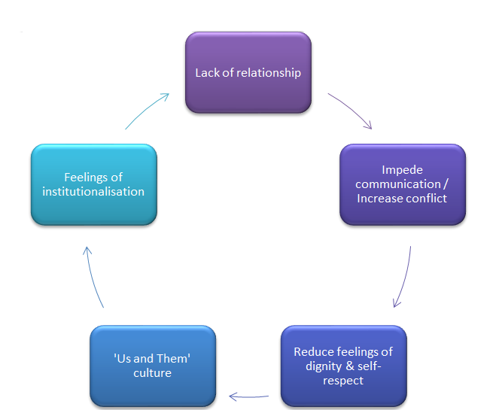

Figure 3. Flow diagram to illustrate how a negative cycle may develop from a lack of communication between staff and detained inpatients

Relationships with Friends and Family
As in staff/inpatient relationships, the literature revealed a dichotomy in inpatients’ relationships with friends and family outside hospital. Whilst there was some evidence of people maintaining these relationships and finding them helpful and supportive throughout their time in hospital, others felt that their outside relationships fell apart during the time they were detained (Hughes et al., 2009).

For some inpatients, being detained resulted in them feeling a loss of former friends and a ‘normal life’ (Seed et al., 2016). This, coupled with social isolation (Loft & Lavender, 2016; Sustere & Tarpey, 2018), detachment or ambivalence from family (Loft & Lavender, 2016; Tapp et al., 2013), and the anxieties that arose from this (Tapp et al., 2013), were felt by some to contribute to a ‘dependence’ on the ward (Seed et al., 2016), even though participants were able to identify reasons why family and friends may appear detached or distanced. These included reasons such as involuntary detention of a relative being distressing for them, or competing commitments such as work (Giacco et al., 2018). The literature describes inpatients’ reduced contact with family and friends resulting in them forming an attachment to peers and the inpatient unit itself as ‘family’ (Seed et al., 2016), which may contribute to and exacerbate feelings of institutionalisation and make them resent their detention under the MHA (Seed et al., 2016). This may present a barrier to engagement and communication with staff and therefore to forming relationships, which may prevent inpatients from feeling like they are being involved in their own care or treated with dignity and respect.

An identified benefit of maintaining relationships with friends and family whilst detained was that people in this network said or did things which helped the individuals realise that they did actually require help and treatment in hospital (Hughes et al., 2009). This may have helped alleviate some negative feelings instilled in a person as a result of being sectioned under the MHA, thus reducing perceptions of institutionalisation. Furthermore, relationships with family, as well as with peers and staff, helped people feel less isolated and more like they were being cared for (Tapp et al., 2013). This is reflected by positive accounts of carers being involved in inpatients’ treatment; for example it was reported that carers were able to help inpatients feel more comfortable in meetings and express their wishes about their treatment (Giacco et al., 2018). It was nicely put by one participant that the outside relationships maintained whilst detained were helpful in reminding inpatients who they are (Hughes et al., 2009).

Communication
The discussed themes of ‘dignity and respect’ and ‘relationships’, particularly those with staff, are naturally linked to another key feature of experience as a detained inpatient: communication. Communication with staff appeared in several of the reviewed papers as an area of importance. Difficulties in communication with staff, such as inpatients finding it hard to explain themselves to staff or likewise struggling to understand some terminology used by clinicians (Giacco et al., 2018), could lead to perceived ‘splits’ between inpatients and staff (Lord, 2014), again illustrating the potential for perceptions of an ‘us’ and ‘them’ separation. A common issue identified with communication was that of transparency and inpatients’ concerns with what they felt they were not being told (Chambers et al., 2014; Grace, 2015). This included such things as not being properly informed about their medication (Chambers et al., 2014), being denied requests but not being told why, not being kept up-to-date with ward rules and procedures (Sustere & Tarpey, 2018), and being uninformed about their section, for example how long they would be detained (Grace, 2015) or the process and implications of their detention (Seed et al., 2016). Participants understandably found this lack of communication about such important parts of their detention distressing (Grace, 2015). Perceptions of poor communication appeared to breed feelings that staff were dishonest, created a lack of trust towards staff (Loft & Lavender, 2016; Grace, 2015; Sustere & Tarpey, 2018), and made inpatients feel distressed and uncared for (Seed et al., 2016).

A further issue with communication appeared to be understaffing, which was mentioned in several of the reviewed articles (e.g. Chambers et al., 2014, Loft & Lavender, 2016). Many wards use temporary staff to fill gaps in staffing: inpatients found the lack of familiar staff intimidating (Grace, 2015), which may have contributed to poor communication, again potentially lowering feelings of dignity and respect within their care and creating barriers to forming effective therapeutic relationships. On the other hand, it was identified that collaboration in care to reach a shared understanding of difficulties between staff and inpatients was helpful, and this involved transparency, proactivity, and the promotion of autonomy in making decisions (Tapp et al., 2013). This highlights the importance of effective communication for people who are detained under the MHA.

Involvement in Decisions
This theme is closely linked to communication, and has been touched on in the earlier synthesis of the category ‘dignity and respect’. It was identified from the reviewed studies that inpatients place importance on being involved in making decisions about their care, and that this is considered a prerequisite for meaningful, effective engagement whilst detained (Chambers et al., 2014; Lord, 2014). Without this involvement, participants felt that they had no control over their decisions and these were made for them, were unchangeable, and were often not made in their best interests (Chambers et al., 2014, Seed et al., 2016, Sustere & Tarpey, 2018). This perceived lack of autonomy made inpatients feel powerless (Chambers et al., 2014) and decreased their sense of self-efficacy as they were unable to leave the ward or practice skills (Hughes et al., 2009). This links to the category ‘access to meaningful activities’ below.

A large discussion point with regards to inpatients’ involvement in decisions concerning their care centred on medication. Participants across the papers reported being ‘forced’ to take medication, which was distressing and produced negative physical and psychological side-effects (Grace, 2015; Hughes et al., 2009; Loft & Lavender, 2016). These included drowsiness and a ‘masking’ rather than reduction of symptoms (Tapp et al., 2013), as well as re-traumatisation from (e.g.) past abuse when subjected to forced intramuscular medication (Hughes et al., 2009). Some helpful aspects of medication were identified in the review: for example that medical treatment helped improve social functioning and engagement in other therapeutic activity (Tapp, 2013). However, the view was largely negative, and some felt it impeded rather than assisted recovery (Hughes et al., 2009).

Access to Meaningful Activities
The review revealed access to meaningful activities as an important part of the experience of detained inpatients as it allowed them to regain a sense of normality by providing opportunities to engage in activities reflective of life in the community (Chambers et al., 2014; Sustere & Tarpey, 2018). Work opportunities allowed people to maintain and develop skills, which as identified above is important in preserving an individual’s sense of self-efficacy whilst detained by allowing them to be involved in making decisions about their care (Hughes et al., 2009; Tapp et al., 2013). This perception of positive risk-taking and providing a sense of personal choice in regards to meaningful activities (Lord, 2014; Sustere & Tarpey, 2018), including access to/choice of talking therapies (Tapp et al., 2013), reflects the DoH (2012) initiative of ‘No decision about me, without me’. This is further supported by findings that involuntary inpatients’ perception of and satisfaction with mental health wards improved after staff were given training to provide therapeutic activities (Wykes et al., 2017).

Institutionalisation: Being Detained

Compliance
As discussed, perceived conflict between detained inpatients and staff can result in an ‘us’ and ‘them’ mentality. Whilst at first this could make people want to rebel against the rules, the literature overall suggested that inpatients would eventually comply with the rules of the institution, whether this was because they learnt that non-compliance was ineffective in getting their needs met, or they eventually lost hope and became ‘too tired to fight’ (Loft & Lavender, 2016; Seed et al., 2016). Some of the reviewed literature identified that participants would comply by hiding their feelings and ‘pretending to be ok’ as they felt they had learned what staff wanted them to do, and so acted in this way in order to get discharged quicker (Hughes et al., 2009; Seed et al., 2016). Grace (2015) referred to this as ‘playing the game’ and gave an example of one gentleman who complied and acted ‘ok’ in order to get released faster, regardless of recovery, and subsequently made an attempt to end his life once released. On the more positive side, others began to comply upon realising that staff were working with them and making a conscious decision to comply in order to attempt recovery (Seed et al., 2016). This suggests that regardless of their motives for compliance, detained inpatients often do eventually comply with the rules imposed upon them. Their motives may however determine the success of their recovery.

Lack of Power and Control
Issues related to this subtheme have been mentioned already in other categories identified from the review. Here, we focus more on the restrictions imposed on the person by the MHA that create a sense of loss of power. A loss of control and feeling of ‘powerlessness’ when in hospital seemed to be associated with negative feelings such as stigma, marginalisation, betrayal and persecution resulting from their detention (e.g. Chambers et al., 2014; Loft & Lavender, 2016), as well as a perceived lack of freedom and independence (Chambers et al., 2014; Loft & Lavender, 2016; Sustere & Tarpey, 2018) (Figure 4).

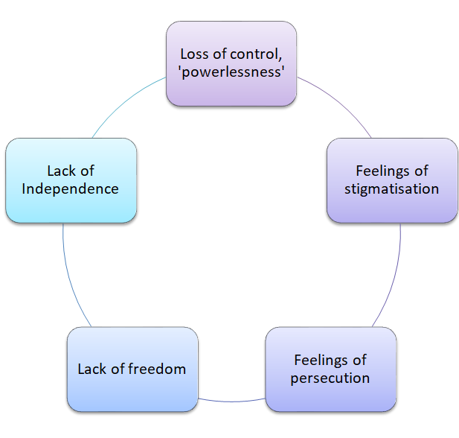
Figure 4. Flow diagram to illustrate how negative feelings may develop from inpatients experiencing a perceived lack of power and control

Some participants’ feelings of losing control reduced their sense of self-worth and increased their distress, hopelessness and therefore risk when detained (Chambers et al., 2014; Loft & Lavender, 2016; Sustere & Tarpey, 2018; Tapp et al., 2013). This was worsened by worries about how their detention under a section of the MHA may affect their future prospects following discharge (Chambers et al., 2014; Seed et al., 2016).

Feelings of powerlessness seemed to be also related to staff attitudes. Rigid rules and punitive attitudes were felt to contribute to inpatients’ perceptions of ‘us’ and ‘them’, which both disrupted therapeutic alliances and made people feel dehumanised through the lack of autonomy that was enforced by both the MHA restrictions and staff attitudes (Chambers et al., 2014; Hughes et al., 2009; Seed et al., 2016). Participants in several of the articles reviewed felt that emotions and normal requests were pathologised by clinicians, and often feelings and behaviours were attributed to them having a ‘mental illness’ (Seed et al., 2016). As such, it was felt that the ‘threat’ of treatment, medication or restraint was used to control inpatients in order to prevent the expression of ‘extreme emotions’ (Grace, 2015; Seed et al., 2016). The ‘overpowering’ presence of professionals on wards coupled with unhelpful staff attitudes is likely to exacerbate people’s sense of limited power and control over their detention, and that this is just ‘how things are’ (Loft & Lavender, 2016; Sustere & Tarpey, 2018). This illustrates the impact that not only MHA-enforced restrictions but also staff attitudes can have on inpatients’ sense of power and control, and supports that detention may have the potential to increase psychological distress and symptoms of this (Grace, 2015).

The Inpatient Environment
A common theme between articles was concerns with the inpatient environment itself. The physical surroundings were described as unclean, oppressive, controlling and ‘uncontaining’ (Chambers et al., 2014; Loft & Lavender, 2016). Psychologically, participants felt as though they were imprisoned due to the constant surveillance and lack of privacy they experienced (Chambers et al., 2014; Lord, 2014). This, combined with the noise from other inpatients and the negative impact of being around other unwell people, led to the description of the environment as an unstimulating, hostile and scary place (Grace, 2015; Lord, 2014). Despite this, it was identified that for some this environment becomes ‘the norm’ (Seed et al., 2016).

Benefits of Detention
Participants in the reviewed articles discussed mixed feelings about their detention, most commonly both anger and relief (Loft & Lavender, 2016; Seed et al., 2016). The relief appeared to emerge from the sense of some personal responsibility being removed, almost giving respite (Seed et al., 2016; Sustere & Tarpey, 2018). Whilst this was noted to be helpful to an extent, it was also thought to be detrimental if this responsibility was restricted for too long (Tapp et al., 2013). This links to the previously discussed categories of ‘dignity and respect’ and ‘involvement in decisions’, which illustrate that participants found it helpful to maintain some agency in order to maintain self-respect and self-efficacy.

Furthermore, participants felt that they were able to learn from their experience of detention through sharing experiences with others (Loft & Lavender, 2016; Tapp et al., 2013). This enabled detained inpatients to not only reduce their feelings of loneliness, but also to better understand their experiences and their ‘illness’, thereby increasing self-compassion (Seed et al., 2016; Tapp et al., 2013).

Discussion

Exploration of the literature investigating what is known about the experience of being detained as an inpatient under the amended MHA identified six categories reflecting salient aspects of detainee experience. A common theme throughout these categories was the desire to be treated with respect whilst detained, which naturally encompassed the importance of effective relationships and communication with staff. This finding may be of particular importance following evidence that poor relationships between staff and inpatients are frequently reported (Cleary, Hunt, Horsfall & Deacon, 2012; Stenhouse, 2011; Weich et al., 2012). These poor relationships can arise due to barriers including low staffing levels, the associated lack of staff continuity, and bureaucratic demands (Johnson et al., 2009). The issue of compulsory medication may contribute to strained staff/inpatient relationships: such treatment is a condition of being subject to the MHA, differing to patients with physical health problems who can refuse treatment. This may exacerbate the experienced power-imbalance if detained individuals do not believe the treatment is helpful and feel like their objections are not being heard. The evidence reviewed illustrates that feeling listened to by staff and that staff are interested in what a person has to say are key aspects of feeling treated with dignity and respect (Giacco et al., 2018; Lord, 2014).

Previous quantitative research has indicated mixed findings regarding inpatients’ satisfaction with involuntary care (e.g. Bonsack & Borgeat, 2005; Rain et al., 2003). The results of this review, using mainly qualitative data, support these mixed findings. Whilst some benefits of detention were identified and discussed through the review, there is still an overwhelmingly negative perspective depicted of detained inpatient experience. Negative perceptions of being detained identified in the review involved feelings of lack of power and control. This is consistent with findings from a previous review, conducted before the 2007 amendments to the MHA (Katsakou & Priebe, 2007), suggesting that the amendments have not yet alleviated this hardship.

Many inpatients complain that there is very little to do on psychiatric wards in the way of therapeutic activities, which can result in intense boredom (e.g. Care Quality Commission [CQC], 2014, 2015; Csipke et al., 2016; Theodoridou, Schlatter, Ajdacic, Rössler & Jäger, 2012; Walsh & Boyle, 2009; Wing & Brown, 1970). This review indicates that a remedy to this may be to support detained inpatients to choose how they use their time, and thereby enable them to do things that are important and relevant to their lives. This may include therapy, work, and/or activities to develop skills, but should be personally meaningful rather than something the service suggests they ‘should’ do. Supporting people to spend their time doing something that they consider personally meaningful may help promote feelings of autonomy, which is important for good psychological health (Deci & Ryan, 1985).

Limitations
Limitations of this review must be considered. The data appraised was mainly qualitative, gained through interviews. This relies on accurate recall from participants. However, some may have been detained up to years beforehand and thus may not recall their experiences as a detained inpatient accurately, or they may recall it in an overly positive or negative way. Furthermore, people may have had multiple inpatient stays, both voluntary and involuntary, so it is possible that their account of their experience may amalgamate the two and make it difficult to extract the experience of one type of hospitalisation from the other. This would make the findings of this review less credible, trustworthy and transferable to practice.

An inherent issue in literature reviews is publication bias. The overall publication rates of both quantitative and qualitative papers is only around 44-45% (Petticrew et al., 2008; Scherer, Langenberg & von Elm, 2006), with unpublished studies being less likely to report significant findings. This reflects underrepresentation of negative findings in the literature (Fanelli, 2012), which is likely to cause important research to be missed as finding no effect is just as important as finding one. This bias in publication of papers may also mean that papers are published which are not necessarily of high quality. This is reflected by the large range (35-95%) in quality assessment scores for papers included in this review. This may affect the review’s findings as a complete picture of inpatient experience may not be available due to relevant papers being unpublished. This issue was addressed in this review through searching online databases of unpublished ‘grey’ literature and student theses, of which two were included in the review.

An issue around quality appraisal was that all relevant papers were reviewed regardless of their quality rating, as the CASP does not advise a quality score ‘cut-off’ below which studies should be excluded. This may affect the integrity of the findings presented, as drawing conclusions using information from ‘weaker’ studies may make the review less representative of reality. The use of a quality appraisal tool did mitigate this somewhat, as the reviewer was cautious to draw assumptions about aspects of the study that had been scored low on quality.

The searches, synthesis and conclusions presented were performed by one reviewer, and it was not possible to perform checks with others to clarify or confirm findings. Therefore the findings may be limited in rigour. The review process is subjective, as is the synthesis of qualitative information; supposedly more so than that of quantitative data (Katsakou & Priebe, 2007). To moderate this, a detailed search strategy is described in the review in an attempt to increase reliability by allowing others to replicate the review and achieve similar findings.

Articles whose participants were detained as inpatients under criminal sections of the MHA were provided by the literature search, and were included in the review to encompass a wider range of experiences of being detained under the MHA. This was both to include multiple perspectives of adult longer-term involuntary hospitalisation, and also to increase reliability of the search as these results would appear if this search strategy were to be replicated. However, this may have slightly skewed the review: if the review had specifically aimed to include criminal inpatient sections, the resulting themes may have been different. This presents a potential limitation that could be explored more in a further review.

Clinical Implications
The knowledge gained from this review may be applied to clinical practice in order to improve inpatient experience of detention under the MHA, in line with the DHSC’s (2018) recommendations and other recent initiatives (see ‘Introduction’) advocating that service-user experience should be improved through increased autonomy and dignity.

Promoting positive staff/inpatient relationships may allow both parties to feel more comfortable collaborating in care, including routinely involving detained inpatients in shared decision-making, which is a quality standard for inpatient care (NICE, 2011). Helping people make informed choices is important, so explaining their options is as important as offering them. Collaborating with inpatients more in their care, for example around treatment options (e.g. medication, psychological therapy) and providing more information about the detention process, might alleviate feelings of being worked ‘on’ rather than ‘with’. This would likely increase feelings of autonomy, inclusion and empowerment. The development and maintenance of effective therapeutic alliances may increase inpatients’ satisfaction on the wards through increased feelings of agency and dignity, respect from self and others, a reduction in isolation and more involvement in one’s own care. Promoting therapeutic engagement and development of effective therapeutic alliances through communication skills training for staff may therefore be an important step in improving detained inpatient experience.

Positive relationships between staff and inpatients may also increase staff’s confidence in implementing LRPs rather than imposing harsher restrictions or penalties than necessary upon inpatients. Use of LRPs would likely increase inpatients’ ownership of treatment and feelings of empowerment and independence. Relationships with staff could then become more trusting, which is vital to promote feelings of self-respect and dignity (e.g. Lord, 2014), and may reduce both perceptions of an ‘us’ and ‘them’ divide between staff and inpatients and also feelings of powerlessness and institutionalisation. This emphasises the importance of relationships, involvement and communication for inpatients detained under the MHA in helping them to preserve their dignity and self-respect, and supports that staff should strive to use LRPs as far as possible in accordance with the Mental Health Units Act (2018).

Detained inpatient experience may be improved through increased staff training around, and increased access to, meaningful therapeutic activity on inpatient wards. Supporting inpatients to choose how they spend their time and thereby engage in interests that are personally relevant and important to them as an individual is likely to increase their sense of autonomy and empowerment, and may both increase inpatient engagement while detained and also help to reduce the number or length of an individual’s admissions (Wykes et al., 2017). Findings suggest that access to meaningful activities can improve inpatients’ perceptions about their environment (Wykes et al., 2017), perhaps due to eliciting a sense of participation and belonging and making the ward environment seem like a less hostile, more welcoming place.

Directions for Future Research
There is relatively limited literature on the experience of inpatients detained under the amended MHA. In order to fully understand and appreciate the experiences that people detained under the Act currently have, further rich, in-depth qualitative exploration is required to allow us to address and improve the most significant issues of MHA-detainee experience. Following the implications for clinical practice, future research could focus on barriers to effective therapeutic relationships and meaningful/therapeutic activity from both staff and detained inpatients’ points of view. Training or other measures may then be implemented to remove these barriers, in order to offer these important experiences to detained inpatients. This may consequently reduce negative perceptions of detention, reduce feelings of institutionalisation, and improve service-user experience as advocated by the aforementioned initiatives such as 'High quality care for all' (2008).

Future research would benefit from attempting to avoid methodological limitations similar to those of the studies reviewed in this report. A major concern was that very few of the studies described how they would handle ethical issues that arose, for example what procedures would be taken should a participant become distressed. Involuntarily detained patients are a vulnerable group of people and research into their detention may cause upset. Future research should consider how to manage this and be transparent about their processes to demonstrate that they are protecting this vulnerable population when including them in research.

It would be helpful if participants were recruited from a variety of geographical locations in England and Wales. This would help us understand whether the experience of detention under the MHA is consistent or perhaps dependent on where a person is detained, as this may indicate that interrelated factors such as socioeconomic and cultural influences can affect detainee experience. Likewise, wider use of interpreters (Giacco et al., 2018) could obtain more diverse viewpoints and accounts of detainee experience, as could inviting people to volunteer to participate rather than them having to be identified by staff. These measures would make the research more inclusive and representative of the target population. This would allow stronger, more credible recommendations to be made from higher-quality studies as they would provide a more accurate and representative idea of what current inpatient experience is, so we can be more confident that we understand what needs addressing and prioritising in order to make meaningful improvements.

The DHSC published recommendations from their independent review in late 2018, which essentially focused on improving service-user experience. It would be useful to replicate this literature review in a few years’ time once these recommendations have had the opportunity to be incorporated into practice, if not legislation in a further amendment to the MHA, to investigate whether their contribution makes any difference to detained inpatient experience. This would help inform the ongoing development of clinical initiatives, legislation and practice.

Conclusions

This review highlights some important issues to address when focusing on the experience of those detained under the MHA. It can be used as a foundation to inform future research and reviews, and to increase awareness of the most significant themes in detained inpatient experience as explained by the available research on this important topic area. This may help to facilitate continuous development of future care initiatives and practice.

The findings suggest that the experience of people detained under the amended MHA could be improved through enabling individuals to have choice and control over their own time and treatment through personally meaningful activities, and development of effective therapeutic alliances with staff. These would allow individuals to maintain agency and a sense of control during detention, due to their dignity and respect being nurtured and relationships improved through better communication with staff and involvement in their treatment. This would potentially reduce negative feelings associated with detention such as isolation and powerlessness, and may empower people to consider their detention as a more positive experience.

References

Armstrong, A., Jackson, N., Doyle, J., Waters, E., & Howes, F. (2005). It's in your hands: the value of handsearching in conducting systematic reviews of public health interventions. Journal of Public Health, 27, 388-91. doi: 10.1093/pubmed/fdi056

Aveyard, H., & Sharp, P. (2013). A beginner's guide to evidence-based practice in health and social care. UK: McGraw-Hill Education.

Blaxter, M. (1996). Criteria for the evaluation of qualitative research papers. Medical Sociology News, 22, 68-71. doi: not available

Bonsack, C. & Borgeat, F. (2005). Perceived coercion and need for hospitalization related to psychiatric admission. International Journal of Law and Psychiatry, 28, 342–347. doi: 10.1016/j.ijlp.2005.03.008

Care Quality Commission (2014). Monitoring the Mental Health Act in 2012/13: Care Quality Commission 2014. Retrieved from https://www.cqc.org.uk/sites/default/files/documents/cqc_mentalhealth_2012_13_07_update.pdf

Care Quality Commission (2015). Monitoring the Mental Health Act in 2015/16. Care Quality Commission. Retrieved from https://www.cqc.org.uk/sites/default/files/20161122_mhareport1516_web.pdf

Chambers, M., Gallagher, A., Borschmann, R., Gillard, S., Turner, K. & Kantaris, X. (2014). The experiences of detained mental health service-users: Issues of dignity in care. BMC Medical Ethics, 15, 50. doi: 10.1186/1472-6939-15-50

Cleary, M., Hunt, G. E., Horsfall, J. & Deacon, M. (2012). Nurse-patient interaction in acute adult inpatient mental health units: a review and synthesis of qualitative studies. Issues in Mental Health Nursing, 33, 66-79. doi: 10.3109/01612840.2011.622428

Cooke, A., Smith, D. & Booth, A. (2012). Beyond PICO: the SPIDER tool for qualitative evidence synthesis. Qualitative Health Research, 22, 1435-1443. doi: 10.1177/1049732312452938

Critical Appraisal Skills Programme. (2018). CASP Qualitative Checklist. Retrieved from https://casp-uk.net/wp-content/uploads/2018/01/CASP-Qualitative-Checklist-2018.pdf

Critical Appraisal Skills Programme. (2018). CASP Randomised Controlled Trial Checklist. Retrieved from https://casp-uk.net/wp-content/uploads/2018/03/CASP-Randomised-Controlled-Trial-Checklist-2018_fillable_form.pdf

Cronin, T., Gouda, P., McDonald, C., & Hallahan, B. (2017). A comparison of mental health legislation in five developed countries: a narrative review. Irish journal of psychological medicine, 34, 261-269. doi: 10.1017/ipm.2017.48

Csipke, E., Williams, P., Rose, D., Koeser, L., McCrone, P., Wykes, T. & Craig, T. (2016). Following the Francis report: investigating patient experience of mental health in-patient care. British Journal of Psychiatry, 209, 35. doi: 10.1192/bjp.bp.115.171124

Department of Health. (2007). Explanatory notes to mental health act 2007. Retrieved from http://www.legislation.gov.uk/ukpga/2007/12/notes/division/3

Department of Health. (2008). High quality care for all: NHS next stage review final report. The Darzi Report, 49. Retrieved from https://assets.publishing.service.gov.uk/government/uploads/system/uploads/attachment_data/file/228836/7432.pdf

Department of Health. (2012). Liberating the NHS: No decision about me, without me. Retrieved from https://www.gov.uk/government/uploads /system/upload/attachmentdata/file216980/Liberating-the-NHS-No-decision-about-me-without-me-Government-response.pdf

Department of Health and Social Care. (2018). Modernising the Mental Health Act – final report from the independent review. Retrieved from https://www.gov.uk/government/publications/modernising-the-mental-health-act-final-report-from-the-independent-review

Deci, E. L. & Ryan, R. M. (1985). The general causality orientations scale: Self-determination in personality. Journal of research in personality, 19, 109-134. doi: 10.1016/0092-6566(85)90023-6

Fistein, E. C., Holland, A. J., Clare, I. C. H., & Gunn, M. J. (2009). A comparison of mental health legislation from diverse Commonwealth jurisdictions. International Journal of law and Psychiatry, 32, 147-155. doi: 10.1016/j.ijlp.2009.02.006

Giacco, D., Mavromara, L., Gamblen, J., Conneely, M., & Priebe, S. (2018). Shared decision-making with involuntary hospital patients: A qualitative study of barriers and facilitators. BJPsych Open, 4, 113-118. doi: 10.1192/bjo.2018.6

Grace, J. D. (2015). The experience of being assessed and detained under the mental health act: An interpretative phenomenological analysis. Available from Dissertations & Theses Europe Full Text: Literature & Language. Retrieved from https://search.proquest.com/docview/1794923960∗

Hannes, K. (2011). Chapter 4: Critical appraisal of qualitative research. In J. Noyes, A. Booth, K. Hannes, A. Harden, J. Harris, S. Lewin & C. Lockwood (Eds.), Supplementary Guidance for Inclusion of Qualitative Research in Cochrane Systematic Reviews of Interventions. Version 1 (updated August 2011). Cochrane Collaboration Qualitative Methods Group, 2011. Retrieved from http://cqrmg.cochrane.org/supplemental-handbook-guidance

Hong, Q. N., Pluye, P., Fàbregues, S., Bartlett, G., Boardman, F., Cargo, M., Dagenais, P., Gagnon, M., Griffiths, F., Nicolau, B., O’Cathain, A., Rousseau, M. C. & Vedel, I. (2018). Mixed methods appraisal tool (MMAT), version 2018. IC Canadian Intellectual Property Office, Industry Canada.

Hughes, R., Hayward, M. & Finlay, W. M. L. (2009). Patients' perceptions of the impact of involuntary inpatient care on self, relationships and recovery. Journal of Mental Health, 18, 152-160. doi: 10.1080/09638230802053326

Johnson, S., Gilburt, H., Lloyd-Evans, B., Osborn, D. P., Boardman, J., Leese, M., Shepherd, G., Thornicroft, G. & Slade, M. (2009). In-patient and residential alternatives to standard acute psychiatric wards in England. The British Journal of Psychiatry, 194, 456-463. doi: 10.1192/bjp.bp.108.051698

Katsakou, C., & Priebe, S. (2007). Patient's experiences of involuntary hospital admission and treatment: a review of qualitative studies. Epidemiology and Psychiatric Sciences, 16, 172-178. doi: 10.1017/S1121189X00004802

Lawton-Smith, S. (2008). Mental Health Act 2007. Retrieved from https://www.kingsfund.org.uk/sites/default/files/briefing-mental-health-act-2007-simon-lawton-smith-kings-fund-december-2008.pdf

Loft, N. O. & Lavender, T. (2016). Exploring compulsory admission experiences of adults with psychosis in the UK using grounded theory. Journal of Mental Health, 25, 297-302. doi: 10.3109/09638237.2015.1101415

Lord, K. M. (2014). When service-user and research worlds come together: An investigation into therapeutic engagement in secure settings. Available from Dissertations & Theses Europe Full Text: Literature & Language. Retrieved from https://search.proquest.com/docview/1779253370∗

Mental Health Act 1983 (c.20). London: HMSO. Retrieved from http://www.legislation.gov.uk/ukpga/1983/20/contents

Mental Health Act 2007 (c.12). London: HMSO. Retrieved from http://www.legislation.gov.uk/ukpga/2007/12/contents

Mental Health Units (Use of Force) Act 2018 (c. 27). London: HMS0. Retrieved from http://www.legislation.gov.uk/ukpga/2018/27/enacted

National Health Service (NHS). (2013). The Handbook to The NHS Constitution. Retrieved from https://assets.publishing.service.gov.uk/government/uploads/system/uploads/attachment_data/file/170649/Handbook_to_the_NHS_Constitution.pdf

National Institute for Health and Care Excellence. (2011). Service-user experience in adult mental health: improving the experience of care for people using adult NHS mental health services (NICE Clinical Guideline No. 136). Retrieved from http://www.nice.org.uk/guidance/cg136/chapter/1-guidance

National Institute for Health and Care Excellence. (2018). Developing NICE guidelines: the manual (NICE Process and Methods No. 20). Retrieved from https://www.nice.org.uk/process/pmg20/chapter/reviewing-research-evidence

NHS Digital (2019). Mental Health Act statistics. Retrieved from https://digital.nhs.uk/data-and-information/publications/statistical/mental-health-act-statistics-annual-figures/2018-19-annual-figures

Petticrew, M., Egan, M., Thomson, H., Hamilton, V., Kunkler, R., & Roberts, H. (2008). Publication bias in qualitative research: what becomes of qualitative research presented at conferences?. Journal of Epidemiology & Community Health, 62, 552-554. doi: 10.1136/jech.2006.059394

Rain, S. D., Williams, V .F., Clark Robbins, P., Monahan, J., Steadman, H. J., & Vesseline, R. (2003). Perceived coercion at hospital admission and adherence to mental health treatment after discharge. Psychiatric Services, 54, 103–105. doi: 10.1176/appi.ps.54.1.103

Scherer, R. W., Langenberg, P. & von Elm, E. (2006). Full publication of results initially presented in abstracts. Cochrane Methodology Review: The Cochrane Library.

Seed, T., Fox, J. & Berry, K. (2016). Experiences of detention under the mental health act for adults with anorexia nervosa. Clinical Psychology & Psychotherapy, 23, 352-362. doi: 10.1002/cpp.1963

Seed, T., Fox, J. R., & Berry, K. (2016). The experience of involuntary detention in acute psychiatric care. A review and synthesis of qualitative studies. International journal of nursing studies, 61, 82-94. doi: 10.1016/j.ijnurstu.2016.05.014

Stenhouse, R. C. (2011). ‘They all said you could come and speak to us’: patients' expectations and experiences of help on an acute psychiatric inpatient ward. Journal of Psychiatric and Mental Health Nursing, 18, 74-80. doi: 10.1111/j.1365-2850.2010.01645.x

Sustere, E. & Tarpey, E. (2019). Least restrictive practice: Its role in patient independence and recovery. The Journal of Forensic Psychiatry & Psychology, 30, 614-629. doi: 10.1080/14789949.2019.1566489

Tapp, J., Warren, F., Fife-Schaw, C., Perkins, D. & Moore, E. (2013). What do the experts by experience tell us about 'what works' in high secure forensic inpatient hospital services? The Journal of Forensic Psychiatry & Psychology, 24, 160-178. doi: 10.1080/14789949.2012.760642

Theodoridou, A., Schlatter, F., Ajdacic, V., Rössler, W. & Jäger, M. (2012). Therapeutic relationship in the context of perceived coercion in a psychiatric population. Psychiatry research, 200, 939-944. doi: 10.1016/j.psychres.2012.04.012

Walker-Tilley, T., Exworthy, T., Baggaley, M., Wilkinson, L., & Nilforooshan, R. (2011). Effect of recent changes to the Mental Health Act 1983 on sections and appeals: possible unintended consequences. The Psychiatrist, 35, 305-307. doi: https://doi.org/10.1192/pb.bp.110.032391

Walsh J. & Boyle, J. (2009). Improving acute psychiatric hospital services according to inpatient experiences. A user-led piece of research as a means to empowerment. Issues in Mental Health Nursing, 30, 31–38. doi: 10.1080/01612840802500733

Weich, S., Griffith, L., Commander, M., Bradby, H., Sashidharan, S. P., Pemberton, S., Jasani, R. & Bhui, K. S. (2012). Experiences of acute mental health care in an ethnically diverse inner city: qualitative interview study. Social psychiatry and psychiatric epidemiology, 47, 119-128. doi: 10.1007/s00127-010-0314-z

Wing, J. K. & Brown, G. W. (1970). Institutionalism and schizophrenia: A comparative study of three mental hospitals. London: Cambridge University Press.

Wykes, T., Csipke, E., Williams, P., Koeser, L., Nash, S., Rose, D., Craig, T. & McCrone, P. (2018). Improving patient experiences of mental health inpatient care: A randomised controlled trial. Psychological Medicine, 48, 488-497. doi: 10.1017/S003329171700188X

Paper 2: Empirical Paper

A thematic analysis of the impact of attending a hearing to review detention on people who remain detained on an acute mental health inpatient ward

Continued detention after a review hearing

Penny Foster¹
¹School of Life Sciences and Education, Staffordshire University

Penny Foster
Doctorate in Clinical Psychology

Word Count: 7998

This paper has been written in accordance with Journal Submission Guidelines for the journal ‘Clinical Psychology & Psychotherapy’ (excluding word count). These guidelines can be found in Appendix A.

Conflict of Interest Statement
No conflicts of interest to declare.

Abstract

In 2018, the Department of Health and Social Care published a review of the Mental Health Act (MHA, 1983; 2007) and associated safeguards, including detention review hearings. This study aims to explore the experience and impact of attending a hearing to review detention under the MHA where detention is upheld. Semi-structured interviews with eight inpatients detained on acute psychiatric wards were analysed using thematic analysis to search for common patterns in meaning. Three themes were identified: ‘Getting out’ (sub-themes: ‘Understanding vs Expectations’ and ‘Left To It’), ‘F**k…I’m not getting out’ (sub-theme: ‘Silenced’) and ‘I’m stuck here’ (sub-themes: ‘Captive’ and ‘I shouldn’t even be here’). Findings suggest that participants were not supported to understand the purpose and process of detention review hearings, which generated unfounded expectations of release. This led to negative emotional responses both during and after the hearing, which were exacerbated by having to remain ‘stuck’ on the ward and subject to compulsory treatment. This highlights the need for intervention both before and after detention review hearings to increase inpatients’ knowledge and understanding of these, manage expectations, and address practical and emotional needs.

Key Practitioner Message
- Inpatients detained on acute psychiatric wards under the MHA can have a limited understanding of the process and purpose of detention review hearings (DRHs)
- This can create unfounded expectations of release following a DRH, leading to negative emotional responses and the negative impact of remaining on a psychiatric inpatient ward
- Provision of education and information about DRHs and support for psychological needs following a DRH need to be improved

Keywords: experience, impact, detention review, Tribunal, inpatient, acute

Introduction

The Mental Health Act (MHA, 1983; amended 2007) provides legal authority in England and Wales for people with mental health difficulties to be admitted to hospital for treatment. Detentions under the MHA are made when someone has a mental health difficulty that requires assessment or treatment in order to maintain the safety of themselves or others (Walker-Tilley, Exworthy, Baggaley, Wilkinson & Nilforooshan, 2011), and is of a nature or degree that makes detention necessary over any other treatment option. Use of the MHA can save lives, but can also mean that people are given treatment against their wishes (Department of Health and Social Care [DHSC], 2018).

MHA powers are usually exercised when people are at their most vulnerable, presenting the risk that people’s rights and personal dignity may suffer as a result of the Act and its powers of detention. Inpatients may therefore be subject to experiences of epistemic injustice (Fricker, 2007) whereby their capacity as a person with knowledge is wrongfully denied. Their concerns and complaints about detention can be ignored or dismissed as ‘symptoms of a disorder’ (DHSC, 2018), thus challenging their human value and creating senses of loss, fear and trauma (Seed, Fox & Berry, 2016). Whilst some inpatients experience detention under the MHA as a ‘sanctuary’ (Seed et al., 2016), it makes others feel dehumanised, marginalised and powerless (Akther et al., 2019).

Detention rates in England are around average for Europe, but they appear to be rising faster here than anywhere else (DHSC, 2018). Detentions under the MHA have climbed 15% from 43,361 in 2005/6 to 49,550 in 2017/18 (NHS Digital, 2019), with a 40% increase reported between 2005/06 and 2015/16 (NHS Digital, 2017). It appears that these account for the detention of new people rather than the same people being repeatedly detained (Care Quality Commission [CQC], 2019). This implies that people are being detained with no previous experience of detention, what this entails, or the implications of detention; therefore their understanding of these issues may be limited.

People are detained under various ‘sections’ of the MHA depending on their treatment needs. The most well-known (Linden, 2009) and most used sections are 2 (s2) and 3 (s3) (NHS Digital, 2019). Individuals can be held for up to 28 days under s2 and from six months to a year at a time under s3. They may then be discharged, changed to ‘voluntary’ inpatient status, or have their section upheld or revised to a different section. Both the MHA Code of Practice (2015) and National Institute for Health and Care Excellence (NICE) Guidelines (2011) state that a person being treated under the MHA has the right to appeal against their detention, and should be supported with this by health and social care professionals.

In England, inpatients have two different options to review a decision to detain or continue detention under the MHA. One option is a Hospital Managers Hearing, where an independent panel considers the potential for discharge from detention. The other is to apply to the First-tier Tribunal for Mental Health, an independent judicial body that reviews the cases of individuals who are compulsorily detained or subject to guardianship and community treatment orders (Administrative Justice and Tribunals Council [AJTC] & CQC, 2011). The Hospital Managers Hearing is organised locally by a Mental Health Administrator rather than the Tribunal Service, and the panel consists of three non-executive directors of the organisation whereas the Tribunal consists of a judge, an independent psychiatrist and a specialist layperson. Both have powers under sections of the MHA to discharge inpatients from their detention. For the purposes of this report, both will be referred to as a ‘detention review hearing’ (DRH).

Previous studies report appeal rates of 22-50% (Deshpande, Morton, Haque & Oyebode, 2008; Nilforooshan, Amin & Warner, 2009; Rimmer, O’Connor & Anderson, 2002). Inpatients may initiate an appeal themselves and automatic referrals to the Tribunal are made periodically on their behalf in line with MHA requirements. Although applications for both types of DRHs have increased, the rate of inpatients being discharged from their sections has dropped (CQC, 2015).

An independent review of the MHA (DHSC, 2018) raised questions about how effective DRHs are at carrying out their purpose. Concerns have been identified by the CQC, the AJTC, and from evidence provided by relevant stakeholders, including such issues as current demand on Tribunal and clinical resources and potential duplication between DRHs. It is concerning that these opportunities for release from detention are anticipated by detained individuals, yet may not be conducted effectively. The DHSC’s review of the MHA has therefore published practice-based recommendations to government that aim to improve the treatment and support received by people experiencing mental health difficulties, and to improve services that support people whilst detained. These recommendations also aim to improve other safeguards, including DRHs.

The DHSC’s (2018) review findings supported recent initiatives emphasising the need to improve the experience of people using the National Health Service (NHS), such as 'High quality care for all' (Department of Health [DOH], 2008) and the NHS Constitution (2013). With proposed changes in legislation having an increased focus on service-user experience, it would be useful to gain insight and understanding into inpatients’ perspectives of DRHs in order to inform future practice.

Whilst experiences of the processes involved in the preparation for a DRH, such as sharing Tribunal reports, managing delays and ensuring appropriate representation, have been explored through previous qualitative research (AJTC & CQC, 2011; DHSC, 2018), there is a lack of empirical evidence that explores the after-effects of actually attending a DRH. People place a great deal of hope in these processes as a means of participating in their care and treatment and restoring their liberty (AJTC & CQC, 2011). It is therefore reasonable to hypothesise that this experience may have an impact on an individual’s mental health and wellbeing, especially as only 23% of inpatients report achieving the DRH outcome they wanted (AJTC & CQC, 2011).

As there is evidence of an increase in people being detained, and literature to suggest that detained individuals face challenges including imbalanced power and other inherent injustices (e.g. Akther et al., 2019; Fricker, 2007), it may be useful to explore the impact of attending a DRH after which detention under the MHA is upheld. This would not only help inform practice and improve inpatient experience of these safeguards, but may also help NHS Trusts to meet NICE quality standards (2011) such as involving service-users in monitoring and improving the performance of services, and protecting service-users from avoidable physical or psychological harm. Exploring nuanced themes and similarities/differences across people’s experiences and perceived impact of attending a DRH that upheld detention may help inform services how to provide appropriate support for individuals whose detention is upheld.

Acute psychiatric inpatient (‘acute’) wards provide care for adults with acute or severe mental health difficulties who require short-term assessment and treatment under s2, or longer-term treatment under s3. It is particularly useful to explore the experiences of people currently detained on acute wards, especially in light of rising MHA detention rates (CQC, 2019; DHSC, 2018), as these are usually the first mental health service in which people will be subject to compulsory detention.

This research focuses on the experiences of people who are currently detained as inpatients in order to avoid any ethical complications associated with contacting people in the community post-discharge; for example causing undue distress when they may have limited support available. This also increases the homogeneity of the group, as those who are no longer detained in hospital may have differing perspectives of the experience. This approach will enhance the potential for the outcomes of this study to directly inform future practice regarding the provision of support for people who remain detained on the ward following attending a DRH, for which there is currently limited empirical research.

Aims
The purpose of this investigation is to identify key patterns of meaning in people’s experiences and the impact of attending a DRH which decides to support continuing detention of a person on an acute psychiatric ward under a section of the MHA. The principal objective is to improve understanding of the inpatient experience of this event and its aftermath.

Method

Recruitment
Inpatients from 11 acute wards across five NHS hospitals in North-West England and Staffordshire were invited to participate. Purposive sampling was used to ensure a homogenous sample with experiences relevant to the research question. Service managers and individual ward managers were approached for support to recruit to the study from their wards, and the study was presented to ward staff at team meetings. The researcher approached inpatients who had been identified as eligible by clinicians (Table 1) and had provided verbal consent to the clinicians to be approached about the study.

Table 1.

Eligibility criteria.
Inclusion Criteria | Exclusion Criteria
Aged 18 years or over | Unable to speak/understand English well enough to participate in an interview
Currently detained on an acute psychiatric ward under Section 2 or 3 of the MHA | Assessed as being unable to give informed consent (by clinical team and researcher)
Have attended a First-tier Tribunal for Mental Health review or a Hospital Managers Hearing that upheld detention
Able to confidently recall details of their review hearing

Inpatients who expressed interest in participating were given a participant information leaflet (PIL, Appendix D) and a participant information sheet (PIS, Appendix E) to consider. They were offered a minimum of 24 hours afterwards to decide whether they wanted to consent to participate, to reduce the possibility of people feeling coerced to take part. The study was also advertised on wards using the PILs and posters (Appendix F) so that people could contact the researcher to discuss participating; however no participants self-identified this way. Recruitment took place between October 2019 and February 2020. Participants were required to complete an informed consent form (Appendix G) at the time of interview before being recruited to the study.

Participants
A target of 8-14 participants was set based on guidance for thematic analysis (TA) that 6-15 participants is appropriate for doctoral research (Smith, 2017). 30 people were identified as eligible by clinicians; 18 consented to discuss the study with the researcher. Four declined to participate, three were deemed by the researcher to lack capacity to provide informed consent, two were not eligible to participate, and one declined due to feeling uncomfortable being audio-recorded. Eight people (5=female, 3=male) were recruited to participate (Table 2) from four of the five hospitals involved.

Table 2.

Participant information.
Pseudonym | MHA Section | First experience of attending a DRH that upheld detention?
Sal | 2 | Yes
Kath | 3 | No
Daniel | 2 | Yes
Nicholas | 3 | Yes
Liz | 3 | Yes
Emily | 3 | No
Becky | 3 | Yes
Ash | 3 | No

Seven participants were White British; one was South-Asian. All eight participants had attended a Tribunal rather than a Hospital Managers Hearing.

Procedure
A qualitative design was chosen as this topic currently has a limited empirical evidence base: qualitative data allows rich descriptions of participants’ personal accounts to be gained that can further our understanding of their particular experiences. Single, semi-structured interviews were conducted with participants. These were audio-recorded to allow the researcher to transcribe what had been said verbatim for analysis. The interviews focused on participants’ experience of attending a DRH after which their MHA detention was upheld, and their perception of any impact this had on them. An interview schedule (Appendix H) was used to prompt the researcher and participants about possible topics to discuss. These were influenced by relevant literature and anecdotal evidence from both ex-acute inpatients and also professionals with experience of working on psychiatric inpatient wards. Someone with previous experience of detention under the MHA was consulted about the interview schedule and their feedback was incorporated before it was finalised. It was intentionally left reasonably broad as this is a topic with scarce research, so participants were encouraged to talk about relevant aspects of their experience that were not listed on the interview schedule.

Participants were interviewed by the researcher for between 18 and 56 minutes (mean=36 minutes). These interviews were transcribed by the researcher, who removed identifiable information and destroyed the audio data following completion of each transcript to maintain confidentiality and anonymity. All interviews were conducted face-to-face on the ward on which the participant was detained, and all consented for their data to be used.

Data Analysis
Inductive TA was used so that common themes from participants’ experiences of attending a DRH after which MHA detention was upheld could be identified and used to inform the research question without predetermined ideas or concepts influencing the data. TA allows data to be organised and described in rich detail (Braun & Clarke, 2006) in order to identify and interpret shared meanings and experiences. The themes created are then ‘grounded’ in the content of the data to provide an account of shared experiences and meanings for the participants, allowing sense to be made of these.

Data was analysed following Braun and Clarke’s (2006) six-phase method for TA (Appendix I) to ensure credibility, replicability and trustworthiness. Familiarity with the data was achieved through transcribing the interviews (Riessman, 1993). The data was then re-read, and potential codes were noted using the computer software package NVivo. Codes were generated across each interview transcript by sorting selections of the text into initial meaningful groups. These were reviewed, amended and refined through repeated reading of each transcript. Coding focused on the explicit semantic content of the transcripts, meaning that themes originated from the content of the data rather than fitting into any predetermined concepts and topics (Braun & Clarke, 2013). Connections between codes were identified, reviewed and refined. Codes were then organised into possible themes. Themes and sub-themes were developed through reviewing these collations of codes across the whole data set. The final themes were chosen based on their salience and prevalence across the data set (Braun & Clarke, 2013). Particular attention was paid to salience as focusing on highly important patterns was considered more meaningful than just their recurrence across the data. Salience was judged by the researcher in terms of data that could advance understanding and be used to address real-world problems in relation to the lived experience being investigated. Identified themes were re-checked against the transcripts to verify that plausible interpretations were made for what participants had said.

The researcher adopted the epistemological position of critical realism to inform analysis. Critical realism integrates aspects of both positivist and constructivist philosophies, suggesting that although there is a ‘real world’ existing independently of our perceptions and theories, our understanding of this world is constructed from our own perspectives, interpretations and social conditioning (Dobson, 2002; Mitchell, 2013). There is therefore a difference between people’s perceptions of reality and reality itself (Healy & Perry, 2000), meaning that every person will have a different view of ‘reality’. This position aims to identify structures and processes resulting in an experience, and is well-suited to the current project as it has been suggested that critical realism can be used to help explain social events and suggest practical recommendations to address social problems (Fletcher, 2017).

Reflexivity
Despite the researcher adopting an open, exploratory position and an analysis method to match this, the existence of context and awareness of this cannot be denied; nor can its potential influence on data interpretation. Therefore the researcher’s reflections were recorded in a research diary throughout data collection and analysis. This bracketing (Tufford & Newman, 2010) facilitated identification and management of possible presuppositions that may influence interpretation (Appendix J); for example pre-existing knowledge around issues of power and distress that can arise from MHA detention. The author’s position and reflections on potential power dynamics between themselves and participants is discussed in a reflexive statement (Appendix K) so that any influences on the current study can be considered (Finlay & Gough, 2003).

Credibility
Codes, themes and thematic ‘maps’ were reviewed and developed through discussions with the author’s research supervisors and an independent Clinical Psychologist with knowledge of TA methodology but not of MHA detention, who provided feedback on the clarity of themes. These discussions were helpful in generating, refining and verifying themes.

Additional Ethical Considerations
Ethical approval was granted by both Staffordshire University Ethics Committee and NHS Research Ethics Committee (Appendices L-N). The researcher required further permission from NHS Trusts (Appendix O), service leads and ward managers to access the wards. Participants’ capacity to consent was considered to ensure the person was able to make an informed decision to participate. A risk assessment and management plan was completed (Appendix P) to help protect both participants and the researcher from harm. A distress management protocol was planned by the researcher in case any participant became distressed during the interview (Appendix Q). It was not necessary to implement this protocol at any time during the study.

Results

Analysis revealed that salient aspects of participants’ experience were common across the data set. This indicated that the themes captured important features of the experience and perceived impact of attending a DRH and remaining detained afterwards. Although it may have been difficult for participants to discuss this experience at a potentially vulnerable, challenging time for them whilst detained, they offered rich, detailed and complex accounts. Three main themes were identified:
- ‘Getting out’
Sub-themes:
  - Understanding vs Expectations
  - Left To It
- ‘F**k…I’m not getting out.’
Sub-theme:
  - Silenced
- ‘I’m stuck here.’
Sub-themes:
  - Captive
  - “I shouldn’t even be here”

Although conceptualised independently, themes were naturally interrelated. Figure 1 illustrates relationships between themes, organised under the overarching theme of ‘From Hope, to Disappointment, to Defeat’.

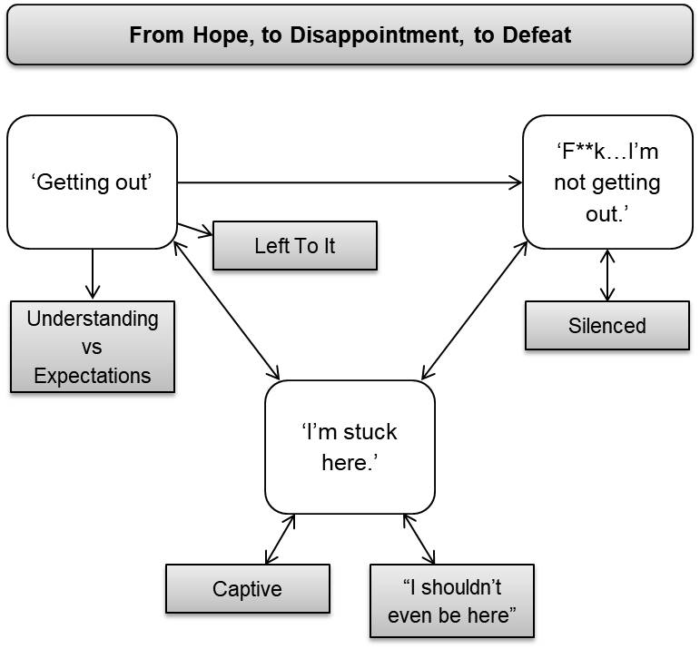

Figure 1: Thematic map representing the relationships between overarching theme, main themes and sub-themes.

Extracts from interviews are presented to illustrate the themes, accompanied by pseudonyms. Participants are not equally quoted as shorter interviews contained more closed answers. This did not affect analysis or theme development.

‘Getting out’
Participants believed that DRHs were their ‘way out’ of detention. Although this is true to an extent as DRHs provide the only means of discharge if the person’s clinical team is unwilling to lift their section, participants appeared to expect discharge rather than considering it as just a possibility. It appeared that no one helped them clarify this, and it was only afterwards that participants realised they had needed professionals to support them through the DRH process.

Understanding vs Expectations
A lack of clarity and understanding about DRHs’ purpose and what they entailed was shared among participants, both before and after they attended. Whilst most participants had heard of a ‘Tribunal’ or ‘managers meeting’ before, they struggled to explain what one was or recognised that their knowledge was limited.

“(Sighs)...I can't say the NHS have...educated me on a Tribunal before…I've just had to kind of pick up the pieces and get on with the job.”–Nicholas

“I think the Tribunal’s there so that you can get your section lifted and get off the ward quicker”–Kath

“I thought I was getting my release date…I don't know why I'm still here today.”–Daniel

Participants’ beliefs that they would be discharged following their DRH reflects the great deal of hope that inpatients can place on DRHs as a means of being discharged from detention. As described by ‘Ash’, however, this is not necessarily the case:

“You're very unlikely to get off [your section following a DRH]. I think that's not explained enough…it needs to be put more realistic that it's so hard to get off.” –Ash

This suggests that not being discharged challenged participants’ understanding and expectations of DRHs, which was confusing and “shocking”. This appeared to leave them in a state of not knowing why this happened or what might happen next. This mismatch between participants’ understanding and expectations suggests a lack of effective information and support provided around DRHs.

Left To It
Participants felt a sense of injustice about their detention being upheld and that they were left alone to figure things out for themselves afterwards. This expressed itself as frustration or dissatisfaction with the support received from staff both before and after their DRH; for example not having DRHs explained to them, being unable to discuss the outcome with the necessary people, or being unsupported with further options/planning. Participants spoke about the support they felt they should have received regarding the DRH, but did not know or believe this was available to them: they did not know what or who to ask.

“You're supposed to get taught what Section 3 is and [Nurse] never told me…that's the first thing they should have done after the Tribunal…I've told three people that I've never had my section read to me…[nursing staff] have let me down so badly, because they should have been preparing me”–Liz

“…the care-coordinator stirred it up and made it worse…And then after that she just disappeared…when she’s supposed to look out for my care needs.”–Sal

A DRH is a potentially unfamiliar, intimidating experience that holds great importance for inpatients. They may therefore require different kinds of support both before and after the event. Participants feeling unsupported by staff at a very emotional, challenging and uncertain time may exacerbate the feelings of frustration and disappointment reflected in the data.

‘F**k…I’m not getting out.’
Participants’ overwhelming realisation that they were not being discharged from detention, and perceptions that they had nobody to turn to, left them feeling helpless and powerless. Rather than the DRH being the thing that would restore their choice and agency over their lives, it transpired to be the opposite.

“I did feel like hurting myself…I just felt like completely helpless, let down, like all my hard work had gone to nothing…I didn't really know what more I could've done to get a better outcome and it wasn't a good outcome.”–Ash

The decision against discharge gave participants no choice but to remain within the ward environment and endure the perceived adverse effects of this, including staying subject to compulsory medication that they believed exacerbated physical and mental health problems. Participants also described perceptions of unjust and impersonal treatment from staff and detrimental aspects of the environment itself, such as screaming, loud alarms, and being around other people who were ‘more unwell’.

“…all they did, the staff, were just laugh. Thought it were funny…it's just humiliating and degrading.”–Liz

“…being a Guinea-pig on various different medications, there's lots of side effects such as itchy skin, hair falling out, all the jingling of the keys that you hear here can set any man off at any point.”–Nicholas

So much hope was perhaps put on DRHs granting discharge as participants were desperate to ‘escape’ an environment they perceived as physically and psychologically harmful. Remaining detained and thereby not regaining choice and control over their lives may have compounded their disempowered position within services and intensified the associated distress.

Silenced
Most participants felt as though they were not heard during the DRH, and that this contributed to the decision to uphold detention. Despite some participants reporting that they were offered the opportunity to represent themselves during the hearing, they found it difficult that they were not allowed to speak as and when they wanted to ‘defend’ themselves.

“…it made me feel like hang on a minute I need to put my hand up here and say something but that wasn't available. I didn't have the right to speak...when things were being said about me that I didn't agree with…I felt agitated, I felt unheard, I felt like I may as well not be in the room…I felt depressed when I walked in and I felt even more depressed when I walked out.”–Nicholas

Perceptions of being silenced may have made participants feel their views were discounted and decisions were made ‘for’ rather than ‘with’ them. Furthermore, many participants felt that the information presented about them in the hearing was untrue, exacerbating perceptions of injustice and powerlessness.

“…I just sat there while…people who were representing me just started coming out with information that was totally untrue...I thought, ‘what – where have you got your information from? That's not what I do on this ward!’”–Kath

This suggests that participants believed they were not given the opportunity to communicate why they should be discharged, or that their voice was neither listened to nor taken seriously.

“My heart was ripped out…Not one of them would listen…I think their job is broken. I wanted them to believe me; I needed them to believe me.”–Daniel

Their inability to speak freely, coupled with perceptions of untrue information being presented, may have contributed to the sense that they were powerless to influence the DRH’s outcome. It seems participants’ feelings about the decision to uphold detention and the information that contributed to this activated feelings of resentment towards staff and detention itself. This perhaps intensified distress caused by the realisation that they were not being discharged after all.

‘I’m stuck here.’
This theme captures participants shifting from initial powerful feelings of injustice and powerlessness to a position of defeat and despondency. They succumbed to the idea that they could not change their situation and had to endure it whether they agreed they needed to be detained or not.

Captive
After participants did not regain their freedom, they felt defeated and resigned to being ‘stuck’ in this environment.

“I just don't know what to do, I'm stuck in the system and I can't get out”–Liz

“It felt like I was snookered. Felt like I might, might as well put a little dog cage in the corner of the room and ask me to sit in there.”–Nicholas

Within this came the belief that they had to submissively comply with treatment and follow the rules of the institution because of new uncertainties such as how much longer they may be detained for. So they had to either accept the outcome, or at least pretend they had, so as not to jeopardise future opportunities for release.

“I'm going to have to just make sure that for six months I bow down, kiss people's feet when they say I need to kiss their feet and I don't know what else I can do.”–Liz

“I knew I wasn't going to get what I wanted, or what I needed...but since then, I've, I've stuck with it because I thought well…if you can't beat them, join them.”–Kath

It appeared that participants’ attitudes changed from seeing DRHs as a means of release to an exercise in futility: they felt like they should have been released and did not understand what they could have done, or could do in the future, to change this outcome. Some participants viewed DRHs as ‘pointless’ due to nothing changing afterwards.

“…it makes you wonder why you actually do it cause I don't think no matter how well I were doing, if I would have ever got off…I don't see the point of Tribunals. I wish I'd not gone for it now.”–Ash

Participants’ accounts conveyed a mix of disappointment, frustration and perhaps fear about their DRH outcome, as if they were hoping for the best but received the worst as their chance to ‘get out’ was snatched away. This was possibly made worse by their limited understanding of potential outcomes and their implications.

“I shouldn’t even be here”
Very few participants believed they should be detained on a psychiatric ward, as they saw themselves as able, well and functioning individuals.

“I feel at my lowest point now after being in a mental health hospital because I'm not mentally unwell.”–Nicholas

Even though three participants recognised that they were struggling with their mental health and needed help, they too disagreed that they should be detained as an inpatient. This supports feeling ‘captive’ as participants felt that they did not require detention on a ward, but were unsure how to ‘escape’ after the DRH was ‘unsuccessful’ (meaning detention was upheld).

“I was going to come in voluntarily. How dare they do that to me? I shouldn't even be here.”–Emily

This sub-theme captures desperation and frustration felt by participants that their opinions, abilities, personal circumstances and characteristics counted for nothing in the decision made to uphold detention. Although they held views and opinions they felt deprived of the opportunity to express these, which forced them to adhere to treatment despite not believing that they needed it.

“Yeah, it made me feel like…I didn't mean nothing. I didn't mean nothing, to anything. You know, because I'm telling them all this, but it…I didn't mean anything to them.”– Daniel

Depriving participants of their individual voice and expression may have been a dehumanising experience: they may have felt seen and treated as ‘just another inpatient’, confined within a system, with no power or influence over their situation.

Discussion

This study sought to improve understanding of the inpatient experience of attending a DRH on an acute ward after which they remained detained under the MHA, and the perceived impact of this. Findings illustrate a journey from hope, to disappointment and turmoil, to resignation and defeat.

From Hope…
Participants expected to be discharged from detention following their DRH. Although further research may aid understanding of what caused these expectations, this finding suggests that participants had an incomplete understanding of DRHs’ process and purpose. Their perception that they were not adequately supported to understand DRHs reflects that inpatients often struggle not only to access information about Tribunals, but also to discuss it with staff (Akhter et al., 2019). This echoes previous findings that communication and appropriately-presented information for inpatients about their care and treatment is limited (Walsh & Boyle, 2009). Furthermore, inpatients have voiced concerns that information about detention is withheld from them, including: details about their section, how long they would be detained, the process and implications of detention (Chambers et al., 2014; Grace, 2015; Seed et al., 2016), and perceptions that hospital staff had refrained from informing them of their right to a Tribunal (DHSC, 2018).

This lack of communication may disempower inpatients if they believe they are not effectively involved in their care and treatment (Chambers et al., 2014). Any agency and hope participants felt from the opportunity to have a DRH was perhaps taken away by them not getting their expected outcome of being discharged, reinforcing their disempowered position within inpatient services. This was exacerbated by a limited understanding of detention, DRHs, and what support may be helpful or available both before and after these. This could be addressed through providing inpatients with information about DRHs and sections, perhaps in an information pack that they can refer back to as suggested by one participant. Practical support and education may have helped participants to develop a more realistic concept and expectations of DRHs, understand their position, and what needs to be achieved before discharge is a more realistic possibility. Increased understanding of these issues and the associated support available may assist inpatients to reclaim some power through greater involvement in their care.

To Disappointment…
Despite most participants reporting a negative emotional response during or following the DRH, including feelings of being unheard, helpless, and distressed about their detention being upheld, emotional support was only mentioned by one participant. This again indicates a lack of knowledge and understanding about from whom or where they can access support, or even what support is available. This reflects that little attention is paid to emotional needs on inpatient wards (Loft & Lavender, 2016; Tierney, 2008) as control and containment is often prioritised over care and support (CQC, 2015).

Barriers to effectively providing such support may include poor relationships between staff and inpatients (Cleary, Hunt, Horsfall & Deacon, 2012; Stenhouse, 2011; Weich et al., 2012). Poor relationships may arise from practical issues including low staffing levels and associated lack of staff continuity (Johnson et al., 2009), which present barriers to providing compassionate care (Christiansen, O'Brien, Kirton, Zubairu & Bray, 2015) and may exacerbate compassion fatigue. Compassion fatigue suggests that staff who work with highly distressed clients become physically and emotionally exhausted over time, making it difficult for them to carry out their roles with empathy and compassion (Figley, 1995; Mathieu, 2007). Similarly, those in a position of power sometimes subconsciously dehumanise those less powerful as this makes it easier to justify difficult decisions made on their behalf that may cause pain and suffering (Lammers & Stapel, 2010). The disconnect between how staff perceive the care they provide and how it is experienced by inpatients may contribute to inpatients’ perceptions of being ‘processed’ rather than ‘cared for’ (DHSC, 2018). Some inpatients report neglectful, impersonal care (DHSC, 2018): if inpatients attribute (Weiner, 1974; 1986) negative interactions with staff as a result of them being ‘uncaring’, this may create a sense of mistrust in staff (CQC, 2020). Poor relationships and lack of trust may deter inpatients from approaching staff to discuss their care and treatment (Lord, 2014), potentially including asking for practical or emotional support around DRHs.

Findings suggest that the longstanding challenge to ‘give voice’ to inpatients’ perspectives during DRHs (Greer, O'Regan & Traverso, 1996) is still significant. Participants felt unheard and powerless during DRHs; perhaps due to reduced autonomy (Chambers et al., 2014) stemming from not being permitted to speak when they wanted to voice their opinions. This was potentially worsened by participants holding conflicting opinions to DRH panels that they should be released, but then remaining detained against their will. This possibly reinforced disempowerment and marginalisation already experienced as a result of detention (Akhter et al., 2019).

Furthermore, participants’ thoughts that ‘untrue’ information was presented about them during their DRH echoes concerns that the Tribunal process is biased against the detainee (DHSC, 2018). Perceptions that their voices and opinions were not heard or were misrepresented reflects epistemic injustice (Fricker, 2007) where inpatients feel their views are discounted as ‘others know best’ and decisions are made ‘for’ rather than ‘with’ them. Inpatients have reported that this represents their experience of detention including their credibility being challenged for no good reason and their testimony not being believed (DHSC, 2018). DRHs may therefore be experienced as dehumanising, supported by findings that dehumanisation can occur in medical settings through disregard of patients’ individuality and emphasis on treating ‘passive individuals’ whose agency and autonomy are neglected (Haslam 2006). This suggests that Tribunals can be humiliating and stressful enough to cause traumatisation (Pandarakalam, 2015), supported by participants in this study describing trauma responses after their DRHs including shock, confusion, sadness and hopelessness (Van Der Kolk, 2014). This illustrates the highly emotive impact that an ‘unsuccessful’ DRH can have, highlighting the need for increased psychological support.

Perceptions of limited support increased participants’ feelings of being stuck on the ward. As reflected in this study’s findings, detained inpatients feel that their environment impedes rather than assists recovery (Hughes, Hayward & Finlay, 2009) due to negative physical and psychological side-effects of compulsory medication (Grace, 2015; Hughes et al., 2009; Loft & Lavender, 2016), noise, and being around other unwell people (Grace, 2015; Lord, 2014). Strong negative feelings towards the ward environment may exacerbate negative feelings and resentment towards DRHs for keeping them within this environment, which may then extend to other aspects of detention including staff. This indicates that support for detained inpatients may be a more general issue in acute settings (CQC, 2020), exacerbated by their increased level of need following an ‘unsuccessful’ DRH. If not addressed, this will potentially feed into the cycle of lack of understanding, lack of support, confusion and turmoil and feeling stuck.

To Defeat
Participants spoke about being more acquiescent following their DRH due to uncertainty about what else to do to achieve discharge. This real or perceived absence of control over the outcome of their situation appeared to create learned helplessness (Maier & Seligman, 1976). This reflects findings that detained individuals do eventually comply with institutional rules, either as they eventually lose hope and become ‘too tired to fight’ or ‘pretend to be ok’ in order to get discharged quicker (Hughes et al., 2009; Seed et al., 2016). These feelings of helplessness and uncertainty about how and when they might be released and having ‘no way out’ echo inpatients’ reports that being on a psychiatric ward feels like being in prison (Chambers et al., 2014): trapped, powerless, and afraid (Akhter et al., 2019; Seed et al., 2016).

It is concerning that an ‘unsuccessful’ DRH leads to people being kept in an environment that they feel is detrimental to their wellbeing and are prepared to mask their true feelings in the hope of this facilitating discharge. This demonstrates the lack of effective communication about what inpatients must do to show that they no longer require compulsory treatment, and highlights the need for increased practical, emotional and psychological support for those who have been through an ‘unsuccessful’ DRH.

Further Research
It may be helpful to conduct further research into possible barriers to inpatients being effectively supported and involved in their care and treatment, with emphasis on DRHs. This could include exploring barriers preventing staff from effectively providing information about detention/DRHs and supporting inpatients with any associated concerns they may have. Such barriers to communication about detention and DRHs may include clinical teams’ understanding of DRHs or how they are following the processes around these, such as reading people their rights and providing information about different MHA sections. Psychological barriers may also exist that prevent staff from feeling able to provide the necessary support; for example barriers to forming effective relationships. Investigating this may indicate necessary support or training for staff that could then improve inpatients’ experience.

Similarly, although it is nursing staff’s responsibility to ensure that inpatients understand their rights and options whilst detained, it is suggested that this responsibility should be shared among the wider multidisciplinary team (MDT) (CQC, 2020) including Independent Mental Health Advocates (IMHAs) who are available to support inpatients with information about such things as their rights and detention. It would seem that the issue is not that inpatients are not asking for support, since they ‘don’t know what they don’t know’, but that support that they are unaware of but may benefit from is not being offered properly. Further research into perceptions of whose responsibility it is/should be to share information about detention, including DRHs, may help address the issue of perceived lack of support and understanding around aspects of detained inpatient experience.

Tribunal receipts increased over 33% between 2007/8 and 2016/17, with s2 appeals now comprising 34% of the English Tribunal’s workload (Glover-Thomas, 2019). It is suggested that this and the associated rise in caseloads will negatively impact inpatients’ experience of Tribunals (Glover-Thomas, 2019). It would be valuable to assess the effect of this increased workload on the performance of panel members and whether this impacts how they communicate with inpatients. This may indicate ways the panel members can be supported so that inpatients will have an improved Tribunal experience.

This study focussed on the impact of attending a DRH after which the individual remained detained under the MHA. Mainly negative accounts were given: this supports a previous survey in which few positive things were reported about Tribunals by carers and ex-inpatients (DHSC, 2018). It may be useful to explore people’s experiences of being discharged following a DRH in order to compare their accounts of attending the hearing to those of participants in this study. This may provide insight into further aspects of the DRH process that require amending or improving, or that work particularly well and should be encouraged.

Limitations
Although the number of participants included meets the criteria for TA (Smith, 2017), it is a smaller sample. Whilst capturing more inpatients’ experiences of DRHs may have provided additional useful data, it is more important to gain rich data from a homogenous group that will enable development of greater understanding of the lived phenomenon being investigated. The number of participants included in this study was sufficient to allow shared patterns of experience to be identified. Detained individuals who have been through the DRH process is a relatively small participant pool, who can be reluctant to engage in research as this may be seen as an additional burden at a challenging time in their lives. The researcher faced many barriers to accessing potential participants in this study, potentially highlighting issues including paternalistic protection of vulnerable people, overworked staff, and fragmented communication within teams. This may be reflective of barriers and restrictions experienced by inpatients, compounding their position as disenfranchised and unheard. Therefore we must recognise the value that can be gained from hearing the voices of the eight people from this marginalised group who participated in the study and facilitated a greater understanding of the DRH experience.

Clinicians directed the researcher to eligible participants, so may only have selected inpatients who they thought were appropriate. People who agreed to participate may have had more of an interest in the study topic, which may result in a less varied set of accounts being represented. Different levels of effort were required by the researcher in interviews as respondents’ accounts varied in their complexity and richness in relation to the research question. This may affect the extent to which different views are represented in the findings. The researcher attempted to mitigate this by continuing to use open questions during all interviews, and reflecting on these issues using bracketing throughout data analysis.

Only one participant was from a minority ethnic background, which highlights a lack of diversity in the sample. It would have been preferable to include people who were unable to speak and understand English well in order to gain a diverse range of experiences, particularly as Black and minority ethnic (BME) groups are disproportionately detained under the MHA (CQC, 2019); however, the resources were unavailable to allow this. This limitation could be expanded on through future research to investigate whether the impact of attending DRH differs or remains consistent across nationalities and cultures.

All participants had attended a Tribunal, so the present study does not include accounts of attending a Hospital Managers Hearing. The two types of DRH may be experienced differently; therefore identified themes may have varied if experience of attending both types of DRH had been discussed and analysed. Similarly, findings may differ between participants who had appealed their detention and those who were automatically referred for a DRH. This data was not gathered in the current study. Further research could investigate this.

Clinical Applications
The findings of this study are important for both Clinical Psychology and wider systems involved in psychiatric inpatients’ health and social care. The findings and recommendations of the DHSC’s (2018) independent review of the MHA have recently been published, and so policies including those of DRHs are likely to be reviewed based on this. This study offers a valuable insight into the lived experience of attending an ‘unsuccessful’ DRH and its consequences for acute inpatients, a group who are otherwise marginalised. The additional knowledge provided of this significant experience for detained inpatients may allow appropriate support to be put into place for these individuals and help improve NHS service-user experience, in line with DHSC and CQC recommendations. This includes involving inpatients in decisions about their care and treatment by improving communication and sharing of information about DRHs between staff and inpatients to help them feel better prepared for it and its potential outcomes, and also provision of more effective practical and emotional support following the DRH. This may require increased support for staff to help them support inpatients in their care.

The Accreditation for Mental Health Inpatient Services (AIMS) Standards (Royal College of Psychiatrists, 2017) promote that it is best practice on inpatient psychiatric wards to provide at least basic psychological support, and the British Psychological Society (BPS, 2012) has called for increased psychological support in acute settings. Clinical psychologists are skilled in helping people with impaired understanding and communication, developing culturally sensitive support approaches, developing strategies to help service-users develop trust in their support teams, and are able to facilitate peer-support groups for inpatients. Furthermore, they can help staff to provide psychological support, for example through reflective practice groups (Collins, 2011). This may enable psychologists to directly or indirectly help inpatients manage their expectations around DRHs and also provide the necessary emotional support following ‘unsuccessful’ ones.

The data echoed previous ideas that imposing medical treatments and legislation based on a medical model of understanding is, for many, counter-therapeutic (e.g. Johnstone, 2018). The MHA’s quite stringent legislation and the mechanisms within it designed to protect vulnerable people may actually be causing as much harm as good. Clinical psychologists are able to facilitate care informed by a different ideological foundation and offer psychologically-informed influence into medically-dominated MDTs, taking into account inpatients’ psychological needs. Implementing this ideology around DRHs and before/aftercare may help address perceived adverse effects of medically-dominated models that inpatients are currently treated from.

Reflections
Although emotional information was discussed in the interviews, the researcher did not fully realise its intensity until reflection on the data and supporting quotes. Perhaps a disconnect was initially experienced in the interviews as participants’ perceptions of reality were beyond the researcher’s understanding, as they were so far removed from their own. This made it hard to fully appreciate the challenges of the experience of attending a DRH and remaining detained afterwards. Through immersion in the data and selection of supporting quotes, the researcher gained more appreciation of participants’ own ‘truth’ which more fully realised the intensity of their experiences. Perhaps this reflects how Tribunal panel members experience inpatients in DRHs: they may not appreciate nor reflect on the experience they nor the inpatient had, and so may not realise the powerful impact of this situation.

Conclusion

The accounts of participants involved in this study illustrate that a lack of knowledge and understanding about the processes of detention and DRHs brings a sense of hope and expectation for release. This was taken away by the DRH itself rather than education or provision of information, meaning that participants experienced powerlessness, emotional confusion and uncertainty around what would happen to them following their DRH. This highlights the need for intervention both before a DRH in terms of provision of information and care-planning about possible outcomes, and also after the DRH for practical and psychological support. The evidence presented in this report demonstrates the negative impact that attending a DRH without adequate preparation and support can have on people. This is therefore a risk factor that clinicians and detained individuals need to be aware of. These findings can help inform practice and national initiatives about the support required both before and after DRHs.

References

Administrative Justice and Tribunals Council & Care Quality Commission. (2011). Patients’ experiences of the first-tier tribunal (Mental health) report of a joint pilot project of the administrative justice and tribunals council and the care quality commission. London: Care Quality Commission.

Akther, S. F., Molyneaux, E., Stuart, R., Johnson, S., Simpson, A. & Oram, S. (2019). Patients' experiences of assessment and detention under mental health legislation: systematic review and qualitative meta-synthesis. BJPsych Open, 5, 1-10. doi: 10.1192/bjo.2019.19

Braun, V. & Clarke, V. (2006). Using thematic analysis in psychology. Qualitative Research in Psychology, 3, 77–101. doi: 10.1191/1478088706qp063oa

Braun, V. & Clarke, V. (2013). Successful qualitative research: A practical guide for beginners. London: Sage.

British Psychological Society. (2012). Commissioning and Delivering Clinical Psychology in Acute Adult Mental Health Care Guidance for Commissioners, Service Managers, Psychology Managers & Practitioners. Leicester: BPS.

Care Quality Commission. (2015). Right here right now: people’s experiences of help, care and support during a mental health crisis. London: Care Quality Commission.

Care Quality Commission. (2019). Monitoring the Mental Health Act in 2017/18. London: Care Quality Commission.

Care Quality Commission. (2020). Monitoring the Mental Health Act in 2018/19. London: Care Quality Commission.

Chambers, M., Gallagher, A., Borschmann, R., Gillard, S., Turner, K. & Kantaris, X. (2014). The experiences of detained mental health service-users: Issues of dignity in care. BMC Medical Ethics, 15, 50. doi: 10.1186/1472-6939-15-50

Christiansen, A., O'Brien, M. R., Kirton, J. A., Zubairu, K., & Bray, L. (2015). Delivering compassionate care: the enablers and barriers. British Journal of Nursing, 24, 833-837. doi: 10.12968/bjon.2015.24.16.833

Cleary, M., Hunt, G. E., Horsfall, J. & Deacon, M. (2012). Nurse-patient interaction in acute adult inpatient mental health units: a review and synthesis of qualitative studies. Issues in Mental Health Nursing, 33, 66-79. doi: 10.3109/01612840.2011.622428

Collins, A. (2011). Exploring psychological processes in reflective practice groups in acute inpatient wards: A grounded theory study. Retrieved from https://create.canterbury.ac.uk/10342/1/Antony_Collins_IRP_PDF.pdf

Department of Health and Social Care. (2018). Modernising the Mental Health Act – final report from the independent review. Retrieved from https://www.gov.uk/government/publications/modernising-the-mental-health-act-final-report-from-the-independent-review

Department of Health. (2008). High quality care for all: NHS next stage review final report. The Darzi Report, 49. Retrieved from https://assets.publishing.service.gov.uk/government/uploads/system/uploads/attachment_data/file/228836/7432.pdf

Department of Health. (2015). The Mental Health Act Code of Practice: Guiding Principles Chapter 22. Retrieved from https://www.gov.uk/government/news/new-mental-health-act-code-of-practice

Deshpande, N., Morton, T., Haque, S. & Oyebode, F. (2008). Appeals to the Mental Health Review Tribunal in an ageing population. Medicine, Science and the Law, 48, 246-250. doi: 10.1258/rsmmsl.48.3.246

Dobson, P.J. (2002). Critical realism and information systems research: why bother with philosophy? Information Research, 7. Retrieved from http://informationr.net/ir/7-2/paper124.html

Figley, C. R. (1995). Compassion fatigue: Toward a new understanding of the costs of caring. In B. H. Stamm (Ed.), Secondary traumatic stress: Self-care issues for clinicians, researchers, and educators (p. 3–28). Derwood, MD: The Sidran Press.

Finlay, L. & Gough, B. (Eds.). (2003). Reflexivity: A practical guide for researchers in health and social sciences. Oxford: Blackwell Science.

Fletcher, A. J. (2017). Applying critical realism in qualitative research: methodology meets method. International journal of social research methodology, 20, 181-194. doi: 10.1080/13645579.2016.1144401

Fricker, M. (2007). Epistemic injustice: Power and the ethics of knowing. Oxford: Oxford University Press.

Glover-Thomas, N. (2019). Therapeutic jurisprudence and mental health tribunals: changing patterns of demand and its impact. Journal of Social Welfare and Family Law, 41, 103-125. doi: 10.1080/09649069.2019.1554798

Grace, J. D. (2015). The experience of being assessed and detained under the mental health act: An interpretative phenomenological analysis. Available from Dissertations & Theses Europe Full Text: Literature & Language. Retrieved from https://search.proquest.com/docview/1794923960∗

Greer, A., O'Regan, M., & Traverso, A. (1996). Therapeutic jurisprudence and patients' perceptions of procedural due process of civil commitment hearings. In D. Wexler & B. Winnick (Eds.), Law in a therapeutic key: developments in therapeutic jurisprudence (pp 923-934). Durham, NC: Carolina Academic Press.

Haslam, N. (2006). Dehumanization: An integrative review. Personality and social psychology review, 10, 252-264. doi: 10.1207/s15327957pspr1003_4

Healy, M. & Perry, C. (2000). Comprehensive criteria to judge validity and reliability of qualitative research within the realism paradigm. Qualitative Market Research – An International Journal, 3, 118-126. doi: 10.1108/13522750010333861

Hughes, R., Hayward, M. & Finlay, W. M. L. (2009). Patients' perceptions of the impact of involuntary inpatient care on self, relationships and recovery. Journal of Mental Health, 18, 152-160. doi: 10.1080/09638230802053326

Johnson, S., Gilburt, H., Lloyd-Evans, B., Osborn, D. P., Boardman, J., Leese, M., Shepherd, G., Thornicroft, G. & Slade, M. (2009). In-patient and residential alternatives to standard acute psychiatric wards in England. The British Journal of Psychiatry, 194, 456-463. doi: 10.1192/bjp.bp.108.051698

Johnstone, L. (2018). Psychological Formulation as an Alternative to Psychiatric Diagnosis. Journal of Humanistic Psychology, 58, 30-46. doi: 10.1177/0022167817722230

Lammers, J. & Stapel, D. A. (2011). Power increases dehumanization. Group Processes & Intergroup Relations, 14, 113-126. doi: 10.1177/1368430210370042

Linden, D. (2009). MENTAL HEALTH CARERS Relevant Legislation (England And Wales): The Mental Health Acts 1983 and 2007. The Princess Royal Trust for Carers. Retrieved from https://professionals.carers.org/sites/default/files/mental-health-acts-1983-and-2007-england-and-wales-external-staff-3881.pdf

Loft, N. O. & Lavender, T. (2016). Exploring compulsory admission experiences of adults with psychosis in the UK using grounded theory. Journal of Mental Health, 25, 297-302. doi: 10.3109/09638237.2015.1101415

Lord, K. M. (2014). When service-user and research worlds come together: An investigation into therapeutic engagement in secure settings. Available from Dissertations & Theses Europe Full Text: Literature & Language. Retrieved from https://search.proquest.com/docview/1779253370∗

Maier, S. F., & Seligman, M. E. (1976). Learned helplessness: theory and evidence. Journal of experimental psychology: general, 105, 3. doi: 10.1037/0096-3445.105.1.3

Mathieu, F. (2007). Running on empty: Compassion fatigue in health professionals. Rehab & Community Care Medicine, 4, 1-7. doi: not available.

Mental Health Act (c.20). (1983). London: HMSO. Retrieved from http://www.legislation.gov.uk/ukpga/1983/20/contents

Mental Health Act (c.12). (2007). London: HMSO. Retrieved from http://www.legislation.gov.uk/ukpga/2007/12/contents

Mitchell, F. (2013). Self directed support. Retrieved from https://www.researchunbound.org.uk/self-directed-support/research-design-and-methods/

National Health Service (NHS). (2013). The Handbook to The NHS Constitution. Retrieved from https://assets.publishing.service.gov.uk/government/uploads/system/uploads/attachment_data/file/170649/Handbook_to_the_NHS_Constitution.pdf

National Institute for Health and Care Excellence. (2011). Service-user experience in adult mental health: improving the experience of care for people using adult NHS mental health services (NICE Clinical Guideline No. 136). Retrieved from http://www.nice.org.uk/guidance/cg136/chapter/1-guidance

NHS Digital. (2017). Mental Health Act Statistics, Annual Figures 2016/17. Retrieved from https://digital.nhs.uk/data-and-information/publications/statistical/mental-health-act-statistics-annual-figures/mental-health-act-statistics-annual-figures-2016-17-experimental-statistics

NHS Digital. (2019). Mental Health Act statistics. Retrieved from https://digital.nhs.uk/data-and-information/publications/statistical/mental-health-act-statistics-annual-figures/2018-19-annual-figures

Nilforooshan, R., Amin, R. & Warner, J. (2009). Ethnicity and outcome of appeal after detention under the Mental Health Act 1983. Psychiatric Bulletin, 33, 288-290. doi: 10.1192/pb.bp.108.021360

Pandarakalam, J. P. (2015). Formal Psychiatric Treatment: advantages and disadvantages. British Journal of Medical Practitioners, 8. Retrieved from https://www.bjmp.org/content/formal-psychiatric-treatment-advantages-and-disadvantages

Riessman, C. (1993). Narrative Analysis. Newbury Park: Sage.

Rimmer, M. A., O'Connor, S. & Anderson, D. (2002). Appeal against detention under the Mental Health Act 1983: relationship to age and incapacity. International journal of geriatric psychiatry, 17, 884-885. doi: 10.1002/gps.660

Royal College of Psychiatrists. (2013). AIMS Accreditation for Inpatient Mental Health Services. Standards for Acute Inpatient Services Working-Age Adults (AIMS-WA) – 6th Edition. Publication number: CCQI1265. Retrieved from https://www.rcpsych.ac.uk/docs/default-source/improving-care/ccqi/quality-networks/aims/aims_wa_6th_edition_final_version-updated_september_2017.pdf?sfvrsn=db5e4eb5_0

Seed, T., Fox, J. R., & Berry, K. (2016). The experience of involuntary detention in acute psychiatric care. A review and synthesis of qualitative studies. International journal of nursing studies, 61, 82-94. doi: 10.1016/j.ijnurstu.2016.05.014

Smith, J. A. (Ed.). (2017). Qualitative psychology: A practical guide to research methods (2nd ed.). London: Sage.

Stenhouse, R. C. (2011). ‘They all said you could come and speak to us’: patients' expectations and experiences of help on an acute psychiatric inpatient ward. Journal of Psychiatric and Mental Health Nursing, 18, 74-80. doi: 10.1111/j.1365-2850.2010.01645.x

Tierney, S. (2008). The individual within a condition: a qualitative study of young people’s reflections on being treated for anorexia nervosa. Journal of the American Psychiatric Nurses Association, 13, 368–375. doi: 10.1177/1078390307309215

Tufford, L., & Newman, P. (2012). Bracketing in qualitative research. Qualitative social work, 11, 80-96. doi: 10.1177/1473325010368316

Van der Kolk, B. (2014). The body keeps the score: Mind, brain and body in the transformation of trauma. UK: Penguin UK.

Walker-Tilley, T., Exworthy, T., Baggaley, M., Wilkinson, L., & Nilforooshan, R. (2011). Effect of recent changes to the Mental Health Act 1983 on sections and appeals: possible unintended consequences. The Psychiatrist, 35, 305-307. doi: 10.1192/pb.bp.110.032391

Walsh J. & Boyle, J. (2009). Improving acute psychiatric hospital services according to inpatient experiences. A user-led piece of research as a means to empowerment. Issues in Mental Health Nursing, 30, 31–38. doi: 10.1080/01612840802500733

Weich, S., Griffith, L., Commander, M., Bradby, H., Sashidharan, S. P., Pemberton, S., Jasani, R. & Bhui, K. S. (2012). Experiences of acute mental health care in an ethnically diverse inner city: qualitative interview study. Social psychiatry and psychiatric epidemiology, 47, 119-128. doi: 10.1007/s00127-010-0314-z

Weiner, B. (1974). Achievement motivation and attribution theory. Morristown, N.J.: General Learning Press.

Weiner, B. (1986). An attributional theory of motivation and emotion. New York: Springer-Verlag.

Paper 3: Executive Summary
of
A thematic analysis of the impact of attending a hearing to review detention on people who remain detained on an acute mental health inpatient ward

Penny Foster
Doctorate in Clinical Psychology

Word Count: 2285

This paper is not intended for publication.
It is written in the style of other summary reports such as the Department of Health and Social Care’s Independent Review of the Mental Health Act (2018) and Care Quality Commission reports.

Executive Summary
Table of Contents

Background 90
Method 91
Recruitment and Participants 91
Procedure 92
Data Analysis 92
Ethical Considerations 93
Key Findings 93
Overview of Themes 94
1. ‘Getting out’ 94
2. ‘F**k…I’m not getting out.’ 95
3. ‘I’m stuck here.’ 96
Implications 97
Recommendations 98
Dissemination 99
Limitations 99
References 100

The purpose of this paper is to increase the accessibility and usability of the research and its findings for anyone involved with detention review hearings, including inpatients and clinical staff. A draft was shared with Tribunal panel members, current acute psychiatric ward staff and a service-user with experience of detention under the Mental Health Act for their comments. Feedback was received from the service-user, two Tribunal panel members and two acute ward staff. This has been incorporated into the final report. The intention was to also share the draft with currently detained inpatients for feedback; unfortunately due to restrictions implemented around the Covid-19 pandemic this was not possible.

Background
The number of people being detained under the Mental Health Act, (MHA) has risen,,. The MHA provides legal authority in England and Wales to detain people with a ‘mental disorder’^{1,2} of a nature or degree that requires treatment in hospital. It seems that more new people are being detained under the MHA rather than the same people being detained again. This indicates that they may have limited experience and understanding of detention and what it involves.

This may include limited knowledge of detention review hearings (DRHs). The two options inpatients in England have to review their MHA detention are Hospital Managers Hearings and the First-tier Tribunal for Mental Health. Although applications for DRHs have increased, the rate of inpatients being discharged from their sections has dropped.

A recent independent review of the MHA published recommendations to government to improve the treatment and support received by people experiencing mental health difficulties and the services that support people whilst they are detained, including DRHs⁵. This proposal for increased focus on service-user experience indicated that it would be useful to gain insight and understanding into inpatients’ perspectives of ‘unsuccessful’ DRHs, meaning when their detention is upheld by the DRH. Qualitative research into this may improve future practice by helping services to understand people’s experiences and what support they need around this. This is of particular importance on acute psychiatric wards as these are usually the first mental health service in which people will experience compulsory detention and DRHs.

This study aimed to contribute to the limited evidence base of how inpatients experience an ‘unsuccessful’ review of their detention, in order to improve understanding of the experience of this event and its aftermath.

Method

Recruitment and Participants
Participants from four different NHS hospitals across North-West England and Staffordshire took part in the study. They were identified as eligible (Table 1) by clinicians on the ward on which they were detained.

Table 1.

Eligibility criteria.
Inclusion Criteria | Exclusion Criteria
Aged 18 years or over | Unable to speak/understand English well enough to participate in an interview
Currently detained on an acute psychiatric ward under Section 2 or 3 of the MHA | Assessed as being unable to give informed consent (by clinical team and researcher)
Have attended a First-tier Tribunal for Mental Health review or a Hospital Managers Hearing which upheld detention
Able to reliably recall details of their review hearing

If they expressed to their clinical team that they were interested in taking part, the researcher approached them to discuss this. 18 inpatients were approached and eight consented to participate (five females, three males). This was a suitable sample size based on current recommendations.

Procedure
A qualitative design was used to gain rich descriptions of participants’ lived experience. Single, semi-structured interviews were conducted with participants on the ward where they were detained. These interviews were audio-recorded so that the interviewer could type them up for analysis. Interviews lasted for an average of 36 minutes. People were assigned a participant number and all identifiable information was removed as interviews were typed up to maintain confidentiality and anonymity.

Interviews followed a schedule of possible questions about how the experience of attending an ‘unsuccessful’ hearing had affected the participants. This schedule had been checked by a service-user with experience of detention under the MHA. The schedule was not a strict guide and they were encouraged to talk about anything that they felt was relevant to the research question.

Data Analysis
Data was analysed using thematic analysis to identify, analyse and report key ‘patterns’ in the data. This involved ‘coding’/grouping data into categories and arranging these into patterns of meaning. These patterns were synthesised into themes that aimed to capture the voices of the participants and reflect their combined views about the experience of attending an ‘unsuccessful’ DRH. The researcher kept a research diary throughout data collection and analysis to help identify any underlying assumptions they might have and how this may influence interpretation of the data.

Ethical Considerations
Ethical approval was granted by both Staffordshire University Ethics Committee and NHS Research Ethics Committee. Participants’ capacity to consent was considered to ensure the person was able to make an informed decision to participate. A distress management protocol was planned by the researcher in case any participant became distressed during the interview, but it was not necessary to implement this protocol at any time during the study.

Key Findings
The data demonstrated the complexity of experiences and perceived impact of attending a DRH and remaining detained afterwards. Three main themes and five sub-themes were identified (Table 2).

Table 2.

Themes Identified.
Theme | Sub-Themes
Getting Out | - Understanding vs Expectations  - Left To It
F**k…I’m not getting out. | - Silenced
I’m stuck here. | - Captive  - ‘I shouldn’t even be here’

Figure 1 provides a visual representation of themes.

Figure 1. Map of the main themes and sub-themes of people’s experiences of an ‘unsuccessful’ DRH.

Overview of Themes
Anonymised quotes are presented to illustrate themes.

- ‘Getting out’
Understanding vs Expectations
- Participants reported a lack of clarity and understanding relating to the process and purpose of the DRH, both before and after they attended.
- Many participants believed that the main purpose of a DRH was to discharge them from their detention.
- This suggests that people are not adequately informed about DRHs.

“Yeah, basically I thought I was getting my release date…I don't know why I'm still here today.”

Left To It
- Participants felt they were not helped to understand the process or purpose of DRHs beforehand, nor what would happen if their detention was upheld.
- They felt they were left to ‘get on with it’ and figure things out for themselves.
- Participants reflected that in retrospect they were not well prepared for the DRH or possible outcomes, yet they did not know who to ask for support or what support was available.
- Participants expressed frustration or dissatisfaction with this lack of ‘practical’ support around their DRH.

“I can't say the NHS have...educated me on a Tribunal before…I've just had to kind of pick up the pieces and get on with the job.”

“You're supposed to get taught what Section 3 is and [Nurse] never told me…it means nothing to the staff, a Tribunal…I feel like it's fraudulent…these [nursing staff] have let me down so badly, because they should have been preparing me…I don't think I'd trust people again”

- ‘F**k…I’m not getting out.’
- The conflict between understanding and expectations of a DRH caused participants to experience negative reactions both during and after the hearing, in response to both the information presented and also the decision to uphold detention.

“It made me feel like…I didn't mean nothing. I didn't mean nothing, to anything. You know, because I'm telling them all this, but…I didn't mean anything to them.”

- A big factor in their distress was that they had to remain on the ward, as they found aspects of this detrimental to their mental and physical health; including having to take medication against their will, poor treatment from staff, a noisy environment, and being around people who were ‘more unwell’.

“…being a Guinea-pig on various different medications, there's lots of side-effects such as itchy skin, hair falling out, all the jingling of the keys that you hear here can set any man off at any point.”

Silenced
- Participants felt that they were not heard during the DRH, and could only speak in a limited slot.
- Participants also reported that they disagreed with a lot of the information they heard, but could not say so at the time.
- Being ‘silenced’ intensified feelings of injustice and powerlessness.

“I found it hard to…be quiet when things were being said about me that I didn't agree with…I felt agitated, I felt unheard, I felt like I may as well not be in the room…I felt depressed when I walked in and I felt even more depressed when I walked out.”

“My heart was ripped out…Not one of them would listen…I think their job is broken. Every single one of them, for not listening to one person, to what I'm saying…I wanted them to believe me; I needed them to believe me.”

- ‘I’m stuck here.’
Captive
- After an ‘unsuccessful’ DRH, participants seemed to become resigned to being ‘stuck’ on the ward.
- Participants did not understand what they could have done or could do in the future to get released, and some viewed DRHs as ‘pointless’ due to nothing changing afterwards.
- Due to their uncertainty about how long they might be detained and what would keep them in hospital, people became almost submissive in order to try and achieve release.

“I'm going to have to just make sure that for six months I bow down, kiss people's feet when they say I need to kiss their feet and I don't know what else I can do.”

“I shouldn’t even be here”
- Many participants believed they did not require detention as they were well, able, or not ‘unwell enough’.
- Some participants recognised that they had mental health difficulties, but did not believe that they required compulsory treatment.
- People felt like they should not be on the ward but were unsure how to ‘escape’ following an ‘unsuccessful’ DRH.

“I feel at my lowest point now after being in a mental health hospital because I'm not mentally unwell.”

Implications
Clinical staff and DRH panels may not realise the intense emotional reactions that inpatients can experience as a result of a DRH being ‘unsuccessful’. This study illustrated a journey from hope, to disappointment and turmoil, to defeat. This was made worse by both limited information about DRHs and other aspects of detention, and a perceived lack of practical support and effective communication around what is involved. This may create poor staff-inpatient relationships,, and deter inpatients from engaging with staff, thereby preventing them being involved in decisions about their care. The data also suggested that emotional support is not provided effectively for inpatients^{7,,} in relation to feelings of being unheard, powerless, or distressed about their detention being upheld. Effective communication about detention and DRHs may address these issues, empower inpatients to be involved in their treatment, and help them gain a clearer understanding of what they can and cannot do to show they no longer require compulsory treatment. This knowledge may allow appropriate support to be put into place for these individuals and help improve service-users’ experience.

Recommendations
The results of this study indicated several clinical implications and areas for future research. These include:
- Focus on improving relationships and communication in order to involve inpatients in their care, including more effective provision of information around detention and DRHs to aid understanding and manage expectations.
- Consider developing an information pack about the detention process and what can happen in DRHs for patients to keep and refer back to.
- Improved psychological support provision on acute inpatient wards in line with best practice recommendations,.
- Further research may clarify current perspectives on whose responsibility it is/should be to provide and ensure inpatients have received and understood information about detention, including DRHs and sections. This may be used to create clearer guidance for both staff and inpatients.
- Further research around clinical staff’s understanding of detention, DRHs and how to discuss these well with inpatients may indicate the need for increased staff training about these so that they can provide more effective support to detained inpatients.

Dissemination
- This executive summary will be shared with the Care Quality Commission’s Service User Reference Panel and MHA External Advisory Group so that it can contribute to the development of a patient MHA experience tool.
- This executive summary will be made available on all the wards involved in the research for both staff and inpatients.
- The empirical paper will be submitted to ‘Clinical Psychology & Psychotherapy’ for publication.

Limitations
- Only one participant was from a minority ethnic background, highlighting a lack of diversity in the sample. Black and minority ethnic (BME) groups are disproportionately detained under the MHA so it would have been useful to interview a more diverse sample.
- Clinicians referred participants to the study who they thought were eligible. The opportunity to participate may not have been offered to all eligible inpatients and meant that a wider spectrum of views and experiences was not represented by the findings.
- All participants had attended a Tribunal rather than a Hospital Managers Hearing. These may be experienced differently. The identified themes may have varied if experience of attending both types of DRH had been discussed and analysed.
- The sample size was relatively small. Replication of the study with more participants may provide additional useful information.

References

- Mental Health Act (c.20). (1983). London: HMSO. Retrieved from http://www.legislation.gov.uk/ukpga/1983/20/contents

- Mental Health Act (c.12). (2007). London: HMSO. Retrieved from http://www.legislation.gov.uk/ukpga/2007/12/contents

- NHS Digital (2017). Mental Health Act Statistics, Annual Figures 2016/17. Retrieved from https://digital.nhs.uk/data-and-information/publications/statistical/mental-health-act-statistics-annual-figures/mental-health-act-statistics-annual-figures-2016-17-experimental-statistics

- NHS Digital (2019). Mental Health Act statistics. Retrieved from https://digital.nhs.uk/data-and-information/publications/statistical/mental-health-act-statistics-annual-figures/2018-19-annual-figures

- Department of Health and Social Care. (2018). Modernising the Mental Health Act – final report from the independent review. Retrieved from https://www.gov.uk/government/publications/modernising-the-mental-health-act-final-report-from-the-independent-review

- Care Quality Commission. (2019a). Monitoring the Mental Health Act in 2016/17 (Amended). London: Care Quality Commission.

- Care Quality Commission. (2015). Right here right now: people’s experiences of help, care and support during a mental health crisis. London: Care Quality Commission.

- Smith, J. A. (Ed.). (2017). Qualitative psychology: A practical guide to research methods (2nd ed.). London: Sage.
- Walsh J. & Boyle, J. (2009). Improving acute psychiatric hospital services according to inpatient experiences. A user-led piece of research as a means to empowerment. Issues in Mental Health Nursing, 30, 31–38. doi: 10.1080/01612840802500733

- Stenhouse, R. C. (2011). ‘They all said you could come and speak to us’: patients' expectations and experiences of help on an acute psychiatric inpatient ward. Journal of Psychiatric and Mental Health Nursing, 18, 74-80. doi: 10.1111/j.1365-2850.2010.01645.x

- Cleary, M., Hunt, G. E., Horsfall, J. & Deacon, M. (2012). Nurse-patient interaction in acute adult inpatient mental health units: a review and synthesis of qualitative studies. Issues in Mental Health Nursing, 33, 66-79. doi: 10.3109/01612840.2011.622428

- Weich, S., Griffith, L., Commander, M., Bradby, H., Sashidharan, S. P., Pemberton, S., Jasani, R. & Bhui, K. S. (2012). Experiences of acute mental health care in an ethnically diverse inner city: qualitative interview study. Social psychiatry and psychiatric epidemiology, 47, 119-128. doi: 10.1007/s00127-010-0314-z

- Lord, K. M. (2014). When service-user and research worlds come together: An investigation into therapeutic engagement in secure settings. Available from Dissertations & Theses Europe Full Text: Literature & Language. Retrieved from https://search.proquest.com/docview/1779253370

- Care Quality Commission. (2020). Monitoring the Mental Health Act in 2018/19. London: Care Quality Commission.

- Tierney, S. (2008). The individual within a condition: a qualitative study of young people’s reflections on being treated for anorexia nervosa. Journal of the American Psychiatric Nurses Association, 13, 368–375. doi: 10.1177/1078390307309215
- Loft, N. O. & Lavender, T. (2016). Exploring compulsory admission experiences of adults with psychosis in the UK using grounded theory. Journal of Mental Health, 25, 297-302. doi: 10.3109/09638237.2015.1101415

- Pandarakalam, J. P. (2015). Formal Psychiatric Treatment: advantages and disadvantages. British Journal of Medical Practitioners, 8. Retrieved from https://www.bjmp.org/content/formal-psychiatric-treatment-advantages-and-disadvantages

- British Psychological Society. (2012). Commissioning and Delivering Clinical Psychology in Acute Adult Mental Health Care Guidance for Commissioners, Service Managers, Psychology Managers & Practitioners. Leicester: BPS.

- Royal College of Psychiatrists. (2013). AIMS Accreditation for Inpatient Mental Health Services. Standards for Acute Inpatient Services Working-Age Adults (AIMS-WA) – 6th Edition. Publication number: CCQI1265. Retrieved from https://www.rcpsych.ac.uk/docs/default-source/improving-care/ccqi/quality-networks/aims/aims_wa_6th_edition_final_version-updated_september_2017.pdf?sfvrsn=db5e4eb5_0

- Care Quality Commission. (2019b). Monitoring the Mental Health Act in 2017/18. London: Care Quality Commission.

Appendix A: Journal Submission Guidelines for Journal ‘Clinical Psychology & Psychotherapy’

From https://onlinelibrary.wiley.com/page/journal/10990879/homepage/ForAuthors.html

2. MANUSCRIPT CATEGORIES AND REQUIREMENTS
Research articles: Substantial articles making a significant theoretical or empirical contribution (submissions should be limited to a maximum of 5,500 words excluding captions and references).
Reviews: Articles providing comprehensive reviews or meta-analyses with an emphasis on clinically relevant studies.

3. PREPARING THE SUBMISSION
Parts of the Manuscript
The manuscript should be submitted in separate files: title page; main text file; figures.

The text file should be presented in the following order:
- A short informative title containing the major key words. The title should not contain abbreviations (see Wiley's best practice SEO tips);
- A short running title of less than 40 characters;
- The full names of the authors;
- The author's institutional affiliations where the work was conducted, with a footnote for the author’s present address if different from where the work was conducted;
- Conflict of Interest statement;
- Acknowledgments;
- Abstract, Key Practitioner Message and keywords;
- Main text;
- References;
- Tables (each table complete with title and footnotes);
- Figure legends;

Figures and appendices and other supporting information should be supplied as separate files†.

Authorship
Please refer to the journal’s Authorship policy in the Editorial Policies and Ethical Considerations section below for details on author listing eligibility.

Acknowledgments
Contributions from anyone who does not meet the criteria for authorship should be listed, with permission from the contributor, in an Acknowledgments section. Financial and material support should also be mentioned, including the name(s) of any sponsor(s) of the research contained in the paper, along with grant number(s). Thanks to anonymous reviewers are not appropriate.

Conflict of Interest Statement
Authors will be asked to provide a conflict of interest statement during the submission process. For details on what to include in this section, see the Conflict of Interest section in the Editorial Policies and Ethical Considerations section below. Submitting authors should ensure they liaise with all co-authors to confirm agreement with the final statement.

Abstract
Enter an abstract of no more than 250 words containing the major keywords. An abstract is a concise summary of the whole paper, not just the conclusions, and is understandable without reference to the rest of the paper. It should contain no citation to other published work.

Key Practitioner Message
All articles should include a Key Practitioner Message of 3-5 bullet points summarizing the relevance of the article to practice.

Keywords
Please provide five-six keywords (see Wiley's best practice SEO tips).

Main Text
- The journal uses US spelling; however, authors may submit using either option, as spelling of accepted papers is converted during the production process.
- Footnotes to the text are not allowed and any such material should be incorporated into the text as parenthetical matter.

References
References should be prepared according to the Publication Manual of the American Psychological Association (6th edition). This means in-text citations should follow the author-date method whereby the author's last name and the year of publication for the source should appear in the text, for example, (Jones, 1998). The complete reference list should appear alphabetically by name at the end of the paper. Please note that for journal articles, issue numbers are not included unless each issue in the volume begins with page 1, and a DOI should be provided for all references where available.

For more information about APA referencing style, please refer to the APA FAQ.
Reference examples follow:

Journal article
Beers, S. R., & De Bellis, M. D. (2002). Neuropsychological function in children with maltreatment-related posttraumatic stress disorder. The American Journal of Psychiatry, 159, 483–486. doi: 10.1176/appi.ajp.159.3.483

Book
Bradley-Johnson, S. (1994). Psychoeducational assessment of students who are visually impaired or blind: Infancy through high school (2nd ed.). Austin, TX: Pro-ed.

Internet Document
Norton, R. (2006, November 4). How to train a cat to operate a light switch [Video file]. Retrieved from http://www.youtube.com/watch?v=Vja83KLQXZs

Endnotes
Endnotes should be placed as a list at the end of the paper only, not at the foot of each page. They should be numbered in the list and referred to in the text with consecutive, superscript Arabic numerals. Keep endnotes brief; they should contain only short comments tangential to the main argument of the paper.

Tables
Tables should be self-contained and complement, not duplicate, information contained in the text. They should be supplied as editable files, not pasted as images. Legends should be concise but comprehensive – the table, legend, and footnotes must be understandable without reference to the text. All abbreviations must be defined in footnotes. Footnote symbols: †, ‡, §, ¶, should be used (in that order) and *, **, *** should be reserved for P-values. Statistical measures such as SD or SEM should be identified in the headings.

Figure Legends
Legends should be concise but comprehensive – the figure and its legend must be understandable without reference to the text. Include definitions of any symbols used and define/explain all abbreviations and units of measurement.

Figures
Although authors are encouraged to send the highest-quality figures possible, for peer-review purposes, a wide variety of formats, sizes, and resolutions are accepted. Click here for the basic figure requirements for figures submitted with manuscripts for initial peer review, as well as the more detailed post-acceptance figure requirements.

Figures submitted in color may be reproduced in color online free of charge. Please note, however, that it is preferable that line figures (e.g. graphs and charts) are supplied in black and white so that they are legible if printed by a reader in black and white. The cost of printing color illustrations in the journal will be charged to the author. The cost is £150 for the first figure and £50 for each figure thereafter. If color illustrations are supplied electronically in either TIFF or EPS format, they may be used in the PDF of the article at no cost to the author, even if this illustration was printed in black and white in the journal. The PDF will appear on the Wiley Online Library site.

Additional Files
Appendices
Appendices will be published after the references. For submission they should be supplied as separate files but referred to in the text.

General Style Points
The following points provide general advice on formatting and style.
- Abbreviations: In general, terms should not be abbreviated unless they are used repeatedly and the abbreviation is helpful to the reader. Initially, use the word in full, followed by the abbreviation in parentheses. Thereafter use the abbreviation only.
- Units of measurement: Measurements should be given in SI or SI-derived units. Visit the Bureau International des Poids et Mesures (BIPM) website for more information about SI units.
- Numbers: numbers under 10 are spelled out, except for: measurements with a unit (8mmol/l); age (6 weeks old), or lists with other numbers (11 dogs, 9 cats, 4 gerbils).
- Trade Names: Chemical substances should be referred to by the generic name only. Trade names should not be used. Drugs should be referred to by their generic names. If proprietary drugs have been used in the study, refer to these by their generic name, mentioning the proprietary name and the name and location of the manufacturer in parentheses.

Appendix B: Critical Appraisal Skills Programme Qualitative Checklist

Can be accessed here: https://casp-uk.net/wp-content/uploads/2018/01/CASP-Qualitative-Checklist-2018.pdf

Appendix C: Critical Appraisal Skills Programme Randomised Controlled Trial Checklist

Can be accessed here: https://casp-uk.net/wp-content/uploads/2018/01/CASP-Randomised-Controlled-Trial-Checklist-2018.pdf

Redacted
Appendix D: Participant Information Leaflet

Appendix D: Participant Information Leaflet
Redacted

Appendix E: Participant Information Sheet

Redacted
Redacted

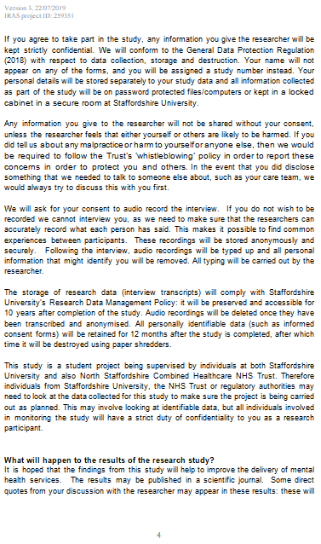

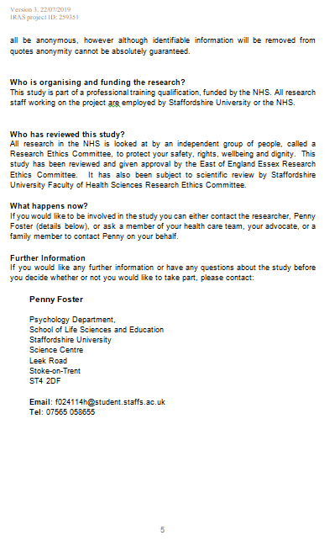
Redacted

Appendix F: Participant Information Poster
Redacted

Appendix G: Informed Consent Form

Appendix H: Semi-Structured Interview Schedule

Interview Schedule
Semi-structured interview that will last up to one hour

Questions about the impact of attending a hearing to review acute inpatient detention

- Can you recall what your thoughts were as you entered the room where the detention review hearing (i.e. First-tier Tribunal for Mental Health review/ Hospital Managers Hearing) was taking place?

- Can you describe what it looked like?

- How do you think attending the hearing affected you?

- What was it like to be in that situation (i.e. a panel deciding whether to keep you detained or not / whether to release you or not)?

- What was good about the experience [of attending]?

- What did you find less helpful about the experience [of attending]?

- What did you do / how did you feel during the hearing?

- What did you do / how did you do just after the hearing?

Appendix I: Thematic Analysis
Step 1: Transcription and familiarisation with the data
Step 2: Coding (Generating Initial Codes)

*(Participant requested to be ‘Participant 24’ as this was their favourite number)
Speaking | Transcript | Initial Codes
Researcher (R) | Ok. And then you went in and they said they're going to disappoint you?
Participant ‘24’* (P’24’) | Yeah. It started from then and then I just started crying. | Sadness  Disappointment
R | Right? Can you tell me a little bit more about maybe what was going on in your head or how you felt when that happened?
P’24’ | I was disappointed. And I think at that point I thought, 'Why am I going through all this'... all that, I were just upset, I want to go home, I miss my family and I knew I had to come back here. I've got to be around loads of people that are unwell and I think that was the hardest bit as well. | Sadness  Disappointment  Regret  I want to go home  Powerless  Pointless  Unhelpful environment
R | Right ok so what is it about being round more unwell people that's difficult?
P’24’ | It's just hard, they hurt people a lot and I don't hurt people. I don't hurt people, I've never hurt people. So then to be around loads of people that are hurting people and especially people who know what they're doing when they're hurting people, in my opinion, it's just harder and I don't need to be on this ward anymore like I've got loads of leave like I don't need to be on here. And I think that irritates a few of the patients. | Different to others  I’m ok, the others aren’t  Unhelpful environment  Different to others
R | Yeah. So it's hard to see people hurting people: how do you think that affects you?
P’24’ | Well, when they're ill, I completely understand it in a sense, but because I don't do it to other people, it's just not nice is it. There was a really nasty incident on the ward, erm... where like this girl - I think this is when it changed my opinion that I really didn't need to be on here - where a patient , it were - it were - I won't say her name, actually. Well, she's called [name], but - erm, pulled some of the staff member's hair and they couldn't get her off her, and she were kneeing her in the face and I helped, and, they got off her and everything. But I think since that day, everyone's on edge. And it's just it's just not - I've been on this ward when it's been a nice place to be where people have been settled and it's been alright and we've been able to watch films at night and now it's just like incident after incident after incident. Like where you're getting woke up at night and stuff like that so it's just not a very nice place to be. So I think that was more from the tribunal that I wouldn't be getting moved to [other ward] because there's been two beds available on [other ward] they've both gone to people in the community. So I just feel let down a lot of the time I suppose; but it's no one's fault, like I don't blame anyone, but. | Different to the others  Unhelpful environment  Unhelpful environment  Let down
R | Yeah, it doesn't change how you feel and doesn't make that any less valid.
P’24’ | But yeah, my, probably my lasting comment throughout all of this would be I don't see the point of tribunals. I wish I'd not gone for it now. | Pointless  Regret
R | What makes you wish that you hadn't?
P’24’ | Because of how shit I felt afterwards. | Sadness  Made my wellbeing worse
R | Can you tell me more about that?
P’24’ | I just felt like hurting, not hurting myself, but there was no point to being settled. But I did feel like hurting myself, cause I did think about swallowing my e-cig, so. I just felt like completely helpless, let down, like all my hard work had gone to nothing, that I don't, I didn't really know what more I could've done to get a better outcome and it wasn't a good outcome. | Pointless  Made my wellbeing worse  Disappointment  Unsupported  Hopeless
R | Yeah. I get you, so if you feel like you did everything then you wouldn't know what else to do in the future?
P’24’ | Yeah, so it was just a bit like helplessness, I suppose. | Hopeless  Let down

Step 2 Continued: Initial codes generated

Acceptance
Appearance
Blaming others
Conducted well
Confusion
Could be worse
Diagnosis
Different to others
Disagreed with what was said in hearing
Disappointment
Dissatisfaction with services
Don’t know what else I could have done
Effects on physical health
Expecting to be released
External or Family support
Fair outcome
Familiarity is helpful
Fear of a setback
Feeling positive
Felt like it was going well
Frustration
Get on with it
Hard to hear what was said
Highlighting own strengths
Hope
Hopeless
I did nothing wrong
I don’t need to be here
I want to go home
I’m ok, the others aren’t
I'd done everything right
Identity
If x had been different, y would have been different
Intimidating
‘Journey’
Just a formality
Lack of clarity or understanding
Lack of control
Leave
Left alone, Unsupported
Let down
Life on hold
Looking to the future
Made my wellbeing worse
Meaning to Staff
Medication
Misled
Mistrust of staff
Multiple sections
Need to be there
Negotiation
No prior warning
Not going my way
Nothing Changes
Opportunity to represent self
Others' preconceptions
Overwhelming
Play the game
Play the system
Pointless
Poor organisation
Power and Powerless
Preparation & organisation
Previous experience
Procedures
Punishment
Recognition
Reflecting on before to now
Regret
Relationships with Staff
Restriction
Sadness
Safety
Self-blame
Shock
Sort it out by self
Staff protecting themselves
Staff support
Support in the tribunal
Support Systems
Surprised by outcome
They don't know me
They don't understand me
They got it wrong
They said positive things
They want one thing, I want another
Time to come to terms
Timely decision
Trapped
Treatment by staff
Unavoidable
Uncertainty
Uncomfortable
Unhelpful Environment
Voice not heard
Ways of managing it
Withholding information
Worries about things outside hospital
Worthless

Step 2 Continued: Refined Codes

Acceptance of needing help
Appearance
Blaming others
Coping strategies
Could be worse
Diagnosis
Disagreed with what was said in hearing
Disappointment
Dissatisfaction with services
Expecting to be released
External or Family support
Fair outcome
Familiarity is helpful
Fear of a setback
Feeling positive
Felt like it was going well
Frustration
Get on with it
Highlighting own strengths
Hope
Hopeless
I did nothing wrong
I don't need to be here
I want to go home
I’m ok, the others aren’t
If x had been different, y would have been different
Increased knowledge
Intimidating
Lack of clarity or understanding
Lack of control
Left alone, Unsupported
Let down
Life on hold
Looking to the future
Made my wellbeing worse
Medication
Misled
Mistrust of staff
Negotiation
Nothing Changes
Opportunity to represent self
Others' preconceptions
Overwhelming
Physical health
Play the game
Pointless
Poor organisation
Poor treatment by staff
Powerless
Punishment
Reflecting on before to now
Regret
Sadness
Self-blame
Some things are private
Sort it out by self
Staff following procedures (preventing release)
Staff support
Staff were unhelpful
Support during the hearing
Timely decision
Trapped
Uncertainty
Uncomfortable
Unhelpful Environment
Voice not heard
What they said was accurate
Worries about things outside hospital
Worthless

Step 3: Searching for themes

‘Collating codes into potential themes’ (Braun & Clarke, 2006)
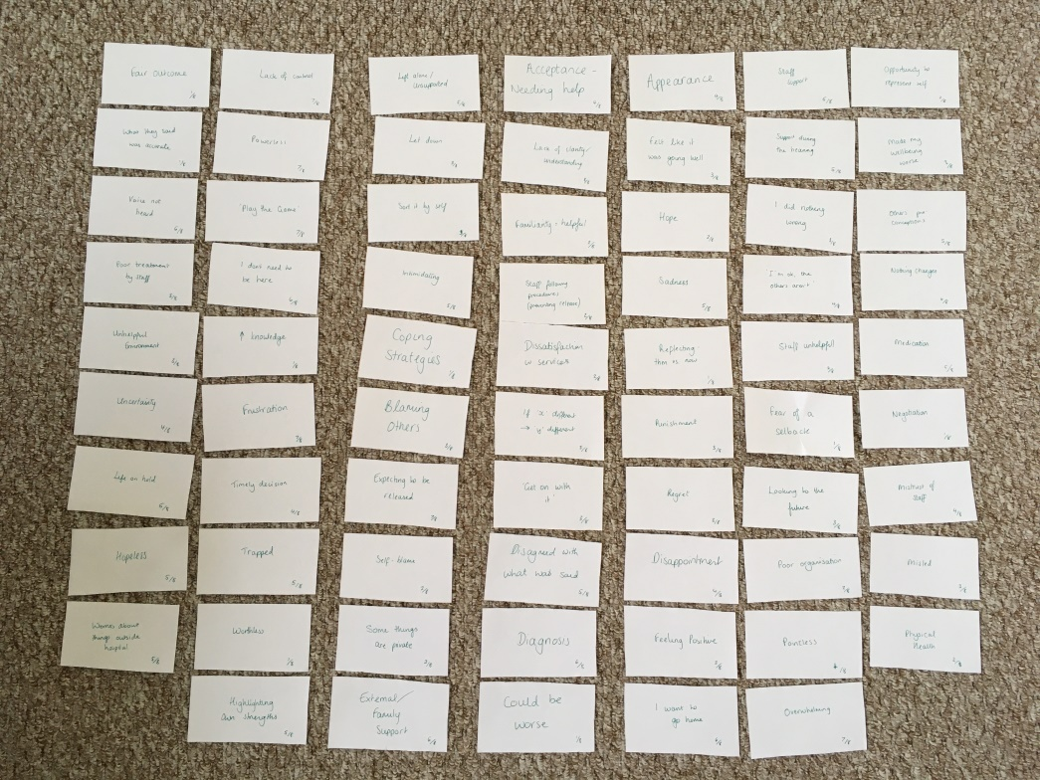
Codes were written onto index cards and laid out so that similar codes could be identified and grouped together.

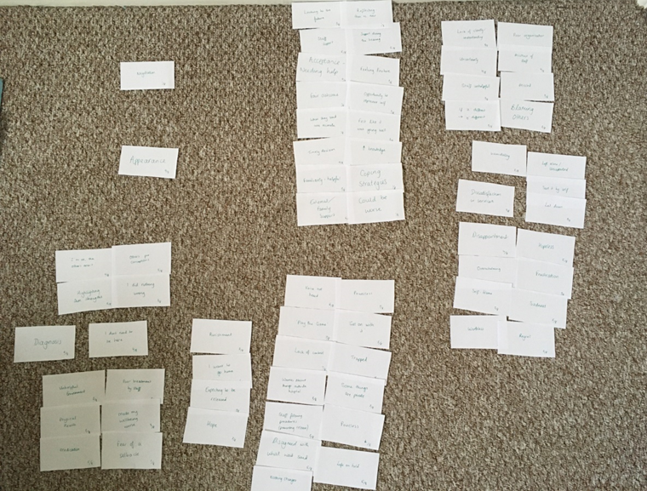
Collections of similar codes were given a title reflecting a potential theme they demonstrated. Themes were modified and refined, which involved rearranging codes and re-naming the developing themes.

Step 4: Reviewing potential themes

Once codes were organised into themes that the researcher felt captured and reflected the most important features of the data, these themes were checked against the coded extracts on NVivo across both data items and the entire data set.

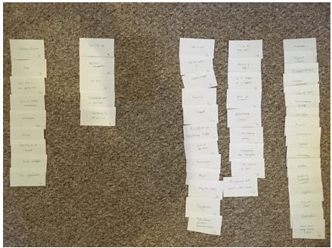

A thematic ‘map’ was constructed to illustrate relationships between the themes and how these reflect a broad level of meaning across the data set - an ‘analytic story’ (Braun & Clarke, 2006). Below is an example of an early draft of mapping potential themes and their relationships as these themes and their titles were refined and developed.

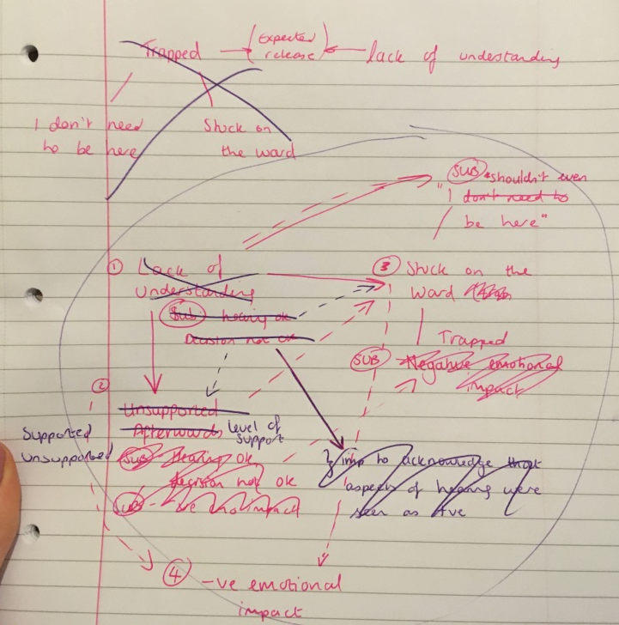

Step 5: Defining and naming themes
Braun and Clarke (2006) advise ‘constructing a concise, punchy and informative name for each theme’ that identifies its essence.
This process included development and evolution as the researcher reviewed themes and began writing comprehensive reports of each theme.
Example of earlier theme arrangement and names
Theme | Understanding vs Expectations | Negative Impact on Wellbeing | Unsupported | Stuck on the Ward
Supporting codes | Acceptance of needing help  Expecting to be released  Feeling positive  Felt like it was going well  Felt misled  Hope  Lack of clarity or understanding  Poor organisation  Staff were unhelpful  Uncertainty | Disappointment  Frustration  Hopeless  Intimidating  Lack of control  Made my wellbeing worse  Medication  Overwhelming  Physical health  Poor treatment by staff  Powerless  Sadness  Self-blame  Unhelpful environment  Voice not heard  Worries about things outside hospital  Worthless | Dissatisfaction with services  Left alone, unsupported  Let down  Mistrust of staff  Sorted it out by self | Sub-theme: Trapped
‘Get on with it’
I want to go home
Life on hold
Nothing changes
‘Play the game’
Pointless
Punishment
Regret
Staff following procedures (preventing release?)
Trapped
 |  |  |  | Sub-theme: ‘I shouldn’t even be here’
Blaming others
Diagnosis
Disagreed with what was said in hearing
Highlighting own strengths
I did nothing wrong
I don’t need to be here
If x had been different, y would have been different
I’m ok, the others aren’t
Others’ preconceptions
Step 6: Producing the report

From Braun & Clarke (2006):

Appendix J: Research Diary Extracts

These extracts have been copied from the researcher’s research diary that was kept to aid reflection on presuppositions about the data throughout collection and analysis so that any potential influence of these could be addressed and mitigated.

The extracts have been edited from the original entries where necessary to maintain confidentiality and anonymity.

03/01/2020: Data Collection
Emailed [Academic Research Supervisor] today about slow horrible recruitment and what to do. Absolutely stressed to death. I'm going to see someone next week to see if he will participate, but then have no other leads until people who are due to have hearings at the end of Jan. Starting to reflect on this: it is quite a small target population as not loads of people end up having tribunals – and also people on acute wards are generally quite unsettled so may not want to participate for all sorts of reasons – but it is very important to get the voices of marginalised individuals heard. So as stressed as I might be it is really important to keep going with recruitment and try to get my target number... Maybe instead of finishing at end of Jan I can keep going til mid-Feb? Just need to be mindful of how this might impact/delay analysis.

23/02/2020: Data Analysis
I’ve printed out the stuff from the Braun & Clarke paper on the six steps for TA… here goes nothing! [doodle of a concerned face]
Having coded and re-read the transcripts, some themes appear to be ‘emerging’. Some of these what I think I might have expected but also some that I wouldn’t probably have thought about. (Lucky the participants did.) Glad I reread the transcripts or else I might have overlooked them [candidate themes]. – BUT! Braun & Clarke are very clear that themes do not just ‘emerge’, it takes bloody hard work to develop a coherent and useful theme! Remember this when arranging the codes!

Appendix K: Reflexive Statement

I am a twenty-nine year old White British female working as a Trainee Clinical Psychologist. I completed this research as a requirement of a Doctoral Programme in Clinical Psychology. I hold an interest in giving power to those in disadvantaged positions and supporting them to have their voice heard, which influenced my epistemological position of critical realism. I therefore consider ethical issues that may contribute to the marginalisation of populations and have an interest in addressing these to improve such populations’ experiences. I recognise that my position of privilege may contrast to those of the populations I wish to support. Although it is not possible to determine the extent to which my age, appearance and professional role may have had an influence on collection, analysis and interpretation of the data in this study, I attempted to use my professional skills to build rapport to facilitate disclosure with participants during interviews, and also to mitigate any power imbalance in order to work collaboratively with this population.

I have previously worked in medium and low secure inpatient services and witnessed both challenges and positives experienced by detained inpatients. An assumption I held about the research topic from my previous professional experience was that participants may have an understanding of tribunals and Hospital Managers Hearings; however reflection helped me to recognise that experiences of people detained in a secure inpatient setting likely differ from those in acute psychiatric inpatient services due to such factors as lability of mental disturbance and familiarity with detention and associated processes. Preconceptions such as this were identified within a reflexive journal maintained during the research process to ensure that these preconceptions were not imposed upon the findings of the study. Reflection facilitated by the reflexive journal reminded me not to assume people’s previous knowledge or experiences of any of the issues discussed in the interview.

The new knowledge and understanding gained by completing this research made me realise the power of detention review hearings and the intense impact they can have on detained individuals. This was further emphasised to me by the feedback provided about Paper 3: Executive Summary by the service-user: she fed back that she could relate to the findings of the study and was glad that I was doing this study as she believed from her lived experience of ‘failing’ at Tribunals that change is needed.

People with an interest in detention review hearings may traditionally be those with an interest in judicial systems and mental health law. My background and training in Clinical Psychology may make me more aware of and interested in the psychological impact of attending these when detention is upheld. This helped me to keep focus on the application of this research to clinical practice and consider how the responses of the eight individuals interviewed may be applied to wider systems. Therefore the research has driven me to disseminate these findings to attempt to address and improve this experience for people. I have also developed an interest in becoming a Specialist Lay Member of the Tribunal Service in order to provide a psychological perspective to proceedings.

Appendix L: Staffordshire University Ethics Committee Ethical Approval

Redacted

Appendix M: Letter of Indemnity

Appendix N: NHS Health Research Authority Notice of Ethical Approval

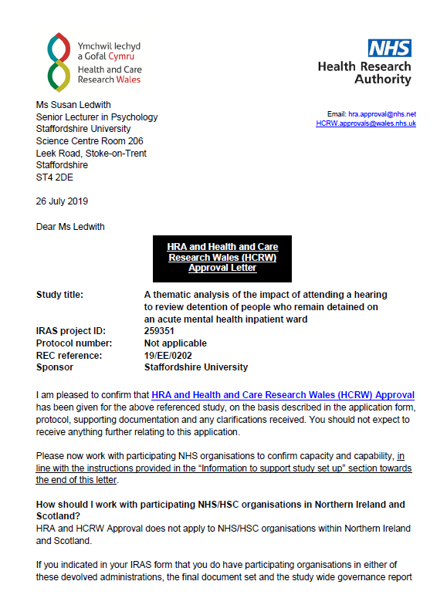

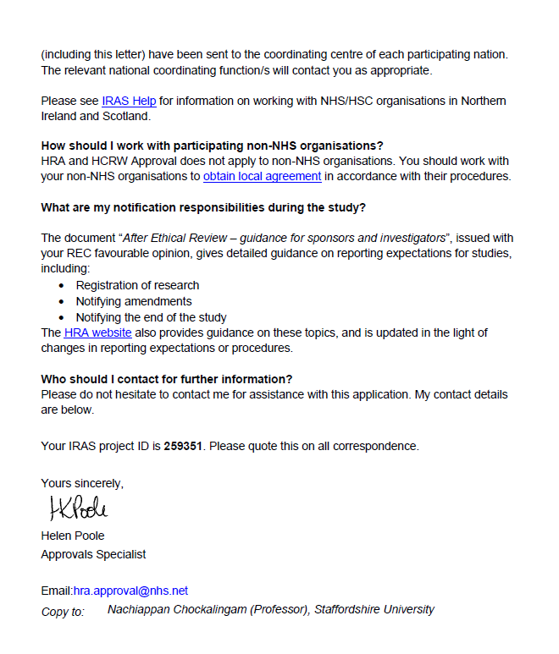

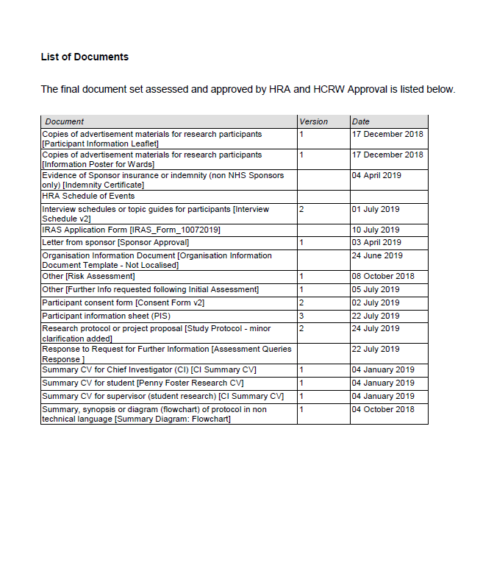

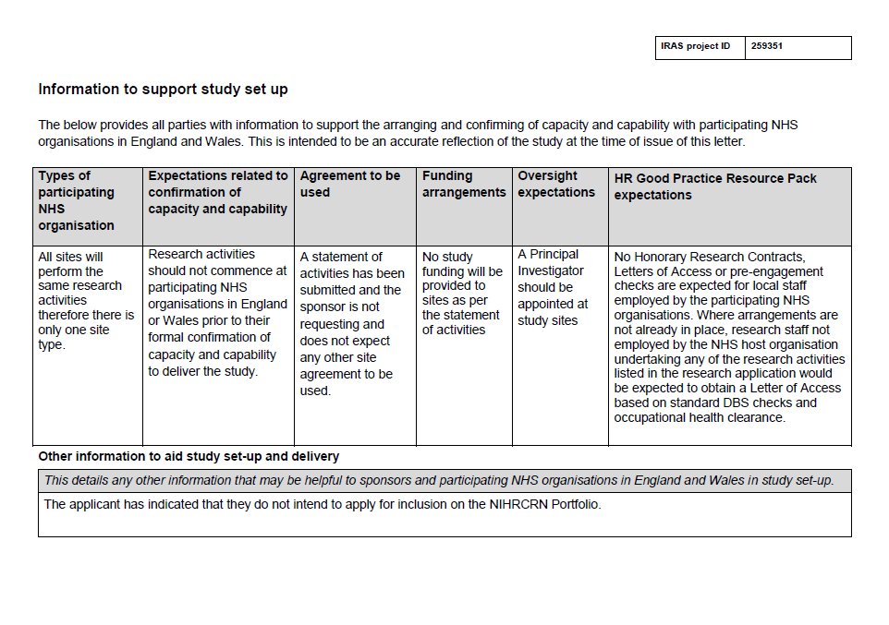

Appendix O: Favourable Opinion of Capacity and Capability from Participating NHS Trusts

Lancashire Care NHS Foundation Trust
Redacted
Redacted
Redacted
Redacted

Midlands Partnership NHS Foundation Trust
Redacted
Redacted
Redacted
Redacted

North Staffordshire Combined Healthcare NHS Trust
Redacted
Redacted
Redacted
Redacted
Redacted

Appendix P: Research Ethics Risk Assessment and Management

Study Title: The impact of attending a hearing to review acute inpatient detention
Identified Risks | Likelihood | Potential Impact/Outcome | Risk Management/ Mitigating Factors
Identify the risks/hazards present | High/Medium/Low | Who might be harmed and how? | Evaluate the risks and decide on the precautions, e.g. Health & Safety
Discussion of a sensitive topic in the interview has the potential to cause the participant distress | Medium | Psychological distress to the participant  Physical aggression or violence to the researcher  Researcher anxiety and stress about having caused distress/ dealing with the situation | - Offer to end the interview  - Signpost the participant to external/internal support services e.g. advocacy, telephone support lines
Discussion of a sensitive topic in the interview has the potential to cause distress to the researcher | Low | Psychological distress to the researcher | - Seek supervision and support from other agencies
Data collection in an unfamiliar location with people not already known to the researcher | Medium | Threats of or actual violence from the inpatients  Physical or psychological harm | - Researcher to make self known to staff and inform them of where the interview will take place  - Allow extra time to familiarise participants with research  - Allow extra time for researcher to familiarise self with the environments (e.g. emergency exits, safety alarms)  - Follow personal safety and security procedures of the ward
Slips and falls | Low | Physical or psychological harm | - Researcher to remain aware of environment and any obstacles or domestic activities that may increase this risk
Altercations with participants or ward staff | Low | Physical violence  Threats  Aggression  Barriers to further research being conducted on the ward | - Researcher to make self known to staff and explain why they are there  - Researcher to be mindful to conduct herself in a way that is unlikely to interfere with smooth running of the ward  - Researcher to report back any significant information to ward staff (in line with participant confidentiality)
Travel risks to location of research project, such as road/rail accident or physical assault | Low/Medium | Physical injury to the researcher  Psychological harm to the researcher | - Remain aware of options for mode of travel and any incidents on the route  - Remain aware of physical environment  - Remain aware of health and safety policies of the research location, e.g. emergency exits
Research participant in danger of harm to self or others | Low/Medium | Immediate or urgent response may be required from care providers or emergency services | - Ensure all verbal and written information about research indicates possible researcher response to indication of danger to self or others

Appendix Q: Distress Management Protocol

In the event of any distress, it was devised that the researcher would offer to cease the interview and provide reassurance to manage the distress.

The researcher and supervisors’ contact details were provided on the PIS, as well as contact details of support services such as the Samaritans and Mind, in case the participant wanted further support afterwards.

Independent Mental Health Advocates (IMHAs) at all study sites were contacted during study set-up so that the researcher could direct participants to advocacy services should they wish to seek this support.

There was also the option that the researcher could follow up with a telephone call in the two days following the interview to check on the participant’s welfare should this be deemed necessary and appropriate by the participant, clinicians, researcher and study supervisors.

∗ Published versions of these theses are available. Theses versions were used for reference in this paper as they contained additional useful information to inform this paper.
∗ Published versions of these theses are available. Theses versions were used for reference in this paper as they contained additional useful information to inform this paper.
Mental Health Act, (1983)
Mental Health Act (1983; amended 2007)
NHS Digital (2017)
NHS Digital (2019)
Department of Health and Social Care (2018)
Care Quality Commission (CQC) (2019a)
CQC (2015)
Smith (2017)
Walsh & Boyle (2009)
Stenhouse (2011)
Cleary, Hunt, Horsfall & Deacon,2(012)
Weich et al. (2012)
Lord (2014)
CQC (2020)
Tierney (2008)
Loft & Lavender (2016)
Pandarakalam (2015)
AIMS Standards (Royal College of Psychiatrists. 2013)
British Psychological Society. (2012)
CQC (2019b)
† NB: the reviewer has looked at reviews and articles published in journal ‘Clinical Psychology & Psychotherapy’ and the tables have been incorporated into the main text as in these papers. Therefore the decision was taken to follow this formatting for the purposes of this thesis. This will be reformatted into the journal’s requirements in preparation for submission to the journal for publication.

