Journal: | Journal of Public Mental Health
Manuscript ID | JPMH-06-2020-0058.R3
Manuscript Type: | Original Research Paper
Keywords: | Culture, South Asian, Religion, IAPT, CBT, Psychological Therapies
Title: Beyond the Barriers: South Asian Women’s Experience of Accessing and Receiving Psychological Therapy in Primary Care.
Title: Beyond the barriers: South Asian women’s experience of accessing and receiving psychological therapy in primary care
Abstract:
Objectives: A number of initiatives have been developed to ensure easy access to
mental health services for Black and Asian Minority Ethnic (BAME) communities.
Improving Access to Psychological Therapies (IAPT) is a service that delivers first
line interventions for South Asian women; however, little is known about what makes
IAPT accessible for this population. This study aims to explore South Asian women’s
experiences of accessing psychological therapy and whether therapy within IAPT
helps individuals to re-frame their experiences within their own cultural context.
Design: A qualitative approach was used.
Method: Semi-structured interviews were carried out with South Asian women who
accessed IAPT. Ten participants took part in the study and interviews were analysed
using Thematic Analysis.
Results: Six themes were identified; access, experience, cultural framework,
therapist characteristics, expectations and ‘sticking with it’. Having a good
therapeutic relationship with the therapist was key. Whilst Cognitive Behavioural
Therapy (CBT) enabled clients to manage their symptoms, manualised CBT led to a
sense of dissatisfaction for some. Clients spoke of having to make a forced choice to
either deny their culture or leave their culture at the door in order to access therapy.
Cultural and religious exclusion had a negative impact on therapy particularly for
those whose difficulties were related to their cultural or religious context.
Conclusion: Culture and religion continues to be excluded from psychological
therapy for South Asian Women. A cultural shift is required from within IAPT services
in order to maintain engagement for this group. Clinical implications are discussed.
Keywords:
South Asian Women, CBT, IAPT, Culture, Religion.

Introduction
The current context in the United Kingdom (UK)
The United Kingdom (UK) has a multicultural society with approximately 12% of its
population from ethnic minority groups (ONS 2011). South Asian ethnic groups (Pakistan,
Indian, Bangladesh and Sri Lankan) form the biggest black and Asian minority ethnic
(BAME) groups in the UK; however, research suggests they underutilise mental health
services (Bhui et al 2003, Bui and Takeuchi 1992, Cooper et al. 2010) and are over
represented in compulsory admissions (Bansal et al. 2014).

In 2007 the government announced the ‘Improving Access to Psychological Therapies
(IAPT) initiative in a bid to provide access to psychological therapies for those with
mild-moderate depression and anxiety. IAPT aims to provide psychological therapy that is
Not hindered by ones’ ethnicity, culture or language (Department of Health, (DoH) 2008)

Research has identified that members of the South Asian community experience
significant levels of mental health difficulties, they also tend to not make use of first line
services compared to the white population (Koffman, et al 1997, Singh et al, 2015) and
often report dissatisfaction with services offered to them (Bhui et al 2002)

There has been a particular focus on providing gender sensitive and gender specific
services for women of BAME communities and to enable better psychological therapy for
them.

Despite initiatives to increase the uptake of psychological therapy for BAME communities
(DoH 2008), access to psychological therapy services remains poor in South Asian and
BAME communities (Mind 2013; Papworth et al. 2013) and they are also less likely to
complete treatment compared to the White British population (Baker, 2018).

In recent years, research has aimed to explore the barriers that South Asian women face
when attempting to access mental health services ( Corrigan 2014;Lowenthal et al 2012).
However, there has also been a significant shift to understanding how to engage people
from BAME backgrounds in psychological therapy (Sandil 2009:Argoro 2014)

The lived experience of accessing therapy by this group is underrepresented in published
work. Little has been done to explore what makes psychological services accessible for
South Asian women. It is time to explore what experiences of IAPT enable some South
Asian women to access and remain engaged in therapy, despite the barriers they may
face. On this occasion males have been excluded as there are specific factors affecting
South Asian Women’s mental distress that differs to that of South Asian men (Soni Raleigh
& Balrajan, 1992).

Research Questions

Firstly, the aim of the project is to explore South Asian women’s experience of accessing
and receiving psychological therapy that uses an IAPT model. What aspects of the
service make psychological therapy accessible for South Asian women? Secondly, does
therapy within IAPT enable individuals to frame their experiences within their own
cultural context?

Method

Design
This study used semi-structured interviews to facilitate an in-depth discussion and
exploration of womens’ experiences of accessing IAPT services.
Recruitment
IAPT services across four NHS Trusts were approached to assist with recruitment. One
non-NHS organisation that uses an IAPT model was also approached. The study was
promoted online through social media; a mosque and a Gudwara were also used as
promotional sites.

Participants
Inclusion criteria
Participants were included in the study if they were:
- Of a Pakistani, Indian or Bangladeshi ethnic background

- Female and at least 18 years of age

- Accessed (completed treatment in the last six months) or currently accessing face-to-face
psychological therapy at either Step 2 or Step 3 (CBT or Counselling) within a service that
offers an IAPT model.
- Must be able to speak English, Urdu, Punjabi or Mirpuri.
Procedure
Independent peer review approval for the study was granted by a UK university. Additional
ethical approval was granted by the Research Ethics Committee of the Health Research
Authority. The interview schedule was informed by previous research (Rabiee & Smith,
2014).
After written consent was obtained, Interviews were conducted by the researcher either
face-to-face or over the phone. All interviews lasted between 30-60 minutes. Interviews
were audio recorded and deleted immediately after being transcribed verbatim by the
author. All interviews were conducted in English and so interviews did not require
translating into English.
Overall Sample
Overall, four participants responded to the social media advertisements and all agreed to
take part. An additional 16 clients were identified from staff within IAPT teams and were
invited to take part in the study. Of these 16, six responded and agreed to take part. A total
of ten participants were recruited into the study.

One participant was recruited from the West Midlands IAPT team, two from North London,
one from West London, five from South London and one from East London. Demographic
information for the participants can be found in Table 1

Data Analysis
The data was analysed using Thematic Analysis. Given the limited research in this area,
an inductive approach was used to identify themes at a semantic level. In this way
participants are giving a voice to the experiences of the world around them (Braun and
Clarke 2013).
Data collected from the interviews was transcribed and was analysed using Braun and
Clarke’s (2006) six-phase method by the researcher. Throughout analysis a reflexive
journal was maintained and an independent researcher reviewed a
sample of the data set and the themes to check their credibility.

Results

A total of six themes were identified: “Access”, “Experience”, “Cultural Framework”,
“Therapist characteristics”, “Expectations” and “Sticking with it”. Figure 1 illustrates these
themes and the relationships between them.

Access
All participants spoke of their experience of entering the IAPT service, this theme was
divided into three sub-themes: referral pathway, location and waiting.
Referral pathway

Most participants reported that they had sought help when things reached ‘crisis point’.
Participants either chose to seek help through the self-referral pathway, asked their GP to
be referred into IAPT or were told by their GP to self-refer into IAPT

“…I went to the doctor and he told me but I feel he was very reluctant even when he did
tell me [about IAPT].” Ashi, 39

Some participants reported reluctance from the GP to make a referral for Psychological
Therapy even when they asked to be referred.

Location
All participants reported that the IAPT service was easily accessible due to the location of
the therapy sessions. These were in community buildings or at the GP practice.

“To be fair I think the location was quite good, I thought that it was quite good that they had options
of being seen in different locations…”
Tam, 32

Eight of the ten participants found that the service was very flexible and were offered
therapy sessions that fitted around work and family commitments.

Waiting
Most participants described waiting for the outcome of their assessment as anxiety
provoking and frustrating. Eight of the ten participants reported a long waiting period
between having their assessment and having their first one-to-one therapy appointment.
“…having CBT was even worse, I had to wait a little more than six months”.
Ashi, 39.
Waiting for therapy often led to the development of unhealthy coping mechanisms.

“So the fact that I was waiting for however many weeks I was waiting, it was...in that times,
like, I kind of developed my own coping mechanisms, which weren’t exactly helpful for
myself”.
Aliyah, 20

Experience
Participants reported mixed feelings about their experiences of accessing IAPT. This
theme has two sub-themes: Personal experience and Experience of manualised Cognitive
Behavioural Therapy (CBT). Manualised CBT refers to an evidence based manualised
treatment protocol for CBT.
Personal Experience
Some participants felt that appointments should be offered to people who really needed it,
thus demoting their own importance. Some described not feeling worthy of having therapy
and experienced a sense of ‘not belonging’ when they accessed therapy.
“I mean, I thought they were always booked out so give it to someone who needs it more”
Aliyah, 20.
When participants felt disappointed in the therapy, they felt they could not openly discuss
their concerns with the therapist so as to not upset or worry the therapist. Instead,
participants felt they should be grateful for receiving a free service, rather than expecting
more.
There was also little control over what treatment interventions clients received, as
interventions were based on the severity of mental health difficulties, which did not always
meet the expectations of the participant.
“I got the impression, well…erm the lady said that I was almost too low risk to be having
face-to-face first so it meant I had to have a workshop first. I wasn’t happy but I needed the
help, so I did”.
Kam, 40.

Experience of manualised CBT
Participants who received CBT found that this offered them practical advice and support
on how to manage their difficulties. It helped participants to understand the connection
between their thoughts and behaviours in order to bring about change.
Although manualised CBT treated the symptoms of mental health difficulties, CBT and the
IAPT model was perceived by some to be a eurocentric model that does not cater to
issues faced by South Asian women, even if manualised CBT was delivered by a South
Asian therapist.

“I am enjoying CBT, I am learning a lot more about my own issues…I knew the principles of
CBT but I didn’t connect the dots together, like, connecting my thoughts to these behaviours”.
Amira, 23.
“I don’t think those steps were made for people of colour. These are modelled upon White
people, come on! Those are not models of people for colour, those are standard procedures
that were not tried and tested or based on the context of what brown people face…like,
immigration, detention centres, non-papers…those are our mental health issues…I don’t
think those models were based on brown people’s mental health concerns”.
Bal, 31

Manualised CBT was perceived as very structured and goal orientated which was often
experienced as ‘textbook therapy’. Due to the structure and rigidity of CBT, there was little
scope to discuss cultural issues that were related to mental health. This felt very limiting.
One participant spoke of searching for additional therapy outside of IAPT that would
incorporate her cultural needs.
“For the cultural stuff I think I might just have to look online to see if there's any groups or if
there's anyone in particular I can talk to elsewhere”.
Aisha 27

Cultural Framework
Culture and religion were a part of participant’s mental health difficulties and for some, a
part of their identity; however, culture and religion was almost always not included in the
therapy. This theme contains 3 sub-themes: cultural fit, cultural competence and stigma.
Cultural fit
To effectively access psychological therapies participants made a forced choice to either;
deny their culture completely or say that the culture was not related to their mental health
difficulties or to leave their culture outside of therapy even though it was part of their
identity;
“I suppose it would have been nice to have my culture recognised. I mean, it’s a part of
who I am. But I just didn’t think the two could go together. I couldn’t see how my culture
could be brought into therapy to help me with my depression so I just never spoke of it”.
Kam, 40.

Cultural competence

Eight out of ten participants reported that their therapist or counsellor had very little
understanding or awareness of the client’s own cultural context and this negatively
impacted on their experience of therapy.
“We have a good relationship but she just cannot understand the context from which I
am speaking, so that makes the therapy not effective”
Bal 31

One participant felt her therapist was culturally aware and was able to respond appropriately
because he was from a similar cultural background and shared the same religious beliefs.
Participants who described their faith as central to their identity felt disappointed by the
therapist’s lack of understanding of the importance and significance of religion as a
protective factor. For one client this led her to discontinue therapy.
Participants often found themselves explaining their cultural context to the therapist which
took up a lot of time, this created a sense of dissatisfaction with the therapy.
Cultural experiences were pathologised and experiences were only seen through the lens
of a western understanding of mental health. Participants felt that therapists from White
British backgrounds were unaware of their cultural context.

“I couldn’t really remember my parents hugging me, giving me a kiss or expressing their love
by saying I love you…so if you were to go to counselling and tell your therapist that, for them
that’s probably something they wouldn’t understand and maybe assume that’s why she is like
that now. She is like this because her parents never hugged her or told her they loved her”.
Ashi, 39.

Culture and religion were excluded from therapy even when this appeared to play a
significant role in the participant’s mental health difficulties. This led to participants feeling
as though only a small part of them was being understood. When therapists did attempt to
make cultural adaptations, they did not meet participants’ cultural needs, instead these
were poles apart.

Stigma
All participants experienced stigma from others such as family, friends, the workplace and
even the GP. Some participants recognised self-stigma impacted on engagement which
was perceived as very confusing and conflicting. Motivation to get better seemed to override the
feelings of shame and stigma which allowed all participants
to access therapy.
“Even though I worry about that and there is shame and stigma, I know I have to go
and do this and do this for myself so that I can get better. Otherwise, I suffer”.
Sara, 34

Therapist Characteristics
Most therapists were described as knowledgeable, warm, trusting, empathic, non-judgmental and as
good listeners and good at offering participants practical advice to manage their mental health.
Three participants found their therapists inflexible and rigid; this appeared to be mediated by the
rigidity of the manualised approach.

Four participants reported that their therapists were seen as dynamic and flexible in their
approach to therapy which fitted the respondent’s needs. Some participants perceived
White British therapists as privileged and therefore, felt they could not understand the
cultural issues and context of South Asian Women.

“She’s [therapist] black…I think it’s been helpful to talk to someone who is not from a privileged
background if that makes sense”
Aisha,27

Five participants felt they needed to be seen by a South Asian therapist who could
understand their cultural context and their needs. Three participants spoke of preferring a
therapist who was warm, trusting, adaptive and who could tailor therapy to meet their
needs, regardless of their ethnicity.

Expectations

Participants spoke of their expectations of the service which were either met and led to a
satisfaction with the service, or unmet, leading to a sense of dissatisfaction and
disengagement with therapy. Expectations were met when therapy was focused on issues
relevant to the client, where appropriate cultural or religious adaptations were made for those who
felt it was necessary and when participants had a good relationship with the therapist.

‘Sticking with it’

Participants spoke of the key motivators that kept them engaged in therapy. There was a
sense that when the expectations of the service or the therapy were not met participants
just ‘stuck with it’ as therapy was seen as the only option to improve their mental
wellbeing.

“ I think I just stuck it out because I needed the face to face. To be fair,erm, I think I stayed for
myself, knowing I needed the help. That was important for me”
Kam 40

Through their interviews participants were able to tell a ‘story’ about their process of
accessing therapy. Figure 2 highlights the interplay between participants’ cultural fit, their
expectations and the impact on engagement. From all the participants there was a sense
that expectations of therapy were either culturally or personally defined. This involved
making a decision to either: deny their culture or argue that culture was not relevant to
their mental health difficulties; to acknowledge that culture was part of mental health but to
leave culture out of the therapy; or to attempt to integrate culture into therapy. This would
lead individuals to then access therapy. If expectations were met the therapy was
experienced positively; however, if therapy did not meet expectations then this was
experienced as ‘not fine’. Individuals would then either disengage from therapy or re-evaluate their
cultural fit. The therapist characteristics and the therapeutic relationship with
their therapist also influenced the experience of therapy

Discussion

A thematic analysis of this data yielded 6 main themes: access, experience, cultural
framework, therapist characteristics, expectations and ‘sticking with it’. The interactions
between the themes and sub-themes are a clear reflection of the complex experiences
that South Asian women face when engaging in talking therapies within IAPT.
A positive therapeutic experience was underpinned by factors such as: a good therapeutic
relationship with the therapist; the expectations and the needs of the client being met by
the therapist; whether the therapy is congruent with their cultural fit; and whether the
therapist was perceived to be culturally competent. Excellent communication styles between
clinicians and individuals from ethnic minority groups can be a foundation for improving access and
engagement in treatment for BAME groups (Aggarwal et al. 2016). Communicating with individuals
regarding their cultural fit, expectation for therapy, and displaying cultural competence may be
more likely to result in improved engagement and treatment retention.
There are specific cultural issues that may impact on engagement that need to be
acknowledged. Transcultural therapy recognises that the individuals’ experiences are
intrinsically linked to the wider social and political context (Fernando, 2012). Bringing these
into the open ensures that a level playing field of shared power exists.
Cultural competence can be defined as “the ability to understand, appreciate and interact with
people from cultures or belief systems different from one's own.” (DeAngelis, 2015). Being culturally
competent, therefore, is about being actively attuned to the participant’s culture and
religion, and being able to appropriately respond to their cultural/religious context and adapt
evidence based treatments for different groups. This was essential only for those who felt their
culture/religion was part of their identity or where mental health was directly related to their
culture/religion. Shepherd et al. (2019) explored the perspectives of health professionals
on culturally competent care and they found health professionals scarcely acknowledged
cultural competence and recommended further staff training and cross-cultural education
in the workplace.

Manualised CBT and CBT based interventions that are not culturally/religiously adapted
appear to be ineffective for individuals whose culture and cultural context is an integral part
of their identity and, to some extent, is related to their mental health difficulty. The lack of
interpersonal care has been found elsewhere (Rathod et al, . (2010). They found that
therapists would often avoid issues around culture and that white therapists felt that therapy
was the same for everyone, and as such, cultural adaptation was unnecessary. Whilst not directly
investigated, implicit or explicit racial bias may also account for the lack of interpersonal
care as experienced by some South Asian women (Cooper et al. 2012)

Findings suggest that manualised CBT appeared to leave little scope to incorporate
culture, even when delivered by a South Asian therapist. Although, undoubtedly,
individuals have benefitted from access to psychological therapies, the IAPT model has
been critiqued for its eurocentric approach (Bassey & Melluish, 2012). Therefore, certain
aspects of CBT do not sit well with South Asian cultures, making manualised CBT
ineffective for some. These findings have been echoed by individuals from the Arab
culture. (Abudabbeh & Hays, 2006; McIndoo & Hopko, 2012).In). In contrast, counselling
approaches were perceived more positively from participants who preferred to tell their
story rather than to treat the symptoms. These findings can be best understood through
understanding the models of ill health. In the West the goal of therapy is to control or get
rid of its symptoms through targeting individual cognition and behaviour. In the East (Asia)
distress is seen as lack of harmony and so the emphasis is placed on harmony and stability of
systemic factors, and the outer relationships of the world, as opposed to individual
autonomy (Fernando, 2012
The IAPT BAME Positive Practice Guide (British Association of Behavioural and Cognitive
Psychotherapies, 2019) recommends exploring with service users their cultural and
religious backgrounds to incorporate these factors into the recovery process .
The results of this study suggest cultural and religious adaption is not consistently
happening in practice for some South Asian Women. These findings have been echoed
elsewhere (Vahdaninia et al, 2020). Vahdaninia et al. (2020) found that there continues to
be a need for culturally adapted services but these are limited in numbers across the UK.
In an effort to make IAPT services more accessible Community Mental Health Workers
(CMHW’s) were recruited to offer culturally adapted treatment as Psychological Wellbeing
Practitioners (PWP’s) in Sheffield. Hakim and Thompson (2019)
explored the experiences of CMHW’s as PWP’s working with BAME’s in IAPT. They found
that; IAPT was inaccessible for South Asians as IAPT’s treatment approach was too
structured for BAME clients. Giving advice to other professionals on the importance of
cultural inclusion had a positive impact on engagement for BAME clients. Staff also
reflected on the need to better modify CBT approaches. These
recommendations further support our findings.
This study has found that therapy within IAPT has not enabled clients to re-frame their
experiences within their own cultural context.

Strengths and Limitations
Only English speaking women took part in the study.
This means the views of non-English speaking women may differ, particularly if so little
acculturation has occurred.
The researcher’s own ethnicity and assumptions about the data can influence the selection
and interpretation of the data. To ensure that bias was reduced all participants’ views were
represented in the paper. Analysis was also reviewed with a peer group and a reflective
journal was also maintained.

Implications for clinical practice

The results highlight the need for clinicians to consistently and continually explore the extent
to which individuals wish for their culture or religion to be integrated into therapy.
Exploring this at the assessment stage can ensure the individual’s expectations for therapy
are congruent with what the clinician (and the service) can offer.
Clinicians within IAPT are evidently well trained at delivering psychological interventions. It
seems that further training to deliver culturally or religiously adapted treatments which
seeks to not only treat symptoms but to consider the individual in the context of their
community is needed.
Delivering culturally/religiously adapted CBT
IAPT which seek to considers the individual in their context ensures a sensitive and value-led
service is being offered. This has been found to have beneficial effects within the UK amongst
BAME groups (Yasmin-Qureshi et al. 2017;Masood, 2015). Providing a sensitive service may
involve consultation with members of the South Asian community with regards to planning,
service delivery and staff recruitment and offering a wider range of treatment options. This
study has identified that there are a range of ways in which people identify with their culture.
In the context of their therapeutic relationship it would be important for therapists to be
aware of how a person identified themselves not only at the point of access, but throughout
the whole therapy process and to actively engage with this in therapy.

Conclusion
This study reveals the complex interplay between the clients’ expectations of the service;
therapist characteristics, their cultural framework and cultural fit, which services need to
consider. These need to be addressed in order to keep clients engaged with therapy,
more work needs to bedone with services to ensure that the right treatments are offered
within IAPT services which are truly culturally appropriate for South Asian women in the UK.

References

Abudabbeh, N., Hays, P.A. (2006). Cognitive-behavioral therapy with people of Arab heritage. In
PA Hays and GY Iwamasa (eds), Culturally Responsive Cognitive-Behavioral Therapy:
Assessment, Practice, and Supervision. pp. 141–159. Washington, DC, USA: American
Psychological Association.
Aggarwal, N.K., Pieh, M.C., Dixon, L., Guarnaccia, P., Alegría, M., and Lewis-Fernandez, R.
(2016). Clinician descriptions of communication strategies to improve treatment
engagement by racial/ethnic minorities in mental health services: A systematic review.
Patient Education and Counseling. 99 (2), pp. 198–209.
Argoro, D. (2014). What are the experiences of BME service users engaging in psychological
therapy? A qualitative study looking at service users’ perspectives of an adult
psychological therapy service. A service evaluation project. University of Leeds,
unpublished thesis.
Baker, C. (2018) Mental health statistics for England: prevalence, services and funding. [online]
available from
<https://researchbriefings.files.parliament.uk/documents/SN06988/SN06988.pdf>
[Retrieved 16th April 2019]
Bansal, N., Bhopal, R., Netto, G., Lyons, D., Steiner, M.F.C., & Sashidharan, S.P. (2014)
Disparate patterns of hospitalisation reflect unmet needs and persistent ethnic inequalities
in mental health care: the Scottish health and ethnicity linkage study. Ethnicity & Health.
19(2), pp. 217-239. DOI: 10.1080/13557858.2013.814764.
Bhui, K., Chandran, M., and Sathyamoorthy, G. (2002) ‘Mental health assessment and South
Asian men’. International Review of Psychiatry. 14(1), pp. 52-59.
DOI:10.1080/09540260120114069
Bhui, K., Stansfeld, S., Hull, S., Priebe, S., Mole, F., and Feder, G. (2003) ‘Ethnic variations in
pathways to and use of specialist mental health services in the UK: Systematic review’.
British Journal of Psychiatry. 182(2), pp. 105-116. DOI:10.1192/bjp.182.2.105
Braun, V., and Clarke, V. (2006) ‘Using thematic analysis in psychology’. Qualitative Research
in Psychology. 3(2), pp. 77-101. DOI:10.1191/1478088706qp063oa
Braun, V., and Clarke, V. (2013) Successful qualitative research: A practical guide for
beginners. London: Sage.
British Association of Behavioural and Cognitive Psychotherapies. (2019) Improving Access to
Psychological Therapies (IAPT). Black, Asian and Minority Ethnic Service user positive
practice guide [online] available from <http://www.babcp.com/files/About/BAME/IAPTBAME-PPG-2019.pdf> [Retrieved 16th December 2019]
Bui, K. T., and Takeuchi, D. T. (1992) ‘Ethnic minority adolescents and the use of community
mental health care services’. American Journal of Community Psychology. 20(4), pp. 403-
417. DOI:10.1007/BF00937752
Cooper, J., E. Murphy, R. Webb, K. Hawton, H. Bergen, K. Waters, and N. Kapur. (2010).
Ethnic Differences in Self-harm, Rates, Characteristics and Service Provision: Three-city
Cohort Study. The British Journal of Psychiatry. 197(3) pp. 212-218.
DOI:10.1192/bjp.bp.109.072637.
Cooper, LA., Roter, D.L., Carson, K.A., Beach, M.C., Sabin, J.A., Greenwald, A.G., and Inui,
T.S. (2012). The Associations of Clinicians’ Implicit Attitudes About Race With Medical
Visit Communication and Patient Ratings of Interpersonal Care. American Journal of
Public Health. 12 (5), pp. 979-987.
Corrigan, P. W. (Ed.). (2014).The Stigma of Disease and Disability: Understanding Causes and
Overcoming Injustices (1st ed.). Washington, DC: American Psychological Association.
DeAngelis, T. (2015). In Search of Cultural Competence. American Psychological Association.
46(3), pp, 46
Department of Health. (2003). Delivering Race Equality: A Framework for Action. London:
Department of Health.
Department of Health (2008). IAPT implementation plan: national guidelines for regional
delivery. London: Department of Health.
Fernando, S. (2012). Race and culture issues in mental health and some
thoughts on ethnic identity. Counselling Psychology Quarterly 25(2), pp. 1-11. DOI:
10.1080/09515070.2012.674299.
Hakim, N., Thompason, A.R. (2019). An evaluation of the transition from BAME community
mental health worker to IAPT low intensity psychological wellbeing practitioner. The
Cognitive Behaviour Therapist, 12 (15), pp.1-19. DOI: 10.1017/S1754470X18000296.
Koffman, J., Fulop, N. J., Pashley, D., and Coleman, K. (1997) ‘Ethnicity and use of acute
psychiatric beds: One-day survey in north and south thames regions’. British Journal of
Psychiatry. 171(3), pp. 238-241. DOI:10.1192/bjp.171.3.238
Loewenthal, D., Mohamed, A., Mukhopadhyay, S., Ganesh, K., and Thomas, R. (2012)
‘Reducing the barriers to accessing psychological therapies for Bengali, Urdu, Tamil and
Somali communities in the UK: Some implications for training, policy and practice’. British
Journal of Guidance & Counselling. 40(1), pp. 43-66. DOI:10.1080/03069885.2011.621519
Masood, Y., Lovell, K., Lunat, F., Atif, N., Waheed, W., et al (2015). Group psychological
intervention for postnatal depression: a nested qualitative study with British South Asian
women. BMC Women's Health. 15, pp. 109-116. DOI 10.1186/s12905-015-0263-5.
McIndoo, C.C., & Hopko, D.R. (2014). Cognitive-behavioral therapy for an Arab college student
with social phobia and depression. Clinical Case Studies. 13, pp. 128–145.
Mind (2013) We still need to talk: A report on access to talking therapies [online] available from
<https://www.mind.org.uk/media/494424/we-still-need-to-talk_report.pdf> [Retrieved on
30th November 2018].
NHS England (2018) The Improving Access to Psychological Therapies Manual [online]
available from <https://www.england.nhs.uk/wp-content/uploads/2019/12/iapt-manualv3.pdf> [Retrieved on 24th January 2018].
Office for National Statistics (2011). CENSUS; Ethnicity and National Identity in England and
Wales (2011). London: Office for National Statistics. [Retrieved on 30th May 2017].
Rabiee, F., and Smith, P. (2014) ‘Understanding mental health and experience of accessing
services among African and African Caribbean Service users and carers in Birmingham,
UK’. Diversity and Equality in Health and Care. 11 (2), pp. 125-134.
Rathod, S., Kingdon, D., Phiri, P., and Gobbi, M. (2010) ‘Developing culturally sensitive cognitive
behaviour therapy for psychosis for ethnic minority patients by exploration and
incorporation of service users' and health professionals' views and opinions’. Behavioural
and Cognitive Psychotherapy. 38 (5), pp. 511-533.
Sandil, R. (2009). Counselling expectations of Asian Indian women: An exploratory study.
Dissertation abstracts international sections A: Humanities and Social Sciences. 7, 2a.
Singh. S., Brown, L., Winsper, C., Gajwani, R,. Islam, Z., Jasani, R., Parsons, H., Rabiee-Khan,
F., and Birchwood., M. (2015). Ethnicity and pathways to care during first episode
psychosis: the role of cultural illness attributions. BMC Psychiatry. 15 (1), pp. 287-294,
DOI: 10.1186/s12888-015-0665-9.
Shepherd, S.M., Willis-Esqueda, C., Newton, D., Sivasubramaniam, D., & Paradies, Y. (2019).
The challenge of cultural competence in the workplace: perspectives of healthcare
providers. BMC Health Services Research. 19 (1), pp. 135. DOI
https://doi.org/10.1186/s12913-019-3959-7.
Soni Raleigh, V., & BALRAJAN, R. (1992). Suicide and self-burning among Indians and West
Indians in England and Wales. British Journal of Psychiatry, 161, 365–368
Vahdaninia, M., simkhadA, b., Van Teijlingen, E., Blunt, H., Mercel-Sanca, A. (2020). Mental
health services designed for Black, Asian and Minority Ethnics (BAME) in the UK: a
scoping review of case studies. Available at
http://eprints.bournemouth.ac.uk/33256/1/Vahdaninia%20et%20al.Accepted%20Dec%20
2019.pdf. [retrieved on 16th August 2020].
Yasmin-Qureshi, S., Sidhu, T., Begum, K. (2017). Innovative ways of engaging with BME
communities. Clinical Psychology Forum. 298, pp.2-7

Tables and Figures
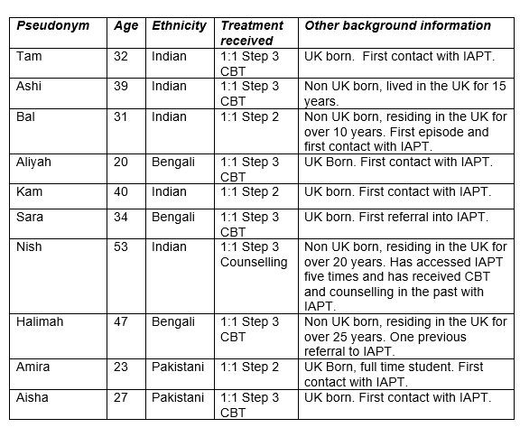
Table 1: Demographic information for participants

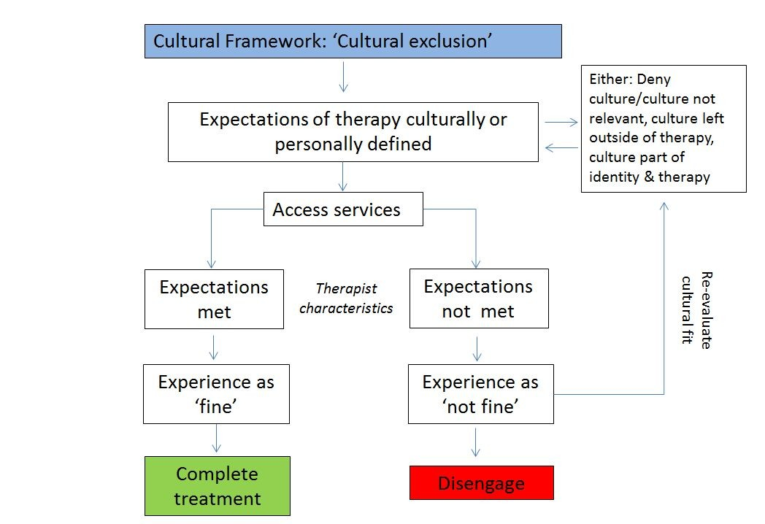
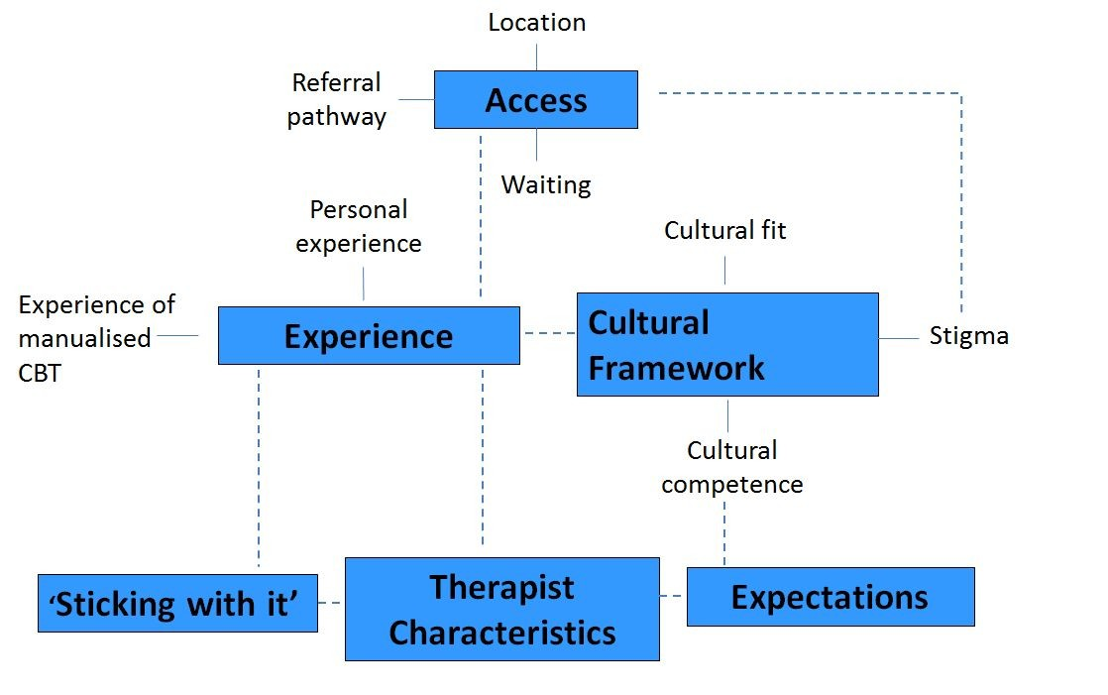
Figure 1: Thematic Map of themes and subthemes. Links between themes and subthemes are identified by the dotted lines

Figure 2: Flowchart of the process of accessing and engaging in psychological therapy

