Plastics derived from disposable greenhouse plastic films and irrigation pipes in agricultural soils: A case study from Turkey
Rezan Gündoğdu^{1*}, Derya Önder¹, Sedat Gündoğdu², Claire Gwinnett³
¹Faculty of Agriculture, Department of Agricultural Structers and Irrigation, Çukurova University, Adana, Turkey
² Cukurova University, Faculty of Fisheries, Department of Basic Sciences, 01330, Adana/Turkey
³ School for Justice, Security and Sustainability, Staffordshire University, UK
* Correspondance to: Faculty of Agriculture, Department of Agricultural Structers and Irrigation, Çukurova University, Adana, Turkey, +90 322 338 63 86, rezan.erdogmus@gmail.com
Highlights
- Soil samples were collected at ten agricultural lands
- The average number of plastics was 16.5 ± 2.4 pcs/kg
- The mean size of plastics was 18.2 ± 1.3 mm
- 41.9 % of extracted plastics were categorized as microplastic
- Almost two of three microplastics (87%) were from greenhouse cover
Abstract
Plastics are ubiquitous. It has been used in human activities, from agriculture to packaging, infrastructure, and health. The wide range of usage makes plastics an omnipresent pollutant in the environment. This study investigated the abundance and type of plastics in agricultural soil in the Adana/Karataş region in Turkey, where disposable low tunnel greenhouse plastic films and irrigation pipes were in use. For this purpose, one kg of soil samples from the top 5 cm (from the surface) was taken from 10 different sampling locations. An average of 16.5 ± 2.4 pcs/kg was found in the soil samples. The highest amount of plastics was seen at the Bahçe-4 location with 39.7 ± 12 pcs/kg and the lowest amount of plastics at the Karataş-1 location with 0.7 ± 0.3 pcs/kg. The average size of plastics was found to be 18.2 ± 1.3 mm. The average size of plastics originating from greenhouse cover was 18.9 ± 1.4 mm, and from disposable irrigation pipes was 12.5 ± 3.5 mm. It was determined that 41.9 % of extracted plastics were microplastic, 36.3% were mesoplastic, 16.3% were macroplastics, and 5.6% were megaplastics. Results indicated that residual plastics decreased in the soil where used plastics were removed after usage. As a result, it is worth noting that a significant amount of plastics remains in soil due to plastics used in agricultural areas.
Keywords: Plasticulture, soil pollution, drip irrigation, low tunnel greenhouse, terrestrial plastics

Graphical Abstract

Acknowledgements
The author also wish to thank Umut Işık for his support sampling campaign.
Funding
This study was supported by the Cukurova University Scientific Project Unit (Project numbers FYL-2020-12847 and FBA-2021-13403).
Author information
Affiliations
Cukurova University, Faculty of Agriculture, Department Agricuştural Structures and Irrigation, 01330 Adana, Turkey
Rezan Gündoğdu & Derya Önder
Cukurova University, Faculty of Fisheries, Department of Basic Sciences, 01330 Adana, Turkey
Sedat Gündoğdu
Staffordshire University, Criminal Justice and Forensic Science Department UK
Claire Gwinnett
Contributions
Rezan Gündoğdu: Conceptualization; Data curation; Formal Analysis; Investigation; Methodology; Project administration; Resources; Software; Validation; Visualization; Writing - original draft; Writing - review & editing, Derya Önder: Conceptualization; Data curation; Investigation; Project administration, Writing - review & editing, Sedat Gündoğdu Data curation; Formal Analysis; Investigation; Methodology; Software; Validation; Visualization; Writing - original draft; Writing - review & editing, Claire Gwinnett: Methodology; Writing - original draft; Writing - review & editing
Corresponding author
Correspondence to Rezan Gündoğdu: rezan.erdogmus@gmail.com
Ethics declarations
Ethics approval and consent to participate
Not applicable
Consent for publication
Not applicable
Competing interests
The authors declare no competing interests.
Introduction
The production of plastic reached 368 million tons in 2019 due to its widespread use (PlasticEurope, 2020). In Europe, an average of 60 million tons of plastic is produced every year, and 27 million tons of this is stored as waste in landfills (WWF, 2018). As of the end of 2021, the total plastic production in Turkey was approximately 10.8 million tons, of which 8.4 million tons were consumed domestically (PAGEV, 2021). Excessive consumption of plastic also causes a significant amount of plastic waste. It is estimated that approximately 32 million tons of municipal waste were produced in Turkey in 2018, of which approximately 10% was plastic (Gündoğdu and Walker, 2021)
Plastic waste in the environment may undergo degradation and decomposition due to physical, chemical, and biological factors. Recent studies have revealed that many plastics, including plastics reported as biodegradable, break down into smaller fragments rather than decompose (Barnes et al., 2009; de Souza Machado et al., 2018). Therefore, plastics larger than 5 mm, turn into particles smaller than 5 mm, often called microplastics (MP), due to the aforementioned factors. MPs can also be released directly into the environment as micro-sized particles designed for various purposes (e.g. resin pellet, microbead, etc.). MPs were first reported in the Sargasso sea by (Carpenter and Smith, 1972). Since this first report, early studies have mainly focused on the marine and freshwater environments. It is now widely known that MPs now can be found in all ecosystems (including, air, water and soil), personal care products, table salt and seafood (Dehghani et al., 2017; Duis and Coors, 2016; Gündoğdu, 2018; Gündoğdu et al., 2021, 2020; Gündoğdu and Çevik, 2017; Lusher et al., 2018). Although most of the information we have about MP pollution today is from aquatic environments, the number of MP studies focused on terrestrial environments has increased (Bläsing and Amelung, 2018; Büks and Kaupenjohann, 2020; Schell et al., 2021). Even with this increase, little is still known about the abundance and impact of MPs in soils, particularly within agricultural settings.
In recent years, the use of plastics in agriculture has increased significantly (Maraveas, 2020). Plasticulture practices are varied and for many purposes, including improving crop productivity, animal nutrition, water use, and reducing food losses. For example, mulching films are used in crop production to suppress weed growth, increase soil temperatures, reduce topsoil and nutrient losses, and reduce soil water evaporation after heavy rainfall (Adhikari et al., 2016; Li et al., 2021). These factors increase crop yields, extend the growing season, and reduce the need for irrigation as well as fertilizer and herbicide applications. However, plastic mulch films are also known to be a significant source of plastic contamination. Their widespread and long-term use, coupled with a lack of systematic collection and management, has led to their accumulation in the soil (Ren et al., 2021). Soil pollution caused by plastics is not limited to mulching films. Disposable irrigation pipes, fruit protection films, and empty agrochemical containers that are poorly managed and abandoned on farms also contribute to agricultural plastic pollution. Büks and Kaupenjohann (2020) state that soils, where plastic-containing agricultural applications are made, contain significant MP residues. The low-tunnel greenhouse plastic films are an important source of MP in arable soils (Huang et al., 2020). This thin-film type plastic (8-50 µm thick polyethylene) is thought to be unaffected by biodegradation processes and, therefore, limiting entry to the soil (Qi et al., 2020a; Steinmetz et al., 2016). Other sources of MPs in agricultural areas can be listed as wastewater treatment sludge, compost, irrigation with wastewater, surface runoff and atmospheric deposition (Bläsing and Amelung, 2018; He et al., 2018). Previous studies have shown that wastewater treatment sludge (Corradini et al., 2019; Nizzetto et al., 2016; Zhang and Liu, 2018), external inputs such as organic fertilizers made from biological wastes (Weithmann et al., 2018) and irrigation wastewater use (Zhang and Liu, 2018) make significant contributions to MP pollution in agricultural soil. Thus, the agro-soil ecosystem is recognized as a critical accumulation area of MPs (Boots et al., 2019; Qi et al., 2020b). MPs in soil threaten human and ecosystem health due to their potential to bioaccumulate in the food web. MPs also risk carrying other pollutants such as pesticides that enter the food chain and harm human and environmental health. MP accumulation in agricultural soil affects soil water holding capacity, soil aggregation, performance, and composition of soil microbial community, soil fauna, and flora which can affect agricultural productivity (Büks et al., 2020; de Souza Machado et al., 2018; Fei et al., 2020; Lehmann et al., 2019; Rillig et al., 2019). MPs also affect organisms that live within and are reliant on the soil environment, including earthworms, snails, and soil nematodes (Lei et al., 2018; Song et al., 2019; Wang et al., 2019).
Plastic applications in agricultural activities are escalating in Turkey as well as all over the world. Plastic greenhouses covered 4270 km² of agricultural land in Europe in 2010 (Steinmetz et al., 2016) and has achieved an annual growth rate of 5-10% worldwide in recent years (He et al., 2018). Greenhouse cover plastics have been widely used in greenhouses and soil mulching of farmland throughout the world since the 1970s. Plastics in use in agricultural areas or unmanaged plastic waste can be broken down into MPs by physical degradation, chemical aging, and biodegradation in agricultural environments (Ng et al., 2018; Rezaei et al., 2019). Therefore, agroecosystems with the widespread use of plastic can also be considered as continuous MP production areas due to the repeated use of plastics used for agricultural purposes every year. The duration of the plastic greenhouses in the fields is positively correlated with the degradation level. The degradation of PE plastic by ultraviolet (UV) exposure, abrasion by soil particles, and wind erosion in field conditions have been expressed in previous studies (Rezaei et al., 2019; Song et al., 2017).
According to PAGEV (2021), 382 000 tons of plastic produced by Turkey as of 2020, is used for agricultural purposes, with the primary application types being greenhouse and disposable drip irrigation piping. Turkey ranks in the top four in the world in greenhouse cultivation, and ranks second in Europe after Spain (Tüzel et al., 2020). Turkey's total greenhouse area has reached 77209.1 ha as of 2018. The low plastic tunnel application is 27.36% of the total greenhouse area (Tüzel et al., 2020). It is worth noting that plastic material in greenhouse applications is relatively high, especially for low tunnel applications. Although there is not enough data, it can be proposed that disposable drip irrigation pipe applications are also increasing in parallel with greenhouse cover applications. This is the first study to quantify MPs from greenhouse covers and irrigation piping conducted on agricultural soils in Turkey. This study aimed to investigate the abundance of plastics in agricultural soils, specifically those that originated from greenhouse cover plastics and disposable drip irrigation pipes.
This study investigates the following hypotheses: both greenhouse films (GF) and disposable irrigation pipes (SUP) usage cause plastic pollution in the soils; removal of plastics after use affects both the number and the size of plastics originating from GF and SUP in the soil. The results aim to guide farmers and decision-makers in better managing the plastic pollution in the fields and further understanding the behavior of plastics in GFSUP applied agricultural soils.
Materials and Methods
Study Area
The sampling area is the agricultural lands in the Adana/Karataş region of the Lower Seyhan Plain (LSP) where the most intensive plastic-use agricultural activities are carried out. LSP, which is an important region of Çukurova Delta, is an area of 210 000 ha, bounded by the Taurus Mountains in the north, the Berdan River in the west, the Mediterranean Sea in the south, and the Ceyhan River in the east. (Yeler et al., 2017) reported that the agricultural product pattern in LSP is wheat in winter and watermelon, corn, cotton, vegetable, and soybean farming in summer. They also noted that it has an important place in citrus production throughout Turkey. This study selected ten different sampling locations where no crops have been planted yet in the Adana/Karataş region; soil samples were taken from these locations in triplicate (Fig.1; Table 1). These sites represent different land and plastic uses, including those that do not use plastic at all. It was noted during an initial field survey prior to sampling that the use of sewage sludge is not common for these areas. The study area is far from other human activities, where intensive agricultural activities are carried out. In addition, although there is heavy vehicle traffic in the seasons when agricultural products are transferred after harvest, it is relatively far from other sources of plastic pollution. However, it is also reported that the process wastes, especially recycling plants, are widely dumped illegally along the irrigation canals, which may also affect the study area (Gündoğdu and walker, 2021). However, all these sources were excluded from the scope of the study.
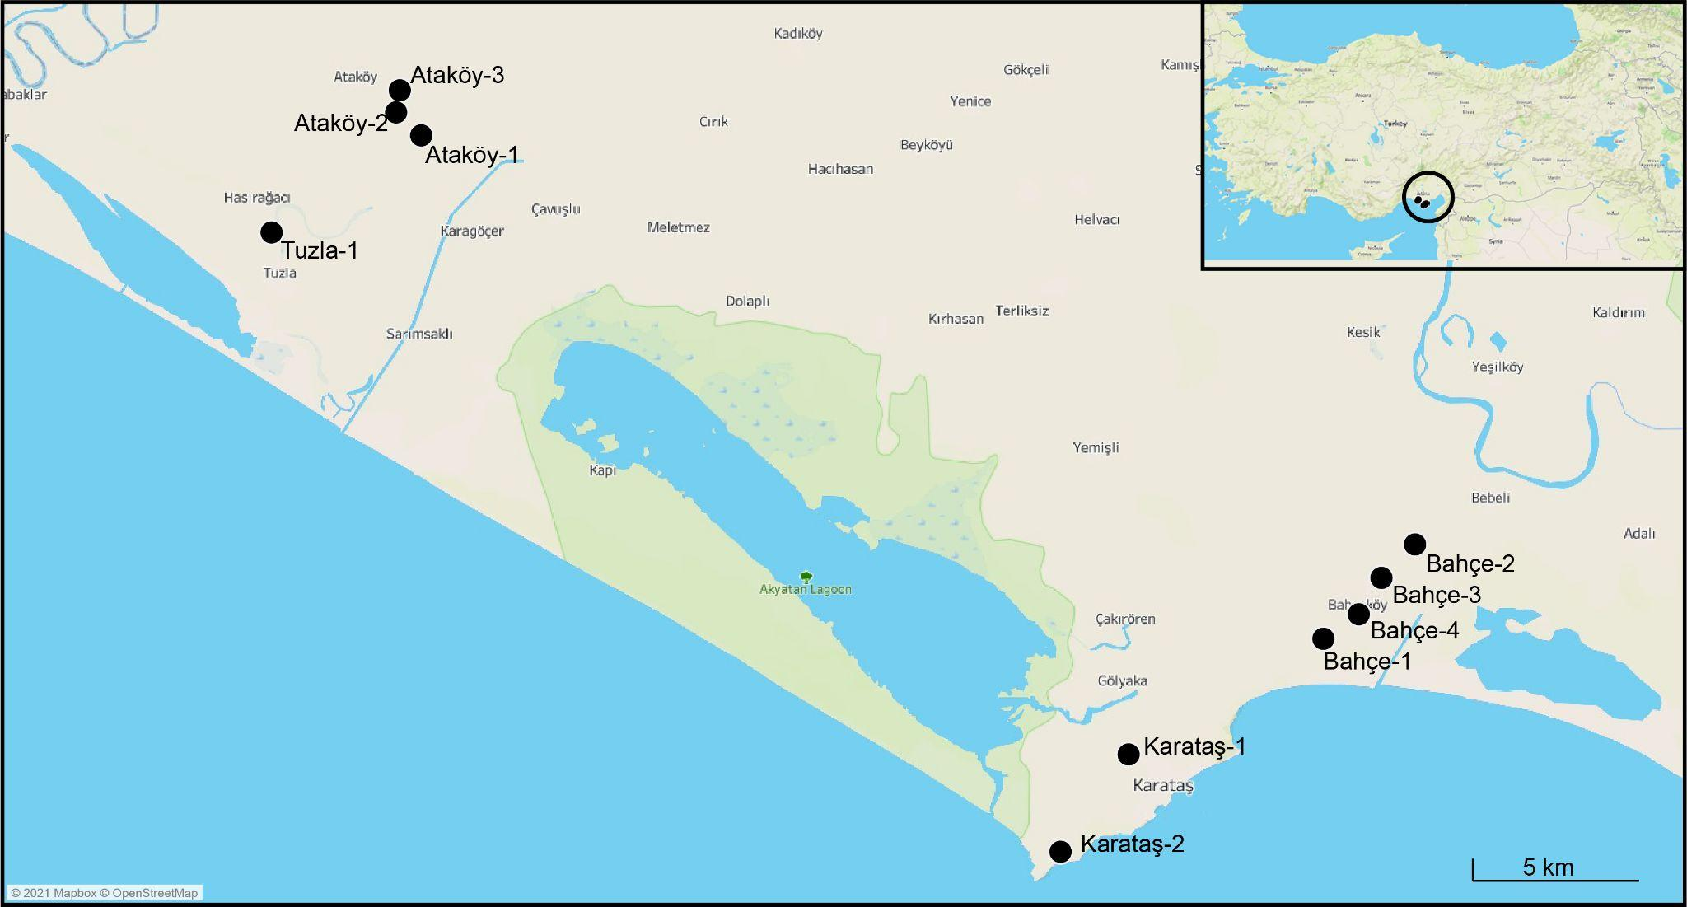
Figure 1. Location of the study area and soil sampling points in the fields
Table 1. Characteristics of sampling locations.
Location | Plastic Usage*¥ | Last yield | Plasticulture background | Removal
Bahçe-1 | GF and SUP | Watermelon | >10 yr | Yes only pipes
Bahçe-2 | None | Maize/Soy | − | −
Bahçe-3 | GF and SUP | Watermelon | >10 yr | Yes
Bahçe-4 | GF and SUP | Watermelon | >5 yr | No
Karataş-1 | None | Wheat | − | −
Karataş-2 | None | Cotton | − | −
Ataköy-1 | GF | Maize | 5 years ago | Yes only pipes
Ataköy-2 | GF and SUP | Tomato/Watermelon | >5 yr | No
Ataköy-3 | GF and SUP | Watermelon/Peanut | <5 yr | No
Tuzla-1 | GF and SUP | Pepper | >5 yr | No
* GF: Greenhouse coverage film, SUP: Disposable irrigation pipes
¥ The plastic types of GF are polyethylene, and SUP are polyethylene and polystyrene.
Sample Preparation and Plastic Extraction
Soil sampling was carried out by combining the soils taken with a steel shovel from 10 randomly selected points close to the centre of the field. Samples were taken from the topsoil (5 cm depth) and blended together to make them homogenous. Subsequently, 3 (replicates) x 1 kg of soil was taken from this blend and transferred to glass jars. As a result, three kg soil samples were taken from each field in total. As this study targeted specific sources of plastics, i.e. greenhouse covers and irrigation pipes, the need to control for procedural contamination from the laboratory clothing or equipment during sampling and processing was unnecessary as any plastics from other sources were eliminated and not counted. However, care was taken not to cross-contaminate samples between field sites by washing equipment between sampling sites, ensuring the glass jars were tightly closed, and keeping samples apart in the laboratory.
The plastic extraction protocol was conducted following methods described by Losh (2015), Frias et al. (2018), and Gündoğdu et al. (2022) with some modifications. Samples were brought to the laboratory, weighed and passed through a stainless steel sieve (Kalyen Co. Istanbul/Turkey) with a 5 mm mesh size to separate particles larger than 5 mm in size (the upper limit for MPs). Then, the jars containing the sieved material were placed in an oven set at 40 °C overnight. After the water in the samples had evaporated, they were removed from the oven and weighed again. The samples were then transferred to sterilized glass jars of 5 litres, and ultrapure water was added to 1 cm above the soil. The samples were then left overnight until the soil was fully in solution which eliminated the aggregation caused by the soil structure. All equipment was washed between samples to prevent cross-contamination.
After the whole sample had become a solution, 4 molars NaI (with a density of approximately 1.6 g/ml) was added to the sample (3-5 cm above), stirred with a glass rod and left overnight to be able to perform the density separation. After the density separation, the floating materials were passed through a 55-micron mesh size sieve. Then, the material remaining on the sieve was placed in a sterile glass jar, and Fenton reagent (organic matter digestion solution) was added to digest all the organic matter (Hurley et al., 2018; Tagg et al., 2017). The mixture was heated on a hot plate set at 40 °C until the organic matter disappeared completely. After all the organic matter was digested, the solution was kept in a closed fume hood for one day to cool, then, the solutions were passed through a 55-micron sieve again, and the remained materials were transferred onto a 0.45-micron pore size membrane filter (Millipore S-Pack HAWG047S6) with the help of a glass filtration system connected to a vacuum pump. The filter paper was transferred into a closed glass petri dish and preserved for microscopic analysis. Filter papers were examined under an Olympus SZX 16 microscope with Canon EOS 450D camera at magnifications between 0.7x and 30x. Known samples of plastic from the GF and SUP were recovered as controls for comparison purposes to enable plastics from these sources to be easily identified in the soil samples. Transparent film plastics originating from GF plastics and black and hard plastics originating from SUP were counted, photographed, and recorded. Plastics larger than 5 mm remaining on the sieve were classified according to their source and measured. Measurements of the photographed particles were also carried out using the Feret’s diameter as part of the ImageJ v1.50i program. Whether the particles were plastic or not was checked with a hot needle after the necessary measurements were made. Size classification of plastics was further done as described by GESAMP (2019), and specifically, the following three classes were used: 1) microplastics: <5 mm, 2) mesoplastics: 5-25 mm, and 3) macroplastics: 25-100 mm.
Although it was clear that the plastic particles extracted from soil were GF and SUP residues used in the field, the particles were analyzed via ATR-FTIR to confirm polymer type. Plastics were analyzed using Thermo Scientific Nicolet IS10 FTIR with a Smart Orbit Diamond ATR System. The instrument was operated in single reflection mode, with a resolution of 2 cm and a mid-IR range of 400 and 4000 cm− 1, at 16 scans per analysis. The polymer types of the plastics were identified using the FDM polymer spectra library.
Plastic concentrations are given as pcs/kg ± standard error. In the statistical analysis, the Kolmogorov Smirnov test was applied to determine whether the number of plastics data fit a normal distribution, and Levene’s homogeneity of variance test was applied to the data, and if necessary, the natural logarithm transformation was used to ensure the data fit the normal distribution. A one-way ANOVA was used to determine whether the number of plastics differed between locations. An independent samples t-test was used to determine the difference in the number and size of plastics between greenhouse films and drip irrigation pipes. Statistical analyzes were performed using SPSS v25 (IBM, Chicago, IL. USA), and Tableau v.20 was used to visualize the data
Results
During the field studies carried out in September 2020, 10 different field sites were visited. Three areas did not have any plastic application, and seven were fields with both greenhouse cover plastic and disposable drip irrigation applications (Table 2). As shown in Table 2, most farmers do not collect the plastics they use, and of the farmers who use plastics have used them for more than five years. Watermelon, tomato, pepper, and peanut farm types were farms that have used plastics for longer than five years.
The mean plastic concentrations from GF and SUP were 16.5 ± 2.4 pcs/kg dry soil across all sampling locations. According to the sites, the highest plastics were determined in the Bahçe-4 location with 37.4 ± 12.0 pcs/kg, and the lowest plastics were determined in the Karataş-1 location with 0.7 ± 0.3 pcs/kg. In the Karataş-2 location, however, no plastics originating from GF and SUP were detected (Figure 2; Figure 3). The ATR-FTIR results also show that the extracted film-type transparent plastic particles and the reference GF were confirmed as polyethylene. Similarly, the extracted black fragment-type plastic particles and two different reference SUPs were confirmed as polystyrene and acrylonitrile butadiene styrene (see appendix).
Since there is no plastic application in Karataş-1 and Karataş-2 locations, the absence or small amounts of plastics was expected. Similarly, a very low plastic was found in the Bahçe-2 location (1.0±0.6 pcs/kg), another location with no plastic application. However, it is thought that the detection of plastics in this area, albeit at a low amount, may be related to the application of plastics in neighboring fields. Therefore, it is possible to propose that the type of agriculture in which plastic application is applied causes a significant amount of plastic residue to be accumulated in the fields. Using a one-way ANOVA test, it was determined that there was a significant difference between the locations in terms of plastic concentrations (Figure 2; p<0.05).
Regarding the sources of plastics, it was determined that 10.3% of plastics were from SUP and 89.7% from GF plastics. The difference between the number of plastics from SUP and GF plastics in all locations was statistically significant (p<0.05). Size distributions of plastics were between 0.11 mm and 185.2 mm, with an average of 18.23 ± 1.35 mm, and did not show a statistically significant difference according to their types (p>0.05). However, the size distributions according to regions showed a significant difference (p<0.05). The mean size of plastics originating from GF was 18.9 ± 1.45 mm, and the average size of plastics originating from SUP was 12.5 ± 3.52 mm (Figure 4).
Figure 2. The number of plastics by location. Bars represent standard errors. The uppercase symbols are based on the DUNCAN multiple comparison tests performed to determine the difference

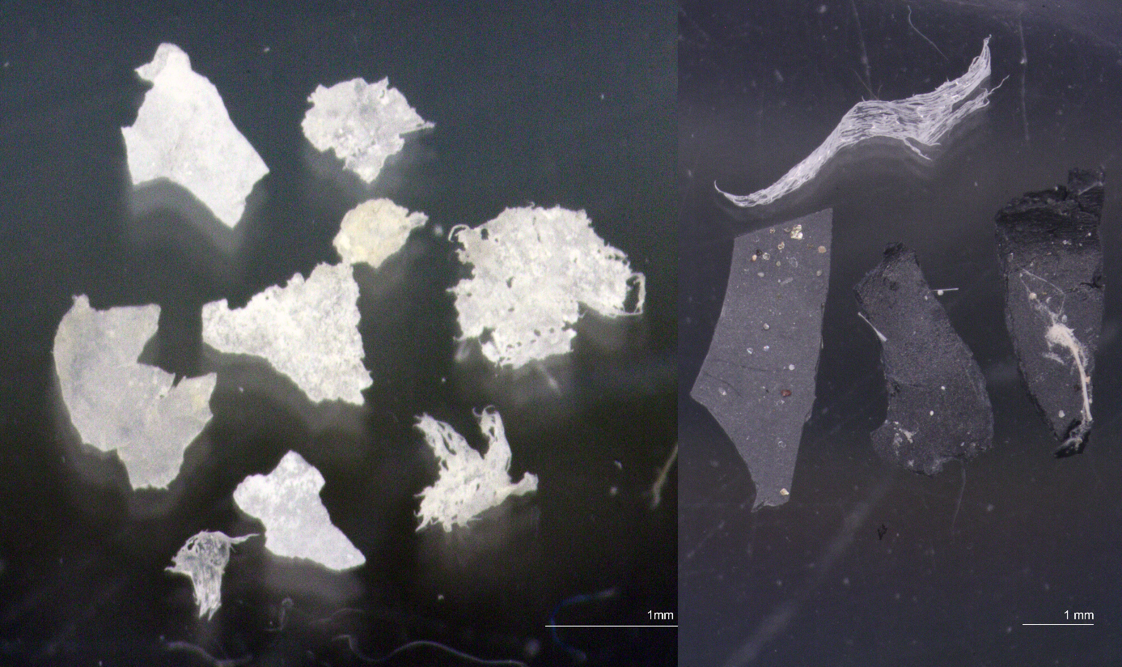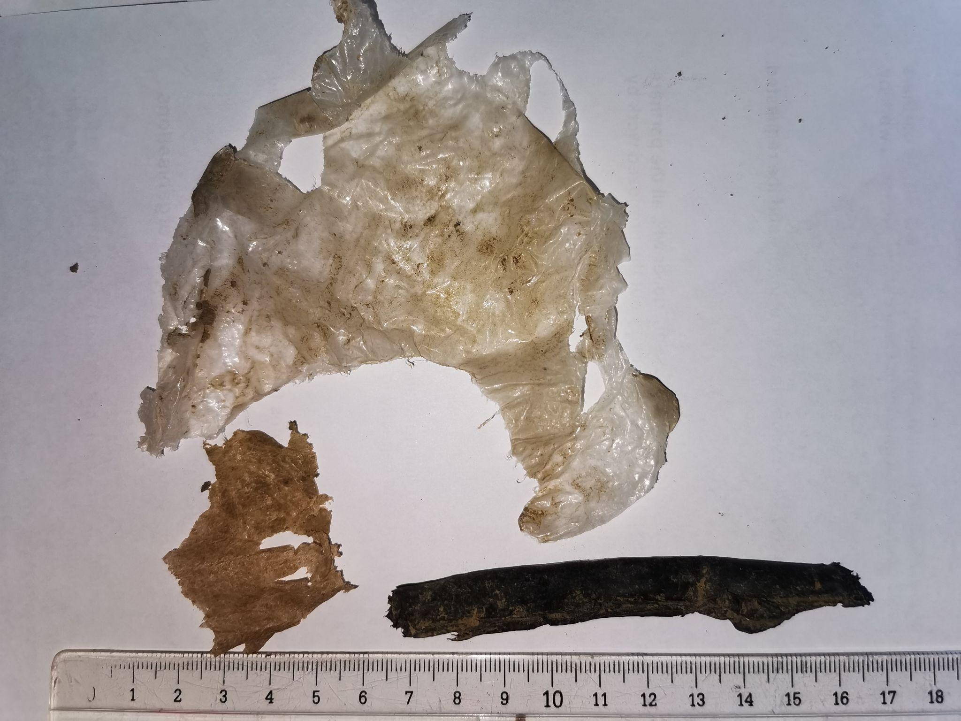
Figure 3. Upper panels: Microscopic images of microplastics were obtained from sampling locations. Transparent fragments are microplastics from greenhouse cover plastics and dark fragments are from drip irrigation pipes; Lower panel: larger residual plastics collected from the field for comparison.
The number of plastics was compared between sites that removed GF and SUP plastic from fields and where they were not. It was determined that the concentration of plastics in each size category is negatively correlated with the removal of plastics in the field (Figure 5a).
Figure 4. Size-frequency distributions of plastics by source
It has been determined that the mean size of both micro and mesoplastics are relatively smaller when there is no removal of used plastics compared to the sites where plastics were removed (Figures 5b and 5c). Although the sizes of the MPs in the fields where only the pipes are removed are relatively smaller than in the case of no removal, there is no significant difference. This reveals that not removing plastics from the field leads to a decrease in MP size. On the contrary, The mean size of both macro and megaplastics increas when the landowners do not remove plastics from field after use (Figure 5d and 5e).
Figure 5. The effect of the post-use removal of plastics from the soil on the total plastic amount and average height. a) Change in the number of plastics per size category, b) Change in the mean size of microplastics, c) Change in the mean size of mesoplastics, d) Change in the mean size of macroplastics, e) Change in the mean size of megaplastics

Discussion
This study determined the plastic concentrations of arable land in the Adana/Karataş region, where GF and SUP were applied. It has been shown that both applications create plastic pollution in agricultural areas.
So far, only a few studies have investigated plastics in broad categories on agricultural land and our study is the first from Turkey. Plastics were found at nine of ten study sites, but their abundances varied greatly. The number of plastics found per kg dry soil was 16.5 ± 2.4 pcs/kg.
The number of MPs in total plastics is 11.13 ± 2.31 pcs/kg. This value is considerably lower than the MP amounts of 78 ± 12.9 pcs/kg and 1444 ± 986 pcs/kg, respectively, reported for agricultural soils in China by Liu et al. (2018) and Yu et al. (2021). Similarly, Boughattas et al. (2021) reported high level of microplastic with 476 pcs/kg concentrations for horticultural soils in Tunisia. In addition, MPs were reported in this study at a much higher level than the average amount reported by Harms et al. (2021) for northern Germany. This difference could be related to the duration of plastic applications in soils. Li et al. (2022) stated that the abundance of plastics in the fields with shorter durations of plastic mulch film applications was generally lower than in other areas where plastic mulch film has been used for a comparable amount of time. However, since we couldn't get reliable information about the duration of the plastic application, we could not make such statements for this study. Another reason for this difference could be related to the source of MPs that is considered. In this study, only two different potential sources were considered. Therefore, the MP pollution level in this study may be much higher if all MP sources were considered. Further detailed studies need to understand the MP pollution profile, and the relationship between the duration and MPs concentration.
The lower abundance of MPs could also be related to the thickness of the applied plastics. Thicker plastics are less likely to disintegrate during removal after harvest (Zhang et al., 2016). Although there is no standard, the thickness range of GFs used in Turkey is 30-800 microns, and the thickness of SUPs varies between 150-600 microns. Indeed, in Turkey, GF films are generally thicker than those in Europe and China (25–50 μm vs. 8 μm) (Wang et al., 2022).
The abundance of plastics in GF and SUP applied soils was significantly higher than in non-plastic used soils (Figure 2). The number of micro-, meso-, macro- and megaplastics we identified in GF and SUP used topsoil was about 47, 78, 17, and 1.2-times higher than in non-plastic used farmlands, respectively. This apparent distinction can probably be ascribed to the application of plastic GF and SUP. The amount of plastic residues does not only differ between plastic applied soils and non-applied soils but also varies with the removal of plastics after use in plastic applied soils. The number of plastics we identified in fields where landowners removed plastics (95.67 pcs/kg) has 4.8 times lower plastic concentration (20 pcs/kg) than soils with no removal activities after use. This clearly indicates that removing plastics from fields after use (not or adequately) has significant effects on decreasing the number of plastic concentrations in soil. The collection of plastics after use also has also a significant effect on the size of plastics in the soil. Accordingly, the fact that the dimensions of plastics, especially MPs, are relatively larger in soil with a higher removal rate. The plastic residues in agricultural soils may present the most significant concerns relating to the impact of plastics on soil quality, ecosystem functionality, and human health and well-being (Choi et al., 2021).
It was observed in this study that SUP and GF plastics were randomly found around the fields, all of which are potential sources of plastic contamination if not collected. High amounts of plastics resulting from the widespread use of plastic film also bring some pollution hazards (Jambeck et al., 2015). MPs from GF plastics may reduce soil porosity and air circulation, alter microbial communities, and lead to low soil fertility, with consequent effects on crop seed germination and seedling growth (Kasirajan and Ngouajio, 2012). In the personal communication with the farmers during the sampling, the farmers stated that the plastic remaining in the field poses a threat to peanut planting, especially after watermelon planting, as the peanuts cannot grow as they get caught in the plastic residues. Cuello et al. (2015) found that GF plastics significantly reduce soil organic matter content and increase greenhouse gas emissions. Also, several studies show that crop yields decrease when GF residues are found in the soil at rates of up to 58.5 kg/ha (Li et al., 2014; Selonen et al., 2019). GF derived plastics can adsorb pesticides and other toxins, reduce soil microbial biomass, and can transfer potentially carcinogenic and mutagenic phthalate acid esters (PAEs) to the soil (Moreno and Moreno, 2008; Fu and Du, 2011; Ramos et al., 2015; Wang et al., 2015; Rodriguez Seijo et al., 2019).
The abundance of plastics in soils varied with land-use types. According to Choi et al. (2020) second highest abundance of MPs was found in agricultural soil. Moreover, the abundance of MPs in agricultural soils also varied with crop types and the presence of other potential plastic source applications (e.g., composting and usage of sewage sludge). Among those sources, GF and SUP plastics are one of the most significant contributors to plastic residues in soil. After being exposed to UV light, combined with mechanical forces, they broke down into smaller plastics and entered soils, especially in areas with a low removal rate of GF and SUP (Steinmetz et al., 2016; Tian et al. 2022).
Conclusion
Plastic usage in the agricultural sector may have worthy benefits in the short term, but the long-term effects cannot be ignored. In particular, GF and SUP plastics break down into smaller plastics, contaminating the soil, as also shown in this study. Over time, plastic breaks down into micro and even nano plastics. Both nano and microplastics can enter the food chain. It has been shown that removing plastics from the soil after use significantly reduces the number of plastics in the soil. However, removing plastics does not entirely mean removing their entire residues. Hence, non-petroleum alternatives to conventional agricultural plastics are needed to tackle the physical and chemical effects of plastics in agricultural soil in the long term. This indicates that besides effective plastic collection activities, it is also needed to find agricultural plastic alternatives. Therefore, decision-makers need to take adequate measures to reduce the plastic pollution load in the soil by coordinating with all stakeholders. In this context, the use of plastic in agricultural production should be controlled with strict protocols, and management plans should be developed. Moreover, future interdisciplinary research is needed to understand the sources, fate, and effects of plastics in agricultural soil.
References
Adhikari, R., Bristow, K.L., Casey, P.S., Freischmidt, G., Hornbuckle, J.W., Adhikari, B., 2016. Preformed and sprayable polymeric mulch film to improve agricultural water use efficiency. Agric. Water Manag. 169, 1–13. https://doi.org/10.1016/j.agwat.2016.02.006
Barnes, D.K.A., Galgani, F., Thompson, R.C., Barlaz, M., 2009. Accumulation and fragmentation of plastic debris in global environments. Philos Trans R Soc L. B Biol Sci 364, 1985–1998. https://doi.org/10.1098/rstb.2008.0205
Bläsing, M., Amelung, W., 2018. Plastics in soil: Analytical methods and possible sources. Sci. Total Environ. 612, 422–435. https://doi.org/10.1016/j.scitotenv.2017.08.086
Boots, B., Russell, C.W., Green, D.S., 2019. Effects of Microplastics in Soil Ecosystems: Above and below Ground. Environ. Sci. Technol. 53, 11496–11506. https://doi.org/10.1021/acs.est.9b03304
Boughattas, I., Hattab, S., Zitouni, N., Mkhinini, M., Missawi, O., Bousserrhine, N., Banni, M., 2021. Assessing the presence of microplastic particles in Tunisian agriculture soils and their potential toxicity effects using Eisenia andrei as bioindicator. Sci. Total Environ. 796, 148959. https://doi.org/10.1016/J.SCITOTENV.2021.148959
Büks, F., Kaupenjohann, M., 2020. Global concentrations of microplastic in soils, a review. SOIL Discuss. 1–26. https://doi.org/10.5194/soil-2020-50
Büks, F., Loes Van Schaik, N., Kaupenjohann, M., 2020. What do we know about how the terrestrial multicellular soil fauna reacts to microplastic? Soil 6, 245–267. https://doi.org/10.5194/soil-6-245-2020
Carpenter, E.J., Anderson, S.J., Harvey, G.R., Miklas, H.P., Peck, B.B., 1972. Polystyrene spherules in coastal waters. Science (80-. ). 178, 749–750. https://doi.org/10.1126/science.178.4062.749
Choi, Y.R., Kim, Y.N., Yoon, J.H., Dickinson, N., Kim, K.H., 2021. Plastic contamination of forest, urban, and agricultural soils: a case study of Yeoju City in the Republic of Korea. J. Soils Sediments 21, 1962–1973. https://doi.org/10.1007/s11368-020-02759-0
Corradini, F., Bartholomeus, H., Huerta Lwanga, E., Gertsen, H., Geissen, V., 2019. Predicting soil microplastic concentration using vis-NIR spectroscopy. Sci. Total Environ. 650, 922–932. https://doi.org/10.1016/j.scitotenv.2018.09.101
Cuello, J.P., Hwang, H.Y., Gutierrez, J., Kim, S.Y., Kim, P.J., 2015. Impact of plastic film mulching on increasing greenhouse gas emissions in temperate upland soil during maize cultivation. Appl. Soil Ecol. 91, 48–57. https://doi.org/10.1016/j.apsoil.2015.02.007
de Souza Machado, A.A., Kloas, W., Zarfl, C., Hempel, S., Rillig, M.C., 2018. Microplastics as an emerging threat to terrestrial ecosystems. Glob. Chang. Biol. 24, 1405–1416. https://doi.org/10.1111/gcb.14020
Dehghani, S., Moore, F., Akhbarizadeh, R., 2017. Microplastic pollution in deposited urban dust, Tehran metropolis, Iran. Environ. Sci. Pollut. Res. 24, 20360–20371. https://doi.org/10.1007/s11356-017-9674-1
Duis, K., Coors, A., 2016. Microplastics in the aquatic and terrestrial environment: sources (with a specific focus on personal care products), fate and effects. Environ. Sci. Eur. 28, 1–25. https://doi.org/10.1186/s12302-015-0069-y
Fei, Y., Huang, S., Zhang, H., Tong, Y., Wen, D., Xia, X., Wang, H., Luo, Y., Barceló, D., 2020. Response of soil enzyme activities and bacterial communities to the accumulation of microplastics in an acid cropped soil. Sci. Total Environ. 707, 135634. https://doi.org/10.1016/j.scitotenv.2019.135634
Frias, J., Pagter, E., Nash, R., O’Connor, I., Carretero, O., Filgueiras, A., Viñas, L., Gago, J., Antunes, J., Bessa, F., Sobral, P., Goruppi, A., Tirelli, V., Pedrotti, M.L., Suaria, G., Aliani, S., Lopes, C., Raimundo, J., Caetano, M., Palazzo, L., de Lucia, Giuseppe Andrea Camedda, A., Muniategui, S., Grueiro, G., Fernandez, V., Andrade, J., Dris, R., Laforsch, C., Scholz-Böttcher, B.M., Gerdts, G., 2018. Standardised protocol for monitoring microplastics in sediments, JPI-Oceans BASEMAN project. https://doi.org/10.13140/RG.2.2.36256.89601/1
Fu, X., Du, Q., 2011. Uptake of di-(2-ethylhexyl) phthalate of vegetables from plastic film greenhouses. J. Agric. Food Chem. 59, 11585–11588. https://doi.org/10.1021/jf203502e
GESAMP, 2019. Guidelines for the monitoring and assessment of plastic litter in the ocean. GESAMP Reports Stud. 99, 130.
Gündoğdu, S., 2018. Contamination of table salts from Turkey with microplastics. Food Addit. Contam. - Part A Chem. Anal. Control. Expo. Risk Assess. 35, 1006–1014. https://doi.org/10.1080/19440049.2018.1447694
Gündoğdu, S., Ayat, B., Aydoğan, B., Çevik, C., Karaca, S., 2022. Hydrometeorological assessments of the transport of microplastic pellets in the Eastern Mediterranean. Sci. Total Environ. 823, 153676. https://doi.org/10.1016/J.SCITOTENV.2022.153676
Gündoğdu, S., Çevik, C., Ataş, N.T., 2020a. Stuffed with microplastics: Microplastic occurrence in traditional stuffed mussels sold in the Turkish market. Food Biosci. 37, 100715. https://doi.org/10.1016/j.fbio.2020.100715
Gündoğdu, S., Çevik, C., Temiz Ataş, N., 2020b. Occurrence of microplastics in the gastrointestinal tracts of some edible fish speciealong the Turkish coast. Turkish J. Zool. 44, 312–323. https://doi.org/10.3906/zoo-2003-49
Gündoğdu, S., Walker, T.R., 2021. Why Turkey should not import plastic waste pollution from developed countries? Mar. Pollut. Bull. 171, 112772.
Harms, I.K., Diekötter, T., Troegel, S., Lenz, M., 2021. Amount, distribution and composition of large microplastics in typical agricultural soils in Northern Germany. Sci. Total Environ. 758, 143615. https://doi.org/10.1016/j.scitotenv.2020.143615
He, D., Luo, Y., Lu, S., Liu, M., Song, Y., Lei, L., 2018. Microplastics in soils: analytical methods, pollution characteristics and ecological risks. TrAC Trends Anal. Chem. 109, 163–172. https://doi.org/10.1016/J.TRAC.2018.10.006
Hurley, R.R., Lusher, A.L., Olsen, M., Nizzetto, L., 2018. Validation of a Method for Extracting Microplastics from Complex, Organic-Rich, Environmental Matrices. Environ. Sci. Technol. 52, 7409–7417. https://doi.org/10.1021/acs.est.8b01517
Jambeck, J.R., Geyer, R., Wilcox, C., Siegler, T.R., Perryman, M., Andrady, A., Narayan, R., Law, K.L., 2015. Plastic waste inputs from land into the ocean. Science (80-. ). 347, 768–771. https://doi.org/10.1126/science.1260352
Kasirajan, S., Ngouajio, M., 2012. Polyethylene and biodegradable mulches for agricultural applications: A review. Agron. Sustain. Dev. 32, 501–529. https://doi.org/10.1007/s13593-011-0068-3
Lehmann, A., Fitschen, K., Rillig, M.C., 2019. Abiotic and biotic factors influencing the effect of microplastic on soil aggregation. Soil Syst. 3, 1–8. https://doi.org/10.3390/soilsystems3010021
Lei, L., Liu, M., Song, Y., Lu, S., Hu, J., Cao, C., Xie, B., Shi, H., He, D., 2018. Polystyrene (nano)microplastics cause size-dependent neurotoxicity, oxidative damage and other adverse effects in Caenorhabditis elegans. Environ. Sci. Nano 5, 2009–2020. https://doi.org/10.1039/c8en00412a
Li, C., Moore-Kucera, J., Lee, J., Corbin, A., Brodhagen, M., Miles, C., Inglis, D., 2014. Effects of biodegradable mulch on soil quality. Appl. Soil Ecol. 79, 59–69. https://doi.org/10.1016/j.apsoil.2014.02.012
Li, C., Sun, M., Xu, X., Zhang, L., 2021. Characteristics and influencing factors of mulch film use for pollution control in china: Microcosmic evidence from smallholder farmers. Resour. Conserv. Recycl. 164, 105222. https://doi.org/10.1016/j.resconrec.2020.105222
Li, Shitong, Ding, F., Flury, M., Wang, Z., Xu, L., Li, Shuangyi, Jones, D.L., Wang, J., 2022. Macro- and microplastic accumulation in soil after 32 years of plastic film mulching. Environ. Pollut. 300, 118945. https://doi.org/10.1016/J.ENVPOL.2022.118945
Liu, M., Lu, S., Song, Y., Lei, L., Hu, J., Lv, W., Zhou, W., Cao, C., Shi, H., Yang, X., He, D., 2018. Microplastic and mesoplastic pollution in farmland soils in suburbs of Shanghai, China. Environ. Pollut. 242, 855–862. https://doi.org/10.1016/j.envpol.2018.07.051
Losh, S., 2015. A proposed method to analyze meso-and microplastic pollution on beaches in Oregon. Honor. Baccalaureate Sci. Environ. Sci. Oregon State University, University Honors College, Oregon, USA.
Maraveas, C., 2020. Environmental sustainability of plastic in agriculture. Agric. 10, 1–15. https://doi.org/10.3390/agriculture10080310
Moreno, M.M., Moreno, A., 2008. Effect of different biodegradable and polyethylene mulches on soil properties and production in a tomato crop. Sci. Hortic. (Amsterdam). 116, 256–263. https://doi.org/10.1016/j.scienta.2008.01.007
Ng, E.L., Huerta Lwanga, E., Eldridge, S.M., Johnston, P., Hu, H.W., Geissen, V., Chen, D., 2018. An overview of microplastic and nanoplastic pollution in agroecosystems. Sci. Total Environ. 627, 1377–1388. https://doi.org/10.1016/j.scitotenv.2018.01.341
Nizzetto, L., Futter, M., Langaas, S., 2016. Are Agricultural Soils Dumps for Microplastics of Urban Origin? Environ. Sci. Technol. 50, 10777–10779. https://doi.org/10.1021/acs.est.6b04140
PAGEV, 2021. Türkiye Plastik Sektör İzleme Raporu 2020 .
PlasticEurope, 2020. Plastics – the Facts 2020, PlasticEurope.
Qi, R., Jones, D.L., Li, Z., Liu, Q., Yan, C., 2020. Behavior of microplastics and plastic film residues in the soil environment: A critical review. Sci. Total Environ. 703, 134722. https://doi.org/10.1016/j.scitotenv.2019.134722
Ramos, L., Berenstein, G., Hughes, E.A., Zalts, A., Montserrat, J.M., 2015. Polyethylene film incorporation into the horticultural soil of small periurban production units in Argentina. Sci. Total Environ. 523, 74–81. https://doi.org/10.1016/j.scitotenv.2015.03.142
Ren, S.Y., Kong, S.F., Ni, H.G., 2021. Contribution of mulch film to microplastics in agricultural soil and surface water in China. Environ. Pollut. 291, 118227. https://doi.org/10.1016/j.envpol.2021.118227
Rezaei, M., Riksen, M.J.P.M., Sirjani, E., Sameni, A., Geissen, V., 2019. Wind erosion as a driver for transport of light density microplastics. Sci. Total Environ. 669, 273–281. https://doi.org/10.1016/j.scitotenv.2019.02.382
Rillig, M.C., Lehmann, A., de Souza Machado, A.A., Yang, G., 2019. Microplastic effects on plants. New Phytol. 223, 1066–1070. https://doi.org/10.1111/nph.15794
Rodriguez-Seijo, A., Lourenço, J., Rocha-Santos, T.A.P., da Costa, J., Duarte, A.C., Vala, H., Pereira, R., 2017. Histopathological and molecular effects of microplastics in Eisenia andrei Bouché. Environ. Pollut. 220, 495–503. https://doi.org/10.1016/j.envpol.2016.09.092
Rodríguez-seijo, A., Pereira, R., 2017. Microplastics in Agricultural Soils Are They a Real Environmental Hazard ?, in: Bioremediation of Agricultural Soils. pp. 46–61.
Rodríguez-Seijo, A., Santos, B., Ferreira Da Silva, E., Cachada, A., Pereira, R., 2018. Low-density polyethylene microplastics as a source and carriers of agrochemicals to soil and earthworms. Environ. Chem. 16, 8–17. https://doi.org/10.1071/EN18162
Schell, T., Hurley, R., Nizzetto, L., Rico, A., Vighi, M., 2021. Spatio-temporal distribution of microplastics in a Mediterranean river catchment: The importance of wastewater as an environmental pathway. J. Hazard. Mater. 420, 126481. https://doi.org/10.1016/j.jhazmat.2021.126481
Selonen, S., Dolar, A., Jemec Kokalj, A., Skalar, T., Parramon Dolcet, L., Hurley, R., van Gestel, C.A.M., 2019. Exploring the impacts of plastics in soil – The effects of polyester textile fibers on soil invertebrates. Sci. Total Environ. 134451. https://doi.org/10.1016/J.SCITOTENV.2019.134451
Song, Y., Cao, C., Qiu, R., Hu, J., Liu, M., Lu, S., Shi, H., Raley-Susman, K.M., He, D., 2019. Uptake and adverse effects of polyethylene terephthalate microplastics fibers on terrestrial snails (Achatina fulica) after soil exposure. Environ. Pollut. 250, 447–455. https://doi.org/10.1016/j.envpol.2019.04.066
Song, Y.K., Hong, S.H., Jang, M., Han, G.M., Jung, S.W., Shim, W.J., 2017. Combined Effects of UV Exposure Duration and Mechanical Abrasion on Microplastic Fragmentation by Polymer Type. Environ. Sci. Technol. 51, 4368–4376. https://doi.org/10.1021/acs.est.6b06155
Steinmetz, Z., Wollmann, C., Schaefer, M., Buchmann, C., David, J., Tröger, J., Muñoz, K., Frör, O., Schaumann, G.E., 2016. Plastic mulching in agriculture. Trading short-term agronomic benefits for long-term soil degradation? Sci. Total Environ. 550, 690–705. https://doi.org/10.1016/j.scitotenv.2016.01.153
Tagg, A.S., Harrison, J.P., Ju-Nam, Y., Sapp, M., Bradley, E.L., Sinclair, C.J., Ojeda, J.J., 2017. Fenton’s reagent for the rapid and efficient isolation of microplastics from wastewater. Chem. Commun. 53, 372–375. https://doi.org/10.1039/c6cc08798a
Tian, L., Jinjin, C., Ji, R., Ma, Y., Yu, X., 2022. Microplastics in agricultural soils: sources, effects, and their fate. Curr. Opin. Environ. Sci. Heal. 25, 100311. https://doi.org/10.1016/J.COESH.2021.100311
Tüzel, Y., Gül, A., Bahar, G., Sait, Ö., Filiz, E., 2020. Türkiye’de örtüaltı yetiştiriciliği ve yeni gelişmeler, in: Türkiye Ziraat Mühendisliği IX.Teknik Kongresi.
Wang, J., Chen, G., Christie, P., Zhang, M., Luo, Y., Teng, Y., 2015. Occurrence and risk assessment of phthalate esters (PAEs) in vegetables and soils of suburban plastic film greenhouses. Sci. Total Environ. 523, 129–137. https://doi.org/10.1016/j.scitotenv.2015.02.101
Wang, J., Liu, X., Li, Y., Powell, T., Wang, X., Wang, G., Zhang, P., 2019. Microplastics as contaminants in the soil environment: A mini-review. Sci. Total Environ. https://doi.org/10.1016/j.scitotenv.2019.07.209
Wang, S., Fan, T., Cheng, W., Wang, L., Zhao, G., Li, S., Dang, Y., Zhang, J., 2022. Occurrence of macroplastic debris in the long-term plastic film-mulched agricultural soil: A case study of Northwest China. Sci. Total Environ. 831, 154881. https://doi.org/10.1016/j.scitotenv.2022.154881
Weithmann, N., Möller, J.N., Löder, M.G.J., Piehl, S., Laforsch, C., Freitag, R., 2018. Organic fertilizer as a vehicle for the entry of microplastic into the environment. Sci. Adv. 4, eaap8060. https://doi.org/10.1126/sciadv.aap8060
WWF, 2018. Out of the plastic trap: saving the Mediterranean from plastic pollution.
Yeler, O., Şatir, O., Berberoğlu, S., 2017. Object based classification of crop pattern using multi-temporal satellite dataset in multi-cropped agricultural areas: Lower seyhan plane case study. Yuz. Yil Univ. J. Agric. Sci. 27, 1–9. https://doi.org/10.29133/yyutbd.305090
Yu, L., Zhang, J. Di, Liu, Y., Chen, L.Y., Tao, S., Liu, W.X., 2021. Distribution characteristics of microplastics in agricultural soils from the largest vegetable production base in China. Sci. Total Environ. 756, 143860. https://doi.org/10.1016/j.scitotenv.2020.143860
Zhang, D., Liu, H., Hu, W., Qin, X., Ma, X., Yan, C., Wang, H., 2016. The status and distribution characteristics of residual mulching film in Xinjiang, China. J. Integr. Agric. 15, 2639–2646. https://doi.org/10.1016/S2095-3119(15)61240-0
Zhang, G.S., Liu, Y.F., 2018. The distribution of microplastics in soil aggregate fractions in southwestern China. Sci. Total Environ. 642, 12–20. https://doi.org/10.1016/j.scitotenv.2018.06.004
Zhou, B., Wang, J., Zhang, H., Shi, H., Fei, Y., Huang, S., Tong, Y., Wen, D., Luo, Y., Barceló, D., 2020. Microplastics in agricultural soils on the coastal plain of Hangzhou Bay, east China: Multiple sources other than plastic mulching film. J. Hazard. Mater. 388, 121814. https://doi.org/10.1016/j.jhazmat.2019.121814

