0

**Finding the evidential potential of solid target damage from shotguns using red light laser scanning and machine learning.**

Mark Jason Broadhead MSc (Hons), AFHEA

A SUBMISSION AS PART OF THE REQUIREMENTS FOR PHD: FORENSIC BALLISTICS AT STAFFORDSHIRE UNIVERSITY

# Abstract

The use of a shotgun in criminal damage presents unique challenges to the discipline of shooting incident reconstruction because typical evidence associated with a firearm discharge can be missing (such as the casing which provides a lot of information on the calibre and type of ammunition used, which with a shotgun remains with the weapon until manually removed (Haag, 2021)). Investigators typically make use of witness panels and measurement of the radial area to perform distance estimation which provides a range of distances a discharge could have come from. Other information such as muzzle and impact velocity is gathered by using automatic detection methods such as chronography and high-speed photography. The technology of laser scanning has been shown to be applicable for gathering evidence in anthropology, medicine and blood spatter analysis. The use of this technology on a shotgun damage site has not been fully investigated with regards to the use of 3D data as opposed to the traditional 2D data currently used and whether using this data could be of later use by investigators. Furthermore, the use of machine learning to analyse the information recovered has been shown to be of potential within the field of distance estimation. By utilising the laser scanning data recovered, prediction of muzzle-to-target distance, muzzle velocity and impact velocity was investigated to explore if the additional information found could be used in an objective fashion to enhance accuracy and minimalize subjectivity. A method was developed for using a red light laser scanner to capture damage from 3 different common building materials (concrete slab, plywood and sheet steel) and analyse these meshes using Geomagic X metrology software. 12Ga, number 7.5 birdshot ammunition was fired at 45 targets (15 from each material) over 3m, 5m and 7m distances (5 targets from each material at each distance). Velocity data from the muzzle was captured using a ballistic chronograph and impact was calculated from high-speed camera footage. Data was collected, processed, normalised and added to MATLAB regression learner where Principle Component Analysis (PCA) was applied as well as leave one out processing (LOOP). Inputs were tried in differing combinations to find the optimal inputs for prediction of muzzle-to-target distance, muzzle velocity and impact velocity. These predictions were averaged by distance as is done in distance estimation in literature. It was found that scan data was critical to prediction in all outputs and that differing materials need different combinations of input, algorithm and principal component analysis (PCA). The behaviours of the material at impact played a role in affecting the optimal input combination for prediction. The average predicted muzzle velocity differed from the average true muzzle velocity by 3.2m/s (0.75%). Average predicted impact velocity differed from average true impact velocity by 8.3m/s (1.74%) and the average predicted muzzle-to-target distance differed from the average true distance by 0.62m (14.41%). The thesis provides a proof-of-concept study into the use of laser scanning coupled with machine learning for forensic shooting incident reconstruction. The thesis demonstrates that laser scanning is capable of maximising evidence from a discharge damage site whilst the machine learning provides an objective approach to estimation.

# Acknowledgements and Dedication

There are many people that I am grateful to in my PhD journey. I am thankful to my family who have helped me get to this point in my life. The students that I taught, and the staff of the School of Law, Policing and Forensics at Staffordshire University have my respect and thanks. The people that assisted me in the practical aspects of the project at Extreme Performance Ammunition were invaluable in their time and efforts to accommodate me within a very busy schedule. In the main, I need to single out a few exemplary individuals without whom I could not have made it this far.

* + *Celia Broadhead* – For being my wife, greatest source of support and for believing in me

even when I didn’t.

* + *Associate Professor Rachel Bolton-King* – For being a great source of inspiration and support during this project and for the tough encouragement when it was needed.
  + *Associate Dean Tony Dodd* – For his tireless efforts in trying to get me to understand machine learning and for keeping my spirits up with his experiences of PhD life.
  + *Emeritus Professor Dave Cheshire* – For starting me on the engineering journey.
  + *Diana Oniko* – For stepping in to assist me with the engineering aspects of the project.
  + *Andrea Alker –* For helping to keep me focused so I could push past my personal issues and produce this work.
  + *Jenni Steen, Laura Wilkinson, Ross Qwok, Lee Trueman –* For the assistance provided throughout the journey and the fun along the way. PhD life has been a lot less stressful with good friends around.
  + *The staff at the Wales Institute of Science and Arts (WISA) –* For supporting and encouraging me whilst starting my career.

This thesis is dedicated to my grandparents, Agnes & Eric Arnold and Sylvia & Brian Broadhead. Without their support and guidance, it would not have been possible to get this far in my life and I hope this makes them proud. I hope I continue to do so.

*“The only person you’re truly competing against is yourself.”*

# – Captain Jean-Luc Picard –

# Table of Contents

Contents

i. Abstract 1

ii. Acknowledgements and Dedication 3

iii. Table of Contents 4

iv. List of Figures 7

v. List of Tables 8

Chapter 1.0 Introduction 9

1.1. Problem Statement and Motivation 9

1.2. Research Question and Proposed Approach 14

1.3. Novelty Statement 16

1.4. Research Challenges 16

1.5. Summary of Contributions 17

1.6. Overall Aims and Objectives 18

Chapter 2.0 Background Research 21

2.1 General introduction 21

2.2 Literature Review 25

2.2.1. Shotguns and Shotgun Analysis 25

2.2.2 Firearm discharge scenario reconstruction and ballistics theory 30

2.2.3 Target Materials 39

2.2.4 Laser Scanning 51

2.2.5 Machine Learning 55

2.3 Overview of Thesis and Layout 62

Chapter 3.0: Method Development 65

3.1 Introduction 65

3.2 Aim and Objectives 65

3.3 Scanning Methodology Development 66

3.4 Shotgun Discharge Data Collection 69

3.4.1 Target Boss Construction and Shooting Phase 69

3.4.2 Shooting test method 70

3.4.3 Scanning method development 73

3.5 Method development findings 80

3.5.1 Scanning method development 80

3.5.2 Scanning data requisition and analysis 86

3.5.3 Analysis via MATLAB regression learner 87

3.6 Equipment Evaluation and Summary 95

Chapter 4.0 Muzzle Velocity Prediction 100

4.1 Introduction 100

4.2 Methodology 102

4.2 Results 104

4.2.1 Potential input combinations 104

4.2.2 Estimated Energy Transfer 104

4.2.3 Calculated muzzle velocity 105

4.2.4 Predicted muzzle velocity 108

4.2.5 Application to shooting incident reconstruction 128

4.2.6 Limitations in muzzle velocity prediction and further work 130

4.3 Conclusion 131

Chapter 5.0: Impact Velocity Prediction 135

5.1 Introduction 135

5.2 Methodology 137

5.3 Results 138

5.3.1 Potential input combinations 138

5.3.2 Estimated Energy Transfer 138

5.3.3 Calculated Impact Velocity 140

5.3.4 Predicted Impact Velocity 145

5.3.5 Application to shooting incident reconstruction 168

5.3.6 Limitations in impact velocity prediction and further work 170

5.4 Conclusion 171

Chapter 6.0 Distance Prediction 174

6.1 Introduction 174

6.2 Methodology 176

6.3 Results 177

6.3.1 Potential Input Combinations 177

6.3.2 Effects of energy transfer on target surfaces 177

6.3.3 Predicted distance 187

6.3.4 Application to Shooting Incident Reconstruction 212

6.3.5 Limitations in Distance Prediction and Further Work 213

6.4 Conclusions 215

Chapter 7.0: Discussion 219

7.1 Introduction 219

7.2 Summary of key findings 220

7.3 Discussion of key findings 221

7.3.1 The applicability of laser scanning to shooting incident reconstruction. 221

7.3.2 Considerations of Machine Learning analysis 223

7.3.3 The use of small datasets and their viability in future forensic ballistics work 226

Chapter 8.0: Conclusions and Further Work 229

8.1 Conclusion 229

8.2 Consideration of the Applicability of the Technique in Other Areas and Further Work. 233

8.2.1 Application of the technique to other areas 233

8.2.2 Further Work 233

# List of Figures

|  |  |  |  |
| --- | --- | --- | --- |
| **List of Figures** | | | |
| **Page Number** | **Figure Number** | **Description** | |
| 15 | 1 | | Detail of the FAROarm scanner showing single point and volumetric tolerance |
| 25 | 2 | | Cutaway view of a shotgun cartridge (Sinha, 2014) |
| 28 | 3 | | Visualisation of the airflow around a bluff body in flight (Vogel, 1994) |
| 67 | 4 | | Photograph of air rifle test setup |
| 67 | 5 | | Simple diagrammatic representation of test setup |
| 69 | 6 | | Assembled target holder |
| 71 | 7 | | Photograph of test weapon in firing jig |
| 73 | 8 | | Photograph of FAROarm Scanner with annotation |
| 74 | 9 | | Scan image of air rifle damage site on wood |
| 78 | 10 | | Example of a mesh from Geomagic |
| 79 | 11 | | Example of a deviation of tolerance map |
| 81 | 12 | | Examples of vernier callipers in use |
| 83 | 13 | | Boxplot of measurement techniques |
| 103 | 14 | | Flowchart showing data retrieval and machine learning process in muzzle velocity prediction |
| 106 | 15 | | Scatterplot of recorded muzzle velocities |
| 107 | 16 | | Boxplot showing spread of recorded muzzle velocities |
| 109-112 | 17 | | Scatterplots of mean predicted muzzle velocities for each material |
| 115-118 | 18 | | Correlation plots showing relationships between input and output data in each material |
| 121 | 19 | | Root-Mean-Square-Error numbers for each combination in muzzle velocity prediction |
| 124 | 20 | | Standard Error of Regression numbers for each combination in muzzle velocity prediction |
| 137 | 21 | | Flowchart showing data retrieval and machine learning process in impact velocity prediction |
| 142 | 22 | | Scatterplots of recorded impact velocities |
| 144 | 23 | | Boxplot showing spread of recorded impact velocities |
| 146-149 | 24 | | Scatterplots of mean predicted impact velocities from each material |
| 151-154 | 25 | | Scatterplots of predicted impact velocities from each material |
| 157-160 | 26 | | Correlation plots showing relationships between input and output data in each material |
| 162 | 27 | | Root-Mean-Square-Error numbers for each combination in impact velocity prediction |
| 164 | 28 | | Standard Error of Regression numbers for each combination in impact velocity prediction |
| 176 | 29 | | Flowchart showing data retrieval and machine learning process in distance prediction |
| 178 | 30 | | Photograph of concrete damage site with annotations |
| 179 | 31 | | Deviation of tolerance colour map for concrete sample |
| 181 | 32 | | Photograph of plywood damage site with annotations |
| 182 | 33 | | Deviation of tolerance colour map for plywood sample |
| 185 | 34 | | Photograph of steel damage site with annotations |
| 186 | 35 | | Deviation of tolerance colour map for steel sample |
| 189-192 | 36 | | Scatterplots of mean predicted distances from each material |
| 195-198 | 37 | | Scatterplots of predicted distances from each material |
| 200-203 | 38 | | Correlation plots showing relationships between input and output data in each material |
| 206 | 39 | | Root-Mean-Square-Error numbers for each combination in distance prediction |
| 209 | 40 | | Standard Error of Regression numbers for each combination in distance prediction |
| 231 | 41 | | Scatterplots and boxplots demonstrating spread of muzzle and impact velocity |

# List of Tables

|  |  |  |  |
| --- | --- | --- | --- |
| **List of Tables** | | | |
| **Page Number** | **Table Number** | **Description** | |
| 35 | 1 | Pros and Cons of three different measuring techniques | |
| 50 | 2 | Common physical measures of materials |  |
| 72 | 3 | Shotgun experiment test matrix |  |
| 82 | 4 | Average Measurements from 3 measurement techniques | |
| 84 | 5 | Percentage of error comparison between callipers and laser scanner | |
| 88 | 6 | Identified potential input variables from experimental work | |
| 103 | 7 | List of repeats for each material, detailing datasets with missing data | |
| 104 | 8 | List of designed input combinations for muzzle velocity prediction | |
| 127 | 9 | Variance of input data (expressed as percentage) after PCA in muzzle velocity | |
| 127 | 10 | Optimal prediction models for each material type in muzzle velocity prediction | |
| 131 | 11 | Optimal muzzle velocity predictions showing widest residual difference between average predicted and average true. | |
| 138 | 12 | List of designed input combinations for impact velocity prediction | |
| 167 | 13 | Variance of input data (expressed as percentage) after PCA in impact velocity | |
| 167 | 14 | Optimal prediction models for each material type in impact velocity prediction | |
| 171 | 15 | Optimal impact velocity predictions showing widest residual difference between average predicted and average true. | |
| 177 | 16 | List of designed input combinations for distance prediction | |
| 210 | 17 | Variance of input data (expressed as percentage) after PCA in distance prediction | |
| 211 | 18 | Optimal prediction models for each material type in distance prediction | |
| 212 | 19 | Optimal distance predictions showing widest residual difference between average predicted and average true. | |
| 215 | 20 | Optimal distance predictions showing widest residual difference between average predicted and average true. | |
| 222 | 21 | Average Scan Measurements at different distances in concrete samples | |
| 232 | 22 | Average impact velocities across all materials at different distances, standard deviation is included to show spread of data | |

# Chapter 1.0 Introduction

## Problem Statement and Motivation

There is a well-established scientific method for the forensic analysis of the differing aspects of firearm investigation and shooting incident reconstruction, which is widely used and continues to be improved upon (Haag, 2021). Examples of this methodology include the use of witness panels for distance determination (Haag, 2021) and the use of probing for angle – of - impact analysis (Nishshanka *Et Al*, 2021). However, recent technological advances such as laser scanning and machine learning present an unexploited avenue of development and as such creates questions around how these technologies can be utilised in a firearm investigation capacity. One such avenue is the investigation of shotgun discharges for the purposes of warnings or criminal damage (where the weapon is discharged with the intention of causing damage to property and not people) where targets could be concrete walls, wooden panels or steel plates (amongst others). The use of firearms in this context represents a full quarter of all firearm discharge offences in the UK (ONS, 2020) and with the shotgun being the most popular legally held weapon in the UK (and responsible for 40% of all firearm crimes) (ONS, 2020). These reasons coupled with the relative complexity of a shotgun discharge damage site (due to the multiple projectiles/ speciality munitions each shell contains) provide a relatively unexplored avenue of research with possible benefits to the investigation of firearm crime within the UK. The current investigation of shotgun crime focuses on determination of range and velocity, utilising 2-dimensional measurement of impact sites (such as measurement of shot pattern width to indicate distance (Haag, 2021)). Subsequently, there is little contemporary forensic analysis of velocity or distance determination in shotgun discharges and work has moved away from this to focusing on the wounding and treatment options, analysis of specialist or new ammunitions and moving to other platforms with a more international impact (such as pistols and assault rifles) (AFTE, 2021/ Science Direct, 2021).

Investigations of this nature typically find little in the way of physical evidence (such as casings) aside from the damage on the object impacted. Due to this lack of physical evidence little can be derived aside from the type of weapon used – if a wad is found then the calibre of weapon may also be ascertained (NABIS, 2015) but the third dimension of depth (and consequently volume) has not been fully explored in a forensic context due to the target material’s behaviour as well as the projectile’s behaviour upon these targets. The current accepted practice for distance determination is that of using witness panels and repeatedly discharging the suspect weapon at different distances. Enough rounds are discharged to take an average to give an approximate range for the pattern appearing as it does on the suspect site, which then gives a determination of distance (typically between two whole numbers) (Haag, 2021). The main issues with this sort of investigation are that:

* + - It is time and resource consuming depending on the weapon used and the availability of the suspect ammunition.
    - The potential lack of availability of ammunition especially in cases where the rounds are discontinued or reloaded.
    - The need for a specialised and costly testing facility (including accreditation and licensing)
    - The state of the weapon may prohibit testing if it is deemed unsafe or breaks during tests.

The effectiveness and utilisation of 3-dimensional scanning apparatus for preservation has been well documented in subsequent sections; however, the further analytical functions of the corresponding metrology software in shooting incident reconstruction situations have not been tested. The overall research question, therefore, is: could the technologies of laser scanning and machine learning being used in the thesis assist investigations of this type?

The use of a shotgun introduces further challenges to the already complex remit of shooting incident reconstruction. Examples are:

* + - Multiple impacts (some overlapping) causing overlapping damage effects on target.
    - Shot swarm effects such as air disruption from one pellet to another or the shielding of the core mass of pellets from further disruption by the outer pellets. (Compton, 1996)
    - Spread and the effect of the choke or other accessories (Haag, 2021)
    - Weather effects such as high wind and temperature (Warlow, 2012)
    - The projectiles’ shape (Farrar & Leeming, 1983)
    - Effects of “flyers” (projectiles that do not conform to the expected aerodynamics of the shot column due to defect) (Haag, 2021)
    - The type of weapon (single barrelled, double barrelled) and modifications such as chokes or barrel length. (Haag, 2021)

The current zeitgeist of western forensic research is intelligence-led investigation (UNIDIR, 2020). This has a focus on incorporating non-subjective means to record and analyse data which theoretically reduces subjectivity from analysts (and therefore confirmation bias). Thereby improving the quality of interpretation of data for use in the criminal justice process (UNIDIR, 2020).

Specifically, the wider relevance to firearm research that the project paves the way for is an improved recording of firearm discharge scenarios where more qualitative analysis can be done on the available evidence recovered. The stored data can be recalled for further work which can be used in analysis, hypothesis development, weapon “fingerprint” development as well as in virtual crime scene work and in creation of models for court exhibits. Additionally, if successful, further work can be done to potentially characterise almost any light weapon system, meaning that the developed method could be used to collect and analyse data from further materials and weapon systems. Thus extending the reach of this method and technology to not only the forensic fields but into fields of warzone investigation, weapon system and ammunition development, weapon disarmament programmes, and data gathering for academic research. To examine such a potentially complex dataset, machine learning could be used.

Machine learning can be broadly described as the use of a computer algorithm to classify or predict trends in sets of data, utilising rules set out by “learning” from historical data (or sample data). This advanced analytical technology can assist research teams in sorting and interpreting data without unwanted bias which can be an issue with using human interactions (Dev *et al*, 2012).

The use of machine learning to assist in the analysis of firearm damage sites improves the objectivity of the current investigation style by reducing operator bias. Machine learning is used widely in everyday life (such as in internet advertising, data collation, logistics and in the automation of complex data analysis) (Bathee, 2018; Altexsoft, 2021; itransition, 2021). The relative advantages and disadvantages of different machine learning methods are described in section 2.1.7. However, it is beginning to be utilised in forensics as a way of trying to reduce subjectivity (Oura *et al, 2022*) and bears further investigation as to an appropriate way of analysing data.

Utilisation of laser scanning to capture data has been proven to be effective, accurate and highly reproduceable in multiple STEM fields (such as Biology and Medicine (Thomas *et al,* 2016)). The biggest advantages that an approach of this nature can provide are:

* + - A non-invasive scene processing method capturing the data without altering a potentially delicate site through direct contact.
    - The ability to manipulate the scanned data to look at minutiae without damaging the site (for example looking at the shape of individual damage sites for angle determination).
    - “by eye” measurements are difficult to do in-situ with any real accuracy due to the size and location of the damage site, which can be eliminated by scanning.
    - Measuring by eye could involve a certain amount of cognitive bias (namely confirmation bias) which is eliminated when using machine measurements.
    - Damage sites vary in size and complexity due to the target’s composition and as such the application of 3D laser scanning can collect the required data without the complications and potential loss of evidence a manual system would bring.
    - The scanning system saves time and effort at the scene which enables deployment to more scenes if needed.
    - The mesh data could be used to make a replica which could be used as a court exhibit or enable a virtual courtroom tour of the scene for reconstruction purposes.

Scanning the damage site also enables an expedient investigation of more unique criminal trends using firearms. 25% of UK firearm crime is destruction/damage of property (ONS, 2020). In a drive-by- shooting context, it is arguably also easier and more practical for a UK-based criminal to use a shotgun as opposed to the more commonly depicted fully automatic weapons. The reasons for the use of either are clear as both shotguns and fully automatic arms fire a hail of projectiles with a single trigger pull, they both have a very simple operation for even untrained users, and they are both highly concealable (with the correct type).

However, the nature of the automatic weapon is that each round fired will eject a cartridge (Haag, 2021). These cartridges (complete with fingerprints, firing pin marks, factory stamps, etc.) will disperse and have an increased chance of one or more being found at the discharge point, whereas shotguns keep the single cartridge inside the weapon until it is manually broken open or racked to load a new cartridge (Wallace, 2008). Thus, using a shotgun arguably removes the need to worry about ammunition casings being found. Both weapons can be manually reloaded (meaning a private individual can make ammunition for the weapons with the correct tools) which creates an opportunity for these manufacturers to remove tell-tale components such as the piston cup from the shotgun (which can be used to identify calibre (Wallace, 2008)). Automatic weapons are illegal in the UK, but shotguns are not (with the correct licensing), which creates wider availability for criminals to acquire.

From a pure ballistics’ standpoint, shotguns provide some unique challenges for an investigator. Arguably, there is no other weapon system that can vary as much as a shotgun, as the ammunition can be changed to provide very different effects on target (Meric *et al*, 2020) and the platform itself can be altered to provide tighter or looser groupings from the projectiles. The versatility of the shotgun is one of the greatest obstacles to overcome for investigators. A potential solution could present if a way of finding out information about the weapon used *from the damage site itself* were to be found and this could be highly effective in mitigating wrongful identification and unsolved cases. An important part of this experiment will be time of flight data (defined in this thesis as the time taken for projectiles to travel at a fixed distance through the air) as this will be one of the measures used in the data collection.

Time of flight data serves two purposes: the first is to provide a target dataset to achieve when trying to predict velocity values; the second reason is to provide similar data to what a forensic firearm scientist would have access to when testing a suspect weapon, which will help to evaluate if the technique developed during the experimental phase is complementary to existing techniques, surpasses them or is not as effective (Outhwaite, 2018). Recording time of flight data for a shotgun creates some issues as (unless the weapon contains a solid slug) the weapon will discharge multiple projectiles which spread out (Mattoo & Nabar, 1969). This could cause damage to equipment or affect data capture by some of the projectiles moving outside of the measured flightpath.

A secondary effect of this research is that questions can be raised about the novel method of dissemination and analysis being used: Can there be forensic justification of using machine learning on small datasets? Can these results be valid within the current and future forensic evidence frameworks? Literature from Oura *et al* (2021) shows that forensic ballistics in particular could benefit from machine learning. Indeed, earlier work by Carriquiry *et al* (2019) describe the use of machine learning in numerous forensic applications with a focus on work by DeKinder and Bonfanti (1999) who used laser profilometry to measure the width and depth of striation marks, automating the analysis. Further work by Hare *et al* (2017) takes this approach further by introducing machine learning. It would appear that, given enough data to learn from, machine learning could be a highly valued method of objective analysis for complex and highly detailed pattern recognition work.

Issues can begin to arise when looking at the replacement of experts with machine learning algorithms and the argument for “appropriate background databases” (Carriquiry *et al*, 2019) to give machine learning the ability to characterise and recognise patterns correctly. On the one hand, there are the advantages of black box machine learning in that operator bias is removed completely (due to it being an automated process) which would potentially have a marked effect on the impartiality of modern evidence analysis. However, as the training and validation data would need to be updated consistently as new developments and trends mean ammunition (particularly shotgun ammunition) is always being improved for performance, it leaves open the possibility of bias entering through this process. Similarly, the data being collected must be realistic to casework of this nature; there is very little evidence for an investigation team to use and as such the evidence remaining must tell all it can.

Once a successful methodology has been worked out, this could provide an evidential advantage in criminal cases, help researchers to understand the relationship of shotgun projectiles between themselves and the target, and pave the way for research to be widened to include differing variables, different weapon systems and different contexts, amongst others. Moreover, operationally the project will begin to identify the most relevant information that can be found on a damage site and demonstrate how to utilise these data for different materials.

## Research Question and Proposed Approach

Using small amounts of samples, can 3-dimensional topographical scan data from a shotgun discharge be utilised to predict distance and velocity from both the muzzle and the target impact and what value could this provide to crime scene and shooting incident investigation?

The proposed approach will utilise professional staff working with in-house protocols (Extreme Performance, 2021). Operations and setup will be conducted in accordance to the SOPs on site (range rules, in-house health and safety and training provided by the site staff). A custom developed method taken from a mixture of scanning industry expertise, training and experimentation (OR3D, 2018)will be used in the later stages of data acquisition. Equipment used in the tests were all of industry standard (the equipment is used frequently for forensic and firearms work) and had been calibrated professionally prior to use.

The method development of the laser scanner will follow industry standard practice for basic operation (OR3D, 2018) of the laser scanner, however it is foreseen that additional amendments may need to be made for the complex shapes the discharges are going to make in the target.

It is proposed that the efficacy of the FAROarm laser scanner be tested utilizing the three criteria of repeatability, accuracy, and precision. For repeatability, the same object will be scanned several times and measurements taken. For accuracy, a group of objects with known sizes will be scanned and measured with the results being compared against the known quantity. For precision, several measurements will be taken and compared to the same measures taken using digital callipers.

The FAROarm is an industry standard precision laser scanner with a reported accuracy of 0.064mm (volumetric), it is expected that this equipment will capture data to a high degree of accuracy and will surpass manual measurement methods – especially for complex scenes (Figure 1 (below) shows a photo of the scanners serial number and calibrated tolerances.

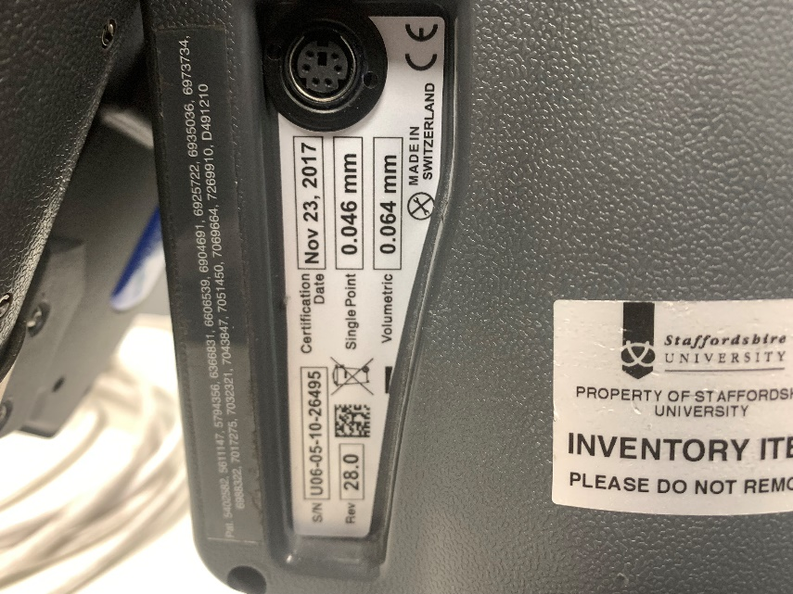

Figure 1: photo detailing the FAROarm scanner used visible is the serial number and calibration date (of which the machine is recalibrated yearly), the single point and volumetric tolerance is also shown.

Once the general performance of the FAROarm has been established, the scanner will be used to identify key additional operational practices on simple damage sites made from firing a .22 calibre air rifle into a target surface and scanning the site. The aim is to identify key operational practices that enable the scanner to get the most complete picture of the damage site possible. Utilization of an air rifle in this instance will:

* + - * Improve safety as the air rifle has a much lower velocity than a shotgun.
      * Enable a more thorough investigation as there is only a singular damage site to scan which makes the scan site simpler.
      * Eliminate the need for transport and set up costs as this test can be done in-house.

After identifying the key operational practices, an appropriate data collection method will be found within the metrology software attached to the GUI for the scanner control. This method will be determined by attending a specialist course on the FAROarm in 2018 (Wells, 2018).

Damage sites will be created from three different common building materials at varying distances common to UK shooting incidents. Velocity at the muzzle and at the terminus will be collected using an appropriate method such as chronography or high-speed photography which are ballistic industry standard methods (Haag, 2021; Mancini & Sidoriak, 2018).

Collected samples will be transported to the scanner and scanned using the developed methodology where the identified analysis platform will be used to exploit these sites and give details on area and volume.

Once all the data is collected from the samples, it is proposed that data be fed into a machine learning algorithm in different input combinations and that the corresponding prediction data be used to identify the best input data for a target output. Secondarily, the scale of effect of material type will be ascertained by these models and inputs.

## Novelty Statement

The analysis of a shotgun damage site using FAROarm scanning as the primary data collection source presents an unexplored avenue of data collection. Although the technology is currently used in overall crime scene documentation (Allen, 2019) and in other forensic fields such as blood spatter (Hakim & Liscio, 2015), further use as an analysis platform of these sites using reverse engineering software presents some clear potential benefits worth investigating. Similarly, machine learning has not been used to look at the relationship of data collected or evaluated for forensic purposes but potentially provides a number of benefits such as:

* Reduced bias (Oura *et al*, 2021)
* Simplification of large amounts of complex data leading to potential further time expediency with casework
* Ability for this data and analysis to be transferred and used more readily, potentially helping future research or prosecution efforts

Laser scanning and analysis of the damage through metrology software presents potential for a unique, novel and highly admissible form of evidence. The utilisation of digital copies for examination work also provide a benefit for the continuity of evidence, which is a key aspect of good forensic practice (and a requirement of ISO 17020/ ISO 17025 accreditation) (UKAS, n.d). The ability to create digital scans of a site is not new in forensic investigation and has legal admissibility as a form of recording evidence (Zarmsky, 2021/ Jowitt, 2011).

## Research Challenges

The challenges of the research that arise from the proposed project highlight a clear gap in knowledge with regards to exploiting information from a damage site. The statistics show that a full quarter of all firearm crime in the UK is property damage (ONS, 2020) and as such represents a huge area where more information can be gathered and used to improve casework. The ability to use the information gained is also of paramount importance to the project and exploring the use of machine learning to fulfil this purpose may lead to work that would create an operational outcome for practitioners to use.

Interpretation of distance data is still largely subjective with basic manual measurements and witness panels used to find a suitable range from which a projectile could have been fired. There is also a worldwide move towards intelligence led investigation (UNIDIR, 2020) which provides a greater framework for linking criminal trends and behaviours across borders with the eventual aim of cutting illicit supplies and capturing individuals who commit crimes in multiple jurisdictions.

This wider application could also include situations where returning to a scene is either impractical or unsafe (Allen, 2019), or where scenes have been cleaned or are too far for other case investigators to get to easily (such as for a jury walkthrough). This element of safety also gives rise to potential use within warzones and the investigation of battlefields where time spent in the field collecting data is dangerous and presents considerable risk to life.

Finally, the use of laser scanning provides an avenue into utilising this technology for the preservation of evidence to a higher degree than current methods. For example, testing and analysis could take place on digital copies of targets rather than the targets themselves which reduces the damage potentially being caused by movement and physical contact with the sample.

## Summary of Contributions

The thesis contributes a novel use of laser scanning into a new method of gathering metrological data from shotgun discharge damage sites and the subsequent analysis (which can be used not only a shotgun discharge situation but has the potential to be used in other discharge scenarios as well). This proof-of-concept study has shown to have great potential for forensic service applicability due to its non-destructive method of data acquisition, is time saving and repeatable. It also has implications for improving the impartiality of estimation evidence or being used as a form of validation when used in tandem with expert testimony.

The thesis contributes a methodology for both data capture and data preparation and notes that a total damage site can be used without concern for overlapping damage as seen in many shotgun discharge events. It also shows that although breaking down the damage site into primary and secondary classifications can be useful for understanding the shot column and its impact behaviours, it is not necessary for this procedure and this part of the investigation alone saves time and effort (although would be very useful for future research).

The implementation of machine learning on the data sets have shown to be highly useful at finding patterns in the data that would be to complex or time consuming for a traditional investigator to find without serious resource expenditure. The use of leave-one-out-processing has shown to be highly applicable for these small datasets and allowed a greater degree of forensic viability over traditional “historical data” learning methods. The thesis also shows that large, historical datasets (such as with Neural Networks or true AI) are not needed for estimation.

The thesis examines a variety of target surfaces with a variety of behaviours and shows that the effect on the target surface affects the usefulness of the individual inputs involved. The work also highlights the importance of volume data and how its effectiveness varies depending on the material surface behaviours being observed.

In summary, the thesis has shown that a basic laser scanner with relevant metrology software is capable of producing data that is accurate, precise and repeatable when utilised in a firearm discharge reconstruction scenario. It has also shown the potential for this collected dataset to predict the muzzle velocity, impact velocity and distance using only a very small amount of data. The thesis also directs future work to enable the development of a usable system in the forensic reconstruction field.

## Overall Aims and Objectives

The overall aim of this investigation is to use machine learning regression to assess the effectiveness of laser scanning and metrology software at collecting meaningful data on shotgun discharges to improve evidential retention and to improve analysis.

This will be achieved by answering the following research questions which will, in turn, answer the overarching research question presented in chapter 1:

* + - How reproducible and reliable is the measurement of muzzle velocity, impact damage, and impact velocity as sources of empirical data?
    - How accurate, reproducible and reliable are machine learning algorithms for the prediction of muzzle velocity, muzzle-to-target distance and impact velocity?
    - Of these data sources, which are critical to the prediction of muzzle-to-target distance, muzzle velocity, and impact velocity?
    - Is the choice of data source and machine learning algorithm affected by the target material and if so, to what extent?
    - Should 3D imaging and machine learning be further investigated and applied to shooting incident reconstruction in the future?

It will be necessary to develop a methodology for using laser scanning and metrology software and to examine the operational limitations of the equipment chosen by comparison of measurements against manual methods to examine the technology’s capabilities, examination of the Faro scanner to find operational best practice for using the equipment in an investigative capacity and evaluating the effectiveness of these tools from a firearm discharge reconstruction standpoint.

Following the design of the methodology, the main data capture experiment (involving setting up and discharging a shotgun against multiple hard targets (plywood, compressed concrete block and sheet steel)) can commence. Once the materials have been shot, the methodology developed previously will be utilised to record useful data from the damage sites, starting with scanning the target sites with the FAROarm and moving onto acquiring deviation, volume and area data with Geomagic X metrology software.

Finally, it will be required to analyse and deduce the most appropriate data collected from evaluating the most appropriate variables to use, and to test the effectiveness of the data by using machine learning algorithms to estimate distance and the kinetic energy of a shotgun discharge at target and muzzle.

The project has been outlined in this chapter and details the projects research questions, motivations and goals. This provides a solid basis and guide to continue on to a literature review which will provide the relevant background reading and theoretical knowledge required for the thesis. The Literature Review chapter will start off with a broad scope and gradually narrow down to more specific topics to provide a rounded and complete overview of the subject.

# Chapter 2.0 Background Research

## General introduction

The recent terrorist attacks in the United Kingdom (UK) and the European Union (EU) coupled with the heightened security alert status of the British Isles has brought to attention the potential for violent incidents to occur. Many of these styles of attack are planned around targeting something with societal impact such as infrastructure or somewhere to create as much panic and confusion as possible (Cross *et al*, 2021). Examples would be a large building or a densely populated area such as a station or marketplace. Attacks using other objects as weapons as well as the use of firearm discharges as a threat against a person have been recorded (Gov, 2022). The use of shotguns as a home defence weapon in America is a popular alternative to rifles and handguns, with many media sources citing them as the most suitable for this task (Defensive Firearms Instruction, 2015/ Massad, 2020/ Parsons-Wraith, 2009) due to the ease of use and increased chances of hitting the assailant a shotgun gives. Well established doctrine such as firing pin analysis (Heard, 2008), Firearm Discharge Residue (FDR) analysis (Zeichner et al, 1992; ASTM E1588, 1993) and bullet striation analysis (Rinker, 2008) have been continuously improved upon to keep them relevant and admissible in modern forensic and legal investigations. However, a lot of these analyses require the possession of a rifled weapon or casing to be effective and in the case of a shotgun discharge incident, the chances are higher that one or both of these vital components are missing.

The recent lack of work around shotgun damage assessment in solid targets, (AFTE, 2021) represents a shift in the research focus from the basic (well-known) ballistic techniques utilised by forensic professionals to looking at more minutiae and individual cases involving wound ballistics or peculiar firearm or ammunition designs. The research needs to encompass and evaluate new technologies that could be used to improve investigation techniques and keep these investigations at the forefront of technological advancement.

In the UK, the shotgun is one of the most popular firearms licences applied for, with 1.3 million licensed shotguns compared to the 535,000 “other” firearms licences granted (Economy, 2017) (“other” in this case would be rifles and moderators such as sound suppressors (Gov, 2022)). This brings into question how much forensic evidence can be recovered after a shooting especially from a scenario where there is a lack of ammunition casings left behind (for example where the assailant has used a shotgun) or, less seriously, where a threat has been made by discharging a weapon at property.

This rise in shotgun discharge incidents has not made a large impact with national media coverage but several recent stories do exist, such as:

* + - Smethwick “snitch” shooting - Black Country, July 2016: a shotgun discharge incident where a victim was labelled a “snitch” and his home fired at after an altercation (Express and Star, 2016).
    - Forest Gate shooting – London, March 2016: 5 people injured during a drive by shotgun discharge incident in London (Standard, 2016)
    - Haydock shooting – St Helens, 2016: a shotgun discharge incident at a front door (Echo, 2016).
    - Exmoor shooting – Exmoor, 2009: a shotgun was discharged at a post box of a woman’s home.

(Daily Mail 2009).

* + - Walton discharge – Walton, 2019: Shotgun discharged at a 23-year-old man possibly from a white van (Liverpool Echo, 2019).
    - Plymouth mass shooting – Plymouth, 2021: shotgun discharged multiple times in a housing estate, killing 5 (BBC, 2021).

Statistics of firearm ownership in the UK show that there are around 4 million legally and illegally owned firearms held by private individuals (UK Government, 2015) (the definition of an illegal firearm is broad and can include a number of different infractions including lack of licence, incorrect storage, neglect, owning a firearm whilst banned from doing so, being in possession of a prohibited type of firearm or a firearm that does not conform to the regulations placed upon it (such as barrel modifications) (UK Government, 2015)). As a total, the world reportedly contains 650 million small arms accessible by civilians (Small Arms Project, 2015). One of the most common types owned in the western world is the shotgun, of which there are a reported 1,338,399 legally held in the UK (UK Government, 2015). Statistics in the UK show that shotguns are less likely to be used in a firearm related incident compared to other weapons (ONS, 2015) (figures showing criminal use remained stable from 2002 to 2014 (ONS, 2015) even after the introduction of the Violent Crime Reduction Act (2006) (Glazebrook, 2012)). In 2014 shotguns were fired in 44% of the 385 cases reported. The most common types of crime where a firearm was used include criminal damage and robbery with the third most common being an offence against the person (ONS, 2015). Firearm crime is a much bigger problem internationally (The Washington Post, 2012) especially in countries where firearms are easier to obtain such as America and the origin of the existing academic research reflects this. There has also been an increase in forensic countermeasures (such as barrel modification to incorporate different ammunition types or reutilisation of antique weapons) used by criminals in order to deceive investigators (O’Keeffe, 2015) which has widened the gap between the amount of knowledge interpreted from collected physical evidence and the criminals involved.

Recent paradigm shifts in UK public perception have arguably removed emphasis from progressing the forensic understanding of firearm investigation, instead concentrating on other aspects of criminal behaviour such as internet and cybercrime or global terrorism (HM Treasury, 2014). These styles of crime are currently at the forefront of public perception due to recent world events such as the Paris attacks in 2015 (Poole & Sneddon, 2018) and the hacking of major organisations such as Microsoft or Sony to gain information or cause disruption to services (Washington Post, 2014). Although not at the current forefront of public perception, the subject of firearm crime still involves highly emotive arguments surrounding civilian ownership of firearms including changing public opinion (Telegraph, 2013/ The Commentator, 2013) and criminal acts reported internationally (such as the Munich shooting (CNN, 2016)). Many of the most current arguments are geared toward responsible ownership of firearms, which firearms are prohibited, and preventing access of these weapons to malicious organised groups. Due to these arguments and the obvious need to identify and apprehend a shooter, it is not surprising that the physical effects and the forensic analysis of such weapons have been extensively studied over the years.

The physical characteristics of projectiles have evolved from the simple round balls of hand cannon and muskets to now being precision engineered and specifically designed for one or two tasks such as lock breaking, armour penetration or non-lethal takedown (Haag, 2021). The shape of the projectile has a marked effect on the damage left behind after a strike (hence the amount of differing styles of projectile available) and as such the perforation of these projectiles has been extensively studied (Jones & Kee Paik, 2012/ Carlucci, 2010/ Wallace, 2008/ Mattijssen & Kerkhoff, 2016)

The construction of shotgun projectiles in particular has seen a high amount of research and development in modern times. Arguably the most notable advancement was that of the change from muzzle loaded projectiles to the Lefaucheux shotgun/cartridge design from 1830 (History Channel, 1998/ Shooting Uk, 2018/ Boothroyd, 1993).

Traditional techniques for making lead shot vary depending on the time and the weapon used but a major industrialisation of ammunition manufacture occurred in 1782 when William Watts of Bristol (UK) patented the first shot tower (Efstathios, 2007). The shot tower is a method of mass production of lead shot by utilising the surface tension of liquid lead to create the ball. Lead was heated to molten state and poured onto a copper sieve at the top of the tower; the lead droplets fell through the tower (the surface area making a sphere) into cold water where the metal solidified. The resulting spheres were collected and any non-spherical shot was re-melted (Maccar, 2017).. Other (more modern) methods of creating lead shot include the Bilemeister method (1961) which removed the need for shot towers by dropping the molten lead into a series of

cooling liquids and rolling the shot continuously; this method creates high quantities of spherical shot but only in no.7 to no.9 sizes (the other sizes becoming problematic) (Bilemiester, 1961). Modern Lead shot is made by sublimation, solid state or by stamping dies to stap the metal into spheres (Anderton, 2018/ American Elements, 2022). The addition of non-lead-based alloyed ammunition being offered as an eco-friendly alternative also meant that differing construction methods needed to be developed.

The development of specialist rounds for specific tasks make the shotgun a highly versatile weapon platform for recreational, commercial, military and law enforcement purposes. The more specialised rounds (slugs, brenneke, dragon’s breath, lead dust, etc.) are beyond the purview of this study (due to the highly specialist nature of these rounds making it unlikely to be used in the UK and thus unsuitable for a proof-of-concept study where the most popular size of ammunition should be used) but the differences in the more standardised rounds (sizes of birdshot and buckshot, compositions of rounds, etc.) are an area of further study to be considered.

The shot from the cartridges can be a pure material (such as “soft” lead) or an alloy, designed to improve performance (such as by adding antimony to harden the lead (Wallace, 2008). Modern shot is around 3-5% antimony which hardens the material to make it more suited to penetrating harder targets (such as thicker-skinned animals) (Bell, 2018). The percentage of antimony in different shot types would have an effect on the type of damage seen at the terminal ballistics stage and as such this would require further research to quantify. Key materials that can make up shot include “soft” (or pure) lead, “hard” lead where antimony has been added to reduce the malleability of the lead, tungsten and steel (Wallace, 2008).

## Literature Review

## 2.2.1. Shotguns and Shotgun Analysis

Differing weapon platforms have distinct differences with regards to operation and this can present evidential differences when gathering usable intelligence for criminal and military investigations (Warlow, 2011). In turn, incorrect differentiation between differing weapon types could provide confusion, particularly in situations where vital evidence (e.g. fired cartridge casings) is missing or where there have been multiple discharges of similar weapons (such as a drive-by shooting, riot or hostage rescue action).

A shotgun is defined in the Oxford English Dictionary as:

*“A smooth-bore gun (fowling-piece) used for firing small-shot, as distinguished from a rifle for*

*firing a bullet.”* (OED online, 2016)

From this definition the general differentiations of a shotgun from other modern firearms is stated: shotguns fire multiple spherical balls called shot, as opposed to a single projectile (bullet), through a smooth-bore barrel where the inner barrel surface is not rifled (as there is no need to spin stabilise the projectile(s) prior to exiting the weapon upon discharge). There are, however, exceptions to these generalisations such as rifled barrels that fire single projectiles called slugs and various other specialist ammunitions for bespoke purposes (NSSF, 2014).

The composition of a basic shotgun cartridge (see figure 1, below) is more complex and has more components than a standard bulleted cartridge; the main components of a shotgun cartridge are as follows:

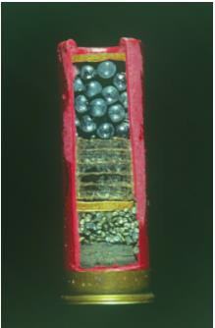

Figure 2: Cutaway view of Shotgun Cartridge (Sinha, 2014)

* The cartridge case is plastic with a metal base (typically brass, brassed steel or 410 grade aluminium).
* Primer is a metallic based primary explosive set off by being struck with the firing pin of the weapon. The primers are more unstable than the propellants but are generally weaker in strength and are used solely to provide the heat required to ignite the propellant.
* Propellant is usually a single base nitrocellulose compound shaped into grains or flakes and is classed as a secondary explosive which is far more stable but needs a heat source to begin burning. Secondary explosives also benefit from being more powerful than primary or initiator explosives which increase the gaseous yield when burnt and thus the velocity.
* Wadding is present in the cartridge to prevent the pressure (from propellant burning) from escaping (maximising the force behind the shot charge and thus maximising velocity). Wads can be made from plastic, felt or cardboard and sometimes have the details of the cartridge composition which can aid in forensic investigation. Some wads can also surround the shot and act as a “sabot” for when the shotgun does not benefit from a choke and thus spread could be increased.
* The shot charge is the measurement of the projectiles loaded into each cartridge. Projectiles typically are ball shaped and made of lead, steel, or bismuth (Wallace, 2008) but more specialised loads exist, including flechettes, “dragon’s breath” (phosphorus coated lead shot), slugs, brenneke rifled slugs, X-REP Taser cartridges and various mixtures for specialist tasks.

Shotguns operate in very much the same way as any other firearm: cartridges are loaded into the chamber by mechanical or manual action, a trigger is pulled and a firing pin is forced forward onto the back of the cartridge, igniting the primary explosive inside the primer unit. When the firing pin strikes the cartridge’s primer unit, friction causes ignition of the primary explosive inside (Dodd, 2005). The explosive primer creates enough heat to set off a secondary explosive (known as the propellant which is more stable and more powerful) within the cartridge (Wallace, 2008). An advantage to this is that the secondary propellant also burns in a more controlled and slower manner in comparison to the primary explosive. Inside the cartridge case the burning propellant causes a massive expansion of gas to push against the wad which in turn pushes the shot charge forward, down the barrel and out to the target. Due to the gaps in and around the shot, the wad is used to ensure that all the pressure created does not escape without acting upon the shot to maximise the useful force created (Haag, 2021). In US manufactured shotgun cartridges, a buffer is sometimes packed around the shot (Haag, 2021). This process differs in comparison to a cartridge fired from a rifled weapon such as a rifle, carbine, or pistol because of the need for the wadding to accomplish the seal to maximise velocity (Sinha, 2014). The problem is that, where efficiency is concerned, shotgun cartridges are not a good energy transfer system. Much of the potential kinetic energy that would be used to propel the projectiles is lost as heat, sound and light (Rinker, 2008). As a result, the amount of energy imparted upon the shot itself could vary as the wads, piston cups or powder charge could all be slightly different, affecting the transfer of energy.

The layers of wadding in a shotgun cartridge are designed to seal any gap in the different layers of the shotgun. In a bullet, the seal is between the back of the bullet and the brass casing, however, due to the multitude of shot in a shotgun cartridge, this cannot be achieved by the projectiles alone. Other differences include the lack of spin forced on the projectile (in most cases) by the inner rifling and the physical makeup of cartridges themselves (Warlow, 2009). This lack of rifling also limits the possibility of using traditional comparison microscopy to look at striation marks in more traditional ammunitions due to the lack of a singular projectile. Other techniques exist where wadding can be examined with examples being “petal slap” markings for distance determination (Haag, 2021) or certain modifications that can leave markings on projectiles (Haag, 2021). Usually, markings on the projectiles could not be used in the same sense as with traditional comparison microscopy of bullets due to the lack of rifling.

The differences in the weapon and ammunition composition present a considerable challenge to forensic investigators. The types of cartridges that can be fired are much more varied than in a rifled weapon and so the ballistic damage from each of these ammunition types will be much more varied as well. The external ballistics and evidential worth of the shot is not the only element to be considered; it is noted by Warlow (2009) that secondary ejecta (that is, the powder, wadding and other elements ejected with the shot) can have an effect on close range targets which can help with identifying the range of a shooting. The wadding (also known as the piston) is the most common secondary ejecta found in a shotgun discharge scenario (Haag, 2021).

An important part of the behaviour of the shot is with its aerodynamics and how this determines the overall damage of the shot. It is reported by Haag (2012) that shotgun discharges using a birdshot load (lots of small pellets) will behave as a single mass of projectile (including associated wads, etc.) and thus create a different damage pattern on target; this is important to note as the behaviour of individual shot is very different in comparison (where energy is lost quite quickly due to the aerodynamics of the shot) and any change of expected pattern could have larger consequences for an investigation.

Spherical shotgun pellets are known as bluff bodies (meaning the shape is not streamline) and a group of shot in flight is collectively known as a shot swarm or cloud. The shot in a shot cloud undergoes two main forms of flight when discharged. The first is when the shot is close enough together that the swarm is considered a body (with each shot affecting its neighbours); after around 20m and above the shot is generally considered to have separated enough to then be in free flight (Compton, 1996).

A sphere in free flight experiences several forces with the primary affecter being drag force. Drag force is the amalgamation of a number of factors that affect the overall aerodynamic performance of a spherical object including air density (rho), velocity (V), Reference area (A) and the drag coefficient (Cd) (NASA, 2015).

The flow of air around the sphere (its drag coefficient) plays an important part in the overall behaviour of the shot which is dependent on velocity (Compton, 1996). To find the drag coefficient, the Reynolds number is also needed. The Reynolds number is a fluid dynamics term which expresses the ratio of inertial and viscous forces acting upon the object in question (NASA, 2014). The higher the power of the number is, the lower the viscosity forces involved. This number is calculated by dividing the inertia force by the viscous force (Compton, 1996).

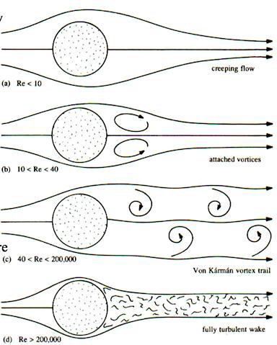The Reynolds number also indicates the sort of airflow pattern that will be found around the projectile whilst it is in free flight. Figure 2 (below) shows the flow around a sphere with different Reynolds numbers.

Figure 3: Visualisation of the airflow around a bluff body in flight (Vogel, 1994)

The flow in the diagram is concerned with a single sphere in free flight and does not consider the shot swarm at large. It is known that shot swarms have a propensity to spread in flight even with a full choke and that this pattern is vaguely conical in shape (Haag, 2021). As the shot is tightly packed together at the start of the intermediate ballistic stage, there is less airflow around each individual pellet (Compton, 1996) and further on that the airflow around each shot will increase by being affected by neighbouring pellets. This is supported by Johnson and Tezduyar (1996) whose simulation of multiple spheres showed interactions such as the tendency to form geometric arrangements and that the velocity is influenced by the number of spheres in the arrangement.

Theoretically, the movement of the shot creates an airflow over the surface which in turn could force the shot apart from its neighbours which (due to the shot now being in free flight) has permanently altered the shot’s flightpath, creating the cone effect. It is however important to know that the modern shotgun also affects this pattern by the addition of accessories such as the choke. The airflow around individual shot is subject to additional, more specific forces which colloquially can be referred to as the projectile’s “drag coefficient”:

* Forebody Drag occurs when the displaced air directly in front of the projectile is compressed and transmitted to the surrounding air as a pressure wave. This wave spreads ahead of the projectile at the speed of sound and bunches up in front which further decreases the kinetic energy of the projectile. It is important to note that this phenomenon usually only occurs at supersonic speeds. (Farrar & Leeming, 1983)
* Base Drag occurs when the wake of an in-flight projectile causes further resistance to the path of travel, inhibiting the speed of the projectile. (Farrar & Leeming, 1983)
* Skin Friction is a form of resistance which occurs when air surrounding the moving projectile moves at slower and slower speeds (relative to the projectile) which creates more drag around the projectile.

The most influential properties of multiple pellet behaviour are detailed by Houck (2015) and include the stacking of the shot in the cartridge before firing (only at short distances) and individual differences to the weapon and ammunition used. This however leaves a lot of questions within the theoretical workings of sphere behaviour such as how much effect the drag coefficient has and what effect do these behaviours have at vastly greater distances in relation to not only the patterns made but the damage inflicted upon the target itself. Standardisation of shotgun cartridges therefore offers some benefit to the typical shooter in terms of the cartridge’s reliability and efficacy.

The proofing of shotgun cartridges is undertaken in multiple countries by different manufacturers with the aim of producing consistency and safety to the user if being loaded into their weapon. In the UK (as well as in many other countries) the standards used come from the rules set out by the Permanent International Commission for the Proof of Small Arms (CIP) (CIP, 2021). These rules and regulations aim to ensure that both barrels and ammunitions have the capability to withstand the pressures and stresses involved with a weapon discharge. From a forensics point of view this also gives a certain security for investigators to work with when looking at shop bought ammunitions and manufacturer made firearms (although the conditions of storage need to be taken into account). On top of these considerations, recent government level reports have indicated a need for the general standards of analysis and investigation of crime scenes to be improved. Calls for ongoing evaluation of methods (both existing and future methods) to provide validity to courts (Obama Whitehouse Archives, 2016), improvement of subjective forms of analysis to be made into more objective forms (Obama Whitehouse Archives, 2016) and recommendations to improve forensic science by investing in research and collaboration. This report highlighted firearm-based forensics and echoes a similar report from the National Academy of Forensic Science in 2009. The report made 13 recommendations including addressing cognitive bias, creation of an oversight entity, and education of professionals, but concluded that much of the work undertaken in forensic science had not had enough testing to establish validity when used in a legal context (Innocence Project, 2019). This set of recommendations highlighted the need for forensic science to be empirical and robust in its approach whilst embracing new technologies, thoroughly testing them, and ensuring they meet the standards needed for a court proceeding.

## 2.2.2 Firearm discharge scenario reconstruction and ballistics theory

Haag (2021) outlines methods and motivations of current shooting scenario reconstruction efforts. The motivations of scene reconstruction (which Haag claims is the goal of criminalistics) are identified by De Forest *et al* (1983) as establishing a common origin of evidence samples, assisting in deducing what happened and supporting these deductions. Haag (2021) elaborates that firearm discharge scenarios offer unique opportunities from the reconstruction perspective due to the predictable behaviours of munitions (projectiles) and the discharge products (firearm discharge residues). The methods employed in a firearm scene reconstruction aim to answer very specific questions and as such Haag (2021) relays some areas in which specialist skills need be considered:

* + - * Class and individual characteristics of firearms
      * Small Arms Munitions
      * Propellants and the chemical/physical properties thereof
      * Exterior and Terminal Ballistics
      * The recognition and subsequent testing of bullet impact sites
      * Trace Evidence

One of the main skills needed for any discharge response scenario is a thorough understanding of ballistics and the ballistic theory of a firearm, as such had become a field in its own right. In forensics this theory is put to use to assist in determination of the points above.

Forensic ballistic analysis is the field of forensic analysis concerned with the discharge of firearms and the behaviour of projectiles with the ultimate aim of finding details of the incident such as the distance of the firearm and the circumstances of the event (such as if it was an accidental discharge or deliberate) (Haag, 2021). As a tool within the remit of scene reconstruction the aim is to recreate the situation to find the geographical data from which other facts can be surmised (for example the angle indicating a shooter’s stance or the behaviour of rounds during a terminal event). Haag (2021) identifies the “ultimate goals” of what he terms “shooting incident reconstruction” but could loosely be applied to a variety of scenarios:

* + - * The range of discharge
      * The position and orientation of the firearm at the moment of discharge
      * The position and orientation of a victim at the moment of discharge
      * The number and sequence of shots
      * The presence, nature and effect of intervening materials
      * Probable flight path
      * Specific end stage ballistics

These goals effectively assist the investigation team in not only reconstructing the scenario (in turn helping to visualise the corresponding events) but also help in subsequent tasks such as directing search efforts or enabling more effective interrogation of suspects. Some techniques and procedures are outlined below.

Distance or range determination has long been one of the most important factors regarding any ballistic discharge investigation: the ability to determine the precise location a projectile was fired from is key when examining the chain of events, especially in situations where multiple shooters are involved or when examining multiple discharges from the same suspected weapon. Current range estimation focuses on getting a relative range and narrowing down with physical evidence (such as the presence and distribution of FDR particulate, burn marks, scorching patterns and bullet wipe markings (Heard, 2013)), and comparing the suspect damage with test firings from the lab in similar materials. Specifically, when examining shotguns, Heard (2013) states that this can be done with considerable accuracy up to 20-30 yards (18-27m) because the pellets disperse as soon as they exit the barrel; this supposition is disputed by Carlucci (2010) and Crompton (1996) who both state that spheres in this situation typically act as a single mass from 0-4m (approx.) from the barrel due to the shot column blocking much of the interaction between the air and each pellet. If the shotgun wadding is of the piston type (that is to say a plastic tube with a petalled shot cup on top) then it is likely that this effect could be enhanced. Research into distance estimation at extremely close ranges (under 1m) have been done by looking at the defect in soft targets (clothed bodies) using simple photography and open-source software (Bolton-King *Et al, 2019*) which has shown a potential method for when the shot has not had time to begin spreading out from the column. The current method in shotgun examination is to measure the radial dispersal of the pellets at different discharge distances (measuring this dispersal usually means measuring the largest distance between pellet strikes across the pattern (Haag, 2021)), comparing these measurements with the suspect discharge and it is stated that reliable distance determination can only be obtained by the empirical analysis of the suspect weapon (Haag, 2021).

Positional determination of the firearm, shooter and target can be determined from a range of techniques such as “stringing” (where either string or a beam of light is positioned from the bullet’s terminal point outwards, following the angle from the terminal target). The pathway created can be used to show the bullet’s flightpath and thus the origin of the shot. This can also determine a discharge position by looking at the height of the origin point. Stringing can also give information on the probable flight path of the round by looking at the angle of entrance to a target surface (Haag, 2021). Haag (2021) however states that whilst stringing is an effective technique for looking at the probable path of a projectile, caution must be used if using actual string lines as they have a tendency to sag after a few metres which can distort the pathway mapping exercise. String can also be difficult to anchor and catch on the edges of a bullet hole – further distorting the mapping process. Due to this there are a variety of other tools that are used including rods, lasers and probes (Haag, 2021/ Garrison, 1996).

Exterior and terminal events such as ricochet or tumbling can have a chaotic effect on firearm rounds which can lead them to behave in unexpected ways. Due to this, it is advised in the literature to try to either recreate (if safe to do so) the discharge in a lab environment or, if this is not possible, use the existing evidence to come to a logical conclusion (Heard, 2013).

Time of flight data and high-speed photography are also extensively used within the field of forensic ballistics to analyse the effects of the projectile upon the target as well as the likely speeds the projectiles were travelling at (Haag, 2021), all helping with scene reconstruction by tests designed to recreate the patterning and damage seen at the site. There are a few ways to measure time of flight data but the most common are high speed photography and chronography.

The chronograph is commonly used in ballistic experiments as a simple method to record the speed of the projectile. Operationally, it functions by the projectile breaking a “trip” mounted in a gateway (usually an optical sensor but can also be audio based (Sydor, 2020)). The shadow of the projectile passing over the first trip starts a timer and passing the second trip stops the timer. The known distance between the two gates is then used to plot the speed of the projectile. The main advantages with these systems are that they are common, relatively cheap (depending on the model) and are commercially viable products (advertised to recreational shooters, military and law enforcement, and hunters for fine tuning weapons), which means that they are being developed with new technology (Sniper Country, 2019) making them more accurate and precise as technology improves. Most domestic style chronographs don’t have the accuracy or ability of professional models which have higher costs due to their increased accuracy and functionality. Potential issues with this equipment when it comes to shotguns revolves around the shot column, the wad and its effect on the trips of the chronograph (Practical Shotgun, 2017). For shotguns, chronographs take a measurement from the first detection to the last through each gate, giving an overall speed for the shot column (Sabre Ballistics, 2018) meaning that the distance of this equipment to the muzzle of the weapon being tested must remain close and constant to minimise any variation occurring.

High-speed photography is used widely in the materials science sector to analyse the failure of materials subjected to impact (Ozbek *et al*, 2018). The apparatus is triggered (via either a manual trigger or an automated one linked to a computer) and the digital camera takes a series of photographs in extremely rapid succession (some models exceed 50000 frames per second (NacInc, 2022)) which can be looked at individually or in sequence once the file is compressed (limiting the number of images but not affecting the overall sequence). As long as there is some sort of distance measure in the frame (for example a series of painted lines at 10cm intervals) then it is simple to calculate the speed of the projectile by using the frames and measure. Advanced systems are able to take more frames a second at higher resolutions improving the quality of data collected. Like chronographs, these are commercially viable systems but are marketed at industry so are priced out of the reach of most members of the public. There are, however, limitations which could affect the quality of data collected (aside from the resolution), for example; Robbe (*Et al*, 2014) identifies multiple issues with high speed camera work such as:

* incorrectly measuring the projectiles travel distance (in the case of an angled approach). This error would distort any subsequent measures by the computer system, Robbe recommends measuring the actual distance travelled across the camera field of view (FOV) as opposed to a premeasured one from one end of the FOV to the other.
* Motion-Blur uncertainty occurs with projectiles moving faster than the camera can effectively cope with, this makes the projectile being measured appear blurry and can be difficult for any measures to take place, the recommendation is to reduce it by selecting appropriate equipment, setting it up correctly and applying a corrective measure from open-source software such as MATLAB.
* Perspective error uncertainty occurs by the 3d object being represented by a 2D image on the camera lenses, this (coupled with motion blur and other imaging errors can create problems with the measure of velocity. Recommendations are to have a system suitable for the task.

Doppler radar is a method used in most modern external ballistics labs and is highly prized for its accuracy (Sierra, 2020) (some systems give an error range of <0.1% (Ballistic Measurements Ltd, 2022)). Doppler radar works on the principle of the Doppler effect which states that the reflected radar signal from a projectile will shift in frequency relative to the frequency of the transmitter and that this reflected signal frequency will be proportional to the velocity of the travelling object (Ballistic Measurements Ltd, 2021). Doppler radar and its associated software offer the benefits of actively recording the projectile’s path to a high degree of accuracy giving real time results and highly accurate velocity measurements. The downside to this system is that it requires a crew of several to operate and process the data for the end user to use (Sierra, 2020). This form of system has been shown to work well with firearm discharge reconstruction (Haag, 2019).

To summarise, all three measurement systems have their advantages and disadvantages and these can be seen in the summary table (Table 1, below) The impact upon the behaviour of the shot as well as the intermediate ballistics to the target from this is described by Carlucci (2010) who looks at the parts of a shotgun cartridge from a design perspective. Carlucci (2010) details the four classes of ballistics acting upon the cartridge (interior, intermediate, exterior and terminal).



Table 1: Pros and Cons of three different systems used to measure velocity

Interior Ballistics deals with the behaviours given to the projectile by the mechanism of the weapon before it fires from the muzzle; this would include the heat transfer, gaseous expansion and the action of the choke. The choke is described by Davidson *et al* (2002) as the most influential part of the barrel for the exterior ballistics and they show that the choke constricts the shot into a tighter grouping which reduces the spread and improves accuracy onto the target.

Intermediate Ballistics deals with the initial motion of the projectiles as they exit the weapon which includes the action of the piston or sabot discharge. The intermediate ballistics and behaviours of the piston are detailed by Dodd (2005) who explains that the use of the piston is to stop metal fouling of the inner barrel due to scraping and to keep the projectiles clustered until after they exit the weapon to reduce the spread of the shot. Aerodynamically speaking, the piston is very unstable and opens up to release the shot after exiting the weapon; the piston can be found up to 30-40m from the firing position and can become lodged in a target if close enough (Dodd, 2005).

Exterior Ballistics deal with the flight of the projectiles from when they leave the muzzle (suggesting being inclusive of Intermediate Ballistics) to when they strike the target; velocities of these projectiles have been widely reported with differing speeds due to differing loads or weapon modification (Warlow, 2011; Dodd, 2005; EleyHawk Ltd, 2015) but are also readily available from ammunition suppliers.

The final ballistic class is Terminal Ballistics, which deals with the impact of the projectiles onto the target and the subsequent energy transfer that ensues. This class includes penetration mechanics, fragmentation spray patterns and overpressure. A way of measuring this behaviour could be to use the Coefficient of Deformation and Restitution, which is a way of measuring the force left behind after an impact has occurred by looking at the elasticity of the impact and the deformation (warping) and restitution (returning to original shape) of the materials involved. For example: sports balls bouncing off a heavy metal rod and their elastic properties being measured (Rod, 1998). Relating to a shotgun discharge, the main area to look at will be Deformation rather than Restitution as there will be little rebound and a far higher chance of lodging shot within the target.

Further to this, De Forest (2004) examined the kinetics of secondary ejecta (in this case FDR particulate) in general firearms, finding that the ejecta reached a velocity of 500-600ft per second (152-183 m/s) with a very rapid deceleration (few detected particles reached over 3ft). The study was aimed at rifled weapons and thus has a limited scope within this study but does show the effectiveness of the technique used (high speed stroboscopic photography). Other similar studies show differing results with secondary ejecta detected up to 18m forward from the shooter and 6m laterally (MUSM, 2015/ Haag, 2021/ Dillion, 1990).

The behaviour of the pellet upon the target mainly details energy transfer and deformation of which these behaviours are able to be measured mathematically with accuracy; however the amount of specialist ammunition available often means that a specific test on a specific ammunition type must be done To prevent mistakes with matching differing bullets or ammunitions. Three major characteristics of any ballistic event occur at the interaction between the target and the projectile: ricochet, perforation and penetration (Haag, 2021). Not all of these behaviours will necessarily happen with every ballistic event, as they are highly dependent on the materials from which both the target and projectile are made.

A definition of Ricochet according to Haag (2021) is:

*“To change the normal path (of a projectile) by impact, typically without perforation or*

*penetration; the glancing rebound of a projectile after impact with a surface.”*

In more depth, a ricochet occurs when the projectile strikes a surface at a low angle (where the incident angle is less than the ricochet angle) causing a deflection in the projectile’s flight path without perforation or penetration of the surface involved. The continuance of a projectile’s flight after an impact will usually have less energy but will have insufficiently imparted all of its energy upon the target surface (Haag, 2021).

Perforation and penetration describe the interaction of the projectile upon the target surface; if the projectile goes through the target, then penetration is achieved; if the projectile does not go through but creates a cratered damage site, then this is known as a perforation which can be measured as a depth (Haag, 2021). These characteristics will have an effect on the type and prevalence of damage created which (depending on material) can create challenges when interpreting this information.

The current basic mathematical theories being used in ballistics research today generally haven’t changed much since their inception (for example the formulae to find kinetic energy is still the same as it was when it was first developed). At each stage more complex issues are found and as such more calculations are created to answer these very specific issues (for example the fundamental armour equation or the Poncelet penetration equation (Sparks, N.D)); such equations typically consist of a number of specialised components (such as Mach numbers and arbitrary constants) to answer very specific problems encountered throughout the subject. Certain, relevant examples of some of these equations are listed.

The Charters and Locke equation takes information from the penetration of the target surface and has been used in metal-to-metal projectile/targets (Ben-Dor *Et al*, 2019). There is an assumption that the higher the velocity of the projectile, the closer the penetration mark becomes hemispherical (Bruce, 1964). The general equation is:

$$\frac{V_{r}}{V_{n}}=4(\frac{P_{c}}{D_{s}})^{3}$$

This differs from the Charters Summers Equation (Texas, N.D) which deals with the penetration capabilities of the projectile itself on targets of equal (the same material), the equation is:

$$P=\left\{\frac{81}{4π}\frac{ρ^{P}}{ρ^{t}}\frac{E}{S^{t}}\right\}$$

(Where P is penetration, t is the target and S is the strength/ stress). This equation has obvious drawbacks in that it cannot really be utilised unless the projectile and the target are made of the same materials, however it does show an aim to try and simplify penetration mechanics to better understand them.

Resnyansky & Katselis (2004) produced work trying to examine penetration mechanics with popular military ballistic calibres (5.56mm, 7.62mm and 12.7mm) against carbon fibre targets notably used on helicopters, this aimed to find the residual energy of any debris that would be dislodged into the vehicle at the terminal ballistic event. They found that although penetration equations can be extended to cover different conventional alloys, when confronted with composite or hybridised materials (such as carbon fibre) this was no longer the case. It was found that a simple penetration equation was best suited:

$$\frac{{MV}_{i}^{2}}{2}=\frac{{MV}_{r}^{2}}{2}+\frac{m_{e}V_{r}^{2}}{2}+E_{f}+W_{s}$$

Where M is mass of the projectile, V is the velocity of the projectile, m is the momentum of the debris, Ef is the target deformation energy and Ws is the energy absorbed by the target at perforation. Again, whereas this equation works (and for a range of calibres), this could not be used on another material to the same effect, the assumptions made (that debris and the projectile have the same velocity after the perforation and that the mass does not change during the impact) further impede usage in other situations (especially with multiple projectiles such as shotguns).

The Wen and Yang equation (2013) deals with finding the penetration depth of ballistic projectiles into concrete with unconfirmed compressive strengths ranging from 75 MPa – 150 MPa:

$$P_{d}=\frac{P}{d}=(\frac{4}{π})\frac{E_{k}}{{δd}^{3}}$$

Where Pd is the depth of penetration, Ek is the initial kinetic energy and d is the projectile diameter. The equation produces a “good agreement” with the papers presented test data but again suffers from an inability to be utilised elsewhere, against targets not of concrete or of a differing projectile shape (which adds complexity to the problem).

Many different equations have been used professionally and have been met with success within their fields, however, when factoring in the relatively sophisticated level of expertise these equations require (in the form of mathematics) it becomes very difficult to find experts within the forensic science community, and even more difficult to translate the equation into an understandable format for a lay jury to understand (Hackman, 2021). For example, most of these equations use velocity or require the understanding of complex theories such as Mach numbers, Scaling factors and drag forces. Therefore, these would not be suitable for general shooting incident reconstruction on site without additional costs to training or hiring individuals that have specialist maths/physics knowledge. Even newer equations are still heavily reliant on specialist maths symbolism to make the areas work (for example Jones and Piak, 2012). This creates an issue of transparency where individuals who are involved with the investigation or judgement of a case may not have the ability to fully understand the relevance or weight of the evidence presented to them.

There is an additional issue around efficiency where an equation needs to be quick and simple to use to better direct search efforts and not impede overall productivity. A complex and lengthy process of equations would require hiring of people with higher level maths skills. They would need to be able to repeatedly select the correct equation, have all the required information to hand and finally work out the answer. This manual process could become strewn with errors, especially if the operator is under high levels of stress or is tired. The equations are only for singular projectiles, against very specific materials, and do not consider influence of multiple shot (indeed the most modern one assumes that there is no interaction (Allen, 2018)). Many of the equations also use correction factors which further complicate matters for non-maths specialists in the field. It is clear that any new method utilised on the information of this study needs to be as simple as possible without that simplicity being detrimental to the overall result (potentially assessed by comparing the level of data being uncovered by the techniques utilised now against the level of data the new method being developed would bring to the investigation). This therefore is supports an argument for some form of automation of equations in the form of a machine learning algorithm (as the machine learning algorithm would be able to organise a large amount of complex data).

## Target Materials

The physical materials that make up the target need to be considered and how these materials are used greatly influences their behaviours under stress. In examples of modern buildings that are designed to take damage from blast energy (such as from an explosive device), the materials used benefit from not only physical characteristics designed to cope with blast energy, but from functional design and the incorporation of different materials to add strength to the whole structure. An example of this sort of material includes “Ultra High-Performance Fibre Reinforced Concrete” (UHPFRC) which is widely used in applications with high strain rate loadings (Mao and Barnett, 2017) (such as on bridges, certain elements of buildings, and runways (Petrov and Selyutina, 2013)). The shape of the material also plays an important part when dealing with ballistic or explosive shock damage and this practice is widely seen in military aspects such as vehicle design (Ricardo, 2017) and with relation to body armour plates (Appleby-Thomas *et al*, 2017).

The basic structure of solids (down at an atomic level) are widely known and described in the literature as:

* + - * Crystalline: common in ceramics, crystalline structures are regularly repeating structures with a regular arrangement. These structures can also have a layered effect where weaker bonds hold the layers together making these materials good for lubricants or for marking (for example, pencil graphite). Crystalline structures can also be structured to behave very differently (such as with diamond), giving the solid very different physical properties such as more or less strength, a different surface, higher or lower melting/boiling points and how the solid reacts with other materials (such as water or air).
      * Metallic: metals bond differently to crystalline structures: the atoms are very close together and as such generally are very strong structures. Properties of metals include them being very ductile (can be pulled into wires) and malleable (can be beaten into sheets) due to the atoms being able to roll over each other within the giant structure without breaking the bonds formed.
      * Polymer: found in plastics, polymers are chains of similar structures that are formed together through the bonding of hydrocarbons. These materials are typically elastic and ductile.

From a molecular standpoint, construction materials are usually bonded with other materials to make them stronger or more flexible for certain tasks. This can be something simple like concrete being poured over a metal rebar grid to add strength to the finished block or something more complex such as the chemical reactions occurring in Portland cement (where dehydrated calcium compounds react with water and gradually crystallise, creating a strong solid adhesive to hold the bricks together (MAST, 2017)).

Such mixed materials will however come with their own set of weaknesses and limitations; some of these weaknesses are down to the atomic level and are known as interstitial defects. These are a group of defects in which atoms occupy a space not usually occupied by atoms and therefore create extra bonds within the structure (increasing the energy required to break these bonds and thus creating an impurity which could affect the overall performance) (Domone and Illston, 2010). Another weakness comes in the form of vacancy where a space exists in the place of an atom, creating a weakness which could be exploited by a sudden impact or force.

These basic materials also have known physical properties when a stressor is applied to them which helps when selecting materials to be used for tasks. Loads that will act upon a solid structure can be generalised as:

* + - * Compression force is a force that pushes between two opposing points. This force is found in construction concerning the top-down forces of walls, columns and supports.
      * Tension deals with forces pushing outwards from a central point and is found in roofing joists where weight needs to be evenly distributed across a surface.
      * Shear is a measurement of deformation where the volume of the material remains the same but the shape changes. More shear than a material can handle causes shear stress which is a tearing motion.
      * Creep is an effect of constant stress on a solid material, gradually deforming it over time, which is usually a permanent change (non-elastic and very brittle)
      * Impact loading is the term used to describe the sudden loading of force onto an object via impact or blast events.

Material resistance either results in the material resisting the strains explained above or they fail. A material’s failure does not always result in a breakage but can result instead in the material becoming too damaged to perform its allotted task correctly anymore. The two main terms used are the material strength and the material toughness, and these describe the ability for a material to resist failure.

Material Strength is the material’s ability to resist plasticity (the ability for a material to irreversibly deform due to pressure) (Ashbury, 2015). The strength of a material is different to its toughness in that toughness is the material’s ability to resist the propagation of a crack. Toughness is further separated into toughness and the fracture toughness where the fracture toughness is the material’s resistance to the propagation of the crack all the way through the material (causing the material to split into pieces) (Ashbury, 2015). This ability for the material to resist and negate impact damage as well as the material’s ability to absorb or conduct the energy from the projectile is very important when considering the analysis of potential damage sites and so the measurements of the toughness and fracture toughness (pressure in Pascals (Pa)) should be considered.

The material impacting the structure (in this case the bullet/projectile) has also gone through a high degree of improvement since its beginnings. Generally, the impactor has to transfer enough energy to the target to damage or deform it beyond the target’s ability to resist. Hence the development of specialist ammunitions which are designed for very specific tasks (epGroup Ltd, N.D).

From an engineering perspective, materials that are likely to become targets or are in areas where they may perform an impact protection function need to obviously be manufactured and utilised in a way that enables the material to achieve this. From this point of view, it is important to both define and quantify failure or success. The definition of failure in forensic engineering is:

*“An unacceptable difference between expected and observed performance”* (Leonards, 1982)

This definition is important as it infers that there is an acceptable level of difference between what stresses materials can or cannot take. It is also broad in its scope as performance can also be measured in many ways. As stated by Gordon (1978); the primary function of engineering is not to prevent failure from occurring but to postpone it for a decent period of time.

The importance of the quality of the material is only a part of what minimises stress damage to structures, another element is the way a material is used within the overall design (Teng *et al*, 2005). Structures can utilise a range of methods to increase functionality and improve defence against attacks and damage.

The selection and overall use of materials is governed partially by the design of the finished structure; does it need to be permanent or temporary? What attacks is it likely to face (e.g. flood, fire or blast)? From what direction? (Defence structures, 2004) These questions are key to determining what precautions are necessary, justified and needed as opposed to something that protects against a very unlikely attack (for example fitting security gates at key public structures to control flow of individuals or the fitting of fire doors could be justified from both a cost and materials perspective). Aside from the obvious cost perspective other limitations could be:

* + - * Structural in nature such as a large ventilation system providing alternate access or the structure needing to be made out of a particular material to function correctly.
      * Within or without an existing structure (for example a historically listed building getting a security upgrade).
      * What materials the existing structure is made of.
      * The effect the construction will have on the general aesthetic of the surrounding area

The angle a structure is built at and its thickness can also have an effect on its physical properties when impacted upon; defensive structures (as well as some military vehicles such as the Ocelot reconnaissance vehicle (MAST, 2017)) can utilise angles to deflect incoming impacts or explosion

damage depending on the expected threat, the effect of the angle of the target is explored in numerous studies on both the defensive and offensive angles (Zhang *et al*, 2013).

The effects of a round/pellet onto a target are partially governed by the materials used in the production of both the projectile and the target surface. Indeed, some materials such as “Kevlar” branded aramid fibre have been specifically designed to stop some projectiles from entering a human body (DuPoint, 2016). Most products go through some sort of QC testing to ensure the product meets the requirements of the customer as well as meeting the laws and regulations of where they are being used.

There are differences for buildings built with military function as opposed to public structures and private residences but the fundamentals will remain similar. One of these fundamentals is having a baseline for the quality of the materials being used in the first place. Standardisation of materials is a way of trying to ensure that a material from a range of different manufacturers meets or exceeds those minimum guidelines (ensuring that they are safe and can withstand external stressors). In the UK, the British Standards Institute works with in field experts to create standards that are compliant within the UK and in the EU (BSI, 2017). Standards can include mixture ratios, standard testing protocols and even sizes of materials (BSI, 2017). Internationally, standards can differ in type and are overseen by many different organisations. For the most part these are seen as business friendly, economical and quality assuring codes of practice as opposed to legislation which is legally binding. However, it should be noted the standards (being generally accepted as industry specific best practice) are used in the planning of legislation meaning that, by complying to these guidelines, companies are in fact compliant with legislation (BSI, 2017). Very few standards are in fact legally binding but certain standards can be “called up” by legislation, effectively giving the standard legal power (HSE, 2017). The main standards used in the UK are British Standards Institute (BSI) and the International Standards Organisation (ISO). Other standards from other organisations from outside the EU or UK are amalgamated by BSI into English versions (prefixed with “BSI EN”) to aid translation and prevent conflict with other standards that may exist (HSE, 2017).

In ballistic impact terms, the terminal ballistics of a projectile(s) should consider the material the projectile is striking; this includes the angle of attack. The angle of attack is defined by Farrar & Leeming (1983) as the angle between the path of arrival of the projectile and the normal angle to the plate under attack (defined as 90 degrees).

Targets can broadly fall into four categories (Farrar and Leeming, 1983):

* + - * Thin targets are targets for which it is assumed that stress and deformation gradients do not exist meaning that target penetration/perforation is very easy.
      * Intermediate targets are layered targets where the rear end of the target exerts considerable influence on the deformation of the projectile.
      * Thick targets differ from intermediate targets by the rear end of the target acting upon the projectile whilst it is much deeper in the target.
      * Semi-infinite targets are targets where the rear side of the target has no influence on the deformation of the projectile.

Perforation of targets occurs when the energy from the projectile is transferred to the target. This transfer imparts certain characteristics upon the target surface as it struggles to cope with the additional energy imparted. Certain characteristics only occur with certain types of projectiles (such as armour piercing projectiles). As this project is dealing with spherical projectiles, the most common behaviours are listed below for which the behaviour would be dependent on the material fired at:

* + - * Plugging occurs when a cylindrical slug is moved out of the target by the projectile acting upon it; the phenomenon occurs when the plug’s edges are sheared away from the target face. (Farrar & Leeming, 1983)
      * Fracture is a failure due to the shockwave travelling through a target, exceeding the compressive strength of that target. (Farrar & Leeming, 1983)
      * Petalling occurs when a conical projectile deforms the back of a target plate and the forces creating the bulge (the energy from the projectile) exceed the elastic ability of the target material, causing it to split. The projectile forces its way through the face and peels the material back – creating the characteristic “petals”. (Farrar & Leeming, 1983)
      * Fragmentation only occurs on brittle materials where the material breaks into smaller pieces, which themselves are treated as penetrators when hitting subsequent targets. (Farrar & Leeming, 1983)
      * Scabbing occurs when the shockwave is reflected from the back of the target plate (for example if it was laminated by a harder material). This is common with explosive loading. (Farrar & Leeming, 1983)

Common materials will behave differently under ballistic stress and so it is important to understand the generally expected physical behaviour of these materials. Three common building materials (slab concrete, plywood and sheet steel) have been selected for testing within the latter part of this thesis due to their commonality in and around structures. They also represent a wide array of material behaviours which will be useful when observing how the individual target material behaviour at impact will influence the findings and predictions of the distance and velocity.

Concrete is an extremely common building material used in many different ways and for many different purposes. Basic concrete is a mixture of mineral, stone and cement which is bound together by mixing with water (creating a slurry which dries with a very strong matrix). As time has progressed, concrete has progressed from being a basic amalgamation of aggregate and binder to being far more complex; reinforcements such as steel rebar, aramid fibre or plastic fibres can be added to prevent failure of the concrete through cracking or additional tension. Pressurised compression of the concrete at the slurry stage is also used to remove air pockets and create a denser final product, again adding to its strength. As a target material, concrete exhibits some interesting divisions when it comes to its performance; for example Werner *et al* (2013) determined that the maximum size of the aggregate within the concrete changed the resistance that the target had to the projectile (larger aggregate increased the resistance).

Concrete slabs are a highly common building material (especially for paving and decorative features) and demonstrate the behaviours that a stone or brick material exhibits under impact stress. The damage behaviours observed from the discharges can be collated into 4 categories:

* + - * Spalling: defined as flakes of material that are broken off from the main body (Robson Forensic, 2021) and caused by changes in the material underneath or behind the area affected. In civil terms this is normally caused by corrosion of the reinforcing bars that expand which cracks and dislodges material (spall). In ballistic terms when the projectile strikes the target, cracks issue from the strike site and when these meet behind the face of the target (i.e. the subsurface) then spalling can occur. Spalling can create issues where more of the surface area is removed from a target face than was directly involved with the striking of the projectile; this can create issues with area of effect analysis such as distance estimation.
      * Ricochet: where the target material has absorbed as much kinetic energy as it can (known as kinetic loading) and reflects the rest back onto the striking object, forcing it to move away from the target material.
      * Cracking: can have several definitions depending on which field is studied (Schon *et al,* 2014) but from an impact perspective, cracking occurs when an imperfection in the material encounters sufficient stress, causing the imperfection to crack.
      * Scabbing: similar to spalling but only occurs in concrete and similar objects. It occurs when the material on the opposite side of the strike surface ejects fragments (a sign of a high velocity impact) (Wilber, 1977).

Wood is a fibrous material that is commonly used as a framework for buildings. It is also used for furniture and doors and occurs naturally in the world. Wood can be natural or man-made (in the case of plyboard and MDF), where additives like binders are used to add strength and create a more homogenous material to work with. As a target material, wood behaves as a non-yielding material. According to Haag (2021) the ballistic behaviour of wood is fairly common sense: strong lead deposits are left and, due to the fibrous nature of the target material, this lead can be detected for some time after the event (years). The material will force fibres to point into the damage site and out of the exit but will not affect the projectile’s shape through its deformation. Plywood is another very common building material used in furniture construction, partitions, and light (non-loadbearing) walls. It is a man-made material utilising overlapping layers of thin wood arranged so that the individual fibres of each layer are crossed to add strength to the overall board. The key damage factors and behaviours for this sort of material are (Naik, 2005):

* + - * Bulging of the rear face of the target
      * Compression around impact site
      * Shear Plugging
      * Yarn Tension
      * Delamination
      * Matrix Cracking

Metals such as steel/aluminium and titanium are common building materials in the civilian market, however they also form a large component of military and law enforcement materials. Armour plating, aircraft components, body armour and security doors are all built out of metals for their strength under stress. Metals are a common type of element in the periodic table (forming a large proportion of it) and have a variety of different properties. Of course, these basic properties are only the basis but arguably they are also the most important when it comes to behaviour under a ballistic event. As targets (or, more accurately, defences), metals provide a strong resistance to incoming fire and the study of metals under ballistic impact is, unsurprisingly, a largely military matter.

Serious research in the field started around World War 2 and continues in various forms (albeit, far more specialised) today. Jonas and Zukas (1979) observed that targets undergoing a ballistic event from a firearm will typically behave in one of several ways:

* + - * Targets may deform without perforation
      * Penetration on axis may occur followed by a radial fracture to allow the projectile passage
      * Shear failure may occur causing a plug to be pushed through the target by the projectile
      * Spalling (or “flaking” of the material around the impact site)
      * Stress pulses could occur (and due to modern technology can be observed as a rippling wave across the target surface as the material attempts to maintain its shape)

This behaviour changes with the thickness, shape and size of the target material (thick armour plates for example would cause plugging to occur, thin steel plates would create deformations and spalling) and this supposition is reflected by Borvik *et al* (2003) and Xiaowei & Guanjun (2012) who also state that the strength or hardness of the material will have an effect on the performance of a blunt projectile at ballistic speeds. Sheet steel itself is a fairly common building material used in more complex designs as the material is malleable and can be shaped. Examples include outbuilding construction, armour plating, decorative panels, and office furniture such as filing cabinets. The key damage factors and behaviours for this sort of material are (Haag, 2021):

* + - * Highly Ductile (the steel will deform and bend before breaking).
      * Buckling (the failure of the geometry of the steel causes the material to deform on a wider scale and remain deformed after the event) (Jankowiak *Et al*, *2015*)
      * Stress Pulses (the occurrence of stress pulses can only be seen in high-speed photography; however little evidence can be seen of this after the event has occurred)
      * Spalling (as in with concrete, where material is sheared off the surface of the target.

Material testing methods will differ depending on what information is wanting to be investigated. Generally, testing methods for samples of this nature can be broken down into two categories: physical tests and chemical tests. Physical testing involves methods that look at the physical characteristics of a sample such as size, morphology (shape), depth, angle, hardness or elasticity. These data can give researchers information about the limitations and physical behaviour of samples and in some cases allow the prediction of behaviour given certain circumstances. Examples of physical testing methods are:

* + - * IZOD/Charpy Impact testing: Impact testing tests a material’s behaviour when hit by an object suddenly. This impact could theoretically be from myriad different objects but all produce a transfer of energy, thus testing the resistance of the material sample. The method of analysis involves cutting a small notch into the sample (either u or v shaped) and swinging a weighted hammer from a known height (providing the impact) toward either the notch face or the reverse side (depending on the test involved). The notch encourages a fracture to occur and the height of the hammer after the initial impact (the bounce back) is recorded (Harvey, 2016).
      * (Vickers, Brunel, Rockwell) Hardness testing: Hardness is defined as the resistance of a material to indentation (University of Maryland, 2001). Hardness testing involves measuring the indentation left behind after a shaped tip is pressed into the sample.

Chemical testing looks at the chemical make-up and structure of a sample material and how this make- up will affect its physical behaviour. Chemical testing is usually destructive although non-destructive techniques are becoming more widespread. Chemical analysis is used in reconstruction to determine extreme close-range shots (Haag, 2021). Usually, a quick chemical test is used to find FDR particulate from powder burn marks on the victim, commonly tested for with the Griess test (which reacts with nitrites) and the Sodium Rhodizonate test (reacting with lead). Both of these tests give a quick and definitive result if the presence of nitrite or lead is detected; however the tests can give false positive results meaning a confirmatory test would need to be done, which is where chemical testing using automated systems can be used, and examples of possible chemical analysis platforms include:

* + - * XRF: X-ray fluorescence is a non-destructive analysis platform that measures the secondary x- ray emissions from an excited atom. A similar tool is EDXRF (energy dispersive x-ray fluorescence) which can rapidly tell the concentrations of various elements in a sample (Thermo-fisher scientific, 2017).
      * ICP/OES: Inductively Coupled Plasma/Optical Emission Spectroscopy is a destructive chemical analysis technique that sprays an aerosol solution containing the material to be analysed (requiring digestion of the sample in acid beforehand) into a plasma torch (fuelled by a gas such as argon). Once the atoms in the sample are vaporised by the plasma torch, they become excited as their energy increases. As the atom “calms” and returns to its normal energy state, the excess energy is emitted as a photon of light in the optical range. Each element has a specific amount of energy released and so this emission can be measured to tell what elements are present in a compound.
      * SEM/EDS: Scanning Electron Microscopy/Energy Dispersive Spectroscopy is a two-step analysis method used widely in forensic science and is considered a “gold standard” in FDR (firearm discharge residue) analysis. This is because a visual inspection of particulate (provided by the Microscope) is required as part of the identification and to target specific areas of interest for the EDS part to scan. The basic premise is that captured particulate is placed inside a vacuum chamber and is struck with a stream of electrons from an electron gun (organic or non-conductive materials need to be coated with a metallic coating beforehand). The electrons’ interaction with the surface of the material forms an image on the screen and is much higher in definition and quality than if this was a light-based microscope. The EDS analysis provides the elemental composition of this two-part analysis: the target area is bombarded with electrons which will knock out existing electrons from the atoms in the element, this excited atom will return to its normal energy state and will disperse the excess energy which is detected by the apparatus. This energy release is characteristic of that element and thus can be quantified by the system.

The behaviour of a ballistic projectile onto a target is paramount to its performance and subsequently its effectiveness to damage or destroy that target. This can have drastic changes on the design, building and implementation of ballistic ammunitions which can be seen from the evolution of shotgun ammunition over the last century. As outlined by Haag (2021), Carlucci (2007), Wallace (2008) and Warlow (2011), the general behaviour of a basic (that is a non-specialist round such as a hollow point, wadcutter or door breacher round) projectile during the terminal ballistic event is that upon contact with the target surface the round begins to flatten (or “mushroom”) which dissipates the energy (due to the larger surface area) more effectively. The round may splinter and create shards which follow separate pathways through the target. In the event of a perforation, the round will continue past the target (possibly on an altered pathway due to deflection) on a slower velocity until eventually the round strikes a surface that transfers the remaining energy out of the projectile into the surface, ceasing its travel. In a penetration, the energy within the round is dissipated into the target fully, which in turn causes stress failures onto the material (causing cracks, splits or cratering in non-yielding targets). In some cases, a rebound may occur which is an example of kinetic loading: the target surface absorbs so much of the energy but there is sufficient resistance within the surface to reflect the remaining energy back the projectile causing it to travel back along its original path (or close to it). To understand the behaviour of the projectile and target surface in more detail it is necessary to understand the mechanical properties of these materials.

Mechanical properties of the materials commonly associated with ballistics and the target surface have been outlined at the start of the section and are explored more fully (in relation to target materials selected for study) in the results chapters, but the way these mechanical properties are quantified has a marked effect on what is and is not “useful” in a crime scene situation due to simplicity and efficiency.

When considering the numerical properties attributed to mechanical properties of materials it is important to understand that materials tested (and therefore given these measures) are done so to make sure that the material conforms to the relevant standard (for example, British Standards, European Standards or Japanese Standards) for use within that territory. Thus, the materials in each territory could be slightly different from one another and could even vary by batch (which would mean a variance within the final number calculated) but the standard would be a minimum acceptable value that these materials had to conform to. Table 2 (below) shows the most common values attributed to these materials and the measure the number refers to:

Table 2: Common physical measures of materials

|  |  |  |
| --- | --- | --- |
| **Identified Variables** | | |
| **Variable** | **Measure** | **Description** |
| Toughness | mPa | Material Toughness (resistance to cracking) measured in mega  Pascals |
| Fracture Toughness | K1c2 | Fracture Toughness (resistance to crack propagation)  measured in Joules |
| Youngs Modulus | E | Defines the relationship between stress and strain when applied to a material. |
| Bulk Modulus | Gc | Material resistance to compression. |
| Material Thickness | M | Thickness of material |
| Material Height | M | Height |
| Material Length | M | Length |
|  |  |  |

## Laser Scanning

Laser scanning of crime scenes is a method of creating a 3-dimensional virtual copy of a scene or area within a scene for court purposes or to run simulations and tests (such as trajectory etc.) (FARO, 2016). The usefulness of a 3D scan is not just limited to providing an overview of a scene (as invariably the detail needed for a forensic investigation would be lost with a whole scene scan). The use of laser scanning and 3D printing of models and objects has gained popularity over the last few years and its use is starting to be transferred to forensic purposes as the scans of small areas (such as wound pathways or tool mark impressions (Siderits *et al*, 2010)) are accurate and detailed. The advantages of scanning an area are that tests can be carried out on copies and the evidence itself does not need to be damaged in order for these tests to be carried out (preserving chain of evidence).

Other forensic disciplines that have also adopted laser scanning as a form of evidence analysis (to either preserve time critical evidence or to digitise existing exhibits for further tests) include forensic facial reconstruction, where laser scanning and computer modelling software is assisting with more traditional reconstruction methods (Sheffield University, 1996) although results are mixed. Another area is crime scene documentation and blood pattern analysis (BPA) (Holowko *et al*, 2016) where scans have proven to be extremely effective in the determination of angles and documenting evidence. In forensic anthropology, 3D laser scanning is being used to assist with age determination of individuals (Villa *et al*, 2015) and to scan and preserve data on structures of archaeological significance (Bournemouth Archaeology, 2013). The concept of laser scanning in these scientific disciplines has proven to be a significant boon in how data are collected and analysed and as such could be found to be a significant technique for other areas to develop in the future.

The DIY industry use of 3D laser equipment for room planning and computer aided design services has proven the accuracy of laser measurement over conventional means and is one of a number of semi- automated methods of measurement. Due to the laser’s thin beam, it can get into small areas and give an accurate depth analysis (provided correct calibration is carried out). These methods give more accuracy and thus create better and more forensically valid reconstructions than drawings or sketches and (although currently used for measuring on crime scenes) could also possibly enable more detailed recording of depth measurement for a more accurate recovery approach (Haag, 2021). Other advantages include the light travelling in straight lines without sagging (an issue with traditional stringing) (Haag, 2021) and the ability to allow a freer movement of investigators (as there are no strings etc. in the way).

However, there are limitations to using this technology such as ensuring the laser has a direct line of sight, as an obstacle on the surface blocking the light pathway or the target surface being concave will limit the amount of data collected. Other limitations include rough surface measurement (due to the varied surface) or reflective/shiny surfaces (due to bounce-back or scattering of the laser). Variables to take into consideration are:

* + - * The timing of the scans vs. the resolution of images: a longer scan time is going to yield a better scan image however this also creates issues such as the length of time it takes to get an image that is acceptable without wasting the time of the investigator taking the scan (FARO, 2011). This will be worked out during the use of the scanner to achieve a balance before results are taken. It is envisaged that a standardised scanning pattern will greatly assist in the expediency of scanning.
      * The individual scanner variables: the scanner will have individual variables that will become known throughout its use and may (if not corrected) give erroneous results. It is important that these variables are documented throughout and that the same scanner is used to prevent variables from other machines possibly affecting results gained and that the machine is calibrated correctly before each period of use (Hahnell III, 2014).
      * Penetration vs. Perforation: penetration of the target is preferable to perforation as it is expected that the scan will provide more information if there is a damage site as opposed to a hole. However, it should be noted that multiple layers of differing materials (for example on van doors or ceramic tiled walls) are an area that requires further investigation.

The FAROarm scanner (the scanner used in the thesis) works by using a laser to plot a number of points along a scan line. These data points record the height and shape of a reflected surface and this data is logged. Each line of data points can be varied in spacing to provide more or fewer points on one object. The scanner points can be either analysed as raw data (each individual data point with its own recorded data) or ordered data which predicts a surface between the data lines and links this into triangular tiles. Raw data has the advantage of being more precise by not having to manipulate data (unlike ordered data) but has the disadvantage of creating a much bigger file size.

The software used for collating and visually representing the data points is also made by Faro and is known as Geomagic. Geomagic is primarily a reverse engineering software which is designed to provide accurate data such as measurements and angles to a scanned virtual replica of an object, ready for creating prototypes or replicas using 3D printing materials.

Certain advantages exist when applying this scanning technology to a forensic context such as:

* + - * Less handling of the exhibit: due to the technology’s skill in accurately replicating objects, it decreases the need for the original exhibit to be handled and potentially damaged by personnel working on the scene.
      * Non-destructive: due to the light used in the scanning, there is minimal risk that the object would be damaged or altered by the heat from the beam.
      * Virtual exhibit: virtual exhibits would make it easier for a jury to not only view evidence but also potentially move/manipulate it without the risk of damage to the original.
      * Elimination of difficult removal: if the evidence is particularly difficult to remove (such as on a load supporting beam in a fire damaged building) then the scans provide a safe and easy solution to collect this data.
      * Preservation of evidence: faro scanning can also help in the preservation of evidence as damage sites in materials that will degrade over time (such as poorly made concrete) may not be viable for analysis at a later date.

However, there are certain limitations that a virtual system such as this has that need to be addressed before its evidential worth can be determined.

* + - * Surface type: the type of surface can have an effect on the reflectivity of the beam (shiny surfaces or heavily textured surfaces yield least detail).
      * Shape: heavily contoured shapes can create areas that the beam cannot reach creating gaps in data.
      * Colour: darker areas can affect the reflectivity of the beam; generally, the lighter the scan area, the better the scan data retrieved.

Further to the actual collection of the data, different datatypes exist which can influence the amount and type of information gained from the scan. These datatypes are known as:

* + - * Raw data: data recovered is in an unaltered state and the cloud of points created makes no joining distinctions between each individual point. This creates a model that is truer in proportion and shape but has an increase in file size (due to each point being treated individually) and can be more confusing to view in higher magnifications (due to the wrap created).
      * Organised data: data which makes assumptions in spaces between points to create a triangular plane which creates a more solid looking model. This is useful for creating exhibits for courtrooms as the models are more visual and would be easier for a lay jury to make sense of.
      * Bad data: data which is the creation of rogue datapoints which do not exist in the real world. The primary cause for this erroneous data is repetition of the scan path which will need to be considered when looking at best practice.

Geomagic X (the iteration of the software in current use) is metrology software primarily used to identify faults and damage with reproduced components. The system uses the scan data (known as a “wrap”) to create a 3D model of the scanned item (known as a “mesh”) which can then be subjected to a fully customisable analysis. Analyses that are most useful in a forensic context would include volume data, measurement, overall area of damage site, and depth analysis.

Geomagic X can also create reports that can easily be exported to common software packages such as PDF documents and Microsoft Excel. The reports are customisable and as such can provide a straightforward way of showing the data to laypersons in an easy-to-understand format. This would be highly useful in courtroom scenarios where reports that are concise and easy to understand are crucial to conveying information to members of the public.

## Machine Learning

The methods of interpreting data differ widely depending on what the expected outcome is to be and what sort of data is available for the analysis. Basic analysis techniques such as simple statistical tests can provide some indication as to what story the data is telling. Certain results of these tests will also determine the sorts of analysis that can be applied later on. For example, tests giving the skew of data determine if certain tests are capable of being used and possible alternatives if this proves to be false.

With regards to firearm analysis, keeping these tests as simple as possible is key to a lot of successful business processes within the firearm industry (quality control testing, ammunition manufacture, etc.) but from an academic or reconstructive perspective, the data acquired is far more complex, with more facets (and, arguably, less control over those facets), and this can make the job of interpretation of the data very difficult.

Narrowing the focus down to the crime scene reconstruction event itself, there are a number of issues that make interpretation of the available data even more challenging:

* + - * Facets: the amount of data that can potentially be gained from a scene is large (depending on what tools the investigators have) but which aspects of this data are actually useful? How is this decided? How can investigators reduce the number of dimensions to this data without missing key components?
      * Specialisation of personnel: the personnel involved with the recovery and interpretation of the recovered data is not just limited to firearm experts: material scientists, statisticians and scanning specialists all can play a part. The further issue of paying for all of these services is also worth considering as more specialists and consultants require more expenditure and resources which can very quickly become difficult to sustain. Any new technique brought in must be cost and resource effective.
      * Evidential potential: the potential of the evidence recovered also comes into play. Is the evidence highly important (person caught with a firearm in a public area) or does the evidence only answer a very specific point? Arguably this is the entire purpose of forensic research but the answer to that question also determines what resources are deployed and what evidence is found.
      * Behaviour of projectiles: the behaviour of a projectile can be altered in myriad ways, for example the head can be deliberately deformed before firing which alters the energy transfer of the projectile; what about multiple projectiles from a shotgun or machine weapon? What about the materials used in the projectiles? Are the rounds factory standard or reloaded? All of these changes make the subsequent testing more difficult and the data recovered more confusing.

With these issues comes a risk of overcomplication which could lead investigators to not pursue paths where such issues are present. Advanced analytical technology can and has assisted investigation teams in sorting and interpreting data without unwanted bias. They can broadly be split into two different sections known as “black box” and “white box” analysis.

Black box analysis is a term used to describe a designed system that produces an output without knowing the inner workings of that system (Dev *et al*, 2012). These systems look at the available data inputs and the expected outputs that should result from those inputs. Examples of black box analysis would include neural networks and machine learning although these are not exclusively black box orientated. On the other hand, white box machine learning is the term for analysis systems where the designed system produces outputs based on the internal structure and pathways of the analysis system (Dev *et al*, 2012). The system concentrates on the internal processes and understanding those processes. Examples of a white box style of analysis would be a designed equation where the process is fully understood.

The name “machine learning” is an umbrella term used for a variety of algorithms that attempt to “learn” and perform either regression or classification styles of analysis with new sets of data based on rules and trends “learned” from test data. Some machine learning systems can be relatively simple (such as a tree algorithm) whilst others are more complex in their approach. There have been successes in society using machine learning algorithms such as the 2HELPS2B system (Rudin, 2020) for predicting seizures in brain aneurism patients, the use of which is interpretable but not explainable (the difference being that explainable algorithms are black box models which use other models to explain their inner workings and thus justify them (Rudin, 2020)). Both methods have advantages and drawbacks; most notably, the black box machine learning doesn’t explain *how* a conclusion is made. This requires the user to go down one of two pathways to explain the systems innermost workings to check for errors; either the black box inner workings are revealed using another black box algorithm (known as “explained” black box) or a model that is not a traditional black box (known as an interpretable model) (Rudin, 2020). The main issues (according to Rudin (2020)) are that the model being used to explain the model in question creates “double trouble” where errors from the data of the questioned model carry over into the explainer model and are not accounted for or detected. This also brings up the issue of approximations: the explainer model has to agree 100% with the questioned model to be of use, as any deviation from this causes there to be an approximation of the process and thus not explaining the questioned model, just attempting to imitate it (Rudin, 2020).

Another issue with machine learning is its reliance on historical data to base its decisions on. Traditionally, the larger an historical database is, the better the algorithm will generally perform. However, research has begun to look at the capabilities on these systems with small datasets (Mahmoud & Zohair, 2019; Zhang & Leng, 2018; Wang *et al,* 2018). This provides an ingress for analysing the effectiveness of regression machine learning in forensic scenarios where evidence and test data is usually highly limited.

Deeper use of data analysis using algorithms (and black box style learning in particular) has received wide amounts of criticism over the last few years with accusations of inaccuracy being prominent. Examples of issues reported which have undermined public confidence in such data analysis techniques include:

*Misuse of data:* the UK COVID-19 examination algorithm was a marking algorithm for GCSE and A- levels which was regarded a failure and scrapped after huge numbers of grades were unjustly marked down (Bennet, 2020). The report on the selection of the algorithm used outlines the benefits of using this process over CAGs (centre assessed grades). The benefits to black box models make a compelling argument (potentially completely impartial with no issue of cognitive bias, no issue of gender/race bias issues, etc.) (OFQUAL, 2020). However, the issue is revealed when the data used to predict the grades is examined. Dr Sophie Bennet (Bennet, 2020) outlines that the algorithm used does not directly predict grade: rather, it predicts how grades should be distributed within a school/college and as such uses data to achieve that goal. This can only have happened if the output variable was incorrect at the design stage.

Inputs for the model appear to not be derived from actual data and large amounts of historical data (due to changes in grade recording processes) are ignored (Bennet, 2020). Lastly, the algorithm was not used in schools with fewer than 5 students (which traditionally are likely to be independent schools) which artificially created inequality in the system as these schools used CAGs instead. The model was more focused on creating a distribution of grades from historical data, transforming it into ranked data and applying the standardisation to enable grade boundaries for that year to be established, rather than giving the students a fair grade based on their work.

This also reveals the issue of trying to train an expert system in an overly complex task without fully understanding the processes used to collect the data and the implications of not assessing the suitability of input data beforehand.

*Representative Sampling:* Representative sampling is a way of trying to remove sample bias from a selection to try and get a sample (and therefore a result) that represents the whole population of data (ShortcutsTV, 2016) without needing to collect the data from that entire population. These samples can be either random or purposive depending on what outcome is being searched for.

The issue with a representative sample is that it can only give a relative idea of the main factors influencing a particular outcome which, in a general research application, is valid and suitable, however, when looking at casework and other highly specialised or highly specific topics – representative sampling at best can only provide a basic insight and at worst provide a highly skewed one.

*Inability to explain black box processes:* black box processes (as explained previously) provide an output depending on the inputs given, but the inner workings of the system are not known. This can be a highly useful tool for data analysis as it means that staff using/inputting the data are not needed to be trained to such a high level (in fact police officers or other laymen could input the data), reducing training time and costs. The issue comes from interpreting the results and figuring out why the computer has come to that conclusion. In a firearms context, testing the resilience of black box systems with new datasets as and when new firearm technology is developed is the only way to ensure that a system is viable for court use and that issues affecting any deviation of performance from expected norms is quantified and utilised as a further input.

*Existing bias with algorithms:* algorithms process vast amounts of data and produce outputs based on a created (and thus predetermined) set of rules that the system has “learned” from training data. Challenges to these rules can occur with certain sets of data (for example, the use of steel projectiles instead of lead in a discharge scenario) that the existing rules cannot account for and therefore produce an unfairly biased and possibly incorrect result; for example, such issues have been reported in algorithms that predict how likely a convicted offender will re-offend upon release (Zhang & Neill, 2017).

*Use in legal context:* From a legal standpoint, the use of algorithms has become highly debated over the last few years. Algorithms like COMPAS (used in the US to inform judges on the likelihood of an offender reoffending) have influenced sentences for convicted people despite the inability for the defence to view the algorithm leading to the decision (partially because it is a black box process so nobody can really “see” the inner workings) (Wired, 2017). Other algorithms designed to assist the decision-making process that have appeared in courtrooms have been shown to fail tests for causation and intent (Bathee, 2018). Bathee (2018) suggests that the answer lies in establishing a precedent for having the proponent of the system prove that the systems decisions were justified. The potential pitfalls of machine learning in a legal context are highlighted by two key points.

The first is that the systems designed and implemented by different organisations are commodities themselves and will fall under laws that mean they don’t have to reveal more information about the algorithm than an expert could use to decide on the relevancy of the output. This creates an issue where a decision has been made and the court cannot follow exactly how that decision has been made, creating a gap in the chain of evidence thus technically making it inadmissible in court. If an expert was called in to explain the system, then the jury would be potentially confused and proceedings made longer (Godsey & Alow, 2011; Schanz & Salfati, 2016) creating yet more bias. This highlights the second issue, which is the over-reliance on technology and the ever-present cost reduction exercises of a privatised industry (Flanagan, 2018) which create an atmosphere where it is very tempting to hand over the decision making to a machine which doesn’t need to be paid, rested, given a pension or costs the business in so many other ways.

Work has been done to implement a system in the field of digital forensics by Page *et al* (2019) who discussed the field of digital evidence and identified 5 hierarchical levels of review that could be applied to test the admissibility of the technique as a whole. In digital forensics a blind examination of the case is the first proposed step where the case is re-examined blind and the results cross checked with the original works interpretations. Within firearm investigation, this could be used as a direct comparison of the proposed technique developed in the thesis and the traditional techniques utilised presently. The second step is a verification review of the examiner’s findings which would be a full validation review of the results of the proposed technique only, which allows for a verification of the steps taken and lessens the chance of misinterpretation. For the technique this could mean a re- examination of the digital portion, collecting the data and running the algorithm again to strengthen any conclusions made. Third is the conceptual peer review to check interpretation of the work which focuses on the examiner’s descriptions of evidence and attempts to ensure that the true interpretation and weight is documented. This could be done alongside the verification review by a separate individual. The fourth stage is a sense review which checks the work to make sure there are no gaps or holes in the interpretation, technique or conclusions and that it is ready to submit as evidence. Finally, a proof check should be done to make sure that the language, spelling and grammar are appropriate/correct. These guidelines are by no means quality standards but provide a basis that can be used to prove the scanning and metrology techniques worth to practitioners so it could eventually be used as evidence.

The machine learning aspect is subtly different as this is a relatively new field within the evidence context. Machine learning has been successful in classifying murder trials into guilty and not guilty verdicts based on the evidence alone and tested utilising miscarriages of justice where an innocent party has been found guilty of a crime (Mitchell & Mitchell, 2020). They note that by expressing the evidence numerically (a scoring system based on relevance weight and admissibility), classification of guilty and innocent verdicts was made 100% of the time and in 100% of the verification cases. What they do not address is how these numbers are assigned; assigning these arbitrary scores to evidence (no matter how objective the scoring system is) requires decision making on the part of the user and as such these scores are partially opinion based.

The second issue is that the evidence is not weighed on individual merit, only on how relevant, admissible and pertinent to either the prosecution or defence they were. This fails to take into account the nuances of a criminal trial such as reason, establishment of *Mens Rea* or *Actus Reas* amongst other arguments which in turn highlights an important issue with replacing human decision making with machine learning: that of machine learning’s need to use historical data to formulate its decisions over a human’s dynamic development of more diverse ideas (Balasubramanian, 2020) which could be highly useful when dealing with mitigating circumstances (such as slow burn) in criminal cases. The algorithm by Mitchell and Mitchell (2020) states that its goal was not to become a tool to replace human interaction; rather its goal was to be used as a tool to assist in cases in decision support. Whereas in the case of this thesis the expert testimony/technique of a discharge analysis could be made more objective by using the system as a validation tool or to overcome a lack of test materials (such as an unsafe weapon or shortage of cartridges seized).

Despite these arguments, the black box style of machine learning does provide a useful service in some areas (particularly in finding innovative solutions for complex logistical problems) such as:

* + - * Healthcare AI (itrexgroup, 2021) for use as a support tool in medical diagnostics and patient treatment recommendations.
      * Computer Vision (itransition, 2021) development giving computers the ability to pull more complex data and create decisions in fields such as Scene Understanding, Visual Identity, Biometric Identification and Facial Recognition.
      * AI Assistants and Chatbots (Altexsoft, 2021) used to streamline customer service and find solutions to some issues customers are having before speaking to an actual person.

The key point is that machine learning provides a useful streamlining service to clients where a lot of data is condensed and analysed into a much smaller number of potential options for the client to have. This works well in industries where the streamlining of data is an important background task (such as in logistics) or in cases where a human workforce is limited in capacity and pre-screening is needed to ensure customers are directed to the relevant persons. What remains to be proven is whether these systems can be utilised in more life changing circumstances (such as in a criminal case) and whether these systems can be used in evidence under the rules of relevance, weight and admissibility. There have also been notable accomplishments in the fields of poor-quality image analysis (Dechesne *et al*, 2019), Automated vehicle and collision avoidance systems (Miao & Guo-You, 2020), logistics (Zhu *et al*, 2021), meteorology and climate monitoring (Cifuentes *et al*, 2020).

The major advantages with machine learning include the ability to probe data and extrapolate relationships in huge dataset that may not be visible to people, the ability to be unbiased in approach to data characterisation or regression, and the ability to handle tasks that traditionally take a lot of manpower to do (for example customer service filtering). Machine learning is an excellent tool for a variety of data-central tasks but its over-reliance in more serious contexts must be used as notes of caution (for example the algorithms for grading GCSE results as seen by OFQUAL (2020)); the solution around its implementation should be as a validation tool and not a calculator and the conclusion and discussion of the wider implications of this thesis will reflect this.

Artificial intelligence is the broadest description of these techniques and machine learning is a subset of this umbrella term, as previously stated machine learning can be further split into black or white box learning. A subset of machine learning that has gained attention in the ballistics field is deep learning (Oura, 2021), this is defined by Microsoft (2021) as:

*“a subset of machine learning based on neural networks that permit a machine to train itself to perform a task”*

The differences between machine learning and its subset of deep learning fundamentally affect what sort of investigative data and outputs are required. Details on the main differences between the two areas are given by Microsoft (2021):

* Deep learning needs large amounts of historical data to work whereas machine learning can use small amounts of data (as previously stated in this section)
* Due to the amount of data and processing power needed, deep learning needs a high-end machine to operate, in comparison with machine learning needing less power to work effectively – this translates into a cost saving for operations.
* Deep learning has the ability to learn from data and create inputs by itself, machine learning cannot do this, this is a technologically impressive feature but would have issues as evidence where the created input would need to be clearly shown to be unbiased.
* The approach to learning differs – machine learning divides the process into smaller steps and combines the results at the end to give a solution whereas deep learning tackles the issue in a more direct fashion.
* The time taken for the processes to execute varies due to the system being used, the amount of data, the output and the algorithm to run however deep learning tends to take much longer due to the additional layers required.

By looking at these comparisons, it is clear that although deep learning is a technologically impressive and viable option for learning with large amounts of data, it is not suitable for small amounts of data or for use where each element of the analysis needs to be traced and scrutinised such as in an evidential scenario.

## Overview of Thesis and Layout

The overall layout of the thesis from this point on splits the work into chapters which detail the development of the method, prediction of distance, and velocities, with critical discussion around both the main findings of the work and the wider implications of the work through differing lenses. The final section is a section on references and appendices.

Development of the method starts with describing the methods used to collect the datasets used in the study (starting with an air rifle experiment to look a simpler damage sites and moving onto the shotgun data collection).

an examination of the capabilities and limitations of the laser scanner by looking at the metrology data produced from air rifle damage sites onto wooden target facings follows which details the optimal scanning method and the repeatability and accuracy of the systems measurements. This feeds into an exploration of the software being used to record the scan data including the optimal method and how to create meshes and analyse them correctly. The scanning and software development method is then detailed and becomes the method for recording the damage sites on the main dataset.

The method for classification of data (locus grouping) and the machine learning are discussed next, as well as the potential inputs that could be exploited from the data. The results of all of the experimental data are recorded with discussion on the suitability and implications of using laser scanners for detail recording of data.

Finally, the analysis of collected data using MATLAB is discussed in all stages and a brief equipment evaluation is presented.

The results sections are split into three chapters for Distance determination, Muzzle Velocity and Impact Velocity but follow the same general layout for each set. The chapters detail the results of these outputs by introducing the main issues around retrieving the particular output and presenting a mini research question to be answered by the chapter. This section finishes with an overview of the rest of the chapter. The methodology section details the exploration of the data and shows how the data was disseminated. The next section examines the results and compares the predicted results with the true results, narrowing down the selection to find the optimal settings for prediction using machine learning.

The final sections of the thesis are a discussion of the main discoveries and the wider implications of the work through societal, clinical and industrial lenses. This then feeds into a conclusion section where the main findings are highlighted, the direct implications are discussed. This section also highlights opportunities for further work.

The final part of this thesis records all of the references used and details the appendices.

This chapter has provided the relevant theoretical information to give a suitable level of knowledge to attempt to deal with the research question outlined in chapter 1, the next stage is to utilise this understanding to design and test a methodology. This will test the equipment to be used for accuracy, repeatability and precision and allow for experimentation to find an optimal data collection method.

# Chapter 3.0: Method Development

## Introduction

From the background reading, it is clear that damage pattern analysis is a complex area that involves a multidisciplinary approach to fully understand. The behaviour and type of target materials as well as the shape of the projectile itself (Farrar & Leeming, 1982) are important factors when considering the amount, spread and type of damage left behind (Haag, 2021); but so to are the internal ballistics of the shot (Carlucci, 2010), the flight of projectiles (Compton, 1996) and the range of discharge (Rinker, 2008).

When investigating a shotgun discharge site, little evidence is typically found, as stated previously (Chapter 1.1) wadding may be found which can identify calibre (NABIS, 2015) but the other main type of evidence when looking at damage for the purposes of velocity or distance estimation are from 2- dimensional measures taken from samples and compared to the measurements of the questioned site (Haag, 2021). The subjective nature of the interpretation of these data could also be further improved by utilising a regression-style of analysis from an automated system, these systems are (if designed correctly) non-subjective by nature and there is a push towards reducing subjectivity in expert evidence (UNIDIR, 2020).

Laser scanning has the potential to capture 3-dimensional data from the target sites and for that information (typically depth and volume) to be potentially used and improve estimations. However, this means that a standard operation procedure (SOP) needs to be developed to ensure the process is reproducible in the future. Data captured can then be used in machine learning software for analysis and prediction.

This chapter details the specific aim and objectives of the method development followed by a detailed account of the development of the scanning process, acquisition of targets from a shooting range, detailing the method of capturing and analysis to extract data and finally an equipment evaluation.

## Aim and Objectives

The aim of this investigation is to quantify and assess the effectiveness of laser scanning and metrology software data on shotgun discharges to improve evidential retention and to improve analysis. This will be achieved by completing the following objectives:

* + - Develop a methodology for using laser scanning and metrology software through analysis of damage sites created by an air rifle using the Faro scanner.
    - Comparing this to manual measurements to examine the technology’s capabilities.
    - Examination of the Faro scanner to find operational best practice for using the equipment in an investigative capacity.
    - Evaluate the effectiveness of these tools for firearm damage investigation.
    - Setting up and discharging a shotgun against multiple hard targets (plywood, compressed concrete block and sheet steel).
    - Scanning the target sites with the Faro arm
    - Acquiring Deviation Volume and Area data with Geomagic X metrology software
    - Analysing and deducing the most appropriate parts of the damage site for use with the machine learning algorithms.
    - Evaluating the most appropriate variables to use.
    - Use machine learning algorithms to estimate distance and the kinetic energy of a shotgun discharge at target and muzzle.

## Scanning Methodology Development

For the preliminary investigations an air rifle was selected, this was because of constraints with the available firing range only being rated for air weapons. This also allowed an opportunity to study the effects of a singular projectile impact, roughly the size of a shotgun pellet without the additional complications of overlapping shots and multiple impact sites. The indoor firing range was set up with a Synx 5.5mm air rifle (the same rifle was used in all tests) clamped into position and with the barrel pushed through a Perspex blast shield. A “Chrony” type A chronoscope was set up and placed 1m from the end of the barrel with two alternate light sources placed directly above the timing gates. A condensed version of the experiment setup (due to room size constraints) is shown in Figure 4 (below).

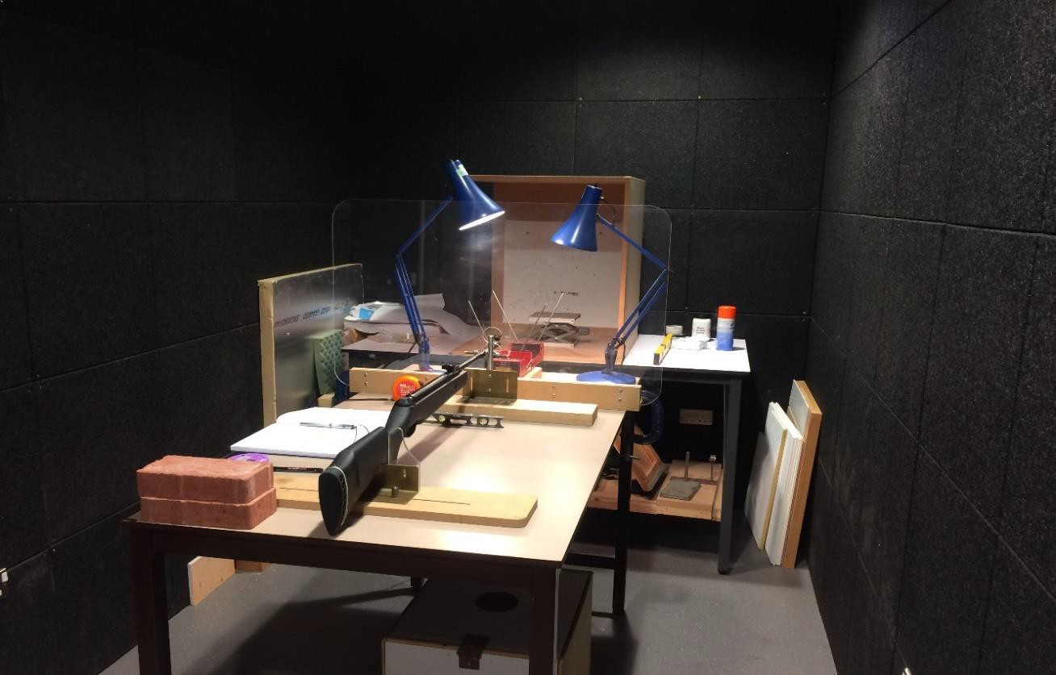

Figure 4: Setup of air rifle test condensed to allow for photography

At a distance of 0.8m from the other end of the chronoscope the target material was placed on an adjustable platform at a 90-degree angle to the muzzle. A number of test shots were fired before the experiment began to ensure the equipment and setup were working properly; these shots were omitted from the results. Figure 5 (below) shows a simple diagrammatic view of the full test area:

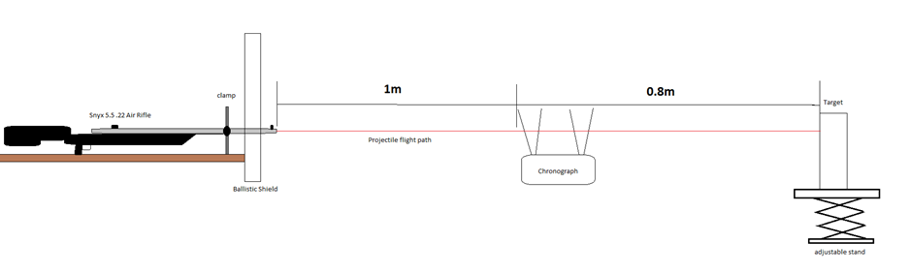

Figure 5: simple diagrammatic representation of test setup

The rounds were individually loaded into the rifle, the rifle clamped back into place (the clamp has a depression which the rifle barrel sat at the bottom of, ensuring that the weapon returned to the same position each time). A spirit level was used to ensure the barrel was level. The safety catch was then switched to the “fire” position. After the trigger was depressed and the projectile hit the target material, the shot velocity was recorded, and the target surface was moved to ensure the next round did not interfere with the previously fired round. The target (a piece of pine wood) was reset to the correct angle (90 degrees) and distance from the muzzle using a spirit level (±0.5mm) and tape measure (±5mm). The target was replaced with blocks of wood and the firing test was repeated 5 times.

The damage sites were measured using a Faroarm fusion laser scanner (model S/N U06-05-10-26495) and Geomagic control X (Version 1.0) software. Shots that did not ricochet out of the target surface were removed with needle-nose pliers. The target surface was sprayed with Rocal “Flawfinder”, a white powder that improves the reflectivity of the laser beam to improve the quality of the data points recovered (this is an SOP developed by the Met Police (Allen, 2019)). The Geomagic software measurement function was used in conjunction with manual measurements taken by a set of vernier callipers. Both measurement tools took a series of measurements (3 repeats of 3-line measurements and 10 repeats of 4 custom gauges) to look for variability in the system (given in section 3.4.3).

The FAROarm laser scanner operates by producing a line of densely packed laser emissions which are then reflected from the target surface, detected by the detector and converted to an XYZ co-ordinate. This line can be altered to have a denser or sparser field of laser points, but this will obviously influence the amount of data collected and thus the quality of scans. The FAROarm can alter the number of points created on that line via the Geomagic software. For this and all experiments this was left at the factory setting (15µm minimum spacing with 4000 points per line).

This shooting test was used to analyse the capabilities of the Faroarm, such as the optimal scanning distance and direction, along with data surrounding its comparability with other measurement methods (in this case, Faithfull Tools 1P54 vernier callipers with reported accuracy to ±0.03mm).

## Shotgun Discharge Data Collection

## Target Boss Construction and Shooting Phase

A target holder was constructed using pine wood and 18mm thick external grade plywood. The target box was fully framed to provide anchor points for clamping and was lined with 18mm plywood to provide stability and ballistic protection. Further protection was provided by adding backing struts and support blocks to allow weight and shock to be distributed throughout the target to alleviate any additional stress on the structure. Targets could either be screwed onto the holder or stacked and secured by other means, such as clamping. The base and stands both have connections for ground spikes to be added for further stability (Figure 6, below). As it wasn’t known how high the target box needed to be (due to not knowing the dimensions of the shotgun stand being used) the struts linking the box to the stand were lengthened so the height of the target box could be adjusted as needed. Lastly the entire apparatus was created so it could be broken down and re-assembled at site for ease of transport.

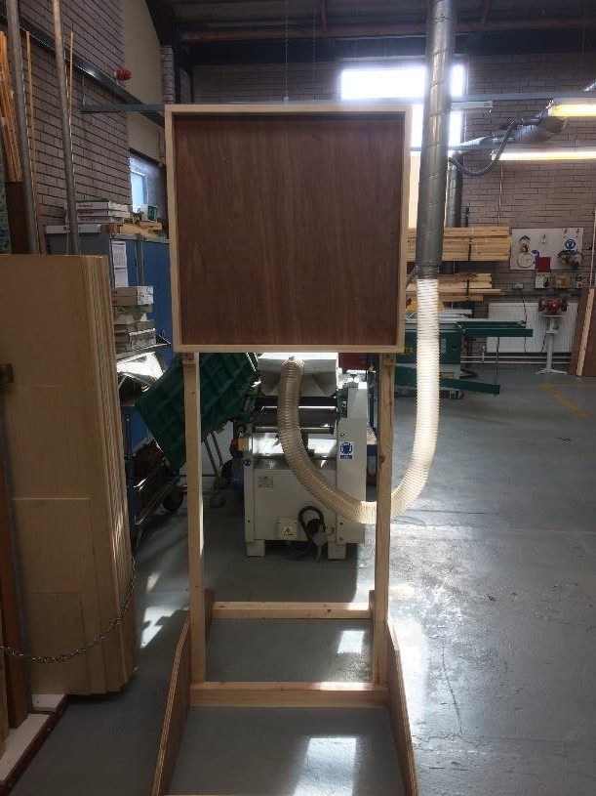

Figure 6: Assembled target holder. The target board stands at 1.6m in height. The board itself has an inner frame dimension of 610mm x 610mm to give space for selected targets to be freely added and removed.

## Shooting test method

The shooting test setup remained the same for each set of targets with the only variation being the targets themselves. The three sets of targets that were used were:

* + - * 25mm thick structural grade Plyboard sheet (600 x 600mm) (EN13986)
      * 1.5mm cold rolled sheet steel (600 x 600mm) (BS EN 10130:2006 DC01)
      * 40mm thick compressed concrete paving block (600 x 600mm)

These materials were chosen as they are a representative sample of common types of materials used in building (stone, metal and wood), to give a cross section of mechanical, physical and chemical properties and behaviours. Another reason these particular materials were chosen was that they gave a large flat surface area of the same material which could encapsulate all of the shot, other common materials such as brick would need to be fixed together with cement which would add further variability to the damage profile. This in turn will provide more information regarding likely outcomes and behaviours in future projects. Of each set of targets there were five repetitions of each set at each distance (3, 5 and 7m) making a total of 45 individual targets. The steel and plywood materials were all graded to international standards. However, all of these materials came in standard sizes (all were available in standard 600mm by 600mm sheets). This enables any further work, testing or projects to replicate the materials used if needed and the materials to fit the target holder without changing the shape of the target box, helping to ensure repeatability.

The shooting tests happened at a licenced range run by EPA Manufacturing in Lincolnshire, the company produces, tests and enables the examination of weapons and ammunition (EPA, 2018). The target boss was positioned against a back wall and the centre weighted down with a sandbag to prevent movement (as the test was being conducted indoors, the ground was too hard for ground spikes to be used). The targets were secured to the target boss with clamps to prevent movement and to contain some of the potential ricochet. The target boss was adjusted to make sure the angle was 90 degrees azimuth and directly opposite the shotgun (also set up at 90 degrees azimuth). The shotgun (a 12 Bore Mossberg pump action shotgun with no choke)

was set up on a firing jig and secured using clamps and ratchet straps (See Figure 5, below); the firing jig was set up to make the weapon level (checked by digital level (±0.1mm level)).

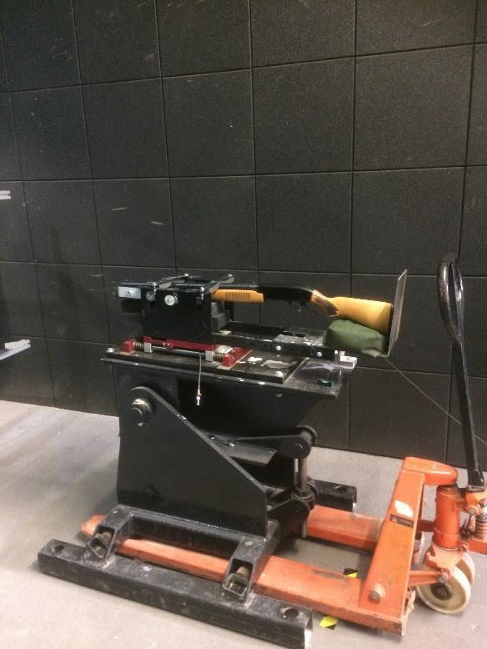

*Figure 7: weapon in firing jig*

The jig and weapon were moved to the correct distance (+- 5cm) and dropped into place after checking the setup with a digital laser measure (Bosch PLR 30 (±2mm). The shotgun was loaded with 1 Round of No.7 Birdshot, the weapon racked, and the safety removed. The experiment team used a remote firing cord to fire the weapon at a safe distance (10m + and around a corner).

The weapon was positioned at 3 different distances during the testing process to give a range of distances from 3m to the maximum distance commonly seen in British casework (Outhwaite, 2018). Other, longer-range distances are commonly seen within both UK and international research (0.7 – 25m from Cakir *et al*, 2003) (0.75 – 10m from Arslan et al, 2011) (12m-24m from Plebe and Compagnini, 2012), however due to the recording methods being used and the risk of potentially damaging equipment with spreading shot it was deemed most appropriate to work within the 3-7m boundary. This also ensured that risk of shot not hitting the target (due to spreading beyond the 600mm target face) was minimised.

A high-speed camera was set up to the left of the target facing to map the shot speed at target for further analysis. The high-speed camera was a Photron Fastcam SA-X2 (with a Sigma 24-70 Lens) and had a frame rate of 30’000 frames per second (at 512x512 pixel resolution), connected to a Panasonic Touchbook laptop (fitted with ballistic plating for protection) with Photron Viewer (v3691) software.

The camera required that a speed board was positioned behind the shot path to enable the shot speed to be measured from the still images produced. This was positioned in line with the camera view and screwed to the wall (ensuring that it was level using the digital level). Artificial lighting was provided by 2 spotlights with diffusion heads to give less of a sharp directional beam. To collect the muzzle velocity data a chronograph was used and set up 0.5m from the muzzle. The timing gates were Sabre Ballistics Type 414-1601 and used Picoscope 6 software to record the data collected with the gates 0.891m apart.

Each target was set at the required distance (7, 5 and 3m) and the shotgun discharged. After discharge, the target was removed from the boss, marked with a Unique Reference Number (URN), wrapped in shrink-wrap and stored for analysis. The next target was installed, distances and angles rechecked and remeasured and the process repeated. Table 3 (below) shows the test matrix being followed:



Table 3: Test matrix used in the shotgun damage data collection phase.

The weapon used was a 12 Bore Mossberg 500 pump action shotgun with no choke. The serial number was H459xxx. The weapon was held on a standard shotgun license meaning it was legal for purchase in the UK by civilians, it is a mass produced shotgun and the lack of choke was an experimental decision as for a proof of concept study there should be no additional variables imparted onto the shot. The initial temperature of the barrel was 14.4 degrees C and was fixed to a jig for stability with a remote firing cord attached for firing at a safe distance. The ammunition used was Lyalvale English Sporter (plastic wad) 28g, 7.5 (UK). The batch number for the ammunition was LCL1270ES2875. The weapon was chosen as it was a basic single barrel shotgun with no choke, negating other variables such as the addition of a choke (constricting the shot path and changing the impact site) and offsetting the barrel due to it being a multiple barrelled weapon (either in the side by side or over-under configurations). It also meant that the process gave a truer account of the behaviour of the shot with a minimal amount of influence from the delivery platform.

The ammunition was selected as the gauge (bore), pellet size and grain (7.5, 28g) is the most common shotgun cartridge bought in the UK (Lyalvale, 2018). Lyalvale Express are a highly popular cartridge brand in the UK where they manufacture and ship from UK facilities, the brand was the testing brand utilised at the test facility and thus it was deemed appropriate to use this brand for ease and consistency.

## Scanning method development

To test the reproducibility, accuracy, and precision of scanning the damage sites, a comparison was made against scanned measurements of air rifle impact strikes into wood with digital callipers (Chapter 3.3). The digital callipers were zeroed before being used and the Faro scanner was calibrated professionally just before the test commenced, this involved the equipment being sent to the manufacturer where full checks are done on the physical apparatus. Tests are conducted to ensure accuracy of linear and volumetric measurements as well as other tests to ISO 10360 (Faro, 2022). Figure 8 (below) shows the scanning apparatus and is annotated to show points of interest.

Gimble mount scanner arm with 4 articulation points

Calibrated flat granite surface

Scanner Head

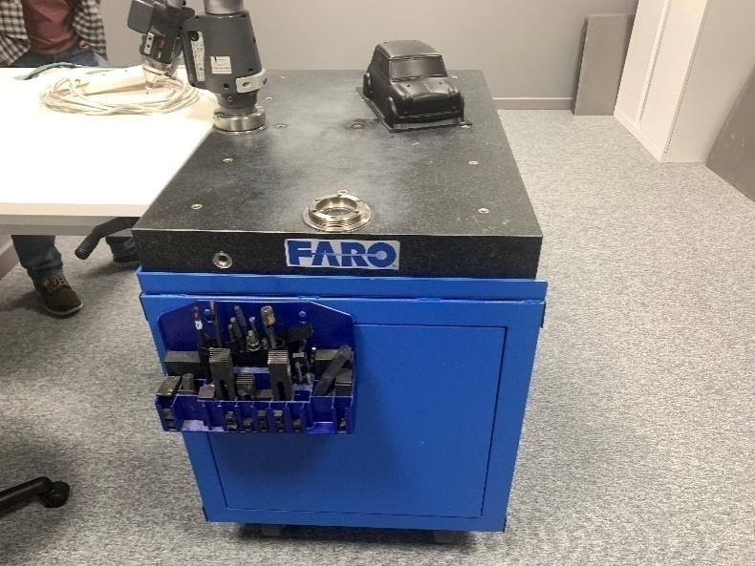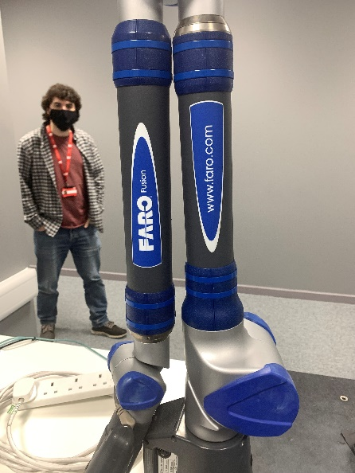

Figure 8: FAROarm scanner apparatus showing points of interest including the gimble mounted arm, levelled granite worksurface and the scanner head.

10 measurements were taken for a single plane – plane axis on a randomly selected damage site (east-west measurement) done by the scan data and then vernier callipers (to keep the test fair so as not to alter the site with the physical tool). Figure 9 below shows a damage site with scan path direction. Both the measurements from the callipers and the Geomagic software (via the Faro scanner data) were then compared using a Wilcoxon test (as some data was not normally distributed) (Laerd, 2022).

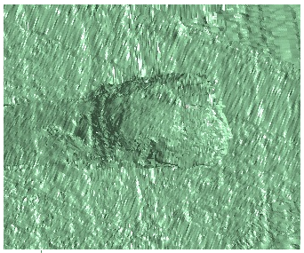

Figure 9: scan image of an air rifle damage site on wood. The Yellow line indicates the "east-west" measurement,.

The results showed that the two compared sets of data were not statistically significant (Z= -1.007, W- 14). This shows that both sets of data are comparable in repeatability. As the exact measurement of the damage site was unknown, further testing was needed to find the accuracy and precision of the scanner against the callipers. During training for this first set of tests (on a separate damage site) it was noticed that the operator would occasionally clamp the blades of the calliper onto the edges of the site – causing damage to the site, after training the operator against this the test commenced. This behaviour was considered for the second set of tests where a harder surface was used for measurement and the callipers were used in a clamping motion and with the more delicate by eye approach.

The FARO arm scanner was compared to the digital callipers against a known measurement. This known quantity had to be as exact as possible and as such required specialist gauges. Custom gauges were created using an automated cutter which is accurate down to 20 microns (~0.02mm).

10 measurements were taken from 4 custom-machined gauges using the scanning and cloud data measurement vs callipered and “by eye” callipered measurements (the callipers used were Faithfull 1P54 digital callipers with a reported error margin of =/-30um (Faithfull Tools, 2018)). The data was used to determine the standard error between the grouped measurements in order to establish the overall accuracy of the chosen method. The results of these experiments are discussed in further sections (Chapter 3.5).

Geomagic Control’s measurement functions allow the area and volume of the damage site to be calculated. Calculation of the volume enables further inference to be gained upon the behaviour of the projectile upon the target (by analysing the shape of the damage site).

However more complex shapes (made by the materials and impact forces present) further increase the complexity of the calculation. The scanners method considers more details without trying to prescribe shapes to different sections (which could diminish the detail and alter the final volume given). This set of calculations is further expanded upon by the Geomagic software and the system’s automatic volume calculation ability. There are several criteria that need to be fulfilled to perform the analysis correctly namely:

* Data points must be of the ordered data type (which can be taken alongside the raw data at the point of scanning.
* The mesh (the collection of triangulated data points) must be “watertight” (no visible gaps/missing data points), if the mesh contains gaps then these must be corrected using the correction tool provided with the data.

Geomagic Control was used to calculate the volume for the scanned models to test the reproducibility and accuracy of the system. The first step was to test the reproducibility of the data points. A random damage site was selected from those available and 10 individual scanned meshes were created. The

data points were converted to meshes and these were made watertight by filling areas that were unable to be scanned; the 10 volumes averaged out at 35.1110mm³ with a standard deviation of 2.70. Following this, one scan mesh was selected at random and the mesh creation/volume calculus repeated 10 times to look for any variation in the same scan sites. All 10 scan meshes calculated the exact same volume (down to 4 decimal places) (35.2029mm³). This shows that any variation comes from the human element and not the apparatus.

Identification of refinement areas centred around the process itself as environmental factors are documented in the technical user guidance from 3DSystems (OR3D, 2018). Concentrating on the process, several areas were found that could be refined:

* Although the surface of the scan table is completely flat (not adding additional information to axes co-ordinates which could potentially skew images created), fixing scan targets to the scan table to ensure that there is no movement of the sample would be advantageous to prevent accidental movement through physical contact.
* Minimisation of bad data is another area that needs consideration. Bad data occurs when reflection of the beam creates a point of data that does not correspond to a physical point in the real world. This creates data that distorts the model and thus affects the measurements and volume data that is collected. The main ways that bad data can be collected are:
  + Excess loose particulate such as dust or loose material can create bad data points. To negate this effect samples are brushed down with a clean dry soft brush to remove particulate and scanning locations are clean and dust free.
  + Natural light levels such as strong sunlight can affect the strength of the beam and thus the amount of data points collected and their location data. Scanning should not be done in strong light conditions or with excess heat (which can damage the apparatus) and ideally should be done indoors.
  + Repeating the direction and position of scan pathways can produce clustered data points which can alter position if a data point exists in that location, essentially creating a double which (due to the logic of the location data process) cannot exist in the same place as the original data point thus moving it.

Human error factors arguably are the easiest to identify and subsequently the hardest to prevent. Scan path variations from the movement of the laser emitter by the operators are partially controlled by the screen prompt (letting the user know when they are in the ideal scan range/angle etc). The scan speed also is a major variable as moving the scanner too fast misses the opportunity to capture

data points and too slowly increases the amount of data points made too much (which can slow or stop the program from operation) the program emits a series of clicks to indicate recording of points, this is used as a method of speed control for the user (the clicks stop if the user moves to fast and data is not recorded). Additions to the scan criteria to address these issues were as follows:

* The use of fixing blocks to ensure no movement of the sample.
* Both Raw and Ordered data are to be used: the raw data points can be stored to prevent any continuity of evidence issues and the ordered data is to be used to provide measurements and volume data for the calculus.
* The reversing and overlapping of scan paths are allowed as this does not appear to create bad data.

The scanning process involved the utilisation of Geomagic X metrology software and followed the scanning protocol outlined in the previous study. In summary, the target materials were laid on the calibrated (6 monthly) worksurface. The scanner was calibrated by moving the scanner in such a way that it forced the gimbal-mounted arm to move significantly. Once the scanner was positioned over the target (staying in the required range via a distance sensor on the scanner which gave a display on the screen), the scan was started and the scan path followed (straight lines following a top to bottom, crossing left to right and diagonally right to left), giving a slow scan which at no point followed the same path over the same datapoints in the same position twice (there was overlap of paths but the positioning system correctly identified these parts and compensated accordingly). Once the scans were completed the point cloud was formed into one singular mass.

Cloud datapoints collected were transformed to a triangulated mesh to enable a measured analysis to take place (an example of a mesh is shown in figure 10, below). The mesh enabled the analysis of the surface to collect meaningful data on the depth and volume of damage sites. Although point to point measurements are able to be done with ease (and would be suitable for a singular damage site from a singular projectile (Truman, Unpublished)), it was deemed unfeasible for this particular set of testing.

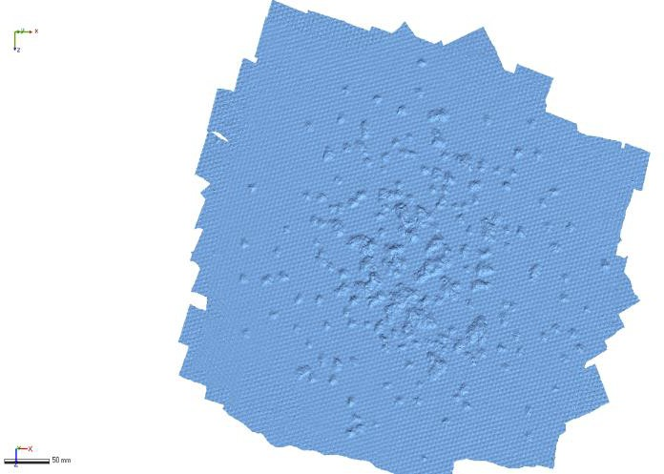

*Figure 10: Example of a mesh*

The reasons were that the cartridge holds 393 individual pellets (Lyalvale, 2018), the spread of and multiple impact sites are too numerous for such an exam to be cost or time effective for a practitioner, and with the current technology a simpler and more expedient method was found.

The damage site mesh was subjected to a “deviation of tolerance” analysis which determined how different the surface is from a determined “zero” surface. The “zero” surface was determined by selecting the areas around the damage sites that had not been subjected to damage (which is also a factor for how much extra material needs to be scanned to provide this) and by creating a coordinate system on the scan to allow the program to determine orientation of the X, Y and Z axes.

The analysis produced a “heat map” of the mesh (see figure 11, below) which was colour coded to represent the areas that deviated from the determined zero. The identified sites were analysed for how much surface material was missing (area) and how much material was missing from the total site (volume).

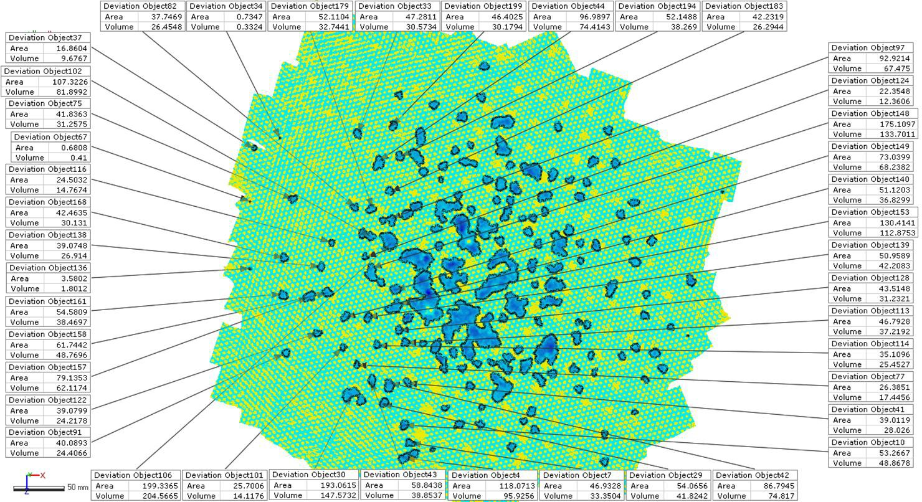

*Figure 11: Example of a mesh deviation of tolerance map (hotter colours indicate a positive deviation from zero whilst colder colours indicate a negative deviation).*

The deviation of tolerance analysis analysed the surface and measured the deviations in terms of the area of the “zero” surface missing and the total volume of that damage site. The Geomagic software then enabled the creation of custom reports and the transfer of data from Geomagic to Excel to allow for further analysis using numerical or statistical software as appropriate.

The measurement data was organised into distances and each deviation was labelled as either “satellite” or “primary” to indicate a satellite shot (outside of the main mass of shot) or primary (within the main shot mass) the largest sites (by area) were classed as the primary damage site, all other damage sites (unless they fell outside of the general measurement pattern) were classed as satellite. No flyers were identified. Samples at 3m and 5m were easily definable into these criteria, however at 7m this main body of shot became almost indistinguishable from the overall swarm pattern, making identification a lot more difficult. The primary damage site as a result was reclassified as the site with the largest mass requiring further differentiation between satellite and primary sites.

The damage sites were further organised into different locus categories (numbered 1-6):

* The primary damage site was reclassified as the largest damage site and labelled “1”.
* Sites separately identified but connected to the primary damage site were classified as “2”.
* Sites that were believed to have only been caused by one pellet became “3”.
* Sites caused by two pellets were classified as “4”.
* Sites caused by three or more pellets became “5”.

Due to the nature of the materials being used, there were already minor defects within the panels, and these were subsequently identified by the software: these sites were given a locus of “6” to indicate that they were not damage caused by the discharge.

All deviations were classified except for deviations that were clearly not of ballistic origin for example:

* Positive deviations caused by shot sticking and creating mounds on the damage site in some steel samples (the positive deviation is recorded as a deviation of its own and not part of the shot site).
* Scans taking readings of the edges of the targets and registering the edge profiles as a deviation to the work surface or damage caused to the edge from storage and transit (both clearly different from shot morphologies in size, shape, and depth/area).

The locus designations enabled a more detailed view of the damage site as a whole by breaking down the site into its constituent parts. This also meant that the path of the projectiles within the shot column could be seen (to an extent) as evidenced by damage sites forming on top of others creating much deeper channels in the target or by the general spread of the pellets. These morphologies show the chaotic nature of the shot column and that there is a great deal of variation even at fixed distances (considering the attempts to control these columns through the piston cup in the ammunition which aim to decrease the overall spread).

The deviation, area, volume and locus datasets were joined by other datasets such as the target dimensions, the high-speed camera data, the chronograph data, and the shot distance.

## Method development findings

## Scanning method development

Of the three different methods that were looked at for measuring damage sites, two of these used a pair of vernier callipers. A “by eye” measure was taken where the measure is taken by the technician observing when the callipers are just touching the target surface, taking the measurement from that point. The second was a clamping method where the callipers are closed until resistance was met, this

was totally inappropriate for forensic casework as the clamping method damaged the presented evidence which altered its appearance – making it inadmissible (an example is shown in figure 12 (below)). The final method used the FARO scanner, as noted previously, the FAROarm scanner and the measurements with the vernier callipers (without clamping) were both very accurate in measures up to and including 8mm.

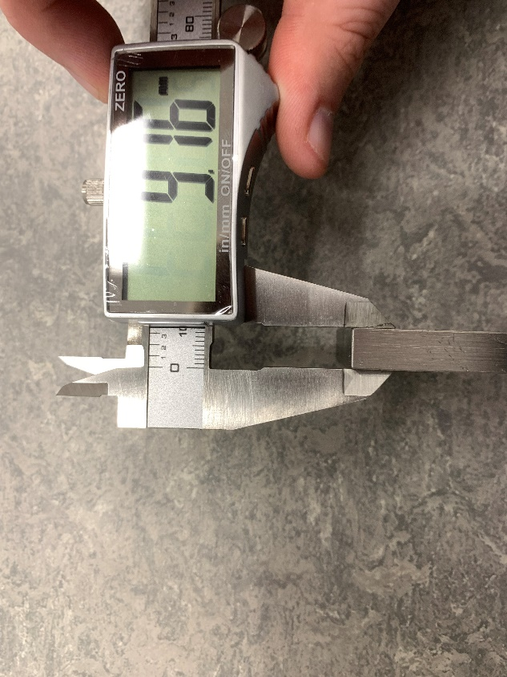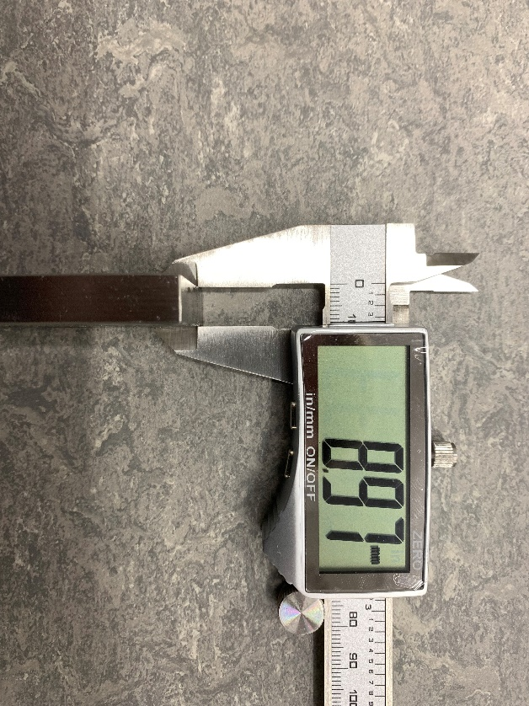

Figure 12: Examples of vernier callipers being used on a 9mm (±0.02mm) block. Left picture is with clamping, right picture is without clamping. The difference in measurements is from the lack of resistance being felt. Resistance felt when clamping will mark or alter exhibits and as such is unsuitable for forensic work. The by-eye measure is more subjective, and results would differ between examiners.

A degree of interchangeability in the best measurement method was observed between these two methods in terms of accuracy. The first test showed that the FAROarm was highly repeatable and accurate with a lower average than the callipers (Faro average = 10.47, callipers average = 10.58, which indicates a smaller level of overall spread in the data) .

Additionally, there were points found that gave scanning a distinct advantage over measuring with callipers including active recording (where measurement data is displayed and recorded with a simple click of the mouse and transferred to the program of the user’s choice), non-contact measuring (removing risk of damage or alteration of evidence), time efficiency and the ability to record and measure complexly shaped damage sites quickly.

Data was loaded into the programme Statistical Package for Social Science (SPSS – v27) and a simple statistical test (Descriptive Statistics Box Plot to show average and range of data) was done to find how much the measurements deviated from the known value, comparing this to the deviation from the use of callipers. The resulting box plot (figure 8, below) shows that there is generally much more variation in the measurements from the scan sites as opposed to the callipers. However, the mean value of the clamped callipered measurements (and for the most part, the majority of them) did not reach the known value. Table 4 (below) gives these mean values.



Table 4: Average measurements given by the 3 measurement techniques. The known measurement is also given.

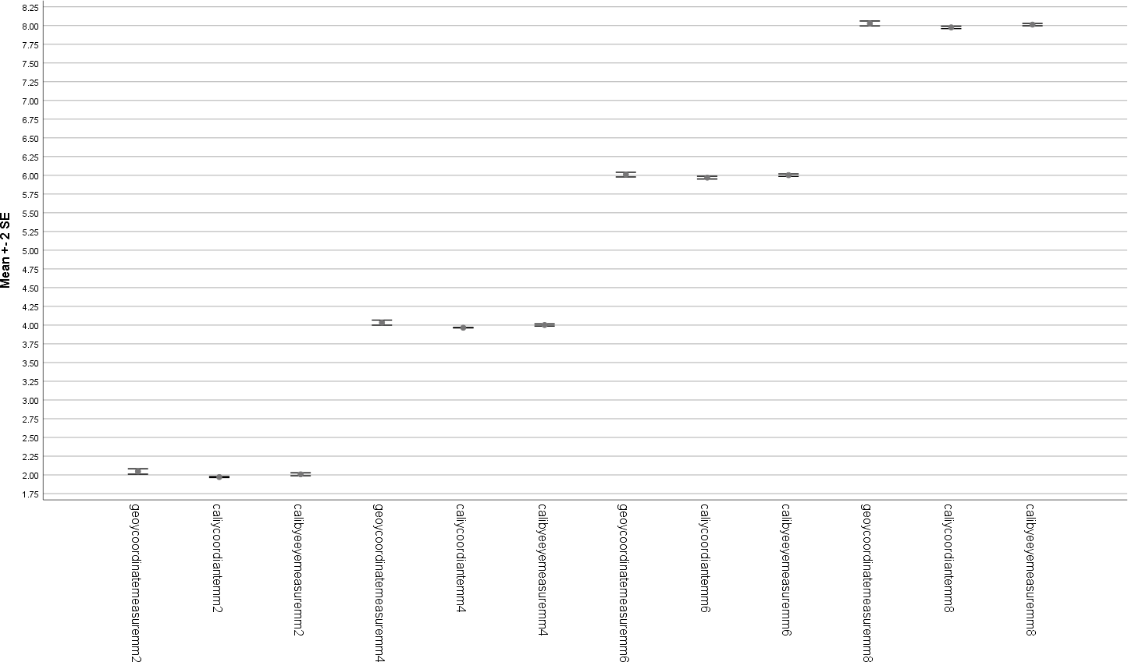

Figure 13: Boxplot of measurement techniques showing Geomagic X software compared with callipered measurements (by eye and clamped) when used on known plane measurements (Y axis).

Plane Measurement (mm)

The mean data for the scans are much closer to the known value and as such the second and third quartiles (representing 50% of the data spread) show that even though the data for the callipers is more precise in this instance the Geomagic software is more accurate (but this may be due to the spread of data). This means that with repeated measures, the Faro scanner data is more appropriate.

To show which method is more precise a Wilcoxon signed ranks test was used. This test assesses if the median ranks of the datasets differ from the known value by a significant amount. The Wilcoxon signed ranks test showed that (in 2mm measurements) using the Geomagic software gave a statistical difference between the measurements attained and the known value (P = 0.037). The use of callipers by “clamping” was statistically significantly different (p = 0.005); the callipered (by eye) measurements proved to be the least significant (P = 0.673). The other measurements (4,6 and 8mm respectively) showed the same pattern where the Geomagic software had showed no statistical difference (P = 0.074/0.721/0.241), the callipered measurements (by eye) also showed none (P = 0.887/0.602/0.156). The callipered (clamping) measurements showed significant differences in all (P = 0.004/0.006/0.016).

The statistics show that the Geomagic software had much less significance in difference than the callipered measurements done by clamping, this cannot be said for “by eye” measurements as these showed the least significance. On the surface, it shows that callipers by eye are more precise than using the software, however, as the statistics show that there is also no statistical difference in the Geomagic measurements, other factors can be taken into consideration when looking at the effectiveness overall as a method, such as the fact that operationally the “by eye” and clamping methods both have a greater potential for variability due to operator conditions (such as the damage being in a hard-to-reach area). Moreover, the risk of altering the damage site during the measurement process is unacceptable in the current forensic climate as this would bring the evidence into disrepute. The data overall shows that the scanning data is highly reproducible and carries the additional benefits discussed previously, even though the data shows that a by eye callipered measure is more accurate in this case, the further benefits of using the scanner (non-contact, not subjective, recordable, quicker and able to gather a lot more information from a more complex damage site). To quantify the actual accuracy, the percentage error was calculated (Table 5, below).



Table 5: Percentage Error of the 3 Measurement techniques against the known samples.

The results show that the callipers (by eye) have a consistently small percentage error when compared to the Geomagic and clamped callipered measurements. It should be noted that 4mm and 8mm measurements showed there was less percentage error in the Geomagic measurements than in the by eye measurements which overall supports the hypothesis that the callipered measurements are affected by cognitive bias. Literature does reflect that digital calliper measurements and scan data are usually both accurate and both sets are reliable for clinical (Hassan et al, 2016) and anthropological (Mullins & Albanese, 2017) use. These studies do also show that generally the scanning data does have some limitations with smaller measurements however this technology is moving forward and higher specification models can be used with a higher degree of accuracy. The additional benefits a scanner brings with it (as listed previously in section 3.5.1) also make the equipment a lot more versatile than just using callipers. It should be noted however that (provided the operator is suitably trained and experienced) the basic data collection can be done with callipers to a high degree of accuracy although the time it would take to measure each site fully would be a highly laborious task due to the complexity of a damage site from a shotgun discharge.

The average percentage error of measurement for the scan data was 2.09%. Utilising the scan data to show the repeatability of scans revealed that the scan data gave a very low standard deviation with 10 repeated measurements at 3 different points (0.16, 0.28, 0.10), this showed that the data being recorded is highly repeatable and this was observed when viewing the data retrieved from scan sites (matching distance and material), the overall relationships between data within the measurements themselves (deviation, area and volume) were very strongly correlated showing the repeatability of the scan data in an operational capacity.

The findings are supported by work published by Balolia & Massey (2020) where it was found that very small details of a scan subject will have more variation but that scans are accurate if utilised appropriately. The work also supports the findings of Urbanova *et al* (2017) where a virtual environment is recommended for highly complex and fragmented work such as ballistic damage. With the ever-progressing technology levels presented by scanner companies these scanners are getting more reliable and more specialised with each iteration including the introduction of alternate wavelengths of light. The FARO Scan arm presented in the study is no longer for general sale but this only goes to prove that even a very basic model (as stated previously) is more that capable of producing valid and relevant scans which can assist in the retrieval of data in complex scenarios (such as damage from shotgun discharges).

## Scanning data requisition and analysis

The scanning data was collected from Geomagic Control X metrology software which is a reverse engineering platform for scanning and measurement of 3-dimensional objects. The programme’s primary application is in the comparison and inspection of CAD models and scans of physical models themselves using a range of different functions (such as surface area analysis, angle and curvature, point to point measurement, etc) (OR3D, 2021). Also acting as a control Graphical User Interface (GUI) for the scanner itself the system enables data gathering, analysis and control in one package.

After undertaking specialist external training and assessing the various functions for applicability to the research, it was decided that the most appropriate data capture method was to utilise the “Deviation of Tolerance” analysis. Originally designed for use in the vehicle and aerospace industry the tool was developed to analyse cracks and deformities in aircraft wings and car body parts (OR3D, 2018). The deviation of tolerance analysis provides 3 key pieces of data (Area, Depth and Deviation from known zero surface). The zero surface is pre-selected by the user from undamaged areas of the target surface. This programme has the advantage of providing all the relevant data to the study in one simple analysis package – it also copes with complex damage which would take an investigator much longer to record and process manually.

The current method of distance estimation from a shotgun discharge is to test fire a suspect weapon with the suspect ammunition at different distances to determine the overall spread of the shot. As has been proven by multiple researchers over the years (Compton, 1996; Haag, 2021; Warlow, 2009; Carlucci, 2014) there is a chaotic nature to the flight of a spherical pellet and a swarm of pellets provides additional forces which can shape a shot pattern. This makes distance and energy estimation without eyewitness accounts very difficult to predict without the weapon or the ammunition type. Distance estimation by a point-to-point measurement of the affected area’s circumference is more difficult if the shot is at an angle or in different materials (as forensic workers then have to waste limited suspect ammunition on calculating the angle of the shot and utilising the correct material as well as the distance). The actual affected area (i.e. the area of the target the shot has directly damaged) should provide a more analogous comparison across the three materials used, as the effect on the material as a whole should be reduced. For example, shooting into sheet steel causes a bowing of the material but taking the individual damage sites into account may provide a more comparable distance estimation across the three material types.

Importantly, it was decided to organise the collected data in a way to assess and understand the position and dynamic of each shot (for example, where concentrations of shot fell into the overall pattern). To achieve this the locus designation system was employed to characterise the damage site at a macro level. This was highly time consuming and involved the classification of over 14000

individually identified damage sites across the 45 targets. Doing this however did provide another input that could potentially be exploited at the analysis stage.

The deviation of tolerance analysis performed well and although selection of the zero surface is a subjective process there is some flexibility built into the programme which can assist in mitigating any mistakes occurring due to bias or inexperience. The system will not negate mistakes but by having a large enough undamaged surface area scanned with the damage site, the system can recognise missed deviations. Rocol was only needed for the steel samples as these had a very high reflectivity rate (even though the material had oxidised to a dull matt finish). This was applied in a laminar flow cabinet to prevent inhalation and transported to the scan area. Excess loose powder fell away when the sheet was lifted from flat to sitting on its edge, preventing it causing bad data. The use of Rocol is standard operation protocol for reflective surfaces for the Met Police scanning unit (Allen, 2018) due to is extremely fine particulate size and is advertised as a glare reducer for 3D scanning (Rocol, 2022) as samples are not being compared between materials the effect on the results will be minimal however further research is needed to ascertain the exact effect on measurement data.

## Analysis via MATLAB regression learner

From all of the experimental work undertaken, there were a number of different input values present that could be utilised in the final model. More constant inputs such as material data (toughness, hardness etc) were omitted as the lack of variability would not improve the model and could introduce a “curse of dimensionality” issue where the model will either overfit or completely fail to find a fit due to having too many variables to calculate (Toward Data Science, 2019). Of all the input variables available, the following table (Table 6, below) shows the potential inputs, where they originate and the category of input.

Table 6: Identified potential input variables from experimental work

|  |  |  |  |
| --- | --- | --- | --- |
| **Identified potential Input Variables** | | | |
| **Variable** | **Iterations** | **Measure** | **Description** |
| Deviation | Total  Locus Specific Grouped Locus | Damage site depth | Deviation from user determined "zero" surface |
| Area | Total  Locus Specific Grouped Locus | Area of damage site | Area of Deviation from user determined "zero" surface |
| Volume | Total  Locus Specific Grouped Locus | Volume of damage site | Volume of Deviation from user determined "zero" surface mesh |
| Locus | N/A |  | Locus data |
| Pico | Average per distance Individual Shots | Shot Speed (muzzle) | Picoscope numerical data |
| High Speed | Average per distance Individual Shots | Shot Speed (Impact) | High speed numerical data |
| High Speed Images | Individual shots | Column Width Column Length | Time lapse still images with pixel measurements of features |
| RGB Saturation | Individual shots Groups by Distance | Depth of damage | Measurement of Red Green and Blue pixels on scan image. |

From casework perspective certain elements would be unfeasible to carry forward without additional data, training or cost involvement but would make for a worthwhile academic study, examples would be the Red, Green, Blue (RGB) saturation of the deviation of tolerance images or the individual high- speed images. Arguably the Picoscope and high-speed data are only recorded for output purposes, however the data are used by reconstruction specialists to aid in scene reconstruction. Locus data is similar in that it is useful for the purposes of this study but is too subjective (even though the primary site is objectively the largest damage site numerically) to be of analytical use in the field. The underpinning goal of forensic science currently is to remove as much bias and subjectivity as possible so unless the locus designations can be made more objective, they should serve only as an indicatory dataset.

The amount of data provided by the Deviation of Tolerance analysis needed to be disseminated and sorted out into more manageable and equal sized dataset’s (as the MATLAB machine learning toolkit only allows datasets of equal size to be used). The total amount of separate data (area, deviation and volume) detected by the analysis exceeded 14’000, this amount of data was not equal between samples and as such was not suitable. Each target’s data was averaged by its locus designation and then further averaged by target to provide a more representative sample of the dataset as a whole. Treating the data like this also gave a more realistic size of data (from 14’000 datapoints to 135), as forensic workers commonly work with small amounts of data and do not have the time or resources to do extensive testing. Once the data was sorted it was then normalised to provide a clearer link between the chosen inputs and outputs to find the most important data for prediction (allowing postulation of which data is needed in different scenarios). The other reasons for normalising the data include reducing the complexity of the data, to allow for patterns and links to be identified more clearly by the machine algorithms, and to improve the generalisation of prediction data. Principal component analysis (PCA) was incorporated to further aid in the identification of important datasets.

Only the concrete dataset was worked on at first to establish the best practice for the other two datasets. Data was exported over to MATLAB from Microsoft Excel (which until now all scan data had been stored on) and turned into a dataset named “Total”. The data was subjected to a correlation plot analysis to produce a plot showing the linear relationships of each input to all of the other inputs in turn. Once this “Corrplot” was done the inputs were subjected to PCA to determine if a reduction of components could assist in the overall model design. The eigenvector showed that a reduction of down to 3 components would eliminate most of the data with the least identifiable variation for a prediction. It was decided that to understand how the variability of the dataset affects any designed model and its accuracy that the PCA should go from the maximum number of components down to 3.

At this stage the size of the dataset was of concern and as such it was decided to employ Leave One Out Processing (LOOP) as the validation and verification method. MATLAB enables LOOP with a simple slider bar for the K-Fold cross validation; if the amount of folds are equal to the amount of observations then MATLAB will enable LOOP (MATLAB, 2021).

From an operational perspective this process of model design was simplified by MATLAB and its GUI, multiple designs could be run with the click of a few buttons. Clear graphical displays showed the behaviour of the models with Root Mean Square Error (RMSE) and Standard Error of Regression (SER); these models could be exported back to the main MATLAB interface to be used later on. Calculations used within the data analysis process remained the same for each material:

Normalisation: all data was normalised to figures between 0 and 1 before going through any machine learning to simplify the data and assist in finding links or patterns to exploit. All outputs were also reverted back to standard numbers to give a real-world comparison of any errors in prediction. The formula used is expressed below:

𝑥 − min (𝑥)

𝑧 = [max(x) − min (𝑥)]

Where “Z” is the normalised figure, “X” is the figure to be converted and “min (*X*)” or “max (*X*)” is the minimum or maximum figure in the data range. When the data needed to be reversed back to a standard figure the following equation was used:

𝑧 = 𝑋 ∗ [max(𝑥) − min(𝑥)] + min(𝑥)

This returned the predicted values to standardised values enabling normalised predictions to be viewed as distance or velocity figures. Averaging the figures enabled the data to be condensed and allowed for data to be normalised into a singular figure. The average was also used to take the average prediction value which was compared to the average recorded value as a measure of suitability for the model. The formula for the average was:

𝑍 = [𝐴1 + 𝐴2 + 𝐴 … + 𝐴𝑛]

𝑛

where A indicated a single datapoint and n is the sample size. Standard Deviation is a measure of the spread of data around the average. This was used as a measure of suitability for predicted models where the spread was compared to the spread of the recorded output. If these figures were similar it could be concluded that there was a similar spread of data between the prediction and recorded values indicating a better fit (when coupled with the average). The formula for the standard deviation was:

∑(𝑥 − 𝑥)−2

√

(𝑛 − 1)

Where X is the sample mean and n is the sample size. Error in this instance is defined as the difference between the predicted and the recorded value and is the formula:

𝑋 − 𝑌

This was used to measure the difference in individual predictions as well as the average across each model to potentially assess the goodness of fit (potentially spotting overfitting) along with standard deviation and average.

RMSE is the Root Mean Squared Error and is the primary measure of suitability when observing machine learning models (MATLAB, 2021) and is a measure of accuracy; it is an alternative to standard error (which is used with linear models) which can be used in both linear and non-linear models. The formula used is:

𝑁

𝑅𝑀𝑆𝐸 = √1 ∑(𝑦𝑖 − 𝑦̂)2

𝑁

𝑖=1

Where n is the number of observations and y is the mean. The RMSE value appears in the MATLAB machine learning GUI to show the user which model(s) should be selected out of the trained ones. The interface also gives a number of graphs showing each prediction in the series, Residual values, and how each response maps against the recorded value. The measure of precision for these models is the Standard Error of Regression (SER) which can be translated as the square route of the adjusted MSE (Mean Square Error) (Frost, 2021). This gives the average distance that a prediction falls from the regression line and as such shows the precision of predictions.

𝑆𝑡𝑎𝑛𝑑𝑎𝑟𝑑 𝐸𝑟𝑟𝑜𝑟 𝑜𝑓 𝑅𝑒𝑔𝑟𝑒𝑠𝑠𝑖𝑜𝑛 = 𝑖≡1

𝑛 − 𝑘

Where n is the standard deviation, k is the standard error and i is the adjusted R value. These equations enabled the best predictive model to be identified and through analysis of the models (and their input combinations) the optimal inputs and their relationships could be ascertained.

The algorithm program then ran the data through several different algorithm types with differing central packets known as kernels (which direct the pattern in which the overall algorithm will carry out its problem solving. Generally, the algorithms fall into several categories:

* Linear
* Gaussian Process Regression
* Support Vector Machines
* Regression Trees

Linear models have predictors that correlate strongly with the output variable, it is a fast method due to the simplicity of the patterns in the data. It is a constrained form of model (due to this simplicity) which lacks the flexibility of more complex models (MATLAB, 2022). These attempt to classify and predict the data via the coefficient relationship between 2 variables (aka the “Predictors” and the “Response”). Linear models operate either as simple linear models (with only one variable to the output) or as multiple linear regression (multiple variations). Kernels for the linear model help to alleviate this oversimplicity, these are the interactions, robust and stepwise options. Interactions linear kernels test for significant interactions between input variables which may give a stronger correlation than just single input variables alone. Robust kernels desensitise the models algorithm to outliers in the data, in an attempt to gain a better prediction. The stepwise kernel essentially does multiple regressions several times, each time removing the weakest correlated input variable (to the output), at the end the strongest variables are left for predictions (Leeds University, N.D).

In GPR, the prediction is modelled on using a probability distribution of random variables (MATHWORKS, 2022). GPR is a non-parametric approach to regression problems (although as opposed to having no parameters, it theoretically can have as many as there are observations) (Schultz *et al*, 2018). The GPR method centres around the function which is a mathematical representation of the relationship between the input and output (Shultz *et al*, 2018). GPR uses the RMSE values calculated and adds weight to attempt to bring the RMSE back to zero. These weights are used as a basis to form the prediction algorithm (Olea, 1999). GPR is excellent for singular datasets however it is not as effective for multivariate data problems. GPR finds distribution over these functions that are consistent with the data, these functions update with more observations which gives the distribution over the functions.

The kernels for GPR are rational quadratic, squared exponential, Matern 5/2 and exponential. The Squared Exponential kernel is described as a universal kernel (Micchelli *et al*, 2006) and consists of 2 parameters; the length scale (which determines the algorithms ability to extrapolate if data is a certain distance away from the mean) and the output-variance (which determines the average distance of the function from the mean and is used as a scaling factor) (Duvenaud, 2014). A rational quadratic kernel is described by Duvenaud (2014) as the equivalent of adding many squared exponential kernels together. This provides smoother variation across differing length scales thus enabling more relationships to be potentially found and exploited by the algorithm. In a similar fashion the exponential kernel is the same as the squared exponential kernel except that the Euclidian distance (length of a segment between the input and output data) is not squared (Zhang *et al¸* N.D). Matern 5/2 kernels look at the covariance (how much random inputs change together) as a function of the distance between the data length scale.

Support Vector Machines are models that separate different classes of complexly mixed variables by introducing a new dimension and performing the separation along that line (Sethi, 2020). This new hyperplane helps classify variables depending on whether the variable is on the positive or negative side of the hyperplane. In regression analysis this process can be used to generalise predictions by looking at where variables fall along these hyperplanes (the position of some of the variables forming support vectors either side of this hyperplane to form the prediction algorithm and minimise error). These models are reportedly ideal for producing highly accurate models with good generalisation without needing to reduce dimensionality (Awad & Kanna, 2015).

SVM can be applied to both linear and nonlinear sets of data, if the data is linear there is a simple division hyperplane to separate the data out, if however, separation is not so simple due to a nonlinear dataset then a number of tools can be applied to help remedy this. The first is the concept of the “soft margin”; soft margins are margins that will allow a few misclassifications as long as the hyperplane positioning maximises the margin placement but minimises the misclassifications (Chen, 2019). The softness of the margin is known as its tolerance, the tolerance gives a penalty to any misclassifications found and as such more penalty = less tolerance, this is one of the hyperparameters that can be used to tune the model later on. The second concept is Kernel tricking, Kernel tricking transforms existing features and creates new features in the data to try and mitigate the issue of misclassification; for example, by using a polynomial kernel the data is transformed into that of a polynomial set, the hyperplane and margins can now curve and more successfully separate data (Chen, 2019). SVM are typically very tolerant of datasets so long as they are normalised, meaning that when used with the experimental data this form of model could prove to be very effective as the data is of equal length and normalised. Kernels for this type of algorithm alter the shape of the plane to try and capture predictions more accurately (linear, quadratic, cubic, gaussian).

Tree Regression models are based on decision models where the structure is essentially a group of IF/ELSE statements that form the shape of branches and leaves of a tree using recursive partitioning (Li, 2019). The “roots” of the model (known as internal nodes) are a group of questions or decisions that the model uses to sort the data. Further internal nodes can be created from the decisions made and thus the model tries to predict new data using this structure. Nodes are created in areas where the information gain can be maximised, and this process is repeated at every split. Tree Regression models can be fine, medium or coarse depending on the need for the accuracy in the model. The difference is in the minimum amount of data each node uses (fine running on the least and coarse running on the most) and thus this affects the density of each tree (more smaller nodes could however lead to overfitting but fewer larger nodes could affect the accuracy of predictions negatively also). Tree regression models are non-linear and non-parametric and as such do not need to conform to many of the assumptions that occur with those sorts of model (Mehta, 2019). This suits the tree regression technique to operations such as data mining where the variables, the relationships between them and the bias of the data are not known.

The Ensemble method of modelling combines multiple tree-based models to better analyse current data and therefore provide more accurate predictions (MathWorks. 2020). There are a number of ways of combining these models into an ensemble model which are the kernels of this algorithm:

The Boosted method gives learners (individual trees) smaller tasks by getting the current model to solve the net-error of the prior tree so that issues such as misclassification of data are given more weight and as such is more likely to be solved correctly by subsequent trees (Nagpal, 2017).

Bagged kernels focus on making the ensemble more robust than the individual models (Rocca, 2019), which produces several training sets of data with replacement (duplication). These sets are trained independently and are then averaged to gain the prediction (ataCademia, n.d).

Stacked methods focus on training independent learners, training a meta learner (aka learning about the learners) and using that meta learner to group the learners together to create the prediction algorithm.

## 

## Equipment Evaluation and Summary

The FAROarm proved to be an invaluable piece of equipment for laser scanning of samples. Once trained (and the methodology worked out) the process was intuitive and simple to repeat for each sample. Although the accuracy and precision experiments showed that the scanner was comparable to a trained person using vernier callipers, the proven additional benefits such as the noncontact nature of the data collection, the expediency of scanning and logging complex and overlapping damage sites and the ability to test virtual replicas instead of the physical evidence mean that utilisation of these scanners surpass manual logging methods. This view is supported by Liscio (*et al*, 2018) who states that laser scanning can aid in the reduction of errors at firearm discharge scenes. The extra considerations that the FAROarm scanner specifically needs are largely cancelled out by newer models – such as the need to improve reflectivity of samples using ROCOL spray, the need to move the sample onto the worksurface for scanning and the need for the gimbal mounting which although suitable for laboratory-based studies would be less advantageous in crime scene scenarios where a more portable and flexible option would be required.

The Geomagic X software was not designed with scene reconstruction in mind however there are a number of useful engineering tools that were able to be adapted and used for the purposes of data collection. Chief amongst these was the deviation of tolerance analysis which took a potentially long and laborious task and simplified it. The process enabled a level of customisation which allowed each sample set to be treated according to its individual characteristics. The Geomagic software integrated well with the FAROarm and was run from a dated laptop (2013 model with windows 10 64 bit OS), which showed that running the more detailed and complex models was not taxing to a computer system and could only be improved with more up to date software.

Operational best practice was devised from a mixture of the current FARO operation instructions, training by OR3D and from experimentation against the actual conditions that the scanner would face in the field with the materials and damage being common at these scenes. These additional points are detailed in the method development section but are briefly described below:

* + - Removal of excess loose particulate such as dust or loose material with a soft dry brush.
    - Scanning should not be done in strong light conditions or with excess heat (which can damage the apparatus) and ideally should be done indoors.
    - Not repeating the direction of scan pathways to minimise clustered data points (also known as bad data) although, reversing of scan paths is allowed as this does not appear to create bad data.
    - The use of fixing blocks where appropriate to ensure no movement of the sample.
    - The use of ROCOL flaw finder spray to assist in the reflectivity issues found with steel samples.
    - Both Raw and Ordered data can be used, the raw data points to prevent any continuity of evidence issues (As these points cannot be altered) and the ordered data is to be used to provide a mesh for measurement.

Deviation of tolerance analysis was selected upon completion of the training provided by OR3D as the most suitable tool for the collection and collation of data due to its ability to give measures of volume and area but also for its time saving ability. The system automatically identifies all of the deviations from the pre-selected “zero” surface and this could be customised to remove clearly redundant points if needed (such as damage outside of the scan area or identified damage clearly not of ballistic origin). This is the first time this tool has been used in this context and was highly valuable in terms of expediency. It is highly recommended for use in further study due to its ability to deliver large amounts of relevant data and its ability to simplify a complex and time-consuming task for a user.

Due to the single line beam and infra-red spectrum source, surface considerations were important in both collecting the data and in the analysis stages. During collection the previously mentioned ROCOL spray was not used for the concrete and plywood samples (as they were matt finished with little reflectivity), this did not affect the collection process for these two materials but was necessary for the steel (even though the surface had dulled with oxidation the scanner had difficulty with the reflectivity of the material). As stated previously this problem could be solved by utilisation of a different configuration of emitters (a crosshatched pattern instead of a line) which would vary the angles of instance increasing the chances of more reflections hitting the collector. Changing the colour of the beams to a blue or green laser would also have a marked improvement on the reflectivity of the beam (due to their shorter wavelengths) and would potentially eliminate the additional use of ROCOL (Jones, 2016).

Both the laser scanner and the metrology software were integral parts to the project. Laser scanning in general is a robust tool that produces accurate and precise 3D replicas of scanned surfaces for measurement. The ability to not touch (and potentially alter) a damage site is of profound importance within the forensic sector, as is the ability to create replicas and test those instead of the actual evidence. Specifically, the FAROarm provided a solid and dependable platform with which to acquire

the cloud data needed for analysis. The development of the SOP specifically for this system and circumstance proved highly effective but as previously stated does limit the system to removable damage sites which may inhibit use in certain scenarios (however more modern iterations of scanner are portable and could be utilised for in scene scanning). With the addition of ROCOL spray, the scanner picked up on details from the steel samples well and provided some proof that this system (current SOP for the police) would work for macro level scans of specific damage sites (aside from whole area scanning which is currently done).

The Geomagic X software required specialist training to utilise effectively and as such became an additional cost to the end user as did the product license itself. Free alternatives are available (such as meshlab) but Geomagic is targeted for use with the FAROarm. Geomagic X was a major improvement over the previous iteration which this project started on and included the addition of deviation of tolerance analysis amongst other analyses not part of this project. The software, although designed for use in reverse engineering and examination of structural failure of components proved to be more than up to the task of identifying (once parameters were in place) and extracting the relevant data from the damage sites. The ability to produce customised reports highlighting useful data within the identified damage sites and visualisation of these areas will also prove beneficial in casework. With further work this system has real potential in improving not only casework but general evidence retention and the analysis of firearm discharge damage.

The machine learning aspect of the project (section 3.5.3) analysed the data presented and found multiple relationships within the data that were exploited even after dimensionality reduction using PCA. The process of analysing the data in MATLAB required some prior knowledge of machine learning as well as trial and error to fully explore the capabilities of the tool kit. However, with the toolkit it became very simple to not only prepare data for analysis but to explore the data as fully as possible. The machine learning aspect of the project has shown promise when dealing with small datasets (Mahmoud & Zohair, 2019; Zhang & Leng, 2018; Wang *et al,* 2018) and has shown that it can be used as a potential method of validation for sample datasets within a forensic context.

To truly predict with data outside of the immediate case requires far more work to make it a viable option and may not be as relevant as utilising the system in a closed fashion (where the machine learning system can only use information pertinent to the case being investigated). As stated previously the use of the machine learning was primarily aimed at identifying which input values were most important and whether this differed in terms of target material but has shown to be a valuable part of the proposed methodology in its own right. As such the thesis not only furthers the work done by Oura *Et al* (2021) but also opens up the potential of using larger datasets to inform and create algorithms that could work to deal with issues surrounding extremely small sample sets of seized ammunition or damaged weapons that break in testing. The use of machine learning to classify rather than predict has shown promise (Oura *Et al*, 2021) and could be a factor to explore especially in the cases of distance determination.

MATLABs machine learning toolbox was quick and intuitive to use and provided a broad range of models and kernels with which to explore the data without having to learn a new coding language to execute. This is of great advantage to users interested in data exploration or to practitioners who may not have the time or resources to become proficient in coding. Running the regression learner has (in this thesis) shown to be a highly adaptable, yet user friendly tool for data exploration and may be suitable to be used as the exploration tool for recovered data (without further optimisation work or fully training a model) to provide flexibility during investigation. Using the regression learner in this way may be of benefit to practitioners wishing to explain their interpretations more fully and use the predictions from the training as the form of validation.

This section has detailed the process of testing the equipment to be used to find an optimal method, gathered the required data from samples and has detailed the exploration of a suitable method for analysing the data. The next section provides details of the results of the data analysis from the shooting tests once data was in its final state (sorted, averaged and normalised). Each of the corresponding chapters combine results of a particular output (Distance, Velocity at muzzle, Velocity at Impact) with the relevant discussion at each stage of the process.

# Chapter 4.0 Muzzle Velocity Prediction

## Introduction

Muzzle velocity is the first step to being able to work out the kinetic energy (KE) of a projectile; a piece of information that becomes important in shooting scene reconstruction, It can however be problematic to calculate in scenes where little physical evidence is present or where multiple projectiles are used (as with common loads in a shotgun). Within the manufacturing industry one way that is used to find the velocity of a manufactured round is with the use of barriers where a flash detector at the muzzle of the weapon is the first measure and a light detector set up 2m away, the time taken for the projectile to reach the first barrier (2m away) is used for the velocity measure (Green, 2021). Green (2021) also reports that this is the standard observed velocity as used by CIP (International Commission for the Proof of Small Arms) who are outlined in Chapter 2 as the organisation who set the standards of testing for proofing munitions for small arms. As noted by Haag (2021):

*“A forensic specialist doesn’t know the conditions of a discharge, but it is their job to find out.”*

Thusly, the prediction of the Muzzle Velocity can assist in efforts to not only predict KE and distance but in cases of long-range incidents; angle of discharge, point of aim (POA) and Line of Sight (LOS) can also be ascertained (Haag, 2021). These latter points may not be hugely relevant in shotgun discharge scenarios but effective ranges of shotguns are largely dependant on what additions are given to the base platform. For example the range of an Ithaca M37 pump action shotgun (a common civilian weapon design) goes from a specific “home defence” weapon (with a minimal expected range, short barrel, smoothbore, iron sights) to the “Deerslayer III” (Telescopic Sight, rifled barrel, longer barrel) which is advertised as being effective to 200 yards (183m) (Ithaca Gun Company, 2021). The extreme range of these specialist shotguns is beyond the scope of the current investigation but bears consideration for further study.

As a result, the specific research questions to be addressed in this chapter are:

* Can muzzle velocity be reliably predicted using the novel method developed in this thesis?
* Which machine learning algorithms and test firing parameters are important in generating a repeatable and accurate prediction of muzzle velocity?
* To what extent do the properties of the terminal surface impact on the predictive capability and potential application of this approach to future casework?

This chapter aims to investigate if utilisation of laser scanning and machine learning in shotgun discharge scenarios used to predict muzzle velocity. Presently there is little forensic analysis of muzzle velocity in shotgun discharges aside from the works that have created the current standards of investigation and work has moved away from this platform to other platforms with a more international impact (such as pistols and assault rifles) (shibboleth, 2021). The work is designed to provide an alternative, technologically inclusive method of data capture and analysis to the current accepted standards to enable useful intelligence to be gained from shotgun discharge scenarios whilst trying to further enhance the objectivity and support an experts’ interpretation during such investigations.

The technique in development is also a potential address to the criticisms from the Presidents Council of Advisors on Science and Technology (PCAST, 2016), particularly the need to evaluate specific methods to determine whether they are scientifically valid and reliable. As a result of its investigation, PCAST recommends that research to improve forensic science be undertaken (specifically by the Federal Bureau of Investigation). Another highly important area that this technique would help to develop is that of expert testimony and its admissibility and the recommendation that it only be accepted after considering the available scientific data. This means that by providing a technique that can be used in conjunction with the expert’s decision-making process, a more objective and rigorous conclusion can be achieved.

The main gap in the field that this project aims to address is that currently there is little documented or peer reviewed methods for utilising the technology of laser scanning (coupled with machine learning) for precision measurements in a shooting incident reconstruction context. This represents an untapped potential of using modern technology to improve the objectivity of prediction and expert opinion with scientifically underpinned data collection and extrapolation. In a British forensic context the subject of machine learning in relation to its use as evidence is an interesting one and part of the project will look at just how practicable these methods could be. Other gaps include the lack of contemporary research on shotguns in general from a ballistic damage perspective. The section will add additional knowledge into the field; specifically it will examine the effectiveness of an alternative method of damage site analysis with a limited dataset and limited inputs (remaining close to the levels of material available to forensic ballistic personnel as possible to provide an effective comparison).

As outlined in chapter 2 current suspect weapon velocity testing is conducted by test firing the weapon with seized ammunition utilising a chronograph with relevant software (Haag, 2021). This is not always able to happen especially if the weapon is in poor condition, homemade (Kodikara & Kudagama, 2014) or suspect ammunition is not found in subsequent searches (whereby a representative sample would be used but would not necessarily represent the ammunition the suspect had; especially in the case of reloaded munitions). In such cases it is often impossible to determine a realistic spread of muzzle velocities. With this in mind, a method of predicting from a damage site would be very beneficial to investigators from a safety and intelligence perspective.

In overview, the rest of the chapters content consists of an overview of the methods used to collect and analyse the data, followed by the presentation of each set of results by material type. The final section will discuss and compare points raised within the results.

## Methodology

The exploration of data presented in this chapter utilises the methodology described in chapter 3; the datasets generated remained the same throughout the analysis of each output. Outputs for other sections (impact velocity and distance) became inputs. The datasets used in this investigation are outlined thusly:

* + - Muzzle velocity obtained from the chronograph (chapter 3.4) is the output dataset (i.e. the dataset that is trying to be predicted).
    - Impact velocity calculated from high-speed camera footage (chapter 3.4)
    - Deviation, area and volume data of each identified damage site in the target materials (chapter 3.4)
    - Muzzle-to-target distance, as recorded by digital laser distometer (chapter 3.4)

Although 15 cartridges were test fired at 15 targets (five from each distance iteration) a number of samples were not used (table 4, below) due to recording failures with either the high-speed camera and/or chronograph, which unfortunately could not be resolved with the resources or range time available. Understandably, these missing datasets may have an effect on the predictive capability and performance of the algorithms and this will be further discussed in subsection 4.3.

Table 7: List of repeats per distance, detailing any datasets (by URN) that could not be used and the data type not recorded

|  |  |  |  |
| --- | --- | --- | --- |
| **Material** | **Distance (m)** | **Number of Repeats** | **URN and missing data** |
| Concrete | 3  5  7 | 5  5  4 | N/A N/A  S47M (Impact) |
| Plywood | 3 | 4 | S23M (Impact)/S33M (Muzzle) |
| 5 | 4 | S43M (Impact) |
| 7 | 5 | N/A |
| Steel | 3 | 4 | S13M (Impact) |
| 5 | 4 | S55m (Impact) |
| 7 | 3 | S47M/ S57M (Muzzle & Impact) |

A summary of the method developed to explore and predict muzzle velocity can be seen in figure 14 (below) however full details of the method can be found in Chapter 3, section 4. Any model tested required a minimum of 2 inputs (as any less than this removed a large number of principle components from the data and singular input relationships are clearly defined in the correlation plots (chapter 3)).

classify damage as either Primary or satellite damage and code with a Locus number



Data Normalised between 0-1



Correlation plots to show individual input relationships



Machine Learning Toolbox selecting K- fold validation at *n*



PCA

Applied



Algorithms run, Lowest two RMSE identified and brought forward



PCA

Lowered by one(minimum m of 2 inputs required).



Graphical representation of Predicted vs Recorded value

*Figure 14: Flowchart showing data retrieval and machine learning design process*

The input combinations were explored to establish the influence of multiple inputs on the predictive capability of the model when predicting muzzle velocity.

Microsoft Excel (version 2108) was used as the main medium for collecting data and for subsequent normalisation before transferring to MATLAB (version 2020a) for PCA and Machine Learning functions. Data was then transferred manually back to Excel for de-normalisation and for all graphical representations. The individual input combinations are outlined in table 5 (below), Optimal models were established by selecting the two lowest RMSE values after running all available algorithms in the machine learning application (details of RMSE and its relevant equation can be found in chapter 3, section 5). Furthermore, the standard error of regression (SER) was calculated and used to assess the algorithms suitability further (details are in chapter 3, section 5).

## Results

## Potential input combinations

The input combinations were designed to maximise the potential relationships between inputs to try and strengthen the overall output prediction. It also allowed for an exploration of the importance of volume data in comparison to the separate deviation (depth) and area data. The list of input combinations is presented in table 5 (below),

Table 8: List of designed input combinations for muzzle velocity prediction. Ticks and crosses show presence or absence of input. Pico (Picoscope) data is the output and as such is not used as an input in this instance.

|  |  |  |  |  |  |  |
| --- | --- | --- | --- | --- | --- | --- |
| **List Of Input Combinations** | | | | | | |
| **Combination**  **Number** | **Muzzle Velocity Output** | | | | | |
| **Deviation** | **Area** | **Volume** | **Distance** | **Pico** | **HISP** |
| 1 | ✓ | ✓ | ✓ | ✓ | Output | ✓ |
| 2 | ✓ ✓ | | * ✓ Output | | | ✗ |
| 3 | ✓ | ✓ | ✗ | ✓ | Output | ✓ |
| 4 | ✓ ✓ | | ✗ ✓ Output | | | ✗ |
| 5 | ✓ | ✓ | ✓ | ✗ | Output | ✗ |
| 6 | ✓ ✓ | | * ✗ Output | | | ✓ |
| 7 | ✗ | ✗ | ✓ | ✓ | Output | ✓ |
| 8 | ✗ ✗ | | * ✓ Output | | | ✗ |
| 9 | ✗ | ✗ | ✓ | ✗ | Output | ✓ |

A major contributor to the physical damage observed is the transfer of energy between the shot and the target surface. To estimate energy transfer, firstly the energy efficiency of the shotgun cartridge must be calculated followed by yield calculations.

## Estimated Energy Transfer

Rinker (2008) explains that the percentage energy efficiency of the cartridge ascertains if any variation in the velocity could be explained as variations in this efficiency. Percentage energy efficiency can be defined as the energy used by the system from the total available energy, for example, the total potential amount of energy that the shotgun cartridge had was worked out using the formula in Rinker (2008) where E is pounds of energy in foot pounds multiplied by the grains of powder in the cartridge.

(𝐸(𝑓𝑡 𝐿𝑏𝑠) ∗ 𝐺𝑟)

As 1 pound of grain contains ~7000 grains (Rinker, 2008) and using an average amount of energy for 1 pound of grain (1’400’000ft lbs) (Rinker, 2008) means there is 200ft lbs per grain of powder. By multiplying this by the grains in the shotgun cartridge used (23Gr) (Lyalvale correspondence, 2021) means that an approximate total potential energy of 4600J with 100% efficiency. The average velocity of the discharges in this study is around 430m/s giving a rough muzzle Ke of 2963.9J (with a total shot mass of 32.02g – worked out from a representative sample of a cartridge (same batch and lot) of which the shot was weighed (the total shot count for these cartridges is 393 pellets (Lyalvale correspondence, 2021))).

The average KE of the discharge is 2963.90J meaning that there is a 64% efficiency in converting the potential useful energy to Kinetic Energy. This shows that there is a vast amount of energy that is being discharged as other forms of energy such as light, heat and sound. Heat can account for 25% of energy loss in a shotgun (Rinker, 2008) and the Pressure Gradient may not utilise all of the energy fast enough (due to slow burn from the powder leading to a slower pressure build up).

Furthermore, this is an issue as the amount of energy transferred to the projectiles is not always going to be the 64% stated. Differences in propellant amount (an issue in manufactured rounds but more so in reloaded rounds (Haag, 2021)) will affect the pressure gradient and impart greater or lesser amounts of energy to the projectiles (Rinker, 2008) .

## Calculated muzzle velocity

The recorded muzzle velocity for each dataset was captured by the use of a chronograph (Picoscope branded). The chronograph took a timing between two sets of gates that the projectiles passed through. The apparatus was situated 1m from the muzzle of the weapon in all tests and was checked after each shot (as part of resetting/ checking the entire apparatus). These recordings were done to the same standards the range had for contractual work (all equipment had been calibrated professionally beforehand, chamber was clear except for the apparatus and test shots were fired (without targets) to calibrate the camera and chronograph). The recorded muzzle velocities are shown in figure 15 (below).

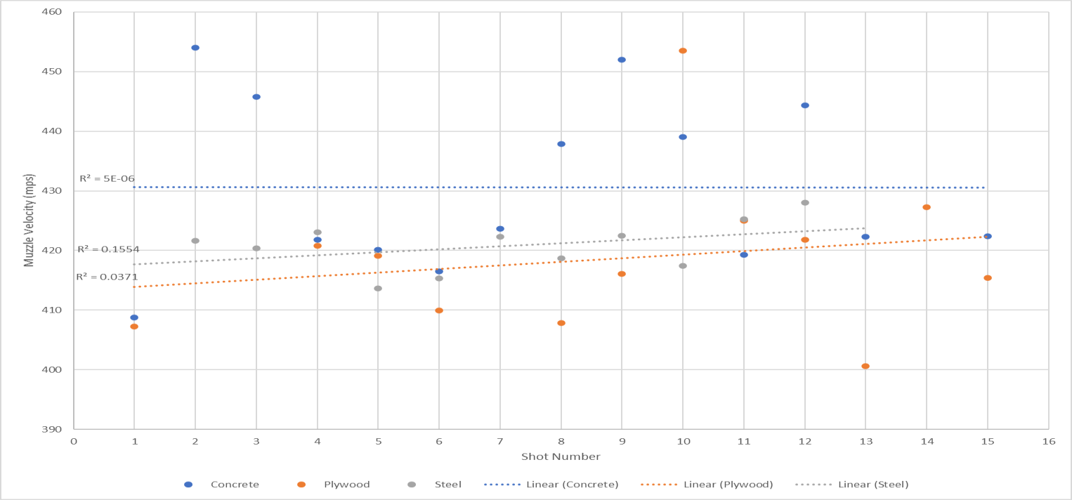

*Figure 15: Recorded Muzzle Velocities across all material types (organised by shot number). Lines of best fit are colour coded to the material type and missing points indicate invalid data sets.*

Muzzle velocity is measured in metres per second (m/s) however most manufacturers tend to use feet per second (fps) and as such conversions will be provided. There is around a 55m/s (180fps) difference in between the highest recorded velocity (concrete, shot 2) and the lowest recorded velocity (plywood, shot 13). However, inclusive of all shots on all materials, the deviation is =/- 18m/s (59fps) and this represents a relatively significant range of velocities over the total amount of recorded shots. In comparison the impact velocity had a much greater range of velocity and all conforming to the expected pattern of greater distance = lower impact velocity. The average across all of the samples is 423.80m/s (1390.41fps) which is faster than the reported velocity from the manufacturers (at 411.48m/s/ 1350.00fps) (Lyalvale Express, 2021).

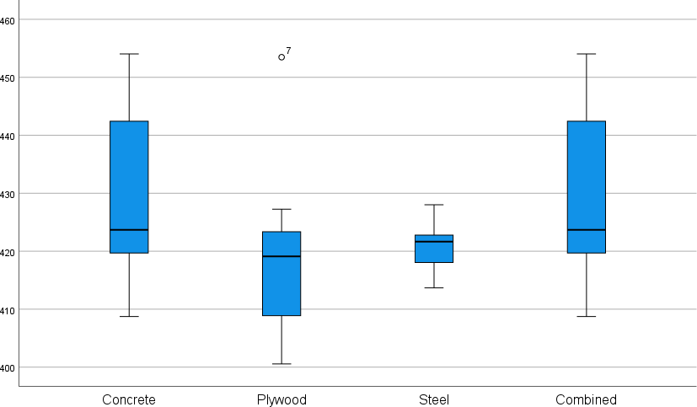The boxplot (figure 16, below) shows that the spread of shot is generally centred around 420 m/s with only one significant outlier (plywood sample with a velocity of 453 m/s). However it should be stated that this outlier is just for the plywood sample – when looking at the combined plot there is no significant outlier (as SPSS identifies these by calculating how far out of the interquartile range it falls and plots that on the graph). This shows that in a general sense all of the rounds fired behaved within a normal range, however when looking at individual materials, one round was abnormally higher than the others.

*Figure 16: Boxplot showing spread of recorded velocities (Muzzle) in individual materials and across all materials.*

The recorded muzzle velocities are not significantly different from each other when analysed with ANOVA when split by distance (.792) or when split by material (.037) showing that the muzzle velocities recorded are not significantly different from the mean across all of the target materials or distances used. The true recorded muzzle velocity across all materials was recorded at 423.80 (± 12.88), specifically; the true recorded muzzle velocity for concrete was 430.57 (± 14.49), for plywood was 418.70 (± 13.51) and for steel was 420.74 (± 4.23).

The shot in the plywood material set that is much higher in velocity explains the rise in the average velocity at 5m. The reason for this could be that the powder burn was far more sudden and the gaseous increase caused the piston cup to compress and expand far more than in the other shots leading to more pressure being needed to eject the shot. Again, it shows the poor efficiency of shotgun cartridges and the challenges faced by investigators everywhere when trying to reconstruct a scenario as inconsistencies in muzzle velocity are commonplace.

## Predicted muzzle velocity

Figure 12 (below) summarises the difference between model performance and true measured muzzle velocity for the 37 damage sites that were carried forward from the 45 cartridges of ammunition test fired on the three target surfaces (concrete, plywood and steel). The mean muzzle velocities predicted by the optimal models in each sample set were 430.94 ± 9.41 m/s for concrete, 417.75 ± 2.47 m/s for plywood and 420.19 ± 4.30 m/s for steel respectively. Comparison to the calculated average muzzle velocities for each material shows that across all of the input combinations (across all of the materials) there is a marked difference in the spread of the data. Figure 17(A-D) illustrates the extent of the differences.

*Figure 17: Mean predicted muzzle velocities (by distance (1=3m, 2=5m, 3=7m)) for Concrete (12A), Plywood (12B), Steel 1 (ignorance of deformation damage) (12C) and steel 2 (inclusive of deformation damage) (12D). Red marker (joined by line for clarity) indicates the true mean velocity, Error bars are standard deviation for the repeats at each distance.*

As the models are predicting very closely to the average of the dataset, it was decided that individual predictions for muzzle velocity were to be grouped together and averaged (by distance fired), this provides more relevant information and helps to eliminate a lot of the variation seen in the concrete and plywood samples which in turn provides a better range of prediction and as such be of more use in an investigative capacity.

The average velocity across the materials is approximately 422 m/s giving approximately total theoretical muzzle KE of 6404(4 sf using a shot mass of 32.02g – worked out from a representative sample of a cartridge (same batch and lot) of which the shot was weighed).

The average true KE of the discharge is 2851.12J meaning that on average there is a 44.5% efficiency in converting the chemical potential energy to Kinetic Energy. This shows that there is a vast amount of energy that is being discharged as other forms of energy such as light, heat and sound (Warlow, 2011). Warlow (2011) references experimentation by the Defence Academy which indicates that around 3% of this non-utilised energy is used to move the projectile (bearing in mind it is still classed as a singular entity at this point) along the barrel, with the majority being released as heat. Specifically in a shotgun, heat can account for 25% of energy loss (Rinker, 2008) and the pressure gradient may not utilise all of the available energy fast enough (due to slow burn from the powder leading to a slower pressure build up). Any of these occurrences could affect the amount of energy imparted directly upon the shot which then would affect the amount of velocity recorded by the Ballistic Chronograph (Picoscope). From Figure 12 it can be ascertained that most of the model iterations perform very closely to the mean with predictions falling about the average of the dataset this could be happening for two reasons, either:

* The models are predicting that the muzzle velocity *should* be the same across the shots and not considering the calculus from Rinker (2008).
* The model is over-generalising (Kovacs & Wills, N.D) and failing to fully utilise the data presented to the system which means that the system will go for the mean values of each training set used.

The concrete samples show the greatest variation in the data set (specifically at 3m) and also show a decrease in this variability as the distance increases, this is not repeated in any other dataset; the plywood samples have a similar level of variation throughout the different distances (even when taking into account the outlier at 5m) and both steel samples gain variation at 7m and have the least variation in the 5m set. Again, it should be noted that although the shots are grouped by distance it

does not show that muzzle velocity is increasing with distance. There is far more variation between individual models which indicates some models are performing better than others and that further investigation is warranted. In the second steel set, the recorded velocities were exactly the same as the previous steel set these figures. However, by including the major deformation data in the analysis gives a better set of predictions (as the predicted values are closer to the recorded) than with the previous set which is a direct result of changing the way that samples are scanned and processed in the Geomagic software. Considering the materials themselves; this variability could be for several reasons:

* Compressed concrete slab is made from a wide variety of different aggregates (MKH Build, 2016), these mixtures could have produced harder or softer areas within the target surface due to particulate size or poor mixing which would behave differently under ballistic impact.
* In steel samples, ignoring the materials behaviour when subjected to a ballistic impact has also decreased the effectiveness of the predictions – the main bowl shape plays a significant role in prediction power – thus material behaviour does affect the predictive abilities of the algorithm with the data collected.

Some predictions across the materials show a greater variability in the deviation than any of the others. This is not the same for all of the combinations of inputs as a lot are still remaining around the average the lack of random variation (as in deviations that fall outside the standard deviation of the recorded values) suggests a prediction utilising the data which gives weight to the first point (that the algorithm is trying to predict and that there is useful data within the PCA dimensions). For further clarity the correlation of the original data can be considered. It is important to consider the level of correlation between each input and output variable prior to PCA taking place. As PCA combines these data and reduces the dimensionality down it relies on these relationships to weight the data combinations correctly. The correlations of all inputs and potential outputs are shown in figure 18 (below).

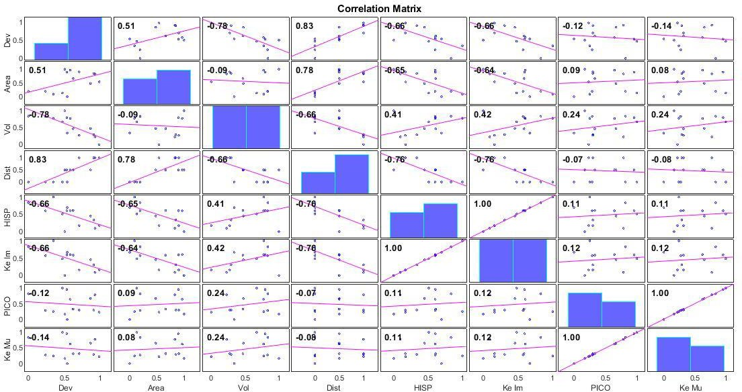

(18A) Correlation Matrix for Concrete Data

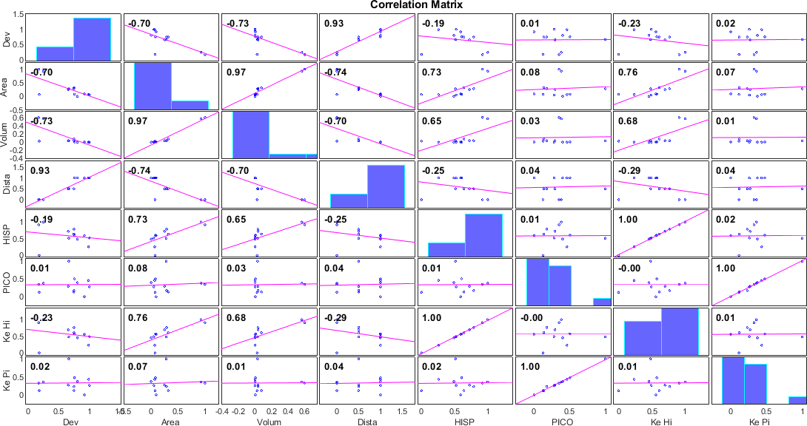

(18B) Correlation Matrix for Plywood Data

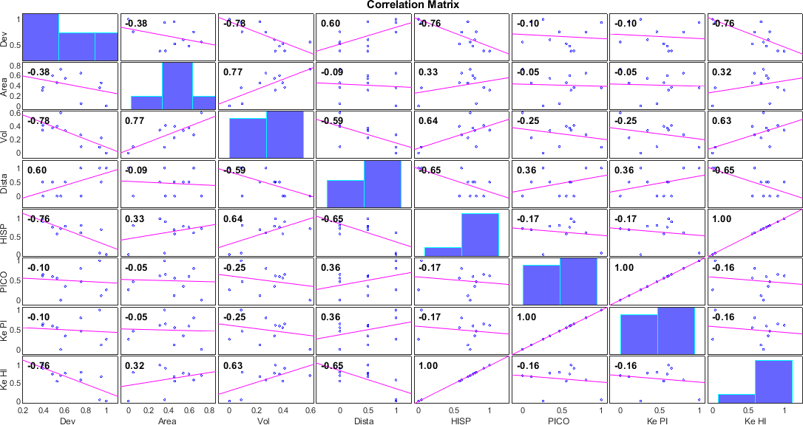

(18C) Correlation Matrix for Steel Data (ignoring deformation)

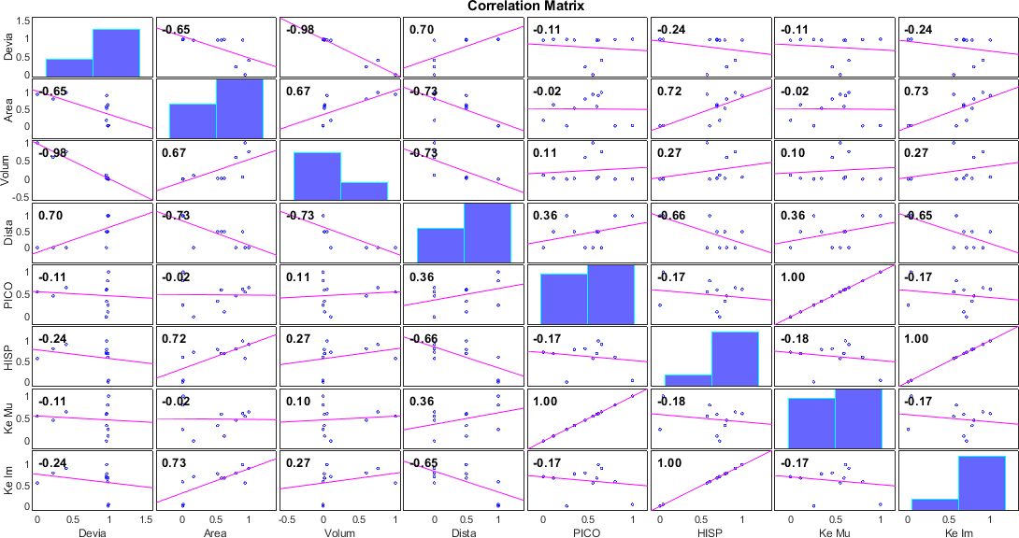

(18D) Correlation Matrix for Steel Data (inclusive of deformation)

*Figure 18: Correlation Plots showing relationships between inputs and outputs. Concrete (13A), Plywood (13B), Steel 1 (Ignoring deformation) (13C), Steel 2 (including deformation) (13D) pink line is line of best fit and number indicates strength of the correlation, a negative number indicates a negative correlation.*

As shown in Figure 13, the majority of input variables (Deviation, Area, Volume, High Speed Camera) exhibit virtually no correlation with the muzzle velocity output in all three target surfaces. The only input that seems to have any correlation with the muzzle velocity output (the velocity measurement from the chronograph) is the volume with a correlation of 0.24 in concrete, Area (0.08) in Plywood and Distance (0.36) in Steel 1 and Steel 2. This would indicate that the material is having a large impact upon the data being recovered and that the inputs with the best relationship to muzzle velocity change depending on the behaviour of this material. This could be down to the material behaviours, for example, the deformation most significantly changed with the change in distance in the steel samples (hence the higher correlation – as more variation was seen here). Another example would be the Area in Plywood, this was the input that had the most variation and as such would be relied on by the algorithm to differentiate between the samples. This outcome adds weight to the idea that the prediction of the Muzzle velocity is over- generalising by predicting the mean result. Increasing the number of test-fires conducted at each distance, increasing the number of distances test-fires were conducted at, and/or to increase the number of inputs within the system would be the only ways to overcome over-generalisation. In the context of predicting muzzle velocity, 45 test fires should have been sufficient to minimise over- generalisation (forensic ballisticians frequently work with far fewer shots available (Outhwaite, 2017)), however, further testing could be conducted in the future to explore this further.

The most likely theory is that the data being used is not very compatible with the output labelled PICO. However, it should not be overlooked that after PCA the data is combined and reconfigured which would potentially utilise other relationships in the data to improve the predictive abilities of the model. The figures all still predict around the mean which again to be expected as the muzzle velocity should not change all that much between shots (especially as all cartridges were from the same box, batch and lot), the question is whether the models are doing this due to lack of useful data (where more variability is expected especially with the LOOP being used as validation) or are extrapolating that the muzzle velocity shouldn’t change with all of the input variables presented. Again, it is difficult to pick an optimal model based on this data alone and as such RMSE and Standard Error of Regression will be examined to find further patterns and optimal models.

The correlations of each input are different in each material and the relationship between certain inputs and the muzzle velocity are highly varied. The Steel iterations of the data shows that there is a stronger correlation in both Volume and Distance inputs compared to the other models. The relationship with Volume is interesting as it does show that a yielding material prediction makes more use of Volume as opposed to Deviation and Area Measures. It is expected that this behaviour will become more important with the impact velocity prediction dataset. The models are generally predicting close to the mean and to find the optimal combination the information from the RMSE and Standard Error of Regression should be analysed. Figure 14 (below) shows the RMSE figures for each of the individual model iterations across all 4 materials.

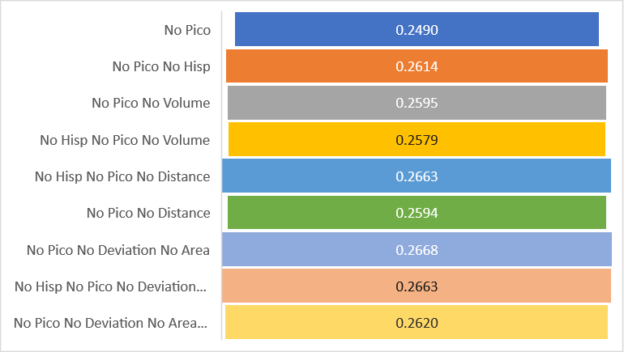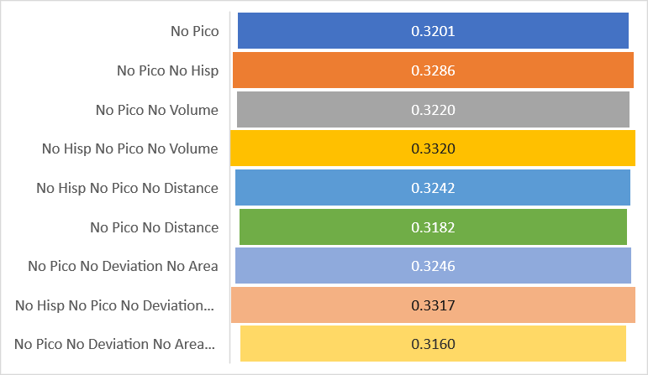

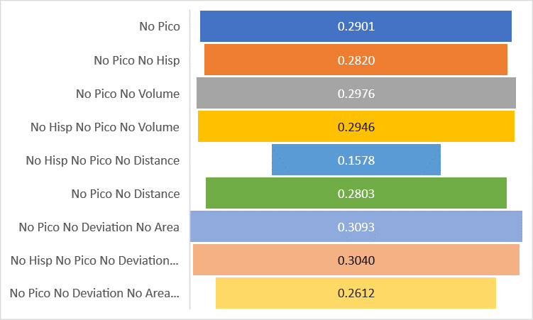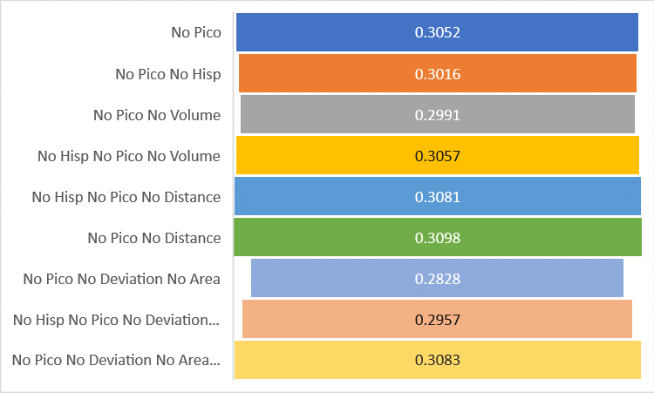

*Figure 19: RMSE numbers for each combination across all materials using normalised figures. Top left: Concrete, Top Right: Plywood, Bottom Left: Steel 1, Bottom Right: Steel 2. The key data shows the input variable combinations used. This is a visual comparison between each input combination, RMSE values are stated in the centre.*

All the RMSE figures (figure 6, above) except 1 present a very similar level of accuracy ranging from 0.3320 to 0.2490; this further shows the lack of strong relationships between the input and the outputs and as such the difficulty the algorithms are having in prediction.

The concrete samples show that Volume is highly important, the second best RMSE shows that having all inputs available is also highly effective – this shows that although Volume data is the most useful input (along with the High-speed data), the algorithm seems to be able to make use of existing relationships within the inputs to make predictions.

In the Plywood samples the RMSE figures show that when compared to the Concrete samples the predictions are all much better in terms of the pure RMSE figure. The optimal model includes all outputs and this strengthens the theory that the model algorithm is extrapolating from other relationships in the data to strengthen the overall predictive power of the model. From the worst performing models it can be surmised that the most important inputs for prediction are Deviation and Area as well as some form of velocity measurement (in this case the High-Speed Camera velocity from the impact). In direct comparison with the concrete dataset, it is not surprising that the “All Inputs” model features as one of the optimal combinations for both. However the differences in both the numerical value for the RMSE and the model combinations indicate that the data is being utilised differently in some form. Most probably it is a direct result of a difference in material behaviour creating different numbers for the inputs and as such strengthening or weakening the relationships between those inputs.

The steel data clearly shows that the optimal model has no velocity data and no distance data which is very interesting seeing as the correlation plots clearly show a strong relationship with distance and the velocity measurement. Also interesting is that volume (another very strong correlation) only provides a marginally higher RMSE when missing than with Deviation and Area missing (which have much smaller correlations). Again, this is due to the PCA process but does highlight that a combination of weak correlations can be as worthwhile to predictions as a singular strong correlation.

Although the RMSE data for each material is very clear as to the optimal input combination, surprisingly, the data also shows that the best method of scanning steel ignores the major deformations as the RMSE shows the data is more effective as the previous method (which is a complete reversal of the prediction of distance in chapter 6). The RMSE data shows that the most effective models ignore Distance and velocity data which reflects the results seen with distance

estimation). Distance and Volume data make the second largest impact with the High-speed data making the smallest impact by its absence.

The predictions are still around the mean as expected since the same inputs are used with a smaller number of samples (due to equipment malfunction) however, there are instances where models are trying to predict the true value as opposed to the mean recorded values which indicates that better RMSE figures are to be expected. This increase of movement also indicates that the correlations differ between the inputs and outputs and the correlation plots from figure 13 would elude to this however further examination is required by looking at the Standard Error of Regression (SER) results (Figure 15, below).

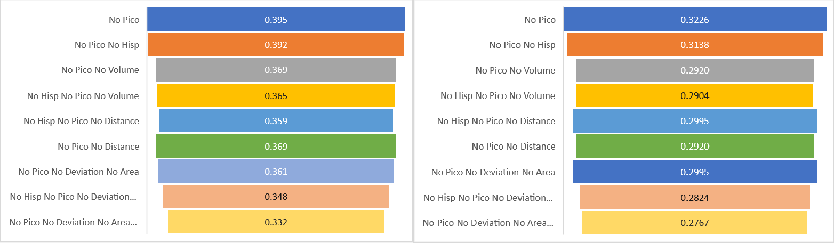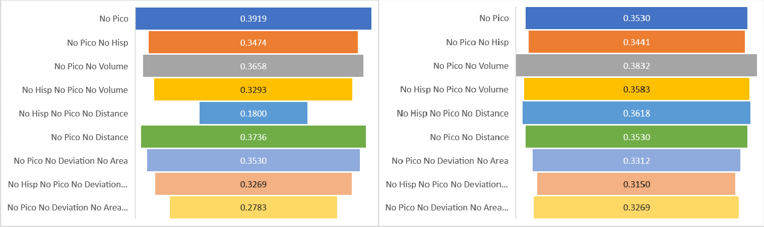

*Figure 20: Standard Error of Regression figures from each material using standardised results. Top left: Concrete, Top Right: Plywood, Bottom Left: Steel 1, Bottom Right: Steel 2 . The key data shows the input variable combinations used. This is a visual comparison between each input combination, SER values are stated in the centre.*

The standard error of regression (the explanation of which is detailed in chapter 3) provides further information surrounding the precision of the prediction (Frost, 2021). From the figure it can be seen that all of the materials are giving a similar SER figure with the exception of a singular model with Steel. This set of results shows that both of the non-yielding materials have an optimal model which ignores distance, deviation and area data (Leaving only volume and impact velocity with a PCA of 2).

The yielding material measured in the same way as the non-yielding (taking into account the major deformation and treating it as damage) provides numerically similar results but the optimal model only contains volume and distance data, the optimal model for the non-yielding sets has the second-best SER result here. The yielding material measured by ignoring the major deformation has the best result of the entire data set which conflicts with the findings of both distance prediction and impact velocity prediction chapters. In this set the deformation caused by the mass of the entire shot column was ignored to attempt to provide a truer representation of the damage caused by the independent pellet strikes, this created a larger dataset more in line with the amount of data captured in the non-yielding sets and was achieved by setting the zero surface to include that deformation. The Steel 1 set shows that utilising the measurement data (deviation, area and volume only) is highly effective at achieving a precise set of predictions. The findings from the SER results mirror the RMSE results in the concrete and steel 1 datasets in terms of optimal model, however, the steel 2 and plywood results do not, as SER is a measure of precision and not accuracy (like with RMSE) it can be used more effectively in the case of muzzle velocity prediction (where distance does not affect the true value and its range. The SER and RMSE results are affected by a number of factors affecting the base data.

Firstly, the true recorded values for muzzle velocity show consistency in the concrete and steel datasets however, the plywood contains an outlier value and the concrete data is more widely spread than the steel. This has affected the results data by giving the algorithm a smaller range to work with. As the algorithm used LOOP as its validation and verification method it tests each prediction by utilising the data from the other samples in the set as its historical data bed. As the range of the true data is much smaller in the steel dataset it is of no surprise that this dataset gives the smallest RMSE and SER data. Similarly, the spread of the data in concrete is much larger, this gives a wider range for the algorithm to contend with and as such the RMSE and SER figures are generally higher.

Secondly, the number of observations will have an effect on the data seen as the algorithm will have more or less to utilise as its historical data bed. This will possibly also have had an affect on the spread

of the data by limiting the chances for particularly high or low velocities. This has affected the true value and the spread to a certain extent which (as stated previously) has clearly affected the output.

The behaviour of the material at impact has not had a marked effect on the dataset as a whole (indicated by the range of RMSE and SER figures being similar in all of the datasets) which is unsurprising as the measurement data has a direct relationship with the impact velocity which can differ (Yaghoubi *Et al,* 2011) from the expected norms outlined in literature (Rinker, 2008/ Haag, 2021). Of the materials presented, certain limitations were found, notably in plywood where the volume data was found to be more varied due to the small impact holes of individual sites and the potential for shot to be lodged within these holes. Moreover, further data that was not recorded such as from the projectile itself (such as its weight) has been shown to be able to help predict muzzle velocity in barrel control tests (Degirmenci, 2015). The data collected may not be the main issue as the dataset in steel 1 that ignored all velocity data from the impact as well as the distance (keeping all of the measurement data) is considerably more effective at accurate a precise measurements than any other, therefore it can be surmised that this has less to do with the behaviour of the materials and more to do with the data collected and subsequently the scanning method.

The scanning method employed in steel 1 (as stated previously) tried to emulate the data recovered in the concrete and plywood samples by treating the major deformation caused by the collective projectile mass as a null factor. This enabled the multiple small impact sites to be counted as separate damage sites in their own right and could be mapped accordingly. As observed in distance prediction (chapter 6) and in impact velocity prediction (chapter 5) this method proved to be less effective at predicting than if the damage sites were inclusive of these deformations. However, in the case of muzzle velocity this method drastically improved the RMSE and SER figures for the steel dataset. This could be from a number of factors such as the existing relationships in the data, the behaviour of the individual impacts upon the target surface or the properties of the materials themselves.

The existing relationships in the base data shows that the volume has a stronger correlation (-0.25) in steel 1 than in steel 2 (0.11). This coupled with a marginally stronger correlation in area data (-0.05 in steel 1 vs. 0.02 in steel 2) indicate that the measurement data is being utilised more fully (as these relationships are reminiscent of the concrete dataset) and provides a greater amount of discriminatory power between samples. All of the data used had gone through dimensionality reduction using PCA (explained in chapter 3) and thus has been transformed into amounts of data that explain the variance within the dataset (depending on what the PCA is reduced by). The utilisation of PCA gave similar

levels of variance throughout the sample sets. This dimensionality reduction played a key part when the different model iterations were tested by promoting certain inputs based on that variance, even though the distance input provided the strongest correlation (and thus was expected to become a key input variable in any optimal model) the PCA reduced its effect on the data (due to it having a small amount of variance). Even when other inputs were removed it became clear that the lack of variance in the distance data made prediction of the velocity difficult for the algorithm. Couple this with a PCA that (for example) recommends 3 components and the effectiveness of those smaller variances are further diminished. Table 9 (below) outlines the spread of these variances as a percentage.

Table 9: Variance of data (expressed as percentage) after PCA

|  |  |  |  |  |  |
| --- | --- | --- | --- | --- | --- |
|  | | | | | |
|  | **Deviation** | **Area** | **Volume** | **Distance** | **Impact V** |
| **Steel1** | 68.70% | 18.10% | 9.00% | 3.90% | 3.00% |
| **Steel2** | 73.50% | 17.70% | 6.30% | 2.00% | 0.40% |
| **Plywood** | 76.40% | 19.50% | 2.70% | 1.30% | 0.10% |
| **Concrete** | 72.90% | 19.00% | 5.40% | 2.30% | 0.50% |

From the table it can be seen that by ignoring the major damage site the variance of the data in the steel set changed, this change improved the variance within volume and distance and removed some of the variation from deviation (which had the most across all the datasets). Distance and velocity measurements consistently have a very low variance which is why even though they exhibited the strongest correlations the overall lacked the significance in their variance for the algorithm to exploit successfully. The optimal model for each material set differs in algorithm type, Principal Component number and required input. Table 10 (below) outlines the optimal prediction models for each material.

Table 10: Optimal prediction models for each material type. Primary criteria for optimal models are RMSE values, secondary criteria are SER.

|  |  |  |  |  |  |
| --- | --- | --- | --- | --- | --- |
| **Material** | **Inputs** | **PCA** | **Algorithm** | **RMSE** | **SER** |
| **Concrete** | Deviation, Area, Volume, Impact Velocity | 4 | SVM (Fine Gaussian) | 0.3181 | 0.3688 |
| **Plywood** | Deviation, Area, Distance, | 3 | SVM (Medium Gaussian) | 0.2579 | 0.2904 |
| **Steel 1** | Deviation, Area, Volume, | 3 | Interactions Linear | 0.1577 | 0.1800 |
| **Steel 2** | Volume, Distance, Impact Velocity | 3 | SVM (Linear) | 0.2828 | 0.3311 |

The optimal prediction algorithms for each model share some commonality across materials which is encouraging for potential later work into finding a singular algorithm type for scene reconstruction efforts. The most common inputs across the materials are deviation, area, and volume however both distance and impact velocity appear in multiple materials.

This highlights that all of the inputs (in the correct combination) are capable of making a prediction, however the amount of variance in the data is a key factor in this process. It has been stated by Jolliffe (1982) that components with very small variances can be the most important within the data which explains why (especially in the steel 2 model) only components with little variance produced the optimal model. The table also highlights that predictions made favour the maximum number of available principal components available to that iteration which is an indication that all of the inputs are of some use. Although one material utilises a linear style of regression for its algorithm (steel 1) the majority utilise a Support Vector Machine approach which is a highly adaptable and robust model which performs well with small datasets making it ideal for this type of regression problem (Otchere *Et al*, 2021).

The prediction of muzzle velocity has shown to be possible if the mean result is calculated and utilised. Optimal models vary with the material; however, multiple models report that the most appropriate algorithms (selected from a combination of RMSE and SER data) is some form of support vector machine (SVM) which has shown in literature to be adept at dealing with small sample sets (Otchere *Et al*, 2021/ Hu *Et al*, 2021/ Chi *Et al*, 2008). By scanning all of the materials in the same way (inclusive of all deformation) the RMSE and SER figures remain largely similar between sets. However, by ignoring the major deformation in the steel samples (the damage in the ply or concrete samples is classed as a removal not a deformation as impacted material is removed at impact rather than warping the materials shape beyond its ability to recover (Haag, 2021)) the RMSE and SER results are generally improved across several models. This is due to the scan method changing the variance in the data leading to an improved result, it would not be possible to replicate this technique in non-yielding materials (due to the lack of deformation in samples).

From a research perspective, the prediction of muzzle velocity using both machine learning and laser scanning has shown to be an area with great potential for further exploration. The applicability of such a technique still requires continuing work to bring it to the standards required for scene reconstruction efforts. The data shows there is potential for a technique to be developed and applied to real world shooting incident reconstruction events. To illustrate this, a hypothetical scenario is outlined to further contextualise the technique into the shooting scene reconstruction perspective.

## Application to shooting incident reconstruction

A discharge is heard on a quiet housing estate in the early hours of the morning, the police are called and a subsequent search finds a defect on the concrete wall of a house, which appears consistent with impact damage from shotgun ammunition. No other firearm evidence is found at the scene, however, during the police investigation, a witness provides a statement and a suspect 12-gauge shotgun with associated ammunition is seized. The witness stated that they believed the shotgun was fired towards the house from someone in the passenger seat of a car with the window down as it was driving past. Reconstructive testing could be used to assess the potential for this firearm and ammunition combination to have been used by estimating the muzzle velocity of the ammunition.

The presented technique could be used in a similar way to existing 2D reconstructive methods such as the use of witness panels which are designed for distance estimation (Haag, 2021). Samples are shot and the circumference of the pattern (excluding flyers) measured to estimate the shooting distance from the spread of the pellets. The new technique would change the measured output to the actual areas of damage instead of the more subjective current method (where the furthest impacts in the damage area are determined by the examiner (Haag, 2021)). During the investigation of the scenario, material representative samples would be shot and scanned for comparison. The produced data would be fed into the system and a prediction would be produced.

The results could then be used in a multitude of ways; Firstly, be used as a tool to assist the expert in their report and provide more objectivity to the damage site prediction and the potential for the seized weapon and ammunition to have been responsible. Secondly, the scans could be used as virtual evidence and amalgamated into interactive crime scenes from larger street level scans (Allen, 2019). Thirdly, the predictions could be used to assess the credibility of a witness statement by corroborating or disputing the witness report of where the discharge took place, this would however need to be coupled with the distance prediction of chapter 5 which would also be appropriate for this task.

The proposed method in this scenario shows a number of advantages that could be added to traditional testing methods such as the witness panel. The additional measures taken have shown to be relevant and applicable to muzzle velocity work and the prediction algorithm provides a further element of objectivity which would strengthen any interpretation made by an expert.

From a position of health and safety the information could be utilised to gain a rough figure to assist in investigations where the weapon is damaged or the munitions are too unstable to safely test (due to age or condition) (de Klerk, 2015). Another advantage is that this technique could be potentially utilised by units with a reactionary approach to criminal investigation such as non-intelligence led forces (reactionary) or forces with damaged infrastructure (UNIDIR, 2021)).

## Limitations in muzzle velocity prediction and further work

As this is still a proof of concept, there are some limitations which need to be addressed with the technique before it can be utilised in an evidential capacity. Firstly, muzzle velocity prediction from the damage site was expected to be (and has shown to be) less effective than the prediction of distance or impact velocity. This is due to the data, as most of the data used to predict is from the terminal ballistic stage of the discharge the relationships between the inputs and outputs are not as correlated. As identified in literature, the most effective ways of measuring muzzle velocity are by use of a device such as a chronograph or radar (Hu *Et al*, 2021/ Haag, 2019) and this measurement (being the output), could not be used as an input variable. Utilisation of the averages of the dataset improved the results but mask the overall issue which can only be remedied by use of inputs that give data from the muzzle (such as chronograph data or radar). This is impractical for use in a forensic context as the expenditure, time and expertise needed would be fiscally unviable to smaller investigation units or reactionary led forces.

Furthermore, this dataset was extremely small (to simulate the limited resources available to an examiner) and as such there is a risk of results overgeneralising (Kovacs & Wills, N.D; Plebe & Compagnini, 2012) due to the weaknesses in the correlations of the base data. This means that the optimal models, input variables and PCA may change with a different dataset (be it by size, ammunition or weapon). This supports the addition of guidelines if this form of analysis were to be utilised. For example it could be used as a form of “sense check” or validation protocol (akin to the suggestions in Page *Et al*, 2019) and that each examination is run on a case-by-case basis (Dalby *Et al*, 2010) to prevent inappropriate historical data informing a biased decision on the part of the system.

Finally, (as stated previously in section 7.0) the efficiency of shotgun cartridges are poor, as observed in the data there is a wide range of recorded velocities. Even though rounds from the same batch and lot were used in each test there is a marked difference between each individual shot and each material although when tested in combination there were no significant outliers, the individual material spreads were all very different. The proposed method does not take into account the potential for the storage (Jung & Sohn, 2010), age or condition of suspect rounds to influence the round at the discharge event, potentially creating more erroneous results (de Klerk, 2015). Only by increasing the sample size can the extent of this trend be catalogued and taken into account.

Further work into this area should take into account the limitations presented in this section:

* + From the results, it is clear that SVM algorithms are an appropriate and robust system to utilise for the size of the dataset (Otchere *Et al*, 2021/ Hu *Et al*, 2021/ Chi *Et al*, 2008) any further work should continue to look at the SVM style of algorithms with differing datasets to assess the applicability of these algorithms to the prediction of muzzle velocity. Introducing differing brands of the same sized ammunition from manufacturers to test the applicability on a wider range of projectiles. This would test the accuracy, applicability and validity of the findings presented whilst also increasing the sample size to enable the more traditional machine learning training to take place (where datasets are partitioned into training, validation and verification sets).
  + Introducing factors that affect the dispersal of shot and the potential velocity such as increasing or decreasing the barrel length and the addition of full, ¼ and ¾ chokes (Maitre *Et al*, 2021). The difference between manufactured and homemade weapons and ammunition (Hsien-Hui *Et al*, 2014) and the effect of barrel temperature variations (Meng *Et al*, 2013)
  + Investigating the use of either velocity radar (Jiang *Et al*. 2021), Doppler Radar (Haag, 2019) or ASAP (Decker *Et al,* 2017) as an alternative velocity measure in lab-based tests as these systems have been shown to be more effective at measuring multiple projectile flight paths and record the velocity across the entire travelled path of the projectile (See Chapter 2, section 2.1). The additional input data (such as deceleration or time of flight data) could assist in creating links within the existing inputs that could potentially improve the prediction of muzzle velocity.

## Conclusion

The novel method presented in this chapter has shown that through the utilisation of laser scanning metrology and machine learning – it is possible to predict the average muzzle velocity of a shotgun discharge. Table 11 (below) shows the optimal prediction per material.

Table 11: Optimal muzzle prediction models showing widest residual difference between the average predicted and the average recorded muzzle velocities.

|  |  |  |  |  |  |  |
| --- | --- | --- | --- | --- | --- | --- |
| **Material** | **Inputs** | **PCA** | **Algorithm** | **True Average (m/s)** | **Predicted Average (m/s)** | **Difference (m/s)** |
| **Concrete Plywood Steel 1**  **Steel 2** | Deviation, Area, Volume, Impact Velocity | 4 | SVM (Fine Gaussian) | 433.84 | 432.55 | 1.29 |
| Deviation, Area, Distance, | 3 | SVM (Medium Gaussian) | 421.83 | 414.50 | 7.33 |
| Deviation, Area, Volume, | 3 | Interactions Linear | 423.56 | 421.43 | 2.13 |
| Volume, Distance, Impact Velocity | 3 | SVM (Linear) | 423.56 | 421.36 | 2.21 |

The performance of the model, inputs required and algorithm to be used is largely dependant on a number of factors discussed such as the material properties (yielding or non-yielding) (Haag, 2021) and the scanning method employed (which changes the variance within the input data). Although optimal models change according to the dataset, the use of support vector machines across multiple models is appropriate for further study.

Of the best performing models, three utilise volume as a required input. Volume readings in the plywood dataset were difficult to obtain due to the size of an individual impact hole and the propensity

for the pellet to be lodged within that hole making it difficult for the scanning beam to penetrate and get a true reading. The presence of a form of metrology data within all data shows that the scanning method employed can and does produce highly valid and repeatable results which provide not only a valuable, accurate and precise recording system but also produces data that can be exploited to the benefit of an investigator.

The individual predictions were of little use as the variation in shots coupled with the variance within the data did not successfully account for individual variations within each tested distance. This shows that the average should always be taken from the range of test shots when looking at the muzzle velocity. This also highlights the issues surrounding the unreliability of shotgun cartridges.

This chapter has shown that it is possible to predict muzzle velocity using 3D scanning data on a specific damage site to extract relevant, accurate, and precise information. The chapter highlights the difficulty in the relationships between the inputs and outputs, indicating more inputs or more datapoints would be needed to solidify any relationships.

In summary the study has brought up a number of significant points surrounding the prediction of muzzle velocity and further work is suggested for the use of said predictions to measure KE. These points are detailed below:

* + In steel samples, method 1 (where the major deformation is ignored as damage to preserve a homogenous data collection technique across all materials) is better for predicting muzzle

velocity. This is in contrast to distance prediction where the second method (utilising the deformation as a damage site itself) is better for prediction.

* + Averaging results give outcomes closer to recorded data averages which supports the use of this in conjunction with existing techniques to provide a kind of validation for experts to use to give a level of objectivity.
  + Essentially, the damage sites give data that is very difficult to use in the prediction of muzzle velocity but SVM aids in this the use of SVM and the expansion of the input data to include further data (either for existing inputs or in the form of new inputs) should be investigated.
  + The relationship in the inputs and outputs and the prevalence of SVM as a suitable model support the expansion of input data in either more samples in the form of a database or the inclusion of more inputs themselves.

The method used to predict muzzle velocity has been shown to be effective and the data has shown the important factors from the damage site that are affected by the change in target material type. As a test of the analysis methods effectiveness this chapter has shown distinct promise the remaining question is can the same data be used to predict a differing output? The next chapter will examine the effectiveness of the technique when the output is changed.

# Chapter 5.0: Impact Velocity Prediction

## Introduction

The stages of a ballistic discharge event are well known (Carlucci, 2010) and the terminus of the event (the projectiles strike upon the target) gives some significant information regarding the flight path, the condition of shot and the damage inflicted upon the target surface (Haag, 2021). During a scene reconstruction it is the effect of the terminal event that provides the most obvious evidence to work with. The way to measure the impact velocity of such an event is usually done with a chronograph (Thompson, 2018), high speed photography (Lutz & Buck, 1984) or radar system (Haag, 2019). Impact velocity can also be used to work out range (if the muzzle velocity is known), lethality of projectile (important in design of non-lethal submunitions (Wahl *et al*, 2006)) and damage recreation (as damage is just the transfer of the energy from the pellet to the target). To find the impact velocity is to be able to begin to work out how much energy was imparted to the target (KE) which is of huge benefit to a forensic examiner. Contemporary impact analysis research generally gravitates towards what happens to soft targets (human and animal bodies) rather than solid targets when dealing with shotguns, therefore the study presented adds to this area by examining a different form of analysis of a different target set. For example, the impact velocity coupled with the design of the projectile will have a different effect upon the target (Santucci & Chang, 2004; Planka, 2011). A further example is in the case of targets behind objects (such as glass panels (Jauhari *Et al,* 1974) and the lethality of the round after perforation of the intermediate object. A way to analyse the complex damage site left behind by a shotgun discharge coupled with the ability to predict the velocity at impact using a small amount of data would therefore be of great benefit to a modern scene reconstruction unit.

As a result, the specific research questions to be addressed in this chapter are:

* + - Can impact velocity be reliably predicted using the novel method developed in this thesis?
    - Which machine learning algorithms and test firing parameters are important in generating a repeatable and accurate prediction of impact velocity?
    - To what extent do the properties of the terminal surface impact on the predictive capability and potential application of this approach to future casework?

The aim of this chapter is to utilise the laser scanning and machine learning method presented and use it to predict the impact velocity of a shotgun discharge. Presently, the majority of peer reviewed works surrounding forensic ballistics deal with issues of soft tissue wounding or with singular projectile weapon platforms such as rifles or pistols (Exlibris, 2021/ AFTE, 2021). The work is designed to provide an alternative, technologically inclusive method of data capture and analysis to the current accepted

standards to enhance and exploit more intelligence from shotgun discharge scenarios whilst also trying to further enhance the objectivity and support an experts’ interpretation during such investigations.

As addressed previously the technique in development is also a potential address to the criticisms from the Presidents Council of Advisors on Science and Technology (PCAST, 2016), particularly the need to evaluate specific methods to determine whether they are scientifically valid and reliable. PCAST recommends that research to improve forensic science be undertaken (PCAST, 2016). Another area that PCAST identified as being problematic that this technique would help to develop is that of expert testimony and its admissibility and the recommendation that it only be accepted after considering the available scientific data. This means that by providing a technique that can be used in conjunction with the expert’s decision-making process, a more objective and rigorous conclusion can be achieved.

The main gap in the field that this project aims to address is that currently there is little documented or peer reviewed methods for utilising the technology of laser scanning (coupled with machine learning) for precision measurements in a shooting incident reconstruction context. This represents an untapped potential of using modern technology to improve the objectivity of prediction and expert opinion with scientifically underpinned data collection and extrapolation.

Current suspect weapon velocity testing is conducted by test firing the weapon with seized ammunition utilising a chronograph with relevant software (Haag, 2021). This is not always able to happen especially if the weapon is in poor condition, homemade or suspect ammunition is not found in subsequent searches (whereby a representative sample would be used but would not necessarily represent the ammunition the suspect had; especially in the case of reloaded munitions). In such cases it is often impossible to determine a realistic spread of impact velocities. With this in mind, a method of predicting from a damage site would be very beneficial to investigators from a safety and intelligence perspective.

In overview, the rest of the chapters content consists of the presentation of each set of results discussion, practical application to a fictious scenario and a discussion on the limitations and further work raised within the results.

## Methodology

The methodology remained the same as with the prediction of muzzle velocity. The data collected for the muzzle velocity prediction was used and therefore the missing data (due to equipment malfunction) remained the same. The only change was that the muzzle velocity (“PICO”) became an input and the impact velocity (“HISP”) became the output. Running the algorithms remained the same as did the validation process (LOOP) and deciding on the optimal model via the RMSE. Chapter 3 provides a detailed account of the methodology; a brief graphical chart of the process is presented in figure 21 (below).

classify damage as either Primary or satellite damage and code with a Locus number



Data Normalised between 0-

1



Correlation plots to show individual input relationship s



Machine Learning Toolbox selecting K-fold validation at *n*



PCA

Applied



Algorithms run, Lowest two RMSE identified and brought forward



PCA

Lowered by one (minim um of 2 inputs required).



Graphical representation of Predicted vs Recorded value

Figure 21: Flowchart showing the data retrieval and machine learning process.

Again, Microsoft Excel (version 2108) was used as the data collection programme and for subsequent normalisation before transferring to MATLAB (version 2020a). MATLABs Regression Toolkit was used for PCA and machine learning functions. Data was then transferred manually back to Excel for de- normalisation and Excel was again used for all graphical representations. The individual input combinations are outlined in section 6.3.1 (below) optimal models were established in the same way as with muzzle velocity, where the two lowest RMSE values (after running all available algorithms in the machine learning application) were selected. Furthermore, the standard error of regression (SER) was also calculated and used as a secondary measure with which to assess the algorithms suitability further.

## Results

## Potential input combinations

The potential input combinations were designed to highlight the relevance of the laser scanning data as well as to ascertain which input variable gave the best prediction for the impact velocity. To analyse this in a repeatable manner, the same 9 input combinations were used as with muzzle velocity – with the obvious change of making the impact velocity an output variable and replacing it within the input combinations with the muzzle velocity. The input combinations are shown in table 12 (below).

Table 12: List of input combinations for predicting impact velocity. Impact velocity (HISP) has become the output variable and as such is absent from any combination

|  |  |  |  |  |  |  |
| --- | --- | --- | --- | --- | --- | --- |
| **List of Input Combinations** | | | | | | |
| **Combination Number** | **Impact Velocity Output** | | | | | |
| **Deviation** | **Area** | **Volume** | **Distance** | **Pico** | **HISP** |
| 1 | ✓ | ✓ | ✓ | ✓ | ✓ | Output |
| 2 | ✓ | ✓ | ✓ | ✓ | ✗ | Output |
| 3 | ✓ | ✓ | ✗ | ✓ | ✓ | Output |
| 4 | ✓ | ✓ | ✗ | ✓ | ✗ | Output |
| 5 | ✓ | ✓ | ✓ | ✗ | ✗ | Output |
| 6 | ✓ | ✓ | ✓ | ✗ | ✓ | Output |
| 7 | ✗ | ✗ | ✓ | ✓ | ✓ | Output |
| 8 | ✗ | ✗ | ✓ | ✓ | ✗ | Output |
| 9 | ✗ | ✗ | ✓ | ✗ | ✓ | Output |

## Estimated Energy Transfer

The energy transfer of the projectile to the target material is a key component in damage mechanics. This, along with the behaviour of the material under ballistic stress and the conditions of the shot (such as range and load) are the major components of what creates the damage observed after a shooting (Haag, 2021). As shown in chapter 4, the projectile strike has a differing effect on each material which will (depending on the material properties) transfer a differing amount of KE to the target face. The amount of energy imparted upon the target can be calculated by the ballistic coefficient (BC).

The ballistic coefficient is measured by finding the Sectional Density of the projectile (which is derived as the Mass (M) of the projectile divided by the square of its Diameter (D), see equation below) (Rinker, 2008):

$$SD= \frac{M}{D^{2}}$$

Once SD is found, this figure can be added to the overall equation where SD is divided by the form factor of the projectile shape (i). The form factor is a mathematical expression of the bullets shape, It creates a comparison of one bullets air resistance to a standard bullet by showing how efficient a projectile with that shape and SD would be (Rinker, 2006). For use with a shotgun projectile (a sphere) the form factor would be the highest value possible (Haag, 2021/ University of Utah, 2021). The form factor is determined ultimately by the shape of the projectile, the shape of its base and the projectiles smoothness (Rinker, 2006). The standard bullets used in Comparisons are known as G numbers (G1, G2, G5, G6, G7, G8, GL), in these reference bullets *i* = 1 and therefore if a projectile gives a lower drag than the standard then the projectiles *i*<1 and if the drag given is greater than the standard then *i*>1 (Rinker, 2006). When i has been found then it can be put into the below equation to find the ballistic coefficient:

$$BC=\frac{SD}{i}$$

In the case of the shogun projectile used within this study, the SD of the projectile would be 0.022kg/m² per pellet (mass taken from a representative sample of 50 pellets extracted from an unfired round within the same batch and lot as the experimentally discharged rounds). This means that the BC of the pellets would be equal to the pellets SD at 0.022kg/m². This figure gives an idea of the loss of velocity of a pellet under ballistic force. An example by Haag (2021) shows that 2 bullets with ballistic coefficients loose velocity at different rates. Reporting that one had a BC of 0.42 and the other 0.21 (and a different in velocity of 69.4m/s). This shows that the lower value lost almost twice as much velocity over the same distance than the first. By adding the pellet into this example it is clear that the projectile would lose nearly 10 times the velocity over the same distance as the lower speed projectile in the example. This further highlights the effective range of a shotgun projectile is drastically smaller than that of a conventional bullet. Furthermore, this means that the amount of energy (KE) imparted upon the target would be much less than that of a traditionally thought of bullet.

Another point is that of kinetic loading (also known as impact loading) which is defined as a high velocity impact by a small mass object (Cantwell & Morton, 1991). The basis of which can be shown by the coefficient of restitution (Catella, 2018) whereby the type of collision is either inelastic or elastic. It is defined as:

𝐸́ = 𝑉𝑒𝑙𝑜𝑐𝑖𝑡𝑦 𝐴𝑓𝑡𝑒𝑟 𝐶𝑜𝑙𝑙𝑖𝑠𝑖𝑜𝑛

𝑉𝑒𝑙𝑜𝑐𝑖𝑡𝑦 𝐵𝑒𝑓𝑜𝑟𝑒 𝐶𝑜𝑙𝑙𝑖𝑠𝑖𝑜𝑛

As there are three different materials each with very different makeups, profiles and characteristics. It is expected (and was observed, see chapter 4) that ricochet could occur, an indication that not all of the energy from the projectile was imparted upon the target. Whilst this was not true for the majority of the plywood and steel samples (some projectiles remained either trapped by the plywood’s fibrous nature or cold welded onto the steel plate). The same could not be said for concrete where most of the projectiles ricocheted off, this needs to be a consideration when looking at the KE imparted to the target. This phenomenon occurred with all of the concrete samples and it is clear that not all of the Ke was transferred to the target and as such this could have an effect on the algorithm (for example there may be some discrepancies in the physical measurement characteristics (whereby the differing materials in the concrete may absorb different levels of Ke, thus creating deeper or shallower damage sites) meaning that non-linear or more complex algorithms need to be used to overcome this. Analysis of this behaviour and its effects should be considered in further work. As the position of the high-speed camera ensured the capture of the projectile impact, there was a chance of capturing rebounding projectiles afterwards however, due to the amount of spalling caused by the impact upon the non-yielding surfaces (especially with concrete), these projectiles were unable to be distinguished from the spall. A Doppler radar system would be able to track these projectiles more effectively (Gilson *Et al*, 2020).

## Calculated Impact Velocity

As the focus of this experiment is to establish the velocity at impact (with a further work objective to establish the KE of said impact, taking into account the behaviours previously mentioned). The high- speed camera (standard equipment utilised by the forensic ballistics community) is sufficient.

Calculated using ImageJ (1.52a) and Excel (2108), working out the velocity from the images presented is simply a matter of converting the pixels into distance travelled and the number for frames into time, then the basic velocity equation can be used (presented below):

𝐷

𝑉 = (𝑇)

100

Where velocity (V) is the sum of distance travelled (D) over the time in seconds (T), divided by 100. The division by 100 ensures the unit is correct (m/s), this gave the velocity for the lead and last projectile in the shot column. These two results were then averaged to give a representation of the velocity of the entire shot column.

The high-speed camera (Sabre Ballistics branded) was calibrated professionally before the testing commenced and a number of test shots (without targets) were fired to make sure the equipment was working correctly. The recordings were taken to the same standards that the range used for contractual work (which included forensic practitioners at the time). The recordings taken are shown in figure 22 (below):

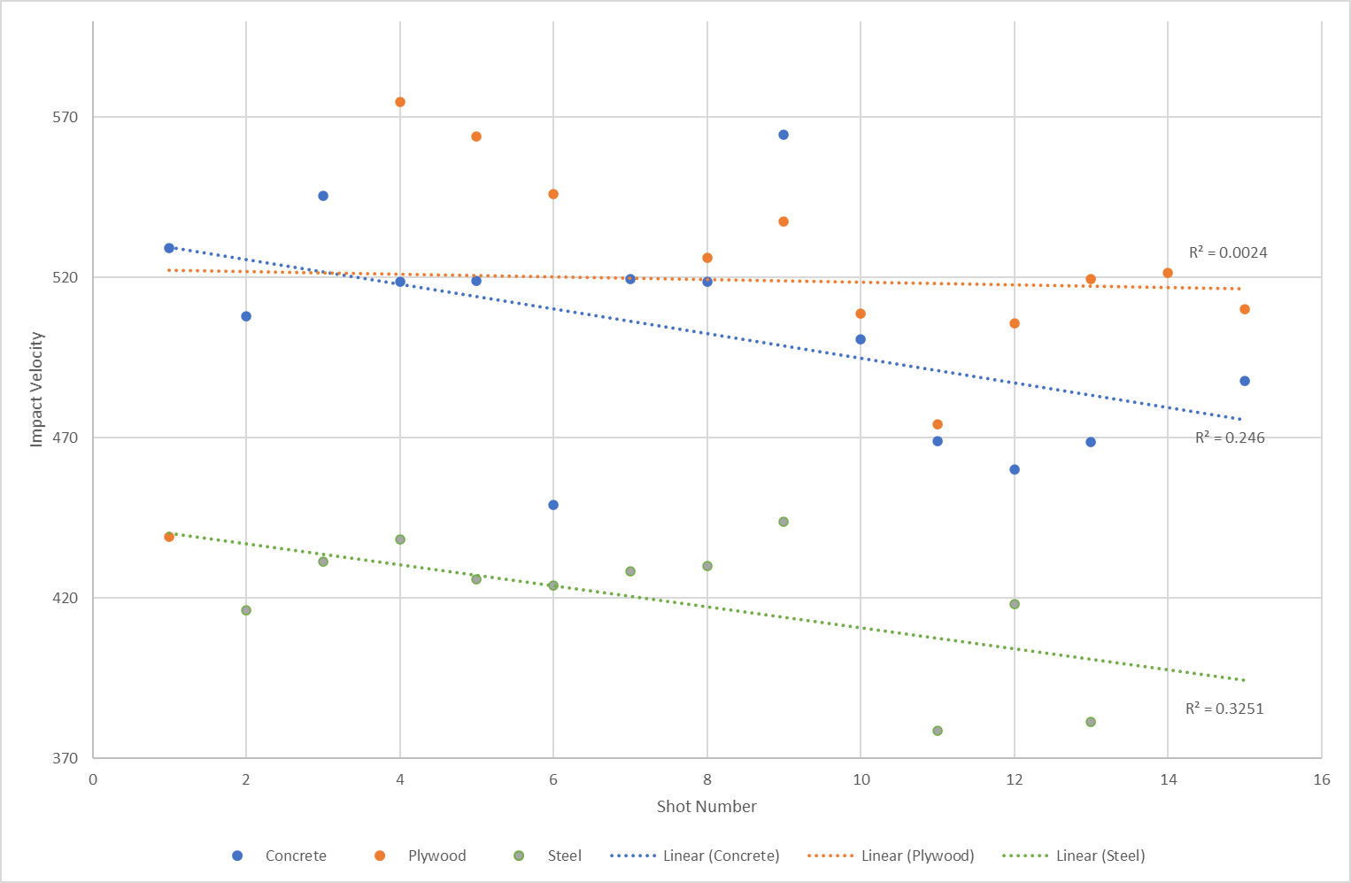

*Figure 22: Recorded impact velocities for all materials (organised by shot number). Lines of best fit are colour coded to the material type and missing points indicate invalid data sets.*

The recorded data across the three datasets show that although small there is a general deceleration of shot with each iteration of distance. It does however also show that this deceleration is subject to many different conditions and forces acting upon the shot itself. This is coupled with the method being used for actually working out the shot speed (detailed in chapter 2) being less suitable for multiple projectiles (as different projectiles will potentially be travelling at different speeds due to shot effects within the column (Crompton, 1996)).

Of the 3 recordings made, two show a slight increase of velocity at 5m which could show that between 3 and 5m there is not enough distance to allow external forces to sufficiently slow projectiles (Carlucci, 2010 & Crompton, 1996). However, it does seem to be sufficient to allow spreading of the shot (measured as area) which greatly aids in differentiation between the two distances. In this way there is a possibility that (with further research and from a scene reconstruction standpoint) there would be less need to treat the shot column as a singular projectile at distances of 3 – 5m, thereby increasing the amount of information on shot behaviours between these distances. It can be seen that the range between the highest and lowest value across the dataset is 196m/s (643f/s) which is not unexpected due to the impacts happening at 3 different distances with a very low BC (0.022) (meaning these bodies will slow down very quickly). The R numbers confirm that the expected behaviours are generally happening (whereby the further the distance travelled, the slower the velocity at impact), however there are 2 potential outliers (shot 1 in concrete and shot 6 in plywood) that do not conform to this trend. To further analyse the data, the results were put through a boxplot and ANOVA testing (as with the muzzle data) to test the data for each set fell within a normal range. The results are shown in figure 23 (below):

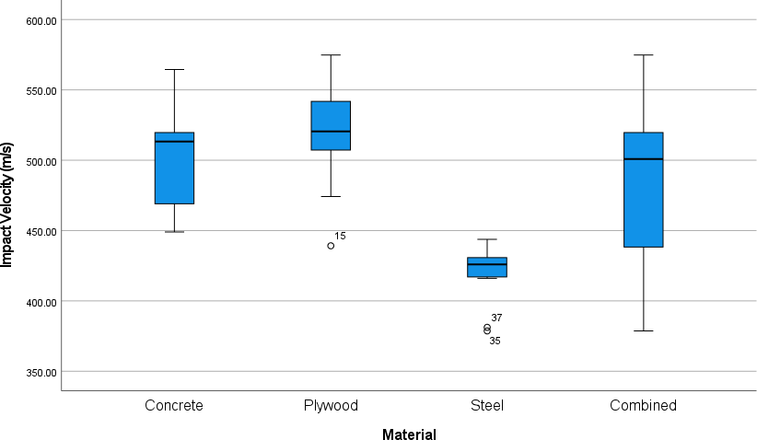

*Figure 23: Boxplot showing spread of recorded velocities (Impact) in individual materials and across all materials.*

The concrete dataset has a spread that shows a normal level of variation for the dataset, this cannot be said for the plywood (where there is one outlier) or steel (where there are two) however the combined data shows a normal variation. The combined median value is around 500m/s and where this is slightly higher in the concrete and plywood sets, the steel samples have a much lower range overall. The outlier for the steel samples both occur at 7m which (as they are both under the normal range) could show that the pellets were abnormally shaped (creating more drag) or that the shot column was longer due to the way the projectiles exited the shot cup (increasing the gap between the first and last pellet). Both of these shots muzzle velocities were within the normal range of that set leading to the conclusion it was a mixture of distance (which shows a clear pattern of deceleration over a distance increase) and an issue with the projectile, not with the internal ballistic event.

When subjected to ANOVA, the recorded impact velocities show that there is a significant difference between the recorded velocities when split by material (.000) but not when split by distance (.382) indicating that each prediction is correct to only use the data for that material. Furthermore, The true recorded impact velocity across all materials was recorded at 483.86 (± 52.73), specifically; the true recorded impact velocity for concrete was 504.21 (± 33.53), for plywood was 519.01 (± 36.95) and for steel was 419.63 (± 21.17). These results are less consistent than in the previous set of data (muzzle v) and show that even at small distance increments there are a lot of variables that could affect the overall speed of the shot column.

The muzzle velocities for steel are far more stable than the other materials and do occur at the lower end of the scale meaning there was less velocity overall and as such it fits that a generally lower velocity would be observed in the impact data. There are a few reasons as to why the steel set was generally more stable and lower, but cartridge makeup and composition is most likely (Rinker, 2008). Other reasons could be the size of each grain of propellant or the ambient temperature of the weapons barrel (Degirmenci, 2015). This is again a reflection on the poor consistency of the shotgun cartridge as a delivery system and also highlights the difficulties that an investigation team face with shotgun ammunition.

## Predicted Impact Velocity

The prediction of impact velocity followed the same procedure as with muzzle velocity to find the optimal model, PCA and input combination. Figure 24 A-D (below) summarises the difference between the model performance and the true measured results for each material.

*Figure 24: Mean predicted impact velocities (by distance (1=3m, 2=5m, 3=7m)) for Concrete (19A), Plywood (19B), Steel 1 (ignorance of deformation damage) (19C) and steel 2 (inclusive of deformation damage) (19D). Red marker (joined by line for clarity) indicates the true mean velocity. Error bars are standard deviation for the repeats at each distance.*

The figure shows a clear decrease in impact velocity as distance increases in all. The figure for concrete also shows that the rate of velocity decrease is steeper after 5m than between 3 and 5m showing that the shot is losing velocity at an increased rate as it spreads and more external forces act upon the (non-aerodynamic) pellets. In plywood the figure shows that the R number (R=0.615) is consistent with the expected decrease in velocity as distance increases. The predictions at 5 and 7m are visually closer than the 3m predictions where they are wildly varied. This could be from a weaker set of data at those datapoints or (more likely) there is a higher amount of variation in the dataset. However there is a slight increase in impact velocity at 5m when compared to 3m which is explained by the abnormally low figure in the 3m set.

The steel 1 figure (ignoring the major deformation by the shot column, concentrating on individual damage sites) shows that the accuracy of predictions get worse as distance increases, this is possibly due to the energy transfer onto the hard steel surface between 5 and 7m being very similar. The abnormally low impacts at 7m should theoretically help to distinguish this but the additional ignorance of the major deformation may also be playing a part. The R number is consistent with expected outcome (more distance = less velocity) however, there is very little change between 3 and 5m velocities with the average of 5m being higher than the average of 3m. The drastic drop in recorded average at 7m is the only reason the R number shows a positive figure. The recorded results give a very similar pattern to the Plywood dataset (but less 100m/s) which is cause for possible further investigation. In the steel 2 figure there is an all-round better level of predictability at 3 and 5m whilst 7m also benefits from the improved distinction between the two lesser distances. This clearly shows that the method which includes using the deformations as damage sites strongly improves impact velocity prediction. There is still a high amount of variation in the 7m dataset, however, none of those predictions are reaching into another distance which indicate a better distinction between the sets.

Unlike with the muzzle velocity (where the predictions were centred around the mean of the dataset and were improved with the averaging of the results), the impact velocity figures are considerably improved on an individual shot basis, therefore the individual shots bear further consideration. Figure 25 (below) shows graphs for each shot across the materials, highlighting their recorded and predicted velocities.

*Figure 25: Predicted impact velocities by shot number for Concrete (20A), Plywood (20B), Steel 1 (ignorance of deformation damage) (20C) and steel 2 (inclusive of deformation damage) (20D). Red marker (joined by line for clarity) indicates the true recorded velocity per shot. Error bars are standard deviation.*

The figure shows a much more conservative decline in impact velocity across all of the materials showing the data is still generally following accepted patterns. In the concrete dataset, shot 9 (a 5m shot) had the second highest muzzle velocity and only just less than the actual highest (shot 2). There are many reasons why this could have happened, for example the density of shot in flight being different, increased pressure in the barrel from the wadding cup compression or an overcharge of powder (this is less likely as these were factory made rounds with high levels of quality control). Similar causation could be argued for why shot 2 in concrete is so low but could also include deformations in the pellets or a faster burn of powder.

In plywood the outlying result was made clear and explained the issue surrounding the 3m and 5m datasets, the very first shot (a 3m) has exceptionally low impact velocity compared to the rest of the set. This very low velocity would have caused the divergence from the normal patterns expected.

This shot also explains the inaccurate average predictions at 3m as well by bringing down the recorded velocity, the predicted velocities are being pulled out as well as the system tries to predict an anomalous value from a pattern dictated by linear relationships in the data. Due to the very low first value the R number (R=0.018) is also low but still indicates a reduction in velocity as distance increases. For the most part predictions across the dataset (aside from the one discussed) are relatively close to their recorded counterparts albeit with a greater amount of variation than in the concrete set (possibly as plywood is a softer material and its behaviours (as described in chapter 4) may give more erroneous data than concrete.

The steel data shows the R number is smaller than in the averaged results but is still showing the expected decline in impact velocity over distance. In the steel 1 set there is very little variation in the 3m and 5m sets which could be due to not including the deformations (as the 7m shots didn’t deform) which in turn could be showing that volume is an important measure not being utilised properly with this method. There is also a high level of variation in the 7m sets which is likely to be due to the makeup and spread of shot damage (more spread, less damage over a wider area). The steel 2 data confirms that the prediction results are more accurate in the 3 and 5m distances and that some models are very accurate at 7m (although this appears to be due to a more conservative or liberal style model predicting either very low or high across the 7m set).

To evaluate which of the models was most appropriate for the data presented, the RMSE and SER figures were analysed. To achieve this the algorithms first reconfigured the data using PCA (principal component analysis). This is a method of finding which datasets have the most variance for the algorithm to exploit and reducing out the impact of the data that does not. As PCA takes advantage of the relationships (variance) in the existing data it would be beneficial to map them visually using a correlation plot. These plots (for each material) are presented in figure 26 (A-D) (below).

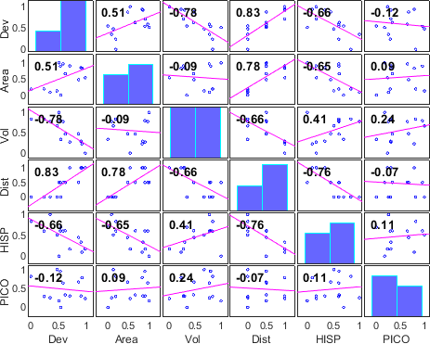

(26A) Correlation Matrix for Concrete Data

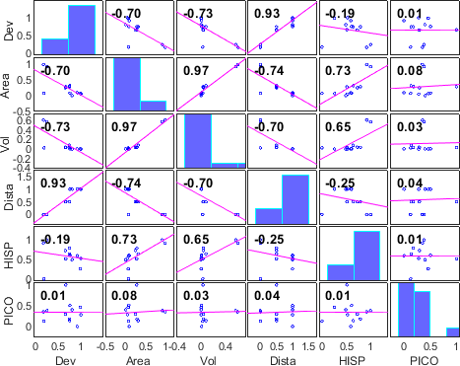

(26B) Correlation Matrix for Plywood Data

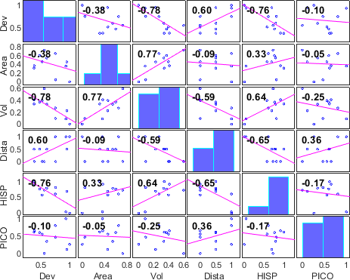

(26C) Correlation Matrix for Steel Data (ignoring deformation)

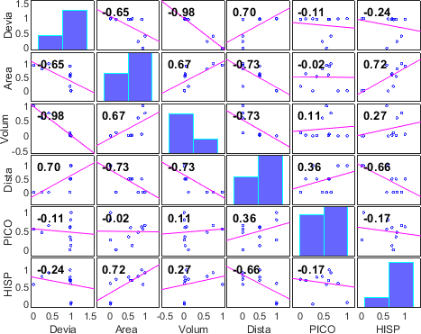

(26D) Correlation Matrix for Steel Data (inclusive of deformation)

*Figure 26: Correlation Plots showing relationships between inputs and outputs. Concrete (21A), Plywood (21B), Steel 1 (Ignoring deformation) (21C), Steel 2 (including deformation) (21D) pink line is line of best fit and number indicates strength of the correlation, a negative number indicates a negative correlation.*

When compared to the correlation plots from the muzzle velocity dataset (chapter 4 section 3.4) it is clear that there are far stronger linear relationships to exploit when trying to predict impact velocity. This is expected at the majority of data is from the impact site itself. Comparing the different inputs with the impact output (labelled HISP), strong relationships are seen within all of the measurement data across all of the materials. Especially strong are the Distance, Area and Deviation inputs with the distance relationship showing extremely strong correlation between the measurement and the measurement data (strengthening the link between distance and the output where it is weak, such as with Plywood). This is normal as the shot will be spreading more with increased distance thus creating more deviation data and more affected area (Heaney & Rowe, 1983). What is interesting is that Volume is decreasing even though the two measures that Geomagic uses to calculate them increases, a decrease in volume is expected with a greater distance as more energy is lost and therefore less is imparted upon the target.

Within the steel samples, volume (thought to be a key factor in prediction due to the materials malleability) has a greater correlation within the steel 1 sample than the steel 2 sample, as steel 1 ignores the major deformation caused by the shot column this is surprising. What is significant is that there are stronger relationships in the data generally by ignoring the deformation caused by the shot column.

The correlations of each input are different in each material and the relationship between certain inputs and the impact velocity are highly varied. Some measurement data is highly correlated throughout but the material behaviours are affecting these relationships. As an example, when compared to the output; Volume data in concrete has a low correlation which is very different to the volume correlations in plywood and steel 1, area data is highly correlated in steel 2 and plywood which could be to do with the materials lack of spalling (where material breaks away from a damage surface

– increasing the area affected, but unpredictably). The models are generally predicting close to the recorded velocity but to find the optimal combination the information from the RMSE and Standard Error of Regression should be analysed. Figure 27 (below) shows the RMSE figures for each of the individual model iterations across all 4 materials.

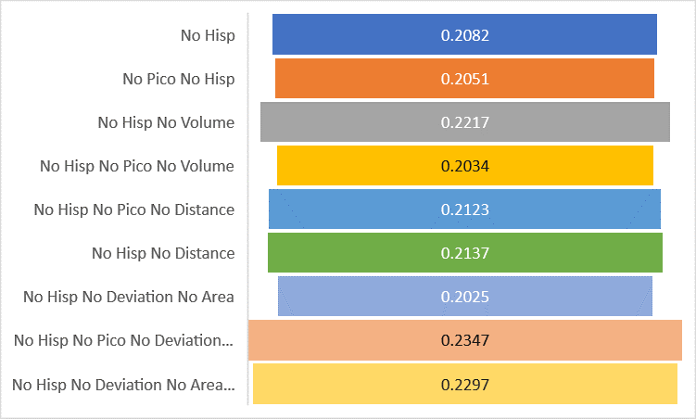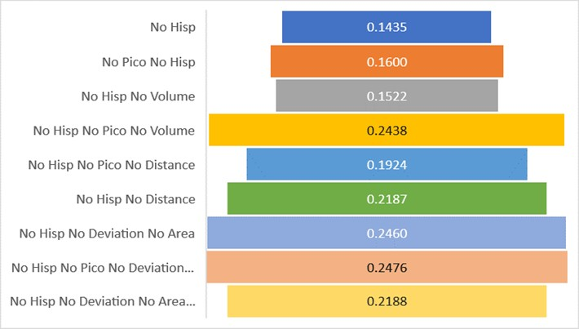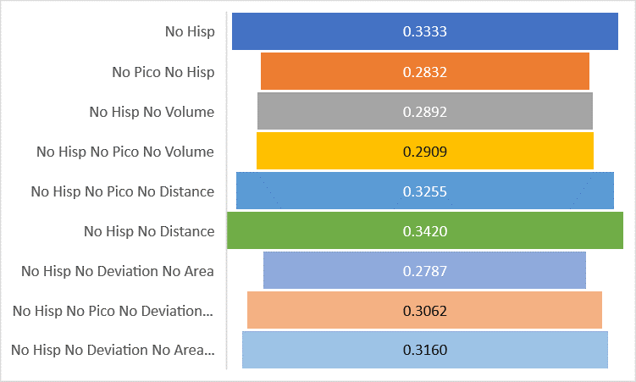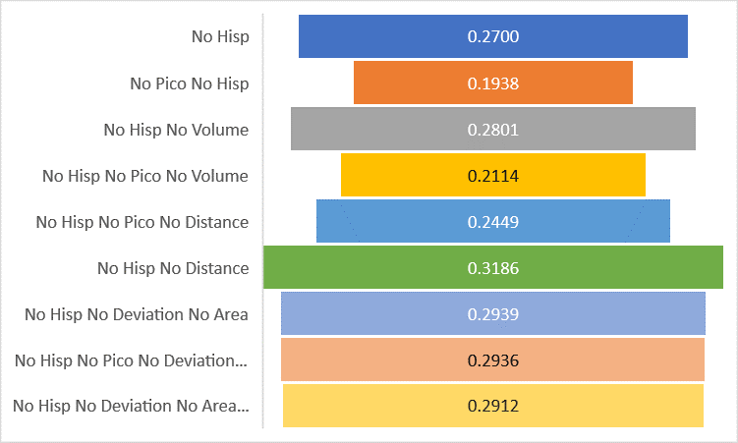

*Figure 27: RMSE results of impact velocity prediction. top left concrete, top right plywood, bottom left steel1, bottom right steel2*

The concrete data shows the RMSE being smaller than in the muzzle velocity dataset which shows that the stronger relationships between the inputs and output are having a marked effect. The optimal model presented ignores the deviation and area data with the second-best model ignoring volume and PICO data, as these inputs have weaker correlations than distance it is obvious that this input would be of major importance and this is shown where combinations missing Distance have a huge difference in RMSE. The plywood optimal input combination includes all available inputs however the two inputs of Volume and PICO seem to have a marked effect on the efficacy of any input combination. The ignorance of either of those inputs seems to have a very positive outcome on the RMSE but both inputs missing has the opposite effect and creates one of the worst input combinations of the set. Interestingly the combination with all available inputs is one of the better performing models in both non-yielding sets and this again is due to the inter-input relationships being strong enough to assist the algorithm.

Although steel 1 provided some of the better correlations between measurement data and the output (generally speaking), the models are producing some of the worst RMSE numbers in impact velocity prediction so far but it is clear that the data is having a far greater effect on these figures. The optimal model ignores deviation and area inputs and other well performing combinations ignore volume. The ignorance of measurement data may indicate issues with the collection method as previously other outputs all relied heavily on at least one measurement. Ignoring distance give the worst outcome which shows that distance is a key factor.

The measured data (deviation, area and volume) appear to play an important role depending on the material being analysed. The RMSE numbers generally show a better set of results than the muzzle velocity predictions and show some very promising input combinations. distance is the variable that affects the accuracy of predictions the most and this is followed by deviation and area with volume being very close behind. This shows that measurement data is highly important as an input but in combination with one another instead of individually. The least important input is PICO data which is the only input that improves a score with its removal. To fully identify the optimal model, the SER data should be considered and is shown as figure 28 (below).

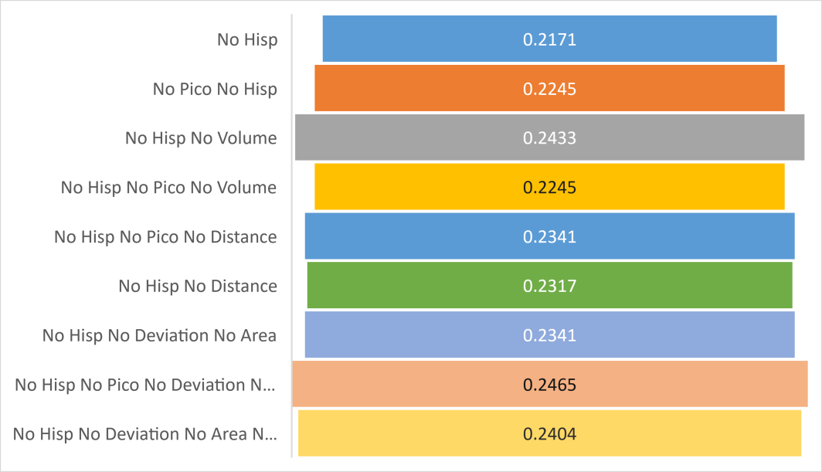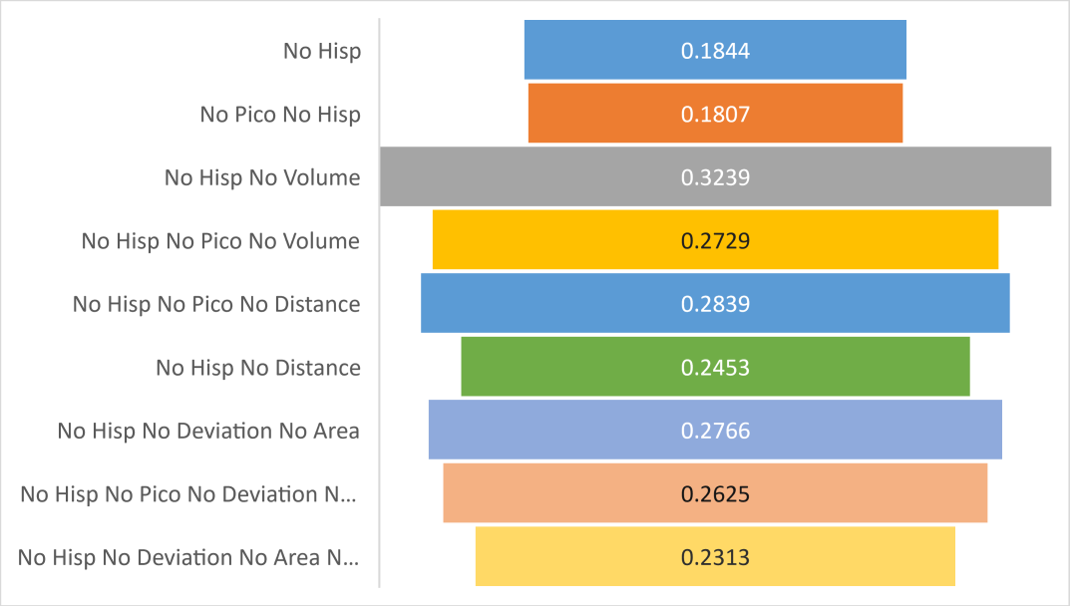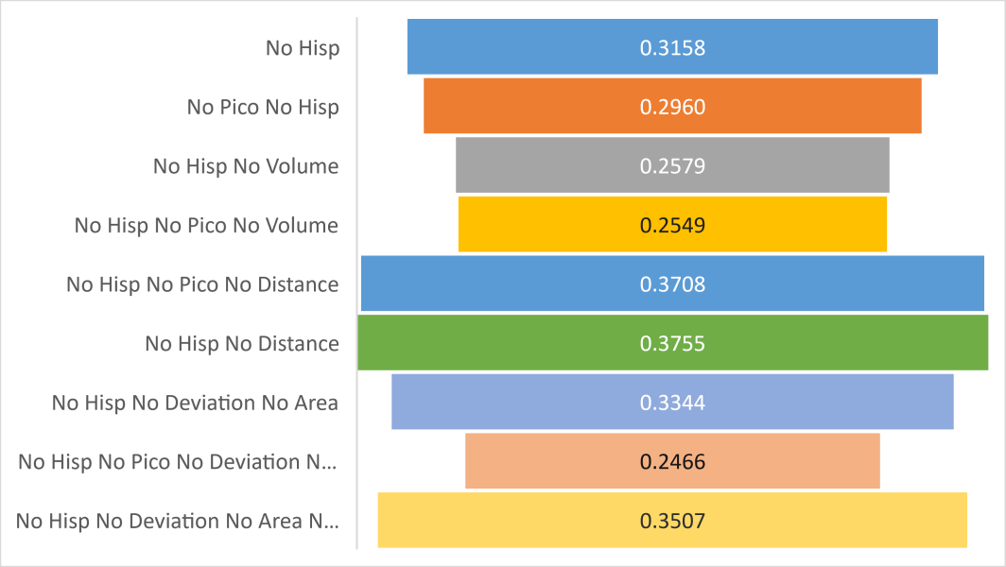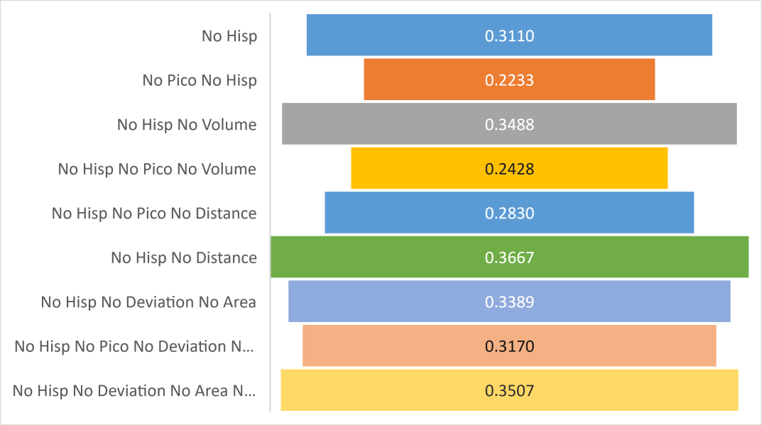

*Figure 28: Standard Error of Regression results for impact velocity prediction. top left concrete, top right plywood, bottom left steel1, bottom right steel2.*

Generally, the SER results show that models have a better level of precision (Frost, 2020) than in the muzzle velocity set, optimal models in the non-yielding dataset either require all inputs to be used or ignore the velocity data (this time from the muzzle velocity recording). Volume appears to be a highly important factor within the dataset, as without volume data present the SER figures become much higher. In the yielding set of data, the first dataset (Steel1) scanned the material whilst ignoring the major deformation caused by the shot mass concaving the material, this method therefore only included damage sites from direct impact marks left behind on the material itself. The reason for this is that data captured more closely relates to scan data that would be captured from a non-yielding material. The second dataset (Steel2) includes the major deformation as a damage site, however; it also means that any individual damage sites within the concave would be included within that site potentially limiting the usefulness of the area data. Optimal models also can ignore either volume data (steel2) or deviation and area data (steel1), however these optimal models do all still ignore any velocity data present.

The optimal method for steel clearly utilises the damage site in its entirety and includes the major deformation from the shot column as a whole. This method makes a fuller use of deviation, area and volume data by obviously including that deformation. Both the RMSE and SER data have been affected by factors affecting the base data.

The true recorded values across each dataset were more varied than with the muzzle velocity data with a larger range of results for the algorithms to work with. The outliers in both the plywood and steel datasets both have affected the algorithms as these were where models predicted least accurately. With a large enough dataset, this problem could be overcome as this increases the chance that there would be more discharges erroneous to the main datasets spread. The attempt to minimise the issue by using LOOP as the validation and verification stage has however meant that some models have predicted very closely to these outlier values, demonstrating the techniques usefulness in a small data management capacity and showing is applicability to this problem over the more traditional splitting of datasets. The number of observations were designed to provide a limited dataset but equipment malfunction/ breakdown was not accounted for, this reduced the amount of samples down even further and as such affected the amount of historical data for the algorithms to use. As a direct result the spread of the data at each distance where data is missing has been affected (such as with plywood at 3m) affecting the standard deviation as well as the standard error of samples. Small datasets have been utilised successfully by Narendra *et al* (2019), Mahmoud & Zohair (2019) and Wang

*et al* (2018) which all show that despite the limitations of size it is possible to get worthwhile models made.

Unlike with the muzzle velocity prediction, the data is highly correlated for impact velocity prediction with the measurement data becoming more valid, this is in line with expected outcomes outlined in literature (Haag, 2021/ Wilber, 1977). The behaviour of the materials at impact (detailed in chapter 4) have had a marked effect on the type of data available. Concrete gave very shallow, open damage sites with evidence of spalling occurring. The reflection in the data shows that the area input is less correlated than plywood or the optimal measure of steel, this would be a direct result of the spalling effect where cracking appears under the point of impact and radiates out further causing material to come away from the target (Haag, 2021/ Robson Forensic, 2021). The expectation that this finding carries forward into the optimal model type is proven correct when looking at the RMSE for the data. Ignorance of the area data produces the optimal model type for prediction, however as area data is always coupled with deviation data (i.e. depth) (for the purposes of analysing the significance of volume), adding them both back in only creates a marginally worse RMSE result showing the importance of deviation data in this set.

Plywood samples (bring a fibrous and softer material) were expected to show an improvement in area data correlation (as no spalling would occur at the satellite sites) but would be more prone to issues with volume or deviation data as pellets became lodged within the satellite sites and the primary site showed an inconsistent profile such as cracking and delamination, creating hidden areas the laser would not be able to penetrate. From the correlation data it can clearly be seen that deviation data has a very weak correlation whilst area is very strong. Moving to the RMSE data this translates into the opposite of what was observed in concrete where the area data is now of more value than the deviation data.

The optimal steel data method was expected to show the strongest volume and deviation correlations as it took into account the major deformation of the shot column. The correlation data shows that in fact, area is the most improved upon with deviation and volume being better in data collected using the first scanning technique. This is due to the area of effect being changed at different distances (and as has already been shown, the general pattern to the data decreases the velocity at impact with increasing the distance).

The correlations within the data only show a partial picture however, the data was reduced using principal component analysis (PCA). This means that the variance in the data (the ability of that data

to affect change in the prediction) also needs to be analysed. Table 13 (below) outlines the data variance in each material for impact velocity prediction.

Table 13: Variance of data (expressed as a percentage) after PCA

|  |  |  |  |  |  |
| --- | --- | --- | --- | --- | --- |
| **Impact V** | | | | | |
|  | **Deviation** | **Area** | **Volume** | **Distance** | **Muzzle V** |
| **Steel1** | 57.20% | 22.40% | 16.50% | 3.80% | 0.20% |
| **Steel2** | 70.10% | 17.50% | 9.00% | 3.00% | 0.40% |
| **Plywood** | 74.20% | 14.10% | 9.80% | 1.80% | 0.10% |
| **Concrete** | 61.40% | 22.40% | 13.50% | 2.20% | 0.50% |

The variance in the data is also telling of the relationships between datasets. In the muzzle velocity dataset it was observed that volume and distance measurements had consistently low variance (decreasing their usefulness to the data) however, volume data has become more varied across all of the materials whilst distance has remained largely the same. As can be seen, the materials all have a more widely distributed variance incorporating all of the measurement data. These variances also shot that the most important variables across the board should be the deviation and area data however as has been shown this is not always the case. Muzzle velocity provides very little variance or correlation between it and the output again showing the disparity between utilising two separate measurement systems or by the unpredictable behaviour of the shotgun cartridge during the discharge event.

With this amount of data the optimal models and PCAs can be discussed, table 14 (below) shows the optimal models (judged primarily by RMSE and secondarily by the SER data).

Table 14: Optimal inputs, PCA and algorithm for prediction of impact velocity across all materials

|  |  |  |  |  |  |
| --- | --- | --- | --- | --- | --- |
| **Material** | **Inputs** | **PCA** | **Algorithm** | **RMSE** | **SER** |
| **Concrete** | Deviation, Area, Volume, Distance | 3 | Stepwise Linear | 0.2050 | 0.2245 |
| **Plywood** | Deviation, Area, Volume, Distance | 3 | Interactions Linear | 0.1599 | 0.1806 |
| **Steel 1** | Deviation, Area, PICO, Distance | 3 | SVM (Cubic) | 0.2892 | 0.2578 |
| **Steel 2** | Deviation, Area, Volume, Distance | 3 | Robust Linear | 0.1937 | 0.2233 |

As in the muzzle velocity dataset, the optimal models share some commonality across all of the datasets which is again encouraging the theory that an “all-in-one” solution could be found (despite the affects the material behaviours at impact are having with the data.

The three materials going forward (concrete, plywood, steel 2) all have the same inputs and a PCA which is at the lowest point before it starts getting rid of larger and larger amounts of variance, this low PCA is encouraging because not only does it match throughout the materials it also shows that the data collected is highly relevant to the prediction of the output. Furthermore, this level of PCA along with the predictions proves that the measurement data collected is highly relevant to this form of analysis.

The algorithms used are all in the linear set which due to the strong correlations between the inputs and output (themselves being linear relationships) is understandable. The fact that the same style of algorithm is being used is again encouraging for an all-inclusive solution being found.

Unlike with the muzzle velocity prediction, it is possible to find a model that works well without averaging the results by distance. However, due to the potential for results that fall to far outside the accepted normal variation of a shotgun discharge and the previous recommendation for this sort of system to be used as a closed system (where no more data than the relevant case data can be used), it would be more advantageous to allow averaged data to become the results (Ramist *Et al,* 1994).

## Application to shooting incident reconstruction

Multiple potential discharge damage sites are found on a building on disputed land. Police are called and a subsequent investigation reveals that both the accuser and accused are licenced shotgun holders both owning 12Ga shotguns. Each blames the other citing reasons of threatening behaviour to gain the land or framing an individual to dismiss the claim. Investigators confiscate both weapons and a limited supply of ammunition from each individual. They then ask the firearm examiner to ascertain which weapon was used. Within the context of this study the method would involve samples being shot and scanned for comparison. The data would be added to the system and a prediction would be produced indicating the relative impact velocities for each weapon at different distances. The results would then be used to assist the expert in their report to provide more objectivity to their findings, identifying which weapon was used and ultimately the shooter.

In this scenario the proposed system could be used as an eliminator alongside the existing methods of reconstruction; scans would be taken of the suspect sites and compared against a series of scanned controls from witness panels. Analysis could take place to assess the likelihood of each weapon and each ammunition causing the damage as well as providing a more detailed comparison with more information than the traditional techniques as described in literature (Haag, 2021).

As stated in chapter 4 (Muzzle Velocity section 2.5), there are other ways in which this system could be of use such as a validation tool to assist experts in objectifying their results. Scan sites being used as virtual evidence in interactive crime scene exhibits (Davey-Jow *Et al*, 2012) or testing the credibility

of suspect or potential witness statements. Finally, from a position of health and safety information could be utilised to gain a rough figure to assist in investigations where the weapon is damaged or the munitions are too unstable to safely test (due to age or condition) (de Klerk, 2015). Another advantage is that this technique could be potentially utilised by units with a reactionary approach to criminal investigation such as non-intelligence led forces or forces with damaged infrastructure such as criminal investigators in warzones or demilitarised areas (UNIDIR, 2021)).

The proposed method and amalgamation of this method into existing tests conducted present a novel data collection and analysis method that has shown to be relevant and applicable to impact velocity work and the prediction algorithm provides a further element of objectivity which would strengthen any interpretation made by an expert.

The prediction of impact velocity is only part of the overall puzzle. Where velocity is useful in forensic reconstruction scenarios it is kinetic energy (Ke) that is the most sought-after information along with Muzzle Ke and Distance (Haag, 2021).

Kinetic energy prediction requires the mass of the projectiles and the velocity of the impact – as the velocity can be predicted – the shot mass can be gained from suspect ammunition. The issue here is that the mass of shot could differ for a number of reasons but considering an “off the shelf” brand (as used in these tests) there is a standardised amount of shot in each cartridge which is counted (Lyalvale, 2020). What is not clear is how to use this weight of shot – is the weight of each individual pellet to be used? Can the total weight be used? From work by Compton (1996) shot from a shotgun is considered a singular projectile up to around 20m from the muzzle meaning that the total shot weight can be used. As these shots are already impacted within and ricocheted from the target – collecting up all of the shot without damaging the damage site or missing some would be impossible so a representative sample could be used from spare ammunition seized from a suspect or from a reference sample taken from the manufacturers. The total weight can be worked out by weighing the representative sample, averaging and then scaling up to the desired number of pellets. For example, if a singular pellet (from a representative sample of 50) weighs an average of 0.03g and the count for the shot in one cartridge is 375 then 0.03*375 would give the approximate total weight of projectile as 11.25g. This could be used in development of less-than-lethal rounds to prevent killing someone or analysing minimum safe discharge distances etc.

## Limitations in impact velocity prediction and further work

The main limitations on this study are the same as with the previous chapter of muzzle velocity as the datasets are the same, as is the technique and the only difference is the output (and obviously another input added in the form of the chronograph data). They are outlined below and illustrate how they are relative to impact prediction.

This study is a proof of concept which outlines a novel technique for the capture and analysis of firearm damage on a hard surface. As this is a proof-of-concept study, further work should build upon this foundation by introducing more data to more thoroughly test the capabilities of the algorithms chosen to understand if they are robust enough to use data from other brands of ammunition or other weapon platforms. As this is a small dataset it can only be said that the results show success for this particular ammunition and target over these particular distances, this means that other combinations may require differing algorithms and PCA combinations to achieve the same results and further testing should be done to resolve this. This supports the addition of guidelines if this form of analysis were to be utilised. For example it could be used as a form of “sense check” or validation protocol (akin to the suggestions in Page *Et al*, 2019) and that each examination is run on a case-by-case basis (Dalby *Et al*, 2010) to prevent inappropriate historical data informing a biased decision on the part of the system.

As the efficiency of shotgun cartridges are poor at both the muzzle and at the target (shown by the variation and erroneous results therein). These differences could have been a manufacturing error or as described by de-Klerk (2015) it could be due to the condition of the ammunition through storage conditions and age. The proposed method doesn’t take this issue into account and as such as previously mentioned, only increasing the same size could this trend be quantified.

Particular to the prediction of impact velocity, the high-speed camera whilst invaluable for capturing the effect of the projectiles onto the target lacked the resolution for clear still images at high speeds which made the process of working out the velocity from these still images time consuming and laborious. Furthermore, there was an inability to identify ricochet from these images due to the poor quality of image which would be a further highly important piece of information to a scene reconstruction team (Haag, 2021). It would be more beneficial to have a different system in place (one that does not need to be in close proximity to the discharge to capture data) as well as having one system to measure both the muzzle, intermediate and terminal ballistic stage such as a Doppler Radar system (Haag, 2019).

Further work should also continue by taking into account the limitations outlined above in this and the previous (muzzle velocity) section:

* + - * Introducing differing brands of the same sized ammunition from manufacturers to test the applicability on a wider range of projectiles. This would test the accuracy, applicability and validity of the findings presented whilst also increasing the sample size to enable the more traditional machine learning training to take place (where datasets are partitioned into training, validation and verification sets).
      * Introducing factors that affect the dispersal of shot and the potential velocity such as increasing or decreasing the barrel length and the addition of full, ¼ and ¾ chokes (Maitre *Et al*, 2021). The difference between manufactured and homemade weapons and ammunition (Hsien-Hui *Et al*, 2014) and the effect of barrel temperature variations (Meng *Et al*, 2013)
      * Investigating the use of either velocity radar (Jiang *Et al*. 2021), Doppler Radar (Haag, 2019) or ASAP (Decker *Et al,* 2017) as an alternative velocity measure in lab-based tests as these systems have been shown to be more effective at measuring multiple projectile flight paths and record the velocity across the entire travelled path of the projectile (See Chapter 2, section 2.1).

## Conclusion

The novel method presented in the previous chapter to predict muzzle velocity was successfully utilised to predict the velocity of impact on a small dataset using laser scanning metrology data. The chapter shows that it is possible to predict the average impact velocity of a shotgun discharge. Table 15 (below) shows the optimal models for each material.

Table 15: Optimal impact prediction models showing widest residual difference between the average predicted and the average recorded velocities (averages grouped by distance)

|  |  |  |  |  |  |  |
| --- | --- | --- | --- | --- | --- | --- |
| **Material** | **Inputs** | **PCA** | **Algorithm** | **True Average (m/s)** | **Predicted Average (m/s)** | **Difference (m/s)** |
| **Concrete**  **Plywood Steel 2** | Deviation, Area, Volume, Distance | 3 | Stepwise Linear | 510.55 | 505.32 | -5.23 |
| Deviation, Area, Volume, Distance | 3 | Interactions Linear | 526.04 | 532.38 | 6.34 |
| Deviation, Area, Volume, Distance | 3 | Robust Linear | 392.6710501 | 379.2655273 | -13.40552284 |

As can be seen, the algorithm is capable of predicting accurately and precisely using a small, localised dataset. All of the optimal input combinations, PCA and algorithms broadly matched which shows great potential for future work around these models. The metrology software exploited by the laser scanner and metrology software has shown again to provide highly relevant and pertinent data.

In summary, the project has revealed some significant points in the prediction of the impact velocity with a small dataset.

* + - The method for impact velocity prediction differs from that of muzzle velocity prediction in steel as the deformations caused by the overall shot mass are now included as damage sites. This shows that this method is the most suitable and that individual material behaviours have a larger part to play in not only the data retrieved by the system but also on the data retrieval method itself.
    - The area data in the 3 and 5m shots suggest that projectiles are not behaving as a singular mass at these distances, instead, it seems like some of the shot is behaving independently of the column at these distances. Which differs from the findings and general understood ballistic theory (Carlucci (2010) and Crompton (1996)).
    - Averaging results give outcomes closer to recorded data averages which supports the use of this in conjunction with existing techniques to provide a kind of validation for experts to use to give a level of objectivity.
    - The data gained from the damage sites are highly suited to the prediction of impact velocity (no doubt because they are a direct result of said impacts).
    - It is not necessary for velocity data to be needed to predict impact velocity and with further work on fine tuning the models there is a real possibility of finding a linear solution (As suggested by Heaney & Rowe for distance estimation (1983)). A linear solution would be simpler for a lay jury to understand and therefore would be of more use if the expert was called before the court to explain the algorithm and any conclusions made.

The chapter has shown that the same dataset as used in the previous chapter can be used to predict velocity at impact, this is of little surprise as the general relationship between the speed data and the metrology data remains the same (for example the lower the overall velocity – the smaller the overall impact and as such the lower the deviation data will be). As the data has shown to be useful in predicting velocity – attempting to utilise it for a completely different set of data (i.e. the range) will provide a further test in the data robustness and examine the effectiveness of exploiting an output with a radically different relationship profile. The next chapter will look at utilising the data to predict the distance of the discharge event - a critical piece of information for investigators.

# Chapter 6.0 Distance Prediction

## Introduction

The estimation of shooting distance in a firearm discharge event is a key factor in directing search efforts and determination of this distance can also be used (in conjunction with angle of entry and stringing techniques) to help precisely locate the position of the barrel at time of discharge; for example, the Oscar Pistorius trial from 2014 used this style of ballistic evidence to identify where the accused was and whether he was in a standing or prone position (Sky News, 2014).

This is of importance in any shooting reconstruction scenario as determining the positions and stances of shooters (especially in multiple shooter or in hostage rescue situations) and victims enables investigators to give an accurate account of rounds discharged and who did what damage (for example during the Lindt Café Siege in Sydney (2014) where officers were potentially responsible for killing a hostage due to the calibre of weapon being used in close quarters (ABC news, 2014)).

In research, although the literature is quite scarce (Oura *Et al*, *2021*) the distance estimation of shotguns is a well-established science with a robust and reliable technique (Haag, 2021) consisting of firing the suspect weapon and ammunition at target plates, the area of the shot is measured and this is compared to the suspect mark. Recent developments within interpretation of shotgun patterning have provided the area with a more contemporary basis and continues to push to find new ways of improving upon the well-established practice. Reasons for the renewed interest in shotgun pattern analysis include the wide variation in ammunition types for shotguns and the effect of these projectiles on the spread of the weapon (Meric *Et al*, 2020), the effect of additional accessories for the weapon such as chokes (Arslan *Et al, 2011*) on the estimation of distance and the use of existing technology to estimate shooting distances under 1m (Bolton-King *Et al,* 2019). Currently however, there is little information (except what has already been presented in this thesis) on using scene capture techniques such as laser scanning and machine learning in a regression style. Deep learning has been used to classify between two different distances of a shotgun discharge but has not been utilised in a regression style or with the restrictions this study has in place (to emulate a real casework scenario) (Oura *Et al*, 2021). The work also only classifies against 2 distances (10m and 17.5m), the deep learning algorithm also requires much more information than is typically available at a scene (Microsoft, 2021). Deep learning also has higher requirements for hardware making expenditure on better IT infrastructure necessary (Microsoft, 2021). Time is also a factor when comparing machine learning to deep learning as the algorithms typically take less time to run in the machine learning type (Microsoft, 2021).

Typical range estimation protocols are described by multiple forensic practitioners, one such example is Haag (2021) who states that distance can be ascertained by the use of firing the suspect weapon and ammunition at witness panels of known distance and comparing the spread (area of effect) results to the measurements taken from the crime scene. As previously stated and observed in the previous chapters (chapters 5 and 6), shotgun ammunition is likely to create outlying results in either muzzle or impact velocity. Therefore, it can be ascertained that witness panels alone will not account for abnormal behaviour from shotgun projectiles, therefore a system that introduces more variables and a machine learning algorithm may be of use in distance estimation as well as in the (already proven) muzzle velocity and impact velocity prediction.

The specific research questions to be addressed within this chapter are:

* + - Can distance be reliably predicted using the novel method developed in this thesis?
    - Which machine learning algorithms and test firing parameters are important in generating a repeatable and accurate prediction of distance?
    - To what extent do the properties of the terminal surface impact on the predictive capability and potential application of this approach to future casework?

This chapter aims to utilise the methods developed in the method section (Chapter 3) to try and predict the distance of a discharge event. There is a well established and robust field around the estimation of distance from literature and it is considered a staple of scene reconstruction efforts (Haag, 2021). This chapter is designed to provide a technologically inclusive method that builds upon the findings of (Oura *Et al*, 2021) and provides a novel method of data capture and analysis to try and further enhance the objectivity of distance estimations. As stated in the other results chapters (Chapters 5 and 6) this work also potentially addresses the recommendations of the Presidents Council of Advisors (PCAST, 2016) to improve forensic science research and developing the admissibility of expert testimony.

Incorporation of machine learning through image analysis has shown to be effective (Oura *Et al*, 2021) in the classification of discharges to known distances but there is little on treating the problem as a regression and utilising the latest technologies such as laser scanning (which have been shown to be highly effective in other fields of forensic analysis such as forensic engineering (Park *Et al*, 2017), Document analysis (Farid *Et al*, 2021) and Anthropology (Sholts *Et al,* 2010)). As has been shown in previous chapters this is possible and can potentially add a suitable level of validation to an expert’s interpretations.

In overview, the rest of the chapter contains the methodology for this part of the project with details of changes from the previous methods in muzzle velocity and impact. The results section details all of the results of the prediction of distance. This section will also detail the observed behaviours of the target materials at impact. In subsequent sections these illustrated behaviours will be discussed and applied to the discussions of both this and the subsequent impact section. The final sections will demonstrate the potential use of distance prediction by employing it in a fictitious case-based scenario and an examination of the limitations of the technique.

## Methodology

The method remained the same as with the prediction of muzzle and impact velocity. The same data was used as was collected for muzzle and impact prediction. Therefore the missing data (due to equipment malfunction) remained the same. The only change was that the muzzle velocity (“PICO”) became an input and the distance (“Distance”) became the output. Running the algorithms remained the same as did the validation process (LOOP) and deciding on the optimal model via the RMSE. Chapter 3 provides a detailed account of the methodology; a brief graphical chart of the process is presented in figure 29 (below).

classify damage as either Primary or satellite damage and code with a Locus number



Data Normalised between 0-

1



Correlation

plots to show individual input relationship s

Machine

Learning Toolbox selecting K-fold validation at *n*



PCA

Applied



Algorithms

run, Lowest two RMSE identified and brought forward

PCA

Lowered by one (minim um of 2 inputs required).



Graphical representation of Predicted vs Recorded value

*Figure 29: Flowchart showing the data retrieval and machine learning process.*

Again, Microsoft Excel (version 2108) was used as the data collection programme and for subsequent normalisation before transferring to MATLAB (version 2020a). MATLABs Regression Toolkit was used for PCA and machine learning functions. Data was then transferred manually back to Excel for de- normalisation and Excel was again used for all graphical representations.

## Results

## Potential Input Combinations

The potential input combinations for distance prediction were different to the muzzle and impact velocity combinations as this output was very different to the other two outputs used, therefore swapping one for another was not practical and a different set of input combinations were devised (Table 16, below).

Table 16: Input combinations for the prediction of distance.

|  |  |  |  |  |  |  |
| --- | --- | --- | --- | --- | --- | --- |
| **List of Input Combinations** | | | | | | |
| **Combination Number** | **Distance Output** | | | | | |
| **Deviation** | **Area** | **Volume** | **Distance** | **Pico** | **HISP** |
| 1 | ✓ | ✓ | ✓ | Output | ✓ | ✓ |
| 2 | ✓ | ✓ | ✗ | Output | ✓ | ✓ |
| 3 | ✗ | ✗ | ✓ | Output | ✓ | ✓ |
| 4 | ✓ | ✓ | ✓ | Output | ✗ | ✗ |
| 5 | ✓ | ✓ | ✓ | Output | ✓ | ✗ |
| 6 | ✓ | ✓ | ✓ | Output | ✗ | ✓ |
| 7 | ✓ | ✓ | ✗ | Output | ✗ | ✓ |
| 8 | ✗ | ✗ | ✓ | Output | ✗ | ✓ |
| 9 | ✓ | ✓ | ✗ | Output | ✓ | ✗ |
| 10 | ✗ | ✗ | ✓ | Output | ✓ | ✗ |

Although the input combinations changed to better suit the output type, the method for working out the optimal combination and model did not change. Between studies the selection of inputs is governed by several factors. The main factor is that the output is not used as part of the inputs, however a secondary part is to look at the type of data and how useful it is in combination, for example, is deviation and area better than volume or do all need to be present? Selecting the inputs in this way ensures that any data not needed by the algorithm can be readily identified. Due to the amount of literature surrounding distance estimation from the damage site it is also appropriate that the physical damage sites themselves are catalogued and discussed.

## Effects of energy transfer on target surfaces

Results are organised by material to better understand and analyse the behaviour of each material when presented as a target. As stated previously, materials have been selected to provide a wide range of material behaviours to analyse and potentially exploit. It is expected that the behaviours of each material will have a significant effect upon the data that is recovered from the targets. As has been observed in the muzzle and impact prediction chapters, correlations in data due to the physical impact have changed as will the overall variance when PCA is applied. This will potentially mean that an “all in one system” cannot be found and that a case-by-case basis (Dalby, *Et al*, 2010) is optimal for this sort of reconstruction. In the set of tests conducted, there were few flyers to contend with, probably a direct result of using standardised, professional quality ammunition from a reliable source. As these have not been investigated (as they have not appeared), the effects of such pellets can only

be a matter of conjecture however, one or two errant pellets in a cascade of 300+ would not provide much detraction from the data recorded at the main site. This highlights an advantage of utilising the actual damage as opposed to the current radial method is that these could be considered and included without needing to decide if they are or are not flyers (which would normally be ignored) (Haag, 2021).

Concrete data was procured from discharging the shotgun onto slabs of 600x600mm compressed concrete. As stated previously in chapter 2 (section) concrete materials exhibit a range of differing behaviours when subjected to a ballistic impact. For a forensic ballistics’ practitioner, other terms are used as opposed to the terms above (which are engineering and material science terms). The two most important are “yielding” and “frangible”. Yield in a material shows deformation when subjected to a ballistic impact but will generally not loose mass until it breaks (Haag, 2021), the more yielding a material the more it will deform before breaking (plugging or shear). Frangible materials will display cracking, plugging and spalling behaviours and is a catch all term for materials that will display those behaviours over yielding (Haag, 2021). Figure 30 (below) shows the physical effect of the pellet strike onto the concrete slab.

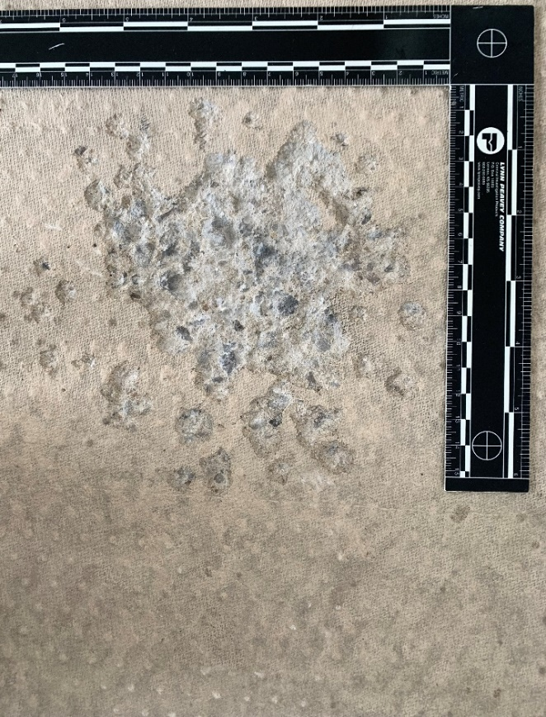

Figure 30: Concrete damage site with scale. This shot was from 3m, the large central primary damage site (blue circle) is made of separate damage sites however the behaviour of the material has bridged these to create the large central site.

The key damage features in the concrete can be observed in figure 25 (above). Darker areas within the damage site are lead shot deposits that have adhered to the concrete surface (blue shaded circle). Most of the shot has ricocheted after striking the target which will need consideration when Analysing KE at the impact site (as not all of the KE has been transferred to the target). This may be automatically considered during the prediction (albeit unknowingly by the system). Satellite shot on the outer edges of the damage site (example in yellow shaded circle) are roughly spherical in shape and were created by cracking and spalling of the material upon contact with the projectile. Sections are present where multiple shot has impacted upon the same area (which may explain the adhesion of lead deposits in some parts). Lighter areas show an increased depth of damage site (due to revealing material not exposed to atmospheric conditions or revealing a separate inner layer of compressed material).

Limitations of detail on a photograph of the damage site can be clarified by utilising the depth map from the Deviation of Tolerance Analysis, which shows more detail in terms of depth of the damage site. The deviation of tolerance of the scan mesh (Figure 31, below) enabled a fuller picture to be drawn of the depth and spread of damage.

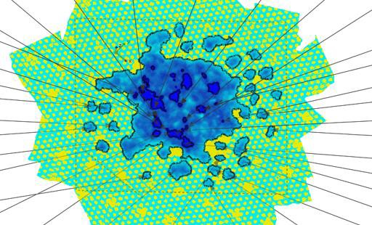

*Figure 31: Deviation of Tolerance Analysis of a concrete sample (3m distance). Darker hues indicate deeper perforations whereas brighter hues (yellow) indicate lumps in the structure that exceed the flat surface (Green).*

From the scan of the damage site, it can be seen that there are deeper perforations where multiple shot has impacted on already created sites. These deeper perforations have occurred in a roughly circular area and in the primary locus of the shot which fits with expected ballistic behaviours from a professional quality shot shell. More importantly the lighter blue areas around each damage site

indicate a gradual tapering, showing the spalling of material and a potential for each damage site to be wider than counterpart sites in other materials.

At different distances, the damage varies to a considerable degree. At 3m there is typically a large, centralised damage site which has an irregular and rounded shape. The surface of the damage site is granular and irregular in depth (as this material is not homogenous, there are much harder aggregates within that will not be impacted in the same way as the plain surface texture). The damage overall is quite shallow in appearance but very clear in comparison to the actual surface. The satellite impacts are very large (which could be due either to multiple impacts creating an overall larger site or from cracking and spalling of the site) and some of these sites are connected indicating very close impacts. There are also irregularly shaped and distributed gaps in between the satellite impacts.

In comparison, at 5m the central damage site is smaller in appearance but still has the same morphological characteristics as in the 3m. As expected there is more satellite shot which again displays a similar although smaller morphology. There is a greater irregularity to the distribution and gaps in between the satellite impacts. At 7m there is no easily identified central mass of shot however there are high concentrations of clustered and overlapping impacts in the interior of the damage site. There are much higher numbers of satellite shot with an even greater degree of irregularly distributed gaps than with shorter distances.

Concrete samples differ enough that these differences could be used to tell very roughly the closest of the shots from the furthest. This means that the damage profile should be sufficiently different to provide numerical data that can determine distance as a predictable output.

Plywood samples were collected from 600x600mm machine sawn squares of structural grade plywood with a 25mm thickness. Figure 32 (below) shows an example of the pellet damage on one of the test boards.

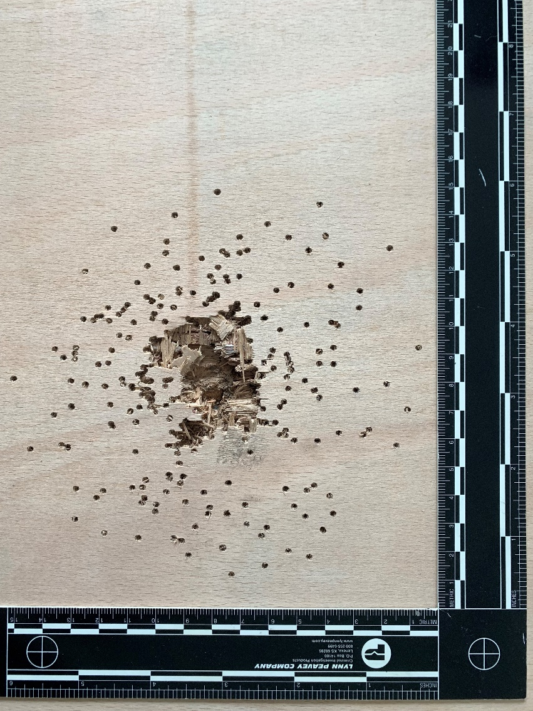

Figure 32: Plywood sample with scale, this shot was from 5m, singular pellet strikes are extremely clear however other behaviours such as compression (red), delamination (orange) and matrix cracking (Green) are highlighted.

Key observed damage features shown in figure 32 give a very clear pattern where single (locus 3, circled blue) and double (locus 4, circled orange) pellet damage sites can be discerned. The primary damage site shows that cracking has occurred between individual impacts and some delamination has occurred (an underlayer is clearly visible and is circled in green). Compression can be seen (circled in yellow) where the wad has impacted the site and a highly magnified view may also show compression around individual sites. The most serious damage can be seen in the central damage site where multiple impacts have broken through multiple layers of laminate but have ricocheted back out of the target site (due to kinetic loading) giving the outward facing splinters seen within.

Unlike with concrete, the damage site with the equivalent distance in plywood will have a smaller area numerically as there is far less collateral damage around each site. This could have a marked effect on the accuracy of any predictions made between material sets, lessening the chance that a singular model can be found for the three outputs across the materials without the addition of another input or classifier algorithm. It is also important to note that forensic practitioners utilise a blanket approach to area (taking the two furthest points that are not deemed “flyers” and linking a circle through these points to give the affected area (Haag, 2021)).

The fundamental difference is that the experimental technique employed within this investigation gives a more accurate definition of “affected area” as the software used to analyse the scans enables individual damage sites to be picked out in between non-damaged areas (with a margin for a user overlap).

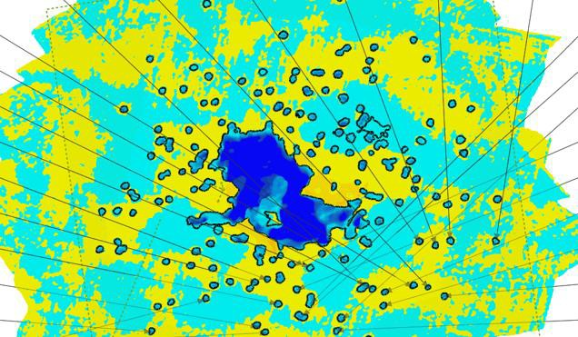When looking at the scan data for the Plywood further information can be gleaned. Figure 33 (below) shows the corresponding scan and Deviation of Tolerance map data.

*Figure 33: Deviation of Tolerance Analysis of a Plywood sample (3m distance). Darker hues indicate deeper perforations whereas brighter hues (yellow) indicate lumps in the structure that exceed the flat surface (Blue/Green).*

Note that the variation in the zero-surface indicates that the plane (helping to determine the zero- surface) found that the surface was not uniformly raised (such as in the concrete samples). The other point to note is that the colours are a visualisation of the relative depth and should not be used without the measurement data. What can be seen is a highly irregularly shaped damage site with a raised area of material (possibly raised during a ricochet, or that has somehow escaped contact) from a laminated area below. The individual spread of the discharge also appears wider than with the steel samples, due to the softness of the material allowing individual pellets to create very localised damage without adversely affecting the material surrounding it. This will create more data per URN which when, averaged out (to create the final dataset), will give a smaller numerical profile.

At different distances, the damage to the target surface varies in both type and severity. At 3m the damage sites all have similar characteristics which help to distinguish from a 5m or 7m shot. 3m distanced impacts all display an irregular central shot mass where the pellets have created damage through multiple layers of laminate material and most of these sites also display some form of splintering facing outward (explained previously). There are also only a small number of satellite impacts around the central mass and some of these are connected damage sites (where multiple shot has impacted around the same area) and these satellite impacts have a more uniform distribution. Finally, there is little or no evidence of piston cup impact on the damage site itself (possibly because it hit the already heavily damaged target area or impacted outside the damage site itself).

With 5m distance impacts there is no large central shot mass. Rather, there are multiple high concentrations of clustered impacts, one reason could be the fibrous nature of the material which has mainly compressed under the impact (as evidenced by the neat singular pellet holes in the satellite). This shows that far less material is being affected by the clustered impact than with the concrete (of which spalling and cracking occurred, removing sections). Extremely high clusters of shot still create damage enough to produce a central damage site but these are not to the same scale as when compared to the concrete sample. There are also clearer impressions from the piston cup striking the target face within the damage area. These are mostly round or rounded indicating a head-on or rear-on strike rather than a strike on the side. There is a larger number of satellite shots than with the 3m samples (which is to be expected) but there are also large, irregularly shaped gaps in the distribution of the satellite shot on the outer edges, indicating the outer shot is more widely affected by the air and by its shape than the closer formation of shot in the central column.

At 7m distances there are fewer clustered or connected damage sites than with the shorter distances (indicating that the shot is spreading out further) There are also irregularly shaped impressions where the piston cup has struck sideways on rather than head or tail first. It is very difficult to visually identify the primary damage site from these impact distances as the spread of the shot is far wider than with the shorter distances. This suggests that as the distance increases the spread will also increase, this is a well-known behaviour of shot (and is the reason for the development of the choke) (Compton, 1996/ Rinker, 2006/ Wallace 2008/ Haag 2021). With more data (for example more shots over more distances a pattern should emerge giving further detail to the spread over the entire shot length.

With the plywood samples it is possible to tell which projectiles have travelled the furthest before hitting the striking surface, the behaviour of the material is (like with concrete) suitably different to make these assertions and warrants further investigation as to the effect of material type on the type of damage recorded at the scene. If steel has a similarly distinct pattern in damage type and the change in that damage over distance then close-range damage can be very easily mapped and this can be used in conjunction with the damage site data to further validate an expert’s decision.

Steel samples were collected from 600x600mm machine cut squares of CR4 grade cold rolled sheet steel with a 1.5mm thickness. Forensically, steel is a yielding material due to the properties of it

bending and deforming under ballistic impact (Haag, 2021). Figure 34 (below) shows the ballistic impact onto sheet steel.

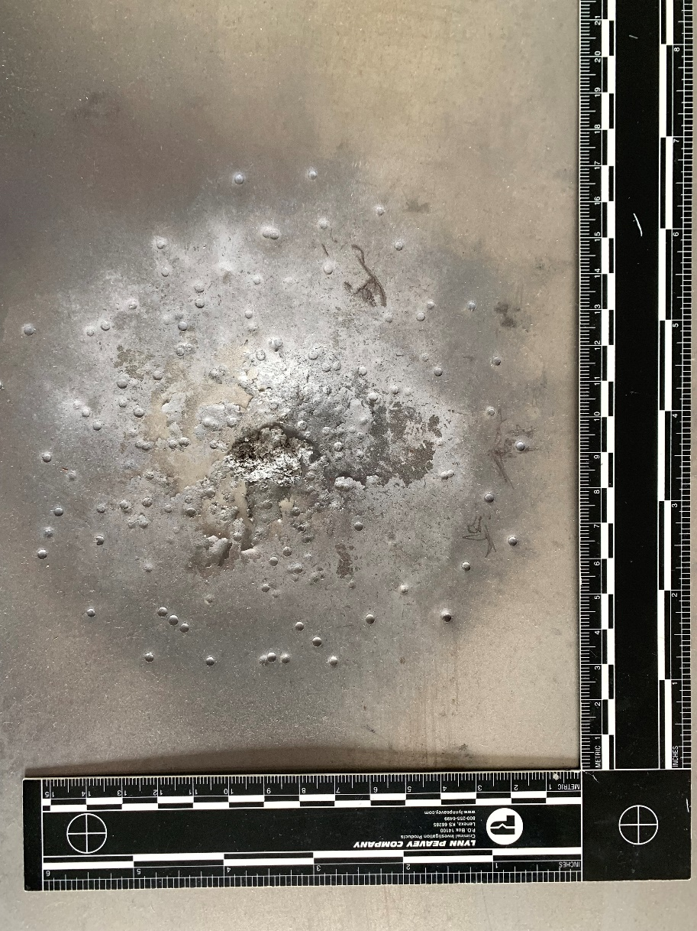

Figure 34: Steel Target after discharge, Areas of interest are the collection of Lead "cold welded" to the target surface (blue) the pellet strike pattern and grey powdering (different from ROCOL - which is white)

The key damage factors and behaviours can be seen in Figure 34 (above) where evidence of the material’s ductile nature can be clearly observed; the rounded edges of each damage site and the dimpled appearance indicate a high level of plasticity (Haag, 2021). However, these are relatively shallow damage sites which shows the softer lead from the pellet is not imparting much KE before the steel has become kinetically loaded and ricochets off the target face. This has happened in the satellite shots; however the central damage site has a mound of lead cold welded to it (i.e. stuck by high amounts of pressure).

This phenomenon is likely caused by the increased number of projectiles in that area, all exerting kinetic energy upon a small target area in a very short space of time. The pellets deform on the target surface but are quickly followed up by more shot. The lead already on the surface absorbs more of the kinetic energy from subsequent shots, flattening these pellets further and diffusing the KE through a larger/thicker area, decreasing the amount of energy upon a single point and allowing more projectiles to land and embed without ricochet. As a result, spalling has occurred where the lead has been flattened to such a degree that it has cracked and started to come away from the surface. The plates themselves needed extra treatment with Rocol powder to allow scanning and some of this residual powder is still visible (right of the damage site). However, this should not be confused with the darker grey deposits around the damage site which are possible cartridge discharge residues (CDR) and are known to be captured on targets at close ranges (Wallace, 2008). Limitations of the photography can again be lessened by utilising the Deviation of Tolerance colourmap data (Figure 35, below).

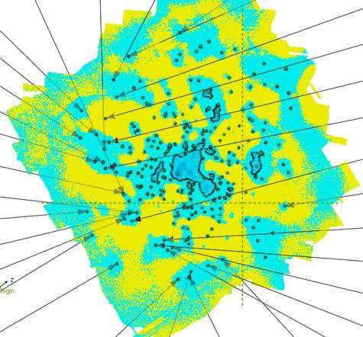

*Figure 35: Deviation of Tolerance data of shotgun discharge onto steel (7m)*

The pattern has more similarity with the plywood than with the concrete – however the damage sites are far shallower and much smaller (individually) owing to the fact that the target material is harder.

Each of the materials produces very different strike patterns which could greatly effect finding a suitable model to cover each medium, rather than just the relative strength of the material vs the strength of the projectiles. As noted previously, concrete is a hard, frangible material that cracks and spalls under ballistic impact. This type of damage could be classed as a “mass removal”, where material

is forcibly removed by the ballistic impact cracking the material. Similarly, the plywood would be a “mass removal” type of damage although the mechanics of this removal are different due to the fibrous nature of the wood’s makeup. Steel does not lose material (unless the velocity and round are of a suitable type that a plug occurs (Jankowiack *et al,* 2014)): instead, it deforms affecting a much wider area than the previous materials making a direct comparison between the two sets difficult. Although not unexpected, the scale of the differences and the numerical data produced will make it harder for the models to differentiate between each material and still provide a realistic prediction. It does however give the opportunity to analyse the data for each material separately to further investigate which inputs are important and whether this changes with the material in question. Also of interest is how different distances produced drastically different material behaviours and how these could be used to classify or indicate distances from discharges when put through the machine learning algorithms.

Impacts at the same distance show a non-uniform and irregular pattern to the individual damage sites created, causing potential confusion for the algorithms (especially in frangible materials like concrete. With multiple shots and averaging of results become easier to define. One example is the similarity between 5 and 7m within the Plywood samples. The Plywood data shows that certain elements of the scans are extremely similar to their counterparts highlighting a potential issue with utilising the actual area data over the more traditional general area of effect (where the spread is analysed as a radial measurement).

## Predicted distance

Recording of the distance was different to the recording of velocity as the distance was not subject to the dynamic variability that is present when analysing velocity, requiring greater detail with the numerical values provided. Furthermore, it should be noted that practitioner texts tend to use whole numbers for distance estimation (however, as these guides are mainly American, they work in feet and inches) (Haag, 2021). It was decided to emulate this style and use whole numbers at 2m intervals starting with 3m (as this was the minimum safe distance required to fit all of the velocity recording equipment and give the pellets a chance to spread so that satellite shot could begin to show). The jig was checked after each shot but there was no movement of the jig due to the firing process.

Figure 36A-D (below) summarises the optimal models from each combination, as the same data was used as with the muzzle and impact velocity, the same samples that contained missing data are also missing here. The mean interim distances for the optimal model in each material were 3.1m (± 0.40 or 13.3%), 5.4m (±0.88 or 16%) and 6.5m (± 0.40 or 6.2%) for concrete; 3.5m (± 0.84 or 26.7%), 5.1m (± 0.22 or 4%) and 6.8m (± 0.58 or 8.3%) for plywood; 4.5m (± 1.45 or 48%), 4.8m (± 0.26 or 5.2%) and 6.1m (± 0.71 or 10.1%) for steel (ignoring major deformation); 3.4m (± 0.81 or 27%), 4.7m (± 0.44 or 8.8%) and 6.5m (± 1.29 or 18.4%) for the second steel set (inclusive of major deformation).

*Figure 36: Mean predicted distances (shot grouped by distance (1=3m, 2=5m, 3=7m)) for target materials: Concrete (31A), Plywood (31B), Steel 1 (ignorance of deformation damage) (31C) and steel 2 (inclusive of deformation damage) (31D). Red marker (joined by line for clarity) indicates the true recorded distance per shot. Error bars are standard deviation.*

The target material’s behaviour at impact is expected to greatly influence the data recovered; if the material is frangible or brittle then all of the impact data (Deviation, Area and Volume) should become highly important. It is noted by Haag (2021) that each material should have distinctly different impact behaviours and therefore physical manifestations depending on the class of material.

The figure shows the effect different models have when multiple predictions in the same group are averaged out which better demonstrates the relative accuracy over each set distance. From the figure is can be seen that most average predictions are within 1m at 3m distances, 0.5m at 5m and 0.5 at 7m, there are exceptions in a few models and this will be down to certain inputs being either missing or having a greater importance (when other inputs with higher variance have been removed for example). Two concrete samples show duplicates with matching predictions and standard deviations, this is two separate models within the same input combination with matching RMSE and SER numbers. As both of these kernels give the same response plots it could be stated that, for the purposes of this investigation, it doesn’t matter which is chosen as the inputs are the same regardless of the chosen kernel. Further predictions are not going to be made with these models as the purpose is to explore which inputs are best (supported by the work of Goin *et al*, 2018).

As observed within muzzle velocity, overgeneralisation occurs when the model has little variable information to exploit within its database causing models that predict along the mean of the dataset, unable to accurately predict and quantify changes in the base data (Kovacs & Wills, N.D; Plebe & Compagnini, 2012). There is very little evidence of overgeneralisation in any of the predictions due to the input data being highly correlated with distance. However, steel 1 data shows far more of an overgeneralised view with predictions at 3m and 7m being pulled toward the mean of the dataset showing that the inputs are clearly missing some key information from the damage site (also showing this is the incorrect method of scanning for distance estimation).

Generally, models are performing best in the central set of predictions (5m) which has been a pattern throughout each of the predictions in this thesis. This could be due to the small data size as this is a classic overgeneralisation behaviour. It also shows a lack of overfitting, where predictions in this dataset would match the recorded values exactly due to matching the training data to closely (Yeom *Et al,* 2018). The concrete and steel 2 sample sets are generally predicting well, with low variability between predictions at the same distance (with one or two exceptions). Plywood has difficulty at 3m with a high variability in predicted results at the same distance, showing key input data may be missing

or (as has been observed within impact velocity prediction) have more natural variability due to the fibrous nature of the material and the size of the individual damage sites.

Certain combinations in the concrete data are straying toward other target distances, particularly at 3m and 7m. Again, this is possibly due to missing or higher variability in key inputs, however, with concrete data there is also the possibly that due to the hardness of the material and the nature of the created damage (spalling and cracking) that one of the key datasets have been affected (most likely area) which has introduced variability into the data (as these spalls and cracks will not form uniformly, rather they will propagate with existing weaknesses within the material). By looking at the detailed plots for the data, more information on the relationships between the inputs and outputs can be quantified (figure 37A-D, below).

*Figure 37: Detailed scatter graphs showing each material: Concrete (32A), Plywood (32B), Steel 1 (ignorance of deformation damage) (32C) and steel 2 (inclusive of deformation damage) (32D).and each shot within that sample set. Red dots indicate the true distance whilst each colour represents a different input combination.*

The detailed scatter plots of show that there is a lot more variation between individual shots along the same distance than the averages alluded to. Particularly, shot 1 in plywood and shot 4 in steel 2 have noticeable variation in nearly all of the predictions. The plywood shot corresponds with the data from its impact velocity, the pellets were recorded at moving much slower than the others of the same set which means that they hit with less velocity and thus less kinetic energy was imparted onto the target. Shot 4 in steel 2 did not correspond to a particularly low velocity shot at impact, as the material is well mixed to a standard that removes weak points due to incorrect mixing, this would mean that the issue may lie with the shot itself causing an abnormal spread, looking at the base data, the shot in question had the lowest muzzle velocity in the set and hit with a much smaller area and volume than any of its counterparts indicating an issue with the spreading of the shot coupled with a low muzzle velocity.

Generally, most models are predicting within 1m of the true value however the variability (shown by the error bars) is still high. The error bars represent the standard deviation of that shot group. Again, the detailed chart shows that steel 1 is overgeneralising and mainly predicts along the mean of the dataset showing that the scan method is inappropriate for distance prediction data collection.

As there is a high amount of variation within the different distance prediction groups, it would be beneficial to examine the relationships and correlations within the base data to give more inference as to which inputs are important when predicting distance. Figure 38A-D (below) details the correlations between the input variables and the output.



(38A) Correlation Matrix for Concrete



(38B) Correlation Matrix for Plywood

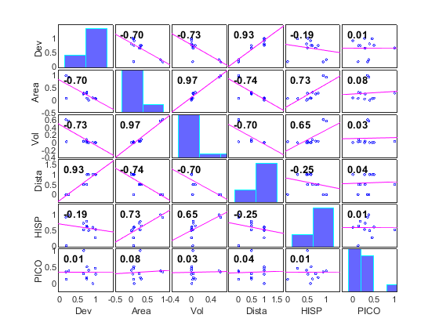

(38C) Correlation Matrix in steel (ignoring deformation)



(38D) Correlation Matrix of Steel (inclusive of deformations)

*Figure 38: Correlation Plots showing relationships between inputs and outputs. Concrete (A), Plywood (B), Steel 1 (Ignoring deformation) (C), Steel 2 (including deformation) (D) pink line is line of best fit and number indicates strength of the correlation, a negative number indicates a negative correlation.*

Figure 38 gives information on the relationships between the inputs and the output. Generally, distance prediction has some of the strongest correlations between datasets out of all of the outputs within this thesis and thus should create some of the most accurate predictions. There are both positive and negative correlations present indicating an increase with distance or a decrease (depending on the input). For example, area increases with distance and will do because of the shot spreading out further with an increase in distance. Volume on the other hand displays a negative correlation indicating that with an increase of distance, the volume of the damage is decreasing because the pellets are hitting over a wider area. This disperses the shot further, increasing the amount of satellite shot and therefore spreading the kinetic energy over a wider area and in smaller concentrations, therefore lessening the amount of multiple projectile impacts and thus depth of the damage sites.

Distance shows high levels of correlation with the impact velocity data (HISP) in steel and in concrete, there is less correlation within plywood however and this was probably due to the high level of erroneous readings in the plywood dataset causing disparity between the correlations. However, plywood shows the strongest correlation between distance and deviation which is again due to the material properties of the satellite shot which punched into the wood and created spherical damage sites with little to no depressions around the site. This creates a very definite deviation unlike in steel or concrete where the damage tended to have a more sloped edge gradient.

Concrete data shows there is less of a correlation with volume data than in the plywood or optimal steel samples. This could be to do with the hardness of the material or the shot hitting particularly hard material within the sample (as it is non-homogenous), the nature of the material to crack and create spall could also potentially be impacting the amount of energy being forced down onto the sample and dissipating it out the side of the material via cracking and spall. In contrast the steel 2 sample shows the strongest correlation which is because of its yielding nature which has created the large deformations at 3m and 5m. Again the material behaviours that have affected the way the damage is represented on the targets are having a marked affect on the relationships within the materials.

Steel 1 shows weak correlations in all measurement data (particularly area and volume) compared to steel 2 which shows that steel 2 is the optimal method for exploiting data from the scan site when looking at distance prediction. This also shows that the individual material behaviours should not be ignored when looking at distance or impact velocity reconstruction work.

As with the impact chapter, further testing of the optimal models and input combinations requires the RMSE and SER data to be examined. Figure 39 (below) shows the RMSE data for each model, colour coded to the scatter charts previously presented.

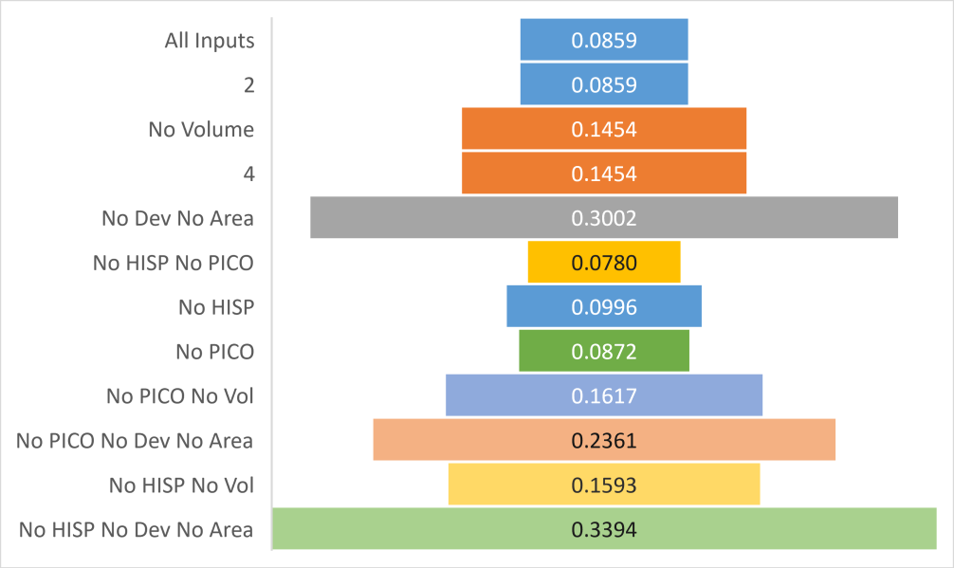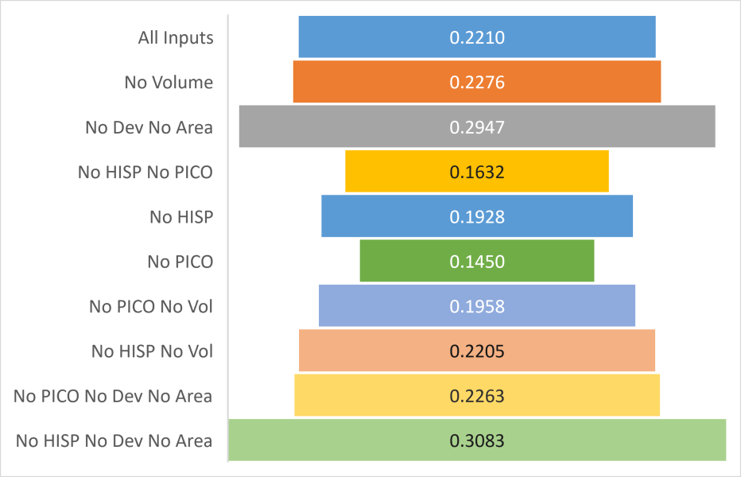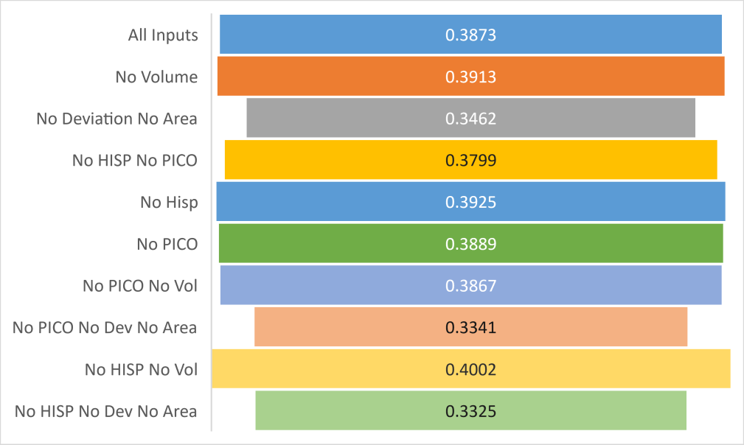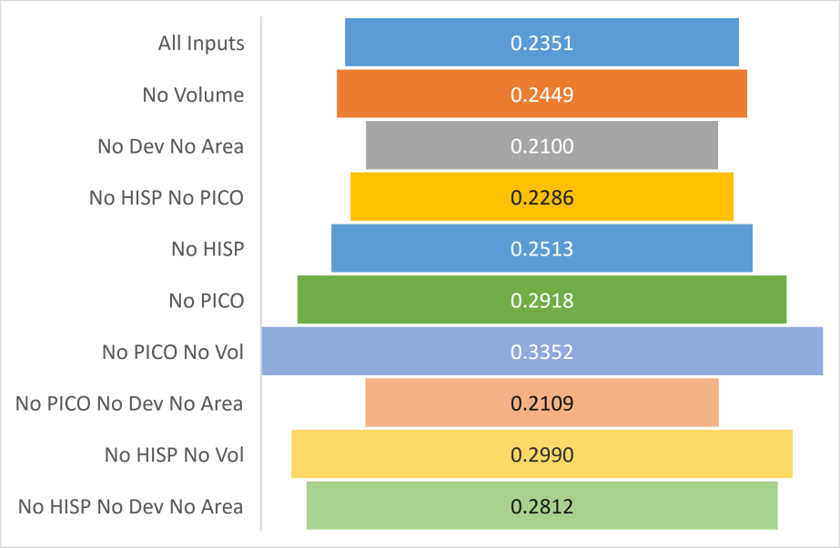

*Figure 39: RMSE results for each input combination in each material. Top left, Concrete. Top Right, Plywood. Bottom Left, Steel1. Bottom Right, Steel2.*

Generally, the RMSE can be used as a measure of overall model accuracy (Frost, 2020) and as such by selecting the lowest RMSE the model with the highest overall accuracy is selected. The materials all give very different general RMSE numbers which is a reflection of the variation caused by the material damage characteristics and the shot impact behaviour which has been observed in the collected results thus far. Concrete gives the smallest RMSE number followed by plywood and then steel which again could be a reflection of the effect of yielding behaviours within the material altering the overall data captured. Finally, the RMSE results confirm the inappropriate scan method of steel 1, showing that the measurement data is being altered due to the yield in the material but ignorance of this yielding behaviour does not equate to a better set of results overall.

In the two non-yielding materials the best models for distance prediction ignored either one or both of the velocity datasets. The velocity data (having the least variance in the dataset) provided little useful data but the impact velocity information was better than the muzzle velocity which is shown by the difference between missing only one of the velocity measures or both of them. From the other input combinations, it can be seen that area and deviation data are the most important inputs (the model without these inputs is the least accurate and has the largest deviation from the recorded average in both plywood and concrete). Volume data is also an important input in both non-yielding materials showing that the measurement data being captured by the scanner is appropriate to scene reconstruction efforts.

What this figure also highlights is how much the addition of the velocity data reduces the predictability of the model. This shows that the nature of the shotgun pellet and its method of delivery are not entirely predictable and that a single errant load can change the predictability of models far more drastically in small datasets.

In the steel 2 dataset, the lack of velocity data actually makes prediction marginally less accurate than removing the deviation and area data. This is due to the yielding behaviour of the material and the creation of the large deformations and so the volume data becomes far more important here (the correlations of the base data indicate that steel 2 has the best correlation between distance and volume). The correlations with deviation and area are also high but due to the deformation including many of the individual damage sites there is generally less of this data to utilise and may be insufficient to differentiate between distances in a yielding material.

The RMSE figures clearly show that the most important inputs for the distance prediction are deviation, area and volume in some way in both yielding and non-yielding materials. The physical measures are important as they provide a link back to the mechanical properties of the material and the theoretical calculations already in use in modern ballistic mechanics.

For example, the depth of a ballistic impact into these materials (as well as many others) has been discussed and researched before, as mentioned in chapter 2 (2.1.2) the terminal ballistic stage (dealing with the impact of the projectile onto the target, the behaviour that each component exhibits and the overall transfer of energy) is described by Carlucci (2010) and Haag (2021). The RMSE figures also support existing specific studies that deal with these measures into targets. For example, the optimal concrete model ignores the velocity data and concentrates on the measured responses. However by removing the deviation and area data – one of the worst models is achieved, this is reflected in work by Pereira (*et al*, 2018) who more accurately simulates volumetric damage from a ballistic impact whilst noting it is a *non-linear volumetric response* (due to the cracking, spalling and other impact behaviours it displays). Meaning that the machine learning algorithms (which can only work with data given) cannot find a suitable pattern to interpret – the deviation and area data are *needed* to give context to what the volume data is telling. Concrete prediction equations (heavily based on classical impact mechanics) such as the Wen & Yang equation (2013) rely on the depth (in this thesis known as deviation). In Plywood the story is largely similar although this could be due to issues with the scanner being able to accurately penetrate down into the damage site to acquire accurate volume data. Again, the area and deviation data are the most important (especially with the damage sites having such defined edges – making area a highly important data choice for the algorithm).

The reverse is true with the steel data, here the major deformation caused by the shot column has created a defining volume that the algorithm can pick up on and use. The algorithm has clearly taken advantage of the malleability of the steel as this has given a more linear pattern of volume against distance.

This again highlights that the data being recovered, along with the scanning method are suitable methods of data retrieval and that these data can produce valid results. To ascertain the truly optimal models the SER data needs to be examined, figure 40 (below) shows the SER figures for all of the combinations and models.

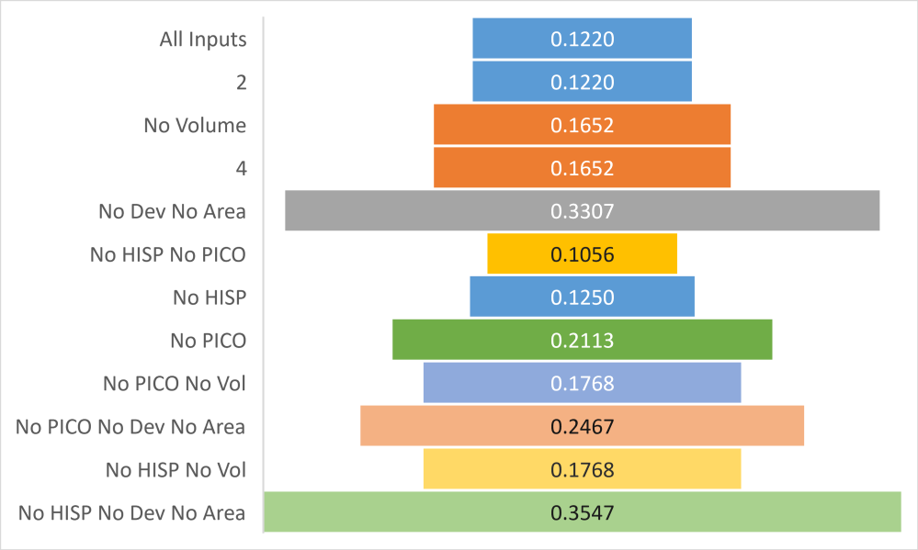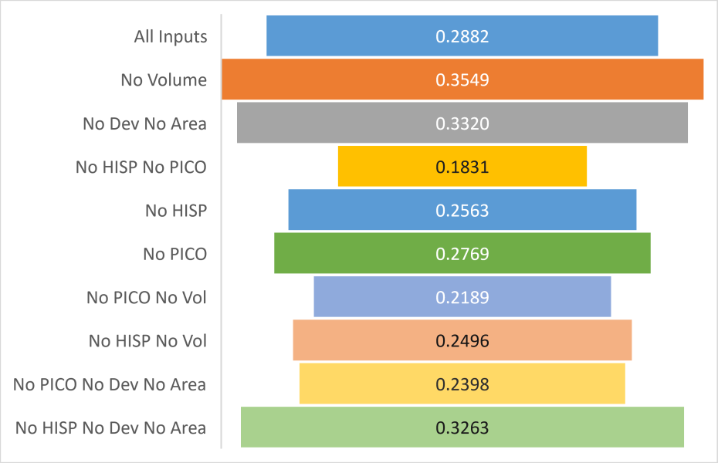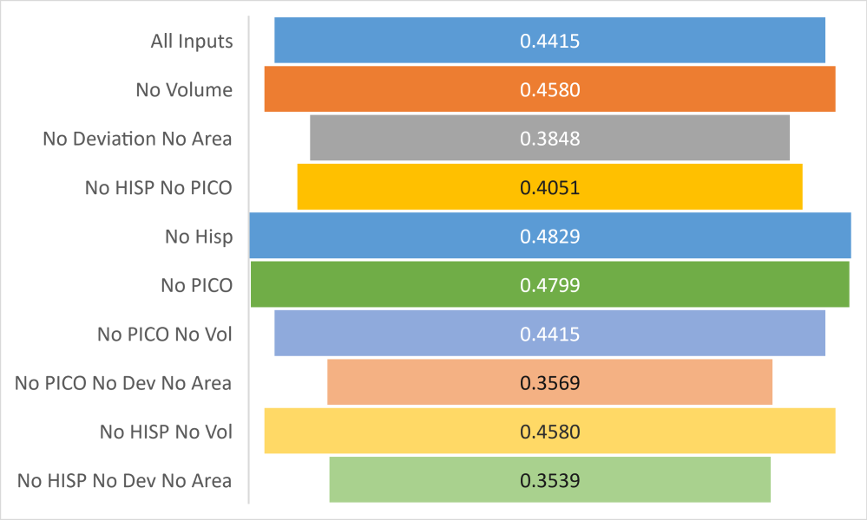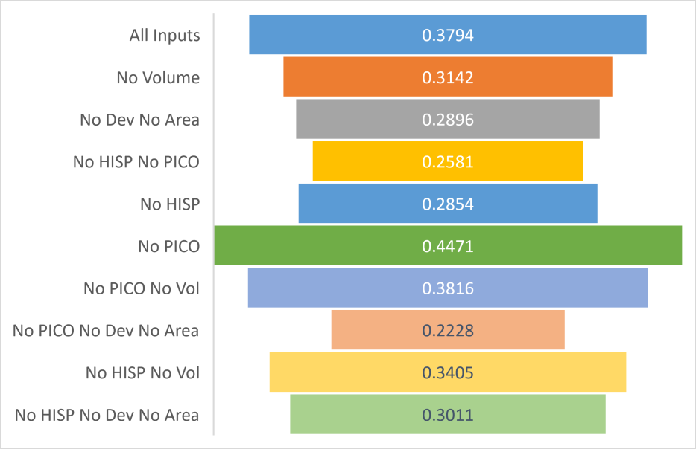

*Figure 40: SER figures for each input combination and material. Top Left, Concrete. Top Right, Plywood. Bottom Left, Steel1. Bottom Right, Steel2.*

In general, the SER results match the RMSE figures, velocity (particularly muzzle velocity) is the main input that improves models’ predictability if it is removed. The impact velocity data however does create higher RMSE and SER figures indicating that the correlations between the impact velocity and distance data are still being exploited. The figures are on par with the impact velocity RMSE and SER showing that data is highly suited to distance prediction (Haag, 2021).

The true measured values lacked the variation of the velocity measurements and therefore (as they were whole numbers to match the industry style (Haag, 2021)) had no outlier values that would offer significance (± 5cm). The fact that the true values are a more stable dataset may be the reason for such small RMSE and SER results (Shahbazi & Byun, 2020). However, the reduction of samples (due to equipment breakdown) has affected the predictability of samples, as an example, there were only 3 samples in the steel dataset, which were not abnormally affected by the base data (as was the case with the first plywood shot), the malleability of the steel should have clearly affected the data so that differentiation would be easy for the algorithm to distinguish against; instead the system has consistently predicted lower than the true value, showing that the lack of data has affected the predictability of the system. As stated before, small datasets have been very successfully used in machine learning (Narendra *et al*, 2019; Mahmoud & Zohair, 2019; Wang *et al*, 2018) so either removing datasets (to allow 3 per distance) or adding more samples to the missing datasets would potentially correct the issue.

The correlations only show a partial picture of the data, to identify how the data is being used post PCA and therefore how the data is being used by the algorithms, the variance needs to be examined. Table (17) (below) shows the variance of each input when looking at the optimal model for distance prediction.

Table 17: Variance of post PCA inputs when predicting distance

|  |  |  |  |  |  |
| --- | --- | --- | --- | --- | --- |
| **Distance** | | | | | |
|  | **Deviation** | **Area** | **Volume** | **impact v** | **Muzzle V** |
| **Steel1** | 53.10% | 27.10% | 14.90% | 4.60% | 0.20% |
| **Steel2** | 62.50% | 21.40% | 12.30% | 3.30% | 0.50% |
| **Plywood** | 63.60% | 17.20% | 16.50% | 2.30% | 0.40% |
| **Concrete** | 50.10% | 26.50% | 16.00% | 5.50% | 1.90% |

The table shows the amount of variance within the dataset after PCA when trying to predict distance. As can be observed the variance is different when utilising different models and this explains the observations around the RMSE and SER figures; deviation and area make up around 75% of the variance in the three materials taken forward (concrete, ply and steel 2) with volume around 15%. This variance shows that the most useful identifying data comes from these 3 measures, however this coupled with the relationships before PCA both play a part in how the inputs interact with the output. Deviation and area will increase with distance due to the natural spread of the shot, but the irregular way in which this spread occurs (and the material behaviour on impact) can increase the chance that this spread becomes similar between the 5m and 7m shots. Because spread has very little time to occur at 3m (where the shots are more uniform and distinctly different in makeup), this enables the model to more successfully predict that distance using just deviation and area in the non-yielding data. This can be observed from the results showing that the 3 measurements taken all have enough of a relationship with the output variable to potentially predict from, however the optimal model in the yielding dataset removes these variables showing that inputs are at least partially dependant on the behaviour of the material (i.e. how yielding it is). The data shows that in concrete, the highest volume is actually from a 5m shot. This could be that the volume (worked out by the system using the Deviation and Area data) is staying proportional to where the deviation decreases, and the area increases (due to the spread of the shot). Therefore, it can be assumed that the amount of removed material is not proportional to the impact mass (which can be supported by literature from Haag, 2021) causing more variation in area data (and also volume) in the steel set. Conversely, steel (being a material that yields to impact forces and has little to no removal of material) has a much clearer and more linear relationship with volume where the data conforms more to the established theory of “more distance = less velocity = less volume”. This fundamental difference in the physical makeup and behaviour of the materials has given more importance to volume input in a yielding material.

Optimal model selection worked in the same way as with muzzle and impact velocities. The primary measure was the RMSE figure with a secondary measure being the SER figure. Table 18 (below) shows the optimal models for all materials and combinations.

Table 18: Optimal Input, PCA and algorithmic combinations with RMSE and SER figures

|  |  |  |  |  |  |
| --- | --- | --- | --- | --- | --- |
| **Material** | **Inputs** | **PCA** | **Algorithm** | **RMSE** | **SER** |
| **Concrete** | Deviation, Area, Volume | 3 | SVM (Quad) | 0.077956821 | 0.1056 |
| **Plywood** | Deviation, Area, Volume | 3 | GPR (5/2 Matern) | 0.163177394 | 0.1632 |
| **Steel 1** | Volume, PICO | 2 | SVM (Linear) | 0.33248 | 0.3539 |
| **Steel 2** | Volume, HISP | 2 | SVM Linear | 0.21088 | 0.2228 |

The optimal combinations for the two non-yielding materials matches in input and number of principal components. The optimal combination for the yielding material only utilised volume and the impact velocity which shows that the material behaviours at the ballistic impact affected the deviation and area data. The optimal input combinations are outlined in table 19 (below).

Table 19: Optimal combinations of inputs, PCA and algorithm showing the true average distances and the average predicted distances with the largest residual difference in each set.

|  |  |  |  |  |  |  |  |  |  |  |
| --- | --- | --- | --- | --- | --- | --- | --- | --- | --- | --- |
| **Material** | **Inputs** | **PCA** | **Algorithm** | **True Average Distance (m)** | | | **Predicted Average Distance** | | | **Largest Difference (m)** |
| **Concrete**  **Plywood Steel 2** | Deviation, Area, Volume | 3 | SVM (Quad) | 3.00 | 5.00 | 7.00 | 3.04 | 5.21 | 6.69 | 0.31 |
| Deviation, Area, Volume | 3 | GPR (5/2 Matern) | 3.00 | 5.00 | 7.00 | 3.77 | 5.04 | 6.95 | 0.77 |
| Volume, HISP | 2 | SVM Linear | 3.00 | 5.00 | 7.00 | 3.78 | 4.38 | 6.40 | 0.78 |

As with impact velocity it is possible to find a model that works well without averaging the results to gain a more general scale, the optimal models perform well at this task and show the widest residual difference at 7m (0.54m) for concrete, at 3m (2.20m) for plywood and 3m (1.98m) for steel. As there is a clear potential for the accretion of data that falls to far outside the accepted normal variation of a shotgun discharge and the previous recommendation for this sort of system to be used as a closed system (where no more data than the relevant case data can be used), it would be more advantageous to allow averaged data to become the results as with the impact and muzzle velocity data before (Ramist *Et al,* 1994).

## Application to Shooting Incident Reconstruction

As with the previous results chapters, to demonstrate the applicability of the proposed technique to practitioners within the forensic shooting reconstruction industry an example scenario is presented.

Units are alerted to a possible shooting when a hospital calls and informs them of a person with suspected gunshot wounds in their care. Upon arrival the person gives a statement that they were crossing an area of land between buildings (a known shortcut) to get home when they were fired upon twice from a building facing this path. Units are sent to investigate and speak to the suspected shooter who informs them that he fired a 12Ga, double barrelled shotgun twice out of an open door into the darkness out of fear as someone was trying to get in.

Two damage sites are located across the street in a concrete wall which is measured as being 7m from the doorway of the suspect’s home. The weapon is seized as well as 6 additional rounds of matching brand ammunition. During testing the weapon is fired at 2m intervals from a minimum of 3m (approximately the distance from the door the suspect said he was when he fired). Unfortunately, the weapon breaks due to being in poor condition meaning there are only 4 shots to compare against (two and 3m and two at 5m). To corroborate one of the stories and to disprove the other, it is asked whether the shots were likely fired from inside the property or outside.

Laser scanning of the damage sites and of the 4 witness panels would be undertaken to capture the data. Once the data is captured the results would be fed into the case- specific algorithm to determine

the predicted distance of the shooting. Traditional measuring methods would be used alongside the deviation, area and volume data from each damage site, the results of which would be compared for the expert’s interpretation. In the subsequent report the expert would state their findings, using the scan data either as the primary source of information for this interpretation or as a form of validation for it.

In this scenario a simple distance estimation problem is presented, traditional techniques such as radius measurement of the site and comparing this to witness panels are standard practice within the industry but lack detailed information about the damage site itself. Utilising detail of these damage sites, it has been shown that potential results give less variance between predicted and true than examples in literature (Haag, 2021; Bresson & Franck, 2009).

## Limitations in Distance Prediction and Further Work

As with the previous chapters on muzzle and impact velocity prediction, there are limitations which broadly encapsulate all three outputs as the method, data and restrictions remained the same. These more general limitations are outlined.

The limited sample set only has one type of ammunition from one type of weapon for study, this means that the results here may only work with this current sample set and further investigation is needed with a wider array of ammunitions to find out if a singular model works best or whether using MATLAB on test data to find an optimal model which can then be used to predict against the suspect samples is the correct procedure. This means that the optimal models, input variables and PCA may change with a different dataset (be it by size, ammunition or weapon). As stated previously in impact prediction this current method could be used as a form of “sense check” or validation protocol (akin to the suggestions in Page *Et al*, 2019) and each examination may in fact benefit from being run on a case-by-case basis (Dalby *Et al*, 2010) to prevent inappropriate historical data informing a biased decision on the part of the system.

The work also assumes a direct impact and a target with very simplistic geometry, although appropriate for this proof-of-concept study it is important that more complex target geometries would affect the ballistic performance. Literature shows that complex geometry’s can deflect projectiles and are used in bullet resistant shutter systems designed for public building protection (EFAPROTECT, 2017).

Although the individual distance predictions were highly accurate in most materials and over most distances, the individual measures are still subject to the chaotic nature and poor efficiency of the shotgun cartridge (which affected some shot and the data retrieved). Utilisation of the averages of the dataset added an extra layer of validation to the dataset as a whole, removal of outliers in such small datasets would be inappropriate as this could affect the overall performance of the models but keeping them in enables outlier data to firstly be identified as such (as during LOOP, the data would be flagged as being from a different distance than the shot was fired from) and would not overall affect the predictions of the rest of the set (as most data would indicate a particular distance).

The proposed method does not take into account the potential for the storage, age or condition of suspect rounds to influence the round at the discharge event, potentially creating more erroneous results (de Klerk, 2015). Another point of note is that although high speed camera footage recorded ricochet in both the Concrete and Steel samples, there was little in the Plywood (and some shot became lodged within the target surface). Due to this, it is entirely plausible that scans picked up the surface of this shot within the damage site and recorded it as the bottom of the damage site. This has little effect on the overall data but could explain some of the variation found within samples with greater singular projectile markers (the ones most likely not to ricochet out). Another explanation is the difficulties in scanning such small sites and getting a full topographical makeup of the damage site from these singular projectile impacts (as the holes are so small that the beam cannot penetrate to the bottom because of debris and the angles needed).

To address these issues in future work, a number of suggestions have already been presented in the future work sections of the impact and muzzle velocity chapters. However, with distance prediction and a number of further opportunities for future work to advance this particular area have been identified.

Firstly, work should continue by looking at amalgamating the work presented into a classification machine learning problem as presented by Oura *Et al* (2021), this would take the scan data and train the system to place suspect datasets into a category rather than predict within a range of learnt outputs. This would be suitable for distance estimation practices as these are rarely reported beyond 2 or 3 decimal places (Haag, 2021) and as such there are a smaller amount of target distances to classify to. This would not be suitable for muzzle or impact velocity as there are to many other variables which would prevent classification – such as the variations in velocity between individual test samples and the type of data being used being weakly correlated to muzzle velocity.

Secondly, the introduction of a wider range of distances up to 7m would provide additional information as to the data being recovered over 1m distance intervals. This would also potentially bring in other input data (especially for close range shots) such as the presence of cartridge residues (Wallace, 2008), further damage mechanics such as full penetrations or the presence of buffer materials.

Thirdly, a direct comparison could take place between the proposed method, the currently used method of distance estimation and a hybrid of the two to determine the overall effectiveness of utilising either the alternative method or the hybrid over the currently used process. This would also open the technique up to potential utilisation against different weapons, attachments and ammunitions including home-made versions (Vinokurov *et al*, 2014; Ward *et al*, 2013).

## Conclusions

The novel method presented in this chapter has shown that by using information gather by the laser scanning of damage sites and by utilising a regression approach through machine learning, it is possible to predict the distance of a shotgun discharge from a small, closed sample set. Table (20) (below) shows the optimal predictions per material.

Table 20: Optimal distance prediction models showing widest residual difference between the average true distance and the corresponding average predicted distance.

|  |  |  |  |  |  |  |  |  |  |  |
| --- | --- | --- | --- | --- | --- | --- | --- | --- | --- | --- |
| **Material** | **Inputs** | **PCA** | **Algorithm** | **True Average Distance (m)** | | | **Predicted Average Distance** | | | **Largest Difference (m)** |
| **Concrete**  **Plywood Steel 2** | Deviation, Area, Volume | 3 | SVM (Quad) | 3.00 | 5.00 | 7.00 | 3.04 | 5.21 | 6.69 | 0.31 |
| Deviation, Area, Volume | 3 | GPR (5/2 Matern) | 3.00 | 5.00 | 7.00 | 3.77 | 5.04 | 6.95 | 0.77 |
| Volume, HISP | 2 | SVM Linear | 3.00 | 5.00 | 7.00 | 3.78 | 4.38 | 6.40 | 0.78 |

The inputs, model and algorithm required again show that these are affected by the behaviours of the material the target is made from. For example the yielding behaviour of the material is a decisive factor in whether deviation and area data from the scan site is required for the optimal model, however the toughness of the material may have an impact on which algorithm to utilise (as the two tougher materials in the dataset both use SVM as their optimal algorithm). The optimal algorithms are support vector machines and gaussian processes which are both kernel-based methods, granting a lot of robustness and resilience to models and would be appropriate for further study into an “all in one” method in the future if the overall structures of optimal models remain the same with differing materials. All of the PCA numbers in the optimal models indicate that a large degree of dimensionality reduction is being used which shows that the data being utilised is highly relevant to the output.

In summary, through the use of machine learning; the utilisation of laser scanning and the data acquired by its metrology software can predict the distance of a shotgun discharge to a significant level using an extremely small dataset. The work complements existing theory and practice in the field by showing a very small number of inputs can predict with accuracy and precision (Der-Chiang *et al*, 2018). And that machine learning can be utilised for this purpose (Oura *Et al*, 2021) Also, some highly

significant points have been discovered regarding the suitability of these inputs between different materials due to their properties and behaviours:

* + - Steel cannot be analysed using the same method as non-yielding materials due to the malleability of the material; the damage site analysis should include the deformations to give a better set of results.
    - Yielding materials make volume data far more important than other inputs and compliment the addition of velocity data in distance prediction.
    - Non-yielding materials decrease the usefulness of velocity data but increase the usefulness of physical damage site data such as Deviation and Area.
    - The proposed method of gathering area data can be used to predict distance although it appears to have disadvantages in softer non-yielding material and with some shots under 5m with yielding material.
    - Generalisation to other ammunition types, weapon platforms and materials is not an important factor at this stage and requires further research but this study and existing work (Plebe and Compagnini, 2012) show that generalisation is possible and can work towards being useful in a limited capacity. However, it is recommended that the “case by case” approach (as recommended by Dalby *et al*, 2010) would provide a more useful and robust analysis at this stage. This should be considered to be doubly important when dealing with shotgun pellets and their chaotic nature.

This chapter has shown that the use of 3D scanning data on a specific damage site is highly effective at extracting relevant, accurate, and precise information which can be used in predicting the distance of the discharge event. Furthermore, it has shown that there is no singular optimal set of inputs, and these inputs appear to change with how much the material yields to a ballistic impact. This chapter has also shown that differing outputs are capable of being predicted with the same dataset which can help to form a fuller picture of a shooting incident. This means that of the datasets that were collected and analysed, all have been successfully predicted to differing extents. The next chapter discusses the work with a view to the wider implications the thesis addresses.

# Chapter 7.0: Discussion

## 7.1 Introduction

The thesis has shown the efficacy of using laser scanning to record damage from a firearm discharge and how the metrological information gained can be exploited to predict ballistic velocity and range using machine learning. This proof-of-concept study used a very small dataset to demonstrate the viability of the method described with a size of data that would be more typical in a challenging forensic ballistics scenario. What has been demonstrated by this thesis is that laser scanning is a viable and effective method of collecting data from a variety of materials and that basic machine learning functions from a commercially available system can be used to analyse the collected data.

The findings of each individual set of experiments give way to very specific discussions which can be found in each results section respectively (chapter 4.0, muzzle velocity prediction/ chapter 5.0, terminal velocity prediction/ chapter 6.0, distance prediction). This chapter aims to bring these individual chapter findings and discussions together to critically consider how the underpinning principles of forensic ballistics and materials science affect the proposed method and how this could affect future efforts when characterising differing firearms, ammunitions and different target materials. The original research question and subsequent objectives provide a suitable starting point for this. The original research question (as stated in chapter 1, section 1.2.1) was:

“Using small amounts of samples, can 3-dimensional topographical scan data from a shotgun discharge be utilised to predict distance and velocity from both the muzzle and the target impact and what value could this provide to crime scene and shooting incident investigation?”

This subsequently required the following objectives to be completed:

* Evaluation of the chosen laser scanner to ascertain a suitable data collection methodology
* Employing the designed methodology in collection from shotgun discharges against different target surfaces.
* Collating and organising the collected data for use in the machine learning package
* Using the machine learning package to perform regression analysis to predict muzzle velocity data
* Using the machine learning package to perform regression analysis to predict impact velocity data
* Using the machine learning package to perform regression analysis to predict firing distance data

Each of these individual objectives provided data and subsequent discussion around their limited scopes, however a number of key general findings were also discovered which encompassed the work as a whole. These general discussion points have not yet been addressed.

## 7.2 Summary of key findings

Summarising the key points, the method described in the thesis provides clear benefits to the reconstruction of shooting incidents and highlights the effectiveness of utilising laser scanning and machine learning. The main implications and contributions to knowledge (chapter 1, 1.2) state that laser scanning coupled with machine learning can collect relevant, accurate and repeatable data and perform an accurate regression analysis on a small sample set from ballistic damage at the macro scale (chapter 1, section 1.5). However, it was not known to what extent these facts applied to the field of shooting incident reconstruction and shotguns in particular. The key overarching findings of this thesis are:

* 3D metrology data does provide more useful information than 2D when coupled with machine learning.
* 3D Metrology data can collect relevant and detailed data of damage sites
  + Better recording of evidence utilising higher detailed scans.
  + This data can be kept and used for future research and analysis.
  + Coupled with a 3D printer enables the creation of models for court exhibits (removing the need for transport of large or fragile exhibits).
  + Further characterisation and comparison opportunities enabling greater intelligence sharing.
  + Further, higher levels of damage analysis which can be used in further related fields.
* Machine learning allows users to use volume data as a third dimensional measurement and effectively analyse its relationship against target materials and how the materials behaviour affects the use of volume data.
* Material behaviours play a significant influence in both the type of algorithm and the success of the predictions.
* The technique allows operators to gain meaningful results even when ignoring overlapping or partial damage effects on target, keeping processes simple and therefore time/ resource effective.
* Small datasets can be used to perform highly accurate levels of regression and leave-one-out-processing is a viable alternative to needing large amounts of data such as with deep learning (Oura *et* al, 2021) or the utilisation of historical case data, which disregards fundamental principles of forensic science recommended by Romolo (*et al,* 2001) and Dalby (2010).
* The use of a technique such as this could potentially reduce impartiality and bias in evidence reporting.

## 7.3 Discussion of key findings

### 7.3.1 The applicability of laser scanning to shooting incident reconstruction.

The analysis of volume data has been a point of interest for scene reconstruction analysts for many years (Stocker *et al*, 2018) however the measurement methods used have been limited in ability and have not accurately reflected the potential of utilising volume data. This could either have been due to oversimplification of what is a complex damage site (for example, utilising a basic volume of a cylinder formulae) or from manual measurement techniques which again do not consider the complexity and minutiae of a damage site.

The traditional 1 or 2-dimensional techniques have less detail than a 3D method which although from the outset seems obvious (as 3D techniques will take note of depth) brings its own set of complications especially if the damage channel is very narrow, fibrous or expands inside the target surface (which introduces further issues when rendering topographical meshes). The advantages shown and the effectiveness of utilising volume data are clearer in target surfaces that show more open damage sites (in the case of this thesis – concrete) or more malleable materials (such as the steel). Nevertheless, the publications emerging (such as Forte and Campana, 2017 and Galvin, 2021) confirm the advantages in detail that 3D analysis has over traditional 2D methods.

The data used in this study can broadly be classified as either measurement data or calculated data. Measurement data considers the scanner data (deviation, area and volume) and the distance from muzzle to target. Calculated data would be velocity from the muzzle and from impact. Key to the implementation of the developed method was the assurance of the repeatability and reliability of the technique and the data being extracted.

The laser scanner was proven to be both repeatable and reproducible within the development of the scanning technique (Chapter 3, section 3.5) which enabled the technology to be utilised on the damage sites from the test firings. The data recovered during the development stages showed that the laser scanner data was also accurate when compared against known measures (the average variation in the scan data was 0.02mm across all four measures). This ensured the data being recovered was of a high quality (the average percentage error of scans was 2.09%) and that any discovered anomalies or discrepancies could be explained by the data and not through error of the scanner.

The data collected by the scanner presented several issues including the amount of data from the complex damage sites and how to best organise that data so as to make it suitable for the machine learning process. Although the oversimplification of the damage site has been previously criticised for lacking detail, a certain amount of simplification has been shown by the thesis to be an effective way of analysing the damage site. By utilising the totals for each measurement the thesis has effectively eliminated issues surrounding partial or overlapping damage (even though this was explored by the utilisation of the URN and Locus designation in the thesis) and was far more expedient and effective than identifying and classifying each individual pellet strike. This means that shotgun discharge sites could be as readily explored and exploited as singular bullet strikes and without further complications or specialities being required. This reflects current scene processing methods outlined by Haag (2021) and Heard (2013) where whole damage site measures are used.

The collected data from the shotgun discharge showed that target samples from matching materials and distances produced similar data in the deviation, area and volume inputs, meaning that highly reproducible data was being recovered from these damage sites. As an example, table 21 (below) shows the average and standard deviation of measurement data from the concrete set.

Table 21: Average scan measurements at different distances in concrete

|  |  |  |  |  |
| --- | --- | --- | --- | --- |
| **Concrete** | | | | |
|  | | **Deviation** | **Area** | **Volume** |
| **Average** | **3m** | -5.10996 | 8776.472 | 17176.15 |
| **Standard Deviation** | **3m** | 0.920763 | 768.5482 | 2263.327 |
| **Average** | **5m** | -4.56852 | 9394.893 | 13416.05 |
| **Standard Deviation** | **5m** | 0.501134 | 1451.114 | 2345.169 |
| **Average** | **7m** | -2.61994 | 1538.499 | 1679.012 |
| **Standard Deviation** | **7m** | 0.591124 | 424.232 | 505.7153 |

The table shows that data recovered varied but conformed to the understood behaviours of ballistic materials impacting a target at different distances. Other factors clearly came into play such as the behaviour of the material at impact (whether material was removed from the damage site rather than shifted, such as with concrete (Haag, 2021)) and the overall effect of the velocity of the shot onto the target. The data being recovered was also reliable as correlations within each dataset showed strong relationships between data that was directly related to the output. For example, using the output of distance the correlations between the output and each of the scanned measurements were consistent with known ballistic behaviours, even whilst taking into account material behaviours (deviation (0.83, 0.93, 0.70), area (-0.78, -0.74, -0.73), vol (-0.66, -0.70, -0.73)).

The benefits of the non-contact process and the expedient method of data collection have been effectively demonstrated and are shown in literature (Fourie *et al*, 2011; White, 2016; Thomas *et al,* 2016). The shotgun damage sites are all very complex and as such exploring all of these with a manual method such as callipers would be extremely laborious and would quite likely result in mistakes or inadmissibility due to alteration of the site through contact. The scan data gives a greater amount of detail and thus aids in the understanding of how these damage sites are made and the behaviours that effect the target. This can aid in understanding the effect of shotgun shot on differing targets and thus how volume data can be most appropriately used to aid investigations.

This was shown when the physical interaction between the shotgun pellets and the physical properties of the target material affected the overall data captured by the scanner. The observed interaction and damage characteristics were consistently produced by repeats within each type of material. For example, in concrete, spalling and cracking behaviours removed material from the impact surface, potentially removing more material than was directly affected by the impact alone (Haag, 2021). In plywood samples some of the shot became lodged, forming the bottom of some scan sites (particularly in single or double pellet strike areas) (Haag, 2021) and the steel samples gave a large bowl-shaped deformation which decreased with an increase of distance. These issues remained the same throughout each of the samples and as such the data recovered reflected these behaviours. As the correlations in the data were strong, it can be surmised that these material behaviours had the potential to affect the reliability of the choice and optimisation of machine-learning algorithm data, but from the results produced, this did not adversely affect predictions.

### 7.3.2 Considerations of Machine Learning analysis

As previously stated in chapter 2, there is a current interest in technological acceleration of the forensics industry (NAS, 2009/ PCAST, 2016) fuelled by a demand for cost effectiveness of a privatised industry and the demand for further impartiality. Thus, a method that increases the amount of data gained without large long-term expense that can act as potential validation for expert testimony would be highly useful.

The predictions from the optimal models showed higher levels of individual prediction accuracy in impact and distance predictions than in muzzle velocity. This was mainly due to the type of data being used to make the predictions all having far stronger correlations with distance and impact velocity than with muzzle velocity. However, when the averages were calculated for each distance iteration in muzzle velocity, these residuals were further reduced (widest residual value of 7.33 ± 2.47m/s). This was due to the muzzle velocity predicting across the mean whereas the impact velocity predicted far closer to individual targets over a wider range.

Averaging the results by distance was more appropriate as this gave better results overall and mitigated any abnormally high or low results due to the performance of the cartridge. Averaging the results also made the work align further with existing practices within distance and velocity estimation (Haag, 2021) making it more appropriate to casework in the future. The averaging of predictions also provided a closer estimate than current casework examples in literature (Haag, 2021).

Overall, the majority of predictions made consistently predicted either close to the target output or the mean of the dataset showing a high level of repeatability by the prediction algorithms. Accuracy was found in all of the optimal predictions by averaging the results however, impact and distance prediction could be used without averaging results so long as outlier data was removed and a larger dataset was used to explore this more fully. This supports the use of a closed system only utilising the data collected as part of the case (Romolo *et al*, 2001/ Dalby *et al*, 2010) and the potential for this system to be used as a form of objective validation for an expert’s interpretation.

There were however, several significant factors that influenced the algorithms performance that should be discussed.

* The data required for optimal prediction is highly dependent on the output required and then the material involved. For example, distance prediction showed that the measurement data from the scanner (deviation, area and volume) are all critical to prediction in non-yielding materials whereas volume is the critical measure in yielding materials. Velocity data is unnecessary in non-yielding materials although impact velocity is used in the optimal model for yielding materials.
* The choice of algorithm and input combinations are subjective to the material in distance estimation and muzzle velocity. Impact velocity utilises all the same data inputs and the same general model (linear) for predictions across materials indicating there is less influence from material behaviours or that these behaviours are clearly helping to differentiate between distances.
* The individual material behaviours identified have affected certain measures within the input data (such as area data in concrete and volume data in steel) but have not adversely affected prediction.
* Attempting to ignore these behaviours (such as within the first steel dataset) does not work in the majority of cases, as the machine learning algorithms find the most useful data to be the metrological data – which is directly affected by the behaviours of the targets when exposed to a ballistic impact.

The potential use of machine learning as a validation method to improve impartiality has obvious societal benefit as the miss-interpretation of evidence, potential conviction of innocent parties or release of guilty parties has major implications on the confidence of the public in law enforcement as well as the costly process for retrial.

Caution must be used however as this tool should never replace expert testimony or expert interpretation, the use of machine learning in current systems previously described in chapter 2 have had negative consequences and received rightful criticism from the public (Bennett, 2020; OFQUAL, 2020). The current practical understanding of machine learning has not yet become advanced enough to replace the decision making and cognitive reasoning of a human mind, thus machine learning may seem like a cheap alternative to trained professionals but only by utilising those professionals and machine learning in concert can trust in both be re-established.

This suggested dual approach could decrease the chances of bias within expert opinion evidence therefore improving the impartiality on a very challenging set of evidence. This is highlighted by papers from the Obama Whitehouse Archives (2020) and the Innocence Project (2009). This suggested approach also would have a marked effect on the suggestions made by Sunde (2021) where forensic reporting (in this case digital forensic reporting) has been found (amongst others – including firearms reporting) to be lacking in any established framework meaning that reporting needs peer review to make it more reliable. For the firearms field the method outlined could be a way of helping with the peer review process and introducing a proto standardisation for reporting practice.

This technique also provides a potential solution to some of the issues highlighted by Morgan and Levin (2021) where they show that there are concerns around reproducibility and the conclusions drawn by experts (the outlined approach could provide a form of validation and sense-checking as well as being openly transferrable between parties involved). The current main limiting factor would be the limited testbed that has been used to collect this data. More data would be needed across a variety of platforms, munitions and target surfaces; each at more distances and with the introduction of differing angles and additions such as chokes. The testing is perhaps the largest limiting factor but arguably is the easiest to remedy as further experimentation and funding for this work is readily available and easily accessed by universities across the world.

The use of simple machine learning in this thesis shows that more complex and larger algorithms such as neural networks and true AI (which take large amounts of data to reach an accurate conclusion in regression and are complex to make) are not necessarily needed for the purposes of prediction (which differs from the literature such as Oura *et al* (2021)). Whereas it is known that small datasets can be problematic in machine learning (due to the need to separate the data into learning, validation and verification sets), the use of LOOP has shown to be a viable alternative and research also reflects other efforts in utilising these small datasets (Mahmoud & Zohair, 2019; Zhang & Leng, 2018; Wang *et al,* 2018). The range of tools available in the machine learning algorithm is readily accessible to both private and commercial entities with no restrictions enabling a wide array of research and literature to be produced and placed in the public domain which increases the repeatability and robustness of the overall technique (including identifying its limitations and methods of overcoming them).

### 7.3.3 The use of small datasets and their viability in future forensic ballistics work

One of the primary objectives of this study was to find out if a small dataset was able to give a high level of predictive value when examining a firearms discharge scenario. Typically, forensic investigators have very little in the way of physical evidence to utilise and as such as much information needs to be extracted from the existing evidence as possible. As studies have already shown (Oura *et al*, 2021) complex neural networks and deep learning algorithms can produce highly accurate and effective predictions; however, the amount of data needed is problematic in most forensic scenarios.

The decision was made to use a very small number of physical samples in this study to try and mimic conditions on a forensic scene (where limited amounts of suspect ammunition had been found). However, this causes issues later in the analysis and court presentation side.

For example, there are some limitations that further research would need to overcome before the approach outlined in the thesis could be considered for use. One that directly affects the wider forensic community is likelihood ratios. Likelihood ratios are used increasingly to convey expert witness evidence to lay juries (Martire *et al.* 2014) in an effort to help juries understand not only the evidence being spoken of but the weight of that evidence to the case. The main issue with likelihood ratios is that they cannot be utilised on small datasets and as such only simpler models can be applied to aid in understanding (such as looking at similarity-only or difference-only methods (Morrison, 2015)). Basu *et al* (2022) however, shows that small numbers of samples can work well but more samples are preferable as this increases confidence.

Due to the limited nature of evidence (such as suspect ammunitions) there are few options left to be able to increase data to allow these likelihood ratios to work effectively apart from using historical data from outside the case being worked on. This can cause issues with current evidence being compared to previous evidence which could be incompatible due to its storage, conditions or recovery (Romolo *et al*, 2001). It seems that the approach by Romolo *et al* (2001) for a case-by-case basis cannot be considered for automated processes without larger amounts of historical and training data to utilise in the background. The thesis however has presented a potentially worthy and valid alternative to using systems that need training on large amounts of historical data whilst keeping to the same rigours needed within a forensic investigation, providing a novel area of further research not yet fully explored within shooting incident reconstruction.

# Chapter 8.0: Conclusions and Further Work

## 8.1 Conclusion

When shooting incidents occur, forensic examiners may be asked to estimate the location and thus distance from where the firearm was discharged. This task falls within the field of shooting incident reconstruction. Traditional methods of estimating muzzle-to-target (firing) distance typically involve test firing a known firearm and ammunition at witness panels placed at various known distances from the firearm muzzle. During such reconstructive testing, muzzle velocity is calculated and one-dimensional measurements (diameter) of the impact damage are compared to the diameter and pattern of the damage site observed at a crime scene. This approach has been used for many years and is low in cost, however, it was hypothesised that the potential use, value and application of reconstructive testing in casework is yet to be realised. High-speed video footage, for example, has been used in research and casework contexts to further understand damage formation on a range of target materials, but this technology is not routinely applied in shooting incident reconstruction. Laser scanning has already proved to be a reliable, accurate and repeatable approach (Fourie et al., 2011) to measurement documentation and recording. Linking this technology with machine learning, which has been demonstrated by Oura *et al* (2021) recently, highlights the potential value of applying classification-based machine-learning to estimate shooting distances.

The purpose of this research was therefore to investigate how using three-dimensional measurement and machine-learning could further enhance and scientifically underpin the principles and practices of shooting incident reconstruction. To achieve this, a series of proof-of-concept studies were designed to investigate and predict the firing distance, muzzle velocity and impact velocity in criminal damage-related scenarios involving impacts with concrete, plywood and steel target materials. As such, one firearm, one type of ammunition and three shooting distances were selected based on their frequency of occurrence in UK casework.

3-dimensional imaging of damage sites has been shown to be highly effective, the thesis has demonstrated that laser scanning records relevant information for shooting incident reconstruction and records more information than the current methods that are used (Haag, 2021). The scanning data has also been shown to be highly repeatable and reproducible whilst the additional benefits of a non-contact procedure and digitally recording sites conforms with current chain of evidence protocols (White, 2016). As demonstrated, the scanner provides a highly effective method of data capture and the associated software is critical for exploiting valid and accurate information from the scan site. All of the information gathered has been utilised in multiple optimal models across output types and materials.

The velocity data recovered from the muzzle and from the impact site were recovered by two differing methods, a high-speed camera for impact velocity and a ballistic chronograph for the muzzle velocity. The muzzle velocity calculated using the calibrated chronograph gave an overall picture of the muzzle velocity of the shot column, which was treated as a singular projectile (Compton, 1996).

The impact velocity data was calculated using open-source image processing software and footage from the high-speed camera (chapter 3.4) but the process was time consuming to perform (taking around 6 hours to process all 37 samples). Figure 41 (below) shows these graphs and the corresponding boxplot which illustrates the relative stability of muzzle velocity and the expected behaviour with impact velocity generally decreasing over distance.

## *Figure 41: Scatter Graphs and Boxplots demonstrating spread of muzzle and impact velocity (muzzle top left and right, impact, bottom left and right)*

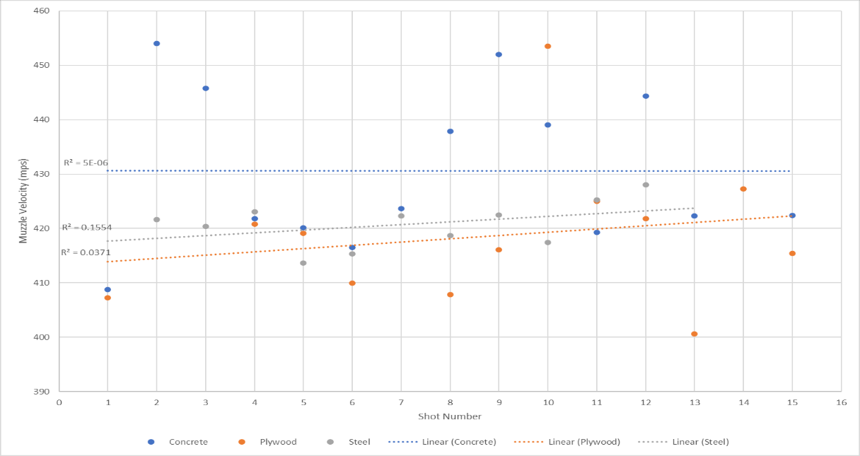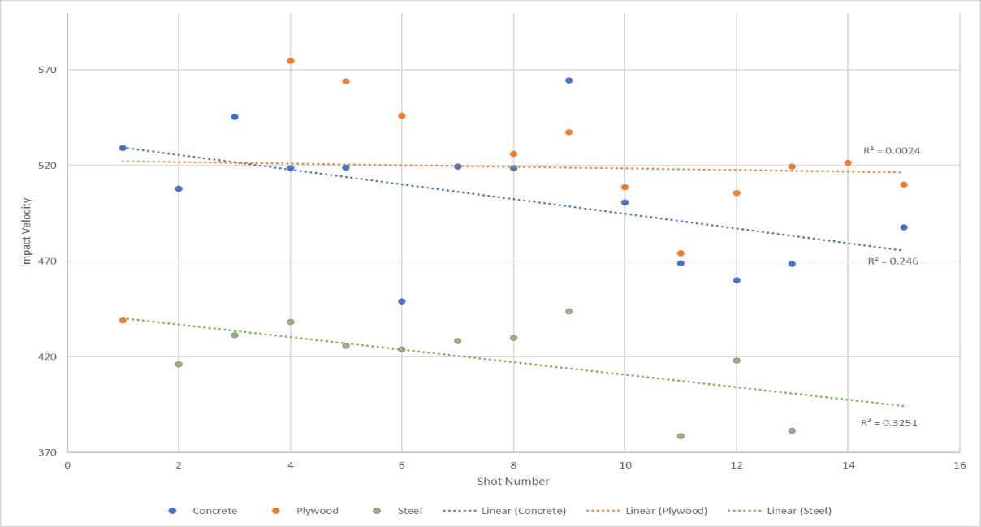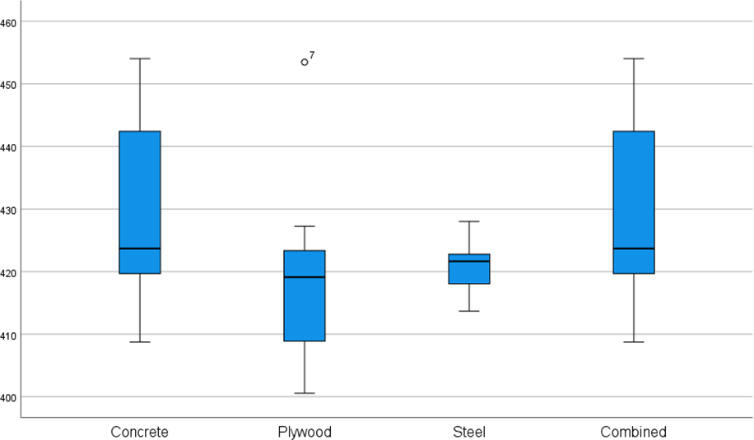

From the perspective of the reliability of the data produced, the calculated muzzle velocity of the shotgun pellets were comparable with, albeit slightly faster (423.80 ± 12.24 m/s) than the shot speeds reported by the manufacturer (411.48). The small variations in muzzle velocity demonstrate consistency and reliability in the repeatability of the internal and external ballistic properties of the ammunition achieved when fired in this particular shotgun and thus suggest that variations in muzzle velocity should not significantly affect the predictive capability and performance of the machine- learning algorithm. The impact velocity data was calculated by capturing images with the high-speed camera and then counting the number of frames the first and last pellets of the shot column were travelling in. This technique, although time consuming showed results that were concurrent with the current understanding of ballistic behaviour. Table 19 (below) shows the calculated average impact velocity across all materials at each range with their standard deviations to show spread of the data overall. Some recordings became outliers in the data but this was explained in each relevant section (chapter 4.2) and deemed most likely due to the shotgun cartridge performance.

Table 22: Average impact velocities across all materials at different distances, standard deviation is included to show spread of data. all data is in m/s

|  |  |  |  |
| --- | --- | --- | --- |
|  | **3m** | **5m** | **7m** |
| **Average** | 496.3233 | 488.6302 | 466.2535 |
| **Standard Deviation** | 58.99898 | 44.09763 | 47.59646 |

The data gathered was shown to be accurate, repeatable and the technique for gathering the data reproducible. With the data collected it was uploaded to the regression learner software which performed the predictions.

The machine learning algorithm program is excellent at exploiting relationships in data and a repeatable, valid method has been created for use with small datasets, the system has been shown to be repeatable (as once intimal findings are implemented the system can run the same operation until done, as with LOOP), valid (the method has shown that the data collected is valid as correlations and relationships are being found and exploited to give accurate predictions) and suitable (the scanning of damage sites has produced large amounts of relevant data in a forensically suitable manner and the data’s analysis has provided trackable results). Predictions are valid and repeatable however there is no singular model that covers all materials. Overall, the method described in thesis shows great potential for providing and exploiting highly valuable and previously unused information to shooting incident reconstruction scenarios.

Following the recommendations of Dalby *Et al* (2010) a case-by-case approach should continue to be adopted along with this method to provide a set of data relevant to the case being used. As previously stated, the work is a proof-of-concept and thus provides a wide array of potential for future work or implementation in other scientific or investigative fields.

## 8.2 Consideration of the Applicability of the Technique in Other Areas and Further Work.

### 8.2.1 Application of the technique to other areas

Wider industrial applications for this technique could look at work around the collection and analysis of data in active conflict zones. Private companies such as ARES (Armament Research Services), UN investigation teams and INTERPOL could make use of this technique to record damage in situ. This would be of distinct advantage in an active conflict area where conditions on the ground would necessitate expedient recovery of information and extraction of personnel and equipment.

Consistently changing conditions may also remove evidence by explosions, artillery strikes or counter offensive actions, making a return to the site to collect more data impossible. The data captured could be collated and used as evidence for war crime tribunals at The Hague; especially in cases involving deliberate or accidental targeting of civilian structures such as Hospitals, Schools or Refugee Centres (Cross *et al*, 2016).

Another area that could benefit from the application of the designed method is the ordinance, munitions and explosives industry where the scans and metrology information could be utilised in a range of applications such as:

* Testing of Munitions against targets; where scans would be utilised along the same lines as outlined within the thesis for the purposes of munition evaluation (Farrar & Leeming, 1983).
* Individual Damage Assessments for specific munitions for the purposes of intelligence collection and countermeasure design.
* Armour Resistance Testing where more data could be gained and gathered by utilising the deviation of tolerance analysis to analyse the overall life of the armour.

The further examples highlighted above also show the potential value of the technique where data can be collected, transferred and analysed to gain further insights into projectile vs target behaviours.

### 8.2.2 Further Work

As muzzle velocity can be predicted with a small amount of training data, the next logical step is to use the recovered data to work out the kinetic energy (KE) from the muzzle. Muzzle Ke prediction requires the mass of the projectiles and the velocity of the discharge, (the formula is shown below) as the velocity can be predicted – only the shot mass remains.

𝐾𝐸 = 0.5 ∗ 𝑀𝑉2

The issue here is that the mass of shot could differ for several reasons but considering an “off the shelf” brand (as used in these tests) there is a standardised amount of shot in each cartridge which is counted (Lyalvale, 2020). The prediction of KE is more appropriate at the impact event (and is discussed further in chapter 5) as this can provide useful information regarding damage, potential ricochet and lethality (Haag, 2021).

It is recommended that further work be carried out to form a more complete picture of the capabilities of this two-pronged approach of laser scanning and machine learning. Of high importance is to increase the sample sizes which would give a greater amount of data for the algorithms to work from, this in turn would enable weaker sections (such as muzzle velocity prediction) to be more fully explored (Mahmoud & Zohair, 2019). Inclusive of this would be the need to further investigate the applicability of kernel-based regression methods (such as SVM or Gaussian processes) to evaluate the applicability of utilising a singular model type with this larger dataset. It would also be useful to investigate if a database system could be incorporated and what additional inputs would be required for such a system (Zhongbo *Et al,* 2021; De Ceuster & Dujardin, 2014; De Ceuster *Et al,* 2012).

Furthermore, introducing differing brands of the same sized ammunition and analysing the effect this has on the machine learning process would be of importance and begin looking at whether a database style system (using large amounts of historical data) would be feasible. Furthering the work from Oura *Et al* (2021), classification could be used to differentiate between the ammunitions by pattern, spread or velocity. As a regression this could predict which ammunition the results belonged to and this would test the applicability and validity of the findings presented whilst also increasing the sample size to enable the more traditional machine learning training to take place (where datasets are partitioned into training, validation and verification sets).

The designed method in fact could deal with a multitude of different scenarios and combinations such as factors that affect the dispersal of shot and the potential velocity, for example, increasing or decreasing the barrel length and the addition of full, ¼ and ¾ chokes (Maitre Et al, 2021). Analysis following guidelines by Dalby *Et al* (2010) theoretically could allow any weapon could be tested against any seized ammunition in the same way as outlined above. However, to make the system truly robust and more useful to practitioners, research would be needed to examine the validity of utilising this style of system over the traditional 2-dimensional surface techniques currently used.

If the designed method were to be compared with the current distance estimation standards (2D witness panels and manual measurement of the two furthest points within the dispersal) then (as this research has shown) far more information is gained by using the new method. This information has been shown to provide an accurate prediction of shots over a 3-7m distance. By utilising this method in conjunction with practitioners at scenes, a comparison could be made to analyse the systems effectiveness as an objective validation method and therefore made more viable for evidence practice.

Other research that could be looked at includes studying the effects of individual measures (such as just using volume), in this way a broader perspective of the effectiveness of the physical input variables could be collected, however there would need to be a sizable increase in samples to achieve this, there would also be the risk of overfitting or underfitting – requiring more input variables to solve.

It is hoped that this work can be expanded upon by future researchers to help to provide a robust, objective and valid alternative method to firearm discharge evidence reconstruction. There is great future potential of the technology and method to address some of the criticisms of forensic science research by PCAST (2016) and suggestions by the earlier report from the NAS (2009).

# 9.0 References

1. A Developer Diary. (2021) Support Vector Machine, Support Vector Machines for Beginners - Kernel SVM. Available from: [Support Vector Machines for Beginners - Training Algorithms - A Developer Diary](http://www.adeveloperdiary.com/data-science/machine-learning/support-vector-machines-for-beginners-training-algorithms/). Accessed July 2021.
2. Abate, D & Sturdy-Colls, C. (2018) A multi-level and multi-sensor documentation approach of the Treblinka extermination and labour camps. Journal of Cultural Heritage. Volume 34., https://doi.org/10.1016/j.culher.2018.04.012.
3. ABC News. (2021). “Sydney siege inquest: Katrina Dawson was lying behind Monis, reconstruction shows”. Available from: [Sydney siege inquest: Katrina Dawson was lying behind Monis, reconstruction shows - ABC News](https://www.abc.net.au/news/2016-06-29/sydney-siege-reconstruction-katrina-dawson-lying-near-monis/7555504). accessed 19/06/2021
4. Activation labs. (2016) “Portable GC/MS equipment Methods”. Available from: http://www.actlabs.com/page.aspx?menu=65&app=221&cat1=534&tp=2&lk=no. Accessed on 27 April 2016.
5. AFTE. (2021) Published paper title search – by date. Searchable Journal Index | AFTE. Keywords “Shotgun”. Accessed 08 Oct. 21
6. Akihiro, I. Hiroshi, T. Kimiyo, K. Masahiko, K. Kunihisa, K. Keiichi, S. Naoki, F. (2008) “Regional and seasonal characteristics of emission sources of fine airborne particulate matter collected in the center and suburbs of Tokyo, Japan as determined by multi-element analysis and source receptor models”. Journal of Environmental Modelling. Vol 10. 1025-1032. DOI: 10.1039/b806483k.
7. Allen, Jonathan. (2019) Conversation and tour of Met Police scanning unit facilities. 16 October 2019
8. Altexsoft. (2021). “Artificial Intelligence in Travel and Hospitality”, Available From: [Artificial Intelligence in Travel and Hospitality (altexsoft.com)](https://www.altexsoft.com/ai-artificial-intelligence-in-travel/). Accessed 14 October 2021.
9. American Elements. 2022. Lead Shot order page. available from: Lead Shot | AMERICAN ELEMENTS ®. accessed 13 September 2022.
10. Anderton. J. (2018) “Shot Tower: How Lead Shot Is Made”. available from: Shot Tower - How Lead Shot is Made – EngineeringClicks. accessed 13 September 2022
11. Anon. (2020) “Interpolation in statistics: Definition, Formula & Example”. Available from:https://study.com/academy/lesson/interpolation-in-statistics-definition-formula- example.html. Accessed 26 June 2020
12. Anon. (n.d) “Machine Learning – Bootstrap Aggregating (bagging)”. Available from: https://datacadamia.com/data_mining/bagging. Accessed 26 June 2020
13. Appleby-Thomas, G.J. Wood, D.C. Hameed, A. Painter, J. Fitzmaurice. B. (2017) “On the effects of powder morphology on the post-comminution ballistic strength of ceramics”. International Journal of Impact Engineering. Volume 100. Pages 46-55. DOI: 10.1016/j.ijimpeng.2016.10.008
14. Arcambeau. (2008) “Lecture 1.C: Gaussian Processes for Regression”. Available from: Lecture 1c: Gaussian Processes for Regression (psu.edu). accessed on 20/06/2021
15. Arslan, M.M., Kar, H., Uner, B. & Cetin, G. (2011) “Firing distance estimates with pellet dispersion from shotgun with various chokes: An experimental, comparative study”. Journal of Forensic Sciences. 56 Vol 4. P988-992. DOI: 10.1111/j.1556-4029.2011.01761.x
16. Attestor Forensics. (2014) “sceneview web information page”. Available From: http://attestor- forensics.com/English/scene/scene-SCENEview.html. Accessed on 15 Feb 2016.
17. Awad, M & Khanna, R. (2015) “Efficient Learning Machines Theories, Concepts and Applications for Engineers and System Designers”. Apress Open.
18. Ayda Safak Agar Ozbek, Jaap Weerheijm, Klaas van Breugel. (2018) “High speed photography technique for measuring impact strength of porous concrete”. Construction and Building Materials, Volume 186, Pages 1092-1104. DOI: 10.1016/j.conbuildmat.2018.08.031
19. Balasubramanian, N. (2020) “Substituting Human Decision Making with Machine Learning: Implications for Organisational Learning”. Available From: Substituting Human Decision Making with Machine Learning: Implications for Organizational Learning (syr.edu). Accessed 02 November 2021
20. Ballistic Measurement Systems Ltd. (2022) “Doppler Radar Product specifications page”. available from: B481 Doppler Radar HPI (ballisticmeasurements.com). accessed 14 September 2022
21. Balolia. K.L, Massey. J.S. (2020) “How Does Scanner Choice and 3D Model Resolution Affect Data Accuracy?”. Journal of Anatomy. 238. 3. https://doi.org/10.1111/joa.13343
22. Bathee, Y. (2018) “The Artificial Intelligence Black Box and the Failure of Intent and Causation”. Harvard Journal of Law and Technology. Vol 31(2). p889
23. BBC News, (2021) “Plymouth shooting: Suspected gunman and five others die”. Available From: Plymouth shooting: Suspected gunman and five others die - BBC News. Accessed 14 August 2021
24. Bell, T. (2018) “The History of Antimony Metal”. Available from: https://www.thebalance.com/history- antimony-metal-2340120. Accessed 3 August 2017
25. Ben-Dor. G, Dubinsky. A, Elperin. T. (2019) “Engineering Models in High-Speed Penetration Mechanics and their Applications”. World Scientific. Singapore
26. Bilemeister. (1961) “B01J2/06 Patient for: Process and Apparatus for Producing spherical Metal Pellets”. Available From: https://patents.google.com/patent/US2978742. Accessed 6 March 2019.
27. Bisely. (2017) “Bisley official information: .22 Magnum pellet. Available From: https://www.bisley- uk.com/product.php?i=BIMAA&c=274, accessed 06 November 2017
28. Blessing, M.M. Lin, P.T. (2016) “Suicide by Shotgun in Southeastern Minnesota”. Journal of Forensic Sciences. Vol 61. 81. pp. S159–S162. doi:10.1111/1556-4029.12946.
29. Bolton-King, R. Kerkhoff, W. Mattijssen, E. Withers, C. (2019) “Novel Distance Estimation Method for Shotgun Discharges at Close Range”. AFTE 2019 50th Annual Training Seminar. 26-31 May 2019.
30. Bolton-King. R, Kerkhoff. W, Mattijssen. E, Withers. C. (2019)” Novel Distance Estimation Method for Shotgun Discharges at Close Range”. available from: Novel Distance Estimation Method for Shotgun Discharges at Close Range - STORE - Staffordshire Online Repository (staffs.ac.uk). accessed 13 September 2022
31. Boothroyd, G. (1993) “The Shotgun: History and Development”. CMA. UK
32. Borvik, T. Hopperstad, O. S. Leinum, J. R. Langseth, M. (2003) “The effect of target strength on the perforation of steel plates using three different projectile nose shapes”. International Journal of Impact Engineering. 28(4). pp. 1005–1038. doi:10.1016/j.ijimpeng.2004.06.004.
33. Breeding. (2008) “Basic Theory of Alternate Light Sources. Available From: http://www.evidencemagazine.com/index.php?option=com_content&task=view&id=93&Itemid=49. Accessed 1 June 2016.
34. Breitenecker. R & Senior. W. (1967) “Shotgun Patterns 1: An Experimental Study on the Influence of Intermediate Targets”. Journal of Forensic Science. 2(12). 12(2):193-204 PMID: 6034029
35. Bresson, F. Franck, O. (2009) “Estimating the Shooting Distance of a 9-mm Parabellum Bullet via Ballistic Experiment”. Forensic Science International. Vol 192. https://doi.org/10.1016/j.forsciint.2009.07.018
36. British Standards Institute. (2017) “General information page”. Available from: https://www.bsigroup.com/en- GB/about-bsi/. Accessed 28 February 2017
37. Brownlee, J. (2018) “A Gentle Introduction to K-Fold Cross-Validation”. Available from: <https://machinelearningmastery.com/k-fold-cross-validation/>. Accessed 30 June 2020
38. Bueno, J. Lednev, I. (2013) “Advanced statistical analysis and discrimination of gunshot residue implementing combined Raman and FT-IR data”. Analytical Methods. 5. p6292-6296. DOI: 10.1039/c3ay40721g
39. Cail, K. & Klatt, E. (2013) “The Effect of Intermediate Clothing Targets on Shotgun Ballistics”. American Journal of Medical Pathology. Vol 34 (4). pp. 348–351. doi:10.1097/PAF.0000000000000051.
40. Çakir, I., Çetin, G., Uner, H.B. & Albek, E. (2003) “Shot range estimation based on pellet distribution in shots with a pump-action shotgun”. Forensic Science International. pp. 211–215. doi:10.1016/S0379- 0738(03)00022-7.
41. Cantwell, W.J & Morton, J. (1991)” The Impact Resistance of Composite Materials – A Review”. Composites. 22. https://doi.org/10.1016/0010-4361(91)90549-V
42. Carlucci, D.E. & Jacobson, S.S. (2010) “Ballistics: Theory and Design of Guns and Ammunition”. CRC Press. Boca Raton
43. Carriquiry. A, Hofmann. H, Tai. X.H & Vanderplas. S. (2019) “Machine Learning in Forensic Applications”. Available From: [Machine learning in forensic applications - Carriquiry - 2019 - Significance - Wiley Online Library](https://rss.onlinelibrary.wiley.com/doi/10.1111/j.1740-9713.2019.01252.x#:~:text=Machine%20learning%20has%20the%20potential%20to%20transform%20how,learning%20methods%20in%20forensic%20applications%20with%20impressive%20results.). Accessed 10 September 2022.
44. Catella, N. (2018) “Integrated Approach to Dynamic Impact Loading”. Presentation at: DOE/NCR Natural Phenomena Hazards Meeting. Available from: PowerPoint Presentation (energy.gov) Accessed 17 November 2021
45. Chen, L. (2019) “Support Vector Machine – Simply Explained”. Available from: https://towardsdatascience.com/support-vector-machine-simply-explained-fee28eba5496. Accessed 15 August 2020.
46. Chi, M. Feng, R. Bruzzone. L. (2008) “Classification of Hyperspectral Remote-Sensing Data with Primal SVM for Small-Sized Training Dataset Problem”. Advances in Space Research. Vol 41. DOI: 10.1016/j.asr.2008.02.012.
47. Cifuentes. J. Marulanda. G. Bello. A. Reneses. J. (2020) “Air Temperature Forecasting Using Machine Learning: A Review”. Energies (Basel). Vol 13(16). <https://doi.org/10.3390/en13164215>
48. CIP. (2021) “Ammunitions Page”. Available from: Ammunitions | Drupal (cip-bobp.org). Accessed: 12 October 2021
49. CNN. (2016) “Munich shootings news report”. Available From: http://edition.cnn.com/2016/07/22/europe/germany-munich-shooting/index.html. Accessed on 27 July 2016
50. Daily Mail. (2009) “Liz Jones Gun Attack on Exmoor Home”. Available From: http://www.dailymail.co.uk/femail/article-1211432/Liz-Jones-My-terror-gun- attack-Exmoor-home.html. Accessed 09 June 2017
51. Dalby, D. Butler, J.W. Birkett. (2010) “Analysis of Gunshot Residue and Associated Materials—A Review”, J. Forens. Sci. 55 924-943. DOI: 10.1111/j.1556-4029.2010.01370.x
52. Davidson, R. Thomson, R.D. Birkbeck, A.E. (2002) “Computational Modelling of the shot pattern of a sporting shotgun”. Sports Engineering. Vol 5(1)
53. Davy-Jow, S.L. Lees, D.M. Russell, S. (2012) “Virtual forensic anthropology: Novel applications of anthropometry and technology in a child death case”. Forensic science international. 224(1-3). https://doi.org/10.1016/j.forsciint.2012.11.002
54. DeForest, P. Gaensslen, R. Lee, H. (1983) “Forensic Science: An Introduction to Criminalistics”. McGraw- Hill.
55. de Klerk, W.P.C. (2015) “Assessment of Stability of Propellants and Safe Lifetimes”. Propellants, explosives, pyrotechnics. 40(3). https://doi.org/10.1002/prep.201500040
56. Dechesne. C. Lefevre. S. Vadaine. R. Hajduch. G. Fablet. R. (2019) “Ship Identification and Characterisation in Sentinel-1 SAR Images with Multi-Task Deep Learning”. Remote Sensing (Basel). Vol 11(24). https://doi.org/10.3390/rs11242997
57. Decker, R. Duca, M. Spickert-Fulton, S. (2017) “Measurement of Bullet Impact Conditions Using Automated In-Flight Photography System”. Defence Technology. Vol 13(4)). 288-294. https://doi.org/10.1016/j.dt.2017.04.004
58. Defence-Structures. (2004) “Critical National Infrastructure information page”. http://www.defence- structures.com/critical-national-infrastructure.html. Accessed 23 March 2017
59. Defensive firearms instruction LLC. (2015) “Home Defense Shotguns”. Available from: https://www.youtube.com/watch?v=1hlykGQ7nM0. Accessed 17 July 2019
60. DeForest, P. Martir, K. Pizolla, P.A. (2004) “Gunshot residue particle velocity and deceleration”. Journal of Forensic science. Vol 49(6). DOI: 10.1520/JFS2003137
61. Degirmenci, E. (2015) “Effect of grain size and Temperature of Double Base Solid Propellants on Internal Ballistics Performance”. Fuel. 146. pp95-102. Available from: https://doi.org/10.1016/j.fuel.2015.01.027
62. Degirmenci, E. (2015) “Semi-Empirical Prediction of Internal Pressure Distribution and Muzzle Velocity in the Rifled Barrel of a Light Weapon”. Journal of the International Measurement Confederation. Vol 70. Pp123-128. https://doi.org/10.1016/j.measurement.2015.03.047
63. Deka, L.J., Bartus, S.D. & Vaidya, U.K. (2009) “Multi-site impact response of S2-glass/epoxy composite laminates”. Composites Science and Technology. 69(6). Pp 725-735. https://doi.org/10.1016/j.compscitech.2008.03.002
64. DeKinder. J & Bonfanti. M. (1999) “Automated Comparisons of Bullet Striations based on 3D Topography”. Forensic Science International. 101(2). DOI: 10.1016/S0379-0738(98)00212-6
65. Demolition ranch. (2015) “Drill Bit Shotgun Shell”. Available From: https://www.youtube.com/watch?v=j6N3v2UvtxQ. Accessed 4 May 2016.
66. Der-Chaing, L, Hung-Yu. C, Qi-Shi. S. (2018) “Learning from small datasets containing nominal attributes”. Neurocomputing. 291. PP226-236. <https://doi.org/10.1016/j.neucom.2018.02.069>
67. Dev, R. Jääskeläinen, A. Katara, M. (2012) “Model-Based GUI Testing: Case Smartphone Camera and Messaging Development”. Advances in Computers. Vol85. Pp65-122. https://doi.org/10.1016/B978-0-12-396526-4.00002-3
68. Dillon. J.H. (1990) “A protocol for Gunshot Residue Examinations in Muzzle to Target Distance Determination”. AFTE Journal. 22(3)
69. Dodd, M. J. (2005) “Terminal Ballistics. A text and Atlas of Gunshot Wounds”. CRC Press. Boca Raton
70. Duez, P. Weller, T. Brubaker, M. Hockensmith, R.E. II. Lilien, R. (2018) “Development and Validation of a Virtual Examination Tool for Firearm Forensics”. J Forensic Sci. 63. 1069-1084. https://doi-org.ezproxy.staffs.ac.uk/10.1111/1556-4029.13668
71. Economy. (2017) “There are more licenced gun owners than you think”. Available from: <https://www.ecnmy.org/engage/the-uk-has-more-licensed-gun-owners-than-you-might-think>. Accessed 14 February 2018
72. EFAPROTECT. (2017) “Private correspondence regarding the internal workings of the EFAPROTECT series of rapid shutter doors (rated against projectiles up to 7.62)”. March 2017.
73. Efstathios, T (N.D) “An Awkward Thing: Bristols Lead Shot Tower. available from: An Awkward Thing: Bristol's Lead Shot Tower (efstathios.co.uk)”. Accessed 13 September 2022
74. EleyHawk. (2015) “Cartridge Specification”. Available From: http://www.eleyhawkltd.com/cartridge/12- gauge/game/grand-prix. Accessed on 15 Feb 2017.
75. epGroup Ltd, (N.D) “7.62x54r product information sheet”. from: Extreme-Performance-Catalogue- 7.62x54R-2019-Brochure.pdf (epgroupltd.com). Accessed 28 Jan 2021.
76. Executive Office of the President, Presidents Council of Advisors on Science and Technology (Obama Whitehouse Archives). (2016) “Report to the President, Forensic Science in Criminal Courts: Ensuring Scientific Validity of Feature Comparison Methods”. Available from: pcast_forensic_science_report_final.pdf (archives.gov). Accessed: 12 October 2021
77. Exlibris search, Keywords: “forensic” “firearms”, from 2010 to present, available from: Ex Libris Discovery forensic firearms (exlibrisgroup.com). Accessed 15 November 2021
78. Express and Star. (2016) “Smethwick snitch shooting court report. Available From: [https://www.expressandstar.com/news/crime/2017/04/28/teen-cleared-of-attempting-to-murder- snitch-in-drive-by-shooting/. Accessed 09 June 2017](https://www.expressandstar.com/news/crime/2017/04/28/teen-cleared-of-attempting-to-murder-%20snitch-in-drive-by-shooting/.%20Accessed%2009%20June%202017)
79. Extreme Performance Group.(2021) “Extreme Performance Group test range specifications”. Available From: Research & Development | EPA Manufacturing Ltd (epgroupltd.com). Accessed 08 October 2021
80. Faithfulltools.com. (2018) “Digital Calliper Specification”. Available from: [https://www.faithfulltools.com/p/FAICALDIG/Digital-Caliper-150mm. Accessed 5 December 2018](https://www.faithfulltools.com/p/FAICALDIG/Digital-Caliper-150mm.%20Accessed%205%20December%202018).
81. Farid, S. Kasem, M.A. Zedan, A.F. Mohamed, G.G. El-Hussein, A. (2021) “Exploring ATR Fourier Transform IR Spectroscopy with Chemometirc Analysis and Laser Scanning Microscopy in the Investigation of Forensic Documents Fraud2. Optics & Laser Technology. Vol 135. <https://doi.org/10.1016/j.optlastec.2020.106704>
82. FARO. (2011) “FARO Laser Scanner Focus 2011 Manual”. Available From: http://www.faro.com/download-centre/search- results?category=Technical+Sheets. Accessed on 03 March 2017.
83. FARO. (2016) “Introduction to the use of FARO products in forensic settings”. Available from: http://www.faro.com/measurement-solutions/industries/forensics. Accessed on 15 February 2017
84. Faro. (2018) “Technical Information on FAROarm laser scanner. Available from: https://www.faro.com/engb/products/factorymetrology/faroarm/?gclid=EAIaIQobChMI5LXvIKI3AIVrb_tCh3bJAFREAAYASAAEgKEy_D_BwE. Accessed 05 July 2018
85. Faro. (2022) “Calibration service web page”. Available from: CMM Calibration | CMM Calibration Services - CMM Inc. (cmmxyz.com). Accessed 14 September 2022
86. Federal Bureau of Investigation. (2011) “The Current state of GSR examinations”. Available from: [https://leb.fbi.gov/2011/may/the-current-status-of-gsr-examinations. Accessed 4 May 2016](https://leb.fbi.gov/2011/may/the-current-status-of-gsr-examinations.%20Accessed%204%20May%202016).
87. Fischer, R. Vielhauer, C. (2015). “Towards Automated Firearm Identification Based on High Resolution 3D Data: Rotation Invariant Features for Multiple Line Profile Measurement of Firing Pin Shape”. SPIE 9393.
88. Flanagan, R.J.(2018) “Cut Costs at All Costs!”. Forensic Science International. 290. Pp26-29. <https://doi.org/10.1016/j.forsciint.2018.06.038>
89. Foard, G. (2009) “Guidance on Recording Lead Bullets from Early Modern Battlefields”. Conservation of Battlefield Archaeology Report. Pp3-2.
90. Fourie, Z. Damstra, J. Gerrits, P. Ren, Y. (2011) “Evaluation of anthropometric accuracy and reliability using different three-dimensional scanning systems”. Forensic Science International, 207(1-3). Pp 127- 134. <https://doi.org/10.1016/j.forsciint.2010.09.018>
91. Frost. J, (2021) “Standard Error of the Regression”. Available From: Standard error of the regression - Statistics By Jim. Accessed 19 August 2021
92. Garrison Jr. D.H. (1996) “The effective use of bullet hole probes in crime scene reconstruction”. ATFE Journal. 28(1)
93. Gilson, L. Imad, A. Rabet, L. Van Roy, J. Gallant, J. (2020). “Real-Time Measurement of Projectile Velocity in a Ballistic Fabric with a High-Frequency Doppler Radar”. Experimental Mechanics. Vol 61. <https://doi.org/10.1007/s11340-020-00676-4>
94. Glazebrook, P.R. (2014) “Blackstone's statutes on criminal law 2014-2015”. 24th edn, Oxford University Press, Oxford.
95. Godsey, M. Alow, M. (2011) “She Blinded Me with Science: Wrongful convictions and the reverse CSI effect”. Wesleyn Law Review, 481.
96. Goin. D.E, Rudolph. K.E, Ahern. J. (2018) “Predictors of Firearm Violence in Urban Communities: a Machine Learning Approach”. Health and Place. 51. PP 61-67. <https://doi.org/10.1016/j.healthplace.2018.02.013>
97. Gordon, J. (1978) “Structures: Or Why Things Don’t Fall Down”. New York. Penguin Books
98. Great Learning Team.(2020) “Support Vector Regression in Machine Learning”. Available from. Support Vector Regression in Machine Learning | What is SVM? (mygreatlearning.com), Accessed 09 March 2021
99. Grogan, M. (2020) “Support Vector Machines and Regression Analysis”. Available from. Support Vector Machines and Regression Analysis | by Michael Grogan | Towards Data Science. Accessed 09 March, 2021
100. Haag, L.C & Haag, M.G. (2021) “Shooting Incident Reconstruction (third Ed)”. Elsevier Academic Press.
101. Haag, L.C. (2019) “The Labradar Device as a Forensic Tool”. AFTE Journal. 51(4)
102. Hackman, L. (2021) “Communication, Forensic Science and the Law”. WIREs, Forensic Science. 3(2). <https://doi.org/10.1002/wfs2.1396>
103. Hahnell III F J. (2014) “10 Key Elements of Courtroom worthy scan data”. Available From: http://psg.leica- geosystems.us/page/10-key-elements-of-courtroom-worthy-scan-data/. Accessed 03 March 2017
104. Hakim, N. and Liscio, E. (2015) “Calculating Point of Origin of Blood Spatter Using Laser Scanning Technology”. Journal of forensic sciences, 60(2). <https://doi.org/10.1111/1556-4029.12639>
105. Hare. E, Hofmann. H & Carriquiry, A. (2017) “Algorithmic Approaches to Match Degraded Land Impressions”. Law Probability and Risk. 16(4). <https://doi.org/10.1093/lpr/mgx018>
106. Harvey, J. (2016) “Charpy vs IZOD an impact testing comparison”. Element. Available From: <https://www.element.com/nucleus/2016/12/12/21/43/charpy-vs-izod-impact>. Accessed 28 March 2017
107. Heaney KD, Rowe WF. (1983) “The application of linear regression to range-of fire estimates based on the spread of shotgun pellet patterns”. J Forensic Sci. 28:846–57. 2. 10.1520/JFS11525J
108. Heard, B,J. (2008) “The Handbook of Firearms and Ballistics”. Wiley-Blackwell. USA
109. Her majesty’s government. (2015) “Firearm and shotgun certificates in England and Wales”. Available from: https://www.gov.uk/government/publications/firearm-and-shotgun-certificates-in-england- and-wales-financial-year-ending-march-2015/firearm-and-shotgun-certificates-in-england-and- wales-financial-year-ending-march-2015#shotgun-certificates). Accessed on 23 May 2017
110. History Channel. (1998) “Tales of the Gun – Episode 11: shotguns”. Available from: <https://www.youtube.com/watch?v=wa1r4Jt2dG8>. Accessed On: 01 July 2018
111. HM Government.(2021) “Statistics on firearm and shotguns certificates, England and Wales. 2020-2021”. Available from Statistics on firearm and shotgun certificates, England and Wales: April 2020 to March 2021 - GOV.UK (www.gov.uk). Accessed 13 September 2022
112. Holowko, E. Januszkiewicz K. Bolewicki, P. Sitnik, R. & Michonski, J. (2016) “Application of multi- resolution 3D techniques in crime scene documentation with bloodstain pattern analysis”. Forensic Science International. 267. 218-227. DOI: 10.1016/j.forsciint.2016.08.036
113. HSE. (2017) “Standards and Legislation information”. Accessed from: http://www.hse.gov.uk/work- equipment-machinery/standard.htm. Accessed 27 March 2017
114. Hsien-Hui. M, Pei-Chieh. T, Hsei-Chang. L, Jin-Jung. H, Chuan-Yi. C. (2014) “The Muzzle Energies of Aboriginal Homemade Long Guns Discharging Blank Cartridges”. Forensic Science Journal. 13(1). Pp35- 44
115. Hu, S. Li, J. Liu, M. Pan, B.(2021) “Research on Phishing Website detection Based of R-SVM Algorithm”. Journal of Physics (Conference Series). Vol 1757
116. Hulstaert, L. (2019) “Black Box Vs White Box Models”. Available from: https://towardsdatascience.com/machine-learning-interpretability-techniques-662c723454f3 . Accessed 11 July 2020.
117. Innocence Project. (2019) “Ten Years Later: The Lasting Impact of the 2009 NAS report”. Available from: Ten Years Later: The Lasting Impact of the 2009 NAS Report (innocenceproject.org). Accessed 12 October 2021
118. Intellspot. (2020) “Linear Regression Models Explained”. Intellspot.com. Available from: <http://www.intellspot.com/linear-regression-models/> Accessed: 12 July 2020
119. Itransition, (2021) “Machine Learning Consultancy”. Available from: Machine Learning Consulting & Development – Itransition. Accessed 14 October 2021
120. Itrex Group. (2021) “Case Study: Web Ai Application Facilitating Healthcare Decision Making”. Available from: Web-Based AI Application for Healthcare Decision-Making— ITRex (itrexgroup.com). Accessed 14 October 2021
121. Jankowiak, T. Rusinek A. Kpenyigba K.M. Pesci. R. (2015) “Ballistic behaviour of steel sheet subjected to Impact and perforation”. Korea Science: Steel and Composite Structures. 16(6).
122. Jauhari M. (1972) “Statistical treatment of pellet dispersion data for estimating range of firing”. J Forensic Sci. 17:141–9. 4.
123. Jauhari, M. Chatterjee, S.M. Ghosh, P.K. (1974) “Remaining Velocity of Bullets Fired Through Glass Plates”. Journal of the Forensic Science Society. Vol 14
124. JMP. (N.D) “Regression Model Assumptions. JMP Statistics Knowledge Portal”. Available from: <https://www.jmp.com/en_us/statistics-knowledge-portal/what-is-regression/simple-linear-regression-assumptions.html>. Accessed on 14 October 2019
125. Johnson, A.A. & Tezduyar, T.E. (1996) “Simulation of Multiple Spheres Falling in a Liquid Filled Tube”. Computer Methods in Mechanics and Engineering. 134(3-4). Pp351-373. <https://doi.org/10.1016/0045-7825(95)00988-4>
126. Jolliffe, I. (1982) “A Note on the Use of Principal Components in Regression”. Applied Statistics. Vol 31
127. Jonas. G. H & Zukas. J. A. (1979) “Technical Report ARBRL-TR-02137”. Mechanics of Penetration: Analysis and Experiment. US Army Armament Research and Development Command (Ballistic Research Laboratory). Virginia. USA.
128. Jones and Kee Paik. (2012) “Impact Perforation of aluminium alloy plates”. Journal of impact engineering. 48, 46-53. doi:10.1016/j.ijimpeng.2011.05.007.
129. Jones. C. (2016) “Red Vs Blue Lasers: a Comparison of Triangulation Sensors”. Available from: Red vs Blue Lasers: A Comparison of Triangulation Sensors (automation.com). Accessed 31 Oct 2021
130. Jowitt, S. (2011)” Three-Dimensional Evidence”. Criminal Law and justice weekly. 175
131. Jung S K. Sohn S Y. (2010) “Investigating the relationship between ammunition stockpile information and subsequent performance”. Reliability Engineering & System Safety. 95(4)
132. Karp, A. (2007) “Completing the Count: Civilian firearms - Annexe online”. Small Arms Survey 2007: Guns and the City. Cambridge: Cambridge University Press. 27 June 2016.
133. Kodikara, S. & Kudagama, M. (2014) “Trap Gun an Unusual Firearm, aimed at Wild Animals but causing a Silent Epidemic of Human Fatalities”. American Journal of Medical Pathology. 35(1). pp. 1–3. doi:10.1097/PAF.0000000000000045.
134. Kovacs, T. Wills, A.J. (N.D) “Generalisation Vs. Discrimination in Learning”. Available from: SYNDROMES/DISORDERS/ILLNESSES (psu.edu). Accessed 10 November 2021
135. Laerd. (2022) “Wilcoxon test in SPSS”. Available from: Wilcoxon Signed Rank Test in SPSS Statistics - procedure, output and interpretation of output using a relevant example. (laerd.com). accessed 15 September 2022
136. Leonards, G.A. (1982) “Investigation of structural failures”. Journal of the Geotechnical Engineering Division. 108(2).
137. Li, L. (2019) “Classification and Regression Analysis with Decision Trees”. Available from: <https://towardsdatascience.com/https-medium-com-lorrli-classification-and-regression-analysis-with-decision-trees-c43cdbc58054>. Accessed on 10 August 2020
138. Liscio, E. Guryn, H. and Stoewner, D. (2018) “Accuracy and Repeatability of Trajectory Rod Measurement Using Laser Scanners”. Journal of forensic sciences. 63(5). <https://doi.org/10.1111/1556-4029.13719>
139. Liverpool Echo. 2016. Haydock shooting report. Available From: http://www.liverpoolecho.co.uk/news/liverpool- news/gunman-fires-front-door-house-10787312 . Accessed 09/06/2017
140. Liverpool Echo. (2019) “Report on shots fired in Liverpool”. Available from: <https://www.liverpoolecho.co.uk/news/liverpool-news/nine-times-shots-fired-liverpool-15803259>. Accessed 12 December 2019.
141. Lutz, M.C & Buck, J.C. (1984) “High Speed Photography Applied to Firearms Identification”. Journal of the Association of Firearm and Toolmark Examiners. 16
142. Mahmoud, L & Zohair, A. (2019) “Prediction of Students Performance by Modelling Small Dataset Size”. International Journal of Educational Technology in Higher Education. 27.
143. Maitre. M, Chiaravalle. A, Horder. M, Chadwick. S, Beavis. A. (2021) “Evaluating the Effect of Barrel Length on Pellet Distribution Patterns of Sawn-Off Shotguns”. Forensic Science International. 320. DOI: 10.1016/j.forsciint.2021.110685
144. Mancini, K & Sidoriak, J. (2018) “Fundamentals of Forensic Photography”. Routledge.
145. Mao, L & Barnett, S.J. (2017) “Investigation of toughness of ultra-high-performance fibre reinforced concrete (UHPFRC) beam under impact loading”. International Journal of Impact Engineering. Volume 99. pp26-38. DOI: 10.1016/j.ijimpeng.2016.09.014
146. Martinez. M. (2021) “Amazon: Everything you wanted to know about its algorithm and innovation. IEEE”. Available from: Amazon: Everything you wanted to know | IEEE Computer Society. Accessed 20 July 2021
147. Massad. A. (2020) “Considerations for Defensive Shotgun Sales”. The Shooting Industry. 65(8)
148. MathWorks. (2020) “Regression Tree Ensembles. MathWorks Help Centre”. Available from: <https://uk.mathworks.com/help/stats/regression-tree-ensembles.html> Accessed 01 September 2021
149. Matlab. (2020) “Cross Validation”. Available from: Cross-Validation - MATLAB & Simulink (mathworks.com) , accessed 22 February 2021
150. MATLAB. (2022) “Choose Regression Model Options”. available from: Choose Regression Model Options - MATLAB & Simulink - MathWorks United Kingdom. accessed 19 September 2022
151. Mattijssen. E.J.A.T & Kerkhoff. W. (2016) “Bullet Trajectory Reconstruction – Methods, Accuracy and Precision”. Forensic Science International. 262. DOI: 10.1016/j.forsciint.2016.03.039
152. Mattoo BN, Nabar BS. (1969) “Evaluation of effective shot dispersion in buckshot patterns”. J Forensic Sci. 14:263–9. 5.
153. Mehta, A. (2019) “A Beginners Guide to Classification and Regression Trees”. Digital Vidya. Available from: <https://www.digitalvidya.com/blog/classification-and-regression-trees/>. Accessed on 12 July 2020

1. Meng H-H, Tsai, P-C, Chen, Y-H. (2013) “The effect of ambient temperature variation to the muzzle energy of airguns”. Forensic Science J. 12: 47-56.
2. Meric, Ç. Polat, M. Ö. and Altun, G. (2020). “Shot range estimation of shotgun grain-loaded cartridges”. Forensic science international. 314. https://doi.org/10.1016/j.forsciint.2020.110375
3. Miao. G. Gou-You. S. (2020) “Ship-Collision Avoidance Decision-Making Learning of Unmanned Surface Vehicles with Automatic Identification System Data System Data Based on Encoder-Decoder Automatic-Response Neural Networks”. Journal of Marine Science and Engineering. 8(10). <https://doi.org/10.3390/jmse8100754>
4. Michigan University. (2000) “Methods for calculating volume in complex shapes”. Available from: <http://www.michigandnr.com/publications/pdfs/IFR/manual/SMII%20Chapter12.pdf>. Accessed 3 April 2017
5. Microsoft Corporation. (2021) “Deep Learning vs Machine Learning in Azure Machine Learning”. Available from: Deep learning vs. machine learning - Azure Machine Learning | Microsoft Docs. Accessed 21 November 2021
6. Mitchell, J & Mitchell, S. (2020) “Machine Learning for determining accurate outcomes in criminal trials”. Law, Probability and Risk. Vol 19
7. MKH Build. (2016) “Compressed Concrete Paving Slabs”. Available from. Compressed Concrete Paving Slabs - MKH Building Materials Sdn Bhd. accessed 17 September 2022
8. Mullins Ryan A, Albanese John. (2017) “Estimating Biological Characteristics With Virtual Laser Data”. Journal of Forensic Sciences. 63(3). DOI: 10.1111/1556-4029.13621
9. NABIS. (2015) “Firearms-Related Crime Scenes information sheet”. Available from: library.college.police.uk/docs/.../Gun_crime_Firearm_related_crime_scenes_final.pdf Accessed 24 March 2017
10. Nac Image Technology. (2022) “High Speed camera specifications”. Available from: MEMRECAM ACS-1 High Speed Slow Motion Camera Systems - nac (nacinc.com). accessed 13 September 2022
11. Nagpal, A. (2017) “Decision Tree Ensembles – Bagging and Boosting”. Available from [Decision Tree Ensembles- Bagging and Boosting | by Anuja Nagpal | Towards Data Science](https://towardsdatascience.com/decision-tree-ensembles-bagging-and-boosting-266a8ba60fd9). Accessed 4 October 2019
12. Naik, N.K. (2005) “Ballistic Impact Behaviour of Thick Composites: Analytical Formulation”. AIAA Journal. 43(7)
13. NASA. (2014) “Reynolds Number” Available From: <https://www.grc.nasa.gov/WWW/BGH/reynolds.html>. Accessed on 23 August 2019
14. NASA. (2015) “Drag”. Available From: <https://www.grc.nasa.gov/WWW/K-12/airplane/dragsphere.html>. Accessed on 23August 2019
15. Nash, P. (2018) “Email correspondence with Mark Broadhead”. 03 May 2018
16. O'Keeffe, C., Champion, S. & Allsop, D. (2015) "Demonstrating the effect of forensic firearm countermeasures: Bullet characteristics generated due to barrel modifications". Forensic science international, vol. 257, pp. 13-19.
17. Olea, R.A. (1999) “Geostatistics for Engineers and Earth Scientists”. Springer Science + Business Media LLC
18. ONS. (2015) “Office of national statistics compendium. Chapter 3: Violent crime and sexual offences – weapons”. Available From: http://www.ons.gov.uk/peoplepopulationandcommunity/crimeandjustice/compendium/focusonviol entcrimeandsexualoffences/2015-02-12/chapter3violentcrimeandsexualoffencesweapons#offences- involving-the-use-of-firearms-introduction. Accessed on 17 April 2016
19. ONS. (2020) “Offences involving the use of firearms: year ending March 2019”. Available from: Offences involving the use of firearms - Office for National Statistics (ons.gov.uk). Accessed on 7 January 2021
20. Open University. (2020) “Assumptions of Multiple Regression Tutorial”. Available from: <http://www.open.ac.uk/socialsciences/spsstutorial/files/tutorials/assumptions.pdf>. Accessed 17th July 2019
21. OR3D. (2021) “Geomagic Control X Training”. Available From: - Approved Geomagic Training Partner (or3d.co.uk), accessed 10 April 2021.
22. Otchere, D.A. Arbi, G. Tarek, O. Gholami, R. Ridha, S. (2021) “Application of Supervised Machine Learning Paradigms in the Prediction of Petroleum Reservoir Properties: Comparative Analysis of ANN and SVM Models. Journal of Petroleum Science and Engineering. 200. DOI: 10.1016/j.petrol.2020.108182
23. Oura, P. Junno, A. Junno, J.A. (2021) “Deep Learning in Forensic Shotgun Pattern Interpretation – A Proof of Concept Study”. Legal Medicine. Vol 53. https://doi.org/10.1016/j.legalmed.2021.101960
24. Outhwaite, M. (2017) “Conversation with Mark Broadhead & Rachel Bolton-King”. 11 December 2018
25. Oxford English Dictionary. (2016) “Definition of the word “Shotgun” . Available From: http://www.oed.com/view/Entry/178666?rskey=qpMTMJ&result=1&isAdvanced=false#eid. Accessed on 2 May 2016.
26. Page, H. Horsman, G. Sarna, A. Foster, J. (2019) “A review of Quality Procedures in the UK Forensics Sciences: What can the field of Digital Forensics Learn?”. Science and Justice. Vol 59(1). Pp 83-92. <https://doi.org/10.1016/j.scijus.2018.09.006>
27. Park, C. Jeon, H. Choi, K. Kim, J. and Park, N. (2018) “Application of 3D Laser Scanner to Forensic Engineering”. Journal of Forensic Science, 63: 930-934.
28. Parsons-Wraith. L. (2009) “Shotguns for Home Defense: The Perfect Gun for Women”. The Shooting Industry. 54(7).
29. Pereira. L.F, Weerheijm. J & Sluys, L.J. (2018) “Simulation of compaction and crushing of concrete in ballistic impact with a new damage model”. International Journal of Impact Engineering. 111
30. Petrov, Y and Selyutina, N. (2013) “DYNAMIC BEHAVIOUR OF CONCRETE AND MORTAR AT HIGH STRAIN RATES”. Materials and Physics Mechanics. 18. 101-107
31. Planka, B. (2011) “Bullet Deformation on Unyielding Targets”. Journal of the Association of Firearm and Toolmark Examiners. Vol 43
32. Poole. H & Sneddon. S.T. (2018) “Exploring and Countering the Linkages Between Organized Crime and Terrorism”. UNDOC Organised Crime and Terrorism Conference. 2018. Qtar
33. Ramist, L. Lewis, C. McCamley-Jenkins, L. (1994) “Student Group Differences in Predicting College Grades: Sex, Language and Ethnic Groups”. ETS Research Report Series. Vol 1
34. Resnyansky, A.D & Katselis, G. (2004) “Penetration Equations for Normal and Oblique Impact of Small Arms Projectiles against Carbon-Fibre Composite Targets”. Available from: (PDF) Penetration equations for normal and oblique impact of small arms projectiles against carbon-fibre composite targets (researchgate.net). accessed 15 September 2022
35. Ricardo. (2017) “Ocelot Light Reconnaissance vehicle”. Available From: [http://www.ricardo.com/en-GB/Our- Markets/defence/Capabilities-and-Case-Studies/](http://www.ricardo.com/en-GB/Our-%20Markets/defence/Capabilities-and-Case-Studies/). Accessed 21 March 2017
36. Rinker, R.A. (2008) “Understanding Firearm Ballistics: Basic to Advanced Ballistics: Simplified, Illustrated, Explained (6th ed)”. Mulberry House Publishing. Indiana. USA
37. Robbe. C, Nsiampa. N, Oukara. A, Papy. A. (2014) “Quantification of the Uncertainties of High Speed Camera Measurements”. International Journal of Metrology and Quality Engineering. 201(5)
38. Rocca, J. (2019) “Ensemble Methods: Bagging, Boosting and Stacking”. Available from: https://towardsdatascience.com/ensemble-methods-bagging-boosting-and-stacking- c9214a10a205. Accessed On: 12 July 2019
39. Rocol. (2022) “Flawfinder product technical information”. Available from: Precision Crack Detection Developer Spray - FLAWFINDER DEVELOPER Spray - ROCOL | ROCOL. Accessed 15 September 2022
40. Rudin, C. (2019) “Stop Explaining black box machine learning models for high stakes decisions and use interpretable models instead”. Nature Machine Intelligence. 1. https://doi.org/10.1038/s42256-019- 0048-x
41. Rudin, C. (2020) “Interpretability Vs Explainability in Machine Learning”. Stochastic Programming Society online Seminar From: Interpretability vs. Explainability in Machine Learning - YouTube . Accessed 16 Feb 2020
42. Vogel. S. (1994) “Life in Moving Fluids”. Princeton University Press
43. Sabre Ballistics. (2018). Private phone conversation with technical department regarding the use of timing gates with shotgun projectiles. date of call: April 2018
44. Santucci, R.A & Chang Y. (2004) “Ballistics for Physicians: Myths About Wound Ballistics and Gunshot Wounds”. Journal of Urology. Vol 171. <https://doi.org/10.1097/01.ju.0000103691.68995.04>
45. Schanz, K. Salfati, C. (2016) “The CSI effect and its controversial existence and Impact: a mixed methods review”. Crime Psychology Review. 2. <https://doi.org/10.1080/23744006.2016.1260276>
46. Science Direct.(2021) “Forensic Science International paper title search – by date”. ScienceDirect Search Results - Keywords(shotgun) - Journal or book title (Forensic Science International) - Content ID (271258). Keywords “Shotgun”. Accessed 08 October 2021
47. Sethi, A.(2020). Support Vector Regression Tutorial for Machine Learning. Analytics Vidhya. Available from: https://www.analyticsvidhya.com/blog/2020/03/support-vector-regression-tutorial-for- machine-learning/
48. Shastry, S. & Langdorf, M.I. 2016. Electronic Vapor Cigarette Battery Explosion Causing Shotgun-like Superficial Wounds and Contusion. Western Journal of Emergency Medicine. [Online]. XVII (2). Available from: <http://escholarship.org/uc/uciem_westjem>. Accessed 15 February 2017
49. Shokrieh, M.M. & Javadpour, G.H. (2008) “Penetration analysis of a projectile in ceramic composite armour”. Composite Structures. 82(2). DOI: 10.1016/j.compstruct.2007.01.023
50. Sholts, S.B. Warmlander, S.K.T.S. Flores, L.M. Miller, K.W.P. Walker, P.L. (2010) “Variation in the Measurement of Cranial Volume and Surface Area Using 3D Laser Scanning Technology”. Journal of Forensic Sciences. Vol 55. <https://doi.org/10.1111/j.1556-4029.2010.01380.x>
51. ShortcutsTv. (2016) “Sociology Shortcuts M15 Representative Sampling”. Available from: SocShortcuts_methods15_1 (sociology.org.uk). Accessed 15 May 2021
52. Siderits, R. (2010) “Three-Dimensional Laser Scanning of crime scene gum as a forensic method demonstrating the creation of virtual tooth surface contour and web based rapid model fabrication”. Federal Bureau of Investigation Forensic science communications. Vol 12. 2
53. Sierra Bulletsmiths. (2020) “Doppler Radar system”. Available from: 2.3.3 Doppler Radar Method – Sierra Bullets. Accessed on 26 February 2021
54. Sinha, J. K. (2014) “Forensic Investigation of Unusual Firearms. ballistic and medico legal evidence”. CRC Press. Boca Raton
55. Sinha, P & Nag, N.K. (1992) “An investigation into pellet dispersion ballistics”. Forensic Sci Int. 55:105– 30. 6.
56. Sky News. (2014) “Ballistics Expert Describes Reeva's 'Defensive Position': Day Thirteen Of Pistorius Trial”. Available From: YouTube. Accessed 19 June 2021
57. Small Arms Project. (2015) “Estimation of Civilian Owned Firearms information sheet”. Available From: <http://www.smallarmssurvey.org/weapons-and-markets/stockpiles/civilian-inventories.html>). Accessed 20 February 2016
58. Sniper Country. (2019) “Best Shooting Chronographs”. Available From Best Shooting Chronographs [2020] | Sniper Country. Accessed 25 February 2021
59. Sparks J C, (N.D) “Basic Terminal Ballistics (slide show)”. Air Force Research Laboratory (AFRL) Wright- Patterson Educational Outreach.
60. Standard. (2016) “Forest gate drive by shooting report”. Available From: http://www.standard.co.uk/news/crime/forest- gate-shooting-man-fighting-for-life-after-five-injured-in-driveby-shooting-in-east-london- a3211756.html. Accessed 09 June 2017
61. Sun, Y. Yu, Z. Wang, Z. & Liu, X. (2015) “Novel protective covering to enhance concrete resistance against projectile impact”. Construction and Building Materials. 96. 484–490.
62. Sydor. (2020) “Products page”. Available From: External Ballistics Imaging, Ballistics Velocity & YAW Measurement, Sydor Technologies. Accessed on 25 February 2021
63. Taofledermaus. (2021) “Taofledermaus Youtube channel”. Available From: [♛GLASS Shotgun Slugs - Your Worst Nightmare - YouTube](https://www.youtube.com/watch?v=7-n4bxxn9gA). Accessed 10 May 2021
64. The Daily Telegraph. (2017) “Seized Firearms Report”. Available From: http://www.telegraph.co.uk/news/2017/02/06/800-guns-seized-major-counter- terror-operation/. Accessed 17 March 2017
65. Texas AE. (N.D) “Lecture 11 Penetration mechanics II”. Available from: Bless_11.pdf (utexas.edu). Accessed 14 September 2022
66. Tharp, A.M & Jason, D.R. (2007) “A first time for everything: Homicide involving the Brenneke SuperSabot shotgun slug”. Journal of Forensic Sciences. 52(2). DOI: 10.1111/j.1556-4029.2006.00374.x
67. ThermoFisher Scientific. (2017) “XRF information page. Available From: https://www.thermofisher.com/uk/en/home/industrial/spectroscopy-elemental-isotope- analysis/spectroscopy-elemental-isotope-analysis-learning-center/elemental-analysis- information/xrf-technology.html#, Accessed 03 April 2017
68. Thomas, D. B, Hiscox, J. D, Dixon, B. J, Potgieter, J. (2016) “3D scanning and printing skeletal tissues for anatomy education”. Journal of anatomy, 229(3)
69. Thompson, E. (2018) “Maximum Range of Shotgun Slugs”. Journal of the Association of Firearm and Toolmark Examiners. Vol 50
70. Towards Data Science. (2019) “The Curse of Dimensionality, Why Highly Dimensional Data can be so Troublesome”. Available from: The Curse of Dimensionality. Why High Dimensional Data Can Be So… | by Tony Yiu | Towards Data Science. Accessed 15 September 2022
71. Tso-Liang Teng, Yi-An Chu, Fwu-An Chang, Bor-Cherng Shen. (2005) “Penetration resistance of reinforced concrete containment structures”. Annals of Nuclear Energy. Volume 32. Issue 3. 281-298.
72. Kumar, N. Rajagopalan, P. Pankajakshan, P. Bhattacharyya, A. Sanyal, S. Balachandran, J. Waghmare, U.V. (2019) “Machine Learning Constrained with Dimensional Analysis and Scaling Laws: Simple, Transferrable, and Interpretable Models of Materials from Small Datasets”. Chemistry of Materials. 31. DOI: 10.1021/acs.chemmater.8b02837
73. UK Government. (2022) “Firearm Crime Statistics: England and Wales. Commons library”. Available from: Firearm Crime Statistics: England & Wales - House of Commons Library (parliament.uk). accessed 13 September 2022
74. United Kingdom Accreditation Service. (N.D) “ISO/IEC 17020 Accreditation for Crime Scene Investigation – an overview”. Available from: https://www.ukas.com/wp- content/uploads/filebase/general_documents/ISO_IEC%2017020%20Accreditation%20for%20Crime%20Scene%20Investigation%20An%20Overview.pdf. Accessed 01 November 2021.
75. United nations institute for Disarmament Research (UNIDIR). (2021) “Handbook Profiling Small Arms Ammunition in Armed Violence Settings”. United Nations Published Document.
76. University of Illinois. (2017) “MAST workshop – Concrete scientific principles”. <http://matse1.matse.illinois.edu/concrete/prin.html>. Accessed 21 March 2017
77. University of Leeds. (N.D) “Stepwise linear regression”. available from: SPSS: Stepwise linear regression (leeds.ac.uk). accessed 19 September 2022
78. University of Maryland. (2001) “hardness testing”. Available From: <http://www.calce.umd.edu/TSFA/Hardness_ad_.htm>. Accessed 28 March 2017
79. University of Missouri. (N.D) “Overview of the XRF”. Available from: http://archaeometry.missouri.edu/xrf_overview.html. Accessed 13 April 2016.
80. Urbanova. P, Ross. A.H, Jurda. M, Splichalova. I. (2017) “The Virtual Approach to the Assessment of Skeletal Injuries in Human Skeletal Remains of Forensic Importance”. Journal of Forensic and Legal Medicine. 49. <https://doi.org/10.1016/j.jflm.2017.05.015>
81. Villa, C., Gaudio, D., Cattaneo, C., Buckberry, J., Wilson, A. S. and Lynnerup, N. (2015) “Surface Curvature of Pelvic Joints from Three Laser Scanners: Separating Anatomy from Measurement Error”. JOURNAL of Forensic Sci. 60: 374–381. DOI: 10.1111/1556-4029.12696
82. Voidburger, T.V. Song, J. Petraco, N. (2016) “Topography Measurements and Applications in Ballistics and Toolmark Identifications”. Surface Topography-Metrology and Properties. Vol 4(1).
83. Wahl, P. Schreyer, N. Yersin, B. (2006) “Injury pattern of the Flash-Ball, A Less-Lethal Weapon Used for Law Enforcement: Report of Two Cases and Review of the Literature”. The Journal of Emergency Medicine. Vol 31(3)
84. Wallace, J.S. (2008) “Chemical Analysis of Firearms, Ammunition and Gunshot Residue”. CRC Press. Boca Raton
85. Wan Nurazreena Wan Hassan, Siti Adibah Othman, Chee Seng Chan, Roshahida Ahmad, Siti Nor'Ain Ali, Anis Abd Rohim. (2016) “Assessing agreement in measurements of orthodontic study models: Digital calliper on plaster models vs 3-dimensional software on models scanned by structured-light scanner”. American Journal of Orthodontics and Dentofacial Orthopedics. Volume 150. Issue 5.
86. Ward. M.S, Kujala. V, Coltrin. A. (2013) “Sawed-Off Shotgun, the effect of barrel length on Shot Pattern Size”. AFTE Journal. Vol 45(1)
87. Warlow, T. (2012) “Firearms, the Law, and Forensic Ballistics”. Taylor & Francis Group.
88. Washington Post. (2014) “What Took Down Microsoft and Sonys Gaming Networks? Meet Lizard Squad, the Hackers Taking the Credit”. Available from: What took down Microsoft and Sony's gaming networks? Meet Lizard Squad, the hackers taking credit: A trollish hacking group says it brought down Sony and Microsoft's gaming networks over the holiday. - ProQuest (staffs.ac.uk). accessed 13 September 2022.
89. Wells, R. (2018) “Training Course on FAROarm 3D scanner and Geomagic Software”. 10-12 December 2018. OR3D.
90. Wen. H.M & Yang. Y. (2013) “A Note on the Deep Penetration of Projectiles into Concrete”. International Journal of Impact Engineering. 66. DOI: 10.1016/j.ijimpeng.2013.11.008
91. Werner, S. Thienel, K.C. Kustermann, A. (2013) “Study of Fractured Surfaces of Concrete Caused by Projectile impact”. International Journal of Impact Engineering, 52. DOI: 10.1016/j.ijimpeng.2012.09.005
92. Wilber, C.G. (1977). “Ballistic science for the Law Enforcement Officer”. Charles C Thomas Publishing. Springfield. USA
93. Willis, B.C. (1932) “Penetrating Wounds of the Abdomen Received from Pistol, Rifle and Shotgun Missiles”. Annals of Surgery. 96 (2)
94. Wired. (2017) “Courts Are Using AI to Sentence Criminals. That Must Stop Now” Available From: | WIRED. Accessed on 30 May 2020
95. Wray JR. Mc Neil JE. Rowe WF. (1983) “Comparison of methods for estimating range of fire based on the spread of buckshot patterns”. J Forensic Sci. 28:846–57.
96. Wright Clutter, S. Bailey, R. Everley, J.C. Mercer, K. (2009) “The use of Liquid Latex for Soot Removal from Fire Scenes and attempted fingerprint development with Ninhydrin”. Journal of Forensic Sciences. Vol 54. 6
97. Xiaowei, C. Guanjun, L. (2012) “Perforation Modes of Metal Plates Struck by a Blunt Rigid Projectile”. Engineering Transactions, 60, 1
98. Yaghoubi, S.A. Chow, M.F. Liaw, B.M. (2011) “Velocity Measuring Approaches for the determination of Ballistic Limits of GLARE 5 Fiber-Metal Laminate Plates”. Experimental and Applied Mechanics. Vol 6. 129-138
99. Yeom, S. Giacomelli, I Fredrikson, M and Jha, S. (2018) “Privacy Risk in Machine Learning: Analyzing the Connection to Overfitting”. 2018 IEEE 31st Computer Security Foundations Symposium (CSF), 2018, pp. 268-282, doi: 10.1109/CSF.2018.00027.
100. Zarmsky, S. (2021) “Why Seeing is Not Always Believing: Consideration Regarding the use of Digital Reconstruction Technology in International Law”. Journal of international law and criminal Justice. 19. Pp213-225. <https://doi.org/10.1093/jicj/mqab048>
101. Zeichner A. Foner H.A. Dvoracheck M. Bergman P and Levin N. (1989) Concentration Techniques for the detection of GSR by SEM/EDX. Journal of Forensic Sciences 34 (2). 312-320
102. Zhang, Y & Ling, C. (2018) 2A Strategy to Apply Machine Learning to Small Datasets in Materials Science”. Computational Materials. Vol 4(25)
103. Zhang, Z & Neill, D. (2017) “Auditing Black Box Algorithms for Bias and Fairness”. Available from: Multidimensional subset scanning for the public good (cmu.edu). Accessed 15 February 2021
104. Zhu. X. Ninh. A. Zhao. H. Liu. Z. (2021) “Demand Forecasting with Supply Chain Information and Machine Learning: Evidence in the Pharmaceutical Industry”. Production and Operations Management. Vol 30. <https://doi.org/10.1111/poms.13426>