Exploring the impact of the Covid-19 pandemic on UK Military Veterans experiencing PTSD. Gaining the perspectives of service users and healthcare professionals.

Natasha Roberts

Thesis submitted in partial fulfilment of the requirements of Staffordshire University for the degree of Doctorate in Clinical Psychology

April 2022

Total Word Count: 19,109

Acknowledgements

I would firstly like to thank all the veterans and healthcare professionals who agreed to take part in this study. Thank you for giving your time, attention and for sharing your valuable experiences and making this research possible.

I would like to say a massive thank you to my academic tutor, Dr Kim Gordon for her compassion, expertise, support, and humour throughout the challenges I’ve faced in completing this thesis. I would also like to thank my clinical supervisor, Dr Vicky Aldridge for her support in getting this research off the ground and with recruitment. A big thank you to Dr Helen Scott for teaching me and reminding me to not look at the top of the mountain, but the step in front of me. This advice has helped me produce not only this thesis but complete the DClin course.

To the DClin Psy 2019 cohort, thank you so much for the laughs, mockery and shared solidary over the past three years. It has definitely been a journey and I’m grateful to have had such a lovely cohort to share this with. I would like to make a special reference to Amelia Durcan and Chanae Mayers for their friendship and laughter which kept me going throughout the journey, your support and friendship has been invaluable to me.

To my friends and family, thank you for your patience and understanding throughout this journey, and for your belief in me, it has made this process so much easier. To my mum and brothers for always keeping me going to my aunties and uncles and all my cousins for always believing in me, and to my nan, for always being proud of me.
A special mention to Bethan, thank you for listening to my continued rants, for your persistent belief in me, for the endless cups of tea and homework clubs, and for your support and encouragement and for making sure my work/life balance is as it should be. Your support has been an incredible anchor throughout these past three years.
Contents

Thesis Abstract 7
Paper One: Literature Review 9
Abstract 10
Introduction 11
Emergency Service Personnel and First Responders 11
Defining PTSD 12
Prevalence of PTSD in Emergency Service Personnel and First Responders 13
Rationale for the Review 14
Method 14
Search Strategy 14
Inclusion and Exclusion Criteria 15
Results 19
Study Characteristics 19
Study Results 29
Critical Appraisal 30
Participants 30
Design 32
PTSD Measures 33
Factors Impacting the Prevalence of PTSD 34
Discussion 37
Clinical Implications and Future Research 38
Limitations of this review 39
References 42
Appendix A: Author guidelines in the British Journal of Psychology 51
Appendix B: Critical Appraisal Tool 52
Appendix C: Data Extraction Table based on Critical Appraisal Tool. 53
Appendix D: Data Extraction Table Key 54
Paper 2: Empirical Research Paper 55
Abstract 56
Introduction 57
Defining Military Veterans 57
PTSD and Military Veterans 57
Severe Acute Respiratory Syndrome Coronavirus 2 (SARS-CoV-2) Health Pandemic 60
Impact of Covid-19 on Service Provision 61
Aims and Objectives 62
Method 62
Ethical Considerations 62
Design 63
Epistemological Position 63
Participants 64
Procedure 64
Data Analysis 65
Reflexivity 66
Results 66
Theme One: Service Provision 67
Theme Two: Barriers to Accessing Services 70
Theme Three: Changes in Clinical Presentation 71
Theme Four: Traumatic Triggers 74
Discussion 75
Clinical Implications 77
Limitations 78
Future Research 79
Conclusion 79
References 80
Appendix A Author Guidelines for Military Psychology Journal 87
Appendix B - Ethical Approval 88
Appendix C- Participant Information Sheets 90
Appendix D - Participant Debrief Sheets 100
Appendix E - Adverse Event Protocol 104
Appendix F - Participant Consent Forms 105
Appendix G - Study Advertisements for Social Media Platforms 109
Appendix H- Focus Group Schedules 111
Appendix I - Braun & Clarke’s (2006) Guidelines for Thematic Analysis 112
Appendix J - Initial Coding Ideas from Phase One of Thematic Analysis 113
Appendix K - Example of Data Extracts with Multiple Codes 114
Appendix L - Picture showing process of searching for themes with examples of codes and themes 116
Appendix M - Initial Thematic Map before Review 117
Appendix N - Extract from Reflexive Journal 118
PAPER 3: EXECUTIVE SUMMARY 120
Acknowledgements 122
Research Summary 122
What is Post-Traumatic Stress Disorder? 123
Why is PTSD relevant to Military Veterans? 124
How does this relate to the Covid-19 Pandemic? 124
How did the pandemic impact services who provide support to veterans? 124
Aims of the Research Study 125
How we conducted the study 125
What the research found 126
Theme One: Impact on Service Provision 127
Theme Two: Barriers to Accessing Services 129
Theme Three - Changes in Clinical Presentation 131
Theme Four - Traumatic Triggers 133
What do these findings mean? 134
What can professionals do to help? 134
How could this study be improved? 135
What happens next? 135
Conclusion 135
References 136
Glossary 138

Thesis Abstract

Post-Traumatic Stress Disorder (PTSD) is the most reported mental health difficulty reported by first responders, emergency service personnel and military veterans. The overall aim of the thesis is to contribute toward the understanding of how individuals who respond to critical incidents such as first responders or emergency service personnel experience PTSD and how military veterans were impacted during the Covid-19 pandemic.

A review of the literature is presented in paper one. A systematic review was conducted of existing literature on PTSD in emergency service personnel and first responders following a critical incident. The literature presents evidence for factors impacting the prevalence and development of psychological distress and PTSD. Direct exposure to a critical incident was a prevalent factor in determining PTSD symptoms and the review found that females experience less symptoms of PTSD than males in this population. The review did not identify the support provisions available to first responders or where they are able to access support post-incident.

Paper two presents the empirical research undertaken which explores the impact of the Covid-19 pandemic on UK military veterans experiencing PTSD. Two veterans and ten healthcare professionals took part in focus groups that were analysed using Thematic Analysis. Six themes were identified: Service Provision”, “Barriers to Accessing Services”, “Changes in Clinical Presentation”, “Traumatic Triggers”, “Commemorations” and “The Impact of the British Armed Forces withdrawing from Afghanistan”. These themes are discussed, and recommendations are made for clinical implications and future research.
In paper three, an executive summary of the empirical paper is presented. The summary is aimed at veterans and healthcare professionals working with veterans in healthcare provisions within the UK. It provides a brief background to existing literature on military veterans and PTSD and the Covid-19 pandemic. An overview of the research is presented and suggestions for services.

Paper One: Literature Review

Post-Traumatic Stress Disorder in Emergency Service Personnel in the United Kingdom, Europe and Australia following a Critical Incident: A review of existing literature on emergency responders.

Word Count: 7999

This paper has broadly been prepared in line with the requirement of the British Journal of Psychology

Appendix A details Author Guidelines for the British Journal of Psychology

Abstract

Objective: A systematic review of existing literature on post-traumatic stress disorder (PTSD) in emergency service personnel and first responders following a critical incident in the United Kingdom (UK), Europe and Australia. The review summarises what is known about the prevalence of PTSD following a critical incident and focuses on emergency service personnel and first responders only.
Method: A systematic literature search was conducted using several databases. Additional studies were hand searched from references cited within the identified papers and any related articles as well as grey literature to reduce any publication bias.
Results: Seven papers met the inclusion criteria to be included within this review. Five of the studies used a cross-section observational design and reported on PTSD within emergency service personnel and first responders. Two of the papers included completed a review of literature on emergency service personnel and first responder with a view to exploring preventative strategies. All the included studies met a reasonable level of quality assessed by using two critical appraisal tools: The Critical Appraisal Skill Programme (CASP) Checklist (2018) and a critical appraisal tool compiled by the author.
Conclusions: Overall, the literature has provided evidence for factors impacting the prevalence and development of psychological distress and PTSD in emergency service personnel and first responders. Previous research has identified direct exposure to a critical incident is a predictor of the development of PTSD. Furthermore, the current review has identified differences between gender and roles, with females across all roles experiencing lower levels of PTSD, and police officers experiencing higher levels of PTSD than other roles. The review recommends that future research explores further evidence of factors that impact the prevalence and development of PTSD in emergency service personnel and first responders so that appropriate post-incident support can be provided.

Introduction

This literature review explores what is known about the prevalence and likelihood of developing post-traumatic stress disorder (PTSD) in emergency service personnel and first responders following a critical incident (Bryant et al., 2019). Emergency service personnel and first responders are occupations are at higher risk of developing PTSD due to the nature of their job roles and high and repeated exposure to traumatic events (Jones et al., 2018). The prevalence and development of PTSD symptoms in emergency service personnel is an important consideration as in the face of unprecedented incidents such as explosions or shootings or any emergency requiring service personnel support, they are responsible for public safety which could be impacted by their psychological distress (Regehr & LeBlanc, 2017). The review will focus on emergency service personnel and first responders in UK, European and Australian populations.
Each strand of the emergency services has their own definition of a critical incident that meets their organisational specifications. For the purposes of this literature review, a broader definition of critical incident has been applied referring to any incident that required a large-scale emergency response to a disaster (Hammond et al., 2001). This is inclusive of mass casualty incidents following a disaster, terrorist attacks and large-scale fires which involves a variety of government agencies, including in some cases military support. The author recognises that there are geographical disparities across the definition of critical incident, however, to ensure depth within the search, incidents that did not meet the defined criteria were not included in this review.

Emergency Service Personnel and First Responders
The World Health Organisation (WHO) acknowledges that there are varying classifications and terminology to describe professionals who respond to emergency or critical incidents and disasters (2008). A first responder is the first individual that is designated to provide medical assistance in an emergency (WHO, 2008). The level of training required to be a first responder can vary dependant on jurisdiction however the minimum level requires a specific level of first aid instructions covering airway, circulation, and spinal control (WHO, 2008). In the United Kingdom (UK), the emergency services are comprised of three main organisations: the police service, the emergency medical services (ambulance) and the fire service (Clark, 2020). The search and rescue services are also considered under the umbrella of emergency services. Of the three organisations, the police force is considered the largest force in the UK (Clark, 2020). In Europe, the emergency services are comprised of police, ambulance personnel and the fire brigade (Reuter et al., 2020).
It is important to consider the prevalence and development of PTSD symptoms in emergency service personnel and first responders as they are responsible for the public safety, and this could be impacted by their psychological distress (Regehr & LeBlanc, 2017). Previous literature has identified that individuals experiencing PTSD symptoms generally experience poorer physical and mental health (Asnaani et al., 2014) only further highlighting the wider impact this can have on public safety if the professional individuals of the emergency services are experiencing symptoms that impact their overall wellbeing and functioning. For example, literature has found that symptoms of re-experiencing are linked to reduced physical health functioning and symptoms of hyperarousal are linked to lower feelings of energy and poorer perceptions of emotional health (Asnaani et al., 2014). When considering this in the context of public safety, individuals who may be experiencing these symptoms and subsequent impact on functioning whilst responding to a critical incident, their decision making, or occupational skills may be negatively impacted which may pose concerns for public safety. This research therefore highlights the importance of exploring what is known about the prevalence and likelihood of developing post-traumatic stress disorder (PTSD) in emergency service personnel and first responders following a critical incident (Bryant et al., 2019).

Defining PTSD
The clinical diagnosis of PTSD was first included in the Diagnostic and Statistical Manual of Mental Disorders (DSM-5) in 1980 (Friedman, Resick, Bryant & Brewin, 2011) which was a paradigm shift in the conceptualisation of psychological distress
(Jones & Wessely, 2007). Prior to this, researchers such as Sigmund Freud had begun to explore stress responses and how this manifest in his clients (Wilson, 1994).
PTSD first became widely recognised when the impact of operational deployments on military veterans were explored following the Vietnam war (Creamer et al., 2011) and it was noted that the impact of being exposed to traumatic incidents and witnessing mass casualties resulted in the development of PTSD symptoms such as nightmares, flashbacks, hypervigilance, and anxiety. Whilst it is recognised that literature on emergency responders is limited, they are exposed to higher levels of traumatic incidents than the general increasing their risk of developing PTSD (Adams et al., 2013). Evidence has shown that in populations of emergency responders, symptoms of PTSD are more likely to be in the avoidance sub scale (avoidance of thoughts and reminders) as opposed to intrusion (nightmares, flashbacks, intrusive thoughts) (Regehr, 2001) however intrusion symptoms are still reported within the population (Hyman, 2004).
The DSM-V currently defines PTSD as a debilitating psychiatric disorder caused by exposure to traumatic stressors (American Psychiatric Association, 2013). The criterion for PTSD is categorised into clusters; intrusion (Criterion B), avoidance (Criterion C), negative alterations in cognitions and mood (Criterion D) and alterations in arousal and reactivity (Criterion E) (Yang et al., 2017).

Prevalence of PTSD in Emergency Service Personnel and First Responders
It can be argued that emergency responders and rescue workers are the hidden victims of disasters and critical incidents due to their exposure to mutilated bodies, mass destruction, multiple casualties, and life-threatening situations (Regehr, 2001). More recent literature has acknowledged that a gap in the evidence exists with regards to duty-related risk factors and prevalence of mental health difficulties in first responders (Jones et al., 2018) however people in these occupations are an increased risk for developing mental health difficulties (Jones et al., 2018). Evidence has demonstrated that early intervention can be useful when considering PTSD in military personnel (Litz, 2004) and research has begun to explore this within emergency responders (Regehr, 2001), such as post incident debriefs with superiors.
Much of the research on the prevalence of PTSD in emergency responders is based on populations from the United States (US) and there is a lack of research on other nations (Wilson, 2015). Due to the variance of exposure experienced by first responders and emergency service personnel, more recent literature has begun to explore risk factors for the prevalence of PTSD within this population and has found peritraumatic stress to be a predictor of the development of PTSD (Marmar et al., 2006). Furthermore, the evidence base has also found differences in the prevalence of PTSD across differing nations (Berger et al., 2012) suggesting that estimating the prevalence of PTSD in emergency service personnel is difficult due to the variability in the samples.

Rationale for the Review

The aim of this review is to provide a synthesis of existing literature and identify what is already known about the mental health impact of PTSD on emergency service personnel and first responders following a critical incident within the UK, Europe and Australia. Much of the existing literature (Allsopp et al., 2019; Overmeire et al., 2021; Vandentorren et al., 2018) focuses on the mental health impact on the wider population but excludes emergency service personnel from this knowledge base. The author therefore considered that health professionals and clinicians working with individuals who identify within the emergency service population may benefit from a synthesis of literature that could support the considerations of therapeutic interventions. The focus of the literature review is specifically on examining PTSD emergency service personnel and first responders following a critical incident.

Method

Search Strategy

A systematic search of existing literature was conducted. Several databases were identified and selected through the following host websites: EBSCOhost and Cochrane. The databases within the host websites included MEDLINE, PsychBOOKS, eBook Collection, PsychARTICLES, PsychINFO, AMED, CINAHL Plus and SPORTDiscus. Other database searches included Oxford Academic, Wiley Online and Science Direct. A grey literature search was also conducted via Ethos; an online host website for unpublished dissertations to ensure bias was minimised within the search strategy. A hand search was completed from the reference list of key texts to ensure all research literature meeting the inclusion and exclusion criteria were included.
The literature search was conducted between June and July 2021. Each search was limited to a publication start date of 1980, when PTSD was first included within the Diagnostic and Statistical Manual (DSM). The searches were completed using the following search terms: (mental health impact OR mental health experiences) AND (emergency service staff OR emergency service personnel OR first responders) AND (post-traumatic stress disorder OR PTSD OR post-traumatic stress disorder) AND (critical incident OR national crisis OR national emergency).

Inclusion and Exclusion Criteria
Studies were included within this review if the following criteria had been met:
- Participants were emergency service personnel and/or first responders (police, firefighters, and paramedics)
- Military personnel that had responded alongside civilian emergency service personnel.
- Geographical location of the study included the United Kingdom and/or Europe and/or Australia.
- The study must report on trauma symptomology within the designated populations.
- Articles were published in the English language (due to a lack of translation resources)

Studies were excluded from this review if they met the following criteria:
- Article included an American population (due to differences within healthcare provision in comparison to the UK, Europe and Australia)
- Article was not written in the English Language
- The article did not report on trauma symptomology following a critical incident, national emergency, or national crisis.

The initial search of the review yielded 3,826 articles, of these 1633 duplicates were removed from the search database. The articles were screened based on title and abstract in the first stage of screening to determine whether the article would meet the inclusion/exclusion criteria which resulted in a retention of 47 articles. Following this, the full text was read to confirm whether the article had met the inclusion and exclusion criteria for the purposes of this review. Following this screening stage, seven articles were retained. A hand search of citations and reference lists of the key texts was completed to ensure that all articles meeting the criteria had been included. A grey literature search was also conducted for the same purpose and neither search yielded any eligible articles. As a result, a final seven articles met the review criteria.
Reviews completed of systematic reviews that had been published found that key information (e.g., trauma symptomatology) was often poorly reported and thus the Preferred Reporting Items for Systematic Reviews and Meta-Analyses (PRISMA) was developed (Liberati et al., 2009). The PRISMA guidelines were developed to ensure transparent reporting of systematic reviews. Figure 1 illustrates the search strategy for this systematic review completed within the four phase PRISMA flow diagram.

Figure 1 Study Flow Chart Following PRISMA guidelines
Identification
Screening
Eligibility
Included
Records identified through database searching and grey literature sources (N=3,826)
EBSCO Host (N=2,929) British Library (N=0)
Cochrane (N=5) Oxford Academic (N=268)
Science Direct (N=571) Wiley Online Library (N=86)

Duplicates Removed (N=1633)
Removed based on title & Abstract (N=1586)
Number of Articles screened by Title and Abstract (N=1633)
Full text articles assessed for eligibility (N=47)
EBSCO Host (N=25)
Wiley Online (N=7)
Science Direct (N=5)
Oxford. Academic (N=10)

Full text articles excluded based on inclusion/exclusion criteria with reasons (N=39)
Geographical Location as United States of America due to differences in healthcare provision (N=12)
Article was not in the English Language due to limited translation services (N=2)
Article was not focused on trauma symptomology or not related to critical incident (N=27)

Hand searching of article reference list using Google Scholar, (using google scholar) and other publications for further eligible articles (N=0)
Articles meeting Inclusion Criteria and therefore included in final review (N=7)
EBSCO Host (N=3)
Oxford Academic (N=3)
Science Direct (N=1)

Data Extraction & Quality Considerations
Two appraisal tools were used to inform data extraction within this review: The Critical Appraisal Skill Programme (CASP) Checklist (2018) was used to appraise the studies which conducted a review of existing literature, and another appraisal tool adapted by the author.
A critical appraisal tool for the observational studies was compiled by the author in line with the Strengthening the Reporting of Observational Studies in Epidemiology checklist (STROBE) (Von Elm et al., 2008) and recommendations made by Young and Solomon (2009). Considerations from The Appraisal tool for Cross-Sectional Studies (AXIS tool) (Downes et al., 2016) were also used to inform the critical appraisal tool. Whilst each of these tools independently provides a substantial guide to reviewing literature of an observational nature, it was not feasible to utilise one tool as both tools independently included questions that were unrelated to the methodology of the included studies. Critical appraisal tools for cohort studies such as the Cohort Study CASP Checklist (2018) were considered however these were ruled out as not all the studies included follow up with their participants.
The STROBE checklist (Von Elm et al., 2008) provides additional guidance on the critical appraisal of observational studies enhancing guidelines recommended by Young and Solomon (2009). This is further enhanced with the inclusion of appraisal items from the AXIS tool (Downes et al., 2016). The amalgamated checklist is presented in Appendix B.
For each of the appraisal tools utilised, the author assessed whether each study addressed all the questions on the checklist to assess quality. This was rated on a scale of “Yes”, “Partial” or “No” and assigned a score of 2, 1 and 0 respectively to give a rating of how each study met the criterion for each question. The highest score a study could receive was 28/28. Studies that scored low on the scale were Details of the rating scale and key can be found in Appendix C and D.

Results

Study Characteristics

All the studies in this review recruited from UK, European and Australian populations. Between each study there was disparity between the organisational structure of the populations, impacting the generalisability of the results to wider populations. The author notes that American populations were excluded from the review due to the differences within the medical services system; for example, in European populations, generally it is ambulance personnel who attend the critical incident first whereas in the US, the medical services are not required to be the first response (Dick, 2003).
Most of the studies within this review were observational studies and used a quantitative methodology (Bennet et al., 2005; Kyron et al., 2019; Misra et al., 2009; Skogstad et al., 2016) with one paper using a mixed method of quantitative and qualitative measures (Frenkel et al., 2021). Two reviews were also included that did not overlap with the studies included in this review (Brooks et al., 2019a; Kleim & Westphal, 2011) as these were broad in nature and did not include a full systematic methodology. A summary of study characteristics can be found in Table 1, along with the main strengths and limitations found.

Table 1: Summary of Study Characteristics

Author, Year, and Place | Participants and Setting | Design | Findings | Strengths | Limitations
Bennett, Williams, Page, Hood, Woollard & Vetter (2005)  United Kingdom | N= 617  Mean Age = 39.58 years  Male and Female and Non-Specified Gender  Emergency Ambulance Personnel in the United Kingdom | Correlation and Regression  The Hospital Anxiety and Depression Scale (HADS: Zigmond & Snaith, 1983)  Post-traumatic Diagnostic Scale (PDS: Foa, 1995)  Cognitive Appraisal Questionnaire (CAQ: Bennett, Conway, & Clatworthy, 2001)  Ambulance Work Stressors Questionnaire (AWSQ: adapted from Clohessy & Ehlers, 1999) | Two-thirds of the sample experienced troubling memories about their work in the past and nearly half of the sample were experiencing troubling memories at the time of the study.  Female ambulance personnel reported markedly lower levels of PTSD and anxiety than men. | Results are generalisable  Clear analysis  Accounted for non-responders  Baseline measures taken from participants | No confidence intervals  No statistical power noted
Brooks, Rubin & Greenberg, 2019a.  United Kingdom | Male and Female First Responders  Demographic Details not noted | Review of Literature | Long term psychological distress was only experienced by a minority of first responders.  Those with a history of psychiatric history or stressful life events prior to the disaster are more likely to be psychologically impacted as well as those who have high exposure to the incident. | Clear recommendations were made as to how occupations can support the population discussed. | Rigour of studies included in the review was not discussed.  Overview of studies reviewed were not clearly defined.
Frenkel, Giessing, Egger-Lampl, Hutter, Oudejans, Kleygrewe, Jaspaert & Plessner (2021)  Austria, Germany, Switzerland, the Netherlands and Spain | N=2567  77% male  Mean Age = 39.69 | Principle Component Analysis  Regression  Qualitative Interviews  Perceived stress was measured using the single item „During the last week, I felt stressed out “, rated with a Likert scale ranging from 1 (not at all) to 7 (very).  German Multidimensional Mood Questionnaire (Wilhelm & Schoebi, 2007).  The use of emotion regulation strategies was assessed by six items, each representing one emotion regulation strategy (Brans et al., 2013): | Female officers with less work experience, feeling unprepared and engaging in negative maladaptive emotion regulation are at risk to develop negative health consequences due to severe work stress in comparison to male officers. | Any strengths? | Any limitations?
Kleim & Westphal (2011)  Sweden | Male and Female First Responders  Demographic Details not noted. | Review of Literature | Minority of first responders who respond to disasters experience substantial psychological distress following the event.  First responders identified as a high-risk group due to risk factors of history of mental illness and injury during rescue operations. | Results from the review could be generalised across emergency service personnel and first responders across different geographical locations.  Reasonable recommendations made to prevention and intervention strategies demonstrating implications of findings. | Rigour of studies included was not discussed.
Kyron, Rikkers, LaMontagne, Bartlett and Lawrence (2019)  Australia | N = 14, 868  Mean Age = Exact mean age not reported however highest number of respondents were within the 45-54 age range.  Male and Females from Australian Emergency Service Agencies. | Correlation and Regression  The Kessler-10 measure was used to  assess symptoms of depression and anxiety (Kessler et al., 2002).  Adapted version of the Posttraumatic  Stress Disorder Checklist for DSM–5 (PCL-5; Blevins, Weathers,  Davis, Witte, & Domino, 2015),  “Have  you ever experienced a stressful event or series of events either at  work or away from work that deeply affected you?” | Longer lengths of service to be associated  with a higher likelihood of being exposed to stressful events  that deeply affected employees at work  Stressful events at work in the sector were experienced by the majority  of personnel, and had a stronger association with posttraumatic  stress symptoms and high psychological distress.  The most frequently reported stressor was traumatic events  experienced in the course of working in each emergency service,  with the exception of the state emergency service. | Response Bias/Confounding Variables accounted for  Clear analysis  Confidence Intervals  Stratified Sampling | Screening measures adapted to be brief therefore not fully representative of the measure.
Misra, Greenberg, Hutchinson, Brain & Glozier (2009)  United Kingdom | N=525  Mean Age = 37 in sample directly involved in the incident vs 40 for those who were not directly involved in the incident.  Male and Female Ambulance Service Personnel. 56% of sample population was directly involved in the 2005 London Bombings. | Chi-Squared and Mann-Whitney U  Trauma Screening Questionnaire (Brewin, Rose and Andrews, 2002)  Substantial stress was defined as responding ‘quite  a bit’ or ‘extremely’ to one or more of five symptoms associated  with adjustment disorders  (Schuster, Stein and Jaycox, 2001) | Overall, 4% of study participants were identified as having  probable PTSD  Those most affected psychologically  were personnel working at the actual disaster  scene. | Clear method of data collection  Considers what the findings contribute to existing evidence and practice.  Baseline measures were taken from participants. | Limitations of the study not considered by the authors
Skogstad, Heir, Hauff and Ekeberg (2016)  Norway | N= 1790  Mean Age Range = 30-49  Male and Female Rescue Personnel following the Norwegian terror attack. | Regression  The PTSD Checklist (PCL), Weathers, Liie, Herman, Huska and Keane (1993). | The levels of PTSS across professional groups were  low except for the unaffiliated volunteers.  Associations  with PTSS were female gender, less preparation, more  exposure and perceiving obstruction in work. Most professionals  were experienced and prepared, unlike the unaffiliated  volunteers. | Clear method of data collection  Clear analysis  Confidence Intervals reported  Baseline measures were taken from participants. | Statistical power not reported  Limitations of the study not discussed by the author  Results not generalisable to a wider population

Study Results
There was some disparity amongst the studies on how many participants within the sample experienced psychological distress. Five of the studies reported that only a minority of participants experienced psychological distress following exposure to a traumatic event or critical incident (Brooks et al., 2019b; Kleim & Westphal, 2011; Misra et al., 2009; Skogstad et al., 2016). Some variability in reporting was present across the studies as Bennett et al. (2005) reported that two thirds of their sample experienced troubling memories after events they had responded to in the past and nearly half of the sample were actively experiencing troubling thoughts at the time of the study.
Interestingly, Bennet et al., 2005; Skogstad et al., 2016 & Frenkel et al., 2021 noted gender differences between the prevalence of PTSD in males and females and found that female personnel (police officers, rescue, and ambulance personnel) were found to experience lower levels of PTSD and anxiety than males in their respective roles. However, each of these studies also reported that pre-disposing factors also influenced the prevalence of experiencing PTSD following responding to a traumatic event as also found in Kleim and Westphal. (2011). Therefore, it is difficult to distinguish whether the gender disparities in prevalence of PTSD were reliant on pre-disposing factors as opposed to exposure to critical incidents/emergencies.
Two of the studies found that an influencing factor in the development of psychological distress was unpreparedness (Frenkel et al., 2021) and lack of experience (Skogstad et al., 2016). This was also supported by Misra et al., (2009). Whilst they did not directly find an influence of unpreparedness and lack of experience, they noted that those individuals who responded directly on scene reported higher levels of PTSD than those who did not. It could be suggested that the unpreparedness of responding to such an unprecedented incident may have factored into the prevalence of PTSD symptoms.

Critical Appraisal

Participants
Not every study within this review looked at the different organisations that comprise the emergency service personnel as a cohort. This can be considered an important factor as each strand could respond within the role of another strand, for example, a police officer could respond first and be required to perform first aid which would be considered the role of ambulance personnel (Skryabina et al, 2020). Four of the studies recruited from the varying strands (Brooks et al., 2019a; Kleim & Westphal, 2011; Kyron et al., 2019; Skogstad et al., 2016). Two of the studies recruited from a sample of ambulance service personnel (Bennett et al., 2005; Misra et al., 2009), whilst one study recruited from police officers (Frenkel et al., 2021). The studies which recruited from individual strands (Bennet et al., 2005, Misra et al., 2009, Frenkel et al., 2021) may be limited in their ability to generalise their findings to other roles within their organisational structure who may have been exposed to the same event.
The studies included in this review that did recruit across a sample of emergency service personnel noted differences between roles. Firefighters were found to have the highest prevalence of PTSD symptoms in Kleim and Westphal (2011), whilst police officers were found to have the highest prevalence of PTSD symptoms in Kyron et al., (2019). It could be assumed that this is due to individual differences between each role and whether the exposure to a traumatic event was direct or indirect, highlighting the importance for research to consider looking at the occupations as a cohort. However as critical incidents require response and intervention from all strands of emergency service personnel (Larson et al., 2006), it can be argued that the individual roles are comparable and have therefore been included for their comparison in this review. Furthermore, there may be differences in post exposure protocol to support individuals who experience trauma across geographical locations and type of incident which may account for these differences however this was not reported by the authors.
The studies included within this review included both male and female participants and reported gender differences within the responses. Three of the studies (Bennett et al., 2005; Frenkel et al., 2021; Misra et al., 2009) had higher response rates from male participants ranging from 77-89% across the studies. In contrast, the observational studies found higher response rates from female participants (Kyron et al., 2019; Skogstad et al., 2016) which Kyron et al., (2019) noted was surprising within their sample. Interestingly, Kyron et al., (2019) recruited from an Australian sample of emergency service agencies which is classified as a male dominated occupation by 76% by the Australian National Skills Commission (https://www.nationalskillscommission.gov.au/community-and-personal-service-workers). It is therefore surprising that this study found a higher female response rate in such a male dominated occupation. The study also found a high response rate from male participants which is reflective of the high recruitment levels of males in Australian emergency services (Baxter-Tomkins & Wallace, 2009). This also suggests sampling bias, however with such large sample sizes across the studies, ranging from 525-14,868 respondents, the studies provide sufficient opportunity to explore any gender differences residing within these occupations.

Representativeness
Representativeness within a study’s sample is paramount to ensure all relevant populations of individuals are included to reduce bias within the sampling (Omair, 2014).
The observational studies included within this review were representative within their own geographical locations due to their sampling method as the populations studied has higher male dominance within the occupation and the sample had more male than female participants (Bennet et al., 2005; Frenkel et al., 2021; Misra et al., 2009). The review completed by Kleim and Westphal (2011), provided an overview of twelve papers that focused on different geographical locations across Europe and the USA and could be considered representative whereas Brooks et al., (2019a) did not specify the number of papers that were reviewed, limiting its representativeness. In the study by Kyron et al., (2019), they used a stratified sampling method due to a large sample size which is also anticipated to yield a representative sample of Australian emergency service personnel.

In the study by Skogstad et al., (2016), the method of participant recruitment affected the representativeness of the study. The authors of the paper identified a “leader” within each participating unit of the study who was responsible for the distribution and collection of the questionnaires. The “leader” was also a senior member of the unit which could have impacted the reliability of both responses and data collection. Similarly, although the initial sampling method suggested a representative population, the leaders themselves may have presented with bias as to whom the questionnaires were distributed to. Furthermore, as the study was limited to a sample set to a specific geographical location and recruitment from the fire service only, it was not generalisable to a wider population of emergency service personnel/first responders across occupational cohorts.
Despite the limitations of the studies that can only be considered representative within their own geographical locations and not to a wider population, three of these studies (Bennett et al., 2005; Misra et al., 2009; Skogstad et al., 2016) looked at a population that responded to a specific critical incident within that location. It could therefore be assumed that the findings from these studies could be representative to populations that have responded to similar incidents for example, the Barcelona terror attack in 2017 (Castañeda, 2018).

Design
The studies in this current review had clear objectives and hypotheses with six studies using a cross-sectional design and two studies reviewing previous research literature on disaster-exposed personnel. With cross-sectional study designs, the data are only relevant to the point in time that the data was collected which is appropriate when looking at the relationships between variables as the design accommodates for numerous variables to be explored at once. Further augmenting the appropriateness of the cross-sectional designs used by the authors is the lack of manipulation of variables or environment as exposure occurred prior to the study. In the studies of Bennett et al., (2005), Misra et al., (2009) and Skogstad et al., (2016) a cross-sectional design was advantageous in collecting preliminary evidence for the impact of responding to a critical incident to provide a baseline of evidence of which future research can build upon should similar incidents occur.
A commonly reported limitation of using a cross-sectional design is the inability to infer causality as it is not possible to know if specific factors have made an individual more or less likely to develop PTSD. This is particularly important to consider within this population as emergency service personnel and first responders will often experience traumatic events throughout their careers (Regehr, 2001; Jones et al., 2018). Future research that considers cross-sectional design should consider a longitudinal study so that a baseline can be established and therefore causality can be inferred at a specific time point. Future research should also consider using measure inclusive of complex PTSD which will be discussed later in this review.
The studies of Kleim and Westphal (2011) and Brooks et al., (2019a) reviewed existing literature but did not apply a systematic methodology and can be considered position papers. However, Kleim and Westphal (2011) gave recommendations for prevention and intervention strategies that can be implemented on an organisational level. The paper by Brooks et al., (2019a) did not give a clear overview of the studies reviewed posing a limitation as it is unclear how the reviews could be replicated or to what degree the literature was critically appraised.

PTSD Measures
Across four of the studies (Bennett et al., 2005; Kyron et al., 2019; Misra et al., 2009; Skogstad, 2016) different measures were used to assess symptoms of PTSD however no studies used an official statistical classification such as the International statistical classification of diseases and related health problems (ICD-10) (WHO, 2019). Previous research has found the ICD-10 is more frequently used and values for clinical training and clinical diagnosis (Mezzich, 2002) than other classifications such as The Statistical Manual of Mental Disorders (DSM-V) (American Psychological Association, 2013).
In the studies of Skogstad et al., (2016) and Kyron et al., (2019), the Posttraumatic. Stress Disorder Checklist for DSM–5 (PCL-5) was used to assess post-traumatic stress. Similarly, Bennett et al., (2005) used the Post-Traumatic Diagnostic Scale (1995) based upon the DSM-5. In Skogstad et al., (2016), trauma symptomology was not detailed however symptom prevalence was reported from a gender and role perspective. The study found that unaffiliated volunteers had significantly more stress symptoms than the professional rescue workers with mean scores of M=32.4 and M=20.5, P<0.001 respectively. The study also found that 15% of the unaffiliated workers scored on the PCL at the threshold of PTSD compared with only 0.2-2.0% of professional workers. There was also a clear gender split with females scoring higher than males at a PTSD sub-threshold level (PCL 35-49). This gender split was also prevalent across the differing occupational roles. Police officers scored highest on the PCL (>50). This finding is also congruent with Kyron et al., (2019) who found that out of a population sample, police officers also scored highest on the PCL-5 with an average score of 26.2, meeting the DSM-5 threshold for PTSD.
Contrastingly, Misra et al., (2009) used the terminology “Probable PTSD” as a diagnostic term using the Trauma Screening Questionnaire (Brewin, Rose & Andrews, 2002) to avoid stigma of psychiatric diagnosis using questionnaires. This may have incurred some bias in respondents due to the unclear nature of diagnosis and unclear definition of what constitutes “probable PTSD”. The author does not state whether participants were informed of the rationale for the terminology used on the measures therefore responses may have been subject to some elements of bias.
The research conducted by Kyron et al., (2019) used adapted measures to assess post-traumatic stress symptoms as the authors stated that reported symptoms could be a result of cumulative trauma from repeated exposure to critical incidents rather than a singular event. However, this excluded questions around self-blame and negative evaluation introduced in the DSM–5 (2013), excluding subscales of the categorisation of symptoms. Furthermore, the authors do not discuss specific symptomology reported by participants limiting the extent to which the study could contribute to evidence bases around psychological interventions.

Factors Impacting the Prevalence of PTSD
The observational studies found various factors that impacted the prevalence of PTSD and psychological distress (Bennett et al., 2005; Frenkel et al., 2021; Kyron et al., 2019; Misra et al., 2009; Skogstad et al., 2016). In the studies of Skogstad et al., (2016) and Frenkel et al., (2021), experience and preparedness were significant factors in predicting the prevalence of PTSD in populations of emergency rescue personnel and European police officers respectively. However, the incidents to which personnel responded were unprecedented (e.g., explosions/shootings), and it can be argued that it can be difficult to prepare a workforce for such unprecedented events.
Furthermore, Skogstad et al., (2016) found that exposure to factors such as perceived threat, explosions/shootings, being injured, other uncertain risks, witnessing people in despair and people with major injuries and fatalities were also significant predictors of psychological distress and PTSD. Similarly, Kyron et al., (2019) found that out of a range of work stressors experienced by emergency services personnel, traumatic events at work were the most significant predictor of psychological distress across all occupational roles. Similarly, the study of Misra et al., (2009) were congruent with these findings and found that emergency personnel who worked directly at the disaster scene were the most psychologically impacted. It can be assumed from these findings that direct exposure can be a significant predictor in the prevalence of psychological distress and PTSD symptoms.
The reviews included in this study found pre-disposing factors of history of mental illness or stressful life events to be predictors of psychological distress in emergency service personnel and first responders (Brooks et al., 2019a; Brooks et al., 2019b Kleim & Westphal, 2011). Furthermore, the reviews also found disaster exposed personnel who experienced direct exposure were more likely to develop PTSD symptoms than those who were not exposed. The findings determine that pre-morbidity and direct exposure to a critical incident are important factors to consider. The author notes here for future considerations of psychological intervention, that level of exposure and injury should be important factors to consider.

Data Analysis
The observational studies in this review applied data analysis methods that were clear and appropriate for the study objectives. In contrast, the reviews by Kleim and Westphal (2011) and Brooks et al., (2019a) were not conducted systematically therefore the reliability of these reviews are in question. Similarly, the reviews did not discuss data extraction methods or use of critical appraisal tools therefore the validity of each review can also be called into question and gives limitations as to the generalisability of their findings.

When using statistical analysis on quantitative data, sample size, effect size and statistical power are of paramount consideration (Arnoldo et al., 2015). Conducting a power analysis prior to running inferential statistics informs the author of the recommended sample size required for the results to have statistical power (Sullivan & Feinn, 2012). When discussing statistical power, this refers to the likelihood that the study will detect an effect of a variable(s) on another variable(s). Statistical power is therefore linked to effect size, which highlights relationships between the variables and accounts for the proportion of explained variance. Of all the observational studies included in this review, none of the studies reported on statistical power or effect size. Whilst it could be assumed that due to the large sample sizes, the authors assumed statistical power would be met, it also suggests a lack of transparency within the data set and possibility of a study being under power, increasing the likelihood for a Type II error to have been made (Linnet, 1987).
Only three of the observational studies reported on missing data (Frenkel et al., 2021; Kyron et al., 2009; Skogstad, 2016). In the study by Frenkel et al., (2021) missing data was briefly mentioned but no explanation was given as to how this was managed, suggesting data bias in the analysis. Skogstad et al., (2016) noted a small percentage (0.5-5%) of missing data and this data was therefore dichotomised and included in statistical analysis. Kyron et al., (2009) also found a small percentage of missing data (0.1%) and single imputation was used prior to data analysis. When considering missing data, data transformation is an important factor in ensuring the reduction of bias and validity of a study (Fink, 2009). Of the remaining observational studies by Misra et al., 2009 and Bennett et al., 2005, it is not noted whether there was any missing data present. In the case of Bennett et al., (2005) the study completed a regression analysis on the dataset which requires a full dataset (Applebaum et al., 2018). There was a lack of clarity from the authors whether the data was transformed or remained missing suggesting that an element of bias could be present, reducing the validity and highlighting a limitation of these studies.
The observational studies consistently reported the exact significance values or p value of their findings as well as descriptive statistics. However, only three observational studies reported on confidence intervals (Kyron et al., 2009; Misra et al., 2009; Skogstad et al., 2016). Confidence intervals provide the range in which the true value of a variable lies therefore providing a more accurate evaluation of the dataset (Sullivan & Feinn, 2012). Without the inclusion of confidence intervals within the reporting of data, it can be difficult to determine the true effect of a variable, thus, questioning the reliability of the studies.

Discussion
The findings from this review highlight similarities and differences in the studies included between factors impacting the prevalence of psychological distress and PTSD in emergency service personnel and first responders. Most of the studies included acknowledge that direct exposure to a critical incident significantly impacted the prevalence and development of psychological distress following the event. The differences between the studies also suggested that the role of the emergency service personnel impacted the prevalence of PTSD symptoms with numerous studies finding police officers to be the most significantly impacted in comparison to fire and ambulance personnel. It can be suggested from these differences that future research could benefit from exploring the different roles and prevalence of PTSD and comparing these across the different personnel groups as highlighted in Walker et al., (2018).
Furthermore, the studies included in the review also noted that there were differences between gender and the prevalence of PTSD with females reported lower levels of PTSD than males (Bennett et al., 2005; Skogstad et al., 2016) which could be due to stigma around reporting trauma in police officers (Edwards & Kotera, 2020) however, this was not further stratified by role therefore it could also be suggested that future research could benefit from exploring this association further.
None of the studies included within this review were without their limitations across the items on the critical appraisal tools utilised. The observational studies posed a limitation with regards to the lack of longitudinal study or a follow up which would have supported the inference of causality between the variables explored (Song and Chung, 2010). However, as this was not present, causality could not be identified. Similarly, the studies were also limited by the representativeness of the sample population and geographical location. However, the author notes that for some of the studies (Bennet et al., 2005; Frenkel et al., 2021; Misra et al., 2009; Skogstad et al., 2016) the critical incident was unprecedented such as explosions or shootings therefore the degree of exposure could be considered greater within these populations however generalisability may be limited as a result.
The current review has identified pre-disposing factors influencing the prevalence and development of PTSD symptoms. Future research could benefit from exploring the impact of pre-disposing factors on the development of PTSD symptoms by comparing individuals who do not identify any pre-disposing factors prior to being exposed to the critical incident, for example, with those who had experienced trauma outside of their occupation prior to the exposure of the critical incident. Existing literature has shown the degree to which pre-disposing factors can impact the likelihood of an individual developing PTSD symptoms (Kessler et al., 1999).

Clinical Implications and Future Research
Although the review looked at emergency service personnel and first responders, the studies highlighted that there are significant differences between the different organisations within these occupations. The difference between the occupations indicates that when discussing and planning therapeutic intervention, it is important to consider the role of the individual and the correlation with their exposure to the critical incident. For example, it could be suggested that ambulance service personnel may experience more exposure to injuries of victims due to the medical nature of their role, however, as all three strands of emergency services respond to and manage medical emergencies, this would need to be explored further to determine the level of disparity between police, ambulance, and fire personnel in the emergency services.
It is also important to consider the differences between males and females that have been identified in this review with regards to the prevalence of PTSD symptoms and psychological distress. Whilst the studies have noted a difference between sexes, the sub sections of PTSD symptoms have not been explored to determine which symptoms are more prevalent for which gender. This again could be important when considering wellbeing support within the organisations but also considering therapeutic interventions. The studies have demonstrated that there are multiple factors that can impact the prevalence of PTSD symptoms across genders and roles within emergency service personnel and has highlighted a case for individual need to be considered when thinking about clinical intervention. However, there is also the consideration of policies and protocols being different within the different occupations, for example in the UK the ambulance service and police force will have a different pathway to employees accessing mental health support (Clark et al., 2021).
Additionally, this review has highlighted that UK, European and Australian literature is limited when investigating responses to critical incidents however there has been an increase of terror attacks in the European state (Andreeva, 2020) and the UK has also seen terror attacks such as the London bombings (Bennet et al., 2005) and the Manchester Arena attack (Hind et al., 2021). Future research would benefit from exploring these populations further over a longitudinal time frame with greater exploration of the factors impacting the prevalence of PTSD within this population.
Future research would also benefit from using standardised measures of PTSD (DSM-V, 2013) so an accurate and valid representation of emergency service personnel and first responders’ psychological distress can be gained. Gaining further empirical evidence into how emergency service personnel and first responders experience PTSD and its prevalence, can be clinically beneficial when thinking about post-incident support required and planning therapeutic interventions for individuals working within these organisations.

Limitations of this review
This review utilised two different appraisal tools which can be considered a limitation as not all studies were measured by the same tool. One of the appraisal tools was composed by the author from an amalgamation of validated measures such as the STROBE checklist (Von Elm et al., 2008; Young & Solomon, 2009) and the AXIS checklist, (Downes et al., 2016). Whilst there was a clear rationale for using an amalgamated appraisal tool, the tool was not standardised or validated. It could be assumed the tool was influenced by the author’s own bias around the articles and only of significant interest to the research questions, which could impact the validity of the appraisals made.

A systematic methodology was used for the purposes of this review however it is possible that some publications were missed through the hand searches or due to articles not being listed within the chosen databases. Publication bias was reduced as much as possible through grey literature searches of the British Library however, unpublished research may have also been missed.
This review excluded any studies that contained a population inside of the US due to the differences between healthcare provision in the emergency services populations and thus the findings for this review are limited to UK, European and Australian populations. Whilst it is recognised that the US experiences more critical incidents, the current review is concerned with events of critical incidences in the UK, Europe, and Australia.

Conclusion
The aim of the review was to provide a synthesis of existing literature and identify what is already known about the mental health impact of PTSD on emergency service personnel and first responders following a critical incident within the UK, Europe, and Australia and seven papers were included. The review found that degree of exposure was a contributing factor to the development of PTSD and personnel who were directly exposed to a critical incident were more likely to develop PTSD than those who were not directly exposed. Furthermore, the current review has identified differences between gender and roles, with females across the divisions of ambulance, police and firefighters experiencing lower levels of PTSD, and police officers experiencing higher levels of PTSD than ambulance and fire personnel. The review also found that personnel with pre-disposing factors such as history of mental health difficulties experienced higher prevalence and development of PTSD symptoms.
Future research should consider exploring the role of the individual and the correlation with their exposure to the critical incident so it can be better understood whether this exists on a graded scale regarding direct and indirect exposure. Future research should also consider exploring factors impacting the prevalence and development of PTSD in emergency service personnel and first responders using standardised measures which inform appropriate interventions such as post-incidents debriefs and therapeutic interventions. Different pathways to accessing mental health support should also be considered in future research to determine more cohesive pathways across the ambulance, police, and fire divisions to support employees in accessing mental health support.

References

Adams, B. D., Davis, S. A., Brown, A., Filardo, E. A., Thomson, M. H., & Wood, D. (2013). Post-traumatic stress disorder (PTSD) in emergency responders scoping study: Annotated bibliography. Ottawa, Ontario, Canada: Defence Research and Development Canada-Centre for Security Science. 10.1016/j.psc.2009.06.001
Adams, R. E., & Boscarino, J. A. (2006). Predictors of PTSD and delayed PTSD after disaster: The impact of exposure and psychosocial resources. The Journal of nervous and mental disease, 194(7), 485. 10.1097/01.nmd.0000228503.95503.e9
Allsopp, K., Brewin, C. R., Barrett, A., Williams, R., Hind, D., Chitsabesan, P., & French, P. (2019). Responding to mental health needs after terror attacks. BMJ (Clinical research ed.), 366, l4828. https://doi.org/10.1136/bmj.l4828
Alves MG, Chor D, Faerstein E, Lopes Cde S, Werneck GL. [Short version of the “job stress scale”: a Portugueselanguage adaptation]. Rev Saude Publica 2004; 38:164–171. https://doi.org/10.1590/S0034-89102004000200003
American Psychiatric Association. (2013). Diagnostic and statistical manual of mental disorders (5th ed.).
Andreeva, C. (2020). The EU’s counter-terrorism policy after 2015— “Europe wasn’t ready”— “but it has proven that it’s adaptable”. In Era Forum (Vol. 20, No. 3, pp. 343-370). Springer Berlin Heidelberg.
Appelbaum, M., Cooper, H., Kline, R. B., Mayo-Wilson, E., Nezu, A. M., & Rao, S. M. (2018). Journal article reporting standards for quantitative research in psychology: The APA Publications and Communications Board task force report. American Psychologist, 73(1), 3. https://doi.org/10.1037/amp0000191
Arnoldo, T., & Víctor, C. V. (2015). Effect size, confidence intervals and statistical power in psychological research. Psychology in Russia: State of the art, 8(3).
Asnaani, A., Reddy, M. K., & Shea, M. T. (2014). The impact of PTSD symptoms on physical and mental health functioning in returning veterans. Journal of anxiety disorders, 28(3), 310-317. https://doi.org/10.1016/j.janxdis.2014.01.005
Baxter-Tomkins, T., & Wallace, M. (2009). Recruitment and retention of volunteers in emergency services. Australian Journal on Volunteering, 14, 39-49.
Bennett, P., Williams, Y., Page, N., Hood, K., Woollard, M., & Vetter, N. (2005). Associations between organizational and incident factors and emotional distress in emergency ambulance personnel. British Journal of Clinical Psychology, 44(2), 215-226. https://10.1348/014466505X29639
Bennett, P., Conway, M., Clatworthy, J., Brooke, S., & Owen, R. (2001). Predicting post-traumatic symptoms in cardiac patients. Heart & lung, 30(6), 458-465. 10.1067/mhl.2001.118296.
Berger, W., Coutinho, E. S. F., Figueira, I., Marques-Portella, C., Luz, M. P., Neylan, T. C., ... & Mendlowicz, M. V. (2012). Rescuers at risk: a systematic review and meta-regression analysis of the worldwide current prevalence and correlates of PTSD in rescue workers. Social psychiatry and psychiatric epidemiology, 47(6), 1001-1011. 10.1007/s00127-011-0408-2
Blevins, C. A., Weathers, F. W., Davis, M. T., Witte, T. K., & Domino, J. L. (2015). The Posttraumatic Stress Disorder Checklist for DSM–5 (PCL-5): Development and initial psychometric evaluation. Journal of Traumatic Stress, 28, 489–498. 10.1002/jts.22059.
Brewin, C. R., Rose, S., Andrews, B., Green, J., Tata, P., McEvedy, C., Turner, S., & Foa, E. B. (2002). Brief screening instrument for post-traumatic stress disorder. The British journal of psychiatry: the journal of mental science, 181, 158–162. https://doi.org/10.1017/s0007125000161896
Brooks, S. K., Rubin, G. J., & Greenberg, N. (2019a). Traumatic stress within disaster-exposed occupations: Overview of the literature and suggestions for the management of traumatic stress in the workplace. British Medical Bulletin, 129(1), 25-34. https://10.1093/bmb/ldy040
Brooks, S. K., Rubin, G. J., & Greenberg, N. (2019b). Traumatic stress within disaster-exposed occupations: Overview of the literature and suggestions for the management of traumatic stress in the workplace. British Medical Bulletin, 129(1), 25-34. https://10.1093/bmb/ldy040 Chicago.
Bryant, R. A., Kenny, L., Rawson, N., Cahill, C., Joscelyne, A., Garber, B., Tockar, J., Dawson, K., & Nickerson, A. (2019). Efficacy of exposure-based cognitive behaviour therapy for post-traumatic stress disorder in emergency service personnel: a randomised clinical trial. Psychological medicine, 49(9), 1565– 1573. https://doi.org/10.1017/S0033291718002234
Castañeda, Aitor. (2018). Reporting on terror. Analysis of the use of infographics in news on the Barcelona terror attacks of 17 August 2017, by print newspapers from the Basque Autonomous Community. Revista Latina de Comunicacion Social. 662-687. 10.4185/RLCS-2018-1275en.
Clark, D., (2020). Statistics and facts about the emergency services in the United Kingdom (UK). https://www.statista.com/topics/5102/emergency-services-in- the-uk/
Clark, L. V., Fida, R., Skinner, J., Murdoch, J., Rees, N., Williams, J., ... & Sanderson, K. (2021). Mental health, well-being and support interventions for UK ambulance services staff: an evidence map, 2000 to 2020. British Paramedic Journal, 5(4), 25-39. https://doi.org/10.29045/14784726.2021.3.5.4.25
Clohessy, S., & Ehlers, A. (1999). PTSD symptoms, responses to intrusive memories and coping in ambulance service workers. British Journal of Clinical Psychology, 38, 251–265. 10.1348/014466599162836
Creamer, M., Wade, D., Fletcher, S., & Forbes, D. (2011). PTSD among military personnel. International Review of Psychiatry, 23(2), 160-165. 10.3109/09540261.2011.559456.
Critical Appraisal Skills Programme (2019). CASP Systematic Review Checklist. [online] Available at: Accessed: July 2021
Critical Appraisal Skills Programme (2019). CASP Cohort Studies Checklist. [online] Available at: Accessed: July 2021
Dick, W. F. (2003). Anglo-American vs. Franco-German emergency medical services system. Prehospital and disaster medicine, 18(1), 29-37. 10.1017/s1049023x00000650.
Downes, M.J, Brennan, M.L, & Williams, H.C. (2016) Development of a critical appraisal tool to assess the quality of cross-sectional studies (AXIS). BMJ Open 2016;6: e011458. doi:10.1136/bmjopen-2016- 011458
Edwards, A.-M., & Kotera, Y. (2020). Mental health in the uk police force: A qualitative investigation into the stigma with mental illness. International Journal of Mental Health and Addiction. Advance online publication. https://doi.org/10.1007/s11469-019-00214-x
Fink, E. L. (2009). The FAQs on data transformation. Null, 76(4), 379-397. https://10.1080/03637750903310352
Frenkel, M. O., Giessing, L., Egger-Lampl, S., Hutter, V., Oudejans, R., Kleygrewe, L., Jaspaert, E., & Plessner, H. (2021). The impact of the COVID-19 pandemic on European police officers: Stress, demands, and coping resources. Journal of criminal justice, 72, 101756. https://doi.org/10.1016/j.jcrimjus.2020.101756
Friedman, M. J., Resick, P. A., Bryant, R. A., & Brewin, C. R. (2011). Considering PTSD for DSM-5. Depression and anxiety, 28(9), 750–769. https://doi.org/10.1002/da.20767
Foa, E. B. (1995). The posttraumatic diagnostic scale (PDS) manual. Minneapolis, MN: National Computer Systems, 1-5.
Hammond, J., & Brooks, J. (2001). The World Trade Center attack. Helping the helpers: the role of critical incident stress management. Critical care (London, England), 5(6), 315–317. https://doi.org/10.1186/cc1059
Hind, D., Allsopp, K., Chitsabesan, P. et al., The psychosocial response to a terrorist attack at Manchester Arena, 2017: a process evaluation. BMC Psychol 9, 22 (2021). https://doi.org/10.1186/s40359-021-00527-4
Hyman, O. (2004). Perceived social support and secondary traumatic stress symptoms in emergency responders. Journal of Traumatic Stress: Official Publication of The International Society for Traumatic Stress Studies, 17(2), 149-156. https://doi.org/10.1023/B:JOTS.0000022621.27014.0e
Jones, E., & Wessely, S. (2007). A paradigm shift in the conceptualization of psychological trauma in the 20th century. Journal of anxiety disorders, 21(2), 164-175. 10.1016/j.janxdis.2006.09.009
Jones, S., Nagel, C., McSweeney, J., & Curran, G. (2018). Prevalence and correlates of psychiatric symptoms among first responders in a Southern State. Archives of psychiatric nursing, 32(6), 828-835. https://doi.org/10.1016/j.apnu.2018.06.007
Kessler, R. C., Sonnega, A., Bromet, E., Hughes, M., Nelson, C. B., & Breslau, N. (1999). Epidemiological risk factors for trauma and PTSD. In R. Yehuda (Ed.), Risk factors for posttraumatic stress disorder (pp. 23–59). American Psychiatric Association.
Kessler, R. C., Andrews, G., Colpe, L. J., Hiripi, E., Mroczek, D. K., Normand, S. L., Walters, E. E., & Zaslavsky, A. M. (2002). Short screening scales to monitor population prevalences and trends in non-specific psychological distress. Psychological medicine, 32(6), 959–976. https://doi.org/10.1017/s0033291702006074
Kleim, B., & Westphal, M. (2011). Mental Health in First Responders: A Review and Recommendation for Prevention and Intervention Strategies. Traumatology, 17(4), 17-24.
https://doi.org/10.1177/1534765611429079
Kyron, M. J., Rikkers, W., LaMontagne, A., Bartlett, J., & Lawrence, D. (2019). Work- related and nonwork stressors, PTSD, and psychological distress: Prevalence and attributable burden among australian police and emergency services e mployees. Psychological Trauma, https://10.1037/tra0000536
Larson, R. C., Metzger, M. D., & Cahn, M. F. (2006). Responding to emergencies: Lessons learned and the need for analysis. INFORMS Journal on Applied Analytics, 36(6), 486-501. https://10.1287/inte.1060.0250
Liberati, A., Altman, D. G., Tetzlaff, J., Mulrow, C., Gøtzsche, P. C., Ioannidis, J. P., ... & Moher, D. (2009). The PRISMA statement for reporting systematic reviews and meta-analyses of studies that evaluate health care interventions: explanation and elaboration. Journal of clinical epidemiology, 62(10), e1-e34. https://doi.org/10.1136/bmj.b2700
Lima, Eduardo de Paula, Vasconcelos, Alina Gomide, Barreto, Sandhi Maria, & Assunção, Ada Ávila. (2016). Lista de eventos traumáticos ocupacionais para profissionais de emergências: adaptação e validação. Avaliação Psicológica, 15(3), 391-401. https://dx.doi.org/10.15689/ap.2016.1503.12
Linnet, K. (1987). Comparison of quantitative diagnostic tests: type I error, power, and sample size. Statistics in Medicine, 6(2), 147-158. https://doi.org/10.1002/sim.4780060207
Litz, B. T. (Ed.). (2004). Early intervention for trauma and traumatic loss. Guilford Press.
Marmar, C. R., McCaslin, S. E., Metzler, T. J., Best, S., Weiss, D. S., Fagan, J., Liberman, A., Pole, N., Otte, C., Yehuda, R., Mohr, D., & Neylan, T. (2006). Predictors of posttraumatic stress in police and other first responders. Annals of the New York Academy of Sciences, 1071, 1–18. https://doi.org/10.1196/annals.1364.001
Mezzich, J. E. (2002). International surveys on the use of ICD-10 and related diagnostic systems. Psychopathology, 35(2-3), 72-75. https://doi.org/10.1159/000065122
Misra, M., Greenberg, N., Hutchinson, C., Brain, A., & Glozier, N. (2009). Psychological impact upon London Ambulance Service of the 2005 bombings. Occupational medicine (Oxford, England), 59(6), 428–433. https://doi.org/10.1093/occmed/kqp100
Omair, A. (2014). Sample size estimation and sampling techniques for selecting a representative sample. Journal of health specialties, 2(4), 142.
Regehr, C. (2001). Crisis debriefing groups for emergency responders: Reviewing the evidence. Brief Treatment and Crisis Intervention, 1(2), 87– 100. https://doi.org/10.1093/brief-treatment/1.2.87
Regehr, C., & LeBlanc, V. R. (2017). PTSD, Acute Stress, Performance and Decision-Making in Emergency Service Workers. The journal of the American Academy of Psychiatry and the Law, 45(2), 184–192.
Reuter, C., Kaufhold, M. A., Spahr, F., Spielhofer, T., & Hahne, A. S. (2020). Emergency service staff and social media–A comparative empirical study of the attitude by emergency services staff in Europe in 2014 and 2017. International Journal of Disaster Risk Reduction, 46, 101516.
Schuster, M. A., Stein, B. D., Jaycox, L., Collins, R. L., Marshall, G. N., Elliott, M. N., Zhou, A. J., Kanouse, D. E., Morrison, J. L., & Berry, S. H. (2001). A national survey of stress reactions after the September 11, 2001, terrorist attacks. The New England journal of medicine, 345(20), 1507–1512. https://doi.org/10.1056/NEJM200111153452024
Skryabina, E. A., Betts, N., Reedy, G., Riley, P., & Amlôt, R. (2020). The role of emergency preparedness exercises in the response to a mass casualty terrorist incident: a mixed methods study. International journal of disaster risk reduction, 46, 101503.
Skogstad, L., Heir, T., Hauff, E., & Ekeberg, Ø. (2016). Post-traumatic stress among rescue workers after terror attacks in Norway. Occupational medicine (Oxford, England), 66(7), 528–535. https://doi.org/10.1093/occmed/kqw063
Song, J. W., & Chung, K. C. (2010). Observational studies: cohort and case-control studies. Plastic and reconstructive surgery, 126(6), 2234.
Sullivan, G. M., & Feinn, R. (2012). Using Effect Size-or Why the P Value Is Not Enough. Journal of graduate medical education, 4(3), 279–282. https://doi.org/10.4300/JGME-D-12-00156.1
Van Overmeire, R., Muysewinkel, E., Van Keer, R. L., Vesentini, L., & Bilsen, J. (2021). Victims of the terrorist attacks in Belgium and professional mental health aid barriers: a qualitative study. Frontiers in psychiatry, 12, 1098.
Vandentorren, S., Pirard, P., Sanna, A., Aubert, L., Motreff, Y., Dantchev, N., ... & Baubet, T. (2018). Healthcare provision and the psychological, somatic and social impact on people involved in the terror attacks in January 2015 in Paris: cohort study. The British Journal of Psychiatry, 212(4), 207-214. doi:10.1192/bjp.2017.63
Von Elm, E., Altman, D. G., Egger, M., Pocock, S. J., Gøtzsche, P. C., & Vandenbroucke, J. P. (2008). The strengthening the reporting of observational studies in epidemiology (STROBE) statement: Guidelines for reporting observational studies. Journal of Clinical Epidemiology, 61(4), 344-349. 10.1016/j.jclinepi.2007.11.008.
Walker, A., McKune, A., Ferguson, S., Pyne, D. B., & Rattray, B. (2016). Chronic occupational exposures can influence the rate of PTSD and depressive disorders in first responders and military personnel. Extreme physiology & medicine, 5, 8. https://doi.org/10.1186/s13728-016-0049-x
Weathers, F.W., Litz, B.T., Herman, D.S., Huska, J.A. and Keane, T.M. (1993) The PTSD Checklist (PCL): Reliability, Validity, and Diagnostic Utility. Annual Convention of the International Society for Traumatic Stress Studies, San Antonio.
Wilhelm, P., & Schoebi, D. (2007). Assessing mood in daily life: Structural validity, sensitivity to change, and reliability of a short scale to measure three basic dimensions of mood. European Journal of Psychological Assessment, 23(4), 258– 267. https://doi.org/10.1027/1015-5759.23.4.258
Wilson J. P. (1994). The historical evolution of PTSD diagnostic criteria: from Freud to DSM-IV. Journal of traumatic stress, 7(4), 681–698. https://doi.org/10.1007/BF02103015
Wilson L. C. (2015). A systematic review of probable posttraumatic stress disorder in first responders following man-made mass violence. Psychiatry research, 229(1-2), 21–26. https://doi.org/10.1016/j.psychres.2015.06.015
World Health Organization. (2019). International statistical classification of diseases and related health problems (11th ed.).
World Health Organization. (2008). Emergency Medical Services Systems in the European Union. https://www.euro.who.int/__data/assets/pdf_file/0016/114406/E92038.pdf
Yang, H., Wang, L., Cao, C., Cao, X., Fang, R., Zhang, J., & Elhai, J. D. (2017). The underlying dimensions of DSM-5 PTSD symptoms and their relations with anxiety and depression in a sample of adolescents exposed to an explosion accident. European journal of psychotraumatology, 8(1), 1272789. https://doi.org/10.1080/20008198.2016.1272789
Young, J. M., & Solomon, M. J. (2009). How to critically appraise an article. Nature clinical practice. Gastroenterology & hepatology, 6(2), 82–91. https://doi.org/10.1038/ncpgasthep1331
Zigmond, A. S., & Snaith, R. P. (1983). The hospital anxiety and depression scale. Acta psychiatrica Scandinavica, 67(6), 361–370. https://doi.org/10.1111/j.1600-0447.1983.tb09716.x

Appendix A: Author guidelines in the British Journal of Psychology

A brief summary of the author guidelines regarding formatting and referencing can be found below.

Author Guidelines
The main text file should be presented in the following order:
- Title
- Main text
- References
- Tables and figures (each complete with title and footnotes)
- Appendices (if relevant)
Supporting information should be supplied as separate files. Tables and figures can be included at the end of the main document or attached as separate files, but they must be mentioned in the text.

References
This journal uses APA reference style; as the journal offers Free Format submission, however, this is for information only and you do not need to format the references in your article. This will instead be taken care of by the typesetter.

A link to the full author guidelines can be found using the link below:

https://bpspsychub.onlinelibrary.wiley.com/hub/journal/20448295/homepage/forauthors.html

Appendix B: Critical Appraisal Tool compiled by the author in line with the STROBE Checklist (Von Elm et al., 2008), Young and Solomon (2009) and the AXIS Tool (Downes et al., 2016).

Item | Yes | Partially | No | Not  Applicable
- Did the study address a clearly focused issue?
(e.g., is there a clearly defined hypothesis/es)
- Was the sample recruited in an acceptable way?
(e.g. are they a representative sample?)
- Did the authors consider an appropriately methodology to answer their question?
- Is the number of participants appropriate?
(e.g., what is the effect size?)
- Is the target/reference population clearly defined?
- Is it clear how the data was collected, and the measures used?
- Were the basic data. Adequately described?
(e.g., were descriptive statistics included in the results)
- Were measures undertaken to address and categorise non-responders?
- Were non responders adequately accounted for throughout the study?
- Does the study give details of measures used for each variable of interest?
- Were the results for the analyses described in the method, presented in a transparent way?
- Does the study explain how quantitative variables were handled in the analyses?
- Are the results generalisable to the population studied?
- Have the authors considered what their findings add to the existing evidence base?

Appendix C: Data Extraction Table based on Critical Appraisal Tool compiled by the author in line with the STROBE Checklist (Von Elm et al., 2008), Young and Solomon (2009) and the AXIS Tool (Downes et al., 2016).

 | Critical Appraisal Question Number
Article Reference | Q1 | Q2 | Q3 | Q4 | Q5 | Q6 | Q7 | Q8 | Q9 | Q10 | Q11 | Q12 | Q13 | Q14 | Score
Bennett et al., (2005) | 2 | 2 | 2 | 2 | 2 | 2 | 2 | 2 | 1 | 2 | 2 | 2 | 2 | 2 | 27/28
Kyron et al., (2019) | 2 | 2 | 2 | 2 | 2 | 2 | 1 | 1 | 1 | 2 | 2 | 2 | 2 | 2 | 25/28
Misra et al., (2009) | 2 | 2 | 2 | 2 | 2 | 2 | 2 | 2 | 2 | 1 | 2 | 2 | 2 | 2 | 27/28
Skogstad et al., (2016) | 2 | 2 | 2 | 2 | 2 | 2 | 2 | 2 | 1 | 1 | 2 | 2 | 2 | 2 | 26/28
Frenkel et al., (2021) | 2 | 2 | 2 | 2 | 2 | 2 | 2 | 1 | 1 | 2 | 2 | 2 | 2 | 2 | 26/28
Brooks et al., (2019) | 2 | 1 | 1 | 0 | 1 | N/A | N/A | 2 | 2 | 2 |  |  |  |  | 11/20
Kleim & Westphal (2011) | 2 | 2 | 1 | 0 | 1 | N/A | N/A | 2 | 2 | 2 |  |  |  |  | 12/20

Appendix D: Data Extraction Table Key

Scoring Definition | Numerical Score
Yes (Y) = All evidence presented supports this item | Yes = 2
Partially (P) = There is insufficient or conflicting evidence to support this item | Partially = 1
No (N) = The authors do not provide evidence for this item or the evidence that has been provided does not support this item | No = 0
Not Applicable (N/A) = This item is not applicable for this study | N/A

Paper 2: Empirical Research Paper

Exploring the impact of Covid 19 and state of lockdown on UK Military Veterans experiencing Post-Traumatic Stress. A service user and healthcare professional perspective.

Natasha Roberts

Word Count: 7995 (excluding figures, references, and appendices)

Thesis submitted in partial fulfilment of the requirements of Staffordshire University for the degree of Doctorate in Clinical Psychology and with the intention of submission for publication in Military Psychology”. Author guidelines for submission can be found in Appendix A

Abstract

Objectives: Post-Traumatic Stress Disorder (PTSD) is considered the most reported disorder within military veteran populations with symptoms including avoidance, re-living/re-experiencing trauma, and hypervigilance. The Covid-19 pandemic is considered the most serious pandemic in over a century and impacted societies and populations worldwide. The research conducted aimed to explore how the pandemic and state of lockdown impacted military veterans in the United Kingdom (UK) experiencing PTSD.

Method: Focus groups were conducted with two veterans and ten healthcare professionals UK. Reflexive Thematic Analysis was used to analyse the data.

Results: Six themes were identified: “service provision”, “barriers to accessing services”, “changes in presentation”, “triggers”, “commemorations” and “the impact of the British Armed Forces withdrawing from Afghanistan”. Veterans experienced an increase in hypervigilance and intrusive dreams during the pandemic and increased alcohol consumption. Healthcare professionals also reported an increase in family dynamic difficulties in veterans during the lockdown due to increased time spent at home. There were barriers to accessing services identified from both veterans and healthcare professionals including the changes in digital provision and veterans having access to such technology to engage in therapy.

Conclusions: The Covid-19 pandemic undoubtedly impacted UK military veterans experiencing PTSD. The findings from the study suggest that service provision should consider a blended approach to therapeutic intervention delivery to meet the individual needs of service users. Service provisions should also consider the inclusive of the family when formulating interventions as the difficulties are experienced by the whole family.

Introduction

Post-Traumatic Stress Disorder (PTSD) is considered the most prevalent psychiatric disorder in military veterans inclusive of its comorbidity with Major Depressive Disorder (MDD) (Bleich et al., 1997). Research into veterans who are diagnosed with such disorders following operational and non-operational deployment found that veterans appear at risk of social exclusion, physical health difficulties and ongoing ill health (Iverson & Greenberg, 2009). The current Covid-19 pandemic saw communities asked to isolate as part of government guidelines which has caused an increase in experiences of social exclusion.
Changes to healthcare provisions because of the pandemic has meant access to these provisions by military veterans has become increasingly difficult due to risk of infection and transmission (Thome et al., 2021), suggesting that a review and reconsideration into the way health provisions are provided to veterans is required (McFarlane et al., 2020). Considering this literature, the researcher felt the subjective experiences of veterans during the pandemic would provide valuable insight into how they were impacted and how services can adapt their provision to support veteran wellbeing both during and following the Covid-19 health crisis.

Defining Military Veterans
Definitions of a veteran differ greatly between different nations and not all military personnel identify with the term post discharge from service (Truusa & Castro, 2019). The United Kingdom (UK) defines military veterans as anyone who has served for at least one day in Her Majesty’s Armed Forces (Office for Veterans Affairs, 2020). This is inclusive of regular and reservists or Merchant Mariners who have seen duty on legally defined military operations (Office for Veteran Affairs, 2020).

PTSD and Military Veterans

PTSD was first identified as a psychiatric disorder in 1980 by the American Psychiatric Association’s (APA) third edition of The Statistical Manual of Mental Disorders (DSM-III) (Pai et al., 2017), as a psychiatric disorder that occurs in individuals who have experienced or witnessed (either directly or vicariously) a traumatic event (Breslau, Lucia, & Davis, 2004). The DSM-V identifies four criteria for meeting the diagnosis threshold for PTSD as: intrusion, avoidance, alteration in cognition and mood and alterations in arousal and reactivity (Friedman et al., 2011). The DSM-V states that individuals must display symptoms of one or more of the four clusters discussed to meet the clinical threshold for PTSD diagnosis (Wilson, 1994; Friedman et al., 2011).
Intrusion symptoms include recurrent, involuntary, distressing, and intrusive memories of the event, recurrent distressing dreams relating to the traumatic event, dissociative reactions such as flashbacks, intense psychological distress at exposure and/or a marked physiological reaction to internal and external cues that symbolise or resemble the traumatic event (DSM-V, 2013). Avoidance symptoms of PTSD pertain to the avoidance of indirect or direct stimuli that remind the individual of the event, and/or avoidance of efforts to avoid any external reminders such as objects, people and places that may arouse distressing memories (Asmundson et al., 2004).
The PTSD criteria of alterations in cognition and mood are conceptualised as inability to remember important aspects of the traumatic event, persistent and/or negative beliefs and appraisals about oneself, others or the world, persistent distorted cognitions about the cause or consequence of the traumatic event, persistent negative emotions, loss of interest in activities, feelings of detachment from others and persistent inability to experience positive emotions (Walton et al., 2018). Alterations in arousal and reactivity associated with experiencing the traumatic event either beginning or worsening post exposure is evidenced by irritable behaviour and angry outbursts, hypervigilance, exaggerated startled response, concentration difficulties and disturbance of sleep (Weston, 2014).
Various theories of the development of PTSD exist with emphasis on the processing and attributions an individual makes of the traumatic event as a risk factor for developing PTSD. For example, the Ehlers and Clark Trauma-Focused Cognitive Behavioural Therapy model (TF-CBT) argues that if the traumatic event is cognitively processed by an individual as posing serious harm or threat to them, then the prevalence of developing PTSD is more likely (2000).
Symptoms akin to PTSD were first reported following the First World War and was originally labelled as a combat stress reaction (Campise & Campise, 2006). Combat stress reaction was first conceptualised as an acute emotional disorder in UK veterans with symptoms of sleep disturbance, apathy, fatigue, muscle tension and palpitations (Mareth & Brooker, 1985). Further psychological symptoms were identified as confusion, night terrors, disorientation and hysteria attributed to the stress of warfare (Mareth & Brooker, 1985). Initially, military research found that the development of PTSD in military forces was due to fear-based stressors such as being on the front line, particularly after the First World War (Solomon, 2013). However, as research and knowledge of PTSD has developed, it is recognised that there are many other contributing factors to the development of PTSD in military veterans, inclusive of adverse childhood experiences (Carroll et al., 2017) and comorbidity of physical health difficulties (Otis et al., 2010).
PTSD is the most reported mental health illness from military veterans worldwide (Palmer et al., 2017) in comparison to depression, anxiety, and alcohol disorders (Iverson et al., 2009). A United States (US) sample found that PTSD accounted for 14-16% of psychiatric distress in US veterans (Gates et al., 2012). In research conducted with UK veterans following operational deployment to Iraq and Afghanistan, PTSD accounted for 28.9% of mental health difficulties with specific PTSD symptoms accounting for 4.8% of reported symptomology (Iverson et al., 2009). In a similar study that explored the prevalence of PTSD in veterans who had returned from operational deployment to Afghanistan and Iraq, PTSD was found to be more prevalent than depression and other disorders such as Traumatic Brain Injury (TBI) (Ramchand et al., 2008,). However, the researchers noted in their review that the measures of PTSD used across the studies were not validated against clinical diagnoses, querying the validity of these findings.
Media reports on veteran mental health has predominantly focused on PTSD as the primary disorder experienced however, UK research has found depression, anxiety and alcohol disorders as the most prevalent difficulties experienced following deployments (Iverson & Greenberg, 2009). Recent research has corroborated these findings and found that health anxiety may be more prevalent in the veteran population in comparison to the general population (McFarlane et al., 2020).
Whilst research suggests that depression may be more prevalent than PTSD, both disorders are highly correlated comorbid pathologies with research finding that 50% of individuals meeting criteria for PTSD, also met the criteria for Major Depressive Disorder (Bleich et al., 1997). In a study of military veteran primary care patients, PTSD was more prevalent in depressed primary care patients and comorbid PTSD was associated with increased illness burden, delayed responses to treatment and poorer prognosis. This suggests that whilst depression has been found to be more prevalent, the comorbidity with PTSD yields poorer prognosis and outcomes for military veterans (Campbell et al., 2007).
Whilst research comparing UK and US military veterans have found that across both populations, most service personnel do not develop psychiatric disorders post service, those who do develop disorders such as depression, anxiety and PTSD appear to be at risk of social exclusion, physical health difficulties and ongoing ill health (Iverson and Greenberg, 2009): risk factors that are currently speculated as an impact of the Covid-19 pandemic (McFarlane et al., 2020).

Severe Acute Respiratory Syndrome Coronavirus 2 (SARS-CoV-2) Health Pandemic
In March 2020, the SARS-Cov-2 health crisis was declared a worldwide pandemic (Covid-19 Pandemic) by the World Health Organisation (WHO, 2020). Each country responded to the pandemic with different mandated rules and regulations determined by the rate of transmission of the infection (WHO, 2020). In the UK, the lockdown and mandated isolation required the population to remain in their own homes and not socialise with any friends, family, or social support networks face-to-face. This caused an increase in social isolation which was further compounded by the hypervigilance and panic experienced as the pandemic went on (Banerjee & Rai, 2020). The rules of social isolation saw individuals unable to access support networks such as family and friends, A challenge experienced by everyone, including the veteran population and posed a who would access these networks regularly (McFarlane et al., 2020).
For individuals worldwide, the imposition of isolation and lockdown had a significant impact and change on their normal daily routines as well as their physical and psychological health (Pietrabissa, & Simpson, 2020). Individuals reported increased hypervigilance around physical health, those who had pre-existing medical conditions and subsequently more vulnerable to contracting Covid-19 (WHO, 2020; Pietrabissa, & Simpson, 2020). Military research conducted at the beginning of the pandemic hypothesised that UK military veterans were likely to experience an increase in their symptoms of hypervigilance, anxiety, and low mood (McFarlane et al., 2020).

Impact of Covid-19 on Service Provision
The Covid-19 health pandemic has been classified as the most serious pandemic in over a century (Shura et al., 2021). Research has demonstrated that due to the pandemic, provision of and access to healthcare has changed, particularly in inpatient mental health settings, where individuals were reluctant to access services due to risk of transmission and infection (Thome et al., 2021). Early research conducted during the pandemic reviewed healthcare provisions for military veterans and suggested that healthcare provisions should be reconsidered considering the pandemic and adapt services to meet the needs of military veterans experiencing service-related PTSD (McFarlane et al., 2020). The pandemic has seen healthcare professionals working differently such as remote working and reduced caseloads due to reduced capacity. This change in service provision has impacted availability of mental health support whilst the focus has been on emergency or critical care environments for individuals who have contracted Covid (Shura et al., 2021). This change has had a major impact in veteran mental health with a reduction in accessibility of services due to services changes the way they operated (McFarlane et al., 2020).
Research has suggested that the reduction in clinical capacity throughout the pandemic has impacted the equitability of service provision provided which has impacted veteran mental health due to increased time on intervention wait lists and reduction in amount and type of interventions offered (McFarlane et al., 2020).
As veterans are more likely to experience health anxiety and physical health difficulties, thus, further compounding existing mental health difficulties (McFarlane et al., 2020), the study aims to obtain subjective experiences of veterans that will support the understanding of the needs of military veterans experiencing PTSD both during and post the current health pandemic.

Aims and Objectives
Arguably, the emergence of the Covid-19 pandemic has significantly impacted the equitability and accessibility of service provision provided for military veterans, with research suggesting that provisions should be reviewed to be sustainable to manage veteran wellbeing throughout the pandemic (Mcfarlane et al., 2020). Current research has argued that mental health concerns both during and post Covid-19 anticipate an increase in the presentation and reported symptomology of PTSD (Shura et al., 2021). Considering the evidence base, it is important to ascertain how the pandemic has impacted military veterans and whether service provision for veterans has been impacted.
The study aims to explore the experiences of military veterans of the British Armed Forces experiencing PTSD symptoms during the current health pandemic. The research will focus on how the pandemic and state of lockdown in the UK has impacted the wellbeing of UK veterans and how they have managed their experiences of PTSD during this time. The study will explore the perspectives of both veterans and healthcare professionals working with or who worked with veterans during the pandemic.

Method

Ethical Considerations
After a peer review of the study protocol, ethical approval was granted from Staffordshire University ethics committee (see Appendix B). The ethical considerations for the project are in line with the British Psychological Society (BPS) Code of Human Research Ethics (2014) and government guidelines at the time of recruitment and data collection (gov.uk, 2020). Data was collected via video communication platform.
Ethical considerations of minimising harm and privacy and dignity of individuals and communities were made in line with BPS guidelines (2014). Participant distress was considered, and appropriate support organisations were detailed on participant information (see Appendix C) and debrief sheets (see Appendix D). An adverse event protocol was also put in place (see Appendix E). Participant information was anonymised by the researcher using pseudonyms and data was encrypted and stored electronically. Consent to take part in the project was obtained in line with the BPS guidelines for internet-mediated research (BPS, 2013).

Design
The initial research design included use of Interpretative Phenomenological Analysis (IPA) for data analysis (Smith et al., 1997; Smith & Shinebourne, 2012) with semi-structured interviews however, due to difficulties in recruitment uptake during Covid-19 and dropouts in attendance for focus groups, the research design was amended. A deductive process was used to conduct a Reflexive Thematic Analysis (TA) (Braun & Clarke, 2006; Braun & Clarke, 2021) utilising focus groups to facilitate group discussion on the impact of the Covid-19 pandemic on UK military veterans experiencing PTSD.
Focus groups are an interactive method of data collection and provide rich insight into what may contribute to motivations of complex behaviours (Morgan & Krueger, 1993). Focus groups provide a unique strength in their ability to see the degree of consensus, disparity and diversity, a quality valuable to data collection (Morgan & Krueger, 1993). Focus groups are subject to limitations of “dominant voices” (Smithson, 2000) whereby one participant may dominate the discussion, removing the valuable strength of group interaction which was controlled for by the researcher’s role in facilitating discussions. Focus groups can also be subject to researcher bias (Morgan, 1996) which was counteracted by completing a reflexive journal throughout the study.

Epistemological Position
The researchers epistemological position sits within a social constructionist position which argues that reality is socially constructed by individuals and new phenomenon is to be understood through their subjective experiences which can be shared experiences (Corbetta, 2003). Thematic analysis was chosen as it fit within keeping of a social constructionist approach and the shared meanings of participants which can be understood within their socio-cultural context (Willig, 1999).

Participants
Participants of the study included two veterans of the British Armed Forces, and ten healthcare professionals who had worked with veterans during the Covid-19 pandemic. Veteran status was self-reported, and all healthcare professional participants worked within veteran specific services. Participants of the study were required to be aged 18 or over, veterans experiencing PTSD (self-reported) or healthcare professionals who had worked with veterans during the pandemic. Access to video communication platforms was also required. Any prospective participants who did not meet this criterion were excluded from participation. A purposive sample was used which identify individuals with specific experiences related to the study objectives, to reduce any sampling bias (Palinkas et al., 2015), and to make effective use of information rich cases who are knowledgeable regarding the phenomenon of interest: how the Covid-19 pandemic impacted UK military veterans experiencing PTSD from the perspective of service users and service providers.

Procedure
Participants were recruited from the general population using social media platforms such as Twitter, Facebook, and LinkedIn. Participant consent forms and information sheets were sent out to participants once they had expressed interest in the project by contacting the researcher (see Appendix F). Participants were required to complete the consent form by ticking twelve items of consent and signing the form before they could take part in the research.
The project was advertised through a short “poster” type image with the eligible criteria and the details of the researcher identified (see Appendix G) via an accessible link across social media platforms. This created a snowball effect whereby the more the post was shared, the wider the sample of possible participants became (Etikan et al., 2016). The research poster was also advertised via crowdsourcing whereby the link was shared on other Facebook pages and groups that were specific to UK military veterans.
Once consent had been obtained by participants. an email invitation was sent to attend a focus group. Three focus groups were created as follows: 1) veteran service users, 2) a focus group for healthcare professionals, and 3) a further group for healthcare professionals. A further focus group was run with healthcare professionals due to participant drop out in the first focus group. Focus group schedules for all focus groups can be found in Appendix H. Data was collected using online video platform Microsoft Teams where each group was recorded and transcribed, producing a verbatim transcript. Transcripts were checked by the researcher to ensure accuracy and to anonymise identifying information by use of pseudonyms.
The service user focus group had 9 participants express interest in taking part, and two participants returned the consent forms and attended the focus group. In the initial professional focus group, 11 participants expressed interest in taking part, four consent forms were returned, and two participants attended. In the second focus group for professionals, eight professionals expressed interest, returned their consent forms, and attended the focus group. Following the focus group, participants were sent a participant debrief sheet and thanked for their time.

Data Analysis
Data from all three focus groups were analysed using Reflexive Thematic Analysis (Braun & Clarke, 2006; Braun & Clarke, 2021). A deductive approach was taken to data analysis which used the research question to guide the analysis as opposed to an inductive approach which does not have a predetermined research question driving data analysis (Braun & Clarke, 2006; Braun & Clarke, 2021). The six phases of Braun & Clarke’s (2006) analysis were followed using a recursive process allowing for free movement between the phases and flexibility with the data for any new themes that emerged in later phases (Braun & Clarke, 2006; Braun & Clarke, 2021). Further details on the six phases can be found in Appendix I. The researcher coded the transcripts at a semantic level, recognising only the explicit content of the data and not inferring implicit meaning (Braun & Clarke, 2006). Details on initial coding, example data extracts, coding into themes and initial thematic map can be found in Appendices J, K, L and M.
The researcher kept a journal detailing personal responses experienced in relation to the data to ensure and maintain methodological rigour. Any assumptions made by the researcher were noted and the journal was used to ensure that codes and themes were grounded within the data and not made from assumptions.

Reflexivity
The researcher is a mixed white and Asian British female, currently completing their final year of Clinical Psychology training. The researcher has previously worked in a military veteran specific service within the National Health Service (NHS) and takes an anti-diagnostic view. The researcher felt their previous experiences of working with military veterans was useful as it allowed the researcher to focus on the subjective experiences and shared meanings of veterans in the context of a new phenomenon of the Covid-19 pandemic. Additionally, the researcher also experienced the pandemic as a new phenomenon and recognised that there could be some shared experiences between them and participants which could have influenced some of the ideas generated.
The researcher noted that their previous experiences and own experience of the pandemic could inevitably influenced their understanding of the data, and a reflexive journal was kept minimising this and ensure themes and codes remained grounded in the data collected. Please see Appendix N for an extract from the reflexive journal.

Results

The Reflexive Thematic Analysis yielded six main themes with subthemes present under four of the main themes outlined in figure one below. The six main themes are identified as: “Service Provision”, “Barriers to Accessing Services”, “Changes in Clinical Presentation”, “Traumatic Triggers”, “Commemorations” and “The Impact of the British Armed Forces withdrawing from Afghanistan”. Themes of Commemorations and The Impact of the British Armed Forces withdrawing from Afghanistan were omitted from this paper as they did not directly link to the research question.

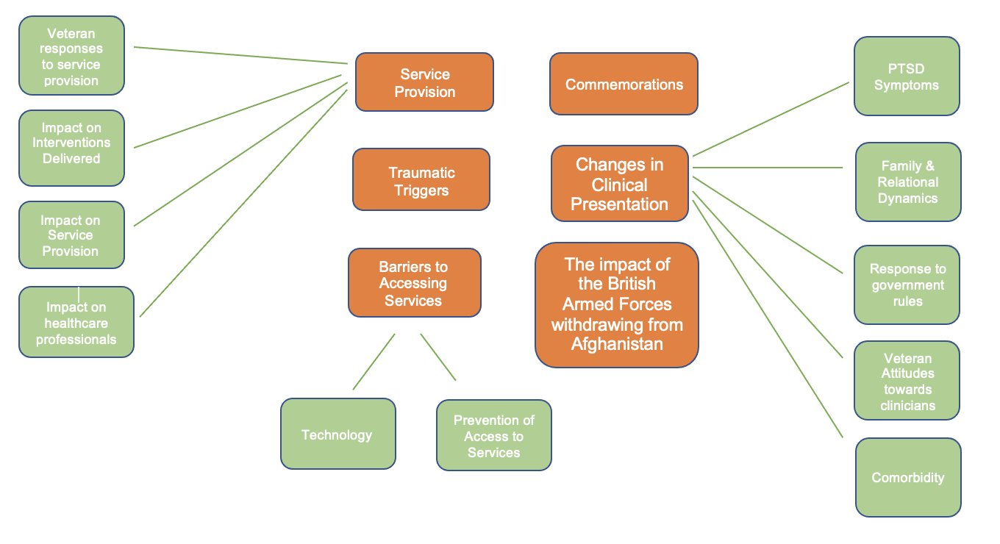
Figure 1. Final Thematic Map Detailing Themes and Sub-themes

Theme One: Service Provision
Changes to service provision in response to the Covid-19 pandemic impacted both veterans and healthcare professionals and was prevalent within this theme and came from sub-themes of service delivery, veteran response to changes in service provision, impact on professionals and impact on interventions delivered.
Service provision was impacted positively by reducing travelling time and Louise (Healthcare Professional) stated “I suppose for us, it's a greater reach for us we can kind of see more people”. A change in volume and routes of referrals into veteran services, with an initial reduction in the beginning of the lockdown was reported “we definitely noticed that reduction in referrals as well” (Amy, Healthcare Professional) which gradually increased as restrictions were lifted, and veterans were able to access more social support and activities. A reflection was made about how services could have been more accessible to veterans earlier in the pandemic “early adoption of video technology would have been good” (David, Healthcare Professional).
Healthcare professionals reflected a reduction in GP referrals due to service users not able to access their GP’s as easily during the pandemic “Veterans haven't been seeing the GP’s though have they during the lockdowns” (Amy, Healthcare Professional). A decline in referrals from Liaison and Diversion and Criminal Justice Service was also noted which have risen as restrictions have been lifted “we would expect to see some people coming in that route off the back of antisocial disruptive behaviour sometimes in the community, I think literally people weren't out drinking and having fights”, “Now, we're getting quite a lot from liaison teams” (David, Healthcare Professional).
The pandemic has seen veteran services to increase their therapeutic offer to meet the changing needs of service users with the introduction of online therapeutic groups “So we started running a live in well, with post-traumatic stress group, started running an anger group” (Louise, Healthcare Professional) and increasing contact with service users on waiting lists “people that we knew, or were on waiting lists, we tried sort of, yes, speak to them, which we possibly wouldn't have done normally, so that was a really nice thing to do, keep in touch with people a bit more” (Louise, Healthcare Professional). It was reflected that this was a change that professionals felt should continue following the pandemic “So that was another development, I suppose that made I think has improved the service or hopefully we’ll continue as we build upon what we've done already and have new iterations of it” (Louise, Healthcare Professional).
The introduction of video communication for therapeutic delivered was reflected upon by healthcare professionals on veterans discussing experiences of trauma within their own homes and the impact this had “I had clients…. who would do live video calls from home, and then they've got to go back to the kids straight after talking about their trauma…it’s weird bringing that stuff up in your house” (Cathy, Healthcare Professional).
Reflections were made on the impact on clinician roles during the pandemic “Because you’re doing things and chasing things over and over…and the way this impacted veterans seeking support” (Angela, Healthcare Professional). Across both professional focus groups, there was reflections that during the pandemic the work became “quite draining” (Angela, Healthcare Professional) and of becoming a “Jack of all trades in veterans’ mental health” (Angela, Healthcare Professional). This interestingly led on to reflections around disparity within service provision “The huge disparity in even in the north. We talked to our Northeast colleagues and their ADHD services are still NHS, can you imagine, and they have, because they've utilized the Covenant really well, they’ll see veterans within three months in that service” (Angela, Healthcare Professional).
Services saw an increase of female veterans coming forward and reflected on whether this was a product of their experiences during the pandemic i.e., being at home more or whether there had been a shift in attitudes around female veterans accessing support “I’d say it’s a bit of both, if you think about those transitioning out. When I think about DCMH and women accessing service, childcare was a real issue for going to appointments, so you could set up a group offer if you ran it alongside a childcare group at the base and a load of women would turn up” (Angela, Healthcare Professional).
Changes to service provision has undoubtedly had an impact on veterans accessing these services with professionals reporting that some veterans displayed a resistance to move to online contacts “We had a lot of initial resistance to online contacts in therapy, therapy specifically at first because people doing trauma in their own home” (Angela, Healthcare Professional) and the impact this had on their therapeutic experience “…a lot of people delayed in therapy or our engagement with services” (Angela, Healthcare Professional). Angela (Healthcare Professional) reflected that this changed over as the pandemic progressed “But over time there's been an improved willingness to engage and actually, like you say, then trying to get people onto other services when they've had this digital offer”. With the reductions in government restrictions, professionals reported a resistance from veterans in their service to return to face-to-face sessions now that a digital option is offered “I mean, we're certainly experiencing some resistance from clients to actually meet face to face now” (Samantha, Healthcare Professional) and the difficulties this raises “you've got some concerns about comes to big complex risk and complex dependency that's quite difficult when you really want to see people face to face and they don't want to come” (Angela, Healthcare Professional).
Changes to service provision allowed services to change the way they delivered their intervention and become more flexible in their approach “ Yeah, I would say some of the Psychological Wellbeing Practitioner (PWP) step 2-3 interventions are now happening in TILS so there’s a lot more case management, so you're doing that behavioural activation, you’re testing motivation, your graded exposure, your low level sleep interventions, mood, which we would usually have sent on to the therapy service” (Angela, Healthcare Professional).

Theme Two: Barriers to Accessing Services
This theme focused on the barriers to accessing services with two sub-themes of technology and prevention of access to services. Resistance to accessing online technology in services was noted “[veterans] don’t go for phone and video in nearly the same willingness that civvies were all flooding to the sort of like, oh isn’t it wonderful, we can do video calls” (Alex, Healthcare Professional). The use of video communication platforms during the pandemic further compounded existing barriers present to accessing services noted by veteran participants “you know, I couldn’t really talk in a muffled mask, and I’ve got problems hearing anyway. So actually, that would have put a real language barrier between the two of us” (Jimmy, Veteran), “It’s the face, the full facial expression is a plus. It’s a smile, auditory, you know, you can see the sadness there or whatever. But without it, you can’t” (Burt, Veteran).
Veterans described the difficulty of accessing services during the pandemic “you can’t go in unless there’s something wrong with ya” (Jimmy, Veteran), “everything was blocked; doctors, hospitals and everything” (Jimmy, Veteran) and the impact on their own physical health “I’ve got to go this afternoon for the first time for a while to give bloods so they can check me diabetes. But that’s been a long time coming and it’s the same with mental health” (Jimmy, Veteran).
Similar views were shared by healthcare professionals about the impact on veterans’ physical health “And they’ve got physical health, and they’re not bein’ routinely seen. There’s a lot being missed” (Angela, Healthcare Professional), and brain injuries “we’ve got a lot of people with pain coming back in related to brain injury that might not have been prevalent before that aren’t being picked up on once because they’ve not been having their reviews” (Angela, Healthcare Professional).
Digital poverty was a prevalent sub-theme of barriers to accessing services with professionals reporting difficulties in completing trauma work “I was ringing him on his housephone, you know, I couldn’t do that kind of trauma work on a housephone. And it really did put a barrier to his treatment” (Samantha, Healthcare Professional). The impact on veterans of engaging in trauma therapy in the home was also reflected upon “I had clients who were working from home, who would do live video calls from home, and then they’ve got to back to the kids straight after talking about their trauma” (Cathy, Healthcare Professional). The reflections made by healthcare professionals highlight additional barriers around using technology to access psychological therapies.

Theme Three: Changes in Clinical Presentation
This theme focused on the changes in presentation experienced by veterans during the pandemic and yielded six subthemes, Alcohol Use, PTSD Symptoms, Family/Relational Dynamics, Response to Government Rules, Attitudes towards Services/Clinicians and Co-Morbidity.
An increase in alcohol consumption by veterans was a pattern prevalent in both healthcare professional focus groups and the veteran focus group. A lack of social activities was speculated as a possible reason for the increase in consumption “because they couldn’t get out and the clubs closed, because they’re at home, they drank a bit more” (Cathy, Healthcare Professional). Both veterans reported an increase in their own alcohol consumption with one veteran reporting “I haven't drank for 10 years I started drinking before Christmas” (Burt, Veteran).
Prevalence of PTSD symptoms was discussed in all three focus groups. An increase in intrusive dreams was reported, with a focus on vividity “I think I understand that dreams are more vivid, now” (Alex, Healthcare Professional). Increases in risk and complexity were prevalent throughout the pandemic “you've got some concerns about comes to big complex risk and complex dependency”, “But these are people, then naturally do become risky 'cause they're quite vulnerable” (Angela, Healthcare Professional).
Healthcare professionals observed an increase in hypervigilance in veteran service users “there was a reinforcement in a way around hypervigilance. Um, and that nowhere is safe” (Samantha, Healthcare Professional). Interestingly Samantha (Healthcare Professional) also reported that for some of their service users the lockdown decreased their hypervigilance and anxiety “actually they felt safe because they didn't have to go to all these places, actually they knew where their loved ones were”. Samantha (Healthcare Professional) further reported that she noticed veterans’ sense of safety “was really empowered”.
Healthcare professionals reported that lockdown guidelines created a sense of shared solidarity and experience in the veteran community “well now everyone else feels exactly the way I felt for all these years. Everyone else can feel that sense of I don't want to leave the house like I am locked in” (Samantha, Healthcare Professional). In contrast to this, the reduction in hypervigilance was conceptualised by one healthcare professional as avoidance which increased in complexity when restrictions were lifted “because it's obviously just part of an avoidance thing, arguably, and so that when we finally did get to see them, they seemed to have got more complex” (David, Healthcare Professional) suggesting the lockdown served as avoidance for veterans from their PTSD symptoms.

Veterans also reported a sense of becoming quiet and withdrawn impacting on their relationships with their partners and a sense of being lost during the COVID-19 lockdown restrictions. Participant Burt, Veteran recalls:
“…I went awfully quiet. She [partner] still seems to get her back up because I don't speak a lot now...because that's how I cope, I distract, I'll do things, you know, when my mind goes... So yes, yes, my missus was upset about the way I acted and stuff”.

Family and relational dynamics were present in the narratives of healthcare professionals who reflected on veterans acknowledging the importance of family support during the pandemic, and credited ‘…the fact that their families need to be involved too” (Angela, Healthcare Professional). Healthcare professionals also reflected on how the lockdown provided veterans with insight into “how that might impact on others when family think they're going to go and jump off a bridge and all those kinds of things would actually do in that home was difficult for some” (Samantha, Healthcare Professional). This was a clear indication of the mental health difficulties faced by veterans and the impact on their families and corroborated by Burt’s (Veteran) account above. The reflections made here stipulate that the increased time with family compounded existing difficulties for veterans due to “the family got to see some of the stuff that they didn't normally see-some of the family dynamics and cracks started to appear” (David, Healthcare Professional).
The impact on children within the family was reflected upon by healthcare professionals “we're seeing a lot more male coercive control. Kids being used - we always saw it small amounts but not I would say we're seeing a lot more relational stuff” (Angela, Healthcare Professional). Angela (Healthcare Professional) further stated “our services need to be a lot more relational and systemic focused because of that and moves to treatments like cognitive analytical therapy that psychodynamic, that DIT, sort of stuff. I think, uh, behavioural family interventions, DBT, a mix of different waves of things”.
Comorbidity within veteran health due to combat trauma and traumatic brain injury (TBI) was present within the reflections of healthcare professionals. Angela (Healthcare Professional) reflected “We've got a lot of people with pain coming back related to brain injury, other symptoms related to the brain injury that might not have been prevalent before that aren't being picked up once they've not been having their reviews”. This reflection speculates on the gaps in referral routes into services and how physical health conditions may be missed by primary care settings due to the restrictions.
Interestingly, there has also been an increase in other comorbid presentations throughout the pandemic which has brought new populations of veterans forward “And that you would say under neurodiversity and ADHD as well as presenting more. Got more autism referrals, people are finding us that might not have come to us before because all the other routes are blocked so they they're populations of people we knew were around” (Angela, Healthcare Professional). This demonstrates the difficulties faced by veterans in attempting to access support and engage with services during the pandemic which may be a triggering experience for them due to the barriers faced.

Theme Four: Traumatic Triggers
This theme focused on things that triggered an onset or perpetuating psychological distress in veterans being seen in services during the pandemic and state of lockdown. A key theme reported was the wearing of masks and how this induced increased hypervigilance in veterans. Angela (Healthcare Professional) reported
“That face masks and face coverings were really quite triggering, so we we actually put some advice out there, particularly black face coverings, triggering around ISIS and Taliban”. Healthcare professionals reported that veterans who had operational deployments to the Gulf War and Bosnian conflicts who witnessed or experienced chemical attacks appeared to be triggered by the mask wearing “Uh, and the further triggering the trauma linked to fast protection but actually hazmat suits, chemical attacks in Gulf, Bosnia, and resistance to wear them due to suspicion around the government agencies” (Angela, Healthcare Professional).
Healthcare professionals also reported an increase in referrals from veterans operationally deployed to Afghan and Iraq “we've got a lot more people come forward from Afghan or from Iraq have now been triggered by that might not come forward” (Angela, Healthcare Professional). It was reflected that this could be due to their previous engagement with services “maybe they're on the first turn of the wheel. Cause sometimes they come around a few times. But actually, this turn because of the pandemic - super angry, whether that's acquired brain injury as well, you know” (Cathy, Healthcare Professional).
A sub-theme also emerged around the noise of pots and pans being banged “one veteran said to me, the pots and the pans. Oh, was the sound was was gunfire or they thought they associated it with the loud noise and that caused re-experiencing in the home” (Samantha, Healthcare Professional), highlighting how arousal symptoms in veterans were activated by commemorations during the pandemic.

Discussion

The Covid-19 pandemic was unprecedented and could not have been prepared for. At the time of writing this research paper, the world was still considered to be in a pandemic and there is a growing body of research on the impact this has had across all populations, with existing research conducted at the beginning of the pandemic.
The aims and objectives of the research project were to explore how the Covid-19 impacted UK military veterans through the experiences of veterans and healthcare professionals. The study found changes to service provision in veterans mental health impacted veterans both positively and negatively. Whilst the change to delivering intervention online meant that healthcare professionals were able to treat a greater reach of service users as evidenced in the theme of service provision, the requirement that veterans had access to technology to support online video communication presented a barrier to accessing treatment. This finding aligns with research by McFarlane (2020) who found that the change to remote working and online therapy reduced the accessibility of services provided. However, the present study was conducted later in the pandemic and found that as services became more accessible due to government regulations lessening, veterans preferred online intervention suggesting that whilst accessibility may be reduced for some veterans, the offer of online treatment may increase engagement from veterans who are able to access this technology.
Whilst this present study found that veterans were still keen to access services face-to- face but initially resistant to online contacts, this is contradictory to previous literature by Thome et al., (2020) which found that individuals were reluctant to access services due to risk of transmission and infection. However, as more time passed during the pandemic, services found that veterans preferred online contact. Whether the reason for this was due to fear of transmission and infection was not stated.
An increase in alcohol consumption as well as hypervigilance and intrusive dreams was found in theme three, changes in clinical presentation and was discussed by both veterans and healthcare professionals. Whilst research by Iverson and Greenberg (2009) stated that depression, anxiety, and alcohol disorders in UK veterans were more prevalent than PTSD, this research paper aligns with the findings from Bleich et al., (1997) who found that PTSD and MDD share comorbid pathologies. There were also some reports in the present study that hypervigilance and anxiety was reduced for veterans during the pandemic as their sense of safety increased due to being at home and increase their sense of solidarity as the entire population shared the experience of lockdown. Not only does this suggest that whilst the pandemic was a shared experience, there were differences in how it impacted PTSD symptoms, but also that the comorbidity between PTSD and MDD in veterans may share a higher correlation than previously reported by Iverson & Greenberg (2009). With the increase in alcohol consumption during the pandemic as well as pre-existing conditions, it suggests that that within the veteran population, it may be difficult to differentiate between each condition due to their correlated comorbidity.

The impact of the pandemic on veteran family and relational dynamics was discussed by healthcare professionals and veterans in their respective focus groups. Veterans reported that they became withdrawn from their loved ones which impacted their relationships and healthcare professionals speculated on the impacted of completing trauma therapy online in the home and how this may impact veterans who return to their families following their session. It was also speculated that the impact on the family may further compound PTSD symptoms such as avoidance as veterans were unable to avoid the impact their difficulties have on the family. This finding corroborates with previous literature conducted on veterans and families; a literature review conducted by Galovski & Lyons (2004), found the arousal symptoms experienced by veterans are predictive of family distress and anger is associated with secondary traumatisation within the family. Healthcare professionals in the present study reported that services also saw an increase in male coercive control and children in the family being impacted suggesting that veterans’ mental health, particularly after the pandemic would benefit from conceptualisation from a family perspective as well as within the individual. Previous literature also found that veterans who experience warzone or combat-related PTSD experience poorer family adaptions upon discharge (Vadterling et al., 2015) which was touched upon by healthcare professionals who speculated about the increase in referrals and whether these were veterans who were reaching out for support for the first time following their discharge from the military.
Healthcare professionals discussed the increase in female veterans accessing veteran mental health services during the pandemic and speculated on possible reasons for this as a. shift in attitudes towards female veterans accessing support and their capacity to access services increasing due to increase in childcare provisions during the pandemic. This finding aligns with existing literature which states that female veteran status is often underreporting and viewed as a descriptive factor rather than an analytical factor in veteran research (Eichler, 2016) suggesting that further research needs to be undertaken on the gender differences in the transition to civilian life and how this may impact male and female veterans accessing mental health support.

Clinical Implications
In this study, there was an indication that in the initial stages of the pandemic, veterans were resistant to online therapy intervention, however as the pandemic progressed, this attitude shifted, and veterans engaged in online contacts well. Interestingly, healthcare professionals reported that as government guidelines lessened the social distancing restrictions, they found that veterans had become resistant to face-to-face contacts and preferred an online delivery of therapy. Whilst it is clear there are mixed perceptions by veterans on the way therapy is delivered, mental health provisions should consider offering a blended approach of online and face-to-face to interventions that is centered around the veterans’ individual needs, making access to therapeutic intervention more accessible. A blended approach would also reduce the barrier of access to technology for veteran who do not have access to such devices to ensure all individual needs are met.
The present study also found alcohol consumption, anxiety, and PTSD to be comorbid conditions reported by veterans and service provisions should consider this comorbidity and the degree of correlation when hypothesising interventions to ensure all needs of the veterans are formulated and considered when understanding their subjective experiences and difficulties. Often, excessive alcohol consumption can be a barrier for veterans accessing mental health services and a wider formulation can support their engagement into appropriate services to meet their needs.
The impact of Covid-19 on veterans and their families was a strong theme in both veteran and healthcare professional narratives in this study. It is evident that a veteran’s experience of PTSD undoubtedly impacts their families with previous research suggesting this is associated with secondary traumatisation within the family unit. Healthcare professionals should consider more systemic formulations when working with veterans their families and mental health provisions should consider models that are inclusive of the family unit when working with an individual such as Systemic Family Therapy, Dialectical Behavioural Therapy and Psychodynamic approaches to meet the needs of veterans and their families.

Limitations
The study experienced difficulties with recruitment uptake, and most participants were healthcare professionals with only two participants with veteran status. This could have biased the narratives presented on the impact of Covid-19 on military veterans as they were mostly reported by professionals, limiting the generalisability of the findings to a wider veteran population. All healthcare professionals in the study worked in veteran specific services therefore comparisons of service provision between mainstream services and veteran specific services could not be made; this could have provided valuable insight into implications for future service changes.
The study accepted self-reported PTSD from veteran participants. Whilst this allowed for the subjective experiences of veteran participants to be explored, it did not allow the study to address any differences in specific subsections of PTSD experienced such as combat-related PTSD or complex PTSD and whether there were differences in the way veterans were impacted by the pandemic depending on how they experienced their post-traumatic stress.

Future Research
Future research should consider the impact of the pandemic on veterans and their families as the findings from this paper have highlighted an increase in familial difficulties because of the pandemic. Existing literature has identified an increased interest in family involvement in their treatment for PTSD (Batten et al., 2009) which the present study has identified became more prevalent during the pandemic suggesting a need for future research into family involvement to inform more systemic models within service provisions for this population.
Existing literature has found veterans with PTSD experience an aversion to loud noises (Hafemeister, & Stockey, 2010) and those with combat-related PTSD experience and increase in PTSD symptoms in response to loud noises (Orr et al., 1995). The pandemic saw commemorations for frontline workers in the form of banging pots and pans which it could be hypothesised, could have increased veteran experiences of PTSD. In light of this, future research should consider the specific subsections of PTSD such as combat-related trauma, complex trauma, veterans with adverse childhood experiences and whether their experiences of the pandemic differed from those within this research paper and whether they experienced more intrusive memories and flashbacks.
This paper has also highlighted the prevalence and impact of comorbid conditions such as physical health and PTSD. Future research should consider the prevalence of pre-existing physical health conditions during the pandemic and how TBI, for example, acts as a barrier for help-seeking among veterans in general, and the impact on veterans’ overall psychological wellbeing during and after COVID-19 and enforced lockdown. Future research could inform clinical services and improve access to these services for veterans experiencing comorbid difficulties.

Conclusion
The study explored the impact of the Covid-19 pandemic on UK military veterans experiencing PTSD. The study found that during the pandemic, military veterans experienced increased alcohol consumption, increase in hypervigilance and intrusive dreams and difficulties within family. However, for some veterans, the lockdown decreased their hypervigilance and gave them a sense of safety. Service provision changes in response to the pandemic have undoubtedly contributed to the difficulties faced by veterans in accessing services and posed new barriers with the introduction of online intervention delivery. However, the study also found that as the pandemic progressed, this became a preference for veterans. The pandemic has undoubtedly impacted UK military veterans with both their experiences of PTSD and accessing services for mental health support. Future research should consider exploring the impact the pandemic had on veterans and their families and how the pandemic impacted veterans experiencing subsections of PTSD such as combat-related trauma, complex PTSD, and those with comorbid conditions such as alcohol consumption.

References

Alharahsheh, H. H., & Pius, A. (2020). A review of key paradigms: Positivism VS interpretivism. Global Academic Journal of Humanities and Social Sciences, 2(3), 39-43.
American Psychiatric Association. (1980). Diagnostic and Statistical Manual of Mental Disorders (3rd ed.).
American Psychiatric Association. (2013). Diagnostic and Statistical Manual of Mental Disorders (5th ed.).
Asmundson, G. J., Stapleton, J. A., & Taylor, S. (2004). Are avoidance and numbing distinct PTSD symptom clusters? Journal of Traumatic Stress: Official Publication of the International Society for Traumatic Stress Studies, 17(6), 467-475. https://doi.org/10.1007/s10960-004-5795-7.
Banerjee, D., & Rai, M. (2020). Social isolation in Covid-19: The impact of loneliness. International journal of social psychiatry, 66(6), 525-527. https://doi.org/10.1177/0020764020922269.
Batten, S. V., Drapalski, A. L., Decker, M. L., DeViva, J. C., Morris, L. J., Mann, M. A., & Dixon, L. B. (2009). Veteran interest in family involvement in PTSD treatment. Psychological Services, 6(3), 184- 189. https://doi.org/10.1037/a0015392.
Bleich, A., Koslowsky, M., Dolev, A., & Lerer, B. (1997). Post-traumatic stress disorder and depression: An analysis of comorbidity. The British Journal of Psychiatry, 170(5), 479-482. https://doi.org/10.1192/bjp.170.5.479.
Braun, V., & Clarke, V. (2021). Can I use TA? Should I use TA? Should I not use TA? Comparing reflexive thematic analysis and other pattern‐based qualitative analytic approaches. Counselling and Psychotherapy Research, 21(1), 37-47. https://doi.org/10.1002/capr.12360
Breslau, N., Lucia, V. C., & Davis, G. C. (2004). Partial PTSD versus full PTSD: an empirical examination of associated impairment. Psychological medicine, 34(7), 1205-1214. https://doi.org/10.1017/S0033291704002594.

British Psychological Society. (2020). Ethics best practice guidance on conducting research with human participants during Covid-19. https://www.bps.org.uk/sites/www.bps.org.uk/files/Policy/Policy%20- %20Files/Conducting%20research%20with%20human%20participants%20du ring%20Covid-19.pdf
Campbell, D. G., Felker, B. L., Liu, C. F., Yano, E. M., Kirchner, J. E., Chan, D., ... & Chaney, E. F. (2007). Prevalence of depression–PTSD comorbidity: Implications for clinical practice guidelines and primary care-based interventions. Journal of general internal medicine, 22(6), 711-718. https://doi.org/10.1007/s11606-006-0101-4
Campise, R. L., Geller, S. K., & Campise, M. E. (2006). Combat Stress. In C. H. Kennedy & E. A. Zillmer (Eds.), Military psychology: Clinical and operational applications (pp. 215–240). The Guilford Press.
Carroll, T. D., Currier, J. M., McCormick, W. H., & Drescher, K. D. (2017). Adverse childhood experiences and risk for suicidal behavior in male Iraq and Afghanistan veterans seeking PTSD treatment. Psychological Trauma: Theory, Research, Practice, and Policy, 9(5), 583– 586. https://doi.org/10.1037/tra0000250.
Coronavirus (Covid-19), (n.d.). GOV.UK. https://www.gov.uk/coronavirus. [Date Accessed 27th November 2021].
Clark, A. M. (1998). The qualitative‐quantitative debate: moving from positivism and confrontation to post‐positivism and reconciliation. Journal of advanced nursing, 27(6), 1242-1249. https://doi.org/10.1046/j.1365- 2648.1998.00651.x
Comte, A. (2015). A general view of positivism. Routledge.
Corbetta, P. (2003). Social research: Theory, methods and techniques. Sage.

Ehlers, A., & Clark, D. M. (2000). A cognitive model of posttraumatic stress disorder. Behaviour research and therapy, 38(4), 319-345. https://doi.org/10.1016/S0005-7967(99)00123-0
Eichler, M. (2017). Add female veterans and stir? A feminist perspective on gendering veterans’ research. Armed Forces & Society, 43(4), 674-694. https://doi.org/10.1177/0095327X16682785
Etikan, I., Alkassim, R., & Abubakar, S. (2016). Comparision of snowball sampling and sequential sampling technique. Biometrics and Biostatistics International Journal, 3(1), 55. https://doi.org/ 10.15406/bbij.2015.03.00055
Flowers, P., & Larkin, M. (1997). Analysis. P. Smith (Ed.). Blackwell Publishing.
Friedman, M. J., Resick, P. A., Bryant, R. A., & Brewin, C. R. (2011). Considering PTSD for DSM‐5. Depression and anxiety, 28(9), 750-769. https://doi.org/10.1002/da.20767
Galovski, T., & Lyons, J. A. (2004). Psychological sequelae of combat violence: A review of the impact of PTSD on the veteran's family and possible interventions. Aggression and violent behavior, 9(5), 477-501. https://doi.org/10.1016/S1359-1789(03)00045-4
Gates, M. A., Holowka, D. W., Vasterling, J. J., Keane, T. M., Marx, B. P., & Rosen, R. C. (2012). Posttraumatic stress disorder in veterans and military personnel: epidemiology, screening, and case recognition. Psychological services, 9(4), 361.
Grubbs, K. M., Fortney, J. C., Kimbrell, T., Pyne, J. M., Hudson, T., Robinson, D., ... & Schnurr, P. P. (2017). Usual care for rural veterans with posttraumatic stress disorder. The Journal of Rural Health, 33(3), 290-296. https://doi.org/10.1111/jrh.12230
Hafemeister, T. L., & Stockey, N. A. (2010). Last stand-The criminal responsibility of war veterans returning from iraq and afghanistan with posttraumatic stress disorder. Ind. LJ, 85, 87.

Iversen, A. C., van Staden, L., Hughes, J. H., Browne, T., Hull, L., Hall, J., ... & Fear, N. T. (2009). The prevalence of common mental disorders and PTSD in the UK military: using data from a clinical interview-based study. BMC psychiatry, 9(1), 1-12. https://doi.org/10.1186/1471-244X-9-68.
Iversen, A., & Greenberg, N. (2009). Mental health of regular and reserve military veterans. Advances in Psychiatric Treatment, 15(2), 100-106. doi:10.1192/apt.bp.107.004713
Mareth, T. R., & Brooker, A. E. (1985). Combat stress reaction: A concept in evolution. Military Medicine, 150(4), 186-190. https://doi.org/10.1093/milmed/150.4.186
Mcfarlane, A., Jetly, R., Castro, C. A., Greenberg, N., & Vermetten, E. (2020). Impact of COVID-19 on mental health care for Veterans: Improvise, adapt, and overcome. Journal of Military, Veteran and Family Health, 6(S2), 17-20. https://doi.org/10.3138/jmvfh.CO19-0001
Morgan, D. L. (1996). Focus groups. Annual review of sociology, 22(1), 129-152. https://doi.org/10.1146/annurev.soc.22.1.129
Morgan, D. L. (1993). Successful focus groups: Advancing the state of the art (Vol. 156). Sage.
Morgan, D. L., & Krueger, R. A. (1993). When to Use Focus Groups and Why. In: D. L. Morgan (Ed.), Successful Focus Groups: Advancing the State of the Art (pp. 3-9). Newsbury Park, CA: Sage Publications. http://dx.doi.org/10.4135/9781483349008.n1
Orr, S. P., Lasko, N. B., Shalev, A. Y., & Pitman, R. K. (1995). Physiologic responses to loud tones in Vietnam veterans with posttraumatic stress disorder. Journal of abnormal psychology, 104(1), 75. https://doi.org/10.1037/0021- 843X.104.1.75
Otis, J. D., Gregor, K., Hardway, C., Morrison, J., Scioli, E., & Sanderson, K. (2010). An examination of the co-morbidity between chronic pain and posttraumatic stress disorder on U.S. Veterans. Psychological Services, 7(3), 126– 135. https://doi.org/10.1037/a0020512

Pai, A., Suris, A. M., & North, C. S. (2017). Posttraumatic stress disorder in the DSM-5: Controversy, change, and conceptual considerations. Behavioral Sciences, 7(1), 7. https://doi.org/10.3390/bs7010007
Palinkas, L. A., Horwitz, S. M., Green, C. A., Wisdom, J. P., Duan, N., & Hoagwood, K. (2015). Purposeful Sampling for Qualitative Data Collection and Analysis in Mixed Method Implementation Research. Administration and policy in mental health, 42(5), 533–544. https://doi.org/10.1007/s10488-013-0528-y
Palmer, E., Murphy, D., & Spencer-Harper, L. (2017). Experience of post-traumatic growth in UK veterans with PTSD: A qualitative study. BMJ Military Health, 163(3), 171-176. http://dx.doi.org/10.1136/jramc-2015-000607.
Pietrabissa, G., & Simpson, S. G. (2020). Psychological consequences of social isolation during COVID-19 outbreak. Frontiers in psychology, 2201. https://doi.org/10.3389/fpsyg.2020.02201
Ramchand, R., Karney, B. R., Osilla, K. C., Burns, R. M., & Caldarone, L. B. (2008). Prevalence of PTSD, depression, and TBI among returning service members. Invisible wounds of war: Psychological and cognitive injuries, their consequences, and services to assist recovery, 35-85.
Ryan, G. (2018). Introduction to positivism, interpretivism and critical theory. Nurse researcher, 25(4), 41-49. https://doi.org/10.7748/nr.2018.e1466.
Shura, R. D., Brearly, T. W., & Tupler, L. A. (2020). Telehealth in response to the COVID‐19 pandemic in rural veteran and military beneficiaries. The Journal of Rural Health, 37(1), 200–204. DOI: 10.1111/jrh.12454
Smith, J. A., & Shinebourne, P. (2012). Interpretative phenomenological analysis. American Psychological Association.
Smithson, J. (2000). Using and analysing focus groups: limitations and possibilities. International journal of social research methodology, 3(2), 103- 119. https://doi.org/10.1080/136455700405172.

Solomon, Z. (2013). Combat stress reaction: The enduring toll of war. Springer Science & Business Media.
Thome, J., Deloyer, J., Coogan, A. N., Bailey-Rodriguez, D., da Cruz E Silva, O. A., Faltraco, F., ... & Fond-Harmant, L. (2021). The impact of the early phase of the COVID-19 pandemic on mental-health services in Europe. The World Journal of Biological Psychiatry, 22(7), 516-525. https://doi.org/10.1080/15622975.2020.1844290.
Truusa, T. T., & Castro, C. A. (2019). Definition of a veteran: the military viewed as a culture. In Military Veteran Reintegration (pp. 5-19). Academic Press. https://doi.org/10.1016/B978-0-12-815312-3.00002-4.
Vasterling, J. J., Taft, C. T., Proctor, S. P., Macdonald, H. Z., Lawrence, A., Kalill, K., ... & Fairbank, J. A. (2015). Establishing a methodology to examine the effects of war‐zone PTSD on the family: The family foundations study. International Journal of Methods in Psychiatric Research, 24(2), 143-155. https://doi.org/10.1002/mpr.1464
Veteran Factsheet (2020). GOV.UK. https://assets.publishing.service.gov.uk/government/uploads/system/uploads/ attachment_data/file/874821/6.6409_CO_Armed-Forces_Veterans- Factsheet_v9_web.pdf
Walton, J. L., Raines, A. M., Cuccurullo, L. A. J., Vidaurri, D. N., Villarosa‐Hurlocker, M. C., & Franklin, C. L. (2018). The relationship between DSM‐5 PTSD symptom clusters and alcohol misuse among military veterans. The American journal on addictions, 27(1), 23-28. https://doi.org/10.1111/ajad.12658
Weston, C. S. (2014). Posttraumatic stress disorder: a theoretical model of the hyperarousal subtype. Frontiers in psychiatry, 5, 37. https://doi.org/10.3389/fpsyt.2014.00037
Williams, M. (2000). Interpretivism and generalisation. Sociology, 34(2), 209-224. doi:10.1177/S0038038500000146

Wilson, J. P. (1994). The historical evolution of PTSD diagnostic criteria: From Freud to DSM-IV. Journal of Traumatic Stress, 7(4), 681-698. https://doi.org/10.1007/BF02103015
World Health Organisation (2020). Coronavirus (Covid-19). https://www.who.int/emergencies/diseases/novel-coronavirus-2019 [Date Accessed 23rd February 2022].

Appendix A Author Guidelines for Military Psychology Journal

Military Psychology journal is published by Taylor and Francis and uses the American Psychological Association (7th edition) referencing guidelines.

A summary of guidelines includes:

Preparing Your Paper

Article Types

Regular Articles
- Should be written with the following elements in the following order: abstract, text, references, tables, and figures
- Should be no more than 30 pages, inclusive of:
  - Abstract
  - Tables
  - References
  - Figure or table captions
  - Footnotes
  - Endnotes
- Should contain no more than 5 keywords. Read making your article more discoverable, including information on choosing a title and search engine optimization.

A link to the full author guidelines can be found using the below link.

https://www.tandfonline.com/action/authorSubmission?show=instructions&journalCode=hmlp20#references

Appendix B - Ethical Approval from Staffordshire University Ethics Committee

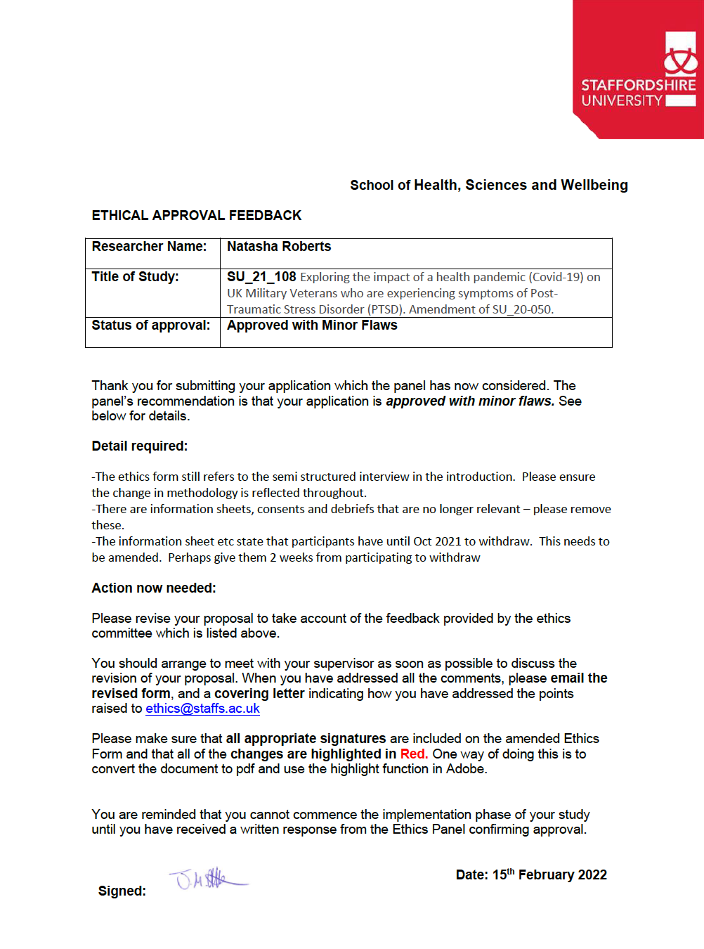

Appendix C- Participant Information Sheets for both Veterans and Healthcare Professionals
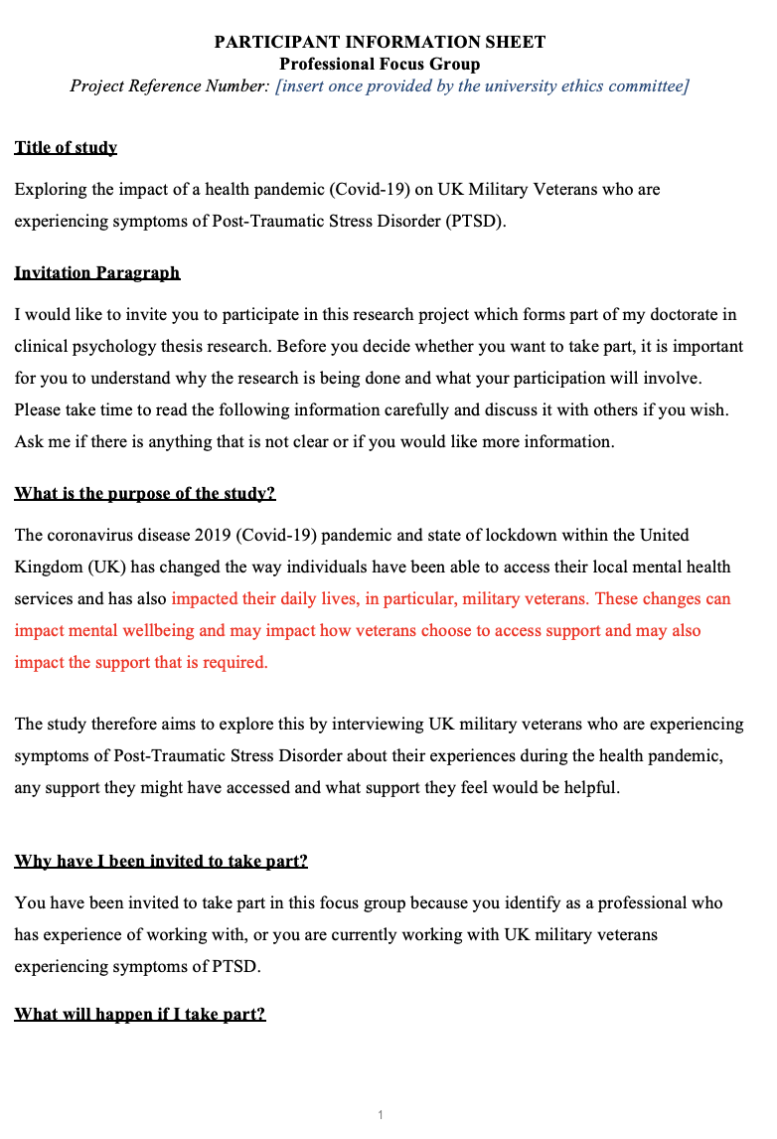

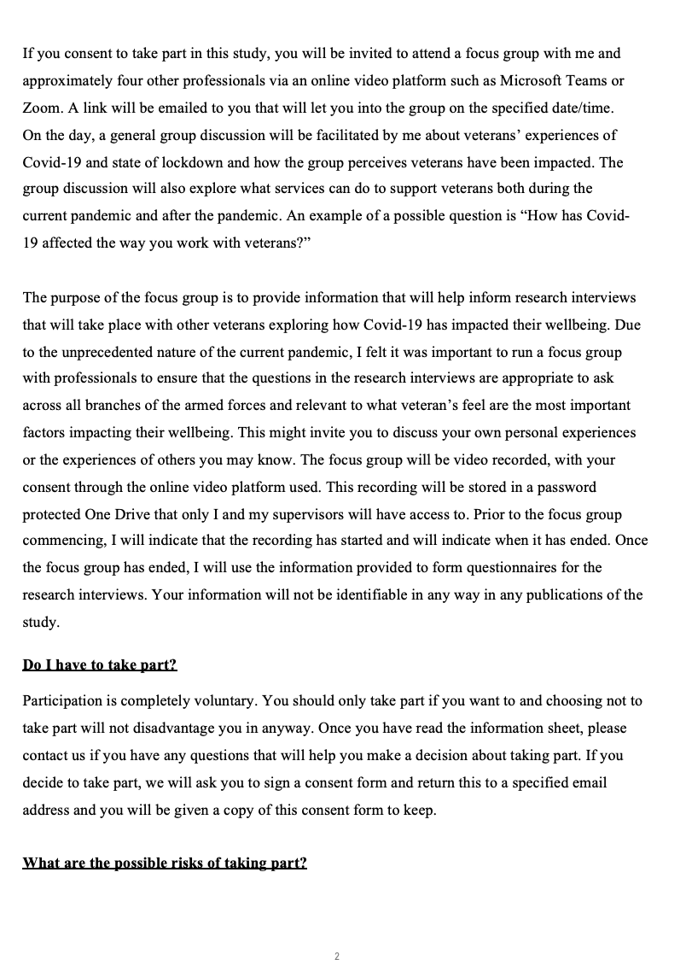
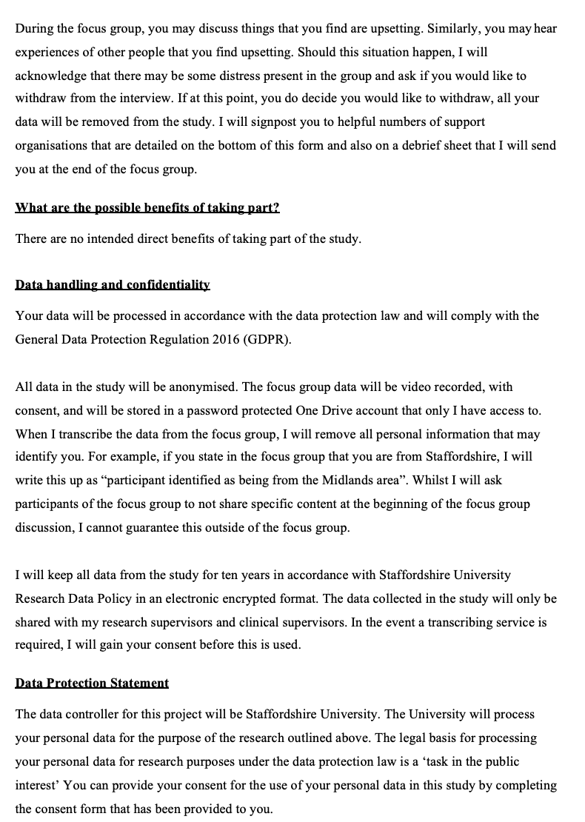
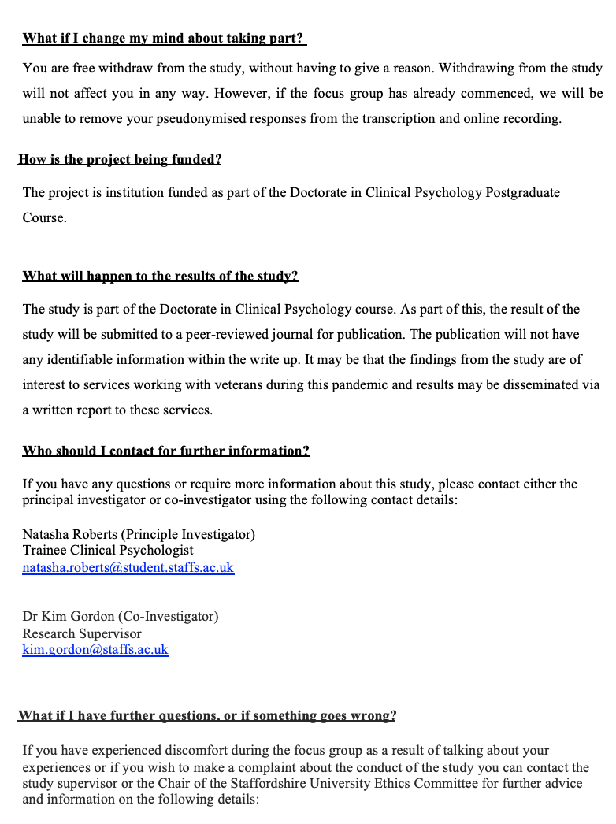
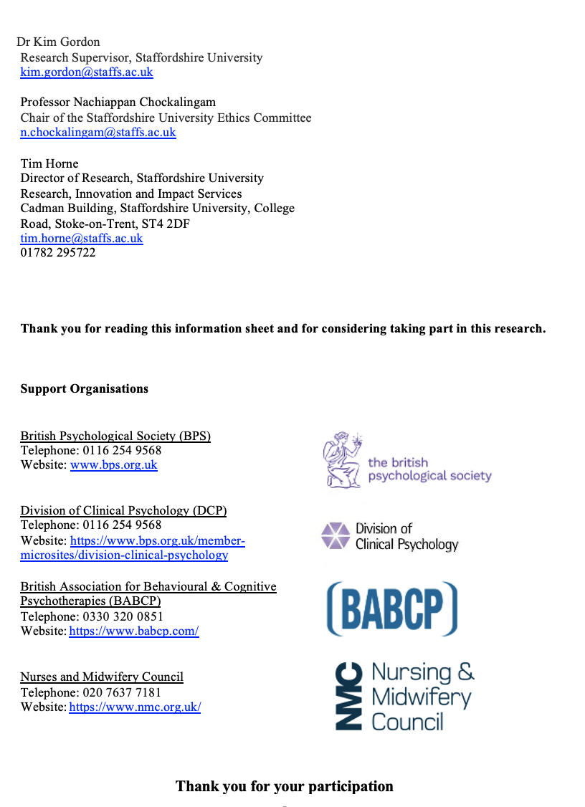

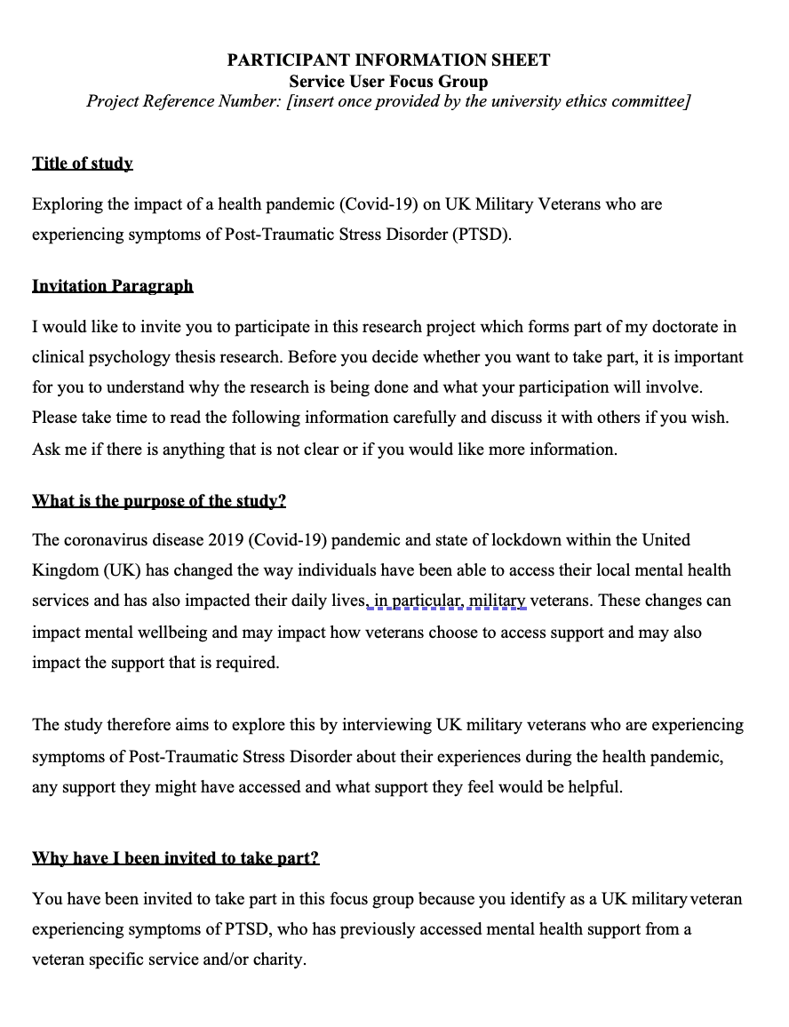

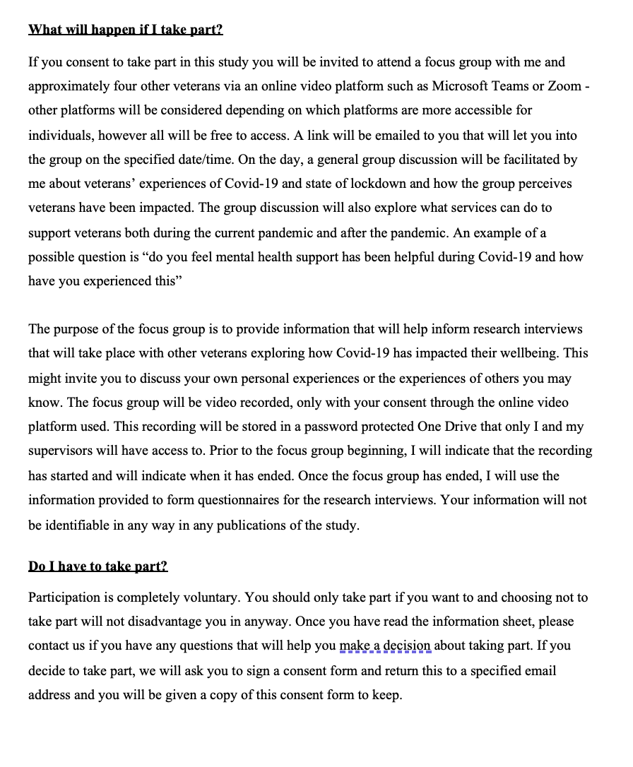

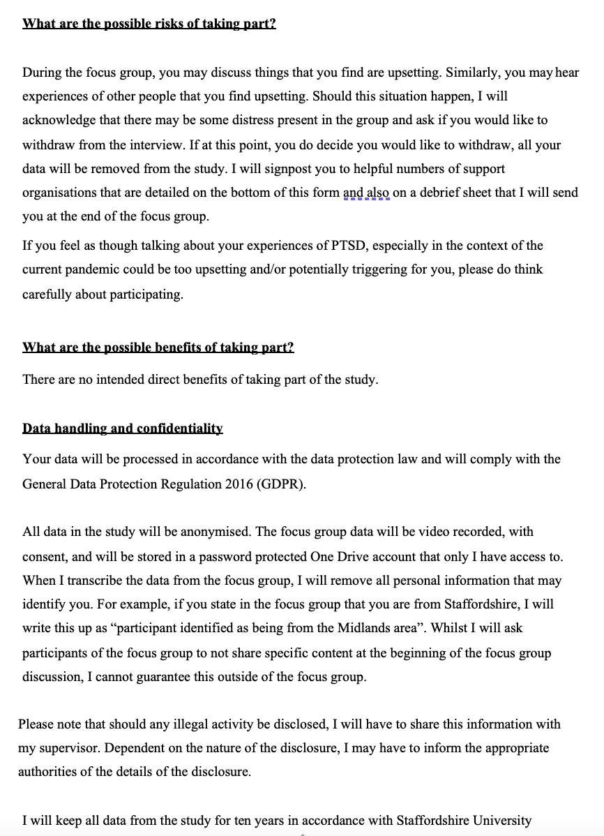

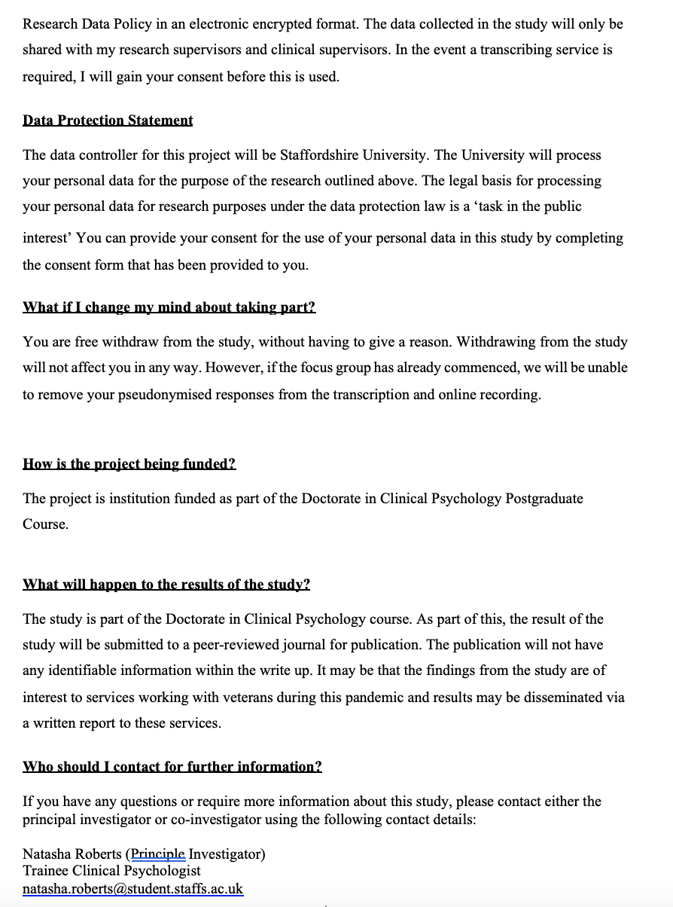

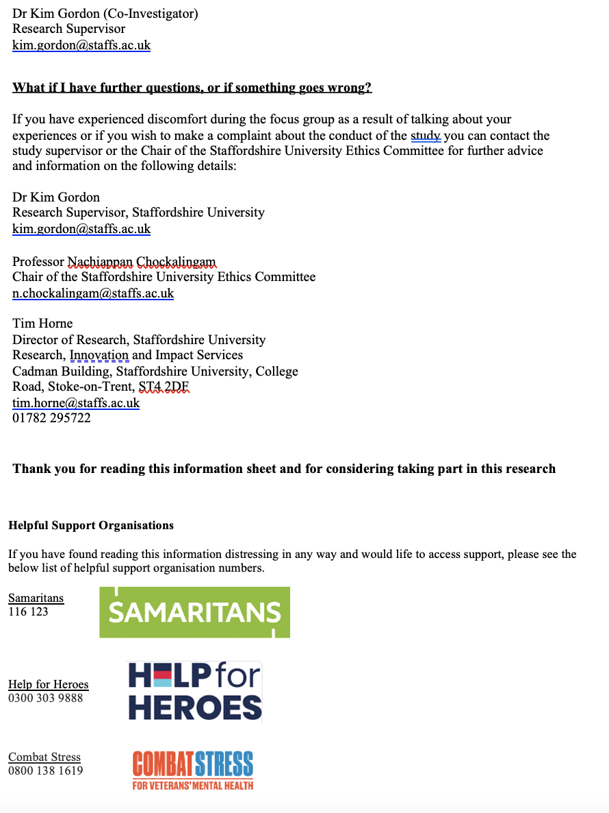

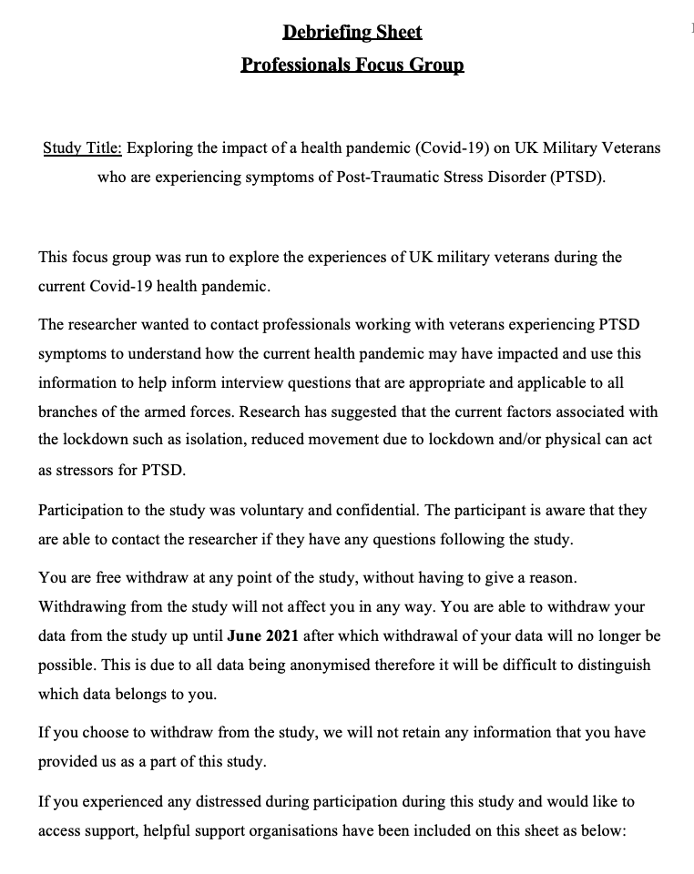
Appendix D - Participant Debrief Sheets for both Veterans and Healthcare Professionals

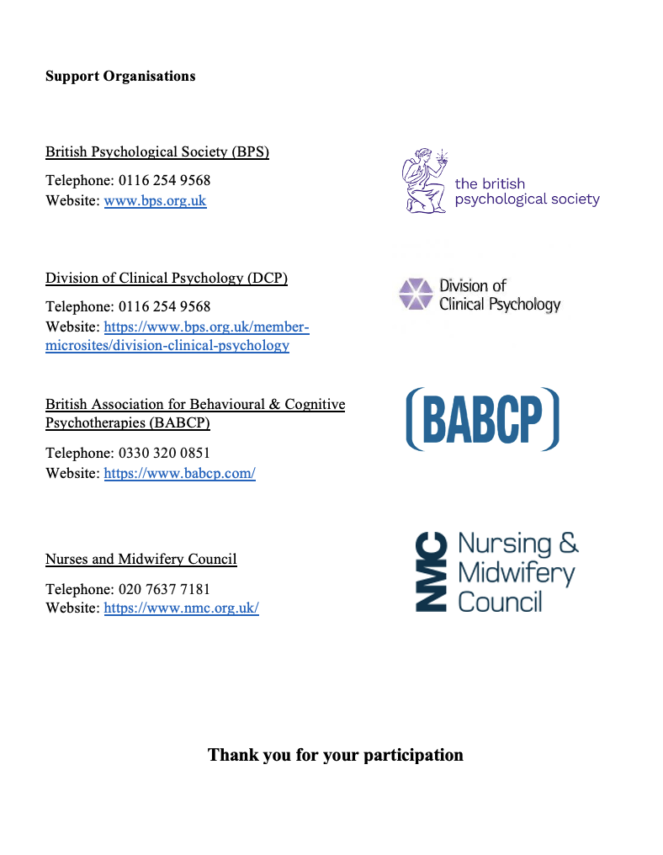
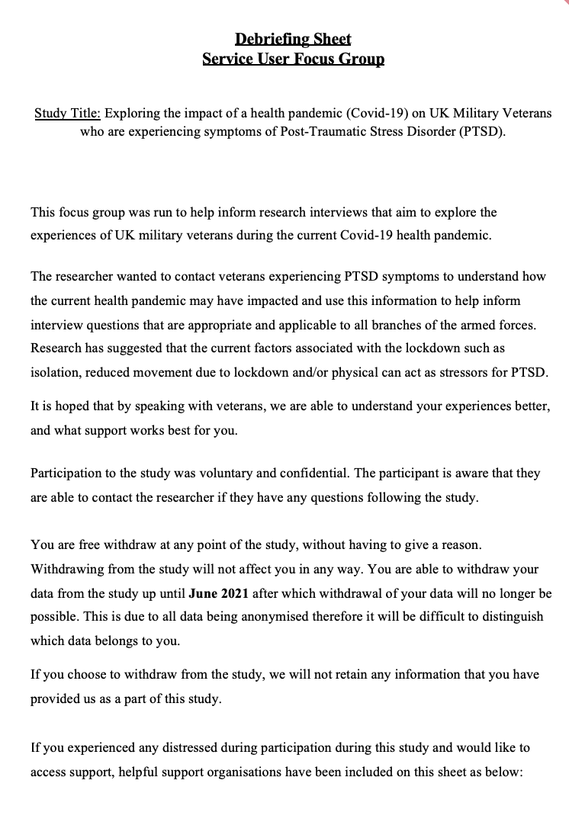
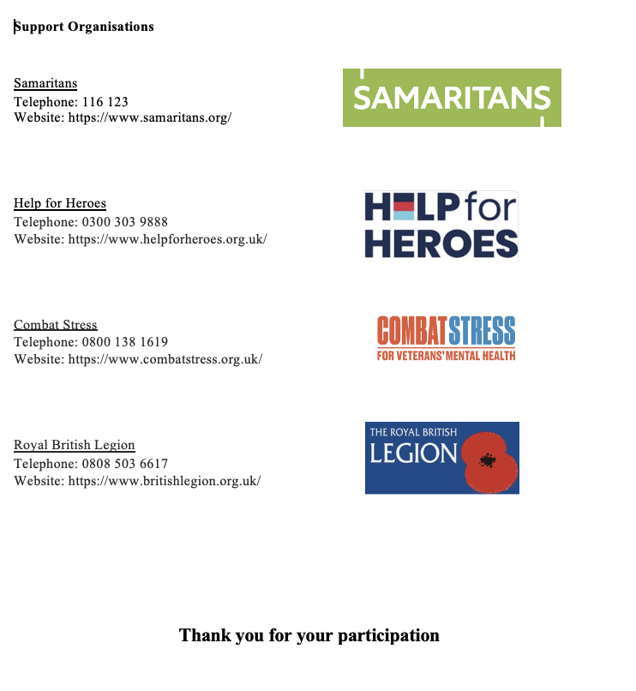

Appendix E - Adverse Event Protocol approved by Staffordshire University Ethical Committee

Please explain how any potential risks or hazards will be dealt with, along with any justificatory statements. This information should highlight any remaining ethical considerations and how to respond to them in a way which may assist the Research Ethics Committee in arriving at some judgement upon the proposal.

Should any adverse event occur with regards to participants mental health and/or distress, the researcher will ascertain participant's state of health by acknowledging that there may be some distress present and participants will be asked if they would like the focus group to be stopped. If the participant agrees to stop the focus group, they will be signposted to the various support networks in the participant information sheet and debriefing sheet. They will be thanked for their time and their data will be withdrawn from the research.

Should participants state that they feel able to continue with the focus group then the researcher will remind participants regarding their right to withdraw and again take verbal consent for the focus group to continue.

The researcher will ensure that all Covid-19 regulations will be followed as per government guidelines. Due to the changing guidelines in line with a phased plan implementation by the government, the researcher will ensure up to date guidelines are adhered to as per government policy outlined at https://www.gov.uk/coronavirus (Last Accessed 21.7.20). As present, individuals who do not live in the same household are unable to meet face to face unless a 2-metre distance is maintained, and appropriate Personal Protective Equipment (PPE) used. Due to this, the research will be carried out via audio and video platforms.

Appendix F - Participant Consent Forms for Veterans and Healthcare Professionals

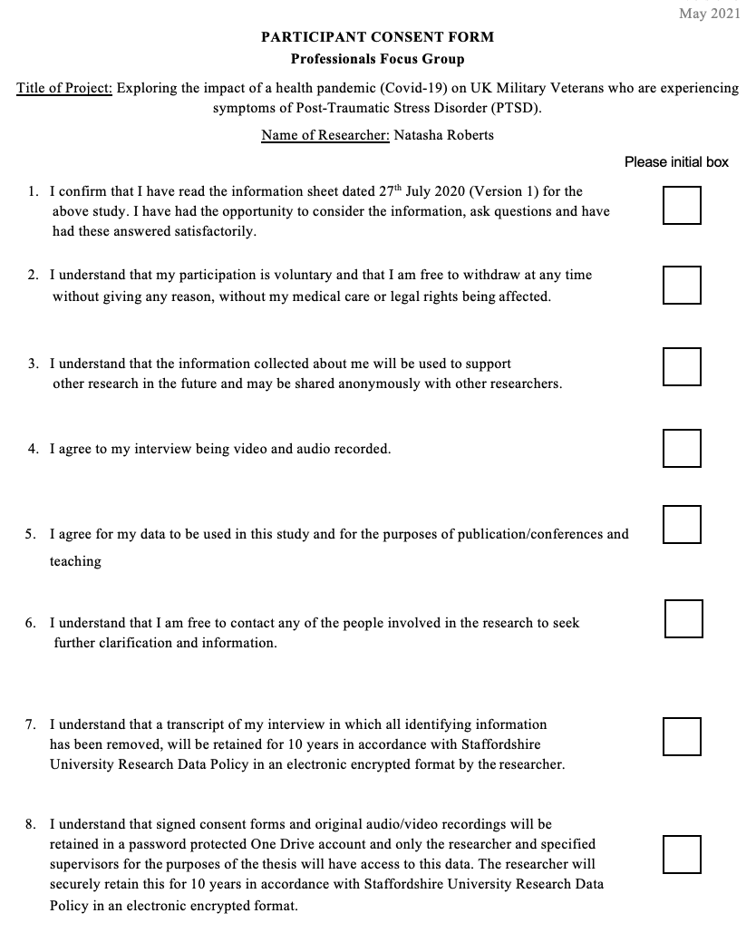

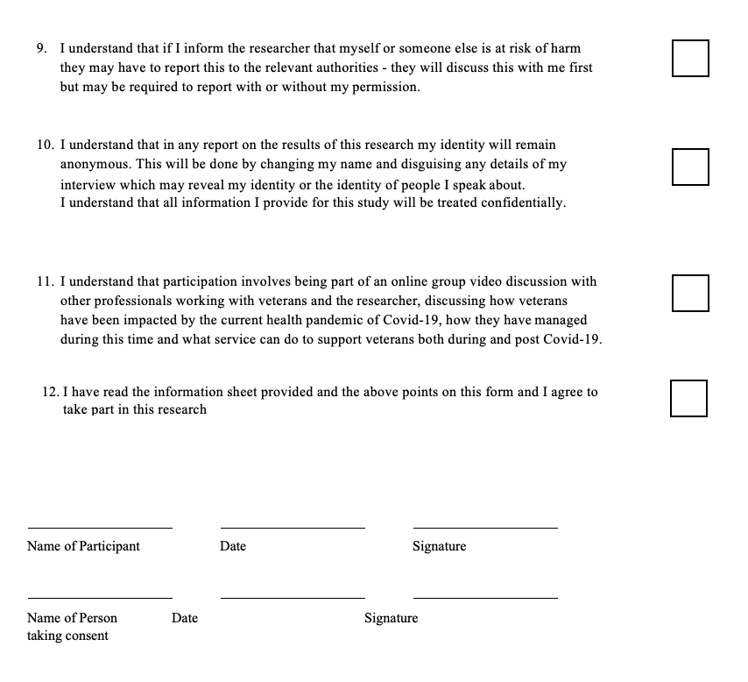

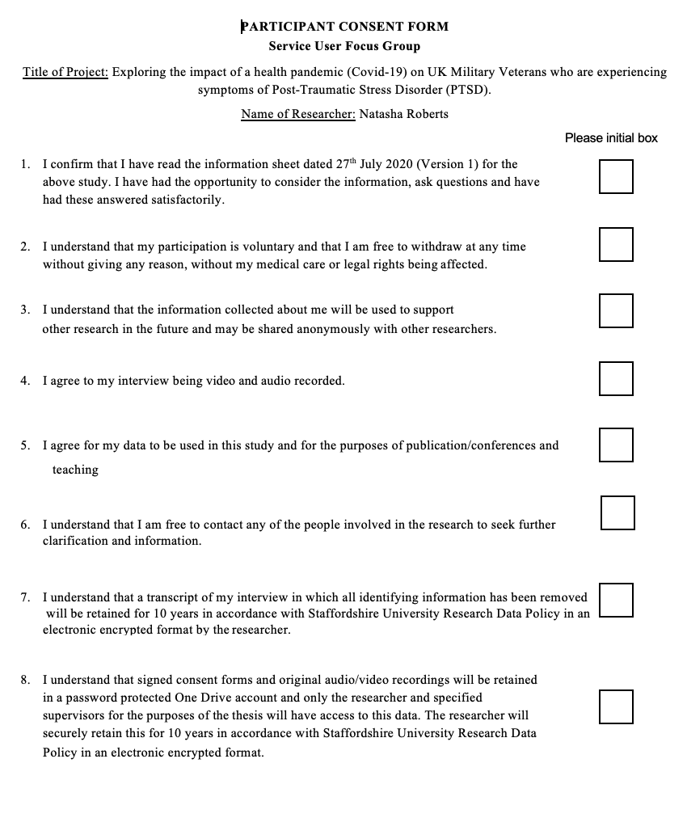

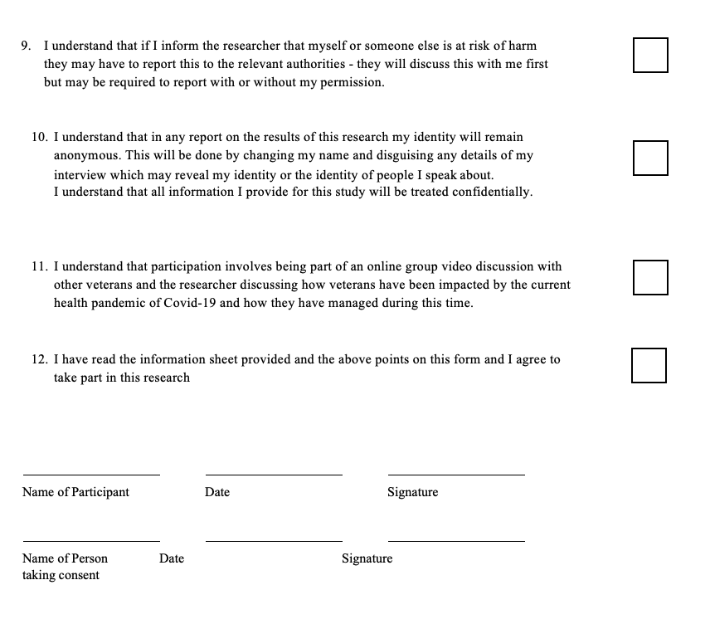

Appendix G - Study Advertisements for Social Media Platforms

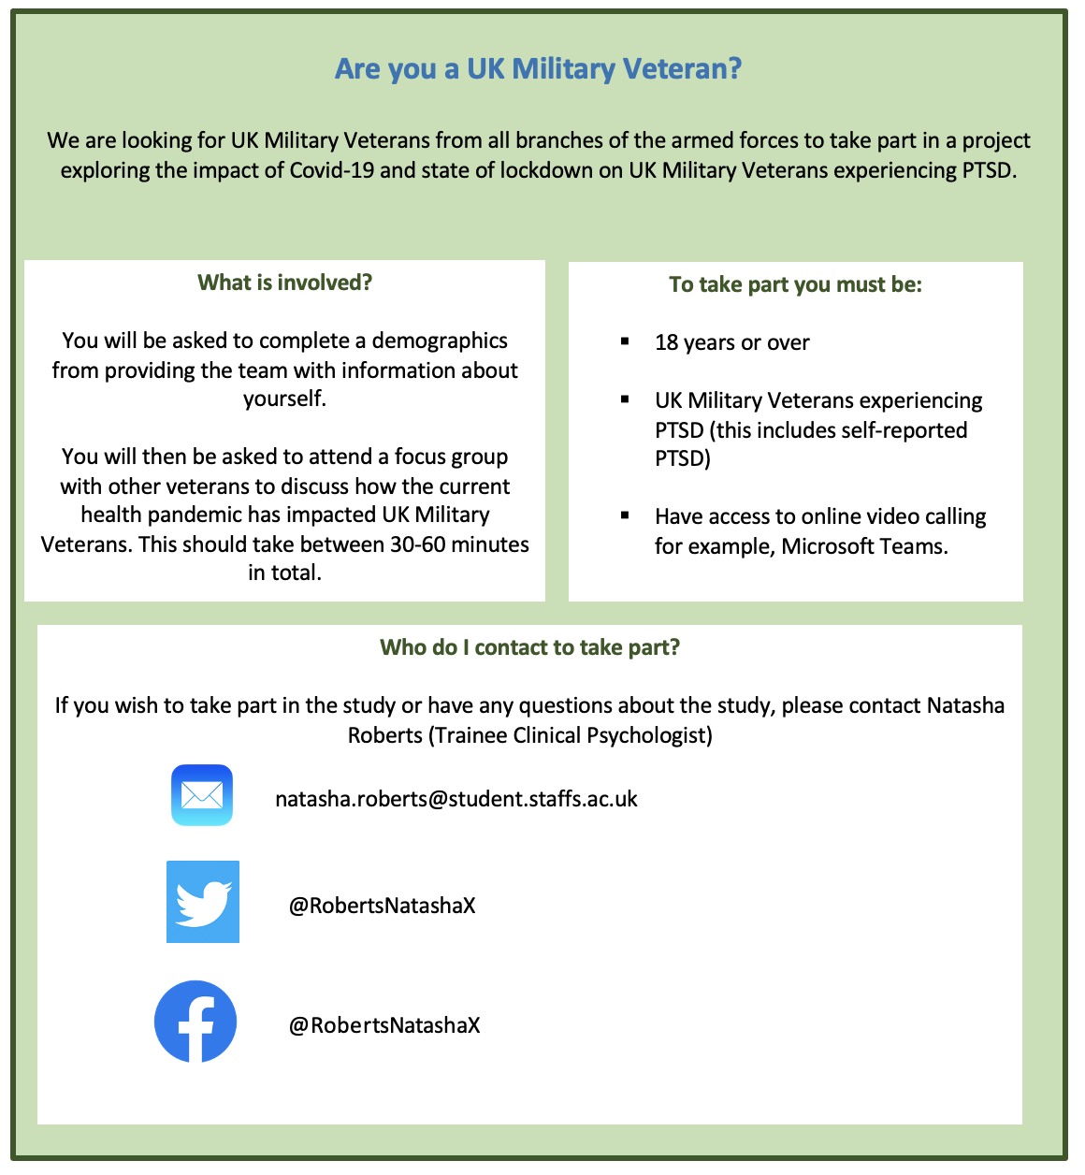

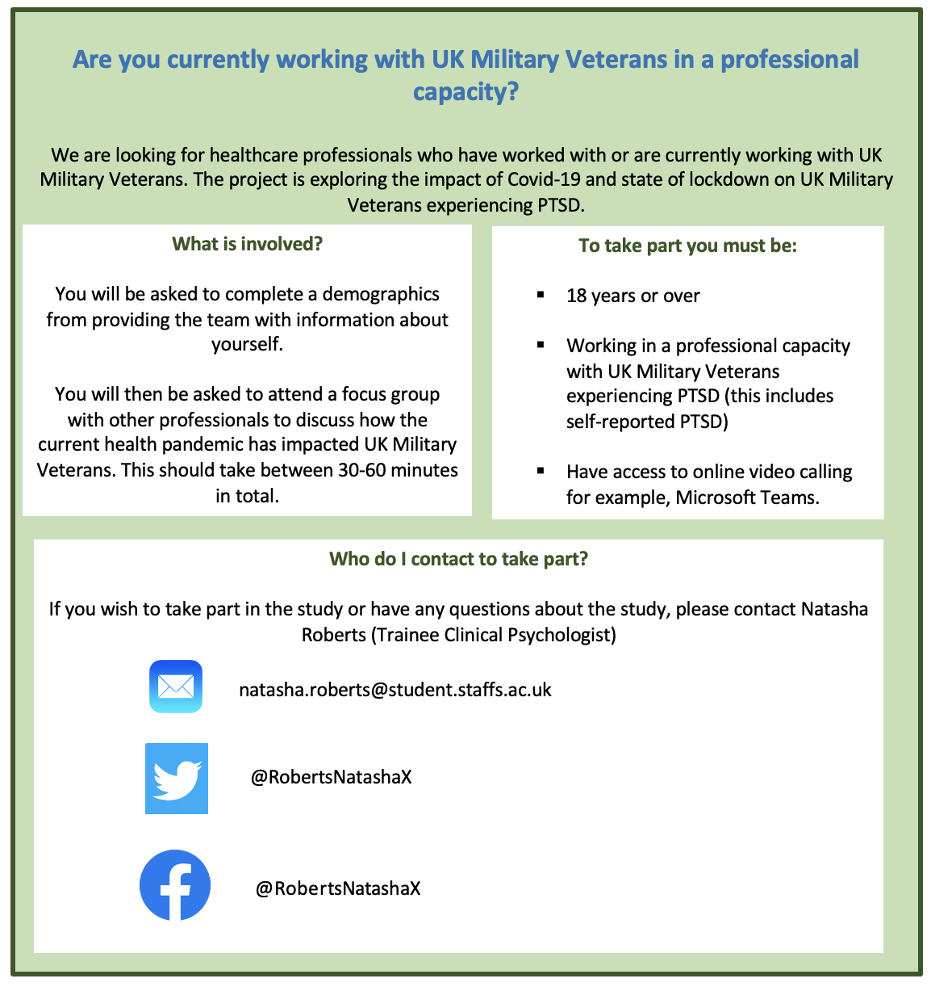

Appendix H- Focus Group Schedules for the Veteran and Healthcare Professionals Focus Groups

Healthcare Professionals Focus Group

- From your professional experience, how do you feel UK military veterans experiencing PTSD were impacted by the Covid-19 pandemic?
- Did you feel there was an increase in PTSD symptoms reported by veterans during the pandemic? If so, how did veterans experience this?
- How was service provision impacted?
- Did the pandemic present any new barriers to accessing your services or further impact existing barriers?
- Was there anything different reported by military veterans during the pandemic outside of their mental health?

Veteran Focus Group

- How do you feel that either yourselves from your personal experience or veterans as a whole were impacted during the COVID 19 pandemic?
- Did you feel that healthcare services for both physical and mental health changed because of the pandemic? If so, how?
- Did you feel there were any new barriers to accessing services?
- How did you feel experiences of PTSD for veterans were impacted because of the pandemic?
- Did you feel military veterans experienced the pandemic differently to civilians?

Appendix I - Table Outlining Braun & Clarke’s (2006) Guidelines for Thematic Analysis

Appendix J - Initial Coding Ideas from Phase One of Thematic Analysis

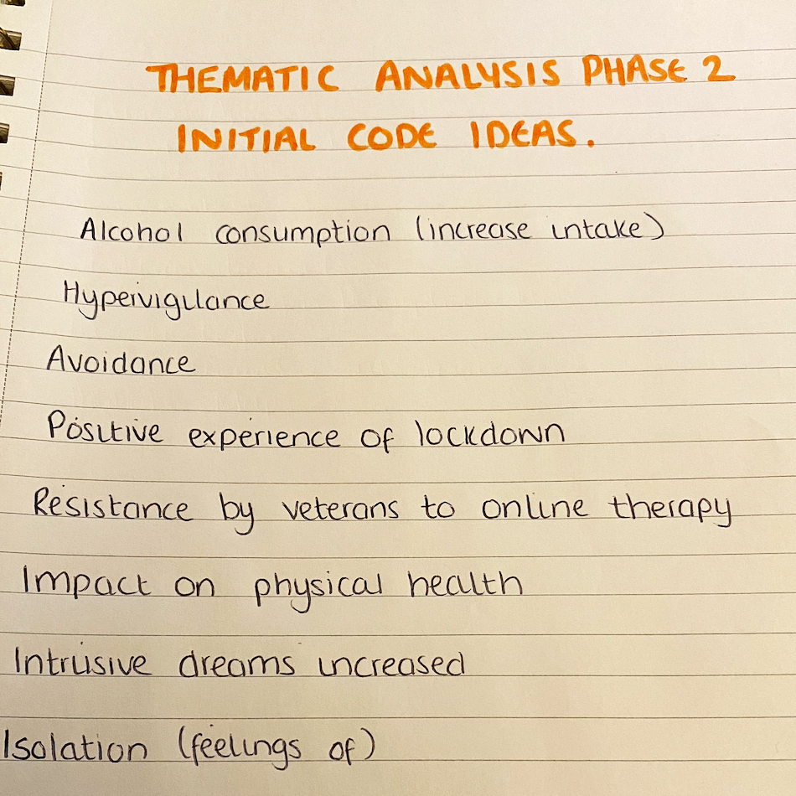

Appendix K - Example of Data Extracts with Multiple Codes

Data Extract | Coded For
“Yeah, totally agree. I mean, it's been a nightmare. Just getting into see me - I'm a diabetic now. And it's been a bloody nightmare. I've gotta go this afternoon for the first time for a while to give bloods so they can check me diabetes. But that's been a long time coming. And it’s the same with mental health. No, it's not the NHS’ fault, but somethings need to be accountable because you have a job and we are part of the Armed Forces Covenant, but we feel we have just been left in the gutter, personally”. | Access to GP’s  Access to mental health provisions  Attitudes towards the NHS  Accountability  Treatment of Veterans  Impact on Physical Health
“Peer support’s been a nightmare. My crisis - I’m fortunate, my daughter is a care manager. She’s helped me immensely whilst I’ve been struggling over the last 18 months. Without my daughter’s help, I would have gone over the top, personally”. | Lack of peer support  Care from family with physical health  Impact on mental wellbeing
“I think for those veterans or those, those people that were really isolated, and had no friends or family and was really on their own, actually lockdown really made them isolated. So, I remember speaking with someone who I was their only contact in me, and I had to do it every week, and I was the only person that they spoke to. And this gentleman didn't have a laptop he didn't have, he only had a house phone, he didn't have a smartphone. | Lack of social support  Impact of lack of social support on isolation experienced  Professionals being only source of contact  Lack of technology as a barrier to accessing support

Appendix L - Picture showing process of searching for themes with examples of codes and themes

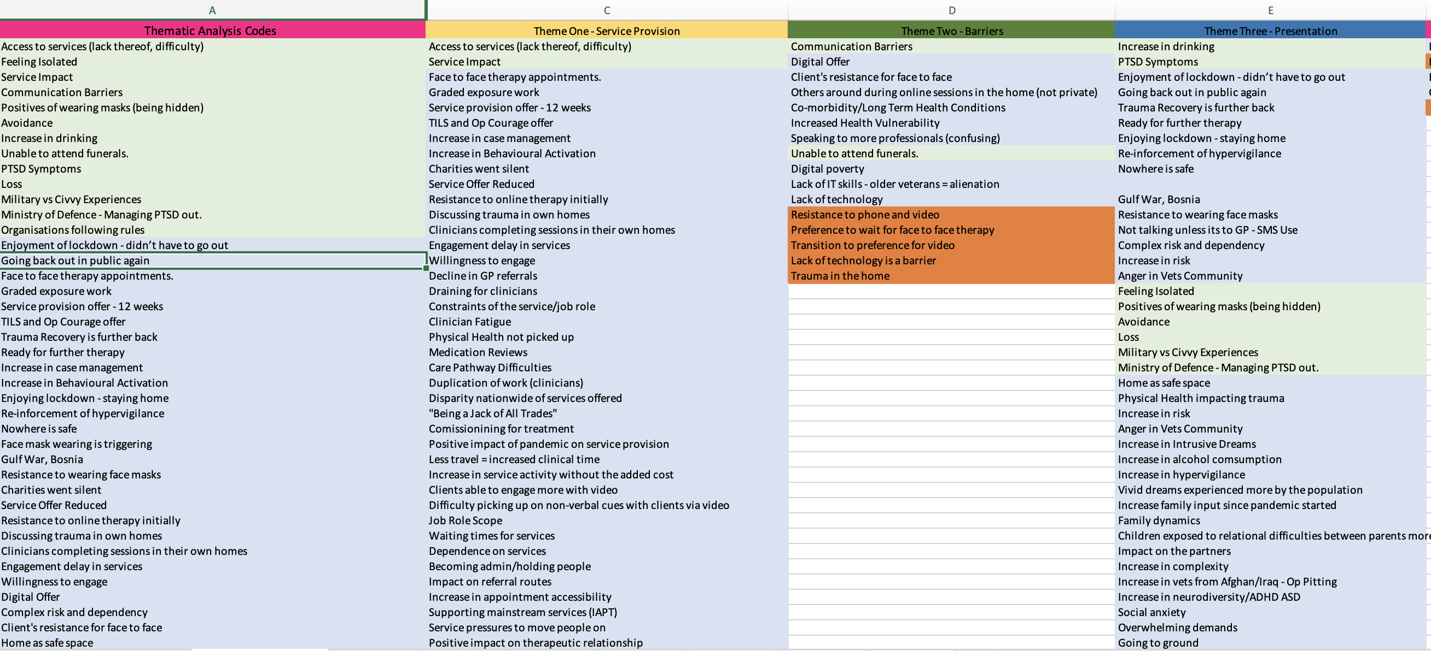

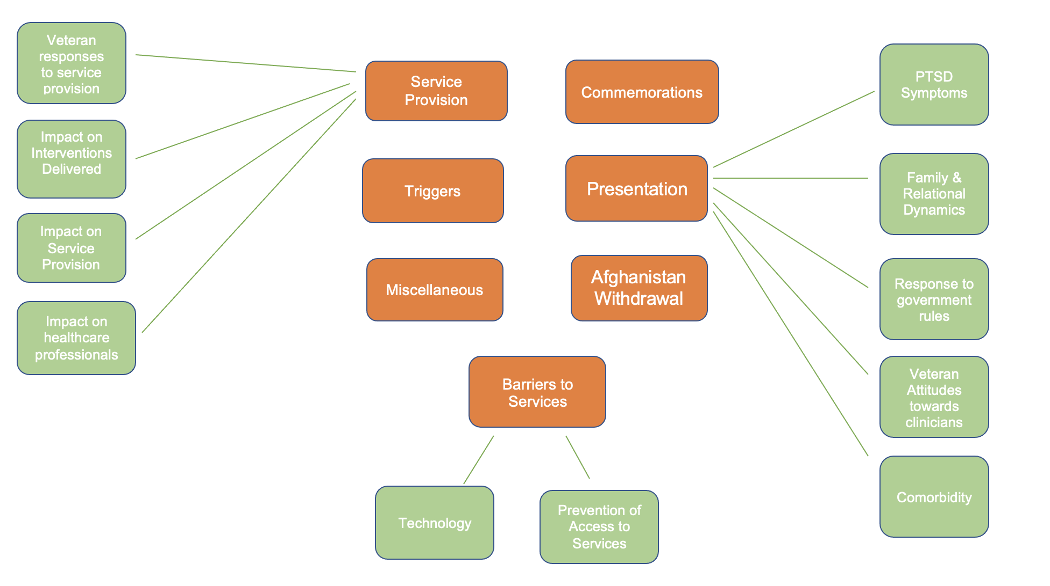
Appendix M - Initial Thematic Map before Review

Appendix N - Extract from Reflexive Journal

At the time of conducting this research I am a 30-year-old mixed white and Asian British female employed as a Trainee Clinical Psychologist within the NHS. I first developed an interest of working with military veterans in the UK when I was in post as an assistant psychologist in an NHS Military Veterans Service. My time in post as an assistant psychologist opened my eyes to how veterans are impacted by their military careers and the current support available for them across the NHS and third sector organisations. My experience here also gave me subjective knowledge and understanding of gaps in service provision and barriers to veterans accessing services.

For one of my third-year placements, I have returned to this placement to gain further experience of working with military veterans. I felt myself feeling strongly about working with this population as I often felt they did not have enough knowledge on services available to them and how to access services. I also felt that military veterans are typical labelled within a diagnostic model and wider socio-cultural context are often lost in their diagnoses. I challenge the medical model and its use of diagnostic language and labelling and endeavour to minimise my own personal use of diagnostic language in my clinical work. I believe that an individual’s personal experiences can be understood through their own subjective experiences which can be enhanced through collaborative discussion where I can promote psychological understanding and mindedness. This stance guided my choice of methodology to complete a qualitative piece of research as I wanted to give veterans an opportunity to share their subjective experiences in a way that could potentially inform clinical practice to better support their needs.

Whilst completing the research, particularly the data analysis, I was aware that I had my own clinical experiences of working with veteran and had my own subjective knowledge of how veterans are impacted due to the experiences shared by my own clients. I reflected on the impact this could have on the research with regards to bias and chose to code my data semantic so that all codes came directly from spoken words of participants to reduce the risk of bias from my subjective interpretation. I used this journal to reflect on anything that I felt may impact my perceptions of my data and kept a separate journal of themes of things that had come up in my sessions with clients so that if anything presented itself in session that was in my research, I could separate the two and limit the influence of my clinical experience on my interpretation of my data sets.

Paper 3: Executive Summary

Word Count: 2477 (excluding title page, references, and glossary)

This paper is not intended for publication. It has been produced as a report aimed at veterans and healthcare professionals working with veterans.

Executive Summary

“Exploring the impact of the Covid-19 pandemic on UK Military Veterans with PTSD. Gaining perspectives of veterans and healthcare professionals working with veterans”

Natasha Roberts
Trainee Clinical Psychologist

Acknowledgements

A huge thank you to the veterans and healthcare professionals who took part in this research, for sharing their time and personal experiences that allowed this research to be possible.

Research Summary

This summary has been prepared for military veterans of the British Armed Forces and healthcare professionals working with military veterans.

This summary will outline a research study that explores how the Covid-19 pandemic impacted UK military veterans experiencing PTSD. The study gained the perspectives of both veterans and healthcare professionals who either worked with military veterans during the pandemic or who are currently working with military veterans. The study was completed as part of the Staffordshire University Clinical Psychology Doctorate. Approval for the study was granted by Staffordshire University ethics committee.

The research will be submitted to the “Military Psychology” to be considered for publication.

When preparing this report, a draft was read by two veterans who provided comments on how to improve accessibility of the document. A glossary of terms can be found at the end of this summary.

Background

What is Post-Traumatic Stress Disorder?

Post- Traumatic Stress Disorder or PTSD is something that occurs in individuals who have experienced a traumatic event either directly, or as a witness to the event (Breslau et al., 2004). Symptoms of PTSD are categorised into four clusters by the Statistical Manual of Mental Disorders (DSM-III) (Pai et al., 2017). The four clusters include:

Avoidance

- Avoiding things that remind an individual of the event such as people, objects, and places.

Intrusion

- Dreams
- Memories
- Nightmares
- Flashbacks

Alterations in Cognition & Mood

- Changes in beliefs about the self, others, and the world around us.
- Low mood
- Worry about the future
- Loss of interest in activities.
Alterations in Arousal & Reactivity

- Irritability
- Easily startled
- Hypervigilance

Why is PTSD relevant to Military Veterans?

PTSD is the most reported mental health difficulty from military veterans worldwide (Palmer et al., 2017). Research that has been conducted in both the UK and the United States of America (USA) found that PTSD was the most reported mental health difficulty following discharge from the military (Gates et al., 2012; Iverson et al., 2009). Research has also found that veterans experiencing PTSD, may also experience other mental health difficulties such as depression, anxiety, alcohol and substance misuse and difficulties within their families (Iverson & Greennberg, 2009; Galovski & Lyons, 2004). As well as experiencing mental health difficulties, veterans are also likely to experience difficulties with their physical health due to combat-related injuries, training exercises and exposure to warzones (Otis et al., 2010).

How does this relate to the Covid-19 Pandemic?
In March 2020, the SARS-Cov-2 health crisis was declared a worldwide pandemic (Covid-19 Pandemic) by the World Health Organisation (WHO, 2020). In the UK, the government mandated guidelines around social isolation which required individuals to remain at home and not socialise with any friends, family, or social support networks face-to-face. This saw an increase in individuals experiencing social isolation and experiencing hypervigilance and panic around their physical health (Banerjee & Rai, 2020). Research conducted in the early stages of the pandemic found that the government rules would stop veterans from being able to access their social support networks and pose a challenge to their wellbeing (McFarlane et al., 2020).

How did the pandemic impact services who provide support to veterans?
The pandemic changed the way that healthcare in the UK was provided, and community mental health services provided therapy and support online. This change had a major impact in veteran mental health as it reduced access to services due to the changes made in response to the government guidelines (McFarlane et al., 2020).
Early research into the pandemic completed a review of healthcare services for military veterans and made suggestions from their review. The research suggested that veteran healthcare should be reconsidering considering the pandemic and services should be adapted to meet the needs of military veterans with PTSD (McFarlane et al., 2020).

Aims of the Research Study
Previous research has found that the Covid-19 pandemic impacted the way mental health services provided support for military veterans such as moving to online therapy sessions which undoubtedly impacted veterans accessing these services. Research has suggested that services providing such support, need to sustain the way they provide support for veterans following the pandemic (McFarlane et al., 2020). Current research has also anticipated that veterans will experience an increase in their experiences of their PTSD (Shura et al., 2021).
The study aims to explore the experiences of military veterans of the British Armed Forces experiencing PTSD during the Covid-19 pandemic. The research focused on how the pandemic impacted the wellbeing of veterans and explored the perspectives of both veterans and healthcare professionals working with or who worked with veterans during the pandemic.

How we conducted the study

The study was open to UK military veterans and healthcare professionals who worked with veterans during the pandemic. The study was advertised on Facebook, Twitter and LinkedIn. Eligible participants were given an information sheet about the study and each participant signed a consent form to take part.
Three focus groups were completed: one with veteran participants and two with healthcare professionals. Two veterans and ten healthcare professionals took part in the study. All focus groups were video recorded and transcribed. Once the focus groups were completed, the researcher conducted a “thematic analysis”. This involved the researcher going through the focus group transcripts and identifying the key ideas that each participant had discussed and finding differences and similarities across all the focus groups.

What the research found
After completed the thematic analysis, the research developed “themes”. Each theme represented the ideas that were most discussed across all of the focus groups.
The study found 6 themes:
Service Provision

Barriers to Accessing Services

Changes in Clinical Presentation

Traumatic Triggers

Commemorations

The Impact of the British Armed Forces withdrawing from Afghanistan.

Themes of Commemorations and The Impact of the British Armed Forces withdrawing from Afghanistan were not discussed in the research paper as they did not directly relate to the research question however they have been kept for considerations on future research.

Each theme is supported by participant quotes from each focus group

All the participants’ names have been changed to protect their identity.

Theme One: Impact on Service Provision

This theme represented how services offering support to veterans had been impact by the pandemic and how this impacted veterans and their wellbeing.
Key Ideas:

- Service provision was impacted positively by moving to online therapy as healthcare professionals were able to see more veterans.
- Healthcare professionals reported that initially, they found a resistance from veterans accessing support online and discussed how this impacted on veterans discussing their traumatic experiences in their homes.
- The change to online therapy allowed services offer new ways of delivering therapy such as online therapeutic groups.
- Services saw an increase of female veterans referring in for mental health support and discussed whether this was a result of the pandemic or changing attitudes towards female veterans accessing support.
- Veterans initially presented with some resistance to online therapy.

“I suppose for us, it's a greater reach for us we can kind of see more people”. - Louise (Healthcare Professional)

“So, we started running a live in well, with post-traumatic stress group, started running an anger group” - Louise (Healthcare Professional)

“When I think about women accessing services, childcare was a real issue for going to appointments” - Angela (Healthcare Professional)

“We had a lot of initial resistance to online contacts in therapy…specifically at first because people doing trauma in their own home...discussing trauma in their own home” - Angela (Healthcare Professional)

Theme Two: Barriers to Accessing Services

This theme represented barriers veterans faced in accessing support for their physical and mental health during the pandemic. Perspectives from both veterans and healthcare professionals are represented.

Key Ideas:

- Access to technology that allows for video communication platforms was a barrier to veterans being able to access support.
- Veterans found it difficult to liaise with individual’s whilst wearing masks as they could not see their faces.
- Veterans with physical health conditions, had difficulty accessing their GP’s during the pandemic and it was discussed that physical health difficulties may have been missed by professionals as veterans were not being routinely seen.

““I was ringing him on his housephone, you know, I couldn’t do that kind of trauma work on a housephone. And it really did put a barrier to his treatment” - Samantha (Healthcare Professional)

“And they’ve got physical health, and they’re not bein’ routinely seen. There’s a lot being missed” - Angela (Healthcare Professional)

“I’ve got to go this afternoon for the first time for a while to give bloods so they can check me diabetes. But that’s been a long time coming and it’s the same with mental health” - Jimmy (Veteran)

“You know, I couldn’t really talk in a muffled mask, and I’ve got problems hearing anyway” - Burt (Veteran)

Theme Three - Changes in Clinical Presentation

This theme represents changes in presentation experienced by veterans during the pandemic and is represented by the perspectives of both veterans and healthcare professionals.

Key Ideas:
- Veterans experienced an increase in alcohol consumption during the pandemic
- Veterans experienced an increase in their experiences of PTSD, with an increase in intrusive dreams and hypervigilance reported.
- However, for some veterans, the lockdown reduced their experiences of hypervigilance, and their sense of safety was empowered.
- Veterans experienced a shared sense of togetherness in the veteran community because everyone was experiencing the same thing.
- Veterans discussed a sense of becoming quiet and withdrawn which impacted their relationships with their partners.
- Healthcare professionals discussed that they experienced an increase in veterans reported difficulties within their families because of their PTSD experiences and discussed how services can support the families of veterans.
- Healthcare professionals reported that they saw an increase in veterans experiencing more than one mental health difficulty or physical conditions such as Traumatic Brain Injury and those with Autistic Spectrum Disorder.

“we're seeing a lot more male coercive control. Kids being used - we always saw it small amounts but not I would say we're seeing a lot more relational stuff” - Angela (Healthcare Professional)

“And that you would say under neurodiversity and ADHD as well as presenting more. Got more autism referrals, people are finding us that might not have come to us before because all the other routes are blocked” - Angela (Healthcare Professional)

“I haven't drank for 10 years I started drinking before Christmas” (Burt, Veteran).

“I think I understand that dreams are more vivid, now” (Alex, Healthcare Professional).

“Actually, they felt safe because they didn't have to go to all these places, actually they knew where their loved ones were”. Samantha (Healthcare Professional)

“There was a reinforcement in a way around hypervigilance. Um, and that nowhere is safe” (Samantha, Healthcare Professional)

Theme Four - Traumatic Triggers

This theme represented things that triggered psychological distress in veterans that were being seen in services during the pandemic.

Key Ideas:
- Veterans were triggered by mask wearing due to their experiences of operational deployments to warzones.
- Veterans were triggered by the noises of pots and pans being banged in commemoration for frontline workers
“That face masks and face coverings were really quite triggering, so we we actually put some advice out there, particularly black face coverings (Angela, Healthcare Professional)

“One veteran said to me, the pots and the pans. Oh, was the sound was was gunfire or they thought they associated it with the loud noise and that caused re-experiencing in the home” (Samantha, Healthcare Professional).

What do these findings mean?

The research study found that the Covid-19 pandemic impacted UK military veterans experiencing PTSD in different ways. Veterans experienced an increased in their alcohol consumption and their PTSD experiences such as intrusive dreams and hypervigilance. Veterans also experienced barriers to accessing services, particularly those who did not have access to technology that would allow them to access online therapy.
Veterans and their families also experienced difficulties within the family unit because of the lockdown and veterans own traumatic experiences. Healthcare professionals discussed that they had seen an increase in veterans experiencing difficulties with their partners and families and they had seen an increase on the impact of children within the home.
The pandemic had a positive impact on the way healthcare professionals were able to deliver therapeutic support to veterans and they were able to see more veterans online and offer new types of therapy such as group therapy.

What can professionals do to help?

Professionals can offer a blended approach of online and face-to-face therapy that meets veteran’s individuals needs to support them to access therapy in a way that is accessible to them. By offering, a blended approach, this will also reduce barriers to access to services for veterans who do not have access to video technology.
Professionals should also consider varying presentations of PTSD such as combat-related PTSD, complex PTSD, anxiety and alcohol and substance misuse and consider all factors contributing to a veteran’s difficulties when thinking about therapy models that may be beneficial in supporting the veteran’s wellbeing. It is important that professionals consider all the contributing factors to a veteran’s wellbeing to ensure all their needs are met.
The research found that during the pandemic, veterans experienced difficulties with their partners and families and services saw an increase in these difficulties during this time. In light of this, professionals should consider including families when supporting military veterans.

How could this study be improved?

The study could be improved by including the perspectives of more veterans. Whilst healthcare professionals discussed what they had experienced and heard from veterans, the study would provide greater insight into the experiences of veterans, from first-hand accounts.
The study could further be improved by considering different types of PTSD specific to military veterans such as combat-related trauma, complex trauma, and childhood trauma and whether there were any differences on the impact of the pandemic on veterans who experience these types of traumas.

What happens next?
The summary will be sent to participants of the study and individuals who requested a copy.

Conclusion
The study explored the impact of the Covid-19 pandemic on UK military veterans experiencing PTSD. The study found that during the pandemic, military veterans experienced an increase in alcohol consumption, hypervigilance and intrusive dreams and difficulties within the family. However, for some veterans, the lockdown decreased their hypervigilance and gave them a sense of safety. The changes to the way therapy were delivered had positive impacts on veterans and also presented barriers to accessing services. Professionals should consider offering a blended approach to therapy to ensure therapy is accessible to all veterans and that their individual needs are met.

References

Banerjee, D., & Rai, M. (2020). Social isolation in Covid-19: The impact of loneliness. International journal of social psychiatry, 66(6), 525-527. https://doi.org/10.1177/0020764020922269.
Breslau, N., Lucia, V. C., & Davis, G. C. (2004). Partial PTSD versus full PTSD: an empirical examination of associated impairment. Psychological medicine, 34(7), 1205-1214. https://doi.org/10.1017/S0033291704002594.
Galovski, T., & Lyons, J. A. (2004). Psychological sequelae of combat violence: A review of the impact of PTSD on the veteran's family and possible interventions. Aggression and violent behavior, 9(5), 477-501. https://doi.org/10.1016/S1359-1789(03)00045-4
Gates, M. A., Holowka, D. W., Vasterling, J. J., Keane, T. M., Marx, B. P., & Rosen, R. C. (2012). Posttraumatic stress disorder in veterans and military personnel: epidemiology, screening, and case recognition. Psychological services, 9(4), 361.
Iversen, A. C., van Staden, L., Hughes, J. H., Browne, T., Hull, L., Hall, J., ... & Fear, N. T. (2009). The prevalence of common mental disorders and PTSD in the UK military: using data from a clinical interview-based study. BMC psychiatry, 9(1), 1-12. https://doi.org/10.1186/1471-244X-9-68.
Iversen, A., & Greenberg, N. (2009). Mental health of regular and reserve military veterans. Advances in Psychiatric Treatment, 15(2), 100-106. doi:10.1192/apt.bp.107.004713
Mcfarlane, A., Jetly, R., Castro, C. A., Greenberg, N., & Vermetten, E. (2020). Impact of COVID-19 on mental health care for Veterans: Improvise, adapt, and overcome. Journal of Military, Veteran and Family Health, 6(S2), 17-20. https://doi.org/10.3138/jmvfh.CO19-0001
Otis, J. D., Gregor, K., Hardway, C., Morrison, J., Scioli, E., & Sanderson, K. (2010). An examination of the co-morbidity between chronic pain and posttraumatic stress disorder on U.S. Veterans. Psychological Services, 7(3), 126– 135. https://doi.org/10.1037/a0020512
Pai, A., Suris, A. M., & North, C. S. (2017). Posttraumatic stress disorder in the DSM-5: Controversy, change, and conceptual considerations. Behavioral Sciences, 7(1), 7. https://doi.org/10.3390/bs7010007
Palmer, E., Murphy, D., & Spencer-Harper, L. (2017). Experience of post-traumatic growth in UK veterans with PTSD: A qualitative study. BMJ Military Health, 163(3), 171-176. http://dx.doi.org/10.1136/jramc-2015-000607.
Shura, R. D., Brearly, T. W., & Tupler, L. A. (2020). Telehealth in response to the COVID‐19 pandemic in rural veteran and military beneficiaries. The Journal of Rural Health, 37(1), 200–204. DOI: 10.1111/jrh.12454
World Health Organisation (2020). Coronavirus (Covid-19). https://www.who.int/emergencies/diseases/novel-coronavirus-2019 [Date Accessed 23rd February 2022].

Glossary

Term | Definition | Example
Arousal | The action or fact of arousing or being aroused. | Irritability, difficulty sleeping, difficulty concentrating
Attention Deficit Hyperactivity Disorder | Any of a range of behavioural disorders occurring primarily in children, including such symptoms as poor concentration, hyperactivity, and learning difficulties. | Being impulsive, hyperactivity, and difficulties with attention span.
Autistic Spectrum Disorder (ASD) | A developmental disability caused by differences in the brain. | Difficulty participating in conversations, difficulties connecting with others’ thoughts or feelings. Difficulty reading others’ body language and facial expressions. For example, a person with ASD may be unable to comprehend if a person is angry or sad.
Childhood Trauma | The experience of an event by a child that is emotionally painful or distressful, which often results in lasting mental and physical effects. | Physical Abuse, Sexual Abuse, Neglect, Emotional abuse
Cognition | The mental action or process of acquiring knowledge and understanding through thought, experience, and the senses. | Thoughts and beliefs and understanding.
Combat | Fighting between armed forces. | World War
Combat-related PTSD | Combat PTSD is defined as a specific type of posttraumatic stress disorder (PTSD) experienced by men and women who have been in combat. | PTSD that has developed from an individual fighting in combat.
Complex Trauma | Complex trauma describes both children's exposure to multiple traumatic events—often of an invasive, interpersonal nature—and the wide-ranging, long-term effects of this exposure. | Childhood trauma or abuse that has a long-lasting impact on an individual.
“et al.,” | This comes from the Latin phrase meaning “and others” It is used to describe research with three or more authors. It uses the first author’s name and et al., is used to describe the other authors. | If this executive summary was referenced it would be “Roberts et al., 2022”
Flashbacks | A flashback is a vivid experience in which you relive some aspects of a traumatic event or feel as if it is happening right now. | Re-living a traumatic event as though it is playing like a movie in your mind.
Hypervigilance | The elevated state of constantly assessing potential threats around you | Looking for exits out of a room or building.
Intrusion | The action of intruding. | A thought or memory coming into your mind without you meaning it.
Neurodiversity | The range of differences in individual brain function and behavioural traits, regarded as part of normal variation in the human population | Traumatic Brain Injury, Autistic Spectrum Disorder, Attention Deficit Hyperactivity Disorder
Pseudonym | A fictitious name, especially one used by an author. | Somebody called Alicia may have their name changed to Sophia to protect their identity in a research paper.
Reactivity | The quality or condition of being reactive | Being irritable, experiencing anger, being overly watchful of one’s surroundings.
Sars-Cov-2 | SARS-CoV-2 is a member of a large family of viruses called coronaviruses. | Symptoms include fever, loss of taste and smell, persistent cough and difficulty breathing.
Thematic Analysis | Thematic analysis is a method of analysing qualitative data. It is usually applied to a set of texts, such as an interview or transcripts. The researcher closely examines the data to identify common themes – topics, ideas and patterns of meaning that come up repeatedly. | Themes identified within this executive summary.
Traumatic Brain Injury (TBI) | A traumatic brain injury,  or TBI, is an injury that affects how the brain works. | A head injury from playing sports, a car accident or being in active combat.
Warzone | A region in which a war is being fought. | World War

