# **Using intersectionality theory to understand barriers faced by those applying to Clinical Psychology Doctorial training courses. A Q methodology approach**

Amelia Durcan

Thesis submitted in partial fulfilment of the requirements of Staffordshire University for the degree of Doctorate in Clinical Psychology

April 2022

Total word count: 18,730

**Acknowledgments**

I would firstly like to acknowledge Staffordshire University and North Staffordshire Combined Healthcare NHS Trust for providing me with the opportunity to undertake this professional doctorate. I extend my thanks particularly to my supervisor, Dr Helen Scott, for her patience, guidance, and support throughout my time on the course. Additionally, thank you to Dr Helen Combes and Dr Sukbinder Bilkhu for their support with the project.

Thank you to the doctorate in clinical psychology 2019 cohort, for three years you have been the most supportive group of people. I am so grateful to have shared this journey with you all. In particular, I wish to recognise Chanae Mayers and Natasha Roberts, for there valued friendship that kept me encouraged throughout.

Thank you to all of the participants who gave up their time to take part in this research. This thesis would not have been possible if it had not been for your valued contributions. I am also sincerely grateful to the volunteers who provided feedback on the executive summary.

I wish to acknowledge the prayers, love, and support I have received from family and friends. Thank you for showing me all I could be, I could not have done this without you. My thesis is dedicated to the people who sadly didn’t get to see me achieve this but were there right from the beginning, my grandma and grandad. It would all have been impossible without you.

**Contents**

**Thesis Abstract** 9

**Paper 1: Literature Review** 11

**Abstract 12**

**Introduction 13**

Aims & Rationale 17

**Method** 17

Search Strategy 18

Quality Assessment 21

**Results** 21

Summary of Findings 21

Overview of the studies 31

Aims and Research Design 32

Ethical consideration 32

Reflexivity 33

Recruitment and Sample Setting 34

Methodology and Intervention 34

Results and Discussion 35

Findings 35

*Incorporating intersectionality theory can improve psychotherapies* 35

*The therapist should locate their intersectional identity in the therapy process.* 36

*The successful incorporation of intersectionality theory into psychotherapy* 37

**Discussion** 39

Theoretical considerations 39

Clinical Implications 39

Limitations and Future Directions 40

Conclusion 41

**References** 42

**Appendix A** 48

Manuscript submission guidelines from Clinical Psychology Review 48

**Appendix B** 49

Joanne Briggs Institute (JBI) Critical Appraisal tools checklist Appraisal Table detailing Appraisal scoring 49

**Appendix C** 51

**Appendix D** 53

**Paper 2: Empirical Paper** 55

Abstract 56

Introduction 57

Clinical Psychology in the U.K. 57

Intersectionality theory 57

Intersectionality informed research and clinical psychology 59

Aims & Objectives 60

**Method** 60

Ethics 60

Epistemological position 61

Design overview 63

Recruitment 63

Existing literature and development of concourse 64

Development of the Q-set 65

Participants 66

Procedure 66

Statistical Analysis 67

**Results** 68

Factor Interpretation 68

Factor 1a: The importance of the applicant’s context being considered within the application process. 71

Factor 1b: My social groups have not negatively impacted my journey. 72

Factor 2: Importance of Clarity, Guidance and Representation 72

Factor 3: Imposter syndrome and trying to blend 73

Factor 4: More support is needed for real change. 74

Non-Significant Q sorts 74

**Discussion** 75

Recommendations for Clinical Psychologists and Doctorate in Clinical Psychology courses 78

Strengths and Limitations 79

Directions for Future Research 79

Conclusion 80

**References** 81

**Appendix A:** 86

Manuscript submission guidelines from The British Journal of Clinical Psychology (BJCP) 86

**Appendix B** 87

Staffordshire University Ethical Approval 87

**Appendix C** 88

Social Media Advertisements 88

**Appendix D** 89

Participant information sheets for focus groups and Q-sorts (pre & post qual) 89

**Appendix E** 98

Inclusion criteria to take part in the study. 98

**Appendix F** 99

Consent form for focus groups and Q-sorts (pre & post qualified) 99

**Appendix G** 101

Demographic form 101

**Appendix H** 104

Overall Participant Demographics from Focus Group (n=15) 104

**Appendix I** 105

Focus Group Schedule 105

**Appendix J** 108

Braun and Clarke (2006) 6 phases of Thematic Analysis. 108

**Appendix K** 109

47 Q-set statements 109

**Appendix L** 111

Overall Participant Demographics from Q-Sorts (n=30). 111

**Appendix M** 113

Link to online software sent as email to participants 113

**Appendix N** 114

Post Sort Survey Questions**.** 114

**Appendix O** 115

Correlation coefficient table. 115

**Appendix P** 116

Seven Factor Model of Unrotated Factor Loadings 116

**Appendix Q** 117

Extracted factor loadings. 117

**Appendix R** 118

Statements association with each factor 118

**Appendix S** 120

Z-scores 120

**Appendix T** 125

Q-sort exemplars for each factor 125

**Appendix U** 130

Non-Significant Q-sort descriptions 130

**Paper 3: Executive Summary** 131

**Background to the Research** 133

Objectives 134

**What We Did** 134

Q methodology 134

Development of the statements 134

Participants 135

Procedure 136

How we analysed the data 137

**What we found** 137

Viewpoint 1: The importance of the applicant’s context being considered within the application process. 137

Viewpoint 2: My social groups have not negatively impacted my journey. 138

Viewpoint 3: Importance of Clarity, Guidance and Representation. 138

Viewpoint 4: Imposter syndrome and trying to blend. 138

Viewpoint 5: More support is needed for real change. 139

**Conclusions** 140

Limitations 141

Recommendations for Clinical Psychologists and Doctorate in Clinical Psychology Courses 142

What’s next? 142

**References** 143

**Glossary of terms** 145

# **Thesis Abstract**

Intersectionality theory can be used to recognise individual’s social groups (such as, ethnicity, gender expression, sexuality, class, etc.) and understand how interconnections between social groups may create further privilege or oppression for the individual. The overall aim of this thesis is to contribute towards understanding intersectionality theory and its potential contributions to clinical psychology.

The first paper is a systematic literature review that asks what is known about the incorporation of intersectionality as a theoretical framework into psychological therapy. The review suggests incorporating intersectionality theory into psychotherapy, albeit within the small numbers and limited settings available to review, can improve the intervention. One issue the review highlighted, however, was that intersectionality theory is not always being incorporated into the psychotherapeutic process comprehensively. It is hypothesised this is due to a lack of understanding of the model, suggesting education around the model may be indicated for those delivering psychotherapy.

The second paper describes a Q methodology study using intersectionality theory to understand barriers faced by those applying to clinical psychology doctorial training courses. Two groups were considered, those pre-qualified (aspiring and trainee Clinical Psychologists) who identified as belonging to more than one disadvantaged social group and those post-qualified (Clinical Psychologists) who were part of the recruitment process. 30 participants completed the 47 statement q-sort and a short post-sort survey. Factor analysis reduced the data to five main viewpoints about barriers and facilitators when applying for clinical psychology training. The results of the study provide evidence that those who belong to several social groups considered disadvantaged face barriers when applying to clinical psychology training. There is also evidence to suggest barriers are similar across disadvantaged social groups. Recommendations are made to courses with a clear role for Clinical Psychologists in supporting the reduction of barriers faced by under-represented groups.

The third paper is an executive summary of the research undertaken in this thesis, written for participants of the empirical study. The paper was written in consultation with three aspiring Clinical Psychologists.

# **Paper 1: Literature Review**

**What is known about the incorporation of intersectionality as a theoretical framework in psychological therapy?**

Words: 7936

(Excluding title page, references, and appendices)

This literature review is intended for publication in the Clinical Psychology Review. Author guidelines can be found in Appendix A, although further modifications will be made prior to submitting to the journal.

## **Abstract**

**Purpose**

Intersectionality theory is a framework for understanding how aspects of individuals’ identities (ethnicity, class, etc.), combine to create different experiences of oppression and privilege. This review critically appraises available literature on how intersectionality theory is being incorporated into psychotherapies, namely individual, couple and family therapy.

**Methods**

The systematic search strategy of 12 databases yielded 11 studies within the inclusion criteria. These studies were identified, appraised (using JBI critical appraisal tool checklists for case reports & qualitative studies), and included in a narrative synthesis.

**Results**

The 12 studies were all U.S. based studies. Nine were case reports and two used qualitative methodology. Participants presented with a variety of difficulties, with the majority seeking psychotherapy within private university run services. The review highlighted potential positives of incorporating intersectionality theory into psychotherapy, including improving therapeutic alliance.

**Conclusions**

Findings suggest potential positives for incorporating intersectionality into psychotherapy. It is noted how important it is for therapists to learn how to have conversations with clients about intersecting identities and oppression. However, only 11 studies from limited settings were available to review, all of which had limitations and varied in quality.

Keywords:Intersectionality theory, psychological therapy, psychotherapy, psychologist, psychotherapist

## **Introduction**

Psychological therapy or psychotherapy has been defined as fundamentally talking-based using psychological theories, and techniques to help people with a broad range of mental health difficulties (Palmer, 2000). Freud (1915) is generally credited with creating talking therapies. Following on from Freud’s development of psychoanalytic practice, many different therapeutic models have been established (House, 2003). Lambert (2013) reported that evidence supports the effectiveness of psychotherapy regardless of the intervention utilised, with therapeutic alliance being considered a greater predictor of symptom focused outcomes. Cultural differences, however, are reported in the prevalence, diagnosis, and in outcomes following therapy for individuals with mental health problems (Rathod et al., 2018). This has led to a marginalisation of certain populations such as those from ‘minority ethnic’ backgrounds (Commander et al., 1997) and elderly people (Burroughs et al., 2006), with such groups being labelled as ‘hard to engage’ by psychotherapy services (Bucci et al., 2019). Benish et al. (2011) proposed that the lack of cultural adaption of psychotherapy, such as not focusing on the individual’s social context, understandably has resulted in poorer uptake of therapy, and less favourable outcomes for individuals who belong to groups considered disadvantaged. This places a responsibility on systems to ensure that therapeutic models are relevant (e.g., adapted) to the variety of individuals in a diverse population, to allow for reductions in disparities in responsiveness, appropriateness, and effectiveness of psychotherapy (Barrerra et al., 2013). Chantler (2005) suggested that although it is well known that groups considered ‘marginalised’ have poorer outcomes in therapy, change within the discipline of psychotherapy has been slow, with the majority of psychological theory and interventions continuing to be criticised as not inclusive for all (Ahsan, 2020). So far adaptions made to psychotherapy have focused on one area of an individual’s identity for example, Bernal et al. (1995, 2009, 2012) developed culturally adapted psychotherapy for Hispanic clients. Making adaptions to therapy that only focus on one part of a person’s intersectional identity (e.g., ethnicity) does not consider the impact of other parts of the individual’s identity (such as age, gender, class) and the potential compounding/protective effect of the interconnections between these groups (Rice et al., 2019).

First coined by Crenshaw (1989, 1990), intersectionality theory is a framework for considering the interconnecting nature of social groups (e.g., class, gender, ethnicity), and how they may create interdependent systems of disadvantage or privilege. Intersectionality theory allows one to understand and explain complexity in the world one lives in and within one’s relationships (Collins & Bilge, 2020). An example of this would be women who identify as bisexual and disabled being significantly more likely than straight non-disabled women to report being the victim of domestic violence (Coston, 2019). Aspects of the theory first emerged when black feminists began to speak out against the intersectional experience of facing sexism in the civil rights movement, whilst also experiencing racism in the feminist movement (Combahee River Collective Statement [CRCS], 1977).

As an analytic tool, intersectionality theory views social groups such as ethnicity, age, sexuality, and skin tone, amongst others, as interrelated and mutually shaping one another. For example, often gender inequality is discussed separately from inequality based on ethnicity, class, or sexuality, which means the experience of people who are subject to multiple forms of oppression is often overlooked (Oja, 2010). Intersectionality theory creates a contextual framework for examining how belonging to several disadvantaged groups can create systems of oppression that influence experiences and opportunities for the individual (Metcalf et al., 2018). This means that inequities do not result from the social devaluing of a single identity factor in isolation, but rather from the intersections of different parts of an individual's identity, power relations, and experience. Power, privilege, and oppression are often much more complex than has been traditionally thought, as an individual may be relatively privileged in one or more aspects of their life, while simultaneously experiencing prejudice, discrimination, or oppression stemming from other aspects of their social background or identity. Intersectionality seeks to explain how these different variables come together to shape experience, identity, and society (Crenshaw, 1990).

In attempts to explore the usefulness of intersectionality theory concerning inequalities within North American public educational institutions Morgan (1996), created a model (Figure 1). The model contains several groups which were highlighted within previous research, giving insight into the complexity of intersecting identities and capturing the possible intersections of oppression and privilege (PettyJohn et al., 2020). Morgan (1996) argues that everyone occupies a specific position within the model and this position informs their experience with disadvantage/oppression. For example, in relation to education, a person who identifies as Asian, disabled, and a women would sit more on the oppressed side of the diagram and is more likely to have faced disadvantages within the educational system than a white, cisgender, male who sits more on the privileged side of the diagram (Morgan, 1996). Some of the language used in Morgan’s model (1996) is dated, such as ‘gender deviant’ and is not terminology currently used. The model was updated in 2020 with three additional groupings: transphobia, nationalism, and islamophobia added (PettyJohn et al., 2020), however, the language within the model was not altered. As with any model, Morgan’s model (1996) does not include all possible groups or interconnections (Collins & Bilge, 2020), it does, however, give insight into the complexities of identity and provides a visual depiction of intersectionality theory.

**Figure 1**

*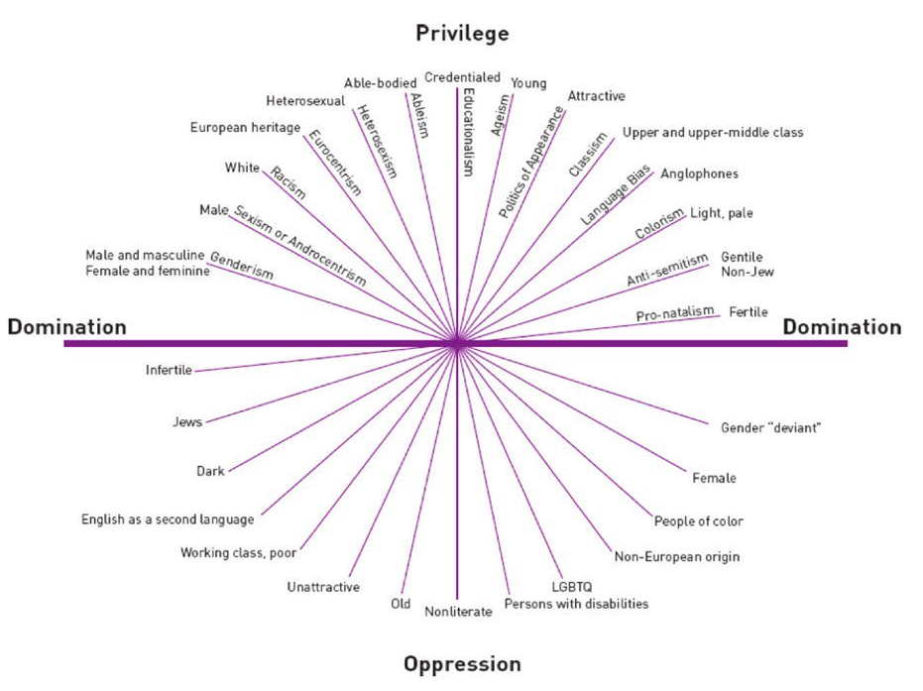Morgan’s (1996) intersectionality model*.

By publishing research focusing on the incorporation of intersectionality theory into psychology, researchers have attempted to raise awareness of intersectionality theory and educate therapists about the theory and its potential within the field (Warner et al., 2018). Whilst research in this field is growing, there is only a small number of United States (U.S.) & United Kingdom (U.K.) based psychologists conducting intersectionality informed psychology research (Rosenthal, 2016). An example is Bowleg et al. (2013) who conducted qualitative interviews to explore the experiences of Black males considering ethnicity, class, and sexuality in the U.S. Bowleg et al. (2013), recommended when used intersectionality theory should place as much emphasis on the strengths, as on the disadvantages related to interlocking social identities. Collins (2000) suggests that intersectionality theory offers transformative potential in the field of psychology by advancing research, teaching, and clinical practice. Moradi and Grzanka (2017) proposed by incorporating intersectionality theory into therapy, therapists can consider how structural and systemic factors can contribute to experiences of privilege and oppression, and how these contribute to the psychological difficulties and distress experienced by a client. Adames et al. (2018) suggests incorporating intersectionality theory into therapy can be done by: firstly, the therapist modelling the sharing of social groups. Secondly, recognising and discussing the client’s multiple social groups. Thirdly, discussing the way clients are impacted by systemic oppression, and finally integrating the client’s personal experiences and narratives into their psychotherapy. Adames et al. (2018) suggests by taking this approach it can open a dialogue in therapy, supporting clients to generate alternative accounts of their lived experiences, which may prevent therapists and therefore services from pathologising many of the difficulties faced by individuals from groups considered disadvantaged.

Researchers have suggested the limited number of published papers within mainstream journals, along with the misrepresentation of the theory within a number of the published papers, may explain the limited number of truly intersectionality informed research papers (Settles et al., 2020). Lewis and Grznka (2016), identified how intersectionality theory was being misrepresented within research, with practitioners having varied success incorporating all the elements of the theory into their clinical practice and therefore the research they published. Lewis and Grznka (2016) developed a way of categorising types of intersectionality informed practice depending on how successfully the therapist had been in incorporating the theory into their practice. They proposed two different categorises of intersectionality to explain the differences in the quality of the intersectionality informed research which they termed ‘weak’ and ‘strong’. Weak intersectionality is used to describe an unsuccessful attempt at incorporating intersectionality theory in its entirety. Defined as a focus on the multiple groups an individual belongs to, without consideration of how these interconnect to form an individual’s identity and may result in structural inequality and power differences. An example of weak intersectionality reported in a study would be where the therapist has asked clients to identify their intersectional groups but has not considered how the interconnection of these groups may play a part in the mental health difficulties the client presents with. Conversely, strong intersectionality is used to describe the successful incorporation of intersectionality theory in its entirety, considering both the interconnections between the social groups an individual belongs to and their unique experience of privilege and/or oppression within the world they live in, this allows for consideration of the complexity of the individual’s experience (Adames et al., 2018). For example, older black males are routinely considered ‘hard to recruit’ within research, but this overlooks the reasons for this, such as experiences of systemic racism. By understanding, however, that due to their intersectional identity these individuals have unique experiences with prejudice and have also experienced past exploitation within healthcare research, this may speak to why this population is less likely to take part in research. By understanding these unique experiences researchers can consider and make changes to their approach. This system of categorisation (weak and strong) allows for practitioners and researchers to consider the quality of the integration of intersectionality theory into their work.

### **Aims & Rationale**

The existing evidence base regarding the incorporation of intersectionality as a theoretical framework in psychotherapy is limited, and as yet there has been no review of the research concerning how intersectionality theory is used within psychotherapy. This review aims to explore, appraise, and synthesise the literature to ascertain the shared themes that emerge to better understand “What is known about the incorporation of intersectionality as a theoretical framework in psychological therapy?” and where further research is indicated.

## **Method**

A systematic strategy was employed for this literature review. A search of the following databases was completed on the 20th of January 2021: EBSCO, Cochrane, Science Direct, Oxford Academic, ProQuest, Sage Journals, Springer Link, Wiley Online, Psych Articles, and Psych Info. The search question was: “What is known about the incorporation of intersectionality as a theoretical framework in psychological therapy?”

### **Search Strategy**

A Boolean String formula that would encapsulate the main concepts of the question was designed, with exclusion terms to rule out irrelevant papers. The search string used was the result of a search of the literature to best represent the relevant terms most frequently used: "Intersectionality theory" OR “therapy, “intersectionality" AND "Psychological therapy", “culturally adapted therapy” AND “intersectionality theory”. To counteract possible publication bias, grey literature searches were also conducted across Ethos Online Theses and Google Scholar. No relevant publications were found within the grey literature. Searches were limited to English-language, with no time or location-based limiters. Articles were assessed for eligibility, using the inclusion and exclusion criteria outlined in Tables 1 and 2.

|  |
| --- |
| Table 1  *Inclusion criteria for article eligibility* |
| The paper is published in a peer-reviewed journal  The paper is written in English (due to not having the resources to access any translation facilities)  The paper has used intersectionality theory to consider multiple aspects of an individual’s identity (ethnicity, class, gender, sexual orientation, etc.)  The paper discusses the use of psychotherapy as an intervention and how intersectionality theory has been incorporated into the intervention. |

|  |
| --- |
| Table 2  *Exclusion criteria for article eligibility* |
| The paper is a letter, summary, or opinion piece  The paper reports counselling as the intervention. Due to the differing nature of psychotherapy and counselling (Schimelpfening & Morin, 2020).  The paper does not use intersectionality theory as a theoretical framework (intersectionality only mentioned as a concept)  The paper focuses on one social group (e.g., ethnicity) an individual belongs to, without consideration of two social groups, intersections between the groups, and potential compounded oppression cannot be considered. |

Figure 2 details the process of the literature review. Following this process, 11 papers met inclusion for review. The reference lists of the included articles were then hand searched for other relevant papers, but no further relevant papers were found.

**Figure 2**

*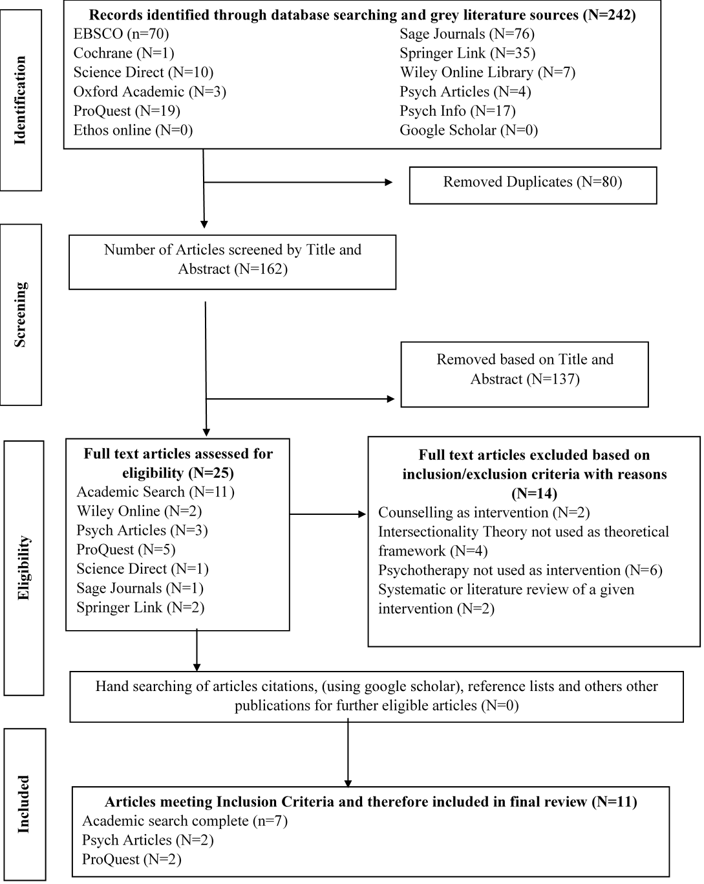Flow chart detailing the literature review process following PRISMA guideline*

### **Quality Assessment**

The 11 papers were critically appraised and then quality assessed using one of two appraisal tools, depending on their methodology:

1. Joanne Briggs Institute (JBI) Critical Appraisal tools checklist for case reports (Moola et al., 2020), comprising eight items.

2. Qualitative papers – JBI Critical Appraisal tools checklist for qualitative reports (Lockwood et al., 2015), comprising ten items.

These particular tools were chosen as they were pertinent to the type of study designs of the papers and are established methods of conducting critical reviews efficiently and thoroughly (Armaou et al., 2020). JBI critical appraisal tool items are scored out of a maximum of three according to whether the criteria was met (yes = 3), partially met (partial = 2) or not met (no=0). Scores were then added to form a total score for each paper appraised. These scores were then converted by the author into percentages giving an indicator of the overall quality of each paper. The items on each tool along with the scores given for them, including percentages, can be seen in Appendix B. An example of the completed JBI appraisal tools can also be found in Appendices C and D, respectively.

## **Results**

### **Summary of Findings**

A summary of each study, including design, findings, strengths, and limitations, is highlighted in Table 3.

**Table 3**

*Summary of study characteristic for the 11 Studies Included in the Review.*

|  |  |  |  |  |  |  |
| --- | --- | --- | --- | --- | --- | --- |
| Author, Year & Place. | Subject (N), Setting & Intervention | Aims & Methodology | Findings | Strengths | | Limitations |
| PettyJohn, Tseng, and Blow (2020).  Michigan state university. U.S. | N=1 Mother (38yrs), Father (41yrs), and Son (8yrs).  Family Therapy at Couple and Family Therapy Program. | Case report introducing a model for approaching conversations about intersectionality in therapy in a way that minimises anxiety, is sensitive to differences and is clinically relevant. | Conversations about intersectionality regarding the client and therapists’ identities can strengthen the therapeutic alliance through improving bonds, tasks, and goals in treatment. | Model for approaching conversations regarding intersectionality in therapy  Self-Assessment questionnaire allows therapists to consider their understanding of clients intersecting identities whilst also considering the power dynamics between the therapist and their clients. | Limited demographic, background, and assessment information about the client.  Short case example comparative to length of paper.  Limitations not discussed.  Client consent procedure not detailed. | |
| Harvey, and Stone Fish (2015).  Connecticut State University. U.S. | N=2 Families  1 Male (15yrs) and his mother.  1 [Transgender] Female (18yrs), her mother and sister.  Family Therapy at department of Marriage and Family Therapy, Southern | Case report outlining a family therapy model (Nurturing Queer Youth) which addresses refuge, supports different dialogs, and nurtures queerness by looking for hidden resilience in the unique intersections of queer youth’s lives. | Model allows for the recognition and fostering of resilience so that queer youth and their loved ones feel better able to understand one another and manage oppression they face. | Explanation of the model and how it could be implemented into therapy.  Detailed case examples. | | No descriptions of therapists intersecting identities.  Limitations of model not discussed.  No information on type of assessment completed to deem appropriateness of the model for clients.  Client consent procedure not detailed. |
| Sun, and Farber (2020).  Rhode Island, U.S. | N=1 Male (24yrs)  Narrative therapy for an adult with HIV at the department of Psychiatry and Human Behaviour, Brown University, | Case report considering a psychotherapy approach informed by intersectionality theory. Which aims to promote psychological well-being and support health behaviours associated with enhanced HIV treatment retention, adherence, and overall health outcomes. | Psychotherapy as an individual-level intervention to reduce HIV stigma can benefit from incorporating intersectionality-informed perspectives. | Intersectionality theory can create a framework advocating for and conceptualising the HIV stigma experience. Considering its impact on clinical presentation, intervention strategies, and the management of therapeutic relationships.  Therapeutic extract examples given in each stage of the approach. | | Limited demographic, background and assessment information about client was provided.  No descriptions of therapists intersecting identities.  Likely due to hypothetical client post-intervention status not explored. |
| Watts-Jones (2010).  New York, U.S. | N=4 (2 couples)  2 Males (mid 30yrs)  1 Male & 1 Female (late 40yrs)  Couples Therapy at the Ackerman Institute for the Family, | Case report outlining a model for locating oneself as the therapist in the therapy process, along with describing its potential clinical development. | Locating one’s self in therapy requires a willingness to go to places that most of us still feel uneasy about engaging, (i.e. ethnicity, sexual orientation, etc.), and the associated power and vulnerability. | Two intervention examples. Other examples of clinical contact provided.  Description of how to locate self as part of therapy.  Description of challenges faced by the therapist and how these may be overcome. | | Intersectionality influenced the author’s position but the theory itself is not defined.  Limited demographic, background, and assessment information about clients was provided.  Client consent procedure not detailed. |
| Adames, Chavez-Dueñas, Sharma, and La Roche (2018).  Chicago, U.S. | N=1 Male (23yrs)  Adult individual integrative therapy for depression at the Chicago School of Professional Psychology, | Case report exploring the challenges of using intersectionality theory to consider how multiple marginalised identities may interconnect to create systemic disadvantage and affects the client’s experience. | To integrate intersectionality theory into practice therapists must create opportunities to discuss social inequalities, using language to emphasise how external structural systems of oppression impact individuals. | Explanation and visual model of both weak and strong intersectionality.  Client background shared to provide context.  Intervention outlined. | | Client consent procedure not detailed.  Limitations not discussed.  No information provided about post-intervention clinical condition of client. |
| Ecklund (2012).  California, U.S. | N=1 Male (7yrs)  Child Psychotherapy in Azusa Pacifica University. | Case report exploring the clinically relevant elements of intersectionality theory often present in child psychotherapy. | Therapists working with children should assess their cognitive and developmental capacity and use this to consider how best to explore the child’s multiple interconnecting identities. | Detailed background providing context for the incorporation of intersectionality theory.  Assessment, intervention, and post-intervention condition described.  Clinical implications make the case study clinically relevant. | | Client consent procedure not detailed.  Limitations/ challenges of approach not discussed. |
| Gangamma, and Shipman (2018)  New York, U.S. | N=2  1 Male (32yrs)  1 Male (16yrs) attended with his mother (45yrs)  Family Therapy at the Department of Marriage and Family Therapy, Syracuse University, | Case report incorporating the use of intersectionality theory into family therapy with resettled refugees. | Incorporating intersectionality theory into family therapy encourages therapists:  1) To become aware of the cultural contexts of forced displacement and resettlement.  2) To acknowledge experiences of injustice during resettlement.  3) To reflect upon multiple intersecting identities in the therapist–family-client relationship. | Introduction sets context and also defines intersectionality.  Intervention described and link with clinical case examples  Limitations of study discussed. | | Client consent procedure not detailed.  Limited information provided about post-intervention clinical condition of client.  No information on type of assessment completed to deem appropriateness of the model for clients. |
| Addison, and Coolhart (2015)  New York, U.S. | N=6 (3 couples)  1 Female (35yrs) & 1 [Transgender] Male (37yrs)  2 Males (early 30yrs)  1 [Transgender] Female (early 40yrs)  1 Female (mid 20yrs)  Couples Therapy at the Community sample at the Department of Marriage and Family Therapy, Syracuse University. | Case report using intersectionality theory to understand queer couple’s experiences within couple’s therapy. | Intersectionality theory when incorporated into couple’s therapy can allow therapists to better understand queer couple’s experiences and therefore be more equipped to support them. | 3 case examples showing how intersectionality theory can be incorporated into couple’s therapy.  Therapist position was detailed in each therapeutic case. | | Intervention not outlined separately.  Clinical implications do not consider therapists understanding of clients intersecting identities whilst also considering the wider context.  Client consent procedure not detailed. |
| Golden, and Oransky (2019).  New York, U.S. | N=9  1 [Transgender] Female (17yrs) and her mother.  1[Transgender] Male (14yrs) and his parents.  1 non-binary person (15yrs) and their father.  1 [Transgender] Female (17yrs) and her mother.  Family Therapy in Division of Paediatric Psychiatry, Columbia University | Case report providing examples of how intersectionality theory can enhance the provision of gender-affirming family therapy used with adolescents and their families. | Intersectionality-informed affirmative family therapy can increase caregiver’s insight and the sense of connection between family members, leading to greater support for transgender youth and a sense of safety in the family unit. | Introduction provides information on the application of intersectionality theory.  Description of how case composites were formed.  Assessment and intervention structure explained.  Limitations acknowledged. | | Limited discussion of clients intersecting identities in the context of the disadvantages they may have faced.  Limited discussion of the potential power imbalances within the therapeutic relationships in the therapy room (i.e., the client, their family, and the therapist) |
| Wilder, Koro-Ljungberg, and Bussing, (2009).  Florida, U.S. | N=8  7 Mothers and 1 Grandmother of Children (age 14-16yrs, 4 Males & 4 Females)  Individual integrative psychotherapy for mothers of children with ADHD at the Division of Child and Adolescent Psychiatry, University of Florida. | Qualitative study using an experience sampling method and discourse analysis to explore in what way the intersections of race, class and marital status influence the context of identity, help seeking behaviours and parenting practices for female guardians of children with ADHD. | The guardians in the study documented similar challenges with parenting a child with an invisible disability. They struggled with the idea of ‘mother blame’, aiming to protect their identity as a ‘good mother’. | Discussion considers the similarities as well as the difference between the guardians with reference to their intersectional identity.  Congruity between research question, research methodology and interpretation of results. | | Philosophical perspective not addressed.  Researcher does not locate themselves from an intersectional standpoint. The influence of the researcher on the research is also not addressed.  Understanding of clients intersecting identities whilst also considering the context to which these identities exist was not considered. |
| Creswell (2014).  Arlington, U.S. | N= 7 Females (18-60yrs)  Dialectical Behavioural therapy (DBT) at a State mental health hospital, | Qualitative study using purposeful sampling and an ethnographical approach to explore the perspectives of women diagnosed with co-occurring disorders on the treatment they have received. To provide recommendations for changes to treatment. | All participants made reference to attending groups however these groups lacked some of the support the women felt they requires such as support with managing drug and alcohol usage. | Explanation and use of intersectionality theory within the research.  Methodology explained.  Results focus on participants intersecting identities and how this has affected wider aspects of their life. | | Limitations not discussed.  No Statement locating the researchers culturally or theoretically.  Explanations of current treatment protocol for unit was not present. |

### **Overview of the studies**

All 11 studies critically appraised in this review were US studies. Nine of the studies were case reports, which focused on an in-depth exploration of psychotherapy with one or more individuals. PettyJohn et al. (2020) incorporated intersectionality theory into family therapy, to allow parents to be open in discussing the differences in their social groups, allowing them to navigate the cultural differences they have in parenting styles, which they felt had led to their son’s challenges with attention and hyperactivity. Harvey and Stone Fish (2015) integrated intersectionality theory into a three-stage family therapy model designed to help clients to have difficult conversation with their parents about their social groups and resolve conflict within families. Sun and Farber (2020) considered individual narrative therapy for one male with a recent diagnosis of HIV, who had negative narratives around his diagnosis. Intersectionality theory was incorporated to promote empowering and affirming identity narratives to increase acceptance of his diagnosis. Watts-Jones (2010) study highlighted how therapists incorporated intersectionality theory by having conversations with their clients about similarities and differences in their intersectional identities, focusing on how these may influence the therapy process. For example, a therapist noting they share social groups with one member of a couple and may therefore be more likely to agree with them within the therapy session, being aware of this may reduce the potential effect of this bias. Adames et al. (2018) incorporated intersectionality theory into their individual psychotherapy by considering how interconnections between the client’s different intersectional groups (gay, non-citizen, AfroLatinx, male) affected his context (experiences of racism & homophobia) and therefore his presentation (depressive symptoms, sense of not belonging). Ecklund (2012) used intersectionality theory in child psychotherapy to consider the child’s intersecting identity, this highlighted how identity development around gender, ethnicity and religion were sources of distress, which then aided intervention planning. Gangamma and Shipman (2018) integrated intersectionality theory to help clients unpack the complexity of their experiences of identity (gender, ethnicity, disability) related oppression (racism, sexism, ableism), allowing for this to be considered within the intervention. Addison and Coolhart (2015) incorporated intersectionality theory to allow for a full understanding of how couple’s complex intersectional identities (ethnicity, gender expression, etc.) intersect with one another creating the context of the difficulties in their relationships (wanting a traditional marriage vs seeing it as conformist and opposing to the trans community). Golden and Oransky (2019) used intersectionality theory to explore ways in which gender identity intersects with and is understood in the context of family members’ other identities (ethnicity, citizen status, religion, etc.), to consider how identities may affect the therapeutic process. The final two papers were qualitative studies. Wilder et al. (2009) used discourse analysis to explore experiences of eight female guardians of children with ADHD during individual psychotherapy. Intersectionality theory was incorporated to consider how the intersection of race, class, gender, and marital status influenced parental practices and help-seeking behaviours. Creswell (2014) was the only study to recruit from a non-university setting, namely, a state mental health hospital for women. They used an ethnographical approach to explore the experiences of seven women receiving intersectionality informed DBT, to consider how the women’s intersectional identities effected their experience of the intervention.

### **Aims and Research Design**

All the studies indicated their aims and objectives, providing sufficient relevant theoretical information to provide a clear rationale for their research. All the studies had similar aims of exploring how intersectionality theory can be incorporated into psychotherapy. The research designs and methodological approaches chosen in the studies were deemed to be appropriate considering their respective aims.

### **Ethical consideration**

Both qualitative papers (Wilder et al., 2009; Creswell, 2014) reported their ethical approval, how informed consent was gained, and the fact there were no incentives offered to participants. Neither, however, discussed how participants would be safeguarded during the research or if any risk assessments were conducted before participants took part in the studies. Journal word count limitations, though, may account for the exclusion of this information. None of the case reports reported receiving ethical approval, though two of the case reports used case composites examples (Sun & Farber, 2019; Golden & Oransky, 2019). A significant limitation of seven of the case reports was the lack of information regarding how informed consent was gained from participants, and thus it was unclear whether participants were aware parts of their therapy were being used for research purposes (Watts-Jones, 2010; Ecklund, 2012; Harvey & Stone Fish, 2015; Addison & Coolhart, 2015; Adames, et al., 2018; Gangamma & Shipman, 2018; PettyJohn et al., 2020).

### **Reflexivity**

Firstly, the philosophical and theoretical perspective of the author, when stated, shares with the reader assumptions that the researcher has made about their research which has informed all aspects of the research. Secondly, it is key that the therapist locates their own intersectional identity before commencing the intervention. An intersectionality informed psychotherapeutic approach requires ongoing commitment from the therapist(s) to reflect on their biases that may influence the therapeutic relationship, for example, examining the social groups individuals share with their clients, along with their views on social groups they do not share (Adames et al., 2018). Wilder et al. (2009) did not discuss the philosophical perspective that underpinned their research. Without this information, as a reviewer it is impossible to know what assumptions they have made about their research and how this may have affected choices made during the research such as choice of methodology. Creswell (2014) detailed how a black feminist theoretical perspective was used to guide their choice of research methodology, however they were not transparent about how this perspective may have affected their interpretation of their results. In six of the case reports the researcher located themselves in the therapy and research, by sharing with their clients and the reader their intersectional identity (Watts-Jones., 2010; Ecklund, 2012; Addison & Coolhart, 2015; Adames et al., 2018; Gangamma & Shipman, 2018; PettyJohn et al., 2019), all suggested this positively impacted their ability to have conversations with clients about how the intersection between the therapist and clients identities may be beneficial and/or limiting within the therapy. In three of the case reports, the intersectional identity of the researcher was not detailed (Harvey & Stone Fish, 2015; Golden & Oransky, 2019, Sun & Farber, 2020). Similarly, in both qualitative papers, the researcher did not locate themselves from an intersectional perspective (Wilder et al., 2009; Creswell, 2014). By not doing so, it means the therapist/researchers’ role in terms of how their own intersectional identity may have led to biases and how these may have influenced their work cannot be considered.

### **Recruitment and Sample Setting**

Both qualitative papers provided clear detail of their selection and recruitment processes. Creswell (2014) used purposive sampling while Wilder et al. (2009) used the experience sampling method, both of which were suitable recruitment methods for their chosen study designs. Seven of the case reports recruited participants through their clinical practice, which is a typical method (Barker et al., 2015). Two of the case reports did not recruit participants, instead they complied case composites based on their experience of using their model with several clients (Golden & Oransky, 2019; Sun & Farber, 2020). There was no consideration in any of the case reports about the potential conflicting role of being both the therapist and the researcher given the potential for bias, for example, in the interpretation of outcomes (Wilson et al., 2011). For 10 of the studies, the psychotherapy took place within state university therapy training programmes, where trainee therapists deliver psychotherapy to private clients, alongside and under the supervision of qualified therapists. The nature of these clinics mean they are only accessible to those who can afford to pay for the service, which is likely to mean certain social groups are not captured within their research, leaving it difficult to consider the possible intersections between certain groups.

### **Methodology and Intervention**

Nine of the studies omitted some key information outlining their methodological process. PettyJohn et al. (2020) missed information regarding the intervention protocol (i.e., what the therapy consisted of), and the case example only provided limited examples of how intersectionality theory was used within their family therapy. Addison and Coolhart (2015) also did not provide a detailed description of their couples therapy protocol separate to their examples, this would have aided in the understanding of how intersectionality theory was used to inform their intervention. This lack of transparency makes it difficult as a reviewer to know how the intervention was implemented. Given the purpose of the research was to present an intervention informed by intersectionality theory, the missing information would also make it difficult for another therapist to implement the intervention. Three of the case reports (Adames et al., 2018; Gangamma & Shipman, 2018; Sun & Farber, 2020) did not provide information on therapy outcomes for the clients following their interventions (adult integrative psychotherapy, family therapy, and narrative therapy). By not providing this information the author makes it difficult for the reviewer to interpret the findings of the study, particularly the potential usefulness of the intersectionality informed intervention.

### **Results and Discussion**

Ten of the studies summarised their results and findings in a balanced and clear manner, making links to the existing literature*.* Watts-Jones's (2010) interpretations of their research findings on therapists locating themselves in therapy was unclear at times, due to the concept of intersectionality theory not being explained earlier in the paper. All of the studies considered the clinical implications of their findings, however, some of the studies did not provide enough information on the client’s outcomes following the intervention making it difficult to assess the clinical applicability of the intersectionality informed intervention (Adames et al., 2018; Gangamma & Shipman, 2018; Sun & Farber, 2020). Five of the studies did not discuss the limitations or challenges of completing their study (Ecklund, 2012; Creswell, 2014; Harvey & Stone Fish, 2015; Adames et al., 2018; PettyJohn et al., 2020), which would have been useful when considering further research in this area.

### **Findings**

When recurring themes appear within the literature, as was the case in this review, it is common for a review to be organised with these themes in mind (McCombes, 2021). The findings of the 11 studies, therefore, are organised according to three themes that represent the key findings of the review.

### ***Incorporating intersectionality theory can improve psychotherapies***

All the studies were in agreement that incorporating intersectionality theory into their model of psychotherapy improved it. Petty-John et al. (2020) reported that highlighting similarities and differences in the therapist and client’s identities during therapy can positively impact bonds, tasks, and goals of treatment, which in turn strengthens the therapeutic alliance. For example, therapists and clients who have dissimilar intersectional identities may have differing ideas about the goal of therapy, and by being aware of this it allows for goals to be collaborative discussed. Harvey and Stone Fish (2015) concluded their intersectionality theory informed three-stage model of family therapy, aided clients in having difficult conversations with their families to resolve conflict within the family, leading to a more nurturing system with increase resilience. Their findings suggested this resilience enables clients to begin to recognise their vulnerability and their strength, making them more readily able to manage the compounding nature of oppression they experience in everyday life (i.e., attending school as a black trans girl) by utilising the strength based skills they have learned within therapy. Sun and Farber (2020) described how intersectionality theory provided a contextual framework for their work allowing the therapist to have a greater understanding of the client’s HIV stigma experiences. By understanding these experiences in the context of the client’s intersectional identity (African American gay man), the therapist reported feeling better able to understand the impact of these on the client’s presentation. Golden and Oransky (2019) concluded that having conversations around family members differing intersectional identities and subsequent experiences, improved caregiver’s insights into the experience of their transgender adolescents. For example, the new found acceptance a father felt for his transgender son when comparing the bravery and persistence his son had shown throughout his transition to the qualities such as courage that he had relied on while working his way out of poverty. Wilder et al. (2009) and Creswell (2014) described how when incorporated into their psychotherapy, intersectionality theory allowed therapist to consider both the similarities and differences experienced by individuals belonging to the same social groups. By doing this it encourages person-centred psychotherapy, reducing the assumptions made by the therapist about the experiences the clients may have had, by instead opening up a dialogue about the client’s experiences with both privilege and oppression.

### ***The therapist should locate their intersectional identity in the therapy process.***

Several papers highlighted the need for the therapist to locate themselves within the therapy process, by having a conversation with their clients about their intersectional identity, highlighting similarities and differences, whilst considering how these may affect the therapy process (Watts-Jones, 2010; Ecklund, 2012; Addison & Coolhart, 2015; Gangamma & Shipman, 2018; Adames et al., 2018; PettyJohn et al., 2020). The studies also suggested this led to clients being more open when talking about the social groups they belong to and the impact of this on their daily lives. Watts-Jones (2010) described how a therapist can locate themselves by initiating such a conversation with their clients, for example, discussing how a black women may feel about having a white man as her therapist, given issues of oppression like racism and sexism and concerns she might have about how an imbalance of power may affect the therapeutic relationship. Gangamma and Shipman (2018) reported that critically reflecting upon the therapist and client’s intersecting identities, allows the therapist to understand how they and their client may be perceiving and experiencing one another, and how this may influence the therapeutic relationship. Addison and Coolhart (2015) found that when the therapist is open to sharing aspects of their intersectional identity, ‘queer’ couples were also willing to have conversations about their intersecting identities. This openness on the part of the therapist could be viewed as a starting point for allowing intersectionality theory to be incorporated into psychotherapy interventions, by engaging clients in the process of identifying the social groups they belong to whilst considering the impact compounded privilege or oppression may have had on their daily lives. It is important to note, however, therapists reported some trepidation sharing some aspects of their intersectional identity due to concerns this would negatively impact the therapeutic alliance due to client beliefs about certain social groupings. Although, the process of locating oneself in the therapy can also act to highlight any potential bias that the therapist may have, allowing them to monitor this to avoid it impacting the therapy (Watts-Jones, 2010). When the therapist did not locate themselves in the therapy (Wilder et al., 2009; Creswell, 2014; Harvey & Stone Fish, 2015; Golden & Oransky, 2019; Sun & Farber, 2020), it made it difficult for the reviewer to consider how this may have impacted on the therapeutic relationship and potential power dynamic within the therapy. Choosing whether to disclose aspects of identity to clients depended on the therapeutic modality chosen, the therapy setting and also the individual therapist's personal preference. For example, a therapist reported feeling uncomfortable sharing her sexual orientation with clients, as she feared being devalued by heterosexual clients (Watts-Jones, 2010). A potential barrier to the therapist locating their intersectional identity in the therapy may be the requirement to discuss one’s own intersectional identity and it’s relating privilege/oppression, for example, a white therapist being cautious to discuss ethnicity with a Asian family, making the therapist less likely to invite discussion about racism that may play an active part in the families difficulties (Watts-Jones, 2010).

### ***The successful incorporation of intersectionality theory into psychotherapy***

Whilst all of the studies incorporated intersectionality theory into their therapeutic intervention, the degree to which they did this varied. Incorporating intersectionality theory to its full potential (strong intersectionality) requires the therapist to stay close to the client’s experiences, considering both the clients internal subjective experience and the impact of external structural systems on the client’s presentation (Adames et al., 2018). An example of this would be the need for a therapist working with a client who identifies as a ‘gay black man’, to consider the individual’s reported symptoms of depression, along with the potential impact of oppression due homophobia and racism on the person’s mental health (Adames et al., 2018). Adames et al. (2018) successfully incorporated intersectionality into their practice by creating opportunities for clients to explore the sources of their difficulties outside of themselves, for example, trauma symptoms that related to experiencing racial microaggressions. This framework aided in depathologising many of the struggles their disadvantaged clients experienced, by giving them permission to generate alternative accounts. Creswell (2014) also successfully incorporated intersectionality theory into their work, by considering how participants’ intersecting identities, namely their education level, ethnicity, and gender had affected wider aspects of their life making them more likely to be diagnosed with a mental health disorder or begin misusing substances. Through incorporating intersectionality theory into psychotherapy, it enables discussion about how someone came to be experiencing their current difficulties, often removing blame from the individual and considering their difficulties as a consequence of their live experiences which have often been negatively impacted by the disadvantaged social groups they belong to. The majority of the studies could have gone further to incorporate intersectionality theory with an emphasis on strong intersectionality. Three of the studies (Wilder et al., 2009; Addison & Coolhart, 2015; Golden & Oransky, 2019) focused solely on aspects of weak intersectionality and thus missed out on opportunities to consider how belonging to multiple disadvantaged groups may lead to compounding disadvantage and inequality. Without this context, it is impossible to consider how this may have affected clients’ lives. These studies all, however, reported positive outcomes based on the incorporation of intersectionality theory into psychotherapy. Addison and Coolhart (2015) provided a stepped guide for therapists about how to incorporate intersectionality theory into couple’s therapy, however, this guide only focused on aspects of weak intersectionality such as identifying clients’ intersectional groups and not strong elements that would have allowed for the impact of the individuals social groups on their experiences to be considered. Similarly, Wilder et al. (2009) explored their clients’ intersecting identities but did not consider how these identities may have informed the narratives their clients had developed in relation to their mental health difficulties. Both these studies, therefore, did not consider how multiple intersecting identities may have led to compounded experiences of oppression, and thus the opportunity to begin to consider alternative narratives for their mental health difficulties (i.e., stepping away from self-blame and internalisation of their mental health difficulties).

## **Discussion**

### **Theoretical considerations**

The review confirmed findings suggested by Moradi and Grzanka (2017) that intersectionality theory can be incorporated into a range of psychotherapy models (including family and couples therapy, children’s psychotherapy, DBT, etc.). The review highlighted the need for therapist to locate themselves within the therapy process by sharing their intersectional identity with clients. Firstly, to consider the potential impact of similarities and differences within the clients and therapist intersectional identities on the therapy process. Secondly, to encourage clients to share the social groups they belong to and begin to consider how this may have impacted their current mental health presentation (Watts-Jones, 2010). The review also confirmed that intersectionality theory is not always being incorporated into the psychotherapeutic process comprehensively (Rosenthal, 2016). Several of the included reviews only incorporated elements of weak intersectionality, missing out on opportunities to include elements of strong intersectionality, such as considering how context contributes to the form of oppression being experienced (Settles et al., 2020), and the possible impact on someone’s mental health. The findings of this review, however, are, tentatively suggested due to only 11 studies being available for review, predominately from one type of setting, the studies varied in quality (50-90% on the appraisal tools) and all had key limitations.

### **Clinical Implications**

The theoretical implications of the review suggests incorporating intersectionality theory into psychotherapy, albeit within the limited settings available to review, can improve the intervention. It is hypothesised that this is achieved by strengthening the therapeutic alliance, aiding understanding of client’s experiences, and allowing for sameness and differences within intersectional groups to be considered, reducing the chance of assumptions being made within therapy (PettyJohn et al., 2020). This will involve therapists identifying the current bias they hold and utilising supervision to help manage these biases. Therapist will also need to have open conversations with individuals from disadvantaged social groups to further their understanding of their experiences, cultural competence training may also aid this. Only a small number of papers were available to review, this supports previous research suggesting that there is still limited use of intersectionality theory within psychology and therefore psychotherapy (Cole 2009). It remains unclear if this is due to avoidance of these conversations or if this is due to a lack of understanding of the model. This strengthens the argument for incorporating intersectionality theory teaching into the training of psychotherapists and psychologists (Grzanka & Miles, 2016).

### **Limitations and Future Directions**

Typically, a systematic review of the literature would endeavour to have more than one reviewer, rather than the sole reviewer for this literature review, to improve the reliability of the search strategy and appraisal process. This would have also strengthened the narrative synthesis as the themes would be corroborated by a second reviewer.

As the studies included in the review had two separate designs, which required two separate appraisal tools. The scoring systems for the two appraisal tools differed making it difficult to provide direct comparison of the studies. Limitations were also encountered when using the appraisal tools themselves. Due to the nature of the questions included in the tools, it was not possible to fully explore how well the included studies incorporated intersectionality theory into psychotherapy. This required the reviewer to think beyond the appraisal tools during the appraisal process to answer the review question.

Given all the reviewed studies were conducted in the U.S. and the majority took place within private clinics, the generalisability of the findings outside this population is limited. At this moment, it is not known whether similar findings would be found in other countries, settings, or cultures, and thus there is a need to explore the use of intersectionality informed psychotherapy with a wider population considering individuals from a wide range of social groups.

The studies included in the review are predominantly case reports (9) with a small number of qualitative papers (2). Although this may allow for an in-depth understanding of how to incorporate intersectionality theory into psychotherapy, it is limited by small numbers which make it more difficult to generalise the findings. The researcher also acted as the therapist within the case studies, potentially creating researcher bias, such bias is more controlled within quantitative research and would strengthen the evidence base. Unfortunately, no quantitative studies could be found that were appropriate to include in this review. Conversely, more qualitative studies would afford the opportunity to discuss the experience of individuals who had received intersectionality informed psychotherapy (Patten & Newhart, 2017).

There remains a limited number of papers within this field, and thus more research in this area is needed. To increase therapists understanding of how intersectionality theory can be incorporated into their work, which is integral to offering psychotherapy that depathologises many of the struggles clients who belong to disadvantaged social groups experience, by giving them permission to generate alternative accounts.

### **Conclusion**

The 11 papers reviewed have provided valuable contributions towards the growing evidence base for intersectionality theory informed psychotherapy. Similar findings were found regarding the positive effects of incorporating intersectionality theory into a range of psychotherapy models. There were limitations to the current literature review, including the limited generalisability of the included studies results. Further research is needed to continue to fully understand how intersectionality theory may be applied to psychotherapy.

## **References**

Adames, H. Y., Chavez-Dueñas, N. Y., Sharma, S., & La Roche, M. J. (2018). Intersectionality in psychotherapy: The experiences of an AfroLatinx queer immigrant. *Psychotherapy, 55*(1), 73-79. http://dx.doi.org/10.1037/pst0000152.

Addison, S. M., & Coolhart, D. (2015). Expanding the therapy paradigm with queer couples: A relational intersectional lens. *Family Process*, *54*(3), 435-453. https://doi.org/10.1111/famp.12171.

Ahsan, S. (2020). Holding up the Mirror: Deconstructing Whiteness in Clinical Psychology. *Journal of Critical Psychology, Counselling and Psychotherapy, 20*(3), 45-55. Armaou, M., Konstantinidis, S., & Blake, H. (2020). The effectiveness of digital interventions for psychological well-being in the workplace: A systematic review protocol. *International journal of environmental research and public health*, *17*(1), 255. https://doi.org/10.3390/ijerph17010255.

Barker, C., Pistrang, N., & Elliott, R. (2015). *Research methods in clinical psychology: An introduction for students and practitioners*. John Wiley & Sons.

Barrera, M., Jr., Castro, F. G., Strycker, L. A., & Toobert, D. J. (2013). Cultural adaptations of behavioral health interventions: A progress report. *Journal of Consulting and Clinical Psychology, 81*(2), 196–205. https://doi.org/10.1037/a0027085.

Benish, S. G., Quintana, S., & Wampold, B. E. (2011). Culturally adapted psychotherapy and the legitimacy of myth: A direct-comparison meta-analysis. *Journal of Counseling Psychology, 58*(3), 279–289. https://doi.org/10.1037/a0023626.

Bernal, G. E., & Domenech Rodríguez, M. M. (2012). *Cultural adaptations: Tools for evidence-based practice with diverse populations*. American Psychological Association. https://doi.org/10.1037/13752-010.

Bernal, G., Bonilla, J., & Bellido, C. (1995). Ecological validity and cultural sensitivity for outcome research: Issues for the cultural adaptation and development of psychosocial treatments with Hispanics. *Journal of Abnormal Child Psychology*, *23*(1), 67-82. https://doi.org/10.1007/BF01447045.

Bernal, G., Jiménez-Chafey, M. I., & Domenech Rodríguez, M. M. (2009). Cultural adaptation of treatments: A resource for considering culture in evidence-based practice. *Professional Psychology: Research and Practice, 40*(4), 361–368. https://doi.org/10.1037/a0016401.

BlackPast, B. (2012, November 16). The Combahee River Collective Statement 1977. BlackPast.org. https://blackpast.org/african-american-history/combahee-river-collective-statement-1977/.

Bowleg, L. (2013). “Once you’ve blended the cake, you can’t take the parts back to the main ingredients”: Black gay and bisexual men’s descriptions and experiences of intersectionality. *Sex Roles*, *68*(11), 754-767. https://doi.org/10.1007/s11199-012-0152-4.

Bucci, S., Berry, N., Morris, R., Berry, K., Haddock, G., Lewis, S., & Edge, D. (2019) “They Are Not Hard-to-Reach Clients. We Have Just Got Hard-to-Reach Services.” Staff Views of Digital Health Tools in Specialist Mental Health Services. *Front Psychiatry*, 344(10), 1-14. https://doi.org/10.3389/fpsyt.2019.00344.

Burroughs, H., Lovell, K., Morley, M., Baldwin, R., Burns, A., & Chew-Graham, C. (2006). ‘Justifiable depression’: how primary care professionals and patients view late-life depression? A qualitative study. *Family practice, 23*(3), 369-377. https://doi.org/10.1093/fampra/cmi115.

Chantler, K. (2005). From disconnection to connection: ‘Race’, gender and the politics of therapy. *British Journal of Guidance & Counselling*, *33*(2), 239-256. https://doi.org/10.1080/03069880500132813.

Cole, E. R. (2009). Intersectionality and research in psychology. *American Psychologist, 64*(3), 170–180. https://doi.org/10.1037/a0014564.

Collins, P. H. (2000). Gender, black feminism, and black political economy. *The Annals of the American Academy of Political and Social Science*, 568(1), 41-53. https://doi.org/10.1177/000271620056800105.

Collins, P. H., & Bilge, S. (2020). *Intersectionality*. John Wiley & Sons. https://doi.org/10.1002/9781119314967.ch7.

Commander, M. J., Dharan, S. S., Odell, S. M., & Surtees, P. G. (1997). Access to mental health care in an inner-city health district. II: Association with demographic factors. *The British Journal of Psychiatry,* 170(4), 317-320. https://doi.org/10.1192/bjp.170.4.317.

Coston, B.M. (2019). Disability, sexual orientation, and the mental health outcomes of intimate partner violence: A comparative study of women in the US. Disability health journal, 12(2), 164-170. https://doi.org/10.1016/j.dhjo.2018.11.002.

Crenshaw, K. (1989). Demarginalizing the intersection of race and sex: A black feminist critique of antidiscrimination doctrine, feminist theory and antiracist politics. *University of Chicago Legal Forum,* 8(1), 139-167. https://doi.org/1229039

Crenshaw, K. (1990). Mapping the margins: Intersectionality, identity politics, and violence against women of color. *Stanford Law Review*, 6(*43)*, 1241-1299. https://doi.org/1229039

Creswell, L. M. (2014). A critical black feminist ethnography of treatment for women with co-occurring disorders in the psychiatric hospital. *The journal of behavioural health services & research*, 41(2), 167-184. https://doi.org/10.1007/s11414-013-9344-0.

Ecklund, K. (2012). Intersectionality of identity in children: A case study. *Professional Psychology: Research and Practice, 43*(3), 256-264. https://doi.org/10.1037/a0028654.

Freud, S. (1915). *The Unconscious. The Standard Edition of the Complete Psychological Works of Sigmund Freud, On the History of the Psycho-Analytic Movement, Papers on Metapsychology and Other Works*. Internationale Zeitschrift.

Gangamma, R., & Shipman, D. (2018). Transnational intersectionality in family therapy with resettled refugees. *Journal of marital and family therapy*, 44(2), 206-219.  https://doi.org/10.1111/jmft.12267.

Golden, R. L., & Oransky, M. (2019). An intersectional approach to therapy with transgender adolescents and their families. *Archives of sexual behaviour*, 48(7), 2011-2025. https://doi.org/10.1007/s10508-018-1354-9.

Grzanka, P. R., & Miles, J. R. (2016). The problem with the phrase “intersecting identities”: LGBT affirmative therapy, intersectionality, and neoliberalism. *Sexuality Research and Social Policy*, 13(4), 371-389. https://doi.org/10.1007/s13178-016-0240-2.

Harvey, R. G., & Stone Fish, L. (2015). Queer youth in family therapy. *Family process*, 54(3), 396-417. https://doi.org/10.1111/famp.12170.

House, R. (2003). *Therapy Beyond Modernity:" Consumer" experiences of profession-centred therapeutic practice.* Routledge. https://doi.org/10.4324/9780429483905.

Lambert, M. J. (2013). *Bergin and Garfield's handbook of psychotherapy and behaviour change*. John Wiley & Sons.

Lewis, J. A., & Grzanka, P. R. (2016). Applying intersectionality theory to research on perceived racism. In A. N. Alvarez, C. T. H. Liang, & H. A. Neville (Eds.), *The cost of racism for people of color: Contextualizing experiences of discrimination* (pp. 31–54). American Psychological Association. https://doi.org/10.1037/14852-003.

*Lockwood C, Munn Z, Porritt K. (2015).* Qualitative research synthesis: methodological guidance for systematic reviewers utilizing meta-aggregation. *Internal Journal of Evidence Based Healthcare,* 13(3), 179–187. https://doi.org/10.1097/XEB.0000000000000062.

McCombes, S. (2021, May 17). How to write a literature review. Scribbr. http://www.scribbr.co.uk/thesis-dissertaion/literature-review/.

Metcalf, H., Russell, D., & Hill, C. (2018). Broadening the science of broadening participation in STEM through critical mixed methodologies and intersectionality frameworks. *American Behavioural Scientist*, 62(5), 580-599. https://doi.org/10.1177%2F0002764218768872.

Moola S, Munn Z, Tufanaru C, Aromataris E, Sears K, Sfetcu R, Currie M, Qureshi R, Mattis P, Lisy K, Mu P-F (2017). Chapter 7: Systematic reviews of etiology and risk. In: Aromataris E, Munn Z (Eds). *Joanna Briggs Institute Reviewer's Manual*. The Joanna Briggs Institute. https://reviewersmanual.joannabriggs.org/.

Moradi, B., & Grzanka, P. R. (2017). Using intersectionality responsibly: Toward critical epistemology, structural analysis, and social justice activism. *Journal of Counseling Psychology,* 64(5), 500–513. https://doi.org/10.1037/cou0000203.

Morgan, K. P. (1996). Describing the emperor's new clothes: Three myths of educational (in-) equity. *The Gender Question in Education. Theory, Pedagogy & Politics*. Routledge. https://doi.org/10.4324/9780429496530-11.

Murphy, D. (2019, August 9). #DiversifyClinPsy. Paper presented at the Group of Trainers in Clinical Psychology Summer Event [video], London. https://www.youtube.com/watch?v=RRldOsD6eUU.

Oja, M. (2010). *Intersectional social categories*. [Doctoral dissertation, The Claremont Graduate University]. Proquest Dissertation Publishing. https://www.proquest.com/openview/a50e7cee032a5eb62286c8426948ab02/.

Palmer, S. (2000). *Introduction to Counselling and psychotherapy: the essential guide*. Sage. https://dx.doi.org/10.4135/9781446279755.

Patten, M. L., & Newhart, M. (2017). *Understanding research methods: An overview of the essentials*. Routledge. https://doi.org/10.4324/9781315213033.

PettyJohn, M. E., Tseng, C. F., & Blow, A. J. (2020). Therapeutic utility of discussing therapist/client intersectionality in treatment: When and how? *Family process*, 59(2), 313-327. https://doi.org/10.1111/famp.12471.

Rathod, S., Gega, L., Degnan, A., Pikard, J., Khan, T., Husain, N., & Naeem, F. (2018). The current status of culturally adapted mental health interventions: a practice-focused review of meta-analyses. *Neuropsychiatric disease and treatment*, 14, 165. http://doi.org/10.2147/NDT.S138430.

Rice, C., Harrison, E., & Friedman, M. (2019). Doing justice to intersectionality in research. *Cultural Studies↔ Critical Methodologies*, 19(6), 409-420. https://doi.org/10.1177%2F1532708619829779.

Rosenthal, L. (2016). Incorporating intersectionality into psychology: An opportunity to promote social justice and equity. *American Psychologist,* 71(6), 474–485. https://doi.org/10.1037/a0040323.

Schimelpfening , N., & Morin, A. (2020, December 24). *Counselling vs. Psychotherapy: Similarities and Differences*. Verywellmind.Com. https://www.verywellmind.com/counselor-or-psychotherapist-1067401.

Settles, I. H., Warner, L. R., Buchanan, N. T., & Jones, M. K. (2020). Understanding psychology's resistance to intersectionality theory using a framework of epistemic exclusion and invisibility. *Journal of Social Issues*, 76(4), 796-813. https://doi.org/10.1111/josi.12403.

Sun, S., & Farber, E. W. (2020). An intersectionality-informed psychotherapy approach to reduce HIV stigma. *Psychotherapy,* 57(1), 23–28. https://doi.org/10.1037/pst0000265.

Warner, L. R., Settles, I. H., & Shields, S. A. (2018). *Intersectionality theory in the psychology of women*. In C. B. Travis, J. W. White, A. Rutherford, W. S. Williams, S. L. Cook, & K. F. Wyche (Eds.), *APA handbook of the psychology of women: History, theory, and battlegrounds (pp. 521–539).* American Psychological Association. https://doi.org/10/1037/0000059-027.

Watts‐Jones, T. D. (2010). Location of self: Opening the door to dialogue on intersectionality in the therapy process. *Family Process*, 49(3), 405-420. https://doi.org/10.1111/j.1545-5300.2010.01330.x.

Wilder, J., Koro-Ljungberg, M., & Bussing, R. (2009). ADHD, motherhood, and intersectionality: An exploratory study. *Race, Gender & Class*, 59-81.

Wilson, G. T., Wilfley, D. E., Agras, W. S., & Bryson, S. W. (2011). Allegiance Bias and Therapist Effects: Results of a Randomized Controlled Trial of Binge Eating Disorder. *Clinical psychology: a publication of the Division of Clinical Psychology of the American Psychological Association*, 18(2), 119–125. https://doi.org/10.1111/j.1468-2850.2011.01243.x.

## **Appendix A**

## Manuscript submission guidelines from Clinical Psychology Review

Manuscript must be limited to less than 50 pages.

Abstract no more than 200 words split into sections on purpose of the research, methods, results, and conclusions with a maximum of 6 key words directly following the abstract.

Referencing style American Psychology Association (APA) 7th ed. Style.

Full author guidelines can be found <https://www.elsevier.com/journals/clinical-psychology-review/0272-7358/guide-for-authors>

## **Appendix B**

## Joanne Briggs Institute (JBI) Critical Appraisal tools checklist Appraisal Table detailing Appraisal scoring

|  |  |  |  |  |  |  |  |  |  |  |  |
| --- | --- | --- | --- | --- | --- | --- | --- | --- | --- | --- | --- |
| **Author, Year & Paper title** | **Joanne Briggs Institute (JBI) Critical Appraisal tools checklist for Case Reports** | | | | | | | | | | **Total (Percentage)** |
| **Case Reports** | 1. Were patient’s demographic characteristics clearly described? | 1. Was the patient’s history clearly described and presented as a timeline? | 1. Was the current clinical condition of the patient on presentation clearly described? | 1. Were diagnostic tests or assessments methods and the results clearly described? | 1. Was the intervention or treatment procedures clearly described? | 1. Was the post-intervention clinical condition clearly described? | 1. Were adverse events or unanticipated events identified and described? | 1. Does the case report provide takeaway lessons? |  |  | Score out of 24 |
| PettyJohn, Tseng, & Blow (2020). | 3 | 0 | 3 | 3 | 3 | 3 | 0 | 3 |  |  | 18/24 (75%) |
| Harvey, & Stone Fish (2015). | 3 | 3 | 3 | 0 | 3 | 3 | 0 | 3 |  |  | 18/24 (75%) |
| Sun, & Farber (2020). | 3 | 0 | 3 | 0 | 3 | 0 | 0 | 3 |  |  | 12/24 (50%) |
| Watts-Jones (2010). | 3 | 3 | 3 | 0 | 3 | 3 | 0 | 3 |  |  | 18/24 (75%) |
| Adames, Chavez-Dueñas, Sharma, & La Roche (2018). | 3 | 3 | 3 | 0 | 3 | 0 | 0 | 3 |  |  | 15/24 (63%) |
| Ecklund (2012). | 3 | 3 | 3 | 3 | 3 | 3 | 0 | 3 |  |  | 21/24 (88%) |
| Gangamma, & Shipman (2018). | 3 | 3 | 3 | 0 | 3 | 0 | 0 | 3 |  |  | 15/24 (63%) |
| Addison, & Coolhart (2015). | 3 | 3 | 3 | 0 | 0 | 3 | 0 | 3 |  |  | 15/24 (63%) |
| Golden, & Oransky (2019). . | 3 | 3 | 3 | 3 | 3 | 3 | 0 | 3 |  |  | 21/24 (88%) |
|  |  |  |  |  |  |  |  |  |  |  |  |
| **Author, Year & Paper title** | **Joanne Briggs Institute (JBI) Critical Appraisal tools checklist for Qualitative Reports** | | | | | | | | | | **Total (Percentage)** |
| **Qualitative Papers** | 1. Is there congruity between the stated philosophical perspective and the research methodology? | 1. Is there congruity between the research methodology and the research question or objectives? | 1. Is there congruity between the research methodology and the methods used to collect data? | 1. Is there congruity between the research methodology and the representation and analysis of data? | 1. Is there congruity between the research methodology and the interpretation of results | 1. Is there a statement locating the researcher culturally or theoretically? | 1. Is the influence of the researcher on the research and vice-versa, addressed? | 1. Are the participant voices, adequately represented? | 1. Is the research ethical according to current criteria or for the resent studies, and is there evidence of the ethical approval by an appropriate body? | 1. Do the conclusions drawn in the research report flow from the analysis, or interpretations, of the data? | Score out of 30 |
| Wilder, Koro-Ljungberg, & Bussing, (2009). | 0 | 3 | 3 | 3 | 3 | 0 | 0 | 3 | 3 | 3 | 21/30  (70%) |
| Creswell (2014). | 3 | 3 | 3 | 3 | 3 | 0 | 3 | 3 | 3 | 3 | 27/30  (90%) |

Key: Each item scored a maximum of three (no= 0, partially =2, and yes=3), these scores were then added to form a total score for each paper appraised. These scores were then converted into percentages giving an indicator of the overall quality of each paper.

## **Appendix C**

Example JBI Critical Appraisal Checklist for Case Report Reviewer: Amelia Durcan Date: 14.04.21 Author: Ecklund Year: 2012 Record Number: 6

|  |  |  |  |  |  |  |  |  |  |  |  |  |  |  |
| --- | --- | --- | --- | --- | --- | --- | --- | --- | --- | --- | --- | --- | --- | --- |
| Question | Yes | | No | Partially | | N/A | | Comments | | | | | Score | |
| 1. Were patient’s demographic characteristics clearly described? | X | |  |  | |  | | Yes, details regarding child’s key demographics. | | | | | 3 | |
| 1. Was the patient’s history clearly described and presented as a timeline? | X | |  |  | |  | | Yes, good detail on child’s background. Clear timeline. | | | | | 3 | |
| 1. Was the current clinical condition of the patient on presentation clearly described? | X | |  |  | |  | | Yes, information on referral and child’s current presentation. | | | | | 3 | |
| 1. Were diagnostic tests or assessments methods and the results clearly described? | X | |  |  | |  | | Yes, assessment period child and his parents described. Goal of treatment described. | | | | | 3 | |
| 1. Was the intervention or treatment procedures clearly described? | X | |  |  | |  | | Yes, detailed description aided by diagram. | | | | | 3 | |
| 1. Was the post-intervention clinical condition clearly described? | x | |  |  | |  | | Yes, discussion in detail in therapy section limitation of intervention not discussed. | | | | | 3 | |
| 1. Were adverse events or unanticipated events identified and described? |  | | X |  | |  | | Adverse events not discussed. | | | | | 0 | |
| 1. Does the case report provide takeaway lessons? | x | |  |  | |  | | Yes, detailed as implication for clinical practice. | | | | | 3 | |
| Overall Appraisal: |  | Include | | | X | | Exclude | |  | Seek further information | No | Total | | 21/24 (88%) |
| Comments |  | Explores clinically relevant elements of intersectionality theory present in child psychotherapy | | | | | | | | | | | | |

## **Appendix D**

Example JBI Critical Appraisal Checklist for Qualitative Research Reviewer: Amelia Durcan Date: 16.04.21 Author: Creswell Year: 2014 Record Number: 12

|  |  |  |  |  |  |  |  |  |  |
| --- | --- | --- | --- | --- | --- | --- | --- | --- | --- |
| Question | Yes | No | Partially | N/A | Comments | | | | Score |
| 1. Is there congruity between the stated philosophical perspective and the research methodology? | X |  |  |  | Yes, clearly states theoretical premise and methodological approach. Critical ethnography viewed through lens of intersectionality. Clear congruity. | | | | 3 |
| 1. Is there congruity between the research methodology and the research question or objectives? | X |  |  |  | Yes, purpose of study to explore perspective of women diagnosed with co-occurring disorder on treatments. Provided by state psychiatric hospital so appropriate recommendations for changes can be made. Choice to use ethnographical approach was chosen. Clear congruity. | | | | 3 |
| 1. Is there congruity between the research methodology and the methods used to collect data? | X |  |  |  | Yes, study used an ethnographical approach and data was collected using interviews. Clear congruity. | | | | 3 |
| 1. Is there congruity between the research methodology and the representation and analysis of data? | X |  |  |  | Yes, study used an ethnographical approach, data was analysed and presented with congruity. | | | | 3 |
| 1. Is there congruity between the research methodology and the interpretation of results? | X |  |  |  | Yes, study used an ethnographical approach, the results are used to discuss the major findings which aligned with the research question. Clear congruity. | | | | 3 |
| 1. Is there a statement locating the researcher culturally or theoretically? |  | X |  |  | No, researcher does not locate themselves in the research culturally or theoretically. | | | | 0 |
| 1. Is the influence of the researcher on the research and vice-versa, addressed? |  | X |  |  | No, relationship between the researcher and the study participants not addressed. Researcher does not examine own role in researcher their influence of the study. | | | | 0 |
| 1. Are the participant voices, adequately represented? | X |  |  |  | Yes, quotes included in results from participants. | | | | 3 |
| 1. Is the research ethical according to current criteria or for the resent studies, and is there evidence of the ethical approval by an appropriate body? | X |  |  |  | Yes, ethical approval from Mid-Atlantic hospital institutional review board (IRB) and Argosy university academic institutions IRBs. | | | | 3 |
| 1. Do the conclusions drawn in the research report flow from the analysis, or interpretations, of the data? | X |  |  |  | Yes, conclusions clearly related to information provided by participants in their interviews. | | | | 3 |
| Overall Appraisal: | Include | | X | Exclude |  | Seek further information | No | Total | 27/30 (90%) |
| Comments | Application of intersectionality theory as praxis to explore women’s experience of psychiatric care. Ethnographical Approach | | | | | | | | |

# **Paper 2: Empirical Paper**

**Using intersectionality theory to understand barriers faced by those applying to Clinical Psychology Doctorial training courses. A Q methodology approach.**

Words: 7972

(Excluding title page, references, and appendices)

This literature review is intended for publication in The British Journal of Clinical Psychology. Manuscript submission guidelines can be found in Appendix A, although further modifications will be made prior to submitting to the journal.

## **Abstract**

**Objectives**

The study explored barriers faced when applying to the doctorate in clinical psychology in the United Kingdom (U.K.). Based on the inclusion criteria, two groups were considered: those pre-qualified (aspiring and trainee Clinical Psychologists) who self-identified as belonging to more than one disadvantaged social group and those post-qualified (Clinical Psychologists) who were part of the recruitment process.

**Design**

A Q methodology design was used, containing 47 statements about barriers for example ‘The lack of feedback from the courses to unsuccessful candidates created barriers for me’

**Methods**

Thirty participants (25 pre-qualified & five qualified) sorted statements about barriers, according to how much they agreed the statement was a barrier for them. Demographic data for participants can be found in Table 1.

**Results**

The review highlighted five different viewpoints. There was a consensus across four viewpoints that barriers such as selection tests and lack of contextual consideration remain in place for those from disadvantaged social groups when applying to clinical psychology training. Participants within the final viewpoint, however, reported that their social groups had not impeded their ability to gain the necessary experience or qualifications to progress in their career, suggesting barriers where not in place for them.

**Conclusions**

The results of the study provide further evidence that those who belong to several social groups, considered disadvantaged, face barriers when applying to clinical psychology training. There is also evidence to suggest barriers are similar across disadvantaged social groups. Recommendations are made to courses with a clear role for Clinical Psychologists in supporting the reduction of barriers faced by under-represented groups.

Keywords: intersectionality theory, clinical psychology, barriers, social groups, disadvantaged social groups.

### **Introduction**

### **Clinical Psychology in the U.K.**

To become a Clinical Psychologist in the U.K. the doctorate in clinical psychology must be completed. The doctorate in clinical psychology is a three- year training programme with a focus on developing trainees academic, research and clinical skills, enabling trainees to work both individually with those experiencing mental health problems and to support teams to work with individuals who have a range of mental health difficulties (British Psychological Society, 2019). Unfortunately, the makeup of clinical psychology training cohorts frequently does not reflect the population demographics of the communities within which training courses are located or serve (Turpin & Coleman, 2010; Wood & Patel, 2017), resulting in certain social groups being under-represented within training cohorts and thus the future workforce. For instance, in 2020 those from global majority ethnic groups made up 20% (n=777) of applicants, with 17% (n=124) of those accepted on to a course (Clearing House Statistics, 2020). Additionally, in 2020 those ranked on the lowest quintile illustrative of socio-economic background (rated based on parents’ level of higher education) represented 9% (n=362) of applicants who applied, 6% (n=49) of whom were accepted onto a course (Clearing House Statistics, 2020). These percentages do represent an ongoing improvement in increasing diversity in comparison to data from previous years (Clearing House Statistics, 2018), however, a disparity continues with those from certain social groups (white, middle class, women), continuing to be statistically more likely to apply and be accepted onto clinical psychology training, comparative to under-represented groups (members of the global ethnic majority, working class, persons with disabilities) (Murphy, 2019). This suggests barriers may be faced by under-represented individuals at various stages when attempting to pursue a career in clinical psychology. Little is known however, about the barriers faced by individuals who belong to certain social groups and how belonging to more than one socially disadvantaged group may create compounded barriers when applying to clinical psychology doctorial training.

### **Intersectionality theory**

Intersectionality theory is a way of naming and recognising the nature of interconnecting social groups, (such as ethnicity, class, gender expression), and the creation of interdependent systems of disadvantage/privilege, for example, how class and gender may interact to create further disadvantage for a working-class, transgender, woman (Oxford University Press, 2021; Collins & Bilge, 2020). Intersectionality theory was first coined by Crenshaw (1989), to describe how ethnicity, sex, and other characteristics intersect with one another creating the context of an individual’s experience. It is suggested, when someone occupies multiple marginalised intersections, their individual experiences reflect social and structural systems of power, privilege, and inequality (Wyatt, Johnson, & Zaidi, 2022). For example, during childbirth and/or pregnancy, black women are four times more likely to die when compared to white women, and those from deprived areas are two times more likely, making the risk for black women from deprived areas significantly higher than white women from affluent areas (Knight et al., 2021). The intersections between power, privilege, and oppression are complex, as an individual may be relatively privileged in one or more aspects of their life, while simultaneously experiencing oppression stemming from other aspects of their identity. Intersectionality seeks to explain how these different variables come together to shape experience, identity, and society (Crenshaw, 1990). Crenshaw’s (1989,1990) work pulled together earlier work by black feminists who detailed their intersectional experience of facing sexism in the civil rights movement, whilst also experiencing racism in the feminist movement (Taylor, 1998).

Morgan (1996) developed a model (figure 1) of intersectionality theory during her work considering the United States (U.S.) college education system in order to explore how interconnected social groups may create compounded disadvantage for those applying to and attending U.S. colleges. It is thought individuals occupy a specific position within the model (figure 1) that informs their experience with oppression (Morgan, 1996). For example, someone who identifies as an older, working class, gay, person of colour is likely to sit on the disadvantaged side of the model, and therefore may face more disadvantage within their life comparative to someone who sits more on the privileged side of the model (PettyJohn et al., 2020). The model enables insight into the complexities of identity and provides a visual depiction of intersectionality theory in the way that it shows potential intersecting identities and allows one to consider how these intersections inform people’s experiences (PettyJohn et al., 2020). The model, however, does not include all groups and the experience of individuals who may belong to these groups, therefore there are many potential groups that may interconnect to create disadvantage for an individual (Collins & Bilge, 2020).

**Figure 1**

*Morgan’s (1996) Intersectionality Model.*

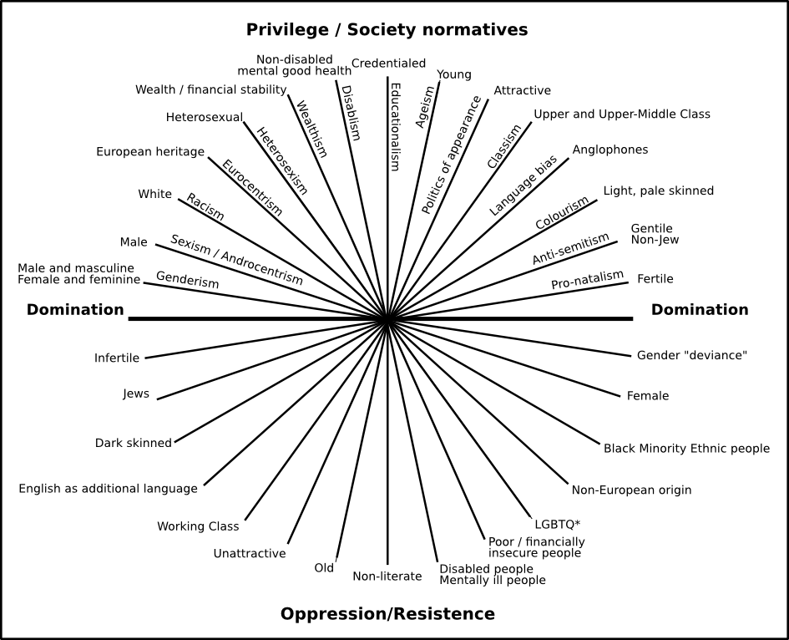

Note. *Gender deviance came into use in the 1960s to refer to everyone whose gender identities and/or expressions did not conform to gender norms. No longer used, due to its suggestion of abnormality and perceived negative connotations, the current preferred terms include gender diverse or trans and/or non-binary.

### **Intersectionality informed research and clinical psychology**

Psychology research within the U.K, continues to largely focus on one area of an individual’s identity, such as ethnicity (Chui, 2021), rather than using intersectionality theory to consider multiple aspects of an individual’s identity. By focusing on just one part of identity, the intersecting nature of other identities (religion, literacy, socio-economic status) has not been considered in research and thus how this can lead to further inequalities has also not been explored. Similarly, when exploring the barriers faced by applicants to clinical psychology training from under-represented groups, this research has often focused on one part of an individual’s identity, such as ethnicity. Ragaven (2018) used interpretative phenomenological analysis of interviews with BAME applicants, to explore their experience of applying for clinical psychology training. Participants spoke about the difficulties in grappling with inequalities such as experiencing racism, having to work harder than their white counterparts, and making attempts to fit in and how this impacted on them. Scior et al. (2007) suggested BAME applicants are less likely to get relevant experience as assistant psychologists or research assistant when compared to their white colleagues.

Lund et al. (2014) used surveys to explore the experiences of fifty-six individuals with disabilities during psychology doctorate training. They found the majority of participants experienced disability related discrimination during their training. The study also highlighted how less than one third of the participants had received mentorship from psychologists with disabilities, speaking to the limited number of psychologists with disabilities. Lund et al. (2014) suggested that psychology training courses should work to remove barriers and provide support for trainees with disabilities. Research has, therefore, identified the potential impact of social groups such as ethnicity and disability on individuals’ experiences, yet there are some social groups, for example, class and sexuality, that have remained absent from the research. In addition, social groups that have been considered, such as ethnicity and disability have been researched in isolation, meaning the impact of the intersectional connection between groups has not been considered.

### **Aims & Objectives**

The aim of the study was to explore barriers faced when applying to the doctorate in clinical psychology in the U.K.

#### ***Objective 1***

To identify viewpoints among individuals who identify with more than one social group considered disadvantaged in the U.K. about possible barriers they faced when applying for a clinical psychology training place.

#### ***Objective 2***

To identify any shared barriers amongst different disadvantaged social groups when applying for clinical psychology training.

#### ***Objective 3***

To identify viewpoints among Clinical Psychologists who are part of the recruitment process about possible barriers faced when they applied for a clinical psychology training place.

#### ***Objective 4***

To identify any differences or similarities in the barriers faced amongst those pre-qualified and those post-qualified when applying to clinical psychology training.

## **Method**

### **Ethics**

After peer-review of the study protocol, ethical approval was granted by the sponsor, Staffordshire University (Appendix B).

## **Epistemological position**

The main author holds a social constructionist epistemological position, believing that all people construct their own reality as they learn from observations of others and social interactions (Berger & Luckmann, 1966). This position highlights the existence of numerous realities and is in concordance with the principle aim of Q methodology, which is to explore and value subjective viewpoints (Stephenson, 1935; Watts & Stenner, 2012).

## **Design overview**

The present study used a cross-sectional design, utilising Q methodology. Within Q methodology, a q-set is initially developed made up of statements relating to the research topic (Brown, 1993). These statements are generated from the concourse, which consists of the everyday discourse (research, guidance, and information within the media) surrounding a particular topic which is analysed for themes (Brown, 1993). This aids in reducing researcher bias by ensuring that statements chosen for the q-set are derived from the population in question, and not solely related to the researchers’ own opinions on the topic (Watts & Stenner, 2005). The q-set statements are then sorted onto a grid (q-sort), ranking the q-set (e.g., most agreed to most disagreed) allows for the exploration of how people construct meaning and develop their overall viewpoint (Stenner et al., 2003). Factor analysis is then utilised to analyses whether participant’s viewpoints differ or are similar to each other, reducing individual viewpoints to common factors (Watts & Stenner, 2005). This allows Q methodology to reveal and describes divergent views in the participants as well as consensus, allowing for a fuller picture of potential barriers faced by different groups (Watts & Stenner, 2005).

Due to the limited research around intersecting systems of oppression and barriers to clinical psychology training, an essentially exploratory research method was indicated (Thomas & Watson, 2002). The decision to use Q methodology over more traditional research methods such as interviews and subsequent qualitative analysis, was based on its ability to allow for direct comparison of data from a range of different stakeholders ensuring all voices on the topic are heard (Hancock, 2007). Figure 2 depicts the stages of the research.

**Figure 2**

*Flow chart detailing overview of the study.*

Statistical Analysis

Data collection

Recruitment

Pilot

Development of the Q set & Post sort survey

Developing the Concourse

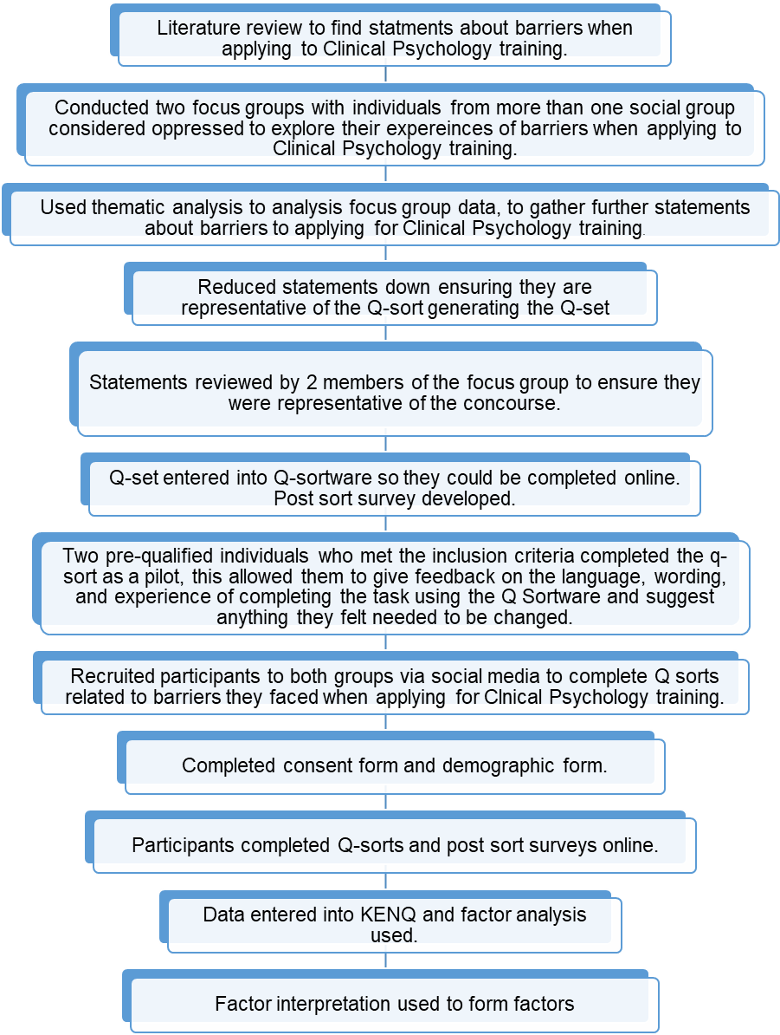

### **Recruitment**

Participants were recruited between May and December 2021, firstly, via advertisements (Appendix C) on social media (Twitter, Facebook & Instagram). Secondly, participant information sheets (Appendix D) were emailed to research leads of all U.K. clinical psychology courses and British Psychology Society assistant psychology support groups. Included in the advertisement and participant information sheet was the inclusion criteria for each population within the study (Appendix E). Those interested were encouraged to contact the researcher for further information via the email address detailed. Once participants had emailed the researcher to express their interest, they were sent a copy of the participant information sheet, a blank consent form (Appendix F) and demographic form (Appendix G), to allow them to make an informed decision about participating in the research. Separate information sheets and consent forms were used for the pre-qualified and post-qualified participants due to the different inclusion criteria. Participants who wished to take part in the study, emailed the researcher a copy of their signed consent form and their completed demographic form. The demographic form, was used to assess the social groups the participants belonged to and their current working role, ensuring they met the inclusion criteria for the research. Following participation, people were given two weeks to withdraw their data using their individual randomised number. No participants withdrew their consent for their data to be included.

### **Existing literature and development of concourse**

**Literature review**

The first stage of Q methodology required a search of the literature to explore and sample “what was known about barriers faced when applying to the doctorate in clinical psychology?” EBSCO (Staffordshire university resource catalogue) and Google Scholar search engines were searched allowing for the search of numerous databases at one time, whilst also considering grey literature. The term “intersectionality theory” was entered in addition to “doctorate in clinical psychology”, “barriers to the doctorate in clinical psychology”, and “diversity in clinical psychology”. Qualitative research (Ragaven, 2019; Bawa et al., 2019; Ahsan, 2020), quantitative research (Scior et al., 2007; Lund et al., 2015), and opinion papers (Turpin & Coleman, 2010; Wood & Patel, 2017) were examined from the literature search. A process of reviewing the text and highlighting potentially relevant statements was utilised. This is standard practice for Q methodology (Brown, 1993). The literature review provided 40 statements related to barriers when applying for clinical psychology training.

**Focus groups**

When there is limited published literature within the area of study it is typical for focus groups to be completed to aid in the development of the concourse (McKeown, & Thomas, 1988). Two focus groups with participants who belonged to the pre-qualified group were conducted in June 2021 (Appendix H for demographic information). The focus groups were conducted via Microsoft Teams with a total of 15 participants split across two groups. These participants did not subsequently take part in the Q-sorts. The focus group schedule (Appendix I) was split into two parts, firstly, gaining opinions on statements taken from the literature review, secondly, a discussion around the participant’s experiences of barriers when applying for clinical psychology training. Following transcription, the content of the focus groups was analysed using a deductive thematic analysis approach (Braun & Clarke, 2006). The thematic analysis approach has a clear systematic process governed by theory, which aids transparency and ensures rigour (Braun & Clarke, 2006), further detail can be found in Appendix J. Thematic analysis is reflective in nature. A reflective journal was kept by the author throughout the research to aid in reflecting on their role within the research. For example, the researcher shared disadvantaged social groups with a number of participants, during the focus groups shared experiences were highlighted, allowing the research to consider this how this may impact on the subsequent analysis.

This generated 250 statements, which were added to the 40 statements taken from the literature review. These statements taken from the overall concourse (literature review and focus groups) were grouped into five themes and 15 subthemes (figure 3), reflecting opinions, beliefs and ideas relating to barriers to applying for clinical psychology training and included direct quotes and research findings.

**Figure 3**

*Themes and sub-themes following thematic analysis of focus group discussion.*

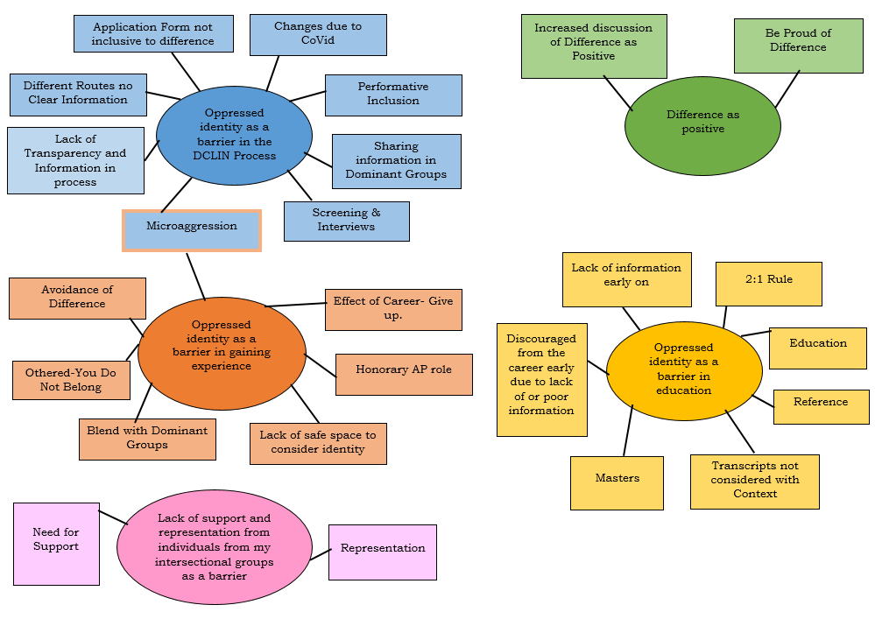

### **Development of the Q-set**

In keeping with Q methodology standard procedure, statements under each theme from the concourse were then reviewed by the researcher for repetition, representativeness of themes, and clarity. This aided in reducing the statements down to a list of statements, creating a smaller but representative version of the concourse known as the q-set. Feedback on the statements was provided by two members of the focus groups to ensure they felt they were representative of the concourse. Statements were refined to include further suggestions, this strengthened the content and face validity, and improved readability. 47 statements from the original 290 items, grouped under the 15 sub-themes were agreed for inclusion in the final q-set (Appendix K).

### **Participants**

The purposive sample consisted of 30 participants (n=30). Twenty-five participants were pre-qualified (assistant psychologists, psychological wellbeing practitioners and trainee Clinical Psychologists) and five participants were post-qualified (Clinical Psychologists). The participants belonged to various social groups considered both disadvantaged and privileged in U.K. society (Appendix L).

### **Procedure**

Participants completed the q-sorts using an online system called Q Sortware. Participants accessed this software via a link included in an email sent to them by the researcher (Appendix M). Prior to administering the main study, two pre-qualified individuals who met the inclusion criteria completed the q-sort as a pilot, this allowed them to give feedback on the language, wording, and experience of completing the task using the Q Sortware and suggest anything they felt needed to be changed. It is usual within Q methodology to utilise a pilot, to ensure content validity (Valenta & Wigger, 1997). Based on this feedback no changes were required to the process or q-set and thus these participants were included in the main study.

The online system presented the participants with the 47 statements, they were asked to sort the statements in terms of how much they agreed with them in relation to the following question: “*What are your views on barriers to gaining a place on clinical psychology training?”* Participants were instructed to read the statements carefully and complete an initial sort of the statements into three categories: agree, disagree, and neutral or unsure. Participants were then asked to rank the statements into the Q-grid (figure 4), which uses a scale ranging from +5 most agree with, through 0 neutral, to -5 most disagree with. First, they ranked their ‘most agree’ (+5) statements by placing them onto the Q-grid, then, their ‘most disagree’ (-5) statements, and, finally, their ‘neutral’ (0) statements. Participants were asked to complete the sort in a forced choice manner, this meant they could only place one statement in each box and only place statements within the confines of the grid. This approach was chosen in order to make the sorting process as simple as possible and to standardise the procedure across participants.

**Figure 4**

*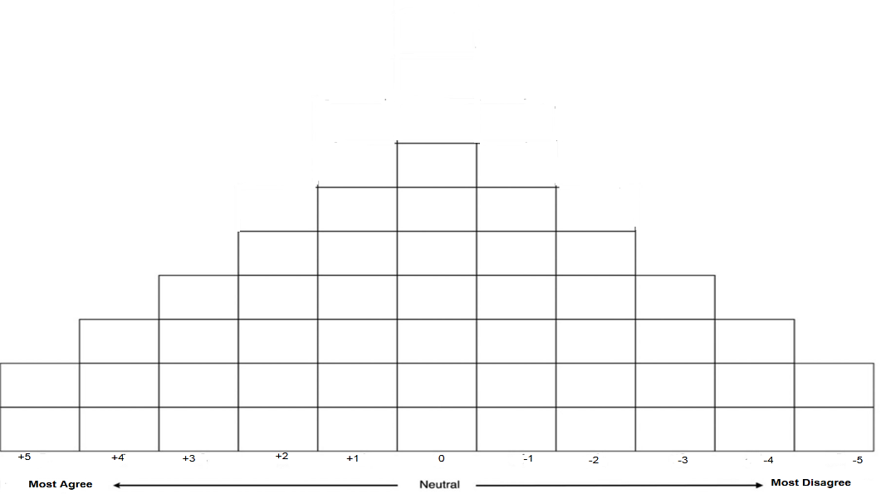Q-sort Grid*

After the sorting process, all participants who completed the Q-sort completed a short survey, consisting of five questions to aid them in reflecting on their placement of statements and also share any additional information they thought was relevant (Appendix N). It is standard practice to have questions about placement of statements asked following the completion of the Q-sort and acts as part of the Q methodology process.

### **Statistical Analysis**

The 30 completed q-sorts were entered into the dedicated computer package Ken-Q (version 1.0.6. Banasick, 2019). The q-sort data was then subjected to a factor analysis to highlight any variables that would explain the relationships between the sorts (Howitt & Cramer, 2010). Reducing the large number of variables (30 q-sorts, 47 statements) into factors that illustrated the key viewpoints about the topic. Relationships between the different q-sorts are indicated by correlation calculations (Appendix O). Centroid Factor analysis identified seven possible factors (Appendix P). Factor loading of ≥0.29 or above was significant at p<0.05 (Brown, 1980). The Kaiser-Guttman criteria suggest that only eigenvalues above 1 should be of interest and thus interpreted (Guttman, 1954; Kaiser, 1960). Eigenvalues are commonly defined as a measure of how much of the common variance of the observed variables a factor explains (Watts and Stenner, 2012). Humphrey’s rule, states “a factor is significant if the cross product of its two highest loadings exceed twice the standard error” (Brown, 1980, p.223). Standard error was calculated to be 0.15 (Brown, 1980). Furthermore, an acceptable factor solution should account for more than 40% of the variance according to Watts and Stenner (2012). Factors one-four met all of the above criteria and were extracted and subjected to varimax orthogonal rotation, in order to maximise their differences and ensure that each factor is statistically independent (Field, 2016). The four extracted factors explained variance after rotation of 59. 25 of the 30 participants loaded onto one of the four factors (Appendix Q).

Within the analysis completed by Ken-Q (Banasick, 2019), a factor array is produced to represent the ideal estimate of the viewpoint of each factor, created using the q-sorts that significantly load onto only one factor (Appendix R). The factor arrays are calculated by a procedure of weighted averaging (i.e., higher loading exemplars are given more weight in the averaging process since they better exemplify the factor). By creating a merged average, the factor exemplar looks like a single completed q-sort (Watts & Stenner, 2012). Factor interpretation was then used to carefully inspect patterns of statements in the factor arrays (Stenner et al, 2003), to uncover, understand and explain the viewpoint captured by the factor and shared by significant loading participants (Watts & Stenner, 2012). Participants’ comments from the post-sort surveys were used to a support the process of interpreting the factors (Watts & Stenner, 2012). Z-scores are also generated to allow for comparison of statements across factors (Appendix S).

## **Results**

Application of Q methodology led to the emergence of four factors which represented five viewpoints: (1a) The importance of personal context being considered during the application process, (1b) My social groups have not negatively impacted my journey, (2) Representation, Guidance & Clarity, (3) Imposter Syndrome and trying to blend, and (4) More support is needed for real change.

### **Factor Interpretation**

A description of each factor account is presented. These factor accounts have been constructed with careful reference to where statements are placed within each factor exemplifying q-sort (Appendix T). The rankings which inform the construction of the factor exemplars are included in the text: (17:+5) for example, indicates that statement 17 was ranked in the +5 position and that this ranking is currently pertinent to the account being offered. This process is further guided by the quotes of participants whose individual q-sorts have loaded significantly on the relevant factor. Preceding quotes are pseudonyms for individuals alongside the group they belong to (pre or post qualified). Summary demographic details (social groups they belong to and their current job role) of participants who loaded onto each factor can be found in table 1.

**Table 1**

*Demographic comparison across factors*

|  |  |  |  |  |  |  |
| --- | --- | --- | --- | --- | --- | --- |
| Demographic | 1a | 1b | 2 | 3 | 4 | No-Factor |
| Age | 18-34 years | 25-54 years | 18-44 years | 25-54 years | 25-44 years | 25-34 years |
| Gender | 6 Females  1 Male | 2 Females  1 Male | 4 Females  1 non-binary | 4 Females | 1 Male  4 Females  1 non-binary | 1 Male  4 Females |
| Sexual Orientation | 1 Queer  2 Lesbian  2 Straight  2 Bisexual | 1 Bisexual  2 Straight | 3 Bisexual  1 Lesbian  1 Queer | 3 Straight  1 Bisexual | 4 Straight  1 Bisexual  1 Pansexual | 2 Straight  1 Gay  1 Bisexual  1 Queer |
| Ethnic Group | 2 White British  2 White European  1 Chinese  1 Black British or Caribbean  1 Black British or African | 2 White British  1 Arab | 3 White European  1 Mixed white & Black African  1 Mixed White & Asian | 4 White British | 1 White British  1 White Irish  1 Black British or African  1 Mixed White and Asian  1 Mixed White & Black Caribbean  1 Turkish | 3 White British  1 White European  1 Black British or Caribbean |
| Nationality | 3 British  1 Northern Ireland  1 Romanian  1 German  1 Nigerian | 1 British  1 Scottish  1 English | 2 British  1 Greek  1 Spanish  1 German | 4 British | 2 British  1 German  1 Irish  1 Dutch  1 French | 4 British  1 Italian |
| Religion | 3 no religion  1 Christian  1 Buddhist  1 Spiritual  1 Muslim | 1 no religion  1 Christian  1 Muslim | 3 No Religion  1 Pagan  1 Muslim | 4 No Religion | 2 No Religion  1 Humanist  1 Christian  1 Muslim  1 Hindu | 3 No Religion  1 Christian  1 Spiritual |
| Disability | 5 No  2 Yes | 3 No | 4 No  1 Yes | 4 No | 4 No  2 Yes | 3 No  1 Yes |
| Class | 6 Working Class  1 Middle Class | 1 Working Class  2 Middle Class | 3 Working Class  2 Middle Class | 3 Working class  1 Middle class | 4 Working Class  2 Middle Class | 4 Yes  1 No |
| Job Role | 5 Trainee Clinical Psychologist  1 Assistant Psychology (AP)  1 Psychological Wellbeing Practitioner (PWP) | 1 Trainee Clinical Psychologist  2 Clinical Psychologist | 3 Trainee Clinical Psychologist  2 AP | 1 Trainee Clinical Psychologist  3 Clinical Psychologist | 5 Trainee Clinical Psychologist  1 PWP | 4 Trainee Clinical Psychologist  1 AP |

**Factor 1**

Factor 1 is a “bipolar factor”, meaning two “oppositional” viewpoints are being expressed by the participants who load onto this factor, creating two exemplifying factor q-sorts (Watts & Stenner, 2005). For example, what the positive version of the factor (1a) sees as a barrier to applying to the doctorate (e.g., honorary assistant psychologist positions) (3: +5), the negative version of the factor (1b) does not see as a barrier to applying (3: -4). Hence, it is necessary to present two narrative accounts for factor 1, denoted as factor 1a and 1b.

Factor 1 explains 24% of the study variance and has the highest eigenvalue of 9.217, and therefore the strongest statistical strength. Ten participants loaded significantly onto the factor, eight pre-qualified, and two qualified (1a included seven pre-qualified participants, and 1b comprised one pre-qualified and two qualified participants).

### **Factor 1a: The importance of the applicant’s context being considered within the application process.**

The participants who loaded onto this factor felt they had been affected by barriers associated with their intersectional identity whilst attempting to become a Clinical Psychologist (5:+5, 15:-5, 45:-4). These included barriers created by their personal circumstances related to their intersectional identity (31:+3) such as being discouraged from applying due to low acceptance statistics for their social groups. For Malika (pre) this related to belonging to multiple under-represented groups, “As a working class, bisexual, black women I felt my intersectional identity was a barrier to applying for the doctorate as statistics stated that I had such a poor chance, and I found it difficult identifying other psychologists who could act as a mentor.” Additional barriers included experiencing microaggressions (8:-4), not being able to work as an honorary assistant psychologist (3:+5), only being interviewed by individuals who belong to dominant groups in clinical psychology (4:-4), and being discouraged from applying (28:+4).

Participants who loaded onto this factor also felt there was an avoidance of conversations about difference within the professional (41:+4). Ola (pre) stated, “When I've tried to bring up discussions regarding my intersectional groups in psychology team meetings. I've found these have been ignored and forgotten about and it definitely leads to feeling silenced or that those parts of my identity are truly devalued. This has led to questioning if I really want to apply for and become a Clinical Psychologist”.

Finally, those who loaded onto this factor felt having their applications reviewed without considering the context (their intersectional identity and the barrier(s) potentially created by it) of their experience had created further barriers for them (34:-4). Helena (pre) reported, “The application form does not provide adequate opportunity to reflect context or personal circumstances. The application process does not adequately account for diversity and difference and contextual admissions would really support those from disadvantaged groups”.

### **Factor 1b: My social groups have not negatively impacted my journey.**

This factor generally represents a reversal of the configuration of statements characteristic of factor 1a. Participants felt that their intersectional groups had not created barriers in their journey (9:+5, 45:+4, 5:-5). Therefore, experiencing microaggressions (8:+5), not sharing an intersectional identity with those on interview panels (4:+4), and working as an honorary assistant psychologist (3:-4) were not seen as barriers for these participants. Noelle (post) shared, “I have found my colleagues and people on my previous interview panels belong to my intersectional groups”. Participants who loaded onto this factor also did not feel they had been discouraged from applying for the doctorate in clinical psychology (28:-5).

Those who loaded onto this factor did not feel their application being considered without context had created a barrier for them (34:-3), and felt courses were making clear attempts to improve diversity. Terry (post) stated, “You can see from the numbers on the clearing house survey our efforts to increase diversity are working. We hope we will continue to see more representation within the cohorts and staff teams”.

### **Factor 2: Importance of Clarity, Guidance and Representation.**

Factor 2 explains 12% of the study variance and has and eigenvalue of 4.2092. Of the five participants who loaded onto this factor, all were pre-qualification.

Similar to factor 1a participants who loaded onto this factor, felt they had faced barriers relating to their intersectional identity whilst attempting to become a Clinical Psychologist. This included the financial implications of applying (17:+5), and being discouraged from applying for the course (28:+5). Participants who loaded onto this factor felt more clarity was needed around the entry requirements of courses (20:+2, 7:+4). Naomi (pre) shared, “I think people should be given realistic information early (at A level), because at this current moment a career in clinical psychology is not an easy ride for people from backgrounds like mine”.

Participants who loaded onto this factor also highlighted at times they had lost aspects of their identity when attempting to blend with dominate groups in clinical psychology (37:+4). This was exemplified by Delilah’s (pre) comments, “my friends in psychology all have very different upbringings to me. When I first started working, I would lie about my background (my parents’ citizen status/ what they did for work) because I was embarrassed. I wanted to fit in and thought this would help”.

Participants who loaded onto this factor also felt finding a mentor who belonged to their intersectional groups had reduced barriers for them (47:+3). Rashida (pre) noted, “Finding allies from my intersectional group has been challenging. As a woman of mixed heritage, I have found it difficult to find groups and spaces to discuss the unique experiences, beliefs and worries I experience. Finding my mentor really helped open this space to me”.

### **Factor 3: Imposter syndrome and trying to blend.**

Factor 3 explains 11% of the study variance and eigenvalue of 2.2174. Of the four participants who loaded onto this factor, one was pre-qualification with the remaining three being Clinical Psychologists.

In keeping with factor 1a and 2, participants who loaded onto this factor felt they had faced barriers relating to their intersectional group whilst attempting to become a Clinical Psychologist, including experiencing microaggressions (8:-4), not receiving adequate information from courses early on in the process (27:-5), not having family members who worked in professional roles (43:-5), and selection tests (2:+4). Eva (post) stated, “the selection tests are not great and lead to some imbalances, as those who can afford to purchase example tests or get them from their friends who belong to the dominant groups in psychology are more likely to score highly”.

Those who loaded on this factor placed an emphasis on the experience of trying to blend into dominant groups in clinical psychology, which had led to them losing aspects of themselves (37:+5). Sadie (post) noted “I have had to suppress parts of my intersectionality identity in order to be favoured more in the application and interview process”. Those who were associated with this factor also reported feeling like an imposter due to their intersectional groups (11:+5). Erica (pre) shared “feeling like an imposter at work means I have had to assimilate to the status quo and leave my own individuality at the door. This has been further influenced through feedback from supervisors and colleagues who are evaluating my clinical competence”.

Participants who loaded onto this factor felt they had found safe spaces to talk about their unique experiences (1:+4). Rachel (post) noted, “I had a mentor who definitely helped me get on. I think she created a safe space for me to think and process things”.

### **Factor 4: More support is needed for real change.**

Factor 4 has an eigenvalue of 1.9781 and explains 12% of the study variance. Of the six participants that were significantly associated with this factor, all were pre-qualification.

Participants disagreed with the fact they had not experienced barriers associated with their intersectional identity during the process of applying for the doctorate (45:-5, 15:-3). These barriers included a lack of knowledge about where to seek support (26:+5), with Odette (pre) echoing these thoughts, “I feel that more support should be in place for individuals who come from under-represented groups during the application process... I feel this will be more supportive than a performative context-based selection at the final stages of interview”. Additional barriers included financial barriers (3:+4, 17:+2), the application process (33:+3, 23:-2, 22:-4), and a lack of information and feedback from courses (18:-3, 20:+3, 10:-3).

Participants also identified with being discouraged from applying to the doctorate due to low representation of their intersectional groups (28:+4). Unlike those who loaded onto factor 2 and 3 participants in this factor found it difficult to find a mentor who belonged to their intersectional groups (47:-5), to help them navigate the barriers they faced. The group also identified with being othered in the world of psychology (38:-4), along with feeling an avoidance of conversations around difference (41:+3).

Participants who loaded onto this factor were the most critical of the courses attempts to diversify, seeing it as performative (21:+5). Sanaya (pre) stated, “I think any efforts to reduce barriers in the clinical doctorate are close to useless and definitely performative, because if they weren't performative, they would actually listen to what people from those underrepresented backgrounds are saying is making their life difficult”.

### **Non-Significant Q sorts**

Five of the q-sorts did not significantly load onto any of the extracted factors, suggesting their perspectives were not closely aligned with any of the factor viewpoints (Appendix U). The five non-significant q-sorts however, all highlighted barriers they faced when applying for clinical psychology training. Having a number of q-sorts that are not significant is typical when using Q methodology (Watts & Stenner, 2005).

## **Discussion**

The viewpoints representative of the sample make important contributions regarding the current application process. The results provide further evidence that there is still much work needed to improve access to training for those from underrepresented backgrounds.

The participants within the study highlighted that selection tests, particularly, those focused on multiple choice, and situational judgment are not the best way to assess the potential success of applicants, particularly those from under-represented backgrounds. This is in keeping with previous research, which suggests selection tests are not culturally sensitive and lead to potential trainees from under-represented backgrounds being excluded at an early stage within the application process (Tong et al., 2019).

Participants also highlighted that their context was not being considered during the application process. According to Clearing House for Postgraduate Courses in Clinical Psychology (CHPCCP) contextual admissions are currently being considered by a number of courses. There is only limited information on the CHPCCP website, meaning it is unclear to applicants how this process will happen. This process was, however seen as performative by some of the participants, due to feeling it happens too late in the application process (it is believed any contextual factors will be considered following interview). It was felt considering context at this point would be unlikely to reduce barriers for or increase the numbers of successful applicants from underrepresented groups, due to disparities happening prior to this stage (Tong et al., 2019).

Participants reported a lack of information at an early stage also created a barrier for them. They felt access to information early (such as at GCSE) could help to introduce those from under-represented backgrounds to a career in clinical psychology, increasing access by providing them with information they may not have known about. The participants also reported a perceived lack of understanding of difference within the profession, which they felt affected the recruitment process. This was in keeping with previous research (Tong et al., 2019) suggesting Clinical Psychologists involved in the recruitment process need to be educated about the experiences of under-represented applicants, allowing them to be more aware of any unconscious bias that may influence decision making behaviour within the recruitment process (screening application forms, conducting interviews, making training position offers).

Statements about the above barriers were rated on the “agree” side of the q-sorts for the majority of factors (1a, 2, 3 and 4). This suggests a consensus across the participants who loaded onto these factors (1a, 2, 3 and 4) that barriers remain in place for those from disadvantaged social groups when applying to clinical psychology training. These findings are in keeping with previous research which indicated barriers are in place for under-represented applicants in the early stages of their careers, and during the application process (at screening and interview stages), with these barriers continuing to not be fully understood by the profession (Tong et al., 2019). One factor (1b) placed the above barriers on the “disagree” side of their q-sorts. The participants, within this factor, empathised how they did not feel their social groups had impeded their ability to gain the necessary experience or qualifications to progress in their career. This is contrary to the other factors in this study and to previous published research within the area (Bender & Richardson, 1990; Turpin, & Fensom, 2004; Turpin & Coleman, 2010; Lund et al., 2014; Tong et al., 2019; Pownall & Brookman-Bryne, 2021).

Similar barriers were highlighted across different disadvantaged social groups, suggesting a number of the barriers noted are not dependant on belonging to a specific disadvantaged social group but are instead associated with belonging to any disadvantaged social group. This was in keeping with previous research which highlighted how barriers (such as experiencing microaggressions and lack of representation) have affected members of disadvantaged social groups including those who belong to global majority ethnic groups (Ragaven, 2018; Bawa, 2019), and individuals who identify as disabled (Lund et al., 2014). The similarities across social groups, may also be related to the compounding nature of discrimination and disadvantage for those who belonged to more than one disadvantaged social group.

Positives in relation to facilitators to applying for clinical psychology training were placed on the agree side of the q-sorts by three factors (1b, 2 and 3). Facilitators included finding a safe space to talk about their unique experiences along with, supervision, and mentorship by Clinical Psychologists who shared their disadvantaged social groups. Mentorship from someone with similar social groups, was seen as important to the participants within the current study. Participants shared how mentorship allowed individuals to recognise the strengths of their social groups, whilst giving them a space to reflect on the barriers they have faced. Participants also shared mentorship schemes, can aid in levelling the playing field for under-represented applicants by providing them with the same information (i.e. selection test examples, help with applications, etc.) as other more dominant social groups in psychology. This is contrary, however, to the other factors (1a and 4) whose q-sorts suggested they found it difficult to find mentors from their disadvantaged social groups to discuss their unique experiences. Additionally, one factor (1b) felt the strategies the courses had implemented such as changes to pre selection tests, to bring about increases in diversity were successful, in that the numbers of those from certain disadvantages social groups had increased in recent years (Clearing House Statistics, 2020). Factors 1a, 2, 3, and 4 along with previous research, suggests more still needs to be done to increase diversity (considering gender expression, ethnicity, religion, sexuality, class, etc.) within training cohort (Murphy, 2019).

There were some similarities in the viewpoints of both groups (pre and post qualified). Pre and post qualified participants loaded on to two factors (1b and 3). This suggests some similarities in viewpoints of participants within these groups particularly around the need to develop a safe space to talk about their unique experiences within supervision or mentorship. Interestingly the two pre-qualified participants who loaded onto factors 1b and 3 were trainee Clinical Psychologists. It is therefore proposed that trainee Clinical Psychologist currently hold viewpoints that are shared with both qualified Clinical Psychologists and also those still aspiring to gain a training position, this may be as a result of their career position, making them able to relate to both those qualified and those aspiring.

There were also some differences in the viewpoints of the groups (pre and post qualified). Factor 1b was represented by one pre-qualified and two post-qualified participants. The opinions of those on this viewpoint differed from those within the other factors (1a, 2, 3 and 4) in regard to their experiences with barriers within the application process. Those who loaded onto factor 1b did not feel they had experienced any barriers related to their social groups, whilst those in the other factors highlighted a number of barriers they had experienced. Although this appears to indicate some differences between those in the post-qualified group and those in the pre-qualified group, post-qualified individuals also loaded onto factor 3 that did highlight barriers faced when applying to clinical psychology training. It is therefore hypothesised, that experience with and therefore understanding of barriers when applying to clinical psychology training, has little to do with the stage of your career and is more strongly linked to your experiences with or knowledge off oppression related to identity.

### **Recommendations for Clinical Psychologists and Doctorate in Clinical Psychology courses**

Based on the available evidence and the results of the current study, the following are recommended for Clinical Psychologist and courses:

* That selection tests be co-production via seeking the opinions of individuals from a range of social groups to inform the process of adapting selection tests to ensure they create equal opportunity for all.
* Considering context at the point courses receive application forms, would be more likely to reduce barriers for those from under-represented backgrounds. Opinions of individuals from a range of social groups, should be sought to inform the implementation of contextual admissions, in a way that fulfils its goal of recognising individuals with strong potential for success within the profession, who otherwise might not have been identified (CHPCCP, 2022).
* Courses should aim to increase the diversity (in the social groups) of people conducting short-listing and in interview panels, this will aid understanding around potential barriers faced by those from under-represented backgrounds.
* Mentoring schemes should ensure mentors are recruited to such schemes from a range of social groups, allowing for mentees to have support from an individual with shared experiences.
* Courses should support the ruining of outreach sessions about a career in psychology. One such initiative in 2020 by University College London brought together Clinical Psychologists and trainee Clinical Psychologists from under-represented backgrounds to talk to A-Level students via zoom about their route to a career in clinical psychology. It is also important for facilitators and speakers at such sessions to be from a range of social groups particularly those from under-represented backgrounds.
* Paid consultation/training by experts by experience (aspiring, trainee, and qualified Clinical Psychologists from various under-represented backgrounds) about their experiences of applying and working within the current clinical psychology context should be considered for those working as part of the recruitment process. Similarly, unconscious bias training may be useful in reducing the effect of unconscious bias within the selection process.

The current study considered participants who belonged to a number of the protected characteristic groups. These recommendations are in keeping with employers obligations under the Equalities Act (2010), which aims to ensure people, are not discriminated against because of their protected characteristics (such as disability, ethnicity and sexual orientation). The nature of employer’s obligations under the Act mean that they need to take positive action to avoid discriminating against any potential employee.

### **Strengths and Limitations**

The strength of Q methodology is that a q-sort is representative of the participant’s viewpoint at a particular moment in time. This means, though, that the reliability of the results may be limited because views have the potential to change over time or depending on the context (Stephenson, 1988). The focus of Q methodology is particularly concerned with the subjective viewpoints of participants (Watts & Stenner, 2012); therefore, generalisability is not as highly prioritised within this methodological approach as it would be in a purely quantitative approach. An appropriate sample size was achieved (Cairns, 2012; Bryant et al., 2017), but it should be kept in mind that the method is not predictive and making generalisations from the results should be treated with caution.

Attempts were made to recruit both pre and post qualified individuals via advertisements online and also emails to courses. Only five qualified participants, however, took part in the study. It is not clear why this was the case, but one possible reason for this may have been due to the busy nature of qualified clinical psychology roles. It was therefore only possible to explore the similarities and differences of those participants who took part. In addition, although participants who took part were representative of many of the social groups considered disadvantaged within U.K. society, they were not representative of all, for example, those with refugee status.

Due to the COVID-19 restrictions in place at the time of planning the study (GOV.UK, 2020), the q-sorts were all completed online using q-sort software. This enabled participants to be recruited nationwide, thus potentially broadening the participant pool at a time when face-to-face research was not possible. Some participants, however, highlighted how the software was not user friendly and meant the q-sorts took longer than they expected. Three participants who originally consented to take part emailed the researcher to say the software was frustrating and they would no longer be completing the research.

### **Directions for Future Research**

The findings of the current study could be built upon through future research. This could be a qualitative methodological approach such as semi-structured interviews to further explore the barriers faced by those who belong to more than one disadvantaged social group, to compare similarities and differences across social groups. Similarly, the use of a quantitative approach such as using surveys to explore the similarities and differences in barriers faced by individuals at various points in their psychology career (aspiring, training, qualified), would allow for a greater number of participants to be included, allowing for an increased level of generalisability. It may also be useful to repeat the study on a longitudinal basis, this would create an opportunity to see if individuals’ viewpoints on barriers to applying for clinical psychology training change or remain the same over time dependant on career progression. Further research is also needed to explore qualified Clinical Psychologist thoughts on barriers to gaining a place on training, especially where they are involved in recruitment onto a training course. The success of course initiatives to improve diversity within cohorts also needs to be monitored and evaluated in an objective way (via comparison of demographic data of those that apply vs those that gain a place on course and also interviews with both applicants and staff about their experiences of initiatives).

### **Conclusion**

Five viewpoints among participants on barriers to applying to clinical psychology training were identified. The study provides evidence that those who belong to several disadvantaged social groups face barriers whilst applying for clinical psychology training. There is also evidence to suggest these barriers are similar across social groups. The recommendations that individual context be held in mind at the earliest stage of the application process and providing further information as early as possible to under-represented groups was demonstrated, suggesting that there is a clear role for Clinical Psychologists in supporting this.

## **References**

Ahsan, S. (2020). Holding Up the Mirror: Deconstructing Whiteness in Clinical Psychology*. Journal of Critical Psychology, Counselling and Psychotherapy,*20(3), 45-55.

Banasick, (2019). KADE: A desktop application for Q methodology. *Journal of Open Source Software*, 4(36), 1360. https://doi.org/10.21105/joss.01360

Bawa, H., Gooden, S., Maleque, F., Naseem, S., Saiqa, N., Oriaku, E.O., Thomas, R.S., Vipulanunthan, V., Bains, M., and Shiel, L. (2019). The journey of BME aspiring psychologists into clinical psychology training: Barriers and ideas for inclusive change. *Clinical Psychology Forum*, 323, 3-7.

Bender, M., & Richardson, A. (1990). The ethnic composition of clinical psychology in Britain. *The Psychologist*, 2, 250-252.

Berger, P. L., & Luckmann, T. (1966). *The social construction of reality: A treatise in the sociology of knowledge*. Penguin.

Braun, V., & Clarke, V. (2006). Using thematic analysis in psychology. *Qualitative research in psychology*, 3(2), 77-101. https://doi.org/10.1191/1478088706qp063oa

British Psychological Society (BPS). (2019). *Standards for the accreditation of Doctoral programmes in clinical psychology.* Leicester. U.K.

Brown, S. R. (1980). *Political subjectivity: Applications of Q methodology in political science*. Yale University Press.

Brown, S. R. (1993). A primer on Q methodology. *Operant subjectivity*, 16(4), 91-138 https://doi.org/10.15133/j.os. 1993.002

Bryant, L. D., Burkinshaw, P., House, A. O., West, R. M., & Ward, V. (2017). Good practice or positive action? Using Q methodology to identify competing views on improving gender equality in academic medicine. *BMJ open*, 7(8), 1-9. http://dx.doi.org/10.1136/bmjopen-2017-015973

Cairns, R. C. (2012). Understanding science in conservation: a Q method approach on the Galápagos Islands. *Conservation and Society*, 10(3), 217-31. https://doi.org/ 10.4103/0972-4923.101835.

Chui, Z., Gazard, B., MacCrimmon, S., Harwood, H., Downs, J., Bakolis, I., ... & Hatch, S. L. (2021). Inequalities in referral pathways for young people accessing secondary mental health services in south east London. *European child & adolescent psychiatry*, 30(7), 1113-1128.  https://doi.org/10.1007/s00787-020-01603-7.

Clearing House for Postgraduate Courses in Clinical Psychology CHPCCP (2020). Equal opportunities data-2020. https://www.leeds.ac.U.K./chpccp/equalopps.html

Clearing House for Postgraduate Courses in Clinical Psychology CHPCCP (2018). Equal opportunities data-2018. https://www.leeds.ac.U.K./chpccp/equalopps.html

Clearing House for Postgraduate Courses in Clinical Psychology CHPCCP (2020). Clearing house contextual admissions information. https://www.leeds.ac.uk/chpccp/Clin14Leeds.html

Collins, P. H., & Bilge, S. (2020). *Intersectionality*. John Wiley & Sons.

Crenshaw, K. (1989). Demarginalizing the intersection of race and sex: A black feminist critique of antidiscrimination doctrine, feminist theory and antiracist politics. *University of Chicago Legal Forum,* 8(1), 139-167. https://doi.org/1229039

Crenshaw, K. (1990). Mapping the margins: Intersectionality, identity politics, and violence against women of color. *Stanford Law Review*, 6(*43)*, 1241-1299. <https://doi.org/1229039>

Legislation.gov.uk. (2010). *Equality Act 2010*. <http://www.legislation.gov.uk/ukpga/2010/15/contents> [Accessed 13 July 2022].

Field, A. (2016). *Discovering statistics using IBM SPSS statistics* (4th edition). Sage.

Friedman, S., & Laurison, D. (2020). *The Class Ceiling: Why it pays to be privileged*. Bristol: Policy Press. https://doi.org/10.1080/01425692.2020.1766812

GOV.UK (2020, October 31). Prime minister’s statement on coronavirus (COVID-19). Prime ministers statement on COVID-19. https://www.gov.uk/government/speeches/pm-address-to-the-nation-on-coronavirus-23-march-2020.

Guttman, L. (1954). Some necessary conditions for common-factor analysis. P*sychometrika,* 19*(*2*),* 149–161. https://doi.org/10.1007/BF02289162.

Hall, J. Pilgrim, D., & Turpin, G. (2015). Clinical psychology in Britain: Historical perspectives. British Psychological Society. London, UK

Hancock, A. M. (2007). Intersectionality as a normative and empirical paradigm. *Politics & Gender*, 3(2), 248-254. https://doi.org/10.1017/S1743923X07000062.

Howitt, D., & Cramer, D. (2010). *Introduction to qualitative methods in psychology* (3rd edition). Pearson.

Kaiser, H. F. (1960). The application of electronic computers to factor analysis. *Educational and Psychological Measurement*, 20(1)*,* 41–151. https://doi.org/10.1177/001316446002000116.

Knight, M., Bunch, K., Vousden, N., Banerjee, A., Cox, P., Cross-Sudworth, F., ... & Kurinczuk, J. J. (2022). A national cohort study and confidential enquiry to investigate ethnic disparities in maternal mortality. *EClinicalMedicine*, 43, 1-15. https://doi.org/10.1016/j.eclinm.2021.101237.

Lund, E. M., Andrews, E. E., & Holt, J. M. (2014). How we treat our own: The experiences and characteristics of psychology trainees with disabilities. *Rehabilitation Psychology*, 59(4), 367-375. https://doi.org/10.1037/a0037502.

McKeown, B., & Thomas, D. (1988). *Q methodology*. Sage Publications.  https://dx.doi.org/10.4135/9781412985512.

Metcalf, H., Russell, D., & Hill, C. (2018). Broadening the science of broadening participation in STEM through critical mixed methodologies and intersectionality frameworks. *American Behavioral Scientist*, 62(5), 580-599. https://doi.org/10.1177%2F0002764218768872.

Morgan, K. P. (1996). Describing the emperor's new clothes: Three myths of educational (in-) equity. *The Gender Question in Education. Theory, Pedagogy & Politics*. Routledge. https://doi.org/10.4324/9780429496530-11.

Murphy, D. (2019, August 9). #DiversifyClinPsy. Paper presented at the Group of Trainers in Clinical Psychology Summer Event [video], London. https://www.youtube.com/watch?v=RRldOsD6eUU (accessed 2020, January 13)

Oxford English Dictionary, (n.d). Intersectionality. Oxford English Dictionary online. https://www.oed.com/view/Entry/429843.

PettyJohn, M. E., Tseng, C. F., & Blow, A. J. (2020). Therapeutic utility of discussing therapist/client intersectionality in treatment: When and how?. *Family process*, 59(2), 313-327. https://doi.org/10.1111/famp.12471.

Pilgrim, D. (2010). British clinical psychology and society. *Psychology Learning & Teaching*, 9(2), 8-12. https://doi.org/10.2304/plat.2010.9.2.8.

Pownall, M., & Brookman-Byrne, A. (2021). What are the barriers to our profession, and how can we remove them? *The Psychologist*, 34, 30-38.

Ragavan, R.N. (2018). Experiences of Black, Asian and Minority Ethnic clinical psychology doctorate applicants within the UK. [Unpublished doctoral dissertation]. University of Hertfordshire. https://ethos.bl.uk/OrderDetails.do?did=1&uin=uk.bl.ethos.784168.

Scior, K., Gray, J., Halsey, R., & Roth, A. (2007). Selection for clinical psychology training: Is there evidence of any bias towards applicants from ethnic minorities. *In Clinical Psychology Forum.* 175, 7-11.

Stenner, P. H., Cooper, D., & Skevington, S. M. (2003). Putting the Q into quality of life; the identification of subjective constructions of health-related quality of life using Q methodology. *Social Science & Medicine*, 57(11), 2161-2172. http://doi.org/[10.1016/s0277-9536(03)00070-4](https://doi.org/10.1016/s0277-9536(03)00070-4).

Stephenson, W. (1988). William James, Niels Bohr, and complementarity: IV —the significance of time. *The Psychological Record*, *38*(1), 19–35. <https://doi.org/10.1007/BF03395004>.

Stephenson, W., (1935). Technique of factor analysis. *Nature,* 136, 297. <https://doi.org/10.1038/136297b0>.

Taylor, U. Y. (1998). Making waves: The theory and practice of Black feminism. *The Black Scholar*, 28(2), 18-28. <https://doi.org/10.1080/00064246.2014.11641239>.

Thomas, D. M., & Watson, R. T. (2002). Q-sorting and MIS research: A primer. *Communications of the Association for information Systems*, 8(1), 141-157. http://doi.org/10.17705/1CAIS.00809.

Tong, K., Peart, A., & Rennalls, S. J. (2019,). Reframing our stories: Addressing barriers faced by Black people trying to access a career in clinical psychology. In *Clinical Psychology Forum*, 323, 15-19.

Turpin, G., & Coleman, G. (2010). Clinical psychology and diversity: Progress and continuing challenges. *Psychology Learning & Teaching*, 9(2), 17-27. https://doi.org/10.2304%2Fplat.2010.9.2.17.

Turpin, G., & Fensom, P. (2004). *Widening access within undergraduate psychology education and its implications for professional psychology: Gender, disability and ethnic diversity*.  British Psychological Society.

Valenta, A. L., & Wigger, U. (1997). Q-methodology: Definition and application in health care informatics. *Journal of the American Medical Informatics Association*, 4(6), 501-510. https://doi.org/10.1136/jamia.1997.0040501.

Watts, S., & Stenner, P. (2005). Doing Q methodology: theory, method and interpretation. *Qualitative research in psychology,* 2(1), 67-91. https://doi.org/10.1191/1478088705qp022oa.

Watts, S., & Stenner, P. (2012). *Introducing Q methodology: the inverted factor technique.* SAGE Publications. https://dx.doi.org/10.4135/9781446251911.

Wood, N., & Patel, N. (2017). On addressing ‘Whiteness’ during clinical psychology training. *South African Journal of Psychology*, *47*(3), 280-291. https://doi.org/10.1177/0081246317722099.

Wyatt, T.R., Johnson, M. & Zaidi, Z. (2022) Intersectionality: a means for centering power and oppression in research. *Adv in Health Sci Educ.* <https://doi.org/10.1007/s10459-022-10110-0>

## **Appendix A:**

## Manuscript submission guidelines from The British Journal of Clinical Psychology (BJCP)

Papers describing qualitative research (including reviews with qualitative analyses) should be no more than 6000 words (including quotes, whether in the text or in tables, but excluding the abstract, tables, figures and references).

Provide a structured abstract under the headings: Objectives, Design, Methods, Results, and Conclusions. For Articles, the abstract should not exceed 250 words. Provide appropriate keywords.

Referencing style American Psychology Association (APA) 7th ed. Style.

Full author guidelines can be found <https://bpspsychub.onlinelibrary.wiley.com/hub/journal/20448260/homepage/forauthors.html>

## **Appendix B**

## Staffordshire University Ethical Approval

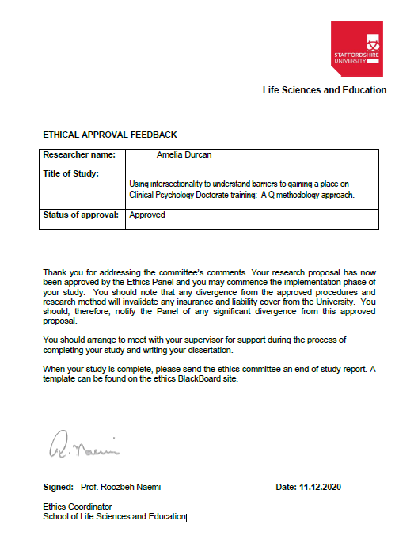

## **Appendix C**

## Social Media Advertisements

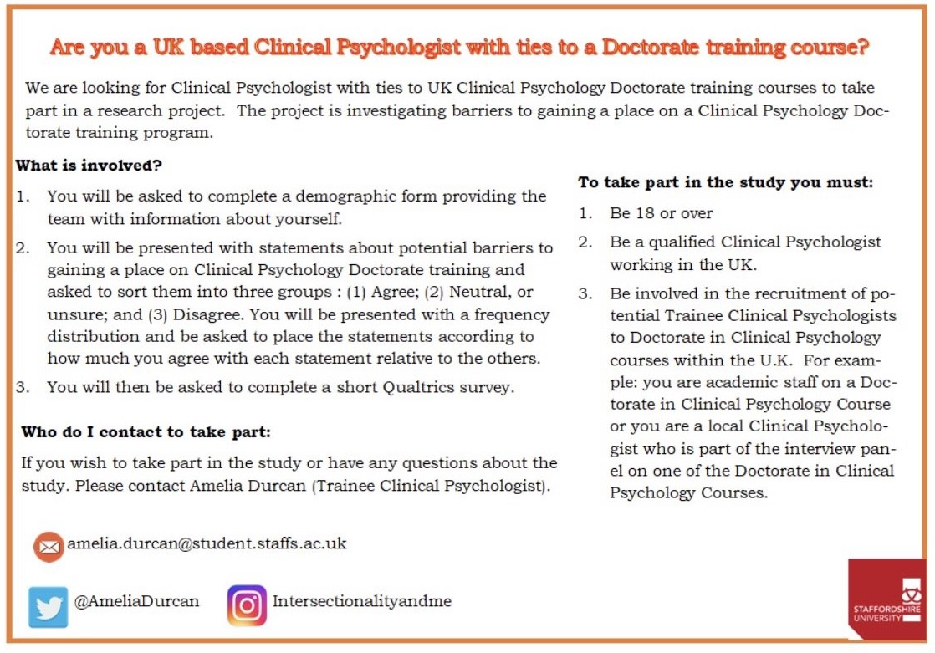

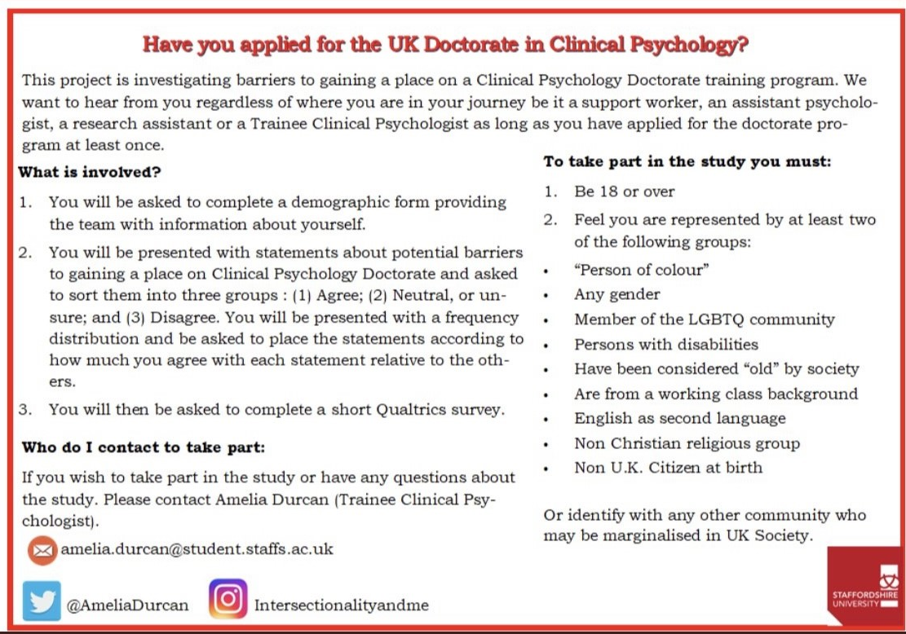

## **Appendix D**

## Participant information sheets for focus groups and Q-sorts (pre & post qual)

**INFORMATION SHEET FOR PARTICIPANTS (Version 1.1 Focus groups)**

**Using intersectionality to understand barriers to gaining a place on Clinical Psychology Doctorate training: A Q methodology approach.**

**Invitation Paragraph**

I would like to invite you to participate in this research project which forms part of my doctorate research. Before you decide whether you want to take part, it is important for you to understand why the research is being done and what your participation will involve. Please take time to read the following information carefully and discuss it with others if you wish. Ask me if there is anything that is not clear or if you would like more information.

**What is the purpose of the study?**

Clearing House for Postgraduate Courses in Clinical Psychology Equal Opportunities data for 2018 Entry shows clear disparages in those considered socially privileged and those considered socially disadvantaged.

|  |
| --- |
| Gained a place on a Clinical Psychology Doctorate Training |
| 84.6% indicated they were heterosexual. |
| 35% represented the highest socio-economic grouping whilst only 4.6% represented the lowest. |
| 88% indicated they had no disability. |
| 68.6% indicated they did not identify with a religion. Christianity was the largest religious group identified with. Only 0.8-1.7% of successful applicants identified with religious groups other than Christian. |
| 86% indicated they were from a white background. |

The aim of the study was to explore barriers faced when applying to the doctorate in clinical psychology in the U.K. Two groups were considered those pre-qualified (aspiring and trainee Clinical Psychologists) who identified as belonging to more than one disadvantaged social group and those post-qualified (Clinical Psychologists) who were part of the recruitment process.

***Objective 1***

To identify viewpoints among individuals who identify with more than one social group considered disadvantaged in the U.K. about possible barriers they faced when applying for a clinical psychology training place.

***Objective 2***

To identify any shared barriers amongst different disadvantaged social groups when applying for clinical psychology training.

***Objective 3***

To identify viewpoints among Clinical Psychologists who are part of the recruitment process about possible barriers faced when they applied for a clinical psychology training place.

***Objective 4***

To identify any differences or similarities in the barriers faced amongst those pre-qualified and those post-qualified when applying to clinical psychology training.

**Why have I been invited to take part?**

You have been invited to take part in the study because:

You feel represented by one or more of the disadvantaged groups below or any other group you feel is disadvantaged in U.K. society:

* “Person of colour”
* Member of the LGBTQ community
* Identify as gender fluid or non-binary
* Persons with disabilities
* Have been considered “old” by society
* Are from a working class background
* English as second language
* Non Christian religious group
* Non U.K. Citizen at birth

**What will happen if I take part?**

You will be asked to complete a demographic form to ensure we as the research team have a full understanding of your demographic profile.

Following this you will be invited to a Focus Group. Focus groups provide a way to collect data, and include the use of carefully selected groups of people that come together to discuss specific questions or issues related to a research question. Interaction is key, and one of the more distinctive characteristics of the focus group is the ability of group members to share their thoughts and ideas in a group setting, as opposed to in a one-on-one interview. Two focus groups of 8 people will be facilitated with the intention of gathering verbal views about barriers to gaining a place on clinical doctorate training.

These focus groups will take place via Microsoft Teams and should take around 1 ½ hours to complete.

Participants will be asked about any barriers they faced in the process of applying for or gaining a place on clinical training. The information provided will inform future stages of the doctoral research.

The focus groups will be recorded on Microsoft Teams; however this will only be done with the consent of the participants, who will be made aware of when the recording starts. Participants will also be asked to keep confidential any information discussed within the focus group.

**Do I have to take part?**

No. Participation is completely voluntary. You should only take part if you want to and choosing not to take part will not disadvantage you in anyway. Once you have read the information sheet, please contact us if you have any questions that will help you make a decision about taking part. If you decide to take part we will ask you to sign a consent form and you will be given a copy of this consent form to keep.

**What are the possible risks of taking part?**

We will be discussing potentially sensitive issues around barriers you may have faced personally and thus this might cause distress. Steps will be taken to minimise any distress and sensitive issues will be managed respectfully and accordingly.

If at any point you feel distressed during the focus group, please inform the researcher and the focus group will stop immediately. You are able to withdraw from the research task if you are finding it distressing. The researcher will also offer breaks during the focus group. Efforts will also be made to provide some time for reflection and debrief after the focus group if required. Potential sources of support are detailed at the end of this information sheet.

**What are the possible benefits of taking part?**

In this case there are no intended benefits for the participant. However, by highlighting some of the difficulties faces by disadvantaged groups we can hope to widen understanding of these difficulties.

**Data handling and confidentiality**

Your data will be processed in accordance with the data protection law and will comply with the General Data Protection Regulation 2016 (GDPR). Each participant will be given an identifying code to anonymise their information. The participants identifying information will be linked to their identifying codes and kept separately. This information will be kept securely in a locked document that only the researcher will have access.

In line with Staffordshire university regulations the research data will be stored for 10 years after the end of the project and destroyed thereafter. The data will be kept in the secure archive room in the form of hard copy data/data saved on to a data stick. Personal confidential data, however, will be destroyed at the end of the data analysis phase. Anonymised data gained will only be shared within the research team.

**Data Protection Statement**

The data controller for this project will be Staffordshire University. The university will process your personal data for the purpose of the research outlined above. The legal basis for processing your personal data for research purposes under the GDPR is a ‘task in the public interest’. You can provide your consent for the use of your personal data in this study by completing the consent form that has been provided to you.

You have the right to access information held about you. Your right of access can be exercised in accordance with the GDPR. You also have other rights including rights of correction, erasure, objection, and data portability. Questions, comments and requests about your personal data can also be sent to the Staffordshire University Data Protection Officer. If you wish to lodge a complaint with the Information Commissioner’s Office, please visit [www.ico.org.U.K.](http://www.ico.org.uk/).

**What if I change my mind about taking part?**

You are free to withdraw at any point of the study, without having to give a reason. Withdrawing from the study will not affect you in any way. If you decide to withdraw from the study following the focus group all of the information you have provided up to that point will be included in the analysis, as it will be impossible at this time to remove it from the other information provided within the focus group.

**What will happen to the results of the study?**

The results of the study will be used to produce a Doctorate in Clinical Psychology thesis. It is the intention of the research team to publish this work in peer reviewed journals. It is therefore likely that the results of the study will be publicly available. All results will be anonymised, you will not be identifiable in any reports written as a result of the study.

**Who should I contact for further information?**

If you have any questions or require more information about this study, please contact me using the following contact details: amelia.durcan@student.staffs.ac.uk.

**What if I have further questions, or if something goes wrong?**

 If this study has harmed you in any way or if you wish to make a complaint please inform the researcher who will try to resolve the matter (see details above).

If you feel you are experiencing some difficulties related to your participation in this study and would prefer to discuss this with someone other than the researcher please contact:

Dr Helen Scott (Clinical Psychologist, Research supervisor) at [h.scott@staffs.ac.uk.](mailto:h.scott@staffs.ac.uk) .

Alternatively you may wish to contact the Chair of the Staffordshire University Ethics Committee for further advice and information:

Dr Tim Horne Research, Innovation and Impact Services

Postal Address: Cadman Building, Staffordshire University, College Road Stoke-on-Trent

ST4 2DF

Email: Tim.horne@staffs.ac.uk

Telephone: 01782295722

**Who has reviewed this study?**

The study has been reviewed and approved by Staffordshire University Ethics Committee

**Thank you for reading this information sheet and for considering taking part in this research.**

**INFORMATION SHEET FOR PARTICIPANTS (Version 2.1 Q-SORT)**

**Using intersectionality to understand barriers to gaining a place on Clinical Psychology Doctorate training: A Q methodology approach.**

**Invitation Paragraph**

I would like to invite you to participate in this research project which forms part of my doctorate research. Before you decide whether you want to take part, it is important for you to understand why the research is being done and what your participation will involve. Please take time to read the following information carefully and discuss it with others if you wish. Ask me if there is anything that is not clear or if you would like more information.

**What is the purpose of the study?**

Clearing House for Postgraduate Courses in Clinical Psychology Equal Opportunities data for 2018 Entry shows clear disparages in those considered socially privileged and those considered socially disadvantaged.

|  |
| --- |
| Gained a place on a Clinical Psychology Doctorate Training |
| 84.6% indicated they were heterosexual. |
| 35% represented the highest socio-economic grouping whilst only 4.6% represented the lowest. |
| 88% indicated they had no disability. |
| 68.6% indicated they did not identify with a religion. Christianity was the largest religious group identified with. Only 0.8-1.7% of successful applicants identified with religious groups other than Christian. |
| 86% indicated they were from a white background. |

The aim of the study was to explore barriers faced when applying to the doctorate in clinical psychology in the U.K. Two groups were considered those pre-qualified (aspiring and trainee Clinical Psychologists) who identified as belonging to more than one disadvantaged social group and those post-qualified (Clinical Psychologists) who were part of the recruitment process.

***Objective 1***

To identify viewpoints among individuals who identify with more than one social group considered disadvantaged in the U.K. about possible barriers they faced when applying for a clinical psychology training place.

***Objective 2***

To identify any shared barriers amongst different disadvantaged social groups when applying for clinical psychology training.

***Objective 3***

To identify viewpoints among Clinical Psychologists who are part of the recruitment process about possible barriers faced when they applied for a clinical psychology training place.

***Objective 4***

To identify any differences or similarities in the barriers faced amongst those pre-qualified and those post-qualified when applying to clinical psychology training.

**Why have I been invited to take part?**

You have been invited to take part in the study because:

You feel represented by more than one of the disadvanataged groups below or any other group you feel is disadvantaged in U.K. society:

* “Person of colour”
* Member of the LGBTQ community
* Any Gender
* Persons with disabilities
* Have been considered “old” by society
* Are from a working class background
* English as second language
* Non Christian religious group
* Non U.K. Citizen at birth

**What will happen if I take part?**

You will be asked to complete a demographic form to ensure we as the research team have a full understanding of your demographic profile.

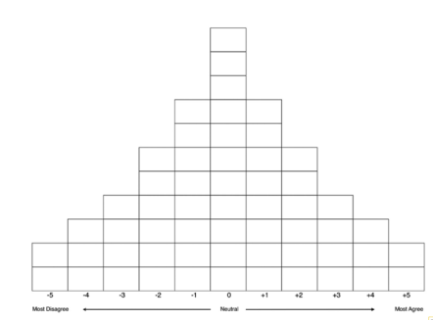Following this you will be invited to take part in a Q sort. The Q sorts will take place online using Q Sortware. Q-methodology is used to investigate the perspectives of participants who represent different stances on an issue, by having participants rank and sort a series of statements. You will be asked to read through the statements for example “being from a minority background makes it harder to gain appropriate training”. You will then be asked to split the statements into three piles to facilitate sorting: (1) Agree; (2) Neutral, or unsure; and (3) disagree. You will then be presented with a frequency distribution and be asked to place the items according to how much you agree with each statement relative to the others. The Q-Sort should take approx. 30 minutes.

You will complete a Qualtrics survey online following completing the Q-sort (approx. 10 minutes) during which you will be asked to comment on the personal meaning of statements you placed at each end of the distribution and any others you felt were important.

The information provided will be used within the researcher’s doctoral thesis.

**Do I have to take part?**

No. Participation is completely voluntary. You should only take part if you want to and choosing not to take part will not disadvantage you in anyway. Once you have read the information sheet, please contact us if you have any questions that will help you make a decision about taking part. If you decide to take part we will ask you to sign a consent form and you will be given a copy of this consent form to keep.

**What are the possible risks of taking part?**

We will be discussing potentially sensitive issues around barriers you may have faced personally and thus this might cause distress. Steps will be taken to minimise any distress and sensitive issues will be managed respectfully and accordingly.

If at any point you feel distressed during the Q sort, survey or post Q sort interview, please stop the task and inform the researcher. You are able to withdraw from the research task if you are finding it distressing. Potential sources of support are detailed at the end of this information sheet.

**What are the possible benefits of taking part?**

In this case there are no intended benefits for the participant. However, by highlighting some of the difficulties faces by disadvantaged groups we can hope to widen understanding of these difficulties.

**Data handling and confidentiality**

Your data will be processed in accordance with the data protection law and will comply with the General Data Protection Regulation 2016 (GDPR). Each participant will be given an identifying code to anonymise their information. The participants identifying information will be linked to their identifying codes and kept separately. This information will be kept securely in a locked document that only the researcher will have access.

In line with Staffordshire university regulations the research data will be stored for 10 years after the end of the project and destroyed thereafter. The data will be kept in the secure archive room in the form of hard copy data/data saved on to a data stick. Personal confidential data, however, will be destroyed at the end of the data analysis phase. Anonymised data gained will only be shared within the research team.

**Data Protection Statement**

The data controller for this project will be Staffordshire University. The university will process your personal data for the purpose of the research outlined above. The legal basis for processing your personal data for research purposes under the GDPR is a ‘task in the public interest’. You can provide your consent for the use of your personal data in this study by completing the consent form that has been provided to you.

You have the right to access information held about you. Your right of access can be exercised in accordance with the GDPR. You also have other rights including rights of correction, erasure, objection, and data portability. Questions, comments and requests about your personal data can also be sent to the Staffordshire University Data Protection Officer. If you wish to lodge a complaint with the Information Commissioner’s Office, please visit [www.ico.org.U.K.](http://www.ico.org.uk/).

**What if I change my mind about taking part?**

You are free to withdraw at any point of the study, without having to give a reason. Withdrawing from the study will not affect you in any way. You are able to withdraw your data from the study up until the point of data analysis (predicted to be 1st December 2021) after which withdrawal of your data will no longer be possible due to the fact the data would have been anonymised and processed by then.

If you choose to withdraw from the study we will not retain any information that you have provided us as a part of this study.

**What will happen to the results of the study?**

The results of the study will be used to produce a Doctorate in Clinical Psychology thesis. It is the intention of the research team to publish this work in peer reviewed journals. It is therefore likely that the results of the study will be publicly available. All results will be anonymised, you will not be identifiable in any reports written as a result of the study.

**Who should I contact for further information?**

If you have any questions or require more information about this study, please contact me using the following contact details: amelia.durcan@student.staffs.ac.uk**.**

**What if I have further questions, or if something goes wrong?**

 If this study has harmed you in any way or if you wish to make a complaint please inform the researcher who will try to resolve the matter (see details above).

If you feel you are experiencing some difficulties related to your participation in this study and would prefer to discuss this with someone other than the researcher please contact:

Dr Helen Scott (Clinical Psychologist, Research supervisor) at [h.scott@staffs.ac.uk](mailto:h.scott@staffs.ac.uk).

Alternatively you may wish to contact the Chair of the Staffordshire University Ethics Committee for further advice and information:

Dr Tim Horne Research, Innovation and Impact Services

Postal Address: Cadman Building, Staffordshire University, College Road Stoke-on-Trent

ST4 2DF

Email: Tim.horne@staffs.ac.uk

Telephone: 01782295722

**Who has reviewed this study?**

The study has been reviewed and approved by Staffordshire University Ethics Committee

**INFORMATION SHEET FOR PARTICIPANTS (Version 2.2 Q-SORT)**

**Using intersectionality to understand barriers to gaining a place on Clinical Psychology Doctorate training: A Q methodology approach.**

**Invitation Paragraph**

I would like to invite you to participate in this research project which forms part of my doctorate research. Before you decide whether you want to take part, it is important for you to understand why the research is being done and what your participation will involve. Please take time to read the following information carefully and discuss it with others if you wish. Ask me if there is anything that is not clear or if you would like more information.

**What is the purpose of the study?**

Clearing House for Postgraduate Courses in Clinical Psychology Equal Opportunities data for 2018 Entry shows clear disparages in those considered socially privileged and those considered socially disadvantaged.

|  |
| --- |
| Gained a place on a Clinical Psychology Doctorate Training |
| 84.6% indicated they were heterosexual. |
| 35% represented the highest socio-economic grouping whilst only 4.6% represented the lowest. |
| 88% indicated they had no disability. |
| 68.6% indicated they did not identify with a religion. Christianity was the largest religious group identified with. Only 0.8-1.7% of successful applicants identified with religious groups other than Christian. |
| 86% indicated they were from a white background. |

The aim of the study was to explore barriers faced when applying to the doctorate in clinical psychology in the U.K. Two groups were considered those pre-qualified (aspiring and trainee Clinical Psychologists) who identified as belonging to more than one disadvantaged social group and those post-qualified (Clinical Psychologists) who were part of the recruitment process.

***Objective 1***

To identify viewpoints among individuals who identify with more than one social group considered disadvantaged in the U.K. about possible barriers they faced when applying for a clinical psychology training place.

***Objective 2***

To identify any shared barriers amongst different disadvantaged social groups when applying for clinical psychology training.

***Objective 3***

To identify viewpoints among Clinical Psychologists who are part of the recruitment process about possible barriers faced when they applied for a clinical psychology training place.

***Objective 4***

To identify any differences or similarities in the barriers faced amongst those pre-qualified and those post-qualified when applying to clinical psychology training.

**Why have I been invited to take part?**

You have been invited to take part in the study because:

You are involved in the recruitment of potential Trainee Clinical Psychologists to Doctorate in Clinical Psychology courses within the U.K. For example: you are academic staff on a Doctorate in Clinical Psychology Course in the U.K. or you are a local Clinical Psychologist who is part of the interview panel on one of the Doctorate in Clinical Psychology Courses in the U.K.

**What will happen if I take part?**

You will be asked to complete a demographic form to ensure we as the research team have a full understanding of your demographic profile.

Following this you will be invited to take part in a Q sort. The Q sorts will take place online using Q Sortware. Q-methodology is used to investigate the perspectives of participants who represent different stances on an issue, by having participants rank and sort a series of statements. You will be asked to read through the statements for example “being from a minority background makes it harder to gain appropriate training”. You will then be asked to split the statements into three piles to facilitate sorting: (1) Agree; (2) Neutral, or unsure; and (3) disagree. You will then be presented with a frequency distribution and be asked to place the items according to how much you agree with each statement relative to the others. The Q-Sort should take approx. 30 minutes.

You will complete a Qualtrics survey online following completing the Q-sort (approx. 10 minutes) during which you will be asked to comment on the personal meaning of statements you placed at each end of the distribution and any others you felt were important.

The information provided will be used within the researcher’s doctoral thesis.

**Do I have to take part?**

No. Participation is completely voluntary. You should only take part if you want to and choosing not to take part will not disadvantage you in anyway. Once you have read the information sheet, please contact us if you have any questions that will help you make a decision about taking part. If you decide to take part we will ask you to sign a consent form and you will be given a copy of this consent form to keep.

**What are the possible risks of taking part?**

We will be discussing potentially sensitive issues around barriers you may have faced personally and thus this might cause distress. Steps will be taken to minimise any distress and sensitive issues will be managed respectfully and accordingly.

If at any point you feel distressed during the Q sort, survey or post Q sort interview, please stop the task and inform the researcher. You are able to withdraw from the research task if you are finding it distressing. Potential sources of support are detailed at the end of this information sheet.

**What are the possible benefits of taking part?**

In this case there are no intended benefits for the participant. However, by highlighting some of the difficulties faces by disadvantaged groups we can hope to widen understanding of these difficulties.

**Data handling and confidentiality**

Your data will be processed in accordance with the data protection law and will comply with the General Data Protection Regulation 2016 (GDPR). Each participant will be given an identifying code to anonymise their information. The participants identifying information will be linked to their identifying codes and kept separately. This information will be kept securely in a locked document that only the researcher will have access.

In line with Staffordshire university regulations the research data will be stored for 10 years after the end of the project and destroyed thereafter. The data will be kept in the secure archive room in the form of hard copy data/data saved on to a data stick. Personal confidential data, however, will be destroyed at the end of the data analysis phase. Anonymised data gained will only be shared within the research team.

**Data Protection Statement**

The data controller for this project will be Staffordshire University. The university will process your personal data for the purpose of the research outlined above. The legal basis for processing your personal data for research purposes under the GDPR is a ‘task in the public interest’. You can provide your consent for the use of your personal data in this study by completing the consent form that has been provided to you.

You have the right to access information held about you. Your right of access can be exercised in accordance with the GDPR. You also have other rights including rights of correction, erasure, objection, and data portability. Questions, comments and requests about your personal data can also be sent to the Staffordshire University Data Protection Officer. If you wish to lodge a complaint with the Information Commissioner’s Office, please visit [www.ico.org.U.K.](http://www.ico.org.uk/).

**What if I change my mind about taking part?**

You are free to withdraw at any point of the study, without having to give a reason. Withdrawing from the study will not affect you in any way. You are able to withdraw your data from the study up until the point of data analysis (predicted to be 1st December 2021) after which withdrawal of your data will no longer be possible due to the fact the data would have been anonymised and processed by then.

If you choose to withdraw from the study we will not retain any information that you have provided us as a part of this study.

**What will happen to the results of the study?**

The results of the study will be used to produce a Doctorate in Clinical Psychology thesis. It is the intention of the research team to publish this work in peer reviewed journals. It is therefore likely that the results of the study will be publicly available. All results will be anonymised, you will not be identifiable in any reports written as a result of the study.

**Who should I contact for further information?**

If you have any questions or require more information about this study, please contact me using the following contact details: amelia.durcan@student.staffs.ac.uk**.**

**What if I have further questions, or if something goes wrong?**

 If this study has harmed you in any way or if you wish to make a complaint please inform the researcher who will try to resolve the matter (see details above).

If you feel you are experiencing some difficulties related to your participation in this study and would prefer to discuss this with someone other than the researcher please contact:

Dr Helen Scott (Clinical Psychologist, Research supervisor) at [h.scott@staffs.ac.uk](mailto:h.scott@staffs.ac.uk).

Alternatively you may wish to contact the Chair of the Staffordshire University Ethics Committee for further advice and information:

Dr Tim Horne Research, Innovation and Impact Services

Postal Address: Cadman Building, Staffordshire University, College Road Stoke-on-Trent

ST4 2DF

Email: Tim.horne@staffs.ac.uk

Telephone: 01782295722

**Who has reviewed this study?**

The study has been reviewed and approved by Staffordshire University Ethics Committee.

## **Appendix E**

## Inclusion criteria to take part in the study.

|  |  |  |
| --- | --- | --- |
| Pre-Qualification | Or | Post Qualification |
| 1. Be 18 or over 2. Have applied for the Doctorate in clinical psychology on at least one occasion (successfully or not). 3. Feel you are represented more than one of the following groups:  * “Person of colour” * Any gender * Member of the LGBTQ community * Persons with disabilities * Have been considered “old” by society * Are from a working class background * English as second language * Non Christian religious group * Non U.K. Citizen at birth * Or identify with any other community who may be marginalised in UK Society. | 1. Be 18 or over  2. Be a qualified Clinical Psychologist working in the UK.  3. Be involved in the recruitment of potential Trainee Clinical Psychologists to Doctorate in Clinical Psychology courses within the U.K. For example: you are academic staff on a Doctorate in Clinical Psychology Course or you are a local Clinical Psychologist who is part of the interview panel on one of the Doctorate in Clinical Psychology Courses. |

## **Appendix F**

## Consent form for focus groups and Q-sorts (pre & post qualified)

**CONSENT FORM (Version1.1/1.2)**

Title of Project: **Using intersectionality to understand barriers to gaining a place on Clinical Psychology Doctorate training: A Q methodology approach.**

Name of Researcher: Amelia Durcan

**PARTICIPATION IN THIS RESEARCH STUDY IS VOLUNTARY**

|  |  |
| --- | --- |
| I have read and understood the study information [Version 1.1 or 1.2], or it has been read to me. I have been able to ask questions about the study and my questions have been answered to my satisfaction. | YES / NO |
| I consent voluntarily to be a participant in this study and understand that I can refuse to answer questions. | YES / NO |
| I understand I can withdraw from the study without having to give a reason. I understand if I decide to withdraw from the study following the focus group all of the information I have provided up to that point will be included in the analysis. | YES / NO |
| I agree to the focus group being recorded | YES / NO/ |
| I agree to maintain the confidentiality of the focus group discussions | YES / NO/ |
| I understand that the information I provide will be used for the researchers thesis and that the information will be anonymised. | YES / NO |
| I understand that my words may be quoted in publications, reports, web pages, and other research outputs. | YES / NO |
| I understand that any personal information that can identify me – such as my name, address, will be kept confidential and not shared with anyone other than the researcher. | YES / NO |
| I agree for the data I provide to be archived at Staffordshire University | YES / NO |

Please retain a copy of this consent form.

Participant name:

Signature:  ________________________________  Date  ________________

Researchers name:

Signature:________________________________  Date  ________________

    
For information please contact: Amelia Durcan ([amelia.durcan@student.staffs.ac.uk](mailto:amelia.durcan@student.staffs.ac.uk)**.)**

**CONSENT FORM (Version2.1/2.2)**

Title of Project: **Using intersectionality to understand barriers to gaining a place on Clinical Psychology Doctorate training: A Q methodology approach.**

Name of Researcher: Amelia Durcan

**PARTICIPATION IN THIS RESEARCH STUDY IS VOLUNTARY**

|  |  |
| --- | --- |
| I have read and understood the study information [Version 2.1/2.2], or it has been read to me. I have been able to ask questions about the study and my questions have been answered to my satisfaction. | YES / NO |
| I consent voluntarily to be a participant in this study and understand that I can refuse to answer questions. | YES / NO |
| I understand I can withdraw from the study without having to give a reason. I understand I can withdraw my data at any time up until the point of data analysis (predicted to be 1st September 2021) after which withdrawal of my data will no longer be possible due to the fact the data would have been anonymised and processed by then. | YES / NO |
| I understand that the information I provide will be used for the researchers thesis and that the information will be anonymised. | YES / NO |
| I understand that my words may be quoted in publications, reports, web pages, and other research outputs. | YES / NO |
| I understand that any personal information that can identify me – such as my name, address, will be kept confidential and not shared with anyone other than the researcher. | YES / NO |
| I agree for the data I provide to be archived at Staffordshire University | YES / NO |

Please retain a copy of this consent form.

Participant name:

Signature:  ________________________________  Date  ________________

Researchers name:

Signature:________________________________  Date  ________________

## **Appendix G**

## Demographic form

|  |
| --- |
| How do you identify your gender? |
| * Agender |
| * Genderqueer |
| * Gender fluid |
| * Man |
| * Non-binary |
| * Questioning or unsure |
| * Transgender |
| * Trans man |
| * Trans woman |
| * Woman |
| * Additional gender category/identity: please specify ________________ |
| * Prefer not to disclose |

|  |
| --- |
| Is your gender identity the same as you were assigned at birth? |
| * Yes- my gender identity is the same as at birth |
| * No- my gender identity has changed |
| * Prefer not to say |

|  |
| --- |
| What is your sexual orientation? |
| * Asexual |
| * Bisexual |
| * Gay |
| * Straight |
| * Lesbian |
| * Pansexual |
| * Queer |
| * Questioning/Unsure |
| * Additional sexual identity category not listed please specify ­­­­­_________________________ |
| * Prefer not to say |

|  |
| --- |
| What is your ethnic group? |
| * White British |
| * White Irish |
| * White Traveller |
| * White other please specify ________________________________________ |
| * Black or Black British - Caribbean |
| * Black or Black British - African |
| * Other Back Background please specify _______________________________________ |
| * Asian or Asian British- Indian |
| * Asian or Asian British- Pakistani |
| * Asian or Asian British- Bangladeshi |
| * Chinese |
| * Other Asian Background please specify__________________________________ |
| * Mixed- White and Black Caribbean |
| * Mixed- White and Black African |
| * Mixed- White and Asian |
| * Other Mixed Background please specify__________________________________ |
| * Arab |
| * Other Ethnic Background please specify__________________________________ |
| * Prefer not to say |

|  |
| --- |
| What is your nationality? |
| ___________________________________________ |

|  |
| --- |
| At any time have you claimed refugee or asylum status |
| * Yes |
| * No |
| * Prefer not to say |

|  |
| --- |
| Is English your first language |
| * Yes |
| * No |
| * Prefer not to say |

|  |
| --- |
| What is your religion or belief |
| * No religion |
| * Buddhist |
| * Christian (including Church of England, Catholic, Protestant and all other Christian denominations) |
| * Hindu |
| * Jewish |
| * Muslim |
| * Sikh |
| * Spiritual |
| * Any other Religion/Belief please specify__________________________________ |
| * Prefer not to say |

|  |  |
| --- | --- |
| Do you consider yourself to have any of the following disabilities or learning difficulties? | |
| * Yes |  |
| * No |  |
| If yes please tick one of more of the following boxes |  |
| * Visual impairment * Hearing impairment * Disability affecting mobility/wheelchair user * Other physical disability * Emotional behavioural disability * Mental ill health * Temporary disability after illness * Profound/complex disability * Multiple disabilities * Moderate learning disability * Severe learning disability | * Dyslexia * Dyscalculia * Other specific learning disability * Multiple learning disabilities * Other please specify ________________________ |

|  |
| --- |
| Which option best describes the type of schooling you received? |
| * Academy |
| * State/Maintained |
| * Faith |
| * Grammar |
| * Private |
| * Alternative provision please specify____________________________________ |
| * Prefer not to say |

|  |
| --- |
| At any point in your schooling years were you eligible for free school meals? |
| * Yes |
| * No |
| * Prefer not to say |

|  |
| --- |
| During your school years, what was the occupation of the highest earner in your family? |
|  |

|  |
| --- |
| At any point in your school years did your household receive income-related benefits? |
| * Yes |
| * No |
| * Prefer not to say |

|  |
| --- |
| Do you consider yourself to be from a lower socio-economic background? |
| * Yes |
| * No |
| * Prefer not to say |

|  |
| --- |
| Please write below your current job role and employing service and trust (or organisation). |
|  |

## **Appendix H**

## Overall Participant Demographics from Focus Group (n=15)

|  |  |
| --- | --- |
| Characteristic |  |
| Current Role | Educational Wellbeing Practitioner 1 (7%)  Assistant Psychologist 7 (47%)  Trainee Clinical Psychologist 5 (33%)  Psychological Wellbeing Practitioner 2 (13%) |
| Age | 18-24 years 2 (13%)  25-34 years 10 (67%)  35-44 years 3 (20%) |
| Gender | Male 3 (20%)  Female 11 (73%)  Transgender 1 (7%) |
| Sexuality | Straight 12 (80%)  Lesbian 1 (7%)  Bisexual 1 (7%)  Heteroflexible 1 (6%) |
| Ethnicity | Black Caribbean 1 (7%)  Black British 1 (7%)  White British 5 (33%)  White Cypriot 1 (6%)  White Irish 1 (7%)  Asian Chinese 1 (6%)  Asian Indian 1 (7%)  Asian Punjabi 1 (7%)  Arab 1 (6%)  Mixed White & Black Caribbean 1 (7%)  Mixed Black Caribbean & MENA Jewish (7%) |
| Nationality | British 12 (80%)  Greek National 1 (6%)  Irish 1 (7%)  Egyptian 1 (7%) |
| First Language | English 12 (80%)  Non-English 3 (20%) |
| Religion | Christian 3 (20%)  No Religion 6 (40%)  Wiccan 1 (7%)  Jain 1 (7%)  Muslim 2 (13%)  Spiritual 2 (13%) |
| Disability | Yes (Including Dyslexia/Dyspraxia/Dyscalculia/Chronic Fatigue/Autism/Mental Health Illness/Physical Disability) 6 (40%)  No 9 (60%) |
| Class | Working Class 8 (53%)  Upper or Middle Class 7 (47%) |

## **Appendix I**

## Focus Group Schedule

Before the group assembles

Test the recording equipment to make sure it is working and that the sound is recording at an acceptable level.

Ensure everyone has viewed the Participant Information Sheet and completed and signed the consent form. This should have been completed online either via email or in an optional 1:1 Microsoft Teams meeting where the participant has the chance to ask any questions.

At the start of the session

Check at this point if anyone has any questions they have yet to raise.

Check that there are no objections to recording; then switch it on. Ensure everyone is aware we are now recording.

Start by going round the group and getting everyone to introduce themselves. Ensure everyone’s full name is on display either via name badges or via their on screen handles on Microsoft teams.

Make sure that everyone is comfortable before you start and that everyone can see each other. Read out the statement on confidentiality:

**Opinions expressed should be treated as confidence among project staff and also among yourselves as the participants. All responses will remain anonymous,** **you will not be identifiable in any reports written as a result of the study.**

Introduction to the session

You need to start off by reiterating the purpose of the meeting:

**I’m very grateful to you all for sparing time to talk about barriers to gaining a place on the Doctorate in Clinical Psychology training programme. The purpose of this focus group is to establish a base of evidence as to possible barriers that may be experienced by different groups considered disadvantaged within U.K. society.**

**I would first like to concentrate on discussing your thoughts on information that is already out in popular forums. I would then like to spend some time talking about your experiences.**

**There are no right or wrong opinions, I would like you to feel comfortable saying what you really think and how you really feel.**

Share with individuals the intersectionality Model**.** Ask Participants to: **Please hold in** **mind throughout today’s session where you feel you fit within this model and also consider disadvantaged and privileged groups that may not be identified on this model.**

Again check at this point if anyone has any questions that they have not raised yet?

Discussion 1: Review of Current Statements

**A major area of interest to this study is potential barriers experienced by individuals attempting to gain a place on the Doctorate in Clinical Psychology training programme. Thinking specifically about these barriers we would like to discuss with you your view points and opinions on the following statements.**

Place 5 statements in front of the participants (can have these show up on screen if needs be). Statements will be grouped with similar content.

**Q1: What are you initial thoughts on the following statements?**

**Q1a: Do you agree or disagree with them?**

**Q1b: Do you think the statements express the same of different opinions?**

Place 5 statements in front of the participants (can have these show up on screen if needs be). Statements will be grouped with similar content.

**Q2: What are you initial thoughts on the following statements?**

**Q2a: Do you agree or disagree with them?**

**Q2b: Do you think the statements express the same of different opinions?**

Place 5 statements in front of the participants (can have these show up on screen if needs be) Statements will be grouped with similar content.

**Q3: What are you initial thoughts on the following statements?**

**Q3a: Do you agree or disagree with them?**

**Q3b: Do you think the statements express the same of different opinions?**

Place 5 statements in front of the participants (can have these show up on screen if needs be) Statements will be grouped with similar content.

**Q4: What are you initial thoughts on the following statements?**

**Q4a: Do you agree or disagree with them?**

**Q4b: Do you think the statements express the same of different opinions?**

Place 5 statements in front of the participants (can have these show up on screen if needs be) Statements will be grouped with similar content.

**Q5: What are you initial thoughts on the following statements?**

**Q5a: Do you agree or disagree with them?**

**Q5b: Do you think the statements express the same of different opinions?**

Discussion 2: Your Experiences

**As mentioned the area of interest to this study is potential barriers experienced by individuals attempting to gain a place on the Doctorate in Clinical Psychology training programme. Particular interest is the barriers experienced by people who represent social groups considered disadvantaged in U.K. society. Holding in mind the social groups you represent think specifically about barriers you personally have experienced during this process.**

**Q6:** **How do you think your experience differs from people who represent other social groups? (For Example: if you identify as BAME how do you think this has changed your experience when compared to your White colleagues?)**

**Q7:** **How do you think your experience is similar to people who represent other social groups? (For Example: if you consider yourself working class how do you think this has changed your experience when compared to your middle class colleagues or is your experience often similar?)**

**Q8:** **For people who represent multiple social groups considered disadvantaged do you think this changes the experience compared to those who identify as belonging to only one socially disadvantaged group? (For Example if you identify as a gay women who is also disabled do you think this would alter your experience compared to a straight individual with a disability?)**

**Q9. What area of the doctorate process (i.e. gaining experience, the application, screening tests interviews) created the largest barriers for you?**

**Q9: Is there any information that you feel is important to be noted regarding barriers to the Doctorate in Clinical Psychology Training particularly those affecting disadvantaged social groups in U.K. society that we have not yet discussed?**

Ending the session

Finally, summarise the discussions and thank participants for their time.

I will be emailing you all a debrief sheet today if you would like to discuss the content of the group or any way in which it affected you please drop me an email.

Thank you again for you time.

## **Appendix J**

## Braun and Clarke (2006) 6 phases of Thematic Analysis.

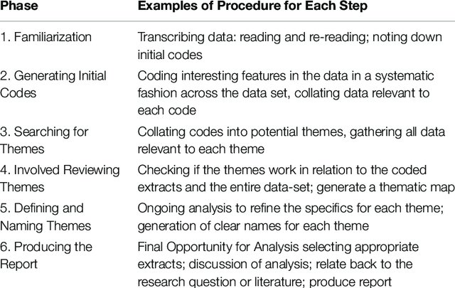

## **Appendix K**

## 47 Q-set statements

|  |
| --- |
| Q-Set Statements |
| 1. I found safe spaces to talk about my unique challenges in the professional psychology world. 2. Sharing selection tests and interview questions in dominant groups does not create barriers for people like me. 3. I have not been in a position to work for free honorary assistant psychologists positions reinforce barriers and therefore have made things more difficult for individuals like me. 4. People on my previous interview panels often share my intersectional groups. 5. I faced barriers when completing my degree(s) and it affected my grade which did or is making gaining a place on the doctorate in clinical psychology harder (2:1 rule). 6. The demographic form on the clearing house website fully captures my intersectional groups. 7. A Masters/Post Gradate qualifications provides additional points during screening. However, due to my circumstances an additional qualification was not possible. 8. I did not experience microaggressions due to my intersectional groups whilst gaining experience to apply for the doctorate in clinical psychology. 9. I do not feel my intersectional groups have affected my ability to get relevant work experience. 10. The lack of feedback from the courses to unsuccessful candidates created barriers for me. 11. On occasion the intersectional groups I belong to have led to me feeling like an imposter at work. This affected opportunities for me. 12. My intersectional groups have meant I have been able to take up opportunities on route to the doctorate in clinical psychology such as job/training programmes in another area of the country. 13. My hope to become a Clinical Psychologist started later than others due to the lack of representation of qualified Clinical Psychologist who represent my intersectional groups. 14. My past/current supervision did/does not meet my needs by fully discussing my experiences through an intersectional lens. 15. I do not think I have faced barriers related to my intersectional groups during the doctorate in clinical psychology application process. 16. Having a mentor from my intersectional groups had reduced barriers I face. 17. I have found the financial implication of applying for the doctorate in clinical psychology difficult i.e. cost of application, attending selection test, attending interviews. 18. I have the same level of access to important information and networks as dominant groups in psychology. 19. I have never attempted to oppress parts of my intersectional identity to blend into dominant groups in psychology to reduce barrier I have faced. 20. The many routes into the doctorate in clinical psychology and lack of clear information has acted as a barrier in my journey. 21. The doctorate in clinical psychology courses attempts to increase diversity are performative and has done nothing to reduce barrier for me. 22. I was able to fully represent myself on the application form as it is flexible and inclusive. 23. The application process is transparent and lack of clear information did not cause barriers for me. 24. Adaption to screening tests/interviews due to CoVID-19 has increased barriers for individuals like me. 25. Support from peers from similar intersectional groups has been important in reducing barriers 26. Not knowing where to go for support has been a barrier in my journey. 27. There was adequate information about the doctorate in clinical psychology during my A Level and Undergraduate degree for me to feel fully informed about the doctorate in clinical psychology process and its requirements 28. I have been discouraged from applying for the doctorate in clinical psychology due to low numbers of people who get on from my intersectional groups. 29. Barriers earlier in my education due to my intersectional groups has made gaining a place on the doctorate in clinical psychology harder i.e. screeners based on verbal reasoning. 30. Gaining an academic reference provided a barrier for me due to it being a long time since I studied/ or they do not know me well. 31. Personal circumstances related to my intersectional groups affected my transcript. These transcripts are not reviewed with context in mind creating a barrier for me. 32. Increased discussion of difference has acted as a positive in reducing barriers. 33. The doctorate in clinical psychology application process can act as a barrier at times making me self-critical, which led to me considering giving up on my career plan. 34. My application being considered without context has served as a barrier for me. 35. I have felt pressured to represent my intersectional groups in the workplace. 36. My intersectional groups have been welcomed and considered as a whole in psychology spaces. 37. I have lost aspects of my intersectional identity trying to blend into dominant psychology groups. 38. I have never felt othered in psychology spaces due to my intersectional groups. 39. My intersectional groups allow me to fit in easily with my colleagues and have helped me gain opportunities which helped my application 40. I have experienced overt and covert discrimination due to my intersectional groups. This has acted as a barrier to me. 41. Avoidance of conversations about difference in psychology spaces has made me feel isolated and lonely. 42. Social Media (Twitter, Instagram, etc.) helped me meet my support system acting as a facilitator to gaining a place on the Doctorate in clinical psychology. 43. I have family members who have "professional" jobs. I therefore knew it was possible to become a Clinical Psychologist from an early age. 44. I have struggled to find a mentor from my intersectional groups. 45. I have not faced any barriers due to my intersectional groups and instead feel they are an advantage in the process of gaining a place on the Doctorate in clinical psychology 46. Getting a clinical reference from a Clinical Psychologist who understood my unique experiences was difficult for me. 47. I had no problem finding a mentor/support group who understood my intersectional identity as a whole and was not just focused on 1 aspect (i.e. ethnicity) |

## **Appendix L**

## Overall Participant Demographics from Q-Sorts (n=30).

|  |  |
| --- | --- |
| Characteristic |  |
| Current Role | Assistant Psychologist 4 (13%)  Trainee Clinical Psychologist 19 (64%)  Psychological Wellbeing Practitioner 2 (7%)  Clinical Psychologist in the Community 1 (3%)  Clinical Psychologist/Member of course team 4 (13%) |
| Age | 18-24 years 2 (7%)  25-34 years 19 (63%)  35-44 years 6 (20%)  45-54 years 3 (10%) |
| Gender | Male 4  Female 24  Non-Binary 2 (7%) |
| Sexuality | Bisexual 9 (30%)  Straight 13 (44%)  Lesbian 3 (10%)  Gay 1 (3%)  Queer 3 (10%)  Pansexual 1 (3%) |
| Ethnicity | White- British 12 (40%)  White- Irish 1 (3%)  White European 6 (20%)  Asian-Chinese 1 (3%)  Black or Black British- Caribbean 2 (7%)  Turkish 1 (3%)  Arab 1 (3%)  Mixed- White & Black Caribbean 2 (7%)  Mixed- White & Black African 2 (7%)  Mixed- White & Asian 2 (7%) |
| Nationality | British 16 (55%)  Irish 1 (4%)  Northern Irish 1 (4%)  English 2 (7%)  Scottish 1 (3%)  Italian 1 (3%)  Greek 1 (3%)  Romanian 1 (3%)  Dutch 1 (3%)  French 1 (3%)  German 1 (3%)  Spanish 1 (3%)  Nigerian 1 (3%) |
| First Language | English 18 (60%)  Non-English 12 (40%) |
| Religion | No Religion 15 (50%)  Christian 4 (13%)  Muslim 5 (18%)  Buddhist 1 (3%)  Pagan 1 (3%)  Humanist 1 (3%)  Hindu 1 (3%)  Spiritual 2 (7%) |
| Disability | Yes (Including Dyslexia/Dyspraxia/Dyscalculia/Chronic Fatigue/Autism/Mental Health Illness/Physical Disability) 7 (23%)  No 23 (77%) |
| Class | Working Class 21 (70%)  Upper/Middle Class 9 (30%) |

## **Appendix M**

## Link to online software sent as email to participants

Using intersectionality to understand barriers when applying to Clinical Psychology Doctorate training: A Q-sort.

Hello,

Please copy and paste the link above into your internet browser and complete the Q-Sort. This will open a page with a Q-Sort icon on the left, please click on this and it will take you to the Q-Sort. If you are a qualified Clinical Psychologist please think back to your experiences prior to training.

Once you have completed the Q-Sort please use the following link to complete the post sort survey <http://staffordshire.qualtrics.com/jfe/form/SV_bQk6jcaDGgAd5Wu>.

You may wish to make note of the statements you most agreed with, most disagreed with and any others you felt were important to aid you in the completion of the survey.

Thank you for taking the time to take part in this research.

Many thanks,

Amelia Durcan

Trainee Clinical Psychologist

Doctorate in Clinical Psychology

Staffordshire University

2019 cohort

## **Appendix N**

## Post Sort Survey Questions**.**

1. Please tell me about the personal meaning of the statement you agree with most?
2. Please tell me about the personal meaning of the statement you disagree with most?
3. Is there any other statement you would like to comment on?
4. Is there any other statement you would like to comment on?
5. How did you find the experience of completing the Q-sort?
6. Do you think there was anything missing from the Q-Sort statements about barriers you have faced that you would like to comment on?

## **Appendix O**

## Correlation coefficient table.



Highlighted red-p <0.05. r ≥0.27 (Brown, 1980).

## **Appendix P**

## Seven Factor Model of Unrotated Factor Loadings

|  |  |  |  |
| --- | --- | --- | --- |
| Factor | Eigenvalue | % of Explained Variance | Cumulative % of Explained Variance |
| 1 | 9.217 | 31 | 31 |
| 2 | 4.2092 | 14 | 45 |
| 3 | 2.2174 | 7 | 52 |
| 4 | 1.9781 | 7 | 59 |
| 5 | 1.2052 | 4 | 63 |
| 6 | 1.1285 | 4 | 67 |
| 7 | 0.8671 | 3 | 70 |

## **Appendix Q**

## Extracted factor loadings.

|  |  |  |  |  |  |  |
| --- | --- | --- | --- | --- | --- | --- |
| **Q-Sort** | **Participant Pseudonym** | **Factor 1a** | **Factor 1b** | **Factor 2** | **Factor 3** | **Factor 4** |
| 1 | Naomi | -0.0903 | 0.0903 | 0.888* | -0.1545 | 0.0126 |
| 2 | Harriet | 0.297 | -0.297 | 0.1333 | 0.2474 | 0.3393 |
| 3 | Owen | -0.0085 | 0.0085 | -0.1614 | -0.0126 | 0.1104 |
| 4 | Emily | 0.0804 | -0.0804 | -0.3852* | -0.0587 | 0.2977 |
| 5 | Ola | 0.6056* | -0.6056 | 0.0407 | 0.1133 | 0.3505 |
| 6 | Colette | 0.8853 | -0.8853 | -0.0858 | 0.0991 | 0.1904 |
| 7 | Delilah | -0.0906 | 0.0906 | 0.9135* | -0.1329 | 0.0038 |
| 8 | Helena | 0.493* | -0.493 | -0.0688 | -0.04 | 0.0022 |
| 9 | Erica | -0.1052 | 0.1052 | -0.1424 | 0.5745* | 0.1039 |
| 10 | Dana | 0.8853* | -0.8853 | -0.0858 | 0.0991 | 0.1904 |
| 11 | Camila | 0.1193 | -0.1193 | -0.1208 | 0.3108 | 0.2645 |
| 12 | Ursula | 0.7409* | -0.7409 | -0.0871 | -0.0196 | 0.2934 |
| 13 | Malakia | 0.7409* | -0.7409 | -0.0871 | -0.0196 | 0.2934 |
| 14 | Cora | 0.0477 | -0.0477 | -0.1137 | 0.2454 | 0.1925 |
| 15 | Sanjay | 0.4358 | -0.4358 | -0.0327 | 0.2021 | 0.5251* |
| 16 | Odette | 0.2281 | -0.2281 | -0.1111 | -0.0092 | 0.6596* |
| 17 | Amira | 0.7967* | -0.7967 | -0.0676 | 0.0003 | 0.3023 |
| 18 | Aaliyah | -0.3918 | 0.3918* | -0.0636 | 0.0752 | -0.3604 |
| 19 | Rosaleen | 0.3874 | -0.3874 | 0.0082 | 0.039 | 0.6578* |
| 20 | Rashida | -0.0906 | 0.0906 | 0.9135* | -0.1329 | 0.0038 |
| 21 | Laura | 0.2281 | -0.2281 | -0.1111 | -0.0092 | 0.6596* |
| 22 | Toluwani | 0.4861 | -0.4861 | -0.2335 | 0.1013 | 0.5862* |
| 23 | Sanaya | 0.3874 | -0.3874 | 0.0082 | 0.039 | 0.6578* |
| 24 | Vera | -0.0906 | 0.0906 | 0.9135* | -0.1329 | 0.0038 |
| 25 | Kassandra | 0.7967* | -0.7967 | -0.0676 | 0.0003 | 0.3023 |
| 26 | Sadie | 0.0499 | -0.0499 | -0.0375 | 0.9101* | -0.0754 |
| 27 | Eva | 0.0499 | -0.0499 | -0.0375 | 0.9101* | -0.0754 |
| 28 | Rachel | 0.0776 | -0.0776 | -0.027 | 0.9171* | -0.0292 |
| 29 | Noelle | -0.8775 | 0.8775* | 0.0591 | -0.1002 | -0.197 |
| 30 | Terry | -0.8853 | 0.8853* | 0.0858 | -0.0991 | -0.1904 |
| % Explained Variance |  | 24 | 24 | 12 | 11 | 12 |

**p<0.05 (Denotes which factor an individual’s Q-sort loaded onto)

## **Appendix R**

## Statements association with each factor

|  |  |  |  |  |  |
| --- | --- | --- | --- | --- | --- |
| Statement | Factor 1a | Factor 1b | Factor 2 | Factor 3 | Factor 4 |
| 1 | 0 | -1 | 0 | 4 | 0 |
| 2 | -1 | 2 | 0 | 4 | 0 |
| 3 | 5 | -4 | -3 | 3 | 4 |
| 4 | -4 | 4 | 4 | 1 | -4 |
| 5 | 5 | -5 | 1 | -4 | -1 |
| 6 | -1 | 2 | -3 | 2 | 0 |
| 7 | -2 | 1 | 4 | -4 | 2 |
| 8 | -4 | 5 | 3 | -4 | -1 |
| 9 | -5 | 5 | -1 | 4 | -3 |
| 10 | 1 | 0 | -1 | -3 | 3 |
| 11 | 1 | -2 | 0 | 5 | 1 |
| 12 | -1 | 0 | 1 | -3 | -1 |
| 13 | 0 | -1 | 1 | 2 | 1 |
| 14 | 0 | 0 | -3 | 3 | 1 |
| 15 | -5 | 4 | -2 | 3 | -3 |
| 16 | 0 | 0 | 3 | -3 | 1 |
| 17 | 3 | -1 | 5 | -3 | 2 |
| 18 | -2 | 2 | 0 | -2 | -3 |
| 19 | -3 | 4 | -3 | -2 | -2 |
| 20 | 0 | 1 | 2 | -2 | 3 |
| 21 | 0 | 1 | -1 | 1 | 5 |
| 22 | -2 | 2 | 2 | 1 | -4 |
| 23 | -1 | 1 | 0 | 1 | -3 |
| 24 | -1 | 1 | 1 | -2 | -2 |
| 25 | 1 | -1 | -1 | 1 | 4 |
| 26 | 1 | -2 | -1 | -2 | 5 |
| 27 | -3 | 3 | 2 | -5 | -2 |
| 28 | 4 | -5 | 5 | 2 | 4 |
| 29 | 2 | -1 | -2 | -1 | -1 |
| 30 | 3 | -4 | 2 | -1 | 1 |
| 31 | 3 | -2 | 1 | -1 | 0 |
| 32 | 0 | -1 | -2 | 2 | 3 |
| 33 | 2 | 0 | -2 | -1 | 2 |
| 34 | 4 | -3 | 2 | -1 | 1 |
| 35 | 2 | -3 | -4 | -1 | 2 |
| 36 | -1 | 0 | 0 | 1 | 0 |
| 37 | 3 | -4 | 4 | 5 | 2 |
| 38 | -2 | 3 | 3 | 0 | -4 |
| 39 | -3 | 2 | 0 | 0 | -2 |
| 40 | 2 | -3 | -5 | 0 | -1 |
| 41 | 4 | -3 | -4 | 0 | 3 |
| 42 | 1 | -2 | -4 | 0 | 0 |
| 43 | -3 | 3 | 0 | -5 | -3 |
| 44 | 2 | -2 | -5 | 3 | 0 |
| 45 | -4 | 3 | 1 | 0 | -5 |
| 46 | 1 | 0 | -2 | 0 | -1 |
| 47 | -1 | 1 | 3 | 2 | -5 |

## **Appendix S**

## Z-scores

|  |  |  |  |  |  |  |
| --- | --- | --- | --- | --- | --- | --- |
| Statement Number | Statement | Factor 1a Z-score | Factor 1b Z-score | Factor 2 Z-score | Factor 3 Z-score | Factor 4 Z-score |
| 1 | I found safe spaces to talk about my unique challenges in the professional psychology world. | 0.03 | 0.39 | 0.31 | -1.37 | 0 |
| 2 | Sharing selection tests and interview questions in dominant groups does not create barriers for people like me. | 0.48 | -0.76 | 0.04 | -1.43 | 0.37 |
| 3 | I have not been in a position to work for free Honorary Assistant Psychologists positions reinforce barriers and therefore have made things more difficult for individuals like me. | -2.05 | 1.64 | 1.17 | -1.34 | -1.49 |
| 4 | People on my previous interview panels often share my intersectional groups. | 1.51 | -1.51 | -1.47 | -0.41 | 1.35 |
| 5 | I faced barriers when completing my degree(s) and it affected my grade which did or is making gaining a place on the Doctorate in clinical psychology harder (2:1 rule). | -1.69 | 1.79 | -0.39 | 1.56 | 0.4 |
| 6 | The demographic form on the clearing house website fully captures my intersectional groups. | 0.65 | -0.79 | 1.16 | -0.8 | -0.08 |
| 7 | A Masters/Post Gradate qualifications provides additional points during screening. However, due to my circumstances an additional qualification was not possible. | 0.68 | -0.42 | -1.53 | 1.54 | -0.83 |
| 8 | I did not experience microaggressions due to my intersectional groups whilst gaining experience to applying for the Doctorate in clinical psychology. | 1.44 | -1.88 | -1.19 | 1.4 | 0.55 |
| 9 | I do not feel my intersectional groups have affected my ability to get relevant work experience. | 1.86 | -1.97 | 0.37 | -1.56 | 0.78 |
| 10 | The lack of feedback from the courses to unsuccessful candidates created barriers for me. | -0.41 | 0.11 | 0.4 | 1.09 | -1.33 |
| 11 | On occasion the intersectional groups I belong to have led to me feeling like an imposter at work. This affected opportunities for me. | -0.44 | 0.83 | 0.04 | -1.95 | -0.27 |
| 12 | My intersectional groups have meant I have been able to take up opportunities on route to the Doctorate in clinical psychology such as job/training programmes in another area of the country. | 0.39 | -0.09 | -0.41 | 1.15 | 0.42 |
| 13 | My hope to become a Clinical Psychologist started later than others due to the lack of representation of qualified Clinical Psychologist who represent my intersectional groups. | -0.15 | 0.46 | -0.39 | -0.8 | -0.13 |
| 14 | My past/current supervision did/does not meet my needs by fully discussing my experiences through an intersectional lens. | -0.17 | 0.09 | 1.1 | -1.26 | -0.15 |
| 15 | I do not think I have faced barriers related to my intersectional groups during the Doctorate in clinical psychology application process. | 1.77 | -1.51 | 0.73 | -1.09 | 0.96 |
| 16 | Having a mentor from my intersectional groups had reduced barrier I face. | 0.22 | 0 | -1.12 | 0.98 | -0.29 |
| 17 | I have found the financial implication of applying for the Doctorate in clinical psychology difficult i.e. cost of application, attending selection test, attending interviews. | -1.19 | 0.44 | -1.87 | 1.02 | -0.66 |
| 18 | I have the same level of access to important information and networks as dominant groups in psychology. | 0.79 | -0.85 | 0.01 | 0.83 | 0.91 |
| 19 | I have never attempted to oppress parts of my intersectional identity to blend into dominant groups in psychology to reduce barrier I have faced. | 1.12 | -1.51 | 1.16 | 0.91 | 0.65 |
| 20 | The many routes into the Doctorate in clinical psychology and lack of clear information has acted as a barrier in my journey. | -0.09 | -0.31 | -0.74 | 0.72 | -1.17 |
| 21 | The Doctorate in clinical psychology courses attempts to increase diversity are performative and has done nothing to reduce barrier for me. | -0.29 | -0.31 | 0.39 | -0.35 | -1.83 |
| 22 | I was able to fully represent myself on the application form as it is flexible and inclusive. | 0.76 | -0.83 | -0.74 | -0.41 | 1.36 |
| 23 | The application process is transparent and lack of clear information did not cause barriers for me. | 0.69 | -0.42 | -0.01 | -0.43 | 0.87 |
| 24 | Adaption to screening tests/interviews due to CoVID-19 has increased barriers for individuals like me. | 0.66 | -0.37 | -0.38 | 0.8 | 0.6 |
| 25 | Support from peers from similar intersectional groups has been important in reducing barriers | -0.47 | 0.44 | 0.4 | -0.41 | -1.61 |
| 26 | Not knowing where to go for support has been a barrier in my journey. | -0.46 | 0.79 | 0.38 | 0.74 | -1.97 |
| 27 | There was adequate information about the Doctorate in clinical psychology during my A Level and Undergraduate degree for me to feel fully informed about the Doctorate in clinical psychology process and its requirements | 1.39 | -1.16 | -0.76 | 1.95 | 0.56 |
| 28 | I have been discouraged from applying for the Doctorate in clinical psychology due to low numbers of people who get on from my intersectional groups. | -1.44 | 1.71 | -1.91 | -0.66 | -1.42 |
| 29 | Barriers earlier in my education due to my intersectional groups has made gaining a place on the Doctorate in clinical psychology harder i.e. screeners based on verbal reasoning. | -0.84 | 0.42 | 0.74 | 0.39 | 0.4 |
| 30 | Gaining an academic reference provided a barrier for me due to it being a long time since I studied/ or they do not know me well. | -1.27 | 1.58 | -0.75 | 0.35 | -0.11 |
| 31 | Personal circumstances related to my intersectional groups affected my transcript. These transcripts are not reviewed with context in mind creating a barrier for me. | -0.96 | 0.79 | -0.39 | 0.39 | 0.33 |
| 32 | Increased discussion of difference has acted as a positive in reducing barriers. | -0.32 | 0.31 | 0.76 | -0.8 | -1.08 |
| 33 | The Doctorate in clinical psychology application process can act as a barrier at times making me self-critical, which led to me considering giving up on my career plan. | -0.67 | 0.04 | 0.77 | 0.33 | -1.02 |
| 34 | My application being considered without context has served as a barrier for me. | -1.32 | 1.14 | -0.75 | 0.37 | -0.65 |
| 35 | I have felt pressured to represent my intersectional groups in the workplace. | -0.81 | 1.14 | 1.51 | 0.45 | -0.94 |
| 36 | My intersectional groups have been welcomed and considered as a whole in psychology spaces. | 0.35 | -0.02 | 0.03 | -0.31 | -0.05 |
| 37 | I have lost aspects of my intersectional identity trying to blend into dominant psychology groups. | -1.15 | 1.51 | -1.53 | -1.81 | -1.05 |
| 38 | I have never felt othered in psychology spaces due to my intersectional groups. | 0.95 | -1.09 | -1.13 | 0.04 | 1.59 |
| 39 | My intersectional groups allow me to fit in easily with my colleagues and have helped me gain opportunities which helped my application | 1.07 | -0.81 | -0.02 | -0.02 | 0.67 |
| 40 | I have experienced overt and covert discrimination due to my intersectional groups. This has acted as a barrier to me. | -0.82 | 1.14 | 1.92 | 0.02 | 0.48 |
| 41 | Avoidance of conversations about difference in psychology spaces has made me feel isolated and lonely. | -1.28 | 1.11 | 1.5 | 0.02 | -1.08 |
| 42 | Social Media (Twitter, Instagram, etc.) helped me meet my support system acting as a facilitator to gaining a place on the Doctorate in clinical psychology. | -0.61 | 0.68 | 1.51 | 0 | 0.25 |
| 43 | I have family members who have "professional" jobs. I therefore knew it was possible to become a Clinical Psychologist from an early age. | 1.02 | -1.11 | 0.03 | 1.95 | 1.1 |
| 44 | I have struggled to find a mentor from my intersectional groups. | -0.62 | 0.74 | 1.89 | -1.11 | 0.21 |
| 45 | I have not faced any barriers due to my intersectional groups and instead feel they are an advantage in the process of gaining a place on the Doctorate in clinical psychology | 1.59 | -1.11 | -0.4 | 0.06 | 1.98 |
| 46 | Getting a clinical reference from a Clinical Psychologist who understood my unique experiences was difficult for me. | -0.5 | 0 | 0.75 | 0 | 0.43 |
| 47 | I had no problem finding a mentor/support group who understood my intersectional identity as a whole and was not just focused on 1 aspect (i.e. ethnicity) | 0.62 | -0.44 | -1.16 | -0.74 | 2.03 |

## **Appendix T**

## Q-sort exemplars for each factor

Factor 1a 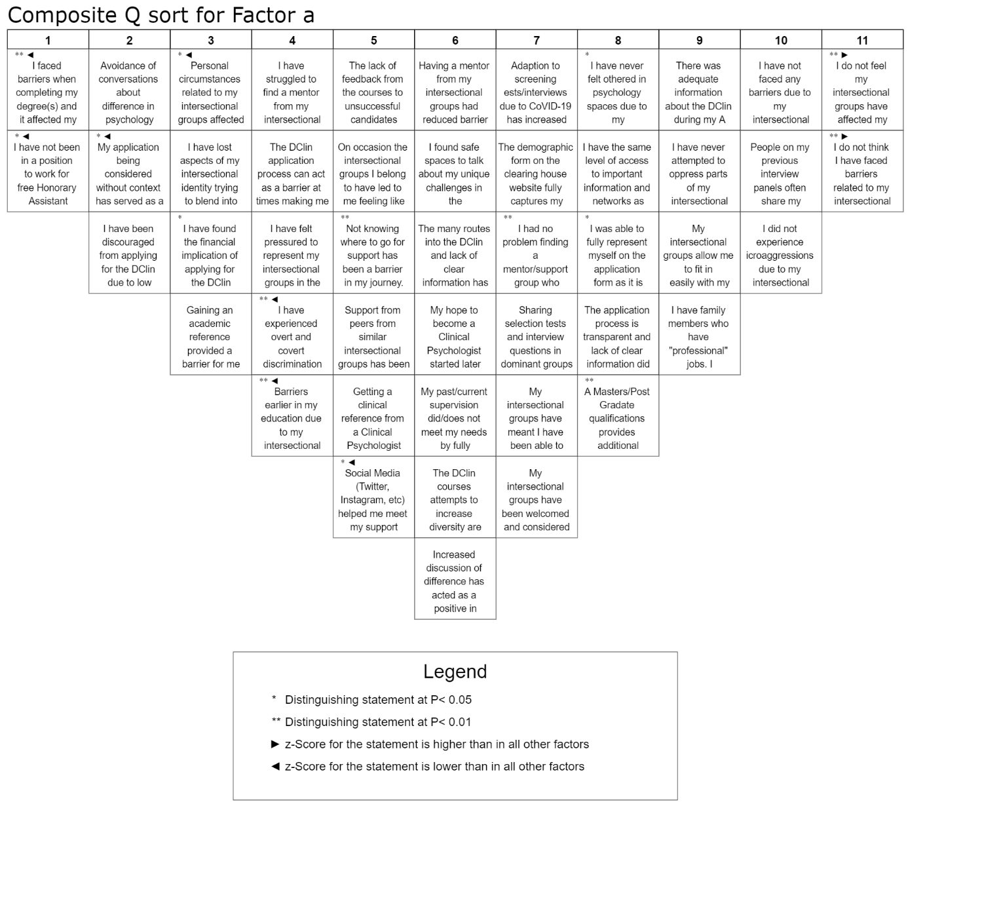

Factor 1b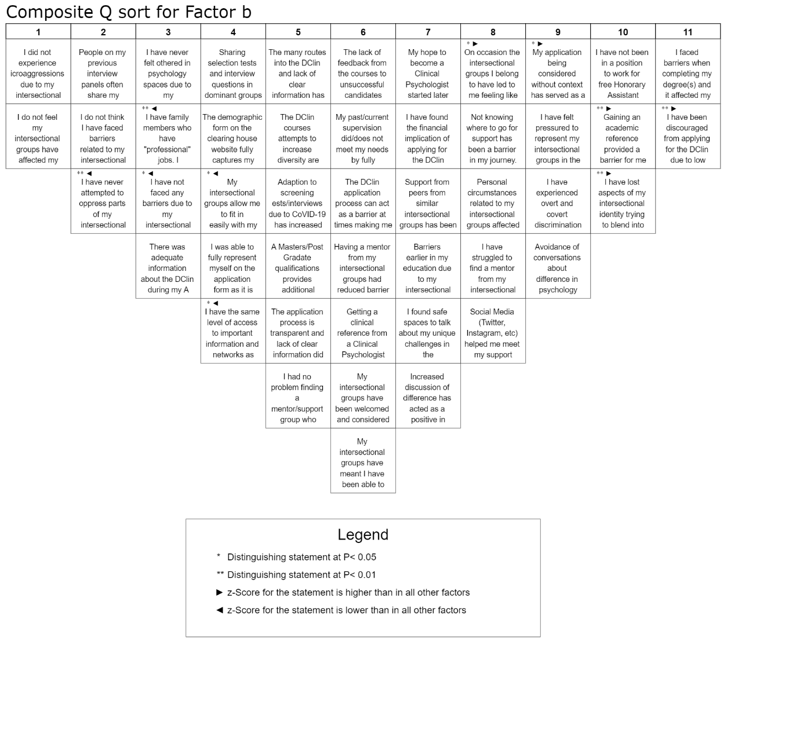

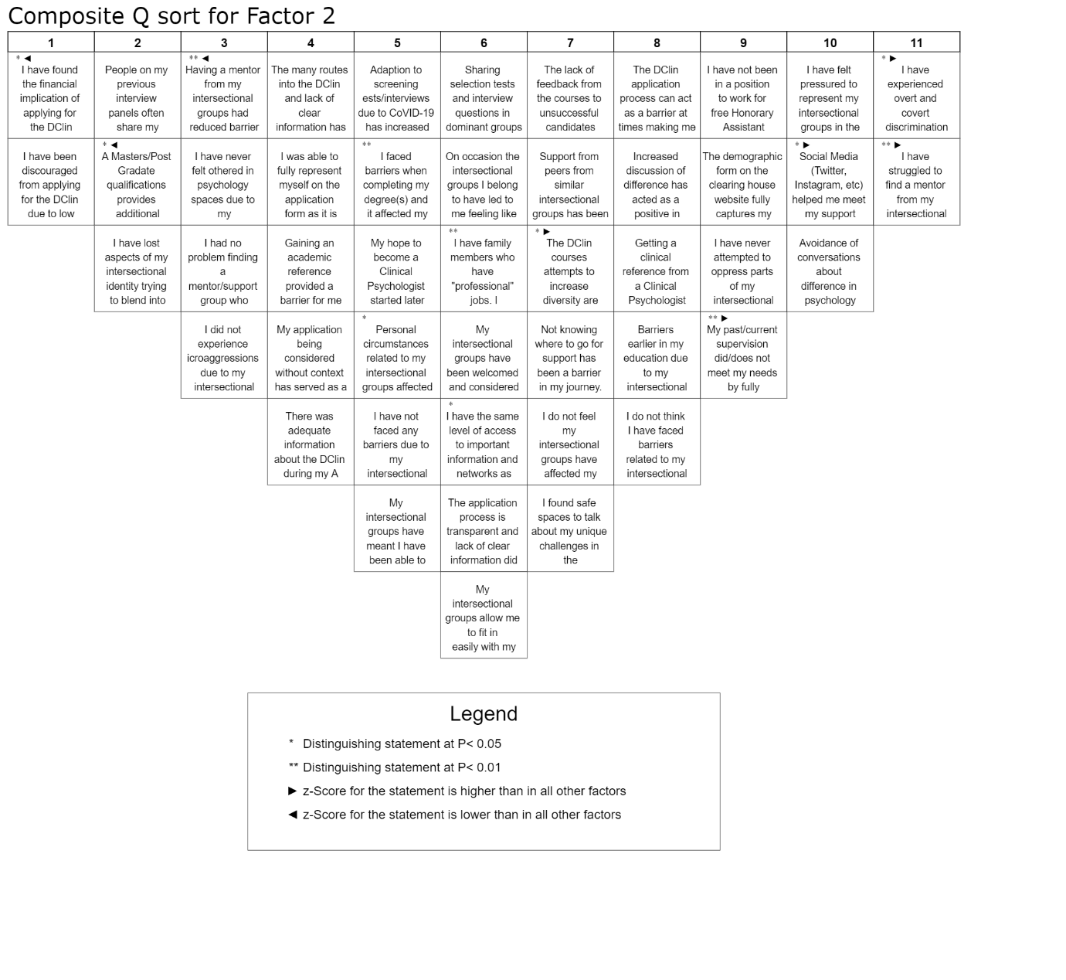Factor 2

Factor 3

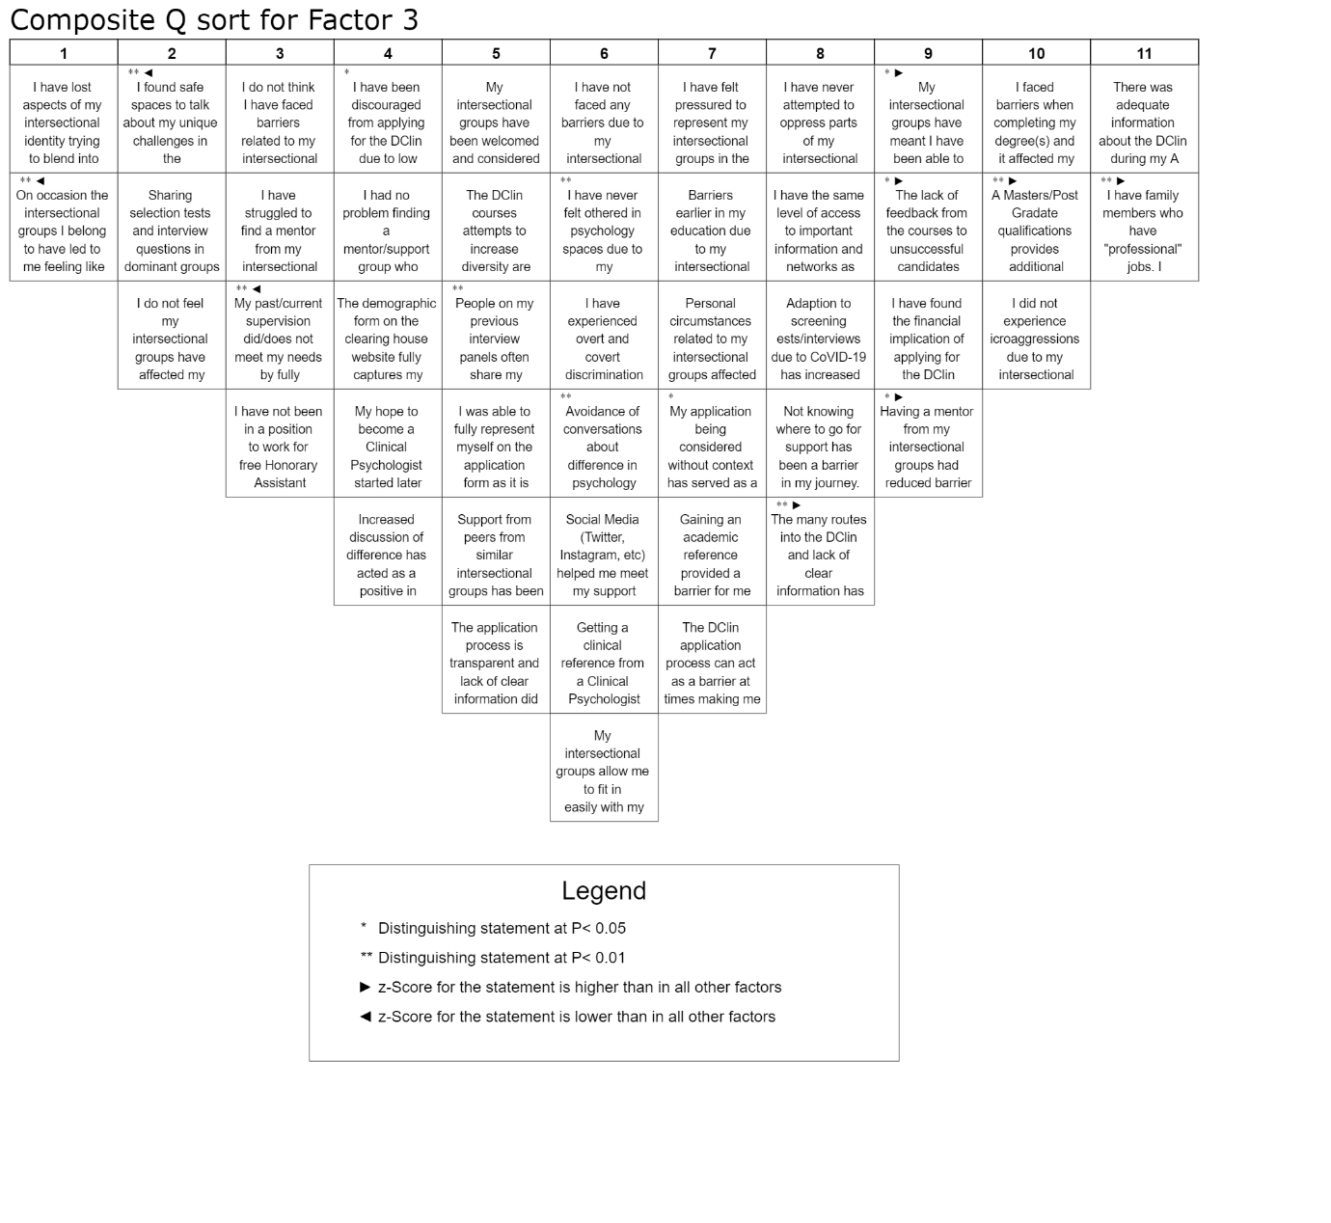

Factor 4

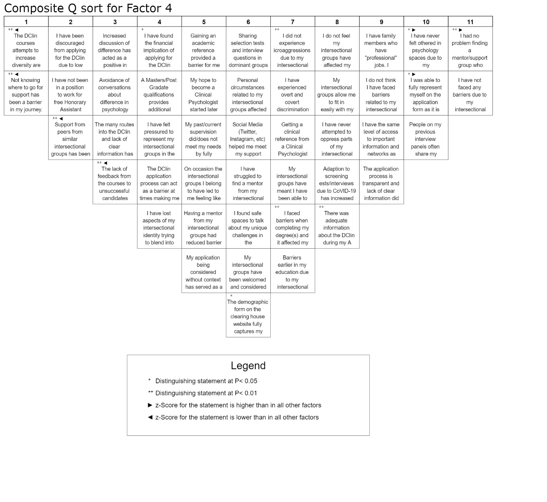

## **Appendix U**

## Non-Significant Q-sort descriptions

|  |  |
| --- | --- |
| Owen (pre) | Owen’s sort highlighted that he had faced barriers associated with his intersectional groups, particularly being unable to take up non-paid opportunities and having a lack of academic role models. |
| Cora (pre) | Cora’s Q-sort emphasised finding a mentor who belonged to her intersectional groups helped to reduce the barriers she felt she faced, allowing her to stop feeling she must hide or conceal her identity from others to be successful. |
| Harriet (pre) | Harriet loaded similarly onto both Factors 1 and 4 but neither loaded significantly, this may suggest she shared similar perspectives to participants who loaded onto Factors 1 and 4. Harriet’s Q-sort highlighted a sense of a lack of clarity around the information provided when applying for training and how this, combined with an awareness of belonging to underrepresented intersectional groups, leads to her feeling demotivated. |
| Colette (pre) | Colette (pre) loaded onto Factor 1 but not to a significant level, suggesting she shared some viewpoints with those that loaded onto Factor 1. Colette’s Q-sort expressed feeling Honorary Assistant Psychologists positions reinforced barriers for those from working class backgrounds. |
| Camilla (pre) | Camilla (pre) loaded onto Factor 3 but not to a significant level, suggesting she shared some viewpoints with those that loaded onto Factor 3. Camilla’s Q-sort suggested she had felt her intersectional identity had led to her standing out in the psychology world at times, leading to her trying to blend in using her identities that fit into mainstream psychology. |

# **Paper 3: Executive Summary**

**A summary of: Using intersectionality theory to understand barriers faced by those applying to Clinical Psychology Doctorial training courses: A Q methodology approach.**

Words: 2491

(Excluding title page, references, and glossary)

This report is an executive summary of a research project that is written for aspiring, trainee, and qualified Clinical Psychologists, and clinical psychology training courses.

When preparing this report, a draft version was read by three aspiring Clinical Psychologists from under-represented backgrounds who were not participants within the research, who volunteered to provided comments on how to improve the accessibility of the document. A glossary of terms can be found following this executive summary.

**Using intersectionality theory to understand barriers when applying to Clinical Psychology Doctorial training courses. A Q methodology approach.**

**Executive Summary of Research**

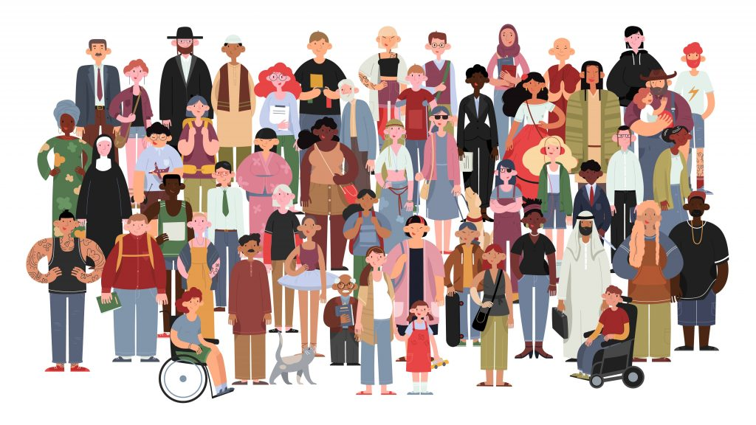

## **Background to the Research**

Clinical Psychologists in the United Kingdom (U.K.) must complete the doctorate in clinical psychology. This is a three- year training programme with a focus on developing trainees’ academic, research and clinical skills, enabling trainees to work both individually with those experiencing mental health problems and to support teams to work with individuals who have a range of mental health difficulties. Clinical psychology as a profession has been criticised for being less accessible to certain social groups such as black males and those who identify as having a disability (Wood & Patel, 2017), and thus there is a lack of representation in the profession from these groups. Recent statistics, demonstrate an improvement in diversity across training cohorts with more representation from groups such as those from under-represented ethnicities and those from working class backgrounds (Clearing House Statistics, 2020). There remains, though, a disparity with those from certain social groups (white, middle class, non-disabled, women) continuing to be statistically more likely to be accepted onto a clinical psychology training course (Murphy, 2019).

Intersectionality theory is a way of identifying and understanding interconnections between social groups (such as gender expression, ethnicity, class & age) (Crenshaw, 1989, 1990). By identifying the social groups an individual belongs to, the aim of intersectionality is to consider how this may disadvantage or advantage individuals. Using intersectionality theory, one can explore how belonging to more than one oppressed social group may lead to compounded discrimination or disadvantage for an individual (Metcalf et al., 2018). For example, the poverty rate for working-age people with disabilities is nearly two and a half times higher than that for people without disabilities, and thus socioeconomic and disability status combine to create further disadvantage for an individual (Tinson et al., 2016).

When considering barriers faced by applicants to clinical psychology training from under-represented groups, research tends to focus on only one social group the individual belongs to, such as ethnicity (Ragaven, 2018), or disability status (Lund et al., 2014). The barriers experienced by other social groups (class, sexuality, gender expression, etc.) have yet to be explored within the research. Additionally, the impact of the interconnection between social groups in potentially compounding disadvantage has not been considered in association with applying for clinical psychology training.

### **Objectives**

1) To identify viewpoints among individuals who identify with more than one social group considered oppressed in the U.K. about possible barriers they faced when applying for a clinical psychology training place.

2) To identify any shared barriers amongst different oppressed social groups when applying for clinical psychology training.

3) To identify viewpoints among Clinical Psychologists who are part of the recruitment process about possible barriers faced when they applied for a clinical psychology training place.

4) To identify any differences or similarities in the barriers faced amongst those pre-qualified (aspiring and trainee Clinical Psychologists) and Clinical Psychologists when applying to clinical psychology training.

## **What We Did**

Staffordshire University Research Ethics Committee provided ethical approval for the research.

### **Q methodology**

Q methodology (Stephenson, 1935) was used to explore the attitudes and beliefs about barriers faced when applying for clinical psychology training. In Q methodology statements about a topic are sorted based on how much an individual agrees or disagrees with that statement, thus enabling individual viewpoints about a topic to be identified and consideration of similarities and differences between individuals.

### **Development of the statements**

To explore what was already known about barriers faced by under-represented groups when applying for clinical psychology training a literature review was undertaken. There was limited research published in this area, therefore, two focus groups were conducted with participants who identified as belonging to more than one oppressed social group and who had applied to clinical psychology training. The information from the literature and focus groups was used to develop statements around perceived barriers. These statements were then reviewed by the researcher, looking for repetition, representativeness, and to ensure clarity. These statements were also shared with two members of the focus groups to ensure they were representative and clear. This left 47 statements to be used in the q-sorts, and example statements can be seen in figure 1.

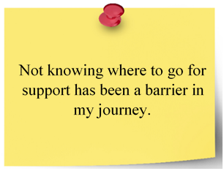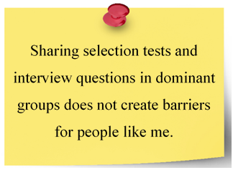

***Figure 1***

*Statements used in q-sort*

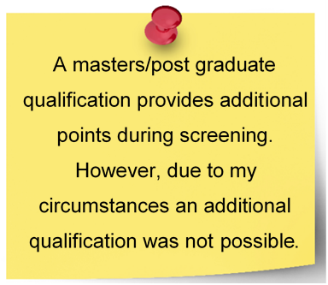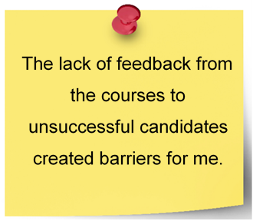

### **Participants**

15 participants were recruited to two focus groups between May-June 2021. 30 participants were then recruited to complete the Q sorts from September- December 2021. Participants were grouped whether they were (1) pre-qualified and belonged to more than one oppressed social group (such as those from working class backgrounds, a member of the Black, Asian, and minority ethnic community, member of the LGBTQIA+ community, persons with disabilities, etc.) or (2) qualified Clinical Psychologists involved in the recruitment process. Participants were recruited via social media advertisements.



### **Procedure**

All participants provided written consent and completed a demographic form asking them about the social groups they belonged to and their current job role. Participants were emailed a link to the q-sort via software called Q Sortware, to an online system for completing the q-sorts. Participants were presented with the statements and the following instruction “please sort the statements into the three piles: agree, disagree and neutral or unsure.” Once the participants had sorted the statements into the three piles, they were presented with a q-sort grid (figure 2) and the following instructions “please sort the statements from those you most agree with (+5) to those you most disagree with (-5).”

After the sorting process, participants completed a short survey, consisting of five questions to aid them in reflecting on their decisions on how they went about sorting the statements, for example, please tell me about the personal meaning of the statement you agree with most?

***Figure 2***

*Q-sort grid*

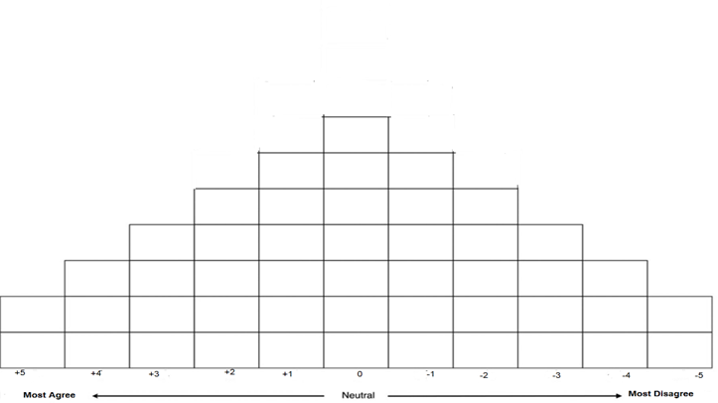

### **How we analysed the data**

The q-sorts were entered into statistical software called KenQ, which allowed for the statistical analysis of the data using a method called “factor analysis.” Factor analysis is a statistical method that groups together q-sorts that hold similar viewpoints, thus allowing for similarities and differences between viewpoints to be considered. The survey information was then used to help further understand the viewpoints of the grouped sorts.

## **What we found**

Five main viewpoints were found, which are detailed below. Five people did not fit into any of the five viewpoints to a significant level, however, they all highlighted barriers noted by the other viewpoints. Table 1 shows the statements about barriers each viewpoint most agreed with. Pseudonyms shown with quotes detail comments made in the post sort survey.

### **Viewpoint 1: The importance of the applicant’s context being considered within the application process.**

This viewpoint had a focus on participants wanting their personal circumstances within the context of their social groups to be understood within the application process. Seven pre-qualified participants agreed most with this viewpoint. Those within this group felt they had been affected by barriers associated with their social groups whilst applying for clinical psychology training. For example, a lack of understanding about difference was seen as a barrier when applying for clinical psychology training. Ola stated, “When I've tried to bring up discussions regarding my intersectional groups, I've found these have been ignored and forgotten about and it definitely leads to feeling silenced and devalued.”

### **Viewpoint 2: My social groups have not negatively impacted my journey.**

This viewpoint emphasised how participants did not feel their social groups had impeded their ability to gain the necessary experience or qualifications to progress in their career. Three individuals agreed most with this viewpoint (1 pre-qualified & 2 Clinical Psychologist). Those within this group felt the current efforts by clinical psychology training courses to improve access to courses for those from under-represented backgrounds had been successful in improving diversity.

### **Viewpoint 3: Importance of Clarity, Guidance and Representation.**

Participants in this viewpoint felt the lack of clarity, guidance, and representation early on in their career had led to disadvantage when applying for clinical psychology training. Five pre-qualified participants agreed most with this viewpoint. One barrier highlighted by this group was lack of information. Naomi shared, “I think more information at A-level about what it is like to pursue a career in clinical psychology is needed. I think they should be given realistic information, because at this current moment a career in clinical psychology is not an easy ride for people from backgrounds like mine.”

Positively, however, participants in this group felt finding a mentor who shared their oppressed social groups had reduced the barriers they faced when applying for clinical psychology training.

### **Viewpoint 4: Imposter syndrome and trying to blend.**

This viewpoint highlighted how participants felt like imposters within the workplace whilst gathering experience to apply for clinical psychology training, and found themselves attempting to blend in or hide their less obvious social groupings for fear of being seen as not belonging in clinical psychology. Four individuals agreed most with this viewpoint (1 pre-qualified & 3 Clinical Psychologist). One barrier highlighted by this group was selection tests. Eva stated, “the selection tests are not great and lead to some imbalances, as those who can afford to purchase example tests or get them from their friends who belong to the dominant groups in psychology are more likely to score highly.”

Those in this group felt finding safe spaces to talk about their unique experiences via supervision and mentorship had acted as a facilitator when applying to training.

### **Viewpoint 5: More support is needed for real change.**

This viewpoint represented participants who were most critical of the courses attempts to increase levels of diversity across training cohorts, whilst these participants acknowledge the current strategies to improve diversity, they did not see them as successful. For example, Odette shared, “I feel that more support should be in place for individuals who come from under-represented groups during the application process… I feel this will be more supportive than a performative context-based selection at the final stages of interview.” Six pre-qualified participants agreed most with this viewpoint. One barrier highlighted by this group was the need for support for under-represented applicants.

***Table 1***

*Overview of statements about barriers most agreed with by each viewpoint.*

|  |  |  |  |  |  |
| --- | --- | --- | --- | --- | --- |
| Barrier | Viewpoint 1 | Viewpoint 2 | Viewpoint 3 | Viewpoint 4 | Viewpoint 5 |
| Lack of knowledge about where to seek support. |  |  |  |  |  |
| The financial implication for applying. |  |  |  |  |  |
| The application form and process |  |  |  |  |  |
| Lack of information early (entry requirements etc.) and feedback from courses. |  |  |  |  |  |
| Being discouraged from applying for Clinical Psychology training. |  |  |  |  |  |
| Finding it difficult to find a mentor who belonged to their social groups. |  |  |  |  |  |
| Being othered in the world of psychology. |  |  |  |  |  |
| Avoidance of conversations about difference within the profession. |  |  |  |  |  |
| Personal circumstances related to their social groups |  |  |  |  |  |
| Not being able to work as an honorary Assistant Psychologist |  |  |  |  |  |
| Being interviewed by people who did not share the same social groups |  |  |  |  |  |
| Experiencing microaggressions |  |  |  |  |  |
| Not having family members who worked in professional roles |  |  |  |  |  |
| Selection test |  |  |  |  |  |

## **Conclusions**

Although more research is needed, the results of this research provide insight into the participants’ experience of barriers when applying for clinical psychology training.

* Barriers such as selection tests, lack of contextual consideration, lack of information early on, and lack of understanding of barriers by those within the clinical psychology profession remained in place for under-represented groups when applying for clinical psychology training. This is in keeping with previous research (Tong et al., 2019).
* Similar barriers were highlighted by those belonging to different under-represented groups.
* Facilitators such as finding safe spaces to discuss unique challenges via supervision and mentorship were also highlighted by a number of the viewpoints.
* Pre and post qualified participants loaded on two factors. This suggests some similarities in viewpoints of those within these groups particularly around facilitators.
* Viewpoint two was different to the other viewpoints in that the participants within this viewpoint did not highlight any barriers when applying for clinical psychology training. This viewpoint was made up of two Clinical Psychologist and one pre-qualified participant, suggesting some differences in the views of these participants and those within the other viewpoints.

### **Limitations**

There are some limitations to the study that should be noted.

* Participants who took part were representative of many of the social groups considered oppressed within U.K. society, but they were not representative of all, for example, those with refugee status.
* Q sorts are representative of the participant’s viewpoint at a particular moment in time. This means the reliability of the results may be limited due to the potential for people’s opinions to change over time.
* This study used Q methodology to focus on exploring the subjective opinions of participants on barriers to applying for clinical psychology training, therefore the results of the study may not be generaliasable outside of these participants.



### **Recommendations for Clinical Psychologists and Doctorate in Clinical Psychology Courses**

* Co-production of pre-selection tests should be encouraged via seeking the opinions of individuals from a range of social groups to inform the process of adapting pre-selection tests to ensure they create equal opportunity for all.
* Paid consultation/training by experts by experience (aspiring, trainee and qualified Clinical Psychologists from various under-represented backgrounds) about their experiences of accessing, learning, applying, and working within the current clinical psychology context could be considered, to educate those involved in the recruitment process about the experiences of under-represented applicants. Additionally, the involvement of Clinical Psychologists from a range of social groups within the recruitment process would aid this.
* Opinions of individuals from a range of social groups should be sought to inform the implementation of contextual admissions. This would allow for ideas around how contextual admissions could be implemented in a way that would support applicants from under-represented groups.
* Courses have begun to set up mentoring schemes such as the Pathfinder (West Midlands Mentoring scheme). It will, however, be important to ensure mentors are recruited to such schemes from a range of social groups, allowing for mentees to have support from an individual with shared experiences.
* Further access to information about a career in psychology early (such as at the G.C.S.E stage) is needed. Providing talks within schools and other settings could help to introduce those from under-represented backgrounds to a career in Clinical Psychology. It is also important for facilitators and speakers at such sessions to be from a range of social groups, particularly those from under-represented backgrounds.

### **What’s next?**

The research paper that this executive summary is based on will be submitted to a scientific journal to be considered for publication. The executive summary will be sent to participants and individuals who have requested a copy.

## **References**

Clearing House for Postgraduate Courses in Clinical Psychology CHPCCP (2020). Equal opportunities data-2020. https://www.leeds.ac.U.K./chpccp/equalopps.html

Crenshaw, K. (1989). Demarginalizing the intersection of race and sex: A black feminist critique of antidiscrimination doctrine, feminist theory and antiracist politics. *University of Chicago Legal Forum,* 8(1), 139-167. https://doi.org/1229039

Crenshaw, K. (1990). Mapping the margins: Intersectionality, identity politics, and violence against women of color. *Stanford Law Review*, 6(*43)*, 1241-1299. https://doi.org/1229039

Lund, E. M., Andrews, E. E., & Holt, J. M. (2014). How we treat our own: The experiences and characteristics of psychology trainees with disabilities. *Rehabilitation Psychology, 59*(4), 367-375. https://doi.org/10.1037/a0037502

Metcalf, H., Russell, D., & Hill, C. (2018). Broadening the science of broadening participation in STEM through critical mixed methodologies and intersectionality frameworks. *American Behavioral Scientist*, 62(5), 580-599. https://doi.org/10.1177%2F0002764218768872

Murphy, D. (2019, August 9). #DiversifyClinPsy. Paper presented at the Group of Trainers in Clinical Psychology Summer Event [video], London. https://www.youtube.com/watch?v=RRldOsD6eUU

Ragavan, R.N. (2018). Experiences of Black, Asian and Minority Ethnic clinical psychology doctorate applicants within the UK. [Unpublished doctoral dissertation]. University of Hertfordshire. https://ethos.bl.uk/OrderDetails.do?did=1&uin=uk.bl.ethos.784168

Stephenson, W., (1935). Technique of factor analysis. *Nature,* 136, 297. https://doi.org/10.1038/136297b0

Tinson, A., Aldridge, H., Born, T. B., & Hughes, C. (2016, December 7). Disability and Poverty. Joseph Rowntree Foundation. https://www.npi.org.uk/publications/income-and-poverty/disability-and-poverty/

Tong, K., Peart, A., & Rennalls, S. J. (2019). Reframing our stories: Addressing barriers faced by Black people trying to access a career in clinical psychology. In *Clinical Psychology Forum*, 323, 15-19.

Wood, N., & Patel, N. (2017). On addressing ‘Whiteness’ during clinical psychology training. *South African Journal of Psychology*, 47(3), 280-291. https://doi.org/10.1177/0081246317722099

## **Glossary of terms**

The glossary lists alphabetically the terms relevant to this thesis and provides a definition of each term, along with examples where appropriate.

|  |  |  |
| --- | --- | --- |
| Term | Examples | Definition |
| Barriers | Not knowing where to go for support during the application process. | A circumstance that prevents progress. |
| Black, Asian and Minority ethnic (BAME) |  | The terminology normally used in the U.K. to describe people of non-white descent.  But, while BAME and BME were born out of a desire to create solidarity between minorities against racism, the terms is now more readily used by white people to lump everyone who is not white into a singular category. For many critics, these term no longer signal unity. Instead, they signal a lazy homogenisation of all non-white groups, and the erasure of individual struggles. <https://metro.co.uk/2020/07/07/bame-debate-why-terminology-matters-when-talking-about-race-12954443/>) |
| Class | Working Class- the social group consisting primarily of people who are employed in unskilled or semi-skilled manual or industrial work. | A system of ordering society whereby people are divided into sets based on perceived social or economic status. |
| Contextual admissions |  | The practice of using additional information, such as where a potential student lives, to assess their attainment and potential |
| Culturally adapted psychotherapy | Culturally adapted Cognitive Behavioural Therapy (CBT) | A systematic approach of modifying a treatment to align it with the client's cultural values. |
| et al. or et al., | Tong et al., 2019 | Meaning “and others” is used to shorten in-text citations with three or more authors. |
| Persons with a disability |  | Someone who has a physical or mental impairment. That impairment has a substantial and long-term adverse effect on their ability to carry out typical day-to-day activities. |
| Disadvantage |  | An unfavourable circumstance or condition that reduces the chances of success or effectiveness. Put in an unfavourable position in relation to someone or something else. |
| Diversity |  | The practice or quality of including or involving people from a range of different social and ethnic backgrounds and of different genders, sexual orientations, etc. |
| Ethnicity |  | The fact or state of belonging to a social group that has a common national or cultural tradition. |
| Facilitators | Mentorship by a Clinical Psychologist. | A person or thing that makes an action or process easy or easier. |
| Gender expression |  | The way in which a person expresses their gender identity, typically through their appearance, dress, and behaviour. |
| Global majority ethnic groups | It refers to people who are Black, Asian, Brown, dual-heritage, indigenous to the global south, and or have been racialised as 'ethnic minorities'. | A collective term that first and foremost speaks to and encourages those so-called to think of themselves as belonging to the global majority. |
| “Hard to engage” |  | A term often used by mental health professional to describe individuals or communities who do not engage in mental health support. Places ownership on individuals to engage with services and not on services to engage with individuals. |
| “Hard to reach” |  | A term often used by researcher to describe individuals or communities who do not recruit to psychological research. Makes not consideration of experiences of individuals and why they may choice not to take part. |
| Identity |  | The fact of being who or what a person or thing is. |
| Intersectional Identity |  | The amalgamation of the social groups an individual belongs to such as their ethnicity, class, religion, sexual orientation, ability, and gender identity. |
| Imposter syndrome |  | The persistent inability to believe that one's success is deserved or has been legitimately achieved as a result of one's own efforts or skills. |
| Intersectionality theory |  | Interconnected nature of social categorisations such as race, class, and gender, regarded as creating overlapping and interdependent systems of discrimination or disadvantage. |
| LGBTQIA+ Community |  | An inclusive term that includes people of all genders and sexualities, such as lesbian, gay, bisexual, transgender, questioning, queer, intersex, asexual, pansexual, and allies. While each letter in LGBTQIA+ stands for a specific group of people, the term encompasses the entire spectrum of gender fluidity and sexual identities. |
| Marginalised |  | To relegate an individual or group to an unimportant or powerless position within a society or group. |
| Mentorship |  | The guidance provided by a mentor, especially an experienced person in a company or educational institution. |
| Minority Ethnic background | Black people within the U.K. | **A group that has different national or cultural traditions from the majority of the population** |
| Disadvantaged | Examples of social disadvantaged include racism (treating people different based on their ethnicity), sexism (treating people different based on their gender), religious persecution (treating people different because of their religion). | Burdened with cruel or unjust impositions or restraints; subjected to a burdensome or harsh exercise of authority or power: |
| Disadvantaged social groups | Examples of socially oppressed groups include persons with disabilities, members of the ethnic global majority, members of the LBTQIA+ community, etc. | People who belong to oppressed social groups may be treated cruelly or be prevented from having the same opportunities, freedom, and benefits as others. |
| Privilege/privileged | Privileged groups can be advantaged based on education, social class, caste, age, height, nationality, geographic location, disability, ethnic or racial category, gender, gender identity, neurology, sexual orientation, physical attractiveness, and religion | A special right, advantage, or immunity granted or available only to a particular person or group. |
| Pseudonyms |  | A fictitious/false name |
| Psychotherapy/psychological therapy | For example:  Cognitive Behavioural Therapy (CBT)  Eye Movement Desensitisation and Reprocessing (EMDR)  Dialectical Behavioural Therapy (DBT)  Systemic/Family Therapy  Psychodynamic Psychotherapy  Mentalisation Based Therapy (MBT)  Cognitive Analytic Therapy (CAT) | Involve exploring psychological difficulties that are getting in the way of how we would like to feel. |
| Social groups | For example:  a religious group, an ethnic group, etc. | A collection of people who interact with each other and share similar characteristics and a sense of unity. |
| Queer |  | “Queerness” is an umbrella term that is both an orientation and a community for those on the LGBTQIA+ spectrum. |
| Under-represented groups | For example, an under-represented group in clinical psychology would be Black Males. | 1. Used to describe groups or communities that make up a smaller percentage than a larger subgroup within a population. |