Exploring the experiences of Year 11 school leavers impacted by the Covid-19 pandemic: An Interpretative Phenomenological Analysis

Adele Flannagan

Thesis submitted in partial fulfilment of the requirements of Staffordshire University for the degree of Doctorate of Clinical Psychology.

April 2022

Total Word Count: 18,616

Supervisor: Dr Joanna Heyes, Course Lead & Clinical Director, Staffordshire University

Acknowledgements

Firstly, and most importantly, a huge thank you to the young people who took part in this research. To the young people consultants- thank you for giving your feedback so openly and honestly and for being so generous with your time. And to the participants- meeting you and hearing your stories was truly an honour. Your voices are central to this thesis, and I hope you feel that I have done a good job of representing you and your experiences.
I’d like to thank my research supervisor Dr Joanna Heyes for her wisdom and support throughout this project. I have been very fortunate to have met some incredible supervisors and teams during my training journey and am so grateful to everyone who shared their knowledge and skills with me. I have taken something from each and every experience and it has shaped the Clinical Psychologist I have become. I will carry a piece of you all with me as I go forwards in my career.
I would like to thank all the people I have worked with up until now, who have shared their passion for working with young people and instilled in me a desire to make things better for the next generation, especially those I worked with at Aquarius, who championed me from the beginning.
To my mum and dad, you supported me and my love of learning from an early age, and it is thanks to you that I had the belief in myself that I could do this. Big thanks to my whole family, including my three sisters, Nicole, Sian and Zoe and to Mila, Maxton and Oscar for always being my biggest cheerleaders and providing me with welcome relief from the stresses and strains of the doctorate by being their funny, silly, kind selves.
I’d also like to thank all my fellow DClinPsy trainees, and especially Becky, Jess, Helena, Fabia and Laura for your friendship and support. We have shared the highs and lows of the last three years and I honestly couldn’t have done it without you.
Finally to Matt- thank you for your unwavering support and belief in me and for never letting me give up on my dream of getting here.

Contents
Acknowledgements 4
Paper 1: Literature Review 10
Abstract 11
Introduction 12
Transitions during Childhood and Adolescence 12
Rituals, Rites of Passage and Ceremonies 13
The Current Literature Review 15
Method 16
Search Strategy and Sources 16
Publication Bias 17
Article Selection Summary 17
Quality Assessment 19
Data Extraction 19
Data Synthesis 19
Results 20
Overview of Included Studies 20
Participants 21
Geographical Origin 21
Sample Size 21
Transition Period 21
Rituals, Rites of Passage or Ceremony 22
Main Findings 34
Rituals, rites of passage and ceremonies 34
Impact of rituals, rites of passage and ceremonies of transition 36
Discussion 38
Overview of Findings 38
Strengths and Limitations 40
Conclusion 42
References 43
Appendices 49
Appendix A 49
Author Guidance 49
Appendix B 53
References for Rejected Full Texts 53
Appendix C 55
Data Extraction Form 55
Appendix D 56
JBI Critical Appraisal Checklist for Qualitative Research 56
Appendix E 56
JBI Critical Appraisal Checklist for Text and Opinion Papers 57
Paper Two: Empirical Paper 58
Abstract 59
Introduction 60
Study Rationale 61
Research question 62
Method 62
Design 62
Sampling 63
Recruitment and Participants 63
Data analysis 65
Reflexivity and Epistemology 66
Results 67
Participant demographics 67
Analysis 67
Discussion 78
Key Findings 78
Strengths and Limitations 81
Implications 82
Future Research 83
Conclusion 83
References 85
Appendices 92
Appendix F 92
Author Guidance 92
Appendix G 95
Participant Recruitment Poster 95
Appendix H 96
List of organisations 96
Appendix I 97
Ethical Approval from Staffordshire University Ethics Committee 97
Appendix J 98
Participant Information Sheet 98
Appendix K 103
Participant Demographic Questionnaire 103
Appendix L 104
Participant Consent Form 104
Appendix M 107
Interview Schedule 107
Appendix N 110
Recruitment Poster- Young People Consultants 110
Appendix O 111
Information Sheet- Young People Consultants 111
Appendix P 113
Participant Debrief Sheet 113
Appendix Q 115
Figure illustrating Interpretative Phenomenological Analysis process 115
Appendix R 116
Example Transcript with Line-By-Line Coding and Development of Emerging Themes 116
Appendix S 118
Generating Superordinate Themes from Emergent Themes (Example from Frankie) 118
Appendix T 119
Generating Superordinate Themes across Transcripts 119
Appendix U 120
Excerpt from Researchers Reflective Diary- During Interviews and Analysis 120
Appendix V 122
Master Table of Themes 122
Paper Three: Executive Summary¹ 128

Thesis Abstract
As part of a Professional Doctorate in Clinical Psychology, the author of this thesis was particularly interested in exploring young people’s experiences and the role of ending rituals in aiding transitions.
Paper 1 presents a comprehensive literature review of 15 published studies that explore the role and impact of rituals, rites of passage and ceremonies during periods of transition for children and adolescents. Findings indicated that educators/educational establishments are often facilitators of ending rituals. Rituals provide societal recognition but have variances across individuals, gender and culture. The role of rituals, rites of passage and ceremonies in modern society was also discussed. Rituals, rites of passage and ceremonies appear to support transitions by aiding identity and social role shifts and increasing self-efficacy, self-esteem and confidence. However, there is a distinct lack of qualitative and quantitative data, therefore clear conclusions could not be made about the benefit of rituals for transitioning young people. Future research could look at providing more empirical evidence with a focus on specific rituals, rites of passage and ceremonies for specific transitions.
Paper 2 is an empirical study which used Interpretive Phenomenological Analysis (IPA) to explore young people’s experiences of the ending of secondary school education prematurely due to the COVID-19 public health crisis and how they made sense of this in relation to the transition to further education, training and employment. Findings suggest that loss, uncertainty, disappointment and change were key components of this experience, which was validated by their sense of togetherness. However, they did feel the need to minimise their feelings and felt invalidated by others. The lack of ending rituals impacted their ability to transition to college.
Paper 3 is an executive summary written as an accessible account of the research for the participants who took part in this research but can also be used to disseminate findings to those interested in the experiences of young people impacted by COVID-19 as well as professionals working with this group. The rationale, method, findings, implications and limitations of the empirical research are summarised.

Paper 1: Literature Review

Understanding the role and impact of rituals, rites of passage and ceremonies during periods of transition for children and adolescents.

Abstract
Objective: Periods of transitions can prove challenging for children and adolescents and whilst there has been extensive research into outcomes of the transition process, little is known about the process and what supports this. This critical literature review aims to pull together these two concepts and consider what it tells us about the role of rituals, rites of passage and ceremonies for children and young people during times of transition.
Method: A search of the literature was conducted using the electronic databases: ERIC, Education Research Complete, SPORTDiscus with Full Text, eBook Collection (EBSCOhost), MEDLINE, CINAHL Plus with Full Text, APA PsycInfo, APA PsycArticles and APA PsycBooks. Fifteen studies were identified and a hand search of reference lists identified no further studies which met the inclusion criteria. The studies were synthesised using a thematic approach.
Results: Key themes identified included the role of educators/educational establishments, societal recognition, individual, gender and cultural differences and rituals, rites of passage and ceremonies in modern society. Positive impacts on transitions were found to be: aiding identity and social role transition and increasing self-efficacy, self-esteem and confidence. A negative impact on parent-child relationships was also found. Quality of the included studies was also reviewed.
Conclusion: The findings provide some evidence to substantiate the use of rituals, rites of passage and ceremonies in supporting some aspects of the transition process for children and adolescents. However, there is a distinct lack of both qualitative and quantitative data to support some claims made and therefore conclusive statements about their benefit for transitioning young people can not be made. Future research could look at addressing this gap, as well as exploring specific rituals, rites of passage and ceremonies for specific transitions.

Introduction

Transitions during Childhood and Adolescence
Childhood and adolescence proves to be a period marked by countless transitions; there are conventional transitions such as starting school or beginning puberty, however even these may not be typical for all. Other transitions might include the birth of a sibling, moving house, parental separation and death of a family member. Whatever the transition, children and young people (YP) must learn to successfully navigate these. These transitions can be viewed as horizontal and vertical (Vogler et al., 2008). Horizontal transitions occur within the immediate environment and on a daily or regular basis, often referring to movement or change in routine. In contrast, vertical transitions are linked to changes over time, are more significant and tend to be specific events that do not occur regularly.
The term ‘transition’ is complex, multi-faceted and cannot be easily captured by a single definition. Broadly speaking the term transition can mean “the process or a period of changing from one state or condition to another” (Oxford Dictionary, 2015). However, a collective theme within definitions highlights the idea that change is situational and external, whereas transition is the internal psychological processes brought about by change. This is best explained by Stringer and Dunsmuir (2012) who argue “transitions are fundamental features of social life and represent periods of change and adaptation . . . it involves internalising and adapting to new situations brought about by change, and encompasses shifts in identity and agency” (p. 5).
Conceptualisations of transition are often underpinned by child development theories but have also been informed more widely by educational and business psychology. These models and theories include Hopson and Adams Transition Cycle (1966); Bronfenbrenner's Ecological Transition Model (1977); Schlossberg's Transition Theory (1984); Bridges’ Transition Model (1991) and Fisher’s Personal Transition Curve Model (2012). Although these all have different ways of conceptualising the transition process, key themes include internal and external factors that impact individual responses, the phases experienced by those transitioning (usually a before, during and ending stage) and the range of emotions experienced by transitioning individuals such as shock, grief and acceptance.
Whilst developing our understanding of the processes by which individuals navigate transitions, these models fail to answer the question as to why transitions are important and what impact these have on children and adolescents. Jindal-Snape and Miller (2008) suggest that transitions are usually positive and indicate progression, however, for some, they can be stressful and traumatic, with significant negative impacts on well-being. The notion of transitions having positive and negative consequences has also been reported by Niesel and Griebel (2005) who found transitions can promote development, but under adverse conditions, lasting difficulties can occur, such as problematic behaviour. Indeed, life transitions have been linked to the development of psychological distress and depressive disorders (Hammen, 2005, Paykel, 2003). When examining the transition from primary to secondary school, for example, a review of the literature found mixed results, although the predominant findings were that transitions had a negative impact on well-being including an increase in school misbehaviour, decline in feelings of school belongingness and connectedness, and higher levels of depression and anxiety (Jindal‐Snape et al., 2020). Therefore, it is important to consider what mitigations could reduce these impacts for children and adolescents during times of transition. One suggested mitigation is the use of rituals, rites of passage (ROP) and ceremonies.

Rituals, Rites of Passage and Ceremonies
Rituals, ROP and ceremonies have been an extensive area of research for anthropologists, sociologists and psychologists alike. Whilst there are slight differences within the practices and behaviours associated with each term, the words are often used as synonyms for one another which can be seen in Table 1. For the purposes of this literature review, the three terms will be viewed as interchangeable.

Table 1: Definition of Terms
Ritual and ritualistic behaviour is seen not only in religious practice but across all human life, providing order and stability especially in times of unrest (Romanoff, 1998; Turner, 1969). Anthropologist, Van Gennep (1960) observed that all cultures have prescribed ways for individuals and societies to deal with emotionally charged situations and that these are intended to mark the transition from one phase of life to another. His theory explained that due to our nature as social beings, value is attached to these transitions which are then interpreted and marked through communal celebrations. Van Gennep called these ceremonies ‘rites of passage’ and they are observed in many cultures and religions such as Jewish Bar/Bat Mitzvah, Maasai Warrior Passage and Amish Rumspringa. Van Gennep (1960) argued these ROP have three stages: separation, liminal, and incorporation. Separation comprises symbolic behaviour signifying the detachment of the individual or group; liminal is between states, where one has left a place or state but has not yet entered or joined the next; finally in the third phase the passage is completed and the individuals undergoing ROP assume their ‘new’ identity and social status. However, it is important to recognise that there is a danger of oversimplifying complex transitions into memorable patterns (Grimes, 2000). Whilst this does not invalidate Van Gennep’s three-stage theory, it is important to highlight its weaknesses, particularly when relating it to cultures and societies outside the scope of the original research. Despite his significant contribution to the study of ROP, much of Van Gennep’s was published in the 1960s, examining African and Oceanic cultures, and therefore it is difficult to say how much of his theory is likely to apply to Westernised modern ROP. Despite these criticisms, research suggests that ceremonial acknowledgment of significant life changes can offer support, connectedness, dignity and a sense of belonging (Richardson, 2012). Research exploring adolescent transitioning has found that YP obtain skills, norms, values and community expectations through these symbolic rituals which prepare them to accept and participate in their new role as adults (Fasick, 1988; Mbiti, 1970 & Van Gennep, 1960). Some researchers even claim that without ROP, mental health difficulties may arise (Kimbali, 1960) and that they are an important factor in the development of “a stable adult personality” (Delaney, 1995, p.891).

The Current Literature Review
Rationale and Aim. Research suggests that transitions during childhood and adolescence are challenging and have negative consequences on well-being, both short and long-term (Sandstrome & Huerta, 2013). Despite this, the research largely examines outcomes of the transition process (e.g. measuring the well-being of children before and after the move from primary to secondary school) with less focus on the process of transition (Hviid & Zittoun, 2008). Similarly, there has been a call to examine modern-day ROP (Escalas, 1993) and it seems that little has been done to respond to this. Best (2000) presents one explanation for this, that modern-day ROP such as high-school proms are under-researched as they are dismissed as ‘trivial’, although it is not known how true this is, given the lack of study. There is also conflicting evidence when examining for whom these rituals play a role: individuals or society. For instance, Young (1963) argues that initiation ceremonies are responses to the situational needs of society as opposed to the psychological needs of individuals. However, Norton and Gino (2014) state that they serve an important function for individuals in restoring feelings of control when faced with loss. This review seeks to provide a critical overview of the role of rituals, ROP and ceremonies in modern society for children and adolescents, and the impact these have on transitions.
Research Question. What does the current literature suggest about rituals, ROP and ceremonies during periods of transition for children and adolescents?

Method

Search Strategy and Sources
Scoping searches were carried out to ascertain that no literature reviews in this specific area already existed. Initial searches used the search terms (child* OR "young person" OR kid* OR adolescen*) AND (enter* OR transit* OR start* OR begin*) AND (ritual* OR “rites of passage” OR ceremon*). Search terms and strategies were adapted based on these initial searches. A full search of the literature was carried out between January 2021 and June 2021, across a range of electronic databases to include papers from psychology, education, medicine and social research areas. Search terms were entered into the EBSCO interface to search ERIC, Education Research Complete, SPORTDiscus with Full Text, eBook Collection (EBSCOhost), MEDLINE, CINAHL Plus with Full Text, APA PsycInfo, APA PsycArticles and APA PsycBooks.
Search Terms. Search terms were selected based upon the review questions and relevant keywords found in databases, abstracts and article titles during the initial scoping searches. Search terms used for a full-text search were:
- child OR children OR "young person" OR kids OR adolescen*
- AND transition OR transitioning OR "transition period" OR "transition phase"
- AND "rites of passage" OR ritual* OR ceremon*
Search Limits. Several limiters were placed on the search, including peer-reviewed publications only. The rationale was to ensure that included papers were of high quality, answered meaningful research questions and drew accurate conclusions based on professionally executed experimentation (Kelly et al., 2014). For pragmatic purposes, papers needed to be written or transcribed into English as the reviewer did not have access to translation services. It was also necessary that the reviewer could access the full-text article.
Inclusion Criteria. Given the focus of the review, papers must have referenced one of the following; (1) rituals, (2) rites of passage, or (3) ceremony AND (1) a transition or (2) transition period. Papers were only included if the discussion centred on 1-to-19 year-olds as this is considered the age range of childhood and adolescence (World Health Organisation, n.d).
Exclusion Criteria. Literature reviews were excluded from the review due to possible reporting biases and the reporting of multiple studies.

Publication Bias
When assessing the validity of a critical review, it is important to consider how this can be undermined by publication bias. Publication bias is defined as the tendency for authors to publish studies with significant results (outcome reporting bias) (Dickersin, 1990). It can also include language, database, and prestige biases. Consequently, the findings that are published, and therefore more likely to be included in systematic reviews, may differ from those that remain unpublished (Ayorinde et al., 2020). There is evidence suggesting that this bias is increasing (Joober et al., 2012), particularly within the psychology field (Fanelli, 2011).

Article Selection Summary
A total of 367 articles were identified in the initial search. Once the limiters were applied, this reduced to 65. Duplicates (n=28) were removed and titles (n=37) were assessed using the inclusion and exclusion criteria with non-compliant papers being rejected (n=12). Reasons for rejection included: adult populations, no reference to rituals, ROP, ceremony and transitions, or book reviews. Abstracts of the remaining papers (n=25) were further assessed in accordance with the inclusion and exclusion criteria; papers failing to meet the criteria were rejected (n=0). The full texts of the remaining articles (n=25) were assessed again and papers satisfying the criteria were included in the review (n=15). Ten papers were excluded primarily due to limited or no discussion of rituals, ROP or ceremonies in relation to a transition or transition period. A reference list of these excluded papers can be found in Appendix B. References of the accepted papers were searched for additional relevant literature but yielded no further studies that met the criteria. A summary of the article selection process can be found in Figure 1. Of the full text articles assessed, 15 were selected for inclusion in the review.

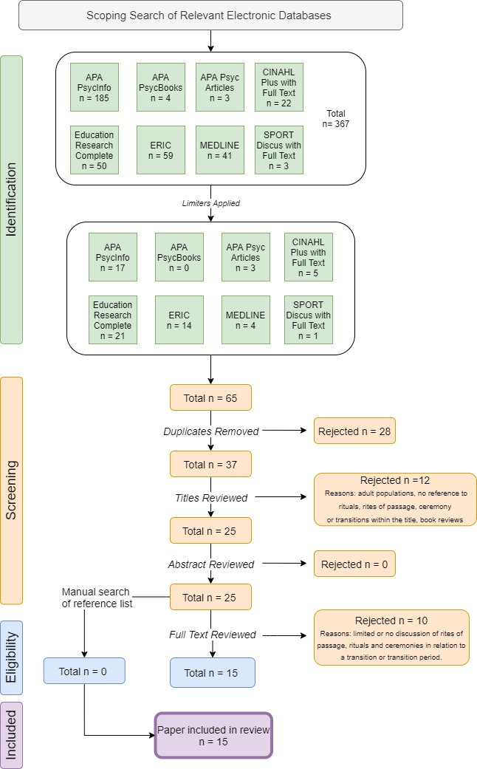
Figure 1: PRISMA flow diagram of the article selection process (Moher et al., 2009)

Quality Assessment
Given the variability of study design within the selected articles, two critical appraisal checklists were chosen to assess the quality of studies included in this review (Appendix D and E). Studies which used qualitative methods were assessed using the JBI Critical Appraisal Checklist for Qualitative Research (Lockwood et al., 2015) (n=5) which contained 10 items. Studies that were predominantly text or opinion papers were assessed using JBI Critical Appraisal Checklist for Text and Opinion Papers (McArthur et al., 2015) (n=10) which contained 6 items. Items were scored 1 to indicate an answer of ‘Yes’ to the item, or 0 to indicate ‘No’ or ‘Unclear’, thus a higher score indicated higher quality. Quality scores were adjusted to take into account the variance in items across the two checklists and provided as a percentage score with 100 indicating a full score. Results are presented in Table 3. The quality score obtained by a study did not affect its inclusion or exclusion but served as additional information for the synthesis of results. Quality assessment scores ranged from 16.7 to 100. The mean quality assessment score was 68.2, indicating good quality, as indicated by the quality rating in Table 2.
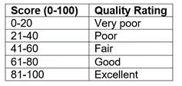
Table 2: Quality Rating

Data Extraction
Data was extracted from the relevant papers using a pro-forma designed for this review (Appendix C). The focus was on the ritual, ROP or ceremony and transition or transition period discussed in the literature in addition to key themes, methodologies and main study conclusions.

Data Synthesis
Studies included in the review were heterogeneous, varying in design and methods of analysis, therefore meta-analysis was not appropriate. The studies fell into two groups based on the critical appraisal tool used (1) qualitative and (2) text and opinion. The selected papers were categorised by their type, summarised, and analysed using thematic analysis. Analysis followed the steps of thematic synthesis outlined by Thomas and Harden (2008) where line-by-line coding was undertaken for each paper. This process enabled the translation of concepts between studies which was useful given the variability of methodologies. An inductive approach was taken as the analysis was led by the data rather than a predetermined framework or theoretical model (Braun & Clarke, 2006). The codes were then grouped to form descriptive themes.

Results

Overview of Included Studies
Methodology and quality. There were a variety of methodologies represented in the included papers; of the fifteen studies included, five used qualitative data collection (Gentina et al., 2012; McCadden, 1997; Skinner et al., 2012; Takato, 2006; Traum & Moran, 2016) and the remaining ten were discussion/opinion articles. Within the fifteen studies, eleven provided an examination or exploration of a particular ritual, rite, ceremony or transition and the remaining four were focused on generic discussion or reflection on the subject area.
Qualitative Studies. The qualitative studies employed a variety of data collection methodologies, including interviewing (Gentina et al., 2012), observation (McCadden, 1997) and focus groups (Skinner et al., 2012). Traum and Moran (2016) used both observation and interviews. Takato (2006) does not identify the means of data collection but it is presumed to be observation based on the author’s reference to “ethnographical investigation” (p.49). The mean quality score within these studies was 68 out of 100 suggesting an overall good level of methodological quality. The main issues with quality, identified within this grouping were that no study acknowledged or discussed the potential for researcher influence on data collection and analysis or the controls used to address this. Only one paper (Takato, 2006), provided clear reference to the researcher’s cultural and theoretical orientation, and the theoretical basis was only established in two papers (Takato, 2006; Traum & Moran, 2016).
Text and Opinion Studies. Within the text and opinion papers, there was little to no discussion on the methodologies used to support the author’s opinions, however, this was not the intent of most papers, which used the existing literature base to support findings. Having said this, Artz et al., (1998) does use the researcher’s discussion transcripts to draw conclusions; Majors and Dewar (2002) reference “both anecdotal and scientific data” and the use of pre and post-measures, and Wolf et al., (2016) cite “using multiple methods”. The mean quality score within this grouping was 68.3. The main issue within these papers was a lack of information about the authors and their expertise within the field, which was not provided in six papers and it was therefore, difficult to assess the validity of the authors’ opinions. Another issue identified was although most papers referenced existing literature, this was often a biased representation in support of the researcher’s opinion or model/framework with a distinct lack of reference to alternative opinions within the evidence base.

Participants
Studies that used participants, and reported age demographics, had a range of 5-to-49 years-old. The gender of participants varied, although was primarily unspecified. Three studies included both male and female participants, one focused on a female population (Gentina et al., 2012) and another on adolescent males (Majors & Dewar, 2002). The ethnicity of participants was rarely reported, although one study focused on African American adolescents (Pinckney IV et al., 2011) and another on Latin American students (Takato, 2006).

Geographical Origin
The origin of the studies included in this review is limited. The majority of studies are North American and Canadian (n=11) which is representative of 73.3% of the selected papers, with the remaining 26.7% of studies originating in the United Kingdom, France, Japan and Malawi (n=1 respectively).

Sample Size
Where used, participant sizes ranged from 2 to 120, with three having more than ten participants. Small sample sizes are often a feature within qualitative research and generalisability is not an intended aim of the research, so this is not considered a limitation. There was an acknowledgement of this within three of the papers.

Transition Period
The adolescent to adulthood transition was a focus of eleven studies. For the remaining four papers, two examined the daily transition between home and school for younger children, one considered the transition from secondary to tertiary education and one examined the transition between schools of different nationalities.

Rituals, Rites of Passage or Ceremony
Within most of the papers, these terms are used interchangeably, but ROP is the most commonly used term (n=9). Three papers (Artz et al., 1998; Baizerman, 1998; Traum & Moran, 2016) were nonspecific and explored the events, experiences or acts that can be considered a ritual, ROP or ceremony, and focused their discussion on these in relation to a specific transition. For example, Traum and Moran (2016) examine the rituals parents, teachers and children engaged in during the daily home-to-school transition.
‘Rituals’. This term was used in two studies, (Takato, 2006; McCadden, 1997); both had a particular focus on school rituals.
‘Rites of Passage’. Specifically designed ROP programs were investigated in four studies; the ROP program (Pinckney IV et al., 2011), the ‘Mantra’ program (Majors & Dewar, 2002), outdoor programs (Bell, 2003) and the ‘Senior Passage’ program (Fleischer, 2005). In the case of two papers, it was a specific event and its role as a rite of passage that was examined; public sphere events (Wolf et al., 2006) and high school graduation (Hayes, 1981). Gentina et al., (2012) and Markstrom, (1998) investigated a single act, make-up use and development of the ego virtue of fidelity respectively, as a rite of passage. Clark and Lovric, (2008) were unique in considering transition itself to be a rite of passage, in this case the high school to university transition.
Ceremony. Skinner et al., (2013) were alone in their investigation of a ceremony on transition, in this case, an initiation ceremony (although the term initiation rite was used interchangeably throughout).
For a summary of the characteristics of the included studies see Table 3 below.

Table 3: Summary Table for Key Findings of Reviewed Papers
Author/s  (Date)  Country | Transition  Period | Rituals/  Rites of Passage (ROP)/  Ceremonies | Purpose/Aim | Research Design/  Methodology | Focus Age Range  Participants (n)  (if used) | Key Findings | Quality  Score  (Original Score)
Artz et al.  (1998)  USA | Adolescence to Adulthood | ROP- Nonspecific | To discuss the professional and research issues related to ROP and understand the meaning and significance of youth and community trends. | Text/Opinion using transcribed discussion. | Adolescents  Youth Workers  (3) | Becoming adult demands reading the meaning embedded in existing forms of ritualised behaviour.  Rituals are living, evolving approaches to being human. | 33.3  (2/6)
Baizerman  (1998)  USA | Adolescence to Adulthood | ROP- Nonspecific | To reflect and discuss the phenomenon of ROP and the notion of transitions, "age" as time and "youth" and "adult" as social statuses and roles. | Text/Opinion | Adolescents | Rites and transitions objectify movements in time and across space. They enable individuals to show how far they have come and how much time they have left. | 16.7  (1/6)
Bell  (2003)  USA | Adolescence to Adulthood | ROP- Outdoor Education Programs | To examine the role of outdoor education programs as ROP in youth to adult transitions and how they link to the ROP model. | Text/Opinion | Adolescents | Outdoor programs should focus on the systematic nature of transition.  Community support and role consensus are important aspects of effective ROP.  Challenges in using the ROP model make the child to adult rite of passage an unrealistic educational endeavour. | 100  (6/6)
Clark and Lovric  (2008)  Canada | Secondary to  tertiary mathematics | ROP-  High School to University Transition. | To examine the notion of ROP and whether they can help understand the transition students undergo from secondary to tertiary mathematics and suggest a theoretical model for transition. | Text/Opinion | High School/  University students | The existence of community for individuals in transition is valuable and important but students must accept some responsibility in negotiating transition.  ROP involves the abandonment of previous attitudes, behaviours, beliefs and knowledge to make way for new. | 83.3  (5/6)
Fleischer  (2005)  USA | Adolescence to Adulthood | ROP- ‘Senior Passage’ Program | To explore the use of 'Senior Passage'- a formal rite of passage program and its implication within education. | Text/Opinion | Senior year (17-18 years old) students | YP wanted to have a meaningful life and a soulful adulthood.  The development of an authentic identity was emphasised across the curriculum and proposed the ‘Senior Passage’ program become mandatory. | 66.7  (4/6)
Gentina et al.  (2012)  France | Adolescence to Adulthood | ROP- Make-up Use | To examine and understand the role and meaning of ritual consumption (use of makeup) during modern adolescents’ transition to adulthood. | Qualitative.  Interviews.  Grounded Theory. | Teenage Girls  14-18 years old females  (25) | Putting on makeup is a ritual that plays a critical role for adolescent girls separating from their childhood and transitioning toward adulthood. | 60  (6/10)
Hayes  (1981)  USA | Adolescence to Adulthood | ROP-  High School Graduation | To discuss high school graduation and adolescent transitioning more generally. | Text/Opinion | High School graduates (17-18 years old) | High school graduation represents a grieving process for adolescents.  This grief and loss of collective identity does not need to be stopped or avoided but rather acknowledged and dealt with honestly. | 83.3  (5/6)
Majors and Dewar  (2002)  UK | Adolescence to Adulthood | ROP-  ‘Mantra’ Program | To explore the work of Mantra, a rite of passage project that is designed to help smooth the transition from adolescence to manhood for both Black and white working-class boys. | Text/Opinion  Reference to anecdotal and scientific data. | Adolescent Boys | Key aspects of the ‘Mantra Program’ were the role of elder/tutors and its cyclical nature, where graduates of the program move into this role. Anecdotal data suggests the program improved participants’ motivation, self-esteem, self-efficacy, attitude and emotional literacy. | 50  (3/6)
Markstrom et al.  (1998)  USA | Adolescence to Adulthood | ROP-  The Ego Virtue of Fidelity | To discuss the use of developmental theory in understanding ROP and consideration of fidelity as a rite of passage for transitioning adolescents. | Text/Opinion | Adolescents | Erik Erikson's psychosocial stage theory can be used to illustrate the occurrence of a contemporary rite of passage.  The presence of fidelity is identified as evidence of successful transition and a positive resolution of the identity crisis that occurs. | 83.3  (5/6)
McCadden  (1997)  USA | Home to School | Rituals- School rituals | To examine the role of transitional rituals in constructing moral kindergartners. | Qualitative  Participant observation study. | 5-6 years old and teacher  (24 students, 1 teacher) | The teacher utilised a series of rituals to help children discard their external (home) roles and make the transition to their school roles. Educational practitioners can and do use ritualistic ways of teaching, knowing and understanding to construct morality in schools. | 60  (6/10)
Pinckney IV et al.  (2011)  USA | Adolescence to Adulthood | ROP-  ROP Program | To examine the ROP Framework on promoting positive youth and the development of Black YP. | Text/Opinion | Adolescents | ROP programs prepare an adolescent for adulthood, providing them with skills, knowledge and awareness deemed vital for their future success.  ROP programs assist Black YP by increasing their self-esteem, self-efficacy, and academic achievement and improving awareness of cultural heritage and connection to adults in the community. | 83.3  (5/6)
Skinner et al.  (2013)  Malawi | Adolescence to Adulthood | Rites/  Ceremony-  Initiation rites | To examine the influence of initiation rites on the HIV risk of adolescent girls. | Qualitative.  Focus group discussions.  Thematic analysis. | Adolescents  females & males  10-19 years old  Adults  20-49 years old  (120 in total) | Participants disagreed as to whether initiation rites are protective or problematic.  Initiation rites are perceived to not be solely about “sex” but a symbol of a young person’s entry into adulthood and continue to be perceived as critical to that transition. | 70  (7/10)
Takato  (2006)  Japan | Between  transnational  schools  (Brazil to Japan) | Ritual-  School Rituals | To examine social rituals and the transition experiences of children traversing national borders. | Qualitative.  Observations.  Ethnographic investigation. | 11-12 years old  (2) | Rituals provide an emotional, collective experience and are linked to a collective identification process in school.  The role of class (Gakkyu) was the most salient aspect in the mechanism of transition. | 80  (8/10)
Traum and Moran  (2016)  USA | Home to School | Rituals- Nonspecific | To give a voice to and explore the values, beliefs, perspectives and meanings for the parents of infants and toddlers and the teachers who are involved in rituals of children's daily home-to-childcare transitions. | Qualitative.  Observations, video,  Interviews.  Naturalistic inquiry.  Constant Comparative  Method. | Parents and teachers.  Toddler age group.  Teachers aged 32-49 years old.  (7 parents, 3 teachers) | Parents and teachers partnered to create and implement individualised strategies to facilitate transitions.  Parents and teachers had different perspectives and assigned diverse meanings to rituals during transitions.  Parents and teachers at times felt uncertain and concerned about transitions. | 70  (7/10)
Wolf et al.  (2016)  USA | High School to College/  University | ROP- Public Sphere Pedagogy (PSP)  Events | To examine the use of pedagogy as a rite of passage in moving students through the transition to college/university. | Text/Opinion  Reference to generic outcome measures. | First-year students at  California State University | Pedagogy can play an active role in supporting students to transition by providing ritual occasions for students to practice their emerging identities.  PSP events encouraged student persistence, enhanced academic achievement and strengthened students’ sense of civic identity and efficacy. | 83.3  (5/6)

Main Findings
Papers were analysed using Thomas and Harden’s (2008) method of thematic synthesis, with themes representing concepts identified in the included studies, generated by analysing patterns of meaning across the studies in response to the research question.

Rituals, rites of passage and ceremonies
Role of Educators and Educational Establishments. Educators and educational establishments play an important role in both creating and facilitating rituals, ROP and ceremonies, as well as being a physical environment for transitions to occur. Teachers were seen as both the creators and facilitators of rituals. McCadden (1997) observed that the rituals constructed by the teacher, particularly through shared language, provided “a symbolic mechanism” through which children transition to students: “Mrs. Hooper is having the students make a transition to the moral language of her classroom” (p.246). This was supported by Traum and Moran (2016), where co-created rituals between teachers and parents such as “kisses at the gate” or saying goodbye, provided predictability and a sense of security to aid daily transitions. Even the class itself creates activities, routines and rituals that support transition: “The role of class or Gakkyu was the most salient aspect in the mechanism, functioning as a unit of academic and non-academic activity” (Takato, 2006, p.60). The class provided a shared experience that enabled collective identification with others. However, there were concerns raised regarding the added responsibility this places on educators. There was also a suggestion that the high school model only aids the transition to adulthood for a few (Artz et al., 1998) perhaps due to the nature of high school rituals which are described as “horrifically empty” (p.371).
Recognition within Society. For many modern rituals, ROP and ceremonies, such as weddings and funerals, witnesses are a key component. Societal acceptance and ‘witnessing’ were found to be important in supporting role transitions: “Personal change and societal role shift occur and are witnessed…thus inviting and validating these changes in social station” (Baizerman, 1998, p.444). Even when these rituals have significant health implications, such as female circumcisions, individuals still undergo this because it is “imbued with social significance” (Artz et al., 1998, p.360), as families use this to determine successful transition. Without this societal recognition, an individual may revert to their previous role: “If the system, such as a family unit, does not recognize a difference in the role of the participant in an ROP model, the participant is at risk of reverting back to the same roles he/she had previously” (Bell, 2003, p46).
Individual, Gender and Cultural Differences. Rituals, ROP and ceremonies are often universal events or experiences, lacking in personalisation; Clark and Lovric (2008) stated “a rite of passage does not get adjusted for individual needs; expectations are the same of everyone” (p.30). Gentina et al., (2012) in their examination of make-up use as a ritual in adolescent transitions, explained how ritual specifics, such as location and time taken, fluctuated between girls and were “more likely to be individually initiated (versus societally required)” (p.120). It appears that not only do rituals hold societal meaning but also diverse individual meaning. When reviewing rituals in the context of daily transitions to school, Traum and Moran (2016) found that parents and teachers assigned different meanings to rituals, with one parent viewing the ritual of saying goodbye as successful, while the other parent/teacher expressed regret.
Gender was highlighted as a differing factor within rituals, ROP and ceremonies. This was unsurprising given traditional ROP separate initiates by gender, suggesting they provide a different function for males and females. For girls, rituals appear to be based on sexualisation, “with the girls, the focus is always more on their sexual selves” whereas for boys “it’s more about strength and power” (Artz et al., 1998, p.359). Similarly, Majors and Dewar (2002) found the transition to manhood was characterised by exhibiting anger and self-destructive behaviour such as substance use.
Rituals, ROP and ceremonies hold significant importance within a culture; “a lack of culturally-sanctioned rites of passage . . . is seen as contributing significantly to individual and social dysfunction” (Fleischer, 2005, p. 180). However, different cultures apply different meaning and relevance to rituals, which is expected given the intrinsic link between culture and society. Not all cultures value the same rituals, ROP or ceremonies in the same way. The ceremony of “Tabidachi no kai” which takes place in Japanese schools held no value to a transfer student from Brazil, “all Brazilians would find it meaningless” (Takato, 2006, p.54). Therefore, rituals, ROP or ceremonies need to incorporate cultural meaning or they will fail to be utilised (Skinner et al., 2012).
Rituals, rites of passage and ceremonies in modern society. It was apparent that rituals, ROP and ceremonies are considered lacking within modern society, particularly for adolescents in Western society, “in our advanced technological society there is no uniform ceremony to mark the transition out of adolescence into adulthood” (Markstrom et al., 1998, p.341). In the absence of modern, meaningful rituals YP appear to create their own: “in the absence of a cultural ritual that is affirming and clear, adolescents…are constructing ritual practices for themselves” (Artz et al., 1998, p.360). These self-created rituals included wearing make-up (Gentina et al., 2012) are “defined by their peers” (Fleischer, 2005, p.182) such as obtaining a driving license or starting drinking. However, these seem to be socially accepted norms linked to biological age rather than rituals per se.

Impact of rituals, rites of passage and ceremonies of transition
Social Role Transition. Rituals, ROP and ceremonies can support children and adolescents to move to their new role within society, by providing a structure and giving guidance on the expectations of their new social role: “intentional rites of passage provide a neat way to organise either/both the transformation of self and its social ordering” (Baizerman, 1998, p.444). Rituals help children to navigate the social rule changes associated both with transitioning from home to school (child to student) and also between schools (Takato, 2006; Traum & Moran, 2016). Rituals are an opportunity to practice the behaviours of the new social group and enable individuals to feel part of the new social community: “rituals provide a structure to assist us in feeling part of a community through shared expression” (Bell, 2003, p.47). Young girls learning to use make-up, for example, “helps prepare them for eventual group membership with adult women” and “clearly was central to transitioning to womanhood” (Gentina et al., 2012, p.120).
Identity. Rituals, ROP and ceremonies support the separation from a person’s previous identity and the formation and adoption of the new identity. Many of the ROP programs and models incorporated themes of identity, including racial and civic identity, indicating this is an important component. ROP programs often use formal ceremonies to bring closure to the old identity and enter the new identity (Pinckney IV et al., 2011) as well as “providing ‘ritual’ occasions for students to practice their emerging identities” (Wolf et al., 2016, p.6). In McCadden’s (1997) study of transitioning nursery children, rituals such as the demonstration and naming of physical ‘tools’, such as colouring pencils, indirectly enabled a transition of control and identity by showing what it meant to be a good student. Clark and Lovric (2008) explained that to make the identity transition from high school to university student “certain attitudes, behaviour, beliefs, knowledge that belong to ‘old’ life are abandoned, making way for new” (p.33). Rituals can also support identity loss, such as the loss of the student identity that comes with leaving school. High school graduation can help adolescents to grieve the passing of their high school experience and the ‘death’ of their identity as a child, (Hayes, 1981).
Parent-Child Relationship. Rituals, ROP and ceremonies impact the parent-child relationship, both positively and negatively. Gentina et al., (2012) found the use of make-up for teenage girls, “distances the child from her parents, in particular the mother” (p.119) and “marked…transitioning from parental to peer influence” (p.121) and whilst this appears to be seen as positive for girls, it is not known how the mothers felt about this. However, in the case of initiation rites, adolescents expressed “the detrimental effects…on the dynamic of parent-child relationships” (Skinner et al., 2012, p.298) with parents no longer viewing them as children and expecting them to make their own decision, without parental guidance.
Self-efficacy, Self-esteem, Confidence and Academic Achievement. Majors and Dewar (2002) found that participation in the ‘Mantra’ ROP program improved motivation, self-esteem, self-efficacy. Pre and post-measurements also noted an improvement in attitude and emotional literacy. Similarly, Pinckney IV et al., (2011) found that culturally responsive ROP programmes help assist self-esteem and self-efficacy and academic achievement. A finding echoed by Wolf et al., (2006) where participation in ROP was connected to increased levels of academic achievement. Participating in school rituals also appears to increase confidence “Masami gained enormous confidence and went through an emotional transformation by participating in Tokubetsu katsudo (or special activities)” (Takato, 2006, p.56).
Non-participation. The idea of rituals, ROP and ceremonies as impactful is also supported when considering the effect of non-participation. Not participating in culturally valued rituals, ROP or ceremonies has negative social implications. “The consequences of not being initiated are considered serious and far-reaching” (p.298) with one participant stating “whenever a person…has not gone through initiation he or she is not regarded as a member in society” (Skinner et al., 2012, p.299). This was reiterated by Artz et al., (1998) who argued: “not getting circumcised make you in effect a non-person” (p.360). By missing the collective experience rituals provide, individuals remain on the periphery of a community and this impedes their transition (Takato, 2006).

Discussion

Overview of Findings
The results suggest that rituals, ROP and ceremonies still have a role in transitions, particularly the adolescent to adulthood transition, and participation can positively impact children and adolescents and their ability to transition successfully.
Given that children spend much of their life in education, it was unsurprising that schools, colleges and universities were found to play an important role in creating and facilitating rituals, ROP and ceremonies during times of transition. However, there did not seem to be any great exploration of why this is the case. In terms of clinical application, Hayes (1981) advocates the need for counsellors in schools to help teachers, parents and students grieve identity loss. It is possible that the high volume of papers (n=7) from the education field included in the review has skewed the results, suggesting a greater role than is true. This could be due to the disparity in research funding between educational research and other areas of study, such as social care. It was surprising that within the included papers, none originated from social care, given the number of transitions that occur for children in care. However, this could also be due to search limitations and inclusion/exclusion criteria, and it is possible that this has been explored in ‘grey’ literature, other literature reviews or books but may also be an area of future investigation.
Societal recognition of rituals, ROP and ceremonies is important as without it they become meaningless and ineffective in supporting transition. However, given these studies originated primarily in Western societies, it is difficult to know whether this is the case within all societies. In some societies, rituals play a much more significant role such as in southern Malawi where community members “continue to perceive initiation rites as critical to young people’s transition to adulthood” (Skinner et al., 2013, p.299). Bell (2003) helps us understand why this may be the case as Western society is currently promoting freedom from strict roles and doesn’t easily revert to the narrow, clearly recognised role definitions demanded by ROP. However, this does have clinical implications, particularly for the role of rituals, ROP or ceremonies in therapeutic interventions with a social element, such as group therapy. This is supported by Shapiro and Ginzberg (2002) who discovered individually tailored termination rituals may help group members achieve a more clearly defined sense of self and gain maximum therapeutic benefit.
Gender, culture and individual difference are also important influences. Rituals place more emphasis on transitioning to a sexual self for females, whereas for males, rituals focus on developing stereotypical masculine characteristics. It could be argued that, although seemingly a different focus, both are supporting the transition to traditional gender roles. This is demonstrated in the traditional ROP of Swaziland where boys are taught about being a leader and in control, and girls are taught how to be submissive and good wives (Mavundla, et al., 2015). These traditional rituals often presume participants to be heterosexual and cisgender where gender role stereotypes are emphasised and reinforced. As this is something Western societies are moving away from, this may also explain the lack of rituals within Western culture that was found.
This lack of rituals, ROP and ceremonies within modern society was recognised, particularly for adolescents. However, only Pinckney IV et al., (2011) specified this was the case within the United States and it is not known if this is true of all modern societies or just Westernised ones. The idea that in the absence of modern formal ROP, YP will create their own, is a worthwhile area for future study, to investigate whether these are considered more effective at supporting transitions.
Rituals, ROP or ceremonies were seen as positively supporting children and adolescents during times of transition. It was understood that they function to aid the social role transition and support the loss of the previous identity and formulation of the new one. They also served to increase self-efficacy, self-esteem and confidence and improve academic achievement. Within clinical psychology, this suggests YP accessing therapy may benefit from rituals, ROP or ceremonies to aid the identity and role transition that occurs when therapy ends. It has been suggested that relevant closing rituals not only celebrate and mark therapy ending but also help clients to fully experience all of the layers of feeling associated with termination (Yalom, 2005). However, further research in this area would be beneficial to determine what these rituals might look like and the processes by which, they aid transition.
In one case, a negative impact was found, on the parent-child relationship. The predominance of positive impacts may be a result of publication bias or a lack of research, however it is equally possible that negative impacts are less likely. It is important to note that no studies were included that examined the impact of more severe rituals such as those that include genital mutilation, which likely has much more negative consequences, such as fear, shame and harmful gender role stereotypes, particularly for women (UNFPA-ESARO, 2020).
Given the impact of nonparticipation, the view of modern rituals, ROP or ceremonies as ‘trivial’ (Best, 2000) is in doubt, particularly in societies and cultures where they are more highly valued. However, even though many of the papers examined modern rituals and ROP in the form of newly created programs such as ‘Mantra’ and ‘Senior Passage’, and suggested the positive impact they have, the distinct lack of formal evaluative data means that it is difficult to draw conclusions about their true impact on supporting transitions. It is not known if this is due to a lack of evidence or a lack of reporting. If the first is true, this could be a key area for future quantitative research and could have clinical implications regarding the implementation of formal ROP programs.

Strengths and Limitations
Despite the number of papers garnered in the initial searches, there was only one within the included studies that originated in the United Kingdom, with the majority from North America. Such a limited geographical span has implications for the generalisability of findings to other countries, particularly given the apparent cultural differences. This, however, may be reflective of the published literature and highlights a gap to be filled. Future research could look to evaluate the literature for other locations, perhaps with a focus on European countries or those that still have more traditional ROP.
Many of the included text and opinion studies were limited by a lack of methodological design. This meant it was impossible to illustrate any causality with regards to participating in rituals and ROP and more successful transitions. Future research determining causality would be beneficial to enable rituals and ROP to be designed and implemented appropriately to support transitions, as well as enable examination of the processes by which rituals facilitate transitions.
A further limitation is the lack of specificity within the search terms. Given there is no clear definition of ‘transition’, the included papers covered a variety of transitions; some vertical (n=2) and some horizontal (n=13) (Vogler et al., 2008). Similarly, the terms rituals, ROP and ceremonies were used interchangeably and all were included in the search. It could be this ambiguity that led to the lack of homogeneity within the reviewed studies in terms of their aims, transition period, participants and methodology which made direct comparison difficult and firm conclusions harder to draw. Despite this, using a broader range of terms proved to be a strength in that it allowed the inclusion of valuable papers from a variety of methodological approaches. Future research could focus on a particular ritual, rite of passage or ceremony or a clearly defined and agreed upon timespan constituting a ‘transition period’.
While this review is as inclusive as possible, there is potential that publication bias may have played a role in the selection and inclusion of papers. A “grey” literature search could have been done to reduce publication bias, however this too comes with consequences as non-peer-reviewed sources, such as conferences papers can often include incorrect or misleading findings.
Due to the vast number of papers gathered from the different fields in initial scoping searches, subsequent searches needed to be tightened using only the relevant databases. It is possible that by implementing restrictions on the subject databases, important papers were missed. This was a necessary restriction to ensure papers were appropriate and would answer the questions posed. The use of several databases and hand searches of the reference lists helped to minimise this. One consequence of this search narrowing could be the lack of quantitative papers and limited qualitative papers found. However, it is also possible that this reflects the state of the current literature base. Further research, using quantitative methods would be a valuable addition to allow for statistical analysis and easier comparisons across studies. It would add the possibility of determining causality between ritual participation and a specific outcome, for example academic achievement.
It is also important to consider the efficacy of the quality assessment tools used. The JBI Critical Appraisal Checklists were chosen as these were deemed the most appropriate due to the methodologies of the included papers. However, there is little research into the quality and effectiveness of these tools. Munn et al., (2021) did find that reviewers consistently made errors when using the JBI Qualitative tool and given this reviewer’s unfamiliarity with using it, this is a possibility. An independent rater could have been used to counteract this and increase confidence in the quality rating.

Conclusion
This review revealed that despite a lack of modern-day rites, rituals and ceremonies, those that do exist continue to have an impact on children and adolescents transitioning, particularly in aiding identity and social role transition and increasing self-efficacy, self-esteem and confidence. It emphasised the importance of considering the role of education and society as well as the differences in ritual utilisation for individuals, genders and cultures. However, there are some substantial gaps, primarily with the lack of empirical data, with most of the current published literature forming text or opinion papers. The review’s findings did hint at the possible negative consequences on parent-child relationships for adolescents and this along with many other areas suggests this is a worthwhile area to continue researching.

References
References marked with an asterisk indicate studies included in the review.
*Artz, S., Scott, D., & Anglin, J. (1998). Rites of Passage: A Conversation on Becoming Adult. Child and Youth Care Forum, 27(5), 355-377. https://doi.org/10.1023/a:1022353413300.
Ayorinde, A., Williams, I., Mannion, R., Song, F., Skrybant, M., Lilford, R., & Chen, Y. (2020). Assessment of publication bias and outcome reporting bias in systematic reviews of health services and delivery research: A meta-epidemiological study. PLOS ONE, 15(1), e0227580. https://doi.org/10.1371/journal.pone.0227580
*Baizerman, M. (1998). Rites of passage: From here to there, from now to then, along these roads and paths. Child & Youth Care Forum, 27(6), 441-445. https://doi.org/10.1007/bf02589268.
*Bell, B. (2003). The Rites of Passage and Outdoor Education: Critical Concerns for Effective Programming. Journal of Experiential Education, 26(1), 41-49. https://doi.org/10.1177/105382590302600107.
Best, A.L. (2000). Prom night: Youth, schools and popular culture. Routledge/Farmer.
Braun, V. & Clarke, V. (2006). Using Thematic Analysis in Psychology. Qualitative Research in Psychology, 3(2), 77-101.
Bridges, W. (1991). Managing transitions: Making the most of change. Addison-Wesley.
Bronfenbrenner, U. (1977). Toward an experimental ecology of human development. American Psychologist, 32(7), 513.
*Clark, M., & Lovric, M. (2008). Suggestion for a theoretical model for secondary-tertiary transition in mathematics. Mathematics Education Research Journal, 20(2), 25-37. https://doi.org/10.1007/bf03217475.
Delaney, C. H (1995) Rites of passage in adolescence. Adolescence, 30, 891-897.
Dickersin, K. (1990). The Existence of Publication Bias and Risk Factors for Its Occurrence. JAMA: The Journal of the American Medical Association, 263(10), 1385. https://doi.org/10.1001/jama.1990.03440100097014
Escalas, J.E. (1993). The consumption of insignificant rituals: A look at debutante balls. Advances in Consumer Research, 20, 709–716.
Fanelli, D. (2011). Negative results are disappearing from most disciplines and countries. Scientometrics, 90(3), 891-904. https://doi.org/10.1007/s11192-011-0494-7
Fasick, F. A. (1988). Patterns of formal education in high school as rites de passage. Adolescence, 23(90): 457–468.
Fisher, J. (2012). Personal Change Stages - John Fisher. Business Balls. http://www.businessballs.com/personalchangeprocess.htm.
*Fleischer, L. (2005). The Development of Authentic Identity: Implications for the Soul of Education. Reclaiming Children and Youth, 14(3), 179-183.
*Gentina, E., Palan, K., & Fosse-Gomez, M. (2012). The practice of using makeup: A consumption ritual of adolescent girls. Journal of Consumer Behaviour, 11(2), 115-123. https://doi.org/10.1002/cb.387.
Grimes, R. (2000). Deeply Into the Bone: Reinventing Rites of Passage. University of California Press.
Hammen, C. (2005). Stress and Depression. Annual Review of Clinical Psychology, 1(1), 293-319. https://doi.org/10.1146/annurev.clinpsy.1.102803.143938
*Hayes, R. (1981). High School Graduation: The Case for Identity Loss. The Personnel and Guidance Journal, 59(6), 369-371. https://doi.org/10.1002/j.2164-4918.1981.tb00571.x.
Hopson, B. and Adams, J. (1966). ‘Towards an understanding: defining some boundaries of transition dynamics’, In: J. Adams., J. Hayes. & B. Hopson eds. Transition: understanding and managing personal change. Martin Robertson.
Hviid, P., & Zittoun, T. (2008). Editorial introduction: Transitions in the process of education. European Journal of Psychology Education, 23(2), 121-130. https://doi.org/10.1007/bf03172740.
Jindal-Snape, D., & Miller, D. (2008). A Challenge of Living? Understanding the Psycho-social Processes of the Child during Primary-secondary Transition through Resilience and Self-esteem Theories. Educational Psychology Review, 20(3), 217-236. https://doi.org/10.1007/s10648-008-9074-7
Jindal‐Snape, D., Hannah, E., Cantali, D., Barlow, W., & MacGillivray, S. (2020). Systematic literature review of primary‒secondary transitions. International research. Review of Education, 8(2), 526-566. https://doi.org/10.1002/rev3.3197
Joober, R., Schmitz, N., Annable, L., & Boksa, P. (2012). Publication bias: What are the challenges and can they be overcome?. Journal of Psychiatry & Neuroscience, 37(3), 149-152. https://doi.org/10.1503/jpn.120065
Kelly, J., Sadeghieh, T., & Adeli, K. (2014). Peer Review in Scientific Publications: Benefits, Critiques, & A Survival Guide. EJIFCC, 25(3), 227–243. https://www.ncbi.nlm.nih.gov/pmc/articles/PMC4975196/.
Kimbali, S. T. (1960) Introduction in Arnold Van Gennep’s Rite of Passage (2nd ed.). The University of Chicago Press.
Lockwood, C., Munn, Z., & Porritt, K. (2015). Qualitative research synthesis: methodological guidance for systematic reviewers utilizing meta-aggregation. International Journal of Evidence-Based Healthcare, 13(3), 179-187. https://doi.org/10.1097/xeb.0000000000000062.
*Majors, R., & Dewar, S. (2002). Mantra rites of passage: Teaching and nurturing our boys to be men in the 21st century. Education Review, 16(1), 80-85.
*Markstrom, C., Berman, R., Sabino, V., & Turner, B. (1998). The ego virtue of fidelity as a psychosocial rite of passage in the transition from adolescence to adulthood. Child & Youth Care Forum, 27(5), 337-354. https://doi.org/10.1007/bf02589260.
Mavundla, S. Dlamini, N., Nyoni, N. & Mac-Ikemenjima, D. (2015). Youth and public policy in Swaziland. Youth Policy Press. https://www.youthpolicy.org/pdfs/Youth_Public_Policy_Swaziland_En.pdf.
Mbiti, J. S. (1970). African religions and philosophy. Anchor Books.
McArthur, A., Klugárová, J., Yan, H., & Florescu, S. (2015). Innovations in the systematic review of text and opinion. International Journal of Evidence-Based Healthcare, 13(3), 188-195. https://doi.org/10.1097/xeb.0000000000000060.
*McCadden, B. (1997). Let's Get Our Houses in Order: The Role of Transitional Rituals in Constructing Moral Kindergartners. The Urban Review, 29(4), 239-252.
Merriam-Webster. (n.d.). Ritual/Rite of Passage/Rite/Ceremony. Merriam-Webster dictionary. https://www.merriam-webster.com/dictionary/ceremony
Moher, D., Liberati, A., Tetzlaff, J., & Altman, D. (2009). Preferred reporting items for systematic reviews and meta-analyses: the PRISMA statement. BMJ, 339, b2535-b2535. https://doi.org/10.1136/bmj.b2535.
Munn, Z., Dias, M., Tufanaru, C., Porritt, K., Stern, C., & Jordan, Z. et al. (2021). The “quality” of JBI qualitative research synthesis: a methodological investigation into the adherence of meta-aggregative systematic reviews to reporting standards and methodological guidance. JBI Evidence Synthesis, 19(5), 1119-1139. https://doi.org/10.11124/jbies-20-00364.
Niesel, R., & Griebel, W. (2005). Transition competence and resiliency in educational institutions. International Journal of Transitions in Childhood, 1, 4-11.
Norton, M., & Gino, F. (2014). Rituals alleviate grieving for loved ones, lovers, and lotteries. Journal of Experimental Psychology: General, 143(1), 266-272. doi: 10.1037/a0031772.
Oxford Dictionary (2015). Transition-definition of transition. Oxford Learner’s Dictionary. https://www.oxfordlearnersdictionaries.com/definition/english/transition_1?q=transition
Paykel, E. (2003). Life events and affective disorders. Acta Psychiatrica Scandinavica, 108, 61-66. https://doi.org/10.1034/j.1600-0447.108.s418.13.x
*Pinckney IV, H., Outley, C., Blake, J., & Kelly, B. (2011). Promoting Positive Youth Development of Black Youth: A Rites of Passage Framework. Journal of Park and Recreation Administration, 29(1), 98-112.
Richardson, C. (2012) Witnessing Life Transitions with Ritual and Ceremony in Family Therapy: Three Examples from a Metis Therapist. Journal of Systemic Therapies, 31(3), pp. 68-78. doi: 10.1521/jsyt.2012.31.3.68.
Romanoff, B. D. (1998). Rituals and the grieving process. Death Studies, 22, 697–711. doi:10.1080/074811898201227
Sandstrome, H., & Huerta, S. (2013). The Negative Effects of Instability on Child Development: A Research Synthesis. The Urban Institute. Retrieved from https://www.urban.org/sites/default/files/publication/32706/412899-The-Negative-Effects-of-Instability-on-Child-Development-A-Research-Synthesis.PDF
Schlossberg, N. K. (1984). Counselling adults in transition: Linking practice with theory. Springer Publishing Company.
Shapiro, E., & Ginzberg, R. (2002). Parting Gifts: Termination Rituals in Group Therapy. International Journal of Group Psychotherapy, 52(3), 319-336. https://doi.org/10.1521/ijgp.52.3.319.45507
*Skinner, J., Underwood, C., Schwandt, H., & Magombo, A. (2012). Transitions to adulthood: Examining the influence of initiation rites on the HIV risk of adolescent girls in Mangochi and Thyolo districts of Malawi. AIDS Care, 25(3), 296-301. https://doi.org/10.1080/09540121.2012.701721.
Stringer, P., & Dunsmuir, S. (2012). Psychological perspectives on transition: Theory and practice (part one). Educational and Child Psychology, 29(1), 6-9.
*Takato, M. (2006). Imagined Ethnicity and Rites of Institution: An Ethnographic Analysis of Transnational Schooling of Nikkeis from Brazil. Educational Studies in Japan, 1(0), 49-62. https://doi.org/10.7571/esjkyoiku.1.49.
Thomas, J., & Harden, A. (2008). Methods for the thematic synthesis of qualitative research in systematic reviews. BMC Medical Research Methodology, 8(1). https://doi.org/10.1186/1471-2288-8-45
*Traum, L., & Moran, M. (2016). Parents’ and teachers’ reflections on the process of daily transitions in an infant and toddler laboratory school. Journal of Early Childhood Teacher Education, 37(4), 331-350. https://doi.org/10.1080/10901027.2016.1241967
Turner, V. (1969). The ritual process. Aldine.
UNFPA-ESARO. (2020). The Impact Of Rites Of Passage And Cultural Practices on Adolescents’ and Young People’s Sexual and Reproductive Health in East and Southern Africa (pp. 1-32). United Nations Population Fund. Retrieved from https://esaro.unfpa.org/sites/default/files/pub-pdf/j7651-8_unfpa_literature_review_-_rites_of_passage_electronic.pdf
Van Gennep, A. (1960). The Rites of Passage. Routledge and Kegan Paul.
Vogler, P., Crivello, G. and Woodhead, M. (2008) Early Childhood Transitions Research: A Review of Concepts, Theory and Practice. The Hague, Bernard van Leer Foundation.
World Health Organisation (n.d) Adolescent health. https://www.who.int/health-topics/adolescent-health#tab=tab_1
*Wolf, T., Loker, W., Ertle, E., Justus, Z., & Kelly, A. (2016). Being and Becoming a College Student: Pedagogy as Rite of Passage. Change: The Magazine of Higher Learning, 48(3), 6-13. https://doi.org/10.1080/00091383.2016.1169831.
Yalom, I. (2005). The theory and practice of group psychotherapy (5th ed.). Basic Books.
Young, P. (1963). The function of male initiation ceremonies: A cross-cultural test of an alternative hypothesis. American Journal of Sociology, 67, 379-396.

Appendices

Appendix A

Author Guidance

British Journal of Developmental Psychology.
Full author guidance can be found here: https://bpspsychub.onlinelibrary.wiley.com/hub/journal/2044835x/homepage/forauthors.html
Manuscript Categories and Requirements
Articles should be no more than 5000 words (excluding the abstract, reference list, tables and figures). In exceptional cases the Editor retains discretion to publish papers beyond this length where the clear and concise expression of the scientific content requires greater length (e.g., explanation of a new theory or a substantially new method). Authors must contact the Editor prior to submission in such a case.
Brief reports are limited to a maximum 2000 words (including the abstract, reference list, tables and figures) and have no more than 15 references. Brief reports will be treated as a priority during the review process and published in the next available issue once they are accepted.
Preparing the Submission
Contributions must be typed in double spacing. All sheets must be numbered.
Parts of the Manuscript
The manuscript should be submitted in separate files: title page; statement of contribution; main text file; figures/tables; supporting information.
Title Page
The title page should contain:
- A short informative title containing the major key words. The title should not contain abbreviations (see Wiley's best practice SEO tips);
- A short running title of less than 40 characters;
- The full names of the authors;
- The author's institutional affiliations where the work was conducted, with a footnote for the author’s present address if different from where the work was conducted;
- Abstract;
- Keywords;
- Data availability statement (see Data Sharing and Data Accessibility Policy);
- Acknowledgments.
Abstract
Please provide an abstract of between 100 and 150 words, giving a concise statement of the intention, results or conclusions of the article and brief information regarding the ages and background and distinctive characteristics of any sample. The abstract should not include any sub-headings.
Keywords
Please provide appropriate keywords.
Acknowledgments
Contributions from anyone who does not meet the criteria for authorship should be listed, with permission from the contributor, in an Acknowledgments section. Financial and material support should also be mentioned. Thanks to anonymous reviewers are not appropriate.
Statement of Contribution
Authors are required to provide a Statement of Contribution that identifies existing knowledge in the area and summarises the new knowledge added by the submitted paper. It should include two subheadings with 2 or 3 bullet points of no more than 100 characters under each, outlining (i) what is already known on this subject, and (ii) what the present study adds. The Statement of Contribution is submitted as a separate file.
Main Text File
As papers are double-blind peer reviewed, the main text file should not include any information that might identify the authors.
The main text file should be presented in the following order:
- Title
- Main text
- References
- Tables and figures (each complete with title and footnotes)
- Appendices (if relevant)
Supporting information should be supplied as separate files. Tables and figures can be included at the end of the main document or attached as separate files but they must be mentioned in the text.
As papers are double-blind peer reviewed, the main text file should not include any information that might identify the authors. Please do not mention the authors’ names or affiliations and always refer to any previous work in the third person.
The journal uses British spelling; however, authors may submit using either option, as spelling of accepted papers is converted during the production process.
References
This journal uses APA reference style; as the journal offers Free Format submission, however, this is for information only and you do not need to format the references in your article. This will instead be taken care of by the typesetter.
Tables
Tables should be self-contained and complement, not duplicate, information contained in the text. They should be supplied as editable files, not pasted as images. Legends should be concise but comprehensive – the table, legend, and footnotes must be understandable without reference to the text. All abbreviations must be defined in footnotes. Footnote symbols: †, ‡, §, ¶, should be used (in that order) and *, **, *** should be reserved for P-values. Statistical measures such as SD or SEM should be identified in the headings.
Figures
Although authors are encouraged to send the highest-quality figures possible, for peer-review purposes, a wide variety of formats, sizes, and resolutions are accepted.
Click here for the basic figure requirements for figures submitted with manuscripts for initial peer review, as well as the more detailed post-acceptance figure requirements.
Legends should be concise but comprehensive – the figure and its legend must be understandable without reference to the text. Include definitions of any symbols used and define/explain all abbreviations and units of measurement.
General Style Points
For guidelines on editorial style, please consult the APA Publication Manual published by the American Psychological Association. The following points provide general advice on formatting and style.
Language: Authors must avoid the use of sexist or any other discriminatory language.
Abbreviations: In general, terms should not be abbreviated unless they are used repeatedly and the abbreviation is helpful to the reader. Initially, use the word in full, followed by the abbreviation in parentheses. Thereafter use the abbreviation only.
Units of measurement: Measurements should be given in SI or SI-derived units. Visit the Bureau International des Poids et Mesures (BIPM) website for more information about SI units.
Effect size: In normal circumstances, effect size should be incorporated.
Numbers: numbers under 10 are spelt out, except for: measurements with a unit (8mmol/l); age (6 weeks old), or lists with other numbers (11 dogs, 9 cats, 4 gerbils).
Sample: Empirical reports must give details of the ages and other key characteristics (e.g., gender, ethnicity, socioeconomic status) of any sample.

Appendix B

References for Rejected Full Texts

Bjornsen, C. (2000). The blessing as a rite of passage in adolescence. Adolescence, 35(128), 357-363.
Cohen, P., Kasen, S., Chen, H., Hartmark, C., & Gordon, K. (2003). Variations in patterns of developmental transmissions in the emerging adulthood period. Developmental Psychology, 39(4), 657-669. https://doi.org/10.1037/0012-1649.39.4.657.
De Vries, R. (1981). Birth and Death: Social Construction at the Poles of Existence. Social Forces, 59(4), 1074. https://doi.org/10.2307/2577982.
Haywood, S. (2012). Liminality, art therapy and childhood sexual abuse. International Journal of Art Therapy, 17(2), 80-86. https://doi.org/10.1080/17454832.2012.687749.
Huser, C., Dockett, S., & Perry, B. (2015). Transition to school: revisiting the bridge metaphor. European Early Childhood Education Research Journal, 24(3), 439-449. https://doi.org/10.1080/1350293x.2015.1102414.
Kazak, A., & Fiese, B. (1997). Family Context in Pediatric Psychology from a Transactional Perspective: Family Rituals and Stories as Example. Journal Of Pediatric Psychology, 22(2), 183-196. https://doi.org/10.1093/jpepsy/22.2.183.
Lam, M. (2009). Crossing the cultural boundary from home to kindergarten in Hong Kong: a case study of a child's strategic actions. European Early Childhood Education Research Journal, 17(1), 125-145. https://doi.org/10.1080/13502930802689095.
Nelson, L., Badger, S., & Wu, B. (2004). The influence of culture in emerging adulthood: Perspectives of Chinese college students. International Journal Of Behavioral Development, 28(1), 26-36. https://doi.org/10.1080/01650250344000244.
Rennie, J. (2006). Meeting kids at the school gate: The literacy and numeracy practices of a remote indigenous community. The Australian Educational Researcher, 33(3), 123-140. https://doi.org/10.1007/bf03216845.
Rosewarne, S., White, E., & Wright, L. (2010). Exploring Transition through Collective Biographical Memory Work: Considerations for Parents and Teachers in Early Childhood Education. Australasian Journal of Early Childhood, 35(3), 24-32. https://doi.org/10.1177/18369391100350030

Appendix C

Data Extraction Form
 | Data Extraction Form
Authors | Gentina, Palan and Fosse-Gomez (Gentina et al.)
Year of Publication | 2012
Title of Paper | The practice of using makeup: A consumption ritual of adolescent girls.
Quality Score | 60
Geographical Origin of Study | France
Transition Period | Adolescence to Adulthood
Ritual/Rites of Passage/Ceremony | Ritual: make-up use
Information of participants/group studied (including age, number) | 25 French females  Aged 14-18 years old
Type of research paper | Qualitative
Aims | To examine and understand the role and meaning of ritual consumption (use of makeup) during modern adolescents’ transition to adulthood.
Design (if applicable) | Grounded theory- inductive analytical process  Constant Comparative Process
Method (if applicable) | Individual interviews
Main themes/points | - Rituals become routine  - Rituals are symbolic and hold emotional significance  - Rituals are dynamic and individual  - Makeup use is a ritual of separation (child to adult, and from parents)  - Makeup use is an initiation rite to womanhood  - Individually initiated versus societally required
Conclusion | Putting on makeup is a ritual that plays a critical role for adolescent girls separating from their childhood and transitioning towards adulthood.
Research Questions 1 | - Rituals become routine  - Rituals are symbolic and hold emotional significance  - Rituals are dynamic and individual
Research Question 2 | - Makeup use is a ritual of separation (child to adult, and from parents)  - Makeup use is an initiation rite to womanhood  - Individually initiated versus societally required

Appendix D

JBI Critical Appraisal Checklist for Qualitative Research

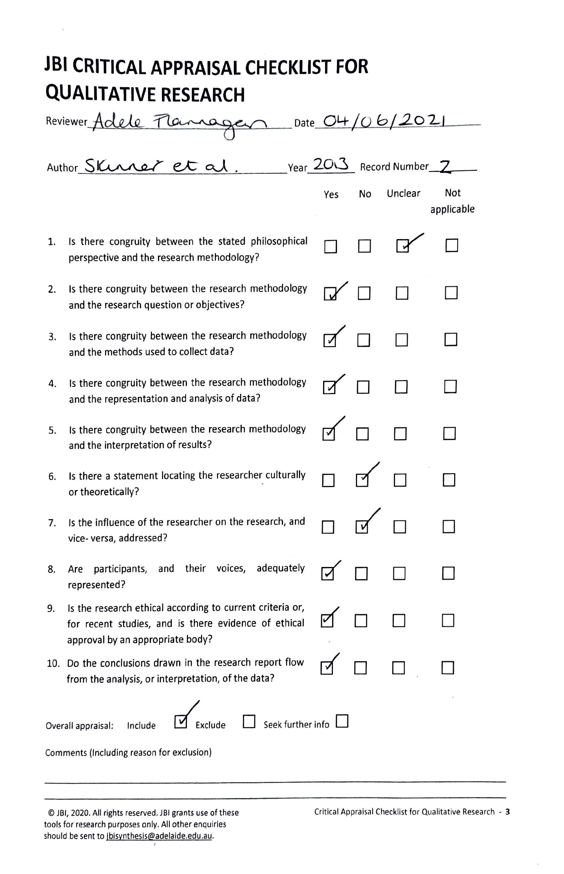
Appendix E

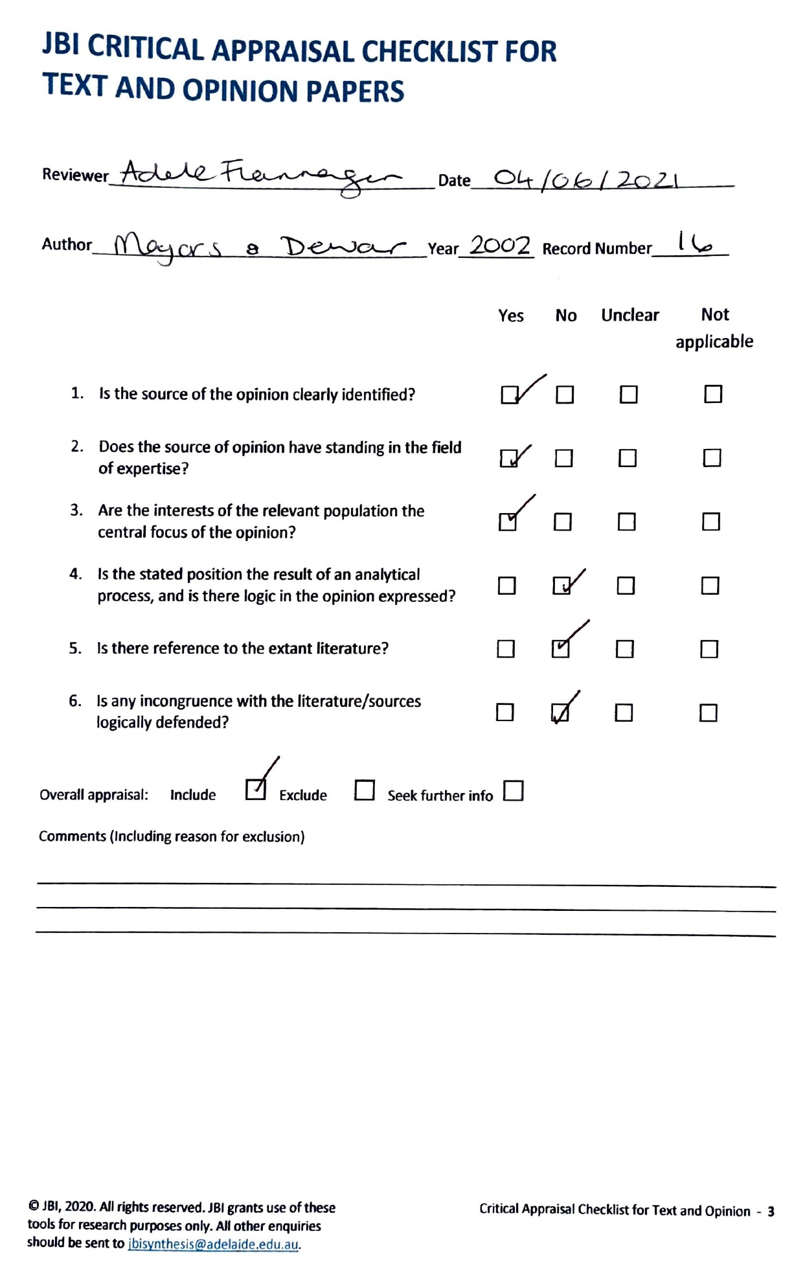
JBI Critical Appraisal Checklist for Text and Opinion Papers

Paper Two: Empirical Paper

“I think my year is one of the ones that did get a bit lost and forgotten”
Exploring the experiences of Year 11 school leavers impacted by the Coronavirus pandemic: An Interpretive Phenomenological Analysis.

Abstract
Objective: The COVID-19 pandemic and associated public health measures caused unprecedented disruption to everyday life in the United Kingdom, including the education of school-age children. One of the year groups significantly impacted were those in their last year of secondary school. To date, there has been no published qualitative research exploring their experience of ending school and transitioning, this study aims to address this.
Method: Semi-structured interviews were conducted with eight young people, aged 17-18 years-old, who left secondary school education prematurely in March 2020 due to the pandemic. Data was analysed using Interpretive Phenomenological Analysis.
Results: 6 superordinate themes were identified: “We all felt the same way”, Endings as a Loss, “It’s definitely deeper than just not sitting GCSEs”, “It was so sudden. And I guess just a bit of a shock.”, “It's fine, but it's not fine, is it?” and Others: Helped and Hurt. Young people were comforted by the collectiveness of their experience, however they struggled with loss and change, and transitions were affected.
Conclusion: Young people’s feelings of loss, uncertainty, disappointment and change were validated by their sense of togetherness. However, they struggled with the transition to college. Young people felt unable to acknowledge or share their feelings, given the circumstance in which they occurred. Implications around support for this group of adolescents are outlined. Further research is required on this topic, particularly longitudinal studies.
Keywords: COVID-19, young people, secondary school, transitions, endings, IPA.

Introduction
Transitioning to the next level of education can be a major challenge for many young people (YP) (Bagnall, 2020), causing disruptions to routines, roles and relationships (Schlossberg, 2011). As YP move to increasingly higher levels of education, they are often required to navigate more complex environments, adapt to new academic and behavioural expectations, and manage shifting peer relationships (Anderson et al., 2000; Jindal-Snape & Miller, 2008; Symonds & Galton, 2014). It is likely that these challenges have been intensified by COVID-19. Exploring the collective experience of YP undergoing educational transitions in the context of a pandemic is necessary to understand the cohort effects, inform psychological formulation and consider the meaning they have attached to this important transition.
The COVID-19 pandemic has been described as “creating the largest disruption of education systems in history”, with school closures impacting around 94% of the world’s student population (United Nations, 2020 p.2), the ramifications of which will be felt for years to come (Araújo et al., 2020). By 20th March 2020, all schools in the United Kingdom (UK) closed to reduce COVID-19 transmission. It was then announced all exams that year would be cancelled, and learning would be delivered remotely.
Studies have shown crisis events, such as COVID-19, negatively alter the psychological well-being of YP (Dalton et al., 2020); with anxiety, depression, disturbances in sleep and appetite, as well as impaired social interactions, being the most common presentations (Imran et al., 2020). Preliminarily research into COVID-19 restrictions suggested they have the potential to significantly threaten the mental health of YP (Fegert et al., 2020). Across studies, focal concerns regarding the implications of school closures and reduced peer interactions have been greater experiences of anxiety and distress, loneliness and boredom, stress, fewer opportunities for developing distress management and emotional regulation techniques and a lack of social scaffolding (Goberstein,et al., 2020; Lee, 2020; Panchal et al., 2021 & Viner et al, 2020). For students, in particular, public health emergencies have a significant impact on their mental health and it has been suggested they will require ongoing attention, help and support from society, families and college (Cao et al., 2020). Despite this early research, Lee (2020) argues that evidence is particularly scarce in relation to the long-term mental health repercussions of large-scale disease outbreaks on YP, and this presents an important gap for research.
Arguably, one of the groups most affected in the UK were those in their last year of secondary school, who experienced interruptions to their GCSE exams and transition to further education (FE). Adolescence, “the phase of life between childhood and adulthood, from ages 10 to 19” (World Health Organisation, n.d), is often seen as an important period of transition and leaving school is a significant change. Research has highlighted the shift from general education to FE, training or employment presents several developmental challenges, such as making career choices. The way in which individuals cope with these challenges depends on their social network, and wider societal, cultural, and institutional conditions (Dietrich et al., 2012); much of which has been impacted by COVID-19. For some, adolescence continues to be a time for educational growth and success, whereas for others, it is marked by declines in academic performance, interest, and perceptions of ability (Roeser et al., 2000).
There is currently limited research (e.g. Dietrich et al., 2012) focusing on transitions from secondary school to FE, training or employment, especially solely focusing on that transition in the context of COVID-19. The small number of reports and studies that do exist focus on YP transitioning from primary to secondary school (Bagnall et al., 2022) or college to university (Pownall et al., 2021).

Study Rationale
Despite literature highlighting the challenges faced by YP because of the COVID-19 pandemic, to the researcher’s knowledge, no research has employed qualitative methodologies to examine the lived experiences of school leavers in the year 2020. As the pandemic continues to evolve, and the focus shifts to those in their exam years in 2021/22, there is a risk that the voices of those in Year 11 in 2020 will be lost. The detailed insights gained from a qualitative study on YP’s experience of leaving secondary school and transitioning to FE, training or employment, the findings may provide insight into the challenges of transition as well as inform the help and support these YP may need in the future. The current research base on educational transitions is largely focused on the impact on academic attainment. With this in mind, there is a danger future research will follow the same pattern; this research aims to prevent that with a focus on the emotional experience.

Research question
How did YP experience the ending of secondary school education prematurely due to the COVID-19 public health crisis and how did they make sense of this in relation to transitioning to the next stage of their lives?

Method

Design
A qualitative design, using semi-structured interviews, was chosen as it fits with the aims of the research, which seeks to understand the meaning of human experience and question a phenomenon as it occurs within context (Schwandt, 2000). Interpretative Phenomenological Analysis (IPA) was chosen as it provides detailed examinations of personal lived experience (Smith et al., 2009). It studies in detail how participants, in this case, Year 11 school leavers, make sense of their personal and social world. IPA is especially valuable when exploring complexity, process or novelty (Smith & Osborn, 2003). It is underpinned by three main theoretical ideas; phenomenology, hermeneutics and idiography. Phenomenology focuses on the way things appear to individuals in an experience and aims to identify the key components of this experience that make it unique or distinguishable from others (Pietkiewicz & Smith, 2012). Hermeneutics is concerned with understanding the mind-set of a person and language which facilitates individuals’ experiences of the world, in order to translate their message (Freeman, 2008). IPA also acknowledges that the researcher is making an interpretation of the participants’ interpretations, known as the ‘double hermeneutic’ (Smith et al., 2009). Therefore, interpretations in the analysis are jointly constructed by the researcher and the participants (Larkin et al., 2006). Idiography refers to the in-depth analysis of single cases and examination of the individual perspectives of study participants, in their unique contexts (Pietkiewicz & Smith, 2012).
Alternative qualitative methods were considered, such as grounded theory (GT) or narrative analysis (NA). However, these were excluded for the following reasons: GT aims to explain phenomena to some degree (Chun Tie et al., 2019) which did not fit with the idiographic nature of this study. NA focuses on the performative aspects of the stories told and whilst it would have been a compatible method, the research questions aimed to explore the essence of the phenomenon and it was for this reason NA was excluded.

Sampling
Typically, small sample sizes are used in IPA to sufficiently detail the experiences of the phenomena being examined (Smith et al., 2009). To ensure the study holds relevance and personal significance to participants, IPA seeks to generate a fairly homogeneous sample through purposive sampling. Smith et al., (2009) suggested there is no correct sample size for IPA, however, for professional doctorates, four to ten interviews is suitable. It is thought this number enables in-depth analyses of similarities and differences within a group (Brocki & Wearden, 2006), with a focus on the quality and richness of the data rather than the number of participants (Larkin & Thompson, 2012).

Recruitment and Participants
Purposive sampling was used, with participants included based on carefully considered eligibility criteria (Table 4).
Table 4.
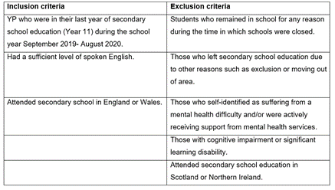
Participant eligibility criteria

There are subtle differences between the four UK nations in terms of their education systems, such as different qualification frameworks, year groupings and school leaving ages. Therefore, to increase homogeneity, the geographic locations of the participants was limited to England and Wales where the greatest similarities exist.
Recruitment was conducted via social media where adverts were posted on the researcher’s social media accounts (Appendix G). Adverts were promoted using hashtags and shared by organisations (Appendix H) that support the target population. Three participants were recruited this way. When no new participants presented, the researcher visited a local college to advertise the study where the remaining five participants were recruited; eight participants were recruited in total. Recruitment ceased when no new participants presented.
Participant information and demographic data is provided below (Table 5). Given the research question was not specifically related to exploring the role of ethnicity or socio-economic status on the experience, this data was not gathered. However, attempts were made to recruit a diverse sample by including a financial incentive for participating and using two recruitment channels.
Table 5.
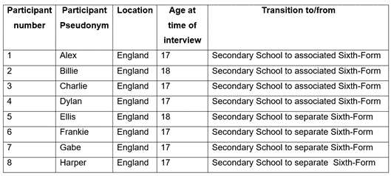
Participant information and demographics

Ethics and Procedure
The Staffordshire University Ethics Committee granted ethical approval in June 2021 (Appendix I). Potential participants could elect to contact the lead researcher through social media private message or email. Individuals who expressed an interest in participating and met the inclusion criteria were given a participant information sheet (Appendix J) and provided with an opportunity to ask questions. Participants who agreed to take part completed a demographic questionnaire (Appendix K) and an electronic consent form (Appendix L).
Interviews were arranged at a time and date convenient to participants and verbal consent was given at the beginning of each interview. All interviews were conducted using video-conferencing (Microsoft Teams). The duration of interviews ranged from 32-to-100 minutes (mean: 45.6). Interviews were audio-recorded and transcribed verbatim. Gender-neutral pseudonyms were allocated to participants by the researcher and used in all transcripts and analyses. The interviews followed a broad schedule (Appendix M) using open-ended questions to guide discussions. Following completion of the interviews, participants were given a debrief information sheet (Appendix P). No participant expressed any distress and no issues of risk arose during interviews.
YP consultants were recruited via social media advert (Appendix N) and word of mouth and were of a similar age to participants (16-18 years old). Those interested in participating in the research, in this capacity, contacted the researcher via social media message or email and were provided with information on the role (Appendix O). Three consultants provided written feedback on study materials and an additional consultant participated in a pilot interview. YP consultants provided feedback on the inclusion of a memory aid, which they did not feel was necessary. They also supported with the language used and their suggestions for rapport building questions were included in the interview schedule. No financial compensation was provided, however the researcher offered support with career development.

Data analysis
Smith et al., (2009) state there are no formal steps for analysis in IPA research. However, in accordance with their guidance, the IPA analysis was undertaken as detailed below. A diagram describing the process can be found in Appendix Q.
Transcripts were read and re-read, alongside watching the video recording, prior to line-by-line coding. Descriptive, linguistic, and conceptual comments were made alongside each transcript (Appendix R). From this, emergent themes were developed. The final superordinate and subordinate themes were selected in line with Smith et al., (2009) recommendations, namely prevalence across all transcripts, representativeness of participants and variation in order to encompass a range of experiences (Appendix S & T).

Reflexivity and Epistemology
Reflexivity is an important part of the IPA process and is understood to be “an attentiveness to the influence of the researcher on the research process” (Engward & Goldspink, 2020, p.41). For this reason, a reflexive diary was kept throughout to capture the researcher’s thoughts, emotions and understanding (Appendix U) and how this may have influenced the process of analysis.
It is also important that researchers are aware of their epistemological approach. In this study the researcher took a social constructivist epistemological stance: the belief that learning involves individuals’ actively co-constructing knowledge (Braun & Clarke, 2013). Social constructivism theory highlights knowledge, such as what it means to be a student and leaving school, in the context of a pandemic, is developed through the interactions individuals have with their friends, teachers, parents and social media. It is through this interaction process that learning occurs. According to social constructivism, truth and meaning about transitions, for example, is created by social processes that are based on an individual’s historic and cultural perspective (Crotty, 1998), such as watching others complete the transition and school cultures.
The social constructivist perspective is preserved in this research through the use of the double hermeneutic. As the researcher jointly constructs interpretations with participants (Larkin et al., 2006) it was important to consider the potential influence I may have on the research process. For example, my own lived experience of leaving secondary school and the importance I placed on ending rituals could have led me to highlight this as a salient factor for participants when this is not true of their experiences. It is also likely, given we shared the experience of living through the COVID-19 pandemic, that some meanings were not clarified due to an assumed shared understanding of terms. It was therefore necessary that the researcher approached the interpretation with self-awareness of these preconceptions and made use of bracketing in the form of a reflective diary and IPA group workshops, to make biases more obvious (Smith et al., 2009).

Results

Participant demographics
Twelve individuals expressed an interest in participating, with eight meeting the criteria and agreeing to be interviewed. Participant age ranged from 17-to-18 (mean: 17.25) years-old. Participant information is detailed in Table 5. Five of the participants identified as female, two as male and one as transgender. Four participants transitioned from their secondary school to the associated sixth-form and the remaining four participants transitioned to a separate sixth-form or college.

Analysis
Six superordinate themes and eleven subordinate themes were elicited through IPA analysis (see Table 6). The six superordinate themes were: “We all felt the same way”, Endings as a Loss, “It’s definitely deeper than just not sitting GCSEs”, “It was so sudden. And I guess just a bit of a shock.”, “It's fine, but it's not fine, is it?”, and Others: Helped and Hurt. A master table of themes and quotes can be found in Appendix V.

Table 6.
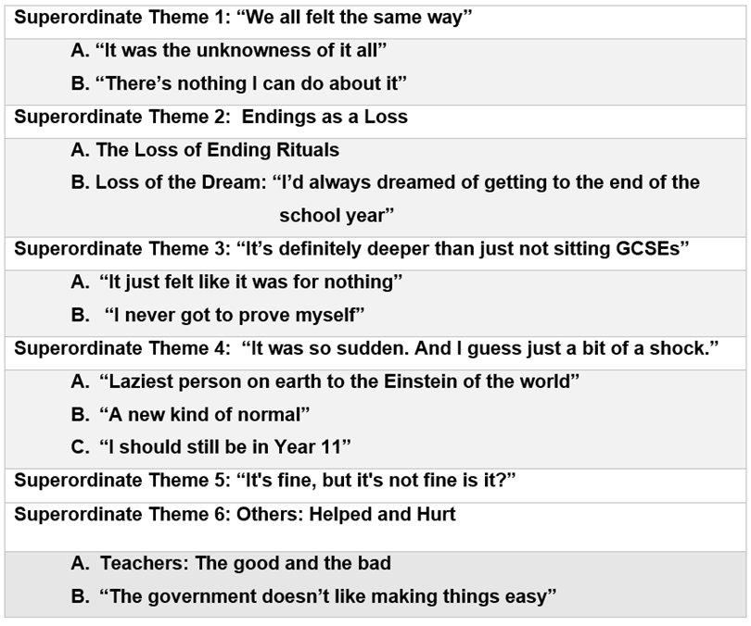
Summary of Superordinate and Subordinate Themes

Theme 1: “We all felt the same way” – Billie (line 199)
All participants experienced a sense of having shared a unique experience and were comforted by feeling they were not alone in that experience or their response to it, and this appeared to provide validation.
"I think we were all confused, which kind of helped because at least we all felt the same way" – Billie (lines 198-199).
"it was really nice to know that all my friends and mates were in the same boat as I was. It wasn't just like Covid has impacted me, it impacted everyone. It wasn't just a me thing, it was we're all in the same situation here." – Harper (lines 404-407).
The most commonly used word to describe this shared experience was “weird”, being said 56 times across six transcripts. When recounting their experience of leaving school, participants did so using the personal pronoun “we” instead of “I”, even though they were describing their individual stories, indicating their year group affiliation.
"we were all quite…not…I wouldn't say shocked because obviously we knew Coronavirus was taking its toll but we didn't expect to be finishing school so soon so we didn't really…we weren't really prepared" – Ellis (lines 22-25)
In most cases, participant’s use of personal pronouns shifted to “I” when describing their transition to college, for example, “I think when I first started sixth-form, I didn’t think there was that much of a jump from GCSE” - Charlie, line 202-203. This suggests the sense of solidarity and group affiliation was felt more acutely during their school-ending experience, with a shift to a more singular mentality once they transitioned to college. This is understandable given the shared history participants had with their secondary school friends, something they lacked at college.
- “It was the unknowness of it all” – Billie (line 14)
Within this shared experience, four participants experienced the ending of school and starting college as a time of increased uncertainty or “unknowness” around what was going to happen or what they should do. This increased feelings of panic, worry and anxiety.
"And they just didn't…they didn't know, I didn't know. So that made it really difficult" – Gabe (lines 162-163).
"everything else was closing down around, like the schools were one of the last things to shut really. So everything was just a bit, like unknown. We didn't really know what to do with ourselves" – Billie (line 11-13).
For Alex, Gabe and Harper, this feeling was exacerbated by others ‘not knowing’, particularly teachers as they were viewed as adults in positions of authority and past experience had taught them, teachers “knew everything”. Participants looked to teachers for answers and reassurance regarding COVID-19, which they were unable to provide.
"they didn't know what they were doing…we didn't know what we doing and it was it was messy" – Frankie (lines 36-38).
- “There’s nothing I can do about it” – Dylan (lines 162-163)
Another aspect of this shared experience, conveyed by six participants, was the lack of control they felt over what was happening, leading to increased helplessness and anxiety, particularly around their grades.
"it gave a sense of almost helplessness at that point because it was all out of my control, yet influenced my life so greatly." – Gabe (lines 269-271).
"they put the whole drill in your head from the start, look this really, really matters and then it's like I've got no control over it" – Billie (lines 119-121)
Participants felt they had control and ownership over the outcome of GCSE exams, whereas they did not feel the same way about centre assessment grades.
Theme 2: Endings as a Loss
This superordinate theme discusses how six participants viewed the end of school as a loss: of routine, friendships, opportunities, and experiences. Two key losses were highlighted as subordinate themes; (1) the loss of ending rituals such as prom, shirt-signing and results day, and how this meant they felt unable to “close the chapter” on secondary school; and (2) the loss of the dream, which explores participants mourning their imagined ending.
For Alex, Frankie and Harper, the loss was primarily related to friendships;
"suddenly having nothing and no-one really, in person to talk to and stuff. That was the hardest part because I felt like I suddenly lost everyone even though I hadn't" – Alex (lines 182-184).
Whereas for others, such as Billie and Frankie, it was the loss of experience;
"the whole prom was meant to happen after school and like you went in for results day and like you had a like, a little celebration and an assemble, like on your last day and you got exam leave and all that. And it was just gone." – Frankie (lines 30-33).
The use of language like “losing” and “gone” indicates YP experienced the ending of school like a bereavement.
- The Loss of Ending Rituals
All participants spoke about the loss of ending rituals associated with leaving school such as shirt signing, prom and end-of-year assemblies, although these rituals appeared to be valued by some more than others. The value seemed to originate in others, who created a sense of anticipation- “throughout Year 11 we did get that sort of hype about oh, like prom” – Ellis (lines 18-19). Participants lamented the loss of the different functions they felt these ending rituals would have had, should they have occurred. There were three main functions identified: (1) to signify an ending, (2) an opportunity to say goodbye, and (3) an opportunity to share their achievements or failures.
For Billie and Gabe, results day would have signified “closing the chapter” on secondary school and provided an opportunity for them to share their grade success or disappointment, not only with each other but also with their teachers.
"I think the thing that I miss more than anything was an in person results day. That felt weird to me. Like I wanted to be able to go up to the teachers and be like, look what I got" – Billie (lines 135-138).
It appears without these ending rituals, and in particular a shared results day, participants’ secondary school experience felt incomplete and lacked a conclusion that enabled them to relinquish their Year 11 identity. This was supported by the experience of participants who did have an in-person results day, which they felt “confirmed” the end:
"it was a very confusing and emotional day as well, because it kind of confirmed that we had left Year 11 as well and that we were moving on." – Alex (lines 327-329).
For Billie, Ellis and Gabe, the loss of results day, prom and end-of-year assemblies meant the loss of an opportunity for a shared social ending, to say ‘a proper’ goodbye to each other, teachers and the secondary school experience.
"we didn't get that nice, rounded ending, like whether a leavers service or prom, things like that. So there wasn't that sort of nice ending, saying goodbye to people." – Ellis (lines 7-9).
There was a sense that ending rituals needed to be ‘proper’ and include sentiment in order to be valued, as epitomised by Harper:
"we did like shirt-signing and that, but they weren't like, they weren't proper because they didn't have the same like, heartfelt sentiment to them. Because it was kind of like, we'll sign your shirt because you're about to go, not because it's the end of the year and we want to give you a happy send off" – Harper (lines 44-48).
It appears a signed shirt was more than just a memento; it was the process of shirt-signing and what this facilitated. In wanting sentimentality, Harper suggests the need for social recognition in a ‘proper’ ending ritual, an acknowledgement from others that their school experience and the relationships within it were meaningful and special. Without this, there was a sense that these rituals are pointless and ineffective.
- Loss of the Dream: “I’d always dreamed of getting to the end of the school year – Alex (line 38-39)
For many, the ending of school in the way that they did, meant the loss of a dream; an imagined ending. Participants had a schema for their school ending that represented a “normal”, “right” ending and was informed by witnessing the experiences of older students, “like we've seen it happen from Year 7” – Charlie (line 371):
"it was kind of upsetting because we wasn't getting the normal end” – Charlie (lines 12-13).
“I just had this dream for the end . . . there were so many things that were supposed to happen before you left school when it doesn't its like, it just, it just isn't right." – Gabe (lines 93-96).
Given the school ending did not happen, it remained perfect within participants’ minds. Reconciling the reality of leaving school in the midst of a pandemic meant grieving this perfect, longed-for dream experience, and confirmed that life was no longer “normal”.
Theme 3: “It’s definitely deeper than just not sitting GCSEs”- Billie (line 439)
In this theme, participants engaged in meaning-making around not taking their GCSE exams and conveyed their disappointment alongside a need for feeling they had earned their grades.
- “It just felt like it was for nothing” – Ellis (line 14)
Four participants discussed their disappointment at having worked hard for their GCSEs and feeling that this work no longer matter and amounted to nothing. Often this was influenced by the narratives from teachers and others about the importance of exams and the emphasis placed on working hard.
"I've been working so hard for two years on GCSE specific work and it's just it was so frustrating…like, it just felt like it was all for nothing" – Ellis (lines 13-14).
- “I never got to prove myself” – Frankie (line 93-94)
For six participants, exams represented an opportunity to prove what they were capable of and without this their results did not hold the same value. Centre assessment grades were deemed to have been “given” and “not earnt” by both themselves and others, as explained by Billie; "a lot of people are like well you didn't even get them grades, they got given to you” (lines 440-441). For many obtaining centre assessment grades did not provide the same sense of satisfaction as taking exams.
"you don't get to have that same feeling because you haven't taken them so you don't like, you don't get the same satisfaction from leaving school." – Harper (lines 151-154).
Participants also felt little ownership over their centre assessment grades:
"I'd rather take the exams myself because then that's all on me then whether I, you know, mess it up or not." – Dylan (lines 93-95).
Whilst participants initially felt relief at not having to take their exams, this was quickly replaced by feelings of disappointment and the anxiety of sitting exams was replaced by anxiety around grades, which was intensified by the uncertainty around how these would be awarded, exemplified by Ellis: "I thought I wouldn't get the grades I deserved" (line 37).
Theme 4: “It was so sudden. And I guess just a bit of a shock.” – Alex (line 29)
In this superordinate theme, participants grappled with the suddenness and shock of changes within their lives. The constituent subordinate themes explored this within the context of three key transitions they experienced during this time; the transition from the absence of work to the expectation of work, transition to a “new normal” and transition to ‘the college student’ identity.
- “Laziest person on earth to the Einstein of the world” – Harper (line 515)
For six participants, it was the transition back to educational work that they found most challenging. The dichotomy between lockdown, where YP were not required to do any schoolwork, and college, where they had substantial workloads, created feelings of shock and anxiety and was described by one participant (Harper) as “horrendous”.
"we'd just done nothing for months and months and months and you know, after the summer holidays, where you go back to school and you try to write and writing feels wrong. You haven't written anything. It was like that times a thousand" – Dylan (lines 215-218).
"it felt like a really long time went by where I had no work to do . . . I think being away from work for that long, it made it a lot more difficult to get back into it." – Gabe (lines 253-254 & 257-258),
Participants were in a unique position to other school year groups, in that they were also transitioning to different academic qualifications (GCSE to A-Level) and for some, a new school, teachers and subjects meant bridging subject work could not be set. Without external motivation, engaging in education work during lockdown was felt to be too difficult.
- “A new kind of normal” – Harper (line 432)
Five participants shared that when their feelings of shock and panic eventually subsided, they were able to transition to a “new normal”. During lockdown, YP were able to create new routines, which often involved little or no academic work: "me going on my console and doing nothing became the new normal"- Harper (line 431). The “new normal” also included adapting to the new COVID-19 restrictions and expectations of them, such as self-isolating, as they returned to education.
"once everyone got over the initial panic and shock after the first couple of weeks, people started to get into kind of like a routine . . . I guess it became normal" – Alex (lines 403-407).
- “I should still be in Year 11” – Dylan (line 195-196)
Transitioning to their new identities as college students was particularly problematic for participants. For five participants, they appeared stuck in the roles and identities they held in Year 11, which affected their sense of belonging to their new college student identity.
"I don't feel as though I'm Year 13, it's kind of…it's really weird. Especially during the first few days of college, I just didn't fit…I felt out of place. I felt like I should be back in the secondary school, kind of where I say…where I belong" – Harper (lines 358-362).
"it just kind of still felt like we shouldn't be there" – Dylan (lines 181-182).
The ‘college student’ identity was synonymised with increased maturity, responsibility and knowledge, and with others treating them as adults. This felt incongruent with participants’ views of themselves, making it difficult for them to transition to the role and identity of a college student.
"it felt really weird to be treated like kind of adults” – Harper (line 290).
"I don't think I was mature enough to be leaving school at that point. I was still very, like, I still felt very young going into sixth-form in Year 12. I didn't feel ready. Because Year 11, I'd always assumed that I'd get to the end and I'd feel much older and more mature and like more knowledgeable and stuff" – Alex (lines 168-172).
This transition to being a college student did not appear to differ depending on the participant’s transitional venue, with the same difficulties being observed in those who transitioned to their school’s sixth-form and those who transitioned to a different institution. For those who progressed within their school, the transition was generally felt to be slightly easier due to familiarity with the environment and routines; "I stayed at my sixth-form so I suppose it wasn't as bad because I kinda knew my way around" – Billie (line 187-188).
Theme 5: “It's fine, but it's not fine is it?” – Billie (lines 365-366)
This superordinate theme reflects how YP felt the need to minimise and dismiss their feelings and experiences and how this was reinforced by others, primarily because of the context in which their experiences were occurring i.e. a pandemic. All eight participants used minimising language such as “just”, “quite”, “a little” when talking about their experiences.
Charlie and Harper felt they should not feel sad or upset, or express their true emotions, such as enjoyment related to their experience, as others were dying;
"like yeah, we didn't get prom but people were dying. So like it's not that important" – Charlie (lines 387-388).
"I know that while I was stuck indoors, there are people like literally dying of it. So I wanted to make sure I wasn't enjoying it too much because that isn't fair" – Harper (lines 637-639).
Billie especially downplayed their emotional experience and this is observed in their initial choice of strong emotional label, which is then revoked: “I wouldn't say betrayed. I think that's a bit strong” (lines 42-43), "I wouldn't say…maybe not as drastic as hopeless" (lines 285-286). The result of this minimisation is that YP felt their experiences were dismissed and they were left feeling neglected, ignored and uncared for. "I felt I mean neglected I guess" – Gabe (lines 28-29), "I don't think anyone else really seems to care which baffled me” – Billie (lines 348-349).
This minimisation seems borne from participants’ sense of social taboo about being honest about how they truly felt in the context of COVID.
Theme 6: Others: Helped and Hurt
- Teachers: The good and the bad
Six participants highlighted the role their teachers played in their experience of both ending secondary school and transitioning to college; both positive and negative; helpful and harmful. Billie, Charlie, Ellis and Harper felt teachers’ responses aided their transition to college, by acknowledging and accounting for their different experience.
"our teachers that we have now are very aware of the fact that we haven't had a normal experience and not…they're not lenient but they understand the fact that we haven't had the exam experience and we're not used to it” – Charlie (lines 345-348).
Both Frankie and Harper shared how teachers providing videos and starter activities helped to aid the transition back to education, “it gently got me back into the whole, you're going to be learning again" – Frankie (lines 168-169). This creating a more “gradual” transition that felt less “daunting”. It also supported the transition to the ‘college student’ identity and the expected roles and responsibilities; “they were getting the messages to students about what it was like to be in sixth-form" – Harper (lines 400-402).
It appears these responses from teachers also served another function, in that it validated YP’s feelings about their experience being difficult.
However, for Alex and Frankie, the lack of communication from their teachers following school ending meant they felt alone and exacerbated their sense of being unimportant; they were not worth contacting.
"I think just even a friendly email from them would've really helped, just to know that people are thinking of you and you're not alone" – Alex (lines 283-285).
- “The government doesn’t like making things easy” – Dylan (lines 75-76)
Four participants wrestled with making sense of government decisions and how this shaped their experience. All four shared the negative impact the government response had, particularly the lack of clarity around grades, school closures and “mixed messages” around COVID rules, increased their confusion, fear and anger.
"I definitely felt angry at some of the decision the government made regarding lockdowns because I felt like there were so many things we could do that didn't require such drastic changes to me in my education," – Gabe (lines 346-348).
Participants struggled with the lack of agency over their own lives resulting from the government’s response, feeling decision making around education should have included them: “it should be down to the people it matters too” – Billie (line 397) indicating a felt sense that their education didn’t matter to the government. Participant narratives around the government’s decisions centred on being unconsidered, their experience being insignificant and their feelings unimportant:
“obviously, the government probably did have slightly more important things to focus on” – Billie (lines 70-71).

Discussion

Key Findings
Six superordinate themes with subordinate themes emerged from the analysis conducted (1) “We all felt the same way”, (2) Endings as a Loss, (3) “It’s definitely deeper than just not sitting GCSE’s”, (4) “It was so sudden. And I guess just a bit of a shock”, (5) “It's fine, but it's not fine is it?” (6) Others: Helped and Hurt.
The primary aim of this study was to explore YP’s experiences of their secondary school ending prematurely due to the COVID-19 pandemic. For YP their experience of leaving secondary school was one filled with sudden and shocking changes, uncertainty and loss. This was mitigated by their sense of togetherness and their creation of a new normal. This is supported by the TELL study (Demkowicz et al., 2020) which demonstrated loss, change and uncertainty were common across participants' accounts of lockdown but they also described a sense of large-scale togetherness. The benefits of sharing an experience have been explained by Gollwitzer (1986) who suggested sharing an event increases its social reality, that events and their implications gain validation when members of a group agree on them.
The ending of school was experienced by many as a loss; participants felt they had lost friends, a routine and expected experiences. This is in line with the Young Mind report (2020) and Teo and Griffiths (2020) who noted many YP found themselves struggling with the loss of the structure and routine school provides. Grief is not limited to death but can also be for relationships and settings such as school. Given one of the findings of this research was participants minimised and dismissed their feelings about the experience, it could be argued this group experienced disenfranchised grief, including self-disenfranchised grief (Kauffman, 2002), which occurs when a loss is not “openly acknowledged, socially validated, or publicly mourned” (Doka, 1989, p.15) and results in individuals having difficulty in acknowledging their own grief as legitimate.
GCSE exams represented a key experience for YP. Contrary to findings by The Centre for Education and Youth (Menzies et al., 2022) which revealed most participants were happy exams had been cancelled, participants in this study, whilst acknowledging the anxiety and stress that comes with exams, wanted the opportunity to prove themselves. However, it is difficult to know how representative this is of YP’s feeling on exams, given the absence of UK research in this area (Putwain, 2008).
The secondary aim was to consider how YP make sense of their experience in relation to transitioning to the next stage of their lives. Participants described the many difficult transitions they were required to navigate during COVID-19, from transitioning in and out of lockdowns, to the college environment and identity. The shock and sudden change to having to engage in education after a prolonged break was particularly problematic for participants. Summer learning loss is already a noted phenomenon whereby students lose academic skills and knowledge over the summer holidays, so the challenge is somewhat expected. The transition back to school brings with it increased pressure to ‘make up’ for lost learning and Fegert et al., (2020) noted this may further exacerbate psychological distress in adolescents and lead to increased mental health difficulties.
Given rituals are thought to provide order and stability whilst marking change, especially in times of disruption and disorder (Romanoff, 1998; Turner, 1969), it is unsurprising that participants felt the loss of ending rituals. In relation to adolescent transitioning, researchers (Fasick, 1988; Mbiti, 1970 & Van Gennep, 1960) have concluded that symbolic rituals enable YP to acquire the skills, norms, values, and community expectations that prepare them to accept and participate in their role as responsible adults within society. Without these rituals it appears incorporation; the re-assimilation of the individual back into society along with their new roles and statuses, was more difficult for YP. Participants appeared caught in the liminal phase, not fully able to assume their new identity as college students. This arguably intertwines with the identity transition-related subordinate theme “I should still be in Year 11”. Broadfıeld and Dawes (2021) concluded the impacts of COVID-19 are greater for YP due to the disruption of traditional markers, which assist individuals in constructing their identities and establishing their place in society. Participants felt ending rituals would have provided a conclusion and opportunity for a shared social ending. This is supported by research suggesting social events can bring recognition to the transition from childhood to adolescence or adulthood (Barry & Schlegel, 1980; Schlegel & Barry, 1980). It may also be YPs’ lack of agency over their experience made the transition more challenging, with Fisher (2012) explaining individuals who believe they have control over a situation find the process of moving towards successful change easier.
Despite the challenges, participants did find teachers were instrumental in aiding their transition to college. This is supported by Valenzuela (1999) who has shown a sense of belonging occurs through connections made with teachers, college counsellors, and staff.
Within the current study, no themes were identified that specifically focused on mental health implications, such as the increase in anxiety and depression that have been demonstrated in other studies (Fegert et al., 2020; Imran et al., 2020). However, throughout the themes, YP described a range of psychological consequences including increased anxiety, worry, low mood, poor routines and isolation. This could be partly explained by the superordinate theme around YP’s dismissal and minimisation of their feelings and experience; within which participants demonstrated an inability to express the psychological impact of their experience due to the context in which their experiences occurred i.e. people dying from COVID-19. Emotional suppression could be considered a culturally relevant emotional regulation strategy implemented by YP and has been documented throughout the pandemic in other populations, such as healthcare workers. Emotional suppression has been independently associated with poorer psychological health (Low et al., 2021). Social narratives about remaining positive may have also influenced this, such as “toxic positivity” which is an overgeneralisation of optimism and happiness across all situations, that denies the impending issues and inhibits unpleasant emotions (Quintero & Long, 2019). This may have meant YP felt unable to feel sad about their experience without being viewed negatively by society. This could also be due to the length of time that has passed since the initial impacts of the pandemic had been felt by this cohort and now, other psychological impacts are being experienced as they return to education and life in general.
Government and school responses also had an impact on YP’s psychological experience, leading to increased feelings of confusion, anger and uncertainty. Mixed messages, a lack of clarity, and poor communication were the key drivers for this. This is supported by the Tell Study (Demkowicz et al., 2020) where several participants described feeling frustrated with the UK government, whom they did not trust to make appropriate or transparent decisions.

Strengths and Limitations
To the researcher’s knowledge, this is the first qualitative study exploring the experiences of this particular cohort in relation to COVID-19 and the use of IPA offered an in-depth detailed examination of their unique experiences. Experts by experience, in the form of YP consultants were conferred with at all stages, which meant YP remained at the forefront of the research. Other strengths include the inclusion of both those transitioning to their secondary schools’ sixth-form and those who went to a different sixth-form/college, which afforded the ability to explore any potential variation.
The use of online/telephone interviewing has both strengths and limitations. Whilst it allowed for a wider geographic pool for recruitment, it also meant the ability to participate in interviews was restricted to those with internet/phone access and this selection bias could have influenced findings. Despite research suggesting remote interviews may negatively influence disclosure (Deakin & Wakefield, 2014; Seitz, 2016), the interviewer’s experience conducting therapeutic interventions online was used to mitigate this.
The study has some further limitations. Firstly, while IPA group supervision and a reflective journal was used to bracket personal biases, for confirmability it would have been beneficial to have had an independent researcher review the transcripts and comment upon the interpretations. This would improve the dependability and credibility of the research.
Given demographic data relating to ethnicity and socio-economic was not sought, the diversity of the sample cannot be commented on and it is unknown how representative it may be. This limited the ability to contextualise the findings particularly given research has shown COVID-19 has had a greater impact on individuals from ethnic minorities and lower socio-economic status (Van Lancker & Parolin, 2020; Bayrakdar & Guveli, 2020).
This research only represents the views of YP in England and those who transitioned to a college or sixth-form; no participants were located in Wales or transitioned to an apprenticeship or training program. However, it is expected many of the implications of this research will apply more broadly, as there are some experiences most YP will share, regardless of where they live or the establishment they transitioned to.

Implications
The findings from this study illustrate the challenges faced by YP transitioning within the context of COVID-19 and provide valuable clinical understanding through the exploration of YP’s subjective experience that can be used to inform psychological formulation when working with this particular group of YP. This is particularly important when considering students in higher education (HE) are reported to have increased symptoms of mental ill health compared with age‐matched controls (Royal College of Psychiatrists, 2003, p.7) and therefore may be more likely to access mental health services.
YP in this study shared their difficulty in navigating transitions, given their suddenness and the shock they felt at this and this indicates that YP would benefit from transitions that they are in control of and where possible, are planned and prepared for. Clinical psychologists alongside educational psychologist and educational mental health practitioners are uniquely placed to use these findings to inform psychological thinking around transitions and promote positive and informed transitional planning at systemic and individual levels within educational establishments.
Whilst online resources (such as the Mentally Healthy Schools Transition toolkit) exist to support stakeholders with transitions and endings, the focus tends to be on younger children and the move to primary/secondary school. The findings of this research, such as the importance of individually valued ending rituals, could be used to inform similar evidence-based guidance, with a focus on supporting the transition to FE/HE. However, it is not known how utilised these existing guides are or how many have accessed them. This could be a beneficial area for future research.
As these YP may likely transition to HE, it is crucial that their sense of belonging at university is carefully considered. Feeling you ‘belong’ at university is associated with lower drop-out rates and increased student success (Murphy et al., 2020; Thomas, 2012). However, there is a danger, given this study found YP felt undeserving of their GCSE grades that this may increase “imposter syndrome” (Ramsey & Brown, 2018) and their sense of belonging. To counter this and given YP in this study highlighted the important role of teachers, strong teacher-student relationships will need to be developed as this has been shown to improve students’ sense of belonging (Chiu et al., 2015).

Future Research
It is reassuring that University College London will be conducting a longitudinal study to follow the educational, career and well-being outcomes of 12,000 Year 11 students across England to find out how the pandemic has affected them, however, this is for the academic year 2020/21. Although this is a worthwhile study, there is a danger, in the words of participant Billie that those in the academic year 2019/20 will be “forgotten about”. Longitudinal research following this cohort of YP as they continue on their education/employment journey would offer further insights into the long-term impacts of this experience, not only in terms of achievement but also mental health implications.
Although not a theme highlighted within this study, participants did discuss positives within the situation, such as more time to spend on hobbies and a reduction in demands. This is supported by quantitative research, which has demonstrated post-traumatic growth in adolescents following COVID-19 (Jian et al., 2022) and this would be a beneficial area for future qualitative research.

Conclusion
This research aimed to explore the experiences of YP whose secondary school ending and transition to FE, training and employment was impacted by the COVID-19 pandemic. It suggests YP were helped by sharing the experience with other YP, which validated their own feelings. Ending school was experienced as a bereavement, with YP grieving the loss of friendships, routine and the expectations they had. The impact of COVID-19 meant transitions to college were challenging, primarily due to the dichotomy in workloads between lockdown and college, as well as feeling ‘stuck’ in the liminal phase, where YP were unable to fully re-incorporated into the college community and their new identity as college students. This was perhaps due to the lack of ending rituals, which facilitate the transition process. These YP will benefit from consideration being given to their sense of belonging as they progress in their education or employment journeys. Further research is needed to explore the long-term implications for this cohort and to ensure their voices continue to be heard.

References
Anderson, L., Jacobs, J., Schramm, S., & Splittgerber, F. (2000). School transitions: beginning of the end or a new beginning?. International Journal of Educational Research, 33(4), 325-339. https://doi.org/10.1016/s0883-0355(00)00020-3
Araújo de Oliveira, F. J., de Lima, L. S. A., Cidade, P. I. M., Nobre, C. B., & Neto, M. L. R. (2020). Impact of Sars-Cov-2 and its reverberation in global higher education and mental health. Psychiatry research, 288, 112977. https://doi: 10.1016/j.psychres.2020.112977.
Bagnall, C. (2020). Talking about School Transition (TaST): an emotional centred intervention to support children over primary-secondary school transition. Pastoral Care in Education, 38(2), 116-137. https://doi.org/10.1080/02643944.2020.1713870
Bagnall, C., Skipper, Y., & Fox, C. (2022). Primary‐secondary school transition under Covid‐19: Exploring the perceptions and experiences of children, parents/guardians, and teachers. British Journal of Educational Psychology. https://doi.org/10.1111/bjep.12485
Barry, H., & Schlegel, A. (1980). Early Childhood Precursors of Adolescent Initiation Ceremonies. Ethos, 8(2), 132–145. http://www.jstor.org/stable/640020
Bayrakdar, S., & Guveli, A. (2020). Inequalities in home learning and schools’ provision of distance teaching during school closure of COVID-19 lockdown in the UK (pp. 1-38). Institute for Social and Economic Research. https://www.iser.essex.ac.uk/research/publications/working-papers/iser/2020-09.pdf.
Braun, V., & Clarke, V. (2013). Successful Qualitative Research: a practical guide for beginners. SAGE Publications Ltd.
Broadfıeld, K., & Dawes, G. (2021). Risking a New Underclass: Young Australians, Broken Transitions, and the Pandemic. The Societal Impacts of Covid-19: A Transnational Perspective, 17-28. https://doi.org/10.26650/b/ss49.2021.006.02
Brocki, J. M., & Wearden, A. J. (2006). A critical evaluation of the use of interpretative phenomenological analysis (IPA) in health psychology. Psychology and Health, 21(1), 87-108. https://doi.org/10.1080/14768320500230185.
Cao, W., Fang, Z., Hou, G., Han, M., Xu, X., Dong, J. And Zheng, J. (2020) The Psychological Impact of the COVID-19 Epidemic on College Students In China. Psychiatry Research, 287, 112934. doi: 10.1016/j.psychres.2020.112934.
Chiu, M., Chow, B., McBride, C., & Mol, S. (2015). Students’ Sense of Belonging at School in 41 Countries. Journal of Cross-Cultural Psychology, 47(2), 175-196. https://doi.org/10.1177/0022022115617031
Chun Tie, Y., Birks, M., & Francis, K. (2019). Grounded Theory Research: A Design Framework for Novice Researchers. SAGE Open Medicine, 7, 2050312118822927. https://doi.org/10.1177/2050312118822927
Crotty, M. (1998) The Foundations Of Social Research: Meaning And Perspectives In The Research Process. Sage.
Dalton, L., Rapa, E., & Stein, A. (2020). Protecting the psychological health of children through effective communication about COVID-19. The Lancet Child & Adolescent Health, 4(5), 346-347. https://doi.org/10.1016/S2352-4642(20)30097-3
Deakin, H., & Wakefield, K. (2014). Skype interviewing: Reflections of two PhD researchers. Qualitative Research, 14(5), 603-616. https://doi.org/10.1177/1468794113488126.
Demkowicz, O, Ashworth, E, O'Neill, A, Hanley, T and Pert, K (2020) Teenagers' Experiences of Life in Lockdown: The TELL study briefing. Project Report. University of Manchester.
Dietrich, J., Parker, P., & Salmela-Aro, K. (2012). Phase-adequate engagement at the post-school transition. Developmental Psychology, 48(6), 1575–1593. https://doi.org/10.1037/a0030188
Doka, K. J. (1989) Disenfranchised Grief: Recognizing Hidden Sorrow. Lexington Books.
Engward, H., & Goldspink, S. (2020). Lodgers in the house: living with the data in interpretive phenomenological analysis research. Reflective Practice, 21(1), 41-53. https://doi.org/10.1080/14623943.2019.1708305
Fasick, F. A. (1988). Patterns of Formal Education in High School as Rites De Passage. Adolescence, 23(90): 457–468.
Fegert, J. M., Vitiello, B., Plener, P. L., & Clemens, V. (2020). Challenges and burden of the Coronavirus 2019 (COVID-19) pandemic for child and adolescent mental health: A narrative review to highlight clinical and research needs in the acute phase and the long return to normality. Child and Adolescent Psychiatry and Mental Health, 14(1), 20. https://doi.org/10.1186/s13034-020-00329-3
Fisher, J. (2012). Personal Change Stages - John Fisher. Business Balls. http://www.businessballs.com/personalchangeprocess.htm.
Freeman, M. (2008). Hermeneutics. In L. M. Given, The SAGE Encyclopedia of Qualitative Research Methods (pp. 385-388). Sage Publications.
Golberstein, E., Wen, H., & Miller, B. F. (2020). Coronavirus disease 2019 (COVID-19) and mental health for children and adolescents. JAMA Pediatrics, 174(9), 819-820. doi:10.1001/jamapediatrics.2020.1456
Gollwitzer, P. M. (1986). Striving for specific identities: The social reality of self-symbolizing. In Baumeister, R. (Ed.), Public self and private self (pp. 143–159). Springer.
Imran, N., Zeshan, M., & Pervaiz, Z. (2020). Mental health considerations for children & adolescents in COVID-19 Pandemic. Pakistan Journal of Medical Sciences, 36 (COVID19-S4). doi: 10.12669/pjms.36.covid19-s4.2759.
Jian, Y., Hu, T., Zong, Y., & Tang, W. (2022). Relationship between post-traumatic disorder and posttraumatic growth in COVID-19 home-confined adolescents: The moderating role of self-efficacy. Current Psychology. https://doi.org/10.1007/s12144-021-02515-8
Jindal-Snape, D., & Miller, D. (2008). A Challenge of Living? Understanding the Psycho-social Processes of the Child during Primary-secondary Transition through Resilience and Self-esteem Theories. Educational Psychology Review, 20(3), 217-236. https://doi.org/10.1007/s10648-008-9074-7
Kauffman J. (2002) The psychology of disenfranchised grief: Liberation, shame, and self-disenfranchisement. In: K. J Doka (Eds). Disenfranchised grief: New directions, challenges, and strategies for practice (pp. 61–77). Research PressPub.
Larkin, M., & Thompson, A. R. (2012). Interpretative phenomenological analysis in mental health and psychotherapy research. Qualitative Research Methods in Mental Health and Psychotherapy, 101-116. https://doi.org/10.1002/9781119973249.
Larkin, M., Watts, S. & Clifton, E. (2006). Giving voice and making sense in interpretative phenomenological analysis. Qualitative Research in Psychology, 3, 102-120. http://dx.doi.org/10.1191/1478088706qp062oa
Lee, J. (2020) Mental health effects of school closures during COVID-19. The Lancet Child & Adolescent Health, 4(6), 421. doi: 10.1016/s2352-4642(20)30109-7.
Low, R., Overall, N., Chang, V., Henderson, A., & Sibley, C. (2021). Emotion regulation and psychological and physical health during a nationwide COVID-19 lockdown. Emotion, 21(8), 1671-1690. https://doi.org/10.1037/emo0001046
Mbiti, J. S. (1970). African Religions and Philosophy. Anchor Books.
Menzies, L., Huband-Thompson, B., Millard, W., & Menzies, L. (2022). Exams 2021: Young people share their views. CfEY. https://cfey.org/2021/02/exams-2021-young-people-share-their-views/.
Murphy, M. C., Gopalan, M., Carter, E. R., Emerson, K. T., Bottoms, B. L., & Walton, G. M. (2020). A customized belonging intervention improves retention of socially disadvantaged students at a broad-access university. Science Advances, 6(29). DOI: 10.1126/sciadv.aba4677
Panchal, U., Salazar de Pablo, G., Franco, M., Moreno, C., Parellada, M., Arango, C., & Fusar-Poli, P. (2021). The impact of COVID-19 lockdown on child and adolescent mental health: systematic review. European Child & Adolescent Psychiatry, 1-27. https://doi.org/10.1007/s00787-021-01856-w
Pietkiewicz, I., & Smith, J. A. (2012). A practical guide to using interpretative phenomenological analysis in qualitative research psychology. Psychological Journal, 20(1), 7-14. DOI: 10.14691/CPPJ.20.1.7
Pownall, M., Harris, R., & Blundell-Birtill, P. (2021). Supporting students during the transition to university in COVID-19: Five key considerations and recommendations for educators. Psychology Learning & Amp; Teaching, 21(1), 3-18. https://doi.org/10.1177/14757257211032486
Putwain, D. (2008). Examination stress and test anxiety. The Psychologist, 21(12), 1026-1029.
Quintero, S., & Long, J. (2019). Toxic positivity: The dark side of positive vibes. The Psychology Group. https://thepsychologygroup.com/toxicpositivity/
Ramsey, E., & Brown, D. (2018). Feeling like a fraud: Helping students renegotiate their academic identities. College & Undergraduate Libraries, 25(1), 86-90. http://dx.doi.org/10.1080/10691316.2017.1364080
Roeser, R., Eccles, J., & Sameroff, A. (2000). School as a Context of Early Adolescents' Academic and Social-Emotional Development: A Summary of Research Findings. The Elementary School Journal, 100(5), 443-471. doi: 10.1086/499650
Romanoff, B. D. (1998). Rituals and the Grieving Process. Death Studies, 22, 697–711. doi:10.1080/074811898201227
Royal College of Psychiatrists (RCP) (2003) The Mental Health of Students in Higher Education, Council Report CR112. http://www.rcpsych.ac.uk/files/pdfversion/cr112.pdf
Schlegel, A., & Barry, H. (1980). The evolutionary significance of adolescent initiation ceremonies. American Ethnologist, 7(4), 696-715. https://doi.org/10.1525/ae.1980.7.4.02a00060
Schlossberg, N. (2011). The Challenge of Change: The Transition Model and its Applications. Journal of Employment Counselling, 48(4), 159-162. https://doi.org/10.1002/j.2161-1920.2011.tb01102.x
Schwandt, T.A., (2000). Three Epistomological stances for qualitative enquiry. In: N.K. Denzin & Y. Lincoln (Eds.). Handbook of qualitative research (pp. 189-213). Sage.
Seitz, S. (2015). Pixilated partnerships, overcoming obstacles in qualitative interviews via Skype: a research note. Qualitative Research, 16(2), 229-235. https://doi.org/10.1177/1468794115577011
Smith, J. & Osborn, M. (2003). Interpretive phenomenological analysis. In J.A. Smith (Ed.) Qualitative psychology: A practical guide to research methods (pp.51-80). Sage.
Smith, J. A.; Flowers, P. & Larkin, M. (2009). Interpretative Phenomenological Analysis: Theory, Method and Research. Sage.
Symonds, J., & Galton, M. (2014). Moving to the next school at age 10-14 years: an international review of psychological development at school transition. Review Of Education, 2(1), 1-27. https://doi.org/10.1002/rev3.3021
Tao, S., Dong, Q., Pratt, M. W., Hunsberger, B., & Pancer, S. (2000). Social support: Relations to coping and adjustment during the transition to university in the People's Republic of China. Journal of Adolescent Research, 15, 123-144
Teo, S., & Griffiths, G. (2020). Child protection in the time of COVID. Journal of Paediatrics and Child Health, 56(6), 1-3. doi: 10.1111/jpc.14916. https://doi.org/10.1177/0743558400151007
Thomas, L. (2013). What works? Facilitating an effective transition into higher education. Widening Participation and Lifelong Learning, 14(1), 4-24. https://doi.org/10.5456/WPLL.14.S.4
Turner, V. (1969). The Ritual Process. Aldine.
United Nations. (2020). Policy Brief: Education during COVID-19 and beyond (pp. 1-26). United Nations. https://www.un.org/development/desa/dspd/wp-content/uploads/sites/22/2020/08/sg_policy_brief_covid-19_and_education_august_2020.pdf
Valenzuela, A. (1999). Subtractive Schooling: U. S.-Mexican Youth and the Politics of Caring. State University of New York Press.
Van Gennep, A. (1960). The Rites of Passage. Routledge and Kegan Paul.
Van Lancker, W., & Parolin, Z. (2020). COVID-19, school closures, and child poverty: a social crisis in the making. The Lancet Public Health, 5(5), e243-e244. https://doi.org/10.1016/S2468-2667(20)30084-0
Viner, R. M., Russell, S. J., Croker, H., Packer, J., Ward, J., Stansfield, C. & Booy, R. (2020). School closure and management practices during coronavirus outbreaks including COVID-19: a rapid systematic review. The Lancet Child & Adolescent Health, 4(5), 397-404. https://doi.org/10.1016/S2352-4642(20)30095-X
World Health Organisation (n.d) Adolescent health. https://www.who.int/health-topics/adolescent-health#tab=tab_1
Young Minds. (2020). Coronavirus: Impact on young people with mental health needs (pp. 1-19). Young Minds. https://www.youngminds.org.uk/media/355gyqcd/coronavirus-report-summer-2020-final.pdf

Appendices

Appendix F

Author Guidance

Journal of Adolescent Research
Full author guidance can be found here: https://journals.sagepub.com/author-instructions/JAR
Manuscript Preparation
Manuscripts should be prepared using the APA Style Guide (Sixth Edition). All pages must be typed, double-spaced (including references, footnotes, and endnotes). Text must be in 12-point Times Roman. Block quotes may be single-spaced. Must include margins of 1inch on all the four sides and number all pages sequentially. All research submitted must adhere with guidelines for the protection of human subjects. Please indicate in your cover letter and in your manuscript how you met this standard (e.g., following protocols approved by an institutional review board).
The manuscript should include four major sections(in this order): Title Page, Abstract, Main Body, and References.
Sections in a manuscript may include the following (in this order): (1) Title page, (2) Abstract, (3) Keywords, (4) Text, (5) Notes, (6) References, (7) Tables, (8) Figures, and (9) Appendices.
1. Title page. Please include the following:
- Full article title
- Acknowledgments and credits
- Each author’s complete name and institutional affiliation(s) and biosketch (2-3 sentences about each author)
- Grant numbers and/or funding information
- Corresponding author (name, address, phone/fax, e-mail)
We strongly encourage authors to include the following key points in their Abstract. Feel free to use this as a template. Note. The Abstract should not exceed 200 words.
2. Abstract. Print the abstract on a separate page headed by the full article title. Omit author(s)’s names.
- Aims. Describe the aims of your study.
- Demographics. Provide information about your sample of participants, including age, gender, race/ethnicity, socioeconomic status, immigrant generational status, etc.
- Settings. Describe the site or context from which your sample was drawn.
- Methodology. Describe the specific qualitative or mixed-method strategy employed for the study (in-depth interviews, case studies, photo elicitation, etc.) Note. We do NOT accept manuscripts that use only quantitative methods. Please include in your methodology a statement about how your research ensured the protection of human subjects (i.e., following protocols that have been approved by an Institutional Review Board).
- Analysis. Describe the type of analysis you used (inductive analysis, deductive analysis, chi sq.; logistic regression, etc.)
- Findings. Briefly describe key findings.
- Implications. Include a concluding sentence regarding implications of study.
3. Text. Begin article text on a new page headed by the full article title.
a. Headings and subheadings. Subheadings should indicate the organization of the content of the manuscript. Generally, three heading levels are sufficient to organize text.
b. Citations. For each text citation there must be a corresponding citation in the reference list and for each reference list citation there must be a corresponding text citation. Each corresponding citation must have identical spelling and year. Each text citation must include at least two pieces of information, author(s) and year of publication.
5. Notes. If explanatory notes are required for your manuscript, insert a number formatted in superscript following almost any punctuation mark. Footnote numbers should not follow dashes ( — ), and if they appear in a sentence in parentheses, the footnote number should be inserted within the parentheses. The Footnotes should be added at the bottom of the page after the references. The word “Footnotes” should be centered at the top of the page.
6. References.
Manuscripts submitted to JAR should strictly follow the APA Style Guide (7thEdition).
7. Tables. They should be structured properly. Each table must have a clear and concise title. When appropriate, use the title to explain an abbreviation parenthetically. Headings should be clear and brief.
8. Figures. They should be numbered consecutively in the order in which they appear in the text and must include figure captions. Figures will appear in the published article in the order in which they are numbered initially. The figure resolution should be 300dpi at the time of submission.
9. Appendices. They should be lettered to distinguish from numbered tables and figures. Include a descriptive title for each appendix (e.g., “Appendix A. Variable Names and Definitions”).Cross-check text for accuracy against appendices.
In addition, all articles must show an awareness of the cultural context of the research questions asked, the population studied, and the results of the study. Each paper submitted MUST include a cover letter indicating how the paper meets at least one of these criteria and the cultural requirement.
In general, manuscripts should not exceed 30-35 typed, double-spaced pages, including references, tables, and figures. Figures and tables should be included as part of the manuscript, not as separate files. If your study uses multiple methods and you feel you need additional space beyond 35 pages to describe each set of methods and integrated findings in-depth, please indicate that in your cover letter. Five to six keywords, to be used in archival retrieval systems, should be indicated on the title page. The title page should also include contact information for the lead author, including affiliation, mailing address, e-mail address, and phone and fax numbers. Manuscripts should include three- to four-sentence biographical paragraphs of each author at the bottom of the title page. Following the title page, an abstract of no more than 200 words should be included. Text and references must conform to American Psychological Association style, as stated in the Publication Manual of the American Psychological Association, Seventh Edition.

Appendix G

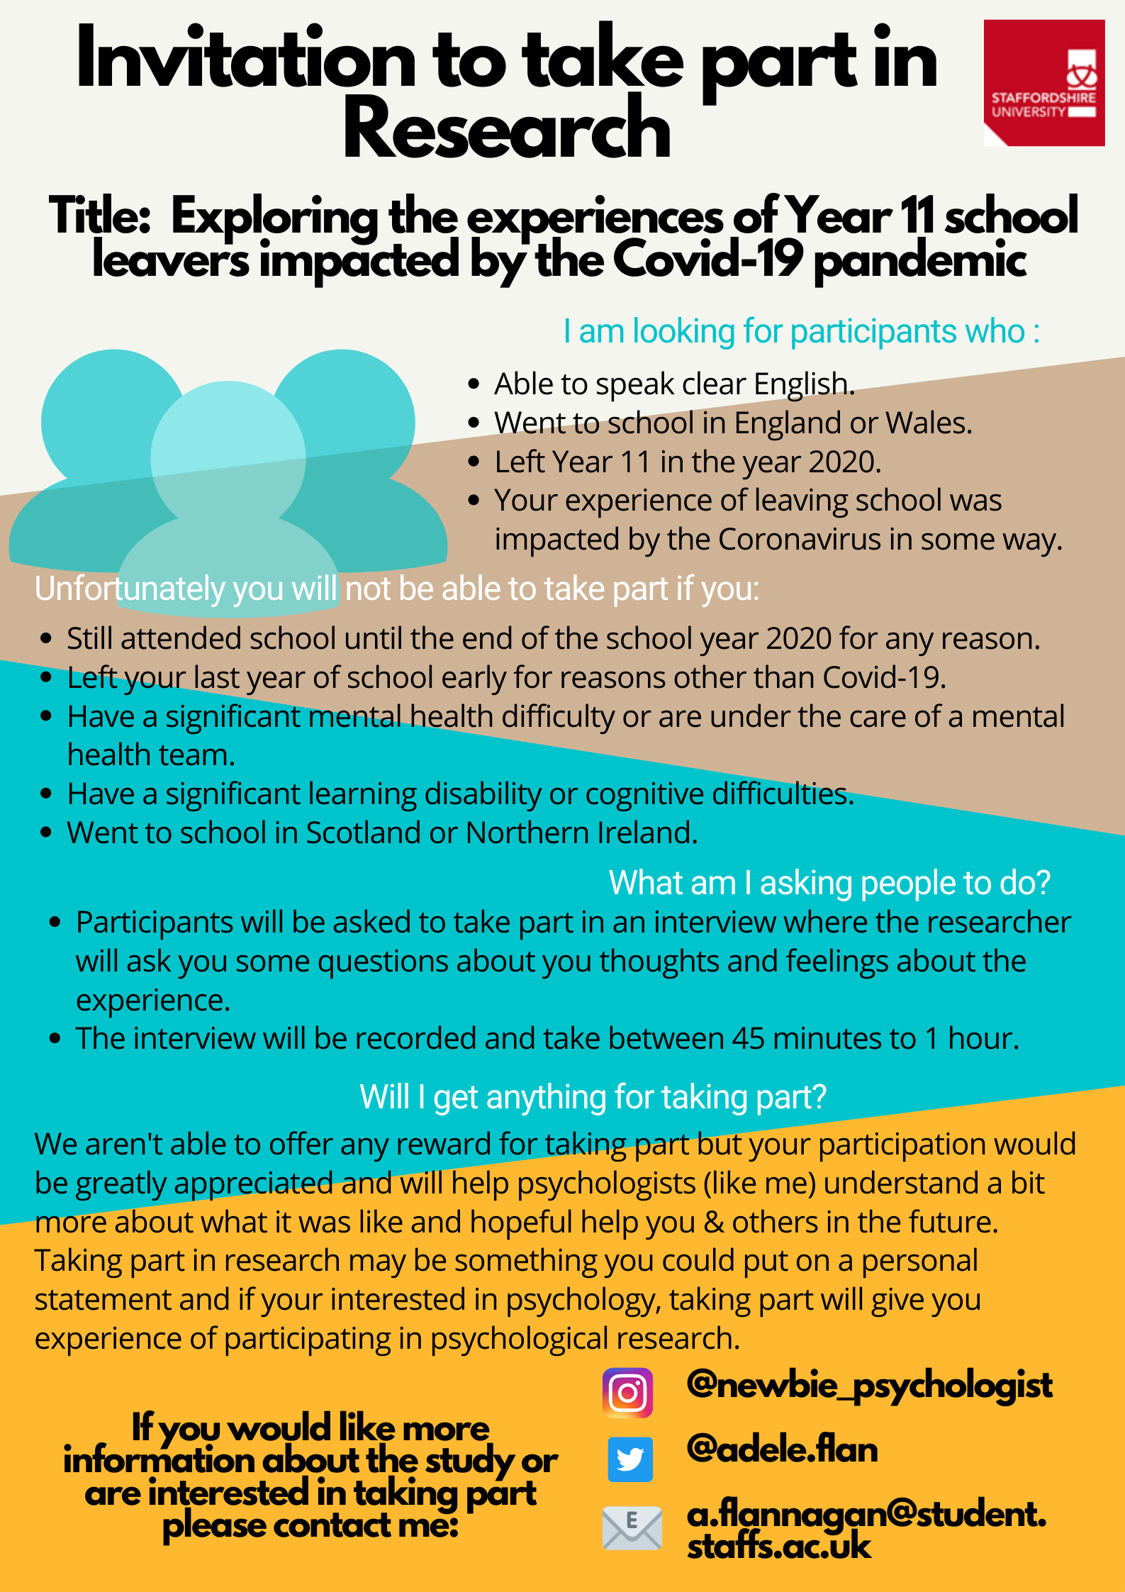
Participant Recruitment Poster

Appendix H

List of organisations
No | Name | Platform | Followers/Reach | Consented
1 | BU | Twitter | 289 | Yes
2 | Change Your Mind | Twitter | 714 | Yes
3 | edpsy.org.uk | Twitter | 3,212 | Yes
4 | Jenby's | Twitter | 295 | Yes
5 | Mind Of My Own | Twitter | 3,524 | Yes
6 | The Centre for Education and Youth | Twitter | 2,592 | Yes
7 | Zumos UK | Twitter | 531 | Yes

Appendix I

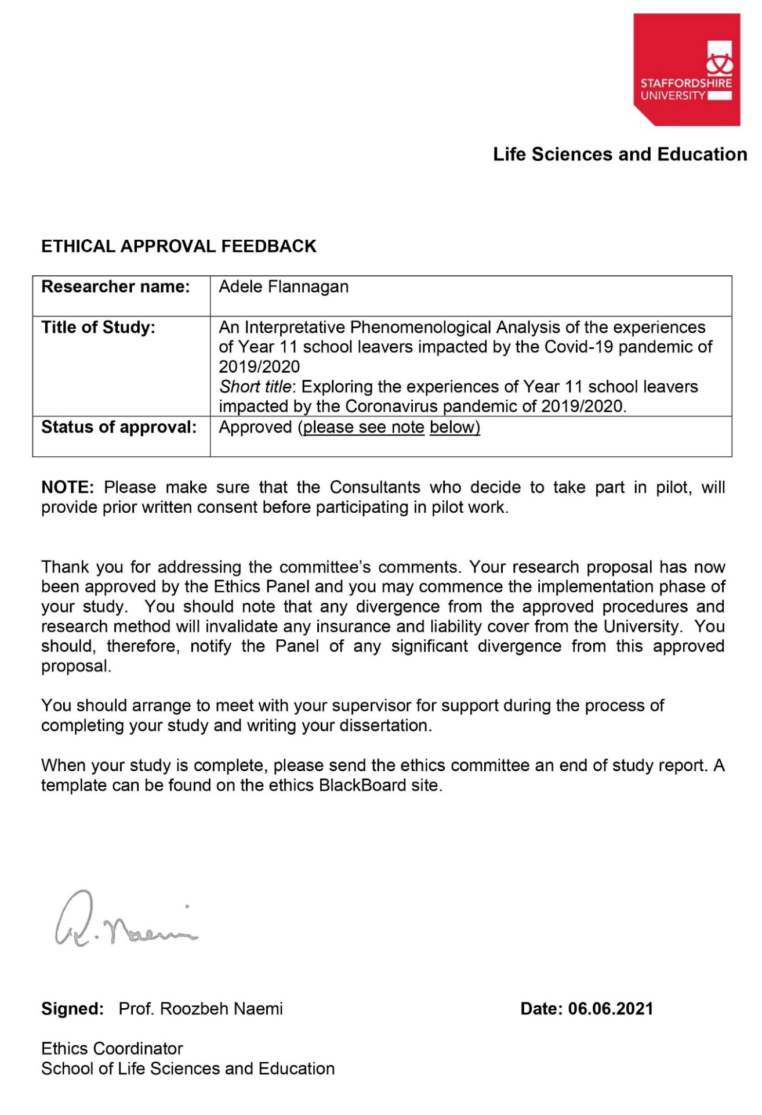
Ethical Approval from Staffordshire University Ethics Committee

Appendix J

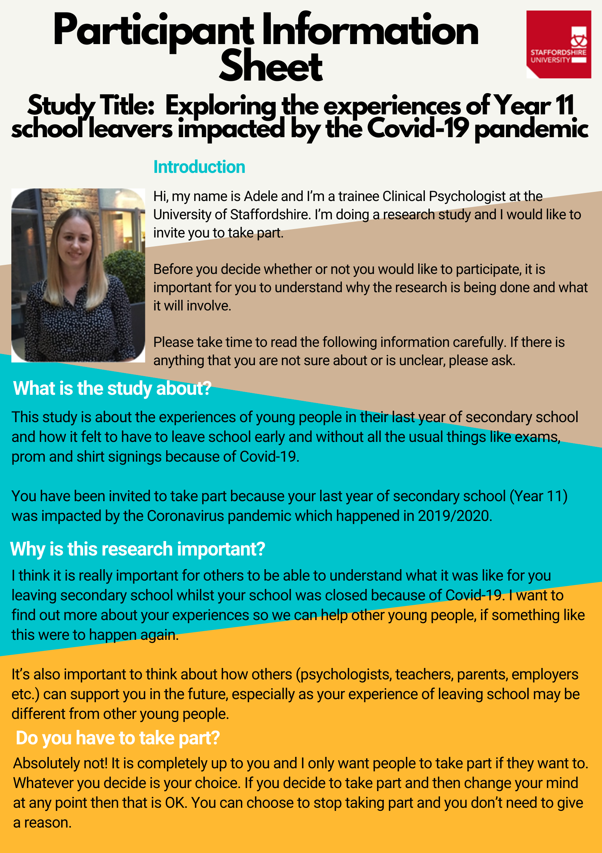
Participant Information Sheet
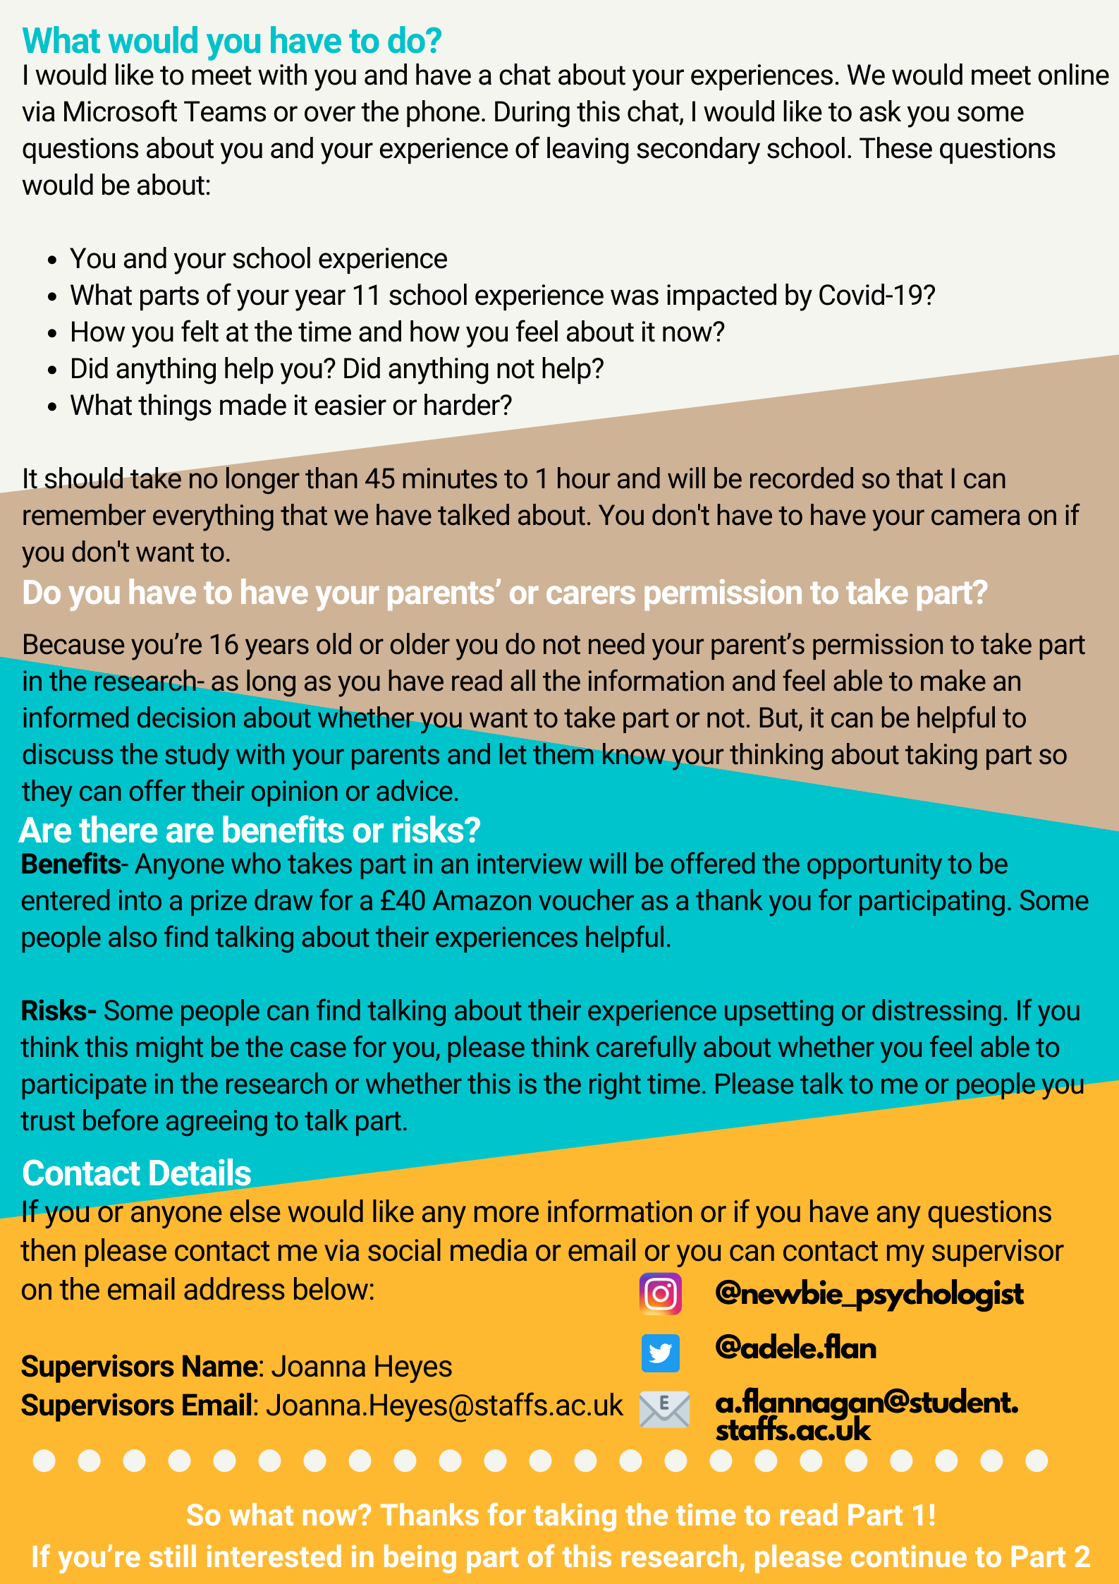
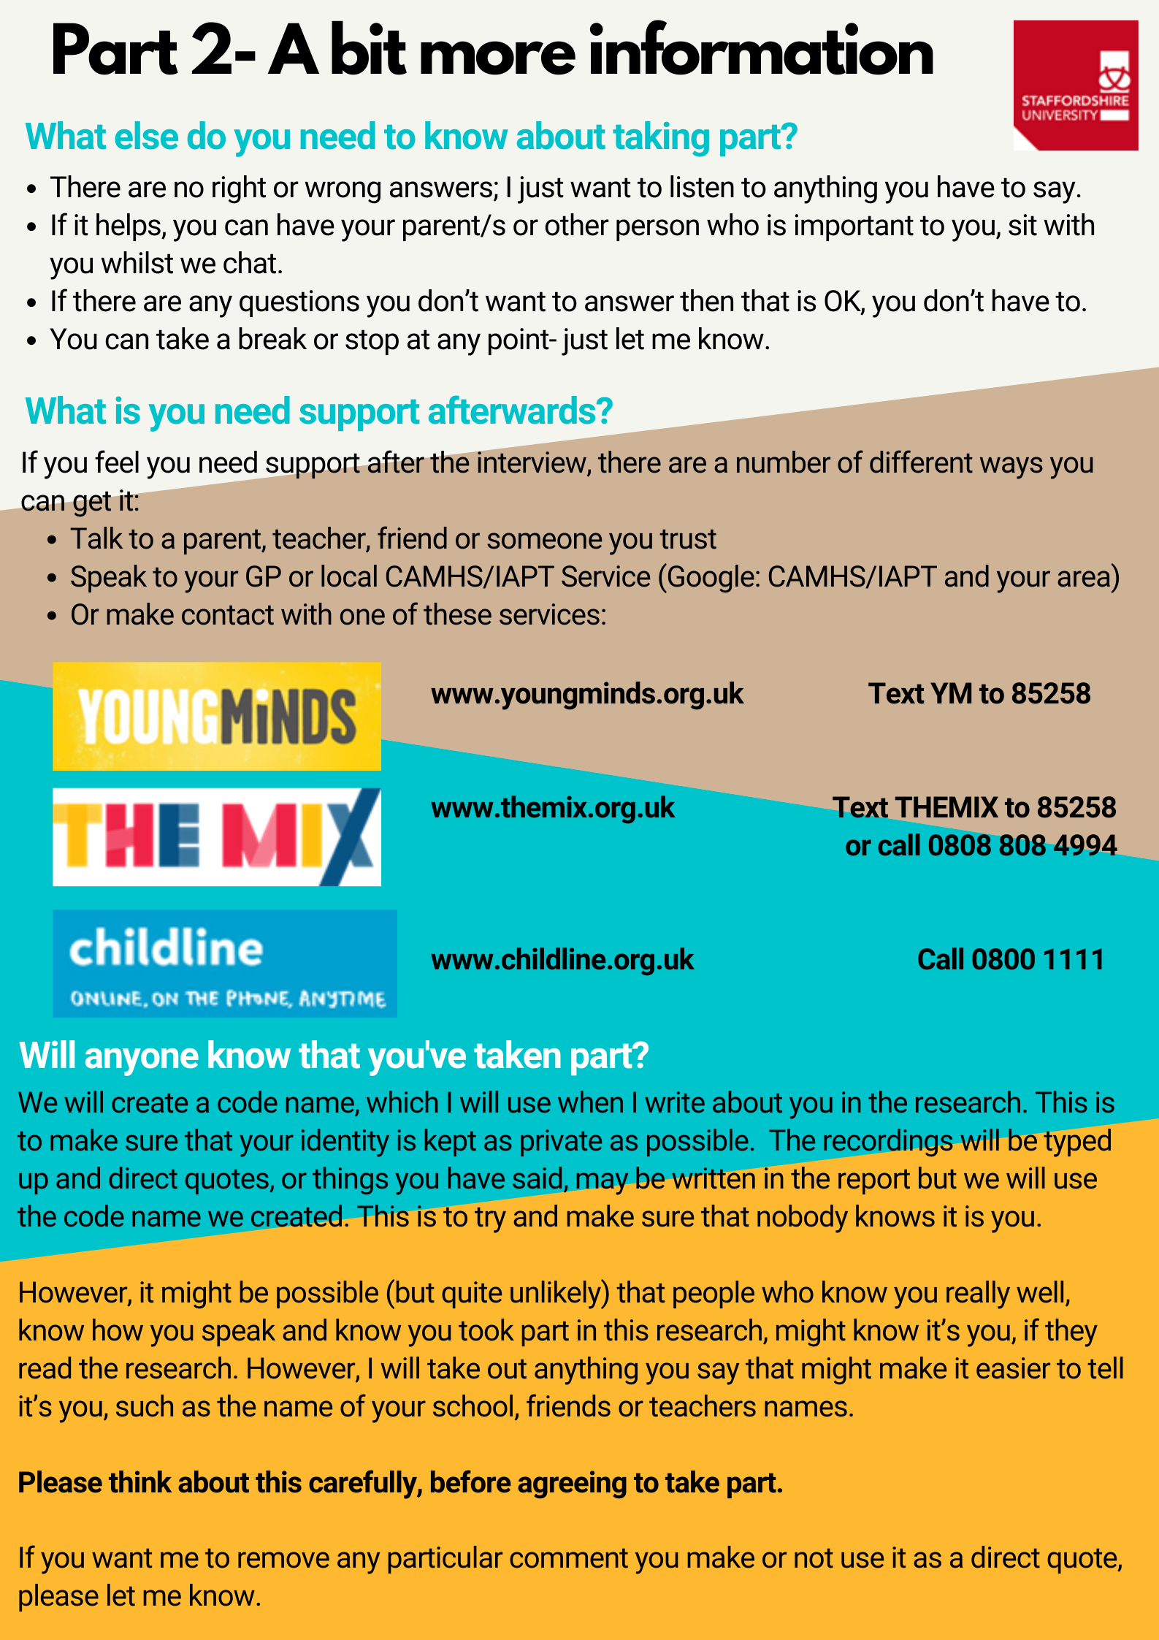
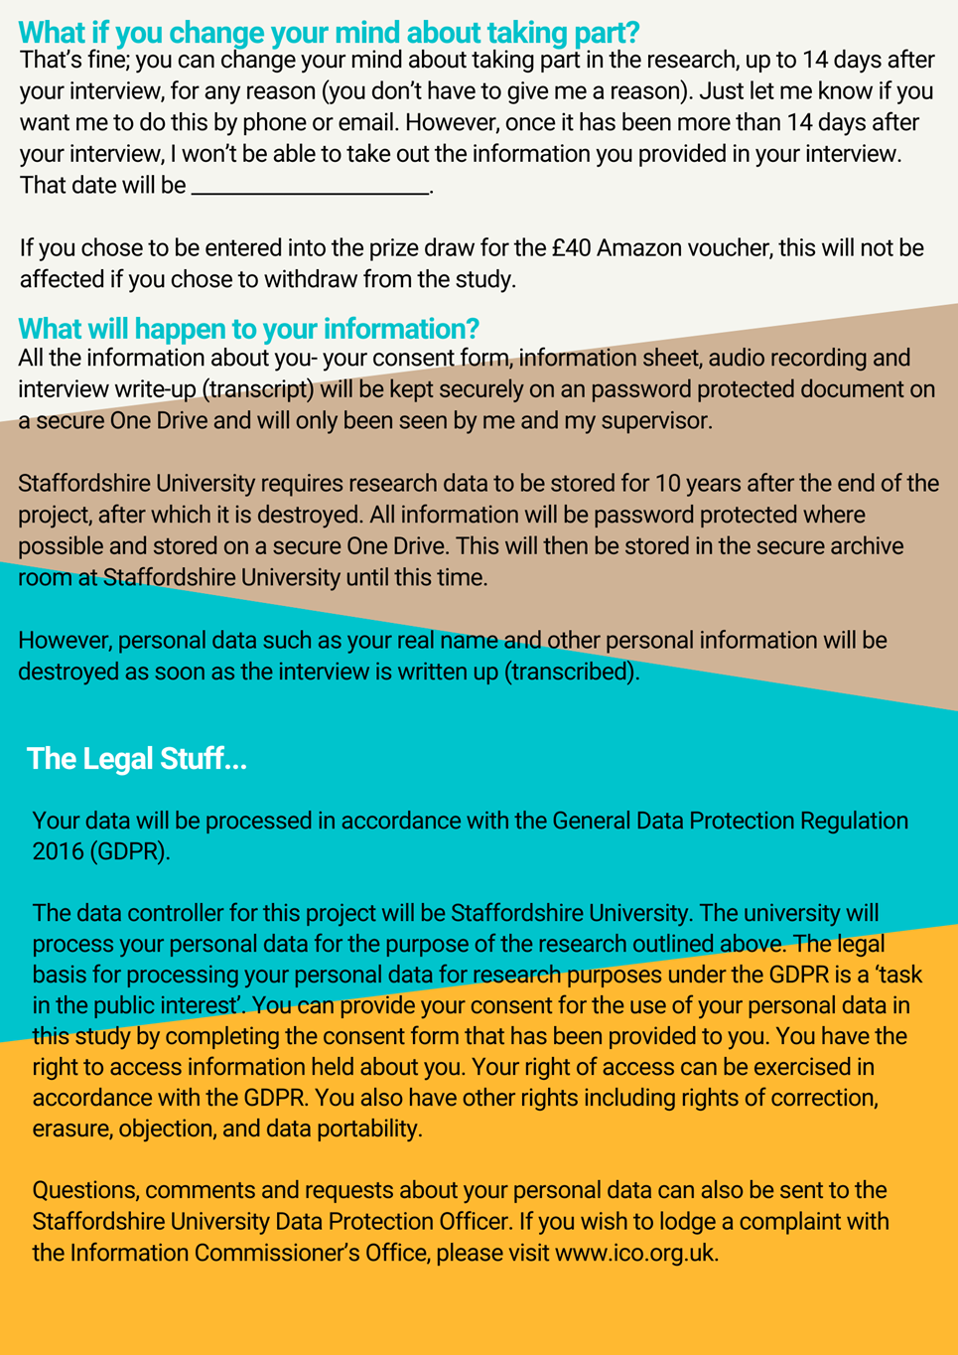
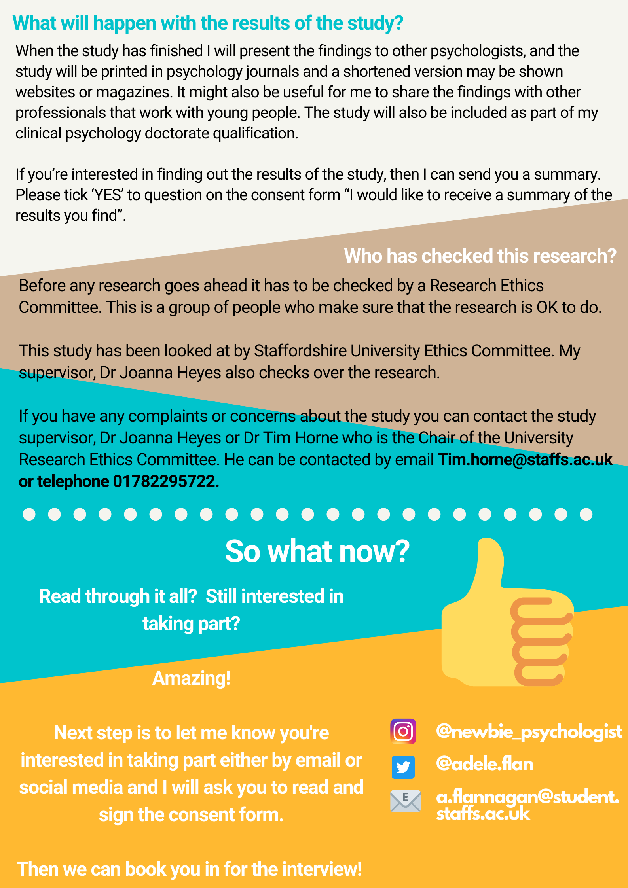

Appendix K

Participant Demographic Questionnaire

Appendix L

Participant Consent Form

Consent Form
Title of Project: Exploring the experiences of Year 11 school leavers impacted by the Covid-19 pandemic of 2019/2020.
Name of Researcher: Adele Flannagan
Participant Name: first and last name here

Please read each statement carefully. If you understand and agree with each statement, I’d like you to put your initials in the box next to the statement. If you do not understand, please ask me to explain it.
Your initials
1) I agree to being interviewed for the research project above.

2) I have read and understood the Information Sheet.

3) I have been given the opportunity to ask the researcher questions about the research and have understood the answers to the questions I have asked.

4) I understand that my decision to take part in this project is entirely voluntary.

5) I have been given information by the researcher about what the project is about, where and why it is being done, and how long it is likely to take.

6) I have been given information by the researcher of what I will be expected to do, and I have been told about any possible distress which taking part in the project may cause me and have been offered support should this happen.

7) I will tell the researcher immediately if I become upset or worried by any questions that I am asked during the interview, or if I have any concerns afterwards.

8) I know that if I say something that means me or someone I know is at risk, the researcher will need take action and may need to break confidentiality.

9) I consent to the interview being recorded.

10) I am happy for the researcher to write about what I say during the interview and publish this as long as this information remains anonymous. I understand that quotes from the interviews may be used, but these will be made anonymous.

11) I understand that I can change my mind about participating in the study until 14 days after the interview has taken place.

12) I am aware of how the information kept about me will be stored and agree for that information to be used for the purposes of this study.

13) I understand that the findings of this study will be shared with other professionals and may be printed in psychology journals/websites/magazines.

I consent for my anonymised interview transcripts to be stored in an open access repository:
Yes/No
I would like to receive a summary of the results of this study:
Yes/No
If you have answered yes, please provide an email address you wish this to be sent to:
Email address
I have informed my parents that I am participating in this study*:
Yes/No
*Please note: if you decide not to inform your parents, you will still be able to participate in this study, if you wish to.
Would you like to be entered into the prize draw to win a £40 Amazon voucher?
Yes/No
If you have answered yes, please provide an email address you wish this be sent to should you win:
Email address

Legal Stuff- GPDR Statement
Your data will be processed inline with the General Data Protection Regulation 2016 (GDPR).
The organisation who controls the data for this project will be Staffordshire University. The university will process your personal data for the purpose of this research. The legal basis for processing your personal data for research purposes under the GDPR is a ‘task in the public interest’. You can provide your consent for the use of your personal data in this study by completing this consent form.
You have the right to access the information held about you. You also have other rights including:
- The right for incorrect information held about you to be corrected.
- The right for information about you to be deleted.
- The right to object to an organisation using your personal data at any time.
- The right to get your personal data from an organisation in a way that is accessible to you.
If you have questions, comments and requests about your personal data you can contact the Staffordshire University Data Protection Officer.
If you wish to lodge a complaint with the Information Commissioner’s Office, please visit www.ico.org.uk.

I have read and understood everything written above and have chosen to consent to participating in this study. I have been given enough time to think about this and agree to follow the instructions and restrictions of the project.

Name of participant: first and last name
Date Signed: Click to enter a date

Name of person taking consent: Adele Flannagan
Date Signed: Click to enter a date

Appendix M

Interview Schedule

Introductions and Consent
Thank you for meeting with me.
Check participant has read information sheet and fully understands. Explain expectations of the interview.
- Interview will last about 45 minutes – 60 minutes.
- The aim of this interview is to gain an in-depth understanding what it was like for you leaving school and the impact of Covid-19 on it.
- The main thing that I am interested in is hearing your experiences – so there are no right or wrong answers – it is just about your experience and views.
- I may say very little because I am interested in listening to your views.
- Some questions may seem obvious but this is because I am interested in hearing your personal thoughts and feelings.
- Please take your time, there’s no rush to answer and you can choose not to answer any questions I ask.
- Reiterate audio recording, confidentiality, right to withdraw.
- Participants to sign consent form if they agree and have not done so already.

Turn on recording
Interview Questions
Rapport building

- Could we start by you telling me a bit about yourself?
Prompt: What kind of things do you like to do?
- Can you tell me a bit about you experience of secondary school?
Prompt: What subjects did you like/dislike? Did you enjoy school?
- What did you go on to do after school? Did you go to college or start an apprenticeship, for example? (Need for question 2)

Research Questions

- Can you tell me about what it was like for you when you found out you wouldn’t be going back to school because of Covid?

Prompts:
- Can you tell me about how you felt (at the time and now)?
- If participant describe feeling an emotion (e.g. happy, sad, disappointed) – Can you tell me what is was about the experience that made you feel that way?
- Did you have any ideas or expectations for what you wanted to happen when you finished school?
- What did you expect your last day to be like?
- What went through your mind at the time?
- Have your feelings about the experience changed over time? If so, in what way?
- How do you think your experience would have changed if you’d had those things?

- Can you tell me what it was like for you to then move onto (insert transitional place e.g. college, work)?
Prompts:
- What thoughts/feelings did you have at the time?
- Have your feelings about the experience changed over time? If so, in what way?
- Was there anything that made the transition easier/harder?

- Can you tell me about what finishing school was like for your mental health and well-being?
Prompt:
- What impact, if any, do you think finishing school earlier had on you?
- For you, what was the hardest/easiest part?
- Was there anything that help/hindered your mental health during that time?

Ending
- Is there anything that we haven’t talked about that you think is an important part of your experience?

General prompts
- How?
- Can you tell me more about that?
- Can you tell me what you were thinking at the time?
- How did you feel?
- What do you mean by...?
- Can you give me an example of...?
- I’ve noticed that you seem (label emotion) have I got that right?
- What did that mean to you?
- How did you make sense of that?

Debrief
- Thank the participant for taking the time to talk, very grateful.
- Explain that a debrief form will be sent to them via email, following today’s interview.
- Emphasise to contact me if they want to discuss anything further.
- Ensure there is someone they can talk to if they need to, reiterate support service contact numbers.
- Time to process and reflect on the interview. How did they find it? Do they have any additional questions?
- Ask about whether they would like to receive information about the findings. If so, how would they prefer this, face-to-face or electronic.

Appendix N

Recruitment Poster- Young People Consultants
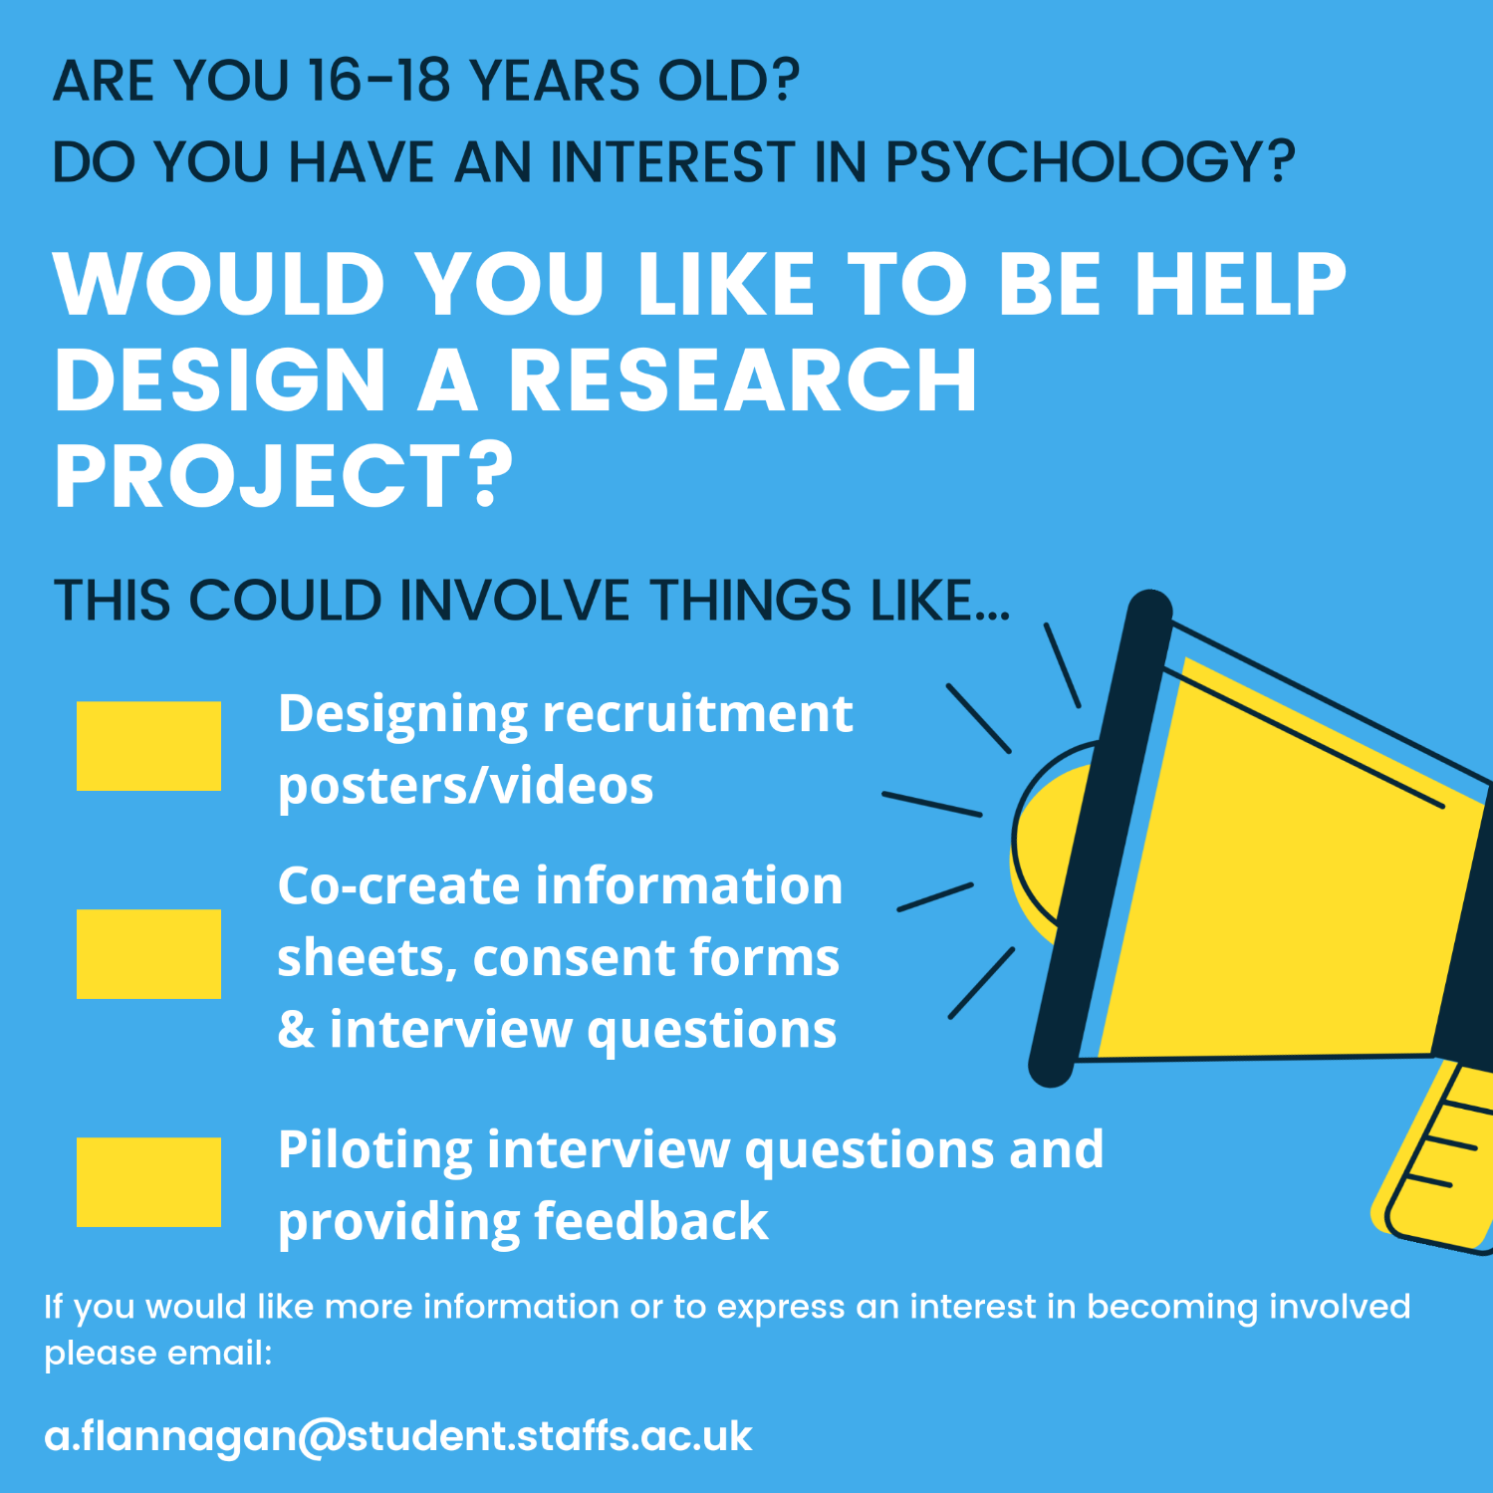

Appendix O

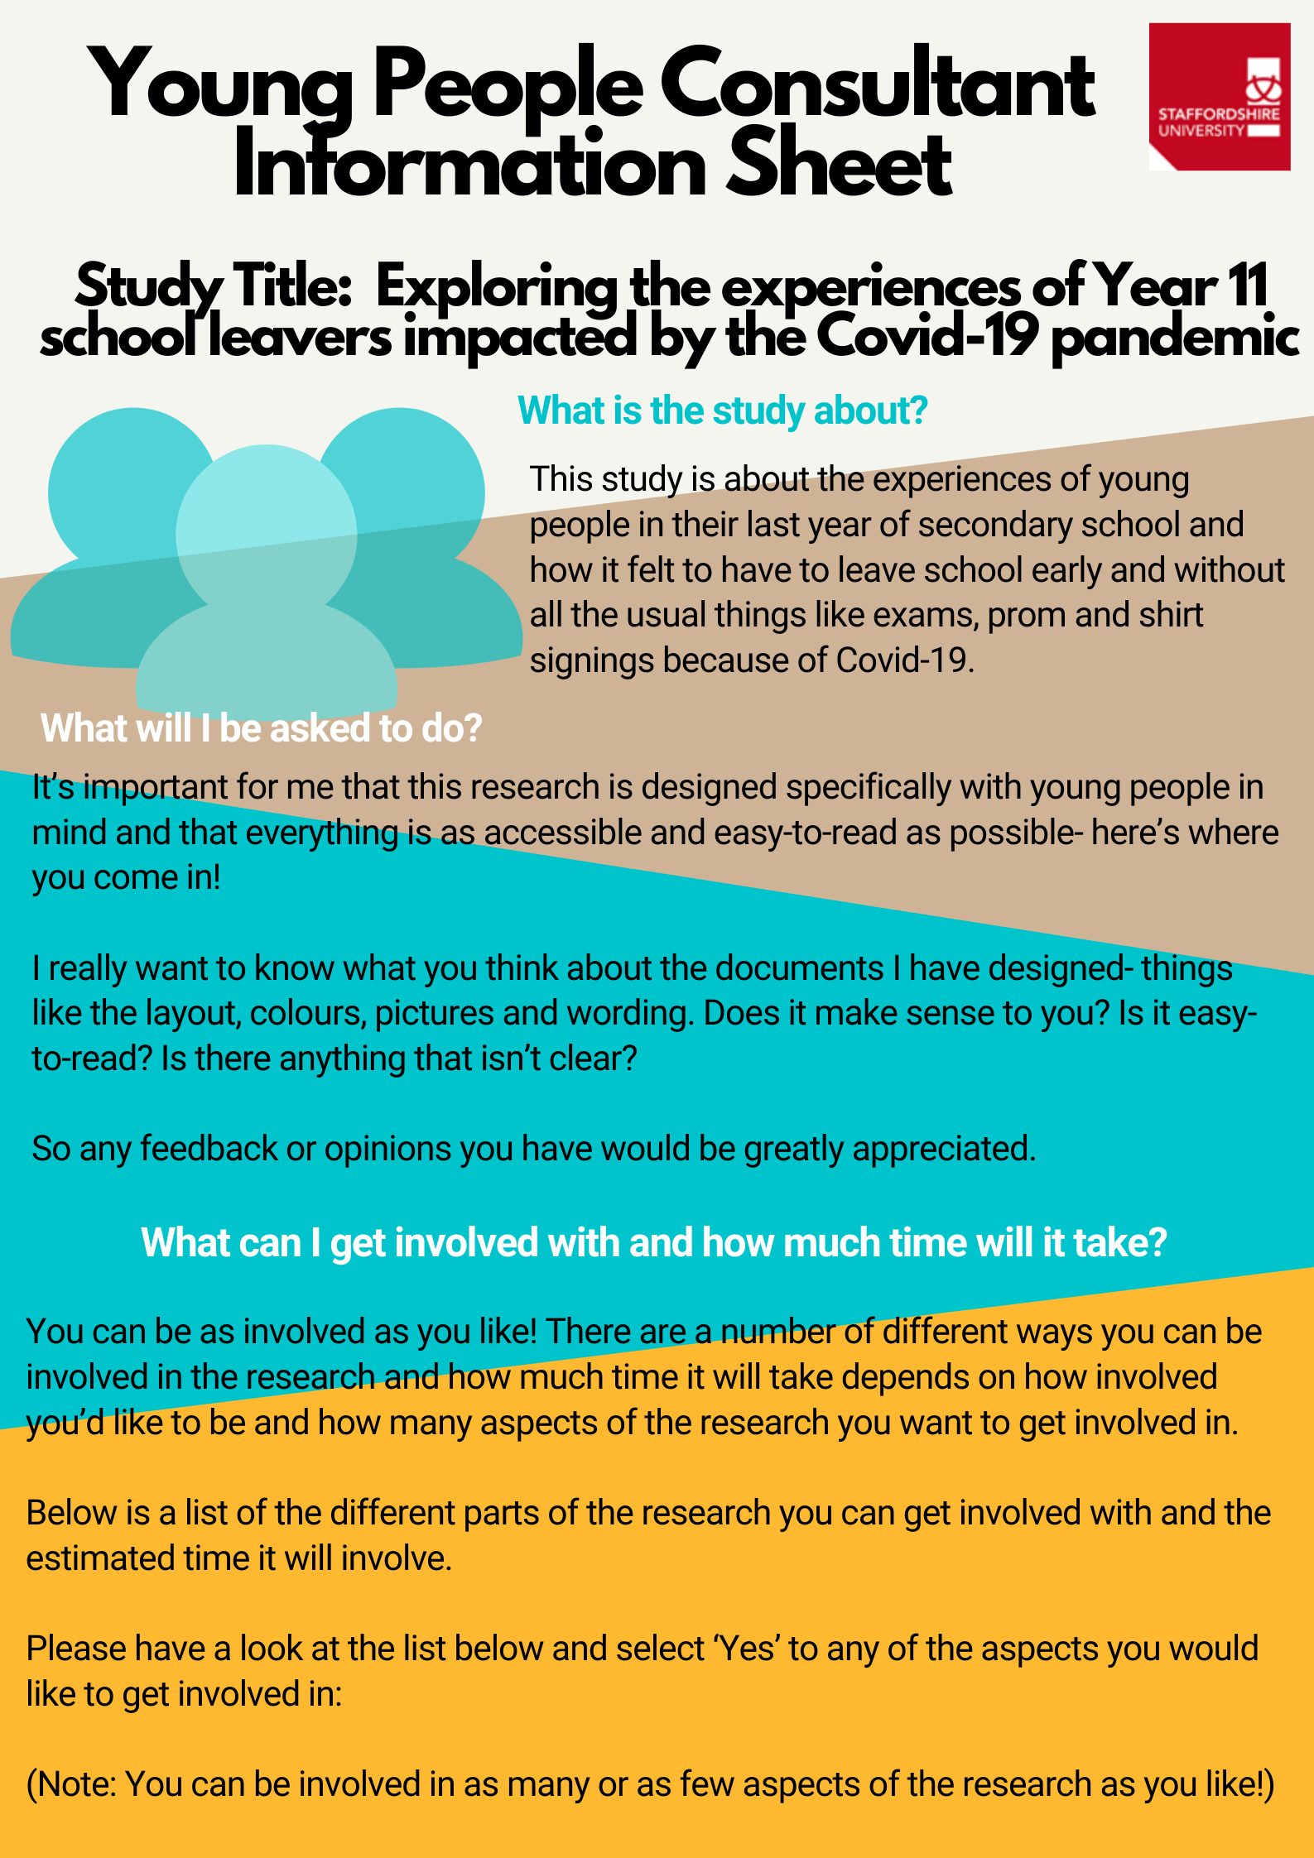
Information Sheet- Young People Consultants
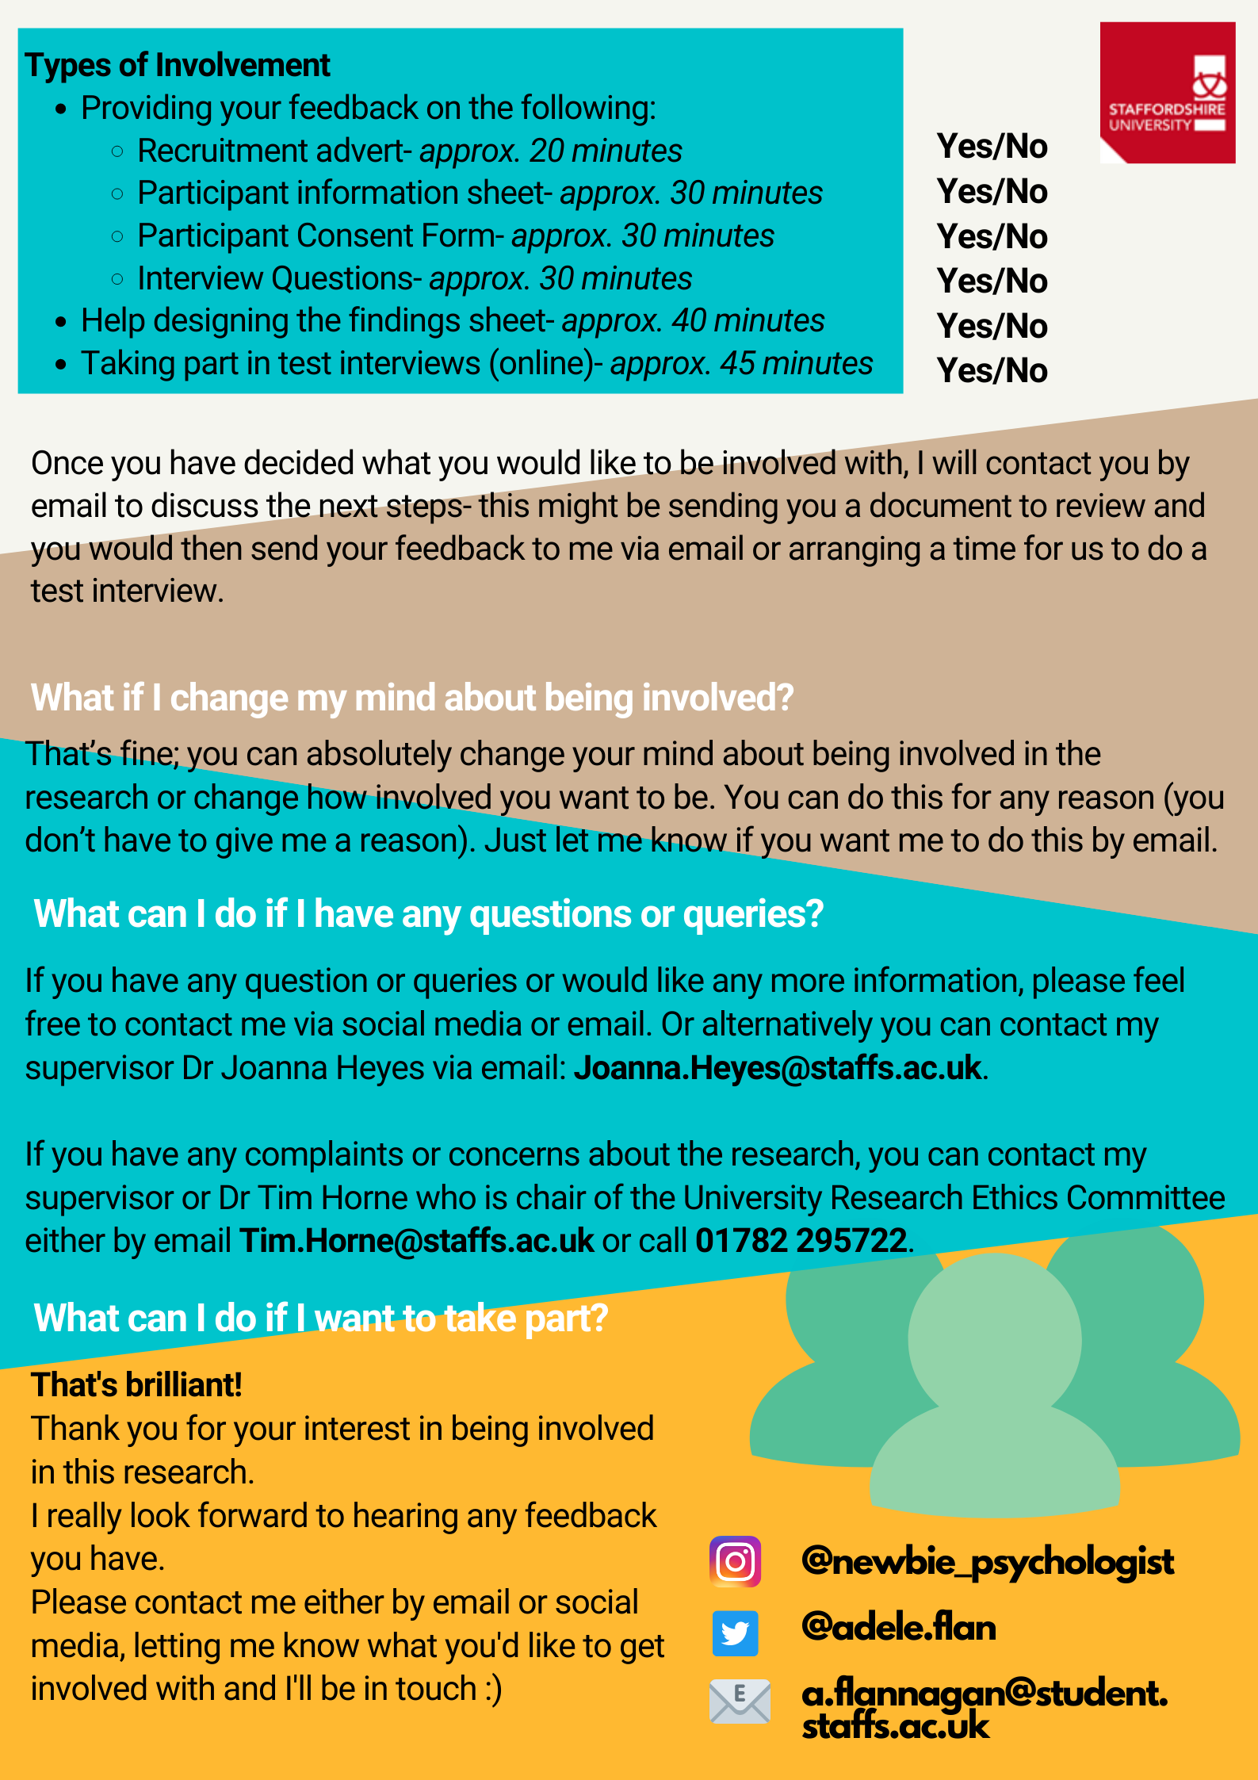

Appendix P

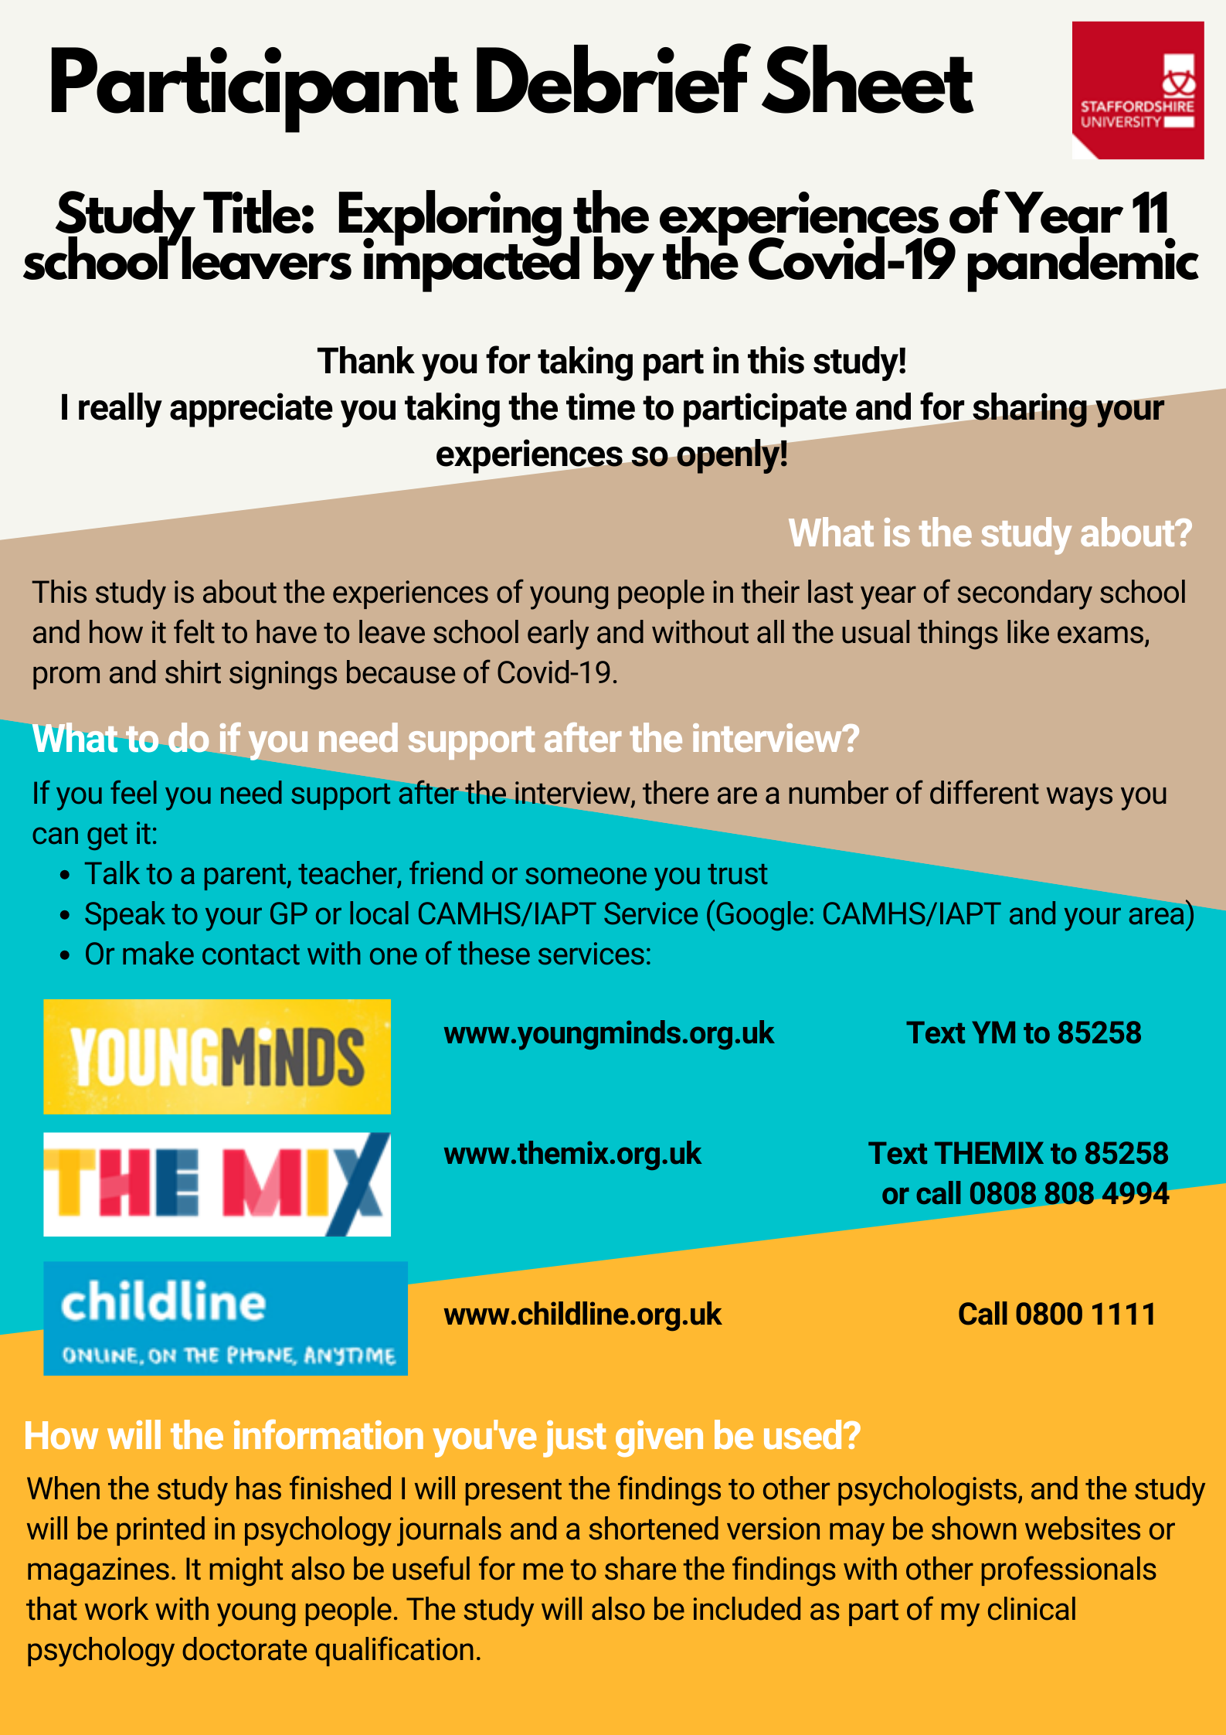
Participant Debrief Sheet
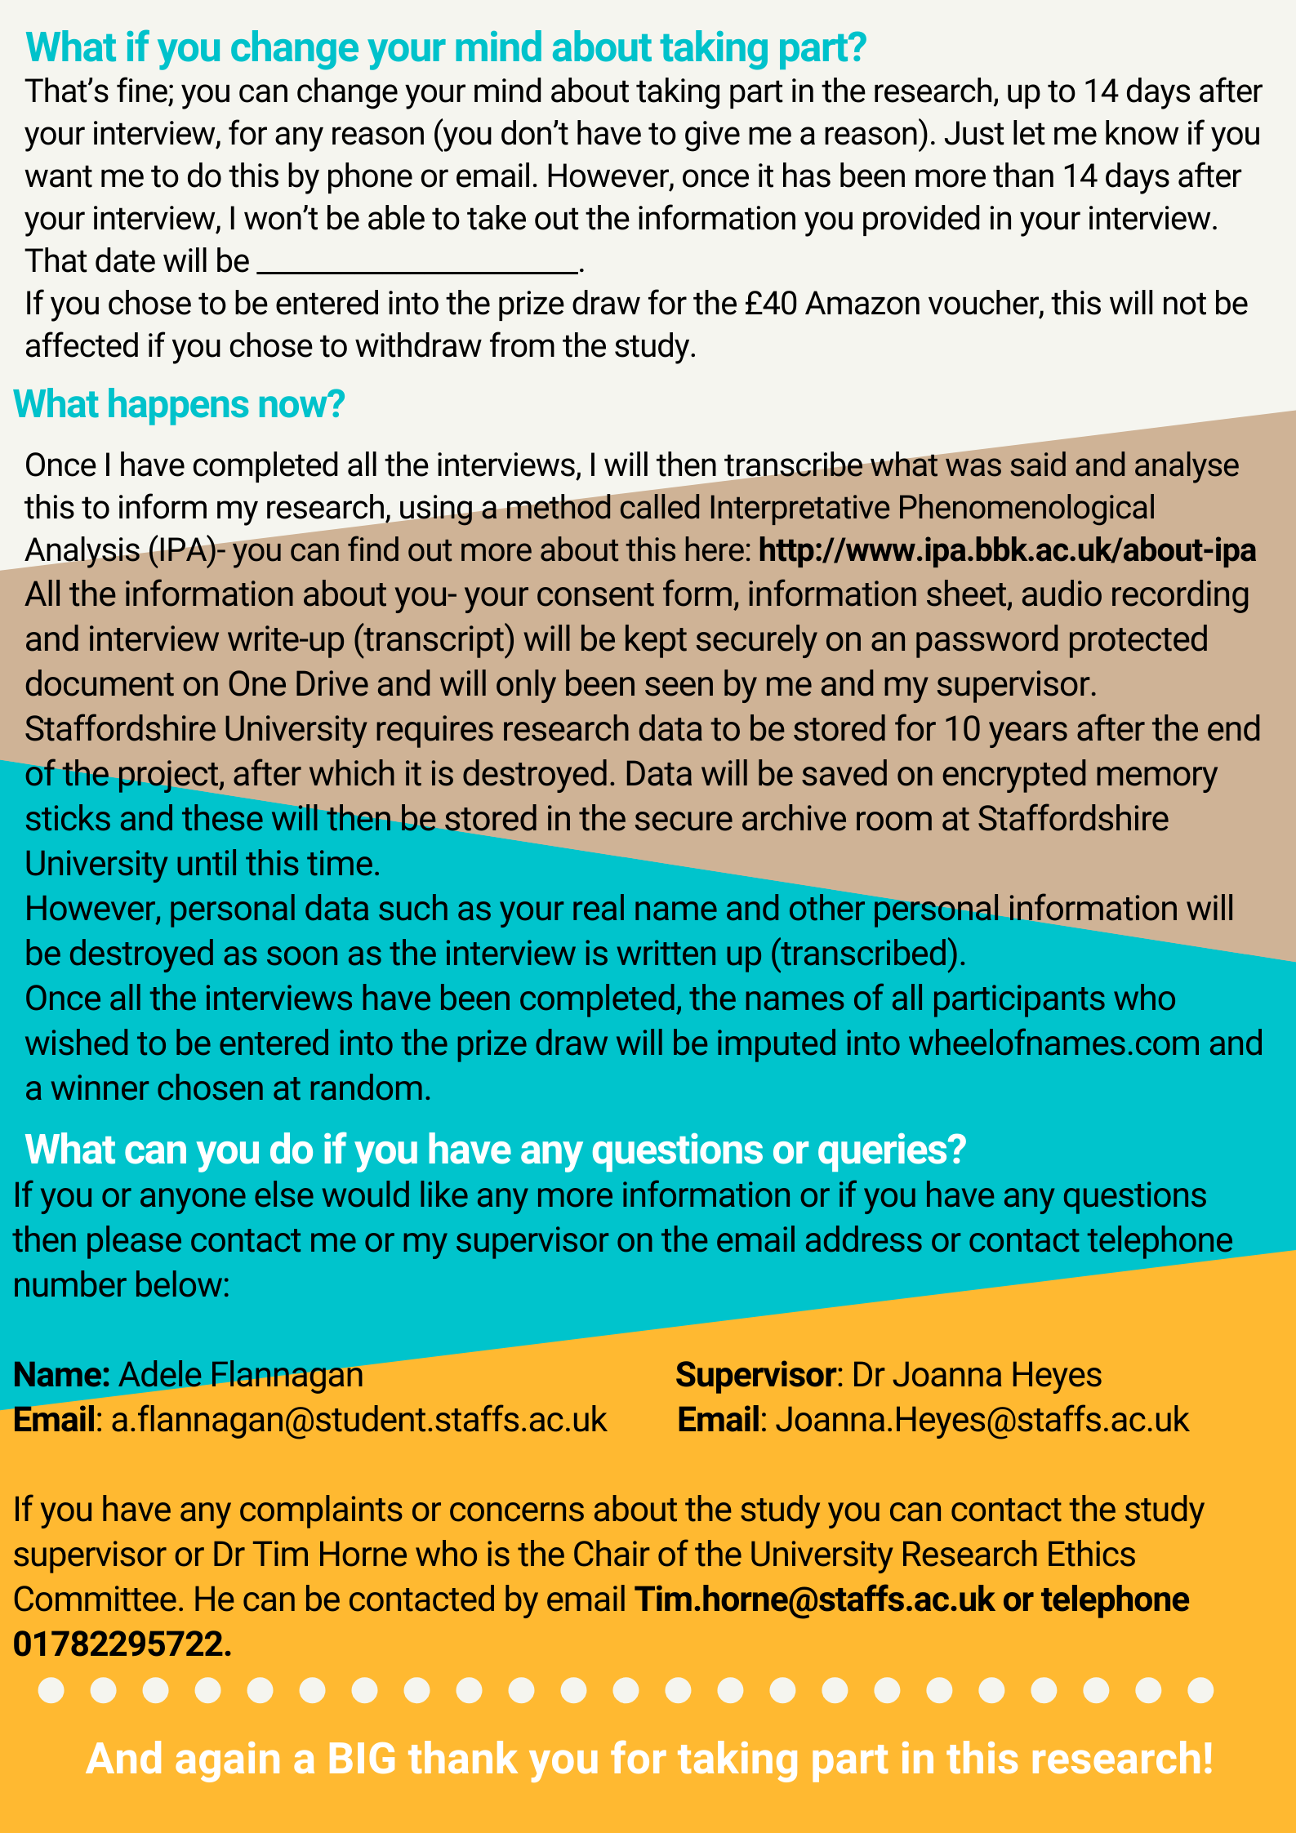

Appendix Q

Figure illustrating Interpretative Phenomenological Analysis process

Appendix R

Example Transcript with Line-By-Line Coding and Development of Emerging Themes
Example 1- Taken from transcript 2, Billie, line-by-line coding is seen in the fourth column and colour coded (green representing descriptive codes, blue was linguistic codes and orange was conceptual codes). Emerging themes are shown in the first column.

Example 2- Taken from transcript 5, Ellis, line-by-line coding is seen in the fourth column and colour coded (green representing descriptive codes, blue was linguistic codes and orange was conceptual codes). Emerging themes are shown in the first column.

Appendix S

Generating Superordinate Themes from Emergent Themes (Example from Frankie)
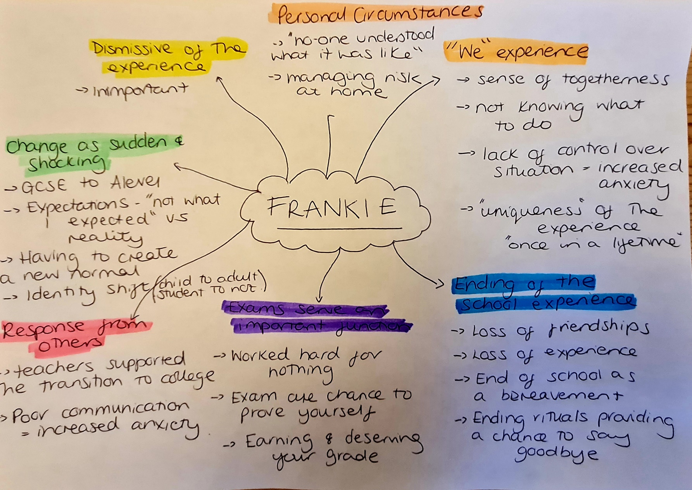

Appendix T

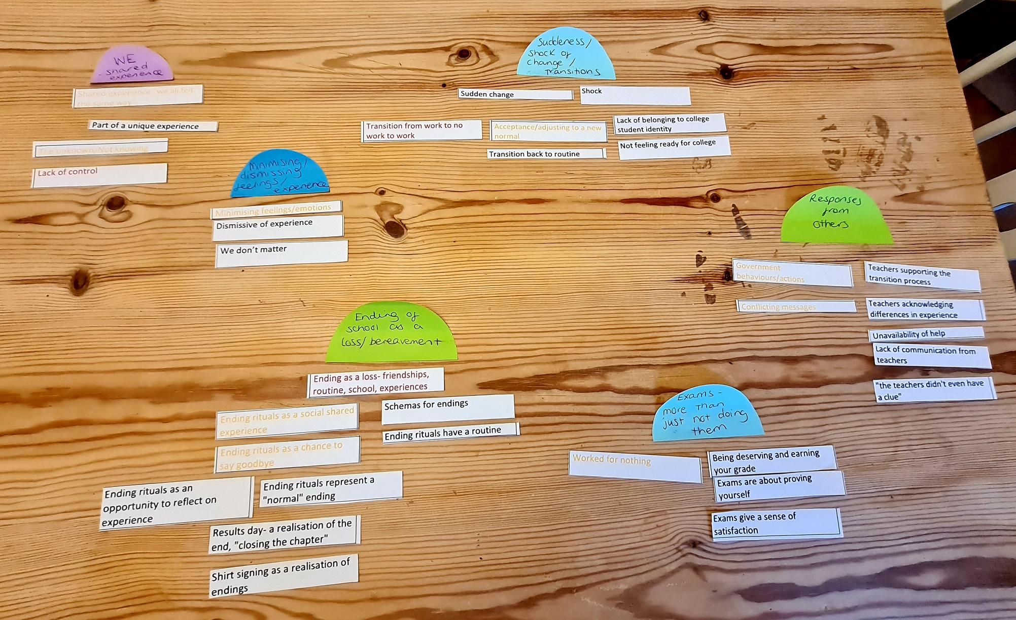
Generating Superordinate Themes across Transcripts

Appendix U

Excerpt from Researchers Reflective Diary- During Interviews and Analysis

After Interviews:

27/10/2021
I'm surprised and somewhat impressed by the maturity of the participants in relation to their experience. Surprising that very few of them are talking about the things I think I would have been upset about like prom, end of year assembly etc. Is it that those things hold less weight than when I was a teenager or is it the context in which they didn't have them- e.g. people were dying from Covid so it felt/seemed less important. Need to be mindful of this when analysing.
Noticing that many of the participants are quite dismissive of their experience- they can't be annoyed/upset about it because at the time people we're dying. How did that impact their feelings then and now?

19/11/2021
Almost all the participants use similar ways of sharing their experience- so far all of them have told their stories using speech/narratives, for example "the teacher were like…" and they would use their words- interesting! Does this have meaning?
Seems that for lots of participants their experiences are shaped by their own circumstances at the time e.g. having vulnerable family members at home, toxic home environment. How much will this have had an impact on their experience of leaving school? How will this shape the analysis as I get more participants?

23/11/2021
Noticing that it's really difficult to separate out the experience of leaving school and starting college and the impact of lockdowns- was it leaving school in the way that they did that has meant they feel certain ways or the impact of Covid and restrictions more generally? What does that means for answering my research question? Definitely something coming through about contradictions/contrast- like in some ways it was good, and some ways bad, feeling worse vs. better, not doing any work vs. doing lots of work.

First read through:

06/12/2021
Surprised about how similar the participants talk about the experience- is this because some participants went to the same school/college? What does this mean for the analysis?
Lots of talk about it being sudden/surprising- so what does that mean? What impact did this have? Seems that finishing school suddenly made the transition to college seems tricky, steeper, harder, even for those who went to their school's sixth form.

13/12/2021
Seems there was a challenge in that the experience didn't go as expected. Expectations vs what really happened- when an experience is different to what you expected what does that mean for people? What impact does it have?
Young people so much more political than I ever was as a teenager- why is that? Result of Covid? Individual interest? Brought about by necessity? Participants talk about impact of government discussions, have an opinion about them.

Initial note taking:

10/01/2022
Lots of use of the word "we"- used in almost all the speech, feeling as though they are speaking for their peers "we", demonstrated the shared experience? We're all in this together? We all had the same experience/felt the same way? Interesting shift in Interview 5- first half uses lots of "we" then changes to "I".
Real sense from interviews that they felt their experiences were dismissed/not important- grounded in reality in terms of how they were treated?
Lots of use of "just", "quite" "a bit"- e.g. I was just a bit stressed, sense of their feelings needing to be minimised/toned down. Or is this just teenage vernacular?
Almost all talk about teachers not wanting them to do ending rituals- particularly shirt-signing and a real belief from teachers that they would be returning. What was that about? How must that have felt? Particularly when it seems most of the young people felt they "knew" they wouldn’t be coming back.

17/01/2022
Interestingly for participants seems although friends still existed during lockdown, there was a felt sense that they didn't- that they had no friends?
Almost grief style language use- losing, gone, lost. Was the experience almost like a grieving process, lost experiences, lost friendships?
Contrasting feelings on advantages/disadvantage of transitioning to school sixth form- in some ways it was beneficial but in some ways not. Knew the environment/some of the teachers but made the transition to "feeling" like a Year 12 harder, the environment was the same, they felt the same but it didn't "feel" the same.
Mixed feelings about exams- initially glad not to take them, some felt it was more representative of ability but also wanted an opportunity to prove self. Sense that grades were given not earn. Was this down to how individuals feel about exams or how well they feel they would perform in exam conditions?

Appendix V

Master Table of Themes

Superordinate Themes | Key Quotes | Subordinate Themes | Key Quotes
1. “We all felt the same way” | Alex: "we all kind of got through it together and helped each other out, I guess" lines 105-106.  Harper: "it was really nice to know that all my friends and mates were in the same boat as I was. It wasn't just like Covid has impacted me, it impacted everyone. It wasn't just a me thing, it was we're all in the same situation here" lines 404-407. | A. “It was the unknowness of it all” | Alex: "it was just very hectic that day, because no-one knew what was going on" lines 14-15.  Billie: "everything else was closing down around, like the schools were one of the last things to shut really. So everything was just a bit, like unknown. We didn't really know what to do with ourselves" lines 11-13.  Frankie: “we had no like, instructions or anything. Like what do you do in a pandemic?" lines 41-42
 | Billie: "I think we were all confused, which kind of helped because at least we all felt the same way" lines 198-199. | B. “There’s nothing I can do about it” | Billie: "you'd worked really hard for something and then it kinda was just like, okay, well you haven't got any control over the outcome of it now" lines 286-288.  Dylan: "there's nothing I can do about it" lines 162-163.  Harper: "I think the constant reminder that the lockdown and everything that happened wasn't my choosing…that was harsh, that I had no control over anything” lines 642-643.
2. Endings as a Loss | Alex: "suddenly having nothing and no-one really, in person to talk to and stuff. That was the hardest part because I felt like I suddenly lost everyone even though I hadn't" lines 182-184.  Frankie: "I didn't get to talk to them so they were just gone" lines 307-398. | A. The Loss of Ending Rituals | Billie: "I think the thing that I miss more than anything was an in person results day. That felt weird to me. Like I wanted to be able to go up to the teachers and be like, look what I got" lines 136-138.  Ellis: "we didn't get that nice, rounded ending, like whether a leavers service or prom, things like that. So there wasn't that sort of nice ending, saying goodbye to people" lines 7-9
 | Harper: "It really feels like you're part of something when you attend an academy or something. So that when you leave, it's…you know, you're not just leaving the school, your losing almost a community I guess" lines 75-78. | B. Loss of the Dream: “I’d always dreamed of getting to the end of the school year” | Alex: "All of that kind of schema of like, last day of school just went completely" lines 41-42.  Gabe: “I just had this dream for the end . . . there were so many things that was supposed to happen before you left school when it doesn't its like, it just, it just isn't right" lines 93-96.  Harper: "in my mind, you do your exams, you know, you have your prom at this day. . . And then having the lockdown just sort of, it threw off the schedule and I didn't know what was going to happen next" lines 168-171.
3. “It’s definitely deeper than just not sitting GCSEs” |  | A. “It just felt like it was for nothing” | Billie: "And like you kinda spent so long doing something all for it to not come to anything, like it didn't really matter what you've done for the whole two years before that for your GCSE's . . . It just felt like you'd wasted your time" lines 44-49.  Ellis: "I've been working so hard for two years on  GCSE specific work and it's just it was so frustrating…like it just felt like it was all for nothing" lines 13-14.  Harper: "Like everything I've been doing up until that point was useless. Because I'd done five years of secondary school for absolutely nothing" lines 549-551.
 |  | B. “I never got to prove myself” | Ellis: "I think the satisfaction of probably doing exams would have been a lot better, you know, rewarding, I would have felt more proud of myself because I'd earned those grades" lines 74-77.  Frankie: "I think it would have been really different because it would have given me like, I would have been able to prove my grades because with not being able to take exams, I was just kind of given a grade" lines 91-93.
4. “It was so sudden. And I guess just a bit of a shock.” | Charlie: "it's a big shock because we'd had like so many months off and because our exams got cancelled we didn't really have work to do in that time . . . And then we went back straightway it was like a lot, it was like A levels. So it's a lot and it was just a big shock really” lines 189-191 &  194-196. | A. “Laziest person on earth to the Einstein of the world” | Billie: "Then obviously going from revising hard-core every day to doing nothing, it's quite a drastic change" lines 299-301.  Gabe: "it felt like a really long time went by where I had no work to do . . . I think being away from work for that long, it made it a lot more difficult to get back into it" lines 53-254 & 257-258.
 |  | B. “A new kind of normal” | Alex: "I guess right now, we've got cases at school rising constantly. It's just kind of normal though, which we just kinda got used to and accepted that's it's gonna happen" lines 77-80.  Charlie: "it was a bit shock but then a bit after it was kind of, it was normal after which is weird" lines 30-31.
 |  | C. “I should still be in Year 11” | Dylan: "it still kind of felt like I just returned to Year 11. . . It felt like I should still be in Year 11. I was like I'm done, I'm not going back to high school, like I'm in the next stage of life" lines 195-197.  Harper: "I'm at college now, I know I'm a college student and I'm doing A levels but why do I still feel like I'm Year 11" lines 355-358
5. “It's fine, but it's not fine is it?” | Billie: "I don't think anyone else really seems to care which baffled me” lines 348-347.  Billie: "You're just a bit confused. I wouldn't say betrayed. I think that's a bit strong, because it wasn't really their fault. But like you just felt a bit lied to" lines 42-44. | Charlie: "like yeah, we didn't  get prom but people were dying. So like it's not that important" lines 387-388.  Ellis: "without being too dramatic…it kinda drove me insane, you know, it was just very…I think it was just very hard to cope with" lines 256-258. | Frankie: "I felt I mean neglected I guess"  lines 28-29.  Harper: "I know that while I was stuck  indoors, there are people like literally dying  of it. So I wanted to make sure I wasn’t  enjoying it too much because that isn’t fair”  lines 637-639.
6. Others: Helped and Hurt |  | A. Teachers: The good and the bad | Charlie: "our teachers that we have now are very aware of the fact that we haven't had a normal experience and not…they're not lenient but they understand the fact that we haven't had the exam experience and we're not used to it and it has been a big jump and a big shock. I think that's good" lines 345-349.  Ellis: "I guess they just sort of made the introduction really welcoming. And they didn't put a lot of pressure on us at the start" lines 184-185.  Frankie: "it was the fact that they didn't communicate with us as well made me quite annoyed because it was like, well what am I supposed to do? I can't reach out because I have no-one's email from school" lines 143-146.
 |  | B. “The government doesn’t like making things easy” | Billie: "even now, they're not being very clear, which I don't think it's fair for like my year" lines 359-360.  Dylan: "Like, I knew that they would have to cancel exams, or they'd have to be like, made really easy but the government doesn't like making things easy" lines 74-76.  Harper: "the fact that there we so many government kind of like, uncertainties, we'll say because no-one knew how to react to a virus, especially the government. And it just kinda made me feel afraid for the future” lines 624-627.

Paper Three: Executive Summary¹

“I think my year is one of the ones that did get a bit lost and forgotten”
Exploring the experiences of Year 11 school leavers impacted by the COVID-19 pandemic

¹With sincere thanks to the young people consultants for reviewing a draft of this paper and providing valuable feedback.

