“Now I know he's let me in…"
Teaching Assistants’ Experiences of supporting Looked After Children:
An Interpretative Phenomenological Analysis.

Adam Matthews

Thesis submitted in partial fulfilment of the requirements of Staffordshire University for the degree of Doctorate in Clinical Psychology

June 2023

Total word count: 18340

THESIS PORTFOLIO: CANDIDATE DECLARATION
Title of degree programme | Professional Doctorate in Clinical Psychology
Candidate name | Adam Matthews
Registration number | XXXXXXX
Initial date of registration | September 2020

Declaration and signature of candidate
I confirm that the thesis submitted is the outcome of work that I have undertaken during my programme of study, and except where explicitly stated, it is all my own work.
I confirm that the decision to submit this thesis is my own.
I confirm that except where explicitly stated, the work has not been submitted for another academic award.
I confirm that the work has been conducted ethically and that I have maintained the anonymity of research participants at all times within the thesis.

Signed: Date: 30th June 2023

Table to show word counts
Title | Word Count
Acknowledgments | 83
Thesis Abstract | 244
Paper one: Literature Review | 7969
Paper two: Empirical Paper | 7993
Paper Three: Executive Summary | 2051
Total Word Count | 18340

Acknowledgements

Firstly, I would like to express my gratitude to the teaching assistants that gave up their valuable time to share their experiences and take part in the research. Thank you for the work that you do and the support you offer to young people.

Secondly, thank you to Dr Paul Beeson for supporting the project and reaching out to the local school community.

Finally, my thankfulness goes to Dr Yvonne Melia. Your expertise, reassurance, guidance, and most of all patience, has been invaluable.

Table of Contents
Acknowledgements 3
Thesis Abstract 8
Paper 1 9
Risk and Mitigating Factors for Compassion Fatigue in Teachers 9
Abstract 10
Introduction 11
Rationale 13
Review Question 14
Definitions and Terminology 14
Compassion Fatigue 14
Burnout 15
Secondary Traumatic Stress 15
Compassion Satisfaction 16
Teachers 16
Method 17
Scoping Searches 17
Search Strategy 17
Publication Bias 19
Quality Assessment 19
Results 21
Search Results 21
Study Characteristics 21
Quality Appraisal 38
Overview of Methodological Quality of Studies 38
Recruitment and Sampling 38
Procedure 39
Measures 39
Professional Quality of Life Scale (ProQOL) 39
Synthesis of Main Findings 41
Demographic and personal factors 41
Professional Factors 42
Relationship factors 43
Discussion 45
Conclusion 48
References 50
Appendices 57
Appendix A 57
Appendix B 59
Paper 2 62
“Now I know he's let me in…" TAs experiences of supporting looked-after children. An Interpretative Phenomenological Analysis. 62
Abstract 63
Introduction 64
Rationale and Aims 67
Research Question 67
Method 68
Ethical Considerations 68
Design 68
Participants and recruitment 69
Procedure 71
Analysis 71
Epistemological perspective and hermeneutics 72
Results 74
Theme 1: No escape – The challenge of maintaining self-other boundaries. 74
Theme 2 – “No money in the world” – The pride and joy that TAs experience. 80
Theme 3 - “Banging your head against a brick wall” - Frustrations of TAs working with LAC 83
Discussion 87
Theme 1: No escape – The challenge of maintaining self-other boundaries. 87
Theme 2 – “No money in the world” – The pride and joy that TAs experience. 88
Theme 3 - Banging your head against a brick wall - Frustrations of TAs working with LAC 89
Strengths and limitations of the study 90
Practice implications 90
Future research 91
Conclusion 92
References 93
Appendices 101
Appendix A - Ethical Approval 102
Appendix B – Information sheet and consent form 105
Appendix C- Recruitment Poster 112
Appendix D- Table detailing the Facebook teaching assistant groups where the research was advertised. 113
Appendix E - Interview Schedule 115
Appendix F- Example of transcript analysis 118
Appendix G - Example of personal experiential theme development. 119
Appendix H - Development of GETs from PETs 120
Appendix I – Table of GETs and PETs and example quotes 121
“Now I know he’s let me in….” TAs experiences of supporting looked after children. Executive Summary 124
124
What did the study aim to do? 126
What was done? 126
Who could take part? 126
Who did take part? 127
What was found? 127
What does this mean for teaching assistants and schools? 131
What this study did well, and what it could have done better? 131
What might this mean for future research? 132

Thesis Abstract

Paper 1 is a literature review of the risk and mitigating factors for compassion fatigue in teachers. Teacher attrition rates are high globally due to the demanding dual roles teachers face and the resulting psychological impact. This review examines the risk and mitigating factors of compassion fatigue (CF) among teachers. Twelve studies reveal themes: personal factors, professional factors, and relationship factors. Self-care practices like mindfulness and certain professional relationships help mitigate CF. A trauma-informed teaching approach is beneficial. Experienced teachers experience lower CF and higher compassion satisfaction (CS). Identifying these factors helps institutions support staff and reduce attrition rates. Further research can clarify definitions and implementation.

Paper 2 is an empirical paper which used IPA to understand the experiences of TAs supporting looked after children. Over 82,000 young people in England were classified as 'looked after' in 2022, facing academic challenges and special needs. Teaching assistants provide crucial emotional support to these students, but research on their experiences is lacking. This project explored the experiences of six TAs working with looked-after children through interviews and analysis. Findings revealed difficulties in disengaging from the role, pride and joy in their work, and the need for better preparation and training. TAs could benefit from additional training specific to working with looked-after children.

Paper 3 is an executive summary of the empirical paper, written to be accessible to teaching assistants. It can be distributed to teaching assistants, special educational needs and disability coordinators, and school leaders.

Paper 1

Risk and Mitigating Factors for Compassion Fatigue in Teachers

A Literature Review

Word count = 7969

Author Note
Paper one has been been written with the intent for publication in the School Psychology journal. Amendments will be made prior to submission to the journal to ensure the papers adhere to all submission guidelines.
Abstract

Levels of teachers leaving the profession are high in the UK and globally, which may be partly due to the dual roles that teachers undertake both in teaching and pastoral roles and the psychological impact of these. This review aimed to examine the risk factors and mitigating factors of the psychological impact of teaching in particular relation to compassion fatigue (CF). Twelve studies were systematically identified, reviewed, and critically appraised using the Crowe Critical Appraisal Tool. Factors from these studies were grouped into three themes: demographic and personal factors, professional factors, and relationship factors. Although common factors were identified, there were also contradictions between studies, and no specific factor appeared to be the most prominent. Despite some contradictions, the review contributes tentative support to existing research on various factors that can help alleviate compassion fatigue. The findings support the effectiveness of self-care practices, specifically mindfulness, as well as certain professional relationships in mitigating CF. Furthermore, adopting a trauma-informed approach to teaching appears to be a protective factor against CF. The review also suggests that older and more experienced teachers may experience lower levels of CF and higher levels of compassion satisfaction (CS). By identifying risk and mitigation factors of compassion fatigue, educational institutions may be able to offer support and guidance to staff to improve well-being, absence, and attrition levels. Additionally, as research progresses, there is a possibility of reaching a greater consensus on how these concepts are defined and implemented.

Introduction

The levels of teachers leaving the profession are high. The last ten years have seen an increase year-on-year in teacher attrition levels (Fullard, 2021). A National Education Union survey (The State of Education: Staff Workload, Wellbeing and Retention. 2021) found that 35% of respondents said they would definitely not be working in education in the next five years. Official national statistics show that around 20% of UK newly qualified teachers leave teaching within the first two years, and 41% leave within ten years. This situation is reflected globally, with the American workforce impacted by 25% of teachers leaving the profession before their third year and approximately 40% leaving within their first five years of teaching and figures from Germany showing that <10% of teachers remain in post until retirement (Chang, 2009). Mental health plays a role in these attrition levels, with two-thirds of teachers in UK state-funded schools saying that they feel stressed at work 60% of the time and 41% saying that they feel stressed most of the time (Mason, 2022). Gluschkoff et al. (2016) note teachers experience more occupational stress and exhibit increased symptoms of poor physical and mental health compared to other professions.

The role of teachers as both educators and carers is well established, with teachers expected to undertake a wide range of pastoral duties (Chittenden, 1999; Hansen & Mulholland, 2005). There is an increasing expectation that teachers should be involved in supporting students’ mental health, where difficulties are increasing, becoming front-line tier-one mental health professionals, which they often feel inadequately prepared to manage (Rothì et al., 2008). As such, teachers may be at particular risk of experiencing the ‘cost of caring’ or Compassion Fatigue (CF), where being compassionate and empathetic can come at a price (Figley, 2013).

CF was first described in healthcare as a unique form of burnout, mainly affecting people in caregiving professions as an explanation for emergency nurses' decrease in their ability to nurture (Joinson, 1992; Lombardo & Eyre, 2011; Sinclair et al., 2017). When people try to see the world from the viewpoint of someone suffering, they suffer (Beck, 2011) and experience the pain of clients and families (Lombardo & Eyre, 2011). CF impacts the ability (capacity and interest) that people need to tolerate the suffering of others (Figley, 2002). CF may develop slowly, quickly, or be intrusive and have several features. CF sufferers may find themselves experiencing higher levels of ‘negative’ emotions, such as resentment, anger, and frustration, alongside a reduced ability for distress tolerance, or emotional outbursts. People may experience lower levels of work satisfaction or difficulties in disconnecting home-life and work-life, and increased absenteeism or attrition from work. Additionally, carers might turn to negative self-soothing behaviours such as drug and alcohol use and have lower productivity and general functioning both at work and at home. Physical symptoms might include (but are not limited to) exhaustion, sleep disturbances, headaches, stomach aches and compromised immunity (Sinclair et al., 2017).

In their systematic review, Ormiston et al. (2022) investigated the study of Compassion Fatigue (CF) and Secondary Traumatic Stress (STS) in teachers by analysing 17 relevant studies. The review revealed four main themes: the lack of consistent definitions for CF and STS across studies, the varying levels of risk faced by teachers and the dependence on measurement tools, the identification of interventions and personal protective factors to mitigate the risk of CF and STS, and the limited existing research in this area. By highlighting these findings, the review provides valuable insights into the current state of knowledge on CF and STS in teachers, while also emphasising the need for further research in this field.

Some risk factors for compassion fatigue in teachers have been identified in existing research. Ormiston et al. (2022) identified two studies where a personal history of trauma or unresolved trauma may increase the risk of CF, matching the predictors of CF identified in healthcare literature (Pirelli et al., 2020). This was supported by Rankin (2022), who also noted that this might be particularly relevant when the student’s trauma triggers the teachers. Working with students with additional educational needs was also identified as a risk factor in several of the studies in Ormiston et al. (2022). Ormiston et al. (2022) report three studies that suggest that the socioeconomic history of the teacher may be a risk factor, with those from a working/middle-class background more likely to experience STS than those from an upper/middle-class background. Working with those children that have experienced trauma is a risk factor for STS (Ormiston et al., 2022); however, this risk can be compounded (and mitigated) depending on the preparedness of the teacher to work with those young people and the training received.

Although STS can never be avoided entirely (Rankin, 2022), authors have noted some mitigating or preventative factors that may help to prevent CF. Trauma training or trauma-informed care training seems to reduce the adverse side effects of STS. Studies in Ormiston et al. (2022) also identified that being trauma-informed may lessen the impact of CF.
Rankin (2022) refers to self-care as the first line of defence against CF. These self-care practices include meditation, therapy, expressing creativity, physical activity, and activities that one enjoys. Alongside this, Rankin (2022) describes engagement in personal and professional relationships as a protective factor, mainly ‘being present’ in those relationships. Ormiston et al. (2022) identified that reflective supervision might impact CF. However, this was through increasing compassion satisfaction as effect sizes on CF were not reported.
Nine of the 17 studies reviewed by Ormiston et al. (2022) identified compassion satisfaction as a mediator for CF; however, this was quantified in various ways, focussing on different components of compassion satisfaction.

Rationale

Ormiston et al. (2022) noted that research into CF and STS in teachers is limited. There is currently one systematic review investigating CF and STS in teachers (Ormiston et al., 2022) and one summary paper detailing an overview of STS in K-12 (approximately student ages 5-18) teaching (Rankin, 2022). There has not been a literature review focusing on the risk and mitigating factors of CF in teachers.
Sinclair et al. (2017) found that absenteeism and attrition were symptoms of CF. The current high levels of teacher attrition may be partly due to experiences or symptoms of CF. If mitigating and risk factors for CF are recognised and addressed in teachers, it may offer support in increasing retention figures and lend support to interventions that may increase well-being and job satisfaction. Therefore, this review intends to build on the review from Ormiston et al. (2022) to identify further mitigating and risk factors for CF in teachers.

Review Question

What are the risk factors and mitigating factors for compassion fatigue in teachers/educators?

Definitions and Terminology

Below are definitions of terms used throughout this review.

Compassion Fatigue

Ormiston et al. (2022) identified that CF definitions are inconsistent across the literature. Whilst Figley (2013) asserts that CF and STS (and terms such as vicarious trauma and secondary victimisation) are synonymous, Stamm (2010) understands CF to be a construct of burnout and STS, which, combined with compassion satisfaction, make up the Professional Quality of Life (as shown in figure 1). The papers analysed in this review continue this complexity by drawing on aspects from differing definitions and often combining them. To simplify this for a literature review, in this paper, CF will be understood to be the negative consequences (outlined previously) experienced when working with people who are experiencing or who have experienced suffering. This definition includes the varying constructs whilst allowing subtleties between them to be discussed.
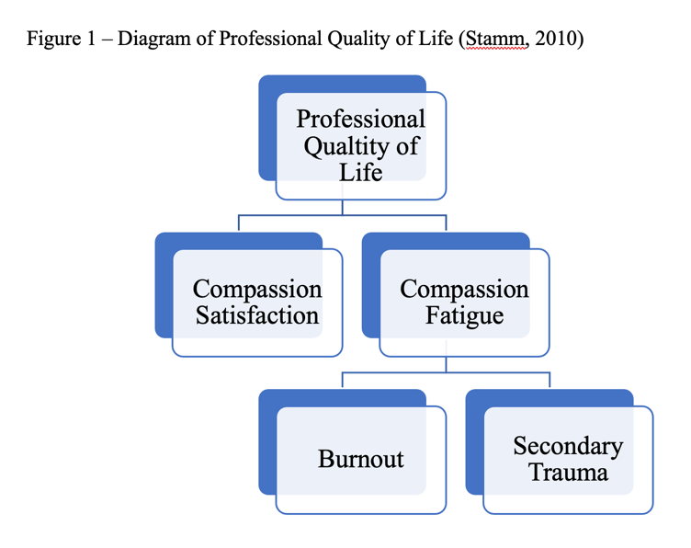

Burnout

Burnout is similar to compassion fatigue (or defined as an element of CF (Stamm, 2010)) in that both are a decline in workplace engagement due to constant contact with stress and emotionally demanding situations, and both share many symptoms; however, they can be conceptually separated by noting that burnout does not result from engagement with others’ distress (Beck, 2011). In education, burnt-out teachers can lead to student apathy, reduced classroom management skills, and increased cynicism (Evers et al., 2004; Żołnierczyk-Zreda, 2005).

Secondary Traumatic Stress

Figley (2013) uses STS and CF interchangeably, and Stamm (2010) describes STS as another element of CF. Both definitions understand STS to be the negative impact of exposure to people who have experienced trauma.

Compassion Satisfaction

If compassion fatigue can be considered the ‘cost of caring’, then compassion satisfaction can be regarded as the ‘benefit’ of caring. It is the joy experienced when being able to help others and improve the world (Stamm, 2012).

Teachers

For this review, the terms teachers and educators are used interchangeably. Teachers have been defined as certified staff working in a state, public or private school, educating students from ages 4 (UK reception) to 18 (UK A-level).

Method

Scoping Searches

An initial unlimited scoping search of the Cochrane Library and Google Scholar was conducted. The search identified one systematic review investigating CF and STS in teachers (Ormiston et al., 2022) and one summary paper detailing an overview of STS in K-12 teaching (Rankin, 2022) but not specifically the risk or mitigating factors for CF. The quantity of search results relating to CF and STS in teachers identified that the review topic was feasible, although appeared to be an understudied area of research.

Search Strategy

Systematic searches were conducted using seven psychology and education databases; CINAHL, PsychARTICLES, PsychINFO, Education Research Complete, ERIC, SPORTDiscus and SCOPUS. The search terms used were: (teach* OR educat*) AND (“compassion* fatigue” OR “secondary trauma* stress” OR “vicarious trauma” OR “indirect trauma”) AND (predictors OR causes OR influences OR factors OR risk OR “associated factors” OR “contributing factors” OR “predisposing factors” OR determinants OR associat* OR correlat* OR reason*). Limiters of English language were set. As noted in Ormiston et al. (2022) CF and STS in education is a relatively new area of research; therefore, search results were not limited by year.

Searches were screened by title, where papers that were clearly unsuitable were removed. Papers were then screened by abstract to assess for eligibility. The remaining papers were read in full and assessed against the inclusion/exclusion criteria (detailed in Table 1). A citation search was completed on the eligible studies from the main search to identify any further relevant studies; no further studies were identified for inclusion. The search strategy followed the Preferred Reporting Items for Systematic Review and Meta-Analyses (PRISMA) (Moher et al., 2009) and is illustrated in Fig 2.

Table 1. Eligibility criteria for inclusion in the review

Criteria | Inclusion | Exclusion
Population | Study focus was on educators teaching students aged 4-18 years (UK reception to A-level equivalent). | Study focus was non-educators or educators of students below age 4, or above 18 years.
Publication type | Peer reviewed journal articles | Book chapters, case studies, dissertation theses.
Subject definition | Definition that matched with used definition of compassion fatigue. | Papers do not have a working definition of ‘stress’ that aligns with the concepts of compassion fatigue.
Language | Written in English | Not written in English

Publication Bias

Psychological research publishing has a disposition not to publish studies showing null results, focusing on the statistically significant rather than publishing studies based on methodological or theoretical quality (Ferguson & Heene, 2012; Hopewell et al., 2005). This is frequently referred to as publication bias. Unpublished research could have been suitable that was not included in the review.
Some dissertation theses were returned in the searches; however, only three of these were available in full. It was decided not to include dissertation theses in the review as these could not be suitably compared to the published literature. Not including the grey literature increased quality assurance as only peer-reviewed journal articles were included.

Quality Assessment

Quality checklists were completed to assess each paper included.
Due to the different methodological approaches being reviewed, the Crowe Critical Appraisal Tool (CCAT) v1.4 was selected as the critical appraisal tool (Crowe, 2013). The CCAT allows for the comparison of different methodological approaches by offering a percentage score for a paper. Crowe & Sheppard (2011) suggest that the CCAT should reflect an accurate assessment of the research based on their validity evaluation. The CCAT examines eight areas of a study (preliminaries, introduction, design, sampling, data collection, ethical matters, results, and discussion), rating each out of five to provide a total score out of 40, which is converted into a percentage.

Figure 2. PRISMA Flowchart demonstrating the search strategy for article inclusion (Moher et al., 2009)

Records identified through database searching:
PsycInfo: (n=559)
PsycArticles (n=33)
CINAHL (n=369)
Scopus (n=140)
ERIC (n=60)
Educational Research Complete (n=123)
SPORTDiscus (n=9)
Total (n=1293)

Records after duplicates removed
(n=1154)
Identification
Screening
Eligibility
Included
Studies included in the review (n=12)
Records screened by title and abstract
(n=1154)

Records excluded, with reasons (n=1129)
Focus not on teachers or educators
Focus not on risk or mitigating factors
Article was not written in English
Compassion fatigue or secondary traumatic stress was not stated in abstract or key-words.

Full-text articles excluded (n=13)
Not directly related to compassion fatigue factors.
Definitions of stress, CF, STS, burnout, that did not map onto construct of compassion fatigue.
Full text studies read and assessed for eligibility (n=25)

Results

Search Results

The initial search produced 1293 results from the combined database searches. Citations were uploaded to RefWorks ProQuest where duplicates were removed, bringing the results to 1154. Studies were then screened by title and abstract which resulted in 25 studies. These were read in full to assess relevance, where a further 13 studies were removed. Overall, 12 studies were retained for inclusion.

Study Characteristics

The main characteristics (aims, participants, methodology, key findings, and limitations) of the eligible studies are outlined in Table 2. Two of the studies used a qualitative design consisting of semi-structured interviews (Keels et al., 2022; Ziaian-Ghafari & Berg, 2019).
Three of the studies utilised a mixed method design (Anderson et al., 2022; Caringi et al., 2015; Lindecker & Cramer, 2021). The remaining seven studies used a quantitative approach (Anama-Green, 2020; Bozgeyikli, 2018; Pérez-Chacón et al., 2021; Sharp Donahoo et al., 2018; Yang et al., 2021; Yang, 2021; Yu et al., 2015). Of the 12 studies included, nine used a version of the Professional Quality of Life (ProQOL) measure (Anama-Green, 2020; Anderson et al., 2022; Bozgeyikli, 2018; Lindecker & Cramer, 2021; Pérez-Chacón et al., 2021; Sharp Donahoo et al., 2018; Yang et al., 2021; Yang, 2021; Yu et al., 2015)
Eight of the studies originated from the United States, one from China, one from Canada, one from Turkey, and one from Spain. All of the studies had been published recently, ranging in publication date from 2015 to 2022.
Table 2 – Summary of studies included in the review

Record | Author(s) | Date | Title | Aims | Participants | Methods | Key findings | Limitations | CCAP %
1 | Anderson, K. M., Haynes, J. D., Ilesanmi, I., & Conner, N. E. | 2022 | Teacher Professional Development on Trauma-Informed Care: Tapping into Students’ Inner Emotional Worlds | To examine the impact of trauma informed professional development for teachers at K-8 urban school. | N=7 (Six teachers, one in-school suspension coordinator) from one school. Six female, one male. $750 stipend given at the end of the course as compensation for involvement Experience 2-22 years. M=9. | Teachers completed the ProQOL pre and post.  Teachers completed a bi-weekly reflective journal, initially based on 4 open ended questions, then changed to make it less time-intensive.  90-minute focus group interview. | Qualitative and quantitative analysed separately. Qualitative data analysed using a constant comparison method. Results showed incorporating TI approaches helped with stress management inside and outside of work.  Quantitative results showed a significant decrease in STS and increase in CS post TI training. | Global pandemic changed the way the training was delivered part way through, and the way teachers were communicating with students. Sampling involved teachers who were interesting in trauma informed instruction. | 77.5
2 | Keels, M., Tackie, H., & Wilkins, N. | 2022 | Educators Need More Than a Strong Belief in the Importance of Student Relationships | To investigate relationship building and the impact of low-quality relationships with students. | N=21 educators in a K-12 Midwestern American school.  90% White  90% Female  2-25 years experience.  Age range 27 -66.  Authors comment this was representative of all staff. | Semi-structured interviews. Analyses using a phenomenological framework grounded in understanding how people think about the social world. Author was working with the school to implement trauma informed practice. | High levels of relationship investment, but relationship building failures put educators at risk of developing CF. | Interview questions not specific to STS or CF.  First round of coding was not conducted by main researcher.  Based on findings from one specialist school therefore not generalisable. | 67.5
3 | Yu, X., Sun, C., Sun, B., Yuan, X., Ding, F., & Zhang, M. | 2022 | The cost of caring: compassion fatigue is a special form of teacher burnout. | To investigate the current situation of CS of primary and secondary school teachers across China. | N=1527 primary and secondary school teachers from 28 provinces of China.  63.85% Female  36.15% Male | Questionnaires were completed anonymously and online. Demographic information was collected. Participants completed the Professional Quality of Life Scale (ProQOL-5) | CF was evident for approx. 93% of teachers at varying intensities.  Teachers with more years’ experience experienced more CS.  More time with students impacted CS. Class teachers experiencing lower levels of CS than middle leaders.  Level of teacher education impacts CS. Higher levels of qualification teachers had lower CS.  Primary school teachers had higher CS than secondary. | Educators in China may have a different experience to Western educators.  Sample size is not equal across different provinces which have varying levels of socioeconomic wealth. | 85
4 | Lindecker, C. A., & Cramer, J. D. | 2021 | Student Self-Disclosure and Faculty Compassion in Online Classrooms | Research Question 3 (of 4):  What demographic factors are associated with CF and CS among faculty members. | Combination of snowball and purposeful sampling. N=238 faculty members with online teaching experience.  Female 67%  White 83%  Age range under 30 – over 55.  Most had +10 years experience. | 3 survey instruments used:  6 demographic questions, 3 faculty experience questions. Both consisting of open and closed questions to obtain information about participants experiences.  ProQOL used for measure CF – however only the burnout part of CF. | Analysis completed with Pearson’s r correlation, t-tests, ANOVA and stepwise multiple regression.  Low to moderate levels of CF were found. Prevalence of student disclosure of personal challenges and trauma did not seem to impact CF.  Two biggest predictors of CF were age and sex, with younger, female faculty members experience higher CF (F=7.65, p<.001) (F=.0.334, p=.03). Older teachers had higher CS (F=20.54, p<.0001) More years of teaching was linked to higher levels of CS (F=20.54, p=<.00001). | Separation of Stamm’s definition of CF, just used the burnout component.  Paper does not discuss own limitations.  Authors comment that findings tend to fit with other CF findings. | 75
5 | Pérez-Chacón, M., Chacón, A., Borda-Mas, M., & Avargues-Navarro, M. L. | 2021 | Sensory processing sensitivity and compassion satisfaction as risk/protective factors from burnout and compassion fatigue in healthcare and education professionals. | To analyse sensory processing sensitivity and compassion satisfaction as risk / protective factors against burnout and compassion fatigue during the first period of the Covid-19 pandemic. | N=1566 (n=872 education professionals, n=694 healthcare professionals). Sampling by convenience. Sample was recruited in a community context.  Female 89%  Male 11%  Majority age range 31-40 | Quantitative methodology. Demographic survey consisted of 12 questions.  Participants completed the Highly Sensitive Person Scale (HSPS) adapted to Spanish. Participants completed Spanish adaptation of the Maslach Burnout Inventory (MBI). Participants completed a Spanish adaptation of the ProQOL-IV) All were completed online. | High sensory processing sensitivity was a risk factor for CF (r=0.37, p=0.000 and r=0.38, p-0.000)  CS was a protective factor for CF (r=-0.22, p=0.000 and r=-0.10, p=0.002) | Some variables could not be controlled when completing the questionnaires due to them being online.  Timing of the study – at the beginning of the pandemic- may have had an impact on stress. | 87.5
6 | Yang, C. | 2021 | Online Teaching Self-Efficacy, Social–Emotional Learning (SEL) Competencies, and Compassion Fatigue Among Educators During the COVID-19 Pandemic | To examine how educators perceived self-efficacy and social and emotional learning competencies influenced educators compassion fatigue during the COVID-19 pandemic. | N=321 educators recruited from a large urban district in California.  Descriptive statistics and demographics were collected. | Educator SEL Competencies scale was used to measure participants perceptions of self-awareness, social awareness, social relationships, and self-management skills.  Online self-efficacy and CF were measured using the DTSES and the ProQOL (as in record 7) | Self-reported online teaching self-efficacy was negatively associated with CF.  Self-perceived SEL competencies were not significantly related to CF.  SEL did act as a moderator for the negative impact of self-efficacy. | Participants were self-selecting and may differ from other groups of educators.  Results are from one urban area of California and may not be generalisable.  Self-reporting measures may be open to confounding factors. Teaching during COVID may not equate to teaching online at other times. | 87.5
7 | Yang, C., Manchanda, S., & Greenstein, J. | 2021 | Educators’ online teaching self-efficacy and compassion fatigue during the COVID-19 pandemic: The dual roles of “connect” | To examine how school connectedness and attempts to connect with school members interacted with compassion fatigue and online teaching self-efficacy during distance learning in the Covid-19 pandemic. | N=321 educators from elementary, middle, and high schools recruited from a large urban district in Northern California.  Female 79.75%  Male 14.95%  Not identified/Nonbinary 5.3%  White 55%  Experience mean 13.96 years. | Data collected online.  ProQOL used for CF.  Online Teaching Self-Efficacy Scale (DTSES) was created to measure online teaching self-efficacy.  To measure school connectedness, a three item Distance Learning School Connectedness Scale (DLSCS) was created  Power calculation completed. | School connectedness had a significant positive correlation with distance learning self-efficacy (r=.13), a negative correlation with educators’ years working in education (r=-.13) but not with compassion fatigue. Attempts to connect with members influences their compassion fatigue and online teaching self-efficacy. Educators with more teaching experience reported lower levels of compassion fatigue than newer educators (r=-.20). White educators reported significantly higher compassion fatigue and significantly lower distance learning self-efficacy than Black educators. | Sample size was relatively small compared to the district.  There is no control data from before distance learning due to the pandemic.  Causal inferences cannot be made from a correlational design. | 87.5
8 | Anama-Green, C. | 2020 | Intrapersonal mindfulness is associated with reduced risk of burnout among Central Appalachian educators | To compare self-reported levels of burnout and secondary traumatic stress with participants levels of interpersonal and intrapersonal mindfulness. | N=144 participants from East Kentucky counties of the central Appalachian region. Recruitment was through professional learning networks, regional educational cooperatives, and professional education organisations.  Female 74.3%  Age range 20-65 – majority in 26-35 range.  White 92.1% | Quantitative methodology.  Participants completed the ProQOL and the Mindfulness in Teaching Scale. Participants also completed a brief demographic survey. The two instruments and the demographic questionnaire were completed online. | Relative Risks and Odds ratios of having STS scores of ‘average/high’ were significantly lower for those with high intrapersonal mindfulness scores.  Intrapersonal mindfulness may be a protective factor for teachers reducing the risk of STS. | Data collection represented a ‘single point in time’ and may not represent all aspects of the work environment. The survey was at the end of an academic year which may affect teacher perceptions.  Participants volunteered to take part, therefore might be a bias towards those participants drawn to ideas of burnout or mindfulness.  Participants involvements in mindfulness activities was not assessed.  Sample demographics did not allow for comparison by race.  A lack of agreed definition of mindfulness affects all research that tries to quantify mindfulness. | 72.5
9 | Ziaian-Ghafari, N., & Berg, D. H. | 2019 | Compassion fatigue: The experiences of teachers working with students with exceptionalities | Exploring the social-emotional experience of teachers working with students with exceptionalities. | Purposeful sampling and snowball sampling. N=5 participants (age 25-40) with in-service teaching experience living in Ontario. | 90-minute semi-structured interviews.  Compassion fatigue and burnout applied as a theoretical lens when reviewing transcripts. | Authors identified three themes relating to compassion fatigue: challenges with inclusion (of studies with exceptionalities joining general education), personal investment in meeting students’ needs, limited resources to support success.  Burnout and compassion fatigue can be circumvented by focussing on supporting positive social-emotional experiences for students. | Small sample size.  Demographics of the participants (authors stating three were early in their careers and two were experienced educators).  Four participants were not in-service teachers (previous teachers who had left the profession). | 72.5
10 | Bozgeyikli, H. | 2018 | Psychological Needs as the Working-Life Quality Predictor of Special Education Teachers | To assess if psychological needs can predict the professional quality of life (factors from ProQOL) | N=238 special education teachers working in Kayseri registered with the Turkish Ministry of National Education.  Female 55%  Male 45%  69.7% Married  30.3% Single. | Assessed using the ProQOL adapted for the Turkish language and the New Psychological Needs Scale | Pearson correlation used. A strong correlation between four dimensions of psychological needs (success, relationship, autonomy, dominance) and the ProQOL. Only relationship needs was a negative predictor of CF, no correlation with other sub-scales.  As level of met psychological needs rises, CS risk and CF and BO fall. | Limitations not identified in the paper.  Turkish population may not be generalisable to UK.  Special education teachers may not reflect general education teachers.  Correlation does not equate to causality. | 85
11 | Sharp Donahoo, L. M., Siegrist, B., & Garrett-Wright, D. | 2018 | Addressing Compassion Fatigue and Stress of Special Education Teachers and Professional Staff Using Mindfulness and Prayer | To study the impact of alternative therapies (mindfulness, prayer, social support) for improvement of compassion fatigue in educators working in special education. | Convenience sample of n=27  (23 teachers and 4 professional staff) working in special education employed in Western Kentucky school district.  Age range 25 – 65  Experience 0->20 years | Quasi-experimental design with a pre/post-test evaluation.  Participants completed the Perceived Stress Scale (PSS) and Professional Quality of Life (ProQOL).  All participants had a 3hr presentation on stress, compassion fatigue and the benefits of prayer and mindfulness.  Participants were self-selecting of what intervention to use. N=15 were given weekly reminders. N=11 had no reminders.  PSS and ProQol were repeated 4-5 weeks after pre-test. | t-tests used to analyse data. Significant improvement in post-test PSS scores of participants with the highest reported levels of use of mindfulness.  ProQOL for compassion satisfaction and PSS scores significantly improved when evaluating the difference in means of groups with highest and lowest levels of prayer and mindfulness (m=20.33 to m=13.5, p=.24). Burnout scores increased from pre to post-test which may be due to school year pressures (m=24.07 to m=32.74, p=<.001).  CS increased with more mindfulness and prayer (m=33.67 to m=40.5 p=.029) | Small sample size.  Geographically narrow sample.  Ambiguity around how often alternative strategies were used. Timings of the surveys during the school year may have had an impact.  Findings were based on self-report surveys. | 65
12 | Caringi, J. C., Stanick, C., Trautman, A., Crosby, L., Devlin, M., & Adams, S | 2015 | Secondary traumatic stress in public school teachers: Contributing and mitigating factors | Research question: What are the contributing and mitigating factors to levels of STS in public school teachers. | Quantitative section n=300 school staff members – participants were not asked their specific job titles. Geographical location was Rocky Mountain west.  Qualitative section n=15 (from quantitative selection)  Female 74.3%  White 74%  Age mean 45.59  Recruited from STS training.  Length of time teaching 3-54 years. Mean 21. | Mixed method design.  Semi-structured interview developed from a pilot study and STS questionnaire. | Qualitative results identified interactions with other staff mostly as protective factors. Spending time with family was identified as protective. Class size was a factor with larger class sized leading to more stress.  Protective factors included feeling successful with students, self-care techniques, | Self-selection bias meaning those interested in trauma may be more inclined to take part in research. All participants had participated in training on STS possible making it more salient to them.  Phone interviews were completed so non-verbal communication as missed.  Suggest RCT might be needed. | 78.8

Quality Appraisal

The included studies were appraised using the CCAT (Crowe, 2013) based on the information available within the studies. The CCAT score are summarised in Table 3 in Appendix 1.

The lowest percentage score on the CCAT was 65% (Sharp Donahoo et al., 2018). This was predominantly due to brevity where sufficient detail needed to score highly on the CCAT was not possible. Conversely, the thoroughness of detail from Pérez-Chacón et al. (2021), Yang et al. (2021), and Yang (2021) allowed the shared highest score of 87.5.

Although there was no evidence of ethical misconduct, typically, details of ethical processes and implications was scarce throughout the included studies. This may be due to limitations of word count for published articles. Except for Ziaian-Ghafari & Berg (2019) no study detailed specifically how the participants were protected from possible harm and where support could be obtained post-study if needed. Anama-Green (2020) and Bozgeyikli (2018) did not specifically reference if ethical approval had been obtained. .

Overview of Methodological Quality of Studies

Recruitment and Sampling

Sample sizes ranged from n=5 (Ziaian-Ghafari & Berg, 2019) to n=1527 (Yu et al., 2015). The qualitative studies (including the qualitative aspects of mixed-method studies) had sample sizes that ranged from n=5 (Ziaian-Ghafari & Berg, 2019) to n=15 (Caringi et al., 2015). Quantitative sample sizes ranged from n=27 (Sharp Donahoo et al., 2018) to n=1527 (Yu et al., 2015)
With the exception of Yang et al. (2021) and Yang (2021), who had a shared sample, all of the studies had unique samples.
Participants were recruited in various ways, such as convenience sampling, snowball sampling, cluster random sampling, and sharing of the study through educational networks.
Anderson et al. (2022) was the only study where a financial stipend (of $750) was noted, however, this was to compensate staff for additional work as part of trauma-informed approach training, from which the participants were obtained, rather than compensation for taking part in the study.
A summary of key demographic features of the studies identified that:
- Where sex was reported, most participants identified as female.
- When participants race was reported, most of the participants that took place in the USA studies identified as white (non-Hispanic) except for Anderson et al. (2022), where participants were described as ‘predominantly teachers of colour’.
- Length of teaching experience ranged across studies from <1 year (Sharp Donahoo et al., 2018) to 54 years (Caringi et al., 2015).
- The studies that specifically identified the age of participants, age ranged from 20-66 years.
Several of the studies recruited participants from groups that were taking part in additional training related to trauma or STS/CF (Anderson et al., 2022; Caringi et al., 2015)

Procedure

Most of the quantitative studies had a similar methodology. The ProQOL-V (or IV) was used to investigate levels of CF and CS. The results from this were then analysed to see how CF and CS were corelated or interacted with other factors that were measured.
The studies with qualitative methodologies and the qualitative aspects of the mixed-method approaches used semi-structured interviews applying a variety of frameworks. Two studies declared that qualitative analysis computer software was used (Anderson et al., 2022; Caringi et al., 2015).

Measures

Professional Quality of Life Scale (ProQOL)

The ProQOL-V (used by eight studies) measures levels of CS and CF. It is one of CF's most widely used measures (Geoffrion et al., 2019). The ProQol uses ten 5-point items to measure burnout, STS and CF (shown in Fig 1). During completion of the ProQOL, participants are required to read a statement relating to their work and rate how often they have experienced these thoughts/feelings in the last 30 days. Keesler & Fukui (2020) found that the three-factor structure of the ProQOL was valid when assessing the quality of life for direct support professionals. Pérez-Chacón et al. (2021) used the Spanish adaptation of the ProQOL-IV.

A summary table of other measures used can be found in Appendix B.

Synthesis of Main Findings

The review identified numerous factors that can influence CF in teachers. These have been grouped and summarised under three themes: demographic and personal factors; professional factors; and relationship factors.

Demographic and personal factors

Location can impact compassion fatigue

Levels of CF can be impacted by geographical location, particularly when this correlates to economic wealth and levels of deprivation. Yu, Xiajun et al. (2022) understood this to be related to higher levels of traumatic experiences faced by students in the western region of China. Lindecker & Cramer (2021) identified higher levels of trauma amongst children in deprived areas and, therefore, higher levels of STS.

Length of time teaching/ age of educators can impact levels of compassion fatigue

Yang et al. (2021) and Yang (2021) demonstrated that those teachers with more years of teaching experienced lower levels of CF. Abraham-Cook (2012) did not find a relationship between years of experience and CF. Lindecker & Cramer (2021) identified that older educators experienced lower levels of CF (although specifically, the burnout construct) than younger educators; the length of service was not significant. Lindecker & Cramer (2021) also noted that CS increased with age and length of service.

Sex as a predictor of CF

Using a stepwise multiple regression, Lindecker & Cramer (2021) identified that sex was a predictor of CF (burnout construct), with females experiencing higher levels of CF than males, but no significant difference was found in CS. Conversely, Yang (2021) found that sex was not a significant factor in levels of CF.

Race as a predictor of CF

Yang (2021) identified that race was a significant predictor of CF, with levels of reported CF for White educators significantly higher than those of Black educators and marginally more significant than educators with multiracial/ethnic backgrounds.

Mindfulness/prayer as a mediating factor

Anama-Green (2020) discovered that intrapersonal mindfulness is a protective factor for STS and was negatively correlated with STS. When intrapersonal mindfulness skill level decreased, STS increased. However, Anama-Green (2020) also identified no correlation between interpersonal mindfulness and STS. Sharp Donahoo et al. (2018) further supported this with findings in their intervention study where participants who used mindfulness more frequently (more than 20 times over two months) had lower stress levels, which they linked to CF. Additionally, they found that higher frequencies of mindfulness and prayer use contributed to higher levels of CS and lower scores on the PSS. Caringi et al. (2015) added some support for this, listing prayer and meditation as one self-care activity that participants found to be protective.

Professional Factors

Grade/level taught can impact levels of compassion fatigue

Yu et al. (2022) showed that primary school teachers had lower levels of CF than secondary teachers. Several reasons are presented for this, including challenging behaviour management of secondary students. Conversely, Yang et al. (2021) identified no significant difference in compassion fatigue depending on the grade taught.

Teaching self-efficacy

Yang (2021) identified that higher levels of teacher self-efficacy (for online education) were negatively correlated to CF levels. Yang (2021) also noted that although social and emotional learning was not a correlator for CF, it was a moderating factor for the impact of teacher self-efficacy. Keels et al. (2022) found a loss in confidence caused by a lack of healthy coping mechanisms could impact teacher efficacy, leading to CF. Caringi et al. (2015) commented that teachers feeling ‘successful’ with students was a protective factor, although they did not define what the term ‘successful’ meant in this instance. It was also identified that reported self-efficacy diminished as class size increased as the focus became classroom management rather than being an effective teacher.

Trauma-informed professional development

Anderson et al. (2022) found that after training on trauma-informed care, there was a significant increase in the mean scores of CS and a significant decrease in the mean scores for STS.

School position

In Yu et al. (2022), CS was lower for class and head teachers. It was posited that this resulted from middle leaders and above spending less time in face-to-face contact with students and head teachers having additional pressures.

Relationship factors

Educator relationships with other professionals as both a risk and mitigating factor of compassion fatigue.

Relationships with members of the schools could be a mitigating factor for CF. Yang et al. (2021) identified that higher levels of what they called school connectedness could result in lower levels of CF; however, this only applied to connectedness to other staff. Bozgeyikli (2018) also identified that relationship needs were a negative predictor of compassion fatigue. None of the other sub-scales in the NPNS were found to be significant predictors. For those teachers where social needs were not met, CF increased. Caringi et al. (2015) added further support for relationships with other staff as a mediating factor, commenting that it was the most helpful resource for mitigating stress through discussion around stressors and learning from peers.

Conversely, Sharp Donahoo et al. (2018) found no correlation with CF when being part of a small, supportive group. Alongside the positive effect of staff relationships, Caringi et al. (2015) also commented that colleagues could also be a source of stress, noting aspects such as a colleague’s lack of commitment, inconsistency, or feeling excluded.

School relationships with students as both a risk and mitigating factor of compassion fatigue.

Attempts to connect with students resulted in higher levels of compassion fatigue, possibly due to increased exposure to trauma (Yang et al., 2021). Ziaian-Ghafari & Berg (2019) identified the difficulties experienced by teachers because of the personal investment in meeting students’ needs increased CF. Students’ experiences of traumatic incidents and the type of incident being relayed to teachers increased CF (Caringi et al., 2015; Ziaian-Ghafari & Berg, 2019). Pérez-Chacón et al. (2021) add that depersonalising from a student’s experiences can help to protect against CF. Ziaian-Ghafari & Berg (2019) comment that teachers who notice a student with exceptionalities struggling to integrate into a mainstream classroom may experience CF. Additionally, teachers that can balance the needs of all in their care, particularly those with exceptionalities, may be less likely to experience CF.
Caringi et al. (2015) noticed class size can impact the connectedness that staff have with students; in their sample, smaller class sizes allowed staff to have increased flexibility to provide students experiencing trauma more attention, decreasing CF.
Keels et al. (2022) identified that emotionally focused relationships could put educators at risk for CF, and educators would often worry about students out of school. Anderson et al. (2022) signpost that the changes in STS and CS scores following trauma-informed professional development came from changes in how teachers were able to relate to students.

Discussion

The review aimed to identify the mitigating and risk factors for CF in teachers. Twelve studies were systematically identified, reviewed, and critically appraised. Factors from these studies were grouped into three themes: demographic and personal factors, professional factors, and relationship factors. The quality of the studies was generally good, with all studies scoring above 65% on the CCAT which enables robust comparisons to be made between them. Ethical considerations were predominantly the weaker areas of the included studies. The review highlighted the complexity of CF in teachers with multiple mitigating and risk factors found. Although themes could be identified, there were contradictions within these.

This review added further evidence to support the findings of previous research (Ormiston et al., 2022; Rankin, 2022). Anama-Green (2020), Caringi et al. (2015), and Sharp Donahoo et al. (2018) identified that self-care (in this context, mindfulness) was a protective factor for CF, corroborating Rankin (2022). Support for Ormiston et al. (2022) came from Anderson et al. (2022), where a trauma-informed approach to teaching was a mitigating factor for CF. Professional relationships were also found to be a mitigating factor for CF (Bozgeyikli, 2018; Caringi et al., 2015; Yang et al., 2021), supporting previous findings by Rankin (2022); however, this was tempered by Sharp Donahoo et al. (2018) who identified that being part of a small reflecting group did not mitigate CF. Lindecker & Cramer (2021) commented that sex was a factor that could influence CF, but Yang et al. (2021), which scored more highly in the quality assessment, identified that there was no correlation between sex and CF. Many of the factors identified in the review contradicted each other, indicating that this is an area of research where more study is needed to draw clear conclusions.

There may be a need for further research with standardised methods of measuring CF in teachers to understand the correlating factors. With most of the studies using the ProQOL, there were several discrepancies in the way it was used. Lindecker & Cramer (2021) used only the burnout component of CF for part of their findings and not STS, which contradicts Figley’s (2013) original definition where STS and CF were synonymous. Other studies emphasised the CS components of the ProQOL score, where CS as an opposite of CF was often inferred. Many studies reported an increase in CS, and it was interpreted that this also meant that CF had fallen. Figley (2013) proposed that higher levels of compassion satisfaction, along with a person’s ability to separate work life and home life, could help to prevent the development of compassion fatigue; however, this has been challenged by findings that compassion satisfaction and compassion fatigue can exist at the same time (Abraham-Cook, 2012; Conrad & Kellar-Guenther, 2006).
It would be suggested that the link between CF and CS may need to be considered in greater detail, particularly to assess if there is causality, as many of the studies suggest a correlation between a rise in CS and a fall in CF (Bozgeyikli, 2018).

Aligning with Ormiston et al. (2022), definitions of CF were blurred through most of the studies included. Many of the studies used Figley’s (2013) definition and later used the ProQOL, where the meaning of CF is different. Where CF was explicitly defined, studies would later use terms such as burnout and stress in some parts; therefore, it became hard to separate the risk and mitigation for each. Difficulties in defining concepts were also evident in other areas of the review with ‘mindfulness’, a term which the papers recognised does not have an agreed definition (Anama-Green, 2020; Sharp Donahoo et al., 2018).

All the quantitative studies relied on self-report measures. Several errors can arise from this, from both the respondent and the survey instrument itself. There may be over-reporting and under-reporting of feelings and where participants may feel results of their measures may be scrutinised, inaccurate reporting may be prevalent (Sinkowitz-Cochran, 2013). Additionally, Abraham-Cook (2012) highlight that people who respond to online requests for surveys (as many of the studies used as a method of recruitment) may not be representative of the overall population, and therefore findings should be generalised with caution. Several of the studies include participants receiving training or interventions (into trauma-informed practice, mindfulness), which may have made these ideas particularly salient at the point of participating, greatly increasing the likelihood that they would be identified as factors relating to CF. Anama-Green (2020) commented further on this recognising a self-selection bias. They noted that in their study, people are drawn to participate in a study about the impact of mindfulness may already have beliefs about the topic and, therefore, may be more likely to emphasise its importance as a mitigating factor for CF. This limitation, where participants are more inclined to participate in research relevant to themselves, can be applied to all the studies where participants were self-selecting.

Where age was identified as a factor of CF, several authors mention that this may be because educators with higher levels of CF and lower levels of CS may have left the profession and therefore not taken part in the research and those with higher resilience to CF remain in the profession. Where Lindecker & Cramer (2021) identified that older educators experienced less CF, older and younger ages were not defined. Keels et al. (2022) recognised that some educators with longer service times may have developed techniques that separate themselves emotionally from students, which allows them to combat the risk effect of student relationships with CF. This highlights a general limitation of the studies that used a correlational approach. Bozgeyikli (2018) affirmed the importance of recognising that correlation does not equal causality, and more research should be conducted to understand the processes in which the factors influence CF.

Anama-Green (2020), Sharp Donahoo et al. (2018), and Yang et al. (2021) identified that the research only gives a snapshot in time. Varying pressures of the school year may increase the importance of some CF factors at differing times. It is suggested that further longitudinal studies are needed to identify how factors influencing CF may change.

Several papers identified that limitation of their studies were conducted with relatively small samples and in a geographically narrow area, therefore questioning the generalisability of their findings to the larger teaching populations (Keels et al., 2022; Sharp Donahoo et al., 2018; Yang et al., 2021). In addition, this review was conducted in the UK, and none of the studies in the review relate to research in the UK. There are shared stressors in the international teaching community (Chen & Miller, 1997), but there are also differences (Yu et al., 2015). Yu et al. (2005) comment on the difference in education systems globally; therefore it is prudent to recognise that factors identified in this review may not be as important for UK teachers. It would be beneficial to have further UK-based research investigating the factors of compassion fatigue in teachers, specifically in the UK.

Yang et al. (2021) identified that race could be a predictive factor of CF, with white educators experiencing higher levels of CF. It was noted in the study that contextual issues of the murder of George Floyd and the Black Lives Matter movement at the time of data collection may have impacted this finding as relationships with students where race and cultural backgrounds were not shared were strained. Keels et al. (2022) further supported this limitation, commenting that educators found it harder to form meaningful relationships where backgrounds were not shared. Although racial inequality continues, it may be beneficial to study this factor at another point where the context is different.

Alongside the limitations related to specific studies, there are some general limitations of this review. The decision not to include dissertation theses may have impacted the review's validity. Publication bias can impact the validity of deductions obtained from reviews of published research (Hopewell et al., 2005). Research into CF in educators is limited (Ormiston et al., 2022). Because of this, there seemed to be a scarcity of literature to review the risk and protective factors of CF; therefore, it was necessary to include studies that mention the risk and protective factors in their findings, but where risk and protective factors are not the main focus of the study.

Conclusion

Factors of CF in teachers are an area that should be investigated more as it is prevalent in schools. Yu et al. (2022) identified that 92.73% of teachers in primary or secondary schools had mild or greater levels of CF, with 25.35% experiencing severe CF.
By understanding the predictors and mediators of CF identified above and the potential demographic vulnerabilities, it may be possible to support educational institutions to protect against risk or encourage mitigation factors to improve teacher well-being, attrition, or absence because of CF. Joinson (2012) notes compassion fatigue is extremely hard to recognise without a solid knowledge of it. At this stage, there does not appear to be enough alignment between factors identified from different studies to draw solid conclusions however tentative support can be offered in some areas. This review adds evidence to previous research for several mitigating factors for compassion fatigue. The review supports evidence that self-care, in particular mindfulness and some professional relationships might help to mitigate CF. Additionally, applying a trauma informed approach to teaching might be a protective factor for CF. Older and more experienced teachers may experience lower levels of CF and higher CS. It would be beneficial for this review to be repeated in the future when more research that investigates explicit factors of CF is available. As research progresses, additional agreement may be on how the concepts are defined and operationalised.

References

Abraham-Cook, S. (2012). The prevalence and correlates of compassion fatigue, compassion satisfaction, and burnout among teachers working in high-poverty urban public schools. University of Florida.
Anama-Green, C. (2020). Intrapersonal mindfulness is associated with reduced risk of burnout among Central Appalachian educators. Explore, https://doi.org/10.31231/osf.io/xq8hd
Anderson, K. M., Haynes, J. D., Ilesanmi, I., & Conner, N. E. (2022). Teacher Professional Development on Trauma-Informed Care: Tapping into Students’ Inner Emotional Worlds. Journal of Education for Students Placed at Risk (JESPAR), 27(1), 59-79. https://doi.org/10.1080/10824669.2021.1977132
Beck, C. T. (2011). Secondary traumatic stress in nurses: A systematic review. Archives of Psychiatric Nursing, 25(1), 1-10. https://doi.org/10.1016/j.apnu.2010.05.005
Boshoff, S. M., Potgieter, J. C., Ellis, S. M., Malan, L., & Mentz, K. (2018). Validation of the Teacher Stress Inventory (TSI) in a multicultural context: The SABPA study. South African Journal of Education, 38(Supplement 2), s1-s13. https://doi.org/10.15700/saje.v38ns2a1491
Bozgeyikli, H. (2018). Psychological Needs as the Working-Life Quality Predictor of Special Education Teachers. Universal Journal of Educational Research, 6(2), 289-295. DOI: 10.13189/ujer.2018.060211
Caringi, J. C., Stanick, C., Trautman, A., Crosby, L., Devlin, M., & Adams, S. (2015). Secondary traumatic stress in public school teachers: Contributing and mitigating factors. Advances in School Mental Health Promotion, 8(4), 244-256. https://doi.org/10.1080/1754730x.2015.1080123
Chang, M. (2009). An appraisal perspective of teacher burnout: Examining the emotional work of teachers. Educational Psychology Review, 21(3), 193-218. https://doi.org/10.1007/s10648-009-9106-y
Chen, M., & Miller, G. (1997). Teacher Stress: a review of the international literature.
Chittenden, A. (1999). Teachers as carers: A case study of a secondary school’s pastoral process. Pastoral Care in Education, 17(2), 14-22. https://doi.org/10.1111/1468-0122.00122
Conrad, D., & Kellar-Guenther, Y. (2006). Compassion fatigue, burnout, and compassion satisfaction among Colorado child protection workers. Child Abuse & Neglect, 30(10), 1071-1080. https://doi.org/10.1016/j.chiabu.2006.03.009
Crowe, M. (2013). Crowe critical appraisal tool (CCAT) user guide. Conchra House: Scotland, UK,
Crowe, M., & Sheppard, L. (2011). A general critical appraisal tool: an evaluation of construct validity. International Journal of Nursing Studies, 48(12), 1505-1516. https://doi.org/10.1016/j.ijnurstu.2011.06.004
Evers, W. J., Tomic, W., & Brouwers, A. (2004). Burnout among teachers: Students’ and teachers’ perceptions compared. School Psychology International, 25(2), 131-148. https://doi.org/10.1177/0143034304043670
Ferguson, C. J., & Heene, M. (2012). A vast graveyard of undead theories: Publication bias and psychological science’s aversion to the null. Perspectives on Psychological Science, 7(6), 555-561. DOI: 10.1177/1745691612459059
Figley, C. R. (2002). Compassion fatigue: Psychotherapists' chronic lack of self care. Journal of Clinical Psychology, 58(11), 1433-1441. https://doi.org/10.1002/jclp.10090
Figley, C. R. (2013). Compassion fatigue: Coping with secondary traumatic stress disorder in those who treat the traumatized. Routledge.
Frank, J. L., Jennings, P. A., & Greenberg, M. T. (2016). Validation of the mindfulness in teaching scale. Mindfulness, 7(1), 155-163. DOI 10.1007/s12671-015-0461-0
Fullard, J. (2021). Local pay and teacher retention in England. Education Policy Institute. Retrieved July 12, 2022, from https://epi.org.uk/publications-and-research/local-pay-and-teacher-retention-in-england/
Geoffrion, S., Lamothe, J., Morizot, J., & Giguère, C. (2019). Construct validity of the professional quality of life (ProQoL) scale in a sample of child protection workers. Journal of Traumatic Stress, 32(4), 566-576. https://doi.org/10.1002/jts.22410
Gluschkoff, K., Elovainio, M., Kinnunen, U., Mullola, S., Hintsanen, M., Keltikangas-Järvinen, L., & Hintsa, T. (2016). Work stress, poor recovery and burnout in teachers. Occupational Medicine, 66(7), 564-570. https://doi.org/10.1093/occmed/kqw086
Hansen, P., & Mulholland, J. A. (2005). Caring and elementary teaching: The concerns of male beginning teachers. Journal of Teacher Education, 56(2), 119-131. https://doi.org/10.1177/0022487104273761
Hopewell, S., Clarke, M., & Mallett, S. (2005). Grey literature and systematic reviews. Publication Bias in Meta-Analysis: Prevention, Assessment and Adjustments, , 49-72. DOI:10.1002/0470870168
Joinson, C. (1992). Coping with compassion fatigue. Nursing, 22(4), 116, 118-9, 120. https://doi.org/10.1097/00152193-199204000-00035
Keels, M., Tackie, H., & Wilkins, N. (2022). Educators Need More Than a Strong Belief in the Importance of Student Relationships. School Mental Health, , 1-13. https://doi.org/10.1007/s12310-022-09506-5
Keesler, J. M., & Fukui, S. (2020). Factor structure of the professional quality of life scale among direct support professionals: factorial validity and scale reliability. Journal of Intellectual Disability Research, 64(9), 681-689. https://doi.org/10.1111/jir.12766
Lindecker, C. A., & Cramer, J. D. (2021). Student Self-Disclosure and Faculty Compassion in Online Classrooms. Online Learning, 25(3), 144-156. https://doi.org/10.24059/olj.v25i3.2347
Lombardo, B., & Eyre, C. (2011). Compassion fatigue: A nurse’s primer. OJIN: The Online Journal of Issues in Nursing, 16(1), 3. https://doi.org/10.3912/OJIN.Vol16No01Man03
Mason, C. (2022). Nearly half of state school teachers 'plan to quit within five years'. TES Magazine. https://www.tes.com/magazine/news/general/nearly-half-state-school-teachers-plan-quit-within-five-years
Moher, D., Liberati, A., Tetzlaff, J., Altman, D. G., & PRISMA Group*. (2009). Preferred reporting items for systematic reviews and meta-analyses: the PRISMA statement. Annals of Internal Medicine, 151(4), 264-269. https://doi.org/10.7326/0003-4819-151-4-200908180-00135
Ormiston, H. E., Nygaard, M. A., & Apgar, S. (2022). A Systematic Review of Secondary Traumatic Stress and Compassion Fatigue in Teachers. School Mental Health, , 1-16. https://doi.org/10.1007/s12310-022-09525-2
Pérez-Chacón, M., Chacón, A., Borda-Mas, M., & Avargues-Navarro, M. L. (2021). Sensory processing sensitivity and compassion satisfaction as risk/protective factors from burnout and compassion fatigue in healthcare and education professionals. International Journal of Environmental Research and Public Health, 18(2), 611. https://doi.org/10.3390/ijerph18020611
Pirelli, G., Formon, D. L., & Maloney, K. (2020). Preventing vicarious trauma (VT), compassion fatigue (CF), and burnout (BO) in forensic mental health: Forensic psychology as exemplar. Professional Psychology: Research and Practice, 51(5), 454. http://dx.doi.org/10.1037/pro0000293
Rankin, B. (2022). An Overview of Research on Secondary Traumatic Stress in K-12 Teaching: What We Know and What We Still Need to Learn. Null, 86(2), 138-150. 10.1080/00131725.2020.1860172
Rothì, D. M., Leavey, G., & Best, R. (2008). On the front-line: Teachers as active observers of pupils’ mental health. Teaching and Teacher Education, 24(5), 1217-1231. https://doi.org/10.1016/j.tate.2007.09.011
Sharp Donahoo, L. M., Siegrist, B., & Garrett-Wright, D. (2018). Addressing compassion fatigue and stress of special education teachers and professional staff using mindfulness and prayer. The Journal of School Nursing, 34(6), 442-448. https://doi.org/10.1177/1059840517725789
Sinclair, S., Raffin-Bouchal, S., Venturato, L., Mijovic-Kondejewski, J., & Smith-MacDonald, L. (2017). Compassion fatigue: A meta-narrative review of the healthcare literature. International Journal of Nursing Studies, 69, 9-24. http://dx.doi.org/10.1016/j.ijnurstu.2017.01.003
Sinkowitz-Cochran, R. L. (2013). Survey design: To ask or not to ask? That is the question…. Clinical Infectious Diseases, 56(8), 1159-1164. https://doi.org/10.1093/cid/cit005
Stamm, B. (2010). The concise manual for the professional quality of life scale. The ProQOL.org.
Stamm, B. H. (2012). Helping the helpers: Compassion satisfaction and compassion fatigue in self-care, management, and policy of suicide prevention hotlines. Resources for Community Suicide Prevention, , 1-4.
The State of Education: Staff Workload, Wellbeing and Retention. (2021). National Education Union. https://neu.org.uk/state-education-staff-workload-wellbeing-and-retention
Yang, C. (2021). Online teaching self-efficacy, social–emotional learning (SEL) competencies, and compassion fatigue among educators during the COVID-19 pandemic. School Psychology Review, 50(4), 505-518. https://doi.org/10.1080/2372966x.2021.1903815
Yang, C., Manchanda, S., & Greenstein, J. (2021). Educators’ online teaching self-efficacy and compassion fatigue during the COVID-19 pandemic: The dual roles of “connect”. School Psychology, 36(6), 504. https://doi.org/10.1037/spq0000475
Yu, X., Sun, C., Sun, B., Yuan, X., Ding, F., & Zhang, M. (2022). The cost of caring: compassion fatigue is a special form of teacher burnout. Sustainability, 14(10), 6071. https://doi.org/10.3390/su14106071
Yu, X., Wang, P., Zhai, X., Dai, H., & Yang, Q. (2015). The effect of work stress on job burnout among teachers: The mediating role of self-efficacy. Social Indicators Research, 122(3), 701-708. https://doi.org/10.1007/s11205-014-0716-5
Ziaian-Ghafari, N., & Berg, D. H. (2019). Compassion fatigue: The experiences of teachers working with students with exceptionalities. Exceptionality Education International, 29(1), 32-53. https://doi.org/10.5206/eei.v29i1.7778
Żołnierczyk-Zreda, D. (2005). An intervention to reduce work-related burnout in teachers. International Journal of Occupational Safety and Ergonomics, 11(4), 423-430. https://doi.org/10.1080/10803548.2005.11076661

Appendices
Appendix A - Table 3 – CCAT scores.

Record | Author(s) | Date | Preliminaries | Introduction | Design | Sampling | Data Collection | Ethical Matters | Results | Discussion | Total (/40) | %
1 | Anderson, K. M., Haynes, J. D., Ilesanmi, I., & Conner, N. E. | 2022 | 5 | 5 | 4 | 3 | 3 | 2 | 4 | 5 | 31 | 77.5
2 | Keels, M., Tackie, H., & Wilkins, N. | 2022 | 5 | 5 | 3 | 3 | 2 | 2 | 4 | 3 | 27 | 67.5
3 | Yu, X., Sun, C., Sun, B., Yuan, X., Ding, F., & Zhang, M. | 2022 | 5 | 5 | 5 | 4 | 4 | 2 | 5 | 4 | 34 | 85
4 | Lindecker, C. A., & Cramer, J. D. | 2021 | 5 | 4 | 4 | 3 | 4 | 2 | 4 | 4 | 30 | 75
5 | Pérez-Chacón, M., Chacón, A., Borda-Mas, M., & Avargues-Navarro, M. L. | 2021 | 5 | 4 | 5 | 4 | 4 | 3 | 5 | 5 | 35 | 87.5
6 | Yang, C. | 2021 | 5 | 5 | 4 | 4 | 5 | 2 | 5 | 5 | 35 | 87.5
7 | Yang, C., Manchanda, S., & Greenstein, J. | 2021 | 5 | 5 | 4 | 4 | 5 | 2 | 5 | 5 | 35 | 87.5
8 | Anama-Green, C. | 2020 | 5 | 3 | 4 | 4 | 4 | 1 | 5 | 3 | 29 | 72.5
9 | Ziaian-Ghafari, N., & Berg, D. H. | 2019 | 3 | 5 | 3 | 2 | 3 | 4 | 4 | 5 | 29 | 72.5
10 | Bozgeyikli, H. | 2018 | 5 | 5 | 4 | 4 | 5 | 1 | 5 | 5 | 34 | 85
11 | Sharp Donahoo, L. M., Siegrist, B., & Garrett-Wright, D. | 2018 | 4 | 2 | 3 | 3 | 4 | 2 | 5 | 3 | 26 | 65
12 | Caringi, J. C., Stanick, C., Trautman, A., Crosby, L., Devlin, M., & Adams, S | 2015 | 5 | 5 | 4 | 4 | 4 | 3 | 4 | 4 | 33 | 82.5
 | Mean scores |  |  |  |  |  |  |  |  |  | 31.5 | 78.8

Appendix B –
Table 4 - Summary of measures
In record | Measure | Summary of Measure
Anama-Green, C. (2020) | Mindfulness in teaching scale | The mindfulness in teaching scale is designed to measure self-reported mindfulness in teachers. Subjects review statements related to aspects of mindfulness and rate these on a 5 factor Likert scale (Frank et al., 2016). Frank et al. (2016) report that the scale has good psychometric properties and the interpersonal subscale able to predict burnout and teaching effectiveness.
Bozgeyikli, H. (2018) | New Psychological Needs Scale | The New Psychological Needs Scale is a self-report assessment consisting of 20 terms across four sub-scales of success, relationship, autonomy, and dominance. High scores in these sub-scales indicated that the person may be lacking that psychological need (Bozgeyikli, 2018).
Yang, C., Manchanda, S., & Greenstein, J. (2021) | Online Teaching Self-Efficacy Scale (DTSES) | DTSES was based on a modified Teacher Subjective Well-being Questionnaire. It measured perceptions of efficacy using a four item Likert scale (Yang et al., 2021). Yang et al. (2021) report that confirmatory factor and reliability analysis supported the measure’s reliability and validity.
Pérez-Chacón, M., Chacón, A., Borda-Mas, M., & Avargues-Navarro, M. L. (2021) | Highly Sensitive Person Scale | HSPS is designed to measures high sensitivity in adults. It consists of 27 questions on a 7 point Likert scale. The scale has a reliability coefficient of .85
Pérez-Chacón, M., Chacón, A., Borda-Mas, M., & Avargues-Navarro, M. L. (2021) | Maslach Burnout Inventory | The MBI is used to measure burnout through three dimensions, emotional exhaustion, depersonalisation, and decreased personal accomplishment. 22 questions are answered using a seven item Likert scale.
Yang, C. (2021) | Educator Social Emotional Learning Competencies | The ESELC has eight items designed to measure perceptions of self-awareness, social awareness, social relationships, and self-management skills. These are assessed with a 4 point Likert scale.
Sharp Donahoo, L. M., Siegrist, B., & Garrett-Wright, D. (2018) | Perceived Stress Scale | The PSS is a 10 item scale measuring perceived stress (thoughts and feelings) around events from the past month.

Paper 2

“Now I know he's let me in…" TAs experiences of supporting looked-after children. An Interpretative Phenomenological Analysis.

Word count - 7986

Author Note
Paper two has been written with the intent for publication in the Child and Adolescent Mental Health journal. Amendments will be made prior to submission to the journal to ensure the papers adhere to all submission guidelines.

Abstract

In 2022, over 82,000 young people in England were considered ‘looked after.’ These children often underperform academically, struggle with challenging behaviours, and have special educational needs.
Despite recognising that students’ psychological and physical health directly impacts the well-being of those who support them, limited research has explored the psychological impact on those caring for looked-after children in education, particularly for teaching assistants (TAs). This project investigated how primary school teaching assistants make sense of their experiences working with looked-after children.
Semi-structured interviews of six primary school teaching assistants were conducted online, and interpretative phenomenological analysis methodology was utilised to analyse the transcripts. Three group experiential themes were identified: No escape – The challenge of maintaining self-other boundaries; “No money in the world” – The pride and joy that TAs experience; and “Banging your head against a brick wall” - Frustrations of TAs working with LAC.
The research found that TAs have difficulties disengaging from their roles, both physically and psychologically, impacting their personal and professional lives. Participants in the study also expressed a sense of pride and joy in their work as TAs despite the emotional challenges. Furthermore, the study revealed that TAs working with looked-after children lacked adequate preparation and clarity in their roles, emphasising the need for formal training regarding looked-after children. It is suggested that TAs might benefit from additional emotional support and further training on trauma informed approaches and adverse childhood experiences.

Introduction

In 2022, over 82,000 young people were categorised as ‘looked-after’ in England, with the primary reason for a child to enter the care system being parental abuse or neglect (Office for National Statistics, 2022). These young people have likely suffered adverse childhood experiences (ACEs), referring to instances in which a child or young person either observes or becomes a victim of physical, psychological, or sexual abuse, neglect, trauma, or experiences the absence of nurturing attachment relationships (Felitti et al., 2019). Additionally, these experiences increase the vulnerability of looked-after children to mental health difficulties in childhood, with 42% of looked-after children having an assessable mental health disorder compared with 8% for non-looked-after children and looked-after children seven times more likely to be diagnosed with a conduct disorder than their non-looked-after peers (McAuley & Davis, 2009; Sargent & O’Brien, 2004).

In 2021, the Department for Education set out the education staff well-being charter (Department for Education, 2021), designed to be a “declaration of support for, and a set of commitments, to the well-being and mental health of everyone working in education”. A primary purpose of the charter was to send a message to the school workforce of the importance of mental health, to open discussions about mental health, and to support schools in creating a staff well-being strategy. The charter recognises that the challenges arising from students’ psychological and physical health directly impact the well-being of those who support them.

Given that looked-after children (LAC) are approximately four times as likely as those who are non-looked-after to have a special educational need (55.9% and 14.9%) and nine times more likely to have an education, health and care plan (with the most common demand for those looked-after children being social, emotional, and mental health), teaching assistants (TAs) often work with the most vulnerable and complex students in schools (Conboy, 2021; Groom, 2006). TAs are expected to develop long-term, one-on-one relationships with young individuals with specific needs such as challenging behaviours, risk of exclusion, difficulty engaging in learning, or struggle to form supportive relationships due to their attachment and trauma histories. TAs working with the complexities of this group might be at risk of psychological harm (Morgan & Baron, 2011; Ravalier et al., 2021)

Children in care frequently bring their emotional states from their home lives into the school environment, and these emotions often manifest themselves within the school setting as challenging behaviours that are regarded as unacceptable by schools; children in care are five times more likely to have a fixed-term exclusion than non-looked-after children (Department for Education, 2020; Morgan & Baron, 2011). Whilst challenging behaviour exhibited by children in care can indicate underlying emotional difficulties they may be experiencing, children's behaviour can evoke negative responses and emotions in school staff as they project their expectations onto them (Darmody et al., 2013; Fancourt, 2019). Children in care often act out their expectations of adults on the staff member, leading the TA to experience feelings of rejection and anger that do not belong to them and ultimately impacting how TAs feel about themselves (Geddes, 2018).

Compassion fatigue (CF), often referred to as ‘the cost of caring,’ is a risk associated with prolonged exposure to the distress and trauma of others, including ACEs. Initially identified in healthcare settings and later recognised in various caregiving roles, such as education, CF is a unique form of burnout that affects individuals in these professions (Figley, 2013). In summary, empathy for those suffering can lead to compassion fatigue, impacting an individual’s capacity to endure the pain of others. CF may manifest as heightened negative emotions (e.g., anger, resentment, frustration), reduced distress tolerance, and difficulties separating work from personal life. TAs working with LAC might struggle to disconnect from the emotional demands of their job, affecting their overall well-being and job satisfaction. (Beck, 2011; Lombardo & Eyre, 2011; Figley, 2002). In addition to the emotional and psychological aspects, compassion fatigue can have physical repercussions, such as exhaustion, sleep disturbances, headaches, stomach aches, and compromised immunity (Sinclair et al., 2017).

Another factor contributing to negative impact on wellbeing is emotional labour (EL). EL involves the effort of regulating emotions in a specific role to meet the emotional expectations of that role. With the recognition that emotional labour can impair teacher well-being (Edwards, 2016; Leeson, 2010), EL likely impacts TAs. When working with looked-after children, EL can incur significant costs, primarily in the form of stress. This stress often arises when there is a disconnect between the emotions expected by the school system, the displayed emotion, and the felt emotion. When TAs are tasked with displaying emotions that they cannot authentically convey, locate, or control, it might result in heightened stress levels (Leeson, 2010). Additionally, the effectiveness of emotional labour can decline when personal resources like energy, time, health, and motivation are limited, increasing the likelihood of experiencing stress. This situation is exacerbated when organisations fail to provide mechanisms for managing private and public emotions, such as through debriefing or adequate clinical supervision, further intensifying the negative impact of emotional labour on well-being (Leeson, 2010; Winter et al., 2019).

When faced with a potentially challenging situation, a cognitive process of situational appraisal takes place, where individuals evaluate the event's significance and ability to cope with the event. Where the event is perceived as threatening, and the ability to cope is perceived as lacking, this will contribute to the individuals feeling stressed (Folkman et al., 1986; Ravalier et al., 2021). Within schools, staff may not have the skills or resources to recognise and support the needs of those children who may have had previous trauma or attachment difficulties or display associated behaviours (Wetz, 2009). TAs, in particular, are often confronted with increasingly demanding and numerous responsibilities for which they may not have been adequately prepared, with some TAs commenting that knowledge is gained through experiences and informal learning from colleagues rather than formal training (Groom, 2006). Additionally, professional development has been paid a dearth of attention (Graves, 2014). The lack of adequate preparation for the role's demands may contribute to workplace stress that affects the well-being of TAs.

Rationale and Aims

The psychological impact of caring for looked-after children who likely display emotional and behavioural difficulties and who have experienced ACEs has been documented for some professional groups and careers, particularly foster carers and social workers (e.g. Leeson, 2010; Morgan & Baron, 2011); however, is research limited for those who work in education. Although teaching assistants play a fundamental role in the care and support of looked-after children, there is scarce qualitative research on their lived experiences, health, and well-being relating to working with this group (Ravalier et al., 2021). To the author’s knowledge, no published research has been conducted on how TAs experience working with looked-after children and the sense made from this. The present study aims to understand teaching assistants’ experiences in this supportive role and offer conceptualisations through a psychological perspective. With the education sector having the third largest incidence of stress-related sickness in the UK, it is important to understand experiences that contribute to or mitigate stress within this group to provide insight into how they can be supported (Ravalier et al., 2021). Understanding the experiences of TAs working with LAC might contribute to developing targeted interventions and support strategies to improve the TA’s well-being.

Research Question

How do primary school teaching assistants make sense of their experiences of working with looked-after children?

Method

Ethical Considerations

The project received ethical approval from the Staffordshire University Research Ethics Committee (Appendix A). Participants provided informed written consent (Appendix B), and measures were taken to ensure confidentiality and anonymity; personal identifying information was removed from transcripts, and pseudonyms were used. Participants were allowed to pause, reschedule, or withdraw from interviews if needed, and information sheets provided guidance on accessing support.

Design

This study utilised a qualitative design employing semi-structured interviews and Interpretative Phenomenological Analysis (IPA). The research question guided the methodology selection, and IPA was chosen because it closely examines personal lived experience. IPA is dedicated to understanding the interesting phenomenon people experience from a first-person perspective and values the subjective knowledge that can be brought from the first-person perspective when developing psychological understanding (Pringle et al., 2011).

Semi-structured interviews provided greater flexibility in exploring specific areas of interest by allowing the researcher to respond to participants' comments. Following guidance from Pietkiewicz and Smith (2014), the interviews were "guided by the schedule, rather than dictating it." Using semi-structured interviews helped to establish rapport and encouraged participants to openly express their emotional responses to their experiences with children in care (Pietkiewicz & Smith, 2014). Since IPA aims to deeply understand participants' lived experiences and allow time for reflection and expression of thoughts and feelings, semi-structured interviews are well-suited (Smith, Jonathan A. & Nizza, 2022).

Participants and recruitment

As the methodology is interested in the depth and richness of data over breadth, IPA does not have a fixed requirement for the number of participants. The primary objective is to delve deeply into the phenomena.
under investigation and make sense of the individual experiences rather than quantity; therefore, IPA tends to have smaller numbers of participants (Pietkiewicz & Smith, 2014). According to Pietkiewicz and Smith (2014), a clinical psychology doctoral research study employing IPA may find 6-8 participants appropriate, as it allows for exploring commonalities and distinctions among individuals without becoming overwhelming. For the present study, a sample of six participants was included.

Primary school teaching assistants were selected because of the longer duration of time that primary school TAs tend to spend with one class or group of children. Recruitment started in September 2022 and finished in April 2023, and participants were recruited using purposive sampling (Rai & Thapa, 2015). Initially, 11 schools were contacted across Stoke-on-Trent and Staffordshire via email. These were schools that were involved in an Attachment Aware Trauma Informed project that was being undertaken by the local authority. Due to no response, recruitment was expanded nationally. Adverts for the project were posted on social media groups for teaching assistants (Appendix C), with members numbers ranging from 2.7K to 53.3K (group descriptions can be found in Appendix D). The researcher also contacted previous colleagues from schools and asked them to share the research with their school networks. Local services (LAC/CAMHS and Education Psychology teams) that worked with looked after children were also asked to share the research. Potential participants interested in the study were contacted via a messenger application or email and sent the participant information sheet and consent form. According to the inclusion and exclusion criteria detailed in Table 1, eligible participants were subsequently contacted to offer an opportunity to discuss any questions. The number of participants recruited from each method is listed in Table 2. An online meeting to complete the research interview was scheduled after written consent was received. Consent to participate was reconfirmed verbally at the start of the interviews.

Table 1 - Participant inclusion and exclusion criteria
Inclusion Criteria | Exclusion Criteria
At least one school year supporting looked-after children in primary schools. | Insufficient time supporting looked-after children. Experience not based in primary schools.
UK Based | Non-UK based.
English speaking | Non-English Speaking
 | Participants struggling with their role as a TA or their wellbeing were asked to consider if now was the right time to take part in research.

Table 2 - Participant recruitment channels

Recruitment Channel | Number of Participants
Social Media (Facebook) | 1
Looked-after child services | 1
Word-of-mouth | 4

The participant characteristics are detailed in Table 3. All participants were female, representing the national statistics for the teaching assistant workforce (92.3% female) (Harris, 2023). The years of experience supporting children in care ranged from seven to 25 years. All participants had worked in mainstream primary schools; Kirsty had additional experience working in a pupil referral unit, and Kathy had additional experience working in mainstream secondary education.

Table 3 - Participant Characteristics.
Name | Age | Years of experience
Jenny | 47 | 29
Kathy | 52 | 7
Kirsty | 38 | 8
Mary | 57 | 26
Sophie | 36 | 8
Stacy | 37 | 20
 | Mean - 44.5 | Mean – 16.3

Procedure

A trial of the interview schedule (Appendix E) was conducted with a former colleague; however, the results from this trial were not incorporated into the research. Subsequently, adjustments were made to the sequencing of the questions.

Participants were interviewed over Microsoft Teams, and the interviews ranged from 46 to 86 minutes, with a mean duration of 63 minutes. Participants were debriefed at the end of their interview. The interviews were transcribed using inbuilt transcription software in Microsoft Teams, then reviewed and edited for accuracy.

Analysis

The researcher followed the IPA analysis procedure outlined in Smith et al. (2022). Firstly, the researcher immersed themselves in the data by listening to recordings of the interviews and reading and re-reading the transcripts. Secondly, exploratory notes were made on the right side of the transcripts noting anything of interest and drawing attention to specific points, phrases or language. The next step involved creating personal experiential statements and producing a “concise and pithy” summary of the assorted notes attached to the transcripts (Smith et al., 2022). These personal experiential statements were added to a column on the left of the transcripts. An example of an annotated transcript can be found in Appendix F. The personal experiential statements were then copied onto virtual whiteboard software which effectively mimicked physically moving paper copies of the personal experiential statements (see Appendix G for an example). These were examined for connections, grouped, and named to become the personal experiential themes (PETs). IPA necessitates a thorough examination of each case due to its focus on capturing unique and specific details; therefore, these stages were repeated for each of the transcripts, and each was colour coded by person before bringing the PETs together. The PETs were studied, looking for similarities and differences to create group experiential themes (GETs). Each participant’s contributions to a theme were tracked by colour coding (Appendix H). PETs that were not relevant to the research questions were cut. As before, this was completed on the virtual whiteboard and copied into a master table of themes (Appendix I).

Epistemological perspective and hermeneutics

The researcher held the epistemological position of interpretivist/constructivist. This paradigm intended to understand the world of human experience, exploring the participants' opinions of the phenomenon while recognising the role of the researchers' background and experiences in the research (Mackenzie & Knipe, 2006).

According to Wiles et al. (2013), the researcher plays a crucial role in collecting and analysing the data, necessitating their constant proximity to it. Alongside this, Heidegger and Gregory, (1998) challenge the idea that we can interpret things without any pre-existing assumptions – we are always influenced by our existing beliefs and the world we live in. This means that our cultural and historical context strongly shapes our understanding, making it hard to break free from those influences knowingly or easily (Engward & Goldspink, 2020). The author had previous experience working in education and supporting looked-after children and therefore had pre-existing knowledge and conceptions that may have affected the interpretation. This was managed through reflexivity.

Engward & Goldspink (2020) comment that reflexivity is not a task to be completed in isolation, but rather an ongoing process throughout the research, whilst considering the risk of excessive self-analysis. To retain reflexivity in a manageable way, a reflective journal was kept noting observations about the author's biases or thoughts about the interviews that were not based on evidence from the transcripts. When analysing the data, it was considered how these biases and ideas might be affecting the results and where the double hermeneutic of the researcher making sense of the participant making sense of their experiences was strongly evident. The author also attended IPA support groups where analysis was discussed and ways to address interpretation were considered.

Results

The interpretative phenomenological analysis aimed to understand how primary school teaching assistants make sense of their experiences working with looked-after children, what it means for teaching assistants to be in this supportive role, and how this is experienced.

The analysis resulted in three group experiential themes representing the participants' experiences of working with children in care. The names of the themes and the relevant participant are outlined in Table 4.

Table 4 – GETs and participants included
Group Experiential Theme | Participant
No escape – The challenge of maintaining self-other boundaries. | Kathy, Stacy, Mary, Kirsty, Jenny
“No money in the world” – The pride and joy that TAs experience. | Jenny, Mary, Sophie, Kirsty, Kathy, Stacy
“Banging your head against a brick wall” - Frustrations of TAs working with LAC. | Stacy, Mary, Kathy, Jenny, Kirsty, Sophie

The group experiential themes are described below with supporting quotes from transcripts.

Theme 1: No escape – The challenge of maintaining self-other boundaries.

Theme one, no escape – the challenge of maintaining self-other boundaries, refers to the challenges participants experienced maintaining both physical and psychological boundaries between themselves and the child they supported and the psychological impact that came from this.

Five of the participants had the shared experience of no psychological escape. They reported being unable to escape the worry about the children they worked with and described taking home the concern or ruminating about what might be happening for the young person and interactions they had with them from the day.

Kathy described the emotional toll that the knowledge of the young person’s history would have on her, noting that every night when she went home, Kathy would experience these challenging emotions.

“So those disclosures happen…it makes you feel angry and very sad that people can do that… How do I cope with them? Well, I suppose I don't. Because I get too attached - I get too involved. You could say I do cope with it because I keep doing what I'm doing but, but then is going home every night exhausted, emotional upset angry is that is that coping with it? It's not really, is it?” – Kathy

Kathy spoke about how she would hold the children she had worked with in her heart and keep them in her memories but did not have the emotional capacity to take any more children on. Kathy is speaking about ‘taking on more’ as though she is quantifying her limits through her physical capacity but is actually speaking about her emotional load and reaching the limit as to what she can bear.

“I can't do it anymore. That's enough for me. Now I've got these. I've got the children that I've got are in here [pointing to her heart], but I can't. I can't keep taking them on and I haven’t the ability to keep doing the job but not take them on. How do I do that? I don't know how to do that. I can't.” – Kathy

Although Stacy described herself as being able to cope and forget about the challenging disclosures and histories she had heard in the day, the experiences she described suggested that the work's impact on her home life was intense.

During the interview, Stacy specifically mentioned being able to switch off, forget, and separate her home and work life several times.

“I just I've always been able to do that…I can separate it. So if like if I was feeling angry, I can switch that off.” - Stacy

“I suppose you don't worry as much, but I just sort of…I know it sounds horrible but forget about it when I come home. Because I think it can just drive you mad? l would just be awake at night or every night.”- Stacy

Despite this, Stacy repeatedly spoke about the work's impact on her at home. Referring to times when her reaction to an event with a looked-after child had not been as she would have liked it because of other classroom pressures, Stacy commented:

“I would come home and over play that that that's scene in my head and think what could I have done differently?” - Stacy

When articulating the combined experiences of school stressors and working with looked-after children, Stacy spoke about persistently offloading to her partner. Stacy identified that this ‘ranting’ would be consistent, emphasising that she (and her partner) could not escape from the psychological impact of the work. Stacy referenced trying to separate work and home life and but despite this, the ‘build up’ of psychological pressures from school broke through like a dam bursting. Stacy described how the emotional baggage of the children would impact her at home in her interactions with her partner.

“[You] take on all of their emotional baggage and God knows what's going on in their lives, as well as manage your own life... It's just a build up. I don't think you realise how much of an impact it has on you at all. So where does that emotion go? Down my boyfriend's ear. That's probably where.” - Stacy

These statements demonstrate that although Stacy believed that she could escape from the psychological impact of working with looked-after children, the reality was that she was bringing the emotional impact and stress of the work home. It appeared that one of the ways Stacy believed she could cope with the effects of the job was to compartmentalise it, but it would still break through into other aspects of her life.

Mary had experienced the physical impacts that came from not being able to mentally switch off from the role at home, recalling how the experience of hearing the background and history of a child in care had affected her at home regarding her sleep and her eating.

“It does upset you. It does cause sleepless nights because you're not used to the way.... So when something happens like that… Socially and emotionally affects you. Physically it affects you.” - Mary

“…mentally it… it can affect you because it affects your sleep and your eating yourself, because you're thinking, well, what's happening to this poor child, you know? What's happened to this poor child in the past?” – Mary

Mary described her experiences as survival, noting that there is no way to get used to hearing about a child’s distressing history, but there are ways to manage it to a level you can cope with.

“You just learn on a day-to-day to survive with it. Yeah, I think that's the word for it. You survive.” – Mary

Kirsty identified how she had taken on children’s trauma and could not shut off from it, again emphasising the idea of being unable to escape from the psychological impact of working with children in care. When Kirsty knew all a child’s background, that could have more of an impact.

“I am someone that doesn't shut off so. I definitely take on a child's trauma… And then you're also aware of triggers yourself… It's difficult to take on that trauma…” – Kirsty

The psychological impact of the work also affected Kirsty’s sleep. Kirsty appeared to rationalise this by identifying that this psychological impact must affect others also.

“I do take things home sometimes and sometimes I can't sleep. Depends on what the disclosure is, but I can't imagine I'm the only person that that has impacts on. It's not nice, is it? When you have to deal with disclosures?” - Kirsty

Similarly to Stacy, Kirsty also highlighted the emotional impact of her role and well-being on her family.

“…when my children went to bed, normally I offload to my partner and just kind of get it off my chest. My children are older now…they're not silly. They can see it, and they know the job I’m in as well, and I will say to them ‘ohh Mummy just needs a little cuddle tonight,’… And maybe I might have too much emotional impact on them, they'll give me those cuddles, but I am able to say guys, it's been a tough day at school today, or mummy’s had to look at their child has not been looked so well at home… Sometimes you can have less patience when you're at home. If you've had an emotional day at work.” - Kirsty

Alongside the inability to escape the work psychologically, there was also an inability to escape physically that impacted participants. There was a prevailing feeling that it was necessary to maintain constant proximity to the child, sometimes experiencing violations of personal physical boundaries due to instances of aggression. As a result, there was a shortage of physical and emotional space and separation.

“He was full of anger, and you could just see in him. And in the end, we had to barricade ourselves in the portacabins. Cause you we had to get the police and everything. He was like chasing us around with this log.” - Stacy

Stacy had an experience where a child she had a good relationship with struggled and ‘lashed out’ at her. Following this, Stacy described the struggle of having to manage her feelings without any way of leaving the situation with no time for recovery.

“You're not allowed to leave the classroom to go and sort yourself out or pull yourself together or have 5 minutes. There’s just no option for any of that in school. You are literally 24/7. All the time. Bang, bang, bang, bang, bang. Break times. Lunch times. You're on call. And there's nowhere to go and I mean, for an adult, there's nowhere to go for 5 minutes.” – Stacy

Stacy further reflected on the lack of emotional and physical space and the impact that this had on staff and the children.

When you're working in a school, there is absolutely no breathing space. There's no time for you to think about your own emotions. Their [student] emotions. I need 5 minutes. I need to pull myself together. Well, if there's not that for you as an adult, It's not there for the children either, is it? – Stacy

Kathy identified the exhaustion from being unable to take a physical break from the students as she would be called for at any time during the day if the students she supported needed input.

“It's mentally exhausting because it's a consistent thing. You can't take a break from it, even when… you don't get breaks or dinners. You know, [Student] could be out on the yard and something would go wrong or something to kick off. Who do they come to? They come to the person that's with him all the time. So it's exhausting, but you're not gonna turn around and say, oh, I can't, I need my dinner.” - Kathy

For Jenny, the workday did not stop when she finished school, and she referenced physically taking work home to support the child’s particular needs. She referenced knowing that this was not good for her mental health with the words ‘should’ and ‘shouldn’t’.

“You don't go home when you should go home. You take things home that you shouldn't take home, especially if you have a particular child in the class at one given moment and you want… you just put that extra effort.” – Jenny

Jenny appeared to be referencing physically taking work home to try and further support the children and taking home the emotion of the work.

For Kathy and Kirsty, the feelings they developed around the children they worked with showed that the work-home boundaries were shifting further to the extent that they wanted to do more for the young people they were supporting. Kirsty and Kathy had strongly considered applying to foster the children that they were working with.

Kirsty noted that her family situation was a barrier that prevented her from being able to foster and also considered that she may have crossed an emotional barrier:

“You've got that you've got that professional barrier, haven't you? That professional line, you know, maybe I crossed the emotional line. I really liked working with him and he was being moved foster placement and I really ‘umhed and ahhed’ about putting up for foster him for him because I just had that… I had a lovely connection with him. But as it was, I couldn't. I'd got three young children of my own and the time, so it just wouldn't have worked in my house.” - Kirsty

Theme 2 – “No money in the world” – The pride and joy that TAs experience.

Where theme one relates more to psychological harm, theme two relates to the phycological protectiveness that comes from the intense feelings of pride and joy that all of the TAs spoke about in their work and their relationships with looked-after children. This was often expressed as the pride from being part of the change for good in a child’s life or the joy and reward from more subtle events that participants felt suggested that a relationship was forming. The title “no money in the World” refers to a quote from Mary describing that no amount of money could persuade her not to do the job.

Jenny recounted the joy she felt when a previous student returned to the school and she saw how well they were doing.

“Not many looked after children have come back after they finished school, moved on to high school. But there was one, and for her to come back and be blossoming in high school. And have goals of what she wanted to achieve in the future. From where she was... That was just lovely. It's just really, really rewarding” – Jenny

Jenny described their reaction to witnessing the positive change in a child and seeing them thrive after being taken into care.

“I think witnessing a child being taken away from the parents or taken from their care and being looked after. If you see that child flourish and they have a smile on their face every day that is just so lovely. And so that's a real positive.” – Jenny

Mary identified the joy that she experienced at being part of the change for a young person. There was a sense of pride and satisfaction that Mary summarised with the word ‘achievement’.

“Yeah, it makes it makes you feel happy. It makes you feel like you are changing people's lives. It makes you feel… Achievement. That you are actually making a difference.” – Mary

Mary reiterated the value of her experiences of being part of the change in a young person’s life by expressing that it exceeds a significant monetary figure.

“It's just… there's no, there's no words for it… it to see a child achieve and to thrive and to change and to become an independent person. It's worth more than £1,000,000. Because you have had an impact on that child's life.” – Mary

Sophie spoke about the experience of seeing a child develop throughout their time in school. They described how the child began school life and was quiet and withdrawn. Through being supported in school and having more stability at home, she became confident and able to participate in a school production over time. While recounting this story, Sophie was moved to tears motivated by pride and joy, and she seemed surprised at her reaction.

“She was in the school play… She spoke in the front of that. And she was confident because she's had that support of everybody. It was. I think it made… it’s making me cry. It was a really emotional scene. From what she was - making me cry - Yeah, it was like she's like different child. I think just like they could…everyone believed in them.” – Sophie

Kirsty spoke both of finding pride in identifying a way to support a child’s learning that enabled them to achieve, and from the realisation that a positive relationship had formed between her and the children that she worked with.

“A child really struggled to read… wouldn't engage in like the phonics green words and flash cards. So, I put it on a football. Then I run and kick the ball, but if it lands, he has to tell me the sound… and then actually being able to see them, read a few sentences. But they feel like they've achieved something. That's when you get the reward. Because, you know, you supported them in that.” – Kirsty

“That's that little boy that I was telling you about. How he did not like that physical contact whatsoever... And that first time he gave me his little finger for me to massage like that was huge and it was huge for him. Like I was actually touching him. But that was just a massive thing. So for me, I'm like, I know I've stepped into his world. Now I know he's let me in.” – Kirsty

Kathy spoke of finding pride in identifying a way to support a child’s learning that enabled them to achieve and from the realisation that a positive relationship had formed between her and the children she worked with.

“I'd like to think that, you know, I've made a difference to those children, even if they don't remember, but even short term. Because they make a difference to you. Like a positive difference. And they do make a positive difference to you.” – Kathy

Stacy identified how building a relationship with a child so that they could trust in the adults around them to the point that they could open up about their feelings was particularly rewarding for her, and she seemed to be proud that she could do that.

“…the trust element, the fact that they'll come and talk to you about the feelings I just think. For a child to do that when they've got so much going on in their own life and the adults in their life have not really cared for them and they've not really been there. Then they have that relationship with you. I think that is rewarding.” - Stacy

Theme 3 - “Banging your head against a brick wall” - Frustrations of TAs working with LAC
Theme 3 explores the frustrations and pressure experienced by TAs when working with LAC that came from the wider education system.

Typically, the frustrations and pressure revolved around TAs feeling unprepared for their role, highlighting a significant gap between their training and the complex demands of working with LAC. This unpreparedness contributed to the challenges they faced in effectively supporting these children along with how they felt about the job they were doing. This was worsened the conflict that arose between the demands and expectations imposed on TAs by the school and class teachers, and the genuine needs of the children they were working with.

Participants lacked formal training specifically for working with children in care across all qualification levels (TA, Higher Level Teaching Assistant, and education degree). Their knowledge of working with LAC was primarily based on experience, with little preparation or role clarification provided.

“…there was actually nothing in the course… …that would be aimed directly at LAC.” - Kathy

“I can't actually think of anything specifically for looked after children.” - Jenny

Five of the six participants commented on a focus for them being the social and emotional health of the children, often with conflicting pressure to support academic achievement.

Kathy’s use of the word chaos, followed by the caveat that she should not say, demonstrates the difficulties experienced trying to engage a child in care with learning when they were not ready for it.

“It was chaos, which is probably not the right answer, but unfortunately that's how it ended up. It ended up being more of a nurture intervention rather than academic because you can't… How do you teach? How do you get a child count to 10 or learn to count to 10 or learn their alphabet or learn certain spellings when they can't even sit still.” – Kathy

This was followed by the experience of being pressured by the teacher to explain why the child was not making sufficient progress.

“Then you would get asked why is that child not making progress, but he is making progress. He's just not making progress at the right because the child, yes, he's in year three, but he's technically in nursery.” - Kathy

Stacy expressed the complexity of the multifaceted role that TAs have in schools and the resulting stress that comes with this.

“… the pressure, the fact that you're trying to consider all of those children, you're trying to educate, and you're trying to be social worker, nurse, dinner lady. You know, juggler of the year.” - Stacy

For Mary, there had been a shift in her experience of the role from educator to ‘social care’ and ‘health care’.

“We're having more and more problems now on a day-to-day basis to deal with. Teaching now is becoming less and less and less because it's more social care health care than it's than it's ever been.” – Mary

Stacy expressed intense concern at the lack of preparation that TAs have when first working with looked-after children.

“I feel like [new TAs] need their eyes opening to how horrific it can actually be. I think they’re just… I don't know… a bit deluded about what children in care are like. I don't think they see the severity of actually what it takes for a child to be in care.” - Stacy

Kathy noted a conflict in her expectation of being a general TA for the whole class and then having to spend all of her time with one student because of the severity of the need.

“You’re just kind of thrown in… You’re just told that you're the TA in that classroom, but when you've got a child that's so out of control - you end up being that child's one-to-one because like he's got no boundaries.”- Kathy

There was a substantial annoyance from Jenny that occurred when not being able to get through to a child. This was evidenced by her choosing ‘frustrating’ as one of the three summary words (see interview schedule: Appendix A), which may have come from a lack of training on effectively working with looked-after children.

“And frustrating because sometimes you just feel like you're banging your head against a brick wall. You've tried absolutely everything you could possibly throw at it, and nothing has worked. They're just not responding.” - Jenny

The lack of clarity around the expectations of the role and how TAs might work with children in care had been a source of conflict for Kirsty, where she had been perceived to be rewarding challenging behaviour but was using her knowledge of working with looked-after children to manage the child and support them. Colleagues wanted the child to be immediately questioned about what had happened and possibly chastised. Kirsty understood that this would not help the child and acted as she perceived to be correct.

“I see people trying to tell have those conversations with children when they're up here. It doesn't work. You have to use that football time and it may look like a reward to some people, but it isn't. It's bringing them down again so they're emotionally ready to have that conversation.” – Kirsty

Conversely, to others’ experiences, Sophie had experienced quite clear expectations in her role in supporting LAC. Behaviour and SEMH needs were managed by another team within the school, and Sophie could focus on the academic progress.

“the managing behaviour… it's the learning mentor or speak to obviously the deputy or the head if there's any behavioural issues? And then, you get referred across to our learning mentor who. She she'd have everything in place.” - Sophie

Discussion

This study aimed to examine the experiences of TAs working with looked after children using IPA. The findings of this study indicate that alongside psychological reward that TAs gain from working with LAC, the also are potential factors that elicit psychological harm. Three group experiential themes were identified: “No escape” – the challenge of physical and psychological boundaries; “No money in the world” - the pride and joy that TAs experience from being part of a looked-after child’s life; and “Banging your head against a brick wall” - frustrations of TAs working with LAC. Each theme will be examined in this discussion, emphasising the connections to previous literature and practical implications. The study’s strengths and limitations will be considered, and suggestions for future research will be provided.

Theme 1: No escape – The challenge of maintaining self-other boundaries.

The present study identified teaching assistants’ difficulties in maintaining physical and psychological boundaries from their roles during their home and professional lives.

When discussing the psychological impact that the TAs carried, predominantly, this was not due to particularly difficult behaviour of the children, but the reaction to understanding a child’s complex history, hearing disclosures, and working with children who have experienced trauma, abuse, or neglect. This psychological impact would also manifest in participants with difficulties in sleeping and eating. This aligns with existing literature (Ormiston et al., 2022) and suggests that TAs might experience compassion fatigue. Alongside the detrimental effect that CF can have on an individual’s well-being, CF has been found as a motivator for teachers to leave the profession and, therefore, is likely to have a similar impact on the wider members of the education workforce, which is experiencing retention difficulties (Christian-Brandt et al., 2020; Ravalier et al., 2021).

It is likely that participants also experienced the negative impact of emotional labour. In situations described by Stacy and Kathy, where there was no time to reflect or switch off from an interaction with a child, there was likely a disparity between the emotion that they felt and the emotion that they were required to display in that situation, resulting in the experience of stress (Leeson, 2010).

TAs frequently relied on personal support systems to manage psychological distress, such as sharing their experiences with their partners. Although beneficial, this indicates a significant absence of formal avenues for addressing the personal impact of the role. Alongside personal support systems, there is a need for formal support in the workplace that can help mitigate the emotional exhaustion of roles in school (Kinman et al., 2011).

Graves (2014) comments on the maternal role that TAs take on. Often, TAs act as a secure base for LAC, and in doing so develop intimate reciprocal relationships with children that can blur the professional and personal roles. These feelings can become so powerful that TAs consider fostering and taking children into their families. This was evident within this study, with two TAs strongly considering fostering.

Theme 2 – “No money in the world” – The pride and joy that TAs experience.

Participants’ experiences were characterised by the pride and joy that they felt in the work that they do, fitting with the overarching idea in Conboy (2021) that despite the emotional difficulties that are evident, TAs generally like their job, or indeed, in this case, can experience joy and pride from their role.

Conversely to the first theme, where compassion fatigue appeared evident, theme two might demonstrate participants’ experiences of compassion satisfaction (CS) or the ‘benefit of caring’ – the joy experienced when helping others (Stamm, 2012). Compassion satisfaction is related closely to the sense of self-efficacy and positive feelings that people experience in helping others, feelings that were evident in all of the participants (Christian-Brandt et al., 2020). Figley (2013) suggests that higher levels of compassion satisfaction might offer protection and counter compassion fatigue’s effects. However, this has been challenged and proposed that both constructs can exist simultaneously (Abraham-Cook, 2012).

With the expectation of some reciprocity in the joy of the relationship, the positive relationship between the TA and the looked-after child may continue to promote their engagement with school (Sebba & Luke, 2019). Additionally, where LAC found that school support was prominent, academic achievement for them was increased (Darmody et al., 2013; Harker et al., 2003).

Theme 3 - Banging your head against a brick wall - Frustrations of TAs working with LAC
Theme three underscores the multifaceted frustrations experienced by TAs in their interactions with LAC, stemming from a combination of inadequate preparation, discord between expectations and child needs, and the intricate dynamics inherent to this challenging role.

Participants in the study faced a complex role as teaching assistants working with looked-after children. They expressed a lack of preparedness due to insufficient training for working with this specific group and ambiguity regarding their job responsibilities, aligning with research by Groom (2006) highlighting the reliance on experiential knowledge rather than formal training among teaching assistants. The findings also support Butt and Lowe's (2012) observation that there is confusion surrounding teaching assistants' roles and expected skills.

Stacy mentioned that TAs lack a sufficient understanding of the factors leading to children being placed in care and how these experiences can manifest in their behaviour. Jenny also encountered challenges in effectively working with a particular child. These instances highlight the evident gaps in formal training regarding the impact of Adverse Childhood Experiences (ACEs) and attachment, observed across all cases (Abbott et al., 2011; Cockroft & Atkinson, 2015). Applying the stress appraisal model to TAs would suggest that the lack of training and available resources would lead to a self-judgement by TAs that they are unable to cope, leading to increased stress levels for TAs (Folkman et al., 1986; Ravalier et al., 2021).

The conflict experienced by Kathy and Kirsty, where their understanding of their role and use of judgment clashed with that of the class teacher and other staff, can be attributed to a lack of consensus on the definition of the role and differing perspectives on inclusivity. This issue has been noted to psychologically impact TAs as they navigate the tensions children face between inclusion and a curriculum that may sometimes be unsuitable (Mackenzie, 2011).

Strengths and limitations of the study

This study offers valuable insights into an underexplored research area, supporting school leaders to consider the emotional well-being of teaching assistants working with looked-after children and to enhance TA training. While the inclusion of six participants aligns with the appropriate sample size for an IPA study, it would have been beneficial to include additional perspectives, such as male participants, to gain further insight into the role. Furthermore, the study's focus on participants from England limits the representation of other countries within the United Kingdom, which could have provided interesting information given the variations in school systems. The recruitment method, primarily relying on word-of-mouth, may introduce a self-selecting bias, potentially limiting the transferability of the findings.

Practice implications

The findings of this study indicate that alongside the psychological reward that TAs gain from working with LAC, there are also potential factors that elicit psychological harm. For school staff to support the emotional needs of students, there is a need for staff to be able to manage their emotional needs of themselves (Ferren, 2021). In line with the education staff well-being charter, school leaders should be proactive in the mental health support offered to staff, particularly those who work with LAC. To support the mitigation of the impact of compassion fatigue, knowledge of CF should be increased across all professional levels of school systems, with Joinson (1992) noting that CF is difficult to notice without a firm understanding of it. Additionally, supporting professional relationships should be encouraged as a mitigating factor for CF (Bozgeyikli, 2018; Caringi et al., 2015; Yang, 2021).
Schools should consider additional staff training on trauma-informed care and ACEs for teachers and TAs working with children in care. Training would support all staff in understanding the reasons for behaviours that might occur and how to meet children's needs best. Further knowledge would help to reduce both the stress experienced by TAs when they feel unable to cope and the frustrations caused by conflict of expectations with teachers. Additionally, by promoting trauma-informed care, the impact of CF can be reduced, and CS increased (Anderson et al., 2022). Finally, schools may benefit from sharing and celebrating the positive experiences of TAs working with LAC.

Future research

The maternal aspect of the role of TA has been well documented (Graves, 2014). It would be beneficial to understand the experiences of male TAs working with looked-after children, particularly concerning their experiences of a paternal role.
Furthermore, it would be valuable to include the perspectives of looked-after children regarding their experiences of being supported by TAs in schools. Additionally, since this research primarily focused on primary school teaching assistants, exploring the experiences of secondary teaching assistants could offer further insights.

Conclusion

This project explored how primary school teaching assistants perceive their experiences working with looked-after children. Online semi-structured interviews were conducted with six teaching assistants, and the transcripts were analysed using interpretative phenomenological analysis methodology. Three main themes emerged from the analysis: "No escape" - the struggle to maintain boundaries between oneself and others, "No money in the world" - the pride and joy experienced by teaching assistants, and "Banging your head against a brick wall" - the frustrations of working with looked-after children.

The research findings indicate that teaching assistants face challenges in disengaging from their physical and psychological roles, impacting their personal and professional lives. Despite the emotional difficulties, participants expressed pride and fulfilment in their work. The study also highlighted the lack of adequate preparation and role clarity for teaching assistants working with looked-after children, emphasising the need for formal training in this area as currently, TAs rely on experiential knowledge.

Schools should be aware of the potential phycological impact arising from working with LAC and promote support to mitigate the effect. To support TAs, professional training should be given around working with and supporting young people with trauma histories and adverse childhood experiences.

References
Abbott, L., McConkey, R., & Dobbins, M. (2011). Key players in inclusion: are we meeting the professional needs of learning support assistants for pupils with complex needs? European Journal of Special Needs Education, 26(2), 215-231. https://doi.org/10.1080/08856257.2011.563608
Abraham-Cook, S. (2012). The prevalence and correlates of compassion fatigue, compassion satisfaction, and burnout among teachers working in high-poverty urban public schools https://scholarship.shu.edu/dissertations/1814
Anderson, K. M., Haynes, J. D., Ilesanmi, I., & Conner, N. E. (2022). Teacher Professional Development on Trauma-Informed Care: Tapping into Students’ Inner Emotional Worlds. Journal of Education for Students Placed at Risk (JESPAR), 27(1), 59-79. https://doi.org/10.1080/10824669.2021.1977132
Beck, C. T. (2011). Secondary traumatic stress in nurses: A systematic review. Archives of Psychiatric Nursing, 25(1), 1-10. https://doi.org/10.1016/j.apnu.2010.05.005
Bozgeyikli, H. (2018). Psychological Needs as the Working-Life Quality Predictor of Special Education Teachers. Universal Journal of Educational Research, 6(2), 289-295. DOI: 10.13189/ujer.2018.060211
Butt, R., & Lowe, K. (2012). Teaching assistants and class teachers: Differing perceptions, role confusion and the benefits of skills-based training. International Journal of Inclusive Education, 16(2), 207-219. https://doi.org/10.1080/13603111003739678
Caringi, J. C., Stanick, C., Trautman, A., Crosby, L., Devlin, M., & Adams, S. (2015). Secondary traumatic stress in public school teachers: Contributing and mitigating factors. Advances in School Mental Health Promotion, 8(4), 244-256. https://doi.org/10.1080/1754730x.2015.1080123
Christian-Brandt, A. S., Santacrose, D. E., & Barnett, M. L. (2020). In the trauma-informed care trenches: Teacher compassion satisfaction, secondary traumatic stress, burnout, and intent to leave education within underserved elementary schools. Child Abuse & Neglect, 110, 104437. https://doi.org/10.1016/j.chiabu.2020.104437
Cockroft, C., & Atkinson, C. (2015). Using the Wider Pedagogical Role model to establish learning support assistants' views about facilitators and barriers to effective practice. Support for Learning, 30(2), 88-104. https://doi.org/10.1111/1467-9604.12081
Conboy, I. (2021). ‘I would say nine times out of 10 they come to the LSA rather than the teacher’. The role of teaching assistants in supporting children's mental health. Support for Learning, 36(3), 380-399. https://doi.org/10.1111/1467-9604.12369
Darmody, M., McMahon, L., & Banks, J. (2013). Education of children in care in Ireland: an exploratory study. http://hdl.handle.net/10147/316454
Department for Education. (2020). Outcomes for children looked after by local authorities in England, 31 March 2019. https://assets.publishing.service.gov.uk/government/uploads/system/uploads/attachment_data/file/884758/CLA_Outcomes_Main_Text_2019.pdf. https://assets.publishing.service.gov.uk/government/uploads/system/uploads/attachment_data/file/884758/CLA_Outcomes_Main_Text_2019.pdf
Department for Education. (2021). Education staff wellbeing charter. https://www.gov.uk/guidance/education-staff-wellbeing-charter
Edwards, L. N. (2016). Looking after the teachers: exploring the emotional labour experienced by teachers of looked after children. Educational Psychology in Practice, 32(1), 54-72. https://doi.org/10.1080/02667363.2015.1112256
Engward, H., & Goldspink, S. (2020). Lodgers in the house: Living with the data in interpretive phenomenological analysis research. Reflective Practice, 21(1), 41-53. https://doi.org/10.1080/14623943.2019.1708305
Fancourt, N. (2019). Looked after children: embedding attachment awareness in schools. Education and Self-Development, 14(1), 11-19. https://doi.org/10.26907/esd14.1.03
Felitti, V. J., Anda, R. F., Nordenberg, D., Williamson, D. F., Spitz, A. M., Edwards, V., Koss, M. P., & Marks, J. S. (2019). Relationship of childhood abuse and household dysfunction to many of the leading causes of death in adults: The adverse childhood experiences (ACE) study. American Journal of Preventive Medicine, 56(6), 774-786. https://doi.org/10.1016/j.amepre.2019.04.001
Ferren, M. (2021). Social and Emotional Supports for Educators during and after the Pandemic. Center for American Progress, 9.
Figley, C. R. (2013). Compassion fatigue: Coping with secondary traumatic stress disorder in those who treat the traumatized. Routledge.
Figley, C. R. (2002). Compassion fatigue: Psychotherapists' chronic lack of self care. Journal of Clinical Psychology, 58(11), 1433-1441. https://doi.org/10.1002/jclp.10090
Folkman, S., Lazarus, R. S., Dunkel-Schetter, C., DeLongis, A., & Gruen, R. J. (1986). Dynamics of a stressful encounter: cognitive appraisal, coping, and encounter outcomes. Journal of Personality and Social Psychology, 50(5), 992. https://doi.org/10.1037/0022-3514.50.5.992
Geddes, H. (2018). Attachment and learning–the links between early experiences and responses in the classroom. International Journal of Nurture in Education, 4(1), 15-21. https://terapia.co.uk/wp-content/uploads/2022/01/geddes_2018-attachment-and-learning.pdf
Graves, S. (2014). New roles, old stereotypes–developing a school workforce in English schools. School Leadership & Management, 34(3), 255-268. https://doi.org/10.1080/13632434.2013.813456
Groom, B. (2006). Building relationships for learning: The developing role of the teaching assistant. Support for Learning, 21(4), 199-203. https://doi.org/10.1111/j.1467-9604.2006.00432.x
Harker, R. M., Dobel‐Ober, D., Lawrence, J., Berridge, D., & Sinclair, R. (2003). Who takes care of education? Looked after children's perceptions of support for educational progress. Child & Family Social Work, 8(2), 89-100. https://doi.org/10.1046/j.1365-2206.2003.00272.x
Harris, H. (2023). Does the teaching assistant role allow gender equality? Retrieved Apr 18, 2023, from https://www.twinkl.co.uk/news/does-the-teaching-assistant-role-allow-gender-equality#:~:text=It%20also%20shows%20the%20majority,7%25%20of%20TAs%20are%20male
Heidegger, M., & Gregory, W. T. (1998). Traditional language and technological language. Journal of Philosophical Research, 23, 129-145. https://doi.org/10.5840/jpr_1998_16
Joinson, C. (1992). Coping with compassion fatigue. Nursing, 22(4), 116, 118-9, 120. https://doi.org/10.1097/00152193-199204000-00035
Kinman, G., Wray, S., & Strange, C. (2011). Emotional labour, burnout and job satisfaction in UK teachers: The role of workplace social support. Educational Psychology, 31(7), 843-856. https://doi.org/10.1080/01443410.2011.608650
Leeson, C. (2010). The emotional labour of caring about looked‐after children. Child & Family Social Work, 15(4), 483-491. https://doi.org/10.1111/j.1365-2206.2010.00704.x
Lombardo, B., & Eyre, C. (2011). Compassion fatigue: A nurse’s primer. OJIN: The Online Journal of Issues in Nursing, 16(1), 3. https://doi.org/10.3912/OJIN.Vol16No01Man03
Mackenzie, S. (2011). ‘Yes, but...’: rhetoric, reality and resistance in teaching assistants' experiences of inclusive education. Support for learning, 26(2), 64-71. https://doi.org/10.1111/j.1467-9604.2011.01479.x
Mackenzie, N., & Knipe, S. (2006). Research dilemmas: Paradigms, methods and methodology. Issues in Educational Research, 16(2), 193-205. http://www.iier.org.au/iier16/mackenzie.html
McAuley, C., & Davis, T. (2009). Emotional well‐being and mental health of looked after children in England. Child & Family Social Work, 14(2), 147-155. https://doi.org/10.1111/j.1365-2206.2009.00619.x
Morgan, K., & Baron, R. (2011). Challenging behaviour in looked after young people, feelings of parental self-efficacy and psychological well-being in foster carers. Adoption & Fostering, 35(1), 18-32. https://doi.org/10.1177/030857591103500104
Office for National Statistics, (2022). Children looked after in England including adoptions. https://explore-education-statistics.service.gov.uk/find-statistics/children-looked-after-in-england-including-adoptions#help-and-support
Ormiston, H. E., Nygaard, M. A., & Apgar, S. (2022). A Systematic Review of Secondary Traumatic Stress and Compassion Fatigue in Teachers. School Mental Health, , 1-16. https://doi.org/10.1007/s12310-022-09525-2
Pietkiewicz, I., & Smith, J. A. (2014). A practical guide to using interpretative phenomenological analysis in qualitative research psychology. Psychological Journal, 20(1), 7-14. https://doi.org/10.14691/cppj.20.1.7
Pringle, J., Drummond, J., McLafferty, E., & Hendry, C. (2011). Interpretative phenomenological analysis: A discussion and critique. Nurse Researcher, 18(3)https://doi.org/10.7748/nr2011.04.18.3.20.c8459
Rai, N., & Thapa, B. (2015). A study on purposive sampling method in research. ( No. 5).
Ravalier, J. M., Walsh, J., & Hoult, E. (2021). The impact of working conditions on the UK’s teaching assistants. Oxford Review of Education, 47(6), 787-804. https://doi.org/10.1080/03054985.2021.1895097
Sebba, J., & Luke, N. (2019). The educational progress and outcomes of children in care: editorial. Oxford Review of Education, 45(4) https://doi.org/10.1080/03054985.2019.1622281
Sinclair, S., Raffin-Bouchal, S., Venturato, L., Mijovic-Kondejewski, J., & Smith-MacDonald, L. (2017). Compassion fatigue: A meta-narrative review of the healthcare literature. International Journal of Nursing Studies, 69, 9-24. https://doi.org/10.1016/j.ijnurstu.2017.01.003
Smith, J. A., & Nizza, I. E. (2022). Essentials of Interpretative Phenomenological Analysis. American Psychological Association. https://doi.org/10.1037/0000259-000
Smith, J., Flowers, P., & Larkin, M. (2022). Interpretative Phenomenological Analysis (2nd ed.). Sage Publications.
Stamm, B. H. (2012). Helping the helpers: Compassion satisfaction and compassion fatigue in self-care, management, and policy of suicide prevention hotlines. Resources for Community Suicide Prevention, 1-4.
Wetz, J. (2009). Urban village schools: Putting relationships at the heart of secondary school organisation and design. London: Calouste Gulbenkian Foundation.
Wiles, R., Bengry-Howell, A., Crow, G., & Nind, M. (2013). But is it innovation?: The development of novel methodological approaches in qualitative research. Methodological Innovations Online, 8(1), 18-33. https://doi.org/10.4256/mio.2013.002
Winter, K., Morrison, F., Cree, V., Ruch, G., Hadfield, M., & Hallett, S. (2019). Emotional labour in social workers’ encounters with children and their families. The British Journal of Social Work, 49(1), 217-233. https://doi.org/10.1093/bjsw/bcy016
Yang, C. (2021). Online teaching self-efficacy, social–emotional learning (SEL) competencies, and compassion fatigue among educators during the COVID-19 pandemic. School Psychology Review, 50(4), 505-518. https://doi.org/10.1080/2372966x.2021.1903815

Appendices

Appendix A - Ethical Approval
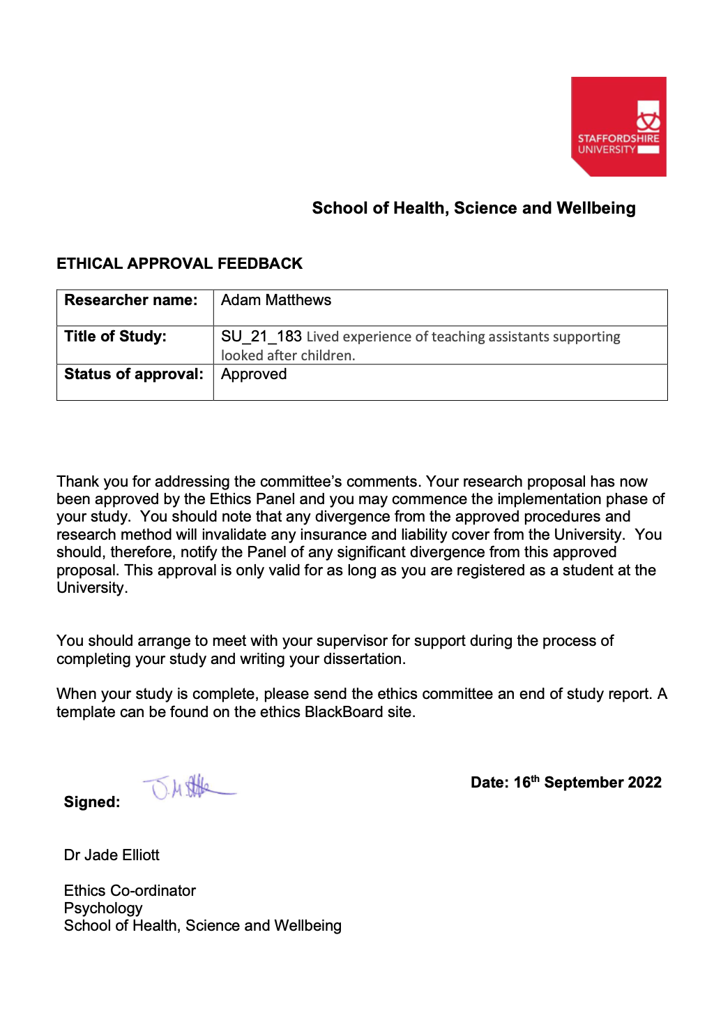

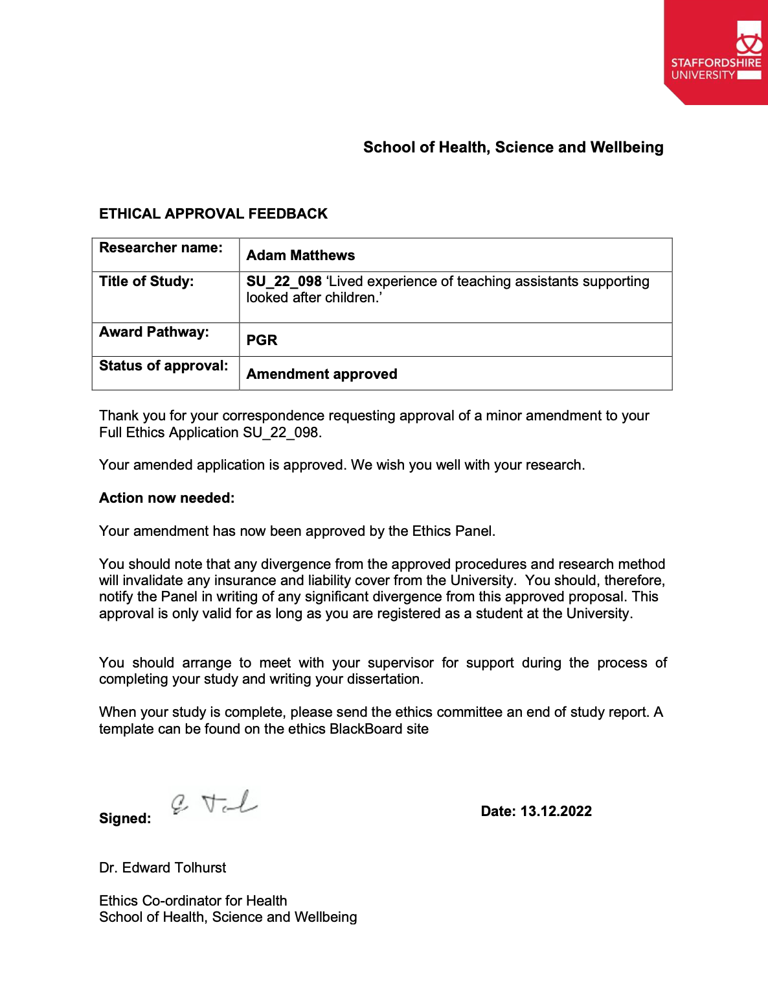

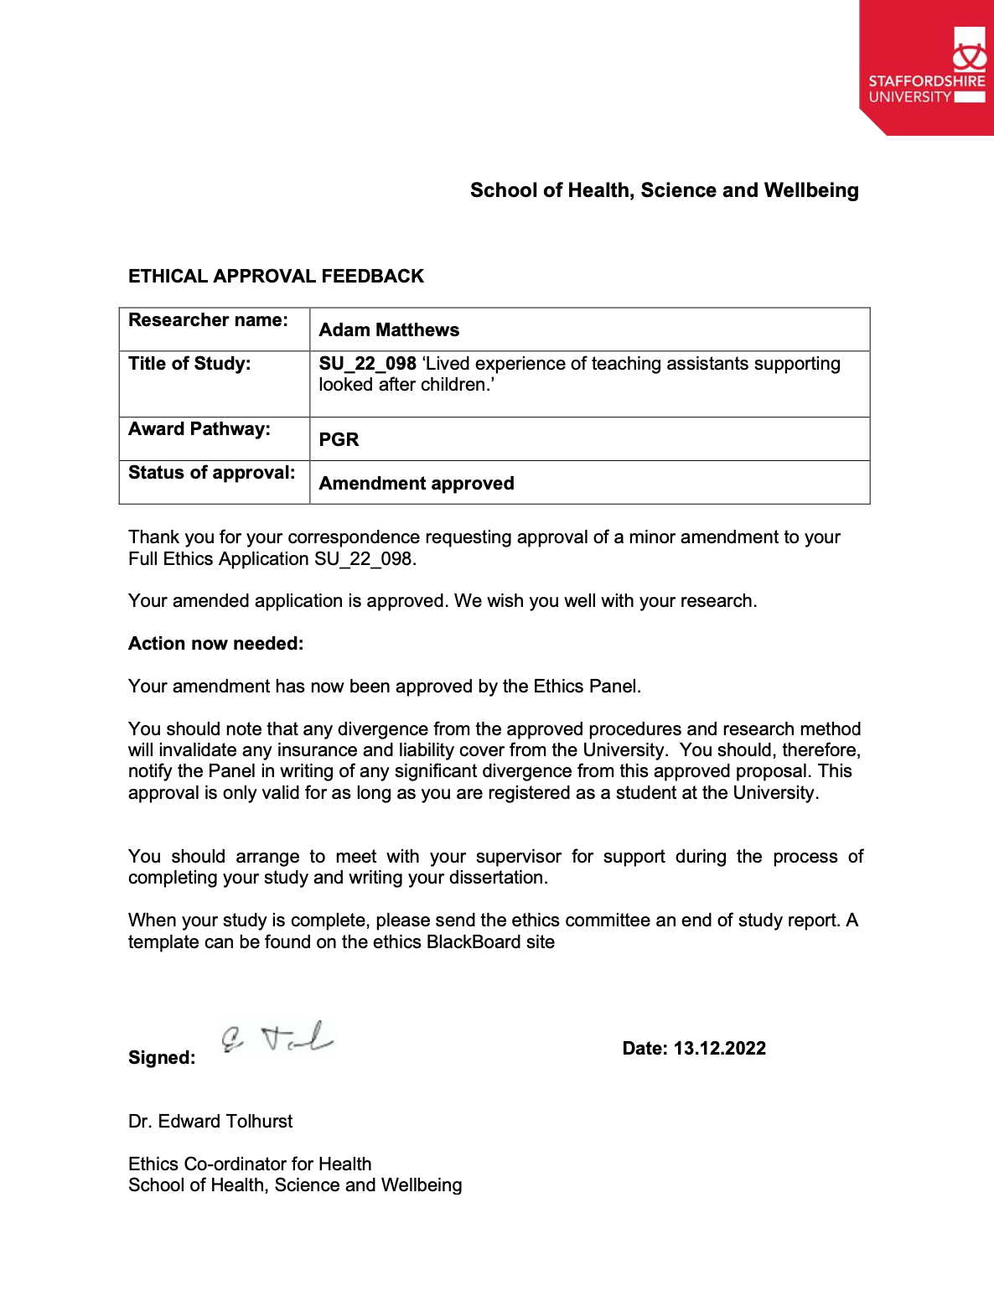

Appendix B – Information sheet and consent form
INFORMATION SHEET FOR PARTICIPANTS

Project Reference Number: [insert once provided by the university ethics committee]

Title of study
Lived experience of teaching assistants supporting looked after children.

Invitation Paragraph

I would like to invite you to participate in this research project which forms part of my Professional Doctorate in Clinical Psychology research. Before you decide whether you want to take part, it is important for you to understand why the research is being done and what your participation will involve. Please take time to read the following information carefully and discuss it with others if you wish. Ask me if there is anything that is not clear or if you would like more information.

What is the purpose of the study?

The study aims to develop an understanding of how teaching assistants experience their role when supporting looked-after children.
Looked after children have often experienced abuse and neglect/developmental trauma that may impact their relationship with education. A high proportion of looked after children require additional support in school. Alongside learning needs, many looked after children have an education and health care plan for social, emotional, and mental health needs and behavioural difficulties. Teaching assistants play a critical role in providing support for such vulnerable children. This support is both pastoral and educational, with teaching assistants often working closely and for long periods with some of the most complex young people. I want to learn more about teaching assistants experience in this role, supporting looked after children specifically.

Why have I been invited to take part?

You have been invited to participate because you are a teaching assistant who has worked closely with looked-after children. You have spent at least one year closely supporting looked after children, have sufficient length of experience, and feel comfortable discussing your experiences. If you are struggling significantly with your role as a teaching assistant or well-being, you should carefully consider whether now is the right time to take part in a study on this subject.

What will happen if I take part?

If you take part, a meeting will be scheduled to take place either remotely via Microsoft Teams (with camera on or off if preferred) or face-to-face at the school where you are employed or at Staffordshire University. The study will involve you taking part in an interview in which you will be asked some background questions (e.g., time spent working with looked after children) and invited to explore your experiences supporting children who are looked after. The interview will last between 60 and 90 minutes. The interviews will be recorded using the inbuilt functionality within Microsoft Teams if remote or using the audio recording functionality of the researcher’s phone if face-to-face. If during the interview process you discuss a safeguarding concern, I will ask if this has been processed according to your school safeguarding policy and will follow appropriate procedures where this is not the case.
After the interview, you will be debriefed, and options regarding further support will be offered if they are needed.

Do I have to take part?

Participation is completely voluntary. You should only take part if you want to and choosing not to take part will not disadvantage you in anyway. Once you have read the information sheet, please contact us if you have any questions that will help you make a decision about taking part. If you decide to take part we will ask you to sign a consent form and you will be given a copy of this consent form to keep.

What are the possible risks of taking part?

Whilst I do not envisage taking part in this project should be unduly distressing, indeed, some people can benefit from exploring their experience, it is possible you may recall some prior experiences relating to your role as a teaching assistant that are more emotive. It is possible that recalling this during the interview may cause you to experience distress or unpleasant feelings.

If you are distressed during the interview process, breaks can be used. If necessary, you have the right to stop, either withdrawing from the research process or rearranging the interview for another time. You will be directed to services for further support following the interview, should you require it.

Additionally, if you are currently experiencing difficulties with your well-being or significant work-related stress, you may want to consider carefully whether taking part in this research is advisable at this time.

What are the possible benefits of taking part?

Although you will not receive any direct benefit from taking part, what we learn about the experience of the role may help with considering support needed by TAs in their role working with looked after children. It may also be beneficial to you to reflect on previous experiences.

Data handling and confidentiality

Your data will be processed in accordance with the data protection law and will comply with the General Data Protection Regulation 2016 (GDPR).
All personally identifying data will be removed from transcripts of the recordings and pseudonyms will be used in the write up. Quotations may be used in the write-up with identifying features removed. All data will be stored electronically on the password protected Microsoft OneDrive of the researcher. Recordings of the interviews will be held up until they have been transcribed and the researcher is sufficiently immersed in the data at which point, they will be deleted. Other data will be held for 10 years per the Staffordshire University policy. Anonymised data (e.g., transcripts) will be shared with the research team or external examiners/auditors as required.

Data Protection Statement

The data controller for this project will be Staffordshire University. The University will process your personal data for the purpose of the research outlined above. The legal basis for processing your personal data for research purposes under the data protection law is a ‘task in the public interest’ You can provide your consent for the use of your personal data in this study by completing the consent form that has been provided to you.

You have the right to access information held about you. Your right of access can be exercised in accordance with the General Data Protection Regulation. You also have other rights including rights of correction, erasure, objection, and data portability. Questions, comments and requests about your personal data can also be sent to the Staffordshire University Data Protection Officer. If you wish to lodge a complaint with the Information Commissioner’s Office, please visit www.ico.org.uk.

What if I change my mind about taking part?

You are free to withdraw at any point in the study, without having to give a reason. Withdrawing from the study will not affect you in any way. You are able to withdraw your data from the study up to two weeks after the interview, after which withdrawal of your data will no longer be possible due to the data having been processed and committed to the final thesis.

If you choose to withdraw from the study we will not retain any information that you have provided us as a part of this study.

What will happen to the results of the study?
The results of the study will be written up for the Trainee Clinical Psychologist’s doctoral thesis with the aim of being published in a peer reviewed journal. The results of the study might also be used in teaching and training and might be disseminated to other relevant parties.

Who should I contact for further information?

If you have any questions or require more information about this study, please contact me or the research supervisor using the following contact details:

Adam Matthews: mt906052@student.staffs.ac.uk

Research supervisor - Dr Yvonne Melia: yvonne.melia@staffs.ac.uk

What if I have further questions, or if something goes wrong?

If this study has harmed you in any way or if you wish to make a complaint about the conduct of the study you can contact the study supervisor or the Chair of the Staffordshire University Ethics Committee, Tim Horne, for further advice and information: ethics@staffs.ac.uk

Thank you for reading this information sheet and for considering taking part in this research.
RESEARCH PROJECT CONSENT FORM

Title of Project: Lived experience of teaching assistants supporting looked after children.

Researcher: Adam Matthews

I have read and understood the information sheet. | Initial ___
I have been given the opportunity to ask questions, and I have had any questions answered satisfactorily. | Initial: ___
I understand that my participation in this study is entirely voluntary and that I can withdraw at any time without having to give an explanation. | Initial: ___
I understand that the interview will be audio-recorded if face-to face or recorded through Microsoft Teams and that I may turn off my camera if preferred. | Initial: ___
I understand that I will be asked to confirm safeguarding procedures have been followed where relevant and that where necessary the researcher will take appropriate safeguarding action. | Initial: ___
I consent that data collected could be used for publication in a scientific journal or could be presented in scientific forums (conferences, seminars, workshops) or can be used for teaching purposes and understand that all data will be presented anonymously. | Initial: ___
I agree that data will only be used for this project although, the data may also be audited for quality control purposes. | Initial: ___
All data will be stored safely on a password protected computer (electronic data), or locked away securely (hard copies of data) for 10 years before being destroyed. | Initial: ___
I understand that I can withdraw my data from the project up to two weeks after the date of interview without having to give an explanation. | Initial: ___
I hereby give consent to take part in this study. | Initial: ___

________________________ ________________ ____________________
Name Participant (print) Date Signature

________________________ ________________ ____________________
Name Researcher (print) Date Signature

Appendix C- Recruitment Poster
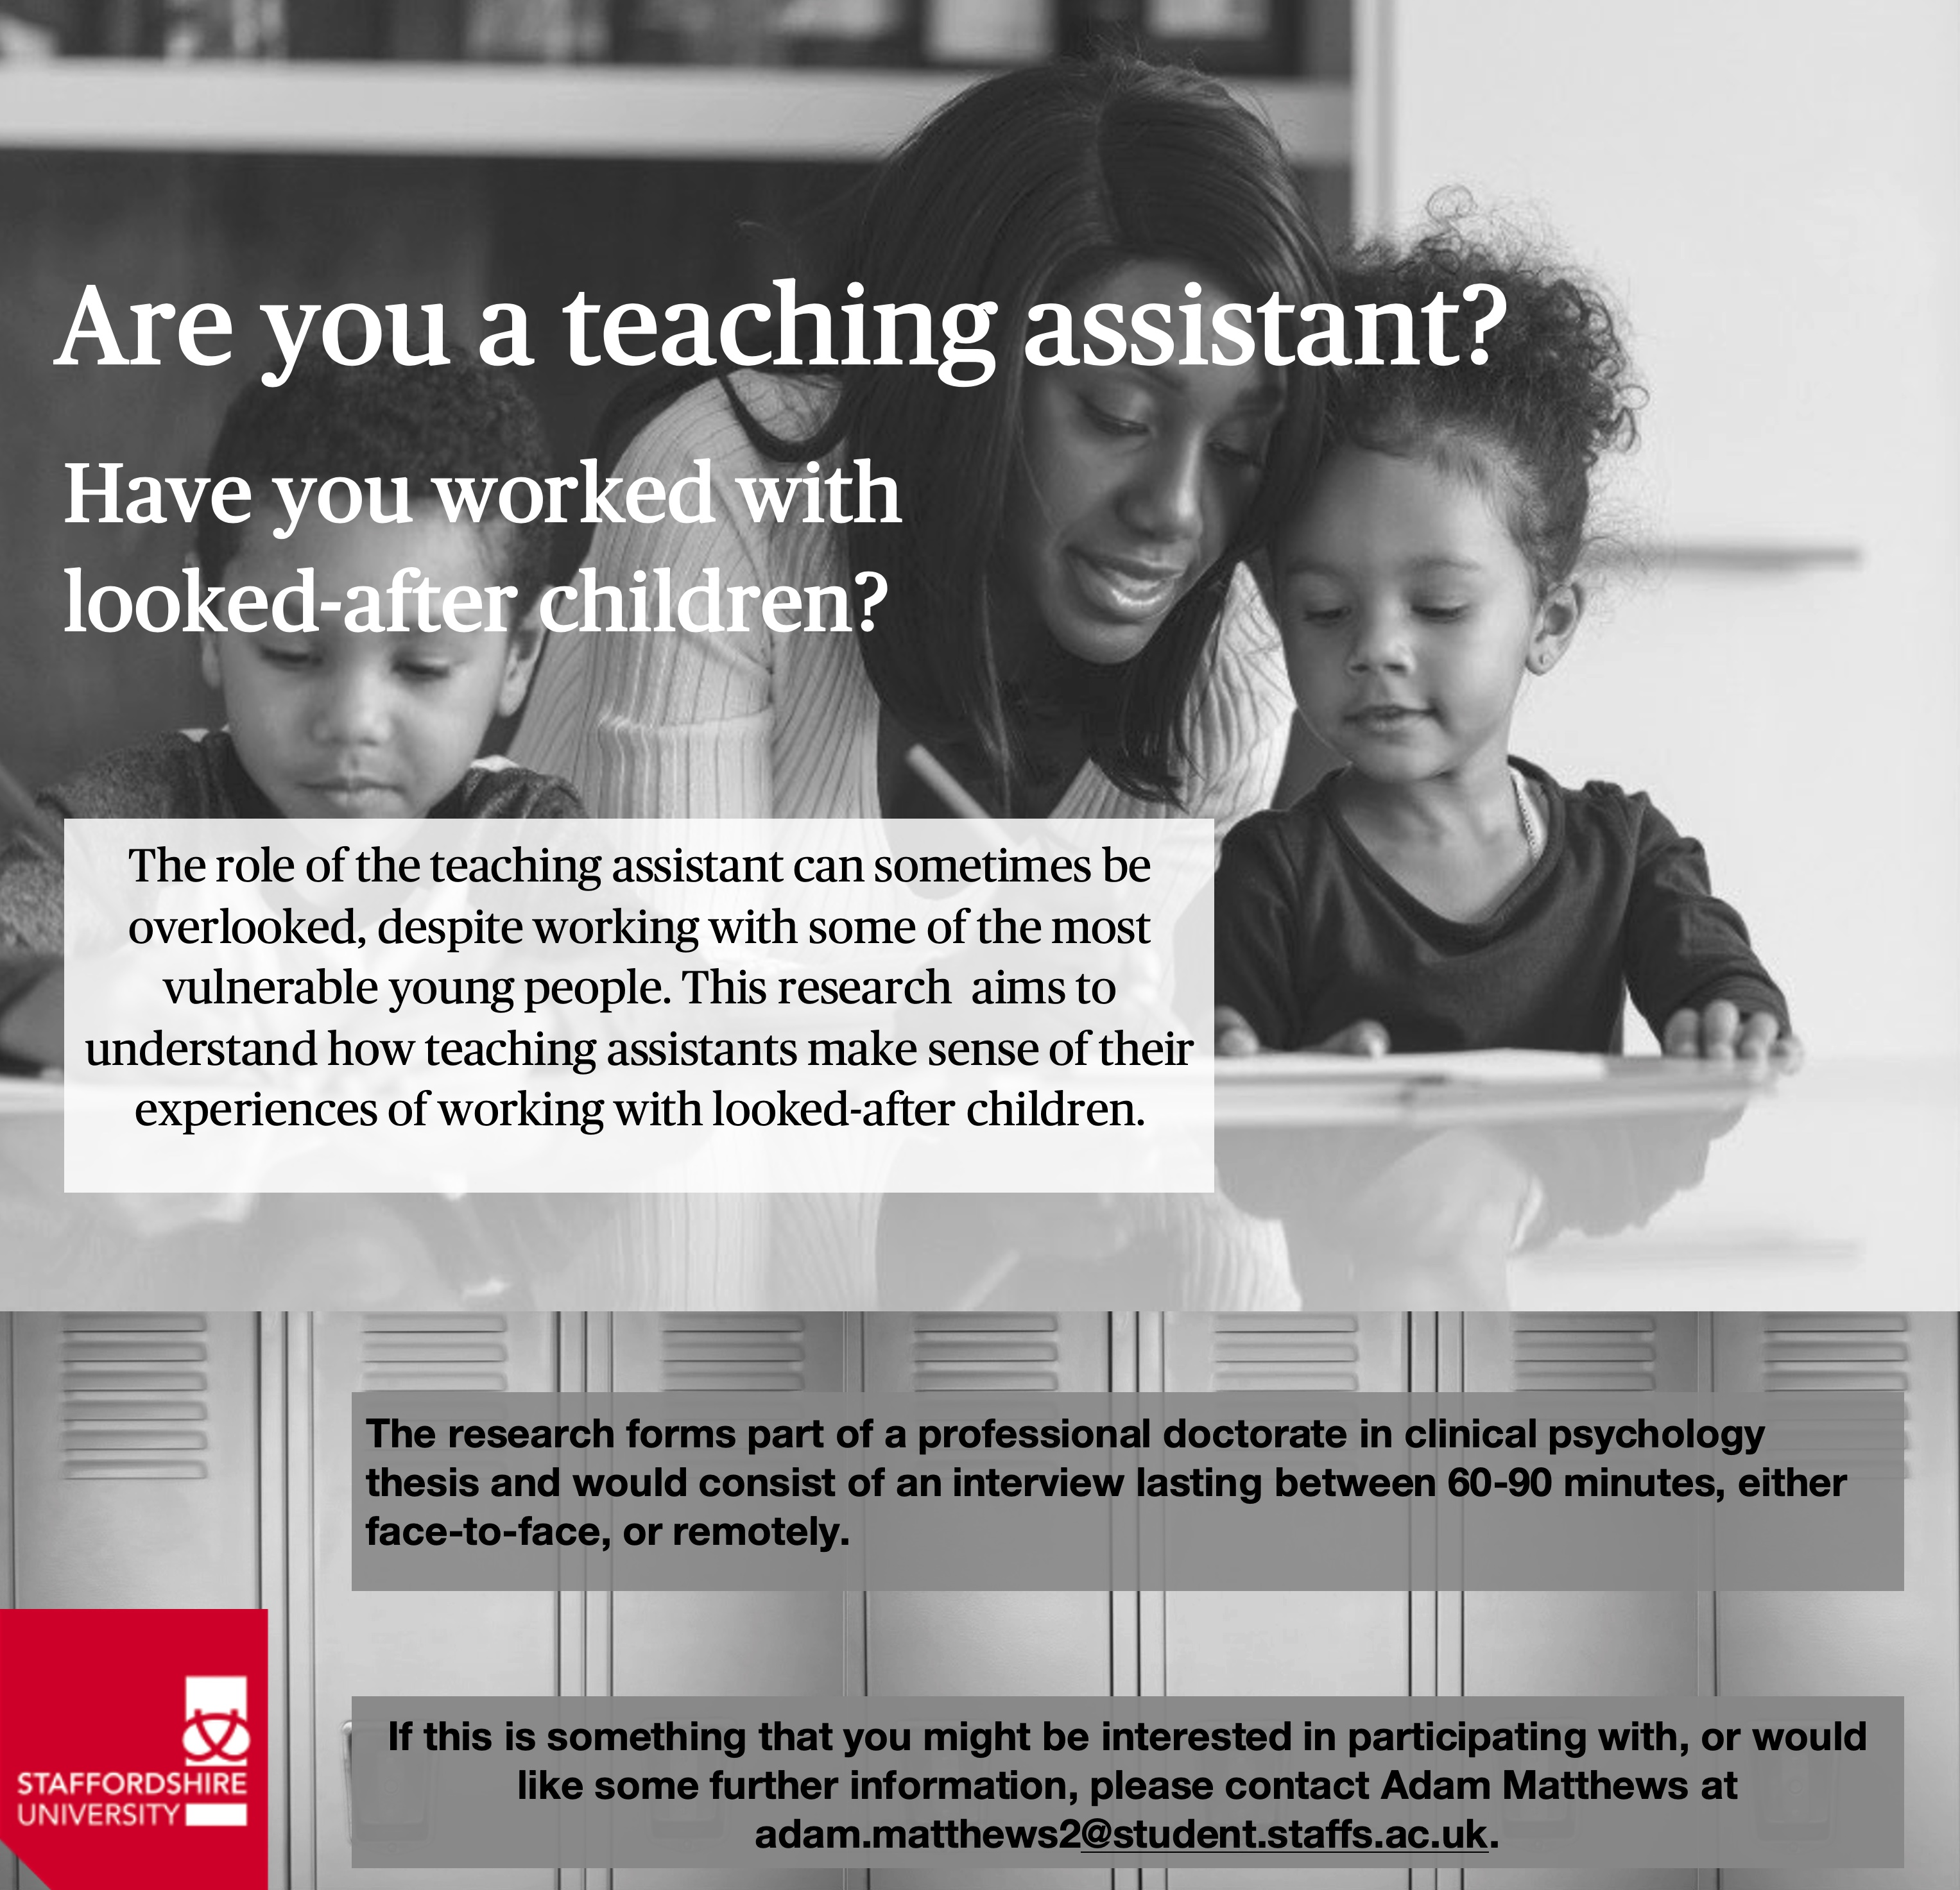

Appendix D- Table detailing the Facebook teaching assistant groups where the research was advertised.

Name of Group | No. of members (Thousand) | Group Description
Teaching Assistants UK | 53.3K | This group is aimed for working TAs qualified or unqualified, people looking into a TA career, advice or support around looking for work and applying for jobs. Any other support, advice or general chat about being a TA.
Twinkl TA (Teaching Support Assistants) Group | 34.8K | A group for UK TAs, LSAs and HLTAs to share ideas, ask advice and connect. Whether you are in the role or looking to join us, this is possibly the biggest network of Teaching Assistants in the UK.
Teaching Assistant Support Group | 6.9K | A group to help each other, to be kind to each other and support each other.
Teaching Assistant..Support Staff | 6.4K | A group for the amazing Teaching and Support Assistants to offer support, ideas and inspiration. Ask questions about resources, interviews, lesson ideas or anything else you are struggling with.
Teaching Assistants, HLTA Forum (share resources and ideas) | 3.3K | This article is about teaching assistants in education. For teaching assistants in UK schools & Teaching assistant (Internationally).
Teaching Assistant Wellbeing (U.K) | 2.7K | This group is designed for TA’s, HLTA’s or anyone working in the education sector to share ideas, resources and ask questions/advice to fellow members.

Appendix E - Interview Schedule
Research Question: What is the lived experience of teaching assistants supporting looked after children?

Preamble/warm up:
We are trying to find out about the experiences of TAs working with this particular group of people. It might help to think of one individual that you spent a lot of time with or are currently working with, or someone that has had a particularly powerful impact on you. If you can, it might help to think back to emotional responses as well as the more practical side to the work.

What has been the nature of the work that you have done with looked-after children?
Prompts
- How long have you been employed as a TA??
- Are you currently supporting any looked after children and how long has this been for?
- What is the nature of the work that you have done with looked-after children?
- 1:1 support, group work, mental health support…

What are your experiences of training regarding supporting looked-after children?
Prompts
- If you have a TA qualification, how was working with looked-after children addressed?
- What in-school CPD has been done about working with looked after children?

What has your experience been in supporting looked after children with their learning?
- Prompts
- Have there been any barriers/facilitators?
- Have there been any positive experiences/challenges?
- What has worked well or not so well?

What are your experiences of supporting the social, emotional, and mental health of looked after children?
Prompts
- What kind of support can you offer?
- What have you found to work well with looked-after children?
- What difficulties or problems have you faced?

What has been your experience of supporting behaviour of looked-after children?
Prompts
- What do you think causes the behaviour?
- What strategies work well/do not work?
- Can you think of examples of things you have done that have been helpful or unhelpful?

What has been your emotional response to working with looked-after children?
Prompts
- Are there any positive experiences that you can recall?
- Are there any negative experiences that you can recall?
- What has been your response when hearing details of the histories of LAC?

How have you been supported when working with looked-after children?
Prompts
- What support is offered to you?
- Do you feel that you have the right amount of support?
- How do you access the support?

If you have had to deal with safeguarding issues or disclosures in your role, what impact does this have on you?
- Prompts
- How did it make you feel at the time and later?
- What did you do to manage your emotions at the time and later?
- What support was offered to you after the disclosure/incident

How have you experienced your relationship with children who are looked after?
Prompts
- Has it been easy, testing…
- Has it been close, distant…

Thinking about individual children you have supported was your experience of this relationship different at the start and over time? Can you describe how this changed?
- Prompts
- How would you describe the individual at the start of the work, how would you describe them at the end/now?
- Why do you think there are these changes?

What is rewarding/challenging about your role in supporting LAC?
- Prompts
- At the end of the day, what do you look back on with pride or smile about?
- What do you look back on and find tough to think about?
- When you describe your role to friends, what do you say?

What impact does this role have on you personally?
- Prompts
- What type of person do you think you have to be to do this type of work?
- What do you feel about the role that you have?
- What do you do when you learn about a child’s history? Does this impact your view/opinion of them or how you interact with them?

What further training might be beneficial to you?

If you had to give three words to describe what it is like supporting a child in care in school what would they be? Can you explain why you chose those particular words

Appendix F- Example of transcript analysis
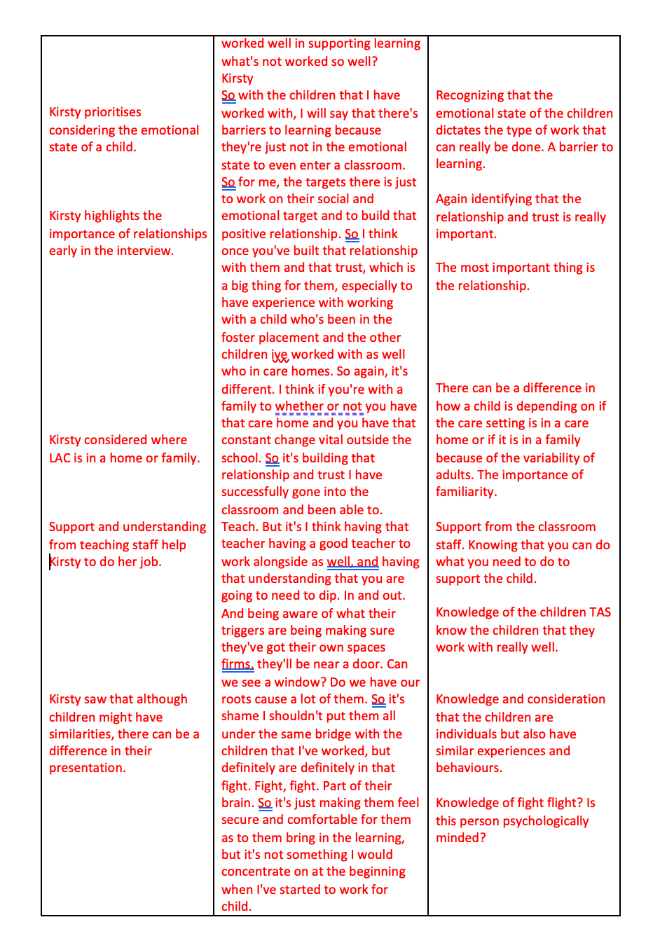

Appendix G - Example of personal experiential theme development.
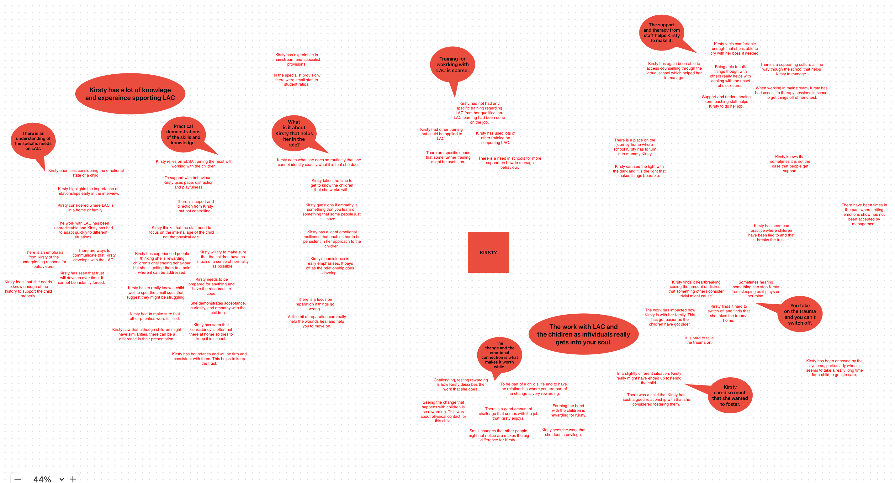

Appendix H - Development of GETs from PETs
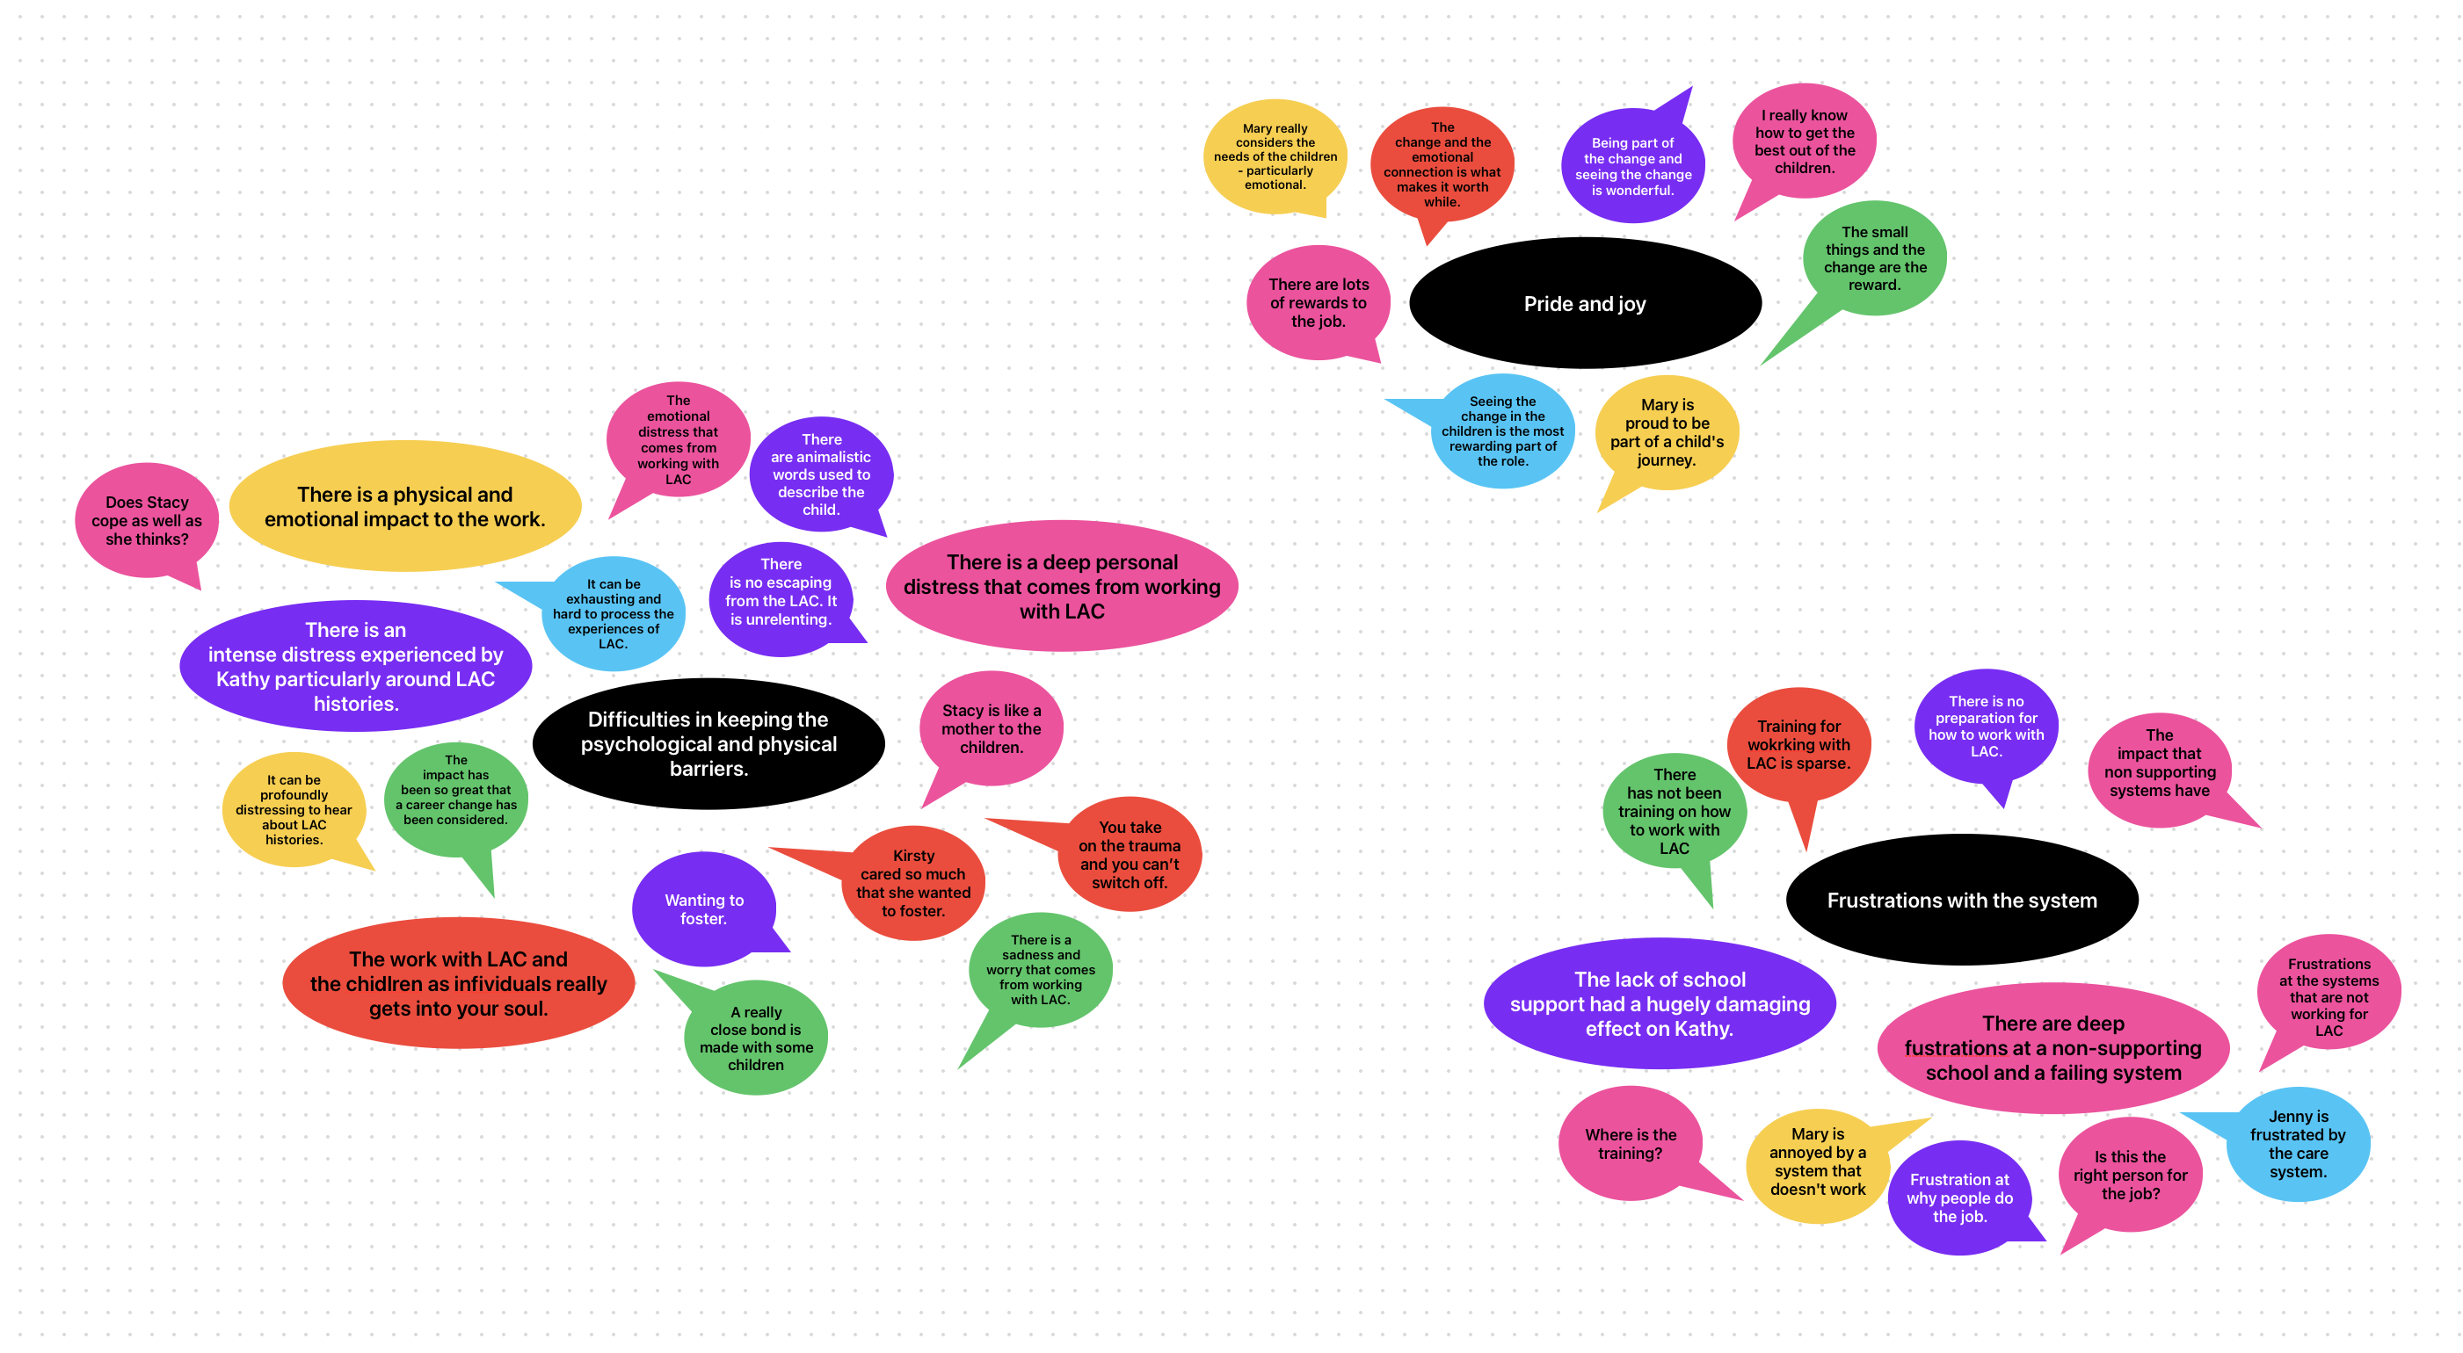

Appendix I – Table of GETs and PETs and example quotes
GETs | PETs | Example supporting quote
Difficulties in keeping the psychological and physical barriers. | There are animalistic words used to describe the child. | and then other days he'd be like, literally feral
 | There is an intense distress experienced by Kathy particularly around LAC histories. | So those disclosures happen…it makes you feel angry and very sad that people can do that… How do I cope with them? Well, I suppose I don't
 | There is no escaping from the LAC. It is unrelenting. | It's mentally exhausting because it's a consistent thing. You can't take a break from it, even when… you don't get breaks or dinners.
 | Wanting to foster. | I wanted to take this child on. I was told I couldn't because it would have been a conflict of interests, which I still believe was wrong.
 | There is a physical and emotional impact to the work | mentally it… it can affect you because it affects your sleep and your eating yourself, because you're thinking, well, what's happening to this poor child, you know? What's happened to this poor child in the past?
 | It can be profoundly distressing to hear about LAC histories. | You just learn on a day-to-day to survive with it. Yeah, I think that's the word for it. You survive
 | Does Stacy cope as well as she thinks? | I suppose you don't worry as much, but I just sort of…I know it sounds horrible but forget about it when I come home. Because I think it can just drive you mad? l would just be awake at night or every night
 | The emotional distress that comes from working with LAC | [You] take on all of their emotional baggage and God knows what's going on in their lives, as well as manage your own life... It's just a build up. I don't think you realise how much of an impact it has on you at all. So where does that emotion go? Down my boyfriend's ear. That's probably where.
 | There is a deep personal distress that comes from working with LAC | I would come home and over play that that that's scene in my head and think what could I have done differently?”
 | Stacy is like a mother to the children. | It's almost like you’re like the school mum really.”
 | It can be exhausting and hard to process the experiences of LAC. | you're absolutely horrified by what they're telling you. Yeah, not to let your face show what you're thinking, but it depends on the disclosure really. Sometime it can be what on Earth are they thinking in that family
 | The impact has been so great that a career change has been considered. | Sometimes I think I'd like to go further with a job role working. That with social services or family layers on down them. Down that road.
 | A really close bond is made with some children | And he said no, I'm getting Skype and alright then I'll see you tomorrow and just little. Just little things like cause he knows what he's doing just and he knows he can be like that too with me and. He knows it's only. A laugh.
 | There is a sadness and worry that comes from working with LAC. | And then not wanting to upset them, if we say the wrong the wrong thing
 | The work with LAC and the children as individuals really gets into your soul. | it's heartbreaking to see that they just can't… They haven't got the tools yet to regulate those emotions
 | Kirsty cared so much that she wanted to foster. | I really uhmed and ahhed about putting up for foster him for him
 | You take on the trauma and you can’t switch off. | I am someone that doesn't shut off so. I definitely take on a child's trauma… And then you're also aware of triggers yourself… It's difficult to take on that trauma…
Pride and joy | Being part of the change and seeing the change is wonderful. | I'd like to think that, you know, I've made a difference to those children, even if they don't remember, but even short term. Because they make a difference to you
 | I really know how to get the best out of the children. | Sometimes they need to see the way out of a situation. I think sometimes they they cause a situation and they think it's so, so bad that they can't, they can't get out of it so the only option is to just keep making it worse.
 | There are lots of rewards to the job. | Just be little Johnny's friends or whatever, but. I think I just find that more rewarding. I think you get to know them better. I think you get to see. More on an individual level at how they react to things. What makes them laugh, what makes them cry
 | Mary really considers the needs of the children - particularly emotional. | But to do but to do that, you've got to know the child. You have got to. Talk obviously get to know the child, what the likes and the dislikes are
 | Mary is proud to be part of a child's journey. | They actually the child is now thriving, improving. You have. You have done the best for that child. You are praying, you you are doing the best for that child, that family
 | The small things and the change are the reward. | She spoke in the front of that. And she was confident because she's had that support of everybody. It was. I think it made… it’s making me cry. It was a really emotional scene. From what she was - making me cry - Yeah, it was like she's like different child
 | Seeing the change in the children is the most rewarding part of the role. | But there was one, and for her to come back and be blossoming in high school. And have goals of what she wanted to achieve in the future. From where she was that. That was just lovely. It's just really, really rewarding.
 | The change and the emotional connection is what makes it worth while. | When they've let you in. And just those little moments for me, it makes. It all worth it.
Frustrations with the system | There has not been training on how to work with LAC | I'm doing my HLT Aa course at the minute. I haven't come across. That hasn't come up
 | Training for working with LAC is sparse. | I would say it only brushes over just as much as it would do SEND children. It doesn't go into detail.
 | Mary is annoyed by a system that doesn't work | some days you feel you can be cross with the system.
 | Where is the training? | very minimal training in my entire TA career. I'm trying to think. We might have had like one session from social services on looked after children
 | There are deep frustrations at a non-supporting school and a failing system | Think the system just lets. It just lets. The whole thing down...in that way that it's just understaffed.
 | Is this the right person for the job? | They're not the best people to be working with the children and they're not the people that can build a relationship. And they're literally just. Working in a school cause it. Suits cause of childcare
 | There is no preparation for how to work with LAC. | That's an easy answer. It's none.
 | The lack of school support had a hugely damaging effect on Kathy. | I literally walked in on the Friday, handed the headmaster my notice of resignation and didn't go back. I didn't have a job to go to. I signed off sick for me notice period. And and that was it.
 | Frustration at why people do the job. | you've got to be really very empathic and understanding and caring and patient and tolerant and and all of those things I I just simply haven't the ability to understand why anybody would do that job if they haven't got any of those qualities.
 | Jenny is frustrated by the care system. | you became aware they should have done that, and didn't do that… hasn't got his PE kit and should have it. You know, this is what they're there for. To help that child have everything that he needs

“Now I know he’s let me in….” TAs experiences of supporting looked after children. Executive Summ

“Now I know he’s let me in…”
TAs Experiences of supporting
Looked After Children.
Executive Summary

In 2021, the Department for Education introduced a charter to prioritise education staff and mental health and well-being. The charter promotes discussions on mental health, recognises its importance, and helps schools develop strategies to support staff well-being. It acknowledges that students’ psychological and physical health challenges can affect the well-being of staff who support them.

In 2022, over 82,000 young people in England were considered ‘looked after’, often due to parental abuse or neglect. These children often face difficult experiences like abuse, neglect, trauma, and a lack of nurturing relationships. They also deal with frequent changes in caregivers, which makes it hard for them to form stable and secure bonds with reliable adults. These early experiences can lead to insecure attachments in children, making them doubt if adults will respond to their needs. Children with insecure attachments may struggle with engaging in new experiences and can display reactive behaviours towards staff and learning tasks, which affects their education.

Looked-after children in the education system tend to have worse outcomes than their peers, often underperforming academically, with lower achievement rates and scores. Children in care also face more exclusions and are more likely to have special educational needs, particularly in social, emotional, and mental health areas. Teaching assistants (TAs) comprise about 30% of the school workforce and play a crucial role in supporting these vulnerable students by building relationships, addressing challenging behaviours, and providing aid related to attachment and trauma.

Limitations in training mean that school staff, including TAs, sometimes lack the necessary skills and resources to support children who have experienced trauma or attachment difficulties effectively. TAs face demanding responsibilities without sufficient preparation or training. Additionally, schools may struggle to address the broader anxieties and insecurities that hinder the educational progress of children in care. Children in care often bring their emotional struggles from home to school, leading to challenging behaviour, and TAs may feel rejected or angry.

Despite the teaching assistant role’s varied nature, the emotional support TAs provide is crucial. Building relationships that foster social and emotional development is vital. TAs are sometimes seen as providing maternal care, which benefits children in care who lack significant adult relationships. Schools play a crucial role in providing stability for these children, and a positive school environment with nurturing teacher relationships dramatically enhances LAC’s overall engagement.

What did the study aim to do?

The research aimed to understand how primary school teaching assistants make sense of their experiences working with looked-after children, what it means for teaching assistants to be in this supportive role, and how this is experienced.

What was done?

The project received ethical approval from the Staffordshire University Research Ethics Committee.
This research used semi-structured interviews and a method called Interpretative Phenomenological Analysis (IPA) to understand people’s personal experiences. IPA was chosen because it focuses on individual perspectives and values subjective knowledge.
Participants gave informed consent to take part in the research and were invited to complete an interview. These took place over video calls and lasted an average of 63 minutes. They were recorded, transcribed, and analysed.

Who could take part?

The inclusion criteria for this research needed TAs to have at least one school year of experience supporting looked-after children in primary school, be based in the UK, and possess English-speaking proficiency.

Who did take part?

Six female teaching assistants took part in the study. The average age for participants was 45, and the average amount of experience was 16 years.

What was found?

Three group experiential themes were found following the analysis of the transcripts.
- Theme 1: No escape – The challenge of maintaining self-other boundaries.
- Theme 2: “No money in the world” – The pride and joy that TAs experience.
- Theme 3: “Banging your head against a brick wall” - Frustrations of TAs working with LAC.

Theme 1: No escape – The challenge of maintaining self-other boundaries.

The study found that teaching assistants struggle to maintain physical and emotional boundaries with the children they support and between their personal and professional lives. The psychological impact they experience is primarily related to understanding a child’s difficult history, hearing disclosures, and working with children who have experienced trauma, abuse, or neglect. They rely on personal support systems due to the lack of formal avenues for addressing the personal impact of their role, which can hinder their performance. Limited emotional and physical space for TAs to handle their emotions and the need to compartmentalise feelings hinder the repair process in the school setting, where LAC require a secure base. TAs often take on a maternal role, developing intimate relationships with children that can blur professional and personal boundaries, leading some to consider fostering children.

Kathy spoke about how the knowledge of a young person’s history would stay with them, and they would spend lots of time in the evening trying to cope and manage the feelings it brought up.
“…it makes you feel angry and very sad that people can do that… You could say I do cope with it because I keep doing what I’m doing, but then is going home every night exhausted, emotional, upset, angry, is that is that coping with it? It’s not really, is it?”

Another participant, Stacy, said that she could separate her school life from her home life, but when describing her experiences, she seemed to think about bad things that had happened at school frequently.
“I know it sounds horrible, but I forget about it when I come home. Because I think it can just drive you mad?

I would come home and overplay that scene in my head and think, what could I have done differently?”

Mary said that the emotional impact had sometimes progressed to the point that it caused her physical distress and impacted her eating and sleeping.
“Mentally it… it can affect you because it affects your sleep and your eating yourself, because you’re thinking, well, what’s happening to this poor child, you know?”

Many participants mentioned that they could not get any break from the children they worked with. They were called upon to support the looked-after child at all points in the day.
“You can’t take a break from it, even when… you don’t get breaks or dinners. You know, [Student] could be out on the yard, and something would go wrong or something to kick off. Who do they come to? They come to the person that’s with him all the time”
“

Theme 2: “No money in the world” – The pride and joy that TAs experience.

Theme 2 explores the intense feelings of pride and joy among the TAs in their work with looked-after children. They take pride in positively impacting children and find joy in the small moments that signify developing relationships. The title “no money in the World” represents one participant, Mary’s, belief that no amount of money would dissuade her from doing this job.

Participants in the study expressed pride and joy in their work as teaching assistants, reflecting an overall positive attitude towards their job. This positive experience could be related to their satisfaction from helping others. The strong and positive relationship between teaching assistants and looked-after children can contribute to the children’s engagement with school. Additionally, when looked-after children receive support from the school, it positively affects their well-being and educational experience.

When describing watching one of the children in care that Sophie had supported performing in a school production, she was moved to tears during the interview because of the overwhelming feelings of pride and joy.
“She was in the school play… She spoke in the front of that. And she was confident because she’s had that support of everybody. It was. I think it made… it’s making me cry. It was a really emotional scene. From what she was - making me cry - Yeah, it was like she’s like a different child. I think just like they could…everyone believed in them.”

Kirsty had experienced that change in the relationship and the trust built over time with the child in care she supported. She spoke about how a seemingly minor event was hugely significant for the child, and that’s how she knew the relationship was there.
“…he did not like that physical contact whatsoever... And that first time he gave me his little finger for me to massage - that was huge for him. I was actually touching him. But that was just a massive thing. So for me, I know I’ve stepped into his world. Now I know he’s let me in.”

Jenny had experienced joy at seeing the positive change in children over time when they were in successful placements and described how emotionally rewarding this was.
“[she was] blossoming in high school. And have goals of what she wanted to achieve in the future. From where she was... That was just lovely. It’s just really, really rewarding.”

Theme 3: “Banging your head against a brick wall” - Frustrations of TAs working with LAC.

Theme 3 explores teaching assistants’ frustrations when working with looked-after children. These frustrations stem from a lack of understanding from the system, unhelpful expectations for both the teaching assistants and the children, competing demands, and challenges in effectively connecting with the children while managing their own experiences in this context.

Participants reported a lack of specific training for working with children in care, regardless of their qualifications as teaching assistants. Their knowledge of working with looked-after children primarily came from their own experiences, with limited preparation or clarification of their role.
“…there was actually nothing in the course… …that would be aimed directly at LAC.” - Kathy

This aligns with previous research indicating that teaching assistants acquire knowledge through experience rather than formal training. The findings emphasise the need to clarify the role of teaching assistants, as a lack of guidance can negatively affect the educational outcomes of the children they support.

Stacy mentioned that TAs are frequently not prepared for the experience of working with children in care and was concerned about the impact of this.
“[New TAs] need their eyes opening to how horrific it can actually be. I think they’re just… I don’t know… a bit deluded about what children in care are like. I don’t think they see the severity of actually what it takes for a child to be in care.”

Mary had identified that there had been a shift in the roles during her time as a TA, with more emphasis on the pastoral nature of the position recently.
“Teaching now is becoming less and less and less because it’s more social care health care than it’s than it’s ever been.”

What does this mean for teaching assistants and schools?

The study highlights that teaching assistants struggle to detach from the emotional impact of working with looked-after children. School leaders should proactively provide mental health support and consider starting reflective practice to support their well-being. Additional training for staff working with children in care would help them better understand and meet their needs. Sharing and celebrating the positive experiences of teaching assistants working with looked-after children can also be beneficial.

What this study did well, and what it could have done better?

This study provides important insights into an underexplored research area. The findings can support school leaders in considering the emotional well-being of teaching assistants working with looked-after children and developing training programs for them. The inclusion of six participants allowed for detailed data collection. However, it would have been beneficial to have additional perspectives. All participants in the study identified as female, and it would have been valuable to include male participants to gain further insights into the role. The study focused solely on participants from England, and including participants from other countries within the United Kingdom could have provided interesting information due to variations in school systems.

What might this mean for future research?

Previous research has shown that the TA role often has a maternal aspect. Studying the experiences of male TAs working with looked-after children, specifically their attachment and paternal roles, would be helpful in understanding the topic fully. Additionally, gathering input from looked-after children about their experiences with TAs in schools would provide valuable insights. Also, exploring the experiences of secondary school TAs and primary school TAs could give further helpful information.

This summary was written in collaboration with a teaching assistant. References have been removed to improve readability. For a complete reference list, please contact the author: Adam Matthews mt906052@student.staffs.ac.uk

