Psychological Factors associated with Somatisation and Seizure Frequency in Seizure Conditions: Comparing Intolerance of Uncertainty, Anxiety Sensitivity, Anxiety, and Depression between People with Epilepsy and Dissociative Seizures

James Rowland

Thesis submitted in partial fulfilment of the requirements of Staffordshire University for the degree of Doctorate in Clinical Psychology

April 2023

Total word count: 18,184

THESIS PORTFOLIO: CANDIDATE DECLARATION
Title of degree programme | Professional Doctorate in Clinical Psychology
Candidate name | James Rowland
Registration number | xxxxxxxx
Initial date of registration | September 2020

Declaration and signature of candidate
I confirm that the thesis submitted is the outcome of work that I have undertaken during my programme of study, and except where explicitly stated, it is all my own work.
I confirm that the decision to submit this thesis is my own.
I confirm that except where explicitly stated, the work has not been submitted for another academic award.
I confirm that the work has been conducted ethically and that I have maintained the anonymity of research participants at all times within the thesis.
Signed: Date: 27/04/2023

Acknowledgements

I am tremendously grateful to my personal tutor and academic supervisor, Dr. Yvonne Melia, for her unwavering support throughout my journey on the doctorate. This project would not have been possible without Yvonne’s clear guidance and patient encouragement. I would also like to thank Dr. Helen Scott and Dr. Michelle Rydon-Grange for their expert advice on the statistical aspects of the paper.
I would like to express considerable thanks to my clinical research supervisors Dr. Gill Cooke, Dr. Abi Methley, and Dr. Antonia Kirkby for their unwavering support and contributions. I would particularly like to thank Dr. Simon Ellis and Dr. Danielle Verity for their vital support in recruitment, without which this project would not have been able to proceed.
I am indebted to the people who took part in this study and those that helped to provide feedback along the way.
Finally, I would like to thank my family and friends for their encouragement and motivation throughout.

Preface

Paper 1 has been written in line with submission guidelines for the Journal of Traumatic Stress, with submission guidelines in Paper 1, Appendix A. Paper 2 has been written in line with submission guidelines for Seizure – European Journal of Epilepsy, with submission guidelines in Paper 2, Appendix A.

Word Count

Document Name | Word Count
Thesis Abstract | 299
Paper One: Literature Review | 7,896
Paper Two: Empirical Paper | 7,922
Paper Three: Executive Summary | 2,067
Total Word Count | 18,184

Contents
Acknowledgements 3
Thesis Abstract 9

Paper 1: Review 10
Abstract 11
Background 11
Method 11
Results 11
Conclusions 11
Introduction 12
Rationale 13
Review Question 13
Methodology 14
Scoping searches 14
Search Strategy 14
Eligibility criteria 14
Table 1 15
Bias 15
Quality Appraisal Method 15
Synthesis 16
Results 17
Identification 17
Screening 17
Eligibility 17
Included 17
Study Characteristics 18
Table 2 18
Study Samples 24
Trauma exposure 24
Procedure 24
Measures 25
Assessing Trauma exposure 27
Associated personality factors 27
Associated mental health difficulties 27
Quality Appraisal 28
Main Findings 30
Correlation between IU and PTSS 30
Regression analyses – IU as a predictor of PTSS in cross-sectional studies 30
Regression analyses – IU as a predictor of PTSS in prospective studies 30
Non-regression Analyses 30
Sub-factors 31
Discussion 31
Limitations of current studies and review 32
Conclusion 34
References 35
Appendix A : Journal of Traumatic Stress 44
Appendix 2 – Quality appraisal scoring using modified AXIS tool 45

Paper 2: Empirical Paper 49
Abstract 50
Introduction 51
Outcomes in seizure studies 52
Wider relevance of this research 53
Hypotheses 53
Method 53
Design and Ethics 53
Service User Involvement 54
Participants 54
Table 1 54
Recruitment and procedure 54
Measures 55
Data Analysis 56
Statistical Assumptions 56
Power Analysis 58
Data Screening 58
Table 2 59
Results 59
Descriptive Statistics to Assess Comparability of PWE and PWDS 59
Table 3 60
Between groups differences in IU, AS, anxiety, depression, and somatisation 61
Table 4 62
Correlations 62
Table 5 63
Multiple regression: Predicting somatisation 63
Table 6 64
Table 7 65
Multiple regression: Predicting seizure frequency 65
Table 8 66
Discussion 67
Limitations 69
Clinical Implications 70
Future Research 71
Conclusion 72
References 73
Appendix A 85
Appendix B 86
Appendix C 87
Appendix D 91
Appendix E 92
Appendix F 97
Appendix G 98
Appendix H 99
Appendix I 101
Appendix J 103
Appendix K 106
Appendix L 107
Appendix M 110
Appendix N 116

Paper 3: Executive Summary 121
Introduction 122
What is the background for this study? 122
Key Terms 123
Why are these factors important for people with seizure conditions? 124
Aims 125
Method 126
What did participation involve? 126
Who participated? 127
Methods of analysis 127
Key findings 128
What are the clinical implications of this research? 129
Limitations 129
Future research 130
What will happen to the results of this study? 130
References 131

Thesis Abstract
Paper 1 is a literature review of 7 databases, exploring 17 studies investigating intolerance of uncertainty (IU) as a potential predictor of post-traumatic stress symptoms in community populations (PTSS). A modified AXIS critical appraisal tool was used, followed by narrative synthesis. Included papers were of good quality. Results suggested that IU was consistently correlated with PTSS, significantly predicting higher PTSS scores in nine out of 12 cross-sectional survey studies and two out of five prospective survey studies. Findings suggested that more research, particularly with longitudinal designs, across different populations would be beneficial, whilst tentatively suggesting that therapeutic interventions targeting IU may be of benefit for people with PTSS.
Paper 2 is a cross-sectional, observational, study investigating psychological factors in 90 participants with a diagnosis of epilepsy (n=44) or dissociative seizures (n=46). The study involved completing online measures of IU, anxiety sensitivity (AS), anxiety, depression, and somatisation. Participants also completed a questionnaire about demographic information and seizure condition factors, such as seizure frequency. Scores on all measures were higher for people with dissociative seizures but not to a statistically significant extent. Multiple regression analysis investigated whether IU, AS, anxiety, depression, or diagnosis of seizure condition predicted somatisation or seizure frequency. Only depression predicted somatisation and no variables predicted seizure frequency. The study found high means for intolerance of uncertainty and anxiety sensitivity, and moderate levels of anxiety, depression, and somatisation in participants with epilepsy and dissociative seizures. Findings suggest that for people with seizure conditions experiencing somatisation, interventions targeting depression could be most impactful, relative to other variables in this study. A key limitation was the collection and analysis of seizure frequency data, reflective of broader issues in the literature.
Paper 3 is an executive summary of paper two, designed for service users and the people supporting them.

Paper 1: Review

What is the Relationship between Intolerance of Uncertainty and Post-Traumatic Stress Symptom Severity in Community Populations?

Word Count: 7896 (excluding title page, references, and appendices)

This article has been written up for potential publication in the Journal of Traumatic Stress (Appendix A). Due to this review being initially submitted as part of a dissertation, needing to meet university marking criteria, changes will be made to formatting and word count following university submission.

Abstract

Background
Intolerance of uncertainty (IU) is a transdiagnostic factor across a range of mental health difficulties. Post-traumatic stress disorder (PTSD) is measured through assessment of post-traumatic stress symptoms (PTSS). This review was designed to synthesise and evaluate evidence of the relationship between IU and PTSS and its potential role as a predictor of PTSD severity in community populations.

Method
A search of 7 databases was conducted. Data was extracted and selected papers appraised using a modified version of the AXIS critical appraisal tool, leading to a narrative synthesis.

Results
17 studies met eligibility criteria. IU was consistently correlated with PTSS. Nine out of 12 cross-sectional studies found IU to be a significant factor in models predicting PTSS severity. Three out of five prospective survey studies did not find that IU significantly predicted PTSS. Overall, inhibitory IU appears more closely related to PTSS than prospective IU.

Conclusions
This review suggests that IU relates to PTSS in a complex, potentially predictive way. Study quality was good. More research is needed to identify the nature of this relationship and how it differs across populations. This could guide developments in interventions for PTSD and PTSS.
Keywords: Intolerance of uncertainty, Post-traumatic stress disorder, Post-traumatic stress symptoms, anxiety, review

Introduction
Intolerance of uncertainty (IU) is a trait resulting in negative interpretations of and responses to uncertainty (Buhr & Dugas, 2002). Initially, IU research focused on its relationship with worry and Generalised Anxiety Disorder (GAD; Carleton, 2012). Subsequently, there has been increased interest in IU’s role as a transdiagnostic factor across a range of conditions including obsessive-compulsive disorder (OCD; Holaway et al., 2006), panic disorder (McEvoy & Mahoney, 2012), social anxiety (SA; Carleton et al., 2010), and depression (Gentes & Ruscio, 2011). A growing number of papers have begun to examine IU’s potential association with Post-traumatic stress disorder (PTSD). The purpose of this review is to evaluate the evidence base for this relationship and elucidate whether this might lead to advances in understanding the development and maintenance of PTSD. Doing so could point towards improvements in psychological treatment for the condition.
IU is conceptualised as consisting of both prospective and inhibitory dimensions. Prospective relates to the cognitive aspects of expecting negative consequences from uncertain future situations. Inhibitory IU relates to behavioural impairment and avoidance when faced with uncertain outcomes. Studies have pointed to prospective and inhibitory IU having different associations with different conditions. For example, prospective IU has been associated specifically with worry in GAD (Hong & Lee, 2015). Inhibitory IU has been more closely associated with depression (Boelen & Lenferink, 2018, Saulnier et al., 2019), social anxiety (Whiting et al., 2013) and OCD symptoms relating to unwanted thoughts (Jacoby et al., 2013). The potential transdiagnostic nature of IU in mental health conditions has led to the development of disorder specific IU scales for a variety of diagnoses, including PTSD, although these have not been widely used in the literature to date (Thibodeau et al., 2015).
Following traumatic events, around a third of people will go onto experience PTSD (American Psychological Association [APA], 2013). The DSM-V cites eight criteria for an individual to be diagnosed with PTSD. These correspond to four diagnostic clusters: re-experiencing, avoidance, arousal and negative changes in cognition and mood. The transition from DSM-IV to DSM-V PTSD criteria resulted in the addition of the latter cluster (APA, 2013). A range of psychotherapeutic (Watkins et al., 2018) and psychopharmacological (Albucher & Liberzon, 2002) treatments exist for PTSD. Relatively high drop-out rates and the demands placed on those undergoing trauma-focused therapeutic work have strengthened arguments for more precision in person-centred PTSD treatment (Qi et al., 2016, Watkins et al., 2018). If IU were to play a role in PTSD development or maintenance then targeted therapeutic support could be developed.
In assessing PTSD, standardised measures are employed such as the PTSD Checklist for DSM-5 (PCL-5; Weathers et al., 2013). Typically, these scales include a clinical cut-off, scoring above this threshold indicating that the individual would meet the diagnostic criteria for PTSD. The measures also identify those beneath the threshold who nevertheless experience post-traumatic stress symptoms (PTSS). PTSS have themselves been demonstrated to impair quality of life, are linked to co-existing mental health difficulties and have been considered as a risk factor for developing PTSD (Marshall et al., 2001, Ullman & Filipas, 2001). Negative life events that are not considered traumatic according to DSM criteria have been demonstrated to lead to PTSS (Mol et al., 2005).
Beyond difficult events, numerous factors have been demonstrated to contribute to the development of PTSS. These include, socio-demographic factors, personality, history, lack of social support, the nature of the trauma, and genetics (Ozer et al., 2003, Sareen, 2014, Tortella-Feliu et al., 2019). Amongst these factors, cognitive behavioural dispositions such as Intolerance of Uncertainty (IU) have begun to be associated with PTSS in the clinical literature (White & Gumley, 2009).

Rationale
Further research is needed to understand how IU could predispose people towards or contribute to maintaining PTSD symptoms. Cognitive models of PTSD emphasize predisposing beliefs and coping state, along with ongoing inhibition of trauma processing, and use of strategies to control threats/symptoms (Ehlers & Clark, 2000). IU has been linked to individuals being more likely to feel threatened by and to pay more attention to potential sources of ambiguity, which could be relevant to both the development, and maintenance of PTSD symptoms (Dugas et al., 2005). IU may contribute to maintaining hypervigilance, and/or inhibiting emotional processing of traumatic experience (White & Gumley, 2009). IU is expressed through cognitive and behavioural avoidance, which have been demonstrated to contribute to the maintenance of PTSD (Dugas et al., 2004, Tolin et al., 2003). Further knowledge about the potential role of IU in relation to PTSD could lead to better understanding of this condition. Furthermore, interventions that consider IU and aim to therapeutically resolve its mechanisms have been demonstrated to lead to clinically significant outcomes (Boswell et al., 2013; Hebert & Dugas, 2018; Ladouceur et al., 2000; McEvoy & Erceg-Hurn, 2016; Oglesby et al., 2017; van der Heiden et al., 2012). Expanding knowledge in this area could lead to improvements in trauma-informed treatment.

Review Question
Are higher levels of IU associated with higher levels of PTSS? Does Increased Intolerance of Uncertainty Predict PTSS Severity?

Methodology

Scoping searches
Prior to conducting the current review, preliminary scoping searches of the Staffordshire University Library Collection (including 166 databases) and Google Scholar were carried out to determine the feasibility of the topic and the potential relevance of the review to existing literature. The International Prospective Register of Systematic Reviews (PROSPERO) and the Cochrane Library were consulted. No published or prospective reviews were found on the topic.

Search Strategy
Following scoping, systematic searches were carried out in May 2022. PRISMA guidelines were followed throughout the search process (Page et al., 2021). Search terms were developed based on results from scoping searches which narrowed the topic specifically to consider research with standardized measures of IU and PTSS: (“Intolerance of uncertainty”) AND (“Post-traumatic*” OR “PTSD” OR “Post-traumatic stress disorder” OR “PTSS” OR “Post Traumatic Stress Symptoms” OR “Trauma”).
Databases were searched individually and were as follows: CINAHL, MEDLINE, PsychARTICLES, PsychINFO, Science Direct, Scopus, and WebofScience. No limiters were set.

Eligibility criteria
See Table 1 for an overview of eligibility criteria. Studies were included if they focused on adult, community populations. This excluded studies of children and those with occupational trauma and clinical populations which would be expected to differ from the general population in PTSD symptom development and maintenance (Goodson et al., 2011; Grubaugh et al., 2011; Haugen et al., 2012, Lee et al., 2020; Morina et al., 2016). Similarly, studies that considered both key variables but did not examine the predictive potential of IU on PTSS were excluded as these were not relevant to the second research question. All studies accepted were peer-reviewed and accessible in English. No restrictions were placed on time since publication. Google Scholar was also used to review citations from identified studies and to search Grey Literature but no further articles were identified.

Table 1
Eligibility criteria
Criteria | Inclusion | Exclusion
Participants | Community adults aged 18+ and student-based studies (mean always 18+) | Primarily occupational trauma (e.g. veteran, police, first-responder) or clinical (e.g. inpatient, psychosis, or physical health condition) populations who may be expected to have more traumatic experience and to respond differently to trauma than the general population.
Topic | Research considering the potential correlational or predictive role of IU in PTSS or PTSD severity | Studies which considered both IU and PTSS but not the associations between the two.
Study Design | Standardised measures of both IU and PTSD.  No exclusions based on differing trauma exposure.
Language | Articles available in English.

Bias
Transparent inclusion and exclusion criteria were set to improve the validity of the review and to reduce the impact of bias on study selection. McDonagh et al., (2013) recommend searches of Grey literature to reduce the risk of positive publication bias towards studies demonstrating significant findings. Therefore, a search of Google-Scholar was undertaken to consider potential relevant literature that was not present in the main databases. No further studies were found.

Quality Appraisal Method
A range of quality appraisal tools were considered for use in this review. The decision was made to combine questions from appraisal tools aimed at both cross-sectional and longitudinal studies so that both could be considered using the same tool. The Appraisal Tool for Cross-Sectional Studies (AXIS; Downes et al., 2016) was chosen because it has been recommended for cross-sectional studies which comprised the majority of the review, and because of its thorough criteria for reporting (Ma et al., 2020). The AXIS consists of 20 questions, all of which were included. For those papers with a longitudinal design, two questions from the CASP Cohort Study Checklist were also included (Critical Appraisal Skills Programme, 2018). These questions appraise the quality of follow-up data collection. The AXIS response system of “Yes/No/Don’t know” was adopted. For the purposes of this review, answers of “yes” were awarded 1 point and answers of “No/Don’t know” were awarded 0 points. Overall scores were then calculated as a percentage of possible total score to provide a numerical appraisal rating. See Appendix 2 for appraisal tool and results.

Synthesis
Narrative synthesis was used to evaluate the studies identified in this review (Lisy & Porritt, 2016). This method was chosen over meta-analysis because the heterogeneity of trauma experience across studies makes direct comparison of statistical outcomes unadvisable. This review focuses on textual description of the relationship between IU and PTSS, along with analysis of variations across study design, methodology, and reporting which may contribute to outcomes.

Results
See Figure 1 for flow diagram of search procedure.
Figure 1.
Search Process Flow Diagram

PRISMA 2009 Flow Diagram (Moher et al, 2009)
Records identified through database searching
CINAHL (n=20)
MEDLINE (n=41)
PsychARTICLES (n=3)
PsychINFO (n=10)
Science Direct (n=323)
Scopus (n= 47)
WebofScience (n=40)
Total (n=484)

Identification
Additional records identified through other sources
(n = 0)

Records after duplicates removed
(n =338)

Records excluded
(n = 271)
Did not focus on IU and PTSS

Screening
Records screened by title and abstract
(n = 338)

Full-text articles excluded, with reasons
(n=50)
Did not include standardised measures of both IU and PTSS (n=22)
Analysis does not focus on relationship between IU and PTSS (n=7)
Population Primarily occupational trauma (e.g. veteran, police, first-responder) or clinical (e.g. inpatient, psychosis, specific physical health problem), or children (n=19)
Intervention study (n=2)

Full-text articles assessed for eligibility
(n = 67 )

Eligibility

Included
Studies meeting inclusion criteria
(n = 17)

Study Characteristics
See Table 2 for an overview of included papers. All studies involved a quantitative approach. Searches yielded no mixed methods results. The majority of papers (12) were cross-sectional survey studies. Five were prospective survey studies (Boelen, 2019; Boelen et al., 2016, Oglesby et al., 2016; Price et al., 2020; Zerach & Magal, 2016).

Table 2
Summary of Studies
Authors, Year and Country of Publication | Aims | Trauma description | Main findings
Arbona et al., 2021  USA | IU and PTSS in trauma exposed Latina college women | Lifetime exposure considered. At least 1 Criterion A1 event (16%), Criterion A1 severely negative interpersonal event (16%). Data from trauma groups analysed. | IU total and subscales correlated with PCL-5 total (r=.47, p<.01) and all subscales. IU was a significant predictor of total PCL-5 (β=.19, p<.01), and subscales of arousal and reactivity (β=.16, p<.01) and negative alterations in mood and cognition (β=.21, p<.001). IU did not predict avoidance, intrusion/re-experiencing PTSD symptoms. Inhibitory IU but not prospective IU explained variance in PTSD total and subscale scores.
Bardeen et al., 2012  USA | Worry and IU on PTSS in trauma exposed students | All participants had experience of DSM Criterion A trauma. Average of 3 traumatic events, 35% of participants met the cut-off score for PTSD. | IUS-12 positively correlated with PTSS total (r=.40, p.001), re-experiencing (r=.31, p<.01), avoidance (r=.35, p<.001), and hyperarousal (r=.39, p<.001). No significant main effect of IU predicting PTSS. The interaction of IU and worry predicted PTSS (β=.21, p<.05). This was only the case with high levels of IU. The interaction of IU and worry only significantly predicted hyperarousal (β=.35, p<.001) but not re-experiencing or avoidance.
Authors, Year and Country of Publication | Aims | Trauma description | Main findings
Boelen, 2010  Netherlands | IU and emotional distress following bereavement | Loss less than 10 years ago, mean months since loss (23.8, SD=28.3) | IU significantly correlated with PSS-SR (r=.47, p<.001). In regression analysis IU significantly predicted PSS-SR severity (β=.16,  p<.05).
Boelen, 2019  Netherlands | IU and PTSS following negative life events | Participants completed the PTSS-R in relation to their most negative event in the last year. They considered impact of negative events, not all being traumatic and therefore used the term "analogue PTS". Excluded if no stressful event over last year | Pre-event inhibitory IU (r=.29, p<.01) and prospective IU (r=.16, p<.05) correlated with post-event PTS total, along with most subscales. Prospective IU did not significantly correlate with PTSS avoidance. In regression, pre-event inhibitory IU (β=.26) but not prospective IU, predicted overall PTSS score post event. Pre-event inhibitory IU predicted avoidance (β=.24, p.05) and hyperarousal (β =.28) but not re-experiencing.
Boelen et al., 2016  Netherlands | Concurrent and prospective associations of IU following bereavement | Bereaved 1 - 12 months ago | Time-2 PTSS correlated (p<0.0024) with prospective IU (r=.29), Inhibitory IU (r=.40), and total IU (r=.37). Cross-sectional model significant with inhibitory (β=0.27, p<0.001) but not prospective IU predicting PTSD. The regression analyses with data from the second time point indicated no predictive relationship between time-1 inhibitory or prospective IU and time-2 PTSS.
Authors, Year and Country of Publication | Aims | Trauma description | Main findings
Clarke et al., 2021  Australia | IU and cognitive flexibility as mediators between neuroticism and mood disorders including PTSD. | Mean PCL-5 score of 47.92 (SD=22.23) | IU correlated with PCL-5 (r=0.68, p<0.001). Regression demonstrated IU as a significant predictor of PCL-5 (β =0.58, p<.001). The indirect effect of IU as mediator of neuroticism on PCL-5 was significant (β=0.87).
Fetzner et al., 2013  USA | IU and PTSD in a community sample | Heterogeneous. Experienced index trauma 1 - 53 months before completing survey. 49 (40%) of participants exceeded PLC-C cut-off score (Used cut-off of 50+ due to self-report). | IUS-12 total, prospective, and inhibitory significantly correlated with all four PCL-C subscales. In regression IUS-12 total significantly predicted PCL-C avoidance (β=.31, p<.01), numbing (β=.26, p<.01), and hyperarousal (β.28, p<.01) subscales but not re-experiencing. Inhibitory IU predicted PCL-C avoidance (β=.44, p<.01), numbing (β=.34<.01), and hyperarousal (β=.29, p<.01), but not re-experiencing. Prospective IU did not account for variance in any PCL-C subscale.
Kreminski et al., 2021  Australia | Explaining PTSD through a hierarchical trans-diagnostic model. | Trauma-exposed (DSM-5 Criterion A), 58.95% above clinical cut-off for PTSD | IU did not have a significant direct or indirect effect on PTSD clusters.
Authors, Year and Country of Publication | Aims | Trauma description | Main findings
O'Brien et al., 2021  USA | Predicting PPE use, trauma and physical symptoms in response to Covid-19 lockdown | Covid related stressors assessed by reporting isolation/quarantine status, and Covid-19 exposure over last two-weeks. 40% reported exposure to Covid-19, 15% reported one or more serious medical conditions. IES-R cut-off suggested 70% participants experienced PTSD level symptoms. | IU significantly correlated with IESR (r=.75, p<.001). Increases in intolerance of uncertainty were significantly associated with higher IES-R scores (β=0.32, p<.001).
Oglesby et al., 2016  USA | Whether pre-trauma IU predicts PTSS following exposure to a campus shooting | Average response time after shooting 17.19 days (SD=6.36). Participants only included with moderate (50%) or high (50%) exposure to campus shooting | Pre-trauma IUS-27 score correlated with all post-trauma PCL-C subscales. IUS-27 total correlated with PCL-C total (r=.51, p<.001). IU predicted higher PTSS following exposure to a traumatic event (β=.32, p=.04). IU predicted higher post-trauma hyperarousal (β=.38, p=.02) and re-experiencing (β=.33, p=.04) but not avoidance, or emotional numbing.
Penney et al., 2020  Canada | IU and negative beliefs about worry across a range of mental health diagnoses including PTSD | Undergraduate sample | IU total, Prospective, and Inhibitory correlated with PTSD subscale of IDAS (p<.001). In regression analysis, IU did not account for unique variance in PTSD subscale.

Authors, Year and Country of Publication | Aims | Trauma description | Main findings
Price et al., 2020  UK | Understanding vulnerability factors for new mothers developing PTSS following birth | Completed measures at 32-42 week's gestation and then 6-12 weeks post-partum. 42% of the sample experienced horror or helplessness, 33.2% felt frightened for themselves or their baby, and 23.7% experienced both of these trauma factors. | IU at T1 correlated with PTSS after birth (r=0.21, p < .01). In regression, IU and perfectionism predicted more negative birth appraisal but only perfectionism predicted PTSS.
Roberts et al., 2021  UK | Parental anxiety factors contributing to PTSS in parents of children with food allergies | Mean IES-R 22.28 (SD=20.34), 42.3% scored above PTSS cut-off of 24, 33.7% scored above cut off for PTSD of 33. Reported events include witnessing anaphylactic reactions (51%), witnessing allergic reactions (39.4%). For PTSS cut-off and above, time since event was less than one week to ten years (Median = 11 months) | IU correlated with PTSS (r=.47, p<.01). When IU and food allergy self-efficacy were added to the model of an adrenalin auto-injector being administered, IU was a significant predictor of PTSS symptoms (β=.07, p=.006). Overall model correctly classified 76.9% of participants.
Authors, Year and Country of Publication | Aims | Trauma description | Main findings
Shapiro et al., 2022  USA | IU and PTSD in those with and without experience of sexual violence | DSM-5 PTSD criteria met by 49.3% of sexual violence group and 22% in other group. In non-sexual violence trauma group -25% physical assault, 21% serious accident, 9% life threatening illness, 8% combat, 7% disaster, 5% imprisonment, 2% torture, and 23% as other. | IU levels were not significantly different between sexual and non-sexual trauma groups, F (1, 243) = .04, p=.84. IU total significantly correlated with PCL-C total (r=51, p<.001) and all PCL-C subscales. Regression analysis in sexual assault group showed IU associated with PCL-C total (β=.32, p<.001), Avoidance (β=.35, p=.004), cognitions/mood (β=.39, p<.001), arousal (β=.33, p<.001) but not re-experiencing. In Non-sexual assault regression, IU associated with total (β=.17, p=.02) and arousal (β=.16, p=.03) but not with re-experiencing (p=.06), avoidance (p=.16), or cognitions/mood (p=.06).
Taylor et al. 2007  Canada | Predictors of PTSS following an air show disaster | All participants exposed to disaster. Used a PCL-C cut-off of 30 to screen for PTSD. Measures completed within 5 weeks after disaster (M=15 days, SD = 5 days). | Discriminant function analysis of groups with significant PTSS and/or depression scores. IU was a significant variable (0.39) in determining difference between those above and below PCL-C cut-off.
Vazquez et al., 2021  Spain | Explanatory model of PTSS and growth following Covid-19. | 2.8% had been infected by Covid-19, 30.1% knew someone close who had. 19.7% had significant stress related symptoms over last month | Generated an overall model to explain PTG and PTSS. IU contributed directly to PTSS (β=.06, p<.001) and via mediation through death anxiety.
Zerach & Magal, 2016  Israel | Stress factors during birth, and PTSS in first time fathers | All present at birth. 29% experienced delivery complications, 4.7% emergency caesarean. | T1 total (r=0.31, p<0.001), prospective (r=0.25, p<0.01), inhibitory (r=0.35, p<0.001) correlated with T2 PCL-5. In the regression model IU did not predict PCL-5.

Study Samples
Two studies were published in Canada (Penney et al., 2020; Taylor at al., 2007), seven in the USA (Arbona et al., 2021; Bardeen et al., 2012; Fetzner et al., 2013; O’Brien et al., 2021; Oglesby et al., 2016; Kreminski et al., 2021; Shapiro et al., 2022), three in Holland (Boelen, 2010 & 2019; Boelen et al., 2016), two in the UK (Price et al. 2020; Roberts et al., 2021), one in Spain (Vazquez et al., 2021) one in Israel (Zerach & Magal, 2016) and one in Australia (Clarke et al, 2021). The online nature of studies meant that participants could vary in nationality. For example, only 51% of Clarke et al.’s (2021) participants identified as living in Australia. 15 studies included majority white participants.
Sample size ranged from 50 (Oglesby et al., 2016) to 1951 (Vazquez et al. 2021). The majority of studies aimed to recruit both men and women but female participants dominated samples. Samples were drawn from student (Arbona et al., 2021; Bardeen et al., 2012; Boelen, 2019; Oglesby et al., 2016; Penney et al., 2020; Shapiro et al., 2022), parent (Price et al., 2020, Roberts et al, 2021; Zerach & Magal, 2016), and general populations (Boelen, 2010; Boelen et al., 2016; Clarke et al., 2021; Fetzner et al., 2013; Kreminski et al., 2021; O’Brien et al., 2021; Taylor et al., 2007; Vazquez et al., 2021).

Trauma exposure
Trauma exposure type differed across studies. This included exposure to a campus shooting (Oglesby et al., 2016), an air-show disaster (Taylor et al., 2007), negative life events (Boelen, 2019), birth trauma (Price et al., 2020; Zerach & Magal, 2016), bereavement (Boelen, 2010; Boelen et al., 2016), negative events involving child’s food allergy (Roberts et al, 2021), Covid-19 related trauma (O’Brien et al., 2021; Vazquez et al., 2021) and heterogeneous exposure (Arbona et al., 2021; Bardeen et al., 2012; Clarke et al., 2021; Fetzner et al., 2013; Kreminski et al., 2021; Penney et al., 2020). Shapiro et al., (2022) compared those with exposure to sexual violence to those with non-sexual violence related trauma.
Studies differed in severity of PTSS in their samples. For example, O’Brien et al. (2021) and Vazquez et al. (2021) both considered Covid-19 related trauma. Whilst 70% of participants in the former study met a cut-off for PTSD level symptoms, just 19.7% did in the latter.
Time since trauma varied across studies. This ranged from current and ongoing exposure (O’Brien et al., 2021; Vazquez et al., 2021), to consideration of life-time exposure (Arbona et al., 2021; Bardeen et al., 2012; Kreminski et al., 2020; Shapiro et al., 2022).

Procedure
Most studies involved completing online measures. Shapiro et al., (2022) were the only exception, using clinician and self-report measures that had been administered on site. Shapiro et al. (2022), along with Boelen et al. (2019) were the only two studies to use second-hand data collected for pre-existing studies. The vast majority of measures used were previously published, validated and had good psychometric properties, with this being entirely true for measures of IU and PTSS.

Measures
The majority of studies (14) used the Intolerance of Uncertainty Scale-12, (IUS-12; Carleton et al., 2007) as a measure of IU. The IUS-12 is a 12-item scale with two factors, one for prospective IU (7 questions), and one for Inhibitory IU (5 questions). The only alternative IU measure was the Intolerance of Uncertainty Scale-27 (Freeston et al., 1994), used in three studies (Boelen, 2010; Clarke et al., 2021; Oglesby et al., 2016). The IUS-27 has been demonstrated to have excellent internal validity (α = .91) and good test-retest reliability (r = .74; Freeston et al., 1994). The IUS-12 significantly correlates with the IUS-27 (r = .96, p < .001; McEvoy & Mahoney, 2011). The IUS-12 tends to be used more frequently than the original, longer version partly because of its brevity and partly because of concerns over the factor structure of the IUS-27 (Hale et al., 2015,). Whilst there is general consensus that the two-factor structure of the IUS-12 is more stable than the potential multi-factor structures of the IUS-27, researchers have also questioned the validity of these sub-factor scales, suggesting that the IUS-12 total score should be favoured (Shihata et al., 2018). The IUS-12 has demonstrated good psychometric properties in clinical and non-clinical samples (Khawaja & Yu, 2010).
All 17 studies included a standardised measure of PTSS. The Posttraumatic Stress Disorder Checklist-Civilian (PCL-C; Weathers et al. 1994) was used in five studies (Bardeen et al., 2012: Fetzner et al., 2013; Oglesby et al., 2016; Shapiro et al., 2022; Taylor et al. 2007). This is a 17-item standardised measure of symptoms relevant to DSM-IV PTSD criteria. The PCL-C was designed to have three subscales corresponding to the DSM-IV clusters of re-experiencing, avoidance/numbing, and arousal. It has been demonstrated to have excellent internal validity for total score (α=.94) and subscales, along with good test-retest reliability and convergent and discriminant validity (Ruggiero et al., 2003).
The Post Traumatic Stress Disorder Checklist-5 (PCL-5; Weathers et al., 2013) is the PCL updated for the DSM-V. There are different versions of the PCL for civilian, military, and specific use, whereas the PCL-5 can be used across groups. The PCL-5 has 20 items reflecting changes in criteria between DSM editions. The self-report scale for the PCL-5 is 0-4 rather than 1-5. It has good psychometric properties (Blevins et al., 2015). The PCL-5 was used in four studies (Arbona et al., 2021; Clarke et al., 2021; Kreminski et al., 2021; Zerach & Magal, 2016).
The Posttraumatic symptom scale self-report version (PSS-SR) (Foa et al., 1993) was used by Boelen (2010 & 2019) and Boelen et al. (2016) to measure PTSS symptoms. This is a 17-item scale with factors relating to the three DSM-IV subscales of PTSD, along with a total score. Participants score relative to their experience over the last month. There is a recommended threshold of 13 or higher indicating expected PTSD. It has been shown to have good internal consistency and reliability (Foa et al., 1993).
The Impact of Events Scale-Revised (IES-R; Weiss, 2007) consists of 22 questions relating to a specific traumatic event that cover hyperarousal, intrusive thoughts, and avoidance behaviours. The clinical cut-off indicating PTSD is 37 or higher. The IES-R was used in three studies (O’Brien et al., 2021, Price et al. 2020; Roberts et al., 2021). It has been demonstrated to have good psychometric properties (Weiss & Marmar, 1997).
The International Trauma Questionnaire (ITQ; Cloitre et al. 2018), contains 12 questions on trauma symptoms and six questions about their impact on functioning over the last month. It is designed to corroborate with International Classification of Diseases-11 (ICD-11) criteria for PTSD, which covers three symptom clusters of re-experiencing, avoidance, and sense of current threat (World Health Organistion, 2019). The ITQ was adapted for use with Covid-19 related trauma by Vazquez et al., (2021) who reported high Cronbach’s alphas for both PTSD symptoms (α = 0.89) and severity (α = 0.86).
Penney et al. (2020) used the Inventory of Depression and Anxiety Symptoms-PTSD subscale (IDAS; Watson et al., 2007). The IDAS consists of 64-items and 12 symptoms subscales such as social anxiety, suicidality, and appetite gain. The PTSD subscale consists of four items. It has been shown to have excellent psychometric properties (Watson et al., 2007).
One study (Shapiro et al., 2022) used a clinician administered diagnostic tool, the Structured Clinical Interview for DSM‑5 (SCID; First et al., 2015). This semi-structured clinical interview can be used to assess a range of DSM-5 disorders including PTSD. In Shapiro et al.’s (2022) research, the interviews were conducted by trainee clinical psychologists, with SCID training and then reviewed by a qualified psychologist.
In some studies, the PTSD measure was modified to specify the type of trauma being considered. Oglesby et al. (2016) adapted the PCL-C to focus on a campus shooting. Taylor et al., (2007) adapted the PCL-C to refer to a specific air-show disaster. Price et al. (2020) asked participants to complete the IES-R based on their recent childbirth. O’Brien et al. (2021) asked the same but in relation to Covid-19. Vazquez et al., (2021) adapted the ITQ to focus on Covid-19 related trauma. Boelen (2010) and Boelen et al., (2016) requested the index trauma be considered in relation to a bereavement.

Assessing Trauma exposure
Nine studies made use of further measures to assess type and degree of trauma exposure (Arbona et al., 2021; Bardeen et al., 2012; Boelen, 2019; Fetzner et al., 2013; Kreminski et al., 2021; Oglesby et al. 2016; Price et al. 2020; Taylor et al. 2007; Zerach & Magal, 2016). These vary in specificity. For example, Oglesby et al. (2016) made use of the Physical Exposure Questionnaire (Littleton et al., 2009) to screen for participants who had considerable exposure to a campus shooting. Alternatively, Fetzner et al. (2013) used the List of Traumatic Experiences (Carleton, 2006), which allows users to report on exposure to up to 16 different types of trauma. A number of these measures are unpublished and/or constructed by study authors; however, they were all used in conjunction with validated, reliable PTSS measures.

Associated personality factors
A range of personality factors were considered alongside IU as potential variables influencing PTSS. Anxiety sensitivity (AS) was considered as a possible covariant predictor of PTSS in six studies (Arbona et al. 2021; Boelen et al., 2019; Fetzner et al., 2013; Oglesby et al. 2016; Shapiro et al., 2022; Taylor et al., 2007). AS is a construct used to define the level to which an individual notices and fears anxiety symptoms.
Neuroticism was considered as a potential covariant in four studies (Boelen, 2010; Boelen et al., 2016; Clarke et al., 2021; Fetzner et al., 2013).
Various forms of optimism and pessimism were measured by Vazquez et al. (2021); namely suspiciousness, death anxiety, primal world beliefs, and identification with humanity. Price et al. (2020) considered the role of perfectionism. O’Brien et al. (2021) measured psychological flexibility. Boelen (2010), Boelen et al. (2016), Penney et al. (2020), and Roberts (2021) measured proclivity to worry. Taylor et al., (2007) assessed tendency towards absorption in events.

Associated mental health difficulties
Associated mental health difficulties were assessed through a range of measures. Key variables considered were affect (Kreminski et al., 2021 & Shapiro et al., 2022) depression (Boelen, 2019; Price et al. 2020; Taylor et al., 2007), anxiety (Clarke et al., 2021; Penney et al., 2020; Roberts et al. 2021; Zerach & Magal, 2016), obsessive compulsive disorder (Penney et al., 2020), social phobia (Clarke et al., 2021), panic disorder (Clarke et al., 2021), eating disorder (Clarke et al., 2021) and health anxiety (Penney et al., 2020). Boelen (2010) and Boelen et al. (2016) assessed complicated and prolonged grief. Taylor et al. (2007) considered dissociative reactions, O’Brien et al., (2021) assessed somatisation.

Quality Appraisal
The aims of all included studies were clear, with designs that suited the research question. Most studies did not provide justification of sample sizes, which appeared to be determined by response rates. Two studies justified sample sizes with power calculations (Price et al., 2020 & Roberts et al., 2021) and one with quota stratified sampling (Vazquez et al., 2021). All sample populations were defined, some more clearly than others were. For example, the majority of studies clarified ethnicity, whereas, Boelen (2019) did not. With that said, Boelen (2019), along with most included authors, did provide thorough information relating to the sample’s potentially traumatic experiences, whereas Penney et al. (2020) and Clarke et al. (2021) did not. These two studies considered PTSD as one outcome among many, explaining why they might have spent less time considering these factors.
Multiple studies struggled to find representative samples. Most of the studies designed to consider men and women in the general population, were majority women with eight mixed-gender studies recruiting over 70% female participation: Roberts et al. (2021; 97%), Taylor et al. (2007; 96%), Boelen (2010; 89.6%), Boelen (2019; 89.6%) Fetzner et al., (2013; 81%), Oglesby et al., (2016; 78%), Penney et al., (2020; 77%), Boelen et al., (2016; 70.9%). Whilst these populations are not equally gender distributed, this is likely to be partially reflective of higher prevalence rates of PTSD in women, estimated at two to three times that of men (Olff, 2017). Not all studies reported ethnicity but for those that did, there tended to be mostly white participants. Overall, student samples and social media recruited samples tended to be more populated by white, female participants except for Arbona et al., (2020) who narrowed their research criteria to consider only Latina women. Bardeen et al.’s (2012) student sample was more evenly distributed by gender and ethnicity. Studies recruiting using Amazon’s Mechanical Turk (M’Turk) crowdsourcing resource tended to lead to more diverse samples (O'Brien et al., 2021 & Kreminski et al., 2021). Clarke et al.’s (2021) mixed method of recruiting students, M’Turk, and a treatment-seeking group provided a diverse sample. Vazquez et al. (2021) recruited a national representative sample of the Spanish population, and this improved diversity. Overall, the reliance on online recruitment and surveys would be expected to deprive samples of those with limited online access and increase the likelihood of self-selection bias.
Secondary selection took place in some studies that selected for specific trauma exposure. There was some idiosyncrasy in what was considered an appropriate level of exposure for different studies. For example, Bardeen et al. (2012) and Kreminski et al., (2021) only included participants with experience of trauma meeting the specificities of DSM-5 criterion A, whereas Boelen (2019) selected participants with more general negative life experiences. Studies involving increased trauma selection specificity used trauma exposure measures discussed above which reduced the potential for bias.
Non-responders were addressed in seven studies but with varying levels of detail. All papers included validated and appropriate measures of IU and PTSS. All standardised measures of IU and PTSS were reported to have good psychometric properties. All six cohort studies provided adequate time-frames between primary and secondary data collection and reported high enough retention to undertake longitudinal analysis. All studies made use of p-values in data reported. Overall, the quality of reporting of methodology was very good.
Results reporting was to a high standard across studies. Basic data were adequately described in all papers with appropriate use of figures and tables. Results were internally consistent and provided for all analyses presented in method sections. Similar to the methodology section, a weakness of many studies were that they did not adequately explain response rates and reasons for non-responders, which could introduce non-response bias. Price et al. (2020) included a thorough participant flow-chart which categorised dropout between time-points. Moreover, they compared demographic information between completers and those who dropped out at time two. Tests suggested that retained participants scored higher in perfectionism, were more likely to be married, have higher educational attainment, and to be in paid employment. Non-responders to initial recruitment can be extremely difficult to account for. Roberts et al. (2020), for example, provided a percentage explanation of where participants were recruited from and explained reasons for not including certain responders. Similar to most other studies, they could not account for why people who may have seen their advertisement on social media chose not to respond. Vazquez et al.’s (2021), method of recruiting through quota stratified sampling reduced potential non-responder bias by targeting recruitment to include a varied demographic pool. Zerach and Magal (2016) contacted a set number of potential participants and could therefore numerically define those that declined to participate but could not ethically investigate differences in this population because consent was not provided.
All studies included in this review provided discussions and conclusions that were justified by their results. All of the studies described their limitations. Ten studies declared that there was no conflict of interest which might bias their reporting (Boelen 2019; Clarke et al., 2021; Kreminski et al., 2021; O’Brien et al., 2021; Oglesby, 2016; Penney et al., 2020; Price et al., 2020; Roberts et al., 2021; Shapiro et al., 2022; Zerach & Magal, 2016. Three studies declared sources of funding which could act as conflicts of interests, although they did not categorically state that conflicts did not exist (Boelen, 2010; Taylor et al., 2007; Vazquez et al., 2021). All studies described consent being obtained from participants. Only two studies did not mention gaining approval for research from an ethical body (Boelen, 2019 & Boelen et al., 2016).
Overall, critical appraisal ratings were high. The lowest scoring studies were 70% (Fetzner et al. 2013, Penney et al., 2020) and the highest scoring was 100% (Vazquez et al., 2021). The modal average was 75%, scored by eight papers. Generally, marks were lost for open, online recruitment increasing the possibility of non-responder bias.

Main Findings

Correlation between IU and PTSS
See Table 2 for detailed results. Correlations were considered as part of 14 regression studies and statistically significant positive associations were found between measures of IU and PTSD in all 14. Of these, five studies were prospective-survey designs and demonstrated significant correlations between pre-trauma IU and post-trauma PTSD (Boelen et al., 2016; Boelen, 2019; Oglesby et al., 2016; Price et al., 2020; Zerach & Magal, 2016). All papers that considered correlation between the sub-factors of IU, demonstrated that inhibitory-IU was more closely associated with PTSD than prospective-IU and total-IU, with almost all correlations being significant (Arbona et al., 2021; Boelen et al., 2016, Boelen, 2019; Fetzner et al., 2013; Penney et al., 2020; Zerach & Magal, 2016). The only exception was that prospective IU was not significantly correlated with PTSS avoidance in Boelen’s (2019) paper.

Regression analyses – IU as a predictor of PTSS in cross-sectional studies
Nine papers focused on cross-sectional regression analyses of the predictive role of IU on PTSS. Seven of these papers demonstrated a predictive relationship, at least for certain subscales (Arbona et al., 2020; Boelen, 2010; Clarke et al., 2021; Fetzner et al., 2013; O’Brien et al., 2021; Roberts et al., 2020; Shapiro et al. 2022). Two found no significant predictive relationship (Bardeen et al., 2012; Penney et al., 2020).

Regression analyses – IU as a predictor of PTSS in prospective studies
Two out of five prospective studies found a predictive relationship of IU on PTSS (Boelen, 2019; Oglesby et al., 2016). Three prospective studies found no significant predictive relationship (Boelen et al. 2016; Price et al., 2020; Zerach & Magal, 2016).

Non-regression Analyses
Two studies involved structural equation modelling. One produced a model in which IU contributed to PTSS (Vazquez et al. 2021) and one found that it did not (Kreminski et al., 2021). One study used discriminant function analysis and found IU to help discriminate between PTSS and non-PTSS groups (Taylor et al. 2007).

Sub-factors
Of the 14 studies reporting correlation, six considered the prospective and inhibitory sub-factors of IU and found both to be significantly associated with PTSS, with inhibitory being more strongly so. Regression analyses found that only inhibitory IU and not prospective IU predicted PTSS scores (Arbona et al., 2020; Boelen et al., 2016 & 2019; Fetzner et al., 2013).
Five studies found a significant relationship between IU and PTSD subscales. Four of these papers were cross-sectional and one (Oglesby; 2016) was prospective. IU predicted arousal in four studies (Arbona 2020; Boelen et al., 2019; Fetzner et al., 2013; Oglesby et al., 2016). IU predicted avoidance in two studies (Boelen et al., 2019; Fetzner et al., 2013). IU did not predict avoidance in two studies (Arbona et al., 2020; Oglesby et al., 2016). IU predicted numbing in one study (Fetzner et al., 2013) and the DSM-5 equivalent of negative alterations in mood and cognition in one further study (Arbona et al., 2002). IU did not predict emotional numbing in one study (Oglesby et al., 2016). IU did not predict re-experiencing in three studies (Arbona et al., 2020; Boelen et al., 2019; Fetzner et al., 2013). IU did predict re-experiencing in one study (Oglesby et al., 2016). These tallies did not include results from Shapiro et al.’s (2022) paper, which included separate analyses for sexual and non-sexual trauma groups. Sexual trauma group regression showed IU significantly predicted avoidance, negative alterations in cognitions and mood, and arousal but not re-experiencing. The non-sexual trauma group regression demonstrated that IU was only significant for arousal. Considering these results together, the evidence-base points towards IU having the strongest relationship with arousal, followed by avoidance and negative alterations in mood and cognition. IU does not appear to have a strong predictive relationship with re-experiencing.

Discussion
This paper involved the systematic identification, critical appraisal, and review of 17 papers that consider the potential association between IU and PTSS. Critical appraisal suggests that the overall quality of papers was of a high standard with no papers suggesting irreconcilably flawed methodology or reporting. Results suggest good evidence for a correlational relationship between IU and PTSS with fourteen of fourteen papers directly considering correlations, finding these to be significant. Nine out of 12 (75%) cross-sectional studies found IU to contribute significantly to regression analyses with PTSS as an outcome, or to contribute significantly to models of PTSS, or to discriminate between PTSS and non-PTSS groups. Only two out of five (40%) papers that involved longitudinal designs found pre-event IU to predict post-event PTSS in regression analysis.
For those studies that considered the two subscales of IU, prospective correlated with but never predicted PTSS, whereas inhibitory could be seen to do both. It is not exactly clear why inhibitory IU might be more relevant to PTSS. Cognitive behavioural models of PTSD, emphasize the role of cognitive, emotional, and behavioural avoidance in maintaining symptoms (Badour et al., 2012; Ehlers & Clark, 2000). Inhibitory IU could contribute to avoidance, particularly of the uncertainty relating to novel experience following a traumatic event. Interestingly, Raines et al. (2019) found that in a veteran sample considering exposure to military trauma, prospective IU was more strongly associated with PTSS. Badawi et al. (2021) found that in a clinical sample with first-responder, military, and occupational injury backgrounds, during a course of trauma informed psychological intervention, decreases in total and inhibitory IU were associated with decreases in each PTSD subscale. They found that prospective IU was also associated with decreases in avoidance, arousal, and re-experiencing. This review included a wide variety of trauma exposure but clinical and veteran samples were not included. It is possible that there could be differences in IU, PTSS relationships across populations.
Five studies found significant regression relationships between IU and specific PTSD subscales. These pointed towards IU explaining the most variance in PTSD arousal and avoidance, less in negative changes in cognition and mood and none in re-experiencing. Theoretically, higher IU could contribute to hypervigilance in attempting to reduce ambiguity, which might explain the link to arousal. High arousal has been associated with poorer outcomes and is therefore a primary area of interest for treatment development (Marshall et al., 2006). The adaptive information processing (AIP) model which underpins Eye-Movement Desensitisation and Reprocessing (EMDR) therapy for PTSD, emphasizes the role of dysfunctional memory storage which can trigger arousal responses in contexts reminiscent of trauma or threat (Shapiro & Laliotis, 2010). IU contributes to ambiguous circumstances being interpreted as threatening (Dugas et al., 2005). It is possible that IU could lower the threshold for interpreting experiences as threatening, thus increasing arousal. Inhibitory IU could exacerbate avoidance of these contexts. Furthermore, if higher IU leads to a bias in recalling memories as more ambiguous, this may justify avoidance of a wider variety of situations (Dugas et al., 2005). Overall, a combination of hypervigilance and avoidance could be assumed to deplete cognitive and emotional resources and coping. IU targeted therapy for GAD has been established and shows promising outcomes (Hebert & Dugas, 2018). Evidence from studies in this review could contribute to tailoring this therapy to PTSD treatment, with a focus on hypervigilance, avoidance management, and reinterpreting or processing ambiguous memories.

Limitations of current studies and review
The majority of studies involved cross-sectional designs, using online recruitment. Cross-sectional studies do not allow for the inference of cause and effect between variables. Furthermore, all studies considered in this review were observational in design.
A shared flaw between included studies and the overall review is the degree of heterogeneity in samples. General population, non-clinical, non-occupational-trauma studies were chosen to reduce variance, however, a broad sample remained.
One area of difference across samples was the definition of trauma event, with some studies using PTSD criteria, others considering exposure to negative but not strictly traumatic events, and some not selecting based on trauma type. Research into factors associated with development of PTSS must take into account a broad range of potentially influencing variables (Taylor, 2017). Characteristics of trauma experience have been shown to play a role in the development and potential maintenance of PTSS (Dunmore et al., 2001 & Galea et al., 2005). Within studies Fetzner et al. (2013), for example, found minimal difference in the IU, PTSD relationship between participants meeting DSM trauma criteria and those with social traumas (e.g. being ridiculed). Nevertheless, Shapiro et al., (2022) did find significant differences between a sexual and non-sexual trauma group. Considering the limited amount of research in the area, it is not yet possible to say whether IU might preferentially effect PTSS development following certain types of trauma.
A second area of difference across studies was the range of associated variables considered in analytical models. Results were not always consistent in regard to IU’s covariance. Using the example of anxiety sensitivity, Oglesby et al. (2016) found this to be a weaker predictor than IU, whilst Kreminski et al. (2021) found that in their model neither predicted PTSS severity, whilst anxiety sensitivity did have an indirect effect as a mediator through negative affect. Within this review, the differences in measures used to assess the same constructs may have exaggerated differences. Eight different PTSS and two different IU measures were used across studies.
Future research would be beneficial to address these limitations. More longitudinal research is needed to assess causation. As the literature develops, reviews focusing on specific trauma types and reviews amalgamating these will be valuable. Studies could aim to include more diversity of demographics, particularly in relation to gender and ethnicity. Further consideration of associated variables, along with those which may mediate or be mediated by IU will be important to more fully understand how PTSD is developed and maintained. Studies monitoring PTSD interventions addressing IU would directly demonstrate the potential clinical relevance of this topic. Considering the relatively limited evidence, it is important to consider alternative explanations for the results in the study, for example, PTSS could be predicting IU, or that there is a bi-directional relationship between the two constructs.

Conclusion
The aim of this review has been to establish whether research suggests that IU is an associated and/or predictive factor for the development of PTSS and PTSD. The included studies were of a high quality. There were mixed outcomes regarding the main questions. Overall, evidence suggests that IU is associated with PTSS at the correlational level. Models demonstrated that IU can act as a significant predictor of PTSS both in cross-sectional and longitudinal designs; however this was not always found to be true. Therefore, more research is needed to identify when and how IU can influence PTSD development and maintenance. This is important to better understand PTSD and develop targeted treatment for those living with trauma related stress symptoms.

References
American Psychiatric Association. (2013). Diagnostic and statistical manual of mental disorders (5th ed.). https://doi.org/10.1176/appi.books.9780890425596
Albucher, R. C., & Liberzon, I. (2002). Psychopharmacological treatment in PTSD: a critical review. Journal of Psychiatric Research, 36(6), 355–367. https://doi.org/10.1016/s0022-3956(02)00058-4
Arbona, C., Rodriguez, L., Dragomir-Davis, M., Olvera, N., de Dios, M. A., & Cano, M. A. (2021). Intolerance of Uncertainty and DSM-5 PTSD Symptom Severity among Trauma Exposed Latina College Women. Journal of Aggression, Maltreatment & Trauma, 31(3) 1–19. https://doi.org/10.1080/10926771.2020.1866132
Blevins, C. A., Weathers, F. W., Davis, M. T., Witte, T. K., & Domino, J. L. (2015). The Posttraumatic Stress Disorder Checklist for DSM-5 (PCL-5): Development and Initial Psychometric Evaluation. Journal of Traumatic Stress, 28(6), 489–498. https://doi.org/10.1002/jts.22059
Boelen, P. (2010). Intolerance of uncertainty and emotional distress following the death of a loved one. Anxiety, Stress & Coping, 23(4), 471–478. https://doi.org/10.1080/10615800903494135
Boelen, P. A. (2019). Intolerance of uncertainty predicts analogue posttraumatic stress following adverse life events. Anxiety, Stress, & Coping, 32(5), 498–504. https://doi.org/10.1080/10615806.2019.1623881
Boelen, P. A., Reijntjes, A., & Smid, G. E. (2016). Concurrent and prospective associations of intolerance of uncertainty with symptoms of prolonged grief, posttraumatic stress, and depression after bereavement. Journal of Anxiety Disorders, 41, 65–72. https://doi.org/10.1016/j.janxdis.2016.03.004
Boswell, J. F., Thompson-Hollands, J., Farchione, T. J., & Barlow, D. H. (2013). Intolerance of Uncertainty: A Common Factor in the Treatment of Emotional Disorders. Journal of Clinical Psychology, 69(6), 630–645. https://doi.org/10.1002/jclp.21965
Buhr, K., & Dugas, M. J. (2002). The intolerance of uncertainty scale: psychometric properties of the English version. Behaviour Research and Therapy, 40(8), 931–945. https://doi.org/10.1016/s0005-7967(01)00092-4
Carleton, R. N., Brundin, P., Asmundson, G. J. G., & Taylor, S. (2006). Traumatic life events questionnaire. Unpublished measure, Department of Psychology, University of Regina, Regina, Canada
Carleton, R. N., Norton, M. A. P. J., & Asmundson, G. J. G. (2007). Fearing the unknown: A short version of the Intolerance of Uncertainty Scale. Journal of Anxiety Disorders, 21(1), 105–117. https://doi.org/10.1016/j.janxdis.2006.03.014
Carleton, R. N., Collimore, K. C., & Asmundson, G. J. G. (2010). “It’s not just the judgements—It’s that I don’t know”: Intolerance of uncertainty as a predictor of social anxiety. Journal of Anxiety Disorders, 24(2), 189–195. https://doi.org/10.1016/j.janxdis.2009.10.007
Carleton, R. N. (2012). The intolerance of uncertainty construct in the context of anxiety disorders: theoretical and practical perspectives. Expert Review of Neurotherapeutics, 12(8), 937–947. https://doi.org/10.1586/ern.12.82
Critical Appraisal Skills Programme. (2018). CASP Checklists. CASP - Critical Appraisal Skills Programme. https://casp-uk.net/casp-tools-checklists/
Cloitre, M., Shevlin, M., Brewin, C. R., Bisson, J. I., Roberts, N. P., Maercker, A., Karatzias, T., & Hyland, P. (2018). The International Trauma Questionnaire: development of a self-report measure of ICD-11 PTSD and complex PTSD. Acta Psychiatrica Scandinavica, 138(6), 536–546. https://doi.org/10.1111/acps.12956
Downes, M. J., Brennan, M. L., Williams, H. C., & Dean, R. S. (2016). Development of a critical appraisal tool to assess the quality of cross-sectional studies (AXIS). BMJ Open, 6(12), e011458. https://doi.org/10.1136/bmjopen-2016-011458
Dugas, M. J., Schwartz, A., & Francis, K. (2004). Brief Report: Intolerance of Uncertainty, Worry, and Depression. Cognitive Therapy and Research, 28(6), 835–842. https://doi.org/10.1007/s10608-004-0669-0
Dunmore, E., Clark, D. M., & Ehlers, A. (2001). A prospective investigation of the role of cognitive factors in persistent posttraumatic stress disorder (PTSD) after physical or sexual assault. Behaviour Research and Therapy, 39(9), 1063–1084. https://doi.org/10.1016/s0005-7967(00)00088-7
Dugas, M. J., Hedayati, M., Karavidas, A., Buhr, K., Francis, K., & Phillips, N. A. (2005). Intolerance of Uncertainty and Information Processing: Evidence of Biased Recall and Interpretations. Cognitive Therapy and Research, 29(1), 57–70. https://doi.org/10.1007/s10608-005-1648-9
Ehlers, A., & Clark, D. M. (2000). A cognitive model of posttraumatic stress disorder. Behaviour Research and Therapy, 38(4), 319–345. https://doi.org/10.1016/s0005-7967(99)00123-0
Fetzner, M. G., Horswill, S. C., Boelen, P. A., & Carleton, R. N. (2013). Intolerance of Uncertainty and PTSD Symptoms: Exploring the Construct Relationship in a Community Sample with a Heterogeneous Trauma History. Cognitive Therapy and Research, 37(4), 725–734. https://doi.org/10.1007/s10608-013-9531-6
First, M. B., Williams, J. B. W., Karg, R. S., & Spitzer, R. L. (2015). Structured clinical interview for DSM-5—Research version (SCID-5 for DSM-5, research version; SCID-5-RV). American Psychiatric Association
Foa, E. B., Riggs, D. S., Dancu, C. V., & Rothbaum, B. O. (1993). Reliability and validity of a brief instrument for assessing post-traumatic stress disorder. Journal of Traumatic Stress, 6(4), 459–473. https://doi.org/10.1002/jts.2490060405
Freeston, M. H., Rhéaume, J., Letarte, H., Dugas, M. J., & Ladouceur, R. (1994). Why do people worry? Personality and Individual Differences, 17(6), 791–802. https://doi.org/10.1016/0191-8869(94)90048-5
Galea, S., Nandi, A., & Vlahov, D. (2005). The Epidemiology of Post-Traumatic Stress Disorder after Disasters. Epidemiologic Reviews, 27(1), 78–91. https://doi.org/10.1093/epirev/mxi003
Gentes, E. L., & Ruscio, A. M. (2011). A meta-analysis of the relation of intolerance of uncertainty to symptoms of generalized anxiety disorder, major depressive disorder, and obsessive–compulsive disorder. Clinical Psychology Review, 31(6), 923–933. https://doi.org/10.1016/j.cpr.2011.05.001
Goodson, J., Helstrom, A., Halpern, J. M., Ferenschak, M. P., Gillihan, S. J., & Powers, M. B. (2011). Treatment of Posttraumatic Stress Disorder in U.S. Combat Veterans: A Meta-Analytic Review. Psychological Reports, 109(2), 573–599. https://doi.org/10.2466/02.09.15.16.pr0.109.5.573-599
Grubaugh, A. L., Zinzow, H. M., Paul, L., Egede, L. E., & Frueh, B. C. (2011). Trauma exposure and posttraumatic stress disorder in adults with severe mental illness: A critical review. Clinical Psychology Review, 31(6), 883–899. https://doi.org/10.1016/j.cpr.2011.04.003
Hale, W., Richmond, M., Bennett, J., Berzins, T., Fields, A., Weber, D., Beck, M., & Osman, A. (2015). Resolving Uncertainty About the Intolerance of Uncertainty Scale–12: Application of Modern Psychometric Strategies. Journal of Personality Assessment, 98(2), 200–208. https://doi.org/10.1080/00223891.2015.1070355
Haugen, P. T., Evces, M., & Weiss, D. S. (2012). Treating posttraumatic stress disorder in first responders: A systematic review. Clinical Psychology Review, 32(5), 370–380. https://doi.org/10.1016/j.cpr.2012.04.001
Hebert, E. A., & Dugas, M. J. (2018). Behavioral Experiments for Intolerance of Uncertainty: Challenging the Unknown in the Treatment of Generalized Anxiety Disorder. Cognitive and Behavioral Practice, 26(2). https://doi.org/10.1016/j.cbpra.2018.07.007
Holaway, R. M., Heimberg, R. G., & Coles, M. E. (2006). A comparison of intolerance of uncertainty in analogue obsessive-compulsive disorder and generalized anxiety disorder. Journal of Anxiety Disorders, 20(2), 158–174. https://doi.org/10.1016/j.janxdis.2005.01.002
Hong, R. Y., & Lee, S. S. M. (2015). Further clarifying prospective and inhibitory intolerance of uncertainty: Factorial and construct validity of test scores from the Intolerance of Uncertainty Scale. Psychological Assessment, 27(2), 605–620. https://doi.org/10.1037/pas0000074
Jacoby, R. J., Fabricant, L. E., Leonard, R. C., Riemann, B. C., & Abramowitz, J. S. (2013). Just to be certain: Confirming the factor structure of the Intolerance of Uncertainty Scale in patients with obsessive-compulsive disorder. Journal of Anxiety Disorders, 27(5), 535–542. https://doi.org/10.1016/j.janxdis.2013.07.008
Khawaja, N., & Yu, L. N. H. (2010). A comparison of the 27-item and 12-item intolerance of uncertainty scales. Clinical Psychologist, 14(3), 97–106. https://doi.org/10.1080/13284207.2010.502542
Ladouceur, R., Gosselin, P., & Dugas, M. J. (2000). Experimental manipulation of intolerance of uncertainty: a study of a theoretical model of worry. Behaviour Research and Therapy, 38(9), 933–941. https://doi.org/10.1016/s0005-7967(99)00133-3
Lee, W., Lee, Y.-R., Yoon, J.-H., Lee, H.-J., & Kang, M.-Y. (2020). Occupational post-traumatic stress disorder: an updated systematic review. BMC Public Health, 20(1), 1-12. https://doi.org/10.1186/s12889-020-08903-2
Lisy, K., & Porritt, K. (2016). Synthesis. International Journal of Evidence-Based Healthcare, 14(4), 201. https://doi.org/10.1097/01.xeb.0000511348.97198.8c
Littleton, H., Grills-Taquechel, A., & Axsom, D. (2009). Resource Loss as a Predictor of Posttrauma Symptoms Among College Women Following the Mass Shooting at Virginia Tech. Violence and Victims, 24(5), 669–686. https://doi.org/10.1891/0886-6708.24.5.669
Ma, L.-L., Wang, Y.-Y., Yang, Z.-H., Huang, D., Weng, H., & Zeng, X.-T. (2020). Methodological quality (risk of bias) assessment tools for primary and secondary medical studies: what are they and which is better? Military Medical Research, 7(7), 1 -11. https://doi.org/10.1186/s40779-020-00238-8
Marshall, R. D., Olfson, M., Hellman, F., Blanco, C., Guardino, M., & Struening, E. L. (2001). Comorbidity, Impairment, and Suicidality in Subthreshold PTSD. American Journal of Psychiatry, 158(9), 1467–1473. https://doi.org/10.1176/appi.ajp.158.9.1467
Marshall, G. N., Schell, T. L., Glynn, S. M., & Shetty, V. (2006). The role of hyperarousal in the manifestation of posttraumatic psychological distress following injury. Journal of Abnormal Psychology, 115(3), 624–628. https://doi.org/10.1037/0021-843x.115.3.624
McDonagh, M., Peterson, K., Raina, P., Chang, S., & Shekelle, P. (2013, February 20). Avoiding Bias in Selecting Studies. Nih.gov; Agency for Healthcare Research and Quality (US). https://www.ncbi.nlm.nih.gov/books/NBK126701/
McEvoy, P. M., & Mahoney, A. E. J. (2011). Achieving certainty about the structure of intolerance of uncertainty in a treatment-seeking sample with anxiety and depression. Journal of Anxiety Disorders, 25(1), 112–122. https://doi.org/10.1016/j.janxdis.2010.08.010
McEvoy, P. M., & Mahoney, A. E. J. (2012). To Be Sure, To Be Sure: Intolerance of Uncertainty Mediates Symptoms of Various Anxiety Disorders and Depression. Behavior Therapy, 43(3), 533–545. https://doi.org/10.1016/j.beth.2011.02.007
McEvoy, P. M., & Erceg-Hurn, D. M. (2016). The search for universal transdiagnostic and trans-therapy change processes: Evidence for intolerance of uncertainty. Journal of Anxiety Disorders, 41, 96–107. https://doi.org/10.1016/j.janxdis.2016.02.002
Moher, D., Liberati, A., Tetzlaff, J., & Altman, D. G. (2009). Preferred reporting items for systematic reviews and meta-analyses: the PRISMA statement. Annals of internal medicine, 151 (4), 264-269.
Mol, S. S. L., Arntz, A., Metsemakers, J. F. M., Dinant, G.-J., Vilters-van Montfort, P. A. P., & Knottnerus, J. A. (2005). Symptoms of post-traumatic stress disorder after non-traumatic events: evidence from an open population study. British Journal of Psychiatry, 186(6), 494–499. https://doi.org/10.1192/bjp.186.6.494
Morina, N., Koerssen, R., & Pollet, T. V. (2016). Interventions for children and adolescents with posttraumatic stress disorder: A meta-analysis of comparative outcome studies. Clinical Psychology Review, 47, 41–54. https://doi.org/10.1016/j.cpr.2016.05.006
O’Brien, W. H., Wang, S., Varga, A. V., Xu, H., Sims, T., Horan, K., & Lim, C. X. (2021). Predicting personal protective equipment use, trauma symptoms, and physical symptoms in the USA during the early weeks of the COVID-19 lockdown (April 9–18, 2020). Journal of Contextual Behavioral Science, 21, 37–47. https://doi.org/10.1016/j.jcbs.2021.05.003
Olff, M. (2017). Sex and gender differences in post-traumatic stress disorder: an update. European Journal of Psychotraumatology, 8(sup4), 1351204. https://doi.org/10.1080/20008198.2017.1351204
Oglesby, M. E., Boffa, J. W., Short, N. A., Raines, A. M., & Schmidt, N. B. (2016). Intolerance of uncertainty as a predictor of post-traumatic stress symptoms following a traumatic event. Journal of Anxiety Disorders, 41, 82–87. https://doi.org/10.1016/j.janxdis.2016.01.005
Ozer, E. J., Best, S. R., Lipsey, T. L., & Weiss, D. S. (2003). Predictors of posttraumatic stress disorder and symptoms in adults: a meta-analysis. Psychological Bulletin, 129(1), 52–73. https://doi.org/10.1037/0033-2909.129.1.52
Page, M. J., McKenzie, J. E., Bossuyt, P. M., Boutron, I., Hoffmann, T. C., Mulrow, C. D., Shamseer, L., Tetzlaff, J. M., Akl, E. A., Brennan, S. E., Chou, R., Glanville, J., Grimshaw, J. M., Hróbjartsson, A., Lalu, M. M., Li, T., Loder, E. W., Mayo-Wilson, E., McDonald, S., & McGuinness, L. A. (2021). The PRISMA 2020 statement: an Updated Guideline for Reporting Systematic Reviews. British Medical Journal, 372(71), n71. https://doi.org/10.1136/bmj.n71
Qi, W., Gevonden, M., & Shalev, A. (2016). Prevention of Post-Traumatic Stress Disorder After Trauma: Current Evidence and Future Directions. Current Psychiatry Reports, 18(2), 1-11. https://doi.org/10.1007/s11920-015-0655-0
Raines, A. M., Oglesby, M. E., Walton, J. L., True, G., & Franklin, C. L. (2019). Intolerance of uncertainty and DSM-5 PTSD symptoms: Associations among a treatment seeking veteran sample. Journal of Anxiety Disorders, 62, 61–67. https://doi.org/10.1016/j.janxdis.2018.12.002
Roberts, K., Meiser-Stedman, R., Brightwell, A., & Young, J. (2021). Parental Anxiety and Posttraumatic Stress Symptoms in Pediatric Food Allergy. Journal of Pediatric Psychology. https://doi.org/10.1093/jpepsy/jsab012
Ruggiero, K. J., Ben, K. D., Scotti, J. R., & Rabalais, A. E. (2003). Psychometric properties of the PTSD checklist—civilian version. Journal of Traumatic Stress, 16(5), 495–502. https://doi.org/10.1023/a:1025714729117
Sareen, J. (2014). Posttraumatic Stress Disorder in Adults: Impact, Comorbidity, Risk Factors, and Treatment. The Canadian Journal of Psychiatry, 59(9), 460–467. https://doi.org/10.1177/070674371405900902
Saulnier, K. G., Allan, N. P., Raines, A. M., & Schmidt, N. B. (2019). Depression and Intolerance of Uncertainty: Relations between Uncertainty Subfactors and Depression Dimensions. Psychiatry, 82(1), 72–79. https://doi.org/10.1080/00332747.2018.1560583
Shapiro, F., & Laliotis, D. (2010). EMDR and the Adaptive Information Processing Model: Integrative Treatment and Case Conceptualization. Clinical Social Work Journal, 39(2), 191–200. https://doi.org/10.1007/s10615-010-0300-7
Shapiro, M. O., Thompson, J. S., Short, N. A., & Schmidt, N. B. (2022). Uncertainty after sexual assault: Understanding associations between IU and PTSD within a treatment-seeking sample. Current Psychology. https://doi.org/10.1007/s12144-021-02554-1
Shihata, S., McEvoy, P. M., & Mullan, B. A. (2018). A bifactor model of intolerance of uncertainty in undergraduate and clinical samples: Do we need to reconsider the two-factor model? Psychological Assessment, 30(7), 893–903. https://doi.org/10.1037/pas0000540
Taylor, PhD, S., Asmundson, PhD, G. J. G., Carleton, MA, R. N., & Brundin, MA, P. (2007). Acute posttraumatic stress symptoms and depression after exposure to the 2005 Saskatchewan Centennial Air Show disaster: Prevalence and predictors. American Journal of Disaster Medicine, 2(5), 217–230. https://doi.org/10.5055/ajdm.2007.0031
Taylor, S. (2017). Clinician’s guide to PTSD : a cognitive-behavioral approach. The Guilford Press.
Taylor, S., Zvolensky, M. J., Cox, B. J., Deacon, B., Heimberg, R. G., Ledley, D. R., Abramowitz, J. S., Holaway, R. M., Sandin, B., Stewart, S. H., Coles, M., Eng, W., Daly, E. S., Arrindell, W. A., Bouvard, M., & Cardenas, S. J. (2007). Robust dimensions of anxiety sensitivity: Development and initial validation of the Anxiety Sensitivity Index-3. Psychological Assessment, 19(2), 176–188. https://doi.org/10.1037/1040-3590.19.2.176
Thibodeau, M. A., Carleton, R. N., McEvoy, P. M., Zvolensky, M. J., Brandt, C. P., Boelen, P. A., Mahoney, A. E. J., Deacon, B. J., & Asmundson, G. J. G. (2015). Developing scales measuring disorder-specific intolerance of uncertainty (DSIU): A new perspective on transdiagnostic. Journal of Anxiety Disorders, 31, 49–57. https://doi.org/10.1016/j.janxdis.2015.01.006
Tolin, D. F., Abramowitz, J. S., Brigidi, B. D., & Foa, E. B. (2003). Intolerance of uncertainty in obsessive-compulsive disorder. Journal of Anxiety Disorders, 17(2), 233–242. https://doi.org/10.1016/s0887-6185(02)00182-2
Tortella-Feliu, M., Fullana, M. A., Pérez-Vigil, A., Torres, X., Chamorro, J., Littarelli, S. A., Solanes, A., Ramella-Cravaro, V., Vilar, A., González-Parra, J. A., Andero, R., Reichenberg, A., Mataix-Cols, D., Vieta, E., Fusar-Poli, P., Ioannidis, J. P. A., Stein, M. B., Radua, J., & Fernández de la Cruz, L. (2019). Risk factors for posttraumatic stress disorder: An umbrella review of systematic reviews and meta-analyses. Neuroscience and Biobehavioral Reviews, 107, 154–165. https://doi.org/10.1016/j.neubiorev.2019.09.013
Ullman, S. E., & Filipas, H. H. (2001). Predictors of PTSD symptom severity and social reactions in sexual assault victims. Journal of Traumatic Stress, 14(2), 369–389. https://doi.org/10.1023/a:1011125220522

Van der Heiden, C., Muris, P., & van der Molen, H. T. (2012). Randomized controlled trial on the effectiveness of metacognitive therapy and intolerance-of-uncertainty therapy for generalized anxiety disorder. Behaviour Research and Therapy, 50(2), 100–109. https://doi.org/10.1016/j.brat.2011.12.005
Vazquez, C., Valiente, C., García, F. E., Contreras, A., Peinado, V., Trucharte, A., & Bentall, R. P. (2021). Post-Traumatic Growth and Stress-Related Responses During the COVID-19 Pandemic in a National Representative Sample: The Role of Positive Core Beliefs About the World and Others. Journal of Happiness Studies. https://doi.org/10.1007/s10902-020-00352-3
Watkins, L. E., Sprang, K. R., & Rothbaum, B. O. (2018). Treating PTSD: a Review of Evidence-Based Psychotherapy Interventions. Frontiers in Behavioral Neuroscience, 12(258), 1–9. https://doi.org/10.3389/fnbeh.2018.00258
Watson, D., O’Hara, M. W., Simms, L. J., Kotov, R., Chmielewski, M., McDade-Montez, E. A., Gamez, W., & Stuart, S. (2007). Development and validation of the Inventory of Depression and Anxiety Symptoms (IDAS). Psychological Assessment, 19(3), 253–268. https://doi.org/10.1037/1040-3590.19.3.253
Weathers, F., Litz, B., Herman, D., Huska, J., & Keane, T. (1994). The PTSD checklist-civilian version (PCL-C). National Center for PTSD.
Weathers, F.W., Litz, B.T., Keane, T.M., Palmieri, P.A., Marx, B.P., & Schnurr, P.P. (2013). The PTSD Checklist for DSM-5 (PCL-5). Scale available from the National Center for PTSD at www.ptsd.va.gov.
Weiss, D. S. (2007). The Impact of Event Scale: Revised. In J. P. Wilson & C. S. Tang (Eds.), Crosscultural assessment of psychological trauma and PTSD (pp. 219–238). Springer Science and Business Media
White, R. G., & Gumley, A. I. (2009). Postpsychotic Posttraumatic Stress Disorder. The Journal of Nervous and Mental Disease, 197(11), 841–849. https://doi.org/10.1097/nmd.0b013e3181bea625
Whiting, S. E., Jenkins, W. S., May, A. C., Rudy, B. M., Davis, T. E., & Reuther, E. T. (2013). The Role of Intolerance of Uncertainty in Social Anxiety Subtypes. Journal of Clinical Psychology, 70(3), 260–272. https://doi.org/10.1002/jclp.22024
World Health Organization (2019). International Statistical Classification of Diseases and Related Health Problems (11th ed.). https://icd.who.int/
Zerach, G., & Magal, O. (2016). Anxiety Sensitivity Among First-Time Fathers Moderates the Relationship Between Exposure to Stress During Birth and Posttraumatic Stress Symptoms. The Journal of Nervous and Mental Disease, 204(5), 381–387. https://doi.org/10.1097/nmd.0000000000000482

Appendix A : Journal of Traumatic Stress

In order to meet university requirements, the structure and word count of this literature review will be adapted following submission for examination. Brief guidance to authors for the Journal of Traumatic Stress can be found below, for a full guide, please refer to:
https://onlinelibrary.wiley.com/page/journal/15736598/homepage/forauthors.html
“Reference Style
Journal of Traumatic Stress uses APA reference style. However, because JTS offers Free Format submission, you do not need to format the references in your article until the revision stage when your article is more likely to be accepted.
Figures and Supporting Information
Figures, supporting information, and appendices should be supplied as separate files, preferably in Word. You should review the basic figure requirements for manuscripts for peer review, as well as the more detailed post-acceptance figure requirements. View Wiley’s FAQs on supporting information.

Review Article |  | Overview of developments in the field or current lines of thought; synthesizes multiple sources of information and has long list of references | 7,500 words, including abstract, references, tables, and figures | Yes | Data Availability Statement  IRB Statement”

Appendix 2 – Quality appraisal scoring using modified AXIS tool
Modified AXIS Questions |  | Arbona et al., 2021 | Bardeen et al., 2012 | Boelen, 2010 | Boelen, 2019 | Boelen et al., 2016 | Clarke et al., 2021 | Fetzner et al., 2013 | Kreminski et al., 2021
Introduction
1. Were the aims/objectives of the study clear |  | 1 | 1 | 1 | 1 | 1 | 1 | 1 | 1
Method
2. Was the study design appropriate for the stated aims? |  | 1 | 1 | 1 | 1 | 1 | 1 | 1 | 1
3. Was the sample size justified? |  | 0 | 0 | 0 | 0 | 0 | 0 | 0 | 0
4. Was the target/reference population clearly defined (is it clear who the research was about)? |  | 1 | 1 | 1 | 0 | 1 | 0 | 1 | 0
5. Was the sample frame taken from an appropriate population base so that it closely represented the target/reference population under investigation? |  | 1 | 0 | 0 | 0 | 0 | 1 | 0 | 1
6. Was the selection process likely to select subject/participants that were representative of the target/reference population under investigation? |  | 1 | 1 | 1 | 1 | 1 | 1 | 1 | 1
7. Were measures taken to address and categorise non-responders? |  | 0 | 1 | 0 | 0 | 0 | 0 | 0 | 0
8. Were the risk factor and outcome variables measured appropriate to the aims of the study? |  | 1 | 1 | 1 | 1 | 1 | 1 | 1 | 1
9. Were the risk factor and outcome variables measured correctly using instruments/measurements that had been trialled, piloted, or published previously? |  | 1 | 1 | 1 | 1 | 1 | 1 | 1 | 1
10. Was the follow up of subjects complete enough? |  | N/A | N/A | N/A | 1 | 1 | N/A | N/A | N/A
11. Was the follow up of subject long enough? |  | N/A | N/A | N/A | 1 | 1 | N/A | N/A | N/A
12. Is it clear what was used to determine statistical significance and or/precision estimates (e.g. p-values/confidence intervals)? |  | 1 | 1 | 1 | 1 | 1 | 1 | 1 | 1
13. Were the methods (including statistical methods) sufficiently described to enable them to be repeated. |  | 1 | 1 | 1 | 1 | 1 | 1 | 1 | 1
Results
14. Were the basic data adequately described? |  | 1 | 1 | 1 | 1 | 1 | 1 | 1 | 1
15. Does the response rate raise concerns about non-response bias? |  | 0 | 0 | 0 | 0 | 0 | 0 | 0 | 0
16. If appropriate, was information about non-responders described? |  | 0 | 0 | 1 | 0 | 0 | 0 | 0 | 0
17. Were the results internally consistent? |  | 1 | 1 | 1 | 1 | 1 | 1 | 1 | 1
18. Were the results presented for all analyses provided in the methods?# |  | 1 | 1 | 1 | 1 | 1 | 1 | 1 | 1
Discussion
19. Were the authors’ discussion and conclusion justified by the results? |  | 1 | 1 | 1 | 1 | 1 | 1 | 1 | 1
20. Were the limitations of the study discussed |  | 1 | 1 | 1 | 1 | 1 | 1 | 1 | 1
Other
21. Were there any funding sources or conflicts of interest that may affect the author’s interpretation of results? |  | 0 | 0 | 0 | 1 | 0 | 1 | 0 | 1
22. Was ethical approval or consent of participants attained? |  | 1 | 1 | 1 | 1 | 1 | 1 | 1 | 1
Total |  | 15 | 15 | 15 | 16 | 16 | 15 | 14 | 15
Total % |  | 75% | 75% | 75% | 73% | 73% | 75% | 70% | 75%

 |  | O’Brien et al., 2021 | Oglesby et al., 2016 | Penney et al., 2020 | Price et al., 2020 | Roberts et al., 2021 | Shapiro et al., 2022 | Taylor et al., 2007 | Vazquez et al., 2021 | Zerach & Magal, 2016
Introduction
1. Were the aims/objectives of the study clear |  | 1 | 1 | 1 | 1 | 1 | 1 | 1 | 1 | 1
Method
2. Was the study design appropriate for the stated aims? |  | 1 | 1 | 1 | 1 | 1 | 1 | 1 | 1 | 1
3. Was the sample size justified? |  | 0 | 0 | 0 | 1 | 1 | 0 | 0 | 1 | 0
4. Was the target/reference population clearly defined (is it clear who the research was about)? |  | 1 | 1 | 0 | 1 | 1 | 1 | 1 | 1 | 1
5. Was the sample frame taken from an appropriate population base so that it closely represented the target/reference population under investigation? |  | 0 | 0 | 0 | 0 | 0 | 0 | 0 | 1 | 1
6. Was the selection process likely to select subject/participants that were representative of the target/reference population under investigation? |  | 1 | 1 | 1 | 1 | 1 | 1 | 1 | 1 | 1
7. Were measures taken to address and categorise non-responders? |  | 0 | 0 | 0 | 1 | 1 | 0 | 0 | 1 | 1
8. Were the risk factor and outcome variables measured appropriate to the aims of the study? |  | 1 | 1 | 1 | 1 | 1 | 1 | 1 | 1 | 1
9. Were the risk factor and outcome variables measured correctly using instruments/measurements that had been trialled, piloted, or published previously? |  | 1 | 1 | 1 | 1 | 1 | 1 | 1 | 1 | 1
10. Was the follow up of subjects complete enough? |  | N/A | 1 | N/A | 1 | N/A | N/A | N/A | N/A | 1
11. Was the follow up of subject long enough? |  | N/A | 1 | N/A | 1 | N/A | N/A | N/A | N/A | 1
12. Is it clear what was used to determine statistical significance and or/precision estimates (e.g. p-values/confidence intervals)? |  | 1 | 1 | 1 | 1 | 1 | 1 | 1 | 1 | 1
13. Were the methods (including statistical methods) sufficiently described to enable them to be repeated. |  | 1 | 1 | 1 | 1 | 1 | 1 | 1 | 1 | 1
Results
14. Were the basic data adequately described? |  | 1 | 1 | 1 | 1 | 1 | 1 | 1 | 1 | 1
15. Does the response rate raise concerns about non-response bias? |  | 0 | 0 | 0 | 1 | 0 | 0 | 0 | 1 | 0
16. If appropriate, was information about non-responders described? |  | 0 | 0 | 0 | 1 | 1 | 0 | 0 | 1 | 1
17. Were the results internally consistent? |  | 1 | 1 | 1 | 1 | 1 | 1 | 1 | 1 | 1
18. Were the results presented for all analyses provided in the methods?# |  | 1 | 1 | 1 | 1 | 1 | 1 | 1 | 1 | 1
Discussion
19. Were the authors’ discussion and conclusion justified by the results? |  | 1 | 1 | 1 | 1 | 1 | 1 | 1 | 1 | 1
20. Were the limitations of the study discussed |  | 1 | 1 | 1 | 1 | 1 | 1 | 1 | 1 | 1
Other
21. Were there any funding sources or conflicts of interest that may affect the author’s interpretation of results? |  | 1 | 1 | 1 | 1 | 1 | 1 | 0 | 1 | 1
22. Was ethical approval or consent of participants attained? |  | 1 | 1 | 1 | 1 | 1 | 1 | 1 | 1 | 1
Total |  | 15 | 17 | 14 | 21 | 18 | 15 | 15 | 20 | 20
Total % |  | 75% | 77% | 70% | 95% | 90% | 75% | 75% | 100% | 91%

Paper 2: Empirical Paper

Psychological Factors associated with Somatisation and Seizure Frequency in Seizure Conditions: Comparing Intolerance of Uncertainty, Anxiety Sensitivity, Anxiety, and Depression between People with Epilepsy and Dissociative Seizures

Word count: 7922 (Excluding the title page, references and appendices)

This paper has been written with the intention of submitting to Seizure – European Journal of Epilepsy. Author guidelines can be found in Appendix A. This paper will initially be submitted to Staffordshire University as part of a doctoral thesis. Word count and formatting have been changed to meet university requirements and will later be adjusted for journal submission.

Abstract
Aims: Research suggests a bi-directional relationship between psychological factors and physical and mental health outcomes in seizure conditions. Intolerance of uncertainty (IU), Anxiety sensitivity (AS), anxiety and depression have been associated with poor outcomes in a range of physical and mental health conditions. This study was designed to investigate their occurrence in people with diagnoses of epilepsy (PWE) or dissociative seizures (PWDS) and their relationship to somatisation, and seizure frequency.
Methods: 90 participants (44 PWE, 46 PWDS), completed a range of online self-report measures for IU (Intolerance of Uncertainty Scale 12), AS (Anxiety Sensitivity index-3), depression (Patient Health Questionnaire-9), anxiety (Generalised Anxiety Disorder assessment-7), somatisation (Patient Health Questionnaire-15), and further demographic and seizure condition questions including reporting seizure frequency. Outcomes on measures were compared to assess differences between PWE and PWDS. Two multiple regression analyses were conducted to find potential predictors of somatisation and then seizure frequency.
Results: Scores across all measures were higher for PWDS than PWE but not to a statistically significant extent. Significant correlations were found between all scale measures. Regression analyses identified that only depression significantly predicted increased somatisation and that no variables significantly predicted seizure frequency. A key limitation was that seizure frequency data violated multiple regression assumptions, meaning that related outcomes may not accurately describe the populations.
Conclusion: This study adds novel evidence for the occurrence of, and associations between, clinically significant levels of IU, AS, anxiety, depression, and somatisation in populations with seizure conditions. Finding that depression was the only significant predictor of somatisation in both groups adds evidence for the importance of treating depression in people with seizure conditions experiencing somatisation. Research exposed limitations in the collection of seizure frequency data.

Introduction
Epilepsy is a condition characterised by the presence of recurring seizures, due to electrical activity in the brain. Dissociative seizures (DS) involve experience of episodes of partial or major loss of bodily control and awareness, similar to seizures but which do not share the same underlying physiological characteristics as epilepsy and do not respond to anti-epileptic medication (Hubsch et al., 2011). Both conditions are associated with poor health outcomes, stigma, and economic costs (De Boer et al., 2008, Karakis et al., 2020). Co-occurring psychological conditions are common, with evidence pointing towards a bi-directional link between both epilepsy and DS symptoms, with psychological factors such as depression and anxiety (Fobian & Elliott, 2019, Galtrey et al., 2016, Mula, 2012). It is therefore important to understand which psychological factors may be relevant for people with seizure conditions so that treatment pathways can target potential psychological difficulties, leading to possible improvements in outcomes for those affected.
Brown and Reuber (2016) conceptualised an Integrated Cognitive Model (ICM) to explain DS. The model suggests that dissociative seizures occur as part of a feedback loop in which psychological factors contribute to triggering episodes by maintaining arousal responses. Potentially relevant factors include catastrophizing, repetitive negative thinking, and low mindfulness, which have all been found to predict seizure frequency in people with DS (PWDS), (Cullingham et al., 2020, Whitfield et al., 2020). Psychological factors that increase stress have been suggested to contribute to increased epilepsy seizure frequency too, with more research called to investigate this relationship (Novakova et al., 2013, Sawyer & Escayg, 2010).
Intolerance of Uncertainty (IU) and Anxiety Sensitivity (AS) are cognitive behavioural dispositions towards causes of fear, which contribute to maintaining stress responses (Boswell et. al. 2013, Carleton, 2012). IU involves a negative reaction to uncertainty on a cognitive, emotional, and behavioural level (Buhr & Dugas, 2002). This contributes to experience of anxiety and stress when facing unknown situations. IU has been linked to coping strategies that maintain anxiety and depression such as avoidance and worry (Flores et al., 2018, Suh & Lee, 2018). IU has been demonstrated to contribute to a range of psychological difficulties, including generalized anxiety disorder (GAD), obsessive compulsive disorder (OCD), and depression (Boswell et. al. 2013). IU has not yet been considered in relation to PWDS. IU has been shown to predict lower quality of life in people with epilepsy (PWE), (Barahmand & Haji, 2014).
AS describes sensitivity to the outcomes of the anxiety response, such as fear of elevated heart-rate leading to a heart-attack. AS has been demonstrated to be closely related and yet distinct from IU in its contribution to different psychological difficulties (Carleton et al., 2007, Carleton, 2012). AS involves fear of embodied experience, which is likely to be relevant to DS and epilepsy due to the physiological experiences at the core of these conditions. AS has been demonstrated to be higher in adolescent populations with DS than sibling controls, and to predict higher PTSD scores in this population but no published studies have considered its role in adults with a diagnosis of DS (Plioplys et al., 2014, Plioplys et al., 2016). AS was found to predict quality of life but not seizure presence over the last year, in PWE (Johnson et al., 2018).
Rates of anxiety and depression have been reported to be higher in PWE and PWDS than the general population (Kwon & Park, 2014, Urbanek et al., 2014). Depression has been argued to play a bi-directional role in epilepsy and DS, both being triggered by the conditions and potentially contributing to their development (Brown and Reuber, 2016, Kanner, 2003). A range of anxiety disorders such as GAD and OCD have been shown to have higher than typical rates in PWE (Brandt & Mula, 2016, Beyenburg et al., 2005). Studies comparing psychological factors in both epilepsy and DS, have typically found them to be more prevalent and predictive of negative outcomes in the latter group (Hovorka et al., 2007, Vilyte & Pretorius, 2019). For example, depression and anxiety have been reported as higher in PWDS than in PWE and to predict lower quality of life (Abe et al., 2020). Comparator studies have identified that PWDS are more likely than PWE to score higher on measures of alexithymia, sadness, catastrophizing, perseveration, and post-traumatic stress (Diprose et al., 2016, Kaplan et al., 2013, Tremont et al., 2012, Whitfield et al., 2020). Therefore, whilst psychological factors may be relevant for both groups, research suggests that they may be more prevalent for PWDS.

Outcomes in seizure studies
Reduction in seizure frequency has been the most common primary outcome for intervention directed towards seizure conditions (Martlew et al., 2014, Mohanraj & Brodie, 2013). Self-report observations of seizure frequency are subject to the difficulties inherent in capturing data about experience over a period of time, such as inconsistent reporting, uncertain criteria and potential for bias. Moreover, high quality studies of therapeutic input reducing seizure frequency are limited (Goldstein et al., 2015). Further outcome measures of the impact of seizure conditions are therefore frequently included in studies alongside reports of seizure frequency. One such outcome is somatisation. Somatisation is the experience of negative bodily sensations, such as headaches, which are thought to be associated with stress-related triggers. Somatisation has been shown to be more highly reported in PWDS than PWE, to predict seizure frequency, to be correlated with increased seizure severity and continuation over time, and to predict lower quality of life (Cullingham et al., 2020, Myers et al., 2019, Reuber et al., 2003, Wolf et al., 2015). IU mediated perceived COVID-19 threat and somatisation in a community, general population study (Gica et al., 2020). Higher levels of AS have been demonstrated to predispose people to higher levels of somatisation (Wood et al., 2011). Anxiety and depression have been consistently associated with somatisation (Löwe et al., 2008).

Wider relevance of this research
Currently Cognitive Behavioural Therapy is a recommended form of psychological intervention for people with seizure conditions, with recent research demonstrating benefits from other therapeutic modalities such as Acceptance and Commitment Therapy or psychodynamic therapies (Cullingham, 2000, Martlew et al., 2014, Modi et al., 2017). The content of therapeutic delivery varies within and between approaches and is often tailored to specific client populations and psychological conditions (Gaynor et al., 2009). Evidence for the presence and role of IU and AS amongst people with seizure conditions could support the promotion of targeted therapeutic intervention to help reduce their influence. Interventions that consider IU and AS and aim to therapeutically resolve their mechanisms have been demonstrated to lead to clinically significant improvements (Boswell et al., 2013; Hebert & Dugas, 2018, Ladouceur et al., 2000; McEvoy & Erceg-Hurn, 2016, Smits et al., 2008, Van der Heiden et al., 2012). Alternatively, clinician and client time may be better spent targeting other psychological factors such as anxiety or depression, if these prove more detrimental to people with seizure conditions. Improvement in psychological treatment is important because standard medication-based treatment is limited for PWDS and for PWE does not target associated psychological factors (LaFrance et al., 2013, Paschal et al., 2014).

Hypotheses
- PWDS will have statistically significantly higher mean scores on measures of IU, AS, anxiety, depression, and somatisation than PWE.
- Higher levels of IU, AS, anxiety, and depression, along with having a diagnosis of DS rather than epilepsy, will predict higher levels of somatisation.
- Higher levels of IU, AS, anxiety, and depression, along with having a diagnosis of DS rather than epilepsy will predict increased seizure frequency.

Method

Design and Ethics
This study involved a cross-sectional, observational design, comparing results on online measures between PWE and PWDS. Ethical approval for the study was obtained from Staffordshire University, and NHS ethics (Appendices B and C). Informed consent was obtained for all participants. The author took a positivist stance to the research, involving a quantitative, hypothesis-testing approach (Park et al., 2020).

Service User Involvement
Prior to recruitment, a service user panel affiliated with Staffordshire University trialled the survey and provided feedback on accessibility. Feedback suggested that the survey was accessible and provided an estimate of time taken.

Participants
Participant total was 90 (epilepsy = 44, DS = 46). Combined group demographic information is summarised in table 1. The majority of the sample identified as women (83.33%). Ages ranged from 18 – 88 (M = 39.06, SD = 16.80). Further demographic information, used for assessing comparability of groups, can be found in table 2.

Table 1
Total combined group participant age, gender, and ethnicity (N = 90)
 | (M) | (SD) | (Range)
 | Category | Frequency | Percentage
Age | (39.06) | (16.80) | (18 – 88)
Gender | Female  Male  Trans male  Non-binary | 75  13  1  1 | 83.33%  14.44%  1.11%  1.11%

Recruitment and procedure
Voluntary response sampling was used to recruit participants reporting diagnoses of either epilepsy or DS, excluding those with both. Participants were required to be 18 years or older and capable of completing measures independently online in English. Recruitment occurred between February and March 2023. Participants responded to research advertisements stating study information, inclusion criteria, and providing a link to the online survey (Appendix D). The advertisement was shared by clinicians in a neurology clinic, neuropsychology service, and in social media groups for people with seizure conditions. Sharing to social media involved the researcher posting the study advertisement to Facebook group pages for people with seizure conditions. All participation involved Qualtrics survey software, with the link leading to a digital participant information sheet, consent form, questionnaires, and debrief sheet (Appendices E – I). Participants were informed that data was anonymous, with Qualtrics generating a randomised password, which could be shared by anyone wanting to withdraw from the study after completion. Alongside the five scale measures, all participants completed a demographic and seizure condition questionnaire (Appendix G).

Measures
The Intolerance of Uncertainty Scale, Short Form (IUS-12; Carleton et al., 2007) is a 12-item measure with each item scored between 1 (not at all characteristic of me) and 5 (Entirely characteristic of me) for statements such as “unforeseen events upset me greatly”. Scores range from 12 to 60, with higher scores representing higher IU. It is based on the original 27-item Intolerance of Uncertainty Scale (Freeston et al., 1994). Both scales are highly correlated and the two-factor structure of the short form version is considered the more stable of the two (Carleton et al., 2007). The first factor, prospective anxiety, relates to fear about uncertain future events, such as dislike of surprises. The second factor, inhibitory anxiety, relates to behavioural inhibition because of concerns around uncertainty, for example avoiding uncertain situations. This study originally planned to use subscale data for analysis, however, research suggests that total score is more robust and should be used in preference to subscale scores (Hale et al., 2015). Internal consistency has been excellent in a previous sample of people with anxiety and depression (α = .97), as was convergent validity with related measures (McEvoy & Mahoney, 2011). In the current study the scale’s reliability was excellent (α = .93).

The Anxiety Sensitivity Index-3 (ASI-3) is an 18-item measure with three factors relating to concerns regarding anxiety-related sensations (Taylor et al. 2007). The scale uses Likert responses to statements such as “it scares me when I feel shaky”. Answers are scored between 0 (very little) and 4 (very much) with outcomes ranging from 0 to 72 and higher scores representing higher AS. The ASI-3 has been tested across a range of countries and in populations with a range psychological difficulties and has been demonstrated to have excellent internal consistency, for example amongst an American community sample (α = .93), (Jardin et al., 2018). In the current study the scale’s reliability was excellent (α = .95).

The Patient Health Questionnaire-15 (PHQ-15) has been recommended for the measurement of somatisation (Kroenke et al., 2002, Sitnikova et al., 2017). Items ask about somatic difficulties such as “how often have you been bothered by stomach pain”. Questions are answered between 0 (not bothered at all) and 2 (bothered a lot), with scores ranging from 0 to 30 and higher scores representing higher levels of somatisation. Previous studies of PWDS and PWE have employed it (Almwled et al., 2022, Cullingham et al., 2020, Dimaro et al., 2014). It has been shown to have good internal consistency (α = 0.79), (Kroenke et al., 2002). It includes one question specifically asking about menstruation which was removed from this study, as in similar research, due to it not being relevant for all participants, potentially over-emphasizing the role of gender on somatisation (Cullingham et al., 2020). In the current study the scale’s reliability was good (α = .88).

The Patient Health Questionnaire-9 (PHQ-9) is a nine-item measure of symptoms associated with depression (Kroenke et al., 2001). Answers are scored between 0 (not at all) and 3 (nearly every day), with scores ranging from 0 to 27, and questions relating to signs of depression over the last two weeks such as “feeling, down, depressed, or hopeless”. Higher scores represent higher levels of depression. It has been validated for use with PWDS, showing good internal consistency (α = 0.87; Baldellou Lopez et al., 2021). It has also been validated for use with PWE (Fiest et al., 2014). In the current study the scale’s reliability was excellent (α = .90).

The General Anxiety Disorder-7 (GAD-7) is a seven-item measure of symptoms associated with anxiety (Spitzer et al., 2006). Respondents state how frequently they experienced anxiety over the last two weeks such as rating “trouble relaxing” between 0 (not at all) and 3 (nearly every day). Scores range from 0 to 21, increasing with higher levels of anxiety. Initial testing demonstrated excellent reliability (α = .92) and validity in a large US sample (Spitzer et al., 2006). It has been validated in studies for use with PWE and PWDS (Brown et al., 2013, Seo et al., 2014, Tong et al., 2016). In the current study the scale’s reliability was excellent (α = .93).

Demographic information was collected through a questionnaire based on one used in a similar study (Whitfield et al., 2020), (Appendix G). Number of seizures occurring over the last four weeks (seizure frequency) was collected for regression analysis. Demographic information was collected to describe the sample, allow for comparison with other studies, and to check for differences in group composition and condition severity between participants with epilepsy and DS.

Data Analysis
SPSS, version 28, was used to analyse all data once downloaded from Qualtrics survey software.

Statistical Assumptions
Prior to analyses, all variables were checked for parametric and regression assumptions.
Parametric between-groups tests require that assumptions of normality and homogeneity of variance are met. Kolmogorov-Smirnov tests and histogram inspection showed that the measure of IU was normally distributed (Appendix J). Non-significant Levene’s tests demonstrated equal variance for this variable (Appendix K). IU between groups was therefore compared with parametric independent t-tests. Somatisation, AS, anxiety, and depression were not normally distributed, therefore these comparisons were conducted with non-parametric Mann-Whitney U tests. All between group tests were two-tailed. Corrections were considered due to concerns regarding type-1 error rate inflation from running multiple between-group comparisons. Due to the non-significant difference in outcomes of all comparisons, corrections were not deemed necessary (Field, 2018).
Demographic data was compared between PWE and PWDS to assess for differences between groups. Chi-square tests were used to compare categorical data and Mann-Whitney U tests were used to compare non-normally distributed ordinal data.
Due to non-normal data, correlations were assessed using non-parametric Spearman’s Rho correlations.
Regression assumptions of normally distributed errors, non-multicollinearity, homoscedasticity, linearity, independent errors, and influence of outliers were assessed for each dependent variable (somatisation and seizure frequency). High levels of correlation were found between IU and AS, AS and anxiety, and anxiety and depression, however all Variance Inflation Factor (VIF) results were under 10 and tolerance statistics were greater than 0.1 and therefore did not indicate problematic multi-collinearity (Tabachnick & Fidell, 2013, Appendix L). For the model predicting somatisation, all assumptions were met, however histogram inspection suggested an outlier with a problematic standardised residual outcome (-3.23, Appendix L and N). Bootstrapping was used to control for its potential influence on normality and the lack of difference between bootstrapped and non-bootstrapped confidence intervals suggested that the outlier did not influence the model (Field, 2018). Bootstrapping is robust to violations of assumptions of normality and homoscedasticity through estimating the sample distribution from the study data, rather than assuming normal distribution (Field, 2018).
Checks of regression assumptions for the model with seizure frequency as the dependent variable highlighted a number of potential violations of regression assumptions. Inspection of histograms and Kolmogorov-Smirnov tests showed that seizure frequency was highly non-normal with two distinct outliers with problematic standardized residuals (Appendix J and N). These outliers were not deemed to be unrepresentative of the sample population and therefore attempts were made to preserve them. Logarithmic transformation was attempted to manage non-normality, particularly extreme positive skew and kurtosis (Field, 2018). Following log transformation, both with and without removal of outliers, non-normality of residuals continued to be problematic when consulting histograms and normal probability plots, and removal of outliers did not lead to any predictors changing significance level when the log-transformed model was run (Appendix M). Therefore, the final regression analysis was run with untransformed data, without removing outliers, whilst using bootstrapping to be more robust against violations to normality and homoscedasticity (Field, 2018, Appendix N).

Power Analysis
The power calculation is based on a similar study that reported a large effect size (Whitfield, et al., 2020). Based on the G*Power calculation for a multiple regression with five predictors (IU, AS, anxiety, depression, and diagnosis of epilepsy or DS) for a large effect size (0.35), power set at 0.8 and alpha at 0.5, a minimum of 43 participants were needed (Faul, et al., 2009).

Data Screening
Of the total 118 people who began the survey, 26 withdrew from the study before finishing and their data was not included, in line with guidance about withdrawal in the participant information sheet and consent form (Appendices E and F). Two participants did not meet inclusion criteria and so their data was deleted. This left 90 participants for overall analysis. Seizure number data was the only variable to include missing data because four participants provided unrelated answers. This was 4.44% of seizure number data and 0.635% of all values. A non-significant Little’s test showed that data was Missing Completely at Random (MCAR), (Chi-Square = 11.249, DF = 6, p = .081). With missing values being MCAR, only in one variable, and with sufficient numbers for regression analysis, missing cases were deleted pairwise (Tabachnick & Fidell, 2013). This meant that for correlation and regression analysis of seizure number, only 86 (41 epilepsy, 45 DS) participants’ data were included.
The means, standard deviations, and ranges for IU, AS, anxiety, depression, somatisation, seizure frequency, and diagnosis are provided in Table 2.

Table 2
Combined outcomes for analysis measures showing means, standard deviations, and ranges (n = 90)
 | M | SD | Range
Intolerance of Uncertainty (IUS-12) | 38.23 | 12.42 | 12-60
Anxiety Sensitivity (ASI-3) | 29.44 | 18.82 | 0-71
Anxiety (GAD-7) | 11.21 | 6.74 | 0-21
Depression (PHQ-9) | 14.49 | 7.65 | 0-27
Somatisation (PHQ-15) | 11.67 | 6.51 | 1-27

Results

Descriptive Statistics to Assess Comparability of PWE and PWDS
PWE and PWDS were compared to assess similarity across demographic categories and overall comparability of groups (Table 2). PWE had significantly longer times since diagnosis of seizure condition, more medication usage, and lower seizure frequency, which are trends found in previous research (Green et al., 2017, Tojek et al., 2000, Whitfield et al., 2020). Therefore, samples were deemed to be representative of wider populations, similar enough to allow for comparison, and no potential confounding variables were identified for regression analyses.

Table 3
Demographic characteristics for considering comparability between PWE and PWDS (n = 90)
 |  | People with epilepsy (N = 44) | People with DS (N = 46) | Between group differences
Age | Mean = 39.41 SD = 15.17 |  | Mean = 38.26 SD = 18.46 | U = 916, p = .44
Gender | 38 = female  6 = male |  | Female = 37  Male = 7  Other = 2 | X² = 8.28, p = .69
Video EEG | Yes = 23, No = 15, Unsure = 6 |  | Yes = 27, No = 15, Unsure = 5 | X² = .23, p = .89
Other neurological condition | 1 = Multiple sclerosis  1 = Brain tumour  1 = Traumatic brain injury  1 = Chronic migraines  1= Hydrocephalus |  | 5 = Functional neurological disorder | X² = 15.09, p = .37
Ethnicity | White British = 19  Other White = 23  Mixed ethnicity = 1  Pakistani = 1 |  | White British = 26  Other White = 16  Mixed ethnicity = 2  Aboriginal = 1  Pakistani = 1 | X² = 35.43, p = .50
Years since diagnosis | Mean = 18.70 SD = 14.31 |  | Mean = 7.70 SD = 9.58 | U = 503, p = <.001
Current or past therapy? | Yes = 25 No = 19 |  | Yes = 27 No = 19 | X² = .03, p = .86
Medication for seizures/mental health? | Yes = 38 No =6 |  | Yes = 26 No = 21 | X² = 9.75, p = .002
Number of seizures over last four weeks [seizure frequency] (n = 86, epilepsy 41, DS 45) | Mean = 11.29 SD = 18.30 |  | Mean = 55.33 SD = 190.64 | U = 1187, p = .022
Most recent seizure | In the last week = 22  In the last month = 9  In the last three months = 1  Last six months = 4  In the last year = 0  Over a year ago = 8 |  | In the last week = 30  In the last month = 14  In the last three months = 0  Last six months = 0  In the last year = 1  Over a year ago = 1 | X² = 13.73, p = 0.17

Between groups differences in IU, AS, anxiety, depression, and somatisation
Mean scores across all measures were higher for PWDS than PWE (Table 4). An Independent t-test was carried out for comparisons of IU between groups because this variable met parametric assumptions.
IU scores from the 44 PWDS (M = 39.43, SD = 12.60) were not significantly higher than the 46 PWE (M = 36.98, SD = 12.24) , t(88)=-.938, p = .351.
Mann-Whitney U tests were carried out for comparisons of somatisation, AS, depression, and anxiety because these variables did not meet parametric assumptions of normality. Medians are reported (Field, 2018).
Somatisation scores for PWDS (Md = 11, n = 46) were not significantly higher than for PWE (Md = 10, n = 44), U = 808.00, p = .099.
AS scores for PWDS (Md = 27) were not significantly higher than for PWE (Md = 22), U = 817.500, p = .116).
Anxiety scores for PWDS (Md = 13) were not significantly higher than for PWE (Md = 11), U = 827.00, p = .135.
Depression scores for PWDS (Md = 17) were not significantly higher than for PWE (Md = 14.50), U = 805, p = .094.

Table 4
Comparison of group (PWE and PWDS) means (SD) for IU, AS, anxiety, depression, somatisation, seizure frequency, and diagnosis (n = 90)
 | PWE  (n = 44) | PWDS  (n = 46)
Intolerance of Uncertainty (IUS-12) | 36.98 (12.24) | 39.43 (12.60)
Anxiety Sensitivity (ASI-3) | 26.48 (18.78) | 32.28 (18.63)
Anxiety (GAD-7) | 10.16 (6.59) | 12.22 (6.80)
Depression (PHQ-9) | 13.18 (7.13) | 15.74 (7.99)
Somatisation (PHQ-15) | 10.39 (5.91) | 12.89 (6.88)
Seizure Frequency+ | 11.29 (109.64) | 55.33 (190.64)
Diagnosis of epilepsy (1), or DS (2) | 1.00 (0.00) | 2.00 (0.00)
Note. +For seizure frequency n = 86 (PWE= 41, PWDS = 45)

Correlations
Correlations were considered for the variables in both regressions with the first regression analysis predicting somatisation and the second predicting seizure frequency. Both analyses included IU, AS, depression, anxiety and diagnosis of either epilepsy or DS as predictor variables. Correlations between these variables are presented in Table 5.
A significant strong positive correlation was found between somatisation and depression (r = .64 p < .001). A significant moderate positive correlation was found between somatisation, IU (r = .43, p < .001), and AS (r = .50 p < .001), and anxiety (r = .52, p < .001). A significant weak positive correlation was found between somatisation and seizure number (.27, p < .05). These correlations suggest that higher levels of somatisation are associated with higher levels of depression, IU, AS, anxiety, and seizure frequency. A significant strong positive correlation was found between IU and AS (r = .83, p < .001) and anxiety (r = .69, p < .001) and depression (r = .63, p < .001), suggesting that higher levels of IU are associated with higher levels of AS, anxiety, and depression. A significant strong positive correlation was found between AS and anxiety (r = .75, p < .001), and depression (r = .67, p < .001) suggesting that higher levels of AS are associated with higher levels of depression and anxiety. A significant strong positive correlation was found between anxiety and depression (r = .81, p < .001), suggesting that higher levels of anxiety are associated with higher levels of depression in this population. No significant correlations were found between diagnosis and any of the other variables except for a significant weak positive correlation with seizure frequency (r = .25, p <.05), suggesting that PWDS are somewhat more likely to report higher numbers of seizures/episodes than PWE. Seizure number was not significantly associated with IU, AS, anxiety, or depression scores.

Table 5
Spearman’s rho correlations with significance levels for regression variables (n = 90)
Variable | 1 | 2 | 3 | 4 | 5 | 6 | 7
- Somatisation (PHQ-15) | -
- Intolerance of uncertainty (IUS-12) | .43** | -
- Anxiety Sensitivity (ASI-3) | .50** | .83** | -
- Anxiety (GAD-7) | .52** | .69** | .75** | -
- Depression (PHQ-9) | .64** | .63** | .67** | .81** | -
- Diagnosis of epilepsy/DS | .18 | .09 | .17 | .16 | .18 | -
- Number of seizures over last four weeks+ | .27* | .04 | .07 | .13 | .21 | .25* | -
Note. *p < .05 (two-tailed) **p < .001 (two-tailed); +For number of seizures over last four weeks n = 86

Multiple regression: Predicting somatisation
The first multiple regression analysis assessed whether somatisation would be predicted by IU, AS, anxiety, depression, and diagnosis of either epilepsy or DS. Predictor variables were entered into the model at the same time using the enter method. Due to concerns about normality of the dependent variable and normality of residuals, bootstrapping was used. Similar confidence intervals between the bootstrapped and non-bootstrapped models suggested that the original model was robust to violations, leading to confidence in the generalisability of the findings.
Regression output is summarised in table 6, with the model proving statistically significant F(5, 84) = 12.17, p = <.001), accounting for 42% of total variance in somatisation severity, 38.6% adjusted. Only depression was a significant predictor of somatisation (β = .62, p = <.001). Neither IU (β = -.040, p = .80), AS (β = .12, p = .46), anxiety (β = -.06, p = .74) or diagnosis (β = .08, p = .33) significantly contributed to the model.

Table 6
Multiple regression analysis of IU, AS, anxiety, depression, and diagnosis of epilepsy or DS as predictors of somatisation (n = 90)

 | Multiple Regression |  |  |  |  |  | Bootstrapping
 | B | SE B | β | Sig. | 95% CI |  | Bias | SE B | Sig. | 95% BCa CI
 |  |  |  |  | Lower | Upper |  |  |  | Lower | Upper
Constant | 3.79 | 1.14 |  | .001 | 1.52 | 6.06 | -.03 | 2.52 | .32 | -2.40 | 7.83
Intolerance of uncertainty (IUS-12) | -.02 | .08 | -.04 | .80 | -.18 | .14 | .002 | .08 | .81 | -.173 | .153
Anxiety sensitivity (ASI-3) | .04 | .06 | .12 | .46 | -.07 | .15 | .003 | .05 | .43 | -.07 | .15
Anxiety (GAD-7) | -.05 | .16 | -.06 | .74 | -.37 | .26 | -.01 | .16 | .75 | -.40 | .21
Depression (PHQ-9) | .53 | .13 | .62 | <.001 | .28 | .78 | .003 | .12 | <.001 | .23 | .78
Diagnosis of epilepsy or DS | 1.08 | 1.10 | .08 | .33 | -1.10 | 3.26 | 8.06 | 1.00 | .28 | -.84 | 3.07
Note. R² = 42%; Adjusted R² = 38.6%. Unstandardised coefficient, standard error, standardised coefficient, significance values and confidence intervals are presented, along with the bootstrapped comparison including bias-corrected accelerated confidence intervals. Bootstrap results are based on 1000 bootstrapped samples.

To improve the precision of the model, the analysis was re-run with only the significant predictor (Table 7). The single predictor model was significant F(1,88) = 60.67, p < .001), explaining 40.8% of the variance in somatisation (40.1% when adjusted). Depression (β = .64, p <.001) remained a significant predictor. The size and direction of the relationship suggested that for participants with seizure conditions, higher levels of depression predict higher levels of somatisation.

Table 7
Multiple regression analysis of depression as a predictor of somatisation with and without bootstrapping (n = 90).
 | Multiple Regression |  |  |  |  |  | Bootstrapping
 | B | SE B | β | Sig. | 95% CI |  | Bias | SE B | Sig. | 95% BCa CI
 |  |  |  |  | Lower | Upper |  |  |  | Lower | Upper
Constant | 3.79 | 1.14 |  | .001 | 1.52 | 6.06 | -.017 | .89 | <.001 | 2.21 | 5.45
Depression (PHQ-9) | .54 | .07 | 0.64 | <.001 | .41 | .68 | 0.00 | 0.07 | <.001 | .41 | 0.67
Note. R² = 40.8%; Adjusted R² = 40.1%. Unstandardised coefficient, standard error, standardised coefficient, significance values and confidence intervals are presented, along with the bootstrapped comparison including bias-corrected accelerated confidence intervals. Bootstrap results are based on 1000 bootstrapped samples.

Multiple regression: Predicting seizure frequency
The second multiple regression analysis was designed to assess whether seizure frequency was predicted by IU, AS, anxiety, depression and diagnosis of either epilepsy or DS. All of the predictor variables, were entered into the model at the same time using the enter method.
Due to concerns regarding the normality of residuals and heteroscedasticity, bootstrapping was used. Differences between confidence intervals in bootstrapped and non-bootstrapped samples suggest that the pre-bootstrapped model did potentially violate assumptions meaning that results should be interpreted with caution because they may not be representative of populations with seizure conditions.
Regression output is summarised in table 8 with the model proving not to be statistically significant F(5, 80) = 1.75, p = .13). Neither IU (β = -.01, p = .98), AS (β = .20, p = .32), anxiety (β = -.28, p = .19), depression (β = .32, p = .10), or diagnosis (β = .12, p = .29) significantly contributed to the model. Therefore, the model demonstrated that higher levels of IU, AS, anxiety, depression, and diagnosis of either epilepsy or DS did not predict increased seizure frequency. Concerns around violations of multiple regression assumptions suggest that this conclusion may not accurately represent these populations.

Table 8
Multiple regression analysis of IU, AS, anxiety, depression, and diagnosis as predictors of seizure frequency, with bootstrapping (n = 86).
 | Multiple Regression |  |  |  |  |  | Bootstrapping
 | B | SE B | β | Sig. | 95% CI |  | Bias | SE B | Sig. | 95% BCa CI
 |  |  |  |  | Lower | Upper |  |  |  | Lower | Upper
Constant | -75.20 | 69.71 |  | .28 | -213.45 | 63.05 | 3.04 | 69.71 | .34 | -260.66 | 30.44
Intolerance of uncertainty (IUS-12) | -.07 | 2.20 | -.01 | .98 | -4.45 | 4.32 | -.06 | 1.70 | .97 | -3.28 | 3.01
Anxiety sensitivity (ASI-3) | 1.50 | 1.49 | .20 | .32 | -1.46 | 4.46 | .03 | 1.70 | .25 | -.06 | 3.95
Anxiety (GAD-7) | -5.67 | 4.33 | -.28 | .19 | -14.29 | 2.95 | -.08 | 5.68 | .40 | -21.06 | 1.46
Depression (PHQ-9) | 5.73 | 3.42 | .32 | .10 | -1.08 | 12.54 | .04 | 3.89 | .20 | .24 | 13.49
Diagnosis of epilepsy or DS | 32.01 | 30.04 | .12 | .29 | -27.77 | 91.79 | -1.18 | 21.51 | .21 | 1.73 | 67.55
Note. R² = .1%; Adjusted R² = .04%. Unstandardised coefficient, standard error, standardised coefficient, significance values and confidence intervals are presented, along with the bootstrapped comparison including bias-corrected accelerated confidence intervals. Bootstrap results are based on 1000 bootstrapped samples

Discussion
This study explored the relationship between psychological factors and seizure conditions. It investigated whether there would be differences in measures of IU, AS, anxiety, depression, and somatisation between PWE and PWDS. Further analysis was carried out to assess whether IU, AS, anxiety, depression, or diagnosis of epilepsy or DS predicted somatisation or seizure frequency. The first hypothesis was partially met, with mean scores on all measures being non-significantly higher for PWDS than PWE. Whilst it was hypothesized that scores would be significantly higher for PWDS, they were representative of moderate to high values on all measures for both.
In the original validation of the IUS-12, the sample mean total score was 25.85 (SD= 9.45) and the cut-off score for the top 10% of cases was 39 (Carleton et al., 2007, Chen et al., 2016). A more recent study identified IUS-12 scores of 36 as a cut-off for identifying high scorers in a student sample (Innes et al., 2017). Wilson et al., 2020 found that a cut-off score of 28 on the IUS-12 differentiated between individuals with and without GAD. Therefore, group means of 37 for PWE and 39 for PWDS found in this study, suggest high levels of IU in both groups, rather than just PWDS as expected.
Initial validation of the ASI-3 included a range of samples from different populations. Non-clinical group means ranged from 12.8 to 16.4 and clinical group means ranged from 26.3 to 32.6 (Taylor et al., 2007). A number of further studies identified mean scores ranging from 10.7 to 16.7 in undergraduate samples (Ghisi et al., 2016). Therefore, mean scores of 26.5 for PWE and 32.3 for PWDS in this study are suggestive of high AS in both samples. The only previous study of AS in PWE reported mean AS scores of 10.23 (Johnson et al., 2018). This suggests potential variability of AS amongst PWE.
For somatisation and anxiety (GAD-7) mean scores for both PWDS and PWE were in the moderate symptom ranges. For depression, mean scores were at the top of the moderate range for PWE group and the bottom of the moderately severe range for the PWDS group. Moderate range somatisation symptoms have been reported in studies of both PWDS and PWE (Baslet et al., 2010, Das et al., 2022). One previous paper found significantly higher levels of somatisation in PWDS than PWE, however, it relied on a somatic symptoms subscale of a broader trauma measure, rather than a validated somatisation specific measure as in the current study (Myers et al., 2019). A review of 32 studies comparing psychological difficulties between PWE and PWDS demonstrated higher rates of depression and anxiety for PWDS, however, when results were combined for meta-analysis, only anxiety scores were significantly higher in PWDS populations (Diprose et al., 2016). However, in the review anxiety scores included a range of anxiety conditions such as PTSD and OCD. When individual studies looked specifically at levels of generalized anxiety, PWE scored non-significantly higher than PWE, as found in this the current study (Galimberti et al., 2003).
The finding of high levels on scores of psychological difficulties in PWE and PWDS in the current study can be explained by multiple possible factors. Living with seizure conditions can be unpredictable and is associated with stigma, economic costs, reduced employment, and relational stress which are all social determinants of mental health (Alegría et al., 2018). Models of seizure conditions, such as the integrated cognitive model of DS, suggest that psychological factors can contribute to seizure conditions by preventing the body from disinhibiting arousal and seizure activation (Brown & Reuber, 2016). It is possible that underlying biological and psychological processes that dispose people to elevated psychological difficulties, could also contribute to the development and severity of seizure conditions. Increasingly, this hypothesis is supported by evidence for the bi-directional relationship between psychological and seizure condition factor severity (Mula, 2012).
The second hypothesis was that higher levels of IU, AS, anxiety, depression along with having a diagnosis of DS rather than epilepsy, would predict higher levels of somatisation. Moderate positive correlations were found between somatisation, IU, AS, and anxiety, and a stronger positive correlation was found between somatisation and depression. Only depression was a significant predictor of increased somatisation. There was no effect of diagnosis in the analysis suggesting that diagnosis of DS relative to epilepsy was not a predictor of somatisation as expected. Only one published study has considered IU as a potential predictor of somatisation, finding it to do so significantly in an autistic population (Larkin et al., 2022). Prior research has found AS to predict somatisation in primary care, black adults, and people with diagnoses of fibromyalgia, and obesity (Avishai Cohen & Zerach, 2020, Fergus et al., 2017, Zvolensky et al., 2022). Depression and Generalized Anxiety (GAD) have been previously shown to predict somatisation, for example, in studies of people with medically unexplained symptoms, refugees, and breast cancer patients (Borho et al., 2021, Leonhart et al., 2016, Rady et al., 2021). Depression tends to be a stronger predictor, remaining significant when anxiety does not, such as in another primary care population study (Piontek et al., 2018).
Somatisation is associated with a range of psychological and physical factors and therefore positive correlations with main study variables are in keeping with the evidence-base. Being associated but not predicted by IU, AS, and anxiety suggests that other variables have an influence on all four outcomes. One such variable suggested by this study is depression, which was found to predict somatisation and be associated with higher IU, AS, and anxiety. Somatisation is a poorly understood concept with a variety of explanatory models (De Gucht & Fischler, 2002). Psycho-social approaches may consider somatisation to be a conversion of unacceptable feelings, or response to stigmatisation of mental health difficulties, adapting them to what may be perceived as more socially acceptable physical complaints. Neuro-biological approaches point towards stress responses and inflammation of the nervous system as key triggers. Depression has been argued to contribute to both psycho-social and neurobiological pathways that could elevate somatisation symptoms (Rief et al., 2010). In seizure conditions, this relationship is likely to be particularly complex due to the previously discussed potential bi-directionality of psychological and organic factors.
The third hypothesis was that higher levels of IU, AS, anxiety, depression, along with having a diagnosis of DS rather than epilepsy would predict increased seizure frequency. No significant correlations or predictions were found for any of the proposed variables and seizure frequency, leading to the rejection of the third hypothesis. Previous studies have found psychological factors to predict seizure frequency in PWE and PWDS (Cullingham et al., 2020, Thapar et al., 2009, Whitfield et al., 2020). Nevertheless, the literature is inconclusive and this is reflected in meta-analyses, finding significant seizure reduction following psychotherapy in some studies and not others (Carlson & Nicholson Perry, 2017, Michaelis et al., 2020). Formerly, DS was considered as a purely psychosomatic condition, entirely attributable to psychological causes (Karakis et al., 2020). Increasingly, research points towards PWDS clustering into groups based on the experience of greater and fewer psychological difficulties, with the latter tending to report organic triggers for onset and severity (Uliaszek et al., 2012). Increasingly, PWE and co-occurring psychological problems are being identified as having distinct treatment needs from PWE for whom psychological difficulties are less relevant (Josephson & Jetté, 2017). Variability in outcomes for studies assessing the effect of psychological factors on people with seizure conditions could be partially explained by psychological factors playing a more significant role in condition severity for some and not for others. All seizure frequency results in this study need to be considered in light of the data having violated multiple regression assumptions and thus possibly misrepresenting the sample.

Limitations
A key limitation in the current study was the quality of seizure frequency data. When self-reporting there is considerable subjectivity about what constitutes a seizure or episode, for example, absence seizures might last seconds and go unnoticed, whereas tonic-clonic seizures can last minutes and be very severe (Ulate-Campos et al., 2016). The problem is compounded in PWDS for whom episodes can last seconds, or for multiple minutes or longer (Hubsch et al., 2011). In light of reporting challenges, some studies have preferentially adopted standardized measures of seizure severity as a key outcome, such as the Liverpool Seizure Severity Scale (LSSS; Scott-Lennox et al., 2001). This scale was designed for people with epilepsy and includes questions relating to self-injury, tongue-biting, and incontinence which are much more commonly associated with PWE than PWDS. Therefore, whilst this and similar scales have been used with PWDS, they are not ideal for comparisons of seizure outcome between PWE and PWDS (Senf-Beckenbach et al., 2022). Moreover, use of these scales makes comparison with previous research that reported seizure frequency without scales difficult. A previous study collected seizure frequency data in categories such as daily and weekly. Whilst this helped data meet statistical assumptions for regression analysis, it limited the model’s effectiveness in picking up subtle effects (Cullingham et al. 2020). Therefore, the problems associated with collecting seizure frequency data in the study reflect wider difficulties in the literature.
A further limitation was that it was not possible to discern with certainty the diagnosis of each participant beyond self-report. The gold-standard approach to distinguishing between epilepsy and DS involves use of video-EEG to monitor potential seizure activity (Bodde et al., 2009). Distinguishing between epileptic and dissociative seizures can be difficult and therefore some previous studies have excluded participants without confirmed v-EEG diagnoses (D’Alessio et al., 2006). Diagnosis without v-EEG is, however, not uncommon and research increasingly includes participants without (Cullingham et al., 2020, Uliaszek et al., 2012). Diagnostic certainty was also affected by the inclusion of a minority of participants with co-existing neurological conditions. It should be noted that neurological and psychiatric comorbidity is common in both epilepsy and DS and therefore involving these participants could potentially have improved the study’s ecological validity in terms of how representative the sample was (Gaitatzis et al., 2004, Williams et al., 2022). To allow for direct comparison of PWE and PWDS, participants with diagnoses of both conditions were not recruited for this study. Prevalence of mixed diagnosis is around 10-20% and therefore represents an important demographic for future consideration (Cuthill & Espie, 2005).
As a result of voluntary response sampling, the majority of the study population identified as white, female. Whilst the female majority reflects current trends in PWDS demographics, it is not representative of gender ratios in PWE. Moreover, continued emphasis of white experience contributes to systemic racial bias in health research (Williams & Wyatt, 2015).

Clinical Implications
IU has not been measured in PWDS before and AS has only been measured in adolescent PWDS. Finding high levels of these two constructs in people with seizure conditions is an important outcome for a number of reasons. Firstly, their prevalence has been associated with mental health conditions, such as depression, anxiety, and OCD (Boswell et. al. 2013). Moreover, their elevated presence in individuals has been shown to predict poorer outcomes regardless of co-occurring problems (Carleton, 2012, Johnson et al., 2018). Tentatively, this suggests that clinicians working therapeutically with people with seizure conditions, may benefit from assessing levels of IU and AS and considering targeted therapeutic support if found. Furthermore, results add to evidence that people with seizure conditions commonly report anxiety and depression, suggesting heightened need for intervention in these populations. To the author’s best knowledge, no previous studies have directly considered depression as a predictor of somatisation in seizure conditions. Traditionally, NICE guidelines have recommended that in the presence of both depression and anxiety symptoms, the former should be treated first (NICE, 2022). This study adds support for doing so when people with seizure conditions are seeking support for somatisation related problems.
There is a common conception that psychological characteristics define differences between PWE and PWDS. In the current study whilst scores were higher in the latter group, the lack of a statistically significant difference across all psychological measures adds to the evidence that the two conditions cannot be easily distinguished by mental health factors alone (Diprose et al., 2016). Therefore, the current study adds support for thinking proactively about psychological intervention in both populations.

Future Research
The current study was cross-sectional and therefore cannot identify causal relationships. Longitudinal research of study variables, particularly the predictive role of depression on somatisation for people with seizure conditions, would be valuable. If a causal relationship were to be found, this would provide a clear rationale for identifying improvements in intervention.
This study expectedly did not find depression to account for all variance in somatisation levels and therefore examination of other potential predictors in this population would be worthwhile. Previous research into predictors of somatisation suggests that alexithymia, which is characterised by difficulties feeling and describing emotions, may be worth further investigation in this population. Levels of alexithymia have been reported as similar in a study comparing PWE and PWDS and it has been shown to predict somatisation in a community sample (Bailey & Henry, 2007, Green et al., 2017). IU, AS, and anxiety were not found to be significant predictors of somatisation. It may therefore be useful for future research to consider the potential predictive role of these factors for other outcomes in seizure conditions. Provisionally, outcomes suggested as important by people with seizure conditions include feelings of burdensomeness, and fear of seizures (Fisher et al., 2000, Rawlings & Reuber, 2016).
A recent paper identified that a common measure of generalized anxiety (GAD) was unreliable for PWE (Gandy et al., 2015). With IU and AS being so closely related to GAD and much less frequently considered for both PWE and PWDS, it is possible measures of these constructs need similar attention in regard to population specificity.
Improvements in methods for measuring seizure frequency across groups of PWE and PWDS are needed to improve the accuracy and reliability of reporting and analysis. One promising avenue of research is the use of assistive recording technologies, which could have positive clinical and research implications by allowing for more objectivity in reporting (Ulate-Campos et al., 2016).

Conclusion
This study adds novel evidence to research into IU, AS, anxiety, depression and somatisation in PWE and PWDS. Associations were found between all of these psychological factors, for both populations. Mean differences on measures were not statistically significantly different between groups, highlighting their potential importance in both populations. Findings demonstrated that only depression proved to be a significant predictor of somatisation. This suggests that understanding and treatment of depression in seizure conditions could be particularly important for people experiencing somatisation. Data for seizure frequency did not prove very robust to statistical assumptions, suggesting that future research into ways of collecting and reporting this would be beneficial.

References

Abe, C., Denney, D., Doyle, A., Cullum, M., Adams, J., Perven, G., Dave, H., Dieppa, M., Hays, R., Agostini, M., & Ding, K. (2020). Comparison of psychiatric comorbidities and impact on quality of life in patients with epilepsy or psychogenic nonepileptic spells. Epilepsy & Behavior, 102, 106649. https://doi.org/10.1016/j.yebeh.2019.106649
Alegría, M., NeMoyer, A., Falgàs Bagué, I., Wang, Y., & Alvarez, K. (2018). Social Determinants of Mental Health: Where We Are and Where We Need to Go. Current Psychiatry Reports, 20(11), 1-20. https://doi.org/10.1007/s11920-018-0969-9
Almwled, A. S., Almuhaydili, A. O., Altamimi, S. M., Alzahrani, M. A., Alnahdi, R. K., Almotairi, S. B., Aljafen, B. N., & Alosaimi, F. D. (2022). Prevalence and biopsychosocial factors associated with treatment adherence among people with epilepsy in a tertiary care hospital in Riyadh, Saudi Arabia. Neurosciences, 27(2), 94–103. https://doi.org/10.17712/nsj.2022.2.20210142
Avishai Cohen, H., & Zerach, G. (2020). Associations Between Posttraumatic Stress Symptoms, Anxiety Sensitivity, Socially Prescribed Perfectionism, and Severity of Somatic Symptoms Among Individuals with Fibromyalgia. Pain Medicine, 22(2), 363-371. https://doi.org/10.1093/pm/pnaa327
American Psychiatric Association. (2013). Diagnostic and statistical manual of mental disorders (5th ed.). American Psychiatric Association.
Bailey, P. E., & Henry, J. D. (2007). Alexithymia, somatization and negative affect in a community sample. Psychiatry Research, 150(1), 13–20. https://doi.org/10.1016/j.psychres.2006.05.024
Baldellou Lopez, M., Goldstein, L. H., Robinson, E. J., Vitoratou, S., Chalder, T., Carson, A., Stone, J., & Reuber, M. (2021). Validation of the PHQ-9 in adults with dissociative seizures. Journal of Psychosomatic Research, 146, 110487. https://doi.org/10.1016/j.jpsychores.2021.110487
Barahmand, U., & Haji, A. (2014). The impact of a, worry and irritability on quality of life in persons with epilepsy: Irritability as mediator. Epilepsy Research, 108(8), 1335–1344. https://doi.org/10.1016/j.eplepsyres.2014.07.002
Baslet, G., Roiko, A., & Prensky, E. (2010). Heterogeneity in psychogenic nonepileptic seizures: Understanding the role of psychiatric and neurological factors. Epilepsy & Behavior, 17(2), 236–241. https://doi.org/10.1016/j.yebeh.2009.12.008
Beyenburg, S., Mitchell, A. J., Schmidt, D., Elger, C. E., & Reuber, M. (2005). Anxiety in patients with epilepsy: Systematic review and suggestions for clinical management. Epilepsy & Behavior, 7(2), 161–171. https://doi.org/10.1016/j.yebeh.2005.05.014
Bodde, N. M. G., Brooks, J. L., Baker, G. A., Boon, P. A. J. M., Hendriksen, J. G. M., & Aldenkamp, A. P. (2009). Psychogenic non-epileptic seizures—Diagnostic issues: A critical review. Clinical Neurology and Neurosurgery, 111(1), 1–9. https://doi.org/10.1016/j.clineuro.2008.09.028
Boswell, J. F., Thompson-Hollands, J., Farchione, T. J., & Barlow, D. H. (2013). Intolerance of Uncertainty: A Common Factor in the Treatment of Emotional Disorders. Journal of Clinical Psychology, 69(6), 630–645. https://doi.org/10.1002/jclp.21965
Brandt, C., & Mula, M. (2016). Anxiety disorders in people with epilepsy. Epilepsy & Behavior, 59, 87–91. https://doi.org/10.1016/j.yebeh.2016.03.020
Brown, R. J., Bouska, J. F., Frow, A., Kirkby, A., Baker, G. A., Kemp, S., Burness, C., & Reuber, M. (2013). Emotional dysregulation, alexithymia, and attachment in psychogenic nonepileptic seizures. Epilepsy & Behavior, 29(1), 178–183. https://doi.org/10.1016/j.yebeh.2013.07.019
Brown, R. J., & Reuber, M. (2016). Towards an integrative theory of psychogenic non-epileptic seizures (PNES). Clinical Psychology Review, 47, 55–70. https://doi.org/10.1016/j.cpr.2016.06.003
Buhr, K., & Dugas, M. J. (2002). The intolerance of uncertainty scale: psychometric properties of the English version. Behaviour Research and Therapy, 40(8), 931–945. https://doi.org/10.1016/s0005-7967(01)00092-4
Carleton, R. N. (2012). The intolerance of uncertainty construct in the context of anxiety disorders: theoretical and practical perspectives. Expert Review of Neurotherapeutics, 12(8), 937–947. https://doi.org/10.1586/ern.12.82
Carleton, R. N., Mulvogue, M. K., Thibodeau, M. A., McCabe, R. E., Antony, M. M., & Asmundson, G. J. G. (2012). Increasingly certain about uncertainty: Intolerance of uncertainty across anxiety and depression. Journal of Anxiety Disorders, 26(3), 468–479. https://doi.org/10.1016/j.janxdis.2012.01.011
Carleton, R. N., Norton, M. A. P. J., & Asmundson, G. J. G. (2007). Fearing the unknown: A short version of the Intolerance of Uncertainty Scale. Journal of Anxiety Disorders, 21(1), 105–117. https://doi.org/10.1016/j.janxdis.2006.03.014
Carleton, R. N., Sharpe, D., & Asmundson, G. J. G. (2007). Anxiety sensitivity and intolerance of uncertainty: Requisites of the fundamental fears? Behaviour Research and Therapy, 45(10), 2307–2316. https://doi.org/10.1016/j.brat.2007.04.006
Carlson, P., & Nicholson Perry, K. (2017). Psychological interventions for psychogenic non-epileptic seizures: A meta-analysis. Seizure, 45, 142–150. https://doi.org/10.1016/j.seizure.2016.12.007
Chen, J. T.-H., & Lovibond, P. F. (2016). Intolerance of Uncertainty Is Associated With Increased Threat Appraisal and Negative Affect Under Ambiguity but Not Uncertainty. Behavior Therapy, 47(1), 42–53. https://doi.org/10.1016/j.beth.2015.09.004
Cullingham, T., Kirkby, A., Eccles, F. J. R., & Sellwood, W. (2020). Psychological inflexibility and somatization in nonepileptic attack disorder. Epilepsy & Behavior, 111, 107155. https://doi.org/10.1016/j.yebeh.2020.107155
Cuthill, F. M., & Espie, C. A. (2005). Sensitivity and specificity of procedures for the differential diagnosis of epileptic and non-epileptic seizures: A systematic review. Seizure, 14(5), 293–303. https://doi.org/10.1016/j.seizure.2005.04.006
D’Alessio, L., Giagante, B., Oddo, S., Silva W, W., Solís, P., Consalvo, D., & Kochen, S. (2006). Psychiatric disorders in patients with psychogenic non-epileptic seizures, with and without comorbid epilepsy. Seizure, 15(5), 333–339. https://doi.org/10.1016/j.seizure.2006.04.003
Das, S., Jiang, X., Jiang, W., Tung, R., Ting, T. Y., & Polli, J. E. (2022). Lack of association between generic brittleness and neuropsychiatric measures in patients with epilepsy. Epilepsy & Behavior, 128, 108587. https://doi.org/10.1016/j.yebeh.2022.108587
De Boer, H. M., Mula, M., & Sander, J. W. (2008). The global burden and stigma of epilepsy. Epilepsy & Behavior, 12(4), 540–546. https://doi.org/10.1016/j.yebeh.2007.12.019
De Gucht, V., & Fischler, B. (2002). Somatization: A Critical Review of Conceptual and Methodological Issues. Psychosomatics, 43(1), 1–9. https://doi.org/10.1176/appi.psy.43.1.1
Dimaro, L. V., Dawson, D. L., Roberts, N. A., Brown, I., Moghaddam, N. G., & Reuber, M. (2014). Anxiety and avoidance in psychogenic nonepileptic seizures: The role of implicit and explicit anxiety. Epilepsy & Behavior, 33, 77–86. https://doi.org/10.1016/j.yebeh.2014.02.016
Diprose, W., Sundram, F., & Menkes, D. B. (2016). Psychiatric comorbidity in psychogenic nonepileptic seizures compared with epilepsy. Epilepsy & Behavior, 56, 123–130. https://doi.org/10.1016/j.yebeh.2015.12.037
Faul, F., Erdfelder, E., Buchner, A., & Lang, A.-G. (2009). Statistical power analyses using G*Power 3.1: Tests for correlation and regression analyses. Behavior Research Methods, 41(4), 1149–1160. https://doi.org/10.3758/brm.41.4.1149
Fergus, T. A., Limbers, C. A., Griggs, J. O., & Kelley, L. P. (2017). Somatic symptom severity among primary care patients who are obese: examining the unique contributions of anxiety sensitivity, discomfort intolerance, and health anxiety. Journal of Behavioral Medicine, 41(1), 43–51. https://doi.org/10.1007/s10865-017-9873-8
Field, A. (2018). Discovering statistics using IBM SPSS statistics (5th ed.). Sage Publications.
Fiest, K. M., Patten, S. B., Wiebe, S., Bulloch, A. G. M., Maxwell, C. J., & Jetté, N. (2014). Validating screening tools for depression in epilepsy. Epilepsia, 55(10), 1642–1650. https://doi.org/10.1111/epi.12754
Fisher, R. S., Vickrey, B. G., Gibson, P., Hermann, B., Penovich, P., Scherer, A., & Walker, S. (2000). The impact of epilepsy from the patient’s perspective I. Descriptions and subjective perceptions. Epilepsy Research, 41(1), 39–51. https://doi.org/10.1016/s0920-1211(00)00126-1
Flores, A., López, F. J., Vervliet, B., & Cobos, P. L. (2018). Intolerance of uncertainty as a vulnerability factor for excessive and inflexible avoidance behavior. Behaviour Research and Therapy, 104, 34–43. https://doi.org/10.1016/j.brat.2018.02.008
Fobian, A. D., & Elliott, L. (2019). A review of functional neurological symptom disorder etiology and the integrated etiological summary model. Journal of Psychiatry & Neuroscience, 44(1), 8–18. https://doi.org/10.1503/jpn.170190
Freeston, M. H., Rhéaume, J., Letarte, H., Dugas, M. J., & Ladouceur, R. (1994). Why do people worry? Personality and Individual Differences, 17(6), 791–802. https://doi.org/10.1016/0191-8869(94)90048-5
Gaitatzis, A., Carroll, K., Majeed, A., & W Sander, J. (2004). The epidemiology of the comorbidity of epilepsy in the general population. Epilepsia, 45(12), 1613–1622. https://doi.org/10.1111/j.0013-9580.2004.17504.x
Galimberti, C. A., Ratti, M. T., Murelli, R., Marchioni, E., Manni, R., & Tartara, A. (2003). Patients with psychogenic nonepileptic seizures, alone or epilepsy-associated, share a psychological profile distinct from that of epilepsy patients. Journal of Neurology, 250(3), 338–346. https://doi.org/10.1007/s00415-003-1009-0
Galtrey, C. M., Mula, M., & Cock, H. R. (2016). Stress and epilepsy: fact or fiction, and what can we do about it? Practical Neurology, 16(4), 270–278. https://doi.org/10.1136/practneurol-2015-001337
Gandy, M., Sharpe, L., Perry, K. N., Miller, L., Thayer, Z., Boserio, J., & Mohamed, A. (2015). Anxiety in epilepsy: A neglected disorder. Journal of Psychosomatic Research, 78(2), 149–155. https://doi.org/10.1016/j.jpsychores.2014.12.002
Gaynor, D., Cock, H., & Agrawal, N. (2009). Psychological treatments for functional non-epileptic attacks: a systematic review. Acta Neuropsychiatrica, 21(4), 158–168. https://doi.org/10.1111/j.1601-5215.2009.00376.x
Ghisi, M., Bottesi, G., Altoè, G., Razzetti, E., Melli, G., & Sica, C. (2016). Factor Structure and Psychometric Properties of the Anxiety Sensitivity Index-3 in an Italian Community Sample. Frontiers in Psychology, 7. https://doi.org/10.3389/fpsyg.2016.00160
Gica, S., Kavakli, M., Durduran, Y., & Ak, M. (2020). The Effect of COVID-19 Pandemic on Psychosomatic Complaints and Investigation of The Mediating Role of Intolerance to Uncertainty, Biological Rhythm Changes and Perceived COVID-19 Threat in this Relationship: A Web-Based Community Survey. Psychiatry and Clinical Psychopharmacology, 30(2), 89. https://doi.org/10.5455/pcp.20200514033022
Goldstein, L. H. (2006). Ictal symptoms of anxiety, avoidance behaviour, and dissociation in patients with dissociative seizures. Journal of Neurology, Neurosurgery & Psychiatry, 77(5), 616–621. https://doi.org/10.1136/jnnp.2005.066878
Goldstein, L. H., Mellers, J. D. C., Landau, S., Stone, J., Carson, A., Medford, N., Reuber, M., Richardson, M., McCrone, P., Murray, J., & Chalder, T. (2015). Cognitive behavioural therapy vs standardised medical care for adults with Dissociative non-Epileptic Seizures (CODES): a multicentre randomised controlled trial protocol. BMC Neurology, 15(1), 1-13. https://doi.org/10.1186/s12883-015-0350-0
Green, B., Norman, P., & Reuber, M. (2017). Attachment style, relationship quality, and psychological distress in patients with psychogenic non-epileptic seizures versus epilepsy. Epilepsy & Behavior, 66, 120–126. https://doi.org/10.1016/j.yebeh.2016.10.015
Hale, W., Richmond, M., Bennett, J., Berzins, T., Fields, A., Weber, D., Beck, M., & Osman, A. (2015). Resolving Uncertainty About the Intolerance of Uncertainty Scale–12: Application of Modern Psychometric Strategies. Journal of Personality Assessment, 98(2), 200–208. https://doi.org/10.1080/00223891.2015.1070355
Hebert, E. A., & Dugas, M. J. (2018). Behavioral Experiments for Intolerance of Uncertainty: Challenging the Unknown in the Treatment of Generalized Anxiety Disorder. Cognitive and Behavioral Practice, 26(2), 421-436. https://doi.org/10.1016/j.cbpra.2018.07.007
Henrich, J., Heine, S. J., & Norenzayan, A. (2010). Most people are not WEIRD. Nature, 466(7302), 29–29. https://doi.org/10.1038/466029a
Hovorka J, Nezádal T, Herman E, Nemcová I, Bajacek M. (2007). Psychogenic non-epileptic seizures, prospective clinical experience: diagnosis, clinical features, risk factors, psychiatric comorbidity, treatment outcome. Epileptic Disord, 9(1), 52-8. doi: 10.1684/epd.2008.0156. PMID: 18319201
Hubsch, C., Baumann, C., Hingray, C., Gospodaru, N., Vignal, J.-P., Vespignani, H., & Maillard, L. (2011). Clinical classification of psychogenic non-epileptic seizures based on video-EEG analysis and automatic clustering. Journal of Neurology, Neurosurgery & Psychiatry, 82(9), 955–960. https://doi.org/10.1136/jnnp.2010.235424
Innes, S. I., Leboeuf-Yde, C., & Walker, B. F. (2017). The relationship between intolerance of uncertainty in chiropractic students and their treatment intervention choices. Chiropractic & Manual Therapies, 25(1), 1-10. https://doi.org/10.1186/s12998-017-0150-2
Jardin, C., Paulus, D., Garey, L., Kauffman, B., Bakhshaie, J., Manning, K., Mayorga, N., & Zvolensky, M. (2018). Towards a greater understanding of anxiety sensitivity across groups: The construct validity of the Anxiety Sensitivity Index-3. Psychiatry Research, 268, 72–81. https://doi.org/10.1016/j.psychres.2018.07.007.
Johnson, A. L., McLeish, A. C., Alsaid-Habia, T., Shear, P. K., & Privitera, M. (2018). Anxiety Sensitivity as a Predictor of Epilepsy-Related Quality of Life and Illness Severity Among Adult Epilepsy. Cognitive Therapy and Research, 43(1), 6–13. https://doi.org/10.1007/s10608-018-9951-4
Josephson, C. B., & Jetté, N. (2017). Psychiatric comorbidities in epilepsy. International Review of Psychiatry, 29(5), 409–424. https://doi.org/10.1080/09540261.2017.1302412
Kanner, A. M. (2003). Depression in epilepsy: prevalence, clinical semiology, pathogenic mechanisms, and treatment. Biological Psychiatry, 54(3), 388–398. https://doi.org/10.1016/s0006-3223(03)00469-4
Kaplan, M. J., Dwivedi, A. K., Privitera, M. D., Isaacs, K., Hughes, C., & Bowman, M. (2013). Comparisons of childhood trauma, alexithymia, and defensive styles in patients with psychogenic non-epileptic seizures vs. epilepsy: Implications for the etiology of conversion disorder. Journal of Psychosomatic Research, 75(2), 142–146. https://doi.org/10.1016/j.jpsychores.2013.06.005
Karakis, I., Janocko, N. J., Morton, M. L., Groover, O., Teagarden, D. L., Villarreal, H. K., Loring, D. W., & Drane, D. L. (2020). Stigma in psychogenic nonepileptic seizures. Epilepsy & Behavior, 111, 107269. https://doi.org/10.1016/j.yebeh.2020.107269
Kroenke, K., Spitzer, R. L., & Williams, J. B. W. (2001). The PHQ-9: Validity of a brief depression severity measure. Journal of General Internal Medicine, 16(9), 606–613. https://doi.org/10.1046/j.1525-1497.2001.016009606.x
Kroenke, K., Spitzer, R. L., & Williams, J. B. W. (2002). The PHQ-15: Validity of a New Measure for Evaluating the Severity of Somatic Symptoms. Psychosomatic Medicine, 64(2), 258–266. https://doi.org/10.1097/00006842-200203000-00008
Kwon, O.-Y., & Park, S.-P. (2014). Depression and Anxiety in People with Epilepsy. Journal of Clinical Neurology, 10(3), 175. https://doi.org/10.3988/jcn.2014.10.3.175
Ladouceur, R., Gosselin, P., & Dugas, M. J. (2000). Experimental manipulation of intolerance of uncertainty: a study of a theoretical model of worry. Behaviour Research and Therapy, 38(9), 933–941. https://doi.org/10.1016/s0005-7967(99)00133-3
LaFrance, W. C., Reuber, M., & Goldstein, L. H. (2013). Management of psychogenic nonepileptic seizures. Epilepsia, 54(1), 53–67. https://doi.org/10.1111/epi.12106
Larkin, F., Ralston, B., Dinsdale, S. J., Kimura, S., & Hayiou-Thomas, M. E. (2022). Alexithymia and intolerance of uncertainty predict somatic symptoms in autistic and non-autistic adults. Autism, 27(3), 136236132211097. https://doi.org/10.1177/13623613221109717
Leonhart, R., Tang, L., Pang, Y., Li, J., Song, L., Fischer, I., Koch, M., Wuensch, A., Fritzsche, K., & Schaefert, R. (2016). Physical and psychological correlates of high somatic symptom severity in Chinese breast cancer patients. Psycho-Oncology, 26(5), 656–663. https://doi.org/10.1002/pon.4203
Löwe, B., Spitzer, R. L., Williams, J. B. W., Mussell, M., Schellberg, D., & Kroenke, K. (2008). Depression, anxiety and somatization in primary care: syndrome overlap and functional impairment. General Hospital Psychiatry, 30(3), 191–199. https://doi.org/10.1016/j.genhosppsych.2008.01.001
Martlew, J., Pulman, J., & Marson, A. G. (2014). Psychological and behavioural treatments for adults with non-epileptic attack disorder. Cochrane Database of Systematic Reviews, 11(2), 1-43. https://doi.org/10.1002/14651858.cd006370.pub2
Mayor, R., Smith, P. E., & Reuber, M. (2011). Management of patients with nonepileptic attack disorder in the United Kingdom: A survey of health care professionals. Epilepsy & Behavior, 21(4), 402–406. https://doi.org/10.1016/j.yebeh.2011.05.019
McEvoy, P. M., & Erceg-Hurn, D. M. (2016). The search for universal transdiagnostic and trans-therapy change processes: Evidence for intolerance of uncertainty. Journal of Anxiety Disorders, 41, 96–107. https://doi.org/10.1016/j.janxdis.2016.02.002
McEvoy, P. M., & Mahoney, A. E. J. (2011). Achieving certainty about the structure of intolerance of uncertainty in a treatment-seeking sample with anxiety and depression. Journal of Anxiety Disorders, 25(1), 112–122. https://doi.org/10.1016/j.janxdis.2010.08.010
Michaelis, R., Tang, V., Nevitt, S. J., Wagner, J. L., Modi, A. C., LaFrance Jr, W. C., Goldstein, L. H., Gandy, M., Bresnahan, R., Valente, K., Donald, K. A., & Reuber, M. (2020). Psychological treatments for people with epilepsy. Cochrane Database of Systematic Reviews, 8(8), 1-117. https://doi.org/10.1002/14651858.cd012081.pub3
Modi, A. C., Wagner, J., Smith, A. W., Kellermann, T. S., & Michaelis, R. (2017). Implementation of psychological clinical trials in epilepsy: Review and guide. Epilepsy & Behavior, 74(1), 104–113. https://doi.org/10.1016/j.yebeh.2017.06.016
Mohanraj, R., & Brodie, M. J. (2013). Early predictors of outcome in newly diagnosed epilepsy. Seizure, 22(5), 333–344. https://doi.org/10.1016/j.seizure.2013.02.002
Mula, M. (2012). Bidirectional link between epilepsy and psychiatric disorders. Nature Reviews Neurology, 8(5), 252–253. https://doi.org/10.1038/nrneurol.2012.69
Myers, L., Trobliger, R., Bortnik, K., Zeng, R., Saal, E., & Lancman, M. (2019). Psychological trauma, somatization, dissociation, and psychiatric comorbidities in patients with psychogenic nonepileptic seizures compared with those in patients with intractable partial epilepsy. Epilepsy & Behavior, 92, 108–113. https://doi.org/10.1016/j.yebeh.2018.12.027
National Institute for Clinical Excellence (NICE). (2022). Depression in adults: treatment and management, NICE guideline [NG222]. Www.nice.org.uk. https://www.nice.org.uk/guidance/ng222/chapter/Recommendations#recognition-and-assessment
Novakova, B., Harris, P. R., Ponnusamy, A., & Reuber, M. (2013). The role of stress as a trigger for epileptic seizures: A narrative review of evidence from human and animal studies. Epilepsia, 54(11), 1866–1876. https://doi.org/10.1111/epi.12377
Olthuis, J. V., Watt, M. C., & Stewart, S. H. (2014). Anxiety Sensitivity Index (ASI-3) subscales predict unique variance in anxiety and depressive symptoms. Journal of Anxiety Disorders, 28(2), 115–124. https://doi.org/10.1016/j.janxdis.2013.04.009
Park, Y. S., Konge, L., & Artino, A. R. (2020). The Positivism Paradigm of Research. Academic Medicine, 95(5), 690–694. Researchgate. https://doi.org/10.1097/ACM.0000000000003093
Paschal, A. M., Rush, S. E., & Sadler, T. (2014). Factors associated with medication adherence in patients with epilepsy and recommendations for improvement. Epilepsy & Behavior, 31, 346–350. https://doi.org/10.1016/j.yebeh.2013.10.002
Piontek, K., Shedden-Mora, M. C., Gladigau, M., Kuby, A., & Löwe, B. (2018). Diagnosis of somatoform disorders in primary care: diagnostic agreement, predictors, and comaprisons with depression and anxiety. BMC Psychiatry, 18(1). https://doi.org/10.1186/s12888-018-1940-3
Plioplys, S., Doss, J., Siddarth, P., Bursch, B., Falcone, T., Forgey, M., Hinman, K., LaFrance, W. C., Laptook, R., Shaw, R. J., Weisbrot, D. M., Willis, M. D., & Caplan, R. (2014). A multisite controlled study of risk factors in pediatric psychogenic nonepileptic seizures. Epilepsia, 55(11), 1739–1747. https://doi.org/10.1111/epi.12773
Plioplys, S., Doss, J., Siddarth, P., Bursch, B., Falcone, T., Forgey, M., Hinman, K., LaFrance, W. C., Laptook, R., Shaw, R. J., Weisbrot, D. M., Willis, M. D., & Caplan, R. (2016). Risk factors for comorbid psychopathology in youth with psychogenic nonepileptic seizures. Seizure, 38, 32–37. https://doi.org/10.1016/j.seizure.2016.03.012
Radell, M. L., Myers, C. E., Beck, K. D., Moustafa, A. A., & Allen, M. T. (2016). The Personality Trait of Intolerance to Uncertainty Affects Behavior in a Novel Computer-Based Conditioned Place Preference Task. Frontiers in Psychology, 7. https://doi.org/10.3389/fpsyg.2016.01175
Rady, A., Alamrawy, R., Ramadan, I., & Abd El Raouf, M. (2021). Does alexithymia, independent of depressive and anxiety disorders, correlate with the severity of somatic manifestations among patients with medically unexplained physical symptoms? Journal of Experimental Psychopathology, 12(4), 204380872110437. https://doi.org/10.1177/20438087211043729
Rawlings, G. H., & Reuber, M. (2016). What patients say about living with psychogenic nonepileptic seizures: A systematic synthesis of qualitative studies. Seizure, 41, 100–111. https://doi.org/10.1016/j.seizure.2016.07.014
Reuber, M., House, A. O., Pukrop, R., Bauer, J., & Elger, C. E. (2003). Somatization, dissociation and general psychopathology in patients with psychogenic non-epileptic seizures. Epilepsy Research, 57(2-3), 159–167. https://doi.org/10.1016/j.eplepsyres.2003.11.004
Rief, W., Hennings, A., Riemer, S., & Euteneuer, F. (2010). Psychobiological differences between depression and somatization. Journal of Psychosomatic Research, 68(5), 495–502. https://doi.org/10.1016/j.jpsychores.2010.02.001
Sawyer, N. T., & Escayg, A. (2010). Stress and Epilepsy: Multiple Models, Multiple Outcomes. Journal of Clinical Neurophysiology, 27(6), 445–452. https://doi.org/10.1097/wnp.0b013e3181fe0573
Senf-Beckenbach, P., Hoheisel, M., Devine, J., Frank, A., Obermann, L., Rose, M., & Hinkelmann, K. (2022). Evaluation of a new body-focused group therapy versus a guided self-help group program for adults with psychogenic non-epileptic seizures (PNES): a pilot randomized controlled feasibility study. Journal of Neurology, 269(1), 427–436. https://doi.org/10.1007/s00415-021-10652-0
Seo, J.-G., Cho, Y. W., Lee, S.-J., Lee, J.-J., Kim, J.-E., Moon, H.-J., & Park, S.-P. (2014). Validation of the Generalized Anxiety Disorder-7 in people with epilepsy: A MEPSY study. Epilepsy & Behavior, 35, 59–63. https://doi.org/10.1016/j.yebeh.2014.04.005
Sitnikova, K., Dijkstra-Kersten, S. M. A., Mokkink, L. B., Terluin, B., van Marwijk, H. W. J., Leone, S. S., van der Horst, H. E., & van der Wouden, J. C. (2017). Systematic review of measurement properties of questionnaires measuring somatization in primary care patients. Journal of Psychosomatic Research, 103, 42–62. https://doi.org/10.1016/j.jpsychores.2017.10.005
Smits, J. A. J., Berry, A. C., Tart, C. D., & Powers, M. B. (2008). The efficacy of cognitive-behavioral interventions for reducing anxiety sensitivity: A meta-analytic review. Behaviour Research and Therapy, 46(9), 1047–1054. https://doi.org/10.1016/j.brat.2008.06.010
Spitzer, R. L., Kroenke, K., Williams, J. B. W., & Löwe, B. (2006). A Brief Measure for Assessing Generalized Anxiety Disorder. Archives of Internal Medicine, 166(10), 1092. https://doi.org/10.1001/archinte.166.10.1092
Stone, J., Carson, A., Duncan, R., Coleman, R., Roberts, R., Warlow, C., Hibberd, C., Murray, G., Cull, R., Pelosi, A., Cavanagh, J., Matthews, K., Goldbeck, R., Smyth, R., Walker, J., Macmahon, A. D., & Sharpe, M. (2009). Symptoms “unexplained by organic disease” in 1144 new neurology out-patients: how often does the diagnosis change at follow-up?. Brain : A Journal of Neurology, 132(Pt 10), 2878–2888. https://doi.org/10.1093/brain/awp220
Suh, H. R., & Lee, B.-K. (2018). Intolerance of Uncertainty, Negative Problem Orientation on Worry. Stress, 26(4), 350–355. https://doi.org/10.17547/kjsr.2018.26.4.350
Tabachnick, B. G., & Fidell, L. S. (2013). Using multivariate statistics (6th ed.). Pearson Education Limited.
Taylor, S., Zvolensky, M. J., Cox, B. J., Deacon, B., Heimberg, R. G., Ledley, D. R., Abramowitz, J. S., Holaway, R. M., Sandin, B., Stewart, S. H., Coles, M., Eng, W., Daly, E. S., Arrindell, W. A., Bouvard, M., & Cardenas, S. J. (2007). Robust dimensions of anxiety sensitivity: Development and initial validation of the Anxiety Sensitivity Index-3. Psychological Assessment, 19(2), 176–188. https://doi.org/10.1037/1040-3590.19.2.176
Thapar, A., Kerr, M., & Harold, G. (2009). Stress, anxiety, depression, and epilepsy: Investigating the relationship between psychological factors and seizures. Epilepsy & Behavior, 14(1), 134–140. https://doi.org/10.1016/j.yebeh.2008.09.004
Tojek, T. M., Lumley, M., Barkley, G., Mahr, G., & Thomas, A. (2000). Stress and Other Psychosocial Characteristics of Patients With Psychogenic Nonepileptic Seizures. Psychosomatics, 41(3), 221–226. https://doi.org/10.1176/appi.psy.41.3.221
Tong, X., An, D., McGonigal, A., Park, S.-P., & Zhou, D. (2016). Validation of the Generalized Anxiety Disorder-7 (GAD-7) among Chinese people with epilepsy. Epilepsy Research, 120, 31–36. https://doi.org/10.1016/j.eplepsyres.2015.11.019
Tremont, G., Smith, M. M., Bauer, L., Alosco, M. L., Davis, J. D., Blum, A. S., & LaFrance, W. C. (2012). Comparison of Personality Characteristics on the Bear-Fedio Inventory Between Patients With Epilepsy and Those With Non-Epileptic Seizures. The Journal of Neuropsychiatry and Clinical Neurosciences, 24(1), 47–52. https://doi.org/10.1176/appi.neuropsych.11020039
Ulate-Campos, A., Coughlin, F., Gaínza-Lein, M., Fernández, I. S., Pearl, P. L., & Loddenkemper, T. (2016). Automated seizure detection systems and their effectiveness for each type of seizure. Seizure, 40, 88–101. https://doi.org/10.1016/j.seizure.2016.06.008
Uliaszek, A. A., Prensky, E., & Baslet, G. (2012). Emotion regulation profiles in psychogenic non-epileptic seizures. Epilepsy & Behavior, 23(3), 364–369. https://doi.org/10.1016/j.yebeh.2012.01.009
Urbanek, M., Harvey, M., McGowan, J., & Agrawal, N. (2014). Regulation of emotions in psychogenic nonepileptic seizures. Epilepsy & Behavior, 37, 110–115. https://doi.org/10.1016/j.yebeh.2014.06.004
van der Heiden, C., Muris, P., & van der Molen, H. T. (2012). Randomized controlled trial on the effectiveness of metacognitive therapy and intolerance-of-uncertainty therapy for generalized anxiety disorder. Behaviour Research and Therapy, 50(2), 100–109. https://doi.org/10.1016/j.brat.2011.12.005
Vilyte, G., & Pretorius, C. (2019). Personality traits, illness behaviors, and psychiatric comorbidity in individuals with psychogenic nonepileptic seizures (PNES), epilepsy, and other nonepileptic seizures (oNES): Differentiating between the conditions. Epilepsy & Behavior, 98, 210–219. https://doi.org/10.1016/j.yebeh.2019.05.043
Whitfield, A., Walsh, S., Levita, L., & Reuber, M. (2020). Catastrophising and repetitive negative thinking tendencies in patients with psychogenic non-epileptic seizures or epilepsy. Seizure, 83, 57–62. https://doi.org/10.1016/j.seizure.2020.09.034
Williams, V., Olaluwoye, O., Dunlop, A., & Faruqui, R. (2022). Physical Health and Mental Health Comorbidities of People With Functional Neurological Disorders Referred to a Community Neuropsychiatry Service Pre-& Post March 2020 Lockdown Due to COVID-19. BJPsych Open, 8(S1), S147–S147. https://doi.org/10.1192/bjo.2022.421
Wilson, E. J., Stapinski, L., Dueber, D. M., Rapee, R. M., Burton, A. L., & Abbott, M. J. (2020). Psychometric properties of the Intolerance of Uncertainty Scale-12 in generalized anxiety disorder: Assessment of factor structure, measurement properties and clinical utility. Journal of Anxiety Disorders, 76(1), 102309. https://doi.org/10.1016/j.janxdis.2020.102309
Wolf, L. D., Hentz, J. G., Ziemba, K. S., Kirlin, K. A., Noe, K. H., Hoerth, M. T., Crepeau, A. Z., Sirven, J. I., Drazkowski, J. F., & Locke, D. E. C. (2015). Quality of life in psychogenic nonepileptic seizures and epilepsy: The role of somatization and alexithymia. Epilepsy & Behavior, 43, 81–88. https://doi.org/10.1016/j.yebeh.2014.12.010
Wood, R. Ll., Maclean, L., & Pallister, I. (2011). Psychological factors contributing to perceptions pain intensity after acute orthopaedic injury. Injury, 42(11), 1214–1218. https://doi.org/10.1016/j.injury.2010.07.245
Zvolensky, M. J., Shepherd, J. M., Clausen, B. K., Kauffman, B. Y., Heggeness, L., & Garey, L. (2022). Anxiety Sensitivity Among Non-Hispanic Black Adults: Relations to Mental Health and Psychosomatic States. Journal of Racial and Ethnic Health Disparities, 10(1). https://doi.org/10.1007/s40615-022-01263-0

Appendix A
Journal Guidelines

To meet examination requirements, the final paper will be adapted to meet journal guidelines following submission. Please refer to the Seizure – European Journal of Epilepsy webpage for the complete author submission guidelines:
https://www.elsevier.com/journals/seizure-european-journal-of-epilepsy/1059-1311/guide-for-authors
“References
There are no strict requirements on reference formatting at submission. References can be in any style or format as long as the style is consistent. Where applicable, author(s) name(s), journal title/book title, chapter title/article title, year of publication, volume number/book chapter and the article number or pagination must be present. Use of DOI is highly encouraged. The reference style used by the journal will be applied to the accepted article by Elsevier at the proof stage. Note that missing data will be highlighted at proof stage for the author to correct.

Formatting requirements
There are no strict formatting requirements but all manuscripts must contain the essential elements needed to convey your manuscript, for example Abstract, Keywords, Introduction, Materials and Methods, Results, Conclusions, Artwork and Tables with Captions.
If your article includes any Videos and/or other Supplementary material, this should be included in your initial submission for peer review purposes.
Divide the article into clearly defined sections.”

Appendix B
Ethical Approval from Staffordshire University

Researcher Name | James Rowland
Title of Study | Intolerance of Uncertainty, Anxiety Sensitivity, and Somatisation in Seizure Conditions
Status of approval: | Approved

Thank you for your submission to the Independent Peer Review (IPR) Panel. Your application is now approved

Action now required: You must now apply to the Integrated Research Applications System (IRAS) for approval to conduct your study. You must not commence the study without Health Research Authority (HRA) approval, and relevant site-specific approvals. Please note that the University Sponsor contact to be named on the form is Prof Nachi Chockalingam.

Please forward a copy of the letter you receive from the IRAS process to ethics@staffs.ac.uk
as soon as possible after you have received approval.

Once you have received HRA approval, and participating Trusts/organisations have confirmed their capacity and capability to support your study, you can commence your research.

You should note that any divergence from the approved procedures and research method will invalidate any insurance and liability cover from the University. You should, therefore, notify the Panel of any significant divergence from this approved proposal.

When your study is complete, please send an end of study report to Dr Edward Tolhurst: e.tolhurst@staffs.ac.uk. A template can be found on the ethics Blackboard site.

Comments for your consideration: None

Signed: Dr Jade Elliott

pp Edward Tolhurst Date: 14th October 2022
University IPR coordinator

Appendix C
Ethical Approval from NHS Ethics
Mr. James Rowland
Trainee clinical psychologist Email: approvals@hra.nhs.uk
HCRW.approvals@wales.nhs.uk
Midlands Partnership Foundation Trust
Staffordshire University
249 Leek Rd
Stoke-on-Trent
ST4 2BP

20 December 2022

Dear Mr. Rowland Wales (HCRW) Approval Letter

Study title: | Intolerance of Uncertainty, Anxiety Sensitivity, and Somatisation in Seizure Conditions
IRAS project ID: | 316771
Protocol number: | N/A
REC reference: | 22/NW/0374
Sponsor | Staffordshire University

I am pleased to confirm that HRA and Health and Care Research Wales (HCRW) Approval has been given for the above referenced study, on the basis described in the application form, protocol, supporting documentation and any clarifications received. You should not expect to receive anything further relating to this application.

Please now work with participating NHS organisations to confirm capacity and capability, in line with the instructions provided in the “Information to support study set up” section towards the end of this letter.

How should I work with participating NHS/HSC organisations in Northern Ireland and Scotland?
HRA and HCRW Approval does not apply to NHS/HSC organisations within Northern Ireland and Scotland.

If you indicated in your IRAS form that you do have participating organisations in either of these devolved administrations, the final document set and the study wide governance report (including this letter) have been sent to the coordinating centre of each participating nation.
The relevant national coordinating function/s will contact you as appropriate.

Please see IRAS Help for information on working with NHS/HSC organisations in Northern Ireland and Scotland.

How should I work with participating non-NHS organisations?
HRA and HCRW Approval does not apply to non-NHS organisations. You should work with your non-NHS organisations to obtain local agreement in accordance with their procedures.

What are my notification responsibilities during the study?

The standard conditions document “After Ethical Review – guidance for sponsors and investigators”, issued with your REC favourable opinion, gives detailed guidance on reporting expectations for studies, including:
Registration of research
Notifying amendments
Notifying the end of the study
The HRA website also provides guidance on these topics, and is updated in the light of changes in reporting expectations or procedures.

Who should I contact for further information?
Please do not hesitate to contact me for assistance with this application. My contact details are below.

Your IRAS project ID is 316771. Please quote this on all correspondence.

Yours sincerely,

Natalie Marking
Approvals Specialist
Email: approvals@hra.nhs.uk
Site approval for recruitment at Northern Care Alliance NHS Foundation Trust

Dear Sponsor Representative,

IRAS reference: | 316771
R&I reference: | 22NEURO23
Study title: | Intolerance of Uncertainty, Anxiety Sensitivity, and Seizures
Study acronym: | IUASS
PI: | Danielle Verity
Care Organisation: | Salford Care Organisation
NIHR: | No
CPMS ID: | N/A
Delivery Reportable to DoH: | No
Funding source: | Non-commercial
Date site selected: | 03.02.2023
Number of calendar days to recruit 1st participant: | 70
Target date for first participant recruited: | 14.04.2023
Target as confirmed in the Organisation Information Document: | 25
Recruitment end date: | 01.09.2023

This email confirms that Northern Care Alliance NHS Foundation Trust has the capacity and capability to deliver the above referenced study. Please find attached our agreed Organisation Information Document as confirmation. Also attached is the HRA approval letter dated 20.12.2022. The documents highlighted on this letter have been reviewed and approved at Northern Care Alliance NHS Foundation Trust.

We agree to start this study on a date to be agreed when you as sponsor give the green light to begin. Once agreed, please confirm the site activation date to all in this email.

Site approval for recruitment at Northern Care Alliance NHS Foundation Trust

RE: IRAS 316771. Confirmation of Capacity and Capability at University Hospitals of North Midlands NHS Trust.

Full Study Title: Intolerance of Uncertainty, Anxiety Sensitivity, and Somatisation in Seizure Conditions (PIC SITE ONLY)

This email confirms that University Hospitals of North Midlands NHS Trust has the capacity and capability to deliver the above referenced study as a PIC site. Please find attached our fully signed PIC agreement as confirmation.

We agree to start this study on a date to be agreed when you as sponsor give the green light to begin.

If you wish to discuss further, please do not hesitate to contact me.

Kind regards

Appendix D
Research Advertisement

Intolerance of Uncertainty and Anxiety Sensitivity in Seizure Conditions

(Recruitment Flyer, Version 1.0, 06/09/2022, IRAS ID. 316771)

Participants wanted!

ARE YOU?

Aged 18+

Diagnosed with either epilepsy or dissociative seizures (not both)

English speaking

Able to access the internet

Able to provide informed consent

This is a study to explore the experiences of people with seizure related conditions, aiming to promote improvements in treatment

WHAT IS INVOLVED?

Completion of a range of online questionnaires (25 minutes estimated time)

HOW TO GET INVOLVED?

To take part, please visit the study website using the link or QR code below. For further info, please contact the Principal Investigator

Website - https://staffordshire.qualtrics.com/jfe/form/SV_cwoDqBPtmm4SULA

Principal Investigator – James Rowland

Mobile: 07814 752784

Email: james.rowland@student.staffs.ac.uk

Appendix E
Participant Information Sheet

Intolerance of Uncertainty and Anxiety Sensitivity in Seizure Conditions
Participant Information Sheet
(Information Sheet, Version 4.0, 20/12/2022, IRAS ID. 316771)

Title of study

Intolerance of Uncertainty and Anxiety Sensitivity in Seizure Conditions

Invitation Paragraph

Thank you for considering involvement in this study, which forms part of my doctoral research. Before you decide whether you want to take part, it is important for you to understand why the research is being done and what your participation will involve. Please take time to read the following information carefully and discuss it with others if you wish. Please contact us if there is anything that is not clear or if you would like more information.

What is the purpose of the study?

We are exploring the experiences of people with epilepsy and dissociative seizures (otherwise known as Nonepileptic Attack Disorder NEAD, or Psychogenic Nonepileptic Seizures PNES). We want to gain a better understanding of seizure conditions, which could lead to improved clinical care to service-users in the future. As an individual with one of these diagnoses, we would highly value your participation.

Why have I been invited to take part?

We aim to recruit adults with diagnoses of either epilepsy or dissociative seizures. We are recruiting from a number of NHS sites and possibly through seizure charities and support groups. The study will be anonymised and will not lead to any changes in treatment from services. We hope to recruit people from a range of different backgrounds. This survey is only intended to be completed by people 18 years or older. If you are younger, please do not continue.

What will happen if I take part?

The study involves completing a single online survey which includes 5 questionnaires and some background questions. The questionnaires will ask about some of the symptoms related to seizure experience. They will also ask about mental health.

The questionnaires should take between 30 minutes and one hour to complete. They will cover topics including experience of anxiety and depression and how you respond to unpredictable events.

Do I have to take part?

Participation is voluntary and up to you. You should only take part if you want to, and choosing not to take part will not affect your support from any service. Once you have read this information sheet, please contact us if you have any questions that will help you make a decision about taking part. If you decide to take part we will ask you to sign an online consent form on the next page.

What are the possible risks of taking part?

We recommend sitting comfortably, with a good posture whilst completing the questionnaires. We recommend completing the questionnaires somewhere private as they contain confidential information.

Answering questions about physical and mental health can be distressing. If you feel distressed at any point, we would recommend taking a break and to consider not completing the rest of the questions. You will be able to pause and then reopen the survey but we would ask you to try to complete questions within a day to improve validity.
If reading this information, or taking part in the survey leads to distressing feelings, please consider speaking to someone you are close to. If further advice is needed, please think about contacting the NHS service responsible for your care in regard to epilepsy or dissociative seizures. Due to the anonymity of the survey process, staff from NHS teams collaborating with the research will not be made aware of your involvement unless you inform them. The below supportive services could also be helpful:
Mind – the mental health charity. Their website includes a range of mental health resources including practical and encouraging advice for when feeling distressed. They also have supportive helplines: www.mind.org.uk
The “Get help now” section of the Mind website, for example, includes some helpful videos teaching calming techniques such as breathing skills: https://www.mind.org.uk/need-urgent-help/
The ACT Mindfully website includes a range of resources for helping when experiencing strong emotions including videos and podcasts: www.actmindfully.com.au
In the event of a medical emergency, please contact NHS 111, or 999.

What are the possible benefits of taking part?

There are no expected direct benefits to participation beyond contributing to a better understanding of seizure conditions, which could lead to improved clinical care to service-users in the future.

How will we use information about you?
We will need to use information from you for this research project.
This information will include the answers you provide to the survey if you choose to take part, although they will not be linked to any identifiable information. Your care team have access to your contact details which they may use to contact you about the study. If you choose to contact the researcher (James Rowland) via telephone or email, they will have access to these contact details which will be securely saved up until the end of the study when they will be no longer be accessible to people outside of your existing care team.
People who do not need to know who you are will not be able to see your name or contact details. Your data will have a code number instead.
We will keep all information about you safe and secure.
Once we have finished the study, we will keep some of the data so we can check the results. We will write our reports in a way that no-one can work out that you took part in the study.
People will use this information to do the research or to check your records to make sure that the research is being done properly.
﻿We need to manage your records in specific ways for the research to be reliable. This means that we won’t be able to let you see or change the data we hold about you.
Analysed data will be written up into a paper, which is intended to be submitted for publication and anonymised material may be used for other purposes such as teaching or training. Data will be archived for potential future review for up to 10 years in accordance with Staffordshire University research policy. All data will be stored exclusively on Staffordshire University’s secure One Drive system. If you have any questions or concerns about confidentiality, please get in touch with me (James Rowland), using my contact details below.

Where can you find out more about how your information is used?
You can find out more about how we use your information
at www.hra.nhs.uk/information-about-patients/
by sending an email to the main researcher (james.rowland@student.staffs.ac.uk), or
by ringing us on 07814 752 784

What if I change my mind about taking part?
You are free withdraw from the study, by contacting the main researcher by email (james.rowland@student.staffs.ac.uk) or telephone (07814752784), without having to give a reason, up until two weeks after completing the survey. Withdrawing from the study will not affect you in any way.

If you choose to withdraw from the study we will not retain any information that you have provided us as a part of this study. To be able to withdraw anonymously you would be asked to provide a unique identifier code before beginning the study.

What will happen to the results of the study?
This study is part of the researcher’s doctoral thesis and will be reviewed as part of this process. Anonymised study results will potentially be shared in relevant forums such as conferences. The current intention is to publish the results in a peer reviewed journal with potential use for teaching or training purposes. A study summary will be provided to the recruiting NHS services and can be requested by anyone participating. If you are happy to share your email address with myself (james.rowland@student.staffs.ac.uk), you can contact me directly to request a copy of this summary after completing the survey.
Who is organising the research?
Staffordshire University are managing and monitoring the research.

Who has reviewed the research?
This project has been reviewed by a research ethics committee to assess patient and public involvement, and the health research authority for legal and governance compliance.

Who should I contact for further information?

If you have any questions or require more information about this study, please contact me using the following contact details:

Work email – james.rowland@student.staffs.ac.uk
Work telephone - 07814 752 784

What if I have further questions, or if something goes wrong?

If this study has harmed you in any way or if you wish to make a complaint about the conduct of the study you can contact the study supervisor or the Chair of the Staffordshire University Ethics Committee for further advice and information.

yvonne.melia@staffs.ac.uk
Dr. Yvonne Melia
Principal Lecturer in Clinical Psychology – Academic Director, DClinPsy
Staffordshire University
R207 Science Centre

Tim.Horne@staffs.ac.uk
Tim Horne
Director of Research,
Staffordshire University

Thank you for reading this information sheet and for considering taking part in this research.

If you would like to be involved please click “next” and complete the consent form provided. The survey will begin on the page after this.

Appendix F
Consent Form

Intolerance of Uncertainty and Anxiety Sensitivity in Seizure Conditions
Consent Form
(Consent Form, Version 2.0, 02/12/2022, IRAS ID. 316771)

- I confirm that I have read the information sheet dated.................... (version...........) for the
above study. I have had the opportunity to consider the information, ask questions and have
had these answered satisfactorily.

- I understand that my participation is voluntary and that I am free to withdraw up
until two weeks after completing the questionnaires without giving any reason, without my medical care or legal rights being affected.

- I understand that my answers will be anonymously grouped with those of other participants. The data will be shared with research supervisors and potentially other parties (e.g. external examiners, university audit).
.
I agree to the above and to take part in the above study.

Thank you for providing your consent, please now click next to proceed to the questions.

Appendix G
Demographic and Seizure Condition Questionnaire

- Where did you find out about this study?
- Which seizure condition have you been formally diagnosed with? (If you have a diagnosis of both conditions, please do not continue with this study).
- Did your diagnosis include a video EEG of one of your seizures/episodes?
- Have you been diagnosed with any other neurological condition e.g. Parkinson’s, dementia, or Multiple Sclerosis (MS)?
- What is your age?
- What is your gender?
- What is your ethnicity?
- How many years since first developing your seizure condition?
- Have you had or are currently receiving past therapy or counselling? (Y/N)
- Are you currently taking anti-epileptic medication, or medication to manage mental health? (Y/N)
- How many seizures or non-epileptic episodes have your experienced over the over last four weeks?
- When was your most recent seizure or non-epileptic episode (last week, month, three months, six months, last year, over a year)?

Appendix H
Scale measures

Patient Health Questionnaire 15 (PHQ-15)
(Responding with options – Not at all, bothered a little, bothered a lot)
- Over the last week, how often have you been bothered by stomach pain?
- Over the last week, how often have you been bothered by back pain?
- Over the last week, how often have you been bothered by pain in your arms, legs or joints (knees, hips, etc.)?
- Over the last week, how often have you been bothered by headaches?
- Over the last week, how often have you been bothered by dizziness?
- Over the last week, how often have you been bothered by feeling your heart pound or race?
- Over the last week, how often have you been bothered by shortness of breath?
- Over the last week, how often have you been bothered by pain or problems during sexual intercourse?
- Over the last week, how often have you been bothered by constipation, loose bowels or diarrhoea?
- Over the last week, how often have you been bothered by nausea, gas or indigestion?
- Over the last week, how often have you been bothered by feeling tired or having low energy?
- Over the last week, how often have you been bothered by trouble sleeping?
- Over the last week, how often have you been bothered by chest pain?
- Over the last week, how often have you been bothered by fainting spells?

Intolerance of Uncertainty Scale 12 (IUS-12)
(Responding with scale ranging from 1 – 5, not at all characteristic of me, somewhat characteristic of me, entirely characteristic of me)
- Unforeseen events upset me greatly
- It frustrates me not having all the information I need
- One should always look ahead so as to avoid surprises
- A small, unforeseen event can spoil everything, even with the best of planning.
- I always want to know what the future has in store for me
- I can’t stand being taken by surprise
- I should be able to organize everything in advance
- Uncertainty keeps me from living a full life.
- . When it’s time to act, uncertainty paralyses me.
- When I am uncertain I can’t function very well.
- The smallest doubt can stop me from acting
- I must get away from all uncertain situations

Anxiety Sensitivity Index (ASI-3)
(Responding with options – 1/Very little, 2/a little, some, 2/much, 4/very much)

- It is important not to appear nervous.
- When I cannot keep my mind on a task, I worry that I might be going crazy.
- It scares me when I feel shaky.
- It scares me when I feel faint
- It is important to me to stay in control of my emotions
- It scares me when I my heart beat rapidly
- It embarrasses me when my stomach growls
- It scares me when I am nauseous (sick stomach).
- When I notice my heart beating rapidly, I worry that I might be having a heart attack.
- It scares me when I become short of breath.
- When my stomach is upset, I worry that I might be seriously ill.
- It scares me when I am unable to keep my mind on a task.
- Other people notice when I feel shaky.
- Unusual body sensations scare me.
- When I am nervous, I worry that I might be mentally ill.
- It scares me when I am nervous.

Patient Health Questionnaire 9 (PHQ-9)
(responding with not at all, several days, more than half the days, nearly every day)
How often have they been bothered by the following over the past 2 weeks? By:
- Little interest or pleasure in doing things
- Feeling, down, depressed, or hopeless
- Trouble falling asleep, staying asleep, or sleeping too much
- Feeling tired or having little energy
- Poor appetite or over-eating?
- Feeling bad about yourself — or that you are a failure or have let yourself or your family down?
- Trouble concentrating on things, such as reading the newspaper or watching television?
- Moving or speaking so slowly that other people could have noticed? Or so fidgety or restless that you have been moving a lot more than usual?
- Thoughts that you would be better off dead, or thoughts of hurting yourself in some way?

Generalized Anxiety Disorder Questionnaire (GAD-7)
(responding with – not at all, several days, more than half the days, nearly every day)
Over the last 2 weeks, how often have you been bothered
by any of the following problems?

- Feeling nervous, anxious or on edge?
- Not being able to stop or control worrying?
- Worrying too much about different things?
- Trouble relaxing?
- Being so restless that it is hard to sit still?
- Becoming easily annoyed or irritable?
- Feeling afraid as if something awful might happen?

Appendix I
Debrief Form
Intolerance of Uncertainty and Anxiety Sensitivity in Seizure Conditions
Debriefing Form
(Debrief Form, Version 2.0, 02/12/2022, IRAS ID. 316771)

Thank you for taking the time to participate in this research. Please now read the following information to complete your participation.

- How can I contact the researcher if I have any further questions or if, for any reason, I wish to withdraw my data once I have left?
Data can be withdrawn up until two weeks after completing the questionnaires.
Please contact the researcher and provide them with your unique identifier code:
Email james.rowland@student.staffs.ac.uk
Telephone: 07814 752 784

Can I obtain a summary of the results of the study?
To obtain details of the results contact the researcher at: james.rowland@student.staffs.ac.uk

- This study has raised personal issues or distress that I would like to address. What can I do?

Please consider taking a moment to talk to someone close to you.
Useful online resources for supporting with distress can be found from the following links:
Mind – the mental health charity. Their website includes a range of mental health resources including practical and encouraging advice for when feeling distressed. They also have supportive helplines: www.mind.org.uk

The ACT Mindfully website includes a range of resources for helping when experiencing strong emotions including videos and podcasts: www.actmindfully.com.au
You may want to think about contacting the NHS service responsible for your care concerning epilepsy or dissociative seizures.
For medical concerns, please contact NHS 111, or 999 in case of an emergency

I have concerns about this study, or the way in which it was conducted, who should I contact?

Dr Yvonne Melia
Principal Lecturer in Clinical Psychology – Academic Director, DClinPsy
Staffordshire University
R207 Science Centre
Email: yvonne.melia@staffs.ac.uk
Dr. Tim Horne
Director of Research, Staffordshire University
Email: Tim.horne@staffs.ac.uk

Appendix J
SPSS Output – Normality checks for study variables

Statistics
 | N |  | Skewness | Std. Error of Skewness | Kurtosis | Std. Error of Kurtosis
 | Valid | Missing
Somatisation | 90 | 0 | .402 | .254 | -.654 | .503
Seizure number | 86 | 4 | 6.310 | .260 | 39.933 | .514
Intolerance of uncertainty | 90 | 0 | -.165 | .254 | -.746 | .503
Anxiety sensitivity | 90 | 0 | .534 | .254 | -.680 | .503
Depression | 90 | 0 | -.191 | .254 | -.943 | .503
Anxiety | 90 | 0 | -.149 | .254 | -1.229 | .503
Diagnosis of epilepsy or DS | 90 | 0 | -.045 | .254 | -2.044 | .503

Tests of Normality
 | Kolmogorov-Smirnovª |  |  | Shapiro-Wilk
 | Statistic | df | Sig. | Statistic | df | Sig.
Somatisation | .113 | 90 | .006 | .964 | 90 | .014
Seizure number | .403 | 86 | <.001 | .224 | 86 | <.001
Intolerance of uncertainty | .070 | 90 | .200* | .976 | 90 | .102
Anxiety sensitivity | .129 | 90 | <.001 | .942 | 90 | <.001
Depression | .106 | 90 | .014 | .963 | 90 | .012
Anxiety | .094 | 90 | .049 | .937 | 90 | <.001
Diagnosis of epilepsy or DS | .346 | 90 | <.001 | .636 | 90 | <.001
*. This is a lower bound of the true significance.
a. Lilliefors Significance Correction

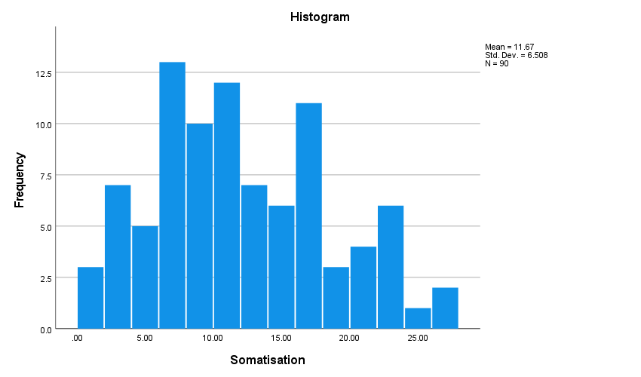

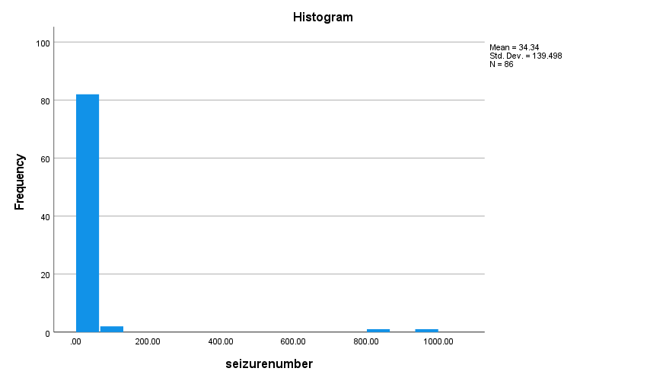

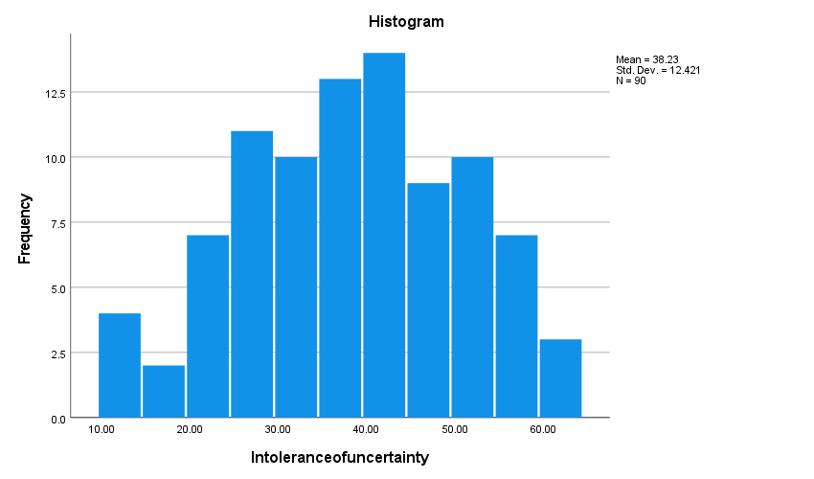

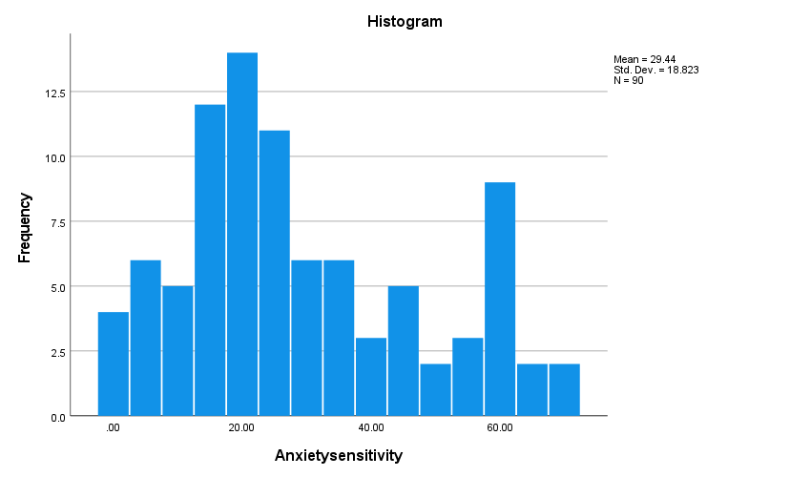

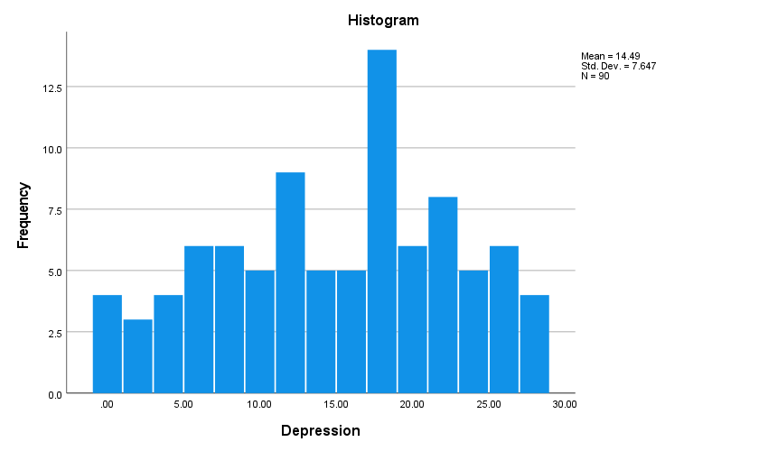

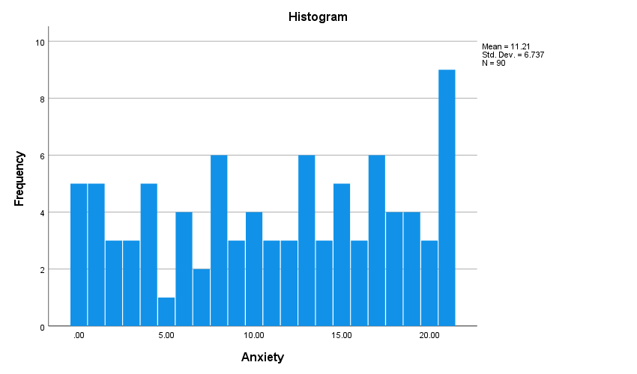

Appendix K
SPSS output -Outcomes for between group comparisons

T-test comparison of intolerance of uncertainty between epilepsy and DS groups.
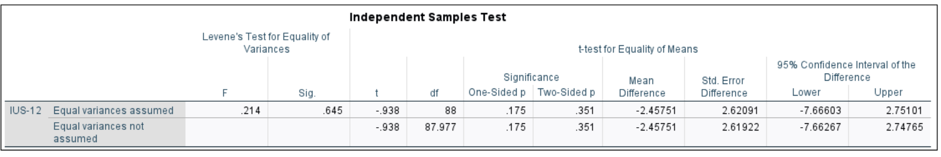

Mann-Whitney U comparison of somatisation, anxiety sensitivity, depression, and anxiety between epilepsy and DS groups.

Test Statisticsª
 | Somatisation | Anxiety sensitivity | Depression | Anxiety
Mann-Whitney U | 808.000 | 817.500 | 805.000 | 827.000
Wilcoxon W | 1798.000 | 1807.500 | 1795.000 | 1817.000
Z | -1.649 | -1.571 | -1.673 | -1.496
Asymp. Sig. (2-tailed) | .099 | .116 | .094 | .135

Appendix L
SPSS Output – First regression model with somatisation as the dependent variable and IU, AS, depression, anxiety, and diagnosis as predictors

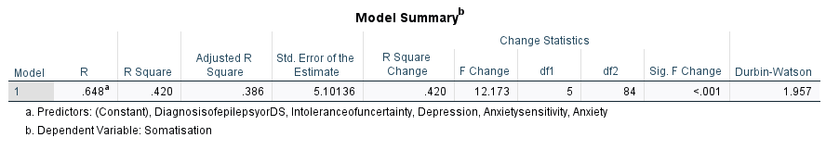
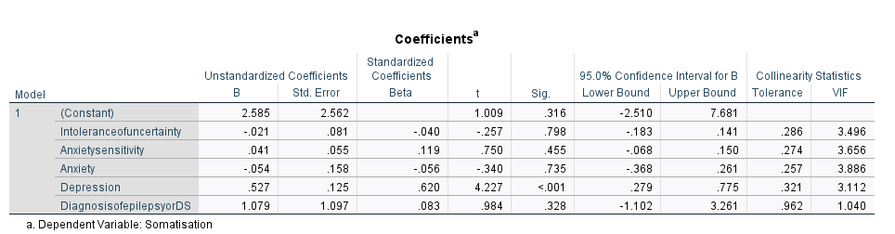

Casewise Diagnosticsª
Case Number | Std. Residual | Somatisation | Predicted Value | Residual
11 | -3.228 | 2.00 | 18.4676 | -16.46764
a. Dependent Variable: Somatisation

Residuals Statisticsª
 | Minimum | Maximum | Mean | Std. Deviation | N
Predicted Value | 3.2666 | 19.1730 | 11.6667 | 4.21874 | 90
Residual | -16.46764 | 11.14208 | .00000 | 4.95599 | 90
Std. Predicted Value | -1.991 | 1.779 | .000 | 1.000 | 90
Std. Residual | -3.228 | 2.184 | .000 | .972 | 90
a. Dependent Variable: Somatisation
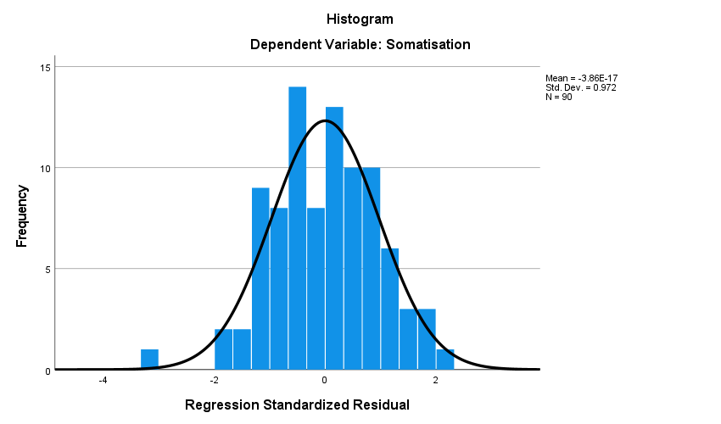

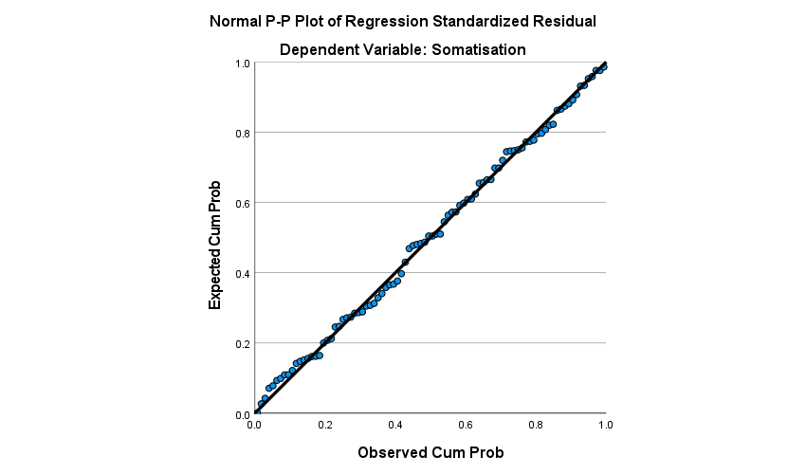

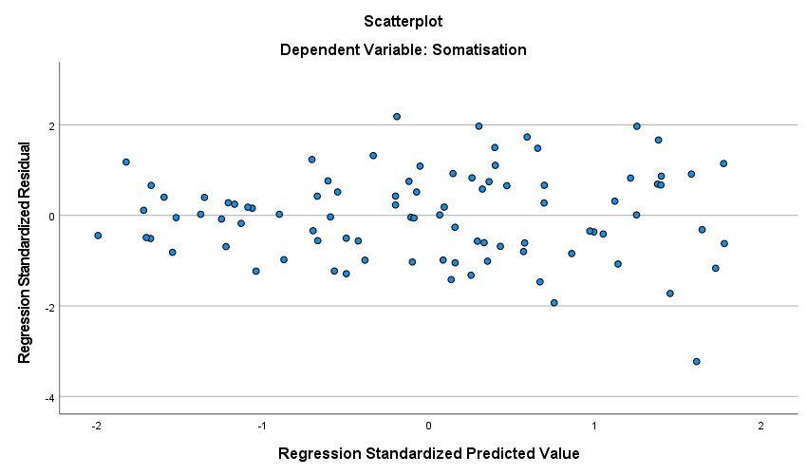

Appendix M
SPSS assumption checks and output for log transformed data for second regression model, predicting seizure frequency.

Output for assumption tests for variable “logseizurenum” – seizure number log transformed including two outliers

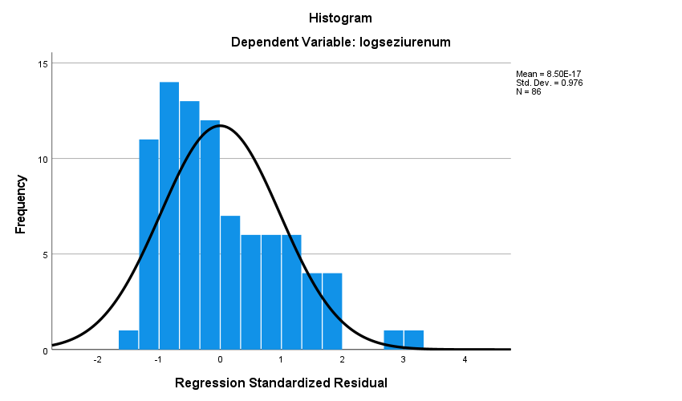

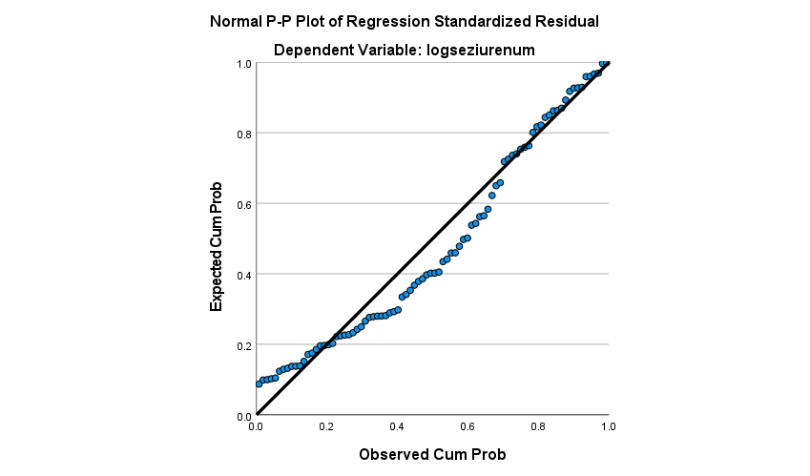

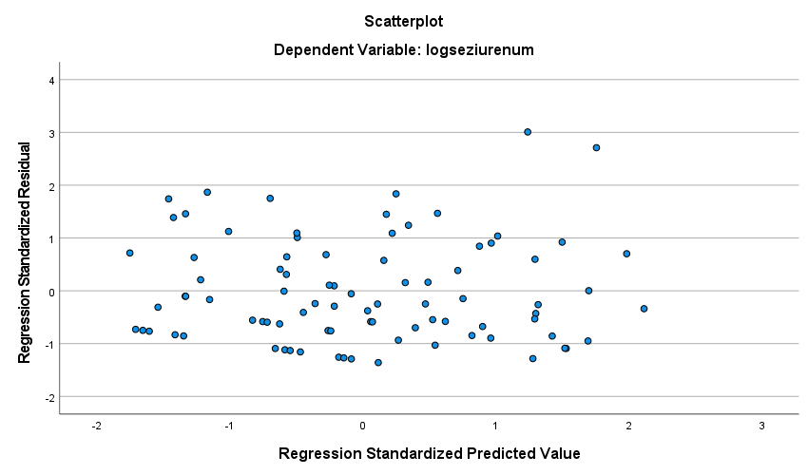

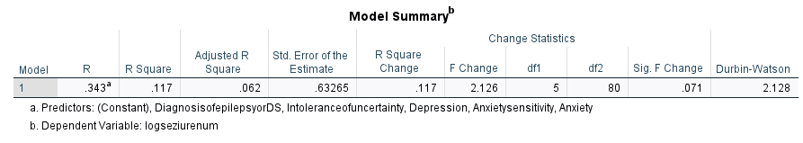

ANOVAª
Model |  | Sum of Squares | df | Mean Square | F | Sig.
1 | Regression | 4.255 | 5 | .851 | 2.126 | .071^{b}
 | Residual | 32.020 | 80 | .400
 | Total | 36.275 | 85
a. Dependent Variable: logseziurenum
b. Predictors: (Constant), DiagnosisofepilepsyorDS, Intoleranceofuncertainty, Depression, Anxietysensitivity, Anxiety

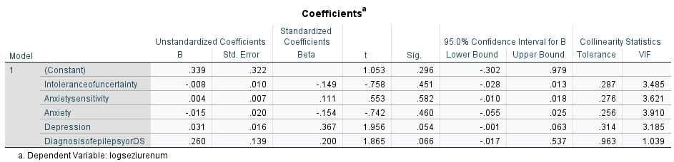

Residuals Statisticsª
 | Minimum | Maximum | Mean | Std. Deviation | N
Predicted Value | .3479 | 1.2745 | .8319 | .22375 | 86
Std. Predicted Value | -2.163 | 1.978 | .000 | 1.000 | 86
Standard Error of Predicted Value | .103 | .286 | .163 | .038 | 86
Adjusted Predicted Value | .2457 | 1.2815 | .8301 | .23059 | 86
Residual | -.86496 | 1.81490 | .00000 | .61376 | 86
Std. Residual | -1.367 | 2.869 | .000 | .970 | 86
Stud. Residual | -1.417 | 2.994 | .001 | 1.007 | 86
Deleted Residual | -.92906 | 1.97726 | .00176 | .66118 | 86
Stud. Deleted Residual | -1.426 | 3.158 | .007 | 1.021 | 86
Mahal. Distance | 1.249 | 16.436 | 4.942 | 2.937 | 86
Cook's Distance | .000 | .134 | .013 | .022 | 86
Centered Leverage Value | .015 | .193 | .058 | .035 | 86
a. Dependent Variable: logseziurenum

Output for assumption checks for variable “logxoutseizurenum” – seizure number log transformed after two extreme outliers had been removed

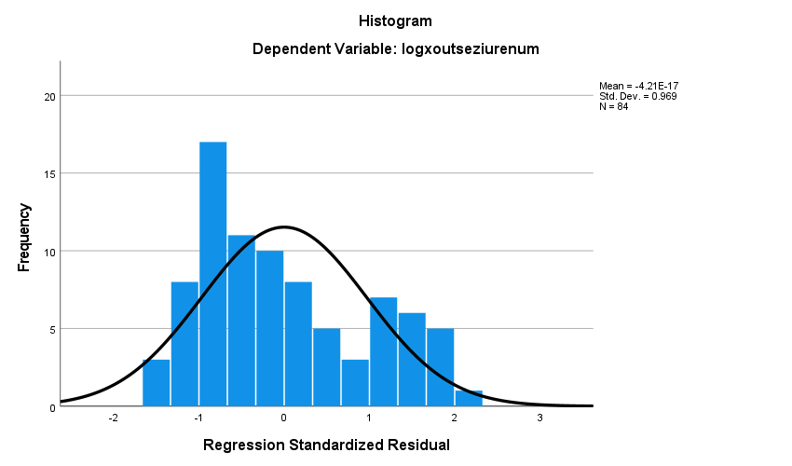

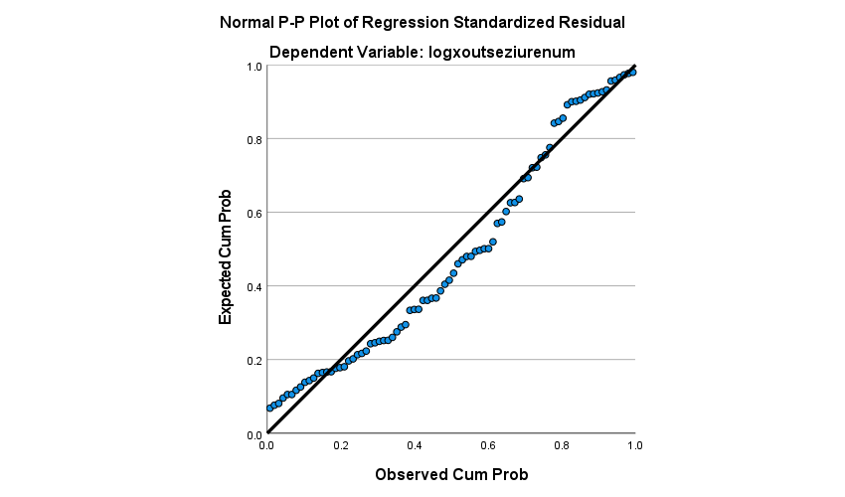

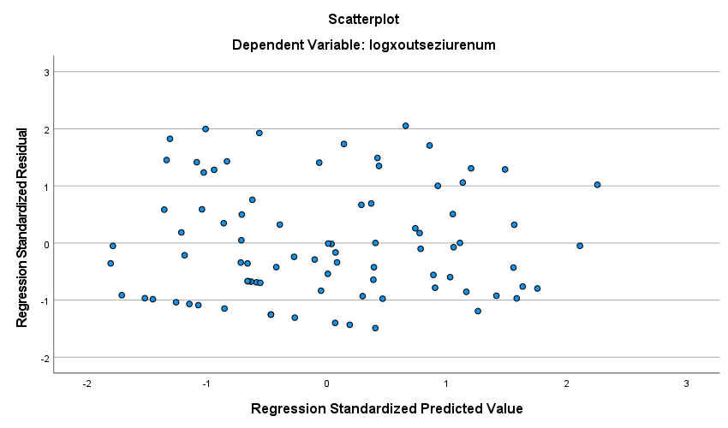

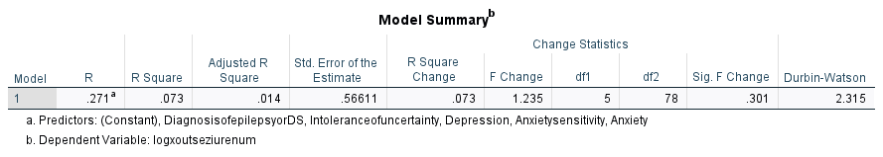

ANOVAª
Model |  | Sum of Squares | df | Mean Square | F | Sig.
1 | Regression | 1.979 | 5 | .396 | 1.235 | .301^{b}
 | Residual | 24.997 | 78 | .320
 | Total | 26.976 | 83
a. Dependent Variable: logxoutseziurenum
b. Predictors: (Constant), DiagnosisofepilepsyorDS, Intoleranceofuncertainty, Depression, Anxietysensitivity, Anxiety

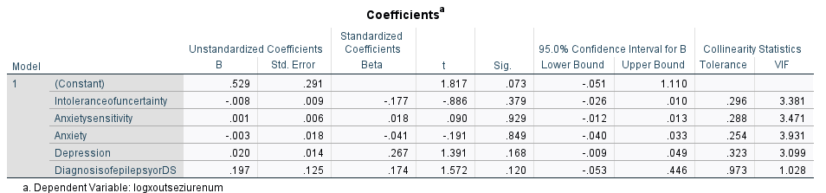

Residuals Statisticsª
 | Minimum | Maximum | Mean | Std. Deviation | N
Predicted Value | .5027 | 1.1296 | .7811 | .15440 | 84
Residual | -.84363 | 1.16270 | .00000 | .54879 | 84
Std. Predicted Value | -1.803 | 2.256 | .000 | 1.000 | 84
Std. Residual | -1.490 | 2.054 | .000 | .969 | 84
a. Dependent Variable: logxoutseziurenum

Appendix N
SPSS output for second regression analysis, predicting seizure number from IU, AS, depression, anxiety, and diagnosis of epilepsy or DS. Analysis run without log transformations and with Bootstrapping

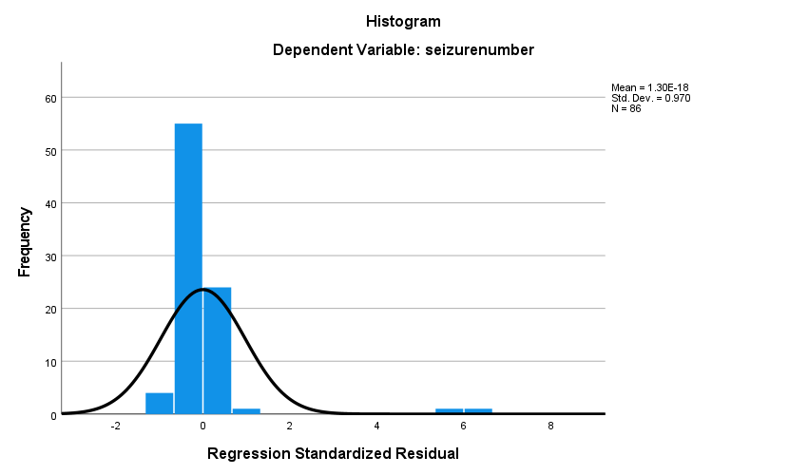

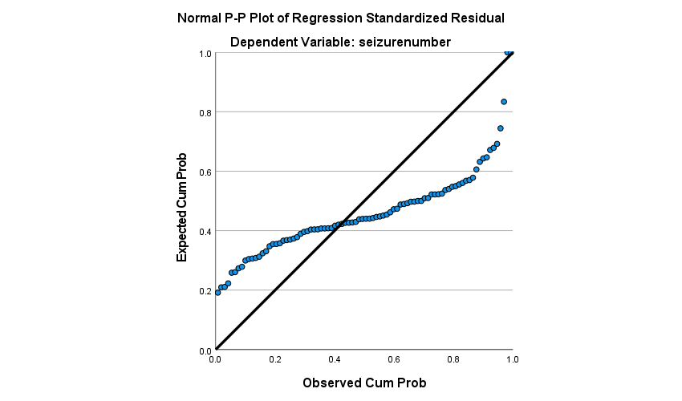

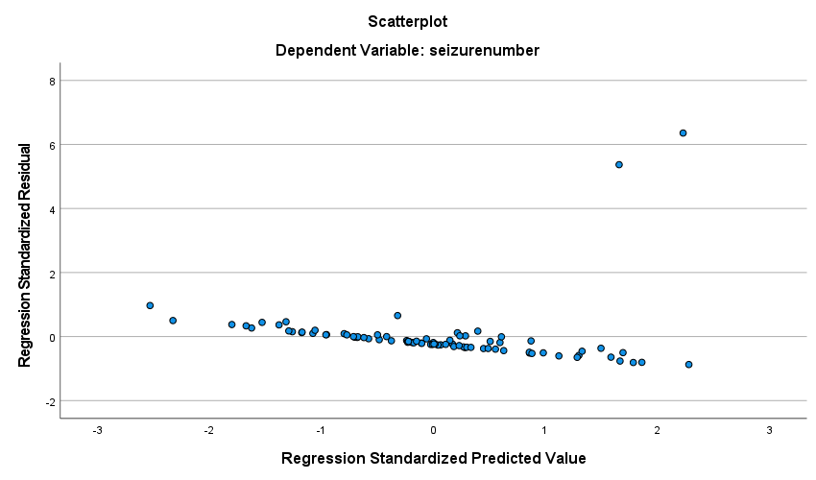

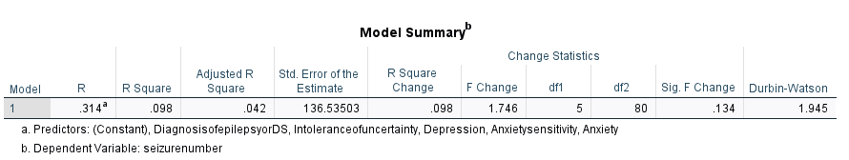

Bootstrap for Model Summary
Model | Durbin-Watson | Bootstrapª
 |  | Bias | Std. Error | BCa 95% Confidence Interval
 |  |  |  | Lower | Upper
1 | 1.945 | -.529 | .454 | 1.128 | 1.829
a. Unless otherwise noted, bootstrap results are based on 1000 bootstrap samples

ANOVAª
Model |  | Sum of Squares | df | Mean Square | F | Sig.
1 | Regression | 162732.086 | 5 | 32546.417 | 1.746 | .134^{b}
 | Residual | 1491345.135 | 80 | 18641.814
 | Total | 1654077.221 | 85
a. Dependent Variable: seizurenumber
b. Predictors: (Constant), DiagnosisofepilepsyorDS, Intoleranceofuncertainty, Depression, Anxietysensitivity, Anxiety

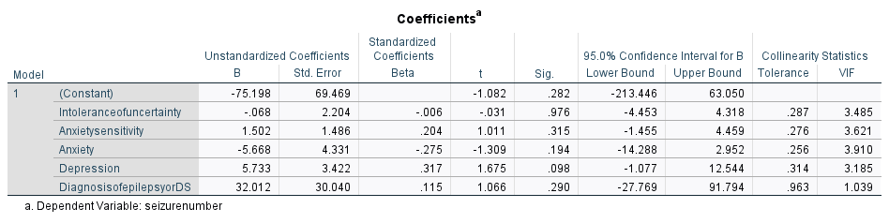

Bootstrap for Coefficients
Model |  | B | Bootstrapª
 |  |  | Bias | Std. Error | Sig. (2-tailed) | BCa 95% Confidence Interval
 |  |  |  |  |  | Lower | Upper
1 | (Constant) | -75.198 | 3.037 | 69.713 | .344 | -260.655 | 30.440
 | Intoleranceofuncertainty | -.068 | -.057 | 1.704 | .971 | -3.281 | 3.011
 | Anxietysensitivity | 1.502 | .026 | 1.228 | .248 | -.058 | 3.945
 | Anxiety | -5.668 | -.079 | 5.680 | .395 | -21.063 | 1.455
 | Depression | 5.733 | .039 | 3.892 | .204 | .241 | 13.485
 | DiagnosisofepilepsyorDS | 32.012 | -1.183 | 21.512 | .206 | 1.727 | 67.549
a. Unless otherwise noted, bootstrap results are based on 1000 bootstrap samples

Casewise Diagnosticsª
Case Number | Std. Residual | seizurenumber | Predicted Value | Residual
17 | 5.370 | 840.00 | 106.8412 | 733.15882
20 | 6.358 | 1000.00 | 131.8466 | 868.15341
a. Dependent Variable: seizurenumber

Residuals Statisticsª
 |  | Statistic | Bootstrap^{b}
 |  |  | Bias | Std. Error | BCa 95% Confidence Interval
 |  |  |  |  | Lower | Upper
Predicted Value | Minimum | -76.4449
 | Maximum | 134.0915
 | Mean | 34.3372 | -.2876 | 14.7958 | 12.1833 | 59.9937
 | Std. Deviation | 43.75494 | 2.00208 | 27.78068 | 4.24262 | 103.99151
 | N | 86 | 0 | 0 | . | .
Residual | Minimum | -119.09148
 | Maximum | 868.15344
 | Mean | .00000 | .00000 | .00000 | . | .
 | Std. Deviation | 132.45843 | -15.17647 | 48.39407 | 18.11280 | 179.48360
 | N | 86 | 0 | 0 | . | .
Std. Predicted Value | Minimum | -2.532
 | Maximum | 2.280
 | Mean | .000 | .000 | .000 | .000 | .000
 | Std. Deviation | 1.000 | .000 | .000 | 1.000 | 1.000
 | N | 86 | 0 | 0 | . | .
Std. Residual | Minimum | -.872
 | Maximum | 6.358
 | Mean | .000 | .000 | .000 | .000 | .000
 | Std. Deviation | .970 | .000 | .000 | .970 | .970
 | N | 86 | 0 | 0 | . | .
a. Dependent Variable: seizurenumber
b. Unless otherwise noted, bootstrap results are based on 1000 bootstrap samples

Paper 3: Executive Summary

Psychological Factors associated with Somatisation and Seizure Frequency in Seizure Conditions: Comparing Intolerance of Uncertainty, Anxiety Sensitivity, Anxiety, and Depression between People with Epilepsy and Dissociative Seizures

Word Count: 2067

Introduction

This report has been written as a summary of a research project into psychological factors effecting people with diagnoses of either epilepsy or dissociative seizures. It has been written for people living with seizure conditions and those supporting them, including professionals and loved ones. Service users generously helped comment on a draft version of this report, advising on content and structure.

What is the background for this study?
Previous studies have shown that psychological difficulties can be more common in people with epilepsy and dissociative seizures. Research has shown that psychological factors may worsen some of the key symptoms found in seizure conditions such as how often someone has a seizure, and the severity of physical symptoms such as headaches, fatigue, and pain. It is important to understand psychological factors that may contribute to poorer physical health outcomes because this may lead to improvements in psychological therapies that help to support with these difficulties.
The study focused on intolerance of uncertainty, anxiety sensitivity, anxiety, depression, and their impact on somatisation and seizure frequency in people with seizure conditions (see key terms for definitions).

Key Terms

Seizure Condition | Epilepsy | Dissociative Seizures
Common alternative names? | None | Non-epileptic attack disorder (NEAD), psychogenic non-epileptic seizures (PNES), functional seizures.
Recurring involuntary seizures causing loss of bodily control? | Yes | Yes
Seizures due to electrical activity in the brain? | Yes | No
Seizures last over two minutes | Rare | Common
Condition develops after 10 years of age | Rare | Common
Gender differences | Slightly more common in men | Much more common in women
Associated difficulties with thinking and memory, fatigue, emotions, social stigma, and employment pressures. | Common | Common

Anxiety Sensitivity
- When anxious, the body responds via increased heart-rate, sweating, or feeling dizzy, for example.
- The more sensitive a person is to these changes, the more concerned they are about them happening and their potential consequences.
Depression and Anxiety
- Depression is characterised by low mood, fatigue, changes to sleep and appetite, and loss of motivation or pleasure in doing things.
- Anxiety is characterised by worry, restlessness, and physical symptoms such as dizziness or palpitations.

Somatisation
- Somatisation is the experience of unpleasant physical feelings in the body, like stomach pain or headaches, which are thought to result from stress-related causes.
Intolerance of Uncertainty
- The level of discomfort people feel towards unknown future circumstances.
- Higher levels of intolerance of uncertainty could mean more worry about future events, or more avoidance of unpredictable situations.

Why are these factors important for people with seizure conditions?
Higher levels of intolerance of uncertainty have been shown to predict lower quality of life in people with epilepsy (Barahmand & Haji, 2014). Research has not yet considered intolerance of uncertainty in people with dissociative seizures, making this a current gap in the research literature.
Higher levels of anxiety sensitivity predicted lower quality of life in people with epilepsy (Johnson et al., 2018). Anxiety sensitivity has also been reported to be higher in teenagers with dissociative seizures than their siblings although it has not been considered in adults (Plioplys et al., 2014, Plioplys et al., 2016). Therefore, more research is needed to understand anxiety sensitivity in adults with dissociative seizures and whether there are differences in anxiety sensitivity between people with epilepsy and people with dissociative seizures.
Levels of anxiety and depression have been shown to be higher in people with epilepsy and people with dissociative seizures than the general population (Kwon & Park, 2014, Urbanek et al., 2014). More research is needed into how anxiety and depression may contribute to somatisation and seizure frequency in people with seizure conditions.
Somatisation has been associated with intolerance of uncertainty, anxiety sensitivity, anxiety, and depression in people without seizure conditions (Gica et al., 2020, Löwe et al., 2008, Wood et al., 2011). A study found that somatisation was reported as being higher in a group of participants with dissociative seizures compared to a group with epilepsy (Myers et al., 2019). Somatisation has been found to predict lower quality of life for people with dissociative seizures and epilepsy (Wolf et al., 2015). More research is needed to understand what contributes to somatisation in seizure conditions so that new treatments can be considered to support with it.
Outcomes
- Somatisation
- Seizure Frequency
Psychological Factors
- Intolerance of uncertainty
- Anxiety sensitivity
- Anxiety
- depression

Aims
This study was designed to consider four types of psychological factors; intolerance of uncertainty, anxiety sensitivity, anxiety, and depression and their potential influence on somatisation and seizure frequency.
If research were to find that people with seizure conditions reported high levels of intolerance of uncertainty and anxiety sensitivity then this might suggest that it would be helpful to develop therapies targeting these factors within these populations. Alternatively, focus may be better spent considering other psychological factors, if they prove to contribute more to poor outcomes such as increased seizure frequency and somatisation.
Previous research has highlighted that psychological difficulties tend to be more common and lead to worse outcomes in people with dissociative seizures than people with epilepsy. (Hovorka et al., 2007, Vilyte & Pretorius, 2019). Therefore, this study also aimed to highlight whether there would be differences in psychological difficulties reported between the participants with epilepsy and those with dissociative seizures. These comparisons could add to evidence for whether psychological services need to tailor support specifically for epilepsy or dissociative seizures, or whether a combined psychological approach could be adopted for both conditions.

Aims
- Do people with dissociative seizures score higher on measures of intolerance of uncertainty, anxiety sensitivity, depression, anxiety, and somatisation than people with epilepsy?
- Do higher levels of intolerance of uncertainty, anxiety sensitivity, anxiety, and depression, or having a diagnosis of dissociative seizures predict higher levels of somatisation?
- Do higher levels of intolerance of uncertainty, anxiety sensitivity, anxiety, and depression, or having a diagnosis of dissociative seizures predict higher seizure frequency?

Method
Ethical approvals for the study were provided by Staffordshire University and NHS ethics.

What did participation involve?
Recruitment took place between February and March 2023. This involved clinicians in a neurology and neuropsychology service sharing a research advertisement with potential participants. This advertisement was also shared in social media groups for people living with seizure conditions. Participants completed five questionnaires (see table 1) and further questions about themselves and their seizure conditions, such as how old they were and how frequently they experienced seizures. All participants needed to sign an online consent form to take part.
Who was invited to take part?
- People with a diagnosis of either epilepsy or dissociative seizures.
- 18 years or older
- Able to complete online questionnaires in written English

Table 1.
Title, author and example question/statement from study questionnaires
Title (author) | Example question/statement
Intolerance of Uncertainty Scale, Short Form  (IUS-12; Carleton et al., 2007) | “Unforeseen events upset me greatly”
Anxiety Sensitivity Index-3 (ASI-3; Taylor et al. 2007). | “It scares me when I feel shaky”.
Patient Health Questionnaire-15 (PHQ-15; Kroenke et al., 2002). | “How often have you been bothered by stomach pain?”
Patient Health Questionnaire-9 (PHQ-9; Kroenke et al., 2001) | “Feeling, down, depressed, or hopeless”
General Anxiety Disorder-7 (GAD-7; Spitzer et al., 2006) | “Trouble relaxing”
Demographic and seizure condition questionnaire  (based on Whitfield et al., 2020) | “How many seizures or non-epileptic episodes have you experienced over the last four weeks?”

Who participated?
Overall 90 participants completed the survey, 44 with diagnoses of epilepsy and 46 with diagnoses of dissociative seizures. The majority of the participants identified as women (83.33%), with an average age of 39 (18 – 88).

Methods of analysis
Two main types of statistical analysis were used in this study.
The first analysis was used to compare differences between people with epilepsy and people with dissociative seizures, on scores from questionnaires. This involves tests which take the averages of both groups and compare them to find if there is a statistically significant difference between the two. Finding a statistically significant result would mean finding that differences in scores were due to having a diagnosis of either epilepsy or dissociative seizures.
The second and third research questions were answered using correlation and multiple regression analyses. Correlations demonstrate how closely two things are related. Multiple regression analysis is similar but goes further in allowing researchers to find out whether an increase or decrease in one factor can predict an increase or decrease in another factor. For example, a correlational relationship might be that when it is sunny more people tend to be outside. A predictive relationship would be that you can predict that more people will go outside when it is sunny (figure 1).

Figure 1.
Example of correlation/regression showing more people outside in sunnier weather
x
x
x
x
x
x
x
x
x
x
x
x
x
x
x
x
x
x
x
x
- Amount of sunshine +
+
Number of people outside
-

Key findings
Aim 1
- Average scores on measures of intolerance of uncertainty, anxiety sensitivity, anxiety, depression, and somatisation were higher for people with dissociative seizures than for people with epilepsy, although differences were not statistically significant (figure 2).
- Scores indicated high levels of intolerance of uncertainty and anxiety sensitivity, and moderate levels of anxiety depression, and somatisation in both groups.

Figure 2.
Average scores for main outcomes by seizure condition group (number of participants = 90)
Aim 2
- Significant positive correlations were found between all psychological factors and somatisation. This meant that generally, people who scored higher on measures of intolerance of uncertainty, anxiety sensitivity, anxiety, and depression, were found to also have higher scores on the measure of somatisation.
- Depression was the only psychological factor found to predict somatisation. This means that as levels of depression increase, it is expected that levels of somatisation increase too.

Aim 3

- None of the psychological factors measured correlated with or predicted seizure frequency. This suggests that the psychological factors investigated were not related to how many seizures people reported.

What are the clinical implications of this research?
- Finding high levels of intolerance of uncertainty, anxiety sensitivity, and moderate levels of anxiety, depression, and somatisation in both groups suggests that it is important for people with seizure conditions to be able to access services offering psychological assessment and intervention.
- The similarity of psychological difficulties reported by both groups suggests that combined psychological support for people with seizure conditions could be developed, rather than support tailored to each condition.
- Depression should be considered as a primary target of intervention for people with seizure conditions and somatisation.

Limitations
- The study asked participants to self-report the number of seizures experienced over the last four weeks. This is difficult to estimate and can differ considerably between individuals. For example, some participants may keep a seizure diary whilst others may guess how many seizures they have had. Some types of seizures are more severe and easier to count, whereas others might last seconds and be easy to miss. This resulted in seizure frequency data that may not be representative of the wider community of people with seizure conditions.
- Some previous studies comparing people with epilepsy and people with dissociative seizures required that all participants had their diagnoses confirmed by professionals. This study relied on participants self-reporting their seizure condition which could increase the chance of bias from the wrong diagnosis being reported.
- The majority of participants who responded to the study identified as women and of being white ethnicity. This limits the representativeness of the results to people who do not identify as belonging to these groups.

Future research
- This study raises questions about what other outcomes elevated levels of psychological difficulties may predict in people with seizure conditions. When people with seizure conditions have been asked about what outcomes matter most to them, suggestions included feelings of being a burden to others, and fear of having seizures (Fisher et al., 2000, Rawlings & Reuber, 2016).
- Improvements in methods for measuring seizure frequency are needed. This is particularly important for studies comparing people with epileptic and dissociative seizures because of the subtle differences between the two.
- Because this study compared people with epilepsy and people with dissociative seizures, people with mixed diagnoses were not invited to participate. Around 10-20% of people with epilepsy also experience dissociative seizures making this an important group to consider in future research.

What will happen to the results of this study?
This study has been written up for potential publication with Seizure - The European Journal of Epilepsy. This executive summary will be shared with participating NHS services and with any participants who have requested a copy.

References

Abe, C., Denney, D., Doyle, A., Cullum, M., Adams, J., Perven, G., Dave, H., Dieppa, M., Hays, R., Agostini, M., & Ding, K. (2020). Comparison of psychiatric comorbidities and impact on quality of life in patients with epilepsy or psychogenic nonepileptic spells. Epilepsy & Behavior, 102, 106649. https://doi.org/10.1016/j.yebeh.2019.106649
Barahmand, U., & Haji, A. (2014). The impact of intolerance of uncertainty, worry and irritability on quality of life in persons with epilepsy: Irritability as mediator. Epilepsy Research, 108(8), 1335–1344. https://doi.org/10.1016/j.eplepsyres.2014.07.002
Boswell, J. F., Thompson-Hollands, J., Farchione, T. J., & Barlow, D. H. (2013). Intolerance of Uncertainty: A Common Factor in the Treatment of Emotional Disorders. Journal of Clinical Psychology, 69(6), 630–645. https://doi.org/10.1002/jclp.21965
Brandt, C., & Mula, M. (2016). Anxiety disorders in people with epilepsy. Epilepsy & Behavior, 59, 87–91. https://doi.org/10.1016/j.yebeh.2016.03.020
Buhr, K., & Dugas, M. J. (2002). The intolerance of uncertainty scale: psychometric properties of the English version. Behaviour Research and Therapy, 40(8), 931–945. https://doi.org/10.1016/s0005-7967(01)00092-4
Carleton, R. N., Norton, M. A. P. J., & Asmundson, G. J. G. (2007). Fearing the unknown: A short version of the Intolerance of Uncertainty Scale. Journal of Anxiety Disorders, 21(1), 105–117. https://doi.org/10.1016/j.janxdis.2006.03.014
Centers for Disease Control and Prevention. (2019). Types of Seizures. Centers for Disease Control and Prevention. https://www.cdc.gov/epilepsy/about/types-of-seizures.htm
Diprose, W., Sundram, F., & Menkes, D. B. (2016). Psychiatric comorbidity in psychogenic nonepileptic seizures compared with epilepsy. Epilepsy & Behavior, 56, 123–130. https://doi.org/10.1016/j.yebeh.2015.12.037
Cullingham, T., Kirkby, A., Eccles, F. J. R., & Sellwood, W. (2020). Psychological inflexibility and somatization in nonepileptic attack disorder. Epilepsy & Behavior, 111, 107155. https://doi.org/10.1016/j.yebeh.2020.107155
Fisher, R. S., Vickrey, B. G., Gibson, P., Hermann, B., Penovich, P., Scherer, A., & Walker, S. (2000). The impact of epilepsy from the patient’s perspective I. Descriptions and subjective perceptions. Epilepsy Research, 41(1), 39–51. https://doi.org/10.1016/s0920-1211(00)00126-1
Gica, S., Kavakli, M., Durduran, Y., & Ak, M. (2020). The Effect of COVID-19 Pandemic on Psychosomatic Complaints and Investigation of the Mediating Role of Intolerance to Uncertainty, Biological Rhythm Changes and Perceived COVID-19 Threat in this Relationship: A Web-Based Community Survey. Psychiatry and Clinical Psychopharmacology, 30(2), 89. https://doi.org/10.5455/pcp.20200514033022
Goldstein, L. H., Robinson, E. J., Mellers, J. D. C., Stone, J., Carson, A., Reuber, M., Medford, N., McCrone, P., Murray, J., Richardson, M. P., Pilecka, I., Eastwood, C., Moore, M., Mosweu, I., Perdue, I., Landau, S., Chalder, T., Abe, A-M., Adab, N., & Agrawal, N. (2020). Cognitive behavioural therapy for adults with dissociative seizures (CODES): a pragmatic, multicentre, randomised controlled trial. The Lancet Psychiatry, 7(6), 491–505. https://doi.org/10.1016/s2215-0366(20)30128-0
He, K., Hong, N., Lapalme-Remis, S., Lan, Y., Huang, M., Li, C., & Yao, L. (2019). Understanding the patient perspective of epilepsy treatment through text mining of online patient support groups. Epilepsy & Behavior, 94, 65–71. https://doi.org/10.1016/j.yebeh.2019.02.002
Hovorka, J., Nezadal, T., Herman, E., Iveta Nemcova, & Bajaček, M. (2007). Psychogenic non-epileptic seizures, prospective clinical experience: diagnosis, clinical features, risk factors, psychiatric comorbidity, treatment outcome. Epileptic Disorders, 9 Suppl 1, S52-8. https://doi.org/10.1684/epd.2008.0156
Hubsch, C., Baumann, C., Hingray, C., Gospodaru, N., Vignal, J.-P., Vespignani, H., & Maillard, L. (2011). Clinical classification of psychogenic non-epileptic seizures based on video-EEG analysis and automatic clustering. Journal of Neurology, Neurosurgery & Psychiatry, 82(9), 955–960. https://doi.org/10.1136/jnnp.2010.235424
Johnson, A. L., McLeish, A. C., Alsaid-Habia, T., Shear, P. K., & Privitera, M. (2018). Anxiety Sensitivity as a Predictor of Epilepsy-Related Quality of Life and Illness Severity among Adult Epilepsy. Cognitive Therapy and Research, 43(1), 6–13. https://doi.org/10.1007/s10608-018-9951-4
Kanner, A. M. (2003). Depression in epilepsy: prevalence, clinical semiology, pathogenic mechanisms, and treatment. Biological Psychiatry, 54(3), 388–398. https://doi.org/10.1016/s0006-3223(03)00469-4
Kroenke, K., Spitzer, R. L., & Williams, J. B. W. (2001). The PHQ-9: Validity of a brief depression severity measure. Journal of General Internal Medicine, 16(9), 606–613. https://doi.org/10.1046/j.1525-1497.2001.016009606.x
Kroenke, K., Spitzer, R. L., & Williams, J. B. W. (2002). The PHQ-15: Validity of a New Measure for Evaluating the Severity of Somatic Symptoms. Psychosomatic Medicine, 64(2), 258–266. https://doi.org/10.1097/00006842-200203000-00008
Kwon, O.-Y., & Park, S.-P. (2014). Depression and Anxiety in People with Epilepsy. Journal of Clinical Neurology, 10(3), 175. https://doi.org/10.3988/jcn.2014.10.3.175
Löwe, B., Spitzer, R. L., Williams, J. B. W., Mussell, M., Schellberg, D., & Kroenke, K. (2008). Depression, anxiety and somatization in primary care: syndrome overlap and functional impairment. General Hospital Psychiatry, 30(3), 191–199. https://doi.org/10.1016/j.genhosppsych.2008.01.001
Myers, L., Trobliger, R., Bortnik, K., Zeng, R., Saal, E., & Lancman, M. (2019). Psychological trauma, somatization, dissociation, and psychiatric comorbidities in patients with psychogenic nonepileptic seizures compared with those in patients with intractable partial epilepsy. Epilepsy & Behavior, 92, 108–113. https://doi.org/10.1016/j.yebeh.2018.12.027
Non-Epileptic Attacks. (2022). Non-Epileptic Attacks. Sites.google.com. https://sites.google.com/sheffield.ac.uk/non-epileptic-attacks/home
Perez, D. L. (2020). The CODES trial for dissociative seizures: a landmark study and inflection point. The Lancet Psychiatry, 7(6), 464–465. https://doi.org/10.1016/s2215-0366(20)30143-7
Plioplys, S., Doss, J., Siddarth, P., Bursch, B., Falcone, T., Forgey, M., Hinman, K., LaFrance, W. C., Laptook, R., Shaw, R. J., Weisbrot, D. M., Willis, M. D., & Caplan, R. (2014). A multisite controlled study of risk factors in pediatric psychogenic nonepileptic seizures. Epilepsia, 55(11), 1739–1747. https://doi.org/10.1111/epi.12773
Plioplys, S., Doss, J., Siddarth, P., Bursch, B., Falcone, T., Forgey, M., Hinman, K., LaFrance, W. C., Laptook, R., Shaw, R. J., Weisbrot, D. M., Willis, M. D., & Caplan, R. (2016). Risk factors for comorbid psychopathology in youth with psychogenic nonepileptic seizures. Seizure, 38, 32–37. https://doi.org/10.1016/j.seizure.2016.03.012
Rawlings, G. H., & Reuber, M. (2016). What patients say about living with psychogenic nonepileptic seizures: A systematic synthesis of qualitative studies. Seizure, 41, 100–111. https://doi.org/10.1016/j.seizure.2016.07.014
Spitzer, R. L., Kroenke, K., Williams, J. B. W., & Löwe, B. (2006). A Brief Measure for Assessing Generalized Anxiety Disorder. Archives of Internal Medicine, 166(10), 1092. https://doi.org/10.1001/archinte.166.10.1092
Taylor, S., Zvolensky, M. J., Cox, B. J., Deacon, B., Heimberg, R. G., Ledley, D. R., Abramowitz, J. S., Holaway, R. M., Sandin, B., Stewart, S. H., Coles, M., Eng, W., Daly, E. S., Arrindell, W. A., Bouvard, M., & Cardenas, S. J. (2007). Robust dimensions of anxiety sensitivity: Development and initial validation of the Anxiety Sensitivity Index-3. Psychological Assessment, 19(2), 176–188. https://doi.org/10.1037/1040-3590.19.2.176
Urbanek, M., Harvey, M., McGowan, J., & Agrawal, N. (2014). Regulation of emotions in psychogenic nonepileptic seizures. Epilepsy & Behavior, 37, 110–115. https://doi.org/10.1016/j.yebeh.2014.06.004
Vilyte, G., & Pretorius, C. (2019). Personality traits, illness behaviors, and psychiatric comorbidity in individuals with psychogenic nonepileptic seizures (PNES), epilepsy, and other nonepileptic seizures (oNES): Differentiating between the conditions. Epilepsy & Behavior, 98, 210–219. https://doi.org/10.1016/j.yebeh.2019.05.043
Whitfield, A., Walsh, S., Levita, L., & Reuber, M. (2020). Catastrophising and repetitive negative thinking tendencies in patients with psychogenic non-epileptic seizures or epilepsy. Seizure, 83, 57–62. https://doi.org/10.1016/j.seizure.2020.09.034
Wood, R. Ll., Maclean, L., & Pallister, I. (2011). Psychological factors contributing to perceptions pain intensity after acute orthopaedic injury. Injury, 42(11), 1214–1218. https://doi.org/10.1016/j.injury.2010.07.245
World Health Organization. (2023a, February 9). Epilepsy. Www.who.int. https://www.who.int/news-room/fact-sheets/detail/epilepsy#:~:text=Around%2050%20million%20people%20worldwide%20have%20epilepsy%2C%20making%20it%20one
World Health Organization. (2023b, March 31). Depressive Disorder (Depression). World Health Organization. https://www.who.int/news-room/fact-sheets/detail/depression

