Exploring the Impact of Suicidal Behaviour on Staff Working in Acute Psychiatric Inpatient Services

Rebecca L. Shinton

Thesis submitted in partial fulfilment of the requirements of Staffordshire University for the degree of Doctorate in Clinical Psychology

April 2022

Total word count: 19,124
(Excludes references, appendices and contents page)

THESIS PORTFOLIO: CANDIDATE DECLARATION
Title of degree programme | Professional Doctorate in Clinical Psychology
Candidate name | Rebecca Shinton
Registration number
Initial date of registration | 17th September 2018

Declaration and signature of candidate
- I confirm that the thesis submitted is the outcome of work that I have undertaken during my programme of study, and except where explicitly stated, it is all my own work.
- I confirm that the decision to submit this thesis is my own.
- I confirm that except where explicitly stated, the work has not been submitted for another academic award.
- I confirm that the work has been conducted ethically and that I have maintained the anonymity of research participants at all times within the thesis.
Signed: Date: 22/04/2022

Table of Contents
List of Appendices 7
Acknowledgements 8
Thesis Abstract 10
Literature Review 11
Abstract 12
Introduction 13
Suicide 14
Impact of Suicide 14
Suicide in Mental Health Services 14
Impact of Suicide on Mental Health Professionals 14
Suicide in Acute Inpatient Settings 15
The Current Literature Review 15
Research Question 16
Method 16
Search Strategy 16
Inclusion and exclusion criteria 16
Search and Screening Process 17
Study Demographics 19
Quality Appraisal 20
Synthesis 25
Results 26
Participants and Sampling 26
Ethical Considerations 28
Quantitative Methods 28
Confounding Variables 29
Generalisability 29
Data Analysis 30
Qualitative Methods 30
Question Content 31
Multiple Raters and Software 32
Synthesis of Findings 32
Emotional Impact of Inpatient Suicide 33
Impact on Practice 34
Failure/guilt 35
Ward Environment as a Contributing Factor 36
Support 37
Analysis of Findings 38
Discussion 39
Limitations of Reviewed Papers 40
Limitations of Literature Review 41
Clinical Implications 42
Future research 42
Overall Conclusions 42
References 44
Empirical Paper 50
Abstract 51
Introduction 51
Impact of Suicide on Inpatient Staff 51
Attempted Suicide 52
“Non-qualified” Staff 53
Clinical Relevance 53
The Current Research 53
Research Question 54
Method 54
Design 54
Methodology 54
Reflexive Thematic Analysis 55
Theoretical Underpinnings 56
Self-reflexive Account 57
Rigour 58
Participants 58
Sample Size 58
Inclusion and Exclusion Criteria 59
Sampling 59
Procedure 60
Data Analysis 61
Ethics 62
Service User Involvement 62
Findings 63
Recruitment Outcomes 63
Participant Demographics 63
Themes and Subthemes 64
Theme One: Direct Personal Impact 65
Feeling Emotionally Overwhelmed 65
Attempting to Find Meaning 65
Heightened Threat System 66
Theme Two: Unrealistic Expectations 66
Responsibility for Managing Risk 67
Unrelenting Nature of Risk 67
Unprepared for the Role 68
Theme Three: Attempting to Contain the Impact 68
Just Carrying On 69
Wearing a Professional Mask 69
Theme Four: Acclimatisation 70
Leaning on Colleagues 70
Accepting the Inevitability of Suicide 70
Discussion 70
Summary of Findings 71
Links to Previous Literature, Clinical Implications and Further Research 71
Strengths and Limitations 74
Conclusion 75
References 77
Executive Summary 86
Purpose of Report 87
Introduction 87
Impact of Suicide 87
Impact of Attempted Suicide 88
Why ‘Non-qualified’ Staff? 88
Aim of this Study 88
The Research Process 89
Approach 89
Participants 89
Materials 91
Ethical Considerations 91
Procedure 91
Data Analysis 92
Reflexivity 93
Main Findings 93
Theme 1 – Direct Personal Impact 94
Theme 2 – Unrealistic Expectations 94
Theme 3 – Attempting to Contain the Impact 95
Theme 4 – Acclimatisation 96
What could be improved? 97
Recommendations 97
What next? 97
References 98
Appendices 100

List of Appendices
A: Target Journals……………………………………………………………………………101
B: Combined Quality Assessment Tool……………………………………………………102
C: Reflective Journal Example Extracts……………………………………………………104
D: Participant Information Sheet……………………………………………………………105
E: Consent Form……………………………………………………………………………..108
F: Sources of Support Form………………………………………………………………...109
G: Ethical Approval…………………………………………………………………………..110
H: Interview Schedule………………………………………………………………………..112
I: Research Process Flowchart……………………………………………………………..114
J: Demographic Form………………………………………………………………………..115
K: Example of ‘Coding’ Phase of TA……………………………………………………….116
L: Example of ‘Generating Themes’ Phase of TA………………………………………...117
M: Participants’ Contributions to Themes………………………………………………….118
N: Supporting Quotes for Themes………………………………………………………….120

Acknowledgements

As I come to the end of my Professional Doctorate in Clinical Psychology, I appreciate that this achievement was only possible with the help and support of those around me.
First and foremost, I must thank my research tutor, Susan Ledwith, who has supported me throughout the whole of my research journey. I began with a simple idea of exploring professional grief after having had many experiences myself of clients in my care dying, from both natural causes and suicide. Sue helped me to mould this into a unique and clinically relevant research question. From those initial ideas, right through to writing up my findings, Sue has offered me unwavering guidance which was invaluable. Thank you so much, Sue!
I also must thank the whole academic team at Staffordshire University. During those overwhelming months with multiple competing demands, their helpful encouragement and support has helped me get through it in one piece! Particularly, our research lead Dr Helen Scott, who has checked in with my research topic and ensured I kept on track with deadlines. She turned something huge and scary into something achievable. Also, Dr Kim Gordon, who offered lots of advice regarding the use of Reflexive Thematic Analysis.
I am also indebted to the support of the University’s Library team, particularly Paul Biggs who helped me sharpen my literature review research question and guided me through the digital library. Also, Andrew Little, who helped me gain access to papers that were not easily accessible for my literature review.
Of course, this thesis would be nothing without the participants who kindly agreed to share their sensitive stories with me. Speaking about the impact of suicide is not an easy task, but their openness and willingness to share has made it possible to gain some insight into this important experience. Thank you all for contributing to this research area.
Special thanks go to the cohort of 2018 who have been a constant source of wisdom and support. Training alongside such a lovely bunch of people made the whole experience much easier!
Finally, I must thank my family and friends. During my time on the course, I have become a wife and a mother. My loved ones have supported me as I transitioned into a new personal identity whilst also encouraging me with my career aspirations. Without their love and encouragement, I am not sure how I would have made it through. Finally, a special shout-out to my little loves, Leo and Oscar, who have made even the most challenging days fun-filled ♥
Thank you all.

Thesis Abstract
This thesis was interested in exploring the experience of working with service users’ suicidal behaviour for staff working in acute psychiatric inpatient services.
The first section of this portfolio comprises a literature review of the existing research exploring the impact of service user suicide on mental health professionals working in acute psychiatric inpatient settings. Nine papers were identified utilising a systematic search strategy. Their quality was appraised using a combination of the QualSyst Tool and the Critical Appraisal Skills Programme Checklist. Their results were further synthesised through narrative analysis. Findings suggested that service user suicide had an emotionally significant impact on staff which tended to be hidden in the workplace. The experience of ‘non-qualified’ staff, however, was missing in the literature.
The second portion of this portfolio outlines the results of an empirical paper, qualitatively exploring the experience of suicidal behaviour (attempted and completed suicide) on ‘non-qualified’ staff based in acute psychiatric inpatient settings. Semi-structured interviews were utilised to interview 10 staff’s experiences and data was analysed using Reflexive Thematic Analysis. Four themes were highlighted; ‘Direct personal impact’, ‘Unrealistic expectations’, ‘Attempting to contain impact’ and ‘Acclimatisation’, containing 10 sub-themes. The results provided insight into the specific experience of working with suicidal behaviour as a non-qualified member of staff, and recommendations are suggested to improve perceived support in its aftermath.
The final section of this portfolio is an executive summary of the empirical paper. This has been developed to be disseminated to those who have expressed an interest in the research and for those with organisational responsibility of acute psychiatric inpatient settings.

Literature Review

A Literature Review and Narrative Synthesis:
The Impact of Suicide on Staff Working in Acute Psychiatric Inpatient Services

Word count: 7,969
(Excludes references)

This paper has been written in accordance with submission guidelines for The Journal of Occupational and Organizational Psychology (Appendix A). This paper will be amended and modified prior to submission.

Abstract

Aim
To explore the emotional impact of inpatient suicide on mental health professionals working in acute psychiatric inpatient settings.
Method
During March and April 2021, major medical and psychological databases were searched using clearly defined search terms. A systematic search strategy identified 9 papers that answered the research question; 6 qualitative and 3 quantitative. The papers’ quality were appraised using the QualSyst tool and the Critical Appraisal Skills Programme Checklist and the results were synthesised using a narrative analysis.
Findings
All papers in the review were of high quality. There was a general consensus that inpatient suicide had an emotionally significant impact on mental health professionals. Furthermore, themes of ‘masking’ grief in the workplace and self-blame were prevalent. The evidence relating to support following an inpatient suicide was unclear. Some received no support. Of those that did, some found it helpful and others did not.
Conclusions
The papers focused on staff in qualified roles, therefore the voices of ‘non-qualified’ staff were missing in the literature, which is a key area for future research. There was a lack of exploration of influencing variables, such as relationship between professional and service user and degree of involvement in the event, which could offer further insights. More work is needed to explore support following inpatient suicide, as the existing literature is unclear.

Introduction

This thesis outlines the results of a literature review exploring the impact of inpatient suicide on mental health professionals working in acute psychiatric inpatient settings. The researcher identified nine papers, following a systematic search and screening process. The results of these papers were appraised and narratively synthesised, and the results are outlined in this report.
The term ‘client’ has been used throughout to refer to the individuals receiving care within inpatient settings.

Suicide
Suicide is the cause of 800,000 deaths per year globally (World Health Organization, 2018) and 6,000 people annually in the United Kingdom (Office for National Statistics, 2018). Consequently, the Mental Health Taskforce (2016) outlined a national ambition to reduce suicides and ensure lessons are learned from each event.

Impact of Suicide
Grief is the natural human response to loss and experienced in a multitude of ways (NHS, 2019). The impact of suicide death on family members has been researched (e.g. Cerel et al., 2008) and traditional grief models have been adapted to conceptualise the emotional process following suicide (e.g. Kubler-Ross and Kessler, 2014). Along with usual grief reactions (e.g. shock, sadness and anger; NHS, 2019), suicide can lead to more complicated forms of bereavement (Knieper, 2010). This may be influenced by a sudden shock, having unanswered questions and potential trauma of being present during the suicide (Knieper, 2010). As grief is recognised as a universal human process (Ayers et al., 2010), it is vital to consider how mental health professionals also react to suicide.

Suicide in Mental Health Services
Hawton and colleagues (2003) found 90% of suicide attempts were made by people with a diagnosed mental health condition. Furthermore, in 2016, 27% of suicides were completed by people who had recent involvement with mental health services (University of Manchester, 2018). Further, 80% of psychiatrists (Kelleher & Campbell, 2014), 50% of psychiatric nurses (Takahashi et al., 2011) and 22% of psychologists (Chemtob et al., 1988) reported suicide of a client under their care. Therefore, this phenomenon is affecting a significant amount of mental health professionals, but what is the impact?

Impact of Suicide on Mental Health Professionals
Professionals experience grief reactions when their clients die (by any cause), such as; crying, sadness, withdrawal and intrusive thoughts (Papadatou, 2002). More specifically, Takahashi et al. (2011) found professionals experienced significant distress in both their personal and professional lives following client suicide. Additionally, Bartels (1987) hypothesised staff travel through four stages post-suicide; shock, recoil, post-trauma and recovery. Therefore, the grief expression itself is similar to that experienced by loved ones, however, professional grief can be burdened by additional characteristics.
Granek and colleagues (2012) found professionals were preoccupied with self-blame and sense of responsibility for the death, which were heightened by post-death investigations. Additionally, Murphy and colleagues (2019) found mental health professionals experienced guilt, reduced self-confidence and fear of negative publicity following a client’s suicide. Therefore, mental health professional grief following a client’s suicide is a unique phenomenon characterised by questioning one’s professional competency, which is not present in personal grief.

Suicide in Acute Inpatient Settings
Roughly 9% of suicides take place within psychiatric inpatient units (Healthcare Quality Improvement Partnership, 2017). As inpatient wards are manned 24 hours, this is an unexpected place for suicide to occur. Thus, inpatient staff may experience heightened responsibility and self-blame in these instances. Bowers et al. (2006) found the ward environment hindered the healing process for staff, e.g. the fast pace, lack of external support and internal investigations following a suicide. Therefore, inpatient staff may be less able to adequately work through Bartels’ (1987) stages of grief like outpatient staff are. Therefore, the inpatient setting itself could offer a unique layer to professional grief. Where non-inpatient staff may have the flexibility to move through the stages of grief, the nature of the ward may prevent this from happening, thus complicating the trajectory of grief.

The Current Literature Review
Inpatient suicide may have a unique impact on mental health professionals, as the ward environment may hinder the grief journey. It is vital to understand this unique phenomenon to better support staff and develop effective organisational processes post-suicide. At the time of writing, there were no previous literature reviews conducted specifically on this topic. Therefore, the purpose of this literature review is to synthesise the research on this topic for the first time.
It is acknowledged that the literature often combines completed and attempted suicide. However, the range of behaviours in attempted suicide is wide and beyond the scope of the current review. Therefore, this literature review focused on experiences of completed suicide as this is a more clearly defined phenomenon.
This paper outlines a systematically-conducted literature review exploring the impact of inpatient suicide on mental health professionals based in acute inpatient services. The aim is to explore the emotional impact of the suicide.

Research Question
What is the impact of inpatient suicide on mental health professionals based in acute inpatient psychiatric services?

Method

Search Strategy
During March and April 2021, keyword searches of medical and psychological databases (Scopus, MEDLINE, CINAHL, PubMed, APA PsycInfo, APA PsyArticles, Cochrane Reviews) and grey literature databases (Open Grey, Grey Net, British Library EThOS, Google Scholar) were conducted using the following search terms; (“inpatient suicide” AND (impact* OR effect* OR experience*) AND (personnel OR staff OR worker* OR professional*)).
This retrieved 2500 results on Google Scholar, therefore, records from Google Scholar were included up until the point where no relevant papers (by screening title) were listed for 5 pages consecutively. The last relevant paper was on page 20, therefore 25 pages of records (n=250) were included for further analysis.

Inclusion and exclusion criteria
To ensure papers were appropriate to the research question, the following inclusion criteria were adopted;
- Papers consisted of participants aged 18 and over.
- Papers had a clearly stated aim of identifying the impact of acute inpatient completed suicide on staff working within those services. The client could have been in hospital or on hospital leave or absconded from hospital when their suicide happened. For most, this was the primary aim, however papers were included where this was one of the objectives. For example, Hunt et al. (2016) had three aims, the third being ‘to examine the experiences of clinical staff who cared for inpatients who completed suicide’ therefore, this was included.
Additionally, the following exclusion criteria were utilised;
- Non-English papers due to lack of translation resources.
- Single-case studies or personal accounts.
Both qualitative and quantitative papers were included and no restrictions were set.

Search and Screening Process
The papers were identified utilising a systematic process of screening, outlined in Figure 1. Using the search terms, 316 records were retrieved and exported to web-based reference management software, RefWorks.
Firstly, non-English papers were removed (n=1) then duplicates (n=57). Removing duplicates was assisted through RefWorks software. Stage 1 removed duplicates if data matched exactly (n=12), stage 2 removed close matches (n=6) and stage 3 used a further algorithm checking closeness (n=20). The author checked suggestions before removing them. Finally, the author created a bibliography to remove final duplicates by eye (n=19).
Records were then screened by title against the inclusion/exclusion criteria. 177 records were removed as they were: not about the impact of suicide (n=154), not about staff’s experiences (n=6), not about suicide (n=13) or not about inpatient suicide (n=4). Therefore, 81 records continued to the next stage.
Next, the abstracts were read. 43 were removed due to not having a focus on experiences of inpatient suicide. The abstracts of 19 records were inconclusive, therefore were taken to the next stage. In all, 38 remaining records continued to the next screening stage.
The full papers of the final records were read by the author. 29 were excluded because they were: guidance reports (n=2), not about the impact of suicide (n=3), not about inpatient suicide (n=15), summary of previous research (n=7), and single-case reports (n=2). This left 9 final papers for inclusion in the review.
Once the final set of papers was identified, their reference lists were scanned for additional relevant papers. This led to identification of one potentially relevant paper (Cotton et al., 1983), however the author was unable to retrieve a copy of the full text. Therefore, it was not included in the review.

Figure 1
Screening Process
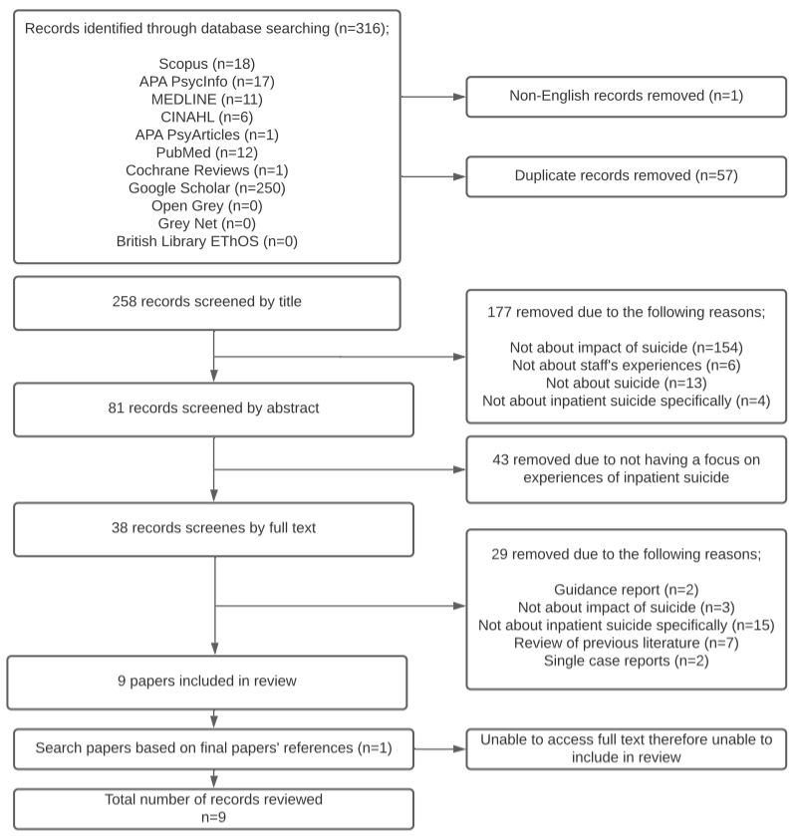
Research databases are biased towards studies with desirable results (Song et al., 2020) with null findings less likely to be published (Easterbrook et al., 1991). The author attempted to overcome this by searching grey literature databases. However, the “file-drawer problem” (Rosenthal, 1979) meant additional relevant research may have remained undiscovered. The author held publication bias in mind.

Study Demographics
The search strategy yielded 9 papers to review; 5 qualitative, 3 quantitative and 1 mixed-methods. 8 papers were published in peer-reviewed journals and 1 paper was a doctoral dissertation. The demographics of the papers are outlined in Table 1. For the mixed-methods paper (Hunt et al., 2016), the quantitative data did not meet the inclusion criteria therefore was excluded from the review but the qualitative portion of the paper was included.

Quality Appraisal
The quality of the papers reviewed was appraised to allow the findings to be understood within set parameters (Schlosser, 2007). A range of appraisal tools are available depending on methodology. As this review identified a diversity of papers, the author sought tools that could assess varying methodologies simultaneously. The Critical Appraisal Skills Programme (CASP, 2021), the Mixed Methods Appraisal Tool (MMAT; Hong et al., 2018) and QualSyst Tool (Kmet et al., 2004) were considered.
CASP has eight separate appraisal tools and is the most common in health-related research (Long et al., 2020). However, the quantitative data in this review did not match any of the CASP checklist definitions (randomised controlled trials, cohort studies, diagnostic studies, or case control studies) (CASP, 2021). Additionally, the author wanted to appraise all papers within one shared tool, rather than separate tools like the CASP.
The author also considered the MMAT which has been purposefully designed to appraise mixed methods (Hong et al., 2018). However, it has been criticised as being limited by having too few items (Hong et al., 2018).

Table 1
Study Demographic Information
Record | Paper | Country | Method | Study Design | Sample Size | Participants
1 | Bohan & Doyle (2008) | Ireland | Qualitative | Semi-structured interviews | 9 nurses | Nurses working in an acute psychiatric unit
2 | Bowers, Simpson, Eyres, Nijman, Hall, Grange & Phillips (2006) | UK | Qualitative | Semi-structured interviews | 40 staff on acute psychiatric inpatient units | F grade mental health nurses (n=17)  Occupational therapists (n=14)  Consultant psychiatrists (n=9)
3 | Cabello, Leon & Sorensen (2016) | Chile | Quantitative | Self-report measures completed remotely;  - Posttraumatic Stress Disorder Checklist – Spanish Version  - Beck Depression Inventory  - Maslach Burnout Inventory | 41 staff on acute psychiatric ward | Nurses (n=6)  Psychologists (n=2)  Occupational Therapists (n=2)  Nursing Assistants (n=5)  Psychiatrists (n=7)  Resident psychiatrists (n=11)  Paramedic technicians (n=8)
4 | Hamaoka, Fullerton, Benedek, Grifford, Theodore & Ursano (2007) | Unknown | Qualitative | 11-item open questionnaire | 16 respondents targeted following the suicide of an inpatient | Rotating psychiatry students (n=15) and surgery student (n=1)
5 | Hunt, Clements, Saini, Rahman, Shaw, Appleby, Kapur & Windfuhr (2016) | England | Mixed methods(but only qualitative portion included) | Semi-structured interviews via telephone | 21 mental health staff | Psychiatrists (n=17) and nurses (n=4).
6 | Joyce (2003) | Unstated | Qualitative | Semi-structured interviews | 9 interviewees | 9 nursing staff members based on an adult acute psychiatric unit.
7 | Rivett (2020) | England | Qualitative | Semi-structured interviews | 10 staff on adult acute psychiatric inpatient ward | Nursing associates (n=2)  Occupational therapists (n=2)  Ward managers (n=1)  Psychiatrists (n=2)  Assistant psychologist (n=2)  Staff nurse (n=1)
8 | Takahashi, Chida, Nakamura, Akasaka, Yagi, Koeda, Takusari, Otsuka & Sakai (2011) | Japan | Quantitative | Survey questionnaire  Impact of Events Scale - Revised | 531 respondents | Psychiatric nurses who had experience in psychiatric inpatient ward experience
9 | Wurst, Mueller, Petitjean, Euler, Thon, Wiesbeck & Woldersdorf (2010) | Switzerland | Quantitative | 63 item questionnaire | 172 respondents (47 of which were based in inpatient psychiatric settings) | Of the inpatient staff;  Trainee psychiatrists (n=26)  Senior psychiatrists (n=7)  Clinical Psychologists (n=14)

The QualSyst Tool (Kmet et al., 2004) was the most appropriate for this dataset as it allowed multiple methodologies to be appraised simultaneously and is more comprehensive than the MMAT. The author still felt some areas of quality were missing, such as; ethical considerations, findings and value of the research. Therefore, the QualSyst Tool was combined with some questions from the CASP Checklist to ensure a thorough quality assessment. The combined appraisal tool can be viewed in Appendix B. The purpose of completing quality appraisal was to assess the quality of the papers, not to employ an exclusion threshold and all papers were included in the overall synthesis.
The final appraisal tool was split into two parts; one for quantitative research (16 questions), and the other qualitative (13 questions). Each question was scored by the author as; not applicable (-), not fulfilled (0), partially fulfilled (1) or fulfilled (2), as per the QualSyst scoring system. An overall score was awarded using the mean score of the answered items. Some questions are mirrored across both methodologies (i.e. ‘question/objective sufficiently described’) though some criteria differ according to what is deemed important for the methodology used. Lee et al. (2008) outlined the overall score indicates how strong the quality is; >0.80 is strong, 0.71-0.79 is good, 0.50-0.70 is adequate and <0.50 is limited. Therefore, this scoring guideline was adopted. The results of the quality assessment can be viewed in Table 2. All papers reached the threshold for strong quality.

Synthesis
Further synthesis was conducted through narrative analysis. This allowed explanations of findings from both quantitative and qualitative data to be combined to ‘tell a story’ (Popay et al., 2006).

Table 2
Scores for Quality Appraisal of Papers
Record | CRITERIA  Scoring; Yes (2), Partial (1), No (0), N/A (-)
 | QUANTITATIVE PAPERS
 | 1 | 2 | 3 | 4 | 5 | 6 | 7 | 8 | 9 | 10 | 11 | 12 | 13 | 14 | 15 | 16 | Overall
3 | 2 | 2 | 2 | 2 | - | - | - | 2 | 0 | 2 | 1 | 0 | 2 | 2 | 2 | 2 | 1.62
8 | 2 | 2 | 2 | 2 | - | - | - | 1 | 0 | 1 | 0 | 0 | 2 | 2 | 2 | 2 | 1.38
9 | 2 | 2 | 2 | 2 | - | - | - | 1 | 0 | 2 | 1 | 2 | 2 | 2 | 2 | 2 | 1.69
 | QUALITATIVE PAPERS
1 | 2 | 2 | 2 | 1 | 2 | 2 | 1 | 0 | 2 | 0 | 2 | 2 | 2 |  |  |  | 1.54
2 | 2 | 2 | 2 | 0 | 2 | 2 | 1 | 2 | 2 | 1 | 2 | 2 | 1 |  |  |  | 1.62
4 | 2 | 2 | 2 | 1 | 1 | 2 | 1 | 0 | 2 | 0 | 0 | 2 | 2 |  |  |  | 1.31
5 | 2 | 2 | 2 | 1 | 2 | 2 | 2 | 0 | 2 | 1 | 2 | 2 | 2 |  |  |  | 1.69
6 | 2 | 2 | 2 | 1 | 2 | 2 | 1 | 2 | 2 | 1 | 2 | 2 | 2 |  |  |  | 1.77
7 | 2 | 2 | 2 | 2 | 2 | 2 | 2 | 0 | 2 | 2 | 2 | 2 | 2 |  |  |  | 1.85

Results
All papers transparently identified the purpose of their research; summarising the previous literature and stating their objectives.

Participants and Sampling
All papers outlined information about participants and recruitment. The quantitative studies ranged from 41 to 531 participants and the qualitative papers ranged from 9 to 40 participants. Only one qualitative paper (Rivett, 2020) stated their target sample size, which they achieved. No quantitative papers provided power calculations, therefore it was not possible to conclude whether sample sizes were appropriate.
The papers included data from a range of professionals based in acute inpatient settings; nurses, ward managers, occupational therapists, psychiatrists, psychologists, nursing assistants, paramedic technicians, medical students, and assistant psychologists. Four papers approached singular professions; Bohan & Doyle (2008), Hunt et al. (2016) and Takahashi et al. (2011) recruited psychiatric nurses, whereas Hamaoka et al. (2007) approached medical students. On the other hand, Bowers et al (2006), Cabello et al. (2016), Joyce (2003), Rivett (2020) and Wurst et al. (2010) recruited a range of professionals.
Only two papers recruited participants from ‘non-qualified’ roles such as, nursing assistants and assistant psychologists (Cabello et al., 2016; Rivett, 2020). However, they did not aim to distinguish between qualified and non-qualified roles, therefore comparisons were not stated and results are reported from the perspective of staff as a whole. It is possible the reviewed papers are missing key voices in the form of non-qualified staff.
Three papers recruited from a specific ward/hospital (Cabello et al., 2016; Hamaoka et al., 2007; Joyce, 2003), four recruited from hospitals within a targeted geographical region (Bohan & Doyle, 2008; Bowers et al., 2006; Takahashi et al., 2011; Wurst et al., 2010) and two papers recruited from inpatient units across the UK (Rivett, 2020; Hunt et al., 2016).
Bohan & Doyle (2008), Joyce (2003) and Rivett (2020) included inclusion and exclusion criteria. The remaining six papers did not, which affects replicability.
Furthermore, Joyce (2003), Rivett (2020) and Takahashi et al. (2011) provided demographic details, such as gender, ethnicity and age which increases generalisability and replicability.
All studies utilised purposive sampling, recruiting participants with a specific set of characteristics i.e. staff working in acute inpatient settings who had experienced inpatient suicide. Most authors approached participants themselves, via; email (Cabello et al., 2016; Hamaoka et al., 2007), mail (Bohan & Doyle, 2008; Joyce, 2003), and face-to-face (Rivett, 2020). Takahashi et al. (2011) “sent out” invitations and Bowers et al. (2006) “approached” participants, but neither specified the method, which makes them difficult to replicate.
On the other hand, Hunt et al. (2016) and Wurst et al. (2010) nominated psychiatrists to help with recruitment. This reduced the risk of researcher recruitment bias but added a potential confounding variable as participants were selected by people external to the research process. Neither paper stated how they controlled for this variable.

Ethical Considerations
All papers sought ethical approval, therefore data was collected in a way that reduced risk of harm to participants. Informed consent was discussed by all papers, meaning participants were given adequate information before volunteering to take part. This suggests a reduced risk of recruitment bias. Bohan & Doyle (2008) and Cabello et al. (2016) discussed confidentiality and anonymity. Rivett (2020) provided the most robust consideration of ethics. It is worth noting that this is a dissertation paper, whereas all other papers were peer-reviewed journal articles, therefore Rivett (2020) could accommodate a larger word count. Overall, all authors considered the impact of their research and ensured participants were recruited voluntarily.

Quantitative Methods
Three papers used quantitative methods of data collection (Cabello et al., 2016; Takahashi et al., 2011; Wurst et al., 2010). All utilised self-report measures which are useful for collecting large amounts of data quickly (Demetriou et al., 2015) and are argued to produce accurate results as respondents are closer to the issues in the questions (Demetriou et al., 2015). Furthermore, self-report measures are useful as they can be replicated.
Takahashi et al. (2011) delivered questionnaires individually, sealed in envelopes to maintain anonymity. Whereas, Cabello et al. (2016) administered questionnaires online thus participants were less likely to be influenced by researcher bias or social desirability. Similarly, Wurst et al. (2010) handed out questionnaires for participants to complete in their own time. All methods are suitable and highlight the researchers considered the impact of bias when collecting their data.
The studies used pre-existing global measures and questionnaires developed specifically for the research. Cabello et al. (2016) used only pre-existing measures, which allowed them to report the validity and reliability of the scales. On the other hand, Wurst et al. (2010) developed a questionnaire solely for their research, based on the existing literature. However, there is no statement of the reliability or validity of their questionnaire. Takahashi et al. (2011) used a combination of a pre-existing scale - which they reported the validity and reliability of - and a specifically designed questionnaire which was based on a literature review.
Cabello et al. (2016) and Wurst et al. (2010) provided the key themes covered in their measures, and Takahashi et al. (2011) provided a full list of the questions asked. This means that all three studies can be replicated.

Confounding Variables
Wurst et al. (2010) controlled for the variables of profession and age in their analysis and discussed their impact. Additionally, Cabello et al. (2016) identified rumours in the workplace and level of autonomy as potential variables, however took no steps to control for these in their data collection. Takahashi et al. (2011) did not identify any extraneous variables.

Generalisability
Cabello et al. (2016) recruited staff from a private psychiatric hospital which reduces the generalisability of their findings. Similarly, Takahashi et al.’s (2011) findings are only applicable to psychiatric nurses in urban Japan, although they recruited from eight hospitals (as opposed to Cabello et al.’s one ward).

Data Analysis
All studies utilised SPSS analysis software for data analysis which reduced researcher bias and allowed analyses to be audited and replicated.
Cabello et al. (2016) clearly stated their statistical tests which were appropriate to their research question. They provided a good overview of their findings, including variance. Similarly, Wurst et al.’s (2010) analysis was in-depth and reported variance.
Takahashi et al.’s (2011) analysis, however, was lacking. They employed descriptive statistics but further exploration of relationships between variables would have been useful. They also did not provide any statements of variance.
Cabello et al. (2016) stated they did not trim data, therefore, the data reported was in its original format and untampered. Neither Takahashi et al. (2011) nor Wurst et al. (2010) discussed data cleaning.

Qualitative Methods
Most qualitative papers (n=5) employed semi-structured interviews, whereas Hamaoka et al. (2007) utilised an open-ended questionnaire. These methods were appropriate and justified considering their objectives were exploratory.
A common criticism of qualitative data is that reliability and validity cannot be verified in the same way as quantitative data. Therefore, the trustworthiness of qualitative data must be confirmed based on its; credibility, dependability, transferability, and confirmability (Lincoln & Guba, 1989).
‘Credibility’ refers to how accurate findings are (Gunawan, 2015) and can be achieved by the researcher being fully immersed in the data i.e. through verbatim transcription of interviews and revisiting transcripts numerous times. Of the papers that employed interviews, all audio-taped and transcribed them verbatim. This ensured the data was accurate from which to draw analysis. Rivett (2020) further transcribed “umms” and silences to ensure a full representation of the data. Furthermore, Bohan & Doyle (2008), Bowers et al. (2006), Hunt et al. (2016) and Rivett (2020) discussed reading transcripts numerous times prior to analysis, ensuring they were immersed in the data. These steps ensured the data they analysed was credible.
Guba & Lincoln (1989) identified an effective way to ensure credibility is through ‘member checking’; returning to participants to check the data is correct. None of the papers completed member checking methods, therefore this is one area in which they might have improved, although member checking is criticised for its juxtaposition with the interpretative nature of qualitative research (Birt et al., 2016).
‘Transferability’ is how generalizable the results are and authors should describe the research thoroughly (Shenton, 2004). All papers described their research setting and sample clearly. The purpose of qualitative research is not to generalise (Shenton, 2004), however the papers described their population sufficiently enough to allow conclusions to be drawn about specific groups.
‘Dependability’ is how accurately data has been gathered. This can include how well the procedure is described and ensuring findings are rooted in the data. All papers provided clear statements about data collection and provided direct quotes to support their interpretations, which increased the dependability of the findings.
Finally, ‘confirmability’ is concerned with the objectivity of the data, such as ensuring results are not significantly influenced by researcher bias (Lincoln and Guba, 1989). Rivett (2020) was the only paper that discussed the use of a reflective journal which allows transparency about biases (Ortlipp, 2005).

Question Content
All the papers that used interviews (Bohan & Doyle 2008; Bowers et al., 2006; Hunt et al., 2016; Joyce, 2003; Rivett, 2020) based their interview schedules on the existing literature, which improved their trustworthiness; as questions were led by evidence rather than biases. Additionally, Rivett (2020) developed their questions with a group of people of their target demographic. Both methods reduced bias. Hamaoka et al. (2016) provided no information regarding how their questionnaire was developed.
Bowers et al. (2006), Hamaoka et al. (2007), Hunt et al. (2016), Joyce (2003) and Rivett (2020) provided examples of themes or questions. This provided procedural reliability and enabled replication. Bohan & Doyle (2008) did not provide examples of questions.
Of those that provided examples, there was some consensus in the key topics. They tended to employ an introduction about the participant and their role, followed by perceptions and impact of inpatient suicide/risk behaviour as well as a discussion of support following an incident. Bowers et al. (2006) differed as their interview schedule focused on the ward structure. However their research question was different, as it was exploring untoward incidents on the ward rather than suicide specifically (although participants voluntarily discussed completed suicide). Rivett (2020) provided a full appendix of their interview schedule which allowed replicability. As Bohan & Doyle (2008) did not provide examples of questions or themes covered in their interviews, their work was less replicable.

Multiple Raters and Software
Bowers et al. (2006), Hamaoka et al. (2016) and Joyce’s (2003) data was read and coded by multiple researchers which reduced researcher bias and improved credibility of the findings. However, Bohan & Doyle (2008), Hunt et al. (2016) and Rivett (2020) did not discuss multiple raters.
Furthermore, two papers used software to store their transcripts and to support with analysis. Bowers et al. (2006) used QSRN6 qualitative data coding software, whereas Rivett (2020) used Microsoft Word for transcriptions. This reduced researcher bias during the initial coding stage and improved their auditability (St. John & Johnson, 2000). No other authors discussed software, however this was not necessarily a disadvantage as coding software can interfere with the natural interpretative process (Bringer et al., 2004).

Synthesis of Findings
The findings of the papers were considered utilising a narrative synthesis. Themes were identified by the researcher reading each paper multiple times and highlighting key findings. Similar ideas were collated together and themes were developed based on their frequency across the papers. Five key themes were identified, displayed in Table 3; emotional impact, impact on practice, failure/guilt, acute ward environment and support.

Emotional Impact of Inpatient Suicide
The findings provided evidence for a significant emotional impact on staff following inpatient suicide. The most common experience was shock (Bohan & Doyle, 2008; Bowers et al., 2006; Hamaoka, 2007; Joyce, 2003; Rivett, 2020; Wurst et al., 2010) which mirrors the literature on traditional grief and Bartels’ (1987) shock stage of professional grief. Kubler-Ross's (1969) grief model identified ‘denial’ as a defence mechanism that initially helps people survive loss; by plunging into shock, it prevents one becoming overwhelmed. Therefore, this suggests the initial stages of professional grief following an inpatient death are like loss of a loved one.
Table 3
Occurrence of Main Themes across Papers
 | Record
 |  | 1 | 2 | 3 | 4 | 5 | 6 | 7 | 8 | 9
Theme | Emotional impact | √ | √ | √ | √ |  | √ | √ | √ | √
 | Impact on practice | √ | √ |  | √ | √ | √ | √ | √ | √
 | Failure/guilt | √ | √ |  |  |  | √ | √ |  | √
 | Acute ward environment | √ | √ |  |  | √ | √ | √ |  | √
 | Support | √ | √ |  | √ |  | √ | √ | √ | √
Tick denotes paper contained theme
Joyce’s (2003) participants felt sad, and Wurst et al. (2010) discussed sadness among the team, however, other papers reported more significant emotional reactions. Bowers et al. (2006) described staff as “emotionally traumatised”. Similarly, Joyce (2003) and Hamaoka et al.’s (2007) participants had flashbacks years after the suicide. This suggested a more complex impact than just sadness, which is similar to the literature regarding general professional grief (Papadatou, 2002). However, Wurst et al.’s (2010) findings contradicted this; they found that shock, sadness and guilt significantly decreased over time. Due to conflicted findings, it was not possible to conclude on the severity or duration of emotional impact following an inpatient suicide.
Another common emotion reported was anger (Bohan & Doyle, 2008; Hamaoka et al., 2007; Joyce, 2003). Bohan & Doyle (2008) found participants’ anger was dually motivated; towards the client, and also themselves for wasted time and effort. Again, the experience of anger can be likened to the traditional grief process (Kubler-Ross, 1969).
Cabello et al. (2016) reported 17.1% and Takahashi et al. (2011) reported 13.7% of participants were at high risk of posttraumatic stress disorder (PTSD), both of which are significantly above the general population (Kessler et al., 1995). Additionally, Cabello et al. (2016) found high levels of depression and burnout amongst staff who had experienced an inpatient suicide. These findings corroborated the qualitative studies and highlighted the clinical impact of inpatient suicide.
Hunt et al. (2016) did not discuss emotional impact.
Bohan & Doyle (2010) also suggested the concept of a ‘domino effect’ following an inpatient suicide i.e., the unsettled atmosphere on the ward led to suicide attempts amongst other inpatients. This caused a tense ward environment where further incidents were almost anticipated, which further compounded emotional distress. Bowers et al. (2006) supported this idea, stating that ‘copycat’ incidents led to heightened anxiety. No other papers discussed this phenomenon, however. This finding is unique to the acute psychiatric inpatient setting, as the suicide undoubtedly affects the whole ward system, including staff and clients.

Impact on Practice
Some papers indicated that inpatient suicide made staff evaluate their working practices. Bohan & Doyle (2010), Joyce (2003), Rivett (2020), Takahashi et al. (2011) and Wurst et al. (2010) identified that staff became hyper-vigilant to avoid further suicides, i.e. increased observations, followed policy more rigidly and became more risk-aversive. This was similar to previous findings of professional grief following any type of death (Knieper, 2010). This may be additionally understood with respect to the concept of a ‘domino effect’ in acute inpatient settings where staff are expecting further suicide attempts (Bohan & Doyle, 2010; Bowers et al., 2006). This hyper-vigilance may be a self-protection mechanism. Rivett (2020) offered insight that staff on inpatient wards are unable to react in traditional ways to stress therefore, subconsciously distance themselves to reduce the emotional impact if a suicide happens again.
Bowers et al. (2006) and Hunt et al (2016) found inpatient suicide led to organisational changes including implementation of new policies, structural team changes and physical changes to the ward, to reduce the risk of further suicide.
Hamaoka (2007) was the only paper that discussed positive personal growth following inpatient suicide. Participants used their experience to explore their understandings of death which highlighted a crossover between professional and personal identity that is not reported by the other studies.

Failure/guilt
Clients are admitted to psychiatric hospital as a last resort at times of crisis when someone is at risk of harm to themselves or others, but 9% of suicides still take place in acute inpatient settings (Healthcare Quality Improvement Partnership, 2017). This added a unique contextual element to professional grief. As acute inpatient psychiatry is generally viewed as a place of safety for the most distressed clients, there was a heightened expectation among inpatient staff to keep people safe and alive, which was a common discourse throughout the papers (Bohan & Doyle, 2010; Joyce, 2003; Rivett, 2020). Therefore, when an inpatient died by suicide, this led to feelings of guilt. Staff felt responsible for the death because they had failed their duty to keep people alive (Bohan & Doyle, 2010; Bowers et al., 2006; Joyce, 2003, Rivett, 2020; Wurst et al., 2010). Bowers et al. (2006) found staff ruminated about what they could have done differently to prevent the death, and Bohan & Doyle (2010) discussed staff guilt was compounded by family members being angry at them as their relative died in a place where suicide “should” have been prevented. It could be hypothesised that this is different to the response following a suicide in community psychiatry as the level of observation and responsibility is heightened in an acute setting.
Joyce (2003) and Rivett (2020) reported a unique reaction that staff questioned the appropriateness of expressing their emotions in the workplace. Joyce (2003) stated staff masked their feelings out of fear of becoming upset in front of colleagues and clients. Rivett (2020) mirrored that participants felt ashamed of their grief. They highlighted observations during interviews where participants stated their emotional impact then quickly changed topics; showing signs of shame and embarrassment. Parkes (1986) outlined workplace demands can overshadow grief and there is no natural outlet for it. Because this grief goes unprocessed, it can become complicated or lead to PTSD (Parkes, 1986). This, along with the mechanism of shock as a self-protective mechanism, adds context to Cabello et al.’s (2016) and Takahashi et al.’s (2011) findings of high prevalence of PTSD. Further, it is possible that inpatient staff masked their grief due to a heightened responsibility for keeping clients safe and alive (Bohan & Doyle, 2010; Bowers et al., 2006; Joyce, 2003; Rivett, 2020; Wurst et al., 2010) and that displaying distress could undermine their expert helper role. Whatever the motivation of masking grief, this hindered acute inpatient staff from travelling smoothly through Bartels’ (1987) grief process.

Ward Environment as a Contributing Factor
Bowers et al. (2006) and Hunt et al. (2016) identified that the nature of the acute psychiatric ward environment influenced the emotional impact of suicide. Bowers et al. (2006) stated multiple demands associated with acute ward working meant staff had limited opportunity to process their emotions. Being responsible for multiple people in distress and managing risks meant staff had to remain focused on their job to keep inpatients safe, which left little time for reflection. Similarly, Hunt et al. (2016) stated the pace of the ward increased the risk of mistakes which influenced feelings of guilt. Combined with the responsibility of keeping people safe (Bohan & Doyle, 2010; Joyce, 2003; Rivett, 2020), this suggests that staff processed inpatient suicide in a unique way.
Furthermore, formal investigations following suicide had a negative impact as they gave the impression that there was accountable blame (Bowers et al., 2006) and led to fear (Wurst et al., 2010). Bowers et al. (2006), Hunt et al. (2016) and Wurst et al. (2010) discussed how formal investigations following a suicide influenced the emotional impact on staff. Furthermore, Wurst et al. (2010) found a significant correlation between ‘fear of lawsuit’ and high levels of distress. Due to heightened responsibility in acute wards, this strengthened feelings of guilt amongst acute inpatient staff.

Support
Most papers discussed support after an inpatient suicide, except for Hunt et al. (2016) and Cabello et al. (2016). Support was discussed as crucial (Bohan & Doyle, 2008) and positively received (Bohan & Doyle, 2008; Bowers et al., 2006; Hamaoka, 2007; Wurst et al., 2010). However, Rivett (2020) reported mixed feelings regarding support with some participants claiming it was lacking. Similarly, Takahashi et al. (2011) found 80% of participants reported receiving no support at all following inpatient suicide. Further, Rivett (2020) was the only paper that found some support was unhelpful. Therefore, the literature regarding support following an inpatient suicide was unclear. Rivett (2020) provided potential insight; the participants who reported adequate support were in roles receiving clinical supervision, however not all acute psychiatric staff had access to clinical supervision. This suggested a disparity of support received based on job role. However, no studies in this review explored this, therefore future research could investigate this to better understand the intricacies of inpatient staff teams.
Informal support was commonly discussed as most beneficial; informal conversations with colleagues (Bohan & Doyle, 2008; Joyce, 2003; Rivett, 2020) and family members (Bohan & Doyle, 2008). However, formal support was also helpful to synthesise the experience (Bowers et al., 2006), promote information sharing (Joyce, 2003; Takahashi et al., 2011) and reduce rumours (Bohan & Doyle, 2008; Joyce, 2003; Cabello et al., 2016).
Joyce (2003) and Rivett (2020) concluded support following an inpatient suicide was important but difficult to define. Joyce (2003) identified a discrepancy between some staff valuing the process of sharing emotions, whereas other team members not wanting to talk, therefore making discussions mandatory would not be helpful for the whole team. Similarly, Rivett (2020) concluded that a “one size fits all” approach would not work due to diverse needs and preferences amongst team members. The concept of masking emotions may offer insight into the polarising views regarding support. Voicing a preference for support would naturally contradict the strong instinct to mask the impact, therefore it is appreciated that true preferences for support following inpatient suicide may not have been captured by the studies.
The high frequency of suicides in acute psychiatric inpatient settings, risk of staff developing PTSD and disrupted grief processes mean that identifying adequate support is essential. This review was unable to find a consensus and future research should focus on exploring and identifying different sources of support.

Analysis of Findings
The papers discussed were part of a literature review conducted to explore the impact of inpatient suicide on mental health professionals working in acute inpatient psychiatric settings. Following a systematic search of relevant databases, nine papers were identified that answered the research question. Through a process of quality assessment and narrative synthesis, a number of conclusions can be drawn.
The literature encompasses the views of a range of mental health professionals working in acute psychiatric inpatient settings. However, the voices of staff in roles that do not require a professional registration are lacking. Cabello et al. (2016) and Rivett (2020) are the only papers that recruited ‘non-qualified’ staff by including assistant psychologists and assistant nurses. As such, although the papers covered a robust range of core medical staff in acute inpatient settings, one cannot draw conclusions about the wider staff team. Likewise, the papers did not distinguish between designations, therefore profession-specific conclusions cannot be drawn.
Staff experienced shock and anger in response to inpatient suicide which marries the literature surrounding traditional grief, suggesting professional grief is similar to personal grief. The uniqueness with professional grief is that staff can experience overwhelming feelings of guilt which is further heightened amongst inpatient staff due to a responsibility to manage risk. Their guilt is compounded by feelings of shame, as the professional is exposed to judgement from organisational procedures, reducing their willingness to express their feelings. Furthermore, masking symptoms may be prevalent for this group (Joyce, 2003; Rivett, 2020) due to a focus on managing multiple risks and a culture of high activity.
The busy nature of the acute ward environment may add another complicating factor which hinders the processing of emotional distress; staff are managing repeated risk incidents and lack time to process.
The literature around support was ambiguous; some finding support helpful, some finding it damaging and some receiving no support at all. It is respected that a “one size fits all” approach would not work, therefore, it is suggested that local organisations work with their teams to develop locally meaningful processes of support in the aftermath of an inpatient suicide.

Discussion
This literature review employed a systematic process of identifying and assessing the evidence-base related to the impact of inpatient suicide on mental health professionals working in acute psychiatric inpatient settings. The findings of the review suggested inpatient suicide led to a significant emotional reaction and heightened guilt which altered professional practice. The acute inpatient setting itself contributed to the grief due to the level of responsibility for risk management and fast working pace. Furthermore, there was discussion about support following an inpatient suicide.
There was a definite emotional reaction following the suicide of an inpatient. The severity and duration of this reaction was unique to each person but the emotional reaction was similar to general professional grief (Papadatou, 2002). However, acute inpatient psychiatry settings meant emotional reactions were heightened by a ‘domino effect’ of further incidents on the ward.
Staff became hyper-vigilant to reduce further anticipated incidents. This process may also serve as a protective mechanism, to emotionally distance and reduce further sadness if a further suicide occurs. There was also discussion of organisational change following a suicide, but the common discourse was the journey of the individual mental health professional.
A common reaction to client death is guilt (Papadatou, 2002), which was corroborated by the papers in this review. This was heightened in the acute psychiatric inpatient setting as it is a last resort for people at risk of harm, therefore professionals felt particularly responsible for the death.
Another concept that matched the general professional grief literature is masked grief, which is reinforced by a culture of shame regarding expressing emotions. Within the context of inpatient acute psychiatry, hiding emotions may serve the purpose of protecting oneself from distress, with consideration to the high prevalence of risk incidents and lack of opportunity to process emotions on the ward. A specific element may be that experiencing intense emotions leads mental health professionals to question their competence to deal with others’ distress which further reinforces the shame and need to mask. Therefore, this prompts a need for identifying appropriate support to allow inpatient staff to process the impact of an inpatient suicide.

Limitations of Reviewed Papers
The review identified more qualitative than quantitative studies which was expected given the explorative nature of the research questions. It was reassuring, however, that the methodologies corroborated each other. For example, the quantitative data in Cabello et al. (2016), Takahashi et al. (2011) and Wurst et al. (2010) provided statistical evidence for the emotional distress found by Bohan & Doyle (2008), Bowers et al. (2006), Hamaoka et al. (2007), Joyce (2003), and Rivett (2020). There are benefits of both methodologies, and future research could consider employing mixed-methods designs to explore the impact of inpatient suicide on mental health professionals.
The papers recruited participants from a variety of countries worldwide. Context and culture are fundamental in how mental health professionals experience inpatient suicide in acute settings, but no papers discussed this. Providing insight into the country’s healthcare system would have offered additional insight.
Although all papers received a high quality score, there was a disparity with how much each paper contributed to the overall synthesis. Cabello et al. (2016) and Hunt et al. (2016) only covered 1 and 2 of the key themes, respectively. Therefore, this raised questions about how valuable these papers are to the overall literature.
There were some areas of quality where the papers were lacking. Sample size was largely a neglected area across the papers. Quantitative papers lacked details about variance and confounding variables, which raised questions about their validity Likewise, reflective accounts within the qualitative papers were limited meaning that potential biases may not have been completely explored.

Limitations of Literature Review
The current review only employed one rater. Quality assessment is a subjective process (Cooper, 1984) and lack of experience in conducting critical appraisal can increase the risk of rater bias (Oremus, 2012). As the author had no prior experience of appraising evidence, this potentially reduced the reliability of their findings. To reduce rater bias, the author was transparent with their assessment and provided raw quality scores, which allows for replicability. Despite concerns regarding bias, it was positive that papers were not excluded based on their quality score. The reliability of the findings could have been improved by using a second reviewer.
The author combined the QualSyst Tool with some questions on the CASP to provide a holistic assessment of quality. However, as a bespoke amalgamation of questions, the reliability and validity of the tool was unclear.
The literature review is lacking in unpublished works. The author attempted to identify some through searching grey literature databases, however no papers were identified, which may be representative of the publication bias in academic research (Song et al., 2010). It was encouraging that this review included one doctoral thesis (Rivett, 2020), however most evidence was peer-reviewed journal articles. Thus, it is unclear whether all relevant research was identified.
Including both quantitative and qualitative data in the review may be considered a conflict of epistemologies (Harden, 2010). Can the truth be identified and measured (quantitative), or is it understood by observations (qualitative)? Nevertheless, the author chose to incorporate both methodologies to gather a broader understanding which allowed them to conclude the prevalence of emotional distress whilst considering individual viewpoints.

Clinical Implications
This literature review found several conclusions that are applicable to real-world populations. Following acute inpatient suicide, mental health professionals experienced a grief reaction that was similar to personal grief. However, their experience was unique in the way they masked their feelings. Due to a culture of high activity and heightened distress present on the ward, staff had no appropriate outlet for their own emotions. These findings highlighted the importance of identifying ways to support staff and to prevent the development of more complicated forms of grief.
Organisations should work closely with their acute inpatient psychiatry teams to explore what sources of support would be helpful following an inpatient suicide. Furthermore, more opportunities for clinical supervision should be offered across multi-professions to ensure team members have opportunities to reflect and process their experiences.

Future research
The experiences of non-qualified staff working in acute psychiatric inpatient units is missing, therefore future research could focus on these groups, leading to a better understanding of the holistic team’s experiences of working with an inpatient who dies by suicide. There is also more exploratory work to be done on support following an inpatient suicide, to identify what is available and what sources of support help staff process their grief. Finally, future research could consider employing mixed methods by gathering quantitative data on the responses to inpatient death by suicide whilst exploring the individuals’ qualitative story.

Overall Conclusions
This report outlined the first literature review conducted into the impact of inpatient suicide on mental health professionals in acute psychiatric inpatient settings. The review allowed the author to draw conclusions about the emotional impact following suicide and how this differed from non-inpatient suicides. For example, the professional grief response seemed to be heightened in the acute inpatient setting due to increased responsibility over risk and a lack of opportunity on the ward to experience grief.
The literature review highlighted that support in the aftermath of a suicide was a key theme discussed but was unable to draw conclusions about what support may be helpful. This may be because psychiatric inpatient staff tend to experience shame and hide their emotions, hence eliciting thoughts around support may have been difficult for the papers discussed.
The literature review has identified gaps in the literature and led to suggestions for future research in the field.

References
Ayers, T., Balk, D., Bolle, J., Bonanno, G. A., Connor, S. R., Cook, A. S., Doka, K., Goodkin, K., Hall, M., Hansson, R. O., Jordan, J., Klass, D., Moss, M., Nadeau, J. W., Neimeyer, R. A., Oltjenbrusk, A., Prigerson, H., Rosenblatt, P., Sandler, I., … Shapiro, E. R. (2010). Report on bereavement and grief research. Death Studies, 28(6), 491 – 575. DOI: 10.1080/07481180490461188
Bartels, S. J. (1987). The aftermath of suicide on the psychiatric inpatient unit. General Hospital Psychiatry, 9(3), 189-197. DOI: 10.1016/0163-8343(87)90007-7
Birt, L., Scott, S., Cavers, D., Campbell, C., & Walter, F. (2016). Member checking: A tool to enhance trustworthiness or merely a nod to validation? Qualitative Health Research, 26(13), 1802-1811. DOI: 10.1177/1049732316654870.
Bohan, F., & Doyle, L. (2008). Nurses’ experience of patient suicide and suicide attempts in an acute unit. Mental Health Practice, 11(5), 12-16. DOI: 10.7748/mhp2008.02.11.5.12.c6338.
Bowers, L., Simpson, A., Eyres, S., Nijman, H., Hall, C., Grange, A., & Phillips, L. (2006). Serious untoward incidents and their aftermath in acute inpatient psychiatry: The Tompkins Acute Ward study. International Journal of Mental Health Nursing, 15(4), 226-234. DOI: 10.1111/j.1447-0349.2006.00428.x.
Bringer, J. D., Johnston, L. H., & Brackenridge, C. H. (2004). Maximizing transparency in doctoral thesis: The complexities of writing about the use of QSR*NVIVO within a grounded theory study. Qualitative Research, 4(2), 247-265. https://doi.org/10.1177/1468794104044434
Cabello, R. A. F., Leon, T., & Sorensen, R. (2016). Post-traumatic symptoms in the staff of a mental health inpatient unit after the suicide of a patient: A case report in Chile. Sumna Psicologica Ust, 13(2), 13-22. DOI: 10.18774/summa-vol13.num2-304
Cerel, J., Jordan, J. R., & Duberstein, P. R. (2008). The impact of suicide on the family. Crisis, 29(1), 38-44. https://doi.org/10.1027/0227-5910.29.1.38
Chemtob, C., Hamada, R. S., Bauer, G., & Torigoe, R. Y. (1988). Patient suicide: Frequency and impact on psychologists. Professional Psychology Research and Practice, 19(4), 416-420. https://doi.org/10.1037/0735-7028.19.4.416
Cooper, H. (1984). The Integrative Research Review: A Systematic Approach. Sage. https://doi.org/10.3102/0013189X015008017
Critical Appraisal Skills Programme. (2018). CASP Checklists. https://casp-uk.net/casp-tools-checklists/
Demetriou, C., Ozer, B. U., & Essau, C. A. (2015). Self-report questionnaires. The Encyclopedia of Clinical Psychology, November 2017, 1-6. DOI: 10.1002/9781118625392.wbecp507
Easterbrook, P. J., Berlin, J. A., Gapolan, R., & Matthew, D. R. (1991). Publication bias in clinical research. Lancet, 337, 867-872. DOI: 10.1016/0140-6736(91)90201
Granek, L., Tozer, R., & Mazzotta, P. (2012). Nature and impact of grief over patient loss on oncologists’ personal and professional lives. Archives of International Medicine, 172(12), 964 – 966. DOI: 10.1001/archinternmed.2012.1426
Gunawan, J. (2015). Ensuring trustworthiness in qualitative research. Belitung Nursing Journal, 1(1), 10-11. http://belitungraya.org/BRP/index.php/bnj/
Hamaoka, D. A., Fullerton, C. S., Benedek, D., M., Grifford, R., Theodore, N., & Ursano, R. J. (2007). Medical students’ responses to an inpatient suicide: Opportunities for education and support. Academic Psychiatry, 31(5), 350-353. DOI: 10.1176/appi.ap.31.5.350
Harden, A. (2010). Mixed methods systematic reviews: Integrating quantitative and qualitative findings. Focus: Technical Brief No 25. Ktdrr.org/ktlibrary/articles_pubs/ncddrwork/focus/focus25/Focus25.pdf
Hawton, K., Houston, K., Haw, C., Townsend, E., & Harriss, L. (2003). Comorbidity of axis I and axis II disorders in patients who attempted suicide. The American Journal of Psychiatry, 160(8), 1494-1500. https://doi.org/10.1176/appi.ajp.160.8.1494
Healthcare Quality Improvement Partnership. (2017). National and Confidential Inquiry into Suicide and Homicide by people with Mental Illness: An Annual Report 2017. Healthcare Quality Improvement Partnership.
Hong, Q. N., Gonzalez-Reyes, A., and Pluye, P. (2018). Improving the usefulness of a tool for appraising the quality of qualitative, quantitative and mixed-methods studies. The Mixed Methods Appraisal Tool (MMAT). Journal of Evaluation in Clinical Practice, 24(3), 459-467. DOI: 10.111/jep.12884
Hong, Q. N., Pluye, P., Fabregues, S., Bartlett, G., Boardman, F., Cargo, M., Dagenais, P., Gagnon, M., Griffiths, F., Nicolau, B., O’Cathain, A., Rasseau, M., and Vedel, I. (2018). Mixed Methods Appraisal Tool (MMAT) version 2018 for information professionals and researchers. Education for Information, 34(4), 285-295. DOI: 10.3233/EFI-180221
Hunt, I. M., Clements, C., Saini, P., Rahman, M. S., Shaw, J., Appleby, L., Kapur, N., & Windfuhr, K. (2016). Suicide after absconding from inpatient care in England: An exploration of mental health professionals’ experiences. Journal of Mental Health, 25(3), 245-253. DOI: 10.3109/09638237.2015.1124394.
Joyce, B. (2003). Effects of suicidal behavior on a psychiatric unit nursing team. Journal of Psychosocial Nursing, 41(3), 14-23. https://doi.org/10.3928/0279-3695-20030301-10
Kelleher, E., & Campbell, A. (2014). A study of consultant psychiatrists’ response to patients’ suicide. Irish Journal of Psychological Medicine, 28(1), 35-37. DOI: 10.1017/S0790966700011952
Kessler, R., Sonnega, A., Bromet, E., Hughes, M., & Nelson, C. (1995). Posttraumatic stress disorder in the National Comorbidity Survey. Archives of General Psychiatry, 52(12), 1048-1060. DOI: 10.1001/arch-psyc.1995.0395024006612
Kmet, L. M., Lee, R. C., & Cook, L. S. (2004). Standard Quality Assessment Criteria for Evaluating Primary Research Papers from a Variety of Fields. Alberta Heritage Foundation for Medical Research. https://doi.org/10.7939/R37M04F16
Knieper, A. J. (2010). The suicide survivor’s grief and recovery. Wiley Online Library, 29(4), 353-64. DOI: doi.org/10.1111/j.1943-278X.1999.tb00530.x
Kubler-Ross, E. (1969). On Death and Dying. Macmillan.
Kubler-Ross, E., & Kessler, D. (2014). On grief and grieving: finding the meaning of grief through the five stages of loss. Scribner.
Lee, L., Packer, T. L., Tang, S. H., & Girdler, S. (2008). Self-management education programs for age-related macular degeneration: A systematic review. Australasian Journal on Ageing, 27, 170–176. https://doi.org/10.1111/j.1741-6612.2008.00298.x
Lincoln, Y. S. & Guba, E. A. (1985). Naturalist inquiry. Sage.
Long, H. A., French, D. P., and Brooks, J. M. (2020). Optimising the value of the critical appraisal skills programme (CASP) tool for quality appraisal in qualitative evidence synthesis. Research Methods in Medicine and Health Sciences, 1(1), 31-42. DOI: 10.1177/2632084320947559
Mental Health Taskforce. (2016). The Five Year Forward View for Mental Health. The Mental Health Taskforce.
Murphy, P. T., Clogher, L., van Laar, A., O’Regan, R., McManus, S., McIntyre, A., O’Connell, A., Geraghty, M., Henry, G., and Hallahan, B. (2019). The impact of service user’s suicide on mental health professionals. Irish Journal of Psychological Medicine, 39(1), 74-84. DOI: 10.1017/ipm.2019.4
NHS. (2019). Grief after bereavement or loss. https://www.nhs.uk/mental-health/feelings-symptoms-behaviours/feelings-and-symptoms/grief-bereavement-loss/
Office for National Statistics. (2018). Registered deaths in the UK from suicide analysed by sex, age, area of usual residence of the deceased and suicide method. Office for National Statistics.
Oremus, M., Oremus, C., Hall, G. B. C., and McKinnon, M. C. (2012). Inter-rater and test-retest reliability of quality assessments by novice student raters using the Jadad and Newcastle-Ottawa Scales. BMJ Open, 2. DOI: 10.1136/bmjopen-2012-001368
Ortlipp, M. (2005). Keeping and using reflective journals in the qualitative research process. Qualitative Reports, 13(4), 695-705. DOI: 10.46743/2160-3715/2008.1579
Papadatou, D. (2002). Greek nurse and physician grief as a result of caring for children dying of cancer. Pediatric Nursing, 28(4), 345 – 353.
Parkes, C. M. (1986). Orienteering the caregiver’s grief. Journal of Palliative Care, 1, 5-7.
Popay, J., Roberts, H., Sowden, A., & Petticrew, M. (2006). Guidance on the conduct of narrative synthesis in systematic reviews: A product from the ESRC Methods Programme. Lancaster University. DOI: 10.13140/2.1.1018.4643.
Rivett, E. L. (2020). A qualitative exploration of acute mental health inpatient staff’s experiences of working with high-risk behaviours and the support they receive. [Unpublished doctoral dissertation, University of Essex]. University of Essex Research Repository. http://repository.essex.ac.uk/28530/
Rosenthal, R. (1979). File drawer problem and tolerance for null results. Psychology Bulletin, 86(3), 638-641. DOI: 10.1037/0033-2909.86.3.638
Schlosser, R. W. (2007). Appraising the quality of systematic reviews. Focus Technical Brief No 17, 1-8. https://ktdrr.org/ktlibrary/articles_pubs/ncddrwork/focus/focus17/Focus17.pdf
Shenton, A. K. (2004). Strategies for ensuring trustworthiness in qualitative research projects. Education for Information, 22, 63-75. DOI: 10.3233/EFI-2004-22201
Song, F., Parekh, S., Hooper, L., Loke, Y. K., Ryder, J., Sutton, A. J., Hing, C., Kwok, C. S., Pang, C., & Harvey, I. (2010). Dissemination and publication of research findings: An updated review of related biases. Health Technology Assessment, 14(8). DOI: 10.3310/hta14080
St. John, W., & Johnson, P. (2000). The pros and cons of data analysis software for qualitative research. Journal of Nursing Scholarship, 31(4), 393-7. DOI: 10.1111/j.1547-5060.2000.00393.x
Takahashi, C., Chida, F., Nakamura, H., Akasaka, H., Yagi, J., Koeda, A., Takusari, E., Otsuka, K., & Sakai, A. (2011). The impact of inpatient suicide on psychiatric nurses and their need for support. BMC Psychiatry, 11(38), 1-8. https://doi.org/10.1186/1471-244X-11-38
University of Manchester. (2018). National Confidential Inquiry into Suicide and Safety and Mental Health. Annual Report: England, Northern Ireland, Scotland, Wales. University of Manchester.
World Health Organization. (2018). Suicide. https://www.who.int/news-room/fact-sheets/detail/suicide
Wurst, F. M., Mueller, S., Petitjean, S., Euler, S., Thon, N., Wiesbeck, G., & Wolfersdorf, M. (2010). Patients’ suicide: A survey of therapists’ reactions. Suicide and Life Threatening Behavior, 40(4), 328-336. DOI: 10.1521/suli.2010.40.4.328.

Empirical Paper

“I thought you were safe on the ward”: Non-Qualified Staff’s Experience of Suicidal Behaviour in Acute Psychiatric Inpatient Settings

Word count: 7,971
(Excludes references)

This paper has been written in accordance with submission guidelines for The Journal of Death and Dying (Appendix A). This paper will be amended and modified prior to submission.

Abstract
Suicide and attempted suicide of people receiving care in acute psychiatric inpatient settings (APISs) leads to significant emotions amongst mental health professionals, characterised by guilt and shame. A sense of responsibility occurs due to hospital being seen as a safe place. However, little is known about what it is like for ‘non-qualified’ staff. This study explored ‘non-qualified’ staff’s experiences of suicide and attempted suicide in APISs. Semi-structured interviews explored ten staff’s experiences. Participants were recruited online and transcripts were analysed using Reflexive Thematic Analysis. Four themes were identified; ‘Direct personal impact’, ‘Unrealistic expectations’, ‘Attempting to contain the impact’ and ‘Acclimatisation’. Ten sub-themes outlined; responsibility for assessing risk, shame and protective strategies to aid acceptance. The results provide insight into the unique experience of non-qualified staff in APISs experiencing suicidal behaviour.

Introduction
Suicide constitutes a significant national issue (Royal College of Psychiatrists, 2020). In the decade preceding 2015, 28% of people who died by suicide were in receipt of professional mental health care, of which 9% were receiving inpatient psychiatric care (Burns et al., 2017). Further, incidents of non-fatal suicide attempts are even more common (Beautrais, 2004). Thus, a high proportion of staff working in inpatient settings are exposed to working with people who die by suicide (Croft et al., 2022) or make suicide attempts (Takahashi et al., 2011). The aim of this research is to explore ‘non-qualified’ staff’s experience of attempted and completed suicide in acute psychiatric inpatient services (APISs).

Impact of Suicide on Inpatient Staff
Research exploring the impact of suicide on staff working in APISs has found a consistent, strong emotional reaction. From feelings of shock (Bohan & Doyle, 2008), sadness (Wurst et al., 2010) and anger (Hamaoka et al., 2007) to post-traumatic stress disorder (Cabello et al., 2016), the emotional significance is substantial. Staff can experience ‘disenfranchised grief’ (Doka, 1989) as their emotions are less acknowledged, compared to family of the deceased person (Kauffman, 2010), leading to feelings of isolation and shame (Joyce, 2003; Rivett, 2020)
People receiving care in APISs are experiencing significant psychological distress, commonly posing a risk of harm to themselves and/or others (Bowers, 2005). As a result, family and friends of those admitted expect risk to be managed (Sakinofsky, 2014). This leads to feelings of guilt following a suicide (Bohan & Doyle, 2008; Joyce, 2003; Rivett, 2020). Feelings of failure may permeate as staff members question their professional competence (Dewar et al., 2000).
Imitative suicides may account for ten percent of suicide deaths by mental health clients (McKenzie et al., 2005). Therefore, inpatient staff can become fearful of further suicide attempts occurring on the ward (Bohan & Doyle, 2008; Bowers et al., 2006). This can lead them to distance themselves from suicidal people (Gibbons et al., 2019) or become more risk-aversive (Sandford et al, 2020).
APISs are busy, chaotic environments with high bed occupancy and staff turnover (Cleary, 2011). This leaves inpatient staff little time to process their emotions (Bowers et al., 2006; Hunt et al., 2016) which can lead to more complicated grief (Adwan, 2014).

Attempted Suicide
Research has not yet explored the impact of working with people who attempt suicide in APISs. However, minimal research into the effects of attempted suicide suggests a similar emotional reaction to suicide. Mental health professionals experience shame, loneliness, guilt (Firouz, 2022) and questioning their professional competence following the attempted suicide of a client (Ramsay & Newman, 2005).
The researcher had personal experience of working with clients who both attempted and completed suicide, and supporting APISs teams following those experiences. In their personal experience, they believed the experience of working with clients who attempted or completed suicide was similar. Further, Firouz (2022) stated the feelings clinicians experienced after an attempted suicide were not unlike the feelings they felt after a completed suicide. Therefore, the researcher combined these together, to explore the impact of working with people who present with ‘suicidal behaviour’ (SB), specifically suicide and attempted suicide.
“Non-qualified” Staff
‘Non-qualified’ refers to those who require no specific training or registration, but play an integral part of the ward team e.g. receptionists, assistants and administration staff (Milne, 2016). They have a key role but receive limited professional support (Sorgaard et al., 2010). Jenkins and Elliot (2004) suggested differences in how API staff experience stress at work, with non-qualified members being more triggered by client demands.
Most of the literature concerning the impact of SB focuses on qualified staff (Bohan & Doyle, 2008; Bowers et al., 2006; Hunt et al., 2016; Ramsay & Newman, 2005). Some papers included junior staff, but did not draw out the intricacies of their unique experience (Cabello et al., 2016; Rivett, 2020). Awenat et al. (2017) included “junior” staff (nursing assistants and support workers), concluding they avoided discussing suicidality, believing it was beyond their remit, therefore missing opportunities to provide valuable contact with clients.
The experience of non-qualified staff who had been involved in SB in APISs was not clearly represented in existing studies, despite being a significant part of the workforce. As these staff members have the most direct contact with clients (Bee et al., 2009), it is important to explore the unique needs of their cohort.

Clinical Relevance
Clinical Psychology provides a vital role in APISs (Ebrahim & Wilkinson, 2021) providing reflective supervision (Raphael et al., 2020), conducting service evaluations (Wood et al., 2018) and offering psychological support for staff wellbeing (Berry et al., 2020). Further, Clinical Psychology has a role in service development (Ebrahim, 2021). Therefore, exploring how SB can affect non-qualified staff should be an area of interest in order to plan provision of staff support in APISs, particularly for non-qualified groups who have fewer opportunities for professional support (Sorgaard et al., 2010).

The Current Research
This paper outlines the results of a qualitative study exploring non-qualified staff’s experiences of inpatient SB.

Research Question
What is the experience of SB for ‘non-qualified’ staff working in APISs?

Method

Design
An explorative, qualitative design explored ‘non-qualified’ staff’s experience of inpatient SB in APISs.
A semi-structured interview schedule (Appendix H) was developed for data collection. The content was based on previous literature (Rhodes-Kropft et al., 2005). The researcher consulted with their research supervisor, fellow trainee Clinical Psychologists and an individual from the target demographic regarding the question content. The interview schedule consisted of primarily open-ended questions to allow follow-ups to any divergent information, ensuring the topic was thoroughly explored.
The interview guided participants to focus on one specific incident of inpatient SB in an API setting. It was hoped focusing on one event would elicit a deeper understanding of the experience. The researcher took inspiration from Rhodes-Kropft and colleagues (2005) by asking participants about their “most memorable” experience. This was asked without positive or negative intonation, so the participant produced their own example.
The key topics covered; an introduction to their job and service context, attitudes towards suicide, frequency of SB, their “most memorable” experience, their involvement in the SB, their personal reaction and reaction of the wider team, helpful interventions, and learning points.

Methodology
The researcher sought to generate rich, explorative data about ‘non-qualified’ APIS staff’s experience of SB. Qualitative research was selected as it aims to enhance understanding of human processes and experiences and can be used to give voice to marginalised groups (Harper & Thompson, 2012).
Reflexive Thematic Analysis (TA) was chosen to guide the research, a process of identifying, analysing, organising, describing and reporting themes found in a dataset. According to Braun and Clarke (2021), reflexive TA can be used from a variety of phenomenological standpoints.
Reflexive TA was selected over ‘coding reliability’ or ‘codebook’ TA as that relies on a structured codebook and multiple coders, whereas the researcher was more aligned to reflexive TA which is more flexible, organic and amenable to the researcher’s experience (Braun & Clarke, 2021).
Interpretative Phenomenological Analysis (IPA) was an alternative pattern-based methodology considered, which generates themes within and across data sets (Smith et al., 2009). However, IPA provides an entire framework for conducting research, whereas TA can be used more flexibly in adapting to presenting data (Braun & Clark, 2021), which was deemed to be more appropriate given the reflexive nature of the research. Additionally, IPA is beneficial for providing an idiographic focus on data (Smith et al., 2009), however the researcher’s analytic focus was on identifying patterned meaning across the data set (rather than unique individual features) which can be achieved with reflexive TA (Braun & Clark, 2021).

Reflexive Thematic Analysis
TA identifies patterns of meaning across datasets through a rigorous process of familiarisation with data, coding, theme development and theme revision (Braun & Clarke, 2006). It is a method popular in social sciences research (Braun & Clarke, 2006). TA highlights the importance of subjectivity, hence has more recently been renamed ‘reflexive TA’ to encompass the self-reflexive requirements. Accordingly, it encourages researchers to identify and consider how their preconceptions influence the research process, and welcomes this awareness (Braun & Clarke, 2022).
Reflexive TA allows one to identify similarities, differences and patterns within the dataset (Braun & Clarke, 2021) which the researcher felt was beneficial for this initial, explorative research.
Braun and Clarke (2021) outlined four domains to consider; orientation to data, focus of meaning, qualitative framework and theoretical framework. The researcher took an inductive approach to the orientation of data, meaning codes and themes were drawn from the data, not shaped by existing theoretical ideas, due to this being a new area of research. The researcher’s focus of meaning was semantic, suggesting meaning was explored at the surface level, not implicit levels. The researcher’s qualitative framework was experiential, attempting to capture people’s perspectives, as opposed to interrogating around the subject. Finally, the researcher’s theoretical framework was critical realist.

Theoretical Underpinnings
‘Ontology’ and ‘epistemology’ refer to philosophical theories that underpin research (Braun & Clarke, 2021). Ontology is what we think we can know about the nature of being, ranging from ‘realist’ to ‘irrealist’ (Howitt, 2019). Between these two, ‘critical realist’ proposes reality is behind a lens of socially-constructed meaning, and each person is influenced by their own subjective knowledge (Braun & Clarke, 2013). Epistemology is how we think we can know it, thus the nature of knowledge production, ranging from ‘objectivist’ to ‘subjectivist’ (Braun & Clarke, 2021). ‘Objectivist’ refers to truthful knowledge being observable in the world without barriers. Whereas, ‘subjectivist’ argues knowledge is fallible and observations are guided by objective theory (Howitt, 2019).
The researcher’s philosophical position was a ‘critical realist’ encompassing the position of ‘realist’ ontology and ‘subjectivist’ epistemology. What people say is taken at face-value, however understanding their truth is influenced by their own socially-constructed meaning. The researcher also believed their own experiences could influence the research process.
One approach to improving health outcome change is controlled trials of interventions to explore their efficacy. However, health and social care systems are complex and critical realism has an alternative merit to approach their research. Eastwood (2019, p.9) explained how critical realism considers “how and why things are” and “what will work for whom in what circumstances”. This is achieved by considering the system consisting of various human actors interacting with social and organisational structures that are ever-evolving. Further, any attempts to seek change in health and social care outcomes will be doing so within influence of such observed conditions. Eastwood (2019) stated this leads to a deeper understanding of complex system and can be a beneficial approach for transformation of health services. This is relevant to the current research which is exploring a phenomenon that occurs within healthcare settings.

Self-reflexive Account
Qualitative research is contextual, taking place within a specific time and place between two or more people (Dodgson, 2019). Hence, the researcher’s influencing factors can shape decision-making (Davis, 2020). Highlighting potential influences increases transparency and rigour (Palaganas et al., 2017). This subsection provides an overview of the researcher’s reflexivity throughout the process, hence is written in first-person.
I am a white, British female from a working-class background in my early 30s. I was influenced by my nurse mother to seek a career in a helping profession. Prior to my doctoral training, I had several work experiences in health and social care services, including as a support worker and Social Worker.
As a Social Worker, 10 service users under my care died. I became interested in how helping professionals experienced service users’ deaths. I completed my MA research on the impact of service user death on Social Workers. Multiple participants shared suicide examples. It appeared that suicide had a different response.
My first doctoral placement was in acute inpatient psychiatry. I worked with a gentleman who subsequently completed suicide following his discharge. I found out through conversation in the office and was left alone to process the news. This felt like a bizarre reaction and made me consider the context of working in an APIS. This influenced my decision to explore the impact suicide has on inpatient staff. Throughout the research process, I have considered these personal experiences and they have influenced my decision-making. I kept a reflective journal throughout (Appendix C) of my opinions towards the research, which aided with data analysis.

Rigour
Academic rigour refers to the ‘trustworthiness’ of qualitative research findings (Lincoln & Guba, 1985). The researcher was aware of their own preconceptions about the topic area having previously worked in APIS and worked with people who presented with SB. They had also witnessed how staffing teams responded to those instances and the emotional impact that occurred. The researcher managed their thoughts and interpretations through the use of their reflective journal and referred to this throughout. They were immersed in the data by re-reading the interview transcripts and referring to their reflective journal. They also explored their insights through regular research supervision and discussed their interpretations with others at reflexive TA workshops and peer supervision. The researcher has attempted to be transparent with their findings, providing quotations from the whole range of participants, to be reflective of all data collected. Further, the researcher utilised Braun and Clarke’s (2022) 15-point checklist for good reflexive TA to ensure a rigorous, systematic and reflexive analytic process.

Participants

Sample Size
10 participants were included in this study. Sample size guidance in qualitative research is inconsistent (Malterud et al., 2016), however Braun and Clarke (2013) suggested doctoral-level TA projects should aim for 10 to 20 participants. A common misunderstanding is that numbers are not important, however, if sample size is too small it may be difficult to support claims, and if it is too large it may restrict deep analysis (Sandelowski, 1995).
Some argue data saturation is important; discontinuing data collection on the basis of no new information emerging (Glaser & Strauss, 1967). However, saturation is unclearly defined (O’Reilly & Parker, 2013), hence should not be the sole criteria for determining sample size. Further, the nature of reflexive TA means that themes are continually expanding, evolving and contracting so the concept of ‘saturation’ is not compatible with the reflexive TA approach (Braun & Clarke, 2019), thus was not utilised in this research.
Alternatively, Malterud et al. (2016) suggested sample size should be interpreted by the researcher continually reflecting on the data; richer information requires fewer participants and vice versa. 10 participants in this research may be deemed to be at the lower end (Braun & Clarke, 2013) however, the researcher continually reviewed the codes, themes and subthemes and reflected that the participants were providing abundant data, therefore 10 participants was deemed to be adequate.

Inclusion and Exclusion Criteria
The inclusion criteria required participants to be aged 18 or above, and working in a ‘non-qualified’ role in an APIS at the time of their SB experience. ‘SB’ included attempted or completed suicide (as defined by participants). Job-role and employing organisation were not specified, and current working status was not restricted, therefore, those retired or who had moved to different roles since their experience were accepted. The final inclusion criterion was that participants were able and willing to talk about their experience.
The exclusion criteria involved those who were in qualified roles at the time of their experience. Additionally, those that were working in any other inpatient settings (e.g. forensics or perinatal) as the focus of this research was on APIS. Finally, non-English speakers were excluded due to no accessibility to translation services.

Sampling
The researcher aimed to recruit a set of participants with a shared experience of working with people who engage in SB in APIS. Therefore, purposive sampling was adopted which allows researchers to access a subset of the population that shares a certain characteristic (Palinkas et al., 2015). This was aligned with the reflexive TA approach as it would allow for patterns to be identified across a subset of data.
Recruitment took place online between April and November 2021 and was promoted on social media platforms, Facebook and Instagram via dedicated profiles for the research. Further, the research poster was shared in specific Facebook groups that the researcher was a member of; ‘Mental Health Professionals’, ‘The Masked AMHP’, and ‘Mental Health Nursing’.
A recruitment poster was developed and authorised by the Ethics Committee, including the words; ‘have you worked in an inpatient psychiatric setting where someone has engaged in suicidal behaviour?’ Prospective participants were asked to contact the researcher directly. At this point, they were provided with the information sheet (Appendix D) and given opportunity to ask questions. Once they confirmed participation and were screened for eligibility, they were reminded their involvement was voluntary and data would remain anonymous.

Procedure
The researcher arranged a convenient date and time to conduct interviews with each individual. They were emailed a demographic form (Appendix J) and consent form (Appendix E) and asked to complete and return both prior to interview.
All interviews took place remotely to comply with Covid-19 restrictions. They were conducted in the researcher’s home, in a private study via Zoom (n=8) or Microsoft Teams (n=2). All but one participant opted to have both video and audio on, whereas one person chose to just use the audio facility. No other people were present in the vicinity to ensure privacy and confidentiality. Prior to interview, the researcher checked consent forms had been received. At the beginning of the interview, participants were provided the opportunity to ask questions and consent verbally.
Interviews were conducted using the interview schedule (Appendix H) and audio-recorded using a Dictaphone. They ranged between 47 and 87 minutes, with a mean length of 58.7 minutes.
Interviews were transcribed verbatim by the researcher. Audio-recordings were uploaded to the researcher’s password-protected laptop, only accessible to the researcher. Initially, audio-recordings were uploaded to the Otter transcription service, however this was insensitive to accents, so audios were listened to and transcriptions were edited using Microsoft Word. Each audio was listened to twice and compared to the text.
The researcher transcribed pauses, laughter, tears and noticeable changes in pitch/volume to provide a full overview of the data. Any identifiable data shared in the interview was omitted from transcription.

Data Analysis
Each transcript was analysed following the six stages of reflexive TA (Braun & Clarke, 2022). The researcher listened to the recordings twice while checking against transcripts, then read through each transcript twice, making observations in their reflective journal. The researcher highlighted text by hand to identify codes; identifying segments of data that appeared meaningful. The researcher took a semantic approach attempting to remain close to the data, whilst appreciating their meanings were influenced by their own interpretative lens. The researcher worked through each transcript twice, then extracts with similar ideas were collated together for later analysis (Appendix K).
Shared meanings were developed due to shared experiences between the researcher and the participants. The researcher was able to understand some of the context participants shared about working in APIS and of working with people who present with SB. Initial themes were generated by collating codes together to create broader patterns of meaning. This, again, was done by hand (Appendix L). Next, initial themes were combined and discarded depending on relevance to the research question. This phase was co-constructed with their research tutor as themes were redefined and repositioned to make the most sense to the dataset.
The researcher referred back to their reflective journal (appendix C) to remind them of thoughts and feelings they had during interviews and initial coding, ensuring all data was taken into account. Once the researcher was satisfied that themes were meaningful to the data and research question, themes were defined, refined and named. Themes, subthemes and codes continued to be reviewed, redefined and abandoned during write up.

Ethics
Full ethical approval was granted by Staffordshire University’s Ethics Committee (Appendix G). Guidance for completing ethical human research was followed (British Psychological Society, 2021). Participants were provided with an information sheet (Appendix D) with the aims of the research, what participation involved, how data was being collected and stored, and how to raise any concerns. It explained confidentiality, anonymity and their right to withdraw. Consent forms (Appendix E) were completed electronically and emailed back prior to interview.
It was acknowledged that SB is a sensitive topic. Participants were assured they could decline any questions, take breaks or end the interview if they wished. Three participants became visibly upset during their interviews and were offered breaks, but they declined. No participants declined questions, took a break or requested to end their interview. Participants were also provided with a ‘sources of support’ form (Appendix F) electronically post-interview containing information of support organisations. Possible distress to the researcher was mediated by access to research supervision and through a reflective journal.

Service User Involvement
Service user involvement in the research process can broaden the researcher’s field of influence, generate new discussions and ensure research is user-friendly (Maccarthy et al., 2019). The researcher consulted with a member of the target demographic (a healthcare support worker who had experienced SB in APIS) through the development of the interview schedule. This ensured questions asked were appropriate and understandable. Further, a potential participant who had been unable to take part in the research offered to help by reading the themes and executive summary. They fed back that the themes reflected their experience and felt the executive summary was accessible. Neither of these people were offered any remuneration for their contribution to the research.

Findings
This section outlines the results; themes and subthemes are introduced with supporting quotations.

Recruitment Outcomes
Throughout research promotion, the researcher received 41 requests for information. Consequently, three people declined, five were excluded based on the inclusion/exclusion criteria and 17 did not respond. The remaining 16 agreed to participate. Of those, six did not attend their arranged interview and did not respond to follow-up emails. Therefore, 10 people were recruited.

Participant Demographics
Table 1 presents participants’ demographic information, collected via the demographic form (Appendix J) and interviews.
All participants described their gender as female. The majority (n=5) were aged 25-34 years. Nine were ‘white’ and one ‘mixed ethnicity’. Two participants were Christian and eight had ‘no religion’. Each was assigned a pseudonym to maintain anonymity. Job-role has been omitted from the table to promote anonymity: healthcare assistant (n=7), benefits advisor (n=1), occupational therapy assistant (n=1) and student nurse (n=1). Participants were permanent (n=7), flexible worker (n=2) and students (n=1). Six shared examples of completed suicides and four attempted suicides. Some participants were involved in the incident (n=7), whereas others found out about it later (n=3).
Table 1
Participant Demographics
Pseudonym | Gender | Age | Ethnicity | Religion | SB | Involvement
Sydney | Female | 45-54 | White | Christianity | Completed | Informed later
Ellen | Female | 35-44 | White | None | Attempted | Directly involved
Regan | Female | 25-34 | White | None | Completed | Informed later
Rachel | Female | 25-34 | White | None | Attempted | Directly involved
Liz | Female | 18-24 | White | None | Completed | Directly involved
Julie | Female | 25-34 | White | None | Attempted | Directly involved
Christine | Female | 25-34 | White | None | Completed | Directly involved
Katie | Female | 45-54 | White | Christianity | Completed | Directly involved
Laurie | Female | 55-64 | Mixed | None | Attempted | Directly involved
Amy | Female | 25-34 | White | None | Completed | Informed later

Themes and Subthemes
Four themes and 10 subthemes were developed through reflexive TA (Braun & Clarke, 2021), displayed in Table 2. Appendix M contains participant contributions to themes and Appendix N shows supporting quotations for subthemes.
Table 2
Themes and Subthemes Derived from the Data
Theme | Subtheme
Direct Personal Impact | Feeling Emotionally Overwhelmed
 | Attempting to Find Meaning
 | Heightened Threat System
Unrealistic Expectations | Responsibility for Managing Risk
 | Unrelenting Nature of Risk
 | Unprepared for the Role
Attempting to Contain the Impact | Just Carrying On
 | Wearing a Professional Mask
Acclimatisation | Leaning on Colleagues
 | The Inevitability of Suicide

Theme One: Direct Personal Impact
This theme encompasses the impacts experienced directly by staff after their exposure to SB. ‘Feeling emotionally overwhelmed’ describes how participants felt emotionally and how this was related to staff sickness absence. ‘Attempting to find meaning’ refers to staff trying to identify a cause for the incident by blaming themselves or others. Finally, ‘heightened threat system’ describes how staff became extra vigilant after an SB event, to prevent it happening again.

Feeling Emotionally Overwhelmed
Participants shared a range of emotions including ‘shock’, ‘sadness’ and ‘feeling upset’ after their experience with SB. Often, this was difficult to contain and they cried whilst at work. Sydney, Liz and Katie also cried during their interviews when recounting their experience, further reflecting the emotional impact. This often had an intrusive effect affecting the person physically too. “It is a bit like you’re going in a fight and you have a punch. You’re a bit groggy afterwards” (Laurie). This experience of physical tiredness was reported more by those directly involved in incidents, however those who found out about it later shared the overwhelming emotional experience.
Staff described feeling ‘traumatised’ which crossed over into their home lives, having; ‘nightmares’, becoming ‘withdrawn’ and ‘not being able to sleep’. These symptoms built up to where staff felt unable to continue providing high quality care. This led to discussions around sickness levels. “Something like that happens and sickness peaks because people just burn out” (Ellen).
Some participants also shared fears for their emotional wellbeing in the future; “it’s trauma after trauma after trauma that’s getting piled on. At some point, I’m sure I will just break” (Katie).

Attempting to Find Meaning
Most participants shared how their SB incident was a ‘shock’. Therefore, in an attempt to make sense of the event, they analysed the information they had. Often, scrutiny was directed inwards, where staff would blame themselves; “you naturally feel guilt because you think “what if?”” (Christie).
Staff would question whether they had missed something and would berate themselves. This guilt also made staff imagine worst-case scenarios. In Rachel’s case, the person made a suicide attempt when Rachel was late to check on them. She blamed herself, comparing the guilt to how she would have felt if the person had died; “I was blaming myself for something that hadn’t even happened” which highlights the self-critical questioning. Participants who were not directly involved in the incident, but found out about it later, reported the same feelings of guilt and failure, suggesting that they did not need to be present during the SB event to experience the emotional toll.
Another avenue for finding meaning was to scrutinise and blame others; “I didn’t understand how they could have discharged him” (Regan). Staff questioned the events surrounding the incident. The interviewer interpreted this as an attempt to mitigate their personal guilt. This process of scrutinising could cause ruptures in teams as everyone was ‘analysing everything’.

Heightened Threat System
Staff described feeling ‘on edge’, ‘more wary’ and ‘more cautious’ after an SB event, anticipating a further incident; “brace yourself. You just kind of armour-plate yourself a little bit ready for when it happens again” (Sydney).
Some participants shared how ‘copy-cat’ incidents could make this anxiety more intense; “it did escalate those behaviours on the ward; that she managed to complete it when they had thought of it” (Amy). Staff did not have the opportunity to recover from the SB event as they were immediately expecting the next one to happen.
Participants distanced themselves from people receiving care on the ward; “I was a bit wary to approach the patient after” (Laurie). This caution was viewed by the researcher as an internal mechanism to avoid becoming too emotionally overwhelmed.

Theme Two: Unrealistic Expectations
This theme describes being a non-qualified ‘frontline’ worker and how this influenced their experiences of SB. ‘Responsibilities for managing risk” explains how non-qualified staff completed the most observations and were responsible for monitoring risk status. ‘Unrelenting nature of risk’ refers to risk incidents taking place regularly on the wards. ‘Not adequately trained’ then describes how staff felt unprepared to manage the risks associated with their job.

Responsibility for Managing Risk
Non-qualified APIS staff made up the majority of the workforce. As they had the most direct contact with clients, they had the responsibility to oversee and report back any issues to their qualified colleagues. They referred to this as being ‘on the frontline’; “we’re doing the groundwork, we’re on the floor every day, we’re the ones building up those really close relationships” (Regan).
Therefore, staff felt they had to be vigilant and “be the eyes and ears” of the nurses. With that came the responsibility to assess suicide risk. Participants expressed how hospital is supposed to be a ‘safe space’ and that it was their job to ‘prevent harm’. Therefore, they felt like they had failed when an SB incident occurred; “we were supposed to look after her. It was literally our jobs to make sure she didn’t manage to kill herself and we failed” (Liz). This was communicated as an intense responsibility that they felt solely responsible for due to their increased direct activity with the people.
It appeared non-qualified staff in APIs experienced a double exposure to SB. Firstly, through the constant responsibility of risk-assessing and secondly, as they are most likely to be physically present when SB has taken place.

Unrelenting Nature of Risk
Participants shared dealing with SB was ‘daily’ and a ‘normal’ part of the job. Staff had to deal with one incident after another, often ‘juggling’ multiple risk scenarios at once; “I just don’t think your brain has time to take a breath” (Regan). Each incident had a profound and cumulative effect. They had little time or opportunity to recover from one thing before another incident occurred, and over time this became ‘too much’.
Participants also shared how suicide risk was unpredictable which meant they had to remain hyper-vigilant to risk at all times. Even when not dealing with an actual SB event, they had to scan for the next one as suicide risk can fluctuate so rapidly; “It’s just because of the type of patients. It is that unpredictability. It’s not like working on a general ward where their observations start going down or there are tell-tale signs that they’re progressively getting worse” (Katie).
Some staff referenced socio-political factors regarding suicide risk, such as recruitment issues leaving mental health services under strain, leading to more severe risk presentations in APISs; “our admissions have been riskier the last year” (Regan). This added to the constant risk workload for the staff.

Unprepared for the Role
Non-qualified staff reported feeling unprepared to manage the demands of their role. There was no official education or training required prior to working on the ward and specific suicide training was lacking. Of those that had attended suicide training, many described it as being an online e-learning module that was not robust enough for working with real-life risk; “I wasn’t trained to use restraint techniques before I started working on the wards” (Rachel).
Non-qualified staff are expected to monitor risk and intervene when incidents occur. However, lack of training left them feeling ‘unprepared’. Therefore, when faced with SB incidents, they ‘froze’ and felt ‘unsure of what to do’. This feeling abated after being exposed to a few SB events and participants shared they mostly learned how to do their job through their non-qualified colleagues.
Some participants also felt their organisations did not invest in non-qualified staff’s professional development. They stated training had been more aimed towards qualified staff’s role in suicide prevention, such as completing risk assessments and making decisions about observation levels; “training was not aimed at unqualified” (Ellen).

Theme Three: Attempting to Contain the Impact
Theme three describes staff’s attempts to control the personal impact of the SB event. ‘Just carrying on’ explains how staff went into an auto-pilot mode focusing on work tasks instead of their emotions. ‘Wearing a professional mask’ explains how staff attempted to minimise their emotions.

Just Carrying On
After SB, participants explained they avoided focusing on their emotional experience. Instead, they focused their energy on completing work tasks and many described this as going into ‘auto-pilot’ mode; “I remember thinking “I’m not going to process this now, I need to just carry on with work”” (Amy). The researcher interpreted this as a controlling mechanism to avoid becoming emotionally overwhelmed whilst at work.
An additional factor with this was the environment was not conducive for therapeutic support; “It would have been nice to have a moment. But where would I have gone? You can’t even go in the toilet, you need a key or a code. There’s nowhere to literally go” (Sydney). Having constant work demands and no safe space to go meant staff had no option but to compartmentalise and save the emotion for later. Going into ‘auto-pilot’ allowed them to complete their shift until they were in a safer place to process what they had experienced.

Wearing a Professional Mask
There was a message amongst participants that expressing emotions on the ward was shameful and undermined their professionalism. This was further highlighted by Sydney, Liz and Katie apologising after crying in their interviews. Therefore, when dealing with an SB incident which was distressing, staff had to hide their emotions in order to be respected. They believed that as mental health workers, they could not show any emotional vulnerabilities themselves, as that could undermine the advice they offer; “You wouldn’t get mortgage advice off somebody who was in debt” (Regan). As a result, staff hid their emotions, putting a ‘professional mask’ on to cover their raw, human self.
When new members of staff joined the ward, they therefore had no one modelling healthy emotional expression and this perpetuated the culture of minimalizing emotional impact; “when I first encountered it, I was quite stressed and worried about it and other staff seemed to see it as more of a self-harm behaviour. They’re dealing with this so often I got the impression some of those responses might make it easier to cope with it” (Rachel).

Theme Four: Acclimatisation
This theme describes ways in which staff adapted their working practices in order to deal with the demands of working with SB. ‘Leaning on colleagues’ describes how staff sought support from their team as a way to cope and ‘the inevitability of suicide’ explains how staff accepted suicide as an unavoidable aspect of working in APISs.

Leaning on Colleagues
Participants shared support from their organisations was lacking, therefore in order to continue working in APISs, they valued support from colleagues; “the Trust I work for are absolutely shocking for debriefs, so it’s just support from your colleagues really” (Katie). This allowed them to share the physical load of risk assessing and the emotional load after SB events.
Developing strong bonds helped staff feel less alone in the aftermath of SB. There was a shared understanding of the non-qualified role and its stresses; “there is something more supportive about an inpatient unit. It’s almost a real appreciation for each other” (Ellen). The researcher interpreted that strong team bonds had developed as there were no other outlets for emotional expression, therefore banding together helped them to manage with the many stresses of their role, which was less isolating.

Accepting the Inevitability of Suicide
Staff dealt with the impact of SB by leaning into acceptance; “if somebody is hell-bent on attempting or doing actual suicide, they’re going to do it and you can’t stop that” (Julie). This is likely influenced by the high prevalence of SB in APISs. It is happening so often that staff have become somewhat acclimatised to it. This process of acceptance may be a protective mechanism to negate the feelings of personal guilt and emotional exhaustion. This allows staff to place suicide in an external context and allow them to continue working without becoming overwhelmed.

Discussion
The aim of this research was to explore ‘non-qualified’ staff’s experience of working with SB in APISs. Reflexive TA was used to analyse interview transcripts from a purposive sample of 10 participants who had experienced this phenomenon. Four themes were identified; ‘Direct personal impact’, ‘Unrealistic expectations’, ‘Attempting to contain the impact’ and ‘Acclimatisation’. This section will discuss the main findings and their implications, both clinical and for future research.

Summary of Findings
Non-qualified staff found themselves in a paradoxical position, as the least trained members of staff but most likely to intervene when SB occurred. Further, they were navigating their experiences within an environment where emotional expression was seen as shameful. Non-qualified staff tend to not access wider professional networks such as registration with professional bodies (Sorgaard et al., 2020), which can help to mitigate some of these cultural ‘norms’. These processes interweaved leading to non-qualified staff experiencing notable emotional impacts. This led them to develop a number of defence mechanisms, which were not always helpful.

Links to Previous Literature, Clinical Implications and Further Research
The emotional reaction of non-qualified staff following an SB event was substantial, similar to qualified staff (Cabello et al., 2016; Firouz, 2022). Staff expressed emotional exhaustion after an SB event, likened to having a “fight”. Typically, when faced with threats, one responds with fight, flight or freeze activating adrenaline production in the body (Donahue, 2020). When the threat subsides, people experience a slump in energy (Donahue, 2020) which may account for staff feeling tired or “groggy” after an SB event. However, APIS staff were not always able to respond in the ‘typical’ way. Fight, flight and freeze are not easily activated for staff working in APISs as they cannot leave the ward. Therefore, non-qualified staff experienced an atypical way of dealing with threats, developing alternative ways of coping, such as distancing themselves, going into auto-pilot, minimalising their emotions and becoming desensitised to suicide.
Additionally, staff likely did not experience the typical peak and fall of adrenaline as the threat of SB never abated. When faced with repeated threats, the cycles of fluctuating adrenaline can lead to ‘adrenaline fatigue’ (Wilson, 2013). Persistent stress can lead to burn-out of the adrenal glands due to prolonged production of cortisol and can eventually lead to difficulties with completing everyday tasks (Wilson, 2013). Non-qualified staff in APISs are faced with high-stress situations daily as outlined in the subtheme ‘unrelenting nature of risk’. Aside from physically responding in-the-moment, they are further plagued by internal cognitions such as personal guilt, blame and trying to make sense of the situation, as well as navigating this within a context of emotional expression being shameful. This was similar to emotional processes described by qualified staff in APISs after SB (Bohan & Doyle, 2008; Joyce, 2003; Firouz, 2022).
Further, the threat of imitative incidents means they are continually scanning for risks, as highlighted in the subtheme ‘heightened threat response’. When staff described being “burnt out”, they may have been experiencing adrenaline fatigue. Long-term heightened stress is associated with physical, biological and psychological changes (Yaribeygi et al., 2017).Therefore, prolonged stress could lead to more serious complications for staff and an increase in sickness rates. Thus, organisations should prioritise adequate support following distressing incidents to improve staff retention.
Non-qualified staff outnumber qualified in APISs, as outlined in the subtheme ‘responsibility for managing risk’. They act as the “eyes and ears” for the qualified team and report back any concerns. An APIS admission is a last resort for people in crisis (Zeigenbein et al., 2006) and many participants described hospital as a “safe space”. As a result, non-qualified staff placed high expectations on themselves to prevent risk. This could contribute to feelings of guilt when SB did occur. This finding is similar to the literature on qualified staff in APISs, who experience self-blame and a sense of responsibility for the SB (Bohan & Doyle, 2008; Joyce, 2003; Rivett, 2020). Slade and Scowcroft (2019) found inpatient staff experienced a ‘crisis of confidence’ questioning their professional competence following SB. This was also communicated by the participants in this research with “if only I had…” type statements, suggesting a similarity between qualified and non-qualified staff in how they appraise their professional competence following an SB event. Organisations should ensure clear guidance is in place so staff are aware of their role expectations and responsibilities in SB events.
The researcher sensed a divide between non-qualified and qualified staff. Participants noted that qualified staff’s professional development was prioritised and they would approach fellow non-qualified staff for support following an SB event rather than qualified. This was not explored in this study, but future research could explore the power dynamics between qualified and non-qualified staff following SB.
Despite being the most present on the ward, participants received little to no training. This left them feeling ill-equipped, as noted in the subtheme ‘unprepared for the role’, and they may make decisions in-the-moment that they later experience guilt over. Staff’s understanding of their responsibilities following SB was not explored in this research, however future projects could inquire whether non-qualified staff are clear in their duties and how this impacts them when faced with SB.
Participation in suicide prevention training can increase self-perceived competence in working with SB (Solin, Tamminen and Partonen, 2021), therefore lack of training may have influenced the participants’ feelings of professional failure. Lees (2011) suggested training as a core procedural requirement to support ‘unqualified’ staff to complete observation work in APISs. Therefore, specific training on practical interventions when faced with SB may improve non-qualified staff’s confidence.
The data suggested a cultural ‘norm’ where emotions were hidden at work by ‘wearing a professional mask’. Participants did not reflect too deeply, despite prompts, instead pushing the focus onto others. This finding was in alignment with other literature exploring the impact of suicide on inpatient staff (Joyce, 2003; Rivett, 2020). This suggests shame is not profession-specific, but rather a generic aspect of ward culture. The researcher interpreted this as a way of staff protecting themselves from being vulnerable and maintaining their professional identity. Concealing distress may also be linked to ‘professional anxiety’ where staff question their competencies (Slade, & Scowcroft, 2019). Wearing a mask allows one to conceal their identity so they can continue to play the part of a competent mental health worker. However, masking distress in this way can lead to more complicated forms of grief (Wagner & Maercker, 2010). As this is the subtle culture in which staff are working, it is learnt by new members that join the team and so the cycle perpetuates.
Organisations should ensure both formal and informal support is offered to mitigate this high-stress work. Clinical supervision improves professional practice and reflection, and improves wellbeing by providing opportunity to explore practice (HCPC, 2019). Clinical supervision should be offered to all APIS staff, not just those with professional status. This would provide an opportunity to model emotional reflection after difficult incidents. Additionally, opportunities to learn how SB can impact staff would be valuable. For example, an understanding of their heightened threat system from a Compassion Focused Therapy approach could help destigmatise the distress and reduce shame (Gilbert, 2010).
Non-qualified staff felt unsupported by management. A change in leadership style in APISs, to one where managers/clinicians are more visible, available and supportive may help staff feel better able to manage the risks. One way to achieve this is through ‘Schwartz rounds’; group reflective practice for all staff to reflect on the emotional and social aspects of their role (General Medical Council, 2019). Maben (2018) outlined Schwartz rounds provide opportunity to mentally process work challenges.
Finally, some participants shared thoughts around SB being an inevitable product of working with people in mental distress. By externalising the phenomena as just part of the job, staff distanced themselves from it and hence guilt was minimised. As SB was so prevalent, the researcher interpreted that staff developed this new narrative as a way to be able to cope with the gravity of SB. Links can be made to compassion fatigue, whereby staff can become “too tired to care and having to forgo compassion in an effort to protect oneself from despair” (Kleiner & Wallace, 2017, p.18). Desensitisation and compassion fatigue merit further research as they were not probed in this study.

Strengths and Limitations
The specific experiences of “non-qualified” APIS staff working with SB was previously unexplored. Therefore, a key strength of this research is it provided an opportunity for a historically underrepresented group to have their voices heard. The researcher had personal experience of working in APISs with people who present with SB. This was advantageous as they were able to provide reflexive insights and understand the intricacies of the phenomenon. Further, conducting interviews remotely added an additional layer of anonymity. When considering emotional expression in this group is often concealed, any opportunity to increase anonymity likely improved participation.
There was not much variance in the sample in terms of job role. The majority of participants (n=7) were healthcare assistants so the analysis was heavily led by these participants. Future research could attempt to capture a wider range of non-qualified staff such as admin workers, reception and domestic staff. It is possible these groups were missed due to the recruitment method. Advertising in groups designed for mental health workers may not be accessed by staff in non-frontline roles.
Similarly, the demographics of participants were limited, for example all identified as female. Sex role theories argue that expressing emotions opposes male role expectations (Wester et al., 2007; Hill & Donatelle, 2005) which may have played a factor in dissuading males from participating. Further, lack of diversity in religion and ethnicity of the sample meant it was not possible to distinguish whether cultural or religious contexts influenced the experience. Research indicates cultural beliefs can affect how one experiences emotions (Nangyeon, 2016), therefore future research could consider the role of culture in emotional expression within the workplace.
It is acknowledged that the use of the term ‘suicidal behaviour’ to encompass attempted and completed suicide is not in line with national UK guidance and may cause some confusion when read alongside other literature. NICE guidelines (National Institute for Health and Care Excellence, 2022) suggest the term ‘self-harm’ to encompass intentional self-poisoning or injury, rather than ‘attempted suicide’ as the purpose of behaviour is not always possible to determine. However, the researcher was interested in the participants’ interpretation of the event, rather than the person’s intention. Future research should be mindful of use of language regarding SB.

Conclusion
This research aimed to explore the following research question: what is non-qualified staff’s experience of SB APIs? Using Reflexive Thematic Analysis, four themes were identified; ‘Direct personal impact’, ‘Unrealistic expectations’, ‘Attempting to contain the impact’ and ‘Acclimatisation’.
SB had a significant emotional impact on staff and the high-risk nature of APISs meant repeated experiences had a cumulative effect. As a protective strategy, staff attempted to distance themselves from their distress, but this makes the healing process more complex (Wager & Maercker, 2010). Non-qualified frontline staff are often the first to notice a change in risk status, but it is their qualified counterparts who are responsible for making decisions regarding risk management. With little training, non-qualified staff were often left unsure of how to respond to SB which could lead them to questioning their professional competence.
These findings have been considered in terms of their clinical implications and recommendations have been suggested. This research will be of interest to staff working in APISs and healthcare management, as well as Clinical Psychologists offering support to staff in APISs.

References
Adwan, J. Z. (2014). Pediatric nurses’ grief experience, burnout and job satisfaction. Journal of Pediatric Nursing, 29, 329-336. DOI: 10.1016/j.pedn.2014.01.011
Awenat, Y., Peters, S., Shaw-Nunez, E., Gooding, P., Pratt, D., & Haddock, G. (2017). Staff experiences and perceptions of working with in-patients who are suicidal: qualitative analysis. British Journal of Psychiatry, 211(2), 103-108. DOI: 10.1192/bjp.bp.116.191817
Beautrais, A. L. (2004). Support for families, Whanau and significant others after a suicide attempt: A literature review and synthesis of the evidence. Canterbury Suicide Project: Christchurch School of Medicine & Health Sciences. https://www.health.govt.nz/system/files/documents/publications/bereavedbysuicide-litreview.pdf
Bee, P. E., Richards, D. A., Loftus, S. J., Baker, J. A., Bailey, L., Lovell, K., Woods, P., & Cox, D. (2009). Mapping nursing activity in acute inpatient mental healthcare settings. Journal of Mental Health, 15(2), 217-226. DOI: 10.1080/09638230600608941
Berry, K., Raphael, J., Winter, R., & Adams, J. (2020). Guidance for psychological professionals on inpatient mental health wards in the Covid-19 pandemic. University of Manchester. DOI: 10.13140/RG.2.2.24476.10886
Bohan, F., & Doyle, L. (2008). Nurses’ experience of patient suicide and suicide attempts in an acute unit. Mental Health Practice, 11(5), 12-16. DOI: 10.7748/mhp2008.02.11.5.12.c6338
Bowers, L. (2005). Reasons for admission and their implications for the nature of acute inpatient psychiatric nursing. Journal of Psychiatric Mental Health Nursing, 12(2), 231-236. DOI: 10.1111/j.1365-2850.2004.00825.x.
Bowers, L., Simpson, A., Eyres, S., Nijman, H., Hall, C., Grange, A., & Phillips, L. (2006). Serious untoward incidents and their aftermath in acute inpatient psychiatry: The Tompkins Acute Ward Study. International Journal of Mental Health Nursing, 15(4), 226-234. DOI: 10.1111/j.1447-0349.2006.00428.x
Braun, V., & Clarke, V. (2006). Using thematic analysis in psychology. Qualitative Research in Psychology, 3, 77-101. DOI 10.1191/1478088706qp063oa
Braun, V., & Clarke, V. (2013). Successful Qualitative Research: A Practical Guide for Beginners. Sage Publications Ltd.
Braun, V., & Clarke, V. (2019). Reflecting on reflexive thematic analysis. Qualitative Research in Sport, Exercise & Health, 4, 589-597. DOI: 10.1080/2159676X.2019.1628806
Braun, V., & Clarke, V. (2021). Thematic Analysis: A Practical Guide. Sage Publications Ltd.
Braun, V., & Clarke, V. (2022). Thematic Analysis: a practical guide. Sage Publications Ltd.
British Psychological Society. (2021). BPS Code of Human Research Ethics. https://www.bps.org.uk/sites/www.bps.org.uk/files/Policy/Policy%20-%20Files/BPS%20Code%20of%20Human%20Research%20Ethics.pdf
Burns, J., Flynn, S., Lowe, R., Turnbull, P., Baird, A., and Stones, P. (2017). National and Confidential Inquiry into Suicide and Homicide by people with Mental Illness: An Annual Report 2017. Healthcare Quality Improvement Partnership. https://www.hqip.org.uk/wp-content/uploads/2018/02/CApw8N.pdf.
Cabello, R. A. F., Leon, T., & Sorensen, R. (2016). Post-traumatic symptoms in the staff of a mental health inpatient unit after the suicide of a patient: A case report in Chile. Sumna Psicologica Ust, 13(2), 13-22. DOI: 10.18774/448x.2016.13.304
Cleary, M. (2011). Ethnographic Research into Nursing in Acute Adult Mental Health Units: A Review. Issues in Mental Health Nursing, 7, 424-435. DOI: 10.3109/01612840.2011.563339
Croft, A., Lascelles, K., Brand, F., Carbonnier, A., Gibbons, R., Wolfart, G., & Hawton, K. (2022). Effects of patient deaths by suicide on clinicians working in mental health: A survey. International Journal of Mental Health Nursing, 32(1), 245-276. DOI: 10.1111/inm/13080
Davis, D. (2020). Presenting research reflexivity in your PhD thesis. Nurse Researcher, 28(3), 37-43. DOI: 10.7748/nr.2020.e1644
Dewar, I., Eagles, J., Klein, S., Gray, N., & Alexander, D. (2000). Psychiatric trainees’ experiences of, and reactions to, patient suicide. Psychiatric Bulletin, 24, 20-23. DOI: 10.1192/pb.24.1.20
Dodgson, J. E. (2019). Reflexivity in qualitative research. Journal of Human Lactation, 35(2), 220-222. DOI: 10.1177/0890334419830990
Doka, K. J. (1989). Disenfranchised Grief: Recognising Hidden Sorrow. Lexington Books.
Donahue, J. J. (2020). Fight-Flight-Freeze System. In V. Zeigler-Hill, T. & T. Shackelford (Eds.), Encyclopedia of personality and individual differences (pp. 1590-1595). Springer. DOI: 10.1007/978-3-318-24612-3_71
Eastwood, J. (2019). Making a realist turn: Applying a Critical Realist Translational Social Epidemiology methodology to the design and evaluation of complex integrated care interventions. International Journal of Integrated Care, 19(3), 1-3. DOI: 10.5334/ijic.4725
Ebrahim, S. (2021). Psychologists’ perspectives on the value of psychology in acute mental health inpatient, crisis home treatment and mental health liaison services. Journal of Mental Health, 5, 666-672. DOI: 10.1080/09638237.2021.1875410
Ebrahim, S., & Wilkinson, L. (2021). Psychological services within the Acute Adult Mental Health Care Pathway: Guidelines for service providers, policy makers and decision makers. The British Psychological Society. https://cms.bps.org.uk/sites/default/files/2022-07/psychological%20services%20within%20the%20Acute%20Adult%20Mental%20Health%20Care%20Pathway%20briefing.pdf
Firouz, A. (2022). In the Wake of Patient Suicide Attempts: The Therapist’s Perspective. (Doctoral dissertation, Adelphi University). ProQuest Dissertations Publishing. https://www.proquest.com/dissertations-theses/wake-patient-suicide-attempts-therapist-s/docview/2680991174/se-2
General Medical Council. (2019). Schwartz rounds. https://www.gmc-uk.org/education/standards-guidance-and-curricula/guidance/reflective-practice/schwartz-rounds
Gibbons, R., Brand, F., Carbonnier, A., Croft, A., Lascelles, K., Wolfart, G., & Hawton, K. (2019). Effects of patient suicide on psychiatrists: Survey of experiences and support required. BJPsych Bulletin, 43(5), 236-241. DOI: 10.1192/bjb.2019.26
Gilbert, P. (2010). The compassionate mind. Constable & Robinson Ltd.
Glaser, B., & Strauss, A. (1967). The discovery of grounded theory: strategies for qualitative research. Aldline.
Hamaoka, D. A., Fullerton, C. D., Benedek, D. M., Grifford, R., Theodore, N., & Ursano, R. J. (2007). Medical students’ responses to an inpatient suicide: Opportunities for education and support. Academic Psychiatry, 31(5), 350-353. DOI: 10.1176/appi.ap.31.5.350
Harper, D., & Thompson, A. R. (2012). Qualitative research methods in mental health and psychotherapy: A guide for students and practitioners. Wiley-Blackwell. DOI: 10.1002/9781119973249
HCPC. (2019). Reflect, discuss, develop: the value of supervision. Health & Care Professions Council. https://www.hcpc-uk.org
Hill, W. G., and Donatelle, R. J. (2005). The impact of gender role conflict on multidimensional social support in older men. International Journal of Men’s Health, 4(3), 267-276. DOI: 10.3149/jmh.0403.267
Howitt, D. (2019). Introduction to qualitative research methods in psychology (4th ed.). Pearson.
Hunt, I. M., Clements, C., Saini, P., Rahman, M. S., Shaw, J., Appleby, L., Kapur, N., and Windfuhr, K. (2016). Suicide after absconding from inpatient care in England: An exploration of mental health professionals’ experiences. Journal of Mental Health, 25(3), 245-253. DOI: 10.3109/09638237.1124394
Jenkins, R., & Elliott, P. (2004). Stressors, burnout and social support: Nurses in acute mental health settings. Journal of Advanced Nursing, 48(6), 622-631. DOI: 10.1111/j.1365-2648.2004.032240.x
Joyce, B. (2003). Effects of suicidal behavior on a psychiatric unit nursing team. Journal of Psychosocial Nursing, 41(3), 14-23. https://doi.org/10.3928/0279-3695-20030301-10
Kauffman, J. (2010). The shame of death, grief and trauma. Routledge.
Kleiner, S., & Wallace, J. E. (2017). Oncologist burnout and compassion fatigue: Investigating time pressure at work as a predictor and the mediating role of work-family conflict. BMC Health Services Research, 17, 639. DOI: 10.1186/s12913-017-2581-9
Lees, L. (2011). Unqualified support staff are doing more observations with minimal training. Do standards exist for this work? Nursing Time, 107(7), 16. http://repository.uhlibrary.co.uk/id/eprint/744
Lincoln, Y, S., & Guba, E. A. (1985). Naturalist inquiry. Sage Publications Ltd.
Maben, J. (2018). A realist informed mixed-methods evaluation of Schwartz Centre Rounds in England. Health Services and Delivery Research, 16(37). DOI: 10.3310/hsdr06370/
Maccarthy, J., Guerin, S., Wilson, A. G., and Dorris, E. R. (2019). Facilitating public and patient involvement in basic and preclinical health research. PLoS ONE, 14(5). DOI: 10.1371/journal.pone.0216600
Malterud, K., Siersma, V. D., & Guassora, A. D. (2016). Sample size in qualitative interview studies: Guided by information power. Qualitative Health Research, 26(13), 1753-1760. DOI: 1177/1049732312617444
McKenzie, N., Landau, S., Kapau, N., Meehan, J., Robinson, J., Bickley, H., Parsons, R., & Appleby, L. (2005). Clustering of suicides among people with mental illness. British Journal of Psychiatry, 187, 476-480. DOI: 10.1192/bjp.187.5.476
Milne, C. (2016, December 6). Is half of the NHS not clinically qualified?. Full Fact. https://fullfact.org/health/half-nhs-not-clinically-qualified/
Nangyeon, L. (2016). Cultural differences in emotion: Differences in emotional arousal level between the East and the West. Integrative Medicine Research, 5(2), 105-109. DOI: 10.1016/j.imr.2016.03.004
National Institute for Health and Care Excellence (2022). Self-harm: assessment, management and preventing recurrence [NICE Guideline No. 225]. https://library.hud.ac.uk/pages/referencing-niceguidelinesguidance/
O’Reilly, M., & Parker, N. (2012). ‘Unsatisfactory Saturation’: A crticial exploration of the notion of saturated sample sizes in qualitative research. Qualitative Research, 13(2), 190-197. DOI: 10.1177/1468794112446106
Palaganas, E. C., Sanchez, M. C., Molintas, M., Visitacion, P., & Caricativo, R. D. (2017). Reflexivity in qualitative research: A journey of learning. The Qualitative Report, 22(2), 426-438. DOI: 10.46743/2160-3715/2017.2552
Palinkas, L. A., Horwitz, S. M., Green, C. A., Wisdom, J. P., Duan, N., & Hodgwood. K. (2015). Purposive sampling for qualitative data collection and analysis in mixed methods implementation research. Administration and Policy in Mental Health, 42(5), 533-544. DOI: 10.1007/510488-013-0528-y
Parkes, C. M. (1986). Orienteering the caregiver’s grief. Journal of Palliative Care, 1, 5-7.
Ramsay, J., & Newman, C. F. (2005). After the attempt: Maintaining the therapeutic alliance following a patient’s suicide attempt. Suicide & Life Threatening Behavior, 35(4), 413-424. DOI: 10.1521/suli.2005.35.4.413
Raphael, J., Haddock, G., Edge, D., Lovell, K., Bucci, S., Winter, R., Drake, R., Price, O., & Berry, K. (2020). Conducting a consensus conference to design a psychology service model for adult mental health wards. British Journal of Clinical Psychology, 59(3), 439-460. DOI: 10.1111/bjc.12260
Rhodes-Kropft, J., Carmody, S. S., Seltzer, D., Redinbaugh, E., Gadmer, N., Block, S., & Arnold, R. M. (2005). “This is just too awful, I just can’t believe I experienced that...”. Medical students’ reactions to their “most memorable” patient death. Academic Medicine, 80(7), 634-640. DOI: 10.1097/00001888-200507000-00005
Rivett, E. L. (2020). A qualitative exploration of acute mental health inpatient staff’s experiences of working with high-risk behaviours and the support they receive. [Unpublished doctoral dissertation, University of Essex]. University of Essex Research Repository. http://repository.essex.ac.uk/28530/
Royal College of Psychiatrists. (2020). Self-harm and suicide in adults. Final report of the Patient Safety Group (CR229). http://www.rcpsych.ac.uk/docs/default-source/improving-care/better-mh-policy/college-reports/college-report-cr229-self-harm-and-suicide.pdf?sfvrsn=b6fdf395-10#:~:text=There%20are%20currently%20between%2081,suicide%20ambition%27%20among%20NHS%20patients
Sakinofsky, I. (2014). Preventing suicide among inpatients. Canadian Journal of Psychiatry, 59, 131-140. DOI: 10.117/070674371405900304
Sandelowski, M. (1995). Sample size in qualitative research. Research in Nursing & Health, 18(2), 179-183. DOI: 10.1002/nur.4770180211.
Sandford, D. M., Kirtley, O. J., Thwaites, R., & O’Connor, R. (2020). The impact on mental health practitioners of the death of a patient by suicide: A systematic review. Clinical Psychology & Psychotherapy, 28(2), 261-294. DOI: 10.1002/cpp.2515
Slade, K., Scowcroft, L., and Dolan, B. (2019). The impact of exposure to suicidal behaviour in institutional settings. Nottingham Trent University and Samaritans. https://irep.ntu.ac.uk/id/eprint/36829/1/1404b_Slade.pdf
Smith, J. A., Flower, P., & Larkin, M. (2009). Interpretative Phenomenological Analysis: Theory, method and research. Sage Publications Ltd.
Solin, P., Tamminen, N., and Partonen, T. (2021). Suicide prevention training: self perceived competence among primary healthcare professionals. Scandinavian Journal of Primary Health Care, 39(3), 332-338. DOI: 10.1080/02813432.2021.1958462
Sorgaard, K. W., Ryan, P., & Dawson, I. (2010). Qualified and unqualified (N-R C) mental health nursing staff – minor difference in sources of stress and burnout. A European multi-centre study. BMC Health Services Research, 10, 163. DOI: 10.1186/1472-6963-10-63
Takahashi, C., Chida, F., Nakamura, H., Akasaka, H., Yagi, J., Koeda, A., Takusari, E., Otsuka, K., & Sakai, A. (2011). The impact of patient suicide on psychiatric nurses and their need for support. BMC Psychiatry, 11(38), 1-8. https://doi.org/10.1186/1471-244X-11-38
Wagner, B., and Maercker, A. (2010). The diagnosis of complicated grief as a mental disorder: a critical appraisal. Psychologica Belgica, 50(1-2), 27-48. DOI: 10.5334/pd-50-1-2-27
Wester, S. R., Christianson, H. F., Vogel, D. L., & Wei, M. (2007). Gender role conflict and psychological distress: The role of social support. Psychology of Men & Masculinity, 8(4), 215. DOI: 10.1037/1524-9220.8.4.215
Wilson, J. L. (2013). Clinical perspective on stress, cortisol and adrenal fatigue. Advances in Integrative Medicine, 1(2), 93-96. DOI: 10.1016/j.aimed.2014.05.002
Wood, L., Williams, C., Billings, J., & Johnson, S. (2018). The role of psychological therapy in a multidisciplinary psychiatric inpatient setting: Perspectives from the multidisciplinary team. Psychology & Psychotherapy: Theory, Research & Practice, 92(4), 554-564. DOI: 10.1192/bjo.2019.33
Wurst, F. M., Mueller, S., Petitjean, S., Euler, S., Thon, N., Wiesbeck, G., & Wolfersdorf, M. (2010). Patients’ suicide: A survey of therapists’ reactions. Suicide and Life Threatening Behavior, 40(4), 328-336. DOI: 10.1521/suli.2010.40.4.328.
Yaribeygi, H., Panahi, Y., Sahraei, H., Johnston, T. P., & Sahebkar, A. (2017). The impact of stress on body function: A review. EXCLI Journal, 16, 1057-1072. DOI: 10.17179/excli2017-480
Zeigenbein, M., Anreis, C., Bruggen, B., Ohlmeier, M., & Kropp, S. (2006). Possible criteria for inpatient psychiatric admissions: Which patients are transferred from emergency services to inpatient psychiatric treatment? BMC Health Services Research, 6, 150. DOI: 10.1186/1472-6963-6-150

Executive Summary

“I thought you were safe on the ward”: Non-Qualified Staff’s Experience of Suicidal Behaviour in Acute Psychiatric Inpatient Settings

Word count: 2,241
(Excludes references)
The Vancouver Referencing style has been adopted to make the report more accessible

Purpose of Report

This report summarises the research into “non-qualified’ staff’s experience of suicidal behaviour in acute inpatient psychiatric services. This has been written for the participants who took part. However, it may also be of interest to qualified staff and those in managerial positions.
To ensure the report is clear, it has been shared with a “non-qualified” member of staff before being finalised.

Introduction

People dying by suicide and making suicide attempts is relatively common in acute inpatient settings (1,2). This has a significant emotional impact on staff (3). However, the environment of the ward can make it difficult for staff to manage their emotions (4). This study explored “non-qualified” staff’s experience of inpatient suicide and suicide attempts in acute psychiatric inpatient settings.

Impact of Suicide

Previous research shows that staff working in acute inpatient settings experience a range of emotions when people die by suicide. This includes shock (3), sadness (5) and anger (6). It has also been found that Post-Traumatic Stress Disorder is higher in staff who have worked with a client who has died by suicide whilst in hospital (7). Despite this, staff sometimes feel like it is not okay to show their emotions at work which means they keep them inside (8).
Because healthcare workers are working to help people and hospital is seen as a ‘safe place’ for people in emotional distress, staff can feel failure, powerlessness and helplessness when clients die by suicide (8,10). They feel a large responsibility to keep people alive, so when clients die by suicide, they feel personally responsible (8,10). This makes staff become more on-edge, fearful that another suicide attempt is going to happen on the ward (3,4).
Working on the wards is also very busy and staff often do not get a chance to leave the ward during their shift, so they do not have time to process their emotions (4, 11).

Impact of Attempted Suicide

Staff experience similar feelings after attempted suicide to what they do following suicide (12). However, research has not yet explored the impact of attempted suicide on staff.
The researcher had experience of working with people who had died by suicide as well as attempted suicide. In their opinion, the emotional impact was similar. Therefore, they decided to combine completed and attempted suicide together to explore the impact of ‘suicidal behaviour’

Why ‘Non-qualified’ Staff?

There has been a lot of research done with qualified staff, particularly doctors and nurses (3, 4). However, ward teams are made up of a lot of different roles, including ‘non-qualified’ staff who do not need specific training or professional registration. This can include support workers, admin workers and domestic staff (13). These members of staff play an important part of the team, but often do not get much support (14).
All staff bring their own expertise to their roles and are equally valuable. The term ‘non-qualified’ has been used in this research to refer to those who do not require professional registration to complete their job.
The experience of ‘non-qualified’ staff following inpatient suicidal behaviour was missing in previous studies. Therefore, that was the focus of this research.

Aim of this Study

To find out what it is like for non-qualified staff following service user suicidal behaviour in acute psychiatric inpatient settings.

The Research Process

Approach

Semi-structured interviews were completed with staff. Qualitative data was thought to be the most appropriate method, due to the research being exploratory (15).
Reflexive Thematic Analysis is a form of data analysis and was identified to be the most appropriate. This is a structured process of looking for patterns within interview content. There is a set of unique phases to complete Reflexive Thematic Analysis which are shown in figure 1 (16). This approach is suitable for new areas of research (17), which was relevant to this study as ‘non-qualified’ staff had not been interviewed in this area before.
Figure 1
Six Phases of Reflexive Thematic Analysis
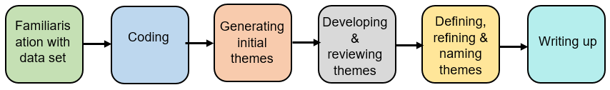
Reflexive Thematic Analysis also places importance on how the researcher’s background and opinions can affect the research (16). The researcher has past experience of working in acute psychiatric inpatient services, including deaths of clients by suicide and attempted suicide

Participants

This study was advertised on social media between April and November 2021. People contacted the researcher directly if they were interested.

To take part, participants had to meet the following criteria;
Inclusion Criteria;
- Aged 18 years+.
- Working in a non-qualified role in an acute psychiatric inpatient setting at time of their experience.
- Willing and able to talk about experience.
Exclusion Criteria;
- Those in qualified roles at the time of their experience.
- Those working in settings other than acute psychiatric inpatient.
- Non-English speakers.

Ten participants took part. Table 1 shows their age, gender, ethnicity and religion.
Table 1
Participant Characteristics
 | Number | % |  | Number | %
Age |  |  | Gender
18-24 | 1 | 10% | Female | 10 | 100%
25-34 | 5 | 50%
35-44  45-54 | 1  2 | 10%  20%
55-64 | 1 | 10%
Ethnicity |  |  | Religion
White | 9 | 90% | No religion | 8 | 80%
Mixed ethnic groups | 1 | 10% | Christianity | 2 | 20%

Materials

The researcher used an ‘interview schedule’ to guide interviews. This prompted participants to share their “most memorable” experience with suicidal behaviour. The interviews were semi-structured meaning some questions were planned in advance but allowed for different ideas to be shared too.
The key topics of the interview covered; staff’s job role and the team they worked with, how often they had dealt with suicidal behaviour, what happened in their “most memorable” experience, their personal reaction and the reaction of their team, helpful support and things they learned.
Participants were also asked to complete a form with their demographic information, which is presented in Table 1.
Following the interviews, participants were sent a ‘sources of support’ leaflet outlining organisations for support, due to the topic being sensitive in nature.

Ethical Considerations

Full ethical approval was granted by Staffordshire University’s Ethics Committee. Informed consent was obtained from participants prior to interviews taking place and they were informed about their right to withdraw.
As the topic was sensitive, participants were provided with a sources of support leaflet which signposted them to additional sources of national support. All data was kept confidential and anonymous, with pseudonym names assigned to increase anonymity.

Procedure

After participants expressed their interest in the study, the research process was followed (as displayed in Figure 2). All interviews took place remotely to comply with Covid-19 regulations.
Firstly, participants were sent the information sheet and given an opportunity to ask any questions. If they were still interested, an interview time was set and they were asked to complete the consent form, followed by the demographic form, prior to interview. Interviews were conducted remotely via Zoom or Microsoft Teams and were audio-recorded to allow the researcher to transcribe them. Interviews lasted between 47 and 87 minutes.
Figure 2
Research Process Flowchart
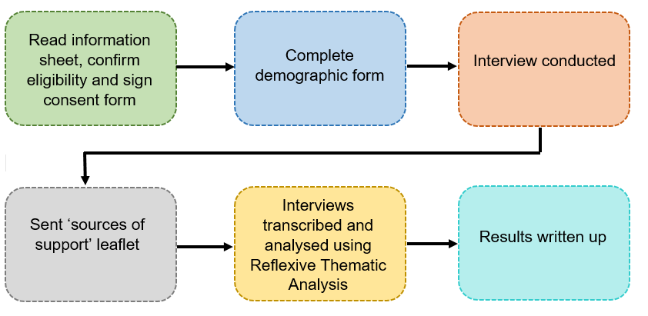

Data Analysis

Interview audio recordings were transcribed and the phases of Reflexive Thematic Analysis were followed (Figure 1). This involved; familiarisation with data, coding, generating initial themes, reviewing themes and then naming themes. This process was followed for each participant transcript and formed the basis of the final themes and sub-themes.

Reflexivity

The researcher used their personal experiences to help guide their interpretations throughout the process. A reflective journal was kept where they made note of any thoughts related to the research and they referred back to this. They also sought regular supervision to discuss opinions.

Main Findings

Four themes and ten sub-themes were identified. These are displayed in Table 2.
Table 2
Themes and Sub-Themes Derived from the Data
Theme | Sub-Theme
Direct Personal Impact | - Feeling emotionally exhausted
 | - Attempting to find meaning
 | - Heightened threat system
Unrealistic Expectations | - Responsibility for managing risk
 | - Unrelenting nature of risk
 | - Unprepared for the role
Attempting to Contain the Impact | - Just carrying on
 | - Wearing a professional mask
Acclimatisation | - Leaning on colleagues
 | - The inevitability of suicide

Theme 1 – Direct Personal Impact

Participants shared a range of emotions following their experience with suicidal behaviour. Feeling emotionally overwhelmed highlighted how emotions built to an unmanageable level and often led to staff feeling “burnt out” and going on sick leave.
Staff also attempted to find meaning by questioning the circumstances surrounding the suicidal behaviour. This manifested itself internally by feeling guilt and also externally by questioning the actions of others.
“It’s just trauma after trauma after trauma getting piled on. At some point, I’m sure I’ll just break.
~ Katie
As a result, staff developed a heightened threat system as they felt constantly ‘on edge’ waiting for the next suicidal behaviour to occur. This could lead them to distance themselves from the people receiving care so it hurts less when the next suicidal behaviour occurs. However, working in acute psychiatric inpatient settings means it is not always possible to distance from clients because they cannot leave the ward.
“I was a bit wary to approach the patient after”
~ Laurie

Theme 2 – Unrealistic Expectations

Non-qualified staff explained they were the most present on the ward and doing the “groundwork”, therefore were most responsible for monitoring risk. This led to them feeling responsible for keeping people alive
This study mainly included those in support work and clinical assistant roles, who had a frontline role on the ward. “We’re doing the groundwork” reflected that non-qualified staff are more present, so are more responsible for assessing risk.
“It was literally our job to make sure she didn’t kill herself
~ Liz
As suicide is common on wards, participants shared feeling that their “brain doesn’t have time to take a breath”. This had a cumulative emotional effect. Risk was unpredictable so staff had to be continuously alert to risk.

“It is that unpredictability”
~ Katie
High levels of stress like this can lead to physical, biological and psychological changes to the body (17), therefore this could hinder staff’s working abilities moving forward.
Despite being the most present and responsible for managing risk, staff reported having little training, hence feeling “unprepared” for the role.

Theme 3 – Attempting to Contain the Impact

Suicidal behaviour happens often in acute psychiatric inpatient services, so staff developed a way to cope, just carrying on or going “into autopilot” by focusing on work tasks rather than their emotions.
“I remember thinking “I’m not going to process this now, I just need to carry on with work””
~ Amy
“There’s nowhere to literally go”
~ Sydney
It was also noted that the ward environment was not designed to help people in distress as there was nowhere to go to take a break.

Furthermore, seeking support was not modelled by other staff on the ward, therefore participants felt it was not appropriate to show their emotions or ask for help. They believed this questioned their professionalism as mental health workers, hence they had to wear a professional mask
This is similar to previous studies into professional grief (8), however may be increased amongst non-qualified staff as they do not have access to wider professional support such as registration bodies or clinical supervision that could give them an outlet for their distress.
“You’re putting a face on of somebody who is quite relaxed but you are not”
~ Laurie

Theme 4 – Acclimatisation
Participants had learned to accept suicidal behaviour as a ‘normal’ aspect of their job and in order to deal with the emotional impact they relied on leaning on colleagues. This was even more important as the support they received generally was limited.
“It’s almost a real appreciation for each other”
~ Ellen

This allowed them to share the emotional load and led to the experience being less isolating.
Another protective strategy was to contextualise suicide and accepting the inevitability of suicide. This acceptance reduced personal responsibility and allowed participants to manage their emotional distress.
“If somebody is hell-bent on suicide, they’re going to do it and you can’t stop that”
~ Julie

What could be improved?

This study wanted to hear the experiences of non-qualified staff in acute psychiatric inpatient settings. However, the participants that took part were mainly in clinical support roles, therefore the themes identified may not be applicable to other non-qualified roles such as admin or ancillary workers.
Likewise, there was little variety in terms of the participant characteristics. The participants were all female, and mainly White, meaning the experiences of diverse individuals have not been explored.
The sampling method meant participants volunteered to take part. Therefore, people who are comfortable discussing their emotions may have been more drawn to take part. As professional grief tends to be hidden, many people with experiences may have been reluctant to share their opinions.

Recommendations

This research suggests that suicidal behaviour has a significant impact on non-qualified staff working in acute psychiatric inpatient settings.
- Non-qualified staff feel ill-prepared to manage risk, therefore training in physical interventions as well as training that normalises professional grief should be implemented by organisations.
- Staff felt unsupported by management. Management style should encourage reflection and clinical supervision for staff from all disciplines.
- A culture of hiding grief was identified, therefore management should ensure support avenues are readily advertised and available as well as encouraging teams to discuss the challenges of their roles through reflective practice.

What next?

The results have been written up and will be submitted to academic journals for consideration for publication. The executive summary will be sent to those who participated in the study and others who requested a copy.

References
- Burns J, Flynn S, Lowe R, Turnbull P, Baird A, Stones P. National and Confidential Inquiry into Suicide and Homicide by people with Mental Illness: An Annual Report 2017. Healthcare Quality Improvement Partnership, 2017. Available from: https://www.hqip.org.uk/wp-content/uploads/2018/02/CApw8N.pdf.
- Beautrais A L. Support for families, Whanau and significant others after a suicide attempt: A literature review and synthesis of the evidence. Canterbury Suicide Project: Christchurch School of Medicine & Health Sciences, 2004. Available from: https://www.health.govt.nz/system/files/documents/publications/bereavedbysuicide-litreview.pdf
- Bohan F, Doyle L. Nurses’ experience of patient suicide and suicide attempts in an acute unit. Mental Health Practice. 2008 Feb 01; 11(5). Available from: http://dx.doi.org/10.7748/mhp2008.02.11.5.12.c6338
- Bowers L, Simpson A, Eyres S, Nijman H, Hall C, Grange A, et al. Serious untoward incidents and their aftermath in acute inpatient psychiatry: The Tompkins Acute Ward Study. Int J Ment Health Nurs. 2006 Oct 26; 15(4):226-234. Available from: https://doi.org/10.1111/j.1447-0349.2009.00428.x
- Wurst FM, Mueller S, Petitjean S, Euler S, Thon N, Wiesbeck G, et al. Patients’ suicide: A survey of therapists’ reactions. Suicide Life Threat Behav. 2010 Aug; 40(4):328-336. Available from: https://doi.org/10.1521/suli.2010.40.4.328
- Hamaoka DA, Fullerton CD, Benedek DM, Grifford R, Theodore N, Ursano RJ. Medical students’ responses to an inpatient suicide: Opportunities for education and support. Acad Psychiatry. 2014 Jan 10; 31(5):350-353. Available from: https://doi.org/10.1176/appi.ap.31.5.350
- Cabello RA, Leon T, Sorensen R. Post-traumatic symptoms in the staff of a mental health inpatient unit after the suicide of a patient: A case report in Chile. Summa Psicologica UST. 2016 Aug; 13(2):13-22. Available from: https://doi.org/10.18774/summa-vol13.num2-304
- Joyce B. Effects of suicidal behaviour on a psychiatric unit nursing team. J Psychosoc Nurs Ment Health Serv. 2003 Mar 01; 41(3):14-23. Available from: https://doi.org/10.3928/0279-3695-20030301-10
- Bowers L. Reasons for admission and their implications for the nature of acute inpatient psychiatric nursing. J Psy Ment Health Nurs. 2005 Mar 18; 12(2):231-236. Available from: https://doi.org/10.1111/j.1365-2850.2004.00825.x
- Rivett EL. A qualitative exploration of acute mental health inpatient staff’s experiences of working with high-risk behaviours and the support they receive [doctoral dissertation on the Internet]. Research Repository: University of Essex; 2020 [cited 2022 Apr 21]. Available from: http://repository.essex.ac.uk/28530/
- Cleary M. Ethnographic Research into Nursing in Acute Adult Mental Health Units: A Review. Issues in Mental Health Nursing. 2011 Jul 07, 7:424-435. Available from: https://doi.org/10.3109/01612840.2011.563339
- Firouz A. In the Wake of Patient Suicide Attempts: The Therapist’s Perspective. [doctoral dissertation on the internet]. ProQuest Dissertations Publishing, Adelphi University; 2022 [cited 2023 Aug 27]. Available from: https://www.proquest.com/dissertations-theses/wake-patient-suicide-attempts-therapist-s/docview/2680991174/se-2
- Milne C. Is half of the NHS not clinically qualified? [Internet]. 2016 [cited 2022 Apr 22]. Available from: https://fullfact.org/health/half-nhs-not-clinically-qualified/
- Sorgaard KW, Ryan P, Dawson I. Qualified and unqualified (N-R-C) mental health nursing staff – minor difference in sources of stress and burnout: A European multi-centre study. BMC Health Services Research. 2010 Jun 14; 10(193):1-12. Available from: https://doi.org/10.1186/1472-6963-10-63
- Harper D, Thompson AR. Qualitative research methods in mental health and psychotherapy: A guide for students and practitioners. John Wiley & Sons Ltd; 2012.
- Braun V, Clarke V. Thematic analysis: A practical guide. Sage Publications Ltd; 2022.
- Yaribeygi H, Panahi Y, Sahraei H, Johnston TP, Sahebkar A. The impact of stress on body function: A review. EXCLI J. 2017 Jul 21;16:1057-1072. Available from: https://doi.org/10.17179/excli2017-480

Appendices
Appendix A: Target Journals
Part One (the literature review) has been written in accordance with the guidance for its target journal; the Journal of Occupational and Organizational Psychology. The full guidance can be found online at
https://bpspsychub.onlinelibrary.wiley.com/hub/journal/20448325/homepage/forauthors.html
The key formatting guidance is as follows;
- 8000 word limit for the whole paper. The word limit does not include abstract, references, figures and tables. Appendices, however, are included in the word limit.
- Abstract should be between 100 and 200 words.
- References may be submitted in any style or format, as long as it is consistent throughout the manuscript. However, the journal follows APA style.
Part Two (the empirical paper) has been written according to the writing guidelines for the target journal, The Journal of Death and Dying. The key requirements are listed below and more guidance can be found at https://www.apa.org/pubs/journals/resources/general-manuscript-preparation-guidelines.
- Manuscripts can be submitted in APA style.
- Abstracts of 100 to 150 words are required to introduce each article.
- Most articles are between 5000-7500 words and while we accept long pieces that mandates additional evaluation because of space limitations.

Appendix B: Combined Quality Assessment Tool
Table 1A
Combined Checklist for Assessing the Quality of Quantitative Studies
CRITERIA |  | YES  (2) | PARTIAL (1) | NO  (0) | N/A
QualSyst Questions
1 | Question/objective sufficiently described?
2 | Study design evident and appropriate?
3 | Method of subject/comparison group selection or source of information/input variables described and appropriate?
4 | Subject (and comparison group, if applicable) characteristics sufficiently described?
5 | If interventional and random allocation was possible, was it reported?
6 | If interventional and blinding of investigators was possible, was it reported?
7 | If interventional and blinding of subjects was possible, was it reported?
8 | Outcome and (if applicable) exposure measure(s) well defined and robust to measurement/misclassification bias? Means of assessment reported?
9 | Sample size appropriate?
10 | Analytic methods described/justified and appropriate?
11 | Some estimate of variance is reported for the main results?
12 | Controlled for confounding?
13 | Results reported in sufficient detail?
14 | Conclusions supported by the results?
CASP Questions
15 | Have ethical issues been taken into consideration?
16 | How valuable is the research?

Table 1B
Combined Checklist for Assessing the Quality of Qualitative Studies
CRITERIA |  | YES  (2) | PARTIAL (1) | NO  (0) | N/A
QualSyst Questions
1 | Question/objective sufficiently described?
2 | Study design evident and appropriate?
3 | Context for the study clear?
4 | Connection to a theoretical framework/wider body of knowledge?
5 | Sampling strategy described, relevant and justified?
6 | Data collection methods clearly described and systematic?
7 | Data analysis clearly described and systematic?
8 | Use of verification procedure(s) to establish credibility?
9 | Conclusions supported by the results?
10 | Reflexivity of the account?
CASP Questions
11 | Have ethical issues been taken into consideration?
12 | Is there a clear statement of findings?
13 | How valuable is the research?
Appendix C: Reflective Journal Example Extract
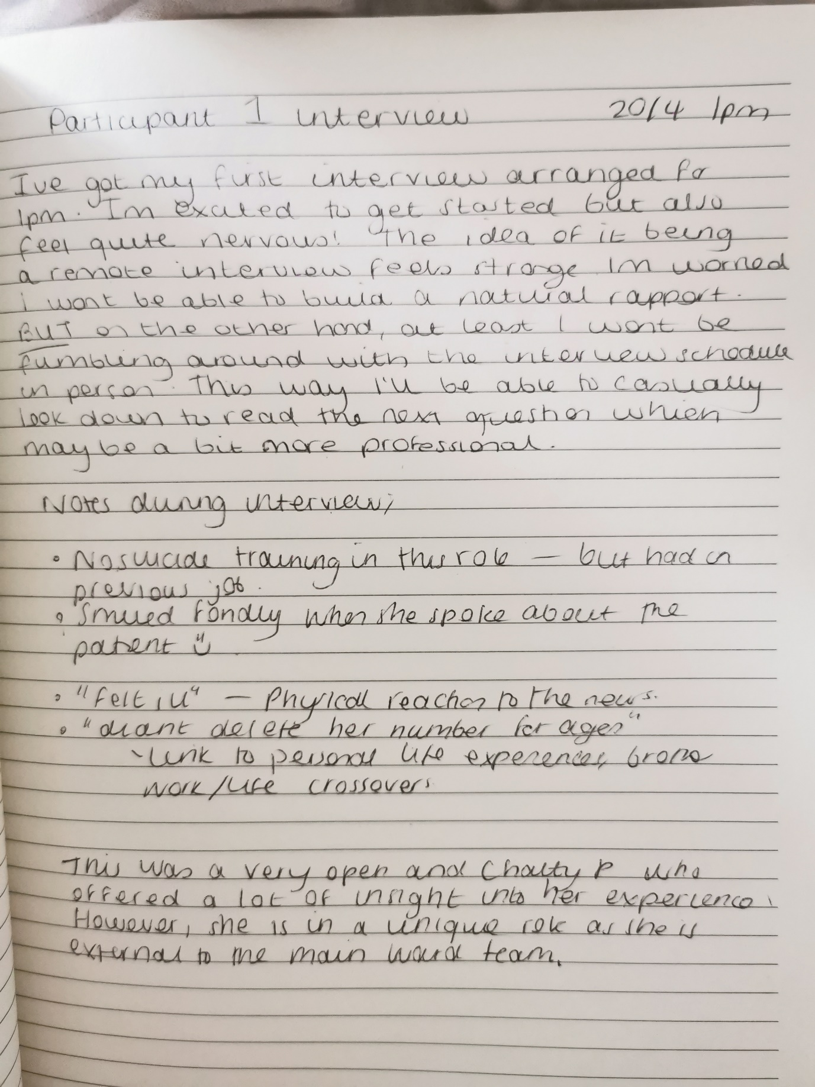
Appendix D: Participant Information Sheet

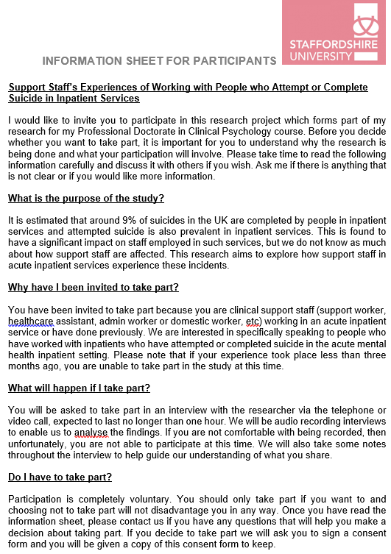

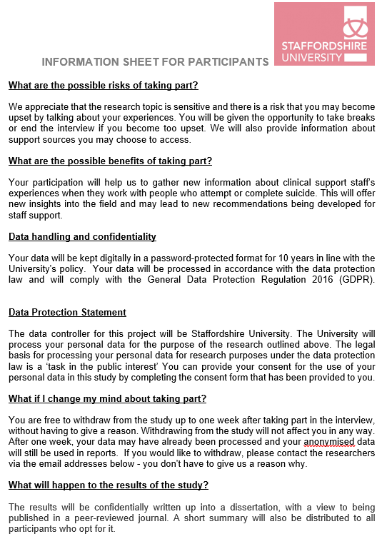

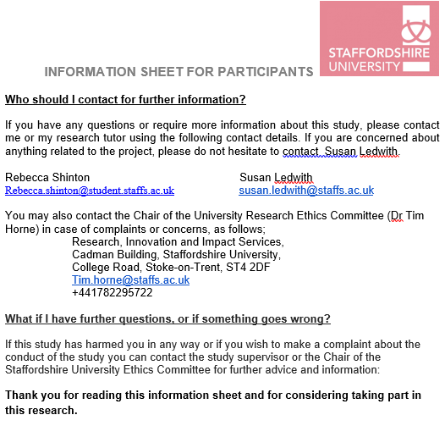

Appendix E: Consent Form
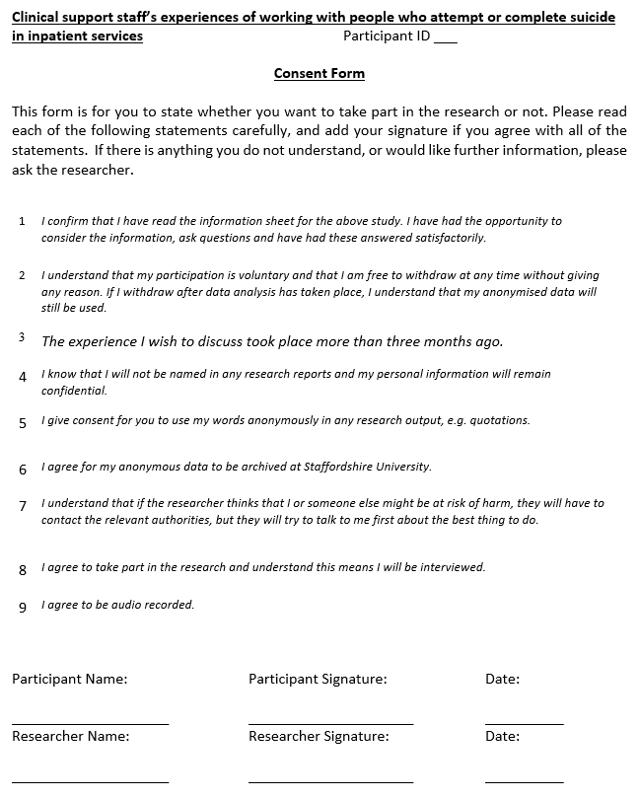
Appendix F: Sources of Support Form

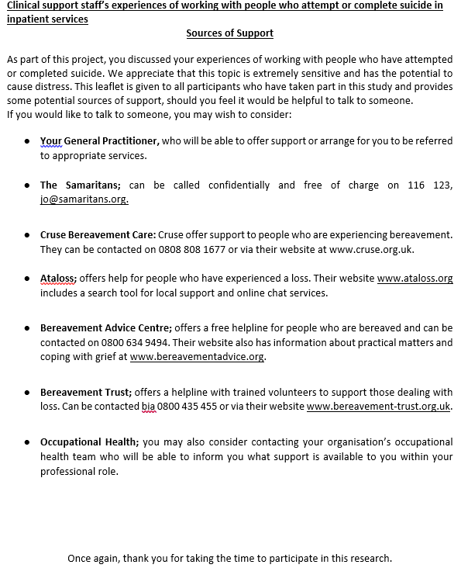
Appendix G: Ethical Approval
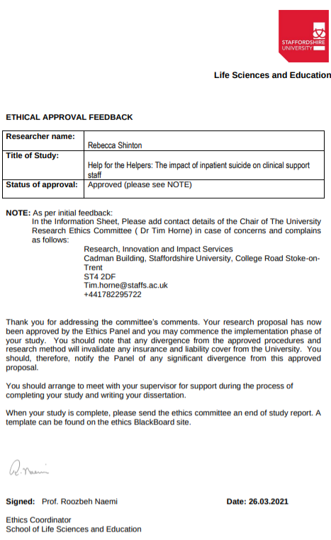
Ethical Approval – After Amendments
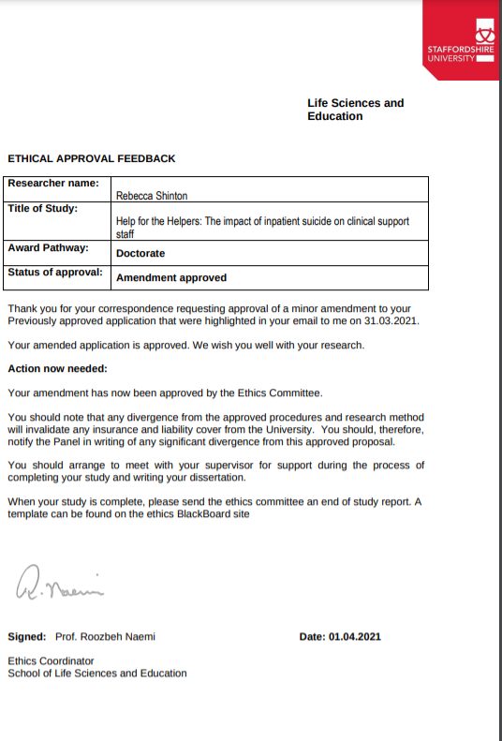

Appendix H: Interview Schedule

How long have you been working in acute psychiatric inpatient care?

What attracted you to working in acute psychiatric inpatient care?

How long have you been in your current role? (for those who are retired or in different roles now, ‘how long were you in your previous support role?’)
- Tell me a bit about your team.
- What other teams have you previously worked in?
- How does your current team compare to others?
Have you ever received any training on working with people who are suicidal?
- If yes, how was the training?
- Do you feel confident working with people who are suicidal?
- What are your attitudes towards suicide?
During your clinical support career, how many times have you experienced working with someone who has attempted or completed suicide whilst an inpatient?

For the purpose of this interview, I would like you to focus on one specific person. Please think about the most memorable example of a service user that attempted or completed suicide whilst you were working with them (For clarity – most emotionally powerful example, or the one that springs to mind)

Firstly, could you please tell me a bit about the person?
- How long had they been known to the team?
- How long had you been working with them?
- What was the nature of your support?
- What was your relationship like with this person?
Please tell me about how you found out about this person’s suicide attempt/completion.
- Where were you when you found out?
- How did you feel initially?
- Who told you?
- How were you told? (face-to-face, phonecall, etc)
What was the reaction of the wider team to the news of this person’s suicide attempt/completion?
- Is suicidal behaviour discussed openly within your team?
- What are your colleagues’ attitudes towards suicide?
Could you tell me about any support you received following the news of this incident?
- What support were you offered?
- Did you take up the offer of support?
- If yes, how was that? If no, why not?

How did this experience affect you at work (if at all)?
- Has it altered your practice?

How did the experience affect your home life (if at all)?
- How? Did you discuss it with family members, for example?

How do you feel you coped with this experience?
- What were your methods of coping?
- Did you take any time off work?
- Did you attend any debrief meetings?
- Did you disclose the experience with people outside of work?
- If yes, did this help? If no, why?

Do you think things could have been handled differently?
- How would this have altered your experience?
What do you think you have learned from this experience?

What do you think may be helpful when faced with a similar situation in the future?

Is there anything else relevant that you feel may be beneficial to share as part of this research?

Thank you for spending the time to share your experiences with me.

Appendix I: Research Process Flowchart
Figure 1
Figure Displaying the Research Process

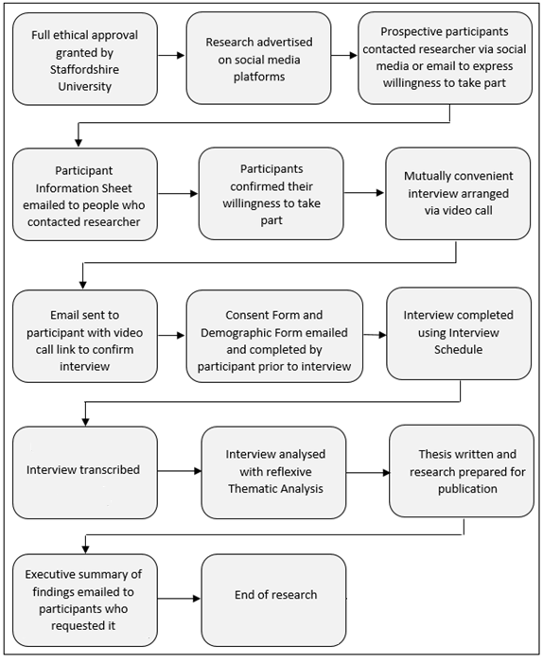
Appendix J: Demographic Form
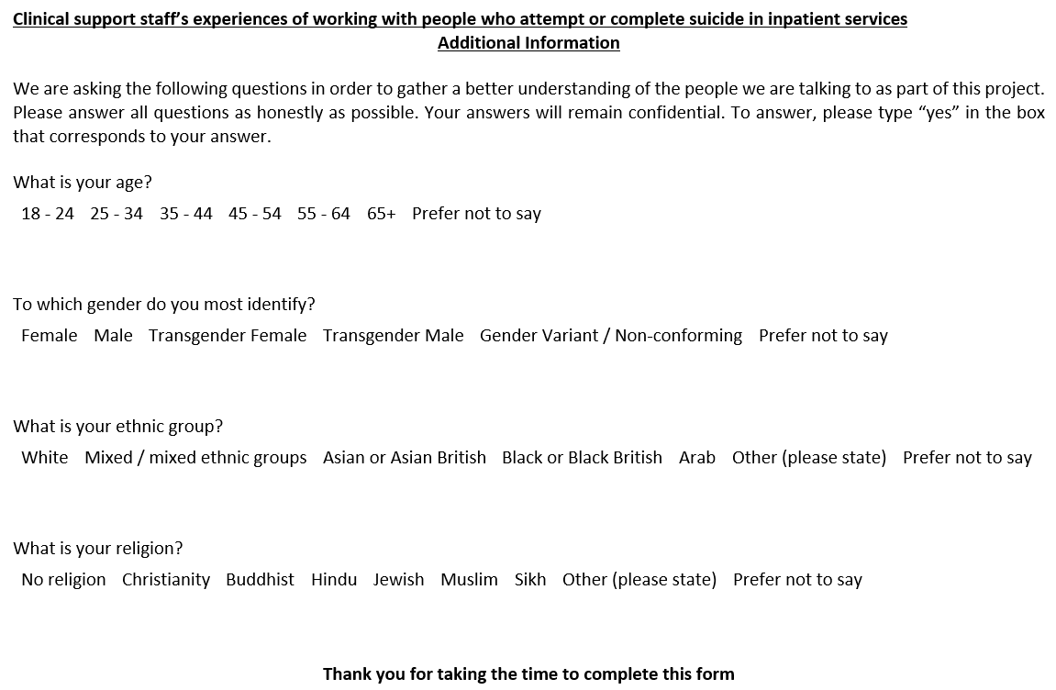
Appendix K: Example of ‘Coding’ Phase of TA
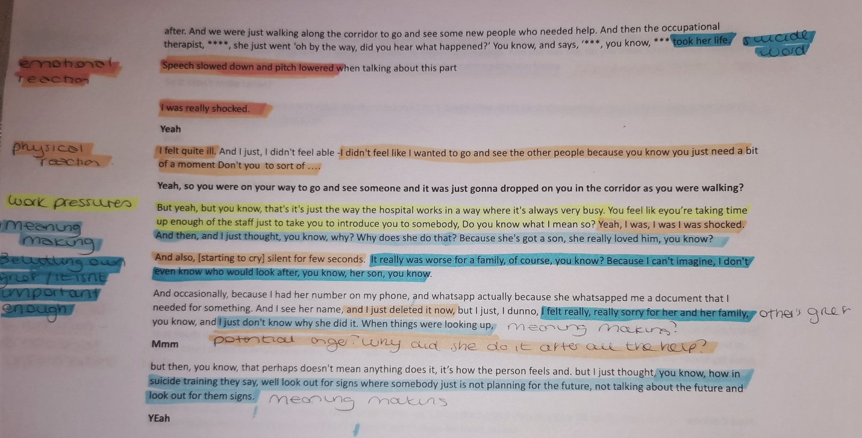

Appendix L: Example of ‘Generating Themes’ Phase of TA
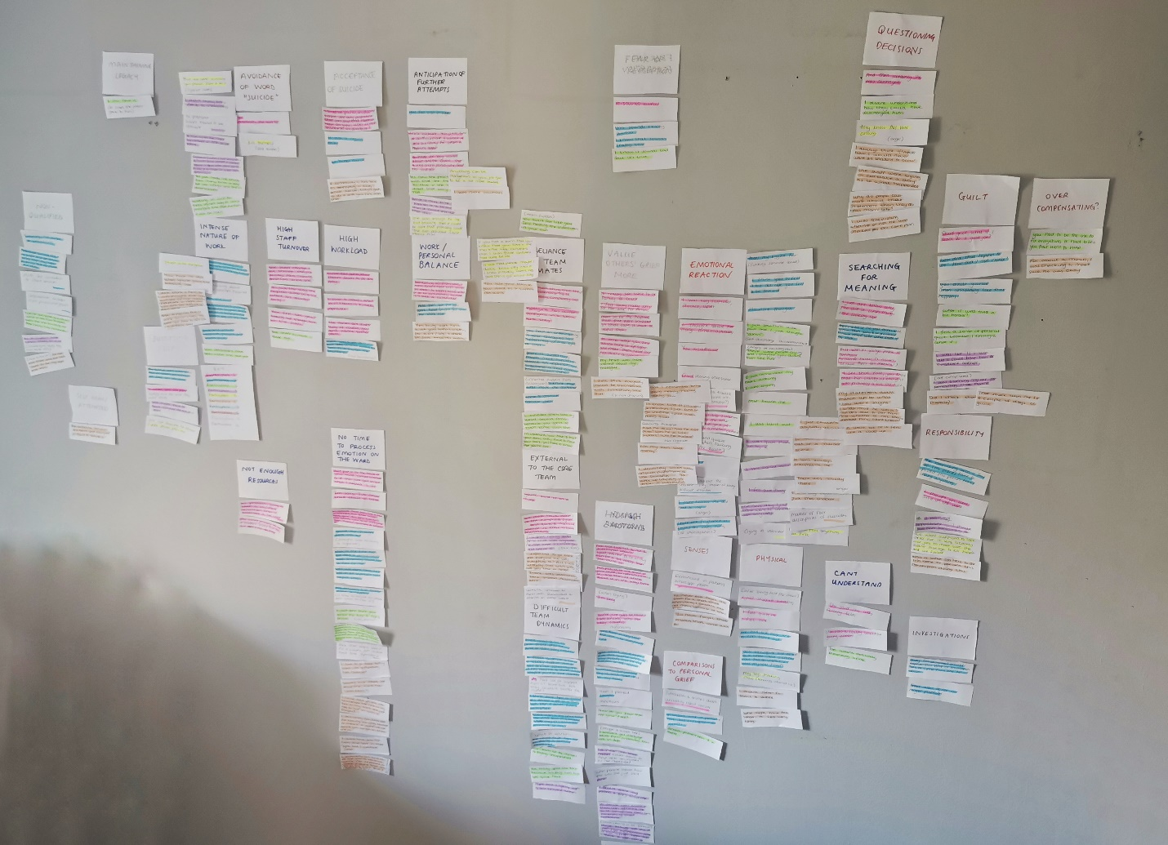

Appendix M: Participants’ Contributions to Themes
Table M1
Table Displaying Participant Contributions to Themes and Subthemes
 | Sydney | Ellen | Regan | Rachel | Liz | Julie | Christine | Katie | Laurie | Amy
Theme One: Direct Personal Impact
Feeling emotionally overwhelmed
Attempting to find meaning
Heightened threat system
Theme Two: Unrealistic Expectations
Responsibility for managing risk
Unrelenting nature of risk
Unprepared for the role
Theme Three: Attempting to Contain the Impact
Just carrying on
Wearing a professional mask
Theme Four: Acclimatisation
Leaning on colleagues
The inevitability of suicide

Appendix N: Supporting Quotes for Themes
Table N1
Table Displaying Supporting Quotations for Themes and Subthemes
Subtheme | Direct Quotation
Theme One: Direct Personal Impact  Feeling emotionally overwhelmed | Sydney:  “You could call it emotional exhaustion”  “I was very surprised, shocked and upset”  “I felt quite ill”  “I felt like I wanted to not go and see the other people because you just need abit of a moment”  Ellen:  “I think you do feel a bit delicate, you feel a bit bruised”  “I’ve had sick days, where I’ve been burnt out”  “Sickness peaks because people just burn out”  “Your adrenaline will be up for a while and I think that has an impact on your physical health”  Regan:  “I was burnt out”  “I just remember my heart sinking, I was crying”  “That haunts me”  Rachel:  “I felt quite heavy”  “The next day I just didn’t want to interact with anybody”  “I was quite shook up by it”  Liz:  “I didn’t feel anything at first”  “If we had people maybe I didn’t know very well or I knew probably weren’t very good then it got almost scary”  Julie:  “It will always traumatise me”  “In those kind of situations, afterwards, I just kind of go internal, I just went really quiet”  “I definitely would wake up with nightmares of the situation. I’d wake up literally in sweat. It was awful”  “I literally just stood there. Just shell shocked”  Christine:  “I was very much in shock”  “I became quite withdrawn”  “It was very traumatic”  Katie:  “I didn’t sleep as well as I normally do”  “I’ve seen some horrific things come through the door, so I don’t think it affected me as much”  Laurie:  “It was quite traumatic”  “It is a bit like you’re going in a fight and you have a punch. You’re a bit groggy afterwards”  Amy:  “I cried because I was so shocked”  “The whole unit, we were just in complete shock, it was completely shocking”
Attempting to find meaning | Sydney:  “Good grief, what if I didn’t do a good job?  “And then suddenly, she was discharged”  “I just don’t know why she did it when things were looking up”  “She said she was feeling better”  “I see that now, you know, that her clarity of thought was probably a bit off kilt”  Ellen:  “How did that happen to me, how did I not notice?  “You doubt yourself when something like that happens”  Regan:  “what if we’d tried a bit harder?”  “I felt a sense of personal guilt because I thought what if...”  “I didn’t understand how they could have discharged him”  Liz:  “They knew this was coming”  Rachel:  “I was late. If I was later, it could have been a completed attempt”  “I was blaming myself for something that hadn’t even happened”  Julie:  That stuck with me for a couple of days, that feeling of guilt”  “Did I check them properly?”  “I was questioning whether or not he was checked as per care plan”  “I always think it’s how I would never want an incident to occur”  “There was nobody there”  “The staff were trying to correlate a story as to what happened”  “Why do people care more about their statements than they do this man’s life?”  “A little bit of it felt like a cover up”  “I understood he was on five minute observations due to self-harm. And whether or not they checked him, I don’t know”  “My statement didn’t match up to what they were saying”  Christine:  “You naturally feel guilt because you think ‘did I miss something?’”  “I started questioning myself all the time”  “There was so much guilt”  “There was a little bit of blame from the patients”  “If that information had been passed over, maybe he’d still be alive”  “We were given very limited information”  “It’s a little bit like a puzzle, if you imagine a puzzle missing bits because your memory’s slightly got patches”  “He was going to do it, there was absolutely no way we could have known”  Katie:  “Things played on my mind”  “There were a lot of questions”  “Nothing that really was voiced but it kind of like hung there”  “Did this person actually know who she was looking for?”  Amy:  “It’s hard not to blame yourself. Was there something she said that I could have flagged up?”  “You analyse everything that you can remember”
Heightened threat system | Sydney:  “It’s made me very worried about another client. There’s a very strong possibility that she will too”  “Brace yourself. You just kind of armourplate yourself a little bit ready for when it happens again”  Ellen:  “You feel a bit on edge”  Regan:  “It’s now the people I work with that are the most secretive or the most settled that worry me more”  Rachel:  “What if next time nobody responds to it seriously then it could end up that way [in death]”  Liz:  “One was enough for me but knowing that it could be more that probably could have been prevented. I can’t imagine that”  “Anything can be dangerous so you just got to be a lot more aware”  Julie:  “I was more cautious”  Christine:  “The dread of looking around the toilet door when you can’t see them on their bed. It’s always there”  “It’s always in the back of your mind”  “We’d just be a little bit more wary”  Katie:  “We always expect to find somebody”  Laurie:  “I was a bit wary to approach that patient after. What is she gonna do now?”  “You are always at the back of your mind thinking, what are they going to do? You know, you’re never relaxed”  Amy:  “It did escalate those behaviours on the ward. That she managed to complete it and they had thought of it”
Theme Two: Unrealistic Expectations  Responsibility for managing risk | Sydney:  “I thought you were safe on the ward”  Ellen:  “Healthcare assistants, they’re the people that are around all the time, they need to be the ones that are picking up on things”  “the overriding arch is that we have to protect this person from doing anything to harm themselves”  Rachel:  “It was my responsibility. I should have been safeguarding her”  Liz:  “We were supposed to look after her. It was literally our jobs to make sure she didn’t manage to kill herself and we failed”  Regan:  “We’re doing the groundwork, we’re on the floor everyday, we’re the ones building up those really close relationships”  Julie:  “The HCAs need to be the eyes and ears”  “this is what I’m here to do. I’m here to prevent this person from doing this.”  Christine:  “The emotions of the people who felt kind of responsible”  Katie:  “the ward was his safe space”  Laurie:  “We are always in contact with patients all the time”  Amy:  “The bulk of the day-to-day bits were done by support workers. I think the experience of the support workers was slightly different”  “I think everyone felt somewhat responsible”
Unrelenting nature of risk | Ellen:  “The pressure”  “On an inpatient unit, you work shifts so you tend to finish at 9.30/10pm and then back in for 7am”  “There would always be one person on the unit at a time that would be making frequent attempts”  “It was a regular thing”  “We don’t have time and in an inpatient ward, it’s just chaos”  Regan:  “Our admissions have been riskier the last year”  “working in such an extra vigilant way for such a prolonged time that eventually it was too much”  “I just don’t think your brain has time to take a breath”  Liz:  “Stuff was dangerous”  Julie:  “That’s a normal thing of work unfortunately, that’s what we have to deal with on a daily basis”  “You have no idea what you’re going to be walking into”  “I went home and then I was due back in that night but I couldn’t sleep”  “I don’t think it helps that I was on nights either, because with the common reoccurence that people on nights shifts, you don’t see daylight, you don’t spreak to people, there’s no support”  Christine:  “You have other patients after that and eventually it goes to the back of your mind”  “Because of the short capacity of staff, it was a consistent juggling act”  “You’re so tired from juggling everything”  Katie:  “Suicide attempts are probably a good 40% of the work”  “you don’t know what you’re running at, it could be anything”  “It’s just because of the type of patients. It is that unpredictability. It’s not like working on a general ward where their obs start going down or there are telltale signs that they’re progressively getting worse!  “Suicide attempts are pretty much daily”  “It’s trauma after trauma after trauma that’s getting piled on. At some point, I’m sure I will just break”.  Laurie:  “Working on the acute ward we are exposing ourselves to injuries from patients, psychologically aswell”  “We deal with suicide attempts nearly every week”  “We were sitting on the bench talking and suddenly the patient said “I don’t want to go back to the ward”.
Unprepared for the role | Sydney:  “you’re kind of on a limb”  Ellen:  “Training is not aimed at unqualifieds”  Rachel:  “I didn’t really know what to do immediately”  “It can often be more unsettled on the acute ward”  “As a support worker, I can’t really do a lot”  “I wasn’t trained to use restraint techniques before I started working on the wards”  Liz:  “But we never actually got shown how to do it” [ligature cutters]  Christine:  “students felt pressure to be allocated patients because there were so many patients and so little staff”
Theme Three: Attempting to Contain the Impact  Just carrying on | Sydney:  “you dissociate”  “just put it to the back of your mind, compartmentalise is and then you just get on with what you need to do”  “just put it to the back of your mind, compartmentalise it and then I’d think about it on the way home”  Rachel:  “When I first encountered it, I was quite stressed and worried about it and other staff seemed to see it as more of a self harm behaviour. They’re dealing with this so often, I get the impression some of those responses might make it easier to cope with it”  Regan:  “It’s just made me think how many times a day we see things and are so desensitised”  Liz:  “I didn’t feel anything at first”  Julie:  “Time might have felt longer. It felt very long”  “And I remember time going really, really, really, slow”  “One of the Psychologists at work was just like ‘you’re not yourself’”  “I deal with issues better by just working through them”  Christine:  “You kind of just went into autopilot being very task orientated”  “I say it casually but after a while you do it so often, you just kind of go into autopilot”  Katie:  “you just go into autopilot to be honest”  Amy:  “I remember thinking ‘I’m not going to process this now, I need to just carry on with work’”
Wearing a professional mask | Sydney:  “I felt like I wanted to not be professional again. I just wanted to be on my own for a bit really but you can’t so...”  “I’m sorry, I’ve never cried about it before”  “You’ve just gotta be resilient. I am actually other than today” (laughs)  “It would have been nice to have a moment, but where would I have gone? You can’t even go in the toilet, you need a key or a code. There’s nowhere to literally go”  “I felt more so for the hospital staff that were involved in their care, it must be awful, that”  “It really was worse for the family, of course”  “I felt really sorry for her and her family”  “In some ways, you don’t wanna bring it up again and make them relive that”  Ellen:  “This is the first time I’ve had a conversation with somebody about how it felt for me”  “You keep it very calm and act like everything’s fine”  “You would never express that, don’t get me wrong, I’m only telling you for the purpose of the research”  “I mean, I wouldn’t say it out loud, but in my head”  Regan:  “It was the most heartbreaking and frustrating thing I’ve ever done at work to finally want help, to finally have changed my thought process around getting help, to be faced with nothing was really hard”  “I wouldn’t get mortgage advice from somebody who was in debt”  “How do you keep that off your face?”  “My heart was more worried about my colleague”  Rachel:  “I’ve never seen that happen” (staff asking for help)  “It’s service users experience that’s then affected me, so it sometimes feels like I’m exposing their experience”  “I wasn’t really aware of if there was anybody for me that I could go and speak to”  “When my parents asked how I was, I just said I was fine when I wasn’t. They wouldn’t get it”  “I didn’t want my parents to worry about me”  Liz:  “I can’t be a staff on that ward if I’m gonna burst out crying in the middle of my shift”  “There are some times on the ward where you have to be that authority figure. And I don’t want to go on there crying and completely demean that”  Julie:  “I actually got told off at one point because we’re not supposed to check patients that are not on the ward. But I had to know.”  “Nobody ever asked me after the event how I was feeling”  “You don’t get validation”  “I had to go back onto my own ward as if nothing had happened”  “I actually got told off for taking too long because it meant a staff member didn’t get to go on their break”  “I expected to go back and everyone ask ‘was everything ok?’. But I was literally met with ‘why did you take so long?”  “There was absolutely zero support. Absolutely zero”  “I don’t think everybody should be traumatised with something like that”  Christine:  “You have support but there was this impression that you’re still meant to get on with it... It wasn’t welcomed”  “You’re not allowed to say anything at first.. You have to wait for permission to say it”  Katie:  “We get offered the counselling services and stuff, but there’s about an 18 month waiting list”  “I’m fine until about another 30 years when I literally have a full on breakdown” (Laughs)  Laurie:  “The patients’ are very observant, sometimes they even know more than me so I think we have to be careful in there”  “You are putting a face on of somebody who is quite relaxed, but you are not”  Amy:  “It very much felt like it was my stuff I had to deal with and I was there to work and other people needed the support from me”  “I found myself apologising” (when cried in front of a patient)
Theme Four: Acclimatisation  Leaning on colleagues | Sydney:  “It’s a good thing that they’re there, otherwise, I’d be completely, completely lost”  “Everyone has different strengths in a team, don’t they?”  Ellen:  “You have an understanding of your colleagues very differently in that type of unit”  “There is something much more supportive about an inpatient unit. It’s almost a real appreciation for each other”  “Those five minute corridor chats”  Regan:  “You didn’t feel like you were holding the information on your own”  “In inpatient, you have to trust your team, they have to have your back and you have to know you’re safe”  “I consider them like my weird second family because you spend so much time with them”  Liz:  “If you had a team that you knew had your back and the ones that were competent, then I was quite confident that we’d be OK”  Julie:  “You use your team on your ward as a support network”  Christine:  “We were all there for the same reasons and we were all there to support each other as much as the patients”  “We all tried to help each other out as much as we could”  “You had each others’ backs”  Katie:  “We supported each other through it and we still support each other through it”  “The Trust that I work for are absolutely shocking for debriefs so it’s just support off your colleagues really”  Laurie:  “People are thinking about your feelings”
The inevitability of suicide | Sydney:  “At some points, on discharge, I don’t see any professionals that can stop that happening. How can you, when someone’s so intent on doing it?”  Katie:  “It’s part of life. It’s what some people choose”  Ellen:  “It’s human nature”  “She could have been seen as doing something intentionally”  Julie:  “If somebody is hell-bent on attempting or doing actual suicide, they’re going to do it and you can’t stop that”  Amy:  “Sometimes it [suicide] happens”

