Wedgwood’s Glazes: a poetic sequence derived from glaze chemistry with contextual essay.

To know a place, dig deep into its geology, dig deep below its choreographed mythology, its brittle crust until you find the ore-seams that wrinkle and underpin an identity of a place. In some ways, this is what Josiah Wedgwood accomplished in a creative re-branding of Stoke-on-Trent, or ‘the Potteries’ via a combination of innovative design, entrepreneurship, and scientific experimentation in the production of apparatus, clay bodies and new glaze chemistries. Stoke-on-Trent’s Wedgwoodian heritage memorializes and privileges the artistic context of this output as a ‘creative narrative’ for the city and a creativity with which its citizens interpellate still. Discussion or remark about the scientific context is not as forthcoming. The nostalgic, artistic and historical prominence of this particular heritage perhaps masks and encumbers the actual reality, which is an interrupted narrative glazed in golden-age remembering. The interplay between science and creativity seem lost in this discourse of nostalgia, the focus placed not on the abstract language of chemical formulae, ores and oxides and salts, but on tangible articles in the economy of memorialisation: pots, bottle kilns, and ‘linear’ storytelling as a vehicle for reminiscence to establish united, whole identities formed by an identification with a place that created pots which has persisted beyond the diminishment of the ceramics industry in the region.
To know a place, dig deep to its molecular level, beyond its hand painted motifs and translucent surface-glaze; close-read its chemistry, its ions, bonds and oxides. This is what supplements divisions between the binary, between what is arts and what is science. A creative interpellation can also be a scientific one, and perhaps a means to identify what provokes a greater sense of différance in subjectivity itself in order to expose the structures of mythologization which persevere narratives of nostalgia. What is persisted in the act of memorialisation is in fact a ‘loss’, a trauma of decline, namely a displacement of the subject where identification as 'potter', as artist following the demise of the pottery industry is no longer true. In the creative discourses that emerge from this lacuna formed by the trauma of différance, the science which underpins and interplays with art and design, in its strange acrobatic language, hieroglyphic formulae, mathematical account book logs, can describe a new way of remembering, a defamiliarized identification with a process so steeped in Romanticized nostalgia. I am as much a stranger to this language, this science-speak, as I am to Stoke-on-Trent; its foreignness suits my own foreignness. For me, to understand Stoke-on-Trent is to decode its science, unravel its heritage, which is as carefully arranged as a high-tea coffee-sets formerly manufactured by its bottle-kilns . Read also its molecules, dig for its ores. To know a place, dig deep.
This article offers some critical context to the poems excerpts ‘Urn’ and ‘Oxide’ from the longer sequence called, ‘Wedgwood’s Glazes’ which are newlipoean transliterations of some of the molecular structures and formulae used in ceramic glazing; they are scientific notations masquerading as indeterminate language, perhaps as strange and abstract as the formulae themselves. They are also architectures of the abstract science visualized on a page; a cartography of molecules in sound. Two hugely dissimilar figures influence the work both in terms of methodology and in the conceptual urge to negotiate the spaces between science and art. Wedgwood emerges inescapably so, given the historical landscape of 'the potteries' from which these poems materialize to explore a kind of autoethnographical realisation of personal relocation (from Wales) and a new identification with Stoke-on-Trent. The second figure, Xenakis, influences the work too; a formalistic virtuoso in the straddle of this gap between art and science.

I: WEDGWOOD
Josiah Wedgwood’s concern for a blending of science and art is first evident in projects such as the medallion portraits of physicians, which suggest identification, or indeed an interpellation, with scientific figures. In commemorating scientists he becomes a representer and representative of science. This identification with science is also evident in his ‘experiment’ and ‘commonplace’ books, and in his letters and personal papers. These entries detail a discourse of investigation, reflection, and experiment, which John Tindall cites as a typical example of a scrupulous ‘scientist’s approach’ in ‘Josiah Wedgwood: Chemist’:
Let it [the limestone] be well burnt in our biscuit oven & out into closed tubs with oil cloth or leather tied over them to preserve it as much as may be from the air [...] Lime stone may be called a neutral salt in a state of cristallization consisting of
An alcaline, or calcarious earth
An acid, called fixed air
& water of [crystallisation]
In burning the lime stone the acid & the water are dispelled & the alcaline earth only remains. (Tindall, 1978, p. 22.)

The generous archive of documents that Wedgwood left suggest that the same observational, empirical approach was applied to the formulation and innovation of his clay bodies, glazes, and the invention of certain apparatus. For example, Wedgewood’s early 1763 glazes involved the use of lead (lead-oxide) and silica to replace more traditional ‘salt-glaze and tin-glaze earthenwares’ (des Fontaines. 1978, 15). Indeed, a glaze is defined as:
A specialised section of the larger group of vitreous substances known as glasses, and regarded as supercooled liquids of very great internal friction...Both are compounds of silica, the ideal glass, and both are produced by fusion to give transparent amorphous solids on cooling. [A] valuable property possessed by silica [is] to combine with basic oxides, especially of the alkaline earth, to produce clear melts. (Singer, 1963. p.7)
The poem excerpts in the ‘Wedgwood’s Glazes’ sequence that accompany this article consequently draw upon the notions of silicas and of oxides, their forms and patterns which parallel poetic forms and phonemic pattern.
II: XENAKIS
Appropriately, the composition of these poems originates in another figure that traverses the boundary between arts and science. Iannis Xenakis, architect and musician, created a methodology that transliterated sound into architectural space, or place, in his innovative graphic scores. His three-dimensional, visual architextures, ‘plastic modulations of material sound’ seem scientific, originated in mathematics and made graphs of sound:
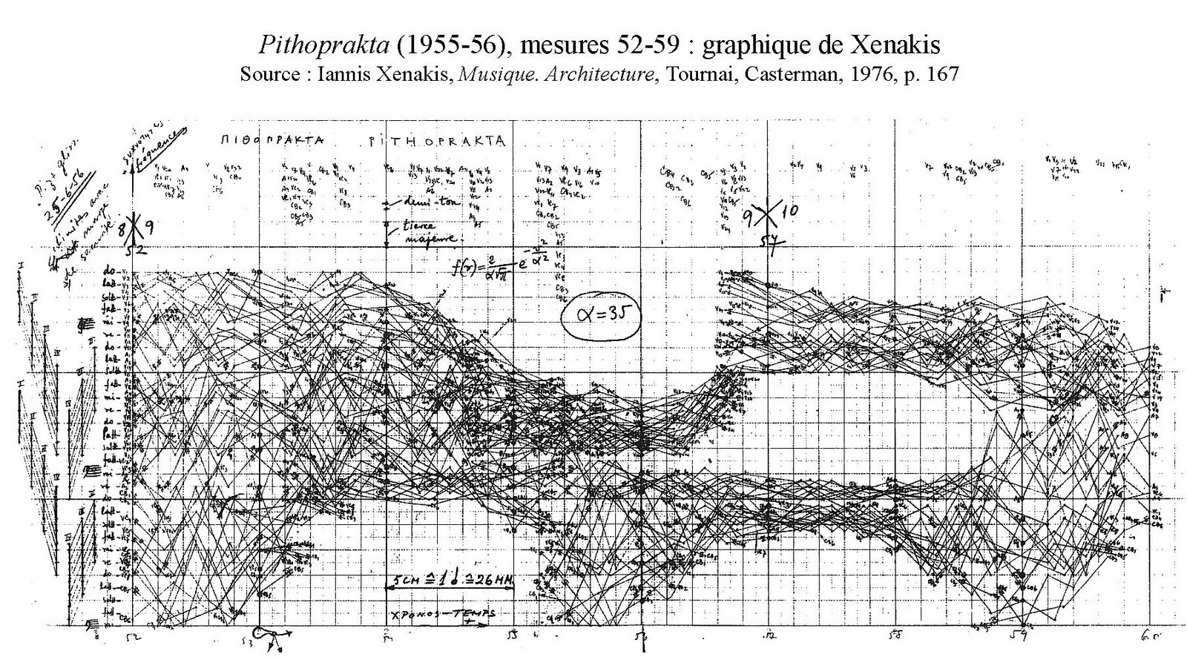
Put simply, pitches are represented on the y axis, duration on the x axis, and, accordingly, the sonic shape can be performed, decoded, or generated electronically from this graphic score. However, the mathematics involved in this process are rich and complex; indeed, his book Formalized Music reads rather more like a treatise on mathematics than a text about music and offers analysis of stochastic processes and their application to his composition:
For these variables the simplest law is:
$$θ\left(γ\right)dγ= \frac{2}{a} \left(\begin{matrix}1- & γ \\ & a\end{matrix}\right) dγ$$
Which gives the probability that a segment (interval of intensity, pitch etc.) within a segment of length a, will have a length included within $γ$ and $y+dγ$ for $0≤γ≤a.$ (Xenakis, 1971, p.13)
By drawing upon the parallels between mathematics and music, Xenakis enables this translation of music, geometry, chance and architecture. However, his aim is not to mathematize music (or musicalize mathematics); his concern too is for a blended space which accommodates both arts and science. The translated transcription of this doctoral defence of the thesis Arts/Sciences: Alloys, records lively debate on this particular point between Xenakis and his supervisor, Revault d’Allonnes who, in his opening statement declares:
For him [Xenakis], science is something which always accompanies this creative demon. Xenakis wants to do something, but not just anything. He wants to compose a determined work, a work which, on a certain level (precisely on the aesthetic level) communicates itself; you go to a concert, you hear a piece by Xenakis; but the work, on another level, can be communicated in another way, by an analytical, rational language which simultaneously analyzes and justifies the work. (Kanach, 1985, p.14).
Somehow, in the act of transposing scientific elements to aesthetics, to allow a bleed to infuse between the two, both traditions are reconsidered and defined in the simultaneous sense to which Revault d’Allonnes alludes. The result is both a new aesthetic and a new science. In a post-structuralist sense, the inversion of these supposed polarities perhaps unearth the ‘untruth’ of its binary opposition.
The Xenakisian method is used to generate ’Wedgwood’s Glazes’ via a process that transliterates molecular chemical patterns found in glaze chemistry into phonemes, and eventually, words. The shapes of this chemistry, the molecular drawings, are placed onto graphs that plot consonants on the x axis; vowels on the y axis. The decoding of the graph results in the creation of sound combinations which are then formed into larger linguistic clusters, or words, that echo Xenakis ‘sound clouds’. If Xenakis’ compositional methodology is granular and molecular, then these poems derived from his technique, are linguistically molecular; a chemical language, dismantled and derived not in traditional narratives, semantics or story, but a representation of chemical forms and structures through language.
‘Oxide’
Oxide is a composed using a graphical transliteration of melanophlogite; a cubic polymorph of silica in a crystalline form. The ‘i’ sound represents the oxygen atoms in the molecular structure.
‘Urn’
‘Urn’ is a transliteration of keatite, which is:
A lithium-aluminosilicate glass ceramic is transformed by a suitable heat treatment into a glass ceramic comprising at least 80 vol.-% of keatite mixed crystals. (US 7501365 B2)
and employing a similar transliterating process to that used to create ‘Oxide’, a graph of sound relating to molecular structure , is generated as its basis for composition; however, this time the molecule structure is placed onto found material, and in this case, that found material is (appropriately) Keats’ ‘Ode to a Grecian Urn’. Where the graph indicates a correlation between an oxygen atom and a letter from Keats’ poem, that sound is used to create the sonic structure of the piece.

Oxide

i i
i i
i i
we ampoule dimpled in the lit-lamp peel
citric and amoebic ; we crib-wink and bicker
primps of tie-died iodine
and pipette in the heckle of zinc
i i
i i
i i

i i
i i
i i
iron wreaths oxide our theory
i in lithium monoliths
i thistle-twists of water
i and the sloth mythology of gold
this language zithers its own threnody
i
i
i
i
i
i
to the same-shit chant of cantos
that can’t shizzle the gnarl of seeped song-swans
that the shimmer of asters rebel-howl
i
i
i

i
i
i
my opals slope my neckline
gassy and dowdy in sags
that oilslick shoulders that tax
the vivid svelt of hexadic prisms
that tremble the oxidized gauze
i
i
i

i
i
i
& oak-lunged walls that jingo and coax
the wreck of inwalks; the lope of lurkspaces
bilabial spits that decanter
isomers and marjoram
gnaw and gum-pink in throb and wort
i
i
i

i
i
i
to the birdwings gourd in cages
in the dangerous seep of flock
the drive of switch-doves method their mixture
of avian femur ; marrow closets cutmarked
we eat the aching slack of bouquet’d sparrow bones
i
i
i

Urn

the altar
reverbs the ores of lovers
tin-tone in brief alla breve annotations
on the cusp of thawed folksongs
darns of moss-smear
lute lout in the ruddy under-rumble
of mottled leitmotif flings

paternosti
dust the astrostrut
of an ars nova chorus
dumbbell meddal and marble
the thespians plough the mudstuff with teaspoons
and fuster the surface for peridot (Mg, Fe)₂SiO₄
to spoof the plathy spectre of trace
(poof)

the priests
tow their roofsteps
tacit in salt-lit cassocks
they tipple wild ditties and schism-kiss
soft tunstalls
that slot in the fronged dangle of litany
in springdrips
hispies spiral in double furls
and owe their yolks
to the vernal philander of lavender
and the sip of gullible piths

the bride
stands dewy in her stellar gestalt
in a genetic dally that scars the ether
in fibrous video
it clefts the delirium
of tassled fatigue

a banter of songfires
skulk a grind along
the permanent barebold of yews
a descant tinnitus festers
nitrous in gouted feet

en face
the langoustines rift
a fever on the tidescape
where lanterns linnet the sand-mist
to bust a stabat mater
on the rump of terns
(you turn if you want to)
where the lave
pips the bough
a reminder of damson
unnourished and diesel-skinned
on the cancer-droop of bulb
blattalbum in the vast salve of blubber
litmus-pink but firm

in the folkgreen
stagprongs tingle the pingsong
of flotsam mountains
a vignette of foodstuffs
in the deviant sextet of press

Bibliography

Fertig, H.H. 1954. “Josiah Wedgwood, Medallions, and Physicians.” Bulletin of the history of medicine 28. 128
des Fontaine, J.. 1978. “Josiah Wedgwood: Master Potter.” In Josiah Wedgwood the arts and sciences united. An exhibition of Josiah Wedgwood's correspondence, experiment books and the ceramic products he developed and manufactured. Exhibition Catalogue of event held at the Science Museum, London, 21 March to 24 September 1978
Hoover, P. 2013. The Norton Anthology of Postmodern American Poetry. W.W Norton, New York, New York.
Kanach, S (trans). 1984. Arts/Sciences: Alloys—The thesis defense of Iannis Xenakis before Oliver Messiaen, Michel Ragon, Olivier Revaul d’Allonnes, Michel Serres, and Bernard Teyssédre. Aesthetics in Music No. 2. New York, Pendragon Press.

Placzek, A.K. 1967. The Ceramic Collector’s Glossary: Architecture and Decorative Art Vol. 7. New York, Da Capo Press.
Singer, F. 1960. Ceramic Glazes. London, Borax Consolidated LTD.
Tindall. J. 1978. “Josiah Wedgwood: Chemist.” In Josiah Wedgwood the arts and sciences united. An exhibition of Josiah Wedgwood's correspondence, experiment books and the ceramic products he developed and manufactured. Exhibition Catalogue of event held at the Science Museum, London, 21 March to 24 September 1978
Xenakis, I. 1971. Formalized Music: Thought and Mathematics in Musical Composition. Bloomington, Indianna University Press.
________. 1976. Musique. Architecture. Casterman, Tournai.
US Patent. “Lithium-aluminosilicate glass ceramic with high keatite content and structural member made thereof.” US 7501365 B2 <http://www.google.co.uk/patents/US7501365> [Accessed 05/06/2013]

'Newlipo' is a term used to describe contemporary writing which is developed from aesthetics and methodologies first put forth by the OULIPO group in the 1960s and 1970s. Paul Hoover notes the use of the term in the introduction to his new 2013 edition of The Norton Anthology of Postmodern American Poetry. W.W Norton, New York, New York, p. xlix

