A global assessment of the societal impacts of
glacier outburst floods

Jonathan L. Carrivick¹ and Fiona S. Tweed²

¹School of Geography, University of Leeds, Woodhouse Lane, Leeds, West Yorkshire, LS2 9JT, UK
²Geography, Staffordshire University, Leek Road, Stoke-on-Trent, Staffordshire, ST4 2DF, UK

Correspondence to:
Dr. Jonathan Carrivick,
email: j.l.carrivick@leeds.ac.uk
tel.:+44 (0)113 343 3324

Abstract
Glacier outburst floods are sudden releases of large amounts of water from a glacier. They are a pervasive natural hazard worldwide. They have an association with climate primarily via glacier mass balance and their impacts on society partly depend on population pressure and land use. Given the ongoing changes in climate and land use and population distributions there is therefore an urgent need to discriminate the spatio-temporal patterning of glacier outburst floods and their impacts. This study presents data compiled from 20 countries and comprising 1348 glacier floods spanning 10 centuries. Societal impacts were assessed using a relative damage index based on recorded deaths, evacuations, and property and infrastructure destruction and disruption. These floods originated from 332 sites; 70 % were from ice-dammed lakes and 36 % had recorded societal impact. The number of floods recorded has apparently reduced since the mid-1990s in all major world regions. Two thirds of sites that have produced > 5 floods (n = 32) have floods occurring progressively earlier in the year. Glacier floods have directly caused at least: 7 deaths in Iceland, 393 deaths in the European Alps, 5745 deaths in South America and 6300 deaths in central Asia. Peru, Nepal and India have experienced fewer floods yet higher levels of damage. One in five sites in the European Alps has produced floods that have damaged farmland, destroyed homes and damaged bridges; 10 % of sites in South America have produced glacier floods that have killed people and damaged infrastructure; 15 % of sites in central Asia have produced floods that have inundated farmland, destroyed homes, damaged roads and damaged infrastructure. Overall, Bhutan and Nepal have the greatest national-level economic consequences of glacier flood impacts. We recommend that accurate, full and standardised monitoring, recording and reporting of glacier floods is essential if spatio-temporal patterns in glacier flood occurrence, magnitude and societal impact are to be better understood. We note that future modelling of the global impact of glacier floods cannot assume that the same trends will continue and will need to consider combining land-use change with probability distributions of geomorphological responses to climate change and to human activity.

Key words: jökulhlaup; GLOF; glacier lake; proglacial; hazard; risk

Highlights:
- 1348 floods from 332 sites, and 36 % of these sites have recorded societal impact
- Over 12,000 deaths recorded globally due to glacier floods
- Recurrence intervals calculated based on volume, discharge and damage
- Damage type and index determined per event, per country and per major world region

1. Introduction and rationale
Glacier outburst floods, or ‘jökulhlaups’, are sudden releases of large amounts of water from a glacier. These floods typically have hydrograph characteristics of dam break floods since they are often initiated by failure of ice, moraine or landslide dams impounding glacial lakes (Tweed and Russell, 1999). They also include a subset of floods generated near-instantaneously by subglacial volcanic or geothermal activity and by heavy rainfall routed through glacier catchments (Roberts, 2005).

Glacier outburst flood occurrence and hydrograph characteristics are linked to climate via glacier downwasting and consequent meltwater production (Haeberli and Beniston, 1998). The formation and evolution of ice- and moraine-dammed lakes are related to environmental factors which are, in turn, heavily dependent on climatic conditions (Carrivick and Tweed, 2013). In particular, the attributes of some glacier outburst floods including timing (date of initiation) and peak discharge can be controlled by climate (e.g. Ng et al., 2007; Kingslake and Ng, 2013, respectively).

Present global deglaciation is increasing the number and extent of glacial lakes around the world (e.g. Paul et al., 2007; Wang et al., 2011; Gardelle et al., 2013; Carrivick and Tweed, 2013; Carrivick and Quincey, 2014; Tweed and Carrivick, 2015). There is a causal relationship between deglaciation and volcanic activity (e.g. Maclennan et al., 2002; Tuffen, 2010; McGuire, 2013) and volcanic activity beneath ice masses can generate glacier outburst floods both through the near-instantaneous melting of ice and from the drainage of meltwater temporarily stored as a water pocket or glacier lake.

Glacier outburst floods have been recorded for many centuries, particularly in Iceland and in Europe where there are records from the 1500s onwards. The societal impact of glacier floods most obviously includes direct destruction and damage to infrastructure and property, disruption to communities and loss of life, as has been reported from Iceland (e.g. Thorarinsson, 1939, 1974; Rist, 1984; Ives, 1991; Tómasson, 1996; Björnsson, 1976, 2003), the European Alps (e.g. Haeberli et al., 1989; Raymond et al. 2003; Huss et al., 2007), South America (e.g. Carey, 2005; Iribarren Anacona et al., 2015) and the Himalaya (e.g. Mool et al., 2001; Ives et al., 2010). Repeated glacier outburst floods from Lac du Mauvoisin, Switzerland, which killed hundreds of people and destroyed houses and infrastructure (Tufnell, 1984; Woodward, 2014), have been recognised as influencing the direction of scientific thinking on glacial geology and geomorphology, thus developing modern science. Firstly, in ‘Principles of Geology’, Lyell (1830) effectively challenged catastrophism and paved the way for scientific theory that recognised the former existence of ice ages and therefore a changing climate. Secondly, Ignaz Venetz, who was an engineer asked to drain water from Lac du Mauvoisin in Switzerland, and was subsequently asked to make the first survey the glaciers of the Alps. His ground-breaking field work, alongside that of Jean de Charpentier, Jens Esmark, William Buckland and ultimately Louis Agassiz, explored the links between glacial fluctuations and environmental change.

Recent major studies of glacier outburst floods have concerned the conceptualisation of sources, triggers and mechanisms (e.g. Tweed and Russell, 1999; Björnsson, 2003), physical mechanisms governing meltwater generation and routing through a glacier (e.g. Roberts, 2005; Kingslake, 2013, 2015; Flowers, 2015) and landscape impacts (e.g. Shakesby, 1985; Maizels, 1991, 1997; Carrivick et al., 2004a,b; Carrivick, 2007; Russell et al., 2006). Whilst these and other regionally-focused research papers (see citations in Table 1) frequently refer to the impacts of glacier outburst floods as being an important rationale for research, there has not yet been a comprehensive global assessment of the impacts of glacier outburst floods on communities and economies.

The aim of this study is to provide the first global analysis of the societal impacts of glacier floods. We focus primarily on descriptive statistics of glacier floods and of their relative impact, because as it will be shown, a precise definition of the absolute impact of most events is impossible given the nature of existing records. In this study we define ‘societal’ as ‘of or relating to the structure, organisation or functioning of human communities (AHD, 2011). We also shorten ‘glacier outburst floods’ to glacier floods for simplicity hereon in this text.

2. Data sources and methods
We created our own database of glacier floods by initially extracting data from published glacier flood inventories (see citations in Table 1). These flood inventories have generally focused on timing and to a lesser degree on magnitude and whilst both are interesting from a phenomenological perspective, the ‘date’ and ‘peak discharge’ attributes reported in the literature are not consistently recorded or calculated, as will be discussed below. In this study, we used several physical attributes together with societal impact attributes primarily to estimate the first-order global societal impact of glacier floods, but also to recognise linkages between physical characteristics and thus to assist correct interpretation of the potential landscape and societal responses to climate and land use change (Pelletier et al., 2015).

Physical and societal impact data was compiled from published literature and available regional/national reports, with guidance from a number of key research experts, to whom we are indebted for their helpful advice and assistance (Table 1). Overall we have compiled records of 1348 glacier floods (Figure 1; Table 2). This is the biggest single compilation of the occurrence and characteristics of glacier floods to date. Of this total, 9 % were in Scandinavia, 22 % were in the European Alps, 6 % were in South America, 16 % were in central Asia, 25 % were in north-west America, 20 % were in Iceland and 2 % were in Greenland. Definition of these global regions was informed by the most recent and most comprehensive global glacier mapping project by Pfeffer et al. (2014).

We stress that our study is based on records of events that we were able to identify and access and for which attributes are available. We acknowledge that there will be events that: (i) we have not been able to capture due to lack of data recording and/or availability, and (ii) we are aware of, but for which attributes are either missing or inconsistent. For example, we know of a few glacier outburst floods that have occurred in New Zealand (e.g. Davies et al., 2003; Goodsell et al., 2005), Svalbard (e.g. Wadham et al., 2001; Cooper et al., 2002), the Canadian high arctic (e.g. Cogley and McCann, 1976) and on the Antarctic Peninsula (e.g. Sone et al., 2007), but these floods do not have a full date (day/month/year) associated with them nor records of any other attributes and therefore are not considered further in this study. We have not included glacier floods from supraglacial lakes in western Greenland or from subglacial lakes in Antarctica for the same reason.

2.1 Physical attributes
Lake name, glacier name, location/region/river, country, latitude, longitude, date, volume, peak discharge, trigger mechanism and dam type were recorded in this study. It was difficult to discriminate glacier flood records from other ‘floods’ in publically-available natural hazards databases, so cross-checking attributes of date and place and ‘name’ was vital. In a minority of cases, extra cross-checking was required to make the correct definition of the attribute ‘name’ because it was not necessarily obvious if that name pertained to a lake or to a glacier, or perhaps even to a catchment, valley river or region. Glacier floods that have been reported without an exact source being known include those in Canada (Geertsema and Clague, 2005), and in the Shimshal region of Pakistan (e.g. Iturrizaga, 2005), for example. Additionally:
- A single glacier can have multiple lakes that have drained;
- A single lake can drain multiple times: well-documented examples include Tulsequah Lake in Canada (e.g. Marcus, 1960), Merzbacher Lake in Kyrgyzstan (Ng et al., 2007), Gornersee in Switzerland (Huss et al., 2007) and Grímsvötn and Grænalón in Iceland (Björnsson, 1976; 2003);
- Large floods can have multiple outlets and inundate multiple rivers and this is probably more common than apparent in the records due to a tendency to report from the largest river only.
- The same event can occur in different countries, because some events are trans-boundary, originating in one country and routing into another.

We determined latitude and longitude for 77 % of our records (Supplementary Information), and have converted the varying coordinate systems used in the literature to a standard (global latitude and longitude in format of decimal degrees, geoid WGMS84). Regarding the ‘date’ attribute, the most commonly reported format was simply ‘year’ but > 50 % also have month and day, which permits analyses of seasonality and assists discrimination of multiple events from the same site within a single year. Since glacier floods often span several days we usually remained uncertain as to whether the day reported pertained to that of the flood onset at source, the time of peak discharge, or to the time of any gauging or flood impact down valley. To give an indication of the spatial scales being considered Mason (1929) reported a 21 m rise in river level at 300 km from source, and also destruction of the village of Abadan 400 km from source in the 1926 Shyok floods in Pakistan.

We also encountered many cases where the timing of a glacier flood as reported in the literature had been constrained for example via remotely-sensed images that bracketed the flood in time. Some literature noted that some glacier lakes drained every year for several decades, but there were no other details available (e.g. Vatnsdalslón, Iceland reported in Thorarinsson, 1939; Glacier lake Moreno had about 24 events registered between 1917 and 2012 and Glacier lake Colonia had floods every summer between 1928 to 1958). Additionally, some glacier lakes are hydrologically connected so that as one drains it causes another in the cascade to do the same, for example at Brady Glacier (Capps and Clague, 2014) and in the Bhutanese Himalaya (Bajracharya et al., 2007). As well as cross-checking dates between multiple literature sources, we converted all dates into the same date format (day/month/year) and to further assist numerical analysis we also incorporated four columns of ‘day’, ‘month’, ‘year’ and ‘Julian day of year’.

In assessing flood magnitude, the attribute volume was compiled and converted to units of M m³. However, in most cases we have been unable to determine whether the reported volume is: (i) measured outflow (with known lake bathymetry and lake drawdown) with consideration of any coincident internal water release (e.g. Huss et al., 2007; Anderson et al., 2003), or (ii) reconstructed from gauged (and separated baseflow) hydrograph analysis (e.g. Ng et al., 2007), (iii) pertaining to water and sediment (e.g. if from a gauged stage record), or only a water fraction (e.g. if from an empirical equation relating drained lake volume). Furthermore, if the peak discharge was gauged, we then have to ask whether baseflow was considered. Additionally, if the peak discharge was reconstructed or estimated, we could not necessarily determine whether the Clague-Mathews (1973) relationship, or one of its derivatives was used (e.g. Evans, 1986; Walder and Costa, 1996; Ng and Björnsson, 2003). We compiled all available details on the drainage mechanism and dam type for individual glacier floods (Fig. 1).

2.2 Societal impact data
Societal impact recorded in this study were primarily sourced from the academic literature, but we sought supplementary data from publically available natural hazards databases, specifically Dartmouth Flood Observatory (2015): Masterlist, Guha-Sapir et al. (2015): EM-DAT, and UNISDR (2015): DI-Stat. Securing societal data from a variety of sources was necessary to surmount the common problems with acquiring such information, which in summary are as described above for the physical attribute data; i.e. that records are not systematic, homogeneous, nor in compatible format (e.g. Petrucci, 2012; UNISDR, 2015; Iribarren Anacona et al., 2015). These natural hazards databases yielded some extra societal impact data and most crucially, these data were quantitative (such data is difficult to obtain) Overall 24 % of the glacier floods we have identified also had a recorded societal impact (Table 2).

In this study, the societal attributes recorded were number of deaths, number of injured persons, number of evacuees/displaced, total affected area, livestock lost, farmland lost, houses/farms destroyed, total persons affected, road damage, bridges damaged, infrastructure damage and financial cost. We also recorded positive impacts wherever available; for example tens of glacier floods in Norway were noted to have contributed additional water into hydropower reservoirs (Jackson and Ragulina, 2014). However, there was no single event for which we were able to populate all of these societal attributes. With specific regard to the publically available natural hazards databases, we found that many countries were not represented at all and we speculate that some countries have not released such data. This could be due to lack of monitoring, recording and communication of information or to the political sensitivity of particular locations.

Additionally, there are ‘word-of-mouth’ reports of glacier floods which are difficult to substantiate; for example Vivian (1979) was told that several thousand people were killed when a huge flood was generated from ice fall into a proglacial lake in Tibet (see Tufnell, 1984). In general, we encountered problems in matching the societal records of glacier flood impacts to the physical data because the date and place of an impact can be different to the date and place of flood origin. This ‘mis-match’ meant that laborious manual cross-checking was the only way to compare the two sets of records. Most commonly, if deaths, injuries, evacuees/displaced persons were reported, they were not quantified. Similarly, ‘livestock lost’, ‘farmland lost’, ‘houses’/’farms destroyed’, and ‘road damaged’ were mentioned quite frequently, for example in the Icelandic (e.g. Thorarinsson, 1939; 1958) and central Asian (e.g. Hewitt, 1982; 1985) literature, but were often unquantified. Perhaps a village name was given, but the size of this village was not, for example. In contrast ‘bridges destroyed’ and ‘infrastructure damage’ frequently named the bridge(s) or the infrastructure, which included hydropower installations, irrigation canals, communal buildings, and tourist facilities, and thus a rudimentary tally of impacts was more easily compiled. Costs reported were often costs of remedial work, and sometimes whilst there was mention of elaborate emergency measures implemented, such as helicopter evacuations of people and emergency pumping of water for example, no costs associated with this emergency action were given.

2.3 Derivation of societal impact of glacier outburst floods
Approaches to assessing glacier flood impacts usually disregard any socio-economic factors (Messner and Meyer, 2006). Those few approaches that do exist to assess the direct impact of floods (and other natural hazard phenomena) can be more or less complex, not least depending on data availability, but also on the scale and intentions of the study. In this study, we were motivated to provide a quantitative comparison between glacier flood events; i.e. of their relative direct impact, rather than an attempt to precisely define the absolute impact of any individual event. Indeed the latter is probably not possible given the problems with reporting of this data as noted in section 2.2 above. Therefore, we applied the simplest (and most clearly documented) societal relative impact classification present in the peer-reviewed literature, which can be employed at both local and regional scale, and which was performed by establishing a priori three damage levels (c.f. Petrucci, 2012; Table 3).

The total impact per glacier flood was then converted to a total impact per country, I_{C}, or per major geographical region (regions as in Figure 1), I_{R} as the sum of relative damage Di caused, as based on the concept that relative damage is the product of relative value, Vi, of a damaged element and the relative level of loss, Li, that it suffered (Varnes, 1984):
I_{R} = ΣDi
where:
Di = Vi x Li
where Vi and Li values were derived using the criteria in Table 3 and as adapted from Petrucci (2012). We added deaths to the quantification of impact most simply whereby one death was given a value, Vi of one and an level, Li, of one. We gathered country area data (CIA, 2016), national population data (ESA, 2016) and national Gross Domestic Product (GDP) data (World Bank, 2016) in order to normalise Di by both a population density and by a measure of economic wealth. Thus we provide a crude measure of national susceptibility and national capability to respond, respectively (c.f. Barredo, 2009). We appreciate that, within national boundaries, regional differences will perturb these capacities and we also recognise that glacier floods are frequently transboundary, but we could not source consistent data to enable greater granularity in our assessment.

2.4 Derivation of recurrence intervals
We calculated a recurrence interval = (n + 1 \ m), where n is the number of years on record and where m is the ordered rank of the event being considered. In this study we considered ranks of volume, discharge and damage.

3. Results
3.1 Spatial distribution of glacier floods
Historical and modern glacier floods occur worldwide (Fig. 1). 70 % of glacier floods are from ice dammed lakes, 9 % are from moraine-dammed lakes, 16 % are from an unknown dam type/trigger, and 3 % are triggered by volcanic activity (Fig. 1). The amount of available information on dam type, trigger mechanism, volume and discharge varies considerably by major world region (Fig. 1). There are spatial differences in the apparent susceptibility of society to the impacts of glacier floods, because the number of events with recorded societal impact per country or per major world region does not correspond with the total number of glacier floods. This discrepancy between the number of floods and the number of floods with recorded impact is due to: (i) the fact that some glacier floods occur far away from people, property and infrastructure (e.g. many glacier floods in British Columbia: Canada, Alaska: USA, Iceland), (ii) some sites produce multiple floods and some yearly floods (Fig. 2), (iii) inconsistent reporting between countries and major world regions regarding event occurrence and physical attributes. We have partially addressed the latter issue by focusing on societal impacts because records are more likely if there has been a preceding flood and more likely to be more detailed if there was societal impact.

3.2 Temporal distribution of glacier floods
Glacier floods have occurred throughout recorded history (Fig. 3). It is useful to consider here for the first time, both for each major region (Fig. 3A) and globally (Fig. 3B), the number of glacier floods on timescales from centuries to days because: (i) it documents some of the raw data for our further investigation of seasonality and recurrence intervals, (iii) it helps hint at process mechanisms, and (iii) this will help future studies put glacier floods in the context of other natural hazards. Interestingly, all major world regions (Fig. 3A) and Figure 3B show an apparent decline in the trend of the number of glacier floods being recorded from the mid-1990s onwards and this is discussed below. There is a predominance of glacier floods in summer months, and this temporal clustering is weaker in the cases of Europe and South America, and more pronounced in the cases of Iceland and central Asia (Fig. 4). Scandinavia is unusual for having a seasonally bimodal distribution, with many floods recorded in the winter month of January (Fig. 4). We do not have a trigger mechanisms recorded for > 90 % of our Scandinavia records, but we speculate that a possible reason for a peak in glacier flood activity in January in Scandinavia is that is a time is when freeze-thaw cycles are pronounced and resultant rockfalls could route into glacier lakes.

For sites that have produced more than three floods, the days of the year on which a flood from a given site has occurred are presented in Figure 5. Figure 5 shows that most northern hemisphere sites are experiencing floods earlier in the year and that in South America, whilst there are only a couple of sites with multiple floods recorded in both of these cases, the day of the year on which a flood occurs is apparently becoming later. This pattern is discussed below and may be partly explained by the apparent (though not statistically significant) reduction in glacier floods from ice-dammed lakes (Fig. 6).

3.3 Glacier flood recurrence intervals
Recurrence intervals are presented for each major world region in Figure 7 and were calculated with consideration of flood magnitude, as defined either by volume (Fig. 7A) discharge (Fig. 7B) or a damage index (Fig. 7C). These estimates of recurrence intervals are fits to past events and not predictions of future ones. The lack of error margins on these graphs reflects our inability to define the magnitude of likely inaccuracies in volume or peak discharge because the method of calculation for these attributes is often not reported. For this reason it is the shape of these lines and the relative placing of the lines pertaining to each major region that is most important rather than the absolute values. For a given recurrence interval, north-west America experiences floods with the greatest volumes (Fig. 7A), but the least damage (Fig. 7C). In contrast, for a given recurrence interval the European Alps experience low volume (Fig. 7A) and low discharge (Fig. 7B) glacier floods, but moderate to high damage is caused (Fig. 7C). If a damage index of ten is considered, which describes impact such as a highway bridge destroyed, or a large village destroyed, or ten persons killed (Table 3), then in broad terms South America has experienced this level of impact on average every ten years, central Asia every twenty years, the European Alps every forty years, Scandinavia every 50 years, Iceland every 60 years and north-west America every 1000 years (Fig. 7C). South America is the most vulnerable region to glacier floods causing societal impact of up to a damage index of ~30, and central Asia is the most vulnerable region to glacier floods causing societal impact > ~30 (Fig. 7C).

3.4 Global impact of glacier floods
The global impact of glacier outburst floods can be crudely assessed using the number of events recorded per country and per major world region (Fig. 8A). Using this measure, north-west America (mainly Alaska), closely followed by the European Alps (mainly Switzerland) and Iceland are the most susceptible regions to glacier floods (Fig. 8A). However, since many floods occur repeatedly from the same location, an assessment of the global impact should also consider the number of sites recorded to be affected by glacier floods, per country and per major world region (Fig. 8B). Given these conditions the European Alps is the most susceptible region, and Switzerland is the most susceptible country (Fig. 8B). Canada, Chile, Tibet and Iceland are other countries that all have ~ 30 sites producing glacier floods (Fig. 8B).

The only societal impact attribute with standardised quantitative reporting was number of deaths. We could not find records of deaths due to glacier floods from Greenland, Scandinavia and north-west America. From the records that we were able to access, glacier floods have directly caused at least 7 deaths in Iceland, 393 deaths in the European Alps, 5745 in South America and 6300 in central Asia. However, 88 % of these 12,445 recorded deaths are attributable to just two events: the 1941 Huaraz, Peru (Carey, 2005) and the 2013 Kedarnath, India (Allen et al., 2015) disasters. The same two events account for 82 % of the total damage caused globally by glacier floods because of the contribution to the damage index of these exceptionally high numbers of reported deaths (Fig. 8C). Iceland and Canada are notable for having relatively high number of events, relatively high number of sites, yet low levels of damage, whereas Peru, Nepal and India have relatively few events yet very high damage (Fig. 8).

The totals by country of all other societal impact-related damage, excluding the exceptionally high numbers of deaths associated with Huaraz in Peru and Kedarnath in India, reveal that Nepal and Switzerland have the most recorded damage due to glacier floods with 22 % and 17 % of the global total, respectively (Fig. 8C). If the major world regions are ranked by damage due to glacier floods, central Asia is the most affected, followed by South America, then the European Alps, Iceland, Scandinavia, north-west America and Greenland (Fig. 8C).

Societal impacts of glacier floods are relatively rarely recorded for floods in Scandinavia and north-west America (Fig. 9A). These are both geographical regions that might be expected to have some of the most detailed records due to their economic development and likely monitoring capability and so this lack of impact is not likely to be an artefact of reporting bias. Where impacts were recorded in Scandinavia and in north-west America, then they only constituted loss of farmland productivity (50 % of events in Scandinavia), and loss of bridges, trails, tracks and other tourist-related infrastructure (< 5 % of events in north-west America) (Fig. 9A). In contrast, < 10 % of all events in the European Alps and in central Asia and < 15 % of all events in South America have produced impacts across the spectrum of impact types (Fig. 9A).

If damage types are calculated as a proportion of the number of sites (Fig. 9B), in comparison to the number of flood events: (i) the global severity of glacier floods apparently increases, and (ii) the type of impacts recorded are more diverse, in comparison to calculations made as a proportion of all events (Fig. 9A). For example, one in five sites in the European Alps has produced floods that have damaged farmland, destroyed homes, and damaged bridges; 10 % of sites in South America have produced glacier floods that have killed people and damaged infrastructure; 15 % of sites in central Asia have produced glacier floods that have inundated farmland, destroyed homes, damaged roads and damaged infrastructure (Fig. 9B).

Mapping the relative damage index reveals that susceptibility to glacier outburst floods has a global coverage and that the highest levels of relative impact occur in all major world regions except north-west America (Fig. 10a). Normalising Di by population density homogenises the global distribution, and actually in comparison to the raw Di values (Fig. 10a) emphasises Alaska, Peru and Iceland and diminishes the prominence of central Asian countries (Fig. 10b). This normalisation by population density is a crude measure of vulnerability (c.f. Alcántara-Ayala, 2002). Italy and Norway, France, Pakistan and Iceland all have a very similar relative damage index (~ 200), but are more (Iceland) or less (Pakistan) vulnerable because of very high or low population density, respectively. Normalising Di by country GDP (Fig. 10c) is a crude measure of the ability of a country to mitigate, manage and recover from the impacts of glacier floods. Using this measure Iceland, Bhutan and Nepal are the countries with the greatest economic consequences of glacier flood impacts (Fig. 10c).

4. Discussion
4.1 Data recording
Investigating, compiling and analysing the data in this study has revealed disparate detection and monitoring of glacier floods and non-standardised data reporting via scientific, public and governmental sources. These concerns are not unique to glacier floods, but potentially retard hazard mitigation and emergency preparation (Lindell and Prater, 2003). Accurate, full and standardised data on glacier floods is needed by regional governments and agencies to determine if external assistance is necessary and, if so, how much and in what form(s). National governments and natural hazards authorities need to estimate glacier flood damage to report to taxpayers and to identify communities - often relatively isolated communities - that have been (or might be) disproportionately affected. Planners need to develop damage predictions to assess the effects of alternative hazard adjustments, to quantify expected losses and to understand the extent to which those losses could be reduced, all in combination to implement cost-effective mitigation strategies: for example, to protect hydropower installations on rivers fed from glaciated regions and to safeguard valuable agricultural land. Road and rail transport requires rivers to be bridged, which are then put at risk from glacier outburst floods; in locations where there are repeated floods, there is a need to protect such communication routes (e.g. Mason, 1929; Stone, 1963; Bachmann, 1979; Tufnell, 1984). Insurers need data on the maximum damage and the most likely damage. These issues of data acquisition and sharing are nowhere more important than for less economically-developed countries where: (i) most deaths from natural disasters occur (Alcántara-Ayala, 2002; Kahn, 2005), (ii) where primary industries such as agriculture and fishing can represent a substantial part of a nation’s economy; for example some glacier floods in west Greenland discharge so much sediment into the fjords and off the coastline that fishing, which is a mainstay of the local and national economy, is severely disrupted (Adam Lyberth, pers. comm.), and (iii) where hydropower dominates a nations’ GDP and socio-economic development potential, such as for Bhutan (Tshering and Tamang, 2016). However, the monitoring of events has resource implications and in locations where such resources are scarce, other priorities frequently and unsurprisingly take precedence.

Whilst several natural hazards databases (e.g. Dartmouth Flood Observatory, 2015: Masterlist, Guha-Sapir et al. 2015: EM-DAT, and UNISDR, 2015: DI-Stat) purport long-term records, they are in reality biased towards more recent events. For example, the EM-DAT database (Guha-Sapir et al., 2015) has the first ‘hydrological flash flood’ event in Austria occurring in 1952, and the first for Iceland in 1974. Yet the scientific literature confirms that there have only been a few glacier floods in Austria since 1947 and many tens of floods in Iceland before 1974. For Nepal, Whiteman (2011, page XXX) comments that “historical records indicate that even during the four decades up to 1970 several GLOFs occurred in Nepal, although a GLOF in 1977 in the Khumbu Himal seems to have been the first to have received significant scientific study (Kattelmann, 2003)”. Furthermore, natural hazards databases can apparently report an ‘aggregate’ or ‘composite’ impact, for example there are circumstances in which heavy rain triggers flash flooding over a catchment area, but only part of the resulting flood is due to a glacier flood. This is suggested by some of the records in the EM-DAT database (Guha-Sapir et al., 2015) in which an individual entry can span several weeks. Toya and Skidmore (2007) mentioned that developing countries have an incentive to exaggerate damage to receive higher amounts of international assistance and therefore data may not be entirely reliable. However, as a generalisation less economically developed countries are perhaps less likely to have agencies responsible for gathering damage data due to different priorities, resource constraints and political settings, for example, as suggested earlier. In short, despite the comprehensive efforts we have made to gather available records of glacier floods in this study, if a flood was not recorded it does not mean there was no flood, and if no impact was recorded for a flood it does not mean that there was no impact. Our global assessment, country totals and damage index are therefore minima.

Furthermore, even when physical attributes are reported, they are far more ambiguous than may be immediately realised. Continuously-recording river stage gauges are not common (although a few countries such as Iceland and Norway have relatively good coverage due to their national monitoring programmes) and are often located many tens of kilometres down valley from a glacier. Furthermore, gauging sites are often destroyed by larger discharges (Haeberli et al., 1989) so records are likely to be biased towards events with lower flow. We suspect that the Clague-Mathews (1973) relationship between drained lake volume and peak discharge has been used to determine many of the reported ‘discharge’ values. Whether a reported discharge was measured at a gauge, or reconstructed using the Clague-Mathews (1973) relationship, it cannot be an accurate reflection of the peak discharge of water released from the glacier because it ignores the evolution of a dam-break type flood hydrograph with time/distance down valley (e.g. Russell et al., 2010; Carrivick et al., 2013). From the records of glacier floods that we analysed, it was often unclear whether the ‘discharge’ of a reported glacier flood included consideration of baseflow or of water already in the glacier hydrological system, since both introduce difficulty when constraining the water balance of a glacier flood (e.g. Huss et al., 2007). Very simply, we draw attention to the fact that uncertainty is almost always unreported in both the volume and the discharge estimated for an individual glacier flood.

Mindful of these uncertainties in glacier flood attributes, it perhaps seems prudent to consider using empirical hydrograph reconstructions (Herget et al., 2015) and stochastic simulations of inundation (Watson et al., 2015). These approaches contrast with the detailed knowledge needed for mechanistic modelling that preferably relies on lake level changes or else an input hydrograph, plus down-valley observations of hydraulics, plus a high- resolution digital elevation model, plus expertise to run the model (e.g. Carrivick et al., 2009, 2010). Morphodynamic models of glacier floods, which could be more accurate than hydrodynamic-only models where there is widespread and intense sediment transport (e.g. Staines and Carrivick, 2015; Guan et al., 2015), are even more computationally demanding. Perhaps most importantly for quantifying socio-economic damage, there are emerging modelling techniques to consider impacts on the scale of individual buildings (e.g. Jenkins et al., 2015).

4.2 Global impact of glacier floods
The number of sites recorded and reported to have produced glacier outburst floods is very small in comparison to the number of glaciers and the numbers of glacier lakes, whether on a global, regional or country scale. For example, Wang et al. (2013) identified 1667 glacier-fed lakes > 0.1 km² in the Tian Shan and 60 of these as potentially dangerous at present, yet our study only found nine sites that have ever been recorded to have produced glacier floods in this area. As a proportion of the number of (individual mountain or outlet) glaciers in each major world region (Pfeffer et al., 2014), just 5.6 % in Iceland have been recorded to produce glacier floods, and this figure falls to 2.2 % for the European Alps, 0.8 % for Scandinavia, 0.3 % for South America and for Canada and US (0.04 % for Alaska) and 0.2 % for central Asia. Globally, the percentage of glaciers that have been recorded to produce glacier floods is 0.17 %. We consider all these percentages to be minima due to the issues of detecting and publically recording glacier flood data, as outlined above.

An apparent decline in the number of glacier floods recorded from the mid-1990s onwards (Fig. 3) is unlikely to be due to issues of detection, given that it is a global pattern and given that improvements in earth observation and monitoring have gained spatio-temporal coverage. The apparent decline in floods is conspicuous given the continued increase in number and size of glacier lakes worldwide (Carrivick and Tweed, 2013). The apparent decline in reported glacier floods could speculatively be ascribed to: (i) successful efforts to stabilise glacier lake moraine dams (e.g. Grabs and Hanisch, 1992) but the number of corresponding engineering projects is very small compared to the number of GLOFs reported, (ii) the fact that successive floods can ‘armour’ flood channels (Ferrer-Boix and Hassan, 2015) and improve conveyance-capacity at the reach scale (Guan et al., 2016) thus enabling a river channel to more efficiently accommodate subsequent similar, (iii) local populations becoming more aware and more resilient (c.f. Carey, 2005), (iv) that over the last 50 years ice-dammed lakes seem to be generating floods less often whereas there is no such trend for moraine-dammed lakes (Fig. 6), nor is there such a trend in the occurrence of glacier floods from englacial water pockets or from volcanic activity (not graphed).

It has been previously documented that some sites are experiencing floods earlier in the year (Fig. 5). Thorarinsson (1939), for example, noted that Vatnsdalslón in Iceland drained gradually earlier in the summer season between 1898 and 1938. Other well-documented examples include Lake Merzbacher in Kyrgyzstan (Ng and Liu, 2009) and Gornersee in Switzerland (Huss et al., 2007). Diminishing flood magnitude with successive events is also typical of the late stage of a ‘jökulhlaup cycle’ in settings that have ice dams (Mathews and Clague, 1993). In these circumstances, ice margin retreat and/or thinning over time reduces the depth of the lake that can be impounded and consequently the amounts of water that can be released on drainage (Evans and Clague, 1994). However, Huss et al. (2007) noted that there was no pattern of peak discharge variation with progression through a jökulhlaup cycle at Gornersee. In general, Tufnell (1984) suggested that three types of periodicity could be identified, namely: (i) annually or sub-annually and associated with retreating glaciers and ice-dammed lakes, e.g. Gornersee, (ii) irregularly, as associated with barrier lakes from glacier advances such as Allalin, Vernagt and Rutor glaciers in Switzerland, and with volcanogenic glacier floods, and (iii) isolated phenomena such as Tete Rousse, Switzerland in 1892. It must be noted however that the periodicity of floods at a site can change: Stone (1963) identified four stages of different periodicity in Alaskan ice-dammed lakes.

Cycles of floods from the same site, and flood periodicity, are dependent on trigger and drainage mechanisms and in the context of societal impacts are important because to some degree they can be dependent on climate and hence may become predictable (e.g. Kingslake and Ng, 2013). Most obviously the key relationship is that between lake water depth and the thickness of damming ice, as well as with hydrologic connections within the glacier (Clague and Evans, 1997; Tweed and Russell, 1999; Roberts et al., 2005; Walder et al., 2006; Carrivick and Tweed, 2013; Tweed and Carrivick, 2015). In contrast, floods from Aniakchak in Alaska (Waythomas et al., 1996) are produced by geothermal and volcanic activity producing meltwater and so are independent of climate. In contrast, floods from Grímsvötn in Iceland decreased in volume but increased in frequency from 1934 to the mid-1970s (Preusser, 1976) because as ice thickness reduced, the threshold for ice-dam flotation diminished: thus even glaciers floods that might be assumed to be independent of climate can be controlled by glacier fluctuations and hence indirectly by climate.

The relative damage index is extremely heterogeneous whether considered on a global, world region or country scale or per event (Fig. 8). The occurrence with which types of impact are recorded is also very heterogeneous (Fig. 9). These two observations together with comparison of the recurrence interval curves by volume, discharge and by damage index together highlight that there is no relationship between the size (volume or peak discharge) of a glacier flood and the societal impact of that flood, as measured by a relative damage index (Fig. 7). Simply, recorded damage is not a function of the physical attributes of the flood. This lack of a relationship between flood size and flood impact is perhaps not surprising because elements of risk are not uniformly distributed in space, but additionally may be because the same material impact (e.g. footbridge or road washed away) can have fundamentally different consequences, i.e. secondary or indirect losses, that depend on social, political, cultural and economic contexts.

Damage also varies with multiple floods from the same site (Fig. 2) as physical and societal adaptation or resilience develops. In terms of adaptation of the physical environment, two floods of similar size (volume or peak discharge) can have different impacts depending on sediment concentration and thus flow rheology, since the time since the last event conditions sediment availability due to geomorphological responses such as collapse of undercut banks infilling the channel, subsequent lower-magnitude flows infilling the channel with sediment, a channel becoming wider and straighter due to erosion by the first event and thus of improved conveyance capacity (e.g. Staines et al., 2015; Guan et al., 2015). Thus glacier floods can behave as a Newtonian fluid, or be of debris flow type (e.g. Huggel et al., 2003; Breien et al., 2008) or exhibit transitional flow regimes (e.g. Carrivick, 2010; Carrivick et al., 2009, 2010, 2011). The Jancarurish, Peru 1950 flood released 2 M m³ of water and transported 3 M m³ sediment and the Tête Rousse 1982 flood generated 0.2 M m³ water and 0.8 M m³ sediment (Liboutry, 1971; Vivian, 1974; Bachmann, 1979; Tufnell, 1984). Unfortunately the sediment-water ratio is rarely measured in glacier floods.

In terms of human adaptation, activity such as progressive development of infrastructure and livelihoods on a floodplain, or conversely relocation to higher ground or even permanent removal of people, property or infrastructure from risk, will change societal impact for a second flood of the same physical characteristics. The nature of these human activities also has a spatio-temporal evolution. Engineered flood defences in distal locations including walls and bunds to protect villages were common in European Alps even in the 18th Century (e.g. Venetz, 1823) but are only recently being constructed in the central Himalaya (Ives et al., 2010). The walls and bunds in Europe are now to a degree superseded by reservoir dams, sluice gates and check weirs in more proximal locations (Kantoush and Sumi, 2010)

5. Conclusions
This study has highlighted considerable spatio-temporal heterogeneity in the style of monitoring and reporting of glacier floods and of their associated societal impacts. Standardised reporting and sharing of data globally has been started most prominently by GRIDBASE (2016) and GAPHAZ (2016) and this study is a progression to a global analysis and data sharing, but there is still a problem that some countries do not have the economic or infrastructural capacity to achieve the necessary monitoring nor to prioritise it against other issues. This problem leads us to make key recommendations that there needs to be accurate, full and standardised monitoring and recording of glacier floods, in particular to preferably discriminate flood volume and peak discharge at source rather than at some distance down valley. Otherwise the physical mechanisms responsible for generation of the flood are masked by the effects of channel topography on flood evolution with distance down valley.

With the available data analysed, our key over-arching findings are that:
- Of 1348 recorded glacier floods, 24 % also had a societal impact recorded.
- Of recorded floods from 332 sites, 36 % had recorded societal impact.
- Recorded glacier floods have predominantly occurred from ice-dammed lakes (70 % of all recorded floods).
- The number of recorded glacier floods per time period has apparently reduced since the mid-1990s in all major world regions, but the reasons for this apparent trend are unclear.
- Two thirds of sites that have produced > 5 glacier floods (n = 32) are doing so progressively earlier in the year, which hints at a global climatic control. However, there was no relationship found between timing and peak discharge of glacier floods
- We have found records of ice-dammed lakes at 78 sites that have produced three or more glacier floods, some annually, including Tulsequah Lake in Canada at > 100 floods and 23 other sites with ten or more floods each.
- North-west America experiences floods with the greatest volumes but with the least damage. In contrast, the European Alps experience low volume and low peak discharge glacier floods, but moderate to high damage.
- South America is the most vulnerable world region to glacier floods causing high levels of societal impact (of up a damage index of ~30), and central Asia is the most vulnerable region to glacier floods causing extreme levels of societal impact (damage index > ~30).
- Glacier floods have directly caused at least 7 deaths in Iceland, at least 393 deaths in the European Alps, at least 5745 in South America and at least 6300 in central Asia. However, 88 % of these 12,445 recorded deaths are attributable to just two events: the 1941 Huaraz, Peru (Carey, 2005) and the 2013 Kedarnath, India (Allen et al., 2015) disasters. Thus a single event with a large impact can change the spatio-temporal pattern considerably.
- Iceland and Canada are notable for having relatively high number of glacier floods and relatively high number of sites, yet low levels of damage; whereas Peru, Nepal and India have relatively few events, yet high levels of damage.
- One in five sites in the European Alps has produced floods that have damaged farmland, destroyed homes, and damaged bridges; 10 % of sites in South America have produced glacier floods that have killed people and damaged infrastructure; 15 % of sites in central Asia have produced glacier floods that have inundated farmland, destroyed homes, damaged roads and damaged infrastructure.
- Bhutan and Nepal are the countries with the greatest economic consequences of glacier flood impacts.

In future work, it is the intention to add to the records of glacier floods compiled and analysed in this study (Supplementary Information) because i) we invite correspondence from anyone with more data to fill any gaps, and ii) more glacier floods will occur in the future. Other studies may wish to include lake area and shape, since the hypsometry of a glacier lake is partly determined by the dam type (e.g. Cook and Quincey, 2015) and has an effect on the rate of water efflux. More sophisticated statistical analyses on the spatial and temporal attributes could be considered, such as by employing non-stationary time-series methods and by normalising impact by spatial density of socio-economic attributes such as building density, respectively. Comparison of our data to other records; of climate, of glacier changes, of socio-economic development, for example could be instructive. Secondary or indirect impacts such damage or disruption to utility services and local businesses, loss of revenue or increase in costs and emergency assistance and recovery expenses are very rarely mentioned in the scientific literature in connection with glacier floods. Neither is there ever any mention of intangible losses, which might include psychological impairments caused by both primary and secondary losses that people experience due to a flood. To our knowledge there has never been an assessment of societal impact in terms of response to a glacier flood, i.e. comparing a socio-economic situation immediately before and in the weeks and months after a flood (e.g. ECLAC, 2003).

Overall, combining glacier flood data with societal impact data recognises the interactions of a non-linear physical system with a human system, both of which can behave in a linear or non-linear manner and with threshold responses. Therefore if future studies attempt modelling of the global impact of glacier floods, be it of geomorphology or of populations or infrastructure, then the response of the Earth’s surface to climate change and to land-use change must be combined with probability distributions of possible geomorphological responses (e.g. Alcántara-Ayala, 2002) and of human activity to statistically characterize risk (Pelletier et al., 2015).

Supplementary Information
Table of lake name, glacier name, date, lat/long, and indication if societal impact record.

Acknowledgements
We are indebted to Victor Baker, Pavel Borodavko, Paul Carling, John Clague, Neil Glasser, Jürgen Herget, Per Holmlund, Christian Huggel, Matthias Huss, Miriam Jackson, Andreas Kääb, Oliver Korup, Felix Ng, Matthew Roberts and Vít Vilímek who all responded very helpfully to our requests for data. Veðurstofa Íslands (the Icelandic Meteorological Office) kindly supplied some data on Iceland’s glacier floods.

References

Alcántara-Ayala, I. (2002). Geomorphology, natural hazards, vulnerability and prevention of natural disasters in developing countries. Geomorphology, 47(2), 107-124.

Allen, S.K., Rastner, P., Arora, M., Huggel, C., Stoffel, M., 2015. Lake outburst and debris flow disaster at Kedarnath, June 2013: hydrometeorological triggering and topographic predisposition. Landslides, 1-13.

AHD: American Heritage Dictionary of the English Language. 2011. [Fifth Edition]. Houghton Mifflin Harcourt Publishing Company.

Anderson, S.P., Walder, J.S., Anderson, R.S., Kraal, E.R., Cunico, M., Fountain, A.G., Trabant, D.C., 2003. Integrated hydrologic and hydrochemical observations of Hidden Creek Lake jökulhlaups, Kennicott glacier, Alaska. Journal of Geophysical Research: Earth Surface, 108(F1).

Askelsson, J. 1936. On the last eruption in Vatnajökull. Visindaftilag islendinga, f8.

Bachmann, R.C. 1979. Glaciers des Alpes. Editions Payot, Lausanne.

Bajracharya, S.R., Mool, P.K., Shrestha, B.R., 2007. Impact of climate change on Himalayan glaciers and glacial lakes: Case studies on GLOF and associated hazards in Nepal and Bhutan. Kathmandu: International Centre for Integrated Mountain Development.

Barredo, J.I., 2009. Normalised flood losses in Europe: 1970–2006. Natural Hazards and Earth System Sciences 9, 97-104.

Breien, H., De Blasio, F.V., Elverhøi, A., Høeg, K., 2008. Erosion and morphology of a debris flow caused by a glacial lake outburst flood, Western Norway. Landslides 5, 271-280.

Björnsson, H. 1976: Marginal and supraglacial lakes in Iceland. Jökull 26, 40-51.

Björnsson, H., 1988. Hydrology of Ice Caps in Volcanic Regions 45, Societas Scientarium Islandica, Reykjavík.

Björnsson, H., 2003. Subglacial lakes and jökulhlaups in Iceland. Global and Planetary Change 35, 255-271.

Björnsson, H., Pálsson, F., and Gudmundsson, M.T., 2000. Surface and bedrock topography of the Mýrdalsjökull ice cap, Iceland: The Katla caldera, eruption sites and routes of jökulhlaups. Jökull 49, p.29-46.

Björnsson H., Pálsson F., Flowers, G.E., and Gudmundsson M.T., 2001. The extraordinary 1996 jökulhlaup from Grímsvötn, Vatnajökull, Iceland, American Geophysical Union Fall Meeting. EOS Transactions of the AGU 82:47.

Björnsson H., Pálsson F., and Mahlmann, A. 2003. In Richard, D. and Gay, M. (Eds.). GLACIORISK Final Report. EVG1 200000512.

Campbell, J.G., Pradesh, H., 2005. Inventory of glaciers, glacial lakes and the identification of potential glacial lake outburst floods (GLOFs) affected by global warming in the mountains of India, Pakistan and China/Tibet Autonomous Region. International Centre for Integrated Mountain Development, GP O. Box, 3226.

Capps, D.M., Clague, J.J., 2014. Evolution of glacier-dammed lakes through space and time; Brady Glacier, Alaska, USA. Geomorphology 210, 59-70.

Capps, D.M., Rabus, B., Clague, J.J., Shugar, D.H., 2010. Identification and characterization of alpine subglacial lakes using interferometric synthetic aperture radar (InSAR): Brady Glacier, Alaska, USA. Journal of Glaciology 56, 861-870.

Carey, M., 2005. Living and dying with glaciers: people's historical vulnerability to avalanches and outburst floods in Peru. Global and Planetary Change 47, 122-134.

Carrivick, J. L., 2007. Modelling coupled hydraulics and sediment transport of a high-magnitude flood and associated landscape change. Annals of Glaciology 45, 143-154.

Carrivick, J. L., 2010. Dam break–Outburst flood propagation and transient hydraulics: A geosciences perspective. Journal of Hydrology 380, 338-355.

Carrivick, J.L., Tweed, F.S., 2013. Proglacial lakes: character, behaviour and geological importance. Quaternary Science Reviews 78, 34-52.

Carrivick, J.L., Quincey, D.J., 2014. Progressive increase in number and volume of ice-marginal lakes on the western margin of the Greenland Ice Sheet. Global and Planetary Change 116, 156-163.

Carrivick, J.L., Russell, A.J., Tweed, F.S., 2004a. Geomorphological evidence for jökulhlaups from Kverkfjöll volcano, Iceland. Geomorphology,63, 81-102.

Carrivick, J.L., Russell, A.J., Tweed, F.S., Twigg, D., 2004b. Palaeohydrology and sedimentary impacts of jökulhlaups from Kverkfjöll, Iceland. Sedimentary Geology 172, 19-40.

Carrivick, J.L., Manville, V., Cronin, S.J., 2009. A fluid dynamics approach to modelling the 18th March 2007 lahar at Mt. Ruapehu, New Zealand. Bulletin of Volcanology 71, 153-169.

Carrivick, J.L., Manville, V., Graettinger, A., Cronin, S.J., 2010. Coupled fluid dynamics-sediment transport modelling of a Crater Lake break-out lahar: Mt. Ruapehu, New Zealand. Journal of Hydrology 388, 399-413.

Carrivick, J.L., Jones, R., Keevil, G., 2011. Experimental insights on geomorphological processes within dam break outburst floods. Journal of Hydrology 408, 153-163.

Carrivick, J.L., Turner, A.G., Russell, A.J., Ingeman-Nielsen, T., Yde, J.C., 2013. Outburst flood evolution at Russell Glacier, western Greenland: effects of a bedrock channel cascade with intermediary lakes. Quaternary Science Reviews 67, 39-58.

Chen, Y., Xu, C., Chen, Y., Li, W., Liu, J., 2010. Response of glacial-lake outburst floods to climate change in the Yarkant River basin on northern slope of Karakoram Mountains, China. Quaternary International 226, 75-81.

CIA: Central Intelligence Agency, 2016. The World Factbook. https://www.cia.gov/library/publications/the-world-factbook/ last visited March 2016.

Clague, J.J., Mathews, W.H., 1973. The magnitude of jökulhlaups. Journal of Glaciology 12, 501-504.

Clague, J. J., Evans, S. G., 1997. The 1994 jökulhlaup at Farrow Creek, British Columbia, Canada. Geomorphology 19, 77-87.

Clague, J.J., Evans, S.G., 2000. A review of catastrophic drainage of moraine-dammed lakes in British Columbia. Quaternary Science Reviews 19, 1763-1783.

Cogley, J. G., McCann, S.B., 1976. An exceptional storm and its effects in the Canadian High Arctic. Arctic and Alpine Research, 105-110.

Cook, S.J., Quincey, D.J., 2015. Estimating the volume of Alpine glacial lakes. Earth Surface Dynamics 3, 559.

Cooper, R.J., Wadham, J.L., Tranter, M., Hodgkins, R., Peters, N.E., 2002. Groundwater hydrochemistry in the active layer of the proglacial zone, Finsterwalderbreen, Svalbard. Journal of Hydrology 269, 208-223.

Dartmouth Flood Observatory, 2015. Global Active Archive of Large Flood Events http://www.dartmouth.edu/~floods/archiveatlas/index.htm last visited March 2016.

Davies, T.R., Smart, C.C., Turnbull, J.M., 2003. Water and sediment outbursts from advanced Franz Josef glacier, New Zealand. Earth Surface Processes and Landforms 28, 1081-1096.

Driedger, C.L., Fountain, A.G., 1989. Glacier outburst floods at Mount Rainier. Washington State, USA: Annals of Glaciology 13, 51-55.

Dussaillant, A., Benito, G., Buytaert, W., Carling, P., Meier, C., Espinoza, F., 2010. Repeated glacial-lake outburst floods in Patagonia: an increasing hazard? Natural Hazards 54, 469-481.

ECLAC (Economic Commission for Latin America and the Caribbean’s) (2003). Handbook for estimating the socio-economic and environmental effects of natural disasters, Section two: Social Aspects, Housing and human settlements, http://www.preventionweb.net/files/1099_Vol2[1].pdf
Last visited March 2016.

Emmer, A., Vilımek, V., 2013. Moraine-dammed lakes: an example from the Cordillera Blanca (Peru). Nat. Hazards Earth Syst. Sci 13, 1551-1565.

ESA: Economic and Social Affairs – United Nations, 2016. World Population Prospects DataQuery http://esa.un.org/unpd/wpp/DataQuery/ last visited March 2016

Evans, S.G., 1986. The maximum discharge of outburst floods caused by the breaching of man-made and natural dams. Canadian Geotechnical Journal 23, 385-387.

Evans, S.G., Clague, J.J., 1994. Recent climatic change and catastrophic geomorphic processes in mountain environments. Geomorphology 10, 107-128.

Feng, Q., 1991. Characteristics of glacier outburst flood in the Yarkant River, Karakorum Mountains. GeoJournal 25, 255-263.

Ferrer‐Boix, C., Hassan, M.A., 2015. Channel adjustments to a succession of water pulses in gravel bed rivers. Water Resources Research 51, 8773-8790.

Flowers, G.E., 2015. Modelling water flow under glaciers and ice sheets. In Proceedings of the Royal Society of London A: Mathematical, Physical and Engineering Sciences 471, p. 20140907.

Flubacher, M., 2007. Dokumentation weltweiter historischer Gletscherkatastrophen: GIS-basierte Inventarisierung, Web-Aufbereitung und Analyse der Ereignisse. Geographisches Institut, Universität Zürich, 94pp.

Gardelle, J., Berthier, E., Arnaud, Y., Kaab, A., 2013. Region-wide glacier mass balances over the Pamir-Karakoram-Himalaya during 1999-2011. Cryosphere 7, 1885-1886.

GAPHAZ: Glacier and Permafrost Hazards in Mountains. 2016. http://gaphaz.org/database last accessed March, 2016.

Geertsema, M., Clague, J.J., 2005. Jökulhlaups at Tulsequah Glacier, northwestern British Columbia, Canada. The Holocene 15, 310-316.

Ghimire, M., 2004. Review of studies on glacier lake outburst floods and associated vulnerability in the Himalayas. Himalayan Review 35, 49-64.

Glazirin, G.E., 2010. A century of investigations on outbursts of the ice-dammed Lake Merzbacher (Central Tien Shan). Austrian Journal of Earth Sciences 103, 171-179.

Goodsell, B., Anderson, B., Lawson, W. J., Owens, I.F., 2005. Outburst flooding at Franz Josef Glacier, South Westland, New Zealand. New Zealand Journal of Geology and Geophysics 48, 95-104.

Grabs, W.E., Hanisch, J., 1992. Objectives and Prevention Methods for Glacier Lake Outburst Moods (GLOFs). Snow Glacier Hydrol. 218, 341-352.

GRIDBASE, 2016. http://www.nimbus.it/Richard and Gay/gridabasemainmenu.asp last accessed March 2016.

Guan, M., Carrivick, J. L., Wright, N. G., Sleigh, P. A., & Staines, K. E. (2016). Quantifying the combined effects of multiple extreme floods on river channel geometry and on flood hazards. Journal of Hydrology, 538, 256-268.

Guan, M., Wright, N.G., Sleigh, P.A., Carrivick, J.L., 2015. Assessment of hydro-morphodynamic modelling and geomorphological impacts of a sediment-charged jökulhlaup, at Sólheimajökull, Iceland. Journal of Hydrology 530, 336-349.

Guha-Sapir, D., Below, R., Hoyois, Ph., 2015. EM-DAT: OFDA/CRED International Disaster Database. http://www.emdat.be/advanced_search/index.html Université Catholique de Louvain, Brussels, Belgium. Last visited March, 2016.

Haeberli, W., 1983. Frequency and characteristics of glacier floods in the Swiss Alps. Annals of Glaciology, 4, 85-90.

Haeberli, W., Alean, J.C., Müller, P., Funk, M., 1989. Assessing risks from glacier hazards in high mountain regions: some experiences in the Swiss Alps. Annals of Glaciology 13, 96-102.

Haeberli, W., Beniston, M., 1998. Climate change and its impacts on glaciers and permafrost in the Alps. Ambio 258-265.

Haeberli, W., Alean, J.C., Müller, P., Funk, M., 1989. Assessing risks from glacier hazards in high mountain regions: some experiences in the Swiss Alps. Annals of Glaciology 13, 96-102.

Hákonarson, M., 1860. Kötluhlaup í Jökulsá á Sólheimasandi: Íslendingur 1, 19th July.

Harrison, S., Winchester, V., 2000. Nineteenth-and twentieth-century glacier fluctuations and climatic implications in the Arco and Colonia valleys, Hielo Patagónico Norte, Chile. Arctic, Antarctic, and Alpine Research, 55-63.

Harrison, S., Glasser, N., Winchester, V., Haresign, E., Warren, C., Jansson, K., 2006. A glacial lake outburst flood associated with recent mountain glacier retreat, Patagonian Andes. The Holocene 16, 611-620.

Herget, J., Schütte, F., Klosterhalfen, A. 2015. Empirical modelling of outburst flood hydrographs. Zeitschrift für Geomorphologie, Supplementary Issues, 59, 177-198.

Hewitt, K., 1982. Natural dams and outburst floods of the Karakoram Himalaya. IAHS 138, 259-269.

Hewitt, K., 1985. Pakistan case study: catastrophic floods. IAHS, 149, 131-135.

Hewitt, K., Liu, J., 2010. Ice-dammed lakes and outburst floods, Karakoram Himalaya: historical perspectives on emerging threats. Physical Geography 31, 528-551.

Hoinkes, H.C., 1969. Surges of the Vernagtferner in the Ötztal Alps since 1599. Canadian Journal of Earth Sciences 6, 853-861.

Huggel, C., Kääb, A. Haeberli, W., 2003. Regional-scale models of debris flows triggered by lake outbursts: the June 25, 2001 debris flow at Täsch (Switzerland) as a test study. In: Rickenmann and Chen (Eds.). Debris-Flow Hazards Mitigation: Mechanics, Prediction, and Assessment. Millpress, Rotterdam, 1151-1162.

Huss, M., Bauder, A., Werder, M., Funk, M., Hock, R., 2007. Glacier-dammed lake outburst events of Gornersee, Switzerland. Journal of Glaciology 53, 189-200.

Iribarren Anacona, P., Mackintosh, A., Norton, K.P., 2015. Hazardous processes and events from glacier and permafrost areas: lessons from the Chilean and Argentinean Andes. Earth Surface Processes and Landforms 40, 2-21.

Iturrizaga, L., 2005. New observations on present and prehistorical glacier-dammed lakes in the Shimshal valley (Karakoram Mountains). Journal of Asian Earth Sciences 25, 545-555.

Ives, J.D. 1991. Landscape change and human response during a thousand years of climatic fluctuations and volcanism: Skaftafell, southeast Iceland. Pirineos 135, 5-50.

Ives, J.D., Shrestha, R.B., Mool, P., 2010. Formation of glacial lakes in the Hindu Kush-Himalayas and GLOF risk assessment (pp. 10-11). Kathmandu: ICIMOD.

Jackson Jr, L.E., 1979. A catastrophic glacial outburst flood (jökulhlaup) mechanism for debris flow generation at the Spiral Tunnels, Kicking Horse River basin, British Columbia. Canadian Geotechnical Journal 16, 806-813.

Jackson, M. Ragulina, G., 2014. Inventory of glacier-related hazardous events in Norway. Norwegian Water Resources and Energy Directorate report no. 83. Oslo, 218 pp.

Jenkins, S.F., Phillips, J.C., Price, R., Feloy, K., Baxter, P.J., Hadmoko, D.S., de Bélizal, E., 2015. Developing building-damage scales for lahars: application to Merapi volcano, Indonesia. Bulletin of Volcanology 77, 1-17.

Kahn, M.E., 2005. The death toll from natural disasters: the role of income, geography, and institutions. Review of Economics and Statistics 87, 271-284.

Kämpfer, C., 2012. The New Lakes: Glacier Lake Outbursts at the Gruben Glacier (Bernese Alps, Switzerland) and their Geological Impacts. Quaternary International 279, 234.

Kantoush, S. A., Sumi, T., 2010. River morphology and sediment management strategies for sustainable reservoir in Japan and European Alps. Annuals of Disas. Prev. Res. Inst., Kyoto Univ, (53), 821-839.

Kattelmann, R., 2003. Glacial lake outburst floods in the Nepal Himalaya: a manageable hazard? Natural Hazards 28, 145-154.

Kingslake, J., 2013. Modelling ice-dammed lake drainage, PhD Thesis - University of Sheffield. 223 pp.

Kingslake, J., 2015. Chaotic dynamics of a glaciohydraulic model. J. Glaciol., 61(227), 493.

Kingslake, J., Ng, F., 2013. Quantifying the predictability of the timing of jökulhlaups from Merzbacher Lake, Kyrgyzstan. Journal of Glaciology 59, 805-818.

Kjøllmoen, B., Engeset, R., 2003. Glasiologiske undersøkelser på Harbardsbreen 1996-2001. Oppdragsrapport nr 1. Sluttrapport

Kjøllmoen, B., Andreassen, L.M., Elvehøy, H., Jackson, M., Giesen. R.H., 2010. Glaciological Investigations in Norway in 2009. NVE Report 2, 2010. 85 p

Klingbjer, P., 2004. Glaciers and climate in northern Sweden during the 19th and 20th century.

Knudsen,N.T., Theakstone, W.H., 1988. Drainage of the Austre Okstindbreen Ice-dammed lake, Okstindan, Norway

Komori, J., Koike, T., Yamanokuchi, T., Tshering, P., 2012. Glacial lake outburst events in the Bhutan Himalayas. Global Environmental Research 16, 59-70.

Liestøl, O. 1956. Glacier dammed lakes in Norway. Norsk Geografisk Tidsskrift 15, 122-149

Lindell, M. K., Prater, C. S., 2003. Assessing community impacts of natural disasters. Natural Hazards Review 4, 176-185.

Liu, J.J., Cheng, Z.L., Su, P.C., 2014. The relationship between air temperature fluctuation and Glacial Lake Outburst Floods in Tibet, China. Quaternary International 321, 78-87.

Lliboutry, L., 1956. Nieves y Glaciars de Chile, fundamento de glaciologia, Santiago, Chile. Ediciones de la Universidad de Chile. 417 pp.

Lliboutry, L., 1971, Les catastrophes glaciaires, La Recherche 2, 417-425.

Lyell, C., 1830. Principles of Geology, vol. 1. London: Murray.

Maclennan, J., Jull, M., McKenzie, D., Slater, L., Grönvold, K., 2002. The link between volcanism and deglaciation in Iceland. Geochemistry, Geophysics, Geosystems 3, 1-25.

Maizels, J., 1991. The origin and evolution of Holocene sandur deposits in areas of jökulhlaup drainage, Iceland. In Environmental Change in Iceland: Past and Present (pp. 267-302). Springer Netherlands.

Maizels, J., 1997. Jökulhlaup deposits in proglacial areas. Quaternary Science Reviews 16(7), 793-819.

Marcus, M.G., 1960. Periodic drainage of glacier-dammed Tulsequah Lake, British Columbia. Geographical Review 50, 89-106.

Mason, K., 1929. Indus floods and Shyok glaciers. Himalayan Journal 1, 10-29.

Mathews, W.H., Clague, J., 1993. The record of jökulhlaups from Summit Lake, northwestern British Columbia. Canadian Journal of Earth Sciences 30, 499-508.

Mayo, L.R., 1989. Advance of Hubbard glacier and 1986 outburst of Russell Fiord, Alaska, USA. Annals of Glaciology 13, 189-194.

McGuire, B., 2013. Hazardous responses of the solid Earth to a changing climate. Climate Forcing of Geological Hazards, 1-33.

Messner, F., Meyer, V., 2006. Flood damage, vulnerability and risk perception–challenges for flood damage research. Springer Netherlands. pp. 149-167

Mool, P.K., Wangda, D., Bajracharya, S.R., Kunzang, K., Gurung, D.R., Joshi, S.P., 2001. Inventory of Glaciers, Glacial Lakes and Glacial Lake Outburst Floods Monitoring and Early Warning Systems in the Hindu Kush-Himalayan Region Bhutan

Narama, C., Duishonakunov, M., Kääb, A., Daiyrov, M., & Abdrakhmatov, K., 2010. The 24 July 2008 outburst flood at the western Zyndan glacier lake and recent regional changes in glacier lakes of the Teskey Ala-Too range, Tien Shan, Kyrgyzstan. Natural Hazards and Earth System Sciences 10, 647-659.

Ng, F., Björnsson, H., 2003. On the Clague-Mathews relation for jökulhlaups. Journal of Glaciology 49, 161-172.

Ng, F., Liu, S., 2009. Temporal dynamics of a jökulhlaup system. Journal of Glaciology 55, 651-665.

Ng, F., Liu, S., Mavlyudov, B., Wang, Y., 2007. Climatic control on the peak discharge of glacier outburst floods. Geophysical Research Letters 34.

O'Connor, J.E., Costa, J.E., 1993. Geologic and hydrologic hazards in glacierized basins in North America resulting from 19th and 20th century global warming. Natural Hazards 8, 121-140.

Paul, F., Kääb, A., Haeberli, W., 2007. Recent glacier changes in the Alps observed by satellite: Consequences for future monitoring strategies. Global and Planetary Change 56, 111-122.

Pelletier, J.D., Brad Murray, A., Pierce, J.L., Bierman, P.R., Breshears, D.D., Crosby, B.T., ... & Lancaster, N., 2015. Forecasting the response of Earth's surface to future climatic and land use changes: A review of methods and research needs. Earth's Future 3, 220-251.

Petrucci, O. Gullà, G., 2009. A Support Analysis Framework for mass movement damage assessment: applications to case studies in Calabria (Italy). Natural Hazards and Earth System Sciences 9, 315–326.

Petrucci, O. Gullà, G., 2010. A simplified method for landslide damage scenario assessment based on historical data. Natural Hazards 52, 539-560.

Petrucci, O., 2012. The Impact of Natural Disasters: Simplified Procedures and Open Problems. In. Tiefenbacher, J., (ed.). Approaches to Managing Disaster - Assessing Hazards, Emergencies and Disaster Impacts. InTech, ISBN 978-953-51-0294-6, 174 pp.

Pfeffer, W.T., Arendt, A.A., Bliss, A., Bolch, T., Cogley, J.G., Gardner, A.S., Hagen, J.O., Hock, R., Kaser, G., Kienholz, C. and Miles, E.S., 2014. The Randolph Glacier Inventory: a globally complete inventory of glaciers. Journal of Glaciology 60, 537-552.

Post, A., Mayo, L.R., 1971. Glacier dammed lakes and outburst floods in Alaska (p. 10). Washington: US Geological Survey.

Preusser, H. 1976. The landscapes of Iceland: types and regions. Doctoral thesis submitted to the University of Saarland, Germany i8n April, 1972. The Hague.

Raymond, M., Wegmann, M., Funk, M., 2003. Inventar gefahrlicher Gletscher in der Schweiz. Mitteilungen der Versuchsanstalt fur Wasserbau, Hydrologie und Glaziologie an der Eidgenossischen Technischen Hochschule Zurich.

Richard, D., Gay, M. 2003. Survey and prevention of extreme glaciological hazards in European mountainous regions, EVG1 2000 00512 Final report (01.01. 2001–31.12. 2003), 58 pp.

Richardson, S.D., Reynolds, J.M., 2000. An overview of glacial hazards in the Himalayas. Quaternary International 65, 31-47.

Rickman, R.L. Rosenkrans, D.S., 1997. Hydrologic conditions and hazards in the Kennicott river basin, Wrangell-St. Elias National Park and Preserve, Alaska. USGS Water-Resources Investigations Report 96-4296. USGS. Anchorage. 96 pp.

Rist, S. 1973. Jökulhlaupaannáll 1971, 1972 og 1973. Jökull 23,55-60.

Rist, S. 1976. Grímsvatnahlaupið 1976. Jökull 26, 80-90.

Rist, S. 1984. Jokulhlaupaannall 198I, 1982 og 1983. Jokull 34, 165-172.

Roberts M.J. 2002. Controls on Supraglacial Outlet Development during Glacial Outburst Floods. PhD thesis, Staffordshire University.

Roberts, M.J., Tweed, F.S., Russell, A.J., Knudsen, Ó., Harris, T.D. 2003. Hydrologic and geomorphic effects of temporary ice-dammed lake formation during jökulhlaups. Earth Surface Processes and Landforms 28, 723-737.

Roberts, M.J., Russell, A.J., Tweed, F.S., Knudsen, Ó., 2001. Controls on englacial sediment deposition during the November 1996 jökulhlaup, Skeiðarárjökull, Iceland. Earth Surface Processes and Landforms 26, 935-952.

Roberts, M.J., 2005. Jökulhlaups: a reassessment of floodwater flow through glaciers. Reviews of Geophysics 43.

Rushmer, E.L. 2006. Sedimentological and geomorphological impacts of the jökulhlaup (glacial outburst flood) in January 2002 at Kverkfjöll, Northern Iceland. Geografiska Annaler Series A, Physical Geography 88, 43-53.

Russell, A.J., Roberts, M.J., Fay, H., Marren, P.M., Cassidy, N.J., Tweed, F.S., Harris, T., 2006. Icelandic jökulhlaup impacts: implications for ice-sheet hydrology, sediment transfer and geomorphology. Geomorphology 75, 33-64.

Russell, A.J., Tweed, F.S., Roberts, M.J., Harris, T.D., Gudmundsson, M.T., Knudsen, Ó., Marren, P.M., 2010. An unusual jökulhlaup resulting from subglacial volcanism, Sólheimajökull, Iceland. Quaternary Science Reviews 29, 1363-1381.

Shakesby, R.A., 1985. Geomorphological effects of jökulhlaups and ice-dammed lakes, Jotunheimen, Norway. Nor. Geogr. Tiddskr., 39, 1-16.

Shrestha, A.B., Eriksson, M., Mool, P., Ghimire, P., Mishra, B., Khanal, N.R., 2010. Glacial lake outburst flood risk assessment of Sun Koshi basin, Nepal. Geomatics, Natural Hazards and Risk 1, 157-169.

Sigurðsson, O., Einarsson, B. 2005. Jökulhlaupaannáll 1989-2004. Okustofnun report OS-2005/031. 1992

Sigurðsson, O., Snorrason, Á., Zóphóníasson, S., 1992. Jökulhlaupaannáll 1984-1988. Jökull 42, 73-81.

Sone, T., Fukui, K., Strelin, J. A., Torielli, C. A., Mori, J., 2007. Glacier lake outburst flood on James Ross Island, Antarctic Peninsula region. Polish Polar Research 28, 3-12.

Staines, K.E., Carrivick, J.L., 2015. Geomorphological impact and morphodynamic effects on flow conveyance of the 1999 jökulhlaup at Sólheimajökull, Iceland. Earth Surface Processes and Landforms 40, 1401-1416.

Staines, K.E., Carrivick, J.L., Tweed, F.S., Evans, A.J., Russell, A.J., Jóhannesson, T., Roberts, M., 2015. A multi‐dimensional analysis of pro‐glacial landscape change at Sólheimajökull, southern Iceland. Earth Surface Processes and Landforms 40, 809-822.

Stone, K.H. 1963. Alaskan ice-dammed lakes. Annals of the Association of American Geographers 53, 332-349.

The World Bank, 2016. Data bank. http://databank.worldbank.org/data/download/GDP.pdf last visited March 2016.

Thorarinsson, S., 1939. The ice-dammed lakes of Iceland with particular reference to their value as indicators of glacier oscillations. Geografiska Annaler 21, 216-242.

Thorarinsson, S. 1958. The Öræfajökull eruption of 1362. Acta Naturalia Islandica 2 (2), 100pp.

Thorarinsson, S., 1974. Vötnin Strı́d. Saga Skeidarárhlaupa og Grı́msvatnagosa [The swift flowing rivers. The history of Grı́msvötn jökulhlaups and eruptions] Menningarsjódur, Reykjavı́k, 254 pp.

Tómasson, H., 1996. The jökulhlaup from Katla in 1918. Annals of Glaciology 22, 249-254.

Toya, H., Skidmore, M., 2007. Economic development and the impacts of natural disasters. Economics Letters 94, 20-25.

Tshering, S., Tamang, B., 2016. Hydropower - Key to sustainable, socio-economic development of Bhutan. http://www.un.org/esa/sustdev/sdissues/energy/op/hydro_tsheringbhutan.pdf last visited March, 2016.

Tuffen, H., 2010. How will melting of ice affect volcanic hazards in the twenty-first century? Philosophical Transactions of the Royal Society A: Mathematical, Physical and Engineering Sciences 368, 2535-2558.

Tufnell, L. 1984. Glacier Hazards. Longman.

Tvede, A., 1989. Floods caused by a glacier-dammed lake at the Folgefonni ice cap, Norway. Annals of Glaciology 13, 262-264.

Tweed, F.S., Russell, A.J., 1999. Controls on the formation and sudden drainage of glacier-impounded lakes: implications for jökulhlaup characteristics. Progress in Physical Geography 23, 79-110.

Tweed, F.S., Carrivick, J.L., 2015. Deglaciation and proglacial lakes. Geology Today 31, 96-102.

UNISDR, 2015. Desinventar Disaster Information System. http://www.desinventar.net/DesInventar/main.jsp last visited March, 2016.

Varnes, D.J., 1984. Landslide hazard zonation—a review of principles and practice. IAEG Commission on Landslides (1984).

Veðurstofa Íslands, 2016. Unpublished archived data on jökulhlaups. Accessed via Matthew Roberts.

Venetz, I. 1823. Rapport fait á la Société Helvétique d’Histoire naturelle, assemblée á Berne, le 24 juillet 1822, sur les travaux du glacier de Giétroz, Naturwissenschaftlicher Anzeiger der allgemeinen Schweizerrischen Gesellschaft für die gesammten Naturwissenschaften 5 82-4.

Vilímek, V., Emmer, A., Huggel, C., Schaub, Y., Würmli, S., 2014. Database of glacial lake outburst floods (GLOFs)–IPL project No. 179. Landslides 11, 161-165.

Vincent, C., Garambois, S., Thibert, E., Lefebvre, E., Meur, L., Six, D., 2010. Origin of the outburst flood from Glacier de Tête Rousse in 1892 (Mont Blanc area, France). Journal of Glaciology 56, 688-698.

Vivian, R. 1979. Les glaciers sont vivants. Denoël, Paris.

Wadham, J.L., Hodgkins, R., Cooper, R.J., Tranter, M., 2001. Evidence for seasonal subglacial outburst events at a polythermal glacier, Finsterwalderbreen, Svalbard. Hydrological Processes 15, 2259-2280.

Walder, J.S., Costa, J.E., 1996. Outburst floods from glacier-dammed lakes: the effect of mode of lake drainage on flood magnitude. Earth Surface Processes and Landforms 21, 701-723.

Walder, J.S., Trabant, D.C., Cunico, M., Fountain, A.G., Anderson, S.P., Anderson, R.S., Malm, A., 2006. Local response of a glacier to annual filling and drainage of an ice-marginal lake. Journal of Glaciology 52, 440-450.

Wang, W., Yao, T., Yang, X., 2011. Variations of glacial lakes and glaciers in the Boshula mountain range, southeast Tibet, from the 1970s to 2009. Annals of Glaciology 52, 9-17.

Wang, X., Ding, Y., Liu, S., Jiang, L., Wu, K., Jiang, Z., Guo, W., 2013. Changes of glacial lakes and implications in Tian Shan, central Asia, based on remote sensing data from 1990 to 2010. Environmental Research Letters 8, 044052.

Watanbe, T., Rothacher, D., 1996. The 1994 Lugge Tsho glacial lake outburst flood, Bhutan Himalaya. Mountain Research and Development, 16(1), 77-81.

Watson, C.S., Carrivick, J., Quincey, D., 2015. An improved method to represent DEM uncertainty in glacial lake outburst flood propagation using stochastic simulations. Journal of Hydrology 529, 1373-1389.

Waythomas, C.F., Walder, J.S., McGimsey, R.G., Neal, C.A., 1996. A catastrophic flood caused by drainage of a caldera lake at Aniakchak Volcano, Alaska, and implications for volcanic hazards assessment. Geological Society of America Bulletin 108, 861-871.

Whiteman, C. A., 2011. Cold region hazards and risks. John Wiley and Sons.

Wilcox, A.C., Wade, A.A., Evans, E.G., 2014. Drainage events from a glacier-dammed lake, Bear Glacier, Alaska: Remote sensing and field observations. Geomorphology 220, 41-49.

Wolfe, D.F.G., Kargel, J.S., Leonard, G.J., 2014. Glacier-dammed ice-marginal lakes of Alaska.

Woodward, J., 2014. The Ice Age: a very short introduction. Oxford University Press

Xiangsong, Z., 1992. Investigation of glacier bursts of the Yarkant River in Xinjiang, China. Annals of Glaciology, 16, 135-139.

Yamada, T., Sharma, C.K., 1993. Glacier lakes and outburst floods in the Nepal Himalaya. IAHS Publications-Publications of the International Association of Hydrological Sciences 218, 319-330.

A global assessment of the societal impacts of glacier outburst floods
Jonathan L. Carrivick and Fiona S. Tweed

List of Tables

Major region | Countries | Key publications for physical attributes | Key source of societal impact data | Acknowledgement of personal assistance
Scandinavia | Norway | Kjøllmoen and Engeset. 2003; Kjøllmoen, et al., 2010; Liestøl, 1956; Knudsen and Theakstone, 1988; Tvede, 1989; Jackson and Ragulina, 2014 | Jackson and Ragulina, 2014 | Miriam Jackson
 | Sweden | Klingbjer, P., 2004 |  | Per Holmlund
Iceland | Iceland | Hákonarson, 1860; Askelsson, 1936; Thorarinsson, 1939, 1958, 1974; Rist, 1973, 1976, 1984; Preusser, 1976; Ives, 1991; Sigurðsson et al., 1992; Sigurðsson and Einarsson, 2005; Björnsson, 1976, 1988, 2003; Björnsson et al., 2000, 2001, 2003; Roberts, 2002; Roberts et al., 2001, 2003; Rushmer, 2006. | Veðurstofa Íslands, 2016 | Matthew Roberts
North-west America | Canada | Jackson, 1979; Mathews and Clague, 1993; Rickman and Rosenkrans, 1997; Clague and Evans, 2000; Geertsema and Clague, 2005; |  | John Clague
 | Alaska, USA | Stone, 1963; Post and Mayo, 1971; Mayo, 1989; Capps et al., 2010; Wolfe et al. 2014; Wilcox et al., 2014 | Stone, 1963; Post and Mayo, 1971
 | Other USA | Dreidger and Fountain, 1989; O’Connor and Costa, 1993
South America | Peru  Chile Argentina | Lliboutry, L., 1956; Harrison and Winchester, 2000; Harrison et al., 2006; Dussaillant et al., 2010; Emmer and Vilímek, 2013; Vilímek et al., 2014; Iribarren Anacona et al. 2015 | Carey, 2005; Peru and Chile and Argentina in UNISDR (2015): DI-Stat; Guha-Sapir et al. (2015): EM-DAT | Vít Vilímek, Christian Huggel
Central Asia | Tibet Bhutan Nepal  India Pakistan Kyrgyzstan KazakhstanTajikistan | Mason, 1929; Hewitt, 1982, 1985; Feng, 1991; Xiangsong, 1992; Yamada and Sharma, 1993; Watanbe and Rothacher, 1996; Richardson and Reynolds, 2000; Mool et al. 2001; Ghimire, 2004; Campbell and Pradesh, 2005; Ng et al., 2007; Ng and Liu, 2009; Chen et al. 2010; Glazarin, 2010; Hewitt and Liu, 2010; Ives et al., 2010; Narama et al., 2010; Shresta et al., 2010; Komori et al., 2012; Liu et al., 2014 | Richardson and Reynolds, 2000; Iturrizaga, 2005; Komori et al., 2012;  Nepal and Uttar Pradesh (India) both in UNISDR (2015): DI-Stat reports;  Guha-Sapir et al. (2015): EM-DAT | Jürgen Herget  Feliz Ng
European Alps | France  Austria  Switzerland  Italy | Hoinkes, 1969; Bachmann, 1979; Haeberli, 1983; Raymond et al., 2003; Richard and Gay, 2003 (and GRIDBASE); GAPHAZ; Huss et al., 2007; Flubacher, 2007; Vincent et al., 2010; Kämpfer, 2012 | Richard and Gay, 2003 and GRIDBASE, GAPHAZ | Christian Huggel, Andreas Kaab

Table 1. Key data sources used for the compilation of physical and societal impact attributes of glacier outburst floods. Other major sources that were not region-specific included Evans (1986) and Walder and Costa (1996).
A global assessment of the societal impacts of glacier outburst floods
Jonathan L. Carrivick and Fiona S. Tweed

 | Scandinavia | European Alps | South America | central Asia | north-west America | Iceland | Greenland | Global
Total records | 118 | 301 | 86 | 216 | 335 | 270 | 22 | 1348
Events with recorded impact (%) | 74 | 39 | 7 | 25 | 10 | 7 | 5 | 24
Total single locations | 20 | 88 | 49 | 79 | 57 | 32 | 7 | 332
Events at single locations with recorded impact (%) | 65 | 45 | 27 | 39 | 14 | 38 | 14 | 36

Table 2. Summary of the total number of records of glacier outburst floods compiled in this study and the number of those events with recorded societal impact.
A global assessment of the societal impacts of glacier outburst floods
Jonathan L. Carrivick and Fiona S. Tweed

 | Sub-type | Vi |  |  | Li
 |  | bridge | tunnel | road | Level 1  (1) | Level 2  (0.5) | Level 3  (0.25)
Road network | Highway | 10 | 10 | 8 | Prolonged road traffic interruption | Temporary road traffic interruption | Limited road traffic disruption but some road damage
 | State road | 8 | 8 | 6
 | County road | 6 | 6 | 4
 | Municipal road | 5 | 5 | 3
 | Track |  |  | 1
Railway network | State railway | 10 | 10 | 8 | Prolonged rail traffic interruption | Temporary rail traffic interruption | Limited rail traffic disruption but some rail damage
 | Regional route | 8 | 8 | 6
 | Service track | 5 | 5 | 3
Residential buildings | Isolated house | 6 |  |  | Building collapse | Building evacuation | No evacuation but some adverse effects
 | Small village | 8
 | Large village | 10
Public buildings | e.g. airport, train or bus station, religious building, town hall, school, | 10 |  |  | Building collapse | Building evacuation | No evacuation but some adverse effects
Service networks | e.g. irrigation or drainage canals, electricity lines, telephone lines, | 5 |  |  | Prolonged service interruption across large areas | Temporary service interruption across large areas | Limited service disruption but some damage in small areas
Productive activities | Agriculture and farming | 4 |  |  | Interruption of production, or loss of production system | Interruption of production and loss of products | Limited loss of products
 | Commerce/business | 5
 | Fishing | 4
 | Other industry | 8
Other infrastructure: hydraulic works | Check dam or weir or sluice | 4 |  |  | collapse | Loss of efficiency | No loss of efficiency but some adverse effects
 | Earth embankment | 5
 | Retaining wall | 6
 | Dam | 10
Tourist facilities and sports resorts | Hotel or resort complex | 10 |  |  | Interruption of activity and loss of facility | Temporary interruption of activity | No interruption of activity but some adverse effects
 | campground | 4
 | Car park | 4
Human fatality | Death of individual reported | 1 |  |  | 1 | - | -

Table 3. Types and sub-types of damaged elements. For each type and sub-type, the value considered for damage assessment is Vi. The Level, Li are multiplying factors for assessing total glacier flood impact per event and per country, I, and are 1, 0.5 and 0.25 for levels 1, 2 and 3, respectively. Adapted from Petrucci (2012), Petrucci and Gullà (2009, 2010).

A global assessment of the societal impacts of glacier outburst floods
Jonathan L. Carrivick and Fiona S. Tweed

List of Figures

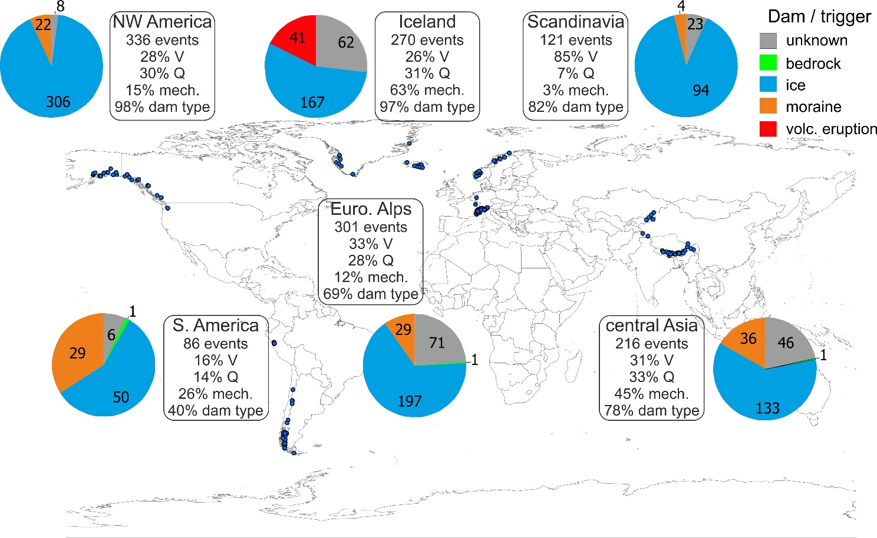

Figure 1. Overview by major region of the proportion of the glacier outburst flood records compiled in this study that include physical attributes; namely volume, V, discharge, Q, flood water release and/or routing mechanisms, and dam type. Note that ‘ice’ includes subglacial, ice-marginal and supraglacial situations, and that ‘volc. eruption’ includes (i) instantaneous outburst of meltwater derived from ice melt due to volcanic activity, (ii) release of water that was temporarily stored having been generated by ice melt due to volcanic activity , (iii) geothermal activity. Numbers on pie charts are the number of floods per dam type/trigger.
A global assessment of the societal impacts of glacier outburst floods
Jonathan L. Carrivick and Fiona S. Tweed
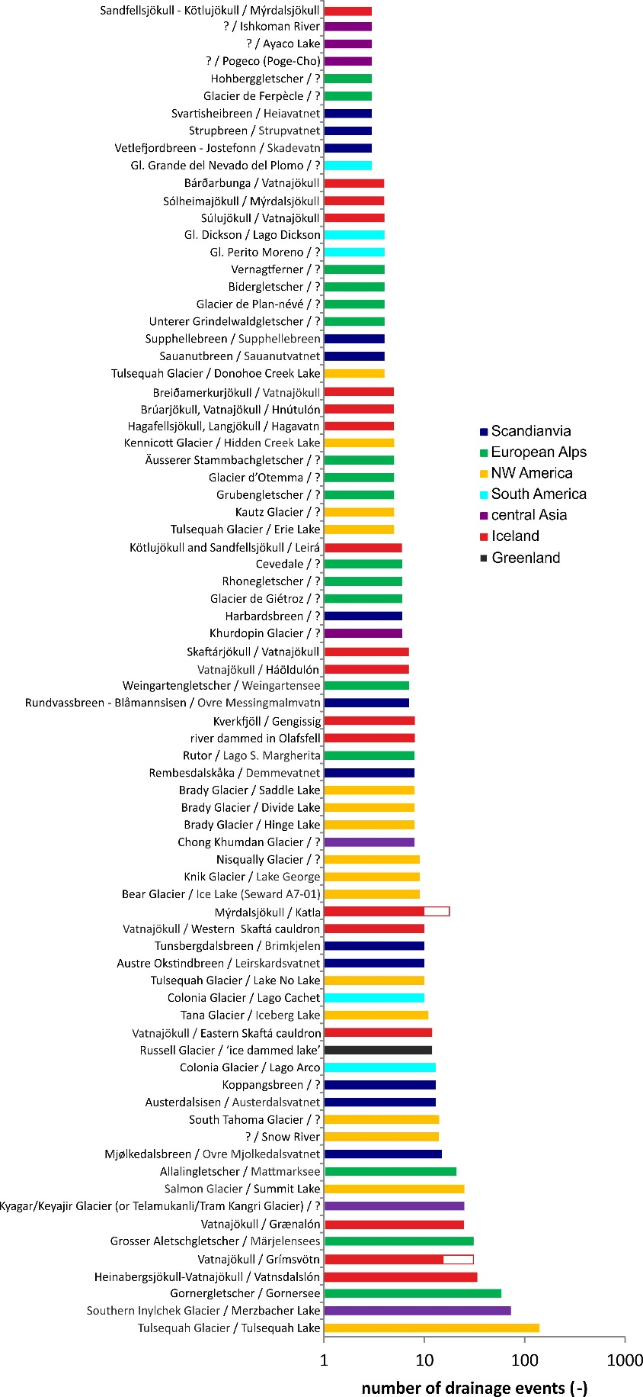
Figure 2. Glacier outburst floods that have originated from the same source three times or more. Note that ‘?’ refers to missing information usually because there was no visible/named lake (e.g. if subglacial or englacial ‘water pocket’). White parts of bars denote documented but unconfirmed sources of floods.
A global assessment of the societal impacts of glacier outburst floods
Jonathan L. Carrivick and Fiona S. Tweed

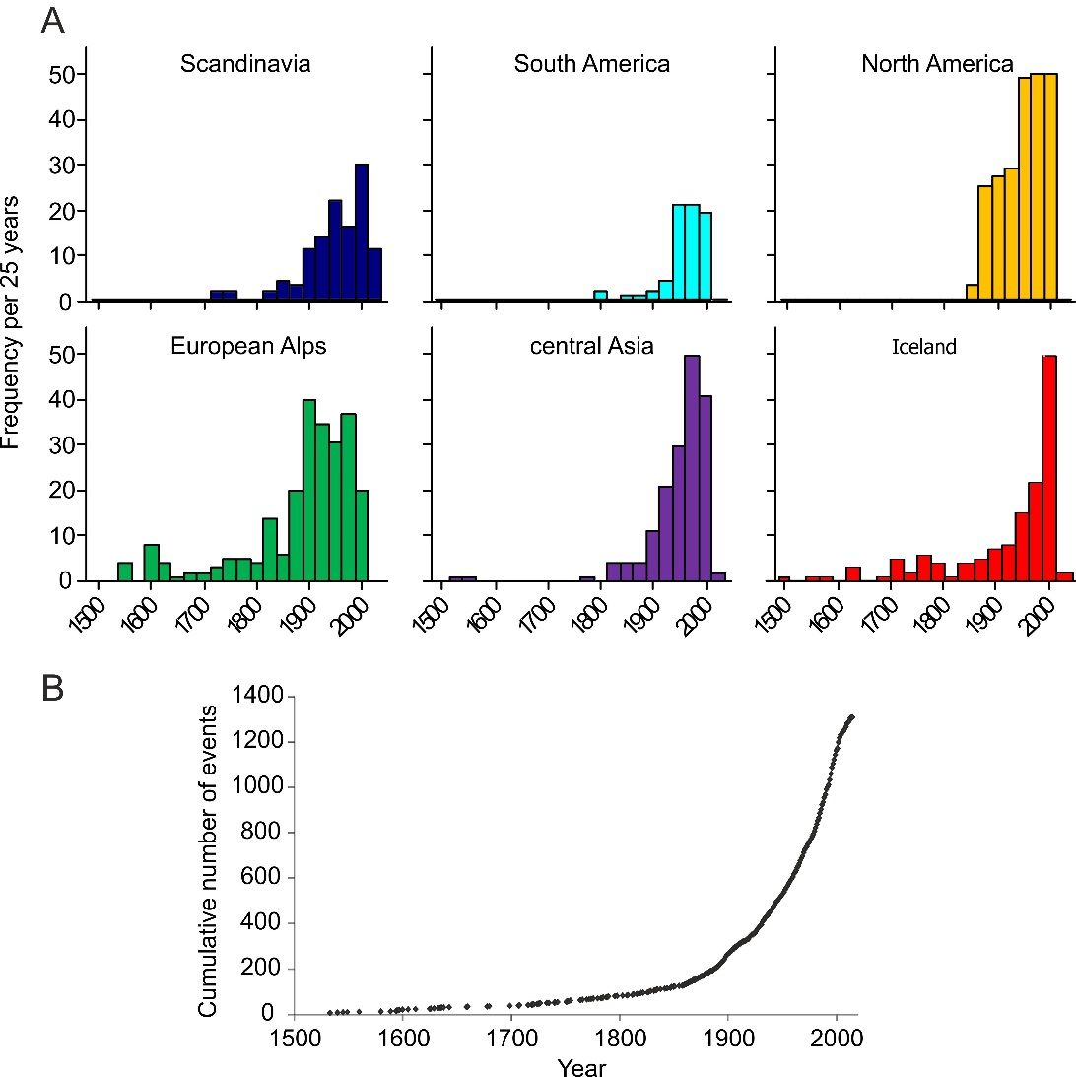

Figure 3. Number of glacier outburst floods per 25 years by major region (A) and as a global cumulative total (B). Note that for clarity the x-axis is limited to displaying records from the last 500 years.
A global assessment of the societal impacts of glacier outburst floods
Jonathan L. Carrivick and Fiona S. Tweed

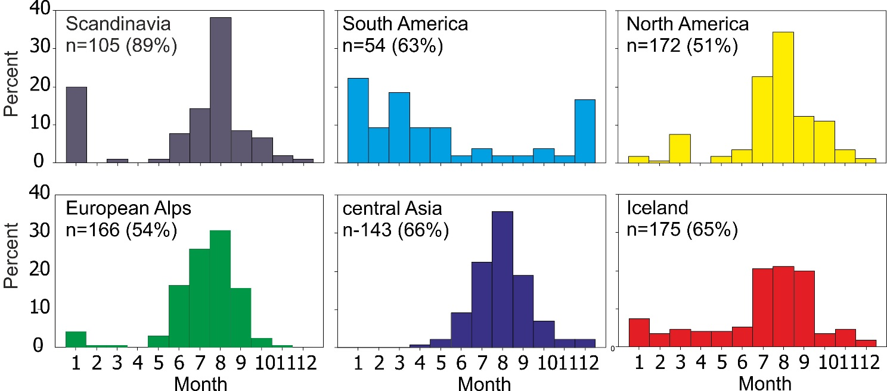

Figure 4. Percentage of glacier outburst floods occurring per month by major region. Note ‘n’ is number of records for which month is known and % in brackets is proportion of all records of glacier floods in that major world region.

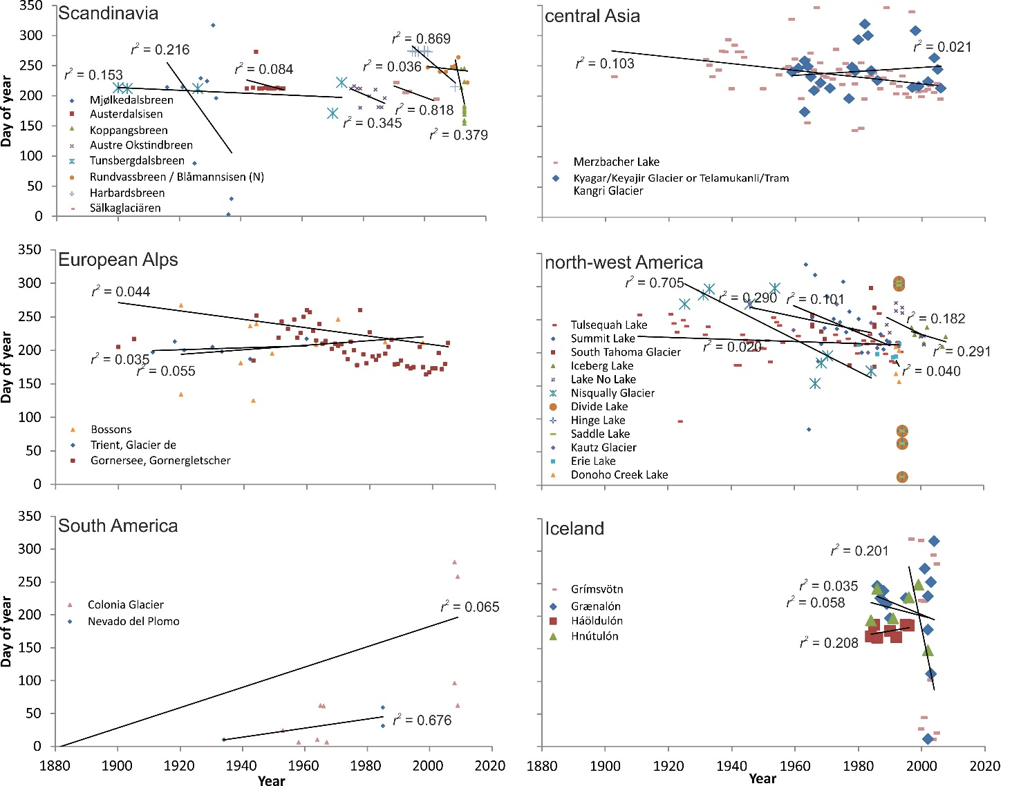

Figure 5. Comparison by major region of the day of year on which glacier lakes have drained, for glacier lakes for which the day of the year is known. Black lines are linear regression best fits. Note that we only have record of three glacier outburst floods from Nevado del Plomo but is included here because there are few multiple glacier lake drainages recorded in South America. Note only lakes that have drained more than 5 times are depicted for clarity.

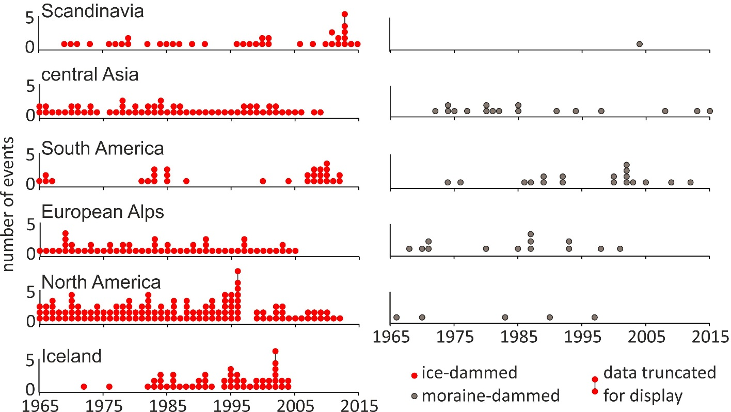

Figure 6. Number of recorded glacier outburst floods per year, discriminated by dam type. The excessively high number of events in 2013 in Scandinavia, in 1996 in North America and in 2003 in Iceland were events in the Lyngen Alps (Jackson and Ragulina, 2014), at Brady Glacier (Capps and Clague, 2014) and at multiple lakes around Vatnajökull (Veðurstofa Íslands, 2016), respectively. Glacier floods from volcanism, ice-dammed lake – volcano interactions, bedrock-dams and from englacial water pockets are not shown for brevity and clarity.
A global assessment of the societal impacts of glacier outburst floods
Jonathan L. Carrivick and Fiona S. Tweed

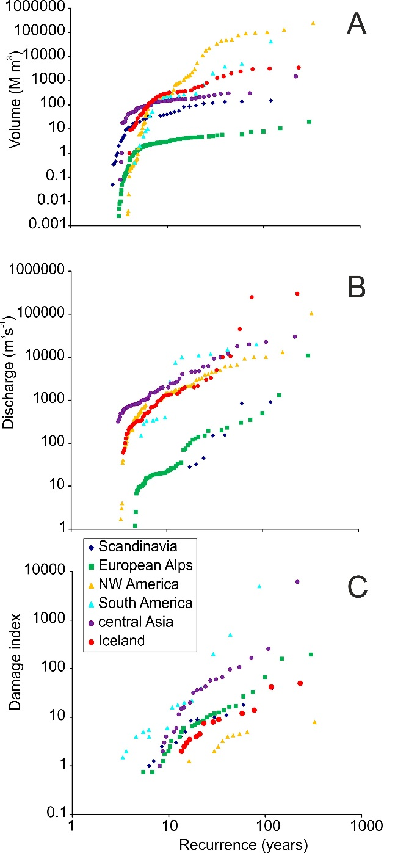

Figure 7. Global glacier outburst flood recurrence intervals calculated by magnitude as defined by volume (A), discharge (B) and an index of damage (C). Note both x and y scales are logarithmic. Note the lack of error margins because we cannot define the magnitude of likely inaccuracies in volume or peak discharge, nor the effect of likely unreported impact. For this reason it is the shape of these lines and the relative placing of the lines pertaining to each major region that is most important rather than the absolute values. These estimates of recurrence intervals are fits to past events and not predictions of future ones.

A global assessment of the societal impacts of glacier outburst floods
Jonathan L. Carrivick and Fiona S. Tweed

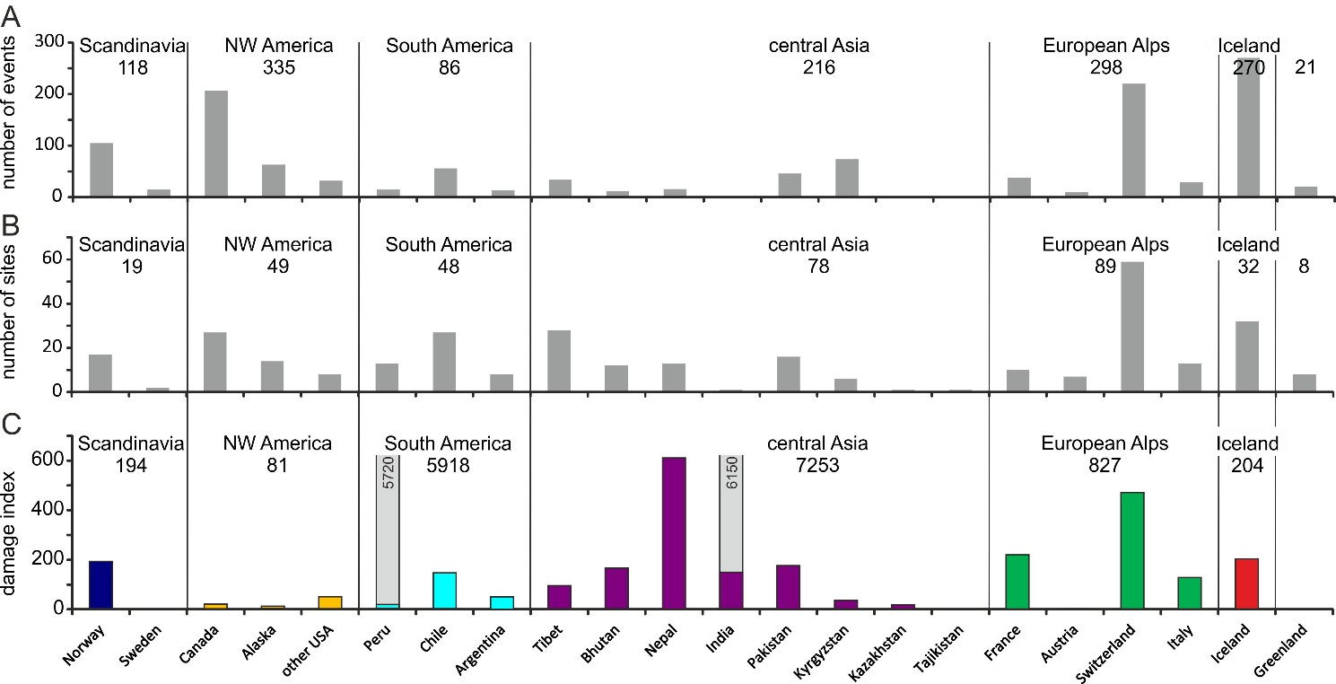

Figure 8. Total number of recorded glacier floods (A), sites with recorded glacier floods (B), and damage index (C) per country and per major world region. The absolute value of the damage index is somewhat arbitrary, but permits comparison between countries and between regions.
A global assessment of the societal impacts of glacier outburst floods
Jonathan L. Carrivick and Fiona S. Tweed

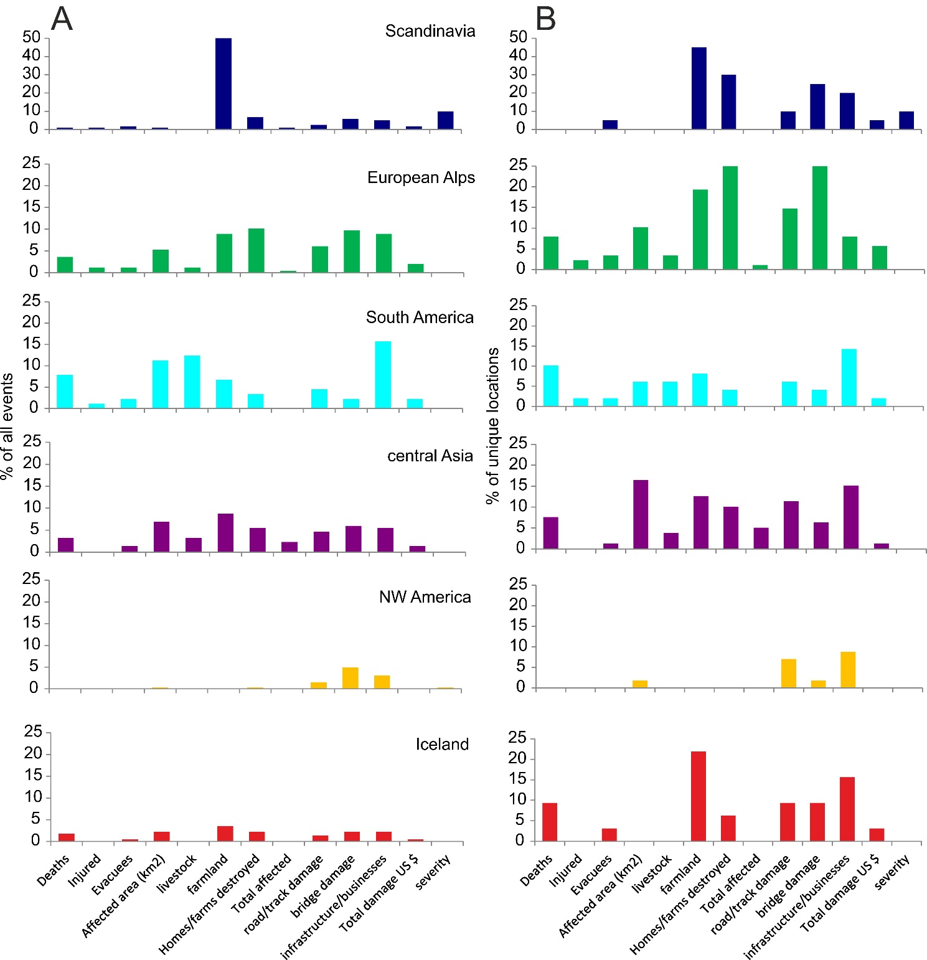
Figure 9. Proportion of all glacier outburst floods (A) and proportion of all glacier outburst flood sites (B) that have some attributes of societal impact recorded. Note different y-scale for Scandinavia.
A global assessment of the societal impacts of glacier outburst floods
Jonathan L. Carrivick and Fiona S. Tweed

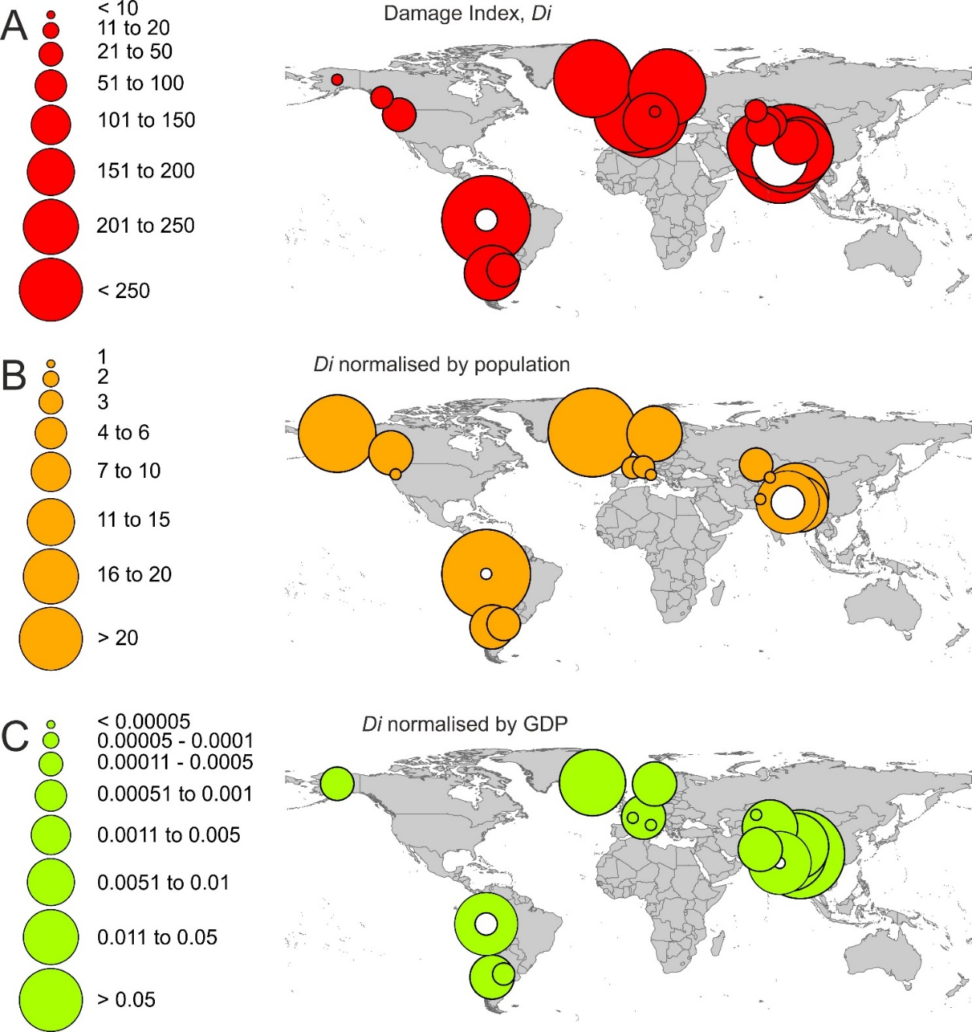

Figure 10. Global societal impact of glacier outburst floods as defined by a relative damage index (A), and this index normalised by population density (B) and by country GDP (C). White circles denote country value without exceptionally high numbers of deaths included. Note that it is the spatial pattern rather than the absolute values that are of interest.

