Deglaciation and proglacial lakes

Fiona S. Tweed¹ and Jonathan L. Carrivick²

¹Geography, Staffordshire University, Leek Road, Stoke-on-Trent, Staffordshire, ST4 2DF, UK
²School of Geography, University of Leeds, Woodhouse Lane, Leeds, West Yorkshire, LS2 9JT, UK

Correspondence to: Prof. Fiona Tweed, Geography, Staffordshire University,
Leek Road, Stoke-on-Trent, ST4 2DF, UK
Tel: +44 1782 294113
Email: f.s.tweed@staffs.ac.uk

‘Deglaciation and proglacial lakes’

Fiona S. Tweed
Geography, Staffordshire University, Leek Road, Stoke-on-Trent, ST4 2DF, UK
Jonathan L. Carrivick
School of Geography, University of Leeds, Woodhouse Lane, Leeds, West Yorkshire, LS2 9JT, UK

Glaciers and ice sheets are important constituents of the Earth’s land surface. Current worldwide retreat of glaciers has implications for the environment and for civilisation. There are a range of geomorphic changes occurring in cold environments and it is anticipated that these will be accentuated as a consequence of climate change. In particular, the number and size of proglacial lakes is currently increasing as a result of deglaciation and their significance for the physical environment and for society is becoming increasingly apparent. This article provides an overview of the major interdependent relationships between climate change, glaciers and proglacial lake development. In particular, it describes the key processes and impacts associated with proglacial lake evolution with reference to examples drawn from the European Alps, North America, the Himalayas, the Andes, Greenland, New Zealand and Iceland.

Our deglaciating planet
Glaciers and ice sheets have advanced and retreated over time and their behaviour can be regarded as one of our barometers of climate change. Changing climate exerts a strong control on the nature and extent of glaciers and ice sheets and the extent and severity of glacial and periglacial processes. At the height of the Devensian glaciation 20,000 years ago, it is estimated that 30 % of the Earth’s land surface was covered by ice. Today, Earth could still be regarded as a glacial planet if viewed from space, given that approximately 10 % of its land surface is currently occupied by ice. However, as is well known, glaciers and ice sheets have been generally retreating since the start of the twentieth century.
In most cold regions across the globe, glacier retreat and thinning has become accentuated over the last thirty years. This decline in ice mass has a range of implications for both natural and human environments. Changes in slope stability, hydrological regimes and sediment fluxes have consequences for water security, power generation and the occurrence of natural hazards, thereby presenting challenges for society. The increasing number and size of proglacial lakes is one of the most obvious effects of deglaciation. Understanding the character and development of proglacial lakes can provide insights into the behaviour of glaciers and ice sheets and help us to anticipate some of the impacts of present and future deglaciation. Such knowledge is important for the effective management of deglaciating environments; for example the monitoring of aquatic ecosystems and the management of water supplies and hydro-electric power generation. Better understanding of proglacial lake evolution is also critical for assessment of the hazards presented by such lakes; for example, glacial lake outburst flooding. In the next section, we define proglacial lakes and examine different lake types before discussing some of the processes and impacts of proglacial lake development.

Proglacial lakes - formation and evolution
Proglacial lakes are masses of water impounded at the margin of an ice sheet or at the edge of a glacier. Proglacial lakes can be dammed by ice, bedrock, moraine or landslide debris or a combination of materials and the configuration and behaviour of such lakes is highly dependent on the nature of the surrounding environment (see Figure 1); in particular, the type of dam and its constituent materials strongly influence proglacial lake characteristics, lake evolution and lake drainage. Failure or overtopping of natural dams frequently leads to glacier lake outburst floods (GLOFS) or jökulhlaups, which are characterised by sudden-onset discharges that are far higher than those generated by snowmelt or rainfall in glacier systems. Jökulhlaups can be powerful agents of landscape change through erosion and sediment deposition and can present a hazard to people, ecosystems and infrastructure.

Ice-dammed lakes
The formation of lakes dammed by ice is usually a result of the thickening or advance of the damming ice margin, whether this is a glacier, an ice cap or an ice sheet. Ice-dammed lakes often form in tributary valleys where advance of a main valley glacier has obstructed river drainage or where tributary glaciers retreat from a junction with a main valley glacier (see Figure 1). Sometimes anomalously rapid glacier advances, known as surges, can result in ice blocking tributary valleys and impeding drainage, thereby creating ice-dammed lakes; for example, the 1986 surge of Hubbard Glacier Alaska, damming water in Russell Fjord. Ice-dammed lakes are strongly influenced by their proximity to ice and their evolution is frequently contingent on the nature of their relationship with it. Ice-dammed lakes exhibit cycles of lake formation, drainage, re-filling and re-emptying as the damming ice changes in thickness or as hydrological characteristics of the dam vary; such changes influence the thresholds for triggering lake drainage along with the magnitude and frequency of floods. For example, during glacial advance, thickening ice dams impound larger amounts of water creating deeper lakes capable of generating periodic high magnitude jökulhlaups, whereas on ice retreat, thinner glacial dams retain gradually less and less water leading to smaller floods that occur on a more frequent basis. These lake filling and drainage cycles have implications for rates of erosion, sediment transfer and deposition along with the hazards that are caused by flooding.

Moraine-dammed lakes
Moraine-dammed lakes usually develop as a consequence of periods of glacier retreat or ice decay. When glaciers and ice sheets recede, water accumulates in topographic depressions formerly occupied by ice (see Figure 1) and the growth of lakes can be swift, sustained by precipitation and glacial meltwater. Debris-covered glaciers, prevalent in the Himalayas and New Zealand, are frequently the sites of moraine-dammed lakes as debris-covered glacier snouts stagnate. In these circumstances, buried ice can melt leaving depressions that rapidly fill with water and ice-cored moraine acts as effective damming material, although gradual melting of the ice core often leads to dam instability.
Moraine-dammed lake evolution is largely dependent on environmental setting. The dynamic evolution of debris-covered glaciers results in enlargement and deepening of moraine-dammed lakes as dead ice melts and subsides and sequences of lakes can develop at an ice margin often eventually coalescing to form one large lake. Ultimately, moraine-dammed lakes can become completely detached from ice. Over the last few decades, the identification and monitoring of moraine-dammed lakes has become increasingly important against a backdrop of glacier and ice sheet retreat. Moraine-dammed lakes have the potential to generate GLOFs as they expand; for example, if the dam loses integrity or there is a debris or ice fall into the lake generating a sufficiently powerful displacement wave, drainage of lake water may be initiated causing a jökulhlaup. There are numerous accounts of destructive floods from the moraine-dammed lakes of the Himalayas and the Andes and such events are likely to become more prevalent with rising numbers of lakes.

Landslide and bedrock-dammed lakes
Glacier retreat frequently results in slope instability as unconsolidated materials are exposed on valley sides which have previously been bolstered by glacial ice. Increased precipitation and overland flow can lead to elevated pore water pressures in valley side materials, triggering valley side falls, flows and slides, all of which can obstruct drainage and lead to the ponding of water (see Figure 1). Landslide-dammed lakes are often transient since the materials forming the dam have poor cohesion and are easily eroded; once a landslide dam is overtopped, down-cutting can occur. Some proglacial lakes are dammed by bedrock, water accumulating in depressions revealed when glaciers retreat (see Figure 1); bedrock forms a much more stable and coherent damming structure than ice or unconsolidated sediments.

Glacier dynamics and proglacial lake evolution
Cycles of ice-dammed lake and moraine-dammed lake formation are strongly linked to glacier dynamics and glacier hydrology, in particular, patterns of advance and retreat, and ice thickening and thinning, which in turn can be linked to changing climate. Glacier margin morphology, physical stability and dynamics are affected by the presence, character and behaviour of an ice-marginal lake. The depth of water at an ice-margin determines (i) the distance ‘up-ice’ that water propagates, (ii) vertical extension of a glacier’s basal hydrological system via basal water pressure and (iii) ice calving rates. These factors encourage faster ice velocity and accentuate ice mass loss from a glacier system. Furthermore, ice-marginal lake water delivers heat to glacier ice and thus causes thermally-induced melting. Thermal melting can cause notches to develop at the water line and this thermal undercutting can strongly influence the rate of calving. The retreat of glaciers into over-deepened glacier basins often results in enhanced calving, which in turn generates positive feedback - calving causes lake expansion and further calving and ice retreat. Additionally heat delivery from ponded meltwater beneath and within a glacier, particularly in crevasses, also contributes to ice mass loss. Where ice-marginal lake water is sufficiently deep relative to the ice thickness, buoyancy will cause flotation of an ice margin and rapid calving, snout retreat and surface lowering, or sudden glacier lake drainage. Glacier ice that is grounded with lake water is often in tension and near fracture and consequently unstable. An ice-marginal lake will therefore cause glacier margin fluctuations, glacier velocity and glacier mass balance to be at least partially decoupled from climate.

Proglacial lakes of the past
The Quaternary record bears witness to the existence of proglacial lakes associated with alternating glacial and interglacial periods and there is abundant evidence of the impacts of proglacial lakes associated with Pleistocene ice sheet deglaciation. Scrutiny of evidence from past proglacial lakes can assist us in anticipating future impacts.
The Quaternary ice sheet margins of northern Eurasia and central Asia dammed huge proglacial lakes, the drainage of which caused profound landscape change; for example, jökulhlaups from the Kuray and Chuya Basins, which drained through the Altai Mountains of southern Siberia. The emptying of lakes impounded at the margins of ice sheets in North America and northern Europe generated some of the largest floods on Earth, eroding great canyons and affecting ocean circulation and sediment fluxes both onshore and offshore. For example, there is extensive evidence of cycles of flooding from Glacial Lake Missoula which formed as a consequence of the deglaciation of the Cordilleran ice sheet in western Montana approximately 15,000 years ago. Research suggests that this lake drained at least forty times and generated discharges over thirteen times that of the average discharge of the river Amazon; these catastrophic floods were responsible for the sculpting of the Channelled Scablands of Washington State and for the deposition of huge quantities of fine-grained sediments in Washington and Oregon. The emptying of Glacial Lake Agassiz formed in association with the deglaciation of the Laurentide Ice Sheet has also been comprehensively researched.
The vast majority of Quaternary proglacial lake basins have flat floors produced by voluminous sedimentation. Terrain that was previously glacially subdued and smoothed can become draped and obscured by thin beds and laminae of silts and clays. Proglacial lake basins, such as those in the Hudson Bay area and on the Canadian Shield, can also be recognised today as very extensive areas of peatlands that have accumulated due to relatively impermeable sediments and poor drainage. These palaeo-lake areas are usually further distinguished by encircling wave-cut cliffs or by coarser sediment that was deposited in shallower water, such as beaches and lags of wave-washed sediment. On a large scale, bathymetry of proglacial lakes is dependent on regional topography. Very large Pleistocene proglacial lakes across North America developed at least partly because the continental land surface slope trended northwards towards the Arctic Ocean. This slope, which was inverse to the direction of ice motion, was accentuated by isostatic depression and thus a considerable accommodation space for meltwater was created in the landscape.
In addition to modifying the physical landscape, the development of a range of physiographic features as a consequence of deglaciation at the end of the Pleistocene would have had a profound effect on early explorers and settlers; this has been particularly commented upon in relation to human settlement of the North American interior. There is some evidence that large proglacial lakes and boggy ground formed by gradually deglaciating terrain may have acted as barriers to recolonization by large mammals and humans. However, it has also been suggested that the presence of proglacial lakes may have encouraged migration by providing resources and easy routes through the terrain, with some such locations being used as staging posts from which further exploration and settlement could be supported.

Current distribution of proglacial lakes
The number and size of proglacial lakes around the world has been increasing as a consequence of deglaciation and we anticipate further growth over the coming decades. For example, research has identified expanding proglacial lakes in the European Alps, Norway, Iceland, Greenland, the Caucasus Mountains, Alaska, New Zealand, Canada, South America and across the Himalaya. Many regions are exhibiting complex patterns of proglacial lake development and behaviour as lakes grow, coalesce and drain. Some ice-dammed lakes have evolved into moraine-dammed lakes as they gradually separate from glacial ice. In any one glacier system, there may be a number of lakes dammed by different materials filling and draining. Figure 2 illustrates some examples of the rapid development of proglacial lakes in response to deglaciating conditions; we comment particularly on examples from Iceland and New Zealand below.
In Iceland, proglacial lake formation has accelerated over the last 15 years, particularly around the southern outlet glaciers of the Mýrsdalsjökull and Vatnajökull ice caps. At Breiðamerkurjökull, the proglacial lake Jökulsárlón has been developing since 1934 and is now 18 km² in surface area (Figure 3). Proglacial lakes have been developing rapidly at Skaftafellsjökull, Svínafellsjökull, Heinabergsjökull, and Fláajökull as a consequence of glacier retreat into overdeepened glacial troughs; some of these troughs extend up to 300m below sea level, implying that proglacial lakes are likely to expand further with continued retreat. At the margins of the piedmont glacier Skeiðarárjökull, small proglacial lakes have grown larger and coalesced. At Mýrdalsjökull ice cap to the south-west of Vatnajökull, the outlet glacier Sólheimajökull has exhibited retreat from 1995 onwards accompanied by the growth and coalescence of proglacial lakes (Figure 4). The current glacier retreat rate here is approximately 100m each year.
In New Zealand, there has been significant retreat of the glaciers of the Southern Alps, and this retreat has accelerated over the last ten years. The Tasman Glacier is currently retreating by approximately 450 to 800 metres each year and terminates in a proglacial lake ~ 8 km in length, 2 km in width and > 200 m in depth. This lake did not exist in 1973. Nearby Hooker and Mueller Glaciers also terminate in proglacial lakes, which are similarly expanding. A scenario envisaged for the near-future evolution of Hooker Glacier lake sees stabilisation when glacier ice velocity equals calving rates, but only when the glacier retreats more than 3 km up-valley from the Hooker Lake outlet after 2028.

Landform and sedimentary impacts of proglacial lakes
The spatially and temporally complex behaviour of proglacial lakes has a range of impacts on the geomorphic environment. As glaciers and ice sheets retreat, they reveal sediments on valley sides that are then subject to paraglacial slope readjustment and sediment fluxes from glacial systems tend to increase as a consequence. However, the presence of proglacial lakes disrupts the flow of meltwater from glaciers and ice sheets resulting in sedimentation, as flow velocities are retarded on entry into lake basins. Sediments that would otherwise be transported into and beyond the proglacial zone therefore become trapped and stored with proglacial lakes, which act sediment sinks. Investigations have established that the presence of proglacial lakes in Patagonia interrupted Pleistocene dust flux to Antarctica by trapping fine-grained sediment. Research on both Quaternary and modern proglacial lake sedimentation within particular catchments demonstrates that evidence of the variability of sediment fluxes can be derived from proglacial lake sediments and that lake sediments can be used to infer regional hydrologic changes and also variations in climate. In these ways, information from the analysis of existing lakes can be used to help us predict what accompanying changes might occur as other lakes form. Over the next decades, it is predicted that many developing proglacial lakes will fill with sediments released from glacial systems as a consequence of present deglaciation.
Sudden drainage of ice, moraine and landslide-dammed lakes results in extremely rapid and intense erosion, transportation and deposition of vast amounts of sediment. This sediment transport creates spectacular landforms including deep canyons and gorges, huge ripples, boulder bars and fans of sediment, examples of which can be seen in the landscapes of the Altai Mountains of south-central Siberia and the Channelled Scablands of Washington State.

Proglacial lake and climate interactions
It is clear that glaciers and ice sheets are responding to a warming climate through retreat, and that the development of proglacial lakes is one such response; however, the relationships between ice, the development of proglacial lakes and climate are more complex than this. The effects of large late-Pleistocene proglacial lakes have been modelled and their presence is thought to have resulted in cooler summers and attendant ice sheet growth, actually delaying ice sheet decay. The drainage of large Quaternary proglacial lakes, such as Lake Agassiz, has been extensively researched and has been demonstrated to have disrupted the salinity gradient that drives meridional overturning circulation, thereby cooling climate due to the sudden inflow of huge amounts of meltwater into the oceans. It is thought that discharges from such lakes could have reached in excess of one million cubic metres per second; as a comparator, the average discharge of the Amazon River is approximately one fifth of this, at two hundred thousand cubic metres per second. Research is ongoing, but it has been suggested that the development and drainage of huge proglacial lakes in Eurasia could also have perturbed regional hydrological conditions and thereby affected global climate. Although most currently forming proglacial lakes are at present too small to generate climate feedbacks, they can affect local environmental conditions through the absorption of incoming shortwave radiation in summertime and its reflection in the winter. Figure 5 illustrates the principal interactions between climate, glaciers and proglacial lakes, summarising some of the above discussion.

What can we expect in the future?
Global climate warming is resulting in substantial glacier and ice sheet retreat. The development of proglacial lakes as a consequence of ice retreat presents a number of issues for society looking forward into the rest of this century and beyond. The drainage of proglacial lakes can result in hazardous jökulhlaups, which cause substantial landscape change. The growth of proglacial lakes also presents opportunities and challenges for water security, both in the context of potable water supplies and water for irrigation and power generation. Further research will be needed to increase understanding of the response of ocean circulation to freshwater inputs and the extent to which the drainage of large proglacial lakes can perturb normal patterns of ocean circulation and stimulate climate fluctuations, given the development of proglacial lakes triggered by current deglaciation. Monitoring of the temporal and spatial evolution of proglacial lakes and their characteristics will be vital to scientific understanding and to develop effective and sustainable ways of living with anticipated changes. Integrating the detection and monitoring of proglacial lakes with physical analyses and socio-economic data remains a key objective for the future.

Summary
Climate change and associated glacier retreat are having profound impacts on cold environments; these impacts have geomorphological and societal consequences. Proglacial lakes are increasing in number and size around the world. It is clear that the study of proglacial lakes and their spatial and temporal development can help us to understand the effects of past deglaciation and to predict some of the likely impacts of future deglaciation. Understanding the formation and evolution of proglacial lakes reveals a number of key processes and interdependencies.
In a geomorphic context, proglacial lakes can act as buffers between glaciers and the proglacial zone, interrupting the flow of meltwater and sediment from glaciers to the oceans. This influences spatial and temporal patterns of erosion, transportation and deposition of sediments in de-glaciating environments. We can examine sediments contained within proglacial lakes in order to establish records of past environmental change and to predict the impacts of future changes. Ice-dammed and moraine-dammed lake filling and draining cycles influence the geomorphic impact of such lakes, affecting the rate of erosion, deposition and landscape development.
Some proglacial lakes have marked influences on glacier and ice sheet dynamics; for example, ice contact lakes affect the stability and character of glacier margins through calving. Proglacial lakes can influence climate and can be influenced by it. The presence of large proglacial lakes during the Pleistocene is thought to have cooled regional climate and retarded ice sheet decay. More widely, it has been established that jökulhlaups from proglacial lakes can modify ocean circulation and climate through the delivery of freshwater and sediment in large quantities. The shift from glaciers terminating on land to glaciers terminating in proglacial lakes is a defining point in deglaciating environments. We expect that proglacial lakes will continue to increase in number and size due to glacier thinning and retreat; their existence and expansion will have a number of fundamental effects, including perturbing glacier dynamics, modulating proglacial meltwater and sediment fluxes and presenting potential hazards.

Acknowledgements
Thanks to the Geological Society of America for supporting the Dynamic Iceland GeoVenture 2014, during which some of the images of Iceland were derived.

Suggestions for further reading
Carrivick, J.L. and Rushmer, E.L. 2006. Understanding high-magnitude outburst floods. Geology Today 22, 60-65.
Carrivick, J.L. 2011. Jökulhlaups: geological importance, deglacial association and hazard management. Geology Today 27, 133-140.
Carrivick, J.L. and Tweed, F.S. 2013. Proglacial lakes: character, behaviour and geological importance. Quaternary Science Reviews 78, 34-52.
Carrivick and Quincey, D.J., 2014. Increasing number and volume of ice-marginal lakes in western Greenland. Global and Planetary Change 116, 156-163.
Clague, J.J. 2013. Cryospheric hazards. Geology Today 29, 73-79.
Clague, J.J. and Evans S.G. A review of catastrophic drainage of moraine-dammed lakes in British Columbia. Quaternary Science Reviews 19, 1763-1783.
Korup, O. and Tweed, F.S. 2007. Ice, moraine and landslide dams in mountainous terrain. Quaternary Science Reviews 26, 3406-3422.
Nayar, A., 2009. When the ice melts. Nature 461, 1042-1046.
Richardson, S.D. and Reynolds, J.M. 2000. An overview of glacial hazards in the Himalayas. Quaternary International 65, 31-47.
Robertson, C. M., Brook, M. S., Holt, K. A., Fuller, I. C., & Benn, D. I. (2013). Calving retreat and proglacial lake growth at Hooker Glacier, Southern Alps, New Zealand. New Zealand Geographer, 69(1), 14-25.
Salinger, J., Chinn, T., Willsman, A., and Fitzharris, B. 2008. Glacier response to climate change. Water and Atmosphere 16, 16-17.
Schomacker, A., 2010. Expansion of ice-marginal lakes at the Vatnajökull ice cap, Iceland, from 1999 to 2009. Geomorphology 119, 232-236.
Stokes, C.R., Popovnin, V., Aleynikov, A., Gurney, S.D. and Shahgedanova, M., 2007.Recent glacier retreat in the Caucasus Mountains, Russia, and associated increase in supraglacial debris cover and supra-/proglacial lake development. Annals of Glaciology 46, 195-203.
Tweed, F.S. and Russell, A.J. 1999. Controls on the formation and sudden drainage of glacier-impounded lakes: implications for jökulhlaup characteristics. Progress in Physical Geography 23, 79-110

Figures

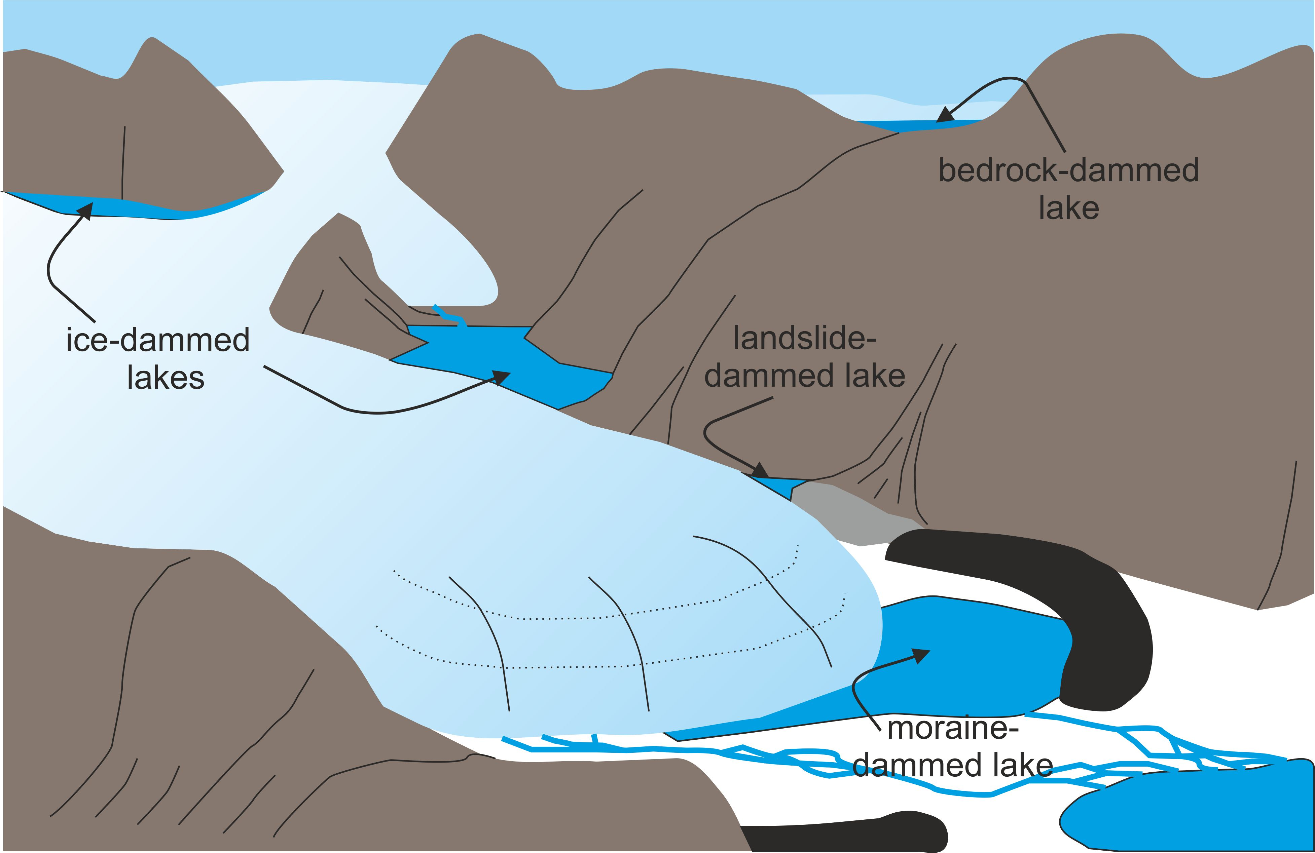
Figure 1: Ice, moraine, landslide and bedrock dammed lakes

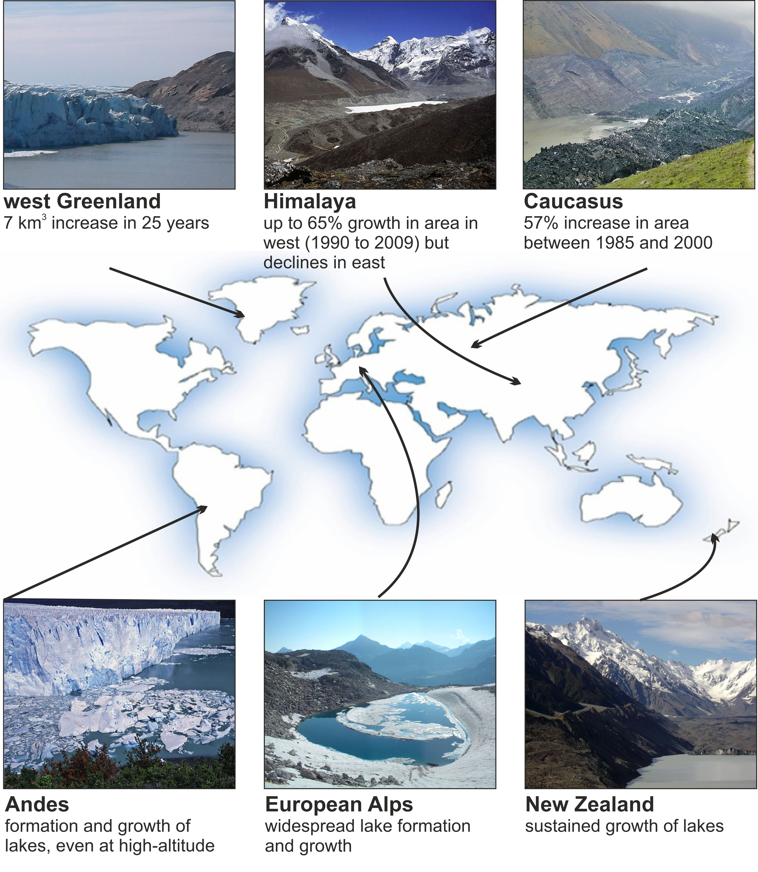

Figure 2: Highlights from around the world of the formation and growth of proglacial lakes. Quantitative studies are at top of figure and qualitative overviews are at bottom of figure (and are all from literature reviewed by Carrivick and Tweed (2013).

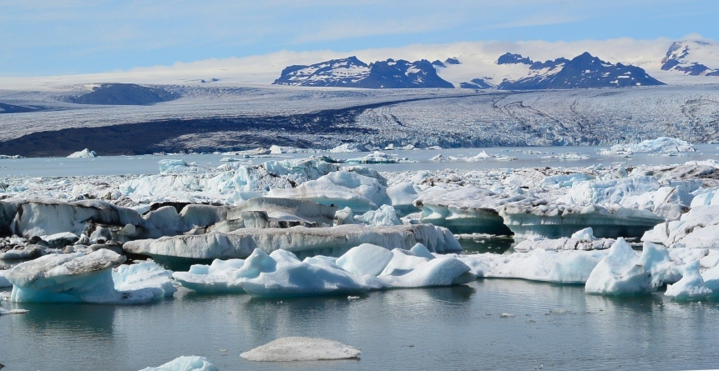

Figure 3: Proglacial lake Jökulsárlón, filled with calving icebergs, at the snout of Breiðamerkurjökull, Iceland.

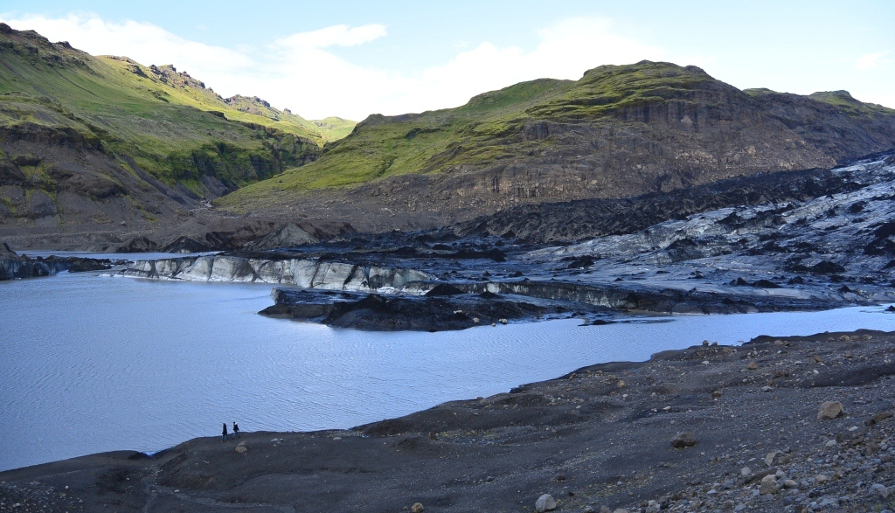

Figure 4: Proglacial lake at Sólheimajökull, Iceland.

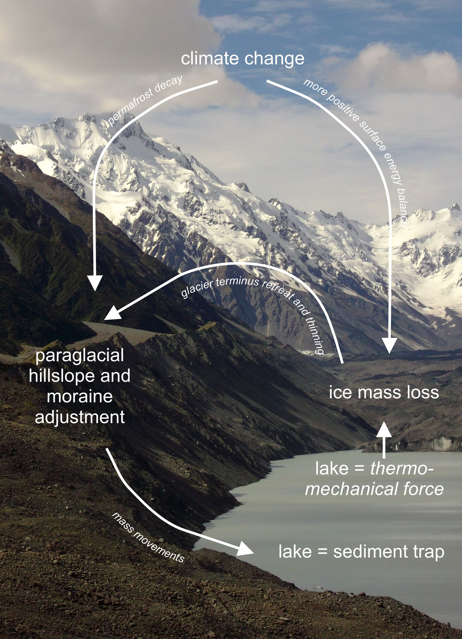

Figure 5: Simplified summary of major interactions between climate glaciers and proglacial lakes. Key processes are italicised.

