A multi-dimensional analysis of proglacial landscape change at Sólheimajökull, southern Iceland

Kate E.H. Staines¹, Jonathan L. Carrivick¹ Fiona S. Tweed²,
Andrew J. Evans¹, Andrew J. Russell³, Tómas Jóhannesson⁴, Matthew Roberts⁴

¹School of Geography, University of Leeds, Woodhouse Lane, Leeds, West Yorkshire, LS2 9JT, UK.
²Geography, Staffordshire University, Science Centre, Leek Road, Stoke-on-Trent, ST4 2DF, UK
³School of Geography, Politics and Sociology, Faculty of Humanities and Social Sciences, Newcastle University, Newcastle upon Tyne, NE1 7RU, UK.
⁴Icelandic Meteorological Office, Bústaðavegi 9, 150 Reykjavík, Iceland

Correspondence to:
Dr. Jonathan Carrivick,
Email: j.l.carrivick@leeds.ac.uk
Tel.: 0113 343 3324

Abstract
Proglacial landscapes are some of the most active on Earth. Previous studies of proglacial landscape change have often been restricted to considering either sedimentological, geomorphological or topographic parameters in isolation and are often mono-dimensional. This study utilised field surveys and digital elevation model analyses to quantify planform, elevation and volumetric proglacial landscape change at Sólheimajökull in southern Iceland for multiple time periods spanning from 1960 to 2010. As expected, the most intense geomorphological changes persistently occurred in the ice-proximal area. During 1960 to 1996 the proglacial river was relatively stable. However, after 2001 braiding intensity was higher, channel slope shallower and there was a shift from overall incision to aggradation. Attributing these proglacial river channel changes to the 1999 jökulhlaup is ambiguous because it coincided with a switch from a period of glacier advance to that of glacier retreat. Furthermore, glacier retreat (of ~ 40 m.yr⁻¹) coincided with ice-marginal lake development and these two factors have both altered the proglacial river channel head elevation. From 2001 to 2010 progressive increase in channel braiding and progressive downstream incision occurred; these together probably reflecting stream power due to increased glacier ablation and reduced sediment supply due to trapping of sediment by the developing ice-marginal lake. Overall, this study highlights rapid spatiotemporal proglacial landscape reactions to changes in glacial meltwater runoff regimes, glacier terminus position, sediment supply and episodic events such as jökuhlaups. Recognising the interplay of these controlling factors on proglacial landscapes will be important for understanding the geological record and for landscape stability assessments.

Keywords DEM; photogrammetry; LiDAR; sediment; moraine; glacier; river

Introduction
Proglacial landscapes are amongst the most dynamic on earth and are characterised by spatially and temporally variable sediment and water fluxes (Maizels, 1979; Ashworth and Ferguson, 1986; Russell and Marren, 1999; Marren, 2005; Carrivick and Rushmer, 2009). These variable fluxes are partly manifest in proglacial river planform, elevation and volumetric changes. On a decadal scale, proglacial rivers can be controlled by (i) climatically-driven glacier advance and retreat and hence glacier terminus elevation, (ii) glacier mass balance, meltwater generation rates and volumes and hence river competence and capacity, (iii) sediment supply, (iv) episodic events such as glacier outburst floods or ‘jökulhlaups’, and (v) base level changes. The relative importance of these controls differ through time and they may interact, so consequently proglacial landforms and deposits vary greatly, as do rates and patterns of landscape change (Marren, 2002a). Understanding decadal-scale proglacial river changes has important implications for deciphering the geological record and for assessments of landscape stability.
Prevailing models of proglacial landscape development are largely qualitative, e.g. sedimentology (Maizels, 1997), proglacial river network patterns (Gurnell et al., 2000), land systems (Evans and Twigg, 2002). Quantitative studies of proglacial landscape development (e.g. ESP&L special issue on ‘Quantifying rates and processes of landscape evolution, November 2011) must make repeated and precise measurement of the land surface. Repeat surveys in proglacial areas are often focused on a particular component; for example on braided rivers (e.g. Schiefer and Gilbert, 2007; Milan et al., 2007) or moraine evolution (e.g. Sletten et al., 2001; Lyså and Lonne, 2001; Schomacker and Kjaer, 2007). In contrast, when whole proglacial areas are assessed for sediment redistribution (e.g. Irvine-Fynn et al., 2011; Bennett and Evans (2012); Carrivick et al. (2013a) sources and sinks can be identified and linkages and feedbacks established.
Previous surveys on proglacial rivers have often been mono-dimensional; i.e. river cross sections or long profiles (e.g. Ashworth and Ferguson, 1986; Maizels, 1997; Marren, 2002a, 2005). Although terrestrial laser scanning (TLS) and airborne light detection and ranging surveys (LiDAR) are now increasingly used in proglacial geomorphological analyses (e.g. Magilligan et al., 2002; Milan et al., 2007; Carrivick et al., 2013a; Williams et al., 2013), they trade better spatial resolution and 3D accuracy with limited temporal coverage. Therefore, the studies on proglacial landscape evolution at Breiðamerkurjökull by Evans and Twigg (2002), at Kvíárjökull, Iceland by Bennett and Evans (2012) and in the upper Lillooet Valley, British Columbia by Schiefer and Gilbert (2007) are notable for spanning 100, 60 and 50 years, respectively.
Braided river morphology is often investigated through repeated planform studies (e.g. Brasington et al., 2000), which can provide valuable information on lateral channel change, such as bar migration and bank erosion. However, where information on elevation and volumetric change is lacking, channel form can be misrepresented and geomorphic processes overlooked. The few studies that have focussed on elevation and volume changes have quantified geomorphic processes; for example, Lane et al., (2003) used synoptic remote sensing to estimate erosion and deposition volumes in a gravel-bedded braided river. Quantification of 3D landscape change requires consistent, high-resolution (spatial and temporal) landscape datasets (Schneeberger et al., 2007) which are rare. Where such datasets do exist, it is usually photogrammetric techniques that have been employed; examples of such techniques being applied to the evolution of glacial landscapes include Etzelmuller and Sollid (1997), Fox and Cziferszky (2008) and Bennett and Evans (2012). Deriving DEMs photogrammetrically works well in ice-marginal and proglacial settings because of (i) a lack of vegetation, (ii) highly textured surfaces, and (iii) the magnitude of geomorphological change, which is often considerably greater than DEM uncertainty (Schiefer and Gilbert, 2007). Confidence in quantifying geomorphological change between sequential DEMs is likely to be greater where this so-called ‘signal-to-noise ratio’ (James et al., 2012) is high; i.e. where uncertainty is low. Multi-temporal landscape measurements can be used to quantify rates of change and assess spatiotemporal variations in geomorphic processes; to-date this has been achieved to a certain extent at a decadal scale (Schiefer and Gilbert, 2007; Bennett and Evans, 2012), but more often on an inter-seasonal scale (e.g. Magilligan et al., 2002; Milan et al., 2007; Williams et al., 2013; Carrivick et al., 2013a).
The aims of this study are to; (i) quantify multi-dimensional proglacial landscape change, (ii) evaluate the key controls on this proglacial landscape change.

Study area
Sólheimajökull is an 8 km long outlet glacier of the Mýrdalsjökull ice cap in southern Iceland (Fig. 1). It is ~ 15 km long, has an area of ~ 47 km², a mean thickness of 270 m and an elevation range of 110 m.asl to 1450 m.asl Sigurdsson et al., (2007). The Jökulsá á Sólheimasandi river (abbreviated to Jökulsá) flows southwards from the glacier terminus across Sólheimasandur and Skógasandur to the North Atlantic Ocean over a distance of ~ 9 km. Streams join the Jökulsá from the Jökulsárgil and Fjallgil gorges to the west and the Heiðarhorn valley to the east (Fig. 1). Sólheimajökull was selected as the study site for four reasons. Firstly, like other Icelandic glaciers, Sólheimajökull and its proglacial area have been repeatedly photographed from the air since the mid-20th Century and consequently repeat aerial photographs exist covering ~ 60 years. Secondly, Sólheimajökull has one of the longest and most studied glacier fluctuation records in Iceland, extending back to the mid-Holocene (Dugmore and Sugden 1991; Mackintosh et al., 2002; Casely and Dugmore, 2004) and the period of aerial photograph coverage includes both glacier terminus advance and retreat phases. Thirdly, the sedimentology and geomorphology of the proglacial area has also been intensely studied (e.g. Maizels 1989a, b, 1991, 1993, 1997), with the Holocene evolution of the sandur being relatively well-constrained. Fourthly, a glacier outburst flood, or ‘jökulhlaup’, occurred in July 1999 at Sólheimajökull, offering the opportunity to examine not only the impact of that event in comparison to ~30 years of preceding ice ablation-fed river flow, but also the landscape response in the ~ 15 years afterwards.
Sólheimajökull is prone to jökulhlaups from the Katla volcanic system (Thorarinsson, 1975; Tweed, 2000). The 1999 jökulhlaup produced several floodwater outlets at the glacier terminus and on the surface of the glacier (Roberts et al., 2003). Peak discharge at the road bridge 4 km downstream of the glacier terminus was calculated at 1700 m³s⁻¹ and this was reached within an hour of flood onset (Sigurðsson et al, 2000). The river is reported to have returned to normal flow conditions within a day (Sigurðsson et al., 2000; Russell et al., 2010). There have been several analyses of the 1999 jökulhlaup event and the proglacial impacts were extensive and are relatively well-understood (e.g. Roberts et al., 2000; Russell et al., 2000; Roberts et al., 2003; Russell et al., 2010; Staines and Carrivick, this issue).

Methodology
Landscape change at Sólheimajökull from 1960 to 2010 was quantified through the analysis of a time-series of orthophotographs and DEMs, in combination with field-surveying. Five sets of panchromatic black-and-white stereo-pair aerial photographs (all those available in summer months); specifically in years 1960, 1975, 1984, 1990 and 1996, were obtained from Landmælingar Íslands (LMÍ). In 1975, 1990 and 1996, two parallel flight lines were surveyed, producing four overlapping photographs for each of these years. In both 1960 and 1984 only one flight line was surveyed. Whilst the 1960 photographs cover the entire site, the lower 3 km of the river channel were not surveyed in 1984. Each photograph on the flight-line overlaps by 60% with the next image and by 30% between parallel flight-lines. The photographs were provided in digital format, having been photogrammetrically scanned at 15 microns (1800 dpi) to give a ground pixel size of < 1 m (Fig. 2A). Colour aerial orthophotographs of the Sólheimajökull terminus and Sólheimasandur for the years 2001 and 2009 were obtained from Loftmyndir ehf. (www.loftmyndir.is). These stereo-pair photographs were taken using a metric (calibrated) frame camera and had been photogrammetrically processed by Loftmyndir ehf. to remove image distortion. The colour orthophotographs were supplied as image files with a ground-pixel size of 50 cm. LiDAR data at 2m grid resolution and < 0.1 m accuracy covering Sólheimajökull and the Jökulsá á Sólheimasandi channel were obtained from the Icelandic Meteorological Office (Veðurstofa Íslands, www.vedur.is), the survey having been conducted by Topscan GmbH (www.topscan.de) in summer 2010.
Orthophotographs for the years 1960 to 2009 were generated by georeferencing in Leica Photogrammetry Suite (LPS) with knowledge of calibrated focal length, lens type and lens distortion (Fig. 2), and with 44 ground control points measured in the field with a Leica GPS500 dual phase differential global positioning system (dGPS). The dGPS base station position was measured for 360 minutes and then post-processed relative to the continuous active IGNS station at Höfn, yielding a 3D accuracy of 0.05 m. All GCPs were surveyed relative to this base position in RTK mode and with accuracy of < 0.02 m. GCP positions are indicated in Figure 1 and sited at points that were (i) visible both in the field and on the aerial photographs, (ii), immovable, features (Schiefer and Gilbert 2007) such as the corners of fields, the edges of buildings and large, outsize boulders; (iii) visible in every set of photographs. As ground control could not be established prior to the photograph surveys, this technique is ideal for the historical photograph analysis (Chandler 1999) performed in this study. The GCPs were located in the ‘point measurement’ module of LPS (Fig. 2C) using the automatic drive function, which automatically determines GCP location from the user-defined coordinates. Triangulation errors were distributed across all of the images using a bundle block adjustment model (Fig. 2D). The addition of ‘advanced robust blunder checking’ significantly reduced the total image unit weight RMSE; all values were smaller than 1 pixel (smaller than the original ground pixel size of the aerial imagery).
Topographic data were extracted in the LPS automatic terrain extraction (eATE) module (Fig. 2E) using the default normalised cross correlation (NCC) reverse matching process with a 7 x 7 window size. Digital Elevation Models (DEMs) (Fig. 2F) were generated at 2 m grid cell size resolution using the photogrammetrically-extracted terrain points, photogrammetrically-extracted contours, airborne LiDAR data and DGPS points. DEM quality and reliability is influenced by the method of data interpolation, but as Schwendel et al., (2010) note, there is no preferred technique. To maximise the reliability and accuracy of the photogrammetrically-derived DEMs, we interpolated a continuous surface through the input points with a non-linear 5th-order polynomial Triangulated Irregular Network (TIN) technique (Fig. 2F); thus each input Z value was honoured in the output surface to reduce error.
We do not have two DEMs produced independently of the same date. So to assess DEM uncertainty 482 points were sampled across the photogrammetrically-derived DEMs in areas of ‘stable’ terrain; i.e. non-glacier and non-valley floor areas that we assumed had undergone little change over the period of study, using the ‘Create Random Points’ ArcGIS tool. We made a quantitative comparison of the difference in elevation of each of these points with the corresponding position in the LiDAR dataset. This comparison, which we consider is the worst case scenario because in photogrammetrically-derived DEMs most error occurs on steeper terrain, a heterogeneous difference in elevation; i.e. a DEM ‘error’, was revealed (c.f. Carlisle, 2005). Inverse distance weighting interpolation between these spatially-distributed ‘error points’ generated an ‘error surface’. This error surface was subtracted from each photogrammetrically-derived DEM to ‘correct’ the photogrammetrically-derived DEM elevation values. Final photogrammetrically-derived DEM uncertainty was quantified against dGPS points and 400 random points (different to those points used to identify error) in the LiDAR dataset; mean elevation differences were 0.05 m and RMSE typically ~ 1.0 m (Table 1), both of which are typical values for photogrammetrically-derived DEMs of proglacial areas (e.g. Evans and Twigg, 2002; Schiefer and Gilbert, 2002; Bennett and Evans, 2012). These RMSE values (Table 1) indicate the uncertainty in elevation measurements. Assessment of uncertainty in our volume calculations follows that of Lane et al. (2003) whereby we use ‘unthresholded’ DEMs of difference, because differences below the level of detection are uncertain, and where volumetric uncertainty, $\sum{volume}$, is calculated as follows:
$$\sum{volume}=d^{2}\sqrt{n}\sum{DoD}$$
where d is raster cell size, n is number of raster cells for which the DEM of difference is calculated, and $\sum{DoD}$ is the error of the DEM of difference as given by $\sqrt{{SD_DEM\#1}^{2}+{SD_DEM\#2}^{2}}$, where SD is the standard deviation of residuals, displayed in Table 1. Volumetric uncertainties are reported in Table 2 for the DEM hillshaded in Figure 3 and for valley floor areas as defined in perimeter by the steep river banks in the 2010 LiDAR data (Fig. 3).
Using the final orthophotographs and final DEMs, geomorphological maps were produced for each year of this study in ArcGIS. Landforms were identified on the basis of their location, morphology, composition and relationship with neighbouring features. Field surveying was conducted in the summers of 2009 and 2010 to verify landform identification. To aid visualization, the corrected DEMs were visualized using multiple- azimuth hill-shading (Fig. 3; Smith and Clark, 2005). A video animation of these hillshaded DEMs is provided as supplementary information. The ice-proximal area was mapped in detail to generate data on channel configuration patterns, features of ice-disintegration and stagnation, non-glacial deposits, the glacier terminus and supraglacial features. Morphometric data were generated from the geomorphological maps, DEMs and orthophotographs to quantitatively describe the landscape and calculate rates of geomorphological change from 1960 to 2010. Elevation and volume data were also obtained from the DEMs to quantify volumetric change over the study period. Spatially-distributed elevation and volume changes for each time period were calculated by subtracting an earlier DEM surface from a later DEM so that negative values in elevation change reflect a reduction in elevation over that time period. This was carried out for the first 6 reaches of the study area only, due to reduced DEM coverage in 1960, 1984 and 2009 (Fig. 3). It should also be noted that quantification of glacier volume changes only applies to the mapped part of the glacier and not to its entire extent.
Existing models of proglacial river channel network evolution (e.g. Gurnell et al., 2000) are largely qualitative. This study quantified a series of metrics to define proglacial river channel evolution. The proglacial area was split into 12 reaches (Fig. 3) to examine proximal to distal variability. Each of the 12 reaches were split into 10 cross-sections and the number of braids counted at each. These values were then averaged to give a braid intensity value for each reach. Reach length was defined on the basis of the mean wetted width (AWW), calculated by dividing the total wetted area (extracted from the digitised river channel) by the length of the channel (measured along the thalweg of the largest channel). Egozi and Ashmore (2008) proposed that reach length should be at least ten times the average wetted width (AWW) at mean daily discharge; the largest AWW was measured in 2010, at 81 m. Reach length was therefore set at 810 m for each year of study. Metrics to determine temporal changes between 1960 and 2010 included number of channels, number of channel bars, thalweg length of main channel, sum of bar lengths, total length of all channels and mean number of channel links and bar index (Table 3); all measured from 114 channel cross sections. Effects of river stage varying in aerial photographs on these metrics were minimised by using the channel count index (Egozi and Ashmore, 2008), which is the least sensitive to flow stage. The intensity of braiding along the entire length of the Jökulsá was measured using Germanoski and Schumm’s (1993) bar index (Equation 5, page 60). We also measured the channel count index because it is not sensitive to variations in channel sinuosity and orientation and has smallest coefficients of variation when compared to other braiding indices (Egozi and Ashmore, 2008).

Results

Our results include qualitative observations and maps to give an overview of the landscape system, and quantification of planform, length, elevation and volume changes on glacier and proglacial surfaces. Video animations of some of these datasets and maps are provided as supplementary information. We firstly describe the glacier changes (and have already given a brief summary of the 1999 jökulhlaup). Secondly, with these two key controls on the proglacial area in mind, we describe the spatiotemporal pattern of proglacial landscape changes.

Glacier changes 1960 to 2010
Sólheimajökull varied considerably in spatial extent between 1960 and 2010 (Figures 4, 5, 6), notably temporarily blocking the tributary valley of Jökulsárgil (Fig. 1) at its largest extent during the 1980s and 1990s. Between 1960 and 1996, Sólheimajökull advanced approximately 400 m, increasing in area by 0.61 km² (Figs. 4A, 5, 6). During retreat, the glacier terminus position retreated by ~ 450 m and the (mapped) area decreased by 74 %, from 1.11 km² in 1996 to 0.28 km² in 2010 (Figs. 5, 6). The rate of glacier length, glacier area and glacier volume change was greatest in the time period 1996 to 2001, 2001 to 2009 and 1996 to 2001, respectively (Figs. 6B and 6C). In 1960, 28 % of the glacier was debris-covered. The greatest proportion of debris cover on the glacier terminus was in 2001; only 36 % of the mapped glacier area was categorised as clear ice at this time when melt-out of englacial eskers and debris-rich ice bands, together with the elevation of subglacial material to the terminus, resulted in the ice-marginal area of Sólheimajökull being characterised by features of ice stagnation. However, by 2010 the percentage of the mapped glacier area that was debris-covered had decreased to 15 %. In all years of study the aerial photographs indicate that the glacier surface was heavily crevassed, and with debris-cones and debris ridges arranged both parallel and transverse to flow. In 2009 and 2010 englacial debris-rich ice bands were visible in the field dipping up-glacier at the glacier terminus, likely formed by the elevation of bed material from the subglacial overdeepening (e.g. Swift et al., 2006), which is known to exist beneath Sólheimajökull (Mackintosh et al., 2000).
The surface elevation of the terminus of Sólheimajökull varied by up to 50 m between 1975 and 1984 (± 1.43 m) between each time period (Fig. 7). Net elevation change from 1960 to 2010 was negative across the glacier surface and in the immediate ice-proximal area. Glacier terminus advance and retreat caused changes in the elevation of the (proglacial) channel head (Fig. 8A), although the measurement of this is probably an underestimate due to the water surface of the ice-marginal lake being in the DEMs (see flat surface at 95 m.asl in Fig. 7). In detail, for the time periods from 1960 to 1996, elevation change across the mapped area of the glacier was positive (Fig. 7), indicating thickening of the glacier ice with its advance. Sólheimajökull terminus volume increased by 0.078 km³ (± 0.024 km³) between 1960 and 1996. In contrast, elevation change across the glacier was negative between 1996 to 2010 (Fig. 7), indicating thinning with ice terminus retreat. Glacier volume decreased between 1996 and 2010 by 0.106 km³ (± 0.005 km³) (Fig. 6C).

Proglacial changes 1960 to 2010
The area covered by the glacier, hummocky and ice-cored moraine, push moraine, rivers, lakes and outwash deposits is quantified in each year of study (Fig. 4). The total area of push moraine decreased by 0.06 km² between 1960 and 2010. This change was most clearly visible at the northern end of the push-moraine belt where Sólheimajökull advanced between 1960 and 1996 (Fig. 5). The ice-marginal lake progressively developed with ice terminus retreat after 1996 (Fig. 5). Erosion along the banks of the Jökulsá also resulted in a reduction of the area of moraine (Figs. 4, 5). The largest area of hummocky moraine was recorded at 0.8 km² in both 1960 and 2001 (Fig. 4). No areas of hummocky moraine were identified in 1984 or 1990. A small area of hummocky moraine was identified in the 1996 orthophotograph covering an area of 0.002 km².
Proglacial river channels exiting from the terminus of Sólheimajökull varied in position and number between each mapped time-period (Fig. 5). In all years, the largest channel emerged from the northern side of the ice terminus and was joined by smaller streams emerging from the centre and south of the terminus (Fig. 5). From the southern side of the glacier terminus, the proglacial channel flowed southwards and was braided for much of its length (Fig. 5). Approximately 2 km south of the glacier terminus, flow within the Jökulsá was confined to a single thread channel for a distance of 1 km as it cut through a belt of moraine (Fig. 5 ). This was the most steeply-incised section of the river, after which the channel widened to a 1.5 km wide plain just north of the bridge. The moraine through which the Jökulsá eroded (Fig. 5) is interpreted as push moraine. This is based on the saw-tooth, discontinuous planform appearance of the ridges and their arrangement in a broad arc (e.g. Evans and Twigg, 2002; Evans et al., 2007; Boulton, 1986). Low amplitude linear features aligned perpendicular to the moraine ridges are considered to be fluted moraine (Evans and Twigg, 2002). The moraine ridges and fluted moraine are persistent features over the period of this study (Fig. 5). This, together with the extensive vegetation cover and position of the moraine above the active river channels, suggests that formation was pre-1960. The moraine, along with some hillslopes, is a sediment source to the proglacial river as demonstrated by elevation reductions interpreted to be due to erosion (Fig. 5). The impact of ice advance and retreat episodes and of the 1999 jökulhlaup can be identified visually in these maps (Figs. 5) and will be quantified in the next sections.
A net increase of 0.215 km² was measured in river channel area between 1960 and 2010 (Fig. 4) but this statistic masks considerable spatiotemporal variability. Therefore a series of areal, vertical and volumetric metrics were used to quantify the spatiotemporal configuration of the proglacial river channel (initiating from the largest or northern outlet) through time (Table 2 and Figs. 7, 9). The area covered by the river channel (was greatest in 2010, measuring 0.67 km², 7.5 % of the total mapped area (9.0 km²). The long profile of the first 4.5 km of the proglacial channel varied little until the time period 1996 to 2001. Between 1996 and 2001 the river long profile became smoothed; minor hummocks were eroded and minor depressions were infilled (Fig. 7A) and this is attributed to the morphodynamic processes of the 1999 jökulhlaup (Staines and Carrivick, this issue). The number, area and length of river channel bars during glacier advance up to 1996 was statistically lower than during glacier retreat after 1996 (Fig. 9A). Bar area was well correlated with wetted channel area (R² = 0.9). The area of river bars showed an overall increase from 1960 to 2010, from 0.56 to 0.76 km², and there were more bars after the 1999 jökulhlaup than before (Fig. 9A).
Mean proglacial river channel gradient has declined overall between 1960 and 2010 but there was a period of steepening during 1975 to 1996; i.e. during glacier terminus advance (Fig. 8B). In absolute terms, the river channel was steepest in 1960 and shallowest in 2009, measuring 0.012 m.m⁻¹ and 0.009 respectively (Fig. 8B). Reaches 1 and 2 showed the greatest variation in channel slope through time; the standard deviation of channel slope in reach 1 was 0.012 m.m⁻¹, ten times greater than in reaches 8 to 12. The channel long profile was relatively stable up until 1996 and varied most between 1996 and 2001 and between 2001 and 2010 (Fig. 7). In detail, Figure 7, which only shows the channel long profile in selected years for clarity, illustrates infilling of minor depressions, subduing of minor hummocks and generally smoothing of the channel long profile between 1996 and 2001; most likely due to the 1999 jökulhlaup (c.f. Staines and Carrivick, this volume). Between 2001 and 2009, i.e. after the 1999 jökulhlaup, the channel long profile generally aggraded, with elevation increases increasing in magnitude down channel (Fig. 7).
Braiding intensity calculated from the number of channel links varied both spatially and temporally (Fig. 9B). Braiding intensities over the mapped area were generally higher in in the post-jökulhlaup/glacier retreat period, ranging from 2.00 in 1996 to 3.37 in 2009 (Table 3). In 1975 and 1984, the mean number of channel links ranged from 1.86 to 1.99 (Table 3). During glacier advance 1960 to 1996, the bar index value increased by 1.2 in ice-proximal reaches (reaches 1 to 5) and decreased by up to 2 in ice-distal reaches (reaches 6 to 12) (Fig. 9C). During glacier ice terminus retreat 1996 to 2010, the opposite occurred; bar index decreased in ice-proximal reaches and increased in ice-distal reaches (Fig. 9C). Relatively, braiding intensity increased overall by 39 % in 1996 to 2010 time period compared with the 1960 to 1996 time period. Notably, the change in braiding intensity was greatest for a single time period between 1996 and 2001, which is the time period including the 1999 jökulhlaup, and braiding intensity was the highest ever of the time studied herein immediately following in 2001 and 2009 (Table 3).
Overall, elevation changes in the first six most proximal proglacial reaches (Fig. 10) produced volume changes that were positive up until 1996 and negative from 1996 to 2010 (Figure 10 inset graph). Volume changes calculated were ranging from 0.035 km³ (± 0.009 km³) between 1975 to 1984, to -0.052 km³ (± 0.012 km³) between 2001 and 2009 (Figure 10 inset graph). The relatively small change in volume from 2009 to 2010 is attributable to the small period of time. There was generally spatial incoherence in proglacial area up to 1996 (Fig. 10), due in part to some random error in the photogrametrically-derived DEMs. However, some non-glacier and non-river channel contributions to changes in surface elevation in Figure 10 can be interpreted to be degradation of ice-cored moraine and at these points changes are typically at ~ 0.2 m.yr⁻¹. Some minor mass movements especially in fluvial gravel cliffs and on steep moraine ridge flanks are evident and so is ice-marginal lake development coincident with glacier terminus break up and detachment (Fig. 10).

Discussion
The most noticeable landscape changes at Sólheimajökull between 1960 and 2010 have been the extent and elevation of the glacier, the physical characteristics of the immediate ice-proximal area and the configuration of the proglacial channel network. The quantifications presented herein (i) acknowledge the potential uncertainty in the photogrametrically-derived DEMs as a ‘noise’, (ii) permit a signal of elevation changes and hence geomorphological activity to emerge, and thereby (iii) enable testing of a number of conceptual models of controls on proglacial landscape evolution, particularly those concerning proglacial river channels.

Glacier advance and retreat
The historical glacier terminus advance and retreat pattern and the magnitude of these changes at Sólheimajökull are typical of (non-surge type) glaciers in Iceland (c.f. Sigurdsson et al., 2007). Whilst the 1999 jökulhlaup occurred virtually at the same time as the switch from glacier advance to retreat phases, the relationship, if any, between the two factors remains unclear. The rate of retreat of Sólheimajökull between 1930 and 1970 was 25 m.yr⁻¹ (Mackintosh et al., 2002), which is substantially lower than between 1996 and 2010, where the Sólheimajökull terminus retreated on average 40 m.yr⁻¹ (Fig. 7). Without ice surface velocity data, understanding retreat, area and volume changes is difficult, but it is notable that whilst debris cover on the terminus has decreased, the ice-marginal lake has developed and expanded (Fig. 5). Glacier length, area and elevation and volume changes (Fig. 10) observations and calculations have important climatic implications. Changes in the historical geometry of Sólheimajökull has been linked to changes in precipitation and temperature fluctuations (Mackintosh et al., 2002). Sólheimajökull has a high mass balance gradient, meaning that extensive changes can be expected with only relatively small mass balance variations (Mackintosh et al., 2000). This sensitivity of the glacier to climate is manifest in the dynamic proglacial landscape, as will be discussed in the next section. However, the inherent coupling between the glacier and proglacial landscape has become complicated by development and expansion of an ice-marginal lake. Retreat of the glacier terminus into ever deeper water due to a subglacial overdeepening could promote calving and thermo-mechanical ice mass loss (Carrivick and Tweed, 2013) and thus accelerate the decline in ice mass volume. Development of the ice-marginal lake will also buffer the meltwater and sediment supply from the glacier to the proglacial landscape. If retreat continues at a similar rate to at present; 40 m.yr⁻¹, Sólheimajökull will have retreated from the area covered by the geomorphological maps presented in this study within 17 years.

Proglacial river channel configuration
Quantification of changes in proglacial landscapes including ice-cored moraine degradation, river planform and elevation changes, and rates of fluvial aggradation/incision and volumes of material transported in proglacial landscapes are very rare. Major river planform changes are often observed during ice terminus advance (Marren, 2002c, 2005). Braiding usually increases in ice-proximal positions during ice advance because aggradation rates tend to be higher (Marren, 2002a, c). However, ice volume loss increases meltwater generation and hence the competence of meltwater streams probably increases (Maizels, 1979). There are therefore three general models of controls on proglacial fluvial systems; progradation of an existing (equilibrium) long profile simply due to ice margin advance (c.f. Thompson and Jones, 1986), changes in sediment supply (e.g. Germanoski and Schumm, 1993) or meltwater supply (Maizels, 1979). All these three models support the most intense river changes being situated ice-proximally. At Sólheimajökull, whilst channel long profile gradient has declined with recent ice terminus retreat (Figs. 8B, 9B), proximal to distal variations in channel braiding (Fig. 9B) are apparently unrelated to the changes in channel slope. It is suggested that these proglacial river planform changes were primarily a response to large-scale sediment transport during the 1999 jökulhlaup and the development of an ice-marginal lake (Fig. 7). These two controls; the 1999 jökulhlaup and the ice-marginal lake development, perhaps explain why the conceptual model of Germanoski and Schumm (1993); where a reduction in sediment supply tends to encourage degradation ice-proximally and aggradation downstream, is supported (Figs. 9B, 9C). Specifically, this study found pronounced river channel incision in the post-jökulhlaup/glacier retreat phase (Fig. 7) and coincident increased braiding. River incision implies a sediment supply limit either due to stream power as meltwater from ice ablation increases, and/or due to trapping of sediment in the developing ice-marginal lake. Thus it can be interpreted that sediment fluxes from channel banks, moraines, and slopes (Fig. 10) has been low in the post-jökulhlaup/glacier retreat phase (c.f. Carrivick et al., 2013b). From 2001 to 2010 the progressive increase in downstream channel braiding (Fig. 9B) suggests that sediment deposited by the jökulhlaup was moving through the proglacial channel system. These interpretations of the spatial disparity in landscape response to the 1999 jökulhlaup imply that jökulhlaup deposits in the geological record could be spatially heterogenous and therefore challenging to recognise.
The impact of the 1999 jökulhlaup is further evident in Figure 11A where the maximum range of fluvial activity is within the time period 1996 to 2001 and the only time period with aggradation in all distal reaches is 1996 to 2001. At Sólheimajökull, proglacial fluvial incision rates of up to 0.53 m.yr⁻¹ (± 5.11 m.yr⁻¹) occurred in 1960 to 1975 and aggradation rates of up to 0.17 m.yr⁻¹ (± 1.39 m.yr⁻¹) occurred in 1984 to 1990. These fluvial incision rates correspond well with measurements at Svinafellsjökull by Thompson and Jones (1986) and at Skaftefellsjökull by Marren (2002c) (Fig. 11B). However, it should firstly be noted that this is the only study with measurements of aggradation rates (Fig. 11B). Secondly, there is a difference in the typical observation interval within each study and it could be suggested that longer time intervals present smaller amounts of measurable geomorphological activity (Fig. 11). Such a time interval bias was noted in a study of alpine geomorphological activity by Carrivick et al. (2013a). Nonetheless, these time period biases merely highlight the difference between gross and net activity; considerable re-working of sediment occurs and this can serve to infill hollows and subdue hummocks, for example. The volume of material moved fluvially, in the first 6 reaches (~ 4 km) in each time period (Fig. 9) is an order of magnitude greater than the volume of material moved across a sandur and along a proglacial stream determined by differencing airborne LiDAR DEMs by Irvine-Fynn et al. (2011) for a 8 km² proglacial area in Svalbard.

Conclusions
This study adds to the very limited quantitative database on decadal-scale proglacial landscape development, explicitly providing planform, elevation and volumetric calculations discriminated by major landform components. It has examined the association of these spatiotemporal changes with the major controls of glacier terminus advance and retreat, a jökulhlaup and development of an ice-marginal lake. The main conclusions discriminated by this study are:
- Between 1960 and 1996, Sólheimajökull advanced ~ 23 m.yr⁻¹, whereas between 1996 and 2010 Sólheimajökull retreated at ~ 40 m.yr⁻¹; the fastest retreat recorded since historical records began. This retreat rate is comparable to that at many other Arctic glaciers and they respond to atmospheric warming and climate change. The greatest rate of change in glacier volume was observed between 1996 and 2001; an average of -0.009 km³ yr⁻¹ (± 0.009 km³ yr⁻¹) coincidentally with the time of the 1999 jökulhlaup.
- Proglacial fluvial incision rates of up to 0.53 m.yr⁻¹ (± 5.11 m.yr⁻¹) occurred in 1960 to 1975 and aggradation rates of up to 0.17 m.yr⁻¹ (± 1.39 m.yr⁻¹) occurred in 1984 to 1990. Whilst noting the uncertainty attached to these calculations, with caution these rates are considered to be higher than measured at other southern Iceland glaciers. Proglacial volume changes were positive between 1960 to 1996 and up to 0.038 km³ (± 0.009 km³) between 1975 and 1984, and negative in the time period 1996 to 2010 and up to -0.051 km³ (± 0.005 km³) between 2001 and 2009. These volume changes are an order of magnitude higher than measured on Svalbard by Irvine-Fynn et al (2011).
- Spatially, the most rapid geomorphological changes persistently occurred ice-proximally. Temporally, the most intense geomorphological changes occurred between 2001 and 2009. This is rather unexpected because it the time period 1996 to 2001 is that which includes the 1999 jökulhlaup. However, the landscape response to the 1999 jökulhlaup may be masked by; (i) the interval of time elapsed between surveys in this study, (ii) the switch from glacier terminus advance to retreat and the development of an ice-marginal lake.
- The proglacial sandur and river channel long profile were relatively stable up until 1996 but the 1999 jökulhlaup smoothed the long profile considerably. Furthermore, the increase in channel braiding intensity, decrease in channel slope and reach-based volume changes together indicated that sediment supply decreased after 1996. Whether this change in the proglacial river was a reaction to the 1999 jökulhlaup, to a phase of glacier retreat or to the development of an ice-marginal lake remains unclear.
- Proximally, the 1999 jökulhlaup had a clear and lasting depositional impact, with only minor reworking and erosion of the ice-marginal deposits occurring in the decade since the flood. In contrast, distal changes between 2001 and 2010 were characterised by progressive channel incision.
More widely, channel aggradation rates have implications for landscape management; for the viability of road bridges and flood protection bunds, for example. In the future, retreat of the terminus into an overdeepened basin and an enlarging ice-marginal lake could together mean that sediment supply to the proglacial area decreases, resulting in a stabilisation of proglacial channel incision rates (e.g. Roussel et al., 2008). Recognition of the interplay of factors controlling proglacial landscape development and the linkages between components of the proglacial landscape has important implications for understanding the geological record and for landscape management.

Acknowledgements
This research was funded by a NERC Doctoral training grant to KEH at the University of Leeds. Thanks to Bjarney Guðbjörnsdóttir and Dalia Prizginiene at Landmælingar Íslands and Kristinn Sveinsson and Skúli Þorvaldsson at Loftmyndir ehf. for their provision of data and helpful advice. Chris Williams, Katie Little, Bernadette Barry and the 2009 Earthwatch team (Mary-Beth Aberlin, Noah Aberlin, Candic Autry and Frank Macchi) are thanked for help with fieldwork. Rob Duller is thanked for useful discussions. Stuart Lane and three anonymous reviewers are thanked for their expansive, critical yet very constructive comments.

References
Aðalgeirsdóttir, G., Guðmundsson, S., Björnsson, H., Pálsson, F., Jóhannesson, T., Hannesdóttir, H., Sigurðsson, S., Berthier, E. 2011. Modelling the 20th and 21st century evolution of Hoffellsjökull glacier, SE-Vatnajökull, Iceland. Cryosphere 5: 961-975.
Ashworth, P. J., Ferguson, R. I., 1986. Interrelationships of channel processes, changes and sediment in a proglacial braided river. Geografiska Annaler, Series A 68: 361-371.
Benn, D. I., Evans, D. J. A., 2010. Glaciers and Glaciation. Hodder Arnold, London.
Bennett, G. L., Evans, D. J. A., 2012, Glacier retreat and landform production on an overdeepened glacier foreland: the debris-charged glacial landsystem at Kvíárjökull, Iceland. Earth Surface Processes and Landforms 37: 1584–1602.
Boulton, G. S., 1986. Push-moraines and glacier-contact fans in marine and terrestrial environments. Sedimentology 33:677–698.
Brasington, J., Rumsby, B. T., McVey, R. A., 2000. Monitoring and modelling morphological change in a braided gravel-bed river using high resolution GPS-based survey. Earth Surface Processes and Landforms 25: 973-990.
Burke, M. J., Woodward, J., Russell, A. J., Fleisher, P. J., 2009. Structural controls on englacial esker sedimentation: Skeiðarárjökull, Iceland. Annals of Glaciology 50: 85-92.
Carlisle, B. H., 2005. Modelling the spatial distribution of DEM error. Transactions in GIS 9: 521-540.
Carrivick, J. L., Rushmer, E. L., 2009. Inter- and intra-catchment variations in proglacial geomorphology: An Example from Franz Josef Glacier and Fox Glacier, New Zealand. Arctic, Antarctic and Alpine Research 41: 18-36.
Carrivick, J.L., Tweed, F.S., 2013. Proglacial lakes: character, behaviour and geological importance. Quaternary Science Reviews 78: 34–52.
Carrivick, J.L., Geilhausen, M., Warburton, J., Dickson, N.E., Carver, S.J., Evans, A.E., Brown, L.E., 2013a. Contemporary geomorphological activity throughout the proglacial area of an alpine catchment. Geomorphology 188: 83-95.
Carrivick, J.L., Turner, A.G.D., Russell, A.J., Ingeman-Nielsen, T., Yde, J.C., 2013b. Outburst flood evolution at Russell Glacier, western Greenland: effects of a bedrock channel cascade with intermediary lakes. Quaternary Science Reviews 67: 39–58.
Casely, A. F., Dugmore, A. J., 2004. Climate change and 'anomalous' glacier fluctuations: the southwest outlets of Mýrdalsjökull, Iceland. Boreas 33: 108-122.
Dowdeswell, J. A., Ove Hagen, J., Björnsson, H., Glazovsky, A. F., Harrison, W. D., Holmlund, P., Jania, J., Koerner, R. M., Lefauconnier, B., Ommanney, C. S. L., Thomas., R. H., 1997. The mass balance of circum-Arctic glaciers and recent climate change. Quaternary Research 48: 1-14.
Dugmore, A. J., Sugden, D. E., 1991. Do the anomalous fluctuations of Sólheimajökull reflect ice-divide migration? Boreas 20: 105-113.
Egozi, R., Ashmore, P., 2008. Defining and measuring braiding intensity. Earth Surface Processes and Landforms 33: 2121-2138.
Etzelmüller, B., Sollid, J.L. 1997. Glacier geomorphometry - an approach for analyzing long-term glacier surface changes using grid-based digital elevation models. Annals of Glaciology 24: 135-141.
Evans, D. J. A., Twigg, D. R., 2002. The active temperate glacial landsystem: a model based on Breiðamerkurjökull and Fjallsjokull, Iceland. Quaternary Science Reviews 21: 2143-2177.
Evans, D. J. A., Twigg, D. R., Rea, B. R., Shand, M., 2007. Surficial geology and geomorphology of the Brúarjökull surging glacier landsystem. Journal of Maps 2007: 349-367.
Fox, A. J., Cziferszky, A., 2008. Unlocking the time capsule of historic aerial photography to measure changes in Antarctic Peninsula glaciers. Photogrammetric Record 23: 51-68.
Frey, H., Haeberli, W., Linsbauer, A., Huggel, C.,Paul, F., 2010. A multi-level strategy for anticipating future glacier lake formation and associated hazard potentials. Natural Hazards and Earth System Sciences 10: 339-352.
Germanoski, D., Schumm, S. A., 1993. Changes in braided river morphology resulting from aggradation and degradation. Journal of Geology 101: 451-466.
Gurnell, A. M., Edwards, P. J., Petts, G. E., Ward, J. V., 2000. A conceptual model for alpine proglacial river channel evolution under changing climatic conditions. Catena 38: 223-242.
Hopkinson, C., Hayashi, M., Peddle, D., 2009. Comparing alpine watershed attributes from LiDAR, Photogrammetric and Contour-based Digital Elevation Models. Hydrological Processes 23: 451-463.
Huggel, C., Kaab, A., Haeberli, W., Teysseire, P., Paul, F., 2002. Remote sensing based assessment of hazards from glacier lake outbursts: a case study in the Swiss Alps. Canadian Geotechnical Journal 39: 316-330.
Irvine-Fynn, T.D.L., Barrand, N.E., Porter, P.R., Hodson, A.J., Murray, T., 2011. Recent High-Arctic glacial sediment redistribution: A process perspective using airborne lidar. Geomorphology 125: 27-39.
James, L. A., Hodgson, M. E., Ghoshal, S., Latiolais, M. M., 2012. Geomorphic change detection using historic maps and DEM differencing: The temporal dimension of geospatial analysis. Geomorphology 137: 181-198.
Koul, M. N., Ganjoo, R. K., 2010. Impact of inter- and intra-annual variation in weather parameters on mass balance and equilibrium line altitude of Naradu Glacier (Himachal Pradesh), NW Himalaya, India. Climatic Change 99: 119-139.
Lane, S.N., Westaway, R.M., Hicks, D.M. 2003. Estimation of erosion and deposition volumes in a large, gravel-bed, braided river using synoptic remote sensing. Earth Surface Processes and Landforms 28: 249-271.
Lyså, A., Lonne, I. 2001: Moraine development at a small High-Arctic valley glacier: Rieperbreen, Svalbard. Journal of Quaternary Science 16: 519-529.
Mackintosh, A. N., Dugmore, A. J., Hubbard, A. L., 2002. Holocene climatic changes in Iceland: evidence from modelling glacier length fluctuations at Solheimajokull: Quaternary International 91: 39-52.
Mackintosh, A. N., Dugmore, A. J., Jacobsen, F. M., 2000. Ice-thickness measurements on Sólheimajökull, southern Iceland and their relevance to its recent behaviour. Jokull 48: 9-16.
Magilligan, F. J., Gomez, B., Mertes, L. A. K., Smith, L. C., Smith, N. D., Finnegan, D., Garvin, J. B., 2002. Geomorphic effectiveness, sandur development, and the pattern of landscape response during jökulhlaups: Skeiðarársandur, southeastern Iceland. Geomorphology 44: 95-113.
Magnusson, E., Bjornsson, H., Dall, J., Palsson, F., 2005. The 20th century retreat of ice caps in Iceland derived from airborne SAR: W-Vatnajokull and N-Myrdalsjokull. Earth and Planetary Science Letters 237: 508-515.
Maizels, J., 1979. Proglacial aggradation and changes in braided channel patterns during a period of glacier advance: An Alpine example: Geografiska Annaler Series A 61: 87-101.
-, 1989a. Sedimentology and palaeohydrology of Holocene flood deposits in front of a jokulhlaup glacier, south Iceland, in Bevan, K., and Carling, P. A., eds., Floods: Hydrological, Sedimentological and Geomorphological Implications. John Wiley and SonsChichester, UK 239-251.
-, 1989b. Sedimentology, Paleoflow Dynamics and Flood History of Jokulhlaup Deposits - Paleohydrology of Holocene Sediment Sequences in Southern Iceland Sandur Deposits. Journal of Sedimentary Petrology 59: 204-223.
-, 1991. The origin and evolution of Holocene sandur deposits in areas of jokulhlaup drainage, Iceland, in Maizels, J., and Caseldine, C., eds., Environmental Change in Iceland: Past and Present.Kluwer Academic Publishers,Netherlands 267-302.
-, 1993. Lithofacies variations within sandur deposits: the role of runoff regime, flow dynamics and sediment supply characteristics. Sedimentary Geology 85: 229-325.
-, 1997. Jökulhlaup deposits in proglacial areas.Quaternary Science Reviews 16: 793-819.
Marren, P. M., Toomath, S. C., 2012. Fluvial adjustments in response to glacier retreat: Skaftafellsjökull, Iceland. Boreas 42: 57-70.
Marren, P. M., 2002a. Criteria for distinguishing high magnitude flood events in the proglacial fluvial sedimentary record: The Extremes of the Extremes: Extraordinary Floods (Proceedings of a symposium held at Reykjavik, Iceland, July 2000)IAHS Publ. 271.
-, 2002b. Fluvial-lacustrine interaction on Skeiðarársandur, Iceland: implications for sandur evolution. Sedimentary Geology 149: 43-58.
-, 2002c. Glacier margin fluctuations, Skaftafellsjökull, Iceland: implications for sandur evolution. Boreas 31: 75-81.
-, 2005. Magnitude and frequency in proglacial rivers: a geomorphological and sedimentological perspective. Earth-Science Reviews 70: 203-251.
Milan, D. J., Heritage, G. L., Hetherington, D.,2007. Application of a 3D laser scanner in the assessment of erosion and deposition volumes and channel change in a proglacial river. Earth Surface Processes and Landforms 32: 1657-1674.
Roberts, M.J., Russell, A.J., Tweed, F.S., Knudsen, Ó., 2000. Ice fracturing during jökulhlaups: implications for englacial floodwater routing and outlet development. Earth Surface Processes and Landforms 25: 1429-1446.
Roberts, M.J., Tweed, F.S., Russell, A.J., Knudsen, Ó., Harris, T.D. 2003. Hydrologic and geomorphic effects of temporary ice-dammed lake formation during jökulhlaups. Earth Surface Processes and Landforms 28: 723-737.
Roussel, E., Chenet, M., Grancher, D., Jomelli, V., 2008. Processes and rates of post-Little Ice Age proximal sandar incision (southern Iceland). Geomorphologie-Relief Processus Environnement 4: 235-247.
Russell, A. J., Marren, P. M., 1999. Proglacial fluvial sedimentary sequences in Greenland and Iceland: A case study from active proglacial environments subject to jökulhlaups, in Jones, A. P., Tucker, M. E., and Hart, J., eds., The Description and Analysis of Quaternary Stratigraphic Field Sections.Quaternary Research Association, London.
Russell, A. J., Tweed, F. S., Knudsen, Ó., 2000. Flash flood at Sölheimajökull heralds the reawakening of an Icelandic subglacial volcano. Geology Today 16: 102-106.
Russell, A. J., Knudsen, O., Fay, H., Marren, P. M., Heinz, J., Tronicke, J., 2001. Morphology and sedimentology of a giant supraglacial, ice-walled, jokulhlaup channel, Skeiðararjökull, Iceland: implications for esker genesis. Global and Planetary Change 28: 193-216.
Russell, A. J., Tweed, F. S., Roberts, M. J., Harris, T. D., Guðmundsson, M. T., Knudsen, Ó., Marren, P. M., 2010. An unusual jökulhlaup resulting from subglacial volcanism, Sólheimajökull, Iceland. Quaternary Science Reviews 29: 1363-1381.
Schiefer, E., Gilbert, R., 2007. Reconstructing morphmetric change in a proglacial landscape using historical aerial hotography and automated DEM generation: Geomorphology 88: 167-178.
Schneeberger, N., Buergi, M., Hersperger, A. M., Ewald, K. C., 2007. Driving forces and rates of landscape change as a promising combination for landscape change research - An application on the northern fringe of the Swiss Alps: Land Use Policy 24: 349-361.
Schomacker, A., Kjær, K. 2007. Origin and de-icing of multiple generations of ice-cored moraines at Brúarjökull, Iceland. Boreas 36: 411-425.
Schwendel, A. C., Fuller, I. C., Death, R. G., 2012. Assessing DEM interpolation methods for effective representation of upland stream morphology for rapid appraisal of bed stability. River Research and Applications 28: 567-584.
Sigurðsson, O., Zóphóníasson, S., Ísleifsson, E., 2000. Jökulhlaup úr Sólheimajökuli 18 Júlí 1999. Jökull 49: 75-80.
Sigurdsson, O., Jonsson, T., Johannesson, T., 2007. Relation between glacier-termini variations and summer temperature in Iceland since 1930. Annals of Glaciology 46, 170-176.
Sletten, K., Lyså, A., Lønne, I., 2001. Formation and disintegration of a high-arctic ice-cored moraine complex, Scott Turnerbreen, Svalbard. Boreas 30: 272-284
Smith, M. J., Clark, C. D., 2005. Methods for the visualization of digital elevation models for landform mapping: Earth Surface Processes and Landforms 30: 885-900.
Swift, D.A., Evans, D.J.A., Fallick, A., 2006.Transverse englacial debris-rich ice bands at Kviárjökull, southeast Iceland. Quaternary Science Reviews 25: 1708-1718.
Thorarinsson, S. 1975. Katla og annáll Kötlugosa. Árbók Ferðafélags Íslands. Reykjavík: 125-149.
Thompson, A., Jones, A., 1986. Rates and causes of proglacial river terrace formation in southeast Iceland: an application of lichenometric dating techniques. Boreas 15: 231-246.
Tweed, F.S., 2000. An ice-dammed lake in Jökulsárgil: predictive modeling and geomorphological evidence. Jökull 48: 17-28.
Westaway, R. M., Lane, S. N., Hicks, D. M., 2000. The development of an automated correction procedure for digital photogrammetry for the study of wide, shallow, gravel-bed rivers. Earth Surface Processes and Landforms 25: 209-226.
Williams, R. D., Brasington, J., Vericat, D., Hicks, D. M., 2013.Hyperscale terrain modelling of braided rivers: fusing mobile terrestrial laser scanning and optical bathymetric mapping: Earth Surface Processes and Landforms 39: 167-183.

A multi-dimensional analysis of proglacial landscape
change at Sólheimajökull, southern Iceland
Kate E.H. Staines, Jonathan L. Carrivick, Fiona S. Tweed, Andrew J. Evans, Andrew J. Russell, Tómas Jóhannesson, Matthew Roberts

 |  | 1960 | 1975 | 1984 | 1990 | 1996 | 2001 | 2009
Mean dZ  (m) | Before | 2.11 | -0.07 | 0.12 | -0.07 | 1.07 | -0.16 | 0.09
 | After | -0.04 | -0.02 | -0.01 | -0.01 | -0.03 | 0.002 | 0.001
Standard deviation dZ | Before | 11.26 | 2.18 | 1.19 | 2.52 | 1.27 | 1.27 | 2.28
 | After | 4.91 | 1.44 | 0.97 | 0.99 | 0.89 | 1.24 | 2.25
RMSE dZ | Before | 11.44 | 2.18 | 1.19 | 2.52 | 1.66 | 1.29 | 2.28
 | After | 4.91 | 1.43 | 0.97 | 0.99 | 0.89 | 1.24 | 2.25

Table 1: Assessment of digital elevation model error at 482 random points before and after correction using derivation of a spatially-variable ‘error surface’. dZ is the elevation difference of all grid cells between a photogrametrically-derived DEM and the LiDAR-derived DEM.

A multi-dimensional analysis of proglacial landscape
change at Sólheimajökull, southern Iceland
Kate E.H. Staines, Jonathan L. Carrivick, Fiona S. Tweed, Andrew J. Evans, Andrew J. Russell, Tómas Jóhannesson, Matthew Roberts

A
year | area (km²) |  | count of cells, n |  | elevation  SD dZ (m)
 | all DEM | valley floor | all  DEM | valley floor |  | Uncertainty all DEM  (km³) | Uncertainty valley floor (km³)
1960 | 5.7 | 2.5 | 1425000 | 625000 | 4.91 | 0.023 | 0.016
1975 | 9 | 4.7 | 2250000 | 1175000 | 1.43 | 0.009 | 0.006
1984 | 6.3 | 2.6 | 1575000 | 650000 | 0.97 | 0.005 | 0.003
1990 | 9 | 4.6 | 2250000 | 1150000 | 0.99 | 0.006 | 0.004
1996 | 9 | 4.5 | 2250000 | 1125000 | 0.89 | 0.005 | 0.004
2001 | 9 | 4.7 | 2250000 | 1175000 | 1.24 | 0.007 | 0.005
2009 | 5.1 | 2.4 | 1275000 | 600000 | 2.25 | 0.010 | 0.007
2010 | 23.5 | 6.3 | 5875000 | 1575000 | (baseline from which error assessed)

B
 | SigmaDoD  (m) | Uncertainty (km³)
1960 to 1975 | 5.11 | 0.024
1975 to 1984 | 1.73 | 0.009
1984 to 1990 | 1.39 | 0.007
1990 to 1996 | 1.33 | 0.008
1996 to 2001 | 1.53 | 0.009
2001 to 2009 | 2.57 | 0.012
1960 to 1996 | 4.99 | 0.024
1996 to 2001 | 1.53 | 0.009
1996 to 2010 | 0.89 | 0.005
Table 2: Propagation of error as defined by standard deviation (SD) in elevation measurements in Table 1 to uncertainty in volume calculations (part A) and change in volume calculations for time periods reported in this study (part B). DEM area in A is that hillshaded in Figure 3.

A multi-dimensional analysis of proglacial landscape
change at Sólheimajökull, southern Iceland
Kate E.H. Staines, Jonathan L. Carrivick, Fiona S. Tweed, Andrew J. Evans, Andrew J. Russell, Tómas Jóhannesson, Matthew Roberts

Year | Total Number  of Bars | Centre-line  Length of Main Channel (km) | Sum of Bar Lengths (km) | Total length of all channels (km) | Mean number of channel links* | Bar index
1960 | 119 | 10.1 | 13.3 | 29.1 | 2.4 | 3.0
1975 | 77 | 10.3 | 8.2 | 21.7 | 1.9 | 1.9
1984 | 60 | 6.5 | 6.3 | 15.4 | 1.9 | 2.2
1990 | 204 | 9.9 | 15.3 | 32.3 | 2.7 | 3.4
1996 | 145 | 9.7 | 9.2 | 23.3 | 2.0 | 2.0
2001 | 341 | 10.2 | 21.5 | 40.5 | 3.3 | 4.7
2009 | 231 | 10.3 | 21.9 | 42.4 | 3.4 | 4.8
2010 | 124 | 10.6 | 16.9 | 34.0 | 2.9 | 3.5

Table 3: Channel measurements in years from 1960 to 2010. Number of channel links measured at 114 cross-sections spaced evenly between the glacier terminus and the Jökulsá estuary. Note the dramatic change between 1996 and 2001 coincident with the 1999 jökulhlaup and the switch from glacier terminus advance pre1996 to retreat post-1996.

A multi-dimensional analysis of proglacial landscape
change at Sólheimajökull, southern Iceland
Kate E.H. Staines, Jonathan L. Carrivick, Fiona S. Tweed, Andrew J. Evans, Andrew J. Russell, Tómas Jóhannesson, Matthew Roberts

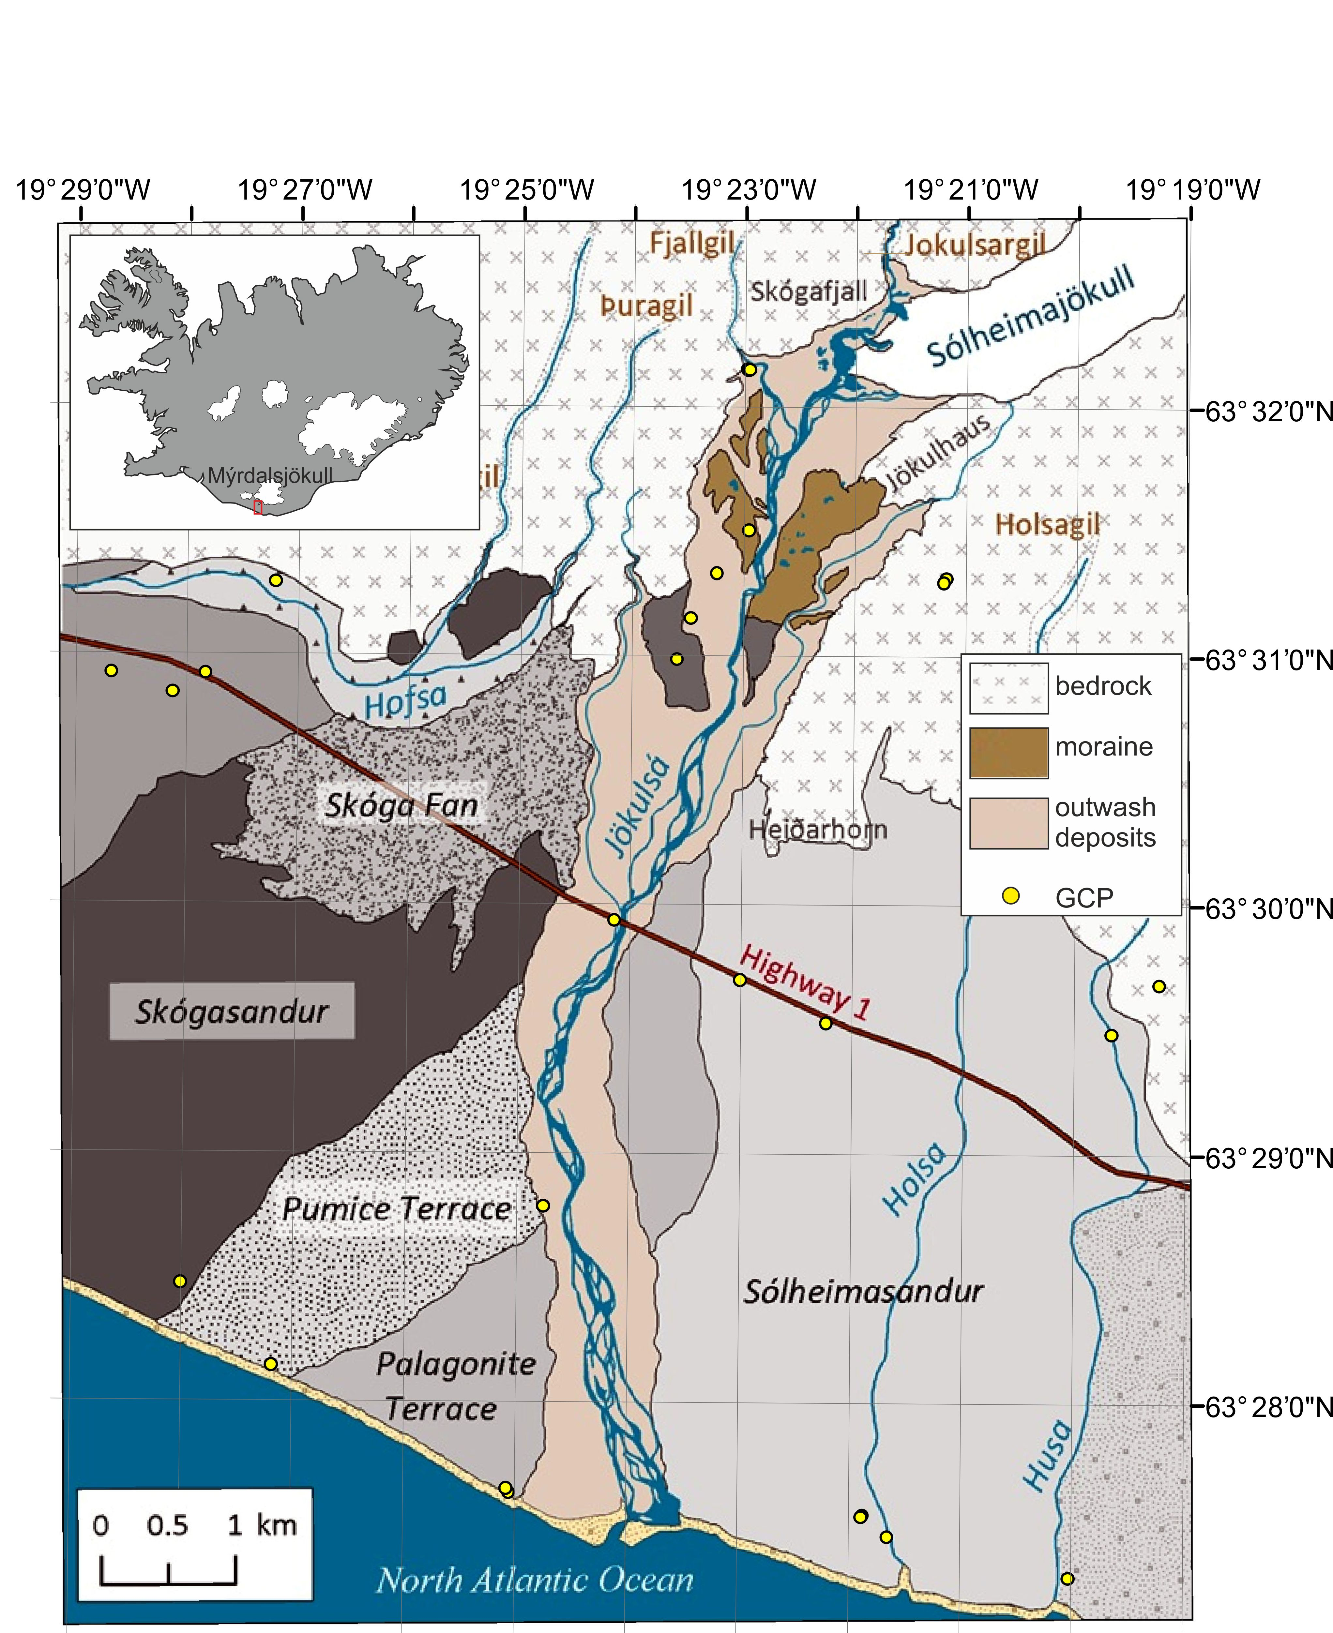

Figure 1: Overview of study site. The five distinct Holocene sandur surfaces (greyshades; named in italics) are after Maizels (1989a, b). Note that 14 other GCPs were located outside of the limit of this diagram.

A multi-dimensional analysis of proglacial landscape
change at Sólheimajökull, southern Iceland
Kate E.H. Staines, Jonathan L. Carrivick, Fiona S. Tweed, Andrew J. Evans, Andrew J. Russell, Tómas Jóhannesson, Matthew Roberts

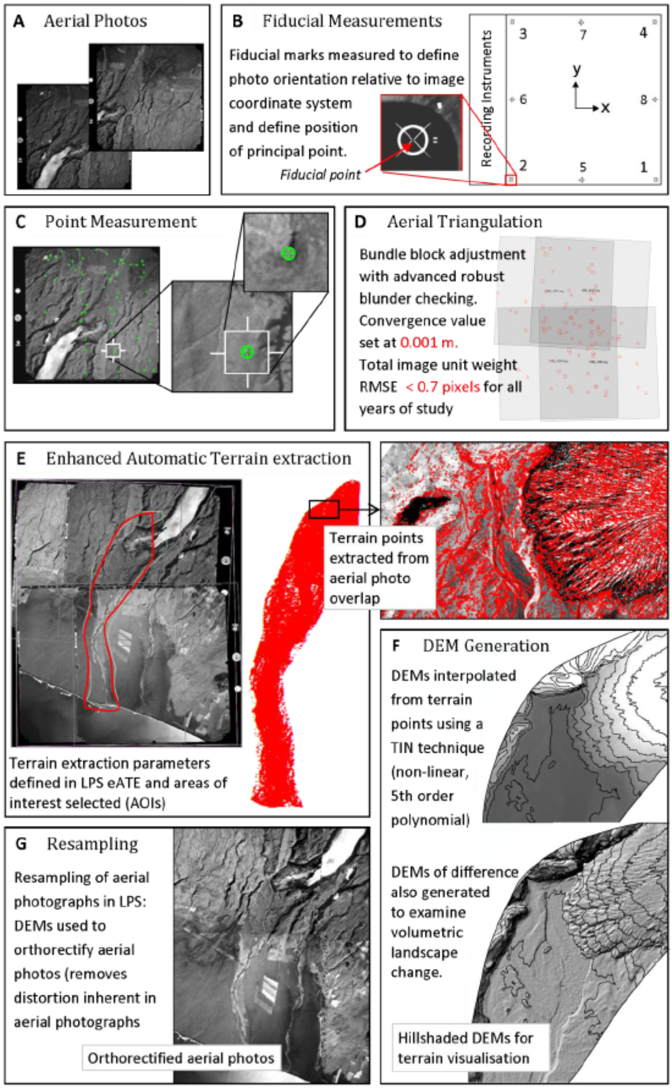
Figure 2: Overview of photogrammetry method used to create orthorectified images and to extract terrain.

A multi-dimensional analysis of proglacial landscape
change at Sólheimajökull, southern Iceland
Kate E.H. Staines, Jonathan L. Carrivick, Fiona S. Tweed, Andrew J. Evans, Andrew J. Russell, Tómas Jóhannesson, Matthew Roberts
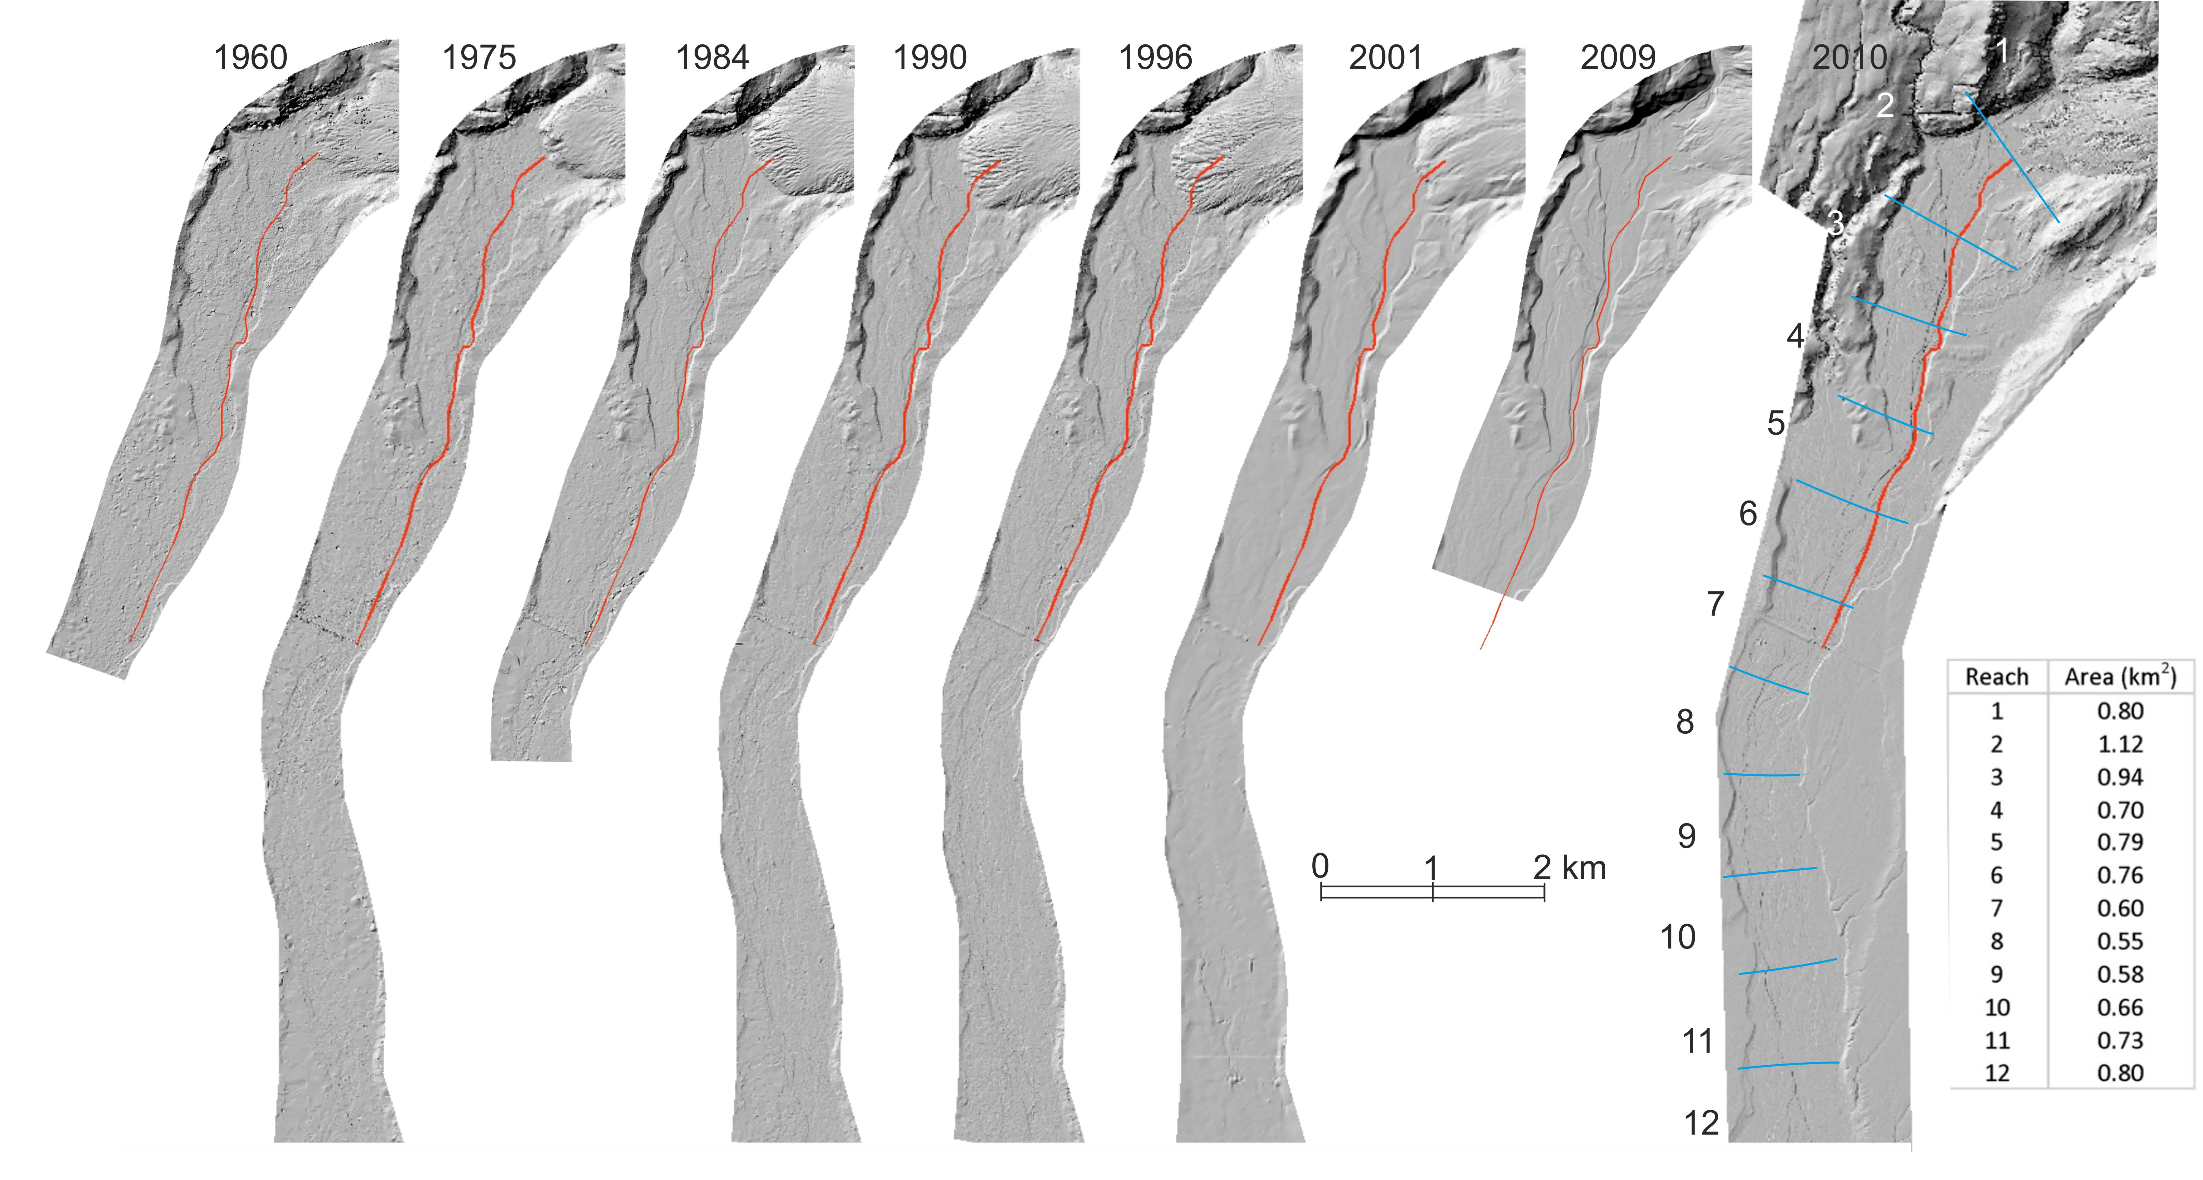
Figure 3: Hillshaded DEMs 1960 to 2010. DEMs 1960 to 1996 generated from photogrammetric terrain points. 2001 and 2009 DEMs created from contour lines. 2010 DEM created from airborne LiDAR point cloud. Definition of fluvial reaches was based on mean wetted width. The red line is the long profile analysed in Figure 7. The inset Table denotes the number and area of the 12 river reaches that are marked in the 2010 map, and that are used in subsequent analysis of the river. A video animation of these hillshaded DEMs is provided as supplementary information.
A multi-dimensional analysis of proglacial landscape
change at Sólheimajökull, southern Iceland
Kate E.H. Staines, Jonathan L. Carrivick, Fiona S. Tweed, Andrew J. Evans, Andrew J. Russell, Tómas Jóhannesson, Matthew Roberts

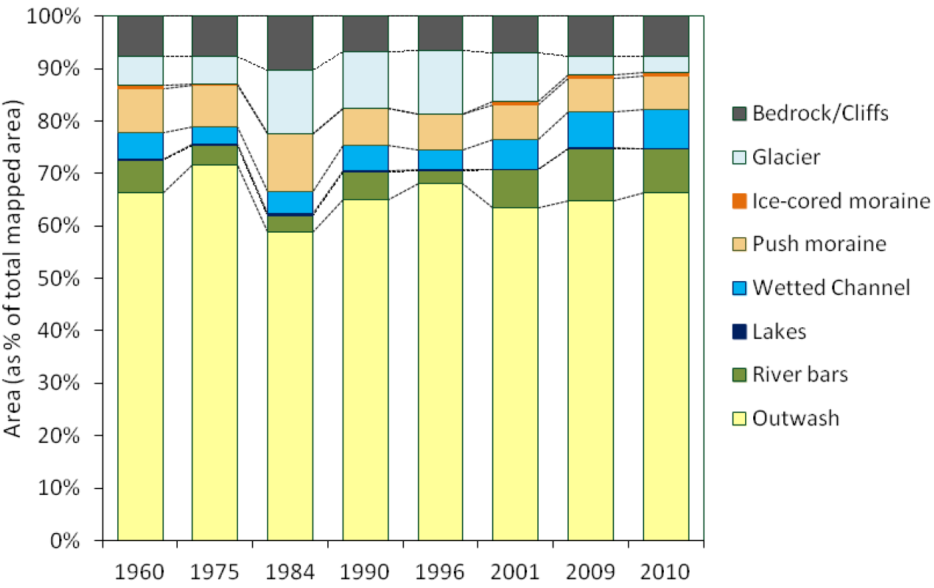
Figure 4. Percentage area occupied by major categories of landforms. The ‘glacier’ refers only to the ice mapped within the study area.

A multi-dimensional analysis of proglacial landscape
change at Sólheimajökull, southern Iceland
Kate E.H. Staines, Jonathan L. Carrivick, Fiona S. Tweed, Andrew J. Evans, Andrew J. Russell, Tómas Jóhannesson, Matthew Roberts

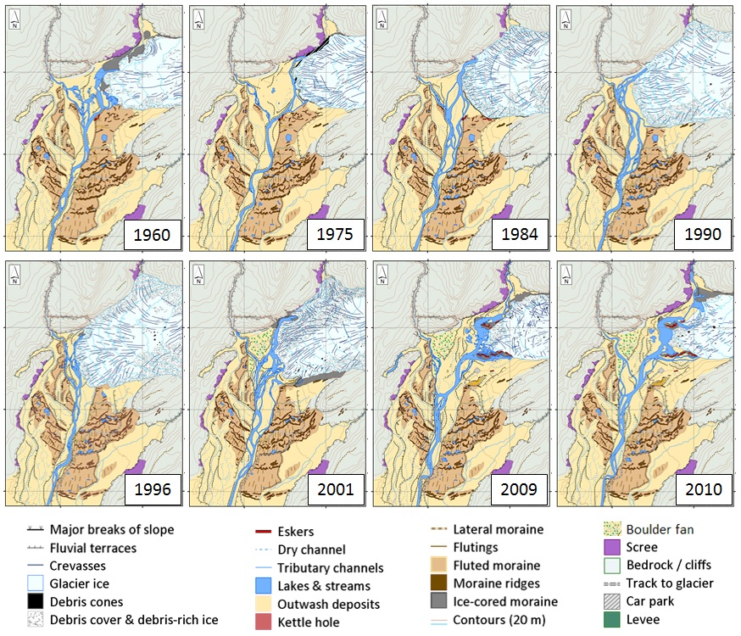
Figure 5: Glacier and immediate ice-proximal area geomorphology from 1960 to 2010. A video animation of these maps is provided as supplementary information.

A multi-dimensional analysis of proglacial landscape
change at Sólheimajökull, southern Iceland
Kate E.H. Staines, Jonathan L. Carrivick, Fiona S. Tweed, Andrew J. Evans, Andrew J. Russell, Tómas Jóhannesson, Matthew Roberts

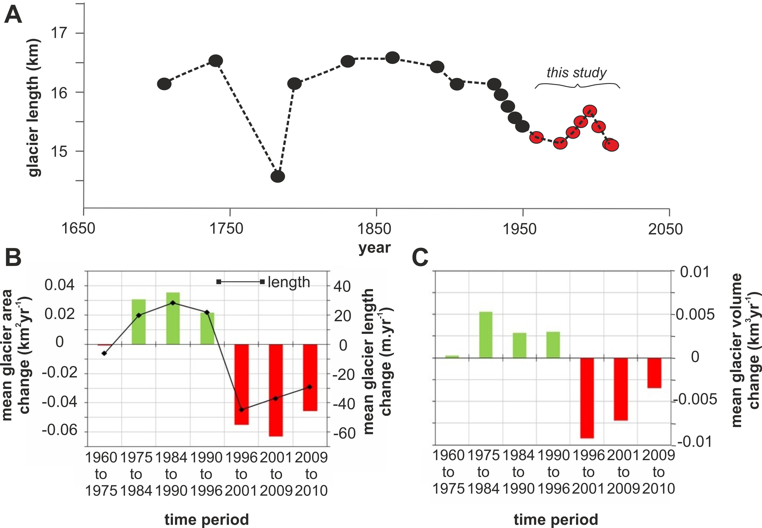
Figure 6: Glacier length changes from data presented in Mackintosh (2002) and from this study (A), and mean annual rates of glacier area (bars) and length (line) (B), and volume (C) change.

A multi-dimensional analysis of proglacial landscape
change at Sólheimajökull, southern Iceland
Kate E.H. Staines, Jonathan L. Carrivick, Fiona S. Tweed, Andrew J. Evans, Andrew J. Russell, Tómas Jóhannesson, Matthew Roberts

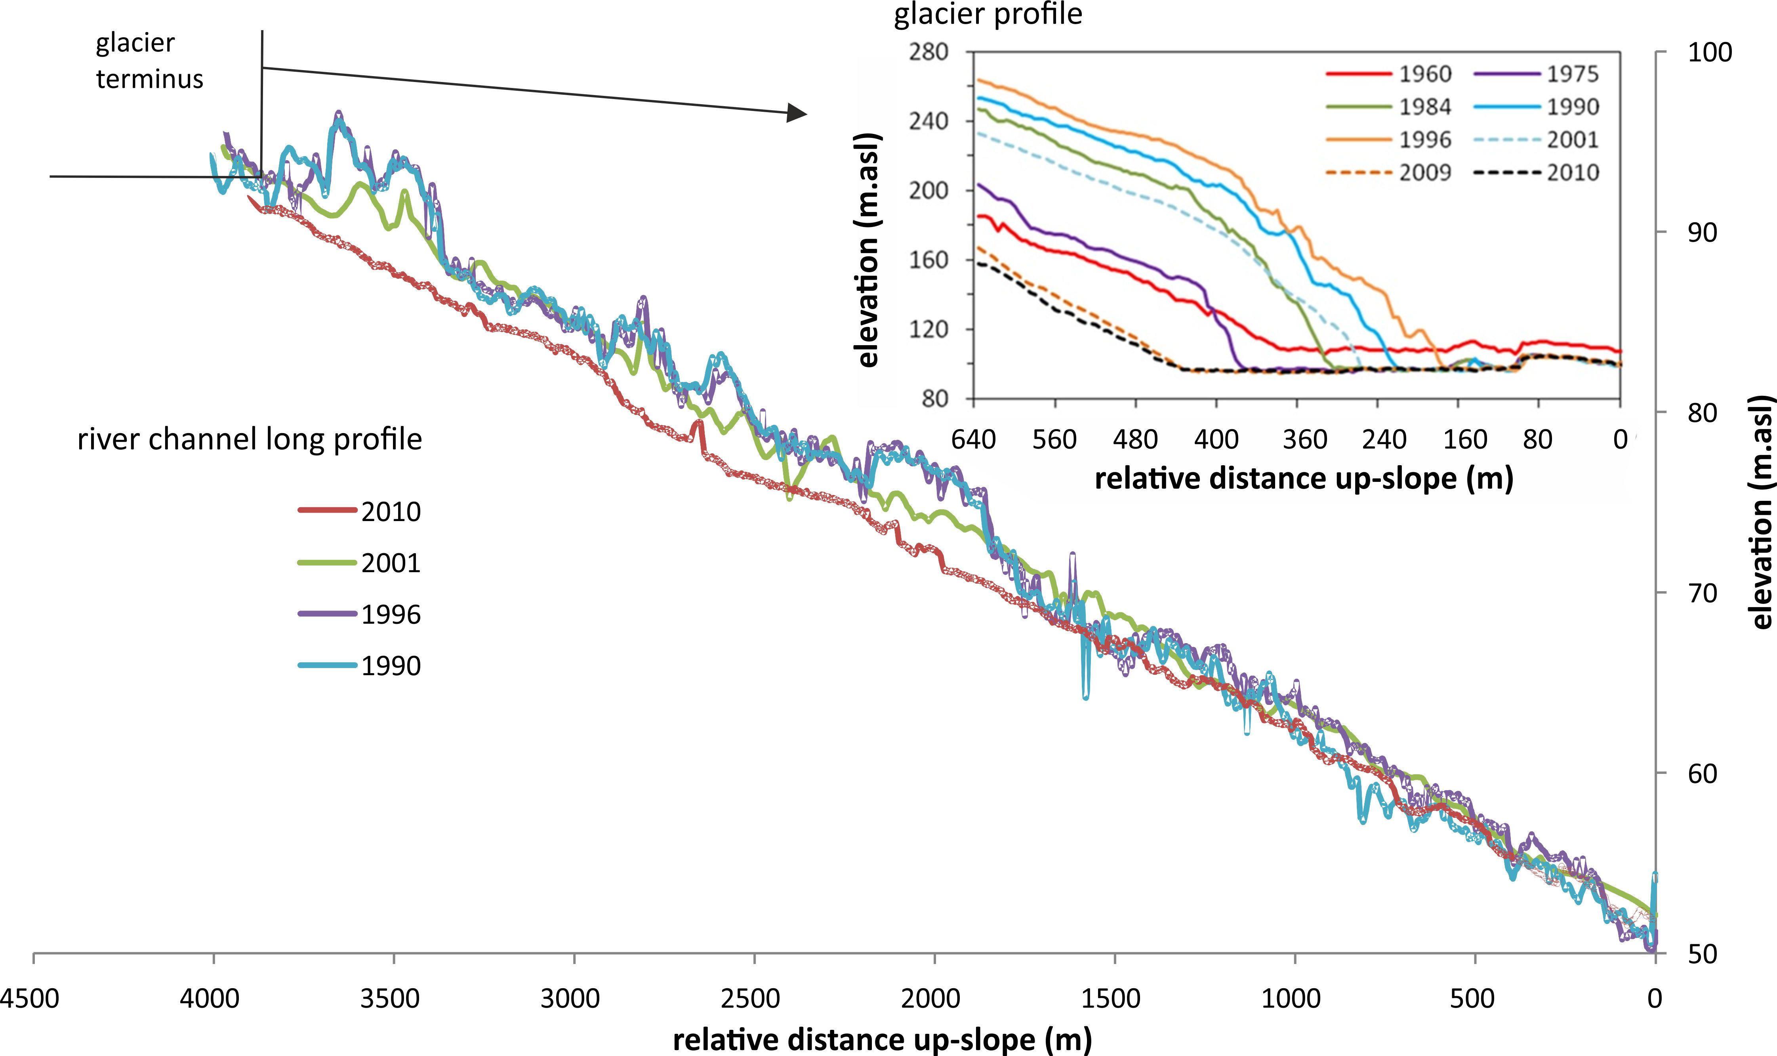

Figure 7: Proglacial river long profile and glacier surface, for selected years. Note smoothing of river long profile between 1996 and 2001 due to the 1999 jökulhlaup.

A multi-dimensional analysis of proglacial landscape
change at Sólheimajökull, southern Iceland
Kate E.H. Staines, Jonathan L. Carrivick, Fiona S. Tweed, Andrew J. Evans, Andrew J. Russell, Tómas Jóhannesson, Matthew Roberts

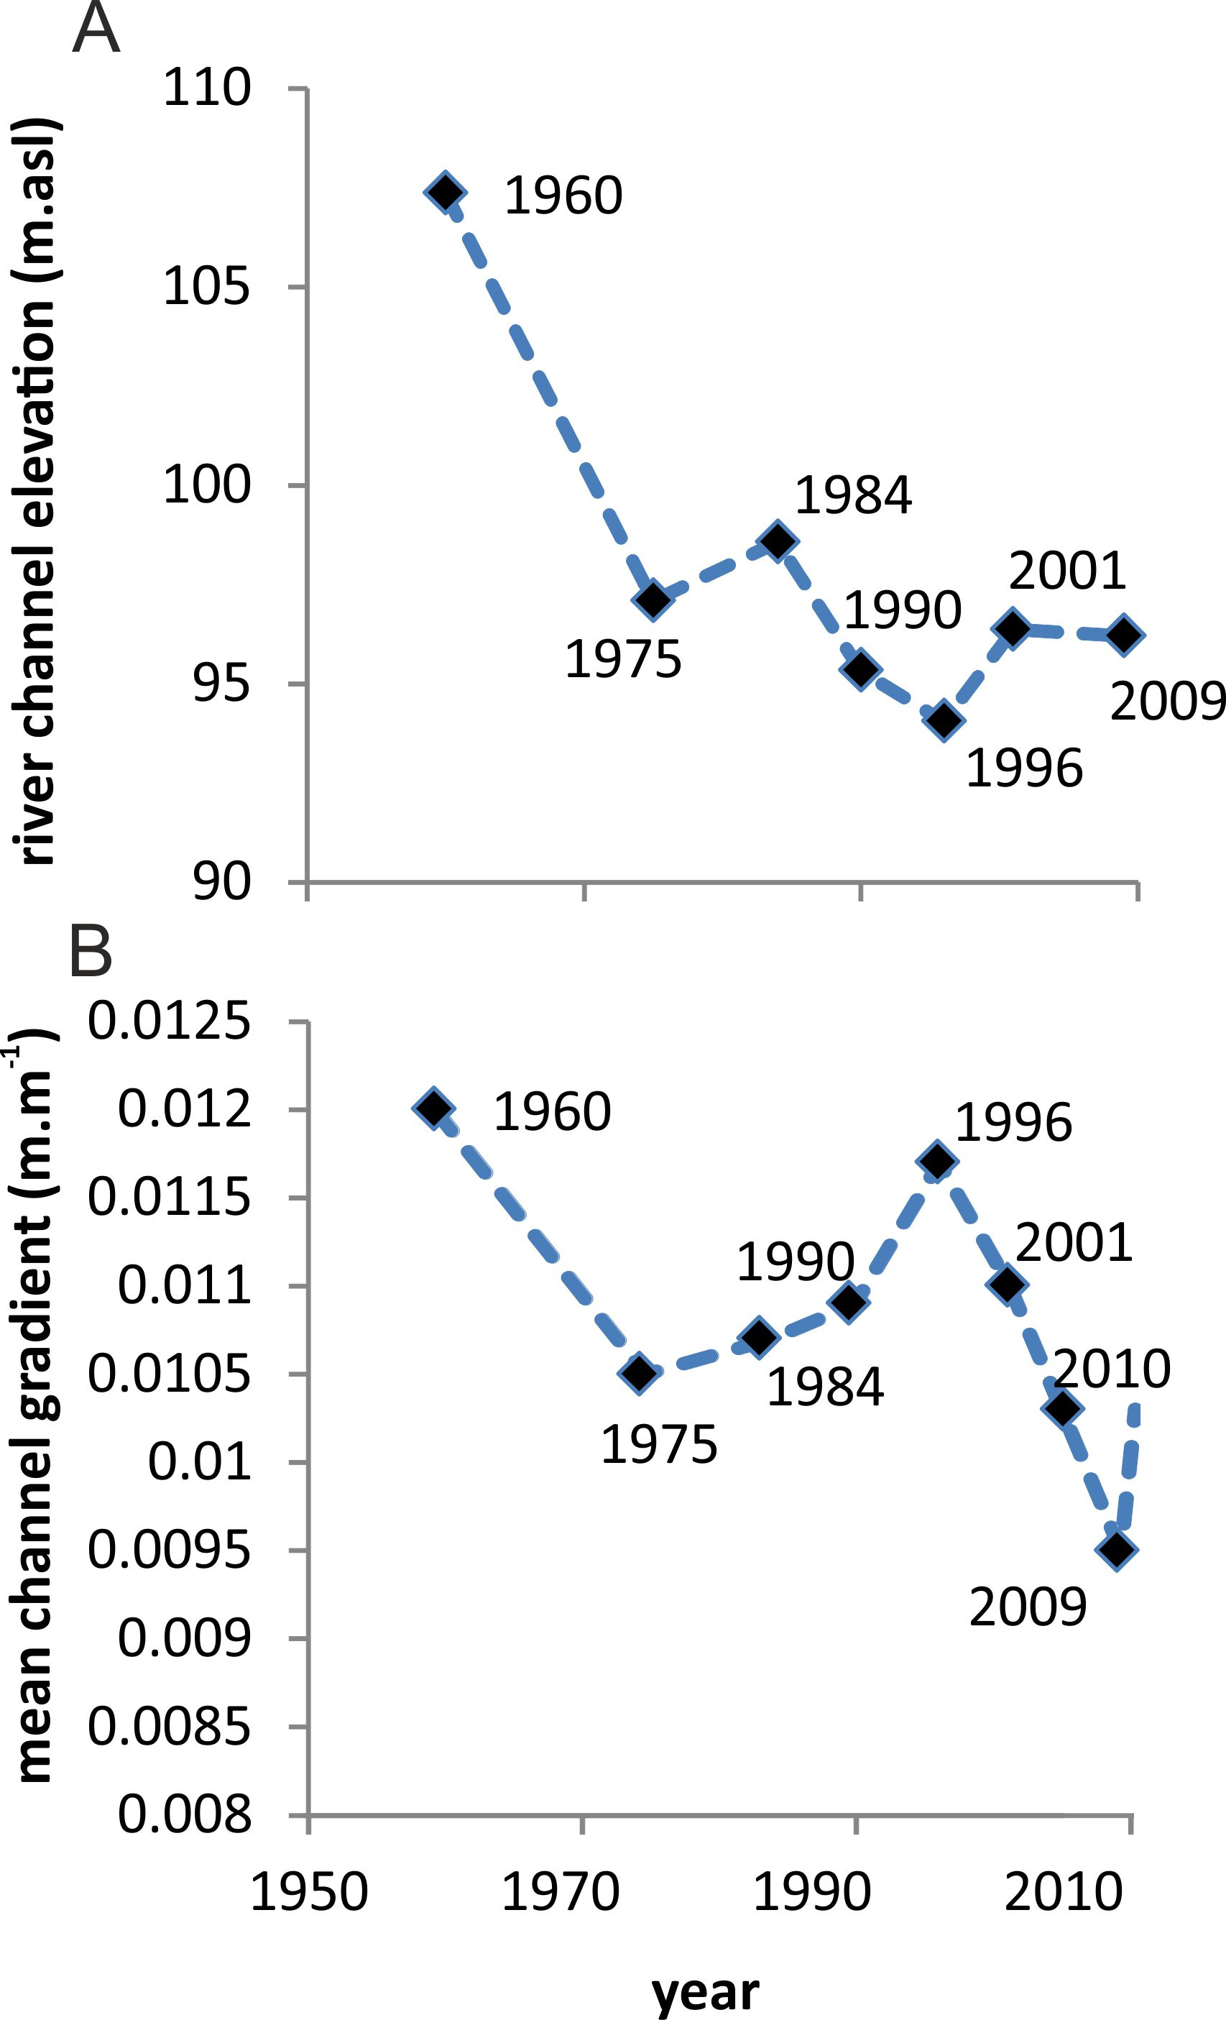
Figure 8: Evolution of proglacial river channel head elevation (A) and mean gradient (B) in response to glacier terminus position changes and ice-marginal lake development.

A multi-dimensional analysis of proglacial landscape
change at Sólheimajökull, southern Iceland
Kate E.H. Staines, Jonathan L. Carrivick, Fiona S. Tweed, Andrew J. Evans, Andrew J. Russell, Tómas Jóhannesson, Matthew Roberts

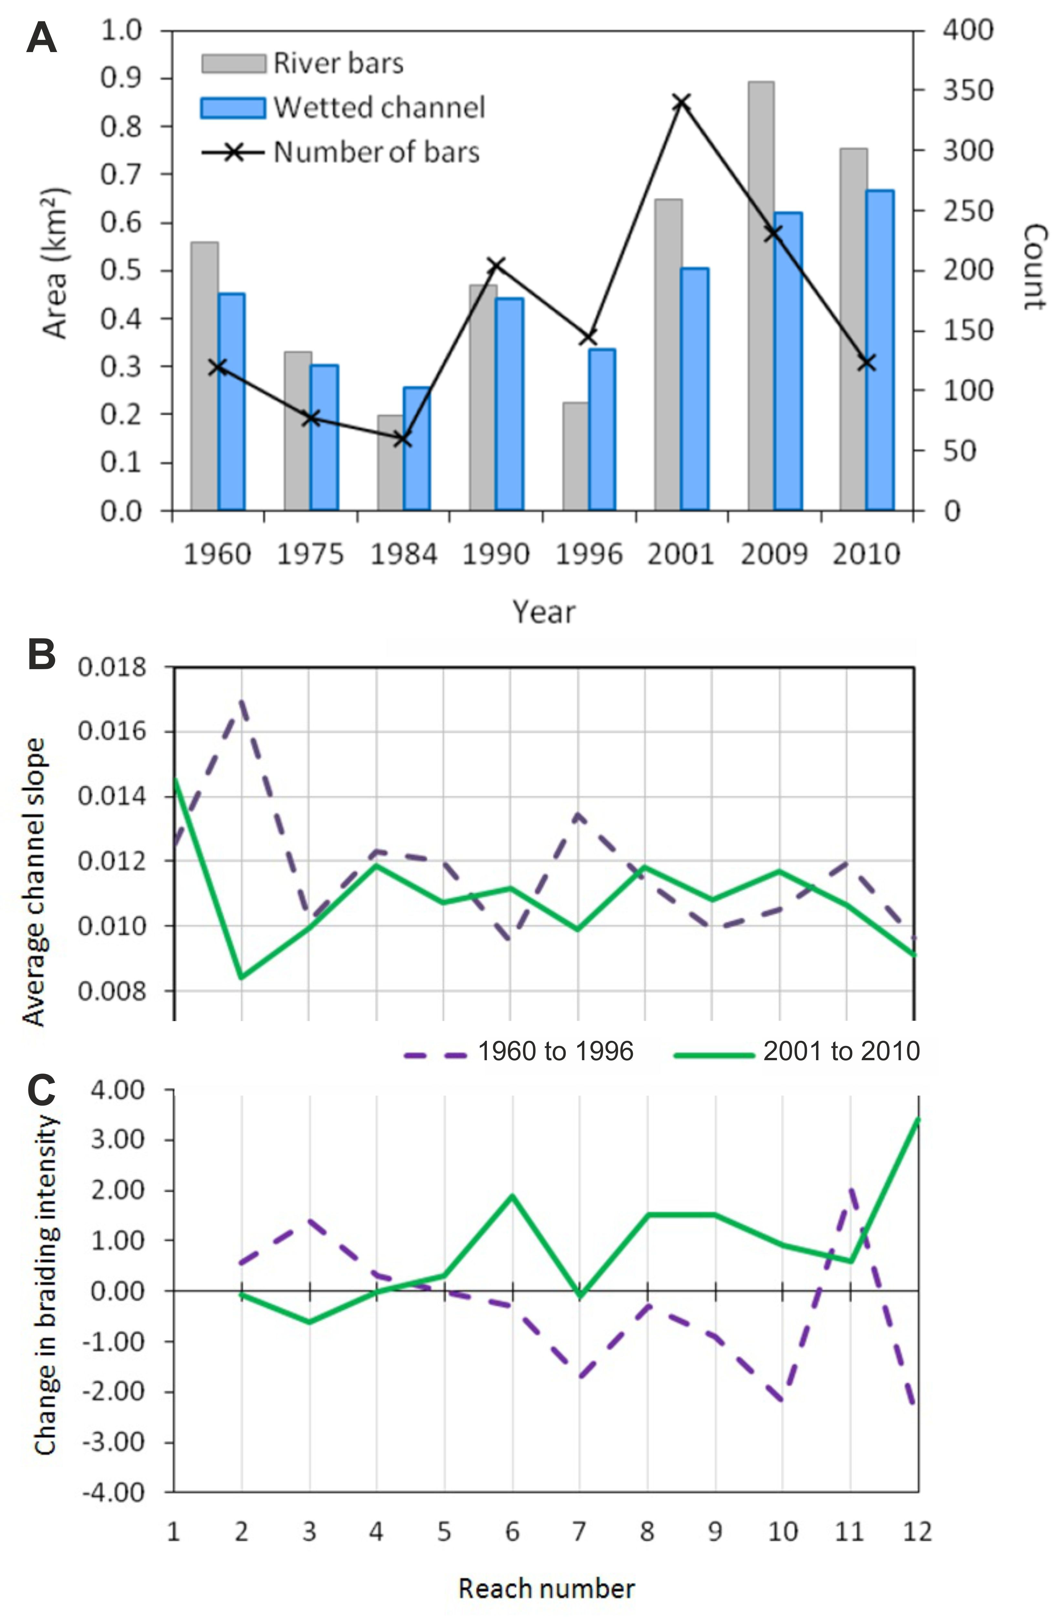
Figure 9: Quantification of spatiotemporal evolution in proglacial braided river, using metrics of area of bars, wetted area and number of bars (A), channel slope (B) and braiding intensity (C). Note highlighted difference in the braided river in the time periods 1960 to 1996 and 2001 to 2010.

A multi-dimensional analysis of proglacial landscape
change at Sólheimajökull, southern Iceland
Kate E.H. Staines, Jonathan L. Carrivick, Fiona S. Tweed, Andrew J. Evans, Andrew J. Russell, Tómas Jóhannesson, Matthew Roberts

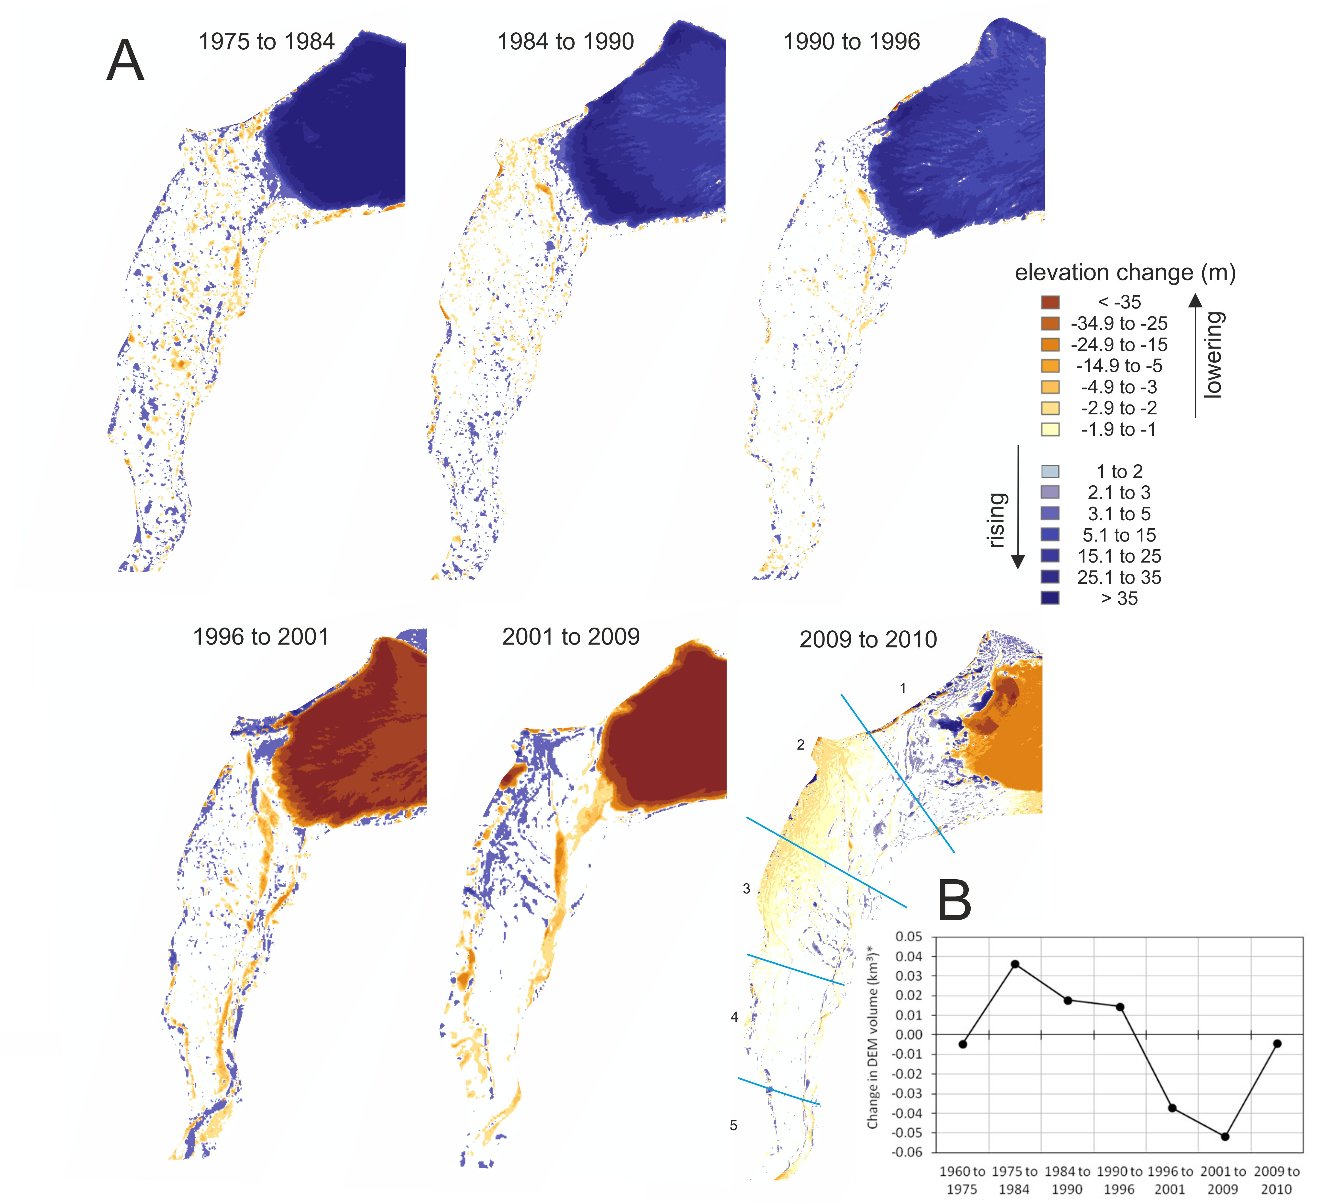
Figure 10: Spatial pattern of elevation changes in time periods between DEMs from 1960 to 2010 (A). Note glacier advance and thickening until 1996, then recession of terminus and thinning. Note relative incoherence (which includes some random error) in proglacial area up to 1996, then impact and adjustment to 1999 jökulhlaup. Part B summarises the change in DEM volume for river reaches 1 to 6 (i.e. the most ice-proximal reaches) for each time period.

A multi-dimensional analysis of proglacial landscape
change at Sólheimajökull, southern Iceland
Kate E.H. Staines, Jonathan L. Carrivick, Fiona S. Tweed, Andrew J. Evans, Andrew J. Russell, Tómas Jóhannesson, Matthew Roberts

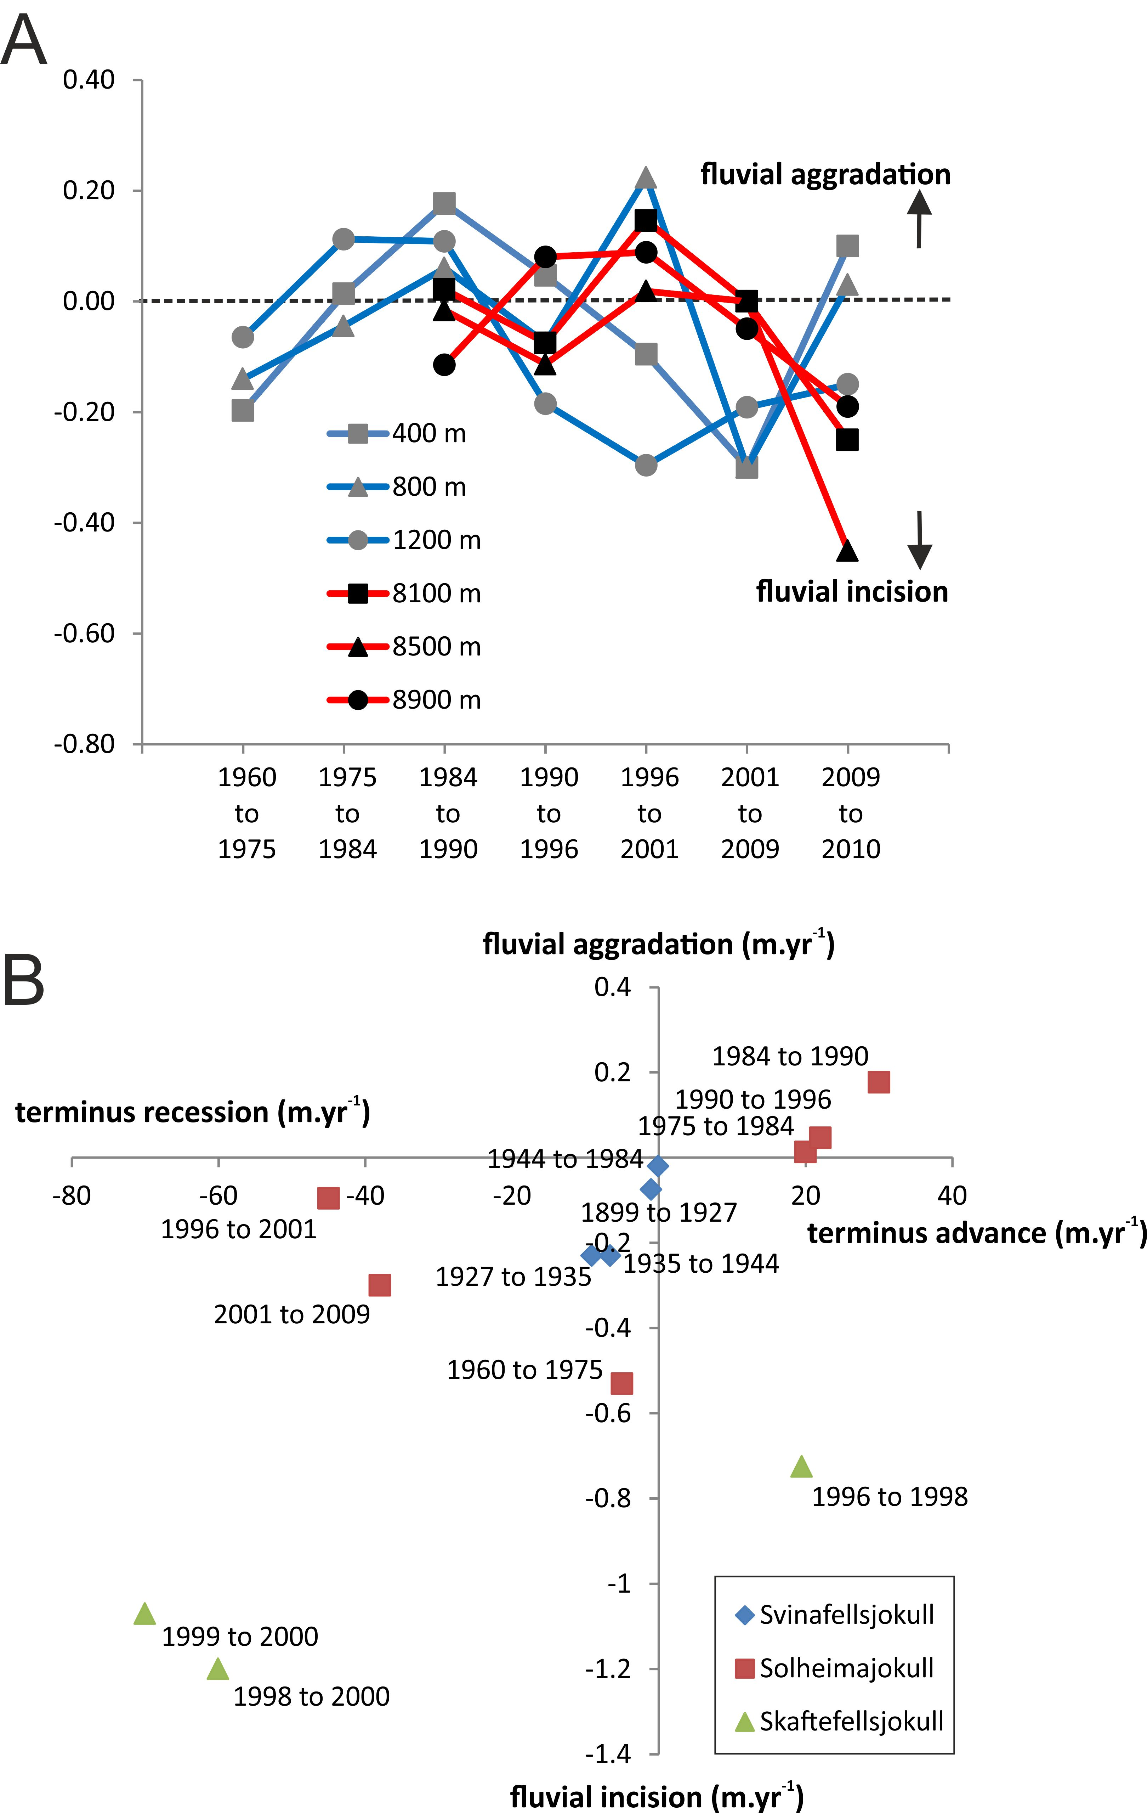

Figure 11: Typical rates of elevation change in the proglacial fluvial area of Sólheimasandur, at three distances down channel from the ice margin chosen to be representative of proximal conditions (blue lines) and at three distances representing distal conditions (red lines) (A). Note data from just 6 of 114 cross sections are displayed in A for clarity. Part B illustrates a comparison of these mean rates of proglacial elevation change with data from Svinafellsjökull (Thompson and Jones, 1986) and Skaftefellsjökull (Marren, 2002c). Note rates of change in elevation by all three studies in part B are based on elevation measurements at selected channel cross-sections; those from this study are those in part A. Note in part B the hint of a control of interval between observations on rates of elevation change measured.

