The relationship between arch height and foot length: Implications for size grading

.
.

Research Highlights

- The direct proportional relationship of foot length and instep dimensions was explored in a normal population
- Foot length demonstrated poor predictive ability on variation of dorsal and plantar arch height.
- Footwear design based on proportionate scaling of instep dimensions with foot length may not be ideal for ergonomic footwear fit.

Abstract
Objective: Medial longitudinal Arch Height is synonymous with classifying foot type and conversely foot function. Detailed knowledge of foot anthropometry is essential in the development of ergonomically sound footwear. Current Footwear design Incorporates a direct proportionate scaling of instep dimensions with those of foot length. The objective of this paper is to investigate if a direct proportional relationship exists between human arch height parameters and foot length in subjects with normal foot posture.

Method: A healthy convenience sample of 62 volunteers was recruited to participate in this observational study. All subjects were screened for normal foot health and posture. Each subject’s foot dimensions were scanned and measured using a 3D Foot Scanner. From this foot length and arch height parameters were obtained. Normalised ratios of arch height with respect to foot length were also calculated. The arch height parameters and the normalised arch ratios were used interchangeably as the dependent variables with the foot length parameters used as the independent variable for Simple Linear Regression and Correlation.
Results Analysis of foot length measures demonstrated poor correlation with all arch height parameters.
Conclusion No significant relationships between arch height and foot length were found. The predictive value of the relationship was found to be poor. This holds significant implications for the current method of proportionate scaling of footwear in terms of fit and function to the midfoot region for a normative population.

Key Words: Anthropometry, Allometry, Footwear, Medial Longitudinal Arch, Footwear Last, Footwear Sizing, Footwear Grading

Abbreviations: (MLA-Medial Longitudinal Arch, FPI- Foot posture Index, FL_TOT-Foot Length Total, INS_L-Instep Length, INS_H-Instep Height, N_H-Navicular Height, NNH_Ins-Normalised Navicular Height to Instep Length, AHI_Ins, Arch Height Index to Instep Length, NNH_TOT-Normalised Navicular Height to Total Foot Length, AHI_TOT, Arch Height Index to Total Foot Length)

1-Introduction

The study of the medial longitudinal arch (MLA) has been the primary anthropometric measure to determine foot type and function throughout the history of anthropology ranging from antiquity (Xarchas & Tsolakidis 2004) to modern day research (Xiong et al., 2010, Pohl & Farr 2010, Murley et al., 2009a, Razeghi & Batt 2002, Williams & McClay 2000). The anatomy of the MLA enables it to function as a truss resolving the loads applied to it into compressive and tensile stresses exploiting the mechanical resistant properties of bone and fascia (Kogler et al., 1999). The Arch shows a high degree of resilience, providing shock attenuation via lengthening in initial loading and recoiling to form a relatively rigid lever during propulsive activities (Nielson et al., 2009, Vinicombe et al., 2001, Xiong et al., 2010).

The shape of MLA is widely variable with demographics such as: race (Igbigbi & Msamati 2002), sex (Krauss et al 2008, Wunderlich & Cavanagh 2001), body type (Dowling et al 2001, Morrison et al 2007), age (Gilmour & Burns 2001, Scott et al 2007), and even geographical location (Mauch et al 2008) displaying notable structural variation in a healthy population, ranging from highly arched to flat (Redmond et al., 2008). Variations in MLA dimensions have been shown to influence the activity of lower limb muscle groups in gait (Murley et al., 2009a) and predispose to injury, high arched dimensions tending towards: skeletal, ankle and lateral lower extremity injury, with those of low arched dimensions predisposing to: soft tissue, knee and medial lower extremity injury. (Williams et al., 2001, Cowan et al., 1993, Cain et al., 2007, Burns et al., 2005)

Numerous methods have been developed to quantify the medial longitudinal arch with considerable debate still on going as to the validity of these various measures (Xiong et al 2010, Razeghi & Batt 2002). The existing measures reported in the literature are based on morphological parameters of the MLA. Methods for classification of the MLA can be placed into one of the following general categories

1) Visual non-quantitative Clinical Subjective Ranking 2) Footprint Indices either Ratio related (Area index, Length Index, Width index) or Angle related 3) Anthropometric Dimension Indices Direct measured values of skeletal landmarks. 4) Anthropometric Angular Indices Measures of skeletal angulation. 5) Foot Mobility Indices Measures of Change in MLA dimension between two stated static positions.

The techniques used to determine the indices are various and include, inked foot printing, pressure mapping, calliper based measurements, radiographic imaging, digital photography, simple visual observation, and most recently three dimensional laser scanning (Xiong et al 2010, Xiong et al 2008, Pohl & Farr 2010, Murley et al 2009b, McPoil et al 2009, McPoil et al 2008a, McPoil et al 2008b, Williams & McClay 2000, Chu et al 1995, Shiang et al 1998, Menz 1998, Cavanagh & Rodgers 1987).

Navicular height defined as the distance from the medial tuberosity of the navicular to the supporting surface is considered to be the best approximation of plantar MLA height, representing the peak of the calcaneal inclination angle (CAI) (Figure 1) (Murley et al., 2009b, Razeghi & Batt 2002, Saltzman et al., 1995). Instep height at 50% total foot length is considered the best approximation of dorsal MLA height (Williams & McClay 2000) representing the dorsal aspect of the medial cuneiform (McPoil et al., 2009), which lies along the inclination angle of the first metatarsal (Figure 1) (Xiong et al., 2010) . Both measures have previously been captured with calliper-based techniques and have demonstrated face validity compared with lateral radiographs of the MLA, (Menz & Munteanu 2005, Williams & McClay 2000, Saltzman et al 1995 Pohl & Farr 2010, Murley et al 2009b). Three-dimensional laser scanning has the advantage of capturing data more rapidly than calliper based techniques, and has increasingly been used in ergonomic and clinical studies (Xiong et al 2008, Krauss et al 2008, Mickle et al 2010, Witana et al 2006, Pfeiffer et al 2006, Telfer & Woodburn 2010, De Mits et al 2010, De Mits et al 2011).

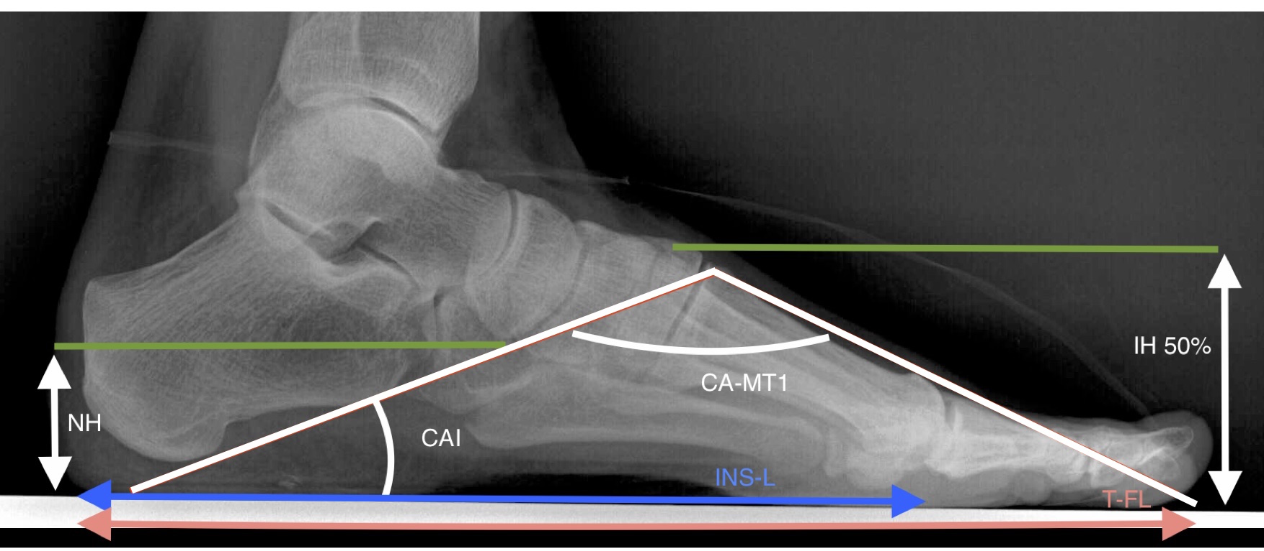
Figure 1 Skeletal arrangement of the medial longitudinal arch. Calcaneal Inclination Angle (Defined as the angle between the tangent to the inferior surface of the calcaneus and the horizontal plane.) (CAI), Calcaneal First Metatarsal Angle (Defined as the angle subtended by tangent to the inferior surface of the calcaneus and the tangent to the dorsal surface of the 1st metatarsal.) (CA-MT1) Instep/Truncated Foot Length (INS-L) Total Foot Length (TF-L) Navicular Height (NH) Instep Height at 50% total foot length (IH 50%).

Scanners such as the USB standard INFOOT 3-D digitizer model IFU-S-01 (I-Ware Laboratory Co Ltd) have shown substantial to near perfect inter and intra rater reliability, and has established validity in comparison to clinical calliper data and radiographic measurements (De Mits et al 2010, De Mits et al 2011).

Even with valid and reliable measures there has been a lack of clarity as to what constitutes abnormal arch height (Murley et al 2009b). Navicular height and dorsal arch height cannot be used alone since the shape of the arch. (Figure 1) is roughly a triangular relationship between arch length and arch height (Figure 1) i.e. a 30mm navicular height would represent a different calcaneal inclination angle in an individual with a standard EU size 43 to that of an individual with EU size 36, dividing the height measures by foot length provide gradient indices to account for this. The normalised navicular height measure (NNH) divides navicular height by foot length and the arch height index (AHI) is the ratio of the instep height at 50% foot length and the foot length (Williams & McClay 2000)

The foot length is defined as either the total foot length (the distance between the most posterior aspect of the heel and the longest toe measured along the foot axis), or truncated foot length/instep length (defined as the perpendicular distance from the first metatarso-phalangeal joint to the most posterior aspect of the heel (Figure 1). These height to length gradients are representative of the calcaneal inclination and calcaneal first metatarsal angles (Figure 1) enabling comparison of arch height throughout the range of foot lengths (Williams & McClay 2000). These normalised measures can only accommodate for the differences if there is a linear relationship between the arch height and foot length measures. However it is not readily apparent in the literature if a linear relationship exists between arch height and foot length (Xiong et al 2008).

Xiong and co-workers (2008) noted this paucity in the literature and concluded that the lack of the true relationship between foot height and foot length dimensions could lead to poor generalised footwear models. While dimensions such as overall stature and foot length have shown a significant proportional relationship (Krishan 2008), it is well documented that no linear relationship exist between the width based foot dimensions and total foot length (Xiong et al 2008). This indicates that various characteristic dimensional foot types are not distributed homogeneously throughout foot length with shorter feet being wider in proportion to those of longer length (Mauch et al 2007,Mauch et al 2009, Bataller et al 2001,Krauss et al 2007, Krauss et al 2008).

To investigate the relationship between arch height and length Xiong et al (2008) and Li et al (2005) studied the relationship of midfoot height and overall foot length dimensions in a healthy sample of a mixed gender using 3 dimensional laser scanning technique. While both studies reported total foot length to be a poor predictor of dorsal arch height, they were carried out exclusively on a Chinese sample with Xiong et al (2008), stating that the results might not be generalizable to other ethnicities.

It has also been previously established that excessive pronation and supination have dimensional effects on the MLA (Vinicombe et al 2001) and must be controlled for in a normal population (Vinicombe et al 2001). Xiong et al (2008) and Li et al (2005) did not appear to control for these variables in their sample. In addition Xiong et al (2008) did not explore or comment on the relationship between foot length and plantar arch height (Navicular Height).

Therefore, the specific aim of this study was to determine if a significant linear relationship exists between medial longitudinal dorsal or plantar arch height and foot length in a Caucasian sample with normal foot posture.

2-Materials and Methods

2.1-Participants
A healthy convenience sample of 62 volunteers was obtained female n= 30 male n=32 (Table 1). The ethical review board at the University approved the study and all subjects gave their written informed consent before participating in the study. Subject’s standing foot posture was assessed for normalcy via the 6 Point Foot Posture index (FPI-6) (Redmond et al., 2006, Redmond et al., 2008).
Criteria for inclusion into the study were:
- No reports of lower limb problems Congenital or Acquired
- 6-FPI score of 0 to +4
- Additional criteria of scores in the arch region of the 6-FPI being 0.

Table 1
Demographic Descriptive Statistics
GENDER |  | AGE  (Yrs.) | WEIGHT  (Kg) | HEIGHT  (m) | BMI  (Kg/m²⁾
Males  (N=32) | Mean | 39.91 | 85.06 | 1.80 | 26.30
 | Std. Deviation (+/-) | 11.88 | 10.04 | 0.06 | 3.71
Females  (N=30) | Mean | 36.80 | 67.43 | 1.65 | 24.96
 | Std. Deviation (+/-) | 11.44 | 13.25 | 0.06 | 5.88

2.2-Data Collection (Procedures & Instrumentation)
In order to compare MLA and foot length characteristics the following anthropometrics were measured: Navicular height, Midfoot dorsal height, Foot length (total and truncated), The indices of Normalised measures of the navicular (NNH) and midfoot dorsal height (AHI) in respect to foot length were calculated from the anthropometrics obtained and correlated with length dimensions.

The USB standard INFOOT 3-D digitizer model IFU-S-01 (I-Ware Laboratory Co Ltd) was used to scan the subject’s feet. All methods of data collection met with international protocols for 3-D scanning and human body measurements (ISO 20685:2010, ISO 7250-1:2008). Calibration of the system was carried out with a test object of known dimensions prior to data collection.
Specific anatomical landmarks were palpated and marked bilaterally on each subject’s foot via green velvet markers. The markers were 5mm in diameter and 2mm thickness and , non reflective to the laser scanner(Figure 2 & 4). The markers were placed onto the subject’s feet in a 50% loaded condition to limit skin movements between marker placement and scanning (Nester 2009, De Mits et al 2011).

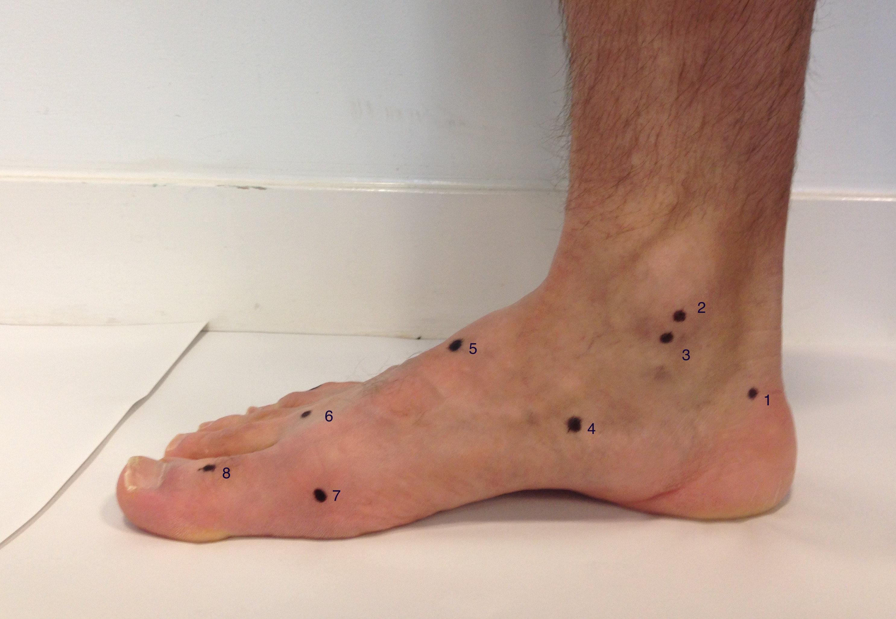
Fig. 2. Medial Reference Landmarks. 1) Inside Heel born point, 2) Medial Malleoli, 3) Tibial Sphyrion, 4) Navicular tuberosity, 5) Dorsal aspect of medial cuneiform, 6) Dorsal aspect of first metatarsal head, 7) Medial aspect of first metatarso-phalangeal joint, 8) Dorsal aspect of first inter phalangeal joint.
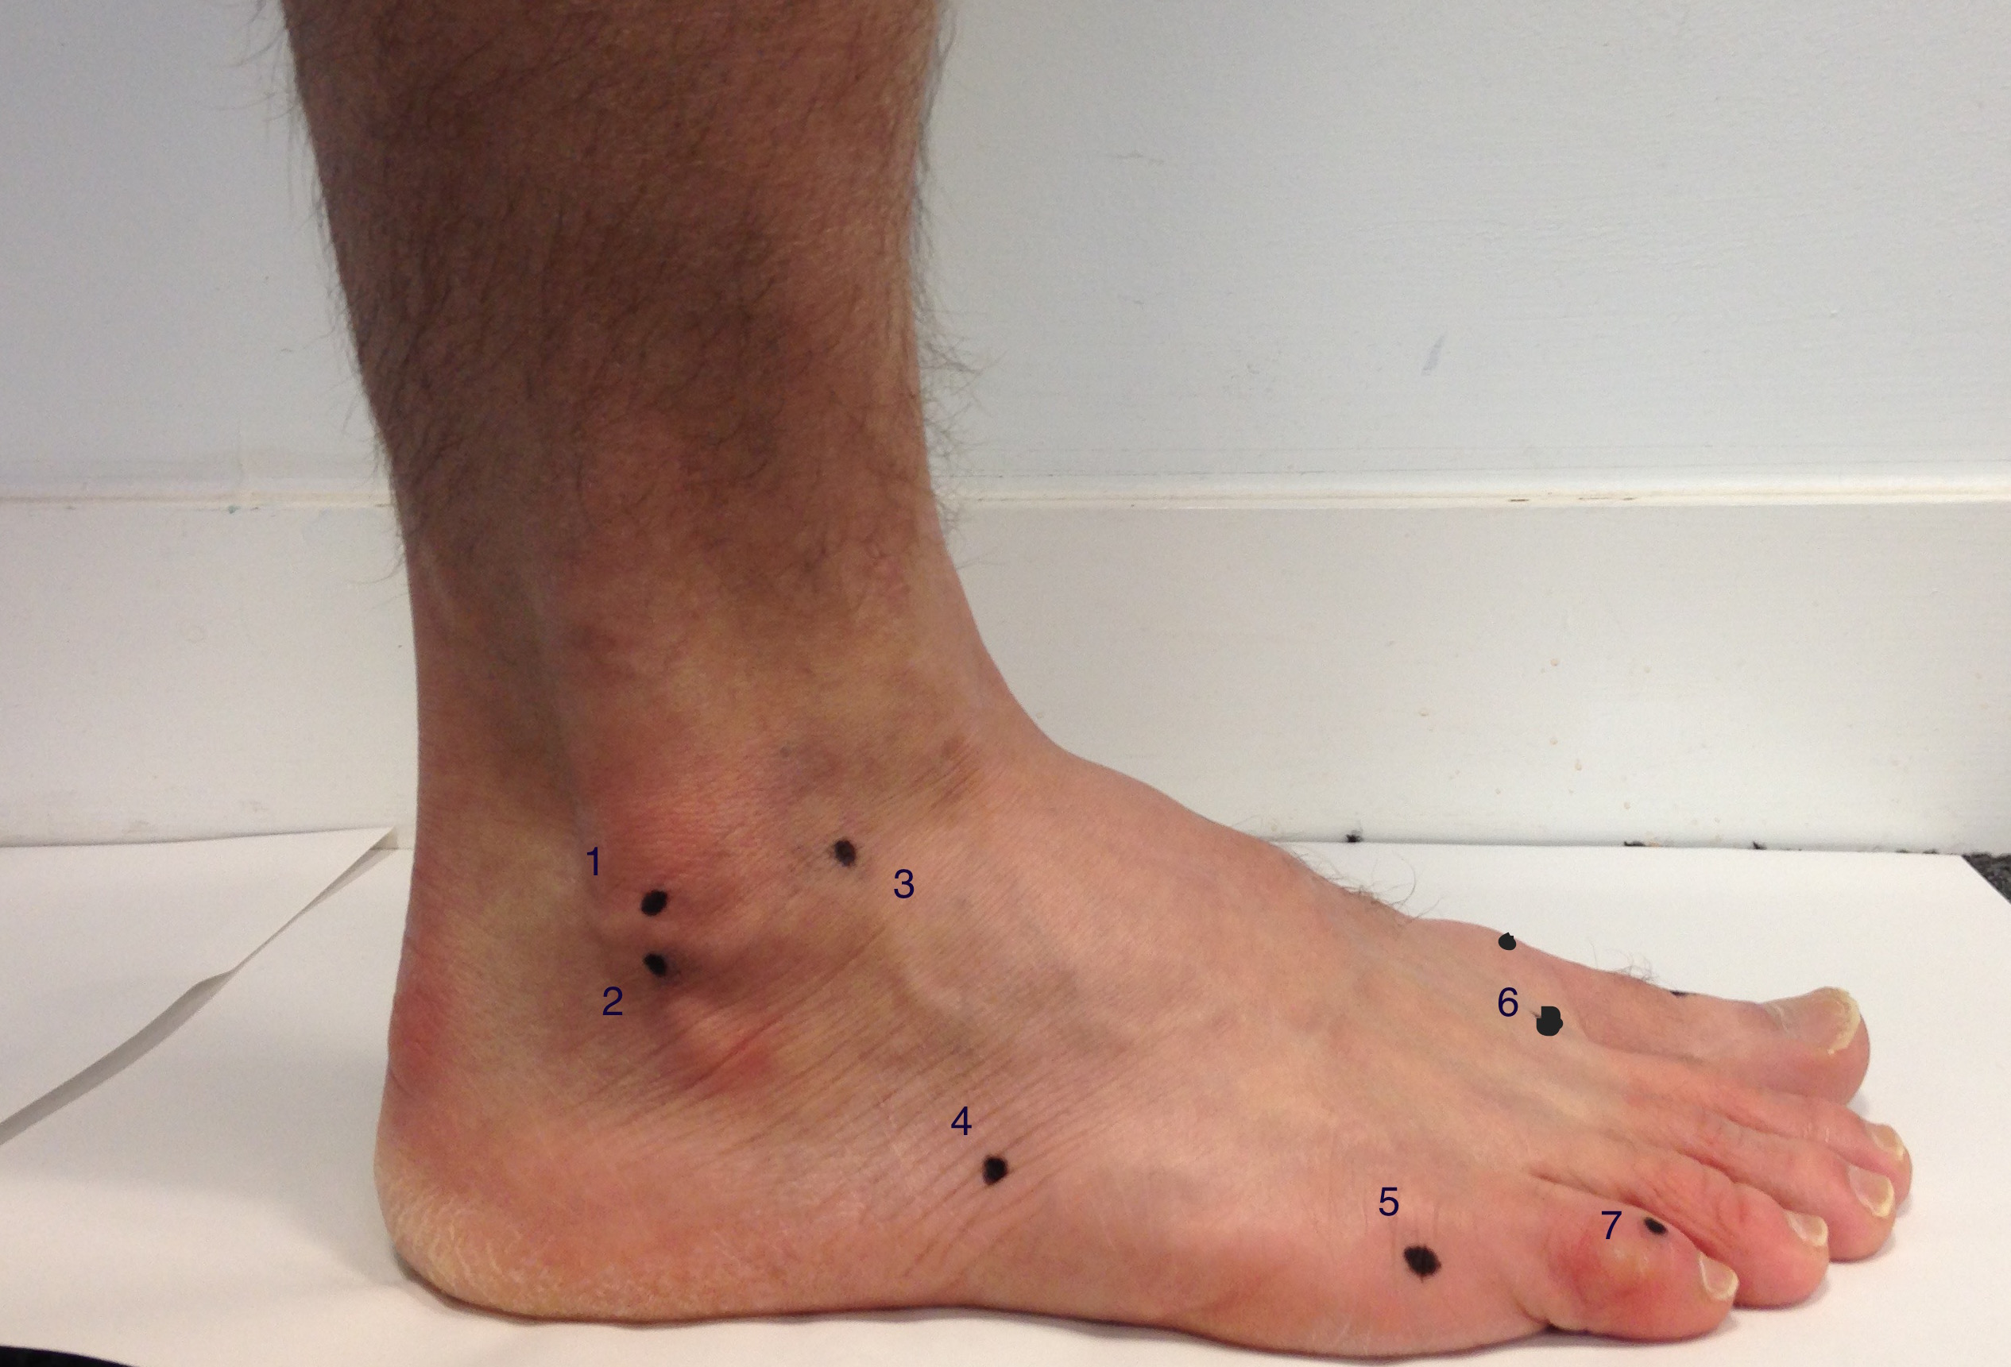
Fig. 3. Lateral Reference Landmarks. : 1) Lateral Malleoli, 2) Fibular Sphyrion, 3) Tentative junction of foot and ankle, 4) Tuberosity of fifth metatarsal, 5) Lateral aspect of fifth metatarso-phalangeal, 6) Dorsal aspect of second metatarsal head, 7) Inter- mediate phalanx of fifth toe.

Subjects were instructed to place their left foot in a relaxed stance position on to the glass footplate inside the laser scanner while the right foot was placed next to the scanner on a step of the same height. The foot was scanned with the data integrated via software to form a 3-D image of the left lower limb from which the anthropometric measures could be taken. Processed data was checked for marker placement and automatically calculated dimensions were then captured. Markers and foot placement were manually adjusted when required. The glass floor plate in the scanner was then cleared to remove prints and dust. The procedure was then repeated for the right foot. This procedure was deemed to approximate a relaxed 50% weight bearing position as advocated by international standards for foot measurements (ISO 7250-1:2008),

From the 22 measures generated by the scan four anthropometric values were used to explore the relationship of interest in this study:
- Total Foot Length: The distance between the pternion and the longest toe measured along the foot axis, (Figure 4). With the foot axis defined as a sagittal bisection of the foot from the midpoint of the posterior aspect of the heel to the second toe (Figure 4)
- Instep Length (Truncated Foot Length): Perpendicular distance from posterior aspect of the heel to the joint line of the first metatarsophalangeal joint. (Figure 4)
- Navicular Height: Distance between the navicular tuberosity and the supporting surface. (Figure 5)
- Instep Height (Midfoot Dorsal Height): The distance between the highest point of the instep and the supporting surface (Measurement taken at 50% foot length.) (Figure 5)

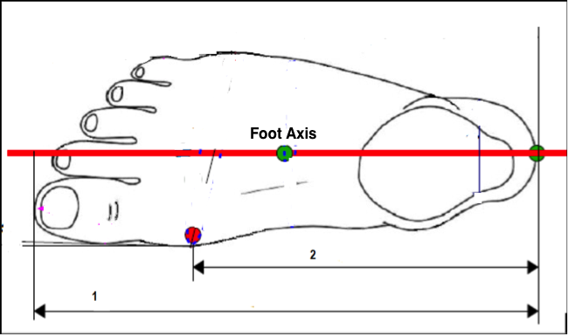
Figure 4,
1) Total Foot Length, 2) Instep (Truncated) Foot Length,
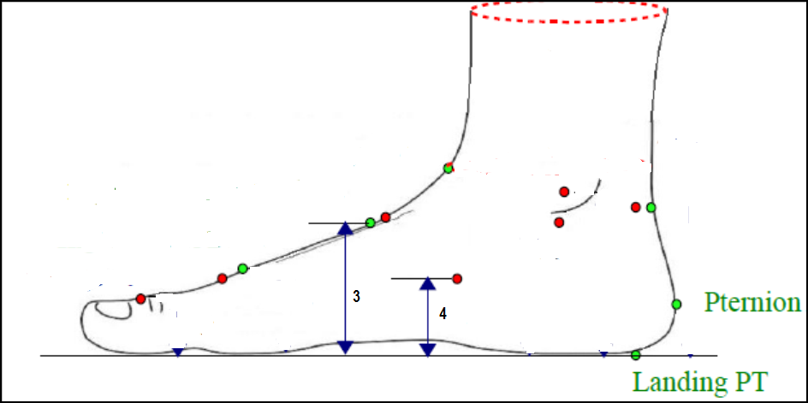
Figure 5,
3) Instep Height, 4) Navicular Height

3-Theory/calculation

3.1- Calculations
From these four measures two clinical indexes NNH and AHI were calculated both for Total foot length (NNH_Tot, AHI_Tot) and Truncated foot/Instep length (NNH_Ins, AHI_Ins) according to the following equations:

$NNH_Tot=\frac{Navicular Height}{Total Foot Length }$ Eq.1

$NNH_Ins=\frac{Navicular Height}{Truncated Foot/Instep Length}$
Eq.2

$AHI_Tot= \frac{Instep Height}{Total Foot Length }$ Eq.3

$AHI_Ins= \frac{Instep Height}{Truncated Foot/Instep Length}$ Eq.4

3.2-Data Analysis
The data obtained both demographic and anthropometric were exported and analysed in SPSS 19 (SPSS Inc., Chicago, IL, USA). Descriptive statistics (Mean, Standard deviation) were obtained for all parameters and assessed for normality (normal distribution) to ensure none of the assumptions of parametric statistical analysis were violated. The test for normality was the Kolmogorov-Smirnov statistic with values >.05 indicating normality. Measured parameters that met normality were analysed via parametric tests those that did not were analysed via the non-parametric alternative.

The variables of length and height were subjected to correlation and simple linear regression analysis. The length parameters Total foot length (FL_TOT) and Instep length (INS_L) were used interchangeably as the independent variables. The height parameters: Navicular Height (N_H) and Instep Height at 50% foot length (INS_H) and clinical indexes Normalised Navicular Height (NNH) and Arch Height Index (AHI) were used interchangeably as the dependent variables. The parametric test used for correlation and regression was the Pearson’s Product-Moment Correlation Coefficient (r) with Spearman’s Rank Order Correlation as the non-parametric alternative. The value derived gave an estimate for the slope co-efficient (β₁) of the simple regression line. These were analysed for statistical significance with p <.05 indicating a significant regression / correlation value (Pallant 2010).

The predictive ability of the independent variable on the observed variations of the dependent variable was further analysed using Coefficient of Determination R².

The effects of extraneous demographic factors: Age, Weight, Height and BMI on foot anthropometrics (Cavanagh & Rogers 1987) were also analysed using correlation analysis.

Mean comparison analysis between the genders’ data sets both demographic and anthropometric was undertaken using Independent T-Tests for normally distributed data with the Mann-Whitney U Test used as the non-parametric alternative.

The left and right foot measures were subjected to separate correlation analysis and not pooled to increase the sample size this preserved the assumptions of independence for statistical analysis with the unit of analysis being the individual subject and not individual feet (Menz 2004).

Comparison analysis was also performed between the left and right foot mean value data sets for any meaningful differences using Independent T-Tests and the Mann-Whitney U test where appropriate.

A repeated measures study was performed to assess the reliability of the scanner and the operator. Reliability was assessed by Intraclass correlation coefficient (ICC) using a two way mixed single measure model (3,1) for absolute agreement (Vinicombe et al 2001) .The Landis & Koch (1977) ranking of agreement was used to evaluate the statistics obtained.

Standard error of measurement (SEM), at 95% confidence intervals was calculated as an additional index of reliability. The SEM has greater clinical application than ICC’s since the value is given in the same units as the original measurement and is representative of the variation that would occur if the measurements in the study were taken more than once (Pohl & Farr 2010).

4-Results

Descriptive Statistics for foot posture and anthropometrics (left and right) are presented for each gender in Tables 2.

Table 2
Descriptive statistics foot Anthropometrics

FOOTSIDE |  | FPI | FL_TOT  (mm) | INS_L  (mm) | INS_H  (mm) | N_H  (mm) | NNH_  Ins | AHI_  Ins | NNH_  Tot | AHI_  Tot
Female Left  Foot | Mean | 2.17 | 240.07 | 177.47 | 63.83 | 39.48 | 0.22 | 0.36 | 0.16 | 0.27
 | Std. Deviation  (+/-) | 1.76 | 9.76 | 7.39 | 3.39 | 3.91 | 0.03 | 0.02 | 0.02 | 0.018
Female Right  Foot | Mean | 2.20 | 240.22 | 177.76 | 64.23 | 40.27 | 0.23 | 0.36 | 0.17 | 0.27
 | Std. Deviation  (+/-) | 1.82 | 9.62 | 7.74 | 4.33 | 4.22 | 0.03 | 0.03 | 0.02 | 0.02
M Male Left Foot | Mean | 1.31 | 268.50 | 196.54 | 73.59 | 45.03 | 0.23 | 0.37 | 0.17 | 0.27
 | Std. Deviation (+/-) | 1.45 | 12.13 | 7.71 | 5.14 | 6.20 | 0.03 | 0.03 | 0.03 | 0.02
Male  Right  Foot | Mean | 2.16 | 268.25 | 197.21 | 73.95 | 45.14 | 0.23 | 0.38 | 0.17 | 0.28
 | Std. Deviation  (+/-) | 1.59 | 11.52 | 8.49 | 5.07 | 6.57 | 0.04 | 0.03 | 0.03 | 0.02

(FPI- Foot posture Index, FL_TOT-Foot Length Total, INS_L-Instep Length, INS_H-Instep Height, N_H-Navicular Height, NNH_Ins-Normalised Navicular Height to Instep Length, AHI_Ins, Arch Height Index to Instep Length, NNH_Tot-Normalised Navicular Height to Total Foot Length, AHI_Tot, Arch Height Index to Total Foot Length,)

Kolmogorov-Smirnov Sig statistic >.05 for normality were met except: ♀Weight, ♀and♂ BMI, ♀ and ♂ Foot posture index both left and right, ♀ left normalised navicular height measures, ♂ right navicular height.

Between gender comparison demonstrated significant statistical differences (p<0.05) for the following : Height, weight and BMI (males demonstrating a higher median values), Left sided foot posture, (Females demonstrating a higher median value), All foot dimensional measures left and right (Males demonstrating higher median values). Of the normalised arch measures only left arch index to instep length (AHI_Ins) displayed significant difference (Males higher median value).

Within Gender comparison between left and right foot anthropometric parameters demonstrated no significant differences.

Correlation and regression analysis of female foot anthropometrics demonstrated a slight to fair level of correlation (r value range .117 to -.264,) between foot length measures (Total and Instep) and arch height measures (Navicular and instep height) .No statistical significant values for the correlation or slope coefficient (β_{1 value}) were reached (tables 3 & 4).
R² Analysis demonstrated poor predictive ability of female foot length measures in respect to variations in arch height (R² values range .000 to .070) (Tables 3 & 4)

Female Normalised arch height measurements calculated in respect of total (NNH_Tot, AHI_Tot) and Instep (NNH_Ins, AHI_Ins) foot length demonstrated moderate negative (inverse) correlations to foot length measures, (r and rho value range: -577 to -.402). With statistical significant values for the correlation and slope coefficient reached (Tables 3 & 4).
A moderate predictive ability of foot length on variations of normalised arch height measures was seen (R² values range .156 to .353) (Tables 3 & 4).

Table 3
Left foot Correlation and R² Analysis

 |  | L_INS_H | L_N_H | L_AHI_Ins | L_AHI_Tot | L_NNH_Ins | L_NNH_Tot
L_FL_TOT  Female | Pearson Correlation^{c} /  Spearman’s Rho  Correlation | .015 | -.189 | -.577** | -.487** | -.550** | -.550**
 | Sig.  (2-tailed) | .939 | .317 | .001 | .006 | .002 | .002
 | R² Value | .000 | .036 | .333 | .353 | .249 | .265
 | N | 30 | 30 | 30 | 30 | 30 | 30
L_INS_L  Female | Pearson Correlation^{c} /  Spearman’s Rho Correlation | .117 | -.114 | -.555** | -.435* | -.402* | -.402*
 | Sig.  (2-tailed) | .538 | .547 | .001 | .016 | .028 | .028
 | R² Value | .014 | .013 | .308 | .202 | .222 | .173
 | N | 30 | 30 | 30 | 30 | 30 | 30
L_FL _TOT  Male | Pearson Correlation | -.169 | -.254 | -.553** | -.628** | -.460** | -.510**
 | Sig.  (2-Tailed) | .354 | .161 | .001 | .000 | .008 | .003
 | R² Value | .029 | .064 | .306 | .394 | .212 | .261
 | N | 32 | 32 | 32 | 32 | 32 | 32
L_INS_L  Male | Pearson Correlation | .012 | -.126 | -.483** | -.411* | -.460** | -.359*
 | Sig.  (2-Tailed) | .948 | .490 | .005 | .019 | .008 | .043
 | R² Value | .000 | .016 | .234 | .169 .169 | .153 | .129
 | N | 32 | 32 | 32 | 32 | 32 | 32
**. Correlation / Regression is significant at the 0.01 level (2-tailed).
*. Correlation / regression is significant at the 0.05 level (2-tailed).
c. Equivalent β₁ slope coefficient value

(FPI- Foot posture Index, FL_TOT-Foot Length Total, INS_L-Instep Length, INS_H-Instep Height, N_H-Navicular Height, NNH_Ins-Normalised Navicular Height to Instep Length, AHI_Ins, Arch Height Index to Instep Length, NNH_Tot -Normalised Navicular Height to Total Foot Length, AHI_Tot, Arch Height Index to Total Foot Length,)

Table 4
Right Foot Correlation and R² Analysis

 |  | R_INS_H | R_N_H | R_AHI_Ins | R_AHI_Tot | R_NNH_Ins | R_NNH_Tot
R_FL_TOT  Female | Pearson Correlation^{c} | -.017 | -.264 | -.547** | -.525** | -.558** | -.557**
 | Sig.  (2-Tailed) | .929 | .158 | .002 | .003 | .001 | .001
 | R² Value | .000 | .070 | .299 | .275 | .249 | .265
 | N | 30 | 30 | 30 | 30 | 30 | 30
R_INS_L  Female | Pearson Correlation^{c} | .096 | -.226 | -.482** | -.395* | -.548** | -.503**
 | Sig.  (2-Tailed) | .613 | .229 | .007 | .031 | .002 | .005
 | R² Value | .009 | .051 | .232 | .156 | .300 | .253
 | N | 30 | 30 | 30 | 30 | 30 | 30
R_FL_TOT  Male | Pearson Correlation^{c} /  Spearman’s Rho  Correlation | -.021 | -.133 | -.450** | -.537** | -.325 | -.376*
 | Sig.  (2-tailed) | .908 | .467 | .010 | .002 | .069 | .034
 | R² Value | .000 | .011 | .202 | .288 | .106 | .141
 | N | 32 | 32 | 32 | 32 | 32 | 32
R_INS_L  Male | Pearson Correlation^{c} /  Spearman’s Rho Correlation | -.042 | -.185 | -.551** | -.468** | -.412* | -.369*
 | Sig.  (2-tailed) | .818 | .311 | .001 | .007 | .019 | .037
 | R² Value | .002 | .023 | .303 | .219 | .169 | .219
 | N | 32 | 32 | 32 | 32 | 32 | 32
**. Correlation / Regression is significant at the 0.01 level (2-tailed).
*. Correlation / regression is significant at the 0.05 level (2-tailed).
c. Equivalent β₁ slope coefficient value
(FPI- Foot posture Index, FL_TOT-Foot Length Total, INS_L-Instep Length, INS_H-Instep Height, N_H-Navicular Height, NNH_Ins-Normalised Navicular Height to Instep Length, AHI_Ins, Arch Height Index to Instep Length, NNH_Tot-Normalised Navicular Height to Total Foot Length, AHI_Tot, Arch Height Index to Total Foot Length,)

Correlation and regression analysis of male anthropometrics (left and right) again demonstrated a slight to fair level of correlation (r value range .012 to -.254) between foot length measures (Total and Instep) and arch height measures (Navicular height Instep height). with no statistical significant values for the correlation or slope coefficient reached (β_{1 value}) (Tables 3 & 4)

R² Analysis demonstrated poor predictive ability of male foot length measures in respect to variations in arch height (R² values range .000 to .064) (Tables 3 & 4,)

Male Normalised arch height measurements demonstrated moderate to fair negative (inverse) correlations to foot length measures (r value range -628 to -.325)
With statistical significant values for the correlation and slope coefficient reached (Table 3 & 4)
A moderate predictive ability of foot length on variations of normalised height measures was seen (R² values range .000 to .394) (Table 3 & 4).

No substantial effects of outliers were observed in either gender analysis for both demographic and anthropometric data with 5% trimmed mean analysis(Pallant 2010).
The effects of extraneous demographic factors on foot anthropometrics yielded a limited number of significant correlations. Total body height and foot length measurements in both genders and foot sides displayed moderate to substantial positive correlations this is in agreement with established research (Krishan 2008) .Total body height also demonstrated a fair level of Inverse (negative) correlation (r value -.378 to -.374) in respect to female left sided AHI measurements) . Age was seen to be moderately correlated with female left foot posture (rho value .439) Weight was seen to show moderate correlation in females in respect to right instep height and right arch height index measurements (rho value .496 to .419) Conversely BMI demonstrated a fair correlation for right female truncated AHI measures (rho .396) In males a fair level of correlation was seen in respect to weight and left instep height (r value .350).

The Repeated Measures study demonstrated Intraclass Correlations with substantial to near perfect levels of agreement (ICC 3.1 range 0.968 – 0.715) for all foot anthropometrics (Table 5). Average standard error of measurement met acceptable levels.

Table 5
Intra-Rater Reliability Measures for Foot Anthropometrics
Foot Anthropometric | Intraclass Correlation Coefficient (ICC 3.1) | Average  Standard Error of Measurement  (SEM) +/- mm
Left Foot Length Total | 0.961 | 0.43
Left Instep Length | 0.968 | 0.43
Left Instep Height | 0.755 | 0.65
Left Navicular Height | 0.715 | 1.29
Right Foot Length Total | 0.786 | 1.74
Right Instep Length | 0.816 | 2.30
Right Instep Height | 0.765 | 0.96
Right Navicular Height | 0.756 | 1.25

5-Discussion

This research intended to study the relationship between foot length and direct arch height measures amongst a sample with normative foot posture. These comparisons were made for both Total Foot Length and Truncated (Instep) length. Both dorsal (Instep Height at 50% Foot length) and plantar (Navicular Height) medial longitudinal arch height parameters were utilised. The parameters investigated in this study correspond to the instep dimensions of the foot (Figure 7). Specifically these parameters describe the dorsal and plantar geometry of the shoe and conversely the dimensions of the shoe upper and foot bed (insole) (Barna 1997, Bertram 2011, Xiong et al 2008). Amongst the most important region for consideration of ergonomic fit is the instep (Xiong et al 2008),

Figure 7 Area of importance for instep shoe dimensions

The results indicated that no significant relationship existed between any of the foot length and direct arch height measures thus supporting the null hypothesis H_{o} “medial longitudinal arch height does not scale isometrically with foot length”. The results also demonstrated that foot length was a poor predictor of variance of Instep / midfoot dorsal height In a largely Caucasian sample this was in agreement with previous allometric work carried out on Chinese subjects (Li et al. 2005, Xiong et al. 2008) thus indicating a similar pattern amongst the two ethnicities. Further to this the current work controlled for the extraneous variable effects of supination and pronation on arch height dimensions by recruiting only subjects with normal foot posture.

Normalised measures of plantar and dorsal arch height in respect to foot length (Normalised Navicular Height NNH, Arch Height Index AHI) were also correlated with foot length parameters. Since normalised arch height measures are in essence a height to length gradient and representative of arch inclination and declination angles this additional analysis describes the distribution of arch height gradients throughout foot length. The correlations obtained demonstrated fair to moderate relationships and predictive abilities, however these correlations were negative indicating an inverse relationship. This indicated that in general the arch height gradient decreases as the foot length increases . With the shorter feet in this study having larger arch height gradients and higher arch inclination angles.

It has been stated that the function of footwear is governed by fit (Krauss et al 2007) and knowledge of the three dimensional variations in foot structure is essential to those involved in footwear development (Mauch et al 2008). If the shoe’s upper and insole are to allow the foot to function within biomechanical norms the dimensions and overall shape of the shoe’s internal structure must correspond to that of the human foot (Mauch et al 2007). Generally shoes are made to a master model of ♀ EU size 37 and ♂ EU size 43 all foot dimensions are then scaled up or down proportionate to foot length (Bertram 2011, Mauch et al 2009, Xiong et al 2008).

The findings of this study has important implications in terms of the shoe fitting since in previous studies it has been shown that variations as small as 1/6th inch in foot shape can result in faulty fit if not accounted for in shoe design (Mauch et al 2008). A recent study of army recruits found that a substantial proportion of personnel could not be fitted with an army boot, specifically due to variations in arch height (Baxter & Baxter 2011). Women with higher arch indexes have been shown to report a higher prevalence of footwear related pain (Paiva de Castro et al 2010a) with 48.5% of diabetic females and 69.2% of diabetic males wearing footwear that was too long for them simply to accommodate height and width dimensions (Paiva de Castro 2010b). To provide more ergonomic footwear lasts, manufactures should consider Allometry (The biological study that explores the non linear geometric relationship between body structures with increasing size) rather than the simple Isometric length dimensional grading currently used (Bertram 2011).

Despite the existence of significant correlation between the normalised arch height with the foot length, the predictive value of a linear regression proved to be low (tables 3 & 4), giving way to the existence of a more complicated nonlinear correlation between the measures. Furthermore foot length may only be one of the predicting independent variables and in future studies when a group of foot dimensions are used as part of a multi variant analysis more complex relationships may be explored and possibly allow greater predictive ability to be achieved (Pallant 2010).

Despite the fact that the static double stance measurements (50% weight bearing) have been shown to be reliable and valid (McPoil et al 2008) they should still be used with a degree of caution when attempting to predict dynamic changes in locomotory activities (Nielson et al 2009, Nester 2009). With even valid tools such as the FPI only predicting 41% of the variance in midstance posture during walking (Redmond et al 2006). Recently methods have become available to scan the foot under dynamic conditions and capture anthropometrics that may be used to construct footwear (Schmeltzpfenning et al 2009, Schmeltzpfenning et al 2011), Ideally further work should be carried out utilizing dynamic scanning to observe the relationship of arch height and other specified anthropometrics (length, width) under locomotory activities. This would provide further improvement to function and fit of footwear in addition to those suggested in this research. Although one could argue that the sample size in the present study is small and the previous experiments have used a larger sample size; for example McPoil et al (2008) used 850 participants, the approach used for data reduction and analysis in the current study is different and the results substantiate the claims made.

Further analysis of the data indicated that for an equal foot length there is a variation in the normalised height indices. This indicates that in addition to being dependent of foot length the arch height indices are dependent to other parameters. Thus in future studies the foot length and other measures like foot width need to be considered for provision of a scaling method for the arch height that can be used in grading.

6-Conclusion

It can be concluded that no significant relationship existed between direct arch height measures and those of foot length in both genders the Null Hypothesis “medial longitudinal arch height does not scale Isometrically with foot length” was supported. A significant relationship was found between normalised arch height measures (AHI and NNH) and foot length in both genders. This however was seen to be an inverse relationship suggesting that shorter feet are proportionally higher in medial longitudinal arch dimensions. Despite the existence of such a significant correlation the predictive value of the relationship was poor indicating that a linear formula may not be used for scaling the footwear arch characteristics according to the foot length. Furthermore the results of this study also supports the existence of variations in the normalised height indices for equal foot length, indicating that the normalised height indices in addition to the foot length may be dependent to other foot dimensions like foot width.

Acknowledgments
The Authors would like to Acknowledge Delcam UK for their technical assistance and kind loan of the I-Ware InFoot Digitizer during this research.

References
ISO “International Organization for Standardization”, 2008. ISO 7250-1:2008. Basic Human Body Measurement for Technological Design, Part 1: Body Measurement Definitions and Landmarks. ISO, Brussels EN.
ISO “International Organization for Standardization”, 2010. ISO 20685: 2010. 3-D Scanning Methodologies for Internationally Compatible Anthropometric Data- bases. ISO, Brussels EN.
Barna, R., 1997. Natural plantar topology and posture: a new standard for anatomical footwear research. In: Proceedings of the 3rd Footwear Biomechanics Symposium (Tokyo), pp. 29e30.
Bataller, A., Alcantara, E., Gonzalez, J., Garcia, A., Alemany, A., 2001. Morphological grouping of Spanish feet using clustering techniques. In: Proceedings of the 5th Footwear Biomechanics Symposium (Zurich), pp. 12e13.
Baxter, M., Baxter, D., 2011. Anthropometric characteristics of feet of soldiers in the New Zealand army. Mil. Med. 176 (4), 438e445.
Bertram, H., 2011. Practical operation of last construction. In: Proceedings of the 10th Footwear Biomechanics Symposium (Tubingen), pp. S10eS11.
Burns, J., Keenan, A., Redmond, A., 2005. Foot type and overuse injury in triathletes. J. Am. Podiatry. Med. Assoc. 95 (3), 235e241.
Cain, L., Nicholson, L., Adams, R., Burns, J., 2007. Foot morphology and foot/ankle injury in indoor football. J. Sci. Med. Sport 10, 311e319.
Cavanagh, P., Rodgers, M., 1987. The arch index: a useful measure from footprints. J. Biomech. 20 (5), 547e551.
Chu, W.C., Lee, S., Chu, W., Wang, T., Lee, M., 1995. The use of arch index to characterize arch height: a digital image processing approach. IEEE Trans. Biomed. Eng. 42 (11), 1088e1093.
Cowan, D., Jones, B., Robinson, J., 1993. Foot morphological characteristics and risk of exercise-related injury. Arch. Fam. Med. 2, 773e777.
De Mits, S., Coorevits, P., De Clercq, D., Elewaut, D., Woodburn, J., Roosen, P., 2010. Reliability and validity of the InFoot 3D digitizer for normal healthy adults. Footwear Sci. 2 (2), 65e75.
De Mits, S., Coorevits, P., De Clercq, D., Elewaut, D., Woodburn, J., Roosen, P., 2011. Reliability and validity of the INFOOT three-dimensional foot digitizer for patients with rheumatoid arthritis. J. Am. Podiatry. Med. Assoc. 101 (3), 198e207.
Dowling, A., Steele, J., Baur, L., 2001. Does obesity influence foot structure and plantar pressure in prepubescent children? Int. J. Obes. 25, 845e852.
Gilmour, J., Burns, Y., 2001. The measurement of the medial longitudinal arch in children. Foot Ankle Int. 22 (6), 493e498.
Igbigbi, P., Msamati, B., 2002. The footprint ratio as a predictor of pes planus: a study of indigenous Malawians. J. Foot Ankle Surg. 41 (6), 394e397.
Kogler, G., Veer, F., Solomonidis, S., Paul, J., 1999. The Influence of medial and lateral placement of orthotic wedges on loading of the plantar aponeurosis. J. Bone Jt. Surg. (Am) 81-A (10), 1403e1413.
Krauss, I., Grau, S., Mauch, M., Maiwald, C., Horstmann, T., 2007. Female foot morphology e implications for last design. In: Proceedings 8th Footwear Biomechanics Symposium Taipei, pp. 39e40.
Krauss, I., Grau, S., Mauch, M., Maiwald, C., Horstmann, T., 2008. Sex-related differences in foot shape. Ergonomics 51 (11), 1693e1709.
Krishan, K., 2008. Estimation of stature from footprint and foot outline dimensions in Gujjars of North India. Forensic Sci. Int. 175, 93e101.
Landis, J., Koch, G., 1977. The measurement of observer agreement for categorical data. Biometrics 33 (1), 159e174.
Li, J., Xu, D., Wang, A., Shao, K., 2005. Analysis of foot shape measured from Chinese Male and female adults. In: Proceedings 7th Footwear Biomechanics Symposium Cleveland.
Mauch, M., Grau, S., Krauss, I., Maiwald, C., Horstmann, T., 2007. New designs in children's footwear based on a foot type classification. In: Proceedings 8th Footwear Biomechanics Symposium Taipei, pp. 59e60.
Mauch, M., Mickle, K., Munro, B., Dowling, A., Grau, S., Steele, J., 2008. Do the feet of German and Australian children differ in structure? Implications for children's shoe design. Ergonomics 51 (4), 527e539.
M. Hill et al. / Applied Ergonomics 59 (2017) 243e250 249
250 M. Hill et al. / Applied Ergonomics 59 (2017) 243e250
Mauch, M., Grau, S., Krauss, I., Maiwald, C., Horstmann, T., 2009. A new approach to children's footwear based on foot type classification. Ergonomics 52 (8), 999e1008.
McPoil, T., Cornwall, M., Vicenzino, B., Teyhen, D., Molloy, J., Christie, D., Collins, N., 2008. Effect of using truncated versus total foot length to calculate arch height ratio. Foot 18, 220e227.
McPoil, T., Vicenzino, B., Cornwall, M., Collins, N., Warren, M., 2009. Reliability and normative values for the foot mobility magnitude: a composite measure of vertical and medial-lateral mobility of the midfoot. J. Foot Ankle Res. 2, 6. Biomed Central [Online] available from: http://www.jfootankleres.com/ content/2/1/6.
Menz, H., 1998. Alternative techniques for the clinical assessment of foot pronation. J. Am. Podiatry. Med. Assoc. 88 (3), 119e129.
Menz, H., 2004. Two feet, or one person? Problems associated with statistical analysis of paired data in foot and ankle medicine. Foot. 14, 2e5.
Menz, H., Munteanu, S., 2005. Validity of 3 clinical techniques for the measurement of static foot posture in older people. J. Orthop. Sports Phys. Ther. 35 (8), 479e486.
Mickle, K., Munro, B., Lord, S., Menz, H., Steele, J., 2010. Foot shape of older people: implications for shoe design. Footwear Sci. 2 (3), 131e139.
Morrison, S., Durward, B., Watt, G., Donaldson, M., 2007. Anthropometric foot structure of prepubescent children with excessive versus normal body mass. J. Am. Podiatry. Med. Assoc. 97 (5), 366e370.
Murley, G., Menz, H., Landorf, K., 2009a. Foot Posture influences the electromyographic activity of selected lower limb muscles during gait. J. Foot Ankle Res. 2, 35. Biomed Central [Online] available from: http://www.jfootankleres.com/ content/2/1/35.
Murley, G., Menz, H., Landorf, K., 2009b. A protocol for classifying normal- and flat- arched foot posture for research studies using clinical and radiographic measurements. J. Foot Ankle Res. 2, 22. Biomed Central [Online] available from: http://www.jfootankleres.com/content/2/1/22.
Nester, C., 2009. Lessons from dynamic cadaver and invasive bone pin studies: do we know how the foot really moves during gait? J. Foot Ankle Res. 2, 18. Biomed Central [Online] available from: http://www.jfootankleres.com/content/2/1/18.
Nielson, R., Rathleff, M., Simonsen, O., Langberg, H., 2009. Determination of normal values for navicular drop during walking a new model correcting for foot length and gender. J. Foot Ankle Res. 2, 12. BioMed Central [Online] available from: http://www.jfootankleres.com/content/2/1/12.
Paiva de Castro, A., Rubens Rebelatto, J., Rabiatti Aurichio, T., 2010a. The relationship between foot pain. Anthropometric variables and footwear among older people. Appl. Ergon. 41, 93e97.
Paiva de Castro, A., Rubens, Rebelatto, J., Rabiatti Aurichio, T., 2010b. The relation- ship between wearing incorrectly sized shoes and foot dimensions, foot pain and diabetes. J. Sport Rehabil. 19, 214e225.
Pallant, J., 2010. SPSS Survival Manual, fourth ed. Open University Press, Berkshire. Pfeiffer, M., Kotz, R., Ledl, T., Hauser, G., Sluga, M., 2006. Prevalence of flat foot in
preschool-aged children. Pediatrics 118 (2), 634e639. Pohl, M., Farr, L., 2010. A comparison of foot arch measurement reliability using
both digital photography and calliper methods. J. Foot Ankle Res. 3, 14. BioMed
Central [Online] available from: http://www.jfootankleres.com/content/3/1/14. Razeghi, M., Batt, M., 2002. Foot type classification: a critical review of current
methods. Gait Posture 15, 282e291. Redmond, A., Crosbie, J., Ouvrier, R., 2006. Development and validation of a novel
rating system for scoring standing foot posture: the Foot Posture Index. Clin.
Biomech. 21, 89e98. Redmond, A., Crane, Y., Menz, H., 2008. Normative values for the foot posture index.
J. Foot Ankle Res. 1, 6. BioMed Central [Online] available from: http://www.
jfootankleres.com/content/1/1/6. Saltzman, C., Nawoczenski, D., Talbot, K., 1995. Measurement of the medial longi-
tudinal arch. Arch. Phys. Med. Rehabil. 76, 45e49. Schmeltzpfenning, T., Plank, C., Krauss, I., Aswendt, P., Grau, S., 2009. Dynamic foot
scanning: a new approach for measurement of human foot shape while walking. In: Proceedings 9th Footwear Biomechanics Symposium. Stellenbosch, pp. 28e30.
Schmeltzpfenning, T., Plank, C., Fritz, B., Aswendt, P., Grau, S., 2011. 3D dynamic behaviour of foot structure may provide additional information for last design. In: Proceedings 9th Footwear Biomechanics Symposium Tubingen, pp. S.147e148.
Scott, G., Menz, H., Newcombe, L., 2007. Age-related difference in foot structure and function. Gait Posture 26, 68e75.
Shiang, T., Lee, S., Lee, S.J., Chu, W., 1998. Evaluating different footprint parameters as a predictor of arch height. IEEE Eng. Med. Biol. 17 (6), 62e66.
Telfer, S., Woodburn, J., 2010. The use of 3D surface scanning for the measurement and assessment of the human foot. J. Foot Ankle Res. 3, 19. BioMed Central [Online] available from: http://www.jfootankleres.com/content/3/1/19.
Vinicombe, A., Raspovic, A., Menz, H., 2001. Reliability of navicular displacement measurement as a clinical indicator of foot posture. J. Am. Podiatr. Med. Assoc. 91 (5), 262e268.
Williams, S., McClay, I., 2000. Measurements used to characterize the foot and the medial longitudinal arch: reliability and validity. Phys. Ther. 80 (9), 864e871.
Witana, C., Xiong, S., Zhao, J., Goonetilleke, R., 2006. Foot measurements from three- dimensional scans: a comparison and evaluation of different methods. Int. J. ind. Ergon. 36, 789e807.
Wunderlich, R., Cavanagh, P., 2001. Gender differences in adult foot shape: implications for shoe design. Med. Sci. Sports Exerc. 33 (4), 605e611.
Xarchas, K., Tsolakidis, G., 2004. Galen: author of the first flatfoot description. J. Am. Podiatr. Med. Assoc. 94 (5), 508e509.
Xiong, S., Goonetilleke, R., Witana, C., Weerasinghe, T., Au, E., 2008. Modelling foot height and shape-related dimensions. Ergonomics 51 (8), 1272e1289.
Xiong, S., Goonetilleke, R., Witana, C., Weerasinghe, T., Au, E., 2010. Foot arch characterization, a review, a new metric and a comparison. J. Am. Podiatr. Med. Assoc. 100 (1), 14e24.

