Article to be printed in colour.

Abstract

Taking measurements of a scene is an integral aspect of the crime scene documentation process, and accepted limits of accuracy for taking measurements at a crime scene vary throughout the world. In the UK, there is no published accepted limit of accuracy, whereas the United States has an accepted limit of accuracy of 0.25 inch. As part of the International organisation for Standardisation 17020 accreditation competency testing is required for all work conducted at the crime scene. As part of this, all measuring devices need to be calibrated within known tolerances in order to meet the required standard, and measurements will be required to have a clearly defined limit of accuracy. This investigation sought to compare measurement capabilities of two different methods for measuring crime scenes; using a tape measure, and a 360º camera with complimentary photogrammetry software application. Participants measured ten fixed and non-fixed items using both methods and these were compared to control measurements taken using a laser distance measure. Statistical analysis using a Wilcoxon Signed Rank test demonstrated statistically significant differences between the tape, software and control measurements. The majority of the differences were negligible, amounting to millimetre differences. The tape measure was found to be more accurate than the software application, which offered greater precision. Measurement errors were attributed to human error in understanding the operation of the software, suggesting that training be given before using the software to take measurements. Transcription errors were present with the tape measure approach. Measurements taken using the photogrammetry software were more reproducible than the tape measure approach, and offered flexibility with regards to the time and location of the documentation process, unlike manual tape measuring.

Keywords: Crime scene measurements; Crime Scene Recording; Measurement Accuracy; Forensic; Digital Imaging Technology; Photogrammetry.

Highlights
- Photogrammetry software provides an alternative method for documenting crime scenes
- Photogrammetric measuring from images compared for accuracy with tape measuring
- Termination point identification improves accuracy of software measurements
- Software removes transcription errors encountered with manual methods
- Accurate data capture reliant on using complimentary measurement techniques

- Introduction

One of the most important aspects of conducting a criminal investigation involves comprehensively recording and documenting the crime scene, given that the process can ultimately determine the success of the subsequent investigation [1]. Crime scenes often present unstable and short-lived environments, containing ephemeral evidence, which can prove difficult for Scene of Crime Officers (SOCO’s) to document efficiently [2]. The documentation process is often laborious and time-consuming [3], as the resultant documentation must provide a thorough and permanent record of the scene, comprising written, graphical, photographic, and video evidence of all contextual information [4, 5]. This may require effective communication of the crime scene environment and the distribution of evidence to other individuals who were not present at the scene [6]. Communication may be via 2D photographs, sketches, or more recently, using 360° visualisation technology and 3D modelling [7]. The adoption of such new technologies within police services is therefore further driven by the need to improve efficiency and effectiveness both for forensic scientists, police and the jury within the criminal justice system [8]. Such technology produces three-dimensional representations of crime scenes, providing spatial perception, and the opportunity for the viewer to navigate themselves throughout the scene in a highly detailed immersive environment [9]. This is not possible with 2D photography.

During scene documentation measurements of objects and evidence within the scene are taken, which establish their precise location and relationship to one another [10]. The position and location of evidence is crucial to an investigation because it can help to reconstruct a sequence of events, which may be used to support or refute an individual’s account of what happened at the scene, or theories about what may have happened. It is therefore essential that such information be accurately recorded. Measurements are frequently taken using a tape measure [11], which are deemed ‘adequate’ for measuring a crime scene ‘in situ’ [12]. With 360° technology the user has the ability to take measurements from digital images using photogrammetry software applications. Photogrammetry allows measurements to be taken from photographs using triangulation methods, which derive the location of features using 3D coordinates (X, Y and Z) [13]. The process requires two or more photographic images to be taken from different positions or viewing directions within a scene [14]. The accuracy of measurements taken using a tape measure or photogrammetry software applications are not only dependent on the accuracy of the instrument, but also rely on the competency of the user. The accuracy of the instrument is frequently reported by the manufacturer. However, details of the experimental work used to support the margin of error are often not transparent, and therefore it is difficult to establish the reliability of such data.

Currently the accepted limits of accuracy vary throughout the world. For example, in the UK there is no published accepted limit of accuracy, whereas in the United States the accepted limit of accuracy is 0.25 inch [15]. However, as part of the International Organisation for Standardisation (ISO) 17020 accreditation competency testing is required for all work conducted at the crime scene. Under the scope of IS0 17020, all measuring devices will need to be calibrated within known tolerances in order to meet the required standard, and measurements will be required to have a clearly defined limit of accuracy [16].

It is important to investigate the accuracy with which photogrammetry software applications are able to record measurements compared to tape measures, which are established within Courts of Law. Without robust and independent study it is not possible to reliably implement their use as part of crime scene documentation. Inaccuracies within crime scene documentation could have profound effects on the interpretation of casework, as described. This investigation has examined the accuracy with which a photogrammetry software application was able to measure items within a mock crime scene, and to evaluate practicalities associated with the use of such technology. The results of this study and their interpretation are likely to be of interest and benefit to any person(s) involved in crime scene work, and will help those involved to make an informed choice when considering options for crime scene documentation.

- Method
2.1 Measuring a single blank wall
A white painted interior wall was measured ten times using a DeWalt DW03050 Laser Distance Measure. The device had a typical measuring tolerance when applied to 100% target reflectivity (such as white painted walls) of +/- 1.5 mm. These tolerances apply between 0.05 m to 10 m, with a confidence level of 95% [17]. The same wall was then photographed with a Spheron SceneCam (Spheron VR Ltd.), which was positioned in the approximate centre of the room. Following calibration of the instrument, two 360º scans of the environment were taken; one at the cameras lower position, and one at the cameras highest position, according to the manufacturer’s instructions [18]. The panoramas were uploaded onto the complimentary SceneCenter software, and measurements were taken by the researcher along the ceiling and floor line. The height of the wall was sectioned into five areas, as shown in figure 1. For each of the five areas ten repeat measurements were taken.
Figure 1: Wall sectioned into five areas. Lines just show the sections and were not drawn onto the wall.

Five pairs of 8 mm diameter paper dots were applied to two opposite corners of the wall (Figure 2). The pairs were positioned to replicate the five areas used in the previous study (Figure 1). A DeWalt DW088K cross line laser was used to ensure that the position of the dot pairs were level. All photographs and measurements were taken using a Spheron SceneCam and ten repeat measurements were taken.

Figure 2: Target dots placed in the corner of the room

A DeWalt DW088K Cross line laser was also used to provide an alternative reference point for the measurements to be taken from. The cross line laser was placed onto the wall directly opposite the wall of interest and a laser line projected onto the wall of interest (Figure 3). Photographs and measurements were taken as described.

Figure 3: Laser level line across the wall

2.2 Measuring the scene
The investigation was conducted at a scene of crime training facility at the host institution, the room was arranged to replicate a typical double bedroom. The same scene was staged for each participant, with fixed and non-fixed items, which the participants could measure. The position of the non-fixed items was standardised by marking out their locations on the floor using UV permanent marker. A plan of the room detailing the ten measurements taken is shown in Figure 4.

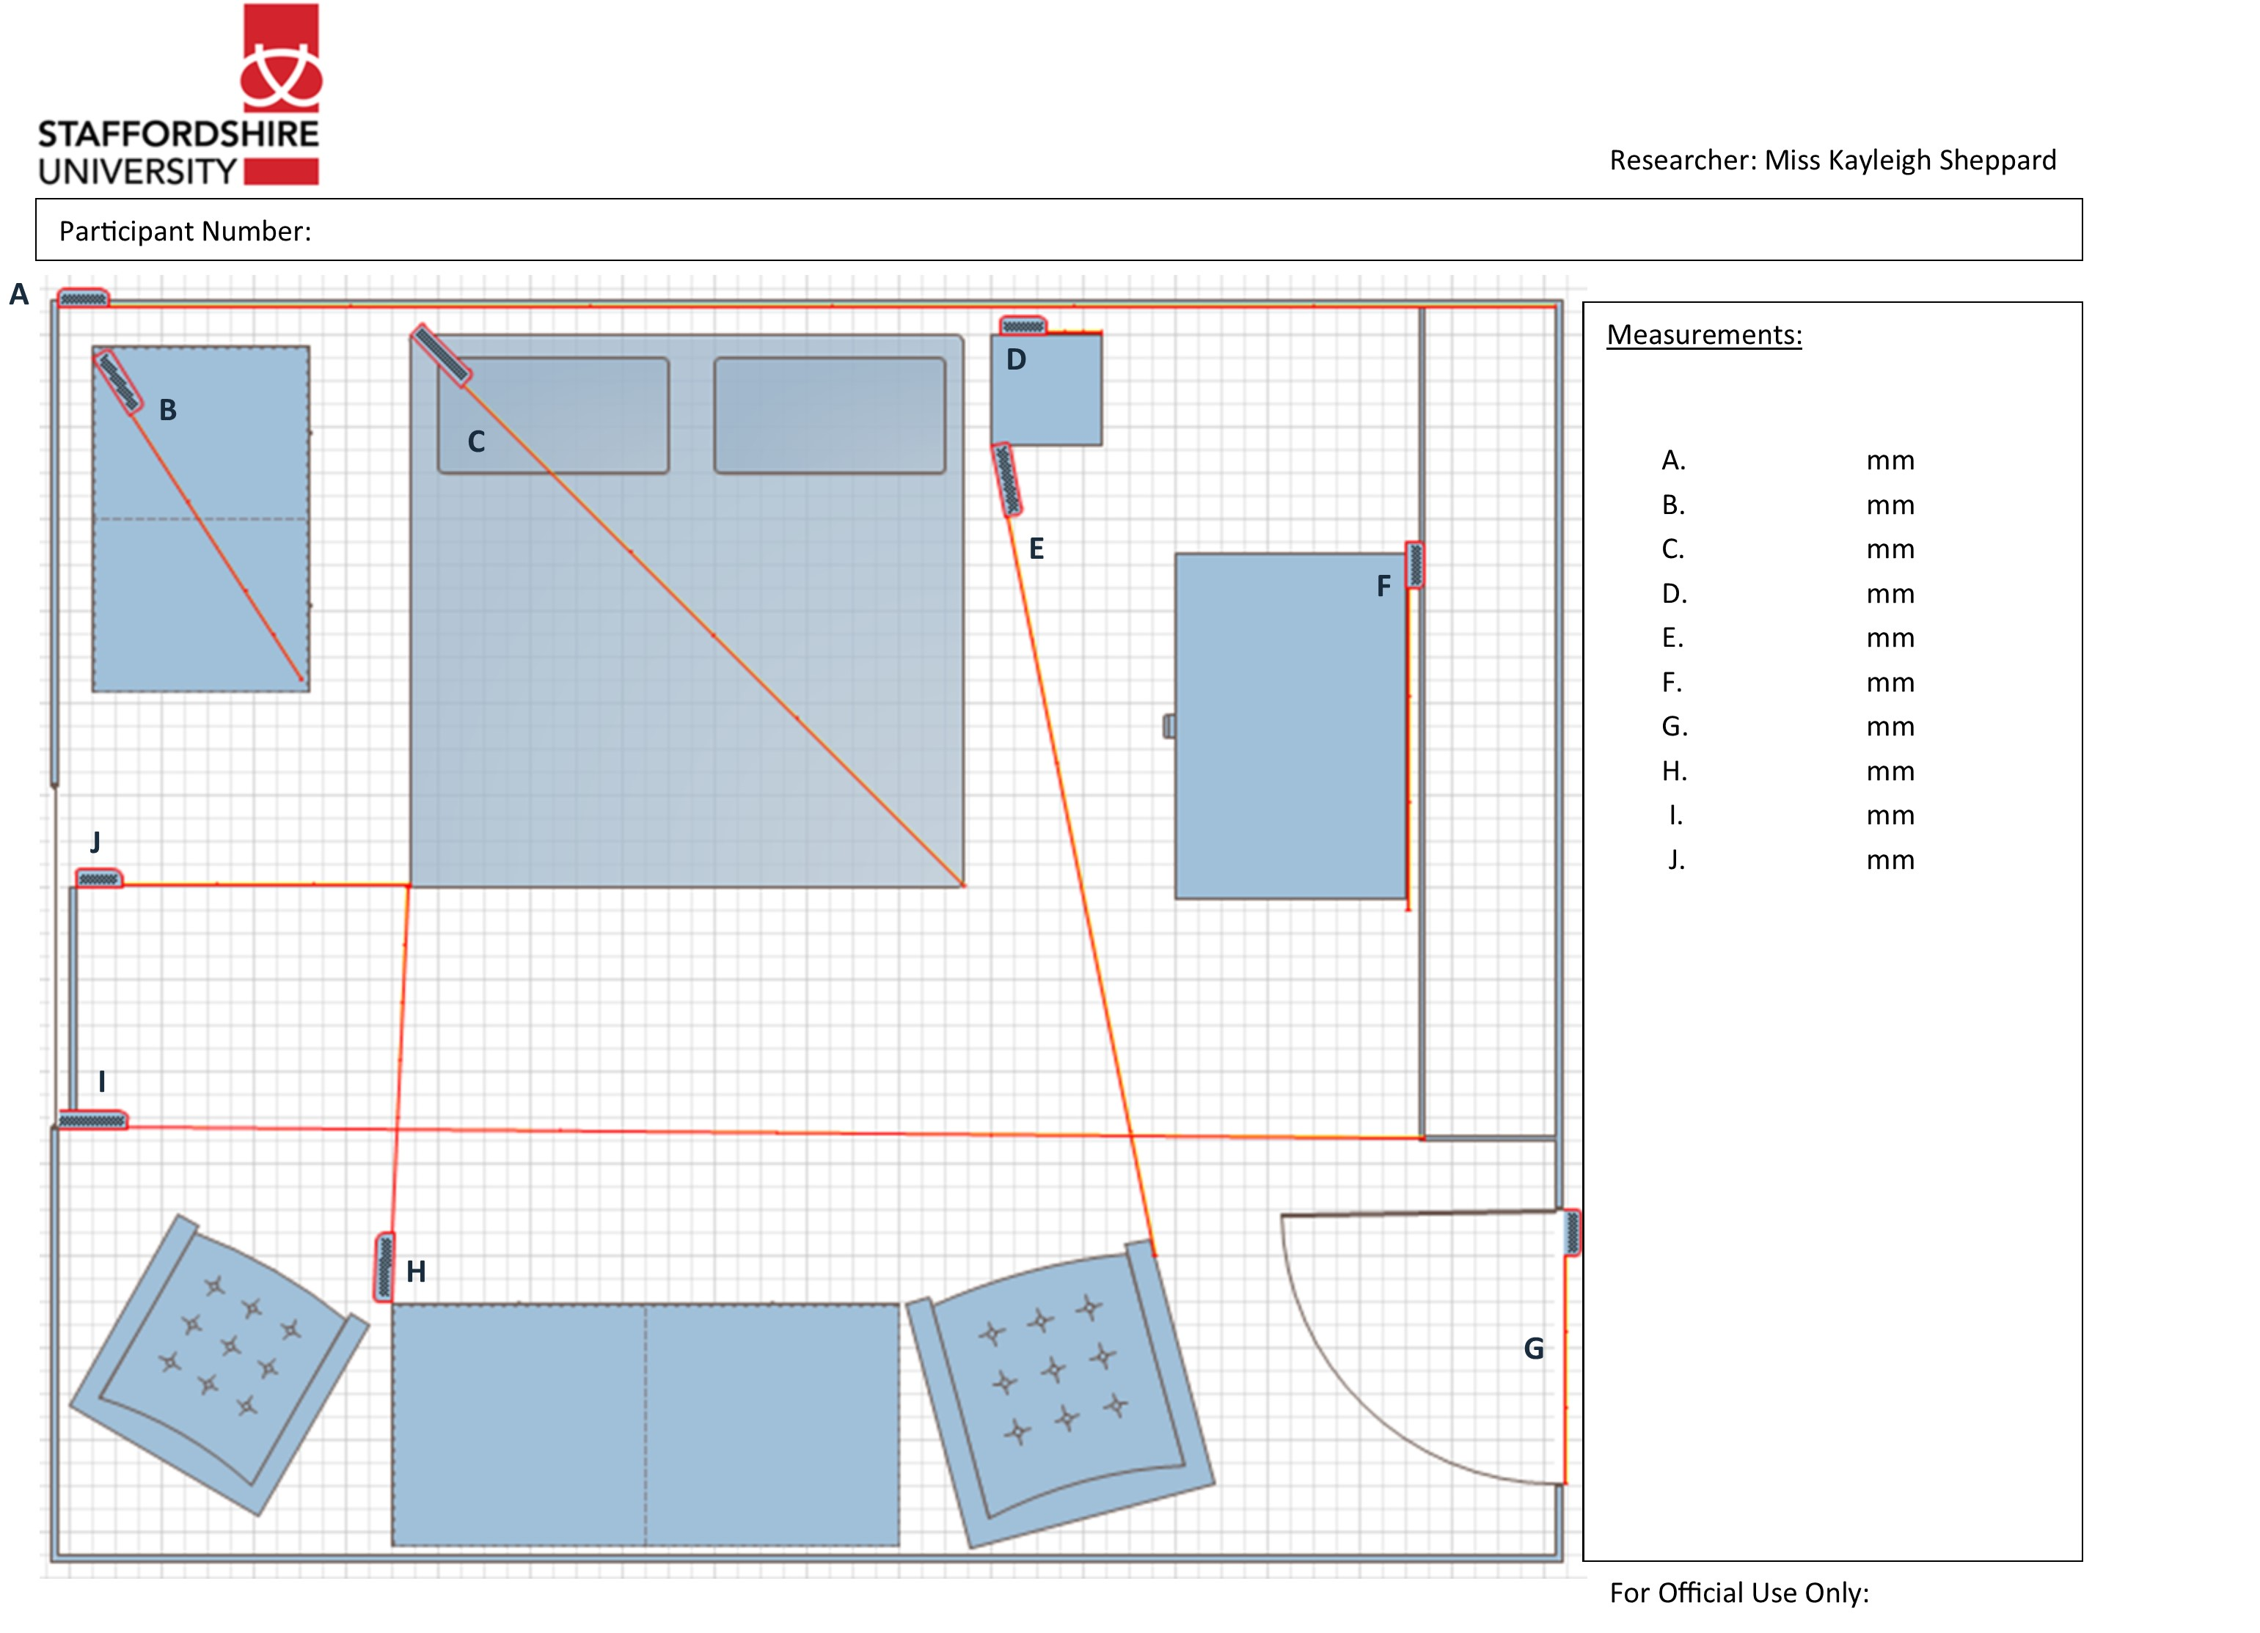
Figure 4: Room plan given to participants showing measurements A-J

Measurements of the fixed and non-fixed items (Figure 4) were taken using a DeWalt DW03050 Laser Distance Measure. This was repeated ten times for each measurement. The mean value was used as the control measurement. Artificial markers were used for items that had no obvious termination points. In this instance the laser distance measure was positioned at the start point, and a cardboard sheet was positioned at the end point, thus providing an ‘end’ to the laser, and allowing a measurement to be taken.

Ten Higher Education students (3 male and 7 female, aged 20-39 years) were recruited from the host institution. The participant group comprised final year BSc undergraduate and MSci students from Forensic awards, and PhD students from the School of Sciences (some of whom had previously studied Forensic Science). Participants were briefed on the aims of the investigation. Participants were provided with a plan of the room in hard copy (Figure 4) and were asked to record measurements of the ten fixed and non-fixed items using an 8 m Draper 25 mm wide tape measure. The plan was then taken from the participant, and they were asked to complete a distraction task, to help prevent them from remembering the measurements from the scene. The distraction tasks included mathematical calculations such as multiplication, division, subtraction, addition, and counting backwards from 30. Participants were then given an identical room plan and asked to take the same ten measurements, but in a different order. The process was repeated until each participant had measured each of the fixed and non-fixed items (Figure 4) ten times.

The bedroom environment was photographed using a Spheron SceneCam (Spheron VR Ltd.). The SceneCam was placed in four different positions within the bedroom to ensure that all ten measurements were visible within the 360º photographs. The resultant panoramas were uploaded onto the SceneCenter software. All participants were asked to take measurements of the ten fixed and non-fixed items on the SceneCenter software application. Participants were asked to record the measurement quoted by the software on an identical plan of the room to that used in the previous study. Distraction tasks were not deemed to be necessary because records of previous marker positions or measurements were not retained. The process was repeated until each participant had measured each of the fixed and non-fixed items ten times. Blank room plans were provided for each repeat.

The distribution of the data sets was determined using a Kolmogorov Smirnov test [19]. A Friedman test [20] was used to establish the existence of statistically significant differences between the control, tape and software measurements for each of the ten fixed and non-fixed items. An alpha level of 0.05 was used. Pairwise comparisons of each data set pair were completed using Wilcoxon Signed Rank tests. For the Wilcoxon Signed Rank test [21] a Bonferroni correction was applied to the alpha level by dividing the original alpha level of 0.05 by 3 (0.016). Effect size was calculated according to Cohen's r [22]. All statistical testing was carried out using SPSS version 23 (IBM SPSS).
3. Results and Discussion
3.1 Measuring a single blank wall
The control mean wall measurement was 2.70 m, with a standard deviation of 0.00088. Table 1 presents the measurements taken using the SceneCenter software for the ceiling, floor and five sections across the wall.
Table 1: Measurements taken using the SceneCam software at the ceiling, floor and sections across the wall

Repeat Number | Ceiling Measurement / m | Floor Measurement / m | Blank Wall Measurements / m  Section across the wall  1 2 3 4 5
1 | 2.66 | 2.66 | 3.37 | 3.47 | 3.41 | 3.17 | 2.54
2 | 2.66 | 2.65 | 3.29 | 3.15 | 2.90 | 2.85 | 2.65
3 | 2.66 | 2.66 | 2.97 | 2.95 | 2.87 | 2.81 | 2.52
4 | 2.66 | 2.65 | 3.25 | 3.10 | 2.73 | 2.35 | 2.12
5 | 2.66 | 2.66 | 3.58 | 4.00 | 3.74 | 3.08 | 2.44
6 | 2.65 | 2.66 | 4.64 | 5.07 | 4.30 | 3.69 | 3.28
7 | 2.66 | 2.65 | 4.37 | 4.09 | 3.62 | 2.70 | 2.31
8 | 2.65 | 2.67 | 5.07 | 5.33 | 4.76 | 4.33 | 3.38
9 | 2.65 | 2.65 | 5.71 | 6.05 | 6.72 | 6.03 | 3.77
10 | 2.66 | 2.66 | 5.03 | 6.25 | 8.39 | 5.70 | 4.24
Mean | 2.66 | 2.66 | 4.13 | 4.35 | 4.34 | 3.67 | 2.93
Relative Standard Deviation (RSD) % | 0.18 | 0.25 | 23.24 | 28.51 | 42.63 | 34.88 | 23.89

The mean wall measurements taken from the ceiling and floor lines were 2.66 m, which were consistent and 4 cm away from the control measurement of 2.70 m. The RSD values were very small, with results of 0.18 and 0.25 for the ceiling and floor lines respectively, providing evidence of a high level of consistency. Consistency between the control and ceiling/floor measurements were attributed to the presence of clear reference points visible in the ceiling/floor corners of the wall. The ability to locate clear reference points resulted in accurate measurements being obtained.

Mean measurements taken across the wall ranged from 2.93 m – 4.35 m, with high RSD values, which were up to 42.63. The high RSD values were due to the range of measurements taken, which varied from 2.12 – 8.39 m. One of the causes for this significant deviation is likely to have originated from the photogrammetric process, whereby the software cannot rebuild depth as a result of blank featureless textures or shadows produced in the corners of rooms associated with blank walls [23], such as that used in this study. The corners of the wall that were not associated with the ceiling or floor lines were less visible, and therefore it was more difficult to assign start and end points. This problem was magnified by the operation of the software, which automatically zooms into the region of interest in order for the user to select the exact pixel for the start and end points. This means that when the end point is selected the user is unaware of the allocated starting point. This often meant that there was little consistency in the heights of the start and end points, which caused inaccurate measurements to be obtained. This also explained why the ceiling and floor lines were easier to measure and gave more accurate results, given that the allocated start and end points were level.

In order to address the difficulties in assigning start and end points five pairs of 8 mm diameter paper dots were applied to two opposite corners of the wall. Table 2 shows the measurements taken on the SceneCenter software using the target dots compared against those taken in the previous study without the target dots.

Table 2: Measurements taken without a reference point (Blank Wall Measurements) compared with those taken using Target Dots.
Repeat Number | Blank Wall Cluster Measurements / m |  |  |  |  | Target Dots Measurements / m
 | 1 | 2 | 3 | 4 | 5 | 1 | 2 | 3 | 4 | 5
1 | 3.37 | 3.47 | 3.41 | 3.17 | 2.54 | 2.68 | 2.68 | 2.68 | 2.68 | 2.68
2 | 3.29 | 3.15 | 2.90 | 2.85 | 2.65 | 2.68 | 2.68 | 2.68 | 2.68 | 2.68
3 | 2.97 | 2.95 | 2.87 | 2.81 | 2.52 | 2.68 | 2.68 | 2.68 | 2.68 | 2.68
4 | 3.25 | 3.10 | 2.73 | 2.35 | 2.12 | 2.68 | 2.68 | 2.68 | 2.68 | 2.68
5 | 3.58 | 4.00 | 3.74 | 3.08 | 2.44 | 2.68 | 2.68 | 2.68 | 2.68 | 2.68
6 | 4.64 | 5.07 | 4.30 | 3.69 | 3.28 | 2.68 | 2.68 | 2.68 | 2.68 | 2.68
7 | 4.37 | 4.09 | 3.62 | 2.70 | 2.31 | 2.68 | 2.68 | 2.68 | 2.68 | 2.68
8 | 5.07 | 5.33 | 4.76 | 4.33 | 3.38 | 2.67 | 2.68 | 2.68 | 2.68 | 2.68
9 | 5.71 | 6.05 | 6.72 | 6.03 | 3.77 | 2.68 | 2.68 | 2.68 | 2.68 | 2.68
10 | 5.03 | 6.25 | 8.39 | 5.70 | 4.24 | 2.68 | 2.68 | 2.68 | 2.68 | 2.68
Mean | 4.13 | 4.35 | 4.34 | 3.67 | 2.93 | 2.68 | 2.68 | 2.68 | 2.68 | 2.68
Relative Standard Deviation (RSD) % | 23.24 | 28.51 | 42.63 | 34.88 | 23.89 | 0.11 | 0 | 0 | 0 | 0

Table 2 demonstrates that the target dots facilitated reproducible and more accurate results, as shown by the mean wall measurements of 2.68 m. The target dot data also resulted in significantly lower RSD’s than measurements taken without the dots, to the extent that measurements of 4/5 sections of the wall had a RSD of 0. Artificial targets are often used in photogrammetry to improve the accuracy of measurements taken [24], but this study had not used a crime scene context.

At a crime scene it may not be possible to use the target dot approach, and therefore a laser line was also used to provide an alternative reference point for the measurements to be taken from. Table 3 shows the measurements taken on the SceneCenter software using the laser line, compared against measurements taken without the reference line.

Table 3: Measurements taken without a reference point (Blank Wall Measurements) compared with those taken using a laser line
Repeat  Number | Blank Wall Measurement / m | Cross Line Laser Measurement / m
1 | 2.56 | 2.68
2 | 2.63 | 2.68
3 | 3.25 | 2.68
4 | 2.75 | 2.68
5 | 3.30 | 2.69
6 | 2.79 | 2.68
7 | 3.22 | 2.68
8 | 3.39 | 2.68
9 | 3.47 | 2.68
10 | 3.25 | 2.68
Mean | 3.061 | 2.681
Relative Standard Deviation (RSD) % | 10.52 | 0.11

Table 3 demonstrates the ability of the laser line to produce more accurate and reproducible measurements using the software, as shown by the mean wall measurement of 2.681 m, compared to those taken without any reference point, which had a mean wall measurement of 3.061 m. The blank wall measurement had a significantly higher RSD value of 10.52 compared to the cross line laser measurement RSD value of 0.11. The target dot study had demonstrated that the important feature was the presence of clear start and end reference points, which the laser level line had simply replicated in a non-invasive manner. The presence of these artificial reference points allowed the researcher to clearly assign start and end points to the measurements, and this resulted in more accurate measurements being obtained.

3.2 Measuring the Scene
A variety of ten fixed and non-fixed items provided different sizes and shapes for the participants to measure. Also, some of the items were easier to measure than others. For example, measurement I (Figure 4) was the width of the room across the floor space, which was easy to achieve given that the start and end points were easy to identify. On the other hand, measurement A (Figure 4) required participants to measure the width of the wall above the existing furniture, which was physically difficult to achieve as a single participant using a tape measure.

Table 4 shows the mean control measurements and RSD values for the items, A to J. The RSD values were very small ranging from 0.0104 – 0.2985, providing evidence of a high level of consistency.

Table 4: Mean and Relative Standard Deviation values for Control Measurements A to J.
Control Measurement
A B C D E F G H I J
Mean/ mm | 3578.9 | 888.8 | 2415.6 | 341.6 | 2881.9 | 921.4 | 789.2 | 1661 | 3526.8 | 1058.6
RSD (%) | 0.0195 | 0.1869 | 0.1583 | 0.2985 | 0.0104 | 0.2126 | 0.0506 | 0.0538 | 0.0376 | 0.0755
In order to take measurements using the software the camera in the scene had to be able to capture the start and end points of the items to be measured. In this study the camera was placed in four different positions, which facilitated the capture of start and end points for all ten fixed and non-fixed items. Figure 5 demonstrates that the position of the camera significantly impacted upon the actual measurements that were obtained from the software. For example, the control measurement for item B was 888.8 mm, yet at position 1 the mean measurement was 870.4 mm, at position 2 it was 864.95 mm, at position 3 it was 851.62 mm, and at position 4 it was 857.88 mm. Analysis of the error bars for item B would also support a significant deviation of measurements. This trend was apparent for all of the fixed and non-fixed items. As with the earlier study measuring the blank wall, the accuracy of the resultant measurement taken using the software application was dependent upon the users’ accuracy in identifying consistent start and end points. Some of the fixed items had bevelled edges or rounded corners, and as a result participants were likely to have chosen different start and end points to measure, resulting in significant deviations.
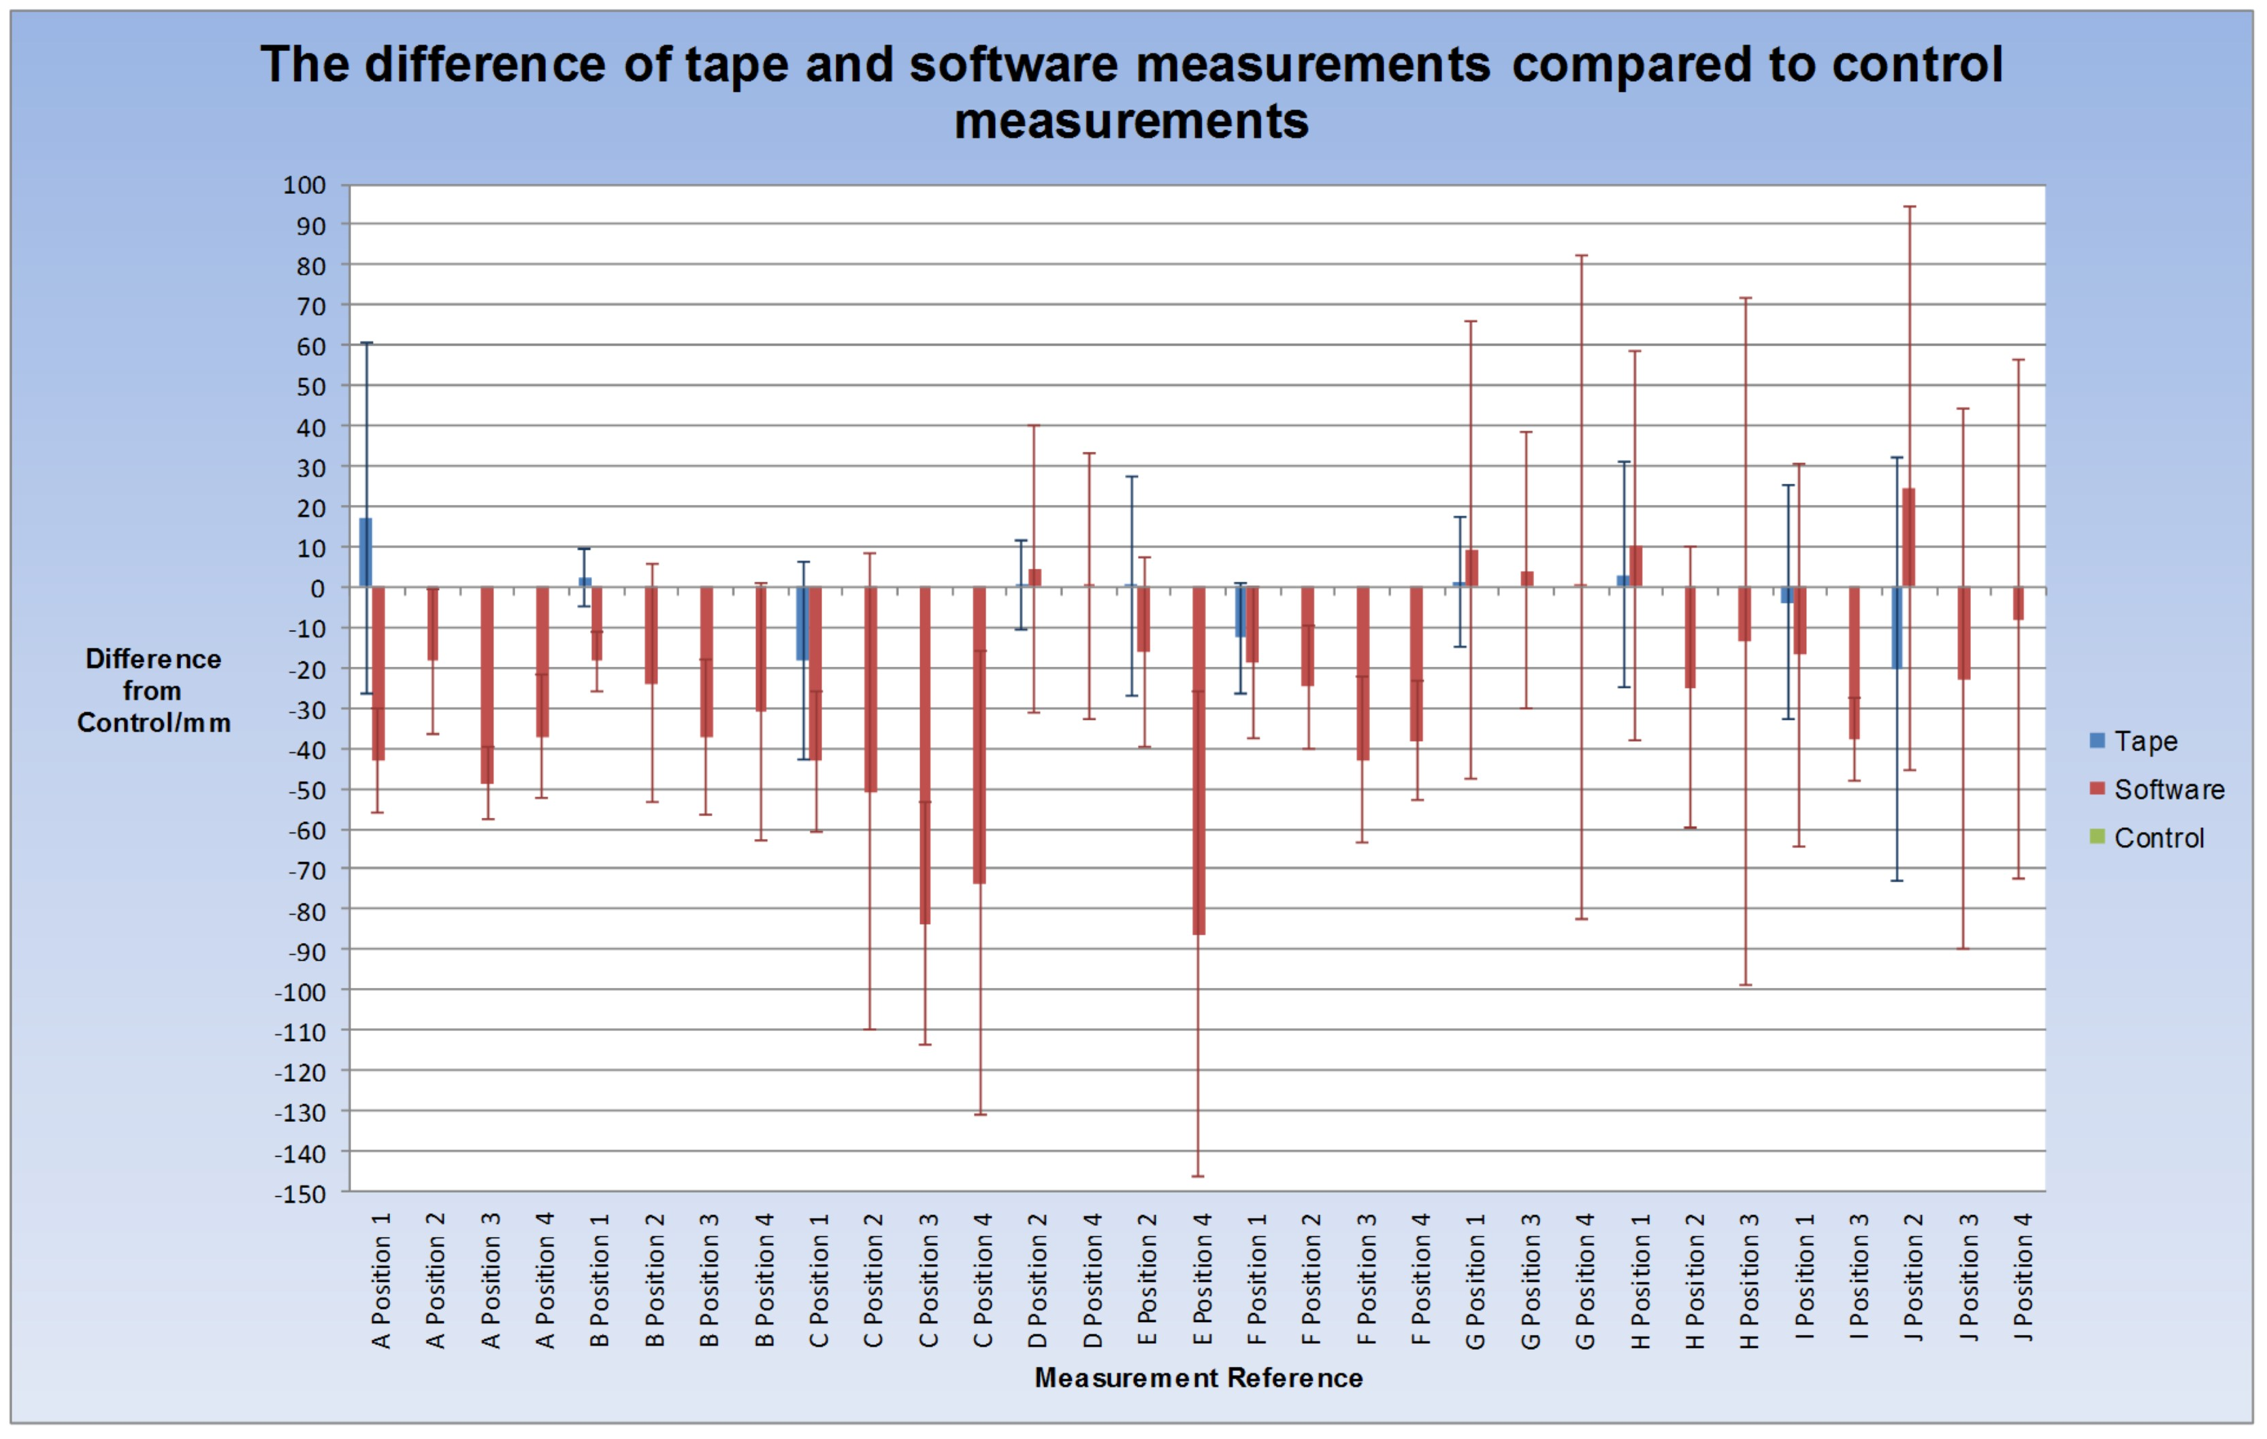
Figure 5: Differences from the control for the tape and software measurements for items A-J.

Taking measurements with the tape measure required participants to be in front of the item to assign appropriate start and end points. Figure 5 demonstrates that the tape measurements ranged from 0.4 – 20 mm difference from the control. The deviation from the control was dependent on the measurement itself. For example, analysis of the error bar for item A shows a significant deviation from the control measurement, the highest shown for any of the tape measurements, with a standard deviation of +/- 43.40 mm. The control measurement was 3579 mm whereas the mean tape measurement was 3596 mm, showing a difference of 17 mm. This large deviation was likely to have originated from the difficulty of measuring the width of the wall around and above the existing furniture. In this instance, the software was capable of producing less deviation, as the item to be measured was considered easier with the software application, which didn’t require participants to navigate around furniture.

All of the tape measurements for the ten items showed deviation from the control. The size of the deviation appeared to be dependent on the size and difficulty of the item to be measured. Items B, D, F and G were smaller measurements and were considered easier to measure compared with the others. Figure 5 demonstrates that these items had the smallest standard deviation when compared to the larger fixed and non-fixed items. Standard deviation values of +/- 7.022, +/- 10.872, +/- 13.825 and +/- 15.95 for items B, D, F and G respectively. Items B, D and F also had bevelled edges or rounded corners, and as a result the deviation within these measurements was likely to have originated from the participants choosing different start and end points to measure.

Measurements taken using the tape measure generally produced smaller standard deviation values compared to the software. This was likely to have originated from the participants’ ability to easily and consistently assign accurate start and end points to the measurement. Using the software it is probably more difficult to consistently replicate the same start and end points for each item when selecting them freehand with the computer mouse. In addition, the accuracy of measurements is dependent upon the start and end points selected and how much detail is present at this point within the panorama. Hard detail points, such as a tabletop are easier to select than softer points, such as a wall corner.

A Friedman test was used due to the absence of normally distributed data sets. The results suggested that there were statistically significant differences between the control, tape and software measurements for each of the ten fixed and non-fixed items (p≤0.05). Pairwise comparisons of each data set demonstrated that there were statistically significant differences between the majority of the data sets, as shown in Table 5. Significant differences were more prominent between the software and control measurements than measurements taken with the tape measure. This was attributed to the users’ ability to accurately assign start and end points to the items, and the ability to accurately repeat this in the same manner each time with the tape measure.

Table 5: P values and Effect Sizes for Pairwise comparisons of the Control, Tape and Software Measurement
Item | Position | Tape vs. Software |  | Software vs. Control |  | Control vs. Tape
 |  | P value | Effect Size / r | P value | Effect Size / r | P Value | Effect Size / r
A | 1 | < 0.001* | 0.576 | < 0.001* | 0.616 | < 0.001* | 0.268
 | 2 | < 0.001* | 0.452 | < 0.001* | 0.525 | < 0.001* | 0.278
 | 3 | < 0.001* | 0.599 | < 0.001* | 0.615 | < 0.001* | 0.278
 | 4 | < 0.001* | 0.567 | < 0.001* | 0.615 | < 0.001* | 0.278
B | 1 | < 0.001* | 0.620 | < 0.001* | 0.615 | < 0.001* | 0.260
 | 2 | < 0.001* | 0.570 | < 0.001* | 0.549 | < 0.001* | 0.260
 | 3 | < 0.001* | 0.607 | < 0.001* | 0.604 | < 0.001* | 0.260
 | 4 | < 0.001* | 0.542 | < 0.001* | 0.536 | < 0.001* | 0.260
C | 1 | < 0.001* | 0.499 | < 0.001* | 0.611 | < 0.001* | 0.450
 | 2 | < 0.001* | 0.485 | < 0.001* | 0.584 | < 0.001* | 0.450
 | 3 | < 0.001* | 0.595 | < 0.001* | 0.613 | < 0.001* | 0.450
 | 4 | < 0.001* | 0.546 | < 0.001* | 0.582 | < 0.001* | 0.450
D | 2 | < 0.001* | 0.267 | < 0.001* | 0.291 | 0.003* | 0.211
 | 4 | < 0.001* | 0.286 | < 0.001* | 0.316 | 0.003* | 0.211
E | 2 | < 0.001* | 0.418 | < 0.001* | 0.495 | 0.342 | 0.068
 | 4 | < 0.001* | 0.559 | < 0.001* | 0.586 | 0.005* | 0.208
F | 1 | 0.002* | 0.222 | < 0.001* | 0.547 | < 0.001* | 0.485
 | 2 | < 0.001* | 0.375 | < 0.001* | 0.573 | < 0.001* | 0.485
 | 3 | < 0.001* | 0.553 | < 0.001* | 0.605 | < 0.001* | 0.485
 | 4 | < 0.001* | 0.545 | < 0.001* | 0.610 | < 0.001* | 0.485
G | 1 | < 0.001* | 0.266 | < 0.001* | 0.274 | 0.628 | 0.037
 | 3 | 0.080 | 0.133 | 0.043* | 0.154 | 0.662 | 0.033
 | 4 | 0.120 | 0.190 | 0.002* | 0.238 | 0.020* | 0.175
H | 1 | 0.103 | 0.122 | 0.127 | 0.114 | 0.946 | 0.005
 | 2 | < 0.001* | 0.431 | < 0.001* | 0.480 | 0.561 | 0.041
 | 3 | 0.003 | 0.212 | 0.018* | 0.168 | 0.561 | 0.041
I | 1 | < 0.001* | 0.361 | < 0.001* | 0.482 | 0.567 | 0.043
 | 3 | < 0.001* | 0.531 | < 0.001* | 0.614 | 0.567 | 0.043
J | 2 | < 0.001* | 0.353 | < 0.001* | 0.260 | < 0.001* | 0.316
 | 3 | 0.509 | 0.053 | 0.436 | 0.062 | < 0.001* | 0.296
 | 4 | 0.069 | 0.130 | 0.682 | 0.029 | < 0.001* | 0.316
* = Statistically significant differences = large effect size

Effect sizes were calculated using Cohen’s r and ranged from very small (r = 0.005) to large (r = 0.620), according to Cohen’s guidelines, over the ten fixed and non-fixed items.
Statistically significant differences were apparent between the control and tape measurements, with very small to medium effect sizes (0.005 – 0.485) and therefore the differences were negligible given that they were only millimetre differences. Differences between the software and control measurements demonstrated small to large effect sizes (0.029 – 0.616), with the majority of differences amounting to a couple of centimetres, and in an extreme case the difference was 8.5 cm.
Currently, measurements taken at crime scenes are assumed to be approximate values, and in the UK there is no published accepted limit of accuracy for measuring crime scenes. However, the accepted limit of accuracy in the United States of America is 0.25 inches (6.35 mm). This may be problematic in practice due to differences in the relative sizes of items, which may be measured at a scene. For example, a 0.25 inch limit of accuracy over a 10 metre span may be considered negligible. However, a 0.25 inch limit of accuracy over a 0.5 inch measurement is half of its original size, which may be considered significant. This problem may be alleviated with the use of a percentage of the original measurement.
Both the tape and the software have advantages and limitations. Tape measurements have to be taken at the scene at the time of the incident, and as a result the SOCO cannot revisit the scene to take further measurements. The software application presents advantages over the tape in this aspect. Tape measurements introduce human error in the form of transcribing errors, misreading the tape measure, and using incorrect units. The software application removes these potential errors, but can introduce other errors and inaccuracies when users are not competent in its use, or where clear reference points are not available. The accuracy of the measurements taken using the software is a function of the resolution of the images being used, and as a result all panoramas were taken at their maximum resolution.
The investigation has demonstrated the level of accuracy when using a tape measure is dependent on the ability of the user. The software measurements were more precise and were more repeatable, but inaccuracies arose from the lack of user knowledge of the software operation. As a result it is a necessity that significant training be given to individuals using this technology. In line with the requirements of ISO 17020 the limits of accuracy need to be defined regardless of the method used to obtain measurements, and this paper details a methodological approach, which could be used to determine the levels of accuracy associated with devices used to measure items within a crime scene. The approach described in this paper may also be useful as part of competency testing.
- Conclusion
This investigation has demonstrated that by utilising target dots to aid with taking measurements with photogrammetry applications where there are blank walls present facilitated reproducible and more accurate results than by solely measuring blank, featureless walls. Crime scene environments may not allow the use of target dots (potential contamination issues), therefore a laser line could be utilised, which has also been shown to significantly improve reproducibility and accuracy of the measurements made. Statistically significant differences were found between the control, tape and the software measurements (p≤0.05), particularly between the control and the software measurements (p≤0.016). Participant derived measurements with the tape measure proved to be more accurate than the software measurements, ranging from 0.0% to 4.48% differences. The size and shape of the measured items are likely to influence a person’s ability to record accurate measurements of them, and each method tested offered advantages and should be used in conjunction. For example, in situations where measurements were considered to be more difficult to take with a tape measure, such as the length of a wall, the software application can provide a solution to capture the measurement more easily. For smaller items with more complex shapes, such as bedside tables, it may prove beneficial to use a tape measure in a forensic environment. This study shows the importance of the appropriate use of complimentary measurement techniques in order to accurately capture data that can assist in a forensic-Police enquiry.

References

- Gee, AP. Escamilla-Ambrosio, PJ. Webb, M. Mayol-Cuevas, W. Calway, A. (2010) Augmented Crime Scenes: Virtual Annotation of Physical Environments for Forensic Investigation. ACM international workshop on multimedia in forensics, security and intelligence. 105–110.
- Komar. DA, Davy-Low. S, Decker. SJ. (2012) The Use of a 3-D Laser Scanner to Document Ephemeral Evidence at Crime Scene and Post-mortem Examinations. Journal of Forensic Sciences. 57. (1). 188-191.
- Elkins, KM. Grya SE. Krohn, ZM. (2015) Evaluation of Technology in Crime Scene Investigation. CSEye.
- Technical Working Group on Crime Scene Investigation [TWGCSI] (2000). Crime Scene Investigation: A Guide for Law Enforcement. Research Report. US Department of Justice. Office of Justice Programs. National Institute of Justice.
- Carrier. B and Spafford. EH. (2003) Getting Physical with the Digital Investigation Process. International Journal of Digital Evidence. 2 (2)
- Fowle, K and Schofield, D. (2013) Technology Corner: Visualising forensic data: Evidence (Part 1). Journal of Digital Forensics, Security and Law. 8 (1).
- Tung, ND. Barr, J. Sheppard, DJ. Elliot, DA. Tottey, LS. Walsh, K AJ. (2015) Spherical Photography and Virtual Tours for Presenting Crime Scene and Forensic Evidence in New Zealand Courtrooms. Journal of Forensic Sciences. 60. (3). 753-758.
- Koper. CS, Lum. C, Willis. JJ, Woods. DJ, Hibdon. J. (2015). Realizing the Potential of Technology in Policing. A Multisite Study of the Social, Organizational, and Behavioural Aspects of Implementing Policing Technologies. Report. Available online: http://cebcp.org/wp-content/technology/ImpactTechnologyFinalReport.pdf.
- Dang, TK. Worring, M. Bui, TD. (2011). A semi-interactive panorama based 3D reconstruction framework or indoor scenes. Computer Vision and Image Understanding. 115. 1516-1524.
- Dutelle. AW (2013) An Introduction to Crime Scene Investigation. Second Edition. Documenting the Crime Scene. Jones & Bartlett Publishers.
- Howard, TLJ. Murta, AD. Gibson, S. (2000) Virtual Environments for Scene of crime Reconstruction and Analysis. Electronic Imaging. International Society for Optics and Photonics.
- Garner, RM. Bevel, T. (2009) Practical Crime Scene Analysis and Reconstruction. CRC Press. 255.
- Schenk, T. (2005) Introduction to Photogrammetry. Autumn Quarter. Department of Civil and Environmental Engineering and Geodetic Science The Ohio State University.
- Huang. F, Klette. R, Schiebe. K. (2008) Panoramic Imaging. Sensor-Line Cameras and Laser Range-Finders. Wiley.
- National Forensic Science Technology Center (2013). Crime Scene Investigation. A Guide for Law Enforcement.
- Forensic Science Regulator (2016). Codes of Practice and Conduct for forensic science providers and practitioners in the Criminal Justice System. Issue 3. Birmingham. The Forensic Science Regulator.
- DeWalt DW03050 Laser Distance Measurer. Instruction Manual. Available Online: http://service.dewalt.pt/PDMSDocuments/EU/Docs//docpdf/dw03050-typ1_en.pdf. Accessed 11/04/2016.
- Spheron SceneCam Solution. User Manual. Edition June 2007. PDF.
- Gray. CD, Kinnear. PR. (2012) IBM SPSS Statistics 19 Made Simple. Psychology Press. East Sussex.
- Coolican, H (2009) Research Methods and Statistics in Psychology. London: United Kingdom. Hodder.
- Mallison. H, Wings. O (2014) Photogrammetry in Paleontology – A Practical Guide. Journal of Paleontological Techniques. 12. 1-31.
- Clarke. TA. (1994) An analysis of the properties of targets used in digital close range photogrammetric measurement. Videometrics III. SPIE Vol. 2350. Boston. 251-262

